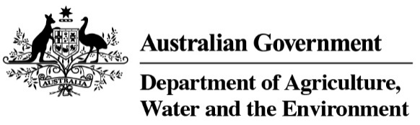

## National Traceability Summit – Voices of Industry Transcript

In 2021, we spoke with farmers, producers, agribusiness owners, exporters, researchers, innovators, grantees and more. They shared their views on what the future of traceability could look like and the challenges they currently face. Here is what they said:

“In the next five to 15 years demand for credentials will increase.”

“Brands need to guarantee their provenance and product quality.”

“We have the power to meet or exceed trading partner standards.”

“Traceability could certainly add another 10-15% value of the hides.”

“A big opportunity is understanding and using blockchain to prove compliance.”

“The ideal traceability system is flexible so that multiple parties can join and share data, is responsive to data threats, is transparent, and adaptable.”

“A shopper can use a QR code to find the product’s origin and see that it meets testing standards.”

“It’s a more integrated system across the supply chain.”

“Traceability is crucial in order to combat emergency animal disease outbreaks.”

“Traceability gives long-term progress for our industries.”

“Information and data sharing is a critical roadblock”

“The effectiveness of traceability varies across industry.”

“We need to mature our approach together.”

“The ideal traceability system is cost effective, simple and completely transparent.”

“Ideally, we want an integrated system.”

“We need to create an environment where people feel they are a part of it.”

It’s time to come together to share ideas, insights and experiences so that we can turn industry voices into enhanced traceability action.