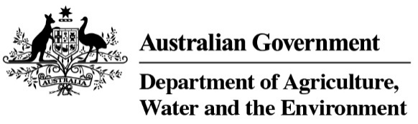

# Video transcript for exporting honey and apiculture to Malaysia

Exporting Honey and apiculture products to Malaysia

At the end of March there are some exciting changes coming for exporting Honey and apiculture products to Malaysia.

Honey and apiculture product exports to Malaysia is going live in NEXDOC.

Which means there will no longer be manual certification for honey and apiculture products to Malaysia. It will be electronic in NEXDOC!

Now to answer some of your questions..

What is NEXDOC?

NEXDOC stands for Next Export Documentation System.

It is a software application used to manage export documentation.

It was developed by the Department of Agriculture, Water and Environment.

What are the benefits?

Printing certificates at your own office

Attaching supporting documents with your request to export.

Tracking your application and liaising with the department directly through the system.

You will be able to submit and amend your application at any time of the day or night. NEXDOC is a 24/7 self-service

The department will be running training drop-in sessions in the lead up to go live.

And there is a dedicated team online to help with any questions you may have.

This is an exciting time to be a Honey or apiculture exporter!

For further information visit [www.awe.gov.au/biosecuirty-trade/export/certificatioon/nexdoc](http://www.awe.gov.au/biosecuirty-trade/export/certificatioon/nexdoc)

ENDS