# Viral haemorrhagic septicaemia (VHS)

Also known as infection with viral haemorrhagic septicaemia virus (VHSV)

From Aquatic animal diseases significant to Australia: identification field guide, 5th edition

Figure 1 VHS in rainbow trout (Oncorhynchus mykiss)

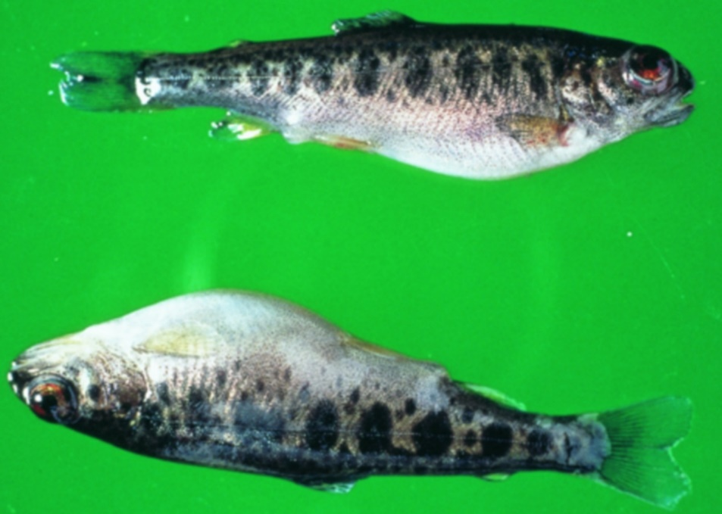

Note: Swollen stomach and exophthalmos (popeye).

Source: T Håstein

Figure 2 Internal organs of rainbow trout (Oncorhynchus mykiss) with VHS

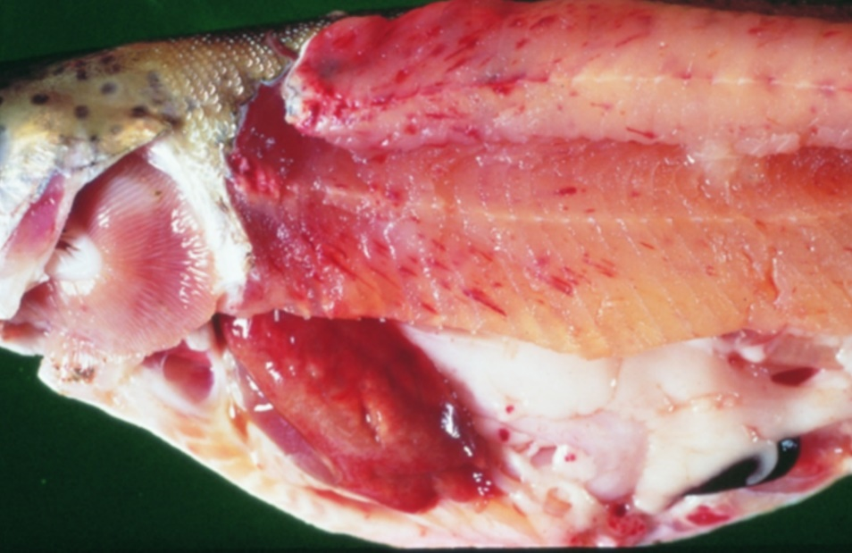

Note: Pale colour of stomach region, pinpoint haemorrhages in fillet and fatty tissue and pale gills.

Source: T Håstein

## Signs of disease

Important: Animals with this disease may show one or more of these signs, but the pathogen may still be present in the absence of any signs.

Disease signs at the farm, tank or pond level are:

* acute infection
  + rapid onset of high mortality
  + lethargic swimming
  + separation from shoal
  + loss of appetite
  + crowding at pond edges.
* chronic infection
  + significant cumulative mortality (protracted)
  + uncoordinated swimming (ataxia) with rotating movement around body axis (spinning).
* neurological form
  + low mortality
  + severe abnormal swimming behaviour (flashing and spiralling).

Gross pathological signs are:

* general
  + exophthalmos (popeye)
  + haemorrhages under the skin, around the base of pectoral and pelvic fins and in the eyes
  + swollen abdomen
  + pale gills, with or without petechial (pinpoint) haemorrhages.
* acute infection
  + slight darkening of the body colour
  + exophthalmos (popeye)
  + bleeding around the eyes
  + bleeding under the skin around the base of the pectoral and pelvic fins
  + skin ulceration
  + swollen abdomen with ascites (fluid in the abdominal cavity)
  + pale gills with petechial (pinpoint) haemorrhages
  + petechial (pinpoint) haemorrhages in the fatty tissue, intestine, gonads, liver, swim bladder and muscle
  + dark-red kidneys.
* chronic infection
  + often an absence of external signs
  + intense darkening of the skin
  + exophthalmos (popeye)
  + pale gills (anaemic)
  + pale abdominal organs
  + pale and mottled liver (evidence of haemorrhages on surface)
  + pale gastrointestinal tract that is empty of food.

Microscopic pathological signs are:

* accumulation of erythrocytes in skeletal muscle fibres
* extensive focal necrosis in the liver, kidney and spleen
* VHS virus-positive endothelial cells in vascular system evident from immunohistochemistry.

## Disease agent

VHS is caused by infection with viral haemorrhagic septicaemia virus (VHSV). VHSV is a rhabdovirus classified within the genus Novirhabdovirus, closely related to infectious haematopoietic necrosis virus (IHNV) and spring viraemia of carp virus (SVCV).

Several genogroups or genotypes of the virus have been identified from different environments in different parts of the world:

* type I, continental Europe—freshwater group, trout farms (highly pathogenic to rainbow trout)
* type II, European marine strain (Baltic Sea)—marine strain affecting wild and cultured marine and freshwater species (has low pathogenicity in rainbow trout)
* type III, north Atlantic marine group (Flemish Cap to Norway, including North Sea near the British Isles)
* type IVa, west coast of North America and east Asian group—marine group affecting a range of free-living marine and cultured species (highly pathogenic in Pacific herring; rainbow trout appear refractory to infection with this genotype)
* type IVb, Great Lakes region-significant mortalities in wild freshwater species in the Great Lakes of North America

## Host range

VHSV has been isolated from a broad range of marine and freshwater fish in Europe and the north Pacific, including cod, sprats, herring, haddock and turbot.

Table 1 Species known to be susceptible to VHSV

| Common name | Scientific name |
| --- | --- |
| American eel | Anguilla rostrata |
| Armoured weaselfish | Hoplobrotula armata |
| Atlantic cod | Gadus morhua |
| Atlantic halibut | Hippoglossus hippoglossus |
| Atlantic herring | Clupea harengus |
| Atlantic salmon | Salmo salar |
| Black crappie | Pomoxis nigromaculatus |
| Black sea bream or black porgy | Acanthopagrus schlegelii |
| Bluegill | Lepomis macrochirus |
| Blue whiting | Micromesistius poutassou |
| Bluntnose minnow | Pimephales notatus |
| Brook trout | Salvelinus fontinalis |
| Brown bullhead | Ameiurus nebulosus |
| Brown trout | Salmo trutta |
| Burbota | Lota lota |
| Channel catfish | Ictalurus punctatus |
| Chinook salmon | Oncorhynchus tshawytscha |
| Chub mackerel | Scomber japonicus |
| Coho salmon | Oncorhynchus kisutch |
| Dab | Limanda limanda |
| Eels | Anguillidae, all species |
| Emerald shiner | Notropis atherinoides |
| English sole | Parophrys vetulus |
| Eulachona | Thaleichthys pacificus |
| European eel | Anguilla anguilla |
| European seabass | Dicentrarchus labrax |
| European sprat | Sprattus sprattus |
| Flounder | Platichthys flesus |
| Fourbeard rockling | Enchelyopus cimbrius |
| Freshwater druma | Aplodinotus grunniens |
| Gilt-head sea bream | Sparus aurata |
| Gizzard shad | Dorosoma cepedianum |
| Golden trout | Oncorhynchus aguabonita |
| Grayling | Thymallus thymallus |
| Greenland halibut | Reinhardtius hippoglossoides |
| Haddock | Melanogrammus aeglefinus |
| Hairtail | Trichiurus lepturus |
| Hong Kong grouper | Epinephelus akaara |
| Hybrid (rainbow trout × coho salmon) | Oncorhynchus mykiss × O. kisutch |
| Iberian nase | Pseudochondrostoma polylepis |
| Japanese eel | Anguilla japonica |
| Japanese floundera | Paralichthys olivaceus |
| Japanese yellowtail | Seriola quinqueradiata |
| Korean flounder | Glyptocephalus stelleri |
| Lake trout | Salvelinus namaycush |
| Lake whitefish | Coregonus clupeaformis |
| Largemouth bass | Micropterus salmoides |
| Lesser argentine | Argentina sphyraena |
| Sea Mullet | Mugil cephalus |
| Mummichoga | Fundulus heteroclitus |
| Muskellungea | Esox masquinongy |
| Norway pout | Trisopterus esmarkii |
| Pacific cod | Gadus macrocephalus |
| Pacific hakea | Merluccius productus |
| Pacific herringa | Clupea pallasii |
| Pacific salmon | Oncorhynchus spp. |
| Pacific sand eel | Ammodytes personatus |
| Pacific sand lance | Ammodytes hexapterus |
| Pacific sardinea | Sardinops sagax |
| Pacific tomcod | Microgadus proximus |
| Pikea | Esox lucius |
| Plaice | Pleuronectes platessa |
| Poor cod | Trisopterus minutus |
| Pumpkinseed | Lepomis gibbosus |
| Rainbow trouta | Oncorhynchus mykiss |
| River lamprey | Lampetra fluviatilis |
| Rock bass | Ambloplites rupestris |
| Rockfish | Sebastes spp. |
| Round gobya | Neogobius melanostomus |
| Sablefisha | Anoplopoma fimbria |
| Sand eel | Ammodytes spp. |
| Sand goby | Pomatoschistus minutus |
| Senegalese sole | Solea senegalensis |
| Shiner perch | Cymatogaster aggregata |
| Shortfin eel | Anguilla australis |
| Shorthead redhorse | Moxostoma macrolepidotum |
| Silver pomfret | Pampus argenteus |
| Silver redhorse | Moxostoma anisurum |
| Smallmouth bassa | Micropterus dolomieu |
| Snapper | Chrysophrys auratus |
| Splake (lake trout × brook trout) | Salvelinus namaycush × S. fontinalis |
| Spottail shiner | Notropis hudsonius |
| Striped bass | Morone saxatilis |
| Surf smelta | Hypomesus pretiosus |
| Three-spined stickleback | Gasterosteus aculeatus |
| Trout-perch | Percopsis omiscomaycus |
| Tubesnout | Aulorhynchus flavidus |
| Turbota | Scophthalmus maximus |
| Walleye pollock or Alaska pollocka | Gadus chalcogramma |
| White bass | Morone chrysops |
| Whitefish (Muksun) | Coregonus muksun |
| Whitefish (Peled) | Coregonus peled |
| White perch | Morone americana |
| Whiting | Merlangius merlangus |
| Yellowback seabream | Evynnis tumifrons |
| Yellow percha | Perca flavescens |

**a** Naturally susceptible. Note: Other species have been shown to be experimentally susceptible.

Table 2 Non-fish carriers

| Common name | Scientific name |
| --- | --- |
| Leeches | Piscicola spp. |
| Piscivorous birds | Various genera and species |

## Presence in Australia

Exotic disease—not recorded in Australia.

Map 1 Presence of VHS, by jurisdiction

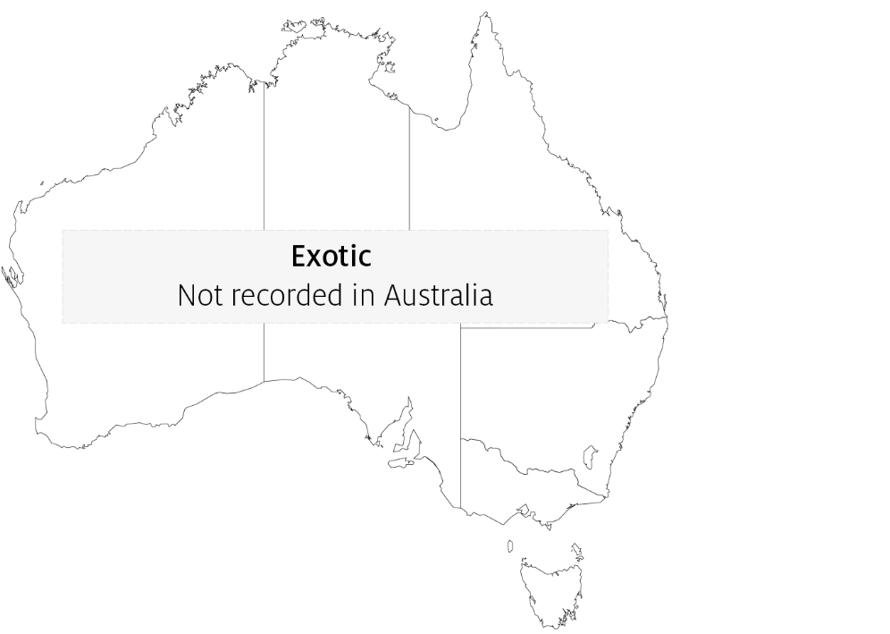

## Epidemiology

* Variant strains of VHSV are responsible for disease in different geographical locations.
* Marine and freshwater species are susceptible to VHSV infection. Younger fish are generally more susceptible to disease.
* Rainbow trout appear to be less susceptible to infection by marine strains of the virus.
* Water temperatures in an outbreak are generally near 10°C. At water temperatures between 15°C and 18°C, the disease generally takes a shorter course with a modest accumulated mortality, but transmission can occur at water temperatures up to 22°C. Mortality and morbidity have rarely been documented when water temperatures are above 18°C, although VHS virus genotype IV has caused at least one fish kill at 20 to 22°C, and some isolates can replicate in vitro at temperatures up to 25°C.
* Transmission is horizontal directly through the water, from virus shed in faeces, urine (predominantly) and sexual fluids of clinically infected or carrier fish. The virus can also be spread by birds that have consumed infected fish, via blood-feeding vectors such as leeches, and on equipment that has been in contact with water from infected fish. The virus gains entry via the gills, skin wounds, oral exposure (predation) and possibly through the skin.
* Once infected, survivors are lifelong carriers of the virus, with intermittent shedding. Stressors (including overcrowding, extreme temperatures and overfeeding) will greatly reduce an animal's resistance to infection.
* Mortality rate can range from 10% to 80%, depending on the VHSV isolate, environmental variables (temperature), age, species, route of exposure and presence of additional stressors. The highest mortality rates occur with acute infection, and lowest mortality rates in the neurological form.
* VHSV is thought to have existed in the marine environment before its apparent transfer to fresh water, where it first became virulent in trout.
* It has been suggested that the European freshwater strains of VHSV originated from fish in the northern Pacific and Atlantic oceans. The mechanism of transfer was possibly through the feeding of marine fish to cultured freshwater species.

## Differential diagnosis

The list of similar diseases in the next section refers only to the diseases covered by this field guide. Gross pathological signs may also be representative of diseases not included in this guide. Do not rely on gross signs to provide a definitive diagnosis. Use them as a tool to help identify the listed diseases that most closely account for the observed signs.

## Similar diseases

Enteric red mouth disease (ERMD), epizootic haematopoietic necrosis (EHN), infection with Aphanomyces invadans (EUS), infectious haematopoietic necrosis (IHN), infectious pancreatic necrosis (IPN) and whirling disease.

## Sample collection

Only trained personnel should collect samples. Using only gross pathological signs to differentiate between diseases is not reliable, and some aquatic animal disease agents pose a risk to humans. If you are not appropriately trained, phone your state or territory hotline number and report your observations. If you have to collect samples, the agency taking your call will advise you on the appropriate course of action. Local or district fisheries or veterinary authorities may also advise on sampling.

## Emergency disease hotline

See something you think is this disease? Report it. Even if you’re not sure.

Call the Emergency Animal Disease Watch Hotline on **1800 675 888**. They will refer you to the right state or territory agency.

## Further reading

CABI Invasive Species Compendium [Viral haemorrhagic septicaemia](https://www.cabi.org/isc/datasheet/66346)

Department of Agriculture, Water and the Environment [AQUAVETPLAN disease strategy manual: Viral haemorrhagic septicaemia](http://www.agriculture.gov.au/animal/aquatic/aquavetplan/viral-haemorrhagic-septicaemia)

World Organisation for Animal Health [Manual of diagnostic tests for aquatic animals](http://www.oie.int/en/international-standard-setting/aquatic-manual/access-online)

These hyperlinks were correct at the time of publication.

## Contact details

Emergency Animal Disease Watch Hotline 1800 675 888

Email [AAH@agriculture.gov.au](mailto:AAH@agriculture.gov.au)Website [agriculture.gov.au/pests-diseases-weeds/aquatic](http://www.agriculture.gov.au/pests-diseases-weeds/aquatic)

© Commonwealth of Australia 2020

This work is copyright. It may be reproduced in whole or in part subject to the inclusion of an acknowledgement of the source and no commercial usage or sale.