C:\Users\A09238\AppData\Local\Microsoft\Windows\Temporary Internet Files\Content.IE5\KJONZDW2\dnp-stacked.tiff

Ashmore Reef and Cartier Island Commonwealth Marine Reserves

Information for visitors

Disclaimer:

The contents of this document have been compiled using a range of source materials. While reasonable care has been taken in its compilation, the Australian Government shall not be liable for any loss or damage that may be occasioned directly or indirectly through the use of or reliance on the contents of the document.

© Commonwealth of Australia 2014

Information contained in this publication may be copied or reproduced for study, research, information or educational purposes, subject to inclusion of an acknowledgment of the source.

Community Information Unit (CIU)   
Department of the Environment   
GPO Box 787  
CANBERRA ACT 2601

Email: marinereserves@environment.gov.au

January 2014

Interpretation (including acronyms)

Ashmore refers to the Ashmore Reef Commonwealth Marine Reserve

Australian Government means the Government of the Commonwealth of Australia

CAMBA refers to the China-Australia Migratory Bird Agreement

Cartier refers to the Cartier Island Commonwealth Marine Reserve

Commonwealth reserve means a reserve established and managed under Division 4 of Part 15 of the Environment Protection and Biodiversity Conservation Act 1999

Customs means the Australian Customs and Border Protection Service

Department means the Australian Government Department of the Environment

Director means the Director of National Parks under section 514A of the EPBC Act

EPBC Act means the Environment Protection and Biodiversity Conservation Act 1999

EPBC Regulations means the Environment Protection and Biodiversity Conservation Regulations 2000

IUCN refers to the International Union for the Conservation of Nature

JAMBA refers to the Japan-Australia Migratory Bird Agreement

Minister means the Australian Government Minister administering the EPBC Act

MoU Box means the area of the eastern Indian Ocean subject to a Memorandum of Understanding between Australia and Indonesia signed in 1974 and reviewed in 1989

Ramsar refers to the Convention on Wetlands of International Importance negotiated in 1971

Reserves refers to the Ashmore Reef Commonwealth Marine Reserve and the Cartier Island Commonwealth Marine Reserve

ROKAMBA refers to the Republic of Korea – Australia Migratory Bird Agreement

1 About this Document

|  |
| --- |
| This document is not a legal instrument and is for information only. It describes the management arrangements for the Ashmore Reef Commonwealth Marine Reserve (Ashmore) and Cartier Island Commonwealth Marine Reserve (Cartier) and provides advice on how visitors, and other users of Ashmore and Cartier, should meet their obligations under the management arrangements. Visitors to Ashmore and Cartier will require authorisation from the Director of National Parks for certain activities.  Interim management arrangements under the *Environment Protection and Biodiversity Conservation Act 1999* (EPBC Act) for Ashmore and Cartier commenced on 26 June 2009 following the expiry of the most recent management plan for the reserves. Under the interim management arrangements, visitors to Ashmore Reef and Cartier Island Commonwealth Marine Reserves will require approval to conduct certain activities from the Director of National Parks. The interim management arrangements will remain in place until the North-west Commonwealth Marine Reserves Network Management Plan comes into effect. |

The North-west Commonwealth Marine Reserves Network is made up of 13 reserves and incorporates Ashmore Reef and Cartier Island Commonwealth Marine Reserves which have been renamed to align with the other reserves in the Network. Ashmore was declared a Commonwealth reserve by the Australian Government on 16 August 1983 by proclamation under the National Parks and Wildlife Conservation Act 1975 (NPWC Act) to protect the area’s outstanding and representative marine ecosystems and facilitate scientific research. Cartier was declared a Commonwealth reserve on 21 June 2000 to protect the area in its natural condition. Ashmore and Cartier are currently protected and managed as Commonwealth reserves under the EPBC Act.

Interim management arrangements for Ashmore and Cartier commenced on 26 June 2009 and will conclude when the North-west Commonwealth Marine Reserves Network Management Plan comes into effect. These arrangements provide for the management of some activities using authorisations (approvals or permits) issued by the Director of National Parks (the Director) under the EPBC Act or EPBC Regulations. Authorisation allows identified activities that would otherwise be prohibited to occur in Ashmore and Cartier. These include commercial activities and those affecting native species. Information on the authorisation process is included in Part 4 – Information for Visitors and Reserve Users. This document describes the values of Ashmore and Cartier, the management arrangements and how the values of Ashmore and Cartier will continue to be protected.

2 Ashmore and Cartier Description and Values

2.1 Location and Characteristics

Ashmore is located 450 nautical miles west of Darwin, 330 nautical miles north of Broome and 60 nautical miles south of the Indonesian island of Roti. It is situated at latitude 12 degrees and 15 minutes south and longitude 123 degrees and 5 minutes east. Cartier lies approximately 25 nautical miles to the south-east of Ashmore. Together Ashmore and Cartier cover approximately 750 square kilometres. They are located in Australia’s External Territory of Ashmore and Cartier Islands and are also within an area subject to a Memorandum of Understanding (MoU) between Indonesia and Australia, known as the MoU Box (see regional map).

Ashmore and Cartier include the seabed and substrata to a depth of 1000 metres and the airspace to a height of 3000 metres. Their boundaries are shown in the maps overleaf.

Ashmore is the largest of only three emergent oceanic reefs present within the north-eastern Indian Ocean and is the only oceanic reef in the region with vegetated islands. Ashmore and Cartier are both located on the Ashmore Terrace on the Continental Slope.

Ashmore and Cartier are situated north of the Tropic of Capricorn where the climate is dry (arid tropical) with annual evaporation being twice the annual average precipitation of 950mm. Rainfall at Ashmore and Cartier is typically restricted to the relatively short summer monsoonal period between December and May which results in freshwater lenses forming on all three Ashmore islands.

Further information on Ashmore and Cartier can be found at www.environment.gov.au/topics/marine/marine-reserves/north-west/ashmore-management and www.environment.gov.au/topics/marine/marine-reserves/north-west/cartier-management

Regional Map indicating location of the Reserves and the MoU Box

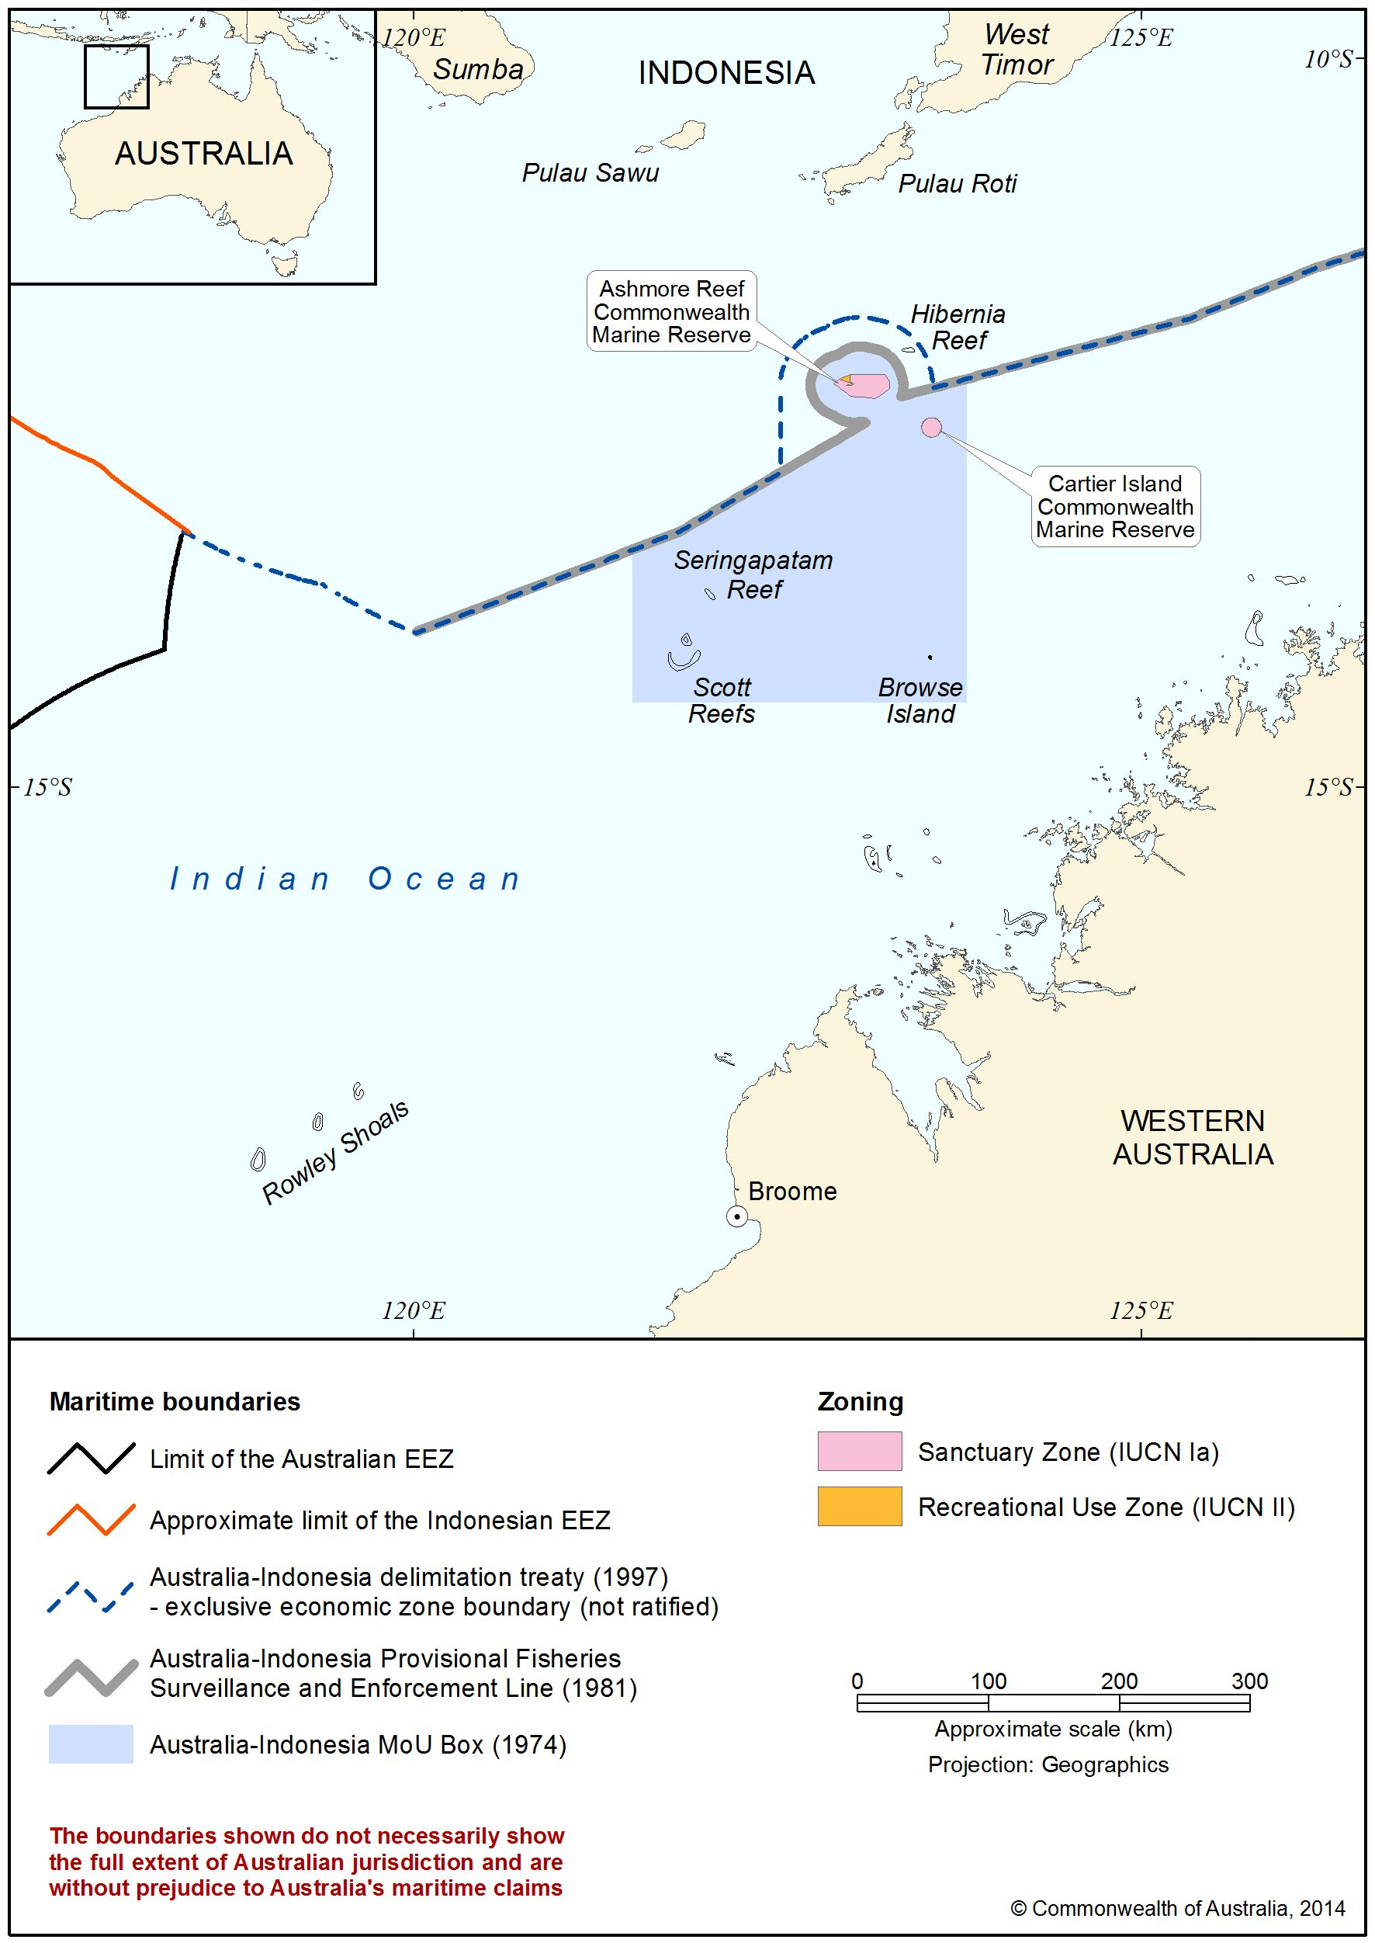

Location and boundaries of Ashmore Reef Commonwealth Marine Reserve

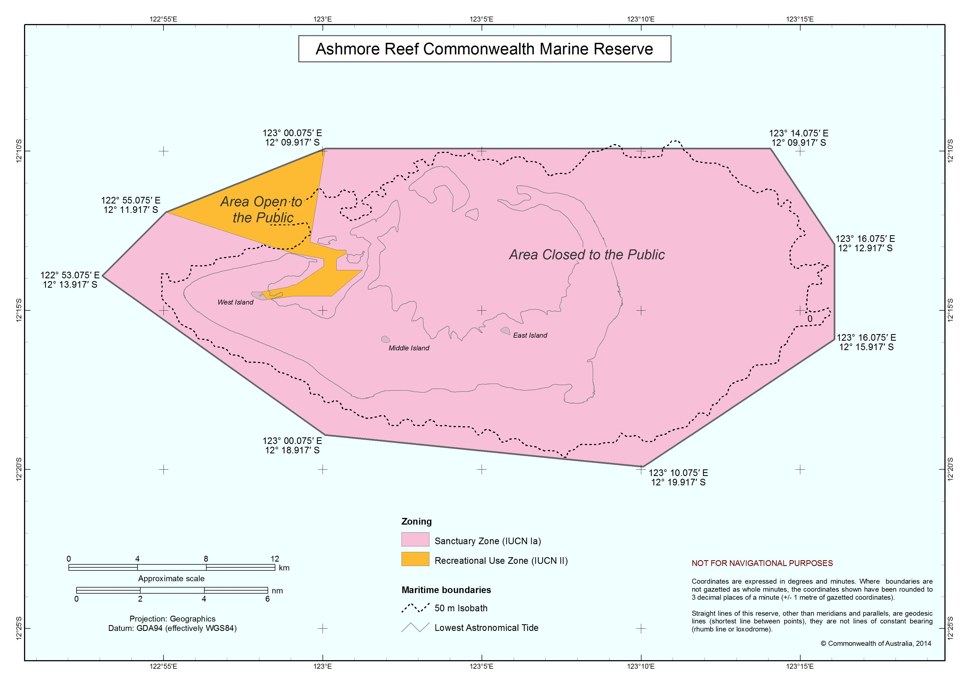

Location and boundaries of Cartier Island Commonwealth Marine Reserve

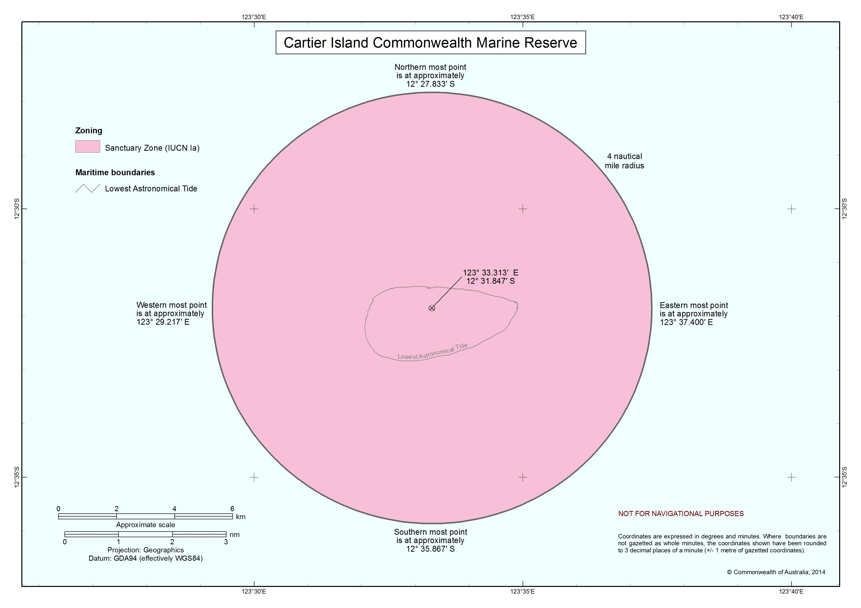

2.2 Environmental Values

Ashmore and Cartier are situated where the biogeographical regions of Australia and South-east Asia intersect to produce outstanding conservation values. They are regarded as biodiversity hotspots supporting a diverse array of terrestrial and marine species, in particular significant communities of sea snakes, dugongs, reef building corals, fish and other marine invertebrate fauna. Ashmore and Cartier also provide important seabird and marine turtle nesting sites and provide staging points and feeding areas for large populations of migratory shorebirds.

In recognition of the international importance of Ashmore in relation to its biodiversity, Ashmore was declared a Ramsar Wetland of International Importance in 2003.

Biodiversity

Coral

Ashmore and Cartier have a high diversity of reef building and non-reef building corals. Ashmore, which is characterised as a scleractinian (or stony) coral reef, has had 255 species of reef building corals as well as a number of species of non-reef building corals identified within its boundaries. This is thought to be the greatest number of reef-building species of any reef area off the Western Australian coast. The coral communities are most abundant on the reef front at both Ashmore and Cartier, although flourishing populations also exist in the lagoons.

There is considerable spatial variation in reef condition within Ashmore and Cartier, with the northern reefs being in better condition (containing a higher density and diversity of live coral) than those in the south. In recent years research has uncovered evidence of mass coral mortality, primarily on the southern sides of the reefs, which may be the result of coral bleaching. Significant coral bleaching events occurred in the region in 1998 and 2003. A survey undertaken in 2009 has indicated there may be some recovery in coral populations.

Marine Invertebrates

There are approximately 136 porifera (sponges), 433 mollusc, 286 crustacean and 192 echinoderm species (including 45 species of holothurian or sea cucumber) found at Ashmore and Cartier. Many of these, including crabs, hermit crabs and sea stars are found in large populations. There are three species of mollusc endemic to Ashmore (Amoria spenceriana, Cymbiola baili and Conus morrisoni). Other marine invertebrate species, particularly the larger bivalves (including giant clams), the gastropod Trochus niloticus and many of the holothurian species (sea cucumbers) are very low in numbers due to a history of over-exploitation. Despite the protection of Ashmore and Cartier, several species of holothurians (Holothuria scabra and Holothuria timana) and the giant clam (Tridacna gigas) are thought to be close to local extinction.

Dugong

Ashmore supports a small dugong population of less than 50 individuals. It is thought that this population is genetically distinct from other Australian populations and the extent to which it interacts with Indonesian populations is unknown. It is possible that the population’s range extends to Cartier and other submerged shoals in the region. The seagrass beds of Ashmore, and perhaps Cartier, are critical habitat for these animals. Dugongs are categorised as vulnerable under the IUCN Red List of Threatened Species and are also protected as a listed migratory and listed marine species under the EPBC Act.

Fish

The marine fish in Ashmore and Cartier are typical of Asia-Pacific coral reefs. Recent research has indicated that the total number of fish species at Ashmore and Cartier may be as high as 650 species. The high density and diversity of fish is linked to the diversity of habitat types, from sheltered and turbid lagoon habitats, to shallow patch reefs dominated by sand and high energy reef front environments influenced by oceanic water. Many of the bottom-dwelling reef fish species depend on Ashmore and Cartier to complete their whole lifecycle, while they are also regularly visited for feeding by several pelagic and oceanic fish species within the region. Fish commonly seen at Ashmore and Cartier include small pelagic fish, parrotfish and groupers as well as larger species such as trevally, coral trout, emperors, snappers, dolphinfish, marlin and sailfish. Several species of sharks including grey reef, white tip reef and hammerhead occur at Ashmore and Cartier, although their numbers are very low.

Marine Turtles

It is thought that Ashmore and Cartier support approximately 11,000 marine turtles. Significant populations of feeding Green, Loggerhead and Hawksbill turtles occur in Ashmore and Cartier and the islands have been identified as critical nesting and inter-nesting habitats for Green turtles. The Ashmore and Cartier population of Green turtles is genetically distinct from the other two breeding populations in the region.

Ashmore and Cartier and their surrounds are also important feeding areas for turtles that breed elsewhere. Individual turtles may spend several decades feeding in Ashmore and Cartier before migrating up to 2000 kilometres to other reefs and beaches for nesting. Many hatchlings from Ashmore and Cartier that have been feeding elsewhere as juveniles also return as adults to Ashmore and Cartier for breeding and nesting. The undisturbed reef flats and sandy beaches of the reserves are critical in supporting turtle populations and helping to ensure their reproductive success.

The three species of marine turtles found at Ashmore and Cartier are recognised as threatened, both nationally and internationally. They are listed on the 2000 IUCN Red List of Threatened Species, under the Convention on the International Trade of Endangered Species of Wild Animals (CITES) and the Convention on the Conservation of Migratory Species of Wild Animals (CMS). They are also protected under the EPBC Act: Green and Hawksbill turtles are listed as nationally vulnerable; and Loggerhead turtles are listed as nationally endangered.

Seabirds and Shorebirds

Ashmore and Cartier support significant and diverse populations of birds. Ninety-three species have been recorded, including more than 35 species listed on migratory bird agreements between the Australian Government and the Governments of Japan (JAMBA), the People’s Republic of China (CAMBA) and the Republic of Korea (ROKAMBA).

Ashmore and Cartier support large breeding populations of seabirds, including 10,000 to 50,000 pairs of sooty terns and 13,000 to 35,000 pairs of common noddies. Large colonies of crested terns, brown boobies and bridled terns are also found, as well as small colonies of black noddies and lesser noddies.

Ashmore and Cartier are also important staging points for many migratory shorebirds. Between March and April and again between October and November flocks of shorebirds use the islands and sand cays as feeding and resting areas during their migration. Eastern curlew, ruddy turnstone, whimbrel, bar-tailed godwit, common sandpiper, Mongolian plover, red-necked stint and grey-tailed tattler have all been recorded at Ashmore and Cartier during their migration between Australia and the Northern Hemisphere. The grey-tailed tattler and the ruddy turnstone have been recorded in numbers of international significance (greater than 1% of the east Asian-Australasian Flyway population). A total of 27 species of migratory shorebirds have been recorded at least once and flocks have been estimated to total at least 17,000 birds on occasion.

Sea Snakes

Ashmore and Cartier have been recognised internationally for their high diversity and density of sea snakes. In the 1990s, it was estimated there were 40,000 sea snakes from at least 13 species present at Ashmore, representing the greatest number of sea snake species recorded for any locality in the world. Three of the species at Ashmore are endemic to Australia’s north-west shelf.

Previous research in the West Island channel recorded sightings of approximately one sea snake per minute. Research since 2003, however, has identified a steep decline in the abundance and diversity of sea snake species at Ashmore and Cartier. Separate surveys over three consecutive years recorded a total absence of two species endemic to the region, the short-headed snake and the leaf-scale snake. Research into the cause of the decline continues, however it is thought that the decline may be related to changes in reef structure and habitats.

Water Quality

There are several major factors affecting the oceanography in the region of Ashmore and Cartier, including monsoons, dominant south-easterly winds and other seasonal influences from the Indian Ocean and the Indonesian Throughflow.

The surface waters are dominated by the Indonesian Throughflow and are therefore warm and generally low in nutrients. During winter, there is a strong south and westerly flow of surface waters. During summer however, the Throughflow weakens and the Eastern Gyral Current may even result in a northward movement of surface water.

Beneath the surface, cooler more nutrient rich waters are believed to be associated with the northward flowing West Australian Current. Mixing of water bodies is thought to occur in shelf break areas around the reef systems of the region, including around Ashmore and Cartier, resulting in localised upwelling and enhanced nutrient availability.

Monsoonal conditions dominate from December to May and, although prolonged periods of rainfall are rare, most of the rainfall at Ashmore and Cartier is restricted to this relatively short summer monsoonal period. Cyclones are common with the region experiencing seven percent of the annual global cyclone total. Cyclones typically move south-west across the Arafura and Timor Seas down the West Australian coastline and contribute to the mixing of the water column.

Sea surface temperatures vary seasonally with the highest oceanic water temperature recorded at 31°C and the highest lagoon water temperature recorded at 35.4°C. Tidal ranges exhibit an average spring tide maximum of 4.75 metres.

Research on the effects of climate change have listed higher water temperatures, increased frequency and severity of cyclones, changes to oceanic currents and increased ocean acidification as possible threats to Ashmore and Cartier.

Habitats

Ashmore and Cartier provide varied habitat that supports a diverse range of flora and fauna. Ashmore contains two extensive lagoons, mobile channelled carbonate sand flats, shifting sand cays, an extensive reef flat and three vegetated islands, known as East, Middle and West Islands. The two lagoons have four northern entrances and have extensive coral growth. Cartier contains one unvegetated sand cay and a mature reef flat with two shallow pools immediately to the north-east of the cay.

The reef front has a high diversity of robust hard and soft corals, gorgonians, sponges and a range of encrusting organisms. The reef crests are generally algal dominated, while the reef flats feature ridges of coral rubble and large areas of seagrass that are important for dugong and sea snake species. The sand flat habitats support a range of species including feeding dugong, turtles, stingrays, echinoderms, molluscs, crustaceans and migrating shorebirds. Areas of sand flats that do not dry at low tide also have a sparse cover of soft corals and various algae.

The lagoons at Ashmore support corals, sponges, burrowing shrimp and a range of holothurians, echinoderms, molluscs and polychaetes on and beneath the sand. This in turn provides habitat and food for a wide range of fish, sharks and sea snakes. The reef structure and communities of Ashmore and Cartier also provide mid-oceanic habitat and food for more mobile crustaceans, whale sharks, manta rays and seabirds.

The vegetated islands of Ashmore (West, Middle and East Islands) provide important nesting habitat for many species, including marine turtles and a number of seabirds and migratory shorebirds. A limited range of plant species have been recorded on the islands.

West Island has a fringing shrubland community, comprising mainly Argusia argentea with isolated examples of other species. The interior of the island is an open herb land with a range of grass species found throughout. East Island is predominantly grassland while Middle Island has the remains of a fringing shrubland and an interior herb field with areas of similar grass species to those found on East Island. The Middle Island shrubs provide the nesting habitat for great frigate birds.

2.3 Cultural Heritage Values

Ashmore has been regularly visited and fished by Indonesian fishers since the early eighteenth century. Early travellers to Ashmore included the Bajo, migratory sea people originating from the coastline of Sulawesi and islands south of Sulawesi, and fishers from the island of Roti.

Indonesian fishers voyaged south of the Indonesian archipelago seeking new sources of trepang (sea cucumber or holothurians), turtle shell, trochus shell, shark fin and reef fish.

One tale of the discovery of Ashmore by the Rotinese is that a vessel sailing from Roti to Timor was forced to run ahead of a storm for five days. The vessel was in open sea and the crew saw some birds and followed them, expecting to find land where they could seek help. They arrived instead at Ashmore, where they remained for some time sheltering and fishing. They then steered north and returned to Roti.

Rotinese sailors continued to visit Ashmore in their wooden perahus (traditional sailed fishing boats). The traditional navigation method was to sail due south in alignment with the most prominent hill-point on the south coast of Roti. If they hadn’t reached Ashmore within a full day of leaving Roti, they would return and realign and sail south again. If the sky was cloudy, the location of Ashmore could be distinguished before sighting land due to the greenish tinge the clouds take on in reflection of the islands.

Traditional fishers replenished water from the freshwater well on West Island and collected fish, birds, bird eggs, holothurians, clam flesh, shells, firewood, turtles and turtle eggs. Ashmore was also used as a staging point for voyaging to other reefs further south. Ashmore and Cartier were used by traditional fishers to bury their dead and there are now at least seven graves on West Island at Ashmore and one on Cartier Island.

Ashmore and Cartier were discovered by Europeans early in the nineteenth century. Captain Nash aboard the Hibernia discovered Cartier Island and Captain Samuel Ashmore discovered Ashmore Reef. The later discovery of phosphate deposits (guano) in the area attracted the attention of American whalers operating in the region in the 1840s. Extraction of the deposits was underway by the mid-nineteenth century. By 1891 all guano was reported to have been removed from Ashmore’s West Island. The amount of material and the consequences of the activity are largely unknown, however it would appear that most populations of nesting birds were driven off West Island by the activity resulting in the birds re-establishing their main nesting grounds on Middle and East Islands.

Disputes between the United States of America and Great Britain between 1878 and 1909 over ownership of Ashmore Reef resulted in confirmation of British sovereignty and the annexure of Cartier Island. In 1932 Britain transferred ownership of Ashmore Reef and Cartier Island to the Australian Government.

Cartier Island and the surrounding area within a ten kilometre radius is a gazetted Defence Practice Area for the purposes of military exercises, and has been used as an air weapons range. Original use of this area for military purposes appears to date back to World War II. In 1986 Cartier Island a mission was conducted to search and clear the island of easily accessible surface and shallow water unexploded ordnance. However, due to highly mobile sand deposits and the difficulty of clearing the reef, Cartier Island the rest of the reef cannot be guaranteed free of unexploded military materials. The possible presence of unexploded ordnance remains a risk to visitors to Cartier and entering the reserve (without permission), landing on the island or anchoring in nearby waters is prohibited. If anchoring is unavoidable due to emergency (e.g. extreme weather condition), great care should be taken to ensure anchoring is on sand and anchors do not drag. Any incident involving unexploded ordnance should be reported to the Police on 000 and the Parks Manager or Work Health and Safety Advisor on (02) 6274 2369 or [parks.healthandsafety@environment.gov.au](mailto:parks.healthandsafety@environment.gov.au)

There is one known shipwreck at Cartier. The Ann Millicent, an iron hulled barque of 944 tons, was wrecked on Cartier Island on 5 January 1888. A wreck believed to be that of the Ann Millicent is visible at low tide on the southern edge of Cartier Island. During World War II a Royal Australian Air Force Beaufighter sustained damage during a conflict and landed on Cartier Island. Following the rescue of the crew, the wreck was strafed by other aircraft and set alight. Some remains of the aircraft are still present on Cartier Island.

2.4 Social and Economic Values

A 1974 Memorandum of Understanding between Australia and Indonesia sets out arrangements by which traditional fishers can access resources in Australia's territorial sea the region. This allows traditional Indonesian fishers to access parts of Ashmore for shelter, freshwater and to visit grave sites.

Ashmore and Cartier have a high value for scientific research because they currently receive relatively few visitors and may play an important role as a biological stepping stone for marine and terrestrial species. Tourism and recreation is mainly limited to West Island at Ashmore. Most visitors arrive by private yacht with only one or two commercial tours visiting each year. Historically there have been few visitors to the reserves and this is likely to continue due to their remoteness.

3 How are Ashmore and Cartier Managed?

Management responsibility for Ashmore and Cartier rests with the Australian Government through the Director of National Parks (the Director). The Director has delegated authority under the EPBC Act and EPBC Regulations to specific members of the Parks Australia Division of the Department of the Environment (the department).

The department has a close working relationship with the Australian Customs and Border Protection Service (Customs). Under a memorandum of agreement, Customs implements several management actions at Ashmore and Cartier on behalf of the Director.

A number of other agencies assist in the management of Ashmore and Cartier, including the Australian Defence Force, the Australian Fisheries Management Authority, the West Australian Department of Fisheries, the Department of Immigration and Citizenship and the Australian Quarantine and Inspection Service.

The Director requires that any risks to the values and effective management of Ashmore and Cartier be assessed periodically to ensure adaptive and responsive management. Effective risk management may require adjustment to management priorities and the re-allocation of resources for management activities to respond to new or increasing risks.

3.1 Strategic Objectives

The strategic objectives for managing Ashmore and Cartier are in line with their IUCN categories (see Part 3.2.2 – IUCN Category) and the relevant management principles set out in Schedule 8 of the EPBC Regulations. These objectives direct management’s efforts in achieving the goals for which Ashmore and Cartier were declared (see Part 1 – About this Document).

Ashmore and Cartier are protected and managed to preserve their natural condition according to the following objectives:

• protect the high conservation values in the marine and terrestrial environments of Ashmore and Cartier, including objects and sites of biological, historical, palaeontological, archaeological, geological and geographical interest

• manage Ashmore and Cartier primarily for scientific research and monitoring purposes with public access limited

• protect Ashmore and Cartier against damage from human activities, and

• encourage and regulate the appropriate use of Ashmore and Cartier.

3.2 Legislative Context

3.2.1 Proclamation of Ashmore and Cartier

Ashmore Reef Commonwealth Marine Reserve was declared by the Australian Government on 16 August 1983 by proclamation under the National Parks and Wildlife Conservation Act 1975 (replaced by the EPBC Act in 1999). Cartier Island Commonwealth Marine Reserve was declared by the Australian Government on 21 June 2000 under the EPBC Act. Both Ashmore and Cartier were declared for the purposes of protecting their outstanding and representative marine ecosystems and to facilitate scientific research.

3.2.2 IUCN Category

The majority of Ashmore and all of Cartier are assigned the IUCN category Ia and is zoned as a “Sanctuary Zone” which means that they are protected areas managed mainly for scientific research or environmental monitoring. Part of Ashmore, comprising West Island Lagoon and part of West Island, is assigned the IUCN category II and is zoned as a “Recreational Use Zone” which means it is a protected area managed mainly for ecosystem conservation and recreation. All parts of both Ashmore and Cartier are managed in accordance with the management principles set down in Schedule 8 of the EPBC Regulations.

3.2.3 EPBC Act and Regulations

Ashmore and Cartier are protected and managed as Commonwealth reserves under the EPBC Act and the EPBC Regulations. For more information on this legislation see www.environment.gov.au/topics/about-us/legislation/environment-protection-and-biodiversity-conservation-act-1999/what

3.2.4 Director of National Parks

The functions of the Director include the administration, management and control of Commonwealth reserves. The Director has a number of specified powers under the EPBC Act and EPBC Regulations allowing these functions to be carried on. The functions include the power to prohibit or control some activities and to issue authorisation for activities that are otherwise prohibited in Commonwealth reserves.

3.2.5 Prohibitions on Public Access

The area of Ashmore that is assigned the IUCN category Ia is closed to the public. The map overleaf shows the internal zones of Ashmore, indicating the public access and closed areas. All of Cartier is closed to the public. For more information on access to Ashmore see www.environment.gov.au/topics/marine/marine-reserves/north-west/ashmore-management

Open and closed areas of Ashmore Reef Commonwealth Marine Reserve

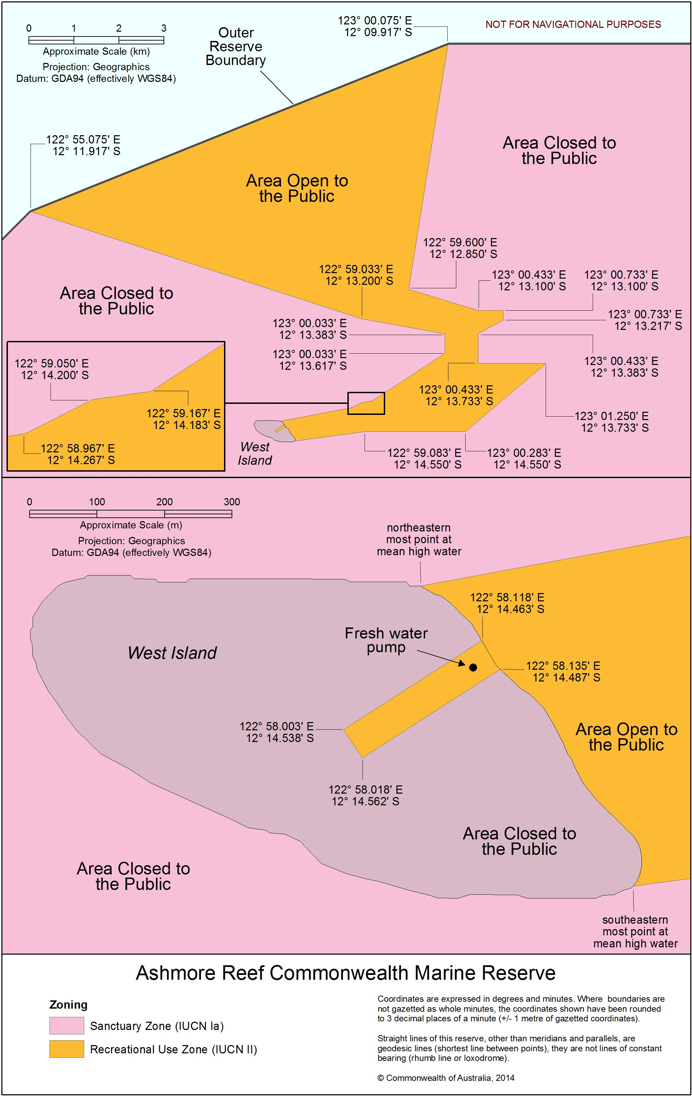

3.3 Protecting the Reserves’ Values

This section describes the Director’s intentions regarding protection of the values of Ashmore and Cartier. More information on the values can be found in Part 2 – Ashmore and Cartier Description and Values.

Environmental Values

The Director intends to ensure the protection of the environmental values of Ashmore and Cartier through activities outlined below.

Biodiversity

It is important to minimise human impacts to protect the biodiversity in Ashmore and Cartier, particularly in the face of threats such as climate change and invasive species. To protect the marine and terrestrial life in Ashmore and Cartier, the Director intends to:

• manage activities to ensure minimal human impact on the values of Ashmore and Cartier

• maintain the prohibition on public access to most of Ashmore and all of Cartier

• continue quarantine and introduced species mitigation strategies to reduce the risk of new introductions and manage current pest population, and

• encourage and facilitate research and monitoring projects directly related to understanding the status and trends over time of species while ensuring minimal human impact to the values of Ashmore and Cartier.

Water quality

It is essential to minimise human-induced disturbances in Ashmore and Cartier and surrounding areas to maintain the area’s high water quality. To do this, the Director intends to:

• liaise with appropriate authorities to respond to incidents of pollution spills

• conduct education and information programs for users regarding pollution, and

• monitor sea surface temperature and other water quality variables, including turbidity and acidity, over time to inform decision making.

Habitats

It is important to monitor ecosystem processes and minimise the influence of human impact. To protect the varied habitats, the Director intends to:

• encourage and facilitate research and monitoring projects directly related to understanding the status and trends of habitats over time while ensuring minimal human impact to the values of Ashmore and Cartier

• assess applications for installations in Ashmore and Cartier with consideration of the potential impacts on the habitats, and

• assess applications for mining and associated activities near Ashmore and Cartier so that these activities do not adversely impact the habitats in Ashmore and Cartier.

Cultural Heritage Values

To protect the cultural heritage values of Ashmore and Cartier, the Director intends to:

• continue the Australian Government presence in Ashmore and Cartier to ensure the protection of cultural items and sites is maintained and provide access to cultural heritage sites where appropriate.

Social and Economic Values

To protect the social and economic values of Ashmore and Cartier, the Director intends to:

• continue education programs with traditional Indonesian fishers regarding the management rules at Ashmore and Cartier, including through the distribution of up-to-date brochures and maps in Bahasa

• continue the Customs compliance presence in Ashmore and Cartier

• liaise with the Australian Fisheries Management Authority and Customs regarding illegal fishing and unauthorised boat arrivals in Ashmore and Cartier, and

• engage with other Australian Government departments and the Indonesian Government regarding sustainable management of the MoU Box.

4 Information for Visitors and Reserve Users

|  |
| --- |
| All persons/visitors wishing to undertake activities other than boat-based recreational activities in Ashmore and Cartier should contact the Commonwealth Marine Reserves Branch prior to visiting.  Phone: 1800 069 352 Email: marinereserves@environment.gov.au  All people wishing to undertake recreational activities in the area open to the public at Ashmore should use this document to familiarise themselves with the rules that apply prior to visiting Ashmore. For more information visit *www.environment.gov.au/topics/marine/marine-reserves/north-west/ashmore-management* or contact the Commonwealth Marine Reserves Branch.  Phone: 1800 069 352 Email: marinereserves@environment.gov.au |

To enable visitors to access Ashmore and Cartier in a way that does not pose unacceptable risks to visitor safety and the values, there are a number of rules that apply to visitors. Some of these rules apply to all visitors. Others apply to particular activities. They are consistent with the IUCN categories of Ashmore and Cartier the EPBC Act and EPBC Regulations, and the interim management arrangements for Ashmore and Cartier. The activities table below provides general advice on zoning and allowed activities within the Ashmore Commonwealth Marine Reserve.

Activities summary for Ashmore Commonwealth Marine Reserve

The following table outlines activities allowed without approval (✓), allowed with a general approval (GA), allowed with approval (A) or not allowed (✗) at Ashmore Commonwealth Marine Reserve.

|  |  |  |
| --- | --- | --- |
| **Activity\*** | **Area open to the public**  **Recreational Use Zone (IUCN II Zones)** | **Areas closed to the public**  **Sanctuary Zone**  **(IUCN Ia zones)** |
| West Island Lagoon, east beach and central corridor of West Island (see map) | Majority of Ashmore Reserve (including Middle & East Islands) |
| **GENERAL USE** |  |  |
| General Access | ✓ | A |
| **COMMERCIAL ACTIVITIES** |  |  |
| Fishing (including collecting#) | ✗ | ✗ |
| Filming and Photography | A | A |
| Tourism and Charters | A | A |
| Other Commercial Activities | ✗ | ✗ |
| **RECREATIONAL ACTIVITIES** |  |  |
| Scuba diving & snorkelling | ✓ | ✗ |
| Fishing | GA** | ✗ |
| **SCIENTIFIC RESEARCH** | A | A |
| * Camping and lighting fires is not allowed in any part of the reserve. ** Fishing (finfish only) for subsistence purposes is allowed. # No collecting allowed. Collecting refers to the collecting of any object, animal or plant from the Reserve, including coral, shells and sedentary species such as sea cucumbers. | | |

4.1 General Information for Everyone Visiting the Reserves

Visitors may only access the open area of Ashmore (see map on page 16) unless under authorisation from the Director. The following rules apply to all visitors to the Ashmore open area and all visitors with authorisation to enter the closed area of Ashmore or Cartier.

All visitors should conduct regular inspections and cleaning of their vessels to minimise the risk of introducing marine pests into Ashmore and Cartier.

Entering the open area (West Island Lagoon) at Ashmore:

• for safety reasons, the lagoon should be entered with caution and you should consider the draught of your vessel and the numerous coral bommies that exist in the entry to the inner lagoon. Navigation markers are located in West Island Lagoon for use by Customs only. Other visitors use these navigation markers at their own risk

• where possible use one of the designated visitor moorings (see Part 4.1.1 – Ashmore Moorings), and

• if all moorings are occupied visitors should anchor on sand only, making sure to keep the anchor clear of coral formations.

Within the open area (West Island Lagoon) at Ashmore:

• all forms of collecting and commercial fishing are prohibited, including the removal of shells

• visitors should not feed fish or any other wildlife: feeding fish and wildlife has been known to change the behaviour of animals and may result in safety risks to visitors as well as affect the ecological balance of the reef community, and

• visitors should not walk on the reef: reef walking can cause severe damage to reef flats and poses a safety risk if visitors don’t see well camouflaged and sometimes venomous animals.

For further rules that apply to all visitors to Ashmore and Cartier please refer to Part 5.1 – Rules and Regulations.

4.1.1 Ashmore Moorings

Capital works, installations or infrastructure development are only allowed where assessed by the Director to provide a net benefit to the protection of the values of Ashmore and Cartier or to be essential for visitor safety. All proposals undergo a rigorous assessment and only works that are consistent with the IUCN categories the EPBC Act and EPBC Regulations, and the interim management arrangements for Ashmore and Carter will be authorised.

In 2003, 13 visitor moorings were installed in West Island Lagoon at Ashmore to reduce anchor damage and provide appropriate accommodation for recreational and traditional Indonesian vessels. Anchoring causes significant damage to fragile features such as coral. Also installed in West Island Lagoon are Customs navigation markers and moorings for use by Australian Government vessels only. Visitors use the navigation markers at their own risk.

The locations of visitor moorings are shown in the plan below. For safety reasons, visitors should follow the rules and restrictions noted.

Ashmore West Island Lagoon Moorings

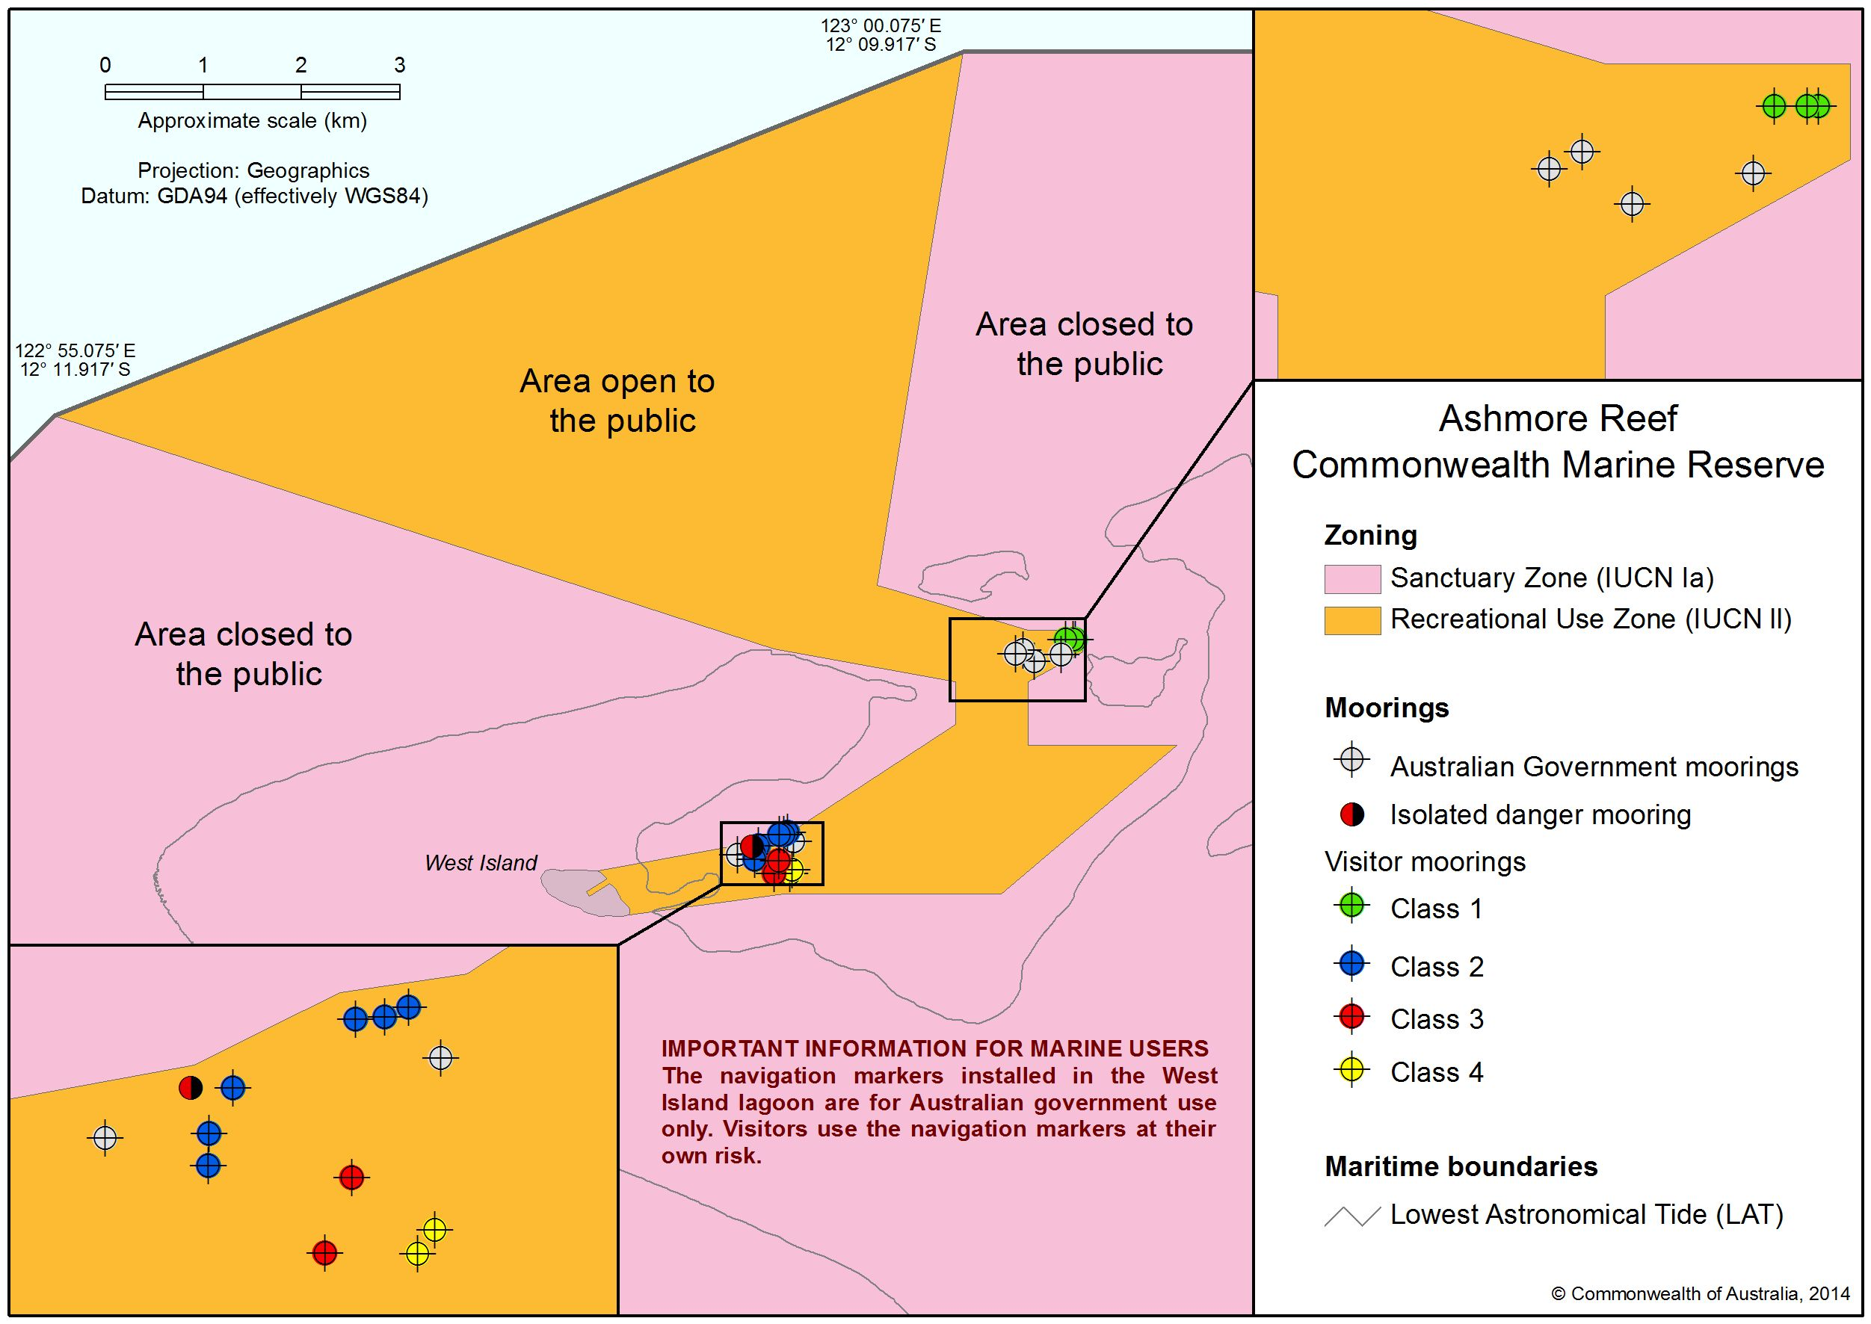

Visitor Mooring Locations and Restrictions at Ashmore West Island Lagoon

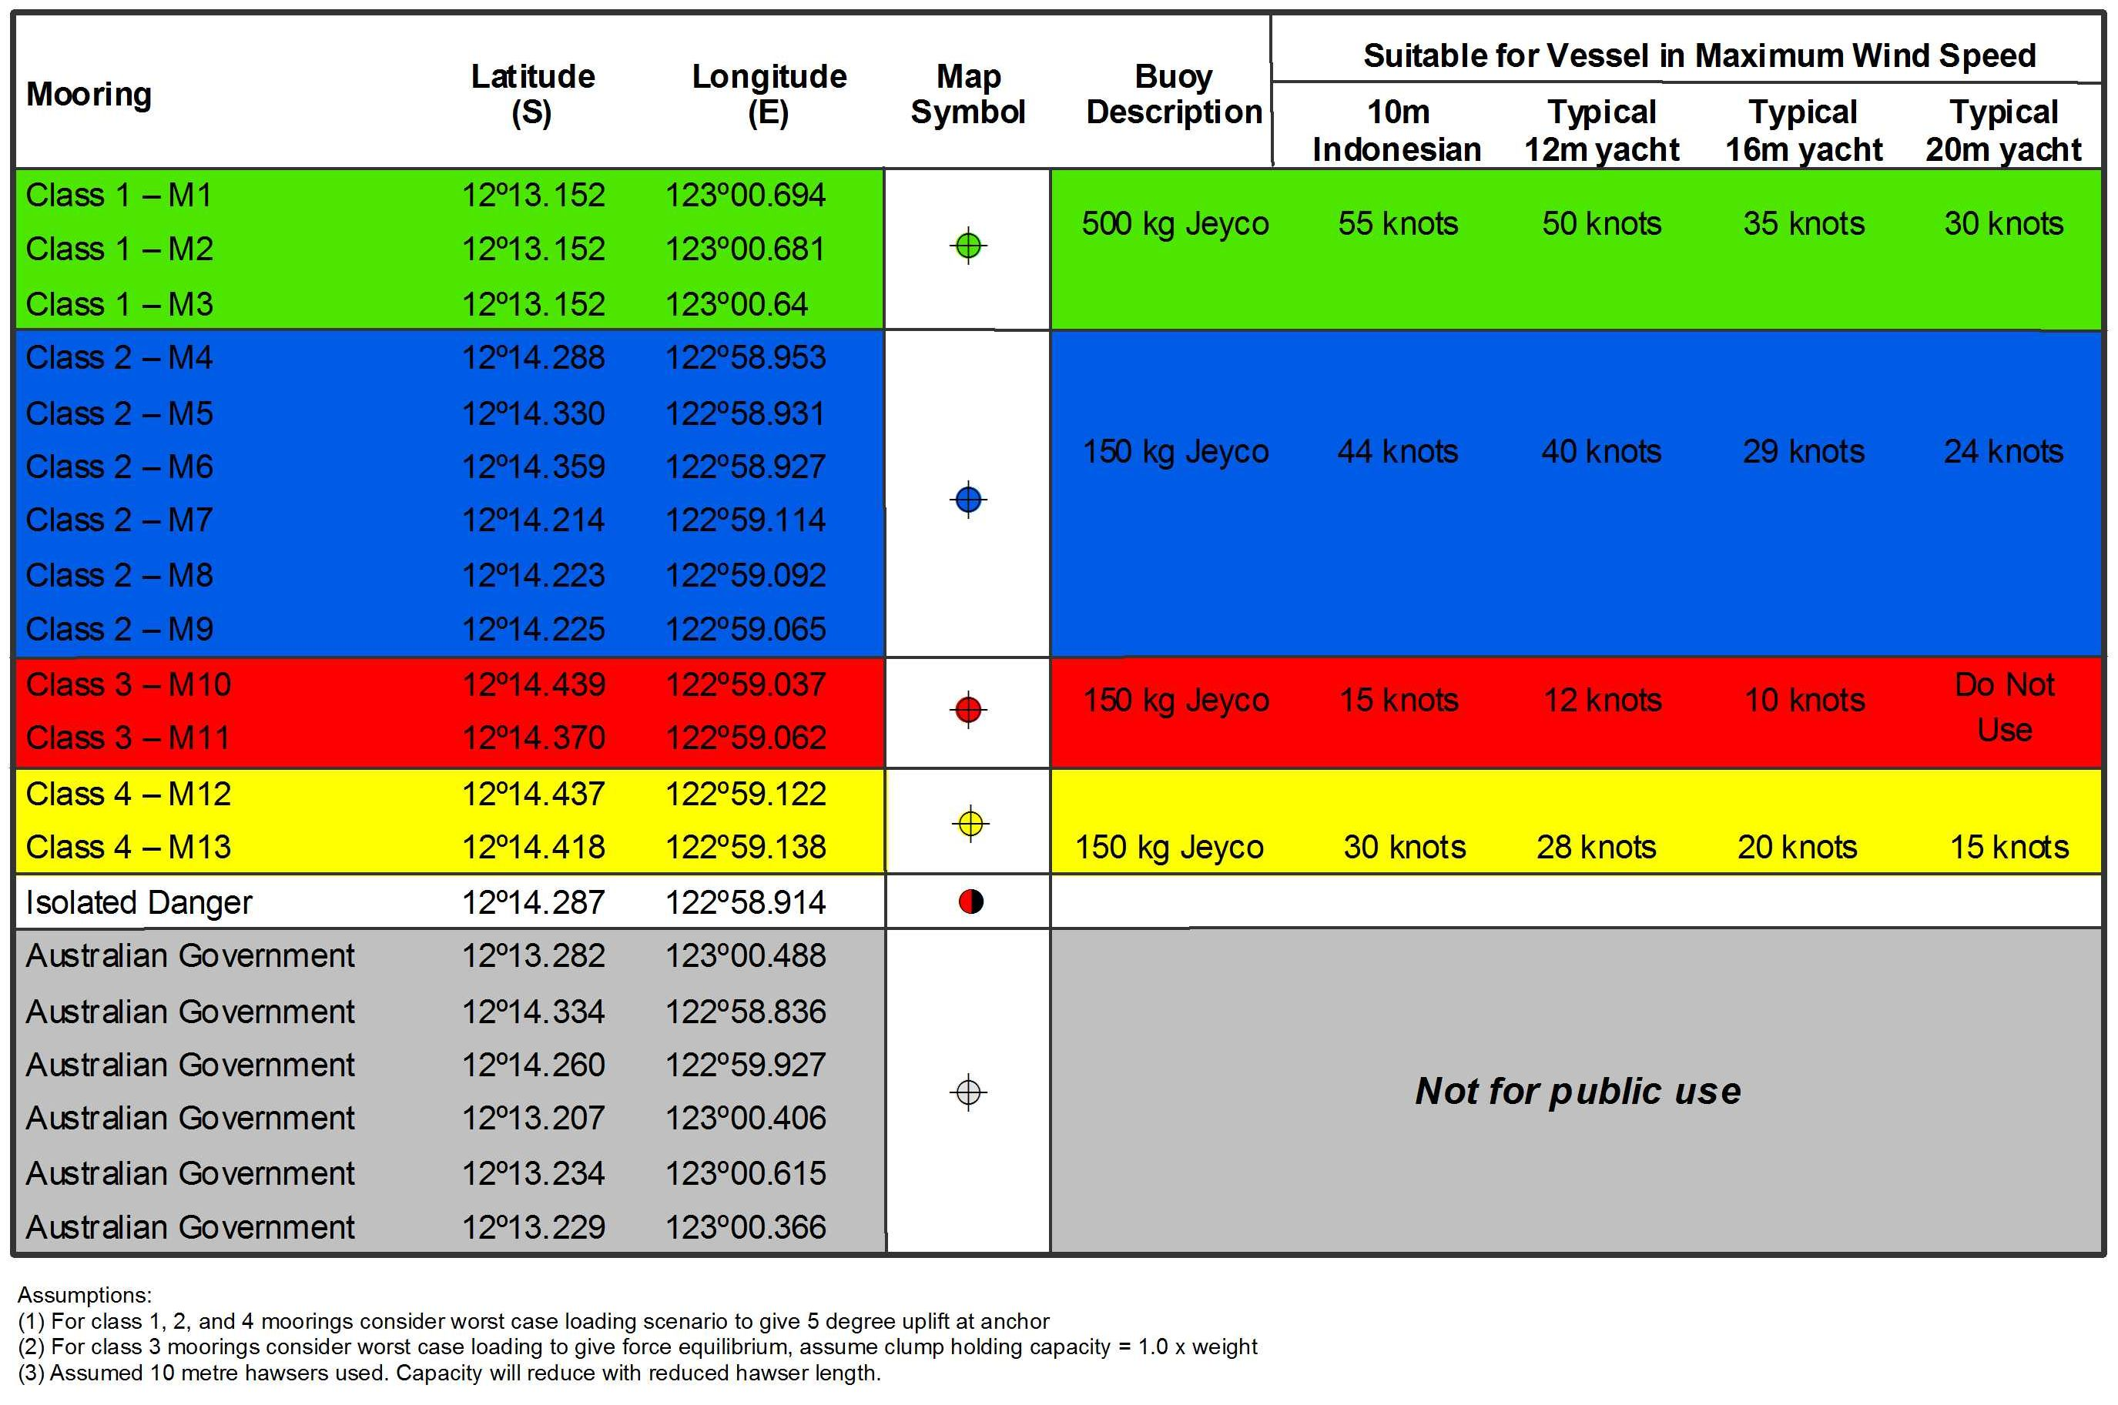

4.2 Recreational fishing – Visitors and Traditional Indonesian fishermen

*Please also read Part 4.1 – General Information for Everyone Visiting the Reserves*

All forms of recreational (or non-commercial) fishing, including charter fishing, game fishing and ‘catch and release’ fishing, are prohibited in the majority of Ashmore and Cartier. The only exception to this is in the open area of Ashmore (West Island Lagoon – see map on page 15). Recreational fishing for finfish (for immediate consumption or consumption within one day's travel) in this area is allowed under a general approval and must be undertaken in accordance with the current authorisation and conditions for non-commercial fishing, an example of which is overleaf.

These rules are consistent with the current interim management arrangements for Ashmore and Cartier, and include:

• recreational fishing for subsistence purposes is allowed in the open area of Ashmore (West Island Lagoon)

• all forms of fishing are prohibited in the closed area of Ashmore and all of Cartier

• recreational fishers may catch enough fish for immediate consumption and one day’s sailing only

• only finfish may be caught

• the take of any other species, including sharks, rays and bottom dwelling invertebrates such as trochus and sea cucumbers (or trepang) is prohibited, and

• fishers must only use a rod and line, handline or hand spear; the use of any other equipment, including, but not limited to, SCUBA, snorkel and/or spear guns, is prohibited.

To obtain a copy of the current authorisation and conditions for non-commercial fishing in Ashmore visit the department’s website www.environment.gov.au/topics/marine/marine-reserves/north-west/ashmore-management or contact the Commonwealth Marine Reserves Branch (see Part 7 – Contacts and Further Information). This approval remains in effect until a management plan for the North-west Commonwealth Reserves Network comes into effect.

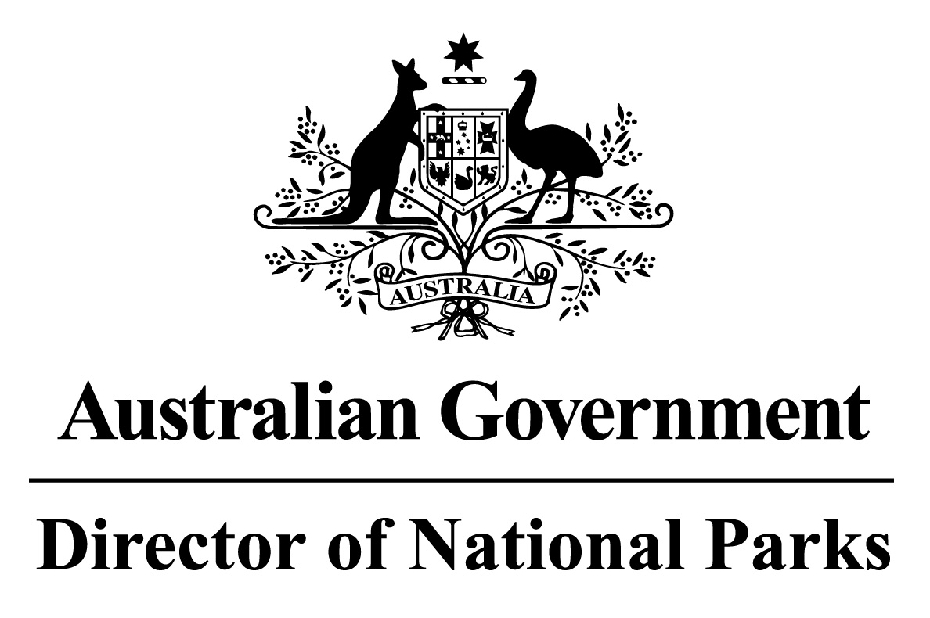

*Environment Protection and Biodiversity Conservation Act 1999*

Section 359B

**Approval of Non-Commercial Fishing in Part of the Ashmore Reef Commonwealth Marine Reserve**

|  |  |
| --- | --- |
| **Approved area** | That part of the Ashmore Reef Commonwealth Marine Reserve being the area shown on maps 1 and 2 in the Schedule to this approval labelled ‘Area Open to the Public’. |
| **Approved action** | Taking members of species of finfish in the Class Osteichthyes (bony fish) for non-commercial purposes. |
| **Approved persons** | Persons taking fish for non-commercial purposes in the approved area. |
| **Conditions of approval** | 1. The maximum number of fish taken in a day must not exceed the number required for immediate consumption or consumption within one day’s travel from the approved area by the approved person or other persons on the same vessel. 2. Fish may only be taken using a rod and line, handline or hand spear. 3. SCUBA diving, or snorkelling or other equipment that allows breathing under the surface of the water must not be used. 4. The approved action must be taken in accordance with:    1. the *Environment Protection and Biodiversity Conservation Act 1*999;    2. the *Environment Protection and Biodiversity Conservation Regulations 2000*;    3. any prohibitions, restrictions or determinations made under the Regulations; and    4. any other notices, information, guidelines, codes of conduct or protocols issued by, or under the authority of, the Director of National Parks. 5. Comply with other applicable Commonwealth and State laws. |

Unless sooner revoked this approval remains in effect until a management plan comes into effect for the reserve.

Signed - 14 December 2013

Commonwealth Marine Reserves Branch

Parks Australia

Department of the Environment

Delegate of the Director of National Parks

4.3 Commercial Tourism

*Please also read Part 4.1 – General Information for Everyone Visiting the Reserves*

Ashmore and Cartier are managed to enable visitors to appreciate, enjoy and understand their values in a way that maintains their conservation significance. To achieve this, a number of conditions apply to commercial tourism operators wishing to visit the reserves.

Commercial tourism in this area is allowed under a general approval, an example of which is overleaf, and must be undertaken in accordance with the current conditions for commercial activities. Commercial tourism operators may use images and video captured at Ashmore and Cartier for promotional purposes. Any other use of images or video requires authorisation from the Director (see Part 4.4 – Commercial Photography / Filming). Commercial tourism operators must hold a current authorisation from the Director to visit Ashmore and Cartier.

No registration or application is required for existing approval holders. Existing approval holders must carry out activities in accordance with the conditions of the general approval.If you do not have an existing approval but wish to undertake commercial tourism in the area of the Ashmore Reef Commonwealth Marine Reserve please contact the Commonwealth Marine Reserves Branch (see Part 7 – Contacts and Further Information).



*Environment Protection and Biodiversity Conservation Act 1999*

Section 359B

Approval of Commercial Activities, Scientific Research and Structures and Works in Ashmore Reef Commonwealth Marine Reserve, Cartier Island Commonwealth Marine Reserve, Mermaid Reef Commonwealth Marine Reserve and Ningaloo Commonwealth Marine Reserve

|  |  |
| --- | --- |
| **Approved areas** | * Ashmore Reef Commonwealth Marine Reserve * Cartier Island Commonwealth Marine Reserve * Mermaid Reef Commonwealth Marine Reserve * Ningaloo Commonwealth Marine Reserve   **Note:**   1. Maps of the reserves are overleaf.   The areas of the reserves are the same as the areas of the former Ashmore Reef, Cartier Island, Mermaid Reef and Ningaloo Commonwealth Marine Reserves, the Proclamations of which were revoked by a Proclamation that took effect on 14 December 2013. |
| **Approved actions** | * Commercial tourism * Commercial media activities * Commercial image capture * Scientific research * Erecting structures, carrying out works and carrying on an excavation |
| **Approved persons** | All persons taking the approved action (including all employees, servants, agents, contractors, clients and invitees engaged in or taking part in the approved action) who held an approval issued by the Director of National Parks to take the approved action in the approved areas immediately prior to the Proclamation of the reserves taking effect on 14 December 2013.  **Note:** Persons who did not have an approval prior to the Proclamation of these reserves taking effect on 14 December 2013 will need to apply for an approval to take the approved actions. |
| **Conditions of approval** | 1. The approved action must be taken in accordance with other applicable Commonwealth and State laws, including holding and complying with any usage right required to take the action. 2. The approved action must be taken in accordance with the conditions of, and only in the area specified in, the approval held prior to the Proclamation of the reserve taking effect on the 14 December 2013. the *Environment Protection and Biodiversity Conservation Regulations 2000*; 3. any prohibitions, restrictions or determinations made under the Regulations; and 4. any other notices, information, guidelines, codes of conduct or protocols issued by, or under the authority of, the Director of National Parks. 5. Comply with other applicable Commonwealth and State laws. |

Unless sooner revoked this approval remains in effect until a management plan comes into effect for the reserve.

Signed - 14 December 2013

Commonwealth Marine Reserves Branch

Parks Australia

Department of the Environment

Delegate of the Director of National Parks

4.4 Commercial Photography / Filming

*Please also read Part 4.1 – General Information for Everyone Visiting the Reserves*

Capturing images (still or video) for commercial purposes requires authorisation from the Director. Professional film crews or photographers travelling to Ashmore and Cartier either on commercial tour operators’ vessels or Australian Government vessels require separate authorisation from the Director, i.e. in addition to any authorisation already granted by the Director to the commercial tour operator.

Commercial media activities in this area are allowed under a general approval, an example of which is overleaf, and must be undertaken in accordance with the current conditions for commercial activities. No registration or application is required for existing approval holders. Existing approval holders must carry out activities in accordance with the conditions of the general approval. If you do not have an existing approval but wish to undertake commercial media activities in the area of the Ashmore Reef Commonwealth Marine Reserve please contact the Commonwealth Marine Reserves Branch (see Part 7 – Contacts and Further Information).



*Environment Protection and Biodiversity Conservation Act 1999*

Section 359B

Approval of Commercial Activities, Scientific Research and Structures and Works in Ashmore Reef Commonwealth Marine Reserve, Cartier Island Commonwealth Marine Reserve, Mermaid Reef Commonwealth Marine Reserve and Ningaloo Commonwealth Marine Reserve

|  |  |
| --- | --- |
| **Approved areas** | * Ashmore Reef Commonwealth Marine Reserve * Cartier Island Commonwealth Marine Reserve * Mermaid Reef Commonwealth Marine Reserve * Ningaloo Commonwealth Marine Reserve   **Note:**   1. Maps of the reserves are overleaf.   The areas of the reserves are the same as the areas of the former Ashmore Reef, Cartier Island, Mermaid Reef and Ningaloo Commonwealth Marine Reserves, the Proclamations of which were revoked by a Proclamation that took effect on 14 December 2013. |
| **Approved actions** | * Commercial tourism * Commercial media activities * Commercial image capture * Scientific research * Erecting structures, carrying out works and carrying on an excavation |
| **Approved persons** | All persons taking the approved action (including all employees, servants, agents, contractors, clients and invitees engaged in or taking part in the approved action) who held an approval issued by the Director of National Parks to take the approved action in the approved areas immediately prior to the Proclamation of the reserves taking effect on 14 December 2013.  **Note:** Persons who did not have an approval prior to the Proclamation of these reserves taking effect on 14 December 2013 will need to apply for an approval to take the approved actions. |
| **Conditions of approval** | 1. The approved action must be taken in accordance with other applicable Commonwealth and State laws, including holding and complying with any usage right required to take the action. 2. The approved action must be taken in accordance with the conditions of, and only in the area specified in, the approval held prior to the Proclamation of the reserve taking effect on the 14 December 2013. the *Environment Protection and Biodiversity Conservation Regulations 2000*; 3. any prohibitions, restrictions or determinations made under the Regulations; and 4. any other notices, information, guidelines, codes of conduct or protocols issued by, or under the authority of, the Director of National Parks. 5. Comply with other applicable Commonwealth and State laws. |

Unless sooner revoked this approval remains in effect until a management plan comes into effect for the reserve.

Signed - 14 December 2013

Commonwealth Marine Reserves Branch

Parks Australia

Department of the Environment

Delegate of the Director of National Parks

4.5 Scientific Research

*Please also read Part 4.1 – General Information for Everyone Visiting the Reserves*

The majority of Ashmore and Cartier are managed as “Sanctuary Zones” (IUCN Category Ia) which means that they are managed primarily as sites for scientific research and environmental monitoring. Scientific research is undertaken to increase understanding of the values of Ashmore and Cartier and risks to them, while minimising the impacts of research activities to those values.

Authorisation from the Director is required to undertake any scientific research in Ashmore and Cartier, an example of which is overleaf. Scientific research involving the removal of wildlife, or part thereof, will be considered under the EPBC Regulations. Scientific research in this area is allowed under a general approval, an example of which is above, and must be undertaken in accordance with the current conditions for these activities.

No registration or application is required for existing approval holders. Existing approval holders must carry out activities in accordance with the conditions of the general approval. If you do not have an existing approval but wish to undertake scientific research in the area of the Ashmore Reef Commonwealth Marine Reserve please contact the Commonwealth Marine Reserves Branch (see Part 7 – Contacts and Further Information).



*Environment Protection and Biodiversity Conservation Act 1999*

Section 359B

Approval of Commercial Activities, Scientific Research and Structures and Works in Ashmore Reef Commonwealth Marine Reserve, Cartier Island Commonwealth Marine Reserve, Mermaid Reef Commonwealth Marine Reserve and Ningaloo Commonwealth Marine Reserve

|  |  |
| --- | --- |
| **Approved areas** | * Ashmore Reef Commonwealth Marine Reserve * Cartier Island Commonwealth Marine Reserve * Mermaid Reef Commonwealth Marine Reserve * Ningaloo Commonwealth Marine Reserve   **Note:**   1. Maps of the reserves are overleaf.   The areas of the reserves are the same as the areas of the former Ashmore Reef, Cartier Island, Mermaid Reef and Ningaloo Commonwealth Marine Reserves, the Proclamations of which were revoked by a Proclamation that took effect on 14 December 2013. |
| **Approved actions** | * Commercial tourism * Commercial media activities * Commercial image capture * Scientific research * Erecting structures, carrying out works and carrying on an excavation |
| **Approved persons** | All persons taking the approved action (including all employees, servants, agents, contractors, clients and invitees engaged in or taking part in the approved action) who held an approval issued by the Director of National Parks to take the approved action in the approved areas immediately prior to the Proclamation of the reserves taking effect on 14 December 2013.  **Note:** Persons who did not have an approval prior to the Proclamation of these reserves taking effect on 14 December 2013 will need to apply for an approval to take the approved actions. |
| **Conditions of approval** | 1. The approved action must be taken in accordance with other applicable Commonwealth and State laws, including holding and complying with any usage right required to take the action. 2. The approved action must be taken in accordance with the conditions of, and only in the area specified in, the approval held prior to the Proclamation of the reserve taking effect on the 14 December 2013. the *Environment Protection and Biodiversity Conservation Regulations 2000*; 3. any prohibitions, restrictions or determinations made under the Regulations; and 4. any other notices, information, guidelines, codes of conduct or protocols issued by, or under the authority of, the Director of National Parks. 5. Comply with other applicable Commonwealth and State laws. |

Unless sooner revoked this approval remains in effect until a management plan comes into effect for the reserve.

Signed - 14 December 2013

Commonwealth Marine Reserves Branch

Parks Australia

Department of the Environment

Delegate of the Director of National Parks

5 Compliance and Enforcement

5.1 Rules and Regulations

The rules that apply to activities in Commonwealth reserves are set out in the EPBC Act and EPBC Regulations. Part 15, Division 4 of the EPBC Act prescribes how Commonwealth reserves will be proclaimed and managed. The EPBC Act (section 354 and 354A) prohibits certain acts in a Commonwealth reserve except in accordance with an approval (section 359B) from the Director when a management plan is not in operation including, but not limited to, commercial activities and the killing, injuring or taking of native species. Part 12 of the EPBC Regulations prohibits, or allows the Director to prohibit or regulate, a range of other activities in Commonwealth reserves unless undertaken in accordance with a permit issued by the Director under the Regulations.

Note:

• Commercial activities are prohibited within Ashmore and Cartier, including within airspace up to 3000m above sea level, in the absence of authorisation from the Director.

• The EPBC Regulations also prohibit people from causing commercial activities to be carried out within a Commonwealth reserve, whether or not they are within a reserve when they do so. An example of this could be where an unlicensed person employs a commercial fishing operator to fish within a Commonwealth reserve. In this case the unlicensed person is also guilty of an offence under Regulation 12.36.

Summary of the EPBC Regulations that apply in a Commonwealth reserve

|  |
| --- |
| This is a summary of the rules that apply in all Commonwealth reserves as prescribed in Part 12 of the EPBC Regulations. It is intended to provide a general overview of the types of activities that are prohibited in a Commonwealth reserve without authorisation from the Director. It should not be relied upon as a complete or exact list. To view Part 12 of the EPBC Regulations in full see *www.comlaw.gov.au*. Note: others rules set out in the conditions of authorisation also apply. |

1. A person must not carry out scientific research without authorisation from the Director.

2. A person must not carry out any commercial activities without authorisation from the Director. Note commercial activities include, but are not limited to, commercial tourism and journalism.

3. A person must not use a captured image of a reserve to derive commercial gain except with authorisation from the Director.

4. A person must not damage, deface, obstruct, remove or interfere with a natural feature, object, sign or structure.

5. A person must not damage, deface, move, possess or interfere with heritage.

6. A person must not discharge or leave wastes or noxious, offensive or polluting substances (including solid, liquid and gaseous materials).

7. A person must not leave any litter.

8. A person must not use a pesticide, herbicide or other poisonous substance.

9. A person must not carry on an excavation, erect a structure or carry out works.

10. A person must not introduce, disturb (including fossicking) or remove minerals, clay, sand, stone or other earth materials.

11. A person must not use a spear gun, firearm, trap, metal detector, fireworks or chainsaw in a reserve. A person may only possess these items if they are on a vessel in passage through a reserve.

12. A person may only bring an animal they own, or are in charge of, into a reserve if they are confined to the vessel and the vessel is on passage through a reserve. The animal must not be left in a reserve.

13. A person must not bring plants into a reserve.

14. A person must comply with the directions of an authorised officer under the EPBC Act.

15. A person must not behave in a way that causes public nuisance.

16. Camping is prohibited unless a camping area or site has been identified through a determination by the Director (Note: Determinations must be published and made available on the department’s website at www.environment.gov.au/topics/marine/marine-reserves/north-west/ashmore-management.

17. A person must not light or use a fire unless the fire is in a portable barbeque or stove or a fireplace provided or authorised by the Director. Fires must not be left unattended.

18. A person must not organise or attend a public gathering of more than 15 persons in a reserve unless the gathering is organised by the Director, or organised in accordance with authorisation from the Director.

19. A person must not display or erect a sign, flag, banner, promotional device or image in a reserve unless with authorisation from the Director.

20. Authorisation is required to bury human remains in a reserve unless the Director has authorised the burial as an emergency.

21. A person must not erect or display a commemorative marker or engage in commemorative activities in a reserve.

Aircraft

22. A person must not taxi an aircraft or land or take off in an aircraft unless in a landing area specified by the Director under a determination.

23. A person must not jump, parachute or disembark an aircraft when the aircraft is above a reserve or the person is likely to land in a reserve.

24. A person must not use an aircraft to drop anything in a reserve.

Please see the EPBC Act and EPBC Regulations, available through www.comlaw.gov.au, for a full list of the rules and regulations relating to Commonwealth reserves.

The Director may make determinations specific to a reserve that applies additional rules to activities described in the EPBC Regulations.

6.3 The North-west Commonwealth Marine Reserves Management Plan

Following the reproclamation of the Commonwealth Marine Reserves Network estate in December 2013, a new management plan for the North-west Network will be developed under the EPBC Act, which includes Ashmore and Cartier Commonwealth Marine Reserves. A management plan will provide for the protection and conservation of each marine reserve by setting out how it will be managed, what activities will be allowed or prohibited and how this will be done. Until the new management plan comes into effect, interim management arrangements currently apply. Further information on management arrangements for the North-west Commonwealth Marine Reserves Network is at www.environment.gov.au/topics/marine/marine-reserves/north-west/management

7 Contacts and Further Information

To apply for authorisation or to obtain additional information:

Contact the Commonwealth Marine Reserves Branch  
Phone: 1800 069 352   
Email: marinereserves@environment.gov.au

Or go to:

Ashmore Reef Commonwealth Marine Reserve: www.environment.gov.au/topics/marine/marine-reserves/north-west/ashmore-management

Cartier Island Commonwealth Marine Reserve: www.environment.gov.au/topics/marine/marine-reserves/north-west/cartier-management

Documents referred to in this document include:

The EPBC Act and EPBC Regulations, both available via the search page on: www.comlaw.gov.au

Reference List

The Ashmore webpage: www.environment.gov.au/topics/marine/marine-reserves/north-west/ashmore

The Cartier webpage: www.environment.gov.au/topics/marine/marine-reserves/north-west/cartier

The North-west Marine Bioregional Plan available at:   
www.environment.gov.au/topics/marine/marine-bioregional-plans/north-west