# Voluntary product stewardship accreditation application guide



© Commonwealth of Australia 2021

**Ownership of intellectual property rights**

Unless otherwise noted, copyright (and any other intellectual property rights) in this publication is owned by the Commonwealth of Australia (referred to as the Commonwealth).

**Creative Commons licence**

All material in this publication is licensed under a [Creative Commons Attribution 4.0 International Licence](https://creativecommons.org/licenses/by/4.0/legalcode) except content supplied by third parties, logos and the Commonwealth Coat of Arms.

Inquiries about the licence and any use of this document should be emailed to [copyright@awe.gov.au](mailto:copyright@awe.gov.au).



**Cataloguing data**

This publication (and any material sourced from it) should be attributed as: DAWE 2021, *Voluntary product stewardship accreditation application guide*, Department of Agriculture, Water and the Environment, Canberra, July 2021.

ISBN 978-1-76003-467-2

This publication is available at <http://environment.gov.au/protection/waste/product-stewardship/product-schemes/voluntary-product-stewardship>

Product Stewardship Policy and Reform Section

GPO Box 858 Canberra ACT 2601

Telephone 1800 77 99 55

Email [PS.Accredit@awe.gov.au](mailto:PS.Accredit@awe.gov.au)

**Disclaimer**

The Australian Government acting through the Department of Agriculture, Water and the Environment has exercised due care and skill in preparing and compiling the information and data in this publication. Notwithstanding, the Department of Agriculture, Water and the Environment, its employees and advisers disclaim all liability, including liability for negligence and for any loss, damage, injury, expense or cost incurred by any person as a result of accessing, using or relying on any of the information or data in this publication to the maximum extent permitted by law.

## About this guide

### Purpose

This guide:

* gives an outline of product stewardship in Australia
* explains what types of product stewardship schemes and arrangements can be accredited under the Australian Government’s accreditation program
* provides information to help you apply for accreditation.

### Resources

You can use this guide to help you complete your accreditation application form. You should also read these documents:

* [Cost recovery implementation statement – Voluntary Product Stewardship accreditation 2020–21](http://environment.gov.au/system/files/pages/472b21c8-6a4b-46f0-9091-2724e7e1aa5a/files/stewardship-accreditation-cris-20-21.pdf)
* [Explanatory statement – Recycling and Waste Reduction Act 2020](https://www.legislation.gov.au/Details/C2020B00104/Explanatory%20Memorandum/Text)
* [Recycling and Waste Reduction (Fees) Rules 2020](https://www.legislation.gov.au/Details/F2020L01627)
* [Recycling and Waste Reduction (Product Stewardship – Accreditation of Voluntary Arrangements) Rules 2020](https://www.legislation.gov.au/Details/F2020L01628)
* [Recycling and Waste Reduction Act 2020](https://www.legislation.gov.au/Details/C2020A00119).

### Contact

Product Stewardship Policy and Reform Section

Department of Agriculture, Water and the Environment

GPO Box 858 Canberra ACT 2601

Telephone 1800 77 99 55

Email [PS.Accredit@awe.gov.au](mailto:PS.Accredit@awe.gov.au)

Contents

About this guide iii

Purpose iii

Resources iii

Contact iii

Introduction 1

What is product stewardship and why it is important? 1

Developing your product stewardship arrangement 2

Australian Government product stewardship accreditation 2

Getting your product stewardship arrangement accredited 3

Examples of accredited product stewardship arrangements 3

Making an application 4

Application form 4

Application fee 4

Submitting an application and paying the application fee 4

Questions and assistance 4

How applications are assessed 5

Application form guidance 6

Section B: Administrator 6

Section C: Arrangement 6

Section D: Compliance 10

Section E: Applicant declaration 10

Glossary 12

**Figures**

Figure 1 Applying product stewardship measures through a product’s life cycle 2

Figure 2 The application process 5

## Introduction

### What is product stewardship and why it is important?

Product stewardship is an approach to waste management that allows organisations to take greater responsibility for reducing the environmental and human health impacts of their products. Product stewardship is a crucial element in meeting Australia’s recycling and waste management challenges.

Each step in the life cycle of a product, from design to post-consumer management, can result in waste and sometimes human health impacts. By adopting product stewardship approaches, organisations have more control over the environmental and health impacts of manufactured goods and materials across their whole life cycle, from design and manufacture to use and disposal.

In Australia and internationally, there has been increasing focus on preventing and managing product waste. There has been a strong shift towards regulating and reducing waste exports; and creating a circular economy − that is, an economy that emphasises reuse, repair and recycling to minimising environmental and health impacts. Many product stewardship innovations that benefit the environment are being explored. This includes better design, improved manufacturing processes and attention to product recyclability

Product stewardship can benefit businesses by helping them to take advantage of profitable and rewarding opportunities. For example, by developing a product stewardship arrangement, businesses can build collaborative partnerships and networks across product supply chains that help to build circular economies.

Also, there is growing consumer and community expectation that businesses will produce environmentally and socially responsible products and services. By doing so, businesses and industries can build customer loyalty and trust and create new opportunities for themselves.

Businesses may use product stewardship for a product or material either individually or collectively across a sector or as an industry. Product stewardship approaches across Australia may be referred to as extended producer responsibility or product stewardship initiatives, programs, schemes or arrangements.

There are many ways that businesses can use product stewardship arrangements (see Figure 1):

* A single company can focus on reducing the environmental impact of one element of a product’s life cycle − for example, replacing virgin materials with recycled materials in a manufacturing process − and take responsibility for how recyclable that product is at the end of its life.
* Using cross-sectoral schemes, members of an industry can work together to target different stages of the life cycle of a product or material. For example, they may:
  + redesign products so they are more durable, repairable, reusable or recyclable
  + use cleaner production practices in manufacturing, such as moving to renewable materials and energy sources
  + make it easier for consumers to repair, reuse or share their product
  + provide a free take-back and recycling service to customers.

Figure 1 Applying product stewardship measures through a product’s life cycle

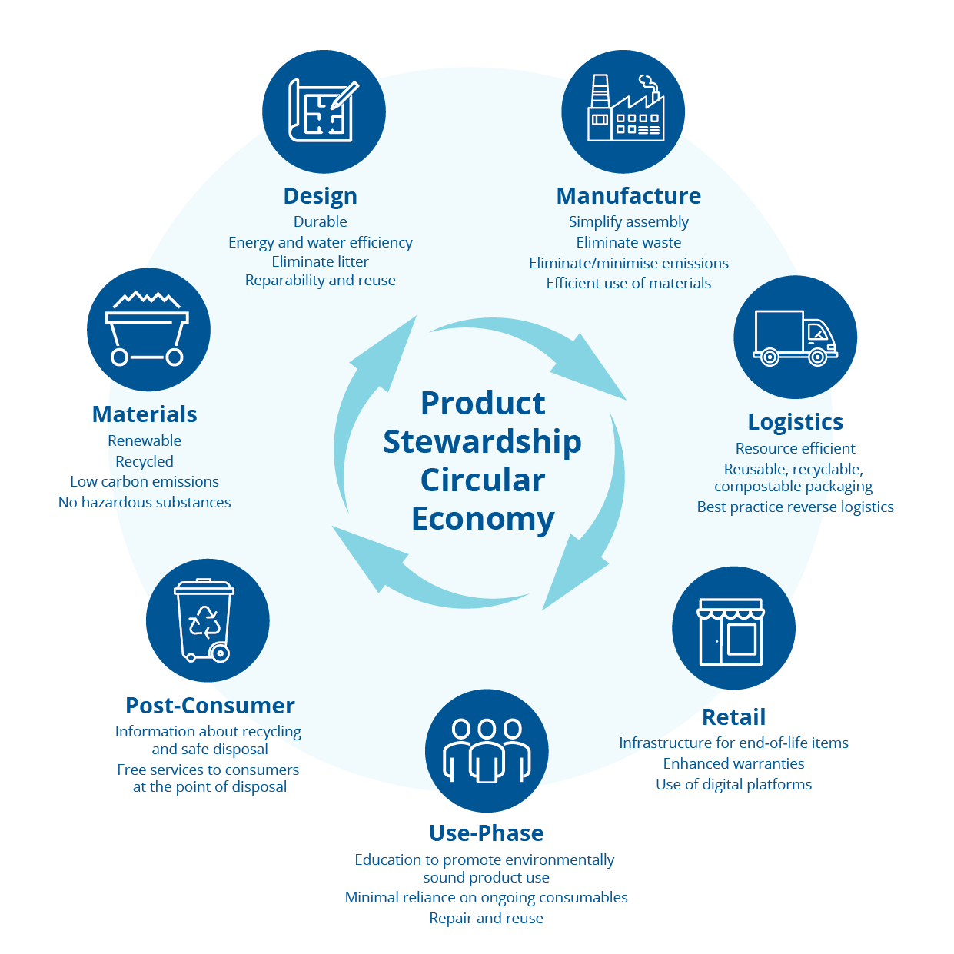

### Developing your product stewardship arrangement

The Product Stewardship Centre of Excellence has been established to support the development of product stewardship arrangements by mentoring, educating, and supporting stakeholders across the product and material supply chains.

If you wish to contact the centre for advice and support on developing and accrediting your product stewardship arrangement, please use the contact details on page 4 of this guide.

### Australian Government product stewardship accreditation

It is important that businesses and industries that implement product stewardship initiatives in Australia are recognised for helping to address Australia’s waste and environmental challenges. The Australian Government has introduced accreditation of voluntary product stewardship arrangements to ensure that businesses making these efforts will be supported and given opportunities to thrive.

If they meet the criteria set out on page 3 of this guide, a business, industry association or other product steward that is implementing or is about to implement a product stewardship arrangement can apply to have their arrangement accredited under the scheme.

Accreditation brings a range of benefits for businesses that implement product stewardship initiatives. An accredited organisation can use the Australian Government product stewardship logo, which signals to their clients that:

* their product is achieving sustainable outcomes and has high industry support
* their business is aligned with the objects of the *Recycling and Waste Reduction Act 2020* and circular economy principles
* the government encourages sustainable procurement of their products.

### Getting your product stewardship arrangement accredited

To be accredited, your voluntary product stewardship arrangement must meet the following criteria (see the [*Recycling and Waste Reduction Act 2020*](https://www.legislation.gov.au/Details/C2020A00119), s 14):

1. Your product must be sold in more than one state or territory.
2. At least one of the following must apply:
   1. Your product contains a hazardous substance.
   2. There is potential to significantly increase the conservation of materials used in the product or to recover resources (including materials and energy) from waste from the product.
   3. There is the potential to significantly reduce the impact that the product (or the substances in it) has on the environment or human safety.

When we assess your application for accreditation, we will consider whether and how the proposed arrangement:

* engages manufacturers, importers and retailers bringing goods to the market
* encourages innovation in design and manufacturing processes, resulting in more sustainable products and services
* manages the quantity of products entering the waste stream
* supports industry networks and collaboration to facilitate circular economies
* provides advice to consumers on how to manage waste, including giving them access to drop-off collection points across Australia
* minimises any threats to human health and safety and the environment from the product.

### Examples of accredited product stewardship arrangements

You can find examples of accredited arrangements on the Department of Agriculture, Water and the Environment’s website under the Product Stewardship tab [current schemes](https://www.environment.gov.au/protection/waste/product-stewardship/products-schemes).

Also, the Product Stewardship Centre of Excellence website has a comprehensive list of the different types of [product stewardship initiatives, schemes, and programs](https://stewardshipexcellence.com.au/product-stewardship/#schemes-initiatives-programs) that exist in Australia. These include accredited and non-accredited arrangements.

## Making an application

### Application form

To get an application form, email [PS.Accredit@awe.gov.au](mailto:PS.Accredit@awe.gov.au). We will send you the form in Word format so that you can download it, save it to your computer and then complete it.

### Application fee

There is an application fee of $5,900 for new arrangements. Your arrangement will be accredited for up to 5 years.

The fee for renewing an existing arrangement is $3,900.

You can apply to accredit your scheme at any time. You can withdraw your application at any stage of the application process, but the fee is non-refundable.

### Submitting an application and paying the application fee

Please email your completed application form to [PS.Accredit@awe.gov.au](mailto:PS.Accredit@awe.gov.au) and let us know when you will be paying the application fee.

You must pay your application fee to the following account:

Name: DAWE EFT Account

BSB: 092009

Account number: 115859

Once you have paid the fee, please email [Reporting_Treasury.Helpdesk@awe.gov.au](mailto:Reporting_Treasury.Helpdesk@awe.gov.au) to let us know. Make sure you attach your receipt of payment.

If you prefer to mail your completed application form, you can send it to:

Product Stewardship Policy and Reform Section

Department of Agriculture, Water and the Environment

GPO Box 858

Canberra ACT 2601

### Questions and assistance

If you need help to complete your application, you should contact both the:

* Department of Agriculture, Water and the Environment by email ([PS.Accredit@awe.gov.au](mailto:PS.Accredit@awe.gov.au)) or phone (1800 77 99 55)
* Product Stewardship Centre of Excellence using their [contact form](https://stewardshipexcellence.com.au/contact/).

## How applications are assessed

|  |
| --- |
| **More information** |
| **ACCC authorisation**  Consider whether your arrangement requires ACCC authorisation under the Competition and Consumer Act 2010.  Find out more:   * the ACCC authorisation process * examples of previous product stewardship arrangements authorised by the ACCC |
| **Preparing your application**  Read the ‘application form guidance’ in this document. Consider how each question applies to your arrangement. |
| **Application fee**  An application fee must be paid prior to the application being assessed. Costs are:   * $5,900 for a new applicant * $3,900 for the renewal of an existing accredited arrangement*   Payment of the fee does not guarantee that an application will be successful.  Application fees are non-refundable.  *These fees are in line with the Australian Government Charging Framework. |
| **Conditions**  The Minister can set conditions on the accreditation of an arrangement. Conditions may include:   * outcomes – e.g. staged increases in recycling targets over the accreditation period * outputs – e.g. actions to be taken to increase industry participation in the arrangement * reporting – e.g. time frames for submission of annual and/or other reports * review – e.g. appointment of an independent reviewer to review the arrangement |
| **Notification of accreditation**  Successful applicants will be granted accreditation for a period of up to 5 years.  Accredited arrangements will receive:   * a certificate of accreditation signed by the Minister * information about any conditions that are imposed (if applicable) * accreditation guidance material * advice on how the product stewardship logo may be used   Details of accredited schemes will also be published on the Department’s website. |

Figure 2 shows our process for assessing an application.

|  |
| --- |
| **More information** |
| **ACCC authorisation**  Consider whether your arrangement requires ACCC authorisation under the Competition and Consumer Act 2010.  Find out more:   * the [ACCC authorisation proces](https://www.accc.gov.au/business/exemptions/authorisation)s * [examples of previous product stewardship arrangements authorised by the ACCC](https://www.accc.gov.au/public-registers/authorisations-and-notifications-registers/authorisations-register) |
| **Preparing your application**  Read the ‘application form guidance’ in this document. Consider how each question applies to your arrangement. |
| **Application fee**  An application fee must be paid prior to the application being assessed. Costs are:   * $5,900 for a new applicant * $3,900 for the renewal of an existing accredited arrangement*   Payment of the fee does not guarantee that an application will be successful.  Application fees are non-refundable.  *These fees are in line with the [Australian Government Charging Framework](https://www.finance.gov.au/government/managing-commonwealth-resources/managing-money-property/managing-money/australian-government-charging-framework). |
| **Conditions**  The Minister can set conditions on the accreditation of an arrangement. Conditions may include:   * outcomes – e.g. staged increases in recycling targets over the accreditation period * outputs – e.g. actions to be taken to increase industry participation in the arrangement * reporting – e.g. time frames for submission of annual and/or other reports * review – e.g. appointment of an independent reviewer to review the arrangement |
| **Notification of accreditation**  Successful applicants will be granted accreditation for a period of up to 5 years.  Accredited arrangements will receive:   * a certificate of accreditation signed by the Minister * information about any conditions that are imposed (if applicable) * accreditation guidance material * advice on how the product stewardship logo may be used   Details of accredited schemes will also be [published on the Department’s website](https://www.environment.gov.au/protection/waste/product-stewardship/products-schemes). |

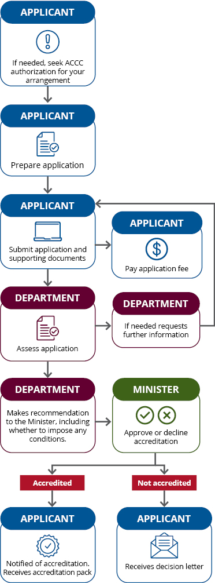Figure 2 The application process

## Application form guidance

The guidance sections below are the ones that appear in the Voluntary product stewardship application form. Please email [PS.Accredit@awe.gov.au](mailto:PS.Accredit@awe.gov.au) for an application form.

### Section B: Administrator

#### Questions 1−6: Administrator and arrangement names

The administrator is the legal entity responsible for managing an arrangement. They are responsible for ensuring the outcomes of the arrangement are achieved. If a company is named as the administrator, please provide a key contact person within that company. The administrator must be a body corporate and may be:

* a corporate entity registered under the *Corporations Act 2001* (Cth)
* an incorporated association
* a statutory corporation.

The arrangement name is the name you have given your arrangement. It is the name that industry and consumers will come to know your scheme by. For example, ‘MobileMuster’ is the arrangement name for the mobile phone recycling program and ‘Tyre Stewardship Scheme’ is an accredited scheme for the recovery of tyres.

### Section C: Arrangement

#### Question 7: Scope of products

You will need to describe the products that are ‘within the scope’ of the arrangement and show how they can be distinguished from products that are ‘out of scope’.

A product that is within the scope is one that is covered under your product stewardship arrangement. A product that is out of scope is not covered by your arrangement.

Please also explain how any ‘like products’ not included in the scope of arrangement will be managed. For example, if your arrangement involves end-of-life reuse, repair or recycling for whitegoods, you might list fridges, washing machines, dryers, ovens and dishwashers as in scope, in that you intend to reuse, repair or recycle the product at end of life. If you do not want to include microwave ovens, water heaters and air conditioners in your arrangement, you will list those products as out of scope. On your application form you should state your management strategies for out-of-scope products that are received at waste collection points − for example, microwave ovens, water heaters and air conditioners may be sent to existing recycling schemes to be recycled or sold to scrap metal recyclers repaired and resold through authorised service and repair businesses.

#### Question 8: Objectives and outcomes of the arrangement

You will need to give an assessment of how effective your arrangement will be. To assess the likely effectiveness of your arrangement, you must outline the *objectives* and measurable *outcomes*.

The *objectives* of your arrangement are the things you are hoping to achieve through the arrangement. For example, they could relate to re-design, waste avoidance, re-use, recycling or recovery of waste.

The *outcomes* of your arrangement are the measurable results that will show whether your arrangement is achieving those objectives.

You must show how your outcomes are to be measured. For example, you might use weight, percentages, units or market share; or you could describe how hazardous or problematic materials have been eliminated or minimised through design. If you are using estimates, you will need to include all the methods you used for calculating them.

#### Question 9: Operation of the arrangement

You will need to set out the way your arrangement will operate.

On your application form, list all members, industry associations(s), trade or sectoral peak bodies or organisations involved in or affected by the arrangement. These can be members that are involved with the design, manufacture, collection, reuse, recycling and disposal of products within the scope of your arrangement. Show how your arrangement will connect and interact with these members or any third parties to the arrangement.

If your scheme intends to collect levies from members − for example, industry-agreed levies on imported products and arrangements among competitors to only deal with businesses that are part of a stewardship scheme − you may need to seek authorisation from the Australian Competition and Consumer Commission (ACCC) to ensure your proposed arrangement complies with the *Competition and Consumer Act 2010*.

You can find out more about the [ACCC authorisation process](https://www.accc.gov.au/business/exemptions/applying-for-authorisation) or for examples of [arrangements authorised by the ACCC](https://www.accc.gov.au/public-registers/authorisations-and-notifications-registers/authorisations-register).

If your arrangement is yet to commence, provide details for the commencement of operations, key milestones, and any planning and processes to support the proposed start date within a reasonable period of time.

#### Question 10: Use of product stewardship logo

Your use of the product stewardship logo lets consumers know that your arrangement has been accredited by the Australian Government and is aligned with the objects of the *Recycling and Waste Reduction Act 2020*.

Before accrediting an arrangement for a specified product, the Minister must be satisfied as to the way you will use the logo. You need to outline how your arrangement and those participating in your arrangement will use the logo, including its placement on products, collection points, websites and promotional materials.

#### Question 11: List of persons who will exercise the product stewardship logo

You will need to identify and list all members or groups that will be authorised to use the logo under the arrangement, including third-party recyclers, contractors and subcontractors.

#### Question 12: Authorisation of use of the product stewardship logo

You will need to describe how you will authorise the use the product stewardship logo by members or groups listed in Question 11: List of persons who will exercise the product stewardship logo.

You will also need to nominate a person who will be responsible for approving that use. For example, the CEO of the company administrating an arrangement may be responsible for signing off on all approvals for accredited members and financial members.

It is also useful to include information on:

* how you will handle the risk of improper use of the logo
* what your processes are for managing failure to use the logo correctly.

#### Question 13: Product stewardship criteria

This question lists criteria needed for your arrangement to be accredited. You will need to select the box for each criterion that applies to your arrangement. At a minimum, you must select:

* 1. ‘sold in more than one state and territory’, and
  2. at least one of the 3 remaining boxes.

You must also explain how your arrangement meets each criterion you have selected. For example, when you select ‘sold in more than one state or territory’, you could show that a product is imported into Queensland, New South Wales and the Australian Capital Territory for sale.

Ensure all of your statements on criteria are backed up with evidence. If you have submitted documentation with your application to back up your claims, you can refer to it here. Where you are referring to large documents, you should give specific chapters or pages.

#### Question 14: Operation of arrangement

You can apply for accreditation if the arrangement is currently operating or will be operating within a reasonable period of time. In this section you must give information about the age and maturity of the operation of your arrangement. If your arrangement has not commenced, you must provide information on the structure that are in place to support the commencement of your arrangement.

This question is slightly different from Question 9: Operation of the arrangement, as it addresses the structures in place that will enable your arrangement to commence or expand.

#### Question 15: Governance and organisational arrangements

You need to show that there are adequate governance and organisational arrangements in place, including procedures for decision-making, risk management and dispute resolution − for example, there must be clear processes or mechanisms that identify how decisions are made and how dispute resolution is managed.

On your application:

* Identify roles of key stakeholders involved in the arrangement − for example, board of directors, financial members, executive management and third-party recyclers. Explain the role of the executive management team and the extent of its involvement in day-to-day management activities and decision-making powers.
* It is useful to include any reporting responsibilities for different stakeholders. Explain how the different stakeholders and key executive management team will effectively work together to meet waste management and recycling objectives. Describe the kinds of disputes that may arise with different stakeholders and explain how your arrangement will manage this.
* State whether any local, state and territory government or departments have been involved and engaged in the design or planning of your arrangement.

#### Question 16: Financial arrangements for the accreditation period

You will need to show whether there are adequate funding and financial processes in place to achieve the proposed outcomes.

List all sources of funding and financial mechanisms for your arrangement, including levies or membership fees. Explain how each of these will be sustained for the duration of the accreditation period or if they are one-off contributions such as grants and gifts.

#### Question 17: Finance for achievement of proposed outcomes

You must demonstrate how the funding sources you detailed in Question 16: Financial arrangements for the accreditation periodare adequate to achieve the outcomes of your arrangement for the accreditation period. You will need to:

* detail what financial thresholds can be identified for your scheme’s performance (for example, operation expenses) and how the identified funding sources contribute towards these thresholds
* give evidence, where possible, including any relevant financial reports for your arrangement (for up to 2 financial years) and information about levies and participant fees if applicable.

If the arrangement has not yet commenced, demonstrate how current funding will grow and how the key stakeholders in the arrangement will make their financial contributions. You need to state when you expect the contributions to start, what risks that you anticipate financially and how these risks will be managed.

#### Question 18: Compliance with Commonwealth, state and territory laws

You will need to demonstrate how your arrangement will comply with environmental, health and safety requirements (including Commonwealth, state and territory laws, contractual and employment obligations, and health and safety requirements).

Detail any specific risks associated with your scheme’s operation − for example, stockpiling, hazardous products or flammable products − and show how your arrangement will address these.

Your outline should include the activities of service providers or any third parties that support the arrangement.

#### Question 19: Benefit to the environment, human health and safety

You will need to show that the arrangement will deliver an overall benefit to the environment and human health and safety over the life cycle of the product. In your application:

* Describe how your arrangement is addressing or incorporating waste avoidance mechanisms, creating more environmentally sound products, designing product(s) for safety and reduction in environmental or human health safety impacts. Also outline any innovations that demonstrate circular economy approaches.
* Describe specifically how your arrangement addresses or incorporates key circular economy principles, such as:
  + designing-out waste
  + prolonging the life of a product
  + functionality and value of products, components and materials
  + evidence of being regenerative and restorative as opposed to delivering ‘less harm’.
* Provide detail on the results you expect your arrangement will achieve − for example:
  + reductions in the amount of waste going to landfill
  + use of the waste product as an input into new products
  + removal of dangerous products or their components from the waste stream, thereby facilitating better human health and safety outcomes.
* Explain how your arrangement will measure outcomes and how results will be monitored and evaluated during the period of accreditation. Include milestones or targets that can be conveyed in the arrangement’s annual report.

### Section D: Compliance

The administrator of your arrangement must be a ‘fit and proper’ person. We can use information collected in this section to make this assessment.

To decide whether your administrator meets this requirement, the Minister can have regard to several matters in your application − for example, whether they:

* are financially viable
* have been convicted of an offence
* have been ordered to pay a fine in relation to the *Recycling and Waste Reduction Act 2020* or other environmental laws at the Commonwealth, state or territory level.

The Minister may refuse to accredit an arrangement if they are not satisfied that the administrator of the arrangement is a fit and proper person or if the persons authorised by the arrangement are otherwise not appropriate.

### Section E: Applicant declaration

Before going ahead with the application, please consider your responsibilities and other matters raised in the declaration.

It is a criminal offence under the *Criminal Code Act 1995* to knowingly give false or misleading information to a Commonwealth officer exercising powers under Commonwealth law. This offence carries a maximum penalty of 12 months imprisonment.

## Glossary

| Term | Definition |
| --- | --- |
| accredited voluntary arrangement | As defined in section 70 of the *Recycling and Waste Reduction Act 2020*, an accredited voluntary arrangement is a voluntary arrangement accredited in relation to a product in accordance with the Recycling and Waste Reduction (Product Stewardship – Accreditation of Voluntary Arrangements) Rules 2020 made for the purpose of the *Recycling and Waste Reduction Act 2020*. |
| administrator | The administrator of a voluntary arrangement is a body corporate responsible for ensuring the outcomes of the arrangement are achieved. See sections 71(c) and (d) of the *Recycling and Waste Reduction Act 2020*. |
| application form | Application for voluntary product stewardship accreditation or renewal form. |
| arrangement | A product stewardship initiative, program or scheme. |
| Minister | The minister responsible for administering the *Recycling and Waste Reduction Act 2020* or a minister delegate. |
| outcomes | As defined in section 5 of the Recycling and Waste Reduction (Product Stewardship – Accreditation of Voluntary Arrangements) Rules 2020, an outcome of a voluntary arrangement is a measurable result relating to a product to be achieved by the arrangement that furthers any objects of the *Recycling and Waste Reduction Act 2020*. |
| product | As defined in section 10 of the *Recycling and Waste Reduction Act 2020*, a product is a thing, including a class of things, that is manufactured or otherwise prescribed by the Recycling and Waste Reduction (Product Stewardship – Accreditation of Voluntary Arrangements) Rules 2020. A product can include a substance or mixture of substances. Voluntary arrangements are accredited for a product that will be the focus of recycling and waste reduction activities. |
| product stewardship logo | As defined in section 73 of the *Recycling and Waste Reduction Act 2020*, the logo is a trademark represented on the Department of Agriculture, Water and the Environment website. Under section 69 of the *Recycling and Waste Reduction Act 2020*, the logo can be used by a person in accordance with an accredited voluntary arrangement. |
| sustainability | The capacity for development that can be sustained into the future, within the capacity of the natural resource base. This includes encouraging sustainable agricultural and fishing practices which maintain and improve the natural resource base. |