

Management of Commercial Harvesting
of Protected Flora in Western Australia
1 July 2013 – 30 June 2018
__________________________________________________________________

For submission under the Commonwealth Environment Protection and Biodiversity Conservation Act 1999

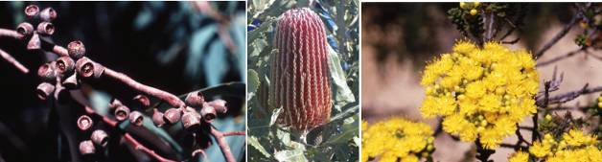

June 2013

Department of Environment and Conservation

Published by the Western Australian Department of Environment and Conservation June 2013.

© Department of Environment and Conservation
TABLE OF CONTENTS

SUMMARY

- INTRODUCTION
  - Purpose of the Management Plan
1.2 Scope of the Management Plan
1.3 Reason for Wildlife Harvest

- BACKGROUND INFORMATION
2.1 Biology and Ecology of Target Species
2.2 Conservation Status of Target Species
2.3 Legislative Basis for Management
2.3.1 Western Australian State Legislation
2.3.2 Federal Legislation

- THREATS AND ISSUES
  - Dieback Disease caused by Phytophthora Species
    - Disease Management
    - Control Of Access
    - Phytosanitary Measures
    - Coordination of Phytophthora Dieback Management and Research
  - Aerial Canker
  - Fire
  - Land Clearing
  - Mining
  - Salinity
  - Weeds
  - Myrtle Rust
- AIMS AND OBJECTIVES OF THIS MANAGEMENT PLAN
- Management
  - Management Measures
    - Licences
      - Crown land
      - Private land
    - Endorsements
      - Endorsements on Crown land managed by DEC
      - Endorsements on other vested Crown lands or reserves
      - Endorsements on unallocated Crown land and unmanaged reserves
      - Taxon-specific endorsements
      - Quotas
    - Conservation Reserves
    - Declared Rare Flora
    - Research
  - Management Strategies
    - Licence Conditions
    - Area-specific Management
    - Taxon-specific Management
      - Regulating, restricting or banning the harvesting of taxa
      - Amendments to the Export Flora List
      - Declared Rare Flora (DRF) and Priority Flora
    - Education
  - Monitoring And Assessment
    - Flora Industry Regions
    - Licence Application and Licensing Procedures
    - Analyses Of Flora Harvest
    - Assessment Of Management Options
      - Area-specific management
      - Taxon-specific management

- AUDIT, MONITORING, REPORTING AND COMPLIANCE
  - Flora Industry Data Management System (FIDMS)
  - Flora Dealer Inspections
  - District Monitoring and Reporting
6.3.1 Verification of Export Permit Applications
  - Role of Wildlife Officers
    - Law enforcement training and operations procedure
  - Advisory Committees On Flora Conservation
  - Reports
    - DEC Reports
    - Reports to the Department of Sustainability, Environment, Water, Population and Communities
      - Reports sent to the Department of Sustainability, Environment, Water, Population and Communities
    - Reports from the Department of Sustainability, Environment, Water, Population and Communities
- KEY PERFORMANCE INDICATORS
- REFERENCES

- APPENDICES

1. Export Flora List
2. DEC Policy Statement No. 13 - Commercial Flora Harvesting
3. Schedule of Declared Rare Flora
4. DEC Policy Statement No. 3 - Phytophthora Dieback
5. Application form for a Commercial Purposes Licence
6. Application for a Commercial Producer's or Nurseryman's Licence
7. Standard licence conditions applying to Commercial Purposes Licences
8. Standard licence conditions applying to Commercial Producer's or Nurseryman's Licences
9. Glossary
10. Section 303FO of the Environment Protection and Biodiversity Conservation Act 1999
11. Species information for protected flora on the Export Flora List

MANAGEMENT OF COMMERCIAL HARVESTING OF PROTECTED FLORA IN WESTERN AUSTRALIA

Summary

Background

Western Australia has a rich and diverse native flora, that is internationally renowned. The conservation of this flora is a major undertaking in the State, with the recognition of the south west region being one of the top 34 world biodiversity hotspots highlighting the importance of this conservation work. The commercial harvesting of native flora is a significant industry in Western Australia, especially in the south west, and its management is an important part of the flora conservation activities in the State.

The sustainable field harvesting of native flora is a key mechanism through which we can help to ensure the long term retention of native flora by providing a clear economic value to the flora’s habitat. This value is attributed through harvesting on both private and public (Crown) lands and occurs outside the core nature conservation reserve system. Harvesting on both public and private land helps to provide financial and management incentives to landholders to value and conserve the State’s flora.

What is Covered by the Plan?

This plan covers:
- All protected flora in Western Australia (all Western Australian native plants); and
- All Australian native plants that are not native to Western Australia but are growing in Western Australia.

Legislative Framework

The management of the flora industry in Western Australia is primarily through the Wildlife Conservation Act 1950, and the Conservation and Land Management Act 1984. Industry regulation is thus on the basis of flora conservation and appropriate land management, rather than for industry development per se. A system of licensing, area and species-specific management, and monitoring has been developed to ensure the conservation of flora being harvested. This system complements other flora conservation initiatives being undertaken in the State, including the undertaking of biogeographical surveys, the development and management of a comprehensive, adequate and representative reserve system, the identification and conservation of threatened species, and the investigation into, and management of, key threatening processes.

This management plan describes the various elements of the management system in place for the conservation of commercially harvested native plant taxa in WA.
1. Introduction

1.1 Purpose of the Management Plan

This plan has been developed by the Department of Environment and Conservation to satisfy the requirements of the Commonwealth Environment Protection and Biodiversity Conservation Act 1999 (EPBC Act) and to meet the legislative, policy and other requirements of the Western Australian Government for the period from 1 July 2013 to 30 June 2018. It is intended to address the goals of the National Strategy for the Conservation of Australia’s Biological Diversity and the Department of Environment and Conservation’s (DEC) draft Biodiversity Conservation Strategy.

The plan is designed to meet the requirements for approval of a Wildlife Trade Management Plan under the EPBC Act

1.2 Scope of the Management Plan

Flora is defined in the Wildlife Conservation Act 1950 as "any plant, including any wildflower, palm, shrub, tree, fern, creeper or vine which is either native to Western Australia or declared to be flora under the Act and includes any part of flora and all seeds and spores thereof". Thus, all parts of the plant including roots, branches, stems, leaves, flowers, seeds and spores come within the legal meaning of flora1. Plants from other parts of Australia (and not declared to be flora in WA) and which are growing in WA, are not referred to as “flora” in this plan, but are instead referred to as “Australian native plants that are not native to Western Australia”.

Classes of flora which are protected in WA under the Wildlife Conservation Act include all flowering plants, conifers and cycads (Spermatophyta), ferns and fern allies (Pteridophyta), mosses and liverworts (Bryophyta) and algae, fungi and lichens (Thallophyta). Under the Wildlife Conservation Act 1950, protected flora on Crown land is deemed to be the property of the Crown, until legally taken.

As indicated above, all Western Australian native plants are protected flora under the Wildlife Conservation Act 1950. This Act also provides for plants not native to Western Australia to be declared as protected flora. At the time of publication, no such plants have been declared as protected flora.

Australian native plants that are not native to Western Australia are not protected flora (unless otherwise declared) and the harvesting of such plants in WA is not subject to regulation under the Wildlife Conservation Act 1950 (unless declared). The cultivation and harvest of such plants does not threaten Western Australian native flora or their habitat. As Western Australia is outside their natural range, the taking of these plants in Western Australia is considered sustainable and non-detrimental. Thus, their harvest in Western Australia is also covered by this plan and may be considered to be taken in accordance with this management plan.

Protected flora may be harvested for commercial purposes subject to the management controls as outlined in this Management Plan. This plan covers the commercial taking (picking) of all protected flora within Western Australia, and has been specifically prepared for approval by the Commonwealth Government in relation to the export of material from the Commonwealth- and State- approved Export Flora List (Appendix 1).
Only taxa listed on the Export Flora List (Appendix 1) may be exported under this plan, unless being exported as a DEC-approved test export. At the time of publication, the Export Flora List allows the export of:
- All Australian native plants that are not native to Western Australia and that are artificially propagated or wild-harvested in WA;
- All protected flora (Western Australian native plants) that are artificially propagated in WA1; and
- Specimens of listed species of protected flora (174 species at the time of preparation of this plan) that may be taken from naturally occurring stands in WA (wild-harvested), in accordance with specified conditions.

This plan does not cover the export of:
- Any CITES I species or eligible threatened species listed under the Commonwealth Environment Protection and Biodiversity Conservation Act 1999 (EPBC Act).

Seeds do not require an export permit or authority under the EPBC Act, however, flowers, foliage, fruits and whole plants do require a permit for export, and export authorisation may only be given where the flora has been harvested in accordance with this Management Plan once approved. All approved flora products (eg. flowers, foliage, fruits, seed and plants) taken under this plan may also be traded within Western Australia and the rest of Australia, subject to individual State and Territory controls.

This management plan also provides for the commercial harvesting of whole plants of protected flora in DEC-approved salvage operations within Western Australia.

This plan replaces the previous 2008-2013 Management Plan prepared for the harvest of protected flora from Western Australia. This plan covers those taxa listed in the Export Flora List (Appendix 1), as updated during the term of this plan. This plan also covers any other protected flora taxa that may, from time to time, be permitted to be harvested from within Western Australia and traded commercially within Australia, or exported only as test exports under 5.2.3.2. The Department may also prepare separate subsidiary management plans for individual taxa or groups of taxa which may require additional management measures. Such management plans will be forwarded separately to the Department of Sustainability, Environment, Water, Population and Communities (DSEWPAC) for approval under the EPBC Act, where appropriate.

This plan may be amended or varied prior to the expiration of its approval under the EPBC Act if the amendments or variations are approved by the Commonwealth Minister for the Environment after consultation with DEC.

1.3 Reason for Wildlife Harvest

The commercial harvesting of wildflowers and foliage for the cut flower trade started in WA in the 1950s. Since then, the native flora industry in Western Australia has become a multi-million dollar industry.

In 2011/12 the wildflower and foliage industry in Western Australia was estimated to have an export value of approximately $4.7 million (Kevin Seaton, Department of Agriculture and Food, pers. com.). This represents a 24% drop in exports over the previous two years and indicates an uncertainty in overseas markets. Some stabilization of the world economy may see a rise in commodity prices in the future and an increased interest in wildflowers (Kevin Seaton, Department of Agriculture and Food, pers. com.). In 2006/07 approximately 64% ($5.69 million) of exports were from wild-harvested wildflowers and foliage (from natural stands on both Crown and private land) however in 2011/12 this figure dropped to 45% ($2.12 million) (DEC flora return database) with the majority now coming from cultivation. In 2012 wild-harvested flora exported directly out of Western Australia went mainly to the Asian market with 82% of the total exports destined for Japan (ABS, 2013). Canada and the United Kingdom were the second and third biggest recipients of exports at 9% and 6% respectively. The remaining 3% went to Singapore, China and Taiwan.

The WA Flora Industry also includes: seed harvesting, primarily for propagation and revegetation purposes; Eucalyptus species stems for production of didgeridoos; and nuts and grasstree stems for the craft market. There is no data available on the value of these industries, but anecdotal evidence suggests that it is worth millions of dollars to the State’s economy.

In 2011/2012 a total of 303 Commercial Purposes Licences were issued to commercial Crown land pickers, and 204 Commercial Producers Licences for private property were issued to sell native flora (both wild-harvested and artificially propagated).

An adequately regulated system of flora harvesting provides a useful economic incentive for active conservation of flora resources, far and above the threats of penalties for clearing native vegetation.

- Background Information

Biology and Ecology of Target Species

Summary information on the biology and ecology of each species of protected flora native to Western Australia can be accessed through the Department’s Florabase website http://florabase.dec.wa.gov.au/. This includes plant description, habitat, flowering time, species distribution and conservation status. None of the taxa which are listed on the Export Flora List are Threatened or Priority species (of conservation concern).

Information on the parts harvested and industry specification has already been collated for taxa on the Export Flora List.

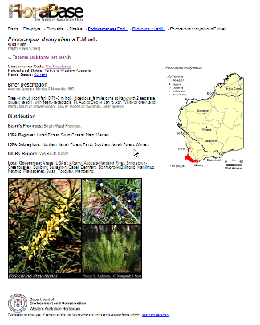
Figure 1. Information on target species biology and ecology can be found on the Department’s Florabase website

Conservation Status of Target Species

The groupings of flora into categories within the Export Flora List (Appendix 1) reflect the structured management strategy being used in Western Australia for commercial flora harvesting and flora conservation. The Export Flora List is arranged so that the extent of specific picking or trade restrictions for any listed taxon can be readily identified and reflect market-driven conservation strategies. The structured management approach to flora conservation is:

- Declared Rare flora (see section 5.1.4 and 5.2.3.3) taxa may not be taken without special permission of the State Minister for Environment, and are not included on the Export Flora List;

- State “priority” listed (see section 5.2.3.3) flora taxa and certain other flora taxa identified as requiring specific management may not be harvested from Crown land, but may be harvested from private property;

- certain flora taxa may be harvested from Crown land, but only under special endorsement that has specific management conditions imposed; and

- flora taxa that have no identified specific management requirements may be harvested from Crown land under general collecting licences with general management conditions.

The Export Flora List provides a clear means of restricting the number of taxa being exploited for the export market where greatest market demand occurs. At the time of writing this plan, the Export Flora List contained 174 taxa permitted for harvesting from natural stands of the 12,257 taxa of Western Australian vascular flora (as at 1 June 2012) (DEC, 2012).

2.3 Legislative Basis for Management

2.3.1 Western Australian State Legislation

The Wildlife Conservation Act 1950, as detailed above (section 1.1) protects flora native to Western Australia (and Australian native plants that are not native to Western Australia and declared to be protected). This protection provides the basis for the management of the flora industry in Western Australia, as detailed in this management plan.

Under the Conservation and Land Management Act 1984, DEC is responsible for the conservation and management of protected flora throughout Western Australia, and for administration of the Wildlife Conservation Act 1950. DEC thus has the authority to exert controls on the commercial harvesting of protected flora in Western Australia on all lands. DEC is also responsible for the management of various public lands including national parks, conservation parks, nature reserves, State forests and timber reserves.

Amendments to the Conservation and Land Management Act 1984 in 1993 gave DEC the statutory authority to promote research on, and encourage the use of, flora for therapeutic, scientific or horticultural purposes. The amendments also give the Western Australia Minister for Environment and the Director General of DEC powers to control the issue of licences for the purpose of developing the potential of products for therapeutic, scientific or horticultural purposes. These powers include the right to provide an exclusive licence.

Amendments to Part V of the Environmental Protection Act 1986 in 2004 introduced reformed vegetation clearing regulations for Western Australia (refer to Section 3.4 – Land Clearing). These regulations require that the clearing of native vegetation must be done under a permit, unless subject to a legal exemption. The issue of licences under the Wildlife Conservation Act 1050 to take or sell protected flora provides an exemption from requiring a clearing permit for that activity under the Environmental Protection Act 1986. Consequently there is an onus on DEC when assessing flora licences to ensure the activity does not conflict with the ten clearing principles for biodiversity, water and soil conservation included in the vegetation clearing assessment framework of the Environmental Protection Act 1986.

A Memorandum of Understanding (MOU) between the Department of Environment and Conservation and the Department of Land Administration in relation to management of the flora industry on unallocated Crown land (UCL) and unmanaged Crown reserves in WA was signed in March 2000. Under this agreement DEC has the ability to implement specific management control measures in relation to flora harvesting over all UCL and unmanaged Crown reserves in Western Australia.

In addition, the Department has a series of formal policy statements to direct its operations. Policy Statement No. 13 addresses the issue of commercial flora harvesting (Appendix 2). It outlines DEC’s overall objective, policies and strategies for the commercial flora industry to ensure that commercial flora harvesting is ecologically sustainable.

Broad strategies for conservation have been developed in the National Strategy for the Conservation of Australia’s Biological Diversity (Anon, 1996), and DEC’s draft Biodiversity Conservation Strategy for Western Australia (DEC, 2006a). These strategies detail general objectives for maintaining biodiversity. The draft Biodiversity Conservation Strategy also addresses the special needs of harvested taxa.

The key strategic directions of the draft Biodiversity Conservation Strategy are:
• Build biodiversity knowledge and improve information management;
• Promote awareness and understanding of biodiversity and related conservation issues;
- Engage and encourage people in biodiversity conservation management;
• Improve biodiversity conservation requirements in natural resource use sectors;
• Enhance effective institutional mechanisms and improve integration and coordination of biodiversity conservation
- Establish and manage the formal conservation reserve system
- Recover threatened species and ecological communities and manage other significant species/ecological communities and ecosystems
- Conserve landscapes/seascapes for biodiversity (integrating on and off-reserve conservation and managing system-wide threats)

One of the objectives of the strategy is to ensure special recognition is given to biodiversity conservation in ecologically sustainable development of natural resources. The draft Biodiversity Conservation Strategy has identified four primary actions:

• To trial new flora and fauna suitable for sustainable use industries, where conservation benefits will be derived, and continue the sustainable use of accredited wildlife-based industries;
• Undertake research on key wildlife species, potentially or currently the subject of wildlife interaction such as whale sharks;
• Develop and implement a sustainable sandalwood plan that provides for biodiversity conservation; and
• Develop and implement appropriate protocols and practices to ensure that industries operating on Crown land and waters (for example apiculture, wildflower and seed harvesting and aquaculture) are consistent with principles of ecologically sustainable development.

While all native flora is protected under the Wildlife Conservation Act 1950, only that flora occurring on Crown land is vested in the Crown, and protected flora occurring on private property is owned by the land owner. Further, it is recognised that private land owners have a vested interest in the conservation and management of their land, and consequently are able to provide more intensive management and regulation of harvesting activities on their lands. As a consequence, the regulatory measures applicable to the management of the flora industry within Western Australia vary between Crown land and private property. The management of the flora industry in Western Australia is, however, effective in ensuring the conservation of the flora through the provisions of the Wildlife Conservation Act 1950, and the operation of other applicable legislation such as the Environmental Protection Act (refer to Section 3.4 – Land Clearing).

2.3.2 Federal Legislation

Flora harvesting, as well as other activities that may affect flora such as land-clearing and mining (see 3.4 and 3.5 below), are subject to the environmental assessment and approval provisions of Chapter 4 of the Environment Protection and Biodiversity Conservation Act 1999 (EPBC Act). Under the EPBC Act a person must not take an action that has, will have or is likely to have a significant impact on a matter of National Environmental Significance (which includes nationally threatened species and ecological communities) without approval from the Commonwealth Environment Minister.

Any significant impact on a matter of National Environmental Significance needs to be referred to the Department of Sustainability, Environment, Water, Population and Communities, which administers the EPBC Act. The list of EPBC-listed threatened species and ecological communities, as well as guidelines on referring actions, can be obtained from the Department of Sustainability, Environment, Water, Population and Communities at www.environment.gov.au.

- Threats and Issues

3.1 Dieback Disease Caused by Phytophthora Species

The disease known as dieback has caused serious damage to large areas of forest, woodlands and heathlands in south-western Australia. It is caused by several species in the fungal genus Phytophthora which infect, rot and often kill the entire root systems and lower stems of susceptible plants. Approximately 40% of the plant species in Western Australia's south-west Botanical Province are susceptible to Phytophthora. In many places, populations of most banksias and some heaths may be severely affected or destroyed. A total of 720,000 ha of land in the south-west of WA was intensively mapped for dieback. Of this, 170,000 ha were found to be affected (DEC, 2006b).

Of the fifteen species of Phytophthora recorded in Western Australia, five (Phytophthora cinnamomi, P. citricola, P. cryptogea, P. drechsleri and P. megasperma) have become widely established in the native vegetation of south west Western Australia. Of these, P. cinnamomi is by far the most damaging, with P. megasperma the only other causing significant damage to the natural environment. A new species, P. multivora, has more recently been found to be well established in tuart forest south of Mandurah, and has the potential to be a significant pathogen, affecting communities not previously thought to be very susceptible to dieback disease (Scott et. al., 2008). Various other species are important to nurseries, horticulture, vegetables and pastures. These fungi spread by the movement of spores in water, and are easily spread in winter and in wetter areas. The fungi can also be spread widely by transporting soil from infested to uninfested areas. Vehicles, especially when driven off tracks or roads, can carry infested soil on tyres or underbody, and thus also have the potential to spread the disease.

Species adversely affected by dieback include representatives of many of the families of native plants. Families and genera which contain a high proportion of Western Australian flora variously susceptible to Phytophthora are:

proteaceae | myrtaceae | ericaceae | other
Adenanthos | Beaufortia | Andersonia | Acacia | Oxylobium
Banksia | Calothamnus | Astroloma | Allocasuarina | Patersonia
Conospermum | Calytrix | Leucopogon | Anarthria | Phlebocarya
Franklandia | Eremaea | Lysinema | Boronia | Podocarpus
Grevillea | Eucalyptus | Monotoca | Conostylis | Xanthorrhoea
Hakea | Hypocalymma | Sphenotoma | Dasypogon
Isopogon | Kunzea | Styphelia | Daviesia
Lambertia | Melaleuca |  | Eutaxia
Persoonia | Regelia |  | Hibbertia
Petrophile | Scholtzia |  | Hovea
Stirlingia | Thryptomene |  | Jacksonia
Synaphea | Verticordia |  | Lasiopetalum
Xylomelum |  |  | Macrozamia

Many of the genera listed above include taxa which are amongst the most important to the flora industry, including Adenanthos, Banksia (which now includes Dryandra), Hakea, Persoonia, Podocarpus, Xylomelum, Leucopogon, Lysinema, Verticordia and Xanthorrhoea.

The impact of infection may vary between sites due to different interactions between the site environment and the fungi. It can take up to three years after infection for visible symptoms of Phytophthora caused dieback to appear in vegetation. On other sites, up to ten years may pass before plants die.

3.1.1 Disease Management

There is no known practical method of eradicating Phytophthora in native vegetation. Disinfectants and fumigants used in horticulture are toxic to plants, are not practical or cost effective for natural ecosystems, and if used in bushland could cause damage to the native vegetation. A number of systemic fungicides are available, the most promising of which is neutralised phosphorous acid (H3PO4), also known as phosphite. Initial research indicates that applications can achieve control of Phytophthora development in infected plants. Currently, however, it is impractical to apply on a broad scale, although it has use for attacking fronts in areas of high conservation value such as populations of Declared Rare Flora. Research into the use of this chemical is continuing.

The current aims of disease management are to prevent introduction of the disease to uninfected areas, and to restrict the spread and intensification of the disease in infected areas. This is done by:

- rating disease hazard (the recognition of sites of different vulnerability so that priorities can be assigned for protection);
- assessing the risk of introduction (this is affected by factors such as the proximity of diseased areas, the season of access and the type of operation planned);
- hygiene (e.g. cleaning of machinery, vehicles, footwear, and whether dry or moist soil conditions);
- quarantine (denying access to areas);
- manipulation of conditions to disfavour the disease and enhance host resistance (e.g. by appropriate road and path construction, manipulation of drainage, stimulation of antagonistic microflora, use of fungicides); and
- education and training.

Management of Phytophthora dieback on lands vested in the Conservation Commission of WA (conservation reserves, State forest and vested timber reserves) is through hygiene measures which aim to prevent the introduction and intensification of the disease. The management of access in forested lands is principally achieved through the declaration of areas as Disease Risk Areas under Part VII (Sections 79-86) of the Conservation and Land Management Act 1084. Part VII may also apply to any other Crown land with the permission of the vesting authority. Other Acts, such as the Mining Act 1978-1987 and the Water Authority Act 1984, also provide for the control of access.

DEC’s policy statement on dieback management, Policy Statement No. 3 – Management of Phytophthora and disease caused by it (Appendix 4), guides management of Phytophthora dieback, including in the area of flora harvesting.

In 2003 DEC produced management and operational guidelines on Phytophthora cinnamomi which collated all previous information into a single document. This in conjunction with other procedural manuals and checklists (e.g. Dieback Hygiene Manual, Fire Control Checklists, Dieback Hygiene Evaluation) guide officers of DEC to plan and implement operations.

3.1.2 Control of Access

Control of access is a key element in minimising the vectored spread of Phytophthora dieback. The following strategies are applied to the commercial flora industry:

- as a condition of the Commercial Purposes Licence, pickers may not take vehicles into areas containing, or suspected of containing, Phytophthora dieback;

- pickers must use existing tracks and roads as designated by the managing agency, and are not permitted to make, cut or extend new tracks by any means;

- in general, on DEC-managed lands, commercial flora harvesters are restricted to all-weather access tracks and roads (i.e. those which are open to the general public) and may not use roads, or pick within areas, which are closed due to disease risk or within disease risk areas, except as described under "Hygiene Evaluation" (see below); and
- the following factors are evaluated before any commercial flora harvesting proceeds which has the potential to introduce, spread or intensify the impact of Phytophthora dieback on lands managed by DEC:
(i) Activity - whether the proposed activity needs to take place.
(ii) Hazard - site, host and climatic factors that influence the probabilities of host mortality.
(iii) Risk - the risk of introduction, spread and intensification of disease.
(iv) Consequence - the consequences of infection on landuse and ecological values.
(v) Hygiene - the hygiene measures required to minimise the consequences.
(vi) Evaluation - the judgement of the manager regarding the adequacy of hygiene tactics to minimise the consequences to a level that is acceptable.

This procedure is referred to as the "Hygiene Evaluation". It is used as a disease management tool to determine appropriate operational hygiene after balancing the risk of disease introduction and spread against the consequences of hygiene failure.

As outlined in section 1.2 above, DEC has an inter-agency agreement with the Department of Land Administration for the management of UCL and unmanaged Crown reserves where the need for specific management has been identified. Phytophthora dieback is an issue which may require additional management of access (i.e. restriction on areas where picking is permitted). DEC evaluates management of non-DEC-managed lands for commercial flora harvesting on a case-by-case basis, and applies management to these areas as required.

3.1.3 Phytosanitary Measures

The following phytosanitary measures aim to minimise the further spread of Phytophthora dieback by flora pickers:

• all vehicles capable of carrying dieback disease from infected to uninfected areas should be washed down and pickers should therefore wash down vehicles before moving from a flora picking area (pickers are urged never to assume that any vehicle is clean, or that the site does not contain dieback if it is within the region from which dieback is known to exist);
• washdown should be undertaken on bridges, rocky crossings or hard, well-drained surfaces within dieback areas (it is important not to wash down in dieback-free areas as these might then become infected from material being washed off the vehicle);
• the washdown liquid should be a hospital grade biocide suitable for use against Phytophthora and the washdown solution should not be kept longer than 24 hours so it is best that the solution is made up fresh each day when required; and
• to make the washdown effective, excess soil must first be removed. This can be done by using a brush or spade to knock off larger clods of soil.

3.1.4 Coordination of Phytophthora dieback management and research

The responsibility for implementation of policy and prescriptions which incorporate the protection of plant communities from disease caused by Phytophthora spp. lies with DEC Regional and District staff, with assistance and advice from specialist staff. DEC’s Management Audit Branch have a role within DEC of periodically checking compliance of management activities with legislation, policies and procedures in relation to Phytophthora dieback.

In October 1996, a review of Phytophthora dieback in Western Australia was prepared for the Western Australian Minister for the Environment. The review provided a series of recommendations pertaining to dieback research, management and administration. Following the publication of the review, a Dieback Coordinator was appointed within DEC to provide for a more integrated approach to dieback management in Western Australia.

Phytophthora dieback does impact on some species listed on the Export Flora List. When monitoring or research indicates that a species on the List is being affected steps will be taken to ensure the species’ survival.

3.2 Aerial Canker
Canker (particularly Cryptodiaporthe melanocraespida and Zythiostroma species) is another disease affecting the State's flora in the south-west. Current data show that disease development can be rapid causing plant death within 2 years. Occurrence of plant disease is dependant on a combination of a susceptible host, infective pathogen, infection site and favourable environmental conditions. Research carried out to date suggests that Cryptodiaporthe melanocraespida preferentially enters through wounds.

Aerial canker may impact on some species listed on the Export Flora List. When research indicates that there is an issue this will be taken into consideration in respect to the management of flora harvesting, including limiting Crown land harvesting, or the removal of the species from the Export Flora List, where this is warranted.

3.3 Fire
The issue of fire is a complex one. Fire may be either a natural event (e.g. lightning strikes) or started by humans, either deliberately (prescribed burning, arson) or by accident. Depending upon its timing, intensity, and frequency, fire may be a tool for regeneration or may adversely affect the conservation status of an area through, for example, changes to taxa composition or local extinctions as a result of too-frequent fire. In addition, in areas close to houses, farms or other property, prescribed use of fire may be necessary for protection of human life and property.

In forest production areas, DEC's burn prescriptions take into account protection of life and property, timber production and nature conservation requirements. On conservation reserves, protection of life and property and nature conservation are the primary considerations.

DEC does not generally burn areas of land specifically for purposes associated with flora harvesting. However, wherever practical, flora harvesters have access to burn plans in State forest areas, and can plan harvesting operations accordingly. Harvesting is generally not permitted during the year before and for several years after a prescribed burn to facilitate the regeneration of species, especially re-seeder species.

Similarly, in the event of a wildfire on DEC managed lands harvesting will not be permitted for several seasons post fire.

3.4 Land Clearing
Amendments to the Environmental Protection Act 1986 in 2004 resulted in tighter restrictions on clearing of native vegetation in WA. Under these amendments, clearing is not generally permitted where the biodiversity values, land conservation and water protection roles of native vegetation would be significantly affected. ‘Clearing’ as defined in the Environmental Protection Act is:
(a) the killing or destruction of;
(b) the removal of;
(c) the severing or ringbarking of trunks or stems of; or
(d) the doing of any other substantial damage to, some or all of the native vegetation in an area, and includes the draining or flooding of land, the burning of vegetation, the grazing of stock, or any other act or activity, that causes:
(e) the killing or destruction of;
(f) the severing of trunks or stems of; or
(g) any other substantial damage to, some or all of the native vegetation in an area.

All clearing of native vegetation requires a permit unless it is exempt. There are exemptions under the Act for activities authorised under certain other legislation. Further exemptions under the associated Environmental Protection (Clearing of Native Vegetation) Regulations 2004 enable day-to-day activities that have a low environmental impact (e.g. maintenance of existing cleared areas around infrastructure, clearing firebreaks or fencelines). Exemptions under the Regulations do not apply in Environmentally Sensitive Areas which are defined and include areas within threatened ecological communities, within 50m of declared rare flora sites, and within 50m of significant wetlands.

The harvesting of protected flora under a licence issued under the Wildlife Conservation Act 1950 is an exempt activity under the Environmental Protection Act 1986, and hence does not require a clearing permit. However, the issue of a licence which enables any such harvesting on private property must take into account the requirements of the Environmental Protection Act 1986 to ensure that it is environmentally acceptable. Non-destructive harvesting of flora, whereby the source plants recover fully from the harvest activity, is regulated simply through the licensing provisions of the Wildlife Conservation Act 1950, while any other proposed harvest activity will require approved management strategies and an assessment against the clearing principles detailed in the Environmental Protection Act 1986. Similarly, any harvest activity that includes the taking of any significant amount of non-target flora, including situations of salvage harvest from land clearing activities, will require assessment for land clearing under the Environmental Protection Act 1986. A Commercial Producers Licence shall not be issued for the sale of protected flora taken from private property if the harvest of that flora would be seriously at variance with the clearing principles. The 10 clearing principles, as specified in Schedule 5 of the Environmental Protection Act 1986, are listed below:

(a) Native vegetation should not be cleared if it comprises a high level of biological diversity.
(b) Native vegetation should not be cleared if it comprises the whole or a part of, or is necessary for the maintenance of, a significant habitat for fauna indigenous to Western Australia.
(c) Native vegetation should not be cleared if it includes, or is necessary for the continued existence of, rare flora.
(d) Native vegetation should not be cleared if it comprises the whole or a part of, or is necessary for the maintenance of a threatened ecological community.
(e) Native vegetation should not be cleared if it is significant as a remnant of native vegetation in an area that has been extensively cleared.
(f) Native vegetation should not be cleared if it is growing in, or in association with, an environment associated with a watercourse or wetland.
(g) Native vegetation should not be cleared if the clearing of the vegetation is likely to cause appreciable land degradation.
(h) Native vegetation should not be cleared if the clearing of the vegetation is likely to have an impact on the environmental values of any adjacent or nearby conservation area.
(i) Native vegetation should not be cleared if the clearing of the vegetation is likely to cause deterioration in the quality of surface or underground water.
(j) Native vegetation should not be cleared the clearing of the vegetation is likely to cause, or exacerbate, the incidence or intensity of flooding.

3.5 Mining

Mining in Western Australia is regulated through the Mining Act 1978 administered by the Department of Mines and Petroleum and the Environmental Protection Act 1986 administered by DEC. In general, areas where mining occurs are outside the main areas for commercial flora harvesting, with the exception of bauxite mining in the jarrah forest, and mineral sands mining along the coast north and south of Perth. One aspect of the commercial flora industry, seed collection for rehabilitation, is involved directly in these and other areas as it is needed for the revegetation of areas after mining is completed. Mining proposals may also require Commonwealth approval under the EPBC Act (see final paragraph of section 2.3 above for further details).

Mining affects a small number of species harvested for the flora industry as it occurs in small pockets of the State. The Department is consulted and made aware of proposals which may affect the flora industry.

However the creation of survey/seismic lines is an issue to the flora industry. The mining industry is responsible for the rehabilitation of these lines and hence flora pickers are denied access to these lines so they do not become permanent tracks.

3.6 Salinity

Salinity is one of the State’s most critical environmental problems. Secondary salinisation has resulted from rising water tables as a consequence of the removal of deep rooted native perennial plants and their replacement by shallow rooted annual crops and pastures. This allows more rainfall to pass below the root zone and accumulates as groundwater, in turn causing the water table to rise. The groundwater mobilises natural salts in the soil as it rises and carries them toward the surface, eventually degrading land and waterways.

In 1996 it was estimated that 1.8 million hectares of farmed areas has been affected by salinity (Government of Western Australia, 1996). As salinity is preventable and thought to be reversible in the long term, the Government of Western Australia released and commenced implementation of the Salinity Action Plan in November 1996. The Salinity Action Plan details measures designed to arrest and reverse the impact of salinity in the State. This Plan was updated and re-released as the State Salinity Strategy in March 2000.

Salinity may, in the longer term, affect a small number of species on the Export Flora List. If this occurs to the extent that the species becomes of conservation concern, harvesting of these species for flowers will be suspended, while seed harvest for revegetation purposes would continue to be permitted.

The flora industry, through the harvesting of native seed, has a significant role to play in the revegetation of cleared land in areas affected by salinity.

3.7 Weeds

Of the 13,481 taxa of vascular plants growing wild in Western Australia (as at June 2012), about 90% are native, the rest (1224 vascular plant taxa) have been introduced and become naturalised in Western Australia (Hussey et al, 2007; DEC, 2012). Many of these plants have the potential to cause degradation and eventual simplification of bushland ecosystems. Invasion of bushland is usually associated with disturbance; hence by keeping disturbance of the bush to a minimum, the chances of further weed invasion can be significantly reduced.

Weeds that are considered to become, or are, a problem to agriculture can be formally ‘declared’ under the Agriculture and Related Resources Protection Act 1976. The list of declared plants is updated each year. As of December 2007, 77 non aquatic plants were gazetted as being Declared Plants. In August 2012, the Minister for Environment also endorsed a revised list of 59 taxa which are serious weeds of roadsides.

In 1999 the Department released an Environmental Weed Strategy for Western Australia which provides information on environmental weeds and their management. This was followed in 2001 by the release of the State Weed Plan which will direct weed management in the State.

Management of weeds in the flora industry is through education of pickers and the industry. In addition, if the cultivation of any Australian native plant that is not native to Western Australia poses a threat to Western Australian native plant species, ecosystems or habitat, DEC may restrict the utilisation of that plant by removing the species from the Export Flora List.

3.8 Myrtle Rust

Myrtle rust is a wind borne pathogen that causes widespread devastation to myrtaceous plants. It is a rust fungus native to South America and is a member of a fungal complex assigned the name Puccinia psidii sensu lato. It is also known by the synonym Uredo rangelii, and the common names ‘guava rust’ and ‘eucalyptus rust’. It was first detected in the central coast of New South Wales in April 2010 and has since been found on numerous properties including natural bushland in NSW, and more recently in Queensland and Victoria.

Myrtle rust is currently not known to be in WA and the susceptibility of many potential and recognised hosts in Western Australia is unknown, however, it has the potential to impact all plants in the family Myrtaceae, including many species of value to the flora industry, and therefore poses a significant threat to the economy and biodiversity of Western Australia.

A Myrtle Rust Preparedness and Response Plan is being drafted jointly by the WA Department of Agriculture and Food (DAFWA), Department of Environment and Conservation (DEC) and Forest Products Commission (FPC) working group. The working group reports to the Minister for Agriculture and Food, Minister for Environment and Minster for Forests through the WA Biosecurity Senior Officers Group.

- Aims and Objectives of this Management Plan

DEC’s overall aim for the management of commercial flora harvesting is:

“to manage the commercial harvesting of protected flora on Crown land and private property to ensure that harvesting is undertaken in a manner that does not jeopardise the conservation of the species [taxon] being harvested, nor, in the case of Crown land, the conservation values of the land" (from Policy Statement No.13, copied at Appendix 2).

The specific objectives of this management plan are to:

- ensure conservation of the taxa subject to this plan by maintaining sustainable populations throughout their existing geographical ranges in the State, taking into account the precautionary principle;

- manage the commercial harvesting of protected flora to ensure that it is undertaken in a manner that does not jeopardise the conservation of the taxon being harvested nor, in the case of Crown land, the conservation values of the land;

- provide for the development and operation of the flora industry in Western Australia in accordance with the principles of ecological sustainability, Government policy and the Wildlife Conservation Act 1950; and

- provide for inter-generational equity by ensuring that the health, diversity and productivity of the environment is maintained or enhanced for the benefit of future generations.

It is necessary to set subsidiary aims which focus these broad objectives and therefore help to determine the appropriate management procedures.

The first objective seeks to ensure the overall conservation of the flora taxa subject to commercial harvesting. The aims subsidiary to this objective are to:

- conduct a biological survey program in order to identify changes to the distribution and conservation status of protected flora;
- record and update information provided through the biological survey program and external sources on the distribution and conservation status of protected flora;
• encourage sustainable commercial flora harvesting on private land to promote the maintenance of biological diversity on such lands;
• progressively develop a representative system of reserves throughout the State to provide for the protection of flora taxa; and
• progressively develop the taxon-specific conservation system that provides full legal protection for threatened and other declared flora taxa on a statewide basis, as Declared Rare Flora (pursuant to the Wildlife Conservation Act 1950).

The second objective focuses on the actual management of the harvest to ensure the conservation of the taxa involved and their habitats. Aims to achieve this objective are to:

• regulate, through a licensing regime, the harvesting (picking) or collection of stems, fruit, seeds, foliage and flowers of protected flora, on Crown land, subject to land use priorities, conservation needs and management conditions;
• regulate, through a licensing regime, the sale of protected flora derived from commercial harvesting on private land, and through that regulation ensure the conservation of harvested flora on private land;
• permit whole plants to be taken from Crown land and sold from private property through special licence conditions where the taking is under a legitimate, DEC-approved, salvage operation;
• implement management practices to conserve harvested species of flora and their habitats, including the use of precautionary measures;
• define management categories for species sharing similar management requirements and, where relevant, implement a system providing for maximum harvest limits to be set; and
• develop and operate suitable monitoring, verification and analysis systems related to the status of plant taxa and the level and impacts of harvesting.

The third objective relates to the development and efficient regulation of the flora industry. The aims subsidiary to this objective are to:

• further develop and maintain an effective administrative, licensing and monitoring system to ensure sustainable operation of the industry;
• provide for a sufficient financial return to the State from licensing and royalties so that the industry meets the cost of regulation required to satisfy State and Commonwealth requirements;
• endorse harvesting on appropriate DEC-managed lands, and lands over which DEC has management agreements in place, within sustainable levels for individual taxa and to maintain the conservation values of those lands; and
• develop feedback strategies to allow for modifications to management where there has been either a change in the status of taxa being harvested, or a change in the management requirements of lands subject to flora harvesting.

The fourth objective relates to inter-generational equity.
The first three objectives are designed to ensure that the commercial harvest is ecologically sustainable and that the use of these resources does not prevent future generations from meeting their needs.

- Management

5.1 Management Measures

The key measures available to DEC to regulate the flora industry include:

- licences which control:
- what flora/parts of flora are taken;
- where they may be taken;
- how they are taken; and
- in the case of flora taken from private property, the sale of the flora;
- licence endorsements which give further control for:
- specific localities from where flora may be taken; and/or
- specific taxa that may be taken by particular licensees;
- quotas to set an upper limit on the quantities of protected flora that may be taken or sold;
- a conservation reserve system to provide 'in-situ' protection of taxa and habitats from exploitation and destruction; and
- statutory protection of Declared Rare Flora to provide 'in-situ' protection of specific taxa from exploitation or destruction on all lands.

The application of these measures to the management of the commercial harvest is discussed in detail below.

5.1.1 Licences

Under the Wildlife Conservation Act 1950, "to take in relation to any flora includes to gather, pluck, cut, pull up, destroy, dig up, remove or injure the flora or permit the same to be done by any means". Under the Act, the taking of protected flora from Crown land is prohibited unless a licence is held. On private property a licence is required to sell protected flora taken from that property. Licences are normally issued for a 12 month period.

No licence is required under the Wildlife Conservation Act 1950 for the harvest or sale of Australian native plant species that are not native to Western Australia (unless declared as protected). The export of such species still requires an export permit under the EPBC Act.

5.1.1.1 Crown land

The following licences apply to flora taken from Crown land.

a) A Commercial Purposes Licence (under S 23C(a) of the Wildlife Conservation Act 1950) is required when taking flora for commercial purposes, e.g. for sale.

b) A Scientific or Other Prescribed Purposes Licence (under S 23C(b) of the Wildlife Conservation Act 1950) is required when taking flora for scientific or specified non-commercial purposes as prescribed in Wildlife Conservation Regulation 56B, i.e. education, hobby, propagation or personal enjoyment.

5.1.1.2 Private land

A Commercial Producer's or Nurseryman's Licence (under S. 23D of the Wildlife Conservation Act 1950) is required for the sale of protected flora taken from private land. A Commercial Producer's Licence is required for the sale of naturally occurring and/or cultivated protected flora, while a Nurseryman's Licence is required for the sale of protected flora which has been artificially propagated. While applications describe the source of flora to be sold, a combined Commercial Producer's or Nurseryman's Licence is issued which allows the applicant to sell flora of either source. Such a licence may be taken out by either the landowner/occupier or a person who has written authorisation from the landowner/occupier.

The application of licence conditions, the screening process in considering licence applications (Section 5.3.2) and the flora harvest/sale returns required of licensees, all provide the basis for the control of harvesting, the strategies adopted in the control of harvesting and the monitoring of harvesting. For further information on these aspects see the sections on Management Strategies and on Monitoring and Assessment.

The State Minister for Environment may revoke or refuse to issue a flora licence issued under the Wildlife Conservation Act 1950, such as in the case where the licensee is convicted of an offence against the Act. This includes offences relating to the contravention of conditions attached to licences, including conditions relating to the conservation of the flora, its habitat or the ecosystem in which it occurs.

5.1.2 Endorsements

A DEC endorsement is the written permission given to a picker to operate on Crown land managed by DEC pursuant to the Conservation and Land Management Act 1984, or Crown land on which DEC, by agreement, manages flora harvesting on behalf of the managing authority. It is an allocation of a specific area, and in some cases specific taxa, to a picker for their use and may specify particular conditions relating to the access or harvest activity, or taxa and quantities that may be harvested. The authority for this mechanism is established through licence conditions on a Commercial Purposes Licence. The principles and strategies for allocation of areas and taxa are outlined in the Management Strategies section.

Pickers applying for endorsements subsequent to all available endorsements (areas or quotas) being allocated are put on a waiting list until an endorsement becomes available.

Endorsements may not be issued beyond the expiry date of the Commercial Purposes Licence and may not exceed 12 months. It is recommended, however, that area-based endorsements are issued on a three monthly basis to encourage contact between pickers and local (District) DEC staff, and to allow more flexibility in area and taxa allocation.

An endorsement may be cancelled for any breach of its provisions.

Under this plan, the operation and use of endorsements as a management tool is tailored to particular situations related to the tenure of the land on which picking is proposed. The requirements for various tenures are outlined below.

5.1.2.1 Endorsements on Crown land managed by DEC

Endorsements are used to regulate picking on multiple use areas of State forests, timber reserves, other Crown land managed by DEC under the Conservation and Land Management Act 1984 or other Crown land where such land is managed by DEC under a management agreement. Holders of a Commercial Purposes Licence are required to obtain a DEC endorsement on their licence from the local DEC District Office. This endorsement identifies the area to be picked, the taxa and quantities which may be taken and the time period approved. A map which identifies the area usually accompanies the endorsement. Areas are normally identifiable in the field by physical boundaries.

The number of endorsements issued for a particular management area is determined by the combination of taxa being sought, and the number of licensees the area is judged to be able to sustain.

5.1.2.2 Endorsements on other vested Crown lands or reserves

In such situations the licensee is required to obtain the written approval of the applicable land manager prior to any picking, and this permission may specify conditions for the picking. Where the land vesting or management authority which has responsibility for a particular block of Crown land agrees, DEC may issue endorsements for flora harvesting on this land in consultation with the vesting or management authority. DEC may also provide advice to the managing authority as to the controls or conditions that might be included in any approval to harvest on such lands.

5.1.2.3 Endorsements on unallocated Crown land and unmanaged Crown reserves

A Memorandum of Understanding (MOU) between DEC and the Department of Land Administration in relation to management of the flora industry on unallocated Crown land (UCL) and unmanaged reserves was signed in March 2000. Under this agreement DEC has the ability to implement specific management control measures in relation to flora harvesting over all UCL and unmanaged reserves in Western Australia. This includes the issuing of endorsements. Endorsements are issued where there is an identified need to do so for the conservation of particular taxa or for the management of the land.

5.1.2.4 Taxon-specific Endorsements

The harvesting of Declared Rare (Threatened) Flora (refer to section 4.1.4, below) is prohibited by law unless specific Ministerial permission is obtained, and this is reflected in conditions on the Commercial Purposes and Commercial Producer's or Nurseryman's Licences. Ministerial permission would not generally be granted unless a conservation benefit was demonstrated. The various options for restriction of harvesting of other protected flora are outlined below in the Management Strategies section.

Some taxa, however, which have special management needs (e.g. susceptibility to intensive harvesting, such as Banksia hookeriana), may be able to be harvested only under certain conditions and, in these cases, the general licence condition is varied to allow restricted harvesting where this can be demonstrated to be sustainable. Measures to ensure that harvesting is sustainable may include:

• special licence conditions being set, to cover such matters as specified harvesting methods and the amount of material (both vegetative and reproductive) which may be taken from any one plant in a season;
• harvest limits through quotas;
• specific areas being closed for picking (e.g. following a fire for a specific number of years, or after a certain number of years of harvesting);
• restrictions being placed on the number of pickers permitted to harvest the taxon; and/or
• royalties being charged to fund research and monitoring.

Where taxa which are to be exported have special management requirements, they will be so identified in the Export Flora List.

5.1.2.5 Quotas

Where data on the level of exploitation of a particular taxon gives rise to concerns about sustainability, DEC has the ability to impose a quota on the amount of material able to be legally taken for commercial purposes, or impose limits on the numbers of pickers allowed to harvest the taxon, or a combination of both strategies. When quotas are set they will be set at conservative levels (i.e. application of precautionary principle) relative to the availability and reproductive capacity of the species being considered for harvest. Quotas may be varied from year to year according to criteria such as rainfall, time since last fire, other land use operations, the impact of past harvests and projected resource availability from field observations.

Where a taxon has a quota proposed, the setting of the quota is discussed with the Western Australian Flora Industry Committee (WAFIAC) (section 6.5). Annual quota levels, when set, are notified to affected sections of the flora industry, the WAFIAC, and the Commonwealth Department of Sustainability, Environment, Water, Population and Communities.

5.1.3 Conservation Reserves

In addition to the general protection afforded to Western Australia's flora under the Wildlife Conservation Act 1950, the establishment and management of a comprehensive, adequate and representative conservation reserve system is a strategic approach to achieve the aim of conserving genetic resources, biological communities, and ecological processes. Through an integrated system of conservation reserves, appropriately managed and broadly representative of the landforms, marine and inland aquatic systems, biogeographic districts and biota of Western Australia, the aim is to maintain habitats and the necessary evolutionary processes and ecological support systems which will maximise the long term persistence of taxa and communities. As well as being broadly representative, the reserve system also seeks to include "special" areas to encompass threatened taxa and ecosystems, geographical outliers, and unique or spectacular landforms.

Western Australia's system of protected areas makes a substantial contribution to the conservation of flora. Large areas of land have been vested in the Conservation Commission of Western Australia and reserved as national parks, conservation parks and nature reserves for the purpose of conserving native flora and fauna and natural ecosystems. Commercial harvesting is not permitted in these areas, other than under special circumstances for the harvest of propagation material for revegetation activities associated with the park or reserve.

The area of land reserved for national parks at 30 June 2012 was 6,246,675 hectares; 10,244,921 hectares were reserved as nature reserves; 847,312 hectares were gazetted as conservation parks; and a further 392,556 hectares for other reserves with a conservation component. The total area of terrestrial conservation reserves was 28,285,218 hectares or 10.23% of the terrestrial area of Western Australia. The identification and acquisition of conservation reserves is an ongoing process, with a further 19,271 hectares having been acquired for conservation reservation, but not yet reserved. These lands are also being managed for conservation by DEC.

5.1.4 Declared Rare Flora

The richness and high degree of endemism in Western Australia's flora, and the localised distribution of many taxa, have resulted in a situation where many flora taxa are naturally rare or have been made rare through habitat loss due to land clearing or other causes. Threats from land clearing, disease infection, weed invasion, drought and other local disturbances are major causes of endangerment of Western Australia's many naturally rare and localised plants.

Under the Wildlife Conservation Act 1950, any protected flora that the State Minister for Environment considers is “likely to become extinct or is rare or otherwise in need of special protection” may be declared to be Rare Flora (also known as Threatened Flora). No person is permitted to take (harvest or disturb in any way) any taxon gazetted as Declared Rare Flora from wild populations anywhere in Western Australia, either on Crown land or private land, without the written consent of the Minister, or his delegate. Failure to obtain this permission can result in fines up to $10,000. Declaration as Rare Flora thus provides greater protection, focuses attention on the need for more detailed research and management, and helps to ensure the continued survival of the taxon in the wild.

Normal procedure has been for only flora which is “likely to become extinct or is rare” to be Declared Rare Flora. There is, however, the facility for the Minister to declare flora “otherwise in need of special protection” to be Declared Rare Flora and therefore to protect that flora from taking (including harvesting) on all lands. This is a mechanism available to the Minister to prevent harvesting of particular flora taxa, if it is felt that such harvesting is unsustainable, or otherwise inappropriate.

Under DEC’s Policy Statement Nº. 9 (Conservation of Threatened Flora in the Wild), protected flora taxa may be recommended for gazettal as Declared Rare Flora if they satisfy each of the following criteria.

a) The taxon (species, subspecies, variety) is well defined, readily identified and represented by a voucher specimen in a State or National Herbarium. It need not necessarily be formally described under conventions in the International Code of Botanical Nomenclature, but such a description is preferred and should be undertaken as soon as possible after listing on the schedule.

b) The taxon has been searched for thoroughly in the wild by competent botanists during the past five years in most likely habitats, according to guidelines approved by the Director General.

c) Searches have established that the plant in the wild is either:
(i) rare; or
(ii) in danger of extinction; or
(iii) deemed to be threatened and in need of special protection; or
(iv) presumed extinct (i.e. the taxon has not been collected from the wild, or otherwise verified, over the past 50 years despite thorough searching, or of which all known wild populations have been destroyed more recently).
d) In the case of hybrids, or suspected hybrids, the following criteria must also be satisfied:

(i) they must be a distinct entity, that is, the progeny are consistent within the agreed taxonomic limits for that taxon group;

(ii) they must be [capable of being] self perpetuating, that is, not reliant on the parent stock for replacement; and

(iii) they are the product of a natural event, that is, both parents are naturally occurring and cross fertilisation was by natural means.

The status of a threatened plant in cultivation has no bearing on this matter. The legislation refers only to the status of plants in the wild.

Plants may be deleted from the schedule of Declared Rare Flora (as flora which is likely to become extinct or is rare) where:

- recent botanical survey as defined above has shown that the taxon is not rare, in danger of extinction or otherwise in need of special protection;

- the taxon is shown to be a hybrid that does not comply with the inclusion criteria; or

- the taxon is no longer threatened because it has been adequately protected by reservation of land where it occurs, or because its population numbers have increased beyond the danger point.

The Declared Rare Flora list is reviewed annually. As at November 2012 there were 413 extant taxa and 14 taxa that are presumed extinct, gazetted as Declared Rare Flora (Appendix 3).

Commercial harvesting of Declared Rare Flora is not generally permitted. An exception may be made in special circumstances, such as where the Minister approves the taking of seed, cuttings or tissue culture material for commercial propagation, where the conservation status of the taxa in the wild would be assisted, or would not be adversely affected (e.g. the establishment of cultivated populations of a rare taxon that is attractive to the flora trade could reduce the likelihood of illegal picking in the wild).

5.1.5 Research

There are various programs designed to provide specialised scientific information which support DEC's management of commercial flora harvesting. The main areas which are being addressed are:

• investigation and documentation of Western Australia's flora, ecological processes and biological resources;
• conservation of threatened taxa and ecological communities; and,
• sustainable use of land and biological resources.
Research programs will also be initiated into specific issues relating to the sustainable harvesting of flora as identified through the monitoring and assessment of the industry. Investigations will include the assessment of the sustainability of harvesting specific taxa, and in specific communities, as well as into the development of specific harvest prescriptions for taxa. Recommendations from research will be presented to the WAFIAC, and management recommendations implemented as required through licence conditions or special endorsements to licences.
5.2 Management Strategies

The mechanisms available to, and used by, DEC in order to regulate the harvesting of flora are detailed in section 4.1 above. The range of measures in place provides scope for tailoring management to specific taxa and specific situations. This section details how those measures can be manipulated, where required, in order to ensure conservation of flora.

5.2.1 Licence Conditions

Under the Wildlife Conservation Act 1950, licences may be issued subject to conditions. A standard set of conditions forms part of the licence, and these are attached to each licence. The standard licence conditions differ between those applying to Commercial Purposes Licences (for Crown land) (Appendix 7) and those applying to Commercial Producer's or Nurseryman's Licences (private property) (Appendix 8) due to the different management and control available to such lands. Both licence types do allow, however, for licence conditions to be imposed that have regard to the conservation of protected flora, and the respective licence conditions can be amended to address conservation concerns or changes in management issues.

These licence conditions outline DEC’s requirements for management of picking. Licence conditions may include such matters as prohibition of taking of certain taxa, methods of taking flora so as to ensure the conservation of the flora, restrictions on areas from where flora may be taken, restrictions on the method of operation so as to ensure the conservation of the habitat and associated ecosystem, including conditions relating to the control of the introduction and spread of dieback disease, requirements to carry and produce the commercial flora licence, and submission of flora returns. It is a requirement of a commercial flora licence that these conditions are complied with, and non-compliance may result in a letter of warning or advice, cancellation or amendment of an endorsement to the licence, non-renewal of the licence, cancellation of the licence, or prosecution, depending on circumstances.

The standard licence conditions may be modified by DEC as necessary to ensure the conservation of protected flora or appropriate land management. Standard licence conditions may also be modified to require special endorsement for certain taxa. Such special licence conditions can, for example, set quotas, limit the locations where a taxon may be harvested, times when it may be harvested, the parts that may be harvested or the parts that must be left on the plant. Special licence conditions can also be used for situations where whole plants may be taken under DEC-approved salvage operations.

Once a licence is issued, the licensee may harvest or sell any protected flora provided it is not specifically prohibited through licence conditions, or the method of operation relating to the harvesting is contrary to the licence conditions as they relate to the conservation of the flora, its habitat and associated ecosystem.

5.2.2 Area-Specific Management

While the Wildlife Conservation Act 1950 provides for the conservation of flora on all lands, there are many land tenures (e.g. private, pastoral leases, reserves vested in other agencies) where DEC is not the land manager. In order to ensure that commercial flora harvesting is sustainable, there need to be measures in place for the management of the industry on all lands. Such mechanisms come from legislation and, more specifically, conditions on flora licences. Licence conditions apply on all land tenures, although conditions applying to Crown and private land differ (refer to Appendices 7 and 8).

Consideration of licence issue, licence conditions and endorsement decisions are all measures that can be used to provide directed restrictions on harvesting in particular areas, where required. These measures have been described under the Management Measures section of this plan. In implementing these measures, DEC has the ability to restrict or stop picking effort within an area, if there is an identified need to do so (e.g. because the populations have declined significantly), or to re-open or expand areas for picking (e.g. when populations have recovered). Such measures will be taken based on population monitoring, and will take a precautionary approach where the scientific evidence is uncertain.

On private land, no licence is required to take protected flora, and hence the provisions of the Wildlife Conservation Act 1950 cannot regulate flora harvesting on these lands, other than where the land owner does not give permission, or in the case of Declared Rare Flora, where the permission of the Minister is required. However, while the taking of the flora may not be able to be regulated per se, the sale is under licence, and consequently indirect regulation is provided through licence conditions where the flora is being harvested for sale. Such conditions may apply to specific areas of private property where this is necessary for the conservation of the flora.

Flora harvesting on private land may also be subject to vegetation clearing provisions included in the Environmental Protection Act 1986 (section 3.4). These provisions enhance the controls on private property flora harvesting, especially if such harvesting has the potential to result in any damage to the flora, its habitat or associated ecosystem.

Ultimately, acquisition of land, as a conservation reserve can be used to provide permanent protection for particular flora populations and habitats.

5.2.3 Taxon-Specific Management

There are several options for individual management of taxa where this may be necessary to ensure conservation, including:

- restrictions on harvest methods, or circumstances under which harvesting may occur;
- restricting harvesting through quotas;
- banning the harvesting of the taxon from Crown land or banning the sale of the taxon where taken from private land;
- removal from the list of flora permitted to be exported (Export Flora List), or assignment to specific categories of the Export Flora List;
- listing on DEC’s Priority Flora list (section 5.2.3.3) as poorly known or rare (but not threatened) flora; and
- gazettal as Declared Rare Flora by the State Minister for Environment (section 5.1.4).

Where the sustainable harvesting of a taxon requires specific management beyond that which may be provided by endorsements to licences, separate subsidiary species-specific management plans will be prepared.

5.2.3.1 Regulating, restricting or banning the harvesting of taxa

Through Commercial Purposes Licence conditions, the Department may specifically restrict or ban the harvesting of any flora taxa on Crown lands if harvesting poses a threat to the taxon (management actions will be based on monitoring and research, taking into account the precautionary principle). Taxon-specific harvest techniques or commercial harvest quotas specifying the quantities of a particular species (or specific products) which may be harvested may be set where there is concern that the method or level of previous harvesting could be unsustainable. Similarly, circumstances in which particular products may be taken from Crown lands can be specified (e.g. salvage situations where whole plants may be taken). Exported taxa for which quotas on Crown land harvesting or where other special restrictions apply, are identified in the Export Flora List.

As outlined above, the taking of a plant taxon on private property can only be legally prevented under the Wildlife Conservation Act 1950 where the taxon is declared as Rare Flora. However, licence conditions and the Export Flora List can be used to prevent and otherwise restrict the commercial trading of protected flora harvested from these lands. Taxa will only be considered for addition to the Export Flora List where the flora is demonstrably able to be sustainably harvested from either Crown or private land, as applicable.

5.2.3.2 Export Flora List and amendments

The taxa to be permitted for export after being taken under this management plan are listed on the Commonwealth- and State- approved Export Flora List. Except in the case of test exports (see below), no flora may be exported under this plan if it is not listed on the Export Flora List. The Export Flora List contains both protected flora (Western Australian native plant species) that is allowed for export and Australian native flora that is not native to Western Australia (none of which has been declared as protected flora as of the commencement of the plan) and which is growing in Western Australia.

The Export Flora List is compiled by DEC in consultation with industry and through the WAFIAC (see section 6.5). The list is then forwarded to DSEWPaC for consideration. If DSEWPaC is satisfied that the taxa included on the draft list are being conserved adequately under the management arrangements in place through this plan, that Agency may approve the Export Flora List, and subsequently the export of the taxa included on it.

The Export Flora List is reviewed and modified as determined necessary by DSEWPaC and DEC during the period of operation of this management plan, following the procedure detailed below. This procedure includes the ability to temporarily add taxa to the Export Flora List on a small-scale trial basis while the potential for full export listing is assessed. At the time of initial approval of this management plan the Export Flora List was as attached at Appendix 1. Both DSEWPac and DEC will maintain copies of the current (at that date) approved Export Flora List during the operation of this plan and copies of the current list will be freely available to interested persons.

Where DEC and DSEWPaC agree that commercial harvesting of a species may not be sustainable, after advice from the WAFIAC, the species can be removed from the Export Flora List. Such decisions will be based on monitoring and research and take into account the precautionary principle. In addition, where DEC or industry considers that a particular species is no longer required for export, and hence does not need to remain on the Export Flora List, advice will be provided to the WAFIAC, seeking endorsement for the removal of that taxon from the list.

With regard to Australian native plants that are not native to Western Australia, if it is evident that species are not being exported in accordance with this Plan, but are being purported as being so, those species may be removed from the Export Flora List.

Where a proponent wishes to add a taxon to the Export Flora List, the following procedure will be followed.

- The proponent will provide voucher specimens of the taxon to DEC for formal identification. DEC will determine whether the taxon is already represented in the Western Australian Herbarium and the distribution of the taxon based on herbarium specimens.
- DEC and the industry will collate information on distribution and population status of commercial stands, desired end product, harvesting technique and regeneration capability of the taxon.
- DEC will assess the application against section 303FO of the EPBC Act (Appendix 11) including, but not limited to, an assessment of the status of the species in the wild, the extent of its habitat, the threats to the species and the potential impacts of the proposed addition on the species or its habitat. DEC will then comment on the proposed inclusion of the taxon on the Export Flora List, and any restrictions on harvests which may be applicable, to WAFIAC for endorsement/comment. If endorsed by DEC and the WAFIAC the proposal will then be forwarded to DSEWPaC for endorsement and, if appropriate, inclusion on the Export Flora List.
- Amendments to the Export Flora List accepted by both DEC and DSEWPaC will be appended to this approved plan as supplements, and will be advised to persons engaged in the flora industry.

Where a taxon is required to be exported for the purpose of evaluating commercial potential, the taxon may be considered for a test export of generally less than 20 specimens. Each test export will be subject to endorsement from DEC provided:

- voucher specimens have been lodged with DEC, and the identity of the taxon is confirmed;
- the taxon is not listed as Declared Rare or priority flora, nor listed as Threatened Flora under the Commonwealth EPBC Act; and
- DEC is satisfied that there are no apparent flora conservation reasons for not permitting the harvest of that flora.

Such taxa will not be added to the Export Flora List until the formal process for adding the taxon has been completed.

5.2.3.3 Declared Rare Flora (DRF) and Priority Flora

Because of the special protection afforded to Declared Rare Flora (refer to section 5.1.4), and hence the obligations that this places on land managers, DEC sets stringent requirements for adequate field surveys to reliably assess a taxon’s conservation status before it will be recommended for declaration as Declared Rare Flora (also referred to as Threatened Flora).

Consequently many taxa are known from only a small number of populations, and may be rare or threatened, but have not been adequately surveyed to demonstrate this. To provide some priorities for survey of these poorly known taxa, DEC maintains a Priority Flora list. In addition to the poorly known taxa, the Priority Flora list includes a further category for those taxa that have been adequately surveyed, and while being rare, are not considered to be threatened. These taxa are listed to facilitate the monitoring of their conservation status. The four priority levels at the time of approval of this plan, are as follows.

1: Priority One: Poorly-known species

Species that are known from one or a few collections or sight records (generally less than five), all on lands not managed for conservation, e.g. agricultural or pastoral lands, urban areas, Shire, Westrail and Main Roads WA road, gravel and rail reserves, and active mineral leases and under threat of habitat destruction or degradation. Species may be included if they are comparatively well known from one or more localities but do not meet adequacy of survey requirements and appear to be under immediate threat from known threatening processes.

2: Priority Two: Poorly-known species

Species that are known from one or a few collections or sight records, some of which are on lands not under imminent threat of habitat destruction or degradation, e.g. national parks, conservation parks, nature reserves, State forest, vacant Crown land, water reserves, etc. Species may be included if they are comparatively well known from one or more localities but do not meet adequacy of survey requirements and appear to be under threat from known threatening processes.

3: Priority Three: Poorly-known species

Species that are known from collections or sight records from several localities not under imminent threat, or from few but widespread localities with either large population size or significant remaining areas of apparently suitable habitat, much of it not under imminent threat. Species may be included if they are comparatively well known from several localities but do not meet adequacy of survey requirements and known threatening processes exist that could affect them.

4: Priority Four: Rare, Near Threatened and other species in need of monitoring

(a) Rare. Species that are considered to have been adequately surveyed, or for which sufficient knowledge is available, and that are considered not currently threatened or in need of special protection, but could be if present circumstances change. These species are usually represented on conservation lands.
(b) Near Threatened. Species that are considered to have been adequately surveyed and that do not qualify for Conservation Dependent, but that are close to qualifying for Vulnerable.
(c) Species that have been removed from the list of threatened species during the past five years for reasons other than taxonomy.

5: Priority Five: Conservation Dependent species

Species that are not threatened but are subject to a specific conservation program, the cessation of which would result in the species becoming threatened within five years.

Known populations of the poorly known priority taxa require monitoring to determine if their conservation status changes whilst field surveys are being undertaken. The list is distributed widely among field staff and interested botanists to encourage and provide a focus for monitoring and survey efforts.

The Priority Flora list is updated regularly, as information becomes available on new taxa that may possibly be threatened, or where survey shows a listed taxon to be more common, or better conserved than originally thought.

It is unlikely that poorly known taxa would support commercial harvesting unless the specimens are propagated. In general, therefore, Crown land populations of flora listed on DEC's Priority Flora list will not be allowed to be commercially harvested unless it can be demonstrated that they can withstand such harvesting. This would normally be due to the identification of new populations, and the subsequent removal of the taxon from the Priority Flora list or via special endorsements with supporting monitoring and management structures. Otherwise, taking of these taxa from Crown land will be restricted to harvesting for propagation or other purposes with conservation benefits. Priority flora populations being harvested on private property will be monitored to ensure their conservation status does not decline. Harvest control for priority flora is implemented through licence conditions.

5.2.4 Education

Education of industry operators on matters of flora conservation and licensing is seen as vital in the management of a sustainable commercial flora industry. Major avenues for education are listed below.

a) Talks and seminars are given by various organisations, including DEC and the Western Australia Department of Agriculture and Food. Topics covered include dieback and other disease management, identification of flora, sustainable picking methods, legislative and licence requirements, industry code of ethics and management requirements for individual taxa.
b) DEC develops educational material on a variety of topics which is circulated to industry.
c) The WAFIAC provides a mechanism for awareness raising across relevant sectors associated with the industry, and is also an outlet through which educational material and management advice can be disseminated widely to the various sectors of the industry. Summary minutes of WAFIAC meetings are also made available for inclusion in sectorial newsletters.
d) DEC attends industry association meetings and forums and provides advice to these groups.

Legislative amendments are proposed to provide the power to require licence applicants to demonstrate that they have a reasonable knowledge of the flora provisions of the Act, licence conditions, and taxa identification and other relevant matters such as dieback management.

In addition, training of DEC officers involved in administration, management and enforcement in relation to the flora industry is ongoing to ensure that personnel are skilled in the conservation of taxa used by the commercial flora industry and are familiar with DEC's management objectives and their implementation. Avenues used for training include:
• formal education including short vocational courses and longer tertiary qualifications;
• seminars and workshops;
• internal DEC courses; and,
• on-the-job training.

5.3 Monitoring and Assessment

5.3.1 Flora Industry Regions

For the purposes of flora industry management, Western Australia has been divided into six regions which correspond as closely as possible with biogeographic, administrative and management boundaries pertinent to the industry. Figure 2 shows DEC's administrative boundaries, while Figure 3 shows the flora industry management regions, as adopted by DEC, and Figure 4 shows IBRA biogeographic regions.

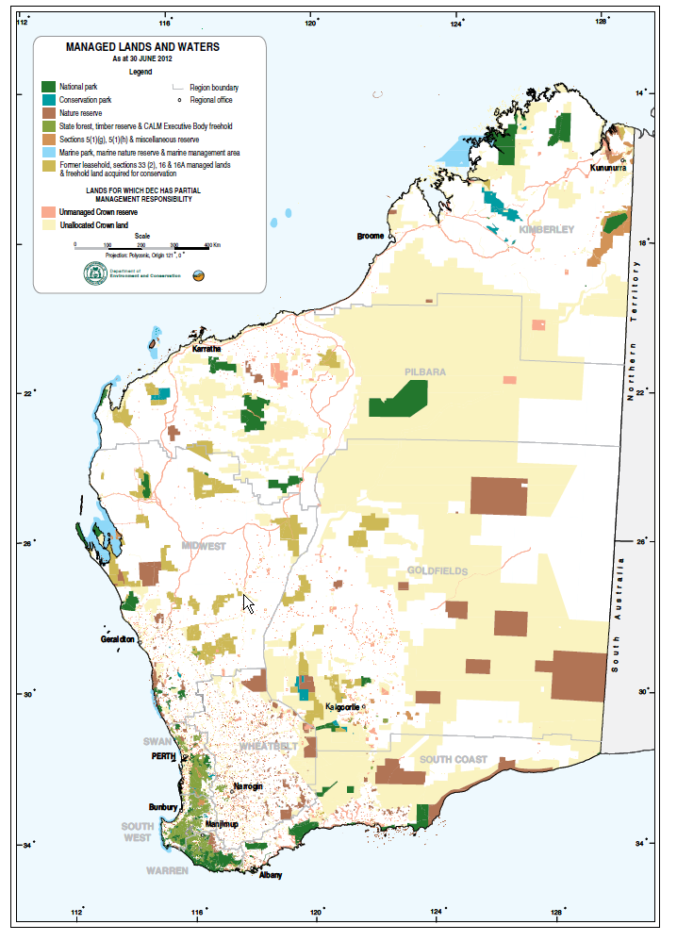
Figure 2. DEC's administrative boundaries (9 Regions).

The six flora industry management regions comprise:
• Southern Sandplain (which largely corresponds with DEC's South Coast Region, plus the eastern part of DEC’s Warren Region);
• Southern Forest (which consists of the western two thirds of DEC's Warren Region, and the southern half of DEC’s South West Region);
• Northern Forest (which consists of the northern half of DEC’s South West Region, with the southern half of Swan Region);
• Northern Sandplain (the northern part of DEC’s Swan Region, in addition to the sandplain north to Carnarvon);
• Wheatbelt; and
• Rangelands (including the goldfields, desert, Pilbara and Kimberley areas).

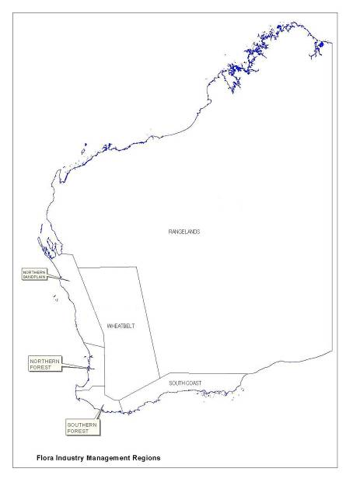
Figure 3. DEC Flora Industry Management Regions.

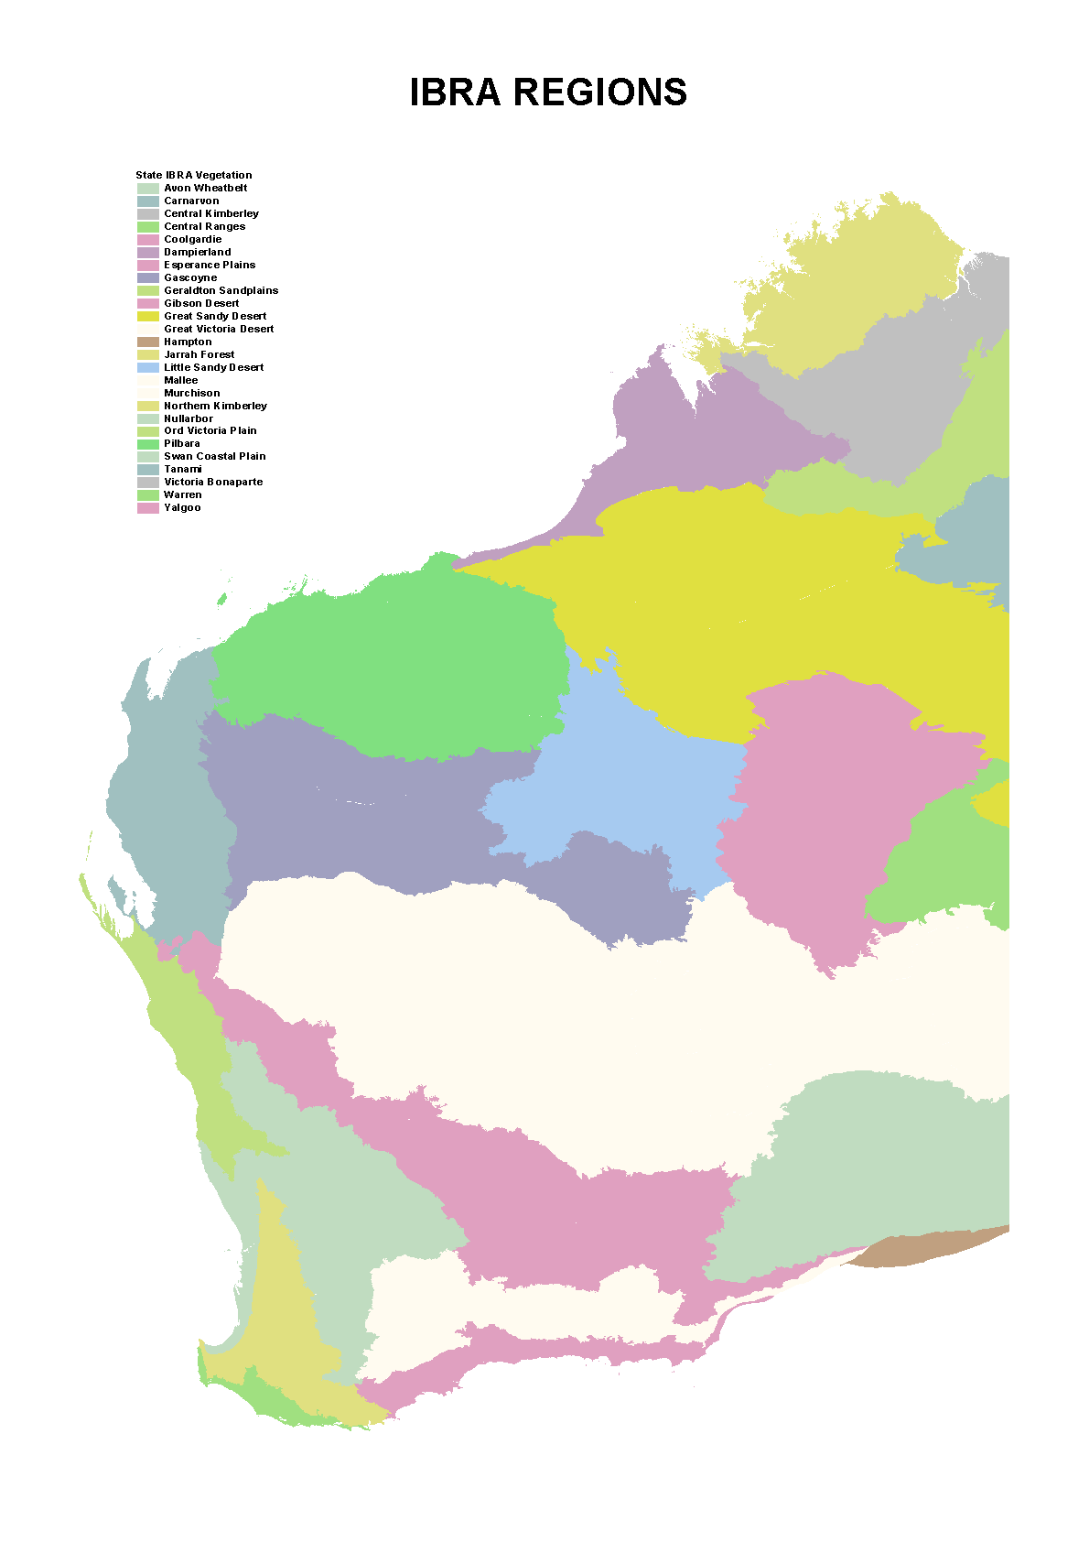

Figure 4. IBRA biogeographic regions.

5.3.2 Licence Application, Licensing Procedures and Flora Returns

Application forms must be completed by an applicant before an application for a commercial flora licence can be considered. The application form for a Commercial Purposes Licence is at Appendix 5, and the application form for a Commercial Producer’s or Nurseryman’s Licence is at Appendix 6.

Each licence applicant must nominate area(s) where they wish to pick, and produce written permission from the management authority for that land, where such an authority exists, as part of their licence application. This is to ensure that applicants are aware of the requirement to have permission of land managers before picking, in accordance with regulation 56E(2) of the Wildlife Conservation Regulations 1970 for Crown land, and section 23D(1) of the Wildlife Conservation Act 1950 for private property. The licence issued has the nominated picking area(s) endorsed on it. In the case of Crown land licences, additional areas can be accessed for flora harvesting provided that the written authority is carried by the picker, as required under licence conditions. In the case of private property, properties must be nominated at the time of licence issue, and protected flora taken from additional properties may not be sold under the licence, even where the landowner has given permission for the flora to be harvested.

On receipt of an application for a commercial flora licence, the DEC screens the application to ensure that it has been completed, and the necessary authorisations are attached. The application is also screened in relation to the flora and products being requested to harvest or sell. Licensees are advised when their application includes prohibited flora, or flora for which special management conditions apply to their harvest, and are required to provide specific justification for such flora to be included in a licence. In such situations, permission is only granted where such conditions can be applied to ensure the conservation of the flora, such as through the species-specific endorsements (Section 5.1.2.4). In the case of private property, applications to sell flora that is otherwise restricted, are investigated to ensure that the flora either is being cultivated on the property, or occurs in sufficient quantity to permit sustainable harvest. This may include property inspections where corroborating evidence is not available.

As a requirement of licence conditions, and in order to facilitate monitoring and enforcement, all commercial licence holders, operating on both Crown and private property, must submit quarterly returns detailing flora taken each month. Data required include taxon, quantity, the unit of measure, and part of flora taken, product use, the status of the land where harvesting was undertaken, whether the flora, is cultivated or wild picked, the name of the private property owner where taken from private land, the grid square location of the flora and the person to whom the flora was supplied.

The licensing system is computerised, containing records of past and present licence holders and all licences held currently and in the past by these persons. In addition, a database management system, containing records of flora returns submitted by licensees, is maintained.

The month prior to the expiry of their licences, licensees receive a renewal notice if the requirement to submit flora returns has been complied with, or, where the requirement has not been met, notification that their licence will not be renewed unless returns are submitted. Reminder letters are automatically computer-generated for those licensees who have overdue flora returns. Failure to submit returns results in non-renewal of the licence.

The State Minister for Environment may revoke a licence that has been issued, or refuse to issue a licence under the Wildlife Conservation Act 1950 to any person who has been convicted of any offence against the Wildlife Conservation Act or Regulations. This includes offences relating to the contravention of conditions attached to licences.

5.3.3 Analyses of Flora Harvest

Harvest data are analysed based on the six flora industry management regions outlined above, and factors influencing biology, ecology and conservation status (including representation in conservation reserves, harvest levels, community/habitat rarity) are also assessed on a regional basis.

The following analyses of harvested taxa can be undertaken using data from flora returns, and other information supplied by DEC officers and industry:

• harvest levels are analysed by taxon to determine major, medium and low use taxa;

• harvest is analysed according to the source of the flora, i.e. whether the flora is taken from Crown or private land, and whether private land harvest is from natural occurring populations, or cultivated flora;

• changing patterns of harvest, or harvest trends, are identified and used as a basis for investigation into causes and potential management issues;

• the main purpose of harvesting is determined, i.e. dried flowers, fresh flowers, seed or woody products; and

• harvest data are analysed at the level of each of the six regions detailed in section 5.3.1, based on 1° by 1° 30' grid cells in the south west and 4° by 6° grid cells in the remainder of the State. A comparison of numbers of taxa and quantity within regions and grid cells is undertaken and provided to regional managers to assist in planning monitoring activities.

DEC's management is based on these analyses and factors such as the taxon’s conservation status, monitoring reports from DEC field officers and research results. These data also help define priorities for research.

Data from flora returns may also be provided in compiled form to industry and other sectors to assist in flora industry development and assessment.

5.3.4 Assessment of Management Options

5.3.4.1 Area-specific management

State forest and other lands managed by DEC where flora harvesting is permitted are subject to specific management by a system of allocation and endorsements. Section 5.1.2 above describes the options that DEC has for management of such land. Specific areas of Crown land, not managed by DEC under the Conservation and Land Management Act, may also have special management requirements. Where an inter-agency agreement is reached between DEC and the managing agency, DEC may manage those areas on a more intensive basis in regard to flora harvesting activities. DEC also makes recommendations to other managing agencies on their management of flora harvesting where this is appropriate. The need for special management on Crown lands is assessed according to the following criteria:

• land tenure and purpose;
• degree of harvest activity;
• conservation value;
• presence of Declared Rare Flora;
• proposals for areas to become conservation reserves; and
• the potential for detrimental impacts from, for example, over harvesting, Phytophthora dieback or erosion.

Regulation of harvest activity of naturally occurring flora on specific areas of private property may be implemented through the standard licence conditions and any specific licence conditions pertaining to the taxa being harvested. Additionally, where a harvest activity has the potential to impact on the conservation of the flora, its habitat or the associated ecosystem, property-specific management can be required to ensure that such an impact does not occur. This management requirement may be as conditions to either the Commercial Producers’ Licence or permits to clear vegetation under the Environmental Protection Act 1986.

5.3.4.2 Taxon-specific management

As outlined in section 5.1.2.4, certain taxa may have special management requirements and are singled out for more intensive management, monitoring and research. Criteria that taxa are assessed on include:

• the quantity harvested;
• the status of the taxon within the conservation estate;
• the distribution, population size and ease of access to the taxon;
• the value of the harvested product;
• the potential for concern over harvest techniques (e.g. regeneration capacity from cut stems);
• the potential impact from pests and diseases (e.g. Phytophthora dieback on Banksia taxa and other taxa, aerial canker); and
• the level of concern in regard to regeneration, including from soil-borne seed banks.

Commercial Purposes and Commercial Producers’ Licences include in their conditions certain flora which may not be harvested, and other flora which may only be harvested under specific endorsement with conditions to ensure the conservation of the flora.

6 Audit, Monitoring, Reporting and Compliance

6.1 Flora Industry Data Management System (FIDMS)

As detailed in section 5.3.2, DEC requires flora returns on a quarterly basis from all licensed flora harvesters. All return data is entered in the FIDMS database. The database can be interrogated to determine harvest levels, trends and locations of flora harvested. This information is used to help determine research requirements, management strategies and flora industry monitoring by DEC district staff and Wildlife Officers.

At the time of data entry, flora returns are checked for inconsistencies, such as unusual quantities of flora or parts being taken, and to confirm the identity of flora that is known to be confused by licensees, usually as a consequence of the use of industry common names. The FIDMS database is also set up to reject certain data entry, such as Declared Rare, Priority Flora or other flora that has harvest restrictions, or names that are not current in the Western Australian Herbarium. Queries with flora returns are referred back to the licensee before the return information is accepted into FIDMS.

Upon receiving an application for an export permit for flora sourced from Western Australia, DSEWPaC staff are encouraged to contact DEC to confirm that the proposed export is in accordance with this plan.

Data held in FIDMS is interrogated to check that flora the subject of an application to DSEWPaC for an export permit has been legally sourced from licensed pickers or persons licensed to sell flora taken from private property. This information forms the basis of advice on the appropriateness or otherwise of DSEWPaC granting or renewing an export permit. The comparison of data held in FIDMS with the details included on export applications also provides a means to cross check the information provided. Any discrepancies are followed up with exporters, dealers and licensees to determine the true source of harvested flora.

In the case of protected flora that is identified as artificially propagated by the permit applicant, DEC uses FIDMS and other knowledge of the flora industry to confirm that the plants are indeed artificially propagated. DEC will not advise that the export permit should be issued unless satisfied that the plant has been grown under controlled conditions and that the parental stock is established and managed in a way that it is not detrimental to the species in the wild.

In the case of hybrid cultivars of Western Australian native flora or Australian native plants not native to Western Australia, export applications are checked to ensure that such plants are known to be cultivated by the industry, and that they are not known to be able to be confused with other Western Australian native species. Approval of the application for such flora is provided on the basis that DEC is satisfied that the growing and harvesting of such flora does not pose any threat to native flora or vegetation.

6.2 Flora Dealer Inspections

The Wildlife Conservation Act 1950 provides for the issue of licences to take or sell protected flora and also allows for terms and conditions to be placed on each licence as discussed in section 5.1.1 above. Dealers are not licensed, however, under the legislation they may not sell any protected flora unless they purchase the flora from another person lawfully entitled to sell the flora to them pursuant to the provisions of a licence issued under section 23C or 23D of the Act. In addition, dealers must keep legible records of the quantity and class or description of flora purchased, the date of the purchase and the name and address of the person from whom the flora was purchased. These records must be retained for not less than 12 months, and produced on demand to a Wildlife Officer.

Wildlife Officers carry out routine inspection of dealers' premises. The frequency of inspection depends, in part, on the size and nature of the dealer's operations. A report is filled out for each inspection. Data collected for each dealer includes the date of the last inspection, the taxa of flora found on the premises, the names and licence numbers of the principal flora pickers who supplied the flora, and whether records are being kept according to legal obligations. These reports are used for ongoing monitoring of dealer activity. These reports also assist DEC in making recommendations to DSEWPaC on whether an export authority should be granted or renewed.

6.3 District Monitoring and Reporting

DEC district staff undertake on-ground administration, monitoring and management. Monitoring and management of the flora industry considers the industry as part of the integrated management of multiple land use on lands that the Department manages where harvesting is permitted.

A standard questionaire is available to district DEC officers dealing with the flora industry, to guide them in their day-to-day monitoring of pickers. This form includes such questions as the names and flora licence numbers of the pickers, taxa being harvested, quantity of flora taken, area in which operations occur, the name of the dealer to whom flora will be sold, and any other relevant observations on picker activities.

District officers are required to be familiar with picking practices and the major commercial flora taxa in their areas. Regional or District reference flora voucher specimen collections are maintained which have specimens representing the major commercially exploited and rare or threatened taxa within the Region/District. These collections may be made available to flora pickers to assist with identifications.

District staff provide information on commercial taxa distribution and quantities for the compilation of records that assist in determining sustainable picker numbers and harvest levels, and numbers of pickers, for allocated blocks under the endorsements system. These data are used in conjunction with information supplied by pickers in flora returns to determine quotas, where applicable.

DEC field officers are responsible for monitoring picking operations and reporting any possible breaches of licence conditions or legislation relating to flora harvesting. The enforcement of these provisions is the responsibility of a network of Wildlife Officers located throughout Western Australia (see section 6.4 for Role of Wildlife Officers). Any activity suspected of breaching the Wildlife Conservation Act 1950, the Wildlife Conservation Regulations 1970 or licence conditions is referred to a Wildlife Officer for investigation and subsequent court action by the Department if appropriate. Flora industry activities that are observed which may lead to non sustainable harvesting are reported by the District office to Head Office for use in defining management and research needs for the industry.

District offices are encouraged to submit annual reports on the status of the industry within their District, addressing inter alia illegal activities, proposals for management and research, and administrative issues. Reporting activity is related to the extent of flora harvesting activity within a District, and the degree of management issues identified by the District officers. These reports cover the preceding calendar year's flora industry activities. District reports are compiled and used for improving management of the flora industry.

District staff (other than Wildlife Officers, see below) do not have authority to enter private land without permission to undertake flora industry inspections. They may, however, request permission to undertake inspections to confirm the details of a Commercial Producer’s or Nurseryman’s Licence, or to inquire as to the flora returns for such licences. Should a land owner refuse permission for an inspection, the DEC may hold the issue or re-issue of a licence, pending such an inspection being granted.

6.3.1 Verification of Export Permit Applications

Wildlife Officers and other DEC staff may also investigate applications for export permits where requested by DSEWPaC. Such investigations may be carried out to verify the details stated by an applicant on an export permit application, such as the source of the plant specimens (location) or the method of harvesting (artificial propagation or wild-harvest). Such investigations may be instigated for protected flora, as well as for Australian native plants that are not native to WA, and may involve activities on Crown or private land. The DEC may recommend the rejection of an application to export flora based on the outcome of such an investigation, including if permission to enter private property is not granted. It is noted that there are severe penalties under the EPBC Act for making false or misleading statements on export permit applications.

6.4 Role of Wildlife Officers

Wildlife Officers have statutory appointment under the Conservation and Land Management Act 1984, with powers defined under that Act and the Wildlife Conservation Act 1950, which includes statutory authority over wildlife management matters on private property, including the harvesting for sale of, and dealing in, protected flora. Wildlife Officers are located at DEC’s Head Office, and at each DEC Regional office and some District offices. Central coordination and support of Wildlife Officers is provided through DEC’s Nature Protection Branch. The primary role of the Wildlife Officers is to ensure compliance with the Wildlife Conservation Act 1950 and the Wildlife Conservation Regulations 1970, including picking licence conditions.

Wildlife Officers have accumulated a substantial amount of flora industry data from field surveys and patrols, licensing information and the findings of research officers. Essential information is also acquired through liaison with flora dealers and pickers. Knowledge of picker activities, market conditions, identification and seasonal development of commercially exploited taxa and factors such as fire and regeneration, provide Wildlife Officers with information on when and where particular taxa are likely to be harvested. Effort is directed seasonally and shifts accordingly.

Field operations may be active or reactive. Wildlife Officers liaise with flora industry representatives and inspect dealers' premises, checking flora on hand and the dealers' records, which may result in subsequent investigations. Having determined the need for a patrol based on seasonal factors and locations known to be targeted by pickers, Wildlife Officers develop patrol plans as necessary. Alternatively, patrols may be planned in response to specific complaints or information about an alleged illegal activity. Wildlife Officers may check for unlicensed pickers, check pickers for compliance with licence conditions, check prohibited picking areas, check protected flora occurrence on private property, or investigate the sale of flora to flora dealers at their premises. Such field inspections may occur on Crown or private land, depending on the nature of information received and the conservation issues pertinent to the area.

Wildlife Officers monitor picker activity, as well as the status and condition of commercially harvested taxa, in the course of their fieldwork. Because of the nature of their duties, Wildlife Officers are able to monitor taxa and populations from year to year and from area to area. Additionally, information from the FIDMS is available to Wildlife Officers to identify taxa that are being harvested in their areas, and highlight any causes for concern, such as the commencement of harvest or increases in the harvest of certain taxa, including taxa that are restricted to private property as a management strategy. Such information is used to formulate inspection patrols to ensure that the conservation of the taxa or their habitat or associated ecosystems is not being compromised by harvest activity. Feedback on taxa and picker activities is provided to Head Office and management recommendations are made as a result of this monitoring.

At the conclusion of such field work, a patrol report and any breach reports are submitted to the officer's supervisor for processing.

Wildlife Officers are also encouraged to submit annual reports on the status of the industry within the area they are stationed, addressing inter alia illegal activities. These reports cover the preceding calendar year.

District and Regional officers, on completion of a course in law enforcement, as described below, may be issued with a wildlife officer authority. These officers support the functions of the appointed Wildlife Officers.

6.4.1 Law enforcement training and operations procedures

All DEC personnel involved in the management of the commercial flora industry are required to know the relevant parts of the Conservation and Land Management Act 1984, the Wildlife Conservation Act 1950 and their associated Regulations. Training on this legislation, general legal principles, gathering and presentation of evidence, and court attendance is provided to all DEC field staff through an accredited training course. Wildlife Officers receive more detailed and extensive ‘on the job’ training in respect of the Wildlife Conservation Act 1950 and legal procedures.

6.5 Advisory Committees on Flora Conservation

The Conservation Commission of Western Australia is established as an advisory, vesting and controlling body under Section 18 of the Conservation and Land Management Act 1984 and is responsible to the WA Minister for Environment. The Conservation Commission considers matters concerning the conservation estate and other nature conservation issues in Western Australia, and can provide advice to the Minister on the appropriateness of the measures contained within this management plan for the conservation of flora.

Threatened Species Scientific Committee (TSSC) provides policy and management advice to DEC on threatened flora conservation. A major function of the TSSC is to provide recommendations for amendments to the schedule of Declared Rare Flora.

The WA Flora Industry Advisory Committee (WAFIAC) was formed in 1992 to provide a forum for consultation between DEC, the industry and other interested parties, and to provide advice to DEC and the WA Minister for Environment on management and conservation of commercially harvested protected flora in Western Australia (e.g. cut flowers, seed, fruit, foliage, cuttings, beansticks, didgeridoos).

The WAFIAC provides a forum for reactive and adaptive management of the flora industry. Members of the Committee are appointed by the Minister to represent the following:
• Department of DEC;
• Department of Agriculture and Food.
• Botanic Gardens and Parks Authority;
• flora industry (dealers, pickers, seed industry and private growers);
• tertiary institutions; and
• voluntary conservation interests.

Examples of the contribution WAFIAC representatives are able to provide for the development of strategies for the management of the flora industry are provided below.

Industry representatives are able to provide information on picking and commercial harvesting practices, and market demand for flora products. Such information is integral to understanding the operation and driving pressures on the flora industry.

The Department of Agriculture and Food has a role in the development of commercial flora production on private land, either through the development of flora cultivation, or the sustainable management of native vegetation. The Botanic Gardens and Parks Authority also has expertise in flora cultivation, as do flora growers and the Wildflower Society of Western Australia (a voluntary conservation organisation). These representatives are able to provide information on flora production and the feasibility of alternative strategies for flora conservation.

DEC, the Botanic Gardens and Parks Authority and the Wildflower Society have considerable expertise in flora conservation. The Wildflower Society also provides an important role in contributing community expectations for flora conservation. These representatives ensure that the conservation of flora has primary consideration in the development of flora management strategies.

Issues relating to commercial harvesting of flora are referred to DEC directly by Departmental staff, industry or the community, or may be raised at the WAFIAC meetings by different sector representatives. The diverse representation on the WAFIAC provides the forum for detailed discussion on flora management and conservation issues, and the development of appropriate management strategies to address issues raised where the implementation of strategies are required to address a potential flora conservation concern.

The WAFIAC thus provides an effective forum for the debate of flora management issues, and the development of appropriate management strategies to address these issues. Where monitoring raises concerns over the commercial harvesting of a particular taxon, the following procedure applies.
a) DEC makes an assessment of the data and populations in the wild. Additional research and monitoring may be undertaken to provide recommendations for action and management.
b) DEC tables its recommendations for discussion at a meeting of the WAFIAC wherever possible. However, if the conservation status of the taxon concerned warrants urgent changes, DEC may implement the necessary actions immediately and inform the Committee subsequently.
c) If restrictions are necessary, options such as limiting the number of pickers, setting quotas, restricting the season, and closing certain areas will be considered.
d) If DEC believes that a taxon cannot be harvested sustainably on Crown land, even with additional management as outlined above, a recommendation will be made to the Minister to ban the harvesting of the taxon from Crown land. If it is believed also that it cannot be sustainably harvested on private land, the taxon will be removed from the Export Flora List covered by this Management Plan. Consideration may also be given to listing the taxon on the Priority Flora list or recommending it for declaration as rare flora.
e) Every effort will be made to give adequate notice to industry about changes affecting commercial harvesting of protected flora.

WAFIAC last formally met in 2008 due to no significant flora management issues being raised by industry or other members since that time. Where minor management issues have been raised, meetings have been held with specific interest groups to resolve those issues as they arise. The capacity remains for WAFIAC to meet should any significant issues be brought to the attention of DEC.

6.6 REPORTS

Reports take several different forms. The following summarise the various reports on the flora harvesting industry within Western Australia.

6.6.1 DEC Reports

As detailed in section 5.3.2, commercial flora harvesters are required as a condition of licence to submit returns covering flora taken each month on a quarterly basis. Data required include taxa, quantity, part, unit measure, the land tenure and grid location where picked, and to whom the flora was supplied.

From this data, monitoring reports are prepared to cover flora taken in each 12 month period (January to December). These data are used as part of the monitoring process described above. The reports will be compiled and forwarded to DSEWPaC, upon completion, usually by 30 June the following year to allow for the submission and data entry of picker return information.

A proforma report form for harvested flora taxa and populations may be completed by Region/District staff and Wildlife Officers, and a copy forwarded to Head Office, whenever a significant issue regarding commercially harvested taxon is located in the field during the course of work. The report includes habitat and population details, the status of the population, the degree of harvesting noted and any recommendations (if required). These reports are used in conjunction with other monitoring methods to monitor the taxon.

Wildlife Officers conduct inspections of dealers' premises to ensure that legislative requirements are being met. These inspection reports are used to assist in making recommendations to DSEWPaC on whether or not to renew an export authority. Following the detection of an offence Wildlife Officers prepare breach reports for evaluation. These reports are used as a basis for the preparation of a case to prosecute or take other action, as appropriate.

One month prior to the expiry of a licence, a report is generated which assesses the status of a picker's harvest returns. If the picker’s returns are satisfactory a letter reminding the picker of the expiry of her/his licence is sent. If returns are incomplete, the picker is informed that the licence can not be renewed until returns have been received. District and Regional staff, Wildlife Officers and licensing staff have access to this information via the FIDMS.

District/Regional flora industry officers are encouraged to submit an annual report to DEC’s Head Office (Nature Protection Branch), covering harvesting activity, enforcement issues, administrative issues, and recommendations for research and management. These annual reports are compiled and a summary is distributed to Regions/District and used by Head Office (Nature Protection Branch) staff to assist in the management of the industry.

6.6.2 Reports to the Department of Sustainability, Environment, Water, Population and Communities

Reports on the implementation of the WA flora management plan will be provided to DSEWPaC on a regular basis as detailed below.

6.6.2.1 Reports sent to the Department of Sustainability, Environment, Water, Population and Communities

Special reports will be provided to DSEWPaC as changes occur, detailing:

- documentary support for any proposed amendments to the Export Flora List, or the list of flora approved for trial exports (additions, deletions or changes in the category of listing);

- any amendments to the list of Declared Rare Flora, as published in the Government Gazette; and,

- variations in standard licence conditions.

Annual reports will be provided to DSEWPaC detailing:

- data summaries from the analysis of flora returns detailed in section 6.5.1, above;

- harvest quotas and the information considered in setting quotas for individual taxa;

- statistics which show the number and category of flora offences, and the recommended action and results;

- statistics on the amount of land reserved for national parks, conservation parks, nature reserves and other reserves with a conservation purpose; and,

- a compilation of the results of research carried out in the previous twelve month period which is relevant to the commercial flora industry.

6.6.3 Reports from the Department of Sustainability, Environment, Water, Population and Communities

DSEWPaC will provide to DEC on an annual annual basis, or as otherwise agreed between DSEWPaC and DEC, a compiled summary of the WA flora exported by each of the international exporters.

7 KEY PERFORMANCE INDICATORS

The specific objectives of this management plan as outlined in section 4 were:

- ensure conservation of the taxa subject to this plan by maintaining sustainable populations throughout their existing geographical ranges in the State, taking into account the precautionary principle;

- manage the commercial harvesting of protected flora to ensure that it is undertaken in a manner that does not jeopardise the conservation of the taxon being harvested nor, in the case of Crown land, the conservation values of the land;

- provide for the development and operation of the flora industry in Western Australia in accordance with the principles of ecological sustainability, Government policy and the Wildlife Conservation Act 1950; and

- provide for inter-generational equity by ensuring that the health, diversity and productivity of the environment is maintained or enhanced for the benefit of future generations.

The above objectives are met through the management measures and strategies outlined in section 5 of the plan, that being through licensing, the implementation of the Export Flora List and the management of the reserve system throughout the State. Annual reports will be provided on any changes to the Export Flora list, Declared Rare Flora List, licence conditions and statistics on the amount of land reserved for national parks, conservation parks, nature reserves and other reserves with a conservation purpose as outlined in section 6.6.2.1.

The following annual Key Performance indicators have been set to measure the success of the management arrangements identified in the plan, through: the comprehensive, adequate and representative reservation of lands for conservation; a measure of effective flora licensing arrangements; and, the outcome of field monitoring of compliance by persons involved in the industry.

KPI 1: Proportion of terrestrial IBRA sub-bioregions with greater than 15% reservation for conservation.

KPI 2: number of commercial flora licences issued under the Wildlife Conservation Act 1950.

KPI 3: number of reported offences under the Wildlife Conservation Act 1950 in relation to commercial flora harvesting in Western Australia, investigated by DEC.

8 REFERENCES

ABS (2013). Australian Bureau of Statistics Customised Report. Commonwealth of Australia.

Anon (1996). National Strategy for the Conservation of Australia’s Biological Diversity. Department of Environment, Sport and Territories

Department of Environment and Conservation (DEC) (2006a). Draft 100- year Biodiversity Conservation Strategy for Western Australia: blueprint to the Bicentenary in 2029, Government of Western Australia, Perth.

Department of Environment and Conservation (DEC) (2006b). Phytophthora Dieback Atlas – From the bush to your back fence: what you need to know, Department of Environment and Conservation.

Department of Environment and Conservation (DEC) (2007). Corporate Plan 2007-2009

Department of Environment and Conservation (DEC) (2012). Western Australian Flora Statistics. http://florabase.dec.wa.gov.au/statistics/

Government of Western Australia (2000). The Salinity Strategy.

Hussey, B.M.J., G.J. Keighery, R.D. Cousens, J. Dodd and S.G. Lloyd (2007). Western Weeds. A guide to the weeds of Western Australia (Second edition). The Weeds Society of Western Australia.

Podger, F.D., S.H. James and M.J. Mulcahy (1996). Review of Dieback in Western Australia – Report to the Western Australian Minister for the Environment.

Scott, P.M., Jung, T., Shearer, B.L., Barber, P.A. and Hardy, G.E.St.J. (2008). Potential role of Phytophthora species in Eucalyptus gomphocephala (tuart) decline. In: Third International Workshop on Phytophthora/Pythium and Related Genera, Ninth International Congress of Plant Pathology, 23 - 24 August, Turin, Italy.

Thackway, R. and Creswell, I.D. (1995). An Interim Biogeographic Rationalisation for Australia, Australian Nature Conservation Agency, Canberra.

Appendix 1

WA FLORA MANAGEMENT PLAN

EXPORT FLORA LIST Page No 1
Taxa which may be harvested from natural stands only where a specific endorsement (and any standard licence conditions) is attached to the licence
Boronia megastigma Brown boronia, Boronia
Banksia hookeriana Hookerana, hookers

Taxa which may be harvested from natural stands, subject to standard licence conditions
Acacia pentadenia Karri wattle
Actinodium cunninghamii Albany daisy, Swamp daisy
Adansonia gregorii Baobab, Boab
Adenanthos cuneatus Templetonia, Native temp
Adenanthos cygnorum Woolly bush
Adenanthos obovatus Basket flower
Agonis flexuosa Peppermint

Allocasuarina decussata Karri She-oak
Allocasuarina humilis Dwarf She-oak
Anigozanthos flavidus Kangaroo paw
Anigozanthos humilis Cats paw
Anigozanthos manglesii Red & green kangaroo paw
Anigozanthos pulcherrimus Yellow kangaroo paw
Anigozanthos rufus Rufous/red kangaroo paw
Baeckea grandiflora Large-flowered Baeckea
Banksia ashbyi Ashby’s banksia
Banksia attenuata Coast banksia
Banksia candolleana Candolleana
Banksia gardneri Ground leaves
Banksia grandis Bull banksia
Banksia heliantha Oak-leaved Dryandra
Banksia ilicifolia Holly-leaved Banksia
Banksia littoralis Swamp banksia
Banksia menziesii Menzies banksia, Firewood banksia
Banksia occidentalis Water banksia
Banksia prionotes Acorn banksia
Banksia repens Ground leaves
Banksia sceptrum Sceptre banksia
Banksia speciosa Showy banksia

EXPORT FLORA LIST Page No 2
Beaufortia decussata Gravel Bottlebrush, Decussata
Beaufortia sparsa Sparsa, Swamp bottlebrush
Beaufortia squarrosa Sand bottlebrush
Boronia purdieana Lemon-scented boronia
Bossiaea aquifolium Miniature holly
Callistemon glaucus Callis greens, Albany bottlebrush
Calothamnus quadrifidus One-sided Bottlebrush
Calytrix flavescens Summer Starflower
Calytrix fraseri Pink Summer Calytrix
Caustis dioica Chinese puzzle
Cephalipterum drummondii Pompom Head
Chaetanthus aristatus
Conospermum amoenum Blue smokebush
Conospermum crassinervium Tassel smokebush
Conospermum nervosum
Conospermum incurvum Plume smokebush
Conospermum stoechadis Common smokebush
Conospermum triplinervium Tree smokebush
Corymbia calophylla Red gumnuts, Honky nuts, Marri
Crowea angustifolia Crowea
Dasypogon bromeliifolius Drumsticks
Daviesia cordata Bookleaf
Eucalyptus forrestiana Fuschia mallee
Eucalyptus gomphocephala Tuart
Eucalyptus lehmannii Bushy yate
Eucalyptus marginata Jarrah
Eucalyptus patens Swan River Blackbutt
Eucalyptus preissiana Bell-fruited mallee
Eucalyptus pyriformis Pear-fruited Mallee
Eucalyptus rudis Flooded gum
Eucalyptus tetragona Blue mallee
Evandra aristata Fisherman’s rod, kangaroo grass
Grevillea diversifolia Variable-leaved Grevillea
Grevillea endlicheriana Spindly Grevillea
Grevillea synapheae Catkin Grevillea
Hakea cucullata Cup-leaf hakea, Scallops
Hakea lasiantha Crowsfoot

EXPORT FLORA LIST Page No 3
Hakea laurina Pincushion Hakea
Hakea pandanicarpa Corked hakea
Hakea platysperma Cricket ball hakea, Native peach
Hybanthus floribundus subsp. adpressum Native violet
Hypocalymma angustifolium White myrtle
Hypocalymma robustum Swan River myrtle
Johnsonia lupulina Hooded lily
Juncus caespiticius Grassy Rush
Juncus holoschoenus Fern rush
Juncus pallidus Coarse rush
Kingia australis Grass girls, Djingarra
Kunzea ericifolia Spearwood
Lachnostachys eriobotrya Sago conspermum
Lachnostachys verbascifolia Lambstail and ears
Lawrencia helmsii Long fingers, Plagianthus
Lechenaultia biloba Blue Leschenaultia
Lepidosperma effusum Spreading Sword-sedge
Lepidosperma gladiatum Coast Sword-sedge
Leptocarpus tenax Slender Twine Rush
Leucopogon parviflorus Coast Beard-heath
Leucopogon polymorphus Baeckea
Leucopogon pulchellus Beard-heath
Leucopogon verticillatus Native bamboo
Lomandra hastilis Kojaneerup rush
Lysinema ciliatum Curry and rice
Macrozamia riedlei Zamia palm
Meeboldina cana
Melaleuca megacephala
Melaleuca rhaphiophylla Beard-heath
Olearia axillaris Coastal Daisybush
Ozothamnus cordatus Seacrest
Pericalymma ellipticum Swamp ti-tree
Persoonia longifolia Snottygobble, cherry bush
Petrophile diversifolia
Philotheca spicata Pepper and Salt
Pimelea suaveolens Scented Banjine
Podocarpus drouynianus Emu bush
Pteridium esculentum Bracken fern
EXPORT FLORA LIST Page No 4
Ptilotus calostachyus Weeping Mulla Mulla
Ptilotus exaltatus Tall mulla mulla
Ptilotus manglesii Pom Poms
Ptilotus obovatus Cotton Bush
Ptilotus rotundifolius Royal Mulla Mulla
Rhodanthe chlorocephala subsp. rosea Roseum everlasting
Rhodanthe chlorocephala subsp. splendida
Rhodanthe floribunda
Rhodanthe manglesii
Scholtzia captitata
Scholtzia involucrata Spiked Scholtzia
Scholtzia oligandra Pink Scholtzia
Sphenotoma dracophylloides
Stirlingia latifolia Blueboy, Stirlingia
Taxandria fragrans Coarse tea tree
Taxandria juniperina Coarse tea tree
Taxandria linearifolia Rosa tea tree
Taxandria parviceps Fine tea tree
Triptilodiscus pygmaeus
Trymalium venustum Karri hazel
Typha domingensis Bullrush
Verticordia densiflora Compacted Featherflower ,Densaflora
Verticordia drummondii Drummond's Featherflower
Verticordia grandis Scarlet Featherflower
Verticordia nitens Yellow morrison, Christmas morrison
Verticordia picta Painted Featherflower
Verticordia plumosa Plumed Featherflower
Verticordia serrata var. ciliata
Verticordia serrata var. serrata
Waitzia acuminata Orange Immortelle
Waitzia suaveolens Fragrant Waitzia
Xanthorrhoea gracilis Grass tree, Wallaby tails
Xanthorrhoea preissii Grass tree, Kangaroo tails
Xanthorrhoea thorntonii Grass tree
Xerochrysum bracteata Bushy everlasting
Xylomelum angustifolium Woody or Sandplain pear
Xylomelum occidentale Holly oak

EXPORT FLORA LIST Page No 5

Taxa which may be harvested from natural stands, but only on private property

Acacia merinthophora Twisted or zigzag wattle
Andersonia caerulea Purple heath, Foxtails
Banksia baueri Woolly Banksia
Banksia baxteri Baxteri
Banksia burdettii Burdett’s banksia
Banksia coccinea Albany banksia
Banksia formosa Formosa, Albany dryandra
Banksia hewardiana
Banksia laricina Rose cones
Banksia nobilis Golden dryandra
Banksia pteridifolia Skeleton leaves
Banksia victoriae Woolly orange banksia
Boronia heterophylla Red boronia
Boronia molloyae Tall Boronia
Chamelaucium megalopetalum Large waxflower
Chamelaucium uncinatum Geraldton wax
Conospermum teretifolium Spider Smokebush
Corynanthera flava Golden cascades
Eucalyptus buprestium Apple Mallee
Geleznowia verrucosa Yellow bells
Grevillea leucopteris White Plume Grevillea
Hakea victoria Royal hakea

Homalospermum firmum
Hypocalymma myrtifolium
Meeboldina scariosa Velvet or Seeded rush
Melaleuca nesophila Mindiyed
Physopsis spicata Hill River lambstail
Verticordia eriocephala Cauliflower bush, Brownii
Verticordia monadelpha var. monadelpha
Verticordia nobilis
Verticordia roei Roe's Featherflower

EXPORT FLORA LIST Page No 6

Taxa which may be harvested from artificially propagated plants

All flora native to Western Australia, except for CITES I species and eligible threatened species listed under the EPBC Act.

Taxa which may be harvested or sold without a licence

All Australian native species that are not native to Western Australia, except for CITES I species and eligible threatened species listed under the EPBC Act.

Appendix 2

DEPARTMENT OF CONSERVATION AND LAND MANAGEMENT¹
POLICY STATEMENT NO. 13
COMMERCIAL FLORA HARVESTING
NOVEMBER 1993

1. BACKGROUND
Flora harvesting is a significant and expanding multi-million dollar industry. Prior to 1980, the Forests Department was responsible for flora management under the Native Flora Protection Act 1935. During this time all flora was considered to be forest produce under the Forests Act and commercial pickers were required to be licensed to pick on State forest, timber reserves and certain other Crown lands.

In 1980, the Acts repealing the Native Flora Protection Act and providing for flora conservation by amending the Wildlife Conservation Act 1950 were proclaimed. The responsibility for control of flora harvesting, including seed, was transferred to the Department of Fisheries and Wildlife, with its management applying to all lands, rather than only some Crown land.

Under the Conservation and Land Management Act 1984, CALM is responsible for the conservation and management of flora throughout Western Australia, and for administration of the Wildlife Conservation Act 1950. CALM thus has the authority to exert controls on the commercial harvesting of protecting flora in Western Australia on all lands.

A survey of the flora industry undertaken in 1980/81 showed that:
- exploitation of Western Australian native plants for cut flowers, seed and nurseries was worth $1.5 million, $0.7 million and at least $3.0 million respectively at the wholesale level;
- 50 per cent of all cut flowers and 80 per cent of all seed were taken from Crown land;
- 588 species were used by the industry;
- Boronia megastigma was the most heavily exploited species and was the only species for which there were any data on the impact of picking;
- exploitation of the genera Verticordia, Stirlingia, Agonis, Banksia and Dryandra accounted for 52 per cent of all cut flowers harvested while the genera Acacia, Kennedia, Eucalyptus and Helipterum accounted for 61 per cent of the total weight of seed collected;
- most picking activity was concentrated around Perth and Mount Barker;
- almost all heavily exploited species have widespread distributions, but a few are geographically restricted and may require intensive research and management.

The estimated value of exports of cut wildflowers (both bush-picked and cultivated) and proteas in 1991 was about $15.5 million (source: Australian Bureau of Statistics). No data are available on the value of seed. Western Australia is largely unique (only South Africa being at all comparable) in having a multi-million dollar industry based on harvesting of indigenous flora from the wild. The most recent estimate is that bush picking comprises approximately 35 per cent of the total wildflower and protea market, reflecting an export value of about $5.5 million. The wildflower sector of the industry has a large export component, while seed is used mainly for revegetation projects within Western Australia.

Export of native flora is covered by the Commonwealth Wildlife Protection (Regulation of
Exports and Imports) Act 1982 administered by the Australian Nature Conservation Agency. In accordance with the requirements of that Act in relation to the export of native flora taken from the wild, CALM produces a management program for the commercial taking of Western Australian flora. The Commonwealth Act requires that the harvesting of native flora for export be undertaken under a management program approved by the Commonwealth Minister, and in a manner that is not detrimental to, or contributes to trade which is detrimental to, the survival of the species. This applies equally to Crown and private lands.

1 As of 1 July 2006 Department of Conservation and Land Management is now known as the Department of Environment and Conservation.

It was estimated in 1988 that the number of species being exploited had increased to about 1,500. There was also considerable growth in the number of Commercial Purposes Licences issued for the taking of flora for commercial purposes from Crown land, from 454 in 1980/81 to 1,333 in 1988/89. Following the twenty-fold increase in licence fees in June 1990 to $100.00 for Commercial Purposes Licences, the number of these licences decreased to 576 in 1990/91 and 661 in 1991/92. The number of Commercial Producer's/Nurseryman's Licences, for the sale of protected flora taken from private land, declined from 199 in 1980/81 to 87 in 1988/89, before increasing to 284 in 1990/91 and 259 in 1991/92, despite the five-fold licence fee increase to $25 in June 1990. This, along with export data, reflects a shift in emphasis from Crown land to private property in the industry.

Although the level of production from commercial plantings has increased dramatically, there are still many wildflower species (e.g. rushes) which are collected almost exclusively from Crown land, including CALM-managed lands. It is likely that this need will continue until economic propagation and cultivation techniques are developed. The pressure to develop techniques for commercial propagation of wildflowers is increasing while areas available for bush picking are reduced due to changes in vesting and purpose, and clearing.

Similarly, the majority of seed is collected from wild populations, although there has been a recent increase in planting of and production from seed orchards. In the case of seed collected for revegetation, the demand for seed will not be satisfied in the short term from seed orchards.

The Department's mission in relation to flora is one of conservation. There is nothing in legislation which specifically gives the Department the function of promoting, encouraging or developing the flora industry. Nevertheless, the Wildlife Conservation Act provides for flora to be commercially utilised.

CALM controls approved commercial harvesting of native flora in order that this resource is managed to ensure its long term conservation; a fair and equitable return is received by the State; wherever possible the operation is commercially viable; and the resource is managed to minimise waste.

Management problems have arisen as a result of inadequacies in the Wildlife Conservation Act 1950. Amendments are proposed to allow, for example, for the licensing of dealers and wholesalers, and the testing of licence applicants, and will improve CALM's management capability.

There is a need for further research on commercial flora harvesting in Western Australia, with emphasis on monitoring (i.e. distribution, abundance, recruitment, population structure) and management of the flora populations and their interaction with the activities of pickers (particularly harvesting practices, fire regimes, dieback). Such research will lead to the development of management strategies, and specific Wildlife Management Programs for individual species or groups of species.
Because of strong public awareness of indigenous flora and its harvesting, and the potential for adverse impacts to occur if the flora industry is not adequately managed, an active campaign to improve industry awareness and education is necessary.

This policy statement does not address issues relating to the Western Australian Government's sovereignty over the State's indigenous flora, derivatives from flora and intellectual property pertaining to flora and its derivatives, nor does it address the extension of sovereignty to flora taken from the wild which is subsequently further developed for uses such as horticulture (including patenting or varieties developed from wild flora) or the extraction of genetic material or compounds for pharmaceutical and other applications.

Flowing from the State's sovereignty and property rights is the right of the State to share in and benefit from any natural product of flora or a product structurally based on any natural product of flora. These matters are the subject of policy and legislative consideration and will be reflected in Departmental policy statements in due course.

2. OBJECTIVE
To manage the commercial harvesting of protected flora on Crown land and private property to ensure that harvesting is undertaken in a manner that does not jeopardise the conservation of the species being harvested, nor, in the case of Crown land, the conservation values of the land.

3. POLICY
The Department will:
3.1 Provide for the development and operation of a flora industry in Western Australia in accordance with Government policy and the Wildlife Conservation Act.
3.2 Permit picking and seed collection under licence on State forest and Crown land other than nature reserves, national parks and conservation parks, subject to land use priorities, conservation needs and management conditions.
3.3 Licence the sale of protected flora derived from commercial picking and seed collection on private property.
3.4 Ensure that the taking of protected flora is in accordance with a management program approved under the Commonwealth Wildlife Protection (Regulations of Exports and Imports) Act 1982.
3.5 Maintain an effective administrative, licensing and monitoring system.
3.6 Ensure that the State receives a return for the flora resource which provides the capacity for undertaking the necessary research and management in relation to flora harvesting.
3.7 Implement management practices to conserve exploited protected flora and its habitat and to ensure its sustainable harvest.
3.8 Liaise with industry and related groups over the management of the flora industry.
3.9 Carry out, cause to be carried out, or promote research on exploited protected flora as necessary.

4. STRATEGIES
To accomplish the Department's objective and policy, the Department will implement the following strategies:
4.1 Licence operators in the industry as appropriate, to pick and sell protected flora, and subject to proposed amendments to the Wildlife Conservation Act 1950, licence processing and trade.
4.2 Prepare and implement a management program for the sustainable harvest of protected flora taken for export in consultation with the Australian Nature Conservation Agency.
4.3 Ensure that licensed operators are familiar with the species, conditions and endorsements applicable to their licences.
4.4 Subject licensed operators to appropriate controls including the keeping of records, provision of returns and compliance with conditions such as may be required by the Department.
4.5 Develop and maintain a computer system for the maintenance and retrieval of data and statistics on the flora industry.
4.6 Collect data on the distribution and commercial utilisation of species in commercial demand.
4.7 Train and maintain staff where protected flora is harvested to implement Departmental policy and strategies and enforce legislative requirements.
4.8 Maintain an active, ongoing program of industry education and awareness relating to flora conservation, using:
- literature (e.g. brochures, posters, booklets, newsletters), videos and slide kits;
- formal education and testing of licence applicants;
- literature and signs at appropriate outlets (e.g. CALM offices, Shire and Police offices, information bays);
- talks to industry groups (e.g. Wildflower Pickers and Producers Association, Flora Export Council of Australia);
- displays at town and agricultural shows.
4.9 Develop and implement a system of licence fees, royalties or other mechanisms to ensure that there is a return to the State from flora taken from Crown land, and to ensure that the industry meets the costs of satisfying State and Commonwealth requirements (e.g. for ongoing monitoring and management).

4.10 Review licence fees and royalties annually.
4.11 Encourage commercial flora production on private property and the establishment and maintenance of private commercial seed orchards and nurseries, especially for species that are of limited supply or are difficult to harvest on a sustainable basis from Crown land.
4.12 Seek to ensure that access to sufficient seed is available to meet future revegetation needs, within conservation and management constraints.
4.13 Monitor distribution, levels of harvesting and impacts of exploitation on protected flora.
4.14 Ensure that a system of conservation reserves exists that adequately protects representative areas and species of exploited flora (the commercial harvesting of flora from areas formally approved by Government as future conservation reserves would normally not be permitted).
4.15 Undertake research on the distribution, reproductive biology, ecology and protection of exploited flora, and recommend the discontinuation of picking of species or populations in the wild where their conservation is under threat.
4.16 Develop Wildlife Management Programs and Interim Wildlife Management Guidelines for exploited plant taxa and appoint management teams for their implementation.
4.17 Endorse picking on CALM-managed lands, and lands over which CALM has management agreements in place, within sustainable levels for specific species and the maintenance of the conservation values of the area.
4.18 Implement Phytophthora dieback management procedures in accordance with the Western Australian Commercial Flora Harvesting Management Program. CALM Policy Statement No. 3 and the various standards and practices developed by the Department as appropriate to the flora industry.
4.19 Liaise with Commonwealth and State authorities, local government and other relevant authorities and groups on appropriate matters including research and monitoring, commercial utilisation, enforcement and joint strategies for public and industry information and education.
4.20 Maintain the Western Australia Flora Industry Advisory Committee to liaise with and receive advice from representatives of the flora industry and other relevant interests.

Syd Shea
EXECUTIVE DIRECTOR

Appendix 3

Wildlife Conservation (Rare Flora) Notice 2012(2)
Made by the Minister for the Environment under section 23F(2) of the Act.

1. Citation
This notice may be cited as the Wildlife Conservation (Rare Flora) Notice 2012(2).

2. Interpretation
In this notice—
“extant” means known to be living in a wild state;
“protected flora” means any flora belonging to the classes of flora declared by the Minister under section 6 of the Act to be protected flora by notice published in the Gazette 9 October 1987, at p. 3855;
“taxon” includes any taxon that is described by a genus name and any other name or description.
Note: The plural form of “taxon” is “taxa”.

3. Rare flora
Subject to clause 4, protected flora—
(a) specified in Schedule 1, being taxa that are extant and considered likely to become extinct or rare and therefore in need of special protection; and
(b) specified in Schedule 2, being taxa that are presumed to be extinct in the wild and therefore in need of special protection,
are declared to be rare flora for the purposes of section 23F of the Act throughout the State.

4. Application
Clause 3 does not apply to those plants of a taxon of protected flora specified in Schedule 1 or 2 that have been planted for any purpose other than such plants that have been planted for the purpose of conservation of that taxon and in accordance with approval given by the Director General.

5. Revocation
The Wildlife Conservation (Rare Flora) Notice 2012 is revoked.

Schedule 1 — Extant taxa
[cl. 3(a)]
Division 1 — Spermatophyta (flowering plants, conifers and cycads)

Acacia anomala
Acacia aphylla
Acacia aprica
Acacia aristulata
Acacia ataxiphylla subsp. magna
Acacia auratiflora
Acacia awestoniana
Acacia brachypoda
Acacia caesariata
Acacia chapmanii subsp. australis
Acacia cochlocarpa subsp. cochlocarpa
Acacia cochlocarpa subsp. velutinosa
Acacia denticulosa
Acacia depressa
Acacia forrestiana
Acacia imitans
Acacia insolita subsp. recurva
Acacia lanuginophylla
Acacia leptalea
Acacia leptoneura
Acacia lobulata
Acacia pharangites
Acacia pygmaea
Acacia recurvata
Acacia rhamphophylla
Acacia sciophanes
Acacia splendens
Acacia subflexuosa subsp. capillata
Acacia unguicula
Acacia vassalii
Acacia volubilis
Acacia wilsonii
Acacia woodmaniorum
Acrotriche orbicularis
Adenanthos dobagii
Adenanthos ellipticus
Adenanthos eyrei
Adenanthos pungens subsp. effusus
Adenanthos pungens subsp. pungens
Adenanthos velutinus
Allocasuarina fibrosa
Allocasuarina globosa
Allocasuarina tortiramula
Aluta quadrata
Andersonia annelsii
Andersonia axilliflora
Andersonia gracilis
Andersonia pinaster
Androcalva adenothalia
Androcalva perlaria
Anigozanthos bicolor subsp. minor
Anigozanthos viridis subsp. terraspectans
Anthocercis gracilis
Apium prostratum subsp. phillipii ms
Asterolasia nivea
Asterolasia sp. Kalgan River (S. Barrett 1522)
Atriplex sp. Yeelirrie Station (L. Trotter & A. Douglas LCH 25025)
Banksia anatona
Banksia aurantia
Banksia brownii
Banksia catoglypta
Banksia cuneata
Banksia fuscobractea
Banksia goodii
Banksia ionthocarpa subsp. chrysophoenix
Banksia ionthocarpa subsp. ionthocarpa
Banksia mimica
Banksia montana
Banksia mucronulata subsp. retrorsa
Banksia nivea subsp. uliginosa
Banksia oligantha
Banksia pseudoplumosa
Banksia rufa subsp. pumila (A.S.George) A.R.Mast & K.R.Thiele
Banksia serratuloides subsp. perissa
Banksia serratuloides subsp. serratuloides
Banksia sphaerocarpa var. dolichostyla
Banksia squarrosa subsp. argillacea
Banksia verticillata
Beyeria cockertonii
Beyeria lepidopetala
Boronia adamsiana
Boronia capitata subsp. capitata
Boronia clavata
Boronia exilis
Boronia revoluta
Brachyscias verecundus
Caladenia barbarella
Caladenia bryceana subsp. bryceana
Caladenia bryceana subsp. cracens
Caladenia busselliana
Caladenia caesarea subsp. maritima
Caladenia christineae
Caladenia dorrienii
Caladenia drakeoides
Caladenia elegans
Caladenia excelsa
Caladenia graniticola
Caladenia harringtoniae
Caladenia hoffmanii
Caladenia huegelii
Caladenia lodgeana
Caladenia luteola
Caladenia melanema
Caladenia procera
Caladenia sp. Quindanning (K. Smith & P. Johns 231)
Caladenia viridescens
Caladenia wanosa
Caladenia williamsiae
Caladenia winfieldii
Calectasia cyanea
Calectasia pignattiana
Calochilus pruinosus
Calytrix breviseta subsp. breviseta
Chamelaucium sp. Cataby (G.J. Keighery 11009)
Chamelaucium sp. C Coastal Plain (R.D. Royce 4872)
Chamelaucium sp. Gingin (N.G. Marchant 6)
Chordifex abortivus
Chorizema humile
Chorizema varium
Commersonia erythrogyna
Conospermum densiflorum subsp. unicephalatum
Conospermum galeatum
Conospermum undulatum
Conostylis dielsii subsp. teres
Conostylis drummondii
Conostylis lepidospermoides
Conostylis micrantha
Conostylis misera
Conostylis rogeri
Conostylis seorsiflora subsp. trichophylla
Conostylis setigera subsp. dasys
Conostylis wonganensis
Coopernookia georgei
Cyphanthera odgersii subsp. occidentalis
Cryptandra congesta
Darwinia acerosa
Darwinia apiculata
Darwinia sp. Mt Heywood (R. Davis 11066)
Darwinia carnea
Darwinia chapmaniana
Darwinia collina
Darwinia ferricola
Darwinia foetida
Darwinia masonii
Darwinia meeboldii
Darwinia nubigena
Darwinia oxylepis
Darwinia polychroma
Darwinia squarrosa
Darwinia whicherensis
Darwinia wittwerorum
Dasymalla axillaris
Daviesia bursarioides
Daviesia cunderdin
Daviesia dielsii
Daviesia elongata subsp. elongata
Daviesia euphorbioides
Daviesia glossosema
Daviesia megacalyx
Daviesia microcarpa
Daviesia obovata
Daviesia ovata
Daviesia pseudaphylla
Daviesia speciosa
Deyeuxia drummondii
Diplolaena andrewsii
Diuris drummondii
Diuris micrantha
Diuris purdiei
Drakaea concolor
Drakaea confluens
Drakaea elastica
Drakaea isolata
Drakaea micrantha
Drummondita ericoides
Drummondita longifolia
Eleocharis keigheryi
Eremophila ciliata
Eremophila denticulata subsp. denticulata
Eremophila denticulata subsp. trisulcata
Eremophila glabra subsp. chlorella
Eremophila koobabbiensis ms
Eremophila lactea
Eremophila nivea
Eremophila pinnatifida
Eremophila resinosa
Eremophila rostrata subsp. rostrata
Eremophila rostrata subsp. trifida
Eremophila scaberula
Eremophila subteretifolia
Eremophila ternifolia
Eremophila vernicosa
Eremophila verticillata
Eremophila virens
Eremophila viscida
Eucalyptus absita
Eucalyptus argutifolia
Eucalyptus articulata
Eucalyptus balanites
Eucalyptus beardiana
Eucalyptus brevipes
Eucalyptus burdettiana
Eucalyptus ceracea
Eucalyptus coronata
Eucalyptus crispata
Eucalyptus crucis subsp. crucis
Eucalyptus crucis subsp. praecipua
Eucalyptus cuprea
Eucalyptus dolorosa
Eucalyptus impensa
Eucalyptus insularis
Eucalyptus johnsoniana
Eucalyptus lateritica
Eucalyptus leprophloia
Eucalyptus merrickiae
Eucalyptus mooreana
Eucalyptus nutans
Eucalyptus phylacis
Eucalyptus platydisca
Eucalyptus pruiniramis
Eucalyptus purpurata
Eucalyptus recta
Eucalyptus rhodantha var. rhodantha
Eucalyptus steedmanii
Eucalyptus suberea
Eucalyptus synandra
Frankenia conferta
Frankenia parvula
Gastrolobium appressum
Gastrolobium diabolophyllum
Gastrolobium glaucum
Gastrolobium graniticum
Gastrolobium hamulosum
Gastrolobium humile
Gastrolobium lehmannii
Gastrolobium luteifolium
Gastrolobium modestum
Gastrolobium papilio
Gastrolobium vestitum
Glyceria drummondii
Goodenia arthrotricha
Goodenia integerrima
Grevillea acropogon
Grevillea althoferorum subsp. althoferorum
Grevillea althoferorum subsp. fragilis
Grevillea batrachioides
Grevillea brachystylis subsp. australis
Grevillea brachystylis subsp. grandis
Grevillea bracteosa subsp. bracteosa
Grevillea bracteosa subsp. howatharra
Grevillea calliantha
Grevillea christineae
Grevillea corrugata
Grevillea curviloba subsp. curviloba
Grevillea curviloba subsp. incurva
Grevillea dryandroides subsp. dryandroides
Grevillea dryandroides subsp. hirsuta
Grevillea elongata
Grevillea flexuosa
Grevillea fuscolutea
Grevillea humifusa
Grevillea infundibularis
Grevillea involucrata
Grevillea maccutcheonii
Grevillea maxwellii
Grevillea murex
Grevillea phanerophlebia
Grevillea pythara
Grevillea rara
Grevillea scapigera
Grevillea sp. Gillingarra (R.J. Cranfield 4087)
Guichenotia seorsiflora
Gyrostemon reticulatus
Hakea aculeata
Hakea megalosperma
Haloragis platycarpa
Hemiandra gardneri
Hemiandra rutilans
Hemigenia ramosissima
Hensmania chapmanii
Hibbertia abyssa
Hibbertia priceana
Hybanthus cymulosus
Hypocalymma angustifolium subsp. Hutt River (S. Patrick 2982)
Hypocalymma longifolium
Hypocalymma sylvestre
Isopogon robustus
Isopogon uncinatus
Jacksonia pungens
Jacksonia quairading
Jacksonia velveta
Kennedia glabrata
Kennedia lateritia
Keraudrenia exastia
Kunzea acicularis
Kunzea similis subsp. mediterranea
Kunzea similis subsp. similis
Lambertia echinata subsp. echinata
Lambertia echinata subsp. occidentalis
Lambertia fairallii
Lambertia orbifolia subsp. orbifolia ms
Lambertia orbifolia subsp. Scott River Plains (L.W.Sage 684)
Lasiopetalum pterocarpum
Lasiopetalum rotundifolium
Latrobea colophona
Laxmannia grandiflora subsp. brendae
Lechenaultia chlorantha
Lechenaultia laricina
Lepidium aschersonii
Lepidium catapycnon
Lepidosperma rostratum
Lepidosperma gibsonii
Leucopogon gnaphalioides
Leucopogon marginatus
Leucopogon obtectus
Leucopogon spectabilis
Leucopogon sp. ciliate Eneabba (F. Obbens & C. Godden s.n. 3/7/2003)
Leucopogon sp. Flynn (F. Hort, J. Hort & A. Lowrie 859)
Lysiosepalum abollatum
Macarthuria keigheryi
Marianthus aquilonaris
Marianthus paralius
Melaleuca sciotostyla
Microcorys eremophiloides
Microtis globula
Muehlenbeckia horrida subsp. abdita
Myoporum cordifolium
Myoporum turbinatum
Myoporum velutinum
Myriophyllum lapidicola
Myriophyllum trifidum
Ornduffia calthifolia
Pandanus spiralis var. flammeus
Paracaleana dixonii
Paragoodia crenulata
Patersonia spirifolia
Persoonia micranthera
Petrophile latericola
Petrophile nivea
Philotheca basistyla
Philotheca falcata
Philotheca wonganensis
Pityrodia augustensis
Pityrodia scabra
Pterostylis sinuata
Ptilotus fasciculatus
Ptilotus pyramidatus
Ptychosema pusillum
Pultenaea pauciflora
Reedia spathacea
Rhagodia acicularis
Rhizanthella gardneri
Ricinocarpos brevis
Ricinocarpos trichophorus
Roycea pycnophylloides
Scaevola macrophylla
Schoenia filifolia subsp. subulifolia
Sphenotoma drummondii
Spirogardnera rubescens
Stachystemon nematophorus
Stylidium amabile
Stylidium coroniforme subsp. coroniforme
Stylidium galioides
Stylidium scintillans
Stylidium semaphorum
Stylidium wilroyense
Symonanthus bancroftii
Synaphea quartzitica
Synaphea stenoloba
Synaphea sp. Fairbridge Farm (D. Papenfus 696)
Synaphea sp. Pinjarra (R.Davis 6578)
Tecticornia bulbosa
Tetraria australiensis
Tetratheca deltoidea
Tetratheca erubescens
Tetratheca harperi
Tetratheca nephelioides
Tetratheca aphylla subsp. aphylla
Tetratheca aphylla subsp. megacarpa
Tetratheca paynterae subsp. cremnobata
Tetratheca paynterae subsp. paynterae
Thelymitra dedmaniarum
Thelymitra psammophila
Thelymitra stellata
Thomasia glabripetala
Thomasia montana
Thomasia sp. Green Hill (S.Paust 1322)
Thryptomene wittweri
Tribonanthes purpurea
Trithuria occidentalis
Typhonium sp. Kununurra (A.N. Start ANS 1467)
Verticordia albida
Verticordia apecta
Verticordia carinata
Verticordia crebra
Verticordia densiflora var. pedunculata
Verticordia fimbrilepis subsp. australis
Verticordia fimbrilepis subsp. fimbrilepis
Verticordia helichrysantha
Verticordia hughanii
Verticordia pityrhops
Verticordia plumosa var. ananeotes
Verticordia plumosa var. pleiobotrya
Verticordia plumosa var. vassensis
Verticordia spicata subsp. squamosa
Verticordia staminosa subsp. cylindracea var. cylindracea
Verticordia staminosa subsp. cylindracea var. erecta
Verticordia staminosa subsp. staminosa
Wurmbea calcicola
Wurmbea tubulosa
Xyris exilis

Division 2 — Pteridophyta (ferns and fern allies)
Asplenium obtusatum subsp. northlandicum
Division 3 — Bryophyta (mosses and liverworts)
Rhacocarpus rehmannianus var. webbianus

Schedule 2 — Taxa Presumed to be extinct [cl. 3(b)]
Spermatophyta (flowering plants, conifers and cycads)
Acacia kingiana
Acacia prismifolia
Coleanthera virgata
Conospermum caeruleum subsp. contortum
Frankenia decurrens
Lepidium drummondii
Leptomeria dielsiana
Leucopogon cryptanthus
Opercularia acolytantha
Picris compacta
Ptilotus caespitulosus
Taraxacum cygnorum
Tetratheca fasciculata
Thomasia gardneri

Bill Marmion MLA
Minister for Environment; Water

Appendix 4

DEPARTMENT OF CONSERVATION AND LAND MANAGEMENT
POLICY STATEMENT No.3
MANAGEMENT OF PHYTOPHTHORA AND DISEASE CAUSED BY IT

DECEMBER 1998

This document replaces Department of Conservation and Land Management Policy Statement No.3 of January 1991 and should be read in conjunction with other Policy Statements and the background paper :- “ Management of Phytophthora and disease caused by it: A revision of Department of Conservation and Land Management Policy Statement No.3 of January 1991 ” prepared by F.D. Podger & K.R. Vear July 1998

INTRODUCTION
1. CALM has a responsibility to monitor the health of native plants, ecological communities and fauna habitat and to respond according to need on a case by case basis.
2. At least 8 distinct species of Phytophthora recur at various places in native plant communities of Western Australia. Whilst the potential importance of several of them still require some further elucidation, Phytophthora cinnamomi alone represents by far the greatest ongoing threat to conservation and other benefits to society which native plant communities provide. This policy therefore concentrates on P. cinnamomi.

MANAGEMENT OBJECTIVES
1. Progressively identify uninfested protectable areas and manage human access to them so that the role of humans as vectors in establishing new centres of infestation is reduced to the lowest possible level,
2. Manage already infested and unprotectable areas in a manner which sustains an appropriate level of environmental and social benefits,
3. Implement, as a component of broader management programs to protect threatened flora, threatened ecological communities and the habitat of threatened fauna, a program for the use of the protective chemical phosphite,
4. Implement programs of interagency research and liaison which are closely linked with:-
a) management requirements, and
b) other Western Australian, interstate, Commonwealth and international institutions involved in research and management on Phytophthora.
5. Encourage community interest and participation particularly through support of the Dieback Consultative Council (DCC) and its prospective Regional Coordination Groups.

MANAGEMENT STRATEGIES

A. MANAGEMENT OF UNINFESTED AREAS WHICH ARE PROTECTABLE
1. Establish and maintain a set of protocols, founded on science and logic, which guide land managers in identifying and managing protectable areas and prioritise the allocation of available resources for protecting them.
2. Implement a long term management system of hygienic access to protectable areas which incorporates the following elements :-
a) The use of accredited Interpreters, supported by the Vegetation Health Service, to prepare up-to-date maps of the distribution P. cinnamomi through the detection and analysis of the disease symptoms in native plants characteristic of disease caused by P. cinnamomi.
b) The progressive identification of protectable areas, which are free of the evidence of infestation by P. cinnamomi, and which are amenable to being protected from the establishment of new centres of infestation arising from the activities of man through the imposition of hygienic management practices.
c) The documentation, implementation and regulation of plans for hygienic human access to all protectable areas,
d) The implementation of appropriate monitoring and review programs.
3. Provide protection, as appropriate, through phosphite application.
4. Provide and maintain appropriate management guidelines and training programs.

B. MANAGEMENT OF LANDS ALREADY INFESTED WITH P. cinnamomi OR THOSE THAT ARE NOT PROTECTABLE
1. Develop and maintain a set of protocols, founded on science and logic, which establish guidelines for identifying and managing infested and unprotectable areas and for setting priorities among management options for them.
2. Where appropriate provide protection through the application of phosphite.
3. Provide appropriate management guidelines and training programs.

C. PROTECTION OF THREATENED FLORA, THREATENED ECOLOGICAL COMMUNITIES AND THE HABITAT OF THREATENED FAUNA BY THE USE OF A SCHEDULE OF TIMED APPLICATIONS OF THE PROTECTIVE CHEMICAL PHOSPHITE
1. Develop and maintain a set of protocols founded on science and logic which:-
a) guide land managers in identifying threatened flora, threatened ecological communities and the habitat of threatened fauna that may benefit from protection through phosphite application, and
b) may be used to establish realistic priorities for use of available resources.
2. Implement and monitor a program using scheduled applications of the protective chemical phosphite for protection of threatened flora, threatened ecological communities and the habitat of threatened fauna.

D. RESEARCH AND LIAISON
As a component of broader programs of research and liaison:-
1. Implement coordinated programs of research and collaboration, which are closely linked to management requirements, and involve other Western Australian, interstate, Commonwealth and international land management and research institutions.
2. Through interaction with the Phytophthora Research Advisory Group establish clear research priorities and agreed allocation of those priorities amongst relevant institutions.
3. Provide appropriate levels of support to the Dieback Consultative Council, its Regional Coordination Groups, and the team responsible for the implementation of the National Threat Abatement Plan for Phytophthora spp.

E. ENCOURAGE COMMUNITY INTEREST AND PARTICIPATION
1. Encourage community interest and participation particularly through support of the Dieback Consultative Council (DCC) and its prospective Regional Coordination Groups.
2. Provide appropriate levels of information to the public on the matters related to P. cinnamomi and disease caused by it.

Responsibility for the maintenance and review of this policy rests with the Executive Director.
Dr S Shea
Executive Director
December 1998
Appendix 5
Current licence application forms can be downloaded from the Departments website at http://www.dec.wa.gov.au/management-and-protection/plants/flora-licensing.html?showall=&start=2
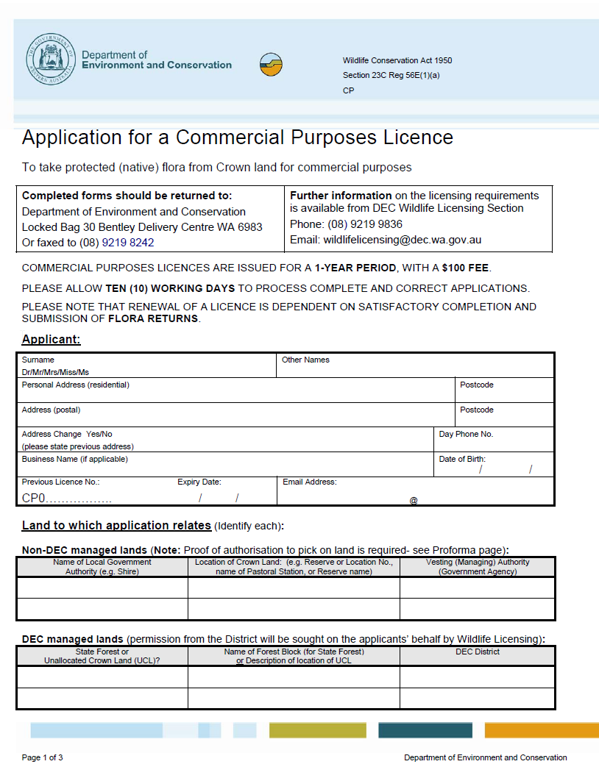

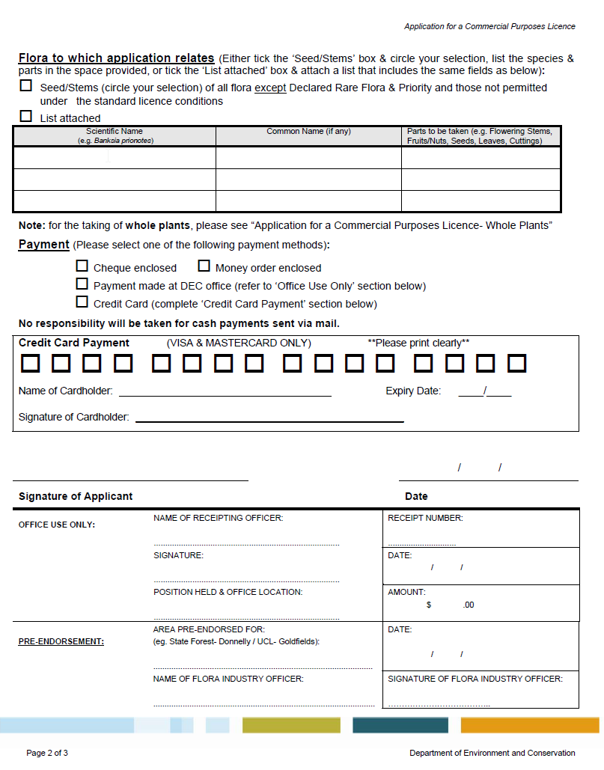

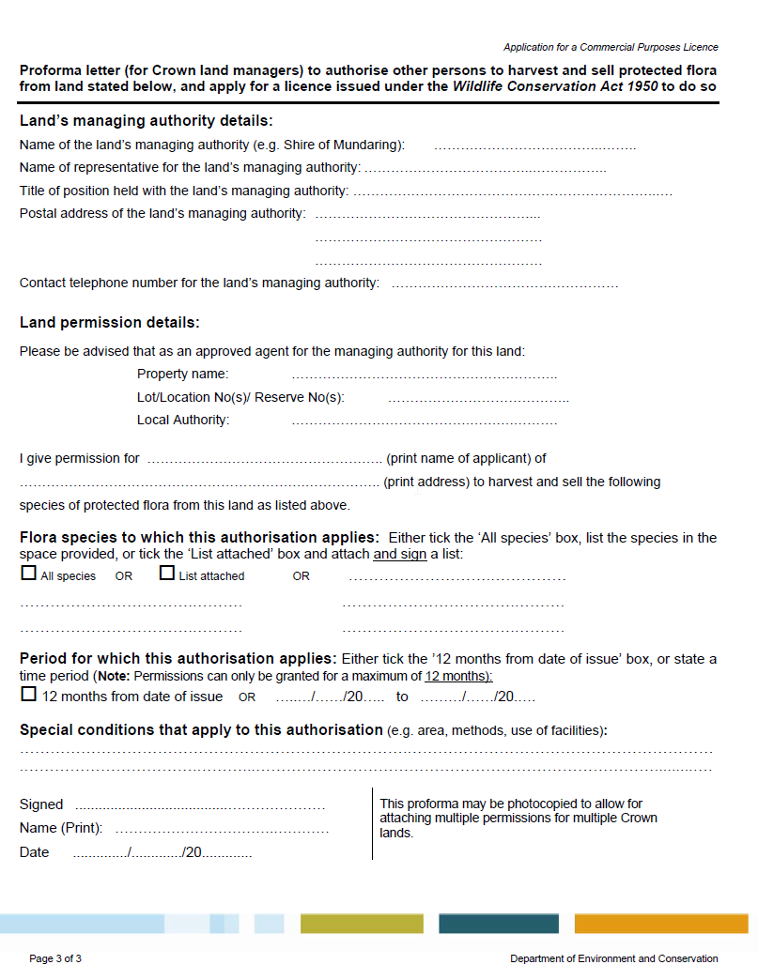

Appendix 6
Current licence application forms can be downloaded from the Departments website at http://www.dec.wa.gov.au/management-and-protection/plants/flora-licensing.html?showall=&start=2

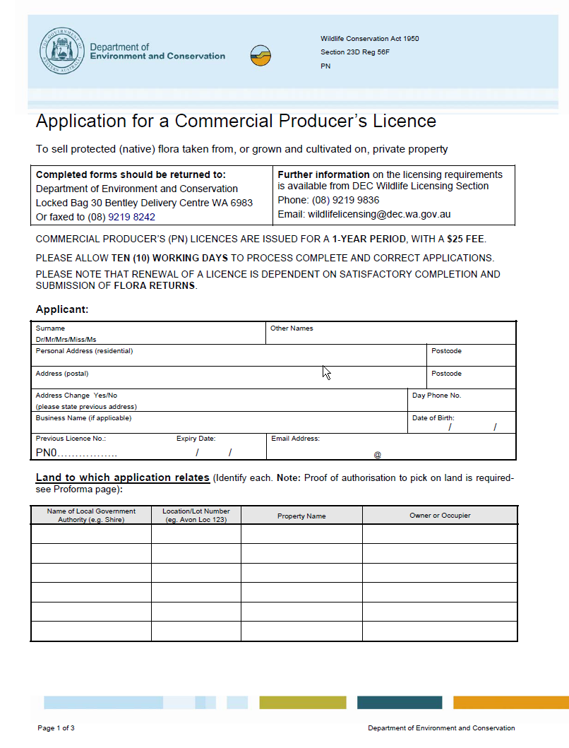

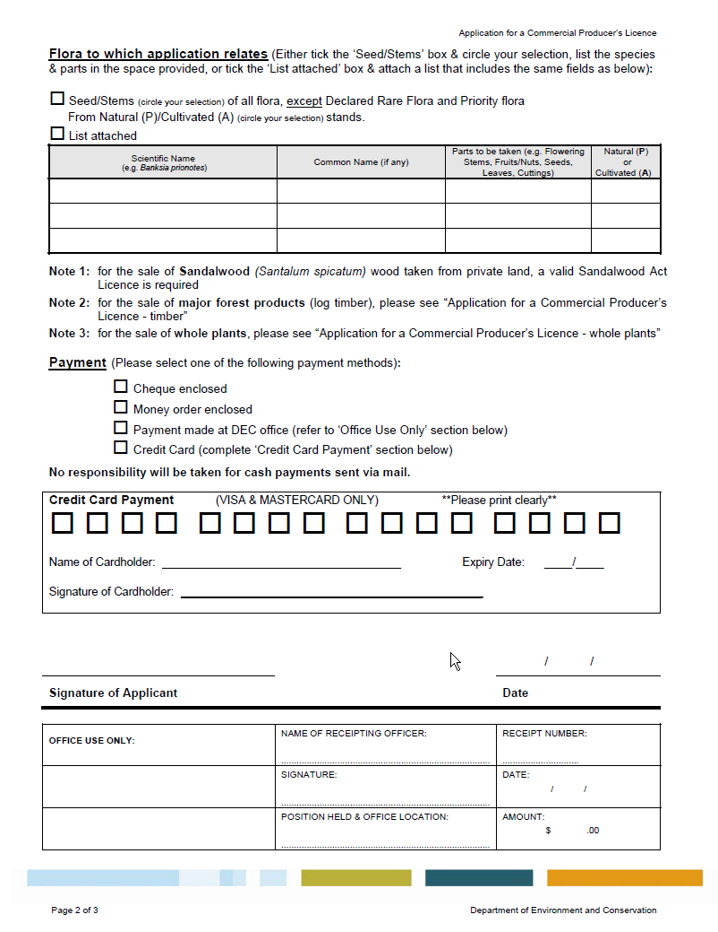

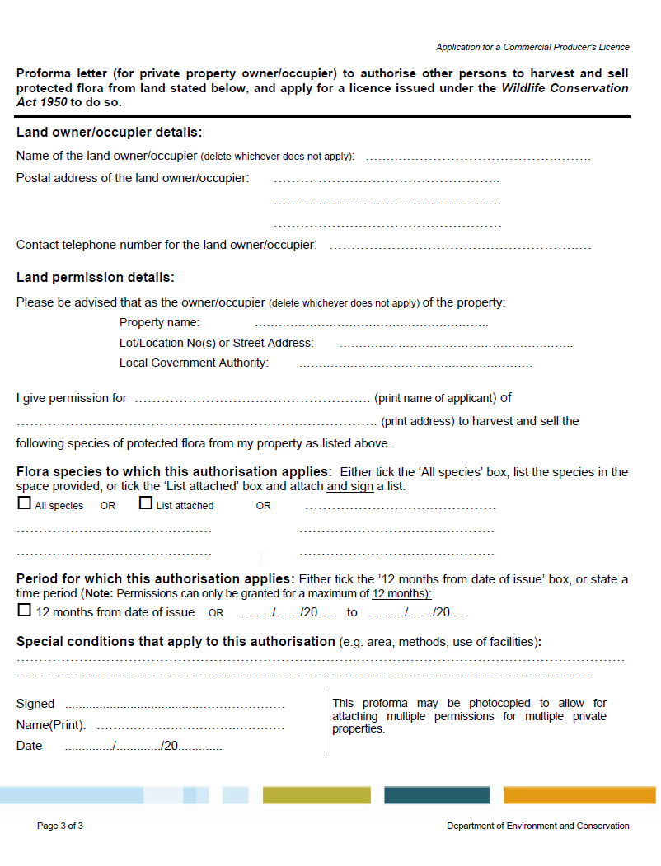

Appendix 7:

COMMERCIAL PURPOSES LICENCE CONDITIONS

WILDLIFE CONSERVATION ACT 1950. SECTION 23C(1)(a)

COMMERCIAL PURPOSES LICENCE

CONDITIONS
1 The licensee shall comply with the provisions of the Wildlife Conservation Act and regulations and any notices in force under this Act and Regulations.
2 This licence DOES NOT authorise the taking from any lands those species of flora declared as rare flora pursuant to Section 23F of the Wildlife Conservation Act.
3 The licensee shall, on a form approved by the Director General, furnish to the Director General, Department of Environment and Conservation, a return of all protected flora taken under this licence for each calendar month. Flora returns shall be forwarded so as to be received no later than the 15th day of the month following the period for which the return form is applicable.
4 No protected flora shall be taken by the licensee in such a manner which destroys or jeopardises the survival of the plant, population or associated vegetation, or in the case of annual flora, in such a manner that jeopardises the survival of the population and associated vegetation.
5 The licensee shall not take whole plants, or roots of plants, unless authorised to do so in writing by the Director General of Environment and Conservation.
6 Further standard conditions are attached which form part of this licence – do not detach.

WILDLIFE CONSERVATION ACT 1950. SECTION 23C(1)(a)

COMMERCIAL PURPOSES LICENCE

FURTHER CONDITIONS RELATING TO COMMERCIAL PURPOSES LICENCE
(Condition numbers 9 to 22)

- This licence does not authorise the taking of those species on The Department of Environment and Conservation’s Priority Flora List, unless further conditions added to this licence expressly authorise the taking (see For Your Information item (c) for more details).
10 This licence does not authorise the taking of the following species:

Andersonia caerulea (Purple Heath)
Banksia baxteri (Baxter's Banksia)
Banksia coccinea (Scarlet Banksia)
Boronia heterophylla (Pink or Red Boronia)
Cephalotus follicularis (Albany Pitcher Plant)
Corynanthera flava (Golden Cascades)
Banksia (previously Dryandra) formosa
Eucalyptus macrocarpa (Mottlecah)
Kunzea ericifolia and K. glabrescens (Spearwood, Tea Tree; when taken as sticks, stakes or similar woody products)
Meeboldina scariosa formally Leptocarpus scariosus (velvet rush or seeded rush)
Macropidia fuliginosa (Black Kangaroo Paw)
Melaleuca viminea (Tea Tree; when taken as sticks, stakes or similar woody products)
Species of the family Orchidaceae (Native Orchids)
Reedia spathacea
Santalum spicatum (Sandalwood; except Sandalwood seed taken for the purpose of propagation)
Verticordia eriocephala (Cauliflower Bush, Brownii, except seed taken for the purpose of propagation).

11 This licence does not authorise the taking of the flora listed below unless further conditions (special endorsement) are added to this licence which expressly authorise the taking of:
a) whole plants (live or dead) of grass trees (Xanthorrhoea and Kingia species), boabs (Adansonia gregorii), fan palms (Livistona species), pineapple bush (Dasypogon hookeri) and zamia palms (Zamiaceae);
b) Banksia hookeriana, Boronia megastigma and Daviesia oppositifolia;
c) Agonis, Kunzea, Leptospermum, Melaleuca (tea tree) and Eucalyptus species, taken for garden sticks, beansticks, craypot sticks, tomato rails or similar woody products;
d) the bark of paperbark tree (Melaleuca species);
e) seeds, fruits or nuts of boabs (Adansonia gregorii), Sandalwood (Santalum spicatum) taken for the purpose of propagation, and fan palms (Livistona species);
- craftwood, including woody fruits such as banksia cones (Banksia species), and stems and branches, such as snakewood (Acacia xiphophylla) or mallee (Eucalyptus species), including material taken for didgeridoo production; and.
- burls or woody outgrowths on Eucalyptus or any other species.
12 a) The licensee must carry this licence and any other written permission which is required under condition 14 and 15, whenever engaged in activities related to the picking, transport or sale of protected flora.
- Whenever engaged in activities related to the picking, transport or sale of protected flora, the licensee must produce this licence and any written permission which is required under condition 14 and 15, when requested to do so by:
  - a Wildlife Officer or any person appointed by the body or authority which has the care or control of the Crown land;
or
  - holders of pastoral leases in respect of Crown land,

from which protected flora is intended to be taken or is taken.

- The licensee must ascertain the agency, body or person which is responsible for the care, control or management of any land from which the licensee intends to take protected flora.
- Before commencing any picking activities on vested and managed Crown Reserves and lands, the licensee must obtain the written permission from the agency, body or person which is responsible for the care, control or management of the land. These include but are not limited to pastoral leases, Shire Reserves, Water Reserves and Catchment areas and public roads dedicated under the Local Government Act and/or Main Roads Act.
- Before commencing any picking activities on land managed by the Department of Environment and Conservation, including State forest and timber reserves, or other unallocated Crown land and unmanaged reserves which the Department manages in relation to the flora industry, the licensee must contact the relevant District office in the District where the land is located and obtain the written permission (endorsement) as required by the District office (refer to ‘For Your Information’ item (j) for managed areas).
- The licensee must not take any protected flora from any Crown land reserved as a Nature Reserve, National Park, Conservation Park, Marine Park, Marine Nature Reserve, or otherwise reserved for the purposes of conservation of flora or fauna or both flora and fauna.
- This licence does not apply to any area of unallocated Crown land or unvested Crown reserve to which a management plan applies that precludes the taking of protected flora.
- The licensee shall only use existing tracks, and shall not extend or cut or make new tracks by any means. For the purposes of condition 18, ‘existing tracks’ do not include:
    - tracks that are being revegetated or are revegetating naturally; or
    - scrub-rolled seismic lines, which have been created for the purposes of exploration,
such that the passage of a vehicle along the tracks will result in damage to the vegetation on the surface of the tracks.
- The licensee must take all necessary precautions to avoid the spread of Phytophthora dieback disease whilst undertaking activities related to the taking of protected flora.
- The licensee must remove any materials introduced to a picking site, and leave the site in a state similar to as would be found under natural conditions, or as prior to picking. Stripped leaves and other plant material taken at the site may be left distributed over the site, but may not be left in discernible heaps, nor distributed to other sites.
- When reasonable and practicable, the licensee, when called upon to do so, shall show any Wildlife Officer or Conservation and Land Management Officer the areas from which the protected flora in his/her possession was taken under this licence.
- Voucher specimens sufficient for the identification of flora taken under the authority of this licence shall be furnished by the licensee to the Director General of the Department of Environment and Conservation when required to do so.

FOR YOUR INFORMATION
Licensees are urged to become acquainted with Sections 23C, 23E and 23F of the Wildlife Conservation Act.
The licensee shall note that:
(a) Classes of flora protected throughout the State and subject to this licence include all Spermatophyta (flowering plants, conifers and cycads), Pteridophyta (ferns and fern allies), Bryophyta (mosses and liverworts) and Thallophyta (algae, fungi and lichens).
- For information on precautions to be taken to avoid the spread of Phytophthora dieback disease, contact the Department of Environment and Conservation.
- The Priority Flora List is available from the Department of Environment and Conservation. Species potentially utilised by the flora industry, but which are on the Priority Flora List include Aotus carinata, Banksia meisneri var. ascendens, Calothamnus rupestris, Banksia (previously Dryandra) polycephala, Banksia (previously Dryandra) serra, Eucalyptus caesia, Eucalyptus kruseana, Livistona alfredii and Verticordia muelleriana, and varieties of Verticordia densiflora, Verticordia plumosa and Verticordia serrata. Endorsement to take Priority Flora, through the addition of a further condition to this licence, will only be given where it can be demonstrated that there are benefits to flora conservation and no detrimental impact on the species.
- It is the responsibility of the licensee to know the name of the flora being harvested prior to the taking of the flora under this licence.
(e) Approval to export flora taken under this licence is required under the Commonwealth Environment Protection and Biodiversity Conservation Act 1999 (EPBC Act). The EPBC Act is administered by the Department of Environment, Water, Heritage and the Arts, Canberra. Approval may only be granted if:
- the flora is listed in the Export Flora List associated with the WA Flora Management Plan approved under the EPBC Act (except for test exports which must have specific approval);
- the flora has been taken in accordance with the WA Flora Management Plan; and
- it can be demonstrated that the flora has been taken in a manner that does not threaten the survival of the species or its habitat.
(f) Under the EPBC Act, a person must not take an action that has, will have or is likely to have a significant impact on any matter of National Environmental Significance without approval from the Commonwealth Environment Minister. Nationally listed threatened species and ecological communities are a matter of National Environmental Significance, and it should be noted that such species may not be the same as those listed as "Rare Flora" under the WA Wildlife Conservation Act 1950. Any significant impact on a matter of National Environmental Significance needs to be referred to the Department of Environment, Water, Heritage and the Arts, which administers the EPBC Act. The list of EPBC-listed threatened species and ecological communities, as well as guidelines on referring actions, can be obtained from the Department of Environment, Water, Heritage and the Arts at www.environment.gov.au.
- Research into flora harvesting has shown that for the species studied, no more than 20% of flowers/stems/seed on a plant should be harvested, so that the plant is able to set sufficient seed for regeneration of the population. This maximum level of harvest should be used as a guide for complying with condition 4.
- The following Government agencies have advised the Department of Environment and Conservation that they will not normally give permission for the taking of protected flora for commercial purposes from reserves or other lands under their control:
Main Roads WA;
Westrail; and
Department for Planning and Infrastructure.
(i) The following local government authorities have advised the Department of Environment and Conservation that they will not normally give permission for the taking of protected flora for commercial purposes from any road reserve, Shire reserve or any other reserve or land owned or under their control:
Albany, Armadale, Beverley, Boyup Brook, Brookton, Broomehill, Bruce Rock, Carnamah, Chapman Valley, Collie, Coorow, Cranbrook, Dalwallinu, Dandaragan, Dardanup, Denmark, Derby/West Kimberley, Dowerin, Dundas, Geraldton, Gingin, Goomalling, Gnowangerup, Harvey, Kalamunda, Katanning, Kellerberrin, Kojonup, Koorda, Kulin, Kwinana, Meekatharra, Merredin, Mingenew, Moora, Morawa, Mt Magnet, Mt Marshall, Mukinbudin, Mullewa, Mundaring, Murchison, Narembeen, Northampton, Plantagenet, Quairading, Ravensthorpe, Rockingham, Roebourne, Serpentine-Jarrahdale, Shark Bay, Swan, Tambellup, Tammin, Three Springs, Trayning, Upper Gascoyne, Victoria Plains, Wagin, Wandering, Westonia, Williams, Wongan-Ballidu, Woodanilling, Wyalkatchem, and Yalgoo.
Please note that the licensee must still obtain the written permission for picking on lands controlled by any local government authority.
(j) Crown land areas that have had their management in relation to flora harvesting devolved to the Department of Environment and Conservation, include:
Kent River Water Catchment (Reserve No. 29660)
Denmark River Water Catchment (Reserve No. 24660)
Waychinicup River Water Catchment Reserve (Reserve No. 29883)
Unallocated Crown land and unmanaged reserves in many of the Department’s Districts, including Swan Coastal, Donnelly and Frankland Districts.
Pastoral leases purchased by the Department for the purpose of conservation, but which may currently be held as unallocated Crown land.
Contact your local Department of Environment and Conservation office for further information.
(k) If renewal of this licence is required it is the responsibility of the licensee to request such renewal one (1) month prior to the expiry date as shown on the licence. Any outstanding flora returns should be submitted prior to application for licence renewal.

Appendix 8

COMMERCIAL PRODUCER’S/NURSERYMAN’S LICENCE CONDITIONS

WILDLIFE CONSERVATION ACT 1950. SECTION 23D(1)(a)

COMMERCIAL PRODUCER’S/NURSERYMAN’S LICENCE

CONDITIONS

- The licensee shall, on a form approved by the Director General, furnish to the Director General, Department of Environment and Conservation, a return of all protected flora taken under this license for each calendar month. Flora returns shall be forwarded so as to be received no later than the 15th day of the month following the period for which the return form is applicable.

- This license must be carried by the licensee when transporting or selling protected flora, and, where the licensee is not the owner/occupier of the property, when taking protected flora from private property detailed under this license. This license must also be shown on demand to a Wildlife Officer or any other authorised DEC officer.

- This license does not authorise the sale of plant material from the following species unless specifically endorsed: Banksia hookeriana, Boronia megastigma, Corynanthera flava, Eucalyptus species taken for didgeridoos and wood products of Santalum spicatum (sandalwood).

- This license does not authorise the sale of major forest products (log timber) taken from private property for the purpose of milling.

- Further standard conditions are attached with form part of this license – do not detach.
Commercial Producer’s Licence

Further Conditions Relating To Commercial Producer’s Licence

(Condition numbers 8 to 13)

General

8 The Licensee shall comply with the provisions of the Wildlife Conservation Act 1950, Wildlife Conservation Regulations 1970, Sandalwood Act 1929 and the Forest Management Regulations 1993 and any orders or other notices in force under these statutes.

9 This licence does not authorise the taking of any flora declared as “rare flora” under Section 23F of the Wildlife Conservation Act 1950.

10 This licence does not authorise the taking of protected flora from Crown land.

11 The licensee is not permitted to sell protected flora where it is taken from naturally occurring plants in such a manner which destroys or jeopardises the survival of the plant, its habitat, or the associated vegetation, unless taken in accordance with approved management guidelines that provide for the conservation of the flora.

12 The Licensee is not permitted to sell whole plants of those species listed on the Export Flora List appended to the management program “Management of Commercial Harvesting of Protected Flora in Western Australia”, taken under authority of this licence, unless the plants have been artificially propagated, or where they are taken as a salvage operation approved by the Department of Environment and Conservation.

13 Voucher specimens sufficient for the identification of protected flora sold under the authority of this licence shall, upon request, be furnished by the Licensee to the Director General, Department of Environment and Conservation.

Additional Information To Commercial Producer’s Licence

For Your Information

(a) The Licensee should become acquainted and comply with Sections 23D, 23E and 23F of the Wildlife Conservation Act 1950.

        - Classes of flora protected throughout the State include all Spermatophyta (flowering plants, conifers and cycads), Pteridophyta (ferns and fern allies), Bryophyta (mosses and liverworts) and Thallophyta (algae, fungi and lichens).

(c) Approval to export flora taken under this licence is required under the Commonwealth Environment Protection and Biodiversity Conservation Act 1999 (EPBC Act). The EPBC Act is administered by the Department of Environment, Water, Heritage and the Arts, Canberra. Approval may only be granted if:
- the flora is listed in the Export Flora List associated with the WA Flora Management Plan approved under the EPBC Act (except for test exports which must have specific approval);
- the flora has been taken in accordance with the WA Flora Management Plan; and
- it can be demonstrated that the flora has been taken in a manner that does not threaten the survival of the species or its habitat.

No species listed as threatened under the EPBC Act or listed on Appendix I of the Convention on International Trade in Endangered Species of Wild Fauna and Flora may be exported under this licence. Such species require the approval of a separate artificial propagation program under the EPBC Act.

(d) Under the Commonwealth EPBC Act, a person must not take an action that has, will have or is likely to have a significant impact on any matter of National Environmental Significance without approval from the Commonwealth Environment Minister. Nationally listed threatened species and ecological communities are a matter of National Environmental Significance, and it should be noted that such species may not be the same as those listed as "Rare Flora" under the WA Wildlife Conservation Act 1950. Any significant impact on a matter of National Environmental Significance needs to be referred to the Department of Environment, Water, Heritage and the Arts, which administers the EPBC Act. The list of EPBC-listed threatened species and ecological communities, as well as guidelines on referring actions, can be obtained from the Department of Environment, Water, Heritage and the Arts at www.environment.gov.au.

(e) If renewal of this licence is required it is the responsibility of the Licensee to request such renewal one month prior to the expiry date shown on the licence, and to ensure that flora returns that are due have been submitted.

Appendix 9

Glossary

DEC-approved salvage operations
Salvage operations under which whole plants may be taken under this management plan are limited to situations where the original vegetation will be permanently destroyed under otherwise legally approved land clearing operations, including urban development, mining, or infrastructure development. Such salvage operations will be subject to DEC licensing and approval based on the following considerations and conditions:
- plants will only be taken from areas that are specifically designated and approved by the relevant land management authority for vegetation clearing;
- the clearing activity must be unrelated to the harvest operation; and,
- DEC will assess salvage proposals, and individually endorse such areas on flora collecting licences.
Declared Rare Flora
Protected flora described as being “rare flora” under section 23F of the Wildlife Conservation Act 1950. Also reffered to as Threatened Flora.

Ecologically Sustainable Development
Taken from the National Strategy for the Conservation of Australia’s Biological Diversity (1996):
- to enhance individual and community wellbeing and welfare by following a path of economic development that safeguards the welfare of future generations;
- to provide for equity within and between generations; and
- to protect biological diversity and maintain essential ecological processes and life-support systems.

Export Flora List
Is a list of species, allocated to several management categories, which have been approved for export by the Department of Environment and Conservation, and the Department of the Environment, Water, Heritage and the Arts.
Flora
Flora is defined in the Wildlife Conservation Act 1950 as "any plant, including any wildflower, palm, shrub, tree, fern, creeper or vine which is either native to Western Australia or declared to be flora under the Act and includes any part of flora and all seeds and spores thereof".

Priority Flora
Taxa of protected flora which are poorly known or are rare but not currently threatened by any identifiable factors.

Precautionary Principle
Where there are threats of serious or irreversible damage, the lack of scientific certainty shall not be used as a reason for postponing measures which seek to protect or restore or prevent loss of biodiversity (DEC Corporate Plan 2007-2009).

Protected flora
Under the Wildlife Conservation Act 1950 all classes of flora are protected in WA. Therefore protected flora includes all flowering plants, conifers and cycads (Spermatophyta), ferns and fern allies (Pteridophyta), mosses and liverworts (Bryophyta) and algae, fungi and lichens (Thallophyta). All parts of the plant including roots, branches, stems, leaves, flowers, seeds and spores come within the legal meaning of flora.

Appendix 10

ENVIRONMENT PROTECTION AND BIODIVERSITY CONSERVATION ACT 1999
- SECT 303FO
Approved wildlife trade management plan
  - The export of a specimen is an export in accordance with an approved wildlife trade management plan if the specimen is, or is derived from, a specimen that was taken in accordance with a plan declared by a declaration in force under subsection (2) to be an approved wildlife trade management plan.

(2) The Minister may, by instrument published in the Gazette, declare that a specified plan is an approved wildlife trade management plan for the purposes of this section.

(3) The Minister must not declare a plan under subsection (2) unless the Minister is satisfied that:

(a) the plan is consistent with the objects of this Part; and
(b) there has been an assessment of the environmental impact of the activities covered by the plan, including (but not limited to) an assessment of:
(i) the status of the species to which the plan relates in the wild; and
(ii) the extent of the habitat of the species to which the plan relates; and
(iii) the threats to the species to which the plan relates; and
(iv) the impacts of the activities covered by the plan on the habitat or relevant ecosystems; and

(c) the plan includes management controls directed towards ensuring that the impacts of the activities covered by the plan on:
(i) a taxon to which the plan relates; and
(ii) any taxa that may be affected by activities covered by the plan; and
(iii) any relevant ecosystem (for example, impacts on habitat or biodiversity);
are ecologically sustainable; and

(d) the activities covered by the plan will not be detrimental to:
(i) the survival of a taxon to which the plan relates; or
(ii) the conservation status of a taxon to which the plan relates; or
(iii) any relevant ecosystem (for example, detriment to habitat or biodiversity); and

(e) the plan includes measures:
(i) to mitigate and/or minimise the environmental impact of the activities covered by the plan; and
(ii) to monitor the environmental impact of the activities covered by the plan; and
(iii) to respond to changes in the environmental impact of the activities covered by the plan; and

(f) if the plan relates to the taking of live specimens that belong to a taxon specified in the regulations—the conditions that, under the regulations, are applicable to the welfare of the specimens are likely to be complied with; and

(g) such other conditions (if any) as are specified in the regulations have been, or are likely to be, satisfied.

(4) In deciding whether to declare a plan under subsection (2), the Minister must have regard to:

(a) whether legislation relating to the protection, conservation or management of the specimens to which the plan relates is in force in the State or Territory concerned; and

(b) whether the legislation applies throughout the State or Territory concerned; and

(c) whether, in the opinion of the Minister, the legislation is effective.

(5) A declaration under subsection (2) ceases to be in force at the beginning of the fifth anniversary of the day on which the declaration took effect. However, this rule does not apply if a period of less than 5 years is specified in the declaration in accordance with subsection 303FT(4).

(6) If a declaration ceases to be in force, this Act does not prevent the Minister from making a fresh declaration under subsection (2).

(7) A fresh declaration may be made during the 90-day period before the time when the current declaration ceases to be in force.

(8) A fresh declaration that is made during that 90-day period takes effect immediately after the end of that period.

Excluding any CITES I species or species listed as threatened under the Commonwealth EPBC Act. Under the EPBC Act, such species may only be exported commercially if sourced from a separate, EPBC Act-approved artificial propagation program. CITES is the Convention on International Trade in Endangered Species of Wild Fauna and Flora and a CITES I species is a species listed on Appendix I of CITES, the highest level of protection under CITES for species that are endangered by trade. Severe penalties apply for any breach of the EPBC Act.
1

