

Ti

**Ecological Risk Assessment for the Marine Aquarium Fish**

**Resource**

Smith K.A., Bissell A. and Bruce C.

**Fisheries Research Report 323**

May 2022

### Correct citation:

Smith, K.A., Bissell A and Bruce C. (2022). Ecological Risk Assessment for the Marine Aquarium Fish Resource. Fisheries Research Report No. 323. Department of Primary Industries and Regional Development, Western Australia. 149 pp.

### Enquiries:

WA Fisheries and Marine Research Laboratories, PO Box 20,

North Beach, WA 6920

Tel: +61 8 9203 0111

Email: [library@fish.wa.gov.au](mailto:library@fish.wa.gov.au) Website: fish.wa.gov.au

A complete list of Fisheries Research Reports is available online at **fish.wa.gov.au**

### Important disclaimer

The Chief Executive Officer of the Department of Primary Industries and Regional Development and the State of Western Australia accept no liability whatsoever by reason of negligence or otherwise arising from the use or release of this information or any part of it.

Department of Primary Industries and Regional Development Gordon Stephenson House

140 William Street

PERTH WA 6000

Telephone: (08) 6551 4444 Website: dpird.wa.gov.au ABN: 18 951 343 745

ISSN: 2202-5758 (Online) ISBN: 978-1-921845-02-4 (Online)

Copyright © State of Western Australia (Department of Primary Industries and Regional Development) 2022

# Table of Contents

List of Acronyms vi

Executive Summary 1

Introduction 2

The Marine Aquarium Fish Resource 2

Aquatic Environment 3

Description of Fisheries 5

* 1. Marine Aquarium Fish Managed Fishery 5
  2. Other resource users 11
  3. Export approval 11
  4. Fishing Gear and Methods 13
  5. Data collection 13
  6. Retained Species 14



* 1. Bycatch Species 78
  2. Ecological Impacts 79



### External Factors 81

**Risk Assessment Methodology 81**

* 1. Scope 82
  2. Risk Identification 83
  3. Risk Assessment Process 83

**Risk Analysis 86**

* 1. Fish 89



* 1. Corals, anemones, corallimorphs & zoanthids 94



* 1. Soft coral 102
  2. Anemones 102
  3. Corallimorphs 103
  4. Zoanthids 103
  5. Other retained species 104



 

* 1. Sponges 105
  2. Other invertebrates 105
  3. Live rock 106
  4. Aquatic plants 106
  5. TEP Species 106
  6. Habitats 107



* 1. Ecosystem Structure 108



* 1. Broader Environment 110



**Risk Evaluation & Treatment 112**

**References 113**

**Appendix A: Full list of retained catches by the Marine Aquarium Fish****Managed Fishery (MAFMF) 125**

**Appendix B: Likelihood and Consequence Levels 143**

**Appendix C: ERA workshop stakeholders 145**

**Appendix D: MAFMF Management Transition Timeline 148**

**Appendix E: MAFMF TACC, NDF thresholds and catch data 149**

# List of Acronyms

|  |  |
| --- | --- |
| CFL | Commercial Fishing Licence |
| CITES | Convention on International Trade in Endangered Species of Wild Fauna and Flora |
| DPIRD | Department of Primary Industries and Regional Development |
| EBFM | Ecosystem Based Fisheries Management |
| EPBC Act | *Environment Protection and Biodiversity Conservation Act 1999* |
| ERA | Ecological Risk Assessment |
| FRMA | Fish Resources Management Act 1994 |
| IUCN | International Union for Conservation of Nature |
| MAFMF | Marine Aquarium Fish Managed Fishery |
| MFL | Managed Fishery Licence |
| NDF | Non-Detrimental Finding |
| TACC | Total Allowable Commercial Catch |
| TEPS | Threatened, Endangered and Protected Species |
| WA | Western Australia |
| WTO | Wildlife Trade Operation |

# Executive Summary

In November 2021, the Department of Primary Industries and Regional Development (Department) convened an Ecological Risk Assessment (ERA) of the Western Australian fisheries that access the Marine Aquarium Fish Resource (Resource). ERAs are conducted by the Department as part of its Ecosystem-Based Fisheries Management framework. Outputs of this ERA will inform future versions of the Harvest Strategy for the Resource. Additionally, this ERA is a requirement of the Wildlife Trade Operation approval for the Marine Aquarium Fish Managed Fishery.

The ERA considered the potential ecological impacts of the Marine Aquarium Fish Managed Fishery, which is the only commercial fishery that targets the Resource, and other extractive sectors that access the Resource. The ERA evaluated the impact of fishing on retained species, threatened, endangered, and protected species, habitats and the broader environment.

A broad range of stakeholders were invited to the ERA workshop, including representatives of the commercial and recreational fishing sectors, Commonwealth, state and local government agencies, James Cook University, and relevant conservation organisations (see Appendix C).

Risk scores were determined based on available research information and expert knowledge on species, fishing activities, fishery regulations and management. This assessment conforms to the AS/NZS ISO 31000 risk management standard and the methodology adopted by the Department, which relies on a likelihood-consequence analysis for estimating risk.

Forty-three ecological components were scored for risk. The majority (39) of ecological components were evaluated as low or negligible risks, which do not require any specific control measures. There were four medium risks, which were assessed as acceptable under the current monitoring and control measures already in place. The ERA did not yield any high risks.

It is recommended that the risks be reviewed in five years.

# Introduction

The Department of Primary Industries and Regional Development (DPIRD, Department) in Western Australia (WA) uses an Ecosystem-Based Fisheries Management (EBFM) approach that considers all relevant ecological, social, economic and governance issues to deliver community outcomes (Fletcher *et al.* 2010; 2012). Ecological risk assessments (ERAs) are undertaken periodically to assess the impacts of fisheries on all the different components of the aquatic environments in which they operate. The outcomes of the risk assessments are used to inform EBFM- based harvest strategies and to prioritise the Department’s monitoring, research and management activities (Fletcher 2015; Fletcher *et al.* 2016).

This report provides information relating to an ERA for the WA Marine Aquarium Fish Resource (Resource) conducted in November 2021. This Resource includes many species of fish, corals and other invertebrates, as well as ‘live rock’ and aquatic plants. The ERA primarily considered the potential ecological impacts of the Marine Aquarium Fish Managed Fishery (MAFMF), which is the only commercial fishery that targets the Resource, on all relevant retained and bycatch species, and on threatened, endangered and protected species (TEPS), habitats, and the broader ecosystem. Impacts of other fishing sectors that access the Resource to a lesser extent was also considered.

The risk assessment methodology used a consequence-likelihood analysis, which involved examining the magnitude of potential consequences from fishing activities and the likelihood that those consequences will occur given current management controls. Risk scores were determined during an external stakeholder workshop on 4 November 2021. The assessment builds on the results of previous risk assessments of the MAFMF undertaken in 2004 and 2014 (Smith *et al.* 2010; DPIRD 2018a). The current risk assessment will inform future versions of the Harvest Strategy for the Resource (DPIRD 2018b).

The scope of the current ERA is for the next five years (i.e., 2021-2025). It is envisioned that ERAs will be undertaken periodically (approximately every five years) to reassess current issues and assess any new issues that may arise. However, a risk assessment can also be triggered earlier if there are significant changes identified in fishery operations or management activities that may change risk levels.

# The Marine Aquarium Fish Resource

The Marine Aquarium Fish Resource includes all species that are collected for marine aquarium ornamental display purposes throughout Western Australian waters, including fish (inclusive of syngnathids and other teleosts, and elasmobranchs), hard coral, soft coral, tridacnid clams, other invertebrates (including sponges, molluscs, crustaceans, echinoderms, etc.), algae, seagrasses and ‘live rock’. The Resource is targeted by the commercial sector and, to a lesser degree, the aquaculture and recreational sectors. The state-wide MAFMF is the only commercial fishery that targets

the Resource. Operators in the aquaculture and public aquarium sectors are also permitted to collect relatively small amounts of specified marine aquarium species for broodstock or public display purposes respectively. Small numbers of these species are also collected under research exemptions.

# Aquatic Environment

The Marine Aquarium Fish Resource includes tropical, subtropical and temperate species that inhabit intertidal and nearshore waters of WA from the Northern Territory border to the South Australian border (Figure 3.1).

The North Coast Bioregion has a variety of tropical habitats, including sand/mud flats, mangroves, seagrasses, macroalgae, filter-feeding communities, corals, soft-bottom areas, and has high species diversity (DEWHA 2008).

Further south, the waters along the Gascoyne Coast represent a transition between the tropical waters of the North-West Shelf and the temperate waters of the West Coast. The majority of species are tropical in nature, although some temperate species can be found at the northern extent of their range. The transition in ocean currents, climate and the range of coastal landforms in this region provide varied and complex marine habitats and associated species (Roberts *et al.* 2002).

South of Kalbarri, the waters of the West Coast Bioregion are predominately temperate. However, the warm, low-nutrient, southward-flowing Leeuwin Current allows for the existence of coral reefs at the Houtman Abrolhos Islands and for the extended southward distribution of many tropical species. From a global perspective, the West Coast is characterised by low nutrient levels and high species diversity, including a large number of endemic species (CoA 2008).

The waters of the South Coast Bioregion are also low in nutrients, due to the seasonal winter presence of the Leeuwin Current and limited terrestrial run-off. Species in this region are predominantly temperate, with many species’ distributions extending across southern Australia. The South Coast is a high-energy environment and is heavily influenced by large swells generated in the Southern Ocean. A mixture of seagrass and kelp habitats occur along the South Coast, and the benthic invertebrate communities, e.g., sponges, ascidians and bryozoans, found in the eastern stretches of the coast are among the world’s most diverse soft sediment ecosystems (CoA 2008).

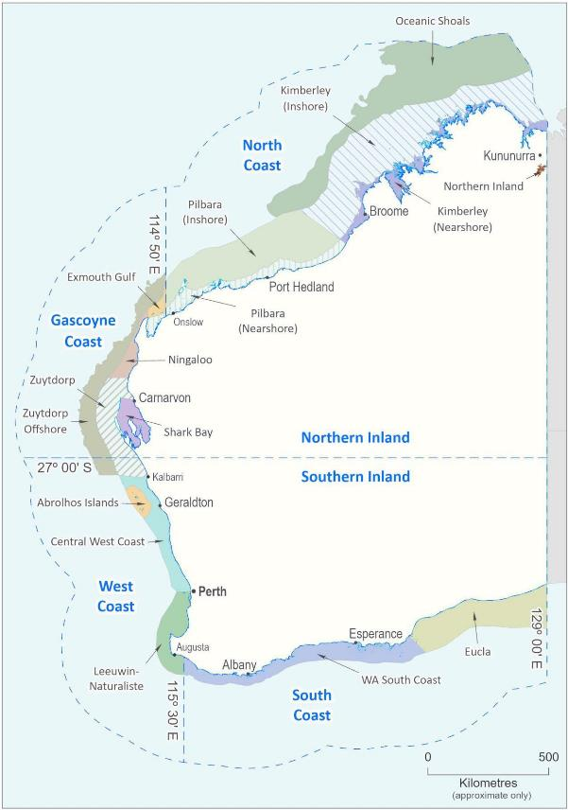

**Figure 3.1. Map of WA showing the boundaries of the Bioregions and Integrated Marine and Coastal Regionalisation of Australia (IMCRA) ecosystems. Source: Gaughan and Santoro (2021).**

# Description of Fisheries

## Marine Aquarium Fish Managed Fishery

The MAFMF is a low volume, high value fishery with effort distributed across the state.

encompasses a total area of 20,781 km2

The gazetted fishery area includes all WA state and Commonwealth waters, which

(Figure 4.1). However, in practice, the fishery operates only in a small portion of state waters, with most effort focused in shallow (<30 m) waters around the south-west Capes region, Perth, Geraldton, Exmouth and

Karratha/Dampier. Fishing activity is also restricted by various permanent spatial closures that apply to the MAFMF (Figure 4.1).

The MAFMF has the capacity to target more than 1,500 marine aquarium species under the *Marine Aquarium Fish Managed Fishery Management Plan 2018* and other subsidiary legislation under the *Fish Resources Management Act 1994* (FRMA). Targeted species include fish (including teleost and elasmobranchs), hard and soft corals, and a range of other invertebrate and plant species. The fishery mainly supplies the international marine aquarium markets, however there is also a domestic market.

The estimated value of the MAFMF is in excess of $2 million per annum with the

majority of the product being exported.

The fishery dates back to the early 1960s when operators fished under permits or conditions on Professional Fishing Licences (PFL; known as Commercial Fishing Licences (CFL) after 1995). The number of licences endorsed to operate in the fishery was limited to 20 in 1986, and this number was increased to 25 following a review of the fishery in 1991. Over this period, the fishery primarily harvested fish. In the late 1980s, five PFLs were issued with endorsements to take up to 2,000 kg of coral per year (i.e., a Total Allowable Commercial Catch (TACC) of 10,000 kg).

In 1995, the *Marine Aquarium Fish Management Plan 1995* was introduced to provide formal management of the fish component of the fishery and 13 Managed Fishery Licences (MFLs) were granted in accordance with access criteria outlined in the Management Plan (1995). The harvesting of invertebrates was managed via a CFL condition until 2005 when a Ministerial Exemption was granted under section 7 of the FRMA to enable all MFL holders in the MAFMF to take invertebrates, seagrasses and algae within prescribed limits.

In 1997, the coral TACC was reduced to 8,000 kg following the expiry of one CFL. It was further reduced to 7,500 kg in the early 2000s as a result of an industry proposal aimed at redistributing coral amongst all 13 MFL holders in the MAFMF.

In 2007, the authority to harvest coral by CFL condition was replaced by the *Prohibition on Fishing (Coral, ‘Live Rock’ and Algae) Order 2007*. This Order restricted the harvesting of coral to six MFL holders, within the existing 7,500 kg TACC, and effectively ensured that only MFL holders were able to commercially fish for coral and live rock in Western Australian waters for the aquarium trade. The Order also allowed for the take of 500 kg of ‘live rock’ by each MFL holder (total of 6,500 kg).

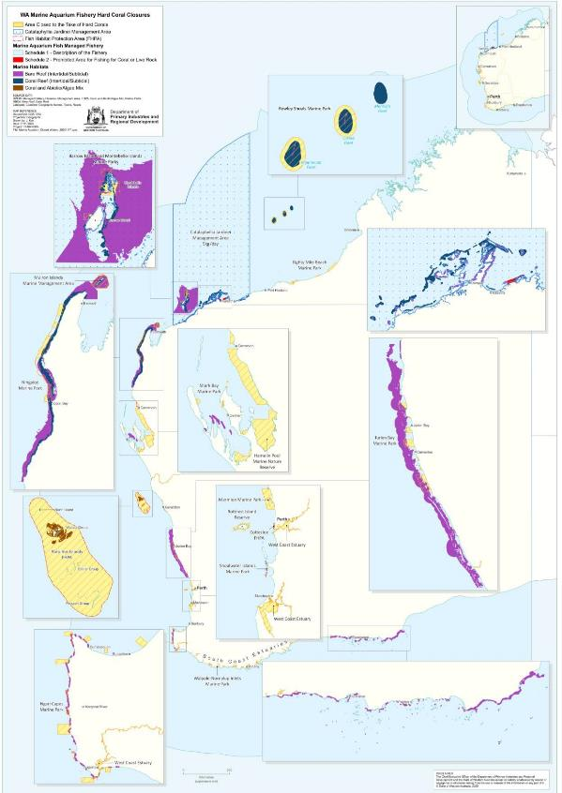

**Figure 4.1. Boundaries and closed areas of the Marine Aquarium Fish Managed Fishery.**

In 2010, the number of MFL holders declined from 13 to 12, resulting in the live rock TACC being reduced to 6,000 kg. However, later in the same year, the amount was increased to 5,000 kg per MFL (60,000 kg live rock TACC).

In November 2018, legislation for the MAFMF was consolidated and replaced by the *Marine Aquarium Fish Managed Fishery Management Plan 2018* (Plan). All existing MFL holders were granted a new MFL under the new Plan. The coral TACC was increased to 15,000 kg following an ERA and development of the Harvest Strategy (DPIRD 2018b). The additional quota (the additional 7,500 kg) was equally distributed across all 12 MAFMF licences, thereby increasing the number of licensees permitted to harvest coral (i.e., all licensees had some degree of coral allocation).

Due to the introduction of the new Management Plan in November 2018, the MAFMF had a proportional coral TACC of 10,502 kg for the initial licensing period 1 November 2018 to 30 June 2019 (Appendix D). The first full TACC of 15,000 kg was implemented in the 2019/20 licensing period (1 July 2019 to 30 June 2020).

Management of the MAFMF includes both output and input controls. Output controls include individual transferable quota for four key species groups and voluntary harvest threshold levels for CITES listed species within the Harvest Strategy.

The current TACCs for the four key species groups in the fishery are:

* 15,000 kg of coral (hard and soft corals combined),
* 2,400 individual giant clams (all species combined, excluding *Tridacna gigas*),
* 2,000 individuals within the order Syngnathiformes (all species combined), and
* 60,000 kg of ‘live rock’.

Non-quota species are managed through the input controls of limited entry, restrictions on permitted gear, numbers of vessels and numbers of collectors. In addition, the MAFMF adopted a Harvest Strategy in 2018 which contains threshold catch levels for quota and non-quota species (DPIRD 2018b).

In accordance with the new Management Plan (2018) and Harvest Strategy (2018), the MAFMF’s licensing period and quota entitlements are managed by financial year. However, previous management arrangements recorded catch and effort data by calendar year. This ERA will review historic data in calendar years to be consistent with the management arrangements that were in place when the majority of the data was being reported.

In addition to the Plan, fishers must also comply with any requirements in the:

* *Fish Resources Management Act 1994*
* *Fish Resources Management Regulations 1995*
* *Western Australian Marine Act 1982*;
* *Western Australian Wildlife Conservation Act 1950*; and
* *Western Australian Conservation and Land Management Act 1984*.

Since 2010, there have been 12 MFL holders in the MAFMF, although not all are active every year. Total effort declined from 981 fishing days in 2007 to 328 fishing days in 2016, then increased to 584 fishing days in 2017 and has subsequently remained stable (Table 4.1). Prior to 2012, reported effort of the MAFMF and the Hermit Crab Fishery was combined, due to some licensees operating in both fisheries. From 2012, licensees were required to report effort in each fishery separately.

MAFMF effort is concentrated in a number of discrete areas adjacent to the limited number of boat landing sites along the WA coastline. During the past five years the fishery has been active in waters from Albany to the Northern Territory border, with most activity being around the Capes region, Perth, Geraldton, Exmouth, Dampier and Broome (Figure 4.2).

**Table 4.1. Annual fishing effort in the Marine Aquarium Fish Managed Fishery. (Active Licences**

**- number of licences reporting any level of catch in that year)**

|  |  |  |
| --- | --- | --- |
| **Year** | **No. of Active Licences** | **Total Fishing Days** |
| 2008 | 10 | 932* |
| 2009 | 11 | 637* |
| 2010 | 10 | 528* |
| 2011 | 10 | 506* |
| 2012 | 9 | 414 |
| 2013 | 10 | 433 |
| 2014 | 10 | 421 |
| 2015 | 8 | 393 |
| 2016 | 8 | 328 |
| 2017 | 11 | 584 |
| 2018 | 12 | 595 |
| 2019 | 10 | 549 |
| 2020 | 11 | 584 |

* reported fishing effort was combined with collection of Hermit Crabs (now a separate fishery).

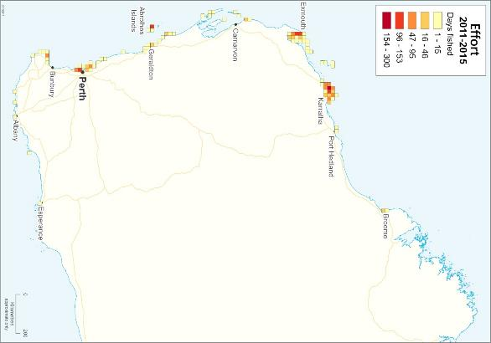

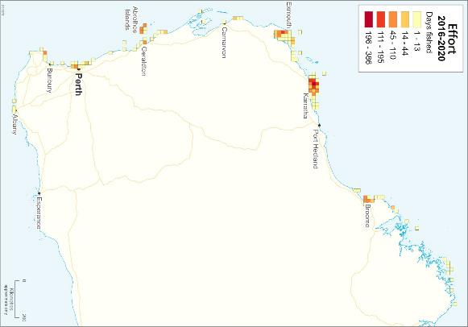

**Figure 4.2. Distribution of fishing effort (fishing days) in the Marine Aquarium Fish Managed Fishery, 2011-2015 and 2016-2020.**

#### Compliance and Enforcement

Management arrangements for the MAFMF are enforced under an Operational Compliance Plan (OCP), which is outlined in the Harvest Strategy for the resource (DPIRD 2018b). The OCP is informed and underpinned by a compliance risk assessment conducted for the fishery, which is reviewed every 1-2 years.

Compliance strategies and activities used in the MAFMF include:

* Land and sea patrols;
* Inspections of species at wholesale and retail outlets;
* Inspection in port;
* At-sea inspection of fishing boats;
* Aerial surveillance;
* Undertaking covert operations and observations;
* Monitoring of entitlement and vessel movements; and
* Intelligence gathering and investigations. Inspections may involve:
* Inspection of all compartments on board the vessels;
* Inspection of all authorisations;
* Inspection of associated paperwork;
* Inspections of fishing gear; and
* Inspection of catch on board the boat.

Compliance statistics for the MAFMF over the last five financial years (2015/16- 2019/20) are available in Table 4.2.

The Department also encourages voluntary compliance through education, awareness and consultation activities.

**Table 4.2. Compliance data for the MAFMF, 2015/16 to 2019/20:**

|  |  |  |  |  |  |
| --- | --- | --- | --- | --- | --- |
| **Year** | **Compliance contacts** | **Briefs** | **Infringements** | **Warnings** | **Total Offences** |
| 2015/16 | 13 | 0 | 4 | 1 | 5 |
| 2016/17 | 16 | 6 | 0 | 3 | 9 |
| 2017/18 | 21 | 5 | 0 | 1 | 6 |
| 2018/19 | 18 | 1 | 3 | 27 | 31 |
| 2019/20 | 15 | 0 | 0 | 0 | 0 |

## Other resource users

No other commercial fisheries are permitted to capture marine species for aquarium display purposes in WA. Each year small additional quantities of species targeted by the MAFMF are collected via Ministerial Exemptions issued under Section 7 of the FRMA (Exemptions). Exemptions are typically granted on a case-by-case basis for aquaculture broodstock, research, education or public aquarium display purposes. Exemptions are granted on the condition there is no elevated risk to the species or ecosystem. The Department recommends that Exemption holders consider opportunities to source specimens (especially corals) from the MAFMF in the first instance.

|  |  |  |  |  |  |  |  |  |  |  |  |
| --- | --- | --- | --- | --- | --- | --- | --- | --- | --- | --- | --- |
| Under Exemptions the Department allows a maximum of 750 kg of coral (hard and | | | | | | | | | | | |
| soft) | to | be | harvested | each | | year | for | aquaculture | broodstock | purposes, | and |
| approximately another 750 kg of coral (hard and soft) to be harvested each year for | | | | | | | | | | | |
| public aquarium displays. Co | | | | |  | | | | | | |

ral and other species collected for research purposes are generally taken in small quantities by exemption holders.

harvested for research purposes is estimated to be <500 kg each year.

Species taken under Exemptions are additional to the MAFMF TACC amounts.

The total amount of coral

There are no documented recreational or customary fisheries for marine aquarium species for this purpose in WA and the level of take by these sectors is believed to be negligible. Recreational fishers are permitted to collect specimens for their own private aquariums but are restricted to normal recreational bag limits and size limits.

## Export approval

|  |  |  |
| --- | --- | --- |
|  | | There is |
| a total prohibition on the recreational take of hard coral (Order Scleractinia), live rock | | |
| and listed fish such as common seadragon (*Phyllopterxy taeniolatus*) and leafy | | |
| seadragon (*Phycodurus eques*). |  | |

A large proportion of product from the MAFMF is exported to supply international

markets, including Asia, USA, Canada and Europe (mainly France and Germany).

In order to export its products, the MAFMF must comply with the requirements of the:

* + - Convention on International Trade in Endangered Species of Wild Fauna and Flora (CITES) and associated Non-Detriment Finding (NDF) reports by the Australian CITES Scientific Authority; and
    - Commonwealth Environment Protection and Biodiversity Conservation Act 1999 (EPBC Act).

As a party to the Convention, Australia must apply all CITES provisions of the EPBC Act to imports and exports of CITES-listed species. Under these provisions, an export permit may only be issued by the CITES Management Authority of the country of export if the CITES Scientific Authority has found that the export will not be detrimental to the wild population. This is known as a Non-Detriment Finding (NDF). CITES species that are permitted to be harvested in the MAFMF include:

* + - Seahorses (*Hippocampus* spp.)
    - Hard coral (Scleractinia), and
    - Giant clams (*Tridacna squamosa, T. maxima*).

The MAFMF was originally issued a Declaration of an Approved Wildlife Trade Operation (WTO) under the EBPC Act (Part 13 and 13A) in October 2005, with renewals issued in 2008, 2012, 2013, 2016 and 2019. The current WTO expires in October 2022. Further details of the current and previous WTO assessments are available at: [http://www.environment.gov.au/topics/marine/fisheries/wa-marine-](http://www.environment.gov.au/topics/marine/fisheries/wa-marine-aquarium) [aquarium](http://www.environment.gov.au/topics/marine/fisheries/wa-marine-aquarium).

Species in the family Syngnathidae were not included in the 2005 WTO but were added in 2008. In 2011, based on information available at the time, the MAFMF was not able to obtain NDFs for historic harvest levels of CITES-listed species due to the recent adoption of more rigorous CITES assessment requirements. Without positive NDFs for CITES-listed species, the MAFMF’s WTO (for both CITES and non-CITES species) was not renewed in October 2011.

In 2012, NDFs were made based on precautionary harvest levels for hard corals (6 species), giant clams and seahorses to support the granting of a short term (12-month) WTO for the MAFMF which commenced on 3 January 2013. However, an agreement between stakeholders could not be reached to manage the harvest of seahorses to levels specified in the NDF, and these species were removed from the MAFMF through an amendment to the *Marine Aquarium Fish Management Plan 1995*. An Exemption was then granted to enable commercial fishers to continue to harvest seahorses (to a cumulative maximum of 2000 individuals) for non-export purposes outside of the legislative framework of the MAFMF.

**Table 4.3. Annual harvest limits for the MAFMF associated with current NDFs:**

|  |  |  |  |
| --- | --- | --- | --- |
| **Species category** | **Species** | **NDF** | **Unit** |
| Seahorses | *Hippocampus angustus* | 328 | individuals |
|  | *Hippocampus subelongatus* | 2000 | individuals |
|  | *Hippocampus tuberculatus* | 100 | individuals |
| Giant clams | *Tridacna maxima* | 2360 | individuals |
|  | *Tridacna squamosa* | 578 | individuals |
| Hard Corals | *Catalaphyllia jardinei* | 530 | kg |
|  | *Duncanopsammia axifuga* | 1555 | kg |
|  | *Fimbriaphyllia (*formerly *Euphyllia) ancora* | 1211 | kg |
|  | *Euphyllia glabrescens* | 1009 | kg |
|  | *Moseleya latistellata* | 588 | kg |
|  | *Trachyphyllia geoffroyi* | 1281 | kg |

## Fishing Gear and Methods

#### Marine Aquarium Fish Managed Fishery

The MAFMF is primarily a hand collection fishery which harvests while wading or diving, using SCUBA or hookah, and operates from small vessels of around 8 m in length. Mobile species such as fish are captured with the use of barrier and hand-held nets (Figure 4.3). More sedentary species such as corals, clams, and aquatic plants are collected by hand.

The fishery operates all year, although operations are weather dependent due to the use of small vessels. Fishing typically occurs in shallow waters (usually <30 m) due to the limits on the operating depth of divers, and mostly occurs in daylight hours (except for syngnathids).

Given that specimens are collected for a live market, licensees are restricted in the quantities they can handle and transport safely (for example, by boat to shore, by vehicle to the holding facility and then on to the retailer) whilst maintaining the product in good condition. The size of holding facilities and access to regular freight and infrastructure services (such as airports, particularly in the remote northern locations of WA) restricts the levels of catch and effort that can be expended in the fishery at any given time.

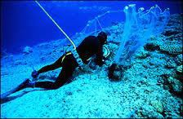

**Figure 4-3 Marine aquarium diver using a barrier net to collect fish**

#### Use of Bait

The MAFMF does not use bait.

## Data collection

It is a legal requirement for MAFMF licensees to accurately measure and record the quantities of their catch. Prior to 2009, MAFMF catch and effort was recorded through compulsory monthly Catch and Effort Statistics (CAES) returns. In 2009, daily logbook

returns were also introduced in recognition of the need for more accurate reporting (including GPS coordinate location). Daily logbook reporting requirements were updated in 2012 to enable more detailed recording of particular species, including CITES listed species.

Information obtained through monthly CAES and daily logbook data included:

* + - licensing/administrative details (nominated operator/master’s name, date signed, managed fishery licence (MFL), boat registration (LFB), boat name and fishing boat licence (FBL) details);
    - fishing effort details (year, month, start and end times, crew names, point of landing, sea-based holding GPS coordinates, 10x10nm block number, days fished per month and per block (for monthly returns), hours fished, hours spent searching and method of collection (wade, dive, snorkel); and
    - catch details (including GPS coordinates, 10x10nm block number, record of all catch by weight for hard and soft coral (excluding Order Corallimorpharia and Order Zoanthidea) and live rock, by volume for algae, seagrass Order Corallimorpharia and Order Zoanthidea, and numbers of individuals for all other catch).

On 1 November 2018, a new management regime was introduced to enable more effective management of key species. This included an electronic logbook system, a new Management Plan with quota management for four categories of entitlement, and a formal Harvest Strategy. The electronic logbook provides for near real time quota management and catch reporting.

|  |  |  |  |  |  |  |  |  |  |
| --- | --- | --- | --- | --- | --- | --- | --- | --- | --- |
| In accordance with the new Management Plan (2018), the licensing period and quota | | | | | | | | | |
| entitlements | are | managed | by | financial | year. | However, | previous | management | |
| arrangements recorded catch and effort data by calendar year. This ERA will review | | | | | | | | | |
| historic data in calendar year to assess any potential risk over the next five years. | | | | | | | | |  |

Summaries of MAFMF catches in the previous year are published by the Department

in the annual ‘State of the Fisheries’ report.

## Retained Species

The MAFMF captures a very diverse array of live fish and invertebrates for the aquarium industry, including scalefish, sharks and rays, hard and soft corals, corallimorphs, zooanthids, anemones, sponges, molluscs, echinoderms, crustaceans and other invertebrates (Table 4.4). ‘Live rock’ and aquatic plants are also harvested. The number of taxa targeted and collected by the fishery varies from year to year largely due to changes in market demand.

In this document, species retained by the MAFMF are divided into the following categories:

* + - Fish, including sharks and rays (excluding Syngnathiformes)
    - Seahorses and pipefish (Syngnathiformes)
    - Hard coral
    - Soft coral
    - Corallimorphs and Zoanthids
    - Anemones
    - Sponges (Porifera)
    - Giant clams
    - Other invertebrates
    - ‘Live rock’ and aquatic plants

**Table 4.4. Total annual catches of each higher level taxonomic group retained by the MAFMF in 2016-2020. Excludes live rock, seagrass, and algae. (n = number of individuals)**

|  |  |  |  |  |  |  |  |  |  |  |
| --- | --- | --- | --- | --- | --- | --- | --- | --- | --- | --- |
| Phylum |  | Common Name | 2016 | 2017 | 2018 |  | 2019 |  | 2020 | Unit |
|  |  |  |  |  |  |  |  |  |  |  |
| Cnidaria | Order Scleractinia | Hard corals | 3519 | 4854 | 5836 |  | 13450 |  | 11907 | kg |
|  |  |  |  |  |  |  |  |  |  |  |
|  | Order Corallimorpharia | Corallimorphs | 2077 | 2302 | 3198 |  | 3050 |  | 3339 | kg |
|  | Order Zoantharia | Zoanthids | 1269 | 1232 | 1763 |  | 1659 |  | 1186 | kg |
|  | Order Alcyonacea | Soft corals | 953 | 761 | 634 |  | 648 |  | 551 | kg |
|  | Order Actiniaria & Ceriantharia | Anemones | 3537 | 4460 | 8816 |  | 4452 |  | 9331 | n |
| Chordata | Teleostei | Bony fish | 15324 | 25870 | 26805 |  | 11758 |  | 28079 | n |
|  | Teleostei: Syngnathiformes | Seahorses, pipefish | 215 | 487 | 220 |  | 122 |  | 303 | n |
|  | Chondrichthyes | Sharks, rays | 100 | 243 | 521 |  | 148 |  | 86 | n |
|  | Ascidians | Sea squirts | 30 | 22 | 20 |  | 21 |  | 0 | n |
| Porifera |  | Sponges | 3972 | 3309 | 4774 |  | 2836 |  | 2268 | n |
| Mollusca | Gastropodia | Snails, sea hares | 15796 | 30672 | 27922 |  | 38315 |  | 40518 | n |
|  | Cephalopodia | Octopus, squid | 25 | 35 | 14 |  | 18 |  | 13 | n |
|  | Bivalvia | Clams | 336 | 571 | 385 |  | 397 |  | 655 | n |
| Arthropoda | Decapoda | Crabs, shrimp, lobster | 5583 | 18893 | 18122 |  | 8434 |  | 6015 | n |
| Echinodermata: | Asteroidea | Seastars | 2678 | 4506 | 4774 |  | 1661 |  | 1385 | n |
|  | Holothuroidea | Sea cucumbers | 875 | 1479 | 584 |  | 794 |  | 206 | n |
|  | Crinoidea | Featherstars | 202 | 433 | 258 |  | 85 |  | 43 | n |
|  | Ophiuroidea | Brittlestars | 27 | 70 | 69 |  | 46 |  | 61 | n |
|  | Echinoidea | Sea urchins, sand dollars | 209 | 692 | 260 |  | 206 |  | 625 | n |
| Annelida | Polychaeta | Polychaete worms | 197 | 167 | 344 |  | 153 |  | 337 | n |

#### Fish (excluding Syngnathiformes)

The MAFMF targets hundreds of species of fish, including 360 species that were reported in the past 5 years (Appendix Table A1). Dominant families in the catch include Pomacentridae (*Chromis* spp., damselfish, anemonefish), Blenniidae (blennies), Chaetodontidae and Pomacanthidae (angelfish, butterflyfish, coral fish), Labridae (wrasses), and Gobiidae (gobies). Most fish caught by the MAFMF are taken

in tropical waters, particularly around Exmouth and the Dampier Archipelago, with a smaller number of species taken in temperate waters, mainly around Perth.

|  |  |  |  |  |  |  |  |  |  |  |  |  |  |
| --- | --- | --- | --- | --- | --- | --- | --- | --- | --- | --- | --- | --- | --- |
| Although a large number of species are captured, recent fish landings have been | | | | | | | | | | | | | |
| dominated by six species (i.e., *Chaetodontoplus duboulayi, Ambassis vachellii,* | | | | | | | | | | | | | |
| *Chromis* |  | *atripectoralis,* |  | *Chelmon* |  | *marginalis,* |  | *Anampses* |  | *lennardi,* | |  | *Istiblennius* |
| *meleagris*), which together comprised about half the total catch during 2016-2020 | | | | | | | | | | | | | |
| (Table 4.5). These six species are assessed individually in this ERA. | | | | | | | | | | |  | | |

The vast majority of fish species retained by the MAFMF are not harvested by other commercial fisheries in WA.

The other fish species harvested by the MAFMF are taken in very small quantities (0- 500 individuals per year). This low level of catch is considered to pose a negligible risk to these species, the vast majority of which are relatively abundant and have wide distributions across the Indo-west Pacific region. The exceptions are a few species with life history traits (e.g. low productivity, small population size, high degree of ecological specialisation) that make them more vulnerable to exploitation. Thus these vulnerable species (i.e., *Amphiprion clarkii* and *Heterodontus portusjacksoni*) are also assessed individually in this ERA.

*Chaetodontoplus duboulayi*

*Chaetodontoplus duboulayi* (scribbled angelfish) (family Pomacanthidae) is widely distributed across northern Australia (north of 26° latitude) and also occurs in southern Papua New Guinea (https://fishesofaustralia.net.au/home/species/646, accessed 20 Jul 2021). It inhabits coastal and inner reef areas (depths of 5–20 m) with rubble, soft bottoms, or open flat bottom areas with rock, coral, sponge, and seawhip outcrops. It is a territorial species typically found in pairs or small groups (Debelius 2003). It attains a maximum length of 28 cm.

There is little published information on the age, growth and timing of sexual maturity of *C. duboulayi*. Spawning in pomacanthids typically involves a single pair, although individual males may mate successively with several different females (Debelius 2003). Eggs and sperm are released near the water surface. Female *C. duboulayi* release numerous batches of eggs during a spawning period of several weeks. Batch fecundity is estimated to be 5,000-33,000 eggs (Arai 1994). Fertilised eggs hatch after about 24 hours, and larvae have a pelagic phase of around 20 days (Thresher and Brothers 1985). *C. duboulayi* is a protogynous hermaphrodite. The main diet of *C. duboulayi* is sponges and tunicates (Debelius 2003).

During 2016-2020, *C. duboulayi* comprised 13% of the total fish catch with annual catches ranging from 1,961 to 3,602 individuals (Table 4.5). Catches were concentrated around Broome, the Dampier Archipelago and Exmouth (Figure 4.4). Under the 2018-2022 MAFMF Harvest Strategy the annual catch of *C. duboulayi* has a threshold level of 5,054 individuals.

The IUCN Red List status for *C. duboulayi* is ‘Least Concern’.

**Table 4.5. Retained annual catches (number) of key fish species (excluding Syngnathiformes) reported by the MAFMF for 2016 – 2020.**

|  |  |  |  |  |  |  |  |  |
| --- | --- | --- | --- | --- | --- | --- | --- | --- |
| **Species** | **Common Name** | **2016** | **2017** | **2018** | **2019** | **2020** | **Average** | **% of catch** |
| *Ambassis vachellii* | Vachell's Glassfish | 3200 | 775 | 4086 | 9 | 13385 | 4291 | 19.9% |
| *Chaetodontoplus duboulayi* | Scribbled Angelfish | 2670 | 3602 | 3553 | 2657 | 1961 | 2889 | 13.4% |
| *Chelmon marginalis* | Margined Coralfish | 943 | 1888 | 1934 | 711 | 1116 | 1318 | 6.1% |
| *Chromis atripectoralis* | Black-axil Chromis | 2106 | 340 | 1301 | 905 | 620 | 1054 | 4.9% |
| *Anampses lennardi* | Blue And Yellow Wrasse | 92 | 1448 | 1552 | 1005 | 1167 | 1053 | 4.9% |
| *Istiblennius meleagris* | Spotted Blenny | 1222 | 640 | 413 | 107 | 813 | 639 | 3.0% |
| *Valenciennea alleni* | Allen's Glidergoby | 0 | 647 | 760 | 771 | 928 | 621 | 2.9% |
| *Valenciennea puellaris* | Orange-spotted Glidergoby | 10 | 1039 | 1046 | 311 | 518 | 585 | 2.7% |
| *Entomacrodus*  *decussatus* | Wavy-lined Blenny | 0 | 655 | 1337 | 360 | 164 | 503 | 2.3% |
| *Chromis viridis* | Blue-green Chromis | 545 | 120 | 1279 | 0 | 219 | 433 | 2.0% |
| *Chaetodontoplus personifer* | Yellowtail Angelfish | 196 | 530 | 556 | 448 | 363 | 419 | 1.9% |
| *Valenciennea muralis* | Mural Glidergoby | 714 | 433 | 487 | 358 | 79 | 414 | 1.9% |
| *Pomacentrus coelestis* | Neon Damsel | 82 | 1360 | 50 | 0 | 30 | 304 | 1.4% |
| *Chromis cinerascens* | Green Chromis | 0 | 0 | 0 | 404 | 998 | 280 | 1.3% |
| *Plotosus lineatus* | Striped Catfish | 0 | 1092 | 50 | 20 | 200 | 272 | 1.3% |
| *Amphiprion clarkii* | Clark's Anemonefish | 240 | 587 | 352 | 87 | 88 | 271 | 1.3% |
| *Microcanthus strigatus* | Stripey | 22 | 532 | 25 | 0 | 594 | 235 | 1.1% |
| Other taxa (n=365) |  | 3282 | 10182 | 8024 | 3605 | 4836 | 5986 | 27.8% |
| **TOTAL** |  | **15324** | **25870** | **26805** | **11758** | **28079** | **21567** | 100.0% |

*Ambassis vachellii*

*Ambassis vachellii* (Vachell's Glassfish) (family Ambassidae) is widely distributed across the tropical Indo-west Pacific, including Western Australian coastal waters from Exmouth northwards (https://fishesofaustralia.net.au/home/species/1586, accessed 20 Jul 2021). It is a small (maximum length 7 cm), short-lived (~1 year), planktivorous, schooling species. It mainly inhabits brackish waters in bays, estuaries and tidal mangrove creeks, sometimes entering fresh water, and is often found at high densities in these environments. Spawning by *A. vachellii* populations occurs over an extended period during the wet season and potentially all year under favourable conditions (Molony and Sheaves 1998). Females release multiple batches of eggs during their lifetime, with an estimated lifetime fecundity of 3,600 eggs (Molony 1993).

During 2016-2020, *A. vachellii* comprised 20% of the total fish catch, with highly variable annual catches ranging from 9 to 13,385 individuals (Table 4.5). All catches were taken near Dampier (Figure 4.4). This species has only been reported by the MAFMF since 2015.

The IUCN Red List status for *A. vachellii* is ‘Least Concern’.

*Chromis atripectoralis*

*Chromis atripectoralis* (Black-axil chromis) (family Pomacentridae) is widely distributed across the tropical Indo-West Pacific, including WA coastal waters from the Houtman Abrolhos northwards (https://fishesofaustralia.net.au/home/species/2810, accessed 20 Jul 2021). Across northern Australia it is a relatively common species observed on shallow (5-12 m depth) coral reefs (https://reeflifesurvey.com/species/chromis-atripectoralis/, accessed 20 Jul 2021).

C*. atripectoralis* is planktivorous and forms large feeding aggregations above branching corals, mostly *Acropora* and *Pocillopora*, in clear lagoons, reef passages, and on seaward reef slopes. Individuals have a home range that encompasses multiple coral colonies and commonly move between different areas of the reef. Compared to some other coral-dwelling damselfish, C*. atripectoralis* is less ecologically specialised because it can use various coral species as habitat, and can also use dead (but intact) coral (Pratchett *et al.* 2012). These traits make *C. atripectoralis* relatively resilient to small, localised disturbances but it is nonetheless coral-dependent and so is vulnerable to large scale coral habitat loss.

C*. atripectoralis* forms pairs during breeding. Like other damselfish species, females lay demersal eggs that are attached to the substrate and guarded by the male. Larvae have pelagic phase of about 20 days, before settling onto a reef. Attains a maximum length of 12 cm. Lifespan in captivity is 8-15 years.

C*. atripectoralis* is very popular in the global aquarium trade (Rhyne *et al.* 2012). There is limited evidence of localised depletion of *C. atripectoralis* in some regions outside of Australia due to overfishing (Nañola *et al.* 2011).

During 2016-2020, *C. atripectoralis* comprised 5% of the total fish catch, with annual catches ranging from 340 to 2,406 individuals. Almost all catches were taken near Dampier (Table 4.5). The annual catch trend has been stable (non-directional) since 2008 (Figure 4.4). Under the 2018-2022 MAF Harvest Strategy the annual catch of

*C. atripectoralis* has a threshold level of 6,130 individuals.

The IUCN Red List status for *C. atripectoralis* is ‘Not evaluated’.

*Chelmon marginalis*

*Chelmon marginalis* (Margined coralfish) (family Chaetodontidae) is a tropical species endemic to northern Australia from the Houtman Abrolhos, Western Australia, to the northern Great Barrier Reef, and reefs in the Coral Sea, Queensland (https://fishesofaustralia.net.au/home/species/2406, accessed 20 Jul 2021). It is reported to be relatively common across this range (https:/[/www.re](http://www.reeflifesurvey.com/species/Chelmon-marginalis)e[flifesurvey.com/species/Chelmon-marginalis,](http://www.reeflifesurvey.com/species/Chelmon-marginalis) accessed 20 Jul 2021).

*C. marginalis* inhabits coral and rocky reefs in coastal waters and on nearshore islands, at depths of 1-30 m. Carnivorous, feeding mainly on benthic invertebrates.

Attains a maximum length of 18 cm. Individuals are usually solitary but form pairs during breeding. Gonochoristic. Eggs and larvae are planktonic.

During 2016-2020, *C. marginalis* comprised 6% of the total fish catch, with annual catches ranging from 711 to 1,934 individuals (Table 4.5). Catches were concentrated around Broome, the Dampier Archipelago and Exmouth (Figure 4.4). The annual catch has been stable since 2008 (Figure 4.5). Under the 2018-2022 MAF Harvest Strategy the annual catch of *C. marginalis* has a threshold level of 3,012 individuals.

The IUCN Red List status for *C. marginalis* is ‘Least Concern’.

*Anampses lennardi*

*Anampses lennardi* (Blue and yellow wrasse) (family Labridae) is endemic to northern Australia from Shark Bay and offshore islands of Western Australia, to the Gulf of Carpentaria, Queensland (https://fishesofaustralia.net.au/home/species/1221, accessed 20 Jul 2021). Inhabits sheltered and silty reefs at depths up to 25 m. Attains a maximum length of 28 cm. It is carnivorous, feeding primarily on benthic macro- invertebrates. Like other labrids, *A. lennardi* is a protogynous hermaphrodite, and produces planktonic eggs and larvae. Other aspects of the life history of *A. lennardi* are unknown. This species is occasionally harvested by recreational fishers for food.

During 2016-2020, *A. lennardi* comprised 6% of the total fish catch, with annual catches ranging from 92 to 1,552 individuals (Table 4.5). Under the 2018-2022 MAF Harvest Strategy the annual catch of *C. marginalis* has a threshold level of 2,092 individuals.

The IUCN Red List status for *A. lennardi* is ‘Least Concern’.

*Istiblennius meleagris*

*Istiblennius meleagris* (Spotted blenny) (family Blennidae) is a common and locally abundant species endemic to tropical and warm temperate parts of Australia, from Perth (WA) northwards to Sydney (NSW) (https://fishesofaustralia.net.au/home/species/1915, accessed 20 Jul 2021). It is found at very shallow (0-3 m) depths and along rocky and mangrove shores, and possibly in brackish or freshwater conditions, sometimes aggregating in groups beneath rocks and coral rubble in the intertidal zone. *I. meleagris* also occurs as an invasive species in the eastern Mediterranean (Rothman *et al.* 2020)

*I. meleagris* attains a maximum length of 15 cm. The life history of this species is poorly known but general traits of blennies include: benthic and territorial, gonochoristic, females lay demersal eggs in a nest typically guarded by the male, males may mate with several females, planktonic larvae.

During 2016-2020, *I. meleagris* comprised 4% of the total fish catch, with annual catches ranging from 107 to 1,222 individuals (Table 4.5). The MAFMF catch of this species has been declining since 2009 (Figure 4.5). Under the 2018-2022 MAF

Harvest Strategy the annual catch of *I. meleagris* has a threshold level of 5,692 individuals.

The IUCN Red List status for *I. meleagris* is ‘Least Concern’.

*Amphiprion clarkii*

*Amphiprion clarkii* (Clark’s anemonefish) (family Pomacentridae) is the most widely distributed anemonefish in the Indo-West Pacific, ranging from the Persian Gulf to eastern Australia, and north to southern Japan (https:/[/www.fishb](http://www.fishbase.se/summary/Amphiprion-clarkii.html)a[se.se/summary/Amphiprion-clarkii.html,](http://www.fishbase.se/summary/Amphiprion-clarkii.html) accessed 20 Jul 2021). Body colours and patterns shows considerable geographical variation across this range. In WA, the species occurs from Houtman Abrolhos northwards, inhabiting lagoons and outer reef slopes to 60 m depth.

Anemonefish live in small family groups consisting of a breeding pair and several juvenile males. Anemonefish are protandrous hermaphrodites, with the dominant male changing sex in the absence of a dominant female. *A. clarkii* spawns on a lunar cycle over an extended period or potentially all year depending on the region (Holtswarth *et al.* 2017). Female *A. clarkii* may produce >1 batch of eggs per month. Demersal eggs that attach to substrate are brooded by the male in a nest that may contain several hundred eggs from multiple spawnings. Larvae of *A. clarkii* have a pelagic phase of about 10 days, which allows for dispersal before settlement on a suitable host (Thresher *et al.* 1989; Ye *et al*. 2011).

Anemonefish live in a mutualistic symbiotic relationship with certain species of anemones and are dependent upon those anemones for habitat and nesting sites. *A. clarkii* can form relationships with the following 10 anemone species: *Cryptodendrum adhaesivum, Entacmaea quadricolor, Heteractis aurora, Heteractis crispa, Heteractis magnifica, Heteractis malu, Macrodactyla doreensis, Stichodactyla gigantea, Stichodactyla haddoni,* and *Stichodactyla mertensii* (Fautin and Allen 1997). *A. clarkii* has a broader range of hosts than other anemonefish, some of which have a single host species. *A. clarkii* may also use soft coral when anemones are not available (Arvedlund and Takemura 2005).

*A. clarkii* attains a maximum length of 14 cm and maximum age of 13 years (Moyer 1986). The diet is primarily plankton.

The MAFMF annual catch of *A. clarkii* declined from 935 in 2010 to 87 in 2019 and 88 in 2020 (Figure 4.5). Globally there has been a shift towards aquarium-bred anemonefish replacing wild-caught fish in the aquarium trade, and so MAFMF catches of *A. clarkii* are expected to remain low or decline further in the future.

The IUCN Red List status for *A. clarkii* is ‘Not evaluated’.

*Heterodontus portusjacksoni*

*Heterodontus portusjacksoni* (Port Jackson Shark) is the main elasmobranch targeted by the MAFMF. During 2016-2020 the annual catch of this species ranged from 47 to 349 individuals (Appendix Table A2), mainly in the Perth region. The MAFMF harvests various other species of demersal sharks and rays but these are taken in small numbers (typically <20 individuals per species per year) (Appendix Table A2).

*Heterodontus portusjacksoni* (Port Jackson Shark) is widespread around southern Australia from northern NSW, to the Houtman Abrolhos, WA, including Tasmania. It inhabits rocky reefs and adjacent sandy and seagrass areas, to depths of 275 m. The species is nocturnal, and individuals usually shelter in caves and under ledges during the day. (https://fishesofaustralia.net.au/home/species/1982, accessed 27 Jul 2021).

There are two major subpopulations of *H. portusjacksoni* in Australia, western (WA, SA, Victoria) and eastern (NSW, Victoria and Tasmania). There may be further structuring within these subpopulations (Day *et al.* 2019).

Males and females aggregate in large numbers in gutters and caves during the winter/spring breeding season. Females lay 10-16 soft leathery spiral egg cases that usually become wedged into crevices on shallow reefs (Powter and Gladstone 2008). The young hatch at about 23 cm after about a year. On the east coast of Australia, *H. portusjacksoni* are known to migrate southwards after breeding, moving up to 850 km before returning to the same breeding reefs the next year (Powter and Gladstone 2009).

Maturity is attained by males at 55-80 cm and 6-12 years, and by females at 65-95 cm and 7-17 years, depending on region (Tovar‐Ávila *et al.* 2007; Jones *et al.* 2008; Powter and Gladstone 2008; Simpfendorfer *et al.* 2019). *H. portusjacksoni* have a maximum reported length of 170 cm and estimated longevity of 35 years.

Although not targeted, *H. portusjacksoni* is taken in various commercial fisheries across its distribution, sometimes in high numbers, and also occasionally by recreational anglers. It is discarded (often alive) as the flesh and fins are considered to be of poor quality.

*H. portusjacksoni* is a commonly discarded species in the WA commercial Temperate Demersal Gillnet and Demersal Longline Fishery, with an estimated 4-7 t being discarded annually in the past five years (Watt *et al.* in press). *H. portusjacksoni* are very resilient to capture stress from gillnet, trawl, and longline gear (Frick *et al.* 2009, Frick *et al.* 2010a, 2010b, Braccini *et al.* 2012), suggesting that the species is likely to have high post-release survival rates from a range of fishing methods. In WA, recreational boat-based fishers in the West Coast and South Coast Bioregions catch relatively small numbers of *H. portusjacksoni*, with 1,217 individuals estimated to have been captured and then released by boat-based fishers in 2017/18 (Ryan *et al.* 2019).

In March 2021, the impact from of all types of fishing on *H. portusjacksoni* in WA was assessed as ‘Negligible’ (Watt *et al.* in press). The status of the *H. portusjacksoni* across its Australian range was assessed as ‘sustainable’ in 2019 (Simpfendorfer *et al.* 2019). The IUCN Red List status for this species globally and in Australia is ‘Least Concern’.

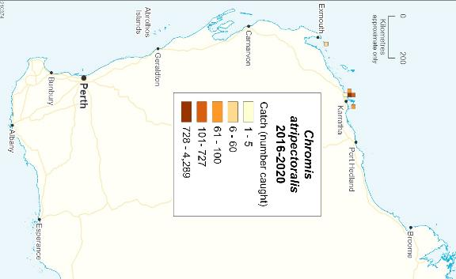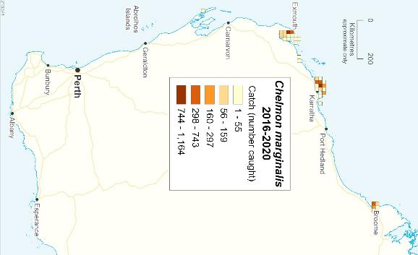

**Figure 4.4. Distribution of the total catches of key fish species retained by the MAFMF by 10x10 nm block during 2016-2020.**

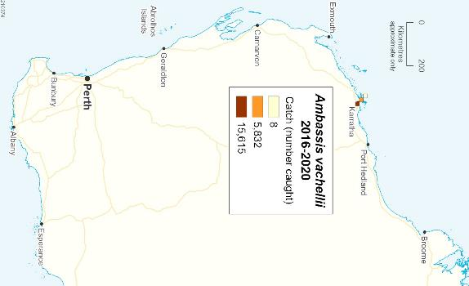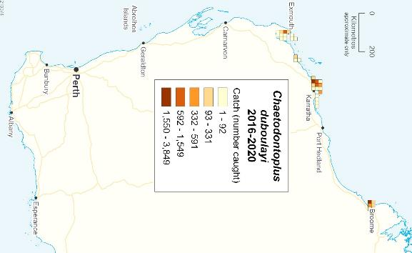

**Figure 4.4 (continued). Distribution of the total catches of key fish species retained by the MAFMF by 10x10 nm block during 2016-2020.**

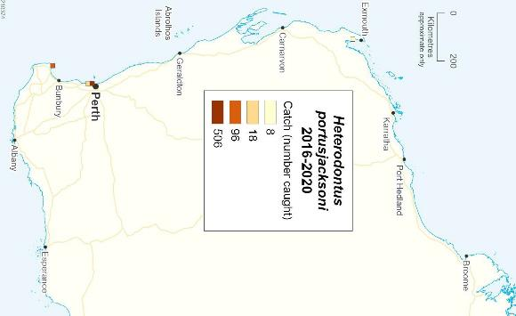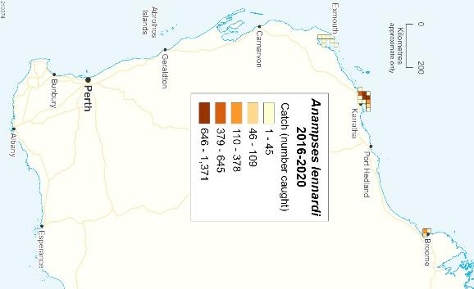

**Figure 4.4 (continued). Distribution of the total catches of key fish species retained by the MAFMF by 10x10 nm block during 2016-2020.**

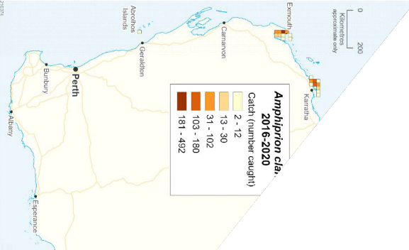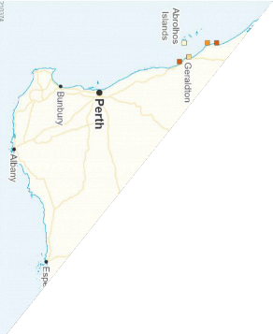

**Figure 4.4 (continued). Distribution of the total catches of key fish species retained by the MAFMF by 10x10 nm block during 2016-2020.**

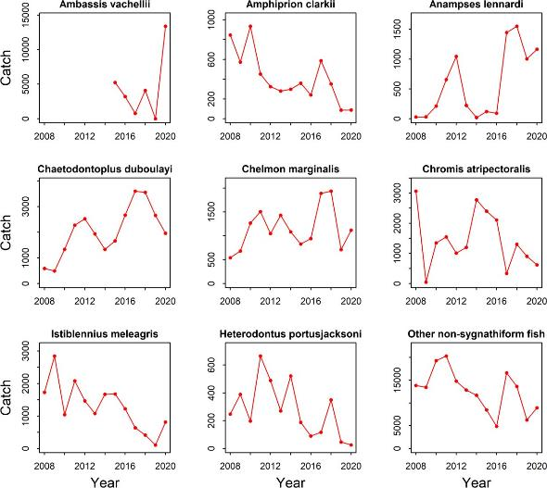

**Figure 4.5. Annual catches of non-syngnathiform fish species retained by the MAFMF, 2008 - 2020.**

#### Syngnathiformes

The order Syngnathiformes comprises six families: Syngnathidae (seahorses, sea- dragons and pipefish), Solenostomidae (ghostpipefish), Aulostomidae (trumpetfish), Fistulariidae (flutemouths), Centriscidae (razorfish) and Macroramphosidae (bellowmouths).

All *Hippocampus* species (family Syngnathidae) are listed under Appendix II of the Convention on International Trade in Endangered Species of Wild Fauna and Flora (CITES), indicating that they are not necessarily threatened with extinction, but may become so unless trade is closely controlled.

All species from the families Syngnathidae and Solenostomidae are listed under Part 13 of the *Environmental Protection and Biodiversity Conservation Act 1999* (EPBC Act).

The MAFMF is permitted to take Syngnathidae and Solenostomidae species, from state waters only, under the current WTO approval which stipulates maximum catch limits based on ‘non-detriment findings’ (NDF) for three seahorse species (*Hippocampus subelongatus, H. angustus* and *H. tuberculatus*) (Table 4.6) (also see Section 4.1). Also, the 2018-2022 MAF Harvest Strategy stipulates catch thresholds of 2,000 for *H. subelongatus*, 200 for *H. angustus* and 100 for all other Syngnathidae species combined (DPIRD 2018b). Furthermore, the MAFMF Management Plan stipulates an annual TACC of 2,000 individuals for the order Syngnathiformes (all species combined).

In WA there is a statewide total prohibition on the capture of the leafy sea dragon (*Phycodurus eques*).

In practise, the MAFMF harvests small numbers of syngnathiform species each year, well below specified limits. During 2016-2020, the total annual catch ranged from 122 to 487 individuals (Table 4.7). The main species harvested are the Western Australian seahorse (*Hippocampus subelongatus)*, western spiny seahorse (*H. angustus)* and spotted pipefish (*Stigmatopora argus*), which collectively comprised 84% of the total catch (Table 4.7). The remaining 16% of the catch was comprised of 19 other syngnathiform taxa, each with an average annual catch of less than 10 individuals (Appendix Table A3). Catches are primarily around Dampier, Exmouth and Perth.

Syngnathiform species are not harvested by any other fishery in WA. Several commercial trawl fisheries in WA have incidental interactions with syngnathid species that have been assessed as a low or negligible risk to those species (DPIRD 2020a, 2020b, 2020c).

The largest threat to syngnathids in WA is habitat loss or degradation (CoA 2012). Many syngnathids inhabit shallow inshore areas and artificial structures, which makes them vulnerable to human disturbance. For example, seagrass or seaweed beds may be physically damaged by dredging, boat propellers and anchors, and by trampling. Coastal developments have the potential to impact on habitats such as seagrass, reef and soft bottom habitats through pollution and urban runoff.

In all syngnathid species, the sexes are separate and the male broods the developing young. Females transfer their eggs to the male pouch (for most *Hippocampus* species) or simple skin folds (vascularised brood area at the same location as the tail) where they are fertilised and remain for between 0-45 days (dependent on water temperature and species). Young are commonly retained within the pouch for some time after they hatch. If there is no brood pouch, young leave the male as they hatch. Batch fecundity ranges from fewer than 100 eggs to several thousand, depending on adult size. More than one batch may be produced per season. Some *Hippocampus* species are monogamous, at least within a single breeding cycle. The larger syngnathid species are thought to live for up to 3-5 years, based on observations of captive specimens. Sexual maturity occurs at one year or less, depending on the species. Syngnathids primarily consume small planktonic crustaceans.

*Hippocampus* species tend to be patchily distributed and occur at low densities. Most species exhibit high site-fidelity and small home ranges, at least during the breeding

season. The newly born young of some species are planktonic, and juvenile dispersal is probably the main means of gene flow in these species.

**Table 4.6. Catch limits relating to Syngnathiform species harvested by the MAFMF.**

|  |  |  |  |
| --- | --- | --- | --- |
| Species | NDF | MAFMF Harvest Strategy threshold | MAFMF  Management Plan |
| All Syngnathiformes species combined | - | - | 2000 |
| *Hippocampus subelongatus* | 2000 | 2000 | - |
| *Hippocampus angustus* | 328 | 328 | - |
| *Hippocampus tuberculatus* | 100 | -* | - |
| All other Syngnathidae (per species) | - | 100 | - |

*Covered under all other Synathidae limit (per species) therefore threshold of 100.

**Table 4.7. Retained annual catches (number) of all Sygnathiformes species reported in the MAFMF for 2016-2020.**

|  |  |  |  |  |  |  |  |  |
| --- | --- | --- | --- | --- | --- | --- | --- | --- |
| **Species** | **Common name** | **2016** | **2017** | **2018** | **2019** | **2020** | **Average** | **% of catch** |
| *Hippocampus*  *subelongatus* | Western Australian  Seahorse | 169 | 249 | 119 | 21 | 230 | 157.6 | 58.5% |
| *Hippocampus angustus* | Western Spiny Seahorse | 27 | 50 | 36 | 50 | 37 | 40 | 14.8% |
| *Stigmatopora argus* | Spotted Pipefish | 0 | 148 | 2 | 0 | 0 | 30 | 11.1% |
| *Phyllopteryx taeniolatus* | Common Seadragon | 4 | 22 | 12 | 0 | 2 | 8 | 3.0% |
| *Haliichthys taeniophorus* | Ribboned Pipefish | 5 | 4 | 7 | 16 | 4 | 7.2 | 2.7% |
| *Filicampus tigris* | Tiger Pipefish | 3 | 1 | 27 | 4 | 1 | 7.2 | 2.7% |
| *Dunckerocampus*  *pessuliferus* | Yellowbanded  Pipefish | 0 | 8 | 9 | 0 | 0 | 3.4 | 1.3% |
| *Hippocampus tuberculatus* | Knobby Seahorse | 0 | 1 | 0 | 1 | 13 | 3 | 1.1% |
| Other (n=14 taxa) |  | 7 | 4 | 8 | 30 | 16 | 3 | 4.8% |
| **TOTAL** |  | **215** | **487** | **220** | **122** | **303** | **269.4** | **100.0%** |

*Hippocampus subelongatus*

*Hippocampus subelongatus* (Western Australian seahorse) is endemic to the west coast of WA, from Cape Leeuwin northwards to Shark Bay (https://fishesofaustralia.net.au/home/ species/1543, accessed 20 Jul 2021). It is most abundant in shallow (1–25 m depth), sheltered, coastal habitats and in estuaries where it is often found on man-made structures such as jetties or moorings. Natural habitats include structures such as rocks, seagrass, algae and sponges.

*H. subelongatus* attains sexual maturity at the end of the first year (age 9-12 months) and a length of ~12 cm (Lourie *et al.* 2004; Payne 2005). Lifespan is around 4 years. Maximum height is 25 cm. Breeding occurs during the warmer months (October to March) (Moore 2001). Brood size is 200-720 eggs with a gestation period of 2-3 weeks. Live young are born at ~12 mm length.

During 2016-2020, *H. subelongatus* comprised 59% of the total syngnathiform catch by the MAFMF, with annual catches ranging from 21 to 249 individuals (Table 4.7; Figure 4.6). Catches were mainly taken in the Perth region (Figure 4.7).

The IUCN conservation category for *H. subelongatus* is ‘Data deficient’.

*Hippocampus angustus*

*Hippocampus angustus* (Western spiny seahorse) is endemic to tropical waters of Western Australia, from Shark Bay to Broome. It inhabits sheltered algal-covered reefs and seagrass beds to about 10 m, although the species has been recorded up to 30 m (https://fishesofaustralia.net.au/home/species/1534 , accessed 20 Jul 2021). The life history of *H. angustus* is poorly known but assumed to be similar to *H. subelongatus*. The maximum height of *H. angustus* is 20 cm.

During 2016-2020, *H. angustus* comprised 15% of the total syngnathiform catch by the MAFMF, with annual catches ranging from 27 to 50 individuals (Table 4.7; Figure 4.6). These catches were taken around Exmouth, Dampier and Broome (Figure 4.7).

The IUCN conservation category for *H. angustus* is ‘Data deficient’.

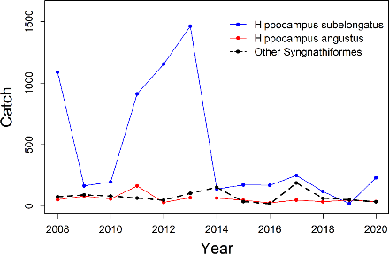

**Figure 4.6. Annual catches of key syngnathiform species retained by the MAFMF, 2008-2020.**

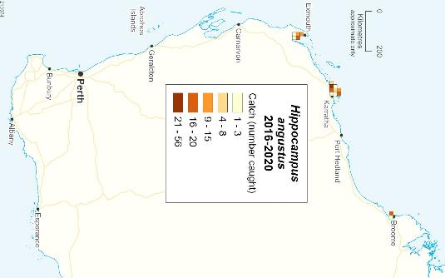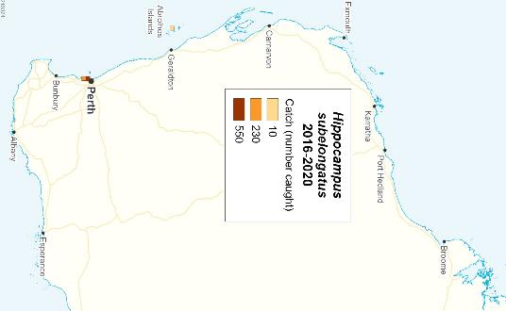

**Figure 4.7. Distribution of reported catches of *Hippocampus subelongatus* and *H. angustus* by 10x10 nm block during 2016-2020.**

*Stigmatopora argus*

*Stigmatopora argus* (spotted pipefish) is widely distributed around the temperate Australian coast from Dongara (WA) southwards to Seal Rocks (NSW), including Tasmania (https://fishesofaustralia.net.au/home/species/3130, accessed 20 Jul 2021). The species also occurs in New Zealand. It occurs at shallow (0-10 m) depths and commonly inhabits seagrass beds (especially *Posidonia* spp.) and other vegetation in inshore bays and estuaries. It is sometimes also found offshore among

floating seaweed, a habit that promotes gene flow (Bertola *et al.* 2020). The maximum length and meristics of fish in Tasmania and Western Australia differ to those elsewhere, suggesting discrete subpopulations in each region.

*S. argus* can reach a maximum of 25 cm in length and has a longevity of about 150 days. Males mature at 11 cm and after about 35 days (Parkinson and Booth 2016). Males brood eggs in a pouch. The maximum recorded brood size is 41 eggs, but reproduction occurs throughout the year and several broods can be produced by each male in their lifetime (Browne and Smith 2007; Parkinson and Booth 2016).

During 2016-2020, *S. argus* comprised 11% of the total syngnathiform catch by the MAFMF, with annual catches ranging from 0 to 148 individuals (Table 4.7). All catches were taken in the Perth region.

The IUCN conservation category for *S argus* is ‘Least concern’.



***Hard coral***

Hard corals (Phylum Cnidaria, Class Anthozoa, Order Scleractinia) are key habitat- forming species in tropical regions, supporting diverse ecological communities and providing many ecosystem services (Fisher *et al.* 2015; Woodhead *et al.* 2019).

Hard corals are colonial organisms that can reproduce both sexually and asexually. Asexual reproduction occurs through budding and/or fragmentation. Sexual reproduction typically occurs through broadcast spawning but may also occur via brooding. The reproductive mode influences vulnerability to exploitation and other forms of disturbance. Brooding corals have more restricted larval dispersal and are much more vulnerable to localised depletion (Noreen *et al.* 2009), compared to broadcast spawning corals that have greater rates of larval production and capacity for larval dispersal, which allows them to more rapidly replenish areas following localised depletion (Ayre and Hughes 2004; Underwood *et al.* 2009).

Most corals species are hermaphrodites. Corals ‘mass spawn’ by releasing eggs and sperm synchronously over several nights at particular times of the year. In WA, mass spawning tends to occur in March-April (Veron 2000). Coral fecundity is typically correlated with colony size, with more polyps producing more eggs. There is limited information about the age (or size) at maturity for most coral species, but the available information indicates it is highly variable amongst species and affected by environmental conditions.

The stock structure is unknown for most coral species. If there are genetically distinct subpopulations that occur over small spatial scales, then localised harvesting or other impacts may disproportionately impact certain subpopulations and potentially result in localised depletion. Most hard coral species host symbiotic dinoflagellates (‘zooxanthelllae’), which live within their tissues and share photosynthetic products with their coral host. Corals also filter-feed via polyps which capture a variety of small planktonic organisms. The combined ability of hard corals to photosynthesis and filter- feed contributes to the high productivity of coral reef ecosystems. Host corals often expel zooxanthelllae from their tissues in response to various types of environmental

stress, resulting in bleaching. Corals can recover after a minor bleaching event, but prolonged, severe or frequent bleaching events are often fatal.

Globally, coral reefs are threatened by climate change (especially ocean warming and acidification), and various other anthropogenic impacts including pollution, physical disturbances and exploitation (Hughes *et al.* 2017). In response to heatwaves and other stressors, total coral cover in Australia is believed to have been declining since about 1990, although patterns differ greatly between regions (GCRMN 2020). The extent and frequency of heat-induced bleaching has been increasing since the 1980s, causing high levels of coral mortality, particularly in eastern Australia (Hughes *et al.* 2018a, 2018b).

In WA, corals are affected by fewer chronic stresses than those in eastern Australia. There are few large river systems adjacent to WA coral reefs, and so terrestrial run- off (which contains sediments, nutrients and pesticides from agriculture) poses little threat to these reefs. Also, outbreaks of crown of thorns starfish have not significantly impacted WA coral reefs, although aggregations have been recorded on some reefs in the Pilbara region (Gilmour *et al.* 2019; Keesing *et al.* 2019).

however, regularly impacted by seasonal storms and cyclones.

Until recently, WA corals had been less affected by elevated ocean temperatures and

bleaching than those in eastern Australia, but there has been a noticeable increase in

WA corals are,

n WA, patterns of coral bleaching and mortality are localised. In general, northern (<18S) reefs tend to be affected during El Niño conditions, while those further south are typically affected during La Niña conditions (Gilmour *et al.* 2019). Also, impacts within each region are patchy. For example, during severe La Niña conditions in 2010/11, north-western Ningaloo Reef was barely affected, whereas areas immediately to the south and east were severely affected.

Around the Dampier Archipelago, where MAFMF coral harvesting is concentrated, bleaching at various levels was reported on coral reefs in 1998, 2005, 2008, 2013 and 2014. However, this area still has relatively high levels of coral cover compared to other parts of the western Pilbara and northern Ningaloo regions, which have experienced more severe bleaching and mortality since 2010 (Babcock *et al.* 2021).

heat stress and bleaching in WA since 2010 (Gilmour *et al.* 2019). I

It is important to note that these observations relate to reef environments, and that corals in ‘off-reef’ environments are rarely monitored. Most of the hard coral species targeted by the MAFMF are harvested from relatively turbid intertidal or inter-reef habitats, and there have been few studies of corals in these habitats. The susceptibility and mortality to heat-induced bleaching is poorly understood for these corals. A recent study of six species (*Cataphyllia jardinei*, *Trachyphyllia geoffroyi*, *Duncanopsammia.axifuga*, *Euphyllia glabrescens Homophyllia australis* and *Micromussa lordhowensis*) in turbid intertidal and/or inter-reef habitats confirmed that these species are susceptible to heat-induced bleaching (Pratchett *et al.* 2020a). *H. australis*, *M. lordhowensis*, *E. glabrescens* and *C. jardinei* exhibited particularly high rates of mortality (>80%) when exposed to prolonged temperature stress. Susceptibility varies among coral taxa and so these results may not be indicative for other harvested species.

In WA, it is expected that heat-related impacts to corals will continue to increase with future ocean warming, and these impacts will be exacerbated by disturbances from cyclones and severe storms, which are also predicted to increase with ongoing climate change (Gilmour *et al.* 2019). These impacts may reduce the sustainability and viability of the MAFMF.

Recently a study by Pratchett *et al.* (2020b) focused on hard corals in turbid waters and provided new information about their local abundance, and their reproductive traits. This study used video transects (n = 130 transects, 50 x 1 m) to survey commercially targeted hard coral species in intertidal and subtidal habitats in the Karratha/Dampier and Exmouth areas (primary coral harvesting areas for the MAFMF).

The combined total abundance of the six focal species in the study (i.e., *H. australis*,

*M. lordhowensis*, *C. jardinei*, *T. geoffroyi*, *D. axifuga*, and *E. glabrescens*) ranged from 0 to 93 colonies per transect (average 7.7 colonies per transect). Abundance was dominated by *T. geoffroyi*, *D. axifuga*, and *E. glabrescens*, with low contributions by the other 3 species. Densities of harvestable species were highly variable among transects, indicating that they were patchily distributed, but very abundant in certain habitats (Table 4.8; and discussed below).

**Table 4.8. Abundance and estimated biomass (± standard error) of key hard coral species observed in video transects (50m x 1m) in WA waters during 2016 – 2020 (adapted from Table**

**4.2 in Pratchett *et al.* 2020b). Note: Mean abundance and biomass are based on only those transects where coral species were actually recorded, whereas the coefficient of variation (cv) captures variability in abundance across all transects. Total biomass is the sum across all transects per species.**

|  |  |  |  |  |
| --- | --- | --- | --- | --- |
| **Species** | **Mean colonies per**  **transect (± se)** | **cv** | **Mean biomass (kg)**  **per transect (± se)** | **Total biomass (kg)**  **(sum of all transects)** |
| *Acanthastrea*  *echinata* | 3.4 ± 0.3 | 0.7 | 2.4 ± 0.3 | 161 |
| *Duncanopsammia*  *axifuga* | 6.9 ± 1.8 | 1.5 | 3.3 ± 1.5 | 109.1 |
| *Euphyllia glabrescens* | 6.6 ± 1.5 | 1.2 | 0.7 ± 0.3 | 18.2 |
| *Euphyllia sp* | 1.8 ± 0.2 | 0.5 | 0.8 ± 0.2 | 15 |
| *Fimbriaphyllia*  *ancora* | 21.3 ± 12 | 1.6 | 4 ± 2.5 | 32 |
| *Homophyllia*  *australis* | 1.3 ± 0.2 | 0.5 | 0.1 ± 0 | 0.6 |
| *Homophyllia*  *bowerbanki* | 2.1 ± 0.5 | 1 | 0.8 ± 0.2 | 13.6 |
| *Micromussa*  *lordhowensis* | 1.5 ± 0.5 | 0.5 | 0.2 ± 0.1 | 0.3 |
| *Trachyphyllia*  *geoffroyi* | 3.5 ± 0.6 | 1 | 0.2 ± 0 | 5.7 |
| **TOTAL** | **4.7 ± 0.6** | **1.9** | **2.7 ± 0.3** | **355.6** |

The observations of Pratchett *et al.* (2020b) suggest high levels of hard coral biomass in key MAFMF collection areas. This is consistent with MAFMF catch trends. There has been repeated harvesting of coral species over extended periods within MAFMF collection areas, which suggests relatively high levels of biomass and may indicate sustainable harvest levels.

The MAFMF mainly harvests hard corals around the Dampier Archipelago and Exmouth, with minor amounts also being taken in temperate waters as far south as Geographe Bay. Recently, in 2019 and 2020, the distribution of the MAFMF hard coral catch expanded northward with minor catches being taken in the Kimberley area.

From 2008 to 2018, total annual catches of hard coral followed a relatively stable trend, ranging between 3,708 and 6,235 kg (Figure 4.8). Total catches increased to 13,450 kg in 2019 and 11,907 kg in 2020. The proportions of individual species in the catch have remained similar since 2008, and so the recent increase in catch is not due to increased targeting of any particular species but rather to concurrent catch increases across multiple species (Figure 4.8).

The fishery generally targets particular colour morphs of each coral species in response to market demand. It is unknown whether colour has a genetic basis. If so, the structure of populations could be altered by highly selective harvesting of colour morphs in high demand. Information about which coral morphs (colour/size/shape) are being retained by the MAFMF is not recorded in catch records.

During 2016-2020, >120 taxa from 10 families were reported in the catch (Appendix Table A4). However, the majority (70% by weight) of the catch over this period was comprised of only 11 taxa (Table 4.9).

At a family level, the catch was mainly comprised of Euphylliidae (35%), Lobophylliidae (21%), Merulinidae (16%), Poritidae (9%) and Dendrophylliidae (8%). The remaining 10% was comprised of Acroporidae, Fungiidae, Pocilloporidae, Agariciidae and Coscinaraeidae.

During 2016-2020, MAFMF catches of Euphylliidae were dominated by *Fimbriaphyllia* (formerly *Euphyllia*) *ancora* (17% of total hard coral catch)*, Euphyllia glabrescens* (11%)*, Catalaphyllia jardinei* (4%) and *Fimbriaphyllia* (formerly *Euphyllia*) *paraancora* (3%).

Globally, euphylliid corals are highly targeted for the aquarium trade. Euphylliid corals reproduce sexually and also reproduce asexually, by fragmentation or budding depending on species. *Euphyllia* and *Fimbriaphyllia* species are described as ‘aggressive’ because they have long sweeper tentacles with nematocysts that are toxic to other coral species. Tentacles can stick to substrate and break off where they can form new colonies. Tentacle tips with swollen acrospheres can become detached and the drifting tips (sealed like neutrally buoyant water balloons) can stick onto any surface, colonizing and potentially damaging other corals. All *Euphyllia* and *Fimbriaphyllia* species have commensal shrimp species associated with them.

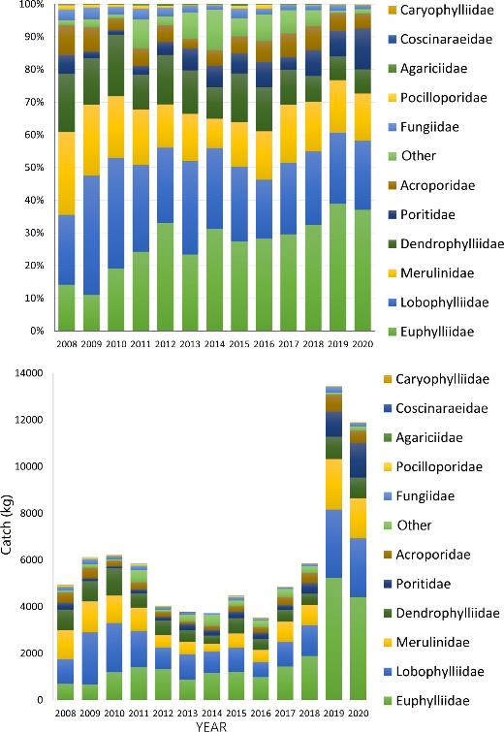

**Figure 4.8. Total annual catches of hard corals by the MAFMF grouped by family, 2008-2020.**

**Table 4.9. Retained annual catches (kg) of key families and species of hard coral (Phylum Cnidaria, Class Anthozoa, Order Scleractinia) reported by the MAFMF during 2016-2020.**

|  |  |  |  |  |  |  |  |  |
| --- | --- | --- | --- | --- | --- | --- | --- | --- |
| **Family** | **Species** | **2016** | **2017** | **2018** | **2019** | **2020** | **Average** | **% of catch** |
| Euphylliidae | *Fimbriaphyllia ancora* | 422 | 821 | 770 | 2556 | 1943 | 1302 | 16.5% |
| Euphylliidae | *Euphyllia glabrescens* | 290 | 467 | 753 | 1461 | 1209 | 836 | 10.6% |
| Poritidae | *Goniopora* spp. | 235 | 176 | 401 | 687 | 988 | 497 | 6.3% |
| Merulinidae | *Trachyphyllia geoffroyi* | 273 | 529 | 327 | 730 | 569 | 485 | 6.1% |
| Dendrophylliidae | *Duncanopsammia axifuga* | 376 | 382 | 315 | 707 | 639 | 484 | 6.1% |
| Lobophylliidae | *Australophyllia wilsoni* | 57 | 207 | 170 | 985 | 375 | 359 | 4.5% |
| Merulinidae | *Dipsastraea* spp. | 151 | 92 | 312 | 750 | 426 | 346 | 4.4% |
| Acroporidae | *Acropora* spp. | 173 | 306 | 377 | 462 | 384 | 340 | 4.3% |
| Euphylliidae | *Catalaphyllia jardinei* | 165 | 107 | 306 | 782 | 308 | 333 | 4.2% |
| Lobophylliidae | *Lobophyllia* spp. | 145 | 169 | 423 | 442 | 382 | 312 | 3.9% |
| Euphylliidae | *Fimbriaphyllia paraancora* | 107 | 19 | 33 | 315 | 770 | 248 | 3.1% |
|  | Other taxa (n= 115) individually  comprising < 3% | 1125 | 1581 | 1650 | 3574 | 3915 | 2369 | 29.9% |
| **TOTAL** | **TOTAL** | **3519** | **4854** | **5836** | **13450** | **11907** | **7913** | **100.0%** |

MAFMF catches of Lobophyllidae are dominated by *Australophyllia* (formerly *Symphyllia*) *wilsoni*, which individually comprised 5% of the total hard coral catch during 2016-2020. There is considerable taxonomic uncertainty about the family Lobophyllidae, including *Homophyllia australis* and *Micromussa lordhowensis* which appear to be restricted to eastern Australia (see Pratchett *et al.* 2020b). Catches of these species reported in WA and the NT (including those reported by the MAFMF) are likely to be new and undescribed species (Pratchett *et al.* 2020b).

MAFMF catches of Merulinidae are dominated by *Trachyphyllia geoffroyi* which individually comprised 6% of the total hard coral catch during 2016-2020. Catches of Poritidae are dominated by members of the genus *Goniopora* and are generally not reported to species level. Catches of Dendrophylliidae are dominated by *Duncanopsammia axifuga*, which individually comprised 6% of the total hard coral catch during 2016-2020

*Fimbriaphyllia ancora*

*Fimbriaphyllia* (formerly *Euphyllia*) *ancora* (anchor or hammer coral) is widespread across the Indo-West Pacific, including across northern Australia, and regarded as common across this range (Veron 2000; Turak *et al.* 2008a). In WA, the species occurs from Exmouth northwards.

Found in shallow water to a maximum depth of 30 m. Has a patchy distribution and can be very abundant in the habitats where it occurs. Prefers turbid water and a gentle current. Occurs on reef slopes in large colonies, often clustered together. Large colonies are also found in shallow environments exposed to moderate wave action. Colonies can cover many square meters.

Colonies are flabello-meandroid, with few or no branchlets. Blue-grey to orange, usually with pale cream or green outer borders to the tentacles. Polyps have large tubular tentacles with anchor or t-shaped tips. A gonochoric (i.e., separate male and female colonies), broadcast spawner (Luzon *et al.* 2017).

The species is popular in aquariums and is strongly targeted across its range.

IUCN Red List status is ‘Vulnerable’, based on an assessment conducted in 2008 (Turak *et al.* 2008a).

In WA, a total biomass of 32 kg was observed for *F. ancora* during 130 transects in subtidal and intertidal habitats (an average of 49 kg per hectare) (Pratchett *et al.* 2020b). On transects where it actually occurred, *F. ancora* had an average count of

21.3 (± 12.0 s.e.) colonies per 50 m2 and average biomass of 4.0 kg (± 2.5 s.e.) per 50 m2 (800 kg per hectare).

*F. ancora* is the most common species of hard coral in the MAFMF catch, comprising 17% of the total hard coral catch during 2016-2020 (Table 4.9). The catch of *F. ancora* was 2,556 kg in 2019 and 1,943 kg in 2020. MAFMF catches occur around Dampier and Exmouth, with minor catches also taken at various sites across the Kimberley region in recent years (Figure 4.9). During 2016-2020, 59% of the catch was taken from two reporting blocks (Figure 4.10). Fragments are collected by hand from parent colony. Small single colonies are also collected.

Recent catches are above the Threshold Level of 1,211 kg specified for *F. ancora* in the MAFMF Harvest Strategy and in the current NDF.

*Fimbriaphyllia paraancora*

*Fimbriaphyllia (*formerly *Euphyllia*) *paraancora* (branching hammer coral) has a limited distribution across the Indo-West Pacific, including across northern Australia. Reported to be patchily distributed and uncommon across this range, but can be common in certain locations (Turak *et al.* 2014b). Occurs in intertidal and subtidal areas to at least 30 m, especially in turbid waters.

The published distribution includes a limited part of far northern Australia (the NT and Qld coast in Gulf of Carpentaria), but does not include WA (Veron 2000; Turak *et al.* 2014b). However, specimens collected by fishers indicate that this species occurs within WA from Broome northwards.

*F. paraancora* was not recorded by Pratchett *et al.* (2020b) during recent surveys of intertidal and subtidal habitats around Karratha in WA.

Colonies are phaceloid, with branching separate corallites 20 mm–40 mm in diameter. Polyps have long tentacles with anchor or t-shaped tips. Tentacles are mainly light brown or green, occasionally with red or blue tones, and with tips in a different colour. Tentacles are similar in appearance to *F. ancora*, but differ in the orientation of the tips which form concentric circles.

A gonochoric, broadcast spawner (Luzon et al. 2017). Growth rate is undescribed.

IUCN Red List status is ‘Vulnerable’, based on an assessment conducted in 2008 (Tukak *et al.* 2014b).

Catches of *F. paraancora* have been reported by the MAFMF across the Kimberley and Pilbara regions (Figure 4.11). Catches to the south of Broome are presumably misidentified catches of *F. ancora*.

Reported catches of *F. paraancora* comprised 3% of the total MAFMF catch of hard corals during 2016-2020 (Table 4.9). The catch of *F. paraancora* was 315 kg in 2019 and 770 kg in 2020, with all of these catches being taken around Broome or further north. About 55% of the catch during 2016-2020 was taken from a single block (Figure 4.10). Fragments are collected by hand from parent colony. Small single colonies are also collected.

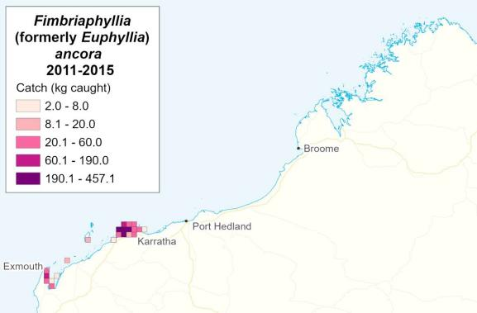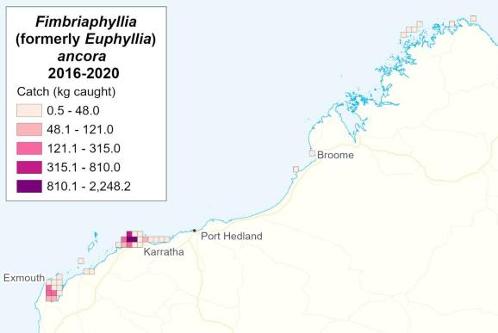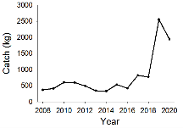

**Figure 4.9. Distribution of reported catches by the MAFMF of *Fimbriaphyllia ancora* by 10x10 nm block during 2011-2015 and 2016-2020. (Inset: annual catch 2008-2020)**

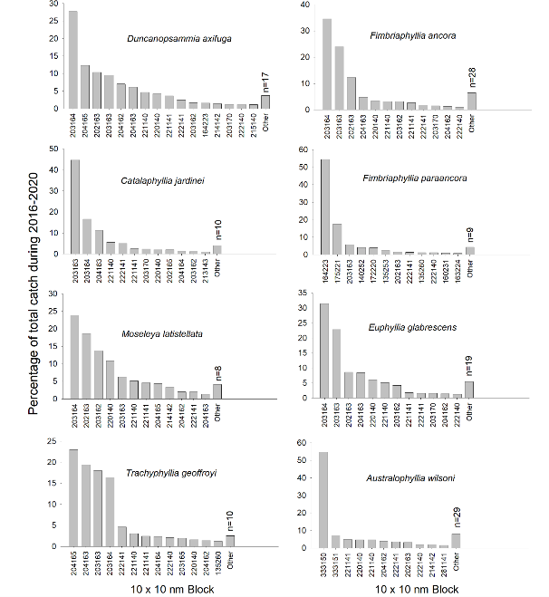

**Figure 4.10. Percentage of total catch of key hard coral species taken by the MAFMF in each 10x10 nm reporting block during 2016-2020.**

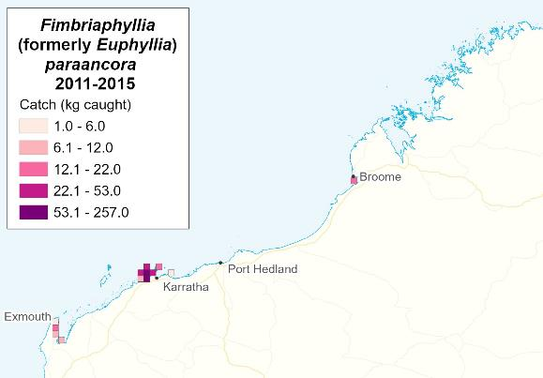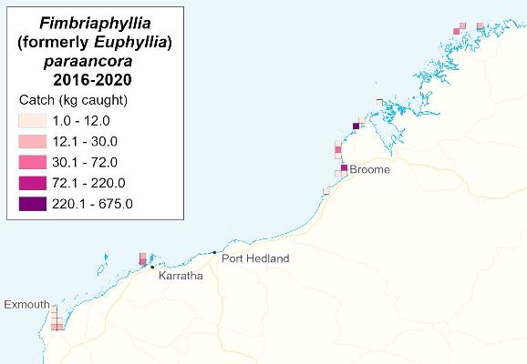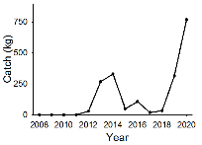

**Figure 4.11. Distribution of reported catches by the MAFMF of *Fimbriaphyllia paraancora* by 10x10 nm block during 2011-2015 and 2016-2020. Inset: annual catch 2008-2020.**

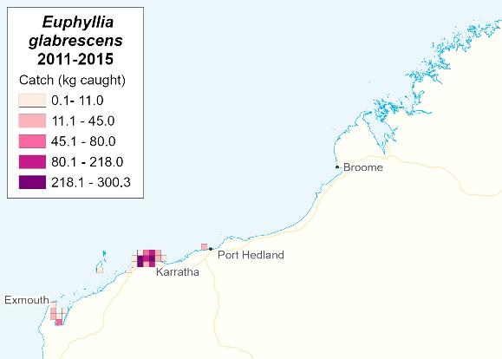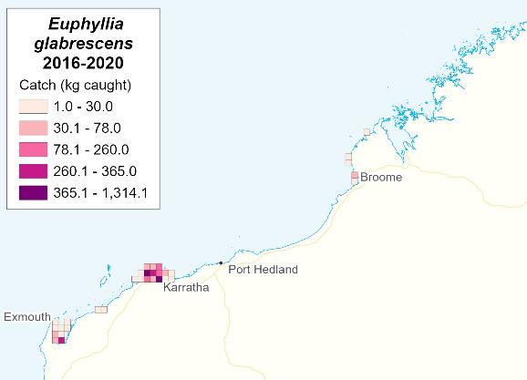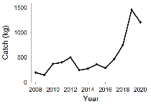

**Figure 4.12. Distribution of reported catches by the MAFMF of *Euphyllia glabrescens* by 10x10 nm block during 2011-2015 and 2016-2020. Inset: annual catch 2008-2020.**

*Euphyllia glabrescens*

*Euphyllia glabrescens* (Torch coral) is widespread across the Indo-West Pacific. In Australia it occurs across northern Australia from the Houtman Abrolhos Islands (WA) to northern NSW (Veron 2000; Turak *et al.* 2014a). Regarded as common throughout most of its range (Turak *et al.* 2014a). Occurs on soft sediments in a range of habitats. In WA, most common on deeper reefs (to a maximum depth of 40 m), but also occurs in intertidal habitats.

The species is popular in aquariums and is strongly targeted across its range.

Colonies are phaceloid. Polyps have long flowing tentacles in a range of colours, including brown, grey-blue or grey-green, with knob-shaped tips that are cream, green, pink or white.

IUCN Red List status is ‘Near Threatened’, based on an assessment conducted in 2008 (Turak *et al.* 2014a).

A hermaphroditic brooder (Richmond and Hunter 1990; Fan *et al.* 2006), thus differing to most *Euphyllia* species which are broadcast spawners (Baird et al. 2009). This reproductive strategy (i.e., brooding larvae) means that recruitment is limited to the immediate vicinity of reproductive adults. Thus population recovery after localised depletion is likely to be slow.

It attains reproductive maturity at a minimum size of 26 mm (average size at maturity is unknown). Harvested sizes observed by Pratchett *et al.* (2020b) ranged from 18- 168 mm (average 67 mm).

An average colony growth of 8.6 mm per year (maximum of 42.0 mm/y) for *E. glabrescens* was observed during a tagging study conducted in intertidal habitats near Karratha (Pratchett *et al.* 2020b)*.* Initial size range of *E. glabrescens* in this study was 9-222 mm diameter.

*E. glabrescens* is susceptible to environmental change, including high vulnerability to elevated temperatures. Overall, colonies monitored in intertidal habitats in WA exhibited high survivorship and moderate growth, but high rates of bleaching and mortality when subject to experimental warming. *E. glabrescens* exhibited high rates of mortality (>80%) when exposed to prolonged temperature stress in experimental tests (Pratchett *et al.* 2020a).

In WA, *E. glabrescens* is patchily distributed, but abundant in some areas. *E. glabrescens* was recorded on 20.8% of all transects during recent surveys of intertidal and subtidal habitats in WA. A total biomass of 18.2 kg was observed for *E. glabrescens* during 130 transects (an average of 28 kg per hectare) (Pratchett *et al.* 2020b). On transects where it actually occurred, *E. glabrescens* had an average count of 6.6 ± 1.5 s.e colonies per 50 m2, and average biomass of 0.7 kg ± 0.3 s.e per 50 m2 (140 kg per hectare) (Pratchett *et al.* 2020b).

*E. glabrescens* comprised 11% of the total MAFMF catch of hard corals during 2016- 2020 (Table 4.9). The catch of *E. glabrescens* was 1,461 kg in 2019 and 1,209 kg in 2020. MAFMF catches occur mainly around Dampier, and to a lesser extent around

Exmouth, and more recently also around Broome (Figure 4.12). During 2016-2020 about 54% of the catch was taken from two blocks (Figure 4.10).

Recent catches are above the Threshold Level of 1,009 kg specified for *E. glabrescens*

in the MAFMF Harvest Strategy and in the current NDF.

*Catalaphyllia jardinei*

*Catalaphyllia jardinei is* widely distributed across the tropical Indo-West Pacific region, including across northern Australia. It occurs in a variety of shallow (0-40 m depth) habitats, but most common on soft substrates (i.e., sand, mud) in protected, coastal areas, especially in turbid waters. Vulnerable to storm disturbance in shallow waters.

It is strongly targeted across its range for the aquarium trade and has been over- exploited in some areas. IUCN Red List status is ‘Vulnerable’, based on an assessment conducted in 2008 (Turak *et al.* 2008b).

*C. jardinei* was not recorded by Pratchett *et al.* (2020b) during recent surveys of intertidal and subtidal habitats in WA, suggesting it was not common in these habitats. Thus *C. jardinei* is relatively rare in intertidal habitats in WA, compared to Queensland waters where the species is abundant in certain habitats (approaching 40 kg per m2) (Pratchett *et al.* 2020b).

*Catalaphyllia* is a monotypic genus.

*C. jardinei* has a large, fleshy oral disc and very large polyps, each with long tendrils, similar in appearance to an anemone. The colour can be fluorescent green, lime green, or brown. Can be harvested as fragments or as small solitary colonies.

It is a hermaphroditic, broadcast spawner. Reproductive maturity is attained at a minimum/average size of 41/99 mm diameter (Pratchett *et al.* 2020b). In Queensland, harvested sizes observed by Pratchett *et al.* (2020b) ranged from 29-104 mm (average 57 mm). Maximum colony diameter reported to be 1,000 mm (Turak *et al.* 2008b). Linear growth rates estimated to be 8-152 mm/year (Green and Shirley, 1999).

Further information on the natural replenishment (e.g. settlement rates and habitat requirements) and growth rates is required to assess the capacity for this species to recover from localised disturbances, including fishing (Pratchett *et al.* 2020b).

*C. jardinei* comprises 4% of the total catch of hard coral by the MAFMF (Table 4.9). Catches of *C. jardinei* were 308 kg in 2019 and 782 kg in 2020. MAFMF catches occur around Dampier and Exmouth (Figure 4.13). During 2016-2020 about 45% of the catch was taken from a single block (Figure 4.10).

MAFMF harvest levels of *C. jardinei* have been relatively conservative since the mid 2000s, when some MAFMF fishers expressed concern about the potential for localised depletion in the Dampier area. In response, a prohibition on catch was implemented in WA in 2007 as temporary measure while other precautionary measures were developed. A 5 kg per day limit was implemented in 2009. In 2013, a NDF catch limit of zero was recommended as a condition of granting a WTO for the MAFMF, and this was given effect in WA through a voluntary agreement with the fishery.

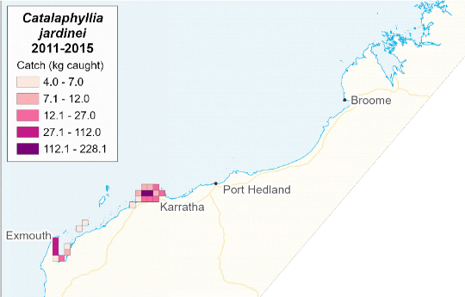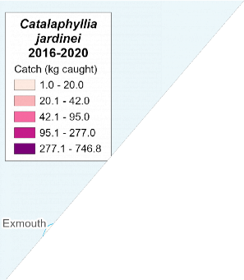

**Figure 4.13. Distribution of reported catches by the MAFMF of *Cataphyllia jardinei* by 10x10 nm block during 2011-2015 and 2016-2020. Inset: annual catch 2008-2020.**

In 2014, an ERA run by the Department rated the historical catch level of *C. jardinei* as being a ‘Negligible’ risk, and the NDF was raised to 180 kg. The 2014 ERA also noted “*doubling the historic harvest over the next five year period resulted in no material change to the risk rating.”* In 2018, based on the ERA outcome, the 5 kg daily limit was removed and a MAFMF Harvest Strategy was implemented with a Threshold Level of 530 kg for *C. jardinei*.

The 2019 catch of 782 kg exceeded the Threshold Level of 530 kg specified for *C. jardinei* in the MAFMF Harvest Strategy and in the current NDF.

*Australophyllia wilsoni*

*Australophyllia* (formerly *Symphyllia*) *wilsoni* (brain coral) is endemic to south-western Australian coast, from approximately Port Hedland southwards to Bremer Bay on the south coast of WA (Veron 1985, 2000). Regarded as uncommon across this range. Typically found at depths of 3-15 m.

It is an unusual hard coral species because it occurs in relatively cool waters (down to a minimum of 15 C in winter, but more typically 21 C) and can regularly be found growing in kelp forest. The colonies from cold water are the most colourful, and so are the most sought after by aquarists.

A hermaphroditic, broadcast spawner (Baird and Thomson 2018).

Colonies are massive or sub-massive, flattened and meandroid. Whole colonies typically harvested. Growth is undescribed, but likely to be relatively slow given cooler water temperatures and the massive/sub-massive form, which is normally associated with slow growth. Anecdotal reports of “extremely slow” growth in captivity.

*A. wilsoni* comprised 4.5% of the total catch of hard coral by the MAFMF during 2016- 2020 (Table 4.9). The reported catch of *A. wilsoni* was 985 kg in 2019 and 375 kg in 2020. Recent MAFMF catches occurred in both tropical and temperate waters, but the highest concentration of catches occurred in the West Coast Bioregion around Cape Naturalist/Geographe Bay (Figure 4.14). During 2016-2020, 55% of the catch was taken from a single block (Figure 4.10).

[IUCN Red List category](https://coraltraits.org/traits/77) for *A. wilsoni* is ‘Least Concern’ based on a 2008 assessment (Turak *et al.* 2008c). Note: this IUCN assessment assumed a species distribution that included the entire southern Australian coast, from WA to NSW, and a section of northern Australia, which is much broader than the currently recognised distribution described above.

*Trachyphyllia geoffroyi*

*Trachyphyllia geoffroyi* has a very broad distribution across the tropical Indo West- Pacific (Hoeksema and Cairns 2020b). In WA, it occurs from approximately Shark Bay northwards according to Veron (2000), or Houtman-Abrolhos Islands (Geraldton) northwards according to Sheppard *et al.* (2008). Despite regional differences in size, shape and colouration, *T. geoffroyi* on the east and west Australian coasts show strong genetic differentiation and it is uncertain whether they belong to the same species. Individuals in WA are more genetically diverse than those in Queensland (Pratchett *et al.* 2020b).

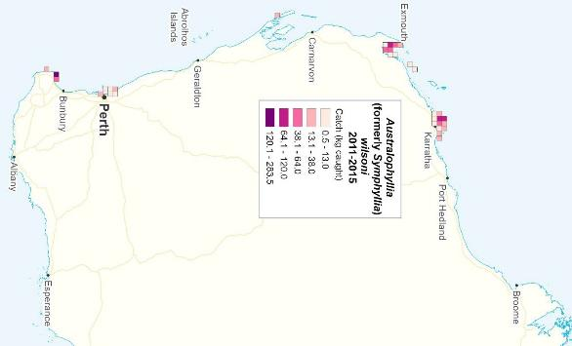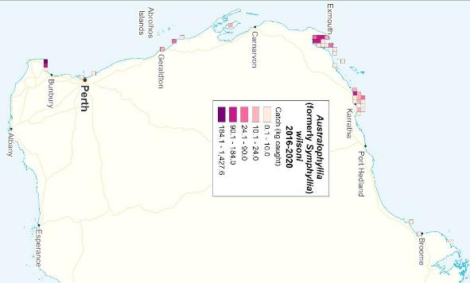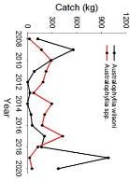

**Figure 4.14. Distribution of reported catches by the MAFMF of *Australophyllia wilsoni* by 10x10 nm block during 2011-2015 and 2016-2020. Inset: annual catch 2008-2020.**

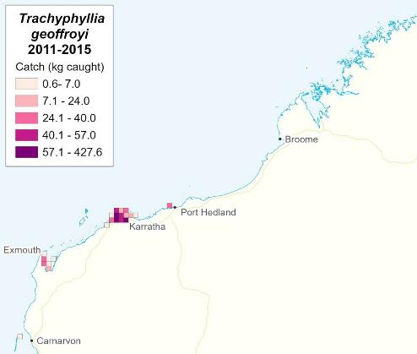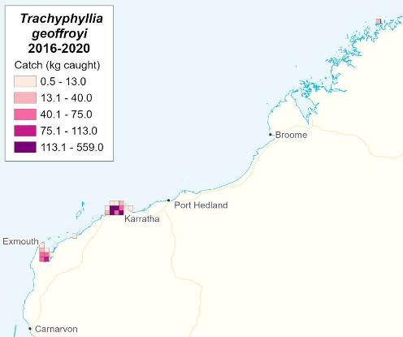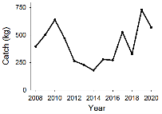

**Figure 4.15. Distribution of reported catches by the MAFMF of *Trachyphyllia geoffroyi* by 10x10 nm block during 2011-2015 and 2016-2020. Inset: annual catch 2008-2020.**

It prefers soft substrates (sand, mud) and is found in inter-reef environments, sheltered reef slopes or in lagoons, to depths of 40 m. Larger individuals are vulnerable to storms. Large colonies are found only in certain protected, shallow habitats.

Colonies are flabello-meandroid and free-living. They are usually hourglass shaped, up to 80 millimetres in length with one to three separate mouths. Large, fully flabello- meandroid colonies are uncommon. Polyps are fleshy and often brightly coloured, especially the mantles, usually yellow, brown, blue or green.

*Trachyphyllia* is a [monotypic](http://en.wikipedia.org/wiki/Monotypic_taxon) genus. It is a hermaphroditic, broadcast spawner (Pratchett *et al.* 2020b).

IUCN Red List status is ‘Near Threatened’, based on an assessment conducted in 2008 (Sheppard *et al.* 2008).

Harvested sizes observed by Pratchett et al (2020b) ranged from 25-162 mm (average 72 mm).

Pratchett *et al.* (2020b) observed negligible (and sometimes negative) change in the diameter of tagged *T. geoffroyi* colonies over 2 years at intertidal sites near Karatha, with average radial growth of -0.03 mm/year (maximum 10.4 mm/year). Initial size range of *T. geoffroyi* colonies in this study was 58-700 mm.

Dandan *et al.* (2015) observed positive (albeit slow) growth in colony mass (in grams, dry weight) over an 18 month period at both intertidal and subtidal sites in the Kimberley region. Initial size range of *T. geoffroyi* in this study was 50-80 mm. Growth was ~30% faster at intertidal sites. Growth steadily declined over the study period, suggesting that growth slows with age. The density (per cm2) of mouth openings was much higher in larger colonies, suggesting that as *T. geoffroyi* colonies age, colony division continues to occur even as the overall growth rate slows down.

Overall, *T. geoffroyi* appears to have a relatively slow growth rate. In general, slow growth is associated with low population productivity and so increases the inherent vulnerability of a species to over-exploitation.

Older colonies may be important for population viability due to the increase in polyp density (and thus reproductive output) with colony age.

*T. geoffroyi* readily bleaches when exposed to elevated temperatures, but rarely succumbs to temperature stress and so appears to be relatively resilient to environmental change. Given they are rarely attached, colonies of *T. geoffroyi* may be particularly vulnerable to severe storm and cyclones.

Densities of *T. geoffroyi* can be reasonably high, but colonies are generally small and contribute little to overall biomass of corals in any given location or habitat. During recent surveys in intertidal and subtidal habitats in WA, *T. geoffroyi* was recorded on 23.8% of transects. A total biomass of 5.7 kg was observed during 130 transects (an average of 9 kg per hectare) (Pratchett *et al.* 2020b). On transects where it occurred,

*T. geoffroyi* had an average count of 3.5 ± 0.6 s.e colonies per 50 m2, and average biomass of 0.2 kg ± 0.0 s.e per 50 m2 (~40 kg per hectare) (Pratchett *et al.* 2020b).

*T. geoffroyi* comprised 6% of the total MAFMF catch of hard corals during 2016-2020 (Table 4.9). From 2008 to 2020, annual catches of *T. geoffroyi* ranged from 180 to 730 kg (mean 415 kg). The catch was 730 kg in 2019 and 569 kg in 2020. MAFMF catches of *T. geoffroyi* mainly occurred around Dampier, and to a lesser extent around Exmouth (Figure 4.15). During 2016-2020, 77% of the catch was reported from four blocks (Figure 4.10).

Recent catches are below the Threshold Level of 1,281 kg specified for *T. geoffroyi* in the MAFMF Harvest Strategy and in the current NDF.

*Duncanopsammia axifuga*

*Duncanopsammia axifuga* (daisy coral) has a limited distribution in the central Indo- Pacific, primarily around tropical Australia and Vietnam. In WA, it occurs from Houtman-Abrolhos Islands (Geraldton) northwards. It attaches to a solid substrate but occurs in areas where soft sand predominates including intertidal reef edges, submerged reef slopes and amongst macroalgae, occurring at depths of 0-30 m.

*D. axifuga* colonies are distinct and conspicuous due to their long, heavily calcified tubular corallites, which face upwards, and large (~1-1.5 cm in diameter) individual polyps with long tentacles which are typically extended both day and night. It usually forms small creeping colonies or low clumps in which the corallites are united at their bases by coenosteum (Hoeksema et al. 2008).

IUCN Red List status is ‘Near Threatened’, based on an assessment conducted in 2008 (Hoeksema et al. 2008).

*Duncanopsammia* is a [monotypic](http://en.wikipedia.org/wiki/Monotypic_taxon) genus. A gonochoric, broadcast spawner. *D. axifuga* a relatively unaggressive coral and a relatively poor competitor. This species often hosts commensal organisms such as barnacles.

Experimental studies of temperature sensitivity suggest that *D. axifuga* will be relatively resilient to changing environmental conditions (Pratchett *et al.* 2020a).

Colonies attain reproductive maturity at a minimum diameter of 50 mm and an average of 83 mm (95% CI = 72 – 94 mm) (Pratchett *et al.* 2020b). Growth rate of *D. axifuga* is relatively fast. A tagging study in intertidal habitats near Karratha indicated an average radial growth of 12.3 mm/year (maximum of 59.6 mm/year) for *D. axifuga* (Pratchett *et al.* 2020b). Initial size range of *D. axifuga* in this study was 38-630 mm.

Harvested sizes observed by Pratchett *et al.* (2020b) ranged from 25-302 mm (average 99 mm).

*D. axifuga* is very rarely reported in established coral monitoring programs, which are not conducted in the habitats favoured by this species (e.g. Johns *et al.* 2014). *D. axifuga* is therefore often described as ‘uncommon’ or ‘rare’ (e.g., Hoeksema *et al.* 2008; DeVantier and Turak 2017). However, recent sampling by Pratchett *et al.* (2020b) in turbid, shallow waters in WA indicates *D. axifuga* is relatively abundant in these habitats.

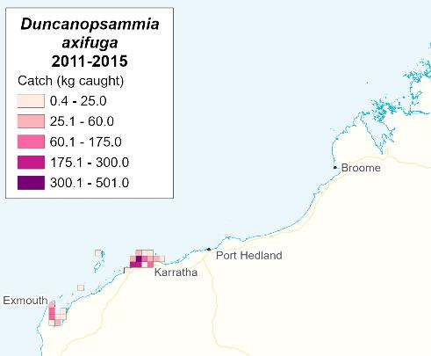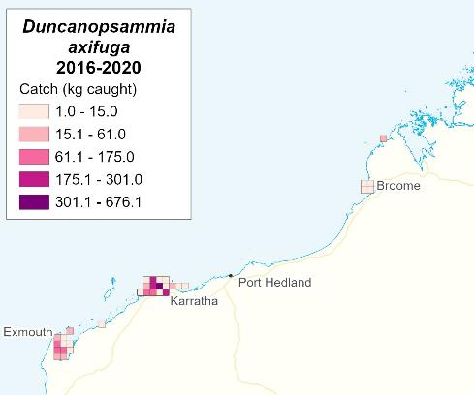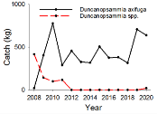

**Figure 4.16. Distribution of reported catches by the MAFMF of *Duncanopsammia axifuga* by 10x10 nm block during 2011-2015 and 2016-2020. Inset: annual catch 2008-2020.**

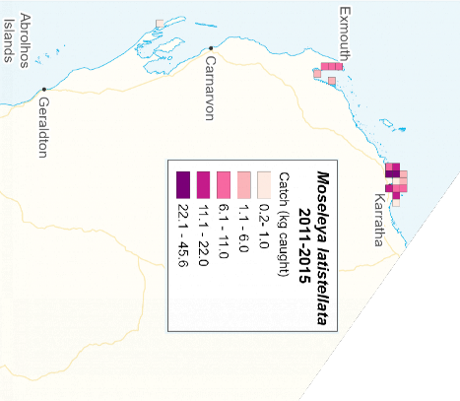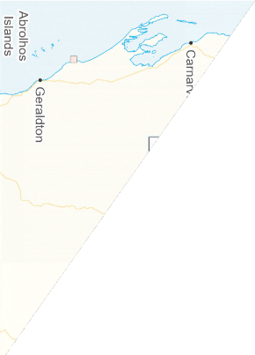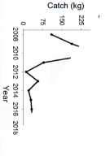

**Figure 4.17. Distribution of reported catches by the MAFMF of *Moseleya latistellata* by 10x10 nm block during 2011-2015 and 2016-2020. Inset: annual catch 2008-2020.**

During recent surveys in WA, *D. axifuga* was recorded on 25.4% of transects in intertidal and subtidal habitats. A total biomass of 109.1 kg was observed for *D. axifuga* during 130 transects (an average density of 168 kg per hectare) (Pratchett *et al.* 2020b). On transects where it occurred, *D. axifuga* had an average count of 6.9 ±

1.7 s.e colonies per 50 m2, and average biomass of 3.3 kg ± 1.5 s.e per 50 m2 (~700 kg per hectare) (Pratchett *et al.* 2020b).

*D. axifuga* comprised 6% of the total MAFMF catch of hard corals during 2016-2020 (Table 4.9). The catch was 707 kg in 2019 and 670 kg in 2020. It is collected as fragments from parent colony or as small single colonies. MAFMF catches of *D. axifuga* mainly occur around Dampier, and to a lesser extent around Exmouth (Figure 4.16).

Over the longer term (2008-2020), annual catches of *D. axifuga* ranged from 315 to 877 kg (mean 486 kg) and were concentrated around Dampier in all years. The catch trend is stable, suggesting the population size around Dampier is sufficient to support this level of harvest.

Recent catches are below the Threshold Level of 1,555 kg specified for *D. axifuga* in the MAFMF Harvest Strategy and in the current NDF.

(*catches include those reported as ‘*Duncanopsammia axifuga’* or *‘Duncanopsammia*

spp*.’)*.

*Moseleya latistellata*

*Moseleya latistellata* occurs across the central Indo-West Pacific, including across northern Australia. Reported to be uncommon across this range (DeVantier *et al.* 2008). It is found in shallow subtidal and intertidal zones at 0-12 m depth. Most often found in turbid water and in relatively low energy muddy substrates. In WA, it occurs from Houtman-Abrolhos Islands (Geraldton) northwards. Usually uncommon in WA but can be common in turbid nearshore habitats.

*Moseleya* is a monotypic genus. *M. latistellata* has a distinctive appearance. Colonies are flat submassive with a maximum diameter of approximately 20cm (less than 50 polyps), and feature large ceroid anglular corallites (up to 50mm diameter). There is often a large central corallite. Colonies are green or brown in colour. The colonies are normally attached but sometimes free-living. Tentacles are extended only on dark nights.

*M. latistellata* is a hermaphroditic, broadcast spawner. Growth rate is undescribed.

IUCN Red List status is ‘Vulnerable’, based on an assessment conducted in 2008 (DeVantier *et al.* 2008).

*M. latistellata* comprised 0.4% of the total MAFMF catch of hard corals during 2016- 2020 (Table 4.9). The catch was 31 kg in 2019 and 29 kg in 2020. MAFMF catches of *M. latistellata* mainly occur around Dampier, and to a lesser extent around Exmouth (Figure 4.17). Does not fragment well, so whole colonies are harvested; mostly at small/medium sizes.

Recent catches are below the Threshold Level of 588 kg specified for *M. latistellata* in the MAFMF Harvest Strategy and in the current NDF.

#### Soft coral

The Order Alcyonacea (Phylum Cnidaria, Class Anthozoa) (MAFMF catch category ‘soft coral’) includes soft corals, sea fans and gorgonians. About 100 genera in 23 families are known to occur in shallow Indo-Pacific coral reefs. Alcyonaceans encompass a wide diversity of morphologies, life history strategies and ecological requirements.

Some alcyonaceans are pioneering species that colonise rapidly and are relatively short-lived, while others are are long-lived and slow growing. Slow growing species are inherently more vulnerable to over-exploitation or other disturbances because their populations are slow to recover or colonise new areas.

Life expectancy and growth rates of most alcyonaceans are unknown. Age is difficult to determine because colonies may shrink when damaged (by storms, predators, etc.), and so there is a weak relationship between size and age. Some large *Sinularia* colonies are thought to be hundreds of years old, and some of the large gorgonian colonies may be many decades old. The family Alcyoniidae contains many slow growing and long-lived species (Fabricius 1995; Bastidas *et al.* 2004).

Alcyonaceans are suspension filter feeders and also possess nematocysts for live prey capture (Fabricius and Alderslade 2001). Many species in warm and shallow waters are also zooxanthellate. Zooxanthellate species include many species within the families Nephtheidae, Alcyoniidae and Xeniidae, amongst others. Zooxanthellate taxa are vulnerable to thermal bleaching, with resilience varying among species (e.g. Strychar *et al.* 2005; Lafratta *et al.* 2017; Slattery *et al.* 2019).

Most alcyonaceans lack an exoskeleton and so are not reef-building, but they do provide habitat for various other reef organisms, including invertebrates and fish. Colonies can cover large areas of reef.

Reproductive strategies vary among species, and include asexual propagation (budding, fragmentation) and sexual (broadcast spawning, brooding) strategies. Asexual propagation is the dominant mode of reproduction for many species. In the Alcyoniidae, most species are gonochoric, broadcast spawners. The larvae have a planktonic phase of days to weeks which allows for some dispersal before settlement (Fabricius and Alderslade 2001).

Alcyonaceans are mainly harvested by the MAFMF around Exmouth and Dampier. During 2016-2020, the total annual catch ranged from 551 to 953 kg. Catches are rarely identified to species level due to difficulties in differentiating the taxa (identification is complex and based on internal features). Most alcyonaceans harvested by the MAFMF belong to the family Alcyoniidae and, of these, most are *Sarcophyton* species (Table 4.10, Appendix Table A5).

**Table 4.10. Retained annual catches (kg) of soft corals (Phylum Cnidaria, Class Anthozoa, Order Alcyonacea) reported by the MAFMF during 2016–2020.**

|  |  |  |  |  |  |  |  |  |
| --- | --- | --- | --- | --- | --- | --- | --- | --- |
| **Family** | **Species** | **2016** | **2017** | **2018** | **2019** | **2020** | **Average** | **% of catch** |
| Alcyoniidae | *Sarcophyton* spp. | 455.7 | 456 | 390.5 | 429.5 | 255.7 | 397.48 | 56.0% |
| Alcyoniidae | *Sinularia* spp. | 3.5 | 2 | 9 | 96 | 162 | 54.5 | 7.7% |
|  | Other Alcyoniidae (5 genera) | 0 | 5 | 3 | 34 | 37 | 15.8 | 2.2% |
| Nephtheidae | *Dendronephthya*  spp. | 12 | 2 | 0 | 28 | 40.5 | 16.5 | 2.3% |
| Other (8 families) |  | 11 | 9 | 8 | 60.5 | 56 | 28.9 | 4.1% |
| Order Alcyonacea  - undifferentiated |  | 471 | 286.5 | 223 | 0 | 0 | 196.1 | 27.6% |
| **TOTAL** |  | **953.2** | **760.5** | **633.5** | **648** | **551.2** | **709.3** | **100.0%** |

*Sarcophyton* species

The *Sarcophyton* genus is widely distributed and abundant across the Indo-West Pacific. Presently there are 80 recognised species in this genus world-wide, and potentially more unrecognised species. *Sarcophyton* species occur from the intertidal to considerable depths. On moderately turbid nearshore reefs and soft substrates, it is relatively common to find extensive colonies consisting of many hundreds of clones, which appear to display fast rates of growth and asexual reproduction, in contrast to colonies on clear-water reefs that tend to be slow-growing (Fabricius and Alderslade 2001).

*Sarcophyton* are gonochoristic, broadcast spawners. They also grow readily from runner formation, colony fragmentation, fission or budding. Aquarists report they are easy to propagate in captivity from cuttings.

*Sarcophyton* are zooxanthellate and so are susceptible to thermal bleaching.

*Sarcophyton* species have a diverse range of morphologies. MAFMF fishers target species with a stalk and undulating top, often referred to as a “toadstool leather coral” or “toadstool coral”.

*Sarcophyton* catches are taken around Dampier and Exmouth (Figure 4.18). During 2016-2020, *Sarcophyton* spp. comprised 56% of the total alcyonacean catch by weight, with annual catches ranging from 256 to 456 kg (Table 4.10, Figure 4.19).

There are no conservation concerns for *Sarcophyton* species.

Other soft coral species

Around 20 additional taxa of soft coral are taken in small quantities by the MAFMF. In 2016-2020 catches were distributed from Perth to Broome, with the majority taken around Dampier or Exmouth (Figure 4.18). Average annual catches are <50 kg for each taxa, except *Sinularia* spp. (Table 4.10). There is virtually no life history information for most soft coral species although some, including *Sinularia* spp., are known to be very slow growing.

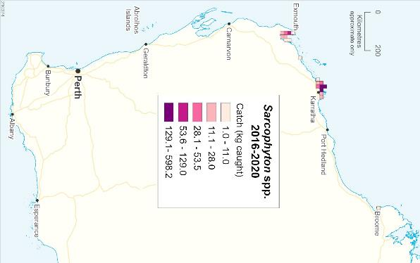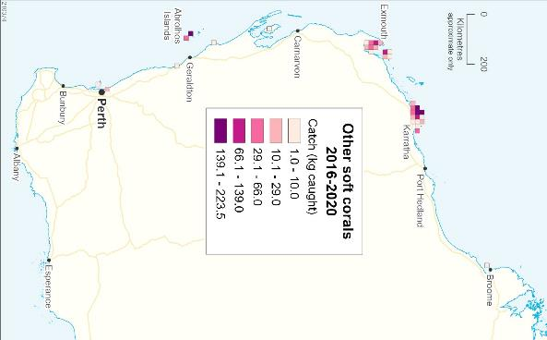

**Figure 4.18. Distribution of catches of *Sarcophyton* spp. and other soft corals by the MAFMF during 2016-2020.**

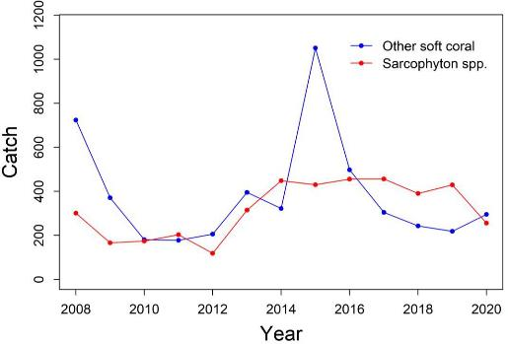

**Figure 4.18. Annual catches (kg) of *Sarcophyton* spp. and other soft corals by the MAFMF during 2008-2020.**

#### Anemones

The MAFMF harvests about 20 species of sea anemone (Phylum Cnidaria, Class Anthozoa, Order Actiniaria), although recent catches were dominated by only two species, *Entacmaea quadricolor* and *Heteractis malu*, that together comprised 80% of the total anemone catch during 2016-2020 (Table 4.11; Appendix Table A6).

Typically, anemones do not produce calcified structures and have the ability to undertake limited movements. Anemones reproduce sexually as broadcast spawners with a brief planktonic stage, or asexually through budding or splitting (without planktonic stage). In captivity and under optimal conditions, asexual reproduction can occur rapidly for some species. Some anemone populations, including those of *E. quadricolor*, have slow growth rates and their populations (along with their associated populations of anemonefish species) can take several decades to recover from major disturbances (Frisch *et al.* 2019). Life spans of most species are unknown, but some species are believed to live for decades or centuries (Fautin and Allen 1997).

Ten species of anemones are known to form mutualistic partnerships with 28 species of anemonefish in the genera *Amphiprion* and *Premnas*.

Some anemone species are zooxanthellate and thus are susceptible to potentially fatal bleaching due to environmental stress (ocean warming, floods, etc.) (Hobbs *et al.* 2013; Thomas *et al.* 2015). While anemones may survive mild bleaching events, these events may still negatively impact on anemonefish because bleached individuals are less favourable hosts (Scott and Dixson 2017; Norin *et al.* 2018).

**Table 4.11. Annual catches (number of individuals) of anemones (Phylum Cnidaria, Class Anthozoa, Order Actiniaria) reported by the MAFMF during 2016 – 2020.**

|  |  |  |  |  |  |  |  |  |
| --- | --- | --- | --- | --- | --- | --- | --- | --- |
| **Species** | **Common Name** | **2016** | **2017** | **2018** | **2019** | **2020** | **Average** | **% of**  **catch** |
| *Entacmaea*  *quadricolor* | Bubbletip  Anemone | 1942 | 2336 | 5270 | 3809 | 7670 | 4205 | 69.0% |
| *Heteractis malu* | Delicate Anemone | 363 | 577 | 2219 | 43 | 170 | 674 | 11.1% |
| Actiniaria -  undifferentiated |  | 1034 | 1287 | 733 | 43 | 163 | 652 | 10.7% |
| *Stichodactyla*  *tapetum* | Miniature Carpet  Anemone | 115 | 86 | 399 | 283 | 654 | 307 | 5.0% |
| *Nemanthus* spp. | Nemanthus Tree  Anemone | 0 | 0 | 1 | 0 | 500 | 100 | 1.6% |
| Other (16 taxa) |  | 63 | 129 | 185 | 253 | 137 | 153.4 | 2.5% |
| **TOTAL** |  | **3517** | **4415** | **8807** | **4431** | **9294** | **6093** | **100.0%** |

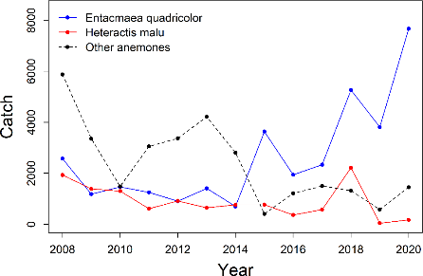

**Figure 4.20. Annual catches (number of individuals) of *Entacmaea quadricolor*, *Heteractis malu***

**and all other anemone species by the MAFMF during 2008-2020.**

*Entacmaea quadricolor*

*Entacmaea quadricolor* (bubbletip anemone) (family Actiniidae) is widespread throughout sub-tropical and tropical waters of the Indo-Pacific area, including the Red Sea and Japan, and across the northern half of Australia. In WA, its range extends south to at least the Houtman-Abrolhos Islands (Geraldton). On the east Australian coast, the species range has been extending southwards since 1990 (Malcolm and Scott 2017). At the same time, severe localised depletions and slow recovery have been documented in some northern areas on the east coast (Frisch *et al.* 2019).

*E. quadricolor* inhabits coral reefs and reef lagoons. Large (up to 40 cm diameter) solitary adults are often found in deeper waters in more dimly lit conditions (Bridge *et al.* 2012). Smaller, younger specimens are often located in groups or colonies nearer to the surface, in bright sunlight. The species is easily recognised by the bulb-like tips on the tentacles. Tentacles are up to 100 mm long and may be various colours.

*E. quadicolor* is a gonochoric, broadcast spawner (Scott and Harrison 2007) and will also readily reproduce asexually under favourable conditions. Juvenile settlement can occur between a few days and a few weeks after spawning (Scott and Harrison 2008).

*E. quadricolor* has mutualistic relationships with 14 anemonefish species and various shrimps and crabs (Fautin and Allen 1997). It is the most abundant and widespread species of host anemone.

*E. quadricolor is* zooxanthellate and so is susceptible to thermal bleaching (Hill *et al.*

2014).

There are no conservation concerns for *E. quadricolor* (not listed).

Annual catches of *E. quadricolor* by the MAFMF have increased over the past 5 years, from 3,636 individuals in 2015 to 7,670 individuals in 2020 (Table 4.11, Figure 4.20). The species comprised 83% of the total anemone catch in 2020. MAFMF catches are reported from Abrolhos Islands to Broome, but mainly occur in Exmouth Gulf and the Dampier area (Figure 4.21).

*Heteractis malu*

*Heteractis malu* (delicate anemone) has a scattered distribution in tropical and warm temperate waters from Australia northwards to Japan, and eastward to Hawaii. It is found burrowing in sediments around coral reefs and reef lagoons. It is most common in shallow, quiet waters. In WA, its distribution extends southwards to Perth and possibly further to the south coast. MAFMF catches of this species have been reported as far south as Albany. *H. malu* is known to have been very abundant in sand and seagrass habitats in Cockburn Sound during the early 1980s (Peterson and Black 1986).

*Heteractis malu* has stout, sparse tentacles up to 40mm in length, with purple tips. The oral disc is brown, purplish or green, with a maximum diameter of 200 mm. Individuals remain buried in sediment up to the level of the oral disc. Individuals can retract completely into the sediment.

*H. malu* is zooxanthellate. It can act as a host for *Amphiprion clarkii.*

There are no conservation concerns for *H. malu*.

During 2008-2020, MAFMF catches of *H. malu* ranged from 43 to 1933 individuals and followed a declining trend over this period (Figure 4.20). During 2019 and 2020 annual catches of *H malu* were 43 and 170 individuals (Table 4.11). The majority of catches have been reported around Perth, with minor quantities also taken in the Exmouth and Dampier areas (Figure 4.21).

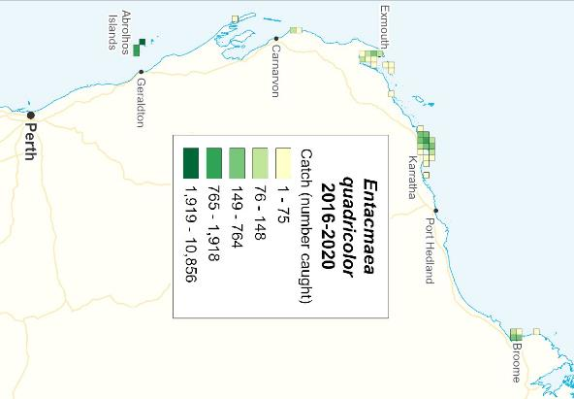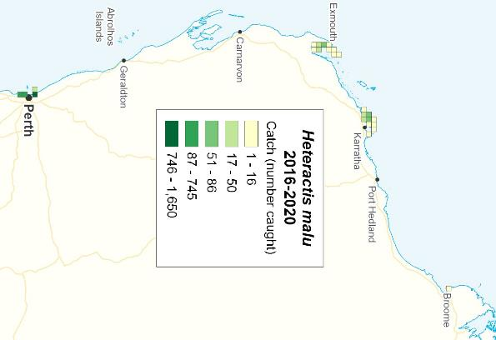

**Figure 4.21. Distribution of total catches (number of individuals) of anemone species *Entacmaea quadricolor* and *Heteractis malu* during 2016-2020.**

#### Corallimorphs

Corallimorphs (Phylum Cnidaria, Class Anthozoa, Order Corallimorpharia) are closely related to hard corals but similar in appearance to anemones. They attach to the substrate by a foot or column and do not create calcareous skeletons. They are not mobile.

Corallimorph species occur in both temperate and tropical marine habitats. They typically form large colonies, which may form a continuous carpet or mat over hard substrates. Reproduction may be sexual but is often asexual via binary fission, resulting in largely clonal colonies. Nutrition is at least partially phototrophic, with zooxanthellae occurring in the body tissues.

Corallimorphs have life history traits, including relatively fast growth and lower susceptibility to bleaching, that allow them to outcompete hard corals in disturbed or degraded environments (Kuguru *et al.* 2007; Norström *et al.* 2009; Jacobs *et al.* 2021).

There are currently 48 recognised species of corallimorphs. However, identification below genus level is difficult based on readily observable morphological differences. During 2016-2020, the annual catch of corallimorphs ranged from 2,077 to 3,339 kg, with the majority reported as ‘Corallimorphidae’ or ‘*Corallimorphus* spp.’ (Appendix Table A7, Figure 4.22). The MAFMF harvests corallimorphs over a wide area of WA from the mid-west region northwards (Figure 4.23).

#### Zoanthids

Zoanthids (Phylum Cnidaria, Class Anthozoa, Order Zoantharia) have the same basic body form as anemones and corallimorphs, i.e., a stalk/foot, a flat oral disc with a mouth in the centre and tentacles around the disc. They are non-calcareous but incorporate sediment from their environment into their body matrix. Zoanthids are usually colonial, with individual animals connected via a fleshy mat or stolon.

Zoanthid species occur in both temperate and tropical marine waters, in shallow and deep water. Many shallow water zoanthids are at least partially phototrophic, with zooxanthellae providing some of their nutrition, supplemented by filter feeding on plankton. Reproduction is primarily asexual, and under favourable conditions can occur quickly through colony extension and fragmentation. Many zoanthids have mutualistic relationships with other species, including sponges and hermit crabs (Ates 2003; Swain and Wulff 2007). Zoanthids are fast growing and can outcompete hard corals in disturbed or degraded environments (Cruz *et al.* 2018).

There are currently around 290 recognised species of zoanthids. Species identification of zoanthids is very difficult due to a lack of clear morphological characters, and therefore MAFMF catches are mostly undifferentiated (Appendix Table A7). The annual MAFMF catch of zoanthids has been trending downwards since 2008 (Figure 4.22). During 2016-2020, the catch of zoanthids ranged from 1,186 to 1,763 kg per year (Table 4.12).

The MAFMF harvests zoanthids over a wide area from Broome to Albany (Figure 4.24).

Under the MAFMF Management Plan, each licensee is subject to a daily limit of no more than 100 litres of Corallimorpharia and no more than 100 litres of Zoantharia (1 litre = 1 kg).

**Table 4.12. Total annual catches (kg) of Corallimorpharia and Zoantharia species reported by the MAFMF during 2016–2020.**

|  |  |  |  |  |  |  |  |
| --- | --- | --- | --- | --- | --- | --- | --- |
| **Order** | **Common Name** | **2016** | **2017** | **2018** | **2019** | **2020** | **Average** |
| Corallimorpharia | Coral-like Anemones | 2077 | 2302 | 3198 | 3050 | 3339 | 2793 |
| Zoantharia | Zoanthid Anemones | 1269 | 1232 | 1763 | 1659 | 1186 | 1422 |

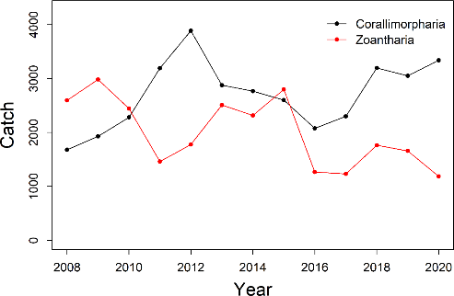

**Figure 4.22. Total annual catches (kg) of Corallimorpharia and Zoantharia species by the MAFMF during 2008-2020.**

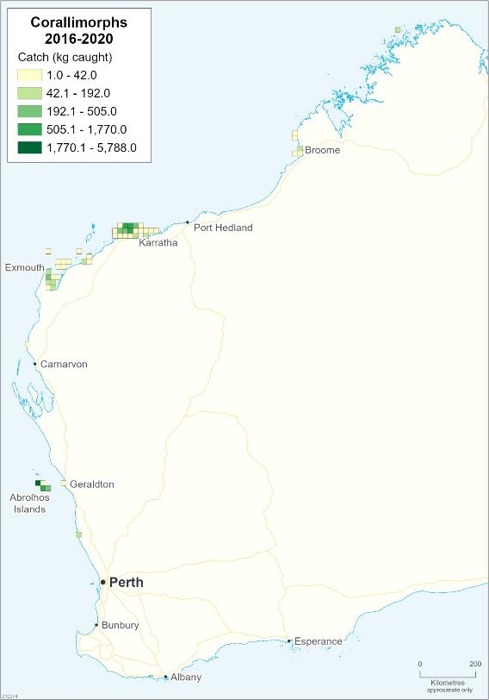

**Figure 4.23. Distribution of total catches of corallimorphs (Order Corallimorpharia) by the MAFMF during 2016-2020.**

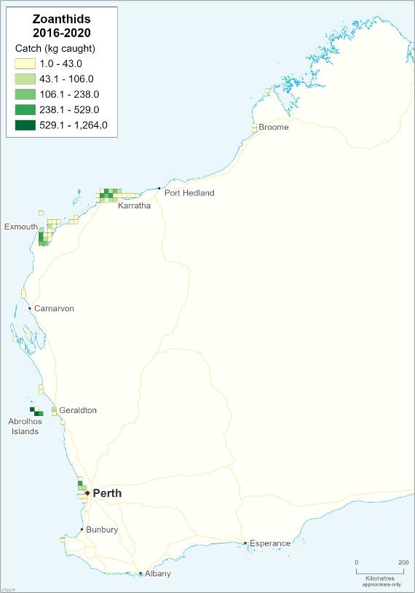

**Figure 4.24. Distribution of total catches of zoanthids (Order Zoantharia) by the MAFMF during 2016-2020.**

#### Giant clams

Three species of giant clams (Phylum Mollusca, Order Bivalvia, Family Cardiidae, Subfamily Tridacninae) are harvested by the MAFMF: *Tridacna maxima, Tridacna squamosa* and *Tridacna noae*.

To date, the vast majority of giant clams taken by the MAFMF have been reported as

*T. maxima*. However, a significant proportion of these catches may actually have been

*T. noae*. *T. noae* is a recently recognised species that was previously misidentified as the morphologically similar *T. maxima* (Borsa *et al.* 2015a, 2015b). Globally, *T. maxima* populations have probably been overestimated in many areas due to confusion with *T. noae* (Neo *et al.* 2017). Recent studies at intertidal and subtidal sites at Ningaloo Reef suggested that *T. noae* was the dominant species and that *T. maxima* was rare or absent at this location (Johnson *et al.* 2016).

Each of the three *Tridacna* species taken by the MAFMF has a wide distribution across the Indo-Pacific region, but with significant genetic structuring across the species range. For each species, individuals in WA appear to belong to a genetically distinct subpopulation that extends across the Indo-Malay-Australia region (i.e., Japan southwards to WA) (Hui *et al.* 2016; Fauvelot *et al.* 2019).

*Tridacna* clams are inhabitants of Indo-Pacific coral reef benthic communities in shallower waters. They live in symbiosis with photosynthetic dinoflagellate algae (*Symbiodinium* spp.) that grow in the mantle tissues. Adult clams receive 70-100 % of their nutrition from the algae and the rest from filter-feeding (Jantzen *et al.* 2008). This symbiosis is an adaptation to living in oligotrophic waters and facilitates the relatively rapid growth of giant clams compared to other bivalves. Photosymbionts are acquired from the environment during the juvenile stage.

*Tridacna* clams are simultaneous hermaphrodites. Individuals initially mature as males but then later develop ovaries, which function simultaneously with the testes. During spawning, sperm are released first, followed by eggs. Gamete release acts as a trigger for nearby clams to spawn, which ensures egg fertilisation. Adults often occur in clusters. Fertilisation rates may be reduced at low clam densities. A planktonic larval phase of 9-12 days allows for dispersal over potentially large distances with the aid of ocean currents. Juvenile settlement is dependent on the presence of suitable substrate.

The maximum lifespans of *Tridacna* clams are poorly known but some species are known to live for several decades or more.

The total annual catch of giant clams (all species) by the MAFMF declined from a maximum of 1,279 individuals in 2010 to a minimum of 230 individuals in 2014, and gradually increased, reaching 654 individuals in 2020 (Table 4.13).

The current harvest rate by the MAFMF is well below the TACC for giant clams (all species combined) which is 2,400 individuals per year (200 per MFL).

Note: CITES Appendix II includes giant clams collectively under the family Tridacnidae, which reflects the taxonomic structure prior to the Tracnidae being

subsumed into the family Cardiidae. Practically, this listing should now reference the subfamily Tridacninae.

**Table 4.13. Total annual catches (number) of giant clams (*Tridacna* spp.) reported by the MAFMF during 2016–2020.**

|  |  |  |  |  |  |  |  |  |
| --- | --- | --- | --- | --- | --- | --- | --- | --- |
| **Species** | **Common Name** | **2016** | **2017** | **2018** | **2019** | **2020** | **Average** | **% of catch** |
| *Tridacna maxima* | Elongate Giant Clam | 207 | 413 | 313 | 320 | 582 | 367 | 78.4% |
| *Tridacna noae* | Noah’s Giant Clam | 100 | 125 | 24 | 16 | 24 | 58 | 12.4% |
| *Tridacna squamosa* | Fluted Giant Clam | 29 | 33 | 45 | 61 | 47 | 43 | 9.2% |
| Tridacna spp. | General Giant Clams | 0 | 0 | 0 | 0 | 1 | 1 | 0.0% |
| TOTAL |  | 336 | 571 | 382 | 397 | 654 | 468 | 100.0% |

*Tridacna maxima*

*Tridacna maxima* (giant elongate clam) has widespread geographic distribution across the Indo-Pacific, similar in range to *T. squamosa* but with more variable population densities across its range compared to *T. squamosa* (Neo *et al.* 2017). In WA, *T. maxima* occurs from the Houtman Abrolhos Islands northwards.

*T. maxima* occurs in shallow areas of reefs and lagoons, up to 20 m, but typically <10

m. It is one of the three boring *Tridacna* species; juveniles are usually fully embedded in the reef substratum (coral or rock), but older individuals eventually outgrow the bored concavity and become only partially embedded. *T. maxima* attains a maximum length of 35-40 cm, but most individuals are <20 cm.

Although *T. maxima* is harvested frequently for subsistence or commercial purposes, and is sought after for the aquarium trade, it is still relatively common globally (Neo *et al.* 2017). The species has been classified by the IUCN as of ‘Lower Risk/Conservation Dependent’.

MAFMF catches of *T. maxima* have been reported between the Houtman Abrolhos Islands and Broome, but mainly in the Exmouth and Dampier area (Figure 4.25).

During 2016-2020, the number of *T. maxima* reported by the MAFMF ranged from 207 to 582 individuals each year and these catches comprised 78% of the total giant clam catch over this period (Table 4.13, Figure 4.26). Many of these catches were probably misidentified *T. noae* and so actual catches of *T. maxima* are likely to have been lower.

The reported harvest level is well below the maximum catch limit of 2360 individuals per year specified in the current NDF for *T. maxima*.

*Tridacna noae*

The global distribution of *Tridacna noae* (Noah’s giant clam) is thought to be broadly similar to that of *T. maxima*. In WA waters, *T. noae* is known to occur at Ningaloo Reef, but has been postulated to occur further south to Shark Bay (Johnson *et al.* 2016; ter Poorten *et al.* 2017).

Given the recent taxonomic ressurection of *T. noae*, the life history and distribution of this species is uncertain and is generally assumed to be similar to *T. maxima*. However, limited evidence suggests some differences in habitat requirements and growth patterns. In the South China Sea, *T. noae* was typically found at shallower depths than *T. maxima* (Neo *et al.* 2018). In Papua New Guinea, observations of

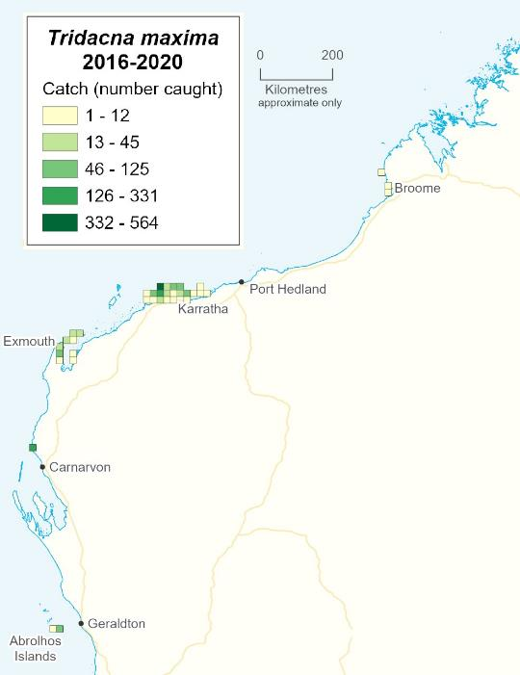

**Figure 4.25. Distribution of reported catches by the MAFMF of giant clam *Tridacna maxima***

**during 2016-2020.**

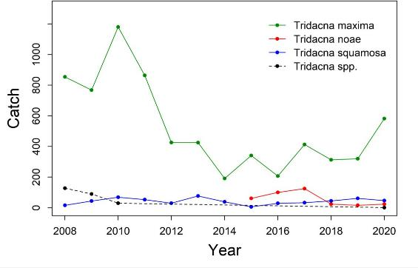

**Figure 4.26. Annual catches (number of individuals) of giant clam species by the MAFMF, 2008- 2020.**

unexploited, co-occuring populations found *T. noae* attained a larger average size compared to *T. maxima*, although both species attain a similar maximum size (~38 cm) (Militz *et al.* 2015).

The conservation status of *T. noae* has not yet been formally assessed.

During 2016-2020, the number of *T. noae* reported by the MAFMF ranged from 16 to 125 individuals per year and these catches comprised 12% of the total giant clam catch over this period (Table 4.13, Figure 4.26). Actual catches of *T. noae* are likely to have been higher due to the misidentification of *T. maxima*.

*Tridacna squamosa*

Globally, *Tridacna squamosa* (fluted giant clam) is the second most common tridacnine species, present from the Red Sea and eastern Africa in the west to the Pitcairn Islands, southern Japan and Queensland (Australia) in the east (Neo *et al.* 2017). In WA, this species occurs from Ningaloo Reef northwards.

*T. squamosa* inhabits reef flats to reef slopes over a wide depth range down to 42 m (Jantzen *et al.* 2008), and is usually found in sheltered sites (e.g. wedged between corals). Juvenile *T. squamosa* are typically byssally attached to coral rubble, while adults may be byssally attached or free-living.

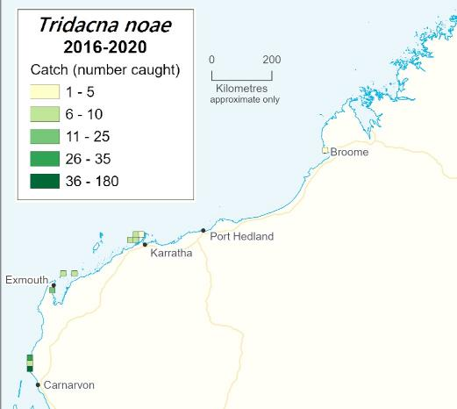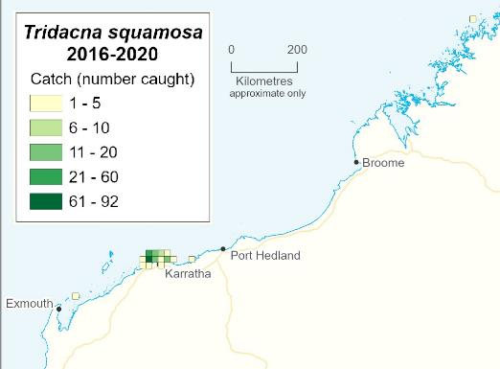

**Figure 4.27. Distribution of reported catches by the MAFMF of giant clams *Tridacna noae* and *T. squamosa* during 2016-2020.**

*T. squamosa* reaches male maturity at approximately 5 cm length (age 3-4 years), female maturity at approximately 15 cm length and a maximum length of 40 cm.

Despite ongoing exploitation, population abundances of *T. squamosa* remain relatively stable across its range (Neo *et al.* 2017). The species is classified by the IUCN as of ‘Lower Risk/Conservation Dependent’.

During 2016-2020, annual catches of *T. squamosa* ranged from 29 to 61 individuals per year and comprised 9% of the total giant clam catch over this period (Table 4.13, Figure 4.26).

This harvest level is well below the maximum catch limit of 578 individuals per year specified in the current NDF for *T. squamosa*.

#### Sponges

Sponges provide various ecosystem services including water filtration, nutrient recycling and habitat formation for many other species.

The sponge community in Pilbara region has high species richness and a high level of species endemism. The nearshore zone of the Pilbara (where MAFMF sponge harvesting occurs) has been described as a ‘biodiversity hotspot’ for sponges and hosts 406 recognised species (Fromont *et al.* 2016).

*Trikentrion flabelliforme* (whiteline sponge) comprises the vast majority (>95% by number) of the sponge catch by the MAFMF (Table 4.14, Appendix A9). It is harvested in the Exmouth and the Dampier areas (Figure 4.28). The annual catch for this species been relatively stable since 2008, fluctuating between 2,154 and 4,560 individuals per year (Figure 4.28).

**Table 4.14. Retained annual catches (number) of sponges reported by the MAFMF during 2016- 2020.**

|  |  |  |  |  |  |  |  |  |
| --- | --- | --- | --- | --- | --- | --- | --- | --- |
| **Species** | **Common Name** | **2016** | **2017** | **2018** | **2019** | **2020** | **Average** | **% of catch** |
| *Trikentrion flabelliforme* | Whiteline Sponge | 3948 | 3267 | 4560 | 2725 | 2154 | 3331 | 97% |
| Porifera - other | Other Sponges | 24 | 42 | 214 | 111 | 114 | 101 | 3% |
| **TOTAL** |  | **3972** | **3309** | **4774** | **2836** | **2268** | **3432** | **100%** |

*T. flabelliforme* occurs around northern Australia, from Exmouth Gulf in WA to Gulf of Carpentaria, and also northwards to Indonesia. In WA, it is mainly found from Exmouth Gulf (Pilbara) to Eclipse Islands (lower Kimberley) and is common across this area (<http://museum.wa.gov.au/online-collections/names/trikentrion-flabelliforme>, accessed 20 Jul 2021). It attaches to rock or dead coral and inhabits turbid marine waters to 30 m depth. *T. flabelliforme* has thick flattened branches or fans with a short basal stalk, up to 30 cm high and is an attractive red or orange colour, frequently

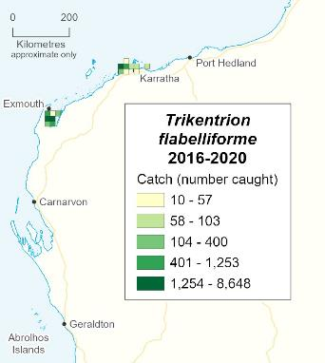

**Figure 4.28. Distribution of total catches of sponge *Trikentrion flabelliforme* by the MAFMF during 2016-2020.**

covered with bands of a (possibly symbiotic) white zoanthid. In turbid waters, the zoanthid may help to prevent sediment accumulating on the sponge surface (Schönberg 2016).

*T. flabelliforme* is hermaphroditic - sperm are broadcast into the water column and captured by another individual, where fertilization occurs. Larvae have a planktonic larval phase which facilitates dispersal before settlement.

There are no conservation concerns for *T. flabelliforme* (not listed).

#### Other invertebrates

The MAFMF harvests hundreds of other invertebrate species that are mostly taken infrequently and in small quantities. These species are often collected opportunistically by MAFMF fishers while targeting other species. Amounts can vary significantly from year to year due to market demand.

The other invertebrate species are grouped into the following broad categories:

**Gastropod Molluscs:** The total annual catch of gastropods has gradually increased from 12,323 individuals in 2008 to 40,518 individuals in 2020 (Figure 4.29, Appendix Table A10). Less than 30% of the recorded catch is identified to family level or lower, but is likely to include dozens of different species. In the past 5 years (2016-2020)

harvesting of gastropods occurred between Perth and Broome, but was most concentrated around Karratha/Dampier (Figure 4.30).

**Cephalopod Molluscs:** Rarely harvested (Appendix Table A11).

**Decapod and Stomatopod Crustaceans (Malacostraca):** During 2016-2020, the total crustacean catch ranged from 5,583 to 18,122 individuals (Figure 4.29, Appendix Table A12). The catch of crustaceans is dominated by various species of crabs, but also includes small numbers of various shrimp and prawn species and, very occasionally, lobsters and mantis shrimp. The crab catch is dominated by marine hermit crabs, which are identified as ‘Diogenidae’ or ‘*Clibanarius* spp.’ in catch records. Recent catches of marine hermit crabs have been concentrated around Broome and Karratha/Dampier.

**Echinoderms:** During 2016-2020, the total echinoderm catch ranged from 2,320 to 7,180 individuals (Appendix Table A13). Catches included sea cucumbers (Class Holothuroidea), sea stars (Class Asteroidea), sea urchins (Class Echinoidea), brittle stars (Class Ophiuroidea) and feather stars (Class Crinoidea) (Figures 4.29, 4.31 and 4.32). Over 50 species/taxa of echinoderms are taken, each in small quantities, typically averaging <100 individuals per year for each taxa (Appendix Table A13).

The most commonly reported species was *Pentagonaster duebeni* (biscuit seastar) wth an average catch of 618 individuals per year during 2016-2020. Catches of this species were spread between Broome and Albany. *P. duebeni* has a very broad distribution around Australia in tropical and temperate waters, up to 160m depth, and is very common across its range (https://bie.ala.org.au/species/urn:lsid:biodiversity.org.au:afd.taxon:bb92a135-1d42- 48f2-967e-59f1ca818576#overview).

**Ascidians:** Rarely harvested (Appendix Table A14).

**Polychaete worms:** Rarely harvested (Appendix Table A14).

Most of the other invertebrate species have low inherent vulnerability to overfishing due to their life history traits. Species with rapid growth, early age at maturity and a high rate of natural mortality typically have high population productivity. A wide geographic range, often maintained by planktonic larval dispersal, results in low vulnerability to localised depletion. Local populations that are replenished annually by recruitment of pelagic larvae irrespective of local adult population abundance have low vulnerability to localised depletion.

For each of the other invertebrate species harvested by the MAFMF, the area over which it is collected is small relative to the total species range. and the quantity taken annually is very small compared to the likely size of the breeding stock.

There are no published conservation concerns for any of the other invertebrate species harvested by the MAFMF.

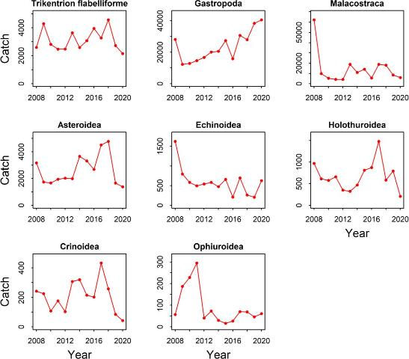

**Figure 4.29. Annual catches (number of individuals) of other invertebrate species by the MAFMF, 2008-2020.**

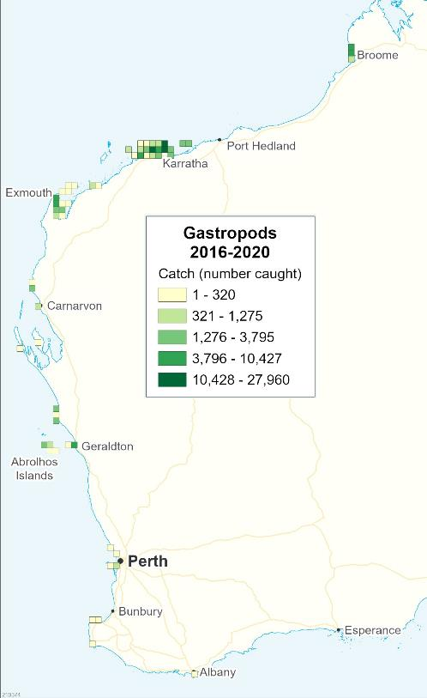

**Figure 4.30. Distribution of total catches of gastropod molluscs by the MAFMF during 2016-2020.**

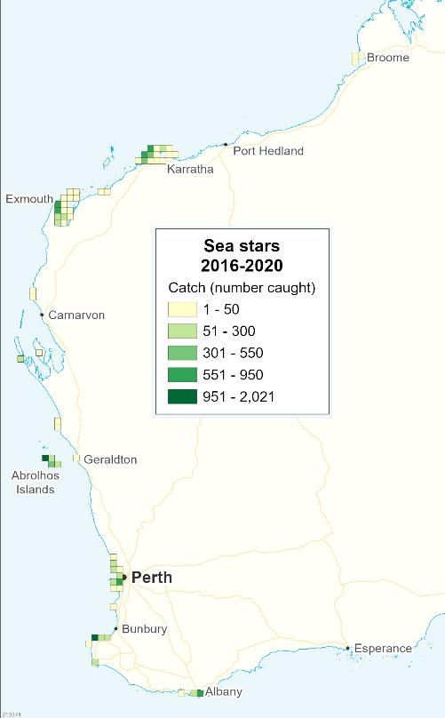

**Figure 4.31. Distribution of total catches of sea stars (Class Asteroidea) by the MAFMF during 2016-2020.**

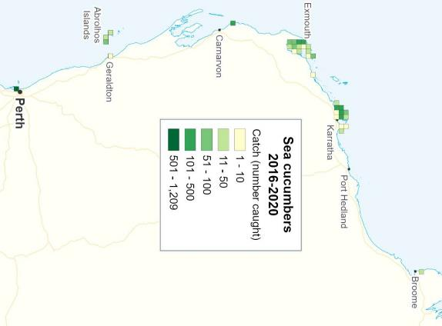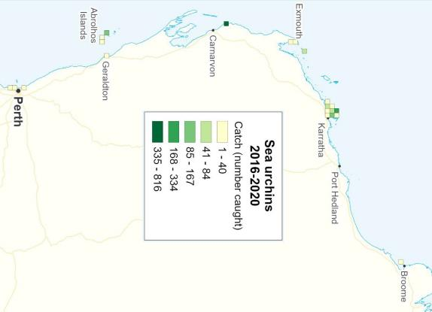

**Figure 4.32. Distribution of total catches of sea cucumbers (Class Holothuroidea) and sea urchins (Class Echinoidea) by the MAFMF during 2016-2020.**

#### Live rock and aquatic plants

‘Live rock’ is the common term used to describe the skeletal remains of hard corals which are encrusted in coralline algae and various other invertebrate species. ‘Live rock’ is defined under Schedule 7 of the Fish Resource Management Regulations 1995 as *“Family Corallinaceae; Classes Polychaeta, Crinoidea, Ascidiacea and Ophiuroidea; Phyla Bryozoa and Porifera; and dead fish of Classes Anthozoa and Hydrozoa”*.

Live rock functions as a habitat and is also an important part of the filtration system in marine aquaria, providing a natural refuge for denitrifying bacteria. The calcium carbonate in live rock may also assist in maintaining desired water chemistry parameters in aquaria, in particular by helping to maintain constant pH by release of calcium carbonate.

Only pieces of a suitable size and appearance are collected. The MAFMF Management Plan stipulates: “*A nominated operator must ensure that live rock is not taken under the authority of the relevant licence unless the whole of any rock, substrate or other substance on or in which the live rock is attached or inhabits is taken with the live rock*.”

The total annual harvest of live rock by the MAFMF has followed a stable trend for the past decade, ranging from 8,621 to 20,595 kg per year during 2010-2020 (Figure 4.33; Appendix Table A14). Live rock is primarily collected around Perth, the Houtman Abrolhos Islands, Exmouth and Karratha (Figure 4.34).

The MAFMF currently harvests very small quantities of aquatic plants (algae and seagrass) (Appendix Table A14). The total harvest of aquatic plants was 19 L in 2019 and 12 L in 2020, taken mainly around Karratha/Dampier.

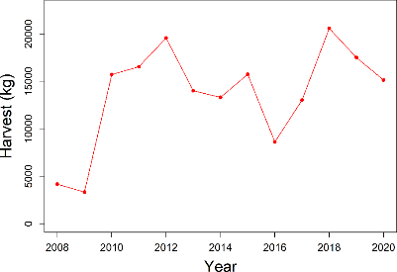

**Figure 4.33. Annual harvest of live rock by the MAFMF, 2008-2020.**

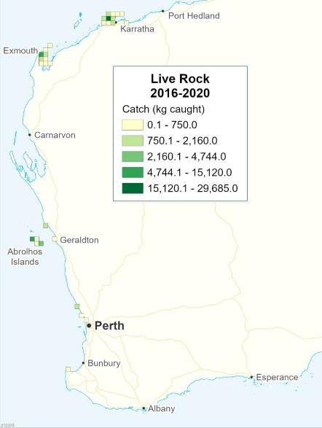

**Figure 4.34. Distribution of total harvest of live rock by the MAFMF during 2016-2020.**

## Bycatch Species

Due to the highly selective nature of the hand collecting method used by the MAFMF, there is no incidental capture of non-target species. All captured species are retained.

Some of the target species collected by the MAFMF, such as corals, seagrass and live rock, can provide habitat for small invertebrates such as bryozoans, brittle stars, shrimps and crabs. Divers typically try to ensure that target species are free of any other species prior to returning to the vessel.

## Ecological Impacts

#### Threatened, Endangered and Protected Species (TEPS)

In WA commercial fishers are required (since 2005/06) to report any interactions with TEPS species in their statutory fishing returns that are lodged with the Department. The Department publishes a summary of all fishery-TEPS interactions annually.

Numerous TEPS occur in WA waters, including marine reptiles (turtles, sea snakes, etc), marine mammals (whales, dolphins, sea lions, dugongs, etc), elasmobranchs (sharks, sawfish, rays), syngnathids (seahorses, seadragons, pipefish), invertebrates (hard corals, giant clams, etc), seabirds and migratory shorebirds. These species are protected by various international agreements and by national and state legislation.

The MAFMF is permitted under national and state legislation to harvest hard coral, giant clams and seahorse species, which are protected species listed under the EPBC Act and under CITES Appendix II.

As an export fishery, the MAFMF requires a Declaration of an Approved Wildlife Trade Operation (WTO) to be issued by Australia’s Department of Agriculture, Water and the Environment (see Section 4.3). A WTO may contain conditions that are intended to ensure the operation of the fishery is consistent with the provisions of the EPBC Act. These conditions include following catch limits specified under a ‘Non-Detriment Finding’ (NDF) for each CITES listed species. NDFs must be made for each CITES species before a WTO can be approved.

NDFs are prepared in accordance with strict guidelines endorsed by CITES signatory nations and take into consideration all factors which could potentially affect the long term sustainability of listed species. NDFs are updated periodically to capture additional data as it becomes available.

Apart from the retained species mentioned above, there have been no interactions with any other TEPS reported by MAFMF operators. Due to the highly selective fishing method (hand collection) and the location of most fishing activity in coastal waters, there are unlikely to be incidental interactions with TEPS by the MAFMF.

#### Habitats

The MAFMF is a statewide hand collection diving/wading fishery with a small number of licence holders (n=12) operating from small trailer boats. Not all fishers are active each year.

Impacts on tidal and shallow (<30 m) subtidal benthic habitats by the MAFMF could potentially occur from anchoring, and during wading or diving to collect sessile benthic organisms such as corals or sponges. Since all fishing is highly targeted and undertaken by hand, the removal of benthic species can be undertaken with minimal damage to the surrounding reef area. The collection of fish and mobile invertebrates with small nets is likely to have little impact on benthic habitats.

The MAFMF total fishing effort is <600 days per year, and this is spread across tidal and subtidal benthic habitats over a large length of coastline (Figure 4.2). This

relatively low and dispersed fishing effort is likely to cause minimal impact to benthic habitats. At a regional level, the risks to benthic habitats are further mitigated by numerous closed areas in the fishery (Figure 4.1).

For the purpose of this assessment, corals and ‘live rock’ are considered under targeted retained species rather than habitat.

#### Ecosystem Structure

*Trophic interactions*

Many of the species harvested by the MAFMF, including coral, anemones and sponges, are habitat-forming, and many have symbiotic relationships with other species such as shrimp or fish. Removals by the MAFMF are likely to have localised impacts on associated species.

The relatively low quantities of individual species, or taxonomic groups, removed by the MAFMF each year over a wide area are unlikely to disrupt ecosystem structure and function to a point where there would be serious or irreversible harm.

*Translocation (pests and disease)*

Pests and diseases may be transferred via vessels in wet areas such as bilges, decks, anchor wells and sea chests and in niche areas of the hull. Fishing vessels may present additional areas including on wet fishing gear or holding tanks. Overall, fishing vessels are typically rated very low risk in terms of translocation of marine pests and diseases at an international scale but examples of local transmission of pest species such as *Undaria pinnatifida* can be identified (Bridgwood and McDonald 2014).

Given that commercial fishers are not permitted to use their boats or gear outside of Australian waters, the risk of international transmission of introduced marine pests and diseases is effectively zero. This suggests a negligible risk of translocation of pests and diseases due to the activity of this fishery.

*Ghost fishing*

The MAFMF uses small nets that are deployed by hand. Nets are always retrieved, negating the possibility of ghost fishing.

#### Broader Environment

*Air and water quality*

Commercial fishing vessels use fuel and emit greenhouse gases, which can potentially impact on air quality. Fishing vessels also have the potential to reduce water quality through discarding of debris and litter as well as by accidental oil and fuel spills.

In 2020 there were 19 MAFMF vessels actively fishing for the Resource, with an average annual effort of 31 fishing days per vessel. This fleet operates over a large geographical area and the impact of vessel emissions on air quality over this area is expected to be minor.

The MAFMF operates over a large geographical area and the impact of accidental spills on water quality over this area is expected to be negligible. MAFMF fishers do not use packaged bait, reducing the likelihood of littering.

*Noise pollution*

Water is an efficient medium for transporting sound waves. In the marine environment sound transmission is highly variable and can be dependent on the acoustic properties of the seabed and surface, variations in sound speed and the temperature and salinity of the water (Richardson *et al.* 1995). For most marine animals, sound is important for communication; for locating their prey and peers; and for short-range and long- range navigation (Erbe *et al.* 2016; Hawkins and Popper 2017).

Noise from vessels, active sonar, synthetic sounds (artificial tones and white noise), acoustic deterrent devices, seismic surveys and noise from energy and construction infrastructure, are all known to affect marine animals (Duarte *et al.* 2021). Both chronic and acute noise pollution can cause detectable effects on intra-specific communication, vital processes, physiology, behavioural patterns (e.g. larval settlement, predator avoidance), health status and survival (e.g. Di Franco *et al.* 2020).

Little is known regarding specific effects of noise pollution on most marine species in Australia. However, globally, there is strong evidence for noise impacts on marine mammals, and numerous studies have also found impacts for fishes and invertebrates, marine birds, and reptiles (Duarte *et al.* 2021).

Noise generated by the MAFMF is likely to have a minimal impact on marine organisms because of the low and dispersed nature of fishing effort and the use of small vessels.

# External Factors

While a number of external influences on the Resource have the potential to impact on the productivity and sustainability of the fisheries and the broader ecosystem in the future (e.g. coastal developments, dredging and climate change), these were not explicitly assessed in this ERA (see ‘Scope’ Section 6.1).

# Risk Assessment Methodology

Risk assessments have been extensively used as a means to filter and prioritise the various fisheries management issues identified in Australia (Fletcher *et al.* 2002). The

risk analysis methodology used for this assessment is based on the global standard for risk assessment and risk management (AS/NZS ISO 31000), which has been adopted for use in a fisheries context (see Fletcher *et al.* 2002; Fletcher 2005; Fletcher 2015). The broader risk assessment process is summarised in Figure 6.1.

The first stage establishes the context or scope of the risk assessment, including determining which activities and geographical extent will be covered, a timeframe for the assessment and the objectives to be delivered (Section 6.1). Secondly, risk identification involves the process of recognising and describing the relevant sources of risk (Section 6.2). Once these components have been identified, risk scores are determined by evaluating the potential consequences (impacts) associated with each issue, and the likelihood (probability) of a particular level of consequence actually occurring (Section 6.3).

Risk evaluation is completed by comparing the risk scores to established levels of acceptable and undesirable risk to help inform decisions about which risks need treatment. For issues with levels of risk that are considered undesirable, risk treatment involves identifying the likely monitoring and reporting requirements and associated management actions, which can either address and/or assist in reducing the risk to acceptable levels.

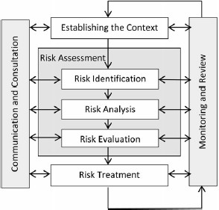

**Figure 6.1. Position of risk assessment within the risk management process.**

## Scope

This risk assessment covers the ecological impacts of harvesting the Resource by all sectors, including commercial fishing (i.e., the MAFMF), recreational fishing and harvesting under Ministerial Exemptions or other permits.

The calculation of risk in the context of a fishery is usually determined within a specified period, which for this assessment is the next five years (i.e., until the end of 2025).

For the purpose of this assessment, risk is defined as *the uncertainty associated with achieving a specific management objective or outcome* (adapted from Fletcher 2015). For the Department, ‘risk’ is the chance of something affecting the agency’s performance against the objectives laid out in their relevant legislation. In contrast, for the commercial fishing industry, the term ‘risk’ generally relates to the potential impacts on their long-term profitability. For the general community, ‘risk’ could relate to possible impact on their enjoyment of the marine environment. The aim for each of these groups is to ensure the ‘risk’ of an unacceptable impact is kept to an acceptable level.

An important part of the risk assessment and risk management process is communication and consultation with stakeholders. Ecological risk assessments undertaken by the Department typically engage all stakeholders of the fishery to participate in a workshop for collectively scoring risk issues. This allows the assessment to consider not only the ecological sustainability of the fishing activities but also how different external environmental, social and economic drivers may affect the performance of the fishery. The current assessment considers only the ecological impacts of fishing, as required to inform the Harvest Strategy for the Resource.

## Risk Identification

The first step in the risk assessment process is to identify issues relevant to the Resource being assessed. Issues are identified using a ‘component tree’ approach, where major risk components are deconstructed into smaller sub-components that are more specific to allow the development of operational objectives (Fletcher *et al.* 2002). The component trees are tailored to suit the individual circumstances of the Resource being examined by adding and expanding some components and collapsing or removing others.

The development of the preliminary component tree (Figure 6.2) for evaluating the ecological sustainability of the Resource was based on:

* + - previous risk assessments of the MAFMF undertaken in 2004 and 2014 (Smith et al. 2010; DPIRD 2018a);
    - risks identified during previous Commonwealth assessments under Parts 13 and 13A of the EPBC Act; and
    - an internal workshop undertaken by Departmental staff in October 2021.

There was an opportunity to modify the preliminary component tree during the ERA workshop held on 4 November 2021.

## Risk Assessment Process

The risk analysis process assists in separating minor acceptable risks from major, unacceptable risks and prioritising management actions. Once the relevant components and issues for the fishery are identified, the process to prioritise each is undertaken using the ISO 31000-based qualitative risk assessment methodology. This

methodology utilises a consequence-likelihood analysis, which involves examining the magnitude of potential consequences from fishing activities and the likelihood that those consequences will occur given current management controls (Fletcher 2015).

Marine Mammals

Coral reef

Trophic interactions

Reptiles

Sand & mud

Pests & disease

Birds

Vegetation

Ghost fishing

Noise pollution

Water quality

Air quality

Broader

Environment

Ecosystem

Structure

Benthic

Habitats

Marine Aquarium Fish Resource

Live rock &

aquatic plants

Other

invertebrates

Giant clams

Sponges

Anemones

Corallimorphs & Zoanthids

Soft Coral

Hard coral

Syngnathids

Fish

TEP Species

Retained

Species

**Figure 6.2. Preliminary component tree for assessing the ecological sustainability of the Marine Aquarium Fish Resource.**

Although consequence and likelihood analyses can range in complexity, this assessment utilised a 4×4 matrix (Figure 6.3). The consequence levels ranged from 1 (e.g. minor impact to fish stocks) to 4 (e.g. major impact to fish stocks) and likelihood levels ranged from 1 (Remote; i.e., < 5% probability) to 4 (Likely; i.e. ≥ 50% probability). Scoring involved an assessment of the likelihood that each level of consequence is occurring, or is likely to occur within the 5-year period specified for this assessment. If an issue is not considered to have any detectable impact, it can be considered to be a 0 consequence; however, it is preferable to score such components as there being a remote (1) likelihood of a minor (1) consequence.

The assessment used a set of pre-defined likelihood and consequence levels (see Appendix B). In total four consequence tables were used in the risk analysis to accommodate the variety of issues and potential outcomes:

1. Target/retained species – measured at a stock level;
2. TEP species – measured at a population or regional level;
3. Habitats – measured at a regional level; and
4. Ecosystem/Environment – measured at a regional level.

For each risk issue, the consequence and likelihood scores were evaluated to determine the highest risk score using the risk matrix (Figure 6.3). Each issue was thus assigned a risk level within one of five categories: Negligible, Low, Medium, High or Severe (Table 6.1).

An external stakeholder ERA workshop was held at the Western Australian Fisheries and Marine Research Laboratories on 4 November 2021. A broad range of stakeholders were invited to participate in the ERA workshop (Appendix C).

|  |  |  |  |  |  |
| --- | --- | --- | --- | --- | --- |
|  | | **Likelihood** | | | |
| Remote (1) | Unlikely (2) | Possible (3) | Likely (4) |
| **Consequence** | Minor (1) | Negligible | Negligible | Low | Low |
| Moderate (2) | Negligible | Low | Medium | Medium |
| High (3) | Low | Medium | High | High |
| Major (4) | Low | Medium | Severe | Severe |

**Figure 6.3. 4×4 Consequence – Likelihood Risk Matrix (based on AS 4360 / ISO 31000).**

**Table 6.1. Risk levels applied to evaluate individual risk issues (modified from Fletcher 2005).**

|  |  |  |  |
| --- | --- | --- | --- |
| **Risk Levels** | **Description** | **Likely Reporting & Monitoring Requirements** | **Likely Management Action** |
| Negligible | Acceptable; Not an issue | Brief Notes – no monitoring | Nil |
| Low | Acceptable; No specific control measures needed | Full Notes needed – periodic monitoring | None specific |
| Medium | Acceptable; With current risk control measures in place (no new management required) | Full Performance Report – regular monitoring | Specific management and/or monitoring required |
| High | Not desirable; Continue strong management actions OR new / further risk control measures to be introduced in the near future | Full Performance Report – regular monitoring | Increased management activities needed |
| Severe | Unacceptable; Major changes required to management in immediate future | Recovery strategy and detailed monitoring | Increased management activities needed urgently |

# Risk Analysis

Twenty-one broad ecological components were identified as potentially impacted by the Marine Aquarium Fish Managed Fishery (Figure 7.1). Where relevant, some of these were further separated into smaller categories to score the risks for individual species or groups of species, resulting in 43 individual ecological components that were assessed.

For retained species, the risks from fishing by the MAFMF and other fishing sectors (if any) were assessed together as the cumulative risk. For all other components, the risk from fishing by the MAFMF only was assessed.

Risk ratings assumed that existing fishery management arrangements would continue to apply for the next five years. For most retained species, it was assumed that annual harvesting by the MAFMF could potentially occur at levels equal to, but not exceeding, the Thresholds specified in the 2018-2022 Resource Harvest Strategy (DPIRD 2018b). The majority of species are currently harvested at levels well below the Threshold, and so this assumption resulted in a precautionary risk rating for these species.

The risk ratings for each ecological component considered in the assessment are summarised in Table 7.1. The risk justifications given below include comments from stakeholders that attended the workshop. While these are a summary of individual views and may not be representative of every stakeholder at the workshop, the risk scores are reflective of the group consensus at the workshop.

Sea snakes

Coral & rocky reef

Trophic interactions

Other TEP species

Sand & mud

Pests & disease

Seagrass & macroalgae

Ghost fishing

Noise pollution

Water quality

Air quality

Broader

Environment

Ecosystem

Structure

Habitats

Marine Aquarium Fish Fishery

Live rock and aquatic plants

Other invertebrate species

Giant clams

Sponges

Anemones

Corallimorphs and

Zoanthids

Soft Coral

Hard coral

Syngnathiformes

Fish (non- Syngnathiform)

ETP Species

Retained Species

**Figure 7.1. Final component tree for assessing the ecological sustainability of the fishery for the Marine Aquarium Fish Resource.**

**Table 7.1. Overview of the objectives, components, and risk scores and ratings considered in the 2021 ecological risk assessment of the fishery for the Marine Aquarium Fish Resource.**

|  |  |  |  |  |  |
| --- | --- | --- | --- | --- | --- |
| **Aspect** | **Fishery Objective** | **Component** | **Issues** | **Risk Scoring** | **Risk rating** |
|  |  | *Hippocampus subelongatus* | All fishing on stock | C2, L1 | NEGLIGIBLE |
|  |  | *Hippocampus angustus* | All fishing on stock | C1, L1 | NEGLIGIBLE |
|  |  | All other syngnathiform species | All fishing on stock | C1, L1 | NEGLIGIBLE |
|  |  | *Chaetodontoplus duboulayi* | All fishing on stock | C1, L1 | NEGLIGIBLE |
|  |  | *Ambassis vachellii* | All fishing on stock | C1, L2 | NEGLIGIBLE |
|  |  | *Chromis atripectoralis* | All fishing on stock | C1, L2 | NEGLIGIBLE |
|  |  | *Chelmon marginalis* | All fishing on stock | C1, L1 | NEGLIGIBLE |
|  |  | *Anampses lennardi* | All fishing on stock | C1, L1 | NEGLIGIBLE |
|  |  | *Amphiprion clarkii* | All fishing on stock | C1, L1 | NEGLIGIBLE |
|  | To maintain biomass of | *Heterodontus portusjacksoni* | All fishing on stock | C1, L1 | NEGLIGIBLE |
| each retained species at |
|  | All other fish species | All fishing on stock | C1, L2 | NEGLIGIBLE |
| Retained species | a level where the main factor affecting |
| *Fimbriaphyllia ancora* | All fishing on stock | C2, L3 | MEDIUM |
|  | recruitment is the |
|  | *Fimbriaphyllia paraancora* | All fishing on stock | C2, L3 | MEDIUM |
| environment |
|  |  | *Euphyllia glabrescens* | All fishing on stock | C2, L2 | LOW |
|  |  | *Catalaphyllia jardinei* | All fishing on stock | C2, L3 | MEDIUM |
|  |  | *Australophyllia wilsoni* | All fishing on stock | C2, L3 | MEDIUM |
|  |  | *Trachyphyllia geoffroyi* | All fishing on stock | C2, L2 | LOW |
|  |  | *Duncanopsammia axifuga* | All fishing on stock | C1, L2 | NEGLIGIBLE |
|  |  | *Moseleya latistellata* | All fishing on stock | C1, L1 | NEGLIGIBLE |
|  |  | *Lobophyllia hemprichii* | All fishing on stock | C1, L2 | NEGLIGIBLE |
|  |  | All other hard coral species | All fishing on stock | C1, L1 | NEGLIGIBLE |
|  |  | All soft coral species | All fishing on stock | C1, L1 | NEGLIGIBLE |

|  |  |  |  |  |  |
| --- | --- | --- | --- | --- | --- |
|  |  | All anemone species | All fishing on stock | C1, L2 | NEGLIGIBLE |
|  | | Corallimorpharia | All fishing on stock | C1, L1 | NEGLIGIBLE |
| Zoantharia | All fishing on stock | C1, L1 | NEGLIGIBLE |
| All *Tridacna* species (giant clams) | All fishing on stock | C1, L2 | NEGLIGIBLE |
| All sponge species | All fishing on stock | C1, L1 | NEGLIGIBLE |
| All gastropod species | All fishing on stock | C1, L1 | NEGLIGIBLE |
| All other invertebrate species | All fishing on stock | C1, L1 | NEGLIGIBLE |
| Live rock | All fishing on stock | C1, L1 | NEGLIGIBLE |
| Aquatic plants | All fishing on stock | C1, L1 | NEGLIGIBLE |
| Bycatch Species |  | (No bycatch in fishery) | MAFMF | - | NA |
| TEPS (non- retained/incidental interactions) | To ensure fishing impacts do not result in serious or irreversible harm to TEP species’ populations | Sea snakes | MAFMF | C1, L1 | NEGLIGIBLE |
| All other TEP species | MAFMF | C1, L1 | NEGLIGIBLE |
|  | To ensure the effects of fishing do not result in serious or irreversible harm to habitat structure and function | Reefs | MAFMF | C1, L3 | LOW |
| Habitats | Seagrass & macroalgae | MAFMF | C1, L2 | NEGLIGIBLE |
|  | Sand & mud | MAFMF | C1, L1 | NEGLIGIBLE |
|  | To ensure the effects of fishing do not result in serious or irreversible harm to ecological processes | Trophic interactions | MAFMF | C1, L1 | NEGLIGIBLE |
| Ecosystem  structure | Translocation (pests & diseases) | MAFMF | C1, L2 | NEGLIGIBLE |
| Ghost fishing (lost gear) | MAFMF | C1, L1 | NEGLIGIBLE |
|  | To ensure the effects of fishing do not result in serious or irreversible harm to the broader environment | Air quality | MAFMF | C1, L1 | NEGLIGIBLE |
| Broader  environment | Water quality | MAFMF | C1, L1 | NEGLIGIBLE |
| Noise pollution | MAFMF | C1, L1 | NEGLIGIBLE |

## Fish

Fish (non- syngnathiform)

Retained species

Other syngnathiform species

*Hippocampus subelongatus*

*Hippocampus angustus*

Syngnathiformes

*Heterodontus portusjacksoni*

Other fish species

*Anampses lennardi*

*Amphiprion clarkii*

*Chromis atripectoralis*

*Chelmon marginalis*

*Chaetodontoplus duboulayi*

*Ambassis vachellii*

#### Hippocampus subelongatus

Risk Rating: Impact of all fishing on the WA stock of *Hippocampus subelongatus*

(C2×L1 = NEGLIGIBLE)

* + - Life history traits suggest high inherent vulnerability to overfishing.
    - MAFMF catch is mainly taken around Perth; fishers report this species is very common in Swan-Canning Estuary, but MAFMF is not allowed to harvest in this area.
    - Environmental factors affect species availability. Fishers observe large annual fluctuations in abundance in Cockburn Sound and Swan-Canning Estuary, suggesting recruitment variations. Also, observed to shift to deeper seagrass beds in response to flooding/freshwater flows from estuary.
    - Fishers report extended breeding season by this species (“*they breed all year round*”).
    - Current catch level is well below Threshold. Catches are constrained by management arrangement and limited market demand. Also, fishers report a lot of ‘red tape’ required to export, which is a disincentive to target seahorses. Additionally, the species is cryptic, difficult to find.
    - Implementation of individual catch entitlements (ranging from 58 to 753 syngnathiform fish per licensee), plus a total fishery syngnathiform quota of 2000, makes it unlikely that the Threshold level of 2000 *H. subelongatus* will be reached in future.
    - Major catch decline in 2014 reflected adoption of current management arrangements.
    - Risk rating reflects current catch level which is constrained by current management arrangements.
    - At the current catch level, the likelihood of a moderate impact was considered remote.

#### Hippocampus angustus

Risk Rating: Impact of all fishing on the WA stock of *Hippocampus angustus* (C1×L1 = NEGLIGIBLE)

* + - Life history traits suggest high inherent vulnerability to overfishing.
    - Tropical species. Fishers report this species is “more widespread than *H. subelongatus*”. Associated with sponge gardens.
    - Not targeted, mainly taken by MAFMF opportunistically when harvesting coral or other species. Not as profitable to harvest as corals. Also, *H. angustus* is difficult to find, more cryptic than *H. subelongatus*. Catches expected to remain at current level.
    - MAFMF catches are very small and well below Threshold of 328 individuals per year, reflecting low level of targeting. Threshold is small compared to likely size of WA stock.
    - The likelihood of the Threshold catch level having even a minor impact on stock was considered remote.

### Other syngnathiform species

Risk Rating: Impact of all fishing on the WA stocks of other syngnathiform species (C1×L1 = NEGLIGIBLE)

* + - *Stigmatopora argus* was assessed as a member of this group.
    - Life history traits of most syngnathiform species suggest high inherent vulnerability to overfishing.
    - MAFMF harvests very low quantities of other syngnathiform species. All species catches are currently well below Threshold levels.
    - There is a Threshold of 100 individuals per year for each syngnathiform species. In addition, there is a total fishery syngnathiform quota of 2000 individuals per year and licensees are restricted to individual entitlements

ranging from 58 to 753 syngnathiform fish per licensee. These management arrangements effectively constrain catches of other syngnathiform species to low levels.

* + - In addition to MAFMF catches, potentially up to 70 syngnathids permitted to be harvested statewide by commercial exemption holders (3 public aquariums).
    - MAFMF fishers report only smaller seadragons are targeted because larger ones very difficult to keep and transport. Fishers noted that seadragons tend to accumulate in eddys and bays.
    - Risk rating reflects current catch levels which are constrained by current management arrangements.
    - The likelihood of the current catch levels having even a minor impact on stocks was considered remote.

#### Chaetodontoplus duboulayi

Risk Rating: Impact of all fishing on the WA stock of *Chaetodontoplus duboulayi*

(C1×L1 = NEGLIGIBLE)

* + - Available life history information suggests low/medium inherent vulnerability to overfishing.
    - Species also found in deeper waters not fished by MAFMF; relatively high numbers of this species reported to be caught as bycatch by trawlers in northern WA, suggesting the species is abundant in deeper waters.
    - MAFMF Threshold of 5,054 individuals per year is small compared to likely size of WA stock.
    - Current MAFMF harvest is below Threshold; MAFMF harvest declining since 2018 and expected to be stable or decline further over next 5 years; a limited market constrains the catch.
    - The likelihood of the Threshold catch level having even a minor impact on stock was considered remote.

#### Ambassis vachellii

Risk Rating: Impact of all fishing on the WA stock of *Ambassis vachellii* (C1×L2 = NEGLIGIBLE)

* + - Life history traits suggest low inherent vulnerability to overfishing.
    - Current harvest by MAFMF is small compared to likely size of WA stock.
    - Only reported by MAFMF since 2015, so not explicitly considered in current Harvest Strategy. Thus a default Threshold of 100 individuals per year currently applies to this species. Current catch level greatly exceeds this Threshold.
    - The current catch level was considered unlikely to have a measurable impact on the stock.

#### Chromis atripectoralis

Risk Rating: Impact of all fishing on the WA stock of *Chromis atripectoralis* (C1×L2 = NEGLIGIBLE)

* + - Life history traits suggest medium inherent vulnerability to overfishing.
    - Wide Indo-Pacific distribution; commonly targeted across this range; reported to have been overfished in some regions (outside of Australia).
    - Current MAFMF harvest is well below Threshold; declining annual harvest due to limited targeting; harvest over next 5 years expected to remain at current level.
    - MAFMF Threshold of 6,130 individuals per year is small compared to likely size of WA stock.
    - The Threshold catch level was considered unlikely to have a measurable impact on the stock.

#### Chelmon marginalis

Risk Rating: Impact of all fishing on the WA stock of *Chelmon marginalis* (C1×L1 = NEGLIGIBLE)

* + - Life history traits suggest low inherent vulnerability to overfishing.
    - Current MAFMF harvest is well below Threshold; harvest over next 5 years expected to remain at current level.
    - MAFMF Threshold of 3,012 individuals per year is small compared to likely size of WA stock.
    - The likelihood of the Threshold catch level having even a minor impact on stock was considered remote.

#### Anampses lennardi

Risk Rating: Impact of all fishing on the WA stock of *Anampses lennardi* (C1×L1 = NEGLIGIBLE)

* + - Life history traits suggest low/medium inherent vulnerability to overfishing.
    - Fast swimming, difficult to catch.
    - Current MAFMF harvest is below Threshold; harvest over next 5 years expected to remain at current level.
    - MAFMF Threshold of 3,012 individuals per year is small compared to likely size of WA stock.
    - The likelihood of the Threshold catch level having even a minor impact on stock was considered remote.

#### Amphiprion clarkii

Risk Rating: Impact of all fishing on the WA stock of *Amphiprion clarkii* (C1×L1 = NEGLIGIBLE)

* + - Life history traits suggest medium/high inherent vulnerability to overfishing.
    - Current MAFMF harvest is well below Threshold; declining MAFMF harvest due to limited targeting; limited market because captive-bred anemonefish replacing wild fish in the global aquarium trade; harvest over next 5 y expected to remain at current level.
    - MAFMF Threshold of 1,870 individuals per year is small compared to likely size of WA stock.
    - The likelihood of the Threshold catch level having even a minor impact on stock was considered remote.

#### Heterodontus portusjacksoni

Risk Rating: Impact of all fishing on the Australian stock of *Heterodontus portusjacksoni* (C1×L1 = NEGLIGIBLE) based on recent external assessments.

* + - Status of the Australian stock of *H. portusjacksoni* was assessed across its range as ‘sustainable’ in 2019 (Simpfendorfer *et al.* 2019).
    - In March 2021, the impact from of all types of fishing on *H. portusjacksoni* in WA was assessed as ‘Negligible’ (Watt *et al.* 2001).
    - The likelihood of the Threshold catch level having even a minor impact on stock was considered remote.

### Other fish species

Risk Rating: Impact of all fishing on the WA stocks of all other fish species (C1×L2 = NEGLIGIBLE).

* + - *Istiblennius meleagris* was assessed as a member of this group.
    - Recent MAFMF catches of other fish include a further 376 taxa; each species catch is small (typically <500 individuals/year); these species generally not harvested by any other WA fisheries.
    - Majority of these other fish have wide species distributions across Indo-West Pacific, many are relatively common. There are gaps in knowledge about the life history traits of most other fish species.
    - MAFMF current catch levels of other fish species are very small relative to their likely stock sizes, suggesting a negligible/low risk to each species.
    - Specific Thresholds apply to some species, otherwise a default Threshold of 100 applies. Thresholds have been recently breached for a few fish species.
    - Threshold catch levels were considered unlikely to have a measurable impact on stocks.

## Corals, anemones, corallimorphs & zoanthids

Zoanthids

Corallimorphs

Anemones

Soft coral

Hard coral

Retained species

Other hard corals

*Lobophyllia hemprichii*

*Moseleya latistellata*

*Duncanopsamma axifuga*

*Trachyphyllia geoffroyi*

*Australophyllia wilsoni*

*Catalaphyllia jardinei*

*Euphyllia glabrescens*

*Fimbriaphyllia paraancora*

*Fimbriaphyllia ancora*

#### Fimbriaphyllia ancora

Risk Rating: Impact of all fishing on the WA stock of *Fimbriaphyllia ancora* (C2×L3 = MEDIUM).

* + - Fishers report that *F. ancora* is abundant in areas where harvesting occurs. Fishers have observed increasing abundance of this coral around port areas (e.g. Dampier) used by the mining industry, where high levels of turbidity are favourable to species such as *F. ancora* that prefer ‘dirty’ water.
    - For more than a decade the vast majority of harvest of this species has been taken from Karratha and Exmouth areas each year. Fishers contend that this is evidence that the breeding stock level in each area is being maintained, and that fishing is not causing localised depletion.
    - Recent FRDC-funded survey in Karratha area confirms *F. ancora* is relatively abundant in that area. No surveys have been conducted in other areas.
    - Recent catches in the Broome area and Kimberley region adjacent to NT border represent a northward expansion of the fishery area for this species. Fishers state this shift reflected changes in the location of home ports for two fishers - one licensee moved to Broome recently and another licence was leased to an NT-based fisher who travels into WA to fish. Thus the shift in fishery area occurred for reasons of convenience, and not because historical fishing grounds became depleted.
    - Fishery area for this species comprises a small fraction of the total species range in WA, with many parts of the range not fished.
    - The vast majority of colonies are brown and not targeted due to their low value. Only certain colours are collected. Fishers believe that colour is not genetically determined but rather is environmentally determined by light exposure and depth. Fishers report that colonies can change colour if moved to new location.
    - The annual MAFMF harvest exceeded the Threshold (1,211 kg) in 2018/19 and 2019/20, and was slightly above the Threshold in 2020/21 (exact 2020/21 catch not presented at workshop, but DPIRD subsequently advised it was 1,384 kg).
    - Commercial fishing sector strongly believes that the Threshold level of 1,211 kg per year has minimal impact on stock.
    - More data about this species are required to reduce uncertainty about sustainable harvest levels. Information on growth-related traits is needed to assess population productivity and resilience. Monitoring of abundance trends is needed, particularly in fished areas, to assess whether localised depletion is occurring.
    - Workshop agreed to rate the Threshold catch level as MEDIUM risk, acknowledging that a precautionary approach should be taken to reflect uncertainty.

#### Fimbriaphyllia paraancora

Risk Rating: Impact of all fishing on the WA stock of *Fimbriaphyllia paraancora*

(C2×L3 = MEDIUM).

* + - Very little known about this species.
    - Distribution of *F. paraancora* in WA is unclear. MAFMF catches are being reported in areas (i.e., south of Broome) not independently confirmed to host this species. Genetic studies needed to resolve distribution.
    - Fishers report identification can be difficult, hybridisation with other species could be contributing to the problem.
    - Fishers report growth rate of this species is “very fast”, faster than *F. ancora*. Currently no independent scientific evidence available to confirm this; research needed.
    - The annual MAFMF harvest exceeded the Threshold (538 kg) in 2019/20, but was below Threshold in 2020/21 (exact 2020/21 catch not presented at workshop, but DPIRD subsequently advised it was 416 kg).
    - Commercial fishing sector believes that the Threshold level of 538 kg per year has minimal impact on stock.
    - More data about this species are required to reduce uncertainty about sustainable harvest levels. Information on growth-related traits is needed to assess population productivity and resilience. Monitoring of abundance trends is needed, particularly in fished areas to assess whether localised depletion is occurring.
    - Workshop agreed to rate the Threshold catch level as MEDIUM risk, acknowledging that a precautionary approach should be taken to reflect uncertainty.

#### Euphyllia glabrescens

Risk Rating: Impact of all fishing on the WA stock of *Euphyllia glabrescens* (C2×L2 = LOW).

* + - Life history of *E. glabrescens* is reasonably well understood, although stock structure of this species across Australia is unknown.
    - Research indicates moderate/fast growth rate and small size/age at maturity, traits associated with high productivity. Reproductive strategy (brooding larvae) makes this species potentially vulnerable to localised depletion.
    - Fishers report that this species is fast growing (“*replenishes every two years*”).
    - Recent FRDC-funded survey in Karratha area confirms *E. glabrescens* is relatively abundant in that area. No surveys have been conducted in other areas.
    - Recent catches in the Broome region represent a northward expansion of the fishery area for this species. Fishers state this shift was due to one licensee moving to Broome recently. Thus shift in fishery area occurred for reasons of convenience, and not because historical fishing grounds became depleted.
    - Monitoring of abundance trends is needed, particularly in fished areas, to assess whether localised depletion is occurring.
    - The annual MAFMF harvest exceeded the Threshold (1,009 kg) in 2018/19 and 2019/20, and was above Threshold in 2020/21 (exact 2020/21 catch not presented at workshop, but DPIRD subsequently advised it was 1,128 kg).
    - Workshop rated the Threshold catch level of 1,009 kg as LOW risk, taking into account the available information on distribution, abundance and productivity of this species.

#### Catalaphyllia jardinei

Risk Rating: Impact of all fishing on the WA stock of *Cataphyllia jardinei* (C2×L3 = MEDIUM).

* + - Recent FRDC-funded survey in Karratha area did not observe this species, implying low abundance in this area. No surveys have been conducted in other areas.
    - The annual MAFMF harvest exceeded the Threshold (530 kg) in 2019/20, but was well below Threshold in 2020/21 (exact 2020/21 catch not presented at workshop, but DPIRD subsequently advised it was 271 kg).
    - Fishers reported multiple reasons why the harvest of this species is expected to remain relatively low over the next 5 years. There is a limited market for this species (only certain colour morphs are popular). *C. jardinei* is very heavy, and fishers quickly fill their personal coral quota if they harvest too much it of it. This species recruits 50-100 m away from coral reefs, so divers need to swim away from the reef to find it. Also, it occurs in areas of low visibility, making it harder to find than many other species.
    - More data about this species are required to reduce uncertainty about sustainable harvest levels. Information on growth-related traits is needed to assess population productivity and resilience. Monitoring of abundance trends is needed, particularly in fished areas, to assess whether localised depletion is occurring.
    - Commercial fishing sector strongly believes that the Threshold level of 530 kg per year has minimal impact on stock.
    - Workshop agreed to rate the Threshold catch level as MEDIUM risk, acknowledging that a precautionary approach should be taken to reflect uncertainty.

#### Australophyllia wilsoni

Risk Rating: Impact of all fishing on the WA stock of *Australophyllia wilsonli* (C2×L3 = MEDIUM).

* + - Endemic to south-west WA (Port Hedland to Bremer Bay). Stock structure unknown. It is possible that tropical and temperate populations are genetically different. If so there may be genetically-based differences in growth and susceptibility to bleaching between populations. Research needed to determine stock structure.
    - On east coast, similar corals are very susceptible to bleaching. Susceptibility in WA is unknown. Fishers report that they have never seen bleaching in this species.
    - Limited evidence suggests species may be slow growing. Fishers disagree, and believe it is fast growing.
    - Fishers report that species is widely distributed, mostly occurring at low densities. Cryptic, growing among weed, hard to find. Harvesting only occurs in areas of high density.
    - More data about this species are required to reduce uncertainty about sustainable harvest levels. Information on growth-related traits in each region is needed to assess population productivity and resilience. Monitoring of abundance trends is needed, particularly in fished areas, to assess whether localised depletion is occurring.
    - This species previously recorded as either *Symphyllia wilsoni* or *Symphyllia*

spp. Combined annual catches have never exceeded Threshold of 1,112 kg.

* + - Commercial fishing sector strongly believes that the Threshold level of 1,112 kg per year has minimal impact on stock.
    - Workshop agreed to rate the Threshold catch level as MEDIUM risk, acknowledging that a precautionary approach should be taken to reflect uncertainty.

#### Trachyphyllia geoffroyi

Risk Rating: Impact of all fishing on the WA stock of *Trachyphyllia geoffroyi* (C2×L2 = LOW).

* + - Research suggests species has a broad distribution and is moderately abundant across this range. There are different stocks in eastern and western Australia. Occurs in a relative wide range of environments.
    - Evidence of small size at maturity; but very slow growing in recent FRDC- funded study. Fishers suggested heatwave conditions during study may have been unfavourable to growth. Fishers report that growth varies depending on environment – this species recruits well but grows slowly in shallow/warm water. It grows faster in turbid, higher flow (less stressful) environments. Fishers observed species recovery after recent heatwave events (suggesting colonies are growing at a reasonable rate).
    - Research suggests not particularly susceptible to bleaching. Fishers agree – they report only bleaching observed in extreme habitats (e.g. close to mangroves in shallow/high temperature waters).
    - Annual MAFMF harvest is well below Threshold of 1,281 kg per year.
    - Fishers explained that *T. geoffroyi* is not harvested by the MAFMF in large quantities because of limited market demand; only certain sizes and colour

morphs are marketable; also this species takes a long time to develop colour in the aquarium. Additionally, competition with the Qld coral fishery limits the amount of *T. geoffroyi* that can be exported by WA.

* + - Further research is required to characterise growth in this species. Monitoring of abundance trends is needed, particularly in fished areas, to assess whether localised depletion is occurring.
    - Workshop rated the Threshold catch level as LOW risk, taking into account the available information on distribution, abundance and apparent resilience of this species.

#### Duncanopsammia axifuga

Risk Rating: Impact of all fishing on the WA stock of *Duncanopsammia axifuga*

(C1×L2 = NEGLIGIBLE).

* + - There is good evidence that this species matures at a small age/size, grows rapidly and colonies attain a large size in WA, indicating high population productivity.
    - There is also good evidence that this is a robust species that copes well with cyclones and sedimentation, and is resilient to temperature stress.
    - MAFMF fishers report *D. axifuga* is very common, it is the most common non- reef coral species that they encounter.
    - Recent FRDC-funded survey in Karratha area confirms *D. axifuga* is very abundant in that area. No surveys have been conducted in other areas, so the abundance in other areas of WA is unknown.
    - The MAFMF harvest of *D. axifuga* has always been well below the Threshold catch level of 1,555 kg per year.
    - Fishers report that *D. axifuga* is very easy to transport, but their harvest is limited because the WA specimens are not as attractive as those from Qld, so there is less demand for *D. axifuga* from WA.
    - Workshop participants did not raise any concerns about the sustainability of this species in WA. However, it was noted that there had been problems with the species elsewhere.
    - Workshop rated the Threshold catch level of 1,555 kg per year as NEGLIGIBLE risk, taking into account the available information on distribution, abundance, productivity and resilience of this species.

#### Moseleya latistellata

Risk Rating: Impact of all fishing on the WA stock of *Moseleya latistellata* (C1×L1 = NEGLIGIBLE).

* + - The annual MAFMF harvest of *M. latistellata* has been very low since 2014 (<50 kg); well below the Threshold catch level of 588 kg per year.
    - MAFMF fishers report *M. latistellata* is relatively abundant but there is low market demand for this species. The green colour is not popular. For this reason they expect harvest levels to remain low over the next 5 years.
    - Harvest level in the NT coral fishery is similarly low, reflecting low demand.
    - The Workshop rated the Threshold catch level of 588 kg per year as NEGLIGIBLE risk, noting that the harvest was predicted to remain well below that level over the next 5 years.

#### Lobophyllia hemprichii

Risk Rating: Impact of all fishing on the WA stock of *Lobophyllia hemprichii* (C1×L2 = NEGLIGIBLE).

* + - Assessment of this species was undertaken at the suggestion of M. Pratchett who noted catches have risen markedly since 2017.
    - Past catches of *L. hemprichii* appear to have been to be mostly reported as *Lobophyllia* spp., so the summed catches of both should be used to represent historical catch of *L. hemprichii*. This reporting problem has been addressed, with majority of *Lobophyllia* now being reported to species level (see table below). However, fishers report small *Lobophyllia* are difficult to identify to species level.

**Annual catches (kg) of *Lobophyllia* spp. and *L. hemprichii* by MAFMF. This summary of catch by financial year was not presented at workshop, but subsequently provided by DPIRD to participants.**

|  |  |  |  |  |  |
| --- | --- | --- | --- | --- | --- |
| Species | 2016-17 | 2017-18 | 2018-19 | 2019-20 | 2020-21 |
| *Lobophyllia hemprichii* |  |  | 182 | 478 | 894 |
| *Lobophyllia spp.* | 103.7 | 418.9 | 445 | 313 | 451 |
| Total (kg) | 103.7 | 418.9 | 627 | 791 | 1,346 |

* + - Limited biological information about *L. hemprichii* (from Qld) suggests low to moderate vulnerability to overfishing or bleaching. No information about stock size in WA.
    - Threshold levels for *Lobophyllia* spp. and *L. hemprichii* are 1,112 and 176 kg, respectively. Problematic to apply these now due to the improved taxonomic resolution of recent reporting. Threshold for *L. hemprichii* needs to be reviewed.
    - More data about this species are required to reduce uncertainty about sustainable harvest levels. More information about WA stock level is needed. Monitoring of abundance trends is needed, particularly in fished areas, to assess whether localised depletion is occurring.
    - The annual MAFMF harvest of *L. hemprichii* (= *Lobophyllia* spp. + *L. hemprichii*

catches combined) was 627 and 791 kg in 2018/19 and 2019/20, respectively.

* + - The Workshop rated these catch levels of *L. hemprichii* as NEGLIGIBLE risk.

### Other hard coral species

Risk Rating: Impact of all fishing on the WA stocks of other hard coral species (C1×L1 = NEGLIGIBLE).

* + - Fishers report that other hard corals are caught opportunistically whilst targeting the main species. They are more inclined to collect light weight species (so as not to impact on quota) or a particularly colourful specimen.
    - *Goniopora* spp. is the most common ‘other hard coral’ taxa collected; this genus is abundant in MAFMF fishery areas. Colonies recruit readily and grow quickly. Regarded as having low inherent vulnerability to overfishing.
    - *Acropora* spp. is moderately common in catch of ‘other coral’ taxa. *Acropora* species are very difficult to identify, so often must be reported as ‘*Acropora* spp.’ *Acropora* colonies grow quickly. Regarded as having low inherent vulnerability to overfishing.
    - Fishers report several reasons for MAFMF harvest of *Acropora spp.* being relatively low – it is not abundant in the turbid/sponge garden habitats they typically work in; MAFMF fishers are not permitted to harvest at the Houtman- Abrolhos Islands where the best *Acropora* specimens are found; *Acropora* is difficult to transport.
    - *Homophyllia australis* and *Micromussa lordhowensis* are species of concern in Qld. These species are reported by the MAFMF, although genetic evidence suggests both are restricted to eastern Australia. WA records of these species are likely to be new and undescribed species (but presumably with similar biological traits to the eastern species, which have high bleaching susceptibility).
    - Taxonomy of *‘Homophyllia australis’* and ‘*Micromussa lordhowensis’* in WA needs to be resolved before true species distribution and abundance can be determined.
    - MAFMF catches of *Homophyllia* and *Micromussa* species have risen in past 2 years but are still relatively low (total *Homophyllia* species <200 kg, *Micromussa* species <300 kg). At these catch levels the workshop rated risks to both species as being negligible.
    - The Workshop rated the current catch levels of other coral species as NEGLIGIBLE risk.
    - Current Threshold levels for many of the other coral taxa are problematic to apply now due to the improved taxonomic resolution of recent reporting. Thresholds for other hard corals need to be reviewed.

## Soft coral

Risk Rating: Impact of all fishing on the WA stocks of soft coral species (C1×L1 = NEGLIGIBLE).

* + - Workshop agreed to score all soft coral taxa together as a single group.
    - Over 50% of all soft corals harvested by the MAFMF is reported to be *Sarcophyton* species, which are likely to be relatively fast growing in turbid, shallow waters where they are mostly harvested by the MAFMF.
    - No known conservation concerns for soft corals. Shallow water species likely to be fast growing.
    - Limited market demand for soft corals, which constrains catch. Also, soft coral is included in the MAFMF total coral quota, so fishers are unlikely to harvest large quantities of comparatively lower-value soft corals because this would restrict their ability to harvest higher-value hard corals.
    - MAFMF fishers report that soft corals are “abundant” and “fast growing”.
    - Usually not possible for fishers to identify soft corals to species level. Thus all catch Thresholds for soft corals refer to higher taxonomic groupings.
    - The recent annual catches of *Sarcophyton* spp. are <500 kg per year, and are below the Threshold of 629 kg per year. Recent catches of all other soft coral taxa are much lower, and all are well below specified Thresholds.
    - The likelihood of the Thresholds catch levels having even a minor impact on stocks was considered remote.

## Anemones

Risk Rating: Impact of all fishing on the WA stocks of anemone species (C1×L2 = NEGLIGIBLE).

* + - Two main anemone species (i.e., *Entacmaea quadricolor* and *Heteractis malu*) are reported by MAFMF. However, fishers acknowledge difficulties with identification of anemone species. Hence the recorded catch composition may not be accurate. Similarly, the apparent rise in catches of *E quadricolor* and decline in catches of *H. malu* must be interpreted with caution due to the likelihood of mis-identifications.
    - Anemone species differ in their biological traits, and so may differ in their inherent vulnerability to over-fishing.
    - In Qld, some populations of anemones, including those of *E quadricolor*, and their associated anemonefish populations have experienced severe depletion associated with environmental changes (floods, bleaching, etc), followed by very slow recovery. This demonstrates that anemone populations are

susceptible to depletion under some circumstances. Similar depletion events have not been observed in WA.

* + - Fishers believe that *E quadricolor* is fast growing and report colonies where they harvest are quite dense; they report rapid re-growth of colonies after harvesting.
    - Fishers report that *H. malu* is very abundant in WA.
    - The total MAFMF harvest of anemones was 9,298 individuals in 2020. This included a reported catch of 7,670 *E quadricolor*, which exceeded the Threshold of 5,156 for this species. Thresholds for other taxa were not breached.
    - The current catch levels were considered unlikely to have a measurable impact on the stocks.

## Corallimorphs

Risk Rating: Impact of all fishing on the WA stocks of corallimorph species (C1×L1 = NEGLIGIBLE).

* + - Under the MAFMF Harvest Strategy, the Threshold level for Corallimorpharia is 12,350 kg per year.
    - The MAFMF Management Plan stipulates that no more than 100 L (=100 kg) per day of Corallimorpharia can be collected under each licence.
    - Since 2008, total annual MAFMF harvest has been <4000 kg. Catch trend is increasing, however, fishers do not expect to reach Threshold level in the next 5 years.
    - Fishers report that substantial quantities of Corallimorphs on the market are collected by Asian fisheries and sold relatively cheaply; this competition limits the amount that the MAFMF can sell.
    - Corallimorphs are harvested with some substrate attached and so some of the reported catch is actually substrate (i.e., live rock).
    - The likelihood of the Thresholds catch levels having even a minor impact on stocks was considered remote.

## Zoanthids

Risk Rating: Impact of all fishing on the WA stocks of zooanthid species (C1×L1 = NEGLIGIBLE).

* + - Under the MAFMF Harvest Strategy, the Threshold level for Zoantharia is 10,195 kg per year.
    - The MAFMF Management Plan stipulates that no more than 100 L (=100 kg) per day of Zoantharia can be collected under each licence.
    - Fishers report that it is highly unlikely that the Threshold level wlll be reached in the next 5 years. MAFMF catch was 1,186 kg in 2020. Catch trend is decreasing, due to limited targeting.
    - Zoanthids are harvested with some substrate attached and so some of the reported catch is actually substrate (i.e., live rock).
    - The likelihood of the Thresholds catch levels having even a minor impact on stocks was considered remote.

## Other retained species

Live rock

Other invertebrates

Retained species

**Giant clams (*Tridacna* species)**

Gastropods

Giant clams (*Tridacna* species)

Sponges

Molluscs

Risk Rating: Impact of all fishing on the WA stocks of *Tridacna* species (C1×L2 = NEGLIGIBLE)

* + - To date the majority of giant clams reported by the MAFMF were *Tridacna maxima*, with minor quantities of *T. noae* and *T. squamosa*. However, workshop noted that many identifications of T. maxima are likely to be incorrect, and the majority may actually be *T. noae*. Hence, workshop agreed to score giant clams as a group.
    - MAFMF fishers report that currently it is not worthwhile for them to target clams due to limited market and low price. Market and value of wild-caught clams has declined due to widespread cultivation. Cultured species are often a higher value product (i.e., better colours) than wild-caught. Clams historically sold for

$150 per clam, now only $8-10 per clam.

* + - Some MAFMF fishers believe the current quota is a constraint to accessing markets – a higher quota that allowed them to supply higher quantities could enable them to develop an export market for clams.
    - The recent annual catches of giant clams (all species combined) have been well below the quota of 2,400 individuals.
    - Threshold catch levels for *Tridacna* species in the MAFMF Harvest Strategy and quotas need to be reviewed, given recent taxonomic revisions including recognition of *T. noae*.
    - The current catch levels were considered unlikely to have a measurable impact on stocks.

### Gastropods

Risk Rating: Impact of all fishing on the WA stocks of gastropod species (C1×L1 = NEGLIGIBLE)

* + - Gastropods harvested by the MAFMF are mostly unidentified, only reported to family or higher taxonomic level.
    - Gastropod annual harvest by the MAFMF has steadily increased from 12,323 individuals in 2009 to 40,518 individuals in 2020.
    - Threshold catch levels in Harvest Strategy are poorly defined for Gastropods.
    - MAFMF fishers report that they supply gastropods to the domestic market only due to international markets being flooded with product from Indonesia and Mexico.
    - The likelihood of the current catch levels having even a minor impact on stocks was considered remote.

## Sponges

Risk Rating: Impact of all fishing on the WA stocks of sponge species (C1×L1 = NEGLIGIBLE)

* + - A single species, *Trikentrion flabelliforme*, comprises virtually all of the MAFMF sponge harvest.
    - MAFMF fishers report that *T. flabelliforme* is abundant, especially in high flow areas. Decline in harvest of this species over past 3 y is reported to be due to reduced targeting. Species is taken opportunistically.
    - *T. flabelliforme* annual harvest has ranged from 2,154 to 4,560 over past 5 y, well below the Threshold level of 8,564 individuals.
    - The likelihood of the Thresholds catch levels having even a minor impact on stocks was considered remote.

## Other invertebrates

Risk Rating: Impact of all fishing on the WA stocks of other invertebrate species (C1×L1 = NEGLIGIBLE)

* + - MAFMF annual catches of crustaceans, and each echinoderm order (i.e., asteroids, echinoids, holothuroids, crinoids, ophiuroids) have not changed greatly since 2008 (i.e., displayed long-term stable catch levels). Catches of other types of invertebrates are relatively minor.
    - Catches of crustaceans and echinoderm taxa are well below respective Thresholds (where Thresholds are defined).
    - Threshold catch levels in the Harvest Strategy are poorly defined for some invertebrates.
    - MAFMF fishers report that echinoderms are taken opportunistically, while targeting other species. Limited market for echinoderms, domestic only, no export.
    - The likelihood of the current catch levels having even a minor impact on stocks was considered remote.

## Live rock

Risk Rating: Impact of all fishing on the WA stock of live rock (C1×L1 = NEGLIGIBLE)

* + - MAFMF annual harvest of live rock has been stable since 2010, remaining well below the quota of 60,000 kg per year.
    - MAFMF fishers report that it is not economically viable for them to harvest live rock. The live rock quota would need to be increased to enable large quantities to be sold to make it viable. Currently vessels and businesses are not set up to harvest large amounts of live rock. Also, freight cost is high.
    - MAFMF fishers expect live rock harvest level to decline in next 5 years.
    - The likelihood of the current catch levels having even a minor impact on stocks was considered remote.

## Aquatic plants

Risk Rating: Impact of all fishing on the WA stocks of aquatic plants (C1×L1 = NEGLIGIBLE)

* + - The MAFMF harvests negligible quantities of aquatic plants.

## TEP Species

Other TEP species

Sea snakes

TEP Species

#### Sea snakes

Risk Rating: Impact of fishing on sea snakes (C1×L1 = NEGLIGIBLE).

* + - MAFMF divers frequently interact with sea snakes that are attracted by the harvesting process. DIvers may use their hand/arm to push sea snakes away, or feed fish to sea snakes to lure them away from the area where they are working. Sea snakes are not harmed in this process.
    - The likelihood of any individuals being impacted was considered remote.

#### Other TEP species

Risk Rating: Impact of fishing on all other TEP species (C1×L1 = NEGLIGIBLE).

* + - To date there have been no reported interactions with any other TEP species by MAFMF fishers.
    - The use of highly targeted hand collection methods with small vessels in shallow waters greatly restricts the potential for interactions with any other TEP species.

## Habitats

Coral & rocky reefs

Seagrass & macroalgae

Sand & mud

Habitats

#### Coral and rocky reef

Risk Rating: Impact of all fishing on coral or rocky reef habitats (C1×L3 = LOW).

* + - MAFMF vessels always anchor in soft sediments, to avoid accidental damage to coral or rocky reef. Skippers check for reef or target species before deploying anchor. Any larger vessels in the fishery use moorings rather than anchors.
    - There is potential for the MAFMF to impact on reef habitats by removing target species which are part of, or attached to, reefs (e.g. hard corals, corallimorphs, live rock).
    - In fished areas, only a tiny fraction of the entire reef habitat is harvested by the MAFMF. Most habitat-forming species are not targeted and only a small proportion of the stock of each targeted species is suitable to be harvested and sold (e.g. due to size/colour preferences).
    - Measurable, localised impacts on reef habitats was considered possible.

#### Seagrass and Macroalgae

Risk Rating: Impact of fishing on seagrass or macroalgal habitats (C1×L2 = NEGLIGIBLE)

* + - MAFMF vessels do occasionally impact on seagrass or macroalgae by anchoring in these habitats. Vegetated habitats will be avoided if bare sand is available for anchoring.
    - The majority of fishing effort by the MAFMF occurs on/around coral reefs. Only a small proportion of effort occurs on/around seagrass or macroalgal habitats.
    - The very infrequent, small-scale disturbances by MAFMF vessels are unlikely to have a measurable impact on seagrass or macroalgae habitats.

#### Sand and mud

Risk Rating: Impact of fishing on sand and mud habitats (C1×L1 = NEGLIGIBLE).

* + - There is potential for the MAFMF to impact on sand and mud habitats when anchors or fishers (whilst diving or wading) come into contact with the substrate.
    - MAFMF vessels always anchor in soft sediments, to avoid reef.
    - MAFMF mostly use small vessels; any larger vessels in the fishery use moorings rather than anchors.
    - Unconsolidated sediments in shallow and intertidal areas are dynamic environments and resident species are adapted to cope with regular minor disturbances. The infrequent, small-scale disturbances by MAFMF vessels and divers are unlikely to have even a minor impact on sand and mud habitats.

## Ecosystem Structure

Discarding and provisioning

Removal of retained species

Trophic interactions

Ghost fishing

Translocation (pests & disease)

Ecosystem Structure

#### Trophic interactions

*Removal of retained species*

Risk Rating: Impact of fishing on trophic interactions by removing retained species (C1×L1 = NEGLIGIBLE).

* + - A high diversity of species spread across a range of trophic levels are taken by the MAFMF. The harvest of higher-level trophic species (e.g. fish) is low. Individual species are mostly taken in relatively small quantities. Total MAFMF removals are spread over a wide area.
    - MAFMF removals are not expected to alter key trophic elements of the ecosystem, such as predator-prey interactions.

*Discarding/provisioning*

Risk Rating: Impact of fishing on trophic interactions by discarding/provisioning (C1×L1 = NEGLIGIBLE)

* + - MAFMF fishers feed sea snakes occasionally. Apart from this activity, there is almost no possibility of discarding/provisioning by the MAFMF because the fishery does not use bait and has no discards.

#### Translocation (pests & disease)

Risk Rating: Impact of fishing on the ecosystem by translocating pests and diseases (C1×L2 = NEGLIGIBLE).

* + - Fishing vessels that move between different areas have the potential to introduce or translocate marine pests and/or disease.
    - MAFMF vessels are removed from the water and washed down after each trip, preventing the build up of biofouling.
    - MAFMF vessels moving between Bioregions are transported by road, typically over long distances in hot, dry conditions (e.g. Perth to Dampier). Any pests/diseases attached to the hull are unlikely to survive.
    - All MAFMF vessels operate exclusively within WA waters, with the exception of one vessel that currently departs from, and returns to, Darwin. This vessel undertakes a single trip each year to fish in the Broome region.
    - DPIRD Biosecurity staff advise there are no known marine species of concern present in Darwin that pose a risk to WA. Similarly, there are no known marine species of concern in northern WA that pose a risk to southern WA.
    - The MAFMF was considered unlikely to translocate marine pests and/or disease.

#### Ghost fishing

Risk Rating: Impact of fishing on the ecosystem by ghost fishing of lost gear (C1×L1 = NEGLIGIBLE).

* + - The small hand held nets used by MAFMF fishers are easily recovered and are unlikely to be lost.
    - MAFMF fishers report that there has never been any cases of lost gear.
    - The MAFMF fishers place their catches for short periods in underwater holding areas. This equipment is easily retrieved and unlikely to be lost.
    - The likelihood of an impact on the ecosystem by ghost fishing from MAFMF was considered remote.

## Broader Environment

Oil/fuel discharge

Debris/litter

Noise pollution

Water quality

Broader Environment

#### Air quality

Greenhouse gas emissions

Fuel exhaust

Air quality

*Fuel exhaust and greenhouse gas emissions*

Risk Rating: Impact of fishing on air quality (C1×L1 = NEGLIGIBLE)

* + - Fishing vessels operating in the MAFMF utilise fuel and emit exhaust fumes and greenhouse gases. Also, MAFMF vessels are regularly transported large distances by road, and towing vehicles utilise fuel and generates emissions.
    - The MAFMF fleet is relatively small and reports a total of <600 fishing days per year across multiple Bioregions. Thus emissions are dispersed over a large geographic area and time period.
    - The likelihood of any measurable impact on air quality from fuel exhaust and greenhouse gas emissions by the MAFMF was considered remote.

#### Water quality

*Debris/litter*

Risk Rating: Impact of debris/litter from fishing on water quality (C1×L1 = NEGLIGIBLE)

* + - Fishing vessels have the potential to reduce water quality through discarding of debris and litter.
    - The MAFMF does not use packaged bait and undertakes only short fishing trips, reducing the likelihood of littering in this fishery.
    - The likelihood of an impact on water quality from debris/litter from MAFMF was considered remote.

*Oil/fuel discharge*

Risk Rating: Impact on water quality from oil/fuel discharge from MAFMF vessels (C1×L1 = NEGLIGIBLE)

* + - Fishing vessels have the potential to reduce water quality through oil and fuel spills.
    - The MAFMF fleet consists of small vessels that are removed from the water after fishing trips. Re-fuelling does not occur when the vessels are in the water.
    - The total MAFMF fishing effort is <600 fishing days per year, and this is spread over a large geographic area and time period. The impact of any small oil/fuel discharges by the MAFMF is likely to be undetectable over these scales.
    - The likelihood of any measurable impact on water quality from oil/fuel discharge from the MAFMF was considered remote.

#### Noise pollution

Risk Rating: Impact of noise pollution from fishing on ecosystem (C1×L1 = NEGLIGIBLE)

* + - Fishing vessels have the potential to contribute to noise pollution.
    - The MAFMF vessels are relatively small and operate for a total of <600 fishing days per year. This effort would result in a minor amount of noise from engines.
    - Engines are switched off while fishing.
    - The likelihood of a measurable impact on the ecosystem due to noise pollution from MAFMF vessels was considered remote.
    - There is potential for noise pollution from other sources (e.g. other larger vessels, seismic surveys), to have a greater impact upon the Resource.

# Risk Evaluation & Treatment

This risk assessment has assisted in the identification and evaluation of the different types of ecological risks associated with the fishery for the Marine Aquarium Fish Resource. Different levels of risk have different levels of acceptability, with different requirements for monitoring and reporting, and management actions (see Table 6.1 for a summary). Risks identified as negligible or low are considered acceptable, requiring either no or periodic monitoring, and no specific management actions. Issued identified as medium risk are considered acceptable providing there is specific monitoring, reporting and management measures implemented. Risks identified as high are considered ‘not desirable’, requiring strong management actions or new control measures to be introduced in the near future. Severe risks are considered ‘unacceptable’ with major changes to management required in the immediate future (Fletcher *et al.* 2002).

Forty-three issues associated with the ecological sustainability of the Marine Aquarium Fish fishery were scored for risk (Table 8.1). The majority (39) of these issues were evaluated as low or negligible risks, which do not require any specific control measures (as per Fletcher *et al.* 2002; Table 6.1). There were 4 medium risks, which were assessed as acceptable under current monitoring and control measures already in place (i.e., no new management actions are required). This risk category applied to 4 retained species of hard corals. The risk assessment did not yield any high risks.

It is recommended that all ecological risks be reviewed in 5 years. Monitoring and risk assessment of the retained species will be conducted annually by evaluating the catches of those species against specified risk-based limits (Thresholds and quotas).

**Table 8.1. Summary of scores across each risk issue scored cumulatively in the 2021 risk rating of the Marine Aquarium Fish Fishery.**

|  |  |  |  |  |  |  |  |
| --- | --- | --- | --- | --- | --- | --- | --- |
| **ty** | **Component** |  | **Risk Score** | |  |  | **Total** |
| **bili** | | **Negligible** | **Low** | **Medium** | **High** | **Severe** |  |
| **Ecological Sustaina** | Retained Species | 26 | 2 | 4 | - | - | **32** |
| Bycatch Species | - | - | - | - | - | **NA** |
| TEP species | 2 | - | - | - | - | **2** |
| Habitats | 2 | 1 | - | - | - | **3** |
| Ecosystem Structure | 3 | - | - | - | - | **3** |
| Broader Environment | 3 | - | - | - | - | **3** |
| **Total** | | **36** | **3** | **4** | **0** | **0** | **43** |

# References

Arai H., 1994. Spawning behavior and early ontogeny of a pomacanthid fish, *Chaetodontoplus duboulayi*, in an aquarium. Japanese Journal of Ichthyology 41:181-187. <https://doi.org/10.11369/jji1950.41.181>

Arvedlund M. and Takemura A. 2005. Long-term observation in situ of the anemonefish *Amphiprion clarkii* (Bennett) in association with a soft coral. Coral Reefs 24:698. <https://doi.org/10.1007/s00338-005-0007-3>

Ates R.M.L. 2003. A preliminary review of zoanthid-hermit crab symbioses (Cnidaria; Zoantharia/Crustacea, Paguridea). Zoologische Verhandelingen 345:41-48.

Ayre D.J. and Hughes T.P. 2004. Climate change, genotypic diversity and gene flow in reef‐ building corals. Ecology Letters 7:273-278. [https://doi.org/10.1111/j.1461-](https://doi.org/10.1111/j.1461-0248.2004.00585.x) [0248.2004.00585.x](https://doi.org/10.1111/j.1461-0248.2004.00585.x)

Babcock R.C., Bustamante R.H., Fulton E.A., Fulton D.J., Haywood M.D., Hobday A.J., Kenyon R., Matear R.J., Plaganyi E.E., Richardson A.J. and Vanderklift M.A. 2019. Severe continental-scale impacts of climate change are happening now: Extreme climate events impact marine habitat forming communities along 45% of Australia’s coast. Frontiers in Marine Science 6:411. <https://doi.org/10.3389/fmars.2019.00411>

Babcock R.C., Thomson D.P., Haywood M.D.E., Vanderklift M.A., Pillans R., Rochester W.A., Miller M., Speed C.W., Shedrawi G., Field S. and Evans R. 2020. Recurrent coral bleaching in north-western Australia and associated declines in coral cover. Marine and Freshwater Research 72:620-632. <https://doi.org/10.1071/MF19378>

Baird A.H., Guest J.R., Willis B.L. 2009. Systematic and biogeographical patterns in the reproductive biology of scleractinian corals. Annual Review of Ecology Evolution, and Systematics 40:551-571. <https://doi.org/10.1146/annurev.ecolsys.110308.120220>

Baird A.H. and Thomson D.P. 2018. Coral reproduction at Hall Bank, a high latitude coral assemblage in Western Australia. Aquatic Biology 27:55-63. <https://doi.org/10.3354/ab00696>

Bastidas C., Fabricius K.E. and Willis B.L. 2004. Demographic aspects of the soft coral Sinularia flexibilis leading to local dominance on coral reefs. In: Coelenterate Biology 2003. pp. 433-441. Springer, Dordrecht.

Bertola L.D., Boehm J.T., Putman N.F., Xue A.T., Robinson J.D., Harris S., Baldwin C.C., Overcast I. and Hickerson, M.J. 2020. Asymmetrical gene flow in five co-distributed syngnathids explained by ocean currents and rafting propensity. Proceedings of the Royal Society B 287(1926):20200657. <https://doi.org/10.1098/rspb.2020.0657>

Black R., Johnson M.S., Prince J., Brealey A. and Bond T. 2011. Evidence of large, local variations in recruitment and mortality in the small giant clam, *Tridacna maxima*, at Ningaloo Marine Park, Western Australia. Marine and Freshwater Research 62:1318- 1326. <https://doi.org/10.1071/MF11093>

Borsa P., Fauvelot C., Andréfouët S., Chai T.T., Kubo H. and Liu L.L. 2015a. On the validity of Noah’s giant clam *Tridacna noae* (Röding, 1798) and its synonymy with Ningaloo giant clam *Tridacna ningaloo* Penny & Willan, 2014. Raffles Bulletin of Zoology 63:484- 489.

Borsa P., Fauvelot C., Tiavouane J., Grulois D., Wabnitz C., Naguit M.A. and Andrefouet S. 2015b. Distribution of Noah’s giant clam, *Tridacna noae*. Marine Biodiversity 45:339- 344. <https://doi.org/10.1007/s12526-014-0265-9>

Braccini M., Van Rijn J., and Frick L. 2012. High Post-Capture Survival for Sharks, Rays and Chimaeras Discarded in the Main Shark Fishery of Australia. PloS One 7: e32547 <https://doi.org/10.1371/journal.pone.0032547>

Bridge T., Scott A. and Steinberg D. 2012. Abundance and diversity of anemonefishes and their host sea anemones at two mesophotic sites on the Great Barrier Reef, Australia. Coral Reefs 31:1057-1062. <https://doi.org/10.1007/s00338-012-0916-x>

Bridgwood S. and McDonald J. 2014. A likelihood analysis of the introduction of marine pests to Western Australian ports via commercial vessels. Fisheries Research Report No. 259. Department of Fisheries, Western Australia. 212 pp. <https://www.fish.wa.gov.au/Documents/research_reports/frr259.pdf>

Browne R.K. and Smith K. 2007. A new pipefish, *Stigmatopora narinosa* (Syngnathidae) from south Australia. Memoirs of the Museum of Victoria 64:1-6. <https://museumsvictoria.com.au/media/4101/64-browne-smith.pdf>

Commonwealth of Australia (CoA). 2008. The South-West Marine Bioregional Plan: Bioregional Profile. Canberra: Department of Environment, Water, Heritage and the Arts. [https://parksaustralia.gov.au/marine/pub/scientific-publications/archive/south-west-](https://parksaustralia.gov.au/marine/pub/scientific-publications/archive/south-west-marine-bioregional-plan.pdf) [marine-bioregional-plan.pdf](https://parksaustralia.gov.au/marine/pub/scientific-publications/archive/south-west-marine-bioregional-plan.pdf)

Commonwealth of Australia (CoA). 2012. Species group report card – bony fishes. Supporting the marine bioregional plan for the North-west Marine Region. <https://www.environment.gov.au/topics/marine/marine-bioregional-plans/north-west>

Cruz I.C., Waters L.G., Kikuchi R.K., Leão Z.M. and Turra, A. 2018. Marginal coral reefs show high susceptibility to phase shift. Marine Pollution Bulletin 135:551-561. <https://doi.org/10.1016/j.marpolbul.2018.07.043>

Dandan S.S., Falter J.L., Lowe R.J. and McCulloch M.T. 2015. Resilience of coral calcification to extreme temperature variations in the Kimberley region, northwest Australia. Coral Reefs 34:1151-1163. <https://doi.org/10.1007/s00338-015-1335-6>

Day J., Clark J.A., Williamson J.E., Brown C. and Gillings M. 2019. Population genetic analyses reveal female reproductive philopatry in the oviparous Port Jackson shark. Marine and Freshwater Research 70:986-994. <https://doi.org/10.1071/MF18255>

Department of Environment, Heritage, Water and the Arts (DEWHA). 2008. Marine Bioregional Planning in the North-West. Canberra, ACT. [https://www.awe.gov.au/sites/default/files/env/pages/1670366b-988b-4201-94a1-](https://www.awe.gov.au/sites/default/files/env/pages/1670366b-988b-4201-94a1-1f29175a4d65/files/north-west-marine-plan.pdf) [1f29175a4d65/files/north-west-marine-plan.pdf](https://www.awe.gov.au/sites/default/files/env/pages/1670366b-988b-4201-94a1-1f29175a4d65/files/north-west-marine-plan.pdf)

Department of Fisheries (DoF). 1995. Management of the Marine Aquarium Fishery. Fisheries Management Paper No. 63. Department of Fisheries, Western Australia. <https://www.fish.wa.gov.au/Documents/management_papers/fmp292.pdf>

Department of Primary Industries and Regional Development (DPIRD). 2018a. Ecosystem- Based Fisheries Management (EBFM) Risk Assessment of the Marine Aquarium Fish Managed Fishery 2014. Fisheries Management Paper No. 293. DPIRD, WA. <https://www.fish.wa.gov.au/Documents/management_papers/fmp293.pdf>

Department of Primary Industries and Regional Development (DPIRD). 2018b. Marine Aquarium Fish Resource of Western Australia Harvest Strategy 2018–2022. Version

1.0. Fisheries Management Paper No. 292. DPIRD, WA. <https://www.fish.wa.gov.au/Documents/management_papers/fmp292.pdf>

Department of Primary Industries and Regional Development (DPIRD). 2020a. Western Australian Marine Stewardship Council Report Series No. 15: Ecological Risk Assessment of the Abrolhos Islands and Mid-West Trawl Managed Fishery. DPIRD, Western Australia.

<https://www.fish.wa.gov.au/Documents/wamsc_reports/wamsc_report_no_15.pdf>

Department of Primary Industries and Regional Development (DPIRD). 2020b. Western Australian Marine Stewardship Council Report Series No. 16: Ecological Risk Assessment of the Shark Bay Invertebrate Fisheries. DPIRD, Western Australia. <https://www.fish.wa.gov.au/Documents/wamsc_reports/wamsc_report_no_16.pdf>

Department of Primary Industries and Regional Development (DPIRD) (2020c). Western Australian Marine Stewardship Council Report Series No. 17: Ecological Risk Assessment of the Exmouth Gulf Prawn Managed Fishery. DPIRD, Western Australia. <https://www.fish.wa.gov.au/Documents/wamsc_reports/wamsc_report_no_17.pdf>

DeVantier L. and Turak E. 2017. Species richness and relative abundance of reef-building corals in the Indo-West Pacific. Diversity, 9(3):25. <https://doi.org/10.3390/d9030025>

DeVantier L., Hodgson G., Huang D., Johan O., Licuanan A., Obura D., Sheppard C., Syahrir

M. and Turak E. 2008. *Moseleya latistellata*. The IUCN Red List of Threatened Species 2008: e.T132870A3470090.

<https://dx.doi.org/10.2305/IUCN.UK.2008.RLTS.T132870A3470090.en>Downloaded on 09 July 2021.

Di Franco E., Pierson P., Di Iorio L., Calò A., Cottalorda J.M., Derijard B., Di Franco, A., Galvé A., Guibbolini M., Lebrun J. and Micheli F. 2020. Effects of marine noise pollution on Mediterranean fishes and invertebrates: A review. Marine Pollution Bulletin 159:111450. <https://doi.org/10.1016/j.marpolbul.2020.111450>

Duarte C.M., Chapuis L., Collin S.P., Costa D.P., Devassy R.P., Eguiluz V.M., Erbe C., Gordon T.A., Halpern B.S., Harding H.R. and Havlik M.N. 2021. The soundscape of the Anthropocene ocean. Science 371(6529). <https://doi.org/10.1126/science.aba4658>

Erbe C., Dunlop R. and Dolman S. 2018. Effects of noise on marine mammals. In: Effects of anthropogenic noise on animals. pp. 277-309. Springer, New York, NY.

Fabricius K. and Alderslade P. 2001. Soft corals and sea fans: a comprehensive guide to the tropical shallow water genera of the central-west Pacific, the Indian Ocean and the Red Sea. Australian Institute of Marine Science.

Fabricius K.E. 1995. Slow population turnover in the soft coral genera *Sinularia* and *Sarcophyton* on mid-and outer-shelf reefs of the Great Barrier Reef. Marine Ecology Progress Series 126:145-152. [https://www.int-](https://www.int-res.com/articles/meps/126/m126p145.pdf) [res.com/articles/meps/126/m126p145.pdf](https://www.int-res.com/articles/meps/126/m126p145.pdf)

Fan T., Lin K., Kuo F., Soong K., Liu L., and Fang L. 2006 Diel patterns of larval release by five brooding scleractinian corals. Marine Ecology Progress Series 321:133–142. <https://www.int-res.com/articles/meps2006/321/m321p133.pdf>

Fautin D.G. and Allen G.R. 1997. Field guide to anemonefishes and their host sea anemone.

Western Australian Museum, Perth.

Fauvelot C., Andréfouët S., Grulois D., Tiavouane J., Wabnitz C.C., Magalon H. and Borsa P. 2019. Phylogeography of Noah’s giant clam. Marine Biodiversity, 49:521-526. <https://doi.org/10.1007/s12526-017-0794-0>

Fisher R., O’Leary R.A., Low-Choy S., Mengersen K., Knowlton N., Brainard R.E. and Caley

M.J. 2015. Species richness on coral reefs and the pursuit of convergent global estimates. Current Biology, 25:500-505. <https://doi.org/10.1016/j.cub.2014.12.022>

Fletcher W. 2005. Application of qualitative risk assessment methodology to prioritise issues for fisheries management. ICES Journal of Marine Research 62:1576-1587. <https://doi.org/10.1016/j.icesjms.2005.06.005>

Fletcher W., Chesson J., Sainsbury K., Fisher M. and Hundloe T., Whitworth B. 2002. Reporting on Ecologically Sustainable Development: A “how to guide” for fisheries in Australia. Canberra, Australia. 120 pp.

Fletcher W.J. 2015. Review and refinement of an existing qualitative risk assessment method for application within an ecosystem-based fisheries management framework. ICES Journal of Marine Science 72:1043-1056. <https://doi.org/10.1093/icesjms/fsu142>

Fletcher W.J., Gaughan D.J., Metcalf S.J., and Shaw J. 2012. Using a regional level, risk based framework to cost effectively implement Ecosystem Based Fisheries Management (EBFM). In: Global progress on Ecosystem-Based Fisheries Management (G.H. Kruse, H.I. Browman, K.L. Cochrane, D. Evans, G.S. Jamieson, P.A. Livingston,

D. Woodby, C. Ik Zhang eds.). Fairbanks: Alaska Sea Grant College Programme. pp. 129-146.

Fletcher W.J., Shaw J., Metcalf S.J. and Gaughan D.J. 2010. An ecosystem based fisheries management framework: the efficient, regional-level planning tool for management agencies. Marine Policy 34:1226-1238. <https://doi.org/10.1016/j.marpol.2010.04.007>

Fletcher W.J., Wise B.S., Joll L.M., Hall N.G., Fisher E.A., Harry A.V., Fairclough D.V., Gaughan D.J., Travaille K., Molony B.W. and Kangas M. 2016. Refinements to harvest strategies to enable effective implementation of Ecosystem Based Fisheries Management for the multi-sector, multi-species fisheries of Western Australia. Fisheries Research 183:594-608. <https://doi.org/10.1016/j.fishres.2016.04.014>

Fisheries Research and Development Corporation (FRDC). 2019

<https://www.fish.gov.au/docs/SharkReport/FRDC_Heterodontus_portusjacksoni.pdf> accessed 27 Jan 2020.

Fisheries Research and Development Corporation (FRDC). 2020. Nets. <http://www.fish.gov.au/fishing-methods/nets>. accessed July 14 2020.

Frick L., Reina R. and Walker T. 2009. The physiological response of Port Jackson sharks and Australian swellsharks to sedation, gillnet capture, and repeated sampling in captivity. North American Journal of Fisheries Management 29:127-139. <https://doi.org/10.1577/M08-031.1>

Frick L., Reina R. and Walker T. 2010a. Stress related changes and post-release survival of Port Jackson sharks (*Heterodontus portusjacksoni*) and gummy sharks (*Mustelus*

*antarcticus*) following gillnet and longline capture in captivity. Journal of Experimental Marine Biology and Ecology 385:29-37. <https://doi.org/10.1016/j.jembe.2010.01.013>

Frick L., Walker T. and Reina R. 2010b. Trawl capture of Port Jackson sharks, *Heterodontus portusjacksoni*, and gummy sharks, *Mustelus antarcticus*, in a controlled setting: Effects of tow duration, air exposure and crowding. Fisheries Research 6:344-350. <https://doi.org/10.1016/j.fishres.2010.08.016>

Frisch A.J., Hobbs J.P.A., Hansen S.T., Williamson D.H., Bonin M.C., Jones G.P. and Rizzari

J.R. 2019. Recovery potential of mutualistic anemone and anemonefish populations. Fisheries Research 218:1-9. <https://doi.org/10.1016/j.fishres.2019.04.018>

Froese R., Demirel N., Coro G., Kleisner K. Winker H. 2016. Estimating fisheries reference points from catch and resilience. Fish and Fisheries 18:506-526. <https://doi.org/10.1111/faf.12190>

Fromont J., Abdul Wahab M.A., Gomez O., Ekins M., Grol M. and Hooper J.N.A. 2016. Patterns of sponge biodiversity in the Pilbara, Northwestern Australia. Diversity, 8: p.21. <https://doi.org/10.3390/d8040021>

Gaughan D.J. and Santoro K. (eds). 2021. Status Reports of the Fisheries and Aquatic Resources of Western Australia 2019/20: The State of the Fisheries. Department of Primary Industries and Regional Development, Western Australia. [https://www.fish.wa.gov.au/Documents/sofar/status_reports_of_the_fisheries_and_aqu](https://www.fish.wa.gov.au/Documents/sofar/status_reports_of_the_fisheries_and_aquatic_resources_2020-21.pdf) [atic_resources_2020-21.pdf](https://www.fish.wa.gov.au/Documents/sofar/status_reports_of_the_fisheries_and_aquatic_resources_2020-21.pdf)

Gilmour J.P., Cook K.L., Ryan N.M., Puotinen M.L., Green R.H., Shedrawi G., Hobbs J.P.A., Thomson D.P., Babcock R.C., Buckee J. and Foster T. 2019. The state of Western Australia’s coral reefs. Coral Reefs 38:651-667. [https://doi.org/10.1007/s00338-019-](https://doi.org/10.1007/s00338-019-01795-8) [01795-8](https://doi.org/10.1007/s00338-019-01795-8)

Global Coral Reef Monitoring Network (GCRMN). 2020. Status of Coral Reefs of the World: 2020. Chapter 8. Status and trends of coral reefs of the Australia region. <https://gcrmn.net/2020-report/>

Green E. and Shirley F. 1999. The global trade in corals. World Conservation Monitoring Centre. Biodiversity Series No.10. Cambridge, UK.

Haddon M., Punt A., Burch P. 2018. simpleSA: A package containing functions to facilitate relatively simple stock assessments. R package version 0.1.18.

Hawkins A.D. and Popper A.N. 2017. A sound approach to assessing the impact of underwater noise on marine fishes and invertebrates. ICES Journal of Marine Science 74:635-651. <https://doi.org/10.1093/icesjms/fsw205>

Hill R., Fernance C., Wilkinson S.P., Davy S.K. and Scott A. 2014. Symbiont shuffling during thermal bleaching and recovery in the sea anemone *Entacmaea quadricolor*. Marine Biology 161:2931-2937. <https://doi.org/10.1007/s00227-014-2557-9>

Hobbs J.P.A., Frisch A.J., Ford B.M., Thums M., Saenz-Agudelo P., Furby K.A. and Berumen

M.L. 2013. Taxonomic, spatial and temporal patterns of bleaching in anemones inhabited by anemonefishes. PloS One 8(8) p.e70966. <https://doi.org/10.1371/journal.pone.0070966>

Hoeksema B., Rogers A. and Quibilan M. 2008. *Duncanopsammia axifuga*. The IUCN Red List of Threatened Species 2008: e.T133114A3573682. <https://dx.doi.org/10.2305/IUCN.UK.2008.RLTS.T133114A3573682.en>Downloaded on 06 July 2021.

Holtswarth J. N., Jose S. B. S., Montes H. R., Morley J. W. and Pinsky M. L. 2017. The reproductive seasonality and fecundity of yellowtail clownfish (*Amphiprion clarkii* in the Philippines. Bulletin of Marine Science 93:997-1007. <https://doi.org/10.5343/bms.2017.1010>

Hughes T.P., Kerry J.T., Baird A.H., Connolly S.R., Dietzel A., Eakin C.M., Heron S.F., Hoey A.S., Hoogenboom M.O., Liu G., McWilliam M.J., Pears R.J., Pratchett M.S., Skirving W.J., Stella J.S., Torda G. 2018b. Global warming transforms coral reef assemblages. Nature 556:492-496. <https://doi.org/10.1038/s41586-018-0041-2>

Hughes T.P., Anderson K.D., Connolly S.R., Heron S.F., Kerry J.T., Lough J.M., Baird, A.H., Baum J.K., Berumen M.L., Bridge T.C. and Claar D.C. 2018a. Spatial and temporal patterns of mass bleaching of corals in the Anthropocene. Science 35980-83. <https://doi.org/10.1126/science.aan8048>

Hughes T.P., Barnes M.L., Bellwood D.R., Cinner J.E., Cumming G.S., Jackson J.B., Kleypas J., Van De Leemput I.A., Lough J.M., Morrison T.H. and Palumbi S.R. 2017. Coral reefs in the Anthropocene. Nature 546:82-90. <https://doi.org/10.1038/nature22901>

Hui M., Kraemer W.E., Seidel C., Nuryanto A., Joshi A. and Kochzius M. 2016. Comparative genetic population structure of three endangered giant clams (Cardiidae: *Tridacna* species) throughout the Indo-West Pacific: implications for divergence, connectivity and conservation. Journal of Molluscan Studies 82:403-414. <https://doi.org/10.1093/mollus/eyw001>

Jacobs K.P., Hunter C.L., Forsman Z.H., Pollock A.L., de Souza M.R. and Toonen R.J. 2021. A phylogenomic examination of Palmyra Atoll’s corallimorpharian invader. Coral Reefs pp. 1-13. <https://doi.org/10.1007/s00338-021-02143-5>

Jantzen C., Wild C., El-Zibdah M., Roa-Quiaoit H.A., Haacke C. and Richter C. 2008. Photosynthetic performance of giant clams, *Tridacna maxima* and *T. squamosa*, Red Sea. Marine Biology 155:211-221. <https://doi.org/10.1007/s00227-008-1019-7>

Johns K.A., Osborne K.O., Logan M. 2014. Contrasting rates of coral recovery and reassembly in coral communities on the Great Barrier Reef. Coral Reefs 33:553-563. <https://doi.org/10.1007/s00338-014-1148-z>

Johnson M.S., Prince J., Brearley A., Rosser N.L. and Black R. 2016. Is *Tridacna maxima* (Bivalvia: Tridacnidae) at Ningaloo Reef, Western Australia?. Molluscan Research 36:264-270. <https://doi.org/10.1080/13235818.2016.1181141>

Jones A.A., Hall N.G. and Potter I.C. 2008. Size compositions and reproductive biology of an important bycatch shark species (*Heterodontus portusjacksoni*) in south-western Australian waters. Journal of the Marine Biological Association of the United Kingdom 88:189-197. <https://doi.org/10.1017/S0025315408000209>

Kailola P.J., Williams M.J., Stewart P.C., Reichelt R.E., McNee A. and Grieve C. 1993. Australian Fisheries Resources. Bureau of Resource Sciences, Department of Primary Industries and Energy, and the FRDC, Canberra, Australia.

Keesing J.K., Thomson D.P., Haywood M.D. and Babcock R.C. 2019. Two time losers: selective feeding by crown-of-thorns starfish on corals most affected by successive coral-bleaching episodes on western Australian coral reefs. Marine Biology 166:1-11. <https://doi.org/10.1007/s00227-019-3515-3>

Kuguru B., Winters G., Beer S., Santos S.R. and Chadwick N.E. 2007. Adaptation strategies of the corallimorpharian *Rhodactis rhodostoma* to irradiance and temperature. Marine Biology 151:1287-1298. <https://doi.org/10.1007/s00227-006-0589-5>

Debelius H, Tanaka H, Kuiter RH. Angelfishes. A comprehensive guide to Pomacanthidae.

Chorleywood, UK: TMC Publishing. 2003.

Lafratta A., Fromont J., Speare P. and Schönberg C.H.L. 2017. Coral bleaching in turbid waters of north-western Australia. Marine and Freshwater Research 68:65-75. <https://www.publish.csiro.au/mf/MF15314>

Lourie S.A., Foster S.J., Cooper E.W. and Vincent A.C. 2004. A guide to the identification of seahorses. Project Seahorse and TRAFFIC North America, 114.

LUCAS J.S. 1988. Giant clams: description, distribution and life history. Giant clams in Asia and the Pacific. ACIAR Monograph, 9: 21–33. <https://aciar.gov.au/sites/default/files/legacy/node/2269/mn9_pdf_81079.pdf>

Luzon K.S., Lin M.F., Lagman M.C.A.A., Licuanan W.R.Y. and Chen C.A. 2017. Resurrecting a subgenus to genus: Molecular phylogeny of *Euphyllia* and *Fimbriaphyllia* (order Scleractinia; family Euphylliidae; clade V). PeerJ 5: p.e4074. <https://doi.org/10.7717/peerj.4074>

Malcolm H. and Scott A. 2017. Range extensions in anemonefishes and host sea anemones in eastern Australia: potential constraints to tropicalisation. Marine and Freshwater Research 68:1224-1232. <https://doi.org/10.1071/MF15420>

McClatchie S., Middleton J., Pattiaratchi C., Currie D. and Kendrick G. 2006. The South-west Marine Region: Ecosystems and Key Species Groups. Department of the Environment and Water Resources.

Militz T.A., Kinch J. and Southgate P.C. 2015. Population demographics of Tridacna noae (Röding, 1798) in New Ireland, Papua New Guinea. Journal of Shellfish Research 34:329-335.

Molony B.W. and Sheaves M.J. 1998. Variations in condition and body constitution in a tropical estuarine fish with year-round recruitment. Mangroves and Salt Marshes 2:177-185. <https://doi.org/10.2983/035.034.0215>

Molony B.W. 1993. The use of multiple indices in the description of growth in the tropical estuarine fish *Ambassis vachelli*, Richardson (Pisces: Chandidae), with reference to the effects of feeding history. Doctoral dissertation, James Cook University.

Moore G.I. 2001. Reproductive biology of the Western Australian seahorse *Hippocampus subelongatus*. Masters Thesis. Department of Zoology, University of Western Australia.

Moyer J.T. 1986. Longevity of the anemonefish *Amphiprion clarkii* at Miyake-jima, Japan with notes on four other species. Copeia 135-139. <https://doi.org/10.2307/1444899>

Nañola C.L., Aliño P.M. and Carpenter K.E. 2011. Exploitation-related reef fish species richness depletion in the epicenter of marine biodiversity. Environmental Biology of Fishes 90:405-420. <https://doi.org/10.1007/s10641-010-9750-6>

Neo M.L., Liu L.L., Huang D. and Soong K. 2018. Thriving populations with low genetic diversity in giant clam species, *Tridacna maxima* and *Tridacna noae*, at Dongsha Atoll, South China Sea. Regional Studies in Marine Science 24:278-287. <https://doi.org/10.1016/j.rsma.2018.09.001>

Neo M.L., Wabnitz C.C.C., Braley R.D., Heslinga G.A., Fauvelot C., Van Wynsberge, S., Andréfouët S., Waters C., Shau-Hwait Tan, A., Gomez E.D. and Costello M.J. 2017. Giant clams (Bivalvia: Cardiidae: Tridacninae): A comprehensive update of species and their distribution, current threats and conservation status. Oceanography and Marine Biology: An Annual Review 55:87-388.

Noreen A.M., Harrison P.L. and Van Oppen M.J. 2009. Genetic diversity and connectivity in a brooding reef coral at the limit of its distribution. Proceedings of the Royal Society B: Biological Sciences 276(1675):3927-3935. <https://doi.org/10.1098/rspb.2009.1050>

Norin T., Mills S.C., Crespel A., Cortese D., Killen S.S. and Beldade R. 2018. Anemone bleaching increases the metabolic demands of symbiont anemonefish. Proceedings of the Royal Society B: Biological Sciences 285(1876):20180282. <https://doi.org/10.1098/rspb.2018.0282>

Norström A.V., Nyström M., Lokrantz J. and Folke C. 2009. Alternative states on coral reefs: beyond coral–macroalgal phase shifts. Marine Ecology Progress Series 376:295-306. <https://www.int-res.com/articles/meps_oa/m376p295.pdf>

Othman A.S., Goh A.S., Todd P.A. 2010. The distribution and status of giant clams (family Tridacnidae) - a short review. Raffles Bulletin of Zoology 58:103-111.

Parkinson K. L. and Booth D. J. 2016. Rapid growth and short life spans characterize pipefish populations in vulnerable seagrass beds. Journal of Fish Biology 88:1847-1855. <https://doi.org/10.1111/jfb.12950>

Payne M.F. 2005. West Australian or tigersnout seahorse, *Hippocampus subelongatus*.

Syngnathid Husbandry in Public Aquariums 2005 Manual, p.85.

Penny S.S. and Willan R.C. 2014. Description of a new species of giant clam (Bivalvia: Tridacnidae) from Ningaloo Reef, Western Australia. Molluscan Research 34:201-211. <https://doi.org/10.1080/13235818.2014.940616>

Peterson C.H. and Black, R., 1986. Abundance patterns of infaunal sea anemones and their potential benthic prey in and outside seagrass patches on a Western Australian sand shelf. Bulletin of Marine Science, 38:498-511.

Powter, D.M. and Gladstone W. 2008. The reproductive biology and ecology of the Port Jackson shark *Heterodontus portusjacksoni* in the coastal waters of eastern Australia. Journal of Fish Biology 72:2615-2633. [https://doi.org/10.1111/j.1095-](https://doi.org/10.1111/j.1095-8649.2008.01878.x) [8649.2008.01878.x](https://doi.org/10.1111/j.1095-8649.2008.01878.x)

Powter D.M. and Gladstone W. 2009. Habitat-Mediated Use of Space by Juvenile and Mating Adult Port Jackson Sharks, *Heterodontus portusjacksoni*, in Eastern Australia. Pacific Science 63:1-14. https://doi.org/10.2984/1534-6188(2009)63[1:HUOSBJ]2.0.CO;2

Pratchett M., Caballes C., Messmer V., Wilson S., Roelofs A., Penny S., Kelley R., and Newman S. 2020b. Vulnerability of commercially harvested corals to fisheries exploitation versus environmental pressures, James Cook University, Townsville. July. CC BY 3.0. <https://frdc.com.au/sites/default/files/products/2014-029-DLD.pdf>

Pratchett M.S., Caballes C.F., Newman S.J., Wilson S.K., Messmer V. and Pratchett D.J. 2020a. Bleaching susceptibility of aquarium corals collected across northern Australia. Coral Reefs 39:663-673. <https://doi.org/10.1007/s00338-020-01939-1>

Pratchett M.S., Coker D.J., Jones G.P. and Munday P.L. 2012. Specialization in habitat use by coral reef damselfishes and their susceptibility to habitat loss. Ecology and Evolution 2:2168-2180. <https://doi.org/10.1002/ece3.321>

Rhyne A.L., Tlusty M.F., Schofield P.J., Kaufman L.E.S., Morris Jr. J.A. and Bruckner, A.W. 2012. Revealing the appetite of the marine aquarium fish trade: the volume and biodiversity of fish imported into the United States. PloS One 7(5) p.e35808. <https://doi.org/10.1371/journal.pone.0035808>

Richardson W.J., Greene Jr. C.R., Malme C.I. and Thomson D.H. 2013. Marine mammals and noise. Academic press.

Richmond R.H. and Hunter C.l. 1990. Reproduction and recruitment of corals: comparisons among the Caribbean, the Tropical Pacific, and the Red Sea. Marine Ecology Progress Series 60:185-203. <https://www.int-res.com/articles/meps/60/m060p185.pdf>

Roberts C.M., McClean C.J., Veron J.E., Hawkins J.P., Allen G.R., McAllister D.E., Mittermeier C.G., Schueler F.W., Spalding M., Wells F. and Vynne C. 2002. Marine biodiversity hotspots and conservation priorities for tropical reefs. Science 295:1280-1284. <https://doi.org/10.1126/science.1067728>

Rothman S.B., Gayer K. and Stern N. 2020. A long-distance traveller: the peacock rockskipper *Istiblennius meleagris* (Valenciennes, 1836) on the Mediterranean intertidal reefs. Biological Invasions 22:2401-2408. <https://doi.org/10.1007/s10530-020-02277-7>

Ryan K.L., Hall N.G., Lai E.K., Smallwood C.B., Tate A., Taylor S.M., Wise B.S. 2019. Statewide survey of boat-based recreational fishing in Western Australia 2017/18. Fisheries Research Report No. 297, DPIRD, WA. <https://www.fish.wa.gov.au/Documents/research_reports/frr297.pdf>

Schönberg C.H.L. 2016. Effects of dredging on filter feeder communities, with a focus on sponges. Report of Theme 6 – Project 6.1 prepared for the Dredging Science Node, Western Australian Marine Science Institution, Perth, Western Australia. 139 pp.

Scott A. and Dixson D.L. 2016. Reef fishes can recognize bleached habitat during settlement: sea anemone bleaching alters anemonefish host selection. Proceedings of the Royal Society B: Biological Sciences 283(1831) p.20152694. <https://doi.org/10.1098/rspb.2015.2694>

Scott A. and Harrison P. 2007. Broadcast spawning of two species of sea anemone, *Entacmaea quadricolor* and *Heteractis crispa*, that host anemonefish. Invertebrate Reproduction & Development 50:163-171. <https://doi.org/10.1080/07924259.2007.9652241>

Scott A. and Harrison P.L. 2008. Larval settlement and juvenile development of sea anemones that provide habitat for anemonefish. Marine Biology 154:833-839. <https://doi.org/10.1007/s00227-008-0976-1>

Sheppard C., Turak E. and Wood E. 2008. *Trachyphyllia geoffroyi*. The IUCN Red List of Threatened Species 2008: e.T133260A3659374. <https://dx.doi.org/10.2305/IUCN.UK.2008.RLTS.T133260A3659374.en>Downloaded on 06 July 2021.

Simpfendorfer C., Chin A., Rigby C., Sherman S. and White W. 2019. Shark futures: a report card for Australia’s sharks and rays. Centre for Sustainable Tropical Fisheries and Aquaculture, James Cook University.

Slattery M., Pankey M.S. and Lesser M.P. 2019. Annual thermal stress increases a soft coral’s susceptibility to bleaching. Scientific Reports 9:1-10. [https://doi.org/10.1038/s41598-](https://doi.org/10.1038/s41598-019-44566-9) [019-44566-9](https://doi.org/10.1038/s41598-019-44566-9)

Smith K.A., Newman S.J. and Cliff G.M. 2010. Marine Aquarium Fish Managed Fishery. ESD Report Series No. 8. Department of Fisheries, Western Australia. <http://www.fish.wa.gov.au/documents/esd_reports/esd008.pdf>

Strychar K.B., Coates M., Sammarco P.W., Piva T.J. and Scott P.T. 2005. Loss of Symbiodinium from bleached soft corals *Sarcophyton ehrenbergi*, *Sinularia* sp. and *Xenia* sp. Journal of Experimental Marine Biology and Ecology 320:159-177. <https://doi.org/10.1016/j.jembe.2004.12.039>

Swain T.D. and Wulff J.L. 2007. Diversity and specificity of Caribbean sponge–zoanthid symbioses: a foundation for understanding the adaptive significance of symbioses and generating hypotheses about higher-order systematics. Biological Journal of the Linnean Society 92:695-711. <https://doi.org/10.1111/j.1095-8312.2007.00861.x>

Ter Poorten J.J., Kirkendale L.A. and Poutiers J.M. 2017. The Cardiidae (Mollusca: Bivalvia) of tropical northern Australia: A synthesis of taxonomy, biodiversity and biogeography with the description of four new species. Records of the Western Australian Museum 32(2).

Thomas L., Stat M., Kendrick G.A. and Hobbs J.P.A. 2015. Severe loss of anemones and anemonefishes from a premier tourist attraction at the Houtman Abrolhos Islands, Western Australia. Marine Biodiversity 45:143-144. [https://doi.org/10.1007/s12526-014-](https://doi.org/10.1007/s12526-014-0242-3) [0242-3](https://doi.org/10.1007/s12526-014-0242-3)

Thresher R.E. and Brothers E.B. 1985. Reproductive ecology and biogeography of Indo‐west Pacific angelfishes (Pisces: Pomacanthidae). Evolution 39:878-887. <https://doi.org/10.1111/j.1558-5646.1985.tb00429.x>

Thresher RE, Colin P.L. and Bell L.J. 1989. Planktonic duration, distribution and population structure of western and central Pacific damselfishes (Pomacentridae). Copeia 420-434. <https://doi.org/10.2307/1445439>

Tovar‐Ávila J., Day R.W. and Walker T.I. 2010. Using rapid assessment and demographic methods to evaluate the effects of fishing on *Heterodontus portusjacksoni* off far‐eastern Victoria, Australia. Journal of Fish Biology 77:1564-1578. [https://doi.org/10.1111/j.1095-](https://doi.org/10.1111/j.1095-8649.2010.02788.x) [8649.2010.02788.x](https://doi.org/10.1111/j.1095-8649.2010.02788.x)

Tovar-Ávila J., Walker T.I. and Day R.W. 2007. Reproduction of *Heterodontus portusjacksoni* in Victoria, Australia: evidence of two populations and reproductive parameters for the eastern population. Marine and Freshwater Research 58:956-965. <https://doi.org/10.1071/MF06230>

Turak E., Sheppard C. and Wood E. 2008a. *Euphyllia ancora*. The IUCN Red List of Threatened Species 2008: e.T133173A3614080. <https://dx.doi.org/10.2305/IUCN.UK.2008.RLTS.T133173A3614080.en>Downloaded on 06 July 2021.

Turak E., Sheppard C. and Wood E. 2008b. *Catalaphyllia jardinei*. The IUCN Red List of Threatened Species 2008: e.T132890A3479919. <https://dx.doi.org/10.2305/IUCN.UK.2008.RLTS.T132890A3479919.en>Downloaded on 06 July 2021.

Turak E., Sheppard C. and Wood E. 2008c. *Symphyllia wilsoni*. The IUCN Red List of Threatened Species 2008: e.T133340A3697941. <https://dx.doi.org/10.2305/IUCN.UK.2008.RLTS.T133340A3697941.en>Downloaded on 04 August 2021

Turak E., Sheppard C. and Wood E. 2014a. *Euphyllia glabrescens*. The IUCN Red List of Threatened Species 2014: e.T133256A54224297. <https://dx.doi.org/10.2305/IUCN.UK.2014-1.RLTS.T133256A54224297.en>Downloaded on 06 July 2021.

Turak E., Sheppard C. and Wood E. 2014b. *Euphyllia paraancora*. The IUCN Red List of Threatened Species 2014: e.T133289A54228736. <https://dx.doi.org/10.2305/IUCN.UK.2014-1.RLTS.T133289A54228736.en>Downloaded on 06 July 2021.

Underwood J.N., Smith L.D., Oppen M.J.V. and Gilmour J.P. 2009. Ecologically relevant dispersal of corals on isolated reefs: implications for managing resilience. Ecological Applications 19:18-29. <https://doi.org/10.1890/07-1461.1>

Veron J. E. H. 2000. Corals of the World. Australian Institute of Marine Science, Townsville, Queenland. 3 Vols.

Veron J.E.N. 1985. New Scleractinia from Australian Coral Reefs. Records of the Western Australian Museum 12:147-183.

Vogt G. 2019. A compilation of longevity data in decapod crustaceans. Nauplius 27. <https://doi.org/10.1590/2358-2936e2019011>

Walker T.I., Hudson R.J. and Gason A.S. 2005. Catch evaluation of target, by-product and by- catch species taken by gillnets and longlines in the shark fishery of south-eastern Australia. Journal of Northwest Atlantic Fishery Science 35:505-530.

Watt M., Braccini M., Smith K.A. and Hourston M. 2021. Ecological Risk Assessment for the Temperate Demersal Elasmobranch Resource. Fisheries Research Report No. 318. Department of Primary Industries and Regional Development, Western Australia. 110 pp. <http://www.fish.wa.gov.au/Documents/research_reports/frr318.pdf>

Woodhead A.J., Hicks C.C., Norström A.V., Williams G.J. and Graham N.A. 2019. Coral reef ecosystem services in the Anthropocene. Functional Ecology 33:-1034. <https://doi.org/10.1111/1365-2435.13331>

Ye L., Yang S.Y., Zhu X.M., Liu M., Lin J.Y. and Wu K.C. 2011. Effects of temperature on survival, development, growth and feeding of larvae of yellowtail clownfish *Amphiprion clarkii* (Pisces: Perciformes). Acta Ecologica Sinica 31:-245. <https://doi.org/10.1016/j.chnaes.2011.06.003>

# Appendix A: Full list of retained catches by the Marine Aquarium Fish Managed Fishery (MAFMF).

**Table A1. Retained annual catches (number) of all fish species (except Syngnathiformes) reported in the MAFMF for 2016 – 2020.**

|  |  |  |  |  |  |  |  |  |
| --- | --- | --- | --- | --- | --- | --- | --- | --- |
| **Species** | **Common Name** | **2016** | **2017** | **2018** | **2019** | **2020** | **Average** | **% of catch** |
| *Ambassis vachellii* | Vachell’s Glassfish | 3200 | 775 | 4086 | 9 | 13385 | 4291 | 19.9% |
| *Chaetodontoplus duboulayi* | Scribbled Angelfish | 2670 | 3602 | 3553 | 2657 | 1961 | 2889 | 13.4% |
| *Chelmon marginalis* | Margined Coralfish | 943 | 1888 | 1934 | 711 | 1116 | 1318 | 6.1% |
| *Chromis atripectoralis* | Black-axil Chromis | 2106 | 340 | 1301 | 905 | 620 | 1054 | 4.9% |
| *Anampses lennardi* | Blue And Yellow Wrasse | 92 | 1448 | 1552 | 1005 | 1167 | 1053 | 4.9% |
| *Istiblennius meleagris* | Spotted Blenny | 1222 | 640 | 413 | 107 | 813 | 639 | 3.0% |
| *Valenciennea alleni* | Allen’s Glidergoby | 0 | 647 | 760 | 771 | 928 | 621 | 2.9% |
| *Valenciennea puellaris* | Orange-spotted Glidergoby | 10 | 1039 | 1046 | 311 | 518 | 585 | 2.7% |
| *Entomacrodus decussatus* | Wavy-lined Blenny | 0 | 655 | 1337 | 360 | 164 | 503 | 2.3% |
| *Chromis viridis* | Blue-green Chromis | 545 | 120 | 1279 | 0 | 219 | 433 | 2.0% |
| *Chaetodontoplus personifer* | Yellowtail Angelfish | 196 | 530 | 556 | 448 | 363 | 419 | 1.9% |
| *Valenciennea muralis* | Mural Glidergoby | 714 | 433 | 487 | 358 | 79 | 414 | 1.9% |
| *Pomacentrus coelestis* | Neon Damsel | 82 | 1360 | 50 | 0 | 30 | 304 | 1.4% |
| *Chromis cinerascens* | Green Chromis | 0 | 0 | 0 | 404 | 998 | 280 | 1.3% |
| *Plotosus lineatus* | Striped Catfish | 0 | 1092 | 50 | 20 | 200 | 272 | 1.3% |
| *Amphiprion clarkii* | Clark’s Anemonefish | 240 | 587 | 352 | 87 | 88 | 271 | 1.3% |
| *Microcanthus strigatus* | Stripey | 22 | 532 | 25 | 0 | 594 | 235 | 1.1% |
| *Neopomacentrus azysron* | Yellowtail Demoiselle | 0 | 90 | 250 | 150 | 360 | 170 | 0.8% |
| *Chromis* spp. | General Chromis | 68 | 240 | 500 | 0 | 0 | 162 | 0.7% |
| *Anoplocapros lenticularis* | Whitebarred Boxfish | 136 | 219 | 215 | 109 | 125 | 161 | 0.7% |
| *Ecsenius bicolor* | Bicolor Combtooth Blenny | 0 | 16 | 71 | 397 | 253 | 147 | 0.7% |
| Blenniidae – undifferentiated | General Blennies | 15 | 148 | 430 | 111 | 15 | 144 | 0.7% |
| *Chromis klunzingeri* | Black-headed Chromis | 238 | 99 | 192 | 30 | 143 | 140 | 0.7% |
| *Ecsenius yaeyamensis* | Palespotted Combtooth Blenny | 0 | 0 | 168 | 230 | 219 | 123 | 0.6% |
| *Istiblennius edentulus* | Rippled Blenny | 0 | 0 | 574 | 0 | 40 | 123 | 0.6% |
| *Cirrhilabrus temminckii* | Peacock Wrasse | 53 | 550 | 0 | 0 | 0 | 121 | 0.6% |
| Apogonidae, Dinolestidae – undifferentiated | General Cardinalfishes & Longfin Pikes | 155 | 200 | 101 | 0 | 134 | 118 | 0.5% |
| *Chromis fumea* | Smoky Chromis | 0 | 404 | 160 | 0 | 18 | 116 | 0.5% |

|  |  |  |  |  |  |  |  |  |
| --- | --- | --- | --- | --- | --- | --- | --- | --- |
| *Pseudanthias cooperi* | Red Basslet | 60 | 350 | 96 | 0 | 6 | 102 | 0.5% |
| *Congrogadus subducens* | Carpet Eel-Blenny | 2 | 456 | 8 | 3 | 1 | 94 | 0.4% |
| *Aracana aurita* | Shaw’s Cowfish | 68 | 130 | 112 | 22 | 91 | 85 | 0.4% |
| *Macropharyngodon ornatus* | Ornate Leopard Wrasse | 64 | 307 | 22 | 25 | 4 | 84 | 0.4% |
| Siganidae – undifferentiated | General Rabbitfishes | 156 | 189 | 31 | 5 | 23 | 81 | 0.4% |
| *Valenciennea immaculata* | Immaculate Goby | 0 | 13 | 112 | 240 | 28 | 79 | 0.4% |
| *Cirripectes filamentosus* | Dusky Blenny | 0 | 0 | 97 | 177 | 98 | 74 | 0.3% |
| *Parupeneus barberinoides* | Bicolour Goatfish | 3 | 239 | 109 | 12 | 7 | 74 | 0.3% |
| *Labroides dimidiatus* | Common Cleanerfish | 0 | 109 | 195 | 44 | 16 | 73 | 0.3% |
| *Gobiodon quinquestrigatus* | Five-line Coralgoby | 34 | 151 | 151 | 10 | 0 | 69 | 0.3% |
| *Trachinops noarlungae* | Yellow-headed Hulafish | 307 | 0 | 20 | 0 | 15 | 68 | 0.3% |
| *Helcogramma striatum* | Striped Threefin | 0 | 50 | 261 |  | 20 | 83 | 0.3% |
| *Halichoeres brownfieldi* | Brownfield’s Wrasse | 152 | 13 | 57 | 10 | 94 | 65 | 0.3% |
| *Chelmon muelleri* | Mueller’s Coralfish | 65 | 67 | 104 | 59 | 26 | 64 | 0.3% |
| *Blenniella periophthalmus* | Blue-streaked Blenny | 0 | 0 | 0 | 312 | 2 | 63 | 0.3% |
| *Chelmonops curiosus* | Western Talma | 45 | 89 | 74 | 40 | 61 | 62 | 0.3% |
| *Chromis westaustralis* | West Australian Puller | 164 | 100 | 41 | 0 | 0 | 61 | 0.3% |
| *Heniochus acuminatus* | Longfin Bannerfish | 37 | 169 | 38 | 5 | 54 | 61 | 0.3% |
| *Cyclichthys orbicularis* | Shortspine Porcupinefish | 42 | 53 | 71 | 38 | 92 | 59 | 0.3% |
| *Ostorhinchus aureus* | Ring-tailed Cardinalfish | 14 | 140 | 85 | 0 | 56 | 59 | 0.3% |
| *Gobiodon histrio* | Maori Coralgoby | 34 | 132 | 33 | 48 | 36 | 57 | 0.3% |
| *Thalassoma amblycephalum* | Blue-headed Wrasse | 0 | 279 | 0 | 0 | 0 | 56 | 0.3% |
| Superclass pisces – undifferentiated | Unknown Aquarium Fish | 211 | 47 | 17 | 0 | 0 | 55 | 0.3% |
| *Tragulichthys jaculiferus* | Longspine Porcupinefish | 0 | 4 | 70 | 120 | 77 | 54 | 0.3% |
| Other taxa (n=330) individually comprising <0.3% |  | 1159 | 5129 | 3559 | 1408 | 2722 | 2795 | 13.0% |
| **TOTAL** |  | **15324** | **25870** | **26805** | **11758** | **28079** | **21567** | 100.0% |

**Table A2. Retained annual catches (number) of all Chondrichthyes (shark and ray) species reported in the MAFMF for 2016 – 2020.**

|  |  |  |  |  |  |  |  |  |
| --- | --- | --- | --- | --- | --- | --- | --- | --- |
| **Species** | **Common Name** | **2016** | **2017** | **2018** | **2019** | **2020** | **Average** | **% of catch** |
| *Heterodontus portusjacksoni* | Port Jackson Shark | 90 | 117 | 349 | 47 | 25 | 125.6 | 57.2% |
| *Taeniura lymma* | Blue-spotted Fantail Stingray | 3 | 43 | 19 | 22 | 11 | 19.6 | 8.9% |
| *Orectolobus wardi* | Northern Wobbegong | 0 | 11 | 44 | 12 | 13 | 16 | 7.3% |

|  |  |  |  |  |  |  |  |  |
| --- | --- | --- | --- | --- | --- | --- | --- | --- |
| *Hemiscyllium trispeculare* | Speckled Carpetshark | 4 | 16 | 25 | 6 | 4 | 11 | 5.0% |
| *Neotrygon australiae* | Bluespotted Maskray | 0 | 5 | 20 | 10 | 1 | 7.2 | 3.3% |
| *Chiloscyllium punctatum* | Grey Carpetshark | 0 | 13 | 11 | 8 | 2 | 6.8 | 3.1% |
| *Orectolobus hutchinsi* | Western Wobbegong | 0 | 5 | 0 | 12 | 6 | 4.6 | 2.1% |
| *Atelomycterus fasciatus* | Banded Catshark | 0 | 0 | 20 | 0 | 0 | 4 | 1.8% |
| *Aulohalaelurus labiosus* | Blackspotted Catshark | 0 | 0 | 1 | 13 | 5 | 3.8 | 1.7% |
| *Trygonorrhina dumerilii* | Southern Fiddler Ray | 0 | 7 | 5 | 2 | 1 | 3 | 1.4% |
| *Stegostoma fasciatum* | Zebra Shark | 0 | 10 | 0 | 3 | 0 | 2.6 | 1.2% |
| *Orectolobus ornatus* | Banded Wobbegong | 1 | 5 | 6 | 0 | 0 | 2.4 | 1.1% |
| *Eucrossorhinus dasypogon* | Tasselled Wobbegong | 2 | 0 | 4 | 1 | 1 | 1.6 | 0.7% |
| *Neotrygon leylandi* | Painted Maskray | 0 | 0 | 4 | 4 | 0 | 1.6 | 0.7% |
| *Atelomycterus macleayi* | Marbled Catshark | 0 | 0 | 0 | 2 | 4 | 1.2 | 0.5% |
| Dasyatidae – undifferentiated | General Stingrays | 0 | 2 | 1 | 1 | 2 | 1.2 | 0.5% |
| Orectolobidae – undifferentiated | General Wobbegongs | 0 | 1 | 4 | 1 | 0 | 1.2 | 0.5% |
| *Aptychotrema vincentiana* | Western Shovelnose Ray | 0 | 0 | 1 | 2 | 2 | 1 | 0.5% |
| *Trygonoptera personata* | Masked Stingaree | 0 | 0 | 0 | 0 | 4 | 0.8 | 0.4% |
| *Hemiscyllium ocellatum* | Epaulette Shark | 0 | 0 | 1 | 0 | 2 | 0.6 | 0.3% |
| *Orectolobus maculatus* | Spotted Wobbegong | 0 | 3 | 0 | 0 | 0 | 0.6 | 0.3% |
| *Nebrius ferrugineus* | Tawny Nurse Shark | 0 | 0 | 1 | 2 | 0 | 0.6 | 0.3% |
| *Trygonoptera ovalis* | Striped Stingaree | 0 | 0 | 2 | 0 | 0 | 0.4 | 0.2% |
| *Parascyllium variolatum* | Varied Carpetshark | 0 | 0 | 2 | 0 | 0 | 0.4 | 0.2% |
| Urolophidae, Plesiobatidae – undifferentiated | General Stingarees & Giant Stingarees | 0 | 1 | 0 | 0 | 0 | 0.2 | 0.1% |
| Scyliorhinidae – undifferentiated | General Scyliorhinidae Catsharks | 0 | 1 | 0 | 0 | 0 | 0.2 | 0.1% |
| Squatinidae | General Angelsharks | 0 | 1 | 0 | 0 | 0 | 0.2 | 0.1% |
| *Carcharhinus melanopterus* | Blacktip Reef Shark | 0 | 1 | 0 | 0 | 0 | 0.2 | 0.1% |
| *Squatina australis* | Australian Angelshark | 0 | 0 | 1 | 0 | 0 | 0.2 | 0.1% |
| *Glaucostegus typus* | Giant Shovelnose Ray | 0 | 0 | 0 | 0 | 1 | 0.2 | 0.1% |
| *Urolophus circularis* | Circular Stingaree | 0 | 1 | 0 | 0 | 0 | 0.2 | 0.1% |
| *Triaenodon obesus* | Whitetip Reef Shark | 0 | 0 | 0 | 0 | 1 | 0.2 | 0.1% |
| *Rhynchobatus australiae* | Whitespotted Guitarfish | 0 | 0 | 0 | 0 | 1 | 0.2 | 0.1% |
| **TOTAL** |  | **100** | **243** | **521** | **148** | **86** | **220** | **100.0%** |

**Table A3. Retained annual catches (number) of all Syngnathiformes species reported in the MAFMF for 2016 – 2020.**

|  |  |  |  |  |  |  |  |  |  |
| --- | --- | --- | --- | --- | --- | --- | --- | --- | --- |
| **Family** | **Species** | **Common name** | **2016** | **2017** | **2018** | **2019** | **2020** | **Average** | **% of catch** |
| **Aulostomidae** | Aulostomidae | General Trumpetfish | 0 | 0 | 1 | 0 | 0 | 0.2 | 0.1% |
| **Centriscidae** | Centriscidae – undifferentiated | Razorfishes | 0 | 0 | 0 | 19 | 0 | 3.8 | 1.4% |
| **Solenostomidae** | *Solenostomus cyanopterus* | Robust Ghostpipefish | 1 | 2 | 0 | 0 | 0 | 0.6 | 0.2% |
| **Syngnathidae** | *Hippocampus subelongatus* | Western Australian Seahorse | 169 | 249 | 119 | 21 | 230 | 157.6 | 58.5% |
|  | *Hippocampus angustus* | Western Spiny Seahorse | 27 | 50 | 36 | 50 | 37 | 40 | 14.8% |
|  | *Stigmatopora argus* | Spotted Pipefish | 0 | 148 | 2 | 0 | 0 | 30 | 11.1% |
|  | *Phyllopteryx taeniolatus* | Common Seadragon | 4 | 22 | 12 | 0 | 2 | 8 | 3.0% |
|  | *Haliichthys taeniophorus* | Ribboned Pipefish | 5 | 4 | 7 | 16 | 4 | 7.2 | 2.7% |
|  | *Filicampus tigris* | Tiger Pipefish | 3 | 1 | 27 | 4 | 1 | 7.2 | 2.7% |
|  | *Dunckerocampus pessuliferus* | Yellowbanded Pipefish | 0 | 8 | 9 | 0 | 0 | 3.4 | 1.3% |
|  | *Hippocampus tuberculatus* | Knobby Seahorse | 0 | 1 | 0 | 1 | 13 | 3 | 1.1% |
|  | Syngnathidae – undifferentiated | General Pipefishes | 0 | 0 | 0 | 5 | 3 | 1.6 | 0.6% |
|  | *Trachyrhamphus bicoarctata* | Bentstick Pipefish | 6 | 1 | 0 | 1 | 0 | 1.6 | 0.6% |
|  | *Hippocampus biocellatus* | False-eye Seahorse | 0 | 1 | 0 | 0 | 6 | 1.4 | 0.5% |
|  | *Hippocampus montebelloensis* | Monte Bello Seahorse | 0 | 0 | 1 | 1 | 4 | 1.2 | 0.4% |
|  | *Corythoichthys intestinalis* | Messmate Pipefish | 0 | 0 | 2 | 2 | 0 | 0.8 | 0.3% |
|  | *Trachyrhamphus longirostris* | Straightstick Pipefish | 0 | 0 | 1 | 2 | 0 | 0.6 | 0.2% |
|  | *Syngnathoides biaculeatus* | Double-end Pipefish | 0 | 0 | 2 | 0 | 0 | 0.4 | 0.1% |
|  | *Halicampus brocki* | Tasselled Pipefish | 0 | 0 | 0 | 0 | 1 | 0.2 | 0.1% |
|  | *Halicampus spinirostris* | Spinysnout Pipefish | 0 | 0 | 0 | 0 | 1 | 0.2 | 0.1% |
|  | *Histiogamphelus cristatus* | Rhino Pipefish | 0 | 0 | 0 | 0 | 1 | 0.2 | 0.1% |
|  | *Dunckerocampus dactyliophorus* | Banded Pipefish | 0 | 0 | 1 | 0 | 0 | 0.2 | 0.1% |
| **TOTAL** | |  | **215** | **487** | **220** | **122** | **303** | **269.4** | **100.0%** |

**Table A4 Retained annual catches (kg) of all hard coral (Phylum Cnidaria, Class Anthozoa, Order Scleractinia) species/groups reported in the MAFMF for 2016 – 2020.**

|  |  |  |  |  |  |  |  |
| --- | --- | --- | --- | --- | --- | --- | --- |
| **Species** | **2016** | **2017** | **2018** | **2019** | **2020** | Average | % of catch |
| *Fimbriaphyllia (Euphyllia) ancora* | 422 | 821 | 770 | 2556 | 1943 | 1302 | 16.5% |
| *Euphyllia glabrescens* | 290 | 467 | 753 | 1461 | 1209 | 836 | 10.6% |
| *Goniopora* spp. | 235 | 176 | 401 | 687 | 988 | 497 | 6.3% |
| *Trachyphyllia geoffroyi* | 273 | 529 | 327 | 730 | 569 | 485 | 6.1% |
| *Duncanopsammia axifuga* | 376 | 382 | 315 | 707 | 639 | 484 | 6.1% |
| *Symphyllia wilsoni* | 57 | 207 | 170 | 985 | 375 | 359 | 4.5% |
| *Dipsastraea* spp. | 151 | 92 | 312 | 750 | 426 | 346 | 4.4% |
| *Acropora* spp. | 173 | 306 | 377 | 462 | 384 | 340 | 4.3% |
| *Catalaphyllia jardinei* | 165 | 107 | 306 | 782 | 308 | 333 | 4.2% |
| *Lobophyllia* spp. | 145 | 169 | 423 | 442 | 382 | 312 | 3.9% |
| *Fimbriaphyllia (Euphyllia) paraancora* | 107 | 19 | 33 | 315 | 770 | 248 | 3.1% |
| *Lobophyllia hemprichii* |  |  | 112 | 277 | 606 | 332 | 2.5% |
| *Symphyllia* spp. | 178 | 427 | 126 | 26 | 54 | 162 | 2.1% |
| Order Scleractinia – undifferentiated | 231 | 320 | 192 |  |  | 248 | 1.9% |
| *Alveopora* spp. | 31 | 18 | 21 | 286 | 344 | 140 | 1.8% |
| *Echinophyllia* spp. | 51 | 52 | 142 | 198 | 159 | 121 | 1.5% |
| *Micromussa (Acanthastrea) lordhowensis* | 29 |  | 10 | 240 | 227 | 126 | 1.3% |
| *Favites* spp. | 43 | 134 | 124 | 112 | 87 | 100 | 1.3% |
| *Turbinaria* spp. | 89 | 95 | 123 | 65 | 106 | 96 | 1.2% |
| *Homophyllia australis* | 29 | 20 | 38 | 111 | 160 | 71 | 0.9% |
| *Fungia* spp. | 50 | 54 | 55 | 129 | 63 | 70 | 0.9% |
| *Acanthastrea* spp. | 50 | 127 | 136 | 29 | 5 | 69 | 0.9% |
| *Acanthastrea echinata* |  |  | 24 | 156 | 165 | 115 | 0.9% |
| *Goniastrea* spp. | 13 | 60 | 38 | 139 | 41 | 58 | 0.7% |
| *Echinophyllia aspera* |  |  | 20 | 159 | 95 | 91 | 0.7% |
| *Goniopora columna* |  |  | 39 | 75 | 122 | 79 | 0.6% |
| *Montipora* spp. | 52 | 35 | 33 | 51 | 42 | 43 | 0.5% |
| *Symphyllia agaricia* | *31* |  | 30 | 66 | 80 | 52 | 0.5% |
| *Plerogyra sinuosa* | *30* | 8 | 64 | 41 | 43 | 37 | 0.5% |
| *Dipsastraea speciosa* | *17* | 22 | 2 | 89 | 50 | 36 | 0.5% |
| *Turbinaria bifrons* |  |  | 10 | 128 | 37 | 58 | 0.4% |
| *Dipsastraea maritima* |  |  | 5 | 73 | 90 | 56 | 0.4% |

|  |  |  |  |  |  |  |  |
| --- | --- | --- | --- | --- | --- | --- | --- |
| *Galaxea* spp. | 3 | 7 | 12 | 54 | 88 | 33 | 0.4% |
| *Dipsastraea amicorum* |  |  | 5 | 62 | 93 | 53 | 0.4% |
| *Moseleya latistellata* | 33 | 36 | 30 | 31 | 29 | 32 | 0.4% |
| *Euphyllia divisa* |  | 4 | 6 | 52 | 96 | 39 | 0.4% |
| *Dipsastraea rosaria* |  |  |  | 47 | 105 | 76 | 0.4% |
| Acroporidae – undifferentiated |  |  | 1 | 99 | 51 | 50 | 0.4% |
| *Cynarina lacrymalis* | 2 | 0 | 3 | 77 | 51 | 27 | 0.3% |
| *Acropora cerealis* |  |  | 17 | 80 | 27 | 41 | 0.3% |
| *Lobophyllia corymbosa* | 4 |  | 28 | 60 | 30 | 31 | 0.3% |
| *Tubastrea* spp. | 5 | 33 | 9 | 26 | 20 | 19 | 0.2% |
| *Blastomussa wellsi* |  | 3 | 3 | 1 | 80 | 22 | 0.2% |
| *Lobophyllia hataii* |  |  | 6 | 35 | 38 | 26 | 0.2% |
| *Caulastrea* spp. | 7 | 3 | 14 | 13 | 36 | 15 | 0.2% |
| *Dipsastraea rotumana* |  |  |  | 4 | 68 | 36 | 0.2% |
| *Lithophyllon* spp. | 3 | 9 | 5 | 9 | 36 | 12 | 0.2% |
| *Fungia repanda* |  |  | 15 | 32 | 15 | 21 | 0.2% |
| *Pocillopora* spp. | 25 | 7 | 9 | 11 | 8 | 12 | 0.2% |
| *Blastomussa* spp. | 5 | 11 | 21 | 21 | 2 | 12 | 0.2% |
| Other taxa (n=76) individually comprising <0.2% | 114 | 96 | 125 | 411 | 465 | 242 | 3.1% |
| **TOTAL** | **3519** | **4854** | **5836** | **13450** | **11907** | **7913** | **100.0%** |

**Table A5. Retained annual catches (kg) of all soft coral (Phylum Cnidaria, Class Anthozoa, Order Alcyonacea) species/groups reported in the MAFMF for 2016 – 2020.**

|  |  |  |  |  |  |  |  |  |
| --- | --- | --- | --- | --- | --- | --- | --- | --- |
| **Family** | **Species** | **2016** | **2017** | **2018** | **2019** | **2020** | **Average** | **% of catch** |
| Order Alcyonacea | Order Alcyonacea – undifferentiated | 471 | 286.5 | 223 | 0 | 0 | 196.1 | 27.6% |
| Alcyoniidae | *Sarcophyton* spp. | 455.7 | 456 | 390.5 | 429.5 | 255.7 | 397.5 | 56.0% |
|  | *Sinularia* spp. | 3.5 | 2 | 9 | 96 | 162 | 54.5 | 7.7% |
|  | *Lobophytum* spp. | 0 | 0 | 3 | 10 | 15 | 5.6 | 0.8% |
|  | *Cladiella australis* | 0 | 5 | 0 | 17 | 0 | 4.4 | 0.6% |
|  | Alcyoniidae – undifferentiated | 0 | 0 | 0 | 3 | 10 | 2.6 | 0.4% |
|  | *Cladiella* spp. | 0 | 0 | 0 | 0 | 10 | 2.0 | 0.3% |
|  | *Anastromvos catherinae* | 0 | 0 | 0 | 4 | 2 | 1.2 | 0.2% |
| Briareidae | *Briareum* spp. | 0 | 0 | 0 | 29 | 10 | 7.8 | 1.1% |
| Clavulariidae | *Clavularia viridis* | 0 | 0 | 0 | 7 | 12 | 3.8 | 0.5% |
|  | *Sarcodictyon* spp. | 0 | 1 | 0 | 2 | 4 | 1.4 | 0.2% |
|  | Clavulariidae – undifferentiated | 0 | 0 | 0 | 0 | 1 | 0.2 | 0.0% |
| Ellisellidae | Ellisellidae – undifferentiated | 0 | 0 | 0 | 2 | 0 | 0.4 | 0.1% |
| Gorgoniidae | *Gorgonia* spp. | 3 | 0 | 7 | 11.5 | 21 | 8.5 | 1.2% |
|  | Gorgoniidae – undifferentiated | 0 | 0 | 0 | 8 | 6 | 2.8 | 0.4% |
| Nephtheidae | *Dendronephthya* spp. | 12 | 2 | 0 | 28 | 40.5 | 16.5 | 2.3% |
| Nidaliidae | *Nephthyigorgia* spp. | 0 | 0 | 0 | 0.5 | 0 | 0.1 | 0.0% |
| Primnoidae | *Primnoella australasiae* | 5 | 0 | 0 | 0 | 0 | 1.0 | 0.1% |
|  | Primnoidae | 0 | 0 | 1 | 0 | 0 | 0.2 | 0.0% |
| Viguieriotidae | *Studeriotes* spp. | 0 | 0 | 0 | 0.5 | 0 | 0.1 | 0.0% |
| Xeniidae | *Anthelia* spp. | 1 | 8 | 0 | 0 | 0 | 1.8 | 0.3% |
|  | *Xenia* spp. | 2 | 0 | 0 | 0 | 1 | 0.6 | 0.1% |
|  | *Sansibia* spp. | 0 | 0 | 0 | 0 | 1 | 0.2 | 0.0% |
| **TOTAL** |  | **953.2** | **760.5** | **633.5** | **648** | **551.2** | **709.3** | **100.0%** |

**Table A6. Total annual catches (number) of anemones (Phylum Cnidaria, Class Anthozoa, Order Actiniaria) reported in the MAFMF for 2016 – 2020.**

|  |  |  |  |  |  |  |  |  |  |
| --- | --- | --- | --- | --- | --- | --- | --- | --- | --- |
| **Family** | **Species** | **Common Name** | **2016** | **2017** | **2018** | **2019** | **2020** | **Average** | **% of catch** |
| Actiniidae | *Entacmaea quadricolor* | Bubbletip Anemone | 1942 | 2336 | 5270 | 3809 | 7670 | 4205 | 69.0% |
|  | *Actinia tenebrosa* | Waratah Anemone | 6 | 0 | 20 | 110 | 0 | 27 | 0.4% |
|  | *Entacmaea spp.* | Entacmaea Anemone | 0 | 0 | 0 | 10 | 12 | 4 | 0.1% |
|  | *Dofleina armata* | Armed Anemone | 0 | 6 | 0 | 2 | 0 | 2 | 0.0% |
| Stichodactylidae | *Heteractis malu* | Delicate Anemone | 363 | 577 | 2219 | 43 | 170 | 674 | 11.1% |
|  | *Stichodactyla tapetum* | Miniature Carpet Anemone | 115 | 86 | 399 | 283 | 654 | 307 | 5.0% |
|  | *Stichodactyla haddoni* | Haddon’s Anemone | 45 | 85 | 70 | 34 | 61 | 59 | 1.0% |
|  | Stichodactylidae – undifferentiated | General Carpet Anemones | 2 | 29 | 17 | 45 | 21 | 23 | 0.4% |
|  | *Heteractis magnifica* | Magnificent Anemone | 3 | 0 | 35 | 8 | 9 | 11 | 0.2% |
|  | *Heteractis* spp. | Heteractis Anemone | 0 | 0 | 15 | 33 | 5 | 11 | 0.2% |
|  | *Heteractis crispa* | Leathery Anemone | 0 | 9 | 8 | 10 | 12 | 8 | 0.1% |
|  | *Stichodactyla mertensii* | Merten’s Anemone | 1 | 0 | 17 | 0 | 0 | 4 | 0.1% |
|  | *Heteractis aurora* | Beaded Anemone | 0 | 0 | 1 | 0 | 15 | 3 | 0.1% |
| Nemanthidae | *Nemanthus* spp. | Nemanthus Tree Anemone | 0 | 0 | 1 | 0 | 500 | 100 | 1.6% |
| Actinodendronidae | *Actinodendron plumosum* | Hells Fire Anemone | 2 | 0 | 0 | 0 | 1 | 1 | 0.0% |
|  | *Actinodendron* spp. | Actinodendron Anemone | 1 | 0 | 2 | 0 | 0 | 1 | 0.0% |
|  | *Megalactis hemprichii* | Megalactis hemprichii Tree Anemone | 0 | 0 | 0 | 1 | 0 | 0 | 0.0% |
| Aliciidae | *Alicia rhadina* | Solitary Anemone | 2 | 0 | 0 | 0 | 0 | 0 | 0.0% |
| Isophelliidae | *Telmatactis* spp. | Club-tipped Anemone | 1 | 0 | 0 | 0 | 0 | 0 | 0.0% |
| Hormathiidae | Hormathiidae – undifferentiated | Hormathiidae Anemone | 0 | 0 | 0 | 0 | 1 | 0 | 0.0% |
| Order Actiniaria | Actiniaria – undifferentiated | Actiniaria – undifferentiated | 1034 | 1287 | 733 | 43 | 163 | 652 | 10.7% |
| **TOTAL** |  |  | **3517** | **4415** | **8807** | **4431** | **9294** | **6093** | **100.0%** |

**Table A7. Retained annual catches (kg) of all Corallimorpharia (Coral-like anemones) and Zoantharia (Zoanthid anemones) (Phylum Cnidaria, Class Anthozoa) reported in the MAFMF for 2016 – 2020.**

|  |  |  |  |  |  |  |  |
| --- | --- | --- | --- | --- | --- | --- | --- |
| **Order** | **Species** | **2016** | **2017** | **2018** | **2019** | **2020** | **Average** |
| **Corallimorpharia** | *Corallimorphus* spp. | 1708 | 2192.5 | 2420 | 36 | 92.5 | 1289.8 |
|  | Corallimorphidae – undifferentiated | 0 | 60 | 362 | 2616 | 2754 | 1158.4 |
|  | Order Corallimorpharia – undifferentiated | 369 | 49 | 331.2 | 225 | 374 | 269.64 |
|  | *Discosoma* spp. | 0 | 0 | 1 | 95 | 108 | 40.8 |
|  | *Rhodactis* spp. | 0 | 0 | 84 | 50 | 10 | 28.8 |
|  | *Rhodactis rhodostoma* | 0 | 0 | 0 | 28 | 0 | 5.6 |
| **TOTAL** |  | **2077** | **2301.5** | **3198.2** | **3050** | **3338.5** | **2793.04** |
|  |  |  |  |  |  |  |  |
| **Order** | **Species** | **2016** | **2017** | **2018** | **2019** | **2020** | **Average** |
| **Zoantharia** | Zoanthidae – undifferentiated | 748.5 | 1035.7 | 1273 | 252 | 129 | 687.64 |
|  | Order Zoantharia – undifferentiated | 340 | 14 | 470 | 1251 | 1007 | 616.4 |
|  | *Palythoa* spp. | 70 | 102 | 20 | 142 | 26 | 72 |
|  | *Zoanthus* spp. | 110 | 80 | 0 | 0 | 9 | 39.8 |
|  | *Palythoa caesia* | 0 | 0 | 0 | 14 | 14 | 5.6 |
|  | *Zoanthus australiae* | 0 | 0 | 0 | 0 | 1 | 0.2 |
| **TOTAL** |  | **1268.5** | **1231.7** | **1763** | **1659** | **1186** | **1421.64** |

**Table A8. Total annual catches (number) of Bivalve Molluscs reported in the MAFMF for 2016 – 2020.**

|  |  |  |  |  |  |  |  |  |
| --- | --- | --- | --- | --- | --- | --- | --- | --- |
| **Species** | **Common Name** | **2016** | **2017** | **2018** | **2019** | **2020** | **Average** | **% of catch** |
| *Tridacna maxima* | Elongate Giant Clam | 207 | 413 | 313 | 320 | 582 | 367 | 78.3% |
| *Tridacna ningaloo* | Ningaloo Giant Clam | 100 | 125 | 24 | 16 | 24 | 58 | 12.3% |
| *Tridacna squamosa* | Fluted Giant Clam | 29 | 33 | 45 | 61 | 47 | 43 | 9.2% |
| *Spondylus* spp. | Thorny Oyster | 0 | 0 | 3 | 0 | 0 | 1 | 0.1% |
| *Lima* spp. | Flame Oyster | 0 | 0 | 0 | 0 | 1 | 0 | 0.0% |
| *Tridacna* spp. | General Giant Clams | 0 | 0 | 0 | 0 | 1 | 0 | 0.0% |
| **TOTAL** |  | **336** | **571** | **385** | **397** | **655** | **469** | **100.0%** |

**Table A9. Retained annual catches (number) of all sponge (Phylum Porifera) species/groups reported in the MAFMF for 2016 – 2020.**

|  |  |  |  |  |  |  |  |  |
| --- | --- | --- | --- | --- | --- | --- | --- | --- |
| **Species** | **Common Name** | **2016** | **2017** | **2018** | **2019** | **2020** | **Average** | **% of catch** |
| *Trikentrion flabelliforme* | Whiteline Sponge | 3948 | 3267 | 4560 | 2725 | 2154 | 3331 | 97.1% |
| Phylum Porifera – undifferentiated | General Sponges | 24 | 42 | 182 | 100 | 54 | 80 | 2.3% |
| *Clathrina* spp. | Paddle Sponge | 0 | 0 | 32 | 10 | 10 | 10 | 0.3% |
| *Reniochalina stalagmitis* | Branched Orange Sponge | 0 | 0 | 0 | 1 | 50 | 10 | 0.3% |
| **TOTAL** |  | **100** | **243** | **521** | **148** | **86** | **220** | **100.0%** |

**Table A10. Total annual catches (number) of Gastropod Molluscs reported in the MAFMF for 2016 – 2020.**

|  |  |  |  |  |  |  |  |  |
| --- | --- | --- | --- | --- | --- | --- | --- | --- |
| **Species** | **Common Name** | **2016** | **2017** | **2018** | **2019** | **2020** | **Average** | **% of**  **catch** |
| Trochidae, Margaritidae, Solariellidae, Tegulidae –  undifferentiated | Top Shells (Trochus Snails) | 13386 | 20217 | 19966 | 26881 | 30553 | 22201 | 72.4% |
| Nassariidae – undifferentiated | General Dog Whelks | 1045 | 1470 | 2190 | 3127 | 3241 | 2215 | 7.2% |
| *Tectus* spp. | Tectus Top Shell | 0 | 0 | 1500 | 4800 | 4000 | 2060 | 6.7% |
| Class Gastropoda – undifferentiated | General Gastropods | 314 | 5370 | 420 | 0 | 0 | 1221 | 4.0% |
| *Doxander campbelli* | Campbelli Stromb Shell | 200 | 1400 | 0 | 621 | 631 | 570 | 1.9% |
| *Turbo* spp. | Turbo Shells | 78 | 955 | 978 | 239 | 572 | 564 | 1.8% |
| *Doxander vittatus* | Vittatus Stromb Shell | 100 | 0 | 1900 | 0 | 0 | 400 | 1.3% |
| *Canarium* spp. | Strombus Shell | 0 | 0 | 501 | 860 | 0 | 272 | 0.9% |
| *Canarium urceus* | Urceus Stromb Shell | 0 | 225 | 0 | 644 | 121 | 198 | 0.6% |
| Cerithiidae – undifferentiated | Creeper Snails | 300 | 480 | 200 | 0 | 0 | 196 | 0.6% |
| *Velacumantus australis* | Mud Creeper Snail | 0 | 0 | 0 | 20 | 781 | 160 | 0.5% |
| Strombidae – undifferentiated | Stromb & Spider Shells | 0 | 0 | 0 | 649 | 7 | 131 | 0.4% |
| *Trochus hanleyanus* | Lined Trochus | 0 | 0 | 0 | 0 | 400 | 80 | 0.3% |
| *Turbo petholatus* | Smooth Turban | 0 | 0 | 0 | 210 | 122 | 66 | 0.2% |
| *Astraea* spp. | Astraea Snail | 250 | 44 | 1 | 0 | 0 | 59 | 0.2% |
| *Euprotomus vomer* | Vomer Stromb Shell | 0 | 0 | 154 | 71 | 48 | 55 | 0.2% |
| Order Nudibranchia – undifferentiated | General Nudibranchs | 27 | 167 | 28 | 10 | 0 | 46 | 0.2% |
| Chromodorididae – undifferentiated | Nudibranch | 29 | 147 | 25 | 15 | 0 | 43 | 0.1% |
| *Dolabella auricularia* | Green Sea Hare | 1 | 88 | 40 | 18 | 7 | 31 | 0.1% |
| *Ceratosoma trilobatum* | Orange Nudibranch | 0 | 0 | 0 | 118 | 0 | 24 | 0.1% |
| Cypraeidae (excluding genus *Zoila*) | Cowrie Shells | 0 | 100 | 8 | 0 | 0 | 22 | 0.1% |
| Aplysiidae – undifferentiated | General Sea Hare | 0 | 4 | 11 | 32 | 28 | 15 | 0.0% |
| *Trochus stellatus* | Stellate Trochus | 65 | 0 | 0 | 0 | 3 | 14 | 0.0% |
| *Goniobranchus fidelis* | Nudibranch | 0 | 5 | 0 | 0 | 0 | 1 | 0.0% |
| *Atergatis* spp. | General Shawl Crabs | 0 | 0 | 0 | 0 | 4 | 1 | 0.0% |

|  |  |  |  |  |  |  |  |  |
| --- | --- | --- | --- | --- | --- | --- | --- | --- |
| Muricidae – undifferentiated | General Murex Shells | 1 | 0 | 0 | 0 | 0 | 0 | 0.0% |
| **TOTAL** |  | **15796** | **30672** | **27922** | **38315** | **40518** | **30645** | **100.0%** |

**Table A11. Total annual catches (number) of Cephalopod Molluscs reported in the MAFMF for 2016 – 2020.**

|  |  |  |  |  |  |  |  |  |
| --- | --- | --- | --- | --- | --- | --- | --- | --- |
| **Species** | **Common Name** | **2016** | **2017** | **2018** | **2019** | **2020** | **Average** | **% of catch** |
| Octopodidae – undifferentiated | Octopodidae Octopus | 13 | 11 | 3 | 4 | 0 | 6 | 29.5% |
| Order Teuthoidea – undifferentiated | General Squids | 1 | 18 | 0 | 10 | 0 | 6 | 27.6% |
| Sepiidae – undifferentiated | General Cuttlefish | 3 | 1 | 8 | 1 | 3 | 3 | 15.2% |
| *Octopus* sp. Cf *tetricus* | Gloomy Octopus (WA species) | 4 | 0 | 0 | 0 | 2 | 1 | 5.7% |
| *Euprymna tasmanica* | Southern Dumpling Squid | 0 | 0 | 0 | 0 | 5 | 1 | 4.8% |
| Order Octopoda – undifferentiated | General Octopus | 1 | 1 | 0 | 1 | 1 | 1 | 3.8% |
| *Sepioloidea lineolata* | Pinstripe Bottletail Squid | 0 | 2 | 1 | 0 | 1 | 1 | 3.8% |
| *Hapalochlaena* spp. | General Blue-ringed Octopus | 1 | 2 | 0 | 1 | 0 | 1 | 3.8% |
| *Hapalochlaena lunulata* | Greater Blue-ringed Octopus | 0 | 0 | 2 | 1 | 0 | 1 | 2.9% |
| *Octopus cyanea* | Day Octopus | 2 | 0 | 0 | 0 | 0 | 0 | 1.9% |
| Sepiolidae – undifferentiated | General Dumpling Squids | 0 | 0 | 0 | 0 | 1 | 0 | 1.0% |
| **TOTAL** |  | **25** | **35** | **14** | **18** | **13** | **21** | **100.0%** |

**Table A12. Total annual catches (number) of decapod and stomatopod crustaceans (Phylum Arthropoda: Class Malacostraca) reported in the MAFMF for 2016 – 2020.**

|  |  |  |  |  |  |  |  |  |
| --- | --- | --- | --- | --- | --- | --- | --- | --- |
| **Species** | **Common Name** | **2016** | **2017** | **2018** | **2019** | **2020** | **Average** | **% of**  **catch** |
| Infraorder brachyura – undifferentiated | General Crabs | 795 | 6829 | 10819 | 0 | 30 | 3694.6 | 32.4% |
| Diogenidae – undifferentiated | General Hermit Crabs (Marine) | 2913 | 5429 | 2442 | 4010 | 2600 | 3478.8 | 30.5% |
| Infraorder caridea - undifferentiated | General Shrimps | 1000 | 5002 | 2001 | 150 | 50 | 1640.6 | 14.4% |
| *Clibanarius* spp. | General Clibanarius Hermit Crabs | 0 | 0 | 1033 | 3015 | 1857 | 1181 | 10.4% |
| *Stenopus hispidus* | Banded Coral Shrimp | 221 | 469 | 325 | 112 | 197 | 264.8 | 2.3% |
| *Neopetrolisthes maculatus* | Neopetrolisthes maculatus Porcelain Crab | 173 | 94 | 174 | 381 | 252 | 214.8 | 1.9% |
| *Neopetrolisthes* spp. | Neopetrolisthes Porcelain Crabs | 56 | 85 | 169 | 194 | 300 | 160.8 | 1.4% |
| Alpheidae – undifferentiated | General Pistol Prawns | 0 | 0 | 131 | 38 | 373 | 108.4 | 1.0% |
| Porcellanidae – undifferentiated | General Porcelain Crabs | 12 | 191 | 193 | 56 | 66 | 103.6 | 0.9% |
| *Lysmata amboinensis* | Cleaner Shrimp | 0 | 224 | 137 | 97 | 2 | 92 | 0.8% |
| *Ancylomenes holthuisi* | Holthuisi Anemone Shrimp | 132 | 84 | 170 | 28 | 0 | 82.8 | 0.7% |
| Order Decapoda – undifferentiated | General Decapods | 55 | 168 | 183 | 0 | 1 | 81.4 | 0.7% |
| *Lysmata vittata* | Red-striped Shrimp | 0 | 81 | 106 | 45 | 55 | 57.4 | 0.5% |
| Lysmatidae – undifferentiated | Carid Shrimp | 0 | 55 | 7 | 5 | 130 | 39.4 | 0.3% |
| *Camposcia retusa* | Spider Sponge Crab | 0 | 0 | 28 | 136 | 19 | 36.6 | 0.3% |
| *Palaemon intermedius* | Striped River Shrimp | 180 | 0 | 0 | 0 | 0 | 36 | 0.3% |
| *Periclimenes brevicarpalis* | Egg-shell Anemone Shrimp | 2 | 28 | 110 | 0 | 14 | 30.8 | 0.3% |
| *Rhynchocinetes durbanensis* | Peppermint Hinge-beaked Shrimp | 0 | 36 | 0 | 53 | 27 | 23.2 | 0.2% |
| *Ancylomenes magnificus* | Magnificus Anemone Shrimp | 26 | 0 | 1 | 46 | 9 | 16.4 | 0.1% |
| Palaemonidae – undifferentiated | General Palaemonid Shrimps | 0 | 70 | 5 | 0 | 0 | 15 | 0.1% |
| Infraorder 137olyple – undifferentiated | General Hermit, Porcelain, Half & Stone Crabs | 0 | 10 | 0 | 51 | 0 | 12.2 | 0.1% |
| *Tetralia nigrolineata* | Acropora Crab | 0 | 0 | 30 | 0 | 0 | 6 | 0.1% |
| *Panulirus ornatus* | Ornate Rock Lobster | 8 | 0 | 11 | 0 | 3 | 4.4 | 0.0% |
| *Rhynchocinetes* spp. | Rhynchocinetes Hinge-beaked Shrimp | 0 | 0 | 0 | 6 | 13 | 3.8 | 0.0% |

|  |  |  |  |  |  |  |  |  |
| --- | --- | --- | --- | --- | --- | --- | --- | --- |
| *Panulirus versicolor* | Painted Rock Lobster | 1 | 4 | 8 | 2 | 1 | 3.2 | 0.0% |
| Rhynchocinetidae – undifferentiated | General Hinge-beaked Shrimps | 0 | 14 | 0 | 2 | 0 | 3.2 | 0.0% |
| *Thor amboinensis* | Bold-spotted Shrimp | 2 | 4 | 9 | 1 | 0 | 3.2 | 0.0% |
| Order Stomatopoda – undifferentiated | General Mantis Shrimps | 0 | 2 | 11 | 1 | 1 | 3 | 0.0% |
| *Hyastenus elatus* | Spider Crab | 0 | 5 | 3 | 3 | 2 | 2.6 | 0.0% |
| Penaeidae – undifferentiated | General Penaeid Prawns | 0 | 0 | 0 | 0 | 13 | 2.6 | 0.0% |
| *Saron neglectus* | Green Marble Saron Shrimp | 0 | 8 | 1 | 0 | 0 | 1.8 | 0.0% |
| Majidae, Epialtidae, Inachidae, Inachoididae & Oregoniidae –  undifferentiated | General Spider Crabs | 0 | 0 | 9 | 0 | 0 | 1.8 | 0.0% |
| *Schizophrys dama* | Pronghorn Decorator Crab | 7 | 0 | 0 | 0 | 0 | 1.4 | 0.0% |
| *Matuta planipes* | Reticulated Surf Crab | 0 | 0 | 6 | 0 | 0 | 1.2 | 0.0% |
| *Phyllognathia ceratophthalma* | Spiny Tiger Shrimp | 0 | 1 | 0 | 1 | 0 | 0.4 | 0.0% |
| *Dardanus megistos* | Spotted Hermit Crab | 0 | 0 | 0 | 1 | 0 | 0.2 | 0.0% |
| **TOTAL** |  | **5583** | **18893** | **18122** | **8434** | **6015** | **11409.4** | **100.0%** |

**Table A13. Total annual catches (number) of Echinoderms reported in the MAFMF for 2016 – 2020.**

|  |  |  |  |  |  |  |  |  |  |
| --- | --- | --- | --- | --- | --- | --- | --- | --- | --- |
| **Class** | **Species** | **Common Name** | **2016** | **2017** | **2018** | **2019** | **2020** | **Average** | **% of catch** |
| **Asteroidea** | Class Asteroidea – undifferentiated | General Starfish | 890 | 1644 | 1792 | 537 | 346 | 1042 | 34.7% |
|  | *Pentagonaster dubeni* | Pentogaster dubeni Biscuit Seastar | 517 | 1041 | 807 | 349 | 375 | 618 | 20.6% |
|  | Astropectinidae – undifferentiated | General Sandsifting Seastars | 0 | 0 | 876 | 356 | 41 | 255 | 8.5% |
|  | *Linckia* spp. | Linckia Seastar | 245 | 453 | 534 | 0 | 22 | 251 | 8.4% |
|  | *Astropecten polyacanthus* | Astropecten polyacanthus Seastar | 534 | 491 | 101 | 0 | 0 | 225 | 7.5% |
|  | *Fromia indica* | Fromia indica Seastar | 210 | 325 | 36 | 45 | 215 | 166 | 5.5% |
|  | *Linckia multifora* | Linckia multifora Seastar | 1 | 7 | 315 | 117 | 185 | 125 | 4.2% |
|  | *Fromia polypora* | Fromia 139olyplex Seastar | 91 | 279 | 80 | 0 | 1 | 90 | 3.0% |
|  | *Echinaster luzonicus* | Echinaster luzonicus Seastar | 21 | 221 | 31 | 10 | 6 | 58 | 1.9% |
|  | *Tosia* spp. | Tosia spp. Biscuit Seastar | 0 | 0 | 49 | 142 | 68 | 52 | 1.7% |
|  | *Goniodiscaster spp.* | Goniodiscaster Seastar | 102 | 24 | 0 | 0 | 0 | 25 | 0.8% |
|  | *Tosia australis* | Tosia australis Biscuit Seastar | 0 | 0 | 0 | 32 | 51 | 17 | 0.6% |
|  | *Linckia laevigata* | Blue Linckia Seastar | 42 | 19 | 0 | 2 | 19 | 16 | 0.5% |
|  | *Fromia* spp. | Fromia Seastar | 0 | 0 | 55 | 0 | 21 | 15 | 0.5% |
|  | *Petricia vernicina* | Petricia vernicina Seastar | 5 | 0 | 40 | 0 | 0 | 9 | 0.3% |
|  | *Nardoa tuberculata* | Green Mesh Seastar | 11 | 0 | 0 | 1 | 27 | 8 | 0.3% |
|  | *Allostichaster polyplax* | Allostichaster 139olyplex Seastar | 0 | 0 | 35 | 0 | 0 | 7 | 0.2% |
|  | Asterinidae – undifferentiated | Asterinidae Seastar | 0 | 0 | 0 | 30 | 0 | 6 | 0.2% |
|  | *Echinaster* spp. | Echinaster Seastar | 0 | 0 | 0 | 12 | 4 | 3 | 0.1% |
|  | *Gomophia* spp. | Gomophia Seastar | 1 | 0 | 6 | 3 | 4 | 3 | 0.1% |
|  | *Anthenea australiae* | Anthenea australiae Seastar | 0 | 0 | 13 | 0 | 0 | 3 | 0.1% |
|  | *Echinaster varicolor* | Echinaster varicolor Seastar | 0 | 0 | 0 | 11 | 0 | 2 | 0.1% |
|  | *Protoreaster nodosus* | Horned Seastar | 8 | 0 | 0 | 0 | 0 | 2 | 0.1% |
|  | *Leiaster teres* | Leiaster teres Seastar | 0 | 0 | 0 | 8 | 0 | 2 | 0.1% |
|  | *Nardoa* spp. | Nardoa Seastar | 0 | 0 | 0 | 6 | 0 | 1 | 0.0% |
|  | *Astropecten preissi* | Astropecten preissi Seastar | 0 | 0 | 3 | 0 | 0 | 1 | 0.0% |

|  |  |  |  |  |  |  |  |  |  |
| --- | --- | --- | --- | --- | --- | --- | --- | --- | --- |
|  | *Iconaster longimanus* | Iconaster longimanus Seastar | 0 | 2 | 0 | 0 | 0 | 0 | 0.0% |
|  | *Culcita schmideliana* | Culcita schmideliana Seastar | 0 | 0 | 1 | 0 | 0 | 0 | 0.0% |
|  | **TOTAL Asteroidea** |  | **2678** | **4506** | **4774** | **1661** | **1385** | **3001** | **100.0%** |
|  |  |  |  |  |  |  |  |  |  |
| **Class** | **Species** | **Common Name** | **2016** | **2017** | **2018** | **2019** | **2020** | **Average** | **% of catch** |
| **Echinoidea** | *Tripneustes gratilla* | Collector Sea Urchin | 51 | 446 | 47 | 56 | 320 | 184 | 46.2% |
|  | Class Echinoidea – undifferentiated | General Sea Urchins | 44 | 244 | 160 | 92 | 48 | 118 | 29.5% |
|  | *Diadema setosum* | Long-spined Sea Urchin | 114 | 0 | 44 | 6 | 35 | 40 | 10.0% |
|  | *Echinometra mathaei* | Short-spined Sea Urchin | 0 | 0 | 0 | 40 | 99 | 28 | 7.0% |
|  | *Centrostephanus tenuispinus* | Western Longspine Sea Urchin | 0 | 0 | 2 | 12 | 80 | 19 | 4.7% |
|  | Clypeasteridae – undifferentiated | General Sand Dollars | 0 | 0 | 0 | 0 | 36 | 7 | 1.8% |
|  | *Diadema* spp. | Diadema spp. Sea Urchin | 0 | 0 | 7 | 0 | 7 | 3 | 0.7% |
|  | Diadematidae – undifferentiated | Diadematidae Sea Urchin | 0 | 1 | 0 | 0 | 0 | 0 | 0.1% |
|  | *Heliocidaris tuberculata* | Black Sea Urchin | 0 | 1 | 0 | 0 | 0 | 0 | 0.1% |
|  | **TOTAL Echinoidea** |  | **209** | **692** | **260** | **206** | **625** | **398** | **100.0%** |
|  |  |  |  |  |  |  |  |  |  |
| **Class** | **Species** | **Common Name** | **2016** | **2017** | **2018** | **2019** | **2020** | **Average** | **% of catch** |
| **Holothuroidea** | *Holothuria (halodeima) edulis* | Burnt Sausage Sea Cucumber | 67 | 385 | 57 | 260 | 120 | 178 | 22.6% |
|  | *Holothuria (mertensiothuria) leucospilota* | Black Sea Cucumber | 202 | 462 | 169 | 33 | 17 | 177 | 22.4% |
|  | *Colochirus quadrangularis* | Cubic Sea Cucumber | 300 | 0 | 20 | 320 | 0 | 128 | 16.3% |
|  | *Pseudocolochirus violaceus* | Red Sea Apple | 39 | 465 | 99 | 17 | 4 | 125 | 15.8% |
|  | Class Holothuroidea – undifferentiated | General Sea Cucumber | 177 | 48 | 69 | 0 | 28 | 64 | 8.2% |
|  | Holothuria (*thymiosycia*) *thomasi* | Tiger Tail Sea Cucumber | 36 | 92 | 110 | 49 | 27 | 63 | 8.0% |
|  | Holothuria (*halodeima*) *atra* | Black Sausage Sea Cucumber | 10 | 0 | 23 | 58 | 10 | 20 | 2.6% |
|  | *Pseudocolochirus* spp. | General Sea Apple | 0 | 25 | 27 | 3 | 0 | 11 | 1.4% |
|  | Cucumariidae – undifferentiated | Cucumariidae Sea Cucumber | 10 | 2 | 0 | 41 | 0 | 11 | 1.3% |
|  | *Holothuria* spp. | Holothuria Sea Cucumber | 34 | 0 | 0 | 13 | 0 | 9 | 1.2% |
|  | *Australostichopus mollis* | Australostichopus mollis Sea Cucumber | 0 | 0 | 10 | 0 | 0 | 2 | 0.3% |
|  | **TOTAL Holothuroidea** |  | **875** | **1479** | **584** | **794** | **206** | **788** | **100.0%** |

|  |  |  |  |  |  |  |  |  |  |
| --- | --- | --- | --- | --- | --- | --- | --- | --- | --- |
| **Class** | **Species** | **Common Name** | **2016** | **2017** | **2018** | **2019** | **2020** | **Average** | **% of catch** |
| **Ophiuroidea** | Class Ophiuroidea – undifferentiated | General Brittlestars | 25 | 70 | 59 | 10 | 42 | 41 | 75.5% |
|  | *Ophiocoma* spp. | Ophiocoma Brittlestar | 0 | 0 | 8 | 26 | 16 | 10 | 18.3% |
|  | Ophiodermatidae – undifferentiated | Ophiodermatidae Brittlestar | 0 | 0 | 0 | 10 | 3 | 3 | 4.8% |
|  | *Ophiarachnella gorgonia* | Ophiarachnella gorgonia Brittlestar | 2 | 0 | 2 | 0 | 0 | 1 | 1.5% |
|  | **TOTAL Ophiuroidea** |  | **27** | **70** | **69** | **46** | **61** | **55** | **100.0%** |
|  |  |  |  |  |  |  |  |  |  |
| **Crinoidea** | Class Crinoidea – undifferentiated | General Featherstars | 84 | 374 | 188 | 85 | 43 | 155 | 75.8% |
|  | *Anneissia bennetti* | O bennetti Featherstar | 75 | 39 | 70 | 0 | 0 | 37 | 18.0% |
|  | Comasteridae – undifferentiated | General Basketstars | 43 | 20 | 0 | 0 | 0 | 13 | 6.2% |
|  | **TOTAL Crinoidea** |  | **202** | **433** | **258** | **85** | **43** | **204** | **100.0%** |
| **TOTAL ECHINODERMS** | |  | **3991** | **7180** | **5945** | **2792** | **2320** | **4446** |  |

**Table A14. Total annual harvests of rock, algae, seagrass, polychaete worms and ascidians reported in the MAFMF for 2016 – 2020.**

|  |  |  |  |  |  |  |  |  |  |
| --- | --- | --- | --- | --- | --- | --- | --- | --- | --- |
| **Category** | **Species** | **Common Name** | **2016** | **2017** | **2018** | **2019** | **2020** | **Average** | **Unit** |
| **Living Rock** | n/a | Living Rock | 8621 | 13038 | 20595 | 17519 | 15133 | 14981.2 | kg |
| **Algae** | Phylum chlorophyta –  undifferentiated | General Green Algae | 41 | 257 | 137 | 0 | 0 | 87 | L |
|  | Halymenia floresii | Dragons Breathe Red Algae | 30 | 20 | 5 | 2 | 4 | 12.2 | L |
|  | Caulerpaceae – undifferentiated | Caulerpaceae Green Algae | 3 | 1 | 32 | 9 | 15 | 12 | L |
|  | Class Rhodophyceae –  undifferentiated | Red Algae | 1 | 0 | 1 | 0 | 0 | 0.4 | L |
|  | Caulerpa serrulata | Sawtooth Algae | 0 | 0 | 0 | 1 | 0 | 0.2 | L |
| **Seagrasses** | Order Alismatales –  undifferentiated | Seagrass | 0 | 44 | 1 | 0 | 0 | 9 | L |
| **Bryozoans** | Phylum bryozoa –  undifferentiated | Bryozoans | 3 | 0 | 1 | 0 | 0 | 0.8 | no. |
| **Polychaete**  **worms** | Serpulidae – undifferentiated | Tube Worms | 122 | 75 | 244 | 70 | 86 | 119.4 | no. |
|  | Class Polychaeta –  undifferentiated | Polychaete Worms | 0 | 46 | 52 | 83 | 45 | 45.2 | no. |
|  | Spirobranchus corniculatus | Christmas Tree Rock Worm | 0 | 0 | 0 | 0 | 206 | 41.2 | no. |
|  | Sabellariidae – undifferentiated | Fan & Featherduster Polychaete Worms | 75 | 46 | 48 | 0 | 0 | 33.8 | no. |
| **Ascidians** | Class Ascidiacea –  undifferentiated | Ascidians | 23 | 22 | 20 | 0 | 0 | 13 | no. |
|  | Polyclinidae – undifferentiated | Polyclinidae Ascidians | 7 | 0 | 0 | 21 | 0 | 5.6 | no. |

**Appendix B: Likelihood and Consequence Levels LIKELIHOOD LEVELS**

|  |  |  |
| --- | --- | --- |
| 1 | Remote | The consequence has never been heard of in these circumstances, but it is not impossible within the timeframe (Probability <5%). |
| 2 | Unlikely | The consequence is not expected to occur in the timeframe but it has been known to occur elsewhere under special circumstances (Probability 5 - <20%). |
| 3 | Possible | Evidence to suggest this consequence level is possible and may occur in some circumstances within the timeframe (Probability 20 - <50%). |
| 4 | Likely | A particular consequence level is expected to occur in the timeframe (Probability  ≥50%). |

**CONSEQUENCE LEVELS**

|  |  |  |
| --- | --- | --- |
| **1. Ecological: Target/Primary (Retained & Discarded) Species** | | |
| 1 | Minor | Fishing impacts either not detectable against background variability for this population; or if detectable, minimal impact on population size and none on dynamics. |
| 2 | Moderate | Maximum acceptable level of depletion of stock. |
| 3 | High | Level of depletion unacceptable but still not affecting recruitment level of the stock. |
| 4 | Major | Level of depletion of stock is already affecting (or will definitely affect) future recruitment potential of the stock. |

|  |  |  |
| --- | --- | --- |
| **2. Ecological: Threatened, Endangered and Protected Species (TEPs)** | | |
| 1 | Minor | Few individuals directly impacted in most years. |
| 2 | Moderate | Level of capture is the maximum that will not impact on recovery. |
| 3 | High | Recovery may be affected and/or some clear. |
| 4 | Major | Recover times are clearly being impacted. |

|  |  |  |
| --- | --- | --- |
| **3. Ecological: Habitat** | | |
| 1 | Minor | Measurable impacts but very localized. Area directly affected well below maximum accepted. |
| 2 | Moderate | Maximum acceptable level of impact to habitat with no long-term impacts on region-wide habitat dynamics. |
| 3 | High | Above acceptable level of loss/impact with region-wide dynamics or related systems may begin to be impacted. |
| 4 | Major | Level of habitat loss clearly generating region-wide effects on dynamics and related systems. |

|  |  |  |
| --- | --- | --- |
| **4. Ecological: Ecosystem/Environment** | | |
| 1 | Minor | Measurable but minor changes to the environment or ecosystem structure but no measurable change to function. |
| 2 | Moderate | Maximum acceptable level of change to the environment or ecosystem structure with no material change in function. |
| 3 | High | Ecosystem function altered to an unacceptable level with some function or major components now missing and/or new species are prevalent. |
| 4 | Major | Long-term, significant impact with an extreme change to both ecosystem structure and function; different dynamics now occur with different species/groups now the major targets of capture or surveys. |

# Appendix C: ERA workshop stakeholders

**Table C.1 List of invited ERA workshop stakeholders.**

|  |  |
| --- | --- |
| **Name** | **Organisation** |
| Kim Smith | DPIRD (Aquatic Science and Assessment) |
| Stephen Newman | DPIRD (Aquatic Science and Assessment) |
| Carly Bruce | DPIRD (Aquatic Science and Assessment) |
| Brent Wise | DPIRD (Aquatic Science and Assessment) |
| Scott Evans | DPIRD (Aquatic Science and Assessment) |
| Rhiannon Jones | DPIRD (Aquatic Resource Management) |
| Amelia Bissell | DPIRD (Aquatic Resource Management) |
| Liam Plant | DPIRD (Operations and Compliance) |
| Neil McGuinness | DPIRD (Entitlement Management Unit) |
| Julia Pezzaniti | DPIRD (Entitlement Management Unit) |
| Steve Nel | DPIRD (Aquaculture Management) |
| Jodie O'Malley | DPIRD (Aquaculture Management) |
| Druime Nolan | DPIRD (Aquaculture Management) |
| Lisa Bennett | DPIRD (Aquatic Biosecurity) |
| Arnold Piccoli | MAFMF Licence Holder |
| Derek Dufall | MAFMF Licence Holder |
| Darren Gebbetis | MAFMF Licence Holder |
| Simon Hawke | MAFMF Licence Holder |
| Benjamin Mitchell | MAFMF Licence Holder |
| Wayne Mckenzie-Brown | MAFMF Licence Holder |
| Steven Marns | MAFMF Licence Holder |
| Daniel Joyce | MAFMF Licence Holder |
| Ian Stocker | MAFMF Licence Holder |
| Anthony Butcher | MAFMF Licence Holder |
| Batavia Coral Farm Pty Ltd | MAFMF Licence Holder |
| Matt Pember | Western Australian Fishing Industry Council (WAFIC) |
| Guy Leyland | Western Australian Fishing Industry Council (WAFIC) |
| Leyland Campbell | Recfishwest |
| Morgan Pratchett | James Cook University / Dept of Agriculture, Water & the Environment |
| Mariana Nahas | Dept of Agriculture, Water & the Environment (Commonwealth) |
| Bronwen Jones | Dept of Agriculture, Water & the Environment (Commonwealth) |
| Eddy Collett | Dept of Agriculture, Water & the Environment (Commonwealth) |
| Evan Needham | Department of Industry, Tourism & Trade (NT) |
| Shane Penny | Department of Industry, Tourism & Trade (NT) |
| Anthony Roelofs | Department of Agriculture & Fisheries (Qld) |
| Danielle Stewart | Department of Agriculture & Fisheries (Qld) |
| Alice Pidd | Department of Agriculture & Fisheries (Qld) |
| Ian Jacobsen | Department of Agriculture & Fisheries (Qld) |
| Jenny Keys | Department of Agriculture & Fisheries (Qld) |
| Shaun Wilson | Dept of Biodiversity, Conservation & Attractions (WA) |
| Claire Ross | Dept of Biodiversity, Conservation & Attractions (WA) |

|  |  |
| --- | --- |
| Zoe Richards | WA Museum Boola Bardip |
| Lisa Kirkendale | WA Museum Boola Bardip |
| Brett Molony | CSIRO |
| Jeff Hansen | Sea Shepherd |
| Piers Verstegen | Conservation Council of Western Australia |
| Leo Guida | Australian Marine Conservation Society |

**Table C.2. List of ERA workshop attendees.**

|  |  |
| --- | --- |
| **Name** | **Organisation** |
| Brent Wise | DPIRD (Aquatic Science & Assessment) |
| Kim Smith | DPIRD (Aquatic Science & Assessment) |
| Stephen Newman | DPIRD (Aquatic Science & Assessment) |
| Carly Bruce | DPIRD (Aquatic Science & Assessment) |
| Scott Evans | DPIRD (Aquatic Science & Assessment) |
| Rhiannon Jones | DPIRD (Aquatic Resource Management) |
| Amelia Bissell | DPIRD (Aquatic Resource Management) |
| Lisa Bennett | DPIRD (Aquatic Biosecurity) |
| Liam Plant | DPIRD (Operations and Compliance) |
| Neil McGuinness | DPIRD (Entitlement Management Unit) |
| Julia Pezzaniti | DPIRD (Entitlement Management Unit) |
| Darren Gebbetis | MAFMF Licence Holder |
| Simon Hawke | MAFMF Licence Holder |
| Benjamin Mitchell | MAFMF Licence Holder |
| Wayne Mckenzie-Brown | MAFMF Licence Holder |
| Steven Marns | MAFMF Licence Holder |
| Daniel Joyce | MAFMF Licence Holder |
| Batavia Coral Farm Pty Ltd | MAFMF Licence Holder |
| Matt Pember | Western Australian Fishing Industry Council (WAFIC) |
| Morgan Pratchett | James Cook University / Dept of Agriculture, Water & the Environment |
| Mariana Nahas | Dept of Agriculture, Water & the Environment (Commonwealth) |
| Evan Needham | Department of Industry, Tourism & Trade (NT) |
| Shane Penny | Department of Industry, Tourism & Trade (NT) |
| Alice Pidd | Department of Agriculture & Fisheries (Qld) |
| Ian Jacobsen | Department of Agriculture & Fisheries (Qld) |
| Jenny Keys | Dept of Agriculture & Fisheries (Qld) |
| Shaun Wilson | Dept of Biodiversity, Conservation & Attractions (WA) |
| Claire Ross | Dept of Biodiversity, Conservation & Attractions (WA) |

**Table C.3. List of ERA workshop apologies.**

|  |  |
| --- | --- |
| **Name** | **Organisation** |
| Zoe Richards | WA Museum Boola Bardip |
| Steve Nel | DPIRD (Aquaculture Management) |
| Jodie O'Malley | DPIRD (Aquaculture Management) |
| Druime Nolan | DPIRD (Aquaculture Management) |
| Guy Leyland | Western Australian Fishing Industry Council (WAFIC) |
| Bronwen Jones | Dept of Agriculture, Water & the Environment (Commonwealth) |
| Eddy Collett | Dept of Agriculture, Water & the Environment (Commonwealth) |
| Anthony Roelofs | Department of Agriculture & Fisheries (Qld) |
| Danielle Stewart | Department of Agriculture & Fisheries (Qld) |
| Leo Guida | Australian Marine Conservation Society |
| Brett Molony | CSIRO |

# Appendix D: MAFMF Management Transition Timeline

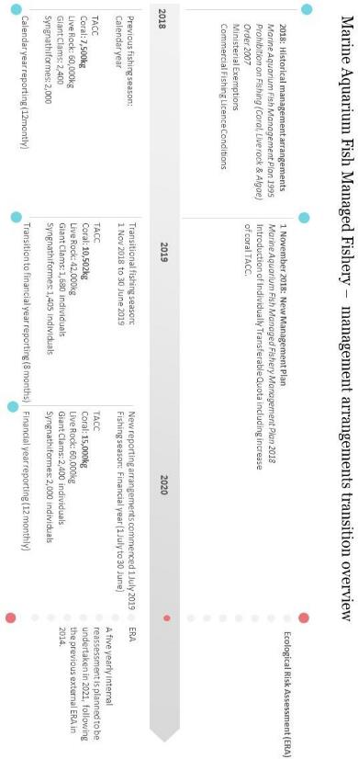

# Appendix E: MAFMF TACC, NDF thresholds and catch data

**Table E.1 Marine Aquarium Fish Managed Fishery quota (as per Management Plan) and catch data by species groups.**

|  |  |  |  |  |
| --- | --- | --- | --- | --- |
| **Species groups** | **1 November 2018 –**  **30 June 2019** | | **2019/20**  **(1 July 2019 – 30 June 2020)** | |
| TACC | Catch | TACC | Catch |
| Coral (hard and soft) | 10,502 kg | 9,066.26 kg | 15,000 kg | 13,342.40 kg |
| Live Rock | 42,000 kg | 14,221 kg | 60,000 kg | 19,799 kg |
| Syngnathiformes | 1,405 individuals | 39 individuals | 2,000 individuals | 281 individuals |
| Giant Clams | 1,680 individuals | 299 individuals | 2,400 individuals | 492 individuals |

**Table E.2 Marine Aquarium Fish Managed Fishery Non-Detriment Finding (NDF) thresholds (as per Harvest Strategy) and catch data of key CITES listed species.**

|  |  |  |  |  |
| --- | --- | --- | --- | --- |
| **CITES listed species** | | **NDF threshold** | **1 Nov 2018 –**  **30 June 2019** | **1 July 2019 – 30**  **June 2020** |
| Hard Corals | *Catalaphyllia jardinei* | 530 kg | 522.20 kg | 703 kg |
| *Duncanopsammia axifuga* | 1,555 kg | 423.20 kg | 538 kg |
| *Fimbriaphyllia ancora* | 1,211 kg | 1,872.10 kg | 2,364 kg |
| *Euphyllia glabrescens* | 1,009 kg | 801.60 kg | 1,497 kg |
| *Moseleya latistellata* | 588 kg | 26 kg | 17 kg |
| *Trachyphyllia geoffroyi* | 1,281 kg | 328 kg | 683 kg |
| Seahorses | *Hippocampus angustus* | 328 ind. | 18 ind. | 53 ind. |
| *Hippocampus subelongatus* | 2,000 ind. | 16 ind. | 178 ind. |
| *Hippocampus tuberculatus* | 100 ind. | 1 ind. | 13 ind. |
| Giant Clams | *Tridacna maxima* | 2,360 ind. | 250 ind. | 405 ind. |
| *Tridacna squamosa* | 578 ind. | – | 65 ind. |