Application for subsequent Wildlife Trade Operation – Marine Aquarium Fish Managed Fishery

The former Department of the Environment and Water Resources (DEWR; now Department of Agriculture, Water and the Environment: DAWE) sets out the requirements for Wildlife Trade Operation (WTO) reassessment in the Guidelines for the ecologically sustainable management of fisheries – 2007 (the Guidelines). Preparation of this application for a subsequent WTO for the Marine Aquarium Fish Managed Fishery (MAFMF) was informed by the Guidelines.
DAWE has produced a table to determine the level of change in a fishery that is not captured in annual reports provided to DAWE. This table is used to guide the level of information required for subsequent assessments, noting the substantial level of detail provided in initial assessments. The completed table below shows how the MAFMF sits against these points.

Level of change, not reported in annual reports, since previous fishery assessment
Issue | Area of Interest | Yes | No
Fishery | Has there been any change to management arrangements, and/or fishing practices?
External Influences | Has there been any change to an environmental issue/influence outside of the fishery management agency’s control?
Interaction with protected species | Has there been any change in the nature, scale, intensity of impact and/or management response?
Ecosystem impact (e.g. – habitat, food chains etc.) | Has there been any change in nature, scale, or intensity of impact and/or subsequent management response?
Target stock status | Has there been any change in the target stock status? e.g. Increase or decrease in number of overfished or uncertain stocks, limit reference points of performance indicators have been triggered.
By-product/bycatch stock status | Has there been any change in the by-product and/or bycatch stock status? e.g. performance indicators triggered or risk assessment outcomes show risk levels have changed.

In line with the Guidelines, the above responses trigger a submission requirement of “standard plus ancillary level of information”. Further information about the identified Area of Interest is summarised below.

Target Stock Status: Changes to the Target Stock Status
In 2012, a Non-Detriment Finding (NDF) was made based on precautionary harvest levels for giant clams, seahorses and six species of hard coral. NDFs for the MAFMF continue to be based on the harvest thresholds detailed in the Marine Aquarium Fish Resource of Western Australia Harvest Strategy 2018 – 2022 (Harvest Strategy).

While the harvest of most of these species has been within the thresholds, catches of some species subject to the NDF have exceeded individual threshold levels over the past two seasons, including Fimbriaphyllia ancora (previously Euphyllia ancora), for which reported catches were significantly higher than the threshold for both the 2018/19 and 2019/20 licensing periods.

 |  | NDF threshold | 1 Nov 2018 –  30 June 2019 | 1 July 2019 – 30 June 2020
Hard Corals | Catalaphyllia jardinei | 530 kg | 522.20 kg | 703.30 kg
 | Duncanopsammia axifuga | 1,555 kg | 423.20 kg | 538.40 kg
 | Fimbriaphyllia ancora (Euphyllia ancora) | 1,211 kg | 1,872.10 kg | 2,364.40 kg
 | Euphyllia glabrescens | 1,009 kg | 801.60 kg | 1,496.50 kg
 | Moseleya latistellata | 588 kg | <30* kg | 17.20 kg
 | Trachyphyllia geoffroyi | 1,281 kg | 328 kg | 683.30 kg
 | Corallimorphidae - undifferentiated | - | 1673 kg | 2936 kg
 | Order Zoantharia – undifferentiated | - | 971 kg | 1194 kg
 | Goniopora spp. | 530 | 337.20 kg | 836.70 kg
 | Euphyllia paraancora | 538 | <200* | 714 kg
 | Lobophyllia hemprichii | 176 | <200* | 478 kg
 | Trachyphyllia geoffroyi | 1281 | 328 kg | 683.30 kg
 | Dipastraea spp. | 962 | 650.80 kg | 294.20 kg
 | Acropora spp. | 673 | 275 kg | 426 kg
 | Lobophyllia spp. | 1112 | 315.40 kg | 313 kg
 | Symphyllia wilsoni | 1112 | 735.10 kg | 566.20 kg
 | Alveopora spp. | - | 47 kg | 423 kg
 | Acanthastrea lordhowensis | - | 158.4 kg | 182.90 kg
 | Acanthastrea echinata | 186 | 135.40 kg | 122 kg
Soft Corals | Sarcophyton spp. | 629 | 345 kg | 261.1 kg
 | Sinularia spp. | 331 | 57.50 kg | 122.50 kg
 | Order Corallimorpharia – undifferentiated | 7630 | 249 kg | 326 kg
Seahorses | Hippocampus angustus | 328 ind. | 18 ind. | 45 ind.
 | Hippocampus subelongatus | 2,000 ind. | 16 ind. | 186 ind.
 | Hippocampus tuberculatus | 100 ind. | 1 ind. | 13 ind.
Giant Clams | Tridacna maxima | 2,360 ind. | 250 ind. | 405 ind.
 | Tridacna squamosa | 578 ind. | – | 65 ind.
* Confidential information – exact quantity cannot be shown
Note: the truncated 2018 – 2019 data period is due to the implementation of the Management Plan.

The Department of Primary Industries and Regional Development (DPIRD) recently conducted an Ecological Risk Assessment of the MAFMF. As part of this process a wide range of species were individually assessed, including those listed above. Despite the high catches, no risk ratings were identified as higher than a Medium risk, including for Fimbriaphyllia ancora. A risk rating of Medium indicates that management arrangements are considered adequate, and no immediate management action is required.

When assessing the catch of species subject to the NDF, as above, the Department of Primary Industries and Regional Development (DPIRD) uses the licensing period, which runs from 1 July to 30 June. This is because the thresholds relate to the licensing period, as do the quota levels which apply for species groups (coral, giant clams, live rock and syngnathiformes).

Within documents such as the Status reports of the fisheries and aquatic resources of Western Australia (SRFAR) or the recently published Fisheries Research Report 323, Ecological Risk Assessment for the Marine Aquarium Fish Resource (ERA), reporting occurs by calendar year. Information from the recent SRFAR, showing the reported catch (kg) of the main coral species landed in the MAFMF for the years 2016 to 2020, is below. This information is also reported by calendar year.

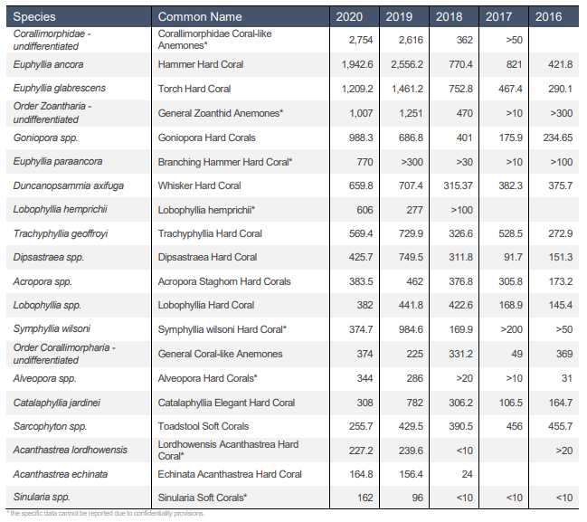

Performance against conditions
Each of the conditions from the 2019 certification of the MAFMF as a Wildlife Trade Operation are reported on below.

Condition 1: Operation of the WA Marine Aquarium Fish Managed Fishery will be carried out in accordance with the management regime under the Fish Resources Management Act 1994 (Western Australia) and the Fish Resources Management Regulations 1995 (Western Australia).

The MAFMF has and will continue to operate in accordance with the Marine Aquarium Fish Managed Fishery Management Plan 2018 (management plan).

Condition 2: The Western Australian Department of Primary Industries and Regional Development to inform the Department of Environment and Energy of any intended material changes to the Western Australian Marine Aquarium Fish Managed Fishery management arrangements that may affect the assessment against which Environment Protection and Biodiversity Conservation Act 1999 decisions are made.

There have been no material changes to the fishery’s management plan or arrangements that could affect the criteria on which the EPBC Act decisions are based.

Condition 3: The Western Australian Department of Primary Industries and Regional Development to produce and present reports to the Department of the Environment and Energy annually as per Appendix B of the ‘Guidelines for the Ecologically Sustainable Management of Fisheries – 2nd Edition’.

DPIRD produces Status Reports of the Fisheries and Aquatic Resources of Western Australia (SRFAR) annually. SRFAR reports for the years 2006/07-2019/20 can be found at http://www.fish.wa.gov.au/About-Us/Publications/Pages/State-of-the-Fisheries-report.aspx

Condition 4: The Western Australian Department of Primary Industries and Regional Development to:
- continue to limit harvest of CITES listed species, according to current non-detriment findings, for each species or species group,
- continue to consult with the Department of the Environment and Energy, prior to a change to the management arrangements for a CITES or EPBC Act listed species being implemented.

As noted above, some species subject to the NDF have exceeded individual threshold levels over the past two seasons, including Fimbriaphyllia ancora, for which reported catches were significantly higher than the threshold for both 2018/19 and 2019/20. Despite catches exceeding the thresholds for this species, the associated risks were assessed in the recent ERA as Medium and deemed acceptable under monitoring and control measures currently in place.

Condition 5: The Western Australian Department of Primary Industries and Regional Development to:
(a) consider conducting a review of the risk assessment for CITES species including coral, with consideration given to determining risk over the next five years.
(b) continue to consider further research into CITES species in the context of the outcomes of the risk assessment, including species distribution and abundance, in areas of high fishing effort
(c) continue to collaborate with relevant stakeholders, to conduct research and provide outcomes of research projects, to the Department of the Environment and Energy, when outcomes are finalised. Outcomes should also be made publicly available.

DPIRD has recently finalised the Ecological Risk Assessment for the Marine Aquarium Fish Resource (ERA). The ERA will be published to the Department’s website. As part of the ERA, CITES listed species, including hard coral, were considered, with the following risk ratings:

Group | Species | Risk rating
 | Fimbriaphyllia ancora | MEDIUM
 | Fimbriaphyllia paraancora | MEDIUM
 | Euphyllia glabrescens | LOW
 | Catalaphyllia jardinei | MEDIUM
Hard corals | Australophyllia wilsoni | MEDIUM
 | Trachyphyllia geoffroyi | LOW
 | Duncanopsammia axifuga | NEGLIGIBLE
 | Moseleya latistellata | NEGLIGIBLE
 | Lobophyllia hemprichii | NEGLIGIBLE
 | All other hard coral species | NEGLIGIBLE
Giant clams | All Tridacna species | NEGLIGIBLE
 | Hippocampus subelongatus | NEGLIGIBLE
Seahorses & pipefish | Hippocampus angustus | NEGLIGIBLE
 | All other syngnathiform species | NEGLIGIBLE
Extract from Table 7.1 of the ERA

Given that the ERA has been finalised and published, the Department will soon commence a review of the Marine Aquarium Fish Resource of Western Australia Harvest Strategy 2018 – 2022.

Progress against previous EPBC Conditions
Progress against previous EPBC conditions can be reviewed at
https://www.awe.gov.au/environment/marine/fisheries/wa/marine-aquarium.

Additional fishery information
GENERAL INFORMATION
Area of the fishery | All Western Australian waters between Northern Territory border and the South Australian border (see map at Figure 1).
Gear used | Primarily hand collection while using SCUBA or hookah. Operators can use handheld nets, handheld tools and fishing lines (barbless hooks only). Further information is available in the Marine Aquarium Fish Managed Fishery Management Plan 2018 (Management Plan).
Information | Information on species retained by the MAFMF and links to management information is here:  - Management Plan – Marine Aquarium Fish Managed Fishery Management Plan 2018  - Harvest strategy – Marine Aquarium Fish Resource of Western Australia Harvest Strategy 2018 - 2022  - Status Reports of the Fisheries and Aquatic Resources of Western Australia 2020-21
MANAGEMENT ARRANGEMENTS
Legislation | The MAFMF is managed by the Department of Primary Industries and Regional Development (DPIRD) under the following legislation:  - Fish Resources Management Act 1994 (FRMA, will be replaced by the Aquatic Resources Management Act once enacted);  - Fish Resources Management Regulations 1995 (FRMR);  - Marine Aquarium Fish Managed Fishery Management Plan 2018  Fishers must also comply with the requirements of (but not limited to):  - The Commonwealth Environment Protection and Biodiversity Conservation Act 1999 (EPBC Act);  - Marine Safety (Domestic Commercial Vessel) National Law Act 2012;  - Western Australian Marine Act 1982;  - Western Australian Wildlife Conservation Act 1950; and  - Western Australian Conservation and Land Management Act 1984.
Regulations, exemptions or licence designation | Marine Aquarium Fish Managed Fishery Licence
Management plan | Marine Aquarium Fish Managed Fishery Management Plan 2018
Other management documents | Prohibition on Fishing (Coral, ‘Live Rock’ and Algae) Order 2007
FISHERY STATUS
Annual report | Page 252 of the Status Reports of the Fisheries and Aquatic Resources of Western Australia 2020-21 (SRFAR).  Previous years:  http://www.fish.wa.gov.au/About-Us/Publications/Pages/State-of-the-Fisheries-report.aspx
Stock assessment | Due to the large number of species captured in the MAFMF, and the relatively low numbers per species, traditional stock assessments are not undertaken. Catches at the lowest taxonomic level are annually monitored based on fisher returns (Newman et al. 2022).  The level of catch of all species on an individual basis is low given the spatial extent of their distribution and the spatial extent of the fishery. Furthermore, for many species the extensive Kimberley area is a refuge given it has a very negligible level of harvest.
Ecological risk assessment | Recently completed. Available on the DPIRD website or upon request.
SPECIES
Target species | The MAFMF is a multi-species fishery which has the capacity to target more than 1500 marine aquarium species under the Marine Aquarium Fish Managed Fishery Management Plan 2018 and other subsidiary legislation under the Fish Resources Management Act 1994. In practice, the MAFMF lands in excess of 250 species for sale as live specimens to the aquarium trade or as broodstock for aquaculture operations. Targeted species include fish (including teleost and elasmobranchs), hard and soft corals, and a range of other invertebrate and plant species.
Byproduct species (retained) | Due to the highly selective nature of the hand collecting method used by the MAFMF, there is no incidental capture of non-target species. All captured species are retained.
Bycatch species (non-retained) | Due to the highly selective nature of the hand collecting method used by the MAFMF, there is no incidental capture of non-target species. All captured species are retained.
Protected species | In WA commercial fishers are required (since 2005/06) to report any interactions with TEPS species in their statutory fishing returns that are lodged with the Department. The Department publishes a summary of all fishery-TEPS interactions annually.  Numerous TEPS occur in WA waters, including marine reptiles (turtles, sea snakes, etc), marine mammals (whales, dolphins, sea lions, dugongs, etc), elasmobranchs (sharks, sawfish, rays), syngnathids (seahorses, seadragons, pipefish), invertebrates (hard corals, giant clams, etc), seabirds and migratory shorebirds. These species are protected by various international agreements and by national and state legislation.  There are no reported TEPS interactions with the MAFMF.  The MAFMF is permitted under national and state legislation to harvest hard coral, giant clams and seahorse species, which are protected species listed under the EPBC Act and under CITES Appendix II.

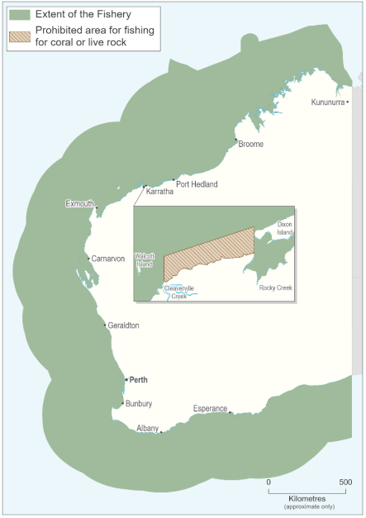
Figure 1. Boundaries of the Marine Aquarium Fish Managed Fishery (source: WA DPIRD).

Contact
Amie Steele, Fisheries Management Officer – (08) 6551 4332 or amie.steele@dpird.wa.gov.au

Important disclaimer
The Chief Executive Officer of the Department of Primary Industries and Regional Development and the State of Western Australia accept no liability whatsoever by reason of negligence or otherwise arising from the use or release of this information or any part of it.
Copyright © Department of Primary Industries and Regional Development, 2022

