Wetlands Australia

National wetlands update February 2016—Issue No 28

Disclaimer

The views and opinions expressed in this publication are those of the authors and do not necessarily reflect those of the Australian Government or the Minister for the Environment.

The Department of the Environment acknowledges the traditional owners of country throughout Australia and their continuing connection to land, sea and community. We pay our respects to them and their cultures and to their elders both past and present.

© Copyright Commonwealth of Australia, 2016

Wetlands Australia National Wetlands Update February 2016—Issue No 28 is licensed by the Commonwealth of Australia for use under a Creative Commons By Attribution 4.0 Australia licence with the exception of the Coat of Arms of the Commonwealth of Australia, the logo of the agency responsible for publishing the report, content supplied by third parties, and any images depicting people. For licence conditions see:

http://creativecommons.org/licenses/by/4.0/

This report should be attributed as ‘Wetlands Australia, National Wetlands Update February 2016—Issue No 28, Commonwealth of Australia 2016’

The Commonwealth of Australia has made all reasonable efforts to identify content supplied by third parties using the following format ‘© Copyright, [name of third party] ’.

Cover images

Front cover: Aerial view of irrigated crops alongside the Murray River near Mildura

(© Copyright, Arthur Mostead and Department of the Environment)

Back cover: Fishing trawlers

(© Copyright, Arthur Mostead and Department of the Environment)

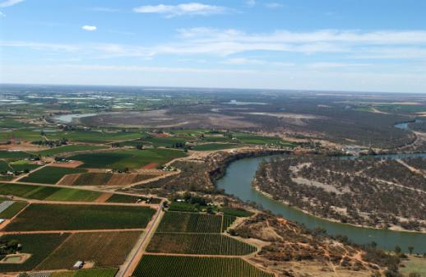

Contents

Introduction to *Wetlands Australia* February 2016 3

Supporting sustainable livelihoods 4

Guide to managing livestock grazing in Victoria’s wetlands 4

Advocacy in a time of adversity 6

Floodplain graziers are boosting production by restoring their wetlands 8

Creative partnerships 10

Sea monkeys … just add water! 10

Banrock Station: Environmental water + wetlands + tourists + wine = economic return 12

Nyul Nyul Rangers manage wetlands and spring country through research and on-ground work 14

The cultural story of the Lake Wellington wetlands 16

Bridging the waters — South East wetland carers surge ahead 18

Green infrastructure 20

Creating green assets — social, economic and ecological benefits of environmental watering 20

Constructed wetlands for wastewater treatment and community benefits 23

Insights from the use of an online wetland management resource 25

Restoring ecosystems and habitats 27

Wise use of Macquarie Marshes wetlands pays bird diversity and water quality dividends 27

Restoring a Ramsar Wetland: Piccaninnie Ponds Conservation Park 29

Frogs and the health of their wetlands: the ACT Bio-Indicator Project 31

Restoring Australia’s Great Southern Seascapes 33

Benefiting wetlands with existing infrastructure 35

Golden perch spawn in record numbers in response to managed environmental flows 37

# Introduction to *Wetlands Australia* February 2016

The global theme for World Wetlands Day 2016 is ‘Wetlands for our future: sustainable livelihoods’.

Wetlands include rivers, lakes, swamps, estuaries and coasts. In Australia, our wetlands play an important role in the processes that keep our landscapes healthy and productive. They support industries such as agriculture, fisheries, forestry and tourism by supplying water for crops, stock and people, maintaining water quality, providing habitat for commercial species and having cultural and recreational values. Maintaining and restoring Australia’s wetlands makes an important contribution to our future environmental, economic and social sustainability.

This edition of *Wetlands Australia* highlights how wetlands are centres of productivity in the landscape and how we can manage them to provide a range of services and benefits for our communities.

If you would like to contribute to future   
editions of *Wetlands Australia*, please contact [wetlandsmail@environment.gov.au](mailto:wetlandsmail@environment.gov.au)

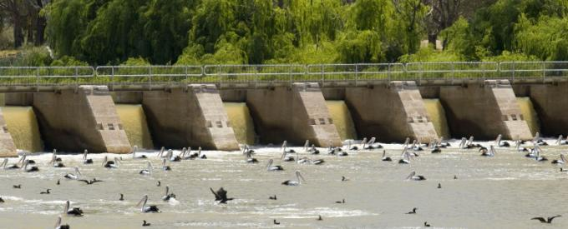

*Birdlife near Lock 1 on the Murray River at Blanchetown* (© Copyright, John Baker and Department of the Environment)

Supporting sustainable livelihoods

# Guide to managing livestock grazing in Victoria’s wetlands

Tamara van Polanen Petel, Policy Officer, Waterway Health, Victorian Department of Environment, Land, Water and Planning

The sustainable use of wetlands for grazing is an important consideration in improving the management of wetlands on private land. A guide to managing livestock grazing in Victoria’s wetlands is now available.

The guide, developed by the Department of Environment, Land, Water and Planning (DELWP), supports livestock grazing management decisions in wetlands by providing:

a livestock grazing decision framework

guidelines on best grazing practice

recommendations on monitoring and evaluation.

Livestock grazing in wetlands is common and widespread in Victoria. While it occurs most often on private land, it can also be licensed on public land. It usually degrades the condition of wetlands and threatens wetland values, but in certain cases grazing can be beneficial to wetland values if carefully managed.

Despite the prevalence of livestock grazing, and the variable responses of wetlands to it, guidance on identifying appropriate livestock grazing options has not been available in Victoria. The livestock grazing decision framework provided in the guide applies an understanding of the potential benefits and impacts of grazing in wetlands. This will assist wetland managers to identify grazing options that meet the following management objectives:

* maintain the vegetation condition of high-quality wetlands
* improve the vegetation condition of poorer quality wetlands
* manage the vegetation condition for significant fauna.

The guide is designed for use by natural resource management (NRM) practitioners, environmental consultants and researchers with expertise in NRM to inform livestock grazing management practices in wetlands on private and public land in Victoria. Agencies that may find the guide helpful include Catchment Management Authorities (CMAs),

Parks Victoria, DELWP, Department of Economic Development, Jobs, Transport and Resources, non-government organisations, including Greening Australia and Trust for Nature, water authorities and local government.

Landowners or land managers who do not have specialist knowledge of wetlands, or lack the required botanic skills, should seek assistance from their local CMA wetland officer before using the guide.

While the guide has been designed for use in Victoria, the decision-making process may be of general use for informing livestock grazing strategies in wetlands in other parts of Australia.

For further information please contact Janet Holmes, Program Leader — Wetland Management ([Janet.Holmes@delwp.vic.gov.au](mailto:Janet.Holmes@delwp.vic.gov.au)) or visit [delwp.vic.gov.au](http://www.delwp.vic.gov.au)

## References

Peters, G., Morris, K., Frood, D., Papas, P. and Roberts, J. (2015). *A guide to managing livestock grazing in Victoria’s wetlands. Decision framework and guidelines — Version 1.0*. Arthur Rylah Institute for

Environmental Research Technical Report Series No. 265. Department of Environment, Land, Water and Planning, Heidelberg, Victoria.

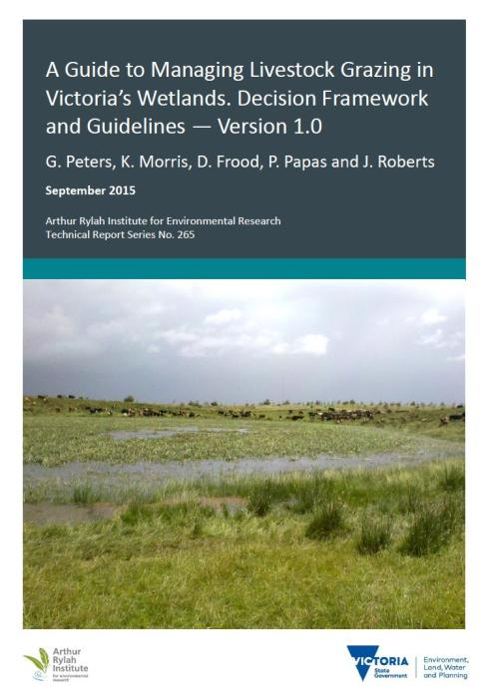

# Advocacy in a time of adversity

Jo Curkpatrick, South Australian Department of Environment, Water and Natural Resources

Clem Mason’s family has farmed nearly 3000 hectares on the banks of Lake Albert at Narrung, and at Jervois on the lower Murray for 30 years.

Running 200 dairy cows, 1000 head of sheep and 1600 hectares of crops, Clem Mason felt the bite of the Millennium drought. Whilst having two centre pivot irrigators was valuable, he lost considerable production during this period, as did many of his neighbours.

Rather than the situation making Clem an opponent to water going to the environment, Clem is now an advocate.

One particular night during the drought was a turning point. Whilst dragging his water pipes into the receding lake, Clem noticed a turtle, covered by a tube worm infestation, on the exposed lakebed.   
‘I realised I wasn’t in this alone, and that it’s up to us as individuals to look after the river and return it to health’.

At this crucial point of the drought, the Coorong Lower Lakes and Murray Mouth Recovery Project was instigated. On Clem’s property, between 500 and 700 metres of land had been eroded and washed away. Clem was approached to fence his property to prevent cattle from grazing on the shore.

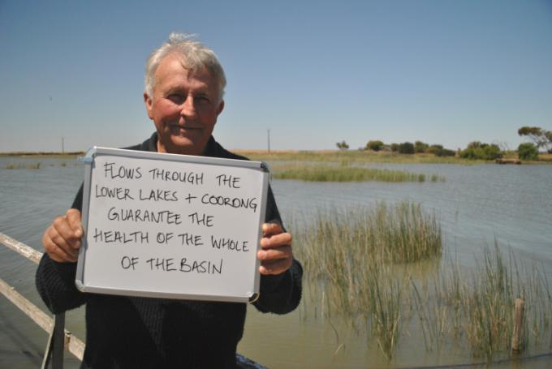

Clem Mason (© Copyright, Nerida Buckley)

His involvement in the Recovery Project has changed his thinking and delivered results for his farm. He has been a valued member of the Project’s community advisory panel, providing guidance and advice to the Project on work undertaken. His farm, like many across the region, has become a focus for revegetation, fencing, returning native vegetation to the wetlands, and pest plant and animal control under the Recovery Project.

‘We’ve gained land here and the reeds have come back as well — they provide breeding grounds for birds and fish.

‘Seeing the birds here proves that we did the right thing for us and the ecology. It’s a win-win.’

‘We never want to be where we were before. If we don’t have a sustainable river, we don’t have water quality that’s good enough to use,’ Clem adds. ‘Our job is to keep a healthy river from top to bottom, and that means allowing it to flush.’

Now entering its final year, the Recovery Project can celebrate significant achievements. Local people like Clem have helped the SA Department of Environment, Water and Natural Resources manage the region through drought.

A pipeline to link into the SA Water network also helped to ensure supply.

And Clem says the internationally significant Coorong, Lakes Alexandrina and Albert Ramsar wetland is a very important place — being the end of the river system.

‘It’s about how we work with our upstream neighbours — it’s bigger than the Coorong, and this little patch — it’s about keeping the whole of the Basin healthy and productive.’

The Coorong, Lower Lakes and Murray Mouth (CLLMM) Recovery Project is funded by the South Australian Government’s *Murray Futures* program and the Australian Government.

For further information, contact the South Australian Department for Environment, Water and Natural Resources on (08) 8204 1910 or see [naturalresources.sa.gov.au](http://naturalresources.sa.gov.au)

# Floodplain graziers are boosting production by restoring their wetlands

Cassie Price, Regional Manager, WetlandCare Australia

A critically endangered plant that was not recorded in the wild for almost 90 years is being reintroduced at Banrock Station, South Australia to safeguard it from extinction. Floodplain graziers in coastal catchments have been ecstatic with the results arising from restoring their previously drained areas of pasture to native wetland grasses.

With the right amount of water across the landscape and a clever grazing regime, farmers are seeing the benefits of returning native floodplain wetland grasses into their pasture rotation. Not only are the cattle benefiting from the nutrients and protein available in the native wetland grasses, farmers are also seeing an improvement in soil health, acid sulfate soil impact reduction and lower costs of invasive weed management.

The great feed quality of native wetland grasses might come as a surprise to some, especially those used to the traditional improved pasture species and methods. Water couch (Paspalum distichum) and some of the soft rush (Eleocharis) species for example have high digestibility, energy and protein content.

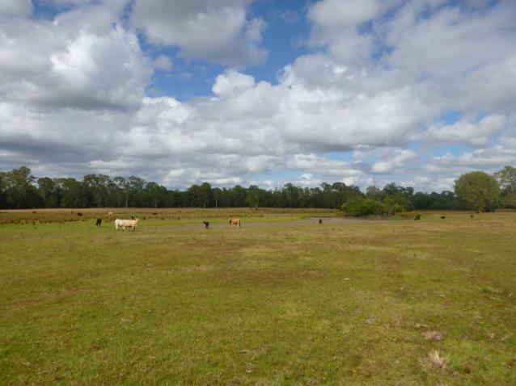

*Healthy wetlands provide productive pastures* (© Copyright, Eli Dutton)

Managed floodplain grazing areas are also providing significant relief in dry conditions. With the strong El Nino and drier than average conditions forecast for approaching years and the longer-term, graziers are turning to their wetland areas as a reliable feed source under drought conditions.

Aside from the benefit to the productive grazing system, the benefits to the wider catchment are immense. Restoring native wetland grasslands into grazing land is creating greater area of habitat, wildlife corridors and fish passage and is improving water quality. Downstream industry, in particular commercial fishing and tourism, is also benefiting exponentially from these updated land management practices.

WetlandCare Australia firmly believes that healthy wetlands and productive grazing can be one and the same and do not need to remain mutually exclusive. We have been working closely with farmers, the Department of Primary Industries, coastal Local Land Services and councils to best utilise natural wetlands in the pursuit of better grazing production on floodplain farms.

While we appreciate that native floodplain grasslands won’t work for every farming situation, we are encouraging farmers to look critically at their low lying areas as a greater resource and to get in touch with us if they would like to know more or discuss new property management possibilities with one of our wetland scientists.

Contact us at [ballina@wetlandcare.com.au](mailto:ballina@wetlandcare.com.au) or on 02 6681 6169. For more details on WetlandCare Australia’s activities, see our website at [wetlandcare.com.au](http://wetlandcare.com.au)

Creative partnerships

# Sea monkeys … just add water!

Nature Foundation South Australia and Commonwealth Environmental Water Office

A wildlife charity and an irrigation water supply body are working together to deliver Commonwealth environmental water... for sea monkeys!

Commonwealth environmental water is being pumped into Lyrup Forest (near Berri, South Australia). This unique environmental watering partnership with the Nature Foundation South Australia’s Water For Nature program and Central Irrigation Trust may be the catalyst for a brine shrimp (also known as sea monkey) breeding event.

This environmental watering event involves the largest irrigation water supply body in South Australia, working in partnership with Nature Foundation South Australia and the Commonwealth. This delivery partnership is using an old Lyrup Irrigation Trust backwashing pipe, originally built for cleaning the Lyrup irrigation pumps, to deliver water to the wetland. The existing irrigation infrastructure will be used to deliver environmental water to a wetland in the off-peak season, enhancing the values of the local recreational site for the Lyrup community.

Watering at the site is expected to provide benefits for many native birds, frogs and turtles. In particular, the Lyrup Forrest reserve has a history of hatching an abundance of brine shrimp (Artemia salina — sold as novelty aquarium pets) biomass when inundated. This environmental watering event is expected to encourage brine shrimp to breed, and in turn draw birds to the site to feed on the shrimp, including musk duck, freckled duck and royal spoonbill. Red-necked avocets have already been recorded at the site following the commencement of the watering event.

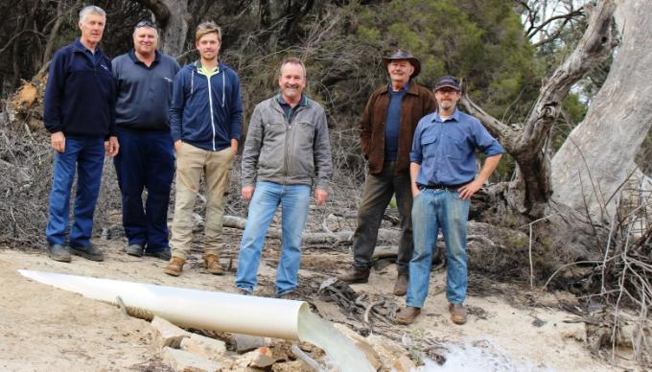

Steven Heinicke, Gary Jaensch, Shaun Reilly, Craig Ferber, John Schwarz and David Reilly at the commencement of the watering event (© Copyright, Commonwealth Environmental Water Office)

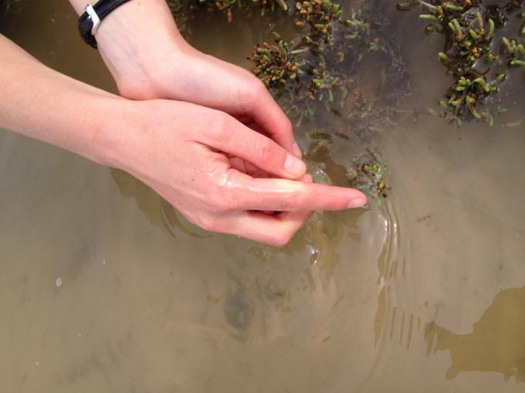

Brine shrimp (Artemia salina) detected at Lyrup Lagoon during watering event in October 2015 (© Copyright, Michelle Campbell, Commonwealth Environmental Water Office)

NFSA’s Water For Nature program partners with private landholders, irrigators, community groups and local government in the South Australian Murray region to deliver community-driven watering projects that achieve environmental benefit to wetlands and floodplains as well as broader reaching economic, cultural and social benefits.

For more information about Nature Foundation South Australia’s Water for Nature program, please visit [naturefoundation.org.au/what-we-do/water](http://naturefoundation.org.au/what-we-do/water-for-nature)-for-nature

# Banrock Station: Environmental water + wetlands + tourists + wine = economic return

Banrock Station and Commonwealth Environmental Water Office

Recognising the economic benefits of environmental water in the tourism and wine sector, Banrock Station sought out and established an important partnership with the Commonwealth Environmental Water Holder.

Banrock Station is a demonstration site for the Ramsar Convention’s fundamental principle of ‘wise use’, combining a wetland wine centre and vineyards (private enterprise) with wetland conservation and rehabilitation in order to raise awareness of the important values and functions of wetlands with around 35,000 visitors to the site each year. Commonwealth Environmental Water Holder David Papps said, ‘This is an exciting partnership. We are delighted to be working with Banrock Station and hope other private enterprises will see how the wise use of environmental water in wetlands serves to restore, maintain and enhance the environment as well as provide secondary benefits of increased tourism and sales.’

This ongoing partnership will see Banrock Station deliver up to 2004 megalitres of Commonwealth environmental water annually to a number of sites across the extensive 1000 hectare Ramsar floodplain, located in the Riverland of South Australia. The watering events will be implemented by Banrock Station Wetland staff. The purpose of the watering is to contribute to environmental outcomes such as supporting the establishment of juvenile red gum and black box trees that were germinated during the 2010–11 floods and improve the condition of mature floodplain trees, understorey and submerged plant communities. It will also provide habitat and breeding opportunities for the nationally threatened regent parrot and southern bell frog.

Banrock Station’s managers are so convinced of the economic benefits of conserving and enhancing wetlands using environmental water that they are looking to share their experience with other businesses that are interested in restoring or enhancing their wetlands/floodplains. ‘We have seen first-hand the way visitors interact with the environment, and how that results in return visits, lingering and wanting to be a part of what we are doing here. We want to share that knowledge with others who are interested in restoring wetlands, and how that can improve economic return,’ said Banrock Station Environmental Manager, Dr Christophe Tourenq.

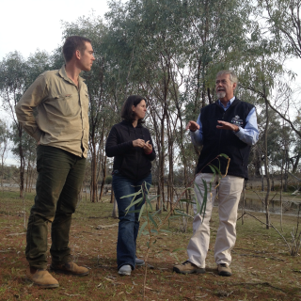

Commonwealth Environmental Water Holder, David Papps, with Banrock Station managers Tim Field and Alison Searle (© Copyright, Commonwealth Environmental Water Office)

Banrock Station has been helping to protect the environment since 1995. Since that time, the Banrock Station Environmental Trust has re-invested profits from the sale of Banrock Station wines into environmental projects around the world, with a commitment to date exceeding $6 million to more than 130 projects in   
thirteen countries.

Banrock Station’s ongoing commitment to environmental sponsorship is based on its own experience   
in restoring and protecting its wetlands and woodlands, which led to its listing as a Ramsar Wetland of International Importance in 2002.

For more information see [banrockstation.com.au](http://banrockstation.com.au)

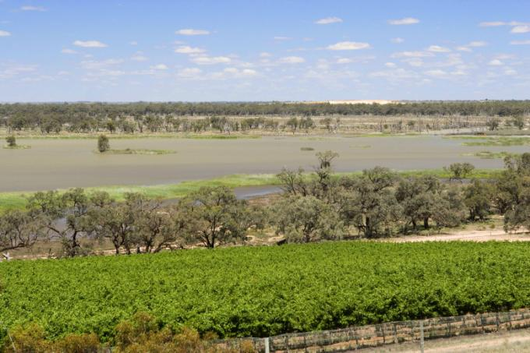

Banrock Station (© Copyright, John Baker and Department of Environment)

# Nyul Nyul Rangers manage wetlands and spring country through research and on-ground work

Mark Rothery, Nyul Nyul Rangers Coordinator, Kimberley Land Council

Nyul Nyul people of the Dampier Peninsula, 110 kilometres north of Broome in the Kimberley region of Western Australia, have a strong association with fresh water sources on their traditional land.

Wetlands and springs support Nyul Nyul livelihoods and animals, birds, plants and medicines associated with hunting and gathering activities important to Nyul Nyul people.

Caring for wetlands in the ‘right way’ is one of the major tasks undertaken by the Nyul Nyul Rangers. The Rangers are protecting these wetlands with management of fire, feral animals and weeds under the Working on Country program in association with the Kimberley Land Council and the Kimberley Ranger Network.

The Rangers have initiated and actively participated in several research projects aimed at investigating these freshwater sources and ecosystems. Partners in the projects include the National Environmental Research Programme (NERP), the North Australian Indigenous Land and Sea Management Alliance (NAILSMA), the University of Western Australia and the WA Department of Water. 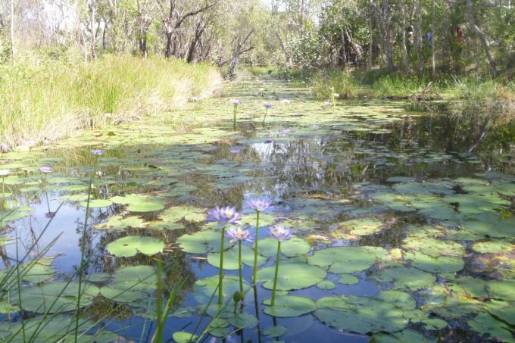

The Nyul Nyul totemic food source emblem the lily thrives in a myriad of billabongs, springs and lakes (© Copyright, Nyul Nyul rangers)

One project used scientific water monitoring techniques, in combination with Nyul Nyul knowledge, to better understand the ecology of key freshwater ecosystems. This project has helped the Rangers to set up monitoring programs to measure the health of wetlands and measure the effectiveness of management activities. Baseline data collected represents a starting point for measuring the impact of future activities.

Another research project has used interviews with elders and traditional owners to investigate in more depth the Nyul Nyul knowledge, values and practices associated with freshwater sources. The Nyul Nyul logo has totems representing the freshwater eel and lily as its emblems, both of which represent food sources and signs of healthy country.

The Rangers also undertake other activities to help   
to monitor and maintain the health of wetlands. Examples include:

* cleaning out and maintaining freshwater spring sources used for drinking water
* biodiversity surveys around wetlands — identifying priority species eg painted snipe, undescribed frogs
* a fencing project to keep feral donkeys out of a significant spring system
* burning to protect wetlands from late season hot fires
* removal of bullrushes and other weeds
* photo monitoring of riparian zones at significant wetlands
* water bore and riparian sampling on contract to the WA Department of Water
* water sampling of community bores and sewerage impacts
* training other ranger groups in water monitoring methods and techniques.

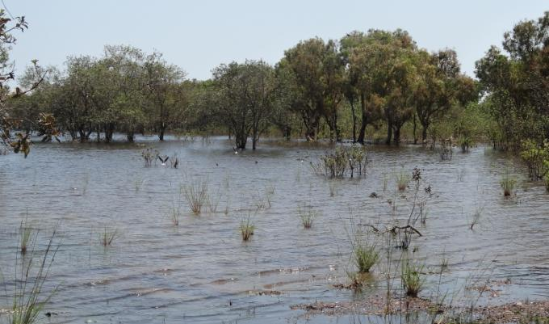

Nyul Nyul Wetlands have significant migratory bird populations and priority species (© Copyright, Nyul Nyul Rangers)

# The cultural story of the Lake Wellington wetlands

Martin Potts, Gippsland Project Manager, Greening Australia

Over 65 per cent of the Gippsland Lakes wetlands on private land located between the Avon and Latrobe Rivers are now being managed for conservation thanks to the recent works being undertaken by Greening Australia.

Working at this landscape scale has provided benefits such as being able to observe migratory bird paths and assessing the connectivity of wetlands and the pathways that frogs and plants follow to disperse through the system. This approach has also provided the opportunity to reveal the Indigenous cultural story that has, in turn, captured the imagination of the local community.

Greening Australia initiated a partnership with Gunaikurnai Land and Waters Aboriginal Corporation and started to look at the landscape though cultural eyes. Working together over the past three years this partnership has seen over 15 new sites being registered as culturally significant, including a now recognised corroboree ground. Old campsites and the pathways that connected them are being identified and some of these are being painted into a story by Indigenous leader Alfie Hudson.

We were looking for an opportunity to create a cultural land map. We have soil layers, flood layers etc, but what would a cultural layer look like? This can tell the story of when people moved through this country, where they camped and what they were doing.

The fringing wetlands of the Gippsland Lakes around Lake Wellington are not only an important filtering system and nursery ground for the Lakes food chain, they also provide essential habitat, in particular for the nationally vulnerable growling grass frog, green and golden bell frog, Australasian bittern and over seven species of migratory wading birds such as the sharp-tailed sandpiper and Latham’s snipe.

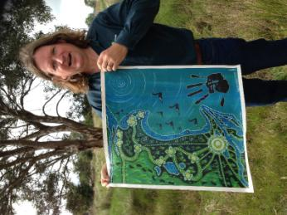

Martin Potts with painting (© Copyright, Paula Camenzuli)

Now we can also add to these key features the importance of these wetlands to the Gunaikurnai peoples. We are learning how these wetlands form part of the old dreamtime stories of Bimba-towera, the fire-tailed finch and Borun and Tuk, whose marriage is a key part of the creation story and is reflected in marriage gatherings today:

‘(In) pre Spring, when the silver wattles are blooming and people from across Gunaikurnai country are gathering for marriage, the water ribbons and wild flower tubers are full, the ducks and swans are laying eggs and the fresh water wetlands would be teeming with life.’ (Words of Gunaikurnai Elder Uncle Wayne Thorpe at a 2015 cultural stories event.)

This is part of the Gunaikurnai story, this is part of the wetlands story, this is now an important part of our story and the work Greening Australia is achieving to help to bring functional connectivity and resilience to Lake Wellington’s fringing wetland system.

For further information please visit [greeningaustralia.org.au](http://greeningaustralia.org.au) to see a short clip on our recent cultural celebration event.

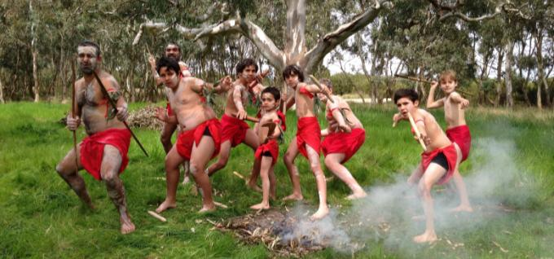

Gunaikurnai dance troupe (© Copyright, Paula Camenzuli)

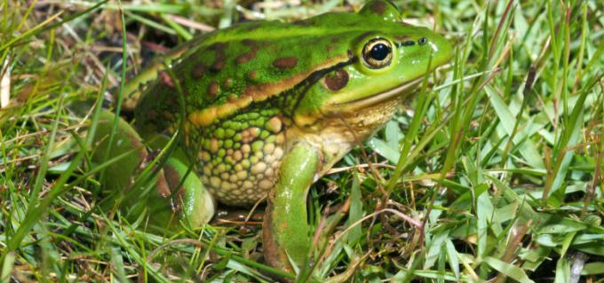

Growling grass frog (© Copyright, Alexander Dudley)

# Bridging the waters — South East wetland carers surge ahead

Michael Andrews, Wetland Program Officer, Conservation Volunteers Australia

‘Realising the potential of our wetlands’ is a South East Local Land Services (LLS) project funded by the Australian Government that aims to build on-ground action, community education and a supportive communication network along the south and far south coast of New South Wales.

Commencing in 2014, the program involves three partners: South East LLS provides funding directly   
to public and private land managers to help them improve wetlands connectivity and condition, WetlandCare brings expertise in monitoring change over time while Conservation Volunteers manages volunteers implementing on-ground work.

Together the partnership provides workshops and forums in strategic locations from Wollongong to the NSW/Victorian border and is building a network of South East wetland carers with the skills and resources to make a real difference.

Adam Woods, wetland workshop, Moruya, NSW


Adam Woods, wetland workshop, Moruya, NSW (© Copyright, Conservation Volunteers Australia)

A snap-shot of achievements at the half-way point of the four year project includes:

* 15 hectares of native revegetation
* 3000 individual plants
* 530 hectares of weed control across priority wetland sites and threatened ecological communities
* 583 invasive rabbits and foxes removed from 5000 hectares
* 4 kilometres of fencing installed to protect 44 hectares of wetland from the impact of stock
* 17 education and awareness events reaching more than 300 people
* over 250 people participating in the South East Wetland Carers Network
* 250 volunteers involved in on-ground works
* 50 private landholders implementing specific project works
* all local government areas in the region implementing projects.

The project has a strong focus on long term protection of mangroves, saltmarsh and seagrasses because these wetland components fix carbon from the atmosphere, the ocean and estuarine waters, and preserve this carbon with remarkable efficiency in deep, organic-rich sediments.

South East LLS’s Senior Landscape Services Officer, Kirsti Sampson, says that the real strength of the project lies in its scale. ‘To date, we have approved and funded over 50 on-ground projects. Our team of agency and non-government organisation staff allows an exceptionally broad reach along the entire south coast of NSW. The cumulative impact of exciting projects and the exchange of skills and knowledge across over 400 kilometres of coastline will significantly improve carbon sequestration, connectivity throughout the landscape and the resilience of wetland communities into the future.’

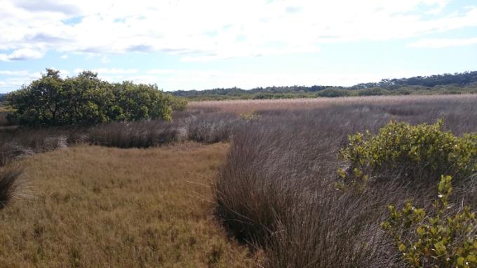

Minnamurra River, Kiama, NSW (© Copyright, Conservation Volunteers Australia)

Green infrastructure

# Creating green assets — social, economic and ecological benefits of environmental watering

Dr Anne Jensen, Water For Nature Committee, Nature Foundation SA

As we get better at physical delivery of environmental water and selecting best environmental outcomes, the next challenge is to measure social and economic benefits.

Water For Nature, an initiative of Nature Foundation SA, is promoting the concept of ‘green assets’ created by environmental watering, sustaining ecosystems to underpin healthy rivers which support local communities and economies.

In a precedent-setting partnership with the Commonwealth Environmental Water Holder, Nature Foundation SA is delivering environmental water to sites along the SA River Murray over 5 years (2012–2016). Water For Nature is working with private landholders, irrigators, community groups and local government, delivering water on smaller sites and complementing larger government projects.

Water For Nature delivered 1.1 gigalitres of water in 2014–15 and aims to reach 2.5 gigalitres in 2015–16. Sponsors provided funding for purchase of pumps, irrigation equipment and project manager time, partners have donated equipment and energy to pump water to target sites, while volunteers have often done the manual work of shifting sprinklers and pipes. This combined effort is the basis for realising social and economic benefits from restoring wetland and floodplain assets.

While evidence for these benefits is still largely qualitative, benefits include new partnerships, involvement of irrigator groups, engagement with local government and schools, and improved health of landscapes and key riverfront visitor locations. Eager new partners include Central Irrigation Trust (joining Renmark Irrigation Trust) which provides expertise and valuable delivery mechanisms through its infrastructure, while gaining an additional customer. The Waikerie and Loxton Men’s Sheds have undertaken invaluable equipment servicing and repair, as well as assisting with moving watering systems across target sites.

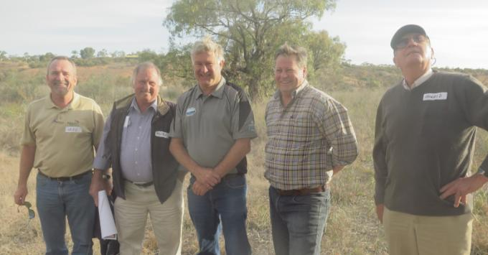

Project Manager Craig Ferber, Loxton, Waikerie Deputy Mayor Michael Vowles, SA Water Regional Manager Peter Forward, Loxton Councillor Trevor Norton and Howard Jones of Murray-Darling Wetlands Inc exploring Water for Nature’s Loxton Riverfront watering site (© Copyright, Anne Jensen)

A special partnership with the District Council of Loxton-Waikerie delivers environmental water via the Council’s storage dam into natural floodrunners to freshen floodplain lagoons and water seedlings which germinated in 2012. Extension of watering along riverside walking trails has also brought social and economic benefits to the Loxton Riverfront. Fresh growth on mature trees and thriving seedlings are rejuvenating the riverfront scene for visitors, boaters and locals.

Alongside the social and economic benefits, the big ecological bonus for the Riverland region is the continued survival of healthy black box regeneration triggered by the 2010–2012 floods, potentially leading to broadscale new recruitment for the first time in 60 years (if they can survive to reproductive age of 20–30 years). A new generation of floodplain plants for the future, including red gums, black box and lignum, will be a priceless asset.

For further information on Water For Nature, please contact Ian Atkinson, CEO of Nature Foundation SA ([ian.atkinson@nfsa.org.au](mailto:ian.atkinson@nfsa.org.au)) or visit the Nature Foundation SA website [naturefoundation.org.au](http://naturefoundation.org.au) and Water for Nature SA youtube videos [youtube.com/user/NatureFoundationSA1/feed](https://www.youtube.com/watch?v=qXd8dsJxoMY)

For further information on the Commonwealth Environmental Water Holder, please contact our Local Engagement Officer based in Berri (South Australia), Michelle Campbell (08 8595 2120; [Michelle.Campbell@environment.gov.au](mailto:Michelle.Campbell@environment.gov.au)) or visit the Commonwealth Environmental Water Office’s website: [environment.gov.au/water/cewo/wetlands](http://environment.gov.au/water/cewo/wetlands)

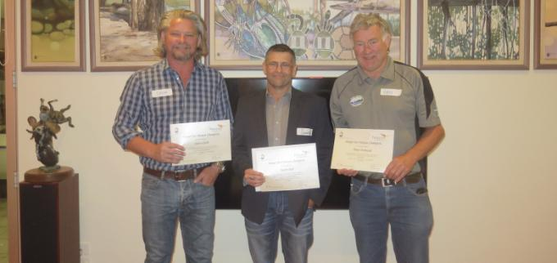

Inaugural Water for Nature champions Steve Clark, Jason Size and Peter Forward (© Copyright, Anne Jensen)

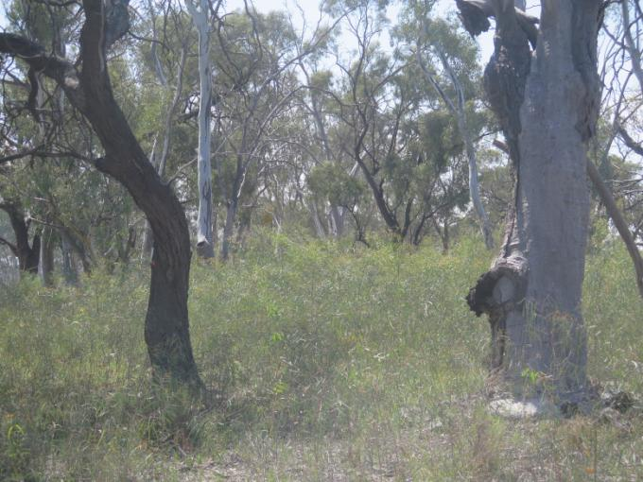

Green growth tips responding to environmental water in a miniature forest of healthy black box (Eucalyptus largiflorens) seedlings at Thiele Flat, Loxton, in the SA Riverland (© Copyright, Anne Jensen)

# Constructed wetlands for wastewater treatment and community benefits

Stefanie Stanley, Ecoteam

Constructed wetlands provide numerous community benefits in addition to wastewater treatment outcomes.

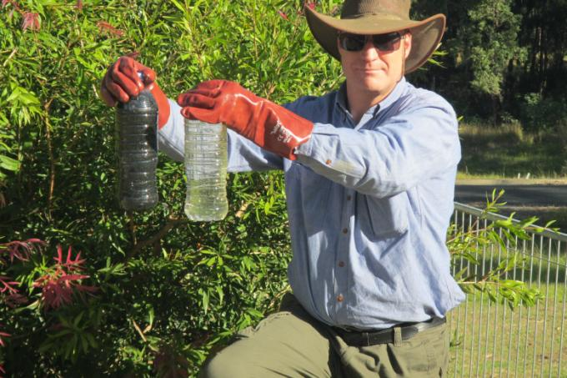

Dr Keith Bolton showing wastewater before treatment (left) and after treatment (right) in the constructed wetland at Malabugilmah Village (© Copyright, Bil Bolton)

Sustainable solutions for wastewater treatment have been successfully implemented by Ecoteam in a number of recent projects across regional NSW and in partnership with organisations overseas.

The Orana Haven Wastewater Treatment project was recently implemented near Brewarrina in western NSW. Orana Haven is a drug and alcohol rehabilitation facility for up to 50 people. Poorly treated wastewater was threatening groundwater supplies. Ecoteam designed and constructed a wastewater treatment system and disinfection system. The treated wastewater is now irrigated onto Orana’s fruit orchard and the plants in the wetland cells which create a green space for the community to enjoy. The community benefits of green space and, in particular, the benefits of green space for mental health have been well documented.

Malabugilmah is an Aboriginal community near Tenterfield. When the community contacted us for assistance, the sewage pump systems were failing and raw sewage was flowing directly into the river. The community health impacts were significant. Ecoteam designed and supervised construction of seven gravity-operated wetland clusters which were positioned to maximise their landscape benefits. A football field was built as part of the project and treated wastewater is irrigated onto the field. Fourteen community members were employed and trained during the project. The community no longer experiences gastrointestinal issues and the children can swim in the river without risk to their health.

Ecoteam recently designed a wastewater treatment wetland in partnership with Borneo Orangutan Survival (Australia) and the Samboja Lestari project in East Kalimantan. Orangutans in Borneo are displaced or orphaned by deforestation activities and are brought to the sanctuary for rehabilitation. Some orangutans are affected by tuberculosis and are unable to be released. Constructed wetlands provide treatment which reduces the risk of transmitting tuberculosis to other orangutans and workers and volunteers on site. Our services were provided on a pro bono basis as we believe in sharing our knowledge with communities in our region. For more details on the Samboja Lestari project, see orangutans.com.au

Rather than creating environmental problems by discharging poorly treated sewage effluent into rivers and oceans, wastewater can be utilised as a community resource. At the same time, community health issues can be resolved and community benefits such as green spaces can be created in addition to the primary aim of wastewater treatment.

For more information about these projects, please visit [ecoteam.com.au/projects](http://ecoteam.com.au/projects)

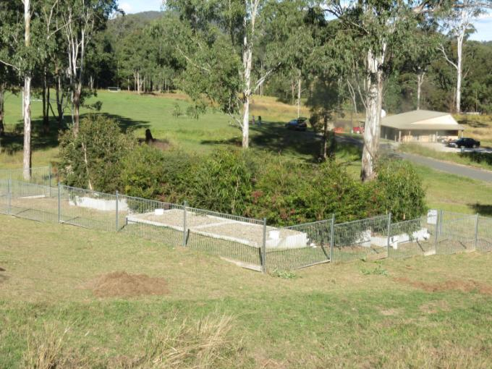

Malabugilmah Wetland Treatment Cells with the irrigated sports field in the background (© Copyright, Bil Bolton)

# Insights from the use of an online wetland management resource

Cameron E Webb, University of Sydney and NSW Health Pathology, and Swapan Paul, Sydney Olympic Park Authority

What insights can be provided by analysing information on the patterns of access to a free online wetlands management resource?

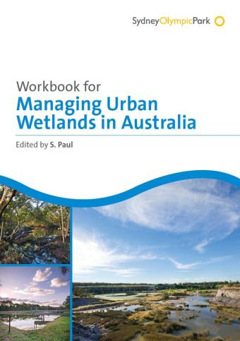

Managing urban wetlands is a concern for local authorities throughout Australia. This is particularly the case within urban areas where wetlands provide an important ecological resource but are also under threat from pollution, urbanisation and a changing climate.

In November 2013, the Sydney Olympic Park Authority launched a free online eBook, ‘Workbook for Managing Urban Wetlands in Australia’. This resource draws on the experience of developing and delivering the Wetland Education and Training (WET) Program at Sydney Olympic Park over a period of 12 years. The eBook has 28 chapters written by eminent wetland scientists, practising ecologists and other dedicated professionals.

Data on the downloads of each individual chapter of the eBook were analysed. A total of 6451 chapter downloads took place over the 22 months since publication. Nearly half of these downloads took place within the first six months of publication, with up to 1200 in March 2014, but the resource is consistently accessed with approximately 280 chapter downloads each month. The introductory chapter, outlining the importance of urban wetlands, was downloaded the most (541 downloads). Of the other individual chapters, those dealing with biological assessments   
of wetlands (227 downloads), water quality testing (246 downloads) and guidelines for management plan development (210 downloads) were most popular. We feel this reflects the demand for practical advice on managing wetlands. The remaining chapters, many with highly specific topics, have been downloaded between 141 and 224 times.

While the eBook was originally targeted at wetland professionals, feedback indicates it has been used as a preferred text book by Australian universities teaching wetland ecology and management. In addition, community groups have benefitted from access to a freely available resource containing a level of detailed information otherwise not easily obtained.

Enjoy reading this eBook and making a difference in the wetland that you care for. Also, please encourage your peers to access this eBook and make use of it.

The eBook can be accessed for free via the website of the Sydney Olympic Park Authority: sopa.nsw.gov.au/resource_centre/wet_ebook_workbook_for_managing_urban_wetlands_in_australia

For more information on the eBook, as well as the Sydney Olympic Park Authority’s Wetland Education and Training Program, please contact Dr Swapan Paul at [Swapan.Paul@sopa.nsw.gov.au](mailto:Swapan.Paul@sopa.nsw.gov.au)

Restoring ecosystems and habitats

# Wise use of Macquarie Marshes wetlands pays bird diversity and water quality dividends

Commonwealth Environmental Water Office

In October 2015, staff from the Commonwealth Environmental Water Office (CEWO) joined staff from the NSW Office of Environment and Heritage (OEH) to undertake bird surveys across the Macquarie Marshes. Since August, 52 gigalitres of much needed environmental water had flowed across the drying system.

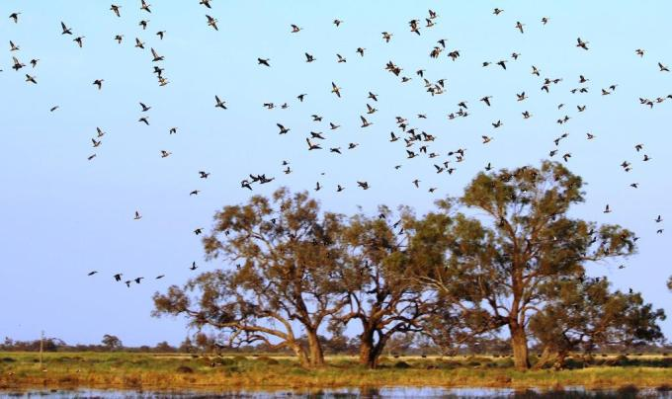

Grey teal and some black duck foraging on the Hall’s flooded back paddock (© Copyright, Commonwealth Environmental Water Office)

Over three days, wetland ecologists, environmental water managers and local Rangers from NSW National Parks and Wildlife Service spotted 130 woodland and wetland bird species at several sites, including several threatened species of birds, such as ducks and herons. Australasian bitterns were heard ‘whooping’ in the south marsh reed beds, with clamorous reed warblers and wrens. Magpie geese were nesting in the reeds, whiskered terns swooped on the bounteous insect population and white-necked herons and ducks dabbled for food in the muddy swamp margins.

On Mole Marsh, one of two private parcels in the Macquarie Marshes Ramsar site, at least eight of the cryptic Australian painted snipe were observed visiting the flooded homestead paddocks during the survey. Several frog species, including the ground dwelling salmon-striped frog, were also heard calling from the reeds.

Mole Marsh is owned by Garry and Leanne Hall, successful cattle and horse breeders, whose family has been actively discussing water allocation issues for over 45 years. Garry is also a member of the Macquarie-Cudgegong Environmental Flows Reference Group, which provides advice on managing discretionary environmental water in the catchment.

‘Our grazing system is all about sustainability, including the use of grazing to promote the spread of water couch and reed,’ says Leanne Hall. Leanne told CEWO that including their property in the survey inspires them, including the children, to get out and about and see it for themselves.

Over in the Hall’s ‘U-block’ the glossy ibis, a listed migratory species, had settled in with grazing cattle and kangaroos. The morning sun revealed a variety of herons happily perched in the big old Coolabah tree — one that has been around, like the Halls, for generations. If wetlands such as these can be used wisely then ecosystem, economic and social/cultural benefits should be available for more generations to come.

Sustainably managing nationally and regionally important wetlands in modified catchments, such as the Macquarie, pays significant ecological and water quality dividends. This is especially important during drier times, as healthy wetland communities provide valuable refuge for a range of important species from the harsher realities of a drying landscape.

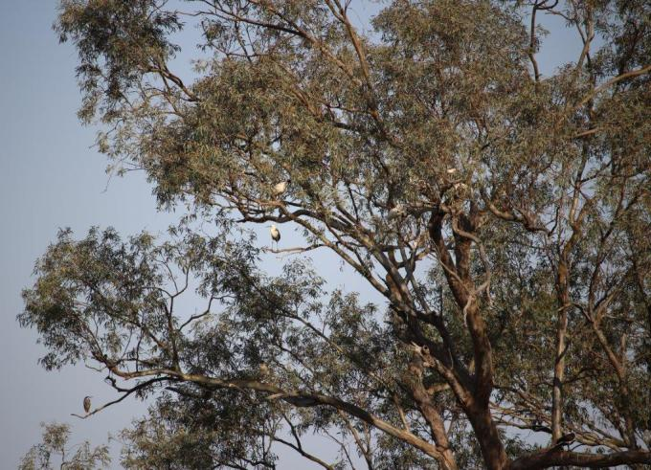

Herons and ibis perched in a coolabah tree (© Copyright, Garry Hall)

# Restoring a Ramsar Wetland: Piccaninnie Ponds Conservation Park

Steve Clarke, Wetland Conservation Ecologist, SA Department of Environment, Water and Natural Resources

Piccaninnie Ponds Conservation Park achieved Ramsar status in 2012 for a multitude of reasons. This karst rising spring is home to 65 national and state listed species and is the flagship of the severely threatened karst rising spring communities.

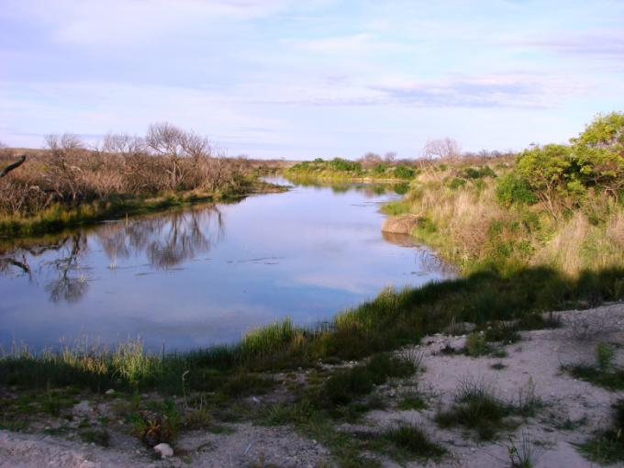

Flow path after planting (© Copyright, Steve Clarke)

These crystal clear springs occur in the karst landscapes near the coast in the southeast of South Australia. They well from deep within the limestone aquifer and create the perfect habitat for many plant and fish species including the nationally listed spiny cray and the variegated and yarra pygmy perch. All but one of these springs now drain to the sea and only the Piccaninnie waters spread into large wetlands within the park.

While drainage, clearing and grazing ceased in Piccaninnie in the mid 1970s, little conservation work was undertaken until 2005 when Pick Swamp, a grazing property to the west, was purchased and restored and re-joined to Piccaninnie. At this time a regulator was constructed south of the main Piccaninnie ponds to restore water levels. These two projects greatly increased the conservation value of the park and now over 150 species of bird have been recorded in the restored Pick Swamp.

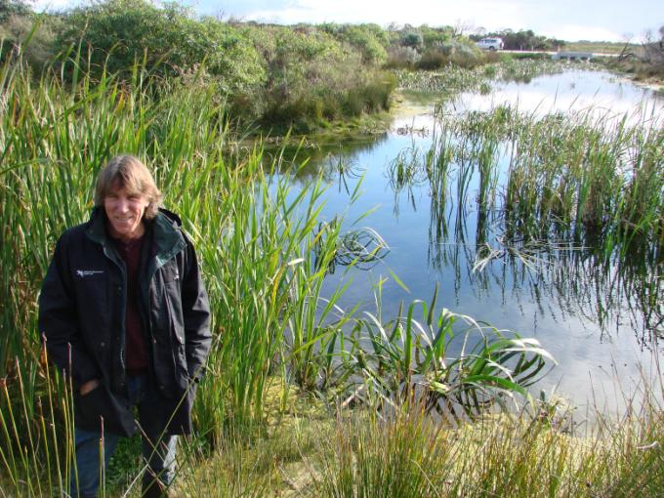

Steve Clarke at the restored flow path (© Copyright, Steve Clarke)

On-ground work for the next stage of restoration commenced in early 2013. The aim was to raise the overall wetland water level by 20 centimetres and open up 30 hectares of eastern wetland that had been isolated for 60 years. This would influence 180 hectares of wetland and recreate part of an old, long lost flow path. The infrastructure work was both extensive and sensitive to ensure those undertaking the restoration work adhered to Ramsar guidelines, which specify that no ecological degradation occurs as a result of the work. Main works included breaching the Piccaninnie road to allow flows to the eastern wetland and construction of a levee, weir and larger fish passageway. The old flow path presented a problem to restore as it was covered with 80 centimetres of drifted sand from the coastal dunes. Over 300 metres of this sand was pulled back to expose the flow path and reconstruct a low dune.

The results of the work have been amazing. Over 7 million litres a day now flow into the eastern wetland and two fish species, jolly tails and eels, long absent, have been recorded. There have also been unexpected benefits such as the unforeseen creation of shallow water areas that have become habitat for the dwarf galaxias, a small fish listed under the Environment Protection and Biodiversity Conservation Act 1999.

Many partners have contributed to the works and volunteer groups have been actively involved since 2005. Restoration work within the Piccaninnie Conservation Park has been funded by the South Australian and Australian Governments. For more information, contact [steve.clarke@sa.gov.au](mailto:steve.clarke@sa.gov.au)

# Frogs and the health of their wetlands: the ACT Bio-Indicator Project

Nick Bakker University of Tasmania, and Anke Maria Hoefer, ACT & Region Frogwatch.

Recent news in biodiversity worldwide has highlighted the dramatic decline of frog species numbers and the important role frogs play in the food web of wetlands and rivers. If frogs disappear from an area, the whole ecosystem can suffer.

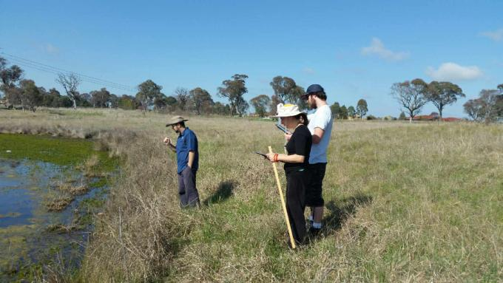

The project team conducting wetland health assessment at a grassland pond on the outskirts of Canberra (© Copyright, Anke Maria Hoefer)

From the mid 1990s Waterwatch and more recently Frogwatch ACT have been stalwarts in capturing and recording frog species data in the ACT and Southern NSW region. Using the wealth of information obtained from many hours of volunteering in the field, Frogwatch ACT, led by coordinator Anke Maria Hoefer, undertook a bio-indicator project in October 2015 to help assess the health and viability of various wetlands identified as frog habitats in several areas around the ACT.

The project, funded by the ACT Government, Environment and Planning Directorate, was set up with the vision of using the data to assist in recognising the distribution and abundance of frogs when related to riparian structure and condition at certain sites. Following on from the project, the information obtained could be used to supplement the Catchment Health Indicator Project (CHIP) to be released by the ACT Government.

Besides Anke Maria, the project team consisted of Upper Murrumbidgee Waterwatch scientific officer, Danswell Starrs, and two students completing environmental studies at the University of Tasmania and Canberra Institute of Technology. The team conducted wetland health assessment at over 30 dams and ponds around the ACT in a variety of urban, semi-urban and bushland environments.

The team worked tirelessly to complete the field work, which included night time frog monitoring, through the month of October to coincide with the local frog breeding season and time of highest activity. Also being recorded was the presence of threatening exotic fish species: eastern gambusia (Gambusia holbrooki), a small aggressive species that preys on amphibian eggs and oriental weather loach (Misgurnus anguillicaudatus), a pest species that feeds on fresh water insect larvae and algae, vital for frog health.

For more information regarding Upper Murrumbidgee Waterwatch or ACT Frogwatch contact the Ginninderra Catchment Group on (02) 62783309.

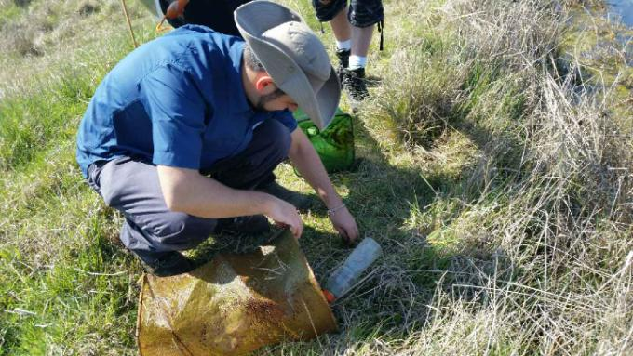

Upper Murrumbidgee Waterwatch scientific officer, Danswell Starrs, checking illegally placed fish traps (© Copyright, Anke Maria Hoefer)

# Restoring Australia’s Great Southern Seascapes

Chris Gillies, Marine Manager, The Nature Conservancy

All along the southern coast of Australia lie hundreds of bays and estuaries with important marine habitats including rocky reefs, seagrass meadows, mangrove forests and saltmarshes. Yet there is one marine habitat you probably haven’t heard of, shellfish reefs.

Shellfish reefs were once an important and common marine habitat all across southern and eastern Australia but were rapidly fished to near extinction during the mid to late 1800s, due to their usefulness as a source of food, and as a source of lime used in the early construction of roads and buildings. Shellfish reefs were not only a biodiverse and structurally complex habitat that supported a rich array of terrestrial and marine species but they also played an important role in estuary health through water filtration, fish production and coastal protection.

The economic benefits of early shellfish harvest must have been substantial. Not only did the shellfish fishery directly support the livelihoods of thousands of commercial fishers but it also supported jobs in the curing and transportation of shellfish as a major food item transported to interior settlements, sold to passing ships and exported to overseas markets. Carpenters and boat builders were also employed to build and maintain the fishing fleets that numbered as many as 100 in a single estuary.

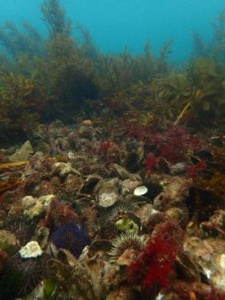

Native flat oyster reefs (Ostrea angasi) in Georges Bay, Tasmania (© Copyright, Chris Gillies)

The near extinction of a precious wetland habitat that sustained early Australian colonialization and expansion for nearly 100 years, and which has gone largely unnoticed by the general public and researchers alike, makes for an intriguing story that is not only important to the ecological history of Australia but   
to its cultural and economic identity as well.

Efforts are underway to repair and restore shellfish reefs across Australia ([natureaustralia.org.au/our-impact/water/port](http://www.natureaustralia.org.au/our-impact/water/port-phillip-bay/)-phillip-bay) and to bring attention to the ecological, economic and social value of repairing marine wetland habitats and their ecosystem services. The Nature Conservancy along with others such as NOAA in the United States ([habitat.noaa.gov/restoration](http://habitat.noaa.gov/restoration)) have demonstrated that when the restoration of marine habitats occurs across large scales, ecosystem services and biodiversity can be restored and the works associated with restoration can contribute to both short and long-term economic benefits for coastal communities.

To find out more about coastal restoration and the Nature Conservancy’s new marine program Great Southern Seascapes visit natureaustralia.org.au/our-work/great-southern-seascapes or contact [chris.gillies@tnc.org](mailto:chris.gillies@tnc.org)

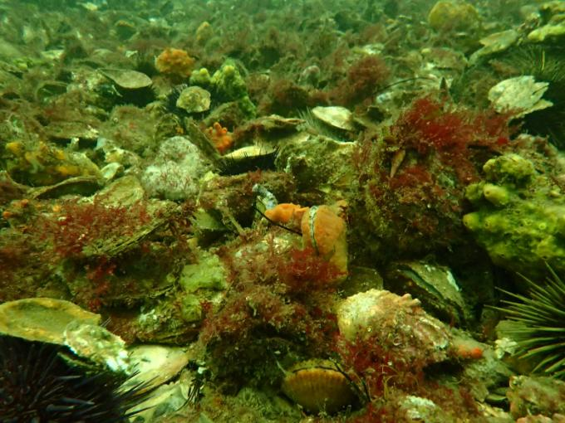

Native flat oyster reefs (Ostrea angasi) in Georges Bay, Tasmania (© Copyright, Chris Gillies)

# Benefiting wetlands with existing infrastructure

Kieran Squire, Community Partnerships Project Officer, River Murray Operations and Major Projects, South Australian Department of Environment, Water and Natural Resources

Reinstating variability in flows along some sections of the River Murray, through the use of existing weirs, is providing benefits to river ecology.

In South Australia, River Murray flows were naturally highly variable, increasing through late winter, peaking in spring and reducing over summer. Flows above 150 000 megalitres per day and below 2000 megalitres per day were common, and river levels could vary by as much as five metres. As a result the river’s ecology is based on highly variable water levels.

While these variations in water levels were good for the environment, they were not good for irrigation, navigation and meeting critical human needs. To create more stable water levels, a series of weirs along the River Murray was built between 1913 and 1937. Now, the river in South Australia is operated as a series of stable pools, which experience very little water level variation. As a result, 70 per cent of wetlands once seasonally inundated are now permanently connected to the river, and this has been detrimental to the environment.

However, weirs can be used to raise and lower water levels to mimic more natural water variability. While fully restoring pre-regulation ecology via water level manipulation is not a realistic goal, achieving improvements to aspects of the ecology is possible, especially in localised areas along the River Murray.

In 2014, the South Australian Department of Environment, Water and Natural Resources (DEWNR) raised the water levels between Lock One and Lock Three (weir pools 1 and 2). Water levels were raised 50 centimetres above the usual level and the resulting inundation brought some positive ecological results and supportive community feedback.

As a result of raising the weir pool levels DEWNR has seen some increased crown growth in river red gums, an increase in both the abundance and diversity of submerged and fringing vegetation, and some change in biofilm composition. Monitoring is now being adjusted to better detect responses as repeat water level fluctuations help to slowly reinstate the ecology and produce greater responses.

The community has been supportive with survey results showing:

* 84 per cent of the community members living alongside weir pools 1 and 2 were supportive of changing the water levels in the weir pools
* 82 per cent experienced little to no impact on their lifestyle
* 40 per cent observed the presence of more birds, yabbies, frogs or fish
* 47 per cent observed increased vegetation growth and health.

The water levels in weir pools 2 and 5 are being raised in 2015 and results will be available sometime in mid-2016. It is expected that this year’s raising will inundate an additional 214 hectares of wetlands and water approximately 920 hectares of vegetation.

Weir Pool Manipulation is part of the Riverine Recovery Project (RRP) which is funded by the South Australian Government’s Murray Futures program and the Australian Government. RRP is a $91 million initiative to improve the health of the River Murray and its wetlands and floodplains from the South Australian border to Wellington.

Contact Kieran Squire at the Department for Environment, Water and Natural Resources by phone on (08) 8463 6505 or visit [naturalresources.sa.gov.au/weirpools](http://naturalresources.sa.gov.au/weirpools)

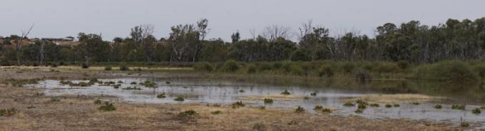

As the weir pool rises, local wetlands and floodplains receive the water they need between high flow events (© Copyright, Kieran Squire)

# Golden perch spawn in record numbers in response to managed environmental flows

Commonwealth Environmental Water Office, Victorian Environmental Water Holder and the Goulburn Broken Catchment Management Authority

Collaborative efforts of federal, state and local water resource managers demonstrate the effectiveness of environmental flows to promote the successful breeding of native fish species.

An environmental watering priority in the Goulburn River for 2014–15 was the provision of environmental flows to support native fish populations. In Spring 2014, Commonwealth environmental water was delivered to the lower Goulburn River over 3 weeks from mid-November to early December as a (fresh) flow pulse with the aim of triggering movement and spawning of golden perch (Macquaria ambigua), which is listed as near threatened under the Victorian Government’s Advisory List of Threatened Vertebrate Fauna in Victoria, 2013.

Golden perch exhibited a strong spawning response to increased flows provided by the delivery of environmental water. In fact, the planned Spring 2014 flow pulse induced golden perch spawning in numbers not previously seen, other than following the 2010 floods, and so can be regarded as an outstanding example of managed flows achieving their aim. Critically endangered silver perch (Bidyanus bidyanus) also spawned in association with increased flows.

It is important to note, however, that although golden perch and silver perch spawned in the Goulburn River in 2014, no young-of-year fish were collected in the 2015 fish monitoring surveys. Therefore, whilst increased flows can promote spawning of these species in the Goulburn River, it appears that this may not necessarily lead to immediate in situ recruitment of juvenile fish. Given that golden perch and silver perch lay semi-buoyant eggs that drift downstream on river currents, potentially over large distances, it is possible that eggs drift downstream into the River Murray, and that any recruitment into the Goulburn River occurs at a later stage by older fish and also potentially by fish from other river systems. The origin and migratory history of golden perch and silver perch is a knowledge gap and represents an important area for future research. Ongoing work by the South Australian Research and Development Institute is trying to address this knowledge gap in the southern Murray-Darling Basin (Zampatti et al., 2014).

As part of the Commonwealth Environmental Water Office’s Long Term Intervention Monitoring Project, a detailed Monitoring and Evaluation Plan from 2015 to 2019 has been developed for the lower Goulburn River, and includes annual fish surveys to further investigate recruitment of native fish. The Monitoring and Evaluation Plan has been developed, and is being implemented, by a consortium monitoring team led by the University of Melbourne in partnership with the Goulburn-Broken Catchment Management Authority, Monash University, SKM Pty Ltd, Streamology Pty Ltd, Victorian Environmental Water Holder and Arthur Rylah Institute for Environmental Research.

Environmental water deliveries in the Goulburn River are managed in collaboration between the Commonwealth Environmental Water Office, Victorian Environmental Water Holder, Goulburn-Broken Catchment Management Authority, Goulburn-Murray Water and the Murray-Darling Basin Authority.

If you would like to know more about environmental watering in the Victorian Goulburn-Broken system, please contact the Goulburn CMA on 03 5822 7700 or visit [gbcma.vic.gov.au](http://gbcma.vic.gov.au)

## Reference

Zampatti, B.P., Wilson, P.J., Baumgartner, L., Koster, W., Livore, J.P. McCasker, N., Thiem, J., Tonkin, Z., Ye, Q. (2014) Reproduction and recruitment of golden perch (Macquaria ambigua) in the southern Murray-Darling Basin in 2013–14: an exploration or river-scale response, connectivity and population dynamics. South Australian Research and Development Institute. SARDI Publication No. F2014/000756-1. SARDI Research Series No. 820. 61pp.

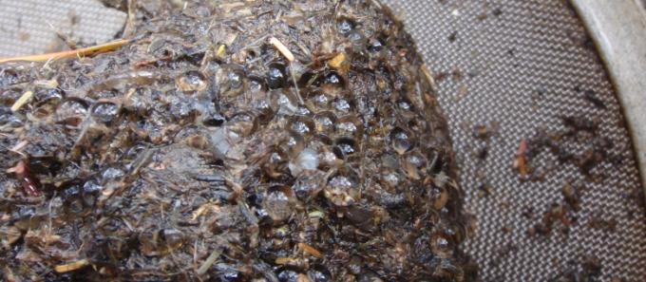

Golden perch eggs collected during monitoring in the Goulburn River in November 2014 (© Copyright, Jim Castles,   
Goulburn-Broken CMA) 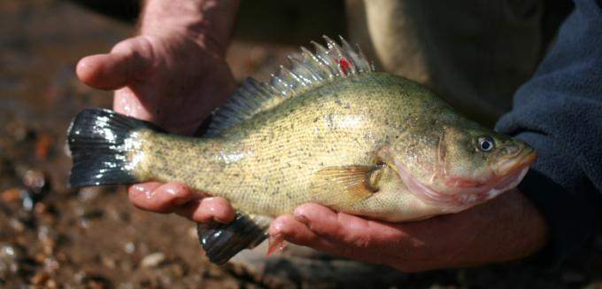

Adult golden perch (© Copyright, Jarod Lyon, Arthur Rylah Institute for Environmental Research)

environment.gov.au

