HYDROLOGY | FOOD WEBS | VEGETATION | WATERBIRDS | FISH | FROGS
Appendix B: Warrego River Hydrology



Introduction
Hydrology, when, where and how water moves through channels, floodplains or wetlands, underpins the environmental and ecological processes in a river system.

Hydrological information from the Warrego River and Western Floodplain is directly relevant to all other indicators measured in the Junction of the Warrego and Darling River systems Selected Area (Selected Area) namely: Food Webs (water quality, microinvertebrates, macroinvertebrates, metabolism); Vegetation; Waterbirds; Frogs and Fish.

The Hydrology indicator provides information on the degree of hydrological connection (channel and floodplain) maintained through the Selected Area during the 2019-20 water year. This particular chapter focusses on hydrological connection through the Warrego channel and the inundation experienced on the Western Floodplain.

Several specific questions were addressed in relation to this indicator:

- What did Commonwealth environmental water contribute to hydrological connectivity of the Warrego Channel within the Selected Area?
- What did Commonwealth environmental water contribute to hydrological connectivity of the western floodplain?
- What did Commonwealth environmental water contribute to sustainable ecosystem diversity?
- Were ecosystems to which Commonwealth environmental water was allocated sustained?
- Was Commonwealth environmental water delivered to a representative suite of ecosystem types?

Weather conditions for the 2019-20 water year are reported in Appendix A: Darling River Hydrology.

Methods

Hydrological connectivity and environmental watering
For the Warrego River, flows entering the Selected Area were measured by plotting flows past Fords Bridge (Figure 1). Flows at 423001–Warrego River @ Fords Bridge (Main channel) were combined with flows past 423002–Warrego River @ Fords Bridge Bywash to give a total flow past Fords Bridge. Connectivity within the lower Warrego channel below Boera Dam was assessed by comparing times when the Boera Dam regulating gates were open (obtained from the CEWO) to water levels at the 423007 – Warrego @ Dicks Dam gauge.

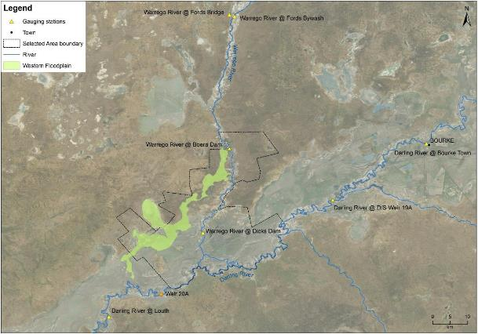
Figure 1 Warrego Channel from Fords Bridge to Darling River confluence.
Environmental watering (dates and volumes) delivered into the system was accessed directly from data provided by the CEWO. These data are presented within hydrographs to describe the role of environmental water in the Selected Area in the 2019-20 water year (July 1 2019 to June 30 2020). A detailed description of the amounts and timing of environmental water delivered to the Selected Area during 2019-20 can be found in Appendix A: Darling River Hydrology.

Inundation mapping

Sentinel image analysis
Three data sources were used to build a model of inundation extent and impact on the Western Floodplain. These included:

- Sentinel imagery
- Existing vegetation mapping
- Rainfall records

These data sources were examined together to produce relationships with inflow and inundation extent. Existing vegetation mapping was used to determine the area and volume of inundation associated with each vegetation community.

All available Sentinel 2 images captured during the 2019-20 water year were provided by the Murray-Darling Basin Authority (MDBA) via the MDBsat system. Those with minimal cloud cover and no other problems were chosen for further analysis. A total of 37 images were selected for analysis (Table 1).
Table 1 Sentinel image dates analysed to map wetland inundation extent.
Image date | MNDWI Threshold | Image date | MNDWI Threshold
5/7/19 | -0.17 | 15/2/20 | -0.22
20/7/19 | -0.12 | 20/2/20 | -0.21
25/7/19 | -0.12 | 21/3/20 | -0.2
4/8/19 | -0.12 | 26/3/20 | -0.2
19/8/19 | -0.12 | 31/3/20 | -0.2
24/8/19 | -0.11 | 5/4/20 | -0.2
29/8/19 | -0.11 | 10/4/20 | -0.21
3/9/19 | -0.13 | 15/4/20 | -0.2
8/9/19 | -0.12 | 25/4/20 | -0.17
13/9/19 | -0.12 | 5/5/20 | -0.12
18/9/19 | -0.11 | 10/5/20 | -0.12
23/9/19 | -0.13 | 15/5/20 | -0.12
28/9/19 | -0.13 | 25/5/20 | -0.12
3/10/19 | -0.13 | 30/5/20 | -0.13
18/10/19 | -0.15 | 4/6/20 | -0.13
28/10/19 | -0.17 | 9/6/20 | -0.12
12/12/19* | -0.24 | 19/6/20 | -0.12
17/12/19 | -0.21 | 29/6/20 | -0.12
21/1/20 | -0.2
*the image capture on 12/12/19 was considered to be rainfall affected so was removed from further analysis

The MDBA also provided the data processed into Modified Normalised Difference Water Indices (MNDWI, Xu 2006). For each date the MNDWI was analysed to determine the water threshold value that was used to classify water and non-water pixels to define the inundation extent. Threshold values were found to lie between -0.12 and -0.22 (Table 1).
Rainfall records were used to exclude image dates within 5 days of heavy rainfall to help reduce mapping error introduced by local, rainfall derived wetting.
The mapped inundation extent for each capture date was used to quantify the inundation extent across each wetland area. For analysis, inundation was considered separately for the Western Floodplain (inside and outside of the the Selected Area boundary) and the Warrego channel.

Ecosystem type assessment
The Australian National Aquatic Ecosystem (ANAE) classification for each sampling site in the Selected Area was mapped using a process of desk-top identification and field verification (Commonwealth of Australia 2014). Existing ANAE GIS layers (Brooks et al. 2013) were used to assign an ecosystem type to each monitoring site, and this was then verified in the field. Sites where existing ANAE mapping did not provide coverage were assigned an ANAE classification using available desktop information and then verified in the field. Field based verification was undertaken following a dichotomous key (Brooks et al. 2013).

The ANAE layer was intersected with the maximum mapped extent of inundation to determine the extent of ANAE classes inundated in the water year.

Results

Hydrological connectivity
The water year commenced with a sustained period of very low or no flow recorded at the Fords Bridge gauges (Figure 2). There was a small flow event with a peak of approximately 600 ML/d in November 2019. A significant flood event commenced in early March 2020 and continued until late May. This event peaked at over 4,300 ML/d, contained around 7% environmental water (Appendix A: Darling River Hydrology) and was the largest flow in the systems since 2012. Both of these flows were visible at Dicks Dam and passed through to the Darling River.

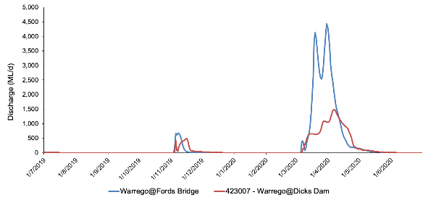
Figure 2 2019-20 water year hydrograph at Fords Bridge (combined channel and bywash gauges).
Within the Selected Area, Boera and Dicks Dams showed a similar pattern across the water year (Figure 3). Both dams commenced the year with water retained from the Cyclone Trevor event in May 2019. Water levels then steadily declined with a relatively small rise caused by the November flow event and a much larger and sustained rise from the event that commenced in March 2020.

Downstream (longitudinal) connectivity to the Darling River commenced on the 8 March 2020 when the Boera Dam gates were opened and continued until 24 May 2020 when they were closed. Previous studies during the LTIM project showed that downstream connectivity from Boera Dam to the Darling River were achieved in less than one day when the Boera gates were open (Commonwealth of Australia 2015). The eastern bywash connects the Warrego River around Boera Dam during significant flow events. For the first time during the LTIM/MER montoring program, the eastern bywash flowed, connecting the system around the Boera Dam wall. Sentinel imagery indicates the that eastern bywash was connected by 21 March 2020 and ceased connection by the 25 April 2020. Total environmental water contribution past Dicks Dam during this connection event was 16,212 ML or 36% of the total flow (Appendix A: Darling River Hydrology)

Connection to the Western Floodplain from the Boera Dam overflow occurs at approximately 2.26 m dam level. Flow on to the Western Floodplain commenced on 7 March 2020 and the dam level remained above 2.26 m at the end of the monitoring period for this water year (Figure 3).

Figure 3 Boera and Dicks Dams levels 2019-20 water year, with downstream connectivity and connection to the Western Floodplain indicated.

Floodplain inundation
The MDBA were able to provide 37 Sentinel cloud free images over the study area (Figure 4, Figure 5, Figure 6, Table 2). Of these, 1 image was considered rain affected and was removed from analysis (12 Dec 2019). The water year started with approximately 492 ha of inundation combined across the three mapping areas (Table 2).
The mapped inundated area declined from July 2019 to March 2020, although the November flow event increased inundation in the dams of the Warrego channel a small amount. The flow event that commenced in March 2020 led to a substantial increase in inundation both on the Western Floodplain and the Warrego channel. Total inundation peaked at over 11,500 ha in April and then declined streadily to the end of the water year.
The imagery indicates that the flow down the Western Floodplain connected to the Darling River by 10 April 2020 and this connection was evident on the imagery from 25 April 2020 but not evident on the imagery from 5 May 2020 or any subsequent image.

Field based evidence provided by Sonya Ardill (personal communications via email) confirmed that the Western Floodplain was connected to the Darling River at Talowla on the 26 April 2020 (Figure 7) and that the landowners (Junks) noted that connected had ceased by mid to late May 2020 although they considered that date to be approximate.

Table 2 Mapped inundation areas with maximum inundation area (ha) highlighted.
Image date | Western Floodplain |  | Warrego channel (ha) | Total (ha)
Image date | Outside Selected Area (ha) | Inside Selected Area (ha) | Warrego channel (ha) | Total (ha)
5 Jul 2019 | 3 | 134 | 355 | 492
20 Jul 2019 | 3 | 79 | 239 | 321
25 Jul 2019 | 2 | 66 | 219 | 288
4 Aug 2019 | 2 | 53 | 205 | 260
19 Aug 2019 | 2 | 30 | 167 | 198
24 Aug 2019 | 2 | 25 | 156 | 182
29 Aug 2019 | 2 | 22 | 149 | 173
3 Sep 2019 | 2 | 21 | 147 | 169
8 Sep 2019 | 1 | 19 | 144 | 165
13 Sep 2019 | 1 | 16 | 130 | 147
18 Sep 2019 | 1 | 13 | 121 | 136
23 Sep 2019 | 2 | 12 | 122 | 135
28 Sep 2019 | 1 | 10 | 112 | 124
3 Oct 2019 | 1 | 9 | 106 | 116
18 Oct 2019 | 1 | 7 | 93 | 101
28 Oct 2019 | 1 | 7 | 85 | 93
19 Dec 2019 | 2 | 11 | 253 | 266
21 Jan 2020 | 107 | 7 | 102 | 217
15 Feb 2020 | 2 | 11 | 83 | 95
20 Feb 2020 | 2 | 7 | 72 | 81
21 Mar 2020 | 185 | 1,321 | 1,073 | 2,579
26 Mar 2020 | 161 | 3,409 | 1,386 | 4,956
31 Mar 2020 | 143 | 4,900 | 1,389 | 6,432
5 Apr 2020 | 637 | 7,169 | 1,568 | 9,374
10 Apr 2020 | 1,054 | 9,014 | 1,468 | 11,536
15 Apr 2020 | 1,204 | 8,699 | 1,257 | 11,160
25 Apr 2020 | 1,302 | 6,095 | 757 | 8,154
5-May-20 | 1,287 | 3,951 | 548 | 5,786
10-May-20 | 1,154 | 3,092 | 514 | 4,760
15-May-20 | 1,019 | 2,760 | 441 | 4,221
25-May-20 | 918 | 2,407 | 346 | 3,671
30-May-20 | 792 | 2,083 | 350 | 3,226
4-Jun-20 | 608 | 1,696 | 311 | 2,615
9-Jun-20 | 439 | 1,182 | 291 | 1,912
19-Jun-20 | 441 | 1,286 | 303 | 2,029
29-Jun-20 | 249 | 849 | 273 | 1,371

Figure 4 Inundated area within the Selected Area (2019-20 water year).

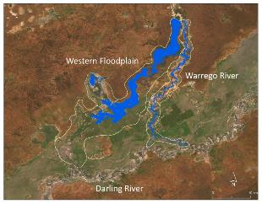
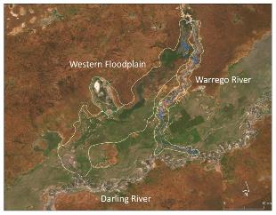
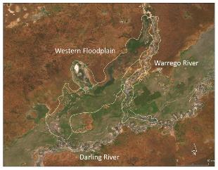
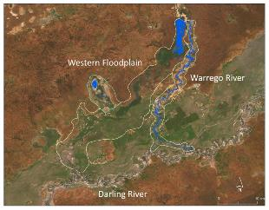
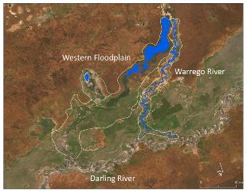
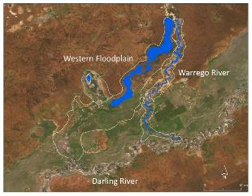
5 Jul 19
21 Mar 20
5 Apr 20
31 Mar 20
20 Feb 20
26 Mar 20

Figure 5 Inundation map sequence 5 July 2019 to 5 April 2020.

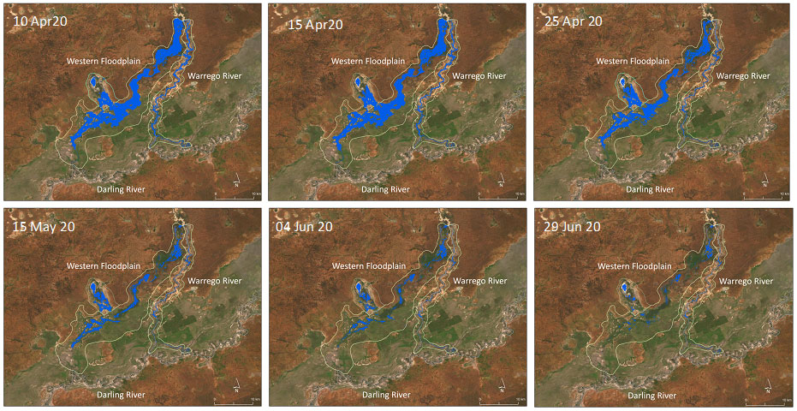

Figure 6 Inundation map sequence 10 April 2020 to 29 June 2020.
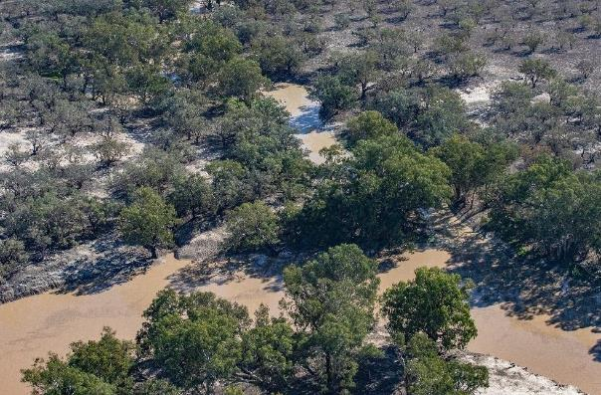
Figure 7 Connection of Western Floodplain to Darling River at Talowla 26 April 2020 (Photograph provided by Sonya Ardill coutesy of NPWS).
A substantial area of the Western Floodplain was inundated at the peak of the flow event in April 2020. In total, 12 mapped vegetation communities were partly inundated with large areas of Lignum shrubland (4,748 ha) and Chenopod shrubland (2,717 ha) inundated for extended periods (Table 3). Almost all of the mapped lignum communites were inundated.

Table 3 Vegetation communities inundated at the largest mapped inundation level (10 April 2020).
Vegetation Community | Area inundated (ha) | % Inundated | Area on WFP (ha)
Anthropogenic herbland | 14.0 | 59% | 23.7
Beefwood - Coolabah woodland | 3.3 | 4% | 79.8
Belah/Black Oak - Western Rosewood - Leopardwood | 1.7 | 1% | 231.6
Canegrass swamp | 0.0 | 0% | 10.1
Chenopod low open shrubland | 2,716.6 | 24% | 11,393.5
Coolabah - River Coobah - Lignum woodland | 89.4 | 97% | 92.4
Coolabah open woodland wetland | 999.4 | 51% | 1,966.9
Gidgee chenopod woodland | 0.0 | 0% | 350.3
Ironwood woodland | 6.3 | 0% | 1,607.3
Lignum shrubland wetland | 4,747.7 | 96% | 4,959.7
Mulga shrubland | 1.9 | 1% | 294.6
Narrow-leaved Hopbush-Scrub Turpentine-Senna shrubland | 7.5 | 1% | 865.6
Poplar Box grassy low woodland | 6.6 | 1% | 1,059.2
Sandplain Mulga | 0.0 | 0% | 41.2
Supplejack woodland | 0.0 | 0% | 2.4
Stream/River/Dam | 14.7 | 100% | 14.7
Whitewood - Western Rosewood low woodland | 0.0 | 0% | 7.3
Unmapped | 404.7
Total | 9,013.8 | 39% | 23,000.2

Ecosystem type

Using the maximum mapped inundation extent, the area of ANAE classes inundated within the water year was mapped for each wetland (Table 4). At total of 5 ANAE types were inundated during the 2019-20 water year including one riverine type and four palustrine types. The mapping shows that a substantial area of F2.2 Lignum Shrubland floodplain was inundated along with F2.4 Shrubland floodplain and a substantial areas of F1.10 Coolibah woodland and forest floodplain.
Table 4 Inundated ANAE areas
 | ANAE Typology | Area inundated (ha) | % inundated | Area total (ha)
Western Floodplain | F1.10 Coolibah woodland and forest floodplain | 999.4 | 51% | 1,966.9
Western Floodplain | F1.11 River cooba woodland floodplain | 89.4 | 97% | 92.4
Western Floodplain | F2.2 Lignum Shrubland floodplain | 4,747.7 | 96% | 4,959.7
Western Floodplain | F2.4 Shrubland floodplain | 2,716.6 | 24% | 11,393.5
Western Floodplain | LT2.2 Temporary floodplain lake with aquatic beds | 14.7 | 100% | 14.7
Western Floodplain | Unclassified | 41.3 | 1% | 4,573.1
Western Floodplain | Unmapped | 404.7
Western Floodplain | Total | 9,013.8 | 39% | 23,000.2
Outside Toorale | Unmapped | 1,054.09 |  | N/A
Warrego Channel | F1.10 Coolibah woodland and forest floodplain | 1,027.8 | 22% | 4,669.8
Warrego Channel | F2.4 Shrubland floodplain | 18.9 | 1% | 2,396.9
Warrego Channel | LT2.2 Temporary floodplain lake with aquatic beds | 357.4 | 94% | 381.2
Warrego Channel | Unclassified | 1.3 | 0% | 1,002.7
Warrego Channel | Total | 1,405.5 | 17% | 8,450.6

Discussion and Conclusion
The 2019-20 water year was marked by strong contrast in flow and inundation conditions. The first nine months of the year were very dry with decreasing inundation in the channel dams and pools, and on the Western Floodplain. The significant flow that commenced in March 2020 connected the Warrego River through to the Darling River for an extended period (77 days), from 8 March 2020 to 24 May 2020. Connection to the Western Floodplain from the overflow point above Boera Dam was evident in early March and was still present at 30 June 2020, the end of the water year. Over 11,500 ha of floodplain and channel habitat was inundated by this event with large areas of the landscape retaining water for extended periods. The eastern bywash, a channel that connects the Warrego River around the Boera Dam wall during high flows, was connected for approximately 30 days. The March-April 2020 flow event was the largest since the LTIM/MER project commenced and led to the longest period of downstream connection of the Warrego channel, largest area of inundation and first connection via the eastern bywash and via the Western Floodplain at Talowla since monitoring for this project began.

Sentinel imagery provided by the MDBA was used for this project for the first time. The increased temporal capture frequency (sub-weekly) compared with Landsat (twice monthly) provided substantially more information on inundation dynamics.

References
Brooks, S., Cottingham, P., Butcher, R, and Hale, J. 2013. Murray-Darling aquatic ecosystem classification: Stage 2 report. Peter Cottingham & Associates report to the Commonwealth Environmental Water Office and Murray-Darling Basin Authority, Canberra.

Commonwealth of Australia. 2014. Commonwealth Environmental Water Office Long Term Intervention Monitoring Project Gwydir River System Selected Area. Commonwealth of Australia.

Commonwealth of Australia 2015. Commonwealth Water Office Long Term Intervention Monitoring Project Junction of the Warrego and Darling rivers Selected Area, Canberra.

Xu (2006) Modification of normalised difference water index (NDWI) to enhance open water features in remotely sensed imagery. International Journal of Remote Sensing. 27:14.

