Appendix D: Vegetation
HYDROLOGY | FOOD WEBS | VEGETATION | WATERBIRDS | FISH |FROGS

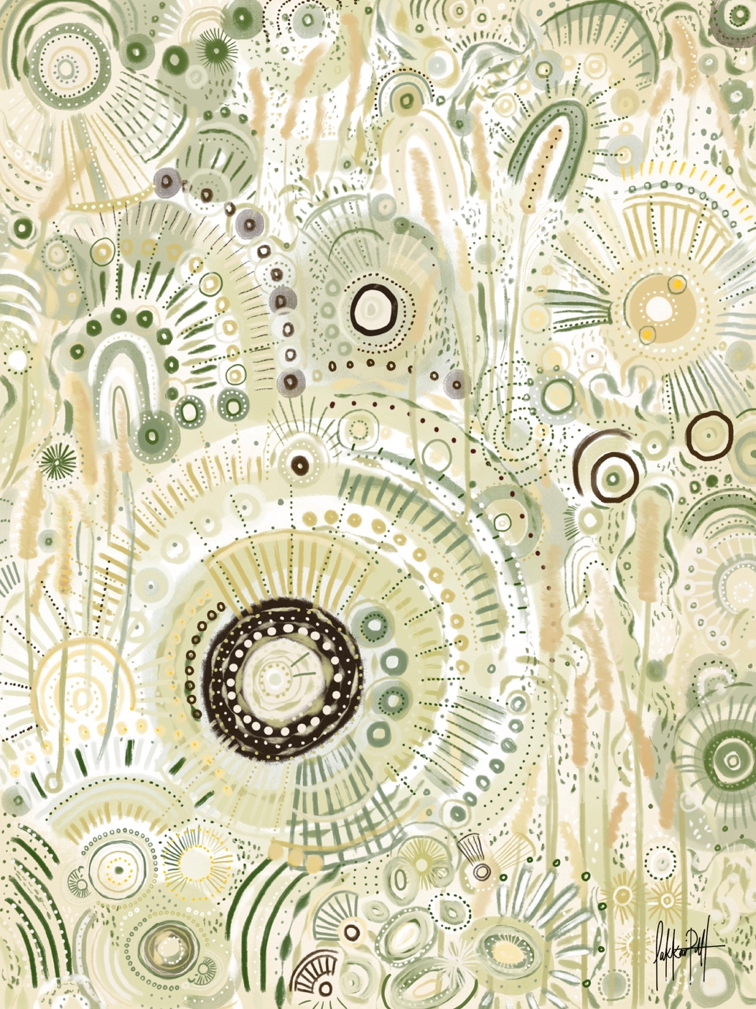

Introduction
The vegetation communities of the Warrego River Western Floodplain are dominated by stands of coolibah (Eucalyptus coolabah) and black box (Eucalyptus largiflorens), lignum (Duma florulenta) and a range of chenopod and other herbaceous species that have adapted to both long dry periods and prolonged periods of inundation. The presence and distribution of these species has been further influenced by the increased inundation patterns due to long-term water management structures on Toorale (Hale et al. 2008, Capon 2009). Compared with communities in other Northern Basin catchments, vegetation on the Western Floodplain is in relatively good condition (Hale et al. 2008). As a result, these communities represent a significant target for Commonwealth environmental water within the Junction of the Warrego and Darling rivers Selected Area (Selected Area). The MER project is a continuation of the LTIM project and aims to investigate the contribution of Commonwealth environmental water to floodplain vegetation diversity, condition and extent. The monitoring of vegetation diversity in the 2019–20 water year within the Selected Area was used to address two key questions:
- What did Commonwealth water contribute to vegetation species diversity?
- What did Commonwealth water contribute to vegetation community diversity?

Previous LTIM monitoring
Previous LTIM monitoring identified clear links between the condition of vegetation communities on the Western Floodplain and inundation, which has been enhanced by Commonwealth environmental water and water management. Maximum vegetation species richness and cover were observed in spring 2016 following the most widespread floodplain inundation to occur in the project. This inundation event maintained vegetation communities until spring 2017, with subsequent dry conditions leading to significant declines in richness and cover until the last LTIM survey in early 2019. Recruitment of floodplain tree species was sporadic during the project, with limited evidence of succession from seedling to sapling at most locations. A combination of unfavourable drought conditions, grazing by goats and macropods and competition for resources by other plant species are likely drivers of the poor recruitment and succession levels observed.

Methods

2019-20 water year
Twenty-four plots were monitored at eight locations throughout the Western Floodplain during October 2019 and March 2020 (Table 1, Figure 1). Plots were located within four broad wetland vegetation communities and paired across differing inundation frequencies (Table 1, Commonwealth of Australia 2019). During the 2019 water year all sites were dry at the time of survey. However, in the 2020 water year, 11 of the 24 sites were either partially or completely inundated (Table 1). Vegetation surveys were undertaken following the standard vegetation diversity method (Commonwealth of Australia 2015, Hale et al. 2013), where vegetation diversity, structure and cover were recorded within each 0.04 ha plot. Environmental variables including the extent and depth of inundation at the time of survey were also noted.
Species richness and total vegetation cover data were analysed using Poisson regression analysis to investigate the influence of survey time (October, March), vegetation community (Table 1) and inundation status (wet, dry) on these measures. ‘Wet’ sites had some proportion of the plot with standing water and often also displayed wet soils. Total vegetation cover and richness for each plot was calculated by adding together the cover of lower and mid strata types, therefore, it was possible to get >100% total cover. Both native and exotic species were included in this analysis.

Table 1 Sites surveyed in October 2019 and March 2020 for vegetation diversity (map projection GDA94 Zone 55).
Vegetation Community | Sites | Eastings | Northings | Inundation
 |  |  |  | Oct-19 | Mar-20
Coolibah-River Cooba-Lignum woodland | WD1.1 | 6668758 | 347881 | Dry | Dry
Coolibah-River Cooba-Lignum woodland | WD1.2 | 6668663 | 347818 | Dry | Dry
Coolibah-River Cooba-Lignum woodland | WD1.3 | 6668610 | 347776 | Dry | Dry
Coolibah-River Cooba-Lignum woodland | WD2.1 | 6667219 | 347814 | Dry | Wet
Coolibah-River Cooba-Lignum woodland | WD2.2 | 6667195 | 347764 | Dry | Dry
Coolibah-River Cooba-Lignum woodland | WD2.3 | 6667165 | 347675 | Dry | Dry
Chenopod shrubland | WD3.1 | 6658750 | 343962 | Dry | Dry
Chenopod shrubland | WD3.2 | 6658762 | 343840 | Dry | Dry
Chenopod shrubland | WD3.3 | 6658822 | 343729 | Dry | Dry
Chenopod shrubland | WD4.1 | 6660934 | 347121 | Dry | Dry
Chenopod shrubland | WD4.2 | 6661041 | 347292 | Dry | Dry
Chenopod shrubland | WD4.3 | 6660788 | 347285 | Dry | Dry
Coolibah woodland wetland | WD5.1 | 6654363 | 341209 | Dry | Wet
Coolibah woodland wetland | WD5.2 | 6654290 | 341161 | Dry | Wet
Coolibah woodland wetland | WD5.3 | 6654320 | 341268 | Dry | Dry
Coolibah woodland wetland | WD6.1 | 6665179 | 347247 | Dry | Wet
Coolibah woodland wetland | WD6.2 | 6665221 | 347382 | Dry | Wet
Coolibah woodland wetland | WD6.3 | 6665082 | 347402 | Dry | Dry
Lignum shrubland wetland | WD7.1 | 6668699 | 347679 | Dry | Wet
Lignum shrubland wetland | WD7.2 | 6668693 | 347608 | Dry | Wet
Lignum shrubland wetland | WD7.3 | 6668627 | 347613 | Dry | Wet
Lignum shrubland wetland | WD8.1 | 6667685 | 348087 | Dry | Wet
Lignum shrubland wetland | WD8.2 | 6667780 | 348055 | Dry | Wet
Lignum shrubland wetland | WD8.3 | 6667585 | 348039 | Dry | Wet

To further explain changes in diversity, individual species were grouped into four functional groups (Brock and Casanova 1997, Hale et al. 2014):
- Amphibious responders (AmR) – plants that change their growth form in response to flooding and drying cycle, including morphologically plastic (ARp) and floating/stranded (ARf) groups
- Amphibious tolerators (AmT) – plants that tolerate flooding patterns without changing their growth form, including low growing (AtI) and woody growth form (Atw)
- Terrestrial damp plants (Tda) – plants that are terrestrial species but tend to grow close to the water margin on damp soils
- Terrestrial dry plants (Tdr) - plants that are terrestrial species which don’t normally grow in wetlands but may encroach into the area due to prolonged drying.
Changes in these functional groups were compared between survey times using Poisson regression analysis to test for differences between respective groups.
Changes in vegetation community composition were investigated using multivariate nMDS plots with differences between survey time and vegetation community assessed using PERMANOVA in Primer 6. SIMPER analysis was used to identify the species that were most responsible for driving patterns in the data, with follow up descriptive univariate analysis of these species then undertaken.

Multi-year comparison
Longer-term changes in vegetation species richness were investigated using Poisson regression analysis on species richness data to investigate the influence of inundation period, survey time (February 2015, May 2015, August 2015, March 2016, December 2016, April 2017, September 2017, May 2018, September 2018, March 2019, October 2019 and March 2020) and vegetation community. Inundation period was defined by calculating the time since last inundation at each site using satellite imagery (Appendix B: Warrego Hydrology) for each survey event. These data were then used to develop four categories of inundation (Inundation Period):
- Currently-wet – site was inundated at the time of survey
- Recently-wet – 1 – 90 days since site was last inundated
- Medium-term dry – 91 – 365 days since site was last inundated and
- Long-term dry – > 365 days since site was last inundated.
Changes in vegetation community composition over all survey times were investigated using multivariate nMDS plots with differences between inundation, survey time and vegetation community assessed using PERMANOVA in Primer 6. For nMDS analyses that had large numbers of data points, the ‘distance among centroids’ function was used to group the data by the appropriate factor to aid interpretation of the nMDS plots.
Seedling height classes for both river cooba (Acacia stenophylla) and coolibah were recorded during the 2019-20 water year, with means analysed alongside five years of LTIM data to study tree recruitment rates within the river cooba and coolibah vegetation communities (Commonwealth of Australia 2015, Hale et al. 2014).

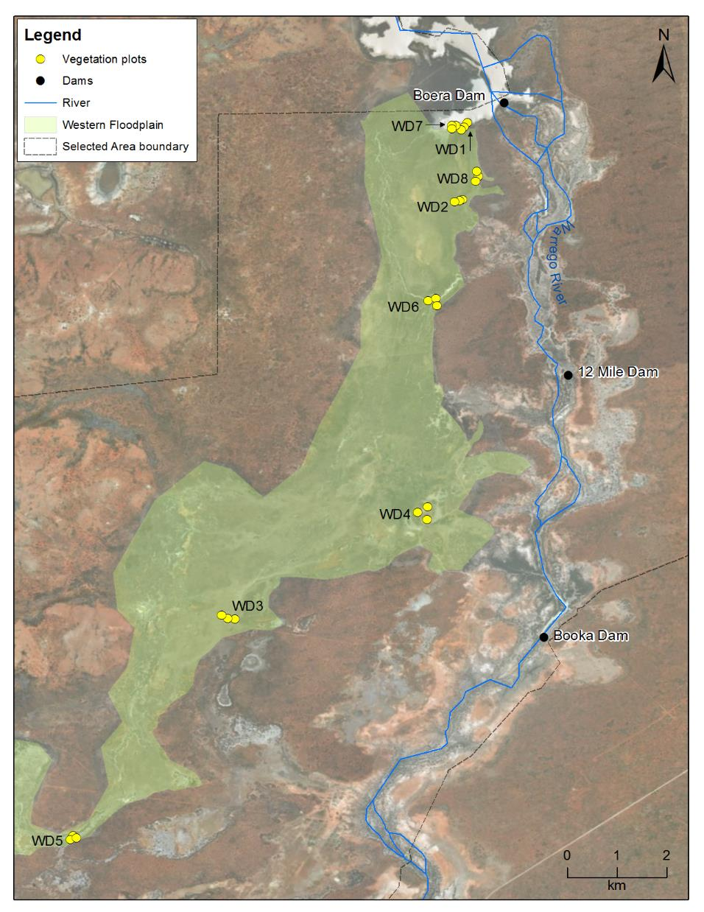
Figure 1 Location of vegetation monitoring sites in the Western Floodplain zone.

Results

2019-20 water year

Species richness
A total of 161 species from 42 families were recorded from within all vegetation plots across both the October 2019 (139 species from 38 families) and the March 2020 (105 species from 35 families) vegetation surveys (Item 8). Mean species richness across all sites and both survey periods (October 2019 and March 2020) was 20.7 ± 8.4 species an increase from 9.3 ± 3.8 species during the 2017-18 water year. Species richness during the 2019-20 water year ranged from 2 (WD7.1 March 2020) to 36 species (WD1.3 October 2019, Figure 2). The October 2019 survey yielded the highest mean species richness value in the six years of LTIM and MER vegetation monitoring within the Selected Area (24.3 ± 7.7 species), and was significantly higher than the March 2020 mean richness of 17.1 ± 7.7 species within the 2019-20 water year (F=9.987, p<0.01).
Vegetation community was found to significantly influence species richness (F=4.770, p<0.01) with Chenopod Shrubland (24.92 ± 4.73 species) having the highest mean species richness, followed by Coolibah-River Cooba-Lignum Woodland (24.42 ± 5.09 species), Coolibah Woodland Wetland (17.33 ± 8.01 species) and Lignum Shrubland Wetland (16.08 ± 5.88 species). The interaction between survey time and vegetation community was also significant (F=6.539, p<0.01), driven by a reduction in richness in the Lignum Shrubland Wetland vegetation community between October 2019 and March 2020 survey times (p<0.001, Figure 3). All other communities showed a similar reduction in richness between survey events (Figure 3).
While all sites were dry during the October 2019 surveys, 11 of the 24 sites were wet during the March 2020 surveys (Table 1). Dry sites during the survey period recorded significantly higher species richness (23.7 ± 6.6) than wet sites (10.5 ± 5.1, F=43.04 p<0.001, Figure 4). Reduced species richness at wet sites (e.g., Lignum Shrubland Wetland in March 2020) is likely to be a short-term response, with this pattern reversed as inundation levels subside, and soil moisture and growing conditions improve.

Figure 2 Mean species richness recorded at each of the eight monitoring locations during the October 2019 and March 2020 vegetation surveys.

Figure 3 Mean species richness at each of the four vegetation communities during the October 2019 and March 2020 vegetation surveys.

Figure 4 Mean species richness across all 24 vegetation monitoring sites grouped by inundation status during the 2019-20 water year.
The two terrestrial functional groups exhibited significantly higher mean species richness values than the amphibious groups (F=146.37 p<0.001, Figure 5), with Tdr the most speciose functional group (106 species), followed by Tda (44), AmT (7) and AmR group (2 species) (Table 2). Whilst the AmR group had a slight increase between surveys, the three most speciose functional groups, Tdr, Tda and AmT, experienced a decline in average species richness between the October 2019 and March 2020 surveys, with the largest relative decrease observed in the Tda functional group which was reduced by 40% between the two survey times (40 and 24 species respectively, Table 2, Figure 5).
Forbs were the most speciose growth form across both survey times in the 2019-20 water year and accounted for 63% of total species in October 2019 (81 species) and 53% in March 2020 (54 species). Forbs showed a 20% reduction in total species between survey times (-27 species), while species number remained similar between survey times for all other growth forms (Figure 6).

Table 2 Species counts and common species for each of the four functional groups recorded at vegetation monitoring sites in the 2019-20 water year.
Functional Group | Species Count |  |  | Common species
Functional Group | October 2019 | March 2020 | Total Count | Common species
AmR | 1 | 2 | 2 | Marsilea drummondi, Marsilea costulifera
AmT | 6 | 5 | 7 | Duma florulenta, Acacia stenophylla, Eleocharis spp. Eryngium rostratum
Tda | 40 | 24 | 44 | Eucalyptus coolibah, Lachnagrostis filiformis, Paspalidium jubiflorum, Aeschynomene indica, Stellaria angustifolia
Tdr | 81 | 72 | 106 | Sclerolaena spp. Einadia nutans, Enchylaena tomentosa, Calotis hispidula, Rhagodia spinescens

Figure 5 Mean species richness of each functional group in each survey time in the 2019-20 water year.

Figure 6 Total number of species per growth form recorded in the 2019-20 water year.

Vegetation cover
Mean total vegetation cover across all 24 sites across both survey periods was 41 ± 30%. Mean vegetation cover was highest during the October survey period, 44 ± 36% compared to 39 ± 23% observed in March 2020, however this difference was not significant. Across both surveys vegetation cover ranged from 0.4 ± 0.3% at WD5 to 107 ± 6% at WD8, with both mean total minimum and maximum vegetation cover values occurring in October 2019 (Figure 7).
Vegetation community type was found to significantly influence mean total vegetation cover with Lignum Shrubland Wetland 58 ± 35%, Coolibah-River Cooba-Lignum Woodland 45 ± 21%, and Chenopod Shrubland 43 ± 26% all exhibiting significantly greater mean total vegetation cover values than Coolibah Woodland Wetland 17 ± 25% (F=7.33, p<0.001). Some noticeable changes in cover occurred within vegetation communities between survey periods, especially within the Lignum Shrubland Wetland community which decreased from 81 ± 32% in October 2019 to 35 ± 19% in March 2020, a likely result of the plot being inundated at the time of the survey, and Chenopod Shrubland which increased vegetation cover from 28 ± 24% in October to 59 ± 19% in March (Figure 8, Figure 10). However, these changes were not significant.

Figure 7 Mean total vegetation cover recorded at monitoring location during the October 2019 and March 2020 vegetation surveys.
Figure 8 Mean total vegetation cover in each vegetation community recorded during the October 2019 and March 2020 vegetation surveys.
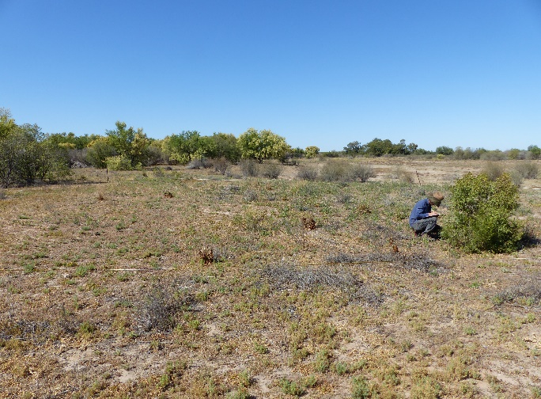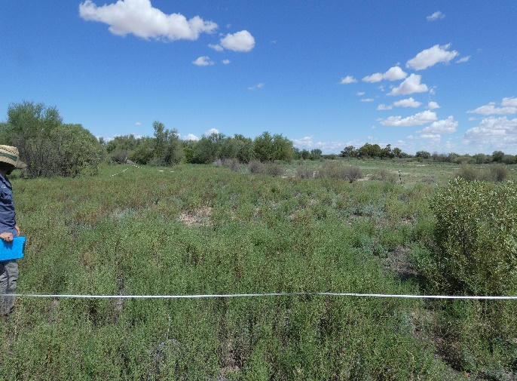
Figure 9 Vegetation cover increased in the Chenopod Shrublands community (WD4-2) between October 2019 (top) and March 2020 (bottom).
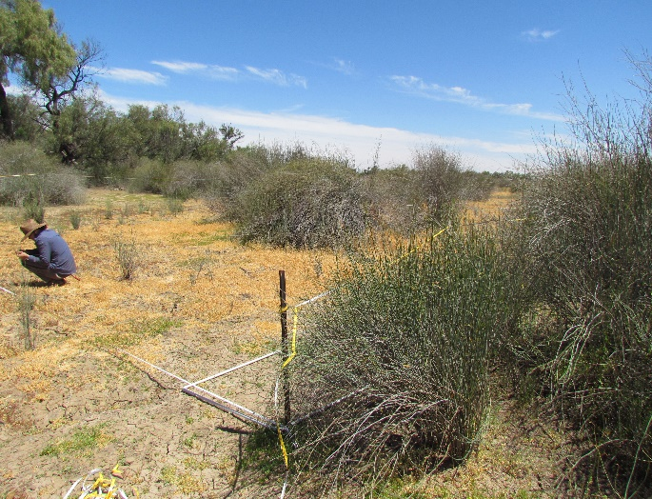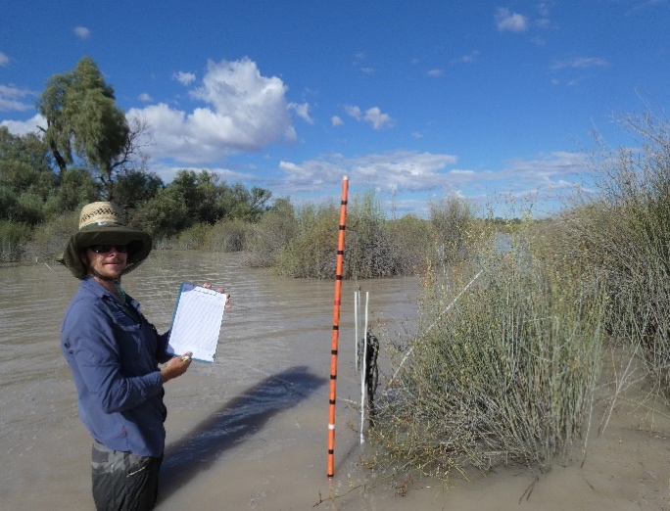
Figure 10 Vegetation cover decreased in the Lignum Shrubland Wetland (WD7-1) between October 2019 (top) and March 2020 (bottom).

Vegetation composition
Significant differences were detected in vegetation community composition between survey times (p<0.001), vegetation community (p<0.001) and Inundation status (p<0.005). A significant interaction was also observed between survey time and vegetation community (p<0.001). Pairwise tests suggest that all vegetation communities except Coolibah Woodland Wetlands were driving differences between survey times, whereas sites within Lignum Shrubland Wetland communities were responsible for differences between wet and dry sites (p<0.005). Wet sites showed a tighter grouping in multidimensional space than dry sites, suggesting they had more similar community composition than dry sites (Figure 11). This was not so apparent in the data when grouped by survey time (Figure 12).
Figure 11 nMDS plot of vegetation data collected during the 2019-2020 water year separated by inundation status.
Figure 12 nMDS plot of community composition vegetation data collected during the 2019-2020 water year separated by survey time.
SIMPER analysis indicated that lower/mid strata species from the AmT, Tda, and Tdr functional groups contributed to the dissimilarity between data groupings (Table 3). Patterns in lignum contributed the most to differences in the data, with blown grass (Lachnagrostis filiformis), swamp starwort (Stellaria angustifolia) and bogan flea (Calotis hispidula) also having a large contribution to the dissimilarity of the October 2019 grouping. The March 2020 grouping was also characterised by lignum, in addition to the terrestrial species budda pea (Aeschynomene indica), galvanised burr (Sclerolaena birchii) and ruby saltbush (Enchylaena tomentosa). Wet sites were characterised by lignum, budda pea, twin-leaved bedstraw (Asperula gemella) and galvanised burr, whereas lignum, swamp starwort, blown grass, and black roly-poly (Sclerolaena muricata) characterised the dry sites (Table 3).
The SIMPER results highlight both the dominance and resilience of lignum. Small fluctuations in mean cover and contribution throughout the survey period indicate the slow response of lignum, in terms of changes in extent, to seasonal changes, which highlights its resilience in this western wetland system. The Tda contributions of blown grass, budda pea, swamp starwort and twin-leaved bedstraw are a response to past inundation and rain events and indicate the strength and influence that these events continued to have across all survey sites. The presence and influence of Tdr species, such as chenopods, indicate that those sites were starting to move beyond the influence of the last rainfall events and beginning to shift into a drier phase, e.g. Medium-term dry (90-365 days, Table 3).

Table 3 SIMPER results for vegetation community data collected in the 2019-20 water year grouped by survey time and inundation status.
Sample grouping | Species (functional group) | Mean Cover (%) | Contribution (%)
October 2019 | Duma florulenta (AmT) | 17.1 | 19.91
October 2019 | Lachnagrostis filiformis (Tda) | 11.88 | 9.43
October 2019 | Stellaria angustifolia (Tda) | 6.39 | 9.14
October 2019 | Calotis hispidula (Tdr) | 0.42 | 4.27
March 2020 | Duma florulenta (AmT) | 21.6 | 27.62
March 2020 | Aeschynomene indica (Tda) | 0.6 | 8.85
March 2020 | Sclerolaena birchii (Tdr) | 1.61 | 5.80
March 2020 | Enchylaena tomentose (Tdr) | 0.82 | 4.66
Wet | Duma florulenta (AmT) | 26.91 | 44.99
Wet | Aeschynomene indica (Tda) | 0.46 | 7.10
Wet | Asperula gemella (Tda) | 0.8 | 6.44
Wet | Sclerolaena birchii (Tdr) | 0.68 | 3.16
Dry | Duma florulenta (AmT) | 16.5 | 19.41
Dry | Stellaria angustifolia (Tda) | 5.28 | 5.76
Dry | Lachnagrostis filiformis (Tda) | 11.87 | 4.49
Dry | Sclerolaena muricata (Tdr) | 1.89 | 4.24

Multi-year Comparison

Species richness
The addition of the 2019-20 water year vegetation data into the previous LTIM project dataset saw a new mean high species richness value of 22.41 (± 7.73 species, Figure 13) observed during the spring 2019 survey, with the autumn 2020 survey recording a significantly lower mean species richness value of 15.5 ± 7.51 species (p<0.01). Until the 2019-20 water year, mean species richness exhibited a three-year decreasing trend and reached the lowest levels recorded across all survey times in autumn 2019 (6.83 ± 5.75 species). This reduction coincided with low flows and reduced inundation events. While species richness was found to be significantly different between survey times (p<0.001) the increased mean species richness observed throughout the 2019-20 water year was a likely result of the inundation of over half the plots during an inundation event in April/May 2019 along with localised rainfall over the same period.
Species richness varied significantly across the inundation categories (p<0.01), with the Recently-wet inundation category (15.06 ± 4.53 species) supporting the highest species richness, followed by Currently-wet (14.31 ± 9.51 species), Medium-term dry (13.91 ± 8.21 species) and Long-term dry (12.54 ± 7.37 species). Vegetation community also significantly influenced species richness (p<0.001), with Chenopod Shrubland (17.61 ± 7.15 species) exhibiting the highest species richness and Coolibah Woodland Wetlands (10.06 ± 6.60 species) the lowest. A significant interaction between vegetation communities and inundation categories highlights the variation in species richness observed across vegetation communities as a result of time since inundation (p<0.001). Both Chenopod Shrubland and Coolibah-River Cooba-Lignum communities showed their highest richness when sites were wet, and had a varied response throughout the remaining inundation categories (Figure 14). In contrast, Coolibah Woodland Wetland plots and Lignum Shrubland Wetland plots displayed highest diversity in Recently-wet and Medium-term dry categories (Figure 14).
Over the course of the LTIM and MER projects, the terrestrial functional group has exhibited a significantly greater species diversity and shown greater species richness variation across inundation categories than the amphibious functional group (p<0.001, Figure 16). The significant interaction between functional group and inundation suggests that functional groups respond differently to time since inundation (p<0.001). Both Amphibious functional groups showed a slight reduction in mean species richness from the Currently-wet to Long-term dry categories. In contrast, the Tda functional group showed maximum richness in the Recently-wet category, dropping significantly to the Long term dry category (Figure 15). While showing considerable variation, species richness of the Tdr group increased steadily from the Currently-wet to Long-term dry inundation category (Figure 15).

Figure 13 Mean total species richness across sampling times of the LTIM/MER project.

Figure 14 Mean species richness of the four vegetation communities split by inundation status across the LTIM/MER project.

Figure 15 Mean species richness of the four functional groups split by inundation status across the LTIM/MER project.

Vegetation Cover
Mean vegetation cover differed between survey times and showed similar trends to mean species richness, with mean cover peaking during summer 2016, at 80 ± 32% in response to significant floodplain inundation. Mean cover then steadily declined to the lowest recorded levels in autumn 2019 (16 ± 19%), then increased again in spring 2019 (p<0.001) (Figure 16).
Poisson modelling detected a significant influence of both vegetation community (p<0.001), and inundation status (p<0.001), with a significant interaction between these two factors (p<0.001). Currently-wet sites showed significantly higher mean vegetation cover in Coolibah-River Cooba-Lignum Woodland and Chenopod Shrubland sites before decreasing across remaining inundation categories (Figure 17). In contrast, the Coolibah Woodland Wetland community showed similar cover values in the Currently- and Recently-wet categories (~42% cover), before decreasing in the Medium-term dry (35 ± 14%) and Long-term dry (12 ± 9%) categories. The Lignum Shrubland Wetland community displayed a different response to flooding peaking in cover within the Medium-term dry category (64 ± 30%), while remaining relatively stable across the other categories (36 – 41% cover, Figure 17).
In contrast to the species richness data, the AmT functional group showed the highest mean cover of all functional groups (Figure 18). This functional group displayed its highest cover when sites were wet during survey (29 ± 20%), and also within the Medium-term dry category (26 ± 18%). Both the AmR and Tda functional groups showed a reduction in mean cover from the Currently-wet to Long-term dry categories (Figure 18). Similarly, the Tdr functional group reduced in cover from the Currently-wet to Medium-term dry categories, but then increased again to 9 ± 13% within the Long-term dry category.

Figure 16 Mean total vegetation cover measured across sampling times of the LTIM/MER project.

Figure 17 Mean total cover of the four vegetation communities split by inundation status measured across the LTIM/MER project.

Figure 18 Mean total cover of the four Inundation Categories split by Functional Group measured across the LTIM/MER project.

Vegetation composition
Adding the current water year’s data to the previously collected LTIM data further supported the findings of the final LTIM report (Commonwealth of Australia 2019). Significant differences were detected between survey times (p<0.001), seasons (p<0.001), vegetation communities (p<0.001) and inundation category (p<0.001). Significant interactions also occurred between each of survey time (p<0.001), season (p<0.05), inundation period (p<0.001) and vegetation community, suggesting different responses to these factors for different vegetation communities.
Separation of survey time centroids was observed with surveys before April 2017 grouped together, and times after this grouped together (Figure 19). This is likely related to the widespread inundation of the floodplain during spring 2016. The recent inundation of just over half the plots in March 2020 means it is unlikely that the vegetation had fully responded by the time of our survey. The vegetation composition responses in the 2019-20 surveys were significantly different to all other times, except for Coolibah Woodland Wetland sites in Spring 2019 and Autumn 2020.
Statistically significant variation was observed between inundation groups, mediated by vegetation community (Table 4). Plots within Lignum Shrubland Wetland communities showed greater differences between inundation classes (all comparisons significantly different), followed by Coolibah–River Cooba–Lignum Woodland and Chenopod Shrubland communities (four significant comparisons each), then Coolibah Woodland Wetland communities (two significant comparisons, Table 4).
Figure 19 nMDS plot of vegetation composition data collected from all survey times of the LTIM/MER project.

Table 4 PERMANOVA results of comparison between inundation categories for each vegetation community (shaded cells represent significant differences).
Lignum Shrubland Wetland
 | Currently wet | Recently wet | Med term dry | Long term dry
Currently wet
Recently wet | 0.002
Med term dry | 0.001 | 0.001
Long term dry | 0.002 | 0.001 | 0.001
Coolibah - River Cooba – Lignum Woodland
 | Currently wet | Recently wet | Med term dry | Long term dry
Currently wet
Recently wet | 0.439
Med term dry | 0.036 | 0.079
Long term dry | 0.017 | 0.012 | 0.006
Coolibah Woodland Wetland
 | Currently wet | Recently wet | Med term dry | Long term dry
Currently wet
Recently wet | 0.054
Med term dry | 0.091 | 0.132
Long term dry | 0.005 | 0.001 | 0.063
Chenopod Shrubland
 | Currently wet | Recently wet | Med term dry | Long term dry
Currently wet
Recently wet | 0.068
Med term dry | 0.001 | 0.358
Long term dry | 0.001 | 0.034 | 0.001

When considered separately, the community composition from each functional group showed significant differences between inundation categories (p<0.005). For the AmR group, significant differences were observed between the Long-term dry and all
other categories (p<0.05) and between the Currently-wet/Medium-term dry paring (p<0.01). The amphibious fern Common nardoo (Marsilea drummondii) was the species most responsible for the dissimilarly between inundation groups. For the AmT functional group, the Currently-wet group was significantly different between all other groups (p<0.005), with the Recently-wet/Long-term dry pairing also being significantly different (p<0.05). Lignum influenced the dissimilarly in all groupings, with Pale spikerush (Eleocharis pallens) also influencing the currently wet category, Juncus species the Recently-wet grouping and Eleocharis species the Medium- and Long-term dry categories.

Tree Recruitment
Average tree recruitment measured within the Coolibah-River Cooba-Lignum vegetation community for river cooba and in the Coolibah Wetland Woodland vegetation
community for coolibah was calculated for three separate age classes across all sample periods (Figure 20-Figure 23). In the river cooba plots of WD1 and WD2, there appears to be little to no survival of 0.2-0.5 m seedlings that were observed in autumn 2018.
Saplings of 0.5-1.5 m have survived marginally better, while saplings in the
1.3-3 m height class have persisted more successfully than the two smaller size classes (Figure 20-Figure 21). Discrepancies in river cooba numbers observed between March 2019 and March 2020 in WD1 may be attributed to a combination of browsers such as feral goats and drought. Leafy saplings observed in March 2020 may have been missed or assessed as dead on the previous two surveys. WD1 retained a small mix of seedling and sapling size classes, while WD2 retained 1.3-3 m saplings despite previously recording all size classes (Figure 20, Figure 21).
At WD5, the coolibah regeneration event in 2015 saw an initial pulse of 50-80 seedlings fail to develop and reduce to very low numbers by the following spring (Figure 22). The seedlings that survived in the 0.2-0.5 m size class persisted to March 2020 (21.3 ± 36.09 individuals). Coolibah saplings in the two taller size classes continue to remain relatively stable, albeit at low numbers, 2.3 ± 4.04 and 2 ± 3.46 individuals respectively (Figure 22). Despite the coolibah regeneration event at WD6 in 2015 which saw an estimated 1,000 seedlings germinate, six years on only five seedlings in the 0.2-0.5 m size class and six saplings in the 0.5-1.3 m size class remain (Figure 23).

Figure 20 Mean river cooba (Acacia stenophylla) recruitment at WD1 across all sample times.

Figure 21 Mean river cooba (Acacia stenophylla) recruitment at WD2 across all sample times.

Figure 22 Mean coolibah (Eucalyptus coolabah) recruitment at WD5 across all sample times.

Figure 23 Mean coolibah (Eucalyptus coolabah) recruitment at WD6 across all sample times.

Discussion
The October 2019 survey the Western Floodplain yielded the highest species richness recorded in the six years of LTIM and MER monitoring. Vegetation cover values were also the highest recorded since the last inundation event in 2017. This pattern of increasing vegetation productivity, indicated by species richness and vegetation cover, is a likely response to inundation and localised rainfall in autumn 2019. The high mean species richness values observed in October 2019 was predominantly driven by the response of forb species in the Tda Functional group. According to Casanova (2015) Tda species require saturated or damp ground to germinate, both of which were readily available across all four vegetation communities in autumn 2019.
While all vegetation survey sites received localised rainfall in autumn 2019, a number were also inundated in the same season. Three of the Coolibah Woodland Wetland plots were inundated during this time with the other three plots only being influenced by rainfall. This allowed the comparison of species richness and vegetation cover responses to inundation. Species richness and cover were not only increased in the Coolibah Woodland Wetland plots where both rainfall and inundation occurred, but the inundated site also maintained its vegetation cover for longer. These findings suggest that plant species found in inundated Coolibah Woodland Wetland sites benefit from a soil moisture subsidy that is not available for plants to draw on in Medium- and Long-term dry sites.
Across all LTIM and MER vegetation monitoring to date, Lignum Shrubland Wetland vegetation communities have exhibited a different vegetation cover pattern to the other Western Floodplain vegetation communities, with peak vegetation cover occurring within the Medium-term dry inundation category. While the Lignum Shrubland Wetland vegetation community is more frequently inundated, the peak cover pattern is likely driven by a combination of the dominant AmT species in this community, lignum, and its slow growth response to inundation (in terms of cover), combined with the full expression of dominant Tda species such as blown grass which take time to develop into dense swards that persist at the end of their life cycle. Consistently high mean cover values and species contributions to differences between vegetation communities reflects lignum’s ability to maintain its condition, and therefore cover, for longer periods in response to inundation and continues to highlight the importance and resilience of this species in the Warrego-Darling wetland system. However, vegetation responses from several of the Lignum Shrubland Wetland sites, which were inundated during the March 2020 survey period, were not fully expressed at the time of survey due to the presence of standing water. We would expect to better observe the actual inundation responses once these sites have dried and favourable growing conditions have returned.
Across all years, Amphibious groups were found to be less speciose than Terrestrial groups. Despite this, the AmT functional group consistently showed the highest cover values across all inundation categories. This pattern can likely be attributed to the AmT group harbouring a small group of species that are either dominant, long-lived, resilient shrub species that respond slowly to changing conditions (lignum and river cooba), or species which respond rapidly to inundation and rain events and persist as ground cover, such as Eleocharis species. Long-term LTIM and MER data show that species richness differences in response to time since inundation are driven by terrestrial functional groups. Both Tda and Tdr groups respond similarly to Currently- and Recently-wet conditions, however, as time since inundation increases species richness declines in Tda and increases in Tdr. Tda species require a damp or saturated floodplain soil profile post inundation in order to germinate and grow while Tdr species do not require flooding, a strategy which enables these species to take advantage of and invade floodplains and wetland edges as conditions dry out (Casanova 2011). These findings highlight both the resilient nature of the vegetation of the Western Floodplain and its variable responses to inundation and rainfall. While the inundation responses of understory species enable us to explore and partition watering requirements at the Functional group level, Casanova (2015) argues that it is the key woody species such as, lignum, river cooba and coolibah, that should not be overlooked as indicators of a watering regime due to their critical importance in wetland and floodplain systems.
While no germination was observed in the two 2019-20 vegetation monitoring surveys, sporadic coolibah and river cooba recruitment has previously been observed following wetter seasons. While large numbers of coolibah seedlings were observed in 2015, unfavourable conditions followed and plant competition and browsing by both feral and native fauna has meant that sapling establishment has been low. Widespread coolibah recruitment events are rare in the landscape and driven by specific environmental cues (Roberts & Marston 2011). Germination cues include the frequency and timing of natural flooding regimes (Good et al. 2017), suitable microsite conditions (Good 2012, Vincent et al. 2018) and an optimal alternating diel temperature regime of 15:30°C (Vincent et al. 2018). Seedling establishment and survival is then dependent upon a follow-up of favourable conditions that promote growth, such as above average rainfall (Good 2012). Recent inundation and localised rainfall in May 2019 triggered budding in Eucalyptus species, including Coolibah, with flowering events observed in the March 2020 survey period. The March 2020 inundation event combined with average rainfall may result in good seed set, which if followed-up by favourable conditions in the 2020-21 water year, could trigger a germination event. This could form a target for future water delivery on the Western Floodplain, especially during summer.
One of the major aims of environmental flows is to provide water allocations that aim to mimic natural flow regimes as much as possible. The germination response of three key Western Floodplain vegetation species, lignum, river cooba and coolibah is greatest following natural flooding events throughout summer months (see Casanova 2015). However, while all each of these three species require wetted soils for seedling establishment and growth, flooding duration preferences vary between species with long duration advantageous for River cooba, less optimal for lignum and detrimental for coolibah (Capon et al. 2012). Environmental water allocations therefore have the potential to enhance or impede the germination and seedling establishment of all three species, depending on timing, duration and extent.

Conclusion
Findings from MER and LTIM projects have identified that inundation strongly influences vegetation patterns on the Western Floodplain. Following on from two very dry years, the 2019-20 water year was highly productive, with species richness and vegetation cover in October 2019 the highest observed in the six years of monitoring, indicating sufficient growing conditions provided by floodplain inundation and localised rainfall in autumn 2019. Throughout the two survey periods, plant growth, flowering and seed setting was apparent, particularly in the Lignum Shrubland Wetland, Coolibah-River Cooba-Lignum Woodland and Chenopod Shrubland vegetation communities. Depending on timing, duration and extent, environmental water delivery for the upcoming 2020-21 water year has the potential to promote the germination of the key wetland woody species such as lignum, river cooba and coolibah.
Inundation promoted amphibious and terrestrial damp species, while extended periods of drought favoured terrestrial dry species. These observations indicate both the inherent resilience in this system and the potential for it to transition into a drier more terrestrial vegetative state in the absence of inundation. Given the recent inundation event observed in March 2020, combined with average rainfall, increased productivity on the Western Floodplain is a pattern which may continue into the start of the 2020-21 water year.

References
Brock, M.A. and Casanova, M.T. 1997. Plant life at the edge of wetlands: ecological responses to wetting and drying patterns. In N. Klomp and Lunt (Eds.), Frontiers of Ecology; Building the Links (pp. 181–192). Oxford, England: Elsevier Science.
Capon, S 2009. Flow dependent Ecosystems of Toorale Station: Ecological character, condition and issues associated with the decommissioning water resources infrastructure. Australian Rivers Institute, Griffith University.
Casanova, M.T. 2015. Review of Water Requirements for Key Floodplain Vegetation for the Northern Basin: Literature review and expert knowledge assessment. Report to the Murray‒Darling Basin Authority, Charophyte Services, Lake Bolac.
Capon, S., Rolls, R.J., James, C., and Mackay, S.J. 2012. Regeneration of Floodplain Vegetation in Response to Large-scale Flooding in the Condamine-Balonne and Border Rivers. Australian Rivers Institute, Griffith University, Australia.
Commonwealth of Australia 2019. Commonwealth Environmental Water Office Monitoring Evaluation and Research Program: Junction of the Warrego and Darling Rivers Selected Area Monitoring, Evaluation and Research Plan (2019-2022), Commonwealth of Australia 2019.
Commonwealth of Australia 2015. Commonwealth Water Office Long Term Intervention Monitoring Project; Junction of the Warrego and Darling rivers Selected Area. Commonwealth of Australia, Canberra.
Freudenberger D. 1998. Scoping the management and research needs of the coolibah woodlands in the Murray-Darling Basin. CSIRO Wildlife and Ecology, Canberra.
Good, M.K. 2012. Plant community patterns and population dynamics of coolabah woodlands. Ph.D. thesis. University of New England.
Good, M., Smith, R. and Pettit, N. (2017). Forests and Woodlands of Australia’s Rivers and Floodplains. In D. A. Keith, ed., Australian Vegetation, 3rd edn. Cambridge: Cambridge University Press, pp. 516-43.
Hale, J., Roberts, J., Page, K. and Kobryn, H. 2008. Riparian Zone Management in the Western Catchment Phase 2: Intersecting Stream. A report to the Western Catchment Management Authority.
Hale, J., Stoffels, R., Butcher, R., Shackleton, M., Brooks, S., Gawne, B., & Stewardson, M, 2014. Commonwealth Environmental Water Office Long Term Intervention Monitoring Project – Standard Methods. Final Report prepared for the Commonwealth Environmental Water Office by The Murray Darling Freshwater Research Centre, MDFRC Publication 29.2/2014, January, 175 pp.
Holland, K.L., Turnadage, C.J., Nicol, J.M, Gehrig, S.L., Strawbridge, A.D. 2013. Floodplain response and recovery: comparison between natural and artificial floods. Goyder Institute for Water Research Technical Report Series 13/4, Adelaide, South Australia.
Foster, N. 2015. Ecological considerations relating to flow related processes within the Barwon-Darling River: A guide for the Barwon-Darling Water Sharing Plan Interagency Panel. NSW Office of Water, Sydney, NSW.
Roberts J., and Marston, F. 2011. Water regime for wetland and floodplain plants: a source book for the Murray–Darling Basin, National Water Commission, Canberra.
Vincent, B.E., Smith, R., Good, M., Clarke, P.J., (2018). Seed germination traits of two common floodplain eucalypts: optimum germination temperatures and influence of leaf litter, in Proceedings of the 9th Australian Stream Management Conference. Hobart, Tasmania.
Workshop, 2015. Comments from participants of the ‘Review of Floodplain Vegetation Water Requirements for the Northern Basin Review’. Participants are listed and summaries are given in Appendix A of this report.

Species List
Family | Scientific name | Common Name | Functional Group | Growth Habit | Exotic
Aizoaceae | Glinus lotoides | Hairy Carpet-weed | Tdr | Forb | No
Aizoaceae | Tetragonia tetragonoides | New Zealand Spinach | Tdr | Forb | No
Aizoaceae | Trianthema triquetrum | Small Hogweed | Tdr | Forb | No
Amaranthaceae | Alternanthera denticulata | Lesser Joyweed | Tda | Forb | No
Amaryllidaceae | Crinum flaccidum | Darling Lily | Tda | Forb | No
Apiaceae | Cyclospermum leptophyllum | Slender celery | Tda | Forb | Yes
Apiaceae | Daucus glochidiatus | Native Carrot | Tdr | Forb | No
Apiaceae | Eryngium rostratum | Blue devil | AmT | Forb | No
Asteraceae | Asteraceae sp. | a Daisy | Tdr | Forb | var
Asteraceae | Brachyscome curvicarpa | Curved-seed Daisy | Tda | Forb | No
Asteraceae | Brachyscome melanocarpa | Black-seeded Daisy | Tda | Forb | No
Asteraceae | Brachyscome sp. | a Daisy | Tda | Forb | No
Asteraceae | Calotis cuneifolia | Purple Burr-daisy | Tdr | Forb | No
Asteraceae | Calotis erinacea | Tangled Burr-daisy | Tdr | Forb | No
Asteraceae | Calotis hispidula | Bogan Flea | Tdr | Forb | No
Asteraceae | Calotis lappulacea | Yellow Burr-daisy | Tdr | Forb | No
Asteraceae | Calotis plumulifera | Woolly-headed Burr-daisy | Tdr | Forb | No
Asteraceae | Calotis sp. | a Burr-daisy | Tda | Forb | No
Asteraceae | Centaurea melitensis | Maltese Thistle | Tdr | Forb | Yes
Asteraceae | Centipeda minima | Spreading Sneezeweed | Tda | Forb | No
Asteraceae | Centipeda thespidioides | Desert Sneezeweed | Tda | Forb | No
Asteraceae | Craspedia haplorrhiza | Billy Buttons | Tda | Forb | No
Asteraceae | Eclipta platyglossa | Yellow Twin-heads | Tda | Trailing | No
Asteraceae | Euchiton sphaericus | Star Cudweed | Tdr | Forb | No
Asteraceae | Gnaphalium diamantinense | Diamantina Cudweed | Tda | Forb | No
Asteraceae | Gnaphalium sp. | a Cudweed | Tdr | Forb | No
Asteraceae | Gnephosis arachnoidea | Erect Yellow-heads | Tdr | Forb | No
Asteraceae | Lactuca serriola | Prickly Lettuce | Tdr | Forb | Yes
Asteraceae | Minuria integerrima | Smooth Minuria | Tdr | Forb | No
Asteraceae | Podolepis capillaris | Invisible Plant | Tdr | Forb | No
Asteraceae | Pseudognaphalium luteoalbum | Jersey Cudweed | Tdr | Forb | No
Asteraceae | Rhodanthe floribunda | Common White Sunray | Tdr | Forb | No
Asteraceae | Rhodanthe stuartiana | Sunray | Tdr | Forb | No
Asteraceae | Senecio glossanthus | Slender Groundsel | Tdr | Forb | No
Asteraceae | Senecio quadridentatus | Cotton Fireweed | Tdr | Forb | No
Asteraceae | Senecio runcinifolius | Tall Groundsel | Tdr | Forb | No
Asteraceae | Senecio sp. | a Groundsel | Tdr | Forb | No
Asteraceae | Soliva anthemifolia | Dwarf Jo-jo | Tdr | Forb | No
Asteraceae | Sonchus oleraceus | Milk Thistle, Common Sow Thistle | Tdr | Forb | Yes
Asteraceae | Taraxacum officinale | Dandelion | Tdr | Forb | Yes
Boraginaceae | Cynoglossum australe | Australian Hound's-tongue | Tda | Forb | No
Boraginaceae | Echium plantagineum | Patterson's Curse | Tdr | Forb | Yes
Boraginaceae | Heliotropium supinum | Prostrate Heliotrope | Tda | Forb | Yes
Brassicaceae | Brassica tournefortii | Mediterranean Turnip | Tdr | Forb | Yes
Brassicaceae | Brassicaceae sp. | a Brassica | Tdr | Forb | var
Brassicaceae | Lepidium sp. | a Peppercress | Tdr | Forb | No
Brassicaceae | Rorippa palustris | Marsh Watercress | Tda | Forb | Yes
Brassicaceae | Sisymbrium irio | London Rocket | Tda | Forb | Yes
Campanulaceae | Wahlenbergia gracilis | Sprawling Bluebell | Tdr | Forb | No
Campanulaceae | Wahlenbergia sp. | a Bluebell | Tda | Forb | No
Caryophyllaceae | Caryophyllaceae | a Caryophyllaceae | Tdr | Forb | var
Caryophyllaceae | Stellaria angustifolia | Swamp Starwort | Tda | Forb | No
Chenopodiaceae | Atriplex angulata | Angular Saltbush | Tdr | Chenopod | No
Chenopodiaceae | Atriplex crassipes | a Saltbush | Tdr | Chenopod | No
Chenopodiaceae | Atriplex eardleyae | Small Saltbush | Tdr | Chenopod | No
Chenopodiaceae | Atriplex leptocarpa | Slender-fruit Saltbush | Tdr | Chenopod | No
Chenopodiaceae | Atriplex lindleyi | Eastern Flat-top Saltbush | Tdr | Chenopod | No
Chenopodiaceae | Atriplex muelleri | Mueller's Saltbush | Tdr | Chenopod | No
Chenopodiaceae | Atriplex sp. | a Saltbush | Tdr | Chenopod | No
Chenopodiaceae | Atriplex spinibractea | Spiny-fruit Saltbush | Tdr | Chenopod | No
Chenopodiaceae | Atriplex suberecta | Lagoon Saltbush | Tdr | Chenopod | No
Chenopodiaceae | Atriplex vesicaria | Bladder Saltbush | Tdr | Chenopod | No
Chenopodiaceae | Chenopodiaceae sp. | a Saltbush | Tdr | Chenopod | No
Chenopodiaceae | Chenopodium desertorum | Desert Goosefoot | Tdr | Chenopod | No
Chenopodiaceae | Chenopodium murale | Nettle-leaf Goosefoot | Tdr | Chenopod | No
Chenopodiaceae | Chenopodium sp. | a Goosefoot | Tdr | Chenopod | No
Chenopodiaceae | Dysphania melanocarpa | Black Crumbweed | Tdr | Chenopod | No
Chenopodiaceae | Dysphania pumilio | Small Crumbweed | Tdr | Chenopod | No
Chenopodiaceae | Einadia nutans | Nodding Saltbush | Tdr | Chenopod | No
Chenopodiaceae | Enchylaena tomentosa | Ruby Saltbush | Tdr | Chenopod | No
Chenopodiaceae | Maireana ciliata | Fissure Weed | Tdr | Chenopod | No
Chenopodiaceae | Rhagodia spinescens | Thorny Saltbush | Tdr | Chenopod | No
Chenopodiaceae | Salsola australis | Buckbush | Tdr | Chenopod | No
Chenopodiaceae | Sclerolaena birchii | Galvinized Burr | Tdr | Chenopod | No
Chenopodiaceae | Sclerolaena diacantha | Grey Copperburr | Tdr | Chenopod | No
Chenopodiaceae | Sclerolaena eriacantha | Silky Copperburr | Tdr | Chenopod | No
Chenopodiaceae | Sclerolaena muricata | Black Rolypoly | Tdr | Chenopod | No
Chenopodiaceae | Sclerolaena sp. | a Copperburr | Tdr | Chenopod | No
Chenopodiaceae | Sclerolaena tricuspis | Streaked Poverty Bush, Giant Redburr | Tdr | Chenopod | No
Convolvulaceae | Convolvulus erubescens | Pink Bindweed | Tda | Trailing | No
Convolvulaceae | Convolvulus graminetinus | Bindweed | Tda | Trailing | No
Convolvulaceae | Convolvulus sp. | a Bindweed | Tda | Trailing | No
Cucurbitaceae | Citrullus amarus | Wild Melon, Camel Melon, Bitter | Tdr | Trailing | Yes
Cucurbitaceae | Cucumis myriocarpus | Paddy Melon | Tdr | Trailing | Yes
Cyperaceae | Eleocharis pallens | Pale Spike Sedge | AmT | Sedge | No
Cyperaceae | Eleocharis pusilla | Small Spike Rush | AmT | Sedge | No
Cyperaceae | Eleocharis sp. | a Spike Rush | AmT | Sedge | No
Euphorbiaceae | Euphorbia drummondii | Caustic Weed | Tdr | Forb | No
Fabaceae | Fabaceae sp. | a Pea | unknown | Variable | Variable
Fabaceae (Faboideae) | Aeschynomene indica | Budda Pea | Tda | Shrub | No
Fabaceae (Faboideae) | Glycine sp. | a Glycine | Tdr | Forb | No
Fabaceae (Faboideae) | Glycine tabacina | Variable Glycine | Tdr | Forb | No
Fabaceae (Faboideae) | Medicago polymorpha | Burr Medic | Tdr | Forb | Yes
Fabaceae (Faboideae) | Medicago sp. | a Medic | Tdr | Forb | Yes
Fabaceae (Faboideae) | Swainsona sp. | a Swainsona | Tdr | Forb | No
Fabaceae (Faboideae) | Trigonella suavissima | Coopers Clover | Tdr | Forb | No
Fabaceae (Mimosoideae) | Acacia stenophylla | River Cooba | AmT | Tree | No
Fabaceae (Mimosoideae) | Acacia victoriae | Gundabluie | Tdr | Shrub | No
Goodeniaceae | Goodenia heteromera | Spreading Goodenia | Tdr | Forb | No
Goodeniaceae | Goodenia pinnatifida | Scrambles Eggs | Tdr | Forb | No
Goodeniaceae | Goodenia sp. | a Goodenia | Tdr | Forb | No
Haloragaceae | Haloragis heterophylla | Variable Raspwort | Tda | Forb | No
Juncaceae | Juncus sp. | a Rush | AmT | Rush | No
Lamiaceae | Mentha australis | River Mint | Tda | Forb | No
Lobeliaceae | Lobelia concolor | Poison Pratia | Tdr | Forb | No
Lobeliaceae | Lobelia darlingensis | Darling Pratia | Tdr | Forb | No
Loranthaceae | Lysiana subfalcata | Northern Mistletoe | Tdr | Mistletoe | No
Lythraceae | Lythrum hyssopifolia | Hyssop Loosestrife | Tda | Forb | No
Malvaceae | Abutilon malvifolium | Bastard Marshmallow | Tdr | Forb | No
Malvaceae | Abutilon otocarpum | Desert Lantern | Tdr | Forb | No
Malvaceae | Abutilon sp. | a Lantern-bush | Tdr | Forb | No
Malvaceae | Malva parviflora | Small-flowered Mallow | Tdr | Forb | Yes
Malvaceae | Sida sp. | a Sida | Tdr | Forb | No
Malvaceae | Sida trichopoda | High Sida | Tdr | Forb | No
Marsileaceae | Marsilea costulifera | Narrow-leaf Nardoo | AmR | Fern | No
Marsileaceae | Marsilea drummondii | Common Nardoo | AmR | Fern | No
Myoporaceae | Myoporum montanum | Western Boobialla | Tdr | Shrub | No
Myrtaceae | Eucalyptus coolabah | Coolibah | Tda | Tree | No
Myrtaceae | Eucalyptus largiflorens | Black Box | Tda | Tree | No
Myrtaceae | Eucalyptus populnea | Bimble Box | Tdr | Tree | No
Nyctaginaceae | Boerhavia dominii | Tarvine | Tdr | Forb | No
Oxalidaceae | Oxalis sp. | a Wood Sorrel | Tda | Forb | No
Papaveraceae | Argemone ochroleuca | Mexican poppy | Tdr | Forb | Yes
Plantaginaceae | Plantago drummondii | Dark Sago-weed | Tda | Forb | No
Plantaginaceae | Plantago sp. | a Plantain | Tdr | Forb | Yes
Plantaginaceae | Plantago turrifera | Small Sago-weed | Tda | Forb | No
Poaceae | Cynodon dactylon | Couch | Tdr | Grass | No
Poaceae | Dactyloctenium radulans | Button Grass | Tdr | Grass | No
Poaceae | Elymus sp. | a Wild Rye | Tdr | Grass | No
Poaceae | Eragrostis setifolia | Neverfail | Tdr | Grass | No
Poaceae | Eriochloa crebra | Tall Cupgrass | Tdr | Grass | No
Poaceae | Hordeum leporinum | Barley Grass | Tdr | Grass | Yes
Poaceae | Lachnagrostis aemula | Blown-grass | Tda | Grass | No
Poaceae | Lachnagrostis filiformis | Blown-grass | Tda | Grass | No
Poaceae | Paspalidium jubiflorum | Warrego Grass | Tda | Grass | No
Poaceae | Poa sp. | a Tussock grass | Tdr | Grass | No
Poaceae | Sporobolus actinocladus | Katoora Grass | Tdr | Grass | No
Poaceae | Sporobolus caroli | Fairy Grass | Tdr | Grass | No
Poaceae | Sporobolus sp. | a Rat's Tail Couch | Tdr | Grass | No
Poaceae | Urochloa panicoides | Urochloa Grass | Tdr | Grass | Yes
Polygonaceae | Duma florulenta | Tangled Lignum | AmT | Shrub | No
Polygonaceae | Persicaria prostrata | Creeping Knotweed | Tda | Forb | No
Polygonaceae | Polygonum plebeium | Small Knotweed | Tda | Forb | No
Polygonaceae | Rumex brownii | Swamp Dock | Tda | Forb | No
Polygonaceae | Rumex crispus | Curled Dock | Tda | Forb | Yes
Polygonaceae | Rumex sp. | a Dock | Tda | Forb | No
Polygonaceae | Rumex tenax | Shiny Dock | Tda | Forb | No
Portulacaceae | Portulaca oleracea | Pigweed | Tdr | Forb | No
Ranunculaceae | Myosurus australis | Mousetail | Tda | Forb | No
Rubiaceae | Asperula gemella | Twin-leaved Bedstraw | Tda | Forb | No
Sapindaceae | Dodonaea viscosa | Sticky Hop-bush | Tdr | Shrub | No
Scrophulariaceae | Eremophila deserti | Turkeybush | Tdr | Shrub | No
Solanaceae | Lycium ferocissimum | African Boxthorn | Tdr | Shrub | Yes
Solanaceae | Nicotiana velutina | Velvet Tobacco | Tdr | Forb | No
Solanaceae | Solanum ellipticum | Velvet Potato Bush | Tda | Forb | No
Solanaceae | Solanum nigrum | Black-berry Nightshade | Tdr | Forb | Yes
Verbenaceae | Phyla canescens | Lippia | Tda | Forb | Yes
Verbenaceae | Verbena officinalis | Common Verbena | Tdr | Forb | Yes
Verbenaceae | Verbena supina | Trailing Verbena | Tda | Forb | Yes
Zygophyllaceae | Tribulus micrococcus | Yellow Vine | Tdr | Forb | No
Zygophyllaceae | Tribulus terrestris | Cat-head | Tdr | Forb | Yes

