HYDROLOGY | FOOD WEBS | VEGETATION | WATERBIRDS | FISH | FROGS

Appendix E: Waterbirds



Introduction
The Warrego River and its associated wetlands, including the Western Floodplain, supports a range of migratory waterbird species listed under various international migratory bird agreements (JAMBA, CAMBA, ROCAMBA) within the Junction of the Warrego and Darling rivers Selected Area (Selected Area; Commonwealth of Australia 2019). It also supports several species listed as vulnerable under the NSW Biodiversity Conservation Act 2016 (BC Act) including the freckled duck (Stictonetta naevosa), brolga (Antigone rubicunda) and white-bellied sea-eagle (Haliaeetus leucogaster; Commonwealth of Australia 2019). As such, it supports high conservation value biodiversity and is likely to be an important refuge for waterbirds at a regional scale during dry periods (Capon 2009).
Monitoring of waterbird diversity in the Selected Area was previously undertaken as part of the LTIM project and continues in the MER project. For the purposes of this report, raptors, reed-inhabiting passerines and tree kingfishers along with traditionally known waterbirds have been included under the definition of ‘waterbirds’ as outlined in the LTIM standard method (Hale et al. 2014). This monitoring seeks to address the following questions:
- What did Commonwealth environmental water contribute to waterbird populations?
- What did Commonwealth environmental water contribute to waterbird species diversity?
- What did Commonwealth environmental water contribute to waterbird survival?

Previous monitoring
Previous LTIM monitoring at dams on the Warrego River and the Western Floodplain, showed that these sites supported significant numbers of nationally and internationally important waterbird species when inundated. Inundation, including water for the environment, contributed significantly to waterbird diversity and abundance. Abundance of waterbirds was highest in the Warrego River sites (Boera Dam, Booka Dam, Ross Billabong), highlighting their importance as waterbird refuge habitats. When inundated, the habitats on the Western Floodplain supported a more diverse waterbird population, with many species taking advantage of the favourable habitat conditions and food resources.

Methods
Four sites on the Warrego River (Boera Dam, Booka Dam, Dicks Dam and Ross Billabong) and one site on the Western Floodplain (Table 1, Figure 1) were surveyed for waterbirds in December 2019 and February 2020. Each site was surveyed in accordance with the standard methods described in Hale et al. (2014). This included a combination of point scans of the visible surface water and mudflat, connected by a walking transect between points during which all bird species were recorded. Bird taxonomy and names follow the latest BirdLife Australia checklist (2019). Birds were detected and identified by visual and aural cues, with the aid of 10x binoculars and a spotting telescope to 45x zoom. Up to 1 hour was spent at each site according to the length of time required to survey the accessible/visible water and mudflat and for the species accumulation rate (including land birds) to plateau. The same procedure and routes were undertaken in both surveys (December and February).
Given the prevailing dry conditions preceding both survey times, there was only limited standing water on the Western Floodplain (Appendix B). As such, survey areas during the monitoring were relatively small on the Western Floodplain, being 3 ha and 2 ha in December and February respectively. Survey areas at the other sites were the same during both surveys at Boera Dam (10 ha), Booka Dam (5 ha), Dicks Dam (5 ha) and Ross Billabong (10 ha).

Table 1 Location of Waterbird diversity monitoring sites.
Monitoring Zone | Site Name | Site Type | Easting | Northing
Warrego River | Ross Billabong | Channel | 347242 | 6636926
Warrego River | Booka Dam | Channel | 349304 | 6658480
Warrego River | Boera Dam | Channel | 348720 | 6669094
Warrego River | Dicks Dam | Channel | 342327 | 6645026
Western Floodplain | Western Floodplain | Floodplain | 347802 | 6665756

For the 2019-2020 water year, species richness, density and diversity data were analysed using Poisson regression to investigate the influence of site type (River, Floodplain) and sampling time (December, February). For data from 2014-2020, statistical differences in richness, abundance and diversity among sampling times (n = 12) over the 6 years of study, site type and inundation category (see below) were investigated. All univariate analyses were completed in R (R Core Team 2018).
Time since water connection was calculated differently for the river and floodplain sites. For river sites, time since connection was calculated as the number of days between when the Boera Dam gates were shut and the first day of sampling. Time since connection for the floodplain was calculated as the number of days between when levels in Boera Dam fell below the connection level to the Western Floodplain and the first day of sampling. Sites that were connected at the time of sampling were given a value of 0 days. The time since connection factor was applied in the modelling in two ways: as a continuous variable; and as a categorical variable with 4 levels.
These categories are outlined below:
- Currently-connected – site is connected;
- Recently-connected – 1 to 90 days since site was last connected;
- Medium-term disconnected – 90 to 365 days since site was last connected; and
- Long-term disconnection – >365 days since site was last connected.
Non-metric multidimensional scaling (nMDS) analyses were used to describe patterns of community composition for site, sampling period and connection category. Fourth-root transformation was applied to density data prior to the calculation of resemblance matrices using Bray-Curtis similarities in PRIMER Version 6.1.13 (http://www.primer-e.com/). Sites with no observations were removed from the analysis. PEMANOVA tests were then performed to compare between survey period and site type. SIMPER tests were performed to assess the dominant species associated with each data grouping.
Waterbird diversity was calculated in PRIMER using the Shannon Diversity Index (H’) with natural logarithm (to the base e). In this index, a higher value indicates a higher diversity.
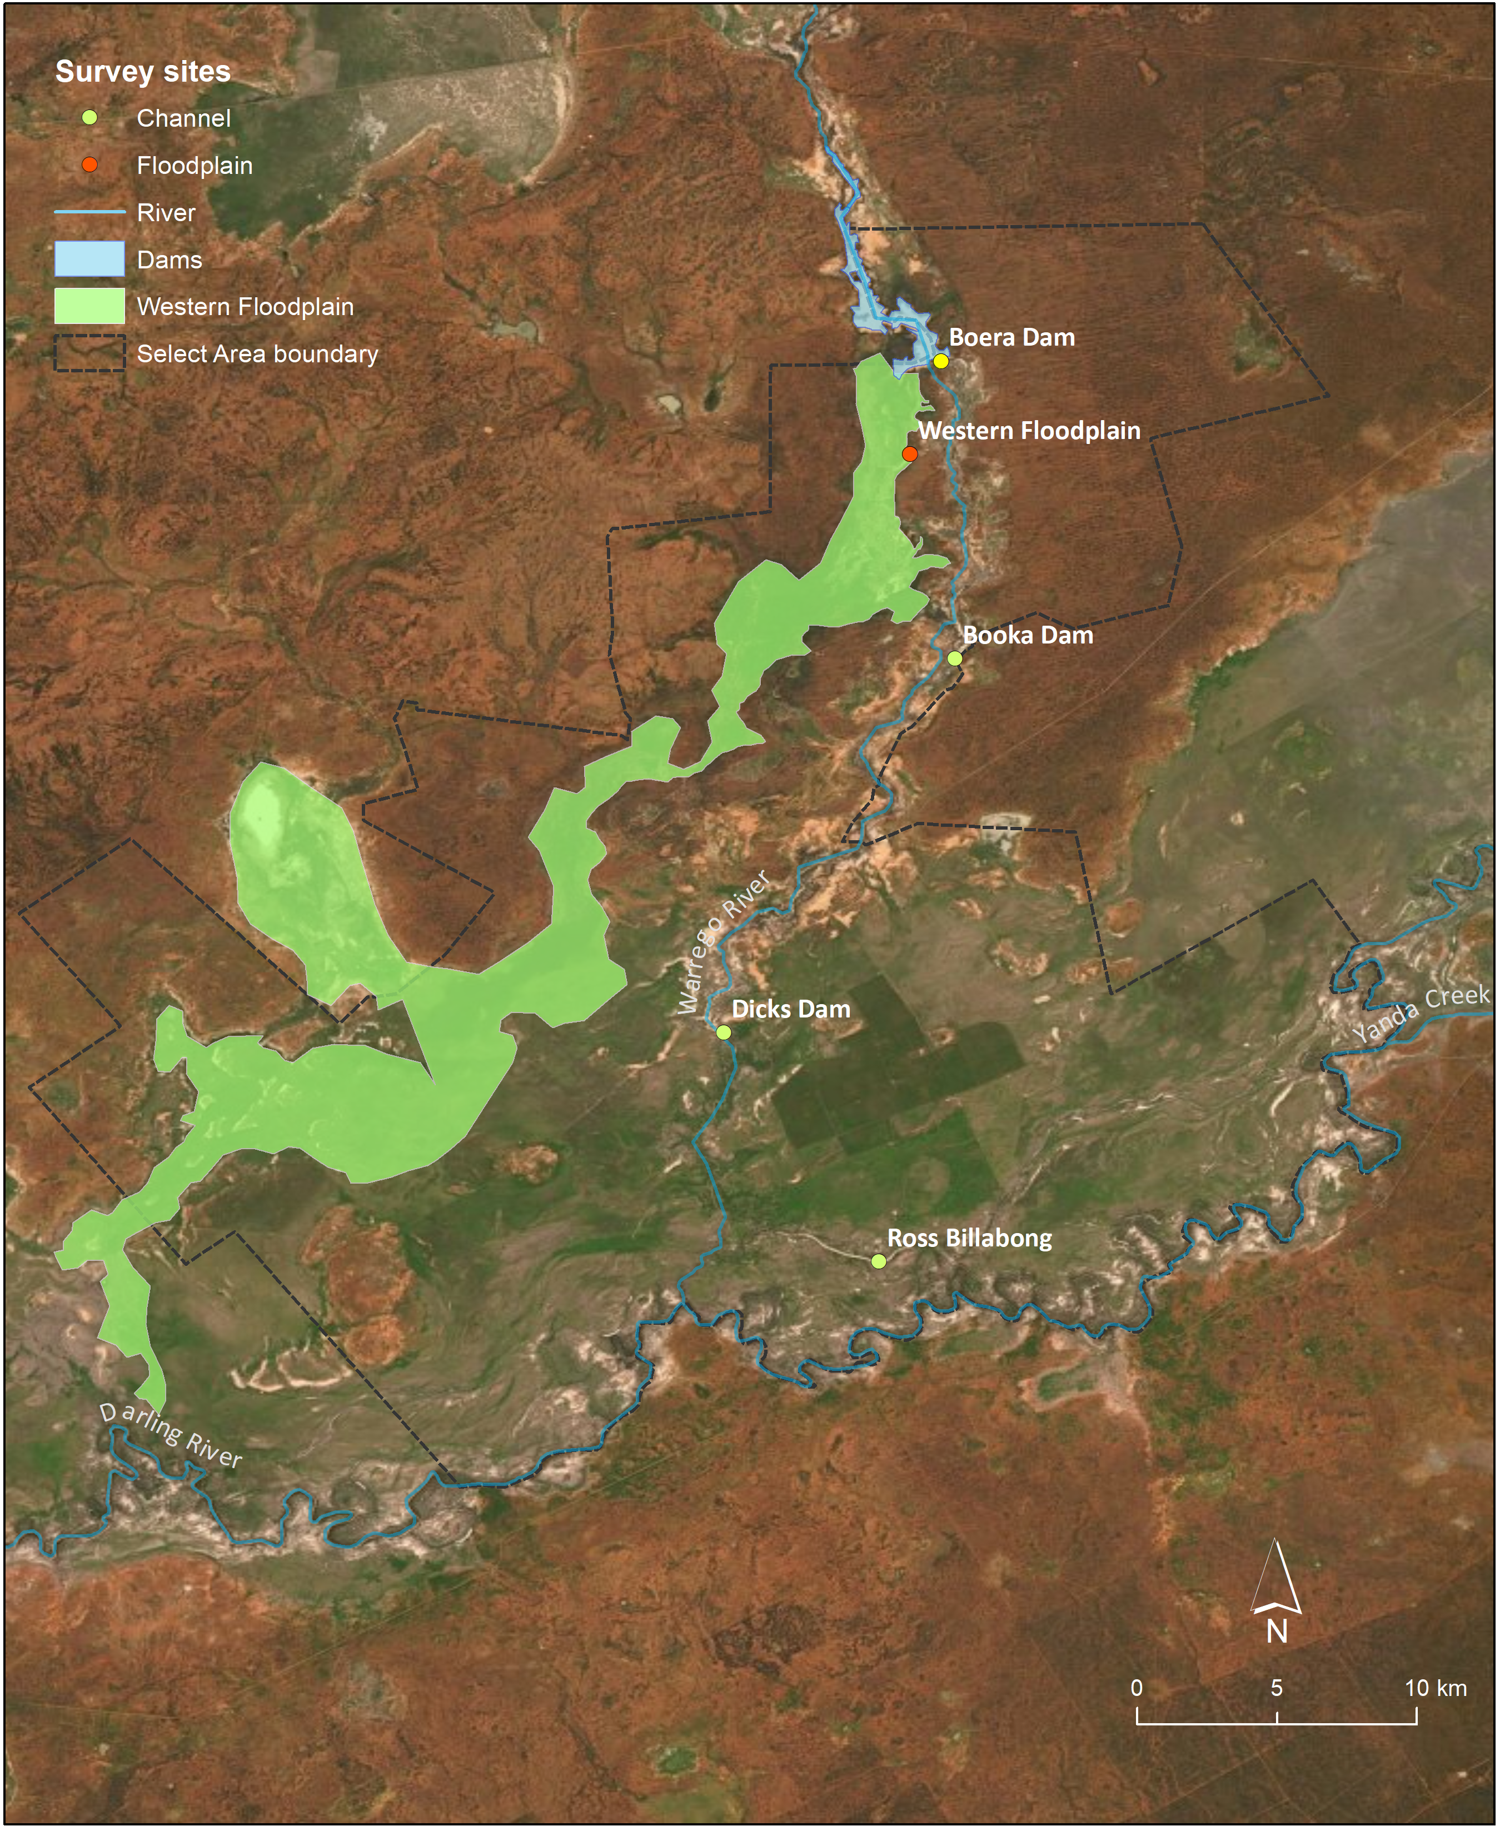
Figure 1 Location of waterbird diversity monitoring sites within the Selected Area.

Results and discussion

2019-20 water year

Waterbird species richness, density and diversity
A total of 84 bird species were recorded across the five survey sites in December 2019 and February 2020, including 26 waterbird species. Waterbird species richness was significantly higher at channel sites than at the Western Floodplain (p<0.05), and was significantly different across site types (p<0.05), with Dicks Dam supporting more waterbird species (16) than elsewhere (e.g. two species at the Western Floodplain, between five and eight species at other channel sites). However, species richness was not significantly different between survey times (Figure 2, Figure 3).

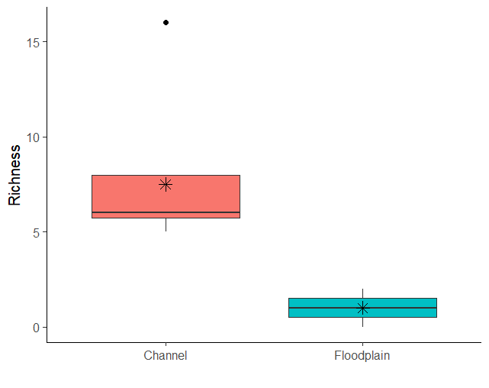
Figure 2 Waterbird species richness in channel vs floodplain sites, 2019–20 water year.
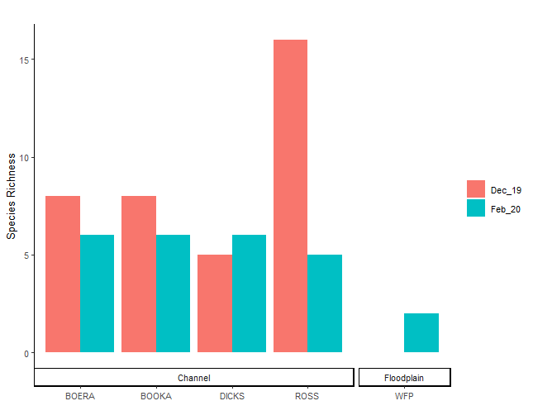
ROSS
DICKS
Figure 3 Waterbird species richness by site, 2019–20 water year.
The most abundant waterbird species in either or both months were the hardhead Aythya australis, grey teal Anas gracilis, pacific black duck Anas superciliosa, Australian wood duck Chenonetta jubata, yellow-billed spoonbill Platalea flavipes, Australian pelican Pelecanus conspicillatus, great cormorant Phalacrocorax carbo and black-tailed native-hen Tribonyx ventralis (Table 2). However, at any one site each of these species numbered at most between 10 and 20 in the visible area of wetland. One waterbird listed as vulnerable under the NSW Biodiversity Conservation Act 2016 (BC Act) was recorded (brolga Antigone rubicunda at Dicks Dam, and one federally listed ‘migratory’ species on international treaties (CAMBA, JAMBA) was recorded (great egret Ardea alba at Boera and Dicks Dams). Otherwise, no nationally significant intercontinental migratory waterbirds (e.g. Palaearctic-breeding charadriiform shorebirds) were recorded, and all waterbird species recorded were common Australian resident species. No evidence of waterbird breeding was observed.
A total of 129 individual waterbirds were recorded in December and 80 individuals in February. Generally, waterbirds were more abundant in December (site mean 29.4 ± 19.04 (SD) birds) than in February (17 ± 9.52 (SD) birds), associated with falling water levels. Large swimming piscivores (pelican 21 vs 5 birds, great cormorant 10 vs 0 birds) were more abundant or localised in February, potentially linked to more concentrated fish populations in receding waterbodies. Dicks Dam, with the highest water level, had the highest waterbird counts in December (77 birds), and Boera Dam, with the largest surface area of water, had the highest waterbird counts in February (39 birds). Waterbird density (birds/ha) was significantly higher at channel sites than at the Western Floodplain (p<0.05) and varied significantly between site types (p<0.05), but not between survey months (Figure 4, Figure 5).

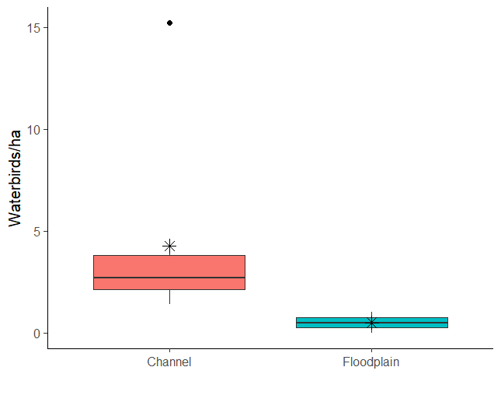
Figure 4 Waterbird densities in channel vs floodplain sites, 2019–20 water year.
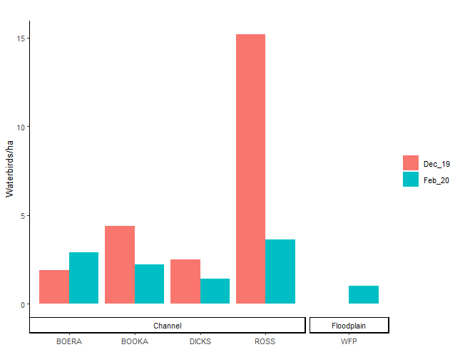
ROSS
DICKS
Figure 5 Waterbird density by site, 2019–20 water year.
Waterbird density and diversity generally declined through summer 2019–20 (Table 2, Figure 3, Figure 5). The channel sites (Boera Dam, Booka Dam, Ross Billabong, Dicks Dam) clearly provided a refuge for some waterbird species during drought times. The relatively high waterbird species richness and density observed at Dicks Dam in December 2019 is related to the relatively high water level and available habitat compared to the other channel sites at that time.

Waterbird diversity was similar across sites, other than the Western Floodplain, especially for the dabbling and filter-feeding ducks guild (Table 2). Channel sites (1.7 ± 0.4) supported higher diversity than the Western Floodplain (0.3 ± 0.5, p<0.05, Figure 6). Shannon diversity was significantly different across sites (p<0.01), but not between survey times (Figure 7).

Table 2 Maximum counts of waterbirds across the five sites, December 2019 and February 2020 (the Migratory Charadriiform Shorebirds functional group was not recorded).
Functional Group | Species | Boera  Dam | Western  Floodplain | Booka  Dam | Ross  Billabong | Dicks Dam
Australian-breeding Charadriiform shorebirds | Pied Stilt | 2
Australian-breeding Charadriiform shorebirds | Black-fronted Dotterel | 4 |  |  | 1 | 6
Australian-breeding Charadriiform shorebirds | Masked Lapwing | 2 |  |  | 4 | 4
Australian-breeding Charadriiform shorebirds | Red-kneed Dotterel |  |  |  |  | 3
Dabbling and filter-feeding ducks | Grey Teal | 10 |  | 4 | 9 | 12
Dabbling and filter-feeding ducks | Pacific Black Duck | 3 | 2 |  | 2 | 9
Dabbling and filter-feeding ducks | Pink-eared Duck | 2
Diving ducks, aquatic gallinules and swans | Hardhead |  |  |  |  | 12
Grazing ducks and geese | Australian Wood Duck | 4 |  | 2 | 8
Piscivores | Australian Pelican | 13 | 1 | 4 | 1 | 3
Piscivores | Great Cormorant | 10
Piscivores | Pied Cormorant |  |  |  | 1
Piscivores | Nankeen Night Heron |  |  | 1
Piscivores | Great Egret | 2 |  |  |  | 1
Piscivores | White-necked Heron | 1 |  | 1 |  | 1
Piscivores | Sacred Kingfisher | 1 |  | 1 | 1 | 1
Rails and shoreline gallinules | Black-tailed Native-hen |  |  | 9 |  | 6
Raptors | Brown Goshawk |  |  |  |  | 1
Raptors | Black Kite |  |  |  |  | 5
Raptors | Whistling Kite | 1 |  | 1 | 1 | 2
Raptors | Nankeen Kestrel |  |  |  |  | 1
Large wading birds | Brolga |  |  |  |  | 2
Large wading birds | Yellow-billed Spoonbill |  |  |  | 3 | 12
Large wading birds | Royal Spoonbill |  |  | 1 |  | 3
Reed-inhabiting passerines | Australian Reed-Warbler | 2 |  | 2 |  | 1
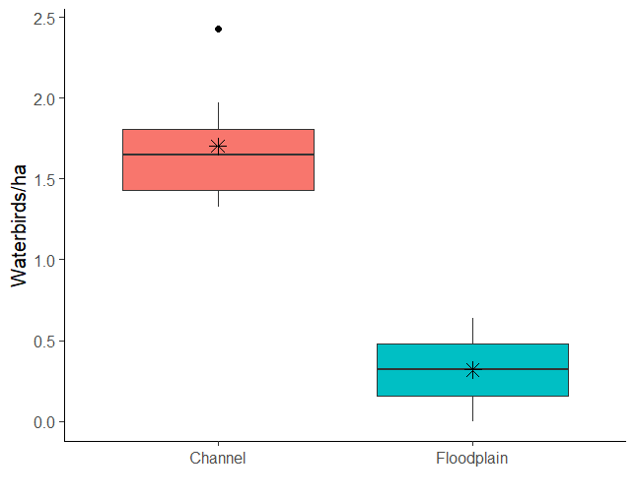
Shannon Diversity
Figure 6 Shannon diversity index of waterbirds at channel vs floodplain sites, 2019–20 water year.
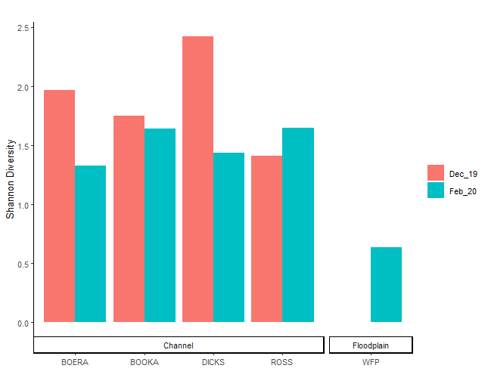
ROSS
DICKS
Figure 7 Shannon diversity index of waterbirds across sites, 2019–20 water year.
Waterbird species richness and abundance of functional groups was depauperate in summer 2019–20, with the migratory charadriiform shorebird guild unrecorded, and terns and grebes among the piscivore guild also unrecorded (Table 2, Figure 8, Figure 9). The dabbling and filter-feeding ducks guild was well-distributed across most sites, other than the Western Floodplain. Boera Dam and Dicks Dam supported more species and numbers of the other guilds, e.g. more large swimming piscivores at Boera Dam, more diving ducks and large wading birds at Dicks Dam. Raptors were also more numerous and diverse at Dicks Dam. However, most functional groups had few species represented in 2019–20. Overall, the dabbling and filter-feeding duck guild (especially Grey Teal) and piscivore guild were the most diverse and/or abundant (Table 2, Figure 8, Figure 9).

Figure 8 Species richness of functional guilds by site and month, 2019–20 water year.

Figure 9 Density of members of waterbird functional guilds by site and month, 2019–20 water year.

Waterbird community composition
There was little obvious clustering of waterbird communities for 2019-20 (Figure 10), reflecting the high variation in conditions between sites and survey times. As such, waterbird assemblages were not significantly different between sampling time or site type.

Figure 10 nMDS ordination of waterbird assemblages recorded at sites within the Selected Area in December (denoted by _11) and February (denoted by _12).

Multi year comparison

Waterbird species richness, density and diversity
Across years, mean waterbird species richness differed significantly by water year (p<0.05; Figure 11) but not site type or inundation category. Mean species richness was significantly lower in 2017-18 (4.8 ± 3.8 species) and 2019-20 (6.2 ± 4.2 species) than in 2014-15 (10.25 ± 6.1 species), 2015-16 (10.1 ± 7.3 species) and 2016-17 (10.8 ± 4.7 species). Waterbird density (birds/ha) was significantly higher in channel sites
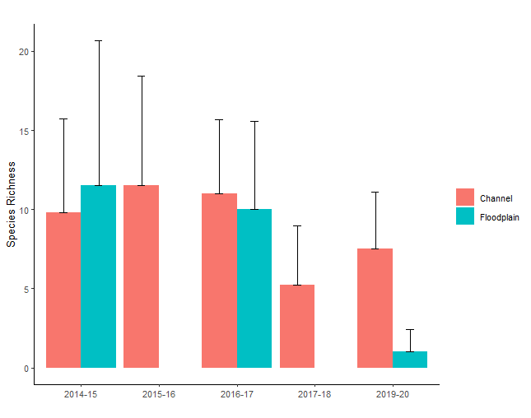
Figure 11 Species richness across years (lines represent standard deviations).
(3.16 ± 3.79 birds/ha) than on the Western Floodplain (0.32 ± 0.35 birds/ha, p<0.001, Figure 12). No significant differences were detected between water years or inundation categories. Mean Shannon diversity differed significantly by water year (p<0.05) and sites type (p<0.01), and there was a significant interaction between water year and site type (p<0.01). Mean diversity was generally higher at the floodplain site than at channel sites, except during 2019-20, where it was significantly lower at the floodplain site (channel sites 1.7 ± 0.35 v’s floodplain site 0.63, p<0.05, Figure 13).
Waterbird abundance (total count) and diversity were lower in summer 2019–20 than in previous water years when the much higher waterbird diversity and abundance (e.g. numbers in the multiple hundreds or thousands and twice as many species) were driven by inundation of the Western Floodplain (Commonwealth of Australia 2019). The notable absence in summer 2019–20 was the migratory charadriiform shorebird guild. However, bird density per hectare was more similar across years, perhaps influenced by differences in available aquatic habitat, observer variation and the concentration of birds at dwindling water sources in 2019–20 (Figure 12). However, species richness was generally poorer in 2019–20, especially on the Western Floodplain (Figure 11), an outcome related to the lack of quality aquatic habitat on the floodplain during this year. Shannon diversity across years (Figure 12) similarly reflects these considerations. All functional groups had fewer species represented in 2019–20 than in previous water years.

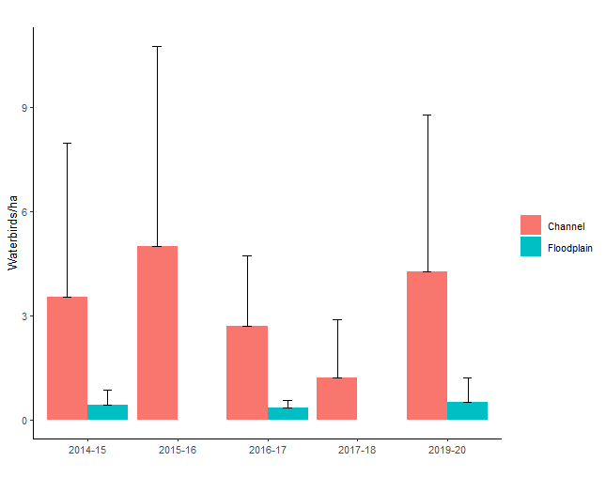
Figure 12 Waterbird density across years (lines represent standard deviations).
The diversity of functional waterbird groups was depauperate in summer 2019–20 compared with previous water years. The migratory charadriiform shorebird guild was unrecorded; the Australian-breeding charadriiform shorebird guild was of three species; the dabbling and filter-feeding duck guild was of three species; the diving ducks, gallinules and swans guild was of only one species; the grazing ducks guild was of one species; the piscivore guild was of seven species, with terns and grebes unrecorded; the rails and shoreline gallinules guild was of one species; the large wading bird guild was of two species; the raptor guild was of five species (although an additional two species were observed while commuting across the dry Western Floodplain); and the reed-inhabiting passerines guild was of only one species. All these values are lower than for the five-year totals (Commonwealth of Australia 2019).

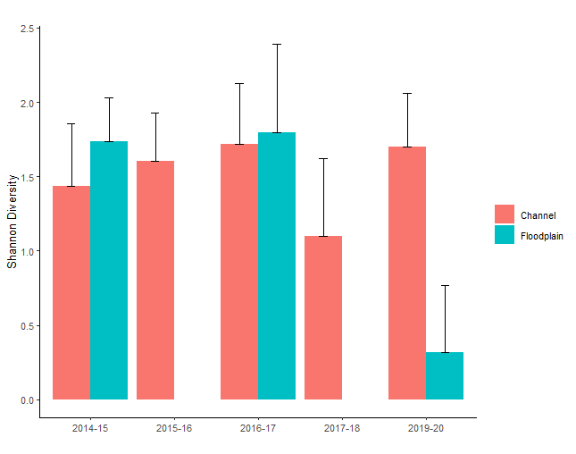
Figure 13 Shannon diversity across years (lines represent standard deviations).

Waterbird community composition
Waterbird assemblages differed significantly between sites (p<0.05) and sampling times (p<0.05) but not site types or inundation categories. There was a significant interaction between site and sampling occasion. Although sampling occasion was a significant source of variation in the waterbird assemblages, pairwise tests between dates did not identify any time that was significantly different from any other, highlighting the variation between sites both within and between survey times (Figure 14).
Figure 14 nMDS ordination of all sampling occasions (SO) during the LTIM/MER project.

Conclusions
Patterns in the waterbird communities at sites in the Selected Area in summer 2019–20 contrasted with those of previous years, in that waterbird diversity and abundance were generally lower and declining in a drought year with dwindling water availability. Waterbirds were essentially absent from the drying Western Floodplain, and Boera Dam, Booka Dam, Ross Billabong and Dicks Dam were refuge areas supporting a depauperate waterbird community that declined through the summer. This situation is the converse of past water years, and shows the opposite effect: namely, a lack of inflows leading to an impoverished, non-breeding and declining waterbird community lacking the nationally and internationally significant guild of Palaearctic-breeding, migratory charadriiform shorebirds. It should be noted that surveys preceded the significant connection event that occurred during March-May 2020, suggesting that conditions at the end of the 2019-20 water year would have been much more favourable for waterbird communities within the Selected Area.

References
Anderson M, Gorley RN, Clarke RK (2008) Permanova+ for Primer: Guide to Software and Statistical Methods. Primer-E Limited.
Anderson MJ (2001) Permutation tests for univariate or multivariate analysis of variance and regression. Canadian Journal of Fisheries and Aquatic Sciences 58: 626–639.
Capon, S.J. 2009. Flow-dependent Ecosystems of Toorale Station: Ecological character, condition and issues associated with decommissioning water resources infrastructure. Australian Rivers Institute, Griffith University.
Clarke KR (1993) Non‐parametric multivariate analyses of changes in community structure. Austral Ecology 18: 117–143.
Commonwealth of Australia 2019. Commonwealth Environmental Water Office Long Term Intervention Monitoring Project Junction of the Warrego and Darling rivers Selected Area – Five Year Evaluation Report. Canberra.
Hale, J., Stoffels, R., Butcher, R., Shackleton, M., Brooks, S., Gawne, B., & Stewardson, M, 2014. Commonwealth Environmental Water Office Long Term Intervention Monitoring Project – Standard Methods. Final Report prepared for the Commonwealth Environmental Water Office by The Murray Darling Freshwater Research Centre, MDFRC Publication 29.2/2014, January, 175 pp.
R Core Team 2018 R: A Language and Environment for Statistical Computing. R Foundation for Statistical Computing, Vienna, Austria, https://www.R-project.org.

