Appendix F: Fish
HYDROLOGY | FOOD WEBS | VEGETATION | WATERBIRDS | FISH | FROGS

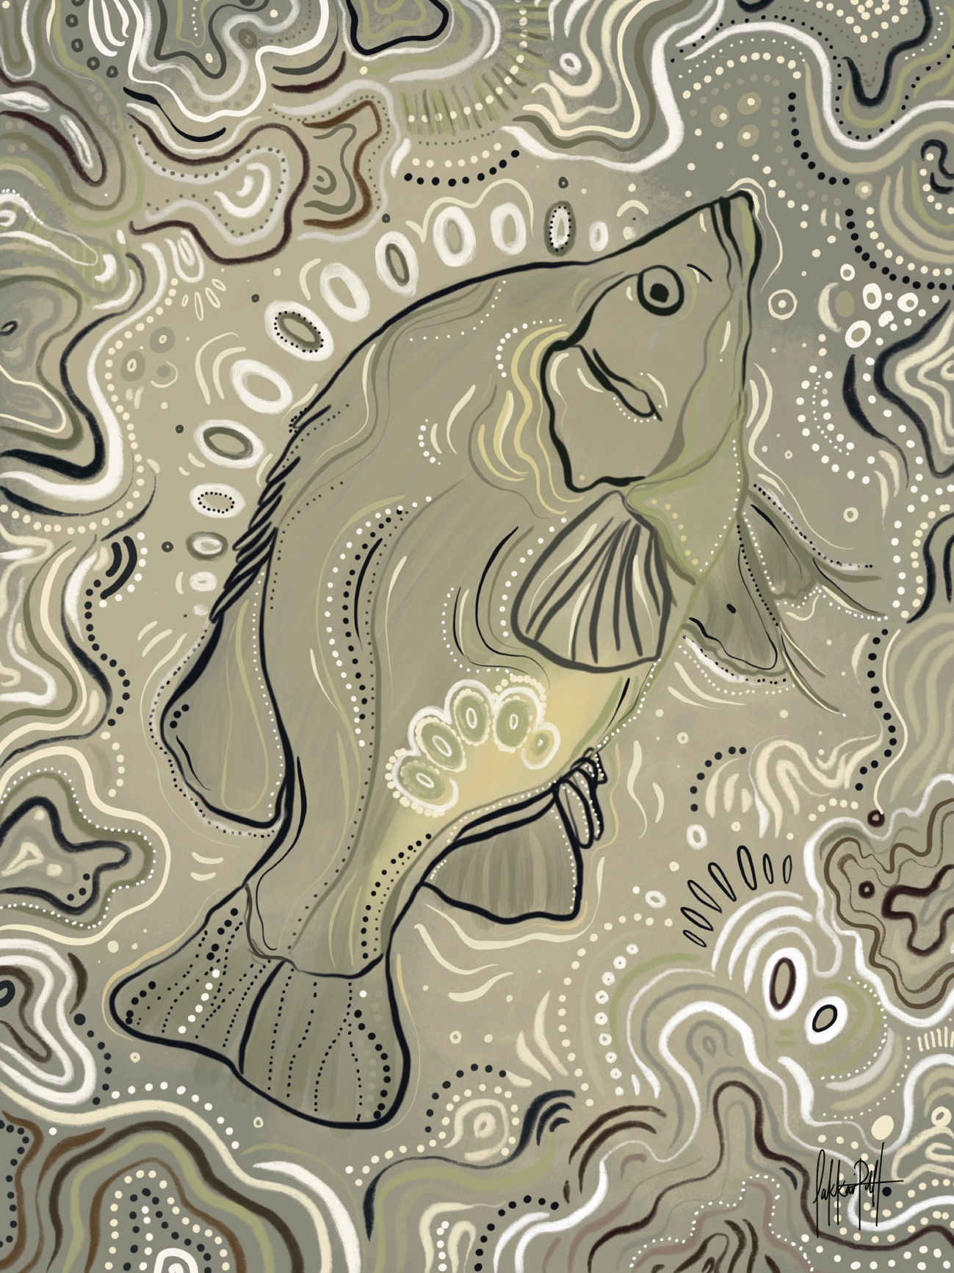

Introduction
There have been few studies that have assessed the fish communities of the Warrego and Darling Rivers simultaneously. The two rivers are very different, varying in length (Darling River length: 2,740 km, Warrego River length: 830 km), stream morphology, regularity of flows, number of tributaries, and number of constructed barriers. The Warrego connects with the Darling south-west of Bourke in north-western New South Wales (NSW) within the Junction of the Warrego and Darling rivers Selected Area (Warrego-Darling Selected Area, Selected Area).
Whilst the Warrego River flows through a relatively undisturbed catchment (Balcombe et al. 2006), the fish assemblages of the Warrego Valley are considered to be in generally poor condition. In the Sustainable Rivers Audit (SRA) No. 2 assessment, the Warrego Valley scored an overall rating of ‘Very Poor’ for the Lowland and Slopes zone, primarily a reflection of the ‘Very Poor’ rating for Recruitment across the entire valley (Murray-Darling Basin Authority 2012). For Nativeness (the proportion of total abundance, biomass, and species present that are native), the Warrego valley scored a rating of ‘Good’, despite there being a relatively high total biomass of alien species captured, particularly common carp (Cyprinus carpio). In summary, the SRA No. 2 program found that the contemporary presence of native species characteristic of the Warrego’s pre-European fish assemblages was outweighed by an apparent paucity of recent fish reproductive activity.
The fish assemblages of the Darling River have been more frequently studied in comparison to the Warrego. In the SRA No. 2 assessment, the fish community of the Darling River was rated as being in “Poor” Overall condition and was characterised by a “Good” rating for Nativeness, and “Poor” rating for both Expectedness and Recruitment. Within all three zones (upper, middle and lower), the fish communities were quite similar, with seven of the 15 predicted native fish species detected and alien species contributing ~35% of the total fish biomass (MDBA 2012).
The aim of the Fish indicator was to assess the outcomes of water releases on the abundance, biomass and health of the fish community in the Warrego-Darling Selected Area. Three separate zones were assessed: (1) directly upstream of the confluence of the Darling and Warrego rivers within the Warrego River, (2) upstream and downstream of the confluence of the Darling/Warrego rivers within the Darling River and (3) an area of river several hundred kilometres upstream of the confluence of the two rivers, in the upper Warrego. Several specific questions were posed in relation to this indicator:
- What did Commonwealth environmental water contribute to native fish community resilience?
- What did Commonwealth environmental water contribute to native fish survival?
- What did Commonwealth environmental water contribute to native fish populations?
- What did Commonwealth environmental water contribute to native fish diversity?

Previous fish community monitoring
Within the Warrego Valley, there have been limited studies of the fish communities. One of the more comprehensive studies was done by Balcombe et al. (2006), who sampled the fish assemblages in 15 waterholes spread among four reaches of the upper Warrego in Queensland (QLD) between October 2001 and April 2002. Sampling targeted periods before and after increased flow events. Ten native species from eight families, and three alien species from two families were recorded. The most abundant and widespread native fish species were bony herring (Nematalosa erebi), Hyrtl’s tandan (Neosilurus hyrtlii) and golden perch (Macquaria ambigua) (Balcombe et al. 2006).
As with many dryland rivers, fish assemblages in the upper Warrego were characterised by marked variations in abundance (Balcombe et al. 2006). The difference in fish abundance was hypothesized to primarily be a reflection of habitat attributes at the waterhole size (Balcombe et al. 2006). It was also suggested the river’s channel morphology across the lower Warrego varies markedly from the headwaters (i.e. above Cunnamulla in south-western QLD), which likely results in differences in the fish assemblages.
Sporadic sampling by Fisheries NSW between 2004 and 2014 across the lower reaches of the Warrego catchment within NSW (as part of the SRA and Carp Hotspots programs), returned catches of 12 species including nine natives and three exotics. Within the boundaries of the Selected Area, two of the species sampled upstream by Balcombe et al. (2006) were not detected; freshwater catfish (Tandanus tandanus) and Australian smelt (Retropinna semoni). However, a small number of the endangered native silver perch (Bidyanus bidyanus) were caught at Dick’s Dam, which is located at the lower end of the Warrego system within the Selected Area, but none were caught upstream. Five sites were sampled across six survey times during 2014-2019 as part of the LTIM project monitoring across the lower Warrego. Similar to previous surveys, seven native and three exotic species were recorded in total across all sites and samples combined. Bony herring, golden perch and spangled perch (Leiopotherapon unicolor) were among the most abundant of the native species caught, with juveniles and adults of most species present sampled at different times during the study (Commonwealth of Australia 2019).
Few studies have examined the fish communities of the Darling River at or near its confluence with the Warrego River. Data collected as part of the SRA program indicated that the fish community of the Bourke to Tilpa reach of the Darling River is dominated by bony herring, spangled perch and golden perch. Hyrtl’s tandan and Murray-Darling rainbowfish (Melanotaenia fluviatilis) were also recorded but in lower numbers (NSW DPI 2015). However, these findings are based on few sites within the Selected Area. Silver perch, olive perchlet (Ambassis agassizii) and freshwater catfish are also expected to occur within this reach (NSW DPI 2015).
Boys and Thoms (2006) completed extensive fish surveys in the mid- and upper-sections of the Darling River to determine the status of fish populations in relation to habitat types. In general, there was a lower abundance of fish at the only site sampled near the Warrego/Darling confluence in comparison to sites upstream toward Bourke and downstream near Tilpa. Golden perch, Murray cod (Maccullochella peelii), bony herring and the exotic common carp were all highly abundant across the region as a whole. Conversely, freshwater catfish, silver perch and carp-gudgeon (Hypseleotris sp.) were all in low abundance or totally absent from most sites.

Methods

Sampling sites

Zone 1: Upper Warrego
Sites sampled in the upper Warrego River were: Ward River Waterhole; Baker’s Bend; Tickleman Garden’s Waterhole; Cunnamulla Weir; and Glenco Waterhole (listed upstream to downstream) (Table 1, Figure 1). Sampling methods used in the upper Warrego were the same as those used for sites within the lower Warrego River and Darling River (Table 1). The five sites spanned ~230 km of river and were all in QLD. The upper Warrego sampling was undertaken by Fisheries Qld as part of the Murray-Darling Basin Authorities annual Murray-Darling Freshwater Fish assessment program with the timing aligned with Sample 1 MER Warrego-Darling Selected Area sampling (Table 1, Table 2, Figure 1, Figure 5).
Cunnamulla weir was the only constructed storage sampled in the upper Warrego zone, the remaining sites were all natural waterholes and varied greatly in size and depth. Ward River Waterhole was the largest at approximately 4.5 km in length and had an average width of 60 m. The smallest site which was also the furthest downstream was Glencoe Waterhole at 0.7 km in length and 40 m in average width. The water at all sites was highly turbid (Figure 5) and in places was relatively deep, with a maximum depth of 9.5 m recorded at the Ward River Waterhole. Similar to the lower Warrego, in-stream habitat for fish was generally sparse, with large woody debris present at all sites, as well as small amounts of undercut banks and overhanging riparian vegetation. Substratum at all sites was dominated by mud and sand, though some rock was present within the Ward River Waterhole site. As a result of many years of drought, the riparian vegetation was sparse and was dominated by the large native river red gums (Eucalyptus camaldulensis) with little or no understorey.

Zone 2: Lower Warrego
The Warrego River is considered intermittent and ephemeral across the lower sections of the system, terminating in a series of swamps and natural and artificial water storages immediately upstream of the Warrego-Darling junction. Data was collected from five sites over two sampling events (Table 1, Table 2) from the lower Warrego River: Ross Billabong; Dick’s Dam; Toorale Homestead; Booka Dam; and Boera Dam (Figure 2, Figure 3). The lowest site (Ross’ Billabong) is approximately 5 km above the junction of the Warrego and Darling rivers, whilst the top site is approximately 45 km upstream of the junction of the two systems (Boera Dam, Figure 2). Water levels were sufficiently high enough so that all five sites could be sampled in both Sample 1 and Sample 2 (Table 2).
Of the five sample sites, four were constructed water storages, whilst Ross Billabong (Figure 2) was the only natural segment of the lower Warrego surveyed. Ross Billabong is around 4-5 km in length and has a maximum carrying capacity of around 13,000 ML. The four constructed dams vary in size and capacity and were intially built by Sir Samuel McCaughey in the late 19th century to help move water out onto the Western Floodplain to improve grazing opportunities and for stock water. The water at all sites and across both samples was highly turbid and relatively shallow, ranging up to a maximum depth of ~1-1.5 m. In-stream habitat for fish was generally sparse, with mainly small and only the occasional large piece of woody debris present, whilst fringing undercut banks were also in low abundance at some sites. The substratum at all sites was dominated by mud, sand and silt. Most sites were fringed by a sparse riparian zone, dominated by large native trees such as river red gums and black box (Eucalyptus largiflorens), as well as small numbers of native shrubs <2 m in height (Figure 3).

Zone 3: Darling River
Sampling was undertaken for this current study, comprises relatively steep banks, widths of ~15-40 m, depths of <4 m, and generally experiences tranquil flows (Figure 4). Turbidity levels varied among sites, ranging from partially turbid at some sites to highly turbid at others (Figure 4). In times of low-flow, little physical habitat is available for fish to use as cover (Boys and Thoms 2006, Figure 4). River red gums dominate the sparse riparian vegetation, occupying a narrow zone adjacent to the high banks (Boys and Thoms 2006).
All five sites sampled on the Darling were located between the townships of Bourke and Louth in north-western NSW (Figure 2). Sites were: Gundabooka; East Toorale; Warrego/Darling Junction; Clover; and Talowla (Table 1). The Darling sites spanned over ~50 km of river from the most upstream to most downstream site
Table 1 Locations of sampling sites in the lower Warrego, upper Warrego and Darling River used for MER Fish (River) assessment. NB*. Electrofishing effort was dependent on water levels during each sample.
Site Name | River | Source | Latitude | Longitude | Altitude | Zone | Electrofishing Effort
Ross’ Billabong | Warrego | LTIM CAT 3 | -30.39029 | 145.40817 | 103 | Lowland | Small boat
Dick's Dam | Warrego | LTIM CAT 3 | -30.3163 | 145.36056 | 99 | Lowland | Backpack/ Small boat
Toorale Homestead | Warrego | LTIM CAT 3 | -30.27954 | 145.3788 | 98 | Lowland | Backpack/ Small boat
Booka Dam | Warrego  Warrego | LTIM CAT 3 | -30.19054 | 145.43962 | 98 | Lowland | Small boat
Boera Dam | Warrego | LTIM CAT 3 | -30.1018 | 145.41962 | 104 | Lowland | Small boat
Ward River Waterhole | Warrego | LTIM CAT 3 | -26.47991 | 146.10105 | 283 | Slopes | Large boat
Baker’s Bend | Warrego | LTIM CAT 3 | -26.69224 | 146.12953 | 275 | Slopes | Large boat
Tickleman Garden’s Waterhole | Warrego | LTIM CAT 3 | -27.86651 | 145.66999 | 201 | Slopes | Large boat
Cunnamulla Weir | Warrego | LTIM CAT 3 | 28.11224 | 145.68675 | 190 | Lowland | Large boat
Glenco Waterhole | Warrego | LTIM CAT 3 | -28.20121 | 145.70705 | 185 | Lowland | Large boat
Gundabooka | Darling | LTIM CAT 3 | -30.411876 | 145.489565 | 105 | Lowland | Medium boat
East Toorale | Darling | LTIM CAT 3 | -30.430188 | 145.386485 | 104 | Lowland | Medium boat
Warrego/Darling Junction | Darling | LTIM CAT 3 | -30.46516 | 145.34579 | 103 | Lowland | Medium boat
Clover | Darling | LTIM CAT 3 | -30.43927 | 145.328948 | 100 | Lowland | Medium boat
Talowla | Darling | LTIM CAT 3 | -30.4680 | 145.2186 | 99 | Lowland | Medium boat

Table 2 Sampling dates for MER Category 3 Fish River Warrego-Darling Rivers Selected Area assessment. “Number of sites sampled” is dependent on water levels but maximum is 5.
Sampling event | Sampling dates | Sampling Zone | Number of sites sampled
Sample 1 | 8-12 July, 2019  5-9 August, 2019  23 June-1 July, 2019 | Lower Warrego  Darling  Upper Warrego | 5  5  5
Sample 2 | 25-29 November, 2019  8-13 December, 2019 | Lower Warrego  Darling | 5  5

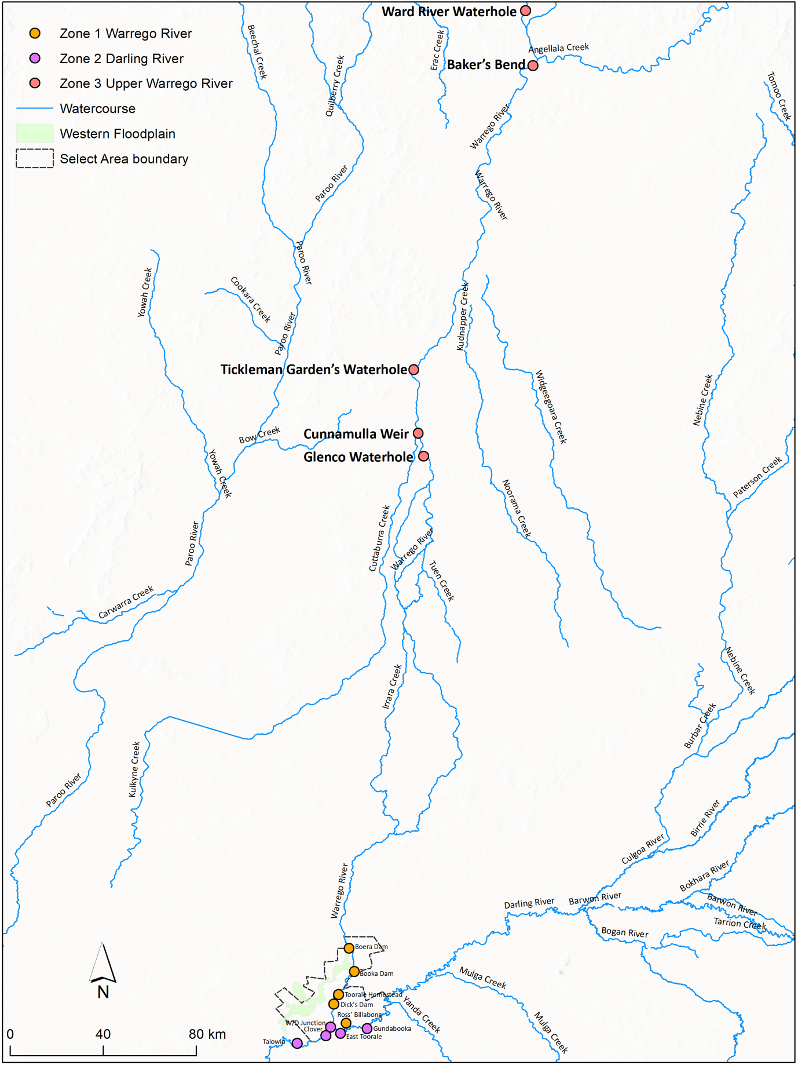
Figure 1 Sampling sites in the three Zones; lower Warrego, Darling and upper Warrego River.

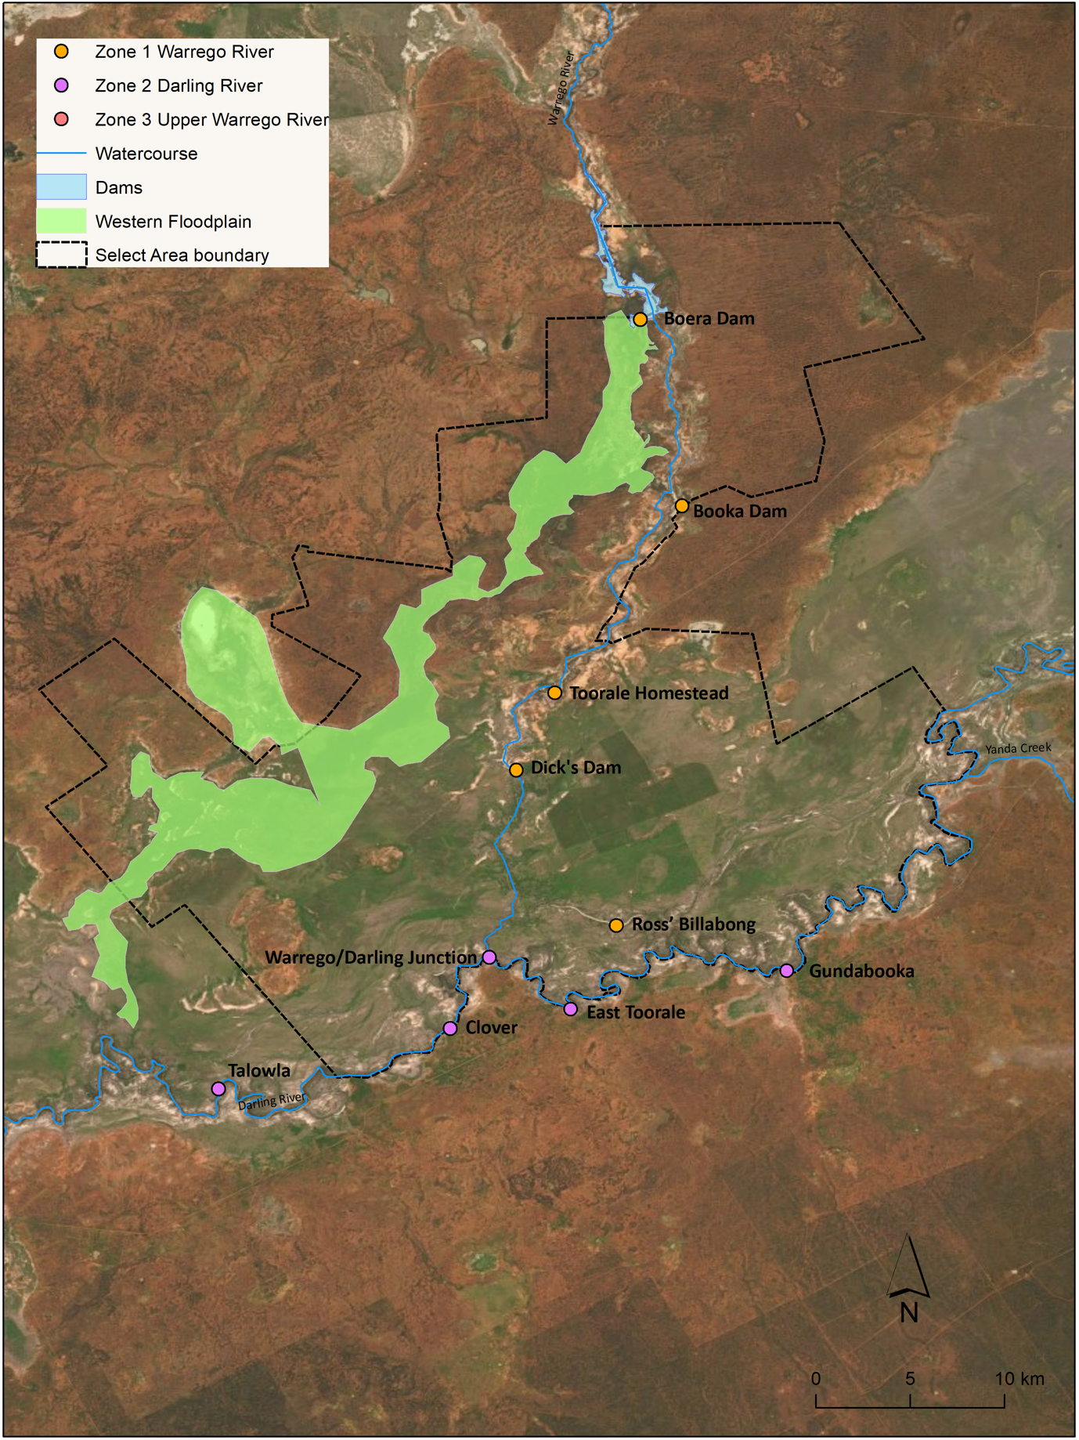
Figure 2 Sampling sites in the Selected Area; lower Warrego River and Darling River.

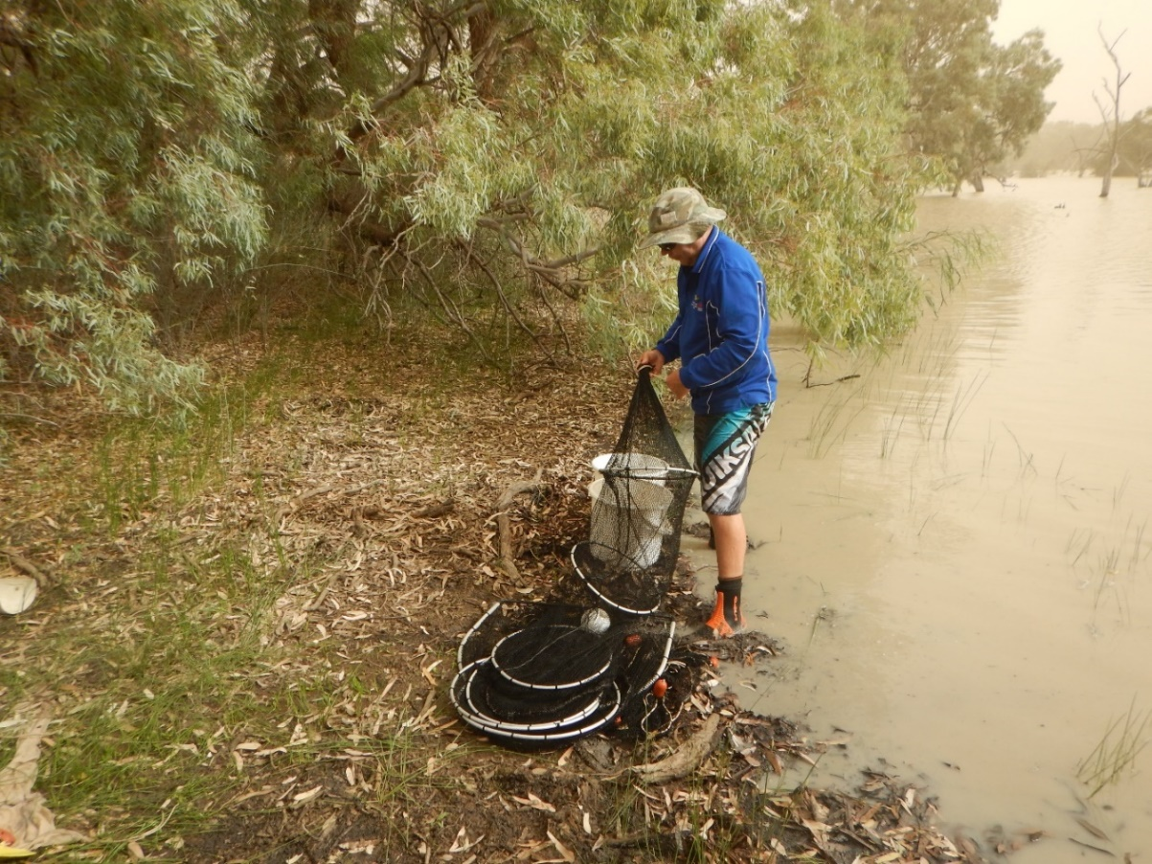
Figure 3 NSW DPI-Fisheries researchers checking large fyke nets at Dick’s Dam, November 2019.
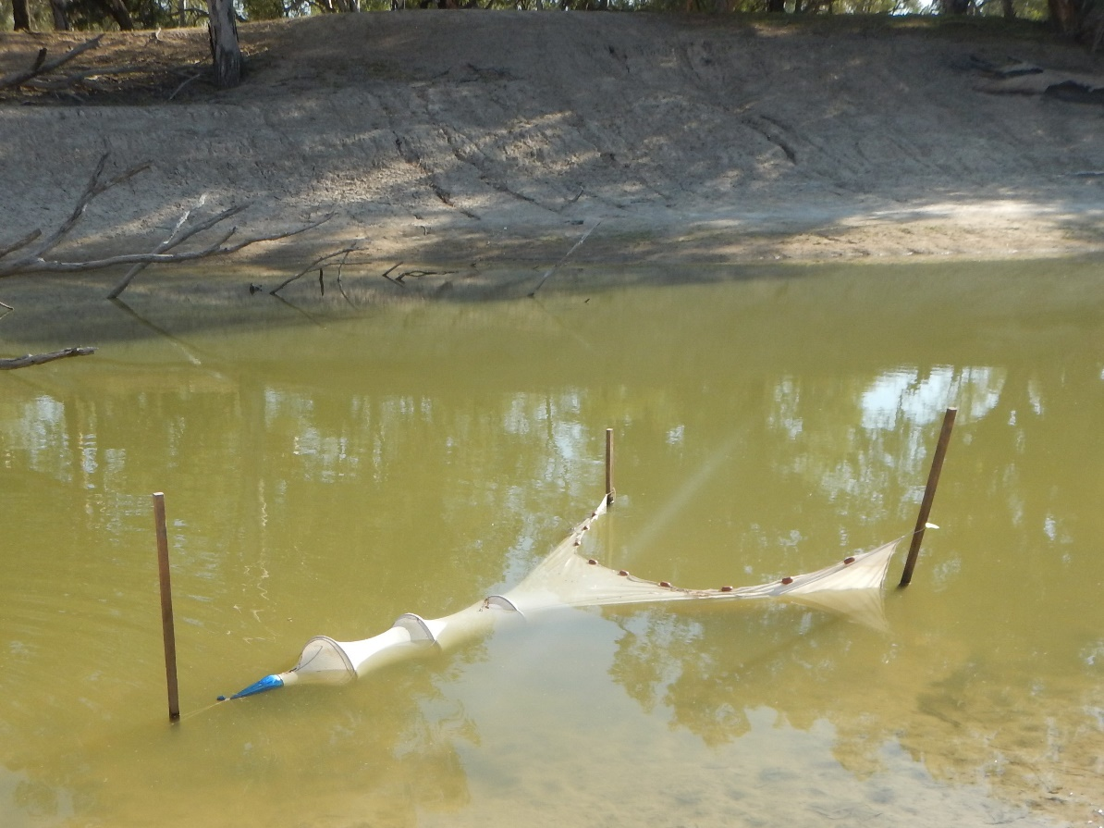
Figure 4 Small fyke net set at Talowla site on the Darling River, November 2019.

Sampling protocols

Three Zones Assessment (Upper Warrego, Lower Warrego and Darling);
Sampling effort at each site for the Three Zone Assessment was a combination of electrofishing (Figure 5), un-baited bait traps, and large mesh fyke nets set in both an upstream and a downstream direction (Figure 3). Electrofishing was undertaken by either small boat (2.5 kW) or large boat (7.5kW) Smith-Root electrofisher unit (Figure 5). Boat electrofishing effort was 12 x 90 second operations at each site and involved a series of ~10 sec power-on and power–off operations, with successive operations undertaken on alternate banks, whilst moving in an upstream direction. All small boat electrofishing was undertaken by two operators, whilst large boat electrofishing was undertaken by three operators.
Bait traps (n = 10 unbaited) were deployed haphazardly throughout the sites in depths of 0.5–1 m, and soaked for up to two hours at the same time as electrofishing operations. Fyke netting were undertaken on alternate days to electrofishing operations. Six large mesh (19 mm, Figure 3) single wing fyke nets set back-to-back facing upstream and downstream were deployed overnight at each site for a minimum of 12 hrs.

Selected Area Assessment (Lower Warrego and Darling);
Sampling effort at each site for the Selected Area Assessment was a combination of electrofishing, un-baited bait traps, large mesh fyke nets and double wing small mesh fyke nets (Figure 4). These methods aligned with previous sampling effort as part of the LTIM project. Electrofishing operations and the deployment of un-baited bait traps were completed as mentioned above in the Three Zones Study methods. In addition, three double wing small mesh nets (3 mm mesh, Figure 4) and three downstream facing large fyke nets (19 mm) were set overnight for a minimum of 12 hrs.
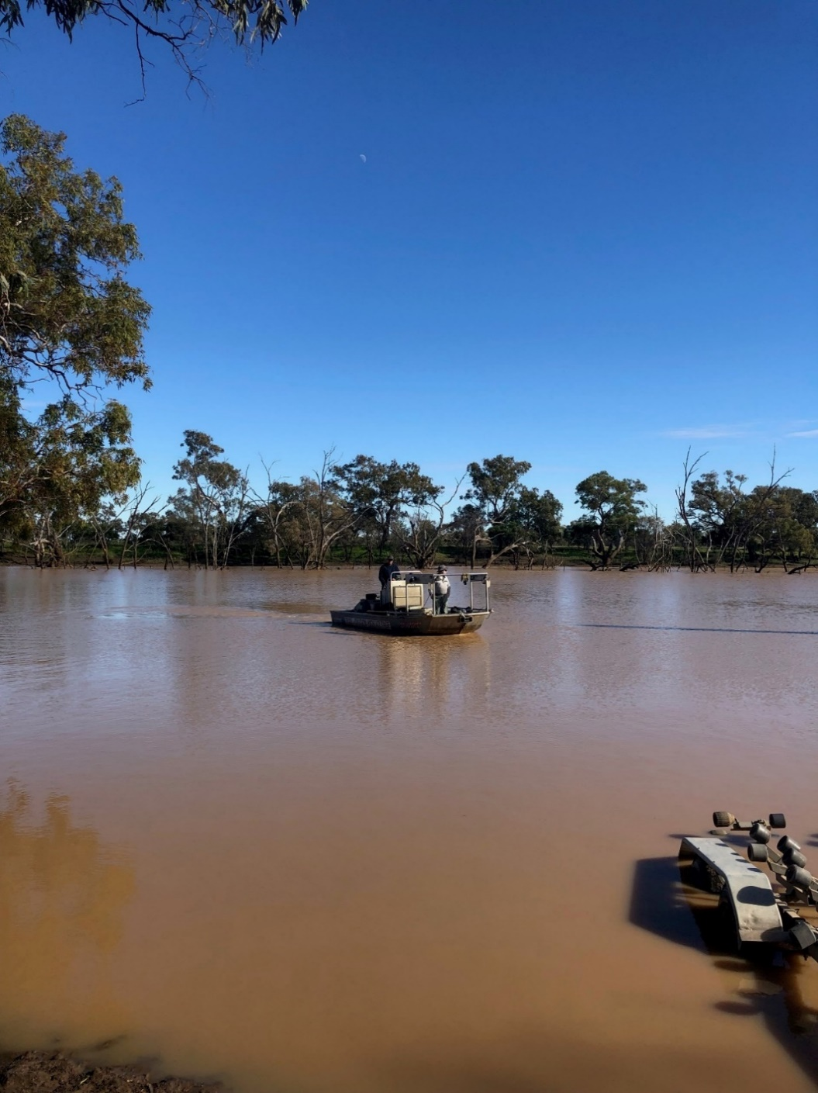
Figure 5 Boat electrofishing sampling within the upper Warrego River, June-July 2019.

General fish field protocol
All fish captured were identified, counted, and measured to the nearest mm; fork length (FL) for species with forked tails, and total length (TL) for all other species. If large numbers of a particular species were captured by a given gear type within a site, only the first 50 individuals of that species were measured, with any subsequent captures counted only. Fish that escaped capture but that could be positively identified were recorded as “observed”. Voucher specimens were retained only if a positive identification could not be made in the field.

Data analyses

Three Zones Assessment
For the Three Zone analyses we used data collected from lower Warrego, upper Warrego and Darling River sites (Figure 1). A total of 15 sites were surveyed as part of Sample 1 for the three zones assessment (upper Warrego, lower Warrego and Darling). During Sample 2, 10 sites were surveyed within two zones (lower Warrego and Darling) (Figure 3).

Non-parametric statistical analysis
Catches from electrofishing, large fyke nets (upstream and downstream sets) and bait traps (unbaited) were combined for statistical analyses. Non-parametric multivariate analysis of variances (PERMANOVA) was used to determine if there were differences between the fish assemblages in abundance and biomass among samples (PRIMER 6 & PERMANOVA; Anderson et al. 2008). Prior to analyses, the data were fourth root transformed and the results used to produce a similarity matrix using the Bray-Curtis resemblance measure. All tests were considered significant at p<0.05. Where differences were identified by PERMANOVA, pair-wise comparisons were then used to determine which groups differed. Similarity percentage (SIMPER) tests were used to identify individual species contributions to average dissimilarities among groups.

Length frequency analysis
Non-parametric Kolmogorov-Smirnov Z tests were used to determine if there were differences among samples in the size structures of the three more abundant large-bodied species present; golden perch, bony herring and common carp. Data from all sites and samples from all three zones were combined for analyses, with samples where <20 individuals were captured excluded. P-values were adjusted to account for increasing experiment-wise error rates associated with multiple comparisons (Ogle 2015).

Selected Area Assessment
For these analyses, only data collected from lower Warrego and Darling sites were used. Sampling methods included; small fyke nets, downstream facing large fyke nets, boat-mounted electrofishing and bait traps. A total of 10 sites were surveyed in both Sample 1 and Sample 2 (Table 2, Figure 3, Figure 4).

Length frequency analysis
Catches from electrofishing, large fyke nets (downstream sets only), small fyke nets, and bait traps (unbaited) were combined for Selected Area statistical analyses. These methods align with previous sampling for the LTIM project. Non-parametric Kolmogorov-Smirnov Z tests were used to determine if there were differences among samples in the size structures of the three more abundant large-bodied species present; golden perch, bony herring and common carp. Data from all sites and samples from the lower Warrego and Darling were combined for analyses, with samples where <20 individuals were captured excluded. P-values were adjusted to account for increasing experiment-wise error rates associated with multiple comparisons (Ogle 2015).

Health metrics
Reference Condition
The predicted pre-European fish community of the Warrego and Darling Basin (Table 3) was derived using the Reference Condition for Fish (RC-F) approach used by the Sustainable Rivers Audit (SRA) and NSW Monitoring, Evaluation and Reporting (NSW MER) programs (Table 4). The RC-F process uses historical and contemporary data, museum collections and expert knowledge to estimate the probability of collecting each species at any randomly selected site within an altitude zone prior to 1770 using the standard sampling protocol (Davies et al. 2008). Rare species were allocated a RC-F probability of capture of 0.1 (collected at 0 < 0.2 of samples), occasional species (collected at 0.21 < 0.7 of samples) an RC-F of 0.45 and common species (collected at 0.71 < 1.0 samples) an RC-F of 0.85 (RC-F scores being the median capture probability within each category), (Table 3).

The definition of a recruit was derived using a similar process as that applied in the SRA and NSW MER programs (Dean Gilligan unpublished data). For large-bodied and generally longer living species (>3-years), an individual was considered to be a recruit if its body length was less than that of a one-year-old of the same species. For small-bodied and generally short-lived species that reach sexual maturity in less than one year, recruits were considered to be those individuals that were less than the species known average length at sexual maturity. The recruitment lengths used for both large- and small-bodied species were derived from published scientific literature or by expert opinion where published data was not available (Table 4).
Metrics, Indicators and the Overall Fish Condition Index
Using the methods described by Robinson (2012), eight fish metrics were derived from the data collected at each site. The eight metrics were then aggregated to produce three fish condition indicators and these indicators were then used to derive an overall Fish Condition Index (SRA ndxFS). Metric and indicator aggregation was done using Expert Rules analysis in the Fuzzy Logic toolbox of MatLab (The Mathworks Inc. USA) using the rule sets developed by Davies et al. (2010).

The Expectedness Indicator (SR-FI_{e}) represents the proportion of native species that are now found within the basin, compared to that which was likely to have been historically present. The Expectedness Indicator is derived from two input metrics; the observed native species richness over the expected species richness at each site, and the total native species richness observed within the zone over the total number of species predicted to have existed within the zone historically (Robinson 2012). The two metrics were aggregated using the Expectedness Indicator Expert Rule set (Carter 2012).

The Nativeness Indicator (SR-FI_{n}) represents the proportion of native versus alien fishes within the river. The Nativeness Indicator is derived from three input metrics; proportion native biomass, proportion native abundance and proportion native species (Robinson 2012). The three metrics were aggregated using the Nativeness Indicator Expert Rule set (Carter 2012).

The Recruitment Indicator (SR-Fi_{r}) represents the recent reproductive activity of the native fish community within each altitude zone. The Recruitment Indicator is derived from three input metrics; the proportion of native species showing evidence of recruitment at a minimum of one site within a zone, the average proportion of sites within a zone at which each species captured was recruiting (RC-F corrected), and the average proportion of total abundance of each species that are new recruits (Robinson 2012). These metrics were aggregated using the Recruitment Indicator Expert Rule set (Carter 2012).

The three indicators were combined using the Fish Index Expert Rule set (Carter 2012) to calculate an overall Fish Condition Index (ndxFS). The Fish Index Expert Rules analysis is weighted as SR-FI_{e} > SR-FI_{r} > SR-FI_{n}. The output generated by the Expert Rules analysis is scaled between 0 and 100, with higher values representing a ‘healthier’ fish community. The index was then partitioned into five equal bands to rate the condition of the fish community; “Excellent” (81-100), “Good” (61-80), “Moderate” (41-60), “Poor” (21-40), or “Very Poor” (0-20).

Table 3 Native freshwater fish species predicted to have occurred across the Warrego and Darling River within the areas for this current study prior to European colonisation. Descriptions of predominance (occurrence) correspond to RC-F categories for the Murray Darling Basin Sustainable Rivers Audit program and are used to generate the fish condition metrics.
Species | Common name | Occurrence
Ambassis agassizii | Olive perchlet | Occasional
Bidyanus bidyanus | Silver perch | Occasional
Craterocephalus stercusmuscarum fulvus | Un-specked hardyhead | Rare
Hypseleotris sp. | Carp-gudgeon | Common
Leiopotherapon unicolor | Spangled perch | Common
Melanotaenia fluviatilis | Murray-Darling rainbowfish | Common
Melanotaenia splendida tatei | Desert rainbowfish | Rare
Mogurnda adspersa | Southern purple-spotted gudgeon | Rare
Nematolosa erebi | Bony herring | Common
Maccullochella peelii | Murray cod | Occasional
Macquaria ambigua | Golden perch | Common
Neosilurus hyrtlii | Hyrtl’s tandan | Occasional
Retropinna semoni | Australian smelt | Common
Tandanus sp. (MDB) | Freshwater catfish | Common

Table 4 Sizes used to distinguish new recruits for species likely to be sampled in the Warrego and Darling rivers. Values represent the length at 1 year-of-age for longer-lived species or the length for species that reach sexual maturity within 1 year.
Species | Estimated size at 1 year old or at sexual maturity (fork or total length)
Native species
Olive perchlet | 26 mm (Pusey et al. 2004)
Silver perch | 75 mm (Mallen-Cooper 1996)
Un-specked hardyhead | 38 mm (Pusey et al. 2004)
Carp gudgeon | 35 mm (Pusey et al. 2004)
Spangled perch | 68 mm (Leggett & Merrick 1987)
Murray-Darling rainbowfish | 45 mm (Pusey et al. 2004)
Desert rainbowfish | 38 mm (Pusey et al. 2004)
S. purple-spotted gudgeon | 40 mm (Pusey et al. 2004)
Bony herring | 67 mm (Cadwallader 1977)
Murray cod | 222 mm (Gavin Butler unpub. data)
Golden perch | 75 mm (Mallen-Cooper 1996)
Hyrtl’s tandan | 130 mm (Pusey et al. 2004)
Australian smelt | 40 mm (Pusey et al. 2004)
Freshwater catfish | 92 mm (Davis 1977)
Alien species
Common carp | 155 mm (Vilizzi and Walker 1999)
Eastern mosquitofish | 20 mm (McDowall 1996)
Common goldfish | 127 mm (Lorenzoni et al. 2007)

Results

Three Zones Assessment

Abundance
In total, 2,880 fish were captured (n=2,224) or observed (n=656) across Sample 1 (winter sampling) and Sample 2 (spring/summer sampling). Sample 2 had the highest captures at 2,265 (n=1,624) or observed (n=641), compared to 615 captured (n=600) or observed (n=15) in Sample 1. A total of 12 fish species were collected in Sample 1 and eight species in Sample 2 (Table 5). In Sample 1, the most abundant large-bodied species were bony herring (n=286), common carp (=120) and golden perch (n=117). The most abundant small-bodied species in Sample 1 were Murray-Darling rainbowfish (n=20) and carp gudgeon (n=8). In Sample 2, the most abundant large-bodied species were golden perch (n=770) and bony herring (n=282). The most abundant small-bodied species in Sample 2 were carp gudgeon (n=375). A number of species had very low abundance including Murray cod (Figure 6) with two individuals collected in Sample 1 and another two in Sample 2 and Freshwater catfish with only one individual collected in Sample 1. Other intermittently collected biota included common yabbies (Figure 7) and freshwater long-armed prawns.
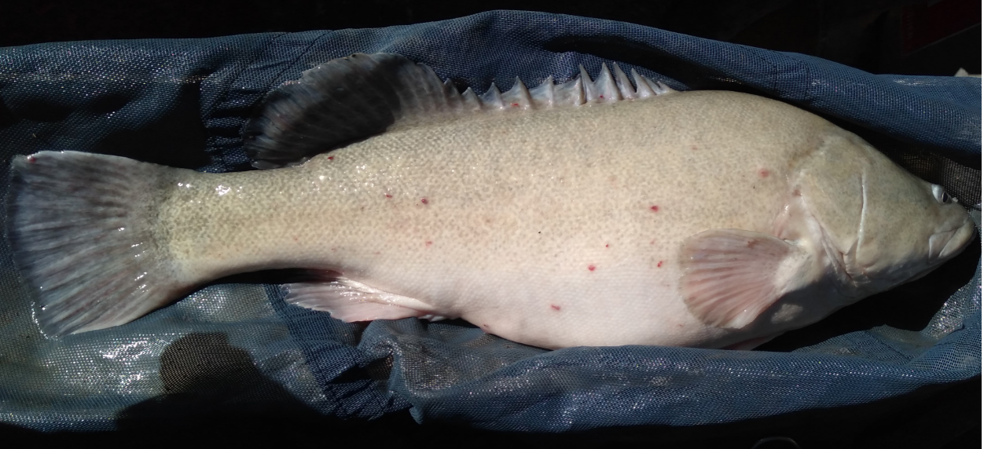
Figure 6 Murray cod (Maccullochella peelii) (TL= 910 mm) collected from Talowla on the Darling River, November 2019.

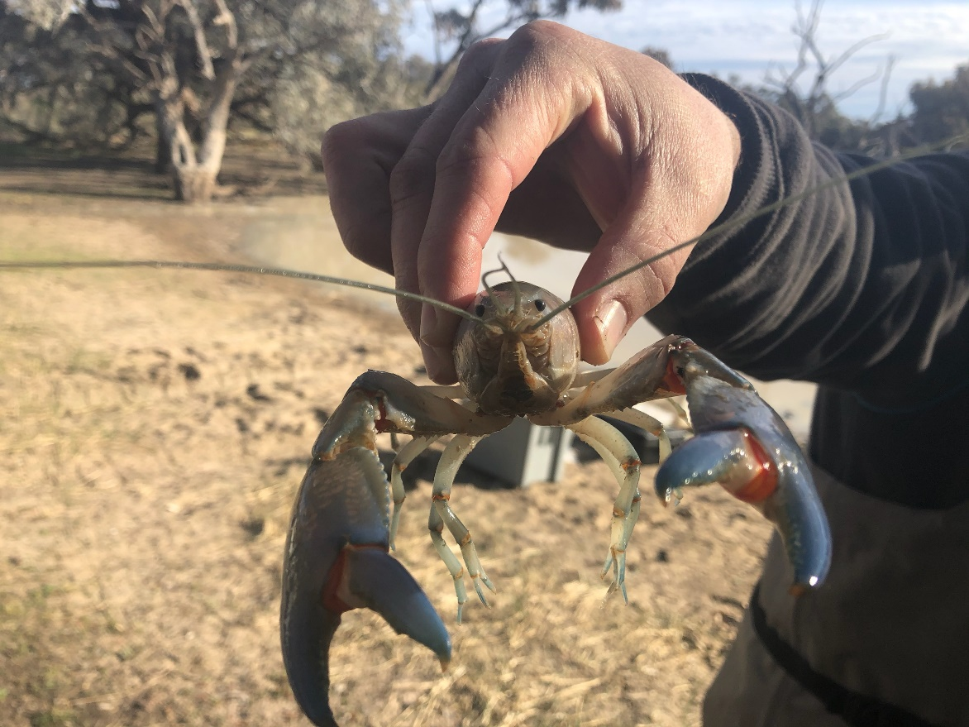
Figure 7 Common yabby (Cherax destructor) collected from Dick’s Dam on the lower Warrego River, November 2019.
There was a significant difference in the overall fish assemblage among the three zones (Pseudo-F_{2,22}=5.87, p<0.01). Pair-wise comparisons revealed differences between all zones: Darling River and lower Warrego (t=2.66, p=0.01), Darling River and upper Warrego (t=2.08, p=0.01) and lower Warrego and upper Warrego (t=2.30, p=0.01).
SIMPER analysis suggested differences between the Darling and the lower Warrego fish community were primarily a result of a greater numbers of bony herring (contribution = 23.88%) and carp-gudgeon (contribution = 20.94%) in the Darling River. Additionally, a greater number of golden perch (contribution = 15.66%) and common carp (contribution = 10.58%) in the lower Warrego contributed to differences.
Differences between the Darling and upper Warrego were a result of a greater number of carp-gudgeon (contribution = 20.97%) and goldfish (contribution = 11.96%) in the Darling. Other differences between these zones were driven by a greater number of Murray-Darling rainbowfish (contribution = 18.07%) and Australian smelt (contribution = 10.72%) in the upper Warrego.

Table 5 List of species used in the analysis for the three zones assessment in the Warrego and Darling River. Ticks indicate that adult and/or juveniles were collected during the three zones assessment during the sampling events in any of the three zones as part of MER Fish (River) assessment.
Species | Sampled during study
 | Adult | Juvenile
Native species
Olive perchlet | ✗ | ✗
Silver perch | ✗ | ✗
Un-specked hardyhead | ✗ | ✗
Carp gudgeon | ✓ | ✓
Spangled perch | ✓ | ✗
Murray-Darling rainbowfish | ✓ | ✓
Desert rainbowfish | ✗ | ✗
S. purple-spotted gudgeon | ✗ | ✗
Bony herring | ✓ | ✓
Murray cod | ✓ | ✗
Golden perch | ✓ | ✓
Hyrtl’s tandan | ✓ | ✗
Australian smelt | ✓ | ✓
Freshwater catfish | ✓ | ✗
Alien species
Common carp | ✓ | ✓
Eastern mosquitofish | ✓ | ✓
Common goldfish | ✓ | ✓

Biomass
Based on estimated and measured weights, a total of 186 kg of fish was collected across all three zones. Biomass was highest in the Darling River at 152.43 kg, lower in the upper Warrego at 22.75 kg and lowest in the lower Warrego at 10.82 kg. Bony herring (60.45 kg), common carp (54.92 kg) and golden perch (35.6 kg) had the highest overall biomass for the large-bodied species. Among the small bodied species, carp gudgeon (93 g) and Murray-Darling rainbowfish (22.6 g) had the highest biomasses.
There was a significant difference in the overall biomass of fish among samples (Pseudo-F_{2,22}=4.74, p<0.01). Pair-wise comparisons revealed the dissimilarity was due to differences between the Darling River and the lower Warrego River (t=2.72, p=0.01), the Darling River and the upper Warrego River (t=1.82, p=0.01) and between the lower Warrego and the upper Warrego (t=1.62, p=0.02).
SIMPER analysis suggested differences between Darling River and lower Warrego River were as a result of the higher biomass of bony herring (contribution = 27.55%), common carp (contribution = 20.92%) and golden perch (contribution = 16.24%) in the Darling compared to the lower Warrego. Differences between the Darling and upper Warrego were as a result of higher biomass of common carp (contribution = 21.48%), bony herring (contribution = 16.68%), Murray cod (contribution = 14.9%), goldfish (contribution = 13.5%) and golden perch (contribution = 10.46%) in the Darling River. Differences between the lower Warrego and the upper Warrego were as a result of higher biomass of golden perch (contribution = 18.66%), bony herring (contribution = 16.95%) and common carp (contribution = 14.58%) in the upper Warrego.

Length frequency
Significant differences were detected in the length-frequency structure of bony herring and golden perch between the upper Warrego and Darling River zones. Comparisons between all other species and zones was not possible due to low capture numbers (Table 6).
For bony herring, differences between the Darling River and upper Warrego populations were due to a greater number of juveniles in the Darling (Figure 8). Catches of golden perch in the lower Warrego zone were dominated by young-of-year individuals and to a lesser extent in the Darling zone (Figure 8). However, catches of golden perch in the upper Warrego zone were dominated by larger and most likely, older individuals (1+). For common carp, all individuals collected in the lower Warrego zone were juveniles (ranging from 15-80 mm). Fewer juveniles were collected in the upper Warrego and Darling zones, with most were over 200 mm (Figure 8).

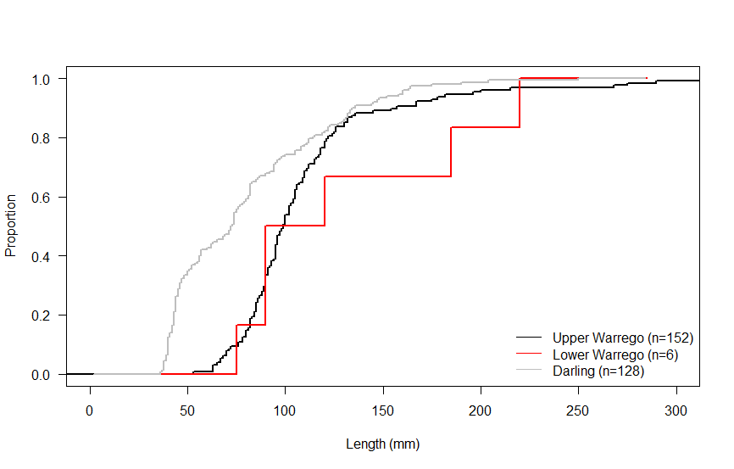

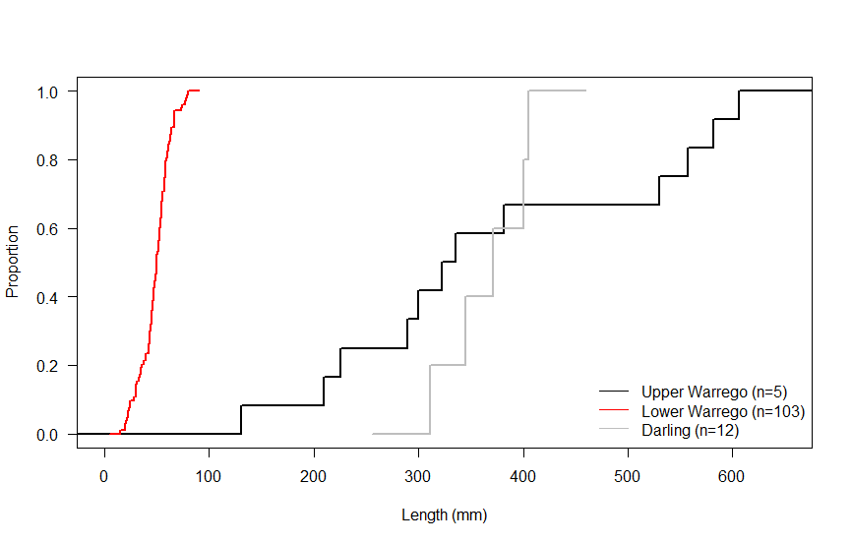
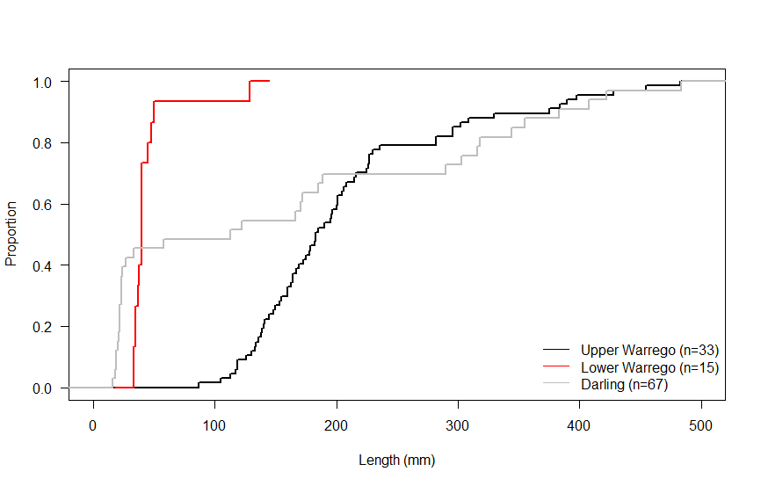
Proportion (%)
Length (mm)

Figure 8 Length frequency distribution (Proportion (%)) of bony herring (top), golden perch (middle) and common carp (bottom) sampled within the three zones. Dashed line is approximate length of one-year-old individual.
Table 6 Kolmogorov-Smirnov results of length frequency comparisons among Zones for the three most abundant fish species sampled (June to August 2019) – indicates <20 individuals were collected and therefore no statistical comparisons could be calculated. Asterisks indicate a significant result.
 | Species
Zone | Bony herring | Golden perch | Common carp
Upper Warrego  V  Lower Warrego | – | – | –
Upper Warrego  V  Darling | <0.001* | <0.001* | –
Lower Warrego  V  Darling | – | – | –

Selected Area analyses

Abundance
In total, 9,166 fish were captured (n=8,510) or observed (n=656) across Sample 1 (winter sampling) and Sample 2 (spring/summer sampling) combined. For both samples combined, the Darling had the highest catch at 7,431, compared to the lower Warrego at 1,079. By sample round, the greatest number of fish were captured in Sample 2 (n=6,804) compared to Sample 1 (n=1,706). A total of nine fish species were collected in the Darling over the two rounds combined, whilst eight were collected across the lower Warrego (Table 7). Among the small-bodied species (those that don’t grow >100 mm), carp gudgeon (n=6,610) was the most abundant species sampled, followed by Eastern mosquitofish (Gambusia holbrooki) (n=95) and Australian smelt (Retropinna semoni) (n=34). The most abundant large-bodied species were golden perch (n=684), bony herring (n=539) and common carp (n=513). Common yabbies and freshwater long-armed prawns were also irregularly collected during sampling.
Table 7 List of species used in the analysis for the Selected Area Assessment in the Warrego and Darling River. Ticks indicate that adult and/or juveniles were collected during the selected area assessment during either of the two sampling events.
Species | Sampled during study
 | Adult | Juvenile
Native species
Olive perchlet | ✗ | ✗
Silver perch | ✗ | ✗
Un-specked hardyhead | ✗ | ✗
Carp gudgeon | ✓ | ✓
Spangled perch | ✓ | ✓
Murray-Darling rainbowfish | ✗ | ✗
Desert rainbowfish | ✗ | ✗
S. purple-spotted gudgeon | ✗ | ✗
Bony herring | ✓ | ✓
Murray cod | ✓ | ✗
Golden perch | ✓ | ✓
Hyrtl’s tandan | ✓ | ✗
Australian smelt | ✓ | ✗
Freshwater catfish | ✗ | ✗
Alien species
Common carp | ✓ | ✓
Eastern mosquitofish | ✓ | ✓
Common goldfish | ✓ | ✓

Biomass
Based on estimated and measured weights, a total of 152.75 kg of fish were collected across the selected area zones during Sample 1 and 2. Bony herring made up the highest biomass at 57.07 kg, followed by the exotic common carp at 47.6 kg and golden perch at 23.3 kg. Biomass was highest in the Darling River at 146.87 kg, compared to the lower Warrego at 5.88 kg. Bony herring (57.06 kg), common carp (47.45 kg) and golden perch (23.33 kg) had the highest overall biomass for the large-bodied species. Among the small bodied species, carp gudgeon (230.2 g) and Eastern mosquitofish (13.9 g) had the highest biomasses.

Length frequency
There were significant differences in the length-frequency of bony herring between Darling Sample 1 and Darling Sample 2 (Table 8). Further comparisons between zones for bony herring was not possible due to the lack of individuals collected (Table 8). There were significant differences between all zones and samples for golden perch except in Darling Sample 1 and Darling Sample 2 (Table 8). There were also differences in length-frequency for common carp between Darling Sample 2 and lower Warrego Sample 1, Darling Sample 2 and lower Warrego Sample 2 and lower Warrego Sample 1 and 2 (Table 8).
There was a higher abundance of young-of-year bony herring detected in Darling Sample 2 compared to Darling Sample 1 (Figure 9). The abundance of bony herring was far lower in the Warrego and those captured were generally larger compared to those in the Darling. Golden perch and common carp in the lower Warrego in both samples were primarily young-of-year. These species were in lower abundance and generally larger in the Darling (Figure 9). In general, there was a higher abundance of fish above 1 year of age in the Darling, with the average size increasing between Sample 1 to 2 (Figure 9).

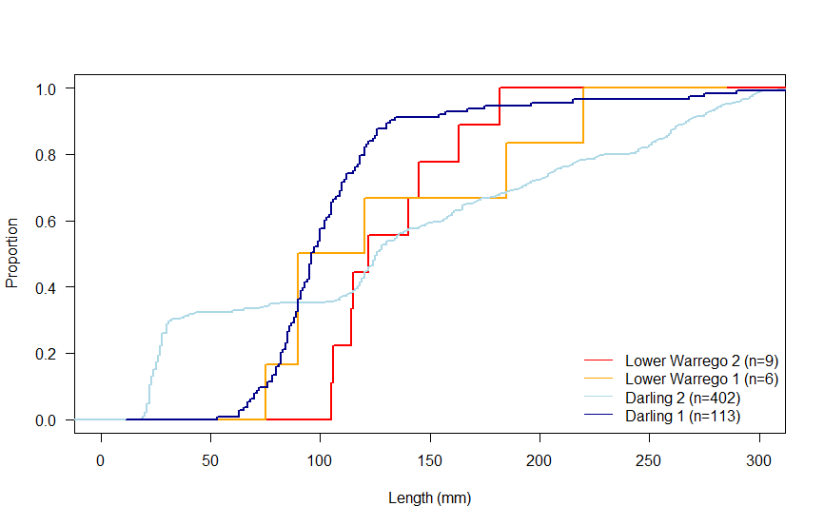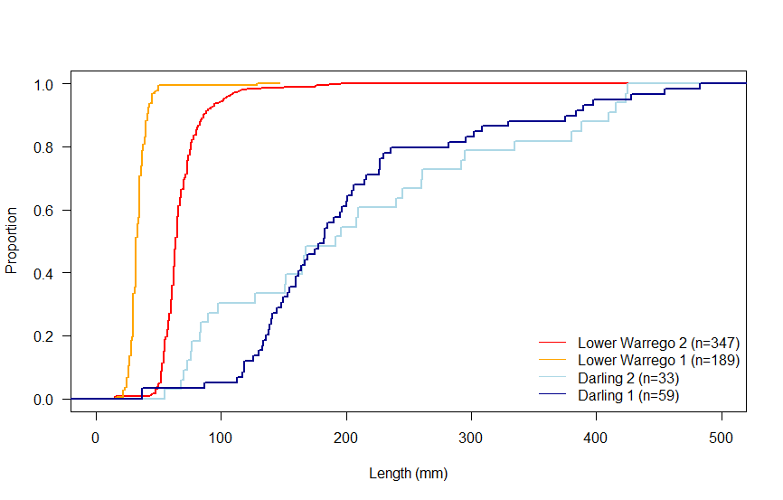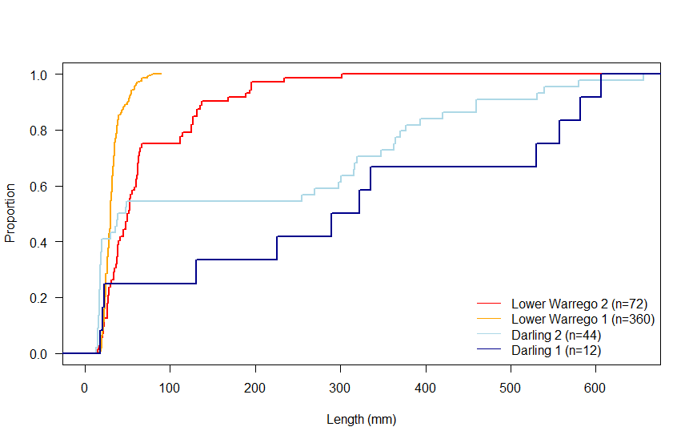
Proportion (%)
Length (mm)
Figure 9 Length frequency distribution (Proportion (%)) of bony herring (top), golden perch (middle) and common carp (bottom) sampled the Selected Area only. Dates for Samples 1 and 2 are provided in Table 2 above. Dashed line is approximate length of one-year-old individual.
Table 8 Kolmogorov-Smirnov results of length frequency comparisons between Sample 1 (August 2019) and Sample 2 (November 2019) for the three most abundant fish species sampled from within the Warrego-Darling Selected Area – indicates <20 individuals were collected. Asterisks indicate significant difference (P<0.05).
 | Species
Zone and Sample Number | Bony herring | Golden perch | Common carp
Darling Sample 1  V  Darling Sample 2 | <0.001* | 0.135 | –
Darling Sample 1  V  Lower Warrego Sample 1 | – | <0.001* | –
Darling Sample 1  V  Lower Warrego Sample 2 | – | <0.001* | –
Darling Sample 2  V  Lower Warrego Sample 1 | – | <0.001* | <0.001*
Darling Sample 2  V  Lower Warrego Sample 2 | – | <0.001* | <0.001
Lower Warrego Sample 1  V  Lower Warrego Sample 2 | – | <0.001* | <0.001*

Health Indicators

Expectedness
Of the 14 native fish species that have been previously sampled or were thought to have historically occurred in the Warrego and Darling Rivers (Table 3), seven were caught at a minimum of one site in the current study (Table 7). Two of the seven species (Murray cod and Hyrtl’s tandan, Figure 8) were only collected in very low numbers; four and seven individuals respectively. The seven native species not caught were: olive perchlet, silver perch, un-specked hardyhead, desert rainbowfish, freshwater catfish, Murray-Darling Rainbowfish and southern purple-spotted gudgeon (Table 7). Of these, three species (un-specked hardyhead, desert rainbowfish and southern purple spotted gudgeon) are considered “rare” or “cryptic” meaning they are only likely to be collected in < 20% of sites sampled within a zone, and two (olive perchlet and silver perch) as “occasional” meaning they are only likely to be collected in 20-70% of sites within a zone (Robinson 2012).
Average Expectedness was highest in the Darling River in Sample 2 at 45.3 ± 1.76 giving the zone an overall rating of “Moderate” for the sample, and lowest in the lower Warrego in Sample 1 at 14.8 ± 3.55 giving it a “Very Poor” rating for the sample (Figure 11). The average Expectedness for both samples and all sites combined for the Darling zone was 33.8 ± 3.97 giving it an overall rating of “Poor”, whilst the lower Warrego zone rated as “Very Poor”, with an overall score of 17.1 ± 3.15.

Nativeness
Of the exotic species sampled, eastern mosquitofish and common carp were caught in both zones, and in both sample rounds. Common goldfish were also present in both Darling samples and in the lower Warrego in Sample 1. Common carp abundance decreased between Sample 1 (n=360) and Sample 2 (n=72) in the lower Warrego. Goldfish in the Darling samples also declined but the overall abundances were much lower (Sample 1, n=13 and Sample 2, n=2). Conversely, eastern gambusia numbers increased in the Darling between Sample 1 (n=6) and Darling Sample 2 (n=86).
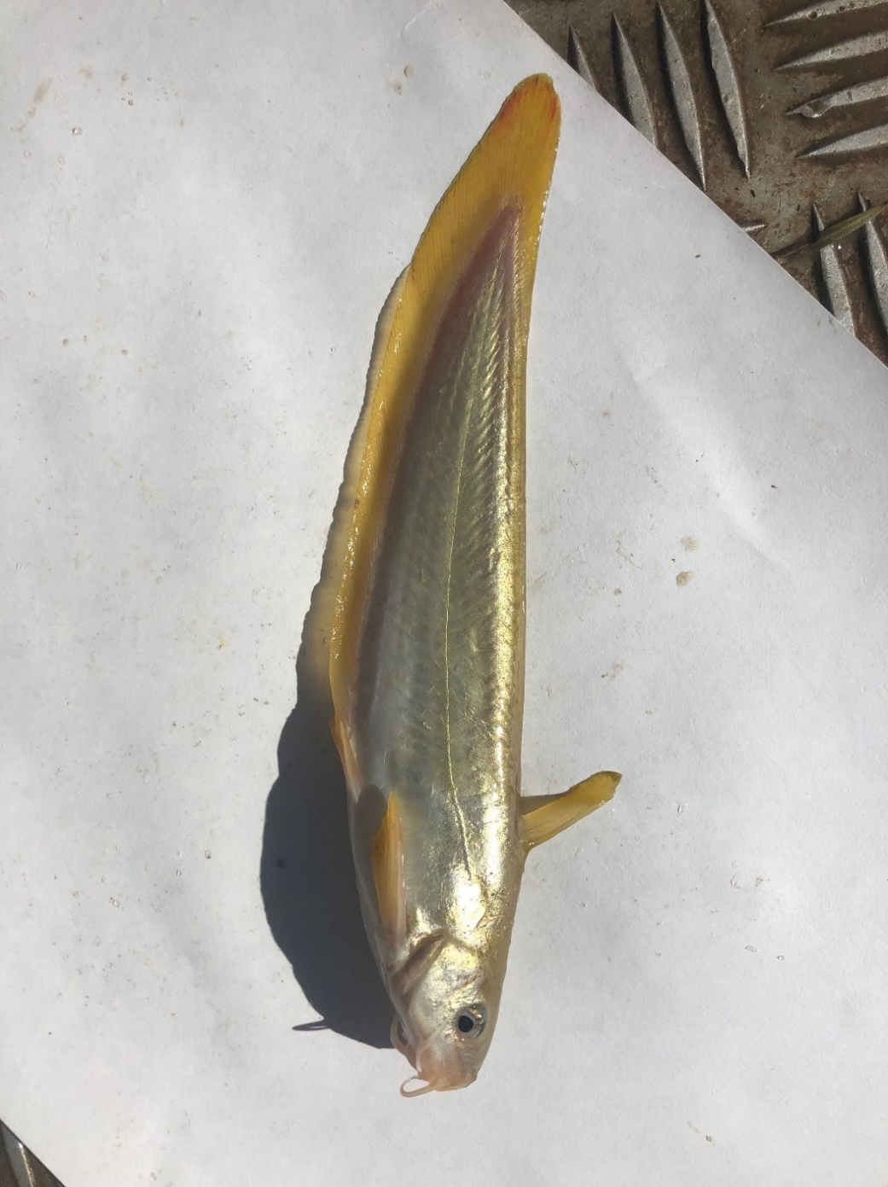
Figure 10 Hyrtl’s tandan (Neosilurus hyrtlii) (TL= 181 mm) collected from the upper Warrego River using an electrofishing boat, June-July 2019.
Overall, Nativeness scores were considerably higher on average in the Darling zone (Sample 1: 75.9 ± 9.96, Sample 2: 86.5 ± 2.58) compared to the lower Warrego (Sample 1: 48.9 ± 9.68, Sample 2: 68 ± 11.9, Figure 11). This was due to the higher combined biomass of exotic species in the Warrego compared to the Darling, as well as a greater abundance of native species in the Darling compared to the Warrego. The average Nativeness score for both samples and all sites combined for the Darling zone was 81.2 ± 5.16 or “Excellent”, whilst the lower Warrego zone rated overall as “Moderate” at 58.5 ± 7.90.

Recruitment
The Recruitment Indicator scores varied considerably between zones and samples (Figure 11). The highest score was in Sample 2 in the Darling zone at 67.4 (“Good”) and the lowest in Sample 2 in the lower Warrego at 11.7 (“Very Poor”, Figure 11). Within the Darling, there was a considerable increase in Recruitment scores between Sample 1 to 2, but conversely a notable decrease in Recruitment in the lower Warrego between Sample 1 and 2 (Figure 11).
On a site-by-site basis, the five Darling River sites in Sample 1 all rated as “Poor”, whilst in Sample 2 all sites rated as “Good”. In the lower Warrego River, all five sites rated as “Poor” in Sample 1 and in Sample 2 all sites rated as “Very Poor”.
Carp-gudgeon recruits were collected at all five Darling sites during both samples, conversely they were absent in Warrego Sample 1 and were only collected at one site in Sample 2. Golden perch recruits were collected during both Darling Samples; at 20% and 60% of sites in Sample 1 and 2 respectively. Bony herring recruits were not collected in either Warrego samples but were collected at 40% and 100% of Darling River sites in Sample 1 and 2 respectively.
Whilst not considered in the calculation of the Recruitment indices, there was evidence of recruitment among all three exotic species sampled; goldfish, common carp and eastern mosquitofish. Goldfish recruits were collected in both Darling Samples (1 and 2) but were not detected in either lower Warrego sample. Common carp recruits were more abundant and were detected in both zones and in both samples as well. Common carp recruits were the most frequently captured exotic species; collected at all sites and both samples within the Warrego zone, and in four of five sites and two of five sites in the Darling Samples 1 and 2, respectively. Eastern mosquitofish, were only collected in the Darling zone, but were detected at all five sites in Sample 2, suggesting a recent breeding event.

Overall condition
The Overall Fish Condition (ndx-FS) scores varied among individual sites within zones, but particularly between zones and samples (Figure 11). For the Darling zone, the average Overall Fish Condition was 19.6 ± 1.61 or “Very Poor” for Sample 1, but increased to 56.3 ± 1.45 or “Moderate” in Sample 2 (Figure 11). In the lower Warrego, there was less variation in average Overall Fish Condition between samples; Sample 1 10.5 ± 2.72 or “Very Poor”, and Sample 2 10 ± 2.77 or “Very Poor” (Figure 11). For both samples combined the Darling zone rated as 38 ± 6.2 or “Poor” and the lower Warrego zone 10.2 ± 1.83 or “Very Poor”.

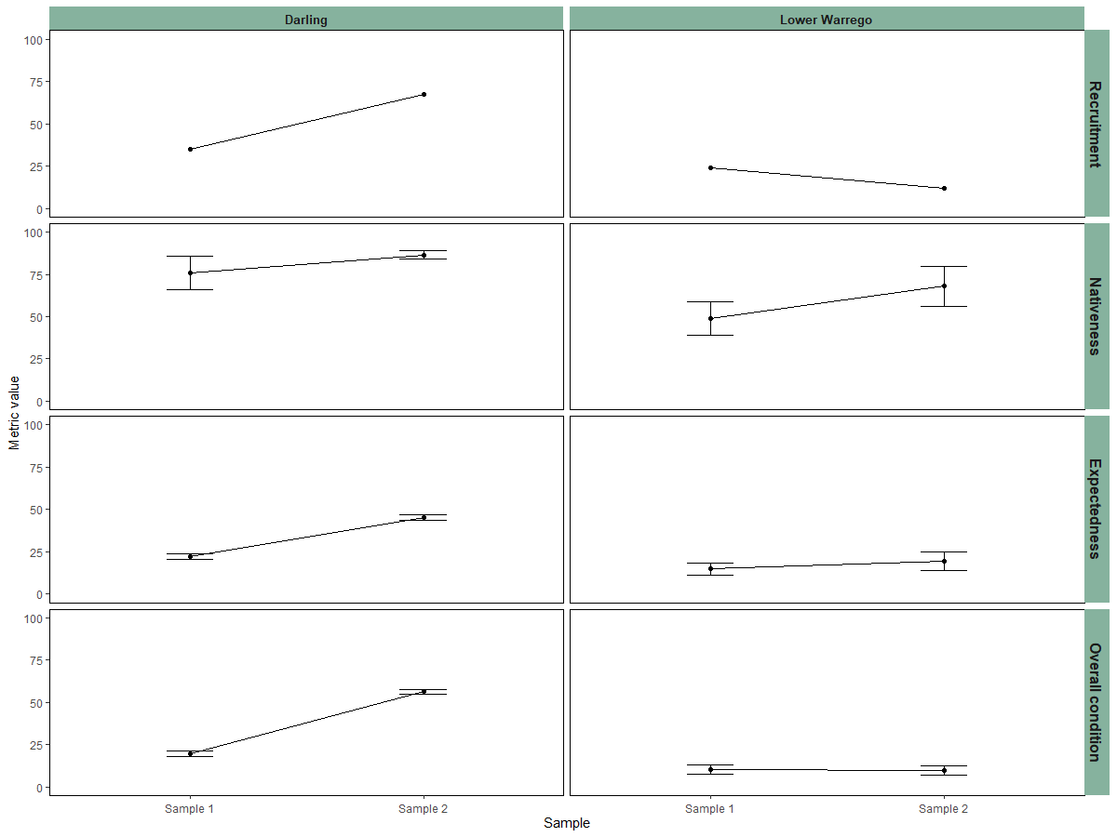
Figure 11 Expectedness, Nativeness, Recruitment and Overall Condition (ndxFS) Indicator values for fish at sites sampled in the Lower Warrego and Darling River for MER Category 3 Fish River Warrego-Darling Rivers Selected Area assessment; July-August 2019 (Sample 1), November-December 2019 (Sample 2).

Discussion
In this study, native fish diversity was consistent among the Warrego and upper Darling sites and was also close to the expected diversity if sampling was undertaken pre-European settlement. However, several species present were in very low abundance across the study sites and were absent from some zones. These results highlight the stressed and fragile nature of the fish communities across the region, with many of the species present potentially close to extirpation. Golden perch abundance and population structure also varied considerably among each of the three zones, with low numbers of young-of-year golden perch and very few, if any mature-sized individuals (Commonwealth of Australia 2019). In contrast, the fish communities of the upper Warrego and Darling Rivers were found to comprise reasonable numbers of mature-sized golden perch, as well as varying numbers of young-of-year individuals. These data suggest that the lower Warrego is a biological nursery, rather than a site for golden perch reproduction. Golden perch larvae drift downstream en masse post-hatch, dispersing over many hundreds of kilometres in their first few weeks of life (Stuart & Sharpe 2019). As such, the source of juvenile golden perch collected in the lower Warrego and Darling zones would most likely be a result of spawning occurring much further upstream in either the upper Warrego or further upstream in the Barwon-Darling. As such, to ensure the ongoing presence of the species in the Warrego-Darling Rivers, there remains a need to better understand where and when golden perch are breeding and how it relates to flow frequency and magnitude, and any instream barriers to downstream movement (Balcombe et al. 2006).
Murray cod were in low abundance in all three zones in the current study; Darling (n=3), upper Warrego (n=1) and lower Warrego (n=0). These results reflect the findings of previous studies in the Warrego catchment, with Murray cod absent from all samples in the lower Warrego during the LTIM project (Commonwealth of Australia 2019). They were also not detected in the upper Warrego in a study by Balcombe et al. (2006) undertaken in 2001-03 and more recently, infrequently across the same area as part of the annual MDBA Fish Surveys (M. Hutchison pers. comm.). A study by Boys and Thoms (2006) in the Darling River near to the area sampled in the current study, detected Murray cod in greater abundance and across a reasonably broad area. The dry conditions and low flows experienced across the Northern MDB in recent times has meant that conditions for Murray cod breeding have likely been less than optimal. Additionally, the extreme conditions also resulted in a number of large fish kills across the region, meaning that the standing stock of mature fish has also been considerably impacted. Generally, Murray cod will spawn in most years and under most conditions (Humphries et al. 2002; Humphries 2005) but the ongoing decline in the quality of their habitat has meant that there have been major declines in the abundance among many populations (Dakin and Kesteven 1937; Rowland 1989; Harris and Rowland 1996; Humphries 2005). Butler et al. (in prep.) has found that spawning for Murray cod in the northern MDB can be heavily impacted when water levels are low, as nest sites are effectively left high-and-dry as water levels drop, a phenomenon that may also limit breeding of Murray cod in the Darling River. It is possible that the existing small populations in the Darling are a result of restocking of hatchery bred fish, with around 17,500 individuals released over the past few years in the reach between Bourke and Louth (NSW DPI 2020).
As with Murray cod and golden perch, a number of other native fish species were also sporadically captured across the three study zones. Boys and Thoms (2006) reported low abundances of freshwater catfish in the Darling River between Bourke and Louth. In the current study, freshwater catfish were only collected in the upper Warrego (n=1) suggesting populations may be all but locally extinct across the three zones. Previous LTIM monitoring in the lower Warrego found that Hyrtl’s tandan appear to follow a boom then bust cycle (Commonwealth of Australia 2019). In this current study, Hyrtl’s tandan was only sampled in the lower Warrego in low numbers and was not collected at all in the Darling River. Balcombe et al. (2006) previously reported a higher abundance of Hyrtl’s tandan in the upper Warrego River, and it may be that current populations in the upper Warrego are experiencing a semi “bust” cycle and may “boom” again when conditions are more favourable. Murray-Darling rainbowfish were also once widespread across the much of the Murray-Darling Basin (MDB) but like most MDB freshwater fish, numbers have declined throughout much of their original range (Lintermans 2007). In this current study, the species was only captured in the upper Warrego and was absent from the lower Warrego and Darling zones all together. In contrast, spangled perch were collected in the Darling and lower Warrego but was absent from the upper Warrego. During previous fish sampling in the upper Warrego Balcombe et al. (2006) reported a relatively high number of spangled perch, suggesting that as with Hyrtl’s tandan, spangled perch may also being experiencing a “bust” cycle. Bony herring and carp-gudgeon were regularly collected across all three zones and during both samples. These two species were previously reported in high abundance within these study area (e.g. Balcombe et al. 2006, Boys and Thoms 2006, Commonwealth of Australia 2019), suggesting an ability to adapt to varying and extreme conditions.
Among all three zones and across both sampling rounds, the exotic species goldfish, common carp and eastern mosquitofish were collected consistently and in relatively high numbers. All three species are considered to be widespread and common in the MDB (Lintermans 2007), with common carp accounting for up to ~90% of the total fish biomass in some rivers (Smith 2005). Common carp has been recorded in the majority of rivers in the MDB and their adaptability has meant they can exist in all aquatic habitat types (Stuart and Jones 2002, Nicol et al. 2004, Smith 2005). Whilst the impact of common carp on native fish is not fully understood, they are known to degrade water quality, undermine river banks and compete with native species for food and space (Lintermans 2007). Common carp numbers in the lower Warrego zone were found to be the highest of the three zones sampled in the current study. The slow flowing water and the lack of large predatory fish (e.g. Murray cod), makes the lower Warrego a suitable environment for common carp. Similar to golden perch, common carp are highly migratory, moving upstream to spawn, feed and establish themselves in new areas (Mallen-Cooper 1999, Stuart and Jones 2006, Stuart et al. 2006). Whilst needed, connectivity between the upper Warrego and Darling rivers via the lower Warrego also provides a likely migration path for common carp including young-of-year individuals, as was evidenced by the large numbers collected in the lower Warrego during the current study.
Connectivity of riverine environments is beneficial for fish as it allows them to move to spawn, to seek shelter and refuge, to recolonize following droughts, for dispersal of recruits, and to counter downstream displacement during high flows (Barrett and Mallen-Cooper 2006). The frequency of disconnection between the Darling and Warrego rivers likely impacts the fish community in both systems. Intervention to ensure a more regular connection via the construction of fishways would likely have a positive effect on the native fish populations within this current study reach. Fishways have been present in the Murray River since the 1930’s (Barrett and Mallen-Cooper 2006) and large amounts of work has been done in recent times to develop, install and examine the benefits of fishways in other parts of the MDB (Baumgartner et al. 2014). Prior to man-made water storages being constructed in the lower Warrego, connectivity was most likely more frequent, allowing fish to passage regularly from the Darling into the Warrego and vice versa. The removal of and/or the construction of fishways over the 11 structures and weirs along the riverine corridor from the Warrego/Darling Junction upstream to Cunnamulla (~360 km) would undoubtedly improve fish passage and have ongoing benefits to the fish communities in both rivers. The recent removal of Peebles Dam, the lowermost dam on the Warrego River within the Warrego-Darling Selected area is a positive step forward in this respect.

Conclusion
In general, populations in the upper Warrego were more similar to the Darling fish community, with fish populations in the ephemeral lower Warrego quite discrete. Several species such as the Murray cod and freshwater catfish exist only in very low abundance across the three study zones. Recent conditions such as droughts have likely influenced abundance for these species. These data were collected prior to high flow events through the system in early 2020, future monitoring will be able to detect and report on any improvements as a result of those flows. For species such as Murray cod, populations could possibly be augmented by restocking in the future if habitats were rehabilitated. However, for many smaller-bodied species this type of intervention is less likely to occur as no facilities currently exist to produce fish and there is little social value given they are not recreational fishing species. Watering events which can charge the system or act as a top-up, would benefit native fish species within these reaches and ensure the systems continue to flow.
Several native species such as golden perch and bony bream were present in all zones and collected during both sampling events. Tailored strategies are needed to effectively manage individual species to ensure aspects of their life-cycle such as spawning and recruitment occur frequently enough to guarantee their longevity. This is particularly important in the lower Warrego which experiences highly variable flow conditions, resulting in a constant shifting baseline. More regular connection between the three zones would benefit the ecology of several native fish species and provide a pathway for them to complete all aspects of the lifecycle including; migration for spawning, larval drift post spawning, and to provide opportunities to source food and access better habitat and shelter.

References
Anderson, M.J., Gorley, R.N., and Clarke, K.R. (2008). 'PERMANOVA + for PRIMER: Guide to Software and Statistical Methods.' (PRIMER-E: Plymouth.)
Balcombe, S.R., Arthington, A.H., Foster, N.D., Thoms, M.C., Wilson, G.G. and Bunn, S.E. (2006). Fish assemblages of an Australian dryland river: abundance, assemblage structure and recruitment patterns in the Warrego River, Murray–Darling Basin. Marine and Freshwater Research, 57(6), 619-633.
Barrett, J. and Mallen-Cooper, M. (2006). The Murray River’s ‘Sea to Hume Dam’ fish passage program: Progress to date and lessons learned. Ecological Management & Restoration, 7(3), 173-183.
Baumgartner, L., Zampatti, B., Jones, M., Stuart, I. and Mallen-Cooper, M. (2014). Fish passage in the Murray-Darling Basin, Australia: Not just an upstream battle. Ecological Management & Restoration, 15(1), 28-39.
Boys, C.A. and Thoms, M.C. (2006). A large-scale, hierarchical approach for assessing habitat associations of fish assemblages in large dryland rivers. Hydrobiologia, 572, 11-31.
Cadwallader, P.L. (1977). “J.O. Langtry’s 1949-50 Murray River investigations”. Fisheries and Wildlife Paper 13. Fisheries and Wildlife Division, Ministry for Conservation, Melbourne.
Carter, S. (2012). Sustainable Rivers Audit 2: Metric Processing System. Report prepared by Environmental Dynamics for the Murray Darling Basin Authority, Canberra.
Commonwealth of Australia (2019). Commonwealth Environmental Water Office Long Term Intervention Monitoring Project: Gwydir River System Selected Area 2018-19 Evaluation Report. Available online: https://www.environment.gov.au/water/cewo/ publications
Dakin, W.J. Kesteven, G.L. (1937). The Murray cod (Maccullochella macquariensis [Cu. et Val.]) New South Wales State Fisheries Bulletin, 1, 1–18.
Davies, P.E., Harris, J.H., Hillman, T.J. and Walker, K.F. (2008). SRA Report 1: A Report on the Ecological Health of Rivers in the Murray–Darling Basin, 2004–2007. Independent Sustainable Rivers Audit Group for the Murray–Darling Basin Ministerial Council. MDBC Publication No. 16/08: Canberra.
Davies, P.E., Harris, J.H., Hillman, T.J. and Walker, K.F. (2010). The Sustainable Rivers Audit: assessing river ecosystem health in the Murray-Darling Basin, Australia. Marine and Freshwater Research, 61, 764–777.
Davis, T.L.O., (1977). Age determination and growth of the freshwater catfish, Tandanus tandanus Mitchell, in the Gwydir River, Australia. Marine and Freshwater Research, 28(2), pp.119-137.
Harris, J.H. and Rowland S.J. (1996). Australian freshwater cods and basses R.M. McDowall (Eds) Freshwater Fishes of South-eastern Australia Reed Books Sydney 150–163.
Humphries, P. (2005). Spawning time and early life history of Murray cod, Maccullochella peelii peelii (Mitchell) in an Australian River. Environmental Biology of Fishes, 72, 393-407.
Humphries, P., Serafini, L.G. and King A.J. (2002). River regulation and fish larvae: changes in space and time Freshwater Biology, 47, 1307-1331.
Leggett, R. and Merrick, J.R., (1987). Australian native fishes for aquariums. JR Merrick Publications.
Lintermans, M. (2007). Fishes of the Murray-Darling Basin: An introductory guide. Canberra.
Lorenzoni, M., Corboli, M., Ghetti, L., Pedicillo, G. and Carosi, A., (2007). Growth and reproduction of the goldfish Carassius auratus: a case study from Italy. In Biological invaders in inland waters: Profiles, distribution, and threats (pp. 259-273). Springer Netherlands.
Mallen-Cooper, M. (1996). Fishways and freshwater fish migration on South-Eastern Australia.
Mallen-Cooper M. (1999). Developing fishways for non-salmonid fishes; a case study from the Murray River in Australia. In: M. Odeh (ed.) Innovations in Fish Passage Technology. Bethseda: American Fisheries Society, pp. 173-195.
McDowall R. (1996). Freshwater Fishes of South-Eastern Australia (second edition). Reed Books, Chatswood, NSW.
Murray–Darling Basin Authority. (2012). Sustainable Rivers Audit 2: The ecological health of rivers in the Murray–Darling Basin at the end of the Millennium Drought (2008–2010). Murray–Darling Basin Authority, Canberra.
Nicol, S.J., Lieschke, J.A., Lyon, J.P. and Koehn, J.D. (2004). Observations on the distribution and abundance of common carp and native fish, and their response to a habitat restoration trial in the Murray River, Australia. New Zealand Journal of Marine and Freshwater Research 38, 541-552.
NSW DPI (2015). Fish and Flows in the Northern Basin: responses of fish to changes in flow in the Northern Murray-Darling Basin – Reach Scale Report. Final report prepared for the Murray-Darling Basin Authority. NSW Department of Primary Industries, Tamworth.
NSW DPI (2020). Available at: https://www.dpi.nsw.gov.au/fishing/recreational/resources/stocking (Accessed 10 August, 2020).
Ogle, D.H. (2015). Introductory Fisheries Analyses with R. Chapman and Hall/CRC.
Pusey B.J., Kennard M.J. and Arthington A.H. (2004). Freshwater Fishes of North-Eastern Australia. CSIRO Publishing: Collingwood.
Robinson W. (2012). Calculating statistics, metrics, sub-indicators and the SRA Fish theme index. A Sustainable Rivers Audit Technical Report. Murray-Darling Basin Authority, Canberra.
Rowland, S.J. (1989). Aspects of the history and fishery of the Murray cod, Maccullochella peeli (Mitchell) (Percichthyidae). Proceedings of the Linnean Society of New South Wales 111, 201–213.
Smith, B.B. (2005). The state of the art: a synopsis on information on common carp (Cyprinus carpio) in Australia. Final Technical Report, SARDI Aquatic Sciences Publication No. RDO4/0064-2; SARDI Research Report Series No. 77, prepared by the South Australian Research and Development Institute (Aquatic Sciences), Adelaide. 66 pp.
Stuart, I. G., and Jones, M. (2002). Ecology and management of common carp in the Barmah-Millewa forest. Final report of the point source management of carp project to Agriculture Fisheries and Forestry Australia. Arthur Rylah Institute for Environmental Research, Heidelberg, Victoria. 214 pp.
Stuart, I. G., and Jones, M. (2006). Large, regulated forest floodplain is an ideal recruitment zone for non-native common carp (Cyprinus carpio L.). Marine and Freshwater Research 57(3), 337–347.
Stuart, I. G., and Sharpe, C.P. (2019). Riverine spawning, long distance larval drift, and floodplain recruitment of a pelagophilic fish: A case study of golden perch (Macquaria ambigua) in the arid Darling River, Australia. Aquatic Conservation: Marine and Freshwater Ecosystems, 30, 675-690.
Stuart I., Williams A., McKenzie J., and Holt T. (2006). The William’s cage: a key tool for carp management in Murray-Darling Basin fishways. Arthur Rylah Institute for Environmental Research (Project R3018SPD), Department of Sustainability and Environment, Heidelberg, Victoria.
Vilizzi, L. and Walker, K.F. (1999). Age and growth of the common carp, Cyprinus carpio, in the River Murray, Australia: validation, consistency of age interpretation, and growth models. Environmental Biology of Fishes, 54(1), pp.77-106.

