Appendix G: Frogs
HYDROLOGY | FOOD WEBS | VEGETATION | WATERBIRDS | FISH | FROGS



Introduction
Frogs are a pivotal part of riverine ecosystems that occupy terrestrial and aquatic food webs as both predator and prey. The role of frogs in the ecosystem changes between larval development and adulthood. As adults, frog populations can obtain extremely high biomass and will consume agricultural pest species, providing useful ecosystem services in the landscape (Doody et al. 2010). As tadpoles they consume algae and provide a food source for fish and predatory macroinvertebrates and later become prey to birds, bats, mammals and reptiles in adult life (Schmidt et al. 2017). These complexities in growth form and habitat use provide many links to the broader food web.
Frogs generally exist in multi-species communities that have niche separation in diet, habitat, activity, and call frequency. Such interspecific variation drives differential responses to environmental factors such as temperature, flow and rainfall. While most tadpoles rely on surface water to develop and many species of frogs need rainfall or flow to create breeding habitat, how and when frogs respond to climatic events varies. Tree frogs such as Litoria caerulea respond heavily to rainfall and temperature but do not use flooded areas, whereas marsh frogs such as Limnodynastes fletcheri respond directly to floods by increasing activity, occupying more ground and breeding in flooded wetlands (Ocock 2013). Knowledge of individual species is therefore important when considering management regimes.
In the Junction of the Warrego and Darling rivers Selected Area (Selected Area), fourteen species of frogs have been recorded on the river and floodplain habitats. These include species with an ability to respond to flooding in Autumn and Spring (Cylorana platycephala, C. verrucosa), species that prefer a longer flood duration (up to 12 months) ideally during spring and summer (Litoria rubella, L. peroni, Limnodynastes tasmanensis, L. fletcheri, Crinia parainsignifera) and species that prefer shorter flooding duration (Litoria caerulea; Rogers et al. 2012). Despite knowledge of how some of the species in the Selected Area respond to flooding generally, specific information on this northern part of the Murray-Darling Basin and responses of rarer species (e.g. Neobatrachus and Uperoleia) is still poorly understood. Longer term studies of the frog community that identify these responses at a finer scale are still needed to understand the likely impact of management.
The MER project is a continuation of the LTIM project and aims to investigate the contribution of Commonwealth environmental water to frog populations. The monitoring of frog diversity in the 2019–20 water year within the Selected Area was used to address three key questions:
- What did Commonwealth environmental water influence frog populations?
- What did Commonwealth environmental water influence frog communities?
- What did Commonwealth environmental water influence frog breeding?

Previous Monitoring
Previous monitoring for the LTIM project suggested that patterns of abundance and richness in the frog communities of the Selected Area reflects the availability and type of habitat and seasonal conditions. Both frog abundance and species richness in the Selected Area were positively associated with hydrological connection, with the greatest responses over the project driven by connection events influenced by Commonwealth environmental water or its management. During and shortly after the Western Floodplain was inundated, frog abundance and richness increased due to the newly available, highly productive temporary habitat capable of supporting breeding and larger frog populations. The more permanent sites in the Warrego River appear to offer more stable habitat for local frog populations, which also show an overall increased response in terms of both richness and abundance to water connection. These responses highlight the importance of maintaining a mosaic of habitat types through environmental watering of the Selected Area to support regional scale frog diversity.

Methods
Frog monitoring was undertaken on two occasions in the 2019-20 water year at four sites within the Warrego River zone and one in the Western Floodplain zone (Table 1, Figure 1). Auditory and non-capture encounter survey (Bower et al. 2014) were undertaken in December 2019 and February 2020, in a manner consistent with previous LTIM standard frog monitoring methods (Commonwealth of Australia 2014). Surveys were conducted after dark with two observers. With survey times ranging from 20 – 60 minutes. Abundance is presented as catch per unit effort (CPUE) with the unit being defined by survey minutes. A headlamp was used to search for frogs along the wetland edge and surrounding terrestrial habitat. Audio surveys extended for the length of the observation period and were used to identify calling frog species. All individuals observed were identified to species, and the number encountered and heard was recorded.
For data from 2019-2020, statistical differences in species richness and CPUE were tested for between month of survey (December and February), and site type (channel, floodplain) using a general linear model. For data from 2014-2020, statistical differences in richness among water year (2014-15, 2015-16, 2016-17, 2017-18, 2019-20) and abundance (CPUE) among survey occasions (n=12) was investigated.
Dicks Dam was removed from multiyear comparisons because it was only sampled in 2019-20. CPUE of all frogs both seen and heard was used in a multivariate nMDS analysis to describe patterns of frog community composition. PERMANOVA tests were used to compare the community across site type (floodplain vs channel). Sites with no detections were removed from multivariate analysis. The community was compared between survey time (December, February) in 2019-20 and survey periods (n=12) and site type (channel and floodplain) in data from 2014-2020. All analyses were completed in R (R Core Team 2018), package vegan was used for community statistics (Oksanen et al. 2019) and figures were produced in ggplot2 (Wickham 2016).

Table 1 Location of frog monitoring sites.
Monitoring Zone | Site Name | Site Type | Easting | Northing
Warrego River | Ross Billabong | Channel | 347242 | 6636926
 | Booka Dam | Channel | 349835 | 6658024
 | Boera Dam | Channel | 348720 | 6669094
 | Dicks Dam | Channel | 342327 | 6645026
Western Floodplain | Western Floodplain | Floodplain | 347802 | 6665756
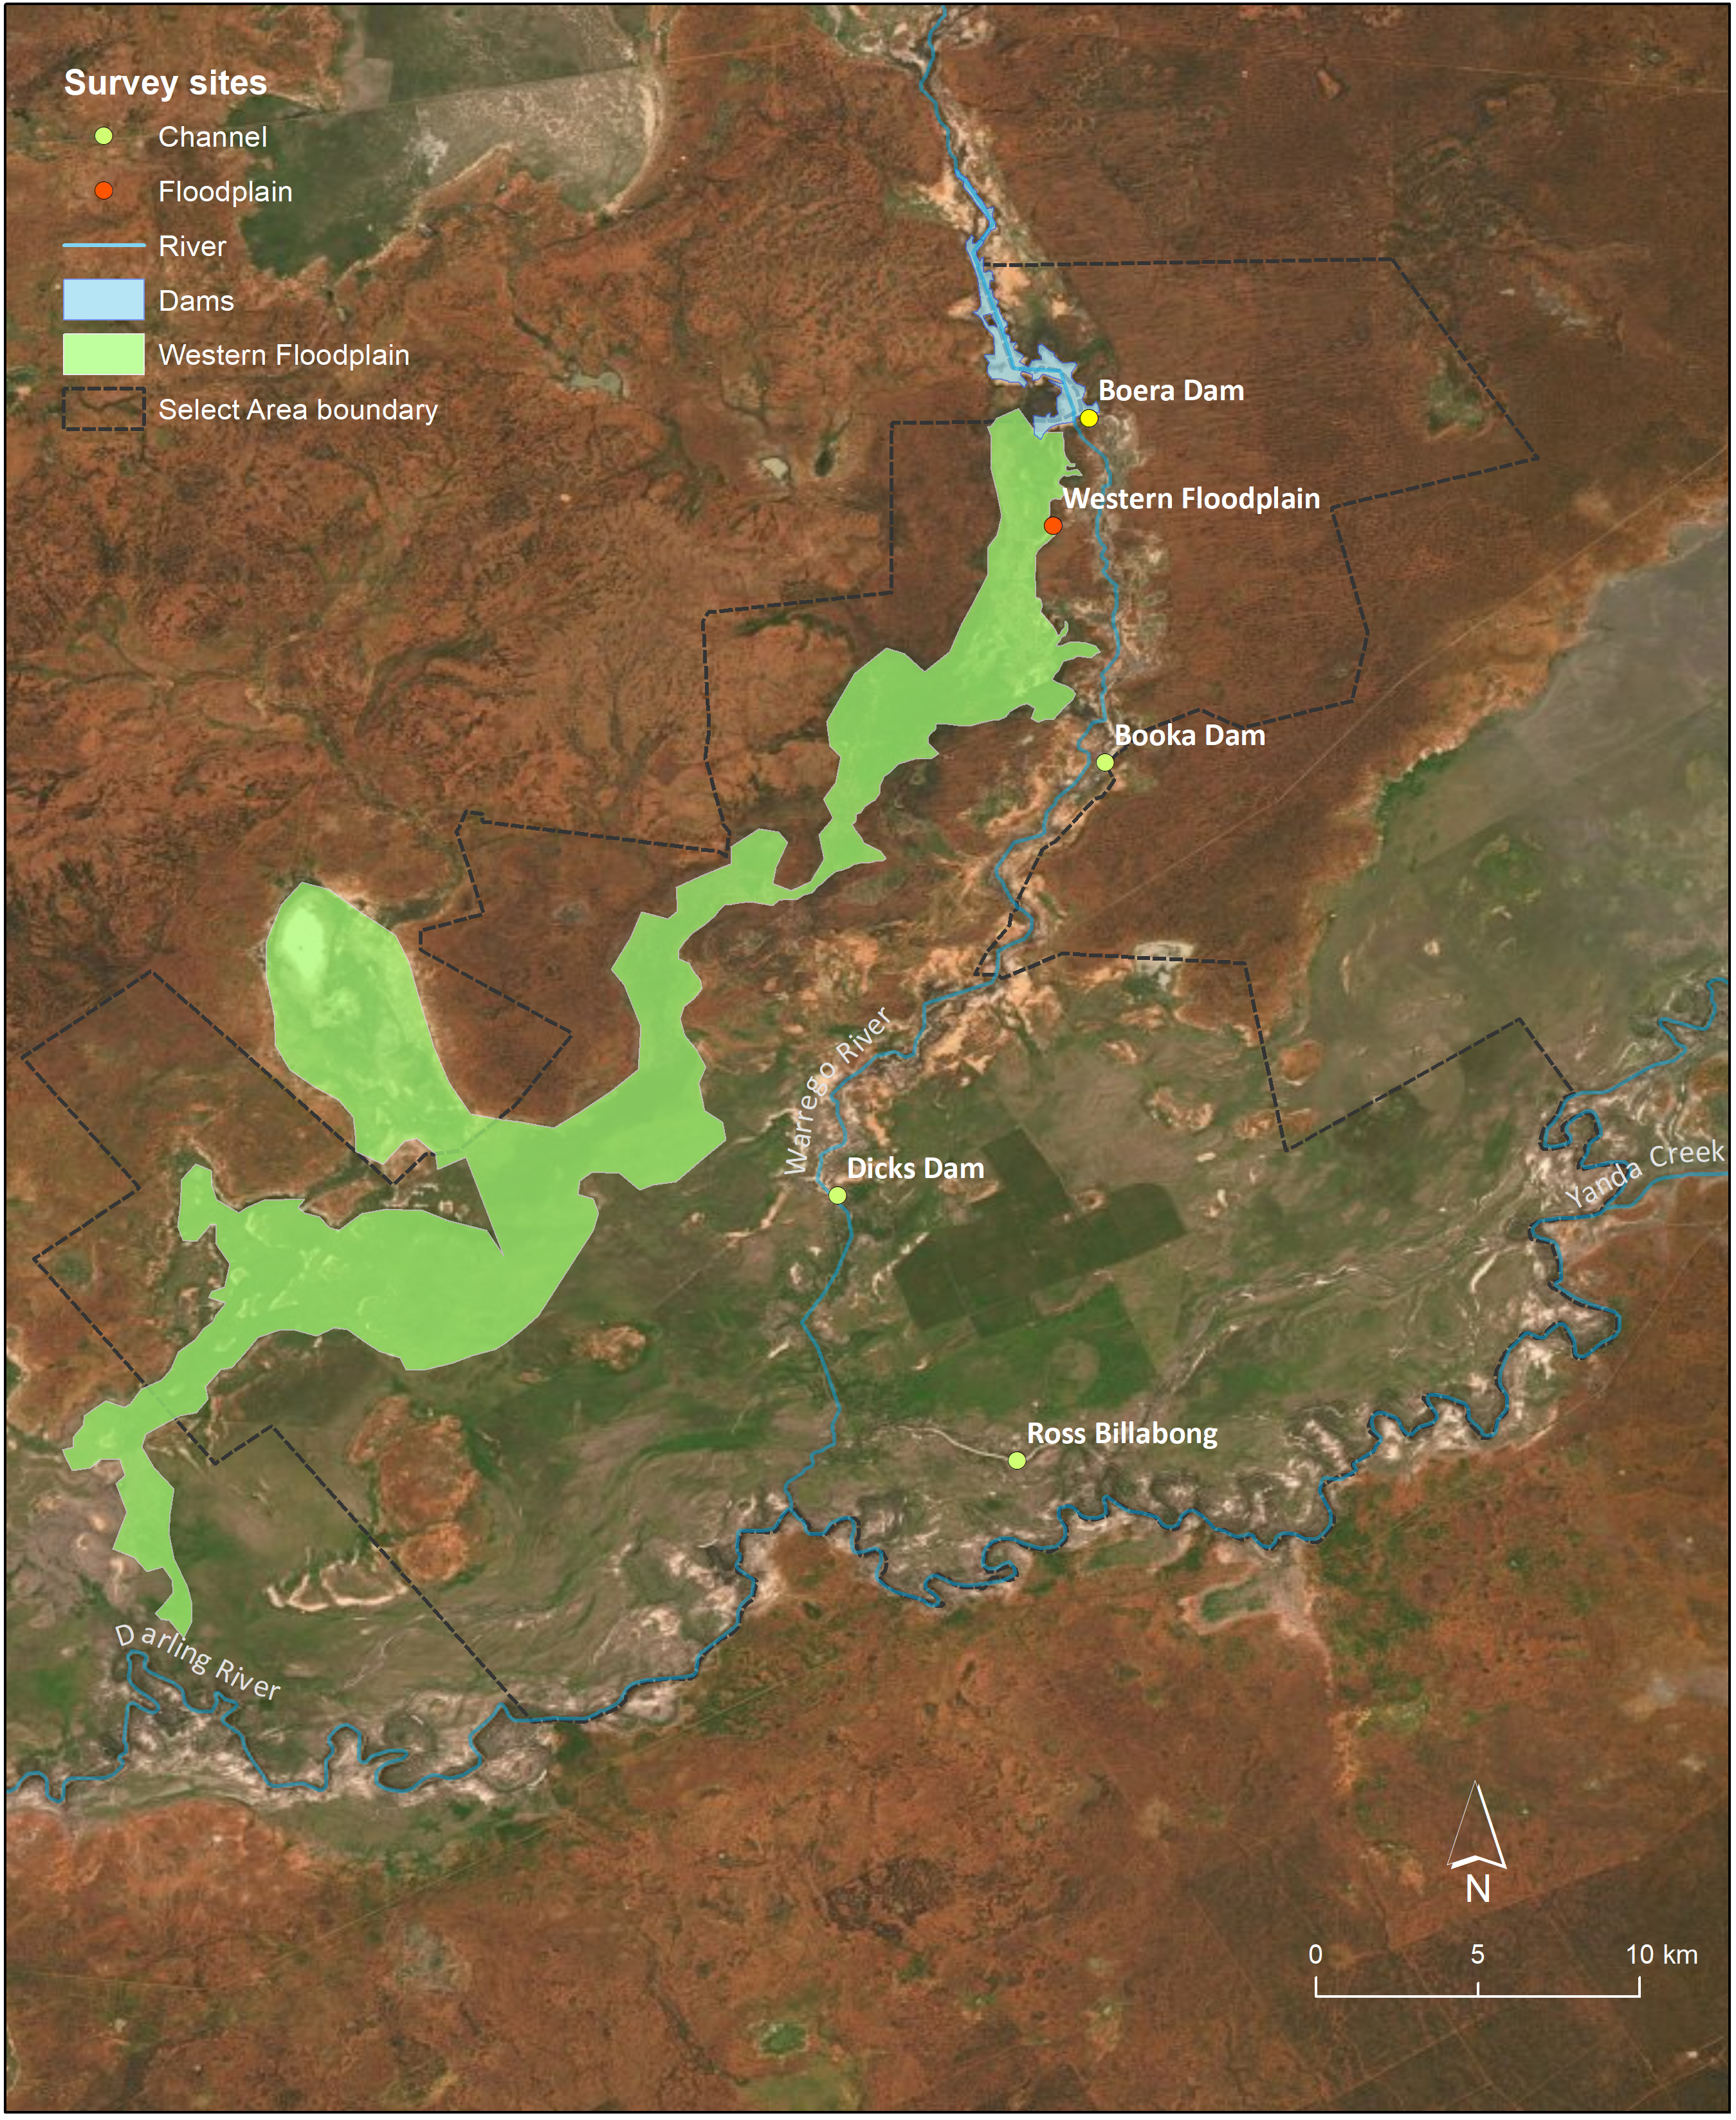
Figure 1 Location of frog survey sites within the Selected Area.

Results

2019-20 water year
Seven frog species were detected within the Selected Area during the 2019-20 monitoring period: six species in December 2019; and five species in February 2020 (Table 2). None of the frog species detected are listed as threatened under the NSW TSC Act or the Commonwealth EPBC Act.
Mean richness averaged 2.1 ± 1.37 (SD) species per survey site and did not differ significantly between December and February (p=0.74). Calling activity, which indicates breeding effort, was more widespread in December with four species calling in four sites compared to February with four species calling in two sites. Mean detections (CPUE) averaged 1.5 ± 1.43 (SD) frogs seen and heard per hour and was similar between survey months (p = 0.15, Figure 2).
The highest abundance (CPUE) of frogs was recorded in Booka Dam in December 2019 with approximately 10 frogs detected per hour. The highest total species richness was also recorded at Booka Dam with five unique species observed over the two survey occasions (Figure 3). All sites had a lower abundance of seen and heard frogs in February, except for Boera Dam which had less calling in December. All surveys detected at least one frog species except for the February 2020 survey in Ross Billabong.
The Peron’s tree frog (Litoria peronii) was detected in the highest numbers of any frog species, whilst the barking frog (Limnodynastes fletcheri) was most widespread; detected across four of the five sites in the 2019-20 monitoring period. A higher richness and overall number of frogs were seen and heard in the channel sites, compared to the Western Floodplain (Figure 4, Figure 5), owing to the small amount of available habitat (restricted to one small waterhole) on the floodplain during both survey times.

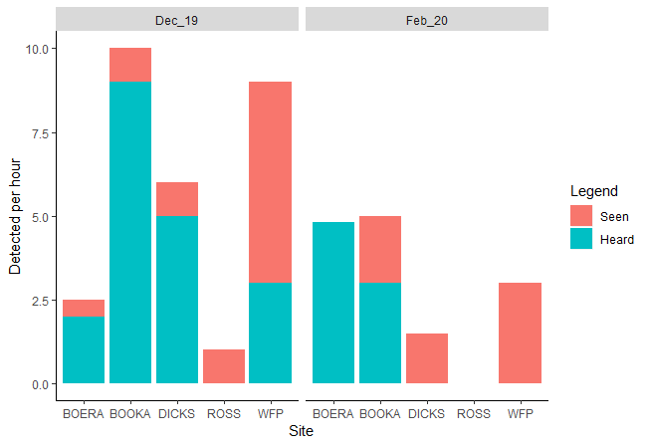
Figure 2 Total frog detections (CPUE) recorded at survey sites along the Warrego River and the Western Floodplain during the 2019-20 water year.
Table 2 Summary table of observations from the 2019-2020 water year.
 |  | BOERA |  | BOOKA |  | DICKS |  | ROSS |  | WFP
 |  | Dec_19 | Feb_20 | Dec_19 | Feb_20 | Dec_19 | Feb_20 | Dec_19 | Feb_20 | Dec_19 | Feb_20
Barking Frog | Limnodynastes fletcheri | 3^ | 1^ |  | 2 |  |  | 1 |  | 2
Desert Froglet | Crinia deserticola
Desert Tree Frog | Litoria rubella |  | 1^ | 2^ | 1^
Eastern Sign-bearing Froglet | Crinia parinsignifera |  |  | 2^ |  | 5^
Green Tree Frog | Litoria caerulea |  | 4^ |  | 2 | 1
Peron's Tree Frog | Litoria peronii | 2^ | 2^ | 6^ | 5^ |  |  |  |  | 3^
Spotted Grass Frog | Limnodynastes tasmaniensis |  |  |  |  |  | 1 |  |  |  | 2
Sudell's Frog | Neobatrachus sudelli |  |  |  |  |  |  |  |  | 1
Number Heard |  | 4 | 8 | 9 | 6 | 5 | 0 | 0 | 0 | 2 | 0
Number Seen |  | 1 | 0 | 1 | 4 | 1 | 1 | 1 | 0 | 4 | 2
Total number |  | 5 | 8 | 10 | 10 | 6 | 1 | 1 | 0 | 6 | 2
Richness seen |  | 1 | 0 | 1 | 2 | 1 | 1 | 1 | 0 | 3 | 1
Richness heard |  | 2 | 4 | 3 | 2 | 1 | 0 | 0 | 0 | 1 | 0
Richness total |  | 2 | 4 | 3 | 4 | 2 | 1 | 1 | 0 | 3 | 1
^ Includes heard observations

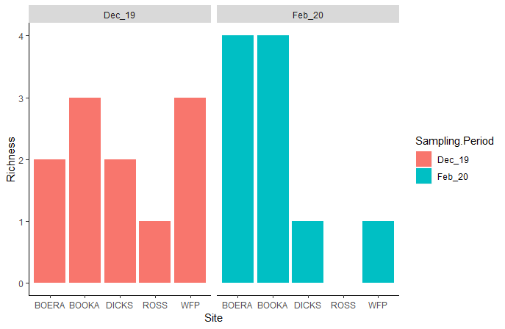
Figure 3 Frog species richness recorded at survey sites along the Warrego River and Western Floodplain during the 2019-20 water year.
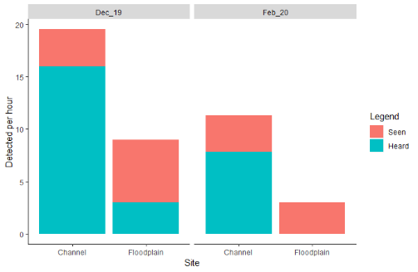
Figure 4 Frog total abundance (CPUE) in the 2019-20 water year in channel and floodplain sites within the Selected Area.

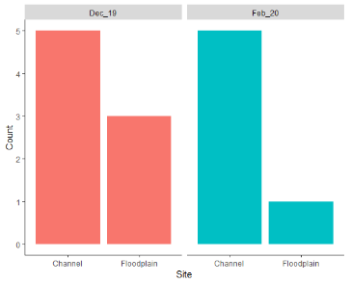
Figure 5 Species richness observed in the 2019-20 water year in channel and floodplain sites within the Selected Area.
To further describe patterns in frog community composition, multivariate analyses were undertaken on species abundance data. PERMANOVA analysis suggested there was no significant differences between the December 2019 or February 2020 survey times in terms of community composition (Figure 6).

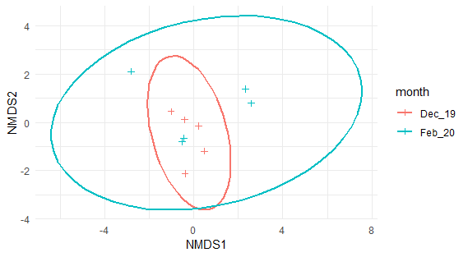
Figure 6 nMDS plot of species abundance data grouped by survey time (ellipses represent 95% confidence intervals).

Multi-year comparisons
Species richness did not change significantly among water year between 2014 and 2020. Surveys detected between 0–8 species with the highest species richness detected in Boera Dam in October 2017 (Figure 7). Overall, abundance (seen + heard) was significantly different between survey periods (p < 0.02), with high detection rates in August 2016 (Figure 8). Channel sites were more consistent than the highly variable Western Floodplain, which had both the highest and lowest abundance (CPUE) of frogs detected in a survey event across the LTIM/MER project. The highest abundance (CPUE) of frogs occurred between 2016 and 2017 around the time where inundation of the Western Floodplain was at its greatest (Figure 9).
Seven species in the frog community are commonly detected in relatively high numbers (desert tree frog, Peron’s tree frog, green tree frog, eastern sign bearing froglet, desert froglet, barking frog, spotted marsh frog), whereas the remaining seven species were rarely detected and generally seen in low numbers of less than five frogs per hour (Figure 10).

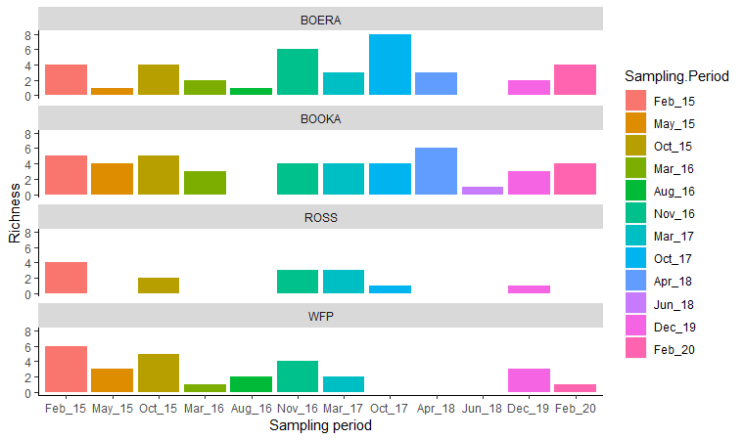
Figure 7 Species richness across all survey periods (Dicks Dam removed).
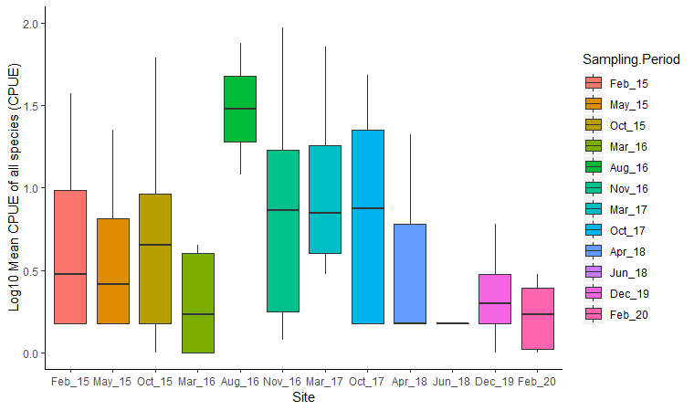
Figure 8 Log₁₀ mean detection (CPUE) of all species and sites (seen and heard) across survey periods (Dicks Dam excluded).

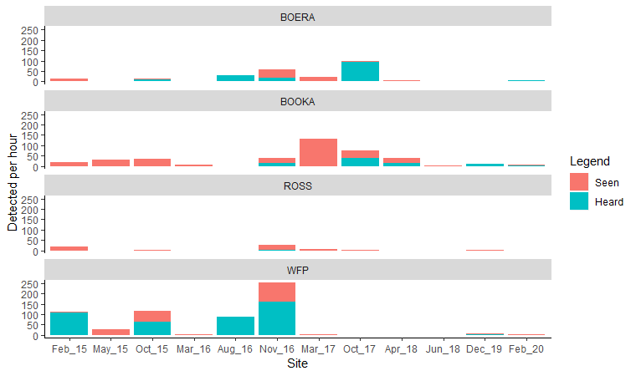
Figure 9 Number of frogs detected per hour (CPUE) in the surveys undertaken between 2015 and 2020.

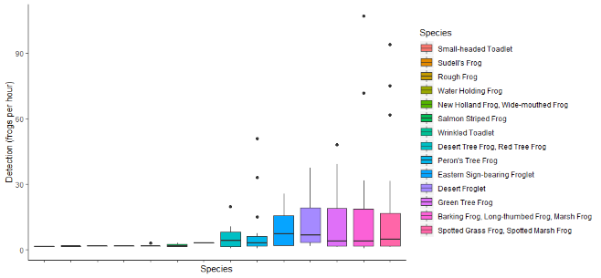

Figure 10 Comparative detection (Log 10 CPUE) for species in the Selected Area between 2014 – 2020.
Multivariate analysis on species abundance data over the twelve survey periods in six years of the project suggested that significant differences in community composition between survey periods (p < 0.01) and site type (p < 0.03, Figure 11).
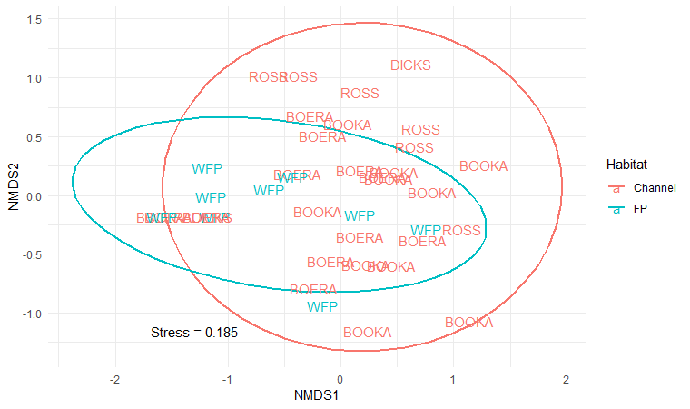
Figure 11 nMDS plot of species abundance data from 2014-20 grouped by survey habitat types.

Discussion
Of the seven species of frog detected in the 2019–2020 water year, six were among the species that have been commonly detected in the Selected Area over the past six years. The less common, painted burrowing frog was also seen on the Western Floodplain, although it was not heard calling. Painted burrowing frogs are typically active after rain and although no rain fell in the region during December, the Western Floodplain was likely wet from localised storms which occurred during November 2019. The activity of some frogs increase during and directly after floods (Ocock 2013), so it is likely that peak activity occurred outside the survey time. The desert froglet was the only common species not observed during the 2019-2020 surveys. This species burrows or aestivates during dry periods emerging only after heavy rainfall (Barton 1999). Given the dry conditions preceding both surveys their non-detection is not surprising and demonstrates the importance of repeat surveys over time to capture and quantify different species.
The survey event in December 2019 detected more individuals and more species than the February 2020 survey event, and frogs had ceased calling on the Western Floodplain in this later survey period. Many frogs have peak calling seasons during September to December in southern Australia (McGinness et al. 2014) so this may reflect these seasonal patterns. More males of barking frog and common eastern froglet (Crinia signifera) are heard calling in areas with higher wetting frequency (McGinness et al. 2014) which is reflected in our data by the high number of frogs observed during the 2016-2017 survey events. The high number of frogs seen and heard in the Western Floodplain during this period demonstrates the capacity for this floodplain habitat to become densely populated by frogs in the right conditions. These high densities of spotted marsh frogs are positive because up to 5% of their diet includes crop pests in some areas so they can serve an important ecosystem service in pest control (Doody et al. 2010). They are also prey for birds, bats, reptiles and terrestrial mammals and thus form an important part of the food web.
Composition of frog species will vary among permanent and non-permanent sites (Wassens & Maher 2011) and this was supported by our multivariate analyses that show differences in the frog community between the Western Floodplain and channel sites between 2014-2020. In the Selected Area, the Western Floodplain is the only site where the wrinkled toadlet has been detected while several species (rough frog, water holding frog, small-headed toadlet, new holland frog, salmon striped frog) have only been detected in channel sites. Some of these species have only been seen in small abundances. Regardless, these results show the importance of protecting multiple types of habitat, maintaining the refuges in the Warrego channel and delivering water to the floodplain, where frogs obtain high abundances and different species assemblages.

Conclusion
The 2019–2020 water year provided the first opportunity across LTIM and MER programs to sample frogs following a wet November. This resulted in detection of lesser known species such as the painted burrowing frog. This ongoing data provides valuable knowledge of the longer term responses of these species and the finer scale nuances that occur between floodplain and river channel habitats. In communities such as frogs where population can vary dramatically in short spaces of time, these data will provide a strong foundation to determine the effects of environmental water.

References
Barton D.P. 1999. Ecology of helminth communities in troical Australian amphibians. International Journal of Parasitology 29: 921-926
Bower DS, Pickett EJ, Stockwell MP, Pollard CJ, Garnham JI, Sanders MR, ... Mahony MJ. 2014. Evaluating monitoring methods to guide adaptive management of a threatened amphibian (L itoria aurea). Ecology and Evolution 4:1361-1368.
Doody JS, Castellano CM, Osborne W, Corey B, Ross S. 2010. Reconciling Farming with Wildlife —Managing diversity in the Riverina rice fields. RIRDC Publication No. 10/0007 https://www.agrifutures.com.au/wp-content/uploads/publications/10-007.pdf.
McGinness HM, Arthur AD, Ward KA, Ward PA. 2014. Floodplain amphibian abundance: responses to flooding and habitat type in Barmah Forest, Murray River, Australia. Wildlife research 41:149-162.
Ocock J. 2013. Linking frogs with flow: Amphibian community response to flow and rainfall on a dryland floodplain wetland. University of New South Wales.
Oksanen J, Guillaume Blanchet F, Friendly M, Kindt R, Legendre P, McGlinn D, ... Wagner H. 2019. vegan: Community Ecology Package. R package version 2.5-6, https://CRAN.R-project.org/package=vegan.
R Core Team. 2018. R: A Language and Environment for Statistical Computing. R Foundation for Statistical Computing, Vienna, Austria, https://www.R-project.org.
Rogers K, Ralph TJ, Saintilan N. 2012. The use of representative species as surrogates for wetland inundation. Wetlands 32:249-256.
Schmidt K, Blanchette ML, Pearson RG, Alford RA, Davis AM. 2017. Trophic roles of tadpoles in tropical Australian streams. Freshwater Biology 62:1929-1941.
Wassens S, Maher M. 2011. River regulation influences the composition and distribution of inland frog communities. River Research and Applications 27:238-246.
Wickham H. ggplot2: Elegant Graphics for Data Analysis. Springer-Verlag New York, 2016.

