HYDROLOGY | FOOD WEBS | VEGETATION | WATERBIRDS | FISH | FROGS

Appendix A: Darling River Hydrology

# Introduction

Hydrology, when, where and how water moves through channels, floodplains or wetlands, underpins the environmental and ecological processes in a river system.

This chapter describes and analyses hydrological information from the Darling River and its tributaries upstream or within the Junction of the Warrego and Darling River systems Selected Area (Selected Area).

The Darling River hydrology indicator provides information on the degree of hydrological connection within the channel that was maintained through the Selected Area during the 2019-20 water year and highlights the contribution of Commonwealth environmental water throughout the year.

Several specific questions were addressed in relation to this indicator:

* What did Commonwealth environmental water from upstream tributaries contribute to hydrological connectivity within the Selected Area?
* What did Commonwealth environmental water contribute to hydrological connectivity of the Darling River within the Selected Area?
* What did Commonwealth environmental water contribute to in-channel habitat availability and connectivity within the Selected Area?

## Weather Conditions 2019-20

The region experienced conditions similar to the long term averages in the 2019-20 water year (BOM 2020). Yearly rainfall totalled 317.6 mm against the long-term average of 316.9 mm (Figure 1) with the majority of rain falling in November, March and April. Temperature was well above the long-term average in December and January and below average from February to May (Figure 2).

Figure 1 Bourke (airport) rainfall for 2019-20 water year.

Figure 2 Bourke (airport) mean maximum monthly temperature 2019-20 water year.

# Methods

## Contribution of the northern tributaries

The northern tributaries of the Murray-Darling Basin upstream of the Selected Area drain the Great Dividing Range in southern Queensland and northern New South Wales, flowing more than 500 km, generally in a westerly direction. The Warrego River catchment defines the western extent of the catchment upstream of the Selected Area, meeting the Darling River at Toorale (Figure 3).

Major tributaries upstream of the Warrego-Darling Selected Area include:

* Warrego River
* Moonie River
* Condamine – Balonne River system
* Border Rivers
* Gwydir River
* Namoi River
* Barwon – Darling River system
* Macquarie River
* Castlereagh River

The stream network, longitudinal connectivity and hydrological behaviour of the Northern Basin upstream of the Selected Area is complex. Catchment boundaries are poorly defined and inconsistently applied and river tributaries alternate between gaining and losing systems through complex interactions with each other and their floodplains. Water management activities are equally complex. The northern tributaries comprise a mixture of regulated, unregulated and ephemeral streams managed across two states with differing government agencies, legislation and policies. This challenge is being addressed through work under the NSW Water Reform Action Plan ([industry.nsw.gov.au/water-reform](https://www.industry.nsw.gov.au/water-reform)).

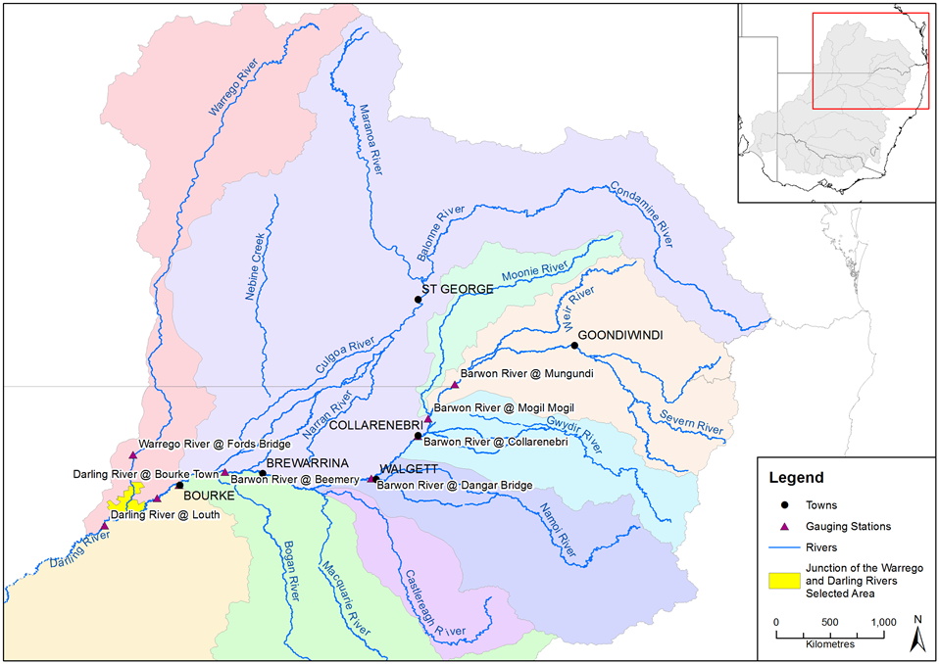

Figure 3 Northern tributaries of the Murray-Darling Basin.

### Commonwealth environmental water holdings

Total Commonwealth environmental water holdings (entitlements) for the northern tributaries are currently 481,867 ML (Table 1). Long Term Average Annual Yield (LTAAY) provides an indication of the long-term reliability of these entitlements and is generally used by the Commonwealth Environmental Water Holder for annual decision-making regarding water use priorities. At the time of writing, LTAAY of Commonwealth environmental water for the northern tributaries upstream of Louth was 300,032 ML. Current Commonwealth environmental water license information is available at:

<http://www.environment.gov.au/water/cewo/about/water-holdings>.

Table 1 Commonwealth surface water Holdings for northern tributaries to June 2020 (source Commonwealth Environmental Water Holder).

| Catchment | Regulated (ML) | | Unregulated (ML) | | Total (ML) | |
| --- | --- | --- | --- | --- | --- | --- |
| Entitlement | LTAAY | Entitlement | LTAAY | Entitlement | LTAAY |
| Condamine-Balonne1 | 45 | 43 | 172,881 | 91,198 | 172,926 | 91,241 |
| Moonie | 0 | 0 | 5,671 | 2,523 | 5,671 | 2,523 |
| Warrego (Qld) | 0 | 0 | 39,455 | 20,096 | 39,455 | 20,096 |
| Warrego (NSW) | 0 | 0 | 17,826 | 13,773 | 17,826 | 13,773 |
| Barwon-Darling | 0 | 0 | 28,631 | 28,631 | 28,631 | 28,631 |
| Border Rivers2 | 18,346 | 6,187 | 21,423 | 9,096 | 39,769 | 15,283 |
| Gwydir2 | 94,033 | 38,014 | 20,451 | 9,919 | 114,484 | 47,933 |
| Namoi | 13,653 | 10,281 | 0 | 0 | 13,653 | 10,281 |
| Peel | 1,257 | 263 | 0 | 0 | 1,257 | 263 |
| Macquarie2 | 126,224 | 65,132 | 8,292 | 4,876 | 134,516 | 70,008 |
| ***TOTAL*** | ***253,558*** | ***119,920*** | ***314,630*** | ***180,112*** | ***568,188*** | ***300,032*** |

**Notes:**

1 Includes (all LTAAY): Nebine Creek (3,842 ML); lower Balonne unsupplemented and overland flow: 86,543 ML; Condamine unsupplemented: 813 ML

2 Supplementary Water entitlements in the NSW Border Rivers, Gwydir and Macquarie catchments are listed for the purposes of this table as unregulated entitlements

In addition to upstream entitlements, there are a number of local Commonwealth environmental water entitlements directly associated with agreed watering actions at the Selected Area (Table 2). The Commonwealth Environmental Water Office (CEWO) has the potential to take against these licences when conditions are satisfied.

Table 2 Commonwealth environmental water entitlements associated with the Selected Area.

| Water source | Water Access Licence | Registered entitlement (ML) | LTAAY (ML) | Trigger flow conditions  (ML/d – location) |
| --- | --- | --- | --- | --- |
| Intersecting Streams Unregulated River | **Boera Dam**  WAL27558 | 1,134 | 8,106 | Fresh in Warrego reaching Darling (approx. 300 ML/d at Fords Bridge) plus >330 ML/d at Louth (425004). |
| **Upstream Boera**  WAL27555 | 972 |
| **Peebles Dam**  WAL27552 | 6,000 |
| Intersecting Streams Unregulated River | **Special High Flow–Boera Dam (for Western Floodplain)**  WAL31152 | 9,720 | 9,720 | Visible flow in Warrego at or near Darling plus  >979 ML/d at Louth (425004). |
| Barwon Darling Unregulated River Access | **A Class**  WAL33701  WAL33704 | 20  47 | 7,672 | >350 ML/d at Bourke (425003) and >260 ML/d at Louth (425004). |
| **B Class**  WAL33784  WAL35944 | 1,437  1,090 | >1,250 ML/d at Bourke (425003) and > 1,130 ML/d at Louth (425004). |
| **C Class**  WAL35943 | 5,078 | >1,339 ML/d at Louth (425004). |

### Hydrology within the Selected Area

The hydrology within the Selected Area is governed by flows in either the Darling River, the Warrego River, or both.

Barwon-Darling River

Located in a semi-arid setting, upstream climatic conditions are the key driver of hydrology within the Selected Area, with the upstream easterly catchments capable of providing overbank flows within the Barwon-Darling River. During major events, floodwaters may extend along the length of the river system.

During drier times, such as 2019, the relationship becomes more complex. From a water management point of view, the Barwon-Darling River system is considered an unregulated stream; however, it is fed by both regulated and unregulated upstream catchments with stream flows, in part, reflecting upstream water management decisions. Further complicating the hydrology is the influence of a series of weir pools, terminal wetlands, anabranches and anastomosing streams.

Warrego River

The Warrego River is essentially unregulated, and due to its semi-arid setting, provides water to the Selected Area intermittently. Within the Selected Area, Warrego flows are further influenced by in-stream structures, such as Boera, Booka, Dicks and Peebles Dams (Appendix B: Warrego River Hydrology).

Environmental water in the Warrego may only be accounted for once the individual conditions associated with each entitlement are met. This is usually based on a flow trigger that differs for each entitlement, based on its location and relative security. Depending on chosen watering strategies, environmental water may or may not be accounted for once the flow trigger is reached.

### Environmental water in the Nothern Tributaries 2019-20 water year

The downstream passage of environmental water events was observed and assessed using WaterNSW real-time flow data for gauging stations located along the Barwon-Darling River system. Mean daily discharge data for the following hydrometric stations was used:

* 416001 – Barwon River at Mungindi
* 422004 – Barwon River at Mogil Mogil
* 422003 – Barwon River at Collarenebri
* 422001 – Barwon River at Walgett
* 422028 – Barwon River at Beemery
* 425003 – Darling River at Bourke
* 425037 – Darling River at Weir 19a
* 425004 – Darling River at Louth

The relationship between these gauging stations and key tributary inflows is shown in Figure 4.

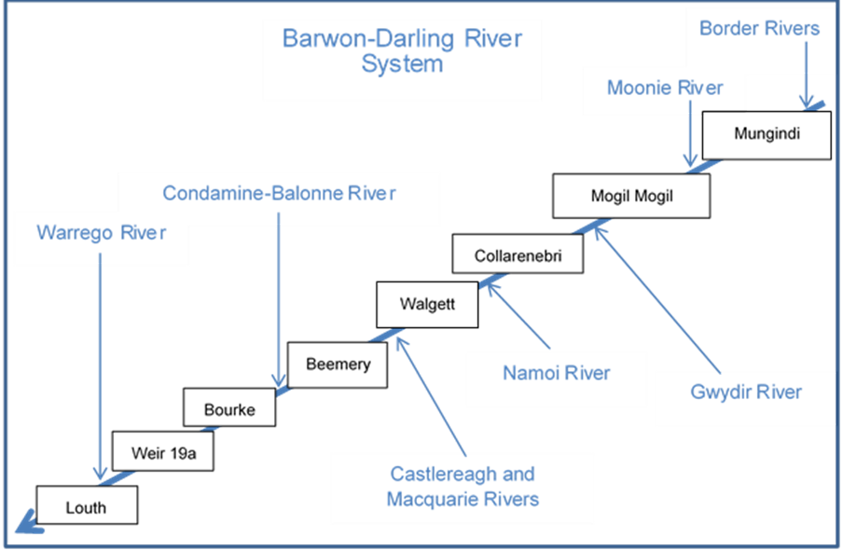

Figure 4 Gauging stations and key tributaries of the Barwon-Darling River system.

Within each water year (from 2014 to 2020), end of system (EOS) environmental water was estimated based on advice from the Department of the Environment and Energy, NSW Department of Industry and Environment - Water (Formerly NSW Department of Industry - Water) and the CSIRO MDB Sustainable yield project (Table 3). The EOS measure was used to estimate the amount of water (as a proportion of the total) that would have made it out of the end of each catchment, considering losses such as evaporation, infiltration etc. It should be noted that while environmental water protection actions like pumping embargoes influence the movement of environmental water through the system, these were not considered in the current analysis.

Table 3 End of system (EOS) flow estimates used to assess passage of environmental water downstream.

| Catchment | Applied EOS flow (%) |
| --- | --- |
| Border Rivers | 80 |
| Moonie | 73 |
| Gwydir | 24 |
| Namoi | 63 |
| Macquarie/Castlereagh | 30 |
| Condamine-Balonne | 37 |
| Barwon-Darling (Mungindi to Bourke) | 80 |
| Warrego | 34 |

## Hydrological connectivity within the Selected Area

An assessment of the hydrological connectivity experienced along the Darling River within the Selected Area was undertaken by comparing flows at the upstream Weir 19A gauge (425037) with the gauging station at Louth (425004) which is the first reliable gauge downstream of the Selected Area (Figure 5, Commonwealth of Australia 2015). This reach was considered to be fully connected when water was flowing past both gauges.

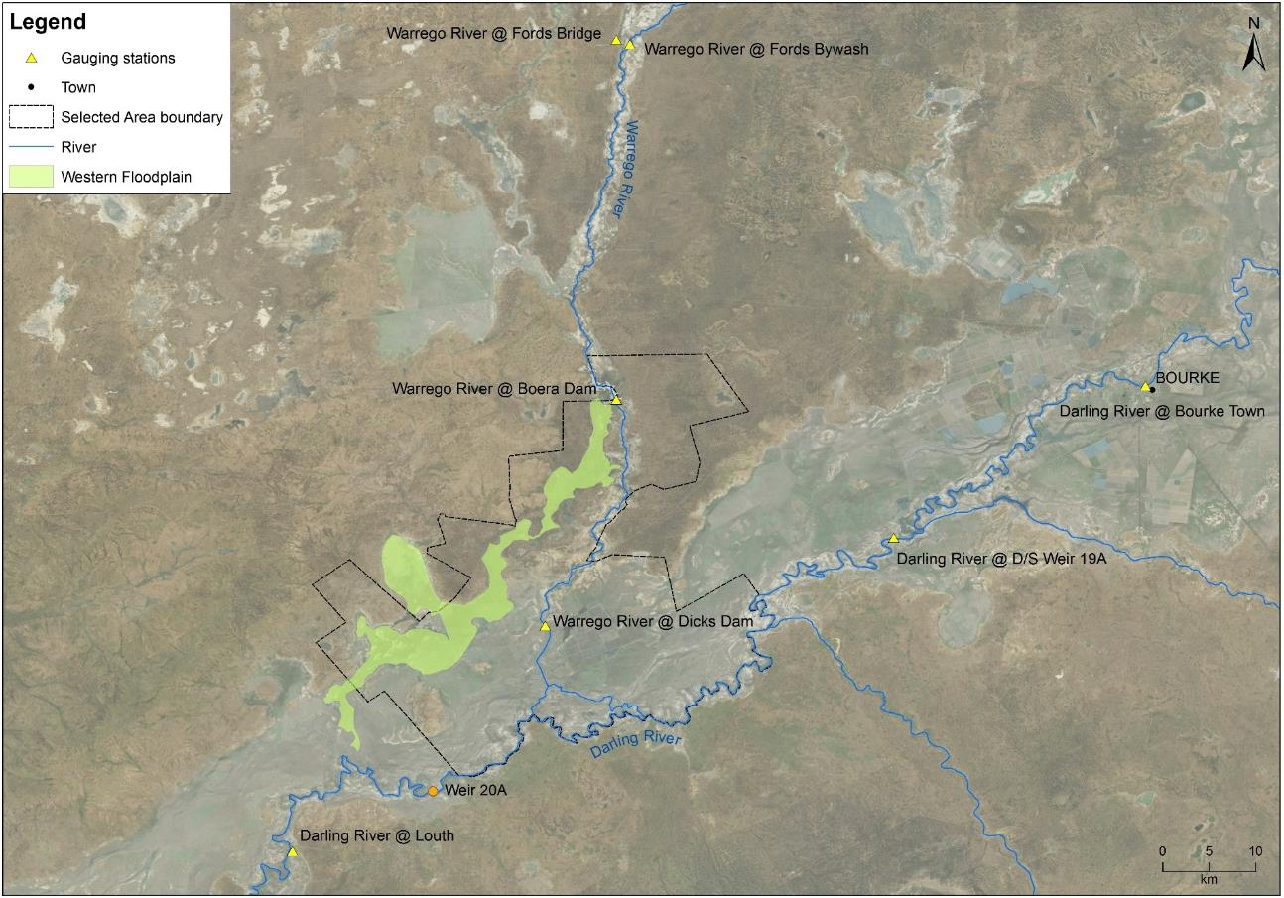

Figure 5 Location of the gauging stations used within the Selected Area.

## In-channel habitat availability and productivity

In-channel benches and anabranches in the Darling River within the Selected Area were identified through desktop mapping of in-stream habitat and aerial photograph interpretation (Commonwealth of Australia 2015). Field survey was undertaken to verify the in-stream habitat features and map additional features. In addition to the number and size of individual habitat features present, height above the current water level was noted using a hypsometer to measure the commence-to-inundate level of benches and the commence-to-flow for anabranch channels (Commonwealth of Australia 2015). Commence-to-flow heights were recorded to the nearest vertical metre.

Snag data was obtained from NSW DPI Fisheries that had been collected for the *Fish and Flows in the Northern Basin* Project in 2015 (NSW DPI 2015). The height above the current water level was recorded using a similar method as that used for benches and anabranches. As part of the *Fish and Flows in the Northern Basin* Project snags were classified into four grades of complexity (Figure 6).

Figure 6 Classification system used to grade complexity of snags (NSW DPI 2015).

The vertical commence-to-flow heights of individual habitat features above the current water level at the time of field survey were converted to a gauged height at the nearest river flow gauge. Benches and anabranches upstream of the Warrego River confluence were linked to the Weir 19A (425037) gauge upstream of the Selected Area, while benches and anabranches downstream of the confluence were linked to the gauging station at Louth (425004). Snags for the entire reach of the Darling River within the Selected Area were linked to the Weir 19A gauge only. These gauges were chosen as they best reflected the hydrology of these sections of the Darling River. However, final commence-to-flow discharges were reported at the Bourke Town (425003) gauging station as it has a more comprehensive flow record. To do this, relationships between the Louth and Weir 19A gauging stations and the Bourke Town gauge were identified by plotting respective flows between 400 and 20,000 ML/d at the gauges from 2002 to present (total length of Weir 19A gauge record). Travel time between gauges was considered, with trendlines and associated regression equations of the relationship between gauges calculated (Commonwealth of Australia 2015). These equations were used to express the commence-to-flow discharges measured at the Louth and Weir 19A gauges to the Bourke Town gauge. The commence-to-flow for each anabranch channel was determined using the entry or exit with the highest gauge height to better represent water flow into each channel.

Total organic carbon (TOC), nitrogen (TN) and phosphorus (TP) release rates from in-channel benches observed on the Darling River upstream of Bourke by Southwell (2008), were combined with the duration of bench inundation. This provided an estimate of total nutrient loads that were contributed to the river from these inundated benches during the water year.

# Results

## Contributions from the Northern Tributaries

Daily flow records (Figure 7) were cross-referenced with internal data and operational reports provided by the CEWO to assess key flow events where environmental water take was accounted in the northern tributaries during the water year. Water ‘take’ is defined as the amount of environmental water accounted during unregulated events where specific streamflow conditions are met to trigger individual environmental water entitlements.

One flow ‘event’ was identified during 2019/20 that included a component of water for the environment:

Event 1. 230,268 ML of upstream environmental water take from the Border Rivers, Moonie, Condamine-Balonne, Macquarie-Castlereagh and Warrego Rivers (7 February – 13 April 2020).

Event 1 was followed by another pulse through the Barwon-Darling River below Brewarrina that originated from tributary flows out of the Castlereagh and Macquarie systems. A small amount of supplementary water for the environment was accounted in the Macquarie River above the Macquarie Marshes during this flow, however, loss rates between here and the Barwon River junction were considered high enough that only a very small proportion (<1%) of this water for the environment would have contributed to downstream flows in the Barwon-Darling. Therefore it was not considered in further analysis.

Figure 7 Mean daily flows at gauging stations on the Barwon-Darling River system during the 2019-20 water year.

Unregulated environmental water contribution for each event during 2019-20 is presented for each northern Murray-Darling Basin catchment in Table 4.

Table 4 Unregulated environmental water (EW) events for 2019-20 water year.

| Basin Plan Region | Tributary | Unregulated EW take (ML) | Total (ML) | Comments |
| --- | --- | --- | --- | --- |
| Qld Border Rivers | Dumaresq-Macintyre River | Event 1: 2,122 | 2,122 | Flow Event 1 in February 2020 |
| Severn River | Event 1: 880 | 880 |
| Macintyre brook | Event 1: 246 | 246 |
| Qld Moonie | Lower Moonie River | Event 1: 4,727 | 4,727 | Flow event 1 in February to March 2020 |
| Qld Condamine –Balonne | Nebine Creek | Event 1: 1,992 | 1,992 | Flow Event 1 in February to March 2020, 1,992 ML contributed to in-stream flows reaching the Darling River |
| Lower Balonne Floodplain system | Event 1: 163,200 | 163,200 | Combination of overland flow and water allocation taken during February and March 2020 |
| Qld Warrego River | Upper | Event 1: 385 | 385 | Flow Event 1 in March 202 |
| Lower | Event 1: 16,100 | 16,100 | Two periods of announced take in February and March 2020 fall into Flow Event 1 |
| NSW Warrego River | Toorale | Event 1: 16,212 | 16,212 | Three Warrego River Licences full allocation reached in March – falls into Event 1 |
| NSW Gwydir | Mallowa Creek | 0 | 0 | Some within valley EW use, but none reached end of system |
| Mehi River | 0 | 0 |
| Carole – Gil Gil Creek | 0 | 0 |
| Macquarie-Castlereagh | Macquarie River | 0 | 0 | Some within valley EW use, but none reached end of system |
| Intersecting Streams- Warrego | Lower Warrego River | Event 1: 16,212 | 16,212 | Water accounted from 11 March 2020 until licence exhausted |
| NSW Intersecting Streams | Toorale Western Floodplain | 0 | 0 | No EW take |
| NSW Barwon - Darling | Barwon-Darling River | Event 1: 28,631 | 28,631 | Two periods of take in February and March 2020 with the lifting of temporary water restrictions |

While some regulated deliveries and supplementary access of water for the environment occurred in the Gwydir River system, these didn’t influence flows into the Barwon River.

Event 1 occurred as a result of widespread rainfall in the northern Basin, and included significant contributions of water for the environment from the Condamine-Balonne, Barwon and Warrego systems. Total environmental water accounted upstream during this period comprised 234,495 ML. Allowing for system losses, this was estimated to contribute 12.2% of the total flow volume at the Selected Area (Table 5).

Table 5 Environmental water flow event 1 (7 February – 13 April 2020) EOS flow assessment.

|  |  |  |  |  |
| --- | --- | --- | --- | --- |
| Gauging Station | Total Event Discharge | Upstream EW | Estimated EOS EW | |
|  | ML | ML | ML | % |
| **Mungindi** | 70,636 | 3,248 | 2,598 | 3.7% |
| **Mogil Mogil** | 200,809 | 7,975 | 6,039 | 3.0% |
| **Collarenebri** | 227,924 | 7,975 | 6,039 | 2.6% |
| **Walgett** | 349,369 | 7,975 | 6,039 | 1.7% |
| **Beemery** | 437,108 | 7,975 | 6,039 | 1.4% |
| **Bourke** | 492,167 | 201,798 | 53,944 | 11.0% |
| **Weir 19A** | 429,810 | 201,798 | 47,109 | 11.0% |
| **Louth** | 478,215 | 234,495 | 58,203 | 12.2% |

Within the Warrego catchment, environmental water was accounted during flow event 1 in 2019-20. EOS flow assessment at Fords Bridge provides an estimate of the volumes and proportions of environmental water entering the Selected Area at Boera Dam. During the period 7 February – 13 April 2020, 85,389 ML flowed past Fords Bridge. Environmental water contributions from upstream totalled 16,485 ML. Allowing for EOS losses, this constitutes 7% of the water that flowed past Fords Bridge and into the Selected Area. Commonwealth environmental water licences were also triggered within Toorale on the Warrego River during event 1 - these totalled 16,212 ML which is approximately 32% of the total flow for this event of 50,750 ML past Dicks Dam.

### Multi-year comparison

Comparing all environmental flow events in the Darling River zone over the LTIM and MER Projects, event 3 in 2016-17 was by far the largest event to flow through the system (Figure 8). While the volume of environmental water was large (42,228 ML), the overall proportion was small (2%, Table 6).

The proportion of environmental water was typically higher in other events, being dependent on which catchment the flows were generated in and the level of regulated water contribution. For example, flows that predominantly came from the Condamine-Balonne catchment (15-16 Event 3) tended to have larger proportions of environmental water due to the relatively large volume of unregulated entitlements held in that catchment. In addition, flows that were composed of regulated flows such as the three events in 2017-18 tended to have a higher proportion of environmental water (24% to 100%). This was aided by pumping embargos put in place to protect these flows through the system. The 2019-20 flow event included more water for the environment by volume than any other flow considered (Table 6). This reflected the relatively large contributions from the Condamine-Balonne and Warrego systems where the CEWO has significant unregulated entitlements.

26%

4%

5%

3%

30%

6%

2%

36%

42%

24%

100%

43%

12%

2%

Figure 8 Multi-year comparison of total flow volumes at Louth gauge.

Table 6 Multi-year comparison of total flow and estimated environmental flow volumes at Louth gauge.

| Water Year | Flow Event | Total Event Discharge (Louth) | Estimated EOS CEW | |
| --- | --- | --- | --- | --- |
| ML | ML | % |
| 2014/15 | Event 1 | 27,797 | 9,593 | 25.7 |
| Event 2 | 27,394 | 1,135 | 4.0 |
| 2015/16 | Event 1 | 53,501 | 2,824 | 5.0 |
| Event 2 | 12,161 | 428 | 3.4 |
| Event 3 | 15,477 | 6,621 | 30.0 |
| 2016/17 | Event 1 | 129,820 | 7,818 | 6.0 |
| Event 2 | 171,909 | 3,102 | 1.8 |
| Event 3 | 1,772,486 | 42,228 | 2.4 |
| Event 4 | 44,161 | 16,101 | 36.5 |
| 2017/18 | Event 1 | 50,514 | 21,669 | 42.9 |
| Event 2 | 14,157 | 3,446 | 24.3 |
| Event 3 | 13,386 | 13,332 | 99.6 |
| 2018/19 | Event 1 | 23,939 | 10,325 | 43.1 |
| 2019-20 | Event 1 | 420,012 | 58,203 | 12.2 |

## Hydrological connectivity within the Selected Area

From 1 July 2019 to late February 2020 the Darling River within the Selected Area reach had very low to no flows (Figure 9). A small flow with a peak discharge of <2,000 ML/d occurred in Novemebr 2019 providing a short period of connectivity (18 days). A much larger and sustained flow commenced in late February 2020, peaking at over   
15,000 ML/d at Bourke Town. This flow resulted in a period of 127 days of longitudinal connectivity that was augmented by 52 days of environmental flows (52,203 ML).

Figure 9 River flows and longitudinal connectivity within the Darling River from Bourke Town to Louth 2019-20 water year.

## In-channel habitat productivity

Three flow pulses occurred in the 2019-20 water year that provided habitat inundation. Flows were large enough to inundate a proportion of the snags, bench surfaces and anabranches found along the reach.

Four snag classes were inundated in the 2019-20 water year (Figure 10). The lowest discharge class (<69 ML/d) was inundated for 93 days, accounting for 26% of all snags. The second lowest class (69 – 1,793 ML/d) was inundated for 83 days across all flow events, while all snags in the 1,796 – 9,109 ML/d class were inundated for at least 45 days during the year, with some snags in this class being inundated for longer periods (Figure 10). All snags in the 9,109 – 14,872 ML/d class were inundated for at least three day in March 2020 (Pulse 2, Table 7). This resulted in a total of 84% of snags becoming inundated during 2019-20.

69 – 2,000 ML/d

2,000 – 9,109 ML/d

9,109 - 14,872 ML/d

14,872 – 18,889 ML/d

Pulse 2

Pulse 3

Pulse 1

Figure 10 Snag inundation during the 2019-20 water year along the Darling River zone of the Selected Area (snags grouped by discharge in ML/d measured at the Bourke Town gauge (NSW 425003)).

Table 7 Duration and proportion of snags inundated in the Darling River during the 2019-20 water year.

|  |  |  |  |  |
| --- | --- | --- | --- | --- |
| Flow Height Range  Bourke to Weir 19A (ML/d) | Snags | Proportion of total snags (%) | Days inundated | % Total time |
| <69 | 973 | 26.1 | 93 | 25.5 |
| 69 – 1,793 | 151 | 4.0 | 83 | 22.7 |
| 1,793 – 9,109 | 1,138 | 30.5 | 45 | 12.3 |
| 9,109 – 14,872 | 860 | 23.0 | 3 | 0.8 |
| 14,872 – 18,889 | 354 | 9.5 | 0 | 0.0 |
| 18,889 – 40,000 | 259 | 6.9 | 0 | 0.0 |

The lowest three bench classes (<2,000 ML/d; 2,000 – 6,500 ML/d and 6,500 – 10,000 ML/d) were inundated in flow pulses 2 and 3 (Figure 11). These events inundated 72% of the total number of benches identified within the Darling River zone, providing access to 60,757 m2 of habitat. Given the lowest commence-to-inundate level of any bench in the reach is 1,846 ML/d, no bench surfaces were inundated during the smaller pulse 1. Benches in the 10,000 – 14,000 ML/d class were inundated during pulse 2, providing access to an additional 14,377 m2 of habitat for a minimum of 8 days (Figure 11).

10,000 – 14,000 ML/d

6,500 – 10,000 ML/d

2,000 – 6,500 ML/d

<2,000 ML/d

14,000 – 20,000 ML/d

Pulse 1

Pulse 2

Pulse 3

Figure 11 Bench inundation during the 2019-20 water year along the Darling River zone of the Warrego-Darling Selected Area. Benches grouped by discharge in ML/d measured at the Bourke Town gauge (NSW 425003).

Combining the amount of bench habitat provided in the Darling River zone with the average 72 hourly nutrient release rates reported in Southwell (2008), it is estimated that these benches would have contributed 90.5 kg of total dissolved organic carbon (TOC), 27.5 kg of total dissolved nitrogen (TN) and 30.8 kg of total dissolved phosphorus (TP) to the river system during the time they were inundated in the 2019 – 20 water year (Table 8).

Table 8 Bench connection and the total release of dissolved nutrients from bench surfaces in the Darling River zone of the Selected Area during the 2019-20 water year.

|  |  |  |  |  |
| --- | --- | --- | --- | --- |
| Discharge class (ML/d) | Days connected (% of total time) | Total release of nutrients (kg) | | |
| TOC | TN | TP |
| <2,000 | 79 (21.6%) | 40.7 | 12.4 | 13.8 |
| 2,000-6,500 | 57 (15.6%) | 24.6 | 7.5 | 8.4 |
| 6,500-10,000 | 35 (9.6%) | 22.2 | 6.8 | 7.6 |
| 10,000-14,000 | 8 (2.2%) | 3.0 | 0.9 | 1.0 |
| 14,000-20,000 | 0 | 0.0 | 0.0 | 0.0 |
| All classes |  | 90.5 | 27.5 | 30.8 |

Anabranches in the <2,000 ML/d, 2,000 – 4,000 ML/d and 4,000 – 10,000 ML/d discharge classes commenced-to-flow in flow pulses 2 and 3 providing a combined distance of 56 km accounting for 90% of the total number of anabranches identified and 93% of the combined length of all anabranches identified in the zone (Figure 12). Anabranches that commence-to-flow at <2,000 ML/d and 2,000 – 4,000 ML/d were inundated for at least 79 days and 66 days respectively. Anabranches in the 4,000 – 10,000 ML/d class were inundated for at least 35 days during the 2019-20 water year (Figure 12).

Pulse 1

Pulse 2

Pulse 3

Figure 12 Anabranch connection during the 2019-20 water year along the Darling River zone of the Selected Area (anabranches grouped by discharge in ML/d measured at Bourke Town (NSW 425003)).

# Discussion and Conclusion

By volume, the flow event in February – April 2020 included the proportion amount of water for the environment of any flow analysed since 2014. This contributed 12.2% of the total flow volume that passed down the Darling River zone of the Selected Area. This flow event had an extended duration and provided a long period of connectivity in the Darling River within the Selected Area. The significant contributions of water for the environment from the Warrego and Condamine-Balonne catchments reflects the higher volumes of entitlement held in these catchments by the CEWO, as well as the larger flow volumes from these catchments, driven by the distributions of rainfall over the northern basin.

A second prominent flow peak occurred in April/May 2020. This flow peak originated in the Castlereagh and Macquarie catchments. While some water for the environment was accounted for in the Macquarie River, this water was used to target environmental objectives in the Macquarie River upstream of the Macquarie Marshes and in the Marshes themselves, with very little of this water making it to the Barwon River. Most of the flows that reached the Barwon River during this event came from the Castlereagh Catchment, with additional contributions from the Bogan River. These systems do not currently have any CEWO entitlements or held environmental water and therefore there was no contribution from environmental water during this event.

In-channel habitat inundation and productivity was enhanced through the contribution of environmental water. The large event that peaked in March 2020 was augmented with over 50,000 ML of Commonwealth environmental water. This event inundated the majority of snags (84%), all benches and connected with all anabranches recorded in the reach.

# References

BOM. 2020. Weather records from Bourke Town weather station 1 July 2019 to 30 June 2020.

Commonwealth of Australia. 2015. Commonwealth Water Office Long Term Intervention Monitoring Project Junction of the Warrego and Darling rivers Selected Area: 2014-15 Evaluation Report, Canberra.

NSW Department of Primary Industries (DPI). 2015. Fish and flows in the Northern Basin: Response of fish to changes in flow in the Northern Murray-Darling – Reach Scale Report. Prepared for the Murray Darling Basin Authority. NSW DPI, Tamworth.

Southwell, M.R. 2008. Floodplains as Dynamic mosaics: Sediment and nutrient patches in a large lowland riverine landscape. PhD Thesis, University of Canberra, Australia