Hydrology (River)

Introduction
The Hydrology (River) indicator provides in-channel hydrological information on the character of Commonwealth environmental water and other environmental water deliveries. This information is directly relevant to a number of other indicators measured in the Junction of the Warrego and Darling rivers Selected Area (Selected Area) including vegetation, waterbirds, fish, and microcrustaceans. The particular influence of hydrology of these indicators will be addressed under their respective sections. The Hydrology (River) indicator will also provide information on the degree of hydrological connectivity maintained through the Selected Area during the 2016-17 water year. One specific question was addressed in relation to this indicator:
- What did Commonwealth environmental water contribute to hydrological connectivity?

Environmental watering in 2016-17
Barwon-Darling and northern tributaries
Unlike other Selected Areas, environmental water is not specifically delivered to the Junction of the Warrego and Darling rivers Selected Area, rather, Commonwealth water is held as unregulated entitlements and its influence is thus reliant on flows out of upstream catchments. During the 2016–17 water year, four flow events containing environmental water flowed down the Darling River within the Selected Area (Appendix B). These occurred in June – August 2016, August – September 2016, September – December 2016 and April – May 2017. Three of these flows were in-channel pulses with the flow during September-December 2016 reaching at or just over bankfull. Total proportions of Commonwealth environment water in the Darling River varied between 1.8% and 36.5% of total flow (Appendix B).
Warrego River
Several flow pulses in the Warrego River occurred between June - November 2016. The demand for environmental flows on the Western Floodplain was very high given the last large-scale inundation of the Western Floodplain at Toorale was in 2012. As per licence conditions, a fresh in the Warrego River in July 2016 was allowed to make visible connection with the Darling River prior to closing the gates in Boera Dam and allowing Commonwealth environmental water to spill to the Western floodplain from 19 July 2016. The gates at Boera were opened again from the 9-12 September 2016 to connect with the Darling River in accordance with licence conditions for a new flow event. Following this, further inflows were spilled to the Western Floodplain with total approved volume reaching the annual allocation of 9,720 ML by 20 September 2016. Water continued to spill onto the Western Floodplain until December 2016. In total, 31,000 ML of water flowed onto the Western Floodplain of which 31% was Commonwealth environmental water.
Another fresh occurred in the Warrego River during September - November 2016. The Boera Dam gates were again opened and once the fresh had connected with the Darling River, Commonwealth environmental water licences on the Warrego River were used to provide a pulse of water down the Warrego River. This flow aimed to provide opportunities for native fish to access habitat, support recruitment and possibly triggering spawning. 10,500 ML of water was released down the lower Warrego River channel and included 7,762 ML (74%) Commonwealth environmental water. The release was managed to provide a slow rise and fall to the pulse and also ensure that water also continued to spill to the Western Floodplain at the same time. Commonwealth water was used to provide connection for 20 days. National Parks and Wildlife Service maintained the connection for an additional 5 days before closing the gates and allowing the remaining water to spill to the Western Floodplain.

Methods
An assessment of the hydrological connectivity experienced along the Darling River within the Selected Area was undertaken by comparing flow regimes at the Weir 19A gauge (upstream) with the gauging station at Louth (425004) which is the first reliable gauge downstream of the Selected Area (Appendix B, Commonwealth of Australia 2015). This reach was considered to be fully connected when water was flowing past both gauges. For the Warrego River, flows entering the Selected Area were measured by plotting flows past Fords Bridge (Figure A-1). Flows at 423001–Warrego River @ Fords Bridge (Main channel) were combined with flows past 423002–Warrego River @ Fords Bridge Bywash to give a total flow past Fords Bridge.
The gauge on the Darling River at Weir 19A (NSW425037) stopped operating from 19 September to 16 November 2016. In the absence of this data, flows at 425037 – Darling River @ Bourke Town were used to provide an estimate of longitudinal connectivity.
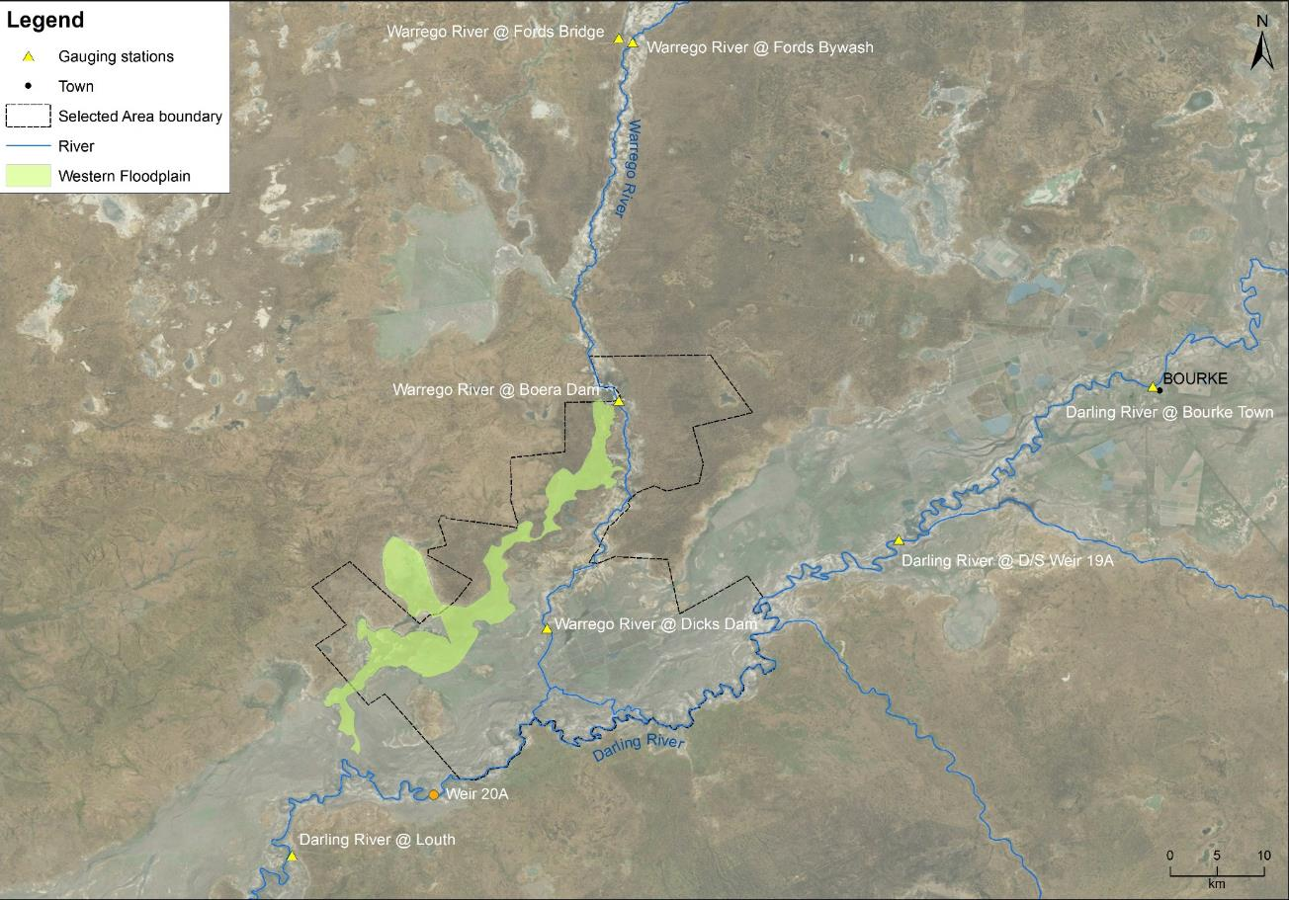
Figure A-1: Location of flow gauging stations used in the hydrological connectivity analysis and extent of the Western Floodplain.

Results

Longitudinal Connectivity
Darling River
The Darling River within the Selected Area was connected (overtopped weir 20A) for 362 days during 2016-17 (Figure A-2). Connectivity was assumed for a portion of the year, as data were not available for 2 months due to the Weir 19A gauge not operating. Given the magnitude of flows upstream of the confluence with the Warrego River at the Louth and Bourke Town gauges in late 2016, it is likely the Darling River remained connected between these gauges for the duration of this period.
Darling River connectivity was driven by three consecutive flow events each containing Commonwealth environmental water (Appendix B). In July – August 2016, these flows included a total upstream take of 14,085 ML Commonwealth environmental water from the Queensland Border Rivers, Castlereagh, Condamine-Balonne and Barwon-Darling River, as well as localised entitlements from Toorale. In August – September 2016, 5,194 ML Commonwealth environmental water was accounted for in the Barwon Darling River system, of which 3,102 ML entered the Selected Area (Appendix B). The relatively large event in September – December comprised 75,711 ML Commonwealth environmental water from all upstream catchments. The final event in April – May 2017 comprised 21,662 ML Commonwealth environmental water from the Condamine-Balonne catchment, Border, Namoi and Macquarie rivers. Due to the size of the first three consecutive events, connectivity was rapid, however, given the relatively small contributions of environmental water (8.5%, 2.4% and 2.4% respectively) connectivity was driven largely by natural flow event. In January – April 2017 connectivity was maintained at Weir 20A downstream of the Selected Area.
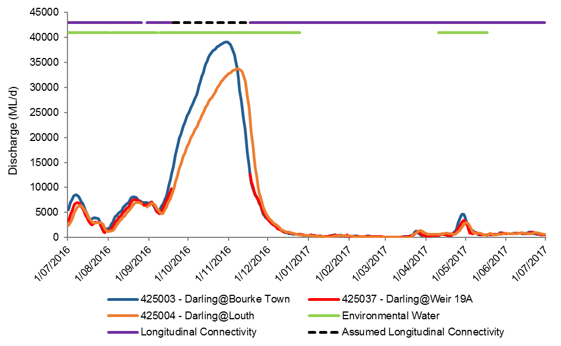
Figure A-2: River flows down the Darling River channel and the timing of longitudinal connectivity in the Selected Area.

Warrego River
Three significant flow events in late 2016 entered the Selected Area from the Warrego catchment during the 2016-17 water year (Figure A-3). These occurred in July, August and September-November 2016 and included approximately 315 ML of Commonwealth environmental water accounted upstream in the Warrego catchment.
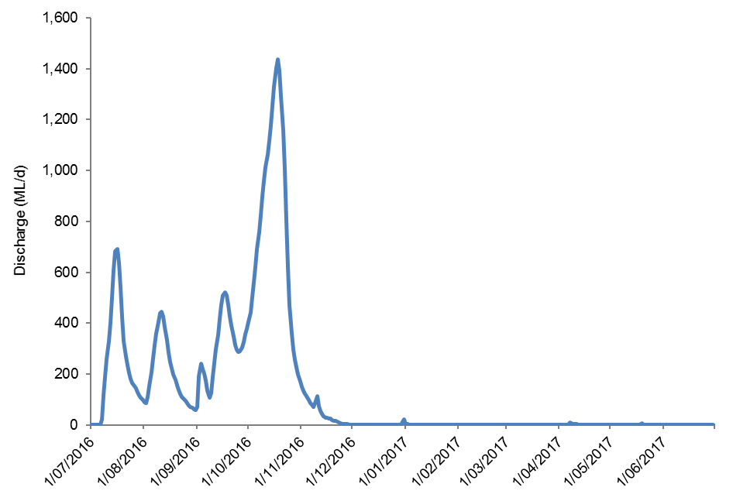
Figure A-3: Flow hydrograph for Warrego River at Fords Bridge upstream of the Selected Area. Note gauges 423001 and 423002 have been combined to produce a total flow past Fords Bridge.

Boera Dam was above the estimated overflow to the Western Floodplain level of 2.26 m at the commencement of the 2016-17 water year and remained so until late December 2016. During December 2016 – January 2017 there was a small increase in water level in Dicks Dam with no connection to Boera Dam. It is likely this increase was a result of localised rainfall recorded in late December/early January. Levels in Boera Dam declined steadily from the beginning of November 2016 until late January 2017 when small inflows were received. These inflows were too small to overflow to the Western Floodplain and were not noted downstream at Dick’s Dam where water levels had been declining since mid-December 2017.
During the July and August inflow events, the gates at Boera Dam were opened to allow flow through to the Darling River, with connection of the lower Warrego channel occurring within one day. This was done to meet the licence requirements of the Toorale water licences. After connection with the Darling was achieved, the gates were closed and water flowed out onto the Western Floodplain being accounted against the Western Floodplain high flow licence until it was exhausted. During the third inflow event in October-November, the Boera gates were opened for a period of 25 days, to provide opportunities for native fish to access habitat and to support recruitment. This included operating the gates to achieve a steady flow increase, several days at peak flow, then a protracted falling limb. The Commonwealth Toorale Warrego River licence was accessed for 20 days of this flow, with NPWS operation of the gates extending the flow to 25 days. This flow was also managed to ensure water continued to flow onto the Western Floodplain.
In total, the Boera Dam gates were opened three times between 11 July and 11 November 2016 resulting in connection for a total of 35 days (Figure A-4). Importantly, in the context of Commonwealth environmental water, Toorale licences on the Warrego were triggered during the 2016-17 water year.
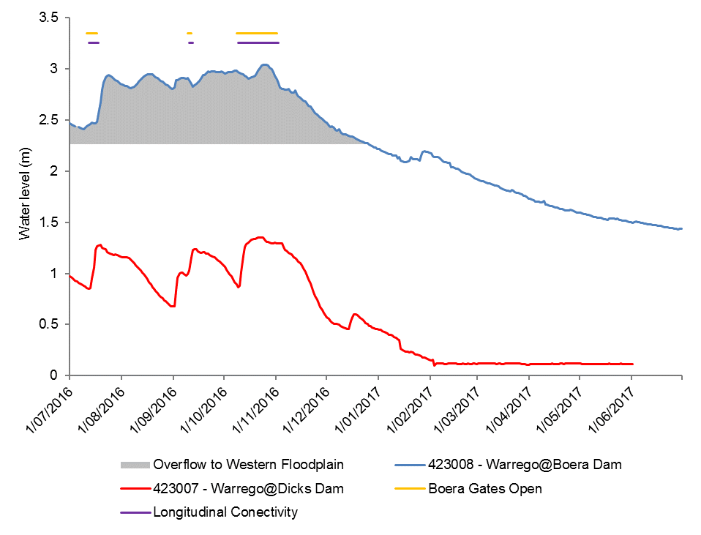
Figure A-4: Water levels at Boera Dam and Dick’s Dam and periods of longitudinal connection and overflow to the Western Floodplain.

Discussion
Flows down the Darling River were moderate to high in the early part of the 2016-17 water year due to generally high rainfall in the catchment and flows from tributary catchments. There were several moderate to large flow peaks throughout the year. One event containing environmental water reached approximate bankfull stage, however most flows remained within the channel. Channel capacity in this reach is around 30,000 – 40,000 ML/d (M. Southwell unpublished data) and peak flows in 2016-17 were around 33,500 ML/d. Hydrology in this section of the Darling River is heavily influenced by weirs, including Weir 19A up stream of the Selected Area and Weir 20A downstream. These weirs maintain connectivity through the Selected Area in times of low flow as experienced in the latter half of the 2016-17 water year.
Several closely-spaced flow events in 2016 dominated the hydrology of the Warrego River channel during 2016-17. Consistent with the Toorale environmental watering strategy, flows were initially diverted to the Western Floodplain in response to very high demand on the floodplain (which had not received large-scale inundation since 2012) and relatively low Darling River demand as it had experienced moderate to high flows in the year to date. Over the course of these events, the annual allocation of 9,720 ML for the Western Floodplain was reached by 20 September 2016, with flows continuing onto the Western Floodplain until late December for a total volume of 31,000 ML. Longitudinal connectivity in the lower Warrego River was restored in October for 25 days following a decision to account Commonwealth environmental water against the Warrego River licences (for 20 days and 7,762 ML). This flow aimed to support fish spawning, recruitment and movement in the Warrego River.

Conclusion
Full longitudinal connection was experienced through the Darling River zone in the Selected Area for the entirety of the 2016-17 water year and for 35 days in total through the Warrego River within the Selected Area. In the Darling River, connection was driven largely by natural flow events with small Commonwealth environmental water contributions, while Weir 20A downstream of the Selected Area maintained connection during drier periods. In the Warrego, releases out of Boera Dam including environmental water in late 2016 resulted in connection to the Darling River for 35 days in total. These flows helped maintain water quality (Appendix F) and supported fish (Appendix L). At the beginning of the 2016-17 water year, sufficient flow stage was reached to provide access to substantial in-channel habitat (Appendix D) along the Darling River.

References
Commonwealth of Australia 2014. Commonwealth Environmental Water Office Long Term Intervention Monitoring Project junction of the Warrego and Darling rivers Selected Area; Annual Evaluation Report – Year 1, Canberra.
Commonwealth of Australia 2015. Commonwealth Water Office Long Term Intervention Monitoring Project Junction of the Warrego and Darling rivers Selected Area, Canberra.
Koehn, J.D. and Nicol, S.J. 2014. Comparative habitat use by large riverine fishes. Marine and freshwater research 65: 164-174.
McGinnes H.M. and Arthur A.D. 2011. Carbon dynamics during flood events in a lowland river: the importance of anabranches. Freshwater Biology 56: 1593–1605.
NSW Department of Primary Industries (DPI) 2015. Fish and flows in the Northern Basin: Response of fish to changes in flow in the Northern Murray-Darling – Reach Scale Report. Prepared for the Murray Darling Basin Authority. NSW DPI, Tamworth.
Sheldon, F. and Thoms, M. C. 2006. Geomorphic In-channel Complexity: the key to organic matter retention in large dryland rivers? Geomorphology 77: 270–285
Southwell, M.R. 2008. Floodplains as Dynamic mosaics: Sediment and nutrient patches in a large lowland riverine landscape. PhD Thesis, University of Canberra, Australia
Thoms, M. C. and Sheldon, F. 1997. River channel complexity and ecosystem processes: the Barwon-Darling River (Australia). In: N. Klomp and I. Lunt (eds.). Frontiers in Ecology: Building the Links. Elsevier, Oxford, pp. 193–206.
Thoms, M.C., Southwell, M.R. and McGinness, H.M. 2005. Floodplain-river ecosystems: Fragmentation and water resource development. Geomorphology 71: 126–138.
Treadwell, S. 1999. Managing snags and large woody debris. In Lovett, S. and Price, P. (eds). Riparian land management guidelines: volume two: on-ground management tools and techniques. P. 15-22. Land and Water Resources Research and Development Corporation, Canberra.

Hydrology (Northern Tributaries)

Introduction
This chapter examines Commonwealth environmental water in the northern tributaries of the Murray Darling Basin (MDB). In particular, it considers the hydrological influences of Commonwealth environmental water at the Junction of the Warrego and Darling rivers Selected Area (Selected Area), during the 2016-17 water year. This indicator links closely with other hydrology indicators as well as the water quality and metabolism indicators. The specific question addressed in this chapter is:
- What did Commonwealth environmental water from upstream tributaries contribute to hydrological connectivity within the Selected Area?

Northern Tributaries of the Murray Darling Basin
The northern tributaries of the MDB catchment upstream of the Selected Area drain from the Great Dividing Range in southern Queensland and northern NSW, flowing more than 500 km in a generally westerly direction. The Warrego River catchment defines the western extent of the catchment upstream of the Selected Area, meeting the Darling River at Toorale (Figure B-1).
Major tributaries upstream of the Selected Area include:
- Warrego River
- Moonie River
- Condamine – Balonne River system
- Border Rivers
- Gwydir River
- Namoi River
- Barwon – Darling River system
- Macquarie River
- Castlereagh River
The stream network, longitudinal connectivity and hydrological behaviour of the northern MDB upstream of the Selected Area is complex. Catchments are poorly defined and inconsistently applied and river tributaries alternate between gaining and losing systems through complex interactions with each other and their floodplains. Water management activities are equally complex. The northern tributaries comprise a mixture of regulated, unregulated and ephemeral streams managed across two States with differing government agencies, legislation and policies. The northern tributaries are home to a population of approximately 560,000 people with annual production values of $5.2b and $1.45b for agriculture and irrigated agriculture, respectively (www.mdba.gov.au).
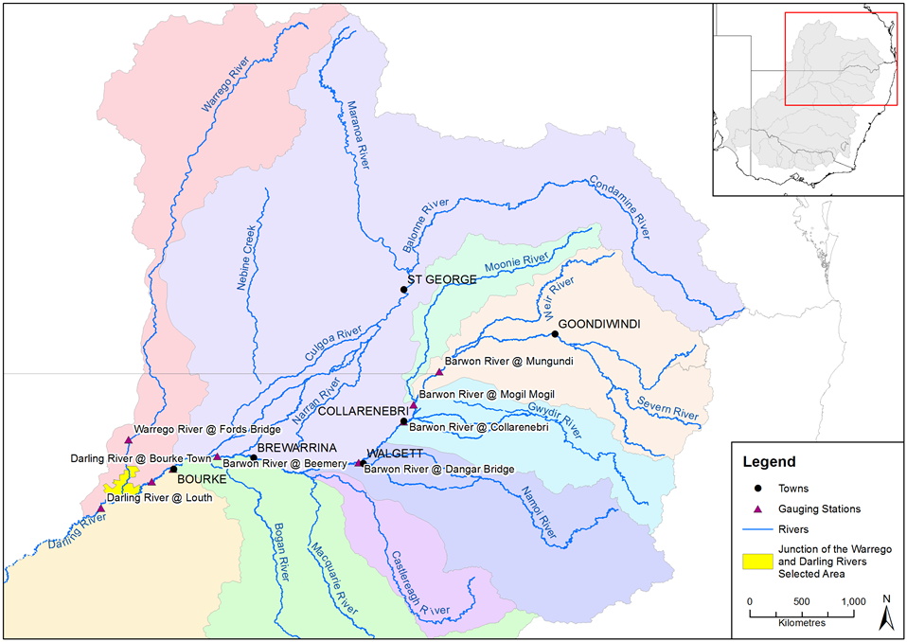
Figure B-1: Northern Tributaries of the Murray Darling Basin (Commonwealth Environmental Water Office).

Commonwealth environmental water holdings
Total Commonwealth environmental water holdings for the northern tributaries are currently 458,453 ML (Figure B-1). Long Term Average Annual Yield (LTAAY) provides an indication of the long term reliability of these entitlements and is generally used by the Commonwealth Environmental Water Holder for annual decision-making regarding water use priorities. At the time of writing, LTAAY of Commonwealth environmental water for the northern tributaries upstream of Louth was 230,727 ML. Current Commonwealth environmental water license information is available at
http://www.environment.gov.au/water/cewo/about/water-holdings

Table B-1: Commonwealth Water Holdings for Northern Tributaries to June 2017 (source Commonwealth Environmental Water Holder).
Catchment | Regulated (ML) |  | Unregulated (ML) |  | Total (ML)
 | Entitlement | LTAAY | Entitlement | LTAAY | Entitlement | LTAAY
Condamine-Balonne¹ | 45 | 43 | 97,281 | 59,100 | 97,326 | 59,143
Moonie | 0 | 0 | 1,415 | 1,100 | 1,415 | 1,100
Warrego (Qld) | 0 | 0 | 16,800 | 8,281 | 16,800 | 8,281
Warrego (NSW) - Toorale | 0 | 0 | 17,826 | 17,826 | 17,826 | 17,826
Barwon-Darling | 0 | 0 | 26,796 | 26,796 | 26,796 | 26,796
Border Rivers | 17,332 | 5,954 | 20,658 | 8,189 | 37,990 | 14,143
Gwydir² | 94,033 | 36,737 | 20,451 | 3,886 | 114,484 | 40,623
Namoi | 10,043 | 7,733 | 0 | 0 | 10,043 | 7,733
Peel | 1,257 | 326 | 0 | 0 | 1,257 | 326
Macquarie² | 126,224 | 53,014 | 8,292 | 1,741 | 134,516 | 54,755
TOTAL | 248,934 | 103,807 | 209,519 | 126,919 | 458,453 | 230,726
Notes:
¹ Includes (all LTAAY): Nebine Creek (1,000 ML); Lower Balonne unsupplemented and overland flow: 56,082 ML; Condamine unsupplemented: 227 ML
² Supplementary Water entitlements in the Gwydir and Macquarie catchments are listed for the purposes of this table as unregulated entitlements

Hydrology within the Selected Area
The hydrology within the Selected Area is governed by flows in either, or both, the Darling River and the Warrego River.
Located in a semi-arid setting, upstream climatic conditions are the key driver of hydrology within the Selected Area, with the easterly catchments capable of providing overbank flows within the Barwon-Darling River. During major events floodwaters may extend along the length of the river system.
During drier times, the relationship becomes more complex. From a water management point of view, the Barwon-Darling River system is considered to be an unregulated stream; however, it is fed by both regulated and unregulated upstream catchments with stream flows, in part, reflecting upstream water management decisions. Further complicating the hydrology is the influence of a series of weir pools, terminal wetlands, anabranches and anastomosing streams.
The Warrego River is essentially unregulated, and due to its semi-arid setting, provides water to the Selected Area intermittently. Within the Selected Area, Warrego flows are further influenced by a number of in-stream structures, such as Boera, Booka, Dicks and Peebles dams.
Commonwealth environmental water in the Warrego may only be accounted for once the individual conditions associated with each entitlement are met. This is usually based on a flow trigger that differs for each entitlement, based on its location and relative security. Depending on chosen watering strategies, Commonwealth environmental water may or may not be accounted for once the flow trigger is reached.

Methods
The downstream passage of Commonwealth environmental water events was observed and assessed using NSW DPI Water real-time flow data for gauging stations located along the Barwon-Darling River system. Mean daily discharge data for the following hydrometric stations was used:
- 416001 – Barwon River at Mungindi
- 422004 – Barwon River at Mogil Mogil
- 422003 – Barwon River at Collarenebri
- 422001 – Barwon River at Walgett
- 422028 – Barwon River at Beemery
- 425003 – Darling River at Bourke
- 425037 – Darling River at Weir 19a
- 425004 – Darling River at Louth

The relationship between these gauging stations and key tributary inflows is shown in Figure B-2
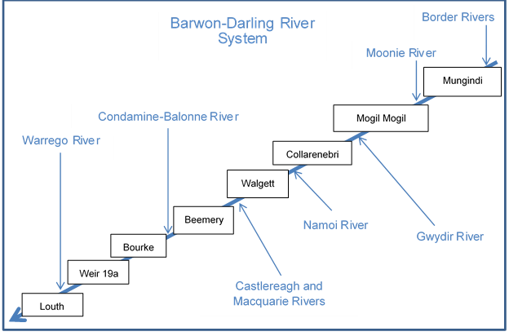
Figure B-2: Gauging stations and key tributaries on Barwon-Darling River system.
End of system (EOS) Commonwealth environmental water was estimated based on advice from Department of the Environment and Energy, NSW Office of Water and the CSIRO MDB Sustainable yield project (Table B-2). The EOS measure was used to estimate the amount of water (as a proportion of the total) which would have made it out of the end of each catchment, taking into account losses such as evaporation, infiltration etc.
Table B-2: End of System flow estimates used to assess downstream passage of Commonwealth environmental water.
Catchment | Applied EOS flow (%)
Border Rivers | 80
Moonie | 73
Gwydir | 24
Namoi | 63
Macquarie/Castlereagh | 76
Condamine-Balonne | 37
Barwon-Darling (Mungindi to Bourke) | 80
Warrego | 34

Results

2016-17 water year
NSW DPI Water daily flow records (Figure B-3) were cross-referenced with internal data and operational reports provided by the Commonwealth Environmental Water Office to assess key flow events where Commonwealth environmental water take was accounted in the northern tributaries during the 2016/17 water year.
Four flow ‘events’ were identified that included a component of Commonwealth environmental water take. Events between June 2016 and January 2017 were continuous, but with three distinct flow peaks. We considered each of these peaks as separate events. Each event is described below:
- 22 June – 1 August, 2016: comprising 13,087 ML Commonwealth environmental water from the Queensland Border Rivers, Castlereagh, Condamine-Balonne and Barwon-Darling River, as well as localised entitlements at Toorale.

- 2 August – 8 September, 2016: comprising 5,194 ML Commonwealth environmental water from Barwon-Darling River system.

- 9 September – 25 December, 2016: A very large event comprising 77,588 ML Commonwealth environmental water from all upstream catchments.

- 10 April – 17 May 2017: comprising 50,967 ML Commonwealth environmental water from the Border Rivers, Condamine-Balonne catchment, Namoi and the Castlereagh / Macquarie Rivers.
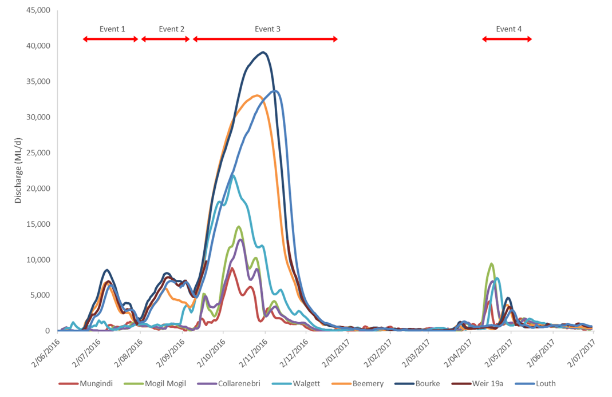

Figure B-3: Mean daily 2016/17 flows at gauging stations on Barwon-Darling River system.

Flow events 1, 2 and 4 were each of similar magnitude and duration, peaking between 8,000 and 10,000 ML/d and lasting approximately 40 days in duration. Flow event 3 was a more significant event with daily flows peaking at close to 40,000 ML/d at Bourke and extending for over 100 days.

Unregulated Commonwealth Environmental Water Take
Flow events where Commonwealth environmental water is accounted can be classified as regulated and unregulated events. Unregulated events are linked to prevailing climatic conditions, requiring specific streamflow conditions to be met in order to trigger individual Commonwealth environmental water entitlements (take). Unregulated Commonwealth environmental water take for each (CEW) event is presented for each MDB catchment in Table B-3.
Table B-3: Unregulated Commonwealth environmental water events for 2016/17 water year
Basin Plan Region | Tributary | Unregulated CEW take (ML) | Annual Total (ML) | Comments
QLD Border Rivers | Dumaresq-Macintyre River | CEW 1 – 914.3 | 21,805.8 | Flow Event 1 (7 July – 13 July)
 |  | CEW 3 – 14,376.8 |  | Flow event 2 (25 August – 25 October)
 |  | CEW 4 – 6,492.1 |  | Flow Event 3 (20 March – 3 April)
 | Severn River | CEW 3 – 823 | 823 | Streamflow in the Severn River at Farnbro peaked at around 6,000 ML/d in early Oct 2016 allowing take on the Severn River in QLD. Flows receded to around 190 ML/d by 12 October.
QLD Moonie | Lower Moonie River | CEW 3 – 1,415 | 1,415 | A small flow pulse in late August, peaking at around 1,500 ML/d at Flinton initiated take on the Commonwealth. A larger flow in late September, peaking at around 8,000 ML/d on 20 September exhausted the approved volume of CEW at Flinton for 2016-17.
QLD Condamine –Balonne | Lower Floodplain | CEW 3 – 28,869.6  CEW 4 -16,892.2 | 45,761.8 | CEW 3 take during September 2016  CEW 4 take during April 2017.
QLD Warrego | Upper Warrego River | CEW 3 | 794.84 | QLD DNRM annouceed an access period for upper Warrego entitlements between 19/09/2016 18:00 and 29/09/2016 18:00 allowing CEW take
 | Lower Warrego River | CEW 1 – 1,912  CEW 2 – 602  CEW 3 – 6,205 | 8,719.96 | Four water harvesting periods were announced by QLD DNRM so far during 2016-17:  Flow event 1 - 1/07/2016 18:00 - 7/07/2016 6:00 (Flow peak ~ 11,000 ML/d)  Flow event 2 - 31/07/2016 6:00 - 2/08/2016 6:00 (Flow peak ~ 5,000 ML/d)  Flow event 3 - 6/09/2016 6:00 - 7/09/2016 12:00 (Flow peak ~ 4,000 ML/d)  Flow event 4 - 23/09/2016 12:00 - 10/10/2016 12:00 (Flow peak ~ 50,000 ML/d)
NSW Gwydir | Mallowa Creek | 0 | 0 | No Supplementary CEW take
 | Mehi River | CEW 3 – 5,000 | 5,000 | Supplementary water event between 17 and 21 September 2016
 | Carole – Gil Gil Creek | CEW 3 – 1,351 | 1,351 | CEW comprised 1,351 ML of 60,000 ML diverted into Carole Creek between 15 and 21 September 2016.
NSW Macquarie-Castlereagh | Macquarie River | CEW 1 – 3,000  CEW 3 – 4,250 | 7,250 | 3,000 ML of Commonwealth supplementary water was delivered between 24 and 30 July.  3,500 ML of Commonwealth supplementary water was delivered between 6 and 13 September.  750 ML of Commonwealth supplementary water was delivered between 19 and 21 December.
NSW Intersecting Streams – Warrego | Lower Warrego River | CEW 3 – 7,762.5 | 7,762.5 | Flows in the Warrego River at Toorale in October 2016 (7,762.50 ML) for fish spawning, recruitment and movement.
NSW Intersecting Streams | Toorale Western Floodplain | CEW 1 – 1,166  CEW 2 – 5,194  CEW 3 – 3,359 | 9,720 | Three flows combined during June-Sept in the Warrego system allowing take of Commonwealth environmnetal water for the Western floodplain from 19 July (following visible connection of the Warrego with the Darling and closure of the regulators at Boera Dam). The gates at Boera were opened again from the 9-12 September in accordance with licence conditions for a new event. Following this, further inflows were spilled to the Western Floodplain with total approved volume reaching the annual allocation of 9,720 ML by 20 Sept 2016.
NSW Barwon - Darling | Barwon-Darling River | CEW 1 – 9,173  CEW 2 – 5,361  CEW 3 – 13,719 | 26,796 | CEW 1 includes take during June 2016.  All classes of entitlement in the Barwon Darling had exceeded the approved volume by mid October 2016.

Regulated Commonwealth Environmental Water Take
Regulated Commonwealth environmental water take is not dependent on specific stream flows and may be triggered in response to a wider range of river or environmental management decision criteria. Regulated Commonwealth environmental water take for each regulated river system is presented in Table B-4.
Table B-4: Regulated Commonwealth environmental water take, 2016/17.
Basin Plan Region | Tributary | Regulated CEW take (ML) | Comments
QLD Border Rivers | Dumaresq-Macintyre River | 0 | Regulated CEW not released during 2016/17
NSW Border Rivers | Severn-Macintyre River | 0 | Regulated CEW not released during 2016/17
NSW Gwydir | Gwydir River | 9,000 | Delivery of 30,000 ML (total) during summer 2017 to inundate broad areas of semi-permanent wetland vegetation.
 | Mallowa Creek | 7,496 | Very little of the natural flows occuring in the Gwydir catchment in September were diverted into the Mallowa wetlands. In response planned deliveries of 5,000 ML were increased to 10,000 ML for delivery over two months between January and March 2017.
NSW Namoi | Namoi River | 9,109 | March – May 2017. Water was delivered from Keepit Dam to maintain 100 ML/d at Gunnedah for silver perch. Water was also being delivered from Gunidgera Weir to maintain flows in the lower river and connection with Barwon River flows. Walgett town Weir was drowned out by water backing up from Walgett Weir (11A) on the Barwon River providing fish passage over the Walgett town Weir. Commonwealth environmental water provided connectivity along the lower Namoi River from Gunidgera Weir to Walgett allowing fish to move from the Barwon River into the Namoi River.
NSW Macquarie-Castlereagh | Macquarie River and floodplain | 47,270 | 24 January – 18 February 17,039 ML to support completion of colonial waterbird breeding (WUM 10055-1)  4 April – 12 April 2,648 ML to allow post-spawning dispersal (WUM 10055-2)  16 April – 15 May 27,583 ML to provide connection from the mid-Macquarie River to the Barwon River via the Macquarie Marshes and lower Macquarie River, to facilitate native fish movement between the two river systems (WUM 10055-3).
Assessing the regulated Commonwealth environmental water accounted during 2016-17, the following Commonwealth environmental water events were considered likely to influence flows within the Selected Area:
- Namoi River – 9,109 ML during May 2017 (of this, approximately 6086 ML was estimated to reach the Barwon River).
- Macquarie-Castlereagh – 27,583 ML during May 2017 (of this, approximately 3,226 ML was estimated to reach the Barwon River)

Other regulated releases fulfilled a range of instream and riparian functions, including:
- Within-reach releases for local environmental benefit.
- Wetland watering for Gwydir Wetlands and Macquarie Marshes.

End-of-system flow event analysis
EOS Commonwealth environmental water figures provide an estimation of the volumetric contribution of upstream Commonwealth environmental water as it passes through the Barwon-Darling system to the Selected Area at Toorale, and further downstream.

B.3.4.1 Event 1
Event 1 was characterised by increased instream flows within the lower reaches of the Barwon-Darling River downstream of Walgett, suggesting significant flow contributions from the Castlereagh and the Condamine-Balonne rivers. Commonwealth environmental water take during this period comprised 13,086.97 ML. Allowing for system losses, this was estimated to contribute around 6% of the total flow volume at the Selected Area (Table B-5).
Table B-5: Commonwealth environmental water flow event 1 (22 June – 1 August, 2016) EOS flow assessment.
Gauging Station | Event Duration | Total Event Discharge | Upstream CEW Take | Estimated EOS CEW
 | Days | ML | ML | ML | %
Mungindi | 40 | 20,065 | 914.3 | 731.44 | 3.6
Mogil Mogil | 40 | 14,224 | 914.3 | 731.44 | 5.1
Collarenebri | 40 | 14,312 | 914.3 | 731.44 | 5.1
Walgett | 40 | 29,670 | 914.3 | 731.44 | 2.5
Beemery | 40 | 140,297 | 3,914.3 | 3,011.44 | 2.1
Bourke | 40 | 184,162 | 11,630.3 | 9,184.24 | 5.0
Weir 19A | 40 | 140,679 | 11,630.3 | 7,015.71 | 5.0
Louth | 40 | 129,820 | 13,086.97 | 7,818.41 | 6.0

B.3.4.2 Event 2
Occurring between 2 August and 8 September 2017, flow event 2 exhibited a similar pattern of water contributions as Event 1. Commonwealth environmental water take during this period comprised 5,194 ML. Allowing for system losses, this was estimated to contribute around 1.8% of flow volume at the Selected Area (Table B-6).
Table B-6: Commonwealth environmental water flow event 2 (2 August – 8 September, 2016) EOS flow assessment.
Gauging Station | Event Duration | Total Event Discharge | Upstream CEW Take | Estimated EOS CEW
 | Days | ML | ML | ML | %
Mungindi | 37 | 18,977 | 0 | 0 | 0
Mogil Mogil | 37 | 22,513 | 0 | 0 | 0
Collarenebri | 37 | 24,300 | 0 | 0 | 0
Walgett | 37 | 50,225 | 0 | 0 | 0
Beemery | 37 | 156,487 | 0 | 0 | 0
Bourke | 37 | 230,256 | 5,194 | 4,155.2 | 1.8
Weir 19A | 37 | 209,264 | 5,194 | 3,776.38 | 1.8
Louth | 37 | 171,909 | 5,194 | 3,102.26 | 1.8

B.3.4.3 Event 3
Flow event 3 occurred from 9 September to 25 December 2016. This larger flow event included significant Commonwealth environmental water take from all upstream subcatchments. Total Commonwealth environmental water take during this period was 77,588.2 ML with significant take within the Border Rivers, Condamine–Balonne and Barwon Darling river systems. Despite large amounts of Commonwealth environmental water take, high natural river flows meant that the relative contribution of this take to be approximately 2.4 % of flow volume at the Selected Area (Table B-7).
Table B-7: 2015/16 Commonwealth environmental water flow event 3 (9 September – 25 December, 2016) EOS flow assessment.
Gauging Station | Event Duration | Total Event Discharge | Upstream CEW Take | Estimated EOS CEW
 | Days | ML | ML | ML | %
Mungindi | 107 | 250,736 | 15,222 | 12,177.60 | 4.9
Mogil Mogil | 107 | 451,693 | 16,637 | 13,207.61 | 2.9
Collarenebri | 107 | 403,852 | 22,988 | 14,741.75 | 3.7
Walgett | 107 | 930,081 | 22,988 | 14,741.75 | 1.6
Beemery | 107 | 1,746,459 | 27,238 | 17,971.75 | 1.0
Bourke | 107 | 1,989,197 | 69,826.2 | 39,628.56 | 2.0
Louth | 107 | 1,772,486 | 77,588.2 | 42,227.64 | 2.4

B.3.4.4 Event 4
Flow event 4 occurred after a period of approximately 4 months of low river flows within the Barwon-Darling river system (Table B-3). This event was characterised by rainfall and increased river flows in catchments upstream of Bourke. Unregulated Commonwealth environmental water take was limited to the Border Rivers and Condamine-Balonne system (Table B-8). However, this event was augmented by regulated releases from the Macquarie into the Barwon-Darling and from the Namoi catchment to facilitate connectivity and fish passage (Table B-4). Accordingly, Commonwealth Environmental Water contributed 36.5% of the total volume of water at the Selected Area (Table B-8).
Table B-8: 2015/16 Commonwealth environmental water flow event 4 (10 April – 17 May, 2017) EOS flow assessment.
Gauging Station | Event Duration | Total Event Discharge | Upstream CEW Take and regulated EOS contributions. | Estimated EOS CEW
 | Days | ML | ML | ML | %
Mungindi | 37 | 57,851 | 6,492.1 | 5,193.68 | 9.0
Mogil Mogil | 37 | 110,500 | 6,492.1 | 5,193.68 | 4.7
Collarenebri | 37 | 91,688 | 6,492.1 | 5,193.68 | 5.7
Walgett | 37 | 89,208 | 12,578.1 | 11,279.68 | 12.6
Beemery | 37 | 47,174 | 34,075.1 | 14,505.68 | 30.7
Bourke | 37 | 54,401 | 50,967.3 | 20,755.79 | 38.2
Weir 19A | 37 | 42,200 | 50,967.3 | 16,100.73 | 38.2
Louth | 37 | 44,161 | 50,967.3 | 16,100.73 | 36.5

B.3.4.5 Warrego River end of system flows
Within the Warrego catchment, Commonwealth environmental water was accounted during flow events 1, 2 and 3. EOS flow assessment at Fords Bridge (Table B-9) provides an estimate of the volumes and proportions of Commonwealth environmental water entering the Selected Area at Boera Dam. The estimated proportion of Commonwealth environmental water during individual events ranged between 3.3% and 8.4% of total flows. Overall, it is estimated that approximately 2,958 ML of Commonwealth environmental water entered Boera Dam during 2016/17. This comprised 6.0% of all inflows.
Table B-9: EOS flow assessment for Commonwealth environmental water in Warrego River.
Flow Event | Total Event Discharge (Fords Bridge) | Upstream Warrego CEW Take | Estimated EOS CEW
 | ML | ML | ML | %
Event 1 | 7,720 | 1,912 | 649 | 8.4
Event 2 | 6,119 | 602 | 204 | 3.3
Event 3 | 35,358 | 6,205 | 2105 | 5.9
Total | 49,197 | 8,719 | 2,958 | 6.0

Multi-year comparison
The 2016/17 water year is the third year of the five year LTIM project at the Selected Area. Comparing 2016/17 flows with preceding 2014/15 and 20115/16 flows, it is apparent that flow event 3 during 2016/17 represents a significant event in the study period (Figure B-4).
2014/15 and 2015/16 water years were characterised by predominantly low flow conditions with occasional small instream flow pulses insufficient to exceed channel capacity. Total volumes for each of these events did not exceed 55,000 ML making them similar in magnitude to flow event 4 during April 2017. Flow events 1 and 2 were incrementally larger, with total volumes of 129,820 ML and 171,909 ML, respectively. Event 3 was approximately an order of magnitude larger than the largest preceding flow (event 2) with a total volume of 1,772,486 ML at Louth.
Total Commonwealth environmental water contributions during each event at the Selected Area in 2016/17 were generally greater than contributions during previous events (Table B-10) with the exception of flow event 2.
The total proportion of Commonwealth environmental water contributed to each flow event during 2016/17 varied between 1.8% and 36.5%. The magnitude and variability of these proportions are similar to those in 2014/15 and 2015/16 (Table B-10). As expected, a higher percent contribution of Commonwealth environmental water occurs during smaller events, coinciding with estimated take volumes between 5,000 and approximately 12,000 ML at Louth. The exception to this was flow 4 in 2016-17 that included a significant proportion of regulated environmental water out of the Namoi and Macquarie catchments. As flow events grow in size, they tend to trigger greater Commonwealth environmental water take, however, the relative contribution is reduced as natural flows increase.
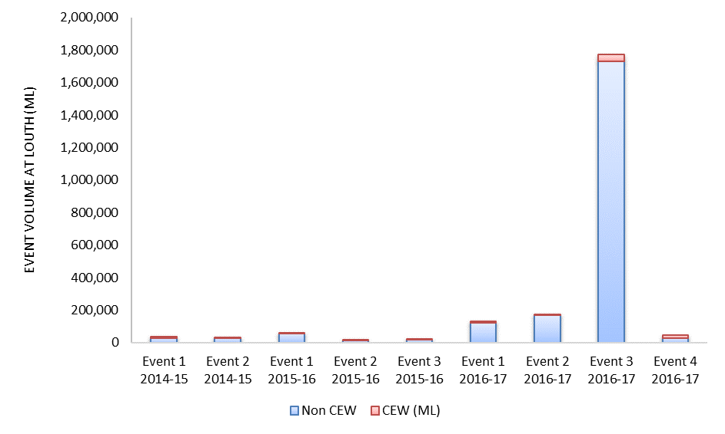
Figure B-4: Multi-year comparison of total flow volumes at Louth gauge.

Table B-10: Multi-year comparison of total flow volumes at Louth gauge.
Water Year | Flow Event | Total Event Discharge (Louth) | Estimated EOS CEW
 |  | ML | ML | %
2014/15 | Event 1 | 27,797 | 9,593 | 25.66
 | Event 2 | 27,394 | 1,135 | 3.98
2015/16 | Event 1 | 53,501 | 2,824 | 5.01
 | Event 2 | 12,161 | 428 | 3.40
 | Event 3 | 15,477 | 6,621 | 29.96
20167/17 | Event 1 | 129,820 | 7,818 | 6.02
 | Event 2 | 171,909 | 3,102 | 1.80
 | Event 3 | 1,772,486 | 42,228 | 2.38
 | Event 4 | 44,161 | 16,101 | 36.46

Discussion
The 2016/17 water year was characterised by ongoing flow events during 2016, which peaked with significant flows in the Selected Area between October and December 2016. Average daily discharge peaked at nearly 40,000 ML/day at Bourke at the start of November. Following that event the river returned to low/base-flow conditions in early January 2017, until another smaller event during April and May 2017.
Total unregulated Commonwealth environmental water take in 2016/17 was 127,480 ML in tributaries influencing the Selected Area. This was augmented with a further 72,875 ML of regulated Commonwealth environmental water in upstream tributaries, of which 9,312 ML moved into the Barwon Darling and through to the Selected Area. A further 9,720 ML of Commonwealth environmental water was diverted from the lower Warrego River onto the Western Floodplain at Toorale.
Allowing for system losses, it is estimated that approximately 69,249 ML of Commonwealth environmental water passed through the Selected Area during 2016/17. This compares with 10,730 ML during 2014/15 and 9,875 ML in 2015/16. Such a volume of water has contributed to aquatic and terrestrial environmental responses and processes within the Selected Area (Appendices H-O).
Although 2016/17 resulted in large volumes of take against Commonwealth environmental water entitlements, the relative proportion of Commonwealth environmental water within flows 1-3 remained similar to that in previous years. The proportion of Commonwealth environmental water was highest in flow event 4 during April and May 2017 where it accounted for 36.5% of total event volume. The high proportion of Commonwealth environmental water in this event was the result of regulated deliveries in the tributaries coinciding with unregulated flows down the Barwon-Darling channel, to increase overall event magnitude and duration. This is a good example of the potential to co-ordinate flows to achieve benefits in multiple catchments.
Unregulated Commonwealth environmental water take is inherently linked to coincident river flow conditions and, accordingly, will always provide a portion of the water available during flow events. Experience at the Selected Area during the past three years indicates that Commonwealth environmental water may contribute up to 30% of the total volume, however, such contributions are only likely to occur under conditions when Commonwealth environmental water take volumes are between 5,000 ML to 12,000 ML. The use of regulated Commonwealth environmental water provides an opportunity to augment natural river freshes and to move environmental water out of the regulated sub catchments, into the Barwon-Darling River and downstream to the Selected Area.

Conclusion
The 2016/17 water year was characterised by significant river flows throughout the Northern Tributaries, particularly during 2016. Four flow events sufficient to trigger unregulated Commonwealth environmental water take occurred during the water year, providing approximately 7,818 ML, 3,102 ML, 42,228 ML and 16,101 ML of Commonwealth environmental water at Louth. It is estimated that during each event Commonwealth environmental water made up around 6.0%, 1.8%, 2.4% and 36.5% of these flows respectively, enhancing instream longitudinal connection and access to habitat throughout the Selected Area. Unregulated Commonwealth environmental water comprised approximately 6.0% of flows in the lower reaches of the Warrego River, contributing a further 2,958 ML into the Selected Area at Boera Dam during flow events 1, 2 and 3.
Regulated Commonwealth environmental water releases helped to augment unregulated take during April and May 2017, contributing to a high proportion of Commonwealth environmental water in the Darling River at the Selected Area during this event. No Commonwealth environmental water entered Boera Dam during this flow event.
Overall, analysis of these flow events indicates that during 2016/17, Commonwealth environmental water take in upstream catchments played a role in promoting the transmission of natural flow events downstream towards the Selected Area. This, in turn, permitted increased take from local licences associated with Toorale Station at the Selected Area, providing benefits for both instream and floodplain ecosystems.

Hydrology (Channel)

Introduction
The lower Warrego River within the Junction of the Warrego and Darling rivers Selected Area (Selected Area), is a complex system with multiple channels flowing within a broader, largely vegetated water course. Along this reach, several in-channel dams and flow diversion structures have been established over the last 150 years (Aurecon 2009). At present these dams are in various states of decommission, with some still heavily influencing the hydrology, while others, which have been breached, have little influence over river flows (Alluvium 2016).
The Hydrology (Channel) indicator is focused on describing the channel network and function of the lower Warrego channel. Previous reporting on this indicator sought to describe: the planform and nature of the channel network; assess flow travel times and quantify channel dimensions (Commonwealth of Australia 2015, Commonwealth of Australia 2016). This chapter further characterises the size and shape of the channels of the lower Warrego River within the Selected Area, and assesses its connectivity during the dominant flow stage.
This indicator links to other indicators being measured including hydrology (floodplain and river), Water quality, metabolism, microinvertebrates, frogs and waterbirds. Broadly, this indicator addresses the following question:
- What did Commonwealth environmental water contribute to hydrological connectivity?

Environmental watering in 2016-17
Warrego River
Several flow pulses in the Warrego River occurred between June - November 2016. The demand for environmental flows on the Western Floodplain was very high given the last large-scale inundation of the Western Floodplain at Toorale was in 2012. As per licence conditions, a fresh in the Warrego River in July 2016 was allowed to make visible connection with the Darling River prior to closing the gates in Boera Dam and allowing Commonwealth environmental water to spill to the Western floodplain from 19 July 2016. The gates at Boera were opened again from the 9-12 September 2016 to connect with the Darling River in accordance with licence conditions for a new flow event. Following this, further inflows were spilled to the Western Floodplain with total approved volume reaching the annual allocation of 9,720 ML by 20 September 2016. Water continued to spill onto the Western Floodplain until December 2016. In total, 31,000 ML of water flowed onto the Western Floodplain of which 31% was Commonwealth environmental water.
Another fresh occurred in the Warrego River during September - November 2016. The Boera Dam gates were again opened and once the fresh had connected with the Darling River, Commonwealth environmental water licences on the Warrego River were used to provide a pulse of water down the Warrego River. This flow aimed to provide opportunities for native fish to access habitat, support recruitment and possibly triggering spawning. 10,500 ML of water was released down the lower Warrego River channel and included 7,762 ML (74%) Commonwealth environmental water. The release was managed to provide a slow rise and fall to the pulse and also ensure that water also continued to spill to the Western Floodplain at the same time. Commonwealth water was used to provide connection for 20 days. National Parks and Wildlife Service maintained the connection for an additional 5 days before closing the gates and allowing the remaining water to spill to the Western Floodplain.

Methods

Environmental water delivery and accounting
Flows down the lower Warrego channel are predominantly dependent on the operation of Boera Dam. Decisions surrounding the management of Toorale entitlements are as important as the amount of entitlements held in influencing ecological outcomes.
Descriptive analysis of Commonwealth environmental water was undertaken by analysis of hydrographs upstream of the Selected Area and examination of gauge heights at Boera and Dicks Dams. Accounting of Commonwealth environmental water was provided by Commonwealth Environmental Water Office staff considering overall water delivery and water sharing plan rules in the catchment (Appendix A, Appendix B).

Channel field survey
Field surveys were conducted on the 6-7 March 2017 to further describe the Warrego channel morphology, building on the aerial photography mapping undertaken in 2014-15 and the lidar-based cross-section analysis undertaken in 2015-16. The field survey comprised inspection and photographic records of the channel from Boera Dam to the confluence with the Darling River. Three total station cross-sections were surveyed at transects used for the 2015-16 lidar-based analysis, to enable comparison. The total station cross-sections were undertaken at transects 8,13 and 16 (Figure C-1). At each cross-section channel bed and bank material were described using field texturing (McDonald et al, 1990). Field observations were also noted.

Image analysis
A Landsat ETM satellite image was captured over the site on 16 October 2016. This image coincided with a steady release of 600 ML/d from Boera Dam for a period of greater than 24 hours. Given that the 2014-15 analysis of flow travel times in the system established that flow from Boera Dam took less than one day to join the Darling River it is assumed that the image captured a steady stage along the study reach. This image was analysed using density slicing of the mid-infrared band to map the open water extent and thus describe the area of channel inundated at this stage.
The inundated area shown by this image is likely to represent the dominant flow stage in this section of the Warrego River given its highly regulated nature below Boera Dam. Apart from local rainfall inflows, this reach is predominantly wetted when the gates at Boera and Booka Dams are opened to comply with Toorale water licence requirements at Boera Dam. The 600 ML/d threshold corresponds to the maximum flow that can be transferred down the river when both gate structures at Boera Dam are open.
This image, along with the topographic surveys, aerial imagery re-analysis and field observations allowed for the refinement of the channel mapping undertaken in year 1 of the LTIM project (Commonwealth of Australian 2015). Here, areas that appeared to have been previously incorrectly mapped as either primary or secondary channels were remapped and channel network statistics re-calculated.
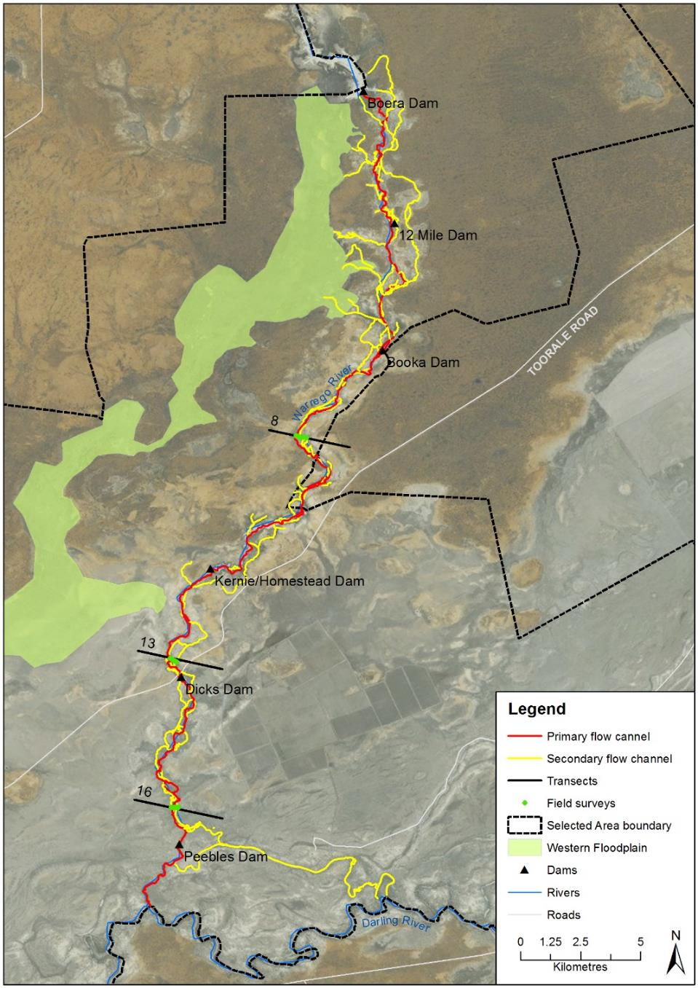
Figure C-1: The lower Warrego River study area with field and lidar cross-sections labelled.

Results and Discussion

Channel morphology
Field survey showed the Warrego channel to be small and incompetent with multiple small channels in some areas and poorly defined banks. In the vicinity of Peebles Dam, the channel resembles a very small gutter-like watercourse, less than 4 m wide and 0.5 m deep, sitting within a broader vegetated open depression that contains remnant dead trees (Figure C-2). At the edges of the open depression are higher banks or ridges with living trees. At this location the river is confined to this single pathway with one main channel.
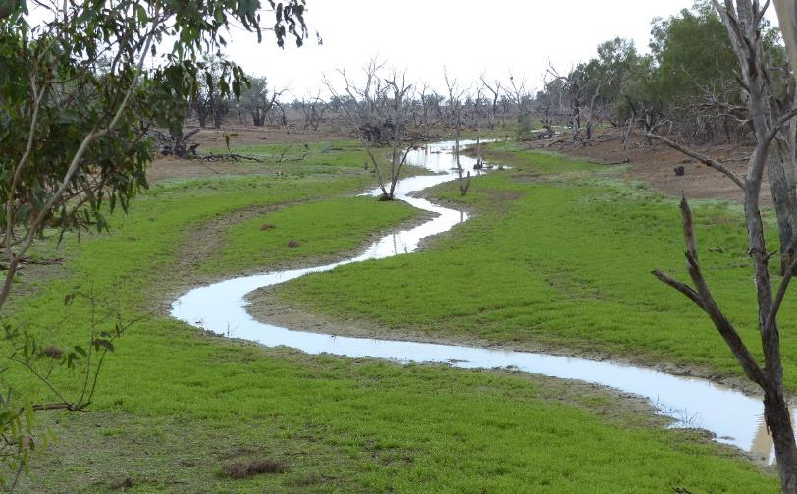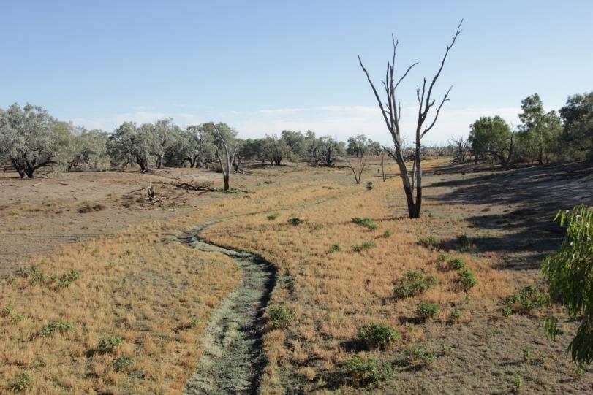
Figure C-2: The Warrego River looking upstream from Peebles Dam under wet (top) and dry (bottom) conditions.
Transect 8
The cross-section and field observations at Transect 8 show up to eight small channels (Figure C-3, Figure C-4). At this site, it was difficult to discern a clear main channel. Several channels or flow paths appeared to be of similar dimensions and showed evidence of recent flow (e.g. debris accumulation on fences or large woody debris). Each individual channel or flow path was less than 10 m across and 1 m deep. The channel denoted with the letter A in Figure C-3 was most likely the main flow path. Although even in the field it was difficult to discern a main channel. Field texturing of the bed and bank material found medium clay.
The channels were relatively indistinct and dissipated within a few hundred metres to form new flow paths or channels. Channel capacity was very low and it appeared that many of the lower lying areas act as flow path.
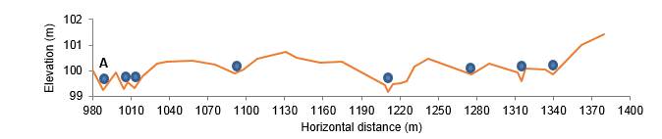
Figure C-3: Transect 8 field cross-section, A is the main channel, blue dots indicate the other channels/flow paths noted in the field. Vertical exaggeration (VE) is approximately 20.

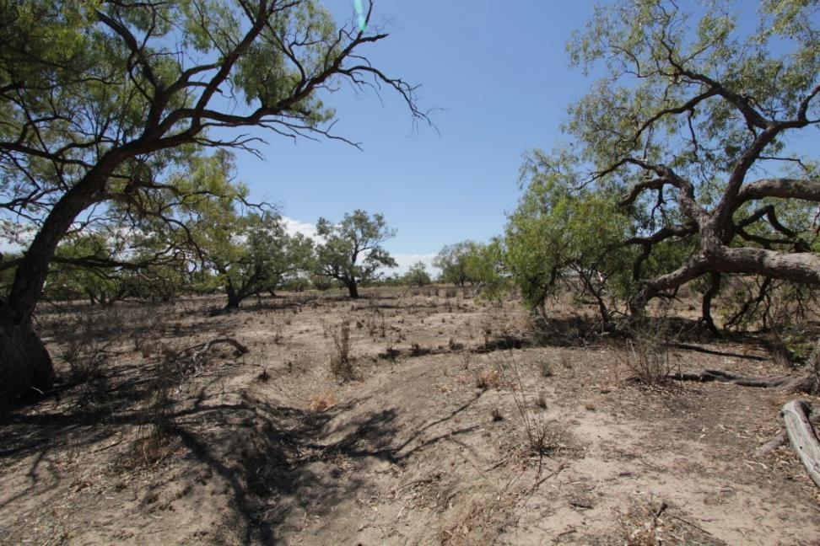
Figure C-4: Small channels and flow paths at Transect 8.

Transect 13
The cross-section and field observations at Transect 13 above Dicks Dam showed a more distinctive main channel with adjacent smaller flow paths (Figure C-5, Figure C-6). The main channel was approximately 30 m wide and 1 m deep. Field texturing of the bed and bank material found medium clay.
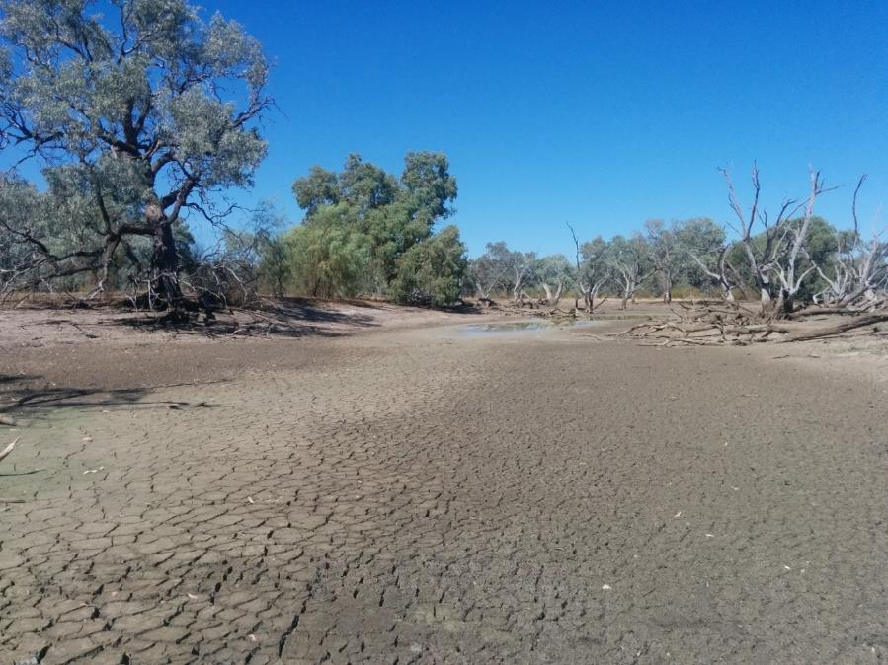
Figure C-5: Main channel at Transect 13, above Dicks Dam.
Transect 16
The cross-section and field observations at Transect 16 up stream of Peebles Dam (Figure C-2, Figure C-6) showed a very small active channel embedded within a broader channel/floodplain complex. The small channel that can be seen clearly in Figure C-2, is approximately 4 m wide and less than 0.5 m deep. The channel bank material was found to be medium clay with heavy clay in the channel bed.

Comparison with Lidar analysis
Comparison of the cross-sections generated from the Lidar and topographic survey show a good general agreement from the two data sources (Figure C-6). However, in this region with poorly defined channels often with multiple flow paths, interpretation of the Lidar based survey is problematic. Channel analysis using Lidar data found that channel width ranged from 10-265 m with depth ranging from 0.2-3.66 m (Commonwealth of Australia 2016). For transects 8, 13 and 16 channel widths were estimated at 10 m, 130 m and 203 m respectively and depth at 0.52 m, 0.54 and 0.27 m. The Lidar analysis also assumed a single main channel and derived channel geometry parameter using this single channel assumption. Field survey at transects 8, 13 and 16 and broader field inspection of the channel shows a more complex channel system with greatly reduced active channel widths. While it was difficult to define clear channel banks in places , channel widths were generally less than 10 m.
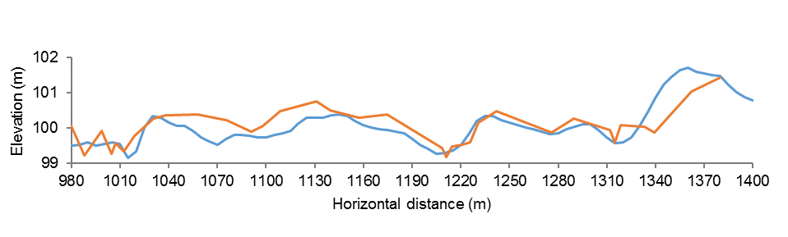
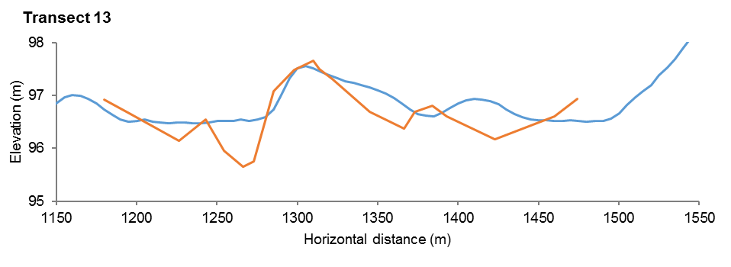
Transect 8
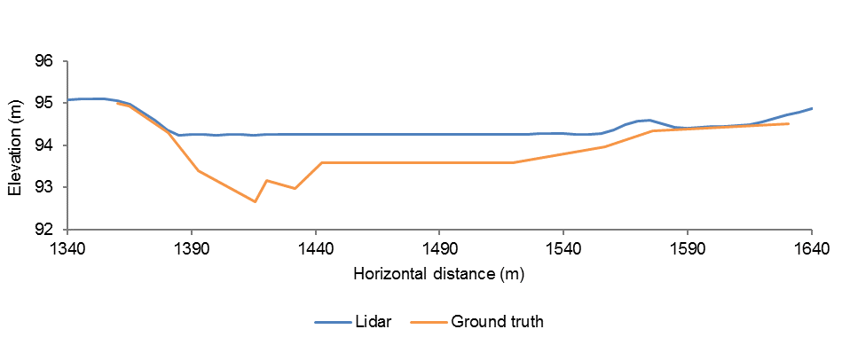
Transect 16

Figure C-6: Comparison of Lidar and topographic survey cross-sections (VE approximately 20).

Image analysis
Inundation results in 2016-17, topographic surveys, aerial imagery re-analysis and field observations enabled the channel hierarchy to be refined. Two channel reaches previously mapped as primary channels were reclassified to secondary channels due to lack of connection at 600 ML/d (Figure C-8, Figure C-9). One primary channel at Homestead Dam was reclassified as a secondary channel following confirmation in the field that this channel was not always inundated when the channel further to the west was inundated (Figure C-8). At Dick’s Dam, field observations suggested that flow down a larger channel that was previously mapped as primary, has now been cut off by a road crossing. Flow is now directed away from this channel by pipes under Toorale Road and as such it now functions as a secondary channel, with flows appearing to back-up into this channel downstream of the road crossing (Figure C-9).
At Booka Dam, aerial images from different periods confirmed inundation is more permanent in the eastern channels (Figure C-10, Figure C-11). Acknowledging these changes, 54.47 km of the channel network within the Selected Area are categorised as primary channels, accounting for 30% of all channels. Secondary channels covered 124.64 km, representing 70% of mapped channels in the Selected Area.
In 2016-17, 1,075 ha of the lower Warrego River was inundated within the Selected Area (Figure C-7), measured after several days of connection at around 600 ML/d through the gates at Boera Dam. This would represent the typical area of inundation expected at this flow rate. Quantification of the channel network of the lower Warrego river indicated that 130.30 km of the channel was inundated at 600 ML/d, accounting for 78% of the total channel network. The length of primary channels inundated was 52.75 km (40% of total), while 77.54 km of secondary channels were inundated (60% of total).
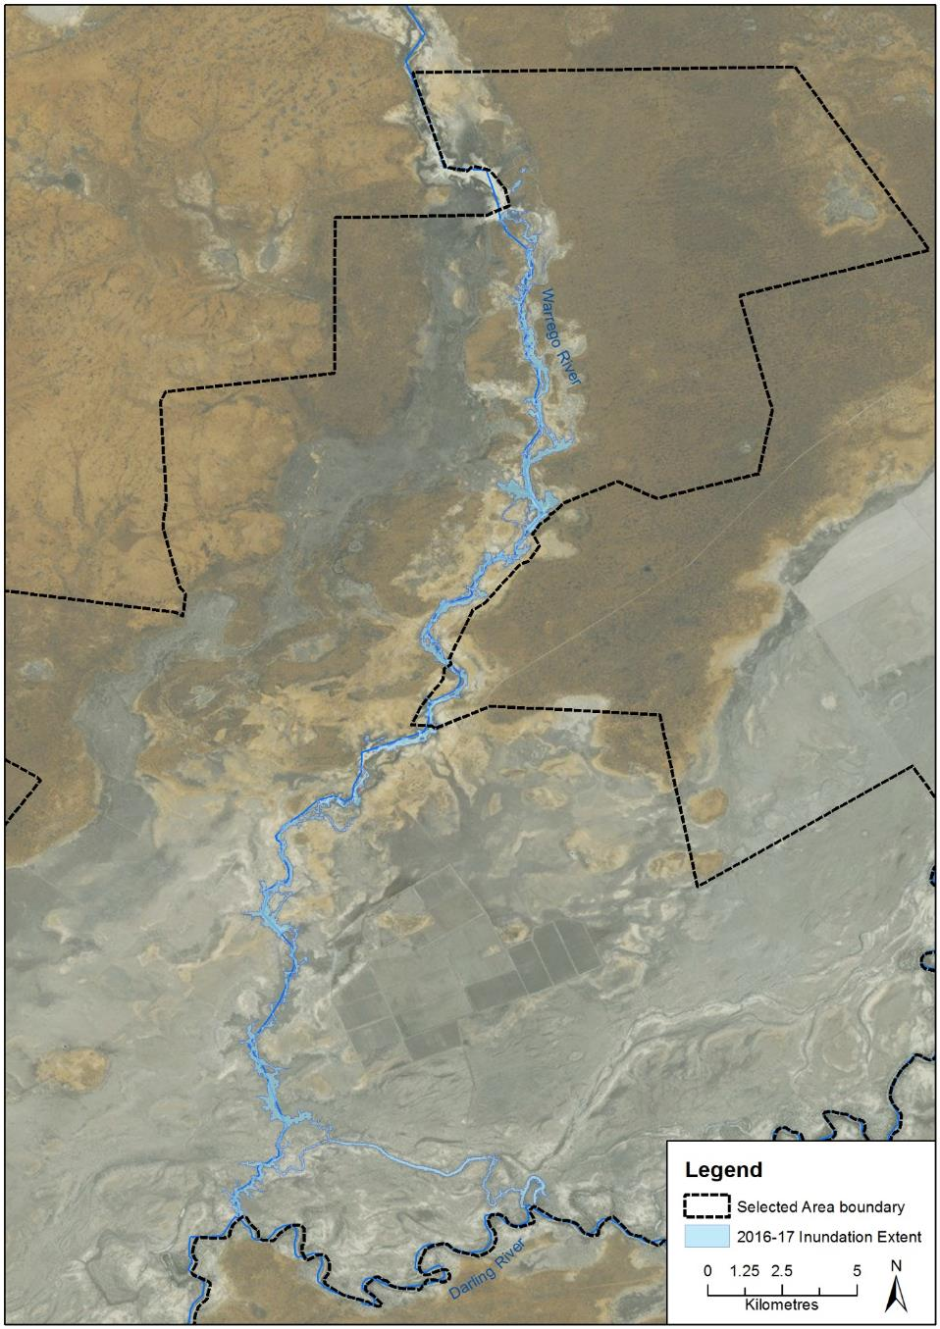
Figure C-7: Inundation extent of the Lower Warrego river in 2016-17.
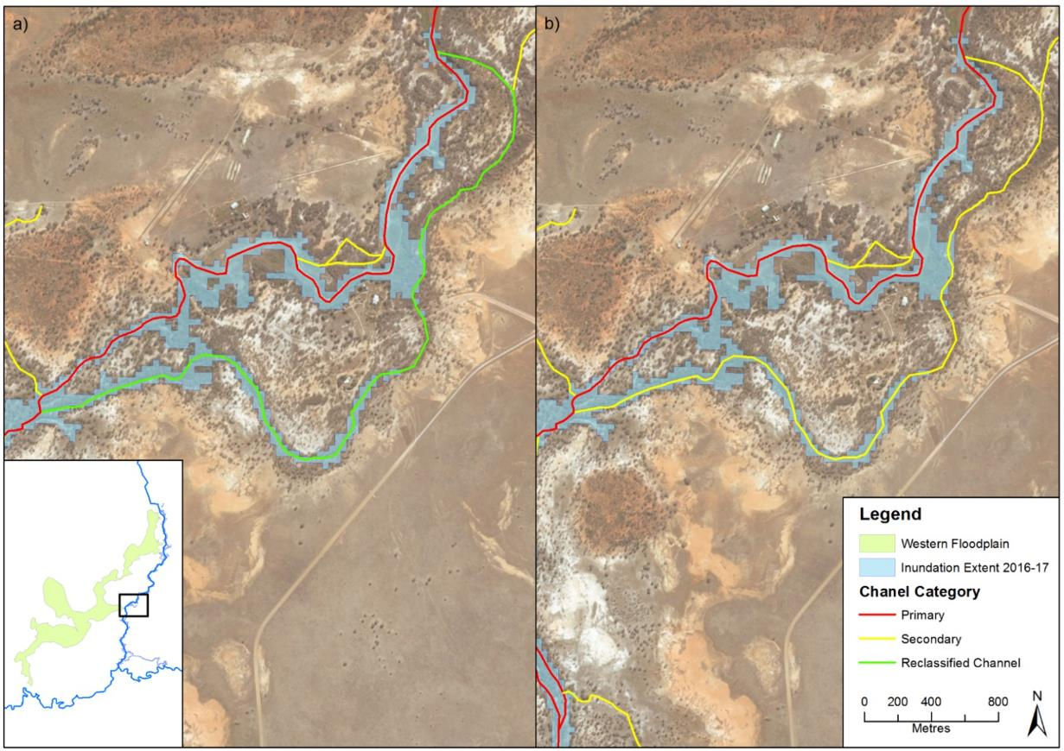
Figure C-8: Amendment of primary channel to secondary channel in the Warrego River at Homestead Dam. a) reclassified channels. b) updated categorisation.
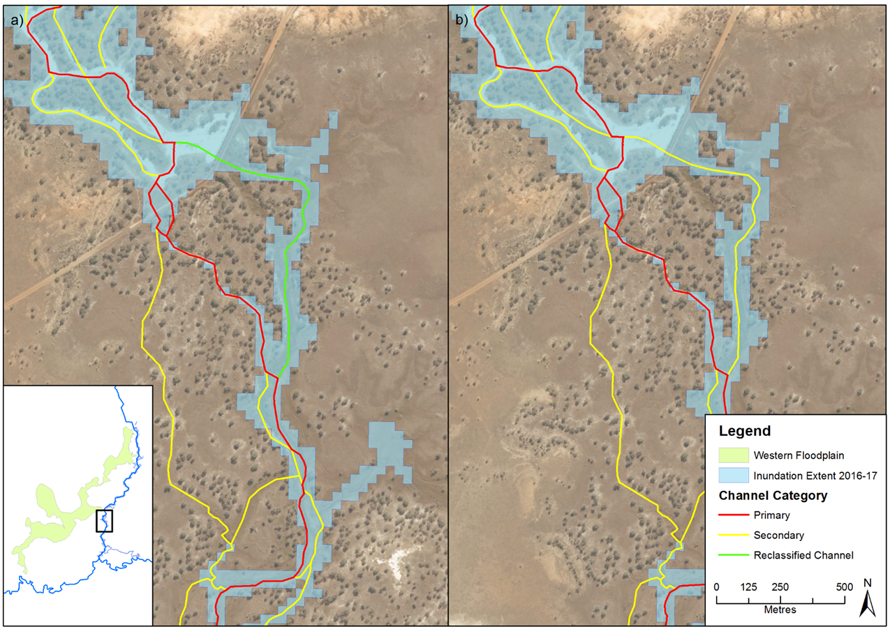
Figure C-9: Amendment of primary channel to secondary channel in the Warrego River at Dick’s Dam. a) reclassified channels. b) updated categorisation.
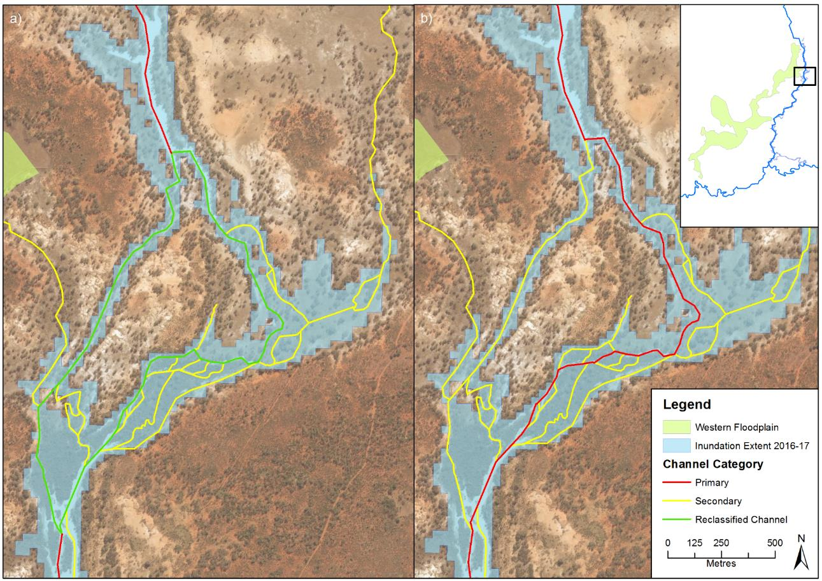
Figure C-10: Amendment of secondary channel to primary channel in the Warrego River at Booka Dam. a) reclassified channels. b) updated categorisation.


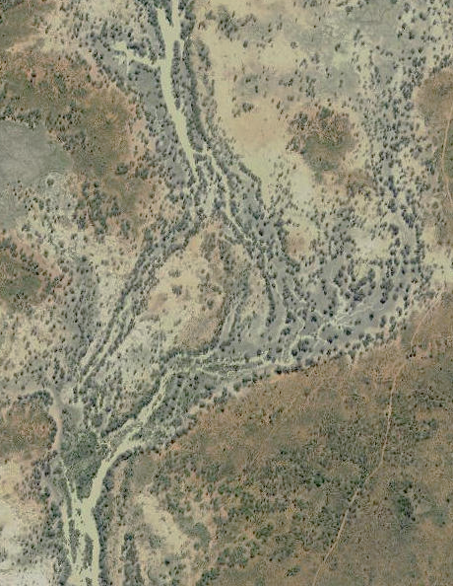
Figure C-11: Aerial image showing inundation of the eastern channels outlined in yellow upstream of Booka Dam (Source: Six Maps).

Conclusion
Topographic surveys carried out at several points on the lower Warrego River were in good agreement with cross sections previously determined from Lidar imagery. However, on ground observations suggest that the channel widths were overestimated from the Lidar transects due to the very shallow and complex nature of the channel network. Field observations suggest that most channels are less than 10m in width.
Analysis of LANDSAT imagery captured at 600ML/d (the dominant flow stage down the lower Warrego River) showed that at this stage 78% of the total channel network is inundated and more secondary channels inundated than primary channel. Using Commonwealth environmental water at this release rate would provide access to many channel habitats within this section of the Warrego River, and allow animals and nutrients to move through most of the channel network.

References
Alluvium 2016. Toorale Environmental Water Delivery Business Case – Report for the NSW Office of Environment and Heritage.
Aurecon 2009. Toorale Station Decommissioning Plan Volume 1. Prepared for the Department of Environment, Water, Heritage and Arts.
Commonwealth of Australia 2015. Commonwealth Water Office Long Term Intervention Monitoring Project Junction of the Warrego and Darling rivers Selected Area – 2014-15 Evaluation Report.
Commonwealth of Australia 2016. Commonwealth Water Office Long Term Intervention Monitoring Project Junction of the Warrego and Darling rivers Selected Area – 2015-16 Evaluation Report.
McDonald , R., Isbell, R., Speight, J., Walker, J. & Hopkins, M. (1990) Australian soil and land survey field handbook second edition. Inkata Press.

Hydrology (Habitat)

Introduction
The Hydrology (Habitat) indicator documents the degree of hydrological connection of in-channel habitats including snags (large woody debris), bench surfaces and anabranch channels in the Darling River channel and assesses the relative influence of Commonwealth environmental water on this connection. These features have been shown to be important for the storage and supply of nutrients and organic matter (Southwell 2008, Thoms et al. 2005, Thoms and Sheldon 1997), and as habitat for native fish and other aquatic species (Crook and Robertson 1999, NSW DPI 2015). They have also been targeted in environmental flow planning to increase habitat availability and facilitate nutrient and carbon cycling (Commonwealth of Australia 2014). This indicator is directly relevant to other indicators measured in the Junction of the Warrego Darling rivers Selected Area (Selected Area) including Hydrology (River and Northern Tributaries), Water Quality, and Stream Metabolism. This indicator addresses the following question:
- What did Commonwealth environmental water contribute to in-channel habitat availability along the Darling River?

Environmental watering in 2016–17
Barwon-Darling and northern tributaries
Unlike other Selected Areas, environmental water is not specifically delivered to the Junction of the Warrego and Darling rivers Selected Area, rather, Commonwealth water is held as unregulated entitlements and its influence is thus reliant on flows out of upstream catchments. During the 2016–17 water year, four flow events containing environmental water flowed down the Darling River within the Selected Area (Appendix B). These occurred in June – August 2016, August – September 2016, September – December 2016 and April – May 2017. Three of these flows were in-channel pulses with the flow during September-December 2016 reaching at or just over bankfull. Total proportions of Commonwealth environment water in the Darling River varied between 1.8% and 36.5% of total flow (Appendix B).

Methods
Benches and anabranches were identified through desktop mapping of in-stream habitat and aerial photograph interpretation along the Darling River within the Selected Area (Commonwealth of Australia 2015). Field survey was undertaken to verify the in-stream habitat features and map additional features. In addition to the number and size of individual habitat features present, height above the current water level was noted using a hypsometer to measure the commence-to-inundate level of benches and the commence-to-flow for anabranch channels (Commonwealth of Australia 2015). Commence-to-flow heights were recorded to the nearest vertical metre.
Snag data was obtained from the NSW DPI Fisheries that had been collected for the Fish and Flows in the Northern Basin Project in 2015 (NSW DPI 2015). The height above the current water level was recorded using a similar method as that used for benches and anabranches. As part of the Fish and Flows in the Northern Basin Project snags were classified into four grades of complexity (Figure D-1).
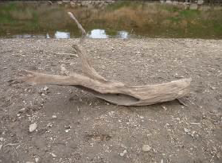
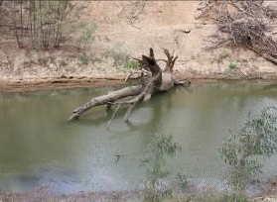
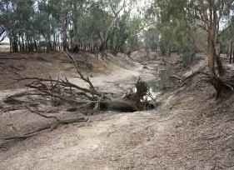
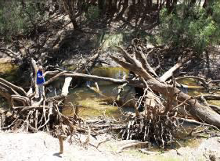
Grade 1: Woody habitat stand – single trunk or branch
Grade 3: Woody habitat stand – one or more trunks with multiple branchings
Grade 4: Woody habitat stand – highly complex complete tree with multiple branchings, or accumulation of separate branchings
Grade 2: Woody habitat stand – trunk or branch with one or two branchings

Figure D-1: Classification system used to grade complexity of snags (NSW DPI 2015).
The vertical commence-to-flow heights of individual habitat features above the current water level at the time of field survey were converted to a gauged height at the nearest river flow gauge. Benches and anabranches upstream of the Warrego River confluence were linked to the Weir 19A (NSW 425037) gauge upstream of the Selected Area, while benches and anabranches downstream of the confluence were linked to the gauging station at Louth (NSW425004) (Figure D-2). Snags for the entire reach of the Darling River within the Selected Area were linked to the Weir 19A gauge only. These gauges were chosen as they best reflected the hydrology of these sections of the Darling River. However, final commence-to-flow discharges were reported at the Bourke Town (NSW 425003) gauging station as it has a more comprehensive flow record. In order to do this, relationships between the Louth and Weir 19A gauging stations and the Bourke Town gauge were identified by plotting respective flows between 400 and 20 000 ML/d at the gauges from 2002 to present (total length of Weir 19A gauge record). Travel time between gauges was taken into account, with trendlines and associated regression equations of the relationship between gauges calculated (Figure D-3). These equations were used to express the commence-to-flow discharges measured at the Louth and Weir 19A gauges to the Bourke Town gauge. The commence-to-flow for each anabranch channel was determined using the entry or exit with the highest gauge height to better represent water flow into each channel.
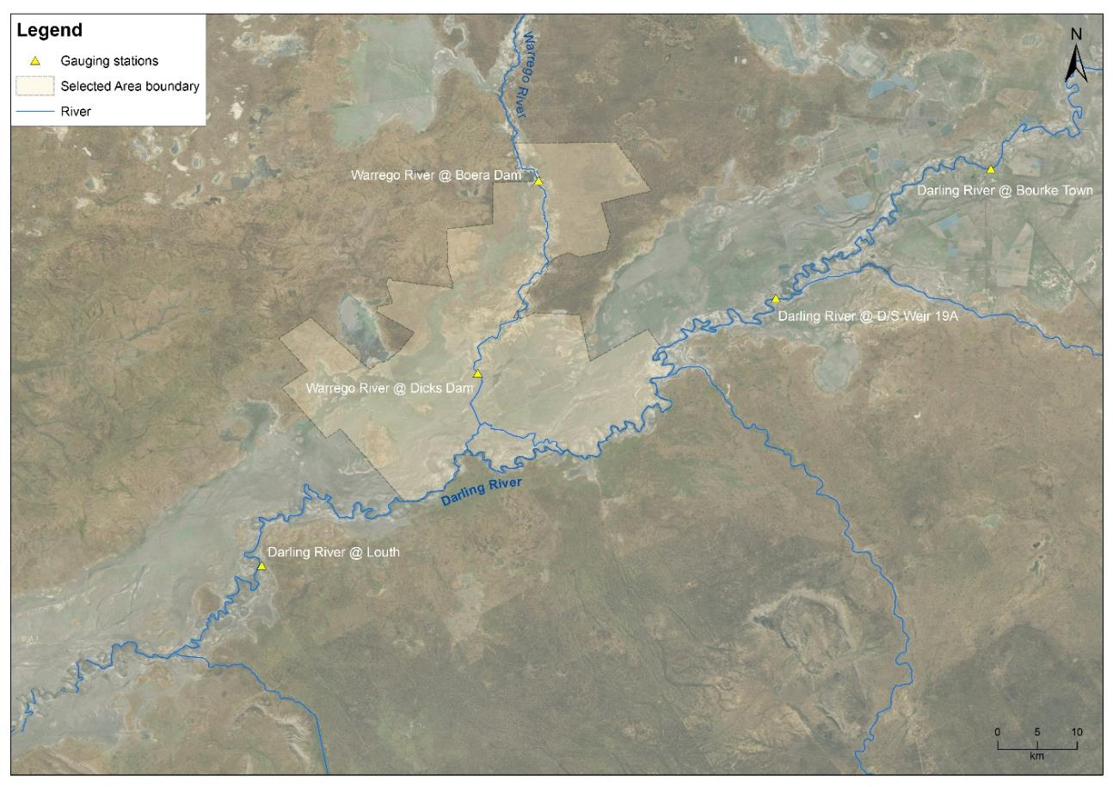
Figure D-2: Location of the gauging stations used in the hydrology (Habitat) indicator analysis.

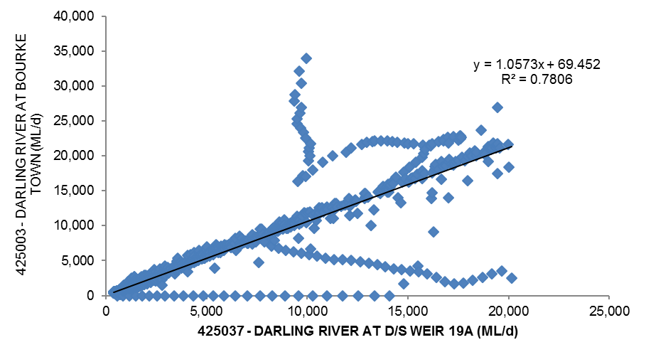
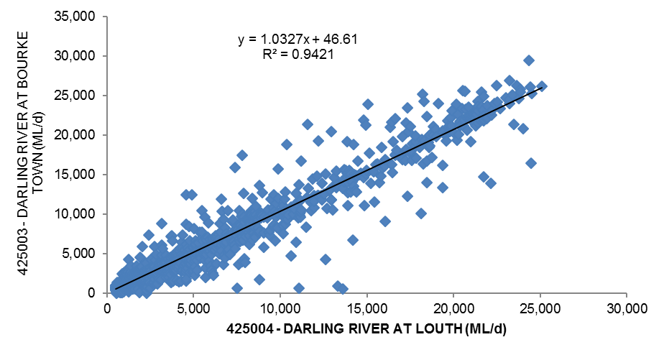

Figure D-3: Relationships between the Darling River @ Bourke Town gauge and a) Darling River @ Weir 19A and b) Darling River @ Louth gauging stations.

Total organic Carbon (TOC), Nitrogen (TN) and Phosphorus (TP) release rates from in-channel benches observed on the Darling River upstream of Bourke by Southwell (2008), were combined with the duration of time benches in the Selected Area were inundated during 2016–17 to provide an estimate of total nutrient loads contributed to the river from these benches during the water year.

Results

Bench surfaces and anabranch channels
One hundred and seventy-three benches with a total area of 8.4 ha were identified along the 76 km reach of the Darling River within the Selected Area. Benches tended to be located low in the river channel, with 124 (71%) benches becoming inundated at flows less than 10,000 ML/d. Of these, 45 (25%) surfaces become inundated at flows less than 2,000 ML/d.
Twenty anabranch channels were identified within the study reach. The total combined length of anabranches was 60 km, which is 44% of the total length of channel in the study reach including the Darling River. Commence-to-flow discharges of anabranch channels ranged from 1,846 ML/d to 16,673 ML/d, with the majority of channels (90%) commencing-to-flow at discharges less than 10,000 ML/d. Further details of the analysis of the extent and distribution of habitat provided in the form of benches and anabranches is provided in the 2014-15 monitoring report (Commonwealth of Australia 2015).

Snags
A total of 33,269 snags were identified within the Darling River zone. Complexity was generally low across all inundation heights, with the majority of snags classified as Grade 1 and Grade 2. The greatest proportion (26%) of snags are found on the channel bed and are inundated when flow is at least 69 ML/d (Figure D-4).
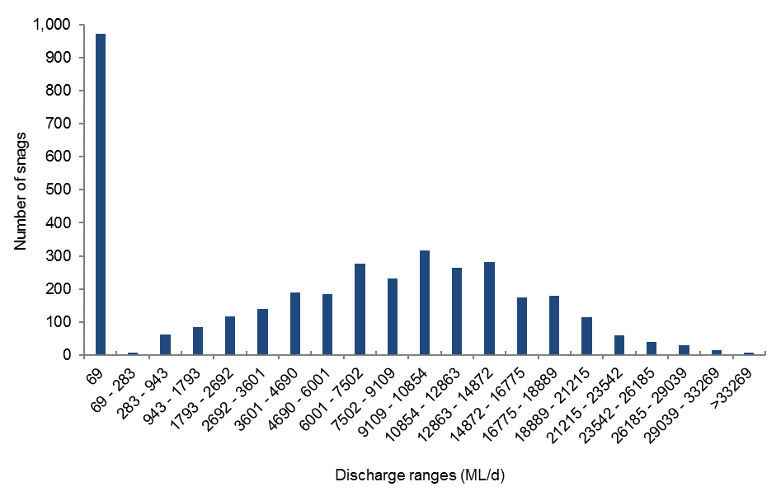

Figure D-4: Distribution of snags across discharge classes. Discharge measured at the Bourke Town gauge (NSW425003).

Connectivity in 2016-17
Four flow events occurred in the 2016-17 water year that provided habitat inundation.
The lowest three bench classes (<2,000 ML/d; 2,000 – 6,500 ML/d and 6,500 – 10,000 ML/d) were inundated in the June and August flow events (Figure D-5). These events inundated 72% of the total number of benches identified within the Darling River zone, providing access to 60,757 m² of habitat. Benches inundated at <2,000 and 2,000 – 6,500 ML/d were continuously inundated until the beginning of December 2017 for 132 days. All five bench classes were inundated during the September - December flow event for a minimum of 53 days, providing access to 83,837 m² of habitat. Benches in the lowest two classes were inundated again in April 2017 for up to nine days.
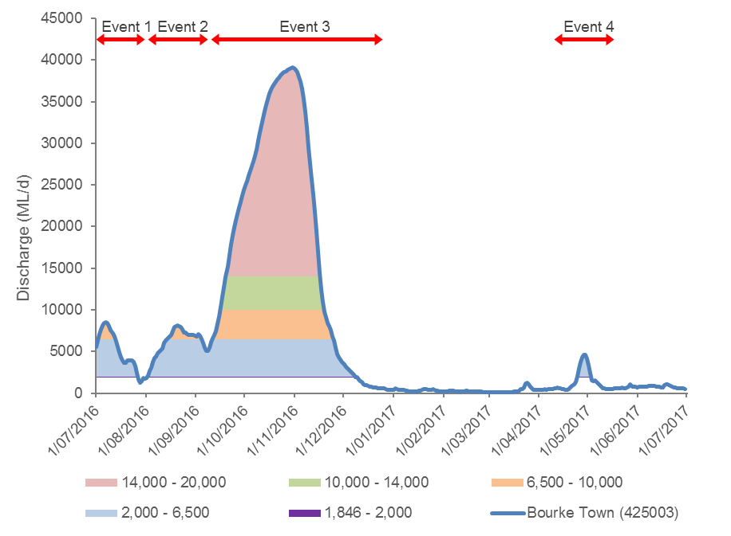
Figure D-5: Bench inundation in the 2016-17 water year along the Darling River within the Selected Area. Discharge measured at the Bourke Town gauge (NSW425003).

Combining the amount of bench habitat provided in the Darling River zone with the average 72 hourly nutrient release rates reported in Southwell (2008), it is estimated that these benches would have contributed 203.9 kg of total dissolved organic carbon (TOC), 62 kg of total dissolved nitrogen (TN) and 69.3 kg of total dissolved phosphorus (TP) to the river system during the time they were inundated in the 2016 – 17 water year (Table D-1).

Table D-1: Quantification of nutrient release from benches in the Darling River in 2016-17.
Discharge class (ML/d) | Total release of nutrients (kg)
 | TOC | TN | TP
<2,000 | 83.9 | 25.5 | 28.5
2,000-6,500 | 46.3 | 14.1 | 15.7
6,500-10,000 | 40.6 | 12.4 | 13.8
10,000-14,000 | 21.7 | 6.6 | 7.4
14,000-20,000 | 11.3 | 3.4 | 3.9
All classes | 203.9 | 62.0 | 69.3

Anabranches in the <2000 ML/d, 2000 – 4000 ML/d and 4000 – 10000 ML/d discharge classes commenced-to-flow in June 2016, and were inundated in July providing a combined distance of 56 km accounting for 90% of the total number of anabranches identified and 93% of the combined length of all anabranches identified in the zone (Figure D-6). During the September-December flow event all anabranch classes were inundated for a minimum 65 days. A combined length of 60.7 km of channel was connected during this period. The lower two classes were again inundated in April 2017 for a minimum of six days.
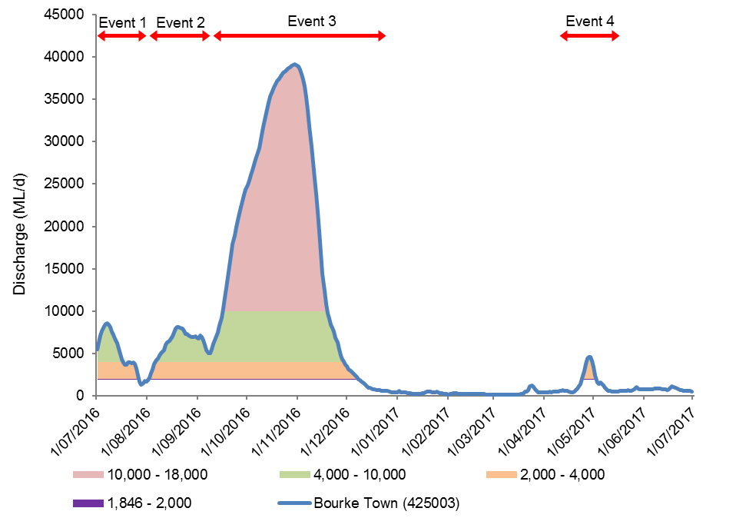
Figure D-6: Anabranch inundation in the 2016-17 water year along the Darling River within the Selected Area. Discharge measured at the Bourke Town gauge (NSW425003).

All snag classes were inundated in the 2016-17 water year. The lowest discharge class (<69 ML/d) was inundated for the entirety of the water year, accounting for 26% of all snags. The ten lowest snag classes were inundated during the July and August 2016 flow events, while snag classes that are inundated at >9,109 ML/d were only inundated during the September to December flow event. Snags inundated at ≤4690 ML/d were inundated again in April 2017. Minimum days of inundation for each snag class ranged from 23 to 365 days (Table D-2).
Table D-2: Duration and proportion of snags inundated in the Darling River in 2016-17.
Flow Height Range Bourke to Weir 19A (ML/d) | Snags | Proportion of total snags(%) | Days inundated
<69 | 973 | 26.1 | 365
69 - 283 | 7 | 0.2 | 307
283 - 943 | 61 | 1.6 | 192
943 - 1793 | 83 | 2.2 | 166
1793 - 2692 | 117 | 3.1 | 155
2692 - 3601 | 139 | 3.7 | 147
3601 - 4690 | 188 | 5.0 | 127
4690 - 6001 | 185 | 5.0 | 113
6001 - 7502 | 277 | 7.4 | 84
7502 - 9109 | 232 | 6.2 | 66
9109 - 10854 | 316 | 8.5 | 63
10854 - 12863 | 263 | 7.0 | 59
12863 - 14872 | 281 | 7.5 | 57
14872 - 16775 | 174 | 4.7 | 55
16775 - 18889 | 180 | 4.8 | 53
18889 - 21215 | 114 | 3.1 | 49
21215 - 23542 | 58 | 1.6 | 45
23542 - 26185 | 39 | 1.0 | 38
26185 - 29039 | 29 | 0.8 | 33
29039 - 33269 | 13 | 0.3 | 26
>33269 | 6 | 0.2 | 23

Discussion
This indicator has quantified the number and character of key in-channel habitats along the Darling River zone within the Selected Area. A total of 173 individual bench surfaces and 20 anabranch channels were identified that predominantly connect to the river channel at flows below bankfull. Large proportions of these benches (71%) and anabranch channels (90%) become connected to the river at flows less than 10,000 ML/d (measured at the Bourke Town gauge). These flows are within the range that may be influenced by Commonwealth environmental water in this reach of the Darling River (Commonwealth of Australia 2015).
Four flow events in the Darling River 2016-17 contained Commonwealth environmental water. In Event 1 and Event 2 in July and August, 72% of benches and 93% of anabranches were inundated each time by flows containing environmental water. In the September-December flow event (Event 3), 100% of benches and anabranches were inundated by flows containing environmental water. The last flow event in April 2017 that contained 66.5% Commonwealth environmental water, inundated 43% of benches and 93% of anabranches. These events led to the release of large quantities of dissolved carbon and nutrients from bench surfaces into the river channel ecosystem. This is a key source of carbon which forms the foundation of aquatic food webs, and provides a source of energy for aquatic organisms (McGinness and Arthur 2011, Sheldon and Thoms 2006). Benches and anabranch channels also provide habitat during connection and are sites where organic matter and sediment accumulate during inundation (Thoms, et al. 2005, Southwell 2008). This two-way exchange of material, at relatively low river discharges, is thought to be important for maintaining the river ecosystem between larger flooding events (Sheldon and Thoms 2006). In addition, benches and anabranch channels form spawning and refuge habitat for fish and other animals in the river (NSW DPI 2015).
Flow events containing a proportion of Commonwealth environmental water inundated 61% of the total number of snags mapped in the Selected Area along the Darling River reach in the first two flow events in 2016-17 water year. In the large September – December flow event with 2.4% Commonwealth environmental water, 100% of snags were inundated. In April, 42% of snags were inundated by flows containing 36.5% Commonwealth environmental water. While 26% of these snags are located on the channel bed and are hence inundated for the majority of the time, the inundation of an additional 27,621 (74%) individual snags provided a range of benefits to the system. Snags play a major role in geomorphological processes and provide important habitat for aquatic and terrestrial organisms, including shade, refuge from high velocity flow and predators, spawning and nursery sites, and attachment sites for invertebrates (Treadwell 1999, Koehn and Nicol 2014). Snags also have a role in carbon and nutrient processing, by providing a substrate for biofilm development in which the bacterial and fungal components contribute to woody substrate decomposition, providing food for benthic algae, invertebrates and microorganisms that form part of food web for fish species (Treadwell 1999, NSW DPI 2015).
The first three flow events contained between 1.8 and 6% Commonwealth environmental water indicating a relatively small additional benefit in terms of habitat inundation. However, the fourth flow event contained 36.5% environmental water, allowing for the inundation of an additional 79 benches, 18 anabranches and 512 snags by Commonwealth environmental water during that event.

Conclusion
During 2016-17, all mapped benches, anabranches and snags were inundated for at least 23 days. This represents inundation of 70% additional habitat features compared to the 2015-16 water year. Habitat lower in the channel was inundated for 160 days, with snags in the lowest category, inundated for the entire water year. In addition to natural flows, Commonwealth environmental flows inundated habitat contributing important quantities of dissolved carbon and nutrients to the river system. While inundated snags would also provide additional habitat for fish and other aquatic biota.

References
Commonwealth of Australia. 2014. Commonwealth Environmental Water Office Long Term Intervention Monitoring Project junction of the Warrego and Darling rivers Selected Area; Annual Evaluation Report – Year 1, Canberra.
Commonwealth of Australia 2015. Commonwealth Water Office Long Term Intervention Monitoring Project Junction of the Warrego and Darling rivers Selected Area: 2014-15 Evaluation Report, Canberra.
Crook, D.A. and Robertson, A.I. 1999. Relationships between riverine fish and woody debris: implications for lowland rivers. Marine and freshwater research 50: 941-953.
Koehn, J.D. and Nicol, S.J. 2014. Comparative habitat use by large riverine fishes. Marine and freshwater research 65: 164-174.
McGuinness H.M. and Arthur A.D. 2011. Carbon dynamics during flood events in a lowland river: the importance of anabranches. Freshwater Biology 56: 1593–1605.
NSW Department of Primary Industries (DPI) 2015. Fish and flows in the Northern Basin: Response of fish to changes in flow in the Northern Murray-Darling – Reach Scale Report. Prepared for the Murray Darling Basin Authority. NSW DPI, Tamworth.
Sheldon, F. and Thoms, M. C. 2006. Geomorphic In-channel Complexity: the key to organic matter retention in large dryland rivers? Geomorphology 77: 270–285
Southwell, M.R. 2008. Floodplains as Dynamic mosaics: Sediment and nutrient patches in a large lowland riverine landscape. PhD Thesis, University of Canberra, Australia
Thoms, M. C. and Sheldon, F. 1997. River channel complexity and ecosystem processes: the Barwon-Darling River (Australia). In: N. Klomp and I. Lunt (eds.). Frontiers in Ecology: Building the Links. Elsevier, Oxford, pp. 193–206.
Thoms, M.C., Southwell, M.R. and McGinness, H.M. 2005. Floodplain-river ecosystems: Fragmentation and water resource development. Geomorphology 71: 126–138.
Treadwell, S. 1999. Managing snags and large woody debris. In Lovett, S. and Price, P. (eds.). Riparian land management guidelines: volume two: on-ground management tools and techniques. P. 15-22. Land and Water Resources Research and Development Corporation, Canberra

Hydrology (Floodplain)

Introduction
The Hydrology (Floodplain) indicator provides information on the influence of Commonwealth environmental water and/or management decisions on the extent of inundation on the Western Floodplain. This information is directly relevant to a number of other indicators measured in the Junction of the Warrego and Darling rivers Selected Area (Selected Area) including vegetation diversity, waterbird diversity, hydrology (river and channel), stream metabolism and microcrustaceans. The particular influence of hydrology on these indicators will be addressed under their respective sections.
Watering the Western Floodplain is an important aspect of water management in the Selected Area. Apart from being a target for Commonwealth environmental water (Commonwealth of Australia 2014), it also has a separate high flow floodplain water licence (Commonwealth of Australia 2015). Water managers can preferentially direct water down the Western Floodplain to meet watering targets by opening or closing the regulating gates at Boera Dam.
Given this, knowledge of the extent and volume of water directed down the Western Floodplain throughout each water year is essential base information from which to evaluate the success of these watering decisions. The hydrology (floodplain) indicator aims to achieve this, by combining information from a range of sources, to build understanding of relationships between inflows, inundation extent and volumes of water in the Western Floodplain. Specifically, this chapter addresses the following question:
- What did Commonwealth environmental water and management contribute to hydrological connectivity of the Western Floodplain?

Environmental watering in 2016-17
Warrego River
Several flow pulses in the Warrego River occurred between June - November 2016. The demand for environmental flows on the Western Floodplain was very high given the last large-scale inundation of the Western Floodplain at Toorale was in 2012. As per licence conditions, a fresh in the Warrego River in July 2016 was allowed to make visible connection with the Darling River prior to closing the gates in Boera Dam and allowing Commonwealth environmental water to spill to the Western floodplain from 19 July 2016 (Figure E-1). The gates at Boera were opened again from the 9-12 September 2016 to connect with the Darling River in accordance with licence conditions for a new flow event. Following this, further inflows were spilled to the Western Floodplain with total approved volume reaching the annual allocation of 9,720 ML by 20 September 2016. Water continued to spill onto the Western Floodplain until December 2016. In total, 31,000 ML of water flowed onto the Western Floodplain of which 31% was Commonwealth environmental water.
Another fresh occurred in the Warrego River during September - November 2016. The Boera Dam gates were again opened and once the fresh had connected with the Darling River, Commonwealth environmental water licences on the Warrego River were used to provide a pulse of water down the Warrego River. This flow aimed to provide opportunities for native fish to access habitat, support recruitment and possibly triggering spawning. 10,500 ML of water was released down the lower Warrego River channel and included 7,762 ML (74%) Commonwealth environmental water. The release was managed to provide a slow rise and fall to the pulse and also ensure that water also continued to spill to the Western Floodplain at the same time. Commonwealth water was used to provide connection for 20 days. National Parks and Wildlife Service maintained the connection for an additional 5 days before closing the gates and allowing the remaining water to spill to the Western Floodplain.

Previous monitoring outcomes
Inundation extent in the 2014-15 and 2015-16 water years ranged from 0.5 to 36.9 ha and 141.17 to 464.14 ha respectively. Three vegetation communities were inundated (>0.01 ha) during the 2014-15 water year, while ten were inundated (>0.01 ha) during the 2015-16 water year. During both water years lignum shrubland wetland was the most extensively inundated vegetation community, followed by coolabah open woodland wetland and coolabah - river coobah – lignum woodland.
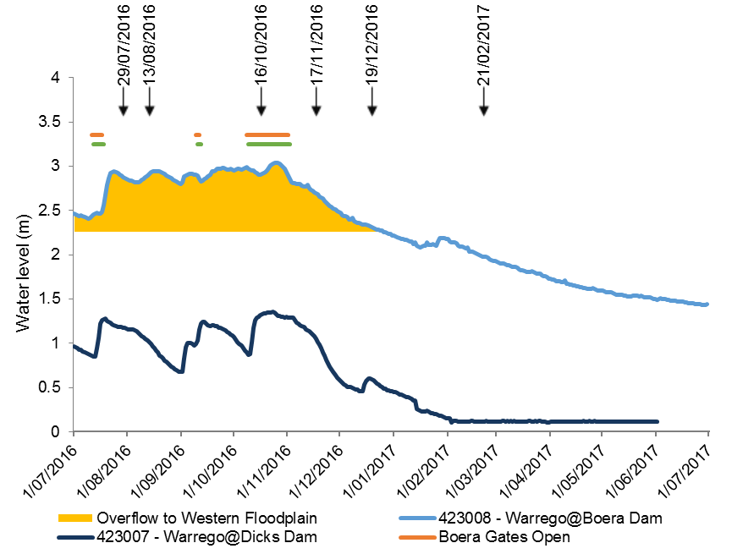
Figure E-1: Boera Dam levels during 2016-17 water year and flow to Western Floodplain and/or into lower Warrego channels (gates open). Arrows indicate LANDSAT image dates using in the analysis.

Methods
A number of data sources were used to build a model of inundation extent and volume in the Western Floodplain of the Warrego River (Commonwealth of Australia 2015). These included:
- Landsat imagery
- Existing vegetation mapping
- Water level records associated with water sensors and gauging stations
- Hydrodynamic model recently developed as part of the LTIM project
These data sources were analysed and combined to produce relationships between inflow, inundation extent and volume. Existing vegetation mapping was used to determine the area of inundation associated with each vegetation community on the Western Floodplain.

Landsat image analysis
All available Landsat 8 images captured during the 2016-17 water year were assessed via the USGS Glovis website (http://glovis.usgs.gov/). Those with no cloud cover or other problems were chosen for further analysis. Six images were selected for analysis, being captured on the following dates; 29 July 2016, 13 August 2016, 16 October 2016, 17 November 2016, 19 December 2016 and 21 February 2017.
The extent of inundation within each image was classified using density slicing of band 6 as described in Frazier and Page (2000). All inundated polygons within the extent of the Western Floodplain were mapped, hence, inundation because of rainfall was also included (Figure E-2). This may potentially overestimate the degree of inundation resulting from overland flow from Boera Dam, but does provide a broader picture of the Western floodplain influenced by inundation during the 2016-17 water year. Each classified inundation image was then intersected with existing vegetation community layers (Commonwealth of Australia 2015) to determine the extent of inundation within each vegetation community at each image capture time.
To estimate the volume of water present in the Western Floodplain at the time of image capture, relationships generated through the hydrodynamic model of the Western Floodplain were used for images on the rising limb of the hydrograph (July and August 2016 images). The maximum volume achieved during the 2016-17 water year was estimated by modelling inundation volume at the maximum gauge height of Boera Dam (3.04 m). To estimate the volume present for images on the falling limb of the hydrograph (October, November, December 2016 and February 2017), the extent of inundation was multiplied by an estimated average water depth. A depth of 0.25 m was used based on the average depth of water over the floodplain estimated from the hydrodynamic model.

Average monthly rainfall
Monthly rainfall was almost double the historical average for May 2016 and almost three time the monthly average for June and September 2016 (Figure E-2). These high rainfall amounts are likely to have influenced inundation extents on the Western Floodplain.
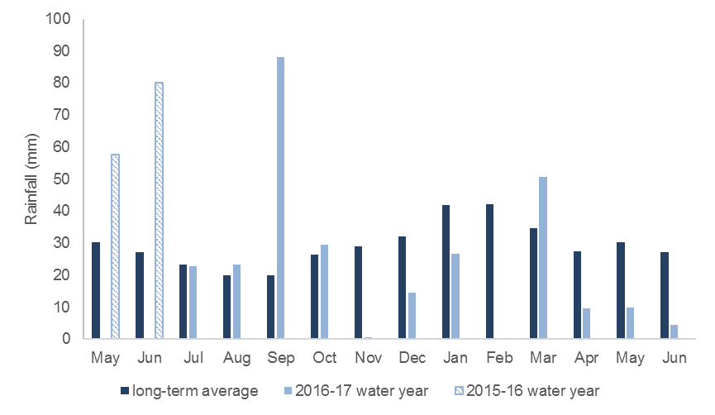
Figure E-2: Average monthly rainfall for the 2016-17 water year at Bourke compared to long term average monthly rainfall (May and June 2016 also included).

Results and Discussion

Landsat image analysis
Inundation mapped using Landsat imagery showed that the total extent of inundation spread south across the Western Floodplain from July through to October 2016 and began to contract from mid-November 2016 (Table E-1, Figure E-3). Inundation was estimated at 1,101.79 ha in July 2016, resulting from a period of overflow onto the floodplain commencing mid-May 2016. Overflow onto the floodplain continued through to late December, peaking at 3.04 m on 24 October. Inundation mapped from the image captured on 16 October (prior to this peak) covered 3,839.11 ha, the maximum mapped extent for the 2016-17 water year. This represents about 35% of the total area of floodplain located within the Selected Area.
Analysis of the final image captured on 21 February 2017 showed an estimated inundation of 550.08 ha. The reduction in inundation extent is consistent with overflow onto the floodplain ceasing in late December and continuing to evaporate, when the Boera Dam level dropped below 2.26 m.
Several vegetation communities were inundated during the image capture period. Lignum shrubland wetland was the most extensively inundated for each image capture date, followed by chenopod low open shrubland (Table E-1). Of the thirteen mapped vegetation communities present on the western floodplain, only two had less than 0.01 ha inundated during the 2016-17 water year; gidgee chenopod woodland and supplejack woodland. Gidgee chenopod woodland is mapped to occur in three areas on the very perimeter of the floodplain, occupying less than 400 ha. Only one area (<2.5 ha) of supplejack woodland is mapped to occur and is also located on the perimeter of the floodplain.
A maximum volume of 9,978 ML of water is estimated to have been on the floodplain during 2016-17 when Boera Dam reached its peak of 3.04 m on the 24 October 2016. By the 21 February 2017, this had dropped to 1,375 ML (Table E-1)
Table E-1: Inundation extent of vegetation communities on Western Floodplain based on Landsat 8 image analysis.
Vegetation Community | Inundated area (ha)
 | 29-Jul-16 | 13-Aug-16 | 16-Oct-16 | 17-Nov-16 | 19-Dec-16 | 21-Feb-17
Anthropogenic herbland |  | 1.43 | 2.52 | 2.25 | 2.876 | 0.051
Beefwood - Coolabah woodland | 0.012 | 0.012 | 0.15 | 0.04
Belah/Black Oak - Western Rosewood - Leopardwood low open woodland |  | 0.12 | 0.71 | 0.08 | 0.074 | 0.44
Chenopod low open shrubland - ephemeral partly derived forbland | 224.66 | 659.33 | 1512.90 | 1121.68 | 275.06 | 168.56
Coolabah - River Cooba - Lignum woodland | 70.16 | 68.40 | 77.09 | 69.08 | 61.03 | 51.77
Coolabah open woodland wetland with chenopod/grassy ground cover | 181.00 | 256.96 | 712.94 | 659.49 | 372.63 | 69.68
Ironwood woodland |  |  | 0.41 | 0.08
Lignum shrubland wetland | 621.55 | 704.60 | 1524.80 | 1508.32 | 1178.98 | 258.28
Mulga shrubland |  |  | 0.07
Narrow-leaved Hopbush-Scrub Turpentine-Senna shrubland | 0.315 | 0.803 | 3.25 | 0.72 | 0.24 | 0.04
Poplar Box grassy low woodland | 0.10 | 0.08 | 0.25 | 0.10 | 0.02
Water | 4.01 | 4.01 | 4.00 | 4.00 | 4.01 | 1.27
Total area inundated (ha) | 1101.79 | 1695.74 | 3839.11 | 3365.83 | 1894.92 | 550.08
Boera Dam height (m) | 2.88 | 2.91 | 2.91 | 2.69 | 2.31 | 1.98
Total volume on Western Floodplain (ML) | 5819 | 6457 | 9597 | 8414 | 4737 | 1375

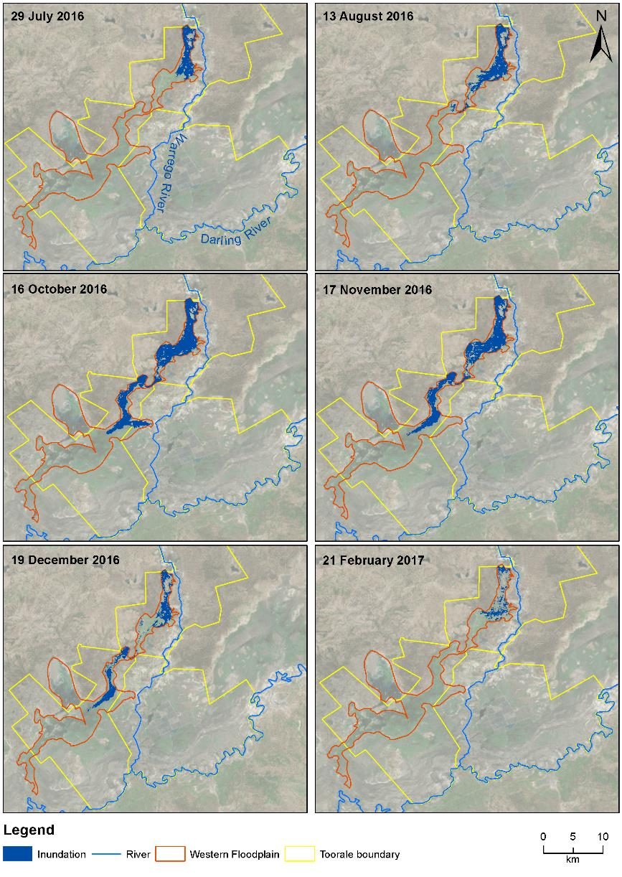
Figure E-3: Inundation extents on the Western Floodplain
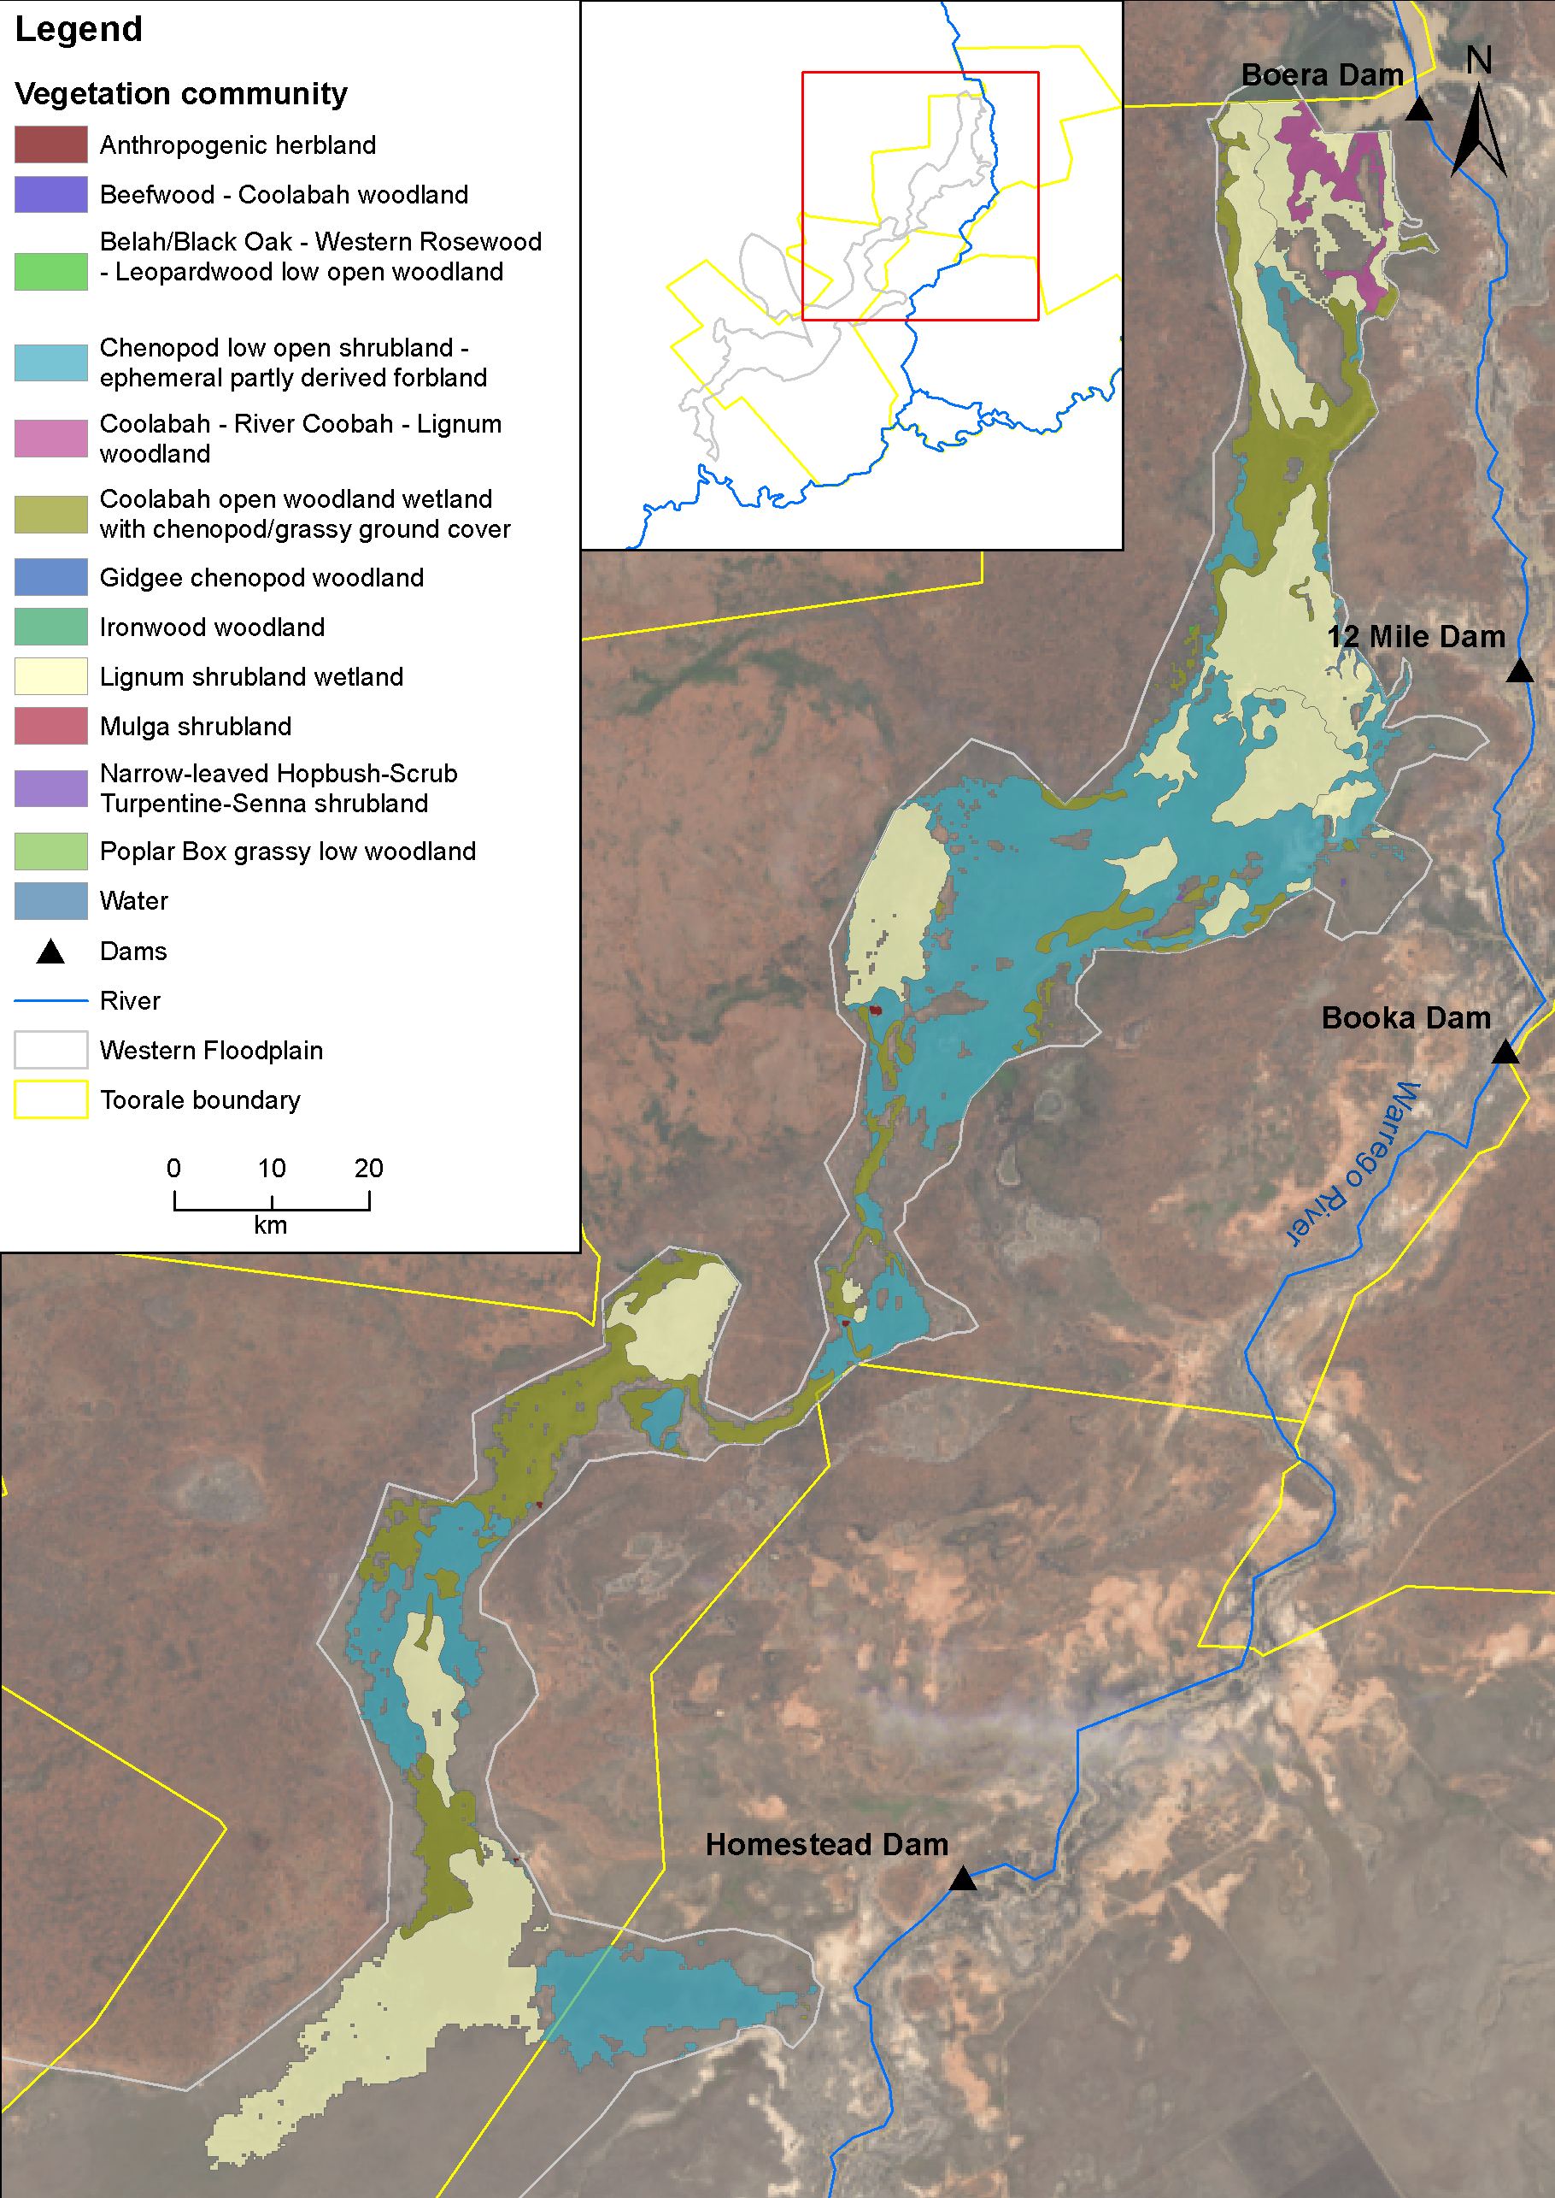
Figure E-4: Inundation of vegetation communities on the Western Floodplain based on Landsat 8 image analysis of image captured 16 October 2016 (maximum inundation captured).

Habitat inundation
Along with vegetation communities, a wide variety of floodplain habitats such as waterholes and connecting channels were also inundated (Figure E-5). These waterholes provided longer term habitat that was utilised by a variety of different fauna (Appendix N-O). These waterholes remained in the landscape until at least February 2017, five months after peak inundation.
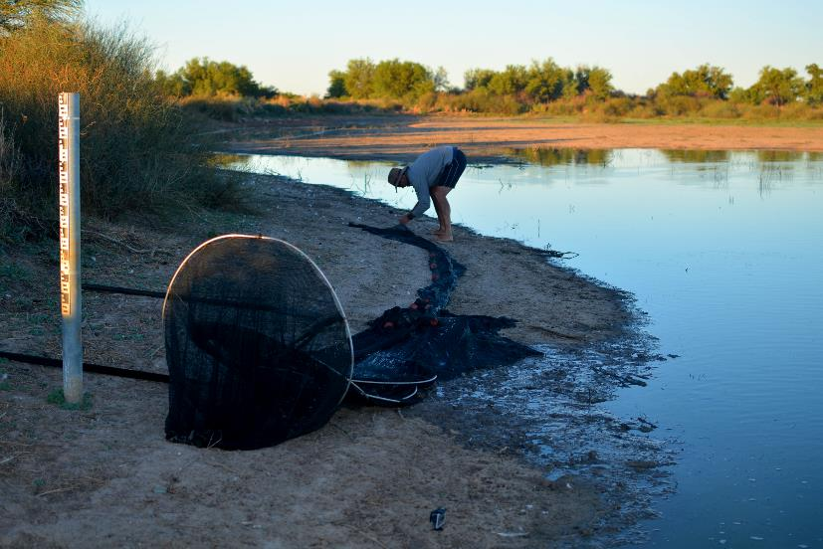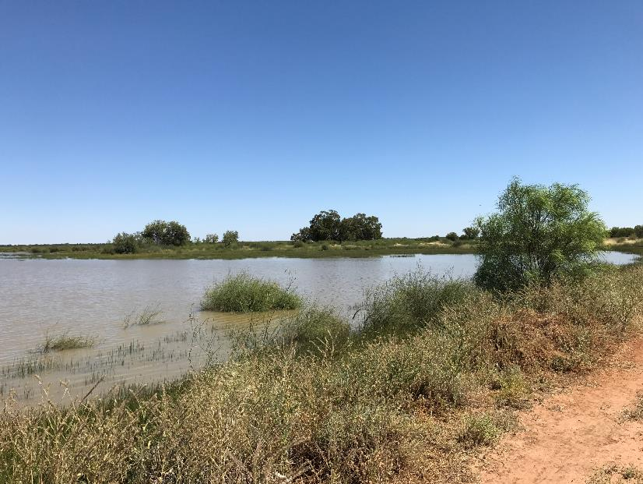
Figure E-5: Sampling a waterhole on the Western Floodplain, February 2017; bottom, Wetland habitat on the Western Floodplain, November 2016

Comparison with previous years
During the 2016-17 water year, the Western Floodplain within the Selected Area experienced the most widespread inundation since major flooding occurred in 2012. All but two of the thirteen mapped vegetation communities on the Western Floodplain were inundated during the 2016-17 water year, with inundation spreading to mid-section of the Western Floodplain. At the time of maximum inundation extent (October 2016), lignum shrubland wetland was the most extensively inundated vegetation community, followed by chenopod low open shrubland. This result is consistent with the distribution of large expanses of these communities that dominate the northern half of the floodplain (Gowans et al. 2012).
More vegetation communities were inundated, and to a much greater extent in the 2016-17 water year than in the previous two water years (Table E-2). This is consistent with Boera Dam levels, with the 2016-17 water year having a more prolonged period of overflow into the Western Floodplain (Figure E-6), resulting in a greater volume of water pushing further down the floodplain. In previous years, connection of Boera Dam with the floodplain has occurred for shorter durations.

Table E-2: Maximum area of inundation for each vegetation community the 2014-15, 2015-16 and 2016-17 water years
Vegetation community | Maximum area inundated (ha)
 | 2016-17 | 2015-16 | 2014-15
Anthropogenic herbland | 2.88 |  | 0.09
Beefwood - Coolabah woodland | 0.15 | 0.01
Belah/Black Oak - Western Rosewood - Leopardwood low open woodland | 0.71 | 4.79
Chenopod low open shrubland - ephemeral partly derived forbland | 1512.90 | 16.03 | 0.28
Coolabah - River Coobah - Lignum woodland | 77.09 | 62.72 | 2.40
Coolabah open woodland wetland with chenopod/grassy ground cover | 712.94 | 97.34 | 14.27
Ironwood woodland | 0.41 | 0.01
Lignum shrubland wetland | 1524.80 | 285.75 | 34.84
Mulga shrubland | 0.07
Narrow-leaved Hopbush-Scrub Turpentine-Senna shrubland | 3.25 | 0.44
Poplar Box grassy low woodland | 0.25 | 0.09

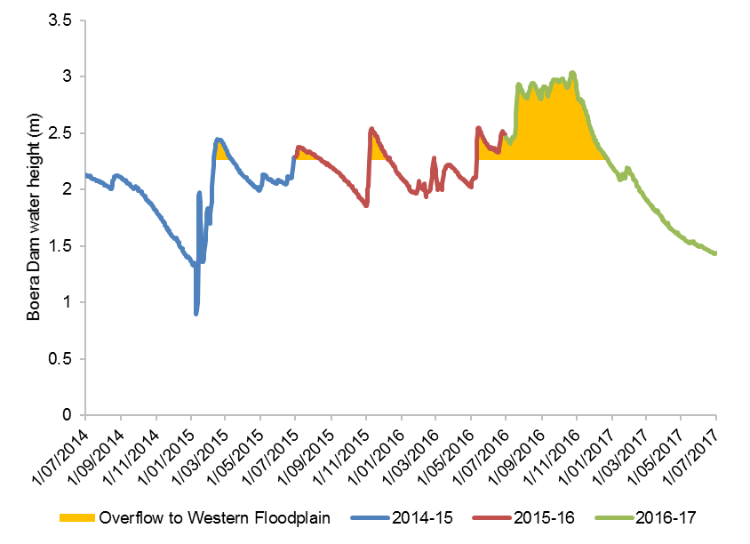
Figure E-6: Boera Dam levels recorded for 2014-15, 2015-16 and 2016-17 water years

Conclusion
Inundation extents on the Western Floodplain ranged from 550.08 ha to 3839.11 ha during late 2015-16 and 2016-17 primarily driven by inflows down the Warrego River from significant rainfall in the upper catchment. Maximum mapped inundation occurred in October 2016 prior to a flow peak resulting in a gauge height of 3.04 m at Boera Dam, with 9,978 ML of water estimated to have been on the floodplain. Lignum shrubland wetlands were the most commonly inundated, followed by chenopod low open shrubland. The prolonged inundation achieved throughout the year benefitted these vegetation communities (Appendix K). Much of the inundation on the floodplain can be attributed to Commonwealth environmental water that made up a significant proportion (31%) of the total water that flowed onto the floodplain during 2016-17. The maintenance of water levels in Boera Dam above the Western Floodplain overflow level through management of the Boera Dam gates by National Parks and Wildlife, provided prolonged inundation of some areas of the floodplain such as waterholes and connecting channels, which provided ideal conditions for animals such as frogs, fish and waterbirds to complete their lifecycles (Appendix M-O).

References
Commonwealth Environmental Water Office (CEWO) 2014. Commonwealth environmental water use options 2014-15: Northern Unregulated Rivers.
Commonwealth of Australia 2015. Commonwealth Water Office Long Term Intervention Monitoring Project Junction of the Warrego and Darling rivers Selected Area
Eco Logical Australia 2017. Aquatic fauna use of the Warrego River Western Floodplain. Prepared for the Commonwealth Environmental Water Office.
Frazier, PS, Page KJ. 2000. Water body detection and delineation with Landsat TM data. Photogrammetric Engineering and Remote Sensing, 66, 1461-1468.
Gowans, S., Milne, R., Westbrooke, M. & Palmer, G. 2012. Survey of Vegetation and Vegetation Condition of Toorale. Prepared for the NSW Office of Environment and Heritage. University of Ballarat, Mt Hellen.

Water Quality

Introduction
The Category I and III Water Quality indicators aim to assess the contribution of Commonwealth environmental water to the improved quality of water in the Darling River within the Junction of the Warrego and Darling rivers Selected Area (Selected Area). As such this indicator is linked to Fish (Channel), Stream Metabolism, Waterbird Diversity, Microinvertebrates, Macroinvertebrates, Frogs and Hydrology (River, Northern Tributaries, Channel and Habitat) indicators. Several specific questions were addressed through this indicator within the Darling River zone during the 2016-17 water year:
- What did Commonwealth environmental water contribute to temperature regimes?
- What did Commonwealth environmental water contribute to pH levels?
- What did Commonwealth environmental water contribute to turbidity regimes?
- What did Commonwealth environmental water contribute to salinity regimes?
- What did Commonwealth environmental water contribute to dissolved oxygen levels?
- What did Commonwealth environmental water contribute to algal suppression?

Environmental watering in 2016-17
Barwon-Darling and northern tributaries
Unlike other Selected Areas, environmental water is not specifically delivered to the Junction of the Warrego and Darling rivers Selected Area, rather, Commonwealth water is held as unregulated entitlements and its influence is thus reliant on flows out of upstream catchments. During the 2016–17 water year, four flow events containing environmental water flowed down the Darling River within the Selected Area (Appendix B). These occurred in June – August 2016, August – September 2016, September – December 2016 and April – May 2017. Three of these flows were in-channel pulses with the flow during September-December 2016 reaching at or just over bankfull. Total proportions of Commonwealth environment water in the Darling River varied between 1.8% and 36.5% of total flow (Appendix B).

Previous monitoring
In the 2014-15 water year, there were insufficient data to make comment on the effect of Commonwealth environmental water due to delays in project commencement and equipment being sourced (Commonwealth of Australia 2015). In 2015-16, a range of low volume discharges with contributions of Commonwealth environmental water (peak flow around 1,300 ML/day) were recorded. Many water quality indicators had their highest recorded values at approximately 500 ML/d, suggesting that this may be a key low flow threshold for the inundation of in-channel features that subsequently affect water quality in the Darling River. Similarly, elevated conductivity was recorded under the highest reported flows in the 2015-16 water year rather than during the very low flow conditions. This suggests the transport of increased dissolved ions and salts along the Darling River are associated with higher flows rather than salt intrusion into the channel during low flows. In contrast, the increase in discharge reduced turbidity, dissolved oxygen and chlorophyll a concentrations, reflecting a dilution effect provided by higher discharge for these indicators.
An outbreak of the native floating aquatic fern Azolla completely covered the water surface of the Darling River channel in the Selected Area in spring, yet water quality indicators remained similar throughout this period and when compared with periods where Azolla was absent. Potential poor water quality associated with the decomposition of Azolla in the channel was averted by a small in-channel flow dispersing the bloom. This highlights the benefit of smaller magnitude flows (highest discharge of 971 ML/d) that contain Commonwealth environmental water in preventing potential water quality problems and ecological consequence such as hypoxia linked to an Azolla outbreak.
Two spot sampling events during 2015-16 revealed the Warrego River had consistently higher turbidity and dissolved oxygen concentrations and lower conductivity regardless of flow conditions than the Darling River. A planned event for longitudinal connectivity between the Warrego and Darling Rivers improved pH and dissolved oxygen concentrations to values within the ANZECC guideline in both the Warrego and Darling Rivers. Turbidity concentrations were exceptionally high and negativity affected rates of instream metabolism.

Methods
              - Darling River long-term stations

Water quality indicators were monitored at two stations in the Darling River zone of the Selected Area that have permanent surface water in a defined channel. The Darling upstream station is located near Yanda homestead, and all Commonwealth environmental water derived in the upstream tributaries of the Darling Basin (except the Warrego River) passes through this reach (Figure F-1). The Darling downstream station is located downstream of the confluence of the Warrego and Darling Rivers near Akuna homestead (Figure F-1). As such, the Darling downstream station can be used to assess the influence of Warrego River inflow to the water chemistry of the Darling River.
Continuous monitoring of the dependant variables; temperature (°C), pH, turbidity (NTU), conductivity (mS/cm), dissolved oxygen (mg/L) and chlorophyll a (μg/L) occurs at the two stations using a Hydrolab DS5-X logger. Each probe is mounted to a floating pontoon to ensure it was kept under the water and away from obstructions. In the Darling upstream station, the probe is connected via a 3-G telemetered system to an RMTek website for data monitoring and download. In the Darling downstream station, the probe is connected to a local logger and downloaded during each visit or periodically by NPWS staff. Each water quality variable is logged at 10 minute intervals. Due to issues with power supply, instrument failure at both sites and the permanent loss of the instrument in the Darling upstream station during a high flow event on 27th September 2016, datasets were partly discontinuous in the 2016-17 water year. In addition, there was no algal suppression data available due to instrument failure.
In the 2016-17, three consecutive in-channel pulse flow events containing Commonwealth environmental water and one period with no Commonwealth environmental water were used to examine responses in water quality indicators (Appendix B). These flow events vary in magnitude, duration and variability in discharge (Table F-1). Daily means (midnight to midnight) of each water quality indicator were calculated from 10 minute interval data, with analyses based on the assumption that daily means were temporally independent. Daily means of water quality indicators were compared between flow events and stations. Regression analyses were used to explore relationships between discharge (ML/d) and each water quality indicator in an attempt to separate the time/season of delivery from the event volume.
Two new PME miniDOT loggers were installed to monitor temperature (°C) and dissolved oxygen concentration (mg/L); one logger at microinvertebrate site Darling Pump (DARPUMP) on 28th March 2017 to replace the loss Hydrolab DS5-X logger in the Darling upstream station and another logger in the Darling downstream station on 24 August 2016 to ensure data continuity and comparability (Figure F-2). Date from the new loggers will be retrieved in the next field trip in 2017-18 water year.
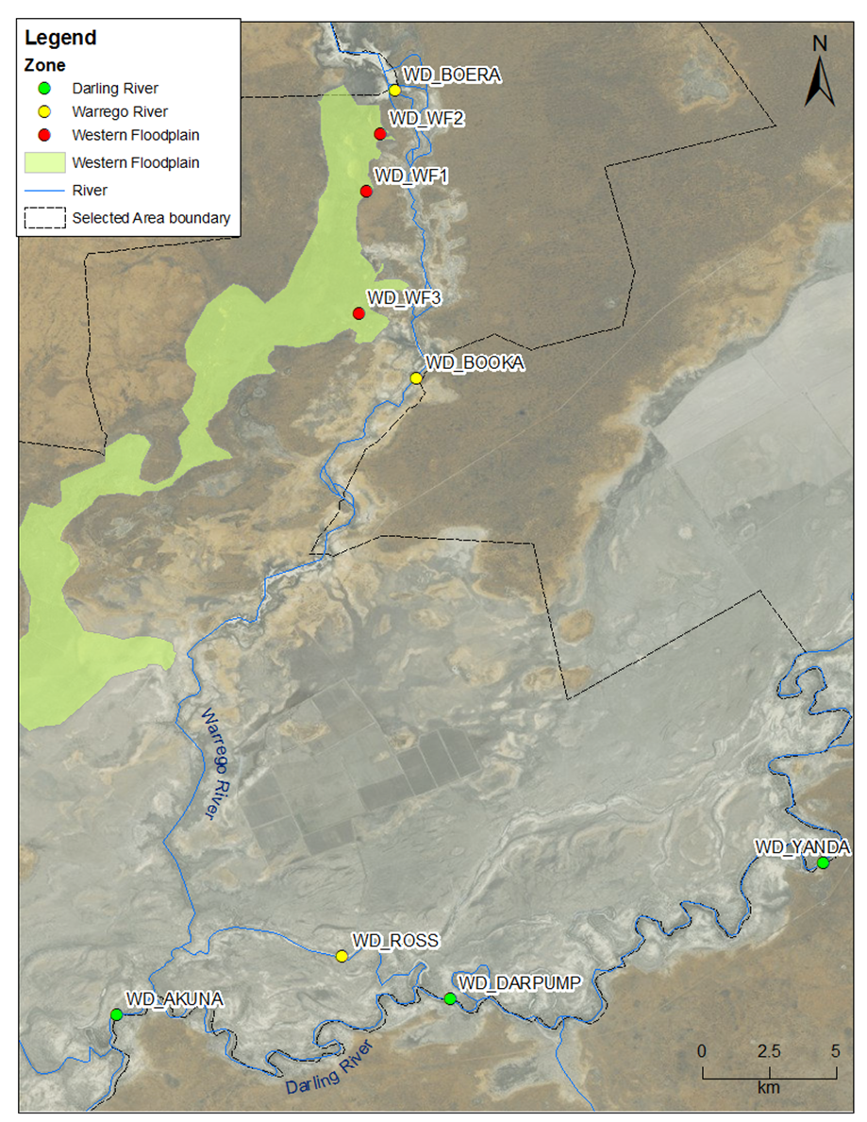
Figure F-1: Location of two long-term water quality monitoring stations (Cat I) in the Darling River and eight spot sampling sites (Cat III) within the Selected Area.

Table F-1: Commonwealth Environmental Water flow events and non-environmental water flow periods used in the analysis of water quality indicators in 2016-17 water year. EW represents Commonwealth Environmental Water.
Event | Time period | Discharge | Number of days at Akuna | Number of days at Yanda | EW
EW1 | 1 Jul 2016  to  1 Aug 2016  (40 days) | 1100-8500 ML/d | 0 | 32 | Comprised of 7,818 ML (estimated contribution of 6.0%) Commonwealth environmental water from the Queensland Border Rivers, Castlereagh, Condamine-Balonne and Barwon-Darling River, as well as localised entitlements at Toorale.
EW2 | 2 Aug 2016 to  8 Sep 2016  (37 days) | 1300-8100 ML/d | 17 | 37 | Comprised of 3,102 ML (estimated contribution of 1.8%) Commonwealth environmental water from Barwon-Darling River system.
EW3 | 9 Sept 2016 to  25 Dec 2016  (107 days) | 490-39000 ML/d | 69 | 19 | Comprised of 42,228 ML (estimated contribution of 2.4%) Commonwealth environmental water from all upstream catchments.
non-EW | 26 Dec 2016 to  28 Jan 2017  (34 days) | 60-550 ML/d | 34 | 0 | Base flow. No Commonwealth environmental water.

F.2.2 Targeted short-term sampling
Category III Water Quality indicators were measured in association with Category III Microinvertebrate indicators in August 2016, November 2016 and March 2017 (Appendix H). Sampling sites were located in three Sampling Zones within the Selected Area: Darling River, Warrego River and the Western Floodplain (Figure F-1, Table F-2). Hydrological conditions within the Selected Area during sampling are described in (Appendix H).
In-situ spot measurements of water column temperature (°C), pH, turbidity (NTU), specific conductivity (mS/cm) and dissolved oxygen (mg/L) were taken using a Hydrolab Quanta water quality multi-probe. Chlorophyll a was sampled by filtering as much sample water as possible (100–1000 mL) through a Whatman glass microfiber grade GF/C filter paper using an electric vacuum pump (EYELA Tokyo Rakahikai Corporation Aspirator A-35 at approximately 7 PSI). The sample volume was recorded and the filter paper placed into a pre-labelled 10 mL vial which was then sealed, wrapped in aluminium foil, placed inside a labelled zip lock bag and then refrigerated below 4 °C. Chlorophyll a was analysed by placing 10 mL of 90% acetone solution in the vial and refrigerating the sample for 24 hours. Samples were then centrifuged and the absorption spectra recorded using a UV-1700 Pharmaspec UV-visible spectrometer at 665 and 750 nm.
Permutational multivariate analysis of variance (PERMANOVA) routine was used to test differences in each water quality parameter between TIME (with 3 random levels, Aug-16, Nov-16 and Mar-17), ZONE (with 3 fixed levels, Darling, Warrego and Western Floodplain), SITE (with 6 fixed levels, AKUNA, DARPUMP, BOERA, BOOKA, ROSS and WF) where SITE was nested with ZONE and interactions (Table F-2). This routine can be used to analyse unbalanced experimental design with hierarchical nesting in an analysis of variance (ANOVA) experimental design using permutation methods ((PRIMER-E, 2009). Up to 999 random permutations estimated the probability of p-values, with levels of significance reported as p<0.05. Where statistically significant differences were detected, pair-wise comparisons in PREMANOVA routine were used to determine the source of the significant differences.
Table F-2: Location of eight spot sampling sites within the Selected Area for category III water quality surveys. Map projection GDA94 Zone 55.
Sampling Zone | Site Name | Site Code | Easting | Northing | Inundation
 |  |  |  |  | Aug-16 | Nov-16 | Mar-17
Darling River | Akuna homestead | AKUNA | 340008 | 6634629 | Wet | Wet | Wet
 | Darling Pump | DARPUMP | 350768 | 6635351 | Wet | Wet | Wet
Warrego Channel | Boera Dam | BOERA | 348526 | 6669158 | Wet | Wet | Wet
 | Booka Dam | BOOKA | 349357 | 6658461 | Wet | Wet | Wet
 | Ross Billabong | ROSS | 347281 | 6636893 | Wet | Wet | Wet
Western Floodplain | Coolabah, Coobah, Lignum woodland | WF2 | 348083 | 6667550 | Wet | Dry | Dry
 | Coolabah open woodland | WF1 | 347848 | 6665662 | Wet | Wet | Dry
 | Lignum shrubland | WF3 | 347476 | 6660850 | Wet | Wet | Wet

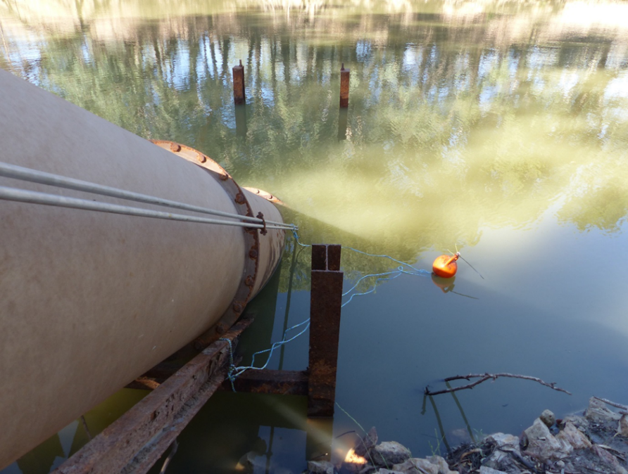
Figure F-2: Photo of new logger set up in Darling Pump to replace the lost logger in the Darling upstream station.

Results
              - Darling River Cat 1 continuous monitoring

The Darling River upstream and downstream stations exhibited similar magnitudes of discharge during this reporting year, with a short time lag for downstream flow (Figure F-3a). Environmental Water period 1 (EW1), 2 (EW2) and 3 (EW3) discharge patterns were influenced by flows down the Darling River zone with portions of Commonwealth environmental water originating in upstream tributaries (Table F-1)
The longitudinal connection between the Warrego and Darling from the opening of Boera gates occurred in EW1 and EW3 resulting in connection for a total of 35 days (Appendix A). However, there are insufficient data to explore the impact of Warrego connection on water quality in the Darling River downstream during these flow periods due to the loss of equipment. Non-environmental water period (non-EW) discharge patterns represent natural base flow condition without Commonwealth environmental water.
Mean daily water temperature increased steadily from July to February due to seasonal variation (Figure F-3b and Figure F-4a). Temperature did not have strong predictable linear relationship with discharge (Figure F-5a), with seasonal rather than flow patterns exerting the largest influence.
Mean daily pH in the upstream station ranged from 7.1 to 7.7 and was lower than values recorded in 2015-16 (Figure F-3and Figure F-7), consistently within the ANZECC water quality guideline values (pH between 6.5 and 8;) throughout the three EW periods. There was no strong predictable relationship with discharge (Figure F-5).
Mean daily turbidity in the downstream station ranged from 121 NTU to 510 NTU and was consistently above the ANZECC water quality guideline (6-50NTU; Figure F-3d and Figure F-4c) and higher than values recorded in 2015-16 (Figure F-6 and Figure F-3). An initial rise in turbidity was recorded for discharge up to 10,000 ML/d suggesting flows of this magnitude inundate and resuspend in-channel fine sediments (Figure F-5c). Above this threshold, turbidity decreased steadily with increasing discharge to 30,000 ML/d through dilution from upstream flows (Figure F-5c).
Mean daily conductivity ranged from 0.10 to 0.58 mS/cm and was consistently below the ANZECC guideline range (Figure F-3 and Figure F-3e). Conductivity levels were lower and less variable during this water year compared with 2015-16 (Figure F-6 and Figure F-3). Discharge during EW periods had lower conductivity compared with non-EW period (Figure F-4d), which is contrary to 2015-16 water year finding where conductivity increased with flows. A very strong negative correlation between conductivity and discharge was observed in the downstream station while a weak positive correlation was observed in the upstream station (Figure F-5d).
Mean daily dissolved oxygen concentrations ranged from 27% to 93% in the downstream station and 49% to 96% in the upstream station (Figure F-3f and Figure F-4e). These mean daily dissolved oxygen concentrations were below the ANZECC water quality guideline (85-110% in dissolved oxygen percent) on most days, which is consistent with 2015-16 findings (Figure F-6 and Figure F-3). Upstream dissolved oxygen concentrations were consistently higher than the downstream station (Figure F-5e). Dissolved oxygen concentrations had the highest recorded values when discharge was around 10,000 ML/d, and decreased with increasing discharge after exceeded 10,000 ML/d at both stations (Figure F-5e).

Table F-3: Water quality indicators measurements (Cat I) in the Darling River long-term stations in 2015-16, 2016-17 and ANZECC (2000) water quality trigger guidelines. n represents the number of data points collected.
Indicator | ANZECC trigger | Station | 2015-16 |  |  |  | 2016-17
 |  |  | Mean | Min. | Max. | n | Mean | Min. | Max. | n
Temperature (°C) | - | Upstream | 21.4 | 10.6 | 30.3 | 234 | 14.5 | 11.2 | 17.9 | 89
 |  | Downstream | 24.6 | 13.4 | 30.9 | 200 | 23.8 | 14.2 | 32.3 | 120
pH | 6.5 - 8 | Upstream | 8.2 | 7.4 | 9.1 | 234 | 7.4 | 7.1 | 7.7 | 89
 |  | Downstream | 7.7 | 7.7 | 7.8 | 15 | - | - | - | -
Turbidity (NTU) | 6 - 50 | Upstream | 86 | 11 | 293 | 183 | - | - | - | -
 |  | Downstream | 96 | 0 | 305 | 200 | 313 | 121 | 511 | 60
Conductivity (mS/cm) | 0.125 - 2.2 | Upstream | 0.64 | 0.35 | 1.57 | 234 | 0.17 | 0.10 | 0.27 | 87
 |  | Downstream | 0.68 | 0.35 | 2.87 | 200 | 0.33 | 0.17 | 0.58 | 120
Dissolved Oxygen (%) | 85 - 110 | Upstream | 90 | 28 | 120 | 234 | 86 | 49 | 97 | 89
 |  | Downstream | 84 | 0 | 124 | 200 | 64 | 27 | 93 | 120
Chlorophyll a ( µg/L) | 5 | Upstream | 15.5 | 1.5 | 33.9 | 233 | - | - | - | -
 |  | Downstream | - | - | - | - | - | - | - | -

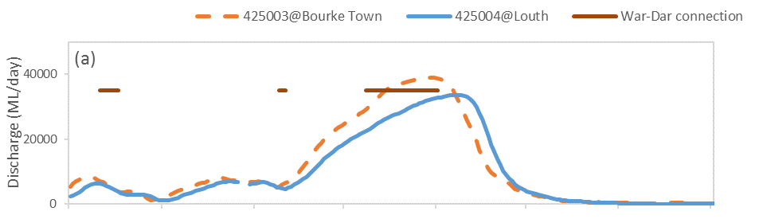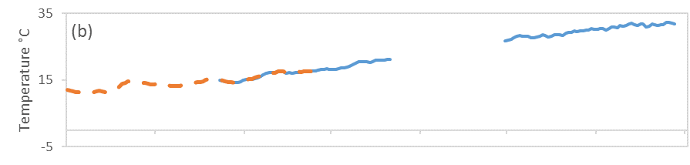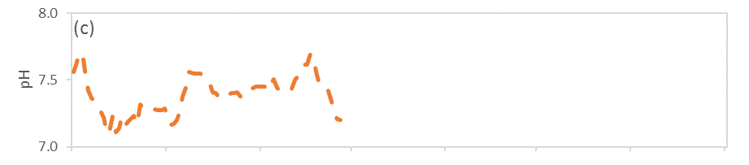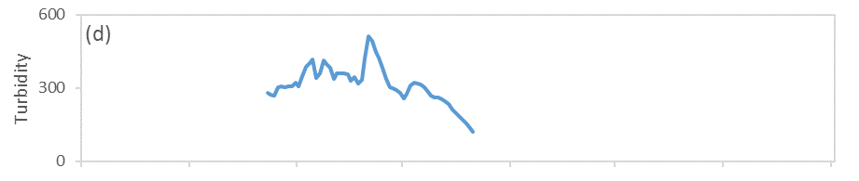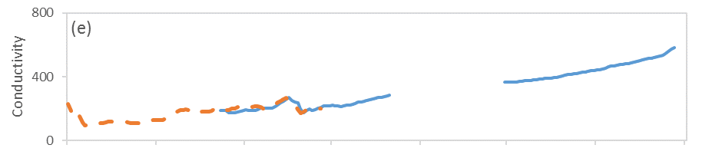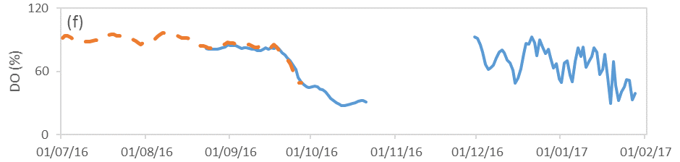
EW1 EW2 EW3 non-EW
Figure F-3: Mean daily (a) discharge at Darling@Bourke Town gauging station (NSW425003) and Darling@Louth gauging station (NSW425004) on the Darling River system, (b) temperature, (c) pH, (d) turbidity, (e) conductivity and (f) dissolved oxygen concentrations at Darling downstream water quality station (Blue) and Darling upstream water quality station (Orange dotted).
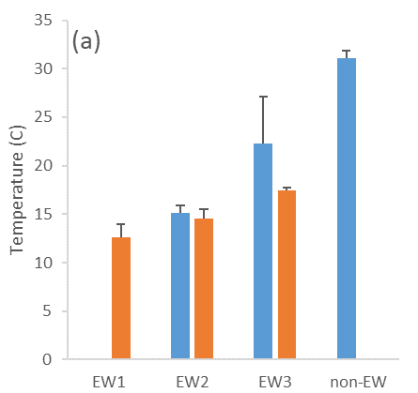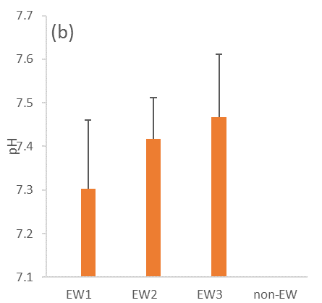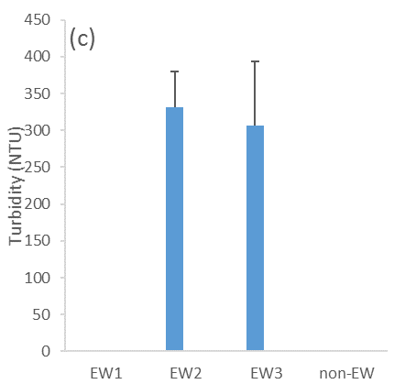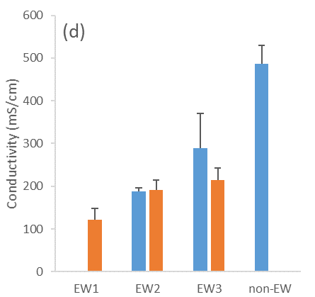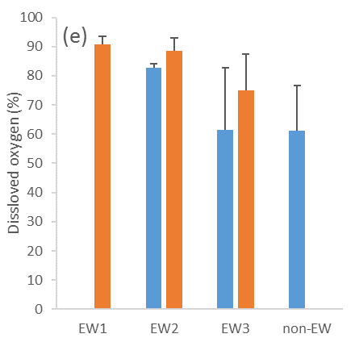
Figure F-4: Average of (a) temperature, (b) pH, (c) turbidity, (d) conductivity and (e) dissolved oxygen concentrations at Darling downstream water quality station (Blue) and Darling upstream water quality station (Orange) in three Commonwealth Environmental Water events (EW) and non-Commonwealth Environmental Water period (non-EW).

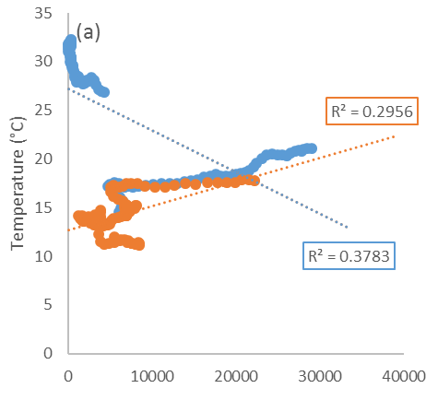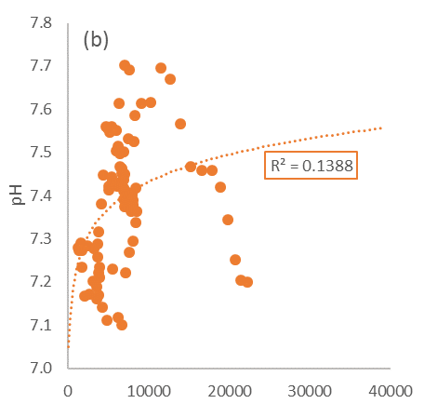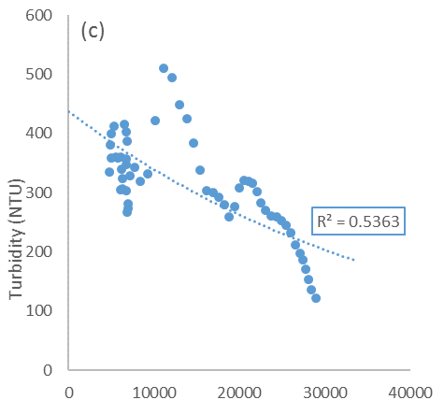

Figure F-5: Regressions between discharge at Darling@Bourke Town gauging station (NSW425003) and Darling@Louth gauging station (NSW425004) and mean daily (a) temperature (linear), (b) pH (log), (c) turbidity (exponential), (d) conductivity (log) and (e) dissolved oxygen concentrations (linear). Blue indicates Darling downstream water quality station. Red indicates Darling upstream water quality station.
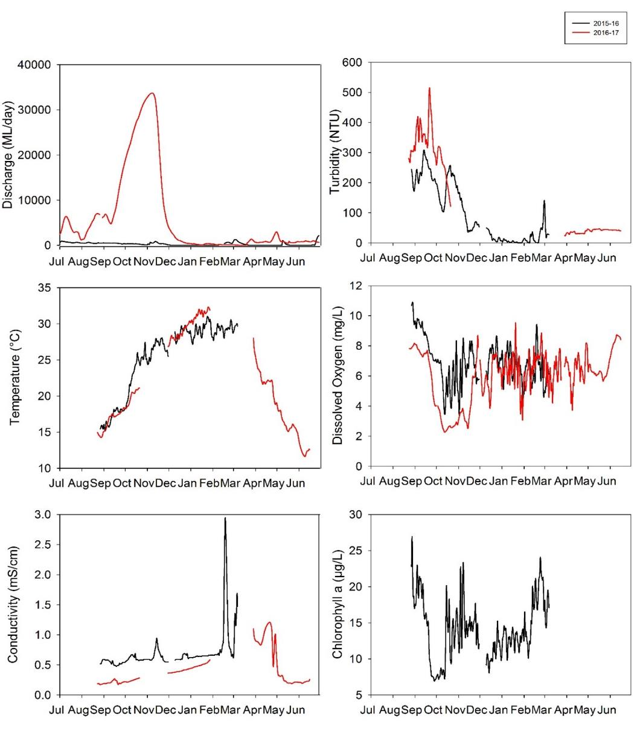
Figure F-6: Mean daily discharge at Darling@Louth gauging station (NSW425004) and water quality indicators in the Darling downstream station in 2015-16 and 2016-17.

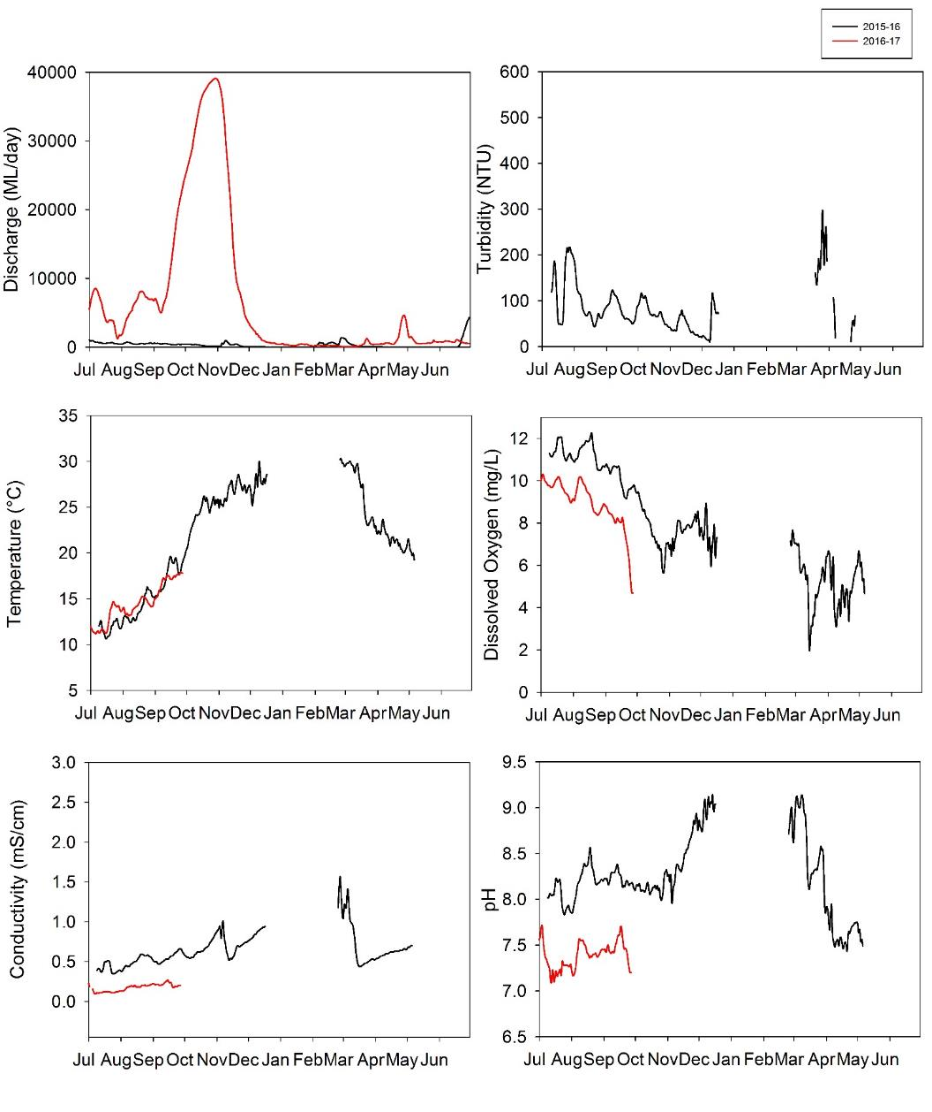
Figure F-7: Mean daily discharge at Darling@Bourke gauging station (NSW425003) and water quality indicators in the Darling upstream station in 2015-16 and 2016-17.

              - Short-term sampling

The Aug-16 sampling event was the wettest of the three sampling times and represented prolonged inundation and water retention within the Selected Area, while Mar-17 captured the contraction period of residual water on the Western Floodplain and the Warrego River, and base flow conditions in the Darling River.
All sites exhibited highly variable water quality conditions during the three sampling periods. Temperature in spring (Nov-16) and summer (Mar-17) were significantly higher than in winter (Aug-16) as expected due to seasonal variation (Pseudo-F 78.677, p<0.0005; Figure F-7a).
The pH in Mar-17 was significantly higher than in Aug-16 and Nov-16 across all sites (Pseudo-F 68.793, p<0.0005; Figure F-7b). In particular, pH in all Warrego sites during the Mar-17 sampling were above the ANZECC guideline (pH between 6.5 and 8) as the channel contracted to disconnected pools.
Turbidity ranged from 30 to 1214 NTU, and was consistently higher than the ANZECC water quality guideline (turbidity between 6 and 50 NTU) across all sites (Figure F-7c). There were significant time and zone interactions observed in turbidity (Pseudo-F 17.547, p<0.005). The highest turbidity recorded of above 1,000 NTU was observed on the Western Floodplain when the site receded to a puddle in Mar-17. It is likely that bioturbation (remnant fish in pools) contributed to these high values. The two Darling sites had lower turbidity level when compared with the Warrego channel and Floodplain sites. The Darling River sites had the lowest turbidity level in Mar-17. In the Warrego sites, there were no consistent spatial and temporal patterns.
Conductivity was within the ANZECC water quality guideline (conductivity between 0.125 and 2.2 mS/cm). There were significant time and site interactions observed in conductivity (Pseudo-F 17.419, p<0.0005). Conductivity in Mar-17 was significantly higher than in Aug-16 and Nov-16 across all sites (Figure F-7d) and reflected a contraction of surface water in all areas.
Dissolved oxygen concentrations ranged from 32.8% to 160% (2.93mg/L to 12.66mg/L), and were generally lower than the ANZECC water quality guideline values (Dissolved oxygen percent between 85% and 110%). Dissolved oxygen in the Western Floodplain was significantly lower than the Darling and Warrego Rivers in all sampling occasions (Pseudo-F 5.8019, p<0.05; Figure F-7e), and decreased to 2.93 mg/L when the site receded to a disconnected puddle in Mar-17.
Chlorophyll a concentrations were above the ANZECC guideline trigger value (chl a 5 µg/L) in Nov-16 and Mar-17 (Figure F-7f). There were significant time and zone interactions (Pseudo-F 18.804, p<0.005). Chlorophyll a concentration reached its highest in Nov-16 in the Darling River and in Mar-17 in the Warrego River and the Western Floodplain. In particular, the highest chlorophyll a concentration of above 600 µg/L was observed in the Western Floodplain Mar-17 sampling, associated with peaks in TN and TP concentrations (Appendix G).

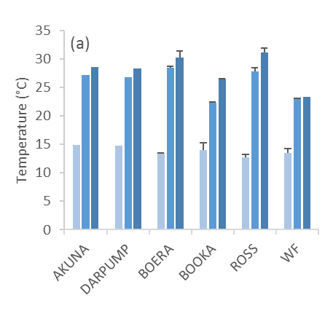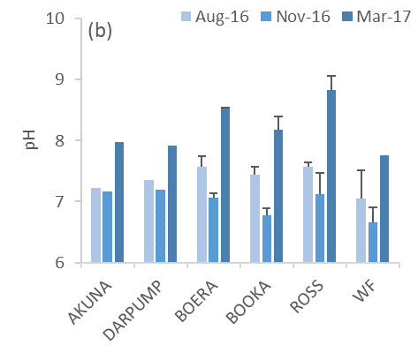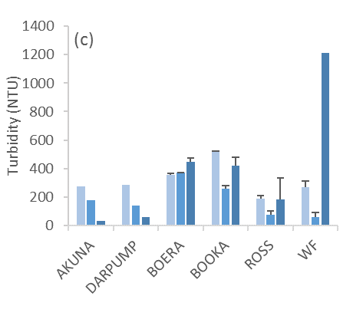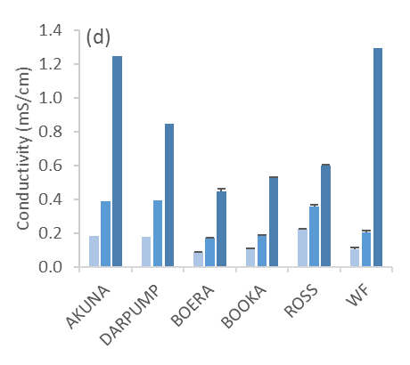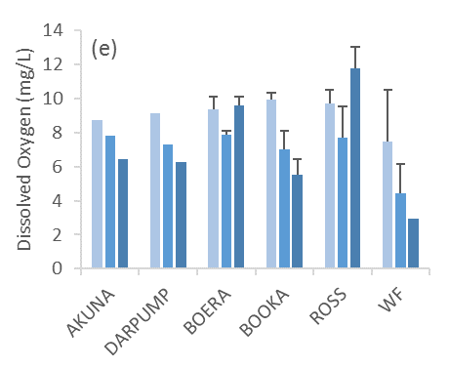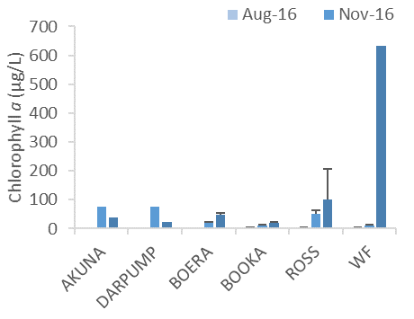
Figure F-8: Mean concentrations ± standard deviation (SD) of (a) temperature, (b) pH, (c) turbidity, (d) conductivity, (e) dissolved oxygen and (f) cholroophyll a concentrations in eight spot sampling sites.

Discussion
F.4.1 Darling River continuous monitoring
The magnitude of flow events in this water year (peak flow around 39,000 ML/d) was much higher than 2015-16 (peak flow around 1300 ML/d) due to high rainfall in the upstream Barwon and Darling catchments. Water quality indicators were highly variable during the four time periods analysed in 2016-17 in response to a large range of event volumes and contributions of Commonwealth environmental water. The comparison of responses in water quality indicators to flows between 2015-16 and 2016-17 will be considered as a ‘dry year’ compared with a ‘wet year’ respectively.
Physicochemical water quality indicators such as pH and conductivity had lower mean values with smaller ranges compared with the “dry year” in 2015-16, likely due to much higher variability and magnitude in discharge. This between years difference suggests that an increase in flow variability and magnitude augmented by Commonwealth environmental water improved pH and conductivity reflecting a dilution effect provided by higher discharge. In 2016-17, the highest conductivity was recorded during the non-EW period (discharge range of 60-550 ML/d) and contrasts the negative relationship between conductivity and discharge. In contrast, turbidity was exceptionally high in both “dry year” and “wet year” periods, and reflects the long term high turbidity in these intermittent floodplain systems (Sheldon & Fellows, 2010).
During the 2015-16, pH and turbidity had their highest recorded values, when discharge was around 10,000 ML/d, suggesting that this may be a key high-flow threshold for the inundation or connection of geomorphic features that subsequently affect ions and suspended sediments levels in the Darling River. Before discharge reached 10,000 ML/d, these variables increased with discharge suggesting longitudinal transport and input of materials from upstream catchments was a major driver of the influx of materials (Bayley & Sparks, 1989). After discharge exceeded 10,000 ML/d, relative variables declined with discharge likely due to the dilution of existing materials from processes such as reduction in resuspension and less input of materials from geomorphic features at higher river stage. Given the relatively small contributions of Commonwealth environmental water in these two period (8.5% and 2.4%), the observed water quality changes were likely driven by natural flow events.
A unimodal relationship was also observed between dissolved oxygen concentration and discharge at around 5,000 ML/d. The highest dissolved oxygen concentrations were recorded when discharge was 5,000 ML/d during EW1 and EW2 events. This suggests that flows in this magnitude may inundate low lying in-channel features such as bars and transport nutrients to stimulate primary production measured as dissolved oxygen concentrations. After discharge exceeded this 5,000 ML/d threshold, dissolved oxygen concentrations declined. No adverse biological outcomes were recorded from this reduced dissolved oxygen period. One possible explanation is that phytoplankton productivity (measured as dissolved oxygen concentration) is limited by light through interactions among turbidity, depth and turbulence (Allan & Castillo 2007). Alternatively, different water sources from upstream tributaries transport various amounts and proportions of nutrients and organic matter, in turn, affecting the balance between productivity and respiration. It is hypothesised that any Commonwealth environmental water contribution above 5,000 ML/d could contribute to a decrease in dissolved oxygen concentration without creating adverse conditions. The lowest dissolved oxygen concentration level was recorded during the non EW event (discharge range of 60 -550 ML/day) in this year.
The downstream station is designed to assess the influence of Warrego flows during longitudinal connectivity of the Warrego and Darling Rivers. Similar to 2015-16, the downstream station had lower conductivity regardless of flow conditions, suggesting that broader spatial patterns were predominantly driven by local characteristics and landscape-scale processes such as sediment and salinity inputs. Spot measurements found consistently lower conductivity levels in the Warrego River than the Darling River suggesting the potential dilution effect to the downstream station. However, there are insufficient data for comparisons during the connectivity events due to the loss of equipment and instrument failure. A consistently higher dissolved oxygen concentration in the downstream station in this year and 2015-16 were also observed. Additional water quality sampling during the peak flow event in this water year showed dilution effects in the Darling in pH and conductivity, TN and chlorophyll a concentrations by the Warrego inflow (Appendix G).
F.4.2 Spot sampling
Spot sampling measurements of pH, turbidity and conductivity were in similar ranges compared with 2015-16, though the systems experienced different order of magnitude flows between years. In contrast, dissolved oxygen concentrations had a wider range in concentrations this watering year associated with a higher range of flow magnitude. It is possible that biological activity (reflected in dissolved oxygen concentration) is more responsive to flow variability compared with smaller changes in physicochemical water quality indicators.
Similar to 2015-16, the Darling River zone had higher conductivity and lower turbidity regardless of flow conditions, suggesting that broader spatial patterns were predominantly driven by catchment characteristics and landscape-scale processes, such as sediment and saline inputs. Moreover, water temperature variation in the continuous monitoring stations and sampling sites is attributed to broader regional climate patterns rather than flow or other environmental conditions.
During base flow condition in the Darling River and the residual water contraction period in the Warrego River and Western Floodplain, pH and conductivity reached their highest level. These similar temporal patterns were observed among sites irrespective of zones, suggesting these patterns were predominantly controlled by flow and water level. In particular, pH exceeded the ANZECC guideline during the contraction period in all Warrego River sites. This reflected the evapoconcentration of ions due to contracting water body size in warm summer climate conditions. This also follows the trend observed in the 2015-16 in both Darling water quality stations that pH increased during low flow period.
Extremely poor water quality conditions were observed in the contraction period in the Western Floodplain. This example demonstrates how water quality deteriorates in the floodplain during the contraction phase when multiple physical and biological processes are driving water quality changes. Evapoconcentration resulted in high conductivity concentrations while internal nutrient cycling boosted primary production. In addition, high volumes of benthic organic matter increased microbial productivity and subsequently reduced oxygen concentrations through their respiration. Therefore, increases in turbidity, conductivity, TN, TP and DOC as well as decreases in dissolved oxygen to below 3 mg/L were all associated with time since connection or recession of flow.

Conclusion
Similar to 2015-16, most water quality indicators had weak linear or logarithmic relationships with discharge but some unimodal relationships were observed suggesting that key threshold for the inundation of in-channel geomorphic features may exist. The differences in thresholds between the ‘dry year’ (2015-16) and ‘wet year’ (2016-17) were at 500 ML/d and 5000-10000 ML/d respectively. It is proposed that inter-annual hydrological variability and antecedent flow condition could play important roles in water quality variability, highlighting the importance of long-term monitoring in highly dynamic system to allow multi-year comparisons.
The higher magnitude and variability of flow events and contributions of Commonwealth environmental water in this water year consistently improved pH and conductivity reflecting a dilution effect when compared with 2015-16. In addition, during the Warrego River connection event in October, a noticeable dilution trend was noted in water quality parameters in the Darling River downstream of the confluence (more detail in Appendix G). Two new loggers will help to ensure data continuity and will further inform the influence of the Warrego River on Darling River water quality over the remainder of the project.

References
Allan, J.D. and Castillo, M.M., 2007. Stream ecology: structure and function of running waters. Springer Science & Business Media.
Bayley, P. B., & Sparks, R. E. 1989. The flood pulse concept in river-floodplain systems. Paper presented at the Proceedings of the International Large River Symposium. Dodge, DP (Ed). Can. Spec. Publ. Fish. Aquat. Sci.
Commonwealth of Australia. 2015. Commonwealth Environmental Water Office Long Term Intervention Monitoring Project Junction of the Warrego and Darling rivers Selected Area. Annual Evaluation Report – Year 1. Commonwealth of Australis, Canberra.
Sheldon, F., & Fellows, C. S. 2010. Water quality in two Australian dryland rivers: spatial and temporal variability and the role of flow. Marine and Freshwater Research, 61(8), 864-874.

Stream Metabolism

Introduction
The Category I Stream Metabolism indicator aims to assess the contribution of Commonwealth environmental water to improving stream metabolism in the Darling River zone of the Junction of the Warrego and Darling rivers Selected Area (Selected Area). As such, this indicator is linked to Hydrology (River and Northern tributaries), Water Quality and Fish (Channel) indicators. Two specific questions were addressed through this indicator within the Darling River zone during the 2016-17:
- What did Commonwealth environmental water contribute to patterns and rates of decomposition?
- What did Commonwealth environmental water contribute to patterns and rates of primary productivity?

Environmental watering in 2016-17
Barwon-Darling and northern tributaries
Unlike other Selected Areas, environmental water is not specifically delivered to the Junction of the Warrego and Darling rivers Selected Area, rather, Commonwealth water is held as unregulated entitlements and its influence is thus reliant on flows out of upstream catchments. During the 2016–17 water year, four flow events containing environmental water flowed down the Darling River within the Selected Area (Appendix B). These occurred in June – August 2016, August – September 2016, September – December 2016 and April – May 2017. Three of these flows were in-channel pulses with the flow during September-December 2016 reaching at or just over bankfull. Total proportions of Commonwealth environment water in the Darling River varied between 1.8% and 36.5% of total flow (Appendix B).
Warrego River
Several flow pulses in the Warrego River occurred between June - November 2016. The demand for environmental flows on the Western Floodplain was very high given the last large-scale inundation of the Western Floodplain at Toorale was in 2012. As per licence conditions, a fresh in the Warrego River in July 2016 was allowed to make visible connection with the Darling River prior to closing the gates in Boera Dam and allowing Commonwealth environmental water to spill to the Western floodplain from 19 July 2016. The gates at Boera were opened again from the 9-12 September 2016 to connect with the Darling River in accordance with licence conditions for a new flow event. Following this, further inflows were spilled to the Western Floodplain with total approved volume reaching the annual allocation of 9,720 ML by 20 September 2016. Water continued to spill onto the Western Floodplain until December 2016. In total, 31,000 ML of water flowed onto the Western Floodplain of which 31% was Commonwealth environmental water.
Another fresh occurred in the Warrego River during September - November 2016. The Boera Dam gates were again opened and once the fresh had connected with the Darling River, Commonwealth environmental water licences on the Warrego River were used to provide a pulse of water down the Warrego River. This flow aimed to provide opportunities for native fish to access habitat, support recruitment and possibly triggering spawning. 10,500 ML of water was released down the lower Warrego River channel and included 7,762 ML (74%) Commonwealth environmental water. The release was managed to provide a slow rise and fall to the pulse and also ensure that water also continued to spill to the Western Floodplain at the same time. Commonwealth water was used to provide connection for 20 days. National Parks and Wildlife Service maintained the connection for an additional 5 days before closing the gates and allowing the remaining water to spill to the Western Floodplain.

Previous monitoring
The monitoring of water quality and metabolism during 2015-16 revealed positive relationships between rates of gross primary production (GPP), ecosystem respiration (ER), net primary production (NPP) and nutrient concentrations in a range of low volume discharge with the contributions of Commonwealth Environmental water (peak flow around 1,300 ML/d), and relatively minor changes in hydrology. Increased rates of GPP and ER were associated with higher discharge, suggesting environmental water in the Darling River contributes to improved water clarity and/or increase inorganic nutrients that promote pelagic primary production.

Methods

Darling River continuous stations
Stream metabolism indicators (Table G-1) were monitored at two stations in the Darling River zone of the Selected Area that have permanent surface water in a defined channel. The Darling upstream station is located near Yanda homestead, and all Commonwealth environmental water derived in the upstream northern tributaries of the Murray Darling Basin (except Warrego River) passes through this reach (Figure G-1). The Darling downstream station is located downstream of the confluence of the Warrego and Darling Rivers near Akuna homestead. As such, the Darling downstream station can be used to assess the influence of Warrego River flow to stream metabolism of the Darling River
Table G-1: Stream metabolism indicators measured in 2016-17 water year.
Indicators | Variables | Units
Stream metabolism (Cat I)  (Darling River long-term stations) | Gross Primary Production | mg O2/L/day
 | Ecosystem Respiration | mg O2/L/day
 | Net Primary Production | mg O2/L/day
Water nutrients (Cat III)  (Spot sampling) | Total Nitrogen | µg/L
 | Total Phosphorus | µg/L
 | Nitrate-nitrite | µg/L
 | Filterable Reactive Phosphorus | µg/L
 | Dissolved Organic Carbon | µg/mL
Water nutrients and quality  (Additional high flow event sampling) | Total Nitrogen | µg/L
 | Total Phosphorus | µg/L
 | Nitrate-nitrite | µg/L
 | Filterable Reactive Phosphorus | µg/L
 | Chlorophyll a | µg/L
 | pH | -
 | Conductivity | mS/cm
Continuous monitoring of the dependant variables temperature (°C) and dissolved oxygen (mg/L) occurs at the two stations using a Hydrolab DS5-X logger. Each probe was mounted to a floating pontoon to ensure it was kept under the water but away from obstructions. In the Darling upstream station, the probe was connected via a 3-G telemetered system to an RMTek website for data monitoring and download. In the Darling downstream station, the probe was connected to a local logger and downloaded during each visit or periodically by NPWS staff. Each water quality variable is logged at 10 minute intervals. Photosynthetically active radiation (PAR) and barometric pressure were also logged at 10 minute intervals.
Daily rates of GPP and ER were calculated using the BASE modelling package (Grace et al. 2015). Regression analyses were used to explore relationships between discharge (ML/d) and each stream metabolism indicator in an attempt to separate the time/season of delivery from the event volume.
Due to issues with power supply, instrument failure (turbidity and biofouling) at both sites and the permanent loss of the instrument in the Darling upstream station during a high flow event on 27th September 2016, datasets were partly discontinuous in the 2016-17 water year. In addition, BASE modelling rejected more than 80% of the dataset due to poor model fitting (Table G-2). Two consecutive in-channel flow events containing Commonwealth environmental water were used to examine responses in stream metabolism indicators (Table G-2). Commonwealth environmental water event 2 (EW2) comprised 5,194 ML (estimated contribution of 1.8%) of Commonwealth environmental water from Barwon-Darling River system and Commonwealth Environmental water event 3 (EW3) comprised 75,711 ML (estimated contribution of 2.1%) of Commonwealth environmental water from all upstream catchments (Appendix F).
Two new PME miniDOT loggers were installed to monitor temperature (°C) and dissolved oxygen concentration (mg/L), one at microinvertebrate site Darling Pump on 28th March 2017 to replace the loss Hydrolab DS5-X logger in the Darling upstream station and another at Akuna on 24 August 2016 to ensure data continuity. New logger data will be retrieved in the next field trip in 2017-18 water year.
Water nutrient samples (Cat I) are collected at approximately 6 weekly intervals throughout the year and analysed at the NATA accredited Environmental Analytical laboratories at Southern Cross University. Monitoring was conducted following the Standard Operating Procedures in Hale et al. (2013).

Table G-2: Summary of Stream Metabolism (Cat I) data records 2016-17. *Pass represents BASE2 outputs with acceptance criteria of R2<0.7, R-hats<1.1, PPP between 0.1 and 0.9, pD is positive and CV of GPP<50.
Station | Event | Period of record  (days) | Days with metabolism data (%)
 |  |  | Pass | Fail | Total
Upstream (Yanda) | EW1 | 1/7/2016 to 1/8/2016  (40 days) | - | - | -
 | EW2 | 2/8/2016 to 8/9/2016  (37 days) | 3 (19%) | 13 (81%) | 16
 | EW3 | 9/9/2016 to 25/12/2016 (107 days) | 3 (17%) | 15 (83%) | 18
 | non-EW | 26/12/2016 to 25/3/2017 (90 days) | - | - | -
Downstream (Akuna) | EW1 | 1/7/2016 to 1/8/2016  (40 days) | - | - | -
 | EW2 | 2/8/2016 to 8/9/2016  (37 days) | 6 (38%) | 10 (62%) | 16
 | EW3 | 9/9/2016 to 25/12/2016 (107 days) | 26 (25%) | 80 (75%) | 106
 | non-EW | 26/12/2016 to 25/3/2017 (90 days) | 0  (0%) | 90 (100%) | 90

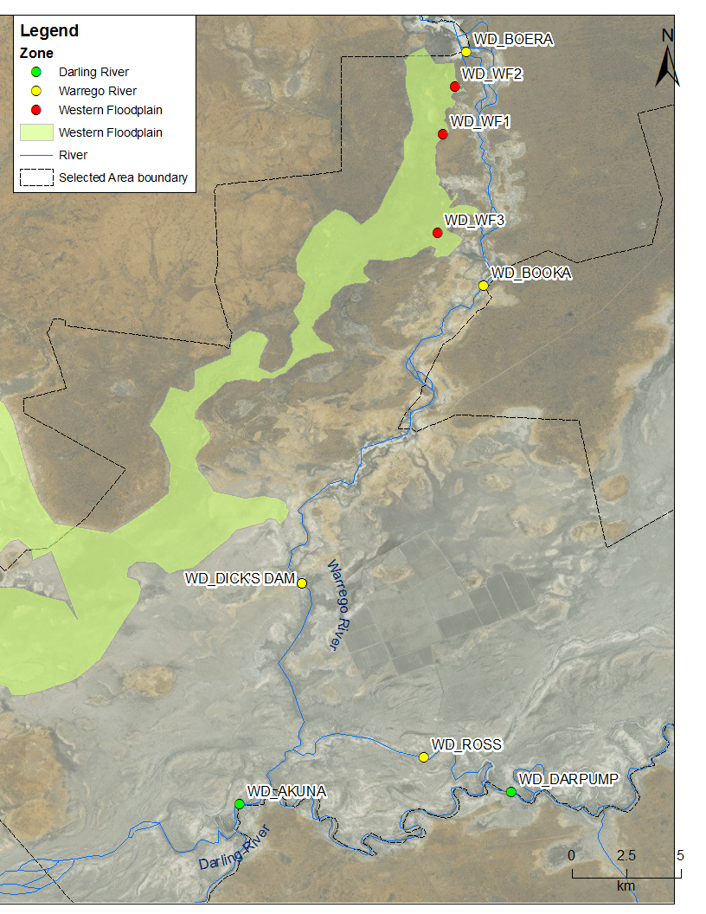
Figure G-1 Location of two long-term stream metabolism monitoring stations (Cat I: Yanda and Akuna) in the Darling River, eight spot sampling sites (Cat III) and additional water quality sampling site (Dick’s Dam) within the Selected Area in 2016-17.

Water nutrients spot sampling
Water column nutrients were measured in association with Category III Water Quality and Category III Microinvertebrate indicators in August 2016, November 2016 and March 2017 (Appendix H). Sampling sites were located in three Sampling Zones within the Selected Area: Darling River, Warrego River and Western Floodplain (Figure G-1 and Table G-3). Hydrological conditions within the Selected Area during sampling are described in (Appendix H).
Water nutrient samples were collected for laboratory analysis of total nitrogen (TN), total phosphorus (TP), nitrate-nitrite (NOx), filterable reactive phosphorus (FRP) and dissolved organic carbon (DOC) (Table G-1). Samples were analysed following the methods in 2015-16 report (Appendix G, Commonwealth of Australia 2016)
Permutational multivariate analysis of variance (PERMANOVA) routine was used to test difference in each water nutrients indicators between TIME (with 3 random levels, Aug-16, Nov-16 and Mar-17), ZONE (with 3 fixed levels, Darling, Warrego and Western Floodplain), SITE (with 6 fixed levels, AKUNA, DARPUMP, BOERA, BOOKA, ROSS and WF) where site was nested with zone and interactions (Table G-3). This routine can be used to analyse unbalanced experimental design with hierarchical nesting in an analysis of variance (ANOVA) experimental design using permutation methods ((PRIMER-E, 2009). Up to 999 random permutations estimated the probability of p-values, with levels of significance reported as p<0.05. Where statistically significant differences were detected, pair-wise comparisons in PREMANOVA routine were used to determine the source of the significant differences.
Table G-3 Location of eight spot sampling sites within the Selected Area for category III water quality surveys. Map projection GDA94 Zone 55.
Sampling Zone | Site Name | Site Code | Easting | Northing | Inundation
 |  |  |  |  | Aug-16 | Nov-16 | Mar-17
Darling River | Akuna homestead | AKUNA | 340008 | 6634629 | Wet | Wet | Wet
 | Darling Pump | DARPUMP | 350768 | 6635351 | Wet | Wet | Wet
Warrego Channel | Boera Dam | BOERA | 348526 | 6669158 | Wet | Wet | Wet
 | Booka Dam | BOOKA | 349357 | 6658461 | Wet | Wet | Wet
 | Ross Billabong | ROSS | 347281 | 6636893 | Wet | Wet | Wet
Western Floodplain | Coolabah, Coobah, Lignum woodland | WF2 | 348083 | 6667550 | Wet | Dry | Dry
 | Coolabah open woodland | WF1 | 347848 | 6665662 | Wet | Wet | Dry
 | Lignum shrubland | WF3 | 347476 | 6660850 | Wet | Wet | Wet

Additional high flow event sampling
Additional water quality samples were collected at approximately 5 day intervals between the 14th October and 20th November 2016 by NPWS staff at three sites (Warrego River, Darling River upstream and Darling River downstream). This sampling occurred during EW3, reflecting daily discharge in the Darling River peaking close to 40,000 ML/d at Bourke and as a flow event extending for over 100 days.
Water samples were collected for laboratory analysis of TN, TP, NOx, FRP, Chlorophyll a, pH, turbidity and conductivity (Table G-1). Samples were analysed following the methods in 2015-16 report (Appendix G, Commonwealth of Australia 2016).
The Warrego River site was located in Dick’s Dam, as all unregulated CEW from the upper and lower Warrego River passes through this point (Figure G-1).
The lower Warrego River NSW entitlement of unregulated Commonwealth environmental water allowed take of 7,800 ML in October 2016, with the gates at Boera opened on 8th October to 1st November 2016. This provided a flow pulse (with a slow rise and fall and maximum rate of 600 ML/d) through the Warrego channel to the Darling River to support native fish in the Warrego. Connection of the lower Warrego channel occurred within one day. The flow provided continuous connection of the Warrego with the Darling River for 25 days, which was the longest period of connection to date during the LTIM program (Appendix A).
The Darling River upstream site was in the town of Bourke about 80 km upstream of the Selected Area, and all Commonwealth environmental water derived from the upstream northern tributaries of the Murray Darling Basin (except Warrego River) passed through this reach. At Bourke upstream of the Selected Area, around 39,360 ML of CEW passed this point during the flow event. This coincided with peak natural river flows that resulted in the relative contribution of this take to be approximately 2.0% of flow volume (Appendix B).
The Darling River downstream site was located downstream of the confluence of the Warrego and Darling Rivers near Akuna homestead (Figure G-1). As such, the Darling downstream station can be used to assess the influence of Warrego River flow to the water chemistry of the Darling River. Total CEW during this event measured at Louth was 42,228 ML, coinciding with a large natural flow event that resulted in the relative contribution of Commonwealth environmental water from this site to be approximately 2.4% of flow volume at Louth downstream of the Selected Area (Appendix B).

Results and discussion

Darling River continuous stations
The Darling River upstream and downstream stations experienced a similar magnitude of discharge during this water year, with a short time lag for downstream flow (Figure G-2a). Rates of mean GPP ranged from 0.02 to 2.89 mg O₂/L/day and rates of ER ranged from 0.001 to 1.18 mg O₂/L/d (Figure G-2b and c). NPP was predominantly net autotrophic ranging from -0.07 to 2.42 mg O₂/L/d (Figure G-2d). GPP, ER and NPP were relatively consistent between the two stations based on all available data during EW2 and EW3. Overall, all measured nutrient concentrations in the downstream station (Akuna) were above the ANZECC water quality guideline value (Table G-4).
This water year GPP, ER and NPP were in the lower range of those recorded in 2015-16. Differences in discharge between the two years suggests flow magnitude and variability is a driver of differences. However, due to the high percentage of data that does not meet the BASE model output requirements (between 0 and 1,400 ML/d), multi-year comparisons are not possible for this low flow period.
In the downstream station, a small increase in GPP and NPP were observed during the rising limb of the largest flow event (EW3) when discharge peaked above 30,000 ML/d (Figure G-2b and d). GPP increased continuously until two weeks after the peak flow and then decreased following the receding limb. There may be a lag in response between metabolism and flow in these high nutrient, highly turbid river systems. This suggests that increased discharge is leading to increased rates of production and a shift in net ecosystem metabolism towards primary production, due to increased supply of inorganic nutrients and carbon (Baldwin et al. 2013). However, no strong predictive relationship was found between metabolism and flow in the downstream station (Figure G-3). Stronger positive responses of GPP and NPP to flow in the upstream station were observed based on six day of data. We do not have sufficient data to conclude the response of metabolism to each flow event with CEW contribution in this water year.
Table G-4: Concentrations of total nitrogen, nitrate-nitrite, ammonium, total phosphorus, filterable reactive phosphorus, dissolved organic carbon and chlorophyll a (Cat I) from NATA. Bold number represented concentrations that exceed ANZECC water quality guideline
Indicators (mg/L) | ANZECC (mg/L) | Akuna 4/07/16 | Akuna 15/08/16 | Akuna 20/03/17 | Akuna  (Average of additional sampling in Section G 3.3)
Total Nitrogen | 0.5 | 0.57 | 0.95 | 0.86 | 1.08
Nitrate-nitrite | 0.04 | 0.113 | 0.154 | <0.005 | 0.48
Ammonium | 0.02 | 0.058 | 0.034 | 0.057 | -
Total Phosphorus | 0.05 | 0.19 | 0.23 | 0.10 | 0.28
Filterable Reactive Phosphorus | 0.02 | 0.069 | 0.093 | 0.016 | 0.27
Dissolved Organic Carbon | - | 8.6 | 12.7 | 11.9 | -
Chlorophyll a | 0.005 | 0.016 | 0.032 | 0.084 | 0.11




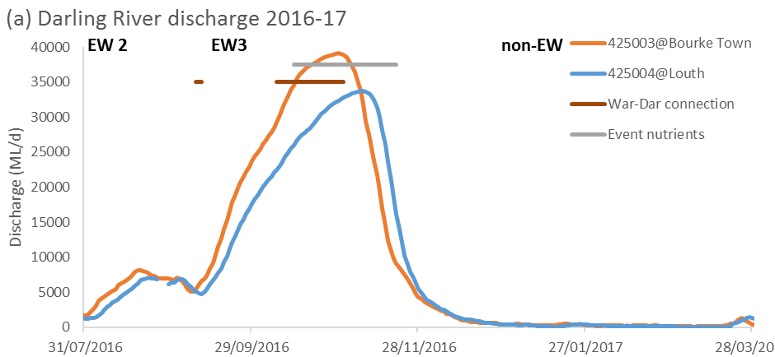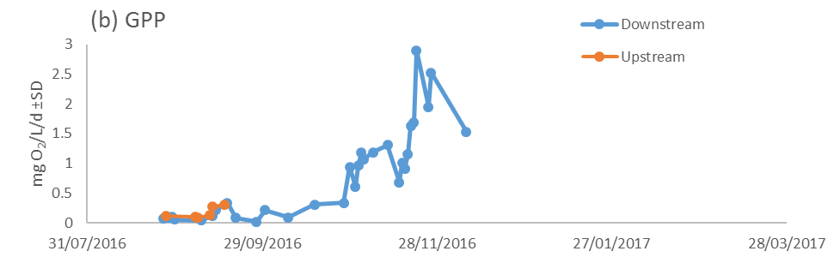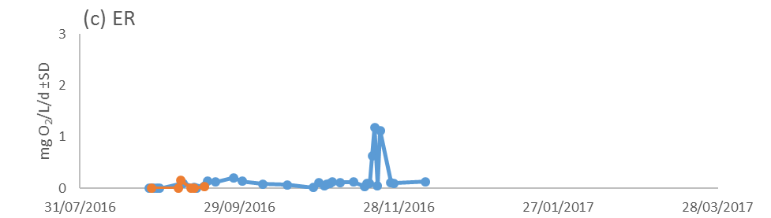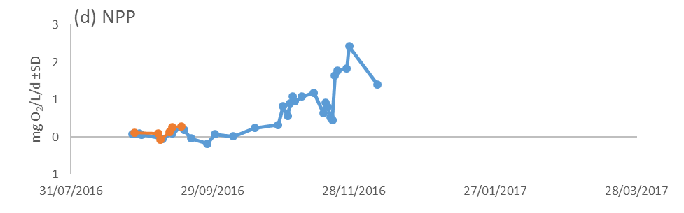
Figure G-2: Mean daily (a) discharge at Darling@Bourke Town gauging station (NSW425003) and Darling@Louth gauging station (NSW425004) on the Darling River system, (b) Gross Primary Production, (c) Ecosystem Respiration and (d) Net Primary Production at Darling downstream water quality station (Blue) and Darling upstream water quality station (Orange).
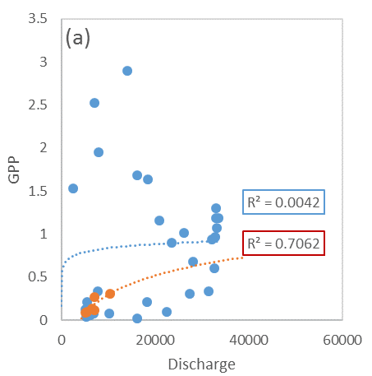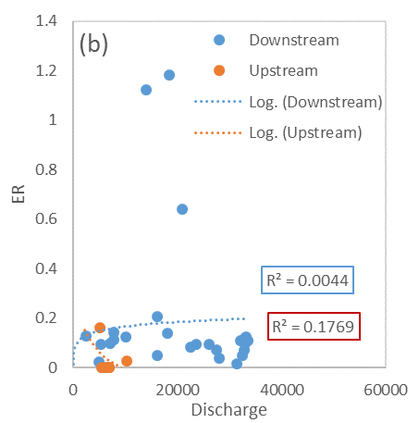
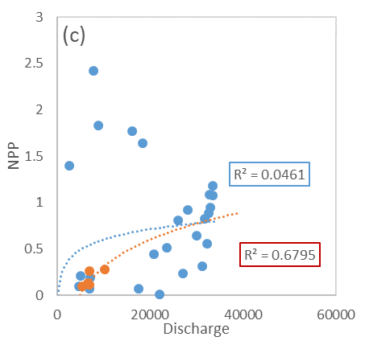
Figure G-3: Regressions between discharge and mean daily (a) Gross Primary Production, (b) Ecosystem Respiration and (c) Net Primary Production. Blue indicates Darling downstream. Orange indicates Darling upstream.

Short term sampling
The Aug-16 sampling occasion was the wettest phase sampled within the Selected Area for this reporting year. Sampling in Nov-16 represents prolonged inundation and a water retention period, while Mar-17 captured the contraction period of residual water on the Western Floodplain and the Warrego River, and base flow conditions in the Darling River.
TN concentrations were generally high, with the highest recorded concentration over 5,500 µg/L on the Western Floodplain in Mar-17, over ten times the ANZECC guideline trigger value (TN at 500 µg/L) in a lowland river ecosystem (Figure G-4a). Boera Dam was the only site with TN concentrations below the ANZECC guideline on two sampling occasions. There were significant time and zone interactions (Pseudo-F 13.302, p<0.05), however, no consistent spatial and temporal patterns were observed.

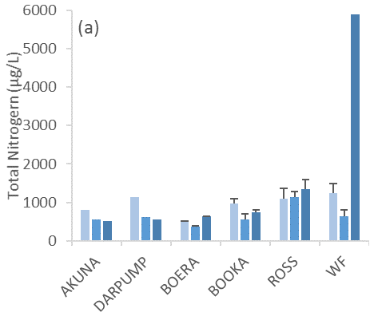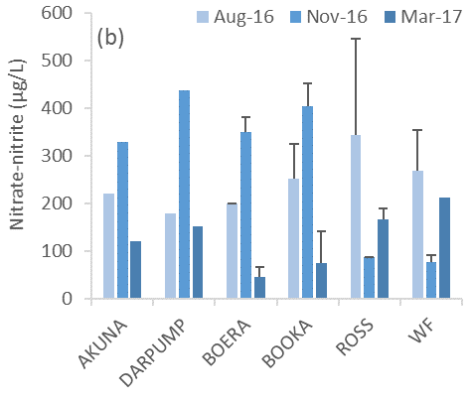

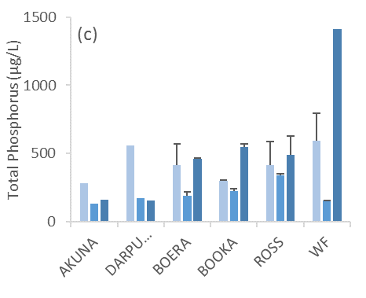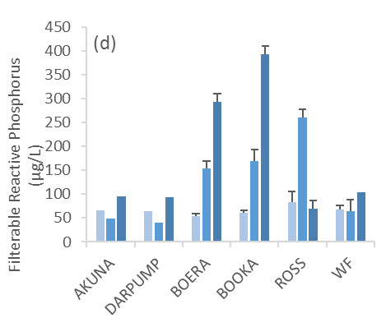

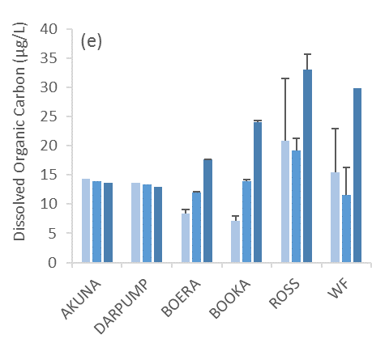
Figure G-4: Mean concentrations ± standard deviation (SD) of (a) total nitrogen, (b) nitrate-nitrite, (c) total phosphorus and (b) filterable reactive phosphorus and (e) dissolved organic carbon concentrations.
NOx concentrations were higher than the ANZECC guideline trigger value (Nitrate-nitrite at 40 µg/L) in all sites and sampling occasions (Figure G-4b). There were significant time and site interactions (Pseudo-F 4.3306, p<0.05), however, no consistent spatial and temporal patterns were observed.
TP concentrations were higher than the ANZECC guideline trigger value (TP at 50 µg/L) in all sites at sampling occasions (Figure G-4c). The highest recorded concentration of over 1,400 µg/L was on the Western Floodplain in Mar-17. There were significant time and zone interactions (Pseudo-F 9.0847, p<0.05), however, no consistent spatial and temporal patterns were observed.
Filterable reactive phosphorus (FRP) concentrations were consistently higher than the ANZECC guideline trigger value (FRP at 20 µg/L). There were significant time and zone interactions (Pseudo-F 19.958, p<0.0005), however, no consistent spatial and temporal patterns were observed (Figure G-4d).
Dissolved Organic Carbon (DOC) concentrations were significantly higher in Mar-17 in the Warrego and Western Floodplain as surface water contracted. There were significant temporal patterns (Pseudo-F 8.3542, p<0.05) with Mar-17 higher than Aug-16 and Nov-16 (pairwise, p<0.05, Figure G-4e). The highest DOC was recorded in the Warrego and Floodplain. DOC concentrations in Darling River were relatively stable throughout the year irrespective of flow variability.
Similar to years 1 and 2 of the project, all spot sampling had exceptionally high nitrogen and phosphorus concentrations irrespective of flow conditions or connectivity. In the Darling River, the decrease in TN, TP and TSS corresponded to reduced discharge, suggesting longitudinal and lateral inputs associated with higher flow events. However, chlorophyll a concentrations did not follow the pattern in TN, TP and TSS, reflecting the nutrients and other materials transported by flood water were not in bioavailable forms.
In the Warrego channel and Western Floodplain, TN and TP concentrations were significantly higher in the contraction period as flows receded, suggesting the internal recycling of nutrients from the sediment and water column. This is further supported by increased DOC concentrations in the same period. It is likely that when inflow ceased by the summer sampling period of Mar-17, nutrients retained during earlier connection events in Aug-16 drove the rapid growth of primary producers in warmer weather. The response of algal biomass measured as chlorophyll a also follows the same rise and fall pattern as DOC. This suggests DOC may be produced by in-stream photosynthesis, autochthonous periphyton and phytoplankton blooms elevating DOC from extracellular release, subsequently from retained nutrients imported during earlier flows.

High flow event – prolonged connection of the Warrego and Darling Rivers
An additional sampling event captured the peak water level in the Warrego channel (water level of 1.352 m at Boera Dam) and the peak of the high flow event (discharge range of 9,000-39,000 ML/d) in the Darling River (Figure G-5 a and b). Discharge peaked on 31 Oct 2016 at Bourke and on 8 Nov 2016 at Louth. Longitudinal connection between the Warrego and Darling Rivers occurred 7 days before the sampling started and persisted for 18 days during the first part of this event sampling (Appendix E). In the second part, receding flows were recorded in both the Warrego channel and the Darling River.
Both Darling River sites had higher TN, TP, chlorophyll a, pH and conductivity concentrations than the Warrego site (Figure G-6). It was predicted that downstream Darling River water quality would be diluted by the Warrego inflow once longitudinal connection between the Warrego and Darling Rivers occurred. This dilution effect is supported by lower TN, chlorophyll a, pH and conductivity concentrations in the downstream Darling site compared with the upstream site during connection, but still higher values than those in the Warrego. However, we do not have similar temporally intensive data to compare the pre-longitudinal connection condition. One interesting pattern is an increase in NOx and FRP at the Darling downstream site immediately after the Warrego and Darling connection event, suggesting the Warrego River is a source of labile nutrients for in-channel productivity that originate from the inundation of organic matter deposited during dry periods (Figure G-6). Therefore, the Warrego flows that contained reduced nutrient concentrations diluted concentrations in Darling downstream stations during the connection event.
Chlorophyll a concentrations were generally low throughout the sampling period with an increase in the last sample in Darling downstream station to the highest chlorophyll a concentration recorded of 112 µg/L. It is possible that the increased in chlorophyll a relates to physicochemical changes associated with the receding flood.
Similar to the finding with water quality indicators, there is no clear correlation between any measured indicators and discharge (Appendix F). It is proposed that the measured indicators respond to change in discharge to a specific threshold as discussed in the WQ (Appendix F).


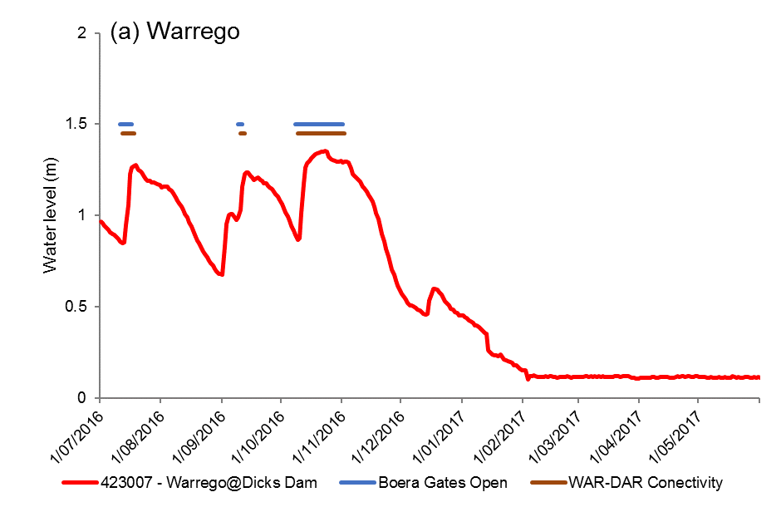
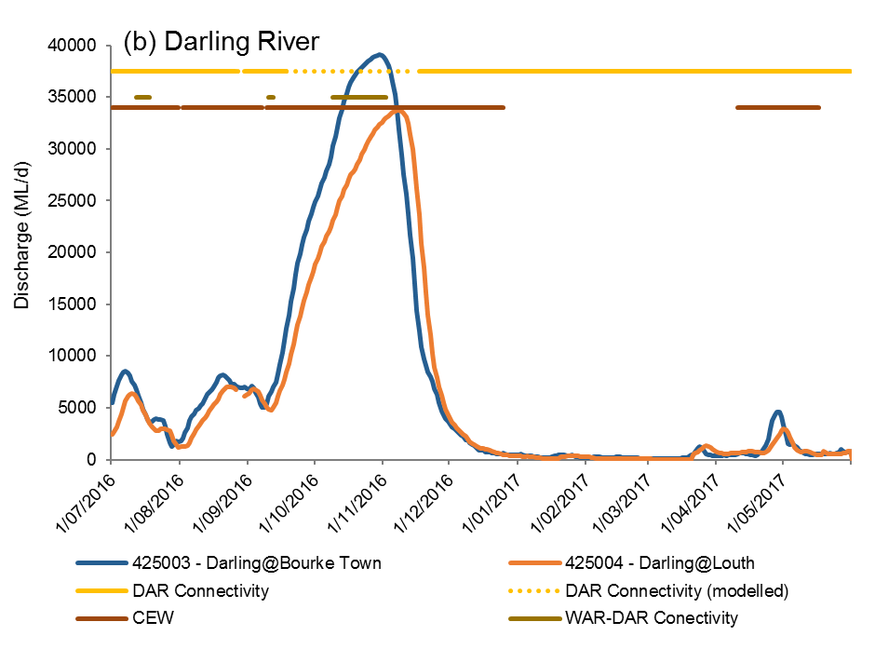
Figure G-5: Mean daily (a) water level at Dicks Dam and (b) discharge at Darling@Bourke Town gauging station (NSW425003) and Darling@Louth gauging station (NSW425004). Black box represents the period of additional water quality sampling.
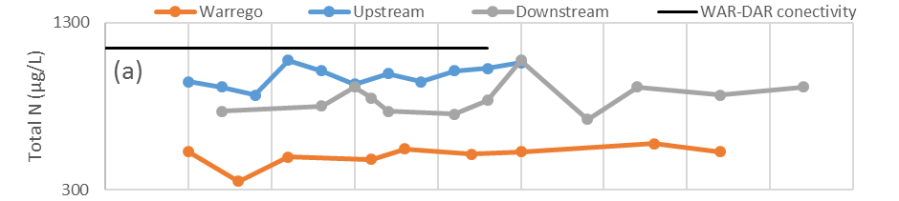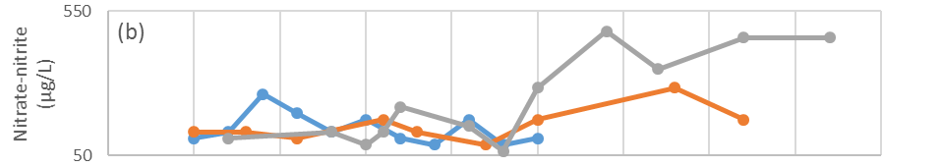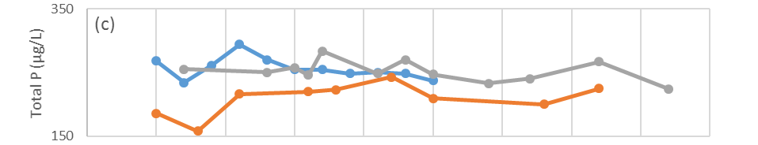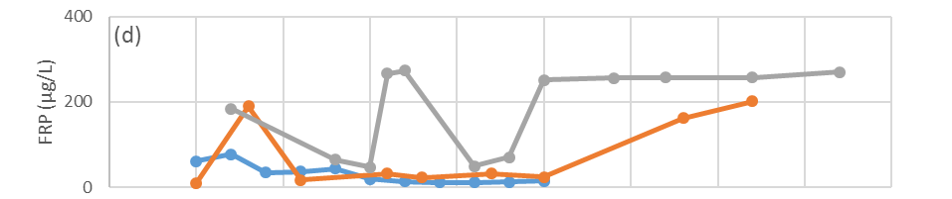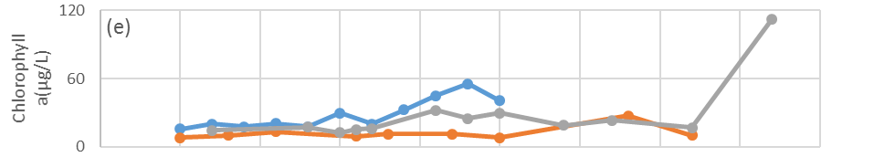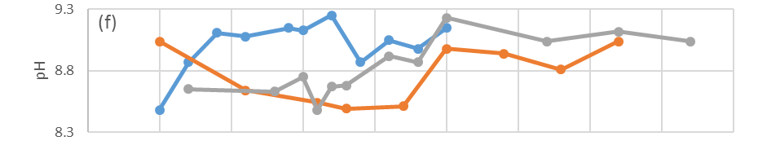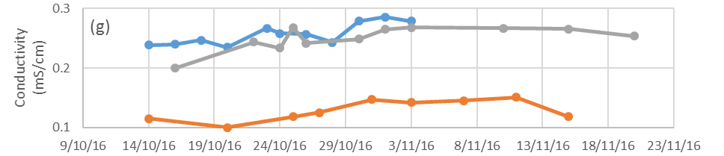
Figure G-6: Concentrations of (a) Total Nitrogen, (b) Nitrate-nitrite, (c) Total Phosphorus, (d) Filterable Reactive Phosphorus, (e) Chlorophyll a concentration, (f) pH and (g) Conductivity. Period of Warrego and Darling River connection also highlighted.

Multi-year comparison
Water column nutrient data were collected from continuous water quality sampling sites (cat 1), seven spot sampling occasions (cat 3) and one addition event sampling (Table G-5). All nutrient concentrations were consistently above the ANZECC water quality guideline values (Figure G-7). In general, the Darling River has lower TN and TP concentrations compared with the Warrego River in the two previous water years when the Warrego channel was disconnected pools. In the two wettest periods in 2016-17 (Sample 5 and additional high flow event), the Darling River had higher TN and TP concentrations than the Warrego River. In contrast, Darling River generally had lower FRP and DOC concentrations than the Warrego River regardless of flow conditions.

Table G-5: Summary of water nutrients data records 2014-17.
ID | Sampling | Category | Water year
1 | Feb-15 | Cat III | 2014-15
2 | May-15 | Cat III | 2014-15
3 | Oct-15 | Cat III | 2015-16
4 | Mar-16 | Cat III | 2015-16
Y2c1 | Year 2 | Cat I | 2015-16
5 | Aug-16 | Cat III | 2016-17
High | High flow event | Additional | 2016-17
6 | Nov-16 | Cat III | 2016-17
7 | Mar-17 | Cat III | 2016-17
Y3c1 | Year 3 | Cat I | 2016-17

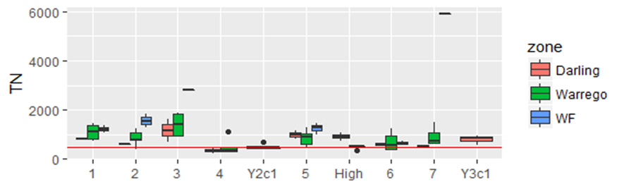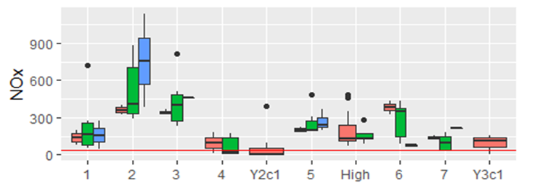
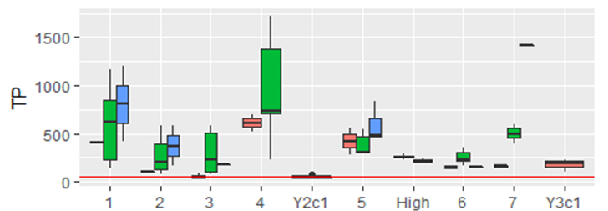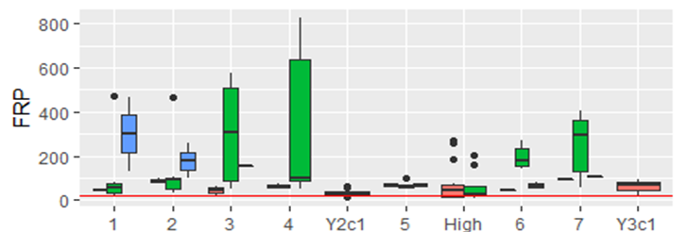
Figure G-7: Multi-year comparison of water nutrients in the Warrego Darling Selected Area (Values in µg/l). 1=Feb-15, 2=May-15, 3=Oct-15, 4=Mar-16, Y2c1=2015-16(cat1), 5=Aug-16, High=additional high flow event, 6=Nov-16, 7=Mar-17, Y3c1=2016-17(cat 1). Red lines represent the relevant ANZECC trigger values.

Conclusion
Overall, rates of GPP, ER and NPP in this water year were generally lower than the 2015-16 water year. This year Commonwealth environmental water contributed to increased rates of primary production during the largest flow event containing 2.4% of CEW (EW3) and shifted the Darling River channel to a net autotrophic ecosystem. This suggests that environmental water in the Darling River contributed to increasing the supply of inorganic nutrients and carbon that promote pelagic primary production and support biota at higher trophic levels such as microinvertebrates and larval fish. Therefore, energy flow and organic matter cycling was dominated by an autotrophic pelagic pathway in the Darling River channel with CEW contribution during this higher flow event.
In general, nutrient concentrations exceeded the ANZECC guideline during the additional high flow event sampling, with higher nutrient concentrations in the Darling River than the Warrego River. Longitudinal connectivity between the Warrego and Darling Rivers diluted TN, chlorophyll a, pH and conductivity concentrations in the Darling downstream station.
There was no clear correlation between all measured metabolism and nutrients indicators with discharge. It is proposed that metabolism and nutrients indicators respond to change in discharge to a specific threshold rather than following a linear trend. Datasets were discontinuous in the 2016-17 water year due to instrument loss and poor model fitting. Two new loggers installed will ensure data continuity and detect the potential influence of the Darling River in the coming year monitoring.

References
Baldwin, D. S., Rees, G. N., Wilson, J. S., Colloff, M. J., Whitworth, K. L., Pitman, T. L., & Wallace, T. A. 2013. Provisioning of bioavailable carbon between the wet and dry phases in a semi-arid floodplain. Oecologia, 172(2), 539-550.
Commonwealth of Australia 2016. Commonwealth Environmental Water Office Long Term Intervention Monitoring Project Junction of the Warrego and Darling rivers Selected Area – 2015-16 Final Evaluation Report. Retrieved from
Grace, M. R., Giling, D. P., Hladyz, S., Caron, V., Thompson, R. M., & Mac Nally, R. 2015. Fast processing of diel oxygen curves: Estimating stream metabolism with BASE (BAyesian Single‐station Estimation). Limnology and Oceanography: Methods, 13(3), 103-114.

Microinvertebrates

Introduction
The category III microinvertebrate indicator aims to assess the contribution of Commonwealth environmental water to microinvertebrate abundance and diversity. Several specific questions were addressed through this indicator within the Junction of the Warrego and Darling rivers Selected Area (Selected Area) during the 2016-17 water year:
- What did Commonwealth environmental water contribute to microinvertebrate productivity?
- What did Commonwealth environmental water contribute to microinvertebrate community composition?
- What did Commonwealth environmental water contribute to connectivity of microinvertebrate communities in floodplain watercourse?

Environmental watering in 2016-17
Barwon-Darling and northern tributaries
Unlike other Selected Areas, environmental water is not specifically delivered to the Junction of the Warrego and Darling rivers Selected Area, rather, Commonwealth water is held as unregulated entitlements and its influence is thus reliant on flows out of upstream catchments. During the 2016–17 water year, four flow events containing environmental water flowed down the Darling River within the Selected Area (Appendix B). These occurred in June – August 2016, August – September 2016, September – December 2016 and April – May 2017. Three of these flows were in-channel pulses with the flow during September-December 2016 reaching at or just over bankfull. Total proportions of Commonwealth environment water in the Darling River varied between 1.8% and 36.5% of total flow (Appendix B).
Warrego River
Several flow pulses in the Warrego River occurred between June - November 2016. The demand for environmental flows on the Western Floodplain was very high given the last large-scale inundation of the Western Floodplain at Toorale was in 2012. As per licence conditions, a fresh in the Warrego River in July 2016 was allowed to make visible connection with the Darling River prior to closing the gates in Boera Dam and allowing Commonwealth environmental water to spill to the Western floodplain from 19 July 2016. The gates at Boera were opened again from the 9-12 September 2016 to connect with the Darling River in accordance with licence conditions for a new flow event. Following this, further inflows were spilled to the Western Floodplain with total approved volume reaching the annual allocation of 9,720 ML by 20 September 2016. Water continued to spill onto the Western Floodplain until December 2016. In total, 31,000 ML of water flowed onto the Western Floodplain of which 31% was Commonwealth environmental water.
Another fresh occurred in the Warrego River during September - November 2016. The Boera Dam gates were again opened and once the fresh had connected with the Darling River, Commonwealth environmental water licences on the Warrego River were used to provide a pulse of water down the Warrego River. This flow aimed to provide opportunities for native fish to access habitat, support recruitment and possibly triggering spawning. 10,500 ML of water was released down the lower Warrego River channel and included 7,762 ML (74%) Commonwealth environmental water. The release was managed to provide a slow rise and fall to the pulse and also ensure that water also continued to spill to the Western Floodplain at the same time. Commonwealth water was used to provide connection for 20 days. National Parks and Wildlife Service maintained the connection for an additional 5 days before closing the gates and allowing the remaining water to spill to the Western Floodplain.

Previous monitoring
In 2015-16, a range of low volume discharge events elevated carbon and phosphorus concentrations and diluted nitrogen concentrations, boosting algal productivity and microbial heterotrophy, and stimulating microinvertebrate food webs. There were no consistent patterns in microinvertebrate densities among sites or over time, but sites such as the Western Floodplain were highly productive. Microinvertebrate community composition differed between the Warrego and Darling Rivers, indicating the potential benefits of the delivery of Commonwealth environmental water to the Warrego system for increasing regional level productivity and diversity through inundation of floodplain and channel habitats. Hydrological connectivity through the channels of the Selected Area contributed to the development and succession of different microinvertebrate communities between systems. Microinvertebrate community composition in the Warrego Channel ‘dry period’ when channel habitats were disconnected pools were significantly different from the connected ‘wet period’ when phosphorus concentrations drove an increase in system productivity. Therefore, connectivity of Warrego channels contributed to the development and succession of different microinvertebrate communities between channel sites, even without the inundation of the Western Floodplain.

Methods

H.2.1 Design
The Category III Water Quality indicators (Appendix F) were measured in association with Category III Stream Metabolism indicators (Appendix G) and Category III Microinvertebrate indicators in August 2016, November 2016 and March 2017 (Table H-1 and Table H-2). Sample sites were located in three zones within the Selected Area: Darling River, Warrego River and the Western Floodplain (Figure H-1).
Table H-1: Location of sites on the Junction of the Warrego and Darling Rivers Selected Area for microinvertebrate surveys. Map projection GDA94 Zone 55.
Sampling Zone | Site Name | Site Code | Easting | Northing | Inundation
 |  |  |  |  | Aug-16 | Nov-16 | Mar-17
Darling River | Akuna homestead | AKUNA | 340008 | 6634629 | Wet | Wet | Wet
 | Darling Pump | DARPUMP | 350768 | 6635351 | Wet | Wet | Wet
Warrego Channel | Boera Dam | BOERA | 348526 | 6669158 | Wet | Wet | Wet
 | Booka Dam | BOOKA | 349357 | 6658461 | Wet | Wet | Wet
 | Ross Billabong | ROSS | 347281 | 6636893 | Wet | Wet | Wet
Western Floodplain | Coolabah, Coobah, Lignum woodland | WF1 | 348083 | 6667550 | Wet | Dry | Dry
 | Coolabah open woodland | WF2 | 347848 | 6665662 | Wet | Wet | Dry
 | Lignum shrubland | WF3 | 347476 | 6660850 | Wet | Wet | Wet
Table H-2: Environmental variables and microinvertebrate responsive variables measured at each sites and sampling occasion.
Indicators | Variables | Units | Code
Water quality | Temperature | °C | temp
 | pH | - | ph
 | Turbidity | NTU | turb
 | Conductivity | mS/cm | cond
 | Dissolved Oxygen | mg/L | do
 | Chlorophyll a | µg/L | chla
 | Redox potential | mV | orp
Water nutrient | Total Nitrogen | µg/L | tn
 | Total Phosphorus | µg/L | tp
 | Nitrate-nitrite | µg/L | nox
 | Filterable Reactive Phosphorus | µg/L | frp
 | Dissolved Organic Carbon | µg/mL | doc
Microinvertebrate | Density | individual/L | -
 | Diversity | - | -
 | Richness | - | -
 | Community presence-absence | - | -
 | Community abundance (sq root) | - | -
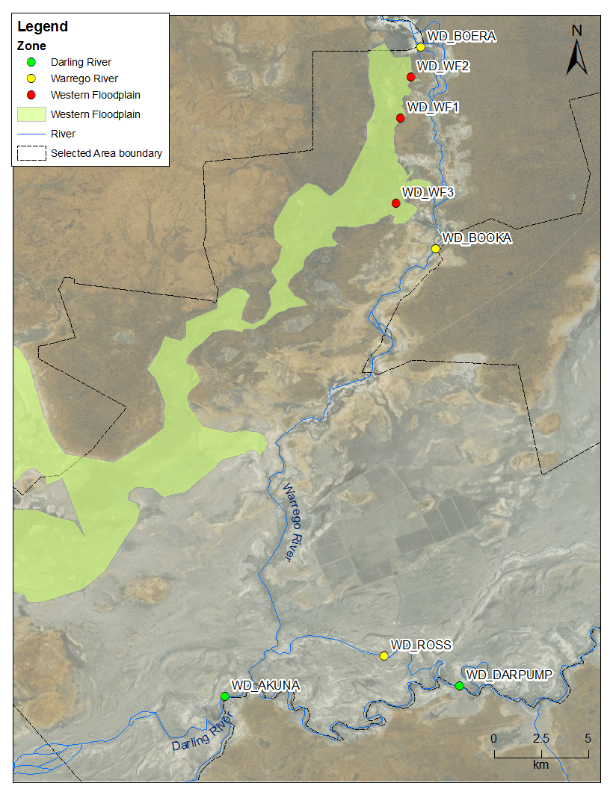
Figure H-1: Location of eight microinvertebrate sites within the Selected Area in 2016-17.

Hydrological conditions within the Selected Area during sampling are described below.
Aug-16 - Wet period (23rd - 26th August 2016).
This sampling period captured the wettest phase in the Selected Area this reporting year. Boera Dam water levels were above the estimated floodplain connection level of 2.26 m because of major inflows from the upstream Warrego catchment as well as localised rainfall (Figure H-2a). An estimated 6,457 ML of inflows had spilled onto the Western Floodplain by this time (Appendix E). As a result, 1,695 ha of the Western Floodplain was inundated as at 13 August 2016 (Appendix E) from Boera Dam overflow. Three Western Floodplain sites were sampled based on vegetation habitats representing different inundation frequency (Table H-1). The gates at Boera Dam were opened for 7 days (11th – 17th July 2016) to allow connection of the Warrego channel to the Darling River one month prior to this sampling occasion (Appendix A). The Darling River hydrology was above base flow with discharge around 7,500 ML/d (Figure H-2b).
Nov-16 – Prolonged inundation/retention period (29th Nov - 2nd Dec 2016).
During this sampling event, levels in Boera Dam had been above the 2.26 m height for floodplain connection for over five months, but were declining steadily with reduced inflow from the upstream Warrego channel. The Western Floodplain was in a contraction phase, yet a large area remained inundated (3,365 ha at 17 Nov 2016) with residual water that included Commonwealth environmental unregulated water take for the Western Floodplain. The total approved Commonwealth environmental water volume inundating the floodplain reached the annual allocation of 9,720 ML (Appendix Hydro River). Two Western Floodplain sites were sampled (WF1 site was dry). Boera gates were opened for 25 days (8 Oct to 1 Nov 2016) one month prior to this sampling occasion to support native fish in the Warrego and allow prolonged connection of the Warrego channel to the Darling River. Darling River discharge was around 4,000 ML/d, after a peak flow one month prior to sampling of 39,000 ML/d during late-October.
Mar-17 – Contraction period (27th- 30th March 2017).
This sampling period was designed to capture the contraction period of residual water on the Western Floodplain and in the Warrego channel. No inflow into the Western Floodplain occurred from mid-December, when the Boera Dam level dropped below 2.26 m. The area of inundation on the Western Floodplain had contracted to disconnected pools. Only the WF3 site had surface water remaining. Longitudinal connectivity between the Warrego River and Darling River had not occurred for four months, and the three Warrego channel sites had become disconnected from each other and the Darling River during this period. The Darling River experienced base flow conditions with discharge around 550ML /d. Four months had elapsed since the peak flow in late-October.

- Warrego River

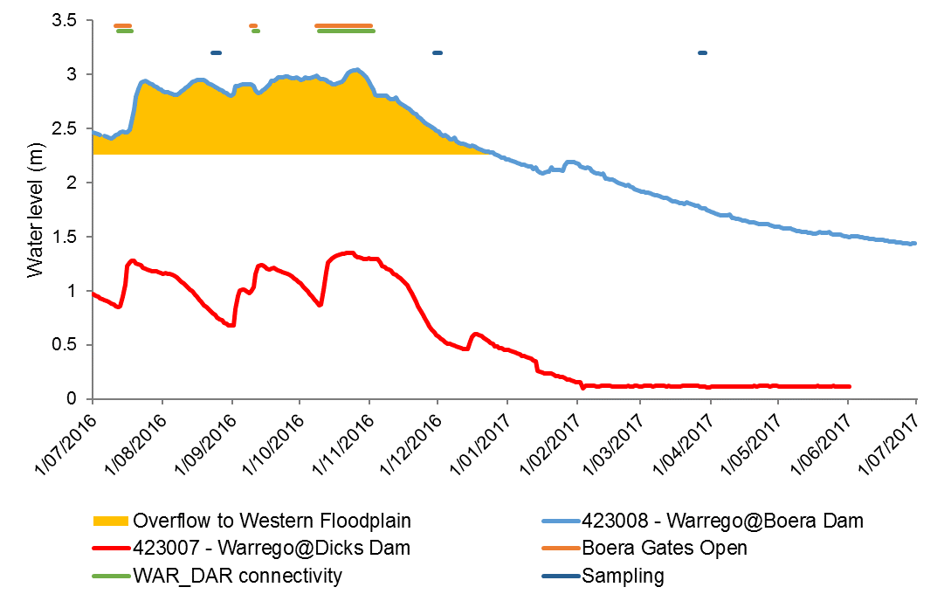
Aug-16 Nov-16 Mar-17
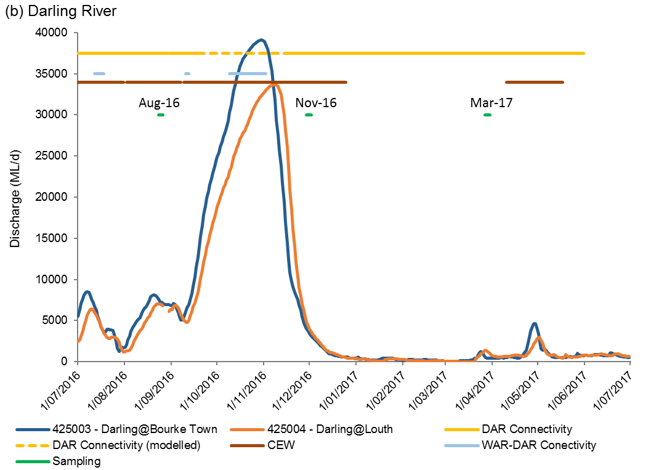
Figure H-2: Mean daily (a) water level in the Warrego River and (b) discharge in the Darling River.

H.2.2 Field methods
Benthic microinvertebrates were sampled by compositing five cores (50 mm diameter x 120 mm long with 250 mL volume) for each site. Replicates were separated by a minimum of 20 linear metres. The composite sample was allowed to settle for a minimum of 15 minutes and then the supernatant was poured through a 63 μm sieve. The retained sample was washed into a labelled jar and stored in ethanol (70 % w/v with Rose Bengal stain) until laboratory analysis.
Pelagic microinvertebrates were sampled from 10 L of water column at each site. Samples were poured through a plankton net (63 μm). Retained samples were stored in ethanol (70 % w/v) with Rose Bengal stain until laboratory analysis.

H.2.3 Laboratory methods
Samples were thoroughly mixed and divided into 12 equal subsamples. One subsample was sorted on a Bogorov tray under a stereo microscope at up to 400x magnification. Microinvertebrates were identified to family level (rotifers and cladocerans), class (copepods) and ostracods. The volumes of the total samples were recorded and subsample totals were scaled up to each total sample volume and reported as density/L. Samples were stored in 70% ethanol with Rose Bengal for auditing purposes.

H.2.4 Statistical methods
Water chemistry and nutrients indicators were used to characterise environmental patterns among study sites. Spearman correlation coefficients were used to examine the degree to which the indicators were inter-related. To identify dominant environmental indicators in the study area, a principal components analysis (PCA) was performed to summarise indicators into a few axes (components).
To describe and summarize the diversity of microinvertebrate community composition, taxa richness (S), Shannon Weiner diversity (d) and density (number of individual/L) was calculated in PRIMER v6.1.13 using the DIVERSE function. PERMANOVA routine was used to test the difference in S, d and density between HABITAT (with 2 fixed levels, benthic and pelagic), TIME (with 3 random levels, Aug-16, Nov-16 and Mar-17), ZONE (with 3 fixed levels, Darling, Warrego and Western Floodplain), SITE (with 6 fixed levels, AKUNA, DARPUMP, BOERA, BOOKA, ROSS and WF) where site was nested with zone and interactions.
The community composition data were transformed into two datasets that weigh the contributions of common and rare species differently. (1) Presence-absence data represents actual taxa occurrence in a community. (2) Abundance data (square root transformation to stabilize variance and to improve normality; Clarke and Warwick, 2001) represents relative proportions of taxa occurrence in a community.
Since different sampling methods were used in benthic and pelagic habitats, a permutational multivariate analysis of variance (PERMANOVA) analysis was used to test the difference in the microinvertebrate community composition between HABITAT (with 2 fixed levels, benthic and pelagic), TIME (with 3 random levels, Aug-16, Nov-16 and Mar-17), ZONE (with 3 fixed levels, Darling, Warrego and Western Floodplain), SITE (with 6 fixed levels, AKUNA, DARPUMP, BOERA, BOOKA, ROSS and WF) where site was nested with zone and interactions. Up to 999 random permutations estimated the probability of p-values, with levels of significance reported as p<0.05. Where PERMANOVA results were significant, two datasets by habitat (benthic and pelagic) were developed to further explore the effects of time, zone and site (zone).
A Bray-Curtis dissimilarity matrix was generated by rank correlating the community structure between samples. Then, nonmetric multidimensional scaling ordinations (nMDS) were used to visualise community patterns and similarity percentages (SIMPER) were used to determine the taxa contributing to the observed community patterns. nMDS output with stress values of less than 0.2 were considered appropriate for interpretation (Clarke and Warwick, 2001).
Vectors of environmental variables were overlain on the PCA ordinations to provide insight for those indicators that were associated between sites. BIOENV analysis was used to examine those environmental indicators that were linked to the patterns of microinvertebrate community composition in PRIMER-E (2009). All analyses were performed in PRIMER v6.1.13 with the PERMANOVA+ v1.0.3 add-on package (PRIMER-E, 2009).

Results

H.3.1 Environmental characteristics
PCA (12 water quality and nutrient indicators) was used to search for multiple environmental drivers contributing to the patterns in microinvertebrate community composition. PC1 (axis-x) explained 39.8% of the variation and the vector overlay suggested that chlorophyll a and conductivity were strongly associated with this variation (Figure H-3). PC2 (axis-y) explained 22.4% of the variation with TN and TP concentrations positively aligned along the axis and temperature negatively aligned the axis (Figure H-3).
The grouping by time shows a distinctive pattern (Figure H-3) that suggests environmental conditions were driving temporal change across the Selected Area (zones and sites). Among all samples, Western Floodplain in Mar-17 had a very distinctive environment with much higher TN, TP, turbidity and chlorophyll a concentration. In summary, there was decreases in NOx, DO and increases in pH, conductivity, temperature, SRP, DOC and chlorophyll a from Aug-16 to Mar-17.
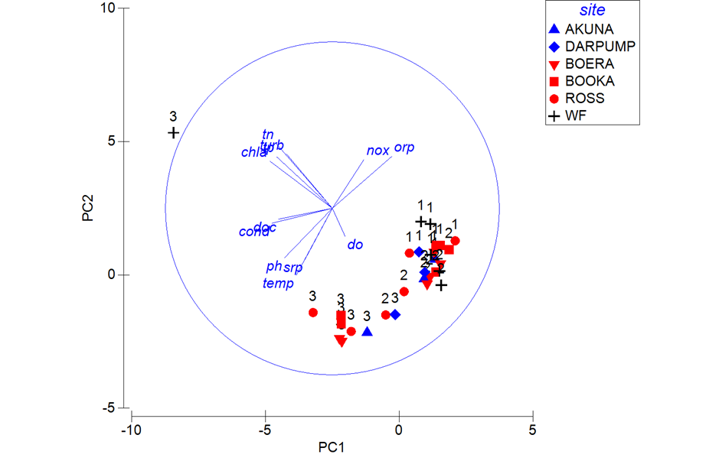
Figure H-3 Principal components analysis (PCA) bi-plot of 12 environmental indicators showing sites, time and vectors of environmental variables (normalised data, Spearman correlation) which underlie the environmental patterns among samples. Sampling occasions 1=Aug-16, 2=Nov-16 and 3=Mar-17.

H.3.2 Microinvertebrates
A total of 45 taxa were identified (from 60 samples). The 15 most abundant taxa (>1% in total abundance) comprised 93% of the total abundance across all sites (Figure H-4). The most abundant taxa was rotifer Genus Brachionus (36% of the total abundance) occurring at 75% of sites and sampling occasions. The second most abundant taxa Copepod nauplii (7% of the total abundance) occurred at 95% sites and sampling occasions. The other most abundant species in descending order were rotifer Order Bdelloida (7%), Family Notommatidae (6%) and Family Filiniidae (6%).
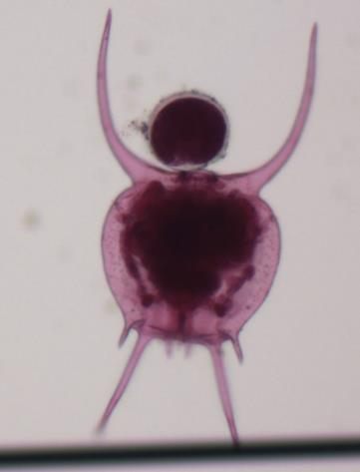
Figure H-4 Microinvertebrates collected in the Selected Area in 2016-17. Rotifer (<1mm, left) and Cladoceran <2mm, right)

H.3.2.1 Density
Pelagic microinvertebrate communities generally had higher densities than benthic communities although there was no significant difference. There were significant time and site interactions observed in density (Pseudo-F 3.6038, p<0.05; Figure H-5). In Mar-17, microinvertebrate densities in Ross Billabong and the Western Floodplain were significantly higher than other sampling occasions (pair wise p<0.05).
In the Western Floodplain, whole system microinvertebrate density peaked in Mar-17 at the system scale (density data scaled to total volume) while the system had contracted to disconnected pools with only the WF3 site with surface water remaining. The highest whole system scale microinvertebrate densities recorded in this year were 5.8 times higher than previous year highest records of 1,600,000 individual in Oct-15 (Table H-3).
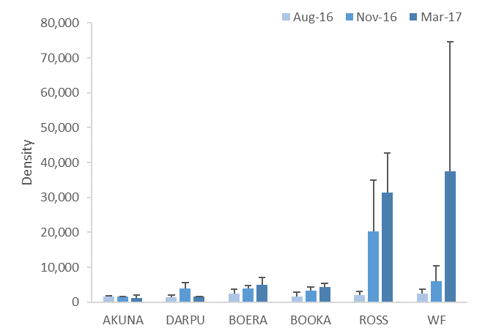
Figure H-5: Mean ± standard deviation (SD) of microinvertebrate density (individuals/L).

Table H-3: Whole system scale microinvertebrate density (number of individual/m²) in the Western Floodplain in 2016-17.
Vegetation community | Site | Aug-16 | Nov-16 | Mar-17
Coolabah/ River Coobah woodland | WF1 | 990,000 | - | -
Coolabah open woodland | WF2 | 420,000 | 2,070,000 | -
Lignum wetland | WF3 | 1,380,000 | 960,000 | 9,360,000
Total |  | 2,780,000 | 3,020,000 | 9,360,000

H.3.2.2 Diversity indices
There was no significant difference between benthic and pelagic habitats for microinvertebrate richness and diversity. Time and zone interactions were found in both richness (Pseudo-F 11.524, p<0.05) and diversity (Pseudo-F 12.03, p<0.005). In particular, diversity in the Western Floodplain was significantly lower in Mar-17 than other sampling occasions (pair wise p<0.05, Figure H-6).
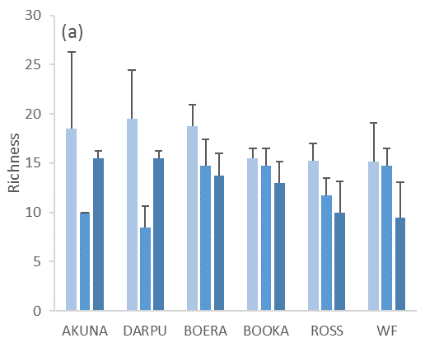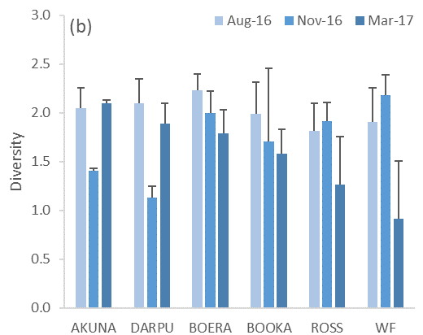
Figure H-6: Mean ± standard deviation (SD) of microinvertebrate (a) taxonomic richness and (b) diversity.

H.3.2.3 Taxonomic composition
Initially, a one-way PERMANOVA analysis was used to test if habitat could explain differences in the microinvertebrate community composition based on abundance. The PERMANOVA result identified that taxonomic composition was significantly different between benthic and pelagic habitats (Pseudo-F=11.602, p=0.001; Figure H-7). Similar patterns were also observed when analysing the presence-absence dataset. Since taxonomic composition was predominantly driven by differences between habitats, the two datasets were analysed separately to explore the effects of time, zone and site (zone).
The differences in community composition between habitats was driven by the higher average abundance of Class Ostracoda, rotifer Genus Lecane, Phylum Nematoda and Phylum Annelida in the benthic habitat and the higher average abundance of rotifer Families Asplanchnidae, Family Centropagidae and Family Filiniidae, Genus Keratella and Genus Polyarthra in the pelagic habitat (Table H-4). The abundance of these nine taxa contributed to 34% of the cumulative dissimilarity between two habitats (Table H-4).
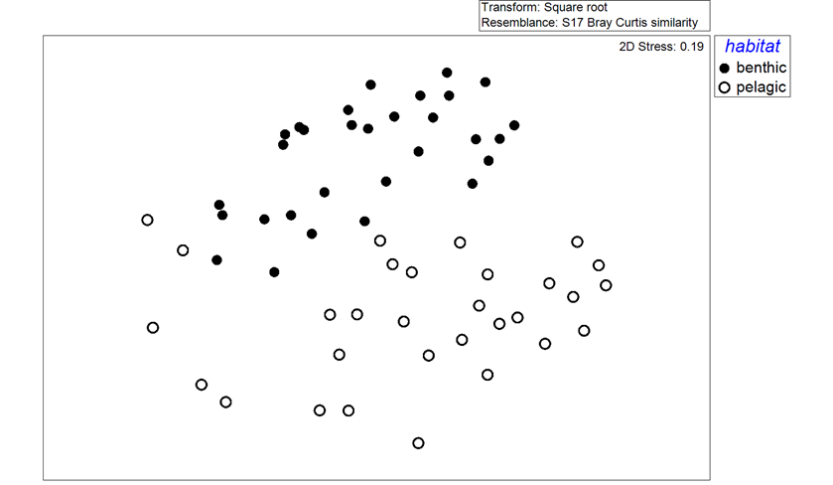
Figure H-7: NMDS ordination of microinvertebrate community composition by benthic and pelagic habitats using abundance dataset.
Table H-4: Microinvertebrate taxa contributing most of the dissimilarities between benthic and pelagic communities based on square root dataset. Bold numbers are the higher average abundance group.
Taxa | Average Abundance |  | Contribution % | Cumulative %
 | Benthic | Pelagic
F. Asplanchnidae | 0.30 | 0.97 | 4.6 | 4.6
F. Centropagidae | 0.23 | 0.70 | 4.0 | 8.5
G. Keratella | 0.37 | 0.73 | 3.7 | 12.2
G. Polyarthra | 0.23 | 0.60 | 3.6 | 15.8
C. Ostracoda | 0.57 | 0.10 | 3.6 | 19.4
G. Lecane | 0.63 | 0.37 | 3.6 | 23.0
F. Filiniidae | 0.43 | 0.83 | 3.6 | 26.6
P. Nematoda | 0.87 | 0.47 | 3.6 | 30.2
P. Annelida | 0.57 | 0.10 | 3.6 | 33.7
O. Bdelloida | 0.90 | 0.50 | 3.4 | 37.1
F. Hexarthridae | 0.47 | 0.63 | 3.4 | 40.5
G. Synchaeta | 0.07 | 0.53 | 3.3 | 43.7
G. Sida | 0.07 | 0.47 | 3.2 | 46.9
G. Ceriodaphnia | 0.27 | 0.50 | 3.2 | 50.1

Benthic habitat
For benthic community composition, a three-way PERMANOVA analysis showed a significant interaction between time and site (zone) (Pseudo-F= 2.3506, d.f.=6, p=0.001) based on the abundance dataset. Benthic community composition in Aug-16 was significantly different to Nov-16 (p=0.047) and Mar-17 (p=0.024) in pairwise tests (Figure H-8a). There was no significant spatial pattern observed (Figure H-8a). The temporal shift in community composition from Aug-16 to Mar-17 was driven by increasing abundance of rotifer Genus Brachionus, Family Filiniidae and Order Bdelloida and Cladoceran Family Moinidae, and decreasing abundance of Phylum Tardigrada and Annelida and Class Ostracoda (Table H-5).
All environmental variables were subsequently fitted into the ordination space as vectors to show those variables correlated to community patterns (Figure H-8b). The BIO-ENV result (12 factors) showed that temperature was the single environmental variable that best correlated with observed community patterns (p=0.558), with increased temperature positively aligned with the temporal shift in community composition from Aug-16 to Mar-17. The spearman correlation of environmental vectors also suggested that higher chlorophyll a concentration (correlation = 0.82), higher conductivity (correlation = 0.69) and lower redox (correlation = 0.61) during Mar-17 were strongly associated with the shift in community composition from Aug-16 (Figure H-8b). This temporal shift in community composition is also strongly correlated to relatively higher density and lowest richness and diversity in Mar-17 (Figure H-8c).

Table H-5: Microinvertebrate taxa contributing most of the dissimilarities between sampling occasions in benthic habitat based on abundance data. Bold numbers are the higher average abundance group.
Taxa | Average Abundance |  |  | Contribution %
 | Aug-16 | Nov-16 | Mar-17 | Aug-16 vs Nov-16 | Aug-16 vs Mar-17
G. Brachionus | 2.92 | 26.03 | 57.38 | 11.1 | 20.9
O. Bdelloida | 7.2 | 26.88 | 31.86 | 8.9 | 9.1
F. Filiniidae | 1.41 | 11.84 | 12.04 | 5.1 | 4.1
C. Ostracoda | 9.81 | 8.43 | 0.31 | 4.0 | 4.1
P. Tardigrada | 8.51 | 0.57 | 0.00 | 3.8 | 3.6
P. Annelida | 6.63 | 5.13 | 2.92 | 3.3 | 2.3
F. Moinidae | 0.00 | 3.70 | 15.98 | 1.7 | 5.8

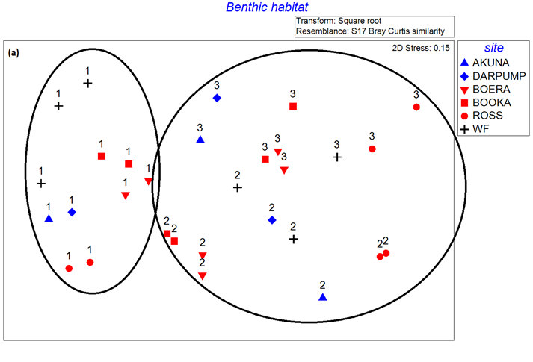
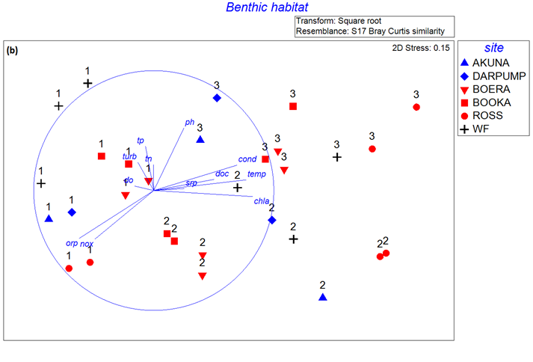
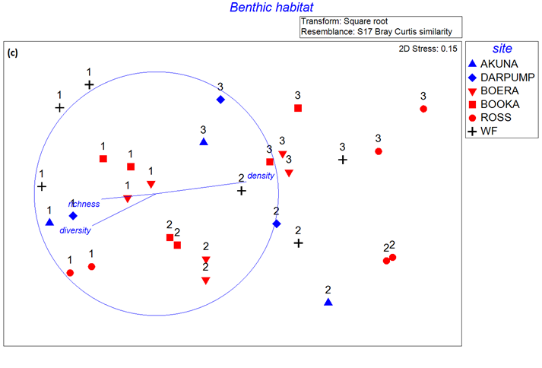
Figure H-8: NMDS ordination of microinvertebrate community composition in benthic habitat using abundance dataset (a) by PERMANOVA result with ellipsoids representing significant dissimilarity between sampling occasions, (b) with environmental indicators vectors and (c) with density and diversity indices vectors. Sampling occasions 1=Aug-16, 2=Nov-16 and 3=Mar-17.
Pelagic habitat
For pelagic community composition, a three-way PERMANOVA analysis revealed a significant interaction between time and site (zone) (Pseudo-F= 2.9123, d.f.=6, p=0.001) based on abundance. In Aug-16, community composition was significantly different to Mar-17 (p=0.025) (Figure H-9a). The difference between Aug-16 and Mar-17 was driven by the higher abundance of rotifer Genera Brachionus and Keratella, Families Hexarthridae and Filiniidae and Cladocera Family Moinidae in Aug-16 and lower abundance of Copepod nauplii in Mar-17 (Table H-6).
All environmental variables were subsequently fitted into the ordination space as vectors to show those variables correlated to community patterns (Figure H-9b). The BIO-ENV result (12 factors) showed that chlorophyll a was the single environmental variable that best correlated with observed community patterns (p=0.615), with increased chlorophyll a concentration positively aligned with the temporal shift in community composition from Aug-16 to Mar-17. Similar to benthic habitats, the spearman correlation of environmental vectors suggested that higher temperature (correlation = 0.75), higher conductivity (correlation = 0.66) and lower redox (correlation = 0.61) during Mar-17 were strongly associated with the shift in community composition from Aug-16 to Mar-17 (Figure H-9b). This temporal shift in community composition also strongly correlated to relatively higher density (0.78) and lowest richness (0.65) in Mar-17 (Figure H-9c).

Table H-6: Microinvertebrate taxa contributing most of the dissimilarities between sampling occasions in pelagic habitat based on abundance data. Bold numbers are the higher average abundance group.
Taxa | Average Abundance |  | Contribution % | Cumulative %
 | Aug-16 | Mar-17
G. Brachionus | 3.1 | 72.6 | 20.7 | 20.7
F. Moinidae | 0.4 | 22.6 | 6.9 | 27.6
G. Keratella | 13.8 | 17.9 | 6.6 | 34.2
F. Hexarthridae | 3.9 | 15.1 | 6.4 | 40.6
F. Filiniidae | 4.2 | 18.4 | 5.4 | 45.9
Copepod nauplii | 23.1 | 22.3 | 5.0 | 50.9
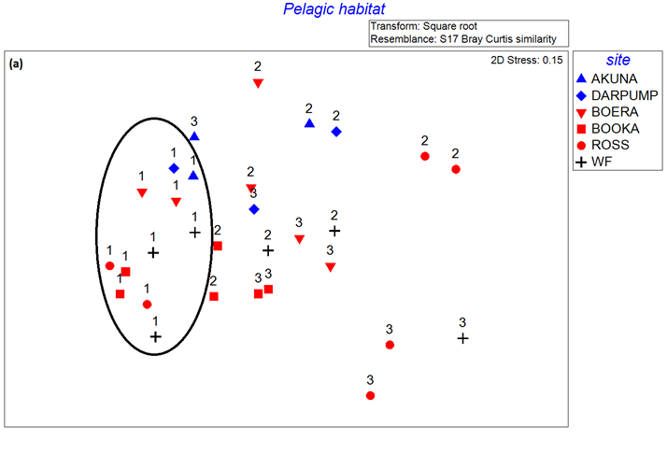

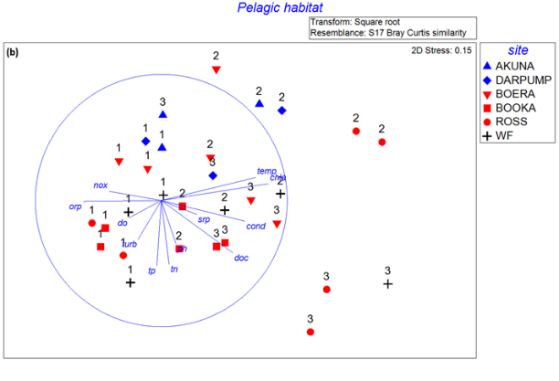
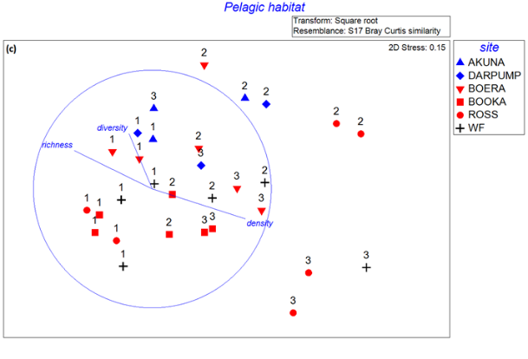
Figure H-9: NMDS ordination of microinvertebrate community composition in pelagic habitat using abundance dataset (a) by PERMANOVA result with ellipsoids representing significant dissimilarity between sampling occasions, (b) with environmental indicator vectors and (c) with density and diversity indices vectors. Sampling occasions 1=Aug-16, 2=Nov-16 and 3=Mar-17.

H.3.2.4 Multi-year comparison
Data collated from five surveys conducted from 2015-17 shows microinvertebrate density, richness and diversity variation over time (Figure H-10 and Figure H-11). The densities and richness of microinvertebrates recorded in this period were similar to those reported in previous studies from the Murray and Ovens Rivers and the Macquarie Marshes floodplain (Kobayashi et al. 2011; Ning et al. 2013). Two-way PERMANOVA analysis revealed a significant interaction between time and site in density (Pseudo-F= 2.8187, d.f.=19, p=0.008), richness (Pseudo-F= 1.9244, d.f.=19, p=0.02) and diversity (Pseudo-F= 2.1753, d.f.=19, p=0.009). In particular, the Western Floodplain had significantly higher density in Mar-17 (pair wise p<0.05) suggesting a positive response to the extensive and prolonged inundation event. However, diversity and richness in the Western Floodplain at this time were the lowest of all sites, supporting the predictions of increased density associated with community succession leading to fewer higher order microinvertebrates with prolonged inundation.

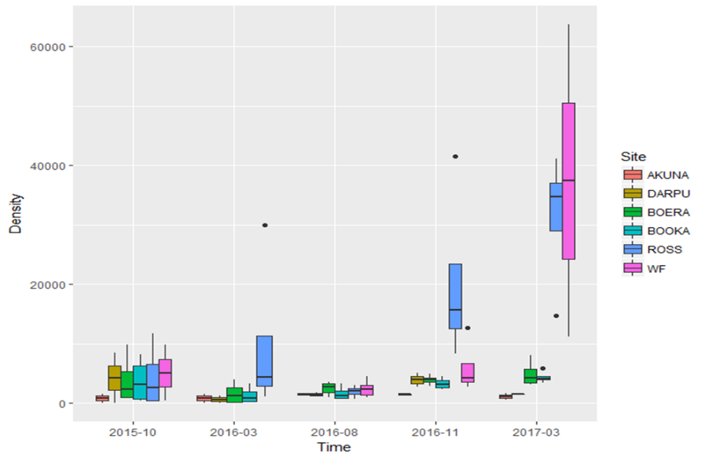
Figure H-10: Multi-year comparison of microinvertebrate density (individuals/l) in the Warrego Darling Selected Area.
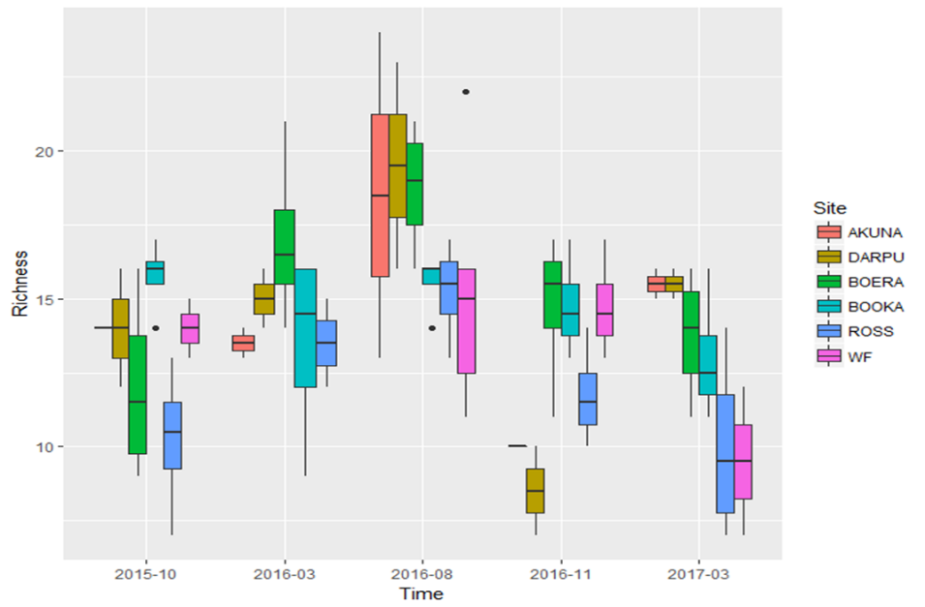
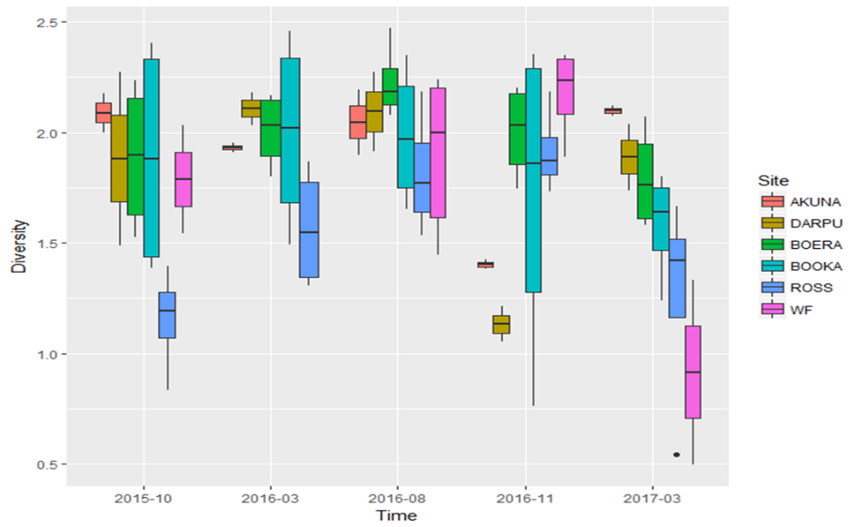
Figure H-11: Multi-year comparison of microinvertebrate (a) richness and (b) diversity in the Warrego Darling Selected Area.

Discussion
In this water year, several moderate to large flow events occurred throughout the Selected Area. Since the timing, magnitude and duration of these flow events was different in the Darling and Warrego, it was expected that the microinvertebrate response would differ between these two systems.
In the Darling River, microinvertebrate density did not show any temporal pattern among monitoring periods with persistent low abundances. On the other hand, microinvertebrate richness and diversity reduced in Nov-16 after the peak flow of 39000 ML/d, suggesting this flood event initiated taxonomic replacement through longitudinal displacement, favouring flow-resistant taxa. This highlights the importance of slower flow habitats such as waterholes and billabongs in the Warrego River as microinvertebrate refuges during high discharge event to support diverse and abundance microinvertebrate communities (Nielsen et al. 2010; Nielsen & Watson, 2008). Moreover, the influence of flow on richness persisted for one month after the flow peak, suggesting there had been insufficient time or resources for recolonization and successional processes for flow-prone taxa to re-establish. Therefore, the effects of hydrological disturbance on microinvertebrate diversity can persist following flows of this magnitude.
In the Warrego River and Western Floodplain, microinvertebrate density increased with each sampling period, reaching the highest density in the contraction period in summer. In particular, the highest densities found in Ross billabong and the Western Floodplain link to high TN, TP and DOC concentrations and subsequently high chlorophyll a concentrations. Highest richness and diversity were found during the wettest sampling period in Aug-16 in the Warrego River and Western Floodplain. This highlights that both longitudinal connection between the Warrego and Darling Rivers and lateral connection between the Warrego River and Western Floodplain, supported by Commonwealth environmental water, increased the diversity of habitats and basal resources resulting in a more diverse assemblage of microinvertebrate taxa. Diverse microinvertebrate communities are especially important food resources for larval fish, as well as waterbirds, and frogs.
The cessation of upstream Warrego inflows and contraction to disconnected pools in the Warrego River between Aug-16 and Mar-17 saw a decrease in microinvertebrate diversity, linked to changes in water quality such as increased conductivity and temperature, and decreased redox potential and dissolved oxygen. Receding water levels leading to the loss of habitat diversity and declining water quality condition may have affected more sensitive taxa in the intermittently inundated Warrego River and Western Floodplain. Shifts in community composition were consistent across all sites during the inundated to contraction phase with a predicted reduction in richness and diversity associated with microinvertebrate succession. This is seen in increased densities of Cladoceran as late successional taxa in the final sample period. This suggests that richness and diversity decrease with time since last inflow, reflecting community succession and resource availability.
Among all measured environmental variables, temperature and chlorophyll a concentration explained most of the variability in microinvertebrate taxonomic composition in both benthic and pelagic habitats. During the three sampling periods, a temporal shift in microinvertebrate taxonomic composition was highly correlated with an increase in temperature, chlorophyll a concentration, conductivity and decrease in redox. The initial inundation of organic matter in channel and floodplain habitats occurred in cooler months that have naturally lower rates of primary production, and the contraction phase coincided with warmer summer months and increased rates of primary production. Teasing apart the effects of inundation and season on microinvertebrates is difficult, but the positive effects of prolonged inundation over warmer months is clear.
During the contraction period in summer, secondary production measured as microinvertebrate density dramatically increased in response to increased primary production in the hydrologically disconnected Warrego and Western Floodplain. In particular, a rotifer taxa, G. Brachionus increased in abundance and dominated community composition in benthic and pelagic habitats. This rotifer genus is known to tolerate various water quality conditions (Shiel 1983).
Temperature seems to play a critical role in affecting water quality and determining the metabolic rates of organisms (primary and secondary producers), highlighting the potential ecological significance of the timing of flow events. In this case, the boom in microinvertebrate biomass did not occur immediately after inundation as predicted by the literature due to cooler water temperatures (Geddes 1984). Instead, the boom was delayed until warmer temperatures and increased rates of primary production were evident. Inundation of channel and floodplain habitats during warmer periods may result in maximum diversity and density of microinvertebrates by providing an increased diversity of physical habitats and basal resources.
The magnitude of flow events in the 2016-17 water year (peak flow around 39,000 ML/d in the Darling River) was much higher and duration of inundation much longer than the 2015-16 watering year (peak flow around 1,300 ML/d). Benthic microinvertebrate densities in 2016-17 (average of 2,191 individual/m²) were much lower than the 2015-16 water year (average of 6,533 individual/m²), despite the substantially larger area and increased time of floodplain inundation. In contrast, pelagic density (average of 1,904 individual/m²) were much higher than the 2015-16 water year (average of 714 individual/m²), likely linked to much higher concentrations of algae in the water column. On the Western Floodplain, during peak mapped inundation, an estimated 9597 ML of water including Commonwealth environmental water inundated 3,839 ha. As a result, microinvertebrate densities in the Western Floodplain during the contraction phase were almost 6 times higher than the previous water year. Following 35 days of longitudinal connection between the Warrego and Darling rivers, there was no significant difference between upstream and downstream sites on the Darling River. This suggests the input of water from the Warrego had little influence on microinvertebrate communities in the Darling, or the response was short term and not detectable at the next sampling period.

Conclusion
Monitoring during 2016-17 revealed significant influences of Commonwealth environmental water and natural inflow on microinvertebrate responses in the Warrego and Darling Rivers. On the Western Floodplain, Commonwealth environmental water contributed to inundation of 3,839 ha and triggered secondary productivity with high microinvertebrate densities to provide food resources for larval fish, waterbirds and frogs. The peak microinvertebrate density recorded in this water year with prolonged and extended inundation were almost six times higher than 2015-16 water year. Of relevance to the management of Commonwealth environmental water, was the unexpected lag in peak microinvertebrate biomass following floodplain inundation due to the colder conditions. By timing floodplain flows for the warmer summer months where possible, maximum microinvertebrate response could be achieved, advantaging higher order consumers which feed on them.
Commonwealth environmental water provided longitudinal connection between the Warrego and Darling Rivers and lateral connection between the Warrego River and Western Floodplain and increased the diversity of habitats and basal resources that in turn, supported a more diverse assemblage of microinvertebrate taxa. This suggests that changes in physico-chemistry associated with inundation patterns are regulating primary and secondary production in the intermittently inundated Warrego River and Western Floodplain. In the Darling River, longitudinal connectivity acts as disturbance for microinvertebrates, reflected in the lower densities and reduced taxa richness following a high flow event with 2.4% of Commonwealth environmental water. Therefore, Commonwealth environmental water contributed to the development and succession of microinvertebrate communities that accentuated differences between the Warrego and Darling River sites. This highlights the importance of the Warrego River as microinvertebrate refuges during high discharge events by providing flow refuge habitats such as waterholes and billabongs. Individuals can then recolonise from these areas back into the main channel when conditions again become favourable. The cessation of upstream Warrego inflows and contraction to disconnected pools led to a decrease in richness and diversity with time since the last inflow, reflecting the loss of habitat diversity and declining water quality conditions.
Timing of the flow events has potential ecological significance, in which the secondary productivity boom was delayed until warmer temperatures and increased rates of primary production were evident. It is suggested that inundation of channel and floodplain habitats during warmer periods may result in maximum diversity and density of microinvertebrates by providing an increased diversity of physical habitats and basal resources.

References
Geddes, M. 1984. Seasonal studies on the zooplankton community of Lake Alexandrina, River Murray, South Australia, and the role of turbidity in determining zooplankton community structure. Marine and Freshwater Research, 35(4), 417-426. doi:http://dx.doi.org/10.1071/MF9840417
Kobayashi, T., Ryder, D. S., Ralph, T. J., Mazumder, D., Saintilan, N., Iles, J. & Hunter, S. 2011. Longitudinal spatial variation in ecological conditions in an in‐channel floodplain river system during flow pulses. River Research and Applications, 27(4), 461-472.
Nielsen, D. L., Gigney, H., & Watson, G. 2010. Riverine habitat heterogeneity: the role of slackwaters in providing hydrologic buffers for benthic microfauna. Hydrobiologia, 638(1), 181.
Nielsen, D. L., & Watson, G. 2008. The response of epibenthic rotifers and microcrustacean communities to flow manipulations in lowland rivers. Hydrobiologia, 603(1), 117-128. doi:10.1007/s10750-007-9251-6
Ning, N. S., Gawne, B., Cook, R. A., & Nielsen, D. L. 2013. Zooplankton dynamics in response to the transition from drought to flooding in four Murray–Darling Basin rivers affected by differing levels of flow regulation. Hydrobiologia, 702(1), 45-62.
Shiel, R. 1983. The genus Brachionus (Rotifera: Brachionidae) in Australia, with a description of a new species. Paper presented at the Proc. r. Soc. Vict.

Macroinvertebrates

Introduction
The macroinvertebrate indicator aims to assess the contribution of Commonwealth environmental water to macroinvertebrate abundance and diversity. A specific question was addressed through this indicator within the Junction of the Warrego and Darling rivers Selected Area (Selected Area) during the 2016-17 water year:
- What did Commonwealth environmental water contribute to macroinvertebrate diversity?

Environmental watering in 2016-17
Barwon-Darling and northern tributaries
Unlike other Selected Areas, environmental water is not specifically delivered to the Junction of the Warrego and Darling rivers Selected Area, rather, Commonwealth water is held as unregulated entitlements and its influence is thus reliant on flows out of upstream catchments. During the 2016–17 water year, four flow events containing environmental water flowed down the Darling River within the Selected Area (Appendix B). These occurred in June – August 2016, August – September 2016, September – December 2016 and April – May 2017. Three of these flows were in-channel pulses with the flow during September-December 2016 reaching at or just over bankfull. Total proportions of Commonwealth environment water in the Darling River varied between 1.8% and 36.5% of total flow (Appendix B).
Warrego River
Several flow pulses in the Warrego River occurred between June - November 2016. The demand for environmental flows on the Western Floodplain was very high given the last large-scale inundation of the Western Floodplain at Toorale was in 2012. As per licence conditions, a fresh in the Warrego River in July 2016 was allowed to make visible connection with the Darling River prior to closing the gates in Boera Dam and allowing Commonwealth environmental water to spill to the Western floodplain from 19 July 2016. The gates at Boera were opened again from the 9-12 September 2016 to connect with the Darling River in accordance with licence conditions for a new flow event. Following this, further inflows were spilled to the Western Floodplain with total approved volume reaching the annual allocation of 9,720 ML by 20 September 2016. Water continued to spill onto the Western Floodplain until December 2016. In total, 31,000 ML of water flowed onto the Western Floodplain of which 31% was Commonwealth environmental water.
Another fresh occurred in the Warrego River during September - November 2016. The Boera Dam gates were again opened and once the fresh had connected with the Darling River, Commonwealth environmental water licences on the Warrego River were used to provide a pulse of water down the Warrego River. This flow aimed to provide opportunities for native fish to access habitat, support recruitment and possibly triggering spawning. 10,500 ML of water was released down the lower Warrego River channel and included 7,762 ML (74%) Commonwealth environmental water. The release was managed to provide a slow rise and fall to the pulse and also ensure that water also continued to spill to the Western Floodplain at the same time. Commonwealth water was used to provide connection for 20 days. National Parks and Wildlife Service maintained the connection for an additional 5 days before closing the gates and allowing the remaining water to spill to the Western Floodplain.

Previous monitoring
In 2015-16, the Warrego River sites had increased macroinvertebrate density and richness compared with Darling River sites regardless of time of year, and current or antecedent flow conditions, suggesting that the connection and disconnection phases in the Warrego channel, in addition to the habitat and resource diversity provided by the inundated Western Floodplain are key drivers of macroinvertebrate communities in the Selected Area.

Methods

Design
Category III macroinvertebrate indicators were monitored in August 2016, November 2016 and March 2017. Sampling sites were located in three Sampling Zones within the Selected Area: Darling River, Warrego River and the Western Floodplain (Table I-1 and Figure I-1).

Table I-1: Location of the sites on the Junction of the Warrego and Darling Rivers Selected Area for macroinvertebrate surveys. Map projection GDA94 Zone 55
Sampling Zone | Site Name | Site Code | Easting | Northing | Inundation
 |  |  |  |  | Aug-16 | Nov-16 | Mar-17
Darling River | Akuna homestead | AKUNA | 340008 | 6634629 | Wet | Wet | Wet
 | Darling Pump | DARPUMP | 350768 | 6635351 | Wet | Wet | Wet
Warrego Channel | Boera Dam | BOERA | 348526 | 6669158 | Wet | Wet | Wet
 | Booka Dam | BOOKA | 349357 | 6658461 | Wet | Wet | Wet
 | Ross Billabong | ROSS | 347281 | 6636893 | Wet | Wet | Wet
Western Floodplain | Coolabah, Coobah, Lignum woodland | WF1 | 348083 | 6667550 | Wet | Dry | Dry
 | Coolabah open woodland | WF2 | 347848 | 6665662 | Wet | Wet | Dry
 | Lignum shrubland | WF3 | 347476 | 6660850 | Wet | Wet | Wet

Figure I-1: Location of eight macroinvertebrate sites within the Selected Area in 2016-17.

Hydrological conditions within the Selected Area during sampling are described below.
Aug-16 - Wet period (23rd - 26th August 2016).
This sampling period captured the wettest phase in the Selected Area this reporting year. Boera Dam water levels were above the estimated floodplain connection level of 2.26 m because of major inflows from the upstream Warrego catchment as well as localised rainfall (Figure I-2a). An estimated 6,457 ML of inflows had spilled onto the Western Floodplain by this time (Appendix E). As a result, 1,695 ha of the Western Floodplain was inundated as at 13 August 2016 (Appendix E) from Boera Dam overflow. Three Western Floodplain sites were sampled based on vegetation habitats representing different inundation frequency (Table H-1). The gates at Boera Dam were opened for 7 days (11th – 17th July 2016) to allow connection of the Warrego channel to the Darling River one month prior to this sampling occasion (Appendix A). The Darling River hydrology was above base flow with discharge around 7,500 ML/d (Figure I-2b).
Nov-16 – Prolonged inundation/retention period (29th Nov - 2nd Dec 2016).
During this sampling event, levels in Boera Dam had been above the 2.26 m height for floodplain connection for over five months, but were declining steadily with reduced inflow from the upstream Warrego channel. The Western Floodplain was in a contraction phase, yet a large area remained inundated (3,365 ha at 17 Nov 2016) with residual water that included Commonwealth environmental unregulated water take for the Western Floodplain. The total approved Commonwealth environmental water volume inundating the floodplain reached the annual allocation of 9,720 ML (Appendix Hydro River). Two Western Floodplain sites were sampled (WF1 site was dry). Boera gates were opened for 25 days (8 Oct to 1 Nov 2016) one month prior to this sampling occasion to support native fish in the Warrego and allow prolonged connection of the Warrego channel to the Darling River. Darling River discharge was around 4,000 ML/d, after a peak flow one month prior to sampling of 39,000 ML/d during late-October.
Mar-17 – Contraction period (27th- 30th March 2017).
This sampling period was designed to capture the contraction period of residual water on the Western Floodplain and in the Warrego channel. No inflow into the Western Floodplain occurred from mid-December, when the Boera Dam level dropped below 2.26 m. The area of inundation on the Western Floodplain had contracted to disconnected pools. Only the WF3 site had surface water remaining. Longitudinal connectivity between the Warrego River and Darling River had not occurred for four months, and the three Warrego channel sites had become disconnected from each other and the Darling River during this period. The Darling River experienced base flow conditions with discharge around 550 ML/d. Four months elapsed since the peak flow in late-October.

(a) Warrego River
Aug-16 Nov-16 Mar-17

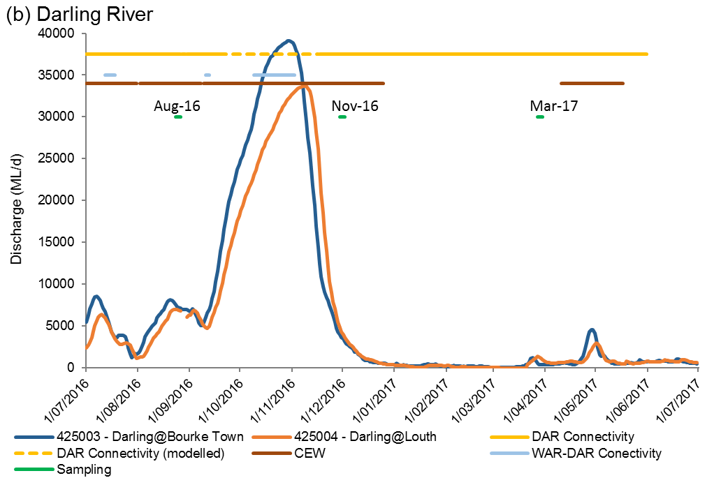
Figure I-2: Mean daily (a) water level in the Warrego River and (b) discharge in the Darling River.

Field and laboratory methods
Macroinvertebrate monitoring was conducted following the Standard Operating Procedures in Hale et al. (2013).

Statistical methods
To describe and summarize the diversity of macroinvertebrate community composition, taxa richness (S), Shannon Weiner diversity (d) and density (number of individual/m²) were calculated in PRIMER v6.1.13 using the DIVERSE function. PERMANOVA routine was used to test the difference in S, d and density between TIME (with 3 random levels, Aug-16, Nov-16 and Mar-17), ZONE (with 3 fixed levels, Darling, Warrego and Western Floodplain), SITE (with 6 fixed levels, AKUNA, DARPUMP, BOERA, BOOKA, ROSS and WF) where site was nested with zone and interactions.
The community composition data were transformed into two datasets that weigh the contributions of common and rare species differently. (1) Presence-absence data represents actual taxa occurrence in a community. (2) Abundance data (square root transformation to stabilize variance and to improve normality; Clarke and Warwick 2001) represents relative proportions of taxa occurrence in a community.
PERMANOVA analyses were used to test the hypotheses for differences in macroinvertebrate S, d, density and community composition between time (with 3 random levels, Aug-16, Nov-16 and Mar-17), zone (with 3 fixed levels, Darling, Warrego and Western Floodplain) and site (with 6 fixed levels, AKUNA, DARPUMP, BOERA, BOOKA, ROSS and WF) where site was nested with zone. Up to 999 random permutations estimated the probability of p-values, with levels of significance reported as p<0.05.
A Bray-Curtis dissimilarity matrix was generated by rank correlating the community structure between samples. Then, nonmetric multidimensional scaling ordinations (nMDS) were used to visualise community patterns and similarity percentages (SIMPER) were used to determine the taxa contributing to the observed community patterns. nMDS output with stress values of less than 0.2 were considered appropriate for interpretation (Clarke and Warwick, 2001).
BIOENV analysis was used to examine which environmental indicators are link to the patterns of macroinvertebrate community composition in PRIMER-E (2009). All analyses were performed in PRIMER v6.1.13 with the PERMANOVA+ v1.0.3 add-on package (PRIMER-E, 2009).

Results
A total of 52 taxa were identified (from 30 samples). The 17 most abundant taxa (>1% in total abundance) comprised 94% of the total abundance with the most abundant taxa Cladocera (36% of the total abundance). The other most abundant species in descending order are Copepoda (14%), Chironominae (11%) and Corixidae (10%) (Figure I-3). All four taxa were common to all sites.

Density
Across all sites and sampling occasions, macroinvertebrate density ranged from 19 individuals per m² to 1,201 individuals per m² (Figure I-4). Macroinvertebrate communities in the Darling River had significantly lower densities than those in the Western Floodplain (Pseudo-F 61.173, p<0.05). Although there was no significant temporal pattern, most of the sites (except DARPUMP) had the highest macroinvertebrate density in Mar-17.
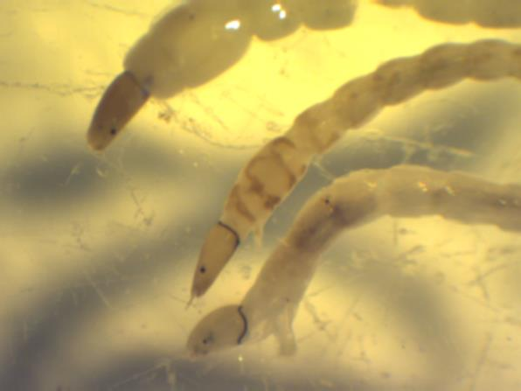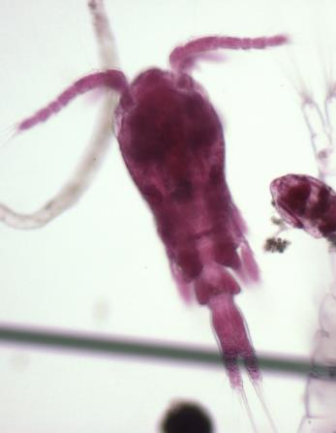
5mm
2mm
0
0
Figure I-3 Macroinvertebrates found in the Selected Area. (a) Chironominae and (b) Copepoda
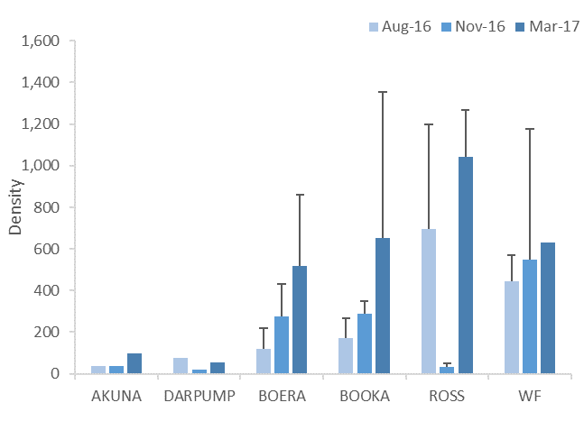
Figure I-4: Mean ± standard deviation (SD) of macroinvertebrate density (individuals/m²).

Diversity indices
Across all sites and sampling occasions, macroinvertebrate richness ranged from 3 to 22 taxa (Figure I-5). Although there was no significant spatial and temporal pattern in richness and diversity, all of the Darling River sites had highest richness and diversity during Mar-17, while all of the Warrego River and Western Floodplain sites had lowest richness and diversity on the same sampling occasion.
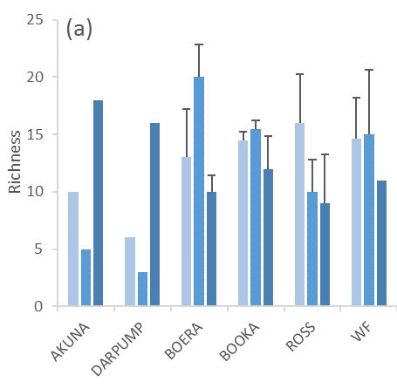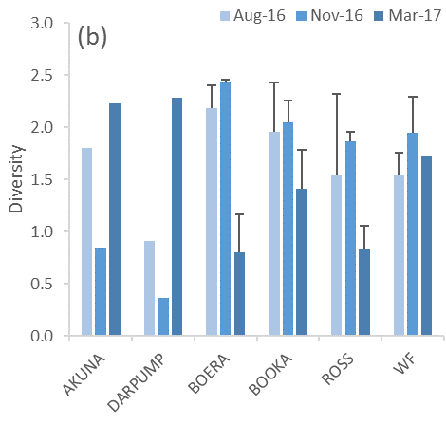
Figure I-5: Mean ± standard deviation (SD) of macroinvertebrate (a) taxonomic richness and (b) diversity.

Taxonomic composition
The two-way PERMANOVA analyses showed a significant interaction between time and zone in the abundance dataset (Pseudo-F=3.0755, p=0.001;Figure I-6). The Darling River and Warrego River community composition were significantly different in all sampling occasions in pairwise tests (p<0.05, Figure I-6a). In the Warrego River, a significant temporal shift in community composition was found between all sampling occasions in pairwise tests (p<0.01). Similar patterns and statistical results were observed from the presence-absence dataset.
Differences in community composition between the Darling and Warrego was driven by the higher abundance of Cladocera, Corixidae, Copepoda in the Warrego and the higher abundance of Atyidae in the Darling. The average abundance of these four taxa contributed 32% to cumulative dissimilarity between the two rivers (Table I-2). In the Warrego River, the temporal shift in community composition from Aug-16 to Mar-17 was driven by increasing abundance of Cladocera, Chrionominae and Corixidae and decreasing abundance of Copepoda (Table I-3).
All environmental indicators were subsequently fitted into the ordination space as vectors to show those indicators correlated to community patterns (Figure I-6b). The BIO-ENV result (12 water quality and nutrient indicators) showed that chlorophyll a was a single environmental variable that best correlated with the observed community patterns (p=0.232). However, this result had a weak correlation that cannot be used to explain the observed differences between communities. The spatial difference in community composition was strongly correlated to relatively higher density (correlation = 0.84) in the Warrego River and the Western Floodplain than the Darling River (Figure I-6c).

Table I-2: Macroinvertebrate taxa contributing most of the dissimilarities between the Warrego and the Darling communities based on abundance dataset. Bold numbers are the higher average abundance group.
Taxa | Average Abundance |  | Contribution % | Cumulative %
 | Warrego | Darling
O.Cladocera | 8.82 | 1.19 | 11.71 | 11.71
F.Corixidae | 5.62 | 1.58 | 7.95 | 19.67
sC.Copepoda | 4.75 | 1.95 | 6.48 | 26.15
F.Atyidae | 0.52 | 2.71 | 6.26 | 32.41
sF.Chironominae | 4.07 | 0.98 | 6.12 | 38.53
F.Leptoceridae | 2.12 | 0.47 | 6.09 | 44.61
F.Palaemonidae | 1.55 | 1.51 | 5.16 | 49.77
F.Caenidae | 2.15 | 0.33 | 4.31 | 54.09

Table I-3: Macroinvertebrate taxa contributing most of the community dissimilarities in the Warrego between three sampling occasions based on abundance dataset. Bold numbers are the higher average abundance group.
Taxa | Average Abundance |  |  | Contribution %
 | Aug-16 | Nov-16 | Mar-17 | Aug-16 vs  Nov-16 | Aug-16 vs  Mar-17 | Nov-16 vs  Mar-17
O.Cladocera | 4.94 | 0.24 | 21.27 | 7.23 | 25.94 | 28.74
sC.Copepoda | 8.66 | 0.64 | 4.94 | 12.06 | 9.22 | 6.67
sF.Chironominae | 1.8 | 3.64 | 6.77 | 4.78 | 8.04 | 6.7
F.Corixidae | 6.28 | 4.51 | 6.07 | 7.79 | 6.69 | 6.93

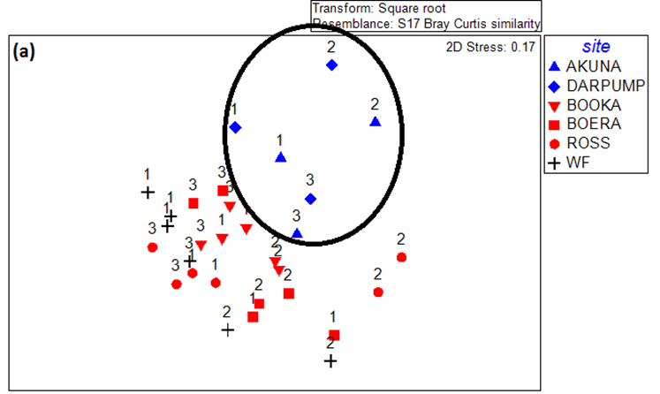
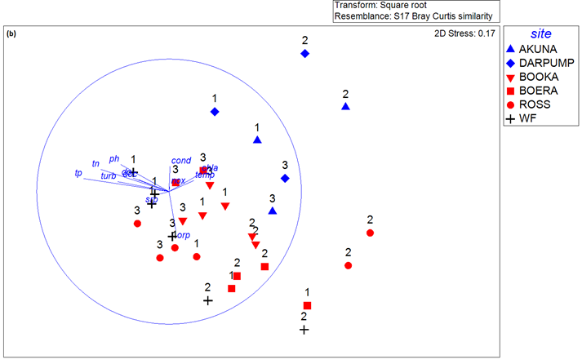
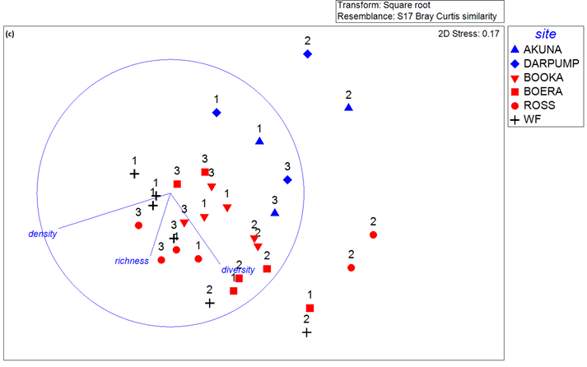
Figure I-6: NMDS ordination of macroinvertebrate community composition using abundance (a) by PERMANOVA result with ellipsoids representing significant dissimilarity between zones, (b) with environmental indicator vectors and (c) with density and diversity indices vectors. Sampling occasions 1=Aug-16, 2=Nov-16 and 3=Mar-17.

Discussion
The magnitude of flow events in the 2016-17 water year (peak flow around 39,000 ML/d in the Darling River) was much higher and the duration of inundation much longer than the 2015-16 watering year (peak flow around 1,300 ML/d). A total of 16 additional macroinvertebrate taxa were found in this watering year compared with 2015-16. It was likely that higher flow variability and the prolonged period of inundation is essential to maintain and potentially increase macroinvertebrate richness and diversity, linked to higher algal and microinvertebrate production as basal resources.
During 2016-17, macroinvertebrate densities in the Warrego River and Western Floodplain were higher than those in the Darling River. Macroinvertebrate community composition was clearly different between the Darling River and the Warrego and the Western Floodplain. These patterns were also observed during 2015-16, reflecting spatial, hydrologic and hydraulic differences between the three zones exerting a strong influence on macroinvertebrate density and community composition.
In the Darling River, density remained consistent regardless of flow conditions. Lowest taxa richness and diversity were observed after the peak flow event (390000 ML/d) in Nov-16, suggesting that flow acted as a disturbance that initiated taxonomic replacement and there may have not been enough re-colonising and successional time for these flow-prone taxa to re-establish. Four months after the event in Mar-17, taxa richness and diversity peaked when the system reverted back to base flow condition, reflecting the longer term influence of flow disturbance.
In the Warrego River and Western Floodplain, macroinvertebrate density increased with each sampling period, reaching the highest density in the contraction phase in summer. The highest densities link to higher TN, TP and DOC concentrations and subsequently highest chlorophyll a concentrations, as well as peak microinvertebrate densities. In contrast, higher richness and diversity were found during the wettest period in Aug-16 and peak inundation in Nov-16. This highlights that both longitudinal connection between the Warrego and Darling Rivers and lateral connection between the Warrego River and Western Floodplain increase the diversity of habitats and basal resources that in turn, support a more diverse assemblage of macroinvertebrate taxa. More diverse macroinvertebrate communities, offer a wider range of feeding opportunities for higher level consumers such as frogs, fish, waterbirds and other aquatic vertebrates.
Twenty five days of longitudinal connection of the Warrego and the Darling Rivers occurred one month prior to the Nov-16 sampling. It was expected to see the Warrego influence downstream of the confluence with the Darling. However, no difference in macroinvertebrates was found between the Darling upstream and downstream sites, suggesting that the influence of Warrego on the Darling was not being detected because either 25 days of connection was not enough or the effect disappeared one month after the connection.

Conclusion
Monitoring during 2016-17 revealed positive influences of Commonwealth environmental water and natural inflow on macroinvertebrate responses in the Warrego and Darling Rivers. On the Western Floodplain, inflows, including 9,720 ML of Commonwealth environmental water inundated a peak mapped area of 3,839 ha and triggered secondary productivity with very high macroinvertebrate densities to provide food resources for fish, waterbirds and frogs.
Commonwealth environmental water contributed to longitudinal connection between the Warrego and Darling Rivers and lateral connection between the Warrego River and Western Floodplain increased the diversity of habitats and basal resources that in turn, support a more diverse assemblage of macroinvertebrate taxa. This suggests that changes in physico-chemistry associated with inundation patterns are regulating primary and secondary production in the intermittently inundated Warrego River and Western Floodplain. In the Darling River, longitudinal high discharge connectivity acts as a disturbance for macroinvertebrates hence lower densities and reduced taxa richness follow a high flow event. Therefore, Commonwealth environmental water contributed to the development and succession of macroinvertebrate communities that accentuated differences between the Warrego and Darling River sites. This highlights the importance of the Warrego River as macroinvertebrate refuges during high discharge event by providing flow refuges such as waterholes and billabongs, providing a food resource in these areas for other fauna, but also providing areas of recolonisation once conditions in the main channel become favourable. The cessation of upstream Warrego inflows and contraction to disconnected pools led to decreased richness and diversity with time since the last inflow, reflecting the loss of habitat diversity and declining water quality conditions.

References
Hale, J., Stoffels, R., Butcher, R., Shackleton, M., Brooks, S., Gawne, B., and Stewardson, M. 2014. Commonwealth Environmental Water Office Long Term Intervention Monitoring Project – Standard Methods. Final Report prepared for the Commonwealth Environmental Water Office by The Murray-Darling Freshwater Research Centre, MDFRC Publication 29.2/2014, January, 175 pp.

Ecosystem Type

Introduction
The Ecosystem Type indicator contributes to the broader scale evaluation of Commonwealth environmental water’s influence on ecosystem diversity. While primarily designed to inform at larger basin scales, information on the types of ecosystems influenced by Commonwealth environmental water is also useful at the Selected Area scale. Several specific questions were addressed by monitoring Ecosystem Type within the Warrego and Darling Rivers during the 2016-17 water year:
- What did Commonwealth environmental water contribute to sustainable ecosystem diversity?
- Were ecosystems to which Commonwealth environmental water was allocated sustained?
- Was Commonwealth environmental water delivered to a representative suite of Ecosystem Types?

Environmental watering in 2016–17
Barwon-Darling and northern tributaries
Unlike other Selected Areas, environmental water is not specifically delivered to the Junction of the Warrego and Darling rivers Selected Area, rather, Commonwealth water is held as unregulated entitlements and its influence is thus reliant on flows out of upstream catchments. During the 2016–17 water year, four flow events containing environmental water flowed down the Darling River within the Selected Area (Appendix B). These occurred in June – August 2016, August – September 2016, September – December 2016 and April – May 2017. Three of these flows were in-channel pulses with the flow during September-December 2016 reaching at or just over bankfull. Total proportions of Commonwealth environment water in the Darling River varied between 1.8% and 36.5% of total flow (Appendix B).
Warrego River
Several flow pulses in the Warrego River occurred between June - November 2016. The demand for environmental flows on the Western Floodplain was very high given the last large-scale inundation of the Western Floodplain at Toorale was in 2012. As per licence conditions, a fresh in the Warrego River in July 2016 was allowed to make visible connection with the Darling River prior to closing the gates in Boera Dam and allowing Commonwealth environmental water to spill to the Western floodplain from 19 July 2016. The gates at Boera were opened again from the 9-12 September 2016 to connect with the Darling River in accordance with licence conditions for a new flow event. Following this, further inflows were spilled to the Western Floodplain with total approved volume reaching the annual allocation of 9,720 ML by 20 September 2016. Water continued to spill onto the Western Floodplain until December 2016. In total, 31,000 ML of water flowed onto the Western Floodplain of which 31% was Commonwealth environmental water.
Another fresh occurred in the Warrego River during September - November 2016. The Boera Dam gates were again opened and once the fresh had connected with the Darling River, Commonwealth environmental water licences on the Warrego River were used to provide a pulse of water down the Warrego River. This flow aimed to provide opportunities for native fish to access habitat, support recruitment and possibly triggering spawning. 10,500 ML of water was released down the lower Warrego River channel and included 7,762 ML (74%) Commonwealth environmental water. The release was managed to provide a slow rise and fall to the pulse and also ensure that water also continued to spill to the Western Floodplain at the same time. Commonwealth water was used to provide connection for 20 days. National Parks and Wildlife Service maintained the connection for an additional 5 days before closing the gates and allowing the remaining water to spill to the Western Floodplain.

Methods
The ANAE classification for each sampling site in the Junction of the Selected Area was mapped using a process of desktop identification and field verification (Commonwealth of Australia 2015). Existing ANAE GIS layers (Brooks et al. 2013) were used to assign an Ecosystem type to each monitoring site, and this was then verified in the field. Sites where existing ANAE mapping did not provide coverage were assigned an ANAE classification using available desktop information and then verified in the field. Field based verification was undertaken following a dichotomous key (Brooks et al. 2013).
No new sites were established in the 2016-17 water year.

Results
Monitoring was undertaken at 41 sites as part of the Selected Area LTIM project in 2016-17. These were classified into nine ANAE Ecosystem types, including five Floodplain types, two Lacustrine types, one Riverine type and one Palustrine type. Forty-one sites are located within the Selected Area (Figure J-1), with the other sites being river flow gauging stations located on upstream tributaries.
Within the Selected Area, a total of 38 sites (93% of all sites), were inundated during the 2016-17 water year (Table J-1; Figure J-1). All nine ecosystem types were inundated (Figure J-2), however not all sites within the F1.11 River cooba woodland floodplain, F1.8 Black box woodland floodplain and Pt2.2.1 Temporary sedge/grass/forb floodplain marsh were inundated.
Table J-1: ANAE Ecosystem Type’s covered by monitoring sites in the Junction of the Warrego Darling rivers Selected Area LTIM Project.
ANAE Typology | Number of sites (All Zones) | Proportion of sites inundated (%)
F1.10 Coolibah woodland and forest floodplain | 4 | 100
F1.11 River cooba woodland floodplain | 6 | 83
F1.8 Black box woodland floodplain | 3 | 67
F2.2 Lignum shrubland floodplain | 6 | 100
F2.4 Shrubland floodplain | 6 | 100
Lt2.1 Temporary lake | 7 | 100
Lt2.2 Temporary floodplain lake with aquatic beds | 2 | 100
Pt2.2.1 Temporary sedge/grass/forb floodplain marsh | 3 | 67
Rp1.4 Permanent lowland stream | 4 | 100
Total | 41 | 93

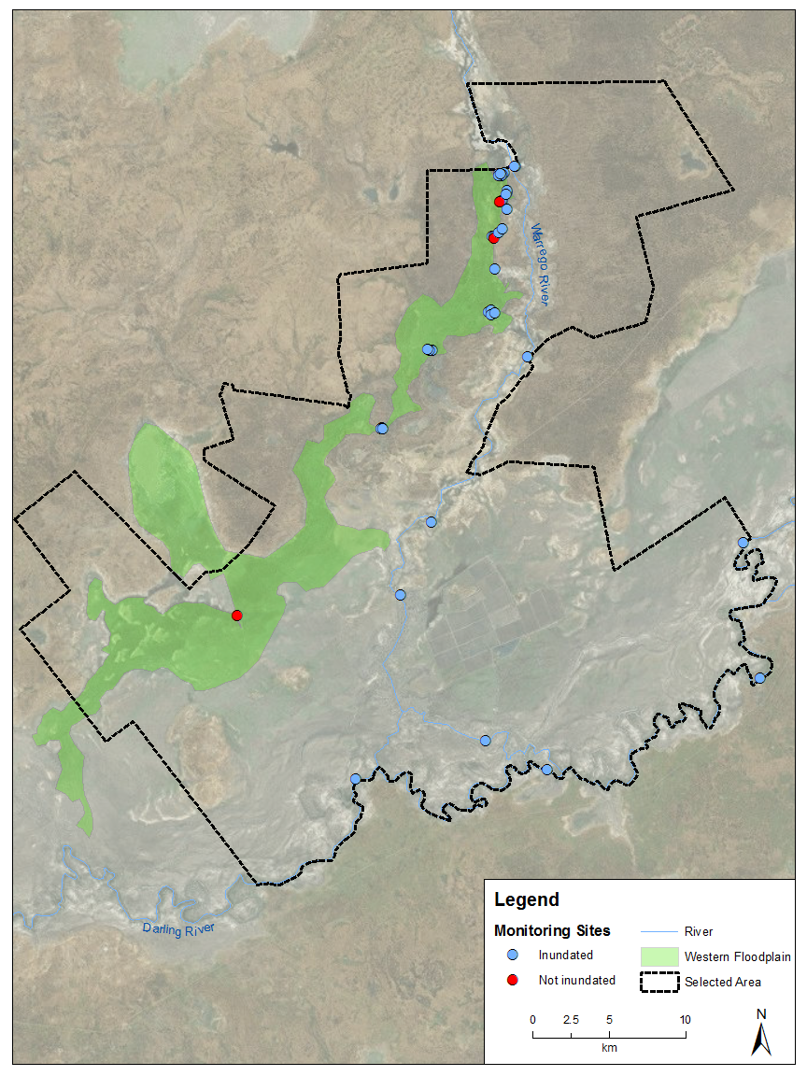
Figure J-1: Inundation status of sites sampled in the Selected Area during the 2016-17 water year.

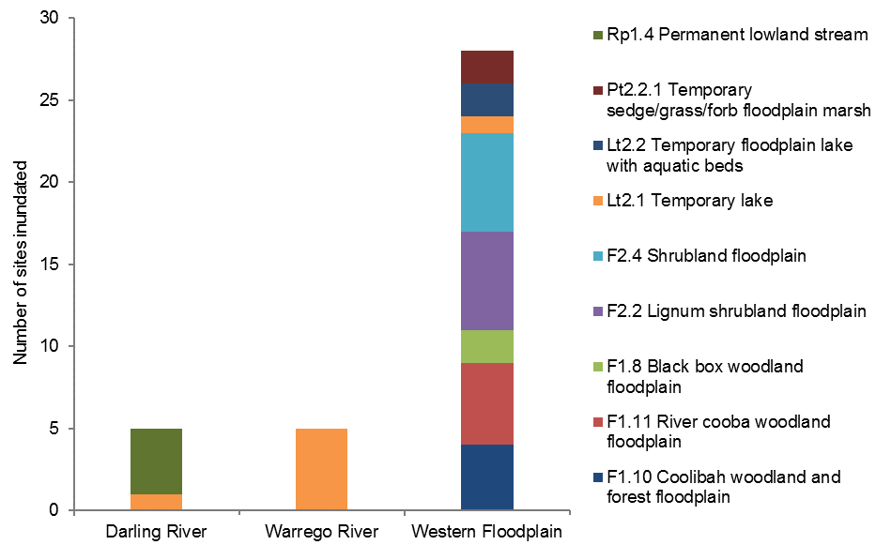
Figure J-2: Distribution of ANAE ecosystem types inundated across the three monitoring zones within the Selected Area.

Discussion
The types of ecosystems monitored in this project are a reflection of the nature of the delivery of environmental water, and the indicators being assessed. While aquatic in-channel habitats are being monitored in the Darling and Warrego River zones, a broader suite of ecosystems including channels, waterholes and floodplains are being monitored on the Western Floodplain. This diversity is reflected in the greater number of Ecosystem Types being monitored in this zone.
In 2016-17, 38 sites across all nine ecosystem types were inundated compared to just 16 across five ecosystem types in 2015-16. Water overflows to the Western Floodplain when water levels in Boera Dam reach 2.26 m, and this occurred from July to December in 2016. There are 31 sites in the Western Floodplain zone of which 28 were inundated in 2016-17, accounting for the 58% increase of sites inundated, and inundation of four additional ecosystem types.
During the 2016-17 water year, Commonwealth environmental water influenced sites within the Warrego and Darling River channels and the Western Floodplain, inundating all ecosystem types monitored in the Selected Area. In 2015-16, Commonwealth environmental water was constrained to the Warrego and Darling River channels, influencing only 2 of the ecosystem types monitored in Selected Area. Sustaining a range of different ecosystems is important for habitat availability and long term diversity and within the Selected Area, the Western Floodplain offers the most diverse habitat and thus should be a priority for environmental water use.

References
Brooks, S., Cottingham, P., Butcher, R, and Hale, J. 2013. Murray-Darling aquatic ecosystem classification: Stage 2 report. Peter Cottingham & Associates report to the Commonwealth Environmental Water Office and Murray-Darling Basin Authority, Canberra.
Commonwealth of Australia. 2015. Commonwealth Environmental Water Office Long Term Intervention Monitoring Project Junction of the Warrego and Darling Rivers Selected Area, Canberra.

Vegetation Diversity

Introduction
The vegetation species of the Warrego River Western Floodplain primarily constitute continuous stands of coolabah, black box and lignum that due to water management structures on Toorale, have adapted to increased inundation patterns (Hale et al. 2008; Capon 2009). Compared with communities in other Northern Basin catchments, vegetation on the Western Floodplain is in relatively good condition (Hale et al. 2008). As a result, these communities represent a significant target for Commonwealth environmental water within the Junction of the Warrego and Darling rivers Selected Area (Selected Area). The LTIM project aims to investigate the contribution of Commonwealth environmental water to floodplain vegetation diversity, condition and extent. The monitoring of vegetation diversity in the 2016–17 water year within the selected area was used to address two key questions:
- What did Commonwealth water contribute to vegetation species diversity?
- What did Commonwealth water contribute to vegetation community diversity?

Environmental watering in 2016-17
Warrego River
Several flow pulses in the Warrego River occurred between June - November 2016. The demand for environmental flows on the Western Floodplain was very high given the last large-scale inundation of the Western Floodplain at Toorale was in 2012. As per licence conditions, a fresh in the Warrego River in July 2016 was allowed to make visible connection with the Darling River prior to closing the gates in Boera Dam and allowing Commonwealth environmental water to spill to the Western floodplain from 19 July 2016. The gates at Boera were opened again from the 9-12 September 2016 to connect with the Darling River in accordance with licence conditions for a new flow event. Following this, further inflows were spilled to the Western Floodplain with total approved volume reaching the annual allocation of 9,720 ML by 20 September 2016. Water continued to spill onto the Western Floodplain until December 2016. In total, 31,000 ML of water flowed onto the Western Floodplain of which 31% was Commonwealth environmental water.
Another fresh occurred in the Warrego River during September - November 2016. The Boera Dam gates were again opened and once the fresh had connected with the Darling River, Commonwealth environmental water licences on the Warrego River were used to provide a pulse of water down the Warrego River. This flow aimed to provide opportunities for native fish to access habitat, support recruitment and possibly triggering spawning. 10,500 ML of water was released down the lower Warrego River channel and included 7,762 ML (74%) Commonwealth environmental water. The release was managed to provide a slow rise and fall to the pulse and also ensure that water also continued to spill to the Western Floodplain at the same time. Commonwealth water was used to provide connection for 20 days. National Parks and Wildlife Service maintained the connection for an additional 5 days before closing the gates and allowing the remaining water to spill to the Western Floodplain.
In line with existing operating rules, the gates at Boera Dam were opened to allow flow through to the Darling river, with connection of the lower Warrego channel occurring within one day. As inflows continued into the Selected Area from the Warrego River, the Boera Dam gates were opened three times between 11 July and 11 November 2016 (Figure K-1).
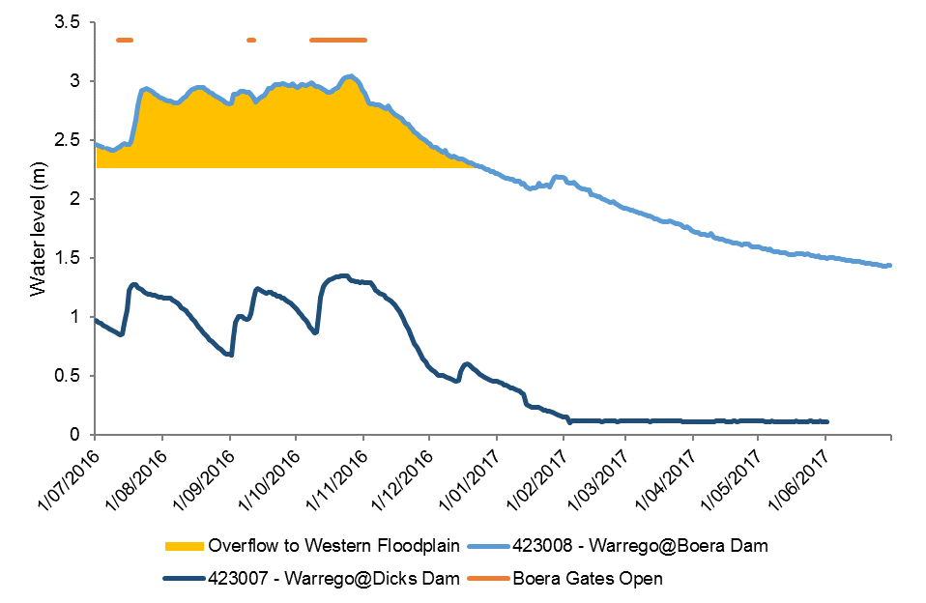
Figure K-1: Boera Dam levels during 2016-17 water year and flow to Western Floodplain and/or into lower Warrego channels (gates open).

Previous LTIM monitoring
Vegetation monitoring was undertaken during the 2014-15 and 2015-16 water years as part of years 1 and 2 of the LTIM project. Monitoring during year 1 suggested surface water reduced terrestrial species richness, identifying a positive causal relationship between inundation and wetland species diversity. The association of inundation and species richness was also observed in year 2 resulting from above average rainfall in 2015, though this led to a general increase in both species diversity and cover. During both years forb species responded rapidly to changes in moisture conditions, showing the largest increase in cover, following inundation, of any plant growth type. Similar to year 1, survey time and vegetation community had significant influences on vegetation patterns in year 2. Both years were influenced by low levels of inundation on the Western Floodplain, restricting a full assessment of inundation driven patterns in vegetation communities. However, they do provide a substantial baseline against which to assess further inundation driven changes.

Methods

2016 - 17 water year
Twenty-four plots were monitored at eight locations throughout the Western Floodplain during December 2016 and April 2017 (Table K-1; Figure K-2). Plots were located within four broad wetland vegetation communities that experienced varying inundation conditions (Table K-1). Plots were classed as being ‘wet’ if there was water present at the time of sampling (Figure K-3), or if they had been inundated since the previous survey time. For the December 2016 survey, sites were classed as ‘wet’ if they had been inundated since the previous survey in March 2016. This was estimated using inundation mapping derived from Landsat 8 image analysis (Appendix E). Vegetation surveys were undertaken following the standard vegetation diversity method (Commonwealth of Australia 2015; Hale et al 2013), where vegetation diversity, structure and dominance were recorded within each 0.04 ha plot. Environmental variables including the extent of inundation were also noted.
Species richness, dominance (percentage cover of most dominant species in a plot) and total vegetation cover data were analysed using factorial regression analysis to investigate the influence of inundation, sampling time and vegetation community. Where necessary, data were transformed to meet model assumptions. Total vegetation cover for each plot was calculated by adding together the cover of lower and mid strata types. Therefore, it was possible to get >100% total cover.
To further explain changes in diversity, individual species were grouped into four functional groups (Brock and Cassanova 1997):
- Amphibious responders (AmR)—plants which change their growth form in response to flooding and drying cycles;
- Amphibious tolerators (AmT)—plants which tolerate flooding patterns without changing their growth form;
- Terrestrial damp plants (Tda)—plants which are terrestrial species but tend to grow close to the water margin on damp soils; and
- Terrestrial dry plants (Tdr)—those which are terrestrial species which don’t normally grow in wetlands but may encroach into the area due to prolonged drying.
Changes in these functional groups were compared between survey times and inundation status using F-tests to test for equality of variances followed by t-tests/ANOVA to test for differences between respective groups.
Changes in vegetation cover were investigated using multivariate nMDS plots with differences between the presence of environmental water, survey time and vegetation community assessed using PERMANOVA in Primer 6. SIMPER analysis was used to identify the species that were most responsible for driving patterns in the data, and follow up descriptive univariate analysis of these species were then undertaken.

Multi-year comparison
Longer-term changes in vegetation species richness were investigated using factorial regression analysis on species richness data to investigate the influence of inundation, survey time (February 2015, May 2015, October 2015, March 2016, December 2016, April 2017) and vegetation community. Changes in vegetation cover over Year 1 and 2 of the LTIM project were investigated using multivariate nMDS plots with differences between inundation, survey time and vegetation community assessed using PERMANOVA in Primer 6.

Table K-1: Sites surveyed in December 2016 and April 2017 for vegetation diversity. Map projection GDA94 Zone 55.
Vegetation Community | Sites | Eastings | Northings | Inundation
 |  |  |  | Dec-16 | Apr-17
Coolibah-River Cooba-Lignum woodland | WD1.1 | 6668758 | 347881 | Wet | Dry
Coolibah-River Cooba-Lignum woodland | WD1.2 | 6668663 | 347818 | Wet | Dry
Coolibah-River Cooba-Lignum woodland | WD1.3 | 6668610 | 347776 | Wet | Dry
Coolibah-River Cooba-Lignum woodland | WD2.1 | 6667219 | 347814 | Wet | Dry
Coolibah-River Cooba-Lignum woodland | WD2.2 | 6667195 | 347764 | Wet | Dry
Coolibah-River Cooba-Lignum woodland | WD2.3 | 6667165 | 347675 | Dry | Dry
Chenopod shrubland | WD3.1 | 6658750 | 343962 | Wet | Dry
Chenopod shrubland | WD3.2 | 6658762 | 343840 | Wet | Wet
Chenopod shrubland | WD3.3 | 6658822 | 343729 | Wet | Wet
Chenopod shrubland | WD4.1 | 6660934 | 347121 | Wet | Wet
Chenopod shrubland | WD4.2 | 6661041 | 347292 | Wet | Dry
Chenopod shrubland | WD4.3 | 6660788 | 347285 | Wet | Dry
Coolibah woodland wetland | WD5.1 | 6654363 | 341209 | Wet | Wet
Coolibah woodland wetland | WD5.2 | 6654290 | 341161 | Wet | Wet
Coolibah woodland wetland | WD5.3 | 6654320 | 341268 | Wet | Dry
Coolibah woodland wetland | WD6.1 | 6665179 | 347247 | Wet | Dry
Coolibah woodland wetland | WD6.2 | 6665221 | 347382 | Wet | Dry
Coolibah woodland wetland | WD6.3 | 6665082 | 347402 | Dry | Dry
Lignum shrubland wetland | WD7.1 | 6668699 | 347679 | Wet | Wet
Lignum shrubland wetland | WD7.2 | 6668693 | 347608 | Wet | Wet
Lignum shrubland wetland | WD7.3 | 6668627 | 347613 | Wet | Wet
Lignum shrubland wetland | WD8.1 | 6667685 | 348087 | Wet | Dry
Lignum shrubland wetland | WD8.2 | 6667780 | 348055 | Wet | Dry
Lignum shrubland wetland | WD8.3 | 6667585 | 348039 | Wet | Dry

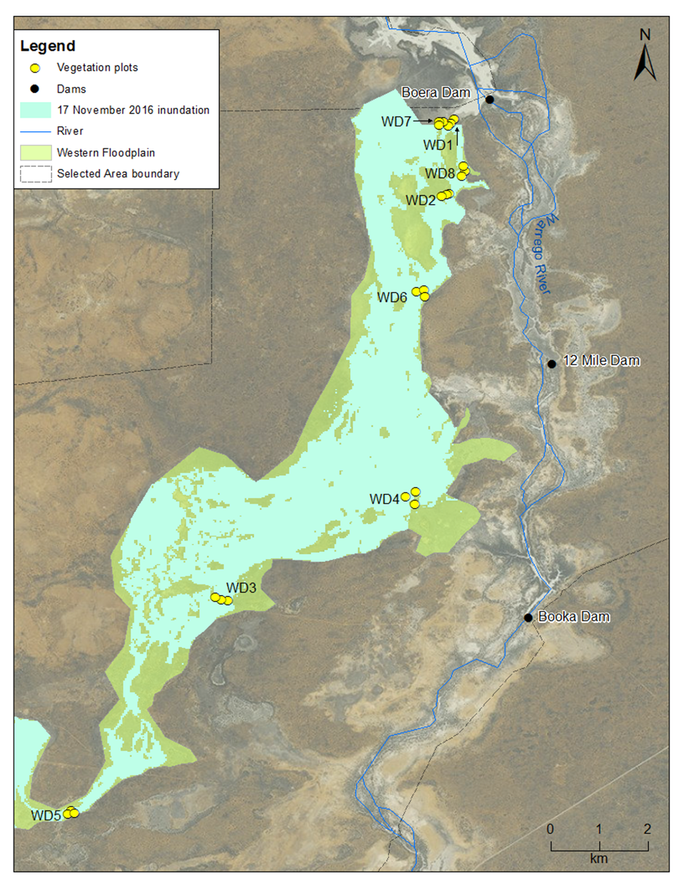
Figure K-2: Location of vegetation monitoring sites in the Western Floodplain zone.

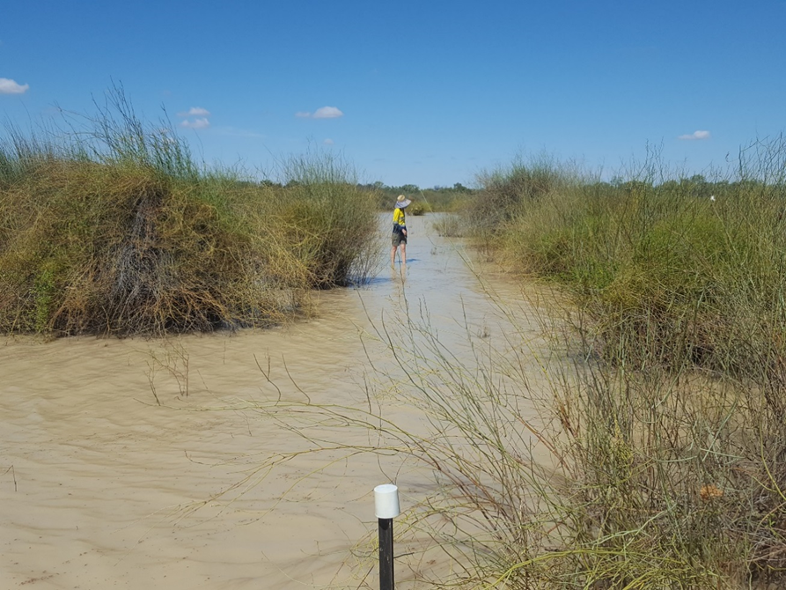
Figure K-3: Plot WD7.1 during the December 2016 survey.

Results

2016-17 water year
Species richness and dominance
A total of 138 species from 39 families were recorded within vegetation plots. Mean species richness recorded for all sites during both survey periods was 16.4, ranging from 4.33 species (WD7, December-16) to 32 species (WD4 December-16; Figure K-4). The low richness observed at WD7 was the result of these plots being substantially inundated at the time of survey (Figure K-3). Mean species richness was significantly higher in December-16 (20.1 species) than in April-17 (12.71 species; p<0.001). Plots located in the Coolibah-River Cooba-Lignum woodland community (19.41 species) and Chenopod shrubland (19 species) had significantly more species than those located in Lignum shrubland wetland (17.45 species) and Coolibah woodland wetland communities (12.42 species; p<0.05). A significant interaction was found between sampling time and vegetation community (Pr<0.05).
Sites that were wet during both survey periods showed significantly higher mean species richness (17.07 species) than sites that were dry (16.89 species; P<0.001). Inundated sites had a higher presence of species within all functional groups compared to dry sites, with the highest difference in terrestrial damp plants (Tda) followed by terrestrial dry plants (Tdr), amphibious responders (AmR) and amphibious tolerators (AmT) (Figure K-5). Changes within the amphibious responder functional group were small despite inundation status changes throughout sites.

Mean species dominance recorded for all sites during both survey periods was 27.1% cover, with the highest mean dominance being 45% (in WD5, December-16) and the lowest being 10.67% (in WD6, April-17). As with species richness, mean species dominance was significantly higher in December-16 (32.58%) than in April-17 (21.54%; p<0.05; Figure K-6). Mean species dominance was also significantly higher in wet plots (31.5%) than dry plots (19.67%; p<0.001). No influence of vegetation community was noted for species dominance (p=0.061).
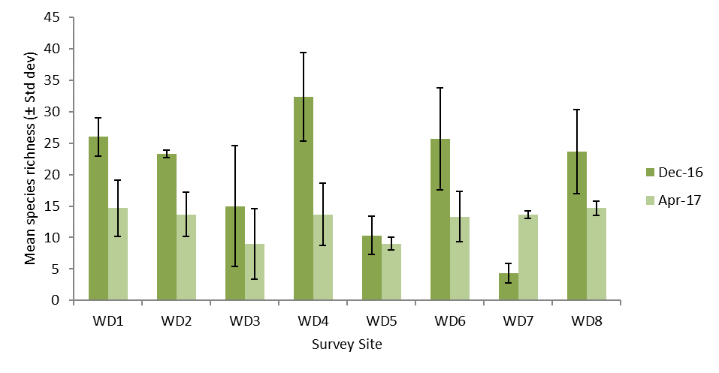
Figure K-4: Mean species richness recorded at each site during the December 2016 and April 2017 surveys.
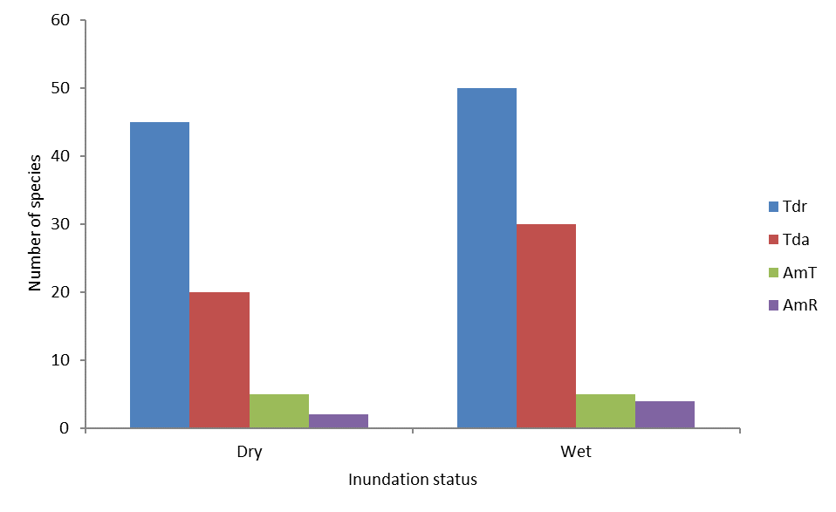
Figure K-5: Total number of species recorded in each functional group during December 2016 and April 2017 survey periods at sites that were inundated versus those that remained dry.

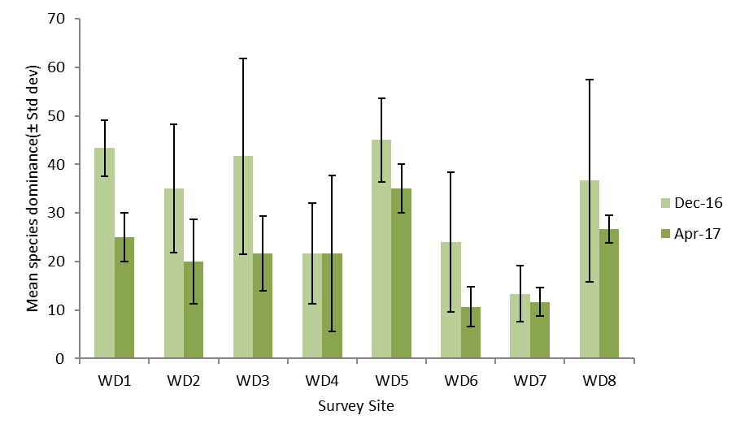
Figure K-6: Mean species dominance recorded at each site during the December 2016 and April 2017 surveys.
Forbs the most abundant growth form in the 2016-17 water year, with 53 species recorded in December-16 and 45 species recorded in April-17 (Figure K-7). Forb species richness also showed the largest reduction over the sampling period, reducing by 8 species or 17.7% between survey times.
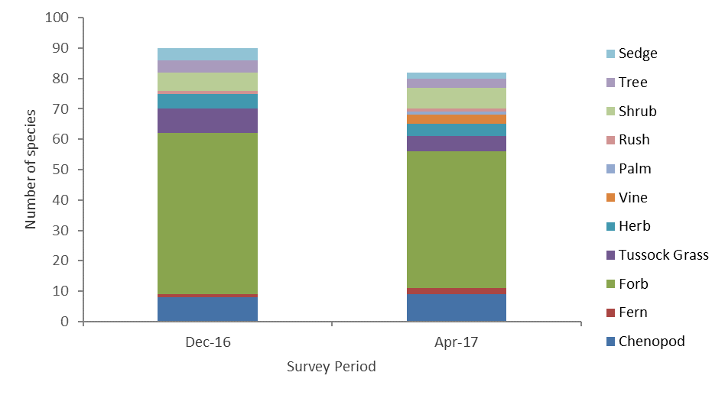
Figure K-7: Total number of species and the distribution of different growth forms recorded across all vegetation plots in December 2016 and April 2017.

Vegetation cover
Mean vegetation cover within each plot was 60.8% during the 2016-17 water year (range 13-142%). Significant differences were observed between sampling time (p<0.001) and vegetation community (p<0.05) with mean cover being greatest in Chenopod shrubland sites (99.6%) and Coolibah-River Cooba-Lignum shrublands in April 2017 (97%, p<0.001; Figure K-8). The influence of inundation was also noted, with dry sites having significantly higher mean vegetation cover (85.72%) than wet sites (45.9%).
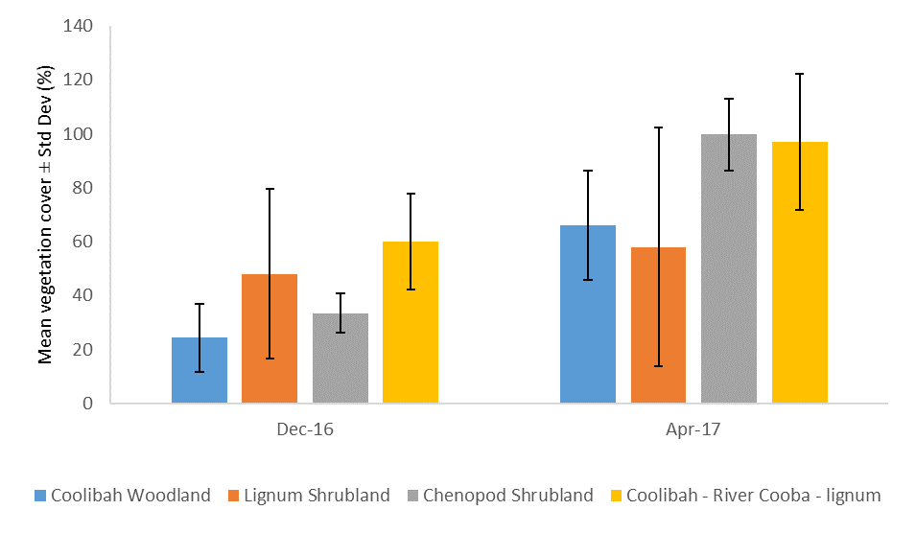
Figure K-8: Percent vegetation cover within monitoring plots surveyed in December-16 and April-17 on the Western Floodplain.

Vegetation composition
Vegetation community composition was further assessed using multivariate analyses derived from species abundance data. The nMDS plot shows minor separation between data grouped by vegetation type and inundation, primarily between Coolibah-River Cooba-Lignum woodland, Lignum-shrubland wetland, and the remaining vegetation communities (Figure K-9). PERMANOVA analyses confirmed significant differences between vegetation community (Pseudo-F=3.15, p<0.005), inundation (Pseudo-F=4.10, p<0.005) and the interaction between vegetation community and inundation (Pseudo-F=1.54, p<0.05). Specifically, significant differences occurred between Coolibah-River Cooba-Lignum woodland (t=1.92, Pr<0.005) and Lignum-shrubland wetland (t=1.61, Pr<0.05).
SIMPER analysis suggested that lignum (Duma florulenta) was a dominant influence on the patterns of different groupings (Table K-2). In addition, coolibah (Eucalyptus coolabah) and warrego grass (Paspalidium jubiflorum) contributed to the grouping of Coolibah woodland communities and creeping knotweed (Persicaria prostrata), common nardoo (Marsilea drummondii), and river mint (Mentha australis) contributed to Lignum shrubland grouping. River cooba (Acacia stenophylla), warrego grass and swamp starwort (Stellaria angustifolia) contributed to the grouping of Coolibah-River Cooba-Lignum plots and for Chenopod Srublands, creeping knotwort and galvanized burr (Sclerolaena birchii) contributed to the grouping of dry sites and Warrego grass and creeping knotweed contributed to the grouping of wet sites (Table K-2).
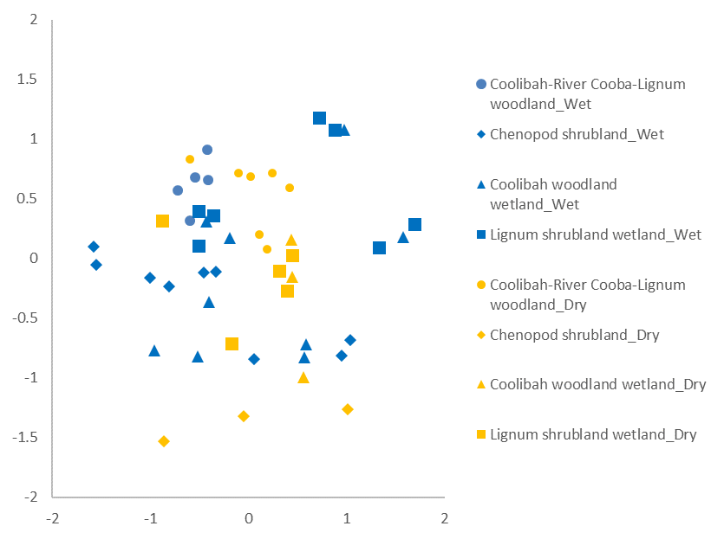
Figure K-9: nMDS plot with the data grouped by vegetation community and inundation status. Wet sites are blue, dry sites are yellow.

Table K-2: Vegetation species contributing most of the similarity between groups based on vegetation community and inundation.
Grouping | Species | % contribution | Cumulative % contribution
Coolibah woodland x Dry | Coolibah | 28.17 | 28.17
 | Lignum | 16.82 | 44.99
 | Warrego grass | 10.17 | 55.16
Coolibah woodland x Wet | Coolibah | 25.52 | 25.52
 | Lignum | 18.73 | 44.25
 | Warrego grass | 12.77 | 57.02
Lignum shrubland x Dry | Lignum | 25.47 | 25.47
 | Creeping knotweed | 12.07 | 37.54
 | Common nardoo | 10.41 | 47.95
Lignum shrubland x Wet | Lignum | 33.87 | 33.87
 | River mint | 17.76 | 51.63
Coolibah-River Cooba-Lignum x Dry | Lignum | 26.51 | 26.51
 | River cooba | 18.59 | 45.1
 | Warrego grass | 15.12 | 60.22
Coolibah-River Cooba-Lignum x Wet | Lignum | 11.94 | 11.94
 | Swamp starwort | 10.35 | 22.29
Chenopod shrubland x Dry | Creeping knotweed | 14.86 | 14.86
 | Galvinised burr | 10.41 | 25.27
Chenopod shrubland x Wet | Warrego grass | 18.57 | 18.57
 | Lignum | 11.28 | 29.85
 | Creeping knotweed | 10.08 | 39.93
* Values represent percentage cover of species within the single site in this grouping, where percentage contributions could not be calculated due to insufficient site numbers.

Multi-year Comparison
Species richness and dominance
Data were analysed from all six surveys conducted from Years 1- 3 of the LTIM project. Significant influences of vegetation community (p<0.001), sampling time (p<.001), and inundation status (p< 0.001) were noted. Chenopod shrubland showed the highest mean richness across all sampling periods (18.7 species), and Coolibah woodland had significantly fewer species than all other groups with 12.9 species per plot (Figure K-10). Plots sampled in August 15 (20.3 species) and December 2016 (20.1 species) had significantly higher mean species richness per plot (p< 0.001) than plots sampled at other times (Figure K-11). Although the influence of inundation status was significant, dry sites (16.42 species) were only just higher in mean richness than wet sites (16.40 species).
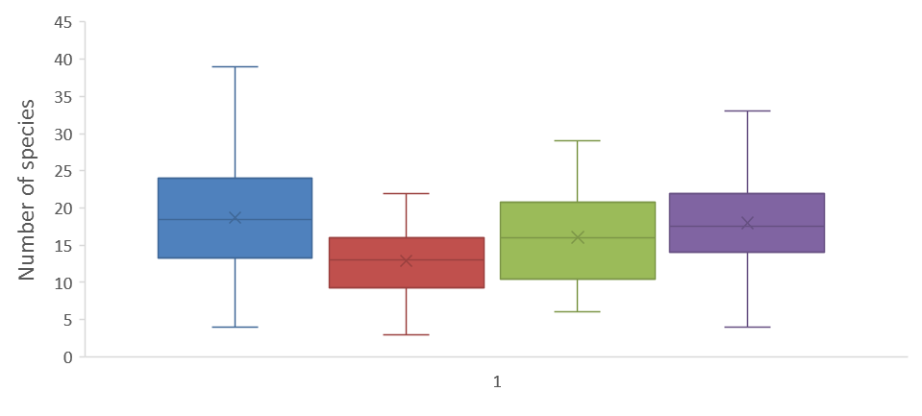
Coolibah-River Cooba-Lignum shrubland
Lignum shrubland
Chenopod shrubland
Coolibah woodland
Figure K-10: Species richness for plots by vegetation community over the life of the LTIM project. Cross represents the mean.

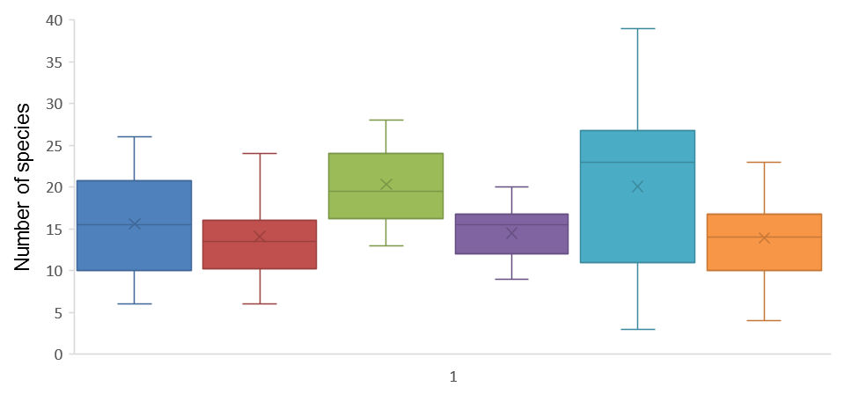
February-15
August-15
May-15
March-16
December-16
April-17
Figure K-11: Vegetation species richness recorded during surveys in Year 1, 2 and 3 of the project. Cross represents the mean.
Over the first three years of the LTIM project, species dominance varied significantly with sampling time (p<0.001) and vegetation community (p<0.001). The interaction of sampling time and vegetation community was also significant (p<0.001), suggesting that different vegetation communities were responding differently in terms of dominance over time. Coolibah-River Cooba-Lignum shrubland plots tended to have consistently higher dominance scores over all times, whereas, Coolibah woodland and Chenopod shrubland communities were more variable (Figure K-12). All communities showed an increase in dominance from March to December 2016 and then a reduction to April 2017. The influence of inundation status was significant (p<0.001) with wet sites having higher mean dominance (26.90%) than dry sites (22.69%).
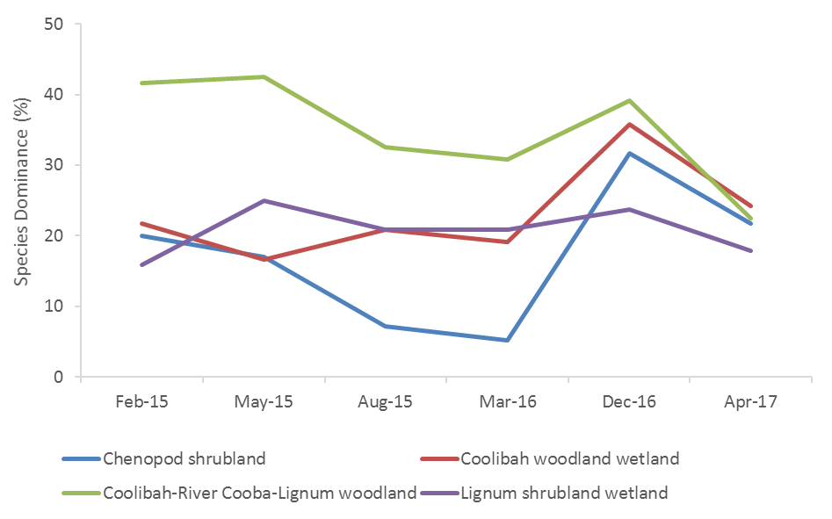
Figure K-12: Changes in dominance for different vegetation communities over year 1-3 of the LTIM project

Vegetation Cover
Mean vegetation cover varied significantly with sampling time (p<0.001) and vegetation community (p<0.001) over years 1-3 of the LTIM project and there was a significant interaction between these factors (p<0.001). All vegetation communities displayed their highest vegetation cover in April 2017, with Coolibah-River Cooba-Lignum communities tending to fluctuate more than other vegetation communities over time (Figure K-13). No significant influence of inundation was observed when compared for all sampling periods to date (p=0.48).
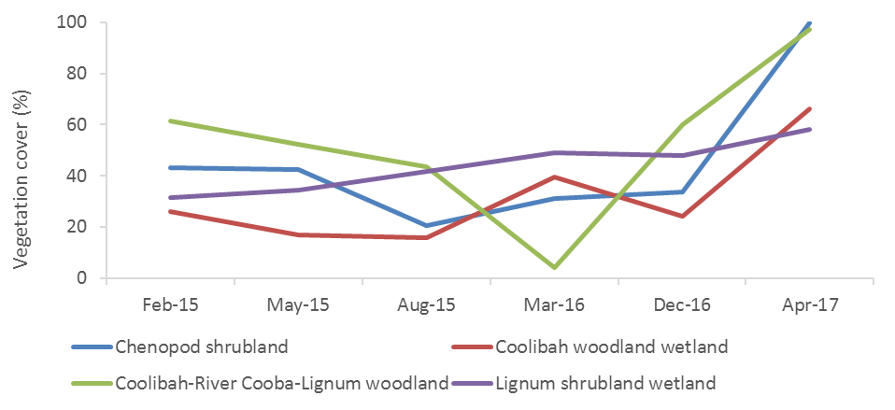
Figure K-13: Changes in vegetation cover for different vegetation communities over year 1-3 of the LTIM project
Vegetation composition
There was little grouping of the data in relation to sample time when community composition data from all years were analysed together, though inundated sites exhibited a closer grouping compared to dry sites – suggestive of more similar species composition within inundated sites (Figure K-11). However, December-16 inundated sites showed more variation than all other inundated sites. This is likely related to increased species richness and cover during the December-16 survey period. PERMANOVA results suggested that inundation status (Psuedo-F=4.66, Pr<0.005) was the main driver of patterns in the community composition data followed by survey time (Psuedo-F=1.81, Pr<0.05) and vegetation community (Psuedo-F=3.51, Pr<0.05).
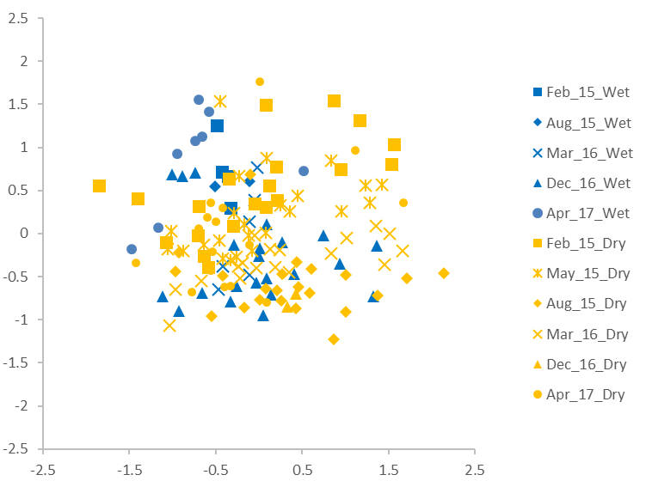
Figure K-14: nMDS plot of vegetation composition data grouped by the six sampling times surveyed and inundation on the Western Floodplain. Wet sites are blue, dry sites are yellow.

Discussion
The flooding event that inundated the Western Floodplain over August – December 2016 was the most significant flooding to occur in the first three years of the LTIM monitoring project and since 2012 when most of the floodplain was inundated. It inundated over 3,840 ha (Appendix E) on the Western Floodplain including 22 of the 24 vegetation monitoring plots. This flooding had a significant influence on the vegetation communities present on the floodplain. During the December 2016 survey period, most sites had moist soils, and were either partially or fully submerged. This presented favourable conditions for many species such as flood tolerant spike sedge that was dominant during this time (Figure K-15). High richness during this time suggests that many other species were also taking advantage of moist conditions. In contrast, mean vegetation cover was higher during the April 2017 sampling when most sites had dried. This was likely influenced by several sites being predominantly inundated during the December 2016 survey, lowering the mean vegetation cover at this time, but is also reflective of the longer duration of inundation at most sites providing a longer-term benefit to vegetation communities in terms of cover. In addition, by April 2017, while overall richness had decreased, terrestrial damp species such as Warrego grass and creeping knotweed had established, increasing the overall vegetation cover (Figure K-16).
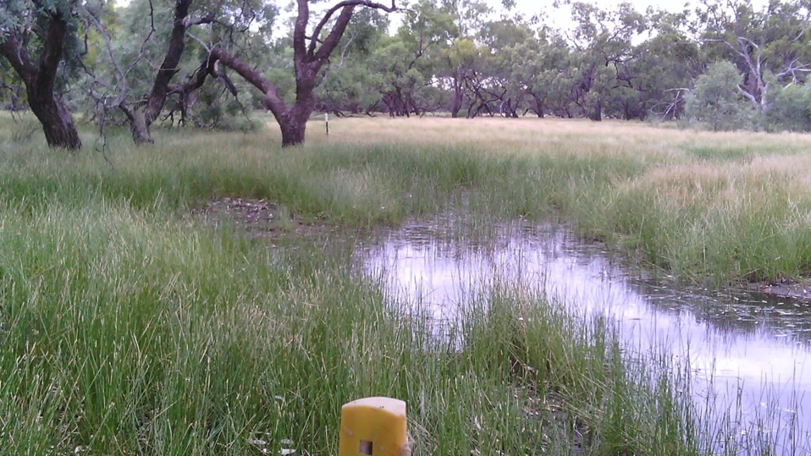
Figure K-15: Plot WD5.2 during the December 2016 survey.
Over the 2016-17 water year, all communities monitored increased in mean vegetation cover, especially Coolibah-River Cooba-Lignum shrublands and Chenopod shrublands, which also had increased species richness when compared to Lignum shrublands or Coolibah woodlands. The ability of these communities to respond positively to inundation, coupled with the fact that a significant area of floodplain was inundated, is an encouraging sign for the overall improved condition of vegetation on the Western Floodplain. This improved condition is also likely to benefit animals using the floodplain such as frogs and waterbirds, in terms of increased habitat quality.
Putting the 2016-17 results in a longer-term context, the 2016 inundation event increased each of the key measured variables from previous years. Species richness increased significantly between March and December 2016, to its highest levels since LTIM monitoring began for three of the four vegetation communities surveyed. Similarly, vegetation cover increased for all vegetation communities in April 2017 to the highest levels seen in the project to date. This highlights the benefits of broad scale, longer duration inundation events in eliciting responses from floodplain vegetation
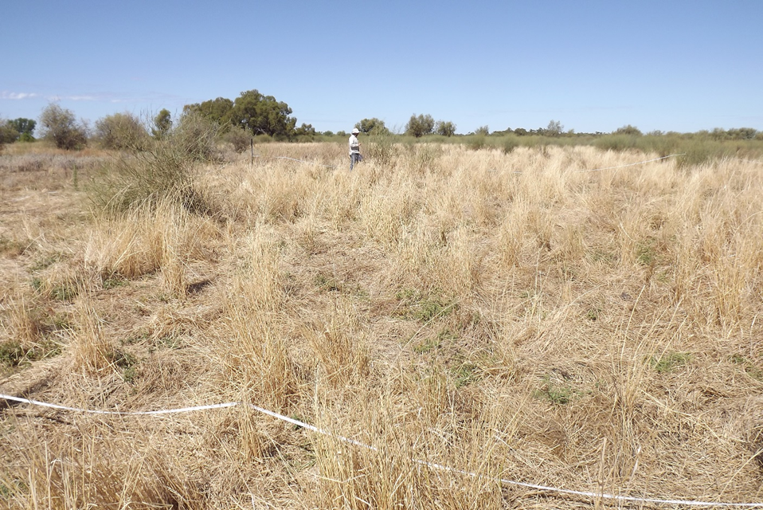
Figure K-16: Plot WD4.2 during the April 2017 survey period.

Conclusion
Significant flooding of the Western Floodplain with Commonwealth Environmental Water during the 2016-17 water year stimulated a positive response from floodplain vegetation communities. Ideal growing conditions during the December 2016 survey period resulted in high species richness and dominance measures when compared with previous sampling occasions. While these measures had decreased by April 2017, the cover of vegetation species had increased significantly, to their highest levels since LTIM monitoring began in 2015. This bodes well for the ongoing health of these floodplain vegetation communities into the future.

References
Brock, M.A. and Casanova, M.T. 1997. Plant life at the edge of wetlands: ecological responses to wetting and drying patterns. In N. Klomp and Lunt (Eds.), Frontiers of Ecology; Building the Links (pp. 181–192). Oxford, England: Elsevier Science.
Capon, S 2009. Flow dependent Ecosystems of Toorale Station: Ecological character, condition and issues associated with the decommissioning water resources infrastructure. Australian Rivers Institute, Griffith University
Commonwealth of Australia 2015. Commonwealth Water Office Long Term Intervention Monitoring Project; Junction of the Warrego and Darling rivers Selected Area. Commonwealth of Australia, Canberra.
Hale, J., Roberts, J., Page, K. and Kobryn, H. 2008. Riparian Zone Management in the Western Catchment Phase 2: Intersecting Stream. A report to the Western Catchment Management Authority.
Hale, J., Stoffels, R., Butcher, R., Shackleton, M., Brooks, S. & Gawne, B. 2013. Commonwealth Environmental Water Office Long Term Intervention Monitoring Project – Standard Methods. Final Report prepared for the Commonwealth Environmental Water Office by The Murray Darling Freshwater Research Centre, MDFRC Publication 29.2/2014, January, 182 pp.

Fish (River)

Introduction
Arid and semi-arid rivers like the Warrego River, who’s flows are intermittent and where the river often dries into isolated waterholes, form challenging conditions for fish (Katz and Freeman 2015; Kerezsy et al. 2013). As a result, the fish assemblages of the Warrego valley are considered to be in a generally degraded condition. The Sustainable Rivers Audit (SRA) integrates three primary indicators of fish assemblage condition (Expectedness, Nativeness, and Recruitment) to produce an overall Fish Index (SR-FI) rating. In the SRA No. 2 report, the Warrego Valley scored an overall rating of ‘Poor’, primarily reflecting very poor recruitment and poor to very poor fish body condition (Murray-Darling Basin Authority 2012). However, indicators relating to native fish diversity and the extent to which pre-European fish assemblages remained intact returned more positive results. In particular, the Warrego Valley attained a ‘Good’ rating for ‘Nativeness’ (the proportion of total abundance, biomass, and species present that are native), although total biomass was dominated by alien species, particularly common carp (Cyprinus carpio). The number of native species observed during sampling from the SRA report differed moderately from that expected under a pre-European reference condition. In summary, the SRA work found that the contemporary presence of native species characteristic of the Warrego’s pre-European fish assemblages was outweighed by an apparent paucity of recent fish reproductive activity.
The aim of the current section of the LTIM monitoring program at the Junction of the Warrego and Darling rivers Selected Area (Selected Area) was to assess the effects of water management on fish abundance, biomass and community health within the Warrego River zone of the Selected Area. Several specific questions were posed in relation to this indicator:
- What did Commonwealth environmental water contribute to native fish community resilience?
- What did Commonwealth environmental water contribute to native fish survival?
- What did Commonwealth environmental water contribute to native fish populations?
- What did Commonwealth environmental water contribute to native fish diversity?

Environmental watering in 2016-17
Barwon-Darling and northern tributaries
Unlike other Selected Areas, environmental water is not specifically delivered to the Junction of the Warrego and Darling rivers Selected Area, rather, Commonwealth water is held as unregulated entitlements and its influence is thus reliant on flows out of upstream catchments. During the 2016–17 water year, four flow events containing environmental water flowed down the Darling River within the Selected Area (Appendix B). These occurred in June – August 2016, August – September 2016, September – December 2016 and April – May 2017. Three of these flows were in-channel pulses with the flow during September-December 2016 reaching at or just over bankfull. Total proportions of Commonwealth environment water in the Darling River varied between 1.8% and 36.5% of total flow (Appendix B).

Warrego River
Several flow pulses in the Warrego River occurred between June - November 2016. The demand for environmental flows on the Western Floodplain was very high given the last large-scale inundation of the Western Floodplain at Toorale was in 2012. As per licence conditions, a fresh in the Warrego River in July 2016 was allowed to make visible connection with the Darling River prior to closing the gates in Boera Dam and allowing Commonwealth environmental water to spill to the Western floodplain from 19 July 2016 (Figure L-1). The gates at Boera were opened again from the 9-12 September 2016 to connect with the Darling River in accordance with licence conditions for a new flow event. Following this, further inflows were spilled to the Western Floodplain with total approved volume reaching the annual allocation of 9,720 ML by 20 September 2016. Water continued to spill onto the Western Floodplain until December 2016. In total, 31,000 ML of water flowed onto the Western Floodplain of which 31% was Commonwealth environmental water.
Another fresh occurred in the Warrego River during September - November 2016. The Boera Dam gates were again opened and once the fresh had connected with the Darling River, Commonwealth environmental water licences on the Warrego River were used to provide a pulse of water down the Warrego River. This flow aimed to provide opportunities for native fish to access habitat, support recruitment and possibly triggering spawning. 10,500 ML of water was released down the lower Warrego River channel and included 7,762 ML (74%) Commonwealth environmental water. The release was managed to provide a slow rise and fall to the pulse and also ensure that water also continued to spill to the Western Floodplain at the same time. Commonwealth water was used to provide connection for 20 days. National Parks and Wildlife Service maintained the connection for an additional 5 days before closing the gates and allowing the remaining water to spill to the Western Floodplain.
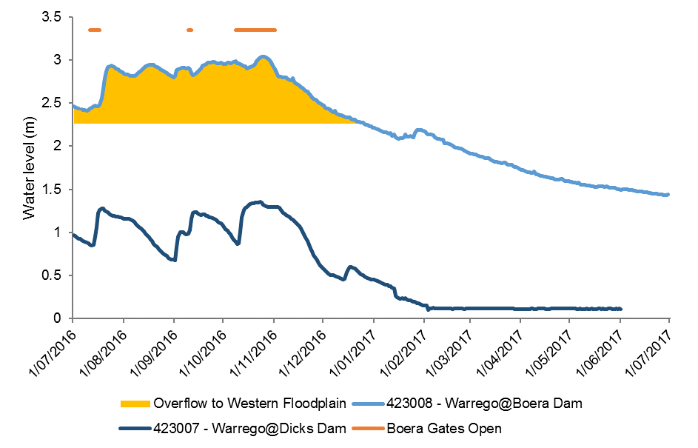
Figure L-1: Gauge heights in Boera and Dick’s dams and periods of connection down the lower Warrego channel in 2016-17 water year. All available data plotted for Warrego at Dicks Dam gauging station.

Previous Monitoring
There have been limited studies of the fish communities within the Warrego River, particularly across the lower sections of the system. Balcombe et al. (2006) studied fish assemblages in 15 waterholes distributed along four reaches of the upper Warrego in Queensland between October 2001 and April 2002. In total, ten native species from eight families, and three alien species from two families were recorded. The most abundant and widespread species, under all watering conditions, was the bony herring (Nematalosa erebi). Hyrtl’s tandan (Neosilurus hyrtlii) was also in high abundance, as was golden perch (Macquaria ambigua). As with many dryland rivers, fish assemblages in the upper Warrego were characterised by marked fluctuations in abundance. For example, bony herring, spangled perch (Leiopotherapon unicolor) and the alien species common carp (Cyprinus carpio) and goldfish (Carassius auratus), underwent an 8,500% decline in abundance in three waterholes over the course of the Balcombe et al. (2006) study. In contrast, Hyrtl’s tandan underwent a 4,150% increase in abundance across the same three waterholes over the same period. Fish abundance appeared to primarily reflect habitat attributes at the waterhole scale.
To what extent the patterns in fish assemblages observed by Balcombe et al. (2006) persist in the river’s lowland zones (i.e. the current study sites) are unclear. In particular, the river’s channel morphology varies markedly from the headwaters (i.e. above Cunnamulla in south-western Queensland) to the lower reaches, possibly driving differences in fish assemblages.
Random and sporadic sampling by Fisheries NSW between 2004 and 2014 across the lower reaches of the Warrego catchment within NSW as part of the SRA and the Carp Hotspots programs, returned catches of 12 species in varying abundances, for all sites combined. Species sampled included three exotics and nine natives. Within the boundaries of the Junction of the Warrego and Darling rivers Selected Area, two of the species sampled upstream were not caught (freshwater catfish, Tandanus sp. and Australian smelt, Retropinna semoni). However, a small number of the endangered native silver perch (Bidyanus bidyanus) were caught at Dicks Dam, whilst none were caught upstream in NSW.
Fish sampling in year 2 of the LTIM project recorded a total of nine species of fish. These included six species of native fish and three exotic species. During the October 2015 survey, spangled perch was the most abundant species caught, followed by Hyrtl’s tandan and golden perch. In March 2016, bony herring dominated the catch. All three exotic species (common carp, goldfish and mosquitofish (Gambusia holbrooki)) were only caught in relatively low numbers in both samples. In addition, only low numbers of recruits were captured among all three exotic species, including common carp. This is despite the increase in flow and connection with the floodplain between samples which are the known preferred conditions and habitat for successful spawning and recruitment in common carp. Overall, fish numbers were significantly higher in March 2016, with length-frequency data of the more abundant large-bodied native fish species suggesting that breeding and recruitment occurred between the two sampling events.

Methods

Sampling sites
Data was collected from five sites over two sampling events (herby referred to as Sample 3 and Sample 4) across the lower Warrego River Basin for Cat 3 Fish River analyses. The five sites were Ross Billabong, Dick’s Dam, Toorale Homestead, Booka Dam and Boera Dam (Figure L-2; Table L-1). Sample 3 was undertaken from the 11th to the 18th of December 2016 when all five sites were surveyed, and Sample 4 was undertaken from the 9th April to the 12th April 2017 when only three of the five sites were surveyed as the remaining two (Dick’s Dam and Toorale Homestead) were dry (Figure L-3). The lowest site (Ross Billabong) was approximately 5 km above the junction of the Warrego and Darling rivers, whilst the top site was approximately 45 km upstream of the junction of the two systems (Boera Dam). The Warrego is considered intermittent and almost ephemeral across the lower end of the system, ending in a series of swamps and artificial water storages immediately upstream of the Warrego-Darling junction.
Of the five sites sampled, four were within artificial water storages. Ross Billabong is around 4-5 km in length and has a maximum carrying capacity of around 13,000 ML. The four in-channel dams vary in size and capacity and were initially built to help drive water onto the western floodplain to improve grazing opportunities. No water was running through the system during either sampling events 3 or 4 and all five sites were in effect isolated pools. The waters at all sites was highly turbid and relatively shallow, ranging up to a maximum depth of ~1-2 m. In-stream habitat for fish was generally sparse, with small and the odd large pieces of woody debris, as well as fringing undercut banks, providing most of the cover. The substratum at all sites was dominated by mud, sand and silt. Most sites were fringed by only a sparse riparian zone, dominated by large native trees such as river red gums (Eucalyptus camaldulensis) and black box (Eucalyptus largiflorens) as well as small quantities of a range of native shrubs <2 m in height.
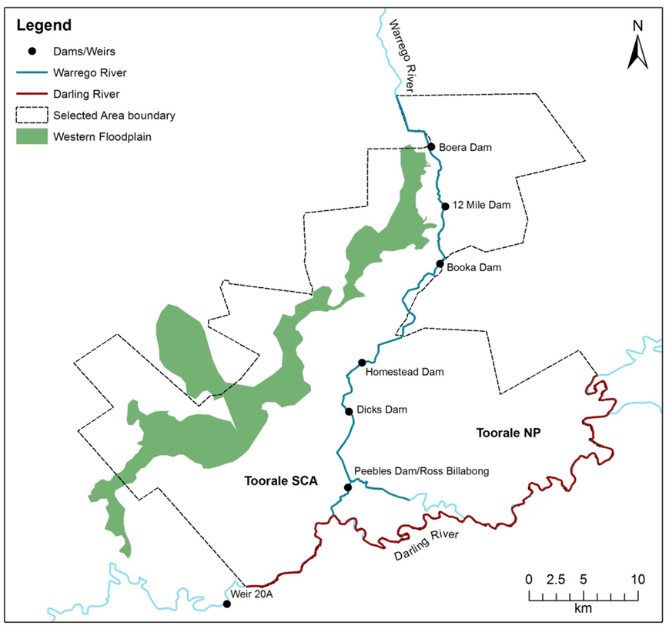
Figure L-2: Location of sampling sites in the lower Warrego River used for LTIM Category 3 Fish River Warrego and Darling Rivers Selected Area assessment.

Table L-1: Locations of sampling sites in the lower Warrego River used for LTIM Category 3 Fish River Warrego and Darling Rivers Selected Area assessment.
Site Name | River | Source | Latitude | Longitude | Altitude | Zone | Electrofishing Effort
Ross Billabong | Warrego  WaW | LTIM CAT 3 | -30.39029 | 145.40817 | 103 | Lowland | Small boat
Dick's Dam | Warrego | LTIM CAT 3 | -30.3163 | 145.36056 | 99 | Lowland | Backpack
Toorale Homestead | Warrego | LTIM CAT 3 | -30.27954 | 145.3788 | 98 | Lowland | Backpack
Booka Dam | Warrego  Warrego | LTIM CAT 3 | -30.19054 | 145.43962 | 98 | Lowland | Small boat
Boera Dam | Warrego | LTIM CAT 3 | -30.1018 | 145.41962 | 104 | Lowland | Small boat
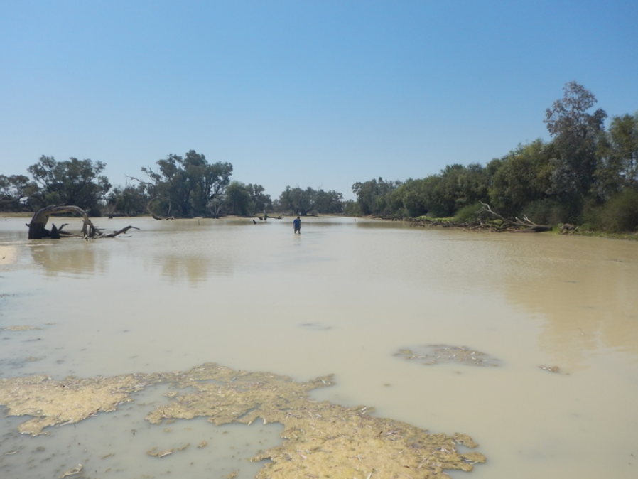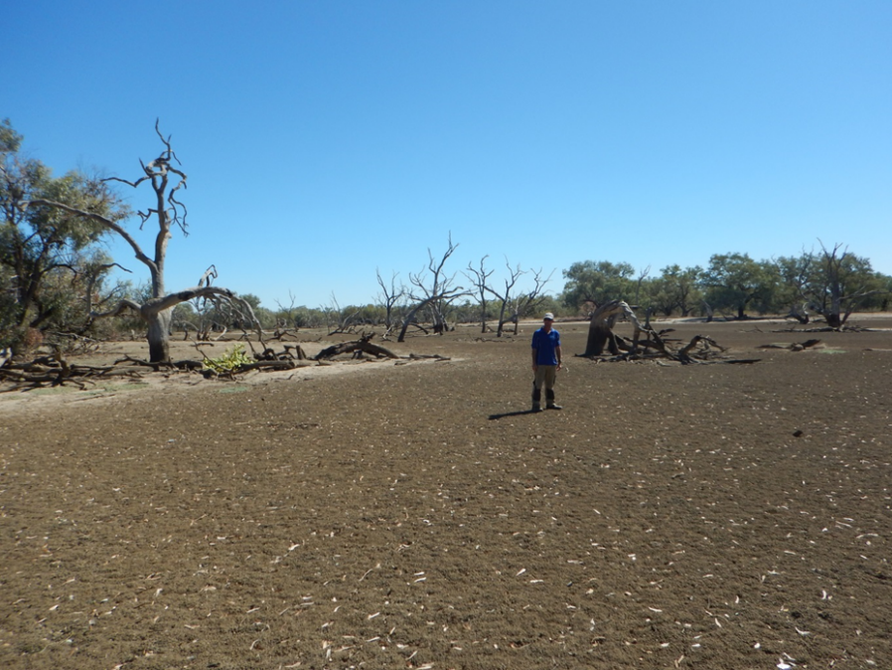
Figure L-3: Dick’s Dam during sampling for LTIM Category 3 Fish River Warrego and Darling Rivers Selected Area assessment, December 2016 (a) and April 2017 (b).

Sampling protocols
Sampling effort at each site was a combination of electrofishing, baited and un-baited bait traps, small and large mesh fyke nets and seine netting. Electrofishing used either a small boat (3.5 kw Smith-Root electrofisher unit), backpack (Smith-Root model LR20), or a combination of boat and backpack. Boat electrofishing involved 12 x 90 second operations, while backpack electrofishing consisted of 8 x 150 second operations. At sites where both boat and backpack sampling was required, the number of operations of each method used was proportional to the area of navigable versus wadable habitat. Boat electrofishing involved a series of ~10 sec power-on and power–off operations, with successive operations undertaken on alternate banks, whilst moving in an upstream direction. Backpack electrofishing involved sampling all areas accessible to the stationary operator, before they would progressively move upstream around ~3 m and repeat the process. All boat and backpack electrofishing was undertaken by two operators.
Bait traps (n = 10 unbaited, n = 5 baited, ‘opera house’ style) were deployed haphazardly throughout the sites in depths of 0.5–1 m, and soaked for up to two hours during electrofishing operations. Seine netting and fyke netting were undertaken on alternate days to electrofishing operations. Each seine operation involved one sampler remaining stationary on the bank, whilst the other dragged the net at full extension from bank to bank in a semi-circle motion; starting downstream of the stationary sampler and working upstream into the “flow”. The seine net was 5 m in length, 1.8 m high and had 5 mm mesh. Three double wing small mesh (3 mm mesh) and three large mesh (19 mm) single wing fyke nets were set overnight for a minimum of 12 hrs.
All fish captured were identified, counted, and measured to the nearest mm. Fork length (FL) was measured for species with forked tails, and total length (TL) was measured for all other species. If large numbers of a particular species were captured by a given gear type within a site, only the first 50 individuals of that species were measured, with any subsequent captures counted only. Fish that escaped capture but that could be positively identified were recorded as “observed”. Voucher specimens were retained for all species that could not be positively identified in the field.

Data analyses
Fish community
All methods were combined for statistical analyses of the fish community. Non-parametric multivariate analysis of variances (PERMANOVA) was used to determine if there were differences between the fish assemblages between the two events in the current reporting period as well as those in the 2015-16 reporting period (PRIMER 6 & PERMANOVA; Anderson et al. 2008). Prior to analyses, the data were fourth root transformed and the results used to produce a similarity matrix using the Bray-Curtis resemblance measure. All tests were considered significant at P <0.05. Where differences were identified by PERMANOVA, pair-wise comparisons were then used to determine which groups differed. Similarity percentage (SIMPER) tests were used to identify individual species contributions to average dissimilarities among groups.

Non-parametric Kolmogorov-Smirnov Z tests were used to determine if there were differences among samples in the size structures of the five most abundant large-bodied (those that grow to <100 mm) species present (golden perch, spangled perch, bony herring, Hyrtl’s tandan and common carp). Data from all sites sampled were combined, with all samples where <20 individuals were captured excluded from the analysis. P-values were adjusted to account for increasing experiment-wise error rates associated with multiple comparisons (Ogle 2015).

Health Metrics
Reference Condition
The predicted pre-European fish community of the lower Warrego Basin was derived using the Reference Condition for Fish (RC-F) approach used by the Sustainable Rivers Audit (SRA) and NSW Monitoring, Evaluation and Reporting (MER) programs (Table L-2 and Table L-3). The RC-F process involves using available historical and contemporary data, museum collections and expert knowledge to estimate the probability of collecting each species at any randomly selected site within an altitude zone if it were sampled using the standard sampling protocol prior to 1770 (Davies et al. 2008). Rare species were allocated a RC-F probability of capture of 0.1 (collected at 0 < 0.2 of samples), occasional species (collected at 0.21 < 0.7 of samples) an RC-F of 0.45 and common species (collected at 0.71 < 1.0 samples) an RC-F of 0.85 (RC-F scores being the median capture probability within each category) (Table L-2).
The definition of a recruit was derived using a similar process as that applied in the SRA and MER programs (Dean Gilligan unpublished data). For large-bodied and generally longer living species (>three years), an individual was considered to be a recruit if its body length was less than that of a one-year-old of the same species. For small-bodied and generally short-lived species that reach sexual maturity in less than one year, recruits were considered to be those individuals that were less than the species known average length at sexual maturity. The recruitment lengths used for both large- and small-bodied species were derived from published scientific literature or by expert opinion where that was not available (Table L-3).
Metrics, Indicators and the Overall Fish Condition Index.
Using the methods described by Robinson (2012), eight fish metrics were derived from the data collected at each site. The eight metrics were then aggregated to produce three fish condition indicators and these indicators were then used to derive an overall Fish Condition Index (SRA ndxFS). Metric and indicator aggregation was done using Expert Rules analysis in the Fuzzy Logic toolbox of MatLab (The Mathworks Inc. USA) using the rules sets developed by Davies et al. (2010).
The Expectedness Indicator (SR-FI_{e}) represents the proportion of native species that are now found within the basin, compared to that which was historically present. The Expectedness Indicator is derived from two input metrics; the observed native species richness over the expected species richness at each site, and the total native species richness observed within the zone over the total number of species predicted to have existed within the zone historically (Robinson 2012). The two metrics were aggregated using the Expectedness Indicator Expert Rule set (Carter 2012).
The Nativeness Indicator (SR-FI_{n}) represents the proportion of native versus alien fishes within the river. The Nativeness Indicator is derived from three input metrics; proportion native biomass, proportion native abundance and proportion native species (Robinson 2012). The three metrics were aggregated using the Nativeness Indicator Expert Rule set (Carter 2012).
The Recruitment Indicator (SR-Fi_{r}) represents the recent reproductive activity of the native fish community within each altitude zone. The Recruitment Indicator is derived from three input metrics; the proportion of native species showing evidence of recruitment at a minimum of one site within a zone, the average proportion of sites within a zone at which each species captured was recruiting (RC-F corrected), and the average proportion of total abundance of each species that are new recruits (Robinson 2012). The three metrics were aggregated using the Recruitment Indicator Expert Rule set (Carter 2012).
The three indicators were combined using the Fish Index Expert Rule set (Carter 2012) to calculate an overall Fish Condition Index (ndxFS). The Fish Index Expert Rules analysis is weighted as SR-FI_{e} > SR-FI_{r} > SR-FI_{n}. The output generated by the Expert Rules analysis is scaled between 0 and 100, with higher values representing a ‘healthier’ fish community. The index was then partitioned into five equal bands to rate the condition of the fish community; “Good” (81-100), “Moderate” (61-80), “Poor” (41-60), “Very Poor” (21-40), or “Extremely Poor” (0-20).
Table L-2: Native freshwater fish species predicted to have occurred across the lower Warrego River prior to European colonisation. Descriptions of predominance (occurrence) correspond to RC-F categories for the Murray Darling Basin Sustainable Rivers Audit program and are used to generate the fish condition metrics.
Species | Common name | Occurrence
Ambassis agassizii | Olive perchlet | Occasional
Bidyanus bidyanus | Silver perch | Occasional
Craterocephalus stercusmuscarum fulvus | Un-specked hardyhead | Rare
Hypseleotris sp. | Carp-gudgeon | Common
Leiopotherapon unicolor | Spangled perch | Common
Melanotaenia fluviatilis | Murray-Darling rainbowfish | Common
Melanotaenia splendida tatei | Desert rainbowfish | Rare
Mogurnda adspersa | Southern purple-spotted gudgeon | Rare
Nematolosa erebi | Bony herring | Common
Maccullochella peelii | Murray cod | Occasional
Macquaria ambigua | Golden perch | Common
Neosilurus hyrtlii | Hyrtl’s tandan | Occasional
Retropinna semoni | Australian smelt | Common
Tandanus sp. (MDB) | Freshwater catfish | Common

Table L-3: Sizes used to distinguish new recruits for species likely to be sampled in the lower Warrego River. Values represent the length at 1 year-of-age for longer-lived species or the age at sexual maturity for species that reach maturity within 1 year.
Species | Estimated size at 1 year old or at sexual maturity (fork or total length) | Sample 3 |  | Sample 4
 |  | Adult | Juv. | Adult | Juv.
Native species
Olive perchlet | 26 mm (Pusey et al. 2004)
Silver perch | 75 mm (Mallen-Cooper 1996)
Un-specked hardyhead | 38 mm (Pusey et al. 2004)
Carp gudgeon | 35 mm (Pusey et al. 2004)
Spangled perch | 68 mm (Leggett & Merrick 1987)
Murray-Darling rainbowfish | 45 mm (Pusey et al. 2004)
Desert rainbowfish | 38 mm (Pusey et al. 2004)
S. purple-spotted gudgeon | 40 mm (Pusey et al. 2004)
Bony herring | 67 mm (Cadwallader 1977)
Murray cod | 222 mm (Gavin Butler unpub. data)
Golden perch | 75 mm (Mallen-Cooper 1996)
Hyrtl’s tandan | 130 mm (Pusey et al. 2004)
Australian smelt | 40 mm (Pusey et al. 2004)
Freshwater catfish | 92 mm (Davis 1977)
Alien species
Common carp | 155 mm (Vilizzi and Walker 1999)
Eastern mosquitofish | 20 mm (McDowall 1996)
Common goldfish | 127 mm (Lorenzoni et al. 2007)

Results

Abundance
In total 3,835 fish were caught (n = 3,706) or observed (n = 129) across all sites and for all methods in Sample 3, and 1318 were caught (n = 972) or observed (n = 346) in Sample 4. Species composition comprised 10 species in Sample 3 (seven native species and three exotic species) and eight in Sample 4 (five native species and three exotic species) (Figure L-4). As in year 2 of the project (Samples 1 and 2), a number of the species present tended to be locally abundant at the site scale, whilst others were reasonably ubiquitous across all sites. In Sample 3, among the large-bodied species, bony herring (n = 1938) was the most abundant large bodied species caught (for all sites and gear types combined), followed by Hyrtl’s tandan (n = 788) and spangled perch (n = 606). In Sample 4, the catch rates were generally lower for all species, with bony herring (n = 314) remaining the most abundant species encountered, whilst common carp (n = 169) and spangled perch (n = 161) ranked as the second and third most abundant species respectively. The numbers of Hyrtl’s tandan captured in Sample 4 had dropped to <15 % of that number caught in the previous sample (n = 101). As in the first two sampling rounds there were few native small-bodied species caught and all were in relatively low abundances. In Sample 3, the two small-bodied species caught during previous sampling, carp gudgeon (Hypseleotris sp.) and Murray-Darling rainbowfish (Melanotaenia fluviatilis), were again captured, but the previously un-encountered Australian smelt (Retropinna semoni) were also caught in low numbers (n = 14) at Boera Dam. Of the three, only Murray-Darling rainbowfish were caught in Sample 4 and only at one site in contrast to the five that they were caught at in Sample 3. The exotic eastern mosquitofish were again caught in low numbers, but were present at more sites than in the first two samples; three of the five surveyed in Sample 3 and two of the three watered sites surveyed in Sample 4.
There was a significant difference in the overall fish assemblage among samples (Pseudo-F_{3,16} = 2.51, P = <0.01). Pair-wise comparisons revealed the dissimilarity was due to differences between Sample 1 and 3 (t = 1.99, P = 0.02) and between Sample 2 and 3 (t = 2.18, P = 0.02). SIMPER analysis suggested differences between Sample 1 and 3 were a result of an increase in the abundance of bony herring (contribution = 20.62%), Hyrtl’s tandan (contribution = 16.35%) and Murray-Darling rainbowfish (contribution = 13.02%) in Year 3. Contrastingly, differences between Year 2 and 3 were a result of increases in common carp (contribution = 20.33%), Hyrtl’s tandan (contribution = 18.98%) and to a lesser degree eastern mosquitofish (contribution = 12.69 %).
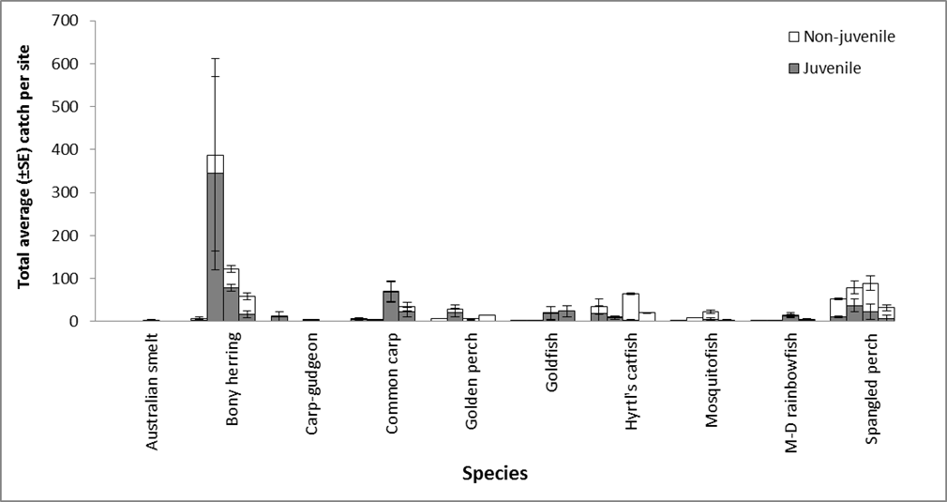
Figure L-4: Average catch ± S.E. per site for all gear types combined for the 9 fish species sampled in the in the lower Warrego River. Samples are sequential starting from the left; October 2015 (Sample 1), April 2016 (Sample 2), December 2016 (Sample 3) and April 2017 (Sample 4). NB*. Juveniles and non-juveniles estimates represent the length at 1 year of age for longer-lived species or the age at sexual maturity for species that reach maturity within 1 year (Table 3).

Biomass
Based on estimated and measured weights, a total of 55.602 kg of fish were recorded across all sites and for all methods in Sample 3, and similarly, despite there being only three sites with water, 52.799 kg in Sample 4. In Sample 3, spangled perch had the highest overall biomass (n = 21.374 kg) among the 10 species sampled, followed by common carp (n = 15.225 kg) and Hyrtl’s tandan (n = 9.035 kg) (Figure L-5). Contrastingly, in Sample 4, common carp (n = 27.725 kg) and spangled perch (n = 8.993 kg) had exchanged ranking, whilst bony herring had become the third highest ranked species (n = 6.065 kg) in biomass. Among the small-bodied species, Murray-Darling rainbowfish had the highest biomass in both Sample 3 (n = 37.6 g) and Sample 4 (17.1g).
Despite the fluctuations in the overall biomass of fish from Sample 1 to sample 4, there was no overall significant difference in biomass among samples (Pseudo-F_{3,16} = 1.91, P = 0.054) (Figure L-6). Post-hoc pair-wise comparisons revealed there was also no significant difference between any two samples.
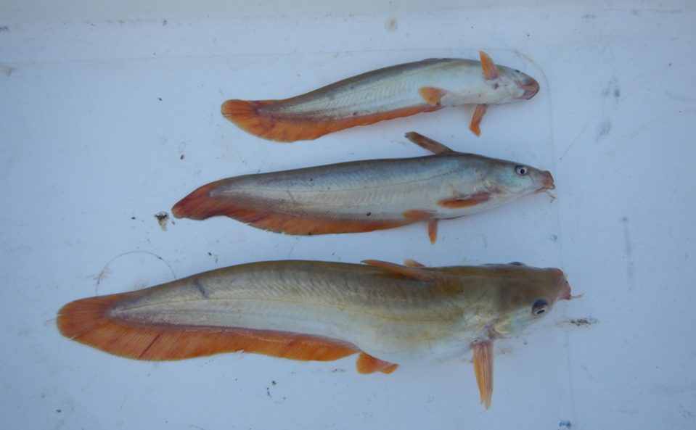
Figure L-5: Size structuring among Hyrtl’s tandan (Neosilurus hyrtlii) captured at Dick’s Dam on the lower Warrego River; Sample 3, December 2016 (Range ~120-250 mm).

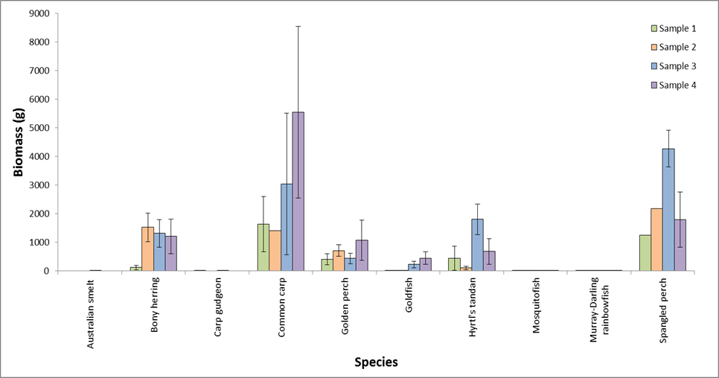
Figure L-6: Average biomass ± S.E. per site for the 9 fish species sampled across the lower Warrego River; October 2015 (Sample 1), April 2016 (Sample 2), December 2016 (Sample 3) and April 2017 (Sample 4).

Length frequency
In general, there were significant differences in the length-frequency among the five more abundant species caught between most samples (golden perch, spangled perch, bony herring, Hyrtl’s tandan and common carp) (Table L-4; Figure L-7). There was also evidence of young-of-year individuals for all five species in most samples. With golden perch, the differences in length frequency distributions between samples was due to the increase in the number of longer individuals in later samples, and also the increase in the numbers of young-of-year caught in Sample 2 and to a lesser degree, Sample 3 (Figure L-7). Similarly, the structure of the spangled perch population tended to skew more toward longer individuals as sampling progressed, with an apparent recruitment event between Sample 2 and 3 also contributing to differences (Figure L-7). This same shift in dominance toward recruits was also apparent among the bony herring population between Sample 2 and 3. However, there was also evidence of recruitment and ongoing survival through each sampling round, with very few fish (<10) over 100 mm FL caught in Sample 1, whilst 50 % of the 293 bony herring caught in Sample 4 were > 100 mm FL (Figure L-7). Among the four native species, Hyrtl’s tandan had the clearest shift in population structure through time. In Sample 1 and 2 the structure of the population tended to be relatively symmetrical but was dominated by young-of-year individuals of less than 130 mm TL. This shifted dramatically toward longer individuals in Sample 3 and 4, with very few young-of-year caught in either of the later samples (Figure L-7).

The small numbers of common carp in Sample 2 meant statistical comparisons between the other three samples could not be undertaken. In general, there was little difference in the structure of the population between Samples 1, 2 & 4 (Figure L-8), with the population dominated by individuals < 200 mm FL and only the odd longer fish. However, as with the majority of other large-bodied species present, there was evidence of a strong recruitment event between Samples 2 and 3 for common carp, with ~ 90 % of the 356 individuals sampled <100 mm FL. Whilst, there was large numbers of recruits present, larger adult fish up to 634 mm FL and 5 kg were also consistently caught in each sample.

Table L-4: Kolmogorov-Smirnov test results of length frequency comparisons between the five most abundant species sampled in the lower Warrego River; October 2015 (Sample 1), April 2016 (Sample 2), December 2016 (Sample 3) and April 2017 (Sample 4). NB* Dark shading indicates significant difference <0.05.
 |  | Zone
 |  | Golden perch | Spangled perch | Bony herring | Hyrtl’s tandan | Common carp
Sample 1  V  Sample 2 | P | <0.001 | <0.001 | <0.001 | <0.001 | --
Sample 1  V  Sample 3 | P | 0.784 | <0.001 | <0.001 | <0.001 | <0.001
Sample 1  V  Sample 4 | P | 0.784 | <0.001 | 0.02 | <0.001 | <0.001
Sample 2  V  Sample 3 | P | <0.001 | <0.001 | <0.001 | <0.001 | --
Sample 2  V  Sample 4 | P | <0.001 | <0.001 | <0.001 | <0.001 | --
Sample 3  V  Sample 4 | P | 0.049 | <0.001 | <0.001 | <0.001 | <0.001

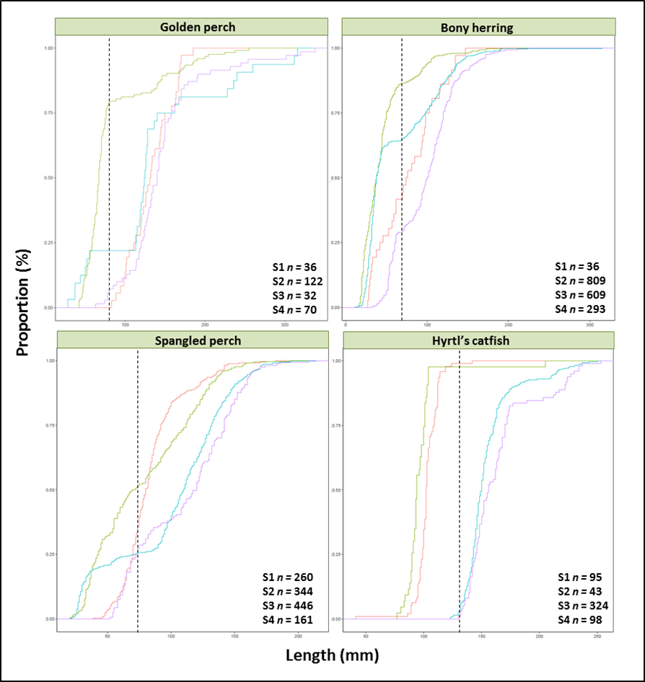
Figure L-7: Cumulative length frequency distribution (Proportion (%)) of golden perch (Macquaria ambigua), spangled perch (Leiopotherapon unicolor), bony herring (Nematolosa erebi) and Hyrtl’s catfish (Neosilurus hyrtlii) sampled in the lower Warrego River, October 2015 (Sample 1 = ), April 2016 (Sample 2 = ), December 2016 (Sample 3 = ) and April 2017 (Sample 4 = ). NB# Dashed line is approximate length of one-year-old individual.
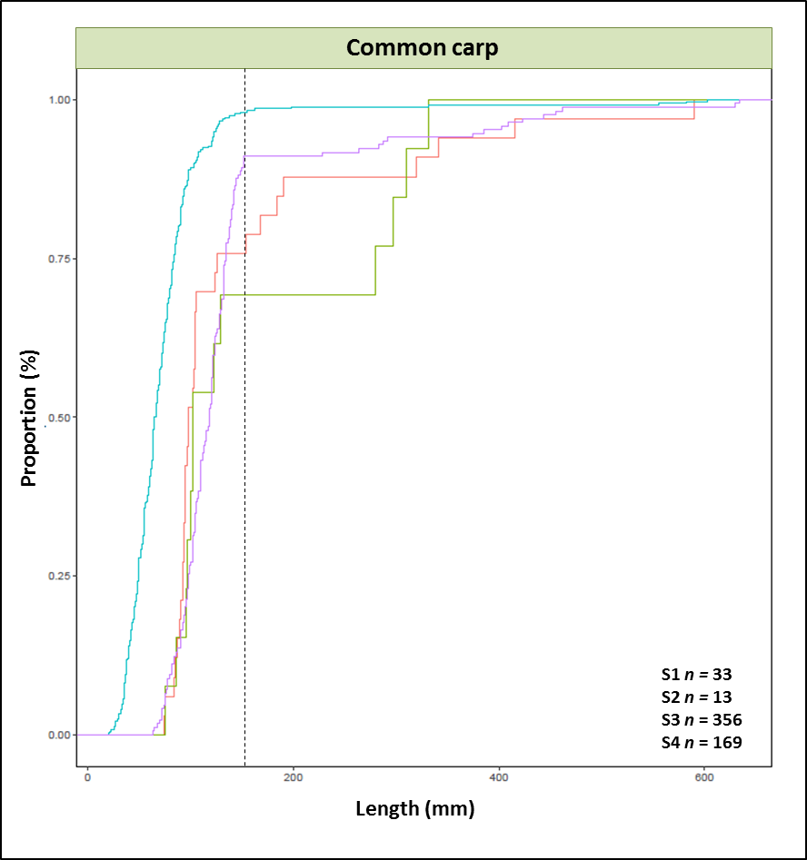
Figure L-8: Cumulative length frequency distribution (Proportion (%)) of common carp (Cyprinus carpio) sampled in the lower Warrego River, October 2015 (Sample 1 = ), April 2016 (Sample 2 = ), December 2016 (Sample 3 = ) and April 2017 (Sample 4 = ). NB# Dashed line is approximate length of one-year-old individual.

Health Indicators
Expectedness
Of the 14 native fish species that have been previously sampled or were thought to have historically occurred in the Warrego, seven were caught at a minimum of one site in Sample 3 and five in Sample 4 (Table 3). The species not caught in Sample 3 but caught in Sample 4 was carp gudgeon and Australian smelt. The seven species not caught in either sample were olive perchlet (Ambassis agassizii), silver perch (Bidyanus bidyanus), un-specked hardyhead (Craterocephalus stercusmuscarum fulvus), desert rainbowfish (Melanotaenia splendida tatei), southern purple-spotted gudgeon (Mogurnda adspersa), Murray cod (Maccullochella peelii), and freshwater catfish (Tandanus sp. MDB). Of the seven, three were considered “rare” or “cryptic” meaning they are only likely to be collected in up to 20% of sites (un-specked hardyhead, desert rainbowfish and southern purple spotted gudgeon), and three as “occasional” (olive perchlet, silver perch and Murray cod) meaning they are only likely to be collected in 20-70% of sites within a zone (Robinson 2012). Freshwater catfish were considered as “common” and “abundant” in the past and would be expected to be caught at a minimum of 70% of sites within a zone (Robinson 2012).
In general, all sites rated low for Expectedness in Sample 3 and were even lower for all sites in Sample 4 (Figure L-9). In Sample 3, all sites except Boera Dam, rated as “Poor” with scores of 58.3. Boera Dam rated as “Moderate” at 68, due to the presence of one additional species compared to the other four sites. In Sample 4, the numbers of native species caught were considerably lower at all sites sampled. Only four species were caught at Boera and Booka Dams resulting in a rating of “Very Poor” for both sites, two species at Ross Billabong resulting a rating of “Extremely Poor”, whilst the two dry sites scored a default rating of “Extremely Poor”. The average (± S.E.) site score for Sample 3 for Expectedness was 60.2 ± 1.94 or “Poor”, whilst for Sample 4 the average was 14.4 ± 6.58 meaning the overall rating had declined to “Extremely Poor”.
Nativeness
As with Sample 1 and 2, eastern mosquitofish, goldfish and common carp (Figure L-6) were all caught in both rounds in year 3 of the project. Common carp had increased in number considerably since Sample 1, and were the most abundant of the three exotics in both Sample 3 (n = 391) and Sample 4 (n = 169). Goldfish numbers had also increased considerably since the earlier sampling rounds and were caught at most sites in both recent rounds. Similarly, mosquitofish numbers were also up in Sample 3 (n = 321) but were only caught in low numbers (n =16) in Sample 4. Combined, exotics made up 29% of the total biomass of fish caught in Sample 3 and 57% in Sample 4.
Despite an increase in the number of exotic species caught, in general the continued low numbers of exotics compared to natives was reflected in the relatively high Nativeness scores for Sample 3 and to a lesser degree Sample 4 (Figure L-9). In Sample 3 four of the five sites rated as “Good”, with Dicks Dam and Toorale Homestead both scoring 98.6 meaning very few exotics compared to natives were caught at either site. Only Ross Billabong scored a rating of “Poor”, which reflects the higher number of common carp caught at the site compared to the other four sites. In contrast to Sample 3, only Booka Dam rated as “Good”, with Ross Billabong and Boera Dam rating as “Poor” and the remaining two dry sites scoring a default “Extremely Poor”. The average (± S.E.) score for Nativeness for Sample 3 was 87.1 ± 7.57 giving the area an overall rating of “Good”, whilst for Sample 4, sites averaged 37.4 ± 16.95 meaning the areas overall rating for the area had declined to “Very Poor” for Nativeness (Figure L-9).
Recruitment
The Recruitment Indicator scores declined considerably between Sample 3 and 4, and were also lower compared to that of Sample 2 (Figure L-9). For Sample 3 the Selected Area scored 79.7 (“Moderate”) for Recruitment, whilst for Sample 4 the Selected Area scored 40.7 (“Poor”). Based on the individual metrics calculated to achieve the overall Recruitment Indicator in Sample 3 and 4, 100% of the native fish sampled were recruiting at a minimum of one site; by number, recruits represented ~48% of the native fish caught in Sample 3 and only ~27% in Sample 4; and the average proportion of sites within the selected area at which each species was recruiting was 80% in Sample 3 and 47% in Sample 4.
There was continued evidence of recruitment among all three exotic species sampled. Mosquitofish recruits were caught at multiple sites in both Sample 3 and 4, whilst all but two individuals among the 300 goldfish caught across both rounds were below the recruit cut-off size of 127 mm. Similarly, 96% and 56% of common carp caught in Sample 3 and Sample 4, respectively, were recruits. By site, common carp recruits were caught at all five sites in Sample 3 and adults at all but Dicks Dam, whilst both recruits and adults were caught at all sites that were surveyed in Sample 4.
Overall condition
As in Sample 1 and 2, the Overall Fish Condition (ndx-FS) varied between sites but more so between sampling times (Figure L-9). In Sample 3, the overall condition had continued to improve at most sites, with Dick’s Dam and Toorale Homestead both scoring ratings of “Good” or 81 and the remaining three sites achieved a rating of “Moderate”. In contrast, Sample 4 saw the three surveyed sites of Ross Billabong, Booka Dam and Boera Dam rate much lower at “Extremely Poor”, “Poor” and “Very Poor” respectively. The dry sites received a default rating of “Extremely Poor”. The site average (±S.E.) for Sample 3 was 74 ± 3.97 giving the selected area an overall rating of “Moderate” at the time, whilst the overall condition site average for Sample 4 was 16 ± 8.28, resulting in an overall rating of “Extremely Poor”.
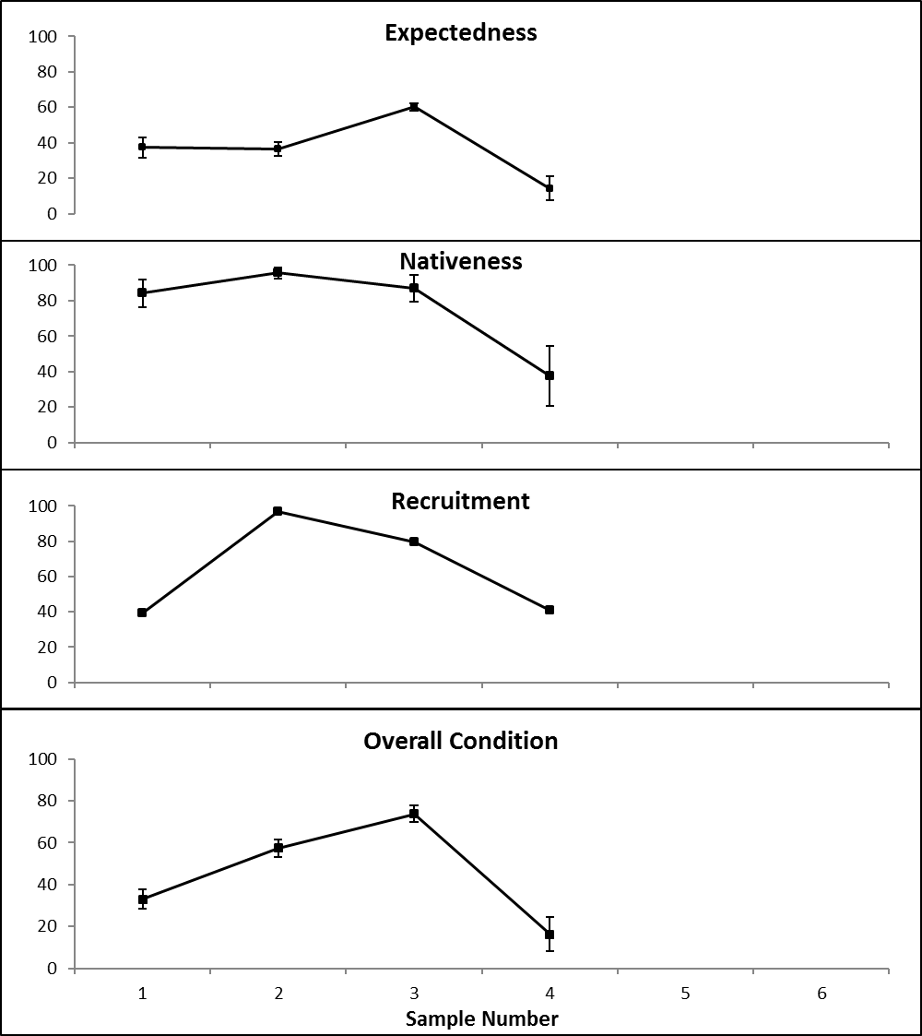
Figure L-9: Expectedness Nativeness, Recruitment and Overall Condition (ndxFS) Indicator values for fish at sites sampled in the lower Warrego River, October 2015 (Sample 1), April 2016 (Sample 2), December 2016 (Sample 3) and April 2017 (Sample 4).

Discussion
The results of the current two sampling rounds further highlight the boom and bust nature of ephemeral river systems like the lower Warrego. In most cases the abundances and the biomass of most fish species present fluctuated markedly between and among samples, most likely based on their individual ability to cope with the rapidly changing environmental conditions experienced across the system. In general, those species that have wide ranging environmental tolerances to factors such as temperature, DO and pH are better able to handle the often rapid and wide-ranging changes in the surrounding abiotic conditions in semi-arid river systems like the Warrego (Katz and Freeman 2015; Kerezsy et al. 2013). All four large-bodied native species found in the current study fit the criteria, as they have not only persisted for almost two years at most sites, but they have grown and reproduced at least once. In addition to being able to cope with abiotic variability, to be successful in these extreme environments a species must also have the ability to rapidly relocate as opportunity presents, be it into more persistent refugia as the system dries down or opportunistically into newly inundated areas to take advantage of resources that may only be available for relatively short periods of time (Kerezsy et al. 2013). Species such golden perch, spangled perch and bony herring, are well known as being highly opportunistic when it comes to moving on small and large flow events, both to colonise and establish populations in areas outside of their normal range or into areas classified as intermittently wetted habitats (Ellis et al. 2015; Kerezsy et el. 2013; Balcombe et al. 2006).
The length-frequency analysis of the more abundant large-bodied native species caught in the current sampling rounds suggests that breeding and recruitment occurred among most native species during the previous year. This was particularly apparent in Sample 3 when relatively large numbers of recruits of bony herring, spangled perch and Murray-Darling rainbowfish were caught at most sites following the extended in channel fresh provided by Commonwealth environmental water. A smaller number of golden perch, carp gudgeon, Australian smelt and Hyrtl’s Tandan recruits were also sampled. This is an encouraging result for the use of Commonwealth water in stimulating fish breeding and recruitment in the lower Warrego system.
The variability in recruitment among species is most likely a reflection of the flow regime experienced throughout 2016-17 suiting some species more than others regarding breeding and recruitment. For example, species such as golden perch, bony herring, spangled perch and rainbowfish have been shown to be “no-flow recruiters” in arid rivers like the Warrego, meaning that they will breed and recruit during low or no flow periods but may also be advantaged by elevated or serial flows resulting in spikes of recruitment (Kerezsy et al. 2011; Balcombe et al. 2006). Contrastingly, Hyrtl’s Tandan showed little sign of recruitment in the current sample rounds which is most likely classifies them as more of a “flow-dependent species”. These species require major flooding in summer to bring about strong recruitment (Kerezsy et al. 2011). There was also evidence of cohort structuring starting to form among some species. For example, Hyrtl’s Tandan caught in Samples 1 and 2 were mostly all juveniles, whilst in Samples 3 and 4 almost all were considered as older than one year. This phenomenon is most likely an artifact of a small founder population re-establishing itself following the almost complete drying down of the system prior to 2015. Since then, the juveniles from a single larger recruitment event appeared first and then these same individuals grew over the eight months between samples, before the same fish as 1+ individuals were recaptured in Samples 3 and 4. It appears that the biggest benefit of the release of water including Commonwealth environmental water for this species in 2016-17 was the maintenance of habitat and water quality that allowed the initial recruits to survive into adult fish.
The continuing low Expectedness Indicator scores for all sites further emphasise the likelihood that the fish species that were caught are most likely the ones that will be encountered the majority of times when sampling fish across the lower Warrego. All of the large-bodied species have been consistently caught throughout the project. The only species not caught in Sample 4 were two short-lived small-bodied species; Australian smelt and carp gudgeon. Both species were in low abundance in Sample 3 and were only captured at one site each, indicating that they are effectively only at best just “hanging-on” in the system. Additionally, all of the Australian smelt and all but one carp-gudgeon were juveniles suggesting a small founder population and potentially a one-off breeding event preceding Sample 3. Both species are considered as “no-flow” recruiters in that they don’t require flooding or increased flows to breed and recruit, but Australian smelt are also considered “seasonal”, spawning in late winter, whilst carp gudgeon are considered “continuous” in that they can spawn from late winter through to the next autumn. As such it is unlikely that flow variability alone is attributing to the low numbers of these small-bodied species but rather it may be other factors dictating localized abundances and distribution. Previous work in highly turbid dryland rivers has suggested that the cessation of flows and the formation of discrete waterholes are generally linked to lower fish abundances (Arthington et al. 2005; Balcombe et al. 2006). In a comparison between the Warrego River and Cooper Creek, Fellows et al. (2009) found that the Warrego had much lower benthic primary production and that the benthic biofilm in Cooper Creek was more productive and also better developed than in the Warrego. A link was suggested between the littoral zone disturbances and reduced benthic biofilm production, due to a greater bank slope and the presence of common carp in the Warrego (Fellows et al. 2009). However, while there was a significant relationship between benthic primary production and fish abundance (Fellows et al. 2009), it was also suggested that other factors such as physical habitat availability or deteriorating water quality also likely played a major role in controlling fish populations as arid-zone rivers dry (Arthington et al. 2005; Balcombe et al. 2006). This highlights the complexity and severity of the processes occuring in rivers like the Warrego. As was likely seen in the current study, smaller-bodied and younger fish are less able to cope with the rapid changes and extremes of the surrounding environment meaning they are lost to the system first.
Unlike Year 2, the Nativeness scores were much lower in Year 3 sampling, with a small decline in Sample 3 and a pronounced decline in Sample 4. These changes can be attributed to a decline in some native species such as bony herring but also to the increase in the number and biomass of common carp and goldfish. In Sample 3 the catches of exotics were dominated by individuals <100 mm for common carp and < 60 mm for goldfish. In Sample 4 these same cohorts had grown, with the common carp population now dominated by individuals between 100 and 150 mm and goldfish by individuals between 70 and 120 mm. This suggests that a major breeding event had occurred for both species, most likely in association with large scale flooding of the Western Floodplain and longitudinal connectivity of the Warrego channel between August and December 2016. In previous reporting it was suggested that the lower Warrego may be an opportunistic source to the wider Darling when conditions are favourable (Commonwealth of Australia 2016). Whilst the exact source of both species is unknown it seems likely that it is reasonably close by given the relative size classes of individuals of both species in Sample 3. Koehn et al. (2016) suggested that whilst common carp can breed and recruit within the river channel, floodplain habitats are preferred over flowing main-river channel habitats and that flows to adjacent wetlands for extended periods can progressively increase populations. Whilst there was protracted inundation of the Western Floodplain in Spring and Summer 2016-17, given that the largest catches of juveniles were at Ross Billabong, which is at the bottom end of the river channel and is not directly connected to the Western Floodplain, it is likely the source of common carp in the main channel came mainly from inundated floodplains directly adjacent to the Warrego river channel, or from individuals moving into the Warrego from the Darling river through the open pipes and breeches of Peebles dam.
The decline in the Recruitment Index scores from Sample 2 to Samples 3 and 4 most likely reflects the switch from a period of consistent cyclic wetting and connectivity, to one of drying and the disconnection of the system and eventually the disappearance of waterholes. In general, when times are good and food is in abundance in dryland rivers, fish will be in better condition which leads to an increase in reproduction and ultimately higher recruitment. Contrastingly, as conditions worsen and the river becomes disconnected and refugia holes begin to dry up, stress is increased and individuals will switch to survival mode, leading to reduced reproduction and recruitment (Puckridge et al. 2000). Balcombe et al. (2006) suggested that most native species in the upper Warrego River recruited in most years despite extreme variations in flow. They found that the overall abundance and numbers of recruits, whilst being somewhat individualistic in nature, tended to be lower for most species in dry years compared to post-wet and wet years. Prior to the current drying down of the Warrego system, over 2015 and 2016 a number of flow peaks and longitudinal connectivity events occurred along the main stem of the river, meaning in effect the river could be said to be at its best. Post December 2016, the system disconnected and retracted back to defined waterholes. As the drying continued, water quality declined, the size and depth of waterholes shrunk and eventually some dried up all together. As this occurred the stress would have increased exponentially on fish populations both across the system as a whole and also at the local waterhole scale. Additionally, in systems like the Warrego that is considered spatially homogenous and lacking in habitat complexity, the risk of predation for fish increases as water holes become smaller and shallower. This is particularly the case for smaller individuals, as they are not only susceptible to terrestrial predators like birds, but also at risk from being predated by larger fish and other aquatic predators from within the waterhole.

Conclusion
The latest rounds of sampling in the lower Warrego provide valuable insights into the functioning of an ephemeral waterway as it cycles from a “boom” cycle of breeding, recruitment and growth, through to a “bust” cycle of drying and localized extirpations. For fish to persist within the lower Warrego, regular maintenance flows for reproduction, survival and growth are required. Periodic flooding is also required to effectively recharge the system. Given the unregulated nature of the Warrego catchment upstream of the Selected Area, river flows entering the Selected Area are variable and reliant upon upstream rainfall. Managing these events when they do enter the Selected Area to ensurie water is retained in at least some of the five waterholes along the lower Warrego must be considered a priority. This will ensure when the system does connect again there are founder populations in the area that can recolonize the system and breed and recruit before the next drying phase. The Commonwealth environmental flow delivered in 2016-17 (for 25 days) appeared to stimulate breeding in several fish species, and maintained suitable conditions for others. Providing flows such as these that can be delivered in between the larger more unregulated floods is recommended in the future.

References
Anderson, M.J., Gorley, R.N., and Clarke, K.R. 2008. 'PERMANOVA + for PRIMER: Guide to Software and Statistical Methods.' (PRIMER-E: Plymouth.)
Arthington, A. H., Balcombe, S. R., Wilson, G. A., Thoms, M. C., and Marshall, J. 2005. Spatial and temporal variation in fish-assemblages structure in isolated waterholes during the 2001 dry seaon of an arid-zone floodplain river, Cooper Creek, Australia. Marine and Freshwater Research, 56, 25–35.
Balcombe, S.R., Arthington, A.H., Foster, N.D., Thoms, M.C., Wilson, G.G. and Bunn, S.E. 2006. Fish assemblages of an Australian dryland river: abundance, assemblage structure and recruitment patterns in the Warrego River, Murray–Darling Basin. Marine and Freshwater Research, 57(6), 619-633.
Cadwallader, P.L. 1977. “J.O. Langtry’s 1949-50 Murray River investigations”. Fisheries and Wildlife Paper 13. Fisheries and Wildlife Division, Ministry for Conservation, Melbourne.
Carter S. 2012. Sustainable Rivers Audit 2: Metric Processing System. Report prepared by Environmental Dynamics for the Murray Darling Basin Authority, Canberra.
Davis, T.L.O. 1977. Age determination and growth of the freshwater catfish, Tandanus tandanus Mitchell, in the Gwydir River, Australia. Marine and Freshwater Research, 28(2), pp.119-137.
Davies P.E., Harris J.H., Hillman T.J. and Walker K.F. 2008. SRA Report 1: A Report on the Ecological Health of Rivers in the Murray–Darling Basin, 2004–2007. Independent Sustainable Rivers Audit Group for the Murray–Darling Basin Ministerial Council. MDBC Publication No. 16/08: Canberra.
Davies P.E., Harris J.H., Hillman T.J. and Walker K.F. 2010. The Sustainable Rivers Audit: assessing river ecosystem health in the Murray-Darling Basin, Australia. Marine and Freshwater Research, 61, 764–777.
Ellis, I., Whiterod, N., Linklater, D., Bogenhuber, D., Brown, P. and Gilligan, D. 2015. Spangled perch (Leiopotherapon unicolor) in the southern Murray-Darling Basin: Flood dispersal and short-term persistence outside its core range. Austral Ecology, 40, 591–600.
Fellows, C.S., Bunn, S. E., Sheldon, F. and Beard, N.J. 2009. Benthic metabolism in two turbid dryland rivers. Freshwater Biology, 54, 236–253.
Commonwealth of Australia 2016. Commonwealth Environmental Water Office Long Term Intervention Monitoring Project: Junction of the Warrego and Darling Rivers Selected Area 2015-16 Evaluation Report. Available online: https://www.environment.gov.au/ water/cewo/publications
Katz, R.A. and Freeman, M.C. 2015. Evidence of population resistance to extreme low flows in a fluvial-dependent fish species. Journal of Fisheries and Aquatic Sciences, 72, 1776-1787.
Kerezsy, A., Balcombe, S.R., Arthington, A.H. and Bunn, S.E. 2011. Continuous recruitment underpins fish persistence in the arid rivers of far-western Queensland, Australia. Marine and Freshwater Research, 62, 1178-1190.
Kerezsy, A., Balcombe, S. R., Tischler, M. and Arthington, A. H. 2013. Fish movement strategies in an ephemeral river in the Simpson Desert, Australia. Austral Ecology, 38, 798–808.
Koehn, J., Todd, C., Stuart, I., Zampatti, B., Ye, Q., Conallin, A., Dodd, L. and Stamation, K. 2016. Managing flows and Carp. Arthur Rylah Institute for Environmental Research Report Series No. 255. Arthur Rylah Institute for Environmental Research, Department of Environment, Land, Water and Planning, Heidelberg, Victoria.
Leggett, R. and Merrick, J.R., 1987. Australian native fishes for aquariums. JR Merrick Publications.
Lorenzoni, M., Corboli, M., Ghetti, L., Pedicillo, G. and Carosi, A. 2007. Growth and reproduction of the goldfish Carassius auratus: a case study from Italy. In Biological invaders in inland waters: Profiles, distribution, and threats (pp. 259-273). Springer Netherlands.
Mallen-Cooper, M. 1996. Fishways and freshwater fish migration on South-Eastern Australia.
McDowall R. (1996). Freshwater Fishes of South-Eastern Australia (second edition). Reed Books, Chatswood, NSW.
Murray–Darling Basin Authority. 2012. Sustainable Rivers Audit 2: The ecological health of rivers in the Murray–Darling Basin at the end of the Millennium Drought (2008–2010). Murray–Darling Basin Authority, Canberra.
Ogle, D.H. 2015. Introductory Fisheries Analyses with R. Chapman and Hall/CRC.
Puckridge, J.T., Walker, K.F. and Costelloe, J.F. 2000. Hydrological persistence and the ecology of dryland rivers. Regulated Rivers: Research & Management, 16(5), 385-402.
Pusey B.J., Kennard M.J. and Arthington A.H. 2004. Freshwater Fishes of North-Eastern Australia. CSIRO Publishing: Collingwood.
Robinson W. 2012. Calculating statistics, metrics, sub-indicators and the SRA Fish theme index. A Sustainable Rivers Audit Technical Report. Murray-Darling Basin Authority, Canberra.
Vilizzi, L. and Walker, K.F. 1999. Age and growth of the common carp, Cyprinus carpio, in the River Murray, Australia: validation, consistency of age interpretation, and growth models. Environmental Biology of Fishes, 54(1), pp.77-106.

Frogs

Introduction
Frogs are a widespread and important taxon in floodplains and rivers and are sensitive to changes in hydrological regime including flooding frequency, inundation period and seasonality of flows. River regulation has a profound impact on hydrological regimes both in the river channel and associated floodplains (Wassens and Maher 2011). Various components of hydrological regime influence key habitat and population processes that affect frog communities, directly through influence on breeding and tadpole development times and indirectly by structuring temporary and permanent habitat (Wassens and Maher 2011; Wassens et al. 2008; MacNally et al. 2009; Healey et al. 1997). Ongoing frog monitoring conducted as part of the LTIM program is helping to build knowledge on how frog communities respond to inundation in the Junction of the Warrego and Darling Rivers Selected Area (Selected Area).
Several specific questions were addressed through the monitoring of frog diversity in the 2016-17 water year in the Junction of the Warrego and Darling Rivers Selected Area:
- What did Commonwealth environmental water contribute to frog populations?
- What did Commonwealth environmental water contribute to frog species diversity?
- What did Commonwealth environmental water contribute to frog survival?

Environmental watering in 2016-17
Warrego River
Several flow pulses in the Warrego River occurred between June - November 2016. The demand for environmental flows on the Western Floodplain was very high given the last large-scale inundation of the Western Floodplain at Toorale was in 2012. As per licence conditions, a fresh in the Warrego River in July 2016 was allowed to make visible connection with the Darling River prior to closing the gates in Boera Dam and allowing Commonwealth environmental water to spill to the Western floodplain from 19 July 2016 (Figure M-1). The gates at Boera were opened again from the 9-12 September 2016 to connect with the Darling River in accordance with licence conditions for a new flow event. Following this, further inflows were spilled to the Western Floodplain with total approved volume reaching the annual allocation of 9,720 ML by 20 September 2016. Water continued to spill onto the Western Floodplain until December 2016. In total, 31,000 ML of water flowed onto the Western Floodplain of which 31% was Commonwealth environmental water.
Another fresh occurred in the Warrego River during September - November 2016. The Boera Dam gates were again opened and once the fresh had connected with the Darling River, Commonwealth environmental water licences on the Warrego River were used to provide a pulse of water down the Warrego River. This flow aimed to provide opportunities for native fish to access habitat, support recruitment and possibly triggering spawning. 10,500 ML of water was released down the lower Warrego River channel and included 7,762 ML (74%) Commonwealth environmental water. The release was managed to provide a slow rise and fall to the pulse and also ensure that water also continued to spill to the Western Floodplain at the same time. Commonwealth water was used to provide connection for 20 days. National Parks and Wildlife Service maintained the connection for an additional 5 days before closing the gates and allowing the remaining water to spill to the Western Floodplain.
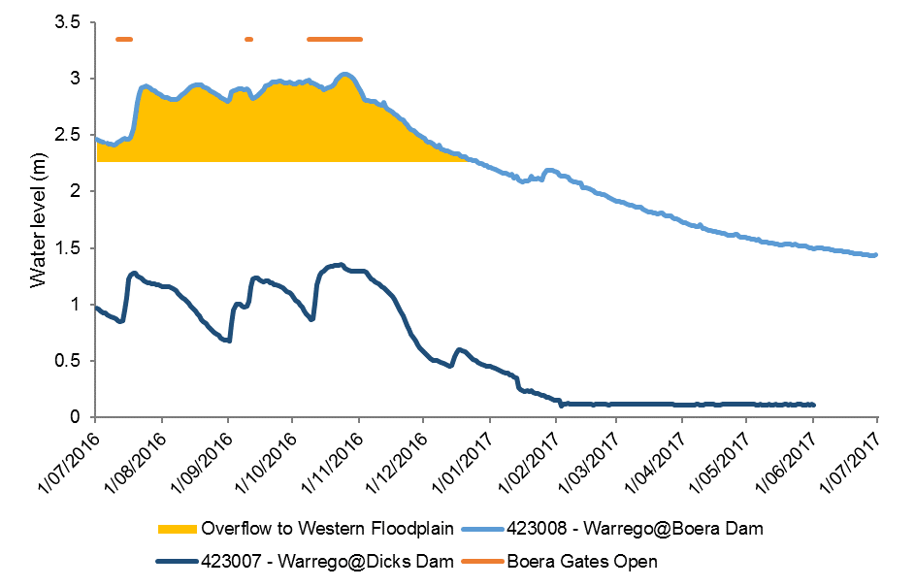
Figure M-1: Boera Dam levels during 2016-17 water year and flow to Western Floodplain (WF) and/or into lower Warrego channels (gates open).

Previous LTIM Monitoring outcomes
Frog surveys were conducted in the 2014-15 water year (February 15, May 15) and in the 2015-16 water year (October 15, March 16) within the Selected Area to collect data for the long-term analysis of frog diversity, abundance and richness at three Warrego River channel sites and one site on the Western Floodplain.
A combined total of twelve species of frogs have been observed in previous water years, with ten being found in the first year and eight in the second. None of the frogs observed were listed as threatened under the NSW TSC Act or the Commonwealth Environment Conservation and Biodiversity Protection Act 1999 (EPBC Act).
Species richness was found to significantly differ between sampling periods but not by site type (floodplain or river). The variance between species richness and sampling period appears to be correlated with the prevailing wet and dry periods in the system at the time of sampling. Overall abundance has not differed significantly between sampling periods or site type, although, high variation of total abundance between sampling periods has been observed on the Western Floodplain which appears to coincide with wetting and drying periods. During or shortly after inundation frog numbers on the Western Floodplain increase due to the newly available habitat and resources.
The more permanent Warrego River channel sites follow a similar trend although they appear to host a more stable frog population that does not fluctuate as strongly as the more variable environment of the Western Floodplain.

Methods
Frog monitoring was undertaken on three occasions in the 2016-17 water year at three sites within the Warrego River zone and one in the Western Floodplain zone (Table M-1, Figure M-2). Surveys were undertaken in August 2016, November 2016 and March 2017. Adult frogs were surveyed after dark by a two-person visual and audio survey (Commonwealth of Australia 2014). Survey times varied by site and date, therefore abundance will be presented as catch per unit effort (CPUE) with the unit being defined by survey minutes. A spotlight was used to search for frogs along the wetland edge and surrounding terrestrial habitat. Audio surveys involved listening to distinct calls of resident frog species. All individuals observed were identified to species and the number recorded.
Species Richness and catch per unit effort (CPUE) data were used to compare between survey times, and the Warrego River and Western Floodplain sites. F-tests were used to test for equality of variance, and appropriate t-tests were employed thereafter. Multivariate nMDS analyses were used to describe patterns of frog community composition. PEMANOVA tests were then completed to compare between survey time and site type (river and floodplain). SIMPER tests were performed to assess the dominant species associated with each data grouping.
Table M-1: Location of frog monitoring sites.
Monitoring Zone | Site Name | Site Type | Easting | Northing
Warrego River | Ross Billabong | Channel | 347242 | 6636926
 | Booka Dam | Channel | 349835 | 6658024
 | Boera Dam | Channel | 348720 | 6669094
Western Floodplain | Western Floodplain | Floodplain | 347802 | 6665756

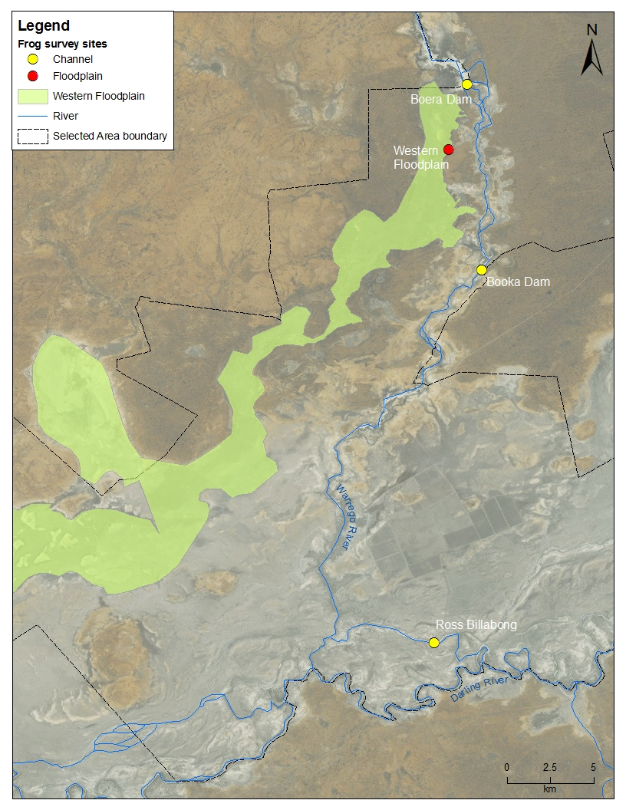
Figure M-2: Location of frog survey sites in the Junction of the Warrego and Darling rivers Selected Area.

Results

Abundance
Eight frog species were recorded within the Selected Area during the 2016-17 monitoring period: two species in August 2016; seven species in November 2016; and five species in March 2017 (Table M-2; Figure M-3). No frog species recorded are listed as threatened under the NSW TSC Act or the Commonwealth EPBC Act.
Mean abundance (CPUE), did not differ significantly between August 2016 (0.425), November 2016 (1.56) and March 2017 (0.695, p=0.43, Table M-2, Figure M-4). Calling activity, which is generally indicative of active breeding, was highest in November 2016, with no calling recorded at any site in March 2017 (Table M-2). Mean species richness differed significantly between August 2016 (0.75), November 2016 (4.25) and March 2017 (3, p=<0.05). August was found to be significantly different in species richness when compared to March 2017 and November 2016 (p=<0.05).
The highest abundance (CPUE) was recorded on the Western Floodplain in November 2016 with approximately 4 frogs being seen/heard every minute of the survey (Figure M-4). The highest species richness recorded at a site was six species observed at Boera Dam in November (Figure M-3,Table M-2). The Western Floodplain, Boera Dam and Ross Billabong sites all showed increased frog abundance between August 2016 and November 2016, then decreased by the March 2017 survey. Booka Dam showed increased frog abundance as the 2016-17 water year progressed. No frogs were recorded at Ross Billabong and Booka Dam in the August 2016 survey (Figure M-4, Figure M-5).
The spotted grass frog (Limnodynastes tasmaniensis) was observed most often, whilst the barking frog (Limnodynastes fletcheri) was the only species observed across all four sites in the 2016-17 monitoring period (Table M-2). A comparison of floodplain and combined Warrego channel sites across the
2016-17 monitoring period indicated that mean abundance and richness did not differ by site type (p=0.19 and p=1 respectively (Figure M-6).
Table M-2: Frog survey results for 2016-17.
Scientific Name | Common Name | Boera Dam |  |  | Booka Dam |  |  | Ross Billabong |  |  | Western Floodplain
 |  | Aug  16 | Nov  16 | Mar  17 | Aug  16 | Nov  16 | Mar  17 | Aug  16 | Nov  16 | Mar  17 | Aug  16 | Nov  16 | Mar  17
Crinia deserticola | Desert Froglet |  | 2 |  |  |  | 14
Crinia parinsignifera | Eastern Sign-bearing Froglet |  |  |  |  |  |  |  |  |  | 8^
Limnodynastes fletcheri | Barking Frog, Long-thumbed Frog, Marsh Frog |  | 13^ | 36 |  | 11^ | 143 |  | 6^ | 1 |  | 20^ | 1
Limnodynastes tasmaniensis | Spotted Grass Frog, Spotted Marsh Frog | 20^ | 26 | 7 |  | 1 | 31 |  |  |  | 50^ | 194^ | 8
Limnodynastes salmini | Salmon Striped Frog |  | 1 |  |  | 1 |  |  | 2
Litoria caerulea | Green Tree Frog |  |  |  |  | 12 | 78 |  | 10 | 6 |  | 2
Litoria peronii | Peron's Tree Frog |  | 5^ | 1 |  |  |  |  |  | 8 |  | 54^
Neobatrachus sudallae | Sudell’s Frog |  | 1
Individuals observed |  | 0 | 33 | 44 | 0 | 15 | 266 | 0 | 16 | 15 | 0 | 100 | 9
Individuals heard |  | 20 | 15 | 0 | 0 | 10 | 0 | 0 | 2 | 0 | 58 | 170 | 0
Total abundance |  | 20 | 48 | 44 | 0 | 25 | 266 | 0 | 18 | 15 | 58 | 270 | 9
Species richness (observed) |  | 0 | 5 | 3 | 0 | 4 | 4 | 0 | 3 | 3 | 0 | 3 | 2
Species richness (heard) |  | 1 | 1 | 0 | 0 | 1 | 0 | 0 | 1 | 0 | 2 | 3 | 0
Total species richness |  | 1 | 6 | 3 | 0 | 4 | 4 | 0 | 3 | 3 | 2 | 4 | 2
^Denotes species recorded by call

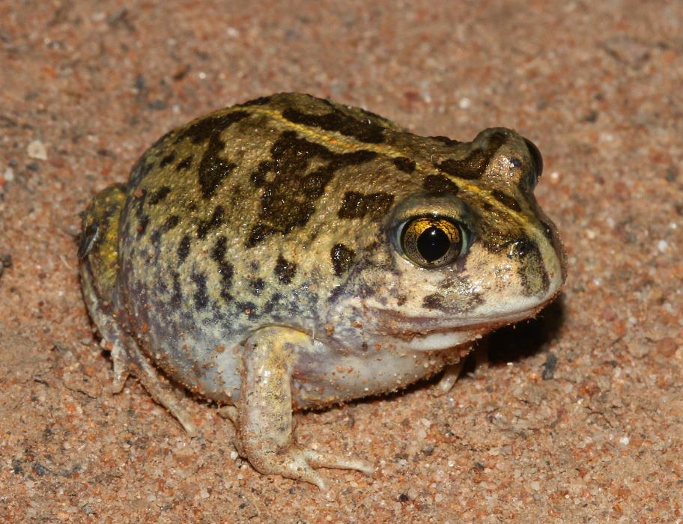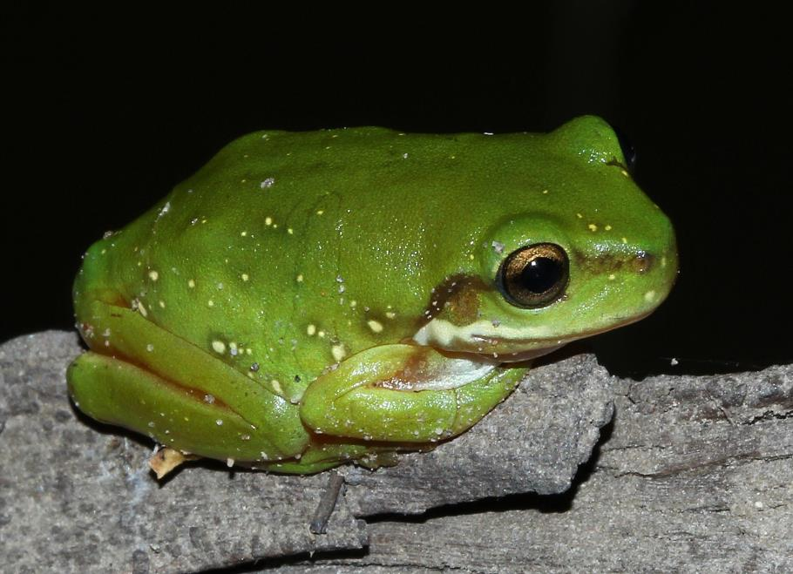
a)
b)
Figure M-3: (a) Sudell’s Frog seen at Boera Dam November 2016; (b) Juvenile Green Tree Frog seen at Ross Billabong.
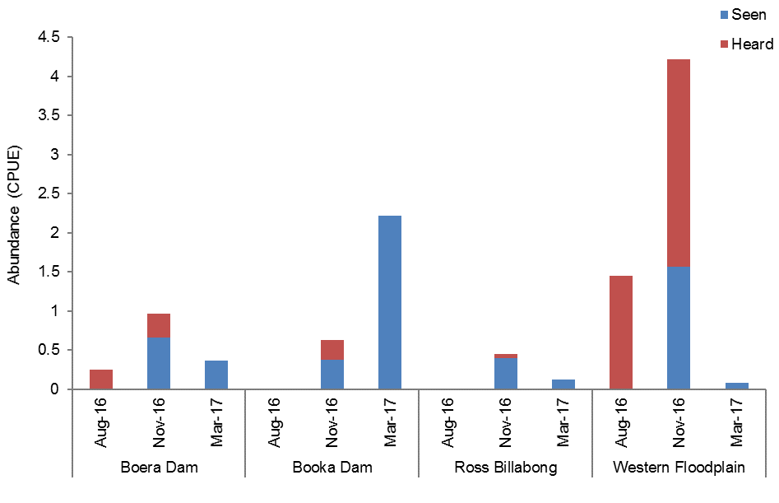
Figure M-4: Total frog abundance (CPUE) recorded at survey sites along the Warrego River and the Western Floodplain during the 2016-17 water year.

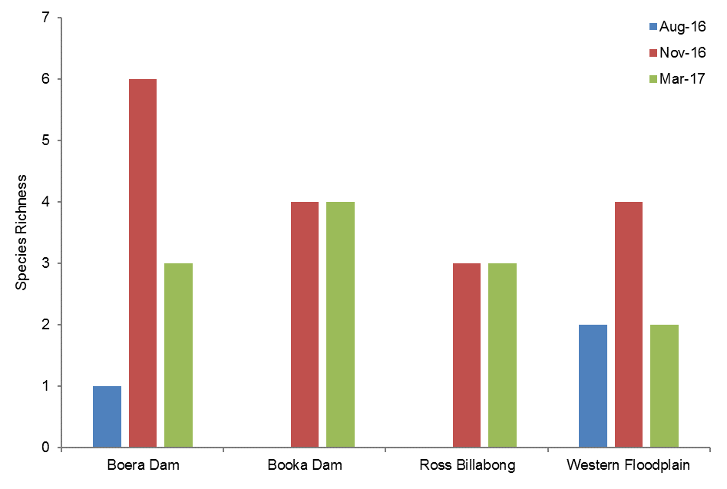
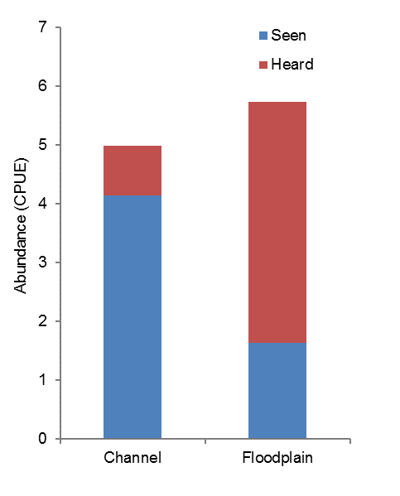
Figure M-5: Frog species richness recorded at survey sites along the Warrego River during the 2016-17 water year.
b)
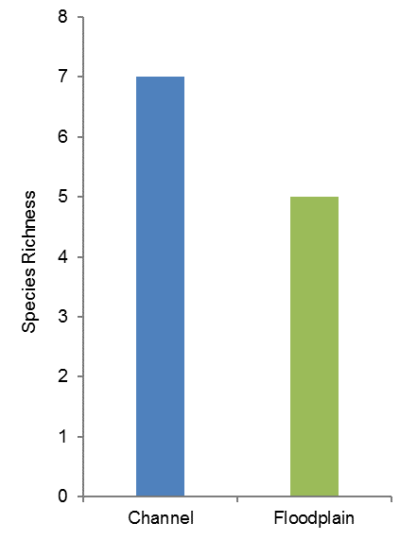
a)
Figure M-6: Frog (a) total abundance (CPUE) and (b) species richness observed in the 2016-17 water year in river channel and floodplain sites along the Warrego River.

To further describe patterns in frog community composition, multivariate analyses was undertaken on species abundance data. PERMANOVA analysis suggested there was no significant differences between survey times (Pr=0.095) or site type (Pr=0.595) in terms of community composition (Figure M-7). SIMPER analysis showed that different species were associated with each data grouping. The spotted grass frog contributed to 100% of the grouping in the August 2016 data. Species that contributed to the grouping in the November 2016 data included the barking frog (44.31%), green tree frog (Litoria caerulea, 20.43%), spotted grass frog (15.59%) and the salmon striped frog (Limnodynastes salmini, 14.75%). The barking frog (39.84%), spotted grass frog (28.19%), the green tree frog (18.74%) and the peron’s tree frog (Litoria peronii, 6.51%), were responsible for the grouping of river sites. The spotted grass frog (87.51%) and the barking frog (12.49%) were responsible for the grouping of the floodplain site data.

Figure M-7: nMDS plot of species abundance data grouped by sampling time and site type.

Multi-year Comparisons
Species composition appeared to change between water years. Four species present in either the
2014-15 or 2015-16 water year surveys were not observed in 2016-17 sampling period; New Holland frog (Cyclorana novaehollandiae), rough frog (C. verrucosa), desert froglet (Crinia deserticola) and wrinkled toadlet (Uperoleia rugosa). The Eastern sign-bearing froglet (Crinia parinsignifera) was recorded for the first time in the 2015-16 water year and then again in the 2016-17 water year. The salmon striped frog was observed for the first time during the November 2016 survey but was absent from the August 2016 and March 2017 surveys.
Overall, abundance did not differ significantly between sampling periods (p=0.33, Figure M-8), however, mean richness per survey period did (p=0.005). The non-significant result for abundance is likely due to the high variation in total counts on the Western Floodplain between sampling periods in all years.
Figure M-9 shows that the number of individuals, particularly heard individuals, was much higher on the Western Floodplain in February 2015, October 2015, August 2016 and November 2016. In these instances, the Western Floodplain was either receiving water (Figure M-1) or had recently been inundated. Abundance and richness were lower when the floodplain dried (Figure M-9, Figure M-10).
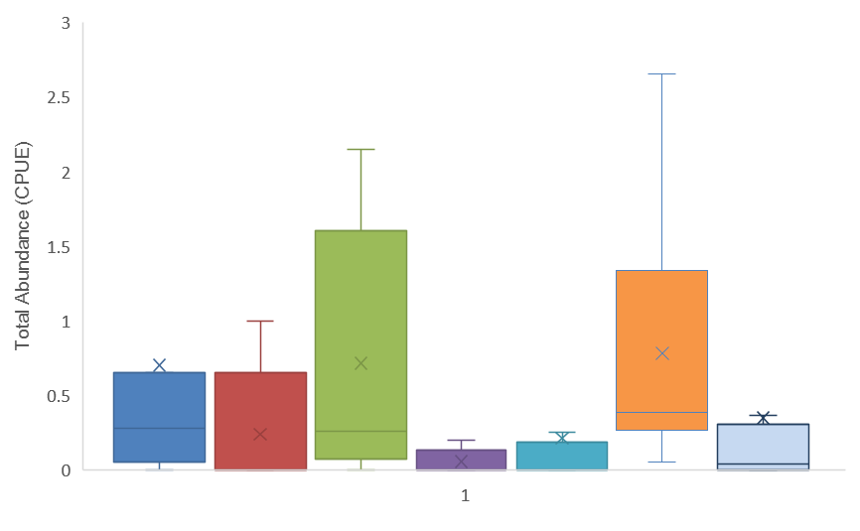
Feb-15 May-15 Oct-15 Mar-16 Aug-16 Nov-16 Mar-17
Figure M-8: Abundance (CPUE) across all sampling periods. Cross represents the mean.
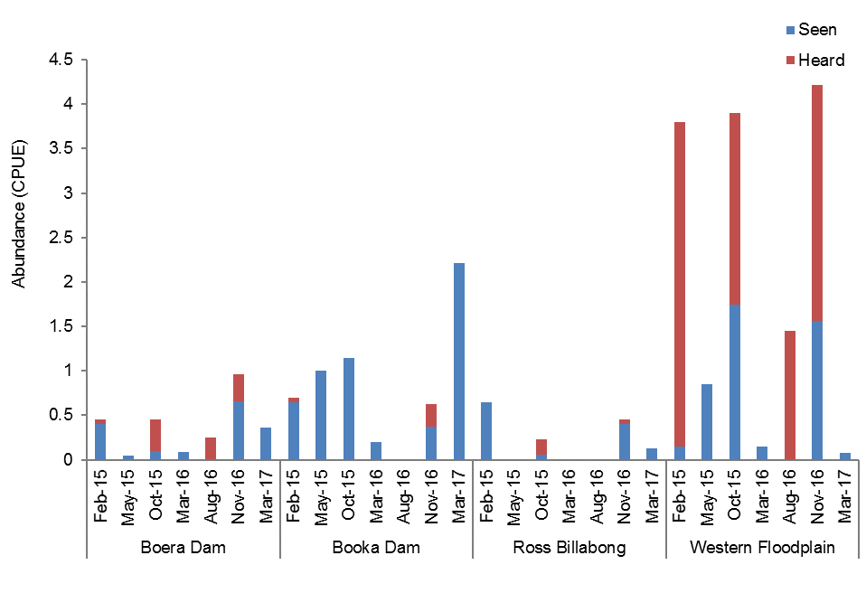
Figure M-9: Total abundance of frogs recorded in the surveys undertaken in Year 1, 2 and 3 of the project.

Figure M-10: Species richness across all sampling periods.
Multivariate analysis on species abundance data over the seven sampling periods in years 1-3 of the project suggested that there was separation of the data in terms of sampling time but little in terms of site type (Figure M-11). PERMANOVA analysis confirmed this with significant differences between sampling times (Pr=0.031) and a non-significant difference between site type (Pr=0.238). A pair-wise tests showed significant differences between all sampling times (Table M-3).
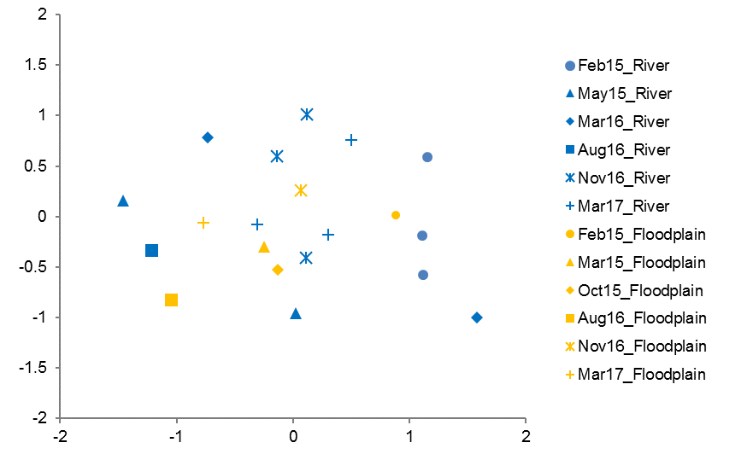
Figure M-11: nMDS plot of species abundance data from Year 1-3 of the project grouped by sampling time and site type.
Table M-3: Pairwise tests that resulted in a significant difference in terms of sampling times.
Survey | Aug-16 | Nov-16 | Mar-17
Feb-15 | p=<0.05 | p=<0.05 | p=<0.05
Aug-16 | – | pP=<0.05 | p=<0.05

Discussion
Frog abundance and species richness was higher at all sites in November 2016 except Booka Dam which peaked in March 2017. The November 2016 survey was completed after two months of relatively high water levels and inundation of the Western Floodplain. During this time, habitat quality and availability increased, resulting in larger more diverse frog communities. These findings are consistent with the recognised strong positive correlation between the presence of emergent aquatic and littoral zone terrestrial vegetation and the occurrence of frogs in wetland areas (Wassens and Maher 2011). In addition, the November 2016 maximum and minimum daily temperatures were several degrees higher than the August 2016 and March 2017 surveys (BoM 2017). This increased temperature likely added to the increased frog activity in the warmer survey period (MacNally et al. 2009).
The greatest difference in species abundance and richness was observed on the Western Floodplain between November and March. This is likely due to the variable environment of the Western Floodplain. The November survey coincided with significant floodplain inundation which would have provided favourable conditions for a large number of frogs, due to increased habitat availability. Higher rates of ‘calling’ which is indicative of breeding activity has consistently been observed at the Western Floodplain during monitoring periods when the floodplain is flooded. In contrast, conditions in March were much drier and hotter with much less available habitat for frogs.
Previous studies investigating the influence of flow regulation on inland frog communities in the southern Murray-Darling Basin have shown that many of the frog species observed in the Junction of the Warrego and Darling Rivers Selected Area, show a preference for temporary sites like those on the Western Floodplain over permanent sites. This is due to the optimal habitat for tadpole development including shallow, slow moving waters, a high abundance of food and refuge from predators in the aquatic vegetation (Wassens and Maher 2011, Wassens et al. 2008, MacNally et al. 2009, Healey et al. 1997). In contrast, the more permanent channel sites within the Warrego channel host a more stable population of frogs that appears to increase with rising waters and decrease as waters recede. As the water levels lower the area of exposed bank and littoral vegetation reduces, decreasing habitat availability.
Over the 3 years of LTIM frog monitoring in the Selected Area, some consistent patterns have emerged in both frog abundance and species richness, driven by system wetting and drying. On the floodplain, larger fluctuations in frog abundance and to a lesser extent species richness occur. In river channel sites, this pattern is less extreme, with populations showing more stability (Figure M-12). This highlights the dynamic nature of systems such as those found in the Selected Area, which produce large booms of productivity when their floodplains become inundated. It also potentially shows the importance of maintaining water in the channel sites to preserve frog populations in the long term. Managing Commonwealth environmental water to inundate the Western Floodplain and maintain more stable habitats in the Warrego river channel will assist in maintaining a diverse and healthy frog population in the Selected Area. A healthy frog population will in turn support higher level predators such as fish, birds and reptiles.
 | Floodplain | Channel  W= wet  D= dry
Abundance | 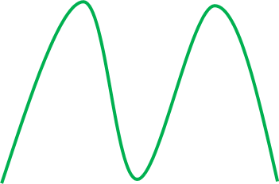 | 
 | D W D W D | D W D W D
Richness |  | 
 | D W D W D | D W D W D
Figure M-12: Conceptual model of the relationship between frog abundance/richness and wet/dry periods.

Conclusion
Patterns of abundance and richness in the frog communities of the Junction of the Warrego and Darling Rivers Selected Area reflect the availability and type of habitat and seasonal conditions. An increase in frogs observed is directly influenced by wetting and higher temperatures. During and shortly after the Western Floodplain is inundated, frog abundance and richness increase due to the newly available, highly productive temporary habitat which supports a high population and stimulates breeding. In 2016-17 this floodplain inundation was provided primarily through Commonwealth environmental water. The more permanent channel sites in the Warrego River appear to offer more stable habitat for local frog populations, with their numbers increasing as the river and dam levels rise and decreasing as receding waters increase the exposed bank area and reduce the inundated littoral zone vegetation. These responses highlight the importance of maintaining a mosaic of habitat types through environmental watering of the Western Floodplain to support regional scale frog diversity.

References
Bureau of Meteorology (BoM) 2017. New South Wales Weather Observation Stations. [online]. Available at: http://www.bom.gov.au/nsw/observations/map.shtml (June 13, 2017).
Commonwealth of Australia 2014. Commonwealth Water Office Long Term Intervention Monitoring Project Junction of the Warrego and Darling rivers Selected Area.
Healey, M. Thompson, D. and Robertson, A. 1997. ‘Amphibian communities associated with billabong habitats on the Murrumbidgee floodplain, Australia’. Australian Journal of Ecology (2)
Mac Nally, R., Horrocks, G., Lada H., Lake, P.S., Thomson, J.R. and Taylor, A.C. 2009 ‘Distribution of anuran amphibians in massively altered landscapes in south-eastern Australia: effects of climate change in aridifying region. Global Ecology and Biogeography (18)
Wassens, S. and Maher, M. 2015. ‘River regulation influences the composition and distribution of inland frog communities’. River Research and Applications (27)
Wassens, S. Watts, R. J., Jansen, A. and Roshier, D. 2008. ‘Movement patterns of southern bell frogs (Litoria raniformis) in response to flooding.’ Wildlife Research (35)

Waterbird Diversity

Introduction
The Warrego River and its associated wetlands, including the Western Floodplain, support high conservation value biodiversity and are likely to provide refugia for waterbirds at a regional scale during dry periods (Capon 2009). Relatively little is known of the waterbird communities within the Junction of the Warrego and Darling rivers (Selected Area). However, monitoring of waterbirds over years 1 and 2 of the LTIM project have detected relatively good numbers in Boera Dam and on the Western Floodplain when it is inundated.
The monitoring of waterbird diversity in the Selected Area for the 2016-17 season addressed the following questions:
- What did Commonwealth environmental water contribute to waterbird populations?
- What did Commonwealth environmental water contribute to waterbird species diversity?
- What did Commonwealth environmental water contribute to waterbird survival?

Environmental watering in 2016-17
Warrego River
Several flow pulses in the Warrego River occurred between June - November 2016. The demand for environmental flows on the Western Floodplain was very high given the last large-scale inundation of the Western Floodplain at Toorale was in 2012. As per licence conditions, a fresh in the Warrego River in July 2016 was allowed to make visible connection with the Darling River prior to closing the gates in Boera Dam and allowing Commonwealth environmental water to spill to the Western floodplain from 19 July 2016 (Figure N-1). The gates at Boera were opened again from the 9-12 September 2016 to connect with the Darling River in accordance with licence conditions for a new flow event. Following this, further inflows were spilled to the Western Floodplain with total approved volume reaching the annual allocation of 9,720 ML by 20 September 2016. Water continued to spill onto the Western Floodplain until December 2016. In total, 31,000 ML of water flowed onto the Western Floodplain of which 31% was Commonwealth environmental water.
Another fresh occurred in the Warrego River during September - November 2016. The Boera Dam gates were again opened and once the fresh had connected with the Darling River, Commonwealth environmental water licences on the Warrego River were used to provide a pulse of water down the Warrego River. This flow aimed to provide opportunities for native fish to access habitat, support recruitment and possibly triggering spawning. 10,500 ML of water was released down the lower Warrego River channel and included 7,762 ML (74%) Commonwealth environmental water. The release was managed to provide a slow rise and fall to the pulse and also ensure that water also continued to spill to the Western Floodplain at the same time. Commonwealth water was used to provide connection for 20 days. National Parks and Wildlife Service maintained the connection for an additional 5 days before closing the gates and allowing the remaining water to spill to the Western Floodplain.
Figure N-1 Boera Dam levels during 2016-17 water year and flow to Western Floodplain and/or into lower Warrego channels (gates open).

              - Previous monitoring outcomes
Seasonal monitoring of waterbird communities for the LTIM project began in 2014-15, with surveys conducted during February and May 2015. Surveys were then undertaken twice during the 2015-16 water year in October 2015 and March 2016. Each year, four sites have been surveyed along the Warrego River and Western Floodplain monitoring zones, which represent floodplain and channel sites. These surveys were conducted using ground survey methods (Commonwealth of Australia, 2015a).
In the 2014-15 water year a total of 86 bird species, including 31 waterbird species were recorded across the four sites. This included one waterbird species, the Eastern great egret (Ardea modesta), listed under two international migratory bird agreements (JAMBA and CAMBA) and two threatened species listed under the NSW TSC Act: brolga (Grus rubicunda) and freckled duck (Stictonetta naevosa). Waterbird breeding was observed at Boera Dam and Ross Billabong during the February 2015 survey for four waterbird species including Australasian darter (Anhinga novaehollandiae), black-fronted dotterel (Elseyornis melanops), royal spoonbill (Platalea regia) and freckled duck.
There was a total of 84 bird species recorded during the 2015-16 water year, of which 34 were waterbird species. This included three waterbird species listed under one or more international agreements: wood sandpiper (Tringa glareola) (JAMBA, CAMBA, ROKAMBA); common sandpiper (Actitis hypoleucos) (CAMBA and JAMBA) and; eastern great egret (Ardea modesta) (JAMBA). There was found to be no significant differences in species richness and abundance with regard to survey time. However, there was significantly greater mean abundance and richness at the Warrego River channel sites than the Western Floodplain.
The previous two years of monitoring data indicate that waterholes along the Warrego River channel provide refugial habitats for waterbirds in the arid landscape of north-western NSW. Boera Dam, one of the largest and most permanent waterbodies in the lower Warrego River, recorded the highest waterbird abundance across all surveys throughout the 2014-15 and 2015-16 water years. There was little seasonal difference in waterbird abundance and richness between October 2015 and March 2016, and a comparison of year 1 and year 2 data indicates that seasonality is not driving patterns in waterbird abundance and richness within the Selected Area. Differences in waterbird abundance and richness seen in the 2014-15 water year were linked to inundation of the Western Floodplain.

Methods
Four sites were surveyed in August and November 2016 and March 2017. These sites were located along the Warrego River and Western Floodplain monitoring zones representing channel and floodplain sites (Table N-1; Figure N-1). Ground surveys were undertaken for a minimum of 20 minutes and maximum of one hour at each survey point, conducted no more than 4 hours after sunrise and/or four hours before sunset, which resulted in a representative bird count for each site (Commonwealth of Australia 2015b).
Point surveys were conducted from one or more points per site to cover the largest possible area of each survey site. Where multiple points were surveyed for a single site, these points were, as far as possible, out of sight from each other and focussed on different sections of the site. All bird species seen and/or heard at each survey point were recorded.
The statistical software SYSTAT Version 13 (http://www.systatsoftware.com) was used to perform ANOVA, t-tests and associated F-tests to compare species richness, waterbird density and diversity data between sampling periods and site types (floodplain v’s channel sites). Non-metric multidimensional scaling (nMDS) analyses was used to describe patterns of community composition data for sampling period and site type. Fourth-root or presence/absence transformations were applied to density data prior to the calculation of resemblance matrices using Bray-Curtis similarities in PRIMER Version 6.1.13 (http://www.primer-e.com/). Sites with no observations were removed from the analysis. PEMANOVA tests were then performed to compare between survey period and site type. SIMPER tests were performed to assess the dominant species associated with each data grouping.
Waterbird diversity was calculated in PRIMER using the Shannon Diversity Index (H’) with natural logarithm (to the base e). In this index, a higher value indicates a higher diversity.
Table N-1 Location of waterbird monitoring sites. All coordinates reported in GDA94 zone 55.
Monitoring Zone | Site Name | Site Type | Easting | Northing
Warrego River | Ross Billabong | Channel | 347242 | 6636926
 | Booka Dam | Channel | 349835 | 6658024
 | Boera Dam | Channel | 348720 | 6669094
Western Floodplain | Western Floodplain | Floodplain | 347802 | 6665756

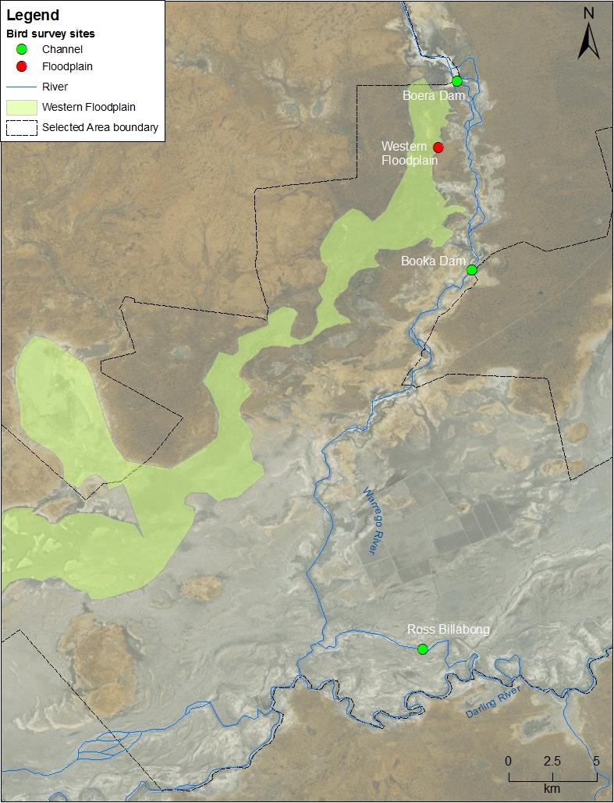
Figure N-1: Location of waterbird diversity monitoring sites within the Junction of the Warrego and Darling rivers Selected Area.

Results
              - Monitoring of the 2016-17 water year
Waterbird species richness, density and diversity
At total of 108 bird species, including 35 waterbird species, were recorded in the 2016-17 surveys of the Warrego River and Western Floodplain (Table N-2, Figure N-2). The Grey Teal (Anas gracilis) was the most abundance waterbird species and was recorded across all sites along with the Pink-eared Duck (Malacorhynchus membranaceus), Australian Wood Duck (Chenonetta jubata), White-faced Heron (Egretta novaehollandiae) and Whistling Kite (Haliastur sphenurus) (Table N-2). No listed species were recorded during this water year.
There was a significant difference in average waterbird species richness between sampling periods (p < 0.05). Species richness was highest in November 2016 (14 ± 3.2 species) followed by March 2017 (9 ± 4.2) and August 2016 (5.5 ± 1.7) (Figure N-3). Average species richness was not significantly different between the Warrego River sites (9.8 ± 4.5) and the Western Floodplain (9 ± 5.6; p = 0.69). Booka Dam, Ross Billabong and the Western Floodplain had the greatest species richness in November 2016, while at Boera Dam species richness was the greatest in March 2017 (Figure N-3).
A total of 804 individual waterbirds were recorded across the three survey periods at the survey sites. Counts were highest in November 2016 with 428 individual waterbirds recorded, followed by March 2017 (217 individuals) and August 2016 (159 individuals). There were 611 individuals counted across the Warrego River, and 193 counted in the Western Floodplain. Within the Warrego River sites, Ross Billabong had the highest count at 277 individuals, followed by Boera Dam with 241 individuals and Booka Dam with 93 individuals (Table N-2).
In the Western Floodplain, average waterbird density (0.33 ± 0.19 birds/ha) was significantly lower than sites in the Warrego River (2.38 ± 0.13 birds/ha; p < 0.05) (Figure N-4). However, the average density of waterbirds was not significantly different between the individual Warrego River sites (p = 0.28) with Boera Dam recording an average of 2.53 ± 1.64 birds per/ha, Booka Dam with 2.33 ± 0.49 birds/ha, and Ross Billabong with 2.29 ±2.31 waterbirds per ha (Figure N-4). There was no significant difference in waterbird density between sampling periods (p = 0.44).
Average waterbird diversity was highest in November 2016 with a Shannon Diversity index (H’) of 2.12 ± 0.18, followed by March 2017 (H’ = 1.34 ± 0.81) then August 2016 (H’ = 1.26 ± 0.43). There was a significant difference between sampling periods (p < 0.05), with post-hoc analysis revealing November 2016 to be significantly higher than August 2016 (p < 0.05). No significant differences occurred between November and March (p = 0.12) or between August and March (p = 0.53). Diversity was similar between sites, with no significant differences occurring between the Warrego River and Western Floodplain (p = 0.83), or between the Warrego River sites (p = 0.86). In March 2017 on the Western Floodplain, only a few species were recorded resulting in a very low diversity of 0.16 (Figure N-5).

Table N-2 Total counts and percent occurrence (across sites) of the 35 waterbird species recorded in the Selected Area in 2016-17.
Functional Group | Common Name | Boera Dam | Booka Dam | Ross Billabong | Western Floodplain | Occurrence (%)
Australian-breeding Charadriiform shorebirds | Black-fronted Dotterel |  | 10 | 8 |  | 50
 | Masked Lapwing | 8 | 2 |  |  | 50
 | Red-kneed Dotterel |  | 2 | 2 |  | 50
 | Red-necked Avocet | 1 |  |  |  | 25
Dabbling and filter-feeding ducks | Australasian Shoveler |  |  |  | 1 | 25
 | Grey Teal | 61 | 16 | 54 | 17 | 100
 | Pacific Black Duck | 26 | 6 |  | 17 | 75
 | Pink-eared Duck | 10 | 2 | 19 | 16 | 100
Diving ducks, aquatic gallinules and swans | Black Swan | 3 |  | 3 |  | 50
 | Dusky Moorhen | 1 |  |  | 8 | 50
 | Eurasian Coot | 13 |  | 5 | 27 | 75
 | Hardhead | 5 |  |  | 39 | 50
Grazing ducks and geese | Australian Wood Duck | 30 | 11 | 18 | 13 | 100
 | Plumed Whistling-Duck |  | 21 | 70 |  | 50
Piscivores | Australasian Darter | 4 | 1 | 3 |  | 75
 | Australasian Grebe |  |  | 10 | 11 | 50
 | Australian Pelican | 10 | 1 |  |  | 50
 | Great Cormorant | 2 | 1 | 4 |  | 75
 | Great Crested Grebe |  |  | 5 |  | 25
 | Intermediate Egret |  |  |  | 1 | 25
 | Little Black Cormorant | 2 | 3 | 8 |  | 75
 | Pied Cormorant | 5 |  | 14 | 1 | 75
 | Sacred Kingfisher |  | 1 |  | 4 | 50
 | Whiskered Tern | 12 |  | 2 |  | 50
 | White-faced Heron | 4 | 4 | 2 | 1 | 100
 | White-necked Heron |  | 7 | 3 |  | 50
Rails and shoreline gallinules | Black-tailed Native-hen |  | 1 |  |  | 25
 | Purple Swamphen |  |  |  | 1 | 25
Raptors | Nankeen Kestrel |  |  | 2 | 2 | 50
 | Wedge-tailed Eagle | 1 |  | 1 | 3 | 75
 | Whistling Kite | 4 | 3 | 2 | 8 | 100
Large wading birds | Australian White Ibis | 6 |  | 2 | 3 | 75
 | Glossy Ibis | 32 |  |  |  | 25
 | Straw-necked Ibis |  |  | 40 | 20 | 50
 | Yellow-billed Spoonbill | 1 | 1 |  |  | 50

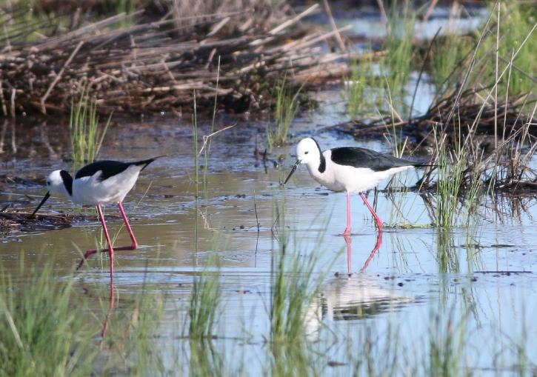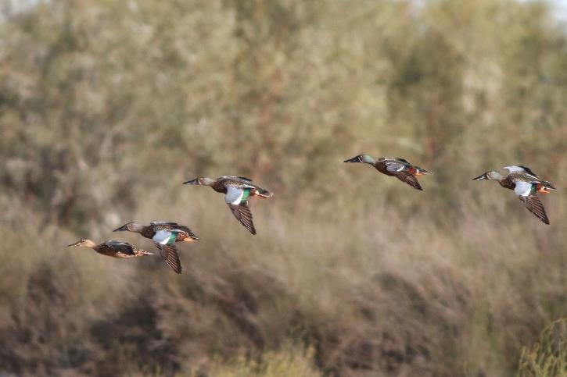
Figure N-2: Black-winged stilt (Himantopus himantopus) feeding on the Western Floodplain (top) and Australasian shoveller ducks (Anas rhynchotis) coming in to land (bottom).
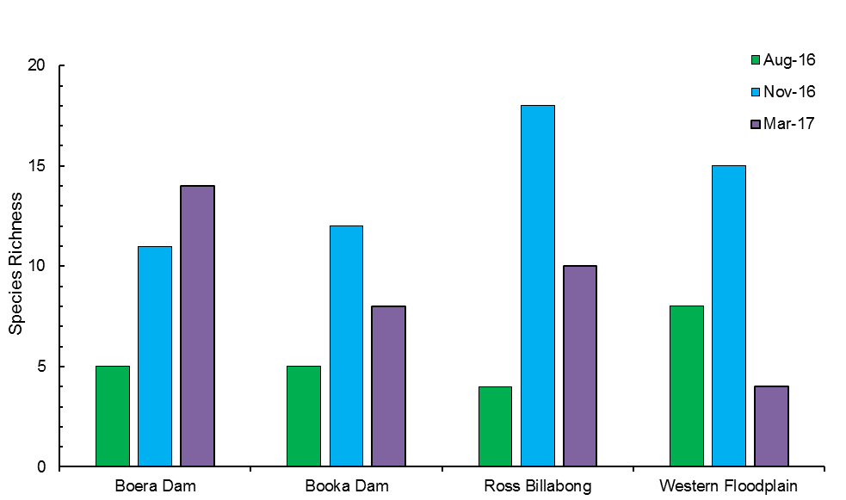
Figure N-3 Species richness for each site and sampling period for the 2016-17 monitoring

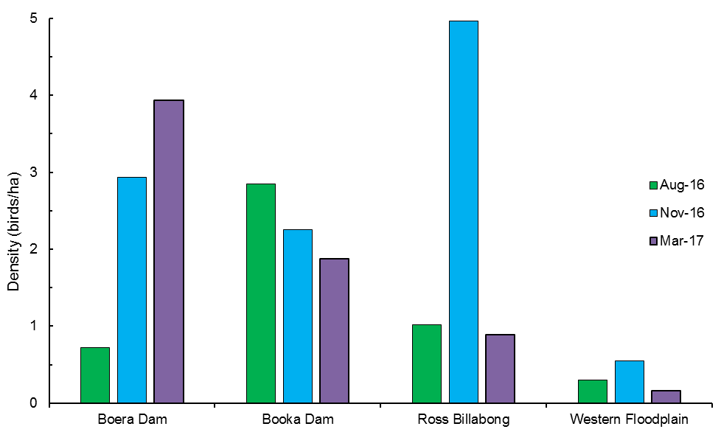
Figure N-4 Waterbird density (individuals per hectare) for each site and sampling period for the 2016-17 monitoring.
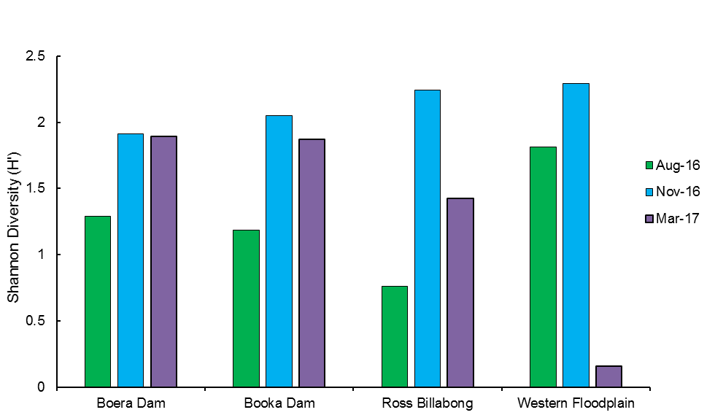
Figure N-5 Waterbird diversity (H’) at each site during each sampling period, using the Shannon diversity index.
Waterbird community composition
To further explain patterns in waterbird density, multivariate analyses were undertaken on species abundance data of each sampling period for each zone (Figure N-6).
PERMANOVA analysis showed a significant separation in species abundance between sampling period (p < 0.05), with post-hoc analysis revealing March 2017 to be significantly different to both August (p < 0.05) and November (p < 0.01). There was no significant separation in species abundance between monitoring zones (p = 0.06) or in the interaction between sampling period and monitoring zone (p = 0.29).
SIMPER analysis showed that in August 2016, Grey Teal (51.7%) was most responsible for the variation within these sites (Table N-3). In November 2016, species contribution was more even, with the White-faced Heron having the highest contribution at 13.6% (Table N-3). In March 2017, the Whistling Kite contributed the most at 25.8%, followed by the Grey Teal at 19.8%. At the Warrego River sites, the Grey Teal contributed to 32% of the total variation with the Pacific Black Duck being the only other species to contributed more than 10% (Table N-3). The Western Floodplain had seven species which contributed to over 10% of the total variation in site grouping; the Whistling Kite being the highest at 29%, with the other six species being lower than 15% (Table N-3).
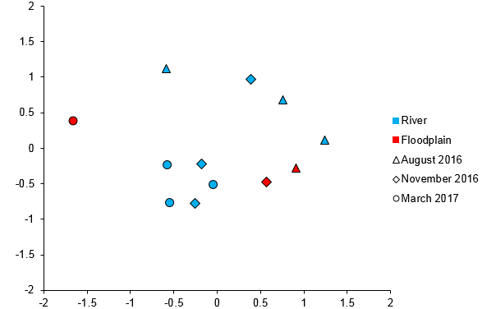
Figure N-6 Non-metric multidimensional scaling plot of waterbird species abundance (birds/ha), grouped by sampling time and zone.

Table N-3 SIMPER results of species contributions to groupings in community composition data. Species contributions of less than 10% were not included.
Grouping | Species | Contribution to grouping (%)
August 2016 | Grey Teal | 51.71
 | Pacific Black Duck | 24.73
November 2016 | White-faced Heron | 13.6
 | Australian Wood Duck | 10.57
 | Eurasian Coot | 10.47
 | Pacific Black Duck | 10.09
March 2017 | Whistling Kite | 25.84
 | Grey Teal | 19.77
 | Australian Wood Duck | 12.34
 | Wedge-tailed Eagle | 11.19
River | Grey Teal | 32.24
 | Pacific Black Duck | 10.06
Floodplain | Whistling Kite | 29
 | Hardhead | 14.63
 | Pacific Black Duck | 11.95
 | Grey Teal | 11.56
 | Pink-eared Duck | 11.12
 | Eurasian Coot | 11.12
 | Australasian Grebe | 10.62

Waterbird breeding and functional guilds
Evidence of waterbird breeding was only observed in November 2016 in two species; the Australasian Grebe (Tachybaptus novaehollandiae), with males exhibiting breeding plumage on the Western Floodplain; and the Grey Teal, with a large group of ducklings observed at Ross Billabong.
There were eight of the ten functional guilds represented in the Selected Area in the 2015-16 monitoring period, with Migratory Charadriiform Shorebirds and Reed-inhabiting Passerines absent. Six of the guilds were represented in all three monitoring periods, with Diving Ducks, Aquatic Gallinules and Swans absent in March 2017, and Rails and Shoreline Gallinules only present in November 2016 (Figure N-7). Piscivores were the most represented guild with a total of 12 species, 11 of which were recorded in November 2016 (Figure N-7). At the Warrego River sites, the average number of guilds represented was highest in November 2016 at 6.3 ±1.2, followed by March 2017 (5 ± 1) and August 2016 (3.7 ± 1.2). There were seven guilds represented at the Western Floodplain, however, in March 2017 only Raptors and Large Wading Birds were represented. The most abundant guild was Dabbling and filter-feeding ducks with a total of 245 individuals from this guild recorded across all sites (30% of total waterbird abundance) with an average of 61.3 ± 26.9 per site (Table N-2).
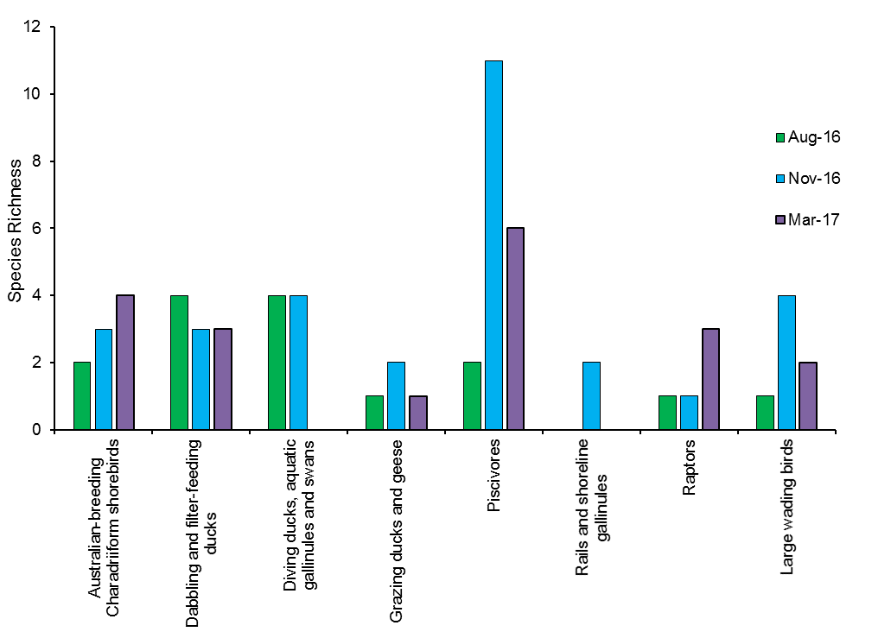
Figure N-7 Waterbird species richness for each functional group observed throughout the 2016-17 monitoring period across all sites.

Multi-year comparison
Across all three years, species richness did not differ significantly between sampling periods (p = 0.14) or between monitoring zones (p = 0.39; Figure N-8). There were no significant differences in waterbird density between sampling periods (p = 0.62). Average waterbird density was higher in the Warrego River (3.14 ± 2.23 birds/ha) than the Western Floodplain (0.27 ± 0.27 birds/ha; Figure N-9). However, this difference was not statistically significant (p = 0.62) likely a result of the high variations between Warrego River sites during most of the sampling periods, especially in October 2015 (Figure N-9). Waterbird diversity was significantly different between sampling periods (p < 0.05), but not between monitoring zones (p = 0.75; Figure N-10). However, there was a significant interaction between the sampling period and monitoring zone (p < 0.05).
There appeared to be a separation in waterbird community composition when grouped by sampling period and monitoring zone (Figure N-11). PERMANOVA analysis showed a significant difference in species abundance data between sampling periods (p < 0.01) and monitoring zones (p < 0.05). The interaction between these two factors was also significant (p < 0.05).
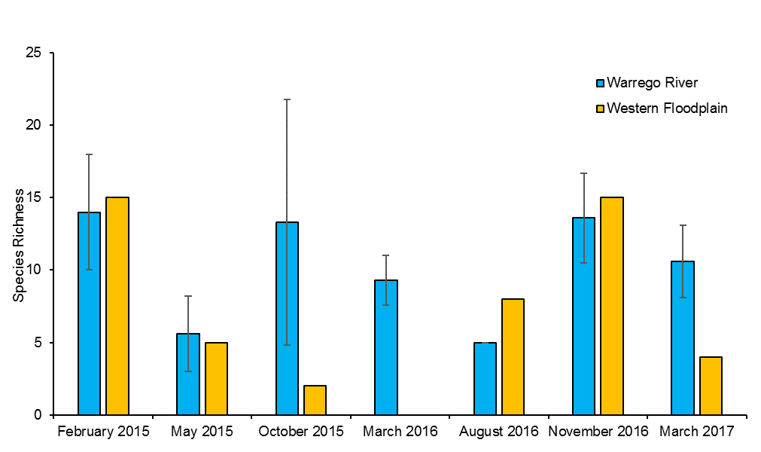
Figure N-8 Waterbird species richness (with standard deviation bars) on the Warrego River and at the Western Floodplain for each sampling period.
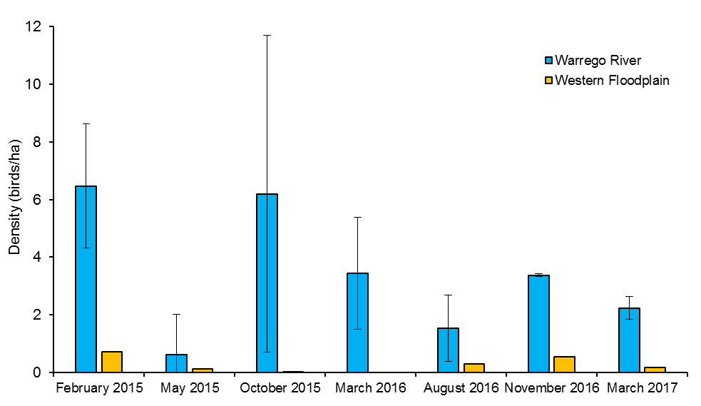
Figure N-9 Average waterbird density (with standard deviation bars) at the Warrego River and Western Floodplain for each sampling period.
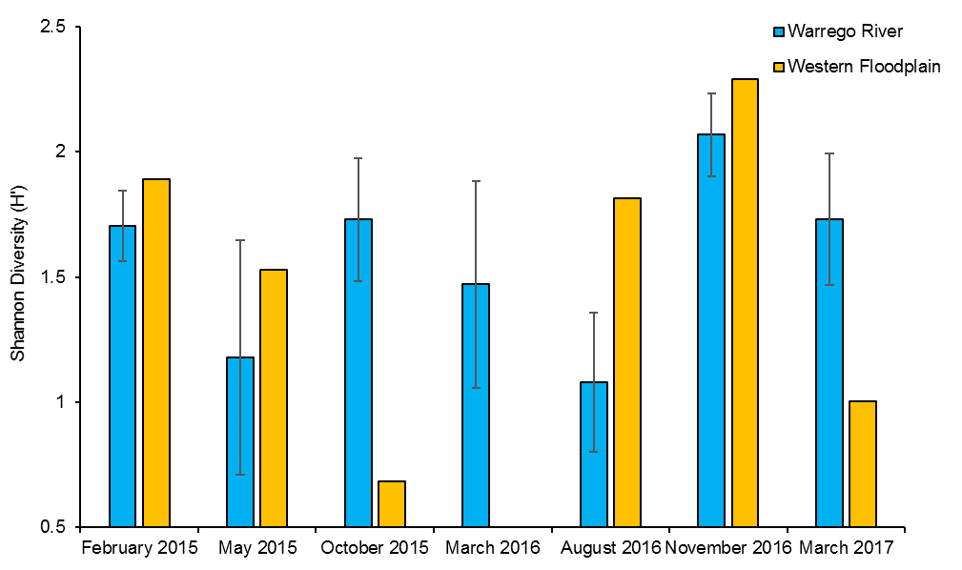
Figure N-10 Average waterbird diversity (with standard deviation bars) at each monitoring zone across sampling periods, using the Shannon diversity index (H’).

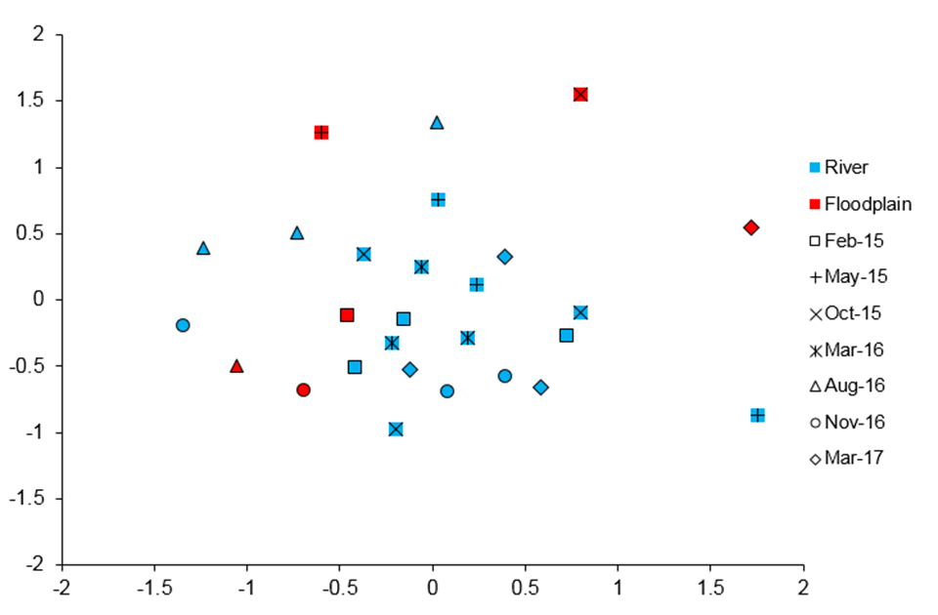
Figure N-11 Non-metric multidimensional scaling plot of waterbird species abundance (birds/ha) across all monitoring years, grouped by sampling time and monitoring zone.

Discussion
Patterns observed in waterbird communities for the 2016-17 water year are consistent with those in previous years, with patterns in species richness, abundance and diversity tending to change with habitat type and inundation, rather than season. Nevertheless, significant differences were noted for species richness and diversity between the three survey periods in 2016-17 with higher richness and diversity in November 2016. Given this was the peak of inundation in both the Western Floodplain and Warrego River during the water year, it could be concluded that patterns observed between sampling periods may have been driven by changes in inundation at the site, rather than seasonal patterns. Waterbirds, especially in arid landscapes, are predominantly nomadic, with their movements dependent on changing patterns of resource distribution (Kingsford et al. 2010). The widespread flooding on the Western Floodplain during late provided predominantly by Commonwealth environmental water in 2016 would have presented increased resource availability for waterbirds on a regional scale.
The Warrego River and Western Floodplain supported similar functional guilds during 2016-17, with only Australian-breeding Charadriiform shorebirds being absent from the floodplain. Overall, piscovores were the most represented group in terms of species richness, and Dabbling and filter-feeding ducks the most abundant, consistent with the previous monitoring years. These patterns are likely to be resource driven, with the widespread connectivity triggering fish breeding and hence food for piscivores (Eco Logical Australia 2017, Appendix L). Widespread inundation on the floodplain and along the Warrego channel system stimulated invertebrate community production (Appendix I) providing widespread feeding opportunities for Dabbling and filter feeding ducks.
Consistent patterns have emerged over the three years of the LTIM project regarding the habitat preference of waterbirds within the Junction of the Warrego and Darling Selected Area. Warrego River sites have consistently shown higher waterbird abundance and density than the Western Floodplain site, likely because they provide more permanent but smaller habitat areas. In contrast, when the Western Floodplain is inundated, species richness and waterbird diversity has been greater than the Warrego River waterholes. This is likely driven by the dominance of a few species (typically ducks) in the Warrego River sites, causing relatively low diversity at these sites. In contrast, the higher diversity at the Western Floodplain during inundation is likely linked to the greater variety of habitats and food resources present on the floodplain, providing more opportunities for a wider range of species.

Conclusion
Outcomes from the 2016-17 monitoring year, along with the previous two years, indicate that inundation, especially of the Western Floodplain is driving patterns of waterbird diversity. The abundance of waterbirds is consistently higher in the Warrego River sites, highlighting their importance as waterbird refuge habitats. When inundated, the various habitats on the Western Floodplain support a more diverse waterbird population, with many species taking advantage of the conditions for food resources. Managing Commonwealth environmental water to inundate both the Western Floodplain and the Warrego river channel will assist in maintaining a diverse and healthy waterbird population in the Selected Area.

References
Capon, S.J. 2009. Flow-dependent Ecosystems of Toorale Station: Ecological character, condition and issues associated with decommissioning water resources infrastructure. Australian Rivers Institute, Griffith University.
Commonwealth of Australia 2015a. Commonwealth Environmental Water Office Long Term intervention Monitoring Project Junction of the Warrego and Darling Rivers Selected Area – 2014-15 Evaluation Report. Commonwealth of Australia.
Commonwealth of Australia 2015b. Commonwealth Environmental Water Office Long Term intervention Monitoring Project Junction of the Warrego and Darling Rivers Selected Area – Monitoring and Evaluation Plan. Commonwealth of Australia.
Eco Logical Australia 2017. Aquatic fauna use of the Warrego River Western Floodplain. Prepared for the Commonwealth Environmental Water Office.
Kingsford, R.T., Roshier, D.A. and Porter, J.L. 2010. Australian Waterbirds – time and space travellers in dynamic desert landscapes. Marine and Freshwater Research, 61, 875-884.

Aquatic fauna on the Warrego River Western Floodplain
This appendix contains a report on some additional monitoring that was commissioned by the CEWO to investigate aquatic fauna use of the Warrego River Western Floodplain during the large connection event in 2016-17. Sampling was undertaken towards the end of the inundation event. This work has been combined into the 2016-17 evaluation of Commonwealth environmental water in the Selected Area.

