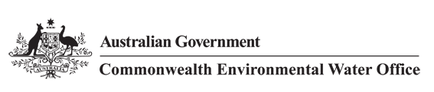



Commonwealth Environmental Water Office
Long Term Intervention Monitoring Project
JUNCTION OF THE WARREGO AND DARLING RIVERS SELECTED AREA
2016-17 Final Evaluation Report

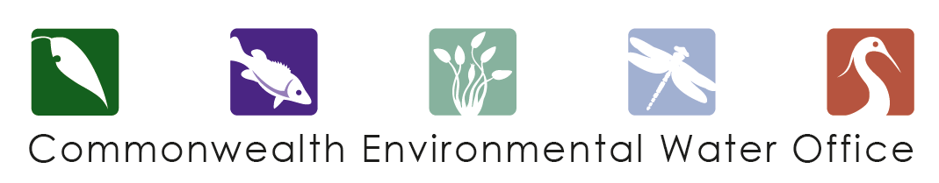
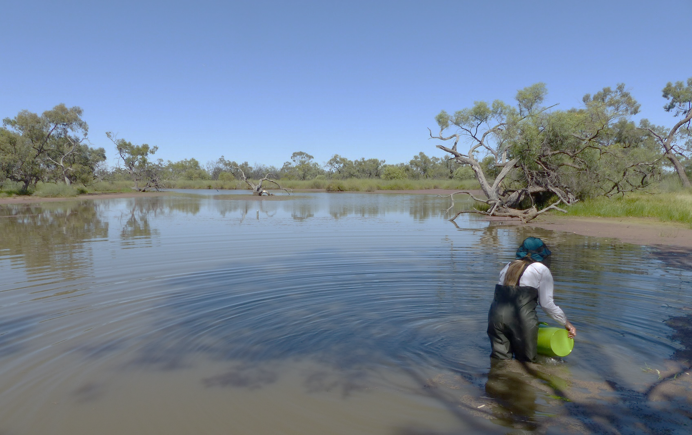

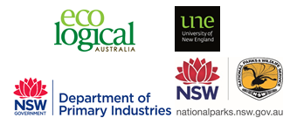

This monitoring project was commissioned and funded by Commonwealth Environmental Water Office, with in-kind support from NSW Office of Environment and Heritage.
Copyright
© Copyright Commonwealth of Australia, 2017


Commonwealth Environmental Water Office Long Term Intervention Monitoring Project Junction of the Warrego and Darling rivers Selected Area is licensed by the Commonwealth of Australia for use under a Creative Commons By Attribution 3.0 Australia licence with the exception of the Coat of Arms of the Commonwealth of Australia, the logo of the agency responsible for publishing the report, content supplied by third parties, and any images depicting people. For licence conditions see: http://creativecommons.org/licenses/by/3.0/au/
This report should be attributed as ‘Commonwealth Environmental Water Office Long Term Intervention Monitoring Project Junction of the Warrego and Darling rivers Selected Area – 2016-17 Final Evaluation Report, Commonwealth of Australia 2017’.
Disclaimer
The views and opinions expressed in this publication are those of the authors and do not necessarily reflect those of the Australian Government or the Minister for the Environment.
While reasonable efforts have been made to ensure that the contents of this publication are factually correct, the Commonwealth does not accept responsibility for the accuracy or completeness of the contents, and shall not be liable for any loss or damage that may be occasioned directly or indirectly through the use of, or reliance on, the contents of this publication.
DOCUMENT TRACKING
Item | Detail
Project Name | Long Term Intervention Monitoring Project – Junction of the Warrego and Darling rivers Selected Area
Project Number | 5305
Project Manager | Dr Mark Southwell  (02) 8081 2688  92 Taylor Street, Armidale NSW 2350
Prepared by | Dr Mark Southwell, Dr Paul Frazier, Ronnie Hill, Linden Burch, Nathalie van der Veer , Rob Cawley, Tim Henderson (ELA)  Assoc. Prof Darren Ryder, Dr Wing Ying Tsoi (UNE)  Dr Gavin Butler (NSW DPI)
Reviewed by | Dr Mark Southwell, Assoc. Prof Darren Ryder
Approved by | Dr Paul Frazier
Status | DRAFT
Version Number | 1
Last saved on | 13 February 2018
Cover photo | Microinvertebrate sampling on the Western Floodplain, Nov 2016 (photo by I.Tsoi)

Acknowledgements
This document has been prepared by Eco Logical Australia Pty Ltd with support from Associate Professor Darren Ryder and Dr Wing Ying Tsoi from the University of New England, Dr Gavin Butler from the DPI fisheries, and staff from NSW Office of Water. The project team would like to thank the NPWS staff at Toorale National Park and State Conservation Area for their assistance and cooperation. We would also like to acknowledge Dr Fiona Dyer and the Lachlan LTIM team for the loan of dissolved oxygen and temperature loggers.

Acknowledgement of Country
The authors of this report as well as the Commonwealth Environmental Water Office respectfully acknowledge the traditional owners, their Elders past and present, their Nations of the Murray-Darling Basin, and their cultural, social, environmental, spiritual and economic connection to their lands and waters. In particular the Barkindji, Murrawarri, Ngemba and Ngiyampaa peoples, traditional owners of the land on which this publication is focused.
Disclaimer
This document may only be used for the purpose for which it was commissioned and in accordance with the contract between Eco Logical Australia Pty Ltd and the Department of the Environment and Energy. The scope of services was defined in consultation with the Department of the Environment and Energy, by time and budgetary constraints imposed by the client, and the availability of reports and other data on the subject area. Changes to available information, legislation and schedules are made on an ongoing basis and readers should obtain up to date information.
Eco Logical Australia Pty Ltd accepts no liability or responsibility whatsoever for or in respect of any use of or reliance upon this report and its supporting material by any third party. Information provided is not intended to be a substitute for site specific assessment or legal advice in relation to any matter. Unauthorised use of this report in any form is prohibited.
Template 29/9/2015

Document control
Version | Date | Reviewed by | Approved by
1 | 28/08/2017 | Assoc. Prof Darren Ryder | Dr Paul Frazier
2 | 4/12/2017 | Dr Mark Southwell | Dr Paul Frazier

Item | Details
ELA Project Number | 5305
Project Director/s | Dr Paul Frazier, Assoc. Prof Darren Ryder
Project Manager | Dr Mark Southwell
Prepared by | Dr Paul Frazier, Assoc. Prof Darren Ryder, Dr Mark Southwell, Dr Wing Tsoi, Dr Gavin Butler, Nathalie van der Veer, Linden Burch, Ronnie Hill, Tim Henderson, Rob Cawley

Contents
Executive summary viii
1 Introduction 1
2 Junction of the Warrego and Darling rivers Selected Area 2
3 Water Management 5
4 Watering Actions in 2016-17 7
5 What did Commonwealth environmental water do in 2016-17 9
5.1 Expected Outcomes 9
5.2 Darling River Flows and Ecosystem Function 9
5.3 Warrego River Flows and Inundation 12
5.4 Water Quality 15
5.5 Biodiversity 15
5.6 Resilience 20
5.7 Summary 21
6 Implications for Future Management of Commonwealth environmental water 22
7 References 23

Appendix A – Hydrology (River)
Appendix B – Hydrology (Northern Tributaries)
Appendix C – Hydrology (Channel)
Appendix D – Hydrology (Habitat)
Appendix E – Hydrology (Floodplain)
Appendix F – Water Quality
Appendix G – Stream Metabolism
Appendix H – Microinvertebrates
Appendix I –Macroinvertebrates
Appendix J – Ecosystem Type
Appendix K – Vegetation Diversity
Appendix L – Fish (River)
Appendix M – Frogs
Appendix N – Waterbird Diversity
Appendix O – Aquatic Fauna on the Warrego River Western Floodplain

List of figures
Figure 2-1 The location of the Junction of the Warrego and Darling rivers Selected Area within the Murray-Darling Basin showing upstream catchments. 2
Figure 2-2 Junction of the Warrego and Darling river Selected Area monitoring zones. 4
Figure 4-1 Monthly rainfall at Bourke Airport for 2016-17 compared to the long term mean (Source: http://www.bom.gov.au/climate/data/index.shtml). 7
Figure 4-2 Mean maximum temperatures for the Bourke Airport during 2016-17 compared to the long term mean (Source: http://www.bom.gov.au/climate/data/index.shtml). 7
Figure 5-1 Mean daily flow at gauging stations on Barwon-Darling River system (1 July 2016 - 30 June 2017). Events used in the analysis of northern tributary contributions are outlined in red. 11
Figure 5-2 Comparison of flow events containing Commonwealth environmental water (CEW) from years 1-3 of the project measured at Louth gauge. 11
Figure 5-3 In-channel habitats along the Darling River within the Selected Area including a bench surface (right), snags and an in-channel island. 12
Figure 5-4 Water level at Boera and Dicks Dams and periods of longitudinal connection and overflow to Western Floodplain. 13
Figure 5-5 Inundation of vegetation communities on the Western Floodplain based on Landsat 8 image analysis of image captured 16 October 2016 (maximum inundation captured). 14
Figure 5-6 Examples of ecosystem types sampled in the Selected Area during the 2016-17 water year. Coolibah Woodland and forest floodplain (top left) shrubland floodplain (top right), temporary floodplain lake with aquatic beds (Bottom left) and Temporary Lake at Ross Billabong (bottom right). 16
Figure 5-7 Size structuring among Hyrtl’s tandan (Neosilurus hyrtlii) captured at Dick’s Dam on the lower Warrego River; Sample 3, December 2016 (Range ~120-250 mm). 18
Figure 5-8 Peron's Tree Frogs (Litoria peronii) observed on the Western Floodplain in February 2017. 19
Figure 5-9 Australasian Shovellers (left) and Black-winged Stilts (right) observed in the Selected Area in August 2016. 19
Figure 5-10 Tiny Teeth (Dentella minutissima) identified in survey plots on the Western Floodplain in April 2017. 20

List of tables
Table 2-1 Junction of the Warrego and Darling rivers Selected Area monitoring zones. 3
Table 5-1 Expected outcomes from the use of Commonwealth environmental water in 2016-17 relevant to the Selected Area. WUM refers to the specific Water Use Minute for the Commonwealth environment water event in question. 10

Blank page

Executive summary

Contributions of Commonwealth environmental water in 2016-17
Darling River zone
- Commonwealth environmental water contributed to four flow events down the Darling River zone, which provided connecting flows through the zone to Louth.
- These flows provided river animals access to all mapped in-channel habitats such as snags, benches and anabranch channels and helped to maintain water quality through the year.
Warrego River zone
- Commonwealth environmental water contributed to inundating 3,839 ha of the Western Floodplain and provided a flow pulse down the Warrego River in October 2016 for 20 days of a 25 day period of connectivity with the Darling.
- This water maintained a mosaic of habitats including native vegetation, stimulated breeding and recruitment of several native fish, frog and turtle species, and resulted in a boom of productivity in the system.
- Warrego River flows also improved Darling River water quality downstream of the confluence.
The Junction of the Warrego and Darling rivers Selected Area (Selected Area) encompasses the Toorale National Park and State Conservation Area managed by NSW OEH. Inflows of Commonwealth environmental water to the Selected Area via the Darling River from upstream tributaries have also been evaluated.
The Selected Area is complex in terms of its ecosystems, hydrology and the way in which Commonwealth environmental water is accounted and managed both within the Selected Area and within upstream tributaries. Most of the Commonwealth environmental water that influences the site is held as unregulated entitlements in the Border Rivers, Moonie, Condamine Balonne, Barwon Darling and Castlereagh and Warrego Rivers. Regulated deliveries from the Gwydir, Namoi and to a lesser extent Macquarie catchments have the potential to influence flows in the Selected Area, particularly during periods of low flow in the Barwon-Darling system. Other water management actions, such as the release of stock and domestic flows, rainfall rejection flows and embargos on upstream pumping also influence flows in the Darling River through this zone.
Use of Commonwealth Toorale entitlements is expected to contribute to the following on-park outcomes at Toorale and/or in the Darling River downstream:
- support periods of high primary productivity triggered by unregulated flow events and increases in carbon and nutrient cycling
- support wetland and aquatic vegetation condition and diversity
- support waterbird survival, condition and diversity
- inundate and connect in-channel habitat associated with riffles, pools, bars and anabranches to support movement and biotic dispersal
- maintain water quality and promote carbon/nutrient cycling processes
- provide hydrological connectivity and improve end-of-system flows.
During the 2016–17 water year, four flow events containing environmental water flowed down the Darling River within the Selected Area. These occurred in June – August 2016, August – September 2016, September – December 2016 and April – May 2017. These events provided approximately 7,818 ML, 3,102 ML, 42,228 ML and 16,101 ML of Commonwealth environmental water respectively (measured at Louth, downstream of the Selected Area). It is estimated that, during each event, Commonwealth environmental water made up around 6.0%, 1.8%, 2.4% and 36.5% of these flows respectively, enhancing instream longitudinal connection in the Darling River, through the Selected Area.
Several closely-spaced flow events in 2016 dominated the hydrology of the Warrego River channel during 2016-17. Unregulated Commonwealth environmental water accounted for in the Warrego River upstream of the Selected Area comprised approximately 6.6% (3,228 ML) of inflows to Boera Dam. Consistent with the Toorale environmental watering strategy, inflows to Boera Dam were initially diverted to the Western Floodplain in response to very high demand on the Western Floodplain which had not received large-scale inundation since 2012 while the Darling River had relatively high flows at the time. Over the course of these events, the annual allocation of 9,720 ML for the Western Floodplain was reached by 20 September 2016, with flows continuing onto the Western Floodplain until late December for a total volume of 31,000 ML. Longitudinal connectivity in the lower Warrego River was also restored in October for 25 days following a decision to account for Commonwealth environmental water against the Warrego River licences (for 20 days) to support fish spawning, recruitment and movement in the Warrego River.
Key Outcomes
Flows and Ecosystem functioning
- Commonwealth environmental water increased the connectivity of the Darling River zone, and contributed to connections in the Warrego River zone during the 2016-17 year. Maintaining connection is important to allow animals to travel up and down the river and to maintain water quality.
- All mapped in-channel habitat including 173 benches, 20 anabranch channels and 33,269 individual snags were inundated in the Darling River zone during 2016-17. Connection of these features provided additional habitat for biota, and allowed for the exchange of organic matter and nutrients between these features and the river channel to stimulate food webs.
- Commonwealth environmental water contributed to the inundation of 3,836 ha of the Western Floodplain in October 2016, including over 3,000 ha of Lignum Shrubland wetland and Chenopod low open shrubland.
- Connection was maintained between Boera Dam and the Western Floodplain for over 6 months from July – December 2016. This connection not only provides water to the floodplain, but also allows the possible movement of material and animals between the river and floodplain.
Water Quality
- Increased flows down the Darling River zone improved water quality such as pH and conductivity through dilution due to higher discharges.
- Thresholds of change were detected for pH, turbidity and dissolved oxygen, which may be useful for the management of flows to maintain water quality. These were likely driven by interactions between turbidity, depth and turbulence influencing algal productivity at higher flows (above 10,000 ML/d).
- Event based monitoring during the flow event in October-November 2016 suggested that when connected, the Warrego river water was improving water quality in the Darling River through dilution. This suggests that flows out of the Warrego may be useful in managing water quality issues in the Darling River.
Biodiversity
- Commonwealth environmental water inundated sites within the Warrego River and Darling River channels, representing all nine ecosystem types monitored in the project, thus maintaining a diversity of habitats in the Selected Area.
- Western Floodplain inundation increased the richness and diversity of vegetation communities and resulted in the highest average vegetation cover observed over the LTIM project (since 2014).
- Prolonged connection between Boera Dam and the Western Floodplain (>6 months) provided breeding opportunities for many native fish, frog and turtle species. The varied habitats available on the floodplain also resulted in more diverse invertebrate, frog and waterbird populations, than the Warrego River channel.
- The flow event containing Commonwealth environmental water stimulated the breeding of many species of fish in the Warrego River zone. This promoted improved population structure in species such as Hyrtl’s catfish, and also in exotic species (carp and goldfish) between surveys across years 2 and 3 of the project.
- Waterholes in the Warrego River continue to provide vital refugial habitat for invertebrate, frog, fish and waterbird populations, during periods of hydrological disconnection.
Resilience
- Commonwealth environmental water inundated areas of the Western Floodplain that hadn’t been inundated in five years. This frequency of inundation is within the range required to keep many floodplain vegetation communities in good condition. Therefore, these flows are likely to sustain large areas of floodplain vegetation in the future and encourage recruitment in some species.
- Commonwealth environmental water helped sustain both stable refugial habitat in the Warrego River as well as more diverse habitats on the Western Floodplain. Maintaining a mosaic of habitats is important for regional scale biodiversity.
Implications for Commonwealth environmental water management
- Monitoring in 2016-17 reinforced observations over the first two years of the LTIM project – that the Western Floodplain constitutes good quality, diverse habitat for a range of biota when inundated, and should remain a target for Commonwealth environmental water within the Selected Area
- The managed flow pulse down the Warrego River zone, increased connectivity, stimulated many fish species to breed and recruit, and prolonged the persistence of and improved the condition of critical refugial waterholes in this system. The flow was successful in meeting its objectives, and should be considered in future years. This also improved water quality in the Darling River downstream of the confluence, which suggests that flows such as this should be considered in future to ameliorate poor water quality in the Darling River when they occur.

Blank page

Introduction
This report presents the monitoring and evaluation results from the Junction of the Warrego and Darling rivers Selected Area (Selected Area) during the 2016-17 water year. The monitoring is being undertaken as part of the Long Term Intervention Monitoring Project (LTIM Project) funded by the Commonwealth Environmental Water Office (CEWO). The LTIM Project is being implemented at seven Selected Areas over a five year period from 2014-15 to 2018-19 to deliver five high-level outcomes:
- Evaluate the contribution of Commonwealth environmental watering to the objectives of the Murray-Darling Basin Authority’s (MDBA) Environmental Watering Plan.
- Evaluate the ecological outcomes of Commonwealth environmental watering at each of the seven Selected Areas.
- Infer ecological outcomes of Commonwealth environmental watering in areas of the Murray-Darling Basin not monitored.
- Support the adaptive management of Commonwealth environmental water.
- Monitor the ecological response to Commonwealth environmental watering at each of the seven Selected Areas.
While results specific to the Junction of the Warrego and Darling rivers Selected Area are reported here, a broader Basin Scale analysis including results from all seven Selected Areas will be produced by the Murray-Darling Freshwater Research Centre (MDFRC).
The report describes the Selected Area, watering actions undertaken during 2016-17 and the ecological outcomes of the application of Commonwealth environmental water in the Selected Area during 2016-17. Detailed analysis, methods and results are presented in the Appendices referred to in the main report.

Junction of the Warrego and Darling rivers Selected Area
The Selected Area is located around 80 km south-west of Bourke in north western NSW (Figure 2-1). The Selected Area is contained within the boundary of the Toorale National Park (NP) and State Conservation Area (SCA) (Figure 2-2). The Selected Area is approximately 92,000 ha in size, and receives flow from both the Darling and Warrego River systems. The Darling River catchment drains the north westerly portion of the Murray-Darling Basin and has a total catchment area of 699,500 km². Most of its tributaries (Macquarie, Castlereagh, Namoi, Gwydir, Macintyre and Condamine-Balonne Rivers) drain from the Great Dividing Range in northern New South Wales and southern Queensland, and provide relatively high amounts of runoff to the catchment. In contrast, other catchments such as the Warrego and the Paroo Rivers to the west, drain more arid, flat catchments and only flow intermittently during periods of high rainfall in their upper catchments, usually manifesting downstream as slow moving floods of relatively long duration. Generally speaking, the Selected Area shows high climatic variability, with low annual rainfall and high evaporation.

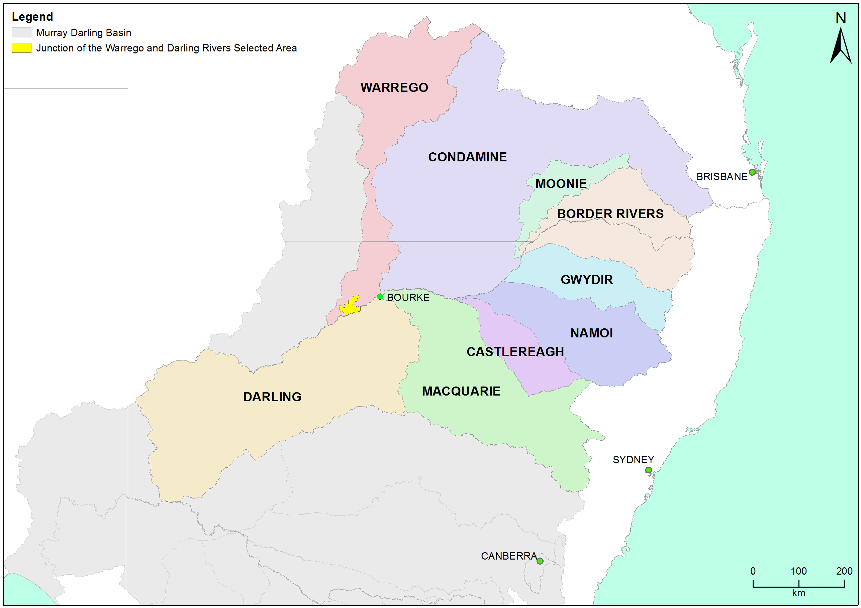
Figure 2-1 The location of the Junction of the Warrego and Darling rivers Selected Area within the Murray-Darling Basin showing upstream catchments.

Within the Selected Area, three monitoring zones have been defined (Table 2-1; Figure 2-2). These zones represent discrete regions of the Selected Area in terms of their geomorphology, hydrology, environmental assets, environmental watering targets and expected outcomes from Commonwealth environmental water.
Table 2-1 Junction of the Warrego and Darling rivers Selected Area monitoring zones.
Zone | Extent | Description | Potential target flow types for monitoring
Western Floodplain | The Western Floodplain of the lower Warrego River from Boera Dam offtake to the Darling River. | A large floodplain surface heavily dissected by small flood runners. Floodwaters inundate this floodplain from overflows at Boera Dam. | Overbank – infrastructure assisted
Warrego River | The lower Warrego River channel extending from the northern boundary of Toorale National Park to the junction with the Darling River, including Ross Billabong. | A single meandering channel that decreases in bankfull capacity downstream. Flows in this lower section of the Warrego River are controlled by a series of six in-channel structures, the lower of which (Peebles Dam) diverts water into Ross Billabong. | Base flows  Freshes up to 600 ML/d
Darling River | The Darling River from the eastern boundary of the Toorale National Park near Hells Gate to Weir 20A downstream of the western boundary of Toorale State Conservation Area. | A single meandering channel that has a bankfull height ranging 12-15 m. The bankfull channel is complex and there are a series of natural rock bars and a weir at the downstream end of the reach that influence flows along this section of the river. | Base flows  Freshes:  1,000-5,000 ML/d  5,000-10,000 ML/d  10,000-30,000 ML/d

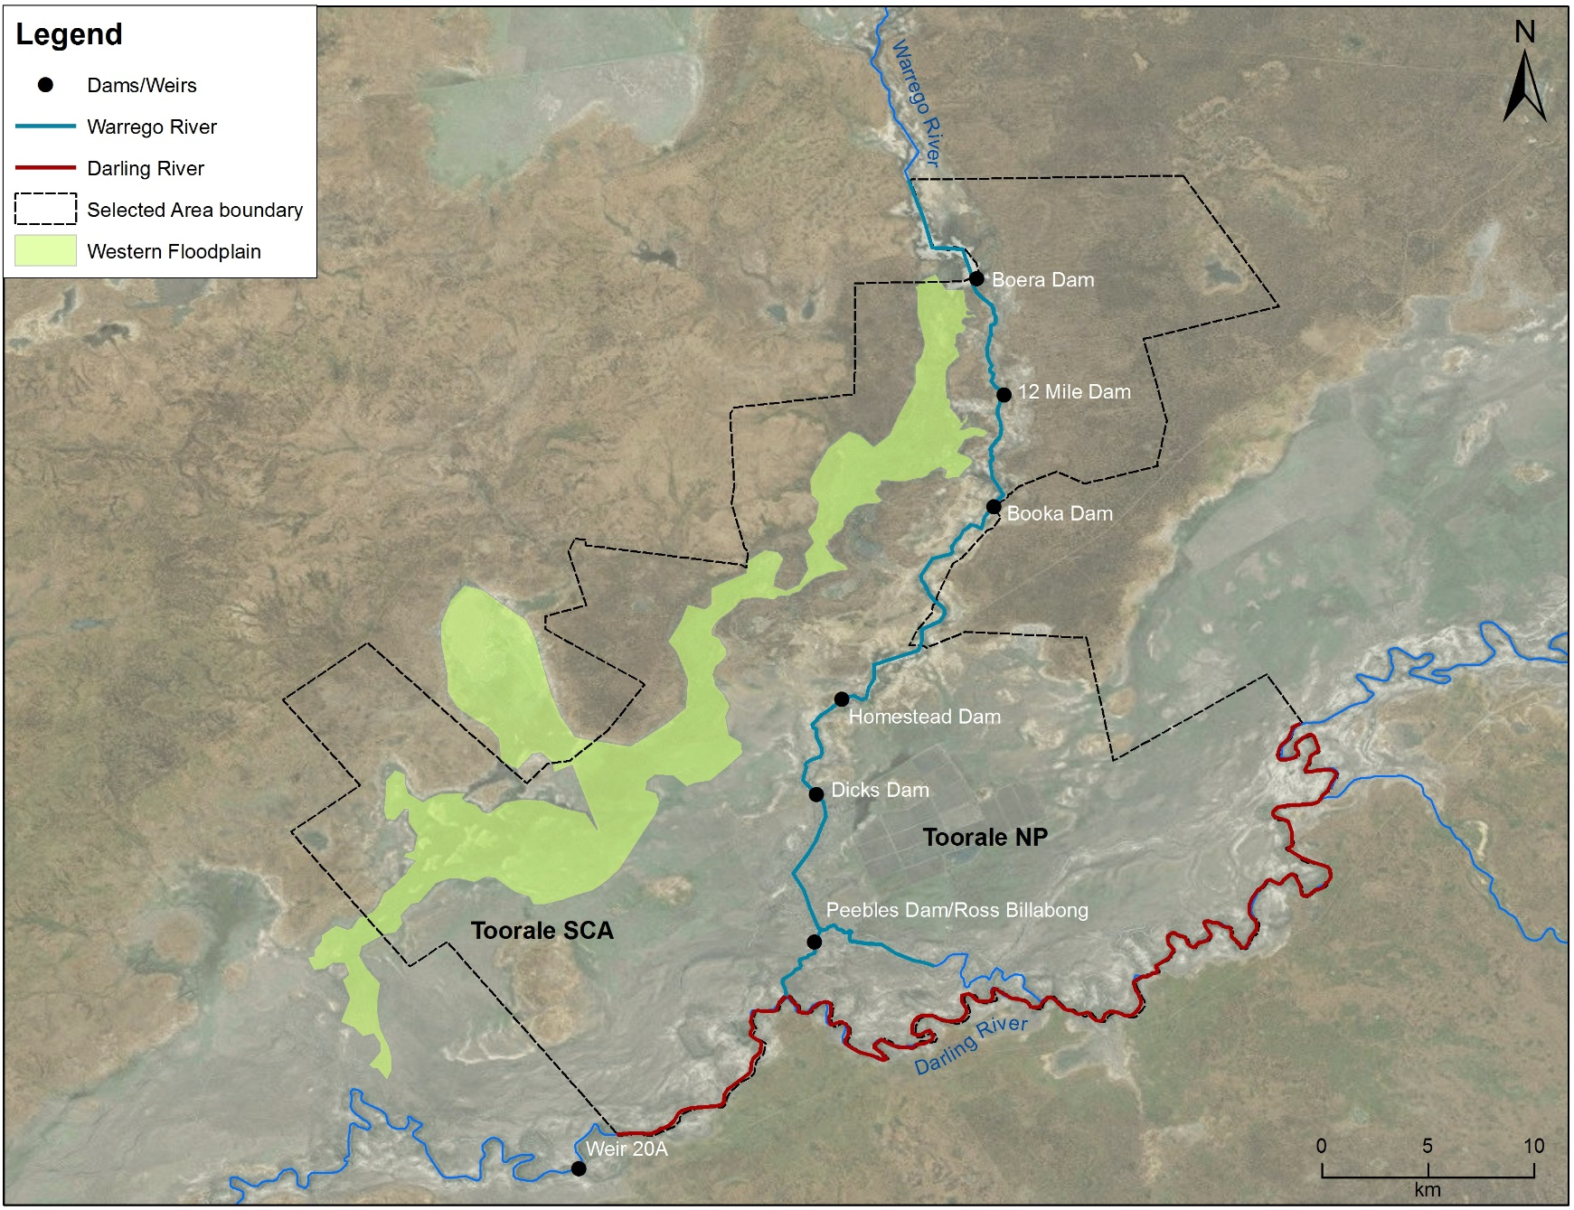
Figure 2-2 Junction of the Warrego and Darling river Selected Area monitoring zones.

Water Management
Over the last 150 years, the hydrology of the Warrego River within the Selected Area has been highly modified. Six dams have been constructed to provide stock and domestic water supply, irrigate the Western Floodplain to improve pasture growth, and more recently to provide water storage for irrigated agriculture (Figure 2-2). Since the establishment of Toorale NP and SCA in 2008, the condition of some dams has degraded, several becoming fully breached (Aurecon 2009). The characteristics and current status of these dams are outlined below (Gawne et al. 2013):
- Boera Dam: a large storage of approximately 3000 ML, likely to have been established since the 1870s. Water persists for around 12 months after filling without further inflows from local runoff. Management of this dam can preferentially divert water down the Western Floodplain.
- 12 Mile Dam: less than 1,000 ML in volume, this dam has been recently breached and not reinstated.
- Booka Dam: approximately 1,000 ML
- Keernie (Homestead) Dam: 1,500 – 2,000 ML (Breached)
- Dicks Dam: 500 – 1,000 ML
- Peebles Dam: a large storage just upstream of the junction of the Warrego and Darling rivers. This is the most permanent of the storages and was previously used for irrigation. The storage holds approximately 10,000 ML and is connected to Ross Billabong, an adjacent floodplain depression. At present the outlet gates are permanently opened to allow flows through to the Darling River downstream.
These dams have been retrospectively licenced under the provision of the Water Act 1912. This includes separate licenced amounts for the Warrego River at 8.1 GL long term average annual yield (LTAAY), the Western Floodplain (accounted at Boera Dam) at 9.7 GL (LTAAY) and the Darling River at 7.6 GL (LTAAY). Conditions placed on these licences determine how Commonwealth environmental water can be managed within the Selected Area. This is especially true for the licences specified at Boera Dam. Before these licences can be accessed, downstream demand to the Darling River must be met during times of low flow. That is, if sustained inflows are entering Boera Dam and the Darling River flow at Louth is below 330 ML/d, then water must be let through the regulator pipes on Boera Dam and all downstream dams on the Warrego to flow to the Darling River until flows at Louth have reached 330 ML/d. Once this has been achieved, the CEWO can choose whether to continue to release water down the lower Warrego channel, therefore activating their Warrego River licence, or close the regulator gates, hold water in Boera Dam to divert water to the Western Floodplain. If flows in the Darling exceed 979 ML/day at Louth, the CEWO can access a high flow floodplain licence to divert water to the Western Floodplain. The CEWO have developed a 5 year Water Use Strategy for Toorale to aid decision making surrounding the operation of Commonwealth environmental water at this site.
Unlike other Selected Areas, Commonwealth environmental water that flows into the Junction of the Warrego and Darling rivers Selected Area is primarily unregulated, and is thus reliant on rainfall, flows and water management decisions in upstream tributaries. The Gwydir, Namoi and to a lesser extent Macquarie catchments are exceptions to this, whereby regulated environmental water has the potential to influence flows in the Selected Area, particularly during periods of low flow in the Barwon-Darling system. Other water management actions, such as the release of stock and domestic flows, rainfall rejection flows and embargos on upstream pumping also influence flows in the Selected Area.
Adding to the complexity of environmental water accounting and delivery in the Selected Area is the fact that the Selected Area and its upstream tributaries fall into multiple Water Planning Areas, each with their own discreet rules, licence types and accounting procedures. Thus, tracking Commonwealth environmental water between and through these areas is challenging.
Use of Commonwealth Toorale entitlements is expected to contribute to the following on-park outcomes at Toorale and/or in the Darling River downstream:
- support periods of high primary productivity triggered by unregulated flow events and carbon and nutrient cycling
- support wetland and aquatic vegetation condition and diversity
- support waterbird survival and condition and diversity
- inundate and connect in-channel habitat associated with riffles, pools, bars and anabranches to support movement and biotic dispersal
- maintain water quality and carbon/nutrient cycling processes
- provide hydrological connectivity and improve end-of-system flows.

Watering Actions in 2016-17
During 2016-17, monthly rainfall was variable compared with long-term means. Rainfall was above average from July to October 2016, and then again in March 2017 (Figure 4-1). However, rainfall in November 2016 and February 2017 was less than 1 mm per month. Mean maximum temperatures were below the long-term mean at the start of the water year (July-October), and generally above average over the November-May period, with the only exception being January where temperatures were slightly lower than the long term mean (Figure 4-2).
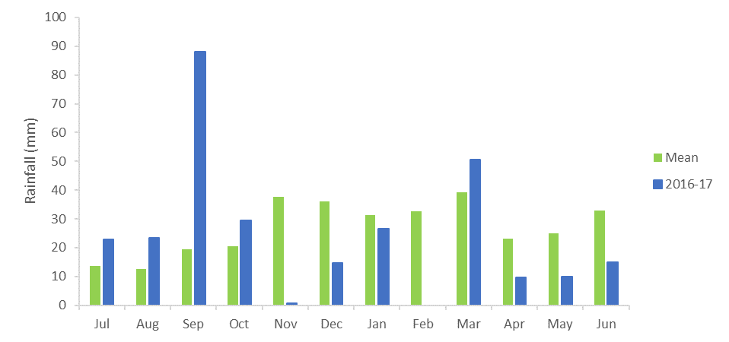

Figure 4-1 Monthly rainfall at Bourke Airport for 2016-17 compared to the long term mean (Source: http://www.bom.gov.au/climate/data/index.shtml).
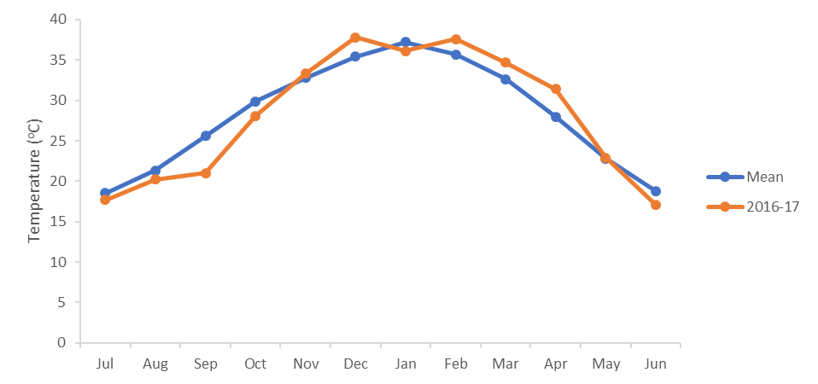
Figure 4-2 Mean maximum temperatures for the Bourke Airport during 2016-17 compared to the long term mean (Source: http://www.bom.gov.au/climate/data/index.shtml).

The 2016-17 water year was characterised by significant river flows throughout the northern tributaries, particularly during 2016. Four flow events sufficient to trigger unregulated Commonwealth environmental water take in the northern catchments occurred during the water year, providing approximately 7,818 ML, 3,102 ML, 42,228 ML and 16,101 ML of Commonwealth environmental water at Louth. It is estimated that during each event Commonwealth environmental water made up around 6.0%, 1.8%, 2.4% and 36.5% of these flows respectively, enhancing instream longitudinal connection and access to habitat throughout the Selected Area. Regulated Commonwealth environmental water releases from the Namoi and Macquarie tributaries, helped to augment unregulated take during April and May 2017, contributing to a high proportion of Commonwealth environmental water in the Darling River at the Selected Area during this event.
Toorale water licences were triggered on two occasions due to high river flow recorded at Ford’s Bridge on the Warrego River. During these events, 31,000 ML of water flowed onto the Western Floodplain including 31% Commonwealth environmental water. Similarly, 10,500 ML of water was released down the lower Warrego River channel and included 74% Commonwealth environmental water.

What did Commonwealth environmental water do in 2016-17

Expected Outcomes
The Selected Area falls within the Northern Unregulated Rivers region where the majority of Commonwealth environmental water holdings provide access to unregulated flows. The CEWO have defined a number of watering options and expected outcomes from the use of Commonwealth environmental water in the Northern Unregulated Rivers (Table 5-1). These expected outcomes are linked to both longer-term and broader objectives set out in the Murray-Darling Basin Plan. The evaluation of Commonwealth environmental water and its management in the Selected Area during 2016-17 is structured around these broader objectives.

Darling River Flows and Ecosystem Function
Widespread rainfall in Spring and Autumn within the northern tributaries helped to maintain hydrological connectivity in the Darling River through the Selected Area for the full duration of the 2016-17 water year (Appendix A). Four flow events occurred that were sufficient to trigger unregulated Commonwealth environmental water take during the water year, providing approximately 7,818 ML, 3,102 ML, 42,228 ML and 16,101 ML of Commonwealth environmental water (measured at at Louth) (Figure 5-1, Appendix B). It is estimated that during each event Commonwealth environmental water made up around 6.0%, 1.8%, 2.4% and 36.5% of these flows respectively, enhancing instream longitudinal connection and access to habitat throughout the Selected Area. The larger flow event that occurred in September - December 2016, was driven by flows out of the Border Rivers, Condamine-Balonne and Barwon Darling River systems. This flow was an order of magnitude bigger than any other that has occurred through the Selected Area since 2015 (Figure 5-2) and peaked at 39,000 ML/d at Bourke. The fresh event that occurred in April-May 2017 was augmented by Commonwealth environmental water from the Namoi and Macquarie catchments, which contributed to the relatively high (36.5%) proportion of environmental water in this flow event.
The increased connectivity observed during 2016-17 produced significant inundation of in-channel habitats with all mapped benches, anabranches and snags becoming inundated for at least 23 days (Figure 5-3, Appendix D). This represents the additional inundation of 70% of habitat features compared to the 2015-16 water year. Habitat lower in the channel was inundated for 160 days, with snags in the lowest category (<69 ML/d) being inundated for the entire water year. In addition to natural flows, Commonwealth environmental water inundated habitat contributing important quantities of dissolved carbon and nutrients to the river system while inundated snags also provided additional habitat for fish and other aquatic biota. It is estimated that 203.9 kg of total dissolved organic carbon (TOC), 62 kg of total dissolved nitrogen (TN) and 69.3 kg of total dissolved phosphorus (TP) was liberated from bench surfaces to the Darling River system during the time they were inundated in the 2016-17 water year.

Table 5-1 Expected outcomes from the use of Commonwealth environmental water in 2016-17 relevant to the Selected Area. WUM refers to the specific Water Use Minute for the Commonwealth environment water event in question.
Flow Type | Expected outcomes for 2016-2017 | Contributions to longer term objectives | Contribution to the following Basin Plan objective | Where these outcomes achieved in 2016-17?
Fresh in Warrego River zone (WUM152-07) | Primary  End of system connectivity  Fish reproduction  Biotic dispersal and movement  Secondary  Nutrient and sediment cycling | Connectivity  Fish diversity  Process | Biodiversity  Ecosystem function  Biodiversity | Yes, Commonwealth environmental water contributed to connectivity through the Warrego channel for 25 days (20 days from CEW). There was evidence of breeding and recruitment in many fish species, enhancing their population structure. This flow also improved Darling River water quality through dilution below the confluence.
Overbank on Western Floodplain zone (WUM 152-08) | Maintain wetland vegetation and waterbird habitat on the Warrego Western Floodplain | Vegetation diversity  Waterbird diversity and population condition | Biodiversity  Resilience | Yes, Commonwealth environmental water contributed to the inundation of 3,839 ha of the floodplain including key floodplain vegetation communities. Positive response from vegetation with cover increasing to highest levels since the project started. Long duration of connection (>6 months) stimulated boom in productivity, which provided food for higher order predators such as waterbirds.
Base Flows and Freshes in Darling River zone (WUM 111-40) | Primary  Connectivity  Flow variability  Habitat refuges  Secondary  Nutrient and sediment cycling  Water quality (Salinity, algal blooms) | Chemical  Connectivity  Process | Water quality  Ecosystem function | Yes, Commonwealth environmental water contributed to connectivity that occurred for 100% of the time through the Darling River zone. Good water quality was maintained during 2016-17 year. Inundation of all mapped benches, anabranch channels and snags for >23 days providing access to habitat and transfer of nutrients and organic material.

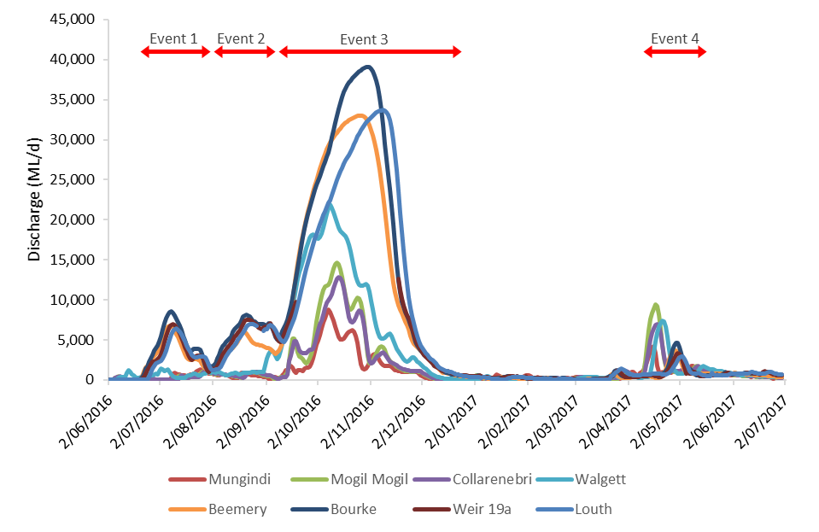
Figure 5-1 Mean daily flow at gauging stations on Barwon-Darling River system (1 July 2016 - 30 June 2017). Events used in the analysis of northern tributary contributions are outlined in red.

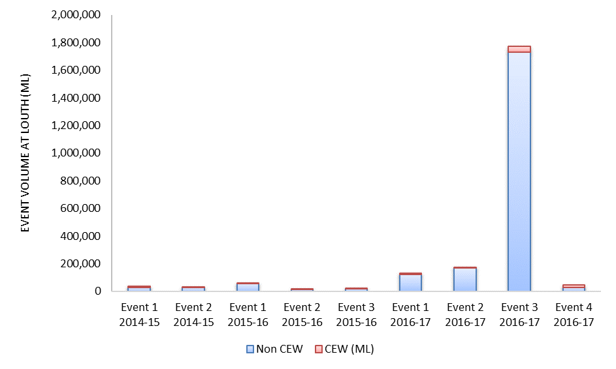
Figure 5-2 Comparison of flow events containing Commonwealth environmental water (CEW) from years 1-3 of the project measured at Louth gauge.
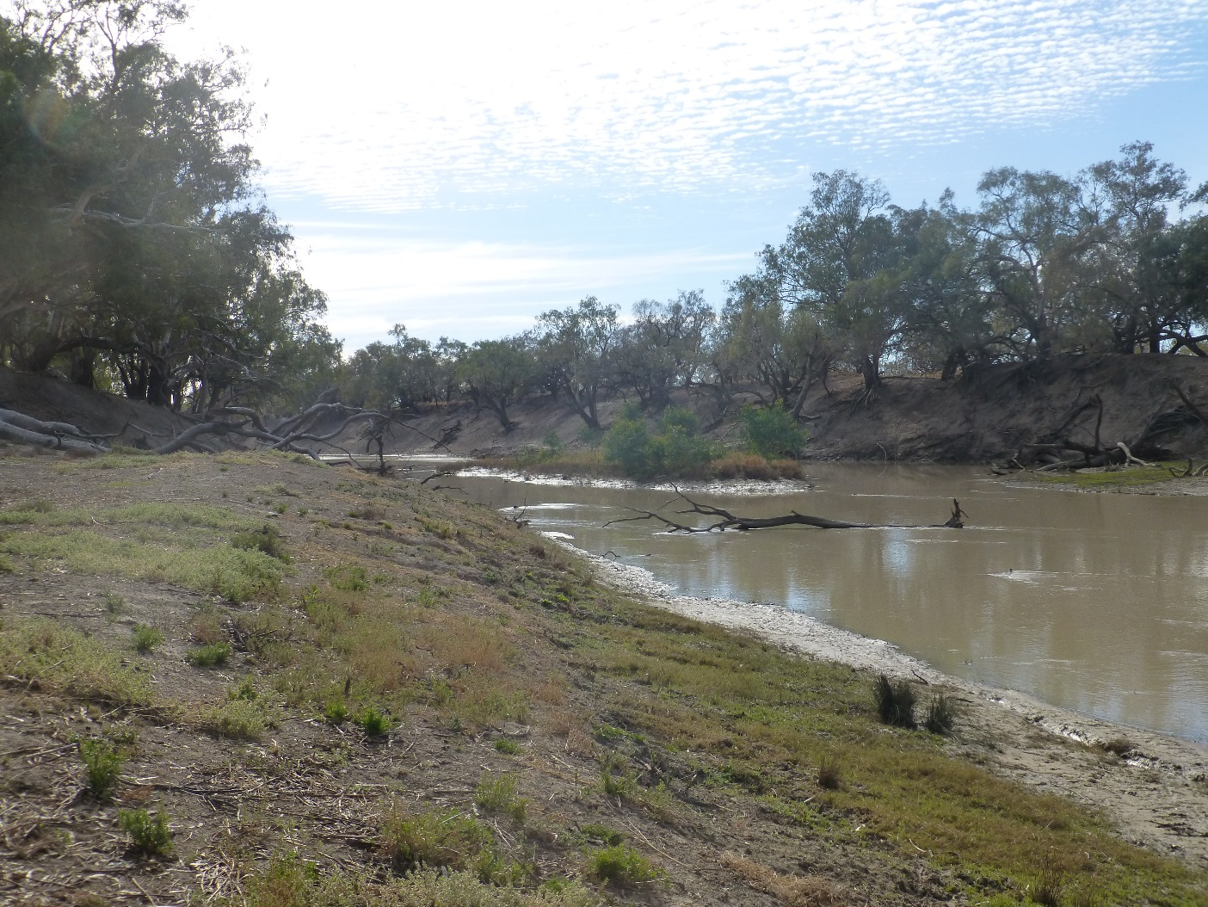
Figure 5-3 In-channel habitats along the Darling River within the Selected Area including a bench surface (right), snags and an in-channel island.

Warrego River Flows and Inundation
Several closely-spaced flow events in 2016 dominated the hydrology of the Warrego River channel during 2016-17 (Figure 5-4). Unregulated Commonwealth environmental water accounted upstream of the Selected Area comprised approximately 6.6% (3,228 ML) of inflows to Boera Dam. Consistent with the Toorale environmental watering strategy, inflows to Boera Dam were initially diverted to the Western Floodplain in response to very high demand while the Darling River was receiving reasonably high flows. Over the course of these events, the annual allocation of 9,720 ML for the Western Floodplain was reached by 20 September 2016, with flows continuing onto the Western Floodplain until late December for a total volume of 31,000 ML.
Commonwealth environmental water was also used to provide a flow down the Warrego to provide opportunities for native fish to access habitat, support recruitment and possibly triggering spawning in October 2016. The releases were managed to provide a slow rise and fall to the pulse and ensure that water also continued to spill to the Western Floodplain (which still had high demands) at the same time. Commonwealth water was used to provide connection for 20 days. National Parks and Wildlife Service maintained the connection for an additional 5 days before closing the regulators and allowing the remaining water to spill to the Western Floodplain. This resulted in longitudinal connectivity in the lower Warrego River for 25 days.
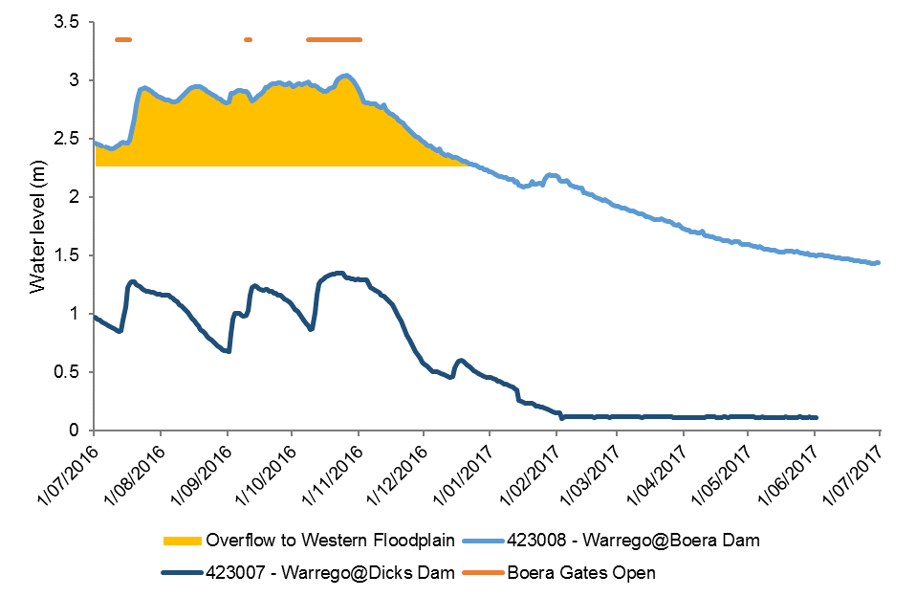
Figure 5-4 Water level at Boera and Dicks Dams and periods of longitudinal connection and overflow to Western Floodplain.

Inundation extents on the Western Floodplain ranged from 550 ha to 3,839 ha (Figure 5-5) during 2016-17, primarily driven by inflows down the Warrego River from significant rainfall in the upper catchment (Appendix E). Maximum mapped inundation occurred in October 2016 prior to a flow peak of 3.04 m measured at Boera Dam on the 25 October 2016. At this time, 9,978 ML of water was estimated to have been on the floodplain. This constituted the most significant inundation of the Western Floodplain over the life of the project, and indeed since 2012, when both the Darling and Warrego systems flooded. Lignum shrubland wetlands were the most commonly inundated vegetation community, followed by chenopod low open shrubland. The maintenance of water levels in Boera Dam above the Western Floodplain overflow level for over 6 months led to prolonged inundation of floodplain habitats such as waterholes and connecting channels, promoting biotic productivity.
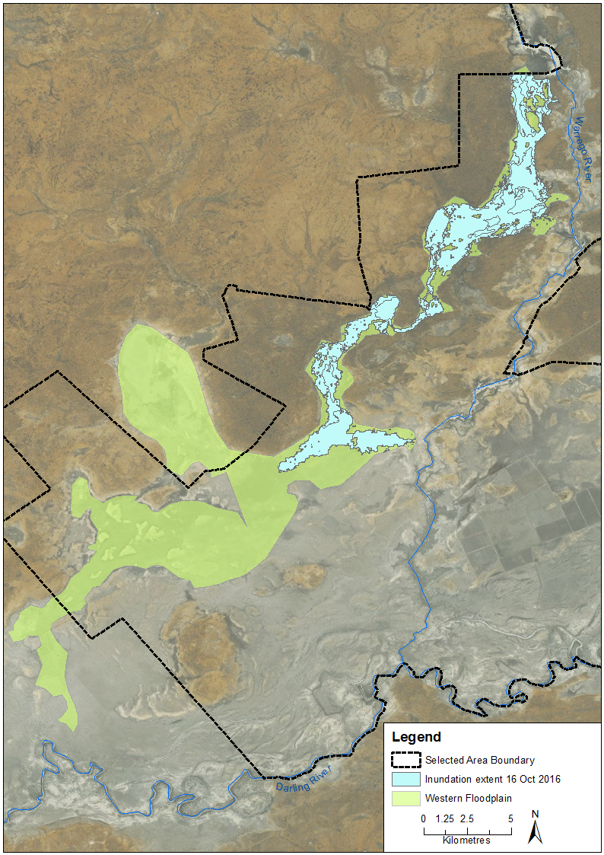
Figure 5-5 Inundation of vegetation communities on the Western Floodplain based on Landsat 8 image analysis of image captured 16 October 2016 (maximum inundation captured).

Water Quality
Water quality indicators were highly variable during the four time-periods analysed in 2016-17 in response to a large range of discharges and contributions of Commonwealth environmental water. Physicochemical water quality indicators such as pH and conductivity had lower mean values with smaller ranges compared to 2015-16, which was a much drier year. This is likely due to the much higher variability and magnitude in discharge in 2016-17. Findings from 2016-17 suggest that an increase in flow variability and magnitude augmented by Commonwealth environmental water improved pH and conductivity reflecting a dilution effect provided by higher discharges. In contrast, turbidity remained exceptionally high in both water years, appearing to reflect the long term high turbidity found in intermittent floodplain systems such as the Darling River and its tributaries (Sheldon & Fellows, 2010).
In the previous water year, pH and turbidity had their highest recorded values when discharge was around 10,000 ML/day, suggesting that this may be a key flow threshold for the inundation or connection of geomorphic features that subsequently affect ions and suspended sediments levels in the Darling River. Before discharge reached 10,000 ML/day, these variables increased, suggesting longitudinal transport and input of materials from upstream catchments (Bayley & Sparks, 1989). Findings from 2016-17 suggest that after discharge exceeded the 10,000 ML/day threshold, these variables declined, likely due to dilution of existing materials from processes such as reduction in resuspension and less input of materials from geomorphic features at higher river stages. A similar discharge threshold was evident in dissolved oxygen concentrations, with dissolved oxygen peaking at around 5,000 ML/d discharge. This may be linked to inundation of in-channel habitats at this level stimulating primary production (measured as dissolved oxygen concentration). Above this threshold, dissolved oxygen concentrations declined, presumably in response to interactions between turbidity, depth and turbulence, limiting phytoplankton productivity.
Event based monitoring during the flow event in October-November 2016 suggested that when connected, the Warrego River water was diluting water quality parameters in the Darling River (Appendix G). This included total nitrogen (TN), chlorophyll a, pH and conductivity concentrations which were consistently lower at the Darling downstream station below the confluence with the Warrego, compared to the Darling upstream site.

Biodiversity
During the 2016-17 water year, Commonwealth environmental water influenced sites within the Warrego and Darling River zones representing all nine ecosystem types monitored in the project, as defined by the Australian National Aquatic Ecosystem (ANAE) Classification Framework (Brooks et al. 2013; Appendix J). All sites within the Coolibah woodland and forest floodplain, Lignum shrubland floodplain, shrubland floodplain, temporary lake, temporary lake with aquatic beds and permanent lowland stream ANAE types were inundated by Commonwealth environmental water (Figure 5-6). The maintenance of a range of ecosystem types which provide a diverse array of habitat types is important for regional scale diversity.
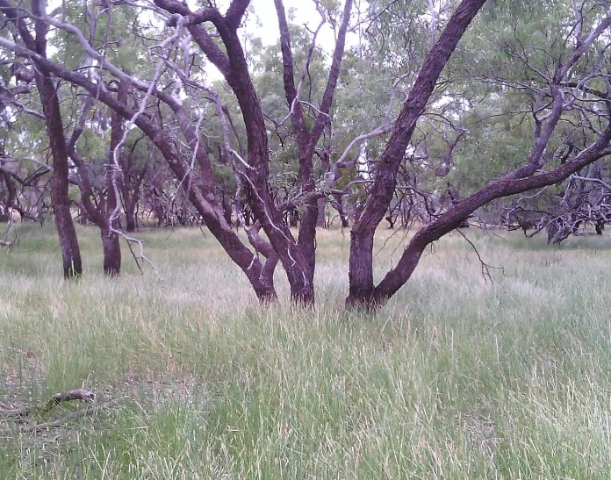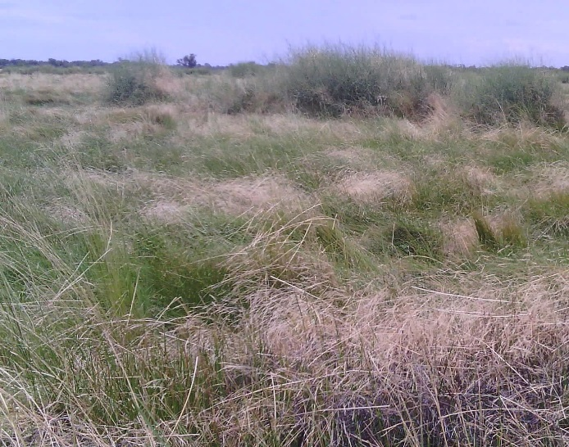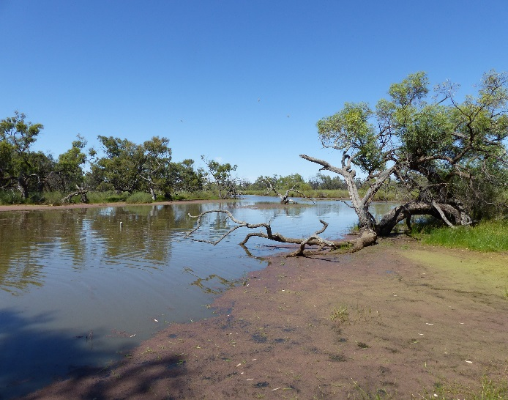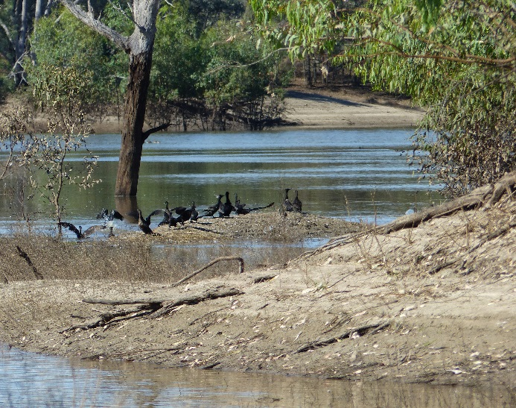
Figure 5-6 Examples of ecosystem types sampled in the Selected Area during the 2016-17 water year. Coolibah Woodland and forest floodplain (top left) shrubland floodplain (top right), temporary floodplain lake with aquatic beds (Bottom left) and Temporary Lake at Ross Billabong (bottom right).
Flows containing Commonwealth environmental water that were released from Boera Dam down the Warrego River, along with water that inundated the Western floodplain in 2016-17 provided longitudinal connectivity and had positive effects on aquatic invertebrate and fish communities.
In the Warrego River and the Western Floodplain, microinvertebrate density increased with each sampling period, and reached the highest density while water levels were contracting over summer (Appendix H). In particular, the highest densities found in Ross Billabong and the Western Floodplain link to high TN, TP and Dissolved Organic Carbon (DOC) concentrations and subsequent high chlorophyll a concentrations. Highest richness and diversity were found during the wettest period in August 2016 in the Warrego River and the Western Floodplain. This highlights that both longitudinal connection between the Warrego and Darling Rivers and lateral connection between the Warrego River and Western Floodplain increase the diversity of habitats and base resources that in turn, support a more diverse assemblage of microinvertebrate taxa. Diverse microinvertebrate communities are good, as they provide food for a greater range of both juvenile and adult animals such as fish, frogs, turtles and birds. In contrast, in the Darling River, microinvertebrate density did not show any temporal pattern among monitoring periods with persistent low abundances. However, microinvertebrate richness and diversity reduced in November 2016 after the peak flow of 39,000 ML/day, suggesting this flood event initiated taxonomic replacement through longitudinal displacement favouring flow-resistant taxa. This highlights the importance of slower flow habitats such as waterholes and billabongs in the Warrego River acting as microinvertebrate refuges during high discharge events, supporting diverse and abundant microinvertebrate communities.
Monitoring during 2016-17 revealed positive influences of Commonwealth environmental water and natural inflow on macroinvertebrate responses in the Warrego and Darling Rivers (Appendix I). On the Western Floodplain, inflows, including 9,720 ML of Commonwealth environmental water inundated 3,839 ha of floodplain and triggered secondary productivity with very high macroinvertebrate densities to provide food resources of larval fish, waterbirds and frogs. Longitudinal connection between the Warrego and Darling rivers and lateral connection between the Warrego River and Western Floodplain increased the diversity of habitats and basal resources that in turn, supported a more diverse assemblage of macroinvertebrate taxa, which in turn support frogs, fish and birds. This suggests that changes in physico-chemistry associated with inundation patterns are regulating primary and secondary production in the intermittently inundated Warrego River and Western Floodplain.
Similar to microinvertebrates, the relatively high flow event in October-November 2016 in the Darling River acted as a disturbance for macroinvertebrate communities causing lower densities and reduced taxa richness. Therefore, Commonwealth environmental water contributed to the development and succession of macroinvertebrate communities that accentuated differences between the Warrego and Darling River sites, providing greater regional scale macroinvertebrate diversity and food sources for higher order animals. This highlights the importance of the Warrego River as a refuge for macroinvertebrates during high discharge events by providing flow refuges such as waterholes and billabongs. The cessation of upstream Warrego inflows and contraction to disconnected pools led to decreases in richness and diversity with time since last inflow, reflecting the loss of habitat diversity and declining water quality conditions.
Ten species of fish were surveyed from five sites in the Warrego River in December 2016 and eight in April 2017 (Appendix L). Only three sites had water in April 2017 so sampling was confined to Boera Dam, Booka Dam and Ross Billabong. Bony Herring (Nematolosa erebi) was the most abundant species in both survey’s. Hyrtl’s tandan (Neosilurus hyrtlii) and spangled perch (Leiopotherapon unicolor) were also plentiful in December. Common carp (Cyprinus carpio) and spangled perch were plentiful in April 2017. There was evidence that most species bred and recruited in response to the flow event in the Warrego in October 2016. There were relatively large numbers of recruits of bony herring, spangled perch, Murray-Darling rainbowfish (Melanotaenia fluviatilis) common carp and goldfish (Carassius auratus) caught at most sites in December 2016. Additional monitoring on the Western Floodplain also suggested that Murray-Darling rainbowfish, carp and goldfish bred on the floodplain (Appendix O). Evidence of improved population structure was noted in species such as Hyrtl’s catfish, carp and goldfish between surveys across years 2 and 3 of the project (Figure 5-7). This suggests that small founder populations are re-establishing in the Warrego fish community since the system dried in 2014. Nevertheless, the abundance and richness of the fish populations was reduced in April 2017, with the system drying substantially to three main waterholes. Replenishing water in at least some of the refugial waterholes on the Warrego River, and where possible providing a flow pulse to stimulate breeding and recruitment, should be a priority for Commonwealth environmental water, to help maintain fish populations during dry times.
Eight frog species were recorded within the Selected Area during the 2016-17 monitoring period: two species in August 2016; seven species in November 2016; and five species in March 2017 (Appendix M). No frog species recorded were listed as threatened under the NSW TSC Act or the Commonwealth EPBC Act. Additional monitoring on the Western Floodplain in February 2017 found large numbers of Peron’s Tree Frog (Litoria peronii) metamorphs, suggesting recent breeding (Figure 5-8, Appendix O). During this period, frog abundance was three times higher in frequently inundated floodplain waterholes compared to less inundated sites. Patterns of abundance and richness in the frog communities of the Selected Area reflect the availability and type of habitat and seasonal conditions. The increase in frog numbers observed is directly influenced by wetting and higher temperatures. During and shortly after the Western Floodplain was inundated, frog abundance and richness increased due to the newly available, highly productive temporary habitat that supported a high population and stimulated breeding. The more permanent channel sites appeared to offer more stable habitat for local frog populations, with their numbers increasing as the river and dam levels rose and decreasing as receding waters exposed bank areas and reduced the amount of inundated fringing vegetation. These responses highlight the importance of maintaining a mosaic of habitat types through environmental watering of the Western Floodplain to support regional scale frog diversity, and in turn food for larger predators such as waterbirds.
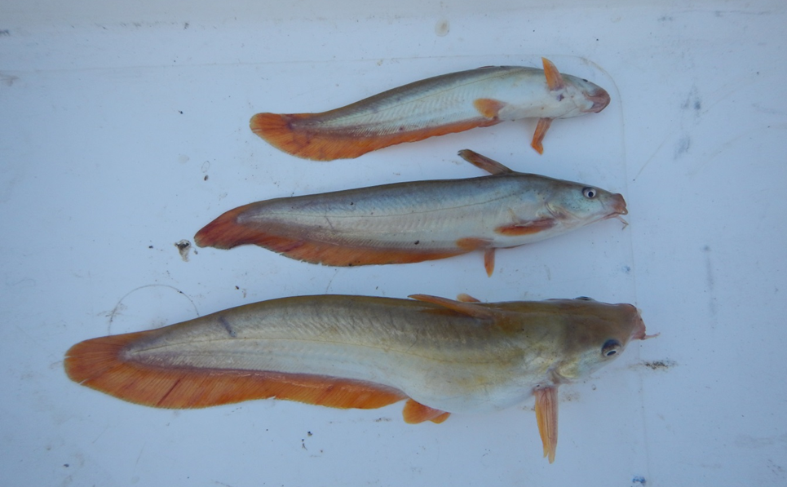
Figure 5-7 Size structuring among Hyrtl’s tandan (Neosilurus hyrtlii) captured at Dick’s Dam on the lower Warrego River; Sample 3, December 2016 (Range ~120-250 mm).

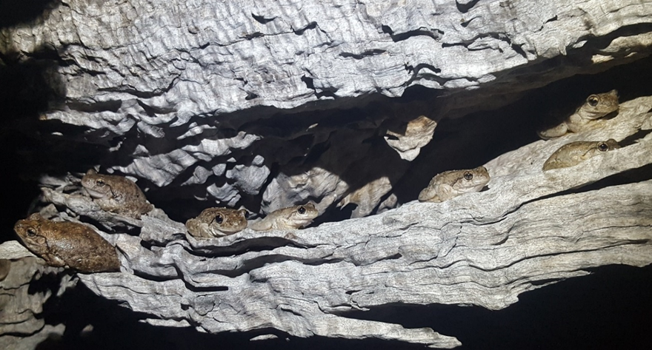
Figure 5-8 Peron's Tree Frogs (Litoria peronii) observed on the Western Floodplain in February 2017.
A total of 108 bird species, including 35 waterbird species, were recorded in the 2016-17 surveys of the Warrego River and Western Floodplain (Appendix N). The Grey Teal (Anas gracilis) was the most abundant waterbird species and was recorded across all sites along with the Pink-eared Duck (Malacorhynchus membranaceus), Australian Wood Duck (Chenonetta jubata), White-faced Heron (Egretta novaehollandiae) and Whistling Kite (Haliastur sphenurus). No listed species were recorded during this water year. Outcomes from the 2016-17 monitoring year, along with the previous two years, indicate that inundation, especially of the Western Floodplain is driving patterns of waterbird diversity. The abundance of waterbirds is consistently higher in the Warrego River sites, highlighting their importance as waterbird refuge habitats. When inundated, the various habitats on the Western Floodplain supports a more diverse waterbird population, with many species taking advantage of the conditions to feed.
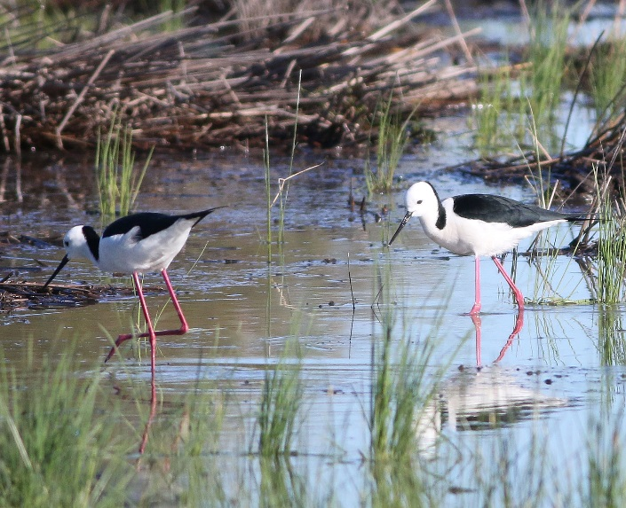
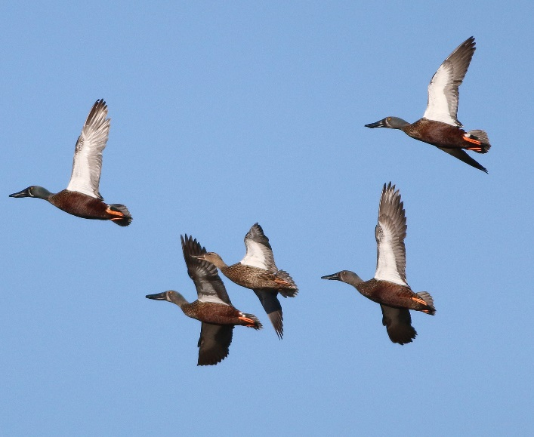
Figure 5-9 Australasian Shovellers (left) and Black-winged Stilts (right) observed in the Selected Area in August 2016.

Eleven of the 13 mapped vegetation communities were inundated during the 2016-17 water year (Appendix E). This included, 1,525 ha of Lignum shrubland wetland, 1,513 ha of Chenopod low open shrubland, 713 ha of Coolabah open woodland and 77 ha of Coolabah – River Cooba – Lignum woodland. Vegetation diversity monitoring identified 138 species from 39 families. This included tiny teeth (Dentella minutissima) which is listed as threatened under the NSW TSC Act, and was observed for the first time in survey plots during 2016-17 (Figure 5-10). Significant flooding of the Western Floodplain with Commonwealth environmental water during the 2016-17 water year stimulated a positive response from vegetation communities present on the floodplain (Appendix K). Ideal growing conditions during the December 2016 survey period resulted in high species richness and dominance measures when compared to previous sampling occasions. While these measures had decreased by April 2017, the cover of vegetation species had increased significantly, to their highest levels since LTIM monitoring began in 2015. This bodes well for the ongoing health of these floodplain vegetation communities into the future.
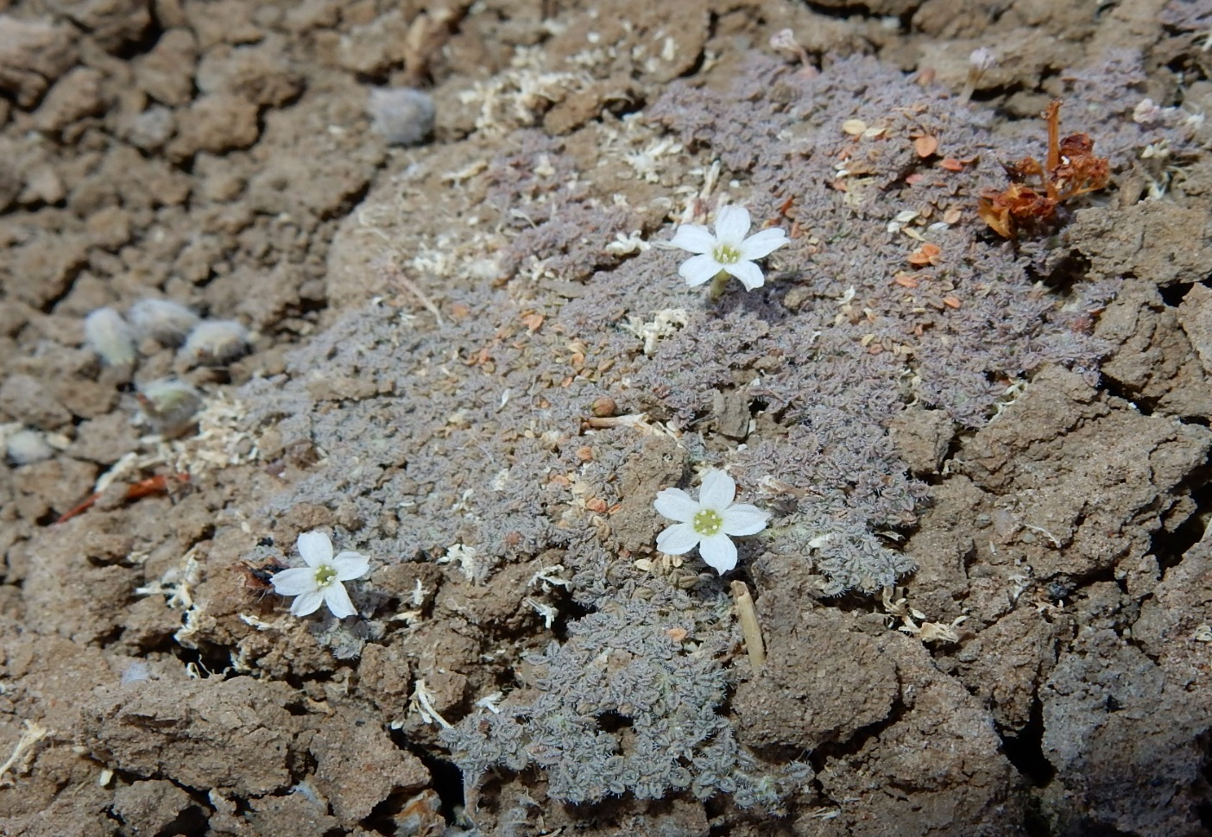
Figure 5-10 Tiny Teeth (Dentella minutissima) identified in survey plots on the Western Floodplain in April 2017.

Resilience
The plants and animals of the Selected Area have adapted to cope with high temporal variation (booms and busts) in resource availability (Kingsford et al. 2010). In semi-arid landscapes, the availability of resources is driven by the presence of water from both rainfall and flooding. The water infrastructure on Toorale that was developed over 150 years ago has resulted in changed temporal patterns of inundation, that the plants and animals present have become adapted to (Capon 2009). For example, vegetation species such as lignum, river cooba and coolibah have colonised the Western Floodplain since inundation frequency has increased from 1 in 20 years to 1 in 2 years on average (Aurecon 2009). Even so, for much of the Western Floodplain, the inundation that occurred in 2016-17 constitutes the first substantial flooding in five years. This inundation frequency is in the middle of the requirements of most key floodplain vegetation species present on the floodplain which require inundation once in every 3-7 years to remain in good condition (Cassanova 2015). Therefore, the flooding experienced in this water year as a result of Commonwealth environmental water, is likely to sustain large areas of floodplain vegetation into the future.
Similarly, Commonwealth environmental water played a key role in connecting refuge waterholes along the Warrego River in 2016-17. These waterholes have been shown to function as stable, more permanent habitat for aquatic biota, which sustain consistent levels of biodiversity. The maintenance of these refuges in a dry landscape, is important as they form source areas for biota when other more productive habitats, such as waterholes and channels on the Western Floodplain become inundated. When these floodplain areas became inundated in 2016-17, a concurrent boom in productivity was observed, with diverse populations of invertebrates, frogs, fish and waterbirds taking advantage of the favourable conditions. Breeding of fish, frog and turtle species was also observed. Maintaining a range of habitats is important for regional scale biodiversity, and the resilience of populations, and in 2016-17, Commonwealth environmental water contributed to this within the Selected Area.

Summary
The first half of the 2016-17 water year was the wettest period experienced in the first three years of the LTIM project. Commonwealth environmental water helped to provide 100% connection through the Darling River zone including four defined flow events containing between 1.8 and 36.5% Commonwealth environmental water. These flows inundated all mapped in-channel habitats, including benches, anabranch channels and snags in the Darling River zone for at least 23 days. This water also improved water quality parameters like pH and conductivity through the dilution effect once discharges increased above 10,000 ML/d. Similarly, dissolved oxygen increased with flow to a threshold of around 5,000 ML/d before declining as flows increased turbidity, depth and turbulence limiting phytoplankton productivity. Event based monitoring during the flow event in October-November 2016 suggested that when connected, the Warrego River water was diluting water quality parameters in the Darling River. This included total nitrogen, chlorophyll a, pH and conductivity concentrations which were consistently lower at the Darling downstream station below the confluence, compared to the Darling upstream site.
Commonwealth environmental water constituted a significant proportion of the water that flowed through the Selected Area from the Warrego River in 2016-17. Flows onto the Western Floodplain that contained around 31% environmental water inundated a maximum of 3,839 ha of floodplain including over 3,000 ha of Lignum Shrubland wetland and Chenopod low open shrubland for an extended period (>2 months). This flooding increased the richness and diversity of vegetation communities and resulted in the highest average vegetation cover observed in the LTIM project. It also likely contributed to recruitment of many species as well. Prolonged connection between Boera Dam and the Western Floodplain (>6 months) provided breeding opportunities for many native fish, frog and turtle species. The varied habitats available on the floodplain also resulted in diverse invertebrate, frog and waterbird populations, compared to the Warrego River channel.
While the Western Floodplain provides high quality but temporary habitat for aquatic fauna in the Selected Area, the waterholes of the Warrego channel continue to provide more stable, longer term refugial habitat. These potentially harbour founder populations during periods of disconnection, that can take advantage of river and floodplain flows when they occur again to disburse, breed and recruit. These observations highlight the importance of maintaining a mosaic of habitat types through environmental watering, including refugial habitats in the Warrego river as well as the diverse habitats of the Western Floodplain to support regional scale biodiversity.

Implications for Future Management of Commonwealth environmental water
Commonwealth environmental water made up a much larger proportion of flows that influenced the Selected Area in 2016-17, especially in the Warrego system. The significant floodplain inundation that occurred increased the health and cover of vegetation communities and inundated some areas of the Western Floodplain that have not been inundated by the river in five years. The floodplain continued to provide high quality habitat that was utilised by a range of fauna. This reinforces observations made over the first two years of the project, and confirms our recommendation that the Western Floodplain remains a priority for Commonwealth environmental water.
In 2016-17, Commonwealth environmental water was released down the Warrego River from Boera Dam to increase connectivity down the Warrego River zone, stimulate fish reproduction and provide opportunity for biotic dispersal and movement. Findings from previous years, in terms of fish recruitment following a short period of connection down the Warrego River in February/March 2016 (Commonwealth of Australia 2016), along with expert knowledge of the project team, were used to inform the design of this flow release. This included a flow event with slow rise and fall to stimulate fish to spawn and then allow conditions conducive to larvae establishment. Monitoring suggested that this water did in fact increase connectivity, and that many fish species breed and recruited following the event. This contributed to the further development of fish community age structure in the Warrego River, and prolonged the persistence of critical refugial waterholes in this system. Event based water quality monitoring also showed that this flow also had positive outcomes in terms of improving water quality in the Darling River, with Warrego flows diluting many variables below the Warrego-Darling confluence. This suggests that the planned fresh down the Warrego was successful in meeting its objectives, and should be considered in future years.

7 References
Aurecon. 2009. Toorale Station Decommissioning Plan Volume 1. Prepared for the Department of Environment, Water, Heritage and Arts.
Bayley, P. B., & Sparks, R. E. (1989). The flood pulse concept in river-floodplain systems. Paper presented at the Proceedings of the International Large River Symposium. Dodge, DP (Ed). Can. Spec. Publ. Fish. Aquat. Sci.
Brooks, S., Cottingham, P., Butcher, R., & Hale, J. 2013. Murray-Darling Basin aquatic ecosystem classification: Stage 2 report. Peter Cottingham & Associates report to the Commonwealth Environmental Water Office and Murray-Darling Basin Authority, Canberra.
Capon, S 2009. Flow dependent Ecosystems of Toorale Station: Ecological character, condition and issues associated with the decommissioning water resources infrastructure. Australian Rivers Institute, Griffith University
Cassanova, M.T. 2015. Review of Water Requirements for Key Floodplain Vegetation for the Northern Basin: Literature review and expert knowledge assessment. Report to the Murray Darling Basin Authority, Canberra
Commonwealth of Australia 2016. Commonwealth Water Office Long Term Intervention Monitoring Project Junction of the Warrego and Darling rivers Selected Area – 2015-16 Evaluation Report.
Gawne B., Brooks S., Butcher R., Cottingham P., Everingham P. & Hale J. 2013. Long-term Intervention Monitoring Project: Monitoring and Evaluation Requirements: Junction of the Warrego and Darling rivers. Report prepared for the Commonwealth Environmental Water Office by The Murray-Darling Freshwater Research Centre, MDFRC Publication 01.2/2013.
Kingsford, R.T., Roshier, D.A. and Porter, J.L. 2010. Australian Waterbirds – time and space travellers in dynamic desert landscapes. Marine and Freshwater Research, 61, 875-884.
Sheldon, F., & Fellows, C. S. (2010). Water quality in two Australian dryland rivers: spatial and temporal variability and the role of flow. Marine and Freshwater Research, 61(8), 864-874

