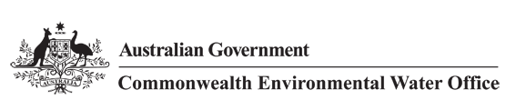



**Commonwealth Environmental Water Office**

**Long Term Intervention Monitoring Project**

**JUNCTION OF THE WARREGO AND DARLING RIVERS SELECTED AREA**

2015-16 Evaluation Report, 29 March 2017



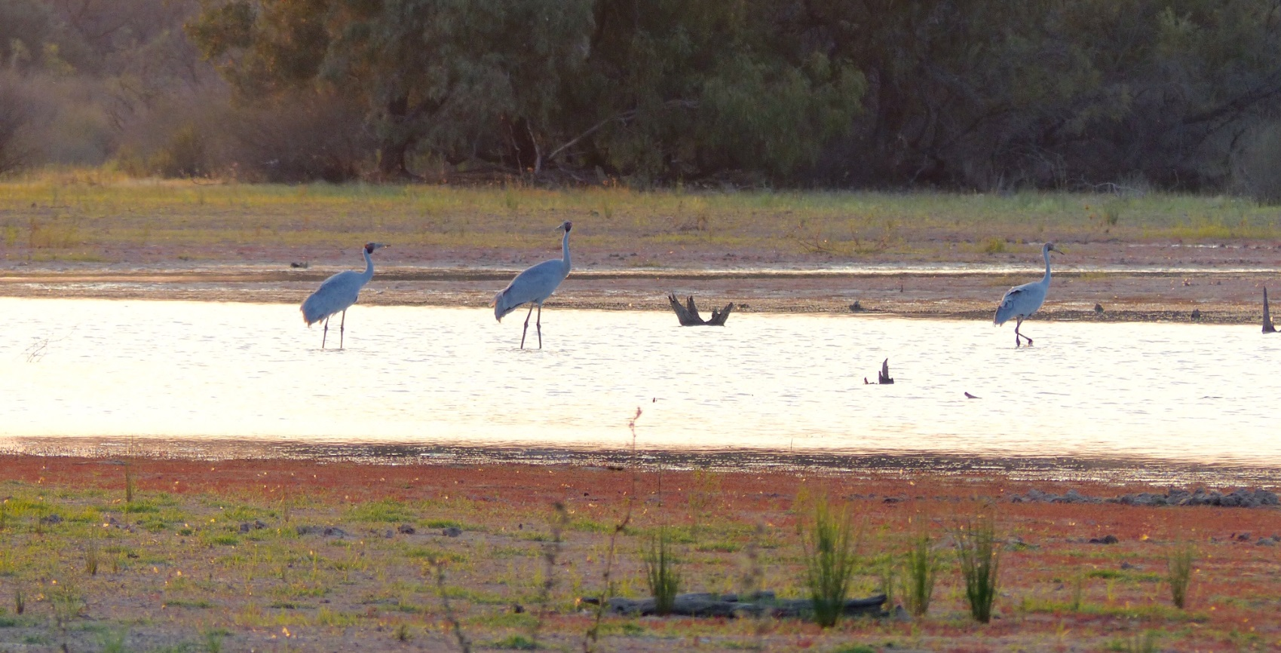





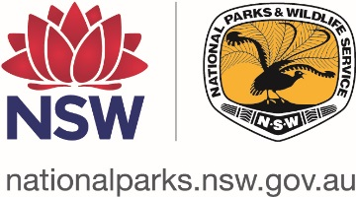

This monitoring project was commissioned and funded by Commonwealth Environmental Water Office, with in-kind support from NSW Office of Environment and Heritage.

**Copyright**

© Copyright Commonwealth of Australia, 2017



Commonwealth Environmental Water Office Long Term Intervention Monitoring Project Junction of the Warrego and Darling rivers Selected Area is licensed by the Commonwealth of Australia for use under a Creative Commons By Attribution 3.0 Australia licence with the exception of the Coat of Arms of the Commonwealth of Australia, the logo of the agency responsible for publishing the report, content supplied by third parties, and any images depicting people. For licence conditions see: <http://creativecommons.org/licenses/by/3.0/au/>

This report should be attributed as ‘Commonwealth Environmental Water Office Long Term Intervention Monitoring Project Junction of the Warrego and Darling rivers Selected Area – 2015-16 Final Evaluation Report, Commonwealth of Australia 2017’.

**Disclaimer**

The views and opinions expressed in this publication are those of the authors and do not necessarily reflect those of the Australian Government or the Minister for the Environment.

While reasonable efforts have been made to ensure that the contents of this publication are factually correct, the Commonwealth does not accept responsibility for the accuracy or completeness of the contents, and shall not be liable for any loss or damage that may be occasioned directly or indirectly through the use of, or reliance on, the contents of this publication.

**DOCUMENT TRACKING**

|  |  |
| --- | --- |
| Item | Detail |
| Project Name | Long Term Intervention Monitoring Project – Junction of the Warrego and Darling rivers Selected Area |
| Project Number | 2428 |
| Project Manager | Dr Mark Southwell  (02) 8081 2688  92 Taylor Street, Armidale NSW 2350 |
| Prepared by | Dr Mark Southwell, Dr Paul Frazier , Ben Martin, Linden Burch, Nathalie van der Veer , Rob Cawley, Lindsey Frost (ELA)  Assoc. Prof Darren Ryder, Dr Wing Ying Tsoi (UNE)  Dr Gavin Butler (NSW DPI) |
| Reviewed by | Dr Mark Southwell, Assoc. Prof Darren Ryder |
| Approved by | Dr Paul Frazier |
| Status | Final |
| Version Number | 2 |
| Last saved on | 29 March 2017 |
| Cover photo | Brolga feeding at Boera Dam, October 2015. Photo by Ben Vincent (UNE). |

Acknowledgements

This document has been prepared by Eco Logical Australia Pty Ltd with support from Associate Professor Darren Ryder and Dr Wing Ying Tsoi from the University of New England, Dr Gavin Butler from the DPI fisheries, and staff from DPI Water. The project team would like to thank the NPWS staff at Toorale National Park and State Conservation Area for their assistance and cooperation.

Acknowledgement of Country

The authors of this report as well as the Commonwealth Environmental Water Office respectfully acknowledge the traditional owners, their Elders past and present, their Nations of the Murray-Darling Basin, and their cultural, social, environmental, spiritual and economic connection to their lands and waters. In particular the Barkindji, Murrawarri, Ngemba and Ngiyampaa peoples, traditional owners of the land on which this publication is focused.

|  |
| --- |
| **Disclaimer** *This document may only be used for the purpose for which it was commissioned and in accordance with the contract between Eco Logical Australia Pty Ltd and the Department of the Environment and Energy. The scope of services was defined in consultation with the Department of the Environment and Energy, by time and budgetary constraints imposed by the client, and the availability of reports and other data on the subject area. Changes to available information, legislation and schedules are made on an ongoing basis and readers should obtain up to date information.*  *Eco Logical Australia Pty Ltd accepts no liability or responsibility whatsoever for or in respect of any use of or reliance upon this report and its supporting material by any third party. Information provided is not intended to be a substitute for site specific assessment or legal advice in relation to any matter. Unauthorised use of this report in any form is prohibited.* |

ate 24/07/2015

**Document control**

|  |  |  |  |
| --- | --- | --- | --- |
| **Version** | **Date** | **Reviewed by** | **Approved by** |
| 1 | 25 August 2016 | Dr Mark Southwell, Assoc. Prof Darren Ryder | Dr Paul Frazier |
| 2 | 21 November 2016 | Dr Mark Southwell, Assoc. Prof Darren Ryder | Dr Paul Frazier |

|  |  |
| --- | --- |
| **Item** | **Details** |
| ELA Project Number | 2428 |
| Project Director/s | Dr Paul Frazier, Assoc. Prof Darren Ryder |
| Project Manager | Dr Mark Southwell |
| Prepared by | Dr Paul Frazier, Assoc. Prof Darren Ryder, Dr Mark Southwell, Nathalie van der Veer, Linden Burch, Ben Martin, Lindsey Frost, Rob Cawley |

Contents

Executive Summary viii

1 Introduction 1

2 Junction of the Warrego and Darling rivers Selected Area 2

3 Water Management 5

4 Watering Actions in 2015-16 7

5 What did Commonwealth environmental water do in 2015-16? 9

5.1 Expected Outcomes 9

5.2 Darling River Flows and Ecosystem Function 10

5.3 Warrego River Flows and Inundation 13

5.4 Water Quality 15

5.5 Biodiversity 15

5.6 Resilience 18

5.7 Summary 19

6 Implications for Future Management of Commonwealth environmental water 20

7 References 21

**Appendix A – Hydrology (River)**

**Appendix B – Hydrology (Northern Tributaries)**

**Appendix C – Hydrology (Channel)**

**Appendix D – Hydrology (Habitat)**

**Appendix E – Hydrology (Floodplain)**

**Appendix F – Water Quality**

**Appendix G – Stream metabolism**

**Appendix H – Microinvertebrates**

**Appendix I –Macroinvertebrates**

**Appendix J – Ecosystem Type**

**Appendix K – Vegetation Diversity**

**Appendix L – Fish (River)**

**Appendix M – Frogs**

**Appendix N – Waterbird Diversity**

List of figures

Figure 2‑1 The location of the Junction of the Warrego and Darling river Selected Area within the Murray-Darling Basin showing upstream catchments. 2

Figure 2‑2 Junction of the Warrego and Darling river Selected Area monitoring zones. 4

Figure 4‑1 Monthly rainfall at Bourke Post Office for 2015-16 compared to the long term mean (Source: http://www.bom.gov.au/climate/data/index.shtml). 7

Figure 4‑2 Mean maximum temperatures for the Bourke Post Office during 2015-16 compared to the long term mean (Source: http://www.bom.gov.au/climate/data/index.shtml). 7

Figure 5‑1 Mean daily flow at gauging stations on Barwon-Darling River system (1 July 2015 - 30 June 2016). Events used in the analysis of northern tributary contributions are boxed in red. 11

Figure 5‑2 Comparison of 2014-2015 and 2015-16 flow event at Louth gauge. Note 2016 Event 4 will be evaluated in 2016-17 reporting. 12

Figure 5‑3 In-channel habitats along the Darling River within the Selected Area. bench (top left), anabranch channel (top right), snag (bottom left) and bench and snags (bottom right). 12

Figure 5‑4 Water level at Boera and Dicks Dams and periods of longitudinal connection and overflow to Western Floodplain. 13

Figure 5‑5 Inundation of vegetation communities on the Western Floodplain based on Landsat 8 image analysis of image captured 17 December 2015 (maximum inundation captured). 14

Figure 5‑6 Examples of ecosystem types sampled in the Selected Area during the 2015-16 water year. Permanent lowland stream at the Darling pumps site (left) and the temporary lakes ecosystem type at Booka Dam (right). 15

Figure 5‑7 Fish species caught in the 2015-16 year. Hyrtl's catfish (left) and spangled perch (right). 17

Figure 5‑8 Frog species surveyed in 2015-16. Green tree frog at Boera Dam (left) and wrinkled toadlet at Booka Dam on the Warrego River (right). 17

Figure 5‑9 White-faced heron (left) and sacred kingfisher (right) observed at Booka Dam during the March 2016 waterbird survey. 18

List of tables

Table 2‑1: Junction of the Warrego and Darling rivers Selected Area monitoring zones. 3

Table 5‑1: Expected outcomes from the 2014-15 and 2015-16 Commonwealth environmental water (CEWO 2014). Outcomes relevant to the Selected Area are shaded blue. 9

Common abbreviations

|  |  |
| --- | --- |
| Abbreviation | Description |
| ANZECC | Australian and New Zealand Environment Conservation Council |
| ASL | Above Sea Level |
| BoM | Bureau of Meteorology |
| CEWO | Commonwealth Environmental Water Office |
| ELA | Eco Logical Australia Pty Ltd |
| HSE | Health, Safety and Environment |
| LTIM Project | Long Term Intervention Monitoring Project |
| M&E Adviser | Monitoring and Evaluation Adviser |
| M&E Plan | Monitoring and Evaluation Plan |
| M&E Provider | Monitoring and Evaluation Provider |
| M&E Requirements | Monitoring and Evaluation Requirements |
| MDB | Murray-Darling Basin |
| MDBA | Murray-Darling Basin Authority |
| MDFRC | Murray-Darling Freshwater Research Centre |
| MDMS | Monitoring Data Management System |
| DPI Water | NSW Department of Primary Industries Water |
| NSW OEH | (NSW) Office of Environment and Heritage |
| QA/QC | Quality Assurance / Quality Control |
| The Department | Department of the Environment and Energy (Commonwealth) |
| UNE | University of New England |

*Blank page*

# Executive Summary

**Contributions of Commonwealth environmental water in 2015-16**

***Darling River zone***

* Commonwealth environmental water contributed to four flow events down the Darling River zone, which provided connecting flows through the zone to Louth.
* These flows provided access to instream habitats such as snags, benches and anabranches and helped to maintain water quality through the year.

***Warrego River zone***

* Commonwealth environmental water made a small (4%) contribution to flows down the Warrego River zone for around 16 days in February/March 2016.
* This flow reconnected previously isolated waterholes, contributing to invertebrate abundance and diversity within this zone, and stimulated breeding and recruitment of several native fish species.
* The reconnection of refuge pools also maintained these stable habitats for frogs and waterbirds.

The Junction of the Warrego and Darling rivers Selected Area (Selected Area) encompasses the Toorale National Park and State Conservation Area managed by NSW OEH. Inflows of Commonwealth environmental water to the Selected Area via the Darling River from upstream tributaries have also been evaluated.

The Selected Area is complex in terms of its ecosystems, hydrology and the way in which Commonwealth environmental water is accounted and managed both within the Selected Area and within upstream tributaries. While most of the Commonwealth environmental water that influences the site is held as unregulated entitlements, regulated deliveries from the Gwydir, Namoi and to a lesser extent Macquarie catchments have the potential to influence flows in the Selected Area, particularly during periods of low flow in the Barwon-Darling system. Other water management actions, such as the release of stock and domestic flows and embargos on upstream pumping also influence flows in the Darling River through this zone.

Use of Commonwealth Toorale entitlements is expected to contribute to the following on-park outcomes at Toorale and/or in the Darling River downstream:

* support periods of high primary productivity triggered by unregulated flow events and increases in carbon and nutrient cycling
* support wetland and aquatic vegetation condition and diversity
* support waterbird survival, condition and diversity
* inundate and connect in-channel habitat associated with riffles, pools, bars and anabranches to support movement and biotic dispersal
* maintain water quality and promote carbon/nutrient cycling processes
* provide hydrological connectivity and improve end-of-system flows

In the Darling catchment, four instream flow events sufficient to trigger Commonwealth environmental water take occurred during July-October 2015, November 2015, January-March 2016 and June 2016. The first three events provided approximately 56,000 ML, 12,600 ML and 22,100 ML of water, respectively, at Louth, downstream of the Selected Area. It is estimated that during each event Commonwealth environmental water made up around 5%, 4% and 30% of these flows respectively, enhancing instream longitudinal connection in the Darling River, through the Selected Area.

Upstream rainfall in the Warrego catchment also produced inflows to the Warrego River zone of the Selected Area during February/March 2016. These inflows included around 4% Commonwealth environmental water accounted in Queensland. In-line with existing operating rules, the gates at Boera Dam were opened to allow flow through to the Darling River, with full connection of the lower Warrego channel occurring within 1 day. As inflows continued into the Selected Area from the Warrego River, the Boera Dam gates were opened four times between 3 February and 9 March 2016 and connection occurred in each of these events, resulting in total connection for 16 days, with the longest period of continuous connection lasting five days. It should be noted that these flows were not of sufficient size to trigger Commonwealth licences in the Warrego at Toorale.

**Key Outcomes**

*Flows and Ecosystem functioning*

* Commonwealth environmental water increased the connectivity of the Darling River zone, and contributed to connections in the Warrego River zone during the 2015-16 year.
* In-channel flow pulses provided access to in-channels habitats, inundating 42% (1,569 individual snags) of snags within the Darling River zone, 26% of in-channel benches and 60% of anabranch channels. Connection of these features provided additional habitat for biota, and allowed for the exchange of organic matter and nutrients between these features and the river channel.
* While Commonwealth environmental water did not influence flows onto the Western Floodplain, localised rainfall generated flows that inundated a maximum of 464 ha of the Western Floodplain in November 2015 and May 2016.
* Lignum shrubland wetlands, coolibah and river cooba communities bordering flood channels and waterholes were inundated on the Western Floodplain during 2015-16.

*Water Quality*

* In-channel flow pulses in the Darling River zone influenced water quality variables, reducing pH, conductivity and turbidity and increasing dissolved oxygen and chlorophyll *a* (algae) concentrations. Levels of primary production increased during these flow events, primarily as a result of increased light penetration linked to lower turbidity.
* In-channel flow pulses containing Commonwealth environmental water dispersed an outbreak of the floating aquatic plant Azolla that completely covered the water surface of the Darling River channel in spring. These flows prevented any potential water quality problems and ecological consequence such as hypoxia linked to this Azolla outbreak.
* Nutrient levels were high once again within the Selected Area with flow events elevating dissolved carbon and phosphorus and diluting nitrogen. All sites acted as carbon sinks during the 2015-16 year.

*Biodiversity*

* Commonwealth environmental water influenced sites within the Warrego River and Darling River channels representing two of the nine ecosystem types monitored in the project, these being permanent lowland streams and temporary lakes.
* Remnant Western Floodplain waterholes contained diverse and abundant frog and macroinvertebrate communities, likely due to the increased availability of good quality habitat.
* Flow connection down the Warrego River zone promoted microinvertebrate diversity between sites.
* Nine species of fish were surveyed in waterholes in the Warrego River zone, including six native and three exotic species. Generally, exotic species abundance was low. Flow connection down the Warrego River zone stimulated breeding and recruitment in a number of native fish species.
* Waterbird numbers were low compared to year 1 of the project, reflecting the generally drier conditions. Boera Dam continued to be an important site for waterbirds, with high abundance and diversity of species recorded.
* Seasonal patterns in vegetation response were noted, primarily due to the occurrence of rainfall preceding spring sampling. Nevertheless, inundation was shown to influence community composition, especially in plots located within lignum shrubland communities.

*Resilience*

* Commonwealth environmental water contributed to flows in the Darling River zone, which maintained water quality within levels acceptable to aquatic biota.
* Commonwealth environmental water contributed to flows in the Warrego River zone, which reconnected previously isolated refuge pools that provide important long term habitat for a range of organisms, including fish, frogs and waterbirds.

**Implications for Commonwealth environmental water management**

* Monitoring in 2015-16 showed that water accounted against Commonwealth environmental water entitlements held in upstream tributaries had downstream ecological benefits in the Selected Area.
* Remnant Western Floodplain waterholes are providing good quality temporary habitat for aquatic biota. This, coupled with the fact that most of the floodplain has not been inundated since 2012, suggests that the Western Floodplain should be prioritised for watering in the short term.

*Blank page*

# Introduction

This report presents the monitoring and evaluation results from the Junction of the Warrego and Darling rivers Selected Area (Selected Area) during the 2015-16 water year. The monitoring is being undertaken as part of the Long Term Intervention Monitoring Project (LTIM Project) funded by the Commonwealth Environmental Water Office (CEWO). The LTIM Project is being implemented at seven Selected Areas over a five year period from 2014-15 to 2018-19 to deliver five high-level outcomes:

1. Evaluate the contribution of Commonwealth environmental watering to the objectives of the Murray-Darling Basin Authority’s (MDBA) Environmental Watering Plan.
2. Evaluate the ecological outcomes of Commonwealth environmental watering at each of the seven Selected Areas.
3. Infer ecological outcomes of Commonwealth environmental watering in areas of the Murray-Darling Basin not monitored.
4. Support the adaptive management of Commonwealth environmental water.
5. Monitor the ecological response to Commonwealth environmental watering at each of the seven Selected Areas.

While results specific to the Junction of the Warrego and Darling rivers Selected Area are reported here, a broader Basin Scale analysis including results from all seven Selected Areas will be produced by the Murray-Darling Freshwater Research Centre (MDFRC).

The report describes the Selected Area, watering actions undertaken during 2015-16 and the ecological outcomes of the application of Commonwealth environmental water in the Selected Area during 2015-16. Detailed analysis, methods and results are presented in the Appendices referred to in the main report.

# Junction of the Warrego and Darling rivers Selected Area

The Selected Area is located around 80 km south-west of Bourke in north western NSW (Figure 2‑1). The Selected Area is contained within the boundary of the Toorale National Park (NP) and State Conservation Area (SCA) (Figure 2‑2). The Selected Area is approximately 92,000 ha in size, and receives flow from both the Darling and Warrego River systems. The Darling River catchment drains the north westerly portion of the Murray-Darling Basin and has a total catchment area of 699,500 km2. Most of its tributaries (Macquarie, Castlereagh, Namoi, Gwydir, Macintyre and Condamine-Balonne Rivers) drain from the Great Dividing Range in northern New South Wales and southern Queensland, and provide relatively high amounts of runoff to the catchment. In contrast, other catchments such as the Warrego and the Paroo Rivers to the west, drain more arid, flat catchments and only flow intermittently during periods of high rainfall in their upper catchments, usually manifesting downstream as slow moving floods of relatively long duration. Generally speaking, the Selected Area shows high climatic variability, with low annual rainfall and high evaporation.

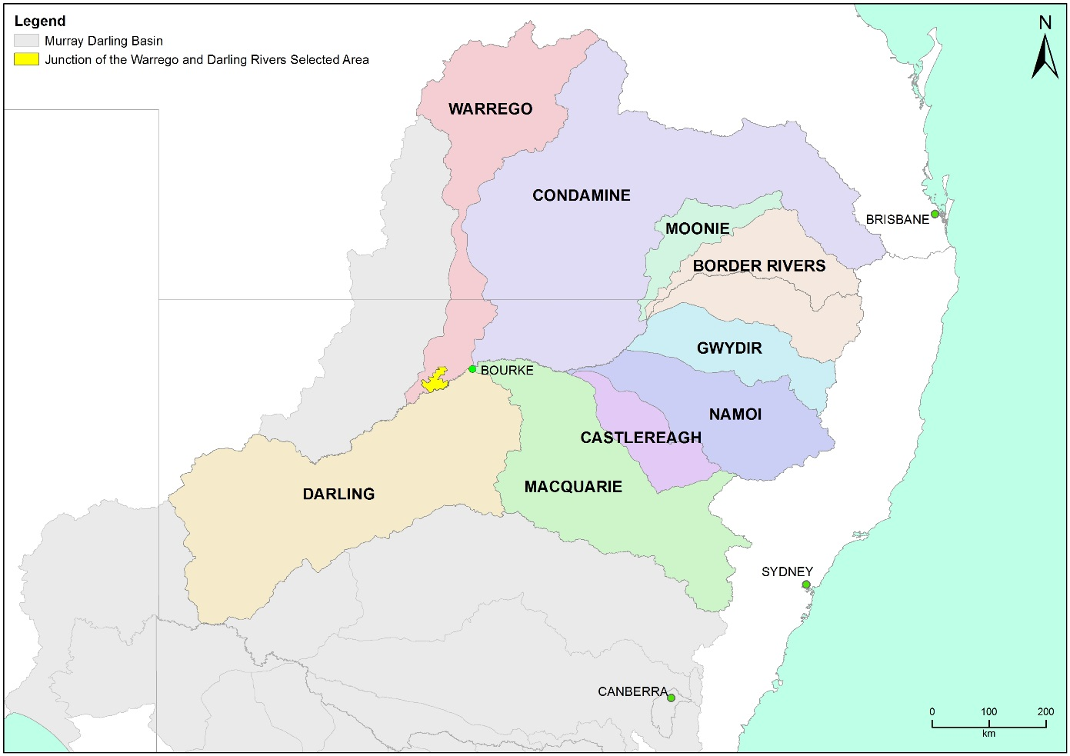

Figure ‑ The location of the Junction of the Warrego and Darling rivers Selected Area within the Murray-Darling Basin showing upstream catchments.

Within the Selected Area, three monitoring zones have been defined (Table 2‑1; Figure 2‑2). These zones represent discrete regions of the Selected Area in terms of their geomorphology, hydrology, environmental assets, environmental watering targets and expected outcomes from Commonwealth environmental water.

Table ‑: Junction of the Warrego and Darling rivers Selected Area monitoring zones.

|  |  |  |  |
| --- | --- | --- | --- |
| Zone | Extent | Description | Potential target flow types for monitoring |
| Western Floodplain | The Western Floodplain of the lower Warrego River from Boera Dam offtake to the Darling River. | A large floodplain surface heavily dissected by small flood runners. Floodwaters inundate this floodplain from overflows at Boera Dam. | Overbank – infrastructure assisted |
| Warrego River | The lower Warrego River channel extending from the northern boundary of Toorale National Park to the junction with the Darling River, including Ross Billabong. | A single meandering channel that decreases in bankfull capacity downstream. Flows in this lower section of the Warrego River are controlled by a series of six in-channel structures, the lower of which (Peebles Dam) diverts water into Ross Billabong. | Base flows  Freshes up to 600 ML/d |
| Darling River | The Darling River from the eastern boundary of the Toorale National Park near Hells Gate to Weir 20A downstream of the western boundary of Toorale State Conservation Area. | A single meandering channel that has a bankfull height ranging 12-15 m. The bankfull channel is complex and there are a series of natural rock bars and a weir at the downstream end of the reach that influence flows along this section of the river. | Baseflows  Freshes:  1,000-5,000 ML/d  5,000-10,000 ML/d  10,000-30,000 ML/d |

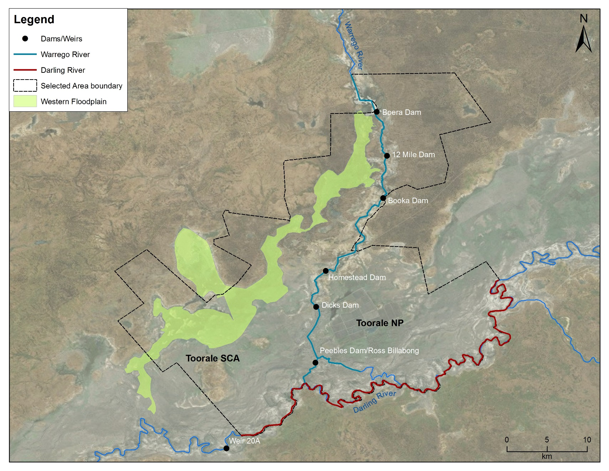

Figure ‑ Junction of the Warrego and Darling river Selected Area monitoring zones.

# Water Management

Over the last 150 years, the hydrology of the Warrego River within the Selected Area has been highly modified. Seven dams have been constructed to provide stock and domestic water supply, irrigate the Western Floodplain to improve pasture growth, and more recently to provide water storage for irrigated agriculture (Figure 2‑2). Since the establishment of Toorale NP and SCA in 2008, the condition of some dams has degraded, several becoming fully breached (Aurecon 2009). A business case with potential options for the repair of these dams has been prepared (Alluvium 2016). The characteristics and current status of these dams are outlined below (Gawne et al. 2013b):

1. Boera Dam: a large storage of approximately 3000 ML, likely to have been established since the 1870s. Water persists for around 12 months after filling without further inflows from local runoff. Management of this dam can preferentially divert water down the Western Floodplain.
2. 12 Mile Dam: less than 1,000 ML in volume, this dam has been recently breached and not reinstated.
3. Booka Dam: approximately 1,000 ML
4. Mumpher (Broken) Dam: volume unknown (Breached)
5. Keernie (Homestead) Dam: 1,500 – 2,000 ML (Breached)
6. Dicks Dam: 500 – 1,000 ML
7. Peebles Dam: a large storage just upstream of the junction of the Warrego and Darling rivers. This is the most permanent of the storages and was previously used for irrigation. The storage holds approximately 10,000 ML and is connected to Ross Billabong, an adjacent floodplain depression. At present the outlet gates are permanently opened.

These dams have been retrospectively licenced under the provision of the *Water Act 1912*. This includes separate licenced amounts for the Warrego River at 8.1 GL long term average annual yield (LTAAY), the Western Floodplain (accounted at Boera Dam) at 9.7 GL (LTAAY) and the Darling River at 8.36 GL (LTAAY). Conditions placed on these licences determine how Commonwealth environmental water can be managed within the Selected Area. This is especially true for the licences specified at Boera Dam. Before these licences can be accessed, downstream demand to the Darling River must be met during times of low flow. That is, if sustained inflows are entering Boera Dam and the Darling River flow at Louth is below 330 ML/d, then water must be let through the regulator pipes on Boera Dam and all downstream dams on the Warrego to flow to the Darling River until flows at Louth have reached 330 ML/d. Once this has been achieved, the CEWO can choose whether to continue to release water down the lower Warrego channel, therefore activating their Warrego River licence, or close the regulator gates, hold water in Boera Dam to trigger their high flow access licence and divert water to the Western Floodplain. The CEWO have developed a 5 year Water Use Strategy for Toorale to aid decision making surrounding the operation of Commonwealth environmental water at this site.

Unlike other Selected Areas, Commonwealth environmental water that flows into the Junction of the Warrego and Darling rivers Selected Area is primarily unregulated, and is thus reliant on rainfall and water management decisions in upstream tributaries. The Gwydir, Namoi and to a lesser extent Macquarie catchments are exceptions to this, whereby regulated environmental water has the potential to influence flows in the Selected Area, particularly during periods of low flow in the Barwon-Darling system. Other water management actions, such as the release of stock and domestic flows, rainfall rejection flows and embargos on upstream pumping also influence flows in the Selected Area.

Adding to the complexity of environmental water accounting and delivery in the Selected Area is the fact that the Selected Area and its upstream tributaries fall into multiple Water Planning Areas, each with their own discreet rules, licence types and accounting procedures. Thus, tracking Commonwealth environmental water between and through these areas is challenging.

Use of Commonwealth Toorale entitlements is expected to contribute to the following on-park outcomes at Toorale and/or in the Darling River downstream:

* support periods of high primary productivity triggered by unregulated flow events and carbon and nutrient cycling
* support wetland and aquatic vegetation condition and diversity
* support waterbird survival and condition and diversity
* inundate and connect in-channel habitat associated with riffles, pools, bars and anabranches to support movement and biotic dispersal
* maintain water quality and carbon/nutrient cycling processes
* provide hydrological connectivity and improve end-of-system flows

# Watering Actions in 2015-16

During 2015-16, monthly rainfall was variable compared with long-term means. Rainfall was above average during July and November in 2015, and then again in January, May and June 2016 (Figure 4‑1). However, rainfall in September 2014 and February-April 2016 were less than 2 mm per month. Mean maximum temperatures were close to the long-term mean at the start and end of the water year, and generally above average over the October-April period, with the only exception being January where temperatures were slightly lower than the long-term mean (Figure 4‑2).

Figure ‑ Monthly rainfall at Bourke Post Office for 2015-16 compared to the long term mean (Source: http://www.bom.gov.au/climate/data/index.shtml).

Figure ‑ Mean maximum temperatures for the Bourke Post Office during 2015-16 compared to the long term mean (Source: <http://www.bom.gov.au/climate/data/index.shtml>).

Four small to moderate flow events containing environmental water flowed down the Darling River during the 2015-16 water year. These occurred in July-October 2015, November 2015, January-March 2016 and June 2016. No environmental water was accounted for in the Warrego River or on the Western Floodplain in the Selected Area. However, a small flow event containing around 4% Commonwealth environmental water from the upper Warrego catchment flowed into the Selected Area during February-March 2016. While this event was too small to trigger Toorale licences, the gates at Boera Dam were opened and water flowed through the lower Warrego channel refilling waterholes and providing connection to the Darling River. Natural flows derived from localised rainfall resulted in three separate inundation events on the Western Floodplain during the 2015-16 water year.

A moderate pulse in the Darling River began in June 2016 reaching 4,818 ML/d at the Bourke Town gauge (NSW425003) by 30 June 2016, peaking at 8,542 ML/d on 7 July 2016. Flow events of this size occur less than 20% of the time. Given the reporting period for year 2 of the LTIM project is the 2015-16 water year, the flow level at 30 June 2016 was considered as the maximum flow level for the associated analysis. Analysis for the full flow event will be undertaken in the 2016-17 annual report.

# What did Commonwealth environmental water do in 2015-16?

## Expected Outcomes

The Selected Area falls within the Northern Unregulated Rivers region where the majority of Commonwealth environmental water holdings provide access to unregulated flows. The CEWO have defined a number of watering options and expected outcomes from the use of Commonwealth environmental water in the Northern Unregulated Rivers (Table 5‑1). For 2015-16, these priorities remained the same as those set in 2014-15 (Table 5‑1). These expected outcomes are linked to both longer-term and broader objectives set out in the Murray-Darling Basin Plan. The evaluation of Commonwealth environmental water and its management in the Selected Area during 2015-16 is structured around these broader objectives.

Table ‑: Expected outcomes from the 2014-15 and 2015-16 Commonwealth environmental water (CEWO 2014).

| Flow Type | Expected outcomes for 2014–15 and 2015-16 | Contributions to longer term objectives | Contribution to the following Basin Plan objective | Where these outcomes achieved in 2015-16? |
| --- | --- | --- | --- | --- |
| Base flows and freshes | Individual survival and condition (individual refuges and ecosystem resistance) | Ecosystem resilience | Resilience | Yes. Commonwealth environmental water contributed to the maintenance of water quality in the Darling River and the reconnection of isolated pools in the Warrego River. |
| Freshes | Salinity  Dissolved oxygen  pH  Dissolved organic carbon | Chemical | Water quality | Yes, Commonwealth environmental water contributed to the maintenance of water quality variables within acceptable limits for biota. Also contributed to the dispersion of an outbreak of the floating weed azolla. |
| Freshes and bankfull | Nutrient and carbon cycling | Process | Ecosystem function | Yes, Commonwealth environmental water contributed to the connection of in channel bench and anabranch habitats allowing for the exchange of organic matter and nutrients |
| Freshes, bankfull and overbank | Fish reproduction  Fish condition | Fish diversity | Biodiversity | Yes. Commonwealth environmental water contributed to a connection event in the Warrego River which stimulated the breeding and recruitment of native fish. |
| Bankfull and overbank | Vegetation reproduction  Vegetation condition | Vegetation diversity | Biodiversity | Minor. Commonwealth environmental water had limited influence on floodplain inundation. |
| Bankfull and overbank | Waterbird survival and condition | Waterbird diversity and population condition | Yes. Commonwealth environmental water contributed to the reconnection of isolated pools in the Warrego River maintaining habitat. |
| Waterbird chicks  Waterbird fledglings | Waterbird diversity | Minor. Limited bird breeding observed during 2015-16 |
| All flow types | Hydrological connectivity including end of system flows | Connectivity | Ecosystem function | Yes. Commonwealth environmental water contributed to connectivity through both the Darling and Warrego River zones in 2015-16, allowing for the movement of biota and the stimulation of primary production. |
|  | Biotic dispersal and movement |  |  |
|  | Primary productivity (of aquatic ecosystems) | Process |  |

## Darling River Flows and Ecosystem Function

The 2015-16 water year was characterised by dry conditions within the Northern Tributaries. Water flowed through the Darling River zone of the Selected Area for 61% of the time during 2015-16, providing full connectivity through this zone. Water was confined to the 20A weir pool for the remainder of the water year (Appendix A). Four instream flow events sufficient to trigger Commonwealth environmental water take occurred during July-October 2015, November 2015, January-March 2016 and June 2016 (Figure 5‑1; Appendix B). The first three events provided approximately 56,000 ML, 12,600 ML and 22,100 ML of water, respectively, at Louth, downstream of the Selected Area. It is estimated that during each event Commonwealth environmental water made up around 5%, 4% and 30% of these flows respectively, and enhanced longitudinal connection through the Selected Area. These results are similar to those observed during the 2014-15 water year (Commonwealth of Australia 2015; Figure 5‑2). A full analysis of the proportion of Commonwealth environmental water influencing the Selected Area during the June 2016 flow will be undertaken in the 2016-17 evaluation report.

These flows also provided connection to instream habitats within the channel of the Darling River   
(Figure 5‑3; Appendix D). An assessment of the connection to snags was undertaken and this showed that around 973 (26%) of the 3,735 snags mapped by DPI fisheries in the Selected Area would have been inundated for around 222 days during 2015-16. The moderate flow event that reached 4,468 ML/d at Bourke on 30 June 2016 would have inundated up to 1,568 (42%) snags in the reach, allowing access to these habitats for aquatic species. This event would have also inundated 26% of the total number of in-channel benches along this reach, with a combined area of 19,762 m2. Nutrient releases from inundated benches were estimated by using published release rate data (Southwell 2008). These calculations estimate that 3.6 kg of dissolved organic carbon, 1.1 kg of total dissolved nitrogen and 1.2 kg of total dissolved phosphorus were released to the river system from inundated benches during this event up until 30 June 2016. The June flow event would also have connected 60% of the anabranch channels in the Darling River zone of the Selected Area. Connection of in channel habitats such as snags, benches and anabranches benefits the river by allowing for the exchange of organic material and nutrients and also providing additional habitat for aquatic animals.

Event 4

Event 3

Event 1

Event

2

Figure ‑ Mean daily flow at gauging stations on Barwon-Darling River system (1 July 2015 - 30 June 2016). Events used in the analysis of northern tributary contributions are boxed in red.

Figure ‑ Comparison of 2014-2015 and 2015-16 flow event at Louth gauge. Note 2016 Event 4 will be evaluated in 2016-17 reporting.

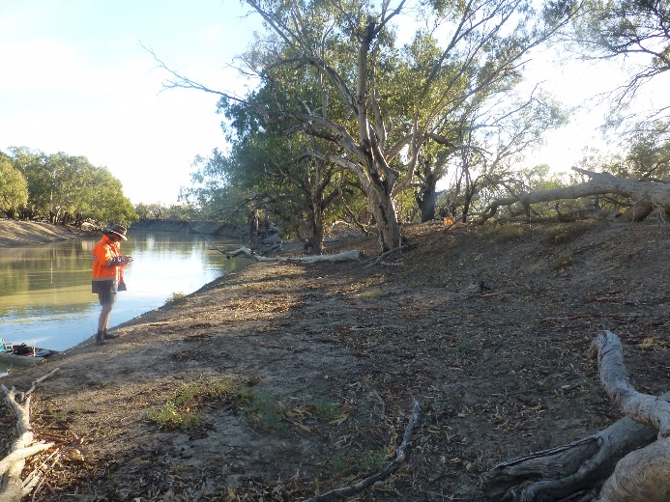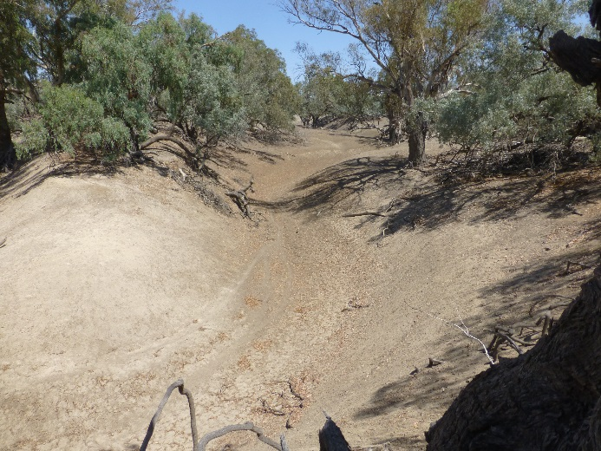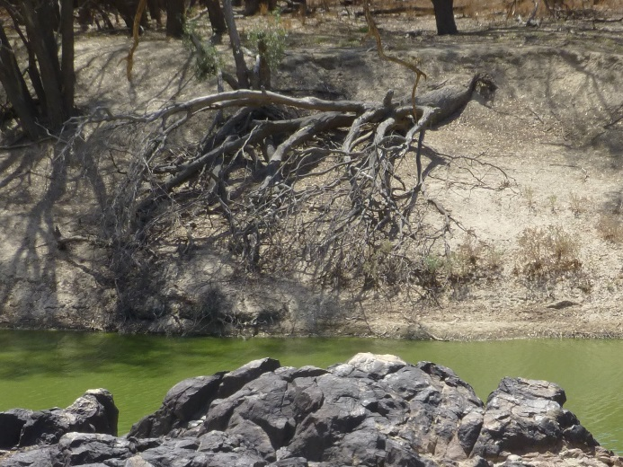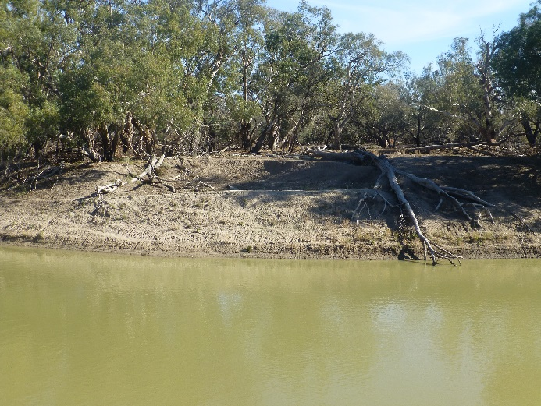

Figure ‑ In-channel habitats along the Darling River within the Selected Area. Bench (top left), anabranch channel (top right), snag (bottom left) and bench and snags (bottom right).

## Warrego River Flows and Inundation

Two significant flow events in early 2016 entered the Selected Area from the Warrego. These occurred in February and March 2016 and included approximately 315 ML of Commonwealth environmental water accounted in the upstream catchment. There were several smaller flow peaks throughout the water year driven by local rainfall runoff, which maintained water levels in Boera Dam and also provided a small fresh through the lower Warrego channel below Boera Dam in November 2015 (Figure 5‑4). Boera Dam was above the estimated overflow level of 2.26 m at 1 July 2015 and remained so until mid-August 2015. Levels in Boera Dam declined steadily from mid-August until November 2015 when significant inflows were received and the dam again overflowed to the Western Floodplain, with gauge height reaching 2.54 m. Boera Dam water levels declined steadily again until February 2016 when inflows from the Warrego River increased.

In-line with existing operating rules, the gates at Boera Dam were opened to allow flow through to the Darling River, with full connection of the lower Warrego channel occurring within 1 day. As inflows continued into the Selected Area from the Warrego River, the Boera Dam gates were opened four times between 3 February and 9 March 2016, and connection occurred in each of these events resulting in connection for a total of 16 days, with the longest period of continuous connection lasting five days   
(Figure 5‑4). Importantly, in the context of Commonwealth environmental water, no Toorale licences on the Warrego River were triggered during the 2015-16 water year.

Figure ‑ Water level at Boera and Dicks Dams and periods of longitudinal connection and overflow to Western Floodplain.

A maximum of 464 ha of the Western Floodplain was inundated from a combination of overflow from Boera Dam and rainfall during 2015-16 (Appendix E). Maximum inundation occurred in November-December 2015 following a flow peak that resulted in a gauge height of 2.54 m at Boera Dam. Lignum shrubland wetlands in the northern part of the floodplain were the most commonly inundated vegetation community, along with coolibah and river cooba communities bordering flood channels and waterholes (Figure 5‑5). The maintenance of water levels in Boera Dam above the Western Floodplain overflow level late in the water year in 2016, bodes well for prolonged inundation of some areas of the floodplain such as waterholes and connecting channels.

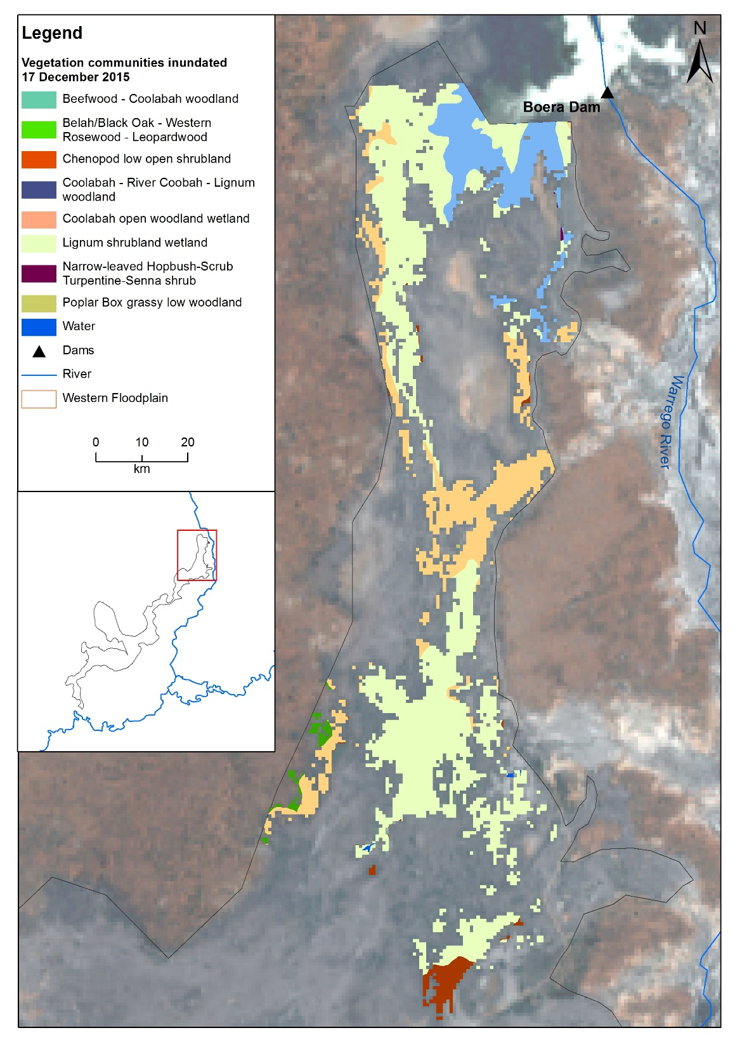

Figure ‑ Inundation of vegetation communities on the Western Floodplain based on Landsat 8 image analysis of image captured 17 December 2015 (maximum inundation captured).

## Water Quality

Water quality parameters were highly variable during the four time periods analysed in 2015-16 which covered a range of low volume discharges and contributions of Commonwealth environmental water. Many water quality parameters had their highest recorded values at approximately 500 ML/d, suggesting that this may be a key threshold for the inundation of in-channel bars that subsequently affect water quality in the Darling River under relatively low flow conditions. Similarly, elevated conductivity was recorded under the highest reported flows in the 2015-16 water year rather than during the very low flow conditions (flow period 3) suggesting the transport of increased dissolved ions and salts along the Darling River with increased flows. In contrast, the increase in discharge reduced turbidity and conductivity but increased dissolved oxygen and chlorophyll *a* (algae) concentrations through increased light availability in the water. An outbreak of the floating aquatic weed Azolla completely covered the water surface of the Darling River channel in spring yet water quality parameters remained similar throughout this period and when compared with periods where Azolla was absent. This highlights the benefit of smaller magnitude flows (highest discharge of 971 ML/d), that contain Commonwealth environmental water, in preventing potential water quality problems and ecological consequence such as hypoxia linked to an Azolla outbreak.

## Biodiversity

During the 2015-16 water year, Commonwealth environmental water influenced sites within the Warrego and Darling River zones representing two of the nine ecosystem types monitored in the project; permanent lowland streams and temporary lakes as defined by the Australian National Aquatic Ecosystem (ANAE) Classification Framework (Brooks et al. 2013; Figure 5‑6; Appendix J). Commonwealth environmental water did not contribute to inundation of ecosystem types on the Western Floodplain. However, some ecosystem types such as floodplain lake, lignum shrubland floodplain and temporary lakes were inundated by Warrego River water and rainfall on the Western Floodplain when the Boera Dam gates were closed.

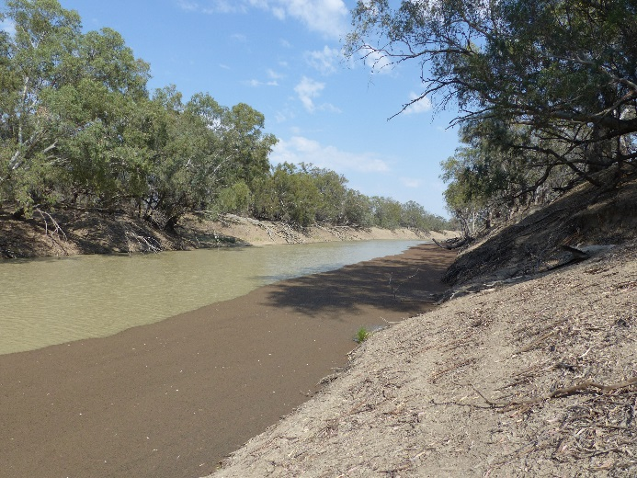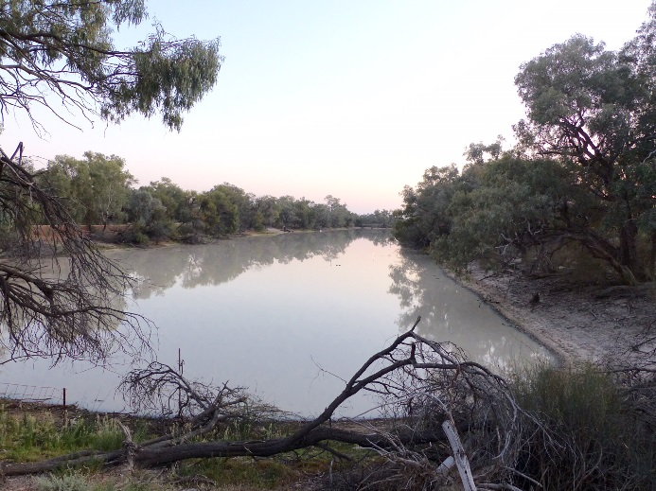

Figure ‑ Examples of ecosystem types sampled in the Selected Area during the 2015-16 water year. Permanent lowland stream at the Darling pumps site (left) and the temporary lakes ecosystem type at Booka Dam (right).

Flows containing a small proportion of Commonwealth environmental water (~4%) that were released from Boera Dam down the Warrego River in February/March 2016 provided longitudinal connectivity down this reach and had positive effects on aquatic invertebrate communities and fish.

Microinvertebrate community composition in the Warrego channel sites differed between sampling periods associated with an increase in phosphorus concentrations and productivity following the connection event (Appendix H). It appears that connectivity of the Warrego channel contributed to the development and succession of different microinvertebrate communities between channel sites, even without the inundation of the Western Floodplain, as was observed in year 1 of the project. Similar temporal patterns were not observed in the Darling River zone, with microinvertebrate community composition being similar in the two Darling River sites irrespective of flow condition. However, differences were noted in communities living in the water column between the Warrego and Darling sites, suggesting they each contribute to the diversity of microinvertebrate communities within the Selected Area.

Clear differences were found in macroinvertebrate communities between the Warrego and Darling River zones, with Warrego River communities having higher density and diversity than Darling River communities (Appendix I). The macroinvertebrate community found in the Western Floodplain site in October 2015 had the highest diversity of any site, illustrating the highly productive nature of the Western Floodplain. While the density of macroinvertebrates was lower following the connection event in the Warrego River, species richness increased. Maintaining invertebrate diversity is important not just for ensuring resilient invertebrate communities but also because they form important food resources for larger animals such as fish, frogs and birds.

A total of nine species of fish were caught in the waterholes of the Warrego River in 2015-16. These included six species of native fish and three exotic species (Figure 5‑7). During the October 2015 survey, spangled perch (*Leiopotherapon unicolor*) was the most abundant species caught, followed by Hyrtl’s tandan (*Neosilurus hyrtlii*) and golden perch (*Macquaria ambigua*). In March 2016, bony herring (*Nematolosa erebi*) dominated the catch. All three exotic species (common carp (*Cyprinus carpio*), goldfish (*Carassius auratus*) and mosquitofish (*Gambusia holbrooki*)) were only caught in relatively low numbers in both samples. In addition, only low numbers of recruits were captured among all three exotic species, including common carp. This is despite the increase in flow and connection with the floodplain between samples which are the known preferred conditions and habitat for successful spawning and recruitment in common carp. Overall fish numbers were significantly higher in March 2016, with length-frequency data of the more abundant large-bodied native fish species suggesting that breeding and recruitment occurred between the two sampling events. In Sample 1, small numbers of young-of-year were caught among all the large-bodied species sampled except golden perch, whilst in Sample 2 young-of-year of all four species were caught, particularly golden perch, spangled perch and bony herring. Given that increases in flow are thought to be one of the primary cues to stimulate spawning in golden and spangled perch, it is likely that the flow event that occurred between the two sampling rounds provided the appropriate conditions to stimulate breeding for these species in the lower Warrego.

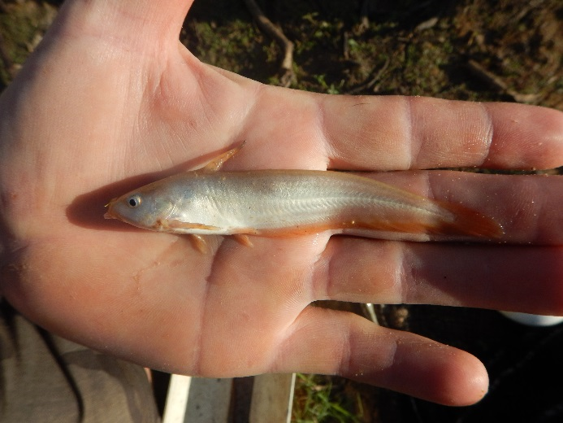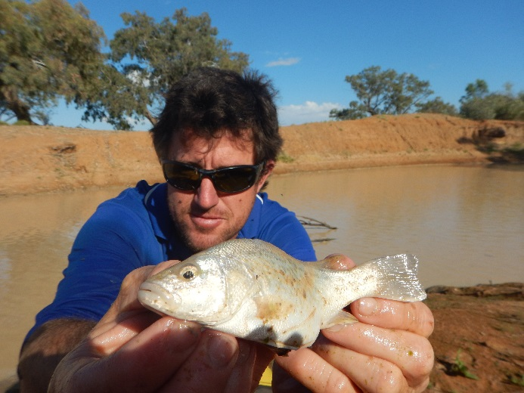

Figure ‑ Fish species caught in the 2015-16 year. Hyrtl's catfish (left) and spangled perch (right).

A total of eight frog species were recorded within the Selected Area during the 2015-16 monitoring period; including five species in October 2015 and six species in March 2016 (Figure 5‑8; Appendix M). No frog species recorded are listed as threatened under the NSW TSC Act or the Commonwealth EPBC Act. Results from frog monitoring in the 2015-16 water year confirm previous findings, showing that the Western Floodplain, when wet, supports abundant and diverse frog populations. This is likely the result of higher vegetative cover in the Western Floodplain providing higher quality habitat. The increases in frog abundance seen on the Western Floodplain during or shortly after inundation indicates the value of temporary habitat for frog populations at the regional scale. Whilst the permanently wet waterhole sites support stable frog populations, the inundation of the floodplain attracts large numbers of frogs and stimulates breeding behaviour, maintaining the resilience of the frog community in the Selected Area.

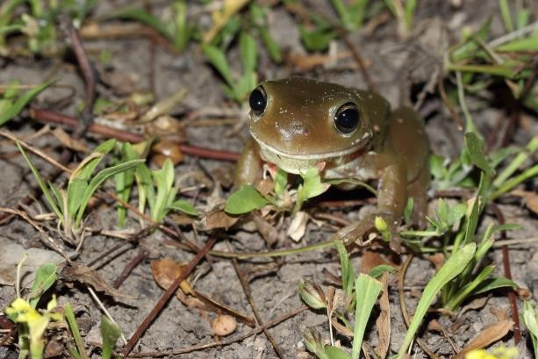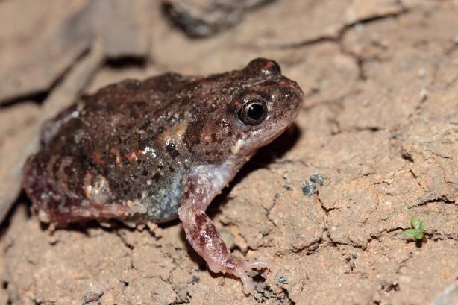

Figure ‑ Frog species surveyed in 2015-16. Green tree frog at Boera Dam (left) and wrinkled toadlet at Booka Dam on the Warrego River (right).

In total, 87 bird species were observed in the 2015-16 surveys in the Warrego River and Western Floodplain zones, of which 34 species were waterbirds (Figure 5‑9; Appendix N). This included three waterbird species listed under one or more international agreements: wood sandpiper (*Tringa glareola*) (JAMBA, CAMBA, ROKAMBA); common sandpiper (*Actitis hypoleucos*) (CAMBA and JAMBA); and eastern great egret (*Ardea modesta*) (JAMBA). Waterbird numbers and diversity on the Western Floodplain were significantly lower than in the Warrego River sites. Boera Dam continued to be an important site with highest species richness and abundance of waterbirds occurring here. Temporal patterns in waterbird functional group dominance appeared to follow patterns in available resources. The abundance of dabbling and filter-feeding ducks, which feed on invertebrates and zooplankton was lower in the March 2016 survey period and this corresponded with lower macroinvertebrate abundances observed at this time (Appendix I). Similarly, piscivores may have benefitted from the increased number of small fish observed in the March 2016 survey period (Appendix L).

Seven of the nine vegetation communities present on the Western Floodplain were inundated during 2015-16 (Appendix E). This included 273.3 ha of lignum shrubland, 94.5 ha of coolibah open woodland, 60.2 ha of coolibah - river cooba - lignum woodland and 16 ha of chenopod low open shrubland. While relatively large areas of the northern section of the floodplain were inundated, results from the vegetation surveys suggested that seasonality was having a larger influence on patterns of vegetation richness (species number) and cover than inundation. Only a relatively small number of vegetation diversity plots were inundated during the 2015-16 year, restricting our ability to assess the influence of inundation on vegetation patterns. Vegetation richness in August 2015 was the highest recorded during the four survey times to date. This is likely the result of increased rainfall across the site in the preceding months stimulating the growth of fast growing forb species. Multivariate analysis suggested that vegetation community composition was different at sites that had been inundated, particularly in inundated lignum *(Meuhlenbeckia florulenta)* sites which contained forb species such as common nardoo (*Marsilea drummondii*) and river mint (*Mentha australis*), which tend to respond quickly to the moist conditions.

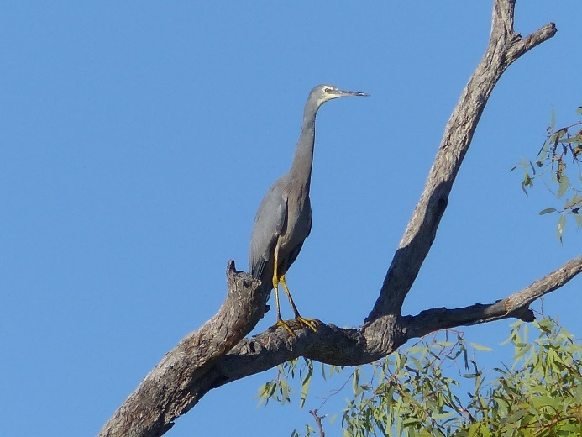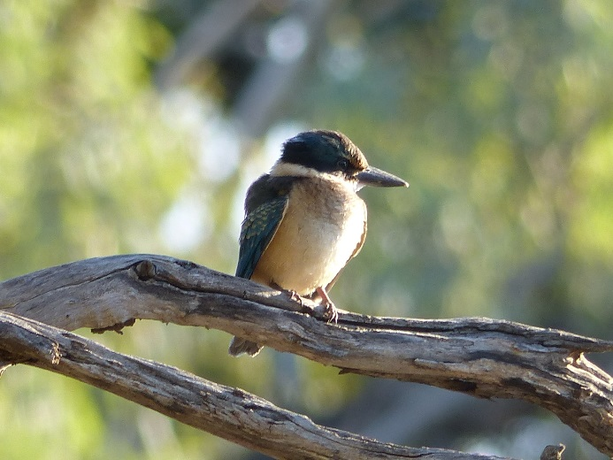

Figure ‑ White-faced heron (left) and sacred kingfisher (right) observed at Booka Dam during the March 2016 waterbird survey.

## Resilience

Outcomes with respect to resilience were centred on the survival and condition of individuals by providing individual refuges and improving ecosystem resistance. These aspects of the ecology were not directly measured in the project. However, some inferences can be made as to the contribution of Commonwealth environmental water and its management to the resilience of the Selected Area in 2015-16. While the contribution of Commonwealth environmental water to the total flows within the Selected Area were relatively small in 2015-16, the four flow pulses in the Darling River containing a degree of Commonwealth environmental water maintained water quality within the levels acceptable to aquatic biota. Similarly in the Warrego River, flows released from Boera Dam reconnected previously isolated refuge pools and stimulated breeding and recruitment of some fish species. These refuge pools provide important long-term habitat for a range of organisms, including fish, frogs and waterbirds.

While no Commonwealth environmental water flowed onto the Western Floodplain in 2015-16, vegetation communities responded positively to above average rainfall during the year. Vegetation cover and species richness increased primarily through relatively fast growing forbs species. Notwithstanding this, for much of the Western Floodplain, it has been over four years since it experienced substantial flooding, being last inundated in 2012. This is at the upper end of the range of watering requirements for many of the species on the floodplain to maintain good condition (lignum 1 in 1-3 years, river cooba 1 in 3-5 years; Cassanova, 2015). Some degree of stress was evident on plants that had not been inundated in the last four years on the Western Floodplain during 2015-16, especially lignum. Above average rainfall in May and June 2016 is an encouraging sign for the upcoming water year.

## Summary

Commonwealth environmental water increased the connectivity of the Warrego and Darling River zones during the 2015-16 water year. Unlike the previous year, Commonwealth environmental water or its management did not influence flows onto the Western Floodplain. In the Darling River, unregulated entitlements in the upstream catchments contributed to flows through the Selected Area during four defined flow events. The proportion of Commonwealth environmental water in these events ranged from 3.4 - 30%. These flow pulses provided access to in-channel habitats, inundating 42% or 1,568 individual snags along the reach, 26% of in-channel benches and 60% of anabranch channels. Connection of these features provides additional habitat for biota, and allows for the exchange of organic matter and nutrients between these features and the river channel. In addition, these flows influenced water quality variables, lowering pH, conductivity and turbidity and increasing dissolved oxygen and chlorophyll *a* (algae) concentrations. Levels of primary production increased during these flow events, primarily as a result of increased light penetration linked to lower turbidity.

Rainfall in the upper Warrego catchment produced several flow events down the Warrego River into the Selected Area in February/March 2016. These contained around 4% Commonwealth environmental water from unregulated entitlements in Queensland. Gates on Boera Dam were opened in accordance with the Toorale water licence operating rules, and water flowed down the lower Warrego River to the Darling confluence for 16 days in total. This event reconnected refuge pools along the channel and stimulated some native fish species to breed and recruit. Piscivorous waterbirds appeared to take advantage of this increase in small fish, with their numbers increasing at Warrego channel sites post flow. This connectivity also contributed to the development of different microinvertebrate communities, increasing the regional diversity of these organisms and providing food for food, frogs and birds.

While no Commonwealth environmental water was accounted for on the Western Floodplain, the waterhole site surveyed contained a high abundance and richness of frog and macroinvertebrate species. This suggests the Western Floodplain is still providing high quality, temporary habitat. Floodplain vegetation responded well to above average rainfall that fell prior to the August survey, with the highest richness and vegetative cover being recorded for any survey time across the project. Inundation was shown to have less of an influence on vegetation communities in plots studied in year 2, with lignum plants in parts of the floodplain that have not been inundated since 2012 appearing to be under some stress.

# Implications for Future Management of Commonwealth environmental water

Commonwealth environmental water only constituted a small proportion of the water that flowed through the Selected Area during 2015-16. Nevertheless, this water provided ecological benefits to the site, primarily in terms of habitat and food provision for a range of water-dependent species in the Warrego and Darling River zones. In the Darling River zone, Commonwealth environmental water increased both longitudinal connectivity of flowing water along the river channel (including in-stream geomorphic habitats) and lateral connectivity between the river channel and adjacent habitat. It also helped to maintain water quality in this reach throughout the water year. While the Commonwealth has limited ability to actively manage environmental water down the Darling and Warrego River, this current LTIM project is showing that downstream benefits in the Selected Area are being achieved from entitlements held in upstream catchments.

While the Commonwealth has little influence on the timing and magnitude of flows entering the Selected Area down the Warrego River, once water enters Boera Dam, operational decisions have a large bearing on the duration and extent of flows to the Western Floodplain, lower Warrego River downstream of Boera Dam and the Darling River downstream of the junction. Flows released down the Warrego channel below Boera Dam in February and March 2015 provided connectivity within the Warrego River zone to the Darling River as well as increased the duration of inundation within the dams and waterholes in this zone. These dams and waterholes provided stable, relatively long term habitat and refuge for a diverse range of species. These flows were also shown to stimulate fish breeding and recruitment of a number of native fish species.

Sampling for aquatic animals was limited on the Western Floodplain in 2015-16 due to the drier conditions experienced during sampling compared to year 1 of the project. Even so, the Western Floodplain was still shown to provide good quality temporary habitat for invertebrates and frogs, with high richness and abundance of these animals in floodplain habitats. Given that vast areas of the middle and lower sections of the Western Floodplain have not been inundated since 2012, we would suggest that the Western Floodplain be prioritised in the Commonwealths water management decisions in the short-term. Above average rainfall in May and June 2016, and good flows in the Warrego River catchment is an encouraging sign for increased floodplain inundation in the upcoming water year.

# References

Alluvium 2016. Toorale Environmental Water Delivery Business Case –Report for the NSW Office of Environment and Heritage.

Aurecon. 2009. *Toorale Station Decommissioning Plan Volume 1*. Prepared for the Department of Environment, Water, Heritage and Arts.

Brooks, S., Cottingham, P., Butcher, R., & Hale, J. 2013. *Murray-Darling Basin aquatic ecosystem classification: Stage 2 report*. Peter Cottingham & Associates report to the Commonwealth Environmental Water Office and Murray-Darling Basin Authority, Canberra.

Cassanova, M.T. 2015. *Review of Water Requirements for Key Floodplain Vegetation for the Northern Basin: Literature review and expert knowledge assessment*. Report to the Murray Darling Basin Authority, Canberra

Commonwealth Environmental Water Office (CEWO). 2014. *Commonwealth environmental water use options 2014-15: Northern Unregulated Rivers.* Commonwealth Environmental Water Holder for the Australian Government, Canberra.

Commonwealth of Australia. 2015. *Commonwealth Water Office Long Term Intervention Monitoring Project Junction of the Warrego and Darling rivers Selected Area – 2014-15 Evaluation Report.* Commonwealth of Australia, Canberra.

Southwell, M.R. 2008. *Floodplains as Dynamic mosaics: Sediment and nutrient patches in a large lowland riverine landscape.* PhD Thesis, University of Canberra, Australia