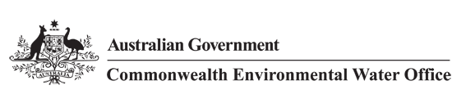



**Commonwealth Environmental Water Office**

**Long Term Intervention Monitoring Project**

**JUNCTION OF THE WARREGO AND DARLING RIVERS SELECTED AREA**

2014-15 Evaluation Report, 1 December 2015

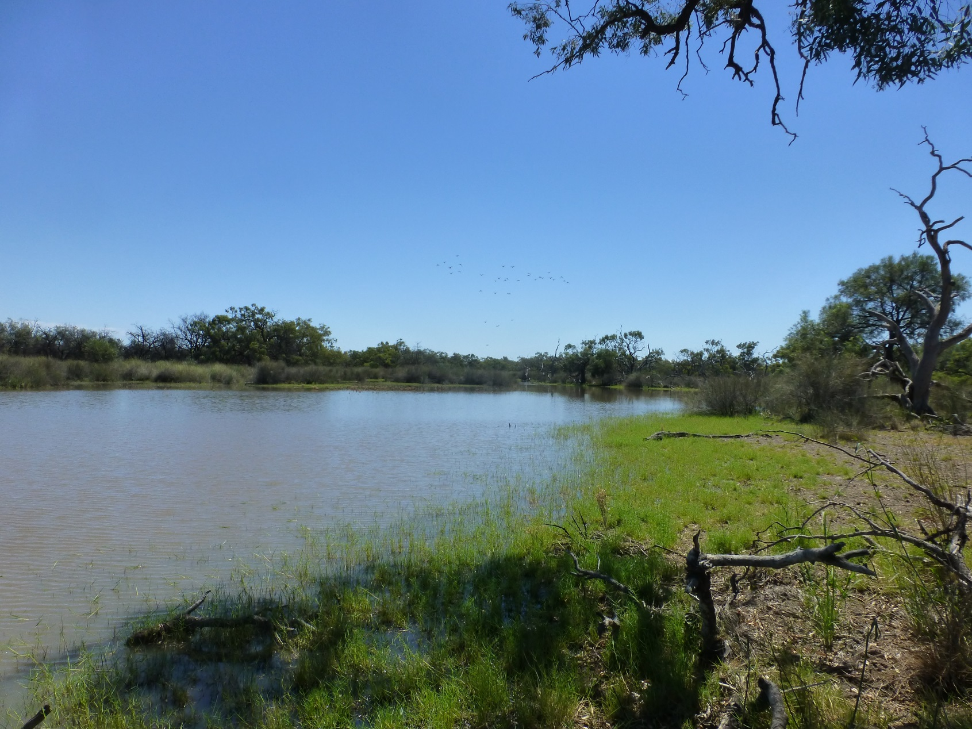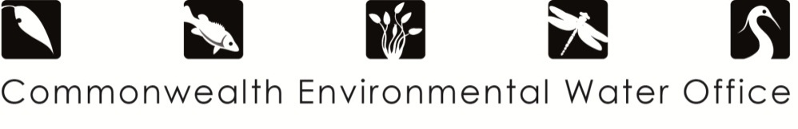



This monitoring project was commissioned and funded by Commonwealth Environmental Water Office.

**Copyright**

© Copyright Commonwealth of Australia, 2015



Commonwealth Environmental Water Office Long Term Intervention Monitoring Project Gwydir River System Selected Area is licensed by the Commonwealth of Australia for use under a Creative Commons By Attribution 3.0 Australia licence with the exception of the Coat of Arms of the Commonwealth of Australia, the logo of the agency responsible for publishing the report, content supplied by third parties, and any images depicting people. For licence conditions see: <http://creativecommons.org/licenses/by/3.0/au/>

This report should be attributed as ‘Commonwealth Environmental Water Office Long Term Intervention Monitoring Project junction of the Warrego and Darling rivers Selected Area; Annual Evaluation Report – Year 1, Commonwealth of Australia 2014’.

**Disclaimer**

The views and opinions expressed in this publication are those of the authors and do not necessarily reflect those of the Australian Government or the Minister for the Environment.

While reasonable efforts have been made to ensure that the contents of this publication are factually correct, the Commonwealth does not accept responsibility for the accuracy or completeness of the contents, and shall not be liable for any loss or damage that may be occasioned directly or indirectly through the use of, or reliance on, the contents of this publication.

**DOCUMENT TRACKING**

|  |  |
| --- | --- |
| Item | Detail |
| Project Name | Long Term Intervention Monitoring Project – Junction of the Warrego and Darling rivers System Selected Area |
| Project Number | 1115 |
| Project Manager | Mark Southwell  (02) 8081 2688  92 Taylor Street, Armidale NSW 2350 |
| Prepared by | Dr Mark Southwell, Assoc. Prof Darren Ryder, Dr Paul Frazier, Emily Southwell, Linden Burch, Ben Martin |
| Reviewed by | Dr Mark Southwell, Assoc. Prof Darren Ryder |
| Approved by | Dr Paul Frazier |
| Status | FINAL |
| Version Number | 2 |
| Last saved on | 1 December 2015 |
| Cover photo | Waterhole on the Warrego Western Floodplain within the Selected Area. Photo: M. Southwell |

Acknowledgements

This document has been prepared by Eco Logical Australia Pty Ltd with support from Associate Professor Darren Ryder from the University of New England, Dr Gavin Butler from the DPI fisheries, and staff from the NSW Office of Environment and Heritage and DPI Water. The project team would like to thank the NPWS staff at Toorale National Park and State Conservation Area for their assistance and cooperation.

|  |
| --- |
| **Disclaimer** *This document may only be used for the purpose for which it was commissioned and in accordance with the contract between Eco Logical Australia Pty Ltd and the Department of the Environment. The scope of services was defined in consultation with the Department of the Environment, by time and budgetary constraints imposed by the client, and the availability of reports and other data on the subject area. Changes to available information, legislation and schedules are made on an ongoing basis and readers should obtain up to date information.*  *Eco Logical Australia Pty Ltd accepts no liability or responsibility whatsoever for or in respect of any use of or reliance upon this report and its supporting material by any third party. Information provided is not intended to be a substitute for site specific assessment or legal advice in relation to any matter. Unauthorised use of this report in any form is prohibited.* |

Template 08/05/2014

**Document control**

|  |  |  |  |
| --- | --- | --- | --- |
| Version | Date | Reviewed by | Approved by |
| 1 | 28 August 2015 | Dr Mark Southwell, Assoc. Prof Darren Ryder | Dr Paul Frazier |
| 2 | 5 November 2015 | Dr Mark Southwell, Assoc. Prof Darren Ryder | Dr Paul Frazier |

|  |  |
| --- | --- |
| Item | Details |
| ELA Project Number | 1115 |
| Project Director/s | Dr Paul Frazier, Assoc. Prof Darren Ryder |
| Project Manager | Dr Mark Southwell |
| Prepared by | Dr Paul Frazier, Assoc. Prof Darren Ryder, Dr Mark Southwell, Emily Southwell, Linden Burch, Ben Martin |

Contents

Executive Summary viii

1 Introduction 1

2 Junction of the Warrego and Darling rivers Selected Area 2

3 Water management 5

4 Watering actions in 2014-15 6

5 What did Commonwealth Environmental Water do in 2014-15? 8

6 Implications for future management of Commonwealth environmental water 19

7 References 20

**Appendix A – Decision tree for considering use of Toorale Warrego Commonwealth environmental water**

**Appendix B – Ecosystem Type**

**Appendix C – Hydrology (River)**

**Appendix D – Hydrology (Northern Tributaries)**

**Appendix E – Hydrology (Floodplain)**

**Appendix F – Hydrology (Channel)**

**Appendix G – Hydrology (Habitat)**

**Appendix H – Water Quality**

**Appendix I – Vegetation Diversity**

**Appendix J – Microinvertebrates**

**Appendix K – Waterbird diversity**

**Appendix L – Frogs**

List of Figures

Figure 2‑1: The location of the Selected Area within the Murray-Darling Basin showing upstream catchments. 2

Figure 2‑2: Junction of the Warrego and Darling rivers Selected Area monitoring zones. Broader location of Selected Area provided in figure 2-1. 4

Figure 4‑1: Monthly rainfall at Bourke Post Office for 2014-15 compared to the long term mean (Source: http://www.bom.gov.au/climate/data/index.shtml). 6

Figure 4‑2: Mean maximum temperatures for the Bourke Post Office during 2014-15 compared to the long term mean (Source: http://www.bom.gov.au/climate/data/index.shtml). 7

Figure 5‑1 Mean daily discharge at gauging stations on Barwon Darling River system (1 July 2014–30 June 2015). Events used in the analysis of northern tributary contributions are boxed in red. 10

Figure 5‑2 Commonwealth environmental water flow volumes at Barwon-Darling gauging stations during unregulated flow event 1 (December – March) and 2 (April – June) during 2014–15. 10

Figure 5‑3 Commence to flow discharges for benches (left) and anabranch channels (right) along the Darling River within the Selected Area. Discharge relevant to the Bourke Town gauge. 11

Figure 5‑4 Water levels experienced at Boera Dam and water level logger on the Western Floodplain. Green line represents overflow level of the Western Floodplain. 11

Figure 5‑5 Water flowing through the western bywash and onto the Western Floodplain in February 2015. 12

Figure 5‑6 Inundation extent modelled from the DEM for various water levels measured at Boera Dam. 13

Figure 5‑7 Lignum shrubland floodplain (left) and temporary lake (right) ecosystem types flooded by Commonwealth environmental water management in 2014-15 within the Selected Area 14

Figure 5‑8 Microinvertebrates sampled in the Selected Area. Copepods (left) <1mm in length dominated the water column samples while Seed shrimps (Ostracod; right) <2 mm in length dominated benthic samples. 15

Figure 5‑9 New Holland Frog (*Cyclorana novaehollandise*; left) and Sudell’s Frog (*Neobatrachus Sudellae*; right) recorded in the Frog surveys during 2014-15. 16

Figure 5‑10 White-necked heron (*Ardea pacifica*: left) and Brolga (*Grus rubicunda*: right) observed within the Selected Area during 2014-15. 17

List of Tables

Table 2‑1: Junction of the Warrego and Darling rivers Selected Area monitoring zones. 3

Table 3‑1: Expected outcomes from the 2014-15 Commonwealth environmental water (CEWO 2014). Outcomes relevant to the Selected Area are shaded blue. 8

Abbreviations

|  |  |
| --- | --- |
| Abbreviation | Description |
| ASL | Above Sea Level |
| BoM | Bureau of Meteorology |
| CAMBA | China-Australia Migratory Bird Agreement |
| CEWO | Commonwealth Environmental Water Office |
| ELA | Eco Logical Australia Pty Ltd |
| HSE | Health, Safety and Environment |
| JAMBA | Japan-Australia Migratory Bird Agreement |
| LTIM Project | Long-Term Intervention Monitoring Project |
| M&E Adviser | Monitoring and Evaluation Adviser |
| M&E Plan | Monitoring and Evaluation Plan |
| M&E Provider | Monitoring and Evaluation Provider |
| M&E Requirements | Monitoring and Evaluation Requirements |
| MDB | Murray-Darling Basin |
| MDBA | Murray-Darling Basin Authority |
| MDFRC | Murray-Darling Freshwater Research Centre |
| MDMS | Monitoring Data Management System |
| DPI Water | NSW Department of Primary Industries Water |
| NSW OEH | (NSW) Office of Environment and Heritage |
| QA/QC | Quality Assurance / Quality Control |
| The Department | Department of the Environment (Commonwealth) |
| UNE | University of New England |

*Blank page*

# Executive Summary

**Contributions of Commonwealth environmental water in 2014-15**

***Darling River zone***

* Commonwealth environmental water contributed to river flows in the Darling River, ensuring periods of connected flow through to Louth.
* These river flows increased access to river channel habitat and promoted nutrient cycling to stimulate food webs within the Darling River.

***Western Floodplain zone***

* Floodplain inundation as a result of Commonwealth environmental water management decisions inundated key floodplain vegetation communities and waterholes. Water persisted on the floodplain for over 8 months.
* Floodplain waterholes supported a diverse and unique range of water bugs, frogs and waterbirds.
* Animal communities on the floodplain were more diverse and abundant than those found in the Warrego or Darling Rivers.

The Junction of the Warrego and Darling rivers Selected Area encompasses the Toorale National Park and State Conservation Area managed by NSW Office of Environment and Heritage (OEH). Inflows of Commonwealth environmental water to the Selected Area from upstream tributaries have also been evaluated.

The Junction of the Warrego and Darling rivers Selected Area is complex in terms of its ecosystems, hydrology and the way in which Commonwealth environmental water is accounted and managed both within the Selected Area and within upstream tributaries. While most of the Commonwealth environmental water which influences the site is held as unregulated entitlements, regulated deliveries from the Gwydir, Namoi and to a lesser extent Macquarie catchments have the potential to influence flows in the Selected Area, particularly during periods of low flow in the Barwon-Darling system. Other water management actions, such as the release of stock and domestic flows, rainfall rejection flows and embargos on upstream pumping also influence flows in the Darling River through this zone.

Three events including Commonwealth environmental water influenced flows down the Darling River zone of the Selected Area during 2014-15. The first was a regulated flow event out of the Gwydir catchment, which contributed a small volume of water into the Selected Area. The second was an unregulated flow event primarily out of the Condamine-Balonne sub-catchment which occurred over Christmas 2014. This provided an in-channel flow pulse with a peak of 2,850 ML/d measured at Bourke. By the time this flow reached the Selected Area it contained around 25% Commonwealth environmental water. The third flow was another unregulated flow which originated in the Macintyre and Barwon catchments later in the 2014-15 year. Peaking at 1,800 ML/d at Bourke this flow contained around 5% Commonwealth environmental water. For the remainder of the water year, low flow conditions prevailed with water being held within the Selected Area behind weir 20A.

Upstream rainfall in the Warrego catchment also produced inflows to the Warrego River zone of the Selected Area during February/March 2015. Flows into Boera Dam were managed in such a way as to provide connection through to the Darling River and also to allow water to flow into the Western Floodplain. While no water was debited from the Western Floodplain licence, management decisions made by the Commonwealth Environmental Water Office (CEWO) resulted in the prolonged inundation of the Western Floodplain.

**Key Outcomes**

*Flows and Ecosystem functioning*

* Commonwealth environmental water increased the connectivity of the Darling River and Western Floodplain zones during the 2014-15 year.
* In-channel flow pulses including Commonwealth environmental water connected 25% of the available bench and 31% of anabranch habitats during 2014-15, providing access to refuge and breeding habitat for organisms and promoting the cycling of nutrients and organic matter that stimulate river food webs down the river channel.
* Commonwealth environmental water management resulted in 36.9 ha of the Western Floodplain becoming inundated including several key vegetation communities such as lignum shrublands and coolibah open woodlands.
* Approximately 71ML of water was held on the Western Floodplain inundating flood channels and waterholes, some of which remained as key refugial habitat for up to 8 months after wetting, assisted by rainfall towards the end of the season.

*Water Quality*

* Although the period of measurement was short, water quality parameters measured in the Darling River zone remained within the ranges expected to occur in this area and did not lead to any adverse impacts on biota.
* While nutrient levels were higher in the Warrego River zones compared to the Darling, presumably as a result of the inundation of organic matter on previously dry areas, they did not appear to be outside of the ‘normal’ range for a system such as the Warrego that would impact on aquatic biota.

*Biodiversity*

* Commonwealth environmental water and management decisions influenced six of the 10 ecosystem types monitored in the LTIM project, including lowland stream, floodplain lake, lignum shrubland floodplain and temporary lake ecosystem types.
* Inundation of the Western Floodplain as a result of Commonwealth environmental water management had a positive effect on the biodiversity of aquatic invertebrates, frogs, birds and vegetation within the Selected Area during 2014-15.
* Patterns observed in microinvertebrate communities show the benefits of inundating a mosaic of ecosystem types. Commonwealth environmental water and its management increased regional level diversity and abundance of food resources for other biota higher up the food chain.
* The increased diversity of the frog community recorded on the Western Floodplain suggests that providing water to this zone is important for maintaining regional scale frog diversity.
* A comparison of floodplain and combined channel sites indicate mean diversity and total abundance of waterbirds was higher on the Western Floodplain. The total occurrence of feeding guilds across the February and May survey periods were also higher for the Western Floodplain, highlighting the importance of additional habitat provided by waterholes on the Western Floodplain inundated as a result of Commonwealth environmental water management decisions.
* Vegetation monitoring suggested that the presence of surface water during the February survey reduced the diversity of terrestrial species that tend not to cope well with periods of inundation. The species diversity at the four inundated sites increased in the May survey after the water had receded, indicating a positive causal link of species diversity to inundation. Increased cover of forb species were observed that were able to respond more quickly to changes in moisture conditions.

*Resilience*

* Links may be drawn between increased aquatic habitat on the Western Floodplain resulting from Commonwealth environmental water management, increased productivity and basal food sources, and increased numbers and diversities of higher level consumers such as frogs and birds.

**Implications for Commonwealth environmental water management**

* The results from year 1 of the LTIM project at the Junction of the Warrego and Darling rivers Selected Area suggest that the application and management of Commonwealth environmental water had positive ecological benefits, primarily in terms of habitat and resource provision for a range of water-dependent species.
* Considering downstream connectivity when delivering targeted environmental flows in upstream catchments will maximise the broader regional benefits of this water.
* Given the ecological benefits of the additional aquatic habitat provided on the Western Floodplain for the biota monitored in year 1 of the LTIM project, considerable weight should be placed on maximising flows to the Western Floodplain through water management decisions at Boera Dam on the Warrego River. This is not to downplay the importance of dams in the Warrego channel as key refuge sites in drier times.

*Blank page*

# Introduction

This report presents the monitoring and evaluation results from the Junction of the Warrego and Darling rivers Selected Area during the 2014-15 water year. The monitoring is being undertaken as part of the Long Term Intervention Monitoring Project (LTIM Project) funded by the Commonwealth Environmental Water Office (CEWO). The LTIM Project is being implemented at seven Selected Areas over a five year period from 2014-15 to 2018-19 to deliver five high-level outcomes:

1. Evaluate the contribution of Commonwealth environmental watering to the objectives of the Murray-Darling Basin Authority’s (MDBA) Environmental Watering Plan
2. Evaluate the ecological outcomes of Commonwealth environmental watering at each of the seven Selected Areas
3. Infer ecological outcomes of Commonwealth environmental watering in areas of the Murray-Darling Basin not monitored
4. Support the adaptive management of Commonwealth environmental water
5. Monitor the ecological response to Commonwealth environmental watering at each of the seven Selected Areas

While results specific to the Junction of the Warrego and Darling rivers Selected Area are reported here, a broader Basin Scale analysis including results from all seven Selected Areas will be produced by the Murray-Darling Freshwater Research Centre (MDFRC).

The report describes the Warrego-Darling study area, watering actions undertaken in the Selected Area during 2014-15 and the ecological outcomes of the application of Commonwealth environmental water at the site during 2014-15. Detailed analysis, methods and results are presented in the Appendices referred to in the main report.

It should be noted that due to delays in contracting, the project did not commence until 18 February 2015. Therefore, monitoring undertaken for the 2014-15 year was restricted to the 5 month period between February and June 2015.

# Junction of the Warrego and Darling rivers Selected Area

The Junction of the Warrego and Darling Rivers is one of seven Selected Areas for monitoring under the LTIM Project, located around 80 km south-west of Bourke in north western NSW (Figure 2‑1). The Junction of the Warrego and Darling rivers Selected Area is contained within the boundary of the Toorale National Park (NP) and State Conservation Area (SCA) (Figure 2‑2). The Selected Area is approximately 92,000 ha in size, and receives flow from both the Darling and Warrego River systems. The Darling River catchment drains the north westerly portion of the Murray-Darling Basin and has a total catchment area of 699,500 km2. Most of its tributaries (Macquarie, Castlereagh, Namoi, Gwydir, Macintyre and Condamine-Balonne Rivers) drain from the Great Dividing Range in northern New South Wales and southern Queensland, and provide relatively high amounts of runoff to the catchment. In contrast, other catchments such as the Warrego and the Paroo Rivers to the west, drain more arid, flat catchments and only flow intermittently during periods of high rainfall in their upper catchments, usually manifesting downstream as slow moving floods of relatively long duration. Generally speaking, the Selected Area shows high climatic variability, with low annual rainfall and high evaporation.

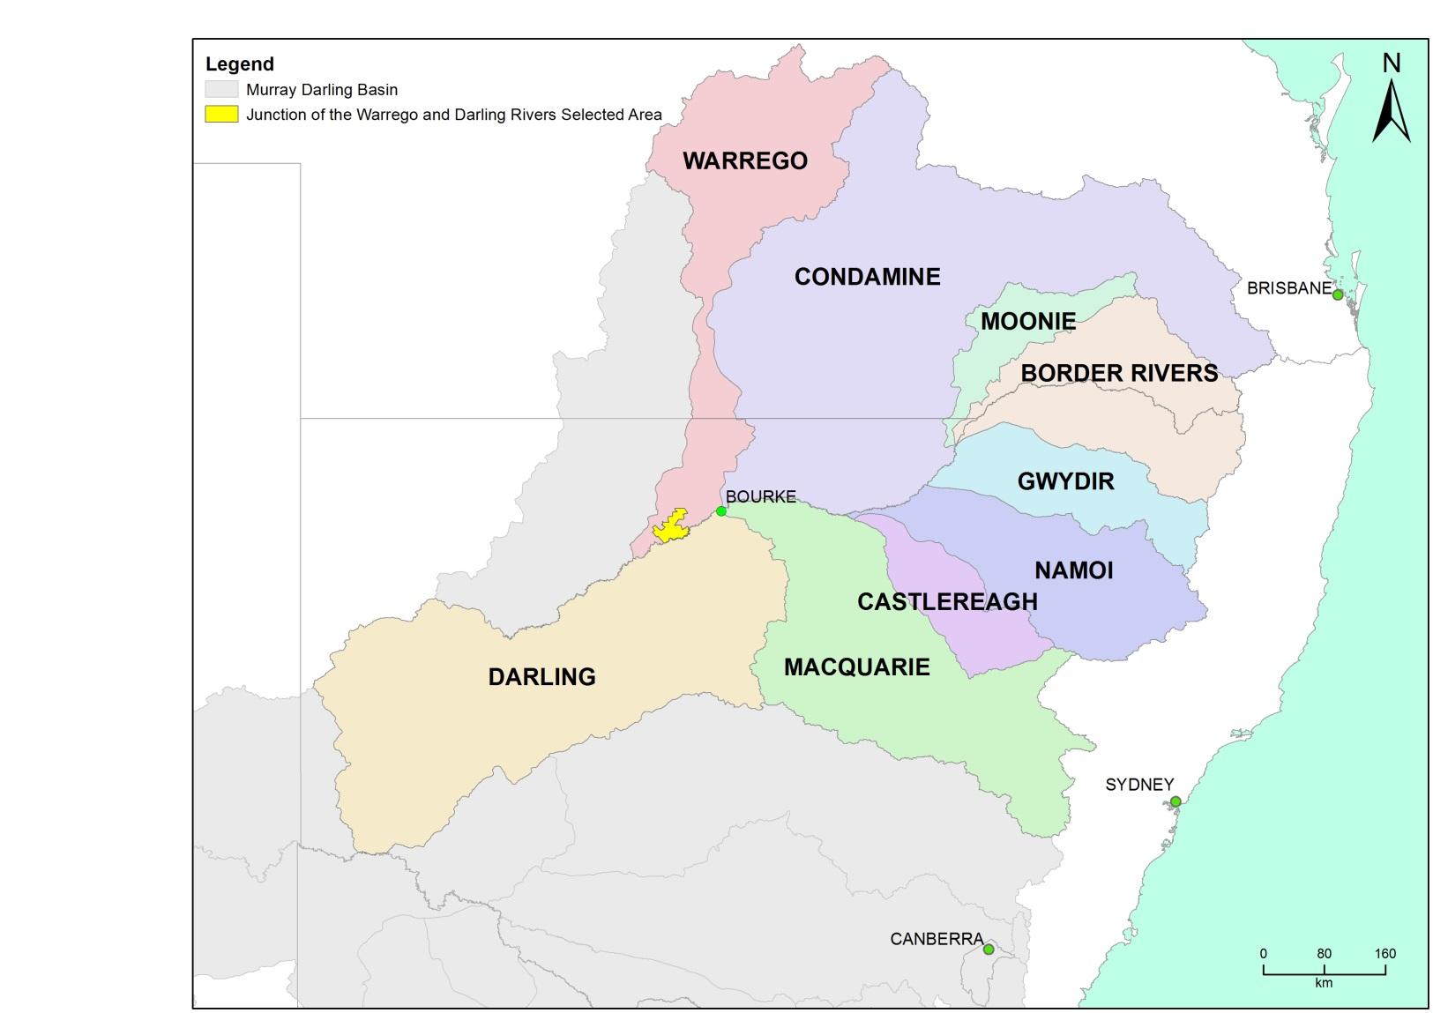

Figure 2‑1: The location of the Selected Area within the Murray-Darling Basin showing upstream catchments.

Within the Selected Area, three monitoring zones have been defined (Table 2‑1; Figure 2‑2). These zones represent discrete regions of the Selected Area in terms of their geomorphology, hydrology, environmental assets, environmental watering targets and expected outcomes from Commonwealth environmental water.

Table 2‑1: Junction of the Warrego and Darling rivers Selected Area monitoring zones.

|  |  |  |  |
| --- | --- | --- | --- |
| Zone | Extent | Description | Potential target flow types for monitoring |
| Western Floodplain | The Western Floodplain of the lower Warrego River from Boera Dam offtake to the Darling River | A large floodplain surface heavily dissected by small flood runners. Floodwaters inundate this floodplain from overflows at Boera Dam. | Overbank – infrastructure assisted |
| Warrego River | The lower Warrego River channel extending from the northern boundary of Toorale National Park to the junction with the Darling River, including Ross Billabong | A single meandering channel that decreases in bankfull capacity downstream. Flows in this lower section of the Warrego River are controlled by a series of six in-channel structures, the lower of which (Peebles Dam) diverts water into Ross Billabong. | Base flows  Freshes up to 600 ML/d |
| Darling River | The Darling River from the eastern boundary of the Toorale National Park near Hells Gate to Weir 20A downstream of the western boundary of Toorale State Conservation Area | A single meandering channel that has a bankfull height ranging 12-15 m. The bankfull channel is complex and there are a series of natural rock bars and a weir at the downstream end of the reach that influence flows along this section of the river. | Baseflows  Freshes:  1,000-5,000 ML/d  5,000-10,000 ML/d  10,000-30,000 ML/d |

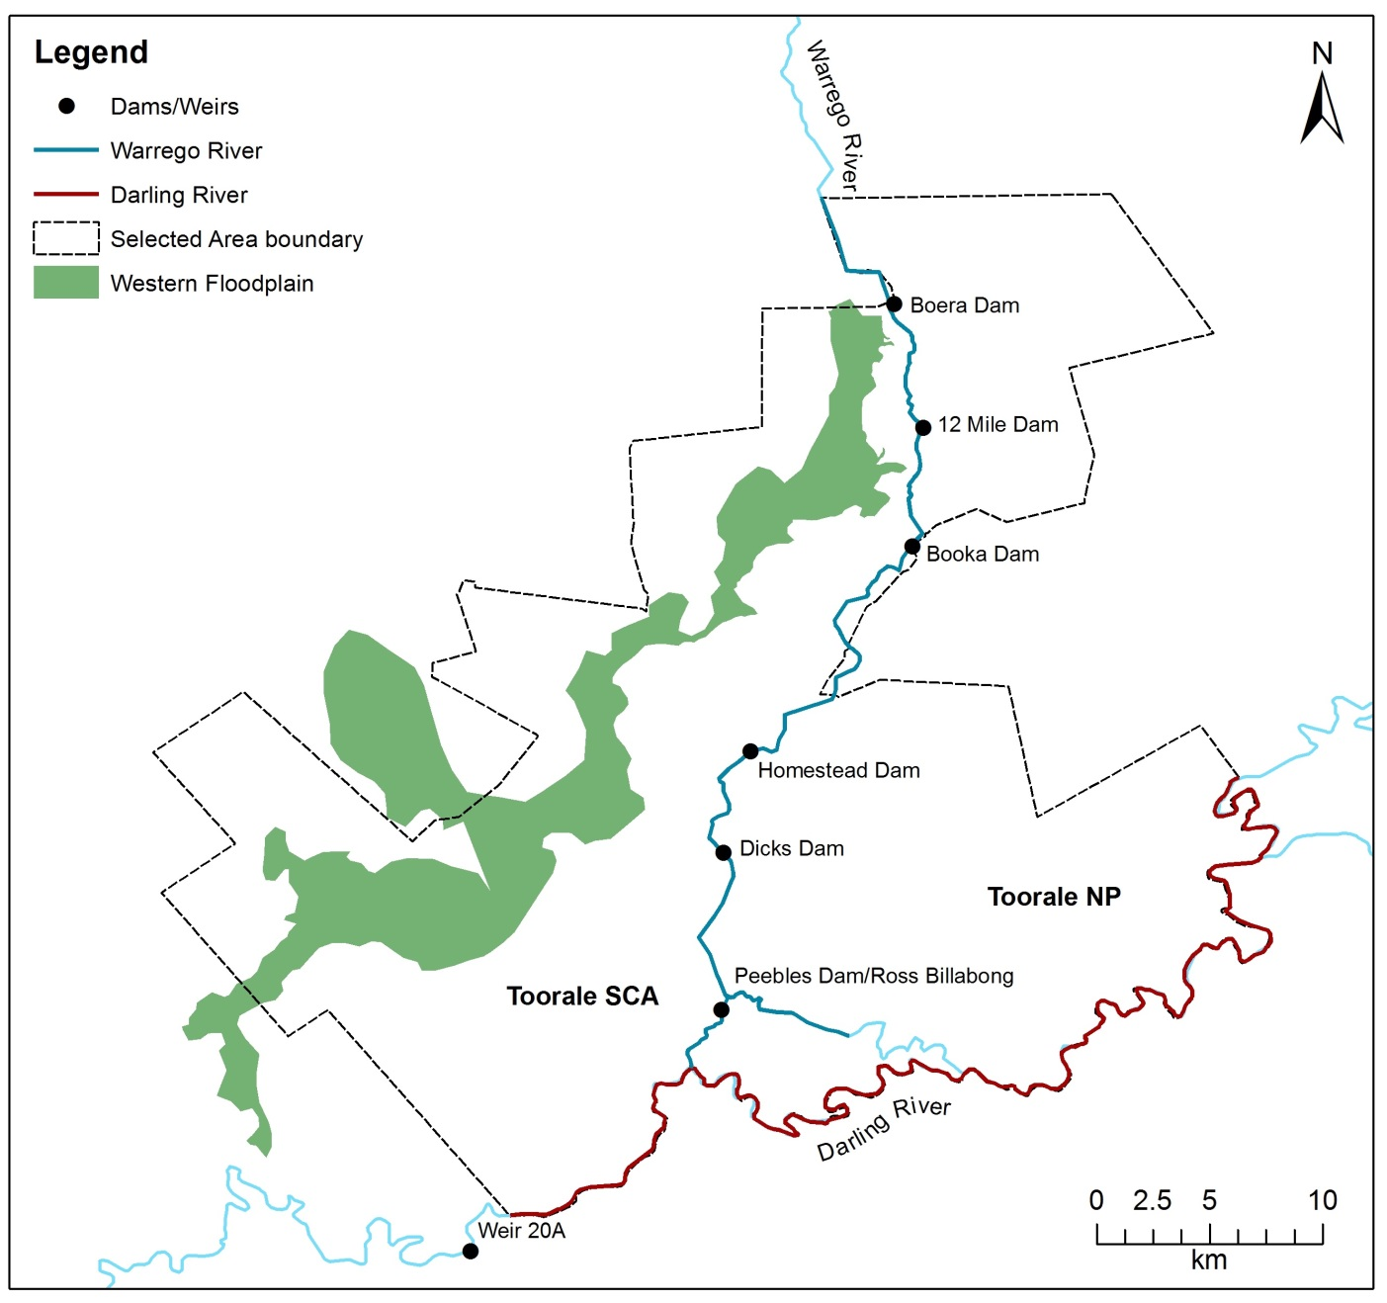

Figure 2‑2: Junction of the Warrego and Darling rivers Selected Area monitoring zones. Broader location of Selected Area provided in figure 2-1.

# Water management

Over the last 150 years, the hydrology of the Warrego River within the Junction of the Warrego and Darling rivers Selected Area has been highly modified. Seven dams have been constructed to provide stock and domestic water supply, irrigate the Western Floodplain to improve pasture growth, and more recently to provide water storage for irrigated agriculture (Figure 2‑2). Since the establishment of Toorale NP and SCA in 2008, the condition of some dams has degraded, several becoming fully breached (Aurecon 2009). The characteristics and current status of these dams are outlined below (Gawne et al. 2013b):

1. Boera Dam: a large storage of approximately 3000 ML, likely to have been established since the 1870s. Water persists for around 12 months after filling in the absence of further inflows from local runoff. Management of this dam can preferentially divert water down the Western Floodplain.
2. 12 Mile Dam: less than 1000 ML in volume, this dam has been recently breached and not reinstated.
3. Booka Dam: approximately 1000 ML
4. Mumpher (Broken) Dam
5. Keernie (Homestead) Dam: 1500 – 2000 ML (Breached)
6. Dicks Dam: 500 – 1000 ML
7. Peebles Dam: a large storage just upstream of the junction of the Warrego and Darling rivers. This is the most permanent of the storages and was previously used for irrigation. The storage holds approximately 10 000 ML and is connected to Ross Billabong, an adjacent floodplain depression.

These dams have been retrospectively licenced under the provision of the *Water Act 1912*. This includes separate licenced amounts for the Warrego River at 8.1 GL long term average annual yield (LTAAY), the Western Floodplain (accounted at Boera Dam) at 9.7 GL (LTAAY) and the Darling River at 7.6 GL (LTAAY). Conditions placed on these licences determine how Commonwealth environmental water can be managed within the Selected Area. This is especially true for the licences specified at Boera Dam. Before these licences can be accessed, a downstream demand to the Darling River must be met during times of low flow. Here, if sustained inflows are entering Boera Dam and the Darling River at Louth is below 330 ML/d, then water must be let through the regulator pipes on Boera Dam and all downstream dams on the Warrego to flow to the Darling River until flows at Louth have reached 330 ML/d. Once this has been achieved, the CEWO can choose whether to continue to release water down the lower Warrego channel, therefore activating their Warrego River licence, or close the regulator gates, hold water in Boera Dam to trigger their high flow access licence and divert water to the Western Floodplain. The CEWO have developed a 5 year Water Use Strategy for Toorale to aid decision making surrounding the operation of Commonwealth environmental water at this site (Appendix A).

Unlike other Selected Areas, Commonwealth environmental water that flows into the Junction of the Warrego and Darling rivers Selected Area is primarily unregulated, and is thus reliant on rainfall and water management decisions in upstream tributaries. The Gwydir, Namoi and to a lesser extent Macquarie catchments are exceptions to this, whereby regulated environmental water has the potential to influence flows in the Selected Area, particularly during periods of low flow in the Barwon-Darling system. Other water management actions, such as the release of stock and domestic flows, rainfall rejection flows and embargos on upstream pumping also influence flows in the Selected Area.

Adding to the complexity of environmental water accounting and delivery in the Selected Area is the fact that the Selected Area and its upstream tributaries fall into multiple Water Planning Areas, each with their own discreet rules, licence types and accounting procedures. Thus, tracking Commonwealth environmental water between and through these areas is challenging.

# Watering actions in 2014-15

Following significant flooding and above average rainfall in 2012, the Selected Area experienced well below average rainfall in 2013, then average rainfall in 2014. A single flow event in February/March 2013 was the last significant flow down the Darling River before the 2014-15 water year. This flow was below the bankfull level at Bourke, however would have provided flushing flows, fish passage, stimulated nutrient cycling, and created some connection with secondary channels bordering the Darling River channel. Localised rain in early March 2014 resulted in Boera Dam on the Warrego River filling and remaining above the level required to connect the Western Floodplain for a 65 day period. Thus, water flowed onto the Western Floodplain, stimulating vegetation growth during this period.

During 2014-15, monthly rainfall was variable compared with long-term means (Figure 4‑1). Rainfall was above average during August, September and December 2014, and then again in May and June 2015. In June 2014 rainfall of 111 mm was over three times the long-term mean. Mean maximum temperatures were close to the long-term mean at the start and end of the water year, and generally above average over the October-March period, with the only exception being January when temperatures were slightly lower than the long term mean (Figure 4‑2).

Figure 4‑1: Monthly rainfall at Bourke Post Office for 2014-15 compared to the long term mean (Source: http://www.bom.gov.au/climate/data/index.shtml).

Figure 4‑2: Mean maximum temperatures for the Bourke Post Office during 2014-15 compared to the long term mean (Source: http://www.bom.gov.au/climate/data/index.shtml).

Three flow events containing Commonwealth environmental water flowed down the Darling River channel, influencing water levels within the Selected Area in 2014-15. The first was a planned release from Copeton Dam in the Gwydir system, which moved through to the Barwon-Darling river and influence water levels as far downstream as Bourke. The next two events were from unregulated end of system flows from a number of upstream tributaries which occurred during December 2014 to March 2015 and April to May 2015. Both flow events were relatively small in-channel events, but influenced water levels through the Darling River zone of the Selected Area.

Upstream rainfall in the Warrego catchment also produced inflows to the Selected Area during February/March 2015. Flows into Boera Dam were managed in such a way as to provide connection through to the Darling River and also to allow water to flow down the Western Floodplain. While no water was debited from the Western Floodplain licence, management decisions made by the CEWO resulted in inundation of the Western Floodplain.

# What did Commonwealth Environmental Water do in 2014-15?

## Expected Outcomes

The Junction of the Warrego and Darling rivers Selected Area falls within the Northern Unregulated Rivers region where the majority of Commonwealth environmental water holdings provide access to unregulated flows. The CEWO have defined a number of watering options and expected outcomes from the use of Commonwealth environmental water in the Northern Unregulated Rivers (Table 5‑1). It should be noted that not all of these outcomes are relevant to the Junction of the Warrego and Darling rivers Selected Area (see blue shading in Table 5‑1). These expected outcomes are linked to both longer term and broader objectives set out in the Murray-Darling Basin Plan. The evaluation of Commonwealth environmental water and its management in the Selected Area during 2014-15 is structured around these broader objectives.

Table 5‑1: Expected outcomes from the 2014-15 Commonwealth environmental water (CEWO 2014). Outcomes relevant to the Selected Area are shaded blue.

| Flow Type | Expected outcomes for 2014–15 | Contributions to longer term objectives | Contribution to the following Basin Plan objective |
| --- | --- | --- | --- |
| Base flows and freshes | Individual survival and condition (individual refuges and ecosystem resistance) | Ecosystem resilience | Resilience |
| Freshes | Salinity  Dissolved oxygen  pH  Dissolved organic carbon | Chemical | Water quality |
| Freshes and bankfull | Nutrient and carbon cycling | Process | Ecosystem function |
| Freshes, bankfull and overbank | Fish reproduction  Fish condition | Fish diversity | Biodiversity |
| Bankfull and overbank | Vegetation reproduction  Vegetation condition | Vegetation diversity | Biodiversity |
| Bankfull and overbank | Waterbird survival and condition | Waterbird diversity and population condition |  |
| Waterbird chicks  Waterbird fledglings | Waterbird diversity |  |
| All flow types | Hydrological connectivity including end of system flows | Connectivity | Ecosystem function |
|  | Biotic dispersal and movement |  |  |
|  | Primary productivity (of aquatic ecosystems) | Process |  |

## Darling River flows and ecosystem function

Water flowed through the Darling River zone of the Selected Area for 60% of the time during 2014-15, providing full connectivity through this zone. Low flow conditions prevailed for the remainder of the year with water being confined to the 20A weir pool (Appendix C). Commonwealth environmental water contributed to this connectivity during three separate events (Figure 5‑1; Appendix D). The first resulted from a regulated block release through the Gwydir sub-catchment down the Mehi River and Carole Creek channels in October-November 2014. Due to low flows in the Barwon River at the time, this flow proceeded down the Barwon-Darling River as a noticeable peak to Weir 19A. While no increase in flow was detected at Louth, this small flow influenced connectivity within the Darling River zone of the Selected Area, as observed by small increases in water levels detected by water level loggers placed in the Weir 20A weirpool. In addition, this flow produced connectivity through the Brewarrina fishway for a period of 10 days. The second flow occurred in December 2014-March 2015 as a result of flows from the Condamine Balonne sub-catchment. This flow peaked at 2,850 ML/d at Bourke and contained around 25% Commonwealth environmental water (Figure 5‑2). The last flow of the 2014-15 water year occurred in May-June 2015, originating in the Macintyre/Barwon sub-catchment and peaked around 1,900 ML/d at Bourke. Commonwealth environmental water was estimated to have contributed around 5% of the volume of this flow event.

In-channel habitats along the Darling River are important in the context of environmental watering as they provide ecological benefit while being in a flow range that can be targeted with environmental water. For this reason, in-channel benches and anabranch channels were mapped and their connection to the river quantified over the 2014-15 period (Appendix G). One hundred and seventy three bench surfaces and 20 anabranch channels were mapped along the 76 km reach of the Darling River within the Selected Area. These features were calculated to become inundated at flow discharges between 1,846 and 18,889 ML/d measured at the Bourke Town gauge. Large proportions of both benches and anabranch channels become connected to the river channel at flows <10,000 ML/d (Figure 5‑3). These flows are within the range that may be influenced by Commonwealth environmental water in this reach of the Darling River.

Inundation of in-channel habitats can mobilise carbon and other nutrients, making them available for use by higher level organisms. During 2014-15, around 25% of benches and 31% of anabranch channels were inundated by flow events containing Commonwealth environmental water, with a total inundated bench area of 19,762 m2 and an anabranch channel length of 33.1 km. Nutrient releases from inundated benches were estimated by using published release rate data (Southwell 2008). These calculations estimate that 3.6 kg of dissolved organic carbon, 1.1 kg of total dissolved nitrogen and 1.2 kg of total dissolved phosphorus were released to the river system from inundated benches. In addition, these habitats would have provided spawning and refuge sites for aquatic animals during connection.

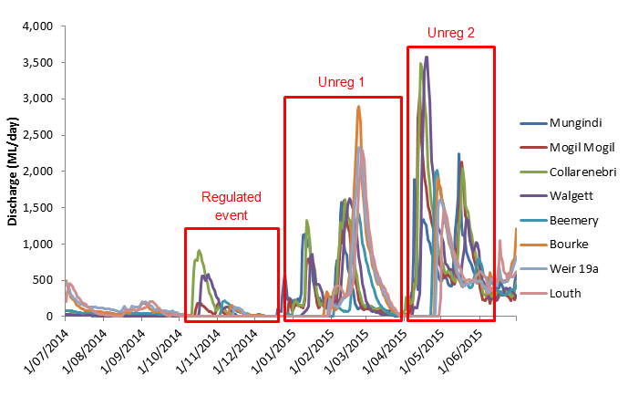

Figure 5‑1 Mean daily discharge at gauging stations on Barwon Darling River system (1 July 2014–30 June 2015). Events used in the analysis of northern tributary contributions are boxed in red.

Figure 5‑2 Commonwealth environmental water flow volumes at Barwon-Darling gauging stations during unregulated flow event 1 (December – March) and 2 (April – June) during 2014–15.

Figure 5‑3 Commence to flow discharges for benches (left) and anabranch channels (right) along the Darling River within the Selected Area. Discharge relevant to the Bourke Town gauge.

## Warrego River flows and inundation

Flows down the Warrego River were dominated by one relatively large event that occurred due to rainfall in the upper Warrego catchment in December 2014-January 2015, resulting in 65 days of inflows to Boera Dam during February-March 2015. To meet licence requirements (which require water to flow through to the Darling River until flows at Louth reach 330 ML/d), a management decision was made to open the regulating gates at Boera Dam for 24 days, providing connection through the lower Warrego channel to the Darling River. Once the gates were closed in early February, water levels in Boera Dam rose above the level required to inundate the Western Floodplain, providing connection for 37 days (Figure 5‑4, Figure 5‑5).

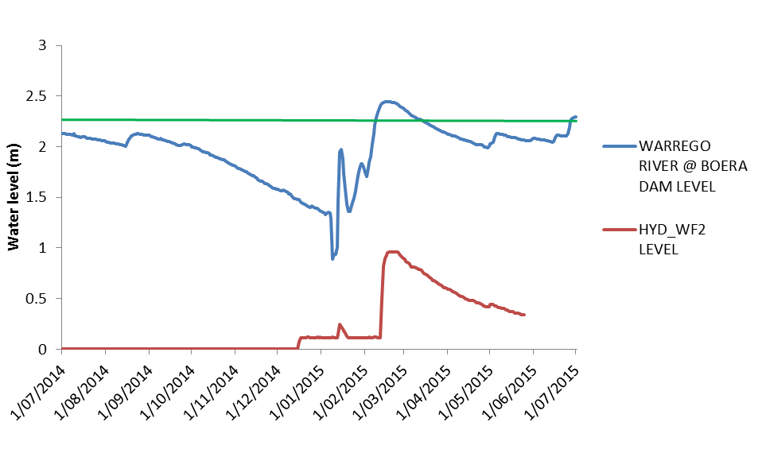

Figure 5‑4 Water levels experienced at Boera Dam and water level logger on the Western Floodplain. Green line represents overflow level of the Western Floodplain.

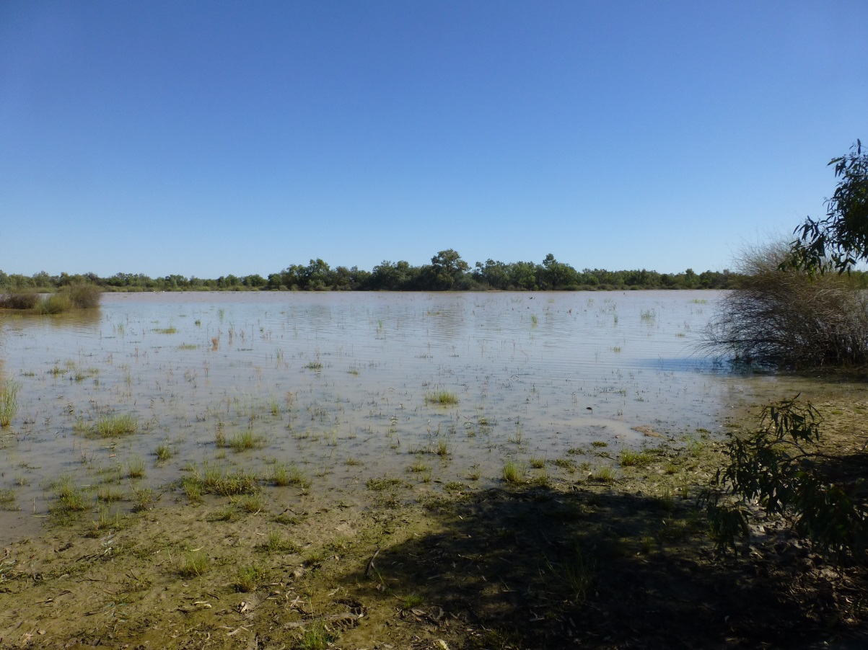

Figure 5‑5 Water flowing through the western bywash and onto the Western Floodplain in February 2015.

Analysis of the Digital Elevation Model (DEM) of the Western Floodplain showed that a maximum of 36.9 ha of floodplain became inundated as a result of the management of Commonwealth environmental water (Figure 5‑6; Appendix E). The relationship between Boera Dam water level and inundation showed large areas of the Western Floodplain become inundated when Boera Dam water levels exceeded 2.36 m.

While the physical connection of both the Warrego River channel and Western Floodplain only occurred for a relatively short time, water persisted in waterholes and dams within both systems for over 6 months providing refuge for aquatic species in an otherwise dry landscape. This longer duration of inundation was important for facilitating metabolic processing in these environments. In addition, the extended inundation allowed sufficient time for successional processes to take place within microinvertebrate populations, thus providing food sources for organisms higher in the food chain such as fish and waterbirds. All sites in the Warrego and Darling Rivers were net consumers of carbon and therefore acted as carbon sinks throughout the 2014-15 year. In contrast the Western Floodplain site when monitored in May was a net producer of carbon, most likely a result of the reduced turbidity of the floodplain waters increasing light penetration and promoting benthic algal production.

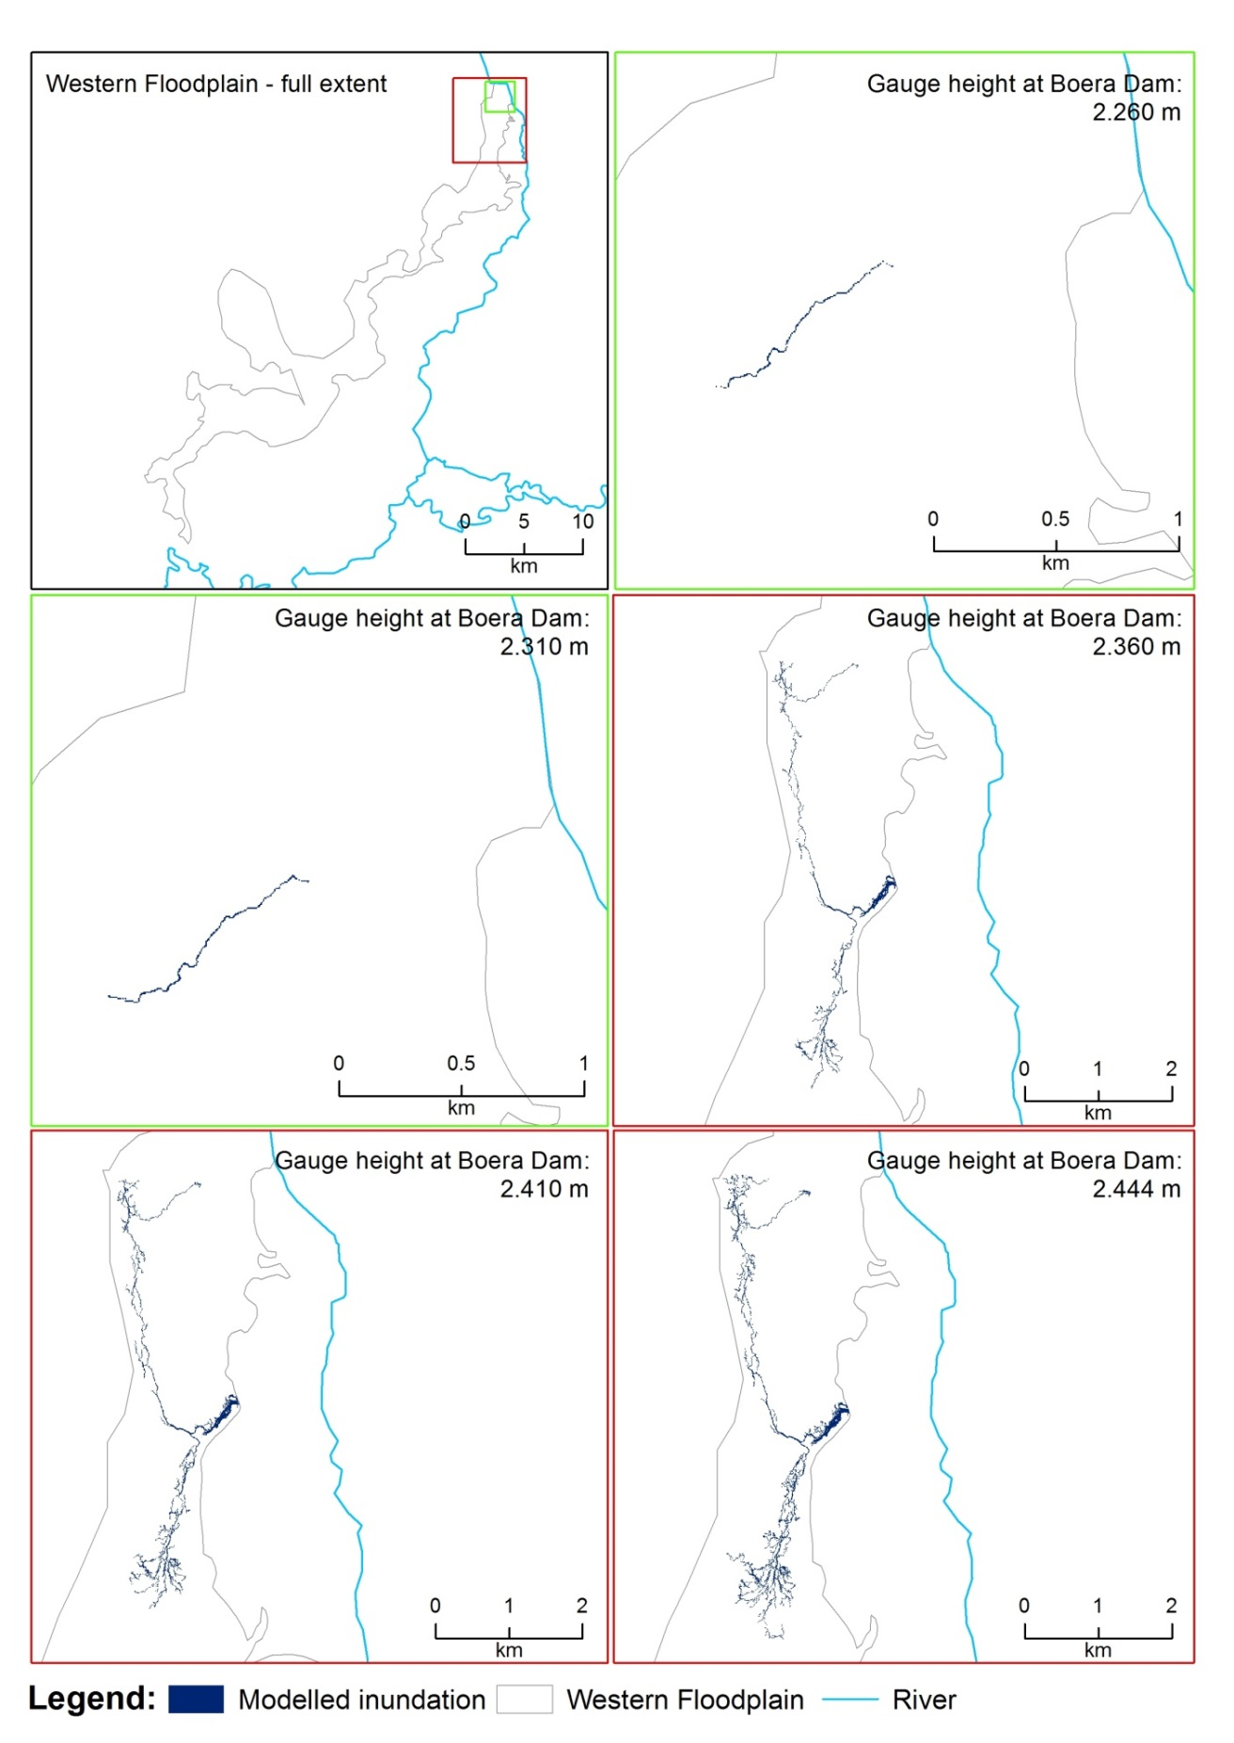

Figure 5‑6 Inundation extent modelled from the DEM for various water levels measured at Boera Dam.

## Water Quality

Two water quality probes were deployed within the Darling River channel; at Yanda Homestead above the Warrego River junction and Akuna homestead below the Warrego River junction with the Darling River zone. While only operational for a short period before this report, they showed changes in water quality with local rainfall. All parameters tested were within the ranges expected to occur in the Darling River zone.

Water quality variables including nutrient concentrations were sampled twice throughout the 2014-15 water year at multiple sites within the Warrego and Darling Rivers and waterholes on the Western Floodplain. Patterns in nutrients within the Selected Area appeared to be driven by higher organic matter loads within the Warrego system as a result of the inundation of organic material in previously dry areas. Significantly higher total nitrogen and dissolved organic carbon concentrations observed in the Warrego compared with Darling River sites, and higher nitrogen oxides and filterable reactive phosphorus were noted in May within the Western Floodplain and Ross Billabong sites. The influence of Commonwealth environmental water management on patterns of water quality is hard to decipher, other than the increased water availability to the Western Floodplain. The water quality parameters measured were within normal ranges for a system such as the Warrego-Darling, and no water quality related stress was observed in any other indicators measured.

## Biodiversity

Commonwealth environmental water and its management influenced six of the 10 ecosystem types monitored in the LTIM project, including lowland stream, floodplain lake, lignum shrubland floodplain and temporary lake ecosystem types as defined by the Australian National Aquatic Ecosystem (ANAE) Classification Framework (Brooks et al. 2013) (Figure 5‑7; Appendix B). Ecosystem types that did not become inundated included shrubland floodplain, Coolibah woodland and forest floodplain, temporary sedge/grass/forb floodplain marsh and Black box woodland floodplain types located on the Western Floodplain. As these ecosystems are either temporary aquatic or reliant on periodic (3-10 years; Roberts and Marston 2000) inundation to maintain their dominant species, the fact that they did not become inundated is of no major concern given the recent widespread inundation which occurred across the Selected Area in 2012.

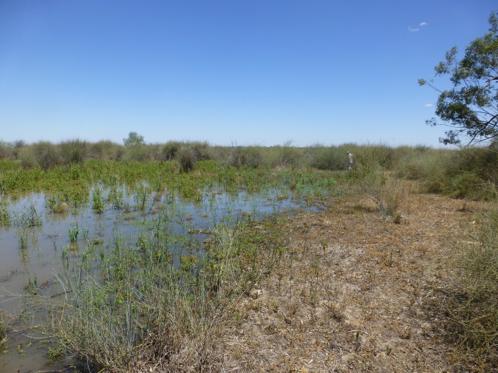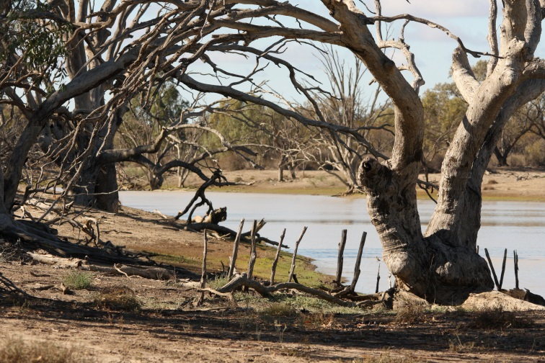

Figure 5‑7 Lignum shrubland floodplain (left) and temporary lake (right) ecosystem types flooded by Commonwealth environmental water management in 2014-15 within the Selected Area

Inundation of the Western Floodplain as a result of Commonwealth environmental water management had a positive effect on the biodiversity of invertebrates, frogs, birds and vegetation within the Selected Area during 2014-15.

Microinvertebrates, were sampled at several sites within the Warrego and Darling River zones as well as one waterhole within the Western Floodplain zone during February and May 2015. Samples were taken from the bottom of waterholes and also from the water column. The inundation of the Warrego River and Western Floodplain zones increased regional scale abundance and diversity of aquatic microinvertebrates (Figure 5‑8; Appendix J). Communities that live on the bottom of waterholes tended to have significantly higher densities than communities that live in the water column. In addition, the composition of communities varied between zones and the two sampling events. Differences were seen in both the abundance and presence-absence data suggesting it was the make-up of communities rather than the dominance of individual species driving the observed patterns. These differences indicate the benefits of inundating a mosaic of ecosystem types. Commonwealth environmental water and its management increased regional level diversity and abundance of food resources for other biota higher up the food chain. Similarly, inundation of habitats for an extended period (at least 4 months) contributed to the development and succession of different aquatic microinvertebrate communities between channel and floodplain habitats.

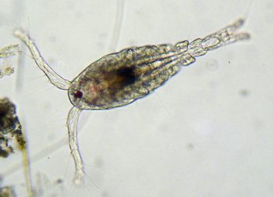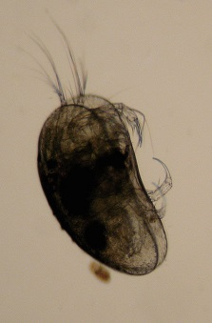

Figure 5‑8 Microinvertebrates sampled in the Selected Area. Copepods (left) <1mm in length dominated the water column samples while Seed shrimps (Ostracod; right) <2 mm in length dominated benthic samples.

Frogs were surveyed twice in the 2014–15 water year at three sites within the Warrego River zone and one in the Western Floodplain zone using visual observations and audio surveys of calls. In total 10 frog species were recorded in the Warrego and Darling rivers Selected Area during the 2015 survey periods; including eight species in February and six species in May (; Appendix L). Frog abundances were similar between sampling periods (February and May 2015), however, calling activity was greatest in February (six species) compared to no calling activity in the May survey. Changes observed in frog abundance and diversity between survey periods and across sites were largely consistent with apparent reductions in available habitat as water levels receded through the year, along with generally colder climatic conditions during the May survey. Overall, channel sites tended to have higher frog abundances, while frog communities tended to be more diverse in the Western Floodplain zone. Increased calling activity during the February survey is consistent with increased summer activity expected for these species. Inundation of waterholes on the Western Floodplain as a result of Commonwealth environmental water management decisions provided habitat for frog communities that were more diverse than in the Warrego river dams. Providing water to this zone is important for maintaining regional scale frog diversity.

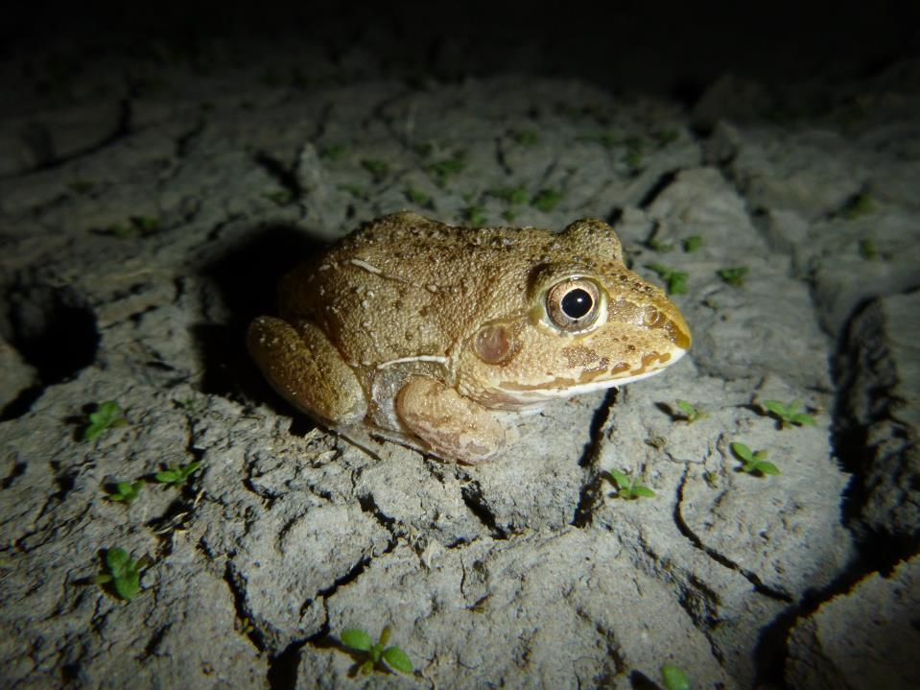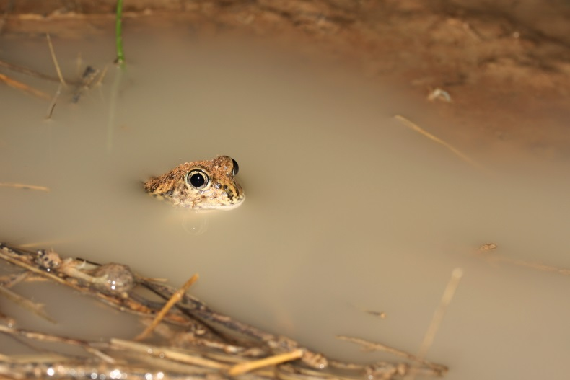

Figure 5‑9 New Holland Frog (*Cyclorana novaehollandise*; left) and Sudell’s Frog (*Neobatrachus Sudellae*; right) recorded in the Frog surveys during 2014-15.

Visual surveys of waterbirds were undertaken during February and May 2015 at three sites within the Warrego River zone and one site within the Western Floodplain zone. In total 86 bird species, including 31 waterbird species were recorded at sites within the Selected Area during February and May 2015 (Figure 5‑10; Appendix K). This included one waterbird species, the Eastern great egret (*Ardea alba*) listed under two international migratory bird agreements (JAMBA and CAMBA) and two threatened species listed under the NSW Threatened Species Conservation Act 1995 (TSC Act): Brolga (*Grus rubicunda*) and Freckled duck (*Stictonetta naevosa*). Mean waterbird diversity and abundance was greater in February than in May. Boera Dam recorded the highest species diversity (19 species) and waterbird abundance (375 waterbirds) during the February survey, comprising 58% of the maximum waterbird count per ha in the 2014-15 survey period. In February, flocks of 50-100 birds of Grey teal *(Anas gracilis)* and Pacific black duck(*Anas superciliosa*) were recorded at Boera Dam. Despite the highest site diversity and abundance recorded at Boera Dam, a comparison of floodplain and combined channel sites indicate mean diversity and total abundance was higher on the Western Floodplain. The total occurrence of feeding guilds across the February and May survey periods was also higher for the Western Floodplain, highlighting the importance of additional habitat provided by waterholes on the Western Floodplain as a result of Commonwealth environmental water management.

Waterbird breeding was observed during February over the 2014-15 survey period and occurred at Boera Dam and Ross Billabong in the Warrego River zone. Breeding activity (broods and/or nests) was observed in four waterbird species, including Australasian darter *(Anhinga novaehollandiae)*, Black-fronted dotterel *(Elseyornis melanops)*, Royal spoonbill *(Platalea regia)* and Freckled duck.

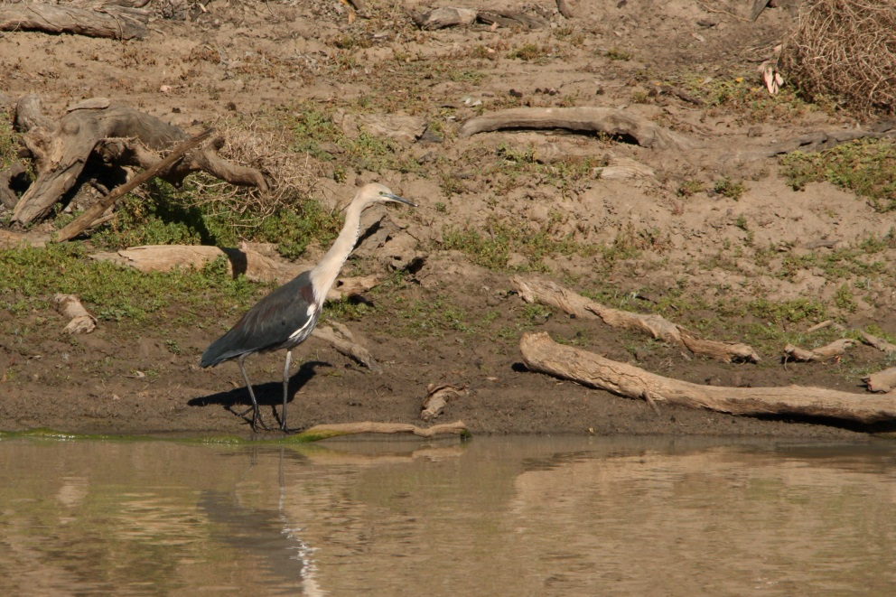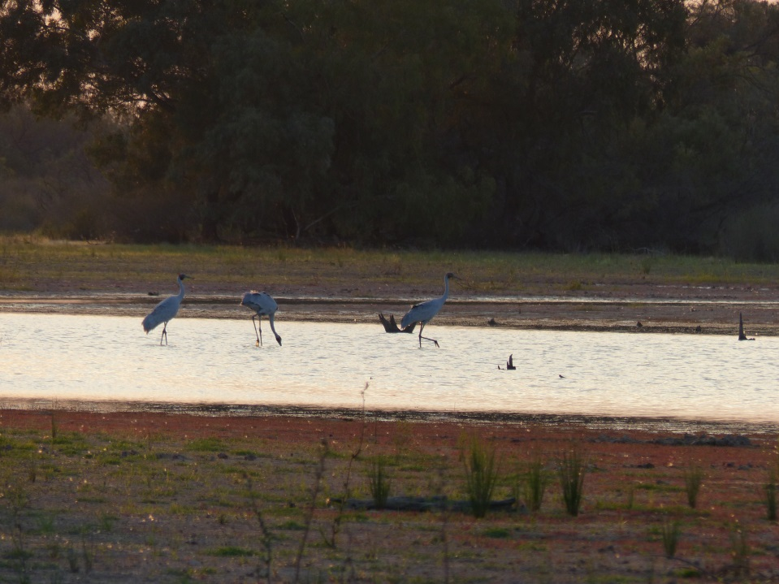

Figure 5‑10 White-necked heron (*Ardea pacifica*: left) and Brolga (*Grus rubicunda*: right) observed within the Selected Area during 2014-15.

Three vegetation communities were inundated on the Western Floodplain during 2014-15. Lignum shrubland had the greatest extent of inundation (25.9 ha), followed by Coolibah open woodland (10.7 ha) with small areas of Coolibah - River Coobah - Lignum woodland (0.3 ha) also inundated in the north of the Western Floodplain. Vegetation monitoring suggested that the presence of surface water during the February survey favoured wetland species and reduced the diversity of terrestrial species that tend not to cope well with periods of inundation (Brock and Cassanova 1997). The species diversity at the four inundated sites increased in the May survey after the water had receded, indicating a positive causal link of species diversity to inundation (Appendix I). The presence of surface water also influenced the cover of forb species such as River mint (*Mentha australis*) and Slender knotweed (*Persicaria prostrata*) that were able to respond more quickly to changes in moisture conditions than other growth forms.

Tangled lignum (*Meuhlenbeckia florulenta*) was a dominant plant species across the Western Floodplain zone, and contributed to differences in vegetation community composition between survey times and with the presence of surface water. While minimal differences were noted in the cover of lignum between survey times or in sites that became inundated, this species is most likely to respond to flooding in terms of a change in cover, over longer timescales (years) (Capon et al. 2009). Monitoring in successive years will allow us to detect the influence of inundation on this and other long-lived species within the Selected Area.

While the influence of inundation on vegetation communities was detected, differences between survey times at dry sites and vegetation communities were also found. The low number of inundated monitoring sites on the Western Floodplain restricted our ability to fully assess the influence of inundation on vegetation patterns in the Selected Area, given the seasonal and community level variation in the data. However, the 2014-15 surveys have provided substantial baseline data which will assist future monitoring and analysis to track the influence of inundation and Commonwealth environmental water on vegetation communities within the Junction of the Warrego and Darling rivers Selected Area.

## Resilience

Outcomes with respect to resilience were centred on the survival and condition of individuals by providing individual refuges and improving ecosystem resistance. While these aspects of the ecology were not directly measured in the project, some inferences can be made as to the contribution of Commonwealth environmental water and its management on the resilience of the Selected Area in 2014-15. The observed increases in density and diversity of microinvertebrates, frogs and birds in waterholes of the Western Floodplain suggests that the increased aquatic habitat resulting from flooding provided a source of food (microinvertebrates) that was potentially utilised by frogs and birds further up the food chain. Waterholes on the floodplain also tended to provide good quality habitat for frogs and birds with relatively high amounts of vegetation surrounding and within the waterholes, compared to waterholes in other zones. Thus, links may be drawn between increased aquatic habitat on the Western Floodplain resulting from Commonwealth environmental water management, increased base food sources, and increased numbers and diversities of higher level consumers such as frogs and birds.

## Summary

Commonwealth environmental water increased the connectivity of the Darling River and Western Floodplain zones during the 2014-15 year. In the Darling River, both regulated holdings out of the Gwydir River and unregulated entitlements in the unregulated upstream catchments contributed to flows through the Selected Area. The largest measured ecological benefit of these flows was the inundation and connection of in-channel habitat along the Darling River. Around 25% of the total number of bench surfaces and anabranch channel were connected to the river, providing additional habitat for biota, and allowing for the exchange of organic matter and nutrients between these features and the river channel. Due to delays in equipment installation, no detailed evaluation of the influence of these flows could be made in the Darling River zone in relation to water quality or metabolism.

Water management decisions made by the CEWO at Boera Dam as a natural flow event entered the Selected Area in early 2015 influenced the flow of water to the Warrego River and Western Floodplain zones. Decisions to close the regulator gates on Boera Dam once downstream licence conditions were met resulted in water flowing to the Western Floodplain for over a month. This resulted in 36.9 ha of inundation of key floodplain communities. Vegetation monitoring suggested this inundation had an influence on vegetation diversity and cover, with changes to the annual forb species that were able to rapidly respond to this wetting. Little change was observed in the cover of key long-lived species such as tangled lignum, coolibah and river cooba. The longer term benefit of flooding to these species will be assessed with surveys in the following years. Increased abundance and diversity of microinvertebrate, frog and bird communities on the Western Floodplain highlights the added importance of providing water to this zone to produce a mosaic of productivity and biodiversity outcomes within and across ecosystem types of the Selected Area.

# Implications for future management of Commonwealth environmental water

The results from year 1 of the LTIM project at the Junction of the Warrego and Darling rivers Selected Area suggest that the application and management of Commonwealth environmental water had positive ecological benefits, primarily in terms of habitat and resource provision for a range of water-dependent species. In the Darling River zone, Commonwealth environmental water increased both longitudinal connectivity of flowing water along the river channel (including in-stream geomorphic habitats) and lateral connectivity between the river channel and adjacent habitat. The delivery of Commonwealth environmental water from the Gwydir catchment into the Barwon-Darling system (which at the time was experiencing low flow conditions) provided additional connectivity benefits to the Darling River zone of the Selected Area beyond the target Gwydir catchment. Considering downstream connectivity when delivering targeted environmental flows in upstream catchments will maximise the broader regional benefits of this water.

While the Commonwealth has little influence on the timing and magnitude of flows entering the Selected Area down the Warrego River, once in Boera Dam, operational decisions have a large bearing on the duration and extent of flows to the Western Floodplain, Warrego River downstream of Boera and even the Darling River downstream of the junction. Flows released down the Warrego channel below Boera Dam in February 2015 provided connectivity within the Warrego River zone to the Darling River as well as increased the duration of inundation within the dams and waterholes in this zone. These dams and waterholes provided habitat and refuge for a diverse range of species for an extended period of time. Decisions to close the gates at Boera Dam once the licence requirements were met allowed water levels to rise in the dam and water to flow to the Western Floodplain. Inundation of the floodplain influenced vegetation communities and provided habitat for increased diversity and abundance of bird, frog and invertebrate species for the remainder of the 2014-15 water year.

Given the unregulated nature of the tributaries that provide water to the Junction of the Warrego and Darling rivers Selected Area, active management of environmental water to the site is almost exclusively confined to the operation of the Boera Dam regulating gates, once water reaches Boera Dam. Decisions here will inevitably be determined by the anticipated magnitude and timing of arriving flows, and Darling River flow levels, but given the ecological benefits of the additional aquatic habitat provided on the Western Floodplain for the biota monitored in year 1 of the LTIM project, considerable weight should be placed on maximising flows to the Western Floodplain. This appears to be catered for in the Toorale 5 year watering use strategy developed by the CEWO. We support this plan in guiding water decisions made down the Warrego channel in the future.

# References

Aurecon 2009. *Toorale Station Decommissioning Plan Volume 1*. Prepared for the Department of Environment, Water, Heritage and Arts.

Brock, M.A. and Casanova, M.T. (1997) Plant life at the edge of wetlands: ecological responses to wetting and drying patterns. *In* Frontiers of Ecology; Building the Links. *Edited by* N.Klomp and Lunt. Elsevier Science, Oxford. Pp. 181-192.

Brooks S., Cottingham P., Butcher R., & Hale J. (2013) *Murray-Darling Basin aquatic ecosystem classification: Stage 2 report*. Peter Cottingham & Associates report to the Commonwealth Environmental Water Office and Murray-Darling Basin Authority, Canberra.

Capon, S. 2009. *Flow-dependent Ecosystems of Toorale Station: Ecological character, condition and issues associated with decommissioning water resources infrastructure.* Australian Rivers Institute, Griffith University.

Commonwealth Environmental Water Office (CEWO). (2014) Commonwealth environmental water use options 2014-15: Northern Unregulated Rivers. Commonwealth Environmental Water Office for the Australian Government.

Southwell MR 2008, *Floodplains as Dynamic mosaics: Sediment and nutrient patches in a large lowland riverine landscape.* PhD Thesis, University of Canberra, Australia

Roberts R. and Marston, F. (2000) Water Regime of Wetland & Floodplain Plants in the Murray-Darling Basin – A Source Book of Ecological Knowledge. Technical Report 30/00. CSIRO Land and Water, Canberra.