

## Quarterly Outcomes Newsletter for the Warrego-Darling Selected Area

Q1 July - September 2021

|  |  |  |
| --- | --- | --- |
|  | | |
|  | We would like to acknowledge the Kurnu/Gunu Baakandji People, the Traditional Custodians of the Darling River and its surrounding landscape.  Thank you for sharing your Country and knowledge of its land, water and life with us.  We pay respects to Elders past, present and emerging. |  |
|  | | |

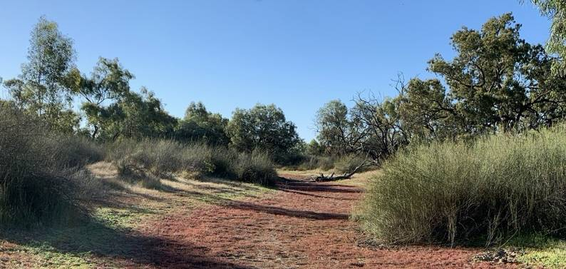

# In a nutshell...

CONTENTS

Catchment conditions

In retrospect: Hydrology of the 20-21 water year

In retrospect: Research In the 20- 21 water year

2020-2021 water year : water quality and foodwebs, waterbirds, fish, vegetation

Communication and engagement Future events

What's next? Enquiries

Water for the environment is used to improve environmental and social values of river systems. It can be either water entitlements that are left in the river, or a specified amount of water that has been set aside in storages that is released into natural waterways when needed.

Either way, the aim is to improve river and wetland health.

Bourke received 26 mm this quarter, 16.5 mm less than the long-term average

Darling River at Warraweena peaked at 46,240 ML/d in late August, 2021

Boera Dam overflowed to the Western Floodplain from late April to beyond the end of June.

Flows and connectivity were high following the March 2021 floods, which Included e-water

While bioavailable P Is a limiting nutrient, turbidity is the driver of productivity. System Is heterotrophic Diversity and abundance of waterbirds generally low, with some evidence of breeding.

9 species of frogs recorded

Fish communities diverse, but showing signs of stress

Inundation mapping research found the MNDWI Index performed best of 8 indicies tested Primary productivity research looks at production and consumption In the benthic layer vs water column

Feature story: Kevin Knight of the Gurnu-Barkandji Nation

Rainfall 20

Bourke received 6.3 mm of rain at the start of

this quarter which is around half of the long

term mean for July at 12.4 mm. August 15

showed a similar trend with only 7.6 mm. The

Rainfall (mm)

largest rain event of the quarter was on Sept 5 10

when 10.4 mm fell.

Bourke (048245) monthly rainfall totals: April = 6.3 mm

August= 7.6 mm September = 12.2 mm*

Temperature

The temperature in Bourke is starting to trend upwards with both July and August highs of 31.8

°C. The monthly mean is currently sitting just above long term means. Highest temperature across all months for the quarter was recorded on 12 September at 32.7 °C.

July: range 13-32 °C; mean 19 °C August: range 15-32 °C; mean 22.4 °C

September: range 18-32.7 °C; mean 25.3 °C*

5

0

Jul Aug Sept

 Bourke 2021  Bourke long-term mean

Total monthly rainfall (mm)

40



30

Temperature (°C)

20

10

0

Long-term mean 2020-21 daily maximum mean

*incomplete record

Bourke mean maximum monthly temperature (°C)

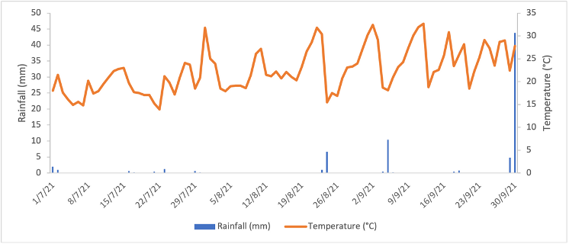

Quarter 1 2021-22 rainfall and temperature at Bourke (048245)

## The Darling River

After being mostly disconnected the for first half of the 2020-21 water year, improved connectivity was observed for the rest of the year. Significant flows out of the Border Rivers and Gwydir Catchments drove flooding in the Barwon Darling system in March-May 2021. This was the biggest flow of the LTIM/MER project and contained around 5% water for the environment in the Darling River monitoring zone. The flow peaked at Warraweena at 46,240 ML/d on April 25, 2021, with flow peaking at Wilcannia at 27,082 ML/d on May 18. The last time Wilcannia saw a peak of this size was in November, 2016.

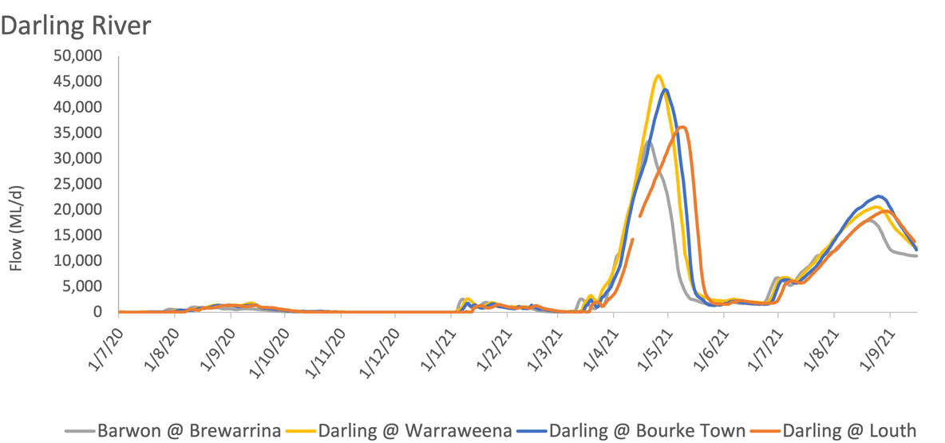

## The Warrego River

No and low flows characteristed the Warrego River for most of the 2020-21 water year. Significant upstream rainfall produced a flow event in February-March which included around 12% Commonwealth water for the environment.

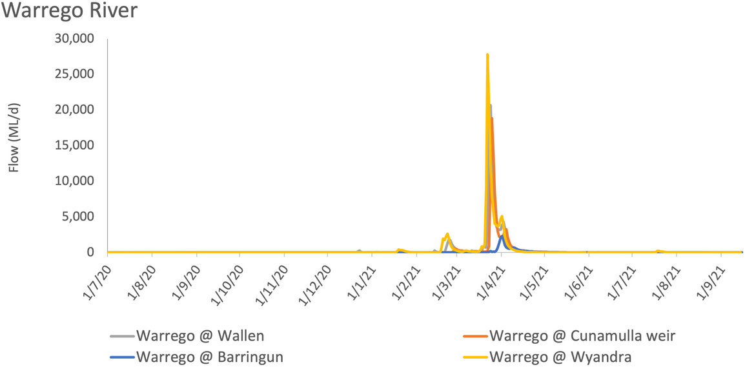

Similarly after a dry July 2020 - March 2021, the Warrego River at Fords Bridge (combined) showed a steep rise in flows peaking at about 750 ML/d in mid-April following the March 2021 rains. From that point, flows steadily declined for the remainder of the year and were running at 2 ML/d at Fords Bridge by June 30.

## The Warrego River

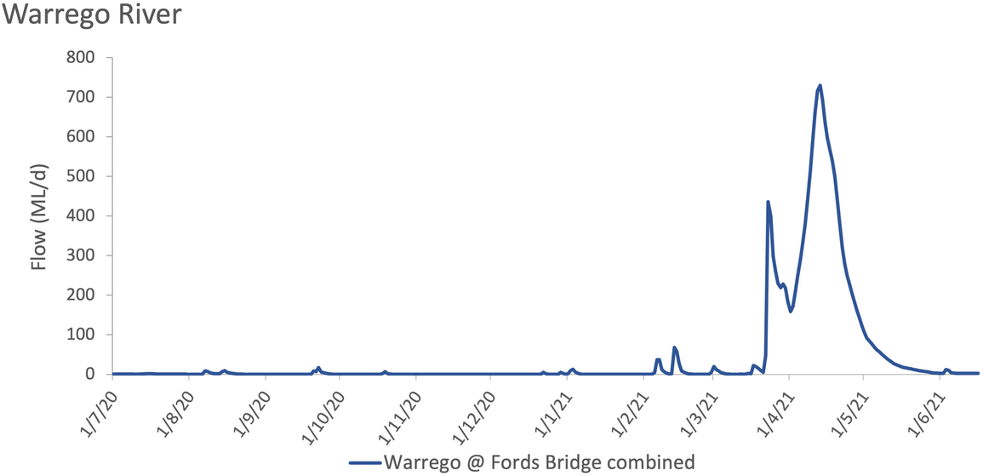

The greatest inundation of the Western Floodplain (194 ha) was observed in July 2020. Flows resulting from the March 21 floods achieved the maximum inundation of 1,390 ha in the Selected Area, most of which was in the Warrego River Channel network between Boera Dam and the Warrego-Darling River confluence.

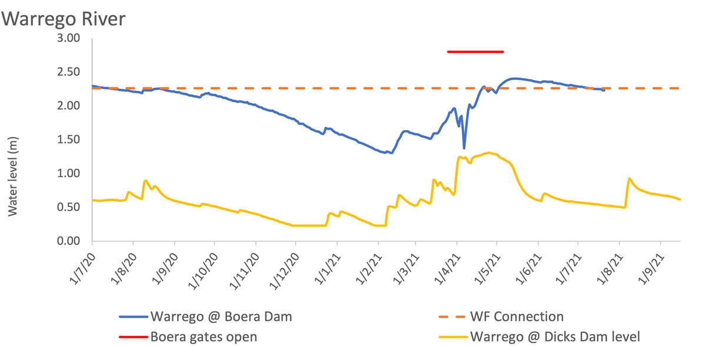

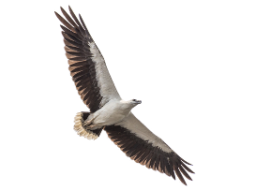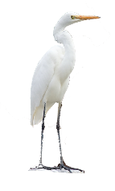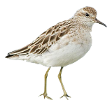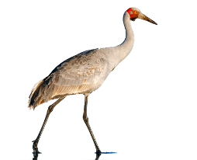

Brolga (credit - eBird)

White bellied sea eagle (credit - eBird)

Great Egret (credit - Wikipedia) Sharp-tailed sandpiper (credit - [NZbirds online](https://www.nzbirdsonline.org.nz/species/sharp-tailed-sandpiper))

### Water Quality

In the 2020-21 water year water quality surveys were taken in November, December 2020 and March 2021. Bioavailable phosphorus (P) was found to be a limiting nutrient for this Selected Area. While bioavailable P was low, it was the extreme turbidity that was the main driver of productivity in the system.

### Foodwebs

During 2020-21 the system continued to be heterotrophic, meaning that more carbon was being consumed than produced in the waterholes of the Selected Area. Lack of carbon production means that the foodwebs are relying on and driven by carbon transported from upstream sources, instead of 'home-grown' carbon. Thus, flow events that transport this material are important for driving the foodwebs in the Selected Area.

Invertebrate communities showed a distinct change in composition over the year, from communities dominated by predators such as backswimmers and water boatmen, to communities dominated by shrimps as flows stimulated algal production and more food for this taxa became available.

# 2020-2021 water year: waterbirds

We observed low abundance and diversity of waterbirds In the 2020-21 water year, reflecting the predominantly dry conditions.

While the dry conditions saw lower numbers and types of waterbirds than we would have liked, species such as the white-bellied sea eagle and the brolga still showed evidence of breeding at these water sources in the Warrego-Darling Selected Area.

We were pleased to see nationally listed migratory species such as the great egret and sharp-tailed sandpiper still being supported by local Warrego-Darling water sources. Many listed woodland birds were also observed making use of the waterholes.

## Frogs

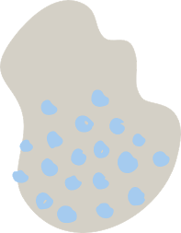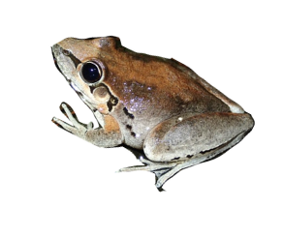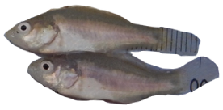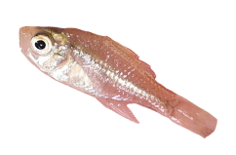

Over the course of the 2020-21 water year we spotted nine different species of frogs. We observed the broad palmed rocket frog in Ross Billabong - a first in the history of the LTIM/MER project. It's likely that the higher than usual rainfall contributed to the number of burrowing frogs observed during our March surveys.

Broad palmed frog (credit - Frogid)

Golden perch (credit - NSW Fisheries)

## Fish

While we sampled many native fish species in the Selected Area, and some in relatively high abundance, the fish community as a whole is under stress.

Species such as the golden perch and bony herring were found in high numbers and showed evidence of recruitment. Other native species like Murray cod and freshwater catfish, were only found in low numbers. It seems as though no boom in native species occurred after the 2020 floods, like we may have expected. More work is needed to understand the drivers responsible for these low numbers of some species. We did find that the lower Warrego River is still a nursery for golden perch. We also observed large numbers of carp recruits in the lower Warrego.

## Vegetation

Flooding in 2019 and 2020 combined with above average rainfall for the 2020-21 water year has resulted In vegetation being in the best condition that has been observed across the entire LTIM/MER project.

We have observed widespread lignum recruitment, seed set in coolibah and flowering in river cooba. This shows the benefit and importance of several larger flooding events in 2019 and 2020 which included water for the environment and above average rainfall, in supporting floodplain

vegetation communities. Lignum recruits (credit - UNE)

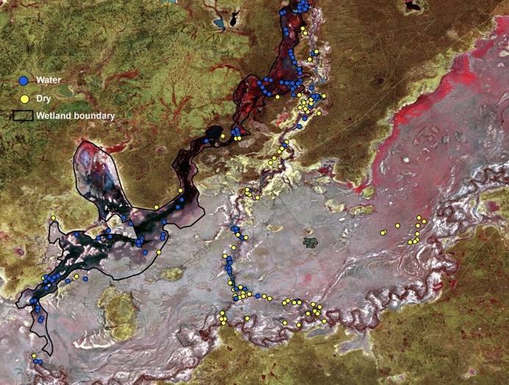

Field validation points used on Toorale

## Inundation mapping

Knowing where our water is as a function of flow, how far it extends and how it dries back is critical for managing environmental water and improving our environment.

We used Sentinel-2 satellite imagery (twice weekly capture and 10 m pixels) to examine the accuracy and applications of water extent mapping in the northern Murray-Darling Basin. In the Warrego Western Floodplain and Gwydir wetlands, we mapped water extent using eight common water indices to determine mapping accuracies and choose the most appropriate index.

We compared eight water mapping indices on Sentinel-2 imagery to test the level of accuracy and usability of each. All indices gave a high level of accuracy ranging from 72-98%.

Our Findings:

Sentinel-2 imaging is well suited to map wetland inundation events

The Modified Normalised Difference Water Index (MNDWI) performed best in this study

The approximate twice weekly capture of Sentinel-2 imagery allows us to undertake flood behaviour assessment, that was previously unachievable with earlier versions of the technology.

## Primary Production

We wanted to learn more about the production and consumption of oxygen in the benthic layer versus the water column of our water sources, and to be able to quantify those amounts. To do this we deployed metabolism chambers and anaylsed the results.

We found that our benthic site at Booka Dam was consuming oxygen while other benthic sites at Boera Dam and Akuna (on the Darling) were both oxygen producers.

The waterholes that we studied were found to be net consumers of both carbon and oxygen, making them heterotrophic.

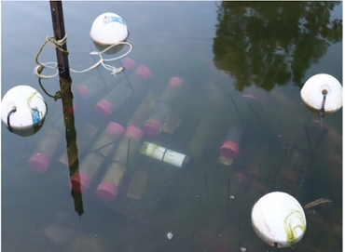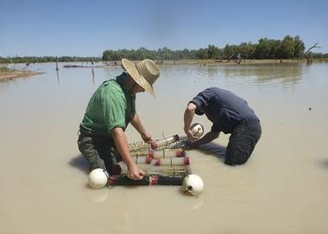

Deployed metabolism chambers

The team installing the chambers

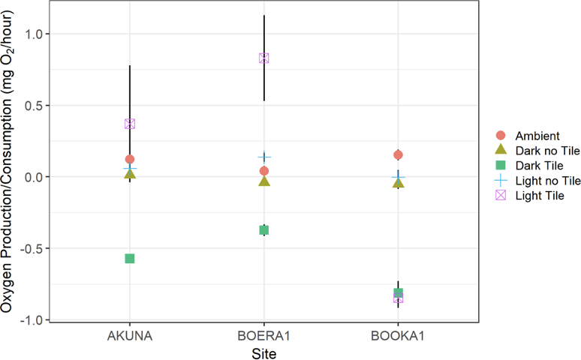

Kevin Knight of the Gurnu-Baakandji Nation

Kevin Knight is our newly appointed Warrego- Darling Selected Area Cultural Advisor. This role is part of a pilot program to help guide communication and engagement with Traditional Owners in the country of the Gurnu-Baakandji People. Kevin will help us to listen and learn from First Nation communities.

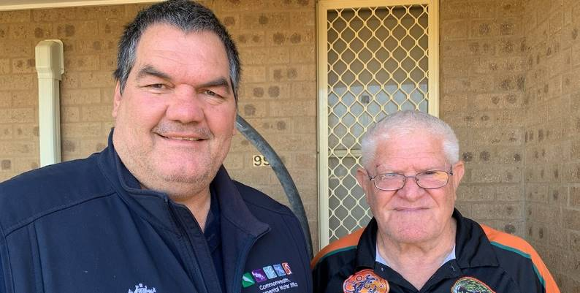

Fig 1: Jason Wilson (left), CEWO and Kevin Knight (right). Credit. Jason Wilson

Kevin is a proud Gurnu-Baakandji man who grew up camping, swimming and playing on the banks of the Baaka (Darling River). Kevin describes the Baaka as the lifeblood that has resourced his people for thousands of years.

In recent years Kevin has become well acquainted with the Warrego-Darling Selected Area, (Toorale National Park) in identifying cultural assets across the site, which help tell the stories of the Baakandji people. Such stories link Kevin and his people to the site long before European arrival. More recently, during its era as an agricultural enterprise, Kevin's family laboured on Toorale Station with his uncle being a blacksmith on Toorale.

To Kevin, the health of the river and its floodplains ties directly to health of his people.

"When the Brolga is dancing, the people of the river too, are dancing"

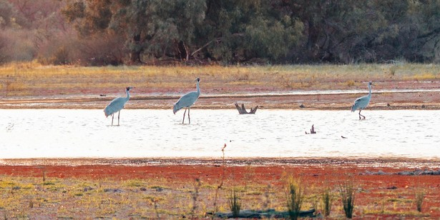

Fig 2. Brolgas, a Kurnu-Baakandji Totem, on the Western Floodplain. Credit. UNE

In this project we will work alongside Kevin, absorbing and capturing some of his knowledge, promoting and facilitating connection to country, while paying our respects to the Traditional Owners of the Gurnu-Baakandji Nation.

### [Hear from Kevin here](https://2rog.com.au/news/meet-kevin-our-gurnu-baakandji-selected-area-cultural-advisor/)

Local media

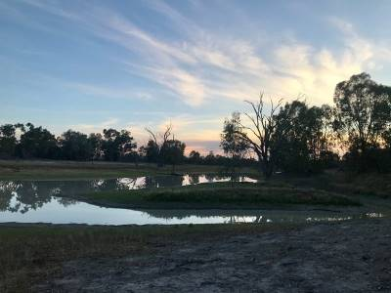

Ross's Billabong on dusk - Credit: 2rog

Press releases Radio Newspapers Online presence

# What's next?

Monitoring

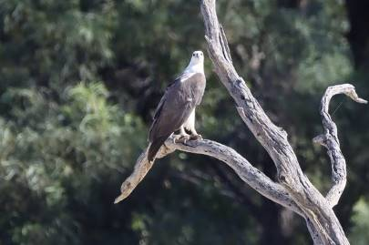

Spotted: A white-belleid sea eagle at Boera Dam, a Gurnu-Barkandji Totem. Credit - UNE

Fish recruitment – ASAP Food webs - Spring Vegetation - November Hydrology – ongoing

Communication and engagement Work together with Kevin to bring more traditional langauge to our comms work and reports

More stories from the Warrego

# Enquiries

For more information and a free Flow-MER newsletter head to [www.flow-mer.com.au](https://flow-mer.org.au/).

Also, stay up to date with news on the Gwydir and Warrego-Darling Selected Areas at [www.2rog.com.au/latestnews](https://2rog.com.au/latestnews/). For questions or comments please email:

*Jason Wilson*

Local Engagement Officer - Walgett (CEWO) [j](mailto:jason.wilson@environment.gov.au)[ason.wilson@environment.gov.au](mailto:ason.wilson@environment.gov.au)

*Jane Humphries*

Local Engagement Officer - Moree (CEWO) [j](mailto:jane.humphries@environment.gov.au)[ane.humphries@environment.gov.au](mailto:ane.humphries@environment.gov.au)

*Dr Mark Southwell* Project Manager (2rog)

[msouthwell@2rog.com.au](mailto:msouthwell@2rog.com.au)

*Sally Dickinson*

Northern Basin Engagement Officer (CEWO) [sally.dickinson@awe.gov.au](mailto:sally.dickinson@awe.gov.au)

