# Water for the environment

Water for the environment is used to improve environmental values of river and wetland systems and its use can provide social and cultural benefits, too. It can be either water entitlements that are left in the river, or a specified amount of water that has been set aside in storages that is released into natural waterways when needed.

Either way, the aim is to improve river and wetland health.

[Learn more](https://www.environment.nsw.gov.au/topics/water/water-for-the-environment/about-water-for-the-environment/what-is-it#%3A~%3Atext%3DWater%20that%20is%20allocated%20and%2Cas%20water%20for%20the%20environment.%26text%3DThey%20provide%20connections%20across%20the%2Cwell%20beyond%20the%20river%20bank)



# This quarter in a nutshell

Significant and widespread rainfall throughout the northern Murray-Darling Basin in November and December 2021, resulted in the largest flooding event since 2012. This included significant flooding in the Condamine-Balonne, Border Rivers, Gwydir, Namoi and Macquarie catchments.

By December, river levels in the Barwon and upper Darling rivers were on the increase with the flood peak located just upstream of Brewarrina



THE WARREGO

Quarter 2 | Oct - Dec 2021

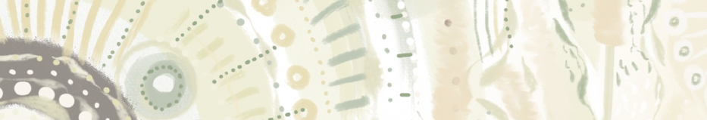

**We would like to acknowledge the Gomeroi/Gamilaroi/Kamilaroi People, the Traditional Owners of the Gwydir wetlands and its surrounds. Thank you for sharing your Country and knowledge of its land, water and life with us.**

**We pay respects to Elders past, present and emerging.**

Artwork © Lakkari Pitt

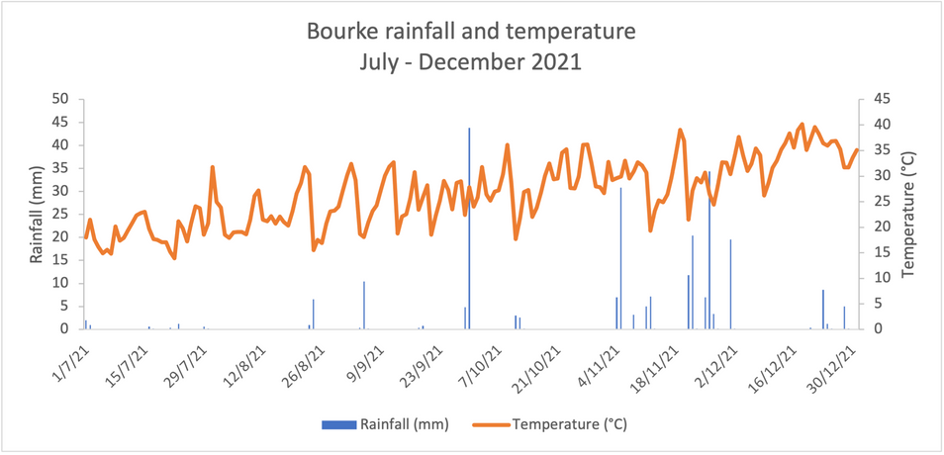Bourke received a total of 172 mm this quarter which is 71.7 mm greater than the long-term average rainfall for this time of year. This quarter temperatures at Bourke ranged between a low of 17.7 ºC (11/10/2021) and a high of 40.2 ºC (18/12/2021).

## Hydrology

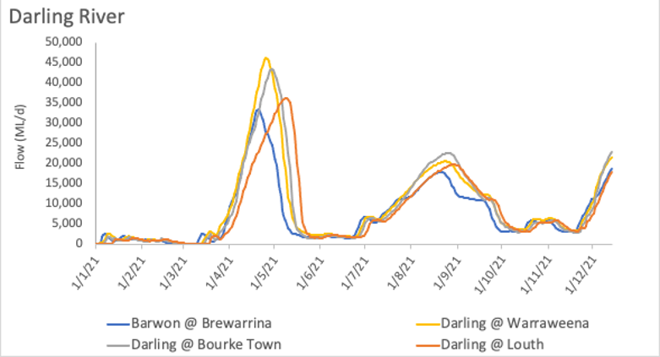Flows resulting from the significant and widespread rainfall in mid-November are making their way through the Darling system late this quarter, although the peak of this event is yet to occur in the Darling, with the flow peak currently upstream of Brewarrina. A total of 1,043,490 ML has flowed through the Darling River past Bourke this quarter, against the long-term average of 228,084 ML for this time of year.

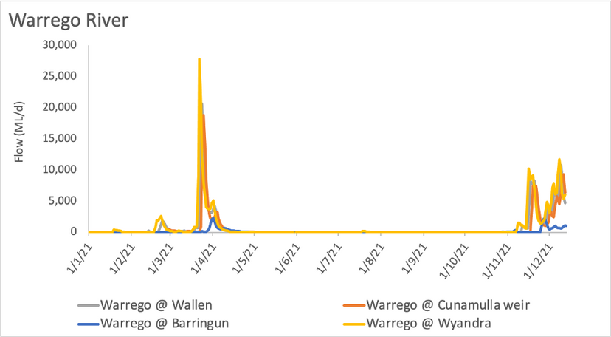Two smaller flow pulses moved through the Warrego River in the quarter, one in August and another in November/December. These flows entered the Selected Area in late December, inundating the northern section of the Western Floodplain and resulting in connection of the Warrego and Darling Rivers.

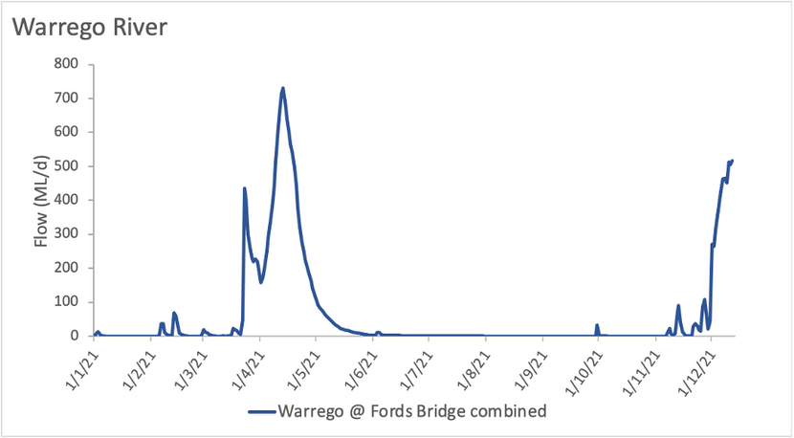A total volume of 18,929 ML flowed down the Warrego River past Fords Bridge between October and December, 2021.

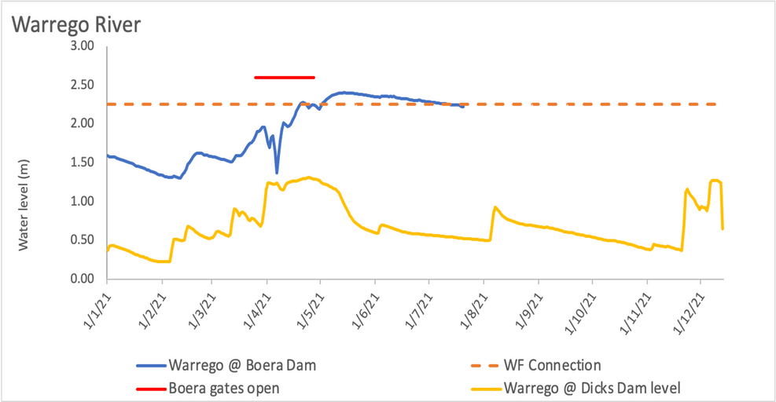The stream level at Dicks Dam began to increase late-November with a peak of approximately 1.3 m occurring from 7-10 December, 2021. There is currently no level recordings at Boera Dam due to the works that are occuring on the dam wall.

The Sentinel image below, taken on the 11/12/2021, shows flow connecting all the way down the Warrego River into the Darling River. Some inundation is evident throughout the landscape in depressions as a result of localised rainfall.

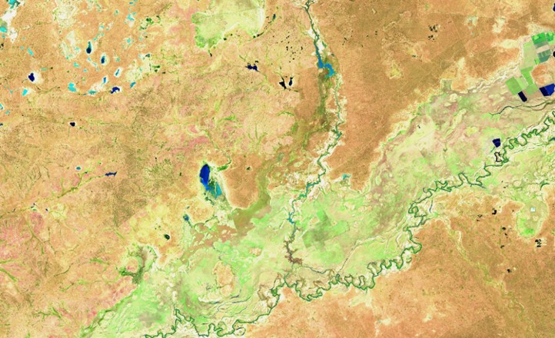

11/12/2021

Junction of the Warrego and Darling Rivers

o

Low Dissolved oxygen concentrations were observed in the Barwon-Darling River associated with poor quality floodwater making its way into the Barwon River. DO levels were particularly low at Walgett due to poor quality floodwater entering from the Namoi catchment. Encouragingly, no significant ecological consequences had been observed associated with this poor water quality.

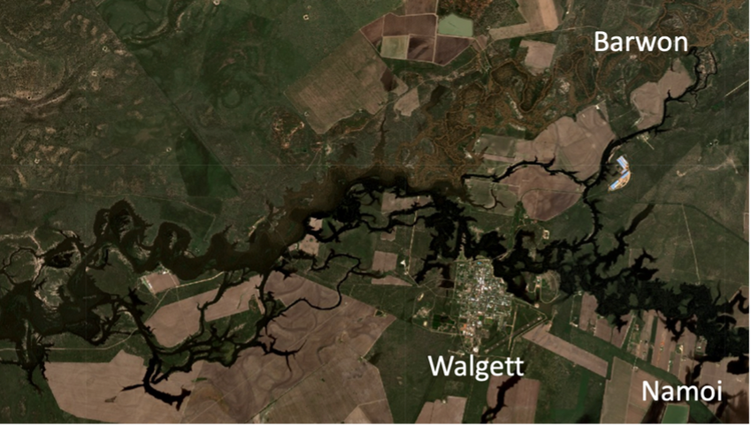

*Floodwater with low dissolved oxygen content (blackwater) entering the Barwon River near Walgett from the Namoi catchment. More oxygenated water (brown in colour) can be seen in the Barwon upstream.*

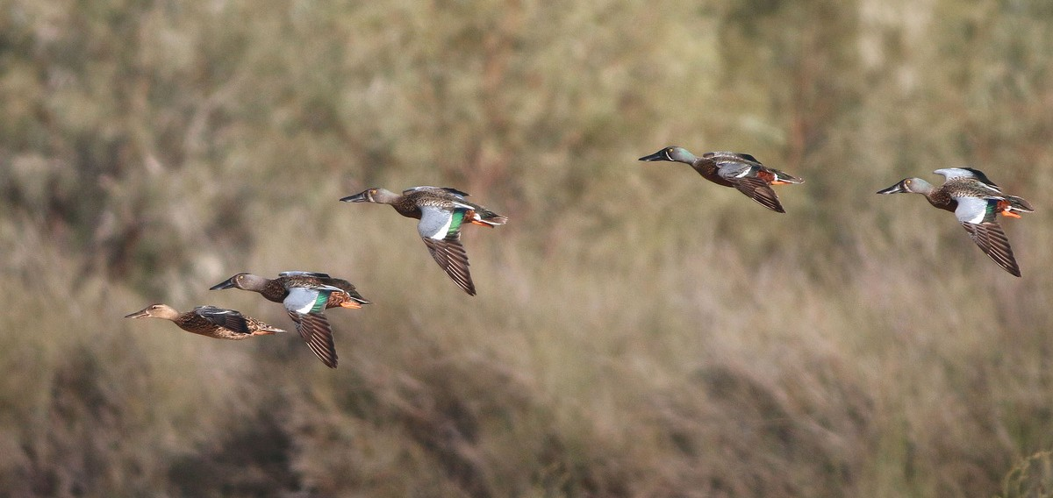

*A flock of Australasian shovelers (Anas rhynchotis) in flight over Toorale National Park; where a brown female (left) leads a group of four males (green feathers on wings). Credit: University of New England.*

Vegetation on the Western Floodplain showed some response to recent rainfall. Ground cover was looking healthy while a moderate species richness was observed. Reproductive activity was observed in various tree species including heavy flowering of black box, seed set in cooba and budding in coolibah. Lignum recruits were still evident and growing in many sites.

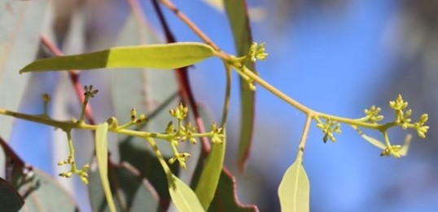

*Coolibah buds observed during spring 2021 monitoring. Credit: University of New England.*

Lignum condition

Lignum condition monitoring suggests that the studied bushes are in moderate condition, having reduced in condition since the last flooding event in early 2020. Bushes have tended to increase in size since the last flood with much larger bushes occurring in the north of the Western Floodplain (core sites) that get inundated more often.

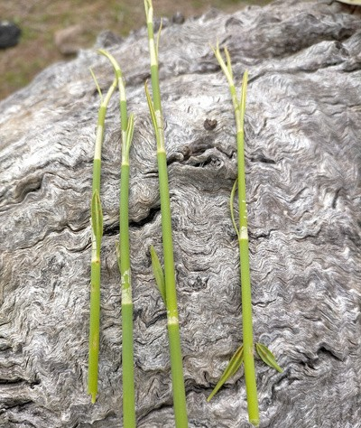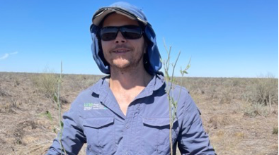

*Lignum seedlings in spring 2021, resulting from early 2020 flooding. Credit: University of New England.*

We produce several communications each quarter to help tell the story of the wetlands we study, the people that study them and the cultures that depend on and care for them. All our stories can be found [here](https://2rog.com.au/latestnews/)

## What's next?

In the upcoming quarter we will be surveying for a range of indicators including: Fish diversity and movement

Food webs Vegetation

Waterbirds diversity and breeding

We will be also keeping a close eye on flows in the system and wetlands inundation

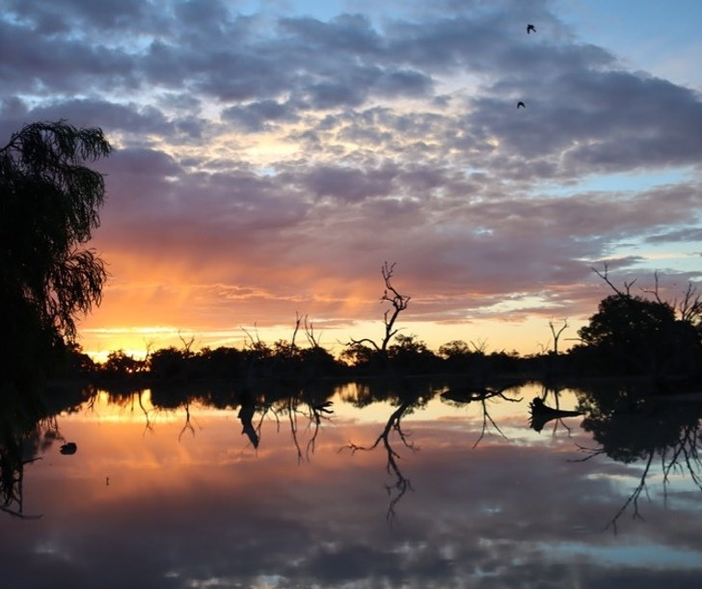

*Sunset at Dick's Dam. Credit: University of New England.*