###### Decision tree for considering use of Toorale Warrego Commonwealth environmental water

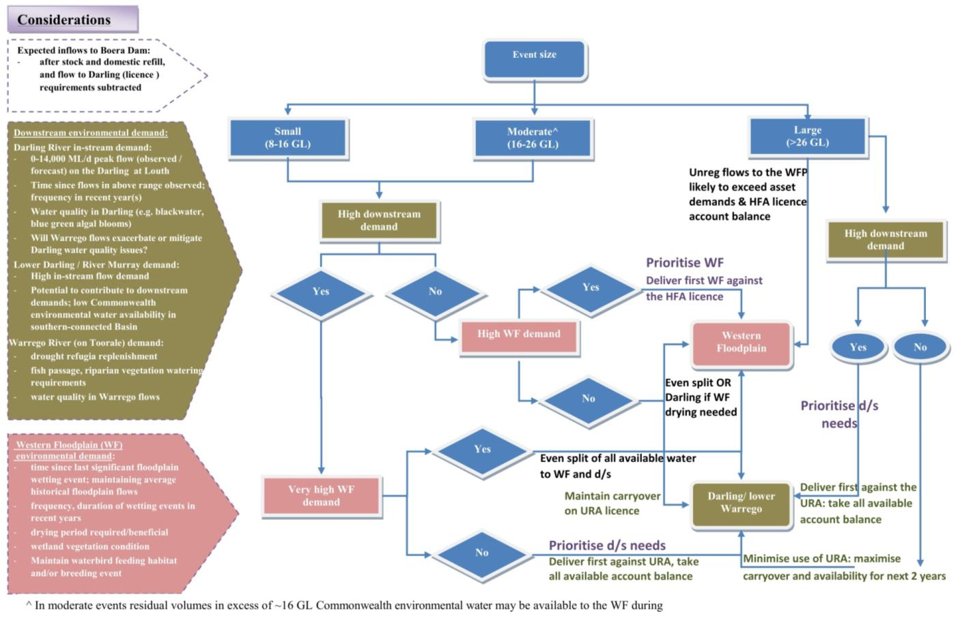

**HFA – Special additional high flow access licence**

**URA – Unregulated river access licence**

###### Ecosystem Type

Introduction

The Ecosystem type indicator contributes to the broader scale evaluation of Commonwealth environmental waters influence on ecosystem diversity. While primarily designed to inform evaluation at larger basin scales, information on the types of ecosystems influenced by Commonwealth environmental water is also useful at the Selected Area scale. Several specific questions were addressed by measuring Ecosystem type within the Warrego and Darling Rivers during the 2014–15 water year:

* What did Commonwealth environmental water contribute to sustainable ecosystem diversity?
* Were ecosystems to which Commonwealth environmental water was allocated sustained?
* Was Commonwealth environmental water delivered to a representative suite of Ecosystem types?

Methods

The ANAE classification for each sampling site in the Junction of the Warrego and Darling rivers Selected Area was mapped using a process of desktop identification and field verification (Commonwealth of Australia 2015). Existing ANAE GIS layers (Brooks et al. 2013) were used to assign an Ecosystem type to each monitoring site, and this was then verified in the field. Sites where existing ANAE mapping did not provide coverage were assigned an ANAE classification using available desktop information and then verified in the field. Field based verification was undertaken following a dichotomous key (Brooks et al. 2013).

Results

Forty sites in total are being sampled as part of the Junction of the Warrego and Darling rivers Selected Area LTIM project. These fall into 10 ANAE Ecosystem types, including five Floodplain types, two Riverine types, two Lacustrine types and one Palustrine type. The Rp1.4: The Permanent lowland streams type is represented at 17 sites. Five sites fall into the Lt2.1: Temporary lake type, while 4 sites fall into the Rt1.4: Temporary lowland stream ecosystem type. All other types are represented by 3 or less sites ().

Twenty-three sites are located within the Selected Area (Figure B‑1), with the other sites being river flow gauging stations located on upstream tributaries. Within the Selected Area, most sites (65%) are situated in the Western Floodplain zone. All of the ecosystem types, except Rt1.4 Temporary lowland stream and Rp1.4: Permanent lowland streams types, were present in the Western Floodplain zone (Table B‑1). Sites within the Darling River zone fall into one ecosystem types; Rp1.4: Permanent lowland stream. The three sites within the Warrego River zone fall into the Lt2.1: Temporary lake ecosystem type.

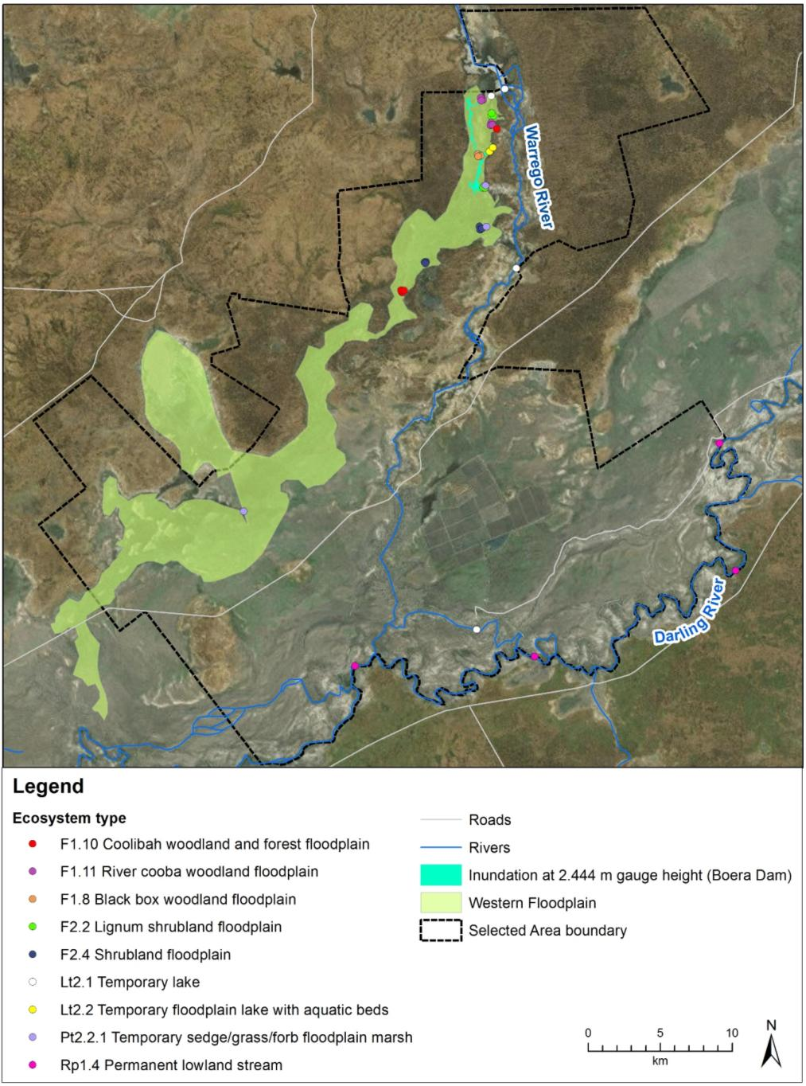

Figure ‑ Sites within the Selected Area and their ANAE mapping status.

Table ‑: ANAE Ecosystem types covered by monitoring sites in the Junction of the Warrego and Darling rivers Selected Area LTIM project.

|  |  |  |
| --- | --- | --- |
| ANAE Typology | Number of sites | % of total sites |
| F1.10 Coolibah woodland and forest floodplain | 2 | 5 |
| F1.11 River cooba woodland floodplain | 2 | 5 |
| F1.8 Black box woodland floodplain | 1 | 3 |
| F2.2 Lignum shrubland floodplain | 2 | 5 |
| F2.4 Shrubland floodplain | 2 | 5 |
| Lt2.1 Temporary lake | 5 | 12 |
| Lt2.2 Temporary floodplain lake with aquatic beds | 2 | 5 |
| Pt2.2.1 Temporary sedge/grass/forb floodplain marsh | 3 | 8 |
| Rp1.4 Permanent lowland stream | 17 | 42 |
| Rt1.4 Temporary lowland stream | 4 | 10 |
| **Total** | **40** | **100** |

Figure ‑ Distribution of ANAE Ecosystem types represented by sites across the three monitoring zones within the Selected Area. Note: some sites monitored in the project are outside of the Selected Area and are hence not represented in this figure.

Discussion

The types of ecosystems monitored in this project are a reflection of the nature of the delivery of environmental water, and the indicators being assessed. While aquatic in-channel habitats are being monitored in the Darling and Warrego River zones, a broader suite of ecosystems including channels, waterholes and floodplains are being monitored in the Western Floodplain zone. This diversity is reflected in the greater number of Ecosystem types being monitored in this zone.

During the 2014–15 water year, Commonwealth environmental water and management influenced a representative suite of sites falling into six of the 10 Ecosystem types monitored in the project. Ecosystem types that were not inundated during the year included Shrubland floodplain, Coolibah woodland and forest floodplain, temporary sedge/grass/forb floodplain marsh and Black box woodland floodplain types located on the Western Floodplain. As these ecosystems are either temporary aquatic or reliant on periodic (3-10 years; Roberts and Marston 2000) inundation to maintain their dominant species, the fact that they did not become inundated is of no major concern given the recent widespread inundation which occurred across the Selected Area in 2012. Ecological responses to Commonwealth environmental water and management were observed for most indicators measured at sites that became inundated, suggesting that this water is in part helping to sustain aquatic ecosystem diversity within the Junction of the Warrego and Darling river Selected Area.

References

Brooks, S., Cottingham, P., Butcher, R, and Hale, J. (2013) Murray-Darling aquatic ecosystem classification: Stage 2 report. Peter Cottingham & Associates report to the Commonwealth Environmental Water Office and Murray-Darling Basin Authority, Canberra.

Commonwealth of Australia (2015) Commonwealth Environmental Water Office Long Term Intervention Monitoring Project Junction of the Warrego and Darling Rivers Selected Area, Canberra.

Roberts R. and Marston, F. (2000) Water Regime of Wetland & Floodplain Plants in the Murray-Darling Basin – A Source Book of Ecological Knowledge. Technical Report 30/00. CSIRO Land and Water, Canberra.

###### Hydrology (River)

Introduction

The Hydrology (River) indicator provides base in-channel hydrological information on the character of water flows through the Junction of the Warrego and Darling rivers Selected Area. This information is directly relevant to a number of other indicators measured in the Selected Area including vegetation, waterbirds, frogs, and microinvertebrates. The particular influence of hydrology on these indicators will be addressed under their respective sections. One specific question was addressed in relation to this indicator:

* What did Commonwealth environmental water contribute to hydrological connectivity?

Environmental watering in 2014–15

Unlike other Selected Areas, environmental water is not specifically delivered to the Junction of the Warrego and Darling rivers Selected Area, rather, Commonwealth environmental water is held as unregulated entitlements and its influence is thus reliant on flows out of upstream catchments. During the 2014–15 water year, three flow events containing environmental water flowed down the Darling River within the selected area (Appendix D). These occurred in October–November 2014, December –March 2015 and April–May 2015. All three flows were in-channel pulses. No Commonwealth environmental water was accounted for on the Warrego River, however, management decisions made by the CEWO resulted in water flowing over the Western Floodplain during February–March 2015 (Appendix E).

Methods

An assessment of the hydrological connectivity experienced along the Darling River within the Selected Area was undertaken by comparing flow regimes at the Weir 19A gauge (upstream) with the gauging station at Louth (425004) which is the first reliable gauge downstream of the Selected Area (Figure C‑1; Commonwealth of Australia 2015). This reach was considered to be fully connected when water was flowing past both gauges. For the Warrego, flows entering the Selected Area were measured by plotting flows past Fords Bridge (Figure C‑1). Flows at 423001–Warrego River @ Fords Bridge (Main channel) were combined with flows past 423002–Warrego River @ Fords Bridge Bywash to give a total flow past Fords Bridge. To quantify flows down the Warrego River channel within the Selected Area the duration of time one or both the control gates on Boera Dam were open was compared with flows registered at the gauging station within Dicks Dam (423007). Operation of the gates at Boera Dam was assessed using the Remote Access Camera mounted in Boera Dam. Here full connection was considered to have occurred when the Boera control gates were open and when Dicks dam was rising in level. SPELL analysis (Gordon et al. 1992) was undertaken to assess the total duration and frequency of flows passing down each channel.

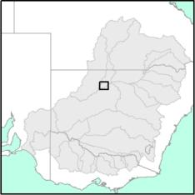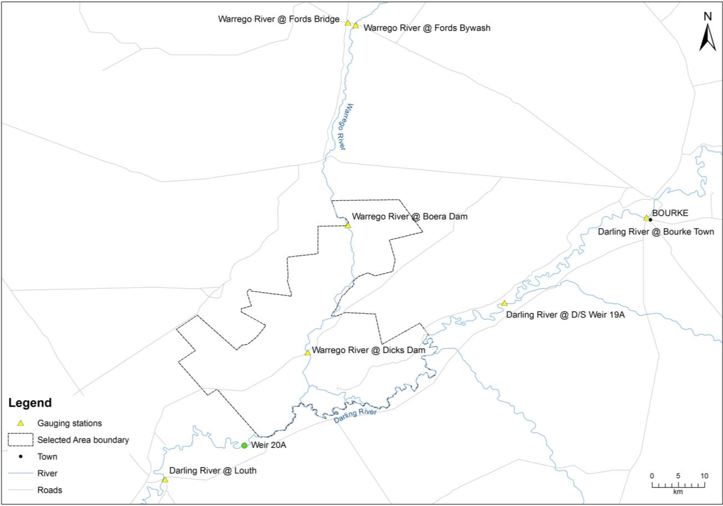

Figure ‑: Location of flow gauging stations used in the hydrological connectivity analysis.

Results

Water flowed through the Darling River within the Selected Area for 60% of the time during 2014–15. The remainder of the time water was confined to the 20A weir pool. This connection was in the form of three relatively long events throughout the season (). The longest of these events was at the start of the water year where water flowed through the length of the Darling channel within the Selected Area for 96 days. This was followed by an extended period of disconnection for 117 days before flows generated mainly in the Condamine-Balonne catchment re-connected this section of river once again. During May–June 2015, increased rainfall in the Border Rivers catchment produced fresh flows through the Selected Area, with several ‘top up’ events keeping the channel flowing for this period.

The Warrego channel upstream of the Selected Area experienced one significant flow event through the 2014–15 water year. This occurred as a result of rainfall in the upper Warrego catchment during December–January, which caused the river to flow at Fords Bridge for a total of 63 days (Figure C‑3). Several small flow peaks were experienced later in the season at Fords Bridge as a result of local runoff from storm events, which produced minor inflows to the Selected Area.

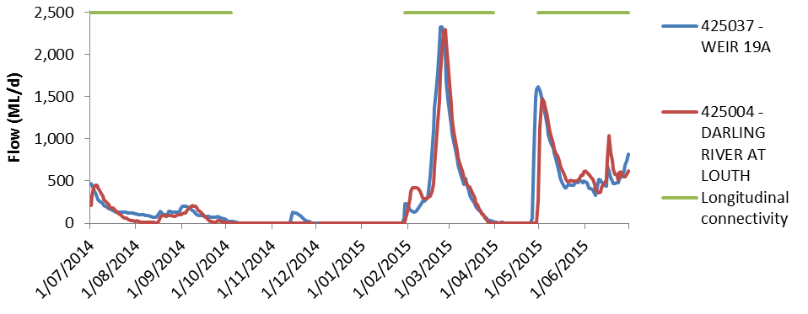

Figure ‑: River flows down the Darling River channel and the timing of longitudinal connectivity down this reach.

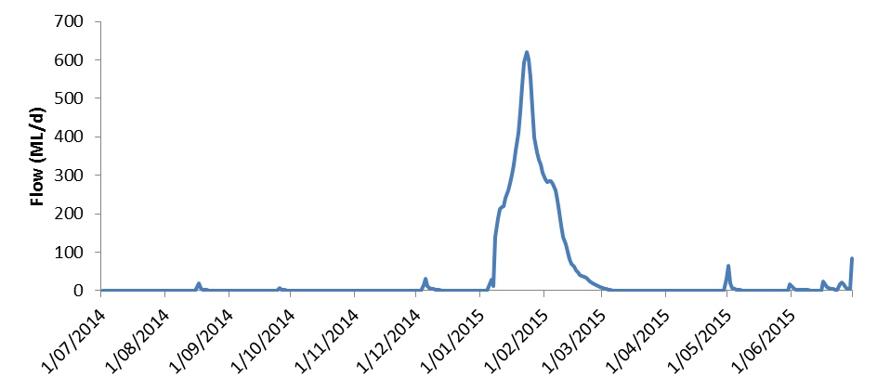

Figure ‑: Flow hydrograph for the Warrego River at Fords Bridge upstream on the Selected Area. Note, gauges 423001 and 423002 have been combined to produce a total flow past Fords Bridge.

Water levels in Boera Dam were relatively high early in the season as a result of an inflow event in March 2014 (Figure C‑4). Dam levels declined through the water year until inflows increased as this flow event described above reached the dam. To meet downstream license conditions, the gates at Boera Dam were opened on the 13th January 2015 to let flows down the lower Warrego channel. These flows caused full connection through to the Darling River. The lower Warrego was fully connected for a 24 day period before the gates were closed on 5th February. Continued inflows to Boera Dam resulted in the dam rising to a level of 2.44 m and spilling onto the Western Floodplain (Appendix E). While connection was broken down the Warrego channel, water levels persisted in at least Boera and Dicks Dams and Ross Billabong through to the end of the season (field observations).

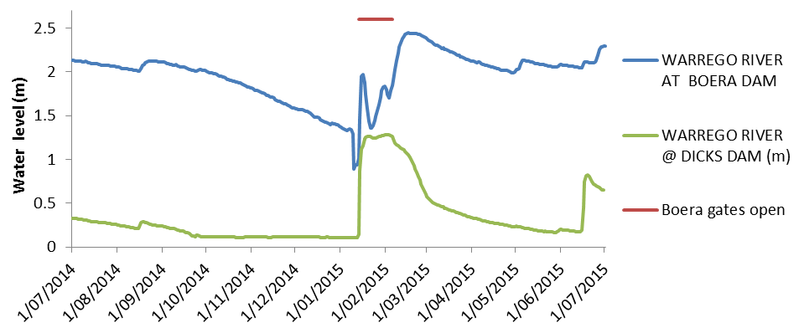

Figure ‑: Water level data for sites on the Warrego River in the Selected Area.

Discussion

Flows down the Darling River during the 2014–15 water year were dominated by small in-channel pulses and low flows. While three flow events were experienced throughout the year, they all remained well in-channel, with the largest event in March 2015 peaking at 2,300 ML/d containing around 25% Commonwealth environmental water (Appendix D). In comparison, channel capacity in this reach of the Darling River is around 30,000–40,000 ML/d (M. Southwell unpublished data). Hydrology of this section of the Darling is heavily influenced by several weirs, which during low flows increase the connection of water through the Selected Area. These include Weir 19A which is located 30 river km upstream of the Selected Area and Weir 20A which forms the downstream end of the Selected Area, around 5 km downstream of the southern Toorale SCA boundary. Given the tendency for salt build up (N. Foster pers comm), and algal blooms (Mitrovic et al. 2011) in these weirs, flushing flows that re-connect them are important for maintaining water quality in this reach.

One flow event in January 2015 dominated the hydrology of the Warrego River during the 2014–15 water year. Due to low flows occurring in the Darling River at the same time, the control gates at Boera Dam were opened to allow flows to pass down the Lower Warrego channel and into the Darling. This is a stipulation of the water license at Boera Dam. These flows connected the Warrego channel between Boera Dam and the Darling for around 24 days before the gates were closed, resulting in water persisting in Booka Dam, Dicks Dam and Ross Billabong through to the end of the season. Once the gates on Boera Dam were closed, water levels rose sufficiently to provide connection with the Western Floodplain.

Conclusion

Full longitudinal hydrological connection was achieved through the Darling River for 60% of the time and through the Warrego River for 24 days within the Selected Area during 2014-15.These flows provided access to in-channel habitat (Appendix G) and maintained water quality (Appendix H). In the Darling this connection took the form of three in-channel pulses, two of which were associated with Commonwealth environmental water (Appendix D). In the Warrego, inflows from the upper catchment in February 2015 resulted in full connection for the Warrego channel below Boera Dam, when the gates at the dam were opened for a 24 day period consistent with license conditions. This resulted in the filling of a number of downstream dams with water providing aquatic habitat in this system through to the end of the season.

References

Commonwealth of Australia (2015). Commonwealth Water Office Long Term Intervention Monitoring Project Junction of the Warrego and Darling rivers Selected Area, Canberra.

Gordon, N. D., McMahon T.A. and Finlayson, B.L. (1992). *Stream Hydrology—An introduction for Ecologists.* Brisbane, Wiley.

Mitrovic, S.M., Hardwick, L. & Dorani, F. 2011. Use of flow management to mitigate cyanobacterial blooms in the Lower Darling River, Australia. *Journal of Plankton Research*. 33; 229–241

*Personal Communication:*

Neil Foster, NSW Office of Water, Tamworth NSW 2340.

*Blank page*

###### Hydrology (Northern Tributaries)

Introduction

This chapter examines Commonwealth environmental water in the Northern Tributaries of the Murray Darling Basin (MDB). In particular, it considers the hydrological influences of Commonwealth environmental water at the junction of the Warrego and Darling rivers Selected Area during the 2014/15 water year. This indicator links closely with other Hydrology indicators as well as the water quality and metabolism indicators. The specific question addressed in this chapter is:

* What did Commonwealth environmental water from upstream tributaries contribute to hydrological connectivity within the Selected Area?

Northern Tributaries of the Murray Darling Basin

The stream network and longitudinal connectivity of the northern MDB is complex and the hydrological behaviour of this system even is more complex. River tributaries alternate between gaining and losing systems through complex interactions with each other and their floodplains. Exacerbating this situation is a pronounced climatic and rainfall gradient from east to west. The catchment upstream of the Selected Area drains the Great Dividing Range in southern Queensland and northern NSW, flowing more than 500 km in a westerly direction across extensive floodplains. The Warrego River catchment defines the western extent of the target catchment, meeting the Darling River in the Selected Area (Figure D‑1).

The major tributaries within the northern MDB include:

* Warrego River
* Moonie River
* Condamine-Balonne River system
* Border Rivers
* Gwydir River
* Namoi River
* Barwon-Darling River system
* Macquarie River
* Castlereagh River

Water management activities are equally complex. The Northern Tributaries comprise a mixture of regulated, unregulated and ephemeral streams managed across two states with various government agencies, legislation and policies. The Northern Tributaries contain a wide range of agricultural water uses including cotton, horticulture, and livestock production.

Annual water diversions reflect the fact that the Northern Tributaries are home to a population of approximately 560,000 people with annual production values of $5.2b and $1.45b for agriculture and irrigated agriculture, respectively (www.mdba.gov.au).

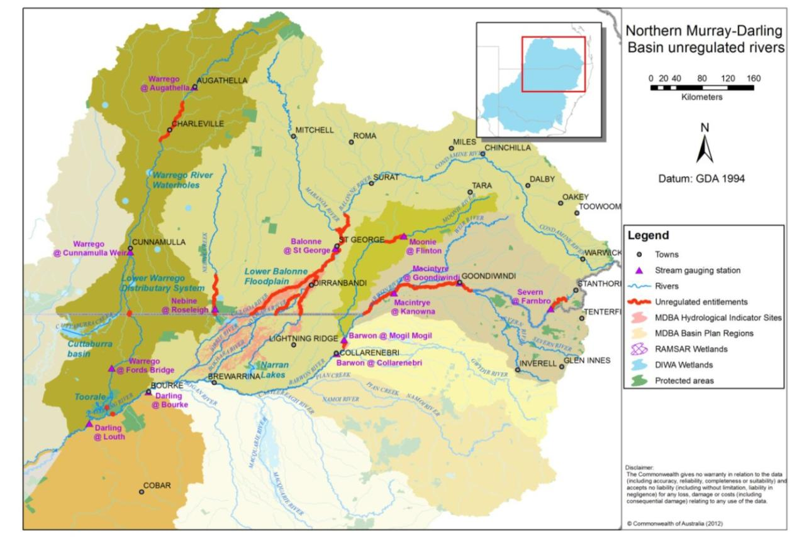

Kilometres

Figure ‑: Northern Tributaries of the Murray Darling Basin (Commonwealth Environmental Water Office).

Commonwealth environmental water in the Northern Tributaries

As at 30 June 2015, Commonwealth environmental water holdings totalled 2,289,433 ML of registered entitlement. This includes 432,290 ML within the Northern Tributaries (Table D‑1).

Long Term Average Annual Yield (LTAAY) provides an indication of the long term reliability of these entitlements and is generally used by the Commonwealth environmental water holder for annual decision-making regarding water use priorities. LTAAY of Commonwealth environmental water for the Northern Tributaries upstream of Louth is 209,309 ML.

Table ‑: Commonwealth Water Holdings for Northern Tributaries at 30 June 2015.

| River System | Security | Registered entitlements (ML) | Long Term Average Annual Yield (ML) |
| --- | --- | --- | --- |
| Queensland | | | |
| Border Rivers | Medium | 15,540 | 5,241 |
| Unsupplemented | 7,851 | 3,150 |
| Condamine Balonne | Unsupplemented | 62,091 | 43,697 |
| Overland Flow | 23,169 | 10,015 |
| Moonie | Unsupplemented | 1,415 | 1,100 |
| [Nebine](http://www.environment.gov.au/ewater/northern/condamine-balonne/index.html) | Unsupplemented | 5,920 | 1,000 |
| St George | Medium | 45 | 43 |
| Warrego | Unsupplemented | 16,050 | 8,000 |
| New South Wales | | | |
| Barwon-Darling | Unregulated | 24,279 | 24,279 |
| Border Rivers | General | 420 | 168 |
| Gwydir | High | 4,508 | 4,508 |
| General | 89,525 | 32,229 |
| Supplementary | 20,451 | 3,886 |
| Macquarie/Cudgegong | General | 126,224 | 53,014 |
| Supplementary | 8,292 | 1,741 |
| Namoi (upper) | General | 105 | 81 |
| Namoi (lower) | General | 7,322 | 5,638 |
| Peel | General | 1,257 | 326 |
| Warrego | Unregulated | 17,826 | 17,826 |

Hydrology within the Junction of the Warrego and Darling rivers Selected Area

The hydrology within the Selected Area is governed by flows in either, or both, the Darling River and the Warrego River (Commonwealth of Australia 2015).

Located in a semi-arid setting, upstream climatic conditions are the key driver of hydrology within the Selected Area; with the easterly catchments capable of providing overbank flows within the Barwon-Darling. During major events floodwaters may extend along the length of the river system.

During drier times the relationship becomes more complex. From a water management point of view, both the Barwon-Darling River system and the Warrego River are considered to be unregulated streams; however, the Barwon-Darling is fed by regulated and unregulated upstream catchments and stream flows reflect upstream water management decisions. Further complicating hydrology is the influence of terminal wetlands, anabranches and abrading streams into which end-of-system flows may disappear.

The Warrego River is essentially unregulated, but due to its semi-arid setting, only flows intermittently in Selected Area. Further complicating this relationship are in-stream structures within the Selected Area, such as Boera, Booka, Dicks and Peebles Dams.

As a result of these many interacting factors, it is difficult to develop a conceptual model to describe the effects of upstream rainfall and/or water management actions on flows in the Selected Area. This analysis adopts an approach where individual flow events that trigger Commonwealth environmental water entitlements are assessed and their effect within the Selected Area described.

In the northern unregulated tributaries, Commonwealth environmental water may only be taken once the individual conditions associated with each entitlement are met. This is usually based on a flow trigger that will differ for each entitlement based on its location and relative security. Depending on individual watering strategies, Commonwealth environmental water may or may not be accounted for once the flow trigger in reached. Commonwealth environmental water may not be used in the same way as an irrigator may extract water, but will usually be left in the river to achieve environmental outcomes.

Methods

The downstream passage of Commonwealth environmental water events was observed and assessed using NSW Office of Water real-time flow data from gauging stations located along the Barwon-Darling River system.

Analysis of these events was undertaken using mean daily discharge data for the following hydrometric stations:

* 416001—Barwon River at Mungindi
* 422004—Barwon River at Mogil Mogil
* 422003—Barwon River at Collarenebri
* 422001—Barwon River at Walgett
* 422028—Barwon River at Beemery
* 425003—Darling River at Bourke
* 425037—Darling River at Weir 19A
* 425004—Darling River at Louth

The relationship between these gauging stations and key tributary inflows is shown in Figure D‑2.

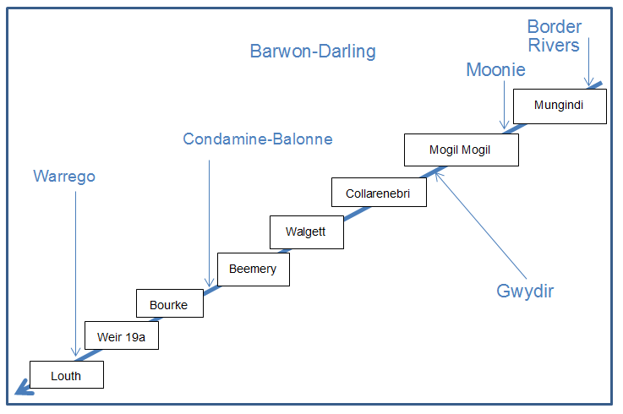

Figure ‑: Gauging stations and key tributaries on Barwon Darling River system used for this analysis.

Daily flow records were cross-referenced with internal operational reports to assess key flow events and usage of Commonwealth environmental water in the Northern Tributaries during the 2014–15 water year. In each case, a judgement was made regarding the likelihood of the flow containing Commonwealth environmental water to influence hydrological conditions within the Selected Area.

Commonwealth environmental water events were divided into regulated and unregulated events. Unregulated events were linked to prevailing climatic conditions, requiring specific streamflow conditions to be met in order to trigger use of individual Commonwealth environmental water entitlements. Regulated Commonwealth environmental water events were not dependent on specific stream flows and were triggered in response to a wider range of river management or environmental decision criteria. No regulated Commonwealth entitlements exist in the Barwon-Darling channel itself, rather for this analysis it refers to holdings in the Gwydir and Macquarie sub-catchments only.

Results

Interpretation of 2014/15 daily flow records (Figure D‑3) indicates the following Commonwealth environmental water flow events:

* July–October: tail down of 2013/14 flow event (not considered further in this report)
* October–November: regulated event originating in Gwydir catchment
* December–March: unregulated event 1 (unreg 1)
* April–May: unregulated event 2 (unreg 2)

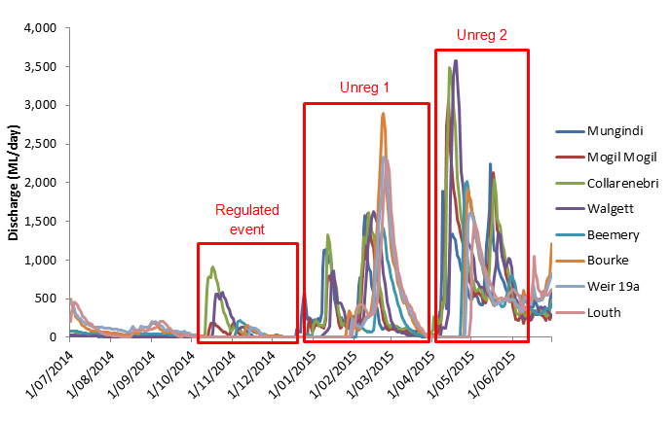

Figure ‑: Mean daily discharge at gauging stations on Barwon Darling River system (1 July 2014–30 June 2015). Events used in the analysis of northern tributary contributions are boxed in red.

A summary of Commonwealth environmental take during these events, and their likely influence on flows within the Selected Area is presented in Table D‑2.

Table ‑: Commonwealth environmental water events for 2014–15.

| Basin Plan Region | Tributary | CEW take (ML) | Comments |
| --- | --- | --- | --- |
| QLD Border Rivers | Dumaresq-Macintyre River | Unreg 1—294.4 | Possible effect at Darling River zone |
| Unreg 2—205.4 | Possible effect at Darling River zone |
| Severn River | Unreg 1—1,248.7 | Possible effect at Darling River zone |
| Unreg 2—2.0 | Unlikely effect at Darling River zone |
| QLD Moonie | Lower Moonie River | Unreg 1—806.4 | Possible effect at Darling River zone |
| Unreg 2—608.6 | Possible effect at Darling River zone |
| QLD Condamine–Balonne | Nebine Creek | 0 | No CEW usage events |
| QLD Warrego | Upper Warrego River | Unreg 1—329.2 | Possible effect at Darling River zone |
| Unreg 2—43.6 | Possible effect at Darling River zone |
| Lower Warrego River | Unreg 1—1,887.3 | Possible effect at Darling River zone |
| Unreg 2—281.6 | Possible effect at Darling River zone |
|  |  |  |  |
| NSW Condamine-Balonne | Lower Balonne | Unreg 1—16,238.5 | Flows reached Barwon River—Possible effect at Darling River zone |
| Unreg 2—147.6 | Flows did not reach Barwon River—Unlikely effect at Darling River zone |
| NSW Gwydir | Gwydir River | 59,895 (combined NSW / CEW) | Regulated flow release to support environmental conditions within the Gwydir Wetlands—Unlikely effect at Darling River zone |
| Mallowa Creek | 10,666.5 | Regulated flows into Mallowa Creek wetlands—Unlikely effect at Darling River zone |
| Mehi River | 13,316 | Regulated release for fish populations during October–November 2014—Possible effect at Darling River zone |
| Carole-Gil Gil Creek | 3,656 | Regulated release for fish populations during October–November 2014—Possible effect at Darling River zone |
| NSW Macquarie-Castlereagh | The Macquarie | 28,494 (combined NSW / CEW) | Regulated flow release to support environmental conditions within the Macquarie—Unlikely effect at Darling River zone as no CEW water flowed through to the end of this sub-catchment. No supplementary access was triggered in the Macquarie in 2014-15. |
| NSW Intersecting Streams—Warrego | Lower Warrego River | 0 | Events in late December and early January provided upstream (QLD) access; however, flows at Louth were insufficient to trigger CEW take for this licence. Accordingly flows progressed downstream within the Warrego—Likely effect at Darling River zone |
| NSW Intersecting Streams | Toorale Western Floodplain | 0 | No trigger flows for this high flow licence. Accordingly flows progressed downstream within the Warrego—Likely effect at Darling River zone |
| Barwon-Darling | Barwon-Darling River | Unreg 1—1,264.27 | Barwon received 8–12 GL inflows from Border rivers in late December. Flows peaked at Collarenebri on 12 January. B Class access was triggered 11–18 January. On 28 January NOW announced no B and C class access in Barwon Darling until embargo lifted—Likely effect at Darling River zone |
| Unreg 2—451.48 | Likely effect at Darling River zone |

Regulated Commonwealth environmental water events

The Gwydir was the only regulated catchment within the Northern Tributaries where Commonwealth environmental water was considered likely to influence flows within the Selected Area during 2014/15 (). A regulated block release of 16,972 ML from Copeton Dam to support native fish populations passed through the lower Gwydir catchment during the second half of October and early November 2014, progressing along both Carole Creek and the Mehi River and further downstream into the Barwon River (Figure D‑4).

Carole Creek enters the Barwon River upstream of Mogil Mogil, where the flow event was seen as a peak flow of approximately 200 ML/d. A second 200 ML/d peak following immediately after this was the result of an operational water release by State Water NSW to allow maintenance works on Tareelaroi Weir on Carole Creek and is not related to Commonwealth environmental water. The Mehi River enters the Barwon River downstream of Mogil Mogil and the Commonwealth environmental water flow event of 900 ML/d was apparent at Collarenebri during this period (Figure D‑4).

From Collarenebri, the Commonwealth environmental water flow pulse was observed to attenuate as it passed down the Barwon-Darling system as far as Weir 19A downstream of Bourke (Figure D‑5). Apart from some minor B-class pumping that occurred downstream of Collarenebri, no pumping of this event occurred. No effect on flow was apparent at Louth, due to the low flow conditions present downstream of Weir 19A. As a regulated flow release, Commonwealth environmental water accounted for 78% of the total flow volume of this flow event ().

This flow was of sufficient size to stimulate 10 consecutive days of connecting flows through the fish ladder over the Brewarrina Weir, providing suitable conditions for fish movement over this barrier. It is also considered likely that a small pulse reached the Selected Area below Bourke around 20 November 2014. However, it is unlikely that this pulse would have exceeded 100 ML/d or caused water to flow over weir 20A at the downstream extent of the Selected Area.

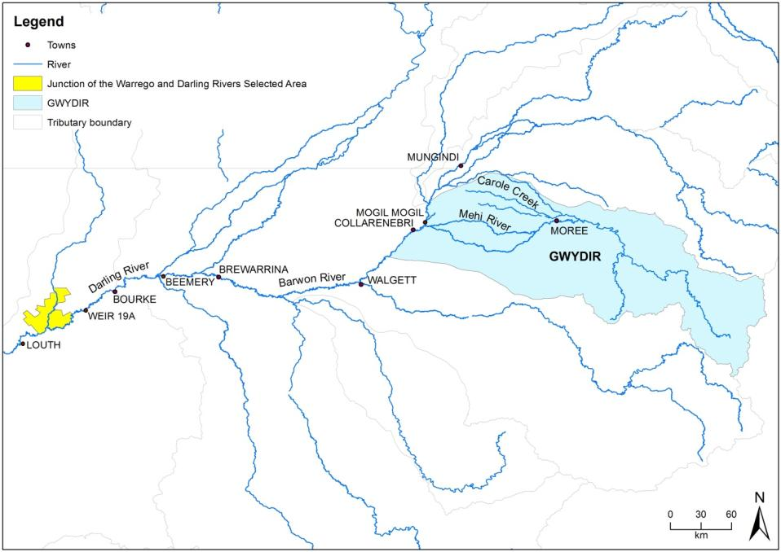

Figure ‑ Location of rivers in the Gwydir Catchment and gauging stations used in the upstream tributaries analysis

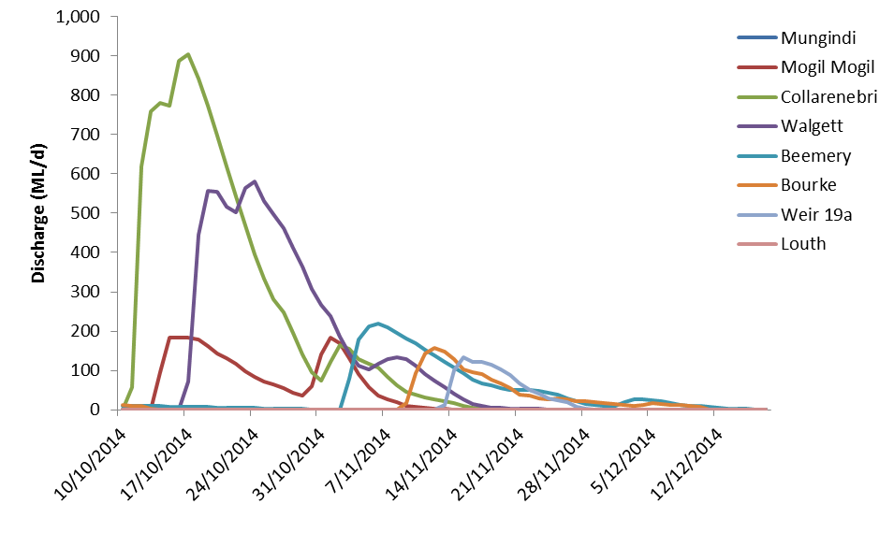

Figure ‑: Barwon-Darling regulated Commonwealth environmental water event, October–December 2014.

Table ‑: Total event discharge for regulated Commonwealth environmental water event 2014/15.

|  |  |  |
| --- | --- | --- |
| Monitoring Location | Total CEW (ML) | Total Discharge (ML) |
| Gwydir catchment at Mehi River and Carole Creek | 16,972 | 21,717 |
| Barwon River at Collarenebri |  | 11,620 |
| Barwon River at Walgett |  | 7,911 |
| Barwon River at Beemery |  | 2,858 |
| Darling River at Bourke |  | 1,511 |
| Darling River at Weir 19a |  | 1,036 |
| Darling River at Louth |  | 0 |

Unregulated Commonwealth environmental water events

The methodology for assessing unregulated Commonwealth environmental water events is more complex than for regulated events. This is because of the complexities of separating Commonwealth environmental water from the naturally occurring flow events that trigger environmental take. Based on the information presented in Table D‑2, unregulated Commonwealth environmental water flows in the Border Rivers, Moonee, Condamine-Balonne, Warrego and Barwon-Darling had the potential to influence the hydrology in the Selected Area during the 2014–15 water year.

Visual inspection of daily flows (Figure D‑6) shows the effect of unregulated Commonwealth environmental water event 1 during December 2014–March 2015, specifically:

* Three separate events originating within the Border Rivers are apparent at Mungindi
* There is attenuation as these events move downstream, however, peak discharge remains around 1,500 ML/d as far downstream as Beemery
* Daily discharge volumes increase noticeably at Bourke, where they are augmented by significant inflows from the Condamine-Balonne catchment
* The effect of flows in the Warrego can be seen by a lengthening of the rising limb of the Louth hydrograph (compared with Bourke) in early February.

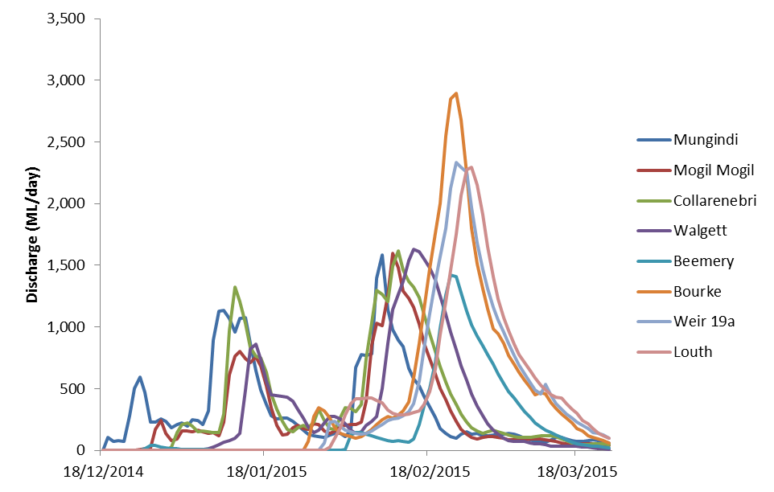

Figure ‑: Barwon-Darling unregulated Commonwealth environmental water event, 1 December 2014–24 March 2015.

A second flow event (event 2) occurred during April–May 2015 (Figure D‑7). This event was characterised by:

* Two flow peaks originating in the eastern catchments (Border Rivers, Moonee and Gwydir)
* Considerably higher peak daily flows in the eastern catchments than Commonwealth environmental water event 1
* Limited inflows from the Condamine-Balonne catchment.

Despite higher daily peak flows in the eastern catchments, Commonwealth environmental water take was more limited during Commonwealth environmental water event 2 than event 1 (Table D‑2). This is likely due to the more ‘flashy’ nature of flows associated with the event providing reduced opportunity for Commonwealth environmental water take, along with the exhaustion of some entitlements and embargo’s restricting the level of take in some upstream tributaries.

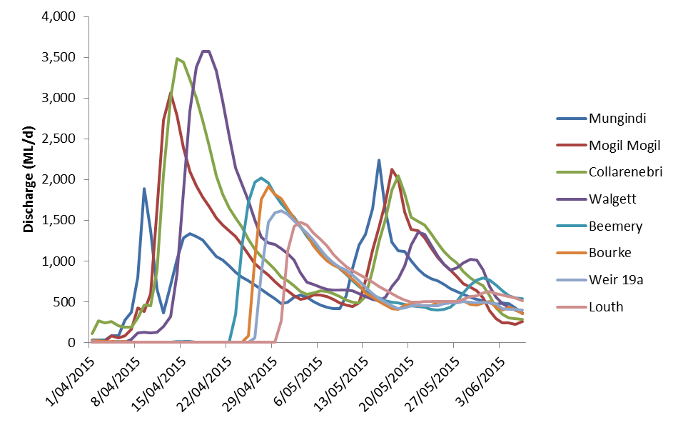

Figure ‑: Barwon-Darling unregulated Commonwealth environmental water event 2, 1 April 2015–6 June 2015.

As part of this analysis, Barwon Darling end of system (EOS) Commonwealth environmental water was estimated based on advice from Department of the Environment, NSW Office of Water and the CSIRO MDB Sustainable yield project (Figure D‑8; Table D‑4). It is noted that estimated EOS Commonwealth environmental water figures are considered indicative only, but provide an indication of the volumetric contribution of upstream Commonwealth environmental water as it passes through the Barwon-Darling system to the Selected Area and further downstream. Total unregulated Commonwealth environmental water contributions at Louth during 2014–15 are estimated to be 9,593 ML and 1,135 ML for unregulated flow event 1 and 2, respectively.

Figure ‑: Commonwealth environmental water flow volumes at Barwon-Darling gauging stations during unregulated flow event 1 (December – March) and 2 (April – June) during 2014–15.

Table ‑: 2014–15 unregulated Commonwealth environmental water flow events and take.

| Gauging station | CEW event | Event duration | | | Total event discharge | Upstream CEW take | Estimated EOS CEW | |
| --- | --- | --- | --- | --- | --- | --- | --- | --- |
| Start | Stop | Days | ML | ML | ML | % |
| Mungindi | Unreg 1 | 18/12/2014 | 24/03/2015 | 96 | 33,591 | 1,543.1 | 1,234.48 | 3.7 |
| Unreg 2 | 1/04/2015 | 6/06/2015 | 66 | 51,004 | 207.4 | 165.92 | 0.3 |
| Mogil Mogil | Unreg 1 | 24/12/2014 | 24/03/2015 | 90 | 29,640 | 2,349.49 | 1,821.47 | 6.1 |
| Unreg 2 | 4/04/2015 | 6/06/2015 | 63 | 64,220 | 816.01 | 608.94 | 0.9 |
| Collarenebri | Unreg 1 | 31/12/2014 | 24/03/2015 | 83 | 36,333 | 2,349.49 | 1,821.47 | 5.0 |
| Unreg 2 | 1/04/2015 | 6/06/2015 | 66 | 74,185 | 816.01 | 608.94 | 0.8 |
| Walgett | Unreg 1 | 4/01/2015 | 24/03/2015 | 79 | 31,844 | 2,349.49 | 1,821.47 | 5.7 |
| Unreg 2 | 7/04/2015 | 6/06/2015 | 60 | 67,332 | 816.01 | 608.94 | 0.9 |
| Beemery | Unreg 1 | 2/02/2015 | 24/03/2015 | 50 | 19,237 | 2,349.49 | 1,821.47 | 9.5 |
| Unreg 2 | 23/04/2015 | 6/06/2015 | 44 | 39,966 | 816.01 | 608.94 | 1.5 |
| Bourke | Unreg 1 | 26/01/2015 | 24/03/2015 | 57 | 40,790 | 19,852.26 | 8,841.13 | 21.7 |
| Unreg 2 | 25/04/2015 | 6/06/2015 | 42 | 33,443 | 1,415.09 | 1,024.73 | 3.1 |
| Weir 19A | Unreg 1 | 29/01/2015 | 24/03/2015 | 54 | 37,354 | 19,852.26 | 8,841.13 | 23.7 |
| Unreg 2 | 26/04/2015 | 6/06/2015 | 41 | 31,131 | 1,415.09 | 1,024.73 | 3.3 |
| Louth | Unreg 1 | 29/01/2015 | 24/03/2015 | 54 | 37,389 | 22,068.78 | 9,593.09 | 25.7 |
| Unreg 2 | 30/04/2015 | 6/06/2015 | 37 | 28,529 | 1,740.23 | 1,135.04 | 4.0 |

Commonwealth environmental water entitlements within the Selected Area

In addition to upstream events, there are a number of local Commonwealth environmental water entitlements directly associated with agreed watering actions at the Warrego Darling Selected Area. These licences are described in Table D‑5. The total 2014–15 take against these local Commonwealth environmental water entitlements was limited, with the only take being 7.33 ML accounted against the Darling River at Toorale Station licence. This was accounted during July 2014 and was considered as part of 2013–14 event in this analysis.

Table ‑: Commonwealth environmental water entitlements associated with the Warrego Darling Selected Area.

|  |  |  |  |  |
| --- | --- | --- | --- | --- |
| Water source | Water Access Licence | Registered entitlement (ML) | LTAAY (ML) | Flow conditions (ML/d—location) |
| Warrego River at Toorale Station | Boera Dam  WAL27558 | 1,134 | 8,106 | Fresh in Warrego reaching Darling (approx. 300 ML/d at Ford’s Bridge) plus >330 ML/d at Louth (425004) |
| Upstream Boera  WAL27555 | 972 |
| Peeble’s Dam  WAL27552 | 6,000 |
| Warrego Western Floodplain | Special High Flow—Boera Dam  WAL31152 | 9,720 | 9,720 | Visible flow in Warrego at or near Darling plus >979 ML/d at Louth (425004) |
| Darling River at Toorale Station | A Class  WAL33701  WAL33704 | 20  47 | 7,672 | >350 ML/d at Bourke (425003) and > 260 ML/d at Louth (425004) |
| B Class  WAL33784  WAL35944 | 1,437  1,090 | >1,250 ML/d at Bourke (425003) and > 1,130 ML/d at Louth (425004) |
| C Class  WAL35943 | 5,078 | >1,339 ML/d at Louth (425004) |

Discussion

The 2014–15 water year provided one regulated and two unregulated flow events where Commonwealth environmental water was considered likely to influence flows down the Darling River zone within the Junction of the Warrego and Darling rivers Selected Area. The regulated release of Commonwealth environmental water delivered through the lower Gwydir catchment occurred when flows in the Barwon River were low. As a result, this event had a relatively large influence on flows in the Barwon with noticeable rises in flow as far downstream as Weir 19A. While this flow did not appear to continue to Louth, it is likely that it would have provided upstream connection into weir 20A, refreshing water in this reach of the Selected Area.

The two unregulated flow events analysed during the season differed in nature. The first event was smaller originating in the upper Barwon catchment, but had a greater contribution from the Condamine-Balonne that bolstered flows in the Darling River below Bourke. In contrast, the second event was characterised by larger contributions in the more easterly catchments, but limited inflows from the Condamine-Balonne, resulting in decreased water availability downstream of Bourke. Commonwealth environmental water take was greater during event 1, despite this being a volumetrically smaller event. This was primarily the result of a NOW embargo on B and C class licence access in the Barwon-Darling commencing 28 January 2015, along with Commonwealth entitlements being exhausted in some upstream tributaries.

Despite the unregulated Commonwealth environmental water flow pulses (event 1 and 2 described above) influencing flow within the Selected Area during 2014–15, river conditions were not sufficient to trigger local Commonwealth environmental water entitlements at Toorale. This was primarily due to the low flow conditions in the Darling River being below the triggers (330 ML/d at Louth) for the Warrego River entitlements, along with the embargo restricting take on the Darling River licences.

Conclusion

The 2014–15 water year was characterised by dry conditions within the Northern Tributaries. As a result, the small regulated Commonwealth environmental water release in the Gwydir catchment increased flows noticeably through to the Selected Area. The two unregulated flow events including a proportion of Commonwealth environmental water occurred from December to March and April to June. Both events passed along the length of the Northern Tributaries, and provided more than 65,000 ML of water at the Warrego Darling Selected Area. It is estimated that within the Selected Area, Commonwealth environmental water made up around 25% and 5% in these two flows respectively, providing longitudinal connection through the Darling River zones of the Selected Area. These flows contributed to increased access to habitat along the channel (Appendix G), maintaining water quality in the Darling River zone and also provided movement opportunities for fish and other animals through the Brewarrina fishway upstream of the Selected Area. These flows also contributed to the broader MDBA Environmental watering strategy through improving river flows and longitudinal connectivity in the northern Basin.

Analysis of these flow events indicates that during 2014–15, Commonwealth environmental water accounted in upstream catchments played an important role in promoting the transmission of natural flow events downstream towards Toorale Station. Allowing for system losses, it is likely that Commonwealth environmental water provided a relatively small, but important, hydrological benefit to instream river conditions at the Junction of the Warrego and Darling rivers Selected Area during2014–15.

References

Commonwealth of Australia (2015). Commonwealth Water Office Long Term Intervention Monitoring Project Junction of the Warrego and Darling rivers Selected Area, Canberra.

###### Hydrology (Floodplain)

Introduction

The Hydrology (Floodplain) indicator provides information on the extent of inundation on the Western Floodplain influenced by Commonwealth environmental water management. This information is directly relevant to a number of other indicators measured in the Junction of the Warrego and Darling rivers Selected Area including vegetation diversity, waterbird diversity, hydrology (river and channel), stream metabolism and microinvertebrates. The particular influence of hydrology of these indicators will be addressed under their respective sections. Watering the Western Floodplain is an important aspect of water management in the Selected Area. Apart from being a target for Commonwealth environmental water (CEWO 2014), it also has a separate water allocation (Commonwealth of Australia 2015). Water managers have the ability to preferentially direct water down the Western Floodplain to meet watering targets by opening or closing the regulating gates at Boera Dam. Given this, knowledge of the extent and volume of water directed down the Western Floodplain throughout each watering season is essential base information by which to evaluate the success of these watering decisions. The hydrology (floodplain) indicator aims to achieve this, by combining information from a range of sources, to build relationships between inflows, inundation extent and volumes of water in the Western Floodplain. Specifically this chapter addresses the following questions:

* What did Commonwealth environmental water contribute to hydrological connectivity of the Western Floodplain?

Environmental watering in 2014–15

Unlike other Selected Areas, environmental water is not specifically delivered to the Junction of the Warrego and Darling rivers Selected Area, rather, Commonwealth environmental water is held as unregulated entitlements and its influence is thus reliant on flows out of upstream catchments. During the 2014–15 water year, three in-channel flow events containing environmental water flowed down the Darling River within the selected area (Appendix D). These occurred in October–November 2014, December–March 2015 and April–May 2015. No Commonwealth environmental water was accounted for on the Warrego River or Western Floodplain in the Selected Area. However, management decisions made by the CEWO resulted in water flowing down the Western Floodplain during February–March 2015. Flows in Boera dam were above the estimated overflow height of the western floodplain (2.26 m on the Boera gauge) for 37 days (). Rises in water level were measured at one of the water level sensors deployed on the western floodplain as a result (sensor code HYD\_WF2; ; ). Water levels in Boera Dam also rose above the overflow height of the Western Floodplain towards the end of the season as a result of local rainfall ().

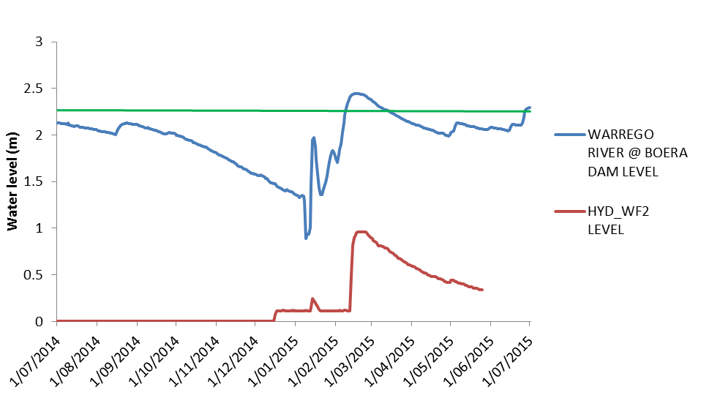

**Figure E‑1: Water levels experienced at Boera Dam and water level logger site WF2 on the Western Floodplain. Green line represents overflow level of the Western Floodplain.**

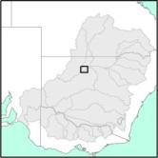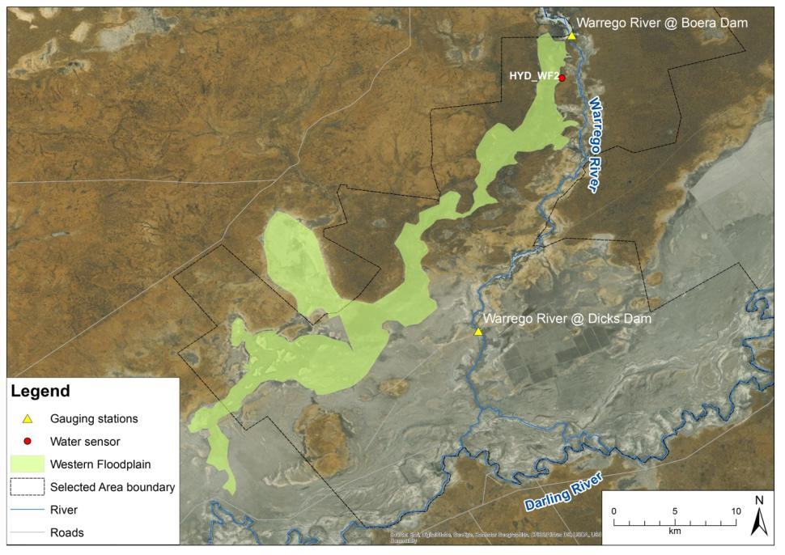

**Figure E‑2: Location of the Western Floodplain, gauging stations and water sensors.**

Methods

A number of data sources were used to build a model of inundation extent and volume in the Western Floodplain of the Warrego River (Commonwealth of Australia 2015). These included:

* Lidar data and Digital Elevation Model (DEM)
* Landsat imagery
* Existing vegetation mapping
* Water level records associated with water sensors and gauging stations

The DEM was the primary source of information used to model the relationship between inflows, and the extent and volume of inundation. The Landsat imagery and water level recorders were used to validate the results from the DEM. Existing vegetation mapping was used to determine the area of inundation associated with each vegetation community on the Western Floodplain.

Flood delineation and volume calculations were undertaken by manipulating the 5 m DEM, produced using recently captured Lidar data. Firstly, the approximate overflow point of Boera Dam was identified from the DEM. The DEM was then ‘flattened’ by applying a correction plane (), to remove the regional north–south gradient. This was done to represent the floodplain as a ‘closed’ system to allow for the estimation of inundation volumes. The average height at the upstream end of the channel was maintained (using the dam overflow as the starting point) while the downstream end was raised by 1.236 m (measured difference in regional relief between the north and south). The flattened DEM was virtually flooded and the water levels checked against a ‘wet’ image (Bing maps June 2012). A high level of agreement was achieved.

The DEM was ‘flooded’ by applying a virtual water level to the adjusted DEM and an extent and volume of water on the floodplain calculated. The ‘flood’ was constrained to where the predicted inundated areas were connected to the dam overflow point. A constraint layer was developed for each water level modelled. Development of the constraint layers required some manual interpretation to account for obstructions (e.g. vegetation impacting the DEM). Downstream areas were considered connected if they were less than 20 m from a connected upstream segment. Volume and extent of inundation was calculated for gauge heights between the estimated overflow height of the floodplain and the maximum height recorded at the Boera Dam gauging station during 2014–15, in 0.05 m height increments ().

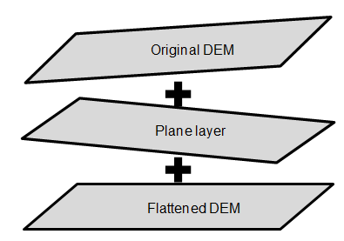

**Figure E‑3: Adjustment of the DEM to remove regional gradient.**

**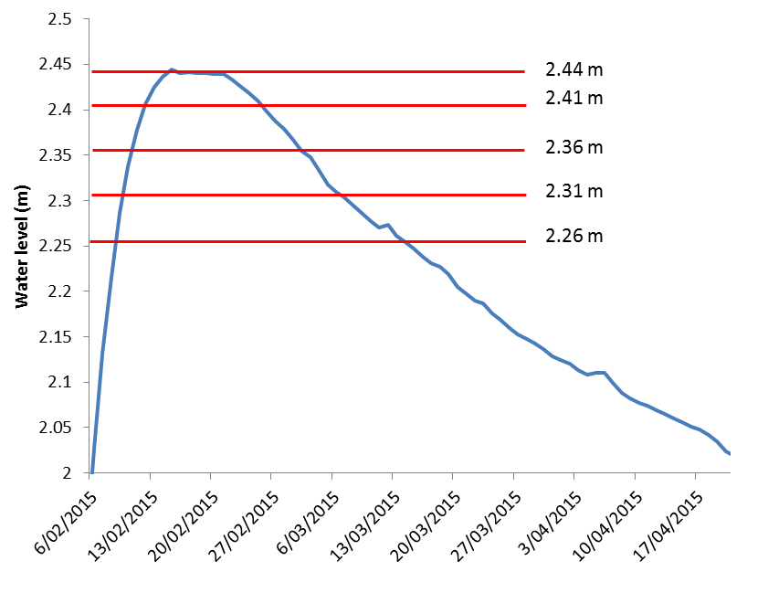**

**Figure E‑4: Water level in Boera Dam during Feb–April 2015. Red lines indicate levels at which floodplain inundation volume and extent were measured.**

The accuracy of the DEM derived inundation extent was verified using Landsat derived inundation extent calculated from an image captured on the 31 January 2015. Here supervised maximum likelihood classification (no probability threshold), was used to determine inundated areas.

Results

Digital Elevation Modelling

Manipulation of the 5 m DEM was successful in estimating the extent and volume of inundation of the Western Floodplain, with good relationships observed between this, Landsat-derived inundation extent, water level data on the floodplain and field observations.

Inundation extent ranged from 0.5–36.9 ha when Boera Dam was above the estimated overflow level of the Western Floodplain (). The resulting inundation extent maps for each height level show that at lower gauge heights, inundation was restricted to a single flood channel at the northern section of the floodplain, until Boera Dam levels increased to 2.36 m (). At this point, inundation increased at a greater rate with increasing water level in Boera Dam () with water spreading down the floodplain through flood channels, inundating a waterhole on the eastern side of the floodplain, and then fanned out through numerous smaller flood channels to the south. Volume estimates suggest that a maximum of 71.8 ML of water was stored in the floodplain during the peak of the flooding event. This figure however, does not account for losses associated with evaporation or seepage.

Three vegetation communities were inundated during February 2015 (Figure E‑7). Lignum shrubland had the greatest extent of inundation (25.9 ha), followed by Coolibah open woodland (10.7 ha). Small areas of Coolibah-River Coobah-Lignum woodland (0.3 ha) were also inundated in the northern floodplain (Figure E‑7).

**Table E‑1: Floodplain volume calculations.**

|  |  |  |  |  |
| --- | --- | --- | --- | --- |
| Gauge height at Boera Dam (m) | AHD height (Adjusted; m) | Description | Volume estimate (ML) | Area (ha) |
| 2.260 | 104.860 | CTF height of floodplain estimate | 1.2 | 0.51 |
| 2.310 | 104.910 |  | 1.5 | 0.64 |
| 2.360 | 104.960 |  | 40 | 19.20 |
| 2.410 | 105.010 |  | 55 | 26.70 |
| 2.444 | 105.044 | Max recorded height | 71 | 36.90 |

**Figure E‑5: Relationship between inundated volume and area on the Western Floodplain with increases in water level in Boera Dam observed during February–March 2015.**

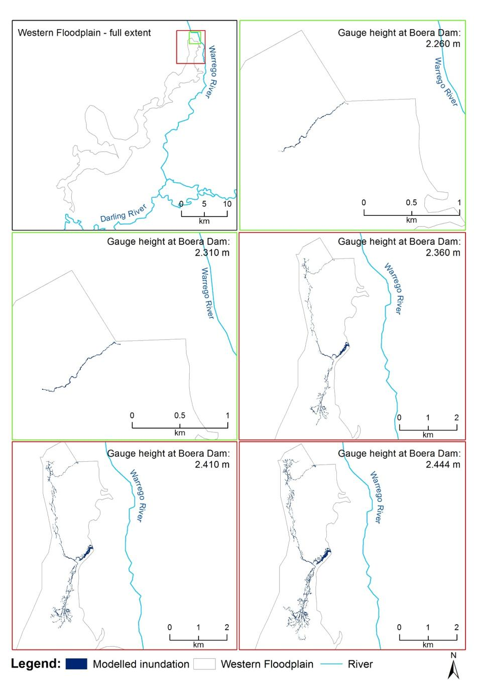

**Figure E‑6: Inundation extent on the Western Floodplain modelled from the DEM for various water levels measured at Boera Dam.**

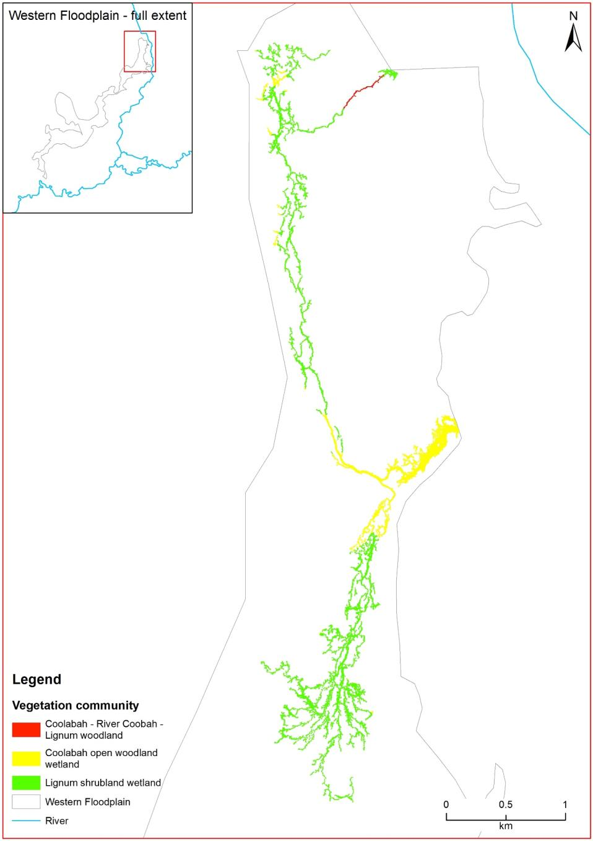

Figure ‑: Inundation of vegetation communities on the Western Floodplain during 2014–15.

Discussion

The DEM produced from the recently captured Lidar data proved useful in estimating the area and volume of inundation down the Western Floodplain, for the relatively small inundation event that occurred in 2014–15. Visual inspections of the DEM suggested that the microtopgraphy of the floodplain (floodplain channels) was well represented.

This analysis suggests that larger increases in floodplain inundation extent and volume occur when heights in Boera Dam reach 2.36 m at the Boera Dam gauge. Further identification of critical thresholds in the water level-inundation extent relationship of the Western Floodplain such as this will be useful to inform management decisions surrounding the operation of the gates at Boera Dam.

Lignum, Coolibah and River Cooba communities become inundated on the Western Floodplain even during the relatively small connection event observed in 2014–15 (Figure E‑7). Coolibah-River Cooba-Lignum woodlands located at the northern end of the floodplain were inundated while Coolibah open woodland wetlands communities surrounding a waterhole adjacent to the Western Embankment further south were also inundated. Large expanses of Lignum shrubland wetland dominate the northern half of the western floodplain (Gowans et al. 2012) which explains the relatively high proportion of this community which became inundated.

Conclusion

In total 36.9 ha of the Western Floodplain was inundated as a result of management decisions made by the CEWO during the 2014–15 water year, with maximum connection achieved in late February 2015. Floodwater inundated Lignum, Coolibah and River Cooba communities bordering flood channel and waterholes within the northern sections of the floodplain. DEM analysis suggests that water levels above 2.36 m may produce increased rate of inundation of the floodplain, as floodwaters appear to move more rapidly down the floodplain at dam levels above this threshold.

References

Commonwealth Environmental Water Office (CEWO). 2014. Commonwealth environmental water use options 2014–15: Northern Unregulated Rivers. Commonwealth Environmental Water Holder for the Australian Government.

Commonwealth of Australia (2015). Commonwealth Water Office Long Term Intervention Monitoring Project Junction of the Warrego and Darling rivers Selected Area, Canberra.

Gowans, S., Milne, R., Westbrooke, M. & Palmer, G. (2012) *Survey of Vegetation and Vegetation Condition of Toorale*. Prepared for the NSW Government Office for Environment and Heritage. University of Ballarat, Mt Hellen. 199pp.

###### Hydrology (Channel)

Introduction

The lower Warrego River within the junction of the Warrego and Darling rivers Selected Area, is a complex anabranching channel, with multiple secondary channels bordering a main channel for most of its length (Holz et al. 2008). Along this stretch of river a number of in-channel dams and flow diversion structures have been established over the last 160 years (Aurecon 2012). At present these dams are in various states of decommission, with some still heavily influencing the hydrology, while others have become breeched and have little influence of river flows (Capon 2009). The Hydrology (Channel) indicator describes the channel network of the lower Warrego, and documents the hydrological connectivity of this river channel system. It links to other indicators being measured including hydrology (Floodplain and River), water quality, metabolism, microinvertebrates, frogs and waterbirds. In particular, it addresses the following question:

* What did Commonwealth environmental water contribute to hydrological connectivity?

Environmental watering in 2014–15

Unlike other Selected Areas, environmental water is not specifically delivered to the Junction of the Warrego and Darling rivers Selected Area, rather, Commonwealth water is held as unregulated entitlements and its influence is thus reliant on flows out of upstream catchments. During the 2014–15 water year, three flow events containing environmental water flowed down the Darling River within the selected area (Appendix D). These occurred in October–November 2014, December–March 2015 and April–May 2015. All three flows were in-channel pulses. No Commonwealth environmental water was accounted for in the Warrego River. However, management decisions made by the CEWO did result in water flowing down the Western Floodplain during February–March 2015 (Appendix E). Water also flowed down the Warrego River below Boera Dam for 24 days during January–February 2015 when the control gates at Boera Dam were opened to allow flows through the Warrego to the Darling River to meet licencing requirements (). This provided connection throughout the Warrego River from Boera Dam to the Darling confluence.

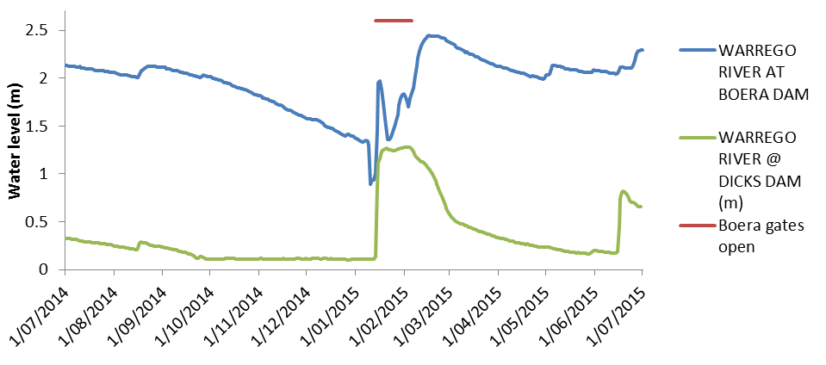

**Figure F‑1: Water level data for sites on the Warrego River in the Selected Area.**

Methods

Channel network mapping

The Lower Warrego River channels were mapped using aerial imagery and photographs to provide a map of the channel network. Images that contained visible water in the main channel of the Warrego were used to distinguish between the main or primary channels and secondary or flood channels. Information of waterhole permanence was obtained through existing water level loggers, field observations and expert opinion.

Flood travel times through the Warrego River system

To build a picture of the time it takes flow events to make their way downstream through the Warrego River system, the flow event that occurred during late December 2014–February 2015 was assessed. This event was a result of inflows from rainfall in the upper Warrego catchment () in late December 2014 and January 2015. Discharge data from various gauging stations along the Warrego catchment were used to assess the travel time of this flow as it moved downstream through the Selected Area and into the Darling River (). Travel times below Boera Dam were assessed by comparing data from a newly established gauge at Dicks Dam on the Warrego and then at the Louth gauge on the Darling River.

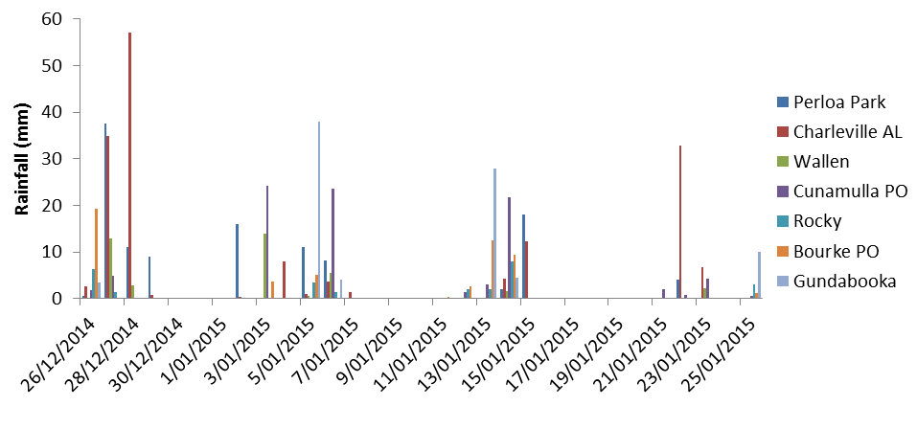

**Figure F‑2: Rainfall records for various weather stations within the Warrego catchment during December 2014–February 2015.**

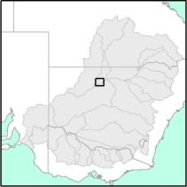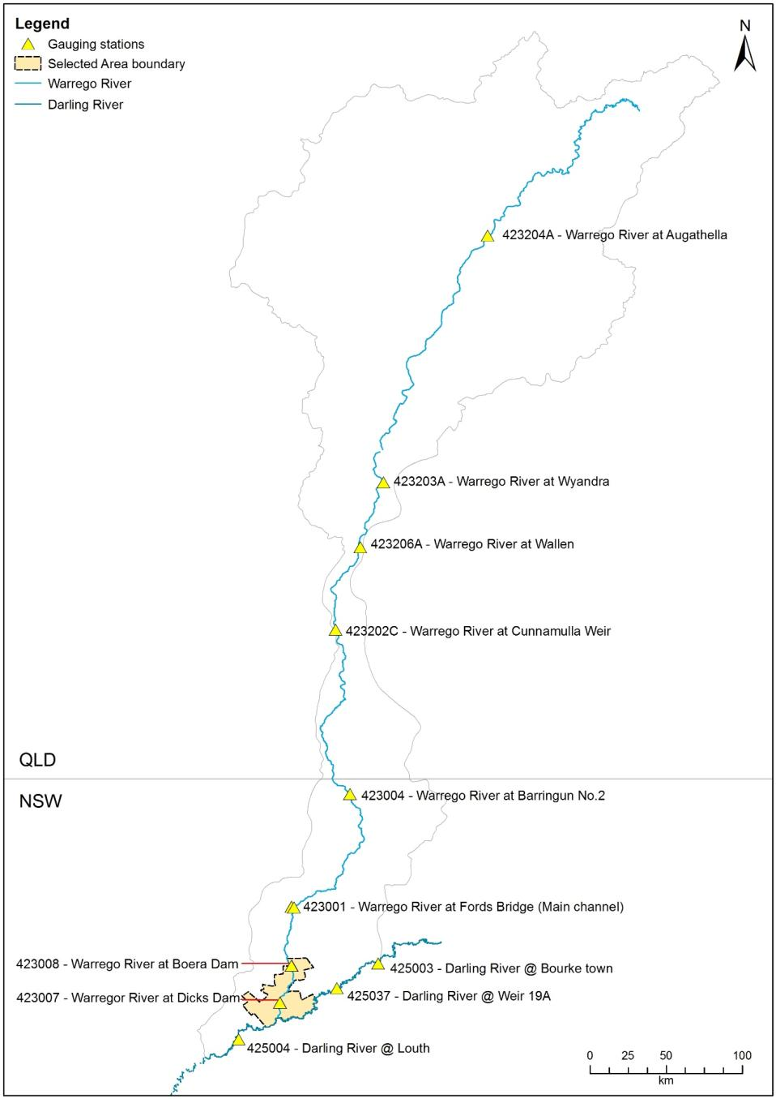

**Figure F‑3: Gauging stations on the Warrego River used in the travel time analysis.**

Results

Channel network mapping

A total of 185.2 km of channels were mapped along the Warrego River within the Selected Area (; ). Of these, 65.4 km (35%) were mapped as primary channels, and 119.8 km (65%) mapped as secondary channels. Secondary channels in the northern section of the Selected Area tend to be longer and are reflective of channels which once joined the western floodplain to the river before the western embankment was established (). There are also several larger flow paths to the east of the Warrego main channel, one of which is called the eastern bywash, through which water can travel around and effectively bypass the Boera Dam wall. This has been reported by Terrill (2012) to flow when Boera Dam gets to a stage height of 3.54 m. Through the mid sections of the Warrego River zone (from Booka Dam to Peebles Dam) the secondary channels tend to be shorter and in closer proximity to the primary river channel. At the downstream end of the Warrego, there are several large secondary channels including Ross Billabong. Ross Billabong joins the Warrego and Darling channels at its eastern extent, through a high level overflow from the Darling, and also through a number of smaller anabranch/flood channels on the Darling. Since the construction of a block bank (Duncan’s Wall) in between Ross Billabong and the Darling River, connection between Ross Billabong and the Warrego main channel has increased, while connection with the Darling River has decreased (Aurecon 2012).

Water levels in the dams on the Warrego River zone of the Selected Area were filled during the January–February 2015 flow event. Boera Dam reached a maximum water level of 2.44 m in February and were maintained above 2 m () throughout the rest of the year by periodic rainfall events (). Water levels in Dicks Dam reached a maximum of 1.28 m in February with water persisting through to the end of June 2015 (). While no water level recordings were taken in either Booka Dam or Ross Billabong, field observations suggest that significant water levels were achieved at both sites in February, and water persisted in both sites through to the end of the water year (). Water levels within Homestead Dam fluctuated throughout the season after receiving inflows in February 2015. Due to the breach in the wall of this dam, water levels receeded more rapidly here, and were only maintained periodically through local rainfall (A.Wall pers comm). No observations were made at 12 Mile Dam.

Flood travel times through the Warrego River system

Flow hydrographs for various stations within the Warrego River catchment are presented in from December 2014–March 2015. Here it can be seen that flows peaked at Augathella, the most upstream gauge, on 1 February 2015. Distinct peaks can then be observed downstream through to the Barringun No.2 gauge. From here the flow peak flattens significantly with a peak observed at Fords Bridge on 22February. Due to the operation of the regulating gates at Boera Dam, flow peaks between here and Fords Bridge were hard to quantify. Instead, inflows to the dam appeared to occur 4–5 days after flows began at Fords Bridge (). Flows down the Warrego below Boera Dam appear to travel relatively quickly, with increases in water level detected in Dicks Dam on the same day flows were released from Boera Dam (). Similarly, the height of the weir pool at Louth on the Darling increased only one day after flows were released from Boera Dam, suggesting that water released from Boera Dam can connect to the Darling within a single day.

The observed flow event took a total of 29 days to pass from the top of the Warrego River catchment—measured at Augathella—to the Selected Area and influence water levels in Boera Dam (Figure F‑11). Once water was released from Boera through the control gates, it moved relatively quickly and reached the Darling River within a single day.

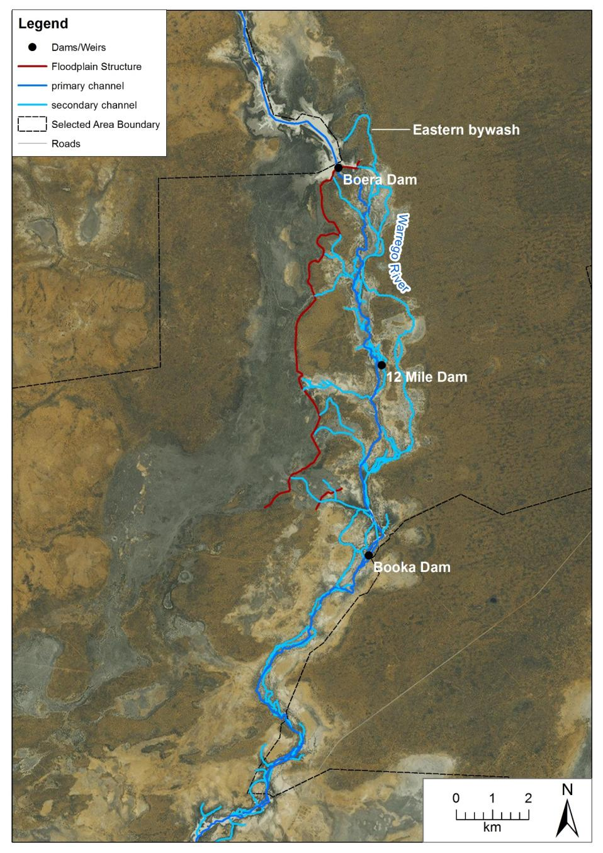

**Figure F‑4: Primary and Secondary channels mapped along the Warrego River in the northern section of the Selected Area.**

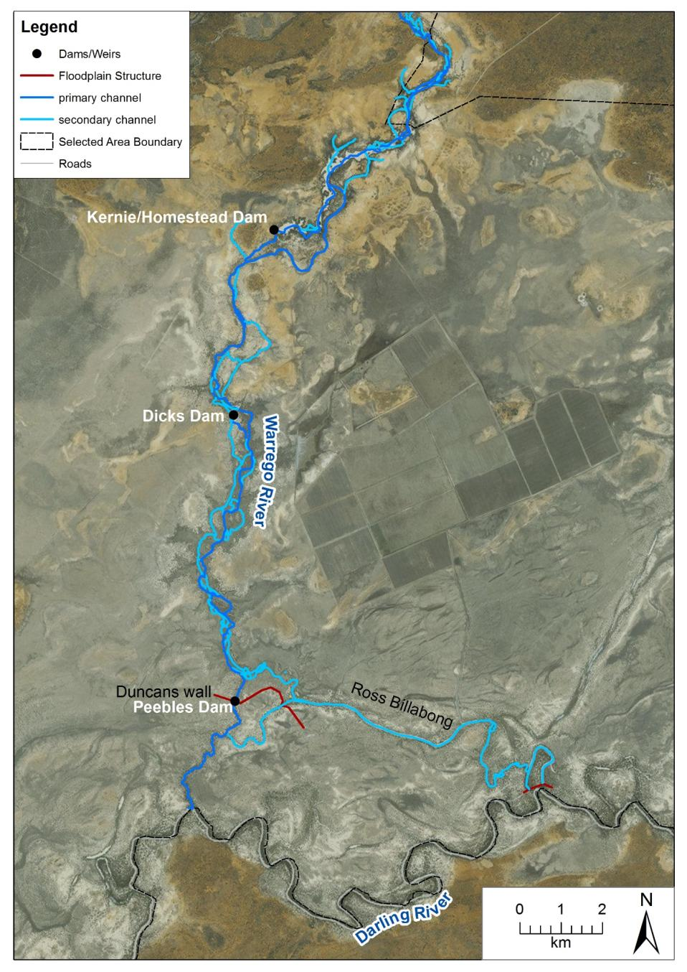

**Figure F‑5: Primary and Secondary channels mapped along the Warrego River in the southern section of the Selected Area.**

**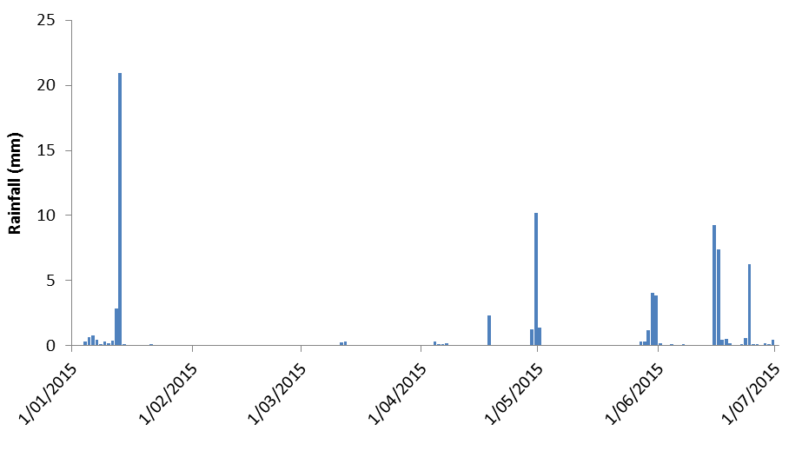**

**Figure F‑6: Rainfall recorded in 2015 at the Boera Dam weather station.**

|  |  |
| --- | --- |
| N:\Projects\15ARM\1115 Warrego Darling LTIM Stage 2\Indicators\Indicators (Y1)\Water quality\Photos\Feb2015\P1030919.JPG  Ross Billabong Feb-15 | N:\Projects\15ARM\1115 Warrego Darling LTIM Stage 2\Indicators\Indicators (Y1)\Water quality\Photos\May2015\P1010058.JPG  Ross Billabong May-15 |
| N:\Projects\15ARM\1115 Warrego Darling LTIM Stage 2\Indicators\Indicators (Y1)\Water quality\Photos\Feb2015\P1030899.JPG  Booka Dam Feb-15 | N:\Projects\15ARM\1115 Warrego Darling LTIM Stage 2\Indicators\Indicators (Y1)\Water quality\Photos\May2015\P1010024.JPG  Booka Dam May-15 |

**Figure F‑7: Water levels in Ross Billabong (top) and Booka Dam (bottom) between February (left) and May (right) 2015.**

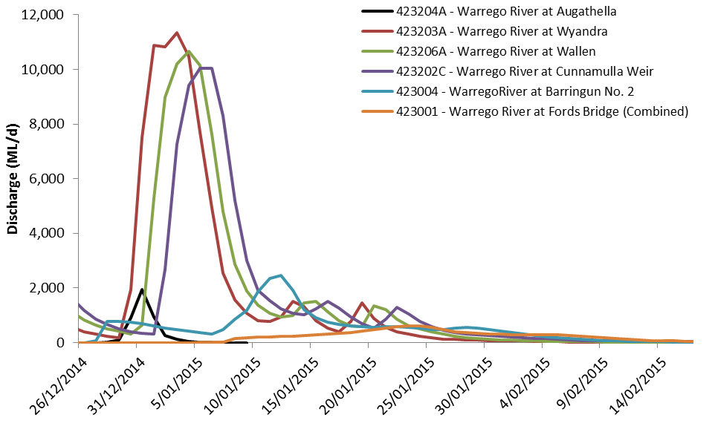

**Figure F‑8: Flow hydrographs from various gauges on the Warrego River. Gauges are listed in downstream order.**

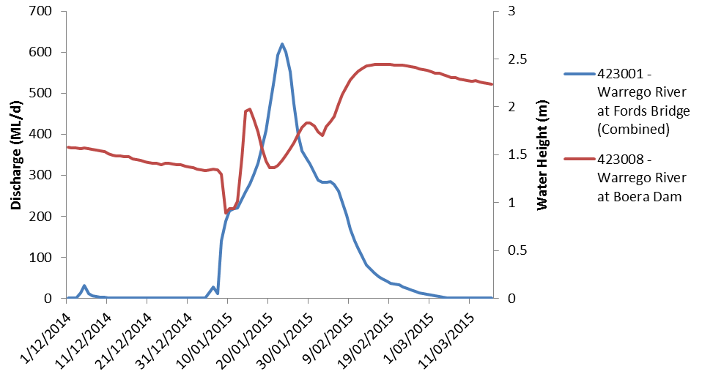

**Figure F‑9: River flows at Fords Bridge and water levels in Boera Dam during December 2014– March 2015.**

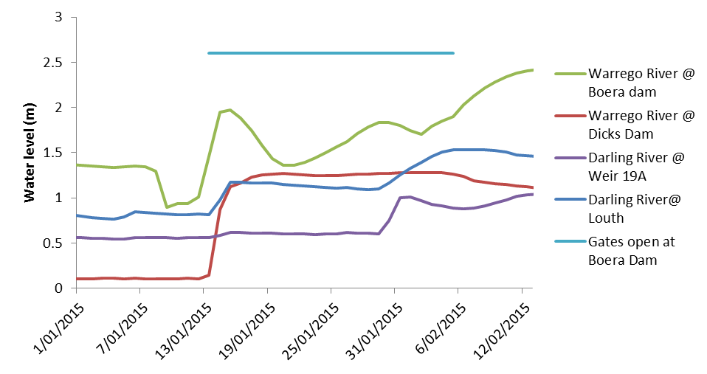

**Figure F‑10: Comparison of flow heights in the Warrego and Darling Rivers. Note horizontal blue line indicates the time the control gates on Boera Dam were open. Weir 19A upstream of the Selected Area was also plotted to compare Darling River flows unrelated to Warrego River inputs.**

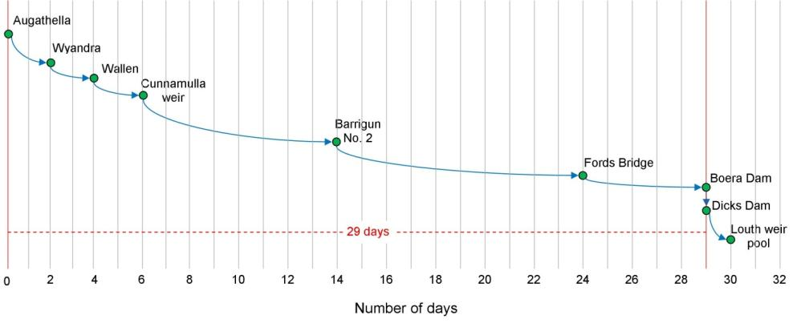

Figure ‑: Travel times for the flow event observed in December 2014–March 2015.

Discussion

The Warrego River within the Selected Area displays a complex channel structure. While only covering a straight line distance of just under 40 km, there is over 185 km of channel length associated with the river. In the northern section of the Selected Area around Boera Dam, channels tend to be associated with flood channels which would have once returned flows from the Western Floodplain back into the main Warrego channel. Significant water infrastructure created within the Selected Area over the last 160 years has significantly influenced the connectivity of these channels. The western embankment, which runs from Boera dam down the eastern edge of the Western Floodplain, restricts the connection and return of water between the floodplain and river channel. One exception to this is the eastern bywash, which during high water levels in Boera Dam, will carry water around the western embankment into the Warrego River downstream (P.Terrill pers comm). Dam levels during 2014–15 did not get high enough to achieve this, therefore the only flows down the Warrego channel were through the regulating gates on Boera Dam. The most prominent secondary channel on the Warrego is Ross Billabong which during large flow events connects the Darling and Warrego Rivers. Its connectivity, especially to the Darling River has been reduced through the construction of block banks.

While full connection of the Warrego channel was only achieved for a relatively short period during 2014–15, its influence on the persistence of water in dams within the reach was longer lived. Water remained at considerable levels within Boera, Booka and Dicks Dams and Ross Billabong from February through to the end of the water year, assisted by localised rainfall events towards the end of the season. Water levels in Boera Dam rose above those required to deliver water to the Western Floodplain in June as a result of local rainfall.

The flow event that made its way through the Warrego River zone in February–March 2015 was indicative of flows events in this system, being generated from rainfall in the upper catchment, with discharge attenuating downstream below Wyandra (Holz et al. 2012). From a practical sense, gaining an understanding of the duration it takes flow events to move through the system is important, given the event based sampling program implemented for the LTIM project. Having up to a month from when flows being to rise in the upper catchment to when they will influence flows in the Selected Area, will allow for the timely deployment of field equipment and staff. The water released from Boera Dam took a relatively short time to reach the Darling River, and this was aided by the fact that regulating gates on Booka, Dicks and Pebbles Dams downstream were all open at the time. This is the standard protocol for the transfer of water to the Darling River to meet the licence requirements for the Toorale water licences held by the Commonwealth.

Conclusion

Multiple flow pathways exist along the Warrego River in the Selected Area, which convey water at different water levels. While a primary channel exists, a greater proportion of channels flow at higher water levels. The connectivity of many of these secondary channels has been impacted by water regulating structures which have been in place at the site for an extended period of time. The system of dams on the Warrego channel has increased the persistence of water in the Selected Area and while flows were only conveyed down the Warrego Channel for just over three weeks, water remained in the landscape for more than 6 months, providing potential refuge for aquatic species.

References

Aurecon (2012) *Toorale Station Decommissioning Plan Volume 1*. Prepared for the Department of Environment, Water, Heritage and Arts.

Capon, S. (2009) *Flow-dependent Ecosystems of Toorale Station: Ecological character, condition and issues associated with decommissioning water resources infrastructure.* Australian Rivers Institute, Griffith University.

Holz, L., Barma, D. & Wettin, P. (2008) Warrego River Scoping Study. WMA Water, Sydney.

Terrill, P. (2012) Report on the survey of Boera Dam on the 12 December 2012. Unpublished OEH report.

*Personal communication:*

Peter Terrill, Wetland Officer, formerly of NSW Office of Environment and Heritage, Dubbo NSW 2830

Andrew Wall, Area Manager NSW National Parks and Wildlife Service, Bourke NSW 2840.

*Blank page*

###### Hydrology (Habitat)

Introduction

The Hydrology (Habitat) indicator documents the degree of hydrological connection of in-channel habitat including benches and anabranches along the Darling channel and assesses the relative influence of Commonwealth environmental water. These features have been shown to be important for the storage and supply of nutrients and organic matter (Southwell 2008, Thoms et al. 2005, Thoms and Sheldon 1997), and have been targeted in environmental flow planning to increase habitat and facilitate nutrient and carbon cycling (Commonwealth of Australia 2015). This indicator is directly relevant to other indicators measured in the Junction of the Warrego Darling Rivers Selected Area including Hydrology (River and Northern Tributaries), Water Quality, and Stream Metabolism. This indicator addresses the following question:

* What did Commonwealth environmental water contribute to in-channel habitat availability along the Darling River?

Environmental watering in 2014–15

Unlike other Selected Areas, environmental water is not specifically delivered to the Junction of the Warrego and Darling rivers Selected Area, rather, Commonwealth water is held as unregulated entitlements and its influence is thus reliant on flows out of upstream catchments. During the 2014–15 water year, three flow events containing environmental water flowed down the Darling River within the selected area (Appendix D). These occurred in October–November 2014, December–March 2015 and April–May 2015. All three flows were in-channel pulses. No Commonwealth environmental water was accounted for on the Warrego River, however, management decisions made by the CEWO resulted in water flowing down the Western Floodplain during February–March 2015 (Appendix E).

Methods

Benches and anabranches were identified through desktop mapping of in-stream habitat and aerial photograph interpretation along the Darling River within the Selected Area (Commonwealth of Australia 2015). Identified in-stream habitat features were verified in the field, and additional benches and anabranches mapped. In addition to the number and size of individual habitats present, height above the current water level was noted using a hypsometer to measure the commence-to-inundate level of benches and the commence-to-flow for anabranch channels (Commonwealth of Australia 2015). Commence-to-flow heights were recorded to the nearest vertical metre.

The vertical commence-to-flow heights of individual habitats above the current water level at the time of field survey were converted to a gauged height at the nearest river flow gauge. Benches and anabranches upstream of the Warrego River confluence were linked to the Weir 19A (NSW 425037) gauge upstream of the Selected Area (). Features downstream of the confluence were linked to the gauging station at Louth (NSW 425004). These gauges were chosen as they best reflected the hydrology of these sections of the Darling River. However, final commence-to-flow discharges were reported at the Bourke Town (NSW 425003) gauging station as it is has a more comprehensive flow record. In order to do this, relationships between the Louth and Weir 19A gauging stations and the Bourke Town gauge were identified by plotting respective flows between 400 and 20 000 ML/d at the gauges from 2002 to present (total length of Weir 19A gauge record). Travel times between gauges was taken into account, with trendlines and associated regression equations of the relationship between gauges calculated (). These equations were used to express the commence-to-flow discharges measured at the Louth and Weir 19A gauges to the Bourke Town gauge. The commence-to-flow for each anabranch channel was determined using the entry or exit with the highest gauge height to better represent water flow into each anabranch.

Total organic Carbon (TOC), Nitrogen (TN) and Phosphorus (TP) release rates from in-channel benches observed on the Darling River upstream of Bourke by Southwell (2008), were combined with the duration of time benches in the Selected Area were inundated during 2014–15 to provide an estimate of total nutrient loads contributed to the river from these benches during the water year.

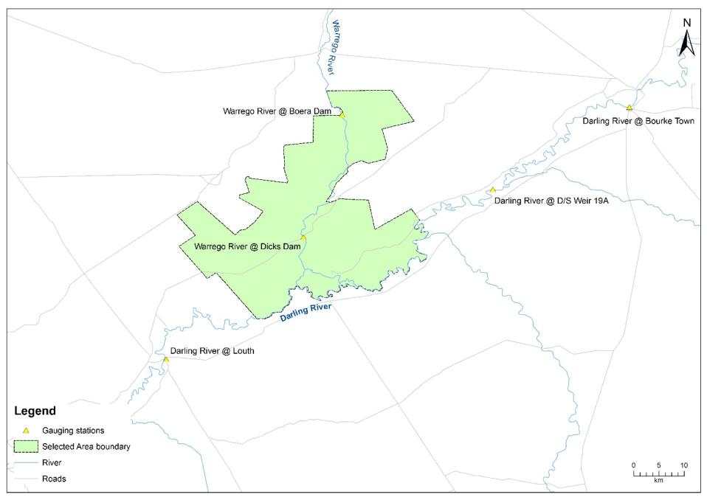

**Figure G‑1: Location of the gauging stations used in the hydrology (Habitat) indicator analysis.**

a)

b)

**Figure G‑2: Relationships between the Darling River @ Bourke Town gauge and a) Darling River @ Weir 19A and b) Darling River @ Louth gauging stations.**

Results

Bench surfaces

One hundred and seventy three benches were identified along the 76 km reach of the Darling River within the Selected Area (). Individual bench surfaces had an average length and width of 50 m (range 8–285 m) and 9.6 m (range 3–30 m) respectively. The average area of individual benches was 485 m2 (range 59–3990 m2) with a total area of 8.4 ha. Bench surfaces were more commonly found in the upstream and downstream sections of the Darling River zone in with Selected Area () with lowest numbers observed in the 10 km reach just upstream of the Warrego River confluence which enters the Darling approximately 60 km down the reach. Cumulative surface area of benches increased steadily along the study reach ().

Bench surfaces were located at various elevations within the Darling River channel. Commence-to-inundate flows ranged from 1,846–18,889 ML/d when measured at the Darling River @ Bourke Town gauging station (). Benches tended to be located low in the river channel, with 124 (71%) benches becoming inundated at flows less than 10,000 ML/d. Of these, 45 (25%) surfaces would become inundated at flows less than 2,000 ML/d ().

Anabranch channels

Twenty anabranch channels were identified within the Darling River zone ranging in length from 347 m to 8,020 m (). The total combined length of anabranches was 60 km, which is 44% of the total length of channel in the study reach including the Darling River. Commence-to-flow discharges of anabranch channels ranged from 1,846 ML/d to 16,673 ML/d. The majority of channels (90%) commence-to-flow at discharges less than 10,000 ML/d (Table G‑1). While the greatest proportion of channels (35%) commence-to-flow at discharges between 2,000–4, 000 ML/d, channels that connect between 6,000–10,000 ML/d make up 42% of the total in terms of anabranch channel length. No consistent pattern was observed between distance downstream and commence-to-flow discharge of individual channels ().

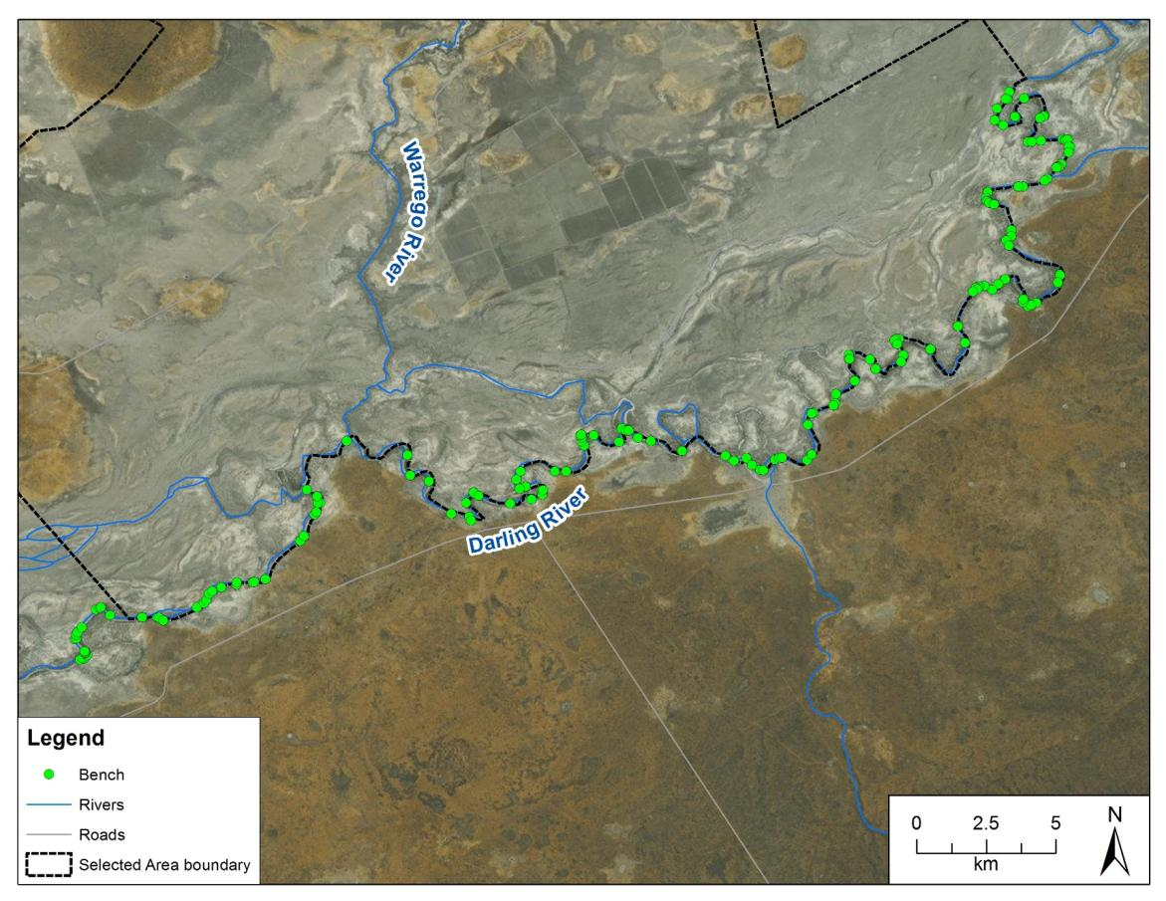

**Figure G‑3: Distribution of bench surfaces down the Darling River zone within the Selected Area.**

**Figure G‑4: Spatial distribution of bench surfaces down the Darling River within the selected Area.**

**Figure G‑5: Cumulative area of benches along the length of the Darling River between the Louth and Weir 19A gauging stations.**

**Figure G‑6: Cumulative frequency plot of bench inundation level and discharge in the Darling River zone of the Selected Area. Discharge measured at the Bourke Town gauge (NSW425003).**

Table ‑: Links between Anabranch channel discharge class, proportion of channels and channel length.

|  |  |  |  |  |
| --- | --- | --- | --- | --- |
| Discharge class (ML/d) | Number of anabranches | Proportion of anabranch channels (%) | Channel length (km) | Proportion of channel length (%) |
| <2000 | 5 | 25 | 14.9 | 25 |
| 2,000–4,000 | 7 | 35 | 15.5 | 26 |
| 4,000–10,000 | 6 | 30 | 25.5 | 42 |
| 10,000–18,000 | 2 | 10 | 4.3 | 7 |
| total | 20 |  | 60.3 |  |

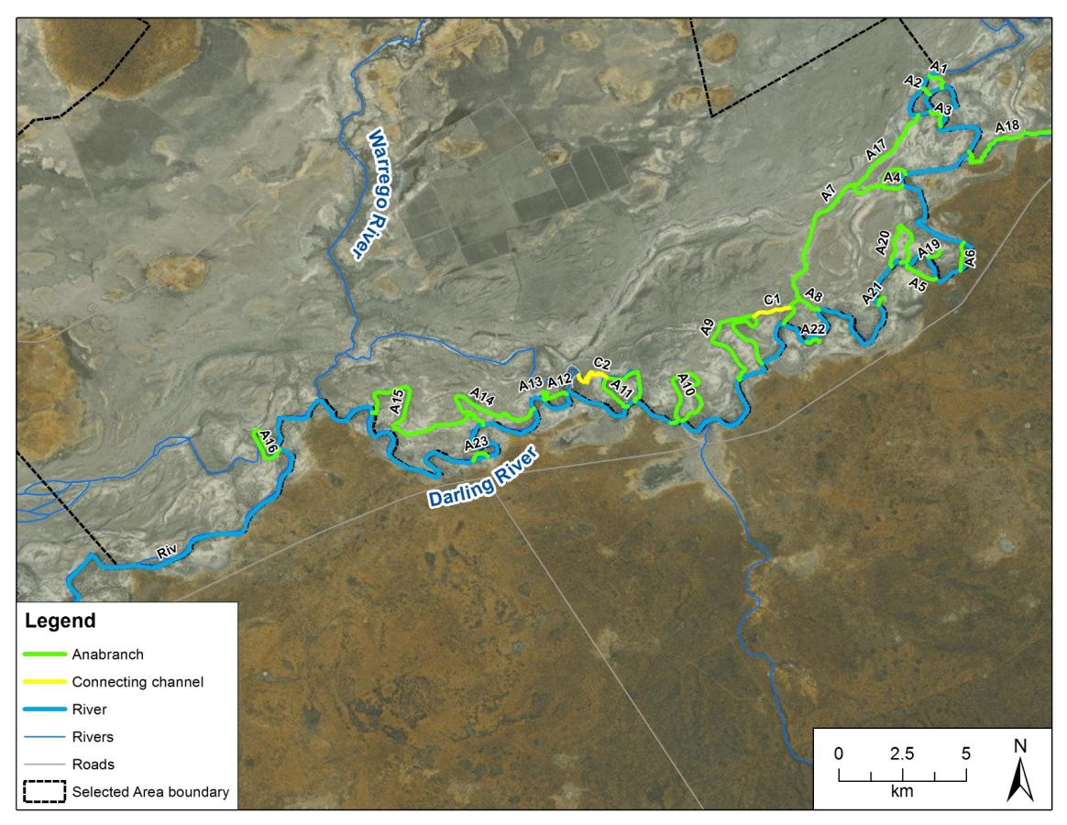

**Figure G‑7: Distribution of anabranch channels along the Darling River within the Selected Area.**

**Figure G‑8: Discharge required to connect anabranch channels on the Darling River zone within the Selected Area. Anabranches ordered in a downstream direction. Discharge measured at the Bourke Town gauge (NSW425003).**

Availability in 2014–15

Several flow events occurred in the 2014–15 water year that inundated bench surfaces along the study reach. Benches that become inundated when flow exceeds 2000 ML/d were inundated for at least six days in February 2015 (). These benches would have been inundated again for one day in April (28/4/2015; ). These benches account for 26% of the total number of benches identified in the Darling River zone, providing 19,762 m2 of habitat. Combining this with the average 72 hourly nutrient release rates reported in Southwell (2008), it is estimated that these benches would have contributed 3.6 kg of total dissolved organic carbon, 1.1 kg of total dissolved nitrogen and 1.2 kg of total dissolved phosphorus to the river system during the time they were inundated.

Anabranches in the lowest (<2000 ML/d) discharge class commenced-to-flow during the 2014–15 water year (). The combined distance of the anabranches that commenced-to-flow during these events was 33.1 km. Together these anabranches account for approximately 31% of the total number of identified anabranches, and 37% of the combined length of all anabranches identified in the zone.

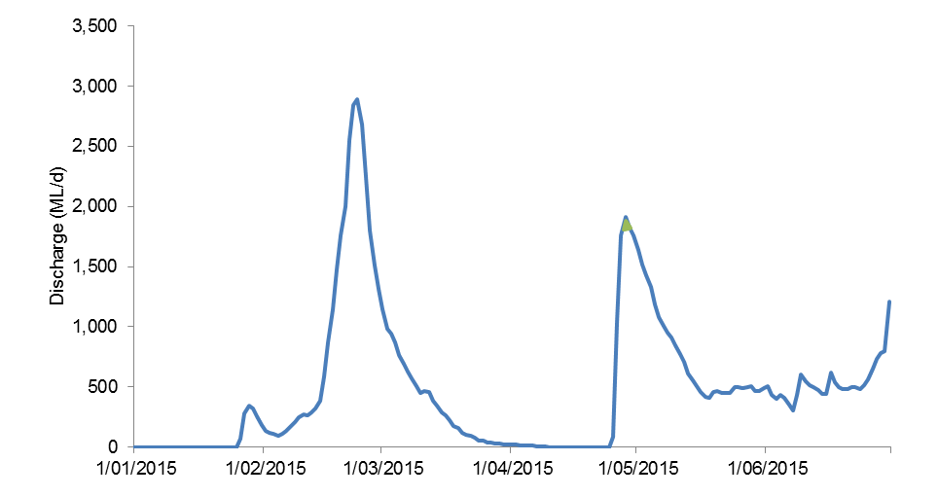

**Figure G‑9: Periods of bench and anabranch channel inundation during the 2014–15 water year along the Darling River within the Selected Area. Discharge measured at the Bourke Town gauge (NSW425003).**

Discussion

This indicator has quantified the number and character of key in channel habitats along the Darling River zone within the Selected Area. A total of 173 individual bench surfaces and 20 anabranch channels were identified that predominantly connect to the river channel at flows below bankfull. Large proportions of these benches (71%) and anabranch channels (90%) become connected to the river at flows less than 10,000 ML/d measured at the Bourke Town gauge. These flows are within the range that may be influenced by Commonwealth environmental water in this reach of the Darling River (Commonwealth of Australia 2015).

Flows containing Commonwealth environmental water, from upstream tributaries while being relatively small in magnitude, inundated 25% and 31% of benches and anabranches respectively in the Selected Area during 2014–15. These events led to the release of small but potentially important quantities of dissolved carbon and nutrients from bench surfaces into the river channel ecosystem. This dissolved organic matter is a source of carbon which forms the foundation of aquatic food webs, and provides a source of energy for aquatic organisms (McGinness and Arthur 2011, Sheldon and Thoms 2006). Benches and anabranch channels also provide habitat during connection and are sites where organic matter and sediment accumulate during inundation (Thoms, et al. 2005, Southwell 2008). This two way exchange of material, at relatively low river discharges, is thought to be important for maintaining the river ecosystem between larger flooding events (Sheldon and Thoms 2006). In addition, bench and anabranch channels form spawning and refuge habitat for fish and other animals in the river.

Conclusion

In-channel bench surfaces and anabranch channels along the Darling River zone within the Selected Area have been shown to become inundated at relatively low discharge volumes, with discharges <10,000 ML/d inundating the majority of these features. During 2014–15, around 30% of benches and anabranch channels were inundated by flow events containing Commonwealth environmental water, which were shown to contribute small but potentially important quantities of dissolved carbon and nutrients to the river system.

References

Commonwealth of Australia (2015) Commonwealth Water Office Long Term Intervention Monitoring Project Junction of the Warrego and Darling rivers Selected Area, Canberra.

McGinnes H.M. and Arthur A.D. (2011) Carbon dynamics during flood events in a lowald river: the importance of anabranches. *Freshwater Biology* **56**: 1593–1605.

Sheldon, F. and Thoms, M. C. (2006) Geomorphic In-channel Complexity: the key to organic matter retention in large dryland rivers? *Geomorphology* **77**: 270–285

Southwell, M.R. (2008) *Floodplains as Dynamic mosaics: Sediment and nutrient patches in a large lowland riverine landscape.* PhD Thesis, University of Canberra, Australia

Thoms, M. C. and Sheldon, F. (1997) River channel complexity and ecosystem processes: the Barwon-Darling River (Australia). In: N. Klomp and I. Lunt (eds.). *Frontiers in Ecology: Building the Links*. Elsevier, Oxford, pp. 193–206.

Thoms, M.C., Southwell, M.R. and McGinness, H.M. (2005) Floodplain-river ecosystems: Fragmentation and water resource development. *Geomorphology* **71**: 126–138.

*Blank page*

###### Water Quality

Introduction

The Water Quality indicator seeks to assess the contribution of Commonwealth environmental water to the improved quality of water in the Darling River within the Selected Area. As such this indicator is linked to the Hydrology (River, Habitat and Northern Tributaries), Metabolism and Microinvertebrate indicators. This indicator addressed the following questions within the Darling River during the 2014–15 water year:

* What did Commonwealth environmental water contribute to temperature regimes?
* What did Commonwealth environmental water contribute to pH levels?
* What did Commonwealth environmental water contribute to turbidity regimes?
* What did Commonwealth environmental water contribute to salinity regimes?
* What did Commonwealth environmental water contribute to dissolved oxygen levels?

Environmental watering in 2014–15

Unlike other Selected Areas, environmental water is not specifically delivered to the Junction of the Warrego and Darling rivers Selected Area, rather, Commonwealth water is held as unregulated entitlements and its influence is thus reliant on flows out of upstream catchments. During the 2014–15 water year, three flow events containing environmental water flowed down the Darling River within the selected area (Appendix D). These occurred in October–November 2014, December–March 2015 and April–May 2015. All three flows were in-channel pulses. No Commonwealth environmental water was accounted for on the Warrego River, however, management decisions made by the CEWO resulted in water flowing down the Western Floodplain during February–March 2015 (Appendix E).

Methods

Two water quality monitoring stations were established at single stations in the Darling River zone of the Selected Area that have permanent surface water in a defined channel. The two stations are located near the ‘Yanda’ homestead upstream (-30.34906, 145.57685) and at the ‘Akuna’ homestead downstream (-30.40978, 145.33438) (Figure H‑1). The site at Akuna will allow for the assessment of the influence of Commonwealth environmental water that includes the Warrego River, while Commonwealth environmental water deliveries from northern tributaries (e.g., Gwydir, Namoi, Macquarie) will pass through both sample stations.

Continuous monitoring of dependant variables Temperature (°C), pH, Turbidity (NTU), Salinity (mS/cm) and dissolved oxygen (mg/L) occurs at each station using a Hydrolab DS5-X probe. The probe was mounted to a floating pontoon at each site. The Yanda station is connected via a 3-G telemetered system in the homestead to an RMTek website for data monitoring and download. Each water quality variable is logged at a 10 minute interval. The ‘Akuna’ station is connected to a local logger and downloaded at each visit or by NPWS staff.

Both probes were installed in late May 2015 due to delays in project commencement and equipment being sourced, and access arrangements with NPWS to the homesteads where the equipment is installed. Issues with power supply at both sites have meant that only a short continuous dataset (25/5/15 to 14/6/15) from the Yanda site is available in Year 1. Daily means (midnight to midnight) were calculated from 10 minute interval data.

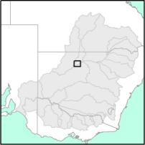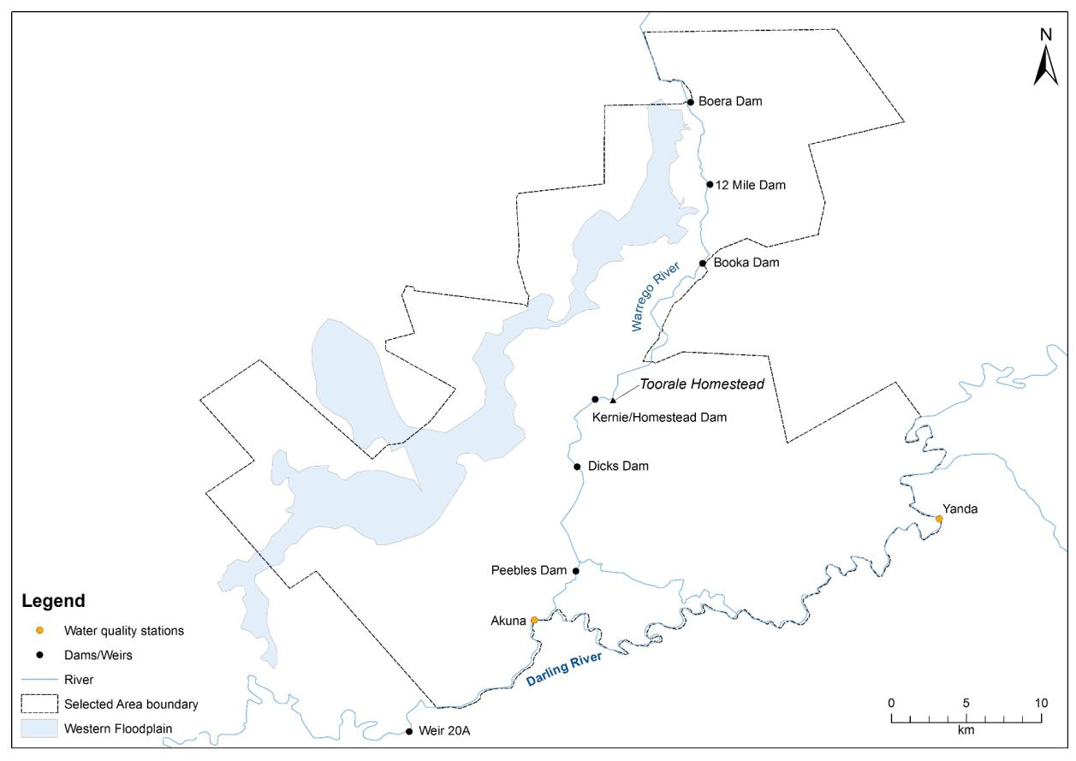

Figure ‑: Location of long-term water quality monitoring stations on the Darling River zone within the Selected Area.

Results

Mean daily temperature ranged from 15.7 to 17.2 ˚C and showed no relationship to changes in discharge (Figure H‑2). All other water quality variables displayed a consistent pattern of a peak value on 29/05/2015 followed by a sharp decrease to the 02/06/2015, followed by consistent levelling of values (Figure H‑2). This did not appear to be related to a change in downstream discharge from Bourke Weir, but rather to a 32 mm daily rainfall event on the 29/05/2015 (Gundabooka Station weather station; http://www.bom.gov.au/climate/data/index.shtml). This event reduced pH by 0.57 units which was associated with a decline in chlorophyll *a* concentration of 20 µg/L and dissolved oxygen from 10.74 to 8 mg/L. Conductivity also reduced considerably from 2064 to 352 µS/cm.

|  |  |
| --- | --- |
|  |  |
|  |  |
|  |  |

Figure ‑: Mean daily temperature (°C), pH, Turbidity (NTU), Salinity (mS/cm) and dissolved oxygen (mg/L) at the Yanda water quality site in the Darling River. Discharge data from NoW gauge at Bourke Town (425003).

Discussion

While there are insufficient data from the Darling River water quality loggers to make comment on the effect of Commonwealth environmental water during 2014–15, the preliminary data presented here suggests that the deployed probes are sensitive to changes in the parameters collected. Early power issues experienced during the year have been fixed, and data is logging successfully on both loggers, therefore providing data with which to assess changes in water quality in the future.

###### Vegetation Diversity

Introduction

This assessment aims to assess the contribution of Commonwealth environmental water to floodplain vegetation diversity, condition and extent. Several specific questions were addressed through the monitoring of vegetation diversity in the 2014–15 water year in the Junction of the Warrego and Darling rivers Selected Area:

* What did Commonwealth water contribute to vegetation species diversity?
* What did Commonwealth water contribute to vegetation community diversity?

Environmental watering in 2014–15

Unlike other Selected Areas, environmental water is not specifically delivered to the Junction of the Warrego and Darling rivers Selected Area, rather, Commonwealth environmental water is held as unregulated entitlements and its influence is thus reliant on flows out of upstream catchments. During the 2014–15 water year, three in-channel flow events containing environmental water flowed down the Darling River within the selected area (Appendix D). These occurred in October–November 2014, December–March 2015 and April–May 2015. No Commonwealth environmental water was accounted for on the Warrego River or Western Floodplain in the Selected Area. However, management decisions made by the CEWO resulted in water flowing down the Western Floodplain during February–March 2015. Flows in Boera Dam were above the estimated overflow height of the western floodplain (2.26 m on the Boera gauge) for 37 days (Figure I‑1). This inundated 36.9 ha of the Western Floodplain (Appendix E) including four vegetation plots during February (Table I‑1). Water levels in Boera Dam also rose above the overflow height of the Western Floodplain towards the end of the season as a result of local rainfall (Figure I‑1).

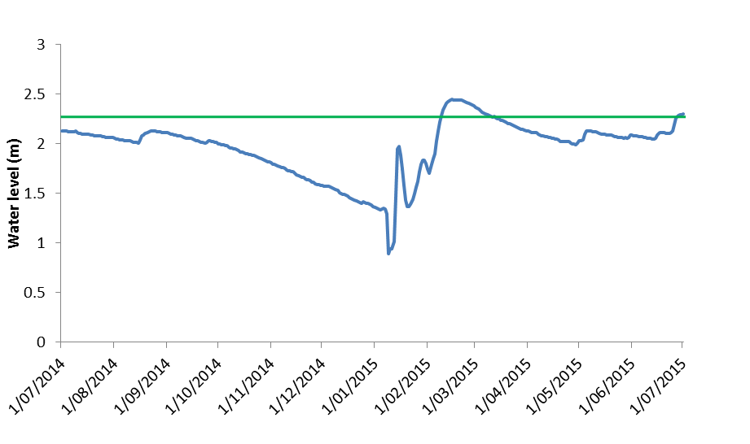

Figure ‑ Water levels experienced at Boera Dam during 2014–15. Green line represents overflow level of the Western Floodplain.

Methods

Twenty four plots were monitored at eight locations throughout the Western Floodplain during February 2015 and May 2015 (Figure I‑2). These plots were located in four broad wetland vegetation communities, and experienced a range of inundation conditions (Table I‑1). Vegetation surveys were completed following the standard vegetation diversity method (Commonwealth of Australia 2015; Hale et al. 2013), which recorded vegetation diversity and structure within each 0.04 ha plot. Environmental variables including the degree of inundation were also noted.

Species diversity was analysed using Poisson regression models on count data which investigated the influence of environmental water, survey time (February–May 2015), and vegetation community. Given that environmental water only influenced a small number of plots, a quasi-paired t-test was performed to assess the influence of environmental water on species diversity. As the influence of sampling time was found to be negligible, a model was initially fitted to all sites that did not receive environmental water over both sampling times. The actual species counts at the four inundated sites were then compared to the predicted counts from the model, and the deviance from the model was assessed. To further explain changes in diversity, individual species were grouped into the four following functional groups (Brock and Cassanova 1997):

* Amphibious responders (AmR)—plants which change their growth form in response to flooding and drying cycles;
* Amphibious tolerators (AmT)—plants which tolerate flooding patterns without changing their growth form;
* Terrestrial damp plants (Tda)—plants which are terrestrial species but tend to grow close to the water margin on damp soils; and
* Terrestrial dry plants (Tdr)—those which are terrestrial species which don’t normally grow in wetlands but may be encroached into the area due to prolonged drying.

Changes in these functional groups were then compared between survey times using f-tests to test for equality of variances and then t-tests to test for differences in means.

Changes in vegetation cover were investigated using multivariate MDS plots with differences between the presence of environmental water, survey time and vegetation community assessed using PERMANOVA in Primer 6. SIMPER analysis was used to identify the species that were most responsible for driving patterns in the data, and follow up descriptive univariate analysis of these species were then undertaken.

Table ‑: Sites surveyed in February and May 2015 for vegetation diversity. Map projection AGD94 Zone 55.

| Vegetation communities | Sites | Easting | Northing | Inundation | |
| --- | --- | --- | --- | --- | --- |
| Feb-15 | May-15 |
| Coolibah-River Cooba-Lignum woodland | WD1.1 | 6668758 | 347881 | Dry | Dry |
| Coolibah-River Cooba-Lignum woodland | WD1.2 | 6668663 | 347818 | Dry | Dry |
| Coolibah-River Cooba-Lignum woodland | WD1.3 | 6668610 | 347776 | Dry | Dry |
| Coolibah-River Cooba-Lignum woodland | WD2.1 | 6667219 | 347814 | Dry | Dry |
| Coolibah-River Cooba-Lignum woodland | WD2.2 | 6667195 | 347764 | Dry | Dry |
| Coolibah-River Cooba-Lignum woodland | WD2.3 | 6667165 | 347675 | Dry | Dry |
| Chenopod shrubland | WD3.1 | 6658750 | 343962 | Dry | Dry |
| Chenopod shrubland | WD3.2 | 6658762 | 343840 | Dry | Dry |
| Chenopod shrubland | WD3.3 | 6658822 | 343729 | Dry | Dry |
| Chenopod shrubland | WD4.1 | 6660934 | 347121 | Dry | Dry |
| Chenopod shrubland | WD4.2 | 6661041 | 347292 | Dry | Dry |
| Chenopod shrubland | WD4.3 | 6660788 | 347285 | Dry | Dry |
| Coolibah woodland wetland | WD5.1 | 6654363 | 341209 | Dry | Dry |
| Coolibah woodland wetland | WD5.2 | 6654290 | 341161 | Dry | Dry |
| Coolibah woodland wetland | WD5.3 | 6654320 | 341268 | Dry | Dry |
| Coolibah woodland wetland | WD6.1 | 6665179 | 347247 | Dry | Dry |
| Coolibah woodland wetland | WD6.2 | 6665221 | 347382 | Wet | Dry |
| Coolibah woodland wetland | WD6.3 | 6665082 | 347402 | Dry | Dry |
| Lignum shrubland wetland | WD7.1 | 6668699 | 347679 | Wet | Dry |
| Lignum shrubland wetland | WD7.2 | 6668693 | 347608 | Wet | Dry |
| Lignum shrubland wetland | WD7.3 | 6668627 | 347613 | Wet | Dry |
| Lignum shrubland wetland | WD8.1 | 6667685 | 348087 | Dry | Dry |
| Lignum shrubland wetland | WD8.2 | 6667780 | 348055 | Dry | Dry |
| Lignum shrubland wetland | WD8.3 | 6667585 | 348039 | Dry | Dry |

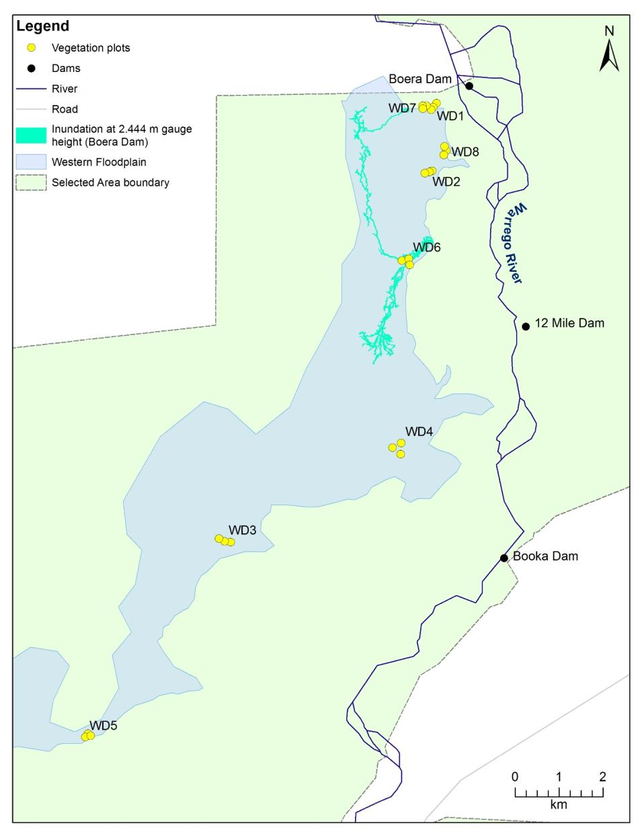

Figure ‑: Location of vegetation monitoring sites in the Western Floodplain zone.

Results

Species diversity

A total of 159 flora species from 33 families were recorded across all vegetation plots. The average number of species recorded at each location during each survey period was 15.1. The lowest average species diversity was 8.0, recorded at WD5 in both February and May 2015, while the highest average diversity, 25.0 species, was recorded at WD4 in February 2015 (Figure I‑3). Poisson regression results suggest that there was no significant difference in diversity between the two sampling occasions, but significant differences were found between vegetation communities (Pr<0.05). The model also suggested that there was a significant effect of inundation on species diversity (Pr<0.001), with sites that were inundated having significantly lower species diversity than sites that were not inundated.

Chenopod shrubland had an average of 19.3 species, followed by Lignum shrubland wetland 17.1, Coolibah-River Cooba-Lignum woodland 12.6, and Coolibah woodland wetland with 11.9. Sites that were wet during sampling tended to have lower species diversity overall (12.0) than those that were dry (15.5). Mean species diversity increased between the February and May survey periods at sites that were inundated in February 2015; conversely sites that were not inundated in February decreased in species diversity (Figure I‑4).

Sites that were wet during February 2015 and then dry in May 2015 increased in species diversity across the four functional groups with time, however these increases were not significant (Figure I‑5). Sites that remained dry had a higher presence of species within the terrestrial dry plants (Tdr) functional group i.e. terrestrial species that encroach in wetlands only after prolonged drying, than those sites that were inundated (Figure I‑6). Inundated sites had a higher presence of species within the terrestrial damp plants (Tda) functional group i.e. terrestrial species that often grow close to the water margin (Figure I‑6). Changes between amphibious functional groups, AmT and AmR sites were negligible across all sites.

Figure ‑: Mean number of species recorded at each site during the February 2015 and May 2015 surveys.

Figure ‑: Mean number of species recorded during February and May 2015 at sites that were inundated in February versus those that remained dry.

Figure ‑: Mean number species recorded within each functional group at sites that were wet in Feb 2015 and dry in May 2015.

Mean number of species

Figure ‑: Mean number of species recorded in each functional group during and February and May 2015 survey periods at sites that were inundated in February versus those that remained dry.

Forbs were the most diverse growth form across both survey periods; 59 species were recorded in February 2015 and 44 in May 2015 (Figure I‑7). Chenopod shrubs displayed the greatest reduction over the sampling period, from 25 species in February 2015 to 9 species in May 2015. The reduction of species diversity across Chenopod shrubs and Forbs was largely driven by reductions in Tdr functional group (Figure I‑8).

Figure ‑: Total number of species and the distribution of different growth forms recorded across all vegetation plots in February 2015 and May 2015.

Figure ‑: Total number of species and the proportion of different functional groups recorded across all vegetation plots in February 2015 and May 2015.

Vegetation composition

To further elucidate patterns in vegetation community composition, multivariate analyses were undertaken on species abundance data. From the nMDS plots, there appeared to be separation of the data when grouped by vegetation community, but little separation when grouped by either survey time or inundation (Figure I‑9). However, PERMANOVA analysis suggested that significant differences existed between vegetation community (Pseudo-F=8.87, pr<0.01), survey time (Pseudo-F=4.77, Pr<0.01), and inundation (Pseudo-F=1.69, pr<0.05), though their interactions were not significant.

SIMPER analysis suggested that the percentage cover of Tangled lignum *(Meuhlenbeckia florulenta)* and Coolibah *(Eucalyptus coolabah)* had a large influence on grouping the data by survey time and inundation (Table I‑2). Additionally, Lesser joyweed *(Alternanthera denticulate)* influenced the grouping of February samples, and Warrego grass *(Paspalidium jubiflorum)* influenced the grouping of May sites. The percentage cover of River mint *(Mentha australis)* and Slender knotweed *(Persicaria prostrata)* also contributed to the grouping of sites that were inundated in February, while Warrego grass contributed to the grouping of sites that remained dry during the 2014–15 water year.

|  |  |
| --- | --- |
|  |  |
|  |  |

Figure ‑: nMDS plots with the data grouped by a) vegetation community, b) survey time and c) inundation status.

Table ‑: Vegetation species contributing most of the similarity between survey times and wet versus dry sites.

|  |  |  |  |
| --- | --- | --- | --- |
| Grouping | Species | % Contribution | Cumulative % Contribution |
| February | Tangled lignum | 29.36 | 29.36 |
| Coolibah | 12.40 | 41.76 |
| Lesser joyweed | 7.45 | 49.20 |
| May | Tangled lignum | 28.51 | 28.51 |
| Coolibah | 9.34 | 37.85 |
| Warrego grass | 8.19 | 46.04 |
| Wet | Tangled lignum | 38.32 | 38.32 |
| River mint | 17.14 | 55.46 |
| Slender knotweed | 17.14 | 72.59 |
| Dry | Tangled lignum | 29.89 | 29.89 |
| Coolibah | 12.21 | 42.10 |
| Warrego grass | 7.69 | 49.79 |

Discussion

Commonwealth environmental water management influenced two of the four vegetation community types surveyed for this project, Coolibah woodland wetland and Lignum shrubland wetland communities. Generally speaking the presence of water reduced the diversity of species from the terrestrial dry plants functional group. These species tend not to cope well with periods of inundation (Brock and Cassanova 1997). The species diversity at the four wet sites increased in the May survey, indicating a positive cause-effect link of species diversity to inundation, though these increases were not significant. The presence of water also influenced the cover of forb species such as river mint and slender knotweed that are able to respond more quickly to changes in moisture conditions than other growth forms.

Tangled lignum is a dominant plant species across the Western Floodplain, and was shown to contribute to differences in vegetation community composition between survey times and with the presence of water. While minimal differences were noted in the cover of lignum between survey times or in sites that became inundated, this species is most likely to respond to flooding in terms of a change in cover, over longer time scales (years) (Capon et al. 2009). Monitoring in successive years will allow us to detect the influence of inundation on this and other longer lived species within the Selected Area.

While the influence of inundation on vegetation communities was detected, differences between survey times and vegetation communities were also found. The low number of sites that were inundated by water on the Western Floodplain restricted our ability to fully assess the influence of inundation on vegetation patterns in the Selected Area, given the seasonal and community variation in the data. However, the 2014–15 surveys have provided substantial baseline data which will assist future monitoring and analysis.

Conclusion

Water that flowed onto the Western Floodplain as a result of water management decisions made by the CEWO appeared to influence vegetation communities that became inundated. This tended to be through reductions in terrestrial species that respond to wetting over relatively short time scales. Changes were also noted between different vegetation communities and survey periods, making it difficult to assign change to flooding alone. It is likely that keystone vegetation species such as Tangled lignum, Coolibah and River cooba will respond to inundation over longer timescales, a hypothesis that may be able to be tested in the upcoming years of the project.

References

Brock, M.A. and Casanova, M.T. (1997) Plant life at the edge of wetlands: ecological responses to wetting and drying patterns. *In* Frontiers of Ecology; Building the Links. *Edited by* N.Klomp and Lunt. Elsevier Science, Oxford. Pp. 181–192

Capon, S.J., James, C.S., Williams, L and Quinn G.P. (2009) Responses to flooding and drying in seedlings of a common Australian desert floodplain shrub: Muehlenbeckia florulenta Meisn. (Tangled lignum). Environment

Commonwealth of Australia (2015) Commonwealth Water Office Long Term Intervention Monitoring Project; Junction of the Warrego and Darling rivers Selected Area, Canberra

Hale J., Stoffels R., Butcher R., Shackleton M., Brooks S. & Gawne B. (2013). Commonwealth Environmental Water Office Long Term Intervention Monitoring Project – Standard Methods. Final Report prepared for the Commonwealth Environmental Water Office by The Murray Darling Freshwater Research Centre, MDFRC Publication 29.2/2014, January, 182 pp.

###### Microinvertebrates

Introduction

The microinvertebrate indicator aims to assess the contribution of Commonwealth environmental watering to microinvertebrate abundance and diversity. Several specific questions were addressed through this indicator within the Junction of the Warrego and Darling rivers Selected Area during the 2014–15 water year:

* What did Commonwealth environmental water contribute to the timing of microinvertebrate productivity and presence of key species in relation to growth of larval fish?
* What did Commonwealth environmental water contribute to connectivity of microinvertebrate communities between the river and floodplain?
* What did Commonwealth environmental water contribute to patterns and rates of primary productivity?

Environmental watering in 2014–15

Unlike other Selected Areas, environmental water is not specifically delivered to the Junction of the Warrego and Darling rivers Selected Area, rather, Commonwealth environmental water is held as unregulated entitlements and its influence is thus reliant on flows out of upstream catchments. During the 2014–15 water year, three in-channel flow events containing environmental water flowed down the Darling River within the selected area (Appendix D). These occurred in October–November 2014, December–March 2015 and April–May 2015. No Commonwealth environmental water was accounted for on the Warrego River or Western Floodplain in the Selected Area. However, management decisions made by the CEWO resulted in water flowing down the Western Floodplain during February–March 2015. Flows in Boera Dam were above the estimated overflow height of the Western Floodplain (2.26 m on the Boera gauge) for 37 days (). This produced 36.9 ha of inundation down the western floodplain including a waterhole to the east of the floodplain (), which was monitored for microinvertebrate diversity. Water depth within this waterhole was also recorded and showed that a maximum depth of around 1 m occurred in late February 2015 (HYD\_WF2 in Figure J‑1). Water levels in Boera Dam also rose above the overflow height of the Western Floodplain towards the end of the water year as a result of local rainfall (Figure J‑1).

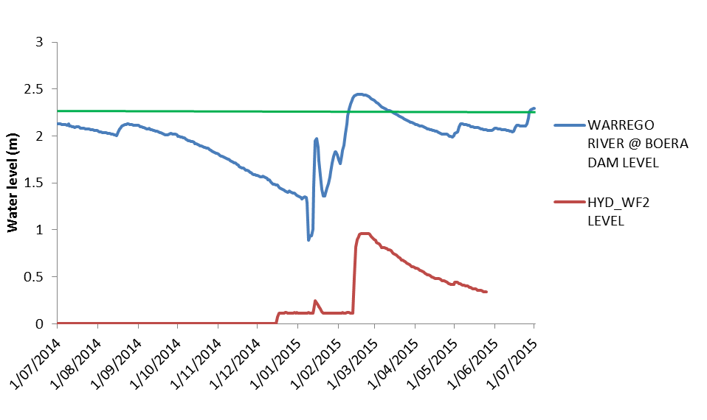

Figure ‑: Water levels experienced at Boera Dam and water level logger site WF2 on the Western Floodplain. Green line represents overflow level of the Western Floodplain.

Methods

Design

Microinvertebrate, metabolism and water chemistry samples were taken from duplicate locations within each monitoring site within the Selected Area. Waterbodies sampled were Boera Dam, Booka Dam and Ross Billabong, the Western Floodplain, and Akuna and Darling Pump sites on the Darling River. Sampling dates covered 23–27 February and 4–8 May 2015 (Table J‑1; Figure J‑2).

Table ‑: Location of sites on the Warrego River and Western Floodplain surveyed for microinvertebrates.

|  |  |  |  |  |
| --- | --- | --- | --- | --- |
| Sampling Zone | Site Name | Site Code | Latitude | Longitude |
| Western Floodplain | WF1 | WD\_WF1 | -30.13320 | 145.41830 |
| Warrego Channel | Ross Billabong | WD\_ROSS | -30.39030 | 145.41040 |
| Booka Dam | WD\_BOOKA | -30.19600 | 145.43510 |
| Boera Dam | WD\_BOERA | -30.09940 | 145.42800 |
| Darling River | Akuna homestead | WD\_AKUNA | -30.40978 | 145.33438 |
| Warrego River pumps | WD\_DARPUM | -30.40465 | 145.44647 |

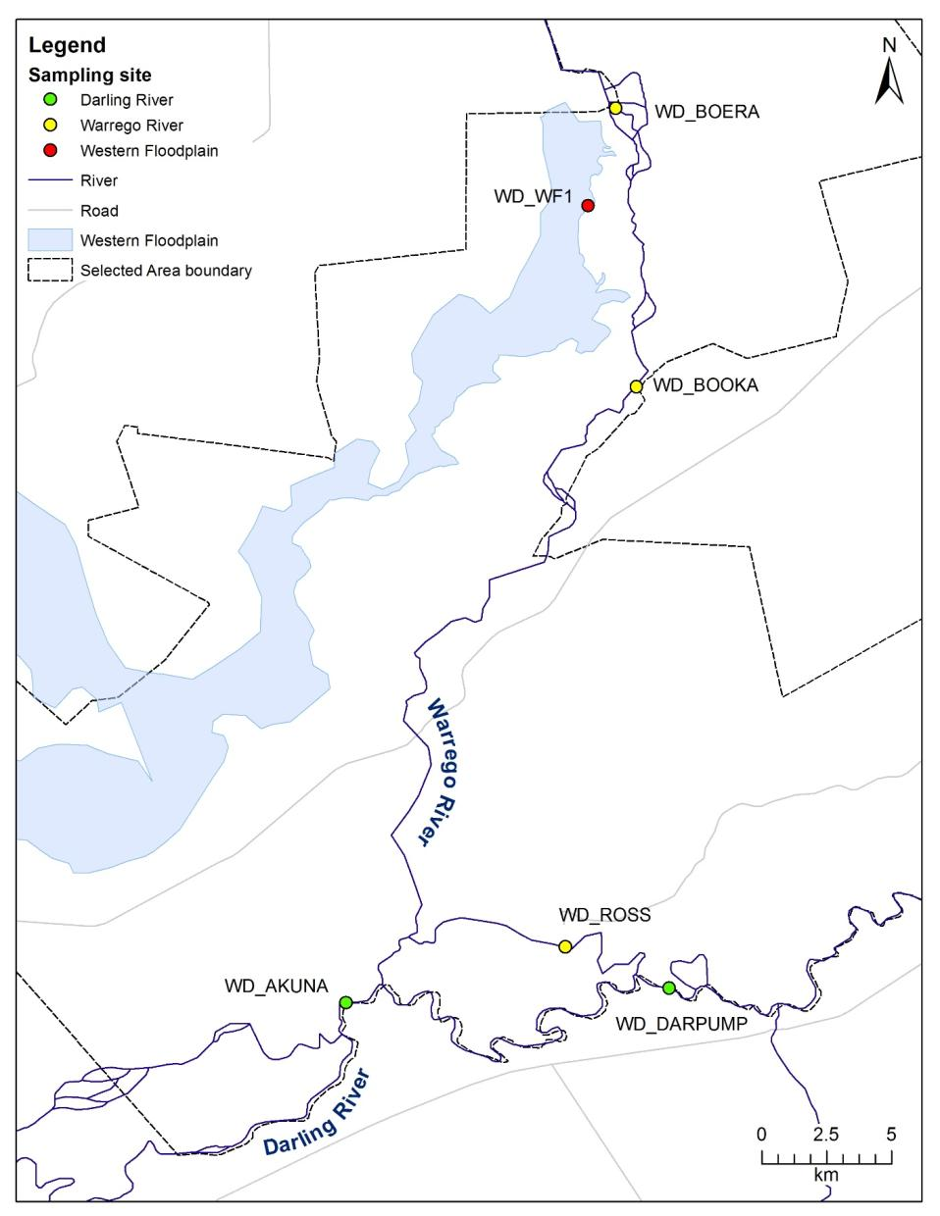

Figure ‑: Microinvertebrate, metabolism and water chemistry sites monitored in the Selected Area in 2014–15.

Microinvertebrate field methods

Benthic microinvertebrates were haphazardly sampled by compositing five cores (50 mm diameter x 120 mm long with 250 mL volume) for each site. Replicates were separated by a minimum of 20 linear metres. The composite sample was allowed to settle for a minimum of 1 hr and then the supernatant was poured through a 63 μm sieve. The retained sample was washed into a labelled jar and stored in ethanol (70 % w/v with Rose Bengal stain) until laboratory analysis.

Pelagic microinvertebrates were sampled by haphazardly sampling 20 L of the water column at each of five locations throughout the site. Samples were poured through a plankton net (63 μm) into a single, 100-L composite sample. Retained samples were stored in ethanol (70 % w/v) with Rose Bengal stain until laboratory analysis.

Nutrient field methods

In-situ spot measurements of water column pH, turbidity (NTU) and specific conductivity (µS/cm) were taken using a Hydrolab Quanta water quality multi-probe. Water column samples were collected for laboratory analysis of chlorophyll *a*, total nitrogen (TN), total phosphorus (TP), nitrate-nitrite (NOx), ammonium (NH4), filterable reactive phosphorus (FRP) and dissolved organic carbon (DOC). Samples were transferred to labelled PET containers that had been acid-washed and thrice rinsed with sample water. Duplicate samples of each variable were taken from each site and stored cold and in the dark until processing each night.

Chlorophyll *a* was sampled by filtering as much sample water as possible (100–1000 mL) through a Whatman glass microfibre grade GF/C filter paper using an electric vacuum pump (EYELA Tokyo Rakahikai Corporation Aspirator A-35 at approximately 7 PSI). The sample volume was recorded and the filter paper placed into a prelabelled 10 mL vial which was then sealed, wrapped in aluminum foil, placed inside a labelled ziplock bag and then refrigerated below 4 °C.

TN and TP were sampled by collecting duplicate 125 mL, unfiltered water samples that were frozen until laboratory analyses. NOx and FRP were sampled by collecting duplicated 125 mL water samples that were filtered through Whatman microfibre filter papers (effective pore size of 0.2 μm) and frozen until laboratory analyses. The 125 mL PET bottles for total and dissolved nutrients were acid-washed and thrice rinsed in sample water before use.

Duplicate NH4 samples were filtered through Whatman microfibre filter papers (effective pore size of 0.2 μm) and placed in acid-washed, 30-mL vials thrice rinsed in sample. Samples were frozen until laboratory analyses. Duplicates remain frozen for audit purposes.

Duplicate Dissolved Organic Carbon samples were filtered through Whatman Microfibre filter papers (effective pore size of 0.2 μm) into 30 mL vials thrice rinsed in sample and frozen until analysis.

A 10% subsample of randomly selected samples was sent to the Environmental Analytical Laboratories at Southern Cross University NATA accredited laboratory as part of the project Quality Assurance Plan. All samples returned did not significantly differ from those analysed at the UNE laboratories.

Metabolism field methods

At each sampling site and period, a single D-Opto dissolved oxygen (DO) logger was deployed in the water column ensuring they were positioned in the water column not touching the sediment or where the logger would be exposed. Loggers were allowed to equilibrate and measured temperature, DO percent saturation and DO concentration (mg/L) at 10-minute intervals over a minimum 48-hour period from midnight to midnight. A Hobo PAR logger was simultaneously deployed in the air. Barometric pressure data were retrieved from the nearest BoM locality at Bourke.

Microinvertebrate laboratory methods

Samples were thoroughly mixed and a 30-mL subsample was sorted on a Bogorov tray under a stereo microscope at up to 400x magnification. Microinvertebrates were identified to family level (cladocerans), class (copepods) and ostracods. The volumes of the total samples were recorded and subsample totals were scaled up to each total sample volume and reported as density/L. Samples were stored in 70% ethanol with Rose Bengal for auditing purposes.

Nutrient laboratory methods

Chorophyll *a* was analysed by placing 10 mL of 90% acetone solution in the vial and refrigerating the sample for 24 hours. Samples were then centrifuged and the absorption spectra recorded using a UV-1700 Pharmaspec UV-visible spectrometer at 665 and 750 nm.

TN was analysed by digesting an unfiltered water sample in a digestion tube with 10 mL of digestion mixture. This contained 40 g of di-potassium-peroxodisulfate (K2S2O8) and 9 g of sodium hydroxide (NaOH) in 1000 mL of Milli Q water. This sample was then digested in the autoclave for 20 minutes. Five mL of the sample was then placed into a 50 mL, acid-washed measuring cylinder and diluted to 50 mL (Hosomi & Sudo 1986). Five mL of buffer solution was added: 100 g of NH4Cl, 20 g sodium tetra borate and 1 g EDTA to 1000 mL with Milli Q water. Nitrite-nitrate (NOx) was analysed by re-filtering the water sample through a Whatman microfibre filter paper (effective pore size of 0.2 μm), diluting 5 mL of sample with 50 mL of Milli Q water, and adding 5 mL of buffer solution.

Fifty mL of each nitrogen sample was measured into a numbered jar. The samples were then filtered. Firstly, the cadmium reduction column was rinsed with 10% buffer solution, making sure the cadmium granules remained covered at all times by either the 10% buffer solution or the sample. The column was drained to 5 mm above the cadmium granules, and 25 mL of the first sample added. This was collected in a separate beaker as it drained through to rinse the column and was discarded. The column was then filled with the sample and 20 mL was collected in the same sample jar. One mL of sulfanilamide solution was added and mixed thoroughly. After 2 minutes, 1 mL of dihydrochloride solution was added and mixed. This was repeated for all water samples. After 10 minutes, the absorbance of each sample was measured using a UV-1700 Pharmaspec UV-visible spectrometer at 543 nm. This colormetric determination of nitrogen can be used when nitrogen is in the range 0.0125 to 2.25 μg/mL. Standards were also prepared before analyzing the samples to calculate linear regression at 0, 0.2, 0.5, 1, 2 and 5 μg/mL of known nitrogen concentration.

TP was measured by digesting an unfiltered water sample in a digestion tube with 10 mL of digestion mixture. This contained 40 g of di-potassium-peroxodisulfate (K2S2O8) and 9 g of sodium hydroxide (NaOH) in 1000 mL of Milli Q water. This sample was then digested in the autoclave for 20 minutes. Before FRP was analysed, the sample was re-filtered through a Whatman Microfibre filter paper (effective pore size of 0.2 μm).

Twenty mL of each phosphorus sample was then added to a plastic FRP tube with 2 mL of colour reagent: 20 mL of ascorbic acid solution with 50 mL of molybdate antimony solution. This was repeated for all water samples. After 8 minutes, the absorbance of each sample was measured using a UV-1700 Pharmaspec UV-visible spectrometer at 705 nm. Standards were prepared before analyzing the samples to calculate linear regression at 0, 0.02, 0.05, 0.2 and 0.5 μg/mL of known phosphorus concentration.

NH4 was analysed using an Orion 95-12 Ammonia Electrode. Samples, standards and the ammonia electrode were equilibrated to a constant temperature. Standards were prepared before analyzing samples to calculate linear regression at 0.01, 0.02, 0.04, 0.06, 0.10, 0.29 and 0.47 ppm.

The concentration of DOC (µg/L) was determined using a Sievers InnovOx Laboratory TOC Analyser.

Microinvertebrate statistical methods

Taxonomic diversity was calculated using the Shannon Weiner Index. Univariate data were checked for normality using the Shapiro-Wilk test, and heterogeneity of variances using Bartlett’s test for comparing between two groups and Levene’s test for comparing more than two groups. Density and Diversity were analysed for both microcrustaceans and complete microinvertebrate communities.

ANOVA factors comprised HABITAT (with 2 fixed levels, Benthic and Pelagic), RIVER (with 2 fixed levels, Warrego and Darling), TIME (with 2 random levels, February 2015 and May 2015), and SITE (with 6 fixed levels, Boera, Booka, Ross, Yanda, Akuna and Western Floodplain) where SITE was nested within RIVER. A mixed-effects general linear model was used to test TIME, RIVER, SITE(RIVER) and HABITAT. Post-hoc pairwise comparisons were performed on significant ANOVA terms using Tukey’s HSD test as group variances were homogeneous. All univariate analyses were performed using SYSTAT Version 13 (SYSTAT Software Inc, 2009).

Multivariate analyses of microinvertebrate and microcrustacean community compositions were used to test for differences between TIME, RIVER, HABITATS and among SITES. Square-root or presence/absence transformations were applied to density data prior to the calculation of resemblance matrices using Bray-Curtis similarities in PRIMER Version 6.1.13 (http://www.primer-e.com/). nMDS, ANOSIM and SIMPER routines in PRIMER were used to visualize and test dissimilarities among samples, and determine the taxa contributing to these patterns, respectively.

Nutrient statistical methods

Univariate data were checked for normality using the Shapiro-Wilk test, and heterogeneity of variances using Bartlett’s test for comparing between two groups and Levene’s test for comparing more than two groups. With the exception of TN, all variables were log (x+1) transformed to meet the ANOVA assumption of normality. ANOVA factors comprised RIVER (with 2 fixed levels, Warrego and Darling), TIME (with 2 random levels, February 2015 and May 2015), and SITE (with 6 fixed levels, Boera, Booka, Ross, Yanda, Akuna and Western Floodplain) where SITE was nested in RIVER. A mixed-effects general linear model was used to test TIME, RIVER and SITE (RIVER).

Metabolism statistical methods

Ten minute interval dissolved oxygen, PAR, conductivity and barometric pressure data were used as input metrics for the BASE model to calculate mean daily Gross Primary Productivity (GPP), Ecosystem Respiration (ER) and Net Primary Production (NPP) (Grace et al. 2015). The use of the BASE model to determine daily rates of GPP, ER and NPP has resulted in a number of diurnal oxygen profiles not meeting model requirements. As such, it is not possible to undertake statistical analyses on the Year 1 dataset.

Results and Discussion

Nutrients

Chlorophyll *a* ranged from a very low 0.338 µg/L at Ross Billabong to a high 19.525 µg/L at the Western Floodplain in May 2015 (Figure J‑3a). However, there were no significant differences in chlorophyll *a* between times, rivers or among sites due to the high variability. Dissolved Organic Carbon concentrations ranged from 7.96 µg/L in February 2015 to a high 34.900 µg/L in May 2015 in the Western Floodplain (Figure J‑3b). Overall, concentrations were higher in the Warrego River than the Darling River (F1,9 = 12.168, p = 0.007), and higher in May than February 2015 (F1,9 = 12.700, p = 0.006).

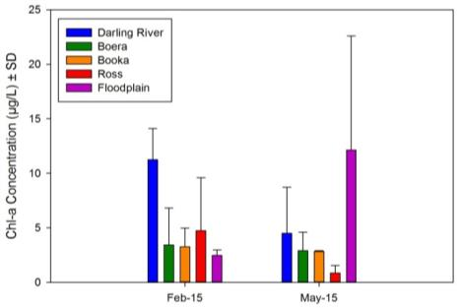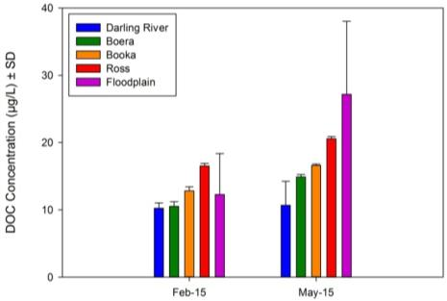

**(a)**

**(b)**

Figure ‑: Mean concentrations ± one standard deviation (SD) of (a) Chlorophyll a and (b) Dissolved Organic Carbon in the Darling and Warrego Rivers in February and May 2015.

Concentrations of TN ranged from 386 µg/L at Boera to 1817 µg/L in the Western Floodplain (both observed in May 2015, Figure J‑4a). TN concentrations in the Warrego River were consistently higher than in the Darling River (F1,9 = 5.292, p = 0.047). Concentrations of NOx ranged from 45 µg/L in February 2015 to a very high 1133 µg/L in May 2015, both in the Western Floodplain (Figure J‑4b). NOx concentrations were significantly higher in May than in February 2015 (F1,9 = 34.358, p < 0.001). This temporal pattern was inconsistent among sites (F8,9 = 4.058, p = 0.026), but there were no significant post-hoc pairwise tests.

Concentrations of TP ranged from 76 µg/L at Boera Dam in May 2015 to 1201 µg/L in the Western Floodplain in February 2015 (Figure J‑5a). Thus, TP concentrations were higher in February than in May (F1,9 = 9.191, p = 0.014), but there were no significant differences between Rivers. FRP concentrations ranged from 23 µg/L at Booka Dam to 472 µg/L at Ross Billabong, both in February 2015 (Figure J‑5b). Sites were inconsistent between sampling times (F8,9 = 8.992, p = 0.002), and post-hoc pairwise tests showed this was driven by high concentrations at Ross 2 and Western Floodplain 1 in May 2015.

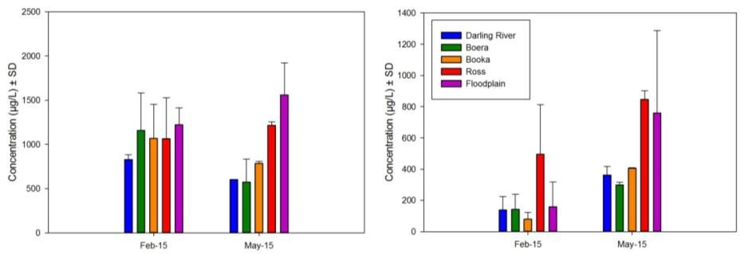

**(a)**

**(b)**

Figure ‑: Mean concentrations ± one standard deviation (SD) of (a) TN and (b) NOx in the Darling and Warrego Rivers in February and May 2015.

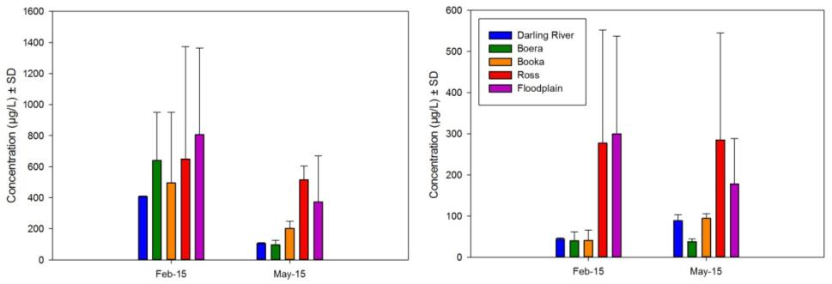

**(a)**

**(b)**

Figure ‑: Mean concentrations ± one standard deviation (SD) of (a) TP and (b) FRP in the Darling and Warrego Rivers in February and May 2015.

Metabolism

With the exception of the Western Floodplain in May, all sites were net heterotrophic throughout the study period (Figure J‑6). In May 2015, the Western Floodplain was only slightly net autotrophic at a rate of 0.08 mg DO/L/day. Irrespective of time since inundation, the remaining sites were strongly heterotrophic, recording values up to 3.9 mg DO/L/day net oxygen consumption.

Rates of GPP and ER were consistently higher in Warrego zone compared with the Darling River zone, although rates of NPP were more similar across all sites.

Boera Dam on the Warrego River consistently had the highest rate of GPP (up to 10.5 mg DO/L/day), with the lowest rate of GPP observed at Yanda on the Darling River (Figure J‑6). Boera Dam also had the highest rate of ER (up to 10.3 mg DO/L/day) in the May sampling period. There was no increase in water column concentrations of chlorophyll a in May, leaving us to hypothesise that lower water levels allowed light penetration to facilitate benthic algal production that would lead to increased GPP and ER.

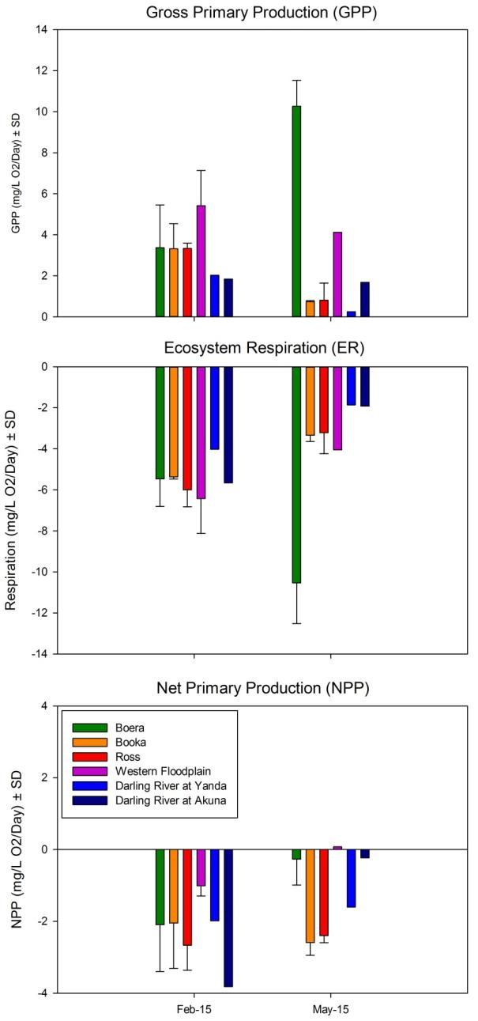

Figure ‑: Rates of GPP, ER and NPP (mg DO/L/day) in the Warrego River (Boera, Booka, Ross and the Western Floodplain) and the Darling River.

Microinvertebrates

Benthic microinvertebrate communities had higher densities than pelagic microinvertebrate communities (F1,25 = 7.650, p = 0.011) and sites on the Warrego River consistently had higher densities than those on the Darling River (F1,25 = 4.946, p = 0.035,Figure J‑7a; Figure J‑7b). Densities of benthic microcrustaceans were similar to pelagic microcrustaceans, but higher densities were observed in the Warrego River than Darling River (F1,25 = 5.105, p = 0.033, Figure J‑7c; Figure J‑7d). No temporal differences in densities were observed for microinvertebrates or microcrustaceans.

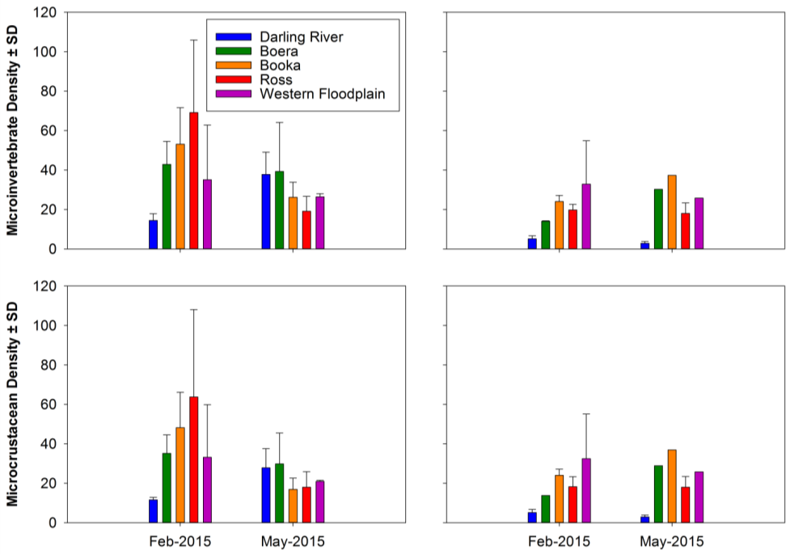

**(a)**

**(b)**

**(c)**

**(d)**

Figure ‑: Density (per L) of (a) benthic microinvertebrate, (b) pelagic microinvertebrate, (c) benthic microcrustacean, and (d) pelagic microcrustacean communities in the Warrego and Darling Rivers in February and May 2015.

Similar patterns were observed for microinvertebrate and microcrustacean diversity (Figure J‑8a; Figure J‑8b). Benthic habitats were more diverse than pelagic habitats (F1,25 = 7.355, p = 0.012), and overall, the Warrego River contained more diverse microinvertebrate communities than the Darling River (F1,25 = 19.871, p < 0.001). Microcrustaceans were more diverse in the Warrego River than the Darling River (F1,25 = 33.448, p < 0.001, Figure J‑8c; Figure J‑8d), with no other significant patterns between sampling times or habitats, or among sites.

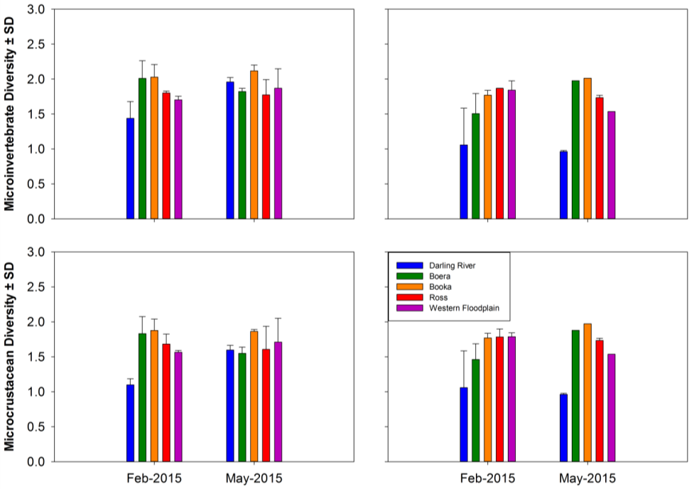

**(a)**

**(b)**

**(c)**

**(d)**

Figure ‑: Diversity (per L) of (a) benthic microinvertebrate, (b) pelagic microinvertebrate, (c) benthic microcrustacean, and (d) pelagic microcrustacean communities in the Warrego and Darling Rivers in February and May 2015.

The community composition of microinvertebrates differed between benthic and pelagic habitats (Global *R* = 0.366, *p* = 0.001), between rivers (Warrego, Darling) (Global *R* = 0.341, *p* = 0.003) and between sampling occasions (Global *R* = 0.367, *p* = 0.001, Figure J‑9). Pairwise comparisons of the River x Habitat interaction found only the Warrego and Darling benthic samples, and Darling pelagic and benthic samples were similar to each other. Similar patterns were observed when analyzing taxonomic composition (i.e. presence/absence data, Figure J‑9b), with significant differences observed between benthic and pelagic habitats (Global *R* = 0.441, *p* = 0.001), between Rivers (Global *R* = 0.310, *p* = 0.013) and between sampling occasions (Global *R* = 0.285, *p* = 0.001). Similarly, pairwise comparisons of the River x Habitat interaction found the Darling pelagic and benthic samples, and the Darling and Warrego benthic samples were similar to each other. These patterns are predominantly driven by abundances of Nauplii and Cyclopoidae across all habitats, and Nematoda in the benthic samples (Table J‑2).

Microcrustacean community composition was similar to microinvertebrate community composition (Figure J‑10). Community composition differed between benthic and pelagic habitats (Global *R* = 0.263, *p* = 0.002), between Rivers (Global *R* = 0.368, *p* = 0.003) and between sampling occasions (Global *R* = 0.414, *p* = 0.001, Figure J‑10a). Pairwise tests of the River x Habitat interaction found only the Darling habitats were similar to each other. Again, the similarity between analyses of abundance data and presence/absence data (Figure J‑9; Figure J‑10) suggest that the patterns are due to the taxonomic composition of microcrustaceans, rather than abundance (Table J‑2). Benthic and pelagic habitats were dissimilar (Global *R* = 0.356, *p* = 0.001), as were Rivers (Global *R* = 0.325, *p* = 0.016) and sampling occasions (Global *R* = 0.473, *p* = 0.001, Figure J‑10b). Pairwise comparisons of the River x Habitat interaction found the Darling pelagic and benthic samples, and the Darling and Warrego benthic samples were similar to each other.

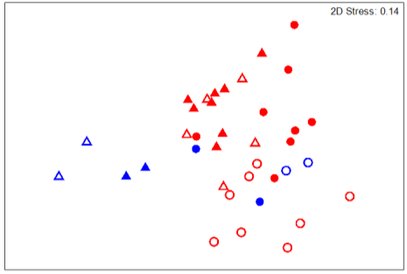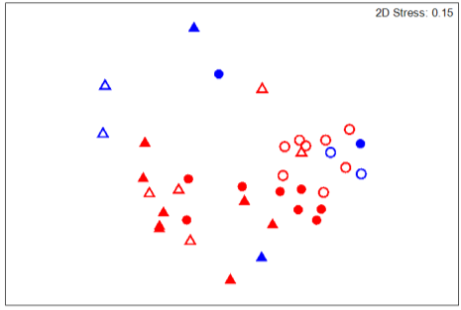

**(a)**

**(b)**

Figure ‑: nMDS ordination plots of microinvertebrate community composition using (a) abundance data, and (b) presence/absence data. Blue circles represent Darling River benthic samples, red circles represent Warrego River benthic samples, blue triangles represent Darling River pelagic samples, red triangles represent Warrego River pelagic samples, and closed and open symbols represent February and May 2015, respectively.

Table ‑: Microinvertebrate taxa contributing most of the similarities between pelagic and benthic densities between the Darling and Warrego Rivers.

|  |  |  |  |  |  |
| --- | --- | --- | --- | --- | --- |
| *Warrego Pelagic Communities* | | | | | |
| SIMPER analysis of microinvertebrate densities | | | SIMPER analysis of microcrustacean densities | | |
| Taxa | Contributed % | Cumulative % | Taxa | Contributed % | Cumulative % |
| Nauplii | 33.75 | 33.75 | Cyclopoida | 21.17 | 21.17 |
| Cyclopoida | 26.99 | 60.74 | Nauplii | 21.17 | 42.33 |
| Ceriodaphnia | 17.23 | 77.97 | Ceriodaphnia | 15.03 | 57.36 |
| Calanoida | 7.70 | 85.67 | Calanoida | 14.69 | 72.05 |
| Sididae | 5.05 | 90.72 | Moinidae | 9.32 | 81.37 |
|  |  |  | Sididae | 5.45 | 86.83 |
|  |  |  | Ceriodaphnia | 5.26 | 92.09 |
| *Darling Pelagic Communities* | | | | | |
| SIMPER analysis of microinvertebrate densities | | | SIMPER analysis of microcrustacean densities | | |
| Taxa | Contributed % | Cumulative % | Taxa | Contributed % | Cumulative % |
| Nauplii | 68.37 | 68.37 | Nauplii | 64.01 | 64.01 |
| Cyclopoida | 19.90 | 88.27 | Calanoida | 11.67 | 75.68 |
| Calanoida | 11.73 | 100.00 | Cyclopoida | 8.75 | 84.44 |
|  |  |  | Bosmina | 7.78 | 92.22 |
| *Warrego Benthic Communities* | | | | | |
| SIMPER analysis of microinvertebrate densities | | | SIMPER analysis of microcrustacean densities | | |
| Taxa | Contributed % | Cumulative % | Taxa | Contributed % | Cumulative % |
| Cyclopoida | 21.14 | 21.14 | Cyclopoida | 19.22 | 19.22 |
| Nauplii | 19.36 | 40.50 | Nauplii | 16.39 | 35.61 |
| Ostracoda | 19.00 | 59.50 | Ostracoda | 14.43 | 50.04 |
| Nematoda | 14.17 | 73.67 | Chydoridae | 14.14 | 64.18 |
| Chydoridae | 7.10 | 80.77 | Macrothrix | 12.55 | 76.73 |
| Ceriodaphnia | 4.89 | 85.66 | Calanoida | 8.33 | 85.06 |
| Macrothrix | 4.58 | 90.24 | Ceriodaphnia | 6.87 | 91.93 |
| *Darling Benthic Communities* | | | | | |
| SIMPER analysis of microinvertebrate densities | | | SIMPER analysis of microcrustacean densities | | |
| Taxa | Contributed % | Cumulative % | Taxa | Contributed % | Cumulative % |
| Nauplii | 27.21 | 27.21 | Cyclopoida | 28.70 | 28.70 |
| Cyclopoida | 27.07 | 54.28 | Nauplii | 28.70 | 57.40 |
| Nematoda | 21.38 | 75.67 | Chydoridae | 12.98 | 70.38 |
| Chydoridae | 14.04 | 89.70 | Macrothrix | 12.98 | 83.36 |
| Macrothrix | 2.81 | 92.51 | Moinidae | 4.66 | 88.02 |
|  |  |  | Calanoida | 4.66 | 92.68 |

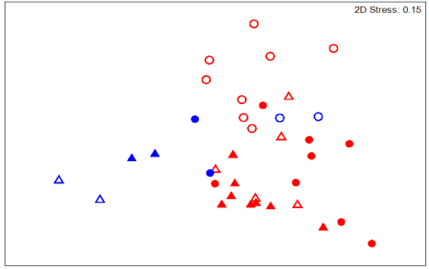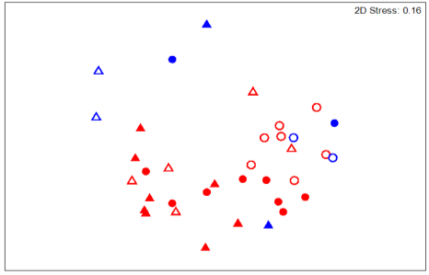

**(a)**

**(b)**

Figure ‑nMDS ordination plots of microcrustacean community composition using (a) abundance data, and (b) presence/absence data. Blue circles represent Darling River benthic samples, red circles represent Warrego River benthic samples, blue triangles represent Darling River pelagic samples, red triangles represent Warrego River pelagic samples, and closed and open symbols represent February and May 2015, respectively.

Conclusion

Spatial patterns in nutrients were only evident in TN and DOC, with significantly higher concentrations in the Warrego compared with the Darling River zone. High NOx and FRP concentrations were recorded in May in Ross Billabong and the Western Floodplain zone that may indicate a more lentic and/or reducing environment. Temporal patterns in nutrient concentrations showed increased NOx in May compared with February, and TP concentrations higher in February than in May. There is no consistent evidence for changes in patterns of nutrient concentrations among sites or over time. All sites (except the Western Floodplain in May) were net heterotrophic and therefore a carbon sink throughout the 2014–15 year, recording values up to 3.9 mg DO/L/day net oxygen consumption. Rates of GPP and ER were consistently higher in the Warrego zone compared with the Darling River zone, although rates of NPP were more similar across all sites. Boera Dam consistently had the highest rate of GPP (up to 10.5 mg DO/L/day), and ER (up to 10.3 mg DO/L/day) but is not aligned to an increase in water column concentrations of chlorophyll *a*, suggesting benthic algal production is regulating rates of GPP and ER.

The inundation of the Warrego River zone increased regional scale abundance and diversity of aquatic microinvertebrates. Significantly lower pelagic than benthic microinvertebrate densities, and significant differences in community composition were evident between in sites, rivers and time. This supports the continuation of the sampling protocol in Year 2 to investigate longer term patterns in microinvertebrate communities. The community composition of microinvertebrates and microcrustaceans differed between the Warrego and Darling River zones indicating the potential benefits for delivery of Commonwealth environmental water to the Warrego system in increasing regional level diversity. These differences were evident in both abundance data and presence-absence data suggesting it was composition rather than dominance of individual taxon driving the observed patterns. Inundation of channel and floodplain habitats for an extended period (at least 4 months) contributed to the development and succession of different aquatic microinvertebrate communities between river systems, and between channel and floodplain habitats.

References

Grace, M. R., Giling, D. P., Hladyz, S., Caron, V., Thompson, R. M., & Mac Nally, R. (2015). Fast processing of diel oxygen curves: Estimating stream metabolism with BASE (Bayesian Single‐station Estimation). Limnology and Oceanography: Methods, 13(3), 103–114.

###### Waterbird diversity

Introduction

Relatively little is known about the waterbird communities within the Selected Area, even though the waterholes on the Warrego River and Western Floodplain are likely to provide refugia for waterbirds at a regional scale during dry periods (Capon 2009). In addition the Warrego River and its wetlands, which include the Western Floodplain contain high conservation value biodiversity (OEH 2014). Monitoring of waterbird diversity in the 2014–15 season addresses several specific question:

* What did Commonwealth environmental water contribute to waterbird survival?
* What did Commonwealth environmental water contribute to waterbird populations?
* What did Commonwealth environmental water contribute to waterbird species diversity?

Environmental watering in 2014–15

Unlike other Selected Areas, environmental water is not specifically delivered to the Junction of the Warrego and Darling rivers Selected Area, rather, Commonwealth environmental water is held as unregulated entitlements and its influence is thus reliant on flows out of upstream catchments. During the 2014–15 water year, three in-channel flow events containing environmental water flowed down the Darling River within the selected area (Appendix D). These occurred in October–November 2014, December–March 2015 and April–May 2015. No Commonwealth environmental water was accounted for on the Warrego River or Western Floodplain in the Selected Area. However, management decisions made by the CEWO resulted in water flowing down the Western Floodplain during February–March 2015. Flows in Boera Dam were above the estimated overflow height of the Western Floodplain (2.26 m on the Boera Dam gauge) for 37 days (). This produced 36.9 ha of inundation down the Western Floodplain including a waterhole to the east of the floodplain (), which was monitored for waterbird diversity (). Water depth within this waterhole reached a maximum depth of around 1 m in late February 2015 (HYD\_WF2 in ). Water levels in Boera Dam also rose above the overflow height of the Western Floodplain towards the end of the water year as a result of local rainfall ().



**Figure K‑1: Water levels experienced at Boera Dam and water level logger site WF2 on the Western Floodplain. Green line represents overflow level of the Western Floodplain.**

Methods

Four sites were surveyed in both February 2015 and May 2015. These sites were spread along the Warrego River and Western Floodplain zones (; ). Monitoring for this indicator was done using foot surveys (Commonwealth of Australia 2015). These surveys were undertaken by moving around each wetland and recording birds from various points. At each survey point all birds were observed and recorded. Birds were also recorded enroute to new points and their species and number noted. During the survey, as much area of each wetland as possible was accessed. Surveys were undertaken for at least 20 minutes but no more than 1 hour at each wetland, in order to gain a representative, not necessarily complete, count of all waterbirds in the wetland. Three replicate surveys were undertaken at each of the four sites and total counts for each site was used in the analysis. The total waterbird count was for individual species from each site was used in the analysis.

**Table K‑1: Location of sites on the Warrego River and Western Floodplain surveyed for waterbird diversity.**

|  |  |  |  |  |
| --- | --- | --- | --- | --- |
| Sampling Zone | Site Name | Site Code | Latitude | Longitude |
| Floodplain | WF1 | WD\_WF1 | -30.13320 | 145.41830 |
| Channel | Ross Billabong | WD\_ROSS | -30.39030 | 145.41040 |
| Booka Dam | WD\_BOOKA | -30.19600 | 145.43510 |
| Boera Dam | WD\_BOERA | -30.09940 | 145.42800 |

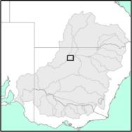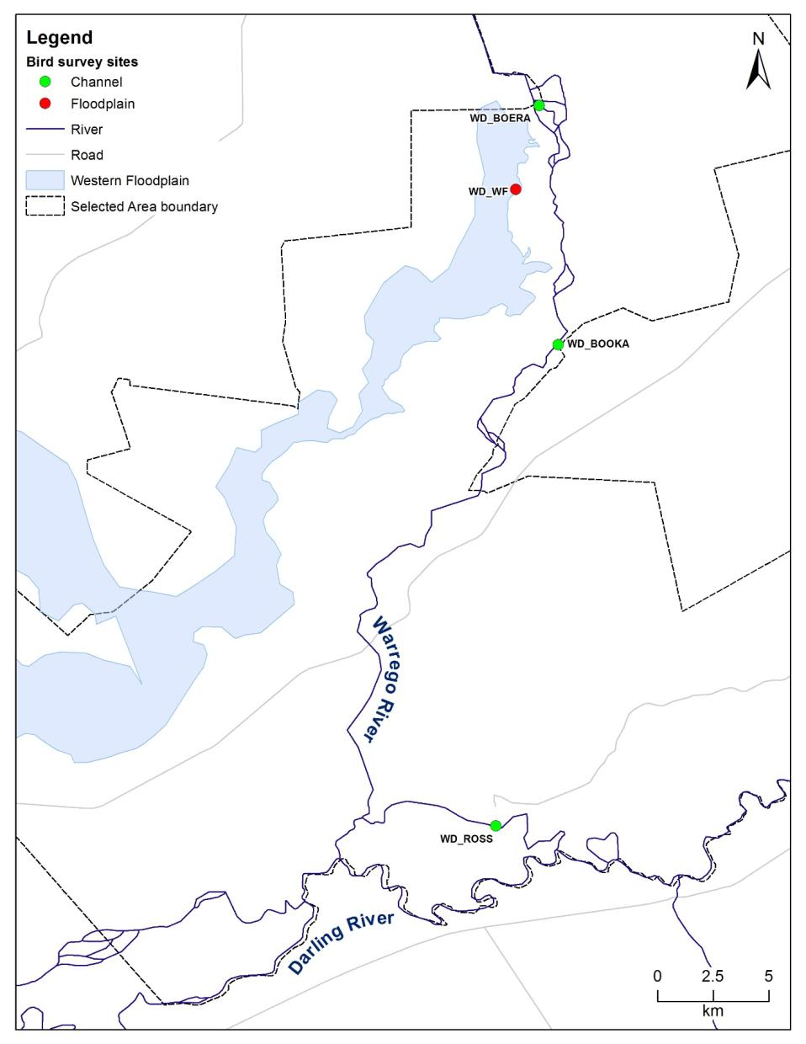

**Figure K‑2: Location of waterbird monitoring sites.**

Factorial regression was undertaken on species diversity, total abundance and functional guild data to compare between survey times and the Warrego River and Western Floodplain zones. F-tests were used to test for equality of variance, and appropriate t-tests were employed thereafter. Multivariate nMDS analyses were used to decipher patterns of bird community composition. Square-root or presence/absence transformations were applied to density data prior to the calculation of resemblance matrices using Bray-Curtis similarities in PRIMER Version 6.1.13 (http://www.primer-e.com/). PEMANOVA tests were then performed to compare between survey time and the presence of Commonwealth environmental water. SIMPER tests were performed to assess the dominant species associated with each data grouping.

Results

Species diversity and abundance

In total 86 bird species, including 31 waterbird species were recorded in the Warrego River and Western Floodplain zones during the February 2015 and May 2015 survey periods (). This included one waterbird species, the Eastern great egret (*Ardea alba*), listed under two international migratory bird agreements (JAMBA and CAMBA) and two threatened species listed under the NSW TSC Act: Brolga *(Grus rubicunda*) and Freckled duck *(Stictonetta naevosa)*.

A total of 676 individual birds were observed during February, and 85 birds in May within the Selected Area, consisting of 26 waterbird species in February and 16 in May. Accordingly, mean waterbird diversity was significantly greater in February (14 species) than in May (6 species; T=2.45; Pr<0.05; ). Similar patterns were seen in waterbird abundance (), however, differences in abundance were not significant (T=3.18, Pr=0.13). The mean waterbird count per site was 5 waterbirds per ha in February and 0.5 waterbirds per ha in May.

Boera Dam recorded the highest species diversity (19 in February) and the highest waterbird abundance (375 waterbirds in February), comprising 58% of the maximum waterbird count per ha in the 2014–15-survey period (; ; ). In February, flocks of 50–100 birds were recorded for the species Grey teal *(Anas gracilis)* and Pacific black duck *(Anas superciliosa)* at Boera Dam.

Despite the highest site diversity and abundance recorded at Boera Dam, a comparison with Western Floodplain and combined Warrego River sites indicated mean diversity and total abundance was higher on the Western Floodplain (), however these increases were not significant (abundance; T=2.45. Pr=0.88; diversity; T=2.45, Pr=0.90). The total occurrence of functional guilds across the February and May survey periods were also higher for the Western Floodplain ().

**Table K‑2: Total counts and percent occurrence of the 31 waterbird species recorded in the Warrego Darling in 2014–15. Functional guilds based on Roshier et al (2002).**

| Functional group (guild) | Common name | Channel | | | Floodplain | % Occurrence |
| --- | --- | --- | --- | --- | --- | --- |
| Boera Dam | Booka Dam | Ross Billabong | Western Floodplain |
| Australian-breeding Charadriiform shorebird | Black fronted Dotterel\* | 2 | 6 | 5 | 6 | 100 |
| Black winged Stilt | 1 |  |  |  | 75 |
| Masked lapwing | 2 |  | 2 | 3 | 75 |
| Dabbling and filter-feeding ducks | Australasian shoveler |  |  | 3 |  | 25 |
| Grey teal | 97 |  | 24 | 43 | 75 |
| Hardhead | 44 |  |  |  | 25 |
| Pacific black duck | 73 | 4 | 2 |  | 75 |
| Pink eared duck | 2 |  | 2 | 23 | 75 |
| Diving ducks, aquatic gallinules, and swans | Black swan | 2 |  |  |  | 25 |
| Eurasian coot | 2 |  | 1 | 3 | 75 |
| Fish-eater | White faced heron |  |  | 2 | 4 | 50 |
| White necked heron |  | 2 | 1 | 4 | 75 |
| Grazing ducks and geese | Australian wood duck | 10 | 15 | 14 | 2 | 100 |
| Freckled duck\*^ | 1 |  |  |  | 25 |
| Large wading birds | Australian white ibis | 3 |  |  | 5 | 50 |
| Brolga ^ |  |  |  | 4 | 25 |
| Royal spoonbill\* | 6 |  |  |  | 25 |
| Straw necked Ibis |  | 29 | 2 |  | 50 |
| Yellow billed spoonbill | 3 |  | 4 |  | 50 |
| Piscivore | Australasian darter\* | 21 |  |  |  | 25 |
| Australasian grebe |  |  | 1 | 6 | 50 |
| Australian pelican | 3 | 2 | 8 |  | 75 |
| Eastern great egret J,C | 2 | 1 |  | 1 | 75 |
| Hoary headed grebe | 8 |  |  | 1 | 50 |
| Little black cormorant |  |  |  | 1 | 25 |
| Little pied cormorant | 1 |  |  |  | 25 |
| Sacred kingfisher | 1 | 1 |  | 2 | 75 |
| Raptors | Nankeen kestrel |  |  | 1 |  | 25 |
| Wedge tailed eagle |  |  |  | 2 | 25 |
| Whistling kite\* | 1 | 2 | 1 | 0 | 100 |
| Reed-inhabiting passerines | Little grassbird |  |  |  | 2 | 25 |
| Species diversity (max total of species) | | 21 | 9 | 16 | 18 |  |
| Species abundance (max total count) | | 285 | 62 | 73 | 112 |
| ^Status: V=vulnerable (NSW *TSC Act*), J= Listed under JAMBA, C=listed under CAMBA migratory bird agreements. \* Breeding activity (nests/broods) or evidence of breeding (breeding plumage, juveniles and empty nests) | | | | | | |

**Table K‑3: Species diversity, abundance and the number of waterbird functional groups at sites on the Warrego River and Western Floodplains.**

|  |  |  |  |  |  |  |  |
| --- | --- | --- | --- | --- | --- | --- | --- |
| Sample zone | Site Name | Waterbird species diversity (total species count) | | Waterbird abundance/ha (maximum waterbird counts) | | Waterbird functional guilds | |
| Feb-15 | May-15 | Feb-15 | May-15 | Feb-15 | May-15 |
| Channel | WD\_BOERA | 19 | 8 | 11.8 | 0.9 | 7 | 6 |
| WD\_BOOKA | 9 | 2 | 5.4 | 0.2 | 7 | 2 |
| WD\_ROSS | 14 | 7 | 2.2 | 0.7 | 8 | 5 |
| Floodplain | WD\_WF | 15 | 6 | 0.7 | 0.1 | 8 | 4 |

**Figure K‑3: Total species recorded at the 3 channel sites and the floodplain site in the Warrego Darling Selected Area that recorded waterbirds in either February 2015 or May 2015.**

F**igure K‑4: Waterbird counts per ha recorded at the 3 channel sites and the floodplain site in the Warrego Darling Selected Area that recorded waterbirds in either February 2015 or May 2015.**

To further elucidate patterns in bird community composition, multivariate analyses were undertaken on species abundance data. From the nMDS plots, there appeared to be separation of the data when grouped by season and zone (). However, PERMANOVA analysis suggested these differences were non-significant. While the differences between groups were non-significant, SIMPER analysis suggested that different species were associated with each grouping (). Grey teal, Australian wood duck *(Chenonetta jubataand)* andBlack-fronted dotterel *(Elseyornis melanops)* contributed to the variation within the February sampling sites, while theWhistling kite *(Haliastur sphenurus)* contributed to the grouping of the May sampling sites. In the Warrego channel, the Grey teal, Whistling kite and the Australian wood duck contributed to the variation, while the Black-fronted dotterel, Grey teal and Masked lapwing *(Vanellus Lobipluvia)* contributed to variation within the Western Floodplain sites.

Waterbird breeding was only observed during February over the 2014–15-survey period and occurred at Boera Dam and Ross Billabong on the Warrego channel (). Breeding activity (broods and/or nests) was observed in four waterbird species, including Australasian darter *(Anhinga novaehollandiae)*, Black-fronted dotterel, Royal spoonbill *(Platalea regia)* and Freckled duck.

|  |  |
| --- | --- |
| a) | b) |

**Figure K‑5: nMDS plots grouped by a) season and b) zone****.**

**Table K‑4: SIMPER results of species contributions to groupings in the community composition.**

|  |  |  |
| --- | --- | --- |
| Grouping | Species | Contribution to grouping (%) |
| February | Grey teal | 19.1 |
| Australian wood duck | 14.6 |
| Black-fronted dotterel | 12.3 |
| May | Black-fronted dotterel | 37.3 |
| Grey teal | 34.3 |
| Whistling kite | 16.4 |
| Warrego channel | Grey teal | 19.6 |
| Whistling kite | 17.8 |
| Australian wood duck | 16.6 |
| Western Floodplain | Black-fronted dotterel | 40 |
| Grey teal | 33.8 |
| Masked lapwing | 26.2 |

**Table K‑5: Summary of breeding activity over the 2014–15 survey period.**

|  |  |  |
| --- | --- | --- |
| Site Name | Common Name | Breeding Evidence |
| Ross Billabong | Black-fronted dotterel | Courting |
| Ross Billabong | Whistling kite | Nest in stag |
| Boera Dam | Royal spoonbill | Courting |
| Boera Dam | Freckled duck | Roosting |
| Boera Dam | Australasian darter | Nest |

Functional guilds

Nine of the eleven functional guilds were represented across the Warrego Darling Selected Area in February and eight in May (). The average number of functional guilds recorded per site was 8 in February, which decreased significantly to 4 in May (T=2.45, Pr<0.05). All functional guilds decreased in the number of waterbirds per ha (between 0.1 and 12 waterbirds per ha) across the sites over the 2014–15 water year ().

Dabbling and filter feeding ducks were dominant in both survey periods. Dabbling and filter feeding ducks include the Grey teal and the Pacific black duck, with flocks of 50–100 birds being recorded in February. The most widespread species recorded in the 2014–15 season included the Black-fronted dotterel, Australian wood duck and Whistling kite, which were recorded at all four sites (). Three waterbird species recorded in the 2014–15 season represented approximately 60% of all waterbird species recorded during the surveys and included the Hardhead (*Aythya australis)*, Pacific black duck and Grey teal. The Grey teal accounted for 40% of the total abundance, and was recorded in February and May; however, greater numbers were recorded in February ().

**Figure K‑6: Waterbird count per ha per functional group recorded in February and May across all sites. Functional groups based on Roshier et al (2002)**

Discussion

The management of Commonwealth environmental water in the Warrego River resulted in the inundation of the Western Floodplain and concomitant provision of waterbird habitat on the floodplain in addition to in-channel dams of the Warrego. Water levels were close to their peak when surveying took place in February 2015 and was beginning to recede at the time of the May survey. It is likely that the higher number of birds in the February survey is a response to the time since inundation of the habitats surveyed, with the recent flow event providing new feeding opportunities and increased habitat for waterbirds. These results also suggest that the management of Commonwealth environmental water in the Warrego is contributing to the MDBA environmental watering strategy, by assisting to maintain current species diversity and provide breeding opportunities.

The provision of water to the Western Floodplain appeared to benefit bird communities with higher abundances and more diverse communities in terms of functional groups being observed on the floodplain, compared to the Warrego channel sites. However, maximum counts and diversity observed within Boera Dam suggest that this area is also important for waterbirds. Within the Lower Warrego River, Boera Dam forms one of the largest and most permanent water sources, and thus appears to support a locally significant waterbird population. Four species of waterbirds bred during February over the 2014–15-survey period at Boera Dam and Ross Billabong on the Warrego channel supporting the importance of these sites and inundation for waterbirds.

Conclusion

Water management decisions made within the Selected Area during 2015, resulted in water flowing onto the Western Floodplain during February 2015, inundating around 36.9 ha including a floodplain waterhole. This floodplain waterhole displayed increased abundances and diversity of waterbirds compared to Warrego channel sites. It is likely that these floodplain areas, along with Boera Dam which also showed high waterbird numbers and diversity, are important for waterbird communities within the Selected Area.

References

Office of Environment and Heritage (OEH) (2014). Statement of Management Intent: Toorale National Parl and Toorale State Conservation Area. Sydney NSW.

Capon, S. (2009) *Flow-dependent Ecosystems of Toorale Station: Ecological character, condition and issues associated with decommissioning water resources infrastructure.* Australian Rivers Institute, Griffith University.

Commonwealth of Australia (2015) Commonwealth Water Office Long Term Intervention Monitoring Project Junction of the Warrego and Darling rivers Selected Area, Canberra.

Roshier, D.A., Robertson, A.I. and Kingsford, R.T. (2002) Responses of waterbirds to flooding in an arid region of Australia and implications for conservation. Biological Conservation. Vol.106 pp.399-411.

*Blank page*

###### Frogs

Introduction

Frogs are sensitive to changes in wetland flooding regimes and respond to various spatial and temporal aspects of flood pulses including the time of inundation, the length of time water remains pooled, the temporal frequency of flood pulses, proximity to permanent water bodies and drought refuges, and the spatial extent of flooding across the floodplain. In addition, interactions with other species (e.g. fish and birds), can also influence how frogs respond in a flood pulse (Wassens 2011). Frog surveys were conducted within the junction of the Warrego and Darling rivers Selected Area during the 2014–15 water year to establish baseline data for the long term analysis of frog diversity, abundance, richness and resilience at the site and to trial the proposed methods and modify as necessary for the following 4 year event-based monitoring (Commonwealth of Australia 2015). In addition, two specific short term questions were addressed:

1. What did Commonwealth environmental water contribute to frog species diversity?
2. What did Commonwealth environmental water contribute to frog reproduction?

Environmental watering in 2014–15

Unlike other Selected Areas, environmental water is not specifically delivered to the Junction of the Warrego and Darling rivers Selected Area, rather, Commonwealth environmental water is held as unregulated entitlements and its influence is thus reliant on flows out of upstream catchments. During the 2014–15 water year, three in-channel flow events containing environmental water flowed down the Darling River within the selected area (Appendix D). These occurred in October–November 2014, December–March 2015 and April–May 2015. No Commonwealth environmental water was accounted for on the Warrego River or Western Floodplain in the Selected Area. However, management decisions made by the CEWO resulted in water flowing down the Western Floodplain during February–March 2015. Flows in Boera Dam were above the estimated overflow height of the western floodplain (2.26 m on the Boera Dam gauge) for 37 days (Figure L‑1). This produced around 36.9 ha of inundation down the Western Floodplain including a waterhole to the east of the floodplain (Appendix E), which was monitored for frog diversity (Figure L‑2). Water depth within this waterhole reached a maximum depth of around 1 m in late February 2015 (HYD\_WF2 in Figure L‑1). Water levels in Boera Dam also rose above the overflow height of the Western Floodplain towards the end of the water year as a result of local rainfall (Figure L‑1).



Figure ‑ Water levels experienced at Boera Dam and water level logger site WF2 on the Western Floodplain. Green line represents overflow level of the Western Floodplain.

Method

Frog monitoring was undertaken twice in the 2014–15 water year at three sites within the Warrego River zone and one in the Western Floodplain zone (). Surveys were undertaken in February and May 2015. Adult frogs were surveyed after dark using a 2 x 20 minute visual encounter (person minutes) and a 6 x 1 minute audio survey (Commonwealth of Australia 2015). A 15–30 Watt spotlight was used to search for frogs along the wetland edge and surrounding terrestrial habitat. Audio surveys involved listening to distinct calls of resident frog species. All individuals observed were identified to species and the number recorded.

Table ‑: Location of sites within the Warrego and Darling Rivers Selected Area surveyed for frog diversity and abundance.

|  |  |  |  |  |
| --- | --- | --- | --- | --- |
| Sampling Zone | Site Name | Site Code | Latitude | Longitude |
| Floodplain | Western Floodplain | WD\_WF1 | -30.13320 | 145.41830 |
| Channel | Ross Billabong | WD\_ROSS | -30.39030 | 145.41040 |
| Booka Dam | WD\_BOOKA | -30.19600 | 145.43510 |
| Boera Dam | WD\_BOERA | -30.09940 | 145.42800 |

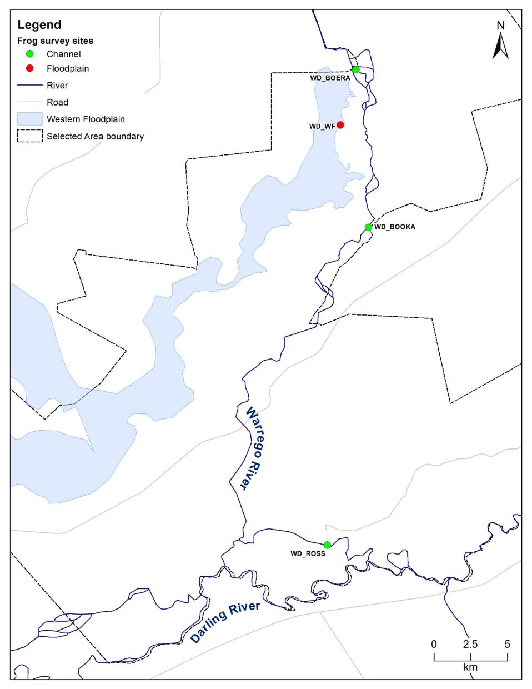

Figure ‑: Location of frog diversity and abundance monitoring sites.

Results

In total 10 frog species were recorded in the Warrego and Darling rivers Selected Area during the 2015 survey periods; including eight species in February and six species in May (Figure L‑3; Table L‑2). No frog species recorded are listed as threatened under the NSW TSC Act or the Commonwealth *Environment Protection and Biodiversity Conservation Act 1999*.

Overall frog abundance was similar across both survey periods with 37 individuals observed in February and 38 individuals observed in May, although the species composition differed between February and May. Calling activity was greatest in February with six species calling. No calling activity was recorded during the May survey.

Figure ‑: Total frog abundance and diversity recorded at each site within the Selected Area during the February 2015 and May 2015 surveys.

Booka Dam recorded the highest abundance during both surveys periods; 20 individuals in February and 13 individuals in May. Diversity remained constant at this site throughout both survey periods (4 species) however species composition varied (Figure L‑4). Abundance at all sites varied between seasons; Boera Dam and Ross Billabong declined between February and May, and abundance at both the Western Floodplain and Booka Dam increased between February and May.

Table ‑: Frog survey results for the 2014–15 water year.

|  |  |  |  |  |  |  |  |  |  |
| --- | --- | --- | --- | --- | --- | --- | --- | --- | --- |
| Scientific Name | Common Name | WD\_BOERA | | WD\_BOOKA | | WD\_ROSS | | WD\_WF | |
| Feb-15 | May-15 | Feb-15 | May-15 | Feb-15 | May-15 | Feb-15 | May-15 |
| *Limnodynastes fletcheri* | Barking Frog, Long-thumbed Frog, Marsh Frog | 1 |  | 2^ |  |  |  | ^ | 13 |
| *Crinia deserticola* | Desert Froglet | 2 |  | 1 | 15 | 6 |  | 1^ |  |
| *Litoria rubella* | Desert Tree Frog, Red Tree Frog | 4^ |  | 7 |  |  |  | 2^ | 1 |
| *Litoria caerulea* | Green Tree Frog |  |  | 1 |  | 4 |  | ^ |  |
| *Cyclorana novaehollandiae* | New Holland Frog, Wide-mouthed Frog |  |  | 2 |  |  |  |  |  |
| *Litoria peronii* | Peron's Tree Frog | 1 |  |  | 1 | 2 |  | ^ |  |
| *Cyclorana verrucosa* | Rough Frog |  |  |  |  | 1 |  |  |  |
| *Limnodynastes tasmaniensis* | Spotted Grass Frog, Spotted Marsh Frog |  | 1 |  | 3 |  |  |  | 3 |
| *Neobatrachus sudellae* | Sudell's Frog |  |  |  | 1 |  |  |  |  |
| *Uperoleia rugosa* | Wrinkled Toadlet |  |  |  |  |  |  | ^ |  |
| **Number of individuals observed (abundance)** | | 9 | 8 | 1 | 13 | 20 | 13 | 0 | 3 |
| **Species diversity (observed)** | | **4** | **1** | **5** | **4** | **4** | **0** | **2** | **3** |
| **Species diversity (heard)** | | **1** | **0** | **1** | **0** | **0** | **0** | **6** | **0** |
| **Total species diversity** | | **4** | **1** | **5** | **4** | **4** | **0** | **6** | **3** |

^ Denotes species recorded during call survey. Number of species recorded during call survey are not included in abundance counts, but are included in diversity counts.

Species diversity across all sites and seasons was highest at Western Floodplain during the February survey. Desert Frog (*Crinia deserticola*) and Desert Tree Frog (*Litoria rubella*) and Peron’s Tree Frog (*Litoria peronii*) were observed in larger numbers at the Western Floodplain during the February survey. The number of species recorded in the May survey declined with only three species recorded, the Barking Frog (*Limnodynastes fletcheri*) was the dominant species present.

No species were observed or heard at Ross Billabong during the May survey. Abundance was also low during the May survey period at Boera Dam with only one individual, the Spotted Grass Frog (*Limnodynastes tasmaniensis*), recorded.

A comparison of floodplain and combined channel sites indicate mean abundance was higher at the combined channel sites during both survey periods (mean = 5.5; range 0–24) (Figure L‑5). However, mean diversity was highest on the Western Floodplain during both survey periods (mean = 4..5; range 3–6).

Figure ‑: Frog diversity at each site recorded during the February 2015 and May 2015 surveys. Note: No species were recorded at WD\_ROSS during the May survey.

Figure ‑: Comparison of mean abundance and species diversity at Floodplain sites (WD\_WF) and combined channel sites (WD\_BOOKA, WD\_BOERA, WD\_ROSS).

To further elucidate patterns in frog community composition, multivariate analysis was undertaken on species abundance data. From the nMDS plot, there appeared to be separation of the data when grouped by survey time (Figure L‑6). Accordingly, PERMANOVA analysis suggested there was a significant difference between survey times (Pseudo-F = 3.14, pr<0.05). Differences between channel and floodplain sites were not significant. SIMPER analysis suggested that different species were associated with each grouping based on survey time. Species that contributed to the grouping in February included the desert frog (45.8%) and the desert tree frog (36.6%). The spotted grass frog was 100% responsible for the grouping in May, due to this species only being recorded during the May survey time (Table L‑2).

Figure ‑: nMDS plot with data grouped by survey time. Note: several sites surveyed in February overlap in multidimensional space, therefore cannot be distinguished from each other on this graph.

Discussion

Frog abundance in the Selected Area varied across the four sites and two surveys periods. Changes in abundance and diversity were not consistent across the study area, with abundance decreasing at Boera Dam and Ross Billabong and increasing at the Western Floodplain and Booka Dam. While these changes were not consistent across the sites, they were consistent with apparent habitat conditions. The water level at all sites receded between February and May. This left little aquatic and riparian vegetation cover and increased exposed bank habitats at Boera Dam and Ross Billabong (Figure L‑7). Conversely the habitat conditions experienced less change between the two seasons on the Western Floodplain and at Booka Dam, suggesting these locations may provide better long term frog habitat for in this system, and should be targeted by Commonwealth environmental water. Commonwealth environmental water management that resulted in inundation of Western Floodplain waterholes thus promoted frog diversity within the Selected Area.

Aquatic vegetation cover and structural complexity is important for many species of frogs and their tadpoles and are important divers of habitat occupancy patterns and recruitment success (Healey *et al.* 1997; Mac Nally *et al.* 2009; Tarr and Babbitt 2002; Wassens 2011). Aquatic vegetation also provides shelter for adult frogs and acts as a substrate for the growth of biofilms and organic matter, which are important food sources for tadpoles (Gillespie 2002; Kupferberg *et al.* 1994; Mokany 2007; Wassens 2011). This supports the decrease in abundance observed at Boera Dam and Ross Billabong, where available habitat declined between the survey times.

|  |  |
| --- | --- |
| N:\Projects\15ARM\1115 Warrego Darling LTIM Stage 2\Fieldwork\Field photos\Feb 2015\Boera just before WF_Feb_15_M_Southwell.JPG  **Boera Dam – Feb-15** | N:\Projects\15ARM\1115 Warrego Darling LTIM Stage 2\Indicators\Indicators (Y1)\Water quality\Photos\May2015\P1010036.JPG  **Boera Dam – May-15** |
| N:\Projects\15ARM\1115 Warrego Darling LTIM Stage 2\Indicators\Indicators (Y1)\Water quality\Photos\Feb2015\P1030919.JPG  **Ross Billabong – Feb-15** | N:\Projects\15ARM\1115 Warrego Darling LTIM Stage 2\Indicators\Indicators (Y1)\Water quality\Photos\May2015\P1010058.JPG  **Ross Billabong – May-15** |
| Figure ‑: Change in riparian habitat at Boera Dam (top) and Ross Billabong (bottom) between February (left) and May (right) survey periods. Note the reduction in aquatic vegetation and riparian groundcover where water line has receded at Boera Dam and the little change at Ross Billabong. | |

The changes in calling activity between February and May were consistent with the changes in seasonal conditions, with cooler temperatures and drier conditions in the May period (Figure L‑8). Male frogs are known to call to attract females when ideal breeding conditions exist (OEH 2014). According to Wassens (2011) most frogs present within the Selected Area respond to spring and February flooding to stimulate breeding, hence their calling activity in the cooler May survey time is consistent with reduced activity during this time of year.



Figure ‑: Daily minimum and maximum air temperature 1/1/2015–29/6/2015. Recorded at Boera Dam. Survey periods highlights by black lines.

Conclusion

Baseline frog abundance and diversity data was successfully collected for two survey periods, February and May 2015. The changes in frog communities between survey periods and across sites were largely consistent with apparent reductions in available habitat at survey sites as water levels receded through the year and generally colder climatic conditions during the May survey. Overall, channel sites tended to have higher frog abundances, while frog communities tended to be more diverse on the Western Floodplain, highlighting the importance of the inundation of the Western Floodplain as a result of Commonwealth environmental water management in 2014-15. The increased calling activity observed during the February survey is consistent with increased spring and summer activity observed in these species. The increased diversity of the frog community recorded on the Western Floodplain suggests that providing water to this zone is important for maintaining regional scale frog diversity.

The frog survey methods outlined in the Monitoring and Evaluation Plan (Commonwealth of Australia 2015) were carried out successfully. No changes to the survey method are required for the remainder of the event based monitoring plan commencing in the 2015–16 water year.

References

Commonwealth of Australia (2015). Commonwealth Water Office Long Term Intervention Monitoring Project Junction of the Warrego and Darling rivers Selected Area, Canberra.

Gillespie, G.R. (2002) ‘Impacts of sediment loads, tadpole density, and food type on the growth and development of tadpoles of the spotted tree frog *Litoria spenceri*: an in-stream experiment’, *Biological Conservation*, vol. 106, pp. 141–150.

Healey, M. Thompson, D. and Robertson, A. (1997) ‘Amphibian communities associated with billabong habitats on the Murrumbidgee floodplain, Australia’. *Australian Journal of Ecology*, vol. 22, pp. 270–278.

Kupferberg, S.J., Marks, J.C. and Power, M.E. (1994) ‘Effects of variation in natural algal and detrital diets on larval anuran (*Hyla regilla*) life-history traits’. *Copeia*, vol. 1994, pp. 446–457.

Mac Nally, R., Horrocks, G., Lada H., Lake, P.S., Thomson, J.R. and Taylor, A.C. (2009) ‘Distribution of anuran amphibians in massively altered landscapes in south-eastern Australia: effects of climate change in aridifying region. *Global Ecology and Biogeography*, vol. 18, pp. 575–585.

Mokany, A. (2007) ‘Impact of tadpoles and mosquito larvae on ephemeral pond structure and processes’. *Marine and Freshwater Research*, vol. 8, pp. 436–444.

Office of Environment and Heritage (OEH), (2014) ‘Frogs—Native animal fact sheet’. Available at: <http://www.environment.nsw.gov.au/animals/Frogs.htm>.

Tar, T.L. and Babbitt, K.J. (2002) ‘Effect of habitat complexity and predator identity on predation of *Rana clamitans* larvae’. *Amphibia Reptilia*, vol. 23, pp. 13–20.

Wassens, S. (2011) ‘Frogs’. In: Rogers, K. & Ralph, T. eds. *Floodplain wetland biota in the Murray-Darling Basin: Water and Habitat Requirements*, NSW Department of Environment, Climate Change and Water, CSRIO Publishing, Collingwood, Vitoria, pp. 253–274.