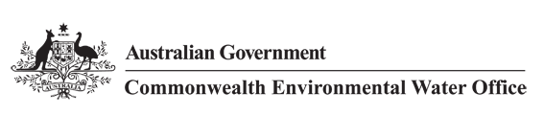



______________________

**A TETRA TECH COMPANY**

**Commonwealth Environmental Water Office**

**Long Term Intervention Monitoring Project**

**JUNCTION OF THE WARREGO AND DARLING RIVERS SELECTED AREA**

Five Year Evaluation Report



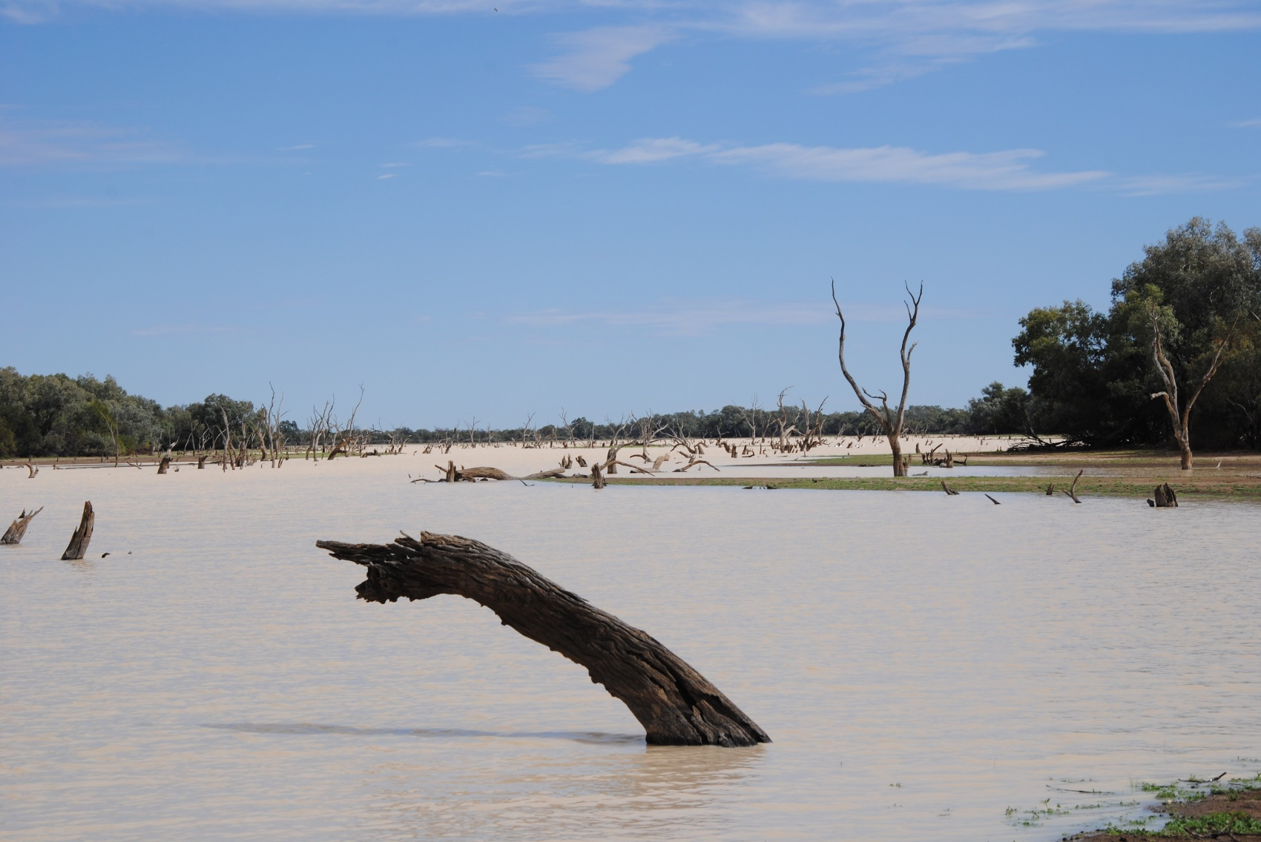

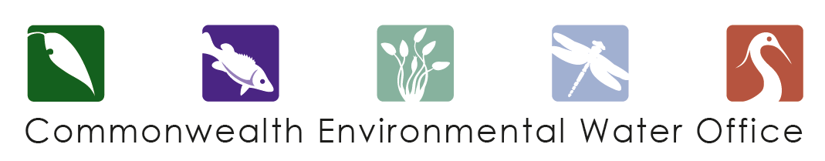

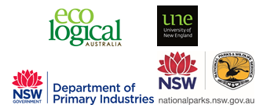

This monitoring project was commissioned and funded by Commonwealth Environmental Water Office, with in-kind support from NSW Office of Environment and Heritage.

**Copyright**

© Copyright Commonwealth of Australia, 2019



Commonwealth Environmental Water Office Long Term Intervention Monitoring Project – Junction of the Warrego and Darling rivers Selected Area, is licensed by the Commonwealth of Australia for use under a Creative Commons by Attribution 3.0 Australia licence, with the exception of the Coat of Arms of the Commonwealth of Australia, the logo of the agency responsible for publishing the report, content supplied by third parties, and any images depicting people. For licence conditions see: <http://creativecommons.org/licenses/by/3.0/au/>

This report should be attributed as ‘Commonwealth Environmental Water Office Long Term Intervention Monitoring Project Junction of the Warrego and Darling rivers Selected Area – Five Year Evaluation Report, Commonwealth of Australia 2019’.

**Disclaimer**

The views and opinions expressed in this publication are those of the authors and do not necessarily reflect those of the Australian Government or the Minister for the Environment.

While reasonable efforts have been made to ensure that the contents of this publication are factually correct, the Commonwealth does not accept responsibility for the accuracy or completeness of the contents, and shall not be liable for any loss or damage that may be occasioned directly or indirectly through the use of, or reliance on, the contents of this publication.

**DOCUMENT TRACKING**

|  |  |
| --- | --- |
| Item | Detail |
| Project Name | Long Term Intervention Monitoring Project – Junction of the Warrego and Darling rivers Selected Area |
| Project Number | 12248 |
| Project Manager | Dr Mark Southwell  (02) 8081 2688  92 Taylor Street, Armidale NSW 2350 |
| Prepared by | Dr Mark Southwell, Dr Peter Hancock, Ronnie Hill, Linden Burch, Matt Elsley, Rob Cawley, Eliza Biggs, Tom Kelly (ELA)  Dr Paul Frazier (2rog)  Assoc. Prof Darren Ryder, Dr Wing Ying Tsoi (UNE)  Dr Gavin Butler and Tom Davis (DPI Fisheries) |
| Reviewed by | Dr Mark Southwell, Assoc. Prof Darren Ryder |
| Approved by | Dr Paul Frazier |
| Status | Final |
| Version Number | 2 |
| Last saved on | 4 March 2020 |
| Cover photo | Boera Dam, October 2017 (photo by Tim Henderson) |

Acknowledgements

This document has been prepared by Eco Logical Australia Pty Ltd with support from Associate Professor Darren Ryder and Dr Wing Ying Tsoi from the University of New England, Dr Paul Frazier from 2rog consulting, Dr Gavin Butler and Tom Davis from DPI Fisheries and staff from Department of Planning, Industry and Environment - Water. The project team would like to thank the NPWS staff at Toorale National Park and State Conservation Area for their assistance and cooperation. We would also like to acknowledge Dr Fiona Dyer and the Lachlan LTIM team for the loan of dissolved oxygen and temperature loggers.

Acknowledgement of Country

The authors of this report as well as the Commonwealth Environmental Water Office respectfully acknowledge the traditional owners, their Elders past and present, their Nations of the Murray-Darling Basin, and their cultural, social, environmental, spiritual and economic connection to their lands and waters. In particular the Barkindji, Murrawarri, Ngemba and Ngiyampaa peoples, traditional owners of the land on which this publication is focused.

|  |
| --- |
| **Disclaimer** *This document may only be used for the purpose for which it was commissioned and in accordance with the contract between Eco Logical Australia Pty Ltd and the Department of the Environment and Energy. The scope of services was defined in consultation with the Department of the Environment and Energy, by time and budgetary constraints imposed by the client, and the availability of reports and other data on the subject area. Changes to available information, legislation and schedules are made on an ongoing basis and readers should obtain up to date information.*  *Eco Logical Australia Pty Ltd accepts no liability or responsibility whatsoever for or in respect of any use of or reliance upon this report and its supporting material by any third party. Information provided is not intended to be a substitute for site specific assessment or legal advice in relation to any matter. Unauthorised use of this report in any form is prohibited.* |

Template 29/9/2015

**Document control**

|  |  |  |  |
| --- | --- | --- | --- |
| Version | Date | Reviewed by | Approved by |
| 1 | 23/8/2019 | Assoc. Prof Darren Ryder | Dr Paul Frazier |
| 2 | 15/11/19 | Dr Mark Southwell | Dr Paul Frazier |

|  |  |
| --- | --- |
| Item | Details |
| ELA Project Number | 12248 |
| Project Director/s | Dr Paul Frazier, Assoc. Prof Darren Ryder |
| Project Manager | Dr Mark Southwell |
| Prepared by | Dr Paul Frazier, Assoc. Prof Darren Ryder, Dr Mark Southwell, Dr Wing Tsoi, Dr Peter Hancock, Linden Burch, Ronnie Hill, Matt Elsley, Rob Cawley, Eliza Biggs, Tom Kelly, Dr Gavin Butler and Tom Davis |

Contents

Executive Summary viii

1 Monitoring and Evaluation of Environmental Water in the Junction of the Warrego and Darling Rivers Selected Area 1

1.1 Introduction 1

1.2 Junction of the Warrego and Darling Rivers Selected Area 1

1.3 Water Management 4

2 Environmental Watering Actions over the LTIM Project 7

3 Key Outcomes from Environmental Water Use 9

3.1 Expected Outcomes 9

3.2 Darling River Flows and Ecosystem Function 15

3.3 Warrego River Flows and Inundation 17

3.4 Water Quality Responses to Flow 18

3.5 Ecological Responses to Flow 19

3.6 Summary 27

4 Implications for Future Management of Commonwealth Environmental Water 28

5 References 30

**Appendix A – Hydrology (Darling River)**

**Appendix B – Hydrology (Warrego River)**

**Appendix C – Hydrology (Northern tributaries)**

**Appendix D – Water Quality – Category I**

**Appendix E – Water Quality – Category III**

**Appendix F – Stream Metabolism**

**Appendix G – Microinvertebrates**

**Appendix H – Macroinvertebrates**

**Appendix I – Ecosystem Type**

**Appendix J – Vegetation Diversity**

**Appendix K – Fish (River)**

**Appendix L – Frogs**

**Appendix M – Waterbird Diversity**

**Appendix N – Fish Movement around Booka Dam**

List of figures

Figure 1‑1: The location of the Warrego-Darling Selected Area within the Murray-Darling Basin, showing upstream catchments. 2

Figure 1‑2: Junction of the Warrego and Darling river Selected Area monitoring zones. 3

Figure 2‑1: Monthly rainfall at Bourke Airport from July 2014 to June 2019 compared to the long-term mean (Source: BoM, 2019a). 7

Figure 2‑2: Mean maximum temperatures at Bourke Airport from July 2014 to June 2019 compared to the long-term mean (Source: BoM, 2019b). 8

Figure 3‑1: In-channel habitats including bench surfaces and snags in the Darling River zone of the Warrego-Darling Selected Area 15

Figure 3‑2: Mean daily flow at gauging stations in the Barwon-Darling River system over the LTIM Project. Events used in the analysis of northern tributary contributions are outlined by the brown arrows. 16

Figure 3‑3: Comparison of flow events containing environmental water (EW) from all years of the LTIM Project measured at Louth gauge. 17

Figure 3‑4: Water level at Boera and Dicks Dams and periods of longitudinal connection and overflow to Western Floodplain. 18

Figure 3‑5: Habitat types within the Western Floodplain. Open water with fringing Lignum Shrubland (top), and temporary floodplain lakes with aquatic beds (bottom). 21

Figure 3‑6: Black winged stilts taking advantage of inundation on the Western Floodplain to feed in August 2016. 23

Figure 3‑7: A knot of Peron’s tree frogs observed on the Western Floodplain in November 2016 24

Figure 3‑8: Juvenile Hyrtl’s catfish (top) and golden perch (bottom) sampled in the Warrego River zone during the LTIM Project 25

Figure 3‑9: Mean daily water level at Warrego River (Barringun No. 2 gauge) 1/9/2016 to 1/1/2019. Rectangles indicate approximate back-calculated birth dates of juvenile golden perch collected between December 2016 and May 2018. Stars indicate golden perch collection events. Shapes with the same colour indicate an association between a spawning event and collection of those fish. 26

List of tables

Table 1‑1: Junction of the Warrego and Darling rivers Selected Area monitoring zones. 4

Table 3‑1: Summary of long term expected outcomes from environmental watering in the northern unregulated river (Source: Commonwealth of Australia, 2017). 9

Table 3‑2: Expected outcomes from the use of Commonwealth environmental water during the LTIM Project relevant to the Warrego-Darling Selected Area. 11

Table 4‑1: Thresholds in water quality variables identified in the Darling River zone. 28

Abbreviations

|  |  |
| --- | --- |
| Abbreviation | Description |
| ANZECC | Australian and New Zealand Environment and Conservation Council |
| CEWO | Commonwealth Environmental Water Office |
| GL | gigalitre |
| GPP | Gross Primary Production |
| ha | hectare |
| km | kilometre |
| LTAAY | long term average annual yield |
| LTIM Project | Long Term Intervention Monitoring Project |
| MDBA | Murray-Darling Basin Authority |
| ML/d | Megalitres per day |
| mS/cm | millisiemens per centimetre |
| NP | National Park |
| NSW | New South Wales |
| SCA | State Conservation Area |
| Warrego-Darling Selected Area | The Junction of the Warrego and Darling rivers Selected Area |

*Blank page*

Executive Summary



**Contributions of Commonwealth Environmental Water**

***Darling River zone***

* Commonwealth environmental water contributed to thirteen flow events down the Darling River zone, which provided connecting flows through the Warrego-Darling Selected Area to Louth.
* The relative contribution of Commonwealth environmental water was greater during small fresh events, rather than in the larger flow experienced through the reach in 2016-17
* These flows provided access for river biota to instream habitats such as snags, benches and anabranch channels, and helped to maintain and improve water quality.

***Warrego River zone***

* Commonwealth environmental water contributed to flow events down the Warrego River and inundation of the Western Floodplain, especially in 2016-17 when flows down the Warrego River to the Warrego-Darling Selected Area were greatest.
* These flows maintained refuge pools and improved water quality in the Warrego River and stimulated breeding events for native fish, including golden perch. These pools may be important recruitment sites for populations of this species across the Northern Murray-Darling Basin.
* Inundation of the Western Floodplain drove booms of productivity, supporting diverse and abundant invertebrate, frog and waterbird populations throughout.

The Junction of the Warrego and Darling rivers Selected Area (Warrego-Darling Selected Area) encompasses the Toorale National Park and State Conservation Area managed by NSW Department of Planning, Industry and Environment. Inflows of Commonwealth environmental water to the Warrego-Darling Selected Area via the Darling River from upstream tributaries have also been evaluated.

The Warrego-Darling Selected Area is complex in terms of its ecosystems, hydrology and the way in which Commonwealth environmental water is accounted and managed both within the Warrego-Darling Selected Area and within upstream tributaries. Most of the Commonwealth environmental water that influences the site is held as unregulated entitlements in the Border Rivers, Moonie, Condamine-Balonne, Barwon-Darling and Castlereagh and Warrego Rivers. Regulated deliveries from the Border Rivers, Gwydir, Namoi and, to a lesser extent, Macquarie catchments have the potential to influence flows in the Warrego-Darling Selected Area, particularly during periods of low flow in the Barwon–Darling system. Other water management actions, such as the release of stock and domestic flows, rainfall rejection flows and embargos on upstream pumping also influence flows in the Darling River through this zone.

The hydrology of the Darling River in the Warrego-Darling Selected Area over the Long Term Intervention Monitoring Project (LTIM Project) was dominated by one larger flow event of approximate bankfull magnitude in July 2016 – December 2016. All other flows through this zone were small freshes of less than a one tenth bankfull stage in magnitude (peak discharges less than 3,000 ML/d at Louth). Of the thirteen flow events monitored, the contribution of Commonwealth environmental water ranged from 1.8% to 99.6%. These flows inundated in-channel habitat features such as snags, benches and anabranches that provide a range of benefits to the river system, such as structural and hydrologic refuges, habitat for aquatic animals, and promoted the transfer of organic material that drives the food webs of the river.

For the duration of the LTIM Project, flow down the Warrego system was episodic, peaking in both the Warrego River channel and on the Western Floodplain during 2016-17. This was followed by a period of minimal inflows during 2017-18 and 2018-19, with limited floodplain inundation and drying of many of the dams along the Warrego River. Moderate inflows late in 2018-19 once again inundated the Western Floodplain and refilled the waterholes of the lower Warrego River. Before these flows, the only water in the Warrego River and Western Floodplain zones of the Warrego-Darling Selected Area was one small waterhole remaining in Boera Dam. The hydrological variability experienced in the Warrego over the LTIM Project is typical of semi-arid rivers and supports the boom and bust ecology that has been consistently documented in the other indicators measured in the project.

**Key Responses to Flow**

*Water Quality*

* Increased flows through the Warrego-Darling Selected Area consistently improved water quality parameters such as electrical conductivity through dilution due to higher discharge. During connection with the Darling River, Warrego River water improved the quality of Darling River water downstream of the confluence.
* Concentrations of dissolved oxygen and chlorophyll *a* were variable over time, influenced by both flow and temperature. Dissolved oxygen tended to decline with increasing flow up to 25,000 ML/d within the Darling River zone (flow measured at either the weir 19A or Louth). Similarly, chlorophyll *a* concentration was highly variable during base and low flow (around 4,000 ML/d) conditions and then decreased with increasing discharge. This likely reflects the inundation of low lying in-channel features such as bars, and transport nutrients to stimulate primary production measured as chlorophyll *a*.
* In the Warrego system within the Selected Area, concentrations of carbon, nitrogen and phosphorus were consistently higher than Australian and New Zealand Environment and Conservation Council (ANZECC) and Queensland Department of Environment and Science guideline values in the Warrego system, with concentrations increasing with time since connection. Levels of primary production followed patterns of nutrient availability and temperature, with maximum productivity in summer low flow conditions.

*Ecology*

* The Darling River was the most hydrologically connected, and higher flows acted as a disturbance for invertebrate populations, impacting flow sensitive taxa and reducing population density. These higher flow events, however, improve water quality, nutrient cycling and provide access to in-channel habitats for other species.
* The Warrego River showed intermediate levels of hydrological connection, which elicited positive responses in invertebrate, frog and waterbird abundance and diversity. Warrego River waterholes acted as longer term refugia, supporting more consistent ecological communities both in abundance and diversity over time. For waterbirds, Boera Dam is an important refugia, and for frogs, Booka Dam supports the largest and most diverse populations.
* The Western Floodplain showed the most variability in flow, with inundation events separated by relatively long dry periods. Inundation of the floodplain stimulated a boom in productivity, supporting the highest abundance and diversity of invertebrates, frogs and waterbirds of any zone.
* The fish community within the Warrego River demonstrated high levels of resilience by surviving and maintaining populations during the highly variable flow conditions experienced over the LTIM Project. During ‘wetter’ times, multiple species bred, recruited and maintained their population structure. Fish communities were severely impacted by drying of the system in 2017, before recolonization and recruitment was again observed in May 2018.
* Following flooding, the cover and richness of vegetation communities on the Western Floodplain increased, driven mainly by annual herbaceous ground cover species. Longer term benefits of inundation were also observed in longer lived species such as lignum.

**Implications for the Commonwealth’s Environmental Water Management**

* The LTIM Project has identified a range of physical, chemical and ecological responses to flow that can assist environmental water management decisions. The identification of different responses within the different monitoring zones means that there are no ‘one size fits all’ recommendations across the Warrego-Darling Selected Area. That is, a similar type of flow in two monitoring zones may not elicit the same response. However, the overall increase in the provision of flows through the Warrego-Darling Selected Area elicited positive ecological responses.
* In the Darling River zone, several thresholds were identified that influence different aspects of the zone’s water quality. These were typically related to a reversal of parameter trends with increasing discharge at certain flow thresholds. In addition, a threshold was noted between salinity concentrations and turbidity, driven by flocculation of fine clay particles at salinities above 0.5 mS/cm. Small flows that reduce salinity and hence increase turbidity may minimise algal productivity and the potential for blooms in this zone.
* Within the Warrego River zones, the Commonwealth Environmental Water Office (CEWO) has more ability to actively manage water, but this is also dependent on the timing and volume of inflows to Boera Dam. Here we consider active management as the ability to route water to different zones (Warrego Channel or Western Floodplain) within the Selected Area. While fish recruitment occurred during most connection events down the lower Warrego, recruit numbers were larger with larger flow events. The timing of flow events is likely to also be important. The lack of flow events during 2018 resulted in near complete system drying, and a resetting of aquatic populations. During wetter times, inundation of channel and floodplain habitats during warmer periods may result in maximum diversity and density of invertebrates and frogs by providing an increased diversity of physical habitats and basal resources.
* While the condition of lignum on the Western Floodplain was maintained for a longer period than other groundcover species following inundation, it did decline as a result of an extended dry period (≈ 950 days) in 2017-19. Observations following recent inundation of the floodplain in March-April 2019 suggests that lignum again improved in condition. Thus, flooding at this interval appears to maintain lignum on the Western Floodplain.

# Monitoring and Evaluation of Environmental Water in the Junction of the Warrego and Darling Rivers Selected Area

## Introduction

This report presents the monitoring and evaluation results from the Junction of the Warrego and Darling rivers Selected Area (Warrego-Darling Selected Area) five year program to monitor the outcomes of environmental watering. The project was undertaken as part of the Long Term Intervention Monitoring Project (LTIM Project) funded by the Commonwealth Environmental Water Office (CEWO). The LTIM Project was implemented at seven Selected Areas over a five-year period from 2014-15 to 2018-19 to deliver five high-level outcomes:

1. Evaluate the contribution of Commonwealth environmental watering to the objectives of the Murray-Darling Basin Authority’s (MDBA) Environmental Watering Plan.
2. Evaluate the ecological outcomes of Commonwealth environmental watering at each of the seven Selected Areas.
3. Infer ecological outcomes of Commonwealth environmental watering in areas of the Murray-Darling Basin not monitored.
4. Support the adaptive management of Commonwealth environmental water.
5. Monitor the ecological response to Commonwealth environmental watering at each of the seven Selected Areas.

While results specific to the Warrego-Darling Selected Area are reported here, a broader Basin Scale analysis including results from all seven Selected Areas will be produced by the Centre for Freshwater Ecosystems at La Trobe University.

The report describes the Warrego-Darling Selected Area watering actions and the ecological outcomes of the application of Commonwealth environmental water in the Warrego-Darling Selected Area during the LTIM Project. Detailed analysis, methods and results are presented in the Appendices referred to in the main report.

## Junction of the Warrego and Darling Rivers Selected Area

The Warrego-Darling Selected Area is in north-western New South Wales (NSW), located around 80 km south-west of Bourke (Figure 1‑1). It is contained within the boundary of the Toorale National Park (NP) and State Conservation Area (SCA) (Figure 1‑2). The Warrego-Darling Selected Area is approximately 92,000 ha and receives flow from both the Darling and Warrego river systems. The Darling River catchment drains the north westerly portion of the Murray-Darling Basin and has a total catchment area of 699,500 km2. Most of its tributaries (Macquarie, Castlereagh, Namoi, Gwydir, Macintyre and Condamine-Balonne Rivers) drain from the Great Dividing Range in northern NSW and southern Queensland and provide relatively high amounts of runoff to the catchment.

In contrast, other catchments such as the Warrego and the Paroo Rivers to the west, drain more arid, flat catchments and only flow intermittently during periods of high rainfall in their upper catchments, usually manifesting downstream as slow-moving floods of relatively long duration. The Warrego-Darling Selected Area shows high climatic variability, with low annual rainfall and high evaporation.

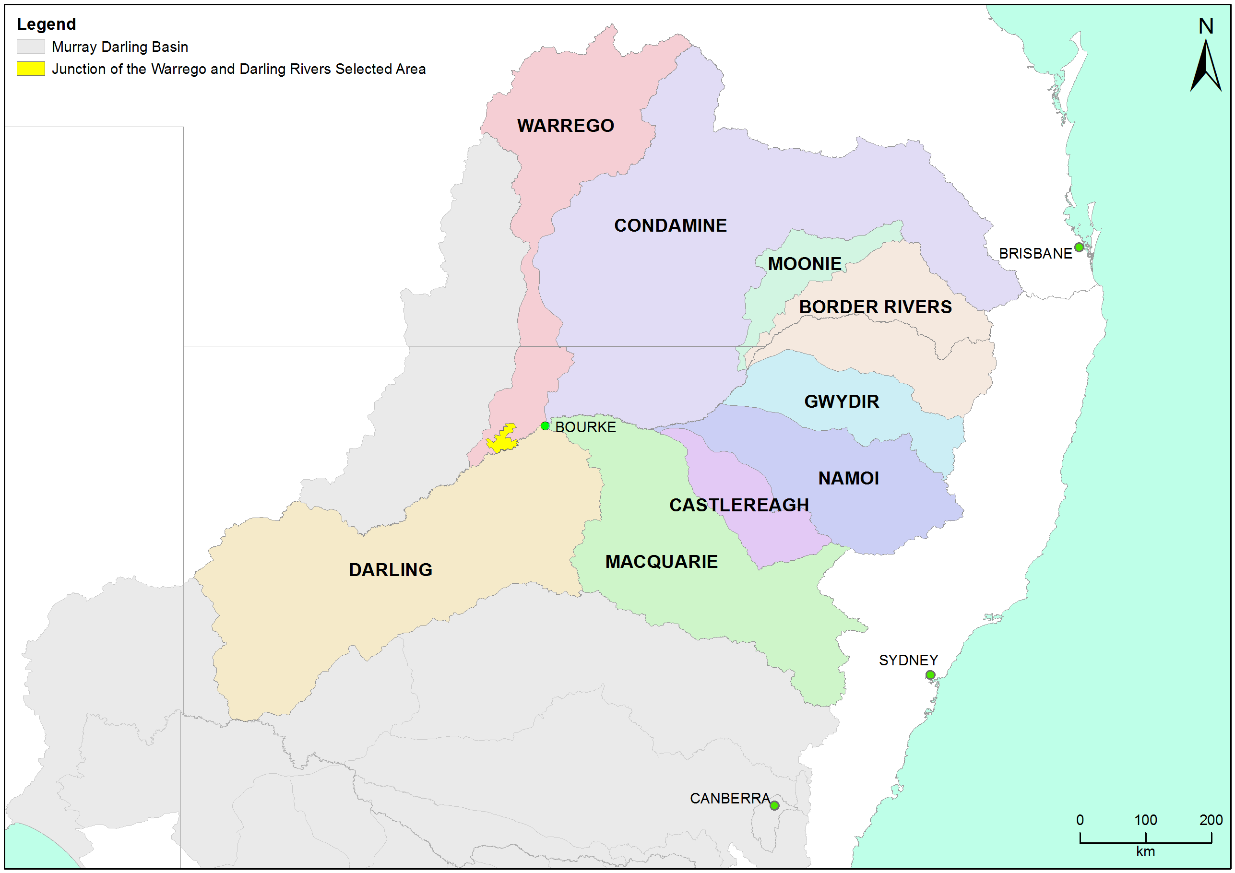

Figure 1‑1: The location of the Warrego-Darling Selected Area within the Murray-Darling Basin, showing upstream catchments.

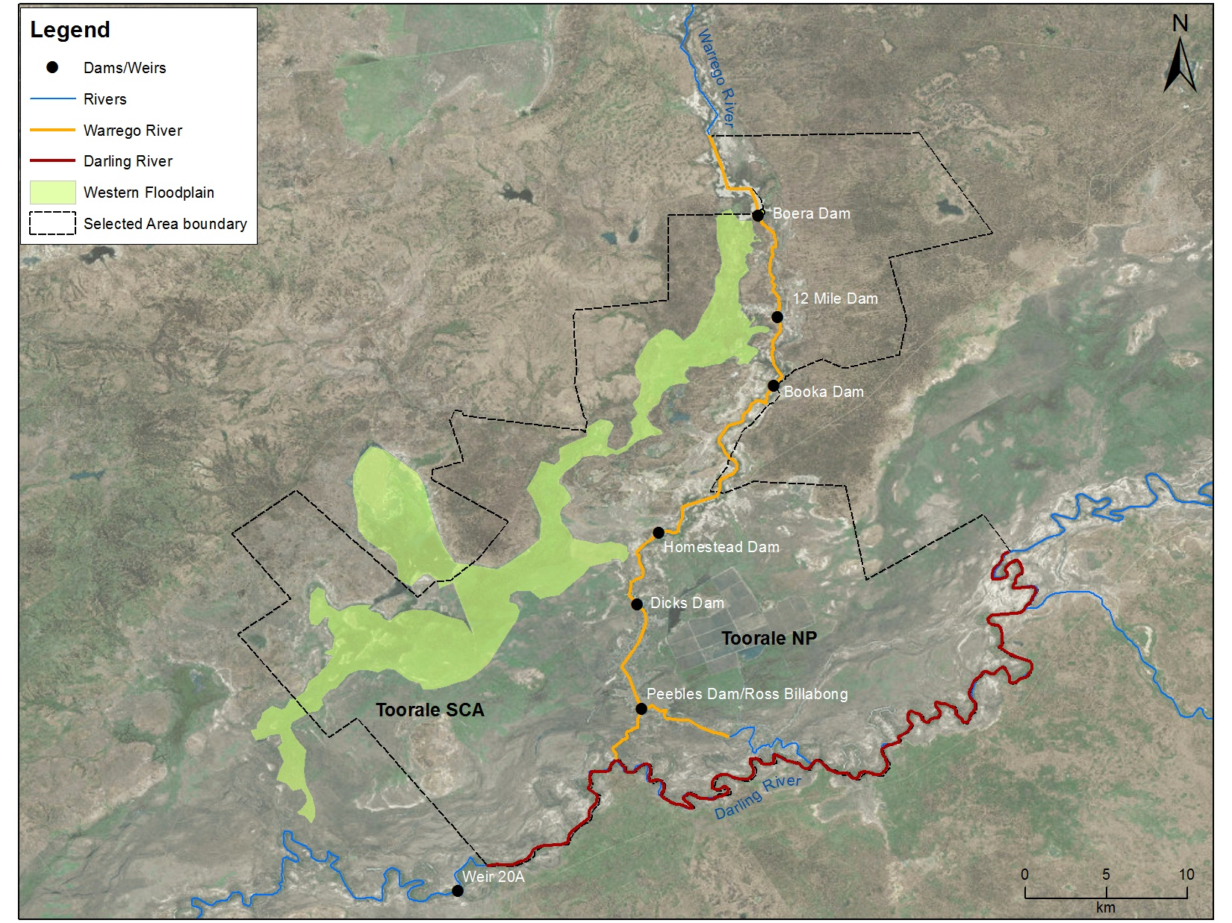

Figure 1‑2: Junction of the Warrego and Darling river Selected Area monitoring zones.

Within the Warrego-Darling Selected Area, three monitoring zones were defined (Table 1‑1; Figure 1‑2). These zones represent discrete regions of the Warrego-Darling Selected Area in terms of their geomorphology, hydrology, environmental assets, environmental watering targets and expected outcomes from Commonwealth environmental water delivery.

Table 1‑1: Junction of the Warrego and Darling rivers Selected Area monitoring zones.

|  |  |  |  |
| --- | --- | --- | --- |
| Zone | Extent | Description | Potential target flow types for monitoring |
| Western Floodplain | The Western Floodplain of the lower Warrego River from Boera Dam offtake to the Darling River. | A large floodplain surface heavily dissected by small flood-runners. Floodwaters inundate this floodplain from overflows at Boera Dam. | Overbank – infrastructure assisted. |
| Warrego River | The lower Warrego River channel extending from the northern boundary of Toorale National Park to the junction with the Darling River, including Ross Billabong. | A single meandering channel that decreases in bankfull capacity downstream. Flows in this lower section of the Warrego River are controlled by a series of six in-channel structures, the lower of which (Peebles Dam) diverts water into Ross Billabong. | Base flows  Freshes up to 6001 ML/d. |
| Darling River | The Darling River from the eastern boundary of the Toorale National Park near Hells Gate, to Weir 20A downstream of the western boundary of Toorale State Conservation Area. | A single meandering channel that has a bankfull height ranging 12-15 m. The bankfull channel is complex and there are a series of natural rock bars and a weir at the downstream end of the reach that influence flows along this section of the river. | Base flows  Freshes:  300 – 500 ML/d  1,000-5,000 ML/d  5,000-10,000 ML/d  10,000-30,000 ML/d |
| 1 This capacity is likely to increase to >1,000 ML/d with the completion of the Toorale Infrastructure Project. | | | |

## Water Management

Over the last 150 years, the hydrology of the Warrego River within the Warrego-Darling Selected Area has been highly modified. Six dams have been constructed to provide stock and domestic water supply, irrigate the Western Floodplain to improve pasture growth, and more recently to provide water storage for irrigated agriculture (Figure 1‑2). Since the establishment of Toorale NP and SCA in 2008, dam maintenance has been largely discontinued in line with preferred park management. As a result, the condition of some dams has degraded, and several have become fully breached (Aurecon 2009). The characteristics and status of these dams are outlined below (Gawne *et al*. 2013):

1. Boera Dam: a large storage of approximately 3,000 ML, likely to have been established since the 1870s. Water persists for around 12 months after filling without further inflows from local runoff. Management of this dam can preferentially divert water down the Western Floodplain.
2. 12 Mile Dam: less than 1,000 ML in volume, this dam has been recently breached and not reinstated.
3. Booka Dam: approximately 1,000 ML.
4. Keernie (Homestead) Dam: 1,500 – 2,000 ML (Breached).
5. Dicks Dam: 500 – 1,000 ML.
6. Peebles Dam: a large storage just upstream of the confluence of the Warrego and Darling rivers. This was the most permanent of the storages and was previously used for irrigation. The storage can hold approximately 10,000 ML and is connected to Ross Billabong, an adjacent floodplain depression. At present the outlet gates are permanently opened to allow flows through to the Darling River downstream.

While planning is underway to upgrade and/or remove these structures (Alluvium 2016), at the time of writing, no on-ground actions had occurred.

These dams have been retrospectively licenced under the provision of the NSW *Water Act 1912*. This includes separate licenced amounts for the Warrego River at 8.1 gigalitres (GL) long term average annual yield (LTAAY), the Western Floodplain (accounted at Boera Dam) at 9.7 GL (LTAAY) and the Darling River at 7.6 GL (LTAAY). These licences are owned and managed by the CEWO in consultation with the NSW National Parks and Wildlife Service and the Kurnu-Barkindji Joint Management Advisory Committee.

Conditions placed on these licences determine how Commonwealth environmental water can be managed within the Warrego-DarlingSelected Area. This is especially true for the licences specified at Boera Dam. Before these licences can be accessed, downstream demand to the Darling River must be met during times of low flow. That is, if sustained inflows are entering Boera Dam, and the Darling River flow at Louth is below 330 ML/d, then water must be let through the regulator pipes on Boera Dam and all downstream dams on the Warrego to flow to the Darling River until flows at Louth have reached 330 ML/d. Once this has been achieved, the CEWO in consultation with the NSW National Parks and Wildlife Service and the Kurnu-Barkindji Joint Management Advisory Committee can choose whether to continue to release water down the lower Warrego channel, therefore activating their Warrego River licence, or close the regulator gates, and hold water in Boera Dam to divert water to the Western Floodplain.

If flows in the Darling exceed 979 ML/d at Louth, the CEWO can access a high flow floodplain licence to divert water to the Western Floodplain. The CEWO have developed a Water Use Strategy for Toorale to aid decision making surrounding the operation of Commonwealth environmental water at this site (Appendix C in <http://www.environment.gov.au/system/files/resources/a3126565-16b2-4d81-96fa-13438d93425d/files/portfolio-mgt-plan-northern-intersecting-streams-2019-20.pdf>). This will be revised through the Toorale Water Infrastructure project.

Unlike other Selected Areas, Commonwealth environmental water that flows into the Warrego-Darling Selected Area is primarily unregulated, and is thus reliant on rainfall, flows and water management decisions in upstream tributaries. The Border Rivers, Gwydir, Namoi and, to a lesser extent, Macquarie tributaries, are exceptions to this, whereby regulated environmental water has the potential to influence flows in the Warrego-Darling Selected Area, particularly during periods of low flow in the Barwon-Darling system. Other water management actions, such as the release of stock and domestic flows, rainfall rejection flows and embargos on upstream pumping also influence flows in the Warrego-Darling Selected Area. These are undertaken in accordance with the relevant long-term watering plans in both Queensland and NSW.

Adding to the complexity of environmental water accounting and delivery in the Warrego-Darling Selected Area is the fact that the Warrego-Darling Selected Area, and its upstream tributaries, fall into multiple water planning areas, each with their own discreet rules, licence types and accounting procedures. Thus, tracking Commonwealth environmental water between and through these areas is challenging and is being addressed through work under the NSW Water Reform Action Plan (<https://www.industry.nsw.gov.au/water-reform>).

Use of Commonwealth Toorale entitlements and other environmental water entitlements upstream is expected to contribute to the following on-park outcomes at Toorale and/or in the Darling River downstream:

* support periods of high primary productivity triggered by unregulated flow events and carbon and nutrient cycling;
* support wetland and aquatic vegetation condition and diversity;
* support waterbird survival and condition and diversity;
* inundate and connect in-channel habitat associated with riffles, pools, bars and anabranches to support movement and biotic dispersal;
* maintain water quality and carbon/nutrient cycling processes; and,
* provide hydrological connectivity and improve end-of-system flows.

# Environmental Watering Actions over the LTIM Project

Historically, rainfall in the Warrego-Darling Selected Area is summer-dominated, however, rainfall has been variable over the LTIM Project period (Figure 2‑1). During the 2014-15 water year, rainfall was above average in August, December, and February-April. During 2015-16 rainfall was above average in November and June, with the June 2016 being the highest recorded monthly rainfall of the project (110 mm; Figure 2‑1). The 2016-17 water year was a relatively wet year with above average rainfall in August, September, October, January, May and June. This was the only year of the project that had an annual rainfall greater than average (389 mm compared to historical average of 355 mm). Monthly rainfall in 2017-18 exceeded the historical average in October – December and March. The 2018-19 water year was the driest year of the project (annual total 205 mm), but falls were above average in August, October and November (Figure 2‑1).

Mean maximum monthly temperatures have predominately been highest during summer over the LTIM Project, with temperatures often higher than the long-term average across all water years. The highest average temperature was recorded in January 2019 (42.6 °C) and lowest during July 2015 (16.7 °C, Figure 2‑2).

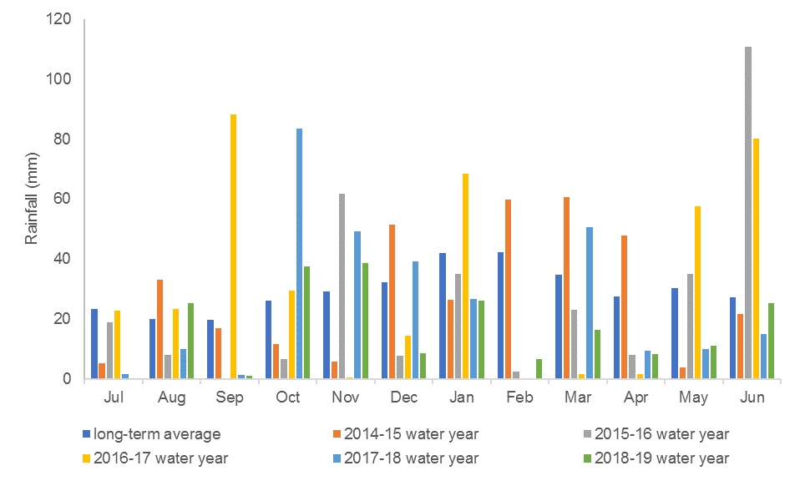

Figure 2‑1: Monthly rainfall at Bourke Airport from July 2014 to June 2019 compared to the long-term mean (Source: BoM, 2019a).

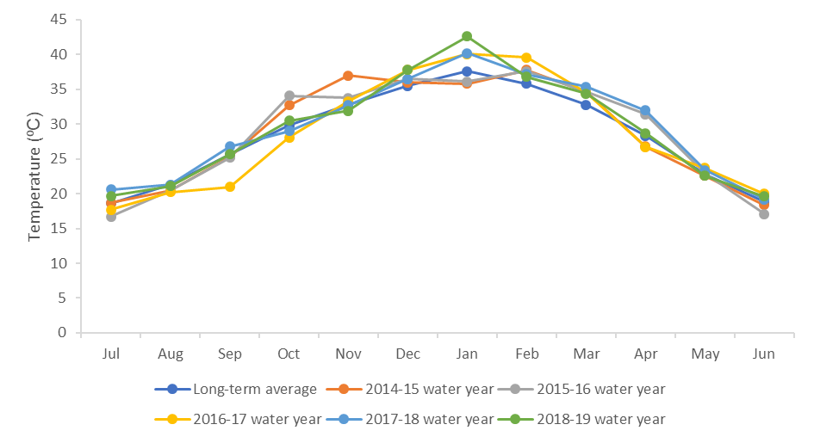

Figure 2‑2: Mean maximum temperatures at Bourke Airport from July 2014 to June 2019 compared to the long-term mean (Source: BoM, 2019b).

During the LTIM Project, thirteen flow events occurred down the Darling River zone that included both unregulated and regulated environmental water. It is estimated that during each event environmental water made up between 1.8% and 99.6% of the total flow volume (Appendix C). This included one regulated flow event, the Northern Connectivity Event, occurring in autumn-winter 2018 that aimed to improve hydrological connection and access to habitat down the length of the Barwon-Darling River. Within the Darling River zone, the Northern Connectivity Event caused a noticeable flow pulse peaking at 800 ML/d at Louth, to progress through the Darling River and led to improved access to in-channel habitats. Other regulated deliveries of environmental water that influenced flows in the Darling River zone were targeted at outcomes within the upstream tributaries, with additional benefits being achieved once the water flowed into the Barwon-Darling River.

In the Warrego River, unregulated entitlements held by the Commonwealth in the Queensland section of the catchment have increased the volume of flows into the Warrego-Darling Selected Area. Upstream contributions of environmental water have been in the order of 3.3% – 17.6% for flow events into Boera Dam at the top of the Warrego-Darling Selected Area. In line with the watering strategy for Toorale, contributions of environmental water have been made to both the Western Floodplain and lower Warrego River over the LTIM Project period. At other times, inundation of the Western Floodplain and connection down the lower Warrego River has occurred as a result of the operation of Boera and Booka Dams following Toorale water licence requirements.

During the largest period of inflows into Boera Dam experienced in September – November 2016, the Boera and Booka Dam regulating gates were initially opened to meet Toorale flow licence conditions. Once these conditions were satisfied, the gates were closed to allow water to flow onto the Western Floodplain and maintain wetland vegetation and waterbird habitat on the floodplain. Mean daily flow in the Darling at Louth during this period ranged between 4,000 – 33,000ML/d. During this event, 16,015 ML of water flowed onto the Western Floodplain, comprising 61% environmental water accounted against the CEWO’s Warrego Western Floodplain licence.

As the peak of the Warrego flow reached Boera Dam, the gates were again opened for a total of 25 days to allow a flow pulse through the lower Warrego River, increasing end of system connectivity and stimulating fish reproduction and movement. The total volume of this flow was 10,500 ML including 74% Commonwealth environmental water. Water was again registered against the Toorale Warrego River Licence during a flow event in April-June 2019. Due to extremely low flows in the Darling River at the time, the regulating gates at Boera and Booka Dams were left open for the duration of the flow event (40 days). Including upstream contributions of unregulated licences, a total of 10,324 ML of environmental water was calculated to have flowed through to the Darling River during this flow, contributing to downstream flows in the Darling to below Wilcannia.

# Key Outcomes from Environmental water Use

## Expected Outcomes

The Warrego-Darling Selected Area falls within the Northern Unregulated Rivers region where the majority of Commonwealth environmental water holdings provide access to unregulated flows. The CEWO have defined several long term expected outcomes from the use of Commonwealth environmental water in the Northern Unregulated Rivers, that link to the outcomes of the Basin-wide Environmental Watering Strategy developed by the Murray-Darling Basin Authority (Commonwealth of Australia 2017, Table 3‑1)

Table 3‑1: Summary of long term expected outcomes from environmental watering in the northern unregulated river (Source: Commonwealth of Australia, 2017).

| BASIN-WIDE OUTCOMES  (Outcomes in red link to the Basin-wide Environmental Watering Strategy) | EXPECTED OUTCOMES FOR NORTHERN UNREGULATED RIVERS ASSETS | | |
| --- | --- | --- | --- |
| IN-CHANNEL ASSETS | OFF-CHANNEL ASSETS | |
| Wetlands, lagoons and billabongs | Anabranches and effluent creeks |
| VEGETATION | Maintain riparian and in-channel vegetation condition, growth and survival. | Maintain and improve wetland vegetation condition, growth and survival in targeted sites. Maintain floodplain vegetation (with use of unregulated holdings and flows). | |
| WATERBIRDS |  | Maintain foraging, roosting and breeding habitats at targeted sites on the floodplain to support waterbirds. | |
| FISH | Provide flows that improve habitat conditions and support different life stages (migration, spawning, recruitment, refuge). | Support natural flow variability and connectivity between the river channel, wetlands anabranches and floodplains. | |
| INVERTEBRATES | Provide habitat (e.g. pools and riffles) and conditions (low flows, freshes, scouring flows) to maintain /improve micro and macroinvertebrate condition and diversity. | | |
| OTHER VERTEBRATES | Provide habitat and conditions to support survival and recruitment of native aquatic fauna (e.g. platypus, native water rat, frogs, turtles). | | |
| CONNECTIVITY | Support longitudinal connectivity in the major unregulated streams. | Support lateral and longitudinal (anabranches) connectivity between the river, wetlands, and floodplains. | |
| PROCESSES | Support primary production, nutrient and carbon cycling and biotic dispersal and movement. | | |
| WATER QUALITY | Maintain water quality within channels and pools. | Support more natural water temperature, flow regimes and connectivity to support nutrient cycling and water quality benefits. | |
| RESILIENCE | Provide refuge habitat for fish and other aquatic fauna. | | |

The evaluation of Commonwealth environmental water, and its management in the Warrego-Darling Selected Area during LTIM Project, is structured around these broader objectives and priorities, with the specific outcomes associated with each Commonwealth environmental watering event provided in Table 3‑2.

Table 3‑2: Expected outcomes from the use of Commonwealth environmental water during the LTIM Project relevant to the Warrego-Darling Selected Area.

| Water Year | Flow Type | Expected outcomes for water year | Contributions to longer term objectives | Contribution to the following BP objective | Were these outcomes achieved? |
| --- | --- | --- | --- | --- | --- |
| 2014-15 | Fresh in Warrego River zone | *Primary*  End of system connectivity  Fish reproduction  Biotic dispersal and movement  *Secondary*  Nutrient and sediment cycling | Connectivity  Fish diversity  Process | Biodiversity  Ecosystem function | **Yes,** Commonwealth environmental water contributed to connectivity through the Warrego Channel and into the Darling River channel in January-February 2015 for 24 days. This refilled refugial pools along the Warrego, that hadn’t been connected since the previous summer. |
| Base Flows and Freshes in Darling River zone | *Primary*  Connectivity  Flow variability  Habitat refuges  *Secondary*  Nutrient and sediment cycling  Water quality (Salinity, algal blooms) | Chemical  Connectivity  Process | Water quality  Ecosystem function | **Yes**, Commonwealth environmental water contributed to connectivity that occurred for 60% of the time through the Darling River zone. Good water quality was maintained during the 2014-15 year. Inundation of around 26% of all mapped benches, anabranch channels and snags providing access to habitat and transfer of nutrients and organic material. |
| 2015-16  2015-16 | Fresh in Warrego River zone | *Primary*  End of system connectivity  Fish reproduction  Biotic dispersal and movement  *Secondary*  Nutrient and sediment cycling | Connectivity  Fish diversity  Process | Biodiversity  Ecosystem function | **Yes,** Commonwealth environmental water contributed to connectivity through the Warrego Channel and into the Darling River channel in January 2016. This constituted the first flow down the Warrego River in 12 months. |
| Base Flows and Freshes in Darling River zone | *Primary*  Connectivity  Flow variability  Habitat refuges  *Secondary*  Nutrient and sediment cycling  Water quality (Salinity, algal blooms) | Chemical  Connectivity  Process | Water quality  Ecosystem function | **Yes**, Commonwealth environmental water contributed to connectivity that occurred for 61% of the time through the Darling River zone. Good water quality was maintained during the 2015-16 year. Inundation of around 30% of all mapped benches, anabranch channels and snags providing access to habitat and transfer of nutrients and organic material. |
| 2016-17 | Fresh in Warrego River zone | *Primary*  End of system connectivity  Fish reproduction  Biotic dispersal and movement  *Secondary*  Nutrient and sediment cycling | Connectivity  Fish diversity  Process | Biodiversity  Ecosystem function  Biodiversity | **Yes**, Commonwealth environmental water contributed to connectivity through the Warrego channel for 25 days (20 days from CEW). There was evidence of breeding and recruitment in many fish species, enhancing their population structure. This flow also improved Darling River water quality through dilution below the confluence. |
| Overbank on Western Floodplain zone | Maintain wetland vegetation and waterbird habitat on the Warrego Western Floodplain | Vegetation diversity  Waterbird diversity and population condition | Biodiversity  Resilience | **Yes**, Commonwealth environmental water contributed to the inundation of 3,839 ha of the floodplain including key floodplain vegetation communities. Positive response from vegetation with cover increasing to highest levels since the project started. Long duration of connection (>6 months) stimulated boom in productivity, which provided food for higher order predators such as waterbirds. |
| Base Flows and Freshes in Darling River zone | *Primary*  Connectivity  Flow variability  Habitat refuges  *Secondary*  Nutrient and sediment cycling  Water quality (Salinity, algal blooms) | Chemical  Connectivity  Process | Water quality  Ecosystem function | **Yes**, Commonwealth environmental water contributed to connectivity that occurred for 100% of the time through the Darling River zone. Good water quality was maintained during the 2016-17 year. Inundation of all mapped benches, anabranch channels and snags for >23 days providing access to habitat and transfer of nutrients and organic material. |
| 2017-18 | Fresh in Warrego River zone | *Primary*  End of system connectivity  Fish reproduction  Biotic dispersal and movement  *Secondary*  Nutrient and sediment cycling | Connectivity  Fish diversity  Process | Biodiversity  Ecosystem function  Biodiversity | **Yes**, Commonwealth environmental water contributed to a flow event in the Warrego River in March-April 2018. The management of Commonwealth water once this entered Boera Dam also provided connectivity through the lower Warrego channel for 16 days. There was evidence of breeding and recruitment in many native fish species, enhancing their population structure. This flow also re-inundated previously dry waterholes and habitat within the lower Warrego river channel. |
| Base Flows and Freshes in Darling River zone | *Primary*  Connectivity  Flow variability  Habitat refuges  *Secondary*  Nutrient and sediment cycling  Water quality (Salinity, algal blooms) | Chemical  Connectivity  Process | Water quality  Ecosystem function | **Yes**, Commonwealth environmental water contributed to connectivity that occurred for 73% of the time through the Darling River zone. Flows including environmental water improved conductivity within the Warrego-Darling Selected Area. These flows also inundated around 30% of snags in the reach providing habitat and substrate for biofilm growth. |
| 2018-19 | Fresh in Warrego River zone | *Primary*  End of system connectivity  Fish reproduction  Biotic dispersal and movement  *Secondary*  Nutrient and sediment cycling | Connectivity  Fish diversity  Process | Biodiversity  Ecosystem function  Biodiversity | **Yes**, Commonwealth environmental water contributed to a flow event in the Warrego River in April-June 2019. The management of Commonwealth water once this water entered Boera Dam also provided connectivity through the lower Warrego channel for 40 days. Once the water hit the Darling River, it promoted flows downstream to below Wilcannia. There was evidence of breeding and recruitment in native fish, frog and invertebrate species within the Warrego River zone. This flow also re-inundated previously dry waterholes and habitat within the lower Warrego river channel. |

## Darling River Flows and Ecosystem Function

The hydrology of the Darling River zone in the Warrego-Darling Selected Area over the LTIM Project was dominated by one large flow pulse of approximate bankfull magnitude in July 2016 – December 2016 (Figure 3‑2). All other flows through this zone were small fresh events of less than a one tenth bankfull stage in magnitude (peak discharges less than 3,000 ML/d at Louth; Appendix A). Out of the thirteen flow events monitored, the contribution of environmental water ranged from 1.8% to 99.6% (Appendix C; Figure 3‑3). These flows inundated in-channel habitat features such as snags (Figure 3‑1), benches and anabranches that provide a range of benefits to the river system, such as structural and hydrologic refuges, habitat for aquatic animals, and promoted the transfer of organic material that drives the food webs of the river.

Environmental water played a larger role in providing connectivity through the Warrego-Darling Selected Area during low flow periods, especially during flow events that were augmented by environmental water released out of the regulated catchments. Several of these events broke prolonged cease to flow periods during the 2017-18 and 2018-19 water years. Several small flow pulses in March – June 2018 reinstated flow through the Darling River zone of the Warrego-Darling Selected Area which had not been flowing for approximately 73 days. The first of these events originated out of the Condamine-Balonne and Moonie catchments and contained 24% environmental water. The second was the Northern Connectivity Event, a regulated release of held environmental water from the Border Rivers and Gwydir catchments. Although not large in magnitude these flows improved the water quality in the Darling River (Commonwealth of Australia 2018) and provided movement opportunities for fish (NSW DPI 2019). These flows were followed by a prolonged period (over 270 days) of no flow, during which time the Weir 20A weir pool within the Warrego-Darling Selected Area dried back to a series of disconnected pools. While connectivity was provided by localised rainfall above the Warrego-Darling Selected Area in 2019, inflows from the Warrego River, including Commonwealth environmental water, significantly increased the magnitude of flows below the Warrego confluence.

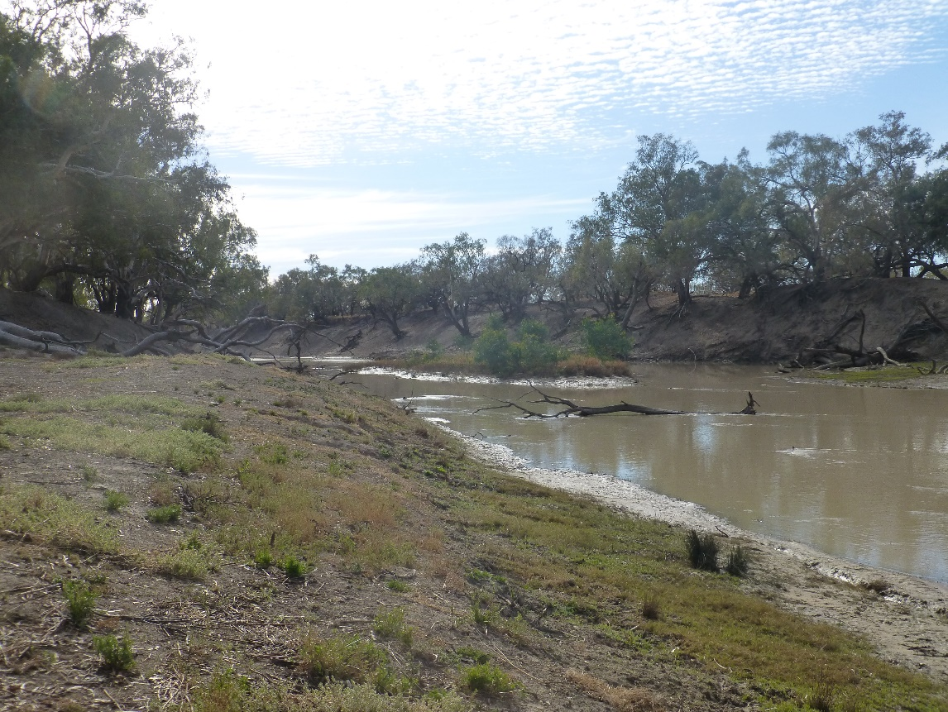

Figure 3‑1: In-channel habitats including bench surfaces and snags in the Darling River zone of the Warrego-Darling Selected Area

14-15 Event 1

15-16 Event 2

15-16 Event 3

16-17 Event 1

16-17 Event 2

16-17 Event 3

16-17 Event 4

17-18 Event 1

17-18 Event 2

17-18 Event 3

18-19 Event 1

15-16 Event 1

14-15 Event 3

14-15 Event 2

Figure 3‑2: Mean daily flow at gauging stations in the Barwon-Darling River system over the LTIM Project. Events used in the analysis of northern tributary contributions are outlined by the brown arrows.

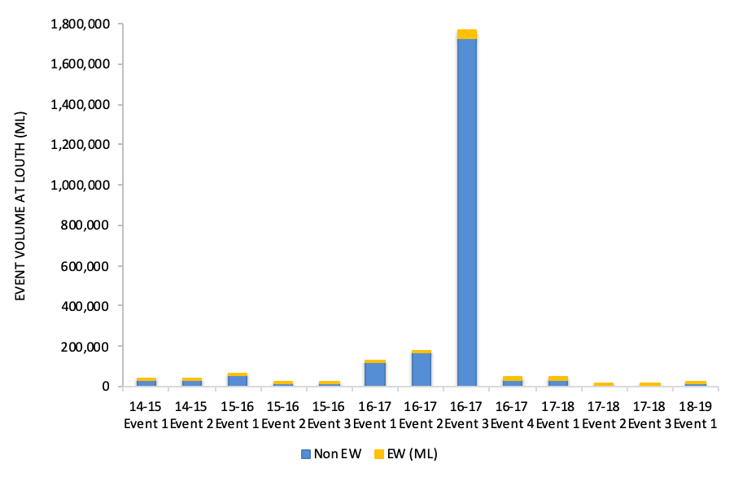

30%

2%

6%

36%

5%

4%

26%

24%

42%

43%

100%

2%

3%

Figure 3‑3: Comparison of flow events containing environmental water (EW) from all years of the LTIM Project measured at Louth gauge.

## Warrego River Flows and Inundation

Over the duration of the LTIM Project, flow down the Warrego system was episodic, peaking in both the Warrego River channel and on the Western Floodplain during 2016-17 (Appendix B; Figure 3‑4). This was followed by a period of minimal inflows during 2017-18 and 2018-19, with limited floodplain inundation and drying of many of the dams along the Warrego River. Moderate inflows late in 2018-19 once again inundated the floodplain and refilled the waterholes of the lower Warrego River. Before these flows, the only water in the Warrego River and Western Floodplain zones was one small waterhole in Boera Dam. The hydrological variability experienced in the Warrego over the LTIM Project is typical of semi-arid rivers and supports the boom and bust ecology that has been documented in the other indicators measured in the project.

Commonwealth environmental water and its management has undoubtedly contributed to hydrological connectivity in the Warrego system within the Warrego-Darling Selected Area. Entitlements held upstream of the Warrego-Darling Selected Area on the Warrego River have contributed to the magnitude of flows entering Boera Dam (Appendix C). Similarly, operation of the Boera and Booka Dam regulating gates in line with the Toorale water licences has increased flow to the lower Warrego River and Western Floodplain throughout the 2014-19 period. Decisions to shut the regulating gates at Boera in July 2016 resulted in inundation of around 35% or 3,839 ha of the Western Floodplain, inundating all of the 13 vegetation communities on the floodplain, most of which had not been inundated since the large floods of 2012. The 2016 inundation event included around 61% environmental water accounted on the Western Floodplain water licence. Downstream flows to the Warrego and Darling Rivers were prioritised during the LTIM Project. During the most recent flow event in April-June 2019, the regulating gates at Boera and Booka Dams were left open for the duration of the inflow event (40 days), with around 77% of the inflows flowing downstream of Dicks Dam, contributing enough flow to the Darling River to restart the river and push flows below Wilcannia. During this time 8,106 ML of environmental water was accounted against the Toorale Warrego River Licence, which comprised 40% of the total flow.

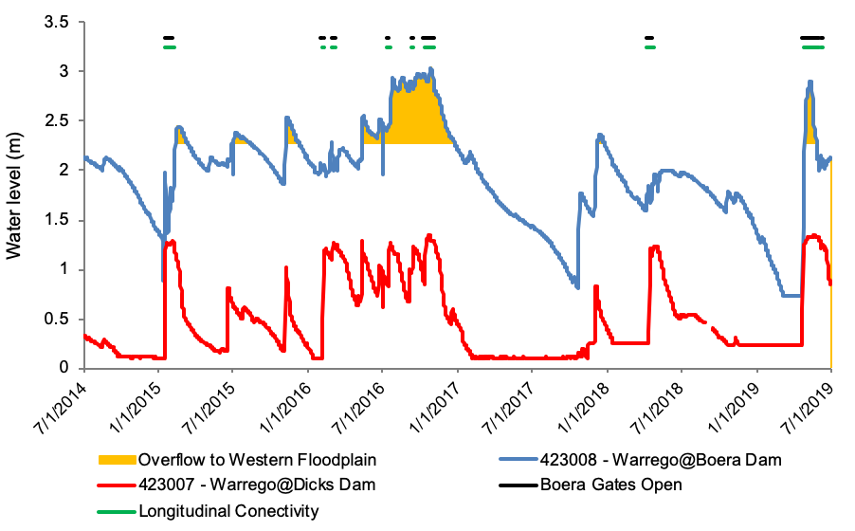

Figure 3‑4: Water level at Boera and Dicks Dams and periods of longitudinal connection and overflow to Western Floodplain.

## Water Quality Responses to Flow

Five years of water quality monitoring over the LTIM Project in the Darling River showed the delivery of environmental water contributed to consistent improvements in water quality (Appendix D; Appendix E). The most consistent pattern was a significant reduction in mean daily pH, conductivity and turbidity when compared with periods without environmental water. This reflects the dilution effects provided by these flows, and the changes in water chemistry associated with the increase in discharge and wetted area of channels. In particular, a potential discharge threshold around 10,000 ML/d was observed in pH and turbidity, suggesting that this may be a key high-flow threshold for the inundation or connection of geomorphic features that subsequently increase ions and suspended sediments inputs in the Darling River. Levels of pH and turbidity increased at discharges around 10,000 ML/d suggesting longitudinal transport and input of materials from upstream catchments. After discharge exceeded these key flow thresholds, concentrations and levels of water quality parameters declined with discharge. This was likely due to the dilution of existing materials as the resuspension of material decreased at higher river stages.

Dissolved oxygen concentrations were highly variable during base flow and low flow conditions (discharge 0-250 ML/d) and reduced with increasing discharge up to 25,000 ML/d within the Darling River zone. A similar pattern was also observed in chlorophyll *a* concentration, with highly variable concentrations during base flow and low flow (around 4,000 ML/d) which then decreased with increasing discharge. It is likely that seasonal changes in temperature in conjunction with low flows exert a strong influence on dissolved oxygen and chlorophyll *a* concentrations. A potential discharge threshold around 4,000 ML/d may inundate low lying in-channel features such as bars and transport nutrients to stimulate primary production measured as chlorophyll *a*.

Differences in upstream water sources containing various amounts and proportions of organic matter and nutrients may have affected the balance between productivity and respiration in different CEW events. Moreover, phytoplankton productivity may be limited by light through interactions among turbidity, depth and turbulence (Hall Jr. *et al.* 2015). Temperature showed little change with flow and was controlled by broader seasonal patterns. There was evidence from *ad hoc* sampling of thermal stratification in the deeper pools of the Darling River zone, but the stratification was not sufficient to produce any harmful ecological impacts.

Stream metabolism rates were highly variable within the Darling River (Appendix D; Appendix F). Gross Primary Production (GPP) rates increased with increasing in-stream total nitrogen and chlorophyll *a* concentrations, suggesting primary productivity rates were predominantly driven by nutrient availability and temperature. Increased discharge and turbidity are likely to limit GPP rates. It is proposed that metabolism indicators respond to change in discharge to a specific threshold rather than following a linear trend. The relationship between discharge and turbidity, and complex interaction between conductivity, turbidity and chlorophyll *a* concentrations observed in the Warrego-Darling Selected Area need further investigation to better predict changes in metabolism in response to flow.

Connection events in the Warrego River led to increased pH to a level that was maintained for up to 50 days following connection. The dilution effect in pH was less evident in the Western Floodplain zone due to differences in antecedent flow condition and the magnitude and duration of inundation in each event. Patterns in pH over time suggest a heightened risk of low pH (acidic) conditions for the floodplain with extended dry periods between inundation events accumulating more organic matter, thus more leachate from rewetted organic matter in the next inundation event. Electrical conductivity levels tended to increase with increasing time since connection in the Warrego and Western Floodplain, reflecting evapoconcentration processes. Concentrations of carbon, nitrogen and phosphorus were consistently higher than Australian and New Zealand Environment and Conservation Council (ANZECC) and Queensland Department of Environment and Science guideline values in the Warrego system, with concentrations increasing with time since connection.

## Ecological Responses to Flow

Monitoring undertaken for the LTIM Project over the past 5 years within the Warrego-Darling Selected Area has improved our knowledge of the ecological responses to flow over a range of environmental conditions. In addition, the hydrology of the three monitoring zones has been more thoroughly characterised.

The interplay between upstream inflows to the Warrego-Darling Selected Area and the water management actions undertaken within the Warrego-Darling Selected Area produces contrasting hydrological conditions within the Darling River, Warrego River and Western Floodplain monitoring zones.

The Darling River zone experiences more permanent inundation, supported by inflows from a large upstream catchment and multiple tributaries, and the impoundment of water through most of the Warrego-Darling Selected Area behind Weir 20A downstream. While being low in volume, inflows to the Darling reach have been relatively consistent over the LTIM Project with connection achieved 62% of the time (Appendix A; Figure 2‑2).

The Warrego River zone is the next most hydrologically connected zone, with flows occurring on 13 separate occasions throughout the project (Appendix B) ranging in duration from one to 40 days. These flows support the persistence of the dams along this reach which provide important ecological refuges. In this zone, Boera and Booka Dams are the most permanent, with water remaining in Boera Dam for the duration of the project, and Booka Dam only drying twice, in November–December 2018 and March-April 2019. Homestead Dam, Dicks Dam and Ross Billabong are less permanent, being dry for various periods of time over the project (Appendix B).

The Western Floodplain is the least hydrologically connected zone in the Warrego-Darling Selected Area, with only 6 periods of connection throughout the project. Periods of floodplain connection ranged from 18 to 230 days. Unlike the other zones, connection to the Western Floodplain provides access to relatively large areas of additional habitat when inundated, with a maximum of 3,839 ha of floodplain inundated after the largest connection period in May – December 2016 (Figure 3‑4). The Western Floodplain has more diverse habitats when inundated than in the other monitoring zones (Figure 3‑5; Appendix I).

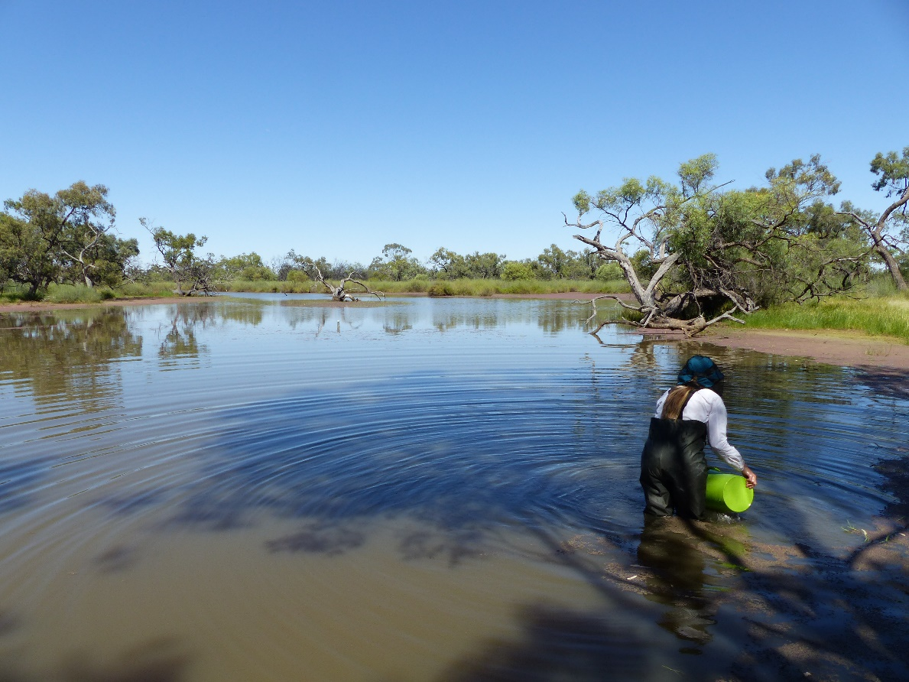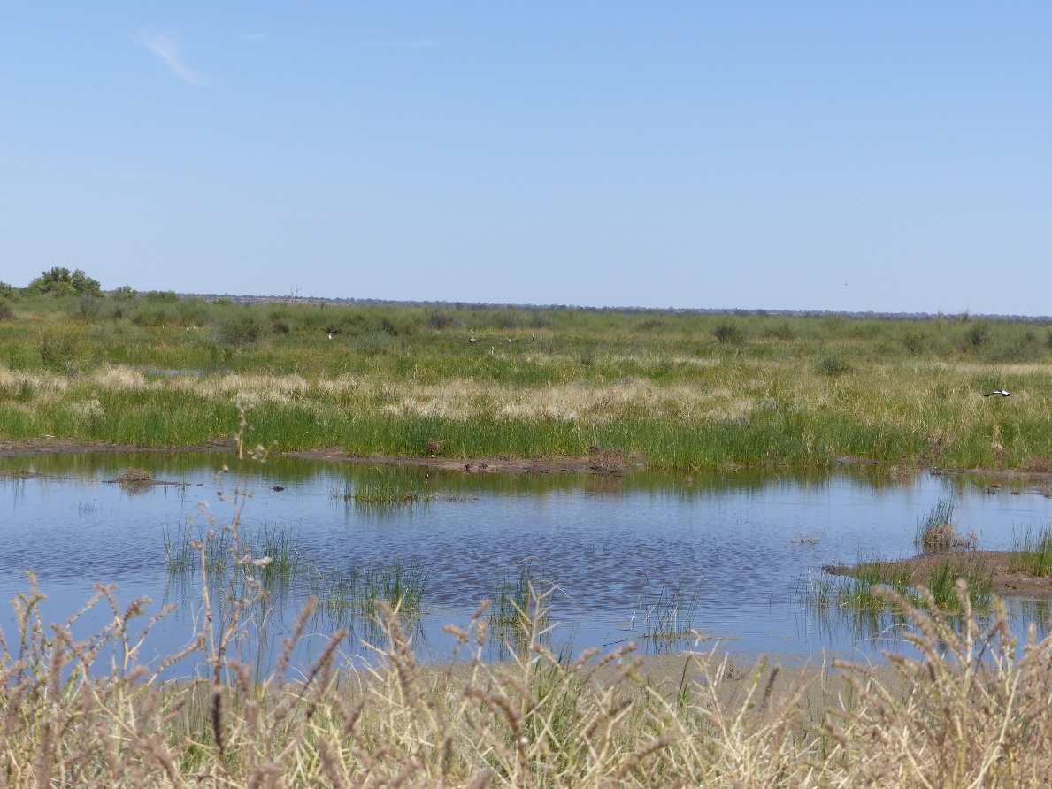

Figure 3‑5: Habitat types within the Western Floodplain. Open water with fringing Lignum Shrubland (top), and temporary floodplain lakes with aquatic beds (bottom).

Microinvertebrates and macroinvertebrates were the only ecological indicators monitored in all three monitoring zones. Similar trends were observed for both indicators: with invertebrate communities in the Western Floodplain displaying higher density, richness and diversity when inundated; Warrego Channel sites being intermediate; and the Darling River communities showing the lowest density, richness and diversity (Appendix G and Appendix H).

For communities on the Western Floodplain and Warrego River, flow elicited a positive response by stimulating primary production, improving water quality, and increasing access to habitat. When inundated, the Western Floodplain provided ideal slow-flow invertebrate habitat and, coupled with the increased nutrients and basal resources with wetting, drove booms in invertebrate productivity. Peaks of diversity and richness were observed 30-50 days after connection in the Warrego Channel and 100 days on the floodplain, with populations then declining as water levels receded and water quality deteriorated. As time since connection increased, species with a higher tolerance to poor water quality dominated. The seasonal timing of flow events also appears to influence the magnitude of the invertebrate response through the regulation of metabolic rates by temperature. During the largest inundation event on the Western Floodplain in winter 2016, the boom in microinvertebrate biomass did not occur immediately after inundation in the Western Floodplain, instead the boom was delayed until warmer temperatures and increased rates of primary production were evident.

In contrast, flow events in the Darling River zone acted as a stressor, reducing invertebrate richness and diversity. In some cases, over a month was required to allow microinvertebrate populations to return to pre-flow diversity (Appendix G). As a result, the composition of invertebrate communities in the Darling River showed strong correlations with hydrology, with communities sampled at flows <500 ML/d being significantly different to communities surveyed at higher flow magnitudes. Macroinvertebrate taxa with highly mobile traits and body shape more adapted to flow had higher abundances at higher discharges.

Waterbirds and frogs were monitored within Warrego River waterholes and on the Western Floodplain and patterns in their populations are consistent with those described above for invertebrates. For waterbirds, maximum richness and density were observed during surveys undertaken at sites that had been connected for between 17 and 68 days (Appendix M). The apparent preference for intermediate levels of connection by waterbirds likely reflects the time taken for lower levels of the food web (invertebrates, plants) to build up in abundance to levels that will feed the waterbird community. Once food is abundant, waterbirds then move in and feed (Figure 3‑6). Spatially, Warrego River sites, being more permanent water sources, appear to have more consistent waterbird communities. This is especially so for Boera Dam, which consistently showed the greatest waterbird richness and diversity over time of any site. On the Western Floodplain, waterbird populations respond more immediately and dramatically to inundation and subsequent drying. Higher standard deviations associated with average species richness and functional guild scores on the Western Floodplain suggest that waterbird use of the floodplain fluctuates over time. This likely reflects changing habitats and levels of productivity between inundation events. The high species richness on the recently inundated Western Floodplain suggest that waterbirds are taking advantage of the highly productive and diverse habitats on the floodplain soon after it becomes inundated. This contrasts with lower standard deviations recorded at the Warrego River sites, suggesting more consistent waterbird populations both in abundance and diversity over time.

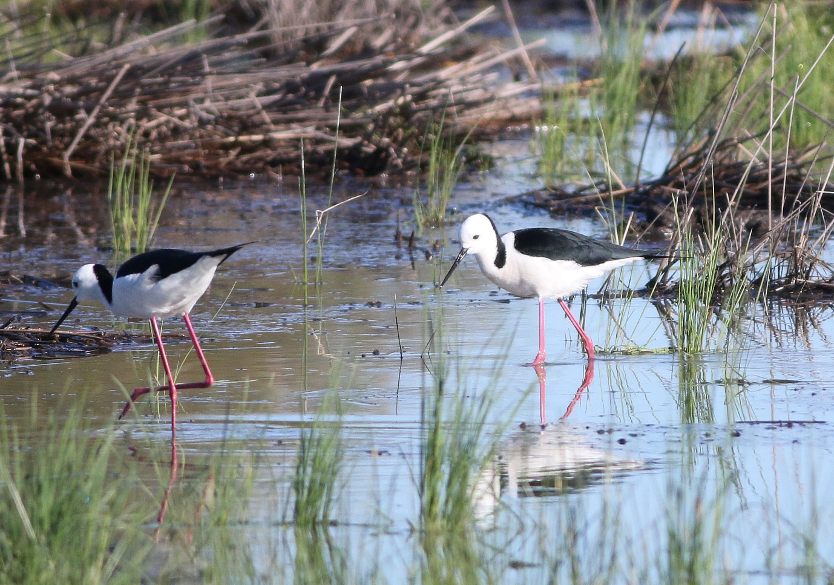

Figure 3‑6: Black winged stilts taking advantage of inundation on the Western Floodplain to feed in August 2016.

Frog communities also showed a positive response to flow and inundation, with species richness and abundance being significantly higher during times of recent connection and inundation on the Western Floodplain (Appendix L). Frog calling, indicative of frog activity was also highest on the Western Floodplain during these periods, with frogs taking advantage of the increased availability of optimal habitat and breeding conditions. Similarly, Booka Dam consistently had the highest frog richness, abundance and diversity of all the survey sites, which is likely a response of the increased fringing habitat such as lignum, and its long persistence in the landscape. Fluctuations in frog abundance and diversity was more evident on the Western Floodplain with frog populations responding more immediately to inundation and subsequent drying (Figure 3‑7). This highlights the dynamic nature of systems such as those found in the Warrego-Darling Selected Area, which produce large booms of productivity when their floodplains become inundated. In contrast, Warrego River sites, being more permanent water bodies, hosted a more stable and less diverse frog community. As with invertebrates, the response of frogs to flows was mediated by temperature, with limited frog activity recorded during winter surveys. Managing Commonwealth environmental water to inundate the Western Floodplain and maintain habitats in the Warrego River channel will assist to maintain a diverse and healthy frog population in the Warrego-Darling Selected Area. A healthy frog population will in turn support higher level predators such as fish, birds and reptiles.

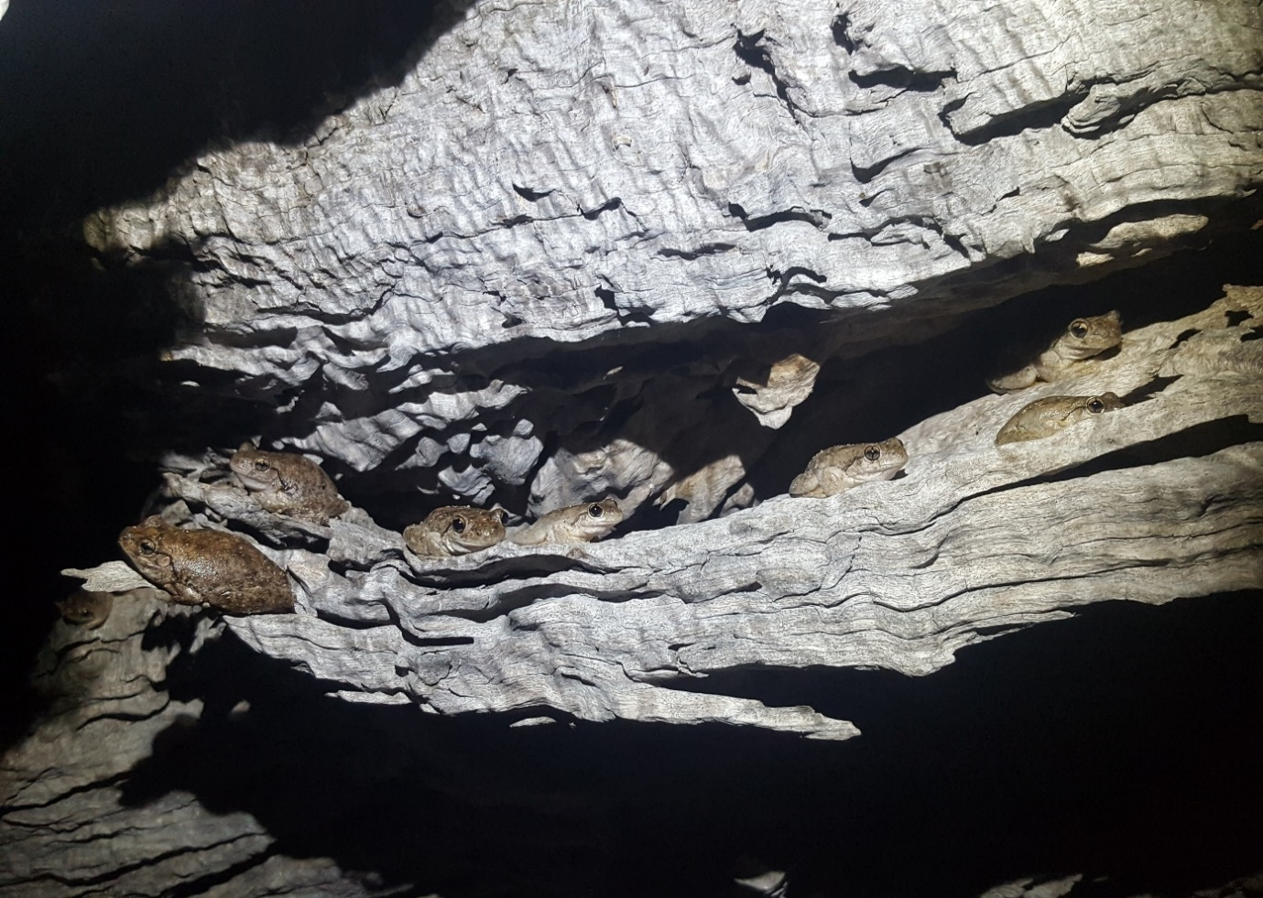

Figure 3‑7: A knot of Peron’s tree frogs observed on the Western Floodplain in November 2016

Fish were monitored in Warrego River waterholes within the Selected Area over four years of the LTIM Project.  Fish species sampled within the Warrego River demonstrated high levels of resilience by surviving and maintaining populations during the highly variable flow conditions experienced within the lower Warrego system over the LTIM Project (Appendix K). Sampling undertaken in 2015 and 2016 showed how the system operates in a “boom” cycle with multiple species including golden perch (*Macquaria ambigua*), spangled perch (*Leiopotherapon unicolor*), bony herring (*Nematolosa erebi*) and Hyrtl’s catfish (*Neosilurus hyrtlii*), breeding, recruiting and growing during a relatively wet period (Figure 3‑8). In contrast, sampling undertaken in 2017 and 2018 demonstrated the opposite extreme with the system switching to a “bust” cycle of drying and localized extirpations. Following the “bust” leading up to the November 2017 sample, in the May 2018 sample, as water again entered the system, recolonization and recruitment were apparent. Age-and-growth analysis for golden perch showed clear links between flow pulses in the system and golden perch recruitment. While higher abundances of recruits were noted for larger flow events, breeding was also recorded during relatively small flow pulses in December 2016 and April 2019 (Figure 3‑9), highlighting the opportunistic nature of fish breeding in the Warrego system. These findings are important in a regional context as it is likely that golden perch recruits from the Warrego catchment are contributing to the wider Darling Basin and perhaps Murray-Darling Basin golden perch population, highlighting the need to understand the processes that are driving spawning and recruitment within the Warrego system.

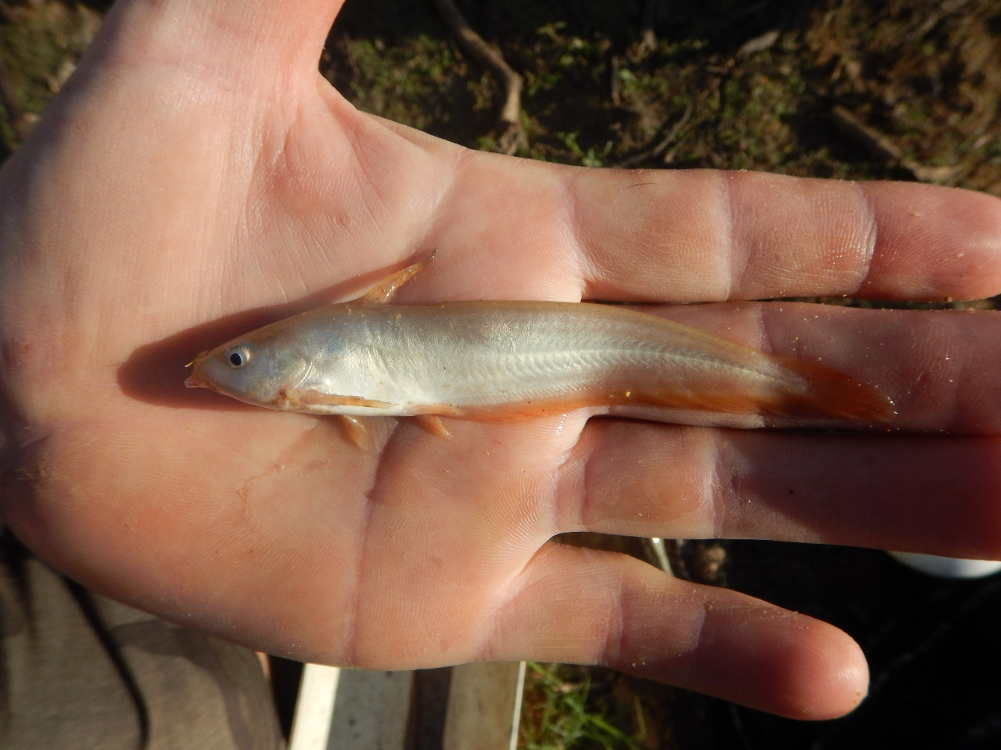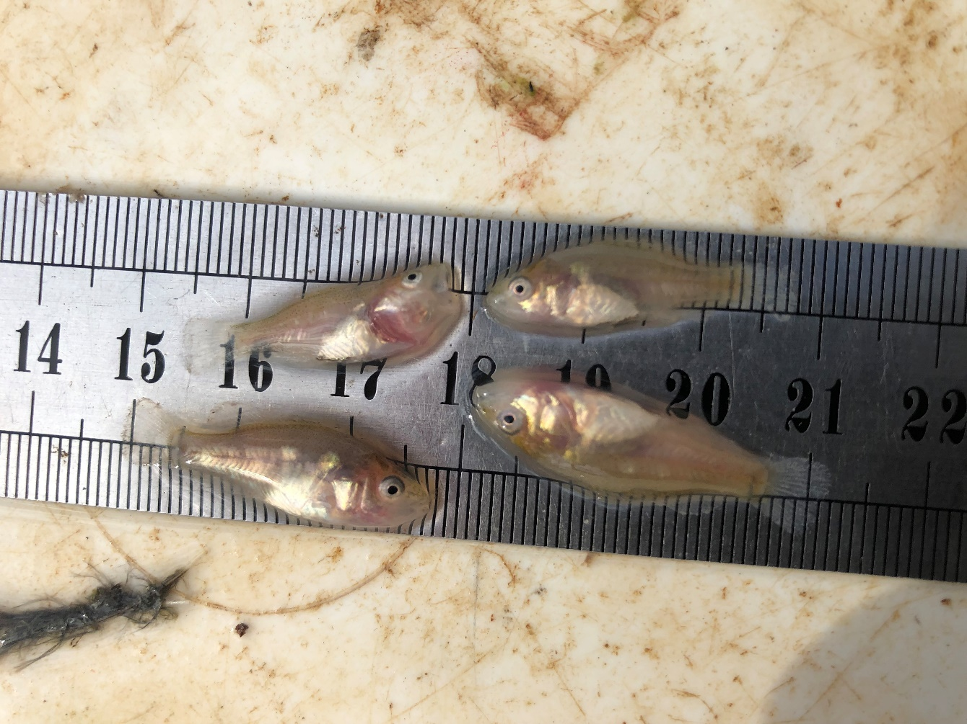

Figure 3‑8: Juvenile Hyrtl’s catfish (top) and golden perch (bottom) sampled in the Warrego River zone during the LTIM Project

Figure 3 9: Mean daily water level at Warrego River (Barringun No. 2 gauge) 1/9/2016 to 1/1/2019. Rectangles indicate approximate back-calculated birth dates of juvenile golden perch collected between December 2016 and May 2018. Stars indicate golden perch collection events. Shapes with the same colour indicate an association between a spawning event and collection of those fish.

Figure 3‑9: Mean daily water level at Warrego River (Barringun No. 2 gauge) 1/9/2016 to 1/1/2019. Rectangles indicate approximate back-calculated birth dates of juvenile golden perch collected within the Selected Area between December 2016 and May 2018. Stars indicate golden perch collection events. Shapes with the same colour indicate an association between a spawning event and collection of those fish.

The Western Floodplain supports a diverse assemblage of vegetation communities, many of which rely on flooding to maintain their condition (Appendix J). Over the duration of the project, vegetation diversity on the Western Floodplain was seen to respond significantly to inundation, with the highest mean species richness and cover being recorded at sites that were recently inundated. Seasonal patterns in vegetation diversity were less evident, with responses more a reflection of the wetting and drying of the floodplain provided by connection with the Warrego River. The lowest recorded levels of both vegetation species richness and cover coincided with the dry period experienced during the final two years of the project. Commonwealth environmental water contributed 61% of the water in the largest inundation event recorded during the LTIM Project (spring 2016). It was in this year that mean vegetation cover was highest, and amphibious vegetation species such as Blown Grass (*Lachnagrostis filiformis*) and Spike-Rush began to emerge as dominant species within the landscape. The condition of lignum, a more permanent floodplain species, also improved during this time. However, the prolonged dry period during the final two years of the project reduced lignum condition, with the plant appearing lifeless by autumn 2019. According to Casanova (2015), lignum can remain essentially dormant, surviving via a persistent rootstock for up to 10 years.  Observations from the floodplain following the most recent inundation event in April-May 2019, suggests lignum has again improved in condition. This highlights the ability of this species to recover following an extensive dry period on the Western Floodplain (≈ 950 days).

Recruitment of floodplain tree species was sporadic during the project with limited evidence of succession from seedling to sapling at most locations. Grazing and competition for resources are likely drivers of this poor recruitment level.

## Summary

Environmental water has influenced flows in all monitoring zones of the Warrego-Darling Selected Area for the duration of the LTIM Project. In the Darling River zone, both unregulated and regulated contributions of environmental water have maintained flows for the majority of the time, maintaining and improving water quality, providing access to in-channel habitats, and stimulating nutrient transfers downstream. For invertebrate communities, these flow events acted as a disturbance, reducing density and diversity and favouring more flow-tolerant taxa.

The Warrego River zone displayed intermediate levels of hydrological connectivity and subsequent ecological responses. In this zone, environmental water contributed to the longest periods of connection, aimed at providing opportunities for fish recruitment and movement and passing flows downstream into the Darling River during low flow periods. These flows maintained and improved the condition of refugial waterholes by improving water quality and stimulating food webs that support relatively stable populations of frogs and waterbirds. Breeding responses were also noted for several fish and frog species who recruited during these connection events.

Environmental water and its management within the Warrego-Darling Selected Area also influenced water flows onto the Western Floodplain and helped inundate a range of vegetation communities and ecosystem types. Inundation of the floodplain elicited a defined boom in productivity with high abundance, richness and diversity of invertebrate, frog and waterbird communities noted. This was linked to increased access to quality habitat and basal resources on the floodplain, that in turn drove higher consumers in the food web.

# Implications for Future Management of Commonwealth Environmental water

The LTIM Project has identified a range of physical, chemical and ecological responses to flow that can assist environmental water management decisions. The identification of different responses within the different monitoring zones means that there are no ‘one size fits all’ recommendations across the Warrego-Darling Selected Area. However, overall increasing or providing flows through the system elicited positive ecological responses.

In the Darling River zone, several thresholds were identified that influence different aspects of the zone’s water quality (Table 4‑1). These were typically related to a reversal of parameter trends with increasing discharge at certain flow thresholds. In addition, a threshold was noted between salinity concentrations and turbidity, driven by flocculation of fine clay particles at salinities above 0.5 mS/cm (Appendix E). While it is acknowledged that the CEWO have limited ability to actively manage flows in the Darling River zone, given most environmental water is held as entitlements, recognition of these thresholds will allow a more thorough assessment of the response to future flow events including environmental water.

Table 4‑1: Thresholds in water quality variables identified in the Darling River zone relative to flows at either Weir 19A or Louth.

|  |  |  |
| --- | --- | --- |
| Parameter | Apparent threshold | Description |
| pH, turbidity | 10,000 ML/d | Change from decreasing to increasing concentrations with discharge. Likely related to increased inputs of ions and suspended sediments. |
| Dissolved oxygen | 25,000 ML/d | Change from decreasing to increasing concentrations with discharge. |
| Chlorophyll *a* | 4,000 ML/d | Change from increasing to decreasing concentrations with discharge. Additional inundation of bank features may increase nutrient input and stimulate primary productivity. |
| Turbidity | 0.5 mS/cm | Reduction in turbidity with salinity above a threshold of 0.5 mS/cm. Likely due to higher salinity concentrations causing flocculation of fine clay particles. |

Within the Warrego River zones, the CEWO has more ability to actively manage water, but this is also dependent on the timing and volume of inflows to Boera Dam. Here we consider active management as the ability to route water to different zones within the Selected Area. Typically, inundation of the floodplain and connection down the Warrego River stimulate a positive ecological response, increasing available habitat and improving water quality. As time since connection increases, water quality tends to decrease, and conditions become less favourable for ecological communities, with resilient taxa dominating the communities. The magnitude of flow appears important in regulating the magnitude of response, with larger flows increasing the diversity of ecological responses. This was highlighted by recruitment of golden perch and other fish species (Appendix K).  While recruitment occurred during most connection events down the lower Warrego, recruit numbers were larger with larger flow events.  The timing of flow events is likely to also be important. Inundation of channel and floodplain habitats during warmer periods may result in maximum diversity and density of invertebrates and frogs by providing an increased diversity of physical habitats and basal resources. As a result, larger populations of waterbirds (complete count and species diversity) are likely to be supported from the larger and more diverse food sources.

In addition to providing increased habitat for aquatic fauna, inundation of the floodplain also benefits floodplain vegetation. Following flooding, the cover and richness of vegetation communities increased, driven mainly by annual herbaceous ground cover species.  Variation in the condition of longer-lived species such as lignum was noted over the LTIM Project. While the condition of lignum was maintained for a longer period than other groundcover following inundation, it did reduce as a result of an extended dry period in 2017-19 (≈ 950 days). Observations following recent inundation of the floodplain in March-April 2019 suggests that lignum again improved in condition. The success of tree recruitment appears to be more related to other factors such as grazing pressure rather than inundation alone.

# References

Alluvium. 2016. *Toorale Environmental Water Delivery Business Case*. Report for the NSW Office of Environment and Heritage.

Aurecon. 2009. *Toorale Station Decommissioning Plan Volume 1*. Prepared for the Department of Environment, Water, Heritage and Arts.

Bureau of Meteorology (BoM). 2019a. *Monthly rainfall: Bourke Airport AWS*. Retrieved from <http://www.bom.gov.au/jsp/ncc/cdio/weatherData/av?p_nccObsCode=139&p_display_type=dataFile&p_startYear=&p_c=&p_stn_num=048245>.

Bureau of Meteorology (BoM). 2019b. *Monthly mean maximum temperature: Bourke Airport AWS*. Retrieved from [http://www.bom.gov.au/jsp/ncc/cdio/weatherData/av?p_nccObsCode=36&p_display_  
type=dataFile&p_startYear=&p_c=&p_stn_num=048245](http://www.bom.gov.au/jsp/ncc/cdio/weatherData/av?p_nccObsCode=36&p_display_type=dataFile&p_startYear=&p_c=&p_stn_num=048245).

Casanova M.T. 2015. *Review of Water Requirements for Key Floodplain Vegetation for the Northern Basin: Literature review and expert knowledge assessment*. Report to the Murray‒Darling Basin Authority, Charophyte Services, Lake Bolac.

Commonwealth of Australia. 2017. *Commonwealth Environmental Water Portfolio Management Plan: Northern Unregulated Rivers 2017–18*. Commonwealth of Australia, Canberra.

Commonwealth of Australia. 2018. *Commonwealth Environmental Water Portfolio Management Plan: Northern Unregulated Rivers 2017–18*. Commonwealth of Australia, Canberra.

Gawne B., Brooks S., Butcher R., Cottingham P., Everingham P. & Hale J. 2013. *Long-term Intervention Monitoring Project: Monitoring and Evaluation Requirements: Junction of the Warrego and Darling rivers*. Report prepared for the Commonwealth Environmental Water Office by The Murray-Darling Freshwater Research Centre, MDFRC Publication 01.2/2013.

Hall Jr., R. O., Yackulic, C. B., Kennedy, T. A., Yard, M. D., Rosi-Marshall, E. J., Voichick, N., & Behn, K. E. 2015. Turbidity, light, temperature, and hydropeaking control primary productivity in the Colorado River, Grand Canyon. *Limnology and Oceanography, 60*(2), 512-526. doi:10.1002/lno.10031.

Junk, W. & Bayley, P. & Sparks, R. 1989. The Flood Pulse Concept in River-Floodplain Systems. *Canadian Journal of Fisheries and Aquatic Sciences, 106*, 110-127.

NSW Department of Primary Industries (NSW DPI). 2019. *Northern Connectivity Event: Native fish condition and movement in the Barwon-Darling*. Report prepared for the Commonwealth Environmental Water Office.