
waste classifications in Australia

Hyder Consulting Pty Ltd  ABN 76 104 485 289  Level 5, 141 Walker Street  Locked Bag 6503  North Sydney NSW 2060  Australia  Tel: +61 2 8907 9000  Fax: +61 2 8907 9001  www.hyderconsulting.com |  |  | 
Department of Sustainability, Environment, Water, Population and Communities
Waste Classifications in Australia
A comparison of waste classifications in the Australian Waste Database with current jurisdictional classifications
Authors | Tanya Rajaratnam Garth Lamb
Checkers | Victoria Bond Stephen Moore
Approver | Ron Wainberg
Report No | AA004643-R02-02
Date | December 22
This report has been prepared for Department of Sustainability, Environment, Water, Population and Communities in accordance with the terms and conditions of appointment for AA004643 dated October 2011. Hyder Consulting Pty Ltd (ABN 76 104 485 289) cannot accept any responsibility for any use of or reliance on the contents of this report by any third party.
The views and opinions expressed in this publication are those of the author and do not necessarily reflect those of the Australian Government or the Parliamentary Secretary for Sustainability and Urban Water. While reasonable efforts have been made to ensure that the contents of this publication are factually correct, the Commonwealth does not accept responsibility for the accuracy or completeness of the contents, and shall not be liable for any loss or damage that may be occasioned directly or indirectly through the use of, or reliance on, the contents of this publication.

CONTENTS
1 Executive Summary 1
2 Introduction 2
2.2 Introduction to classifications 4
2.3 Background to the AWD 5
2.4 Classification concepts 6
2.5 Classifications in use 7
2.6 Description of AWD classification system and use 8
2.7 Current status of the AWD 11
3 Jurisdictional classifications 13
4.1 Jurisdiction alignment with the AWD 20
4.2 New South Wales 23
4.3 Victoria 30
4.4 Queensland 37
4.5 South Australia 45
4.6 Western Australia 54
4.7 Tasmania 60
4.8 Australian Capital Territory 63
4.9 Northern Territory 68
5 Controlled Waste NEPM 71
5.1 Controlled waste by jurisdictions 74
6 Summary and discussion 78

Appendix A: Jurisdictional classifications associated with the implementation of the Controlled Waste NEPM

- Executive Summary
The central objective of this study is to document the National Waste Classification System that was developed in the early 1990s as part of the Australian Waste Database (AWD) project, to document the various waste classification systems that are currently used within each Australian jurisdiction, and to consider the degree to which they align with the AWD. A detailed description of the AWD project is provided in Chapter 2.
It is apparent that a range of different waste classification systems are currently being used within each jurisdiction (with the exception of Tasmania), depending on the specific function for which they are used. Generally, classifications used for measuring and reporting landfill activities, and those used for recycling activities, differ between jurisdictions.
This report provides a brief overview of why this is the case and of how the relevant waste-related data is collected within each jurisdiction. However, it does not provide any assessment of the quality of information gathered; this is suggested as an area of future research.
The number of classification systems identified and reviewed for each jurisdiction within this study are summarised in Table 1-1. Hyder’s assessment of the overall alignment of each jurisdiction’s classification systems with the National Waste Classification System developed through the AWD project is also shown.
Based on the comparisons undertaken in this current study, Hyder finds that:
- Tasmania is the only jurisdiction which has a classification system considered to be fully aligned with the AWD system
- The classification systems in NSW and WA are (overall) considered partially aligned with the AWD system
- The classification systems in Victoria, Queensland, South Australia, the ACT and the NT are not aligned to the AWD.

Table 1-1 Summary of classifications reviewed, and their overall alignment to the Australian Waste Database
Jurisdiction | No. of classification systems identified and reviewed | Overall assessment against the Australian Waste Database
New South Wales | 3 | Partially aligned
Victoria | 4 | Not aligned
Queensland | 4 | Not aligned
South Australia | 5 | Not aligned
Western Australia | 3 | Partially aligned
Tasmania | 1 | Fully aligned
Australian Capital Territory | 2 | Not aligned
Northern Territory | 1 | Not aligned
TOTAL | 23 | N/A

- Introduction
The Department of Sustainability, Environment, Water, Population and Communities (DSEWPaC) commissioned Hyder Consulting (Hyder) to undertake this study in order to assess the alignment between the waste classifications developed as part of the Australian Waste Database (AWD) project, and those implemented by the various Australian jurisdictions.
The National Waste Policy: Less Waste, More Resources, was endorsed by the Environment Protection and Heritage Council in November 2009 and contains 16 specific strategies for implementation. Two are of particular relevance to this current study:
- Strategy 4, which calls for the introduction of a national definition and classification system for wastes that aligns with definitions in international conventions; and
- Strategy 16, which calls for the publication of three-yearly reports on the trends in waste management and resource recovery, and will be underpinned by a system providing access to integrated national core data.
Potential advantages associated with the development and use of a standard national classification system, and of the development of an integrated national database of waste-related information for measuring trends in generation and resource recovery, had been recognised prior to the development of the National Waste Policy.
In the 1990s the Australian Government supported the development of an Australian Waste Database (AWD), funding a major project that was undertaken by the CRC for Waste Management and Pollution Control. While this project represented a start to fulfilling objectives now outlined under Strategy 16 of the National Waste Policy, the AWD project did not meet all expectations.
The AWD is currently managed by the CSIRO, but is dormant. In 2008, the Australian Government funded the Waste Management Association of Australia (WMAA) to undertake a feasibility study into the potential revitalisation of the AWD. This study identified a number of potential benefits (both financial and non-financial) that could be achieved but also documented reasons the AWD was not widely adopted. Ultimately the Australian Government is not seeking to directly revisit the AWD project.
Of relevance to this current project, the AWD project did involve the development of proposed national classification systems for measuring and reporting waste-related information. The purpose of this current study is to document the national classification system that was developed through the AWD project, and to assess how this dormant national system compares to the classification systems that are currently used by each Australian jurisdiction.
As an initial step towards implementing the two National Waste Policy strategies outlined above, and in order to aid the eventual design and development of a user friendly national waste data system, it is necessary to understand the differences between the classification systems adopted by each Australian jurisdiction. It is also important to understand the reasons for these differences, especially if these relate to specific needs within a particular jurisdiction.
The Department therefore commissioned this study in order to define the differences between the various classification systems currently in use and to document, where appropriate, any specific reasons for these differences.
The objective of this study is not to propose a standard national classification system or set out the framework for the National Waste Data System under Strategy 16 of the National Waste Policy. Rather, the objective is to document existing classification systems in use and to better understand why the AWD project did not become routinely implemented.
    - Important note on report terminology
In keeping with the discussion above, it is important to note that Hyder has attempted throughout this report to replicate the exact terminology used by relevant bodies in terms of the various classification systems in use across Australia.
While there are numerous examples where it would be possible to slightly amend the terminology used in order to provide greater consistency for comparison (for example, the term ‘building & demolition waste’ appears synonymous with the alternate term ‘construction & demolition waste’), the objective of this current study is to document the various classification systems in use and explain areas of similarity and difference between those systems.
It is not the objective of this study to provide suggestions for the standardisation of the various systems, and accordingly the terminology used throughout this report depends on the relevant jurisdiction / system being described.
It should also be noted that the information presented within this report is sourced from both published information available in the public domain, internal information provided by the jurisdictions, and information provided through personal communication with relevant stakeholders. It is correct to the best knowledge of the researchers and government officers who provided the information.

  - Introduction to classifications
Where there is a limited range of options for dealing with waste, there may be little incentive to differentiate between different types of ‘waste’. For example, many Australian communities historically had access to a local ‘tip’ where any unwanted materials could be dumped at little or no cost. There may have been little understanding of the potential impacts associated with different waste items, and little regulatory oversight of the dumping area.
There is now, however, an increasingly detailed understanding around the different degrees of environmental, social and economic risks associated with various types of ‘waste’. For example, it would generally be accepted that there is a much higher risk to human health and the natural environment associated with industrial waste from a chemical manufacturing facility than there would be associated with virgin soil excavated from a green-fields construction site.
Flowing from the greater understanding of the potential impacts of waste materials, increasingly strict regulatory controls have been imposed on those organisations that manage discarded materials. There are now often price signals in place to reflect the degree of difficulty involved in safely managing different types of waste. There are also increasingly sophisticated systems and techniques available for recovering valuable resources from waste materials.
In modern Australian society there are a wide variety of reasons why organisations and/or individuals may seek a more detailed understanding of the characteristics of ‘waste’. The type of information required – and the level of detail – will to a large extent depend on why the particular stakeholder is seeking to understand the waste characteristics.
In order to gain a very high-level understanding, for example, it is common to differentiate between the primary source of the waste. The three most common ‘source sector’ classifications are municipal solid waste (MSW); commercial and industrial (C&I) waste; and construction and demolition (C&D) waste. On the basis of these general classifications, assumptions can be made about the likely composition of the material (for example, we may assume MSW will include putrescible items such as food scraps and nappies, while C&D waste may include a higher portion of inert materials such as discarded bricks and tiles).
Such a broad understanding of the source of the waste may in some instances provide a sufficient level of detail for a specific use or user. Other users, however, will require a more detailed understanding of the characteristics of waste. An organisation considering the viability of developing a facility to recover resources from C&D waste, for example, may need to know the average percentage of each material type (such as metals, plastics, greenwaste or soil) that they could expect to receive at a certain location.
In selecting specific processing technology or working up a detailed business case for investing in a resource recovery facility, an organisation may then require an even greater level of detail – such as what portion of the plastics is expected to be PET, what portion is HDPE, etc.
The extremely broad range of reasons why an organisation or individual may wish to understand the characteristics of waste has given rise to an extremely broad variety of methods for classifying and describing waste characteristics.
This current study focuses on the different classification systems that are currently being used by each Australian jurisdiction. The function of each classification system, in terms of how and why it is used, is also explained.
  - Background to the AWD
A series of conventions, regulations and policies that came into existence in the early 1990s, notably the National Waste Minimisation and Recycling Strategy (1992) and the National Kerbside Recycling Strategy (1992), required the collection and reporting of solid and hazardous waste data. In response to this, the Australian Waste Database (AWD) project was initiated by the (then) Cooperative Research Centre for Waste Management and Pollution Control and the (then) Commonwealth Environment Protection Authority.
The central aim of the AWD project was to establish a database on waste generation in Australia, which could be used by State and Commonwealth environmental and waste management agencies (and other interested organisations) to set and monitor the achievement of national waste minimisation targets.
In order to allow for meaningful comparison of data between various regions, and to accurately observe trends in the data over time, it was recognised that the baseline information being gathered for the AWD would need to be collected and reported in a standard format. The AWD project therefore also encompassed aspects of classification system development, waste sampling and analysis.
Given the wide spectrum of requirements for the collection and reporting of information about waste generation and management that were in place at the time, a major problem was identified in that, through a lack of coordination and standards, information would be collected in forms that would not facilitate aggregation and comparison across industry sectors or across inter-regional, inter-state and international borders.
In developing the proposal for a uniform national system for waste-related data classification and collection, a number of key principles were recognised:
- The need to clearly differentiate between waste streams and the composition of those waste streams
- The need to ensure national uniformity in the broad categories of both the waste streams and the compositional analysis, and at the same time provide flexibility in the sub-categories to account for local regional needs
- The need to enable data to be collected which will satisfy the monitoring requirements of national waste policies and strategies, such as various industry targets
- To the greatest extent possible, existing data collection requirements should be made use of, for example collection of data associated with landfill levies.
A Technical Review Group was established, including representatives from various Australian Local, State and Commonwealth waste and environment agencies. Following the review of various classification systems in use at the time across Australia, New Zealand and other OECD countries, the group developed a Draft National Solid Waste Classification system.
The intention was for this draft classification system to be trialled for a period of 12 months before final revisions were made and each jurisdiction adopted the standard classification system, to ensure consistency in future data collection efforts.

  - Classification concepts
The AWD project drew a clear and very important distinction between waste “designation” and waste “classification”. Waste designation refers to the legal definition of solid waste, as written into various Acts and Regulations. These designations (which have developed organically over a period of many years) are usually unique to each jurisdiction, and enable the various responsible bodies (such as EPAs) to enforce their Acts.
In NSW, for example, the Protection of the Environment Operations Act 1997 defines (or designates) waste as:
- any substance (whether solid, liquid or gaseous) that is discharged, emitted or deposited in the environment in such volume, constituency or manner as to cause an alteration in the environment
- any discarded, rejected, unwanted, surplus or abandoned substance
- any otherwise discarded, rejected, unwanted, surplus or abandoned substance intended for sale or for recycling, processing, recovery or purification by a separate operation from that which produced the substance
- any processed, recycled, re-used or recovered substance produced wholly or partly from waste that is applied to land, or used as fuel, but only in the circumstances prescribed by the regulations
- any substance prescribed by the regulations to be waste.
The waste designation systems used by the various Australian jurisdictions were recently reviewed and summarised in the Australian Waste Classifications – Roles in Decision Making report that was compiled for DSEWPaC by Hyder during 2010.
Waste classification systems for the AWD, by contrast, were designed to facilitate data collection and monitoring across a range of jurisdictions. Waste classification systems require prior application of designation systems in order to define (or designate) a material as a "waste" that may then be classified to provide additional detail about its characteristics. It is important to note that it is (theoretically) possible for all jurisdictions to use a standard classification system, despite having different designation systems.
The national classification system developed through the AWD was in two parts:
- Waste Streams: A description of the waste stream’s attributes of source (for example ‘domestic waste’ from the ‘municipal waste stream’), disposal method (for example ‘landfill’ or ‘recycling’), weighing method (for example ‘weighbridge’) and bulk composition (for example ‘mixed’ or ‘paper/cardboard’)
- Waste Composition: A detailed description of the material composition of the waste streams, primarily using percentage of material types as the collected data (other factors, such as moisture content or calorific value, might also be assessed).
In developing the AWD, the intention was for the first part of the classification system (waste streams) to be assessed by staff at the relevant facility (for example a landfill or a recycling facility) in a matter of seconds, for example by weighbridge operators through a brief inspection of the waste material load / conversation with the person delivering material. Information would be gathered on an ‘as received’ basis, with regional results routinely reported to the AWD by the relevant State Authority.
This intended use of the system, and the technology available at the time of its development, is reflected in the way the system was designed. Each descriptor is assigned a single letter or number so as to allow for simple entering onto a clipboard or spread sheet. Using an example provided in the September 1993 report detailing the final draft (Version 6) of the Draft National Solid Waste Classification System, household residual solid waste delivered to a landfill for disposal in a standard council collection vehicle would be classified as:
“4 Landfill / A Municipal Waste / 1 Domestic Waste / 0 Weighbridge / 0 mixed: 6.5t”. This classification refers to the processing / disposal route (landfill); the waste stream principal source (municipal waste); the secondary source (domestic waste); the measurement / transport mode (weighbridge); and the material composition (mixed).
For actual reporting purposes, however, this information would be recorded as “4/A/1/0/0/6.5t”. Given several of the data fields may stay the same for a single facility (for example the specific site might always be a landfill with a weighbridge), the expectation was that operators would only need to enter 2-3 numbers / letters, and this would take less than 30 seconds.
It should be noted that the advanced computer and data collection / collation systems that are currently widely used may not have been available at the time of the AWD development. It should also be noted, however, that the AWD envisaged improvements in data collection technology. For example, the design allowed for the insertion of ANZSIC industry codes for the secondary source of C&I waste, as it was believed that bar code readers might potentially be used in the future to enable collection companies to easily record the source industry associated with collected waste materials.
The main area of investigation in this current study, however, concerns the actual classification systems and underlying information being collected, rather than the practical concerns of how information might be physically recorded at a relevant facility.
The second part of the classification system developed through the AWD project (waste composition) was intended for use in more detailed waste audits, for example where the user is seeking detailed information on the waste material’s composition in order to understand its suitability for specific treatment methods (such as what portion of the material might be organic matter that is suitable for recovery through a composting system). Often this would be undertaken for specific purposes, and on a sporadic basis. The outcomes and results would not be reported to a State Authority in the same way that results of the waste stream attributes were intended to be.
This current study focuses on comparing the first part of the AWD project, being the Waste Stream Classification System, with the various classification systems currently used across each Australian jurisdiction to measure and report waste and recycling related information.
  - Classifications in use
A variety of theoretical reasons exist for why an organisation or individual may wish to understand the characteristics of waste materials (in other words why they may wish to ‘classify’ waste) and these have been outlined above. There are, however, a number of real-world constraints on the ability to accurately gather this information. For example, it may not always be possible to easily and safely identify and accurately record the various types of material in a bag of mixed waste delivered to a waste management facility.
The previous section outlines a distinction between waste stream classifications (generally a description of the waste stream’s attributes of source, disposal method, weighing method and bulk composition) and waste composition classifications (generally a more detailed description of specific materials in the stream). In practical application, a combination of systems and methods are often used to analyse and describe the characteristics of waste.
While the waste stream classification system used by a specific jurisdiction may be designed to allow a weighbridge operator to record the material composition of an incoming load, in practice a high portion of material may present in mixed loads. This is especially the case at landfill disposal facilities. As a consequence, conducting a safe and accurate assessment of the specific characteristics of a load of waste material arriving at landfill can be extremely difficult, if not impossible.
Often waste stream characteristics (such as tonnes of material to a specific facility, recorded on an ‘as received’ basis) are combined with less frequent analysis of the material composition (such as detailed audits) in order to provide an estimate of the tonnes of various material streams delivered to the facility. For example, a waste audit (or series of audits) may suggest that disposable nappies represent 5% (by weight) of the incoming waste to a specific landfill facility. If the weighbridge records show a total of 100,000 tonnes of waste received in the last financial year, it may be estimated that 5,000 tonnes of nappies were disposed in that period.
In other instances, it may be possible for the weighbridge operator to categorise and record the material composition as material is delivered to the facility (for example, a load of source-separated green waste may be easily identified at the landfill facility).
It is not always immediately clear how publicly-available jurisdictional information on waste streams has been derived; some information may be based on direct observation of incoming loads, while other information might be extrapolated based on the general extrapolation process described above.
It is also important to understand that there is a significant difference between the availability of a classification system, and that system’s implementation and use. This report documents the available systems within each jurisdiction; it does not seek to assess the degree or accuracy of their usage.
  - Description of AWD classification system and use
Under the AWD Waste Stream Classification System, the processes giving rise to waste streams are categorised into principal source (such as ‘municipal waste’) and secondary source (such as ‘domestic waste’). Other attributes of the waste stream, which enable their identification, definition or provide other useful information, are provided in further fields describing:
- The processing / disposal route for the waste stream
- The measurement mode for the waste stream (for example by weighbridge or by recording the estimated size of vehicles etc)
- Whether the waste stream consists of mixed material types, or whether source segregation has been undertaken
Based on the final draft National Solid Waste Classification System (Version 6, published September 1993), Table 2-2 – Abridged version of the draft solid waste classification summarises the minimum data the developers of the AWD considered should be reported on waste stream arisings in regions, and provided by the relevant State Authorities to feed into the AWD. Following on from this, Table 2-3 from the same document, displays the complete version of the draft solid waste classification. It should be noted that these two depictions of the AWD’s classification system (abridged and complete) that appear in this section are available online via the CSIRO website, should readers wish to learn more.
In relation to the abridged version in Table 2-2, those descriptors in bold were considered “the preferred minimum data collected on a daily basis at the gatehouse of the landfill” while the other descriptors can be “used selectively to suit local needs, or in total for intensive surveys or as technology becomes available to make comprehensive routine data collection feasible”.
Table 2-2 Abridged version of the Draft Solid Waste Classification
Draft National Solid Waste Classification System Version 6, September 1993
Processing / Disposal Route | Waste Stream  Principal Source | Sub-stream 1  Secondary Source | Sub-stream 2  Measurement / Transport mode | Sub-stream 3  Material Composition
1 Recycling | A: Municipal Waste | 1 Domestic waste | 0 Weighbridge | 0 Mixed
2 Composting |  | 2 Other domestic | 1 Truck count
3 Incineration |  | 3 Other council | 20 Other
4 Landfill
5 On-site | B: Commercial & Industrial | X Waste processing facility
 | C: Building and Demolition

The September 1993 paper describing Version 6 of the Draft National Solid Waste Classification system notes that the full version of the Waste Stream Classification System (which appears below in Table 2-3), “will rarely be used routinely by any State”.
“Individual States may desire to report on parts of the full version [Table 2-3] on a routine basis, and on other parts on an ad-hoc intensive survey basis. The purpose of providing the full version is to encourage States to use a uniform system whenever they have the need to collect data beyond the minimum described in [Table 2-2]. The decision on how much of the full version to use, and the frequency of use, will remain with the relevant State Authority.”
The complete version of the final draft National Solid Waste Classification system is displayed in Table 2-3, and presented later as Figure 3-1 in a format consistent with the display used for each of the various jurisdictional classifications explained in the Chapter 3 of this report.

Table 2-3 Complete version of the Draft Solid Waste Classification
Draft National Solid Waste Classification System Version 6, September 1993
Processing / Disposal Route | Waste Stream  Principal Source | Sub-stream 1  Secondary Source | Sub-stream 2  Measurement / Transport mode | Sub-stream 3  Material Composition
1 Recycling | A: Municipal Waste | 1 Domestic waste | 0 All, Weighbridge | 0 Mixed
2 Composting |  | 2 Other Domestic | 1 Cars, station wagons | 1 Paper/cardboard
3 Incineration |  | 3 Other Council | 2 Utes, p/vans, sgl axle trailers | 2 Food/kitchen
4 Landfill |  |  | 3 lge utes, multiple axle trailers | 3 Garden
5 On-site | B: Comm. & Ind. | 0 Unknown | 4 Open trucks, Gross wt <5t | 4.1 Wood
 |  | A Agriculture | 5 Open trucks, 5t < Gr wt < TD 12t<> | 4.2 Trees > 150mm dia
 |  | B Mining | 6 Open trucks, Gross wt .>12t | 5 Tyres
 |  | C Manufacturing | 7 Compactors, bins <8m3 | 6 Glass
 |  | D Electricity, Gas and Water | 8 Compactors, bins 8 - 12 m3 | 7 Plastic
 |  | F Wholesale and Retail Trade | 9 Compactors, bins 12 - 19m3 | 8.1 Ferrous - mixed
 |  | G Transport and Storage | 10 Compactors, bins 19 - 32m3 | 8.2 Ferrous - cars
 |  | HIJ Services sector | 11 Compactors, bins >32m3 | 9.1 Special - Other
 |  | K Community services(hlth,ed) | 12 Other | 9.2 Special - Sewage sldg
 |  | L Recreation, Tourism |  | 9.3 Special - Dusty waste
 |  |  |  | 9.4 Putrescible/Organic (K)
 | C: Bldg. and Demo. | X Waste Processing Facility |  | 9.5 Asbestos(N220)
 |  |  |  | 9.6 Clinical & Pharm.(R)
 |  |  |  | 10 Clean fill (mixed)
 |  |  |  | 10.1 Bricks
 |  |  |  | 10.2 Concrete
 |  |  |  | 10.3 Carpet
 |  |  |  | 10.4 Plaster board
 |  |  |  | 10.5 Non-ferrous - Al.
 |  |  |  | 10.6 Non-ferrous - Other
 |  |  |  | 10.7 Ceramics
 |  |  |  | 10.8 Clean excavated matl
 |  |  |  | 11 Other segregated
  - Current status of the AWD
While this current study is concerned mainly with the classification systems developed through the AWD project, and the extent to which they have been adopted by the various jurisdictions, an understanding of the history and current status of the overall AWD project may assist in understanding the myriad of classification systems currently being used in Australia.
As noted in Section 2, the AWD is currently managed by the CSIRO, but is dormant. There is no single, identifiable reason the AWD project failed to achieve its central aim of establishing a database that could be used on an ongoing basis by relevant stakeholders to set and monitor the achievement of national waste minimisation targets. However, a number of potential contributing issues have been identified through this current study.
The original funding for the AWD project came from the Australian Government through Environment Australia (the responsibilities of which have since been assumed by DSEWPaC) to the CRC for Waste Management and Pollution Control. It is possible that, had the project been jointly funded by the jurisdictions, there may have been greater jurisdictional buy-in to the project. The project’s ongoing success depended on the relevant jurisdictional authorities supplying data to the AWD.
As different jurisdictions had different levels of input to the AWD project, there may also have been some parochial resistance from those jurisdictions that were not as deeply involved in developing the system when it came to adopting and using it.
As previously noted, the usefulness of the AWD depends to a large extent on the availability and reliability of waste related data. This is a complex area and, through Hyder’s experience in developing national waste datasets for the ongoing series of Waste and Recycling in Australia reports for DSEWPaC, we understand there are significant ongoing issues with the data collection systems used to collect information in many regions. Issues associated with the availability of resources within some jurisdictions to establish the appropriate data collection systems and supply information to the AWD were also significant.
It is observed that there is generally a stronger focus on the precision of data collection where there are financial implications related to the results; specifically, there are more robust systems of measurement and assessment in areas where landfill levies are applied. This may partly be due to such levies providing a revenue stream that allows for stronger jurisdictional resourcing in relation to data collection and monitoring, and also to the requirement of the jurisdictional regulators to create a ‘level playing field’ by attempting to ensure all operators accurately record the relevant information.
The wider adoption (and/or escalation of) landfill levies since the time of the AWD’s development means that there is now likely to be more robust data collection systems available in some jurisdictions, compared to what were in place during the early 1990s.
The CRC submitted its final report on the AWD project to Environment Australia in January 1996. The CRC continued to update the information database and website until 1998, although limited resources were available to perform this task and, partly due to ongoing changes of responsible personnel within the various jurisdictional agencies, the burden of collecting and updating information exceeded the resources available within the CRC to maintain the AWD.
In late 2003 the CRC provided the AWD to the CSIRO and thereby completely ceased maintaining the database. The CSIRO developed its own website to house the relevant AWD information (accessible at http://awd.csiro.au/). However, the CSIRO did not continue to collect data and update the database.
In early 2008, the (then) Australian Department of Environment, Water, Heritage and the Arts (DEWHA) funded the Waste Management Association of Australia (WMAA) to undertake a feasibility study into the potential revitalisation of the AWD.
The WMAA study suggested financial savings could be achieved by re-invigorating the AWD, primarily due to the national rationalisation of survey instruments. The savings would predominately be realised by local governments in terms of time being allocated to responding to a multitude of surveys, and knowing in advance what should be monitored in order to be able to answer the questions that will be asked. Other savings may be realised by data collectors in terms of time spent on administrative tasks managing their own survey instruments.
The WMAA study suggested benefits to the Australian Government may arise over time, but predominately be non-financial. Standardisation of nomenclature, terminology and data collection methodologies; training and accreditation of data collectors; the rationalisation of surveys and associated responses; and coordination of data collection activities would be expected to improve the quality of data being contributed to the national data bank.
Other potential non-financial benefits identified included:
- the building up, over time and through cooperation and coordination, of a national data bank containing good quality, consistent, and complementary information
- increased transparency between stakeholders requiring data and stakeholders who provide data, which, together with the National Waste Policy, will lead towards mutual understanding of national, state, regional and local priorities
- increased efficiencies in data collection activities; and subsequently
- a reduced reporting burden for local and regional councils, and waste disposal and resource recovery facility owners.
In conclusion, the benefits of a standard national system for classifying and reporting waste-related data have been recognised by numerous Government and non-government bodies over at least the past two decades. Despite this, the attempted implementation of systems to increase standardisation appear to have had limited success.
The objective of this current study is not to re-state the likely benefits of a standard classification and data collection system, but to investigate the degree to which there is current alignment between the various classification systems in use by the Australian jurisdictions.

- Jurisdictional classifications
This chapter outlines and explains the relevant classification systems currently being used in each Australian jurisdiction.
It is noted that the National Waste Classification System that was developed through the AWD project included a separate processing / disposal route category (with options being recycling, composting, incineration, landfill or onsite) in order to allow for a single classification system to be used at any facility. As shown within this chapter, however, many jurisdictions have developed different classification systems to serve different functions.
Table 3-4 shows the key classification systems used within each jurisdiction, depending on the function associated with the classification in terms of what data is being collected, by which agency, and for what reason.
Research for this study identified that the various classification systems in use throughout the different jurisdiction are not always documented in an easily accessible format for internal or external stakeholders. Hyder found it necessary, in some cases, to consult several different staff, in addition to reviewing reporting templates and referring to a range of public and internal sources, in order to develop diagrammatical representations for review and comparison.
Hyder’s ability to provide detailed commentary around the reason for design decisions associated with specific jurisdictional classification systems is hampered by the fact that some systems were originally developed a relatively long time ago, and the specific staff (or even responsible agency) may no longer be available to discuss the original design.
It should be noted that this current report attempts only to describe the key classification systems being used by state and territory government authorities to gather and assess data at a jurisdictional level. A wide variety of additional classification systems are likely to be in use across Australia; for example, many private facility operators may use their own classification system for internal record-keeping purposes, while several industry associations and non-government organisations conduct surveys on waste and resource recovery which are used by a range of organisations nationally.
The following section of the report provides an overview of the key data collection pathways and responsible bodies within each Australian jurisdiction. Table 3-4 provides a summary of these pathways in order to outline the reasons classification systems are used in each jurisdiction.
Detailed diagrams representing the key classification systems used in each jurisdiction are then presented, in conjunction with a comparison of the alignment of these to the AWD system.
Classification systems associated with the inter- and intra-state movement of hazardous wastes and implementation of the Controlled Wastes NEPM are considered separately to the other classification systems in use, with a summary of similarities and differences around controlled waste provided in Chapter 5 and a detailed comparison table included as Appendix A.

Table 3-4 Summary of data collection pathways that may require the use of classification systems, and purpose of data collection within each Australian jurisdiction
Jurisdiction | Government Body | Key jurisdiction-wide waste data collection pathways, requiring the implementation of classification systems | Primary purposes / end-uses of the information
New South Wales | Office of Environment and Heritage (OEH) | - Annual Survey of Local Government (waste and resource recovery)  - Monthly reporting by licensed waste facilities in the Regulated Area (SMA, ERA and RRA)  - Annual reporting by licensed waste facilities in non-regulated areas  - All data from household Chemical Cleanout program  - Transport certification data on Controlled Hazardous Waste  - Several reprocessing industry surveys for select material categories in C&I and C&D waste streams (part-funded or undertaken on behalf of OEH)  - Litter survey (undertaken by Keep Australia Beautiful) | Primary reasons for data collection:  - Payment of landfill levy under section 88 of the Protection of the Environment Operations Act 1997 (POEO Act)  - Demonstrating compliance with the conditions of an environment protection licence under Schedule 1 of the POEO Act  - Tracking hazardous waste within NSW and interstate in accordance with Movement of Controlled Waste NEPM  - Reporting against NSW Waste Avoidance and Resource Recovery (WARR) Strategy performance indicators in 4 key result areas  - WARR Act requirements for Extended Producer Responsibility Priority Statements  - Requirements of the NEPM for used packaging materials  Key waste data published for legislative requirements :  - Two-yearly (approx.) report on progress of NSW Waste Avoidance & Resource Recovery Strategy, reported in four key result areas:  - Resource Recovery  - Waste Prevention & Avoidance  - Toxicity  - Litter & illegal dumping  - Extended Producer Responsibility Priority Statements (as required)
Victoria | Environment Protection Authority (EPA) | - Landfill Levy – Quarterly & Annual Landfill Returns  - Transport certification data on Prescribed Industrial Waste - Monthly PIW returns  - Annual volumetric estimates for some waste facilities | Primary reasons:  - Payment of the landfill levy  - Variable landfill levies for municipal and different hazard categories of industrial waste  - Volumetric assessments are part of the licence conditions for some facilities  - Tracking hazardous wastes within Victoria and interstate in accordance with Movement of Controlled Waste NEPM  EPA Victoria mainly uses data internally but transfers all data to Sustainability Victoria for inclusion in other reports.
 | Sustainability Victoria (Sus. Vic) | Sustainability Victoria collects:  - Local Government Data Collection survey (LGDC)  - State Environment Protection Policy for Used Packaging Materials survey (SEPP)  - Annual Survey of Recycling Industries  - Annual Litter Survey | Primary reasons:  - Legislative requirements and progress for the Towards Zero Waste Strategy  - Requirements of the NEPM for used packaging materials  - Recycling industry survey has consistent structure and monitors trends over long time periods (currently data exists for 8 years)  - Litter survey is consistent with Keep Australia Beautiful annual litter reporting  The following key waste reports are published:  - Local Government Annual Survey Report  - Annual Survey of Recycling industries Report  - Annual Litter Survey
Queensland | Department of Environment and Resource Management (DERM) | Current data collection in (2011 financial year):  - Annual Reporting for licensed Landfill facilities in non-levied zones  - Annual Local Government Survey  - Annual Reporting by licensed recyclers & reprocessors  - Hazardous waste movements  Additional future data collection from FY 2012:  - Monthly Landfill Reporting for licensed Landfill facilities in Levy Zone (from 1 Dec 2011)  - New reporting requirements for other waste handlers/facilities (local governments and recyclers) expected to be introduced according to legislative requirements | Primary reasons:  - Payment of landfill levy (to be introduced 1 December 2011 in specifies zones of the state, applicable only to commercial waste)  - Requirements of the NEPM for used packaging materials  - Tracking hazardous waste in accordance with Movement of Controlled Waste NEPM  - Requirements of the NEPM for used packaging materials  Key state-wide reporting published is:  - Annual Waste and Recycling Report card
South Australia | Environment Protection Authority (EPA) | Current data collection:  - Annual survey for waste depots (>10,000 tonnes p.a.)  - Waste Levy Audits of Landfills  - Hazardous waste movements  The EPA and Zerowaste SA are currently working to jointly develop a new reporting system for landfill facilities, with five key waste streams identified. | Primary reasons:  - In terms of the levy application, the only distinction is between Clean Fill – which does not attract the levy – and other waste, which does attract the levy. Therefore, landfills are only required to report total tonnages in these two streams  - Some landfill facilities are small in size and capacity, have no weighbridge, and/or are sometimes un-manned, and accordingly data collection capability is limited  - Tracking hazardous waste in accordance with Movement of Controlled Waste NEPM
 | Zerowaste SA | - Local Government Kerbside Performance Surveys (with or without domestic waste audit data)  - Annual Recycling Industry Survey  - Household Hazardous Waste and Farm Chemical collection program data  - Zerowaste Environmental User System (ZEUS) | Primary reasons:  - Kerbside performance reports are mandatory for LGAs receiving Performance Grants, but other LGAs submit data voluntarily  - Requirements of the NEPM for used packaging materials  - Requirements of SA Container deposit legislation  Key reports published:  - Annual Recycling Activity in SA report  - Mid-term and Final reviews of SA Waste Strategy
 | Office of Local Government | - Annual survey of Local government includes a section for reporting total tonnages of waste collected by the council | Primary reasons:  Annual Local Government survey conducted on wide range of parameters (including waste management services) to benchmark costs and performance of LGA across the state
Western Australia | Department of Environment and Conservation (DEC) | Key waste data collection requires:  - Metropolitan Landfills (only) Report Monthly on Waste Classification and Composition  - Surveys of Recycling Activity (from all source streams) based on re-processor surveys, industry surveys and export data  - Ad hoc Landfill/Transfer Station audits undertaken (for C&I, C&D streams)  - Ad hoc domestic waste audits undertaken by Local Government  - Movements of hazardous wastes | Primary Reasons:  - Licenced Metro landfills report under Waste Avoidance and Resource Recovery legislation  - Tracking hazardous waste in accordance with Movement of Controlled Waste NEPM  - Local Government Survey complies with legislative data requirements, including for NEPMs  - Most regional landfill facilities are small in size and capacity, have no weighbridge and/or are un-manned so data collection capability is limited  Key report published:  - Annual Report on Recycling Activity
Tasmania |  | Limited waste data is collected and currently consists of:  - Annual landfill performance report from  - Movements of hazardous waste materials | Primary reasons:  - Compliance with facility license conditions for Level 2 licensed landfills only  - Tracking hazardous waste in accordance with Movement of Controlled Waste NEPM  At present there is limited waste data collection at a state-wide level however a standard classification system exists for all waste reporting which is based on the AWD system, and additional reporting is expected to be introduced in the near future.
Australian Capital Territory | Territory and Municipal Services (TAMS) | - Weighbridge tonnages (and tonnages estimates according to set guidelines)  - Domestic Kerbside Audits  - Landfill Audits  - Annual Recycling Industry Statistics Survey  - Other C&D and C&I stream industry interviews  - Data from certified Controlled Wastes transported | Primary reasons:  - Tracking hazardous waste in accordance with Movement of Controlled Waste NEPM  - Compliance with Environmental Authorisations  - Accountability Indicators reporting throughout year  Key data published:  - TAMs Annual Report (legislative requirement)
Northern Territory | Department of Natural Resources, Environment, the Arts and Sport (NREAS) | - Licensed landfill annual compliance reports  Data from certified Listed Wastes transported by licensed waste handlers & facilities | Primary reasons:  - Compliance with landfill license conditions  - Tracking hazardous waste in accordance with Movement of Controlled Waste NEPM  - Most regional landfill facilities are small in size and capacity, have no weighbridge and/or are un-manned so data collection capability is limited  Territory-wide data is not currently published in a systematic way.

  - Jurisdiction alignment with the AWD
A qualitative assessment has been undertaken of how well each of the jurisdictional classification systems in use compares with the national classification system proposed under the AWD. For each classification system, alignment has been considered across four key parameters from the AWD
- Processing / disposal route (recycling, composting, incineration, landfill, on-site)
- Waste stream – principal source (municipal waste, Commercial & Industrial, Building and demolition)
- Sub-stream 1 – Secondary source (domestic waste, other domestic, other council etc)
- Sub-stream 3 – Material composition (mixed, paper / cardboard, glass etc).
Across each of these assessment categories, each jurisdictional classification system has been rated according to its alignment with the AWD, based on the rating system outlined in Table 3-5. Note the ‘Measurement / Transport Mode’ category under the AWD was not included in the comparison of jurisdictional classification systems. This aspect of the AWD is of a more operational nature than the other categories, which describe attributes of the waste.
Table 3-5 Qualitative assessment system adopted for comparison with the AWD
Alignment to the AWD | Rating | Description
Fully aligned | 3 | No practical difference between this classification system and the AWD system; may be some slight cosmetic terminology difference (for example ‘building & demolition’ or ‘construction & demolition)
Partially aligned | 2 | Does not fully align with AWD, but contains strong similarities and / or the intention of the classification appears aligned with the AWD (for example, adopts only the AWD processing / disposal route description applicable for its function, without containing reference to other AWD route options)
Not aligned | 1 | Significant differences from the AWD classification system and / or does not appear aligned with the intention of the AWD classification

An overall assessment of how each jurisdictional classification system, and how all the jurisdiction’s classification system, align with the AWD has also be undertaken. These overall assessments are based on the average ratings across each of the individual assessment criteria, with the following system adopted:
- Fully aligned: average score greater than 2.5
- Partially aligned: average score in the range of 2-2.5
- Not aligned: average score less than 2.
    - Important note on comparisons
It is important to note that this report does not necessarily suggest the National Waste Classification System developed under the AWD is superior to any specific classification system that has been developed by any individual jurisdiction. Accordingly, the rating system used only compares the classification’s alignment to the AWD: it specifically does not provide any value judgement as to the design of the system being reviewed, or its suitability for meeting the specific jurisdictional objectives for which it was designed. Furthermore, no assessment is provided on the degree to which data is collected (i.e. response rate to surveys) in the jurisdictions, based on the available classification systems.
To assist the reader when viewing the jurisdictions diagrams, it is important to note that to aid in the comparison process, when Hyder was generating diagrams to depict the classification systems present in jurisdictions, when it seemed that jurisdictions deployed categories beyond those used in the AWD (processing/disposal route, principal source, secondary source, material compositions) these have been identified in the jurisdictional classification diagrams in yellow.

Figure 3-1 The National Waste Classification System, developed through the Australian Waste Database project
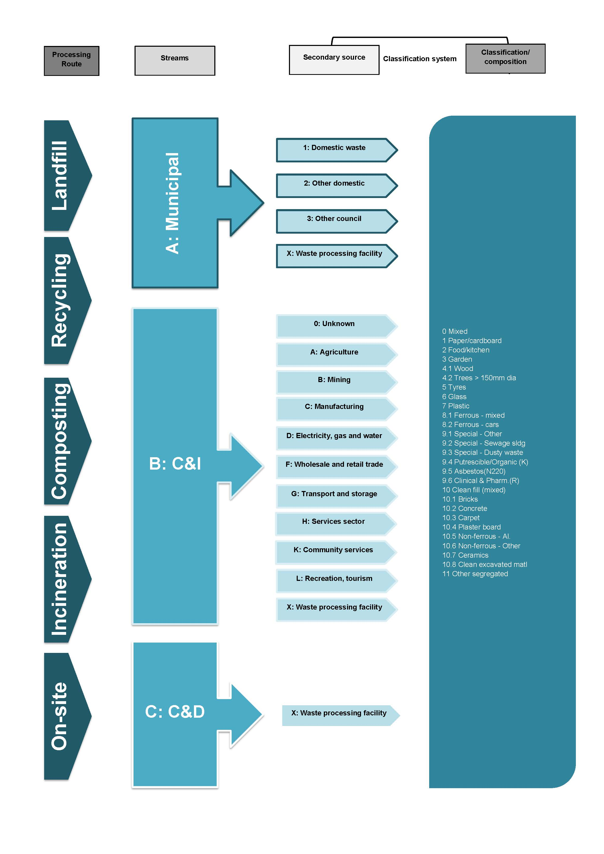

  - New South Wales
The NSW Office of Environment and Heritage (OEH) was, until recently, the authority with primary responsibility for waste and recycling data management in NSW. Roles in this area were undertaken by two division of the OEH, being the Environment and Heritage Policy and Programs Group, and the Environment Protection and Regulation Group.
On 5 October 2011, the NSW Government announced it will be establishing an Environment Protection Authority (EPA) as an independent, statutory authority. The Protection of the Environment Legislation Amendment Bill 2011 was introduced into Parliament on 11 October. At the time of publishing this report, however, there was some uncertainty around which current OEH responsibilities would be assumed by the new EPA.
At present, the Environment Protection and Regulation Group administers the Waste and Environment Levy under Section 88 of the Protection of the Environment Operations Act 1997 (POEO Act). The levy applies at three different rates across the state, being highest for the Sydney Metropolitan Area (SMA), lower for the Extended Regulated Area (ERA), and lowest for the Regional Regulated Area (RRA). The levy does not apply to the rest of the regional and rural areas of the state.
Waste facilities in NSW are required by legislation to submit reports to OEH, associated with the following main purposes:
- Paying the waste and environment levy
- Demonstrating compliance with the conditions of an environment protection licence
- Tracking hazardous waste movements within NSW and interstate
- Reporting on waste disposed at landfill and waste transported from landfills for recycling or recovery.
Licensed waste facility occupiers within the regulated areas, who are liable for the landfill levy, must submit a monthly report on all waste received and waste transported off site for recovery/recycling or further disposal. This is a legislative requirement under Section 88 of the POEO Act. Landfill facilities outside of the Regulated Area are required to submit an annual report on waste quantities. The waste classification system for landfill reporting was simplified and standardised by the Protection of the Environment Operations (Waste) Regulation 2005.
OEH has a legislative requirement to report state-wide waste disposal and recovery data as part of Progress Reporting on the NSW Waste Avoidance & Resource Recovery Strategy. The strategy requires improvements in four key result areas:
- Resource Recovery
- Waste Prevention & Avoidance
- Toxicity
- Litter & Illegal Dumping.
A key data collection pathway that contributes to the WARR Progress Report is the Local Government Waste and Resource Recovery Data Survey. This program commenced in 2006 and surveys local councils on the characteristics of waste collected, disposed and recovered. The survey also incorporates information requirements under the Used Packaging Materials NEPM.
The Waste Avoidance and Resource Recovery Act 2001 also sets a requirement for the development of Extended Producer Responsibility (EPR) Priority Statements to be reported on a regular basis; this forms a key requirement for collecting data on problem and hazardous waste materials in addition to those identified in the Controlled Waste NEPM.
The Household Chemical CleanOut program started in 2003 to divert hazardous waste materials from landfill. The program covers the entire state, and a significant amount of data is collected on 43 different target materials.
Annual surveys of recyclers and reprocessing companies that handle waste materials recovered from the Municipal, C&I and C&D streams have been undertaken through various methods over the past several years. In 2006-07 there was a single survey of all recycling and reprocessing industries undertaken by the (then) Department of Environment and Conservation. More recently, there have been a range of different annual surveys undertaken to estimate recycling and reprocessing activities for individual waste material classes. Some of these surveys were commissioned by the OEH (or former DECCW), but the majority have been undertaken by other organisations through direct or indirect part funding.
The principal data collected from the recycling and reprocessing industry used in the most recent WARR Progress Report were:
- A survey of C&D reprocessors undertaken by WMAA
- A survey of organics reprocessors undertaken by Compost Australia
- A survey of glass reprocessors undertaken by MS2 on behalf of DECCW
- A national survey of plastics reprocessors undertaken by PACIA
- A survey of paper reprocessors undertaken by Industry Edge on behalf of DECCW.
Given there are multiple surveys for different materials, some of these surveys are not in the direct control of OEH. Survey methods have also been subject to change, and there is not considered to be consistent approach to surveying the recycling and reprocessing industry on an annual basis in NSW. Therefore no standard waste classification system for this material pathway was considered suitable for inclusion in the comparative analysis of this current study.
Three relevant classification systems have been identified as being used in NSW, and their alignment with the National Waste Classification System developed under the AWD is assessed in Section 4.2.1. Each of the detailed classification systems are also displayed graphically, with the Local Government Annual Survey being displayed in two parts (landfill and recovery):
Figure 3-2 Monthly/Annual Licensed and Non-Licensed Landfill Reporting (currently NSW OEH, but subject to change)
Figure 3-3 Local Government Annual Survey – Landfill (NSW OEH)
Figure 3-4 Local Government Annual Survey – Recycling (NSW OEH)
Figure 3-5 Household Chemical Cleanout Reporting (NSW OEH).

Figure 3-2 Monthly/Annual Licensed and Non-Licensed Landfill Reporting (currently NSW OEH, but subject to change)
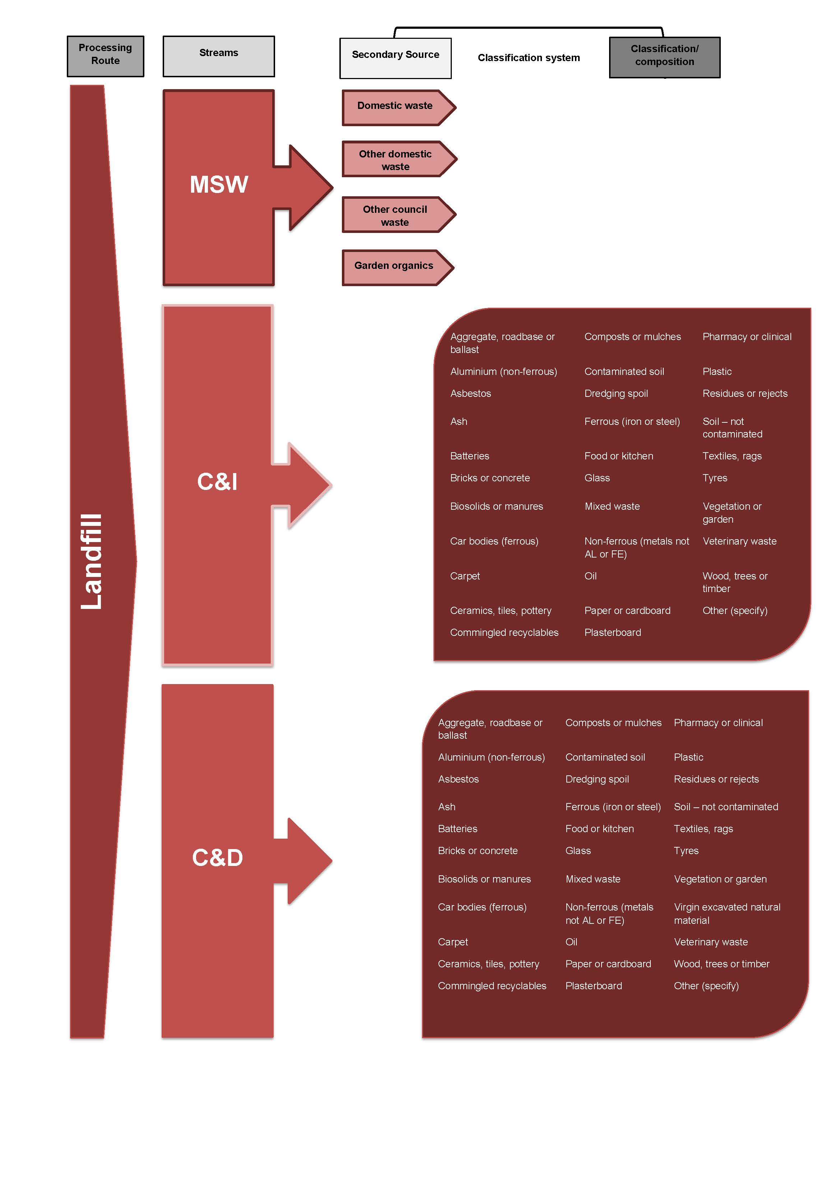
Figure 3-3 Local Government Annual Survey – Landfill (NSW OEH)
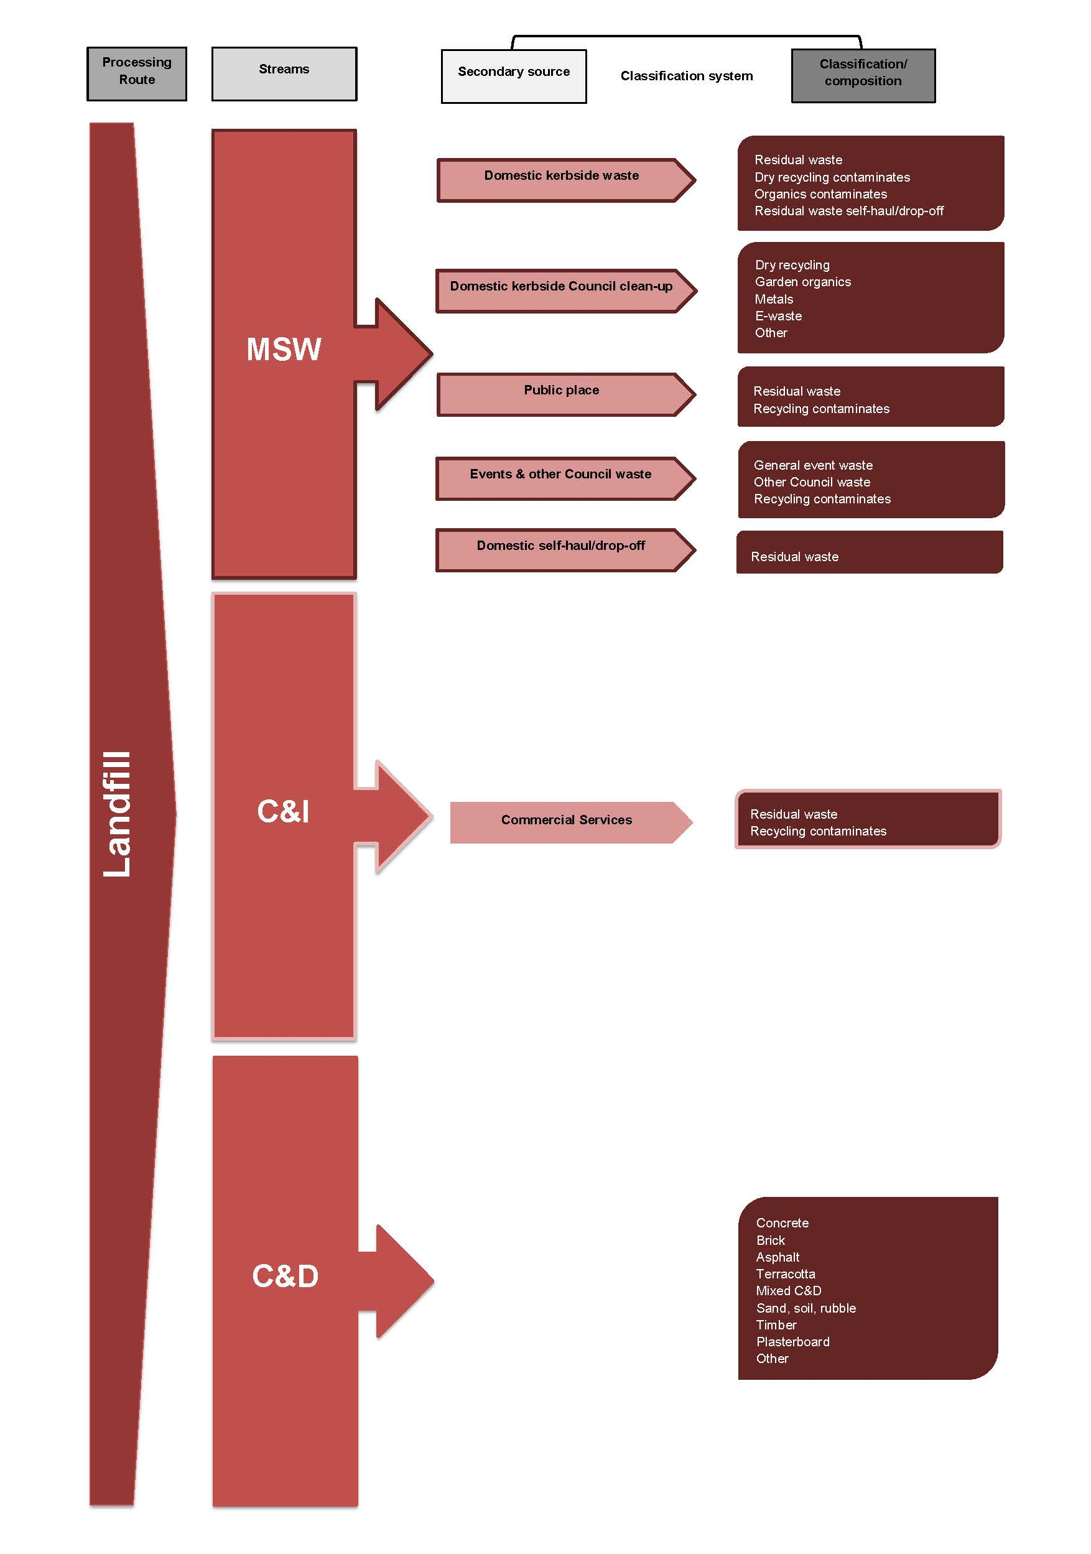
Figure 3-4 Local Government Annual Survey – Recycling (NSW OEH)
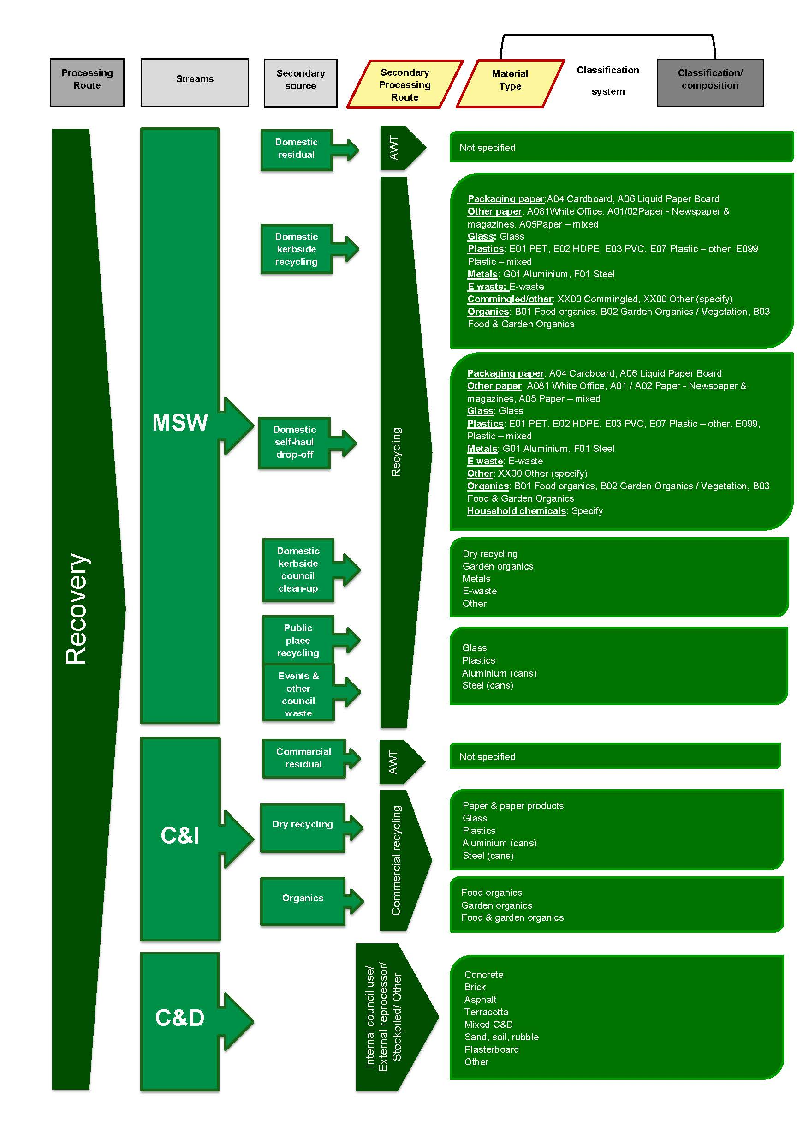
Figure 3-5 Household Chemical Cleanout Reporting (NSW OEH)
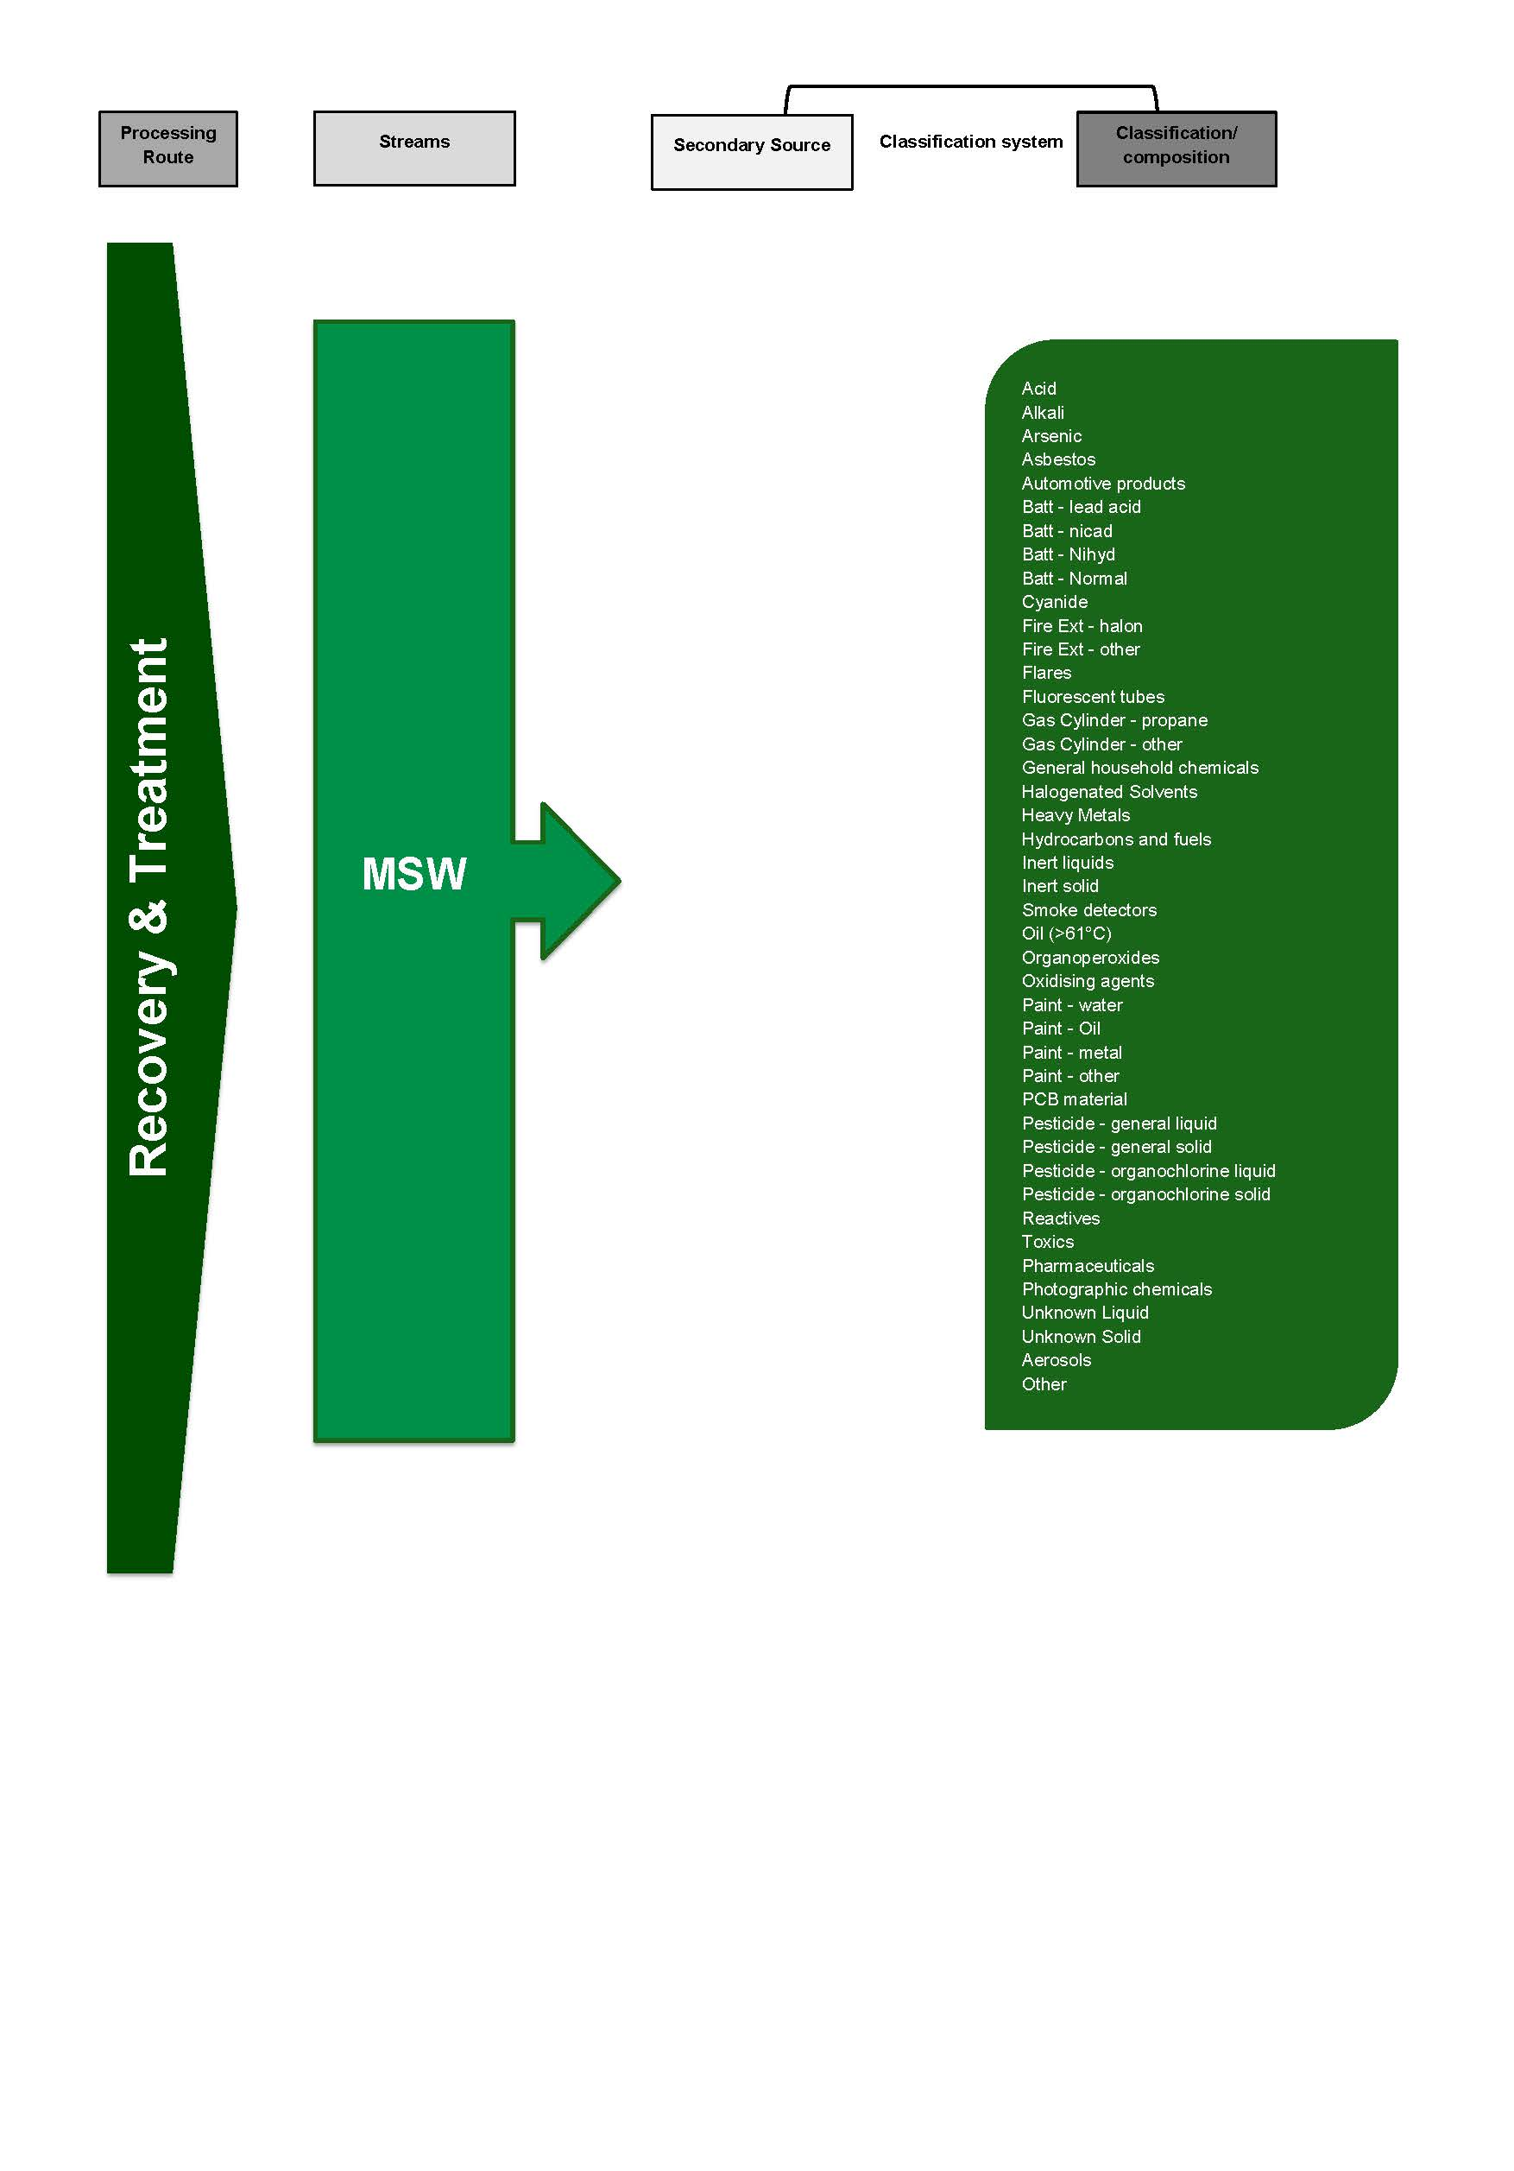

    - Comparison to the AWD
The degree of alignment between the National Waste Classification System developed under the AWD and each of the three classification systems identified as being used in NSW (each of them by the Office of Environment and Heritage) has been assessed using the qualitative method described in 4.1. The results of this assessment are displayed in Table 3-6.
It is noted Household Chemical Cleanout program relates to the management of a very specific waste stream; as the function of this system is very different to the proposed function of the AWD classification system, a low degree of alignment is to be expected.

Table 3-6 Qualitative assessment of alignment between the AWD and classification system used in NSW
 | Monthly/Annual Licensed Landfill Facility Reporting  (OEH) | Local Government Annual Survey  (OEH) | Household Chemical Cleanout Reporting  (OEH)
Processing / Disposal Route | 2 | 2 | 2
Waste Stream - Principal Source | 3 | 3 | 2
Sub-stream 1 - Secondary source | 2 | 2 | 1
Sub-stream 3 - Material composition | 2 | 2 | 1
Overall assessment | 2.25 | 2.25 | 1.5

Based on average results across all three of the NSW classification systems, overall this jurisdiction’s classification systems are considered to be partially aligned with the AWD.

Table 3-7 Key to qualitative assessment table
Alignment to AWD | Rating for each specific category | Overall rating based on average scores
Fully aligned | 3 | >2.5
Partially aligned | 2 | 2-2.5
Not aligned | 1 | <2

  - Victoria
The Environment Protection Authority Victoria (EPA Victoria) and Sustainability Victoria are the two government agencies with primary responsibility for the collection of waste and recycling data in Victoria. Several waste classification systems have been identified relating to the different state-wide reporting pathways managed by these two agencies.
    - EPA Victoria
EPA Victoria administers the state’s statutory framework for waste and its key responsibilities in this area include works approvals and licenses for facilities such as landfills. Waste data is collected by EPA Victoria for the following reasons:
- Receipt of landfill levies collected from licensed landfills based on the tonnages of waste sent to landfill
- Payment of landfill levy rebates to landfill facilities for tonnages diverted from landfill
- Ensuring compliance with license requirements for waste facilities
- Tracking the handling and management of Prescribed Industrial Wastes through the transport certification system.
EPA Victoria collects data on tonnages received by licensed landfills by one of two streams, being either MSW or industrial waste. The EPA also collects data on MSW and industrial waste removed from landfills for recycling, where a rebate is claimed.
Landfill facilities in Victoria are required to submit quarterly Landfill Levy Statements on tonnages of the two main waste streams of MSW and industrial, due to the historical differences in the landfill levy applied to these two streams. At present, this difference in levy rate only applies to non-metropolitan landfills.
Quarterly Statements include a voluntary option to report tonnages in the subclasses of ‘Commercial & Industrial’ or ‘Building & Demolition’, although the voluntary nature of this requirement means data collected in these classes is not consistent across the state. Some landfill facilities may be required to report volumetric waste data on an annual basis in other subcategories of the waste streams, (e.g. ‘putrescible waste’) as part of specific license requirements for the facility; licence-specific requirements are not standard across the state.
Detailed data is collected on the waste class of Prescribed Industrial Waste (PIWs), a subclass of the industrial waste stream, due to legislative requirements for tracking these materials, and the variable landfill levy rate applicable for different PIWs. PIWs include waste materials listed under the Movement of Controlled Waste NEPM and a series of additional materials, which are set out in the Environment Protection (Industrial Waste Resource) Regulations 2009 (Victoria).
PIWs are classified for the purposes of waste tracking certification and payment of the landfill levy according to their Hazard Category. Category A are the most hazardous while Category C are the least hazardous of this material class. PIWs classified in the Hazard Category A are banned from landfill and therefore do not feature in the classification system for landfill data reporting. Materials in Hazard Category B are only permitted to be disposed at one landfill facility in Victoria. The general materials in Hazard Category C include packaged asbestos.
Information regarding the classification of hazardous wastes, under the requirements of the Controlled Waste NEPM, is outlined in Chapter 5 and Appendix A.
EPA Victoria uses the waste data it collects primarily for internal purposes and does not publish comprehensive data in the public domain, with the exception of data provided for State of the Environment Reporting. However, it does provide various forms of the data to a wide range of stakeholders, including Sustainability Victoria. Information gathered by the EPA is also included in a range of other reports, for example in the Victorian Recycling Industry Annual Survey to calculate state recovery rates for each sector.
    - Sustainability Victoria
Sustainability Victoria delivers a range of programs designed to improve resource recovery and sustainable resource use across the state, working with local governments, households, businesses, schools and other organisations. Sustainability Victoria undertakes a wide range of waste and resource recovery data collection activities, primarily to measure progress against the objectives of the Sustainability in Action: Towards Zero Waste Strategy (TZW) and related legislative requirements. The TZW policy was launched in 2005 and supports a reduction in waste generation and maximised opportunities for material recovery. The strategy sets four state-wide targets for waste reduction, resource recovery and littering, and specific targets and actions for Victoria's municipal and business sectors to deliver more sustainable use of resources by 2014.
Sustainability Victoria has been conducting the State Environment Protection Policy for Used Packaging Materials survey (SEPP) survey since the 2001 financial year, and provides a comprehensive 10-year dataset on a range of detailed recyclable material categories. The survey requirement for local government was introduced in response to the national agreement on a Used Packaging Materials NEPM.
EPA Victoria was initially responsible for collecting the NEPM data, and EcoRecyle conducted its own local government survey of recycling; these data collection pathways were combined into the SEPP to meet packaging covenant requirements. As the SEPP only collects data on packaging and container recyclables, the Victorian Local Government Annual survey also collects total tonnages for secondary streams of MSW to complete the picture of waste and resource recovery activities of local government.
Sustainability Victoria (and the predecessor organisation EcoRecycle Victoria) has conducted the Victorian Recycling Industry Annual Survey since 1993. The most recent survey sought data from 90 Victorian reprocessing companies in seven main sectors of materials recovery (paper, glass, metals etc.), and includes information gathered from the 36 plastic reprocessing companies that are already surveyed as part of the National Plastics Recycling Survey. The Recycling Industry Annual Survey is designed to provide consistent sets of data for recyclable material categories, monitoring trends over long time periods, although it has been modified and expanded over time to meet local changes to the industry and to improve data capture.
The annual Victorian Litter Report, which contributes to objectives of the TZW Strategy, was first piloted in 2003 prior to the development of the National Litter Index (which was developed by Keep Australia Beautiful in 2006). The Victorian survey measures litter in terms of a litter item count and as a littering behaviour rate and classifies the data into eight main material types.
Four main classification systems have been identified as being used in Victoria for the purposes described in the two sections above, and their alignment with the National Waste Classification System developed under the AWD is assessed in Section 4.3.3. Each of the detailed classification systems are also displayed graphically:
Figure 3-6 Quarterly/Annual Landfill Levy Statement (EPA Victoria)
Figure 3-7 Local Government Annual Survey and SEPP Survey (Sustainability Victoria)
Figure 3-8 Victorian Recycling Industry Annual Survey (Sustainability Victoria)
Figure 3-9 Victorian Litter Report (Sustainability Victoria).

Figure 3-6 Quarterly/Annual Landfill Levy Statement (EPA Victoria)
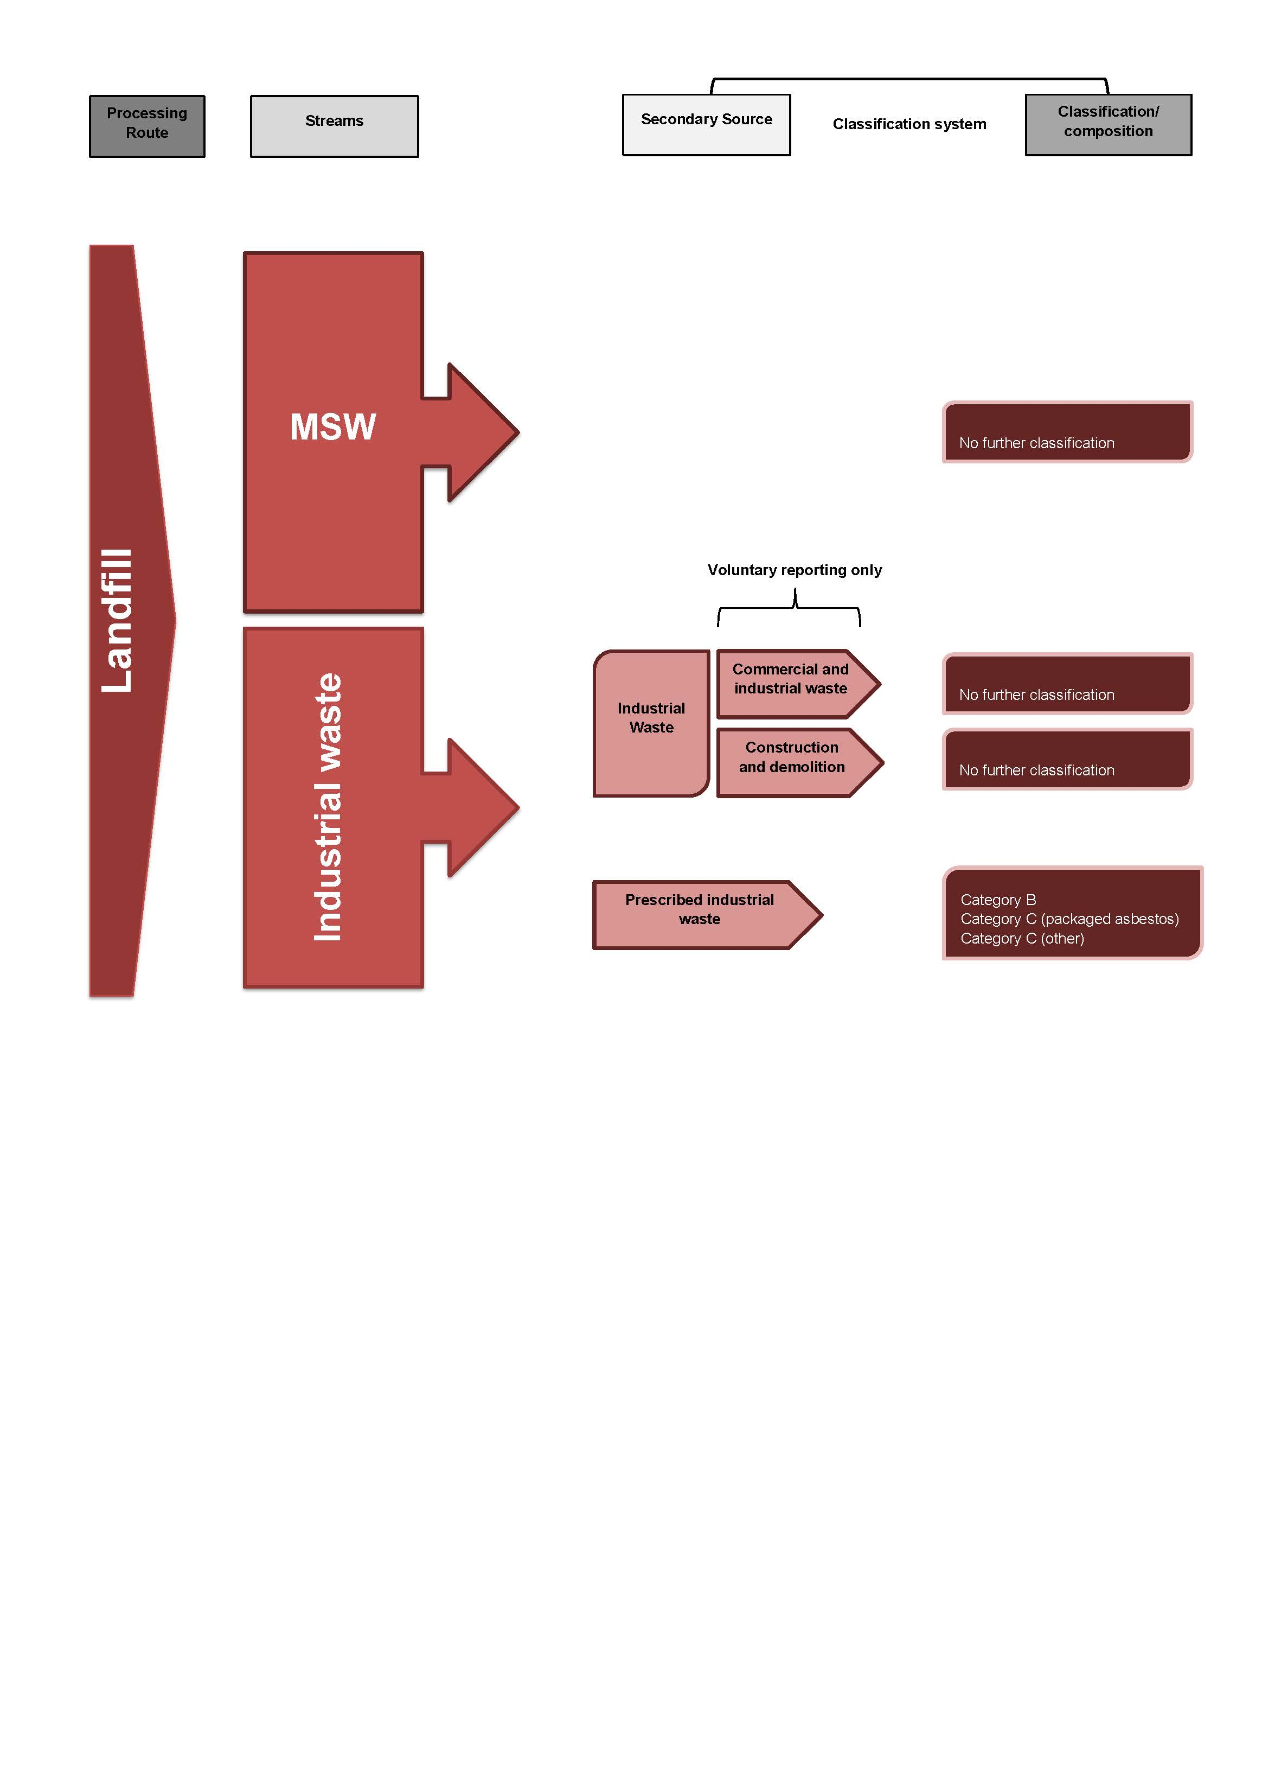
Figure 3-7 Local Government Annual Survey and SEPP Survey (Sustainability Victoria)
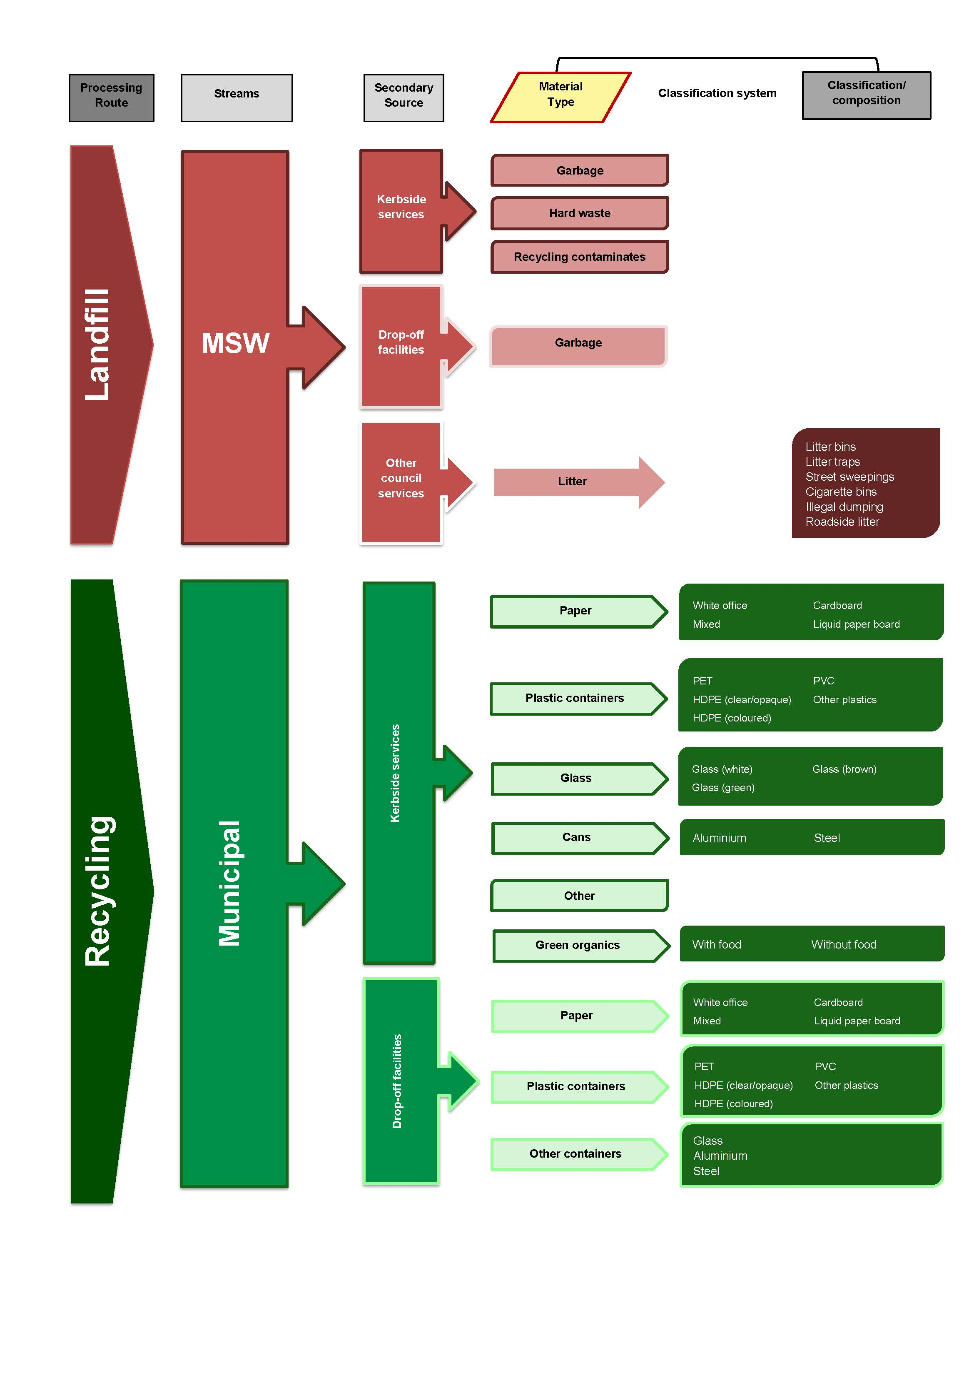
Figure 3-8 Victorian Recycling Industry Annual Survey (Sustainability Victoria)
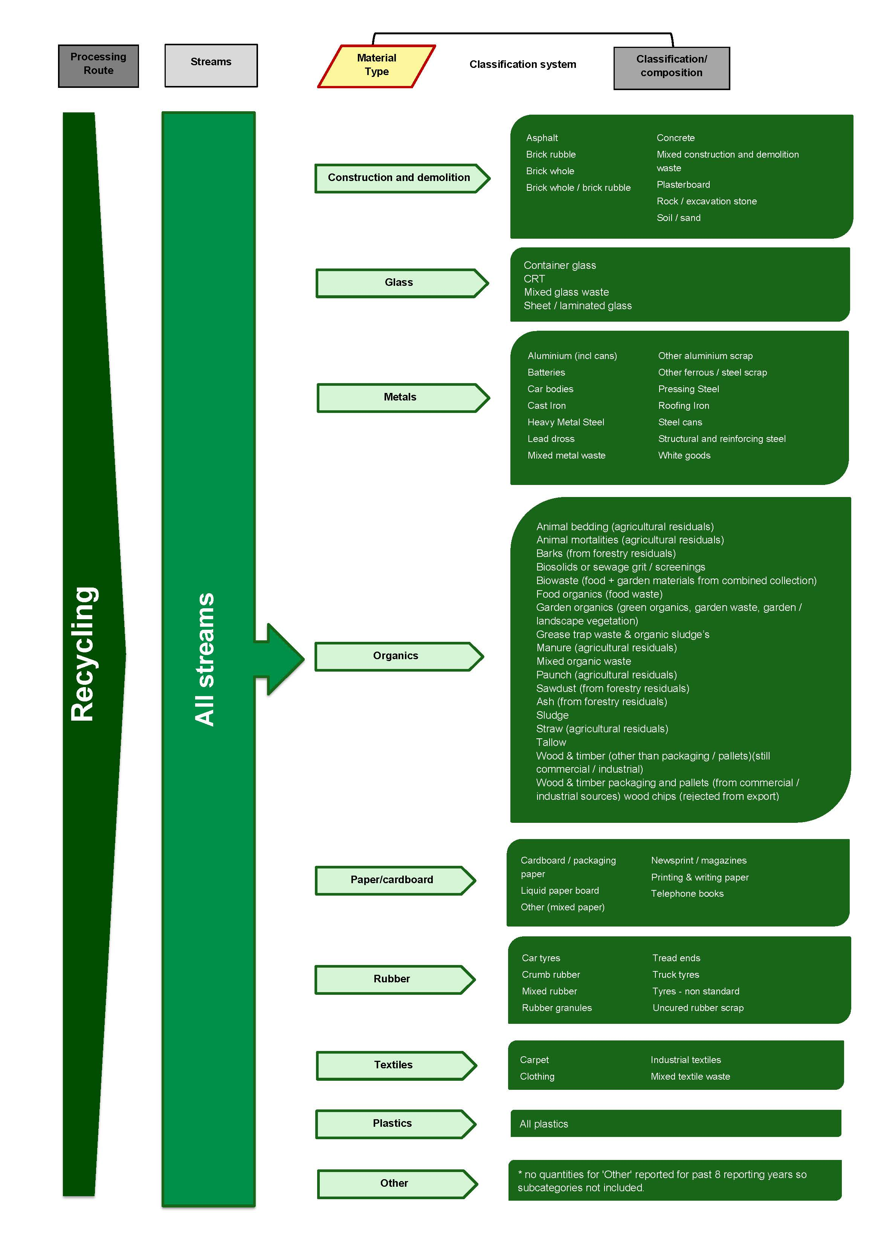
Figure 3-9 Victorian Litter Report (Sustainability Victoria)

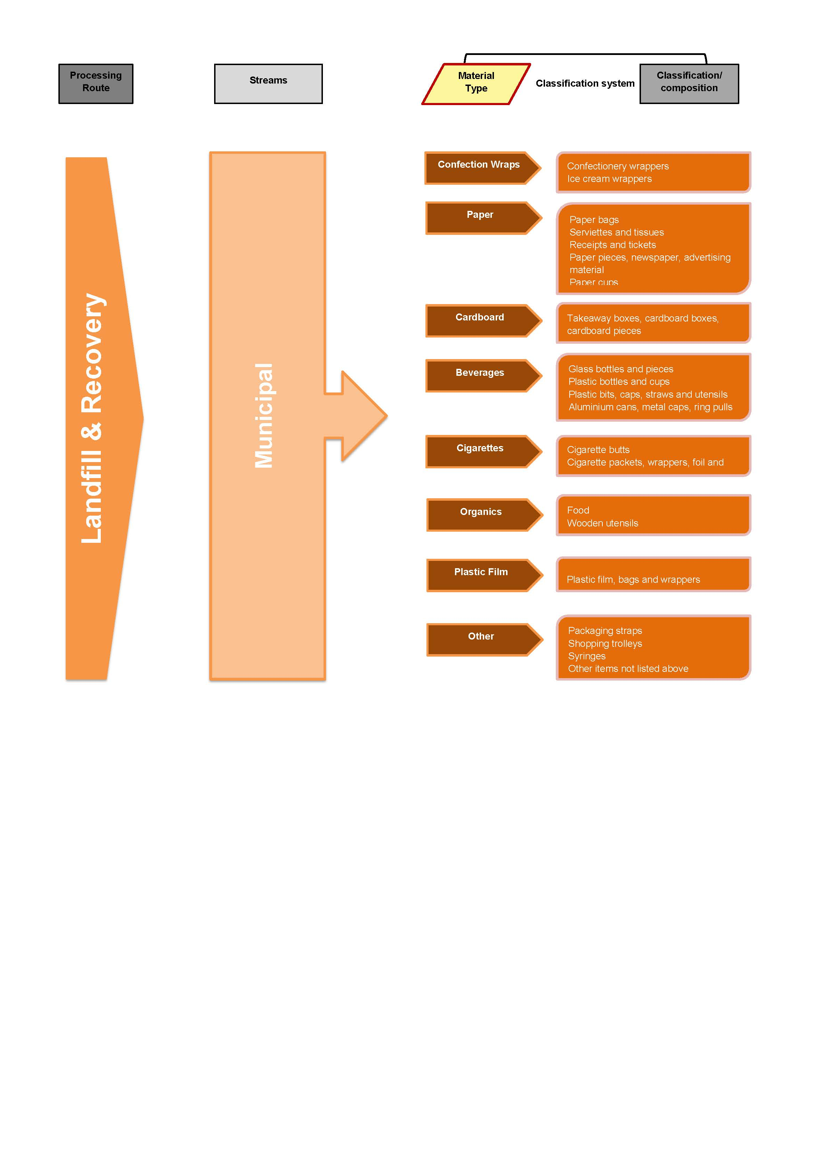
    - Comparison to the AWD
The degree of alignment between the National Waste Classification System developed under the AWD and each of the four classification systems identified as being used in Victoria (one by EPA Victoria, and three by Sustainability Victoria) has been assessed using the qualitative method described in 4.1. The results of this assessment are displayed in Table 3-8.
It is noted the Annual Litter Survey relates to the management of a specific waste stream; as the function of this system is very different to the proposed function of the AWD classification system, a low degree of alignment is to be expected.

Table 3-8 Qualitative assessment of alignment between the AWD and classification system used in Victoria
 | Quarterly/Annual Landfill Levy Statement  (EPA) | Local Government Data Collection Survey  (Sus. Vic) | Annual Recycling Industry Survey  (Sus. Vic) | Annual Litter Survey  (Sus. Vic)
Processing / Disposal Route | 2 | 2 | 2 | 1
Waste Stream - Principal Source | 2 | 2 | 1 | 2
Sub-stream 1 - Secondary source | 1 | 2 | 1 | 1
Sub-stream 3 - Material composition | 1 | 1 | 2 | 1
Overall assessment | 1.5 | 1.75 | 1.5 | 1.25

Based on average results across all four of the Victorian classification systems, overall this jurisdiction’s classification systems are considered to be not aligned with the AWD.

Table 3-9 Key to qualitative assessment table
Alignment to AWD | Rating for each specific category | Overall rating based on average scores
Fully aligned | 3 | >2.5
Partially aligned | 2 | 2-2.5
Not aligned | 1 | <2

  - Queensland
Comprehensive and quantitative state-wide data on waste and recycling was first collected in Queensland in 1998, and the waste classifications used in reporting have changed considerably since this time. The Department of Environment and Resource Management (DERM) currently has primary responsibility for state-wide waste data collection activities and the key data collection pathways from 2011-12 are:
- Annual reports submitted by licensed landfills and other waste disposal facilities
- Annual mandatory reporting by waste operators, recycling and reprocessing companies defined by Queensland legislation as ‘reporting entities’
- Annual Waste and Recycling Survey of Local Government relating to collection activities
- Monthly reporting related to tracking the movement of controlled waste.
In addition to providing high-level data for purposes such as State of the Environment reports, the quantitative data collected by DERM contributes primarily to the State of Waste and Recycling in Queensland series of reports that have been published for six periods since 2003. The reports also outline trends and changes in the total waste streams that have occurred since 1997–98.
In May 2010, the Queensland Government agreed to a significant reform package for waste management and resource efficiency, and a key element of the reform package is the Queensland Waste Strategy 2010–2020. Under this strategy, the state introduced a landfill levy that came into effect on 1 December 2011, enabled by the Waste Reduction and Recycling Act 2011 (WRR Act) that was passed in October 2011. Key provisions of the WRR Act include:
- Introduction of a waste disposal levy
- A requirement for Queensland government agencies, local governments and planning entities to prepare waste management plans (WRR Act Sections 138-146)
- Mandatory waste reporting by Local Authorities, State Entities, Planning Entities and Reporting Entities
- Introduction of product stewardship arrangements for any waste products that are identified as a growing problem for landfill in the future
- Strengthened litter and illegal dumping offences, including public reporting of vehicle-related littering offences.
The waste disposal levy applies to specified local government areas within the state (covering 98% of the Queensland population), with these LGAs referred to as the Landfill Levy Zone. The levy is only applied to waste disposed to landfill by commercial operators, although this includes waste from municipal sources collected by waste contractors on behalf of private individuals. Relevant landfill facilities are required to submit monthly data reports in accordance with the new legislation. Under the levy reporting system, waste is classified by stream, class and material type, and these classifications are used to categorise waste that is delivered to, handled within, and exported from, any waste disposal site within the Levy Zone. Waste classes are common across the waste streams.
The new waste legislation includes provisions for additional waste and recycling data reporting requirements for a range of entities other than landfills (WRR Act, Section 7). Part 5 of the Waste Reduction and Recycling Regulation 2011 identifies the entities required to report under the Act and includes licensed landfills, holders of a waste management license and all other operators undertaking commercial sorting, resource recovery, recycling or reprocessing and handling at least 1,000 tonnes of this material per year. The mandatory reporting requirements will initially apply for the 2011–12 year, with affected entities required to report by August 2012.
As such, Queensland is the first of the Australian states to legislate mandatory data reporting by private sector recyclers. The format of the voluntary survey of recyclers used in 2011 will be reviewed and modified in line with the new mandatory reporting requirements before the first reporting deadline on 31 August 2012.
Queensland local councils are also now required by Section 147 of the Waste Reduction and Recycling Act 2011 to submit a report after each financial year through the Annual Waste and Recycling Survey. This survey is designed to provide a comprehensive review of the provision of waste services and recycling performance of councils across the state. The 2011 survey utilises a range of terminology and different levels of classification, depending on the material type, secondary waste stream or processing route. It is likely the survey format from 2012 onwards may be revised in line with the new legislative requirements.
Four waste classification systems have been identified as being used for reporting purposes in Queensland during 2011, and their alignment with the National Waste Classification System developed under the AWD is assessed in Section 4.4.1. It should be noted that Queensland waste data reporting systems are currently under review as a result of the legislation introduced in late 2011 and reporting templates have not yet been finalised for the financial year ending June 2012.
The detailed classification systems displayed graphically below were used in 2010-11 but have a potential to change, with the exception of the classification system for Monthly Landfill Reporting in the new levy zone. The classification system within the 2011 Local Government Survey is displayed in the diagrams in two parts (being landfill and recovery):
Figure 3-10 Annual Landfill Reporting – non-levy zone and prior to levy (DERM)
Figure 3-11 Monthly Landfill Reporting – levy zone (DERM)
Figure 3-12 Annual Survey of Recyclers (DERM)
Figure 3-13 Annual Local Government Waste Management Survey – Landfill (DERM)
Figure 3-14 Annual Local Government Waste Management Survey – Recovery (DERM).
Note: in the subsequent figures, RRD refers to ‘Resource Recovery Deduction’, while RRA refers to Resource Recovery Area.

Figure 3-10 Annual Landfill Reporting – non-levy zone and prior to levy (DERM)
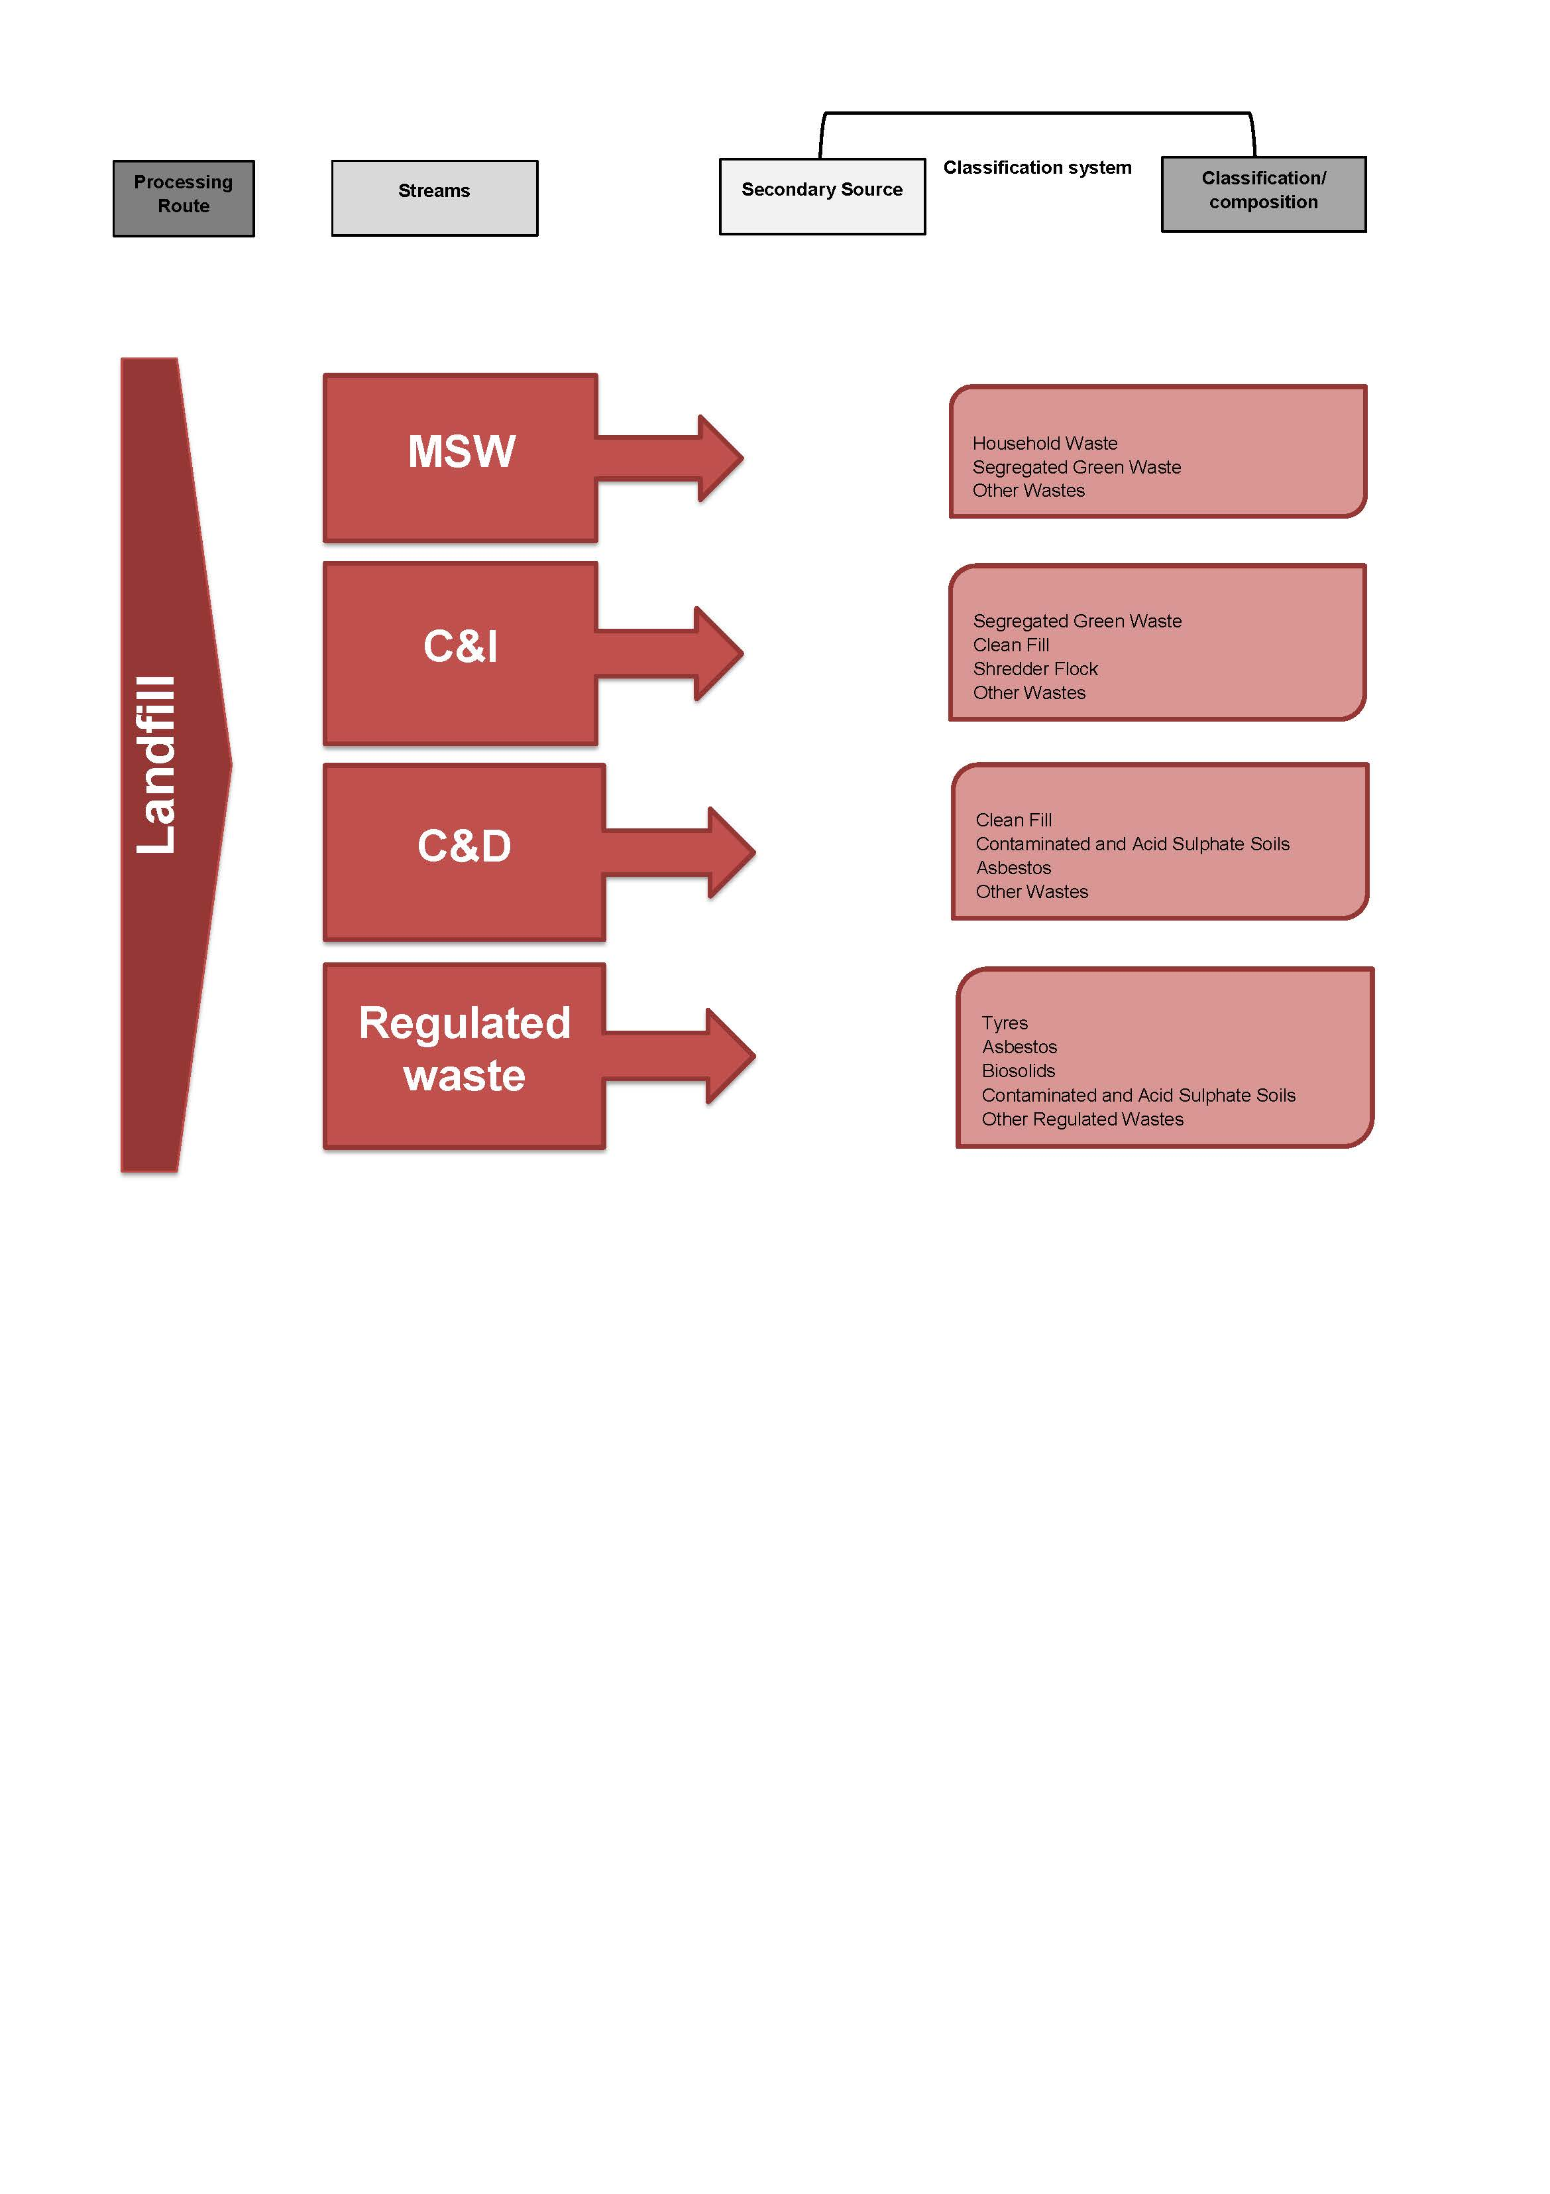
Figure 3-11 Monthly Landfill Reporting – levy zone (DERM)
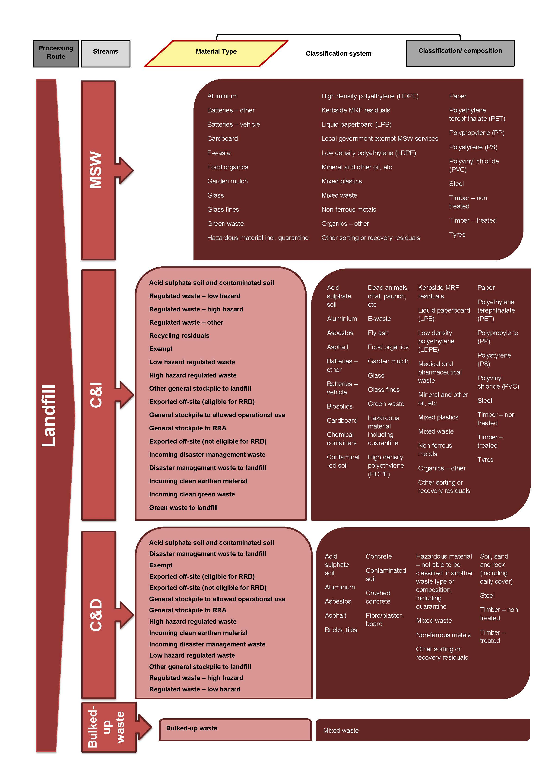
Figure 3-12 Annual Survey of Recyclers (DERM)
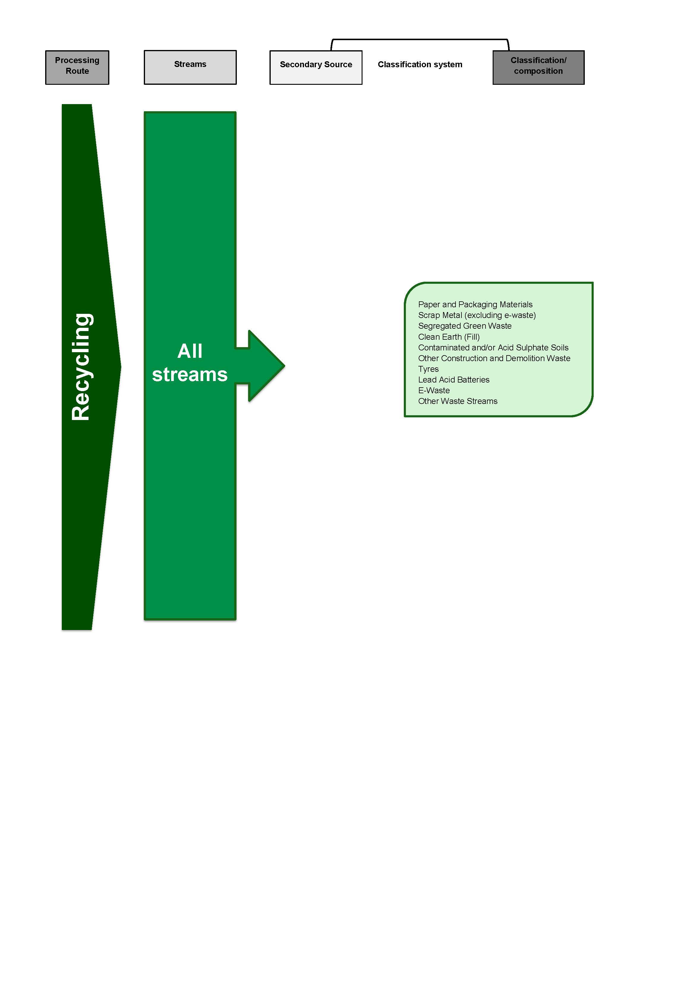
Figure 3-13 Annual Local Government Waste Management Survey – Landfill (DERM)
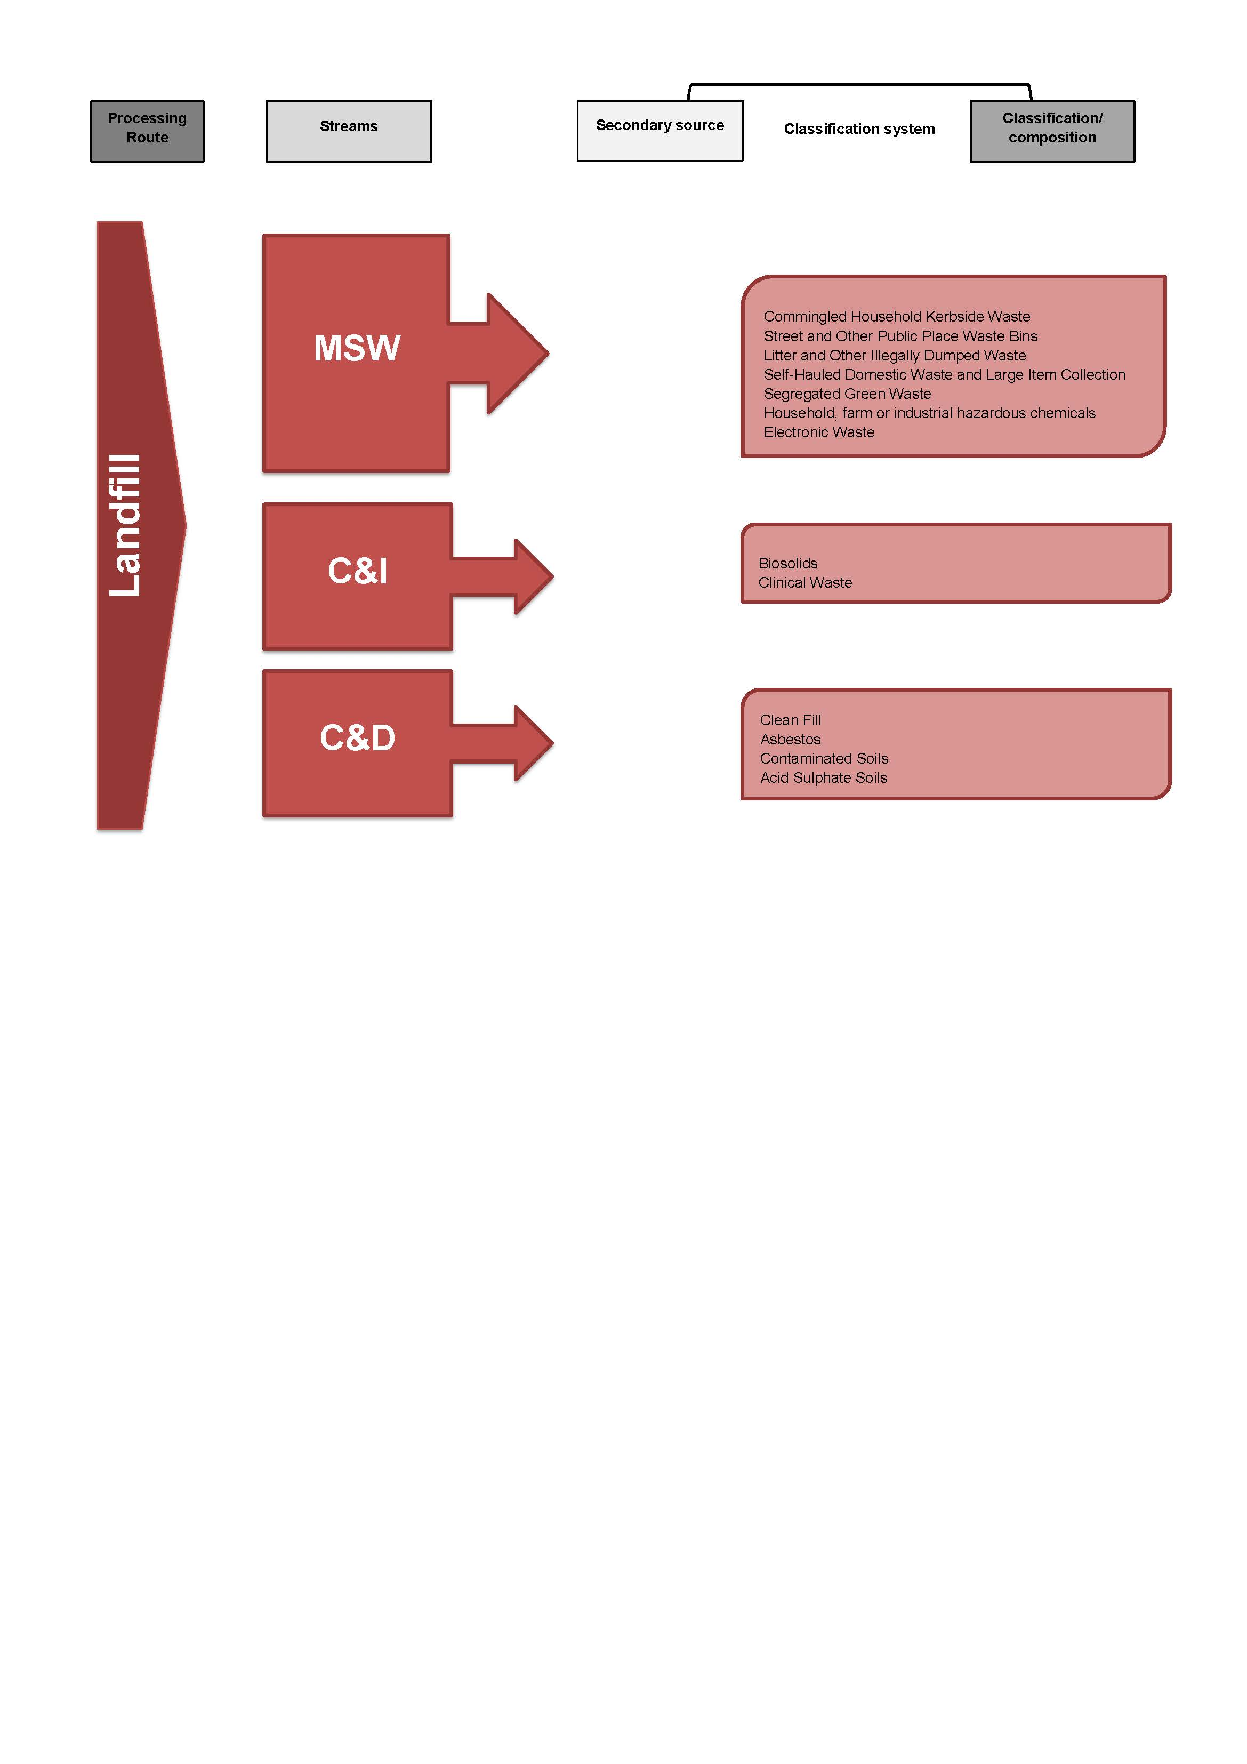
Figure 3-14 Annual Local Government Waste Management Survey – Recovery (DERM)
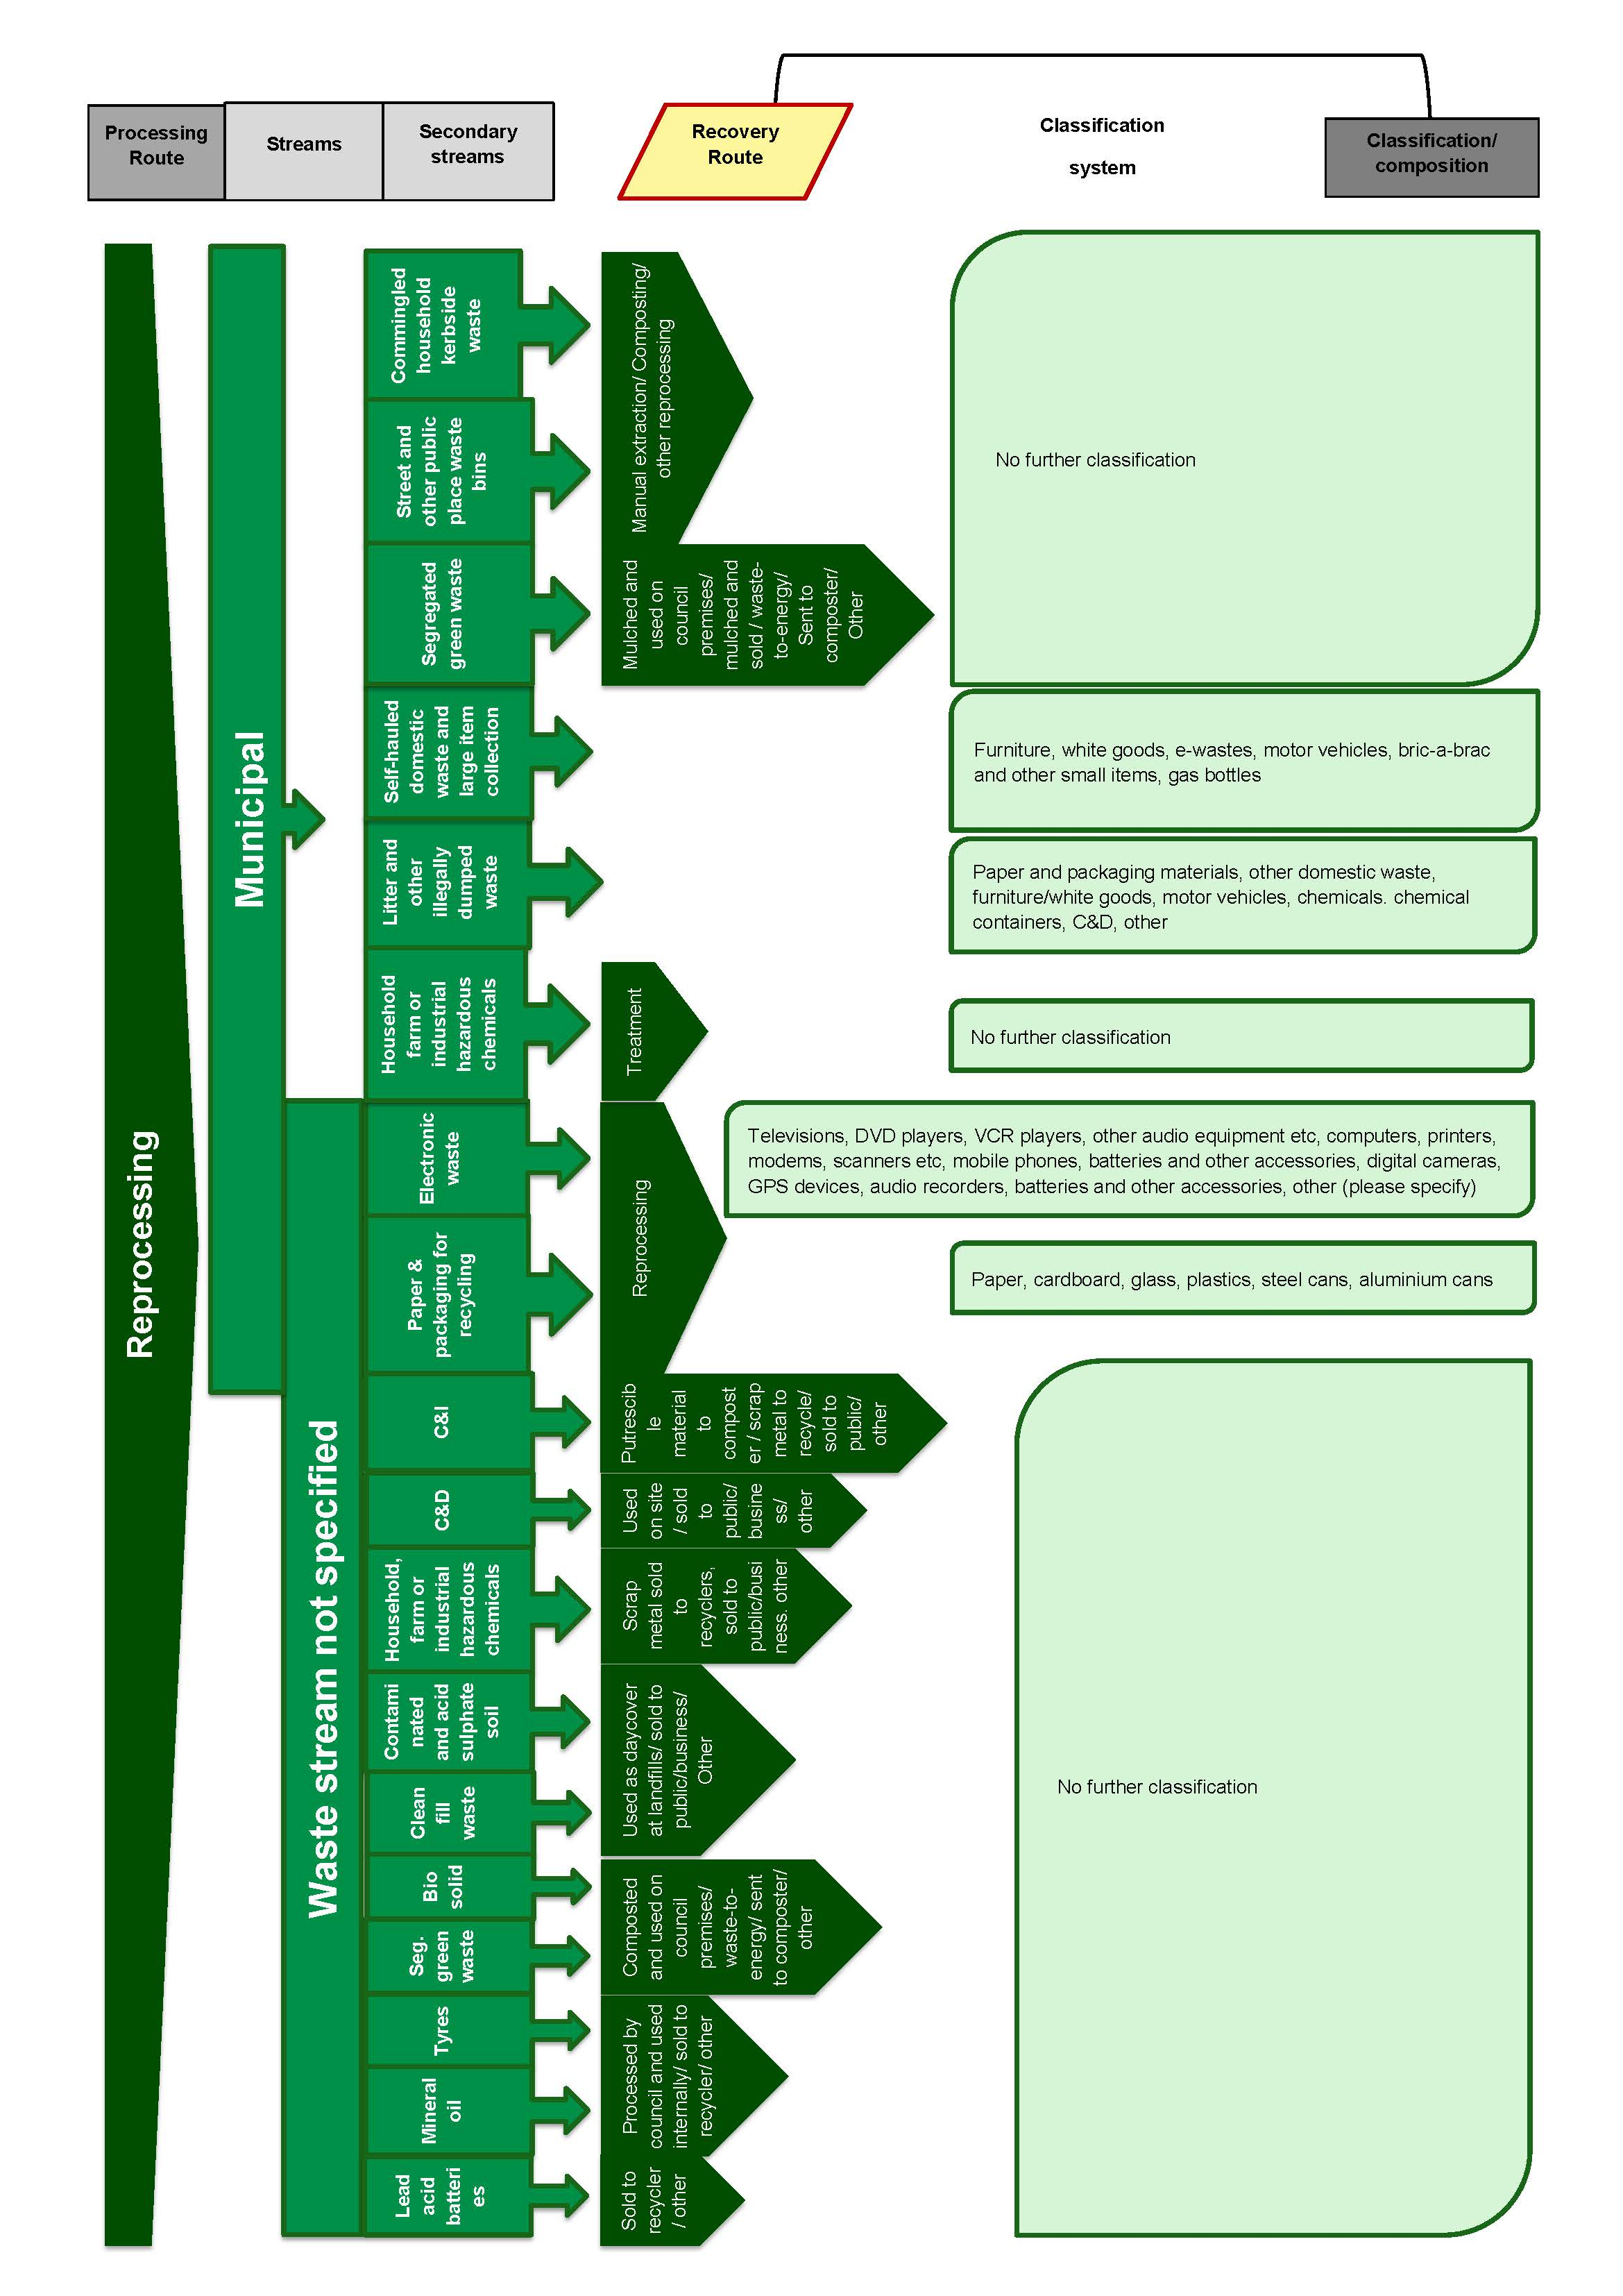

    - Comparison to the AWD
The degree of alignment between the National Waste Classification System developed under the AWD and each of the four classification systems identified as being used in Queensland (in each case administered by the Department of Environment and Resource Management - DERM) has been assessed using the qualitative method described in 4.1. The results of this assessment are displayed in Table 3-10.

Table 3-10 Qualitative assessment of alignment between the AWD and classification systems in Queensland
 | Annual Landfill Reporting (non-levy zones)  (DERM) | Monthly Landfill Reporting (within levy zone)  (DERM) | Annual Survey of Recyclers  (DERM) | Annual Local Government Waste Management Survey  (DERM)
Processing / Disposal Route | 2 | 2 | 2 | 2
Waste Stream - Principal Source | 2 | 2 | 1 | 2
Sub-stream 1 - Secondary source | 1 | 1 | 1 | 1
Sub-stream 3 - Material composition | 1 | 2 | 1 | 1
Overall assessment | 1.5 | 1.75 | 1.25 | 1.5

Based on average results across all four of the Queensland classification systems, overall this jurisdiction’s classification systems are considered to be not aligned with the AWD.

Table 3-11 Key to qualitative assessment table
Alignment to AWD | Rating for each specific category | Overall rating based on average scores
Fully aligned | 3 | >2.5
Partially aligned | 2 | 2-2.5
Not aligned | 1 | <2

  - South Australia
There are several key reporting pathways for waste-related information in South Australia, which are managed by different state government authorities that have each developed separate waste classification systems to suit their specific purposes.
    - Environment Protection Authority
The Environment Protection Act 1993 (EP Act) underpins the key legislative requirements of the South Australian Environment Protection Authority (EPA) to collect waste data. Created under the Act, the Environment Protection (Waste to Resources) Policy 2010 (W2R EPP) supports South Australia’s Strategic Plan 2007 target of reducing waste to landfill by 25% by 2014 and provides the regulatory underpinning for South Australia’s Waste Strategy 2010- 2015. Among its many functions, the W2R EPP also includes provisions for the staged disposal bans of certain waste types from landfill, improved controls on illegal dumping, and obligations relating to listed waste, medical waste, waste transport and several quantitative waste data collection and reporting requirements.
As such, the EPA has responsibility for the following main reporting pathways for state-wide quantitative waste data:
- Monthly and Annual Landfill Reporting
- Reporting for the Container Deposit Legislation
- Reporting on the movement of Listed and Controlled Waste materials.
The landfill levy administered by the EPA applies a higher (double) levy to waste sent to landfills in Metropolitan areas compared to landfills in all other areas of the state. The levy applies to all waste sent to landfill, although for Waste Fill the levy is set at zero dollars. The EPA currently collects tonnage and volumetric data for only two main solid waste streams, which are reported by landfill facilities for the purposes of paying the landfill levy. These waste streams are:
- Solid Waste (both Metropolitan and Non-metropolitan)
- Waste Fill (Clean Fill).
Data is collected from landfill facilities in the form of monthly tonnage-based returns and an annual volumetric survey, which are required for all waste depots that receive more than 10,000 tonnes of waste per annum, where a weighbridge is installed. Smaller landfills, receiving less than 10,000 tonnes per annum and where there is no weighbridge, are required to submit estimates according to a population-based formula (as set out in the regulations under the Act) which occurs on either a monthly, quarterly or annual frequency, depending on the facility.
Data collected by the EPA is primarily for the purposes of paying the landfill levy and therefore there is no requirement for more detailed data from waste facilities, such as classification according to waste stream. Based on information provided to Hyder during this study, we understand that major landfills do have sophisticated data collection systems, and would be capable of reporting waste tonnages according to much more detailed classifications if required, although this capability is not consistent across the state; many landfills in regional areas do not possess weighbridges and may in some cases be un-manned.
EPA and Zero Waste SA, the two key bodies with responsibility for waste in South Australia, are currently working together to develop a new reporting system for landfill facilities, which in the future is expected to encompass data collection across five waste streams: MSW; C&D; C&I; Contaminated Soil; and Waste Fill (Clean Fill).
    - Zero Waste SA
Zero Waste SA (ZWSA) is a statutory authority established by the Zero Waste SA Act, 2004. It aims to provide strategic policy advice, guidance and leadership to government and stakeholders to bring about change. ZWSA establishes programs and projects that are designed to maximise waste reduction, promote resource recovery and recycling, and ecological sustainability. ZWSA is responsible for provision of South Australia’s Waste Strategy 2011-15, which has two key objectives:
- Maximising the useful life of materials through reuse and recycling
- Avoiding and reducing waste.
Under these objectives there are key landfill diversion targets set for MSW, C&I, and C&D waste. ZWSA has implemented a environmental data management system, (the ZWSA Environment Users System (ZEUS) for the collection, analysis and reporting of data from waste and recycling activities across South Australia, and for the measurement of the targets set out in the strategy.
ZWSA collects several more detailed sets of quantitative waste data as part of its activities, with the main data collection pathways it manages being:
- Annual Local Government Kerbside Performance Surveys
- Annual Recycling Industry Activity Survey
- Household Hazardous Waste Collection Program data
- Local government illegally dumped waste data
- Annual Compost Processors Survey (conducted by Compost Australia on behalf of ZWSA)
- Annual Litter Survey (conducted by KESAB Environmental Solutions on behalf of ZWSA and Keep Australia Beautiful)
- Voluntary submission of monthly (or less frequent) waste datasets (in various formats) by various local government authorities and waste and recycling businesses.
ZWSA compiles a range of data collected directly from local government, industry sources and through the Recycling Industry surveys into its Annual Recycling Activity in SA report. The requirement for reporting of recycling activity has its basis in the Waste Strategy.
Completion of the Local Government Kerbside Performance Survey is a requirement under waste infrastructure grants provided by ZWSA to relevant councils. The annual survey collects a detailed dataset of materials recovered by LGAs in order to measure the effectiveness of grants disbursed by ZWSA, and is based on councils undertaking domestic waste audits of kerbside waste, recycling and organics collections. Completion of the survey is currently linked to selective funding and is only mandatory for some councils, although voluntary completion by other councils is encouraged and Hyder understands the agency is aiming for participation by all LGAs across the state in the future.
There is currently an informal process through which a large proportion of South Australian local government authorities submit regular waste and recycling collection datasets to Zero Waste SA for the purposes of monitoring and reporting at the state level. Data is submitted in a range of formats, depending on the council, but often as an Excel spread sheet. Some councils enter and manage data directly through the ZWSA Environment Users System (ZEUS).
ZEUS is a recently-developed, web-based data management system that is designed to enable simple collection of waste and recycling data within South Australia from a range of organisations, particularly local government and waste and recycling facilities. ZEUS was developed to allow ZWSA to improve measurement of the state’s performance against targets set in South Australia’s Waste Strategy 2011-15 and the SA Strategic Plan, and the system is configured in a series of modules such as MSW, Illegal Dumping, C&I, and C&D.
Councils also submit data to ZWSA related to illegally dumped materials within their LGAs. The data submission process is voluntary and occurs through a range of different formats and at different frequencies, depending on the council. The main methods are an online survey form, email of spread sheets and, in cases where council officers use hand-held devices to record illegal dumping incidents in the field, data can be automatically submitted through a web-based application.
ZWSA also conducts a collection program for household hazardous waste in collaboration with local governments, providing regular collection events throughout the state at various drop-off points. The program also includes a permanent hazardous waste drop-off point in the Adelaide area. An extensive list of hazardous substances are collected through the state-wide program, with data classified for reporting purposes into 41 waste material categories and 117 subcategories. Many of the materials are Listed Wastes as defined in the Environment Protection Act 1993 (SA) Schedule 1 (Part B). The data collected from this program is reported to councils and other state government departments in summary form.
    - Office of Local Government
The Office of Local Government conducts an Annual Survey of local government authorities as a requirement for federal funding grants disbursed through the South Australian Local Government Grants Commission. The annual survey collects data across a broad range of topics and includes a section relating to waste and recycling activities.
This survey is a mandatory reporting pathway for local governments in South Australia and is considered to provide a complete state-wide dataset relating to municipal waste and recycling quantities. The data, which is also used by Zero Waste SA and other agencies, is collected according to a high order classification system of five waste streams (Waste, Recycling, Green Organics, Hard Waste and Hazardous Materials), providing the total annual tonnage of each waste stream collected by each council.
Five classification systems have been identified as being used in South Australia, and their alignment with the National Waste Classification System developed under the AWD is assessed in Section 4.5.4. Each of the detailed classification systems are also displayed graphically:
Figure 3-15 Annual Landfill Reporting (EPA SA)
Figure 3-16 Annual Local Government Survey (Office of Local Government)
Figure 3-17 Annual Kerbside Performance Reporting (Zerowaste SA)
Figure 3-18 Annual Recycling Activity Survey (Zerowaste SA)
Figure 3-19 Household Hazardous Waste Collection program reporting (Zero Waste SA).

Figure 3-15 Annual Landfill Reporting (EPA SA)

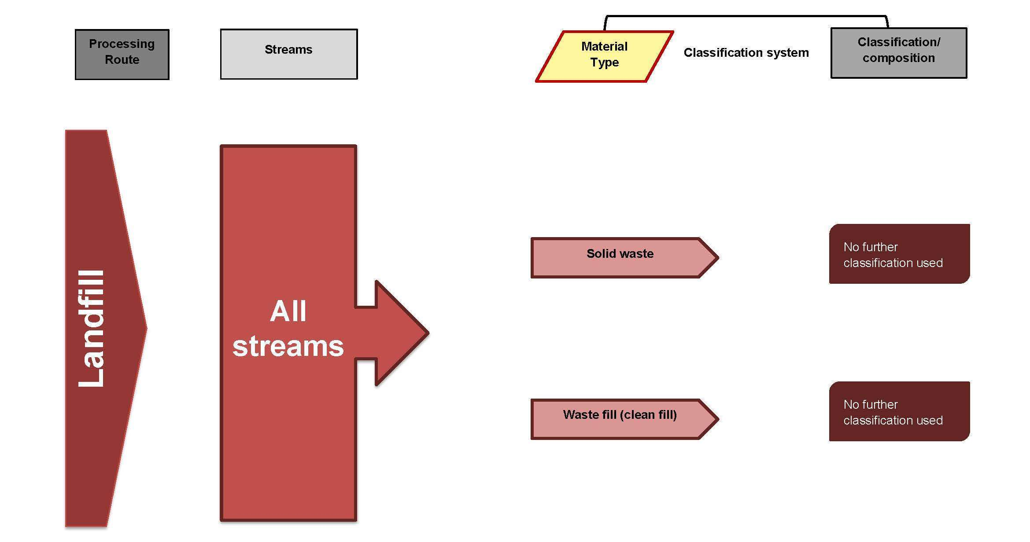

Figure 3-16 Annual Local Government Survey (Office of Local Government)

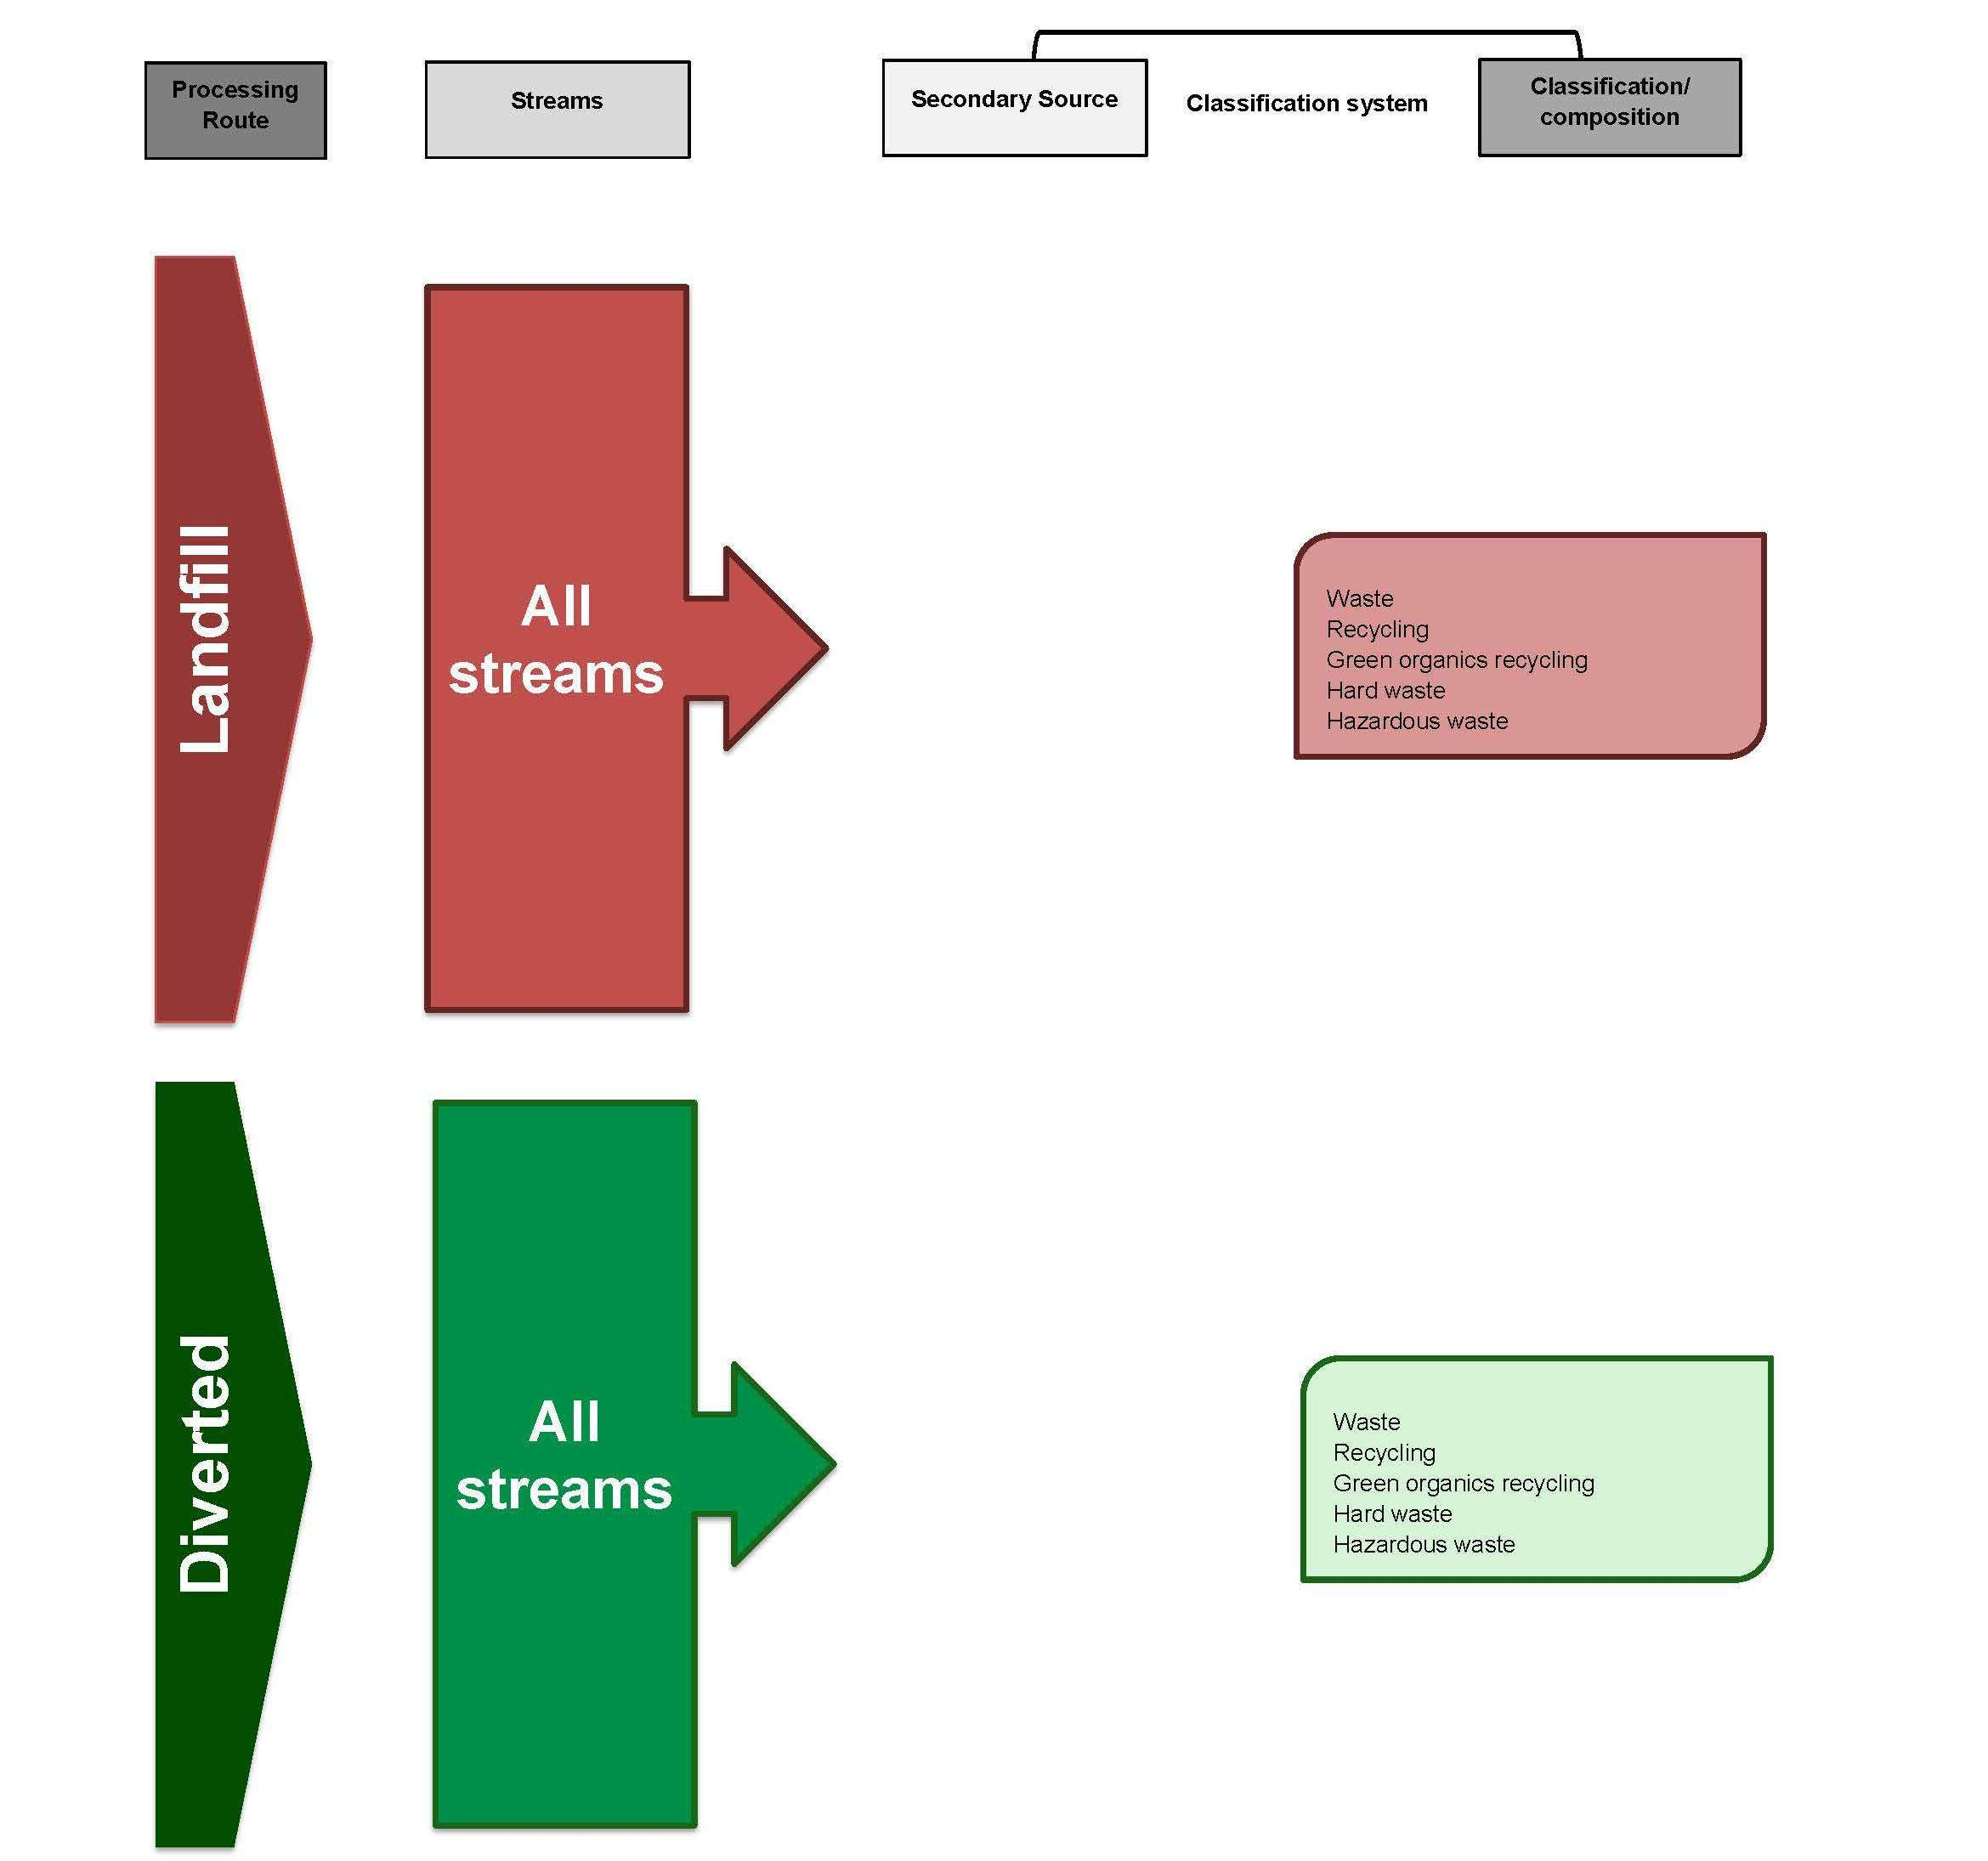

Figure 3-17 Annual Kerbside Performance Reporting (Zerowaste SA)
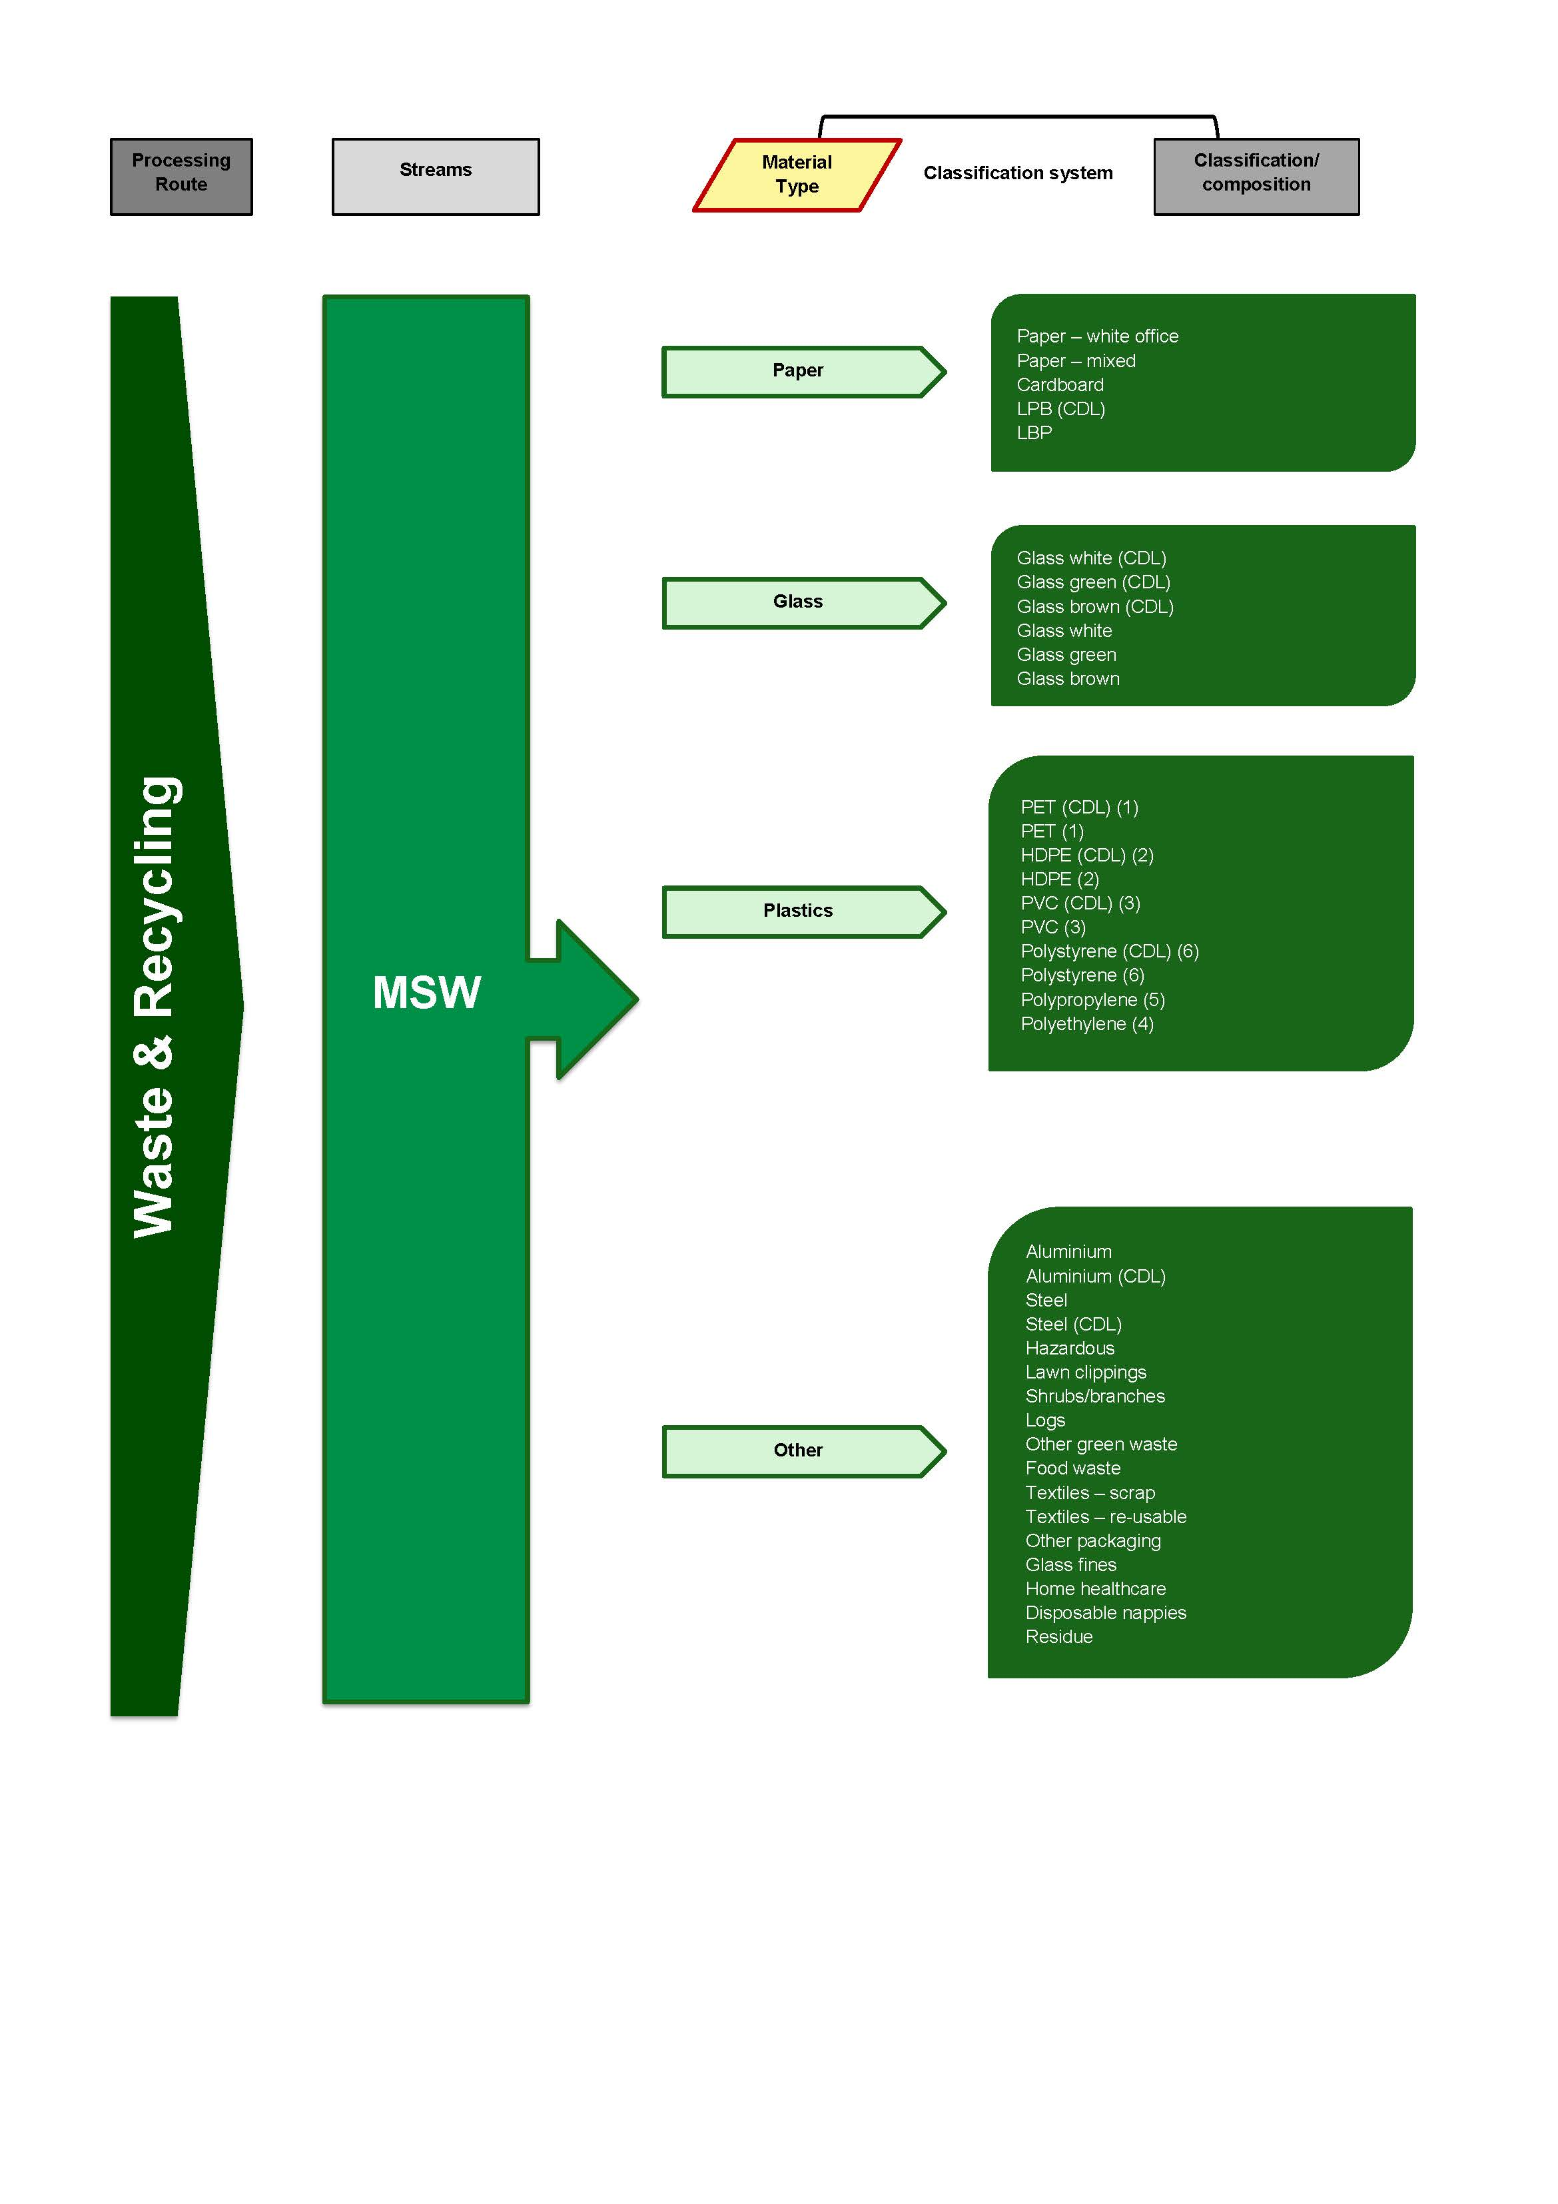
Figure 3-18 Annual Recycling Activity Survey (Zerowaste SA)
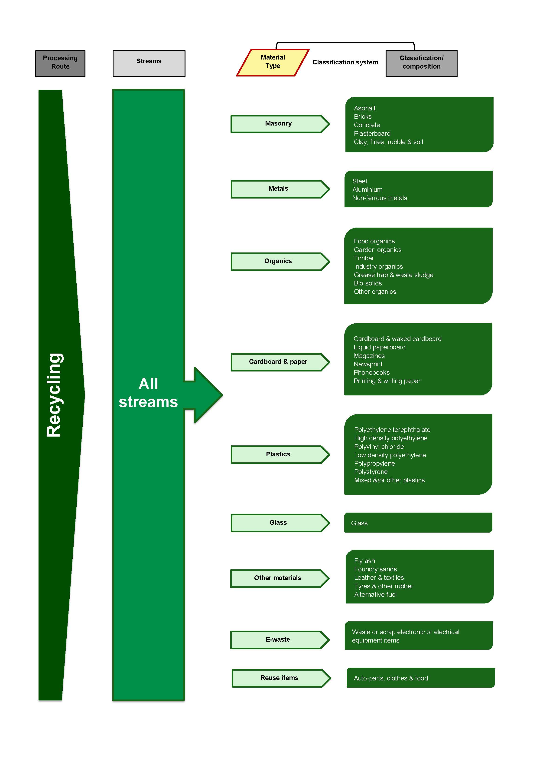
Figure 3-19 Household Hazardous Waste Collection program reporting (Zero Waste SA)
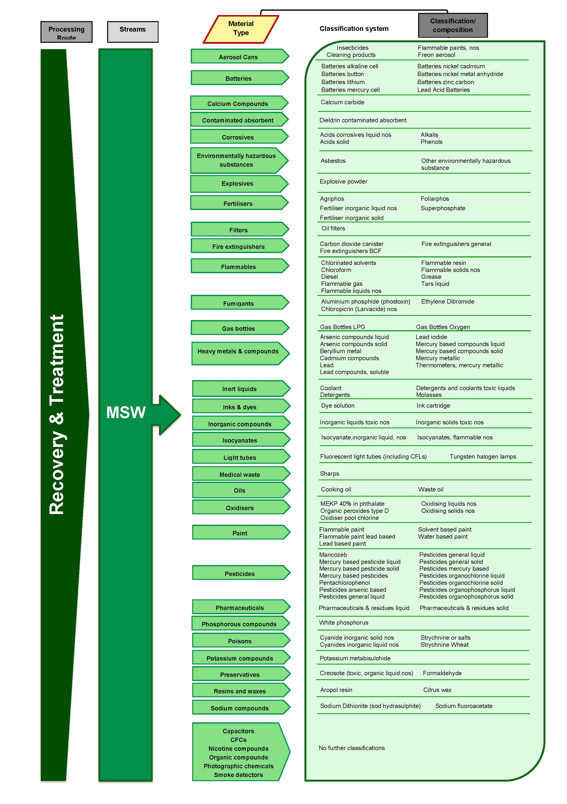

    - Comparison to the AWD
The degree of alignment between the National Waste Classification System developed under the AWD and four classification systems identified as being used in South Australia (one by the South Australian EPA, and three by Zero Waste SA) has been assessed using the qualitative method described in Section 4.1. The results of this assessment are displayed in Table 3-12. Note that the alignment of the household hazardous waste classification system has not been assessed; hazardous wastes are covered separately in Chapter 5.

Table 3-12 Qualitative assessment of alignment between AWD and classification systems in South Australia
 | Annual Landfill Reporting  (EPA) | Annual Local Government Survey  (Zero Waste SA) | Annual Kerbside Performance Reporting  (Zero Waste SA) | Annual Recycling Activity Survey  (Zero Waste SA)
Processing / Disposal Route | 2 | 2 | 1 | 2
Waste Stream - Principal Source | 1 | 1 | 2 | 1
Sub-stream 1 - Secondary source | 1 | 1 | 1 | 1
Sub-stream 3 - Material composition | 1 | 1 | 2 | 2
Overall assessment | 1.25 | 1.25 | 1.5 | 1.5

Based on average results across all four of the South Australian classification systems, overall this jurisdiction’s classification systems are considered not aligned with the AWD.

Table 3-13 Key to qualitative assessment table
Alignment to AWD | Rating for each specific category | Overall rating based on average scores
Fully aligned | 3 | >2.5
Partially aligned | 2 | 2-2.5
Not aligned | 1 | <2

  - Western Australia
The WA Department of Environment and Conservation (DEC) established a waste data collection program several years ago, at a time when the AWD classification system was available for reference. The system WA developed is based on the AWD system, and aims to establish a comprehensive and clear system of waste classification and measurement across the state. It particularly provides detailed information on problem waste materials, for which resource recovery has been poor in the region.
The primary pathways for state-wide waste data collection that are managed by DEC are:
- Monthly Reporting by landfills (Metropolitan Landfills only)
- An annual Census of waste and recycling services provided by local governments
- A survey of reprocessing and recycling activity in Western Australia
- Reporting on the movement of Controlled Waste materials
- Annual Compost Processors Survey (conducted by Compost Australia on behalf of DEC)
- Annual Litter Survey (conducted by Keep Australia Beautiful WA on behalf of DEC).
The DEC manages the landfill levy and requires monthly data reporting under Waste Avoidance and Resource Recovery (WARR) legislation. The landfill surveys collect data in a structure based on the AWD classification system. The landfill levy applies only to metropolitan waste, and so only metropolitan landfills (defined as those located in metropolitan areas, or those that receive any waste from metropolitan areas), are required to submit quantitative waste data to the DEC. Most regional landfill facilities are small in size and capacity, and may have no weighbridge or staff to facilitate the collection of detailed waste data.
The structure of data collection for the local government Census on waste and recycling activity is also based on the classification system developed through the AWD project and this current approach has being occurring since the 2006–07 financial year. Previously, from 2004–05 to 2005–06, local government were asked about recycling activity as part of reporting obligations under the Used Packaging Materials NEPM; these requirements are now incorporated into the Census. Prior to this, quantitative information on the amounts of recycling and material recovery occurring through Western Australian local governments was obtained through a Resource Recovery Rebate Scheme.
A recycling activity survey is undertaken on an annual basis on behalf of the DEC. Hyder has been contracted to undertaken these surveys for the last several years. This survey classifies the materials handled by reprocessors according a slightly different system, which is not as closely based on the AWD system. This is primarily because the recycling activity survey and report includes data from a range of other sources, including Australian Customs and PACIA, and the classification system used for collecting data in is designed to be compatible with these available data sources.
Three classification systems have been identified as being used in Western Australia, and their alignment with the National Waste Classification System developed under the AWD is assessed in Section 4.6.1. Each of the detailed classification systems are also displayed graphically, with the Local Government Census displayed in two parts (being landfill and recycling):
Figure 3-20 Quarterly Metropolitan Landfill Reporting (DEC)
Figure 3-21 Local Government Census –Landfill (DEC)
Figure 3-22 Local Government Census –Recovery (DEC)
Figure 3-23 Reprocessing Industry Survey (DEC).

Figure 3-20 Quarterly Metropolitan Landfill Reporting (DEC)
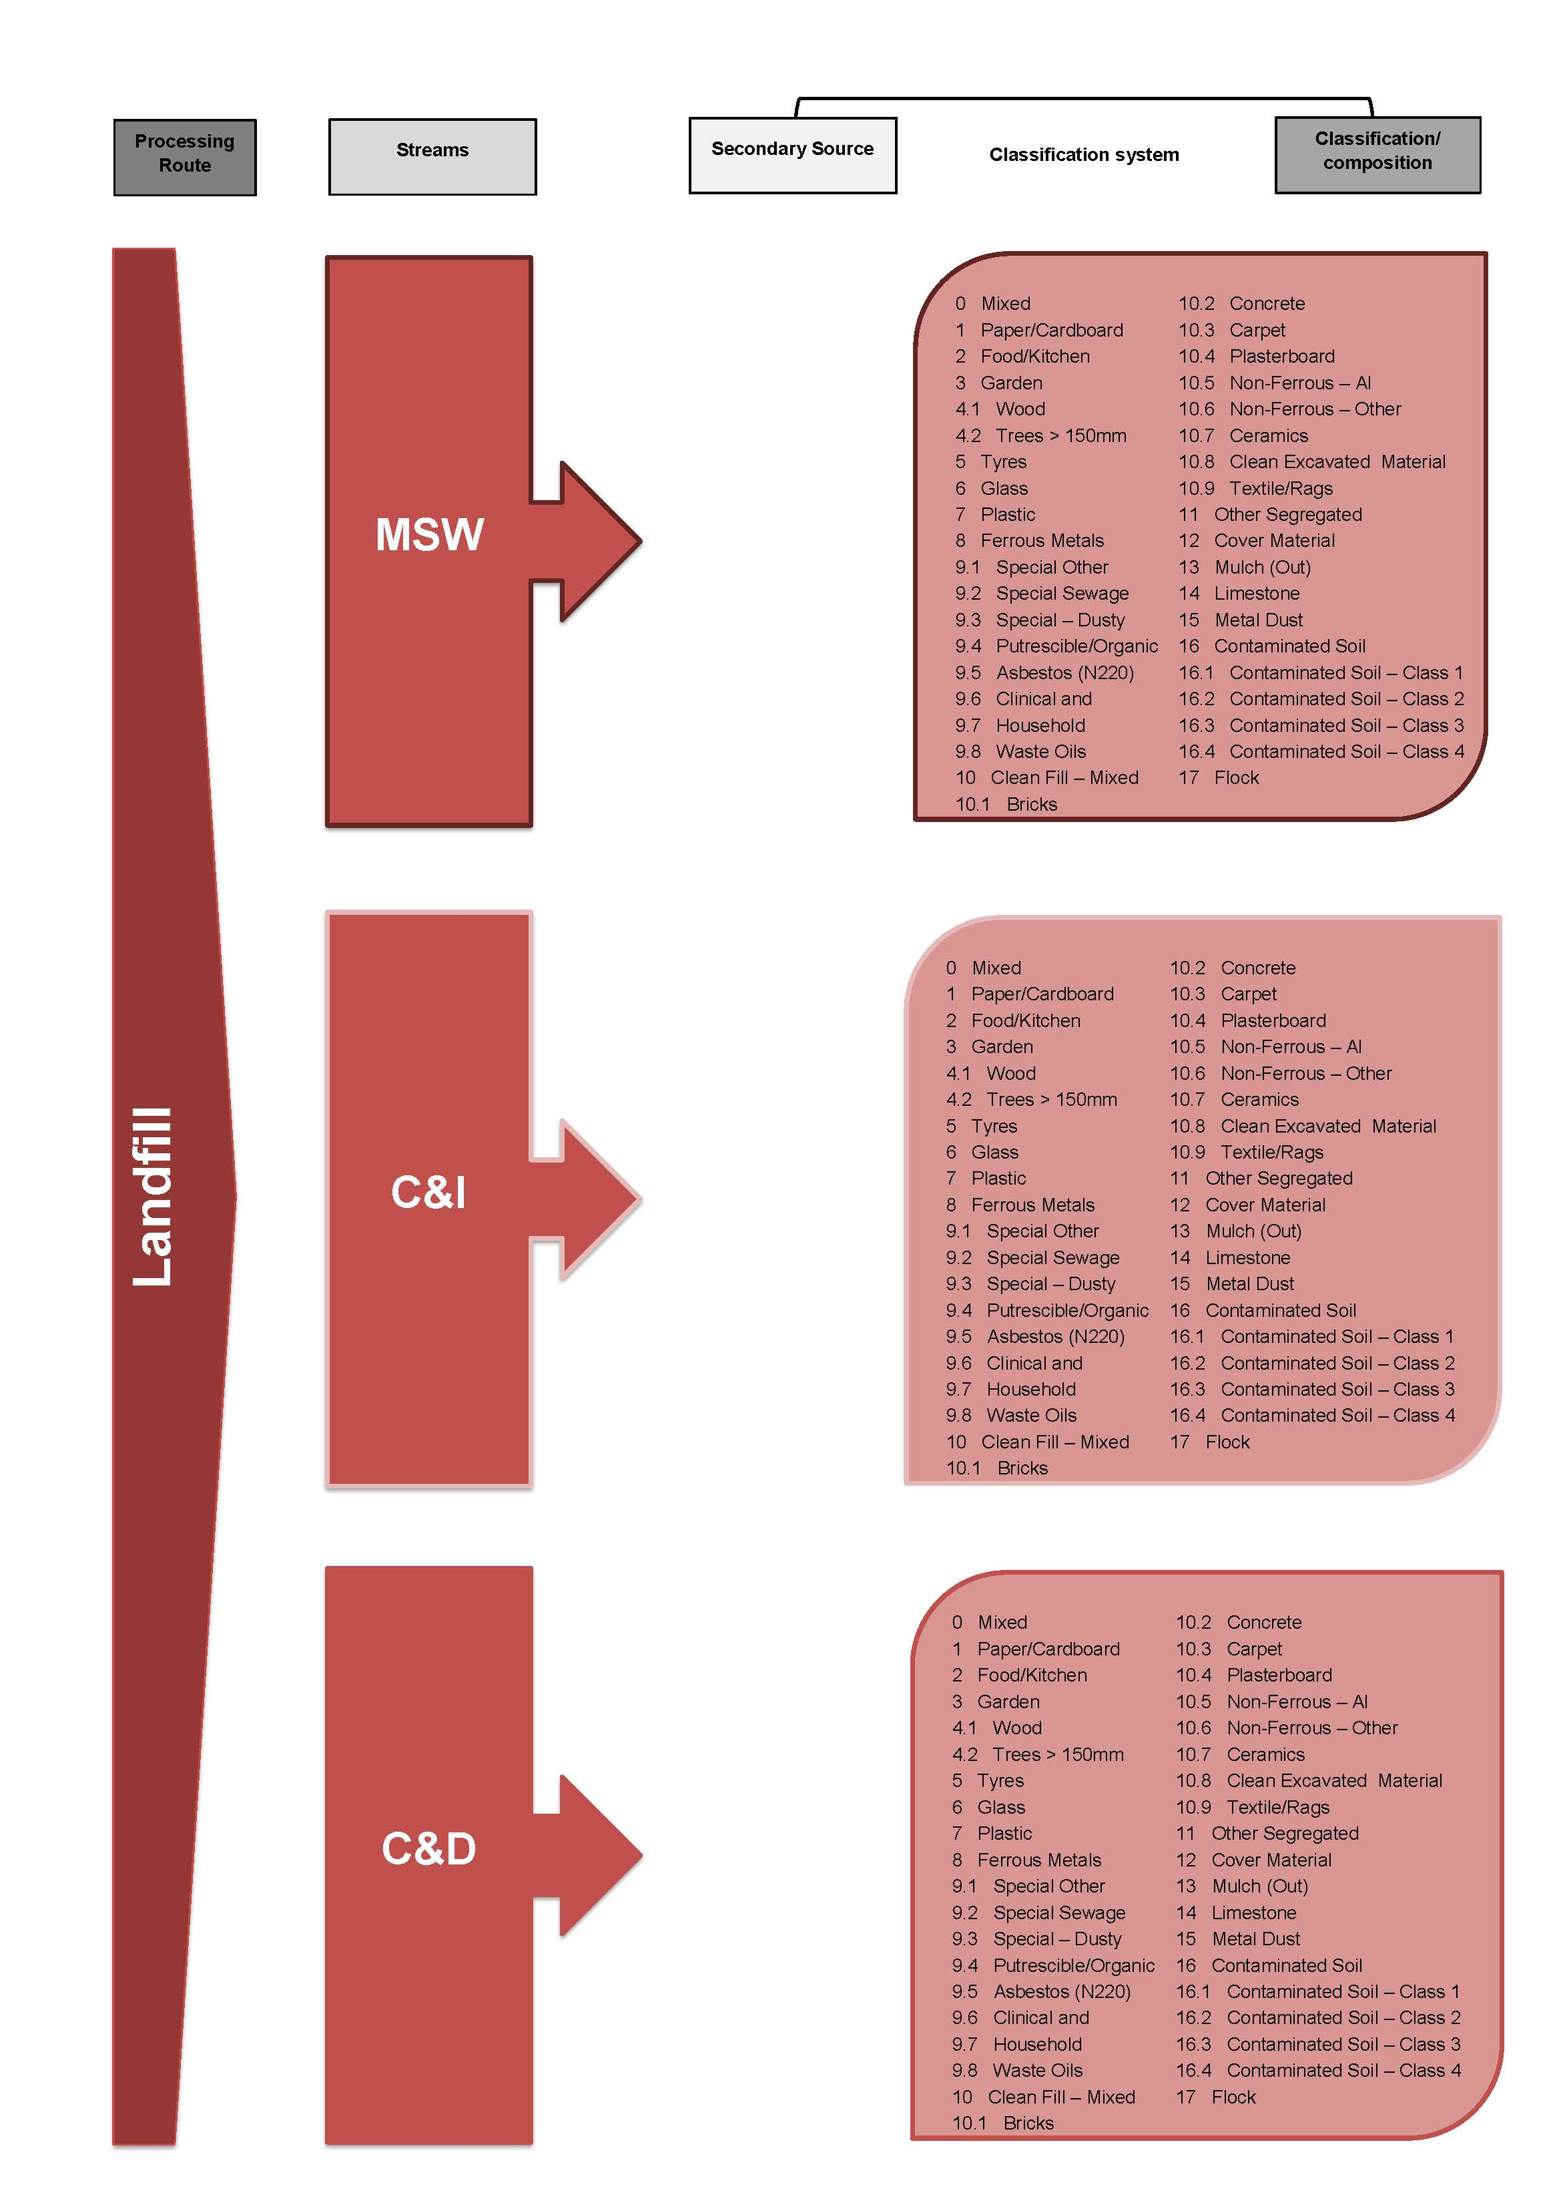
Figure 3-21 Local Government Census –Landfill (DEC)
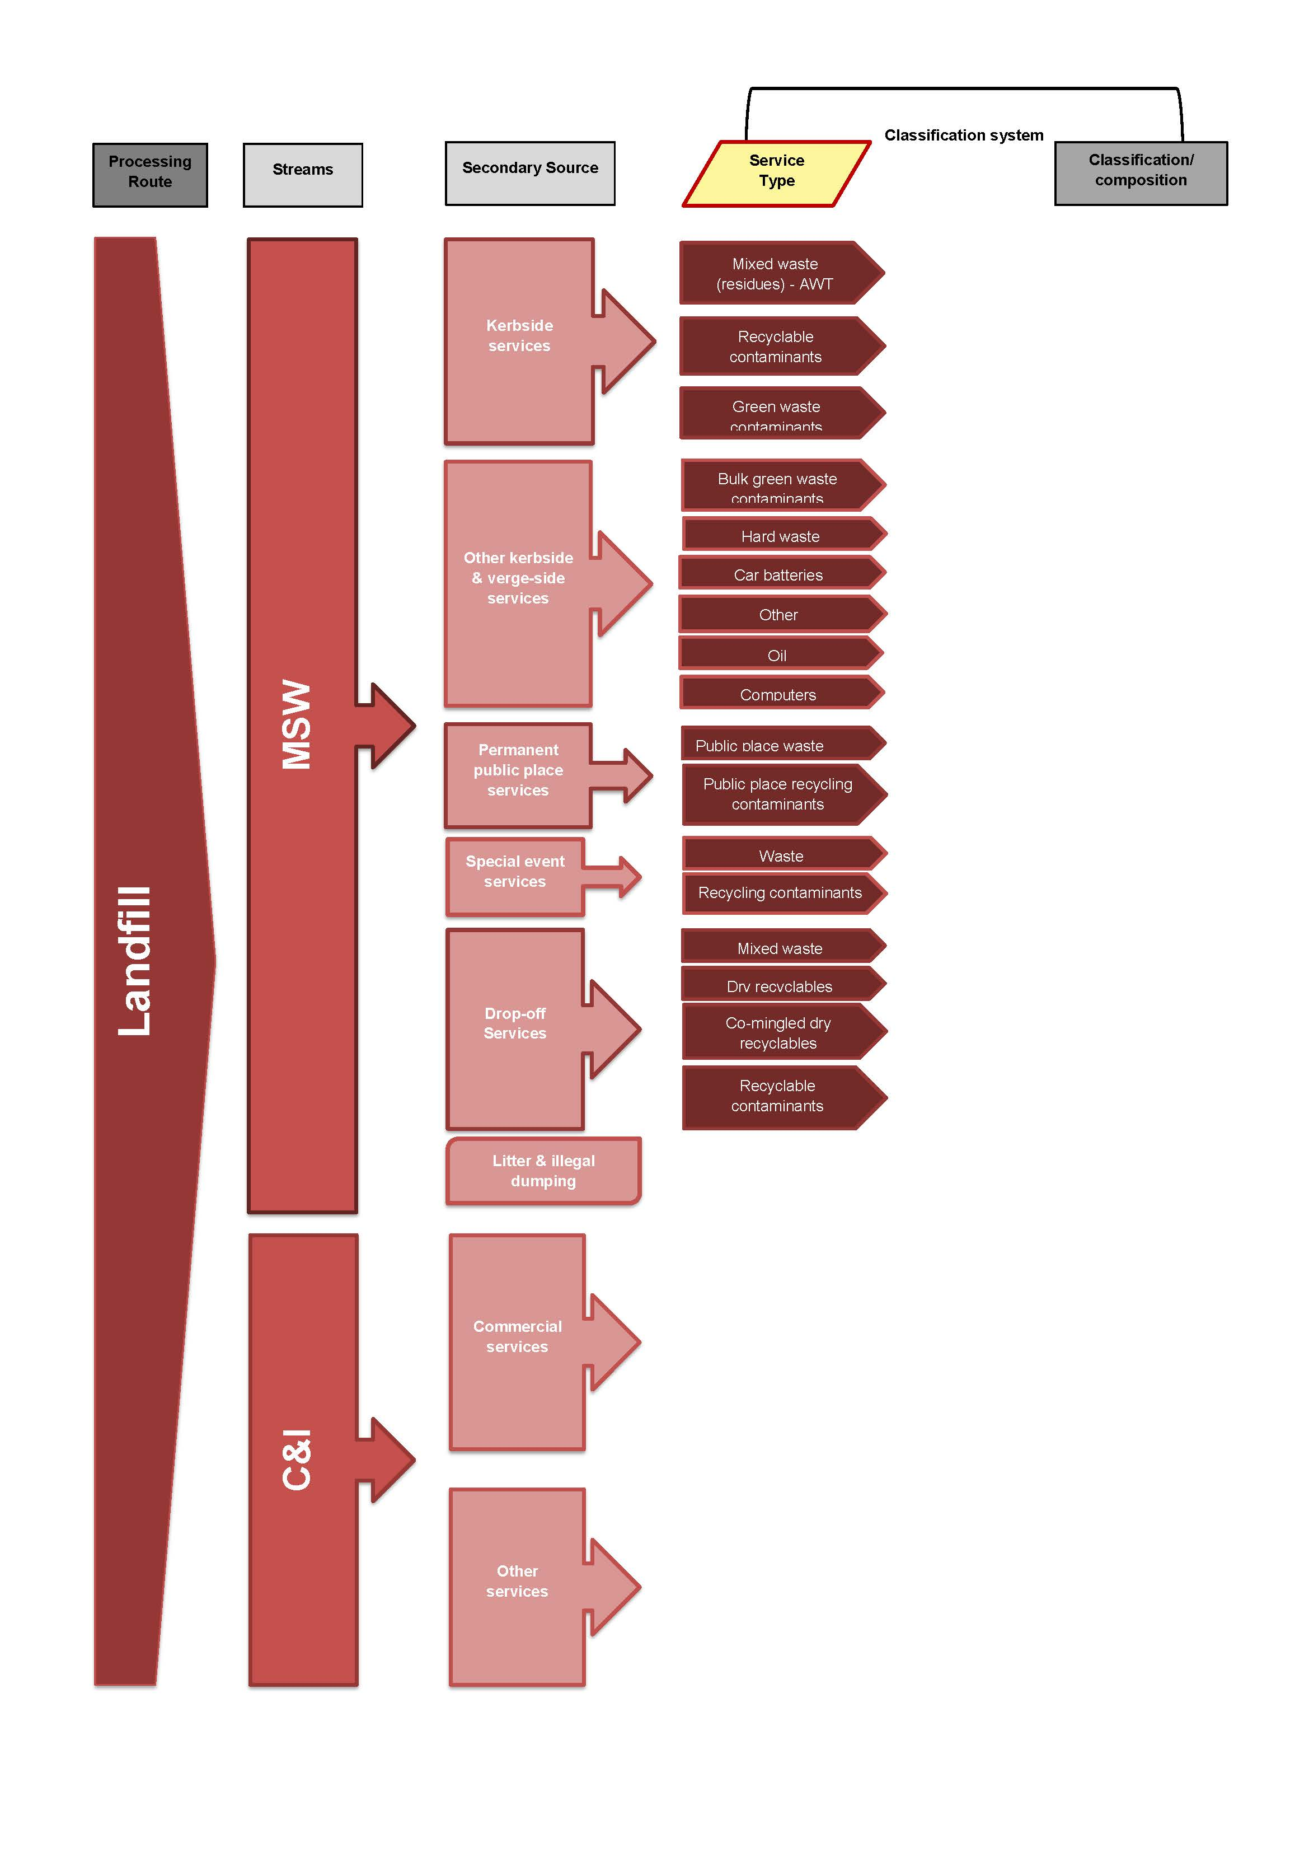
Figure 3-22 Local Government Census –Recovery (DEC)
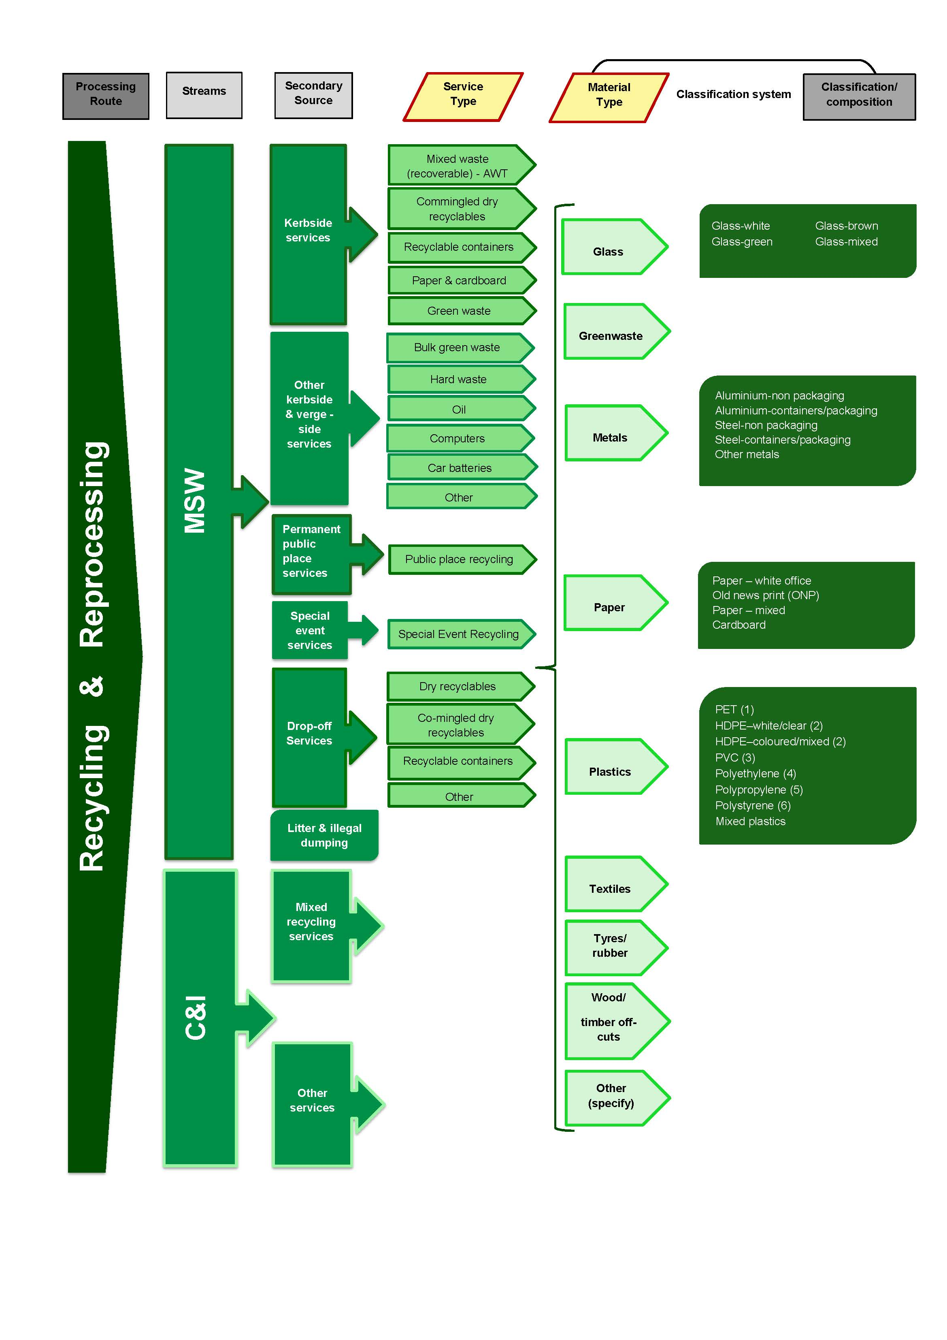

Figure 3-23 Reprocessing Industry Survey (DEC)
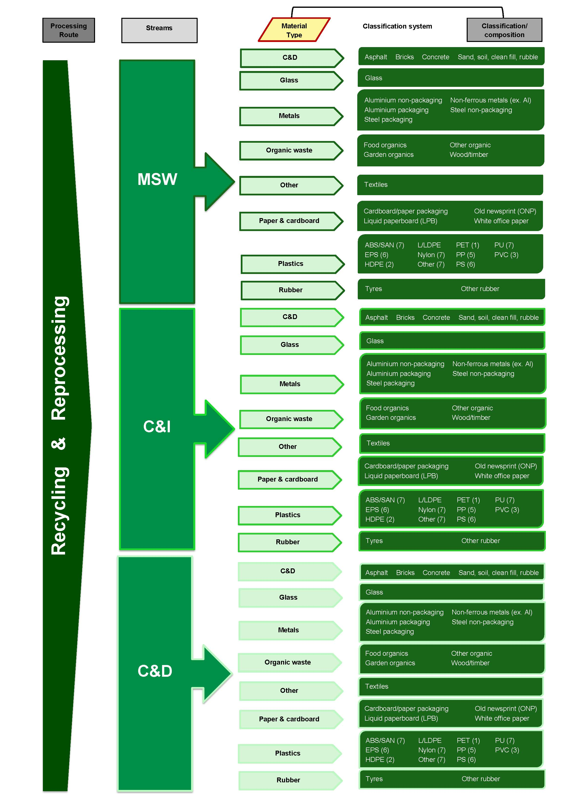
    - Comparison to the AWD
The degree of alignment between the National Waste Classification System developed under the AWD and each of the three classification systems identified as being used in Western Australia (by the Department of Environment and Conservation) has been assessed using the qualitative method described in Section 4.1. The results of this assessment are displayed in Table 3-14.

Table 3-14 Qualitative assessment of alignment between AWD and classification systems in Western Australia
 | Quarterly Metropolitan Landfill Reporting  (DEC) | Local Government Annual Census  (DEC) | Reprocessing Industry Survey  (DEC)
Processing / Disposal Route | 2 | 2 | 2
Waste Stream - Principal Source | 3 | 2 | 3
Sub-stream 1 - Secondary source | 1 | 1 | 1
Sub-stream 3 - Material composition | 3 | 2 | 2
Overall assessment | 2.25 | 1.75 | 2

Based on average results across all three of the Western Australia classification systems, overall this jurisdiction’s classification systems are considered partially aligned with the AWD.

Table 3-15 Key to qualitative assessment table
Alignment to AWD | Rating for each specific category | Overall rating based on average scores
Fully aligned | 3 | >2.5
Partially aligned | 2 | 2-2.5
Not aligned | 1 | <2

  - Tasmania
In April 2006 the Tasmanian Department of Tourism, Arts and the Environment (DTAE) introduced a system of Environment Protection Notices (EPNs) that impose waste data reporting obligations upon operators of municipal landfills. Under these EPNs, landfill operators must report waste data for each financial year, in accordance with the Tasmanian Solid Waste Classification System, which has been jointly adopted by State and Local Government.
The classification system, which is supported by an agreed set of definitions, is based on the National Waste Classification System developed under the AWD project.
Hyder understands that only a limited amount of data is currently being collected in Tasmania, specifically related to landfill disposal of waste from Waste Depots that are regulated by the EPA as Level 2 Activities, meaning they have the capacity to process greater than 100 tonnes per annum. There is also a legislative requirement to track the interstate movement of hazardous ‘listed’ waste materials.
State and Local Government in Tasmania have also agreed to jointly pursue the collection and reporting of waste data on a consistent basis with the following objectives in mind:
- To facilitate a consistent and coordinated approach to data collection, to allow for better characterisation and classification of waste streams, the amount of waste generated, waste diverted from landfill, resources recovered and materials recycled in the State
- To facilitate waste management strategic planning, budgeting and cost control for all levels of government
- To facilitate the identification of priority areas and opportunities for resource recovery; and
- To measure progress that is made in resource recovery.
The Tasmanian Government expects these steps will enable the production of better waste prevention strategies, and optimise recovery opportunities. Improved data collection and data management systems will provide a means to measure the progress of initiatives and actions designed to meet the objectives of the Tasmanian Waste and Resource Management Strategy 2009 and the National Waste Policy 2009.
Waste data is collected by the EPA Division each year from each of Tasmania's Level 2 landfills. This information is collated and published in the EPA's Annual Report.
Data from Waste Transfer Stations (WTS) is also vital to the development of a state-wide waste database. WTS are key facilities for resource recovery and WTS can ‘see’ information about waste (such as its source) which is invisible following consolidation and transport of that waste to a disposal point. As such, collection of waste data from WTSs has been flagged as vital to furthering the Government’s objectives. To assist Local Government, a model contract clause has also been provided for inclusion in WTS contracts.
In December 2006 and January 2007 DTAE, together with local government officers from each of Tasmania's three regions, conducted workshops on how to collect and report waste-related data. The material presented at the workshops included a sample reporting spreadsheet prepared by Hobart City Council.
Only one classification system has been identified as being used in Tasmania, and its alignment with the National Waste Classification System developed under the AWD is assessed in Section 4.7.1. The detailed classification system is also displayed graphically:
Figure 3-24 Reporting by Regulated Waste Depots (EPA Tasmania).

Figure 3-24 Reporting by Regulated Waste Depots (EPA Tasmania)
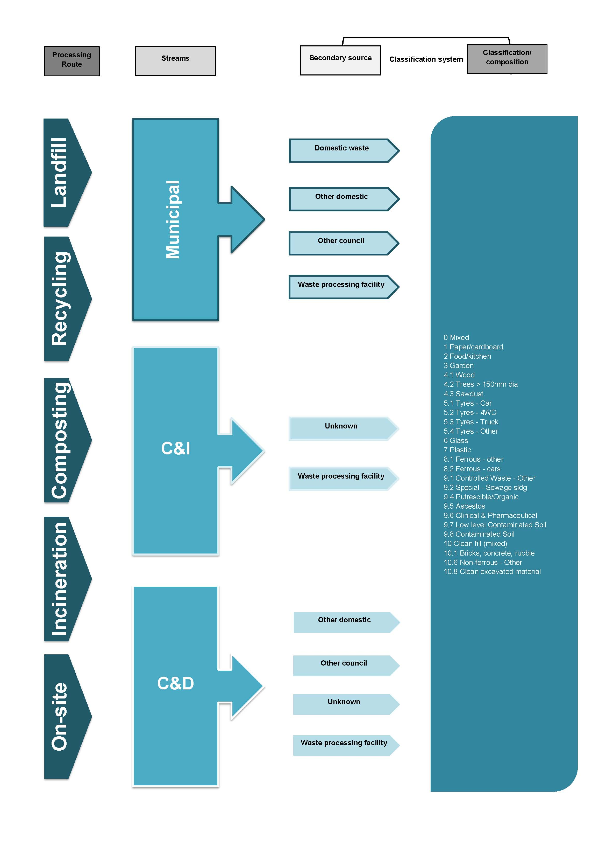

    - Comparison to the AWD
The degree of alignment between the National Waste Classification System developed under the AWD and the classification systems identified as being used in Tasmania (by the Tasmanian EPA) has been assessed using the qualitative method described in Section 4.1. The results of this assessment are displayed in Table 3-16.

Table 3-16 Qualitative assessment of alignment between AWD and classification systems in Tasmania
Reporting by Regulated Waste Depots (>100 tpa)
(EPA)
Processing / Disposal Route | 3
Waste Stream - Principal Source | 3
Sub-stream 1 - Secondary source | 3
Sub-stream 3 - Material composition | 3
Overall assessment | 3

It is evident that Tasmania has adopted the classification system proposed under the AWD, and this jurisdiction’s classification system is therefore considered fully aligned with the AWD.
It should be noted that some small differences do exist, including through the inclusion of some additional material composition categories in order to meet specific needs within Tasmania. However, these variations appear to have been carried out in a manner consistent with the intent of the National Waste Classification System, which was designed to provide some flexibility at this level of classification.

Table 3-17 Key to qualitative assessment table
Alignment to AWD | Rating for each specific category | Overall rating based on average scores
Fully aligned | 3 | >2.5
Partially aligned | 2 | 2-2.5
Not aligned | 1 | <2

  - Australian Capital Territory
The Territory and Municipal Services Directorate (TAMS) is responsible for managing waste collection and landfill services in the ACT, and carries out the majority of data collection and reporting in relation to waste. As the ACT Government owns the only landfill facility currently servicing the ACT, it has full access to the primary data from waste crossing the weighbridge. There are also four Waste Transfer Stations, four Recycling Drop-off centres, and a C&D Recycling Centre. One MRF is operated under contract in the region.
TAMS collects primary data from the landfill and other waste facilities across four main streams, which are defined as ‘commercial and industrial’, ‘construction and demolition’, ‘private delivery’ and ‘household collected’. The description of waste types typically categorised into these streams at the waste facility weighbridge is:
- ‘Commercial and industrial’ waste is considered to include general commercial waste, garden waste, animal processing waste, special burial waste and asbestos from commercial sources
- ‘Construction and demolition’ is considered to include builders waste, clean fill and treated fill
- ‘Private delivery’ is domestic waste delivered in a private vehicle
- ‘Household collected’ is municipal kerbside waste delivered by collection trucks that collect waste under contract to the ACT Government or Queanbeyan City Council (which is within NSW).
Fees for smaller waste quantities are charged according to load size rather than tonnage, and there are fee differences for different waste streams and materials. A strict operational procedure exists for landfill operators for visually assessing small loads by waste volume and categorising the load according to the waste stream.
It should be noted that ACT waste facilities accept waste from both the ACT region and Queanbeyan, and therefore domestic waste delivered by collection trucks comprises waste from both ACT and NSW households. Other waste streams are not categorised according to their geographical origin, with the assumption that all material is from the ACT.
TAMS has a range of internal uses for the raw data collected by waste facilities, predominantly annual and quarterly reporting. As there are very few waste facilities in the ACT, the most accurate data (which the government uses to determine flows of specific material types going to landfill) is gained through detailed waste audits.
The data structure for reporting material classes of waste received at facilities and for reporting waste audit data are therefore closely aligned. Waste audits are conducted periodically, with the most recent datasets from a domestic waste audit conducted in 2009 and a combined series of landfill audits undertaken in 2010.
The ACT Government undertakes an annual survey of recyclers, the Annual Recycling Industry Statistics Survey, which is sent to those companies actively involved in reprocessing industries. The survey is very short in format, with the intention that it can be completed within 10 minutes in order to increase the participation rate of companies. The survey form can be completed online or in paper form and allows companies to report total tonnages for a list of 24 higher classes of materials (such as Demolition Waste, Paper, Glass etc.) and specific classes of hazardous or problematic waste materials (such as Mobile phones, Tyres, Batteries etc.).
The Annual Recycling Industry Statistics Survey does not allow for reporting of subclasses of waste materials and the collected data provides an estimate only of the total amount of materials reprocessed on an annual basis as it is sent to companies identified by TAMS.
Hyder understands that material classifications used for reporting purposes in the C&D waste stream have been developed on the basis of weighbridge data procedures, interviews undertaken at waste facilities, and reviews of primary data.
As in all other jurisdictions, a separate classification system exists for the hazardous waste materials defined as ‘Controlled Waste’. Data on waste tracking is collected for all transport and handling activities associated with the movement of Controlled Waste, which is legislated by the Environment Protection Regulation 2005 (Part 7) in accordance with the Controlled Waste NEPM.
The ACT has not legislated its own list of waste materials that are classified as Controlled Waste, with the statute (EPR 2005 Schedule 7.1) defining the ‘Controlled Waste’ class as:
‘…a thing mentioned in the NEPM, schedule A, list 1 (Waste categories) if it has 1 or more of the characteristics mentioned in the NEPM, schedule A, list 2 (Characteristics of controlled wastes).’
In addition to the statutory requirement to track certified movements of controlled waste, the ACT Government has a statutory requirement to publish an Annual Report in which waste and resource recovery statistics are required to be reported. The legislation which requires the publishing of this annual report also specifies a number of ‘Accountability Indicators’ and waste data is classified within these requirements.
Raw data on waste and recycling tonnages is also reported annually to the public in the form of graphical fact sheets on the TAMS website, and key waste data is compiled in the annual State of the Environment Report.
The ACT Government recently introduced the Draft ACT Sustainable Waste Strategy 2010- 2025, and is in the progress of finalising a waste strategy. It is expected that waste data collection will also contribute to future progress reports on the implementation of policies within the strategy. Certain waste material categories are also tracked for contractual purposes, for example some resource recovery contracts have a limited amount of free access to landfill as part of their contract.
Two distinct classification systems have been identified as being used in the ACT, and their alignment with the National Waste Classification System developed under the AWD is assessed in Section 4.8.1. The detailed classification systems are also displayed graphically:
Figure 3-25 ACT General waste data (TAMS)
Figure 3-26 ACT Annual Recycling Industry Statistics Survey (TAMS).

Figure 3-25 ACT General waste data (TAMS)
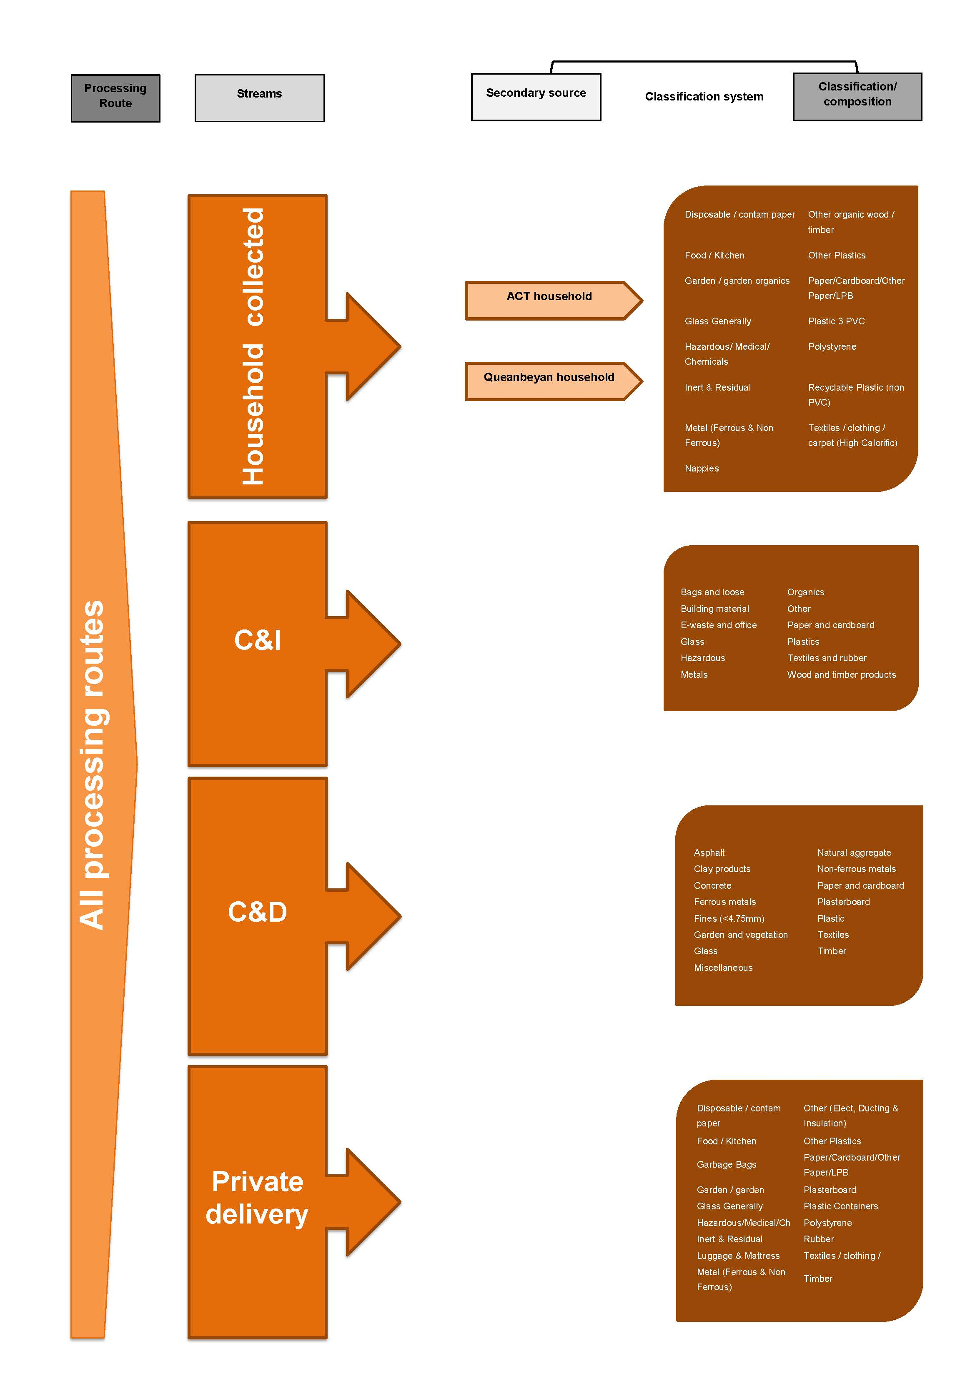
Figure 3-26 ACT Annual Recycling Industry Statistics Survey (TAMS)

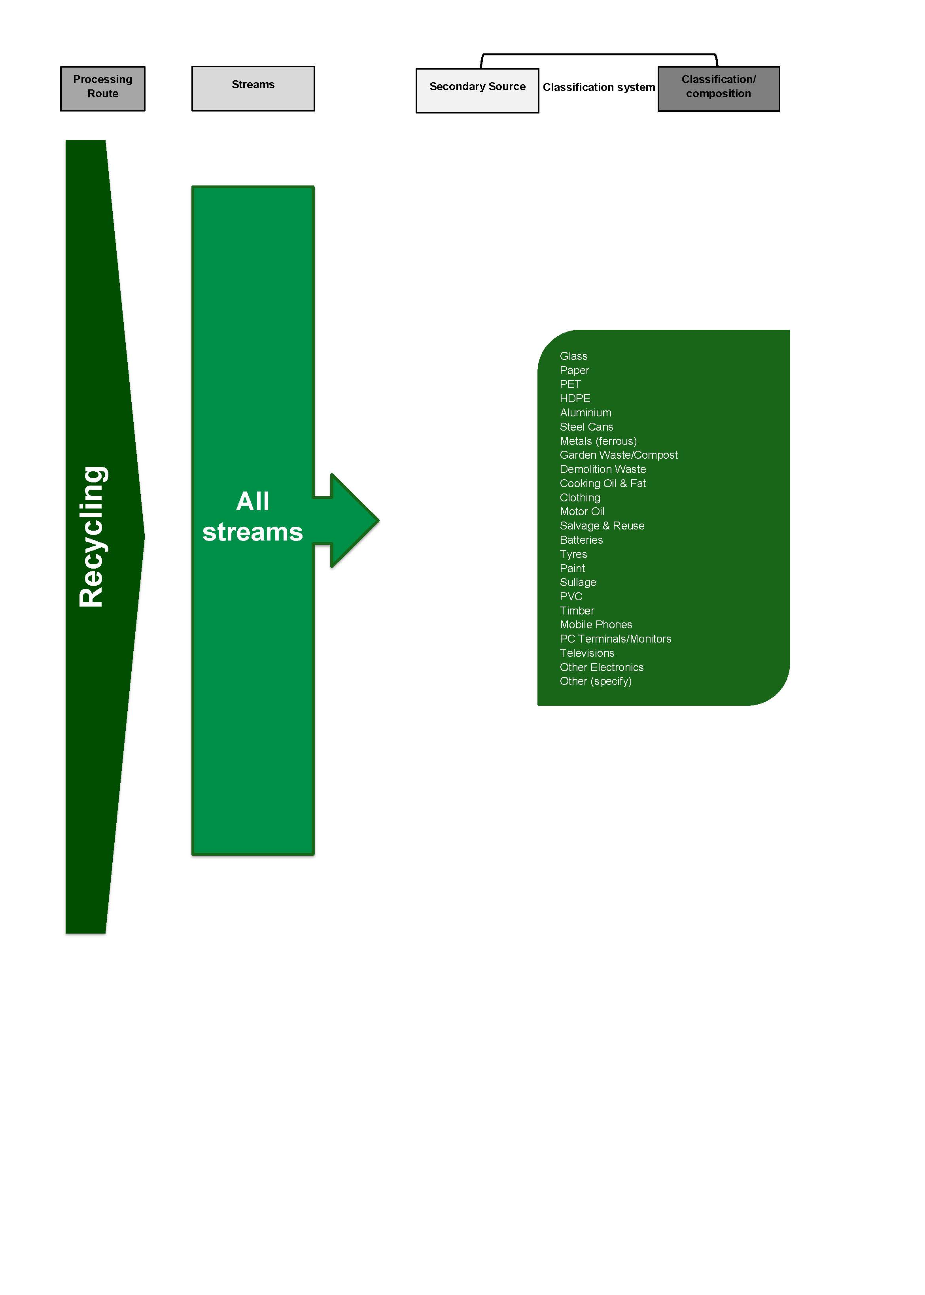
    - Comparison to the AWD
The degree of alignment between the National Waste Classification System developed under the AWD and each of the two classification systems identified as being used in the ACT (by Territory and Municipal Services – TAMS) has been assessed using the qualitative method described in Section 4.1. The results of this assessment are displayed in Table 3-14.

Table 3-18 Qualitative assessment of alignment between AWD and classification systems in Western Australia
 | General Waste Data  (TAMS) | Annual Recycling Statistics Return  (TAMS)
Processing / Disposal Route | 1 | 2
Waste Stream - Principal Source | 2 | 1
Sub-stream 1 - Secondary source | 1 | 1
Sub-stream 3 - Material composition | 1 | 1
Overall assessment | 1.25 | 1.25

Based on average results across the two ACT classification systems, overall this jurisdiction’s classification systems are considered not aligned with the AWD.
Reasons for the ACT to have developed a unique classification system were discussed in Section 4.8.

Table 3-19 Key to qualitative assessment table
Alignment to AWD | Rating for each specific category | Overall rating based on average scores
Fully aligned | 3 | >2.5
Partially aligned | 2 | 2-2.5
Not aligned | 1 | <2

  - Northern Territory
A Northern Territory Waste Strategy is expected to be released in mid-2012, and based on discussion associated with this current study Hyder understands that there will be additional waste-related data collection and reporting undertaken in the near future. A container deposit scheme is also due to start in 2012, and there will be additional data collection activities for the targeted materials, although associated classifications are not available yet.
Currently, there are two territory-wide reporting pathways for quantitative waste data:
- Annual Audit & Compliance Report for licensed landfill facilities
- tracking the movement of ‘listed’ waste materials.
Licensed waste facilities (of which there is a limited number, less than 10) are required to participate in the audit to meet license conditions.
Waste categories are largely reported at the discretion of the landfill operator at the current time, with a number of optional blank fields for data rather than specific classifications.
As flagged above, there are a very limited number of sizeable landfill operations within the NT that have the capacity to collect data. In terms of resource recovery classifications, the relevant categories are limited to Electronics and Whitegoods, as well as some C&D waste materials.
No data is collected systematically from local government, although most landfills are operated by councils. Some councils do undertake periodic waste audits, and the information can be made available to the NT Government, although there are no formal requirements to do so.
No specific data is collected on C&I waste streams in the NT, although the Territory Government has undertaken an audit of several specific problem waste categories. The results of this audit are not currently publicly available.
Categories of hazardous waste investigated in the 2006 audit of industrial waste streams were:
- Quarantine and medical wastes
- Putrescible liquid wastes
- Metal protective coating wastes
- Waste oils
- Radioactive wastes
- Intermittently generated chemical wastes
- Other wastes (including sandblasting and tyres).
One classification system has been identified as being used in the Northern Territory, and its alignment with the National Waste Classification System developed under the AWD is assessed in Section 4.9.1. The detailed classification system is also displayed graphically:
Figure 3-27 Annual Audit and Compliance Report for Licensed Waste Facilities (NREAS).

Figure 3-27 Annual Audit and Compliance Report for Licensed Waste Facilities (NREAS)
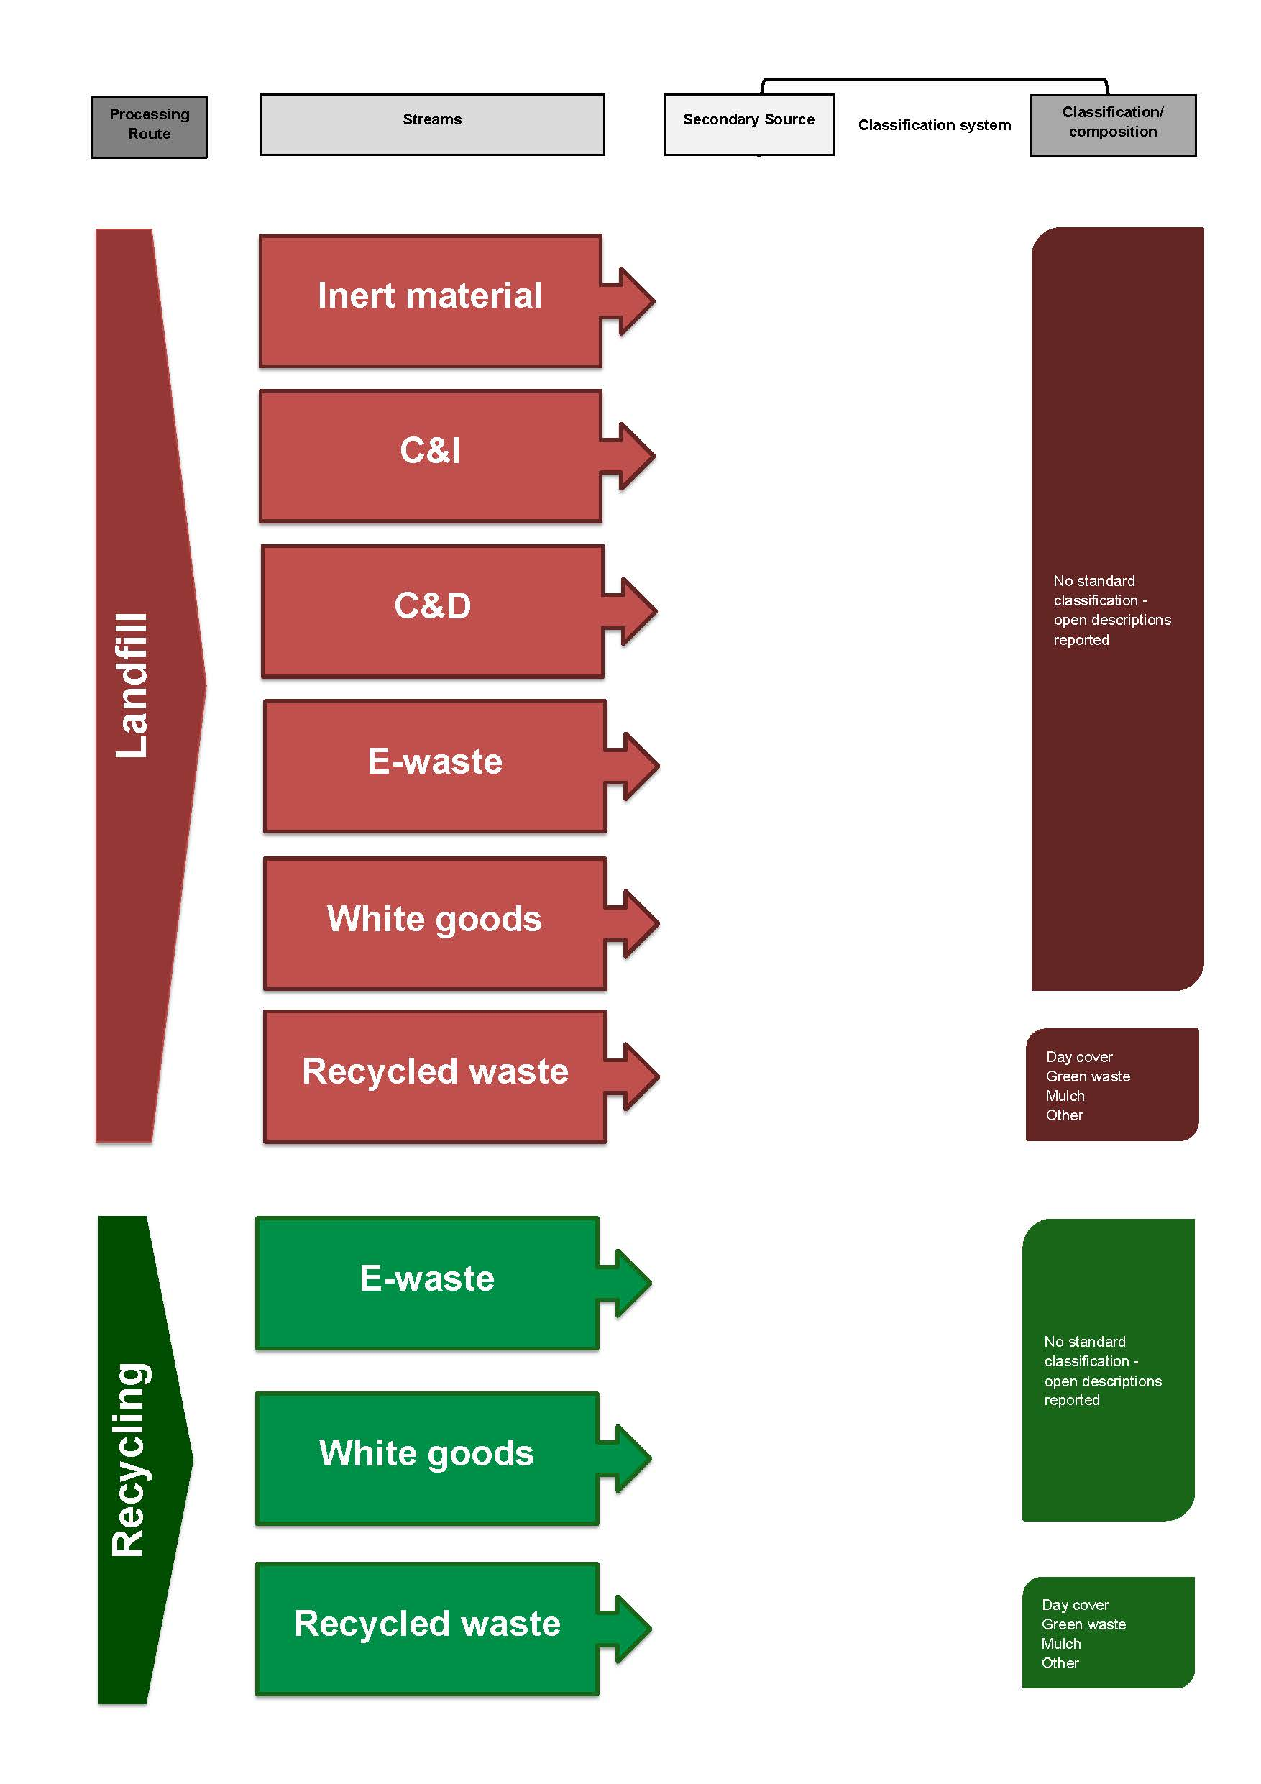

    - Comparison to the AWD
The degree of alignment between the National Waste Classification System developed under the AWD and the classification system identified as being used in the Northern Territory (by the Department of Natural Resources, Environment, the Arts and Sport - NREAS) has been assessed using the qualitative method described in Section 4.1. The results of this assessment are displayed in Table 3-16.

Table 3-20 Qualitative assessment of alignment between AWD and classification systems in Tasmania
Annual Audit and Compliance Report for Licensed Waste Facilities
(NREAS)
Processing / Disposal Route | 2
Waste Stream - Principal Source | 1
Sub-stream 1 - Secondary source | 1
Sub-stream 3 - Material composition | 1
Overall assessment | 1.25

Based on the results summarised above, the Northern Territory classification system is, overall, considered not aligned with the AWD.

Table 3-21 Key to qualitative assessment table
Alignment to AWD | Rating for each specific category | Overall rating based on average scores
Fully aligned | 3 | >2.5
Partially aligned | 2 | 2-2.5
Not aligned | 1 | <2

- Controlled Waste NEPM
A national approach to the management of hazardous waste materials was developed in 1998, when the (then) National Environment Protection Council instigated a National Environment Protection Measure (NEPM) to cover the transport of controlled waste between Australian states and territories.
The National Environment Protection (Movement of Controlled Waste between States and Territories) Measure 2004, otherwise referred to as the Controlled Waste NEPM, is designed to provide a comprehensive national system for monitoring and reporting all interstate movements of controlled waste, in line with Australia’s international obligations under the Basel Convention.
All Australian jurisdictions have incorporated provisions of the Controlled Waste NEPM into relevant state and territory legislation in order to monitor the production, movement and treatment / disposal of controlled wastes across borders.
In addition, most jurisdictions also have statutory powers to control the movement of hazardous waste materials within their own borders and this may or may not include all of the materials listed under the Controlled Waste NEPM. In some cases these jurisdictional-specific powers place controls on an additional set of materials, which are not included in the NEPM.
All generators, transporters and facility operators handling controlled wastes, as defined under the NEPM, are required to comply with data management, tracking and other provisions under the relevant legislation.
Table 5-22 sets out the waste codes and descriptions of materials which must be tracked if crossing any state or territory border under the National Environment Protection (Movement of Controlled Waste between States and Territories) Measure 2004 (Schedule A, List 1). Waste codes reflect either the contaminants or source of the waste.
The classification systems used within each jurisdiction to control the movement of hazardous wastes are discussed in Section 5.1.

Table 5-22 Waste codes and materials, as set out in the Controlled Waste NEPM
Waste Code | Waste stream or wastes having as constituents:
B100 | Acidic solutions or acids in solid form
K100 | Animal effluent and residues (abattoir effluent, poultry and fish processing waste)
D170 | Antimony, antimony compounds
D130 | Arsenic, arsenic compounds
N220 | Asbestos
D290 | Barium compounds other than barium sulphate
C100 | Basic solutions or bases in solid form
D160 | Beryllium, beryllium compounds
D310 | Boron compounds
D150 | Cadmium, cadmium compounds
N230 | Ceramic-based fibres with physico-chemical characteristics similar to those of asbestos
D350 | Chlorates
D140 | Chromium compounds that are hexavalent or trivalent
R100 | Clinical and related wastes
D200 | Cobalt compounds
N100 | Containers that are contaminated with residues of a listed waste
D190 | Copper compounds
A130 | Cyanides (inorganic)
M210 | Cyanides (organic)
N160 | Encapsulated, chemically fixed, solidified or polymerised wastes
G100 | Ethers
N190 | Filter cake
N190 | Fire debris and fire washwaters
N140 | Fly ash
N150 | Grease trap waste
G150 | Halogenated organic solvents
M260 | Highly odorous organic chemicals (including mercaptans and acrylates)
D110 | Inorganic fluorine compounds excluding calcium fluoride
D330 | Inorganic sulphides
M220 | Isocyanate compounds
D220 | Lead; lead compounds
D120 | Mercury; mercury compounds
D100 | Metal carbonyls
D210 | Nickel compounds
D300 | Non toxic salts
H110 | Organic phosphorus compounds
G110 | Organic solvents excluding halogenated solvents
M160 | Organohalogen compounds - other than substances referred to in this list
D340 | Oxidising agents
M150 | Perchlorates
D360 | Phenols, phenol compounds including chlorophenols
T120 | Phosphorus compounds excluding mineral phosphates
M170 | Polychlorinated dibenzo-furan (any congener)
M180 | Polychlorinated dibenzo-p-dioxin (any congener)
T210 | Reactive chemicals
T220 | Reducing agents
T190 | Residues from industrial waste treatment/disposal operations.
D240 | Selenium; selenium compounds
N120 | Soils contaminated with a controlled waste
M250 | Surface active agents (surfactants), containing principally organic constituents and which may contain metals and inorganic materials
K140 | Tannery wastes (including leather dust, ash, sludges and flours)
D250 | Tellurium, tellurium compounds
D180 | Thallium; thallium compounds
M230 | Triethylamine catalysts for setting foundry sands
T140 | Tyres
D270 | Vanadium compounds
T100 | Waste chemical substances arising from research and development or teaching activities including those which are not identified and/or are new and whose effects on human health and/or the environment are not known
E100 | Waste containing peroxides other than hydrogen peroxide
A120 | Waste from heat treatment and tempering operations containing cyanides
H170 | Waste from the manufacture, formulation and use of wood-preserving chemicals
R140 | Waste from the production and preparation of pharmaceutical products
R120 | Waste from the production, formulation and use of biocides and phytopharmaceuticals
F100 | Waste from the production, formulation and use of inks, dyes, pigments, paints lacquers and varnish
G160 | Waste from the production, formulation and use of organic solvents
T120 | Waste from the production, formulation and use of photographic chemicals and processing materials
F110 | Waste from the production, formulation and use of resins, latex, plasticisers, glues and adhesives
J100 | Waste mineral oils unfit for their original intended use
E120 | Waste of an explosive nature not subject to other legislation
J120 | Waste oil/water, hydrocarbons/water mixtures or emulsions
R120 | Waste pharmaceuticals, drugs and medicines
A100 | Waste resulting from surface treatment of metals and plastics
J160 | Waste tarry residues arising from refining, distillation, and any pyrolytic treatment
M100 | Waste, substances and articles containing or contaminated with polychlorinated biphenyls (PCBs), polychlorinated naphthalenes (PCNs), polychlorinated terphenyls (PCTs) and/or polybrominated biphenyls (PBBs)
K190 | Wool scouring waste
D230 | Zinc compounds

  - Controlled waste by jurisdictions
A review of the controlled waste classification systems used in each Australian jurisdiction has been undertaken for this current study. Appendix A lists the waste classifications identified in the Controlled Waste NEPM (as per Table 5-22), which is applicable to interstate movements of materials in all jurisdictions. The Appendix compares these NEPM classifications with the classifications used within each jurisdiction for the movement of controlled wastes.
It is noted that, in some instances, the classification system used in relation to the movement of controlled waste within a jurisdiction may differ from the classification used for the movement of controlled waste across jurisdictional borders. For example, the classification system displayed in Appendix A for South Australia relates to the movement of controlled waste within the state.
There is generally a high degree of similarity between the controlled waste classifications used within each jurisdiction, which is to be expected given the national approach to developing the Controlled Waste NEPM. There are, however, some instances where individual jurisdictions have not adopted the same classifications included under the NEPM for intra-state hazardous waste movements, as highlighted within the Appendix.
There may be a number of reasons for the differences between the jurisdictions, including different characteristics of the controlled waste generated in a specific jurisdiction, but these issues were not investigated within this current study.
There are also differences related to the inclusion of additional waste material classifications within each jurisdiction, with the exception of the ACT. Additional categories included with the relevant legislation by each Australian jurisdiction are displayed in Table 5-23. South Australia in particular has expanded its list of intrastate controlled wastes well beyond the materials listed under the Controlled Waste NEPM.

Table 5-23 Additional categories included under jurisdictional provisions relating to management of controlled wastes, compared with the Controlled Waste NEPM
New South Wales | Victoria | Queensland | South Australia | Western Australia | Tasmania | Northern Territory
Cytotoxic | Animal and vegetable oils and derivatives | Food processing waste | Alkali metals and alkaline earth metals | Organochlorine pesticides (OCPs) | A waste within the meaning of the Quarantine Regulations 2000 of the Commonwealth, as amended | Sewerage sludge and residues including nightsoil and septic tank sludge
Dangerous goods nos | Caustic neutralised wastes containing metallic constituents | Pesticides, including organochlorine | Calcium carbide | Polychorinated Biphenyls (PCBs) | Exhibits an environmentally significant characteristic and is derived or arises from a poison as defined in the Poisons Act 1971
Industrial waste nos | Heterocyclic organic compounds | Sewage sludge and residues, including nightsoil and septic tank sludge | Carbon disulphide | Sewage | Exhibits an environmentally significant characteristic and is derived or arises from a scheduled waste within the meaning of a National Management Plan*
Inert sludges or slurries | Inert sludges or slurries | tallow | Carcinogens teratogens and mutagens | Vegetable and food processing waste | Exhibits an environmentally significant characteristic and is derived or arises from an agvet chemical as defined in the Dangerous Substances (Safe Handling) Act 2005
Inorganic compounds nos | Inorganic chemicals (not otherwise specified) | vegetable oils | Cytotoxic wastes |  | Exhibits an environmentally significant characteristic and is derived or arises from dangerous goods as defined in the Dangerous Goods (Safe Transport) Act 1998
Liquid food waste | Non-halogenated organic chemicals (not otherwise specified) |  | Dangerous substances within the meaning of the Dangerous Substances Act 1979 |  | Sewage sludge, sewage residue, nightsoil or sludge from an on-site waste water management system
Non-controlled liquids | Silver and silver compounds |  | Distillation residues
Not characterised | Spent catalysts |  | Heterocyclic organic compounds containing oxygen, nitrogen or sulphur
Organic compounds nos | Textile effluent and residues (not otherwise specified) |  | Hydrocarbons and their oxygen, nitrogen and sulphur compounds (including oils)
Quarantine waste | Vegetable, fruit, food processing effluent |  | Laboratory chemicals
Reserved | Vehicle, machinery and industrial washwaters with or without detergents |  | Lime sludges or slurries
Sewage sludge & residues |  |  | Manganese compounds
 |  |  | Medical waste consisting of— (a) a needle, syringe with needle, surgical instrument or other article that is discarded in the course of medical*, dental or veterinary practice or research and has a sharp edge or point capable of inflicting a penetrating injury on a person who comes into contact with it; or
 |  |  | Medical waste consisting of— (b) human tissue, bone, organ, body part or foetus; or
 |  |  | Medical waste consisting of— (c) a vessel, bag or tube containing a liquid body substance; or
 |  |  | Medical waste consisting of— (d) an animal carcass discarded in the course of veterinary or medical* practice or research; or
 |  |  | Medical waste consisting of— (e) a specimen or culture discarded in the course of medical*, dental or veterinary practice or research and any material that has come into contact with such a specimen or culture; or
 |  |  | Medical waste consisting of— (f) any other article or matter that is discarded in the course of medical*, dental or veterinary practice or research and that poses a significant risk to the health of a person who comes into contact with it.
 |  |  | Nitrates
 |  |  | Organometallic residues
 |  |  | Paint sludges and residues
 |  |  | Pesticides (including herbicides and fungicides)
 |  |  | Poisons within the meaning of the Drugs Act 1908
 |  |  | Silver compounds and solutions
 |  |  | Solvent recovery residues

- Summary and discussion
The overall alignment of each jurisdiction’s classification systems with key features of the National Waste Classification System developed under the AWD is displayed in Table 6-24, based on average assessment scores for each of the identified classification systems within each jurisdiction.
Tasmania is the only jurisdiction which has a classification system considered to be fully aligned with the AWD system, while the classification systems in NSW and WA are (overall) considered partially aligned with the AWD system. The classification systems in Victoria, Queensland, SA, the ACT and the NT are not aligned to the AWD.
It is noted that the classification systems used in Tasmania and WA were developed relatively recently, at a time where the AWD classification system was available to the developers as a reference point. NSW is also understood to have had a relatively long history of waste classification system use, and was quite involved in the development of the AWD system; this may explain the jurisdiction’s classifications being partially aligned with the AWD classification.

Table 6-24 Summary of the degree of alignment between jurisdictional classifications and the AWD
 | NSW | VIC | QLD | SA | WA | TAS | ACT | NT
Processing / Disposal Route | 2.0 | 1.8 | 2.0 | 1.8 | 2.0 | 3.0 | 1.5 | 2.0
Waste Stream - Principal Source | 2.7 | 1.8 | 1.8 | 1.3 | 2.7 | 3.0 | 1.5 | 1.0
Sub-stream 1 - Secondary source | 1.7 | 1.3 | 1.0 | 1.0 | 1.0 | 3.0 | 1.0 | 1.0
Sub-stream 3 - Material composition | 1.7 | 1.3 | 1.3 | 1.5 | 2.3 | 3.0 | 1.0 | 1.0
Overall assessment | 2.0 | 1.5 | 1.5 | 1.4 | 2.0 | 3.0 | 1.3 | 1.3

Key to qualitative assessment | Fully aligned – Av. score >2.5 | Partially aligned – Av. score 2-2.5 | Not aligned – Av. Score <2

Based on information Hyder gathered from stakeholders contacted during the data gathering phase of this current study, there is anecdotal evidence of in-principle support within various government agencies for finding a nationally consistent classification system on which to collect and report waste-related data.
Several stakeholders did also, however, point out the accuracy and precision (i.e. the quality) of the waste data collected at the jurisdictional level throughout Australia is almost as critical to the issue of national consistency as the data structure or classification systems used in the collection process.
In some jurisdictions (generally those with landfill levies) there may be legislative requirements to measure and report certain waste-related information. In other jurisdictions and regions, there may effectively be voluntary reporting requirements (or compliance may not be enforced).
It is noted that the Australian Bureau of Statistics is able to use statutory powers to collect information, including in relation to some waste management activities. However, some non-coded landfills as well as a significant portion of the organisations involved in recycling and reprocessing are outside the scope of the industry codes used by the ABS to gather data.
At a jurisdictional level, there is an important distinction to be made between the availability of a classification system, and the application of this classification system.
Data quality appears to vary considerably both between the jurisdictions and between the different reporting pathways within each jurisdiction. For example, data collected through licensed landfill reporting may be considered to be rigorous when it is systematically audited to ensure compliance with license requirements and accurate payment of landfill levies. In contrast, some surveys conducted by external organisations, and relating to certain waste stream materials, may be considered to provide indicative information only, and may not be representative of the whole state, not inclusive of all reprocessing pathways and companies, or both.
A thorough assessment of the quality of waste data gathered by the jurisdictions is beyond the scope of this study, although Hyder considers this issue may warrant further consideration and research. By comparing the quality of information available with the data collection systems in place, it may be possible to better identify the most successful systems. It is suggested that the ABS should be included in any review, given its potential to gather information that may not be available to other organisations.
This current study details the key waste classification systems that are currently used across Australia. A total of 24 systems (23 jurisdictional, and 1 national system) are discussed and graphically displayed.
The variety of systems in use is primarily due to the different functions these classifications are designed to perform. In particular, there is a distinction between the systems designed for classifying waste to landfill, and the systems designed for classifying various recycling activities.
While the classification system developed as part of the AWD project attempted to serve all processing / disposal streams within one system, it is noted that recycling and reprocessing activities in 2011 are, generally, more widespread than they were in the 1990s (and new technologies, such as Mechanical Biological Treatment systems have since been developed in several jurisdictions). Any future efforts to develop consistent national classification systems may be more successful if these two general material pathways are considered separately. A certain degree of consistency would be required, however, in order to ensure the commonly used mass balance equation is still applicable: i.e. waste generation = waste to disposal + waste to recycling / recovery.
As highlighted above, there appears to be general support for the development of a system to encourage national consistency in data collection and reporting, with the potential benefits this may provide being well recognised by a range of stakeholders. This current study has, however, identified a number of factors that may have contributed to the limited success of the AWD project, which attempted to address these issues more than two decades ago.
It is recommended that any future attempt to develop national consistency takes account of the reasons the AWD project did not meet its objectives, and in particular:
- Ensure high-level, in-principle support for development of a system prior to the detailed design phase
- Ensure stakeholder buy in, possibly including joint financial commitment and/or EPHC-equivalent endorsement, so all jurisdictions have the opportunity of taking an equal role in system development
- Ensure there is a commitment to the long-term support of any project; there are limited benefits of investing in the development of a waste data system if there is no funding commitment to ensure the regular provision of data.

Appendix A
Jurisdictional classifications associated with implementation of the Controlled Waste NEPM

Table 6-25 Jurisdictional classifications associated with management of controlled waste, compared with the Controlled Waste NEPM.
The classifications used within each jurisdiction are compared to Schedule A, List 1 of the Controlled Waste NEPM. Note that the jurisdictional classification systems may be used for the intra-state movement of controlled waste, while the Controlled Waste NEPM is focused on inter-state movements. Grey cells denote classifications that appear in the NEPM list, but are not included in the relevant jurisdictional list. Orange cells denote areas where the terminology between the NEPM list and the jurisdictional list are not consistent, but the intent of the classification appears consistent. Any additional categories adopted by a jurisdiction are shown in Table 5-23.
NEPM | New South Wales | Victoria | Queensland | South Australia | Western Australia | Tasmania | Northern Territory
Controlled Wastes | Controlled Wastes | Prescribed industrial wastes that are encapsulated, chemically fixed, solidified or polymerised | Regulated Wastes | Listed Wastes | Controlled Wastes | Controlled Wastes | Listed Wastes
Acidic solutions or acids in solid form | Acidic solutions or acids in solid form | Acids in a solid form and acidic solutions with a pH value of 4 or less | Acidic solutions and acids in solid form | Acids and acidic solutions | Acidic solutions or acids in solid form | Acidic solutions or acids in solid form | Acidic solutions or acids in solid form
Animal effluent and residues (abattoir effluent, poultry and fish processing waste) |  | Animal effluent and residues including abattoir effluent, poultry and fish processing wastes | Animal effluent and residues, including abattoir effluent and poultry and fish processing wastes |  | Animal effluent or residues (including abattoir effluent, poultry, and fish processing waste) | Animal effluent and residues (abattoir effluent, poultry and fish processing waste) | Animal effluent and residues (abattoir effluent, poultry and fish processing waste)
Antimony, antimony compounds | Antimony; antimony compounds | Antimony and antimony compounds | Antimony and antimony compounds | Antimony and antimony compounds and solutions | Antimony; antimony compounds | Antimony; antimony compounds | Antimony, antimony compounds
Arsenic, arsenic compounds | Arsenic; arsenic compounds | Arsenic and arsenic compounds | Arsenic and arsenic compounds | Arsenic and arsenic compounds and solutions | Arsenic; arsenic compounds | Arsenic; arsenic compounds | Arsenic, arsenic compounds
Asbestos |  | Asbestos (all forms) | Asbestos | Asbestos | Asbestos | Asbestos | Asbestos
Barium compounds other than barium sulphate | Barium compounds (excluding barium sulphate) | Barium and barium compounds | Barium compounds, other than barium sulfate | Barium compounds and solutions | Barium compounds other than barium sulphate | Barium compounds (excluding barium sulphate) | Barium compounds other than barium sulphate
Basic solutions or bases in solid form | Basic solutions or bases in solid form | Alkaline solids and alkaline solutions with a pH value of 9 or more | Basic (alkaline) solutions and bases (alkalis) in solid form | Alkalis and alkaline solutions | Basic solutions or bases in solid form | Basic solutions or bases in solid form | Basic solutions or bases in solid form
Beryllium, beryllium compounds | Beryllium; beryllium compounds | Beryllium and beryllium compounds | Beryllium and beryllium compounds | Beryllium and beryllium compounds | Beryllium; beryllium compounds | Beryllium; beryllium compounds | Beryllium, beryllium compounds
Boron compounds | Boron compounds | Boron and boron compounds | Boron compounds | Boron and boron compounds | Boron compounds | Boron compounds | Boron compounds
Cadmium, cadmium compounds | Cadmium; cadmium compounds | Cadmium and cadmium compounds | Cadmium and cadmium compounds | Cadmium and cadmium compounds and solutions | Cadmium; cadmium compounds | Cadmium; cadmium compounds | Cadmium, cadmium compounds
Ceramic-based fibres with physico-chemical characteristics similar to those of asbestos | Ceramic-based fibres similar to asbestos | Ceramic based fibres with physicochemical characteristics similar to those of asbestos |  |  | Ceramic based fibres with physio-chemical characteristics similar to those of asbestos | Ceramic-based fibres with physico-chemical characteristics similar to those of asbestos | Ceramic-based fibres with physico-chemical characteristics similar to those of asbestos
Chlorates | Chlorates |  | Chlorates | Chlorates | Chlorates | Chlorates | Chlorates
Chromium compounds that are hexavalent or trivalent | Chromium compounds (hexavalent and trivalent) | Chromium compounds | Chromium compounds (hexavalent and trivalent) | Chromium compounds and solutions | Chromium compounds (hexavalent or trivalent) | Chromium compounds (hexavalent and trivalent) | Chromium compounds that are hexavalent or trivalent
Clinical and related wastes | Clinical and related wastes | Clinical and related wastes (not otherwise specified) | Clinical and related waste | Six separate 'Medical Waste' classifications used (See list of additional materials) | Clinical waste | Clinical and related wastes | Clinical and related wastes
Cobalt compounds | Cobalt compounds | Cobalt and cobalt compounds |  |  | Cobalt or cobalt compounds | Cobalt compounds | Cobalt compounds
Containers that are contaminated with residues of a listed waste | Containers & drums containing controlled waste residues |  | Containers contaminated with a regulated waste |  | Containers or drums that are contaminated with residues of a controlled waste | Containers which are contaminated with residues of substances referred to in this list | Containers that are contaminated with residues of a listed waste
Copper compounds | Copper compounds | Copper compounds | Copper compounds | Copper compounds and solutions | Copper compounds | Copper compounds | Copper compounds
Cyanides (inorganic) | Cyanides (inorganic) | Cyanides (inorganic) | Cyanides (inorganic) | Cyanides or cyanide solutions and cyanide complexes | Cyanides (inorganic) | Cyanides (inorganic) | Cyanides (inorganic)
Cyanides (organic) | Cyanides (organic) | Cyanides (organic) | Cyanides (organic) | Included in above classification | Cyanides (organic) | Cyanides (organic)/nitriles | Cyanides (organic)
Encapsulated, chemically fixed, solidified or polymerised wastes | Encapsulated, chemically-fixed, solidified, polymer wastes | Prescribed industrial wastes that are encapsulated, chemically fixed, solidified or polymerised | Encapsulated, chemically-fixed, solidified or polymerised wastes |  | Encapsulated, chemically-fixed, solidified, or polymerized wastes | Encapsulated, chemically-fixed, solidified or polymerised wastes (referred to in this list) | Encapsulated, chemically fixed, solidified or polymerised wastes
Ethers | Ethers |  | Ethers |  | Ethers | Ethers | Ethers
Filter cake | Filter cake | Filter cake | Filter cake |  | Filter cake | Filter cake contaminated with residues of substances referred to in this list | Filter cake
Fire debris and fire washwaters | Fire debris and fire washwaters |  |  |  | Fire debris or fire washwaters | Fire debris and fire washwaters | Fire debris and fire washwaters
Fly ash | Fly ash | Fly ash | Fly ash |  | Fly ash | Fly ash excluding fly ash generated from Australian coal fired power stations | Fly ash
Grease trap waste |  | Grease interceptor trap effluent | Grease trap waste |  | Waste from grease traps | Grease trap waste
Halogenated organic solvents | Halogenated organic solvents | Halogenated organic solvents | Halogenated organic solvents | Organic halogen compounds (excluding solid inert polymeric materials) | Halogenated organic solvents | Halogenated organic solvents | Halogenated organic solvents
Highly odorous organic chemicals (including mercaptans and acrylates) | Odorous organic chemicals incl. mercaptans & acrylates | Highly odorous organic chemicals (including mercaptans and acrylates) | Highly odorous organic chemicals, including mercaptans and acrylates | Mercaptans | Highly odorous organic chemicals (including mercaptans and acrylates) | Highly odorous organic chemicals (including mercaptans and acrylates) | Highly odorous organic chemicals (including mercaptans and acrylates)
Inorganic fluorine compounds excluding calcium fluoride | Inorganic fluorine compounds excluding calcium fluoride | Inorganic fluorine compounds (excluding calcium fluoride) | Inorganic fluorine compounds, other than calcium fluoride | Fluoride compounds | Inorganic fluorine compounds excluding calcium fluoride | Inorganic fluorine compounds excluding calcium fluoride | Inorganic fluorine compounds excluding calcium fluoride
Inorganic sulphides | Inorganic sulfides | Inorganic sulphur containing compounds | Inorganic sulfides | Sulphides and sulphide solutions | Inorganic sulphides | Inorganic sulfides | Inorganic sulfides
Isocyanate compounds | Isocyanate compounds | Isocyanate compounds | Isocyanate compounds | Isocyanate compounds (excluding solid inert polymeric materials) | Isocyanate compounds | Isocyanate compounds | Isocyanate compounds
Lead; lead compounds | Lead; lead compounds | Lead and lead compounds | Lead and lead compounds including lead-acid batteries | Lead compounds and solutions | Lead; lead compounds | Lead; lead compounds | Lead, lead compounds
Mercury; mercury compounds | Mercury; mercury compounds | Mercury and mercury compounds | Mercury and mercury compounds | Mercury compounds and equipment containing mercury | Mercury; mercury compounds | Mercury; mercury compounds | Mercury, mercury compounds
Metal carbonyls | Metal carbonyls | Metal carbonyls | Metal carbonyls |  | Metal carbonyls | Metal carbonyls | Metal carbonyls
Nickel compounds | Nickel compounds | Nickel compounds | Nickel compounds | Nickel compounds and solutions | Nickel compounds | Nickel compounds | Nickel compounds
Non toxic salts | Non toxic salts | Non-toxic salts | Non-toxic salts including, for example, saline effluent |  | Non toxic salts | Non toxic salts | Non-toxic salts
Organic phosphorus compounds | Organic phosphorous compounds |  | Organic phosphorous compounds | Organic phosphates | Organic phosphorus compounds | Organic phosphorus compounds | Organic phosphorus compounds
Organic solvents excluding halogenated solvents | Organic solvents excluding halogenated solvents | Organic solvents (excluding halogenated solvents) | Organic solvents, other than halogenated solvents , including, for example, ethanol | Organic solvents | Organic solvents excluding halogenated solvents | Organic solvents excluding halogenated solvents | Organic solvents excluding halogenated solvents
Organohalogen compounds - other than substances referred to in this list | Organohalogen compounds not elsewhere listed | Halogrenated organic chemicals not otherwise specified | Organohalogen compounds, other than another substance stated in this schedule | Halogens | Organohalogen compounds other than substances referred to elsewhere in this Schedule | Organohalogen compounds - other than substances referred to in this list | Organohalogen compounds that are not otherwise specified in this Schedule
Oxidising agents |  | Oxidising agents including chlorates, perchlorates, peroxides | Oxidising agents | Oxidising agents |  | Oxidising Agents
Perchlorates | Perchlorates |  | Perchlorates | Perchlorates | Perchlorates | Perchlorates | Perchlorates
Phenols, phenol compounds including chlorophenols | Phenols, phenol compounds including chlorophenols | Phenol and phenol compounds (including halogenated phenols) | Phenols and phenol compounds, including chlorophenols | Phenolic compounds (excluding solid inert polymeric materials) | Phenols; phenol compounds including chlorophenols | Phenols, phenol compounds including chlorophenols | Phenols, phenol compounds including chlorophenols
Phosphorus compounds excluding mineral phosphates | Phosphorus compounds excluding mineral phosphates | Phosphorus and phosphorous compounds | Phosphorus compounds, other than mineral phosphates | Phosphorus and its compounds | Phosphorus compounds other than mineral phosphates | Phosphorus compounds excluding mineral phosphates | Phosphorus compounds other than mineral phosphates
Polychlorinated dibenzo-furan (any congener) | Polychlorinated dibenzo-furan (any congener) | Any congener of polychlorinated dibenzo-furans (PCDFs) | Polychlorinated dibenzo-furan (any congener) |  | Polychlorinated dibenzo-furan (any congener) | Polychlorinated dibenzo-furan (any congener) | Polychlorinated dibenzo-furan (any congener)
Polychlorinated dibenzo-p-dioxin (any congener) | Polychlorinated dibenzo-p-dioxin (any congener) | Any congener of polychlorinated dibenzo-p-dioxins (PCDDs) | Polychlorinated dibenzo-p-dioxin (any congener) |  | Polychlorinated dibenzo-p-dioxin (any congener) | Polychlorinated dibenzo-p-dioxin (any congener) | Polychlorinated dibenzo-p-dioxin (any congener)
Reactive chemicals |  | Highly reactive chemicals (not otherwise specified) | Reactive chemicals | Reactive chemicals |  | Reactive chemicals
Reducing agents |  |  | Reducing agents | Reducing agents |  | Reducing agents
Residues from industrial waste treatment/disposal operations. | Industrial waste treatment/disposal residues | Residues from industrial waste treatment or disposal operations (not otherwise specified) including filter backwash waters | Residues from industrial waste treatment or disposal operations |  | Residues from industrial waste treatment or disposal operations | Residues from industrial waste treatment/disposal operations | Residue from industrial waste treatment or disposal operations
Selenium; selenium compounds | Selenium; selenium compounds | Selenium and selenium compounds | Selenium and selenium compounds | Selenium and selenium compounds and solutions | Selenium; selenium compounds | Selenium; selenium compounds | Selenium, selenium compounds
Soils contaminated with a controlled waste | Soils contaminated with a controlled waste | Contaminated soil that is either Category A waste, Category B waste or Category C waste, as defined in the Environment Protection (Prescribed Waste) Regulations 1998. |  |  | Soils contaminated with a controlled waste | Soils contaminated with a controlled waste | Soils contaminated with a listed waste
Surface active agents (surfactants), containing principally organic constituents and which may contain metals and inorganic materials | Surfactants containing principally organic constituents | Detergents and surface active agents (surfactants) | Surface active agents (surfactants) containing principally organic constituents, whether or not also containing metals and other inorganic materials | Surfactants | Surface active agents (surfactants), containing mainly organic constituents and which may contain metals and inorganic materials | Surface active agents (surfactants), containing principally organic constituents and which may contain metals and inorganic materials | Surface active agents (surfactants) that contain principally organic constituents and that may contain metals and inorganic materials
Tannery wastes (including leather dust, ash, sludges and flours) |  | Tannery wastes (not otherwise specified) including leather dust, ash, sludges and flours | Tannery wastes, including leather dust, ash, sludges and flours |  | Tannery wastes (including leather dust, ash, sludge, or flours) | Tannery wastes (including leather dust, ash, sludges and flours) | Tannery wastes (including leather dust, ash, sludges and flours)
Tellurium, tellurium compounds | Tellurium; tellurium compounds | Tellurium and tellurium compounds | Tellurium and tellurium compounds |  | Tellurium; tellurium compounds | Tellurium; tellurium compounds | Tellurium, tellurium compounds
Thallium; thallium compounds | Thallium; thallium compounds | Thallium and thallium compounds | Thallium and thallium compounds | Thallium and thallium compounds and solutions | Thallium; thallium compounds | Thallium; thallium compounds | Thallium, thallium compounds
Triethylamine catalysts for setting foundry sands | Triethylamine catalysts for setting foundry sands |  | Triethylamine catalysts for setting foundry sands |  | Triethylamine catalysts for setting foundry sands | Triethylamine catalysts for setting foundry sands | Triethylamine catalysts for setting foundry sands
Tyres |  |  | Tyres |  | Tyres | Tyres | Tyres
Vanadium compounds | Vanadium compounds | Vanadium compounds | Vanadium compounds | Vanadium compounds | Vanadium compounds | Vanadium compounds | Vanadium compounds
Waste chemical substances arising from research and development or teaching activities including those which are not identified and/or are new and whose effects on human health and/or the environment are not known | Waste arising from R&D or teaching activities | Waste chemical substances arising from research and development or teaching activities (not otherwise specified), that are new or unidentified substances with unknown human health or environmental effects | Chemical waste arising from a research and development or teaching activity, including new or unidentified material and material whose effects on human health or the environment are not known |  | Waste chemical substances arising from research and development or teaching activities which substances are not identified or are new or the effects of which on human health or the environment are not known | Waste chemical substances arising from research and development or teaching activities including those which are not identified and/or are new and whose effects on human health and/or the environment are not known. | Waste chemical substances arising from research and development or teaching activities, including those substances which are not identified and/or are new and the effects of which on human health and/or the environment are not known
Waste containing peroxides other than hydrogen peroxide | Waste containing peroxides excluding hydrogen peroxide |  | Waste containing peroxides other than hydrogen peroxide | Peroxides | Waste containing peroxides other than hydrogen peroxide | Waste containing peroxides other than hydrogen peroxide | Wastes containing peroxides other than hydrogen peroxide
Waste from heat treatment and tempering operations containing cyanides | Cyanide waste from heat treatment & tempering operations |  | Waste from a heat treatment or tempering operation that uses cyanides |  | Waste from heat treatment or tempering operations containing cyanides | Waste from heat treatment and tempering operations containing cyanides | Waste, containing cyanides, from heat treatment and tempering operations
Waste from the manufacture, formulation and use of wood-preserving chemicals | Waste wood-preserving chemicals | Waste from the production, formulation and use of: — wood-preserving chemicals (not otherwise specified) | Waste from the manufacture, formulation or use of the following: * wood-preserving chemicals |  | Waste from the manufacture, formulation, or use of wood-preserving chemicals | Waste from manufacture, formulation and use of wood-preserving chemicals | Waste from the manufacture, formulation and use of wood-preserving chemicals
Waste from the production and preparation of pharmaceutical products | Waste from prod & prep of pharmaceutical products | Waste from the production, formulation and use of: — pharmaceutical products (not otherwise specified) | Waste from the manufacture or preparation of pharmaceutical products |  | Waste from the production or preparation of pharmaceutical products | Waste from the production and preparation of pharmaceutical products | Waste from the production and preparation of pharmaceutical products
Waste from the production, formulation and use of biocides and phytopharmaceuticals | Waste biocides and phytopharmaceuticals | Waste from the production, formulation and use of: — biocides and phytopharmaceuticals (not otherwise specified) | Waste from the manufacture, formulation or use of the following: * biocides or phytopharmaceuticals |  | Waste from the production, formulation, or use of biocides and phytopharmaceuticals | Waste from the production, formulation and use of biocides and phytopharmaceuticals | Waste from the production, formulation and use of biocides and phytopharmaceuticals
Waste from the production, formulation and use of inks, dyes, pigments, paints lacquers and varnish | Waste ink, dye, pigment, paint, lacquer & varnish | Waste from the production, formulation and use of: — inks, dyes, pigments, paints, lacquers and varnish (not otherwise specified) | Waste from the manufacture, formulation or use of the following: * inks, dyes, pigments, paints, lacquers or varnish |  | Waste from the production, formulation, or use of inks, dyes, pigments, paints, lacquers, or varnish | Waste from the production, formulation and use of inks, dyes, pigments, paints, lacquers and varnish | Waste from the production, formulation and use of inks, dyes, pigments, paints lacquers and varnish
Waste from the production, formulation and use of organic solvents | Waste from production formulation & use of organic solvents | Waste from the production, formulation and use of: — organic solvents (not otherwise specified) | Waste from the manufacture, formulation or use of the following: * organic solvents |  | Waste from the production, formulation, or use of organic solvents | Waste from the production, formulation and use of organic solvents | Waste from the production, formulation and use of organic solvents
Waste from the production, formulation and use of photographic chemicals and processing materials | Photographic chemicals & processing waste | Waste from the production, formulation and use of: — photographic chemicals and processing materials | Waste from the manufacture, formulation or use of the following: * photographic chemicals or processing materials |  | Waste from the production, formulation, or use of photographic chemicals or processing material | Waste from the production, formulation and use of photographic chemicals and processing materials | Waste from the production, formulation and use of photographic chemicals and processing materials
Waste from the production, formulation and use of resins, latex, plasticisers, glues and adhesives | Waste resin, latex, plasticiser, glue & adhesive | Waste from the production, formulation and use of: — resins, latex, plasticisers, glues and adhesives (not otherwise specified) excluding solid inert polymeric materials | Waste from the manufacture, formulation or use of the following: * resins, latex, plasticisers, glues or other adhesives | Adhesives (excluding solid inert polymeric materials) | Waste from the production, formulation, or use of resins, latex, plasticisers, glues, or adhesives | Waste from the production, formulation and use of resins, latex, plasticisers, glues and adhesives | Waste from the production, formulation and use of resins, latex, plasticisers, glues and adhesives
Waste mineral oils unfit for their original intended use | Waste mineral oils |  | Mineral oils |  | Waste mineral oils unfit for their intended use | Waste mineral oils unfit for their original intended use | Waste mineral oils unfit for their original intended use
Waste of an explosive nature not subject to other legislation | Explosive waste not subject to other legislation | Wastes of an explosive nature not subject to any other legislation including azides | Waste of an explosive nature, other than an explosive within the meaning of the Explosives Act 1999 |  | Wastes of an explosive nature not subject to any other written law | Waste of an explosive nature not subject to other legislation | Waste of an explosive nature not subject to the Dangerous Goods Act
Waste oil/water, hydrocarbons/water mixtures or emulsions | Waste oil/hydrocarbons mixtures/emulsions in water | Waste oil and water mixtures or emulsions and hydrocarbon and water mixtures or emulsions | Hydrocarbons and water mixtures or emulsions, including oil and water mixtures or emulsions |  | Mineral oil emulsions | Waste oil/water, hydrocarbons/water mixtures or emulsions | Waste mixtures, or waste emulsions, of oil and water or hydrocarbon and water
Waste pharmaceuticals, drugs and medicines | Waste pharmaceuticals, drugs and medicines |  | Pharmaceuticals, drugs and medicines | Pharmaceutical wastes and residues | Waste pharmaceuticals drugs or medicines | Waste pharmaceuticals, drugs and medicines | Waste pharmaceuticals, waste drugs and waste medicines
Waste resulting from surface treatment of metals and plastics | Waste from surface treatment of metals & plastics | Waste resulting from surface treatment of metals and plastics | Waste from surface treatment of metals or plastics |  | Waste resulting from surface treatments of metals or plastics | Waste resulting from surface treatment of metals and plastics | Waste resulting from surface treatment of metals and plastics
Waste tarry residues arising from refining, distillation, and any pyrolytic treatment | Waste tarry residues | Waste tarry residues arising from refining, distillation, and any pyrolytic treatment | Tarry residues arising from refining, distillation or any pyrolytic treatment |  | Waste tarry residues arising from refining, distillation, or pyrolytic treatment | Waste tarry residues arising from refining, distillation, and any pyrolytic treatment | Waste tarry residues arising from refining, distillation and any pyrolytic treatment
Waste, substances and articles containing or contaminated with polychlorinated biphenyls (PCBs), polychlorinated naphthalenes (PCNs), polychlorinated terphenyls (PCTs) and/or polybrominated biphenyls (PBBs) | Waste substances & articles cnt PCB, PCN, PCT, PBB | Waste substances or articles containing or contaminated with polychlorinated biphenyls (PCBs) or polybrominated biphenyls (PCBs) or polybrominated biphenyls (PBBs) | Material containing polychlorinated biphenyls (PCBs), polychlorinated napthalenes (PCNs), polychlorinated terphenyls (PCTs) or polybrominated biphenyls (PBBs) | Polychlorinated biphenyls | Waste, substances, or articles containing or contaminated by polychlorinated biphenyls (PCBs), polychlorinated napthalenes (PCNs), polychlorinated terphenyls (PCTs), or polybrominated biphenyls (PBBs) | Waste substances and articles containing or contaminated with polychlorinated biphenyls (PCBs), polychlorinated naphthalenes (PCNs), polychlorinated terphenyls (PCTs) and/or polybrominated biphenyls (PBBs) | Waste substances and articles containing or contaminated with polychlorinated biphenyls (PCBs), polychlorinated naphthalenes (PCNs), polychlorinated terphenyls (PCTs) and/or polybrominated biphenyls (PBBs)
Wool scouring waste |  | Wool scouring wastes | Wool scouring wastes |  | Wool scouring wastes | Wool scouring waste | Wool scouring waste
Zinc compounds | Zinc compounds | Zinc compounds | Zinc compounds | Zinc compounds and solutions | Zinc compounds | Zinc compounds | Zinc compounds

PET: Polyethylene Terephthalate
HDPE: high density polyethylene
Source: htp://awd.csiro.au/Classn4.aspx
final draft National Solid Waste Classification System (Version 6, published September 1993: http://awd.csiro.au/Classn4.aspx )
The Regulated Area in NSW includes Sydney Metropolitan area (SMA), the Extended Regulated area (ERA) which includes the Hunter and Illawarra regions, and the Regional Regulated Area (RRA) which includes 19 Local Government areas north of Port Stephens up to the Queensland border, and Blue Mountains and Wollondilly.
The relevant ACT legislation refers directly to the waste materials listed under Schedule A, List 1 of the Controlled Waste NEPM, with no additional materials subject to controlled movement within this jurisdiction
National Environment Protection (Movement of Controlled Waste between States and Territories) Measure 2004 (Schedule A, List 1) (Commonwealth)
Protection of the Environment Operations (Waste) Regulation 2005 (Schedule 1) (NSW) – Note: this list is for movement of wastes within NSW
Environment Protection (Prescribed Waste) Regulations 1998 (Vic)
Environmental Protection Regulation 2008 (Schedule 7) (QLD)
Environment Protection Act 1993 (SA) Schedule 1 (Part B) (SA) – Note: this list is for movement of wastes within SA
Environmental Protection (Controlled Waste) Regulations 2004 (WA)
Environmental Management and Pollution Control (Waste Management) Regulations 2010 (Regulation 5) (Tas)
Waste Management and Pollution Control (Administration) Regulations (Northern Territory)

