Exports of Australian waste-derived products and wastes in April 2020
29 June 2020 Joe Pickin and Sally Donovan
Blue Environment is commissioned by the Department of Agriculture, Water and the Environment to analyse and report on monthly exports of waste-derived products (e.g. recycled plastic chip) and materials that are still wastes. The data is provided by the Australian Bureau of Statistics, and comprises monthly data covering the previous six months, including any updates to previously reported data. On a tonnage basis nearly all these exports are materials recovered from waste streams for recycling or energy recovery, but a small portion is hazardous waste sent for treatment.

Summary
In April 2020, Australia exported about 423,000 tonnes of waste-derived products and wastes with a value of $261 million. This represents a decrease of 1% in tonnage and 22% in value compared to the previous month. The exported quantity of material in the category ‘other’, comprising mostly organic residues, more than doubled to 43,000 tonnes from 20,000 tonnes in March. Hazardous waste exports also increased modestly, while exports of all other categories decreased.

About 113,000 tonnes were exported in April in codes that could be affected by the COAG export bans. This is 27% of the total exports of waste-derived products and waste.

No obvious effects of the COVID-19 pandemic are apparent in the data.

Comparison by destination
The top 10 recipients of Australian waste-derived products and wastes between July 2018 and April 2020 were Indonesia, India, Vietnam, China (including Hong Kong and Macau), Bangladesh, Malaysia, Thailand, the Republic of Korea, Taiwan and Pakistan. In April 2020, 82% by weight of Australia’s exported waste-derived products and wastes were sent to these countries.

Table 1 (overleaf) compares exports of waste-derived products and wastes to these top 10 countries in March and April 2020 and includes each country’s 2018-19 monthly average. April 2020 exports to Bangladesh, Malaysia, Thailand, Taiwan and Pakistan were higher than their 2018-19 monthly averages. Exports to the other countries were lower. Bangladesh received the largest increase in exports, up to 100,000 tonnes from 68,000 tonnes in March.

April 2020 exports of waste-derived products and wastes to Bangladesh, Taiwan and Pakistan were dominated by scrap metals (100%, 97% and 98% respectively). Metals also made up the majority of exports received by Vietnam (75%), the Republic of Korea (63%) and India (61%). The remainder to Republic of Korea was mainly hazardous waste (24%), while paper and cardboard was the next largest export to India (37%) and Vietnam (24%). Exports to Indonesia, China and Thailand were split between paper and cardboard (74%, 57% and 56% respectively) and metals (26%, 32% and 38%). Exports to Malaysia were more varied, with 40% paper and cardboard, 18% metals and 25% ‘other’.

No obvious effects of the COVID-19 pandemic are apparent in the data.

Table 1 Comparison of month-to-month exports of waste-derived products and wastes by destination
 |  |  |  | Tonnes |  |  |  |  |  |  |  |  | Value
Export destination (ranked by tonnes since July 2018) |  | Apr-20 |  |  |  | Mar-20 |  |  |  |  | Apr-20 |  | Mar-20
 |  | Tonnes | % of total |  | Tonnes |  |  | % change | 2018-19 monthly avg |  | $ mil | $ mil |  | % change |  | 2018-19 monthly avg
1 | Indonesia | 48,000 | 11% |  | 71,000 |  |  | -32% | 60,000 |  | $12.8 | $22.7 |  | -43% |  | $23.7
2 | India | 37,000 | 9% |  | 91,000 |  |  | -59% | 49,000 |  | $17.1 | $54.2 |  | -68% |  | $33.5
3 | Vietnam | 42,000 | 10% |  | 25,000 |  |  | 67% | 61,000 |  | $17.2 | $11.5 |  | 50% |  | $29.8
4 | China | 20,000 | 5% |  | 21,000 |  |  | -4% | 54,000 |  | $29.1 | $32.9 |  | -12% |  | $41.6
5 | Bangladesh | 100,000 | 24% |  | 68,000 |  |  | 47% | 25,000 |  | $41.5 | $34.4 |  | 21% |  | $11.2
6 | Malaysia | 29,000 | 7% |  | 37,000 |  |  | -20% | 27,000 |  | $10.1 | $15.5 |  | -35% |  | $10.4
7 | Thailand | 28,000 | 7% |  | 17,000 |  |  | 61% | 20,000 |  | $10.0 | $7.7 |  | 30% |  | $7.9
8 | Korea, Republic of | 11,000 | 3% |  | 9,000 |  |  | 29% | 15,000 |  | $52.4 | $19.1 |  | 175% |  | $32.6
9 | Taiwan | 17,000 | 4% |  | 16,000 |  |  | 12% | 13,000 |  | $9.4 | $9.2 |  | 3% |  | $8.3
10 | Pakistan | 15,000 | 4% |  | 19,000 |  |  | -23% | 5,000 |  | $7.0 | $10.4 |  | -33% |  | $3.3
Top 10 total |  | 349,000 | 82% |  | 374,000 |  |  | -7% | 329,000 |  | $206.7 | $217.4 |  | -5% |  | $202.1
Monthly total |  | 423,000 | - |  | 428,000 |  |  | -1% | 369,000 |  | $261.3 | $334.1 |  | -22% |  | $258.8

Figure 1 presents the monthly trend in tonnes of exports of waste-derived products and waste from Australia by destination between July 2017 and April 2020. Exports to Indonesia dropped to a low of 5,600 tonnes in December 2019 but have since climbed back to mid-2019 levels. Exports to India fell from 91,000 tonnes in March to 37,000 tonnes in April 2020, their lowest level since November 2018. Exports to Vietnam continued to increase (to 42,000 tonnes) after dropping to 15,000 tonnes in February 2020, but remain well below the six-figure levels seen in some months during 2018. Exports to China remained steady at 20,000 tonnes after reaching a low of 17,000 tonnes in February. Exports to Bangladesh continued to climb from 68,000 tonnes in March to 100,000 tonnes. Overall, no clear trend is apparent in the overall quantity of waste exports over the 30-month timeframe.
Figure 1 Monthly exports of waste-derived products and waste from Australia by destination, ranked by total quantity received, July 2018 to April 2020
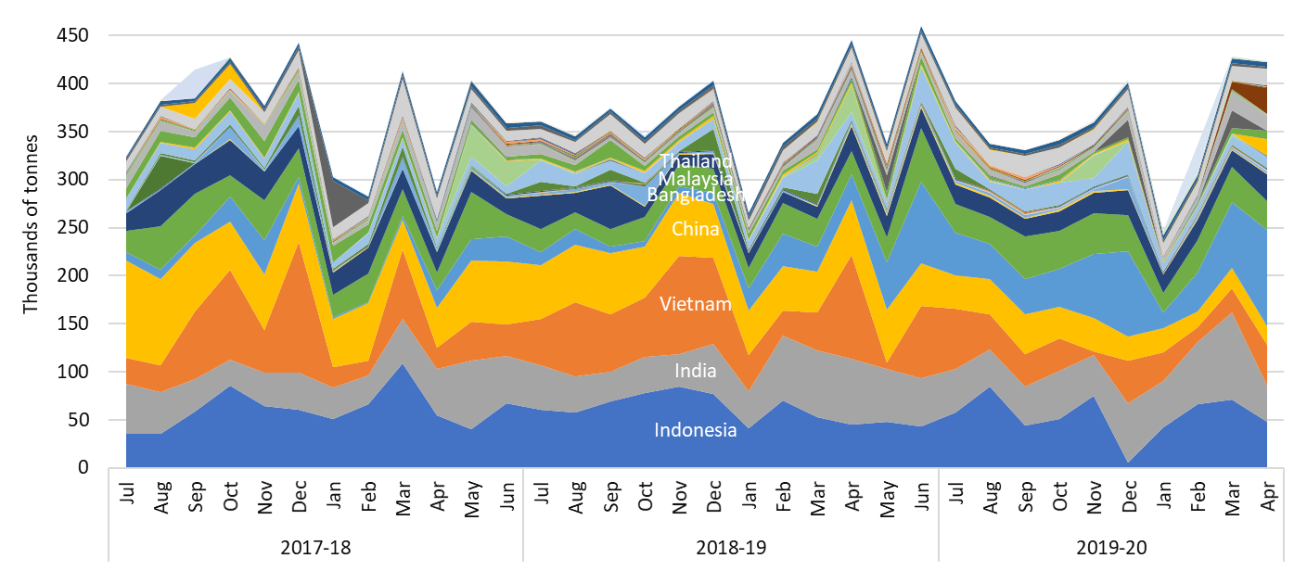
The reported value of exports for April 2020 was $261 million, decreasing from $334 million in March and close to 2018-19 monthly average of $258 million. The fall in value is proportionally much greater than the decline in tonnes due to lower values per tonne of many waste-derived product categories including metals, hazardous and ‘other’.

Comparison by material
Table 2 compares April 2020 export tonnages and values with March and with the 2018-19 monthly average, by material type.
Table 2 Comparison of export tonnage and value by material
 |  |  |  |  |  |  | 2018-19 monthly avg |  |  |  |  |  |  | 2018-19 monthly avg
 | Apr-20 |  |  |  | Mar-20 |  |  |  | Apr-20 |  |  | Mar-20
 | tonnes | % of total |  | tonnes |  | % change |  | tonnes | $ mil | % of total |  | $ mil | % change |  | $ mil
Glass | 1,600 | 0% |  | 4,200 |  | -60% |  | 1,300 | $0.08 | <1% |  | $0.25 | -66% |  | $0.06
Paper and cardboard | 100,000 | 24% |  | 102,000 |  | -2% |  | 93,000 | $19.1 | 7% |  | $20.3 | -6% |  | $19.5
Plastics | 7,600 | 2% |  | 9,300 |  | -19% |  | 16,000 | $2.2 | <1% |  | $2.7 | -18% |  | $3.6
Tyres | 3,700 | 1% |  | 5,600 |  | -33% |  | 10,000 | $1.9 | <1% |  | $1.6 | 19% |  | $1.8
Metals | 262,000 | 62% |  | 283,000 |  | -7% |  | 220,000 | $171 | 65% |  | $242 | -29% |  | $180.3
Hazardous (excl. tyres) | 5,400 | 1% |  | 4,300 |  | 25% |  | 5,600 | $42.7 | 16% |  | $42.3 | 1% |  | $33.2
Other | 43,000 | 10% |  | 20,000 |  | 116% |  | 24,000 | $24.3 | 9% |  | $24.6 | -1% |  | $20.3
Total | 423,000 | - |  | 428,000 |  | -1% |  | 369,000 | $261.3 | - |  | $334.1 | -22% |  | $258.8

Comparison with the previous month –
- Glass exports fell from 4,200 in March to 1,600 tonnes in April. Exports were mainly to Thailand (43%) and Malaysia (57%).
- Paper and cardboard exports remained steady at 100,000 tonnes. Exports went mainly to Indonesia (36%), Thailand (16%), India (14%) and Malaysia (12%). Unbleached kraft comprised 51% and unsorted scrap 41%. While paper and cardboard accounted for 24% of the tonnages of waste exports, their value of $19.1 million represented only 7% of the total.
- Exports of waste plastics fell 19% to 7,600 tonnes. The largest recipients were Malaysia (33%), China (24%) and Latvia (13%). Exported scrap plastics comprised mixed plastics (68%) and ethylenes (32%). They were valued at $2.2 million, 18% less than March 2020.
- Exports of waste tyres dropped 33% to 3,700 tonnes. The main recipients were Malaysia (37%), U.S. (23%), the Republic of Korea (14%) and India (10%). Despite lower tonnages, the reported value of waste tyres increased from $1.6 to $1.9 million due to reduced quantities of cheaper scrap to India and Malaysia and increased quantities of costlier materials to Korea.
- Monthly metal exports decreased from 283,000 to 262,000 tonnes, but remain the largest portion of exported waste-derived products and waste at 62%. The total value was $171 million, or 65% of the total value of waste exports. The main recipients were Bangladesh (38%), Vietnam (12%) and Saudi Arabia (11%).
- Exports of hazardous waste (excluding tyres) grew from 4,300 to 5,400 tonnes between March and April 2020. The largest components were lead waste and scrap (55%), followed by slag from the manufacture of iron and steel (13%). While accounting for only 1% of total tonnes, hazardous waste represented 16% of the reported value at $42.7 million. The value is dominated by copper containing slag, ash and residues, which has an anomalously high reported value exceeding $500 per kilogram (the value of pure copper is under $10/kg).
- Exports in the other wastes category increased from 20,000 tonnes in March to 43,000 tonnes in April 2020, while the value decreased slightly. The largest sub-categories were sawdust and wood waste (39%), non-wheat cereal residues (19%) and wheat cereal residues (18%).
Comparison with the 2018-19 monthly average – April 2020 exports in the glass, paper and cardboard, metal and ‘other’ waste categories were higher than their 2018-19 monthly average. Exports of hazardous waste were somewhat lower, and plastics and tyres much lower, than their 2018-19 average. Due to the large quantities of metals and ‘other’ exports, overall quantities in April 2020 were higher than the monthly average for 2018-19. The reported value for the month was similar to the monthly average.

Figure 2 presents the monthly trend in exports of waste from Australia in tonnes by material type between July 2017 and April 2020. Scrap metal exports remain volatile. Exports of scrap paper and cardboard have increased in recent months but are relatively stable. Monthly scrap tyre exports have fallen strongly over the past year to reach their lowest level in the monthly data set from July 2017. Exports of recovered plastics fell in early 2017-18, recovered to peak in early 2019, then fell to a low in August. They remain below the 2018-19 monthly average.  Figure 3 presents monthly trends in the average reported value per tonne of key waste exports between July 2017 and April 2020. Over this timeframe reported values for:  - metals have been volatile and fell in April to their lowest value since January 2018  - paper and cardboard have been fairly stable, but declined in late 2019 then recovered in early 2020 to $191/tonne in April 2020  - glass have oscillated, but were stable for much of 2019 before dropping late in the year then rising to their current relatively stable level  - plastics have been driven by low-grade mixed materials that comprise most of the exported tonnes – reported values for this grade fell from an average of $263/t over 2017-18 to a low of $137/t in February 2019 then climbed back, standing at $290/t in April 2020. | Figure 2 Monthly exports of waste-derived products and wastes from Australia by material type, July 2017 – April 2020  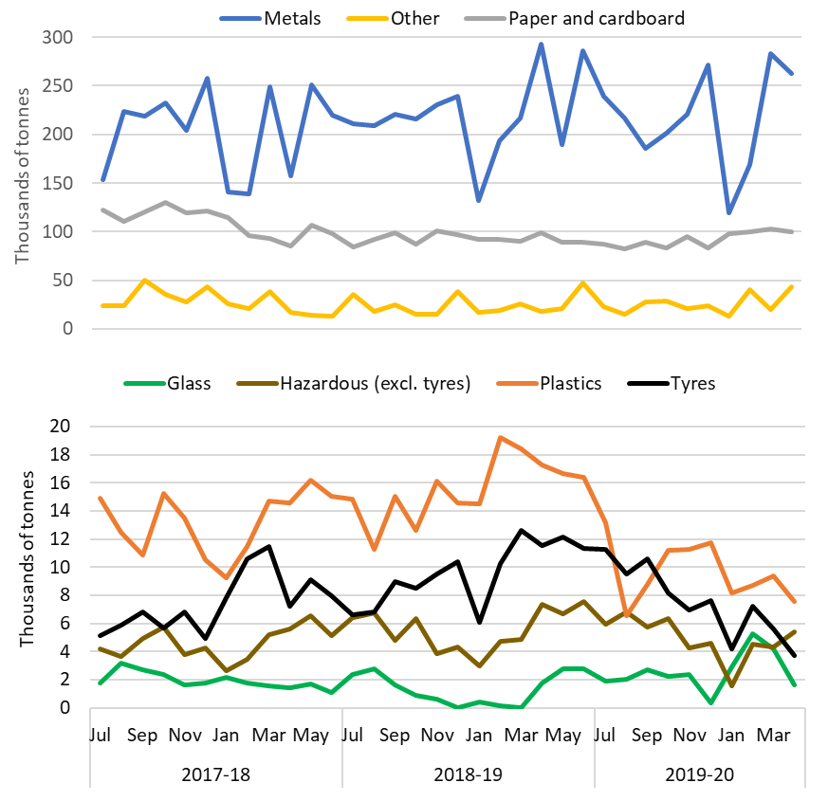
Figure 3 Comparison of unit values by material (in $/t), July 2017 – April 2020
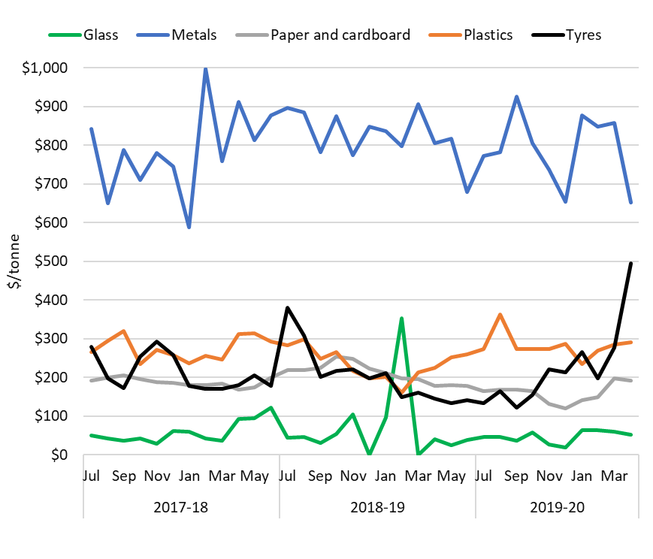

COAG waste export ban
A March 2020 meeting of the Council of Australian Governments agreed to a timetable for implementing bans on exporting waste glass, paper, plastics and tyres not processed into a value-added material. The relevant materials, dates and main export codes are shown in Table 3.
Table 3 Material types facing export bans
Material | Ban date | AHECC code | AHECC description | Apr-20 exports in this code (rounded tonnes) |  | Estimated % of tonnes to be banned
Glass | Jul 2020 | 70010000 | Cullet and other waste and scrap of glass; glass in the mass |  | 1,600 | 100%
Paper and cardboard | Jul 2024 | 47071000 | Recovered (waste and scrap), unbleached, kraft paper or paperboard or corrugated paper or paperboard |  | 44,000 | 32%
Paper and cardboard | Jul 2024 | 47072000 | Recovered (waste and scrap) paper or paperboard, made mainly of bleached chemical pulp, not coloured in the mass |  | 80 | 32%
Paper and cardboard | Jul 2024 | 47073000 | Recovered (waste and scrap) paper or paperboard, made mainly of mechanical pulp (e.g. newspapers, journals and similar) |  | 6,900 | 32%
Paper and cardboard | Jul 2024 | 47079000 | Waste and scrap paper or paperboard (incl. unsorted waste & scrap) (excl. unbleached kraft or corrugated (470710); that made mainly from bleached chemical pulp, not coloured in the mass; or made mainly of mechanical pulp) |  | 48,000 | 32%
Plastics | Jul 2022 | 39151000 | Waste, parings and scrap, of polymers of ethylene |  | 2,600 | 100%
Plastics | Jul 2022 | 39152000 | Waste, parings and scrap, of polymers of styrene |  | 0 | 100%
Plastics | Jul 2022 | 39153000 | Waste, parings and scrap, of polymers of vinyl chloride |  | 20 | 100%
Plastics | Jul 2021 | 39159092 | Waste, parings and scrap, of plastics (excl. those of polymers of ethylene, styrene or vinyl chloride) |  | 4,900 | 83%
Whole tyres | Dec 2021 | 40040000 | Waste, parings and scrap of rubber (excl. of hard rubber) and powders and granules obtained therefrom |  | 1,500 | 44%
Whole tyres | Dec 2021 | 40122000 | Used pneumatic rubber tyres, whether or not subject to recutting or regrooving |  | 1,100 | 100% ⁸
Whole tyres | Dec 2021 | 40129000 | Solid or cushion rubber tyres, rubber tyre treads (incl. Interchangeable tyre treads) and rubber tyre flaps |  | 1,100 | 6% ⁸

In April 2020, about 113,000 tonnes of waste-derived products and wastes were exported within the codes listed above, down from 136,000 in March. This represents about 27% of the total quantity of waste-derived products and waste exported for the month.

The current status of waste import restrictions
Following China’s lead, various Asian countries have flagged or implemented restrictions on the import of waste-derived products and wastes. These are described in Table 4 for the top 10 export countries in the same order as in Table 1. The information presented has been compiled based on publicly available sources, sometimes translated from languages other than English.
Table 4 Status of waste import restrictions
Country | Scope of restrictions | Announced & implemented | Associated exports (tonnes) |  |  | Impact and uncertainties
Country | Scope of restrictions | Announced & implemented | Types | 2018-19 | Apr 20 | Impact and uncertainties
Indonesia | Temporary moratorium on all waste scrap imports commenced 23 November 2019 as the new Ministerial Regulation No. 84/2019 on the Provisions on the import of non-hazardous and non-toxic waste for industrial purposes is implemented. All shipments subject to inspection dates after 22 November 2019 have been stopped. Under the new regulation, transhipments are banned. Only direct shipments from exporters that have obtained a permit (which would be subject to occasional verification) and have inspected containers prior to shipment would be allowed. Scrap imports to be restricted to arrive at eight ports only in Jakarta, Semarang, Surabaya (2), Makassar, Medan, Batam and Cilegon. The set contamination thresholds are unclear with industry interpretation suggesting it could be 0% which contradicts the previous suggestion of 2% with a two-year transition to 0.5%. Illegally imported plastic waste to be returned back to exporters. Reportedly rejected eight containers of ‘contaminated’ paper and plastic material in July 2019. In September 2019, Indonesia announced it would send 100 containers of contaminated material (particularly plastics) back to Australia, but to date only a small number have been returned. Determined in February 2020 to ease the rules on metal scrap imports due to mill supply shortages. | Ann.: Apr-19  Imp.: Nov-19 | Plastics, Paper and cardboard, metals, glass, hazardous waste, tyres, other. | 725,700  (60,500 per  month) | 48,000 | Impact uncertain.
India | Import of scrap plastics banned from August 2019. Also covers areas previously exempt under the 2016 ban such as special economic zones (SEZ) and export-oriented units (EOU). Excludes electrical/electronic assemblies or components that are defective which can be imported within a year of export. A six-month extension has been granted to three SEZs which allows plastic scrap to be imported until May 31 2020. India set a contamination limit of 1% for recovered paper years ago. It now intends to enforce this by randomly inspecting 5 mixed paper bales per container.  India’s Central Pollution Control Board has been reviewing the pyrolysis industry and has ordered the closure of 270 plants that were not compliant with environmental regulations. It is expected this will lead to a subsequent restriction on the import of waste tyres in the near future. | Ann.: Mar-19  Imp.: Mar-19, Aug-19 for importers currently exempt under SEZs and EOUs. | Plastics | 700  (60 per month) | 0 | Impact uncertain.
Vietnam | Tighter controls over imports of plastic, paper and metals. Accepted only if importers prove their shipment meets specified environmental standards and there is capacity to process the materials. No new licences issued for waste imports³¹. Plastic scrap imports to be banned by 2025. Under new national standard QCVN 32: 2019/BTNMT, import of e-waste plastics (e.g. cases of TVs and computers) would be forbidden. From 22 February 2019, all imports through road and railway border gates banned. Import of mixed metal waste (containing any plastic, paper, other non-metallic metals) now understood to be restricted. Composition of metal waste needs to be 99% metal to be allowed in. | Ann. in Aug-18 apparently implemented.  Mixed metal waste restricted from Oct 2018. | Plastic, paper, metals | 732,600  (61,100 per month) | 42,000 | Has apparently affected imports of scrap plastic and metal from Australia.  Environmental reference standards are unavailable in English.
China | Declared restrictions and then, in April 2018, a ban on 32 types of waste-derived products.  From 1 July 2019, import restrictions were placed on eight solid waste codes pertaining to metals. China is now reported to have enshrined in law its intention to stop all imports of waste, with the aim of full implementation by the end of 2020. In the meantime, it continues to issue permits for imports of waste fibre and will allow 4.5 million tonnes to be imported this year. Quotas are also still being issued for metals . | Ann.: Jul & Nov-17, Apr-18, Jul-19, Dec-19, Jan-20  Imp.: Jan & Mar-18, Dec-18, Dec-19 | Plastic, paper, metals, other | 643,000  (53,600 per month) | 20,000 | Impact evident (2016-17 exports averaged 105,300/month and averaged 62,000/month in 2017-18).
Bangladesh | No apparent waste import restrictions. Received only metals and hazardous wastes from Australia during this financial year, which are not subject to export bans. |  |  |  | 0 | None
Malaysia | Import permits revoked from 114 factories that process imported plastic waste,. Import of non-recyclable plastic waste to be banned by 2021. Contaminated, mislabelled or illegally imported plastic waste loads to be sent back to source . Malaysia has continued returning contaminated containers of plastic waste to countries of origin with 150 returned and another 110 to be sent back by midyear. Enforcement at ports has improved and over 200 illegal plastic recycling facilities closed down in a bid to crackdown on illegal waste imports. | Jul-18. | Plastic | 55,200  (4,600 per month) | 2,500 | No impact apparent.
Thailand | Revoked a broad plastic scrap import allowance, meaning plastic waste and scrap is banned from import by 2021,,. Looking to ban e-waste imports within 2 years³¹. In January 2020, a new subcommittee was set up to ensure the proposed bans can be achieved, and will not be prevented by loopholes. | Ann. Aug-18, plastic imp. Aug-18, e-waste <2 yrs. | Plastic | 11,200  (900 per month) | 300 | No impact apparent Announcement available in Thai only.
Korea, Republic of | Announced on 17 February 2020 that it plans to reduce wastepaper imports. On 5 February 2020 announced intention to increase domestic collection of high quality plastics for recycling which is expected to result in limits on imports of plastic bottles. | Ann.: Feb-20 | Paper and cardboard  Plastic bottles | 13,200  (1,100 per month) | 200
Taiwan | Import of plastic waste is banned. Exceptions are made to licensed local firms that import plastic waste originating from their own overseas production processes or are a single material, but not from original production processes. Paper imports restricted to only deinked paper, kraft paper, corrugated paper or cardboard that is not bleached. Import of waste newspapers and magazines banned. | Ann.: Aug-18  Imp.: Oct-18 | Plastic, paper | 17,700  (1,500 per month) | 600 | No impact apparent.
Pakistan | No import bans apparent. Received mainly metals from Australia, which are not subject to export bans. |  |  |  | 0 | No impact apparent

Data in these summaries is sourced from the Australian Bureau of Statistics and is originally entered by exporters or their agents. It cannot be guaranteed that exporters use the correct codes or values for their exports, so this data should be used with caution. Data may be revised for up to six months after initial publication as customs declarations are amended by individual traders. Due to these revisions, there may be discrepancies between this and preceding reports.
Some of these recovered materials contain a proportion of contamination (or ‘off-spec’ content) that needs to be extracted before the material can be used.
Dollar values refer to Australian dollars.
Based on the 2018-19 characteristics of these materials.
It is believed that most or all of this product is derived from municipal recycling collections.
Comprises the proportion of material in AHECC code 47079000. However, significant miscoding is apparent in the data.
Assumes no material was sorted and processed to the extent that will be required for future export.
2018-19 Australian Border Force data on tyres exports differed from the equivalent ABS data, and neither were consistent with industry-reported export quantities.
Argus (21 November 2019), Indonesia suspends scrap imports amid new policy
VOA news (2019) Indonesia vows to send back illegal plastic waste
Inside Indonesia (2020) Buried under the weight of the recycling crisis
Indonesia will ease rules on scrap metal imports, https://www.wastetodaymagazine.com/article/indonesia-will-ease-rules-on-import-of-scrap-metal/
Business Today, (24 June 2019) India bans import of plastic waste from August this year to curb pollution
Ministry of Environment, Forest and Climate Change (2019) Amendment in Hazardous Waste (Management & Transboundary Movement Rules, 2016)
Business Standard, (2 December 2019) Govt grants six month extension to plastic scrap imports in three SEZs
Waste Dive, (15 January 2020), India to enforce 1% contamination rate on paper imports, conduct random inspections
India legal, (6 January 2020), NGT calls for review of CPCB’s report on pyrolysis units.
Tyre and Rubber recycling, (22 September 2019), Near total ban on waste tyre imports imminent in India
Vietnam Briefing (2018) Vietnam to Restrict Surging Scrap Imports
VN Express International (2019) Vietnam to end plastic scrap imports from 2025
Ministry of Natural Resources and Environment of the Socialist Republic of Vietnam (2018) Vietnam to ban imports of plastic from used electronics
VietnamPlus (2019) Scrap imports through road, railway border gates to be banned, Ministry of Information and Communications
S&P Global Platts (2019) Vietnam’s Jan scrap imports plunge amid stricter government rules
Ministry of Commerce, State Development & Reform Commission (incl. former State Development Planning Commission), General Administration of Customs (2018) Announcement No. 6 [2018] of the Ministry of Ecology and Environment, the Ministry of Commerce, the National Development and Reform Commission and the General Administration of Customs
Ministry of Ecology and Environment of the People’s Republic of China (2018) Announcement on adjusting the catalogue of imported waste management
Resource Recycling (5 May 2020) China moves closer to complete import ban
Bureau of International Recycling (24 December 2019) Chinese quotas for waste & scrap imports: full list of 1st batch 2020
Bureau of International Recycling (8 January 2020) Chinese quotas for waste & scrap imports: full list of 2nd batch 2020
Recycling Today (10 January 2020) China issues second batch of scrap import quotas
FMT News (2018) Permits to import plastic waste for 114 factories revoked
Waste Management Review (2018) Malaysia, Thailand and Vietnam waste imports crackdown
The Star Online (2018) Govt to ban import of all non-recyclable waste
The Australian (2019) Australia would vet any waste returns, says Ley
Malaymail (2019) Yeo Bee Yin moots RM1,500 charge per shipping container to cut illegal imported plastic waste
EcoWatch (21 January 2020) Malaysia sends plastic waste back to 13 wealthy countries, says it won’t be ‘the rubbish dump of the world’.
The Nation (2018) Import of plastic waste banned
CIWM (2018) Thailand set to ban plastic waste imports by 2021
Government Gazette Thailand (2018)
Bangkok Post (2020) Waste plastic imports ‘to be banned’
Resource Recycling (2020) South Korea to enact import restrictions
Taipei Times (2018) New waste plastic, paper import rules to take effect
Pakistan Today (2020) Import of hazardous plastic scrap surges to 65,000 tonnes

