Exports of Australian waste and recovered materials in April 2021
7 July 2021, Sally Donovan and Joe Pickin
©The Department of Agriculture, Water and the Environment
Blue Environment is commissioned by the Department of Agriculture, Water and the Environment to produce, analyse and report on monthly exports of waste and recovered materials. The original data is provided by the Australian Bureau of Statistics (ABS), and comprises monthly data and updates to previously reported data,,. The ABS data is transformed to account for issues such as trade codes covering a mixture of wastes and non-wastes, and to make it consistent with national waste data methods. On a tonnage basis nearly all these exports are materials recovered from waste streams for recycling or energy recovery, but a small portion is hazardous waste sent for treatment. Monthly data is highly variable, and trends are best observed through the annual reports produced in this series.

Summary
In April 2021, Australia exported about 383,000 tonnes of waste and recovered materials with a reported value of $332 million. This represents a decline of 6% in tonnage and an increase of 9% in value compared to the previous month. The exports included 335,000 tonnes (88%) within the scope of national waste reporting (‘core waste plus ash’).
About 119,000 tonnes were exported in April in codes that could be affected by Australia’s export bans. This is 31% of the total exports of waste and recovered materials. From 1 January 2021, the export of unprocessed waste glass from Australia was banned.

Comparison by destination
The top 10 recipients of Australian waste and recovered materials between July 2019 and April 2021, in order, were Indonesia, India, Vietnam, Bangladesh, Malaysia, China (including Hong Kong and Macau), Thailand, Taiwan, the Republic of Korea and Pakistan. In April 2021, 90% by weight of Australia’s exported waste and recovered materials was sent to these destinations.
Table 1 (overleaf) compares exports of waste and recovered materials to the top 10 destinations in March and April 2021 and includes each recipient’s 2019-20 monthly average. Exports to India, Bangladesh and Taiwan grew in April while those to Vietnam, the Republic of Korea and Pakistan declined. Exports to the other destinations remained fairly level. Compared with their 2019-20 monthly average, the April exports to Indonesia, Vietnam and Taiwan were much higher and those to Bangladesh and China much lower.
Scrap metals were the sole or main export to Bangladesh (100%), Taiwan (99%) and China (85%). Pakistan also received mostly metals (80%) and some textiles (12%). Exports to Thailand and Indonesia were split between metals and paper and cardboard (75% to 25% for Thailand and 23% to 74% for Indonesia). Vietnam received metals (59%) and agricultural organics (35%). Exports to India were a mix of scrap metals (55%), paper and cardboard (32%) and tyres (11%). Malaysia received a mix of paper and cardboard (36%), metals (28%) and plastics (20%). The Republic of Korea received metals (51%), agricultural organics (28%) and hazardous waste (14%).

Table 1 Comparison of month-to-month exports of waste and recovered materials by destination
Export destination (ranked by tonnes since July 2019) |  | Apr-21 |  | Mar-21 |  | 2019-20 monthly avg tonnes | Apr-21 | Mar-21 |  | 2019-20 monthly avg  $ mil
 |  | tonnes | % of total | tonnes | % change |  | $ mil | $ mil | % change
1 | Indonesia | 86,000 | 22% | 82,000 | 5% | 52,000 | $29.9 | $25.3 | 18% | $16.1
2 | India | 44,000 | 11% | 32,000 | 38% | 48,000 | $30.8 | $22.0 | 40% | $27.4
3 | Vietnam | 67,000 | 18% | 99,000 | -32% | 35,000 | $27.2 | $55.8 | -51% | $14.3
4 | Bangladesh | 32,000 | 8% | 27,000 | 20% | 52,000 | $16.0 | $11.4 | 40% | $20.6
5 | Malaysia | 25,000 | 7% | 24,000 | 5% | 32,000 | $18.7 | $17.5 | 7% | $13.2
6 | China | 7,800 | 2% | 8,300 | -6% | 27,000 | $34.7 | $33.2 | 5% | $28.3
7 | Thailand | 29,000 | 8% | 27,000 | 8% | 22,000 | $16.3 | $14.1 | 15% | $7.62
8 | Taiwan | 31,000 | 8% | 26,000 | 19% | 17,000 | $15.9 | $12.4 | 28% | $9.32
9 | Korea, Republic of | 15,000 | 4% | 18,000 | -18% | 15,000 | $41.1 | $29.7 | 38% | $39.4
10 | Pakistan | 7,000 | 2% | 14,000 | -49% | 9,100 | $5.00 | $7.66 | -35% | $5.01
Top 10 total |  | 345,000 | 90% | 356,000 | -3% | 309,000 | $235.5 | $229.1 | 3% | $181.3
Monthly total |  | 383,000 | - | 409,000 | -6% | 354,000 | $332.2 | $305.3 | 9% | $237.7

Figure 1 presents the trend in tonnes of exports of waste and recovered materials from Australia by destination between July 2017 and April 2021. Monthly exports are volatile and no overall trend is evident over the 46-month timeframe. In recent months, exports of waste and recovered materials to Indonesia, Vietnam and Malaysia appear to be increasing, while those to Taiwan and China are falling. Exports to China, in particular, have fallen greatly, from over 100,000 tonnes in July 2017 to less than 10,000 tonnes in April 2021.
Figure 1 Monthly exports of waste and recovered materials from Australia by destination
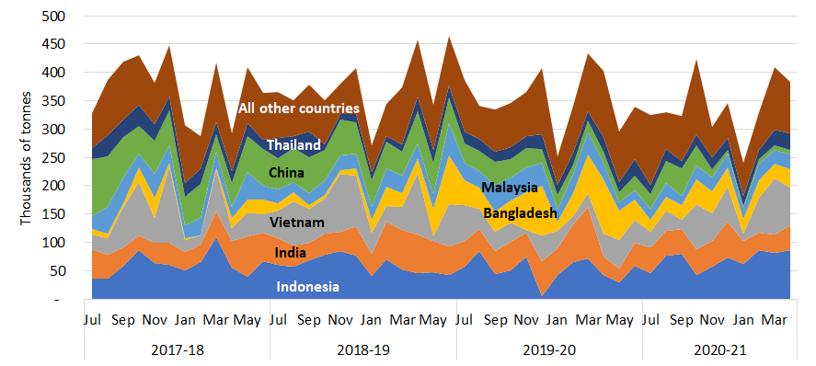

The reported value of exports for April 2021 was $332 million, up from $305 million in March and significantly exceeding the monthly averages in 2019-20 ($238 million), 2018-19 ($260 million) and 2017-18 ($237 million). The average reported value per tonne of almost all material types increased this month, giving an increase in value despite a fall in tonnes.

Comparison by material
Table 2 compares April 2021 export tonnages and values with March and with the 2019-20 monthly average, by material type. Around 88% falls within the ‘core waste plus ash’ scope of national waste reporting.
Table 2 Comparison of export tonnage and value by material
 | Apr-21 |  | Mar-21 |  |  | 2019-20 monthly avg  tonnes | Apr-21 |  | Mar-21 |  |  | 2019-20 monthly avg  $ mil
 | tonnes | % of total | tonnes | % change |  |  | $ mil | % of total | $ mil | % change
Glass | 60 | 0% | 40 | 64% |  | 2,200 | $0.03 | <1% | $0.10 | -71% |  | $0.11
Hazardous (excl. tyres) | 4,200 | 1% | 3,100 | 36% |  | 3,500 | $43.0 | 13% | $23.1 | 86% |  | $37.1
Metals | 204,000 | 53% | 225,000 | -10% |  | 212,000 | $231 | 69% | $221 | 5% |  | $163
Paper & cardboard | 98,000 | 26% | 99,000 | -1% |  | 88,000 | $22.4 | 7% | $21.9 | 2% |  | $14.2
Plastics | 11,000 | 3% | 10,000 | 7% |  | 9,400 | $3.96 | 1% | $3.27 | 21% |  | $2.59
Textiles | 8,200 | 2% | 10,000 | -16% |  | 7,800 | $6.72 | 2% | $7.75 | -13% |  | $6.30
Tyres | 9,300 | 2% | 11,000 | -12% |  | 7,100 | $1.72 | <1% | $1.59 | 8% |  | $1.47
Other | 48,000 | 13% | 51,000 | -6% |  | 24,000 | $23.5 | 7% | $26.7 | -12% |  | $12.9
Total | 338,000 | - | 409,000 | -6% |  | 354,000 | $332 | - | $305 | 9% |  | $238

Comparison with the previous month –
- Unprocessed glass waste exports have been banned since January 2021. New codes were introduced to distinguish between processed and unprocessed glass waste, and between processed glass that is furnace-ready or not furnace-ready. In April, small amounts of processed non-furnace ready glass were exported to India and New Zealand.
- Exports of hazardous waste (excluding tyres) rose from 3,100 to 4,200 tonnes. These were mainly lead waste and scrap (75%) and lead-containing slag, ash and residues (12%). The value increased more substantially than the tonnes as exports of anomalously high value copper slag, ash and residues doubled.
- Monthly exports of scrap metals dropped back to 204,000 tonnes after the unusually high 225,000 tonnes reported in March. Conversely, the value increased as the unit value of metals rose from $981 to $1,133. Exports were widely distributed, including to Vietnam (19%), Bangladesh (16%), Taiwan (15%), India (12%), Thailand (11%) and Indonesia (10%).
- Exports of scrap paper and cardboard were consistent between March and April 2021, going mainly to Indonesia (64%) and India (14%). Tonnages were split between unbleached kraft (53%) and unsorted scrap (47%). Despite representing 26% of tonnage of exported waste and recovered materials, the reported value, at $22.4 million, represented only 7% of the total.
- Exports of scrap plastics rose by 7%. The largest recipients were Malaysia (46%) and Indonesia (16%). These exports comprised mixed and ‘other’ plastics (57%) and polyethylenes (42%). The value per tonne of plastics reached $356, the highest since August 2019.
- Exports of waste textiles dropped from 10,000 to 8,200 tonnes in April 2021. The main receiving countries were the United Arab Emirates (57%), Malaysia (18%) and Pakistan (10%). Worn clothing and other worn textile articles accounted for more than 99% of textile waste.
- Exports of waste tyres fell from 11,000 to 9,300 tonnes between March and April 2021. The main recipients were India (53%) and Malaysia (18%). The value rose from $150 to $185 per tonne, leading to an increase in the value of tyres, despite the decrease in tonnes.
- Exports in the waste category other dropped slightly from 51,000 to 48,000 tonnes. Over 99% were agricultural organics. The change in value was similar to the change in tonnes.

Comparison with the 2019-20 monthly average – April 2021 export tonnages were 8% higher than last year’s monthly average, and the value was 40% higher. Tonnages were greater than the 2019-20 average for all waste types except glass and metals. The values were higher for all waste types except glass.
Trends in tonnage and unit value
Metals
Textiles
Tyres
Figure 2 presents the monthly trend in exports of waste from Australia in tonnes by material type between July 2017 and April 2021. Scrap metal exports remain high after the anomalously low value reported in January 2021. Exports of scrap paper and cardboard had been gradually declining but have climbed in recent months. Scrap tyre quantities fell steadily over 2019-20 to reach their lowest level in April but have subsequently increased¹⁰. Exports of recovered plastics fell in early 2017-18, recovered to peak in early 2019, then fell to a low in August. They have grown during 2020-21.  Figure 3 presents monthly trends in the average reported value per tonne of key waste exports from July 2017 to April 2021. Reported values for:  - metals declined from February 2018 to June 2020 but have risen strongly since  - paper and cardboard had been on a gently declining trend but have risen steadily since December 2020  - plastics fell steadily during 2018 due to China’s restrictions, but recovered as exports of low-grade mixed materials fell while higher value streams remained consistent  - textiles were consistently between $740 and $1,000/t but towards the low end of | Figure 2 Monthly exports of waste and recovered materials from Australia by material type, July 2017 to April 2021  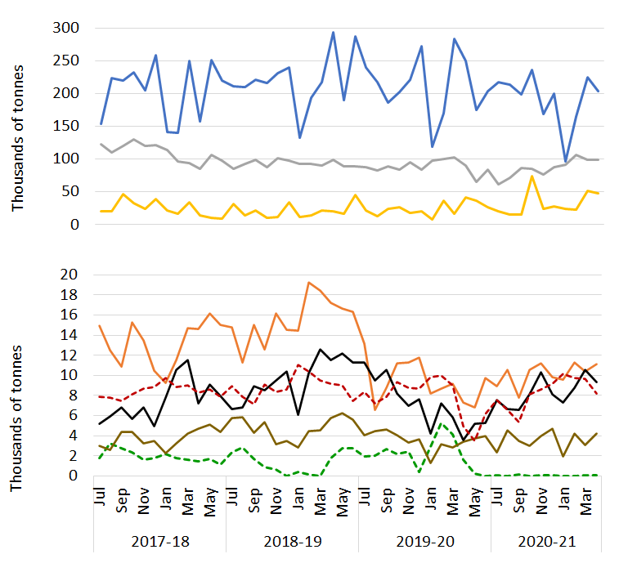  Paper & card  Tyres  Plastics  Hazardous  Metals  Other  Glass
Figure 3 Comparison of unit values by material (in $/t), July 2017 to April 2021
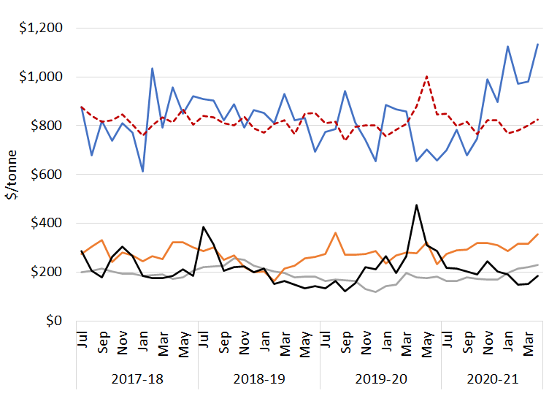
Textiles
Plastics
Paper & card.

that range in 2020-21
- tyres dipped in 2019, peaked in April 2020 and have been declining since
- glass are not shown as, since the export ban began, low tonnages have resulted in erratic unit values.

Port of loading and state of origin
Between January 2020 and April 2021 about 81% of Australia’s waste and recovered materials were exported from four ports: Melbourne (25%); Sydney (20%); Brisbane (19%); and Fremantle (17%). Figure 4 compares the average monthly tonnes exported between January 2020 and March 2021 with the April 2021 tonnes, by material group, from each of the top four ports and from all other ports combined. Exports from Brisbane were below average for all waste types except glass and plastics in April. Exports from Melbourne, Fremantle and Sydney were above average in April. Increases occurred for nearly all material types, but the most significant were metals and paper and cardboard. Exports from Sydney in the ‘other’ category were also substantially higher than average due to a large shipment (24,000 tonnes) of brewing and distilling dregs to Vietnam. Exports to all other ports were below average. This was mainly due to metals and ‘other’ waste. Exports of ‘other’ waste from all other ports have been volatile throughout the analysis period.
Figure 4 Monthly exports by material from port of loading – latest month compared with average
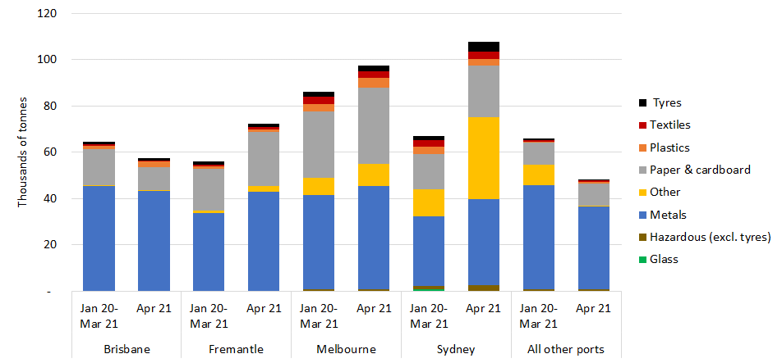

Most waste and recovered materials are exported from a port in the jurisdiction where they are generated, but Tasmania exported less than half of its waste from Launceston while the rest went via Melbourne (48%) and Sydney (5%). It is understood that materials from the Australian Capital Territory are exported from Sydney.

Australian waste export ban
A March 2020 meeting of the then Council of Australian Governments agreed to a timetable for implementing bans on exporting waste glass, paper, plastics, and tyres not processed into a value-added material. The relevant materials, dates and main export codes are shown in Table 3.
In April 2021, about 119,000 tonnes of waste and recovered materials were exported within the codes listed, down slightly from 120,000 tonnes in March. This represents about 31% of the total quantity of waste and recovered materials exported for the month, and 35% of all exports within the ‘core waste + ash’ scope of national waste reporting.
An impending key milestone is the ban on exports of mixed polymer scrap plastics, which is due to come into force on 1 July 2021. Government and industry are dealing with the challenge of ensuring that sufficient local sorting capacity is available for mixed rigid packaging plastics from kerbside collections, which has previously been exported. About 6,400 tonnes of material were exported under the relevant code in April 2021.
Table 3 Material types facing export bans
Material | Ban date | AHECC code | AHECC description | Apr 21 exports in this code (rounded tonnes) |  | Estimated % of tonnes to be banned
Glass (unprocessed) | Jan 2021 | 70010091 | Glass in the mass, cullet and other waste and scrap of glass, nes |  | 25 | Ban in effect
Paper and cardboard | Jul 2024 | 47071000 | Recovered (waste and scrap), unbleached, kraft paper or paperboard or corrugated paper or paperboard |  | 52,000 | 47%
 |  | 47072000 | Recovered (waste and scrap) paper or paperboard, made mainly of bleached chemical pulp, not coloured in the mass |  | 60
 |  | 47073000 | Recovered (waste and scrap) paper or paperboard, made mainly of mechanical pulp (e.g. newspapers, journals) |  | 500
 |  | 47079000 | Waste and scrap paper or paperboard (incl. unsorted waste & scrap) (excl. unbleached kraft or corrugated (470710); that made mainly from bleached chemical pulp, not coloured in the mass; or made mainly of mechanical pulp) |  | 46,000
Plastics | Jul 2022 | 39151000 | Waste, parings and scrap, of polymers of ethylene |  | 4,700 | 100%
 |  | 39152000 | Waste, parings and scrap, of polymers of styrene |  | 40
 |  | 39153000 | Waste, parings and scrap, of polymers of vinyl chloride |  | 30
 | Jul 2021 | 39159092 | Waste, parings and scrap, of plastics (excl. those of polymers of ethylene, styrene or vinyl chloride) |  | 6,400 | 83%
Whole tyres | Dec 2021 | 40040000 | Waste, parings and scrap of rubber (excl. of hard rubber) and powders and granules obtained therefrom |  | 6,600 | 44% ¹⁰
 |  | 40122000 | Used pneumatic rubber tyres, whether or not subject to recutting or regrooving |  | 1,600 | 100% ¹⁰
 |  | 40129000 | Solid or cushion rubber tyres, rubber tyre treads (incl. interchangeable tyre treads) and rubber tyre flaps |  | 1,200 | 6% ¹⁰

Restrictions on waste imports – latest news
Further restrictions on plastics waste trade could be coming as the fifth session of the United Nations Environment Assembly (UNEA), held earlier this year, proposed a global treaty on plastics waste, with 120 countries already indicating support. Due to the COVID pandemic, the UNEA was unable to finalise an agreement but has put it on the agenda for next year’s meeting, when in-person sessions are expected to resume. Proposed import regulations on scrap metals in Malaysia and India are raising concerns about the future of the metal industries in these two countries. The proportion of scrap in metals production needs to increase from 30-35% to 50% to comply with emissions reduction commitments and import restrictions could jeopardise this transition.

No updates were found on restrictions in Australia’s other major export destinations.

Restrictions on waste import – overview
The current status of import restrictions to Australia’s top 10 waste and recovered materials destinations is summarised in Table 4, while
Table 5 provides details of the import restriction policies, their dates and amount of waste potentially impacted by the bans.
Table 4 Summary of import restrictions by material and top 10 destinations
 | Glass | Haz. waste (excl. tyres) | Metals | Paper & cardboard | Plastics | Tyres | Textiles
Indonesia | Restricted | Restricted | Restricted | Restricted | Restricted | Restricted |  |  | Key
India |  |  | Considering |  | Restricted | Considering |  |  | Restricted | Restrictions are in place
Bangladesh |  |  |  |  | Restricted |  |  |  | Announced | Restrictions announced but not yet implemented
Vietnam |  |  | Restricted | Restricted | Restricted |  |  |  | Considering | Restrictions are under consideration
China |  |  | Restricted | Restricted | Restricted
Malaysia |  |  | Considering |  | Restricted
Thailand |  |  |  |  | Restricted
Taiwan |  |  |  | Restricted | Restricted
Republic of Korea |  |  |  | Restricted | Restricted | Announced
Pakistan |  |  |  |  |  | Restricted

Table 5 Status of waste import restrictions
Destination | Scope of restrictions | Announced & implemented | Associated exports (tonnes) |  |  | Impact and uncertainties
 |  |  | Types | 2019-20 | Apr 21
Indonesia | On 27 May 2020 the Indonesian Government published a decree on the implementation of import of non-hazardous and toxic material waste. This limits contamination of imported scrap plastics and paper to 2% and announces the formation of a task force to develop a road map accelerating the availability of domestic raw materials. This will include a staged reduction of import quotas. From January 2021, exporters have been required to complete a registration process, described as cumbersome and lengthy, to continue exporting to Indonesia. | Ann.: Apr-19  Imp.: Nov-19 | Plastics, Paper and cardboard, metals, glass, hazardous waste, tyres, other. | 627,000  (52,000 per  month) | 86,000 | Imports reduced from 61,000 per month in 2018-19 to 52,000 in 2019-20.
India | In 2016 India banned the import of scrap plastics with an exemption for special economic zones (SEZ) and export-oriented units (EOU). In August 2019 the ban was expanded to cover these zones, however, on 27 January 2021 this expansion was revoked meaning waste plastics can again be imported to these areas. The ban excludes electrical/electronic assemblies or components that are defective which can be imported within a year of export. India also has a contamination limit of 1% for recovered paper, which it enforces by randomly inspecting five mixed paper bales per container . India has proposed a new policy seeking to increase local scrap metal processing and reducing reliance on imports. | Ann.: Mar-19  Imp.: Mar-19 to Aug-19  Lifted: Jan-21 | Plastics | 60  (5 per month) | 160 | Plastics imports reduced from 60 to 5 tonnes per month from 2018-19 to 2019-20.
Bangladesh | The Bangladesh Ministry of Commerce Import Policy Order 2015-2018 includes details of waste import regulations. Metals and glass are allowed for bona fide industrial units, paper and cardboard is unrestricted and textiles are allowed with some restrictions. The regulations also mention exemptions for other waste types that would fall under the waste groups hazardous and ‘other’. | Imp: Feb-16 | Plastics |  | 0 | None.
Vietnam | On 24 September 2020 Vietnam published ‘Promulgation of the list of waste permitted for import as production materials’, overriding previous regulations. Unsorted scrap paper imports and granulated slag from iron and steel manufacture are to be banned by the end of 2021. This builds on a range of 2018 restrictions that allow waste imports only if shipments meet environmental standards and processing capacity is demonstrated. The earlier restrictions covered scrap metals, plastic, paper, glass, and blast furnace slag dust. Under new national standard QCVN 32: 2019/BTNMT, import of e-waste plastics (e.g., cases of TVs and computers) would be forbidden. Scrap metal waste needs to be 99% metal to be allowed in. | Ann. in Sep-20.  Mixed metal waste restricted from Oct 2018. | Plastic, paper, metals | 420,000  (35,000 per month) | 43,000 | Imports reduced from 61,000 to 35,000 tonnes per month between 2018-19 and 2019-20.
Malaysia | Malaysia continues its crackdown on plastics waste imports with renewed support from the Basel Convention amendment on plastics waste, which came into force in January 2021. Recently a large shipment of plastics waste was accepted only after inspection showed it contained clean homogenous polyethylene. The Basel Action Network encouraged the Malaysian government to similarly inspect all shipments of plastics waste coming into the country to ensure continued compliance. Proposed import restrictions on metals are still under negotiation²¹. | Jul-18. | Plastics, metals | 49,000  (4,100 per month) | 5,100 | No impact apparent.
China | From 1 January 2021, China has implemented a ban on the import of all solid waste. However, certain materials such as scrap metals are defined as resources rather than waste under the new legislation and can continue to be imported. | Ann.: Apr-20  Imp.: Jan 1, 2021 | All solid wastes | 328,000  (27,000 per month) | 7,800 | Imports fell from over 100,000 tonnes per month in 2016-17 to 27,000 in 2019-20.
Thailand | Thailand has announced its intention to implement a ban on the import of all plastics waste by 2022. However, this is still under debate due to uncertainty that locally generated plastics waste can satisfy feedstock requirements of the 157 plastics recycling facilities. A ban on 428 types of electronic waste has also been announced. | Ann. Aug-18, plastics imp. Aug-18, e-waste <2 yrs. | Plastics | 9,500  (800 per month) | 70 | Plastics imports reduced from 900 to 800 tonnes per month between 2018-19 and 2019-20.
Taiwan | Import of plastics waste is banned. Exceptions are made to licensed local firms that import plastics waste originating from their own overseas production processes or are a single material, but not from original production processes. Paper imports are restricted to deinked paper, kraft paper, corrugated paper or cardboard that is not bleached. Import of waste newspapers and magazines banned. | Ann.: Aug-18  Imp.: Oct-18 | Plastics, paper | 14,200  (1,200 per month) | 420 | Imports reduced from 1,500 to 1,200 per month between 2018-19 and 2019-20.
Korea, Republic of | On 6 January 2021, the Ministry of Environment announced bans or restrictions on their top 10 waste import materials. Total imports are to reduce by 35% by 2022 and 65% by 2025. Bans on plastics, mixed waste paper and waste fibre will commence in 2022, and on coal ash and tyres in 2023. Corrugated cardboard, dust and sludge will be subject to restrictions in 2023. A ban on imports of PET, PE, PP and PS came into force at the end of June 2020. | Ann.: Feb-20 | Paper and cardboard  Plastics | 13,000  (1,100 per month) | 316 | Imports of both products have decreased significantly over 2020.
Pakistan | On 25 September 2020 the Pakistan Government Ministry of Commerce banned the import of re-treaded tyres and used pneumatic tyres. | Sep-20 | Tyres |  | 0 | No impact apparent.

The export codes mapped to waste and recovered materials in 2020-21 differ slightly from those in 2019-20. Details are given in the accompanying workbook (under ‘Ref lists’). The historical data presented here has been updated.
Data in these summaries is originally entered by exporters or their agents. It cannot be guaranteed that exporters use the correct codes or values for their exports, so this data should be used with caution.
Data may be revised for up to six months after initial publication as customs declarations are amended by individual traders. Due to these revisions, there may be discrepancies between this and preceding reports.
The data presented is gross weight, including packaging. This value is used for consistency because the quantities of exported materials are presented in varied units, including numbers of items.
Some of these recovered materials contain a proportion of contamination (or ‘off-spec’ content) that needs to be extracted before the material can be used.
Dollar values refer to Australian dollars. Historical values are inflated based on the annualised consumer price index.
See the National Waste Report 2020 on the Department of Agriculture, Water and the Environment website.
The NZ export was miscoded as unprocessed waste glass.
The reported value of this copper slag and ash waste was around $460/kg. The value of pure copper is typically around $10/kg.
Tyre export quantities in the ABS data are generally lower than reported through industry sources. Significant miscoding is likely.
Earlier data were unavailable.
Australian Harmonized Export Commodity Classification.
Based on the 2018-19 characteristics of these materials.
Previously 700100000.
This 25 tonne export was miscoded by the exporter. It was actually water filtration media (processed non-furnace glass) sent by an exporter licensed to do so. The correct AHECC code for this export should have been 70011002.
Comprises the proportion of material in AHECC code 47079000, but significant miscoding is apparent in the data.
Assumes no material was sorted and processed to the extent that will be required for future export.
Excludes fuels.
Langrand M. (March 2021) A new global treaty to tackle plastic pollution?
Taylor B (June 2021) BIR Convention: Everybody wants it, yet no one does
Majumder R (June 2021) Malaysia’s import restrictions on metal scrap may lose out recycling investments
Minister of Trade, Minister of Environment and Forestry, Minister of Trade Industry and Head of State Policy, Republic of Indonesia (May 2020), Implementation of import of non hazardous and toxic material waste as raw material industry.
EU-WID Pulp and paper (16 October 2020) Indonesia postpones introduction of exporter registration to 1 January 2021.
Business Today, (24 June 2019) India bans import of plastic waste from August this year to curb pollution.
Waste Dive, (15 January 2020), India to enforce 1% contamination rate on paper imports, conduct random inspections.
Bone C. (2021) India mulls over self-sufficient future without imported scrap
Ministry of Commerce, Government of the People’s Republic of Bangladesh (2016) Import Policy Order 2015-2018
Prime Minister of Vietnam (24 September 2020) Promulgation of the list of waste permitted for import as production materials. Unofficial translation.
Vietnam - National Technical Regulations on Wastes (18 November 2019), https://www.cciclondon.com/portal/article/index/cat_id/35/id/286.html
Ministry of Natural Resources and Environment of the Socialist Republic of Vietnam (2018) Vietnam to ban imports of plastic from used electronics.
S&P Global Platts (2019) Vietnam’s Jan scrap imports plunge amid stricter government rules.
Reuters (2021) Malaysia permits import of US plastic waste shipment after it passes new UN treaty test https://www.reuters.com/article/us-malaysia-environment-plastic-idUSKBN2BG0ZL
The Sun Daily (2 February 2021) Waste not want not: Malaysia moves to become a leader in tackling plastic waste.
Ministry of Ecology and Environment, People’s Republic of China (25 November 2020) MEE Announcement No. 53 2020 (unofficial translation by Institute of Scrap Recycling Industries.
REB market intelligence (25 January 2021) Thailand considering plastic import ban from 1st January 2022.
Saengmanee (2020) The year nature bounced back.
Taipei Times (2018) New waste plastic, paper import rules to take effect.
Business Korea (7 January 2021) Waste import ban roadmaps to come out soon.
Inquirer.net (10 January 2021) S. Korea to phase out industrial waste imports.
The Korea Times (2020) Plastic waste imports banned in Korea amid mounting local trash.
Pakistan Government Ministry of Commerce (2020) Import Policy Order 2020.

