Exports of Australian waste and recovered materials in February 2021
21 June 2021, Sally Donovan and Joe Pickin
©The Department of Agriculture, Water and the Environment
Blue Environment is commissioned by the Department of Agriculture, Water and the Environment to produce, analyse and report on monthly exports of waste and recovered materials. The original data is provided by the Australian Bureau of Statistics (ABS), and comprises monthly data and updates to previously reported data,,. The ABS data is transformed to account for issues such as trade codes covering a mixture of wastes and non-wastes, and to make it consistent with national waste data methods. On a tonnage basis nearly all these exports are materials recovered from waste streams for recycling or energy recovery, but a small portion is hazardous waste sent for treatment. Monthly data is highly variable, and trends are best observed through the annual reports produced in this series.

Summary
In February 2021, Australia exported about 329,000 tonnes of waste and recovered materials with a reported value of $253 million. This represents an increase of 37% in tonnage and 45% in value compared to the previous month. The exports included 307,000 tonnes (93%) within the scope of national waste reporting (‘core waste plus ash’).
About 127,000 tonnes were exported in February in codes that could be affected by Australia’s export bans. This is 38% of the total exports of waste and recovered materials. Exporting unprocessed waste glass from Australia was banned from 1 January 2021 and no waste glass exports were reported in February.

Comparison by destination
The top 10 recipients of Australian waste and recovered materials between July 2019 and February 2021, in order, were Indonesia, India, Bangladesh, Vietnam, Malaysia, China (including Hong Kong and Macau), Thailand, Taiwan, the Republic of Korea and Pakistan. In February 2021, 90% by weight of Australia’s exported waste and recovered materials were sent to these destinations.
Table 1 (overleaf) compares exports of waste and recovered materials to these top 10 destinations in January and February 2021 and includes each destination’s 2019-20 monthly average. Exports to India, Thailand and Republic of Korea dropped while exports to all other destinations increased, especially Vietnam, where metal exports were back up to over 50,000 tonnes after recording a low of just 328 tonnes in January. Exports to China rose despite its ban on waste imports. For the Republic of Korea, the value decreased much more substantially than the tonnes due to receipt of anomalously high value hazardous waste in January.
Metals were the main export to Bangladesh (99%), Taiwan (97%) and Vietnam (82%). Metals also made up the majority of exports received by Pakistan (88%), China (56%), India (56%) and Thailand (55%). For Pakistan the remaining material was mostly textiles (12%). For China it was plastics (23%) and timber and agricultural organics (11%). For India it was paper and cardboard (25%) and tyres (17%) and for Thailand it was paper and cardboard (43%). Indonesia received mainly paper and cardboard (79%) followed by metals (17%). Exports to the Republic of Korea included metals (41%), agricultural organics (25%), paper and cardboard (20%) and hazardous materials (11%). Exports to Malaysia were also mixed, including paper and cardboard (45%), metals (23%) and plastics (14%).
Table 1 Comparison of month-to-month exports of waste and recovered materials by destination
Export destination (ranked by tonnes since July 2019) |  | Feb-21 |  | Jan-21 |  | 2019-20 monthly avg tonnes | Feb-21 | Jan-21 |  | 2019-20 monthly avg  $ mil
 |  | tonnes | % of total | tonnes | % change | 2019-20 monthly avg tonnes | $ mil | $ mil | % change | 2019-20 monthly avg  $ mil
1 | Indonesia | 86,000 | 26% | 61,000 | 40% | 52,000 | $25.9 | $15.2 | 71% | $16.1
2 | India | 31,000 | 9% | 42,000 | -26% | 48,000 | $23.0 | $25.7 | -10% | $27.4
3 | Bangladesh | 30,000 | 9% | 25,000 | 23% | 52,000 | $12.9 | $11.0 | 17% | $20.6
4 | Vietnam | 62,000 | 19% | 14,000 | 355% | 35,000 | $28.4 | $3.19 | 793% | $14.3
5 | Malaysia | 30,000 | 9% | 20,000 | 47% | 32,000 | $18.9 | $12.3 | 53% | $13.2
6 | China | 8,500 | 3% | 3,400 | 149% | 27,000 | $23.8 | $15.0 | 59% | $28.3
7 | Thailand | 16,000 | 5% | 18,000 | -10% | 22,000 | $9.28 | $7.59 | 22% | $7.62
8 | Taiwan | 12,000 | 4% | 11,000 | 14% | 17,000 | $5.92 | $7.05 | -16% | $9.32
9 | Korea, Republic of | 12,000 | 4% | 12,000 | -5% | 15,000 | $13.9 | $31.1 | -55% | $39.4
10 | Pakistan | 10,000 | 3% | 6,300 | 59% | 9,100 | $6.25 | $3.94 | 59% | $5.01
Top 10 total |  | 298,000 | 90% | 212,000 | 40% | 309,000 | $168.3 | $132.1 | 27% | $181.3
Monthly total |  | 329,000 | - | 241,000 | 37% | 354,000 | $253.1 | $174.2 | 45% | $237.7

Figure 1 presents the trend in tonnes of exports of waste and recovered materials from Australia by destination between July 2017 and February 2021. Monthly exports are volatile and no overall trend is evident over the 44-month timeframe. So far in 2020-21 monthly average exports to Indonesia have been 13,000 tonnes higher than the 2019-20 monthly average due to a surge in paper and cardboard exports, most likely diverted from China. Exports to Vietnam have also climbed this financial year but those to all other destinations have mostly fallen.
Figure 1 Monthly exports of waste and recovered materials from Australia by destination
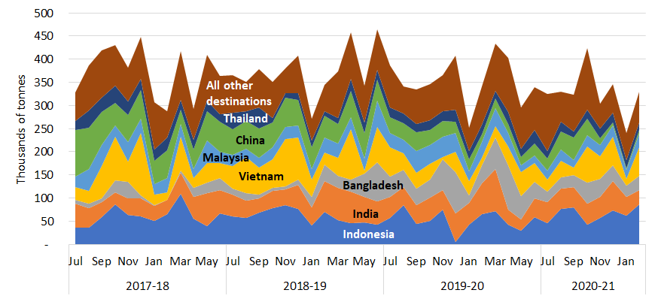

The reported value of exports for February 2021 was $253 million, up from $174 million in January and exceeding the 2019-20 monthly average of $238 million. The rise in value was of similar scale to the rise in tonnes.

Comparison by material
Table 2 compares February 2021 export tonnages and values with January and with the 2019-20 monthly average, by material type. Around 93% falls within the ‘core waste plus ash’ scope of national waste reporting.
Table 2 Comparison of export tonnage and value by material
 | Feb-21 |  | Jan-21 |  |  | 2019-20 monthly avg  tonnes | Feb-21 |  | Jan-21 |  |  | 2019-20 monthly avg  $ mil
 | tonnes | % of total | tonnes | % change |  | 2019-20 monthly avg  tonnes | $ mil | % of total | $ mil | % change |  | 2019-20 monthly avg  $ mil
Glass | 0 | 0% | 0 | n/a |  | 2,200 | $0.00 | 0% | $0.00 | n/a |  | $0.11
Hazardous (excl. tyres) | 4,200 | 1% | 1,900 | 121% |  | 3,500 | $41.2 | 16% | $21.8 | 89% |  | $37.1
Metals | 166,000 | 50% | 97,000 | 71% |  | 212,000 | $161 | 64% | $109 | 48% |  | $163
Paper & cardboard | 107,000 | 33% | 92,000 | 16% |  | 88,000 | $22.9 | 9% | $18.1 | 27% |  | $14.2
Plastics | 11,000 | 3% | 9,600 | 18% |  | 9,400 | $3.57 | 1% | $2.74 | 30% |  | $2.59
Textiles | 10,000 | 3% | 10,000 | -4% |  | 7,800 | $7.63 | 3% | $7.79 | -2% |  | $6.30
Tyres | 8,800 | 3% | 7,300 | 21% |  | 7,100 | $1.31 | <1% | $1.38 | -6% |  | $1.47
Other | 23,000 | 7% | 24,000 | -3% |  | 24,000 | $15.1 | 6% | $13.7 | 10% |  | $12.9
Total | 329,000 | - | 241,000 | 37% |  | 354,000 | $253 | - | $174 | 45% |  | $238

Comparison with the previous month –
- Glass waste exports that have not been processed into a value-added material are now subject to an export ban. No glass waste was exported in January or February 2021.
- Exports of hazardous waste (excluding tyres) increased from 1,900 to 4,200 tonnes between January and February 2021. The largest components were lead waste and scrap (52%), and lead-containing slag, ash and residues (40%). The value increased less substantially than the tonnes due to a drop in the reported unit value of lead-containing slag, ash and residues from $1,680 to less than $800.
- Monthly exports of scrap metals rose from 97,000 to 166,000 tonnes and accounted for half of exported waste and recovered materials. The total value was $161 million, or 64% of the total value of waste exports. The main recipients were Vietnam (30%), Bangladesh (18%) and India (10%).
- Exports of recovered paper and cardboard in February 2021 increased by 16% and exceeded the monthly average last financial year. Exports went mainly to Indonesia (64%). Tonnages were split between unbleached kraft 58% and unsorted scrap 41%. Despite representing 33% of the tonnage of exported waste and recovered materials, the value, at $22.9 million, represented only 9% of the total.
- Exports of scrap plastics rose 18% between January and February 2021. The largest recipients were Malaysia (39%), China (17%) and Indonesia (17%). Exported scrap plastics comprised mixed and ‘other’ plastics (60%) and polyethylenes (40%). Most of the increase was of polyethylenes, which are more valuable, and as a result the value increased more significantly than the tonnage.
- Exports of waste textiles remained steady at 10,000 tonnes. The main receiving countries were the United Arab Emirates (59%), Malaysia (14%) and Pakistan (12%). Worn clothing and other worn textile articles accounted for more than 99% of textile waste.
- Exports of waste tyres rose from 7,300 to 8,800 tonnes between January and February 2021. The main recipients were India (59%) and Malaysia (22%). Conversely, the value decreased as the proportion of low value ‘waste, parings and scrap of rubber’ increased slightly while the reported unit value of ‘used pneumatic rubber tyres’ fell.
- Exports in the waste category other dropped slightly by 3% in February. Conversely, the value rose 10% as the unit value of rose from $576 to $656. Around 95% of the tonnes in this category were agricultural organics.
Comparison with the 2019-20 monthly average – February 2021 export tonnages were 7% lower than last year’s monthly average, while the value was 6% higher. Tonnages were greater than the 2019-20 average for all waste types except glass, metals and ‘other’. The values differed similarly with the exception of tyres (for which the value was lower due to an increase in the proportion of low value scrap rubber), and metals (for which the unit value was higher).
Trends in tonnage and unit value
Paper & cardboard
Figure 2 presents the monthly trend in exports of waste from Australia in tonnes by material type between July 2017 and February 2021. Scrap metal exports climbed after dropping to their lowest value over the analysis period in January 2021. Exports of scrap paper and cardboard fell for much of the period but grew in recent months. Monthly exports of scrap tyres fell steadily over 2019-20 to reach their lowest level in April but subsequently increased⁹. Exports of recovered plastics fell in early 2017-18, recovered to peak in early 2019, then fell to a low in August. They have grown during 2020-21.  Figure 3 presents monthly trends in the average reported value per tonne of key waste exports from July 2017 to February 2021. Reported values for:  - metals were on a declining trend from July 2018 but have risen substantially in the past few months  - paper and cardboard had been on a gently declining trend but also increased in recent months  - plastics fell steadily during 2018 due to China’s restrictions, but recovered as exports of low-grade mixed materials fell while higher value streams remained consistent  - textiles were consistently between $740 and $1,000/t | Figure 2 Monthly exports of waste and recovered materials from Australia by material type, July 2017 to February 2021  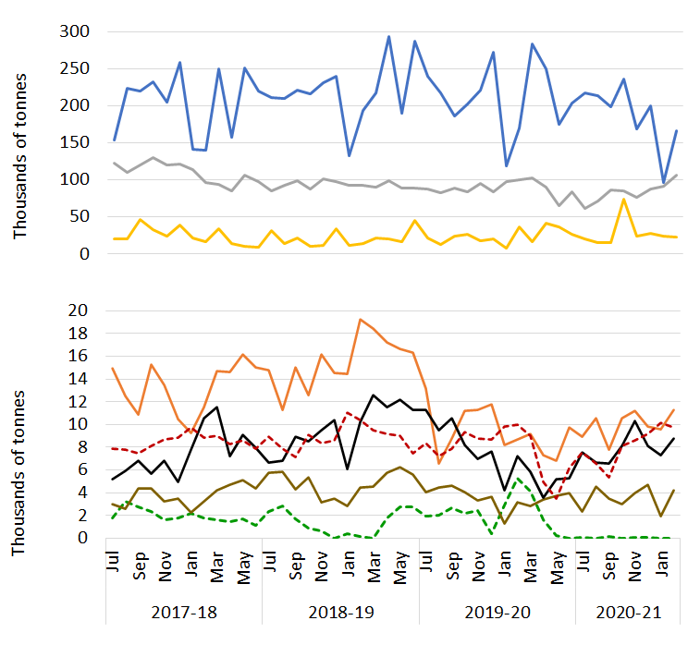  Plastics  Tyres  Glass  Hazardous  Metals  Other  Textiles
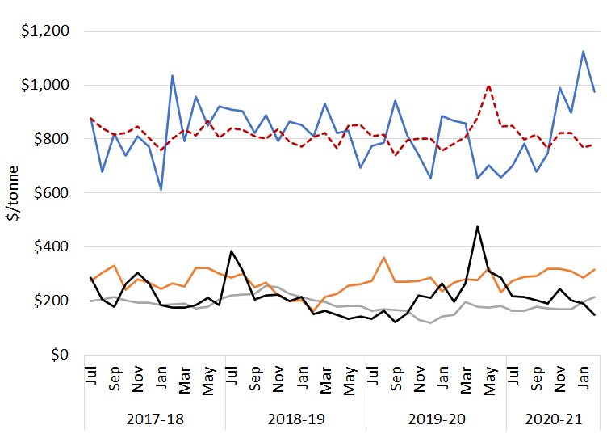
Figure 3 Comparison of unit values by material (in $/t), July 2017 to February 2021
Plastics
Paper & card.
Tyres
Textiles
Metals
but towards the low end of that range in 2020-21
- tyres dipped in 2019, recovered to a peak in April 2020 then began a gradual decline
- glass are not shown as, since the export ban began, low tonnages have resulted in erratic unit values.

Port of loading and state of origin
Between January 2020 and February 2021 about 81% of Australia’s waste and recovered materials were exported from four ports: Melbourne (26%); Sydney (20%); Brisbane (19%); and Fremantle (17%). Figure 4 shows the average monthly tonnes exported by material group between January 2020 to January 2021, and the February 2021 tonnes from each of the top four ports and from all other ports combined. Metals exports from the four main ports were down, leading to below-average exports from Brisbane and Fremantle in February 2021. In Melbourne and Sydney, the fall in metals exports was offset by increased exports for most other waste groups, especially paper and cardboard, resulting in above-average exports overall. Metal exports from ‘all other ports’ were up in February 2021, mainly due to exports of iron and ferrous waste and scrap from WA to Vietnam. Exports from all other ports were above average for all waste categories except ‘other’, for which exports have been highly variable throughout the analysis period.
Figure 4 Monthly exports by material from port of loading – latest month compared with average
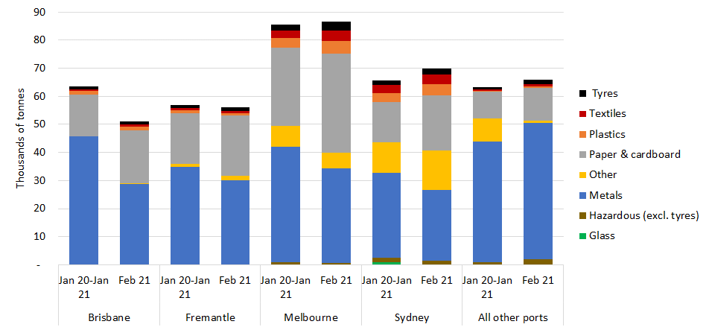

Most waste and recovered materials originating in a jurisdiction are exported from a port in that jurisdiction, but Tasmania exports more than half of its waste via Melbourne and it is understood that materials from the Australian Capital Territory are exported from Sydney.

Australian waste export ban
A March 2020 meeting of the then Council of Australian Governments agreed to a timetable for implementing bans on exporting waste glass, paper, plastics, and tyres not processed into a value-added material. The relevant materials, dates and main export codes are shown in Table 3.
In February 2021, about 127,000 tonnes of waste and recovered materials were exported within the codes listed, up from 109,000 tonnes in January. This represents about 38% of the total quantity of waste and recovered materials exported for the month, and 41% of all exports within the ‘core waste + ash’ scope of national waste reporting.
An impending key milestone is the ban on exports of mixed polymer scrap plastics, which is due to come into force on 1 July 2021. Government and industry are dealing with the challenge of ensuring that sufficient local sorting capacity is available for mixed rigid packaging plastic from kerbside collections, which has previously been exported. About 6,700 tonnes of this material were exported under the relevant code in February 2021.
Table 3 Material types facing export bans
Material | Ban date | AHECC code | AHECC description | Feb 21 exports in this code (rounded tonnes) |  | Estimated % of tonnes to be banned
Glass | Jan 2021 | 70010091 | Glass in the mass, cullet and other waste and scrap of glass, not elsewhere specified |  | 0 | Ban in effect
Paper and cardboard | Jul 2024 | 47071000 | Recovered (waste and scrap), unbleached, kraft paper or paperboard or corrugated paper or paperboard |  | 62,000 | 47%
Paper and cardboard | Jul 2024 | 47072000 | Recovered (waste and scrap) paper or paperboard, made mainly of bleached chemical pulp, not coloured in the mass |  | 0 | 47%
Paper and cardboard | Jul 2024 | 47073000 | Recovered (waste and scrap) paper or paperboard, made mainly of mechanical pulp (e.g. newspapers, journals) |  | 1,000 | 47%
Paper and cardboard | Jul 2024 | 47079000 | Waste and scrap paper or paperboard (incl. unsorted waste and scrap) (excl. unbleached kraft or corrugated (470710); that made mainly from bleached chemical pulp, not coloured in the mass; or made mainly of mechanical pulp) |  | 43,000 | 47%
Plastics | Jul 2022 | 39151000 | Waste, parings and scrap, of polymers of ethylene |  | 4,500 | 100%
Plastics | Jul 2022 | 39152000 | Waste, parings and scrap, of polymers of styrene |  | 40 | 100%
Plastics | Jul 2022 | 39153000 | Waste, parings and scrap, of polymers of vinyl chloride |  | 20 | 100%
Plastics | Jul 2021 | 39159092 | Waste, parings and scrap, of plastics (excl. those of polymers of ethylene, styrene or vinyl chloride) |  | 6,700 | 83%
Whole tyres | Dec 2021 | 40040000 | Waste, parings and scrap of rubber (excl. of hard rubber) and powders and granules obtained therefrom |  | 6,800 | 44% ⁹
Whole tyres | Dec 2021 | 40122000 | Used pneumatic rubber tyres, whether or not subject to recutting or regrooving |  | 1,400 | 100% ⁹
Whole tyres | Dec 2021 | 40129000 | Solid or cushion rubber tyres, rubber tyre treads (incl. interchangeable tyre treads) and rubber tyre flaps |  | 630 | 6% ⁹

Restrictions on waste imports – latest news
India’s Ministry of Environment and Forests established a committee to review imports of many waste types including tyres, textiles and paper and cardboard, but it has not produced a report after more than a year. On 27 January, the Indian government announced that its previous ban on the import of scrap plastics to export-oriented units and special economic zones will be lifted. This is apparently to ensure sufficient supplies for the plastics reprocessing industry, which provides significant employment. Imports must comply with the new amendments to the Basel Convention regarding plastics waste.
Malaysia recently flagged its intention to apply the plastic waste amendment to the Basel Convention by returning a shipment from Los Angeles – a particular concern as the US is not a Convention signatory. However, the shipment was found to be clean, homogenous polyethylene and was ultimately accepted.

Restrictions on waste import – overview
The current status of import restrictions to Australia’s top 10 waste and recovered materials destinations is summarised in Table 4, while
Table 5 provides details of the import restriction policies, their dates and amount of waste potentially impacted by the bans.
Table 4 Summary of import restrictions by material and top 10 destination
 | Glass | Haz. waste (excl. tyres) | Metals | Paper & cardboard | Plastics | Tyres | Textiles
Indonesia | Restricted | Restricted | Restricted | Restricted | Restricted | Restricted |  |  | Key
India |  |  |  |  | Restricted | Considering |  |  | Restricted | Restrictions are in place
Bangladesh |  |  |  |  |  |  |  |  | Announced | Restrictions announced but not yet implemented
Vietnam |  |  | Restricted | Restricted | Restricted |  |  |  | Considering | Restrictions are under consideration
China |  |  | Restricted | Restricted | Restricted
Malaysia |  |  |  |  | Restricted
Thailand |  |  |  |  | Restricted
Taiwan |  |  |  | Restricted | Restricted
Republic of Korea |  |  |  | Restricted | Restricted | Announced
Pakistan |  |  |  |  |  | Restricted

Table 5 Status of waste import restrictions
Destination | Scope of restrictions | Announced & implemented | Associated exports (tonnes) |  |  | Impact and uncertainties
Destination | Scope of restrictions | Announced & implemented | Types | 2019-20 | Feb 21 | Impact and uncertainties
Indonesia | On 27 May 2020 the Indonesian Government published a decree on the implementation of import of non-hazardous and toxic material waste. This limits contamination of imported scrap plastic and paper to 2% and announces the formation of a task force to develop a road map accelerating the availability of domestic raw materials. This will include a staged reduction of import quotas. On 15 October 2020, they further announced exporters will need to complete a registration process, described as cumbersome and lengthy, to continue exporting to Indonesia, which came into force in January 2021. | Ann.: Apr-19  Imp.: Nov-19 | Plastics, Paper and cardboard, metals, glass, hazardous waste, tyres, other. | 627,000  (52,000 per  month) | 86,000 | Imports reduced from 61,000 per month in 2018-19 to 52,000 in 2019-20.
India | In 2016 India banned the import of scrap plastics with an exemption for ‘special economic zones’ and ‘export-oriented units’. In August 2019 the ban was expanded to cover these zones but on 27 January 2021 the expansion was revoked, so waste plastics can again be imported to these areas. The ban excludes electrical/electronic assemblies or components that are defective which can be imported within a year of export. India also has a contamination limit of 1% for recovered paper, which it enforces by randomly inspecting five mixed paper bales per container. | Ann.: Mar-19  Imp.: Mar-19 to Aug-19  Lifted: Jan-21 | Plastics | 60  (5 per month) | 20 | Plastics imports reduced from 60 to 5 tonnes per month from 2018-19 to 2019-20.
Bangladesh | The Bangladesh Ministry of Commerce Import Policy Order 2015-2018 includes details of waste import regulations. Metals and glass are allowed for bona fide industrial units, paper and cardboard is unrestricted and textiles are allowed with some restrictions. The regulations also mention exemptions for other waste types that would fall under the waste groups hazardous and ‘other’. | Imp: Feb-16 | Plastics |  | 0 | None
Vietnam | On 24 September 2020 Vietnam published ‘Promulgation of the list of waste permitted for import as production materials’, overriding previous relevant regulations. Unsorted scrap paper imports and granulated slag from the manufacture of iron or steel are scheduled to be banned by the end of 2021. This builds on a range of restrictions regulated in 2018 that allow waste imports only if shipments meet specified environmental standards and there is capacity to process the materials. These covered scrap iron and steel, plastic, paper, glass, non-ferrous metal and blast furnace slag dust. Under new national standard QCVN 32: 2019/BTNMT, import of e-waste plastics (e.g. cases of TVs and computers) would be forbidden. Scrap metal waste needs to be 99% metal to be allowed in. | Ann. in Sep-20.  Mixed metal waste restricted from Oct 2018. | Plastic, paper, metals | 420,000  (35,000 per month) | 57,000 | Imports reduced from 61,000 to 35,000 tonnes per month between 2018-19 and 2019-20.
Malaysia | Malaysia continues its crackdown on plastic waste imports with renewed support from the Basel Convention amendment on plastic waste, which came into force in January 2021. Recently a large shipment of plastic waste was accepted only after inspection showed it contained clean homogenous polyethylene²¹. The Basel Action Network encouraged the Malaysian government to similarly inspect all shipments of plastics waste coming into the country to ensure continued compliance. | Jul-18. | Plastic, metals | 49,000  (4,100 per month) | 4,400 | No impact apparent.
China | From 1 January 2021, China has implemented a ban on the import of all solid waste. However, certain materials such as scrap metals are defined as resources rather than waste under the new legislation and can continue to be imported. | Ann.: Apr-20  Imp.: Jan 1, 2021 | All solid wastes | 328,000  (27,000 per month) | 8,500 | Imports gradually reduced from over 100,000 tonnes per month in 2016-17 to 27,000 in 2018-19.
Thailand | Thailand announced its intention to implement a ban on the import of all plastic wastes by 2022. However, this is still under debate due to uncertainty that locally generated plastic waste can satisfy feedstock requirements of the 157 plastic recycling facilities. A ban on 428 types of electronic waste has also been announced. | Ann. Aug-18, plastic imp. Aug-18, e-waste <2 yrs. | Plastic | 9,500  (800 per month) | 240 | Plastics imports reduced from 900 to 800 tonnes per month between 2018-19 and 2019-20.
Taiwan | Import of plastic waste is banned. Exceptions are made to licensed local firms that import plastic waste originating from their own overseas production processes or are a single material, but not from original production processes. Paper imports are restricted to deinked paper, kraft paper, corrugated paper or cardboard that is not bleached. Import of waste newspapers and magazines banned. | Ann.: Aug-18  Imp.: Oct-18 | Plastic, paper | 14,200  (1,200 per month) | 330 | Imports reduced from 1,500 to 1,200 per month between 2018-19 and 2019-20.
Korea, Republic of | On 6 January 2021, the Ministry of Environment announced bans or restrictions on their top 10 waste import materials. Total imports to be reduced 35% by 2022 and 65% by 2025. Bans on plastics, mixed waste paper and waste fibre will commence in 2022, and on coal ash and tyres in 2023. Corrugated cardboard, dust and sludge will be subject to restrictions in 2023. Previously announced (30 June 2020) a ban on imports of PET, PE, PP and PS with immediate effect. | Ann.: Feb-20 | Paper and cardboard  Plastic | 13,000  (1,100 per month) | 2,400 | Imports of both products have decreased significantly over 2020
Pakistan | On 25 September 2020 the Pakistan Government Ministry of Commerce published Import Policy Order 2020, which came into force immediately. This bans the import of re-treaded tyres and used pneumatic tyres. | Sep-20 | Tyres |  | 0 | No impact apparent

The export codes mapped to waste and recovered materials in 2020-21 differ slightly from those in 2019-20. Details are given in the accompanying workbook (under ‘Ref lists’). The historical data presented here has been updated.
Data in these summaries is originally entered by exporters or their agents. It cannot be guaranteed that exporters use the correct codes or values for their exports, so this data should be used with caution.
Data may be revised for up to six months after initial publication as customs declarations are amended by individual traders. Due to these revisions, there may be discrepancies between this and preceding reports.
The data presented is gross weight, including packaging but excluding shipping containers. This value is used for consistency because the quantities of exported materials are presented in varied units, including numbers of items.
Some of these recovered materials contain a proportion of contamination (or ‘off-spec’ content) that needs to be extracted before the material can be used.
Dollar values refer to Australian dollars. Historical values are inflated based on the annualised consumer price index.
The reported value of this copper slag and ash waste exceeded $440/kg. The value of pure copper is typically around $10/kg.
See the National Waste Report 2020 on the Department of Agriculture, Water and the Environment website.
Tyre export quantities are much lower than reported through industry sources. Significant miscoding is likely.
Earlier data were unavailable.
Value revised from the 118,000 reported in the January version of this report due to amendments to the ABS data set.
Australian Harmonized Export Commodity Classification.
Based on the 2018-19 characteristics of these materials.
Previously 70010000
Comprises the proportion of material in AHECC code 47079000, but significant miscoding is apparent in the data.
Assumes no material was sorted and processed to the extent that will be required for future export.
Excludes fuels.
The Economic Times (13 January 2021) NGT raps govt over delay in report on import of hazardous waste
Scrap News (8 February 2021) India reopens access to recovered polyethylene
Waste Advantage Magazine (2021) Malaysia to return US plastic waste shipment under new UN rules https://wasteadvantagemag.com/malaysia-to-return-u-s-plastic-waste-shipment-under-new-u-n-rules/
Reuters (2021) Malaysia permits import of US plastic waste shipment after it passes new UN treaty test https://www.reuters.com/article/us-malaysia-environment-plastic-idUSKBN2BG0ZL
Minister of Trade, Minister of Environment and Forestry, Minister of Trade Industry and Head of State Policy, Republic of Indonesia (May 2020), Implementation of import of non hazardous and toxic material waste as raw material industry.
EU-WID Pulp and paper (16 October 2020) Indonesia postpones introduction of exporter registration to 1 January 2021.
Business Today, (24 June 2019) India bans import of plastic waste from August this year to curb pollution.
Waste Dive, (15 January 2020), India to enforce 1% contamination rate on paper imports, conduct random inspections.
Ministry of Commerce, Government of the People’s Republic of Bangladesh (2016) Import Policy Order 2015-2018
Prime Minister of Vietnam (24 September 2020) Promulgation of the list of waste permitted for import as production materials. Unofficial translation.
Vietnam - National Technical Regulations on Wastes (18 November 2019), https://www.cciclondon.com/portal/article/index/cat_id/35/id/286.html
Ministry of Natural Resources and Environment of the Socialist Republic of Vietnam (2018) Vietnam to ban imports of plastic from used electronics.
S&P Global Platts (2019) Vietnam’s Jan scrap imports plunge amid stricter government rules.
The Sun Daily (2 February 2021) Waste not want not: Malaysia moves to become a leader in tackling plastic waste.
Ministry of Ecology and Environment, People’s Republic of China (25 November 2020) MEE Announcement No. 53 2020 (unofficial translation by Institute of Scrap Recycling Industries.
REB market intelligence (25 January 2021) Thailand considering plastic import ban from 1st January 2022.
Saengmanee (2020) The year nature bounced back.
Taipei Times (2018) New waste plastic, paper import rules to take effect.
Business Korea (7 January 2021) Waste import ban roadmaps to come out soon.
Inquirer.net (10 January 2021) S. Korea to phase out industrial waste imports.
The Korea Times (2020) Plastic waste imports banned in Korea amid mounting local trash.
Pakistan Government Ministry of Commerce (2020) Import Policy Order 2020.

