Exports of Australian waste and recovered materials in March 2021
21 June 2021, Sally Donovan and Joe Pickin
©The Department of Agriculture, Water and the Environment
Blue Environment is commissioned by the Department of Agriculture, Water and the Environment to produce, analyse and report on monthly exports of waste and recovered materials. The original data is provided by the Australian Bureau of Statistics (ABS), and comprises monthly data and updates to previously reported data,,. The ABS data is transformed to account for issues such as trade codes covering a mixture of wastes and non-wastes, and to make it consistent with national waste data methods. On a tonnage basis nearly all these exports are materials recovered from waste streams for recycling or energy recovery, but a small portion is hazardous waste sent for treatment. Monthly data is highly variable, and trends are best observed through the annual reports produced in this series.

Summary
In March 2021, Australia exported about 442,000 tonnes of waste and recovered materials with a reported value of $321 million. This represents an increase of 34% in tonnage and 27% in value compared to the previous month. The exports included 386,000 tonnes (87%) within the scope of national waste reporting (‘core waste plus ash’).
About 130,000 tonnes were exported in March in codes that could be affected by Australia’s export bans. This is 29% of the total exports of waste and recovered materials. New AHECC codes for glass exports were introduced to distinguish between processed and unprocessed waste glass from 1 January 2021. A small amount of material was exported under one of these new codes in March. No impact of the forthcoming ban on export of mixed plastic scrap (scheduled for 1 July 2021) is apparent in the data.

Comparison by destination
The top 10 recipients of Australian waste and recovered materials between July 2019 and March 2021, in order, were Indonesia, India, Bangladesh, Vietnam, Malaysia, China (including Hong Kong and Macau), Thailand, Taiwan, the Republic of Korea and Pakistan. In March 2021, 88% by weight of Australia’s exported waste and recovered materials was sent to these destinations.
Table 1 (overleaf) compares exports of waste and recovered materials to these top 10 destinations in January and February 2021 and includes each destination’s 2019-20 monthly average. Exports increased to all destinations except Malaysia and China. The largest increases were to Taiwan and Thailand, due to increased scrap metal exports, and to Vietnam due to metals and a shipment of brewing or distilling dregs from Sydney.
Scrap metals were the main export to Bangladesh (100%), Taiwan (99%), Vietnam (81%), Pakistan (80%) and China (80%). Metals accounted for just over half of the exports to India (54%) followed by paper and cardboard (27%) and tyres (17%). The main export to Indonesia was scrap paper and cardboard (76%) followed by metals (18%). Exports to the Republic of Korea included metals (52%), agricultural organics (23%), hazardous waste (11%) and paper and cardboard (10%). Exports to Malaysia were also mixed including paper and cardboard (37%), metals (26%) and plastics (25%).
Table 1 Comparison of month-to-month exports of waste and recovered materials by destination
Export destination (ranked by tonnes since July 2019) |  | Mar-21 |  | Feb-21 |  | 2019-20 monthly avg tonnes | Mar-21 | Feb-21 |  | 2019-20 monthly avg  $ mil
 |  | tonnes | % of total | tonnes | % change |  | $ mil | $ mil | % change
1 | Indonesia | 93,000 | 21% | 86,000 | 8% | 52,000 | $29.0 | $25.9 | 12% | $16.1
2 | India | 35,000 | 8% | 31,000 | 13% | 48,000 | $23.3 | $23.0 | 1% | $27.4
3 | Bangladesh | 33,000 | 7% | 30,000 | 8% | 52,000 | $13.8 | $12.9 | 7% | $20.6
4 | Vietnam | 103,000 | 23% | 62,000 | 67% | 35,000 | $57.1 | $28.4 | 101% | $14.3
5 | Malaysia | 25,000 | 6% | 30,000 | -17% | 32,000 | $17.8 | $18.9 | -6% | $13.2
6 | China | 8,400 | 2% | 8,500 | -1% | 27,000 | $33.6 | $23.8 | 41% | $28.3
7 | Thailand | 29,000 | 7% | 16,000 | 78% | 22,000 | $15.1 | $9.28 | 63% | $7.62
8 | Taiwan | 28,000 | 6% | 12,000 | 127% | 17,000 | $13.5 | $5.92 | 128% | $9.32
9 | Korea, Republic of | 19,000 | 4% | 12,000 | 60% | 15,000 | $31.5 | $13.9 | 127% | $39.4
10 | Pakistan | 15,000 | 3% | 10,000 | 46% | 9,100 | $8.32 | $6.25 | 33% | $5.01
Top 10 total |  | 388,000 | 88% | 298,000 | 30% | 309,000 | $243.0 | $168.3 | 44% | $181.3
Monthly total |  | 442,000 | - | 329,000 | 34% | 354,000 | $320.7 | $253.1 | 27% | $237.7

Figure 1 presents the trend in tonnes of exports of waste and recovered materials from Australia by destination between July 2017 and March 2021. Monthly exports are volatile and no overall trend is evident over the 45-month timeframe. Exports of waste and recovered materials to Indonesia and Vietnam have grown during this financial year, while those to India, Malaysia, China, Taiwan, the Republic of Korea and Pakistan have fallen. Exports to Bangladesh, Thailand and other destinations in the top 10 have levelled off.
Figure 1 Monthly exports of waste and recovered materials from Australia by destination
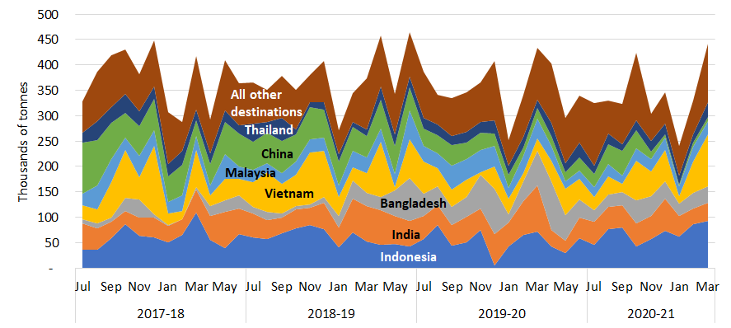

The reported value of exports for March 2021 was $321 million, up from $253 million in February and greater than the 2019-20 monthly average of $238 million. The monthly rise in value was similar to the rise in tonnes.

Comparison by material
Table 2 compares March 2021 export tonnages and values with February and with the 2019-20 monthly average, by material type. Around 87% falls within the ‘core waste plus ash’ scope of national waste reporting.

Table 2 Comparison of export tonnage and value by material
 | Mar-21 |  | Feb-21 |  |  | 2019-20 monthly avg  tonnes | Mar-21 |  | Feb-21 |  |  | 2019-20 monthly avg  $ mil
 | tonnes | % of total | tonnes | % change |  |  | $ mil | % of total | $ mil | % change
Glass | 40 | <1% | 0 | n/a |  | 2,200 | $0.10 | <1% | $0.00 | n/a |  | $0.11
Hazardous (excl. tyres) | 3,200 | 1% | 4,200 | -25% |  | 3,500 | $23.3 | 7% | $41.2 | -44% |  | $37.1
Metals | 242,000 | 55% | 166,000 | 46% |  | 212,000 | $232 | 72% | $161 | 44% |  | $163
Paper & cardboard | 108,000 | 24% | 107,000 | 1% |  | 88,000 | $24.1 | 8% | $22.9 | 5% |  | $14.2
Plastics | 12,000 | 3% | 11,000 | 2% |  | 9,400 | $3.74 | 1% | $3.57 | 5% |  | $2.59
Textiles | 10,000 | 2% | 10,000 | 1% |  | 7,800 | $7.93 | 2% | $7.63 | 4% |  | $6.30
Tyres | 11,000 | 2% | 8,800 | 27% |  | 7,100 | $1.65 | <1% | $1.31 | 26% |  | $1.47
Other | 57,000 | 13% | 23,000 | 146% |  | 24,000 | $28.3 | 9% | $15.1 | 87% |  | $12.9
Total | 442,000 | - | 329,000 | 34% |  | 354,000 | $321 | - | $253 | 27% |  | $238

Comparison with the previous month –
- Unprocessed glass waste exports are now subject to an export ban. A small amount of glass processed into non furnace-ready fines and/or cullet was exported in March.
- Exports of hazardous waste (excluding tyres) fell from 4,200 to 3,200 tonnes. Unusually, there were no exports of lead-containing slag, ash and residues, and the tonnes were nearly all lead waste and scrap (96%). However, these lead exports accounted for only 23% of the value, with copper slag, ash and residues accounting for 76% due to an anomalously high reported value.
- Monthly exports of scrap metals experienced a major increase and accounted for about two-thirds of the total rise in exports. Their reported value was $232 million, or 72% of the total value of waste exports. The main recipients were Vietnam (34%), Bangladesh (13%) and Taiwan (11%).
- Exports of scrap paper and cardboard were consistent between February and March 2021. Exports went mainly to Indonesia (66%) with smaller amounts going to 12 other destinations. Tonnages were split between unbleached kraft 64% and unsorted scrap 34%. Despite representing 24% of tonnage of exported waste and recovered materials, the reported value, at $24.1 million, represented only 8% of the total.
- Exports of scrap plastics rose by 2%. The largest recipients were Malaysia (54%) and Indonesia (17%). These exports comprised mixed and ‘other’ plastics (57%) and polyethylenes (42%). The value increased slightly more than the tonnes due to a smaller proportion of low value mixed scrap.
- Exports of waste textiles have remained steady at 10,000 tonnes since January 2021. The main receiving countries in March were the United Arab Emirates (60%), Malaysia (14%) and Pakistan (10%). Worn clothing and other worn textile articles accounted for more than 99% of textile waste.
- Exports of waste tyres rose from 8,800 to 11,000 tonnes between February and March 2021. The main recipients were India (53%) and Malaysia (14%). The value similarly increased as the unit value held steady, after dropping consistently between November 2020 and February 2021.
- Exports in the waste category other more than doubled from 23,000 to 57,000 tonnes due largely to a shipment of 22,000 tonnes of sawdust to Japan. These large one-off shipments of sawdust occur periodically. The remaining exports in this category were mainly agricultural organics (61%).

Comparison with the 2019-20 monthly average – March 2021 export tonnages were 25% higher than last year’s monthly average, and the value was 35% higher. Tonnages were greater than the 2019-20 average for all waste types except glass and hazardous. The values differed similarly.

Trends in tonnage and unit value
Textiles
Paper & cardboard
Tyres
Figure 2 presents the monthly trend in exports of waste from Australia in tonnes by material type between July 2017 and March 2021. Scrap metal exports climbed after dropping to their lowest value over the analysis period in January 2021. Exports of scrap paper and cardboard fell for much of the period but grew in recent months. Monthly exports of scrap tyres fell steadily over 2019-20 to reach their lowest level in April but subsequently increased⁹. Exports of recovered plastics fell in early 2017-18, recovered to peak in early 2019, then fell to a low in August. They have grown during 2020-21.  Figure 3 presents monthly trends in the average reported value per tonne of key waste exports from July 2017 to March 2021. Reported values for:  - metals declined gradually from July 2018 but have been increasing in recent months  - paper and cardboard had been on a gently declining trend but have risen steadily since December 2020  - plastics fell steadily during 2018 due to China’s restrictions, but recovered as exports of low-grade mixed materials fell while higher value streams remained consistent  - textiles were consistently between $740 and $1,000/t but towards the low end of | Figure 2 Monthly exports of waste and recovered materials from Australia by material type, July 2017 to March 2021  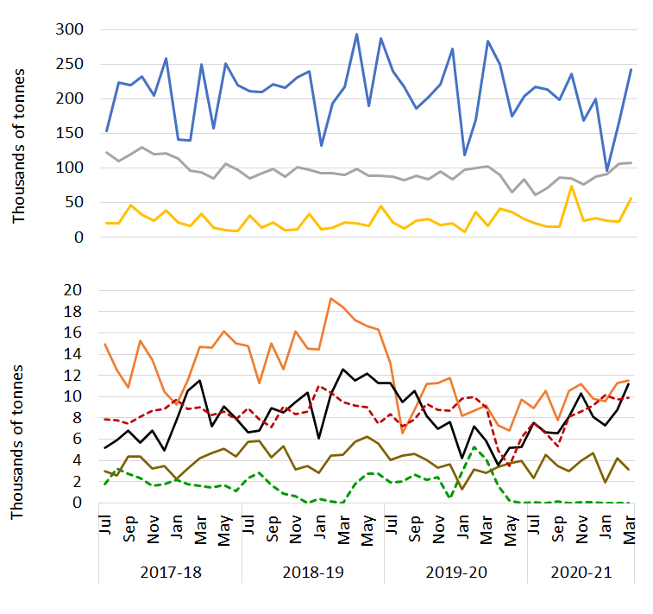  Hazardous  Plastics  Tyres  Other  Metals  Glass
Figure 3 Comparison of unit values by material (in $/t), July 2017 to March 2021
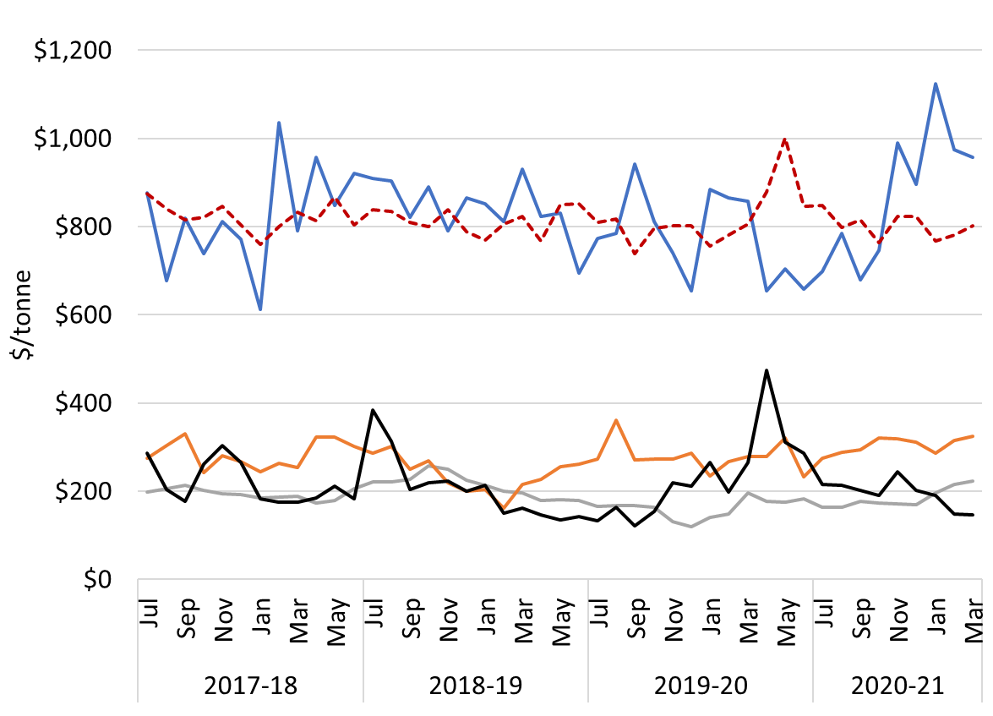
Textiles
Plastics
Paper & card.
Metals

that range in 2020-21
- tyres dipped in 2019, peaked in April 2020 and have been declining since
- glass are not shown as, since the export ban began, low tonnages have resulted in erratic unit values.

Port of loading and state of origin
Between January 2020 and March 2021 about 81% of Australia’s waste and recovered materials were exported from four ports: Melbourne (25%); Sydney (20%); Brisbane (19%); and Fremantle (16%). Figure 4 shows the average monthly tonnes exported by material group between January 2020 and February 2021, and the March 2021 tonnes from each of the top four ports and from all other ports combined. Exports from Fremantle were below average in March, mainly due to a drop in metal exports. Brisbane and Melbourne both exported above average metals and paper and cardboard. Exports from Sydney were relatively high for paper and cardboard and ‘other’. Until September 2020 exports in the ‘other’ category from Sydney mainly consisted of brans, sharps and residues of milling but since then, exports of brewing or distilling dregs have grown steadily to reach over 19,000 tonnes this month. Exports from all other ports were substantially above average due to three large shipments of ferrous waste and scrap to Vietnam and a large shipment of sawdust from Albany to Japan.
Figure 4 Monthly exports by material from port of loading – latest month compared with average
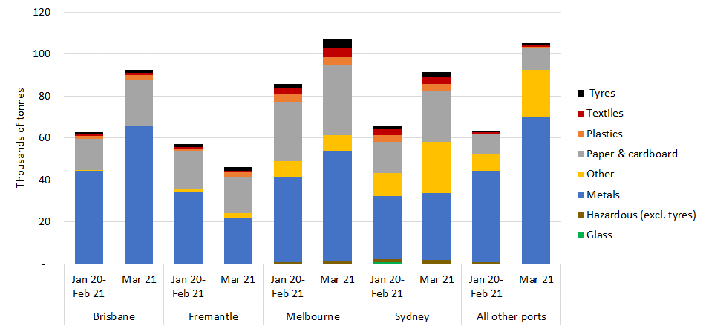

Most waste and recovered materials are exported from a port in the jurisdiction where they are generated, but Tasmania exports more than half of its waste via Melbourne and it is understood that materials from the Australian Capital Territory are exported from Sydney.

Australian waste export ban
A March 2020 meeting of the then Council of Australian Governments agreed to a timetable for implementing bans on exporting waste glass, paper, plastics, and tyres not processed into a value-added material. The relevant materials, dates and main export codes are shown in Table 3.
In March 2021, about 130,000 tonnes of waste and recovered materials were exported within the codes listed, up from 127,000 tonnes in February. This represents about 29% of the total quantity of waste and recovered materials exported for the month, and 34% of all exports within the ‘core waste + ash’ scope of national waste reporting.
An impending key milestone is the ban on exports of mixed polymer scrap plastics, which is due to come into force on 1 July 2021. Government and industry are dealing with the challenge of ensuring that sufficient local sorting capacity is available for mixed rigid packaging plastic from kerbside collections, which has previously been exported. About 6,600 tonnes of material were exported under the relevant code in March 2021.
Table 3 Material types facing export bans
Material | Ban date | AHECC code | AHECC description | Mar 21 exports in this code (rounded tonnes) |  | Estimated % of tonnes to be banned
Glass | Jan 2021 | 70010091 | Glass in the mass, cullet and other waste and scrap of glass, not elsewhere specified |  | 0 | Ban in effect
Paper and cardboard | Jul 2024 | 47071000 | Recovered (waste and scrap), unbleached, kraft paper or paperboard or corrugated paper or paperboard |  | 69,000 | 47%
 |  | 47072000 | Recovered (waste and scrap) paper or paperboard, made mainly of bleached chemical pulp, not coloured in the mass |  | 90
 |  | 47073000 | Recovered (waste and scrap) paper or paperboard, made mainly of mechanical pulp (e.g. newspapers, journals) |  | 1,400
 |  | 47079000 | Waste and scrap paper or paperboard (incl. unsorted waste & scrap) (excl. unbleached kraft or corrugated (470710); that made mainly from bleached chemical pulp, not coloured in the mass; or made mainly of mechanical pulp) |  | 37,000
Plastics | Jul 2022 | 39151000 | Waste, parings and scrap, of polymers of ethylene |  | 4,900 | 100%
 |  | 39152000 | Waste, parings and scrap, of polymers of styrene |  | 40
 |  | 39153000 | Waste, parings and scrap, of polymers of vinyl chloride |  | 20
 | Jul 2021 | 39159092 | Waste, parings and scrap, of plastics (excl. those of polymers of ethylene, styrene or vinyl chloride) |  | 6,600 | 83%
Whole tyres | Dec 2021 | 40040000 | Waste, parings and scrap of rubber (excl. of hard rubber) and powders and granules obtained therefrom |  | 8,300 | 44% ⁹
 |  | 40122000 | Used pneumatic rubber tyres, whether or not subject to recutting or regrooving |  | 1,700 | 100% ⁹
 |  | 40129000 | Solid or cushion rubber tyres, rubber tyre treads (incl. interchangeable tyre treads) and rubber tyre flaps |  | 1,200 | 6% ⁹

Restrictions on waste imports – latest news
India’s Ministry of Environment and Forests established a committee to review imports of many waste types including tyres, textiles and paper and cardboard, but it has not produced a report after more than a year. On 27 January, the Indian government announced that its previous ban on the import of plastics waste to export-oriented units and special economic zones will be lifted. This is apparently to ensure sufficient supplies for the plastics reprocessing industry, which provides significant employment. Imports must comply with the new amendments to the Basel Convention regarding plastics waste.
Malaysia recently flagged its intention to apply the plastic waste amendment to the Basel Convention by returning a shipment from Los Angeles – a particular concern as the US is not a Convention signatory. However, the shipment was found to be clean, homogenous polyethylene and was ultimately accepted.
No updates were found on restrictions in Australia’s other major export destinations.

Restrictions on waste import – overview
The current status of import restrictions to Australia’s top 10 waste and recovered materials destinations is summarised in Table 4, while
Table 5 provides details of the import restriction policies, their dates and amount of waste potentially impacted by the bans.
Table 4 Summary of import restrictions by material and top 10 destination
 | Glass | Haz. waste (excl. tyres) | Metals | Paper & cardboard | Plastics | Tyres | Textiles
Indonesia | Restricted | Restricted | Restricted | Restricted | Restricted | Restricted |  |  | Key
India |  |  |  |  | Restricted | Considering |  |  | Restricted | Restrictions are in place
Bangladesh |  |  |  |  | Restricted |  |  |  | Announced | Restrictions announced but not yet implemented
Vietnam |  |  | Restricted | Restricted | Restricted |  |  |  | Considering | Restrictions are under consideration
China |  |  | Restricted | Restricted | Restricted
Malaysia |  |  |  |  | Restricted
Thailand |  |  |  |  | Restricted
Taiwan |  |  |  | Restricted | Restricted
Republic of Korea |  |  |  | Restricted | Restricted | Announced
Pakistan |  |  |  |  |  | Restricted

Table 5 Status of waste import restrictions
Destination | Scope of restrictions | Announced & implemented | Associated exports (tonnes) |  |  | Impact and uncertainties
 |  |  | Types | 2019-20 | Mar 21
Indonesia | On 27 May 2020 the Indonesian Government published a decree on the implementation of import of non-hazardous and toxic material waste. This limits contamination of imported scrap plastic and paper to 2% and announces the formation of a task force to develop a road map accelerating the availability of domestic raw materials. This will include a staged reduction of import quotas. On 15 October 2020, they further announced exporters will need to complete a registration process, described as cumbersome and lengthy, to continue exporting to Indonesia, which came into force in January 2021. | Ann.: Apr-19  Imp.: Nov-19 | Plastics, Paper and cardboard, metals, glass, hazardous waste, tyres, other. | 627,000  (52,000 per  month) | 93,000 | Imports reduced from 61,000 per month in 2018-19 to 52,000 in 2019-20.
India | In 2016 India banned the import of scrap plastics with an exemption for special economic zones (SEZ) and export-oriented units (EOU). In August 2019 the ban was expanded to cover these zones, however, on 27 January 2021 this expansion was revoked meaning waste plastics can again be imported to these areas. The ban excludes electrical/electronic assemblies or components that are defective which can be imported within a year of export. India also has a contamination limit of 1% for recovered paper, which it enforces by randomly inspecting five mixed paper bales per container . | Ann.: Mar-19  Imp.: Mar-19 to Aug-19  Lifted: Jan-21 | Plastics | 60  (5 per month) | 30 | Plastics imports reduced from 60 to 5 tonnes per month from 2018-19 to 2019-20.
Bangladesh | The Bangladesh Ministry of Commerce Import Policy Order 2015-2018 includes details of waste import regulations. Metals and glass are allowed for bona fide industrial units, paper and cardboard is unrestricted and textiles are allowed with some restrictions. The regulations also mention exemptions for other waste types that would fall under the waste groups hazardous and ‘other’. | Imp: Feb-16 | Plastics |  | 0 | None
Vietnam | On 24 September 2020 Vietnam published ‘Promulgation of the list of waste permitted for import as production materials’, overriding previous relevant regulations. Unsorted scrap paper imports and granulated slag from the manufacture of iron or steel are scheduled to be banned by the end of 2021. This builds on a range of restrictions regulated in 2018 that allow waste imports only if e.g., shipments meet specified environmental standards and there is capacity to process the materials. These covered scrap iron and steel, plastic, paper, glass, non-ferrous metal and blast furnace slag dust. Under new national standard QCVN 32: 2019/BTNMT, import of e-waste plastics (e.g. cases of TVs and computers) would be forbidden. Scrap metal waste needs to be 99% metal to be allowed in. | Ann. in Sep-20.  Mixed metal waste restricted from Oct 2018. | Plastic, paper, metals | 420,000  (35,000 per month) | 89,000 | Imports reduced from 61,000 to 35,000 tonnes per month between 2018-19 and 2019-20.
Malaysia | Malaysia continues its crackdown on plastic waste imports with renewed support from the Basel Convention amendment on plastic waste, which came into force in January 2021. Recently a large shipment of plastic waste was accepted only after inspection showed it contained clean homogenous polyethylene²⁰. The Basel Action Network encouraged the Malaysian government to similarly inspect all shipments of plastics waste coming into the country to ensure continued compliance. | Jul-18. | Plastic, metals | 49,000  (4,100 per month) | 6,300 | No impact apparent.
China | From 1 January 2021, China has implemented a ban on the import of all solid waste. However, certain materials such as scrap metals are defined as resources rather than waste under the new legislation and can continue to be imported | Ann.: Apr-20  Imp.: Jan 1, 2021 | All solid wastes | 328,000  (27,000 per month) | 8,400 | Imports gradually reduced from over 100,000 tonnes per month in 2016-17 to 27,000 in 2018-19.
Thailand | Thailand announced its intention to implement a ban on the import of all plastic wastes by 2022. However, this is still under debate due to uncertainty that locally generated plastic waste can satisfy feedstock requirements of the 157 plastic recycling facilities. A ban on 428 types of electronic waste has also been announced. | Ann. Aug-18, plastic imp. Aug-18, e-waste <2 yrs. | Plastic | 9,500  (800 per month) | 290 | Plastics imports reduced from 900 to 800 tonnes per month between 2018-19 and 2019-20.
Taiwan | Import of plastic waste is banned. Exceptions are made to licensed local firms that import plastic waste originating from their own overseas production processes or are a single material, but not from original production processes. Paper imports are restricted to deinked paper, kraft paper, corrugated paper or cardboard that is not bleached. Import of waste newspapers and magazines banned. | Ann.: Aug-18  Imp.: Oct-18 | Plastic, paper | 14,200  (1,200 per month) | 390 | Imports reduced from 1,500 to 1,200 per month between 2018-19 and 2019-20.
Korea, Republic of | On 6 January 2021, the Ministry of Environment announced bans or restriction on their top 10 waste import materials. Total imports to be reduced 35% by 2022 and 65% by 2025. Bans on plastics, mixed waste paper and waste fibre will commence in 2022, and on coal ash and tyres in 2023. Corrugated cardboard, dust and sludge will be subject to restrictions in 2023. Previously announced (30 June 2020) a ban on imports of PET, PE, PP and PS with immediate effect. | Ann.: Feb-20 | Paper and cardboard  Plastic | 13,000  (1,100 per month) | 1,800 | Imports of both products have decreased significantly over 2020
Pakistan | On 25 September 2020 the Pakistan Government Ministry of Commerce published Import Policy Order 2020, which came into force immediately. This bans the import of re-treaded tyres and used pneumatic tyres. | Sep-20 | Tyres |  | 0 | No impact apparent

The export codes mapped to waste and recovered materials in 2020-21 differ slightly from those in 2019-20. Details are given in the accompanying workbook (under ‘Ref lists’). The historical data presented here has been updated.
Data in these summaries is originally entered by exporters or their agents. It cannot be guaranteed that exporters use the correct codes or values for their exports, so this data should be used with caution.
Data may be revised for up to six months after initial publication as customs declarations are amended by individual traders. Due to these revisions, there may be discrepancies between this and preceding reports.
The data presented is gross weight, including packaging but excluding shipping containers. This value is used for consistency because the quantities of exported materials are presented in varied units, including numbers of items.
Some of these recovered materials contain a proportion of contamination (or ‘off-spec’ content) that needs to be extracted before the material can be used.
Dollar values refer to Australian dollars. Historical values are inflated based on the annualised consumer price index.
See the National Waste Report 2020 on the Department of Agriculture, Water and the Environment website.
The reported value of this copper slag and ash waste was around $440/kg. The value of pure copper is typically around $10/kg.
Tyre export quantities are much lower than reported through industry sources. Significant miscoding is likely.
Earlier data were unavailable.
Australian Harmonized Export Commodity Classification.
Based on the 2018-19 characteristics of these materials.
Previously 70010000
Comprises the proportion of material in AHECC code 47079000, but significant miscoding is apparent in the data.
Assumes no material was sorted and processed to the extent that will be required for future export.
Excludes fuels.
The Economic Times (13 January 2021) NGT raps govt over delay in report on import of hazardous waste
Scrap News (8 February 2021) India reopens access to recovered polyethylene
Waste Advantage Magazine (2021) Malaysia to return US plastic waste shipment under new UN rules https://wasteadvantagemag.com/malaysia-to-return-u-s-plastic-waste-shipment-under-new-u-n-rules/
Reuters (2021) Malaysia permits import of US plastic waste shipment after it passes new UN treaty test https://www.reuters.com/article/us-malaysia-environment-plastic-idUSKBN2BG0ZL
Minister of Trade, Minister of Environment and Forestry, Minister of Trade Industry and Head of State Policy, Republic of Indonesia (May 2020), Implementation of import of non hazardous and toxic material waste as raw material industry.
EU-WID Pulp and paper (16 October 2020) Indonesia postpones introduction of exporter registration to 1 January 2021.
Business Today, (24 June 2019) India bans import of plastic waste from August this year to curb pollution.
Waste Dive, (15 January 2020), India to enforce 1% contamination rate on paper imports, conduct random inspections.
Ministry of Commerce, Government of the People’s Republic of Bangladesh (2016) Import Policy Order 2015-2018
Prime Minister of Vietnam (24 September 2020) Promulgation of the list of waste permitted for import as production materials. Unofficial translation.
Vietnam - National Technical Regulations on Wastes (18 November 2019), https://www.cciclondon.com/portal/article/index/cat_id/35/id/286.html
Ministry of Natural Resources and Environment of the Socialist Republic of Vietnam (2018) Vietnam to ban imports of plastic from used electronics.
S&P Global Platts (2019) Vietnam’s Jan scrap imports plunge amid stricter government rules.
The Sun Daily (2 February 2021) Waste not want not: Malaysia moves to become a leader in tackling plastic waste.
Ministry of Ecology and Environment, People’s Republic of China (25 November 2020) MEE Announcement No. 53 2020 (unofficial translation by Institute of Scrap Recycling Industries.
REB market intelligence (25 January 2021) Thailand considering plastic import ban from 1st January 2022.
Saengmanee (2020) The year nature bounced back.
Taipei Times (2018) New waste plastic, paper import rules to take effect.
Business Korea (7 January 2021) Waste import ban roadmaps to come out soon.
Inquirer.net (10 January 2021) S. Korea to phase out industrial waste imports.
The Korea Times (2020) Plastic waste imports banned in Korea amid mounting local trash.
Pakistan Government Ministry of Commerce (2020) Import Policy Order 2020.

