|  |  |
| --- | --- |
| Summary of the history and development of WasteDataFlow | |
|  |
|  | | |
|  | | |

|  |  |
| --- | --- |
|  |  |
| Summary of the history and development of WasteDataFlow | |
|  | | |
| Sinclair Knight Merz  ABN 37 001 024 095  214 Northbourne Avenue Braddon ACT 2612 Australia Postal address PO Box 930 Dickson ACT 2602 Australia  Tel: +61 2 6246 2700  Fax: +61 2 6246 2799  Web: www.skmconsulting.com | | |
|  | | |
| COPYRIGHT: The concepts and information contained in this document are the property of Sinclair Knight Merz Pty Ltd. Use or copying of this document in whole or in part without the written permission of Sinclair Knight Merz constitutes an infringement of copyright. | |
| LIMITATION: This report has been prepared on behalf of and for the exclusive use of Sinclair Knight Merz Pty Ltd’s Client, and is subject to and issued in connection with the provisions of the agreement between Sinclair Knight Merz and its Client. Sinclair Knight Merz accepts no liability or responsibility whatsoever for or in respect of any use of or reliance upon this report by any third party. | |

The views and opinions expressed in this publication are those of the authors and do not necessarily reflect those of the Australian Government or the Minister for Sustainability, Environment, Water, Population and Communities.

While reasonable efforts have been made to ensure that the contents of this publication are factually correct, the Commonwealth does not accept responsibility for the accuracy or completeness of the contents, and shall not be liable for any loss or damage that may be occasioned directly or indirectly through the use of, or reliance on, the contents of this publication.

Table of contents

Executive summary—WasteDataFlow 1

Detailed report—WasteDataFlow 9

1 Background and drivers 10

1.1 Project history 10

1.2 Ongoing drivers 12

1.3 Evolution of waste management 14

2 Dataset and data uses 16

2.1 Dataset 16

2.2 Data uses 21

3 System design 24

3.1 Development approach 24

3.2 Development time frame 25

4 Roles and responsibilities 26

4.1 Project governance 26

4.2 Project operation 27

5 Operational features 29

5.1 User levels within WDF 29

5.2 Entering data and creating a quarterly submission 30

5.3 Validation and authorisation of data 30

6 System costs 33

7 System benefits 34

7.1 Government 34

7.2 Regulatory bodies 35

7.3 Local authorities 36

7.4 Other stakeholders 36

8 Lessons learnt 38

Screenshots—WasteDataFlow 39

Data entry 39

Data authorisation 42

Reports 43

|  |  |
| --- | --- |
| Executive summary—WasteDataFlow | |
| **Data system** | WasteDataFlow |
| **Country** | UK |
| **Waste streams** | Municipal waste |
| **Operational since** | April 2004 |
| **Survey method** | Quarterly online returns |
| **Background and drivers** | |
| WasteDataFlow (WDF) is the UK’s web-based data collection system for municipal waste collected by local authorities. Since its inception in 2004 it has been developed and enhanced to become the recognised data reporting method for local authorities and a data management tool for a wide range of public and private sector organisations.  Before 2004 Defra’s annual waste management surveys of UK local authorities were initially paper based, then Excel based. However, government bodies and the waste management industry recognised that as more sustainable waste management practices developed, improved data reporting systems would be needed to support evidence-based policy making. This was because under the annual municipal waste management surveys:   * national statistics, including estimates of total municipal waste and household recycling rates, were published 12 to 18 months after the end of the reporting period * there were different datasets used in different parts of the UK * the level of detail was insufficient to allow meaningful analysis of the effectiveness of different systems and to demonstrate compliance with the EU Landfill Directive (1999/31/EC), which sets limits on the amount of biodegradable municipal waste (BMW) that can be landfilled.   In October 2002 a steering group made up of government and industry representatives was set up to review this situation and develop options for improvement. The project was developed with Landfill Tax Credit Scheme legacy funding and led by the Chartered Institution of Wastes Management Environmental Body. By September 2003, the group had concluded that a web-based quarterly reporting system, which would allow more timely reporting of accurate data, would be the most effective method of data collection.  The system was also to be used to demonstrate the UK’s compliance with the EU Landfill Directive. The schemes designed to deliver the Landfill Directive across the UK were due to come in to force on 1 April 2005 and there was a desire for the data reporting system to be operational for a year before this date to allow the smooth implementation of the schemes.  WDF (developed by SKM Enviros) went live on 30 April 2004, replacing the existing Department for Environment, Food and Rural Affairs (Defra) municipal waste management survey in England and similar surveys in Wales and Northern Ireland. Scotland joined the system in January 2006 and started full data collection in April 2006. WDF has been operating since 2004, with continued development of questions to meet the changing needs of the stakeholders, and improved functionality to help reduce the burden on local authorities. | |
| **Data set and data uses** | |
| **Dataset**  WDF only collects information on and related to local authority collected municipal waste. It does not include commercial and industrial wastes or construction and demolition wastes which are not collected by local authorities.  The survey provides a total of 63 questions, of which 40 are common to all four countries (England, Wales, Northern Ireland and Scotland). Scotland has a further 11 questions specific to its need to report commercial and industrial breakdowns of some waste streams, and there are another 12 questions used by one, two or three countries.  **Questions:** The questions in WDF are split into four main categories:   * general infrastructure—for example, number of premises receiving a regular waste collection service, and number of households by dry recyclables collection method * recycling waste—for example, tonnes by material collected through kerbside schemes from household sources, and tonnes by material collected from commercial, industrial or other non-household sources by the local authority or its contractors * residual waste—for example, tonnes of waste disposed of in non-hazardous landfill, tonnes of waste disposed of by incineration with energy recovery, and tonnes of waste disposed of by advanced thermal treatment such as pyrolosis and gasification * waste costs—for example, the net cost of household waste collection.   Within these categories there is a division between questions based on waste collection and others based on waste treatment/disposal.  **Material types:** Some of the questions ask for the tonnage recorded to be split out by material type. There are 62 material types listed in WDF, ranging from different types of glass (green, brown, clear and mixed) to paint, textiles and footwear, and so on. It is not compulsory for the local authority to use all the material categories, but there are three main reasons for their use:   * The landfill allowance scheme is about avoiding biodegradable waste going to landfill. Using the material categories allows biodegradability percentages to be applied to the waste. * Some materials, such as rubble, need to be recorded separately as they are treated differently. This especially applies to the categorisation of waste as household waste. * Some materials are on the list at the request of the local authorities for their own internal recording and reporting purposes.   **Treatment or disposal facility:** Some questions ask for the actual destination of the recycling/waste. This is to allow the regulatory authorities to track the waste and recycling to help in their policing of the local authorities’ duty of care. The destination must be a licensed facility. WDF maintains a list, updated quarterly, of all licensed facilities in the UK.  **Data uses**  WDF is used in many ways, from national policy development to effective service delivery by local authorities. Its uses include:  **Measuring progress against targets:** At the national level there are a range of indicators used to measure/assess progress toward policy targets. These indicators can also be used to assess the effectiveness of different policy measures. WDF provides a robust tool for systematic and consistent gathering of the data needed to calculate the different indicators specified across the UK. This includes recycling rates, landfill diversion and so on.  At the local level, local authorities can useWDF to track the performance of their service and to target and monitor improvements that can help to increase the cost-effectiveness of a service—for example, using material-specific tonnage data associated with recycling schemes to target materials with a poor capture rate.  **Supporting evidence-based decision making:** WDF supports evidence-based decision making in a number of areas:   * **Options assessment:** The tools (such as life-cycle assessment tools) used to assess overall environmental outcomes or the ecological impact of waste management need good-quality input data to deliver the most reliable output. For municipal waste, WDF is the major source of such data. * **Assessment of capacity needs and infrastructure requirements:** Effective capacity planning for future facilities is an important factor in ensuring that the correct balance of facilities is developed to support strategic and policy aims. Without accurate data and the ability to track trends, which WDF provides, it would be difficult to assess the long-term capacity required for residual waste treatment facilities. Inaccurate assessment can result in facilities being oversized, leading in turn to inefficient operations and increased waste management costs. * **Benchmarking:** The ability to benchmark performance allows a local authority to compare its performance with that of other local authorities, to determine whether there is scope for improvement. WDF is used to produce performance benchmarks (as highlighted below) against which local authorities can assess their kerbside dry recycling schemes.   Example of WDF data being used in benchmarking     * **Private sector investment:** For private sector organisations to innovate, invest and grow, they need to build confidence in the accuracy of the information they use to support their investment decisions. They will automatically turn to a national-level system as the most reliable source of information, and WDF fulfils this function. * **Research programs:** Research projects need data to assess and evaluate the impact of policy and technical changes. Drawing this data from WDF can result in lower research costs, as the primary data collection has been undertaken consistently and the data has been validated. * **Carbon impacts:** Understanding where to focus efforts on reducing the carbon impacts of waste management requires a baseline of robust waste arising and management data which can then be converted into appropriate carbon indicators. This is another fundamental requirement fulfilled by WDF.   The range of decision-making processes it supports highlights that WDF, by collecting data once and using it numerous times, can reduce the burden of data gathering/reporting and provide a single consistent data source for all stakeholders.  **Providing wider access to data:** WDF has proved very popular as a public resource of up-to-date information in downloadable form. In the financial year 2007-08 there were 1022 active external users and a total of 14 500 external user downloads, with the number of downloads per user ranging from one to 988. In 2009-10 there were 22 700 reports run by users outside local authorities and government. Local authority and government users ran a total of 31 500 reports. | |
| **System design** | |
| WDF provides local authorities with an easy-to-use single portal for submitting quarterly data returns on the provision and performance of waste collection and treatment in their area, with an option to record the data monthly. It is used by all 358 local authorities in England, 22 local authorities in Wales, 26 local councils in Northern Ireland and 32 local authorities in Scotland.  WDF comprises the website www.wastedataflow.org and the associated survey database which lies behind it. The website has three main elements:   * the survey questionnaire and associated web pages for data entry and authorisation * the reporting section, which allows users to query the survey database and produce predefined reports for download in Microsoft Excel format * the guidance section, which contains survey documentation and other information.   The WDF data collection and reporting system was written for a Microsoft environment using the .net framework 1.1/3.5 and SQL server technologies. It is currently configured on two servers running the Windows 2003 server operating system, one holding the database and one hosting the website. The database is managed with MS SQL Server 2005 and the website is hosted on Microsoft Internet Information Server. The servers are maintained and backed up by a separate contractor for Defra. | |
| **Roles and responsibilities** | |
| The project is managed through a formal governance structure consisting of a UK project management board, a UK operational group and a user group of local authorities in each country. A hierarchy of project governance bodies ensures that WDF best meets the diverse needs of its stakeholders.   * **Project board:** This is made up of representatives of Defra, the devolved governments and assemblies (of Wales, Scotland and Northern Ireland) and the Chartered Institute of Wastes Management. It is responsible for the overall delivery and financial control of WDF. The project board meets every six months. * **Operations group:** This sits below the project board and comprises representatives of Defra, the EA, SKM Enviros, SEPA, WAG and the EAW, the Northern Ireland Environment Protection Agency (NIEA) and local authorities. The operations group is responsible for the day-to-day delivery of the WDF survey tool. Each country representative provides input on performance of WDF validation and training for their country, and on improvement/change requirements. The operations group meets every quarter. * **User groups:** User group meetings are an opportunity for local authorities to feed back their experiences, discuss guidance, discuss policy updates and trial new ideas. The user groups generally meet twice yearly and meetings are held separately for each country. User group meetings are attended by local authority representatives and representatives of the country’s monitoring authorities (for example Defra and Environment Agency or Welsh Assembly Government and Environment Agency Wales). SKM Enviros (as system manager) attends the England user group meetings.   Operationally, WDF responsibilities focus on ensuring that good-quality data is entered. All parties involved in the WDF project play a vital role in achieving this.   * **Local authorities:** Local authority users are the source of all the data in the system. There are three levels of local authority users: ‘data-entry’, ‘data authoring’ and ‘report only’ (‘report only’ users are generally outside the waste team and have access to only the outputs from WDF). Local authorities are responsible for entering and authorising their data. They enter data on the amounts of waste collected for recycling and re-use (by 62 material types); the amount of residual waste; and the management routes used, down to the individual waste facilities. Timescales for data entry vary across the UK. In Wales an authority has 30 days from the end of the quarter to submit a fit-for-purpose return; in Scotland it has 42 days; in Northern Ireland it has two months; and in England it has three months. * **SKM Enviros:** As system manager with particular validation responsibilities for England, SKM Enviros has three core tasks: * operating a central helpline service for local authority users and some public users across the UK * validating the returns from English local authorities—this involves checking each quarterly return from each local authority by extracting the input data into a purpose-built spreadsheet which collates and cross-checks the data * coordinating the functional needs of all stakeholders to create and then manage a development/improvement plan for the WDF survey engine. * **Government agencies:** The relevant agencies in each country (the EA, the EAW, the NIEA and SEPA) are responsible for: * performing a comprehensive set of validation checks on each individual local authority return (for England, SKM Enviros handles validation)—this includes raising any queries with the authority, having the data confirmed or corrected, and ensuring that the validation of each return is quality-assured * providing comprehensive training on the WDF system for all local authority users * auditing data returns under their landfill allowance schemes, producing reconciliations of BMW to landfill. * **Defra:** Defra analyse data at a regional level on a quarterly basis and a national level on an annual basis.   This rigorous, consistent and comprehensive approach to data submission and validation provides a complete and accurate picture of national municipal waste arisings and management. | |
| **Operational features** | |
| The operational features of the WDF system are:   * Main survey data collection engine: * a flexible question management database * a user-friendly data entry interface * regularly maintained lists of approved waste destinations (as permits and sites change each month) * user management to allow different levels of system access. * Main survey validation process: * functionality for returns to have one of several approval levels * analysis in reports and on screen highlighting certain mathematical/comparative checks * security settings limiting the reports available to each user level and which data (depending on approval level) the report will show. * Main survey reporting engine: * ability to use the data from the quarterly surveys of each local authority in reports that, by being delivered in Excel format, allow the recipient to further analyse the data * reports that simplify the more complex detail of data collected and represent it back to users in a way they need and can understand.   This system sits within an operational framework that offers:   * manual quality assurance of each local authority return * ongoing training and support to local authority users. | |
| **System costs** | |

In 2002, the original estimate for the consultation, design and delivery of the WasteDataFlow (WDF) system was £500 000. The outsourced finalisation, design and development costs needed only 50% of this budget.

From 2004 to 2009 the outsourced services for: project management, telephone and email helpdesk support to all users, data validation services (England only), guidance, documentation, user training (England) and survey development, has been in the range of £200 000 to £350 000 per annum. The cost has depended on the extent of survey modification and system improvements needed each year. There has also been input to WDF management from Defra but generally this has been absorbed into the team’s duties. Validation and training in the other countries was kept within the relevant departments.

|  |
| --- |
|  |
| **System benefits** |
| There have been a range of benefits, including:   * WDF has greatly increased the timeliness of data. Previously, under the annual municipal waste management survey, national statistics (including estimates of total municipal waste and household recycling rates) were published 12–18 months after the end of the reporting period. Now quarterly statistics are released within six months. * The more detailed nature of the dataset means that far more policy and parliamentary questions can be answered quickly and easily. * By collecting data once and using it numerous times, WDF reduces the burden on data reporters and ensures that a single consistent data source is being used by all stakeholders. * Without the detailed level of data gathered by WDF, regulatory bodies across the UK would not be able to estimate the quantity of BMW landfilled and measure the UK’s progress against the Landfill Directive. * Individual local authorities have benefited from digging more deeply into their information to complete the WDF return, and from having to work more closely with service contractors. These benefits include: * a reduced data reporting burden, especially in relation to freedom of information requests * cost recovery opportunities through closer contract management. * Before WDF, access to detailed local authority data was limited and information had to be obtained directly from the local authorities. Now anyone can register on WDF and download detailed question information or summary reports. * WDF provides a baseline of robust waste arising and management data which can then be converted into appropriate carbon indicators, enabling a better understanding of where to focus efforts to reduce the carbon impacts of waste management. |
| **Lessons learnt** |
| WDF is a software solution to an information need. The following lessons from the WDF experience can be brought to bear on other waste data developing projects.   * Work with the key stakeholders on what their drivers and information needs are—for example, legislation and the performance indicators to show that legislative requirements are being met. This is the basis for building up to a set of primary data needs. * While working on the primary data needs, identify any secondary data that may be required or useful to ensure the accuracy of the primary data. For example, the primary data need may be to determine how many tonnes were recycled each year. To validate this and add value, there could be a secondary data request for the tonnes recycled by material, or for the tonnes recycled by recycling facility used, combined with a request for quarterly (or monthly) data rather than just annual data. * Develop the specification for a survey tool so that it is not only suitable to meet the information needs now but also flexible enough to cope with changes to these needs over time. The type and technology of the tool will depend on the detail and type of data requested. * Identify the appropriate provider to deliver the tool (based on flexibility of service as well as practicality of ideas) and then work with them to deliver the technical element of the  solution—databases, spreadsheets, paper surveys, stand-alone, web based, telephone and so on. * Once the system is running, provide operational support—training, data validation, system improvements and regular reviews to ensure that the data requests are still fulfilling the information needs of all stakeholders. |

Detailed report—WasteDataFlow

WasteDataFlow (WDF) is the UK’s web-based data collection system for local authority collected municipal waste. Since its inception in 2004, it has been developed and enhanced to become the recognised data reporting method for local authorities and a data management tool for a wide range of public and private sector organisations.

The ability of WDF to take a dataset—whose complexity continues to increase as the UK’s waste management practices move towards more sustainable husbanding of resources—and provide it in an open and re-usable form is considered to be vital. The role of WDF in providing the best information for informed local decision making will become ever more important.

WDF only collects information on and related to local authority collected municipal waste. It does not include information on commercial and industrial wastes or construction and demolition wastes which are not collected by local authorities.

# Background and drivers

This section looks at the project history, legislation and waste management environment that form the background of the current WasteDataFlow (WDF) system.

## Project history

Before 2004 annual waste management surveys were undertaken for UK local authorities. These were initially paper based, then Excel based. The annual returns were managed by different bodies in each part of the UK:

* the Department for Environment, Food and Rural Affairs (Defra) in England
* the Scottish Environment Protection Agency (SEPA)
* the Welsh Assembly Government (WAG) and the Environment Agency Wales (EAW)
* the Northern Ireland Environment and Heritage Service (NIEHS).

There was also a survey by the Chartered Institute of Public Finance and Accountancy relating to the costs of waste management. Other data came from reporting on waste-based performance indicators and various ad hoc requests for information from local authorities.

Government bodies and the waste management industry recognised that as more sustainable waste management practices developed, improved data reporting systems would be needed to support evidence-based policy making. This was because under the annual municipal waste management surveys:

* national statistics, including estimates of total municipal waste and household recycling rates, were published 12 to 18 months after the end of the reporting period
* different datasets were used in different parts of the UK
* the level of detail was insufficient to allow meaningful analysis of the effectiveness of different systems and to demonstrate compliance with the EU Landfill Directive (1999/31/EC), which sets limits on the amount of biodegradable municipal waste (BMW) that can be landfilled.

In October 2002 a steering group was established to review this situation and develop options for improvement. The steering group included representatives of Defra, WAG, SEPA, the NIEHS, the EAW, local authorities and industry representatives. The aim was to develop a system that would:

* provide a single point of data entry for local authorities
* enable a quality-control process and deliver national statistics within a short timescale
* ensure the design of questions to meet all users’ needs.

The project was developed with Landfill Tax Credit Scheme legacy funding[1] and led by the Chartered Institution of Wastes Management Environmental Body. By September 2003 the group had concluded that a web-based quarterly reporting system, which would allow more timely reporting of accurate data, would be the most effective method of data collection. It had also agreed on a dataset which included data on the amounts of waste collected for recycling and re-use, broken down by 31 material types; the amount of residual waste; and the management routes used, down to the individual waste facilities.

The system was also to be used to demonstrate the UK’s compliance with the EU Landfill Directive, which was to be achieved in the UK by system of landfill allowances specifying the amount of BMW local authorities can landfill each year. The different landfill allowance schemes across the UK were due to come into force on 1 April 2005 and there was a desire for the data reporting systems to be operational for a year before this date to allow the smooth implementation of the schemes.

SKM Enviros was contracted in September 2003 to take the output from the steering group and deliver the system ready for the launch of data entry in April 2004. Reporting outputs were to be completed in the following three months.

WDF went live on 30 April 2004, replacing the existing Defra municipal waste management survey in England and similar surveys in Wales and Northern Ireland. Since 2004 there has been continued development of questions to meet the changing needs of the stakeholders, and improved functionality to help reduce the burden on local authorities. Key stages of WDF are listed below. Across all these years there has also been regular development of the system’s reporting outputs.

* April 2004—WDF goes live for England, Wales and Northern Ireland.
* 2004–05—local authorities and their contractors and suppliers work to develop the availability of raw data to the level of detail required by WDF. Local authorities build up their internal teams.
* 2005–06—the first full year’s reliable data is available.
* April 2006—WDF goes live for Scotland following a trial period from January to March 2006.
* April 2007—the reporting for England is updated to reflect the introduction of revised performance indicators for local authorities.
* 2007–08—the questions on the processing and treatment of residual waste are expanded to include tracking of the final destination of the waste and optional tonnage by material type.
* 2008—uploading of data directly into WDF (in XML format) is introduced.
* 2009—the list of waste materials available to the authorities to report against is revised and expanded.
* 2010—questions on detailed costs of waste collection, treatment and disposal are introduced for Wales. These are only asked annually.

## Ongoing drivers

### Policy drivers

Across the UK, the overarching policy aims relate to more sustainable waste management practices and moving towards a ‘zero-waste’ economy—that is, one in which no resources are wasted. These aims are consistent with the principal EU drivers encompassed in:

* the Revised Waste Framework Directive (2008/98/EC), which requires member states to take measures to encourage options that deliver the best overall environmental outcome and will require member states to put measures in place to ensure the recycling of 50 per cent of household waste, recognising the importance of viewing waste as a resource, and moving management practices up the waste hierarchy
* the Landfill Directive and its transposed UK legislation, with its far-sighted measures to reduce greenhouse gas emissions from landfill sites through the diversion of BMW from landfill.

These aims have been translated into a range of policy objectives and targets across the UK that affect how local authorities choose to manage the waste under their control.

**England:** Waste Strategy 2007 captures the objective to meet and exceed the Landfill Directive diversion targets for BMW in 2010, 2013 and 2020, with targets of:

* recycling and composting at least 45 per cent of household waste by 2015 and 50 per cent by 2020
* recovering 67 per cent of municipal waste by 2015 and 75 per cent by 2020.

Although the targets are under review at present, the desire to move towards a zero-waste economy is likely to result in these being the minimum standards when the waste goals for 2014–20 are published in May 2011.

**Wales:** Towards Zero Waste (June 2010) aims to move Wales toward zero waste by 2050. The goal of reducing the ecological footprint to ‘one Wales: one planet’ levels by 2050 will partly be delivered through national targets of:

* 70 per cent recycling/composting of all wastes by 2025
* 90 per cent re-use/recycling of construction wastes by 2025
* a 30 per cent maximum for residual waste by 2025
* household waste reduction (based on 2007 baseline data) by 1.5 per cent per year until 2050 and by 27 per cent by 2025.

Wales is set to become the first country in the UK to introduce legally binding recycling targets for councils, under legislation passed in early November 2010.

**Scotland:** The National Waste Strategy Zero Waste Plan (June 2010) sets the strategic direction for Scottish waste policy over the next 10 years. It details national targets of:

* 50 per cent recycling, composting or preparing for re-use of waste from households by 2013, and from households and similar by 2020
* 60 per cent recycling, composting or preparing for re-use of waste from households by 2020
* 70 per cent recycling, composting or preparing for re-use of waste from construction and demolition by 2020
* no more than 5 per cent of all waste to landfill by 2025
* 70 per cent recycling, composting or preparing for re-use of all waste by 2025
* no more than 1.8 million tonnes of BMW to landfill by 2013, and no more than 1.26 million by 2020.

**Northern Ireland:** Toward Resource Management: The Northern Ireland Waste Management Strategy 2006–2020 provides a long-term vision and framework for waste management. It sets national targets for household waste recycling and composting of 40 per cent by 2015 and 45 per cent by 2020. The strategy is currently under review, and it is expected that the 2020 recycling/composting target will be increased to a minimum of 50 per cent in line with the revised EU Waste Framework Directive.

### Regulations

Alongside the policy drivers there are a range of regulatory instruments and requirements designed to support the achievement of strategy objectives and EU obligations.

**Landfill allowances** specify through allocation the amounts of BMW that waste disposal authorities can landfill each year. The measures have been implemented through regulation in England, Wales, Scotland and Northern Ireland level, with variations in the final approach adopted between the different countries. Only England has adopted the trading mechanisms in the *Waste and Emissions Trading Act 2003*, through the Landfill Allowance Trading Scheme (LATS). LATS allows waste disposal authorities to trade their landfill allowances so that a local authority needing to landfill more than its allocation of allowances can buy extra allowances from local authorities that landfill less than their allocation. The future role of LATS is unclear, so local authorities may need to carefully consider whether they should enter into trading of allowances at present.

**Landfill tax** is now considered to be a greater driver of the diversion of waste from landfill than LATS, as a result of the annual escalator increasing the economic viability of a wider range of waste prevention/management options. Because of the increasing impact of the landfill tax, Defra intends, following consultation, to consider the future of LATS beyond 2013.

**A new interpretation of the definition of municipal waste** broadens the definition to cover more commercial and industrial material,[2] and this will change approaches to measuring BMW. The government intends to measure all landfilled BMW at the point of landfill using landfill operator returns, because the commercial and industrial elements are not captured through WDF. Potential changes to Schedule 2 of the Controlled Waste Regulations could also have implications for local authority collected municipal waste arisings.

Additional drivers of sustainable resource consumption are imposed indirectly on waste management through targets in legislation such as the *Climate Change Act 2008*, which requires that emissions be reduced by at least 80 per cent by 2050 (compared to 1990 levels), and the associated Low Carbon Transition Plan 2009 and Low Carbon Industrial Strategy. Defra’s Climate Change Plan also considers how to reduce the climate change impact of waste management activity, and individual local authorities are increasingly thinking about the role of waste management in contributing to carbon emissions. Understanding where to focus efforts on reducing the carbon impacts of waste management requires a baseline of robust waste-arising and management data which can then be converted into appropriate carbon indicators. This fundamental requirement is fulfilled by WDF.

In addition, the EU Waste Statistics Regulation (2002/2150/EC) requires the UK (and each individual country within it) to return biennial data on the generation, recovery, incineration and disposal of all waste arisings. While Defra plays a coordinating role in compiling the UK-level statistics, Scotland, Wales and Northern Ireland also produce comprehensive Waste Statistics Regulation returns to support the UK return. The returns cover:

* generation of waste by sector
* generation of waste by type
* management summary (based on the disposal and recovery operations detailed in the waste framework directive)
* waste sent for recycling by waste type
* waste sent for incineration by waste type
* waste sent for disposal into land or water by waste type.

A robust data collection system continues to be needed to deliver high-quality data on local authority collected municipal waste. WDF therefore has a continuing critical role to play in meeting this EU reporting requirement and supporting the various policy and legislative requirements described above.

## Evolution of waste management

Achieving the aspirations set out in the various strategies across the UK will require further evolution in waste management practices, moving from the disposal-based practices of the 1980s and 1990s to true recognition of waste as a vital resource. This change is a gradual process driven by measures such as LATS and the landfill tax. Figure 1 illustrates how waste management practices are evolving as a result of policies and legislation based on good-quality data and sound interpretation of the information.

Figure 1: Evolution of waste management practices

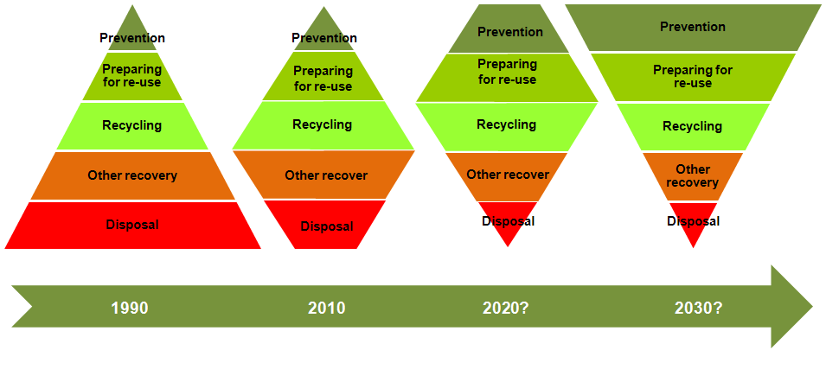

These changes in waste management practices increase the complexity of the systems used, with:

* a wider range of options available (‘right-weighting’, lifetime optimisation of equipment, designing for re-use, material substitution, source segregation of recyclable materials, enclosed composting, anaerobic digestion, mechanical biological treatment and so on)
* differing levels of performance from those options
* the need to understand the practicalities inherent in these processes (such as collection and treatment systems), how the processes interact, the achievability and limitations of systems performance, and timescale constraints.

This level of complexity makes it more difficult to appraise the options. Selecting the correct approach is increasingly more involved and reliant on high-quality data being readily available. This is further compounded by the need for:

* a wider range of evidence, including weight-based or volume-based data, composition data allowing for seasonality, conversion factors and bulk densities, and market specifications and prices
* better understanding of the commercial and industrial component which will be partly addressed by a separate Defra-funded study to estimate the quantity of commercial and industrial waste in the UK.

Increasing system complexity also increases the need for good access to data and consistent collection of data. Examples of current operational issues affecting data collection are:

* segregated materials often pass through many hands before they reach their ultimate point of recovery, which can make it difficult to identify the final destination and the actual quantity of material recovered or rejected
* some recycling and re-use facilities do not have access to weighing facilities, which means that tonnages are sometimes estimated based on volume and density assumptions
* some facilities treat or process incoming material from a number of local authorities together, so that an individual local authority’s contribution to the facility’s outputs can only be estimated.

As waste management practices evolve over the next 20 years, access to the best available data will continue to be a critical issue.

# Dataset and data uses

This section looks at the nature of the data that is requested through WasteDataFlow (WDF) and how the data is used.

## Dataset

WDF provides local authorities with an easy-to-use single portal for submitting quarterly data returns on the provision and performance of waste collection and treatment in their area, with an option to record the data monthly. It is used by all 358 local authorities in England, 22 local authorities in Wales, 26 local councils in Northern Ireland and 32 local authorities in Scotland.

**Questions:** The survey provides a total of 63 questions, of which 40 are common to all four countries. Scotland has a further 11 questions specific to its need to report commercial and industrial breakdowns of some waste streams, and there are another 12 questions used by one, two or three countries.

The questions in WDF are split into four main categories: general infrastructure, recycling waste, residual waste and waste costs. Within these categories the questions are split into two groups: questions about waste collection and questions about waste treatment/disposal. The core questions asked of a unitary authority in England (unitary authorities handle both waste collection and waste treatment and disposal) are listed in Table 1 below.

**Material types:** As Table 1 indicates, some of the questions ask for the tonnage recorded to be split out by material type. It is not compulsory for the local authority to use all the 62 material categories, but there are three main reasons for their use:

* The landfill allowance scheme is about avoiding biodegradable waste going to landfill. Using the material categories allows biodegradability percentages to be applied to the waste.
* Some materials, such as rubble, need to be recorded separately as they are treated differently. This especially applies to the categorisation of waste as household waste.
* Some materials are on the list at the request of the local authorities for their own internal recording and reporting purposes.

**Treatment or disposal facility:** Some questions ask for the actual destination of the recycling/waste that is needed, as indicated in Table 1. This is to allow the Environment Agency to track the waste and recycling to help in its policing of the local authorities’ duty of care. The destination must be a licensed facility. WDF maintains a list, updated regularly, of all licensed facilities in the UK.

Table 1: Core unitary authority questions for England (questions marked A are asked annually only)

|  |  |  |  |
| --- | --- | --- | --- |
| **General and infrastructure questions** | | **By facility** | **By material** |
| General authority information | |  |  |
| 1 | Population, area, population density of authority A | n/a | n/a |
| 2 | No. of households, dwelling stock, index of deprivation and BMW% conversion factor[3] A | n/a | n/a |
| Waste collection infrastructure | |  |  |
| 3 | No. of premises receiving a regular waste collection service A | n/a | n/a |
| 4 | No. of households by residual waste containment method | n/a | n/a |
| 5 | No. of households by dry recyclables collection method | n/a | n/a |
| 6 | No. of households by green waste/organics collection method | n/a | n/a |
| 7 | How many households are served by a kerbside collection of exactly one to four or more recyclables? | n/a | n/a |
| 8 | Participation rates for the kerbside dry recyclable and green waste collections A | n/a | n/a |
| 15 | Total no. of civic amenity sites operated by local authority or its contractors | n/a | n/a |
| 28 | Type of organisation contracted for household waste A | n/a | n/a |
| 29 | Type of organisation contracted for non-household waste A | n/a | n/a |
| 30 | Type of organisation contracted for recycling and composting servicesA | n/a | n/a |
| 21 | No. of home composting bins distributed by local authority (broken down by composter type) | n/a | n/a |
| 22 | Initiatives for the promotion of home composting A | n/a | n/a |
| **Waste collected specifically for recycling, re-use or composting** | | **By facility** | **By material** |
| Recycling/re-use collected tonnages | |  |  |
| 10 | Tonnes of material collected through kerbside schemes from household sources by or on behalf of the local authority or its contractors | No | Yes |
| 11 | Tonnes of material collected from commercial, industrial or other non-household sources by local authority or its contractors | No | Yes |
| 12 | Tonnes of material collected from kerbside schemes by non-contracted voluntary/community sector from household sources | No | Yes |
| 16 | Tonnes of material collected for recycling/re-use at household waste recycling centres[4] operated by local authority or its contractors | No | Yes |
| 17 | Tonnes of material collected for recycling/re-use at bring sites operated by local authority or its contractors | No | Yes |
| 33 | Tonnes of material collected for recycling at bring sites operated by voluntary/community sector | No | Yes |
| 18 | Composting/recycling tonnage collected through any other recycling schemes | No | Yes |
| 34 | Tonnes of material collected for recycling at street recycling bins | No | Yes |
| Destination of recycling/re-use/composting tonnages | |  |  |
| 19 | What is the final destination of your materials sent for recycling? | Yes | Yes |
| 61 | Tonnes of organic waste disposed of by anaerobic digestion | No | Yes |
| 62 | Tonnes of organic waste disposed of by in-vessel composting | No | Yes |
| 63 | Tonnes of green waste disposed of in windrow or other composting | No | Yes |
| 35 | What is the final destination of your materials sent for re-use? | Yes | Yes |
| **General waste (residual, not collected specifically for recycling/re-use/composting)** | | **By facility** | **By material** |
| Waste collected for disposal | |  |  |
| 23 | Tonnages of other wastes collected for disposal (by waste source) | n/a | No |
| 24 | No. of reported fly-tipping incidents | n/a | n/a |
| 25 | No. of abandoned vehicles disposed of by your authority | n/a | n/a |
| 26 | No. of fridges/freezers disposed of by your authority | n/a | n/a |
| Waste treatment or disposal technology | |  |  |
| 51 | Tonnes of waste disposed of in inert landfill | Yes | No |
| 52 | Tonnes of waste disposed of in non-hazardous landfill | Yes | No |
| 53 | Tonnes of waste disposed of in hazardous landfill | Yes | No |
| 54 | Tonnes of waste disposed of by incineration with energy recovery | Yes | No |
| 55 | Tonnes of waste disposed of by incineration without energy recovery | Yes | No |
| 56 | Tonnes of waste converted to refuse-derived fuel | Yes | No |
| 57 | Tonnes of waste disposed of by advanced thermal treatment e.g. pyrolosis and gasification | Yes | No |
| 58 | Tonnes of recyclables sent to material recovery facility | Yes | No |
| 59 | Tonnes of waste disposed of by mechanical biological treatment | Yes | No |
| 60 | Tonnes of residual waste disposed of by anaerobic digestion | Yes | No |
| 64 | Tonnes of residual waste sent to a residual material recovery facility | Yes | No |
| 65 | Tonnes of waste disposed of in any other method not covered elsewhere | Yes | No |
| 69 | Ratio of household and non-household waste for questions above | n/a | n/a |
| 70 | Tonnes separated from the residual waste and sent for recycling | Yes | Yes |
| 19a | What is the final destination of your materials recovered from the residual stream and sent for recycling? | Yes | Yes |
| **Financial information (only collected annually)** | | **By facility** | **By material** |
| 31 | What was the net cost of household waste collection? A | n/a | n/a |
| 32 | What was the net cost of waste disposal? A | n/a | n/a |

Table 2: WDF materials list

|  |  |  |  |
| --- | --- | --- | --- |
| **Heading** | **WDF material** | **Heading** | **WDF material** |
| Glass | Green glass | Batteries | Automotive batteries |
|  | Brown glass |  | Post-consumer, non-automotive batteries |
|  | Clear glass | Tyres | Car tyres |
|  | Mixed glass |  | Van tyres |
| Paper | Paper |  | Large vehicle tyres |
|  | Card |  | Mixed tyres |
|  | Books | Furniture | Furniture |
|  | Mixed paper and card | Construction | Rubble |
| Cans | Steel cans |  | Soil |
|  | Aluminium cans |  | Plasterboard |
|  | Mixed cans | Oils | Vegetable oil |
| Plastics | Mixed plastics |  | Mineral oil |
|  | Mixed plastic bottles | Other materials | Aluminium foil |
|  | PET [1] |  | Aerosols |
|  | HDPE [2] |  | Bric-a-brac |
|  | PVC [3] |  | Cardboard drink packaging |
|  | LDPE [4] |  | Fire extinguishers |
|  | PP [5] |  | Gas bottles |
|  | PS [6] |  | Ink and toner cartridges |
|  | OTHER [7] |  | Mattresses |
| Garden and food | Green garden waste only |  | Paint |
|  | Waste food only |  | Textiles and footwear |
|  | Mixed garden and food waste |  | Video tapes, DVDs and CDs |
|  | Wood for composting |  | Yellow pages |
|  | Other compostable waste |  | Other materials |
| Wood | Wood |  | Bicycles |
|  | Chipboard and MDF | Co-mingled | Co-mingled materials (only for use on collection questions) |
|  | Composite wood materials |  |  |
| WEEE[5] | WEEE—large domestic appliances |  |  |
|  | WEEE—small domestic appliances |  |  |
|  | WEEE—cathode ray tubes |  |  |
|  | WEEE—fluorescent tubes and other light bulbs |  |  |
|  | WEEE—fridges and freezers |  |  |
|  | Other scrap metal |  |  |

Figure 2 shows how the tonnage questions connect to represent the flow of waste through the system.

Figure 2: WDF tonnage question map

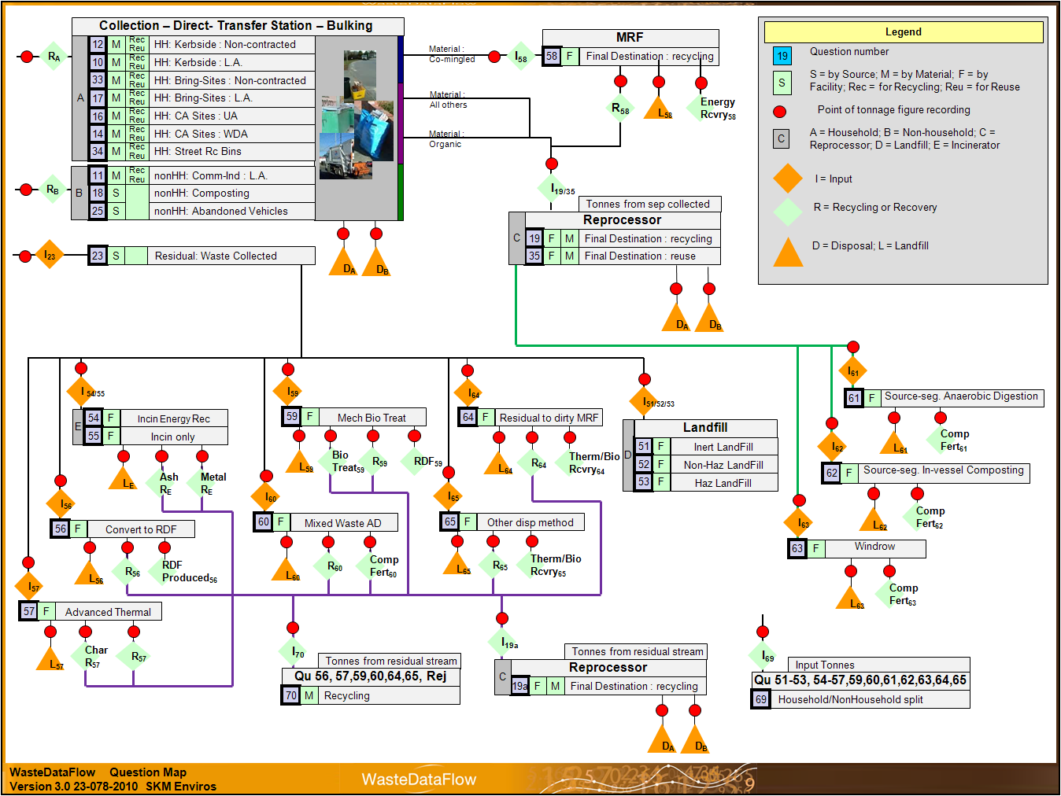

## Data uses

WDF is used in many ways, from national policy development to effective service delivery by local authorities. Some of its uses are highlighted below.

**Measuring progress against targets:** At the national level there are a range of indicators used to measure/assess progress toward policy targets. These indicators can also be used to assess the effectiveness of different policy measures. WDF provides a robust tool for the systematic and consistent gathering of the data needed to calculate the different indicators specified across the UK. This includes recycling rates, landfill diversion and so on. WDF supplies data for returns required by the EU Waste Statistics Regulation (2002/2150/EC), details of which can be found at <http://www.defra.gov.uk/evidence/statistics/environment/waste/wreuwastestats.htm>. It is anticipated that WDF will be used as a source of data in relation to the target in the revised EU Waste Framework Directive (2008/98/EC) to recycle 50 per cent of household waste.

WDF is a key source of information to support the Defra Waste Programme. It also acts to measure progress against the Defra Public Service Agreement target on household waste recycling, and measure progress against EU Landfill Directive (1999/31/EC) targets, including the Landfill Allowance Trading Scheme in England, the Landfill Allowance Scheme in Wales and Scotland, and the Northern Ireland Landfill Allowance Scheme. Further information on the legislation surrounding the EU Landfill Directive and its implementation can be found at <http://www.defra.gov.uk/environment/waste/strategy/legislation/landfill/index.htm>.

At the local level, local authorities can useWDF to track the performance of their service and to target and monitor improvements that can help to increase the cost-effectiveness of a service—for example, using material-specific tonnage data associated with recycling schemes to target materials with a poor capture rate. This will become increasingly important as the UK strives to further improve its recycling performance. The significant improvement in recycling and composting performance so far achieved has been mainly through the introduction of collection infrastructure. Future improvements will partly depend on achieving more uniform high performance across all authorities.

WDF can be adapted to report against any new indicators deemed necessary to measure future performance in place of the recent national indicators regime. This may simply require alternative calculations based on the existing dataset to generate the new ‘C variables’ required for a new indicator; or it could require the introduction of a new question, which could be a UK-wide question or a specific question to support an indicator required by one or more of the devolved administrations.

In England the original performance indicators (best value performance indicators) were superseded by national indicators in 2007–08. From 2011 onwards it is expected that there will not be indicators as such, but the government will continue to collect headline tonnage figures. As well as the indicators listed for England below, there are separate indicators for Wales, Northern Ireland and Scotland.

Performance indicators for England are or have been:

* NI191—Amount of residual household waste per household
* NI192—Percentage of household waste that is sent for re-use, recycling or composting
* NI193—Percentage of municipal waste sent to landfill
* BVPI 82a—Percentage of household waste arisings which have been sent by the authority for recycling
* BVPI 82b—Percentage of household waste arisings which have been sent by the authority for composting or treatment by anaerobic digestion
* BVPI 82c—Percentage of the total tonnage of household waste arisings which have been used to recover heat, power and other energy sources
* BVPI 82d—Percentage of household waste arisings which have been landfilled
* BVPI 84a—Number of kilograms of household waste collected per head of population
* BVPI 84b—Percentage change from the previous financial year in the number of kilograms of household waste collected per head of population
* BVPI 86—Cost of household waste collection per household
* BVPI 87—Cost of waste disposal per tonne of municipal waste
* BVPI 91a—Percentage of households resident in the authority’s area served by kerbside collection of recyclables
* BVPI 91b—Percentage of households resident in the authority’s area served by kerbside collection of at least two recyclables.

**Supporting informed decision making:** Evidence-based decision making should ensure that the right solutions are selected for a particular locality/community, which should in turn ensure the best use of public money. This is particularly relevant as authorities are encouraged to make local decisions on waste systems.WDF supports evidence-based decision making in a number of areas:

* **Options assessment:** The tools (such as life-cycle assessment tools) used to assess overall environmental outcomes or the ecological impact of waste management need good-quality input data to deliver the most reliable output. In addition, WDF outputs can be used to support strategic environmental assessments and sustainability appraisals.
* **Assessment of capacity needs and infrastructure requirements:** Effective capacity planning for future facilities is an important factor in ensuring that the correct balance of facilities is developed to support strategic and policy aims. Without accurate data and the ability to track trends, which WDF provides, it would be difficult to assess the long-term capacity required for residual waste treatment facilities. Inaccurate assessment can result in facilities being oversized, leading in turn to inefficient operations and increased waste management costs. In the UK this will become increasingly important at local authority level with the streamlining of planning systems.
* **Benchmarking:** The ability to benchmark performance allows a local authority to compare its performance with that of other local authorities, to determine whether there is scope for improvement. Understanding the levels of performance that can be achieved can also help a local authority select the most appropriate collection systems. Figure 3 shows performance benchmarks produced by Waste and Resources Action Programme (WRAP) analysis of WDF against which local authorities can assess their kerbside dry recycling schemes.

Figure 3: Example of WDF data being used in benchmarking



* **Private sector investment:** For private sector organisations to innovate, invest and grow, they need to build confidence in the accuracy of the information they use to support their investment decisions. To create conditions in which businesses play a larger role in civil society and help to develop innovative approaches to re-use, recycling and recovery of waste that maximise resources returned to the supply chain, there is a need for good-quality data on which to base decisions. Again, this is a function that can be supported by WDF, as private sector organisations will automatically turn to a national-level system as the most reliable source of information.
* **Research programs:** Research projects use data to assess and evaluate the impact of policy and technical changes to determine:
* whether there would be a net benefit from introducing a system change
* whether a particular system or technology can deliver the claimed results/benefits
* the potential effects of a policy/regulatory change and whether they will achieve the desired outcomes.

The data required for such research can often be drawn from WDF. This can result in lower research costs, as the primary data collection has been undertaken consistently and the data has been validated.

The range of decision-making processes it supports highlights that WDF, by collecting data once and using it numerous times, can reduce the burden of data gathering/reporting and provide a single consistent data source for all stakeholders.

**Providing wider access to data:** WDF has proved very popular as a public resource of up-to-date information in a downloadable form. As public scrutiny of the use of ‘taxpayers’ money’ increases, WDF allows members of the public to examine the performance of their local authority; and the new input indicator ‘Cost of local authority waste management per household’ proposed for May 2011 will allow a level of cost-effectiveness to be evaluated.

This ready access to waste management data has the additional benefit of reducing the burden on government and local authorities arising from freedom of information requests under the *Freedom of Information Act 2000* and the Environmental Information Regulations 2004.

# System design

WasteDataFlow (WDF) comprises the website www.wastedataflow.org and the associated survey database which lies behind it. The website has three main elements:

* the survey questionnaire and associated web pages for data entry and authorisation
* the reporting section, which allows users to query the survey database and produce predefined reports for download in Microsoft Excel format
* the guidance section, which contains survey documentation and other information.

The WDF data collection and reporting system was written for a Microsoft environment using the .net framework 1.1/3.5 and SQL server technologies. It is currently configured on two servers running the Windows 2003 server operating system, one holding the database and one hosting the website. The database is managed with MS SQL Server 2005 and the website is hosted on Microsoft Internet Information Server. The servers are maintained and backed up by a separate contractor for the Department for Environment, Food and Rural Affairs (Defra).

The system is an n-tier application with two physical layers: the database server and the web/application server. The dedicated database server hosts an MS SQL database for data storage and the stored procedures that form part of the business layer. The dedicated web/application server hosts the C#/ASP.net business and user interface layer of the application and the htm web page elements of the application. The web server also hosts the standard website that sits in front of the application providing a home page, news page and guidance document storage and presentation.

All through the development of the system, SKM Enviros has striven to make the system flexible and to have its flexibility managed through the database rather than through code. That way, more updates can be made with less work; tasks that do not require development code changes also incur less risk and cost. For example, the questions in the survey are generated from built-in content management functionality whereby all question text (questions, columns and rows) is controlled by database entries, not hard coding. This makes them easier to amend. The database, rather than code, also identifies which periods the questions are active for, which countries they apply to and, for England, which authority types. In fact the headline question text can be amended through the user interface by users with development-level access.

Some elements of the system, such as the rolling-up of quarterly submissions and the calculation of data for reports, are controlled by a combination of database and stored procedure. While these elements do require some technical development knowledge to adjust or add to, they still bring the benefit of not requiring actual survey tool code changes.

## Development approach

In 2002 the government set up a steering group to review the need for data on waste. In 2003 the steering group assessed the technological options available for distributed, centralised, hard-copy and online surveys. They concluded that the only way to achieve a flexible, controlled system with instant access to the data for all users was to go with a centralised database survey accessed through a web front end.

The group then conferred on the nature, detail and timing of data needs, leading to a list of questions to be included in the revised survey. The needs of the online survey were defined at a functional level for a subsequent tender process to identify a possible service provider.

Providing a functional specification rather than a design specification allowed for a range of technical responses and so gave the steering group some access to the range of ideas and facilities available in the marketplace—for example, one tender conceived the technical aspect of data collection as electronic, with barcode scanning of loads at collection sending the weighbridge tonnage straight to the database. However, it also meant that tenders were less directly comparable.

From its evaluation of the various responses, the group chose a suitable developer. The main criteria were flexibility of approach, understanding of the issues, and price.

Subsequent development has been done on an organic, as-needed basis.

## Development time frame

In October 2002 a steering group was set up to review the waste management data situation and develop options for improvement. The key expected benefits were a single point of data entry for local authorities, a quality control process, and the ability to design questions to meet all users’ needs. A plan was put in place based on three stages:

* Stage 1: consultation and project scoping (three months)
* Stage 2: project development (12 months, including piloting)
* Stage 3: project implementation (rollout to all local authorities) for April 2004.

Although the steering group was in place Stage 1 commenced later than expected. Stage 2 was condensed into six months with the launch of data entry (Stage 3) in April 2004. The reporting outputs were to be completed in the following three months. The performance indicator reporting actually took longer and was released in September 2004.

Since then, WDF has been continuously developed to keep up to date with changing reporting and data collection needs. The last few years have seen significant changes to facilitate data entry and authorisation by local authorities and to improve the way data can be reported from the system. The original PDF-based reporting was replaced with a new reporting function which enables summary variables to be extracted into Excel for further analysis and presentation. This provides excellent opportunities for further use of WDF data. All reports now operate in this way. The system is flexible and database driven, allowing new reports to be created very quickly and easily.

The manual keying of data into WDF was recognised as a potential area for human error. The system has therefore been developed to receive automatic uploads of data in XML format. The XML can be generated directly from local authority systems, or generated using an Excel file which is available for download from the WDF website. It is encouraging that over the last two years there has been increasing take-up of this auto-upload function by authorities.

Future development of WDF will focus on reporting by destinations and materials, reviewing and improving key questions (and removing redundant questions), and bringing the validation of data returns closer to the data entry stage to further improve data quality and the efficiency of making returns.

# Roles and responsibilities

WasteDataFlow (WDF) was developed with Landfill Tax Credit Scheme legacy funding through a project originally led by the Chartered Institution of Wastes Management Environmental Body. It was delivered to the Department for Environment, Food and Rural Affairs (Defra) and went live on 30 April 2004, replacing the existing Defra municipal waste management survey in England and similar surveys in Wales and Northern Ireland. Scotland joined the system in January 2006 and started full data collection in April 2006.

## Project governance

The project is managed through a formal governance structure consisting of a UK Project Management Board, a UK Operational Group and a user group of local authorities in each country. A hierarchy of project governance bodies ensures that WDF best meets the diverse needs of its stakeholders.

* **Project board:** The project board is made up of representatives of Defra, the devolved governments and assemblies (of Wales, Scotland and Northern Ireland) and the Chartered Institute of Wastes Management. It is responsible for the overall delivery and financial control of WDF. The project board meets every six months.
* **Operations group:** The operations group sits below the project board and comprises representatives of Defra, the Environment Agency (EA), SKM Enviros (for England’s validation and data entry and overall development), the Scottish Environment Protection Agency (SEPA) (for Scotland’s data entry and validation), the Welsh Assembly Government (WAG) and the Environment Agency Wales (EAW) (for Wales’ data entry and validation), the Northern Ireland Environment Agency (NIEA) (for Northern Ireland’s data entry and validation), and local authorities. The operations group is responsible for the day-to-day delivery on the ground of the WDF survey tool. Each country representative provides input on performance of WDF validation and training for their country, and on improvement/change requirements. The operations group meets every quarter.
* **Defra/EA with management contractor SKM Enviros:** Under the WDF management contract some elements cover all countries (such as development and helpline) and other elements apply to England only (such as validation and training). Some liaison between Defra/EA and SKM Enviros on England-only elements, particularly on validation, takes place outside the operations group.
* **User group (England):** It is vital that the local authorities have a voice in the development and use of the WDF survey. The user group meetings are an opportunity for local authorities to feed back their experiences, discuss guidance from Defra/EA and SKM Enviros, discuss policy updates and trial new ideas. The user group meets twice yearly and is attended by up to 20 local authority representatives. Although originally developed as a group organised independently of Defra input, it has in recent years needed central organising and this has been done by Defra and SKM Enviros.
* **User groups (other countries):** The user groups for Northern Ireland, Scotland and Wales are run by the NIEA, SEPA and WAG. SKM Enviros provides them with development updates, feedback from the England user group and responses to ad hoc enquiries as they are made.

There is no formal governance mechanism or event at which general public or other bodies are represented. However, much of this type of feedback comes through the WDF helpdesk and is reported back to the operations group by the SKM Enviros representative.

There is no formal governance mechanism or event at which industry members (waste management companies) are represented individually.

## Project operation

Operationally, WDF responsibilities focus on ensuring that good-quality data is entered. All parties involved in the WDF project play a vital role in achieving this.

### Local authorities

Local authority users are the source of all the data in the system. There are three levels of local authority users: data entry, data authoring and report only. The report-only users are generally outside the waste team.

Local authorities are responsible for entering and authorising their data. They enter data on the amounts of waste collected for recycling and re-use (broken down into 62 material types); the amount of residual waste; and the management routes used, down to the individual waste facilities.

Before local authorities can enter their data they need to be provided with it. In most cases this means receiving a mixture of reports from their own teams and from the contractors they employ. The legal driver to submit data rests with the local authority and is passed on to contractors through the detail of the contracts and the relationship between the authority and the contractor.

Some of the improvements in data quality and timeliness which have occurred over time have resulted from local authorities improving their relationships and/or contracts with the suppliers of waste management functions. For example, in the early years of WDF (2004 to 2006) data was often withheld, especially on the final destination of recyclates, on the grounds that there were ‘confidentiality issues’. Defra did not accept this as a good reason, as no details of processes were being requested. Local authorities have worked closely with their suppliers on this issue, and now no such concerns are raised and the required data is gathered.

The time allowed to submit returns varies between countries. In Wales an authority only has 30 days from the end of the quarter to submit a fit-for-purpose return; in Scotland it has 42 days; in Northern Ireland it has two months; and in England it has three months.

In England, which has the largest number of authorities, there are two types of authorities: unitary authorities, which manage all waste collection and disposal; and waste disposal authorities and waste collection authorities. For WDF purposes the key differences are:

* varying numbers and types of WDF questions—unitary authorities have 46 questions, disposal authorities have 32 and collection authorities have 28
* waste responsibilities—unitary authorities provide all the waste management services in their area, but in other (‘two-tier’) areas one disposal authority will be responsible for the disposal of waste collected by a number of collection authorities
* regulatory responsibilities—in two-tier areas the legal requirement for submission of data through WDF lies with the disposal authority, but the disposal authority needs data from the collection authority to be entered to make a complete submission.

### SKM Enviros (UK-wide responsibilities)

In delivering WDF services for the UK as a whole, SKM Enviros has two core tasks:

* operating a central helpline service for local authority users and some public users across the UK. This is a working-hours helpline taking calls regularly through the day. The helpline offers practical advice on the use of WDF and supports the dissemination of policy and procedures set by Defra.
* Coordinating the functional needs of all stakeholders to create and then manage a development/improvement plan for the WDF survey engine.

### Country-level responsibilities

After authorisation by the local authority, the relevant organisation in each country (SKM Enviros for England, SEPA for Scotland et cetera) performs a comprehensive set of validation checks on each individual local authority return. Queries are raised with the authority, data confirmed or corrected, and the validation of each return quality-assured.

Validating the returns from English local authorities involves checking each quarterly return from each local authority by extracting the input data into a purpose-built spreadsheet which collates and cross-checks the data. The validation spreadsheet has over 100 cross-checks, which not only compare the data entered in the quarterly return but also check the return against data from the previous quarter.

Each country provides comprehensive training on the WDF system for all local authorities. Training ranges from large-scale events to one-on-one sessions. More recently training has been delivered via ‘webinars’—web seminars that delegates log on to from their workplace to attend. These courses are shorter, more flexible and easier to arrange than in person events. They are also very effective and well received by the trainees, and have a low environmental impact.

As part of the validation and helpline service, SKM Enviros produces the help and guidance documentation that is either distributed by email or made available on the WDF website.

### Government agencies

The WDF system is owned by the UK government via Defra. The EA has substantial input as the auditing authority for the Landfill Allowance Trading Scheme (LATS) and environment issues. Defra has specific responsibility for the data of authorities in England. The NIEA has this responsibility for Northern Ireland, SEPA for Scotland, and WAG and the EAW for Wales.

Under the EU Landfill Directive (1999/31/EC), the UK has been set targets for reducing the amount of biodegradable municipal waste (BMW) sent to landfill. These targets have been translated into landfill allowances for individual local authorities. WDF enables waste disposal and unitary authorities to meet their current reporting requirements under the landfill allowance schemes; it also allows for easy data analysis by the monitoring authority in each country, for example the Environment Agency for England. The EA, EAW, NIEA and SEPA audit data returns under their landfill allowance schemes, producing reconciliations of BMW to landfill.

Finally, Defra analyses data at regional level on a quarterly basis and national level on an annual basis.

This rigorous, consistent and comprehensive approach to data submission and validation provides a complete and accurate picture of national municipal waste arisings and management.

### ‘External’ users

One of the drivers for WDF is to reduce the burden on local authorities in respect of freedom of information requests from the public by providing a publicly accessible reporting point. The WDF interface also provides data to individuals, groups, agencies or companies that might otherwise issue their own surveys to local authorities.

# Operational features

The operational features of the WasteDataFlow (WDF) system are:

* Main survey data collection engine:
* a flexible question management database
* a user-friendly data entry interface
* regularly maintained lists of approved waste destinations (as permits and sites change each month)
* user management to allow different levels of system access.
* Main survey validation process:
* functionality for returns to have one of several approval levels
* analysis in reports and on-screen highlighting certain mathematical/comparative checks
* security settings limiting the reports available to each user level and which data (depending on approval level) the report will show.
* Main survey reporting engine:
* ability to use the data from the quarterly surveys of each local authority in reports that, by being delivered in Excel format, allow the recipient to further analyse the data.
* reports that simplify the more complex detail of data collected and represent it back to users in a way they need and can understand.

This system sits within an operational framework that offers:

* manual quality assurance of each local authority return
* ongoing training and support to local authority users. This must be ongoing, not a one-off or just to cover improvements to the survey—mainly because the users change (move jobs, get promoted and so on).

## User levels within WDF

WDF has been designed with six levels of user access and seven levels to record the status of the data; these are shown in Table 3.

Table 3: Levels of access and data designed into WDF

|  |  |  |  |
| --- | --- | --- | --- |
| **User Title** | **User level** | **Data level** | **Description** |
| Local authority data entry user (LADEU) | 10 | 0 | Monthly data is entered by the data entry user |
| Local authority data entry user (LADEU) | 10 | 10 | Monthly data is rolled up for a quarter by data entry user at level 10 |
| Local authority admin user (LAAU) | 20 | 20 | Quarterly return is authorised by local authority admin user at level 20 |
| National level 1 (NL1) | 30 | 30 | validates/authorises data at level 30 |
| National level 2 (NL2) | 35 | 35 | validates/authorises data at level 35 |
| National level 3 (NL3) | 40 | 40 | validates/authorises data at level 40 |
| Developer level | 50 | 50 | System developers |

There is no limit to the number of people who can be given access rights for an organisation. Levels 10 and 20 are ring fenced to allow local authorities two access levels, one for data entry and roll-up and one for data authorisation.

Access rights to information in WDF are as follows:

* levels 0–10—data can only be viewed by named individuals given access by the local authority
* levels 20–40—once data has been rolled up by a local authority it effectively enters the WDF system and the information is available to all users with designated access to that authority’s data from levels 20–40.
* the monthly direct answers to questions cannot be viewed or edited by other local authorities at any time; the data can be accessed by other local authorities through reports once it has been aggregate into a quarterly return and authorised at level 20.

## Entering data and creating a quarterly submission

Each authority enters data into the database. This is done by staff given LADEU access. WDF allows a local authority to enter data on a monthly basis, but requires a minimum of quarterly data. Local authorities not wishing to enter data monthly simply put the full quarter’s tonnage in the third month.

Once the data for a quarter has been entered and the person entering the data is satisfied that it is accurate, the data for the quarter is then rolled up into a quarterly return. The system will not allow a return to be rolled up if there are any unprocessed questions. When the rolled-up data has been authorised, the LADEU is locked from the quarter and the LAAU gains control of the data for validation and authorisation.

During the rolling-up procedure WDF creates the quarterly return from the monthly entries. For tonnage questions this means summing monthly data; for absolute and text data like number of houses or collection frequency, the entry in the last month is taken. At the same time WDF calculates the standard data used in reporting (for example subtotals, cross-totals and material summaries). Doing the processing at this stage makes the generation of reports for multiple authorities and periods much quicker.

Once a return is rolled up, the data entry for those three months is locked. The data can be seen in the question layout but only in aggregated form.

## Validation and authorisation of data

Once data has been entered into WDF it can either be validated and passed to the next level or authorised and passed to the next level, or both. Validation and authorisation use the same process but are differently defined.

* **Validation** involves checking the data entered before it is passed to the next level for authorisation. Validation checks for England are summarised in Table 4.
* **Authorisation** can either be a final check on data which has been previously validated or a full validation and authorisation of data which has not previously been validated. A national organisation may be assigned one level of access at which it will need to both validate and authorise the data, or two levels of access allowing it to validate the information at one level and then pass it on internally to another level for authorisation. The authorisation or validation procedure is identical for levels 20 to 40.

Table 4: Validation checks for England

| **Summary of checks** |
| --- |
| Check all main non-tonnage data (households, collection authority sites etc.) against same period last year. *Series of checks across different questions.* |
| Check all main entered tonnages against same period last year. *Series of checks across different questions.* |
| Check all main key calculated tonnages against same period last year. *Series of checks;* *includes household waste, household recycling and total landfilled.* |
| Check for material recovery facility (MRF) ‘total recycling collected’ and ‘sent’ discrepancy. *Series of checks across different questions.*  then Calculate and check MRF reject rate. |
| Check ‘collected’ and ‘sent’ discrepancy, including total re-use, total residual and total recycling. |
| Check that rejects quoted are not greater than collected tonnage. *Series of checks across different questions.* |
| Ensure that comments have been entered for questions involving ‘other’ technology.  *Series of checks across different questions.* |
| Check whether materials listed in ‘other materials’ are not better reported against an existing material type, especially if there is a biodegradability element. *Series of checks across different questions.* |
| Check that materials listed in ‘organic’ questions are organic. *Series of checks across different questions.* |
| Check for double counting of ‘collected’ and ‘sent’ rejects. |
| Check where stockpiling that it is noted and accounted for. |
| Check organic materials ‘sent’ and ‘collected’ matches. |
| Check that destination details (full name, address and licence number) are listed for each material recorded as sent to an ‘other exempt’ facility. *Series of checks across different questions.* |
| Check that rubble ‘collected’ and ‘sent’ for recycling and re-use is in line with policy.  Cross-check rubble recycled and incinerator bottom ash. |
| Material rule checks:   * Ensure that no rubble has been reported in Q18 * Check asbestos * Check that refuse-derived fuel is in the right question. |
| Cross-check households receiving collection and tonnages collected. *Series of checks on different questions.* |
| Check with the authority that it is aware of the definition of gully emptyings as opposed to highways waste. |
| Check that all landfill tonnage has a registered landfill site entry. |
| Check discrepancy on questions for treatment technology that can include moisture loss. |
| Check all details of mechanical biological treatment. *Series of checks.* |
| If input to incineration, check that there is incinerator bottom ash. |
| Cross-check residual treatment questions and Q19a and Q70. |
| Ensure local authority is aware of the impact of answering Q69 and that the calculated household factors are correct. |
| Check treatment type recorded in Q65 to see whether it would be more appropriate to record this in a specific waste treatment question. Also check that inputs and outputs match. |

### Local authority authorisation

People assigned both LADEU (level 10) and LAAU (level 20) access can view and edit monthly data to the point at which it is rolled up as a quarterly submission, but only the LADEU can submitted data to level 20. Once data has been submitted for authorisation only LAAUs with level 20 access can authorise the data on to level 30.

Following authorisation of the quarterly submission by the LAAU, the quarterly return moves to level 30. This is considered the formal release of the data by the local authority. At this point it becomes available to the NL1 user for authorisation.

If the LAAU is not happy with the information in the quarterly submission, they can release the entry back to level 10 where the LADEU can release it back to monthly data (level 0) to allow the data to be modified. The LADEU then rolls the data up again and submits it to level 20.

The WDF system keeps an audit trail of the validation process (dates, times and users) and also logs, when data returns from level 0 to level 10, exactly which questions and which data have been altered. This information is available to the users to assist in validation and authorisation.

Importantly, once data has been authorised by a local authority to level 20 it effectively enters the WDF realm and is available to other local authorities via reports (but not the question reports). It also passes to a national organisation for further validation and authorisation (NL1), and the local authority loses the ability to edit the data, though the data can still be viewed.

### National-level authorisation

Each user in a national organisation who is granted access is assigned access rights for each local authority within their country. Authorisation tasks and responsibilities differ for each country, but are summarised in sub-section 5.3.1 above.

In all cases, although the data has been available for most WDF users to report on since level 20, it does not become accessible to the public until it is released by an NL2 user to level 40. This has become particularly important as the mechanism to prevent early release of national statistics. In practice each authority’s quarterly return is only authorised to level 40 on the same day as the official release of the national waste statistics (which are calculated and reportable through WDF).

# System costs

In 2002, the original estimate for the consultation, design and delivery of the WasteDataFlow (WDF) system was £500 000. The outsourced finalisation, design and development costs needed only 50% of this budget.

From 2004 to 2009 the outsourced services for: project management, telephone and email helpdesk support to all users, data validation services (England only), guidance, documentation, user training (England), and survey development, has been in the range of £200 000 to £350 000 per annum. The cost has depended on the extent of survey modification and system improvements needed each year. There has also been input to WDF management from Defra but generally this has been absorbed into the team’s duties. Validation and training in the other countries was kept within the relevant departments.

# System benefits

## Government

WasteDataFlow (WDF) has greatly increased the timeliness of data. Previously, under the annual municipal waste management survey, national statistics (including estimates of total municipal waste and household recycling rates) were published 12–18 months after the end of the reporting period. Now quarterly statistics are released within six months—for example, data for the quarter ending September is published in early March, and the Department for Environment, Food and Rural Affairs (Defra) is seeking to improve this further. This means that policymakers have access to more regular and timely indicators of how municipal wastes and their management are changing.

Figures 4 and 5 show how timeliness has also been improved by improvements in the way WDF operates. Whereas in the first full year of WDF the data for all authorities (that is, at a national level) was in actuality only available at the end of the year (Figure 4), in subsequent years this data was available within a few weeks of the end of the quarter (Figure 5).

Figure 4: Response rates against reporting deadlines 2005–06



Figure 5: Response rates against reporting deadlines 2006–07 and 2007–08 (at April 2008)



The more detailed nature of the dataset means that far more policy and parliamentary questions can be answered, for example: the amounts of separately collected aluminium (a key material in the Waste Strategy 2007), estimates of the reject rates for recycling, and the location of disposal of municipal waste to landfill. Analysis of inter-regional movements, required for planning policy, is also being developed.

By collecting data once and using it numerous times, WDF reduces the burden on data reporters and ensures that a single consistent data source is being used by all stakeholders.

WDF can also be flexible and proactive in its data collection. For example, food waste is moving higher on the policy agenda, so a modification to WDF to capture more information on this waste stream is under consideration.

## Regulatory bodies

Without the detailed level of data gathered by WDF, regulatory bodies across the UK would not be able to estimate the quantity of biodegradable municipal waste (BMW) landfilled and measure the UK’s progress against the EU Landfill Directive (1999/31/EC) Article 5 targets for the diversion of BMW from landfill.

The method of estimating the quantity of BMW landfilled is complex,[6] as it needs to take account of the impact of recycling and composting on the biodegradable content of landfilled municipal waste. This involves determining the biodegradable content of waste diverted from landfill, which requires a detailed breakdown of the materials diverted for recycling and composting. Previously this level of detailed data was not gathered.

## Local authorities

Individual local authorities have benefited from digging more deeply into their information to complete the WDF return, and from having to work more closely with service contractors. These benefits include:

* a reduced data reporting burden especially in relation to freedom of information requests
* cost recovery opportunities through closer contract management.

For example, WDF has been used by Suffolk County Council and its seven waste collection authorities to help improve data recording and transfer and performance management. Over an 18 month period the discrepancy between the tonnages reported by the county and those reported by the collection authorities has reduced from an estimated 8 per cent to less than 0.7 per cent. The amount of time spent monitoring, reporting and auditing the data has also been reduced. In conjunction with other work being carried out to streamline the reporting system, financial savings have been identified.

The reporting system in Suffolk has been made more accurate and timely through the establishment of a number of protocols, including a deadline for the collection authorities to complete WDF and linking the payment of recycling credits directly to WDF entries. Whereas previously it could take months to establish the county-level recycling rate, this can now be reported a month in arrears. The accuracy of the data has also improved. The collection authorities and the council can now submit data to WDF up to two months ahead of the quarterly deadline.

Suffolk County Council can now identify coding errors on weighbridge tickets on a month-to-month basis by comparing the collection authority declarations and the contractor invoice totals. It is estimated that the council had overpaid £10 000 through miscoding of material types which this system stopped from occurring again. Further work is also being done to improve data accuracy.

A user group has been established to enable all the Suffolk waste collection authorities to discuss any issues surrounding WDF and data capture, and annual audits of all collection authorities and contractors are carried out.

## Other stakeholders

Before WDF, access to detailed local authority data was limited and required information to be obtained directly from the local authorities. Now anyone can register on WDF and download detailed question information or summary reports. Figure 6 shows a sample screenshot of the summary report on municipal waste management methods.

Figure 6: Sample screenshot of summary report on municipal waste management methods

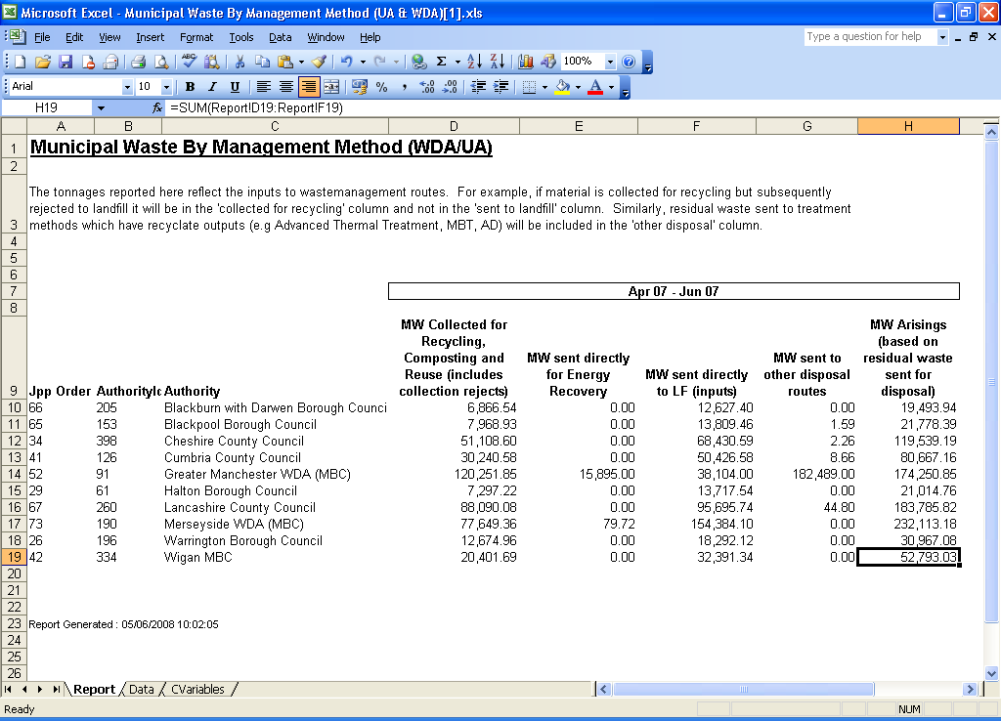

In the financial year 2007–08 there were 1022 active external users and a total of 14 500 external user downloads, with the number of downloads per user ranging from one to 988.

# Lessons learnt

WasteDataFlow (WDF) is a software solution to an information need. The following lessons from the WDF experience can be brought to bear on other waste data development projects.

* Work with the key stakeholders on what their drivers and information needs are—for example, legislation and the performance indicators to show that legislative requirements are being met. This is the basis for building up to a set of primary data needs.
* While working on the primary data needs, identify any secondary data that may be required or useful to ensure the accuracy of the primary data. For example, the primary data need may be to determine how many tonnes were recycled each year. To validate this and add value, there could be a secondary data request for the tonnes recycled by material, or for the tonnes recycled by recycling facility used, combined with data request for quarterly (or monthly) data rather than just annual data.
* Develop the specification for a survey tool so that it is not only suitable to meet the information needs now but also flexible enough to cope with changes to these needs over time. The type and technology of the tool will depend on the detail and type of data requested.
* Identify the appropriate provider to deliver the tool (based on flexibility of service as well as practicality of ideas) and then work with them to deliver the technical element of the solution—databases, spreadsheets, paper surveys, stand-alone, web based, telephone and so on.
* Once the system is running, provide operational support—training, data validation, system improvement and regular reviews to ensure that the data requests are still fulfilling the information needs of all stakeholders.

Points to consider:

* Make sure the information need is clearly identified. It is reasonably straightforward to create a list of ‘data we would like’ or ‘data we imagine might be useful one day’. But the burden on the people tracking down the data should be balanced against the use that will be made of the data.
* If people can see that what they are being asked for is relevant and useful then they are more likely to provide it.
* Much of the effort involved in data collection is unrelated to the ease of use of the survey tool but relies on the contracts and infrastructure in place for waste handling.
* If waste service providers are not contracted to report certain information—for example the contamination level in the waste they accept—then in many cases they will not provide it.
* If waste is processed on a ‘load’ basis rather than by weight, tonnage data may not be available.
* When looking at what information is needed, consider all stakeholders including the people who will be submitting the data. Again, if the data being surveyed is useful to them then they will be more likely to submit it (and to do so accurately and on time).
* Engage with the organisations that will be providing the data. If they feel part of the solution, they are more likely to be involved.
* Consider flexibility, but avoid over–complication of the solution. For example, if the solution as a whole is database driven, it is worth investing in a system that will allow the questions and their content to change over time. However, if only a few pieces of data are required then a database solution may be too complex and a spreadsheet-based survey could be appropriate.
* Determining and implementing the reporting and output of data/information from the system is as important as designing the data collection. This includes knowing what format is required, whether benchmarking is needed and whether trend analysis is needed.

Screenshots—WasteDataFlow

This section provides sample screenshots from the WasteDataFlow system.

# Data entry

Figure S1: Question selection

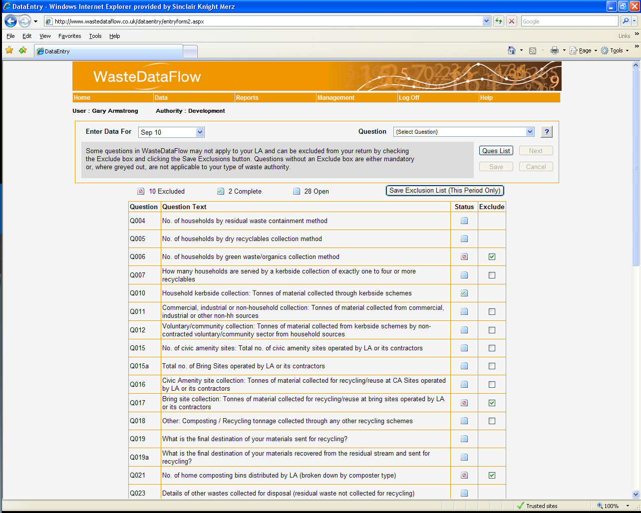

Figure S2: Material-only question

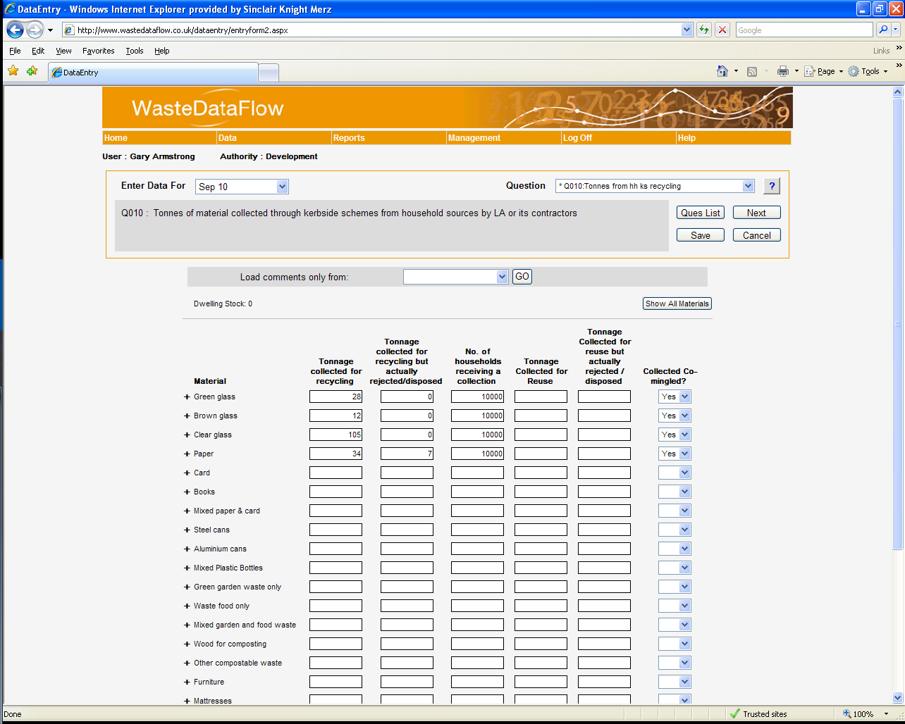

Figure S3: Facility and material question

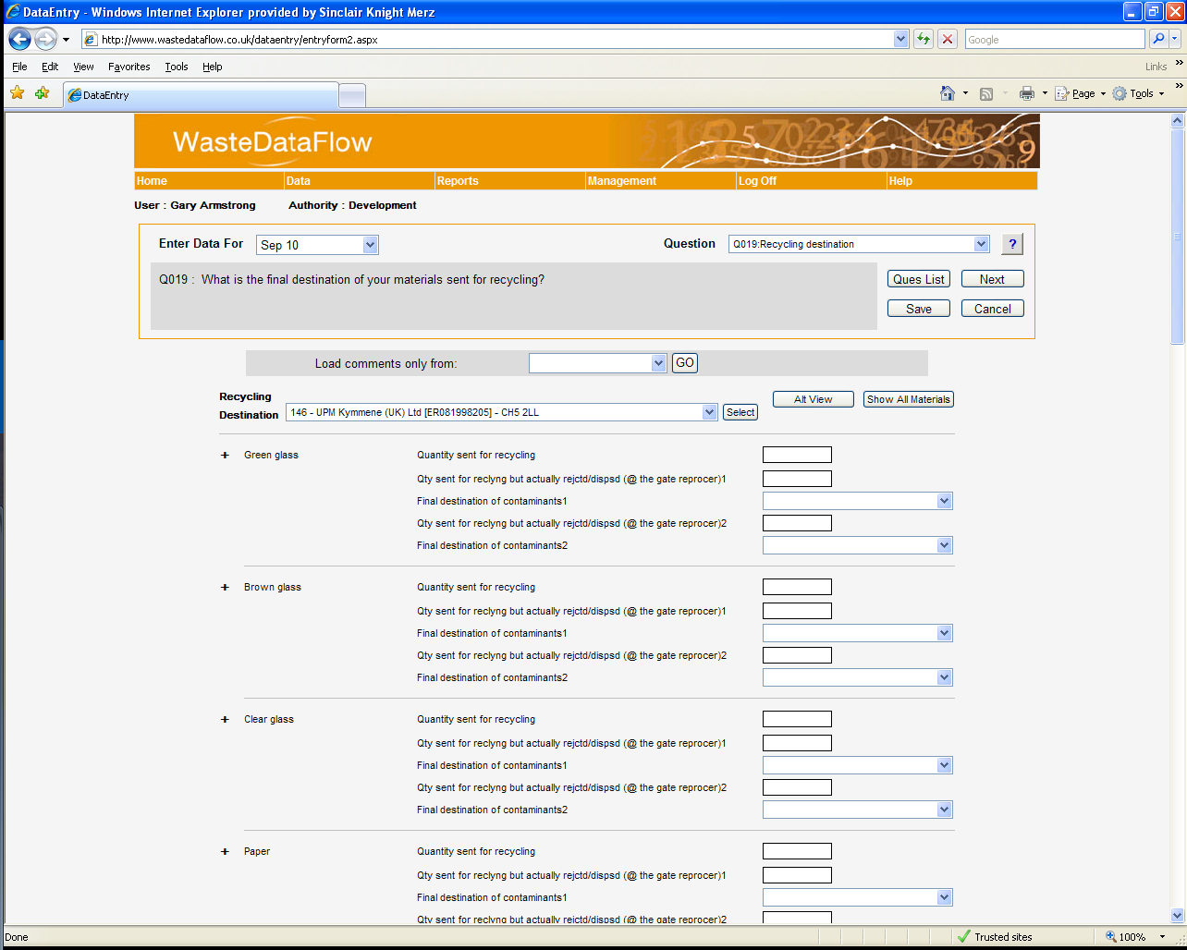

Figure S4: Facility-only question

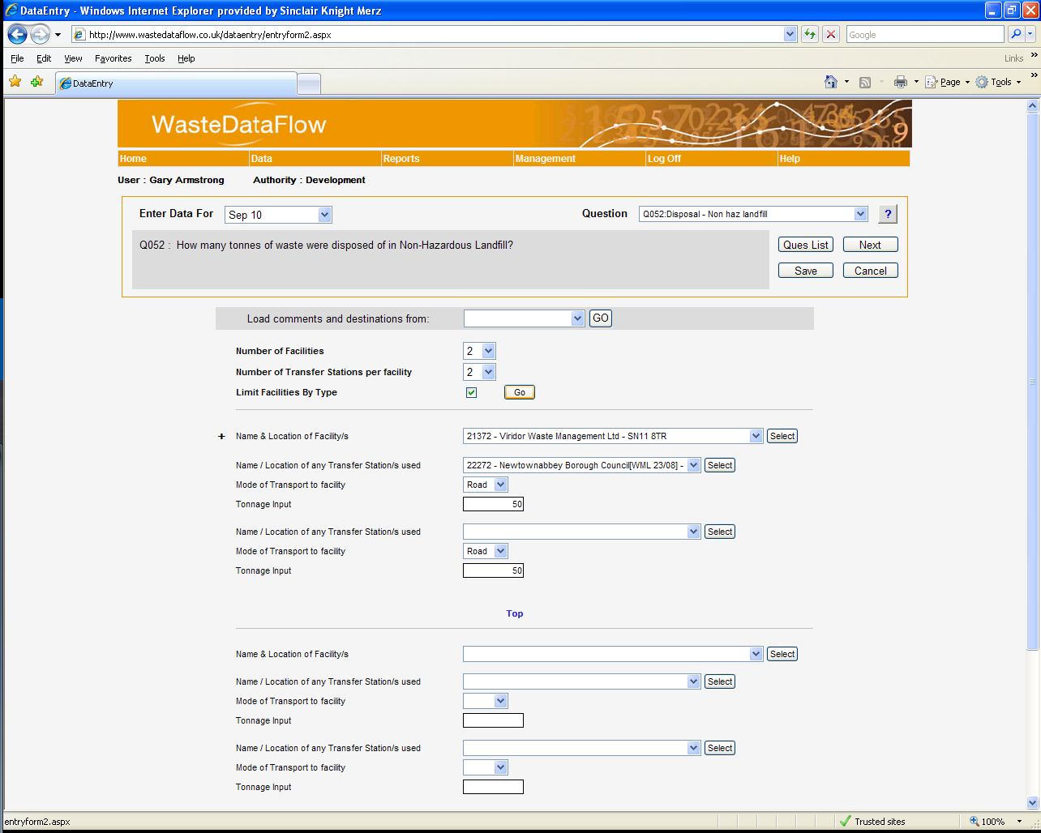

# Data authorisation

Figure S5: Quarterly return selection

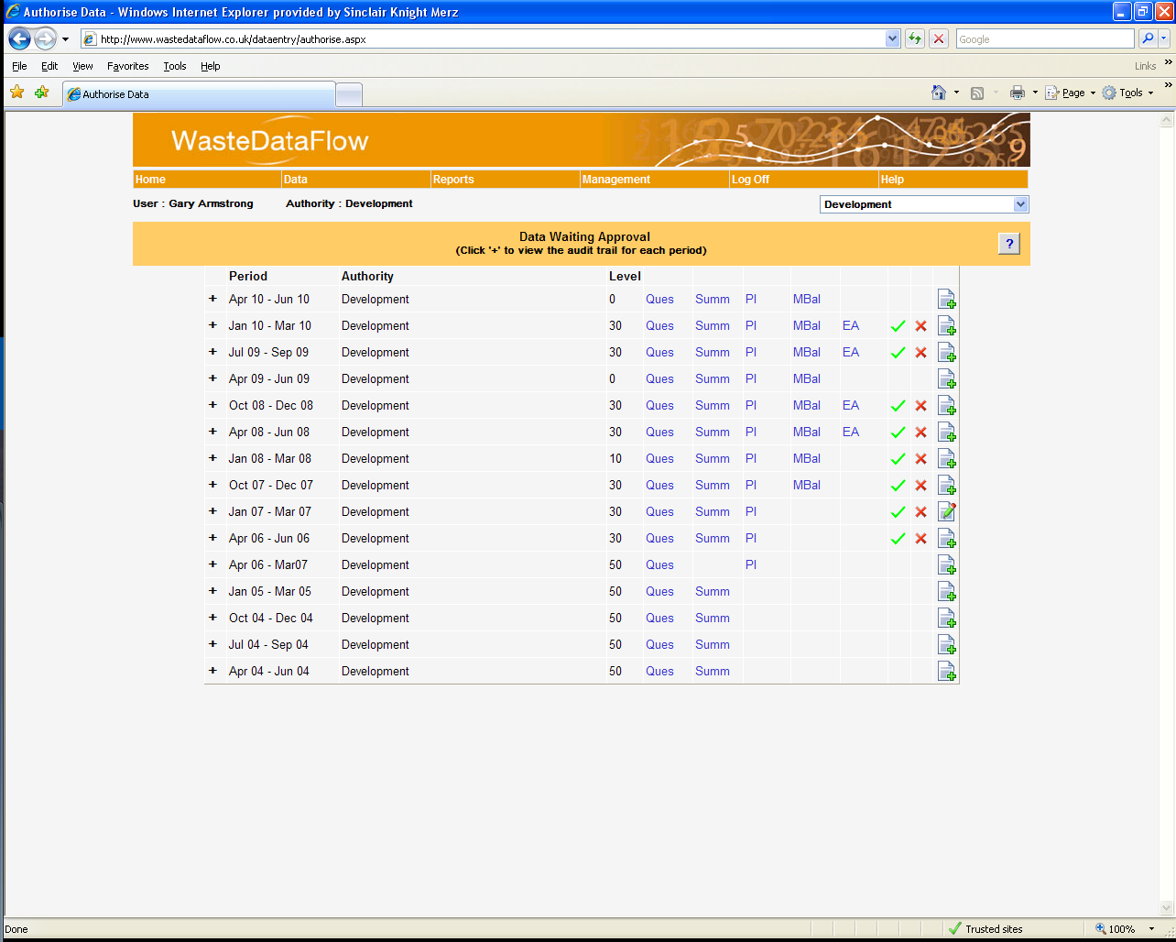

Figure S6: Quarterly return showing roll-up history and changed question log

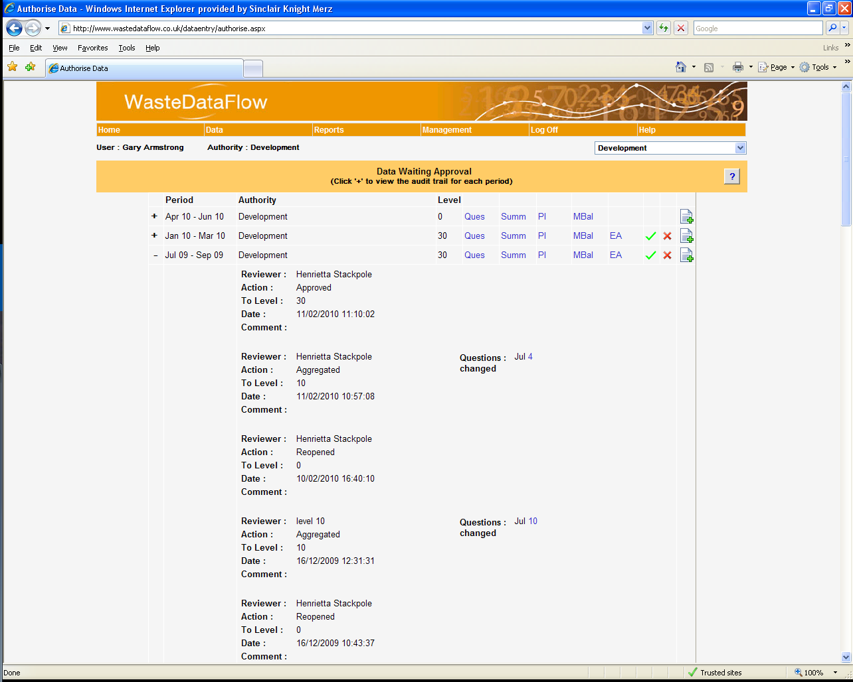

# Reports

Figure S7: Report selection page

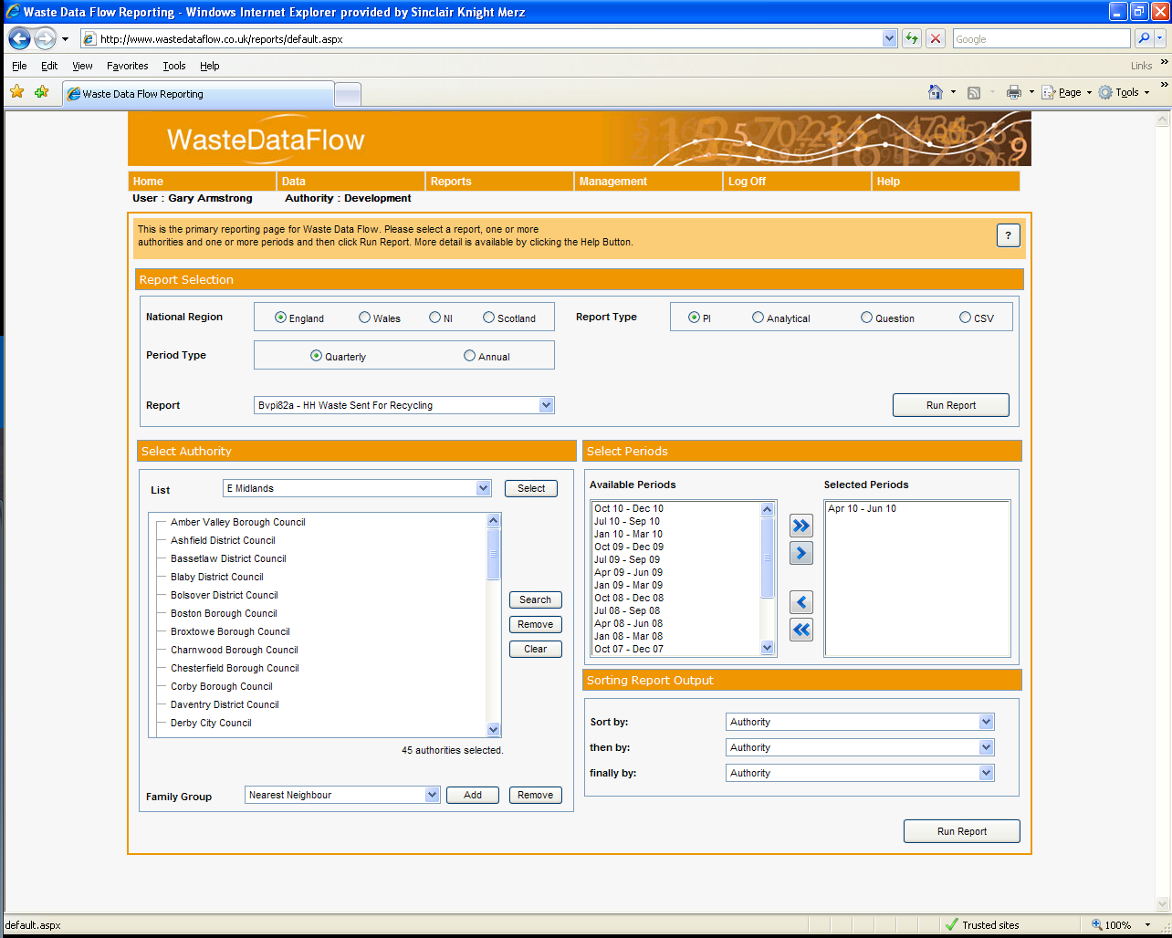

Figure S8: Excel report output

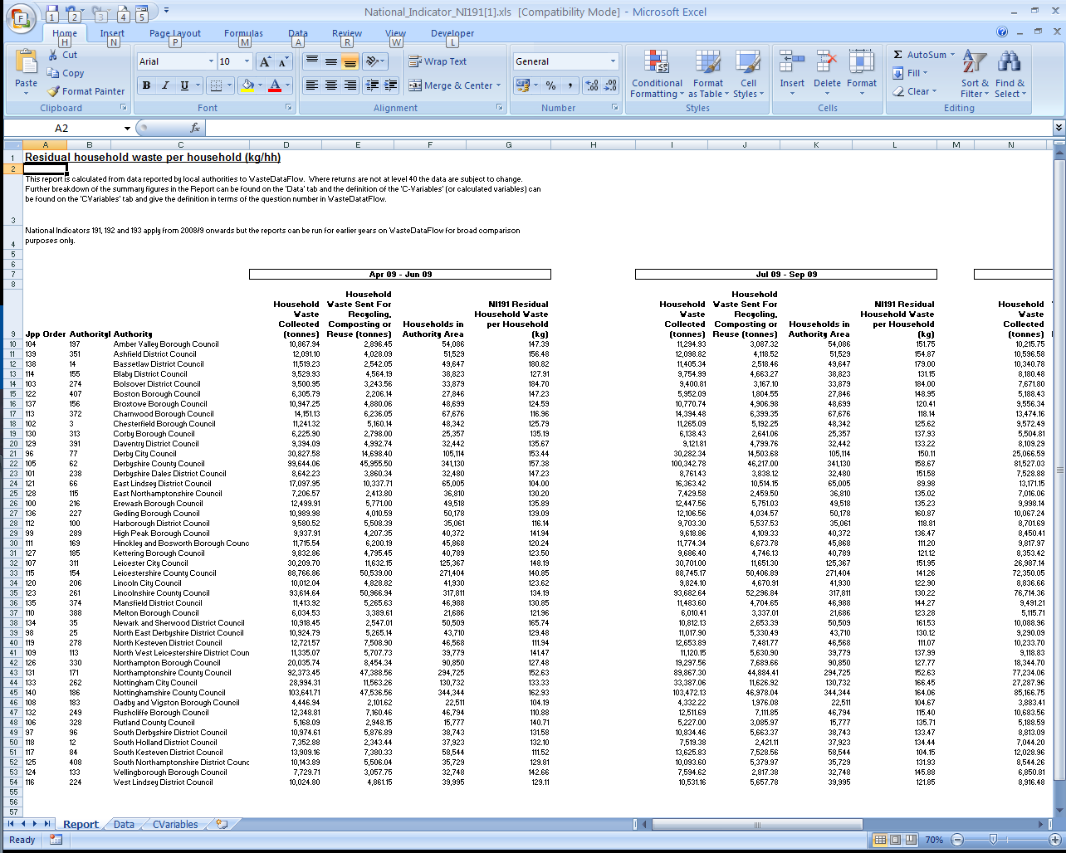

1. The Landfill Tax Credit Scheme was a scheme for the distribution of funds generated from landfill tax (or landfill levy) in the UK. Designed to help mitigate the effects of landfill on local communities, it encouraged partnerships between landfill operators, their local communities and the voluntary and public sectors.
2. Historically in the UK the definition of municipal waste has only included commercial and industrial waste collected by local authorities. To comply with EU requirements, the definition has been broadened to cover all commercial and industrial waste that is similar in nature to household waste.
3. BMW% conversion factor is the proportion of municipal waste which is deemed to be biodegradable. It varies between England (68%), Wales (64%), Scotland (63%) and Northern Ireland (61%).
4. Facilities where householders can take waste free of charge.
5. Waste electrical and electronic equipment.
6. A detailed explanation of the method of calculating the quantity of BMW landfilled from WDF is at http://www.wastedataflow.org/documents/MassBal/UA_Mass_Balance_v2.pdf