# Water for Fodder Program – interim achievements

October 2020

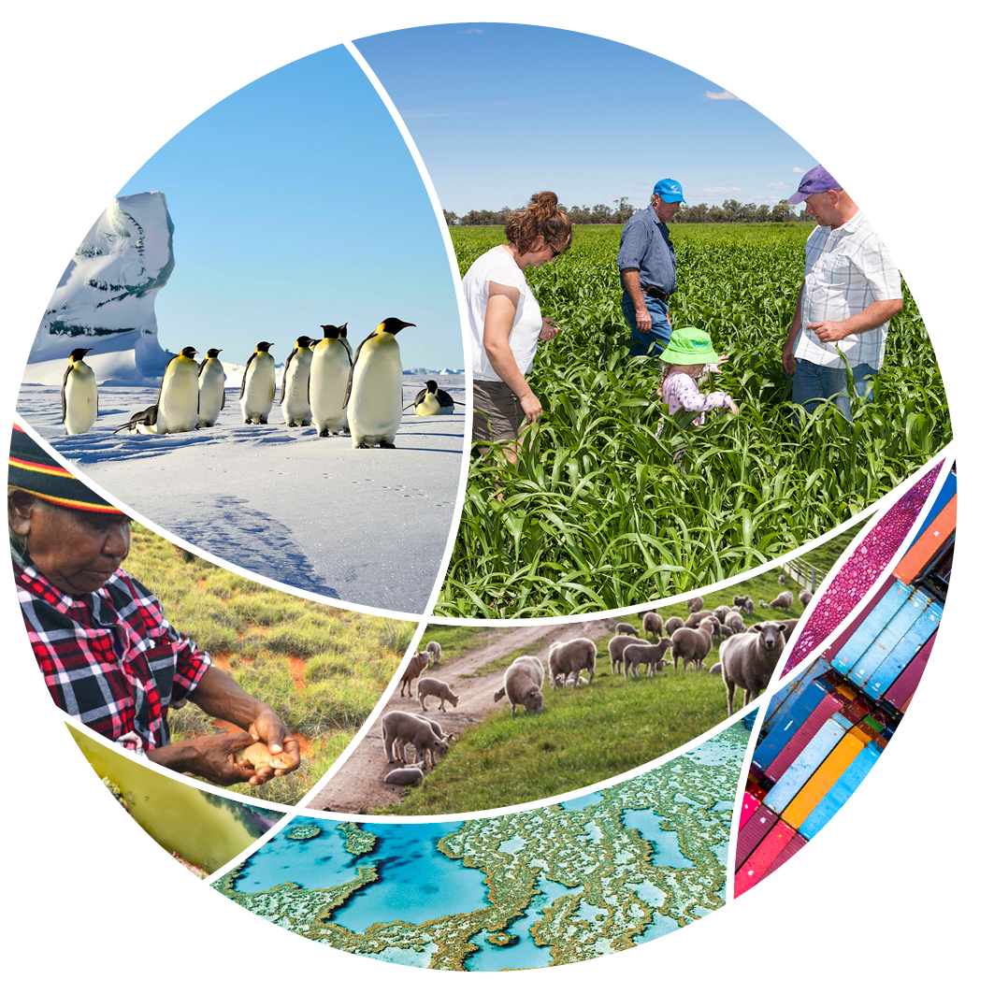

© Commonwealth of Australia 2020

**Ownership of intellectual property rights**

Unless otherwise noted, copyright (and any other intellectual property rights) in this publication is owned by the Commonwealth of Australia (referred to as the Commonwealth).

**Creative Commons licence**

All material in this publication is licensed under a [Creative Commons Attribution 4.0 International Licence](https://creativecommons.org/licenses/by/4.0/legalcode) except content supplied by third parties, logos and the Commonwealth Coat of Arms.

Inquiries about the licence and any use of this document should be emailed to [copyright@awe.gov.au](mailto:copyright@awe.gov.au).



**Cataloguing data**

This publication (and any material sourced from it) should be attributed as: Department of Agriculture, Water and the Environment 2020, *Water for Fodder Program – Interim achievements*, Canberra, October. CC BY 4.0.

ISBN 978-1-76003-347-7

This publication is available at [awe.gov.au/publications](http://awe.gov.au/publications).

Department of Agriculture, Water and the Environment

GPO Box 858 Canberra ACT 2601

Telephone 1800 900 090

Web [awe.gov.au](http://agriculture.gov.au/)

**Disclaimer**

The Australian Government acting through the Department of Agriculture, Water and the Environment has exercised due care and skill in preparing and compiling the information and data in this publication. Notwithstanding, the Department of Agriculture, Water and the Environment, its employees and advisers disclaim all liability, including liability for negligence and for any loss, damage, injury, expense or cost incurred by any person as a result of accessing, using or relying on any of the information or data in this publication to the maximum extent permitted by law.

## Summary

Round 1 of the Water for Fodder Program is complete, with 800 applicants in the southern-connected Murray–Darling Basin each receiving 50 megalitre parcels of water at a discounted rate to grow fodder or pasture. The primary aim of the program was to increase livestock farmers’ drought resilience by enabling them to grow fodder or pasture to maintain their breeding stock.

The Department of Agriculture, Water and the Environment developed a Monitoring, Evaluation, Reporting and Improvement (MERI) framework to determine whether the program fulfilled its objectives.

This is an interim report on the achievements of the program in the 2019–20 water year. A final report on program achievements will be developed following data being received from participants who carried water over into the 2020–21 water year.

Round 1 of the program is on-track to achieve its objectives. As of early July 2020, more than 25,400 hectares of fodder or pasture were planted, with over 31,500 tonnes of fodder harvested. Accounting for those yet to report their harvesting and those who have grown pasture, the target for fodder production of 38,400 tonnes from Round 1 could reasonably be expected to be met.

Of the applicants who were successful in receiving water under the program and reported on their water use, 71% strongly agreed or agreed that the program increased their confidence in their ability to withstand the drought.

This can be at least partially attributed to the additional farm income and reduced farm input costs experienced by the majority of program participants, as a result of being able to grow fodder at relatively low cost. For example, 78% of program participants strongly agreed or agreed that they had additional farm income as a result of participating in the program, with participants saving an average of more than $23,000 in livestock feed costs.

Of those participating in the program, 85% of respondents agreed or strongly agreed that growing a fodder crop during the drought had a positive effect on their mental health. Communities have benefitted from over $11.1 million estimated by respondents spent to grow and harvest fodder crops, with 98% of respondents reporting spending this money within 100 kilometres of their home. Additionally, 53% of respondents agreed or strongly agreed that producing the fodder under the program assisted in retaining employees, with only 15% disagreeing or strongly disagreeing. Keeping jobs in communities during droughts has significant socio-economic benefits.

While Round 1 of the program has seen many positive outcomes, there are some areas for improvement. Most notable of these was the difficulty many successful applicants reported in completing the secondary application process, with multiple resubmissions of the application form often necessary. The department could also have improved its communication with water network operators, who expressed dissatisfaction at not being more involved in program design.

Despite these issues, 86% of applicants found their experience in contacting the department to be positive.

On 4 September 2020 the Hon Keith Pitt MP, Minister for Resources, Water and Northern Australia and the Hon David Speirs MP, South Australian Minister for Environment and Water, announced that Round 2 of the program would not proceed. This was in recognition of the improved seasonal conditions across much of the Murray–Darling Basin. Learnings from the implementation of this program will inform future drought responses.

Contents

Summary iii

Program background 1

Review of Round 1 1

Compliance activities 1

Monitoring, Evaluation, Reporting and Improvement framework 2

Program logic 2

Evaluation questions 2

Data 2

Evaluation 4

How much fodder is being produced? 4

What has been the impact on farm business? 4

Has the department efficiently delivered the program? 4

Has South Australia met the requirements of the program? 4

Further achievements 5

Appendix A: Program logic and achievements 6

Appendix B: Achievements against the program’s evaluation framework 7

How much fodder has been produced? 7

What has been the impact on farm businesses? 8

Has the department efficiently delivered the program? 9

Has South Australia met the requirements of the program? 11

Tables

Table B1 Evaluation of fodder production 7

Table B2 Evaluation of impact on farm businesses 8

Table B3 Evaluation of departmental administration of the program 9

Table B4 Evaluation of whether South Australia has met the requirements of the program 11

## Program background

On 7 November 2019, the Prime Minister announced the Water for Fodder Program as part of the Australian Government’s Drought Response, Resilience and Preparedness Plan. Up to 100 gigalitres of water would be produced from the Adelaide Desalination Plant and an equivalent amount released to farmers in the southern-connected Murray–Darling Basin. The water would be offered to farmers at a discounted rate to grow fodder and pasture to maintain their breeding stock through the drought.

Applications for Round 1 of the Water for Fodder Program closed on 13 December 2019, with more than 4,100 applications received. From these, 800 applicants were selected using a random ballot. They each received 50 megalitres of water at a cost of $100 per megalitre.

### Review of Round 1

Following the completion of Round 1, the department engaged Marsden Jacob Associates to independently review water availability in the Murray–Darling Basin in 2020–21 and the risk exposure of water dependent agricultural sectors across the Basin. The department also conducted a review into program administration and eligibility requirements to allow for improvements to be made ahead of a potential Round 2.

The review found that the program was well received, with 68% of respondents to a public survey expressing support for the Water for Fodder Program, and 84% of respondents indicating they would apply again under a future round of the program.

The results of the review, the report from Marsden Jacob Associates and a stakeholder views report were published on the department’s website on 7 August 2020.

On 4 September 2020, the the Hon. Keith Pitt MP, Minister for Resources, Water and Northern Australia, and the Hon. David Speirs MP, South Australian Minister for Environment and Water, announced that Round 2 of the Water for Fodder Program would not proceed due to improved seasonal conditions across the southern-connected Murray–Darling Basin.

### Compliance activities

The department is conducting a number of activities to ensure that participants are compliant with the requirements of the program. These activities include, but are not limited to:

* using remote sensing, such as through satellite imagery
* audits of evidence, such as metering records, allocation account statements (for any allocation accounts held by the applicant), invoices and photographs
* surveys, including a water acquittal survey
* on-site farm inspections.

These activities also provide the department with information on the effectiveness of the program in achieving its objectives.

## Monitoring, Evaluation, Reporting and Improvement framework

The Monitoring, Evaluation, Reporting and Improvement (MERI) framework for the program provides a method of assessing and reporting on whether the program is achieving its objectives, and how the program can be improved.

The MERI framework:

* describes the overarching program logic for the program
* provides the framework for the department to:
  + collect, generate and analyse data so that the program may be monitored and evaluated in a systematic manner
  + set and measure program performance against key performance indicators
  + report on program performance in a logical and consistent way
  + inform decisions to improve the program.

### Program logic

The program logic shows the overarching logic through which the program’s activities are aligned.

The program logic is at Appendix AAppendix A: Program logic.

### Evaluation questions

The department developed 4 evaluation questions to assess whether the program objectives were achieved:

1. How much fodder has been produced?
2. What has been the impact on farm business?
3. Has the department efficiently delivered the program?
4. Has South Australia met the requirements of the program?

A number of secondary questions to better assist in evaluating each primary question.

Key performance indicators we also developed to assist in quantitatively answering the evaluation questions and evaluating program outcomes.

A summary of achievements against the program’s evaluation questions is at Appendix B.

### Data

Data collected in the program assessment process was critical in evaluating the program and the extent to which it has achieved its objectives.

#### Water use survey

Participants were required to report on how they had used the water they received. This survey was a critical component of the evaluation of the program.

The survey aimed to confirm that the water received under the program was used on the land linked to the allocation account the participant applied under. This was a critical requirement of the program. Participants were asked to disclose if they would need to carry over any water to the 2020–21 water year. If so, participants were required to confirm their ability to carry the water over or arrange a temporary transfer to another account with the sole purpose of carry over, as approved by the department. Approximately 66 participants registered their temporary transfer arrangements with the department.

Some of the additional insights or estimates the survey sought to gain included:

* which fodder crops participants grew
* the quantity of fodder grown under the program
* the expenses incurred by farmers in growing their crops
* any fodder which was sold by participants and any income received as a result
* the impacts of the program on the ability of farms to withstand drought and maintain breeding stock
* the impacts of the program on the financial positions of participants
* the socio-economic impacts of the program on broader communities
* the impacts of the program on the mental health of participants
* participant satisfaction with the program experience.

The survey did not adequately account for those participants who grew pasture for grazing. This may lead to total impact on farm feedstock production being underreported.

This interim report does not take into account fodder grown in the 2020–21 spring growth period. With over 9 gigalitres of water carried-over into 2020–21, there is still significant fodder production to be reported by participants.

As participants self-reported their data, there may be some errors in what is presented. For example, there may be errors in differentiating between the crop grown with the water received under the program and the crop grown with participants’ own water.

## Evaluation

A summary of achievements against the program’s original evaluation questions is at Appendix B.

### How much fodder is being produced?

The program is on-track to achieve its fodder production goals following Round 1, with an estimate of 31,500 tonnes of fodder reported as being produced as of July 2020.

### What has been the impact on farm business?

The impact of the program on farm businesses has been very positive, with 92% of participating farm businesses agreeing or strongly agreeing that the program has led to increased animal feedstock availability. Similarly, 78% of participants reported increased farm income as a result of participating in the program, with an estimated $12.6 million saved by reduced livestock feed costs.

The program has also had positive impacts on drought resilience, with 71% of participants agreeing that the program has increased their confidence that their farm can withstand drought.

### Has the department efficiently delivered the program?

Whilst the program was delivered quickly and efficiently, participants raised some issues with the application process.

In terms of application submission, 44% of conditionally accepted applicants had to submit their application twice due to errors, with a further 19% having to submit their application 3 or more times. The department also received feedback from many applicants who found the application process onerous and challenging, especially since applications were completed entirely online to ensure quick program delivery and some applicants had limited digital capability.

The implementation of the program adhered to relevant stardards, with no breaches of probity identified.

Some water network operators reported a significant increase in their workload during the application period as a result of fielding enquiries from applicants.

Communications about the program were successful, with more than 32,000 views on the program website on the day of the program launch. Of program participants, 86% agreed that when they contacted the department, they were satisfied with the response they received.

### Has South Australia met the requirements of the program?

South Australia satisfied its requirements under the program. The state traded the full 40 gigalitres of allocations from the entitlement used to supply Metropolitan Adelaide with River Murray water to successful applicants under Round 1. The state processed all trades in line with the expected services standards.

SA Water has confirmed that the Adelaide Desalination Plant produced enough water in 2019–20 to supply Round 1.

The Essential Services Commission of South Australia is yet to verify the marginal cost of production of water from the Adelaide Desalination Plant.

The South Australian Government has established the South Australian Drought Resilience Fund and is finalising the guidelines by which funding will be offered for approved projects. As Round 2 of the Water for Fodder Program is not proceeding, the Drought Resilience Fund will be scaled back in size from $10 million to $4 million.

### Further achievements

The department has uncovered some additional achievements, which do not necessarily directly address the program logic. The program benefitted many participating farmers’ wellbeing, with 85% of respondents agreeing or strongly agreeing that growing a fodder crop during the drought had a positive effect on their mental health.

The program also benefitted broader communities supporting these farmers, with program participants putting more than $11.1 million into local economies. Over 98% of participants reported they had spent this money within 100 kilometres of their home. Such economic activity assists rural communities experiencing drought in the southern Murray–Darling Basin. These positive stories also contribute to the overall success of the program.

## Appendix A: Program logic and achievements

This shows the program logic and program achievements. The logic begins with the foundational activity of generating increased water for farm use, with 40 gigalitres provided. The project outputs are over 25,000 hectares of fodder and pasture crops planted, with 31,500 tonnes harvested as at July 2020.
The logic then progresses into intermediate outcomes. Respondents mostly retained the fodder they grew, with 91% keeping all of their fodder and 9% selling at least some fodder. More than $2 million has been earned from selling fodder to date. This had minimal effect on the fodder market. These outcomes led to respondents saving more than $12.6 million in livestock feed costs, and 78% agreeing that they had additional farm income that they would not have had if they did not participate in the program.
The logic culminates in the longer-term program outcomes. Two related outcomes are an improved ability to maintain herd numbers and genetic stock, with 84% of respondents agreeing that the program assisted them to maintain stock. Additional farm income and reduced costs as a result of the program have had a positive impact on farms’ financial positions. These outcomes lead to the ultimate long-term outcome of improved drought resilience, with 71% of respondents agreeing that the program has increased their confidence in their farm’s ability to withstand drought.
Other benefits of the program include 85% of respondents agreeing that both growing a crop during the drought has had a positive impact on their mental health and that the program has been a positive experience. Additionally, 53% of respondents agreed that producing the fodder under the program helped them to retain employees, while only 15% disagreed. Respondents also estimated spending over $11.1 million to grow and harvest fodder crops in local communities.

## Appendix B: Achievements against the program’s evaluation framework

### How much fodder has been produced?

Fodder production is on-track to meet targets.

Table B Evaluation of fodder production

|  |  |  |  |
| --- | --- | --- | --- |
| Criterion | Indicators | Assessment | Analysis |
| How much fodder has been produced? | Program yields 80% (38,400 t) of expected possible fodder production for Round 1 (48,000 t). | On-track | * Approximately 31,500 tonnes were reported as being produced by July 2020. However, wet autumn conditions led to over 9 gigalitres (estimated) being carried over to the 2020–21 water year. * In July 2020, over 25,400 hectares were reported as being planted in total. On average, participants reported planting 42 hectares was reported as being planted, with 52% planting clover and 50% planting rye. |
| What is the overall effect on fodder market? | Program has minimal market effect or leads to softening of market prices. | On-track | * There have been no stakeholder reports of adverse market effects. |

### What has been the impact on farm businesses?

The program has had positive effects on farm businesses and communities.

Table B Evaluation of impact on farm businesses

| Criterion | Indicators | Assessment | Analysis |
| --- | --- | --- | --- |
| How many businesses report increased animal feedstock on-hand, and if so much extra? | Participating farm businesses report increased animal feedstock availability. | On-track | * 92% of survey respondents agreed or strongly agreed that they had more animal feedstock available than if they had not participated in the program. |
| How many businesses report increased farm income as a result of participating, and how much? | Participating farm businesses report increased income. | On-track | * 78% of respondents agree or strongly agree that they have additional farm income they would not have had if they did not participate in the program. * Over $12.6 million in total reported by respondents as saved by not having to buy in feed, on average $23,685 per farmer. |
| How many businesses report other socio-economic benefits of being able to produce in time of drought? | Some participating businesses report positive socio-economic benefits of being able to produce in time of drought. | On-track | * 71% of respondents agree or strongly agree that participating in the program has them made more confident in their farm’s ability to withstand the drought. * 84% of respondents agree or strongly agree that producing the fodder under the program assisted them to retain stock. * 53% of respondents agree or strongly agree that producing the fodder under the program assisted in retaining employees, with only 15% disagreeing or strongly disagreeing. * 85% of respondents agree or strongly agree that growing a fodder crop during the drought has had a positive effect on their mental health. * 85% of respondents agree or strongly agree that participating in the program has been a positive experience. * Over $11.1 million in total estimated by respondents spent to grow and harvest fodder crops, with over 98% of respondents reporting spending this money within 100 km of their home. |
| Have there been any negative effects as a result of changes to water markets in the Basin that can be reasonably attributed to the program? | There are no material effects as a result of changes to water markets in the Basin that can be reasonably attributed to the program. | On-track | * There have been no stakeholder reports of adverse market effects. |

### Has the department efficiently delivered the program?

The department delivered the program fairly, however some efficiency issues have been identified.

Table B Evaluation of departmental administration of the program

| Criterion | Indicators | Assessment | Analysis |
| --- | --- | --- | --- |
| Have applicants been fairly and equally treated? | * Probity advisor provides confirmation of compliance with processes * Complaints about handling of applications not upheld | On-track | * Applicants have been fairly and equally treated. * The Australian Government Solicitor was engaged to provide probity advice on the program. The program guidelines, assessment plan and probity plan were developed in consultation with the probity advisor. No breaches in process were identified. * The department staff involved in the program all completed conflict of interest declarations in accordance with the probity plan. No conflicts of interest were disclosed. * The company responsible for conducting the random ballot signed a Deed of Confidentiality and Conflict of Interest. Staff of the company and the independent scrutineer also completed conflict of interest declarations. No conflicts of interest were disclosed. * The was one complaint received by an unsuccessful applicant. The complaint was managed in accordance with the complaint handling procedure. The complaint was not upheld. |
| Is the application process simple and easy? | * Number of emails and calls received on how to complete application form * Number of applicants that have to withdraw or resubmit their application | Not achieved | * Feedback from participants was that they did not find application process simple and easy. * 49% of survey respondents required assistance in completing their stage 1 application. * Of those who were conditionally accepted: * 37% had to submit their application once * 44% had to submit their application twice * 19% had to submit their application 3 or more times. |
| Have communications on the program been timely and effective? | * Unique website visits * Responses to “Is this website helpful?” are generally positive * Number of emails and phone calls responded to * Complaints and compliments received | Some issues | * Whilst communications on the program were generally seen as timely and effective there were some issues. * The Water for Fodder website pages received over 80,000 views from when the webpage was launched in late November 2019 until September 2020, the most of any water related content on the department’s website in that time period. This peaked with over 32,000 views on 11 December 2019, the day applications for Round 1 opened. * 56% of responses to the question “Is this website helpful?” across the Water for Fodder website pages were yes, with the remaining 44% being no. The proportion of positive responses was very similar to the average for water content on the department’s website over this time period. * The department responded to over 2,000 emails and over 600 calls from stakeholders and applicants. * Of those who were conditionally accepted, 86% of respondents agreed or strongly agreed that when they contacted the Water for Fodder team, they were satisfied with the response they received. |
| Have water network operators been negatively affected? | No material increase in operating costs for water network operators that can be reasonably attributed to the program. | Some issues | * Some water network operators were dissatisfied that the department did not consult with them more extensively on program design and administration. * Water network operators have provided feedback that their workload during the application period increased because of enquiries from program applicants. |

### Has South Australia met the requirements of the program?

Whilst there have been minor delays of delivering milestones, South Australia has met the requirements of the program.

Table B Evaluation of whether South Australia has met the requirements of the program

|  |  |  |  |
| --- | --- | --- | --- |
| Criterion | Indicators | Assessment | Analysis |
| Has South Australia transferred water entitlements to program participants in a timely manner? | The release and transfer of 40 GL of temporary water allocation from water entitlements held by the state in SA Water’s Metropolitan Adelaide River Murray Licence. | On-track | South Australia has transferred the full 40 gigalitres of Metropolitan Adelaide River Murray water to successful applicants under the program.  The state processed all trades in line with the expected services standards. |
| Has the Adelaide Desalination Plant produced an appropriate amount of water? | The Adelaide Desalination Plant produces up to 100 GL per annum of water and releasing an identical volume of water from allocations from water entitlements held by the South Australian Government or its agencies in the connected Southern Murray–Darling Basin for the purposes of the Water for Fodder Program. | On-track | The Adelaide Desalination Plant has produced at least 40 gigalitres. |
| Has South Australia only charged the cost of production of water? | The Essential Services Commission of South Australia (ESCOSA) independently reviews and verifies the marginal cost of the supply of water under this arrangement to ensure there is no profit gained from the arrangements. | Delayed | ESCOSA’s report has been delayed from June 2020. |
| Has South Australia developed and implemented a drought program? | A drought program of up to $10 million to be developed and implemented in South Australia from the proceeds that are received by the state from the sale of water allocations to irrigators in the southern Murray–Darling Basin. | On-track | The South Australian Government has established the fund and is finalising the guidelines by which funding will be offered for approved projects.  The program will be reduced to $4 million due to Round 2 not proceeding. |
| Has South Australia complied with trading rules in relation to the program? | Complying with the Murray–Darling Basin Ministerial Council’s conditions it set in agreeing to trading from SA Water’s Metropolitan Adelaide River Murray Licence and/or water account under Schedule E, clause 7(2) in the Murray–Darling Basin Agreement. | On-track | No breaches of trading conditions have been reported by the Murray–Darling Basin Authority. |