Developing the roadmap for water market reform
Principal Adviser, Daryl Quinlivan, facilitated by Garry Smith
Accessible version of PowerPoint delivered 6 December 2021 online to members of the public.

Welcome

Acknowledgement of Country
We acknowledge the Traditional Owners of Country throughout Australia and recognise their continuing connection to land, water and culture. We pay our respects to their Elders past, present and emerging.

Roadmap for water market reform

Context for the roadmap – the ‘what’:
- ACCC final inquiry report – published 26 March 2021
- contained 29 recommendations and 70 specific actions for water market reform
- the roadmap – considering ACCC findings to develop a phased, practical, cost-effective implementation plan
Context for the roadmap – the ‘how’:
To be developed by the Principal Adviser with the support of the advisory group, and in consultation with Basin states and stakeholders
Advisory group to provide advice on economics, water markets, and anticipated impacts of proposed reforms on water users

Context for roadmap – the ‘when’:
- By December 2021, provide advice on actions supported by Basin states that can be implemented quickly to help restore confidence in water markets
- By June 2022, deliver a phased implementation plan (‘roadmap’) for water market reform that is practical, cost- effective and supported by Basin states.

Timeline:
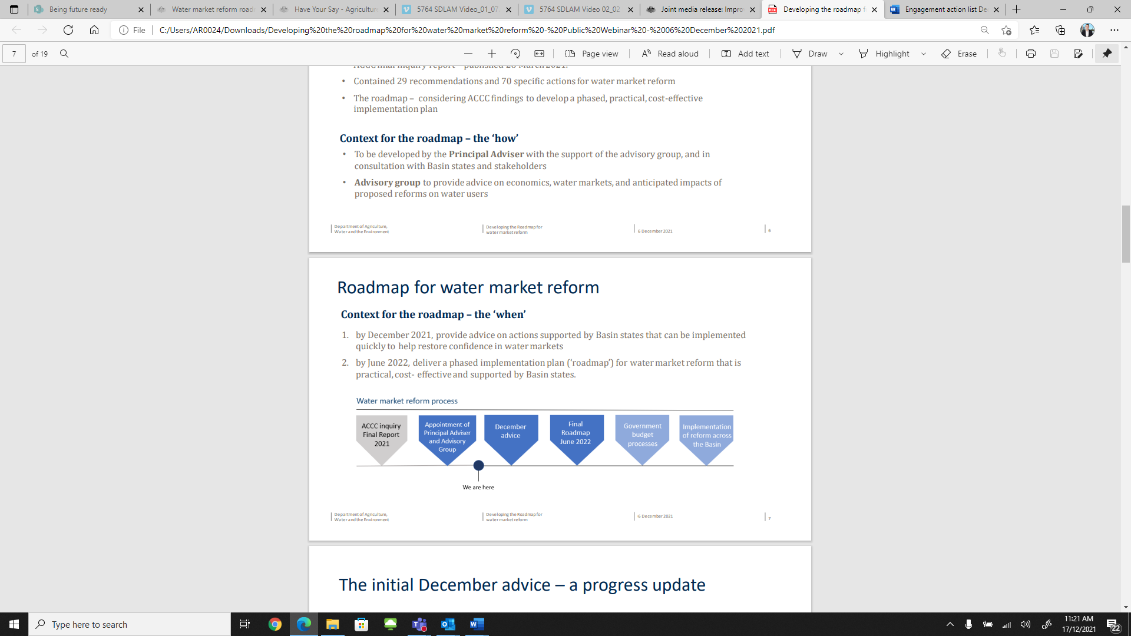
- ACCC delivered inquiry final report in 2021
- Appointment of principal adviser and advisory group
We are here in the process.
- December advice
- Final Roadmap June 2022
- Government budget processes
- Implementation of reform across the Basin

The initial December advice – a progress update
- Progress to date by Basin governments
- Establishing an evidence base for reforms
- Identifying key potential reform opportunities to be explored:
  - Basin wide water market education
  - Intermediary code and conduct regulation
  - Improved access to information: data & system integration
  - Institutional arrangements

Key potential reform opportunities
- Basin wide market education: Ensuring availability and accessibility of information to enable communities and individuals to have confidence in the operation of water markets and their ability to enter those markets.
- Mandatory intermediary code: A mandatory intermediary code would potentially regulate all parties carrying out intermediary services, including some Irrigation Infrastructure Operators (IIOs).
- Conduct regulation: new Basin-wide legislation to strengthen and broaden insider trading prohibitions, as well as new market manipulation prohibitions will regulate the conduct of market participants.
- Digital infrastructure for trade: Improving digital infrastructure and water market data is expected to have considerable benefits to water markets but is likely to also require significant investment. DAWE has engaged the CSIRO to assess the benefits and costs in detail with trade service providers.

Conduct regulation
- The ACCC recommended strengthening and broadening insider trading prohibitions, as well as new market manipulation prohibitions.
- December advice: potential commitments to support these measures inprinciple
- Implementation details (scope of prohibitions, who will regulate) to be worked out for the June 2022 roadmap.

Mandatory intermediary code

Why have a mandatory intermediary code?
- The ACCC recommended introducing an enforceable mandatory code for intermediaries, including water brokers, exchange platforms and Irrigation Infrastructure Operators (IIOs).
- Voluntary code has not been sufficiently effective.
- A mandatory code will support effective operation of water markets by promoting confidence and ensuring a consistent baseline for consumer protection.
- December advice: potential commitments to support a code in-principle.

What obligations will be included?
- Duty to act in client’s best interests or to disclose if acting for both parties
- Complaints handling process
- Record-keeping obligations
- Trust accounts if handling money on behalf of clients
- Professional indemnity insurance

What services could potentially be covered?
- Advisory
- Information
- Settlement
- Matching
- Submitting trade applications
- Exchange

Matters still under consideration:
- Application – beyond the basin?
- Who will enforce the code?
- Appropriate exclusions (if any)>

Digital infrastructure & reporting for trade
- The ACCC recommended improvements to digital infrastructure for trade including water market data standards and system integration.
- December advice: potential new commitments to increase collection and publication of trade data (reasons for trade and ‘strike-date’ information).
- Most recommendations regarding data and systems for trade are yet to be considered.
  - CSIRO has been engaged to assess the benefits and costs in detail with trade service providers, recognising potentially significant impact on trade service providers.
  - Consequential issue of how to make this information available to meet various needs.

Institutional arrangements
- The ACCC recommended creating a new 'Water Markets Agency' to centralise all water market functions in one agency.
- The new and improved functions would span:
  - Market surveillance, compliance and enforcement
  - Advisory and advocacy functions
  - Information and reporting functions
- Need to test this proposal against the need to ensure reforms are practical and cost-effective, and having regard to the number of existing regulatory agencies in the water management sector

Next steps

Thank you for your participation today
- Feedback from today’s session will help inform advice as part of the roadmap.
- The first piece of advice is due December.
- Plan for 2022 is under development.

Contact
- Email: water.markets@agriculture.gov.au
- Stay involved: https://www.awe.gov.au/water/policy/markets/reform
© Commonwealth of Australia 2021
Unless otherwise noted, copyright (and any other intellectual property rights) in this publication is owned by the Commonwealth of Australia (referred to as the Commonwealth).
All material in this publication is licensed under a Creative Commons Attribution 4.0 International Licence except content supplied by third parties, logos and the Commonwealth Coat of Arms.
The Australian Government acting through the Department of Agriculture, Water and the Environment has exercised due care and skill in preparing and compiling the information and data in this publication. Notwithstanding, the Department of Agriculture, Water and the Environment, its employees and advisers disclaim all liability, including liability for negligence and for any loss, damage, injury, expense or cost incurred by any person as a result of accessing, using or relying on any of the information or data in this publication to the maximum extent permitted by law.

