Commonwealth Environmental Water Office

Water Management Plan

Chapter 3.9 – Lachlan River

2020–21

This document represents a sub-chapter of ‘Commonwealth Environmental Water Office Water Management Plan 2020-21, Commonwealth of Australia, 2020’.

Please visit: <https://www.environment.gov.au/water/cewo/publications>/water-management-plan-2020-21 for links to the main document.

Acknowledgement of the Traditional Owners of the Murray–Darling Basin

The Commonwealth Environmental Water Office respectfully acknowledges the Traditional Owners, their Elders past and present, their Nations of the Murray–Darling Basin, and their cultural, social, environmental, spiritual and economic connection to their lands and waters.

© Copyright Commonwealth of Australia, 2020.



Commonwealth Environmental Water Office Water Management Plan 2020-21is licensed by the Commonwealth of Australia for use under a Creative Commons Attribution 4.0 International licence with the exception of the Coat of Arms of the Commonwealth of Australia, the logo of the agency responsible for publishing the report, content supplied by third parties, and any images depicting people. For licence conditions see: https://creativecommons.org/licenses/by/4.0/

This report should be attributed as ‘Commonwealth Environmental Water Office Water Management Plan 2020-21, Commonwealth of Australia, 2020’.

The Commonwealth of Australia has made all reasonable efforts to identify content supplied by third parties using the following format ‘© Copyright’ noting the third party.

The views and opinions expressed in this publication are those of the authors and do not necessarily reflect those of the Australian Government or the Minister for the Environment.

While reasonable efforts have been made to ensure that the contents of this publication are factually correct, the Commonwealth does not accept responsibility for the accuracy or completeness of the contents and shall not be liable for any loss or damage that may be occasioned directly or indirectly by, or reliance on, the contents of this publication.

For more information about Commonwealth environmental water, please contact us at:

1800 803 772

[ewater@awe.gov.au](mailto:ewater@awe.gov.au)

[www.environment.gov.au/water/cewo](http://www.environment.gov.au/water/cewo)

@theCEWH

GPO Box 858, Canberra ACT 2601

## Lachlan River

### Region overview

#### The Lachlan Valley

The Lachlan River (Figure 1) is the fourth longest river in Australia at 1 448 kilometres with a catchment of around 90 000 square kilometres. Flow attenuation in the system is high due to the low gradient of the system and it can take 90 days for a flow event from Wyangala Dam to reach the end of the river system at The Great Cumbung (Barma Water Resources 2011). Many anabranches and distributary creeks in the Lachlan terminate in wetlands. Not all environmental water is sourced from dam releases – unregulated tributary inflows can be ordered and accounted for as environmental water and allowed to reach assets by bypassing regulating storages. The harvesting of water for consumptive purposes has significantly modified the flow of the Lachlan River (Higgisson et al, 2019).

#### Traditional Owners

The Lachlan River flows through the lands of the Nari Nari, Ngiyampaa, Wiradjuri and Yita Yita Nations, and the Commonwealth Environvmental Water Office (CEWO) respectfully acknowledge these people, their Elders past, present and future, as the Traditional Owners of the land on which this chapter is focused.

#### Important sites and values

The draft Long Term Water Plan for the Lachlan Catchment (OEH 2018a and b) provides greater detail on the environmental assets found in the Lachlan Catchment and their watering requirements. The Commonwealth works with NSW agencies to deliver flows to priority sites that are identified from year to year and as conditions change during the year. During 2019-20 sites such as Booberoi Creek, Yarrabandai Lagoon, the river channel, Brewster Weir pool and a number of lower Lachlan wetlands, including the core reed beds of The Great Cumbung (Figure 2) were watered to create a mosaic of drought refuge sites throughout the Lachlan riverine system.

#### Stakeholder engagement

The CEWO continues to work with NSW Department of Planning, Industry and Environment (NSW DPIE-ESS) in reviewing, coordinating and managing environmental watering actions in the Lachlan Catchment. This work is done in conjunction with the CEWO’s Monitoring, Evaluating and Research (MER) Program provider, the University of Canberra, the river operator WaterNSW and the Lachlan Environmental Water Advisory Group (EWAG). This work is further complemented by regular landholder visits and discussion.

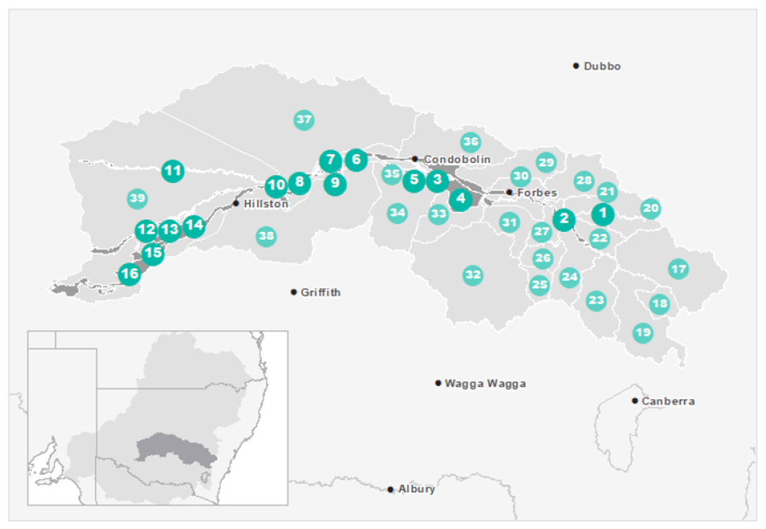

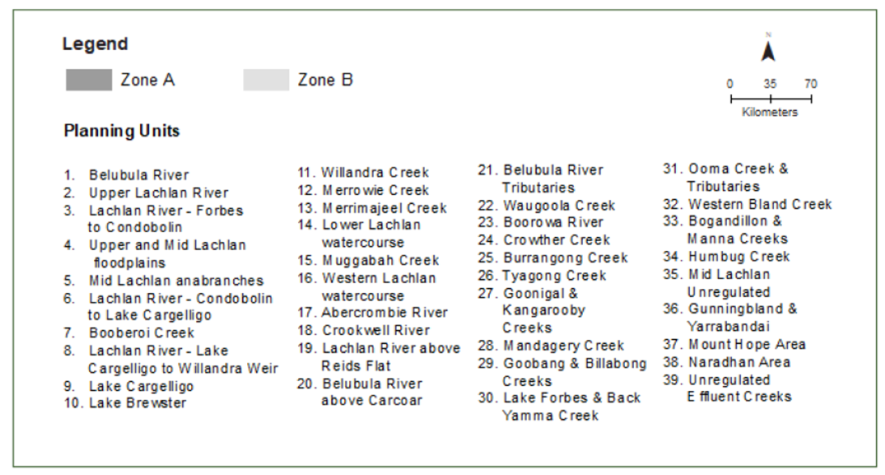

**Figure 1**: The Lachlan valley showing the division of planning units into Zone A and B as used in the draft Long Term Water Plan for the Lachlan Catchment (NSW OEH 2018a)

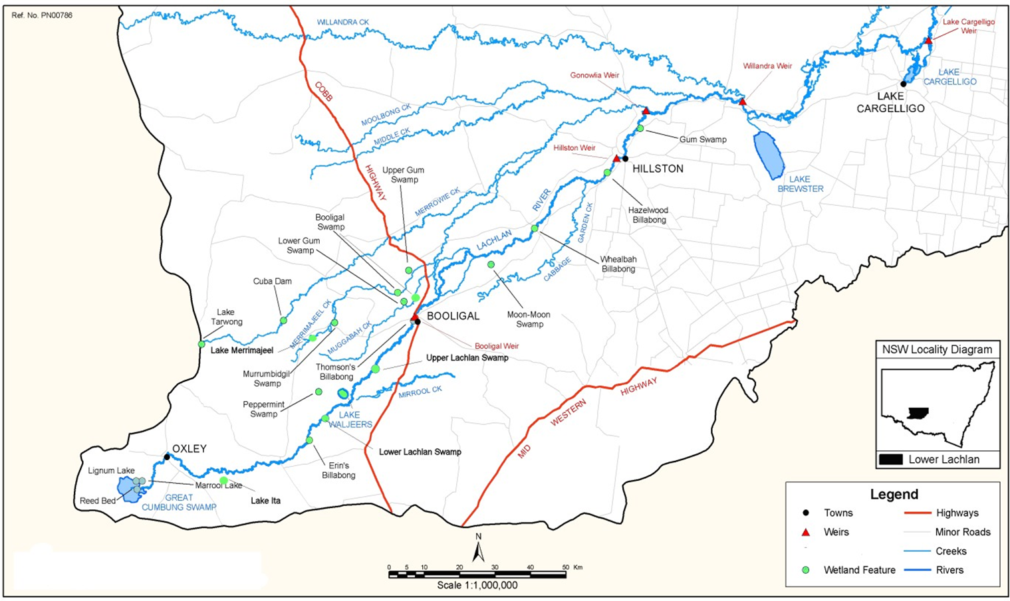

**Figure 2**: Map of the Lower Lachlan Catchment (Driver et al 2003)

### Environmental objectives

Table 1 sets out the objectives for environmental watering in the Lachlan River catchment, based on long‑term environmental objectives in the Basin Plan, draft state Long-Term Water Plans (LTWP), site management plans, and best available knowledge.

The objectives that are targeted in a particular year may vary, depending on available water, catchment conditions, operational feasibility, and demand for environmental water. These objectives will continue to be revised as part of the CEWO’s commitment to adaptive management.

**Table 1**: Summary of objectives for environmental watering in the Lachlan River catchment.

|  |  |  |
| --- | --- | --- |
| **Basin-Wide**  **Matters** | **In-Channel Assets** | **Off-Channel Assets** |
| **Vegetation** | * Maintain riparian and in channel vegetation condition. * Increase periods of growth for nonwoody vegetation communities that closely fringe or occur within river corridors. | * Maintain the current extent of floodplain vegetation near river channels and on low-lying areas of the floodplain. * Maintain the condition of black box, river red gum and lignum shrublands. * Maintain and improve condition of wetland vegetation. |
| **Waterbirds** | * Provide habitat and food sources to support waterbird survival and recruitment and maintain condition and current species diversity. | * Support naturally triggered bird breeding events that may be in danger of failing due to falling water levels. * Provide habitat and food sources for migratory birds |
| **Native Fish** | * Provide flows to support habitat and food sources and promote increased movement, recruitment and survival/condition of native fish. | * Provide flow cues to promote increased movement, recruitment and survival/condition of native fish (particularly for floodplain specialists). |
| **Invertebrates** | * Provide habitat to support increased invertebrate survival, diversity, abundance and condition. | |
| **Other vertebrates** | * Provide habitat to support survival, maintain condition and provide recruitment opportunities for rakali (native water rat), frogs and turtles. | |
| **Connectivity** | * Maintain longitudinal & lateral connectivity through contributing to an increase in the frequency of freshes. | * Maintain latitudinal connectivity (within constraints) to wetlands, floodplains, creeks and anabranches by contributing an increase in the frequency of lowland floodplain flows. |
| **Process**  **Water quality**  **Resilience** | * Increase primary productivity, nutrient and carbon cycling, biotic dispersal and movement. Increase transport of organic matter and nutrients downstream. * Maintain water quality and provide refuge habitat from adverse water quality events. * Provide drought refuge habitat and maintenance/condition of native biota. | |

### First Nations Environmental Objectives

Advice on environmental water objectives in the Lachlan Catchment has been provided by the Murray Lower Darling Rivers Indigenous Nations (MLDRIN) and the Northern Basin Aboriginal Nations (NBAN) through the First Nations Environmental Water Guidance project. Table 2 includes just some of the common objectives for the Lachlan Catchment, provided by MLDRIN, selected as they were raised by two or more participating Nations for the region. It is important to note these objectives do not represent the detail, depth and complexity of Nations’ localised water-related objectives. Table 3 shows the First Nations environmental water objectives provided by NBAN for the Lachlan Catchment.

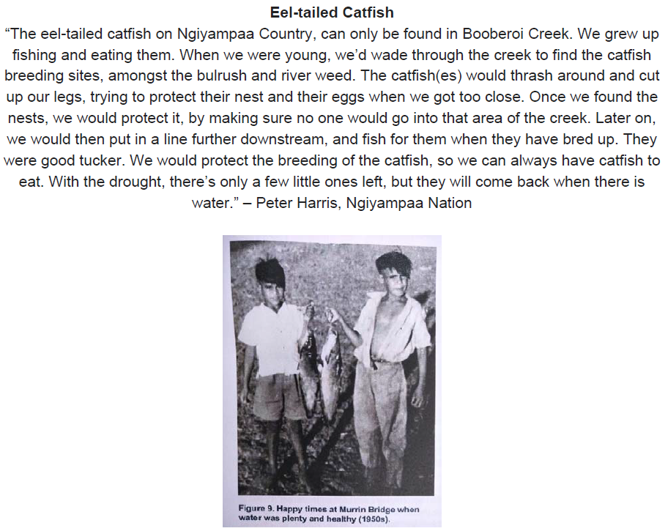Some of these objectives sit outside the scope of water for the environment to influence, while for others, the link between water for the environment and the site or issues is not well understood.  Environmental flows will aim to contribute to identified objectives, where possible.  The Commonwealth Environmental Water Holder (CEWH) is committed to continuing to strengthen engagement with all Southern Basin First Nations to support those Nations to articulate objectives for water management.

Figure 3: Eel-tailed Catfish story (NBAN, 2020)

**Table 2:** First Nations environmental objectives for the Lachlan Catchment 2020-21 provided by MLDRIN (MLDRIN 2020)

|  |
| --- |
| **Waterways and Places in Need of watering** |
| Billabongs (general), All on Country, Murrumbidgee, Lachlan |
| **River Flows and Connectivity** |
| Improve water quality, Improve timing and seasonality of flows, Improve flows and quantity (rivers and general), Remove barriers and constraints. |
| **Vegetation** |
| Lignum, River Red Gum. |
| **Fish** |
| Murray Cod, Yellowbelly (Golden Perch, Callop), Catfish, Silver perch . |
| **Waterbirds** |
| Ducks (general), Pelican, Swan (general) |
| **Other species** |
| Murray Cray |

**Table 3**: First Nations environmental objectives for the Lachlan system for 2020-21 provided by NBAN (NBAN Ltd 2020)

|  |
| --- |
| **River flows and Connectivity** |
| Priority sites**:** Lachlan River needs to flow at all times, Booberoi Creek. |
| **Native Vegetation** |
| Indicator species**:** River Red Gum, Black Box i, Bulrush, Ribbon Weed, Pinrush. |
| **Native Birds** |
| Indicator species**:** Black Duck, Emu i, White Cockatoo i, Black Swan, Kookaburra I . |
| **Native Animals** |
| Indicator species**:** Water Rats, Turtles, Yellowbelly, Catfish, Frogs. |
| **Connecting with Country** |
| Flows from the Lachlan River at all times, to flow into Booberoi Creek and Willandra Creek for Ngiyampaa Wangaaypuwan People to Connect with Country at the waterways |

i Water for the environment targeting other environmental outcomes may influence this species or objective

### Recent conditions and seasonal outlook

#### Recent conditions and environmental water use

As noted by Dyer et al. (2015-2019) and Higgisson et al. (2019) the Lachlan Catchment can experience highly variable rainfall and related flow conditions. In 2016-17, the catchment experienced widescale flooding due to heavy rainfall. This was beneficial to wetland and floodplain vegetation and waterbird populations. However, the widescale flooding also caused a significant hypoxic blackwater event that negatively impacted on large bodied native fish like Murray cod. During 2017-18 to 2018-19, the use of Commonwealth environmental water in the Lachlan River system included a focus on the recovery of Murray cod populations.

Drought conditions deepened in many NSW catchments during 2018-19. By the start of 2019-20 the Lachlan Catchment was being managed under Stage 3 of the NSW Extreme Event Policy (NSW Department of Industry 2018). The use of Commonwealth environmental water in the Lachlan River during 2019-20 focused on building resilience and maintaining drought refugia at key sites across the catchment.

Details of previous Commonwealth environmental use in the Lachlan catchment are available at: <http://www.environment.gov.au/water/cewo/catchment/lachlan>

#### Seasonal outlook

NSW Department of Planning, Industry and Environment (2020a) notes that the Lachlan catchment will continue to be managed under the NSW Extreme Event Policy for the foreseeable future and may escalate from Stage 3 to Stage 4 (extreme drought) if there is no significant improvement in the system. The Bureau of Meteorology *(*2020) suggests there is largely a 70-75 per cent chance of above median rainfall across the Lachlan River catchment between July and September 2020.While this forecast indicates that the severe dry conditions may ease, as of May 2020, a total of 315 gigalitres of inflows into storages in the Lachlan catchment would be required before new general security allocations could be made NSW Department of Planning, Industry and Environment, (2020a).

#### Water availability

On 1 July 2020, the NSW Department of Planning, Industry and Environment (2020b) announced 70 per cent allocation against high security entitlements and no new allocation to general security allocations. The restriction of accessing 43 per cent of the 1 July 2019 general account balance remains and a further 50 per cent restriction has been applied for 2020-21 on the active general security account balance as at 30 June 2020 (NSW DPIE 2020b). Based on this, as at 1 July 2020 the CEWO has around 650 megalitres of water, with 16 gigalitres still held in the WaterNSW Drought Account.

The CEWO will continue to monitor catchment conditions, inflows and changes to water availability and will undertake watering actions should additional water become available (either through the release of water from the Drought Account or increased water allocations following large rain events).

#### Environmental demands

Environmental demands, and need to avoid further damage to key assets, remain high as a result of drought conditions across the catchment. The environmental water demands for assets in the Lachlan River catchment in 2020-21 are represented in Table 4. Note that the capacity to contribute to these environmental demands is contingent on a substantial improvement in water availability in the catchment.

**Table 4:** Environmental demands, priority for watering in 2020–21 and outlook for coming year in the Lachlan River catchment.

| **Environmental assets and Long Term Water Plan unit (PU) reference number (see Figure 1 and more detailed description at bottom of table)** | **Indicative demand (for all sources of water in the system)** | | **Watering history** | **2020–21** | | **Implications for future demands** |
| --- | --- | --- | --- | --- | --- | --- |
| **Flow/Volume** | **Required frequency (maximum dry interval)** | **(from all sources of water)** | **Environmental demands for water**  **(all sources)** | **Potential Commonwealth environmental water contribution?** | **Likely urgency of demand in 2021–22 if watering occurred as planned in 2020–21** |
| **Lachlan River (PU 2, 3, 6, 8, 14, 16)**  Protect tributary inflows (natural trigger) or deliver upon environmental triggers (e.g. timing or temperature) being reached, to target native fish, in-stream productivity, native vegetation and connectivity along the river channel | >600 ML/d, based on conceptual hydrographs (Ellis et al. 2016), other flow objectives and available water allocations. | 5–10 years in 10 (Annual for the maintenance of drought refuge) | From 2018-2020 a pulse and minimum flow period in spring has been provided | High | High priority for Commonwealth environmental watering (likely to receive water even under low water resource availability) | High |
| **Yarrabandai Lagoon (formerly known as Burrawang West, PU 3) (see note 1)**  Provide off-channel drouth refuge habitat for native frogs and waterbirds | 400-800 ML in total | 5–10 years in 10 (Annual for the maintenance of drought refuge) | Previously watered by NSW. Watered since 2018-19 and received high natural flows in winter 2020. | Moderate | Priority for Commonwealth environmental watering (likely to receive water even under low water resource availability), subject to site assessment | Moderate |
| **Brewster Weir Pool (PU 8)**  Help maintain weir pool height to maintain olive perchlet habitat | Up to 5 GL dependant on the operational level and management requirements of the weir | 5–10 years in 10 (Annual for the maintenance of drought refuge) | Watered since 2017-18 and received variable flows in May 2020 as operational water was moved into Lake Brewster | High | High priority for Commonwealth environmental watering (likely to receive water even under low water resource availability) | High |
| **Mid-Lachlan anabranches (PU 5)**  Provide lateral connectivity to anabranch systems, maintain native vegetation and native fish outcomes | Nerathong and Wallamundry Creek >30ML/day, Wallaroi Creek >70ML/day for 10 days min annually, Oct to April | Annual | These systems receive water from annual consumptive demand and replenishment flows. | Low | Option to be considered under moderate- high water resource availability. | Low |
| **Booberoi Creek (PU 7)**  Maintain populations of native fish, aquatic plants and connectivity to the Lachlan River. | Up to 100 ML/day at Booberoi Offtake with return flows at Booberoi Creek return monitored. | 5–10 years in 10. (Annual for the maintenance of drought refuge) | Watered every year since 2017. | High | High priority for Commonwealth environmental watering (likely to receive water even under low water resource availability) | High |
| **Lake Brewster (PU 10)**  Habitat for breeding pelican colony. Wetland vegetation support water quality outcomes | Flows are managed where possible to avoid inundation of nests if pelican breeding has occurred | As required | Watered in 2016 and 2017 for pelican and aquatic vegetation outcomes. Operational inflows into the lake commenced in May 2020. | Contingency | Option to be considered under all water resource availabilities if breeding event is triggered, however more likely to occur under moderate or high water resource availability | Contingency |
| **Willandra Creek (PU 11)**  Lateral connectivity to major distributary and native vegetation | >70 ML/d | 5–10 years in 10. | Distributary receives stock and domestic flows. Demand is usually met annual by operational flows. | Low | A low priority for environmental water. Asset receives more water under regulated conditions than would have occurred naturally | Low |
| **Merrowie Creek (PU 12)**  Lateral connectivity to major distributaries, foraging and nesting habitat for waterbirds | >160 ML/d for 30 days | 5-7 years in 10 | This demand was partial met in three of the previous four years, including delivery to Murphy’s Lake | Moderate | Option to be considered under moderate- high water resource availability. | Moderate |
| >150 ML/d for 45 days | 5-7 years in 10 | Wetland inundation targets last achieved in 2016 flood. | Moderate | Option to be considered under moderate-high water resource availability. | Moderate |
| **Merrimajeel Creek (PU 13)**  Provide lateral connectivity to major distributaries, foraging and nesting habitat for waterbirds and maintain wetland vegetation | Small wetland inundation: >300-650 ML/d for 30 days minimum | 7-8 years in 10 | Wetland inundation targets last achieved in 2016 flood. In 2019-20 some flows were delivered to Murrumbidgil Swamp. | Moderate | Option to be considered under moderate-high water resource availability. | Moderate |
| Large wetland inundation >850 ML/d for 60 days minimum | 3-5 years in 10 | Wetland inundation targets last achieved in 2016 flood | Moderate | Option to be considered under high water resource availability. | Moderate |
| **Merrimajeel Creek (PU 13)**  Where extensive natural flooding provides foraging areas and habitat for food resources to support a successful breeding event, provide flows to support breeding events once they have established. | Variable and seeks to provide at least 0.8 metres of depth below nests until chicks have fledged | As required | Water provided during breeding events in 2012, 2015 and 2016. | High | Watering required, if feasible. Option is associated with moderate to high water resource availability (wet conditions). | High |
| **Muggabah Creek (PU15)**  Where extensive natural flooding provides foraging areas and habitat for food resources to support a successful breeding event, provide flows to support breeding events once they have established. | Variable and seeks to provide at least 0.8 metres of depth below nests until chicks have fledged | As required | Water provided during breeding events in 2012, 2015 and 2016. | High | Watering required, if feasible. Option is associated with moderate to high water resource availability (wet conditions). | High |
| **Lachlan Swamps (PU 16)**  Provide connectivity to major distributaries, foraging and nesting habitat for waterbirds and maintain wetland vegetation | Small wetland inundation: | 7-8 years in 10 | This demand was last met in 2016. | Moderate | Option to be considered under moderate- high water resource availability. | Moderate |
| Large wetland inundation: >1,200 ML/d for 60 days minimum | 3-5 years in 10 | This demand was last met in 2016. | Moderate | Option to be considered under high water resource availability. | Moderate |
| **Great Cumbung Swamp (PU 16)**  Provide drought refuge, longitudinal connectivity, foraging and nesting habitat for waterbirds and maintain wetland vegetation. Compliments landscape scale outcomes in Murrumbidgee wetlands | Small fresh event >150 ML/d for 10 days minimum | Annual | Has been met in 5 of the last 5 years | High | High priority for Commonwealth environmental watering (likely to receive water even under low water resource availability) | High |
| Small wetland inundation: >650 ML/d for 30 days minimum | 7-8 years in 10 | This demand was last met in 2016. | Moderate | Option to be considered under moderate- high water resource availability. | Moderate |
| Large wetland inundation: >1,200 ML/d for 60 days minimum | 3-5 years in 10 | This demand was last met in 2016. | Moderate | Option to be considered under high water resource availability. | Moderate |
| **Lake Cowal (PU 4) and other lake systems within the catchment**  Provide habitat for native fish and colonial nesting waterbirds | Demand yet to be assessed | Various and may be linked to delivery of operational flows | Various. Systems may receive natural inflows and be a source of floodwater returning to the Lachlan River. | Various - may have limited capacity to deliver Commonwealth environmental water to some assets | | |

Planning Unit (PU) naming as per Lachlan Long Term Water Plan Part B: Lachlan planning units (Draft for exhibition):

|  |  |
| --- | --- |
| PU1: Belubula River | PU9: Lake Cargelligo |
| PU2: Upper Lachlan River | PU10: Lake Brewster |
| PU3: Lachlan River - Forbes to Condobolin (Lachlan River, Horseshoe Lagoon, Bumbuggan Creek) | PU11: Willandra Creek |
| PU4: Upper and Mid Lachlan floodplain (Thurumbidgee Lagoon, Bundaburra Creek, Lake Cowal) | PU12: Merrowie Creek (Cuba Dam, Chillichil swamp, Merrowie Creek wetlands, Box Creek) |
| PU5: Mid Lachlan anabranches (Island, Wallamundry, Wallaroi and Narrathong Creeks) | PU13: Merrimajeel Creek (Merrimajeel Creek, Booligal Wetlands, Lake Merrimajeel, Murrumbidgil Swamp) |
| PU6: Lachlan River - Condobolin to Lake Cargelligo (Lachlan River, Borapine & Kiagathur Creeks, Yarnel Lagoon) | PU14: Lower Lachlan watercourse (Lachlan River, Moon Moon Lake) |
| PU7: Booberoi Creek | PU15: Muggabah Creek |
| PU8: Lachlan River - Lake Cargelligo to Willandra Weir (Lachlan River, Box Creek) | PU16: Western Lachlan watercourse including The Great Cumbung Swamp (Lachlan River, Great Cumbung Swamp, Lake Waljeers, Pimpara Creek, Lachlan swamp, Baconian swamp, Lake Ita) |

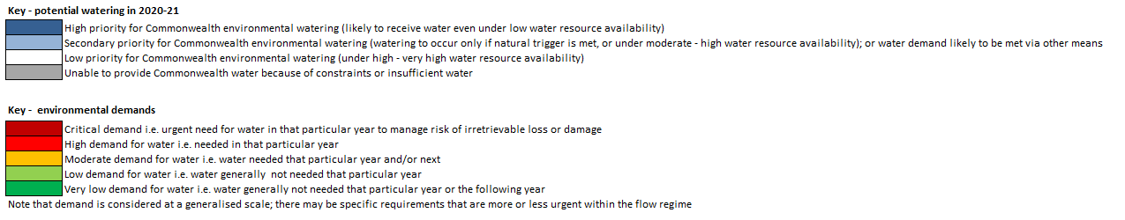

### Water delivery in 2020-21

Based on the demand for water for the environment, water availability (supply), and catchment conditions, the overall purpose for managing Commonwealth water for the environment in the Lachlan catchment in 2020-21 is to avoid damage and protect the health and resilience of aquatic ecosystems and wetland areas.

The planning of watering actions is undertaken in partnership with NSW agencies. A range of scenarios, from very dry to very wet conditions, are planned for so that environmental water managers can respond quickly to changing catchment conditions during the year.

Very low water availability, ongoing dry conditions and related restrictions on water use are likely to limit the ability to delivery environmental flows in the Lachlan River catchment during 2020-21. With the anticipated volumes for the start of 2020-21, Commonwealth environmental water is proposed to be used in a joint watering action with NSW to delivery a flow down Booberoi Creek (Booberoi Weir has been closed since March to allow the Booberoi off-take channel to dry down ahead of de-silting works by WaterNSW). This action will re-start the system after the completion of de-silting works and will provide a flushing pulse in September-October to coincide with fish movement back into the creek once the off-take is reopened, and should provide an end of system return flow. This action will help maintain Booberoi Creek as an important drought refugia site in the Lachlan system.

Should there be substantial rainfall and a significant increase in water availability during 2020-21, watering actions will be scaled up accordingly. This may enable drought refugia to be consolidated for another year. Alternatively, under very wet conditions, watering actions may seek to compliment other flows in the system to maintain the health of floodplain vegetation, maintain water quality where feasible to do so and/or the need to support waterbird breeding events.

### Monitoring and Lessons Learned

#### Monitoring

The CEWO [Monitoring, Evaluation and Research (MER) Program](http://www.environment.gov.au/water/cewo/monitoring/mer-program) (2019-20 to 2021-22) integrates and replaces monitoring and research activities under the [Long-Term Intervention Monitoring (LTIM)](http://www.environment.gov.au/water/cewo/monitoring/ltim-project) and [Environmental Water Knowledge and Research (EWKR)](http://www.environment.gov.au/water/cewo/monitoring/ewkr) projects.

The University of Canberra is the lead agency, contracted by the CEWO, to undertake the Lachlan MER project. A detailed [MER Plan](http://www.environment.gov.au/water/cewo/publications/mer-plan-lachlan-2019) has been developed by the University of Canberra for the Lachlan River which sets out the schedule of activities to be undertaken to June 2022. Further information about the Lachlan MER project is available from <http://www.environment.gov.au/water/cewo/catchment/lachlan/monitoring>.

Additional monitoring is also undertaken by NSW agencies. Landholders and community members play a critical role in providing real-time, onground advice and observations of conditions in the catchment, including the progress and outcomes from the use of environmental water.

#### Lessons learned

Outcomes from monitoring and lessons learned in previous years are a critical component for the effective and efficient use of Commonwealth water for the environment. These learnings are incorporated into the way environmental water is managed.

Key findings in the Lachlan Catchment are summarised in Table 5.

**Table 5**: Key lessons learned in the Lachlan Catchment

| **Monitoring Indicator** | **Lesson learned** |
| --- | --- |
| Hydrology (River) | * The spring pulse from Wyangala (2016-2018) has demonstrated its value in enabling a number of watering actions to be efficiently and effectively delivered as part of a larger flow event (Dyer et al. 2019), including all of the main river channel, Yarrabandai Lagoon, Booberoi Creek, Brewster Weir pool, Noonamah and the Great Cumbung. * Dyer et al. (2019) also notes the increasing influence and importance of these watering actions have as they move downstream. For example, in 2018-19 these flows contributed 4 per cent of the flow in the mid-Lachlan (at Forbes). In the lower Lachlan (at Booligal) these flows contributed 24 per cent of the flow, doubled the number of freshes that exceeded 200 ML/day and provided the only fresh to reach 500 ML/day for the watering year. * Based on Sentinel monitoring, the combination of multiple pulses delivered at Booligal in May-June may achieve a greater spread into the Great Cumbung when compared to a spring pulse. Depending on the objectives to be targeted and catchment conditions, the use of water in autumn-winter, delivered to Booligal, may be a more efficient at watering the Great Cumbung region than delivery during spring. Winter-autumn would take advantage of lower temperatures and possible winter rain. However, spring may remain a preferred time in terms of response from the core reed beds and upstream in-channel outcomes. Proposed research under MER will inform these decisions into the future. * Consistently reviewing the planned annual hydrograph can enable water saving to be made during the year (e.g. the dispersal pulse as end of fish nesting period may not be required if operational flows can achieve this). |
| Native fish (River Community and Larvae) | * Dyer et al. (2019) notes evidence that a remnant adult population of Murray cod persists in the lower Lachlan below Lake Brewster after the 2016 hypoxic water event. Monitoring has shown this population to be spawning and will be the most likely recovery pathway for this species. It will be important for future water delivery to continue to provide breeding opportunities, by facilitating the movement of pre-spawning fish and maintaining spawning habitat during nesting periods to prevent rapid water level drops and nest abandonment or desiccation. * The provision of a ‘minimum flow’ targets during the spawning season for nesting fish species may also be river reach specific. The decision in 2018-19 to not include a minimum flow target at Hillston (lower Lachlan) appears to have had no impact on cod larvae response in that year. This would suggest that nesting fish species are (a) nesting at sites lower than existing low flow levels, and/or (b) that flows delivered to the upper Lachlan continued to provide benefit to the lower Lachlan in addition to operational base flows. These flows would be better informed/targeted if incorporated with habitat mapping undertaken by NSW and fish movement monitoring (yet to be undertaken in the Lachlan) (Dyer et al. 2019). * Watts et al. (2019) note the learning from the 2015-16 watering action that targeted, but failed to detect, golden perch spawning in the Lachlan River (Dyer et al. 2016). Future watering actions targeting golden perch spawning as an objective, will need to be undertaken in a year of high water availability to be able to provide increasing flows over several days combined with increasing water temperatures (above 23°C). Under such catchment conditions consideration will also have to be given to the likelihood that golden perch may have spawned on earlier high flows (translucent releases or flood flows). * The integration of eDNA metabarcoding in the 2018-19 monitoring efforts resulted in more robust species richness data for the lower Lachlan River through the detection of freshwater catfish and silver perch. * Monitoring coordinated by NSW continues to show the importance of off-channel habitat, such as Booberoi Creek, to a range of native fish including Freshwater catfish. Monitoring has also shown that Olive perchlet are continuing to persist in Brewster Weir pool (McGrath 2020). * Linked to the theme of stream metabolism below, CEWO (2017) notes the difficulty in the timely provision of water for native fish refuge flows during hypoxic water quality events. Long travel times for the delivery of flows can mean that it is not possible to provide refuge flows in time to prevent or minimise the impacts of fish kills, especially in the lower Lachlan. The recent installation of dissolved oxygen loggers on NSW gauges in the system will help with earlier detection of hypoxic water conditions. |
| Vegetation condition and diversity | * There is a challenge for environmental water managers in maintaining the health of floodplain vegetation, especially at sites that are easier to provide water to (Higgisson et al. 2019). These sites may be prone to river redgum encroachment. Planning of events for vegetation outcomes must include and trial not only the timing of flow events but also the duration and depth of flows to match what is required for the vegetation outcomes being targeted at individual sites. * Dyer et al. (2019) found that frequently watered sites, such as Nooran Lake, have the greatest number of native amphibious species present and can frequently replenish soil seedbanks. Maintaining flows to these sites may help reduce the number of terrestrial plant species that would be able to invade these sites in the absence of regular watering. A comparison of approaches and results with watering similar wetland sites for vegetation outcomes in the Murrumbidgee Catchment (Wassens 2020) may also help inform such an approach in the Lachlan Catchment. |
| Stream metabolism | * Dyer et al. (2019) suggest that pulses at the warmer time of year may improve the ability of flows to provide a boost in productivity to the river system. Planning of flows for spring-early summer will take the following points into consideration: * the other objectives that may also be targeted with the use of water * where those objectives may be met as the water moves down the river channel * how best to use environmental water with other water, such as the Lachlan Water Quality Allowance, also being delivered in the system, identifying and filling gaps in key component of the hydrograph where required. * minimising the risk of generating hypoxic events by providing pulses into the river when water temperatures begin to exceed 16 degrees C. |
| Waterbirds | * Brandis (2016) concluded that even with the provision of flows, the abandonment of Booligal wetland nesting sites by straw necked ibis during June-October 2015 was in response to a combination of factors relating to hotter temperatures, declines in flows and water levels, reduction in foraging habitat and better habitat being available in other catchments. * Brandis and Lyons (2016) notes the response of straw necked ibis during the August- November 2016 breeding event where the colony exceeded 200 000 nests at its peak. This work also showed the effectiveness of the use of drones to assist with monitoring waterbird outcomes. Dyer et al. (2017) notes that this response highlights the importance of regional weather patterns, and the value of extensive flooding to provide foraging areas and habitat for food resources to thrive in a successful breeding event. The strategy of using flows to support breeding events once they have established (rather than trying to trigger a breeding event) is therefore sound. The management of water levels at the second waterbird colony site in the Booligal Wetlands in 2016-17 demonstrates the value of this approach. |
| Frogs | * At sites like the Booligal Wetlands and The Great Cumbung, there is a need for standing water to be present in the landscape to enable summer breeding frog species to be able to complete their life cycle Dyer et al. (2016). The provision of flows during warmer months of the year needs to include consideration of the potential to contribute to the breeding of carp in the same areas where frog outcomes may be sought. Carp exclusion/management activities may be required on a site-by-site basis prior to flows being delivered in summer for frog outcomes. |

### Bibliography

Brandis, K (2016), *Response of straw-necked ibis (Threskiornis spinicollis) to Commonwealth environmental watering in the lower Lachlan, 2015*. Report prepared by the Centre for Ecosystem Science, University of New South Wales for the Commonwealth Environmental Water Office 2016. <https://www.environment.gov.au/water/cewo/publications/ibis-response-lower-lachlan>

Brandis, K and Lyons, M. (2016). *Colonial Waterbird Monitoring in the Lower Lachlan 2016*. Report prepared by the Centre for Ecosystem Science, University of New South Wales for the Commonwealth Environmental Water Office 2016. <https://www.environment.gov.au/system/files/resources/08f6b8dc-c9d6-4481-86bf-bbb3fea76ddf/files/colonial-waterbird-monitoring-lower-lachlan-2016.pdf>

Bureau of Meteorology (2020) Climate outlooks – weeks, months and seasons 7 May 2020. <http://www.bom.gov.au/climate/outlooks/#/rainfall/median/seasonal/1>

Commonwealth Environmental Water Office (2017). *Blackwater Review* - Environmental water used to moderate low dissolved oxygen levels in the southern Murray Darling Basin during 2016/17. <http://www.environment.gov.au/water/cewo/publications/blackwater-review>

Driver, P., Chowdhury, S., Hameed, T., Lloyd-Jones, P., Raisin, G., Ribbons, C. and Singh, G., 2003. Reference and modified flows of the Lachlan Valley wetlands. Report for the NHT funded project 'Lachlan Floodplain Wetlands Adaptive Water Management Framework', NSW Government.

<https://www.researchgate.net/publication/235726340_Reference_and_modified_flows_of_the_Lachlan_Valley_wetlands_Report_for_the_NHT_funded_project_'Lachlan_Floodplain_Wetlands_Adaptive_Water_Management_Framework>'

Dyer, F., Broadhurst, B., Thiem, J., Thompson, R., Driver, P., Bowen, S., Asmus, M and Lenehan, J. (2015). *Commonwealth Environmental Water Office Long Term Intervention Monitoring Project: Lower Lachlan river system Selected Area 2014-15 Annual Monitoring and Evaluation Report.* Commonwealth of Australia, 2015. <http://www.environment.gov.au/water/cewo/publications/lachlan-ltim-report>

Dyer, F., Broadhurst, B., Tschierschke, A., Thiem, J., Thompson, R., Driver, P., Bowen, S., Asmus, M, Wassens, S., and Walcott, A. (2016). *Commonwealth Environmental Water Office Long Term Intervention Monitoring Project: Lower Lachlan river system Selected Area 2015-16 Monitoring and Evaluation Synthesis Report*. Commonwealth of Australia, 2016. <http://www.environment.gov.au/water/cewo/publications/lachlan-ltim-report-2015-16>

Dyer, F., Broadhurst, B., Tschierschke, A., Thiem, J., Thompson, R., Bowen, S., Asmus, M., Brandis, K., Lyons, M., Spencer, J., Callaghan, D., Driver, P., Lenehan, J. (2017). *Commonwealth Environmental Water Office Long Term Intervention Monitoring Project: Lower Lachlan river system Selected Area 2016-17 Monitoring and Evaluation Report*. Commonwealth of Australia, 2017. <http://www.environment.gov.au/water/cewo/publications/ltim-lachlan-annual-report-2016-17>

Dyer, F., Broadhurst, B., Tschierschke, A., Thiem, J., Thompson, R., Bowen, S., Driver, P. (2018). *Commonwealth Environmental Water Office Long Term Intervention Monitoring Project: Lower Lachlan river system Selected Area 2017-18 Monitoring and Evaluation Summary Report*. Commonwealth of Australia, 2018

<https://www.environment.gov.au/water/cewo/publications/ltim-lachlan-annual-report-2017-18>

Dyer, F., Broadhurst, B., Tschierschke, A., Higgisson, W., Allan, H., Thiem, J., Wright, D., Thompson, R. (2019). *Commonwealth Environmental Water Office Long Term Intervention Monitoring Project: Lachlan river system Selected Area 2018-19 Monitoring and Evaluation Technical Report*. Commonwealth of Australia, 2019.

Ellis, I., Cheshire, K., Townsend, A., Copeland, C. Danaher, K. and Webb, L. (2016). *Fish and Flows in the Murray River Catchment - A review of environmental water requirements for native fish in the Murray River Catchment*. NSW Department of Primary Industries, Queanbeyan. <http://www.dpi.nsw.gov.au/__data/assets/pdf_file/0003/664356/fish-and-flows-in-the-murray-river-catchment.pdf>

Higgisson, W, Higgisson, B, Powell, M, Driver, P, Dyer, F. (2019), Impacts of water resource development on hydrological connectivity of different floodplain habitats in a highly variable system. *River Res Applic*. 2019; 1– 11. <https://doi.org/10.1002/rra.3409>

McGrath, N (2020), *Brewster Weirpool fish sampling, March 2020*. Unpublished Report. NSW Department of Planning, Industry and Environment

Murray Lower Darling Rivers Indigenous Nations (MLDRIN) (2020). *First Nations Environmental Water Guidance Project. MLDRIN Member Nations 2020‐21 Priorities.* Report provided to Commonwealth Environmental Water Office.

New South Wales Department of Environment and Heritage - Lachlan Long Term Water Plan Part A: Lachlan catchment (Draft for exhibition) (2018a). <https://www.environment.nsw.gov.au/-/media/OEH/Corporate-Site/Documents/Water/Water-for-the-environment/lachlan-long-term-water-plan-part-a-180583.pdf>*.*

New South Wales Department of Environment and Heritage - *Lachlan Long Term Water Plan Part B: Lachlan planning units (Draft for exhibition*) (2018b). <https://www.environment.nsw.gov.au/-/media/OEH/Corporate-Site/Documents/Water/Water-for-the-environment/lachlan-long-term-water-plan-part-b-180589.pdf>

New South Wales Department of Industry (2018). *NSW Extreme Events Policy, Policy framework for the management of NSW Murray–Darling Basin water resources during extreme events*, <https://www.industry.nsw.gov.au/__data/assets/pdf_file/0008/187703/Extreme-Events-policy.pdf>

New South Wales Department of Planning, Industry and Environment (2020a). *Lachlan Regulated River Water Source Water allocation update* 15 May 2020. <https://www.industry.nsw.gov.au/__data/assets/pdf_file/0020/301466/WAS-Lachlan-20200515.pdf>

New South Wales Department of Planning, Industry and Environment (NSW DPIE 2020b). *NSW Regulated River Water Sources – Opening water allocations 2020-21*. <https://www.industry.nsw.gov.au/__data/assets/pdf_file/0012/313032/WAS-Regulated-Rivers-20200701.pdf>

Northern Basin Aboriginal Nations (NBAN) Ltd. (2020) *First Nations Environmental Water Guidance Report*. Provided to the Commonwealth Environmental Water Office.

Wassens, S., Michael, D., Spencer, J.,Thiem, J., Thomas, R., Kobayashi, T., Jenkins, K., Wolfenden, B., Hall, A., Bourke, G., Bino, G., Davis, T., Heath, J., Kuo, W., Amos, C. and Brandis, K. (2020) *Commonwealth Environmental Water Office Long-Term Intervention Monitoring project Murrumbidgee River System Selected Area evaluation. Technical Report, 2014-19*. Report prepared for the Commonwealth Environmental Water Office

Watts, RJ, Dyer, F, Frazier, P, et al. (2019) Learning from concurrent adaptive management in multiple catchments within a large environmental flows program in Australia. *River Res Applic*. 2020; 36: 668–680. <https://doi.org/10.1002/rra.3620>