# Commonwealth Environmental Water Office Water Management Plan 2021–22

Chapter 11 Lachlan River Water Plan

© Commonwealth of Australia 2021

**Ownership of intellectual property rights**

Unless otherwise noted, copyright (and any other intellectual property rights) in this publication is owned by the Commonwealth of Australia (referred to as the Commonwealth).

**Creative Commons licence**

All material in this publication is licensed under a [Creative Commons Attribution 4.0 International Licence](https://creativecommons.org/licenses/by/4.0/legalcode) except content supplied by third parties, logos and the Commonwealth Coat of Arms.

Inquiries about the licence and any use of this document should be emailed to [copyright@awe.gov.au](mailto:copyright@awe.gov.au).



**Cataloguing data**

This publication (and any material sourced from it) should be attributed as: Commonwealth of Australia 2021, *Commonwealth Environmental Water Office Water Management Plan 2021–22: Lachlan River Water Plan*, Canberra. CC BY 4.0.

ISBN 978-1-76003-434-4

This publication is available at [environment.gov.au/water/cewo/publications/water-management-plan-2021–22](https://www.environment.gov.au/water/cewo/publications/water-management-plan-2021-22).

For more information about Commonwealth environmental water, contact us at:

Commonwealth Environmental Water Office

Department of Agriculture, Water and the Environment

GPO Box 858 Canberra ACT 2601

Telephone 1800 803 772

Email [ewater@awe.gov.au](mailto:ewater@awe.gov.au)

Web [environment.gov.au/water/cewo](http://www.environment.gov.au/water/cewo)

For issues accessing links in this document, please visit the [homepage](https://www.environment.gov.au/water/cewo) or let us know by [email](mailto:ewater@awe.gov.au).

**Disclaimer**

The Commonwealth of Australia has made all reasonable efforts to identify content supplied by third parties using the format ‘© Copyright’ noting the third party.

The views and opinions expressed in this publication are those of the authors and do not necessarily reflect those of the Australian Government or the Minister for the Environment.

While reasonable efforts have been made to ensure that the contents of this publication are factually correct, the Commonwealth does not accept responsibility for the accuracy or completeness of the contents and shall not be liable for any loss or damage that may be occasioned directly or indirectly by, or reliance on, the contents of this publication.

**Acknowledgement of the Traditional Owners of the Murray–Darling Basin**

The Commonwealth Environmental Water Office respectfully acknowledges the Traditional Owners, their Elders past and present, their Nations of the Murray–Darling Basin, and their cultural, social, environmental, spiritual and economic connection to their lands and waters.

Contents

11 Lachlan River 1

11.1 Region overview 1

11.2 Environmental objectives 4

11.3 First Nations environmental watering objectives 5

11.4 Recent conditions and seasonal outlook 5

11.5 Water delivery in 2021–22 12

11.6 Monitoring and lessons learned 12

References 16

**Tables**

Table LR1 Environmental demands and watering priorities, 2021–22, and outlook for coming year, Lachlan River catchment 7

Table LR2 Key lessons learned in the Lachlan River Catchment 13

**Maps**

Map LR1 The Lachlan Valley showing the division of planning units 3

Map LR2 The Lower Lachlan Catchment 4

## Lachlan River

### Region overview

#### Lachlan Valley

The Lachlan River is the fourth longest river in Australia at 1,448 kilometres with a catchment of around 90,0002 kilometres. The Lachlan runs from the Great Dividing Range in central New South Wales, westwards through to the Great Cumbung Swamp. Flow attenuation in the system is high due to the low gradient of the system and it can take 90 days for a flow event from Wyangala Dam to reach the end of the river system at The Great Cumbung Swamp (Map LR1, Map LR2, Barma Water Resources 2011). Many anabranches and distributary creeks in the Lachlan terminate in wetlands. Not all environmental water is sourced from dam releases – unregulated tributary inflows can be ordered and accounted for as environmental water and allowed to reach assets by bypassing regulating storages. The harvesting of water for consumptive purposes has significantly modified the flow of the Lachlan River (Higgisson et al, 2019).

#### Traditional Owners

The Lachlan River flows through the lands of the Nari Nari, Ngiyampaa, Wiradjuri and Yita Yita Nations. The Commonwealth Environmental Water Office (CEWO) respectfully acknowledges these people, their Elders past and present, as the Traditional Owners of the land on which this chapter is focused.

#### Important sites and values

The Lachlan Valley contains eight nationally important wetlands, including the Great Cumbung Swamp, the Lachlan Swamp, Booligal Wetlands, Merrowie Creek Wetlands, Lake Merrimajeel/Murrumbidgil Swamp, Lake Brewster, Cuba Dam and Lake Cowal. Below Wyangala and Carcoar dams, the catchment’s lowlands are recognised as an endangered ecological community.

The Great Cumbung Swamp comprises a variety of wetland types that supports one of the largest areas of common reed in NSW, as well as lignum shrublands and river red gums. Booligal Wetlands support some of most extensive areas of lignum in NSW.

The *Basin-wide environmental watering strategy* (MDBA, 2019) identifies the Booligal Wetlands, Great Cumbung Swamp, Lake Brewster and Lake Cowal as being of Basin-wide significance for waterbirds. The valley provides habitat for a number of birds listed under international migratory bird agreements, including great egret, glossy ibis, sharp-tailed sandpiper, common greenshank, Latham’s snipe, painted snipe, and white-bellied sea-eagle. The valley also attracts several birds listed as vulnerable, including the Australasian bittern, blue-billed duck and the freckled duck.

The Lachlan River between Condobolin to Booligal is also recognised as being of Basin-wide importance for native fish.

The Long Term Water Plan for the Lachlan Catchment (NSW DPIE 2020a and b) provides greater detail on the environmental assets found in the Lachlan Catchment and their watering requirements.

#### Stakeholder engagement

The CEWO continues to work with NSW Department of Planning, Industry and Environment, Environment Energy and Science (NSW DPIE-ESS) in reviewing, coordinating, and managing environmental watering actions in the Lachlan Catchment. This work is done in conjunction with the CEWO’s Monitoring, Evaluating and Research (MER) Program provider, the University of Canberra, the river operator WaterNSW and the Lachlan Environmental Water Advisory Group (EWAG). This work is further complemented by regular landholder visits and discussion, which includes the work being progressed for the proposed Great Cumbung Region Water Management Plan.

The CEWO will continue to work with NSW agencies, particularly NSW DPIE EES and NSW National Parks and Wildlife Service who have established processes and relationships with First Nations communities in the Lachlan catchment, to undertake watering actions that also contribute to cultural outcomes whenever possible. The CEWO’s Monitoring Evaluation and Research (MER) project, led by the University of Canberra, also provides further opportunities to work with and learn alongside First Nations communities in the Lachlan catchment.

Map LR The Lachlan Valley showing the division of planning units

Note: Planning units divided into Zone A and B as used in the draft Long Term Water Plan for the Lachlan Catchment. Source: NSW DPIE 2020a

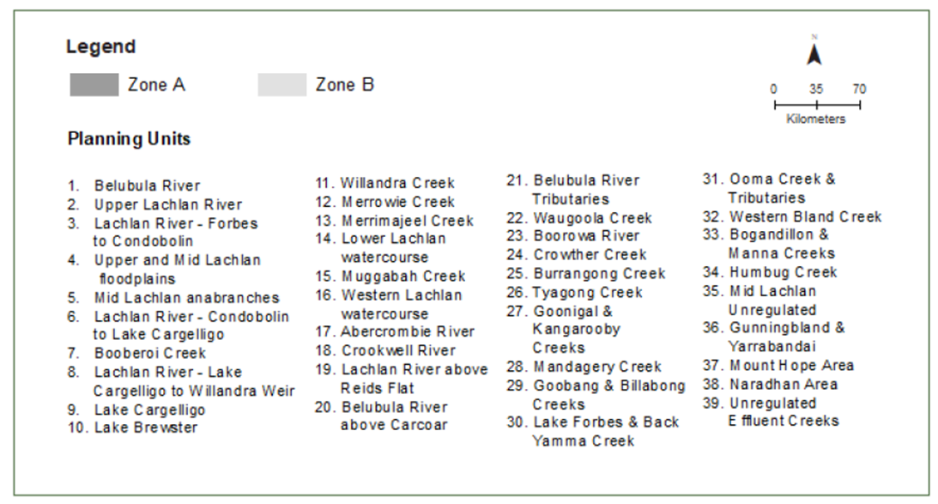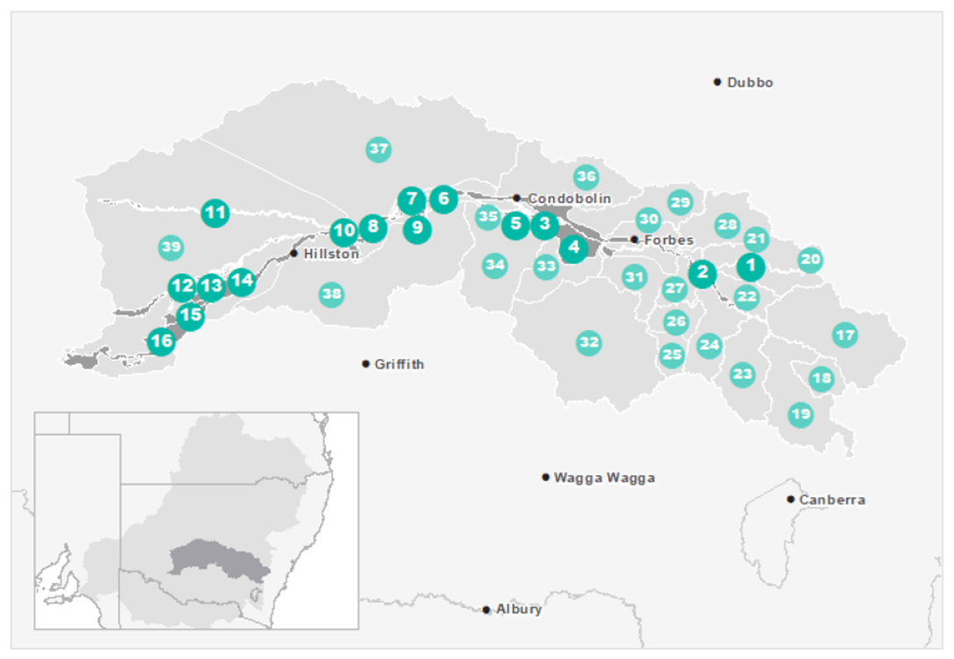

Map LR The Lower Lachlan Catchment

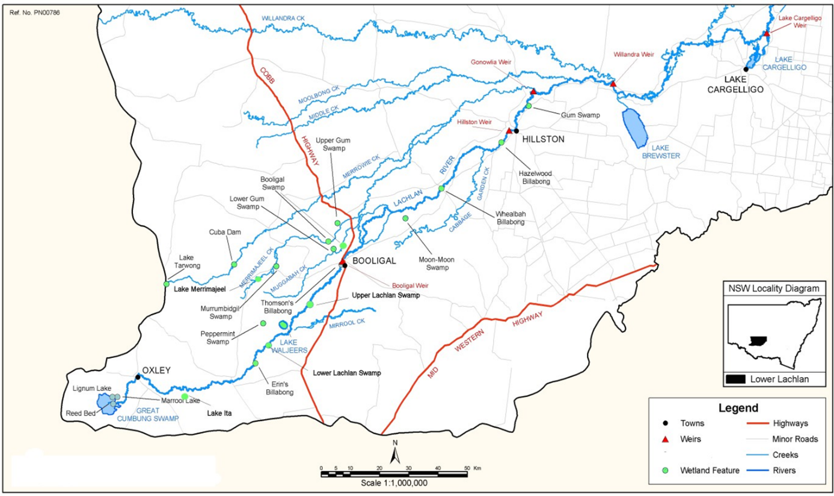

Source: (Driver et al 2003)

### Environmental objectives

Based on long-term environmental objectives in the Basin Plan, NSW Lachlan long-term watering plans, site management plans, and best available knowledge, the following objectives are relevant for environmental watering in the Lachlan River catchment.

The objectives that are targeted in a particular year may vary, depending on available water, catchment conditions, operational feasibility, and demand for environmental water. These objectives will continue to be revised as part of the Commonwealth Environmental Water Office’s (CEWO) commitment to adaptive management. These objectives will also seek to align with the Lachlan Annual Environmental Watering Priorities published by NSW each year. The objectives are:

* Vegetation – Maintain or increase the extent and improve the condition, growth and survival of riparian, in-channel, floodplain, and wetland vegetation.
* Waterbirds – Increase waterbird abundance and maintain species diversity by supporting naturally triggered breeding events, and maintaining suitable refuge, feeding, and breeding habitat at targeted floodplain sites.
* Native fish – Prevent loss of native fish species and increase distribution and abundance, by supporting opportunities for movement, dispersal, reproduction, and recruitment.
* Other vertebrates – Support opportunities for the recruitment of other native aquatic species, including rakali (native water rat), frogs, and turtles.
* Invertebrates – Provide habitat to support increased invertebrate survival, diversity, abundance, and condition.
* Connectivity – Maintain longitudinal & lateral connectivity through contributing to an increase in the frequency of freshes and Maintain latitudinal connectivity (within constraints) to wetlands, floodplains, creeks, and anabranches by contributing an increase in the frequency of lowland floodplain flows.
* Processes/water quality/resilience – Increase primary productivity, nutrient and carbon cycling, biotic dispersal, and movement. Increase transport of organic matter and nutrients downstream. Maintain water quality and provide refuge habitat from adverse water quality events. Provide drought refuge habitat and maintenance/condition of native biota.

### First Nations environmental watering objectives

The CEWO is committed to working with First Nations groups to better understand their objectives. NSW engagement processes, particularly the Lachlan Environmental Water Advisory Group, continue to play an important role for First Nations representatives to influence water use decisions. The Ngiyampaa Nation Plan, prepared by the Ngiyampaa Wangaaypuwan Nation Planning Working Group, notes the objectives and cultural significance of Willandra Creek and Booberoi Creek. Initial discussions have also commenced with NSW National Parks and Wildlife Service and the Mawambul Co-Management Group regarding the potential to deliver water for the environment into Lake Ita within Kalyarr National Park. The CEWO will use environmental flows to contribute to these objectives where possible and where this is consistent with the Commonwealth Environmental Water Holder’s statutory responsibility of protecting and restoring environmental assets in the Basin.

### Recent conditions and seasonal outlook

#### Recent conditions and environmental water use

At the end of 2019-20 the Lachlan catchment was at Stage 3 (severe) drought criticality under the NSW Extreme Events Policy (NSW DPI, 2018). The arrival of La Nina conditions in May-June 2020 brought rainfall across the Lachlan River system. This enabled water that had been set aside under the NSW Extreme Events Policy to be made available for use from August 2020. The rainfall resulted in two translucent flow events (August-September and November-December 2020) which contributed to inundation of the lower Lachlan River floodplain.

Commonwealth and NSW water for the environment was used in partnership to further enhance the environmental outcomes generated by the translucent flow events. This use targeted outcomes relating to connecting the river to floodplain habitats, maintaining native vegetation health, supporting waterbird breeding, and improving flow variability. Water for the environment was provided to Booberoi Creek, the river channel, Lake Brewster, the lower Lachlan wetlands, including the core reed beds of The Great Cumbung Swamp.

As of early May 2021, of the approximately 76 GL of Commonwealth environmental water available for use in 2020-21, about 42 GL has been used with approximately 34 GL to be carried over into 2021-22. Wet conditions have seen the use of translucent flow and air space releases from Wyangala Dam in July to August 2021.

Learn more about previous [Commonwealth environmental water use in the Lachlan River catchment](https://www.environment.gov.au/water/cewo/catchment/lachlan/history).

#### Seasonal outlook

The Bureau of Meteorology (2021, accessed 5 August) is forecasting median rainfall for much of eastern Australia. The El Niño–Southern Oscillation being neutral but may change to result in an increased chance of above median spring rainfall for much of eastern Australia.

Storage levels as of early August 2021, (WaterNSW, 2021 accessed 5 August) were:

* Wyangala Dam is about 95% full
* Lake Cargelligo is about 79% full
* Lake Brewster is 29% full.

#### Water availability

Given the wet catchment conditions it is anticipated that water availability will be high for 2021-22. As of early May 2021, of the approximately 76 GL available for use in 2020-21, around 42 GL has been used with the remaining 34 GL to be carried over into 2021-22.

#### Environmental demands

Environmental demands are moderate as a result of the need to further restore key assets after the drought conditions across the catchment prior to 2020-21.

For the environmental water demands for assets in the Lachlan River catchment in 2021–22, see Table LR1. The capacity to contribute to these environmental demands is dependent on overall water availability in the catchment.

Over the longer term the Commonwealth Environmental Water Office is concerned about the ability of environmental water to maintain the resilience, or prevent further degradation, of key environmental assets in the lower Lachlan catchment due to climate change and potential further impacts of river regulation. Recent modelling by Larkin et. al., (2020) suggests that over the next 50 years and under a drier climate, the Lachlan River system may become a system of disconnected waterholes for long periods. The lower Lachlan wetlands, including The Great Cumbung Swamp, will be much less frequently inundated. This will fundamentally change the dynamics of the Lachlan River ecosystem and the objectives currently being targeted using environmental water.

Table LR Environmental demands and watering priorities, 2021–22, and outlook for coming year, Lachlan River catchment

| Environmental assets and Long Term Water Plan unit (PU) reference number (see Figure 1 and more detailed description at bottom of table) | Target values | Indicative demand (for all sources of water in the system) | | Watering history (from all sources of water) | 2021–22 | | Implications for future demands |
| --- | --- | --- | --- | --- | --- | --- | --- |
| Flow/volume | Required frequency (maximum dry interval) | Environmental demands for water (all sources) | Potential Commonwealth environmental water contribution? | Likely urgency of demand in 2022–23 if watering occurred as planned in 2021–22 |
| **Lachlan River (PU 2, 3, 6, 8, 14, 16)** | Protect tributary inflows (natural trigger) or deliver upon environmental triggers (e.g., timing or temperature) being reached  Maintain native vegetation condition  Native fish reproduction, conditioning, and maintenance.  Maintain in-channel habitats, in-stream productivity, and longitudinal connectivity.  Duration and frequency of pulse dependent on outcomes required and potential contribution/linkage to other watering actions. | >300 ML/d in the Lachlan River at Booligal (412005) to also contribute to small scale wetland inundation. If releases are made from Wyangala Dam, will be delivered as part of a small fresh of less than2600 ML/day in the Lachlan River at Forbes (412004). | Timing: September to March (but can occur any time). Usually early Spring and/or early December (at end of cod nesting)  Duration: 30 days, 2–8 months of habitat inundation  Frequency: 7-8 years in 10 (75% of years). Annual for the maintenance of drought refuge  Maximum inter-event period: 2 years | Flow/volume met every year since 2011-12. | High | A high priority for watering in 2021–22. | High |
| >650 ML/d in the Lachlan River at Booligal (412005) to also contribute to small scale wetland inundation. Will be delivered as part of a small fresh of around 2600 ML/day in the Lachlan River at Forbes (412004) if releases are made from Wyangala Dam. | Timing: October to April (but can occur any time). Usually early Spring and/or early December (at end of cod nesting)  Duration: 30 days, 2–8 months of habitat inundation  Frequency: 5-7 years in 10 (60% of years). Annual for the maintenance of drought refuge.  Maximum inter-event period: 3 years | Flow/volume met every year except 2014-15 and 2018-19. | High | A high priority for watering in 2021–22. | High |
| >1200 ML/d in the Lachlan River at Booligal (412005) to also contribute to large scale wetland inundation. May be delivered to extend duration of translucent flows from Wyangala Dam or Lake Brewster. | Timing: October to April (but can occur any time). Usually early Spring and/or early December (at end of cod nesting)  Duration: 60 days, 2–3 months of habitat inundation  Frequency: 2–3 years in 10 (25% of years)  Maximum inter-event period: 5 years | Flow/volume met in 2012-13, 2013-14, 2015-16, 2016-17 (flood year), and 2020-21. | Moderate | Secondary priority for Commonwealth environmental watering. Will occur only if natural trigger is met, or under moderate to high resource availability. | Low |
| **Booberoi Creek (PU 7)** | Maintain populations of native fish, aquatic plants, and connectivity to the Lachlan River.  Assist with recovery in upper reach after desilting in 2019-20.  Maintain First Nations cultural values associated with Booberoi Creek. | >120 ML/d via the Booberoi Creek at Offtake (412189) to contribute to a large fresh. May be delivered as part of a larger Lachlan River watering action (e.g., spring pulse release from Wyangala Dam). | Timing: July to September (but can occur any time).  Duration: 5 days, 2–3 months of habitat inundation  Frequency: 5–10 years in 10 (75% of years)  Maximum inter-event period: 2 years | Flow/volume met in 2011-12, 2012-13, 2016-17 (flood year), 2018-2019 and 2020-21. | High | A high priority for watering in 2021–22. | High |
| **Mid-Lachlan anabranches (PU 5)**  **Wallamundry Creek and Wallaroi Creek** | Provide lateral connectivity to anabranch systems, maintain native vegetation and native fish outcomes | >120 ML/d via Wallaroi Creek upstream Worrongorra Weir (412046) to provide a large fresh. | Timing: July to September (but can occur any time).  Duration: 5 days  Frequency: 5–10 years in 10 (75% of years)  Maximum inter-event period: 2 years | Flow/volume met in 2011-12, 2012-13, 2013-14, 2016-17 (flood year), 2019-2020 and 2020-21. | Low | A low priority for watering in 2021–22. | Low |
| >200 ML/d Wallamundry Creek at Island Creek (412016) | Flow/volume met every year since 2011-12. | Low | A low priority for watering in 2021–22. | Low |
| **Willandra Creek (PU 11)**  **Includes Morrison’s Lake** | Maintain lateral connectivity to major distributary  Maintain riparian vegetation health.  Maintain foraging and nesting habitat for waterbirds  Maintain riparian habitat for other species i.e., frogs  Morrison’s Lake has significant cultural values. | >250 ML/d via Willandra at Road Bridge (412012). Small freshes (>70 ML/day) are provided annually by operational flows. | Timing: July to September (but can occur any time).  Duration: 5 days  Frequency: 5–10 years in 10 (75% of years)  Maximum inter-event period: 2 years | Flow/volume met in 2011-12, 2012-13, 2013-14, 2015-16, 2016-17 (flood year), 2019-2020 and 2020-21. | Low | A low priority for Commonwealth environmental water. Asset receives more water under regulated conditions than would have occurred naturally | Low |
| Morrison’s Lake Nature Reserve - 400 to 500 ML to fill but may require up to 3 GL for conveyance and to also target blackbox | Can be completed in conjunction with Willandra replenishment flows. | Received water in 2016-17 (flood year). | Moderate | Secondary priority for Commonwealth environmental watering. Will occur under moderate to high resource availability. Demand may be met by other means. | Low |
| **Lake Cargelligo (PU9)** | Maintain lateral connectivity to major distributary  Native fish reproduction, conditioning, and maintenance  Maintain foraging and nesting habitat for waterbirds | >65% full at Lake Cargelligo at Storage (412107) | Timing: September to March (can occur anytime)  Duration: varies depending on objective may include up to 2–6 months of habitat inundation  Frequency: 5–7 years in 10 (60% of years)  Maximum inter-event period: 3 years | Flow/volume met every year since 2011-12. | Moderate | A high priority for watering in 2021–22. Trial watering action linked to spring pulse in the Lachlan River. Seeks to determine if larval native fish drift from the river on a pulse flow and potentially contribute to native fish recruitment outcomes in Lake Cargelligo. | Moderate |
| **Brewster Weir Pool (PU 8)** | Help maintain weir pool height to maintain olive perchlet habitat | Up to 5 GL dependant on the operational level and management requirements of the weir at Lachlan Lake B Weir (412048). May be delivered as part of pulse flows in the Lachlan | 5–10 years in 10 (annual for the maintenance of drought refuge) | Flow/volume met every year since 2011-12. | Low | A low priority for watering in 2021–22. | Low |
| **Lake Brewster (PU 10)** | Maintain foraging and nesting habitat for waterbirds and pelicans.  Maintain aquatic vegetation health. | Flows are managed where possible to avoid inundation of nests if pelican breeding has occurred. 2000 ML use in 2020-21. | As required | Watered in 2020-21 for pelican and aquatic vegetation outcomes. | Moderate | Secondary priority for Commonwealth environmental watering. Will occur only if natural trigger is met, or under moderate to high resource availability. Demand may be met by other means. | Low |
| **Merrowie Creek (PU 12)**  **While not referenced in LTWP, this system includes Lake Tarwong at end of system (Box Creek)** | Maintain lateral connectivity to major distributaries  Maintain riparian vegetation health.  Maintain foraging and nesting habitat for waterbirds  Maintain riparian habitat for other species i.e., frogs | >150-160 ML/d via Merrowie Ck at Offtake (412163) to provide small fresh and/or small wetland inundation. | Timing: September to March (can occur anytime)  Duration: 30 days, 2–8 months of habitat inundation  Frequency: 7-8 years in 10 (75% of years)  Maximum inter-event period: 2 years | Flow/volume met annually via stock and domestic replenishment flows each winter/early spring. | Low | A low priority for watering in 2021–22. | Low |
| >150 ML/d via Merrowie Ck at Offtake (412163) to provide large wetland inundation. | Timing: September to June (can occur anytime)  Duration: 60 days, 2–3 months of habitat inundation  Frequency: 3-5 years in 10 (40% of years)  Maximum inter-event period: 4 years | Duration target only met in 2011-12, 2012-13, and 2016-17. Duration of ~30 days reached during Aug-Sept 2020 translucent flow event (peaked at 575 ML/day) and duration of ~14 days reached in Nov 2020 translucent flow event (peaked at 325 ML/day). Could be delivered in conjunction with stock and domestic replenishment flows.  2020-21 translucent flow event did not reach Lake Tarwong at end of Merrowie-Box Creek system. | Moderate | Secondary priority for Commonwealth environmental watering. Targeting of Lake Tarwong will occur only if natural trigger is met, or under moderate to high resource availability. | Low |
| **Merrimajeel Creek (PU 13)**  **Includes Lake Merrimajeel, Murrumbidgil Swamp and Booligal wetlands.**  **See also waterbird breeding contingency below.** | Maintain lateral connectivity to major distributaries  Maintain riparian vegetation health.  Maintain foraging and nesting habitat for waterbirds  Maintain riparian habitat for other species i.e., frogs | >300 ML/d in Lachlan River at Booligal (412005) to contribute to small wetland inundation. | Timing: September to March (can occur anytime)  Duration: 30 days  Frequency: 7-8 years in 10 (75% of years)  Maximum inter-event period: 2 years | Flow/volume met every year since 2011-12. Received translucent flows in 2020-21. | Low | A low priority for watering in 2021–22. | Low |
| >650 ML/d in Lachlan River at Booligal (412005) to contribute to small wetland inundation.  Note: flows at Booligal do not always translate to flows further into Merrimajeel Creek Cobb Hwy (412122), e.g., 2017-18 flows at Booligal did not register at Cobb Highway gauge. | Timing: October to April (can occur anytime)  Duration: 30 days, 2–8 months of habitat inundation  Frequency: 5-7 years in 10 (60% of years)  Maximum inter-event period: 3 years | Flow/volume met every year at Booligal except for 2014-15 and 2018-19. Received translucent flows in 2020-21. | Low | A low priority for watering in 2021–22. | Low |
| >850 ML/d in Lachlan River at Booligal (412005) to contribute to large wetland inundation | Timing: August to February (can occur anytime)  Duration: 60 days, 2–6 months of habitat inundation  Frequency: 3-5 years in 10 (40% of years)  Maximum inter-event period: 4 years | Flow/volume met in 2011-12, 2012-13, 2013-14, 2015-16, 2016-17 (flood year) and 2020-21 (translucent flows). | Moderate | Secondary priority for Commonwealth environmental watering. Will occur only if natural trigger is met, or under moderate to high resource availability. | Low |
| >1200 ML/d in Lachlan River at Booligal (412005) to contribute to large wetland inundation | Timing: Any time  Duration: 60 days, 2–3 months of habitat inundation  Frequency: 2-3 years in 10 (25% of years)  Maximum inter-event period: 5 years | Flow/volume met in 2011-12, 2012-13, 2013-14, 2015-16, 2016-17 (flood year) and 2020-21 (translucent flows). | Moderate | Secondary priority for Commonwealth environmental watering. Will occur only if natural trigger is met, or under moderate to high resource availability. | Low |
| **Muggabah Creek (PU15)**  **See also waterbird breeding contingency below.** | Maintain lateral connectivity to major distributaries  Maintain riparian vegetation health.  Maintain foraging and nesting habitat for waterbirds  Maintain riparian habitat for other species i.e., frogs | >300 ML/d in Lachlan River at Booligal (412005) to contribute to small wetland inundation.  Note: flows at Booligal do not always translate to flows further into Muggabah Creek Cobb Hwy (412124), e.g., 2017-18 flows at Booligal did not register at Cobb Highway gauge. Flows rarely reach or go above 250 ML/day and require flood or translucent flows to be achieved. | As per equivalent Merrimajeel action above. | As per equivalent Merrimajeel action above. | Low | A low priority for watering in 2021–22. | Low |
| >650 ML/d in Lachlan River at Booligal (412005) to contribute to large wetland inundation. | As per equivalent Merrimajeel action above. | As per equivalent Merrimajeel action above. | Low | A low priority for watering in 2021–22. | Low |
| >850 ML/d in Lachlan River at Booligal (412005) to contribute to large wetland inundation | As per equivalent Merrimajeel action above. | As per equivalent Merrimajeel action above. | Moderate | Secondary priority for Commonwealth environmental watering. Will occur only if natural trigger is met, or under moderate to high resource availability. | Low |
| >1200 ML/d in Lachlan River at Booligal (412005) to contribute to large wetland inundation | As per equivalent Merrimajeel action above. | As per equivalent Merrimajeel action above. | Moderate | Secondary priority for Commonwealth environmental watering. Will occur only if natural trigger is met, or under moderate to high resource availability. | Low |
| **Western Lachlan watercourse (PU 16)**  **Includes Lachlan River channel, Great Cumbung Swamp, Lachlan swamp, Lake Waljeers, Baconian swamp** | Lateral and longitudinal connectivity, support movement, spawning and recruitment of aquatic species.  Riparian and wetland vegetation health.  Nutrient and carbon cycling  Maintain refuge for aquatic biota and fish  Maintain riparian habitat for other species i.e., water birds | >650 ML/d in Lachlan River at Booligal (412005) to contribute to small wetland inundation. | Timing: September to March (can occur anytime)  Duration: 30 days, 2–8 months of habitat inundation  Frequency: 7-8 years in 10 (75% of years)  Maximum inter-event period: 2 years | Flow/volume met in 2011-12, 2012-13, 2013-14, 2015-16, 2016-17 (flood year) and 2020-21 (translucent flows). | **High (to maintain core reed beds of Great Cumbung)** | A high priority for watering in 2021–22. | **High (to maintain core reed beds of Great Cumbung)** |
| >850 ML/d in Lachlan River at Booligal (412005) to contribute to small wetland inundation. | Timing: October to April (can occur anytime)  Duration: 60 days, 2–6 months of habitat inundation  Frequency: 5-7 years in 10 (60% of years)  Maximum inter-event period: 3 years | Flow/volume met in 2011-12, 2012-13, 2013-14, 2015-16, 2016-17 (flood year) and 2020-21 (translucent flows). | **High (to maintain core reed beds of Great Cumbung)** | A high priority for watering in 2021–22. | **Moderate (to maintain core reed beds of Great Cumbung)** |
| >1200 ML/d in Lachlan River at Booligal (412005) to contribute to large wetland inundation | Timing: August to February (but can occur any time)  Duration: 60 days, 2–3 months of habitat inundation  Frequency: 3-5 years in 10 (40% of years)  Maximum inter-event period: 4 years | Flow/volume met in 2011-12, 2012-13, 2013-14, 2015-16, 2016-17 (flood year) and 2020-21 (translucent flows). | **Moderate** | Secondary priority for Commonwealth environmental watering. Will occur only if natural trigger is met, or under moderate to high resource availability. | **Low** |
| >1200 ML/d in Lachlan River at Booligal (412005) to contribute to large wetland inundation | Timing: Any time  Duration: 60 days, 2–3 months of habitat inundation  Frequency: 2-3 years in 10 (25% of years)  Maximum inter-event period: 5 years | Flow/volume met in 2011-12, 2012-13, 2013-14, 2015-16, 2016-17 (flood year) and 2020-21 (translucent flows). | **Moderate** | Secondary priority for Commonwealth environmental watering. Will occur only if natural trigger is met, or under moderate to high resource availability. | **Low** |
| **Wetlands, lagoons, and billabongs (various PUs)**  **Includes, but not limited to, Yarrabandai Lagoon, Noonamah, Comayjong, Fletchers Lake and Lake Ita.** | Maintain off-channel drought refuge habitat for native frogs and waterbirds  Support movement, spawning and recruitment of aquatic species.  Maintain floodplain vegetation health | Site specific. Delivery may involve the use of regulators and/or pumping. | Will vary from site to site and depending on the outcomes being sought. Likely to be annual to maintain wetland vegetation with a period of drying down followed by re-inundation. | Various and site specific. Several sites have received water frequently in recent years (e.g., Noonamah), some have just commenced receiving water (e.g., Comayjong) and planning is underway for other sites, such as Lake Ita, to be able to be watered in the future. | High | A high priority for watering in 2021–22. | Moderate |
| **Waterbird breeding contingency** | Waterbird breeding sites including (but not limited to) Lake Brewster, the Booligal wetlands (Merrimajeel Creek, Muggabah Creek), Lachlan Swamps and Great Cumbung Swamp. | Variable and seeks to provide at least 0.8 metres of depth below nests until chicks have fledged | **As required, more likely in very wet/flood years** | Water provided during breeding events in 2012, 2015 and 2016. Small pelican rookery supported at Lake Brewster in 2020-21. | High (Contingency: bird breeding) | Depending on timing, option to be considered if breeding event is triggered, however more likely to occur under moderate or high water resource availability | High (Contingency: bird breeding) |
| **Water quality contingency:** | River channel and seeks to maintain dissolved oxygen concentration at approximately 4 mg/L. | Variable and may depend on in-channel flow rates (e.g., flood recession). | **As required, more likely in very wet/flood years or during very low flow periods and heat waves in summer.** | **Use of Lachlan Water Quality Allowance would occur before use of Commonwealth environmental water.** | High (Fish refuge flows) | Depending on ability to source high quality water and noting potential long travel times from storages to impacted sites in lower Lachlan. | High (Fish refuge flows) |

Note: reference numbers in table drawn from Lachlan Long Term Water Plan Part B: Lachlan planning units (NSW DPIE 2020).

**Key**

|  |  |
| --- | --- |
| Potential watering in 2021–22 | |
|  | High priority for Commonwealth environmental watering (likely to receive water even under low water availability) |
|  | Secondary priority for Commonwealth environmental watering (watering to occur only if natural trigger is met, or under moderate – high water resource availability); or water demand likely to be met via other means |
|  | Low priority for Commonwealth environmental watering (under high – very high water resource availability); or unable to provide water because of constraints or insufficient water |
| Environmental demands (demand is considered at a generalised scale; there may be specific requirements that are more or less urgent within the flow regime) | |
|  | High to critical demand for water (needed in that particular year or urgent in that particular year to manage risk of irretrievable loss or damage) |
|  | Moderate demand for water (water needed in that particular year, the next year, or both) |
|  | Low demand for water (water generally not needed in that particular year) |

### Water delivery in 2021–22

Based on the demand for water for the environment, water availability (supply), and catchment conditions, the overall purpose for managing Commonwealth water for the environment in the Lachlan catchment in 2021–22 is to maintain and protect the health and resilience of aquatic ecosystems and wetland areas.

The planning of watering actions is undertaken in partnership with NSW agencies. A range of scenarios, from very dry to very wet conditions, are planned for so that environmental water managers can respond quickly to changing catchment conditions during the year. In comparison to 2020-21, the return to wetter/average conditions, and related increases in water availability, will provide an ability to deliver a broader range of environmental flows in the Lachlan River catchment during 2021-22.

The inclusion of a spring pulse from Wyangala Dam has demonstrated its value in enabling several watering actions to be efficiently and effectively delivered as part of a larger flow event. A spring pulse potentially includes all the main river channel while also enabling watering actions into Yarrabandai Lagoon, Booberoi Creek, Brewster Weir pool, Noonamah, Comayjong, Fletchers Lake and The Great Cumbung Swamp. The pulse being planned for 2021–22 seeks to expand on this approach with the potential inclusion of Lake Cargelligo as a watering site. The volume of environmental water required would be dependent on the size of any natural flow event which ideally is used as a trigger for delivery (the larger the natural event, the less environmental water required). Depending on the inflow scenario, distributaries such as Willandra, Merrowie, Merrimajeel and Muggabah Creeks would be considered for watering in conjunction with stock and domestic replenishment flows where applicable. Wherever possible Commonwealth environmental water is proposed to be used in conjunction with water provided by NSW.

Should there be substantial rainfall and a significant increase in water availability during 2021– 22, watering actions will be scaled up accordingly. Under very wet conditions, watering actions may seek to compliment other flows in the system to maintain the health of floodplain vegetation, maintain water quality where feasible to do so and/or the need to support waterbird breeding events. Watering actions that contribute to maintaining waterbird habitat within the Lachlan catchment, and potentially link to waterbird habitat in other parts of the Basin (e.g., the Macquarie, Murrumbidgee, and Mid-Murray catchments).

### Monitoring and lessons learned

#### Monitoring

The CEWO [Monitoring, Evaluation and Research (MER) Program](http://www.environment.gov.au/water/cewo/monitoring/mer-program) (2019–20 to 2021–22) integrates and replaces monitoring and research activities under the [Long-Term Intervention Monitoring (LTIM)](http://www.environment.gov.au/water/cewo/monitoring/ltim-project) and [Environmental Water Knowledge and Research (EWKR)](http://www.environment.gov.au/water/cewo/monitoring/ewkr) projects.

The University of Canberra is the lead agency, contracted by the CEWO, to undertake the Lachlan LTIM (Dyer et al 2015, 2016, 2017, 2018, 2019) and MER projects (Dyer et al 2020). A detailed [MER Plan](http://www.environment.gov.au/water/cewo/publications/mer-plan-lachlan-2019) has been developed by the University of Canberra for the Lachlan River which sets out the schedule of activities to be undertaken to June 2022. Learn more about the [Lachlan MER project](http://www.environment.gov.au/water/cewo/catchment/lachlan/monitoring).

Additional monitoring is also undertaken by NSW agencies. Landholders and community members play a critical role in providing real-time, on ground advice and observations of conditions in the catchment, including the progress and outcomes from the use of environmental water.

#### Lessons learned

Outcomes from monitoring and lessons learned in previous years are a critical component for the effective and efficient use of Commonwealth water for the environment. These learnings are incorporated into the way environmental water is managed.

Key findings from monitoring in the Lachlan River Catchment are summarised in Table LR2.

Table LR Key lessons learned in the Lachlan River Catchment

| Theme | Lessons learned |
| --- | --- |
| Native fish | * Dyer et al. (2019) notes evidence that a remnant adult population of Murray cod persists in the lower Lachlan below Lake Brewster after the 2016 hypoxic water event. Monitoring has shown this population to be spawning and will be the most likely recovery pathway for this species. It will be important for future water delivery to continue to provide breeding opportunities, by facilitating the movement of pre-spawning fish and maintaining spawning habitat during nesting periods to prevent rapid water level drops and nest abandonment or desiccation. Dyer et al. (2020) suggests that increased variability during the Murray cod nesting season may improve spawning and recruitment outcomes for Murray cod. * The provision of a ‘minimum flow’ targets during the spawning season for nesting fish species may also be river reach specific. The decision in 2018–19 to not include a minimum flow target at Hillston (lower Lachlan) appears to have had no impact on cod larvae response in that year. This would suggest that nesting fish species are (a) nesting at sites lower than existing low flow levels, and/or (b) that flows delivered to the upper Lachlan continued to provide benefit to the lower Lachlan in addition to operational base flows. These flows would be better informed/targeted if incorporated with habitat mapping undertaken by NSW and fish movement monitoring (yet to be undertaken in the Lachlan) (Dyer et al. 2019). * Watts et al. (2019) note the learning from the 2015–16 watering action that targeted, but failed to detect, golden perch spawning in the Lachlan River (Dyer et al. 2016). Future watering actions targeting golden perch spawning as an objective, will need to be undertaken in a year of high water availability to be able to provide increasing flows over several days combined with increasing water temperatures (above 23°C). Under such catchment conditions consideration will also have to be given to the likelihood that golden perch may have spawned on earlier high flows (translucent releases or flood flows). This has been shown to be the case in 2020–21 with Golden perch spawning detected for the first time in seven years of monitoring (Dyer, 2021) and linked to 2020–21 translucent flow events. * The integration of eDNA metabarcoding in the 2018–19 monitoring efforts resulted in more robust species richness data for the lower Lachlan River through the detection of freshwater catfish and silver perch. * Monitoring coordinated by NSW continues to show the importance of off-channel habitat, such as Booberoi Creek, to a range of native fish including Freshwater catfish. Monitoring has also shown that Olive perchlet are continuing to persist in Brewster Weir pool (McGrath 2020). * Linked to the theme of stream metabolism below, CEWO (2017) notes the difficulty in the timely provision of water for native fish refuge flows during hypoxic water quality events. Long travel times for the delivery of flows can mean that it is not possible to provide refuge flows in time to prevent or minimise the impacts of fish kills, especially in the lower Lachlan. The recent installation of dissolved oxygen loggers on NSW gauges in the system will help with earlier detection of hypoxic water conditions. |
| Vegetation | * Dyer et al. (2020) notes the MER research project that focusses on the reed beds of the Cumbung Swamp has shown that environmental water is maintaining the condition of the central reed beds of the Great Cumbung Swamp, promoting growth, cover, and reproduction. * There is a challenge for environmental water managers in maintaining the health of floodplain vegetation, especially at sites that are easier to provide water to (Higgisson et al. 2019). These sites may be prone to river redgum encroachment. Planning of events for vegetation outcomes must include and trial not only the timing of flow events but also the duration and depth of flows to match what is required for the vegetation outcomes being targeted at individual sites. * Dyer et al. (2019) found that frequently watered sites, such as Nooran Lake, have the greatest number of native amphibious species present and can frequently replenish soil seedbanks. Maintaining flows to these sites may help reduce the number of terrestrial plant species that would be able to invade these sites in the absence of regular watering. A comparison of approaches and results with watering similar wetland sites for vegetation outcomes in the Murrumbidgee Catchment (Wassens 2020) may also help inform such an approach in the Lachlan Catchment. |
| Connectivity | * Dyer et al. (2020) found that all four of the 2019–20 watering actions provided water to parts of the river system that would otherwise have been dry in 2019–20, thus contributing to the provision of refuge habitat for water dependent species. * Dyer et al. (2019) also notes the increasing influence and importance of these watering actions have as they move downstream. For example, in 2018–19 these flows contributed 4 % of the flow in the mid-Lachlan (at Forbes). In the lower Lachlan (at Booligal) these flows contributed 24 % of the flow, doubled the number of freshes that exceeded 200 ML/day and provided the only fresh to reach 500 ML/day for the watering year. * Based on Sentinel monitoring, the combination of multiple pulses delivered at Booligal in May-June may achieve a greater spread into the Great Cumbung when compared to a spring pulse. Depending on the objectives to be targeted and catchment conditions, the use of water in autumn-winter, delivered to Booligal, may be a more efficient at watering the Great Cumbung region than delivery during spring. Winter-autumn would take advantage of lower temperatures and possible winter rain. However, spring may remain a preferred time in terms of response from the core reed beds and upstream in-channel outcomes. Proposed research under MER will inform these decisions into the future. * Consistently reviewing the planned annual hydrograph can enable water saving to be made during the year (e.g., the dispersal pulse as end of fish nesting period may not be required if operational flows can achieve this). |
| Waterbirds | * Brandis (2016) concluded that even with the provision of flows, the abandonment of Booligal wetland nesting sites by straw necked ibis during June-October 2015 was in response to a combination of factors relating to hotter temperatures, declines in flows and water levels, reduction in foraging habitat and better habitat being available in other catchments. * Brandis and Lyons (2016) note the response of straw necked ibis during the August- November 2016 breeding event where the colony exceeded 200,000 nests at its peak. This work also showed the effectiveness of the use of drones to assist with monitoring waterbird outcomes. Dyer et al. (2017) notes that this response highlights the importance of regional weather patterns, and the value of extensive flooding to provide foraging areas and habitat for food resources to thrive in a successful breeding event. The strategy of using flows to support breeding events once they have established (rather than trying to trigger a breeding event) is therefore sound. The management of water levels at the second waterbird colony site in the Booligal Wetlands in 2016-17 demonstrates the value of this approach. |
| Stream metabolism | * Dyer et al. (2019) suggest that pulses at the warmer time of year may improve the ability of flows to provide a boost in productivity to the river system. Planning of flows for spring-early summer will take the following points into consideration: * the other objectives that may also be targeted with the use of water * where those objectives may be met as the water moves down the river channel * how best to use environmental water with other water, such as the Lachlan Water Quality Allowance, also being delivered in the system, identifying and filling gaps in key component of the hydrograph where required. * minimising the risk of generating hypoxic events by providing pulses into the river when water temperatures begin to exceed 16 degrees Celsius. |
| Other aquatic animals | * Frogs: At sites like the Booligal Wetlands and The Great Cumbung, there is a need for standing water to be present in the landscape to enable summer breeding frog species to be able to complete their life cycle Dyer et al. (2016). The provision of flows during warmer months of the year needs to include consideration of the potential to contribute to the breeding of carp in the same areas where frog outcomes may be sought. Carp exclusion/management activities may be required on a site-by-site basis prior to flows being delivered in summer for frog outcomes. |

### References

Barma Water Resources in association with Thurtell L and Wettin P 2011, [Environmental Water Delivery: Lachlan River](https://www.environment.gov.au/system/files/resources/252af7fc-a98c-4e88-9eb8-5ca2e3bd8e12/files/ewater-delivery-lachlan-river.pdf), prepared for Commonwealth Environmental Water, Department of Sustainability, Environment, Water, Population and Communities, Canberra.

Brandis, K 2016, [Response of straw-necked ibis (Threskiornis spinicollis) to Commonwealth environmental watering in the lower Lachlan, 2015](https://www.environment.gov.au/water/cewo/publications/ibis-response-lower-lachlan), report prepared by the Centre for Ecosystem Science, University of New South Wales for the Commonwealth Environmental Water Office, Canberra.

Brandis, K and Lyons, M. 2016, [*Colonial Waterbird Monitoring in the Lower* Lachlan 2016](https://www.environment.gov.au/system/files/resources/08f6b8dc-c9d6-4481-86bf-bbb3fea76ddf/files/colonial-waterbird-monitoring-lower-lachlan-2016.pdf), report prepared by the Centre for Ecosystem Science, University of New South Wales for the Commonwealth Environmental Water Office.

Bureau of Meteorology 2021, [Climate outlooks – weeks, months and seasons](http://www.bom.gov.au/climate/outlooks/#/rainfall/summary), Canberra, accessed 5 August 2021.

Commonwealth Environmental Water Office 2017, [Blackwater Review - Environmental water used to moderate low dissolved oxygen levels in the southern Murray Darling Basin during 2016/17](http://www.environment.gov.au/water/cewo/publications/blackwater-review), Canberra, accessed 5 August 2021.

Driver, P., Chowdhury, S., Hameed, T., Lloyd-Jones, P., Raisin, G., Ribbons, C. and Singh, G. 2003, *Reference and modified flows of the Lachlan Valley* wetlands, Report for the NHT funded project 'Lachlan Floodplain Wetlands Adaptive Water Management Framework', Sydney.

Dyer, F 2021, [Lachlan River Monitoring, Evaluation and Research Quarterly Outcomes Newsletter January-March 2021](https://www.environment.gov.au/system/files/pages/d63037c8-003e-43f2-8580-059a2a89f883/files/lachlan-mer-quarterly-outcomes-newsletter-jan-march-2021.pdf), Sydney, accessed 5 August 2021.

Dyer, F., Broadhurst, B., Thiem, J., Thompson, R., Driver, P., Bowen, S., Asmus, M and Lenehan, J. 2015, [Commonwealth Environmental Water Office Long Term Intervention Monitoring Project: Lower Lachlan river system Selected Area 2014-15 Annual Monitoring and Evaluation Report](http://www.environment.gov.au/water/cewo/publications/lachlan-ltim-report), Canberra.

Dyer, F., Broadhurst, B., Tschierschke, A., Thiem, J., Thompson, R., Driver, P., Bowen, S., Asmus, M, Wassens, S., and Walcott, A. 2016, [Commonwealth Environmental Water Office Long Term Intervention Monitoring Project: Lower Lachlan river system Selected Area 2015-16 Monitoring and Evaluation Synthesis Report](http://www.environment.gov.au/water/cewo/publications/lachlan-ltim-report-2015-16), Canberra.

Dyer, F., Broadhurst, B., Tschierschke, A., Thiem, J., Thompson, R., Bowen, S., Asmus, M., Brandis, K., Lyons, M., Spencer, J., Callaghan, D., Driver, P., Lenehan, J. 2017, [Commonwealth Environmental Water Office Long Term Intervention Monitoring Project: Lower Lachlan river system Selected Area 2016-17 Monitoring and Evaluation Report](http://www.environment.gov.au/water/cewo/publications/ltim-lachlan-annual-report-2016-17), Canberra.

Dyer, F., Broadhurst, B., Tschierschke, A., Thiem, J., Thompson, R., Bowen, S., Driver, P. 2018, [Commonwealth Environmental Water Office Long Term Intervention Monitoring Project: Lower Lachlan river system Selected Area 2017-18 Monitoring and Evaluation Summary Report](https://www.environment.gov.au/water/cewo/publications/ltim-lachlan-annual-report-2017-18), Canberra.

Dyer, F., Broadhurst, B., Tschierschke, A., Higgisson, W., Allan, H., Thiem, J., Wright, D., Thompson, R. 2019, [Commonwealth Environmental Water Office Long Term Intervention Monitoring Project: Lachlan river system Selected Area 2018-19 Monitoring and Evaluation Technical Report](https://www.environment.gov.au/water/cewo/publications/ltim-lachlan-annual-report-2018-19), Canberra.

Dyer, F., Broadhurst, B., Tschierschke, A., Higgisson, W., Thiem, J., Wright, D., Kerezsy, A. Thompson, R. 2020, [Commonwealth Environmental Water Office Monitoring, Evaluation and Research Project: Lachlan river system Selected Area 2019-20 Monitoring and Evaluation Technical Report](https://www.environment.gov.au/water/cewo/publications/2019-20-lachlan-mer-annual-report), Canberra.

Higgisson, W, Higgisson, B, Powell, M, Driver, P, Dyer, F. 2019, [Impacts of water resource development on hydrological connectivity of different floodplain habitats in a highly variable system](https://doi.org/10.1002/rra.3409), *River Research and Applications*; vol. 1, pp. 11, [DOI: 10.1002/rra.3409](https://doi.org/10.1002/rra.3409).

Larkin, Z.T., Ralph, T.J., Tooth, S. et al. 2020, [Identifying threshold responses of Australian dryland rivers to future hydroclimatic change](https://doi.org/10.1038/s41598-020-63622-3)., *Science Rep*, vol. 10, pp. 6653, DOI: [10.1038/s41598-020-63622-3](https://doi.org/10.1038/s41598-020-63622-3).

Murray‒Darling Basin Authority 2019, [Basin-wide environmental watering strategy](https://www.mdba.gov.au/sites/default/files/pubs/basin-wide-environmental-watering-strategy-November-2019.pdf), *MDBA publication*, vol. 19, no. 42, DOI: 978-1-925762-47-1.

McGrath, N 2020, Brewster Weirpool fish sampling, March 2020, Unpublished Report, NSW Department of Planning, Industry and Environment, Sydney.

New South Wales Department of Industry 2018, [NSW Extreme Events Policy, Policy framework for the management of NSW Murray–Darling Basin water resources during extreme events](https://www.industry.nsw.gov.au/__data/assets/pdf_file/0008/187703/Extreme-Events-policy.pdf), Sydney.

New South Wales Department of Planning, Industry and Environment 2020a, [Lachlan Long Term Water Plan Part A: Lachlan catchment](https://www.environment.nsw.gov.au/research-and-publications/publications-search/lachlan-long-term-water-plan-part-a-catchment), Sydney.

New South Wales Department of Planning, Industry and Environment (2020b), [Lachlan Long Term Water Plan Part B: Lachlan planning units](https://www.environment.nsw.gov.au/research-and-publications/publications-search/lachlan-long-term-water-plan-part-b-planning-units), Sydney.

WaterNSW 2021, [WaterInsights](https://waterinsights.waternsw.com.au/11983-lachlan-regulated-river/storage), accessed 5 August 2021.

Wassens, S., Michael, D., Spencer, J.,Thiem, J., Thomas, R., Kobayashi, T., Jenkins, K., Wolfenden, B., Hall, A., Bourke, G., Bino, G., Davis, T., Heath, J., Kuo, W., Amos, C. and Brandis, K. 2020, [Commonwealth Environmental Water Office Long-Term Intervention Monitoring project Murrumbidgee River System Selected Area evaluation. Technical Report, 2014-20](https://www.environment.gov.au/water/cewo/publications/cewo-mer-murrumbidgee-summary-technical-reports-2019-20), Report prepared for the Commonwealth Environmental Water Office, Canberra.

Watts, RJ, Dyer, F, Frazier, P, et al. 2019, [Learning from concurrent adaptive management in multiple catchments within a large environmental flows program in Australia](https://doi.org/10.1002/rra.3620)*, River Research and Application*, vol. 36, pp. 668–680, DOI: [10.1002/rra.3620](https://doi.org/10.1002/rra.3620).