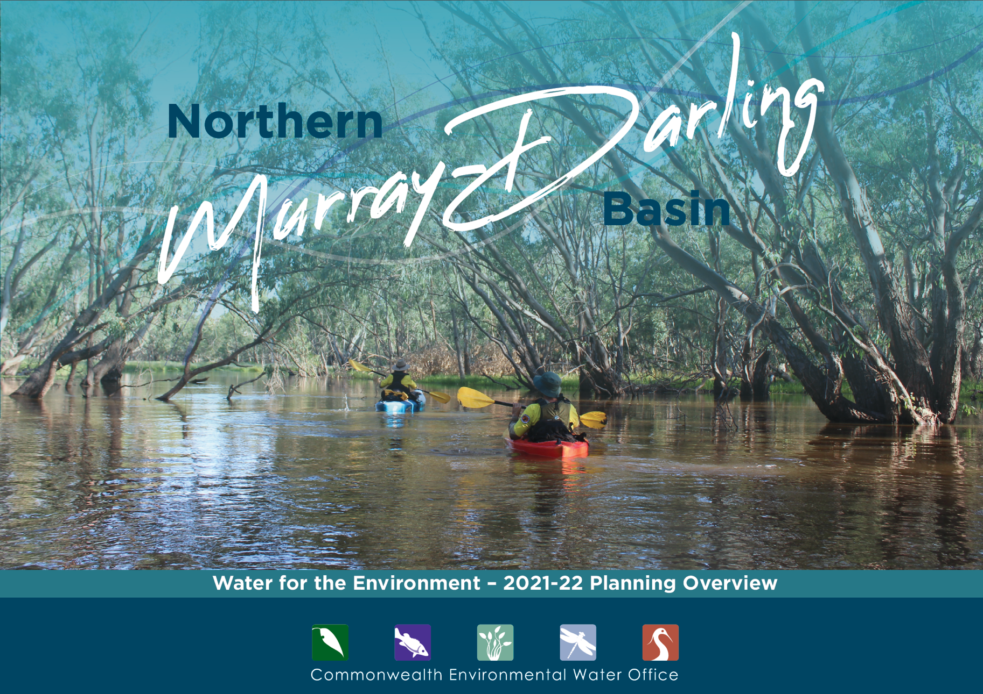

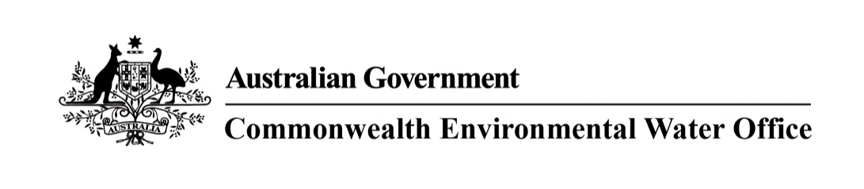

# Northern Murray-Darling Basin

## A message from the Commonwealth Environmental Water Holder

The rainfall and inflows across much of the Murray-Darling Basin over the last 12 months have been a welcome relief. I’m pleased to see the rivers of the north and south of the Basin connected, with the Barwon-Darling River once again flowing from Queensland to the Murray River.

Water storages across the northern Basin have increased substantially during 2021, resulting in much improved water allocations. However, due to the severity of the record-breaking drought, recovery of river and wetland ecosystems will take time and require further large flows.

Our water use in the year ahead will continue to support the recovery of native fish populations and the internationally important Macquarie Marshes, Gwydir Wetlands and Narran Lakes. We plan to use water for the environment to boost the benefits of natural inflows by keeping rivers flowing for longer and topping up small flushes.

We will scale our water use as the season unfolds. Careful planning is critical to making the most for the environment from the water available.

These environmental outcomes will be aided by the efforts of the NSW and Queensland governments to protect environmental flows into and along the Barwon-Darling River.

We are continuing to build relationships with First Nations communities, to learn from and identify ways to support cultural values alongside environmental outcomes.

We look forward to working with our partners in the coming year to deliver water to where it’s needed most.  
  
**Hilton Taylor**  
Interim Commonwealth Environmental Water Holder

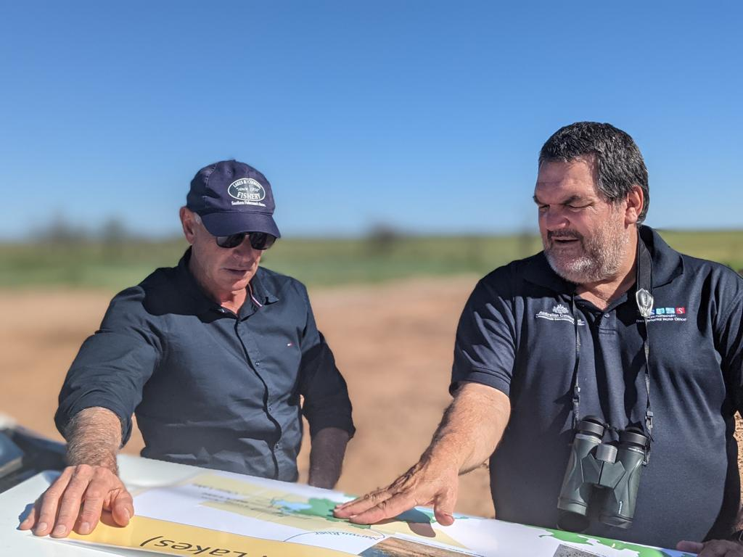

## Planning our use of water for the environment in 2021-22

Each year, planning the best use of Commonwealth water begins long before the water starts flowing.

We work with local water managers, scientists, First Nations, river operators and landholders to prioritise critical sites and carefully plan where water for the environment will be delivered in the year ahead. Their advice ensures our water use is backed by science and meets local needs.

We prepare a Water Management Plan which considers

* water availability for the coming year
* seasonal rainfall outlook
* health of river and wetland plants and animals.

What we aim to achieve - when, where and how our water is delivered - depends on how much water is allocated to our entitlements by state governments. Every year is different. We plan water use scenarios for a range of weather conditions (from dry to wet) so we can adapt to whatever seasonal conditions eventuate.

### Water available in 2021-22*

|  |  |  |  |
| --- | --- | --- | --- |
|  | **Carryover from previous year** | **Potential allocations to  Commonwealth entitlements** | |
|  |  | **Dry\*\*** | **Wet\*\*\*** |
| **Macquarie** | **71GL** | **87GL** | **197GL** |
| **Namoi** | **13GL** | **14GL** | **27GL** |
| **Gwydir** | **60GL** | **74GL** | **140GL** |
| **Border Rivers** | **7GL** | **10GL** | **16GL** |

* For regulated systems only.

** 90 percentile – calculations based on historical driest 9 out of 10 years. Cumulative total estimated for 30 June 2022.

*** 10 percentile – calculations based on historical wettest 1 out of 10 years. Cumulative total estimated for 30 June 2022.

## Healthy rivers, healthy communities

Many rivers of the Murray-Darling Basin have been changed to provide water for towns, industry, food and fibre production.

This has interrupted the natural flow of water that plants and animals need to survive. With natural runoff from rainfall now captured in dams or extracted for human use, the pattern of flow in rivers needs to be actively managed to keep them healthy.

The Commonwealth Environmental Water Office provides water for the environment when native plants and animals need it most. This is critical to keeping rivers healthy, so they continue to sustain healthy communities.

Water availability can change dramatically in the northern Basin. This changes how we use water for the environment and is why we need to carefully plan our potential watering options every year.

In wetter years, we look to improve river system health and help fish and wildlife build up numbers. In the driest years we maintain system health and reduce environmental damage.

Our highest priority in most years is to support internationally important wetlands and increase the connection of northern rivers with the Barwon-Darling River.

To view our Water Management Plan 2021-22, or an overview of planning in the Southern Murray-Darling Basin, visit **environment.gov.au/water/cewo**

Our Local Engagement Officers are based in Moree, Walgett and Goondiwindi.

For more information contact:

* Moree, NSW - Jane Humphries, 0437 141 495
* Walgett, NSW - Jason Wilson, 0418 210 389
* Goondiwindi, QLD – Sally Dickinson, 0448 759 650

## Working with First Nations

The Commonwealth Environmental Water Office pays respect to the Traditional Owners and First Nations of the Murray-Darling Basin.

We acknowledge their enduring cultural, social, environmental, spiritual and economic connection to the rivers, wetlands and floodplains of the Basin. We are committed to continuously improving how we work with First Nations across the Basin to manage water for the environment.

## Planning water 2021-22

### We plan water use scenarios for very dry through to very wet conditions and adapt to whatever season eventuates

Rivers in the northern Basin can switch from being dry to in flood within days or weeks. In times of drought, rivers can shrink back to small pools or dry up completely.

The return of wetter conditions provides an opportunity for rivers to flow from top to bottom and reconnect to important wetlands. These are critical times for plants and animals to feed and breed and recover from the drought. Native fish take the opportunity to move throughout the river system and build resilience for when the dry times return.

### A) Condamine-Balonne

Support recovery of native fish across the Lower Balonne. Rebuild important waterbird habitat at Narran Lakes. Enhance connection with Barwon-Darling system.

### B) Border Rivers

Support recovery of native fish, particularly in the Border Rivers main channels. Enhance connection with Barwon system.

### C) Gwydir

Restore condition of key wetland areas along Mallowa Creek, Carole Creek, and the Lower Gwydir and Gingham watercourses. Enhance connection between Gwydir and Barwon systems.

### D) Warrego

Increase connection with Darling River. Maintain health of the Warrego floodplain.

### E) Barwon-Darling

Protect unregulated flows to refresh refuge pools, improve water quality, boost native fish health and promote fish movement along the Barwon-Darling.

### F) Namoi

Support drought recovery in the Namoi and Peel rivers. Increase connection between habitats. Support native fish movement and improve fish health.

### G) Macquarie

Support drought recovery of Macquarie Marshes, including at Ramsar and waterbird breeding sites. Support native fish breeding and growth.

