Reed beds in a lake with clouds reflecting in the water


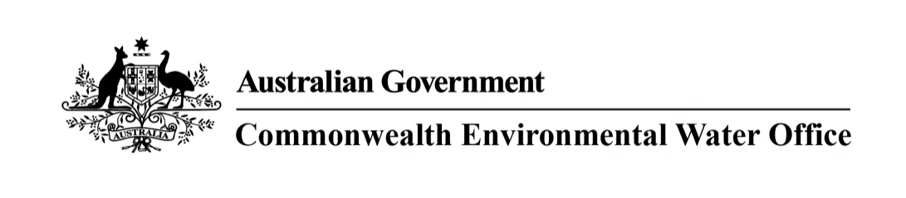

# Southern Murray-Darling Basin

## A message from the Commonwealth Environmental Water Holder

Rainfall across much of the Murray-Darling Basin has brought significant relief for communities and the environment. I’m delighted to see the rivers of the north and south of the Basin connected, with the Darling River once again flowing from its headwaters in Queensland all the way to the River Murray.

Even with wetter conditions, water for the environment has an important role to play. Many floodplain wetlands have not received water for several years. Water for the environment may need to build on nature’s work at ‘thirsty’ sites, including the mid-Murrumbidgee wetlands, the NSW Central Murray Forests, Hattah-Kulkyne, and the floodplains at Chowilla, Pike and Katarapko in South Australia. With more water in the Menindee Lakes, we have an opportunity to provide flows to benefit native fish in the Lower Darling/Baaka, as well as a flow down the Great Darling Anabranch – the first since 2017.

If the wet continues, this will present both opportunities and risks. We will be responsive to conditions and will avoid delivering water where it will exacerbate third-party impacts from flooding. We will look to capitalise on opportunities to extend the duration of flows into important wetlands to benefit wetland plants and support waterbird breeding.

We are also prepared to help mitigate risks, such as providing refuge habitat for wildlife if natural flooding results in low-oxygen blackwater events.

I am pleased this year’s Plan includes a statement from First Nations of the southern Basin outlining their shared concerns for the rivers across the region. We will continue to build relationships with First Nations communities to identify ways to support cultural values alongside environmental outcomes.

We look forward to working with our partners in the coming year to deliver water to where it’s needed most.

**Hilton Taylor**  
Interim Commonwealth Environmental Water Holder

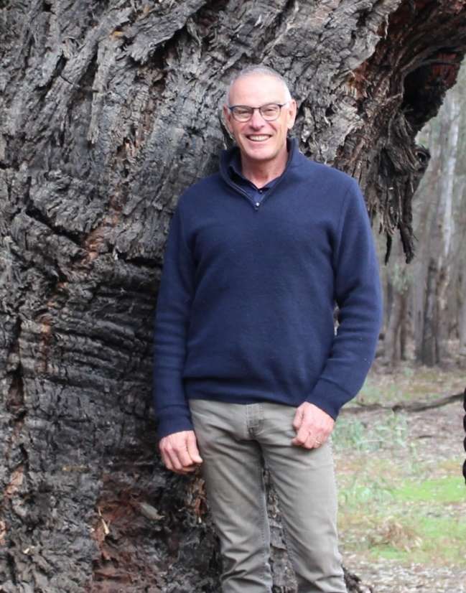

## Planning our use of water for the environment in 2021-22

Each year, planning the best use of Commonwealth water begins long before the water   
starts flowing.

We work with local water managers, scientists, First Nations, river operators and landholders to prioritise critical sites and carefully plan where water for the environment will be delivered in the year ahead. Their advice ensures our water use is backed by science and meets local needs.

We prepare a Water Management Plan which considers:

* water availability for the coming year
* seasonal rainfall outlook
* the health of river and wetland plants and animals.

What we aim to achieve - when, where and how our water is delivered - depends on how much water is allocated to our entitlements by state governments. Every year is different.

We plan water use scenarios for a range of weather conditions (from dry to wet) so we can adapt to whatever seasonal conditions eventuate.

## Forecast water available in 2021-22*

|  |  |  |  |
| --- | --- | --- | --- |
|  | **Carryover from previous year** | **Potential allocations to Commonwealth entitlements** | |
|  |  | **Dry\*\*** | **Wet\*\*\*** |
| **Southern-connected Basin\*** | **538GL** | **1,570GL** | **2,070GL** |
| **Lachlan river valley** | **36GL** | **46GL** | **150GL** |
| **Wimmera river valley** | **0GL** | **0GL** | **0GL** |

* Southern Connected Basin is the network of rivers that feed into the Murray River between the Hume Dam and the sea.

** 90 percentile – calculations based on historical driest 9 out of 10 years. Cumulative total estimated for 30 June 2022.

*** 10 percentile – calculations based on historical wettest 1 out of 10 years. Cumulative total estimated for 30 June 2022.

## Healthy rivers, healthy communities

Many rivers of the Murray-Darling Basin have been changed to provide water for towns, industry and food production.

This has interrupted the natural flow of water that plants and animals need to survive. With natural runoff from rainfall now captured in dams, the pattern of flow in rivers needs to be actively managed to keep them healthy.

We deliver water for the environment when native plants and animals need it most. This is critical to keeping rivers healthy, so they continue to sustain healthy communities. It is also key to meeting our international obligations to conserve important listed wetlands.

To view our Water Management Plan 2021-22, or an overview of planning in the Northern Murray-Darling Basin, visit **environment.gov.au/water/cewo**

Our Local Engagement Officers are based in Berri, Mildura, Griffith, Wagga Wagga and Wodonga.

For more information contact:

* Berri, SA - Michelle Campbell, 0437 064 664
* Mildura, VIC - Richard Mintern, 0437 218 649
* Wodonga, VIC - Anthony Wilson, 0419 188 430
* Griffith, NSW - Michele Groat, 0427 682 309
* Wagga Wagga, NSW - Erin Lenon, 0417 965 714

## Planning for 2021-22

**We plan water use scenarios for very dry through to very wet conditions and adapt to whatever season eventuates.**

Water managed for river health is used to benefit multiple sites as it flows down the river. It also creates positive social and economic benefits for communities along the way. With careful planning, we squeeze the most out of every drop.

## Working with First Nations

The Commonwealth Environmental Water Office pays respect to the Traditional Owners of the Murray-Darling Basin.

We acknowledge their enduring cultural, social, environmental, spiritual and economic connection to the rivers, wetlands and floodplains of the Basin. We are committed to continuously improving how we work with First Nations across the Basin to manage water for the environment.

### A) Coorong Lower Lakes Murray Mouth

Keep Murray flowing through to the Coorong. Maintain water quality & habitat for native fish and wildlife. Allow fish to move between fresh & saltwater. Flush salt out of the Basin.

### B) Lower Murray Floodplain Wetlands

Contribute to flows to Hattah-Kulkyne Lakes and the Chowilla, Pike and Katarapko floodplains to restore key habitat for native wildlife.

### C) Baaka/Darling River and Great Darling Anabranch

Improve fish habitat and support breeding and movement of Murray cod and Golden perch, including along the Great Darling Anabranch.

### D) Murray River Channel

Support native fish breeding and movement and connect low-lying wetlands along the entire river.

### E) Mid-Murray Forests & Creeks

Connect rivers, low-lying wetlands and waterways in the Edward/Kolety-Wakool system and the Barmah-Millewa, Werai and Koondrook-Perricoota forests to support native fish, wetland plants, and waterbirds.

### F) Northern Victorian Rivers

Provide food and habitat for native fish, and aquatic animals including yabbies and platypus. Promote seed germination and plant growth on riverbanks.

### G) Lachlan River

Help native fish such as Golden perch breed, feed and thrive. Support native plant habitat including the reed beds of the Great Cumbung Swamp.

### H) Murrumbidgee River

Provide water to Mid-Murrumbidgee wetlands and Lowbidgee floodplain after natural flows have receded, to maintain and improve habitat for native fish, waterbirds and other wildlife.

