### What is a water mouse?

The water mouse is a small native mammal with grey water-resistant fur and a white belly. It’s an unusual rodent because it eats crabs rather than seeds, primarily lives in saline coastal habitats, and it builds and modifies permanent long-term shelters by carrying mud in its mouth. The water mouse is often confused with the more common water rat, which lives in similar wet habitats.

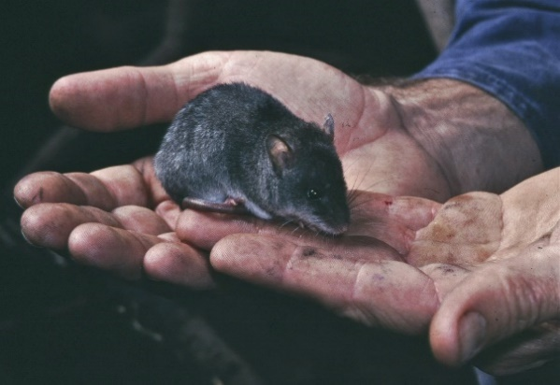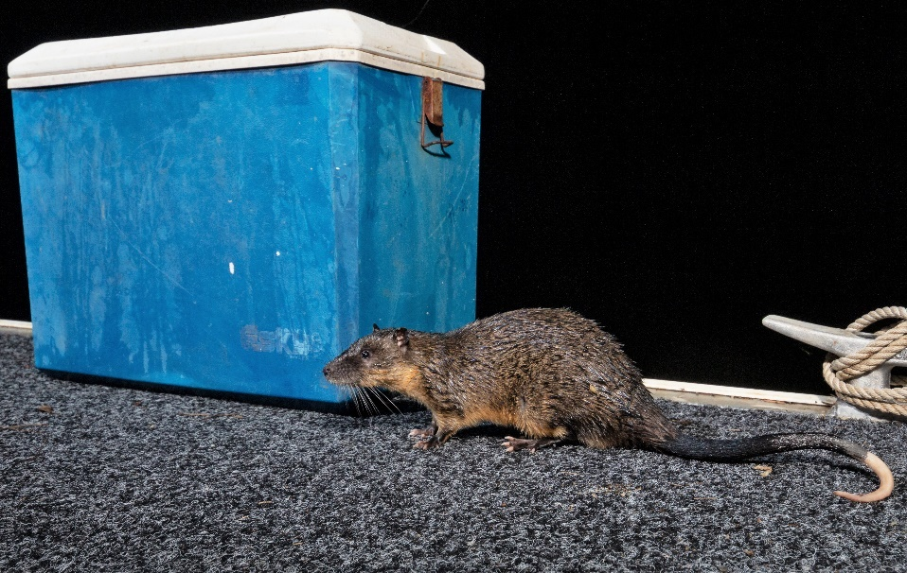

*The grey-white water mouse (left) is often confused with the larger brown-cream water rat (right).*

*Image credits: Queensland Museum (left), Ethan mann (right).*

### Where does it live?

The water mouse mostly lives in mangroves and saltmarshes, but has also been found in coastal floodplains, freshwater to saline wetlands, swamps and wet heath. It is nocturnal and secretive. Most known locations are along the central to southern Queensland coast and sand islands, and a few individuals have been recorded from Cairns, scattered locations across the Top End of the Northern Territory including the Tiwi Islands, and in southern New Guinea. The water mouse is likely to live in places we don’t know about yet such as the Gulf of Carpentaria and Cape York, and maybe even along the Kimberley coast.

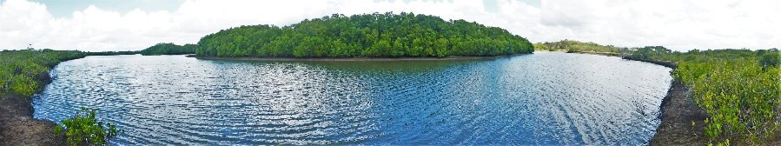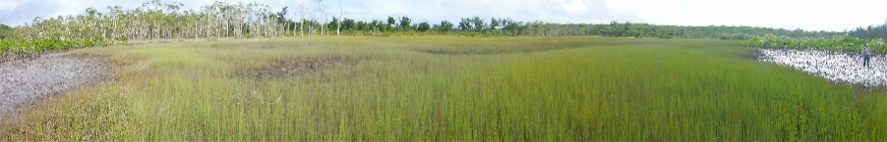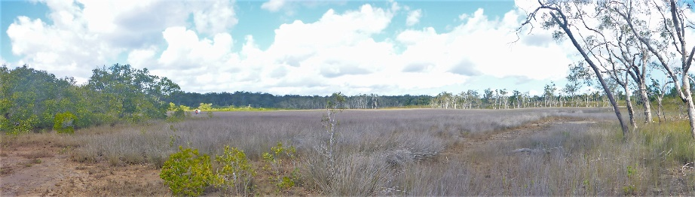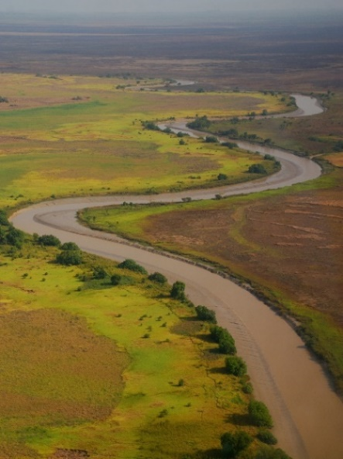

*Water mouse habitats: mangrove, reed swamp, saltmarsh and subcoastal floodplains.*

*Image credits: Janina Kaluza, Kauri Creek (left) and Melissa Bruton, Arnhem Land (right).*

### Why are we concerned about it?

The water mouse is a fascinating small mammal. It is classed as Vulnerable to extinction at the international, national and state levels. The water mouse has lost a lot of habitat to the built environment and farms along the east Queensland coast. It can’t live on disturbed houseblocks or canal developments, industrial estates, commercial processing facilities, cropping paddocks, motorways, aquaculture ponds, etc. And it struggles in areas where coastal developments change water flow, increase exposure to waves and acid sulfate soils, draw down groundwater, or leach chemicals and insecticides. It’s unlikely the water mouse will survive in the future where built-up areas prevent coastal habitats from moving inland as sea levels rise.

Added to this, foxes are breaking in to water mouse mud shelters and eating the residents at a concerningly high rate along the central and southern Queensland coast. And pigs, cattle and fire are known to damage their homes and habitat. There is also an ongoing risk of oil spill from shipping activity along the east coast of Queensland.

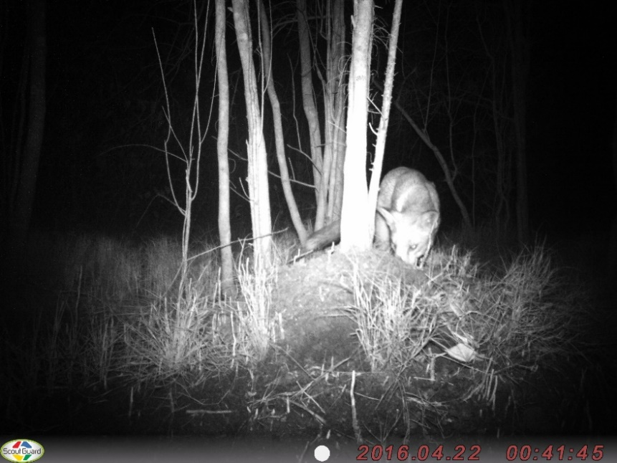 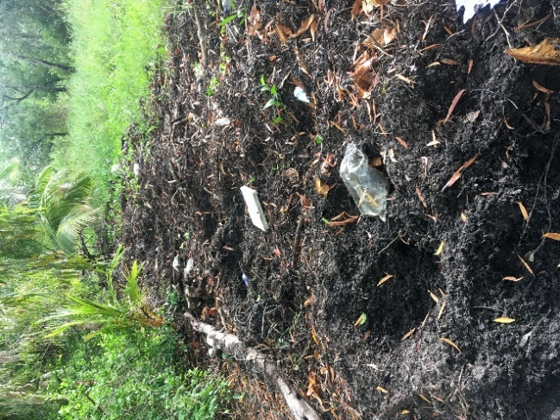

*European red fox dismantling a water mouse mud shelter, and extensive feral pig rooting at the high tide mark behind mangroves in far north Queensland.*

*Image credits: Janina Kaluza (left) and Melissa Bruton (right).*

### Is the water mouse going to be ok in remote areas?

There is good reason to believe that feral pigs and climate change are harming the water mouse in remote parts of coastal northern Australia. Extensive mangrove dieback, increased cyclone intensity, more extreme seasonal floods, and sea level rise are all a concern. We don’t know how, or if, the water mouse survives when its mud shelters are underwater and exposed to significant water movement (e.g. large waves, strong currents).

Regular fires in saltmarsh and seasonal wetland habitats may also be a problem. We don’t know yet if cattle, buffalo, cats and weeds are an issue in remote areas.

### Why do we need a national recovery plan for the water mouse?

The potential water mouse distribution covers four states and territories with a diverse arrangement of overlapping and adjacent land management tenures and Custodianship arrangements, including intertidal areas that are often the boundary between land and sea management agencies. It is heavily impacted by coastal development and there are large gaps in knowledge about where it occurs and how it is faring. A high level of cooperation and communication is required among partner groups and organisations with a diversity of experiences and capacities across coastal northern Australia to better understand the water mouse and to care for it on Country. Codeveloping and implementing a national recovery plan will help partners to work together, share learnings and share capacity across the water mouse distribution.

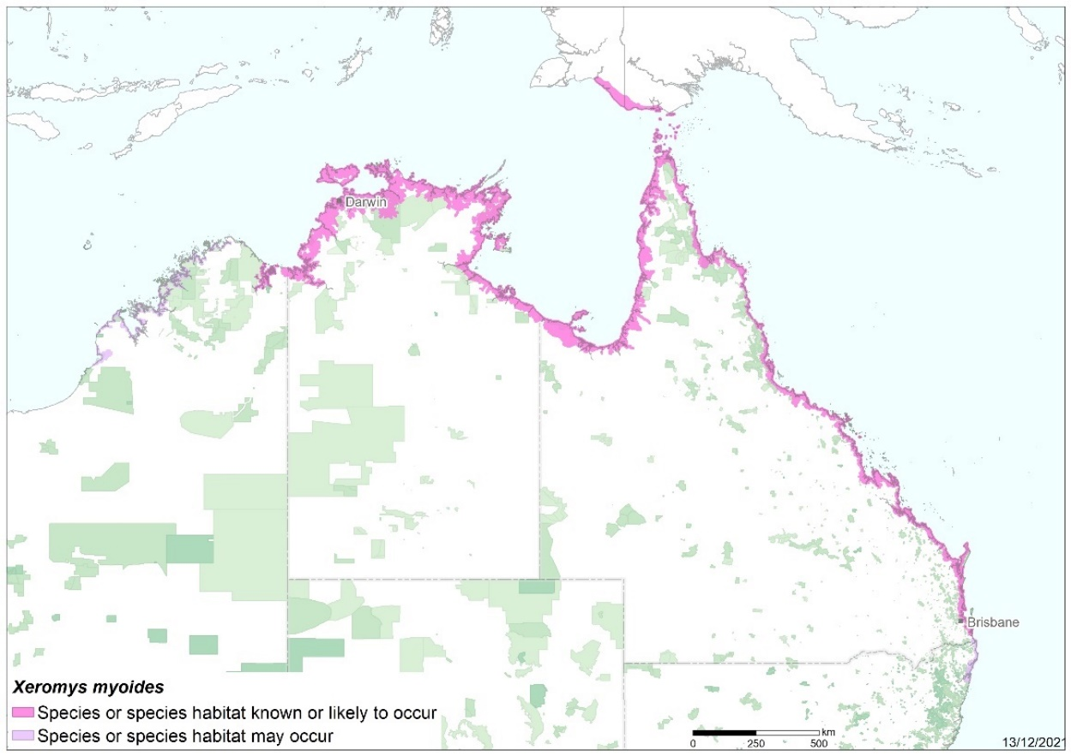

*Potential (purple) and likely (pink) water mouse range from Broome (WA) to Brooms Head (NSW).*

### What are the opportunities?

The water mouse does, or may, occur in many areas where there are funding and co-management opportunities already in place, or the groundwork has occurred to develop and progress land management and custodianship partnership arrangements. These include government funding and support for National Parks, Marine Parks, Indigenous Protected Areas, and Land and Sea Ranger programs; management bodies for exclusive and joint-managed protected areas, National and World Heritage Areas, and Department of Defence land; and support for managing threatened species through natural resource management (NRM) and philanthropic programs for private landholders and Native Title Custodians. What this means is there are opportunities for land managers and Custodians to continue working with established programs, processes and relationships to do effective on-ground work to search for the water mouse, care for it where it is known to occur, track its response to management actions and the changing environment, and adapt land management practices as needed.

### What’s the plan (in a nutshell)?

This draft plan outlines a framework and proposed actions that we can take as a national community over the next ten years to stabilise water mouse populations. It aims to guide and prioritise actions that support local land management planning processes and Custodianship. It’s a draft plan that needs more input from land managers and Custodians, and other partners living and working across the potential water mouse range. It’s important to note that – with a few exceptions that relate to regulating coastal development – the actions, responsibilities and funding sources outlined in recovery plans are a guide and not an obligation.

The draft water mouse recovery plan focuses on:

1. **Stopping coastal developments from causing further loss of water mouse habitat by improving regulation and encouraging sustainable approaches to growth.** The draft plan aims to do this by encouraging regional approaches to managing growth in an ecologically sustainable way, and by providing clear and unambiguous information for regulators assessing development proposals that may impact the water mouse.
2. **Better understanding threats to the water mouse and taking local actions to reduce them.** The draft plan aims to do this by providing guiding information for land managers and Custodians so they can include the water mouse in local land management plans and activities, and track water mouse population responses to targeted land management programs. The plan also provides guidance for land management and research program funding.
3. **Better understanding where the water mouse occurs and making sure it is looked after by land and sea Custodians everywhere that it lives.** The draft plan aims to do this by ensuring all potential land and sea and managers are identified and engaged in water mouse Custodianship, and by providing guiding information to support inventory survey programs in potential water mouse locations across its range.

We value your feedback and encourage you to let us know how we can improve the draft plan so it works best for you and your community.

### Who are water mouse recovery partners?

A lot of people will need to work together as a big community to ensure the water mouse has a long-term stable population. This includes people working in policy and regulation, people on the ground who can search for the water mouse, researchers and Custodians who can work out what is harming it in different locations, Custodians and land managers who can take action to address these threats, ecologists and Custodians who can track the water mouse response to threats and their management, and agencies and organisations that can help co-ordinate and communicate information and funding. The water mouse does, and could, live on the Country of many different peoples and agencies. See Table 1 of the plan for a draft list of partners.

A water mouse recovery team with representatives from across its range, and from different experiences and capacities, will help connect everybody, link on-ground actions with funding bodies, and gather and share information.

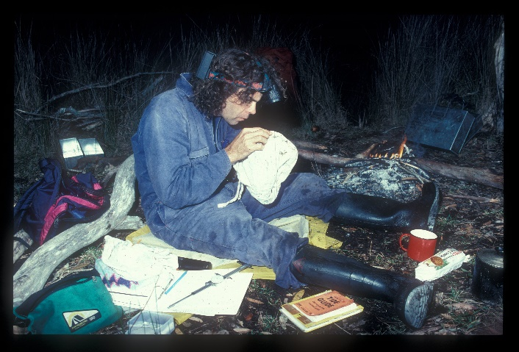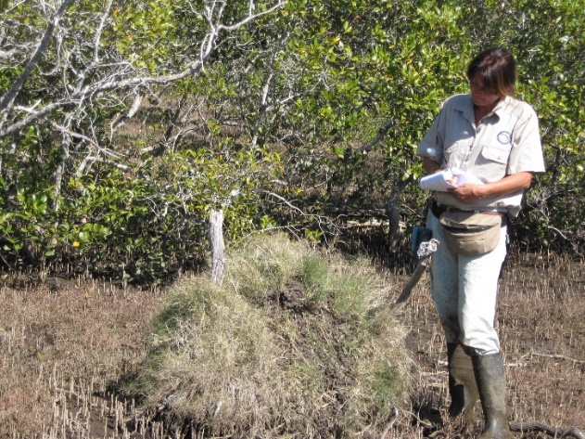

*Researchers Steve van Dyck (left) and Janina Kaluza (right) gather water mouse information to help guide local management programs in southern Queensland.*

*Image credits: Queensland Museum (left), Raymond Donald (right).*

### What can I do now?

The best way to get involved now is to read through the plan and send your thoughts by email or video to [recoveryplans@environment.gov.au](mailto:recoveryplans@environment.gov.au) to make sure the final plan works for you and your community. The red text within the draft plan highlights areas that need further input, but feedback on any and all parts of the plan is welcome. There is an opportunity to consider how the draft species and threat information in the plan could be included in draft land management plans and programs for your Country.

You are encouraged to share images, artwork, quotes etc. that express what the water mouse means to you, what you are doing as a land manager or Custodian of water mouse Country, or what you would like to see happen in the future.

If you are interested in water mouse recovery team membership, be sure to include this information in your feedback.

Everyone is busy so the draft plan will be open to comment for an extended four-month period. During this time we welcome all submissions about the plan including notification from partner organisations to let us know if you would like to discuss the draft plan in further detail.

### How will my feedback be handled?

All feedback you provide will be considered when preparing a revised version of the plan. If there is significant disagreement among partner submissions, the Department will work with the relevant partners to resolve the dispute. Sensitive information should be clearly marked as such in your submission. The Department respects the rights of partners to retain control of intellectual property and to only share information where it is appropriate to do so.