‘The Waters of Australian Deserts’ Cultural Heritage Study

A report to the Department of Environment and Energy and the
Australian Heritage Council

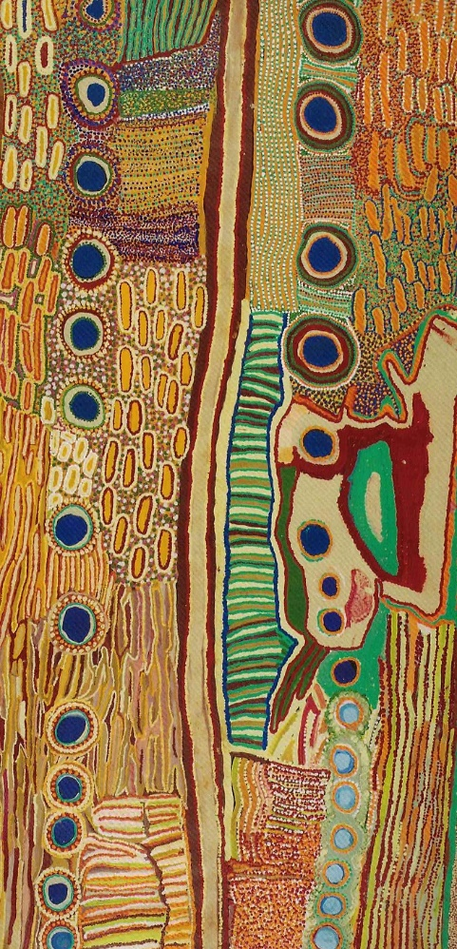

Canning Stock Route and surrounding country 2008,
by 14 women artists at Kunawarritji (well 33 of the Canning Stock Route).
Showing waterholes made into wells in the country crossed by the Canning Stock Route,
and alternative permanent and ephemeral water places used
when the Canning wells were closed off to the Martu people
(Yiwarra Kuju 2010: 44-5)

Ingereth Macfarlane and Anne McConnell
Final Report March 2017

Table of contents

List of tables 3
List of maps and figures 4
Acknowledgments 5
PART 1: Introduction and background 6
1.1 Introduction to the study 6
1.2 The study area 7
1.3 Study scope 9
1.4 Existing cultural heritage identification and assessment for the Australian arid zone 10
PART 2: Study approach 15
2.1. General approach 15
2.2. Study methods 17
2.2.1 Thematic essay and construction of themes 17
2.2.2 Identification of heritage places 20
2.2.3 Assessment framework 23
2.3 Study limitations 32
PART 3: Thematic essay: a framework for understanding the cultural heritage significance of Australian deserts, as limited by the sub-theme of water 34
3.1 Towards a thematic framework: understanding Australian desert environments, the qualities of desert waters and their influence on people’s occupation of the deserts 34
a) Aridity 34
b) Variability, unpredictability and extremes 35
c) Forms of water 36
d) Vast scale, with long distances between patchily distributed resources 37
e) A history of rangeland pastoral landuse 40
3.2 A thematic history of the Australian Deserts: interactions of people, deserts and waters through time 41
Introduction 41
3.2.1 Waters of the Australian deserts 41
3.2.2 Theme: ‘Learning how to live in the arid zone’ 48
3.2.3 Theme: Living in ‘sparselands’ 54
3.2.4 Theme: Living in rangelands 73
3.2.5 Theme: The Australian Desert as a conceptual environment 84
3.2.6 Important themes that do not relate to water 95
3.2.7 Conclusion 97
Table 3.1 Chronology of events in the arid zone 98
PART 4: Identification and assessment of places of potential National Heritage significance 104
4.1 Assessed places of National Heritage significance (Preliminary List) 104
4.2 Discussion 112
PART 5: Priority Places for National Heritage Listing 118
5.1 Priority List of water-related desert Cultural Heritage Places 118
Initial Priority List 118
Ranked Priority List of Ten Places 121
Additional Representative Priority Places 122
5.2 Review of existing arid zone National Heritage Listings and Cultural Heritage values 127
5.3 Priority Place Individual Assessments 129
PART 6: Recommendations 118
PART 7: References 130
List of Appendices 145

Appendices
(Appendices are provided in three additional separate files)
Appendix 1 – Terms of reference for the study
Appendix 2 – Copy of the letter sent to stakeholders regarding the study
Appendix 3 – Responses received from stakeholder groups
Appendix 4 – List of stakeholders emailed by the Department of Environment and Energy
Appendix 5 – Experts consulted for the study
Appendix 6 – Place Assessment Matrix
Appendix 7 – Ten Individual Priority Place assessments

List of tables
Table 1.1 Numbers of Cultural Heritage Places in the Australian arid region listed on the various national and higher level lists…………………………………………………………………………………………12
Table 1.2 World Heritage Properties within the Australian arid region……………………………………….12
Table 1.3 National Heritage Properties within the Australian arid region………………………………..….13
Table 1.4 Commonwealth Heritage Properties within the Australian arid region…………………….….14
Table 2.1 Waters of Australian Deserts project thematic assessment approach with a natural heritage parallel…………………………………………………………………………………………………..…………24
Table 3 Forms of water in the Australian arid zone……………………………………………………………………..36
Table 3.1 Chronological sequence of major changes and events in the Australian deserts………....98
Table 4.1 Preliminary List of Australian arid zone desert water cultural heritage places (ie places assessed as being worthy of listing on the National Heritage List)……………………………….…105
Table 5.1 Study key Priority Places list……………………………………………………………………….……………....119
Table 5.2 Short list of 10 ranked Priority Places ………………………………………………………………….….....122
Table 5.3 Adjunct Priority Places – representative Cultural Landscapes……………………………………..127
Table 5.4 Cultural Heritage Places in the Arid Zone already registered
on the National Heritage List (as at May 2016……………………………………………………………....129
Table 5.5 Places in the arid zone registered for their Natural Values on the National Heritage List
(as at May 2016) but which have Cultural Value at the national level…………………………………….….129

List of maps and figures

Map 1 Study area boundary …………………………………………………………………………………………………8
Map 2 The six major areas within the Australian Arid Zone (from Smith 2013: 5 fig 1.4)…...….9
Map 3 Rainfall variability (from Smith 2013: 9 Fig 1.5)………………………………………………………….35
Map 4 Land forms - elevation (from Woinarski et al 2014: 62)……………………………………………..38
Map 5 Remoteness (from Woinarski et al 2014: 8)……………………………………………………………….39
Map 6 Population density (from Woinarski et al 2014: 133)………………………………………………….40
Map 7 Griffith Taylor’s 1926 ‘Habitability map’ (from Woinarski et al 2014: 125)…………….……55
Map 8 Sites of major ochre quarries (open triangles): 1) Wilkie Mia (on NHL), 2) Karrku, 3) Pukardu
grindstone quarries (squares): 6) Kurutiti (Helen Springs) 7) Anna Creek (Palthirri-pirdi) 8) Tooths Nob (Wadla wadlyu) 9) Innaminka quarries 10) Yambacoona Hill. 11) Mt Isa axe quarries
(4 and 5 not relevant to this discussion) (from Smith 2013: 268 fig 8.2)………………………………….62
Map 9 Eastern Lake Eyre exchange routes (from Smith 2013: 267 Fig 8.1)……………………………..63
Map 10 Map of light pollution in Australia (map courtesy of Instituto di Scienza e Tecnologia dell’Inquinamento Luminoso from www.lightpollution.it/dmsp/)..............................................69
Map 11 Canning Stock route map crossed by Songline tracks (from Yiwarra Kuju 2010 p 18)….79
Map 12 Route of the Woomera rocket range over the Western Desert
(from Davenport et al 2005: xiv)……………………………………………………………………………….…87
Map 13 Map of all Preliminary List places (geographic base map).................................…………..109
Map 14 Map of ten Priority Places (on satellite image base map).................................…………...125
Map 15 Map of seven Desert Cultural Landscapes (on satellite image base map).................…..126
Cover Canning Stock Route and surrounding country 2008, by 14 women artists at Kunawarritji (well 33 of the Canning Stock Route). Waterholes made into wells are shown in the country crossed by the Canning Stock Route, and alternative permanent and ephemeral water places used when the Canning wells were closed off to the Martu people. (Yiwarra Kuju 2010: 44-5)
Figure 2.1 Outline of the approach to Waters of Australian Deserts cultural heritage study…….16
Fig 3.1 Irrwanyere Ranger Dean Ah Chee’s drawing of the living Rainbow Serpent in Rainbow Spring, from which fresh water cannot be taken, used on the interpretation sign at the Irrwanyere spring camp ground, 2007 ……………………………………………………………………………………………………….………..42
Fig 3.2 Flowing Artesian bore, Carcory Station, abandoned by Sidney Kidman 1906, near Birdsville, 2015 ……………………………………………………………………………………………………………………………………..…46
Fig 4 1920s Simplex Windmill at Kenya Station (now part of the collection of the
National Museum of Australia). See website for a history of windmills in Australia http://www.nma.gov.au/collections/highlights/kenya-station-windmill ....................................47
Fig 5 Stock yard, Birdsville Track (October 2015) .........................................................................48
Fig 6 Mrs Paddy grinding grass seed 2013 (photo I Morton Ngintuka 2014: 32)………………….…….61
Fig 7 Seven Sisters Songline by Josephine Mick, Pipalyatjara, 1994. From the ‘Kungkarangkalpa: Seven Sisters Songline’ Alive with the Dreaming! Songlines of the Western Desert project website……………………………………………………………………………………………………………………………………68
Fig 8 Maralinga, prohibited area sign on the Emu/Nawa Road………………………………………………..91

Acknowledgments

The Waters of Australian Deserts Cultural Thematic Study for the Australian Heritage Council is supported through funding from the Australian Government.

Many thanks to the arid zone and other experts who have generously given their time and shared their work to inform this report, to the community groups who contributed, and to the members of the Department of Environment and Energy, Heritage Branch who have provided advice and assistance throughout the preparation of the report.

We also acknowledge the interests in the content of this report that traditional owners of country within the Australian arid zone and all stakeholders concerned with the cultural heritage of the region will have. We respect their interests and while consultation was outside the scope of this report, we trust that full consultation will be a part of any future actions.

PART 1: Introduction and background

1.1 Introduction to the study

The Australian deserts are continental in scale. They stretch 2000km from the arid coast of Western Australia to western Queensland and NSW. This major geographic component of the Australian continent crosses numerous state and other administrative boundaries and over 90 traditional Indigenous language group areas.

Australia’s deserts form one of the world’s major desert regions: the largest block of arid zone in the southern hemisphere - 70% of the continent’s current landmass, 5.3 million km². They combine to make Australia the driest of the world’s inhabited continents.

To focus on the desert is to reverse the dominant perspective of the urban capital cities, facing out to sea with arid lands at their back, reflected in the language commonly used for the arid and semi-arid inland areas: ‘Outside country’, ‘back country’, ‘the back of Bourke’, ‘beyond the black stump’, ‘the dead heart’ or ‘the red heart’. Note that the evocative term ‘the outback’ does contain the arid zone, but also includes the higher rainfall areas of the Top End, the Gulf and Cape York (see Woinarski et al 2014: 5-9, 14, 18-34).

The arid zone presents a paradox of geographic centrality, and social, political and economic marginality from the point of view of coastal urban population concentrations; large in extent but not in terms of its economic and political standing. It does however play a distinctive part in a national Australian identity. Much of this is legendary or symbolic, not grounded in experience. However, growing numbers of visitors now come to test these legends and see for themselves. There is an increasingly large transient flow of 4WD visitors and tourists through the deserts whose count annually more-or-less matches the resident population. This presents another cogent reason for examining the cultural heritage of the deserts. Any protection for places in desert areas that isolation may have provided in the past can no longer be relied upon.

The National Heritage List is a list of places of outstanding heritage value to the nation. In 2015-16, Council commissioned preliminary research into the indicative cultural (historic and Indigenous) National Heritage values associated with Australian deserts, as limited by the sub-theme of water.

The Terms of Reference for the study set out the background rationale and framework for this work:
The Australian Heritage Council considers the deserts to be a highly significant part of Australia’s heritage. The traditional and contemporary history of Australian deserts has centred on the availability of water. The rivers, waterholes and wetlands of Australian deserts are of great significance in Aboriginal traditional
songs and stories, were important for the survival of Aboriginal peoples, early European explorers and needed to be carefully considered in the foundation of Australia’s inland agriculture. In the natural world, reliable water sources are critical for the survival of refugia communities of plants and animals. The natural, historic and Indigenous heritage significance of Australian deserts is intrinsically, although not always, associated with water.
In order to provide a more prioritised approach at this point in time Council would like expert guidance on Australia’s desert Indigenous and historic heritage places of outstanding value to the nation as limited by the sub-theme of water.
This cultural heritage thematic study is intended to complement previous studies of the natural values associated with Australian deserts. These previous studies provided a national overview of the geoheritage and biodiversity heritage values associated with Australia’s arid zone (Wakelin and Associates 2011).
Once this cultural thematic study is complete the Council will use the study to identify potential places for listing consideration.

This study offers the opportunity to consider ‘the Australian deserts’ as a region, and to ask in what ways the histories and cultures of people in this region are distinctive compared to those of the non-desert fringes of the continent. As the geographically dominant part of the Australian continent, any distinctive qualities of desert Australia, and those places which demonstrate that distinctiveness, have the potential to be significant national identifiers. To establish what they are requires definition of the qualities of the Australian deserts. The contextual thematic essay (Part 3 below) explores these qualities. It provides ‘a framework for understanding the cultural heritage significance of Australian deserts, as limited by the sub-theme of water’. It reviews the characteristics of Australian deserts and the forms of water that occur in them. People’s responses to these are traced. Contextual themes which inform consideration of the cultural heritage of the deserts are drawn out from these characteristics of the deserts and their waters, and people’s responses and adaptations to these through time.

Part 2 of this report sets out the approach and methodology of the project. Part 4 presents a Preliminary list of cultural heritage places which fit within the study thematic framework and which are considered to have potential National Heritage level significance. Part 5 presents a shortlist of places assessed as having priority for listing on the National Heritage List (a ranked list of the top 10 places). Appendix 7 presents detailed information for each of the priority places.

Report authorship
The report was written jointly by Ingereth Macfarlane (primary authorship of part 3) and Anne McConnell (primary authorship of Parts 1 and 2).

1.2 The study area

The study area is the Australian arid zone, often colloquially referred to as the ‘Australian Desert’, but in reality a series of distinct deserts and other environments united by the common factor of their aridity.

The definition of aridity used by the Department of Environment to define the boundary of the study area is based on a ‘moisture index’ of less than 0.2, where any value less than 1.0 indicates that the
ratio of moisture lost through evaporation is greater than the moisture gained from rainfall (see map 1). This is discussed further in Part 3.2.

For clarity, in this report ‘the arid zone’ is used to refer to the whole of the study area (as defined by the moisture index of 0.2). The boundary merges into semi-arid country, which is defined by a moisture index between 0.2 and 0.4 (Desert Knowledge CRC 2006). The term ‘desert’ is used to refer to a particular desert within that region ie a sub-area of the broader ‘arid zone’.

The arid zone within this boundary extends from the ‘maritime desert’ of the arid rocky coastline of the Pilbara in Western Australia, to the treeless plains and high cliffs of the Nullarbor plain with the Great Victoria Desert to its north, across the Great and Little Sandy Deserts, the Tanami Desert, with the Davenport and Murchison Ranges to their east, and the Gibson Desert to the central MacDonnell Ranges, which give rise to the Finke River which flows into the vast sandy dune fields of the Simpson Desert, then the Strezlecki Desert, the Flinders Ranges in the south, and the huge salt playa Lake Eyre and the channel country of Paroo and Darling Rivers and Coopers Creek on the eastern edge. Excluded from the area is most of the Kimberley region, the Gulf of Carpentaria area, eastern Australia, SW Western Australia and Eyre Peninsula (see map 1).

Within this boundary, six desert sub-regions have been defined (see Map 2, from Smith 2013: 5). They are 1) Pilbara, 2) Western Desert, 3) Central Australia, 4) Arid rivers region, 5) Nullabour Plain, 6) Darling-Paroo river system. Within these are finer-grained bio-regions.

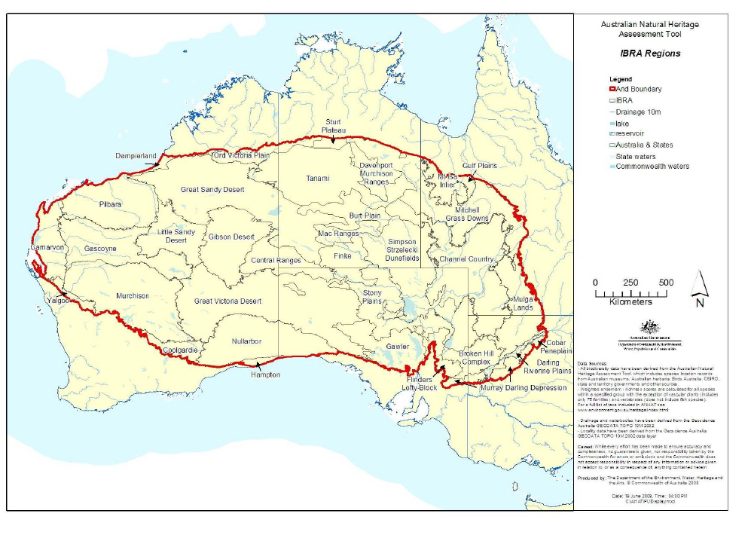

Map 1 Boundary of the study area (from Terms of Reference for the study)

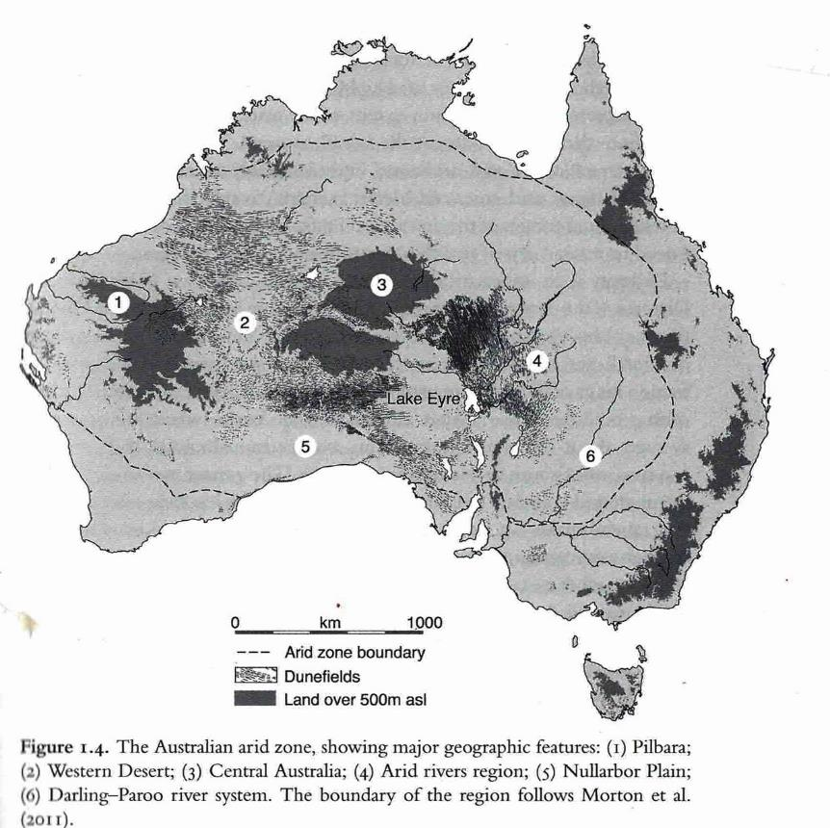

Map 2 The six major areas within the Australian Arid Zone (from Smith 2013: 5 fig 1.4 - NB the boundary of the arid zone contains a larger section of the northern semi-arid country in this definition)

1.3 Study scope

This is a desktop study only. Its scope is given by the following factors:

- a regional boundary of the ‘arid zone’ which is defined in terms of the moisture index, ie ratio of rainfall to evaporation (see discussion Part 1.3 and 3.2, Map 1), rather than by an arbitrary administrative boundary such as a state border.

- an all-inclusive range of types and ages of cultural heritage places consisting of places, routes, areas, or associative landscapes which tell the stories of pre-colonial Indigenous history and culture, the histories of colonial contact and continuing life in the desert, for both Indigenous and non-Indigenous people. The study is not focussed on a particular ‘type’ of place (such as ‘rock art’ or ‘benevolent institution’) that have been the basis of previous thematic cultural heritage assessment studies for the NHC.

- the combination of factors a) and b) sets up a dual basis for the scope of the project – a climatic/geographically defined region and cultural heritage reflecting the historical processes of living in that region.

- the broad geographic extent of the arid zone study area - 70% of Australia.

- the broad heritage base – 45-50,000 years of Indigenous histories, overlaid by colonial histories and recent histories are involved in the study.

- the limitation on the scope and structure of the study in terms of a sub-theme of water.

Note that there is a stated aim in the Terms of Reference to align this cultural heritage assessment with the natural heritage assessments for the Australian Deserts as far as possible, largely through the ‘limitation’ of water and by inclusion of the IBRA bioregions in the preliminary and priority list. However this will occur at a later stage in the heritage assessment process, and only cultural values are assessed in this report.

Scope of Consultation

Consultation with interest groups
No direct consultation with interest groups has been carried out in compiling this list. A letter signed by the AHC Chair was sent to stakeholder groups such as local councils and Land Councils advising them that the project was underway in April 2016 (Appendix 2 and Appendix 4). Several of the groups responded, and their submissions are included in Appendix 3. They make recommendations regarding particular places, and draw attention to the Ten Deserts Initiative which aims to coordinate work across state borders in the arid zone (www.tendeserts.org). These responses informed the development of the Preliminary List. However, it is important to be aware that the list of places identified in this report and their ranking has not been subject to any direct community consultative process, which is a standard and crucial part of action regarding cultural significance (Australia ICOMOS Burra Charter 2013; AHC Ask First 2002).

This lack is critical in relation to Indigenous places as indicated in the Environmental Protection and Biodiversity (EPBC) Act 1999 (hereafter the EPBC Act 1999) (Regulations 2000, Schedule 5B, 6) which has as a principle for the management of National Heritage places that ‘Indigenous people are the primary source of information on the value of their heritage and the active participation of Indigenous people in identification, assessment and management is integral to the effective protection of Indigenous heritage values’. Such consultation with the relevant Indigenous traditional owners and communities will be an essential next step.

Consultation with experts
Specialists identified as experts in the prehistoric and historic archaeology, history and cultural geography of Australia’s deserts were contacted and informed about the study. They provided advice on places that they considered most important within their area of expertise, additional references and access to relevant literature. A list of the experts consulted is provided in Appendix 5.

1.4 Existing cultural heritage identification and assessment for the Australian arid zone

Existing knowledge base
Overall, the identification and assessment of cultural heritage places in the Australian arid zone is relatively poor. We suggest this reflects the relative remoteness and difficulty of access of this region. There are no whole-of-region systematic studies and few smaller scale systematic arid zone heritage studies. There is a small number of national studies (eg, Pearson and Lennon’s (2007) NHL pastoral study, McDonald and Clayton’s (2016) NHL rock art study) which include the arid and semi- arid areas, a Queensland government state-wide mining heritage study (Pearson 1994, Lennon et al 1996), a South Australian government study of twentieth century heritage (Marsden & Cosgrove
2004; Bell et al 2008), of the Birdsville and Strzelecki Tracks (Historic Research 2002) and the Oodnadatta Track (Austral Archaeology 2001), potential World Heritage studies of Lake Eyre (Marshall 1995) and the Nullarbor Plain (Cane 1992). Few places of potential national level significance have been identified in these studies. Apart from the national rock art study and the Nullarbor Plain World Heritage study, the systematic heritage studies all relate to historic heritage.

Place-based and regional archaeological, historical, geographical and anthropological studies of the deserts have provided detailed historical understandings and site descriptions. Additional place specific data has also been sought directly from specialist experts in the arid zone.

The ‘arid zone’ is rarely considered as a single region, except in several key studies: Morton and Stafford Smith’s ecological overviews (1990 and 2011), Mike Smith’s long term environmental and human occupation overview The Archaeology of Australian deserts (2013) and Roslyn Haynes’ study of representations of the deserts in Seeking the Centre: the Australian desert in literature, art and film (1998). Analysis by comparison of the long-term human history of the Australian deserts with those of other continental desert systems has also been important in refining understanding of the distinctive qualities of Australian deserts (see 23 degrees south: archaeology and environmental history of the southern deserts 2005 ed Hesse and Smith, and Desert peoples: archaeological perspectives, 2007 ed Hiscock and Veth).

Existing heritage listings
Various local, state and national heritage lists and registers can provide a picture of the nature and conservation status of heritage places. Local and state registers often comprise lists of sites which do not record level of significance and value against themes. Because of this and the large size of the study region, the study focussed on examining those places in the Australian arid zone that have been listed for their national or greater heritage value. To this end the World Heritage List, National Heritage List, the Commonwealth Heritage List and the Register of the National Estate were reviewed. This was considered to be useful in the process of identification of places and their boundaries, in particular for the study’s priority places.

The Commonwealth Heritage List, which comprises significant Commonwealth-owned heritage, does not necessarily imply national level heritage significance (but this listing does provide legislative protection). Similarly, listing on the Register of the National Estate does not necessarily imply national level significance – it covers places which are locally significant through to those of national significance. The Register of the National Estate was closed in 2007 and is no longer a statutory list, and does not have any protective status.

A review of the above lists and registers shows that in the Australian arid zone currently there are no purely cultural World Heritage properties and that there are eight National Heritage List cultural places, and three Commonwealth Heritage List cultural places. These comprise a small proportion (in all cases less than 9%) of the full Australian listing for each list. This arguably does not adequately represent the great time depth and diversity of human life in the arid zone.

The number of Indigenous and historic heritage places in the arid zone for each of the lists reviewed is shown in Table 1.1.

Table 1.1 Numbers of cultural heritage places in the Australian arid region listed on the various national and higher level lists

LIST | TOTAL NUMBER PLACES ON LIST | TOTAL NUMBER CULTURAL HERITAGE PLACES | TOTAL NUMBER PLACES IN THE ARID ZONE | INDIGENOUS PLACES IN ARID ZONE | HISTORIC PLACES IN ARID ZONE
World Heritage List  (Australian places in brackets) | 1,031 (19) | (7)  [incl 4 mixed properties] | 3 | - | -
National Heritage List | 103 | 72 | 15 | 4 | 4
Register of the National Estate | >13,000 | (dominated by historic heritage places) | 604 | 205 | 269
Commonwealth Heritage List | 396 | (dominated by historic heritage places) | 5 | 1 | 2
Note: No totals for types of heritage places for all lists are provided as there is overlap between the lists.

World Heritage List
Three of Australia’s 19 World Heritage Areas are in the arid zone. None are listed for their cultural heritage values alone, one (Uluru-Kata Tjuta) is a mixed natural-cultural heritage place, and the other two are natural heritage places. These places (properties) are listed in Table 1.2.

Table 1.2 World Heritage properties within the Australian arid region

PLACE (PROPERTY) | LOCATION | TYPE PROPERTY | PROPERTY STATUS | PROPERTY ID
Shark Bay, Western Australia | WA | Natural | Declared Property | 105020
The Ningaloo Coast | WA | Natural | Declared Property | 106208
Uluru-Kata Tjuta National Park | NT | Mixed | Declared Property | 105040

National Heritage List
There are four Indigenous places, four historic places and seven natural places currently on the National Heritage List in the Australian arid zone. Several of the natural National Heritage List places also have acknowledged cultural values and/or cultural values identified by this study.

The National Heritage List arid zone places are listed in Table 1.3. Three of these places are also World Heritage properties (see above) and one of these, Uluru-Kata Tjuta National Park, is also on the Commonwealth Heritage List (see below). National Heritage List places located in the arid zone make up only c.14.5% of all places currently on the List, and the cultural heritage places represent c.11% of all cultural heritage places on the List.

Table 1.3 National Heritage properties within the Australian arid region

PLACE | LOCATION | TYPE PLACE | PLACE STATUS
Hermansburg Historic Precinct | NT | Indigenous | Listed Place
Koonalda Cave | SA | Indigenous | Listed Place
Wilgie Mia Ochre Quarry | WA | Indigenous | Listed Place
Dampier Archipelago (including Burrup Peninsula) | WA | Indigenous | Listed Place
QANTAS Hangar Longreach | Qld | Historic | Listed Place
City of Broken Hill | NSW | Historic | Listed Place
The Burke, Wills, King & Yandruwandah National Heritage | SA | Historic | Listed Place
Goldfields Water Supply Scheme | WA | Historic | Listed Place
Uluru – Kata Tjuta National Park | NT | Natural | Listed Place
Dinosaur Stampede Monument | Qld | Natural | Listed Place
Great Artesian Basin Springs: Elizabeth | Qld | Natural | Listed Place
Great Artesian Basin Springs: Witjira – Dalhousie | SA | Natural | Listed Place
Shark Bay, Western Australia | WA | Natural | Listed Place
The Ningaloo Coast | WA | Natural | Listed Place
The West Kimberley | WA | Natural | Listed Place

Commonwealth Heritage List
Places on the Commonwealth Heritage List are those located on Commonwealth land and can have significance ranging from local to national. There are only five Commonwealth Heritage listed places in the arid zone, shown in Table 1.4. They represent less than 1% of places on the Commonwealth Heritage List. Two are listed as historic places, two are listed as natural places, and the other, Uluru-Kata Tjuta National Park, is listed as an Indigenous place. The Broken Hill Post Office is contained in the National Heritage listed City of Broken Hill.

It is also worth noting that Uluru-Kata Tjuta National Park has a different status in each of its three different level listings – once as an Indigenous heritage place, once as natural place and once as a combined heritage place.

Table 1.4 Commonwealth Heritage properties within the Australian arid region

PLACE (PROPERTY) | LOCATION | TYPE PROPERTY | PROPERTY STATUS
Uluru-Kata Tjuta National Park | NT | Indigenous | Listed place
Arid A Type Residence (Alice Springs) | NT | Historic | Listed place
Broken Hill Post Office | NSW | Historic | Listed place
Learmonth Air Weapons Range Facility | WA | Natural | Listed place
Ningaloo Marine Area | WA | Natural | Listed place

Register of the National Estate
The Register of the National Estate (RNE) contained over 13,000 places in 2007 when it was closed. While it is no longer a statutory list, the 205 Indigenous places and 269 historic places within the arid zone in the archived listing provide insights into the types of places that were included on the Register when it was operational. Although the RNE listed places are spread widely across the arid zone, there are some large regional gaps. The most obvious gap is the Western Desert-Central Australian Desert area, reflecting the limited knowledge of this area and the politics of listing Indigenous places at the time the RNE was being populated (Prof Mike Smith pers comm 16/12/16).

Arid zone Indigenous places on the Register of the National Estate include archaeological sites, quarries, water sources, missions, stone arrangements, rock art sites and complexes, significant landscape features, and important songline locations. Three arid zone Indigenous cultural heritage places listed on the Register of the National Estate have been listed on the National Heritage List (ie, Uluru-Kata Tjuta, Koonalda, Wilgie Mia Ochre Quarry). It is noticeable that the Register of the National Estate Indigenous place listings in the arid zone are often areal listings rather than single site listings. These encompass suites or complexes of sites and/or values in their landscape setting. Examples are the Burrup Peninsula - North Area, Sturts Meadows Area, Cleland Hills Aboriginal Area, The Granites Area, and whole reserves such as Emily and Jessie Gaps Nature Park, and Uluru - Kata Tjuta National Park. This suggests that highly significant Indigenous heritage may not always be readily encapsulated in single sites or small areas. This is has relevance for the present project.

In terms of historic heritage, the Register of the National Estate has less place diversity, predominantly featuring single buildings and sites or structures, with the built heritage being predominantly located within arid zone towns. Non-urban places include single or small numbers of bridges, jetties, hangars, woolsheds, mining heritage sites/structures, graves and early exploration sites. There are a number of pastoral sites that are almost all homesteads. As with the Indigenous sites, a small number of Register of the National Estate historic cultural heritage places in the arid zone have had their high national value recognised through their listing on the National Heritage List.

PART 2 Study approach

2.1. General approach
The Waters of Australian Deserts Cultural Heritage Study is constrained by the scope set by the project Terms of Reference (refer Section 1.2 and Appendix 1). The Terms of Reference require identification of Indigenous and historic cultural heritage places of potential national heritage significance that reflect those significant aspects of the human use of the Australian deserts that have been influenced by water. These are scoping themes. This involves consideration of a series of elements, and hence the assessment process which takes all of these into account involves a series of steps, as follows. The key stages of the study and their sequencing are shown in Figure 2.1.

Step 1 Review of arid zone geography, history and heritage
In this step the following sources of information were used: 1) key published and accessible unpublished documentary sources; 2) expert knowledge (verbal and written); and 3) a review of national level heritage lists. The use of expert knowledge has been extremely important as there is a considerable body of work that has been undertaken on the history and heritage of the arid zone that is not easily accessible or not documented.

Step 2 Compilation of the thematic essay
This step uses the information derived from Step 1 to outline the geography and history of the arid zone, and to explore the history of the arid zone via themes which are derived from considering the effect of water availability in the arid zone. These are contextual themes. Key heritage places are identified under each theme and discussed. The thematic essay is presented in Part 3 of the report.

Step 3 Compilation of a list of places of potential national heritage significance
The places in this list (the Preliminary List) are all those places identified by the study (through Steps 1 and 2) that are considered by the study to be 1) significant in relation to the theme of Australian deserts and limited by the sub-theme water and 2) to have national heritage significance (in relation to the National Heritage List criteria) and to be potentially worthy of inclusion on the National Heritage List. The selection of places for this Preliminary List is based on assessment of individual places against relevant measures designed for places to meet conditions 1 and 2 above. The assessment measures used are the National Heritage List criteria, National Heritage List indicators, thematic indicators and integrity. Assessment of a place’s threshold for listing on the National Heritage List was also undertaken at this stage. A threshold ranking is given in the criteria matrix based on comparative analysis of identified places from expert advice and the analytical description in the thematic essay. The full analysis is provided as a place/ assessment measure matrix (Appendix 6). This step resulted in a Preliminary List of 61 cultural heritage places of a wide variety of place types which is presented in Part 4 (Section 4.1).

Step 4 Creation of a Priority List
A priority list of 10 places was then derived from the places on the Preliminary List. The prioritisation was achieved by selecting those cultural heritage places on the Preliminary List that were considered to best reflect the contextual themes (ie the significant responses of people living in a desert and responding to water availability) through comparative analysis of other identified places which reflect a similar response, and where relevant through comparative assessment against other similar places. This step also included a second review of integrity. The Priority List is presented in Part 5, Section 5.1.
Figure 2.1 Outline of the approach to Waters of Australian Deserts cultural heritage study
THE WATERS OF AUSTRALIAN DESERTS CULTURAL HERITAGE STUDY
SCOPE & TOR
HISTORY & HERITAGE REVIEW
to understand the history the Australian Arid zone
- histories and archaeological research
- heritage studies
- expert advice
- national scope heritage lists
GEOGRAPHY REVIEW
to explore the physical nature of the Australian Arid zone and the forms in which water occurs
- secondary desert geography references
DERIVATION OF STUDY SCOPING THEMES
these reflect the qualities of deserts, the nature of desert waters and their influence on how people live in the Australian arid zone
THEMATIC ESSAY – contextual themes
- provides analytical description of Australian deserts and their qualities,
and of the special nature of water occurrence in the Australian arid zone
- summarises the history of human occupation of the Aust arid zone
- explores people’s use of the Australian arid zone and identifies significant places known to have resulted from this use
PLACE ASSESSMENT 1
IDENTIFICATION OF PLACES OF NATIONAL HERITAGE SIGNIFICANCE
Uses 1. NHL criteria; 2. NHL indicators (generic); 3. thematic indicators (response types); 4. water indicators; 5. place integrity; 6. threshold test
LIST OF PLACES OF ASSESSED OUTSTANDING NATIONAL HERITAGE SIGNIFICANCE RELATED TO THE DESERTS & WATER
[ PRELIMINARY LIST ]
Places are grouped in terms of people’s responses to the Austalian deserts (ie by thematic indicators)
PRIORITY LIST OF PLACES FOR NATIONAL HERITAGE LISTING
[ PRIORITY LIST ]
[includes a secondary priority list of representative cultural landscapes as a complementary approach which potentially provides a good fit where attempting combined cultural and natural values NHL listings]
PLACE ASSESSMENT 2
IDENTIFICATION OF PLACES OF PRIORITY FOR LISTING ON THE NATIONAL HERITAGE LIST
Places selected are best examples of types established in the Preliminary List, evaluated on the basis of comparative analysis with other listed places (and other places as relevant) and the study’s national thematic indicators

Step 5 Documentation of the Priority Places
As required in the project terms of reference, detailed documentation of each of the priority places identified has also been compiled which includes a general significance assessment and evaluation of the place against the NHL criteria. A project-specific place template was created based on the data required in the project terms of reference. The priority place individual assessments and other summary place data are presented in Part 5, Section 5.1.

The methods used in the above steps are described below in Section 2.2.

2.2. Study methods

2.2.1 Thematic essay and construction of contextual themes

Scope of the essay
The thematic essay is an analytical description which provides a background context for understanding the histories of people’s responses to the dynamics of Australian desert environments. It sets out and explains the contextual themes that guide these understandings. Places important in relation to the contextual themes are highlighted through the discussion.

Given the areal breadth and time depth covered by the essay, it does not claim to be all-inclusive. Input from expert reseachers has been drawn upon to mimimise any inbalance in the coverage of places and environments. The absence of consultation with relevant Indigenous elders and representative bodies means that any places of significance to Indigenous people that have not already entered into discussion in the public domain will not be included in the discussion.

Framing of the essay
At the core of this study is the exploration and representation of people's responses to Australian arid zone environments over time. The thematic essay explores the dimensions of these responses to the characteristic qualities of Australian arid zone environments and associated waters. The characteristics and responses are captured in four key contextual themes that are considered to best explain people's response to the desert environment over time, and what is significant and special about the history of human use of the desert. These are as follows:

Theme 1: Learning to live in the Australian arid zone
‘Profound adaptability’ is Peter Veth’s summary of people’s successful occupation of the arid zone, a deep time picture based on increasingly detailed evidence from excavations in each of the various component parts of the arid zone (Veth 2005: 140). This theme takes in the evidence for these adaptations in pre-colonial times. Further, the emphasis on ‘learning’ in the framing of the theme is designed to draw attention to change in adaptations through time including those of non-Indigenous incomers in historical times. It is argued that the structural principles for initial colonisation by both pre-historic and historic people share a similar foundation – to establish knowledge of reliable waters and use them as ‘stepping stones’ through the country.

Any occupation of the desert implies that those people have successfully overcome water scarcity. The way in which that has been worked out, and the lives that follow from it, are the key foci of this theme. An implication of this is that the obverse, the abandonment of places when the adaptations and methods fail, is also a part of this theme.

This theme includes inter-cultural aspects of learning to live in the deserts – inter-cultural interactions between Indigenous, ‘Afghan’, Chinese and European peoples which were integral to the colonial development of desert regions.

The clusters of places in the Preliminary List that are included as representing and demonstrating these characteristics of the arid zone are:
  - Excavated archaeological sites
  - Indigenous occupation sites and water places
  - Historic settlements based on particular water places
  - Early European explorers’ routes
Summary: Theme 1 ‘Learning how to live in the arid zone’ captures the key desert physical qualities of aridity combined with variability, unpredictability and extremes in the context of human adaptations to these through time.

Theme 2: Living in sparselands
‘Deserts are difficult environments for people’, ‘not just because scarcity of water is a limiting factor, but also because of the inherent patchiness and temporal variability’ of critical resources such as fuel and plant food (Smith 2005: 94, Smith and Hesse 2005: 10).

The quality of patchiness of resources, including water, is the key focus of this theme. This results in the qualities of long distances between places, remoteness, low population and the need for mobility and communication - a structural constraint on the patterns of life that are possible in the arid zone. This is a characteristic of deserts that is not captured by any one particular place, as it involves multiple places linked together over distance.

The clusters of places in the Preliminary List that are included as representing and demonstrating these characteristics of the arid zone are those that connect places together through systems of mobility and communication. They are:
- Cultural landscapes of particular environments/environment clusters
- Regional rock art complexes
- Songlines
- Water routes
- Trade routes
- Long distance transport routes
- Long distance communications routes
Summary: Theme 2 ‘Living in sparselands’ captures the characteristic of vastness, long distances and low population densities in Australian deserts and the need for mobility and communication.

Theme three: Living in rangelands
This theme is about the desert as an economic environment. It relates to land use and the ways in which the resources and ‘boom-and-bust’ bounty of the semi-arid and arid zone lands have been exploited as pastoral ‘rangelands’. It includes comparison with prior (Holocene) Indigenous people’s harvesting of the same areas’ grass-seed productivity.

The clusters of places in the Preliminary List that are included as representing and demonstrating these characteristics of the arid zone are:
- Early pastoral stations (sheep and cattle) based on different forms of natural water supply
- Stations demonstrating the history of exploitation of artesian waters with bores
- Exclusion fences to control threats to stock
- Stock routes
- Frontier and pastoral conflict locations
- Grindstone quarries that enable the exploitation of grass seed resources
Summary: Theme 3 ’Living in Rangelands’ captures the dominant colonial ‘rangelands’ history of land use in the arid and semi-arid zone and the contrasting grain harvesting pre-colonial economy in the same areas.

Theme four: The Australian deserts as conceptual environment
This theme relates to the particular influential concepts that have been held about the Australian arid zone (ie the ‘dead heart’, the Outback, a wasteland, a place of potential bounty and beauty), and the ways these concepts have influenced exploitation and appreciation of the Australian arid zone. This includes pictorial and other representations of the arid zone.

The clusters of places in the Preliminary list that are included as representing and demonstrating these characteristics of the arid zone are:
- Places selected for historic use based on the conceptualisation of deserts as wasteland
- Places with important associations with artistic endeavour or traditions
- Star scapes

Summary: Theme 4 ‘The Australian desert as a conceptual environment’ reflects people’s expectations of desert characteristics, reflecting either desert inexperience rather than reality, or long-term intimate experience of deserts.

These first three contextual themes are clearly inter-linked, but each picks up a particular, essential characteristic of the desert in order for it to be emphasised as distinct. The fourth contextual theme is overlaid rather than interlinked.

It should be noted that there are potentially other clusters of places or place types that might be expected to occur (for example aesthetically valued or inspirational landscapes under Theme 4). However because of the water focus of the study these have not emerged in the thematic analysis.

Sources used
The basis of the thematic history was a review of the physical geography, archaeology, history and cultural gepography of the Australian arid zone. The physical geography review used published sources, and was aimed at providing an understanding the arid zone environment and climate, and the nature and condition of aridity. The history review used published and unpublished documentary sources, expert knowledge and Ingereth Macfarlane’s research in the arid zone.

Documentary sources were accessed through searches of National Library of Australia and State Library of South Australia catalogue databases and Google Scholar, from the existing NHL place listings and materials from the current Department of Environment and Energy library.

Targetted consultation with identified specialists in the prehistoric and historic archaeology, history, anthropology and cultural geography of Australia’s deserts (listed in Appendix 5) was undertaken via email, phone calls or meetings. The specialists provided a rich source of distilled and published and unpublished material, and were generous in providing advice from their experience. This
consultation was used to identify significant places, to understand the heritage context of places, better understand their significance and to determine the management context and potential issues.

Although there was no provision for broader consultation, a letter of notification of the project was sent from the Heritage Council to major regional stakeholder groups such as local councils and Aboriginal Land Councils as part of the project. This letter included an invitation to provide input into the study. There was a small number of responses and with follow up discussion these provided further detailed information about places seen as regionally significant for consideration in the study. A copy of the letter and the responses received are provided in Appendix 2 and 3.

2.2.2 Identification of heritage places

Sources
A variety of sources were used to identify heritage places for the study including:
- published and unpublished historical documentary sources
- expert knowledge
- heritage studies
- heritage lists

These sources, other than heritage lists, are described above in Section 1.5 and 2.2.1, because the heritage place identification was undertaken as an integral part of the preparation of the thematic essay.

To assist in reliable identification within the zone boundary the Department of Environment and Energy provided a listing of all places on the national listings within the Australian arid zone. Lists with a national or broader scope were reviewed (ie the World Heritage List the National Heritage List, Commonwealth Heritage List and Register of the National Estate).

State and local heritage registers/lists were not used in the identification of heritage places. The size of the study area and the fact that the registers/lists are large and have limited search capacity presents difficulties in identifying Indigenous and historic heritage related to specific themes such as desert and water, and particular levels of significance such as potential national heritage significance. The relative lack of systematic cultural heritage identification and assessment within the Australia arid zone (refer Section 2.3) further reduced the worth of such a review. Using expert knowledge was therefore seen as a more useful alternative approach to identifying heritage places in the arid zone.

Given the broad range of cultural heritage to be considered (Indigenous and historic across all historic themes and place types) and a relative lack of previous systematic study of arid zone heritage, the targeting of expert knowledge for identifying places (as well as assessing places), has provided one of the main sources of place information. This also has had the advantage of generating high quality and current information. (Expert knowledge has also assisted with the comparative analysis of places, refer Section 2.2.3).

Cultural Heritage values
The broad range of Indigenous (Aboriginal) and historic heritage values have been considered in the identification of place, in accordance with the Terms of Reference.

These are defined as follows:
‘Indigenous heritage values – include tangible and intangible expressions of culture that link generations of Indigenous peoples over time. These can include spirituality, law, knowledge, practices, traditional resources or other beliefs or attachments.’
‘Historic heritage values - may include, but is not limited to, buildings, monuments, gardens, landscapes, objects, archaeological sites and many other types of places which embody aesthetic, historic, scientific or social values. Historic places or objects tell us about the society formed in Australia over the past few centuries and provide a link to past events, processes and people.’
The project terms of reference also state that ‘For the purpose of this study, historic heritage values do not include values associated with Indigenous history, tradition or traditional use’. Although this management differentiation of Indigenous and historic heritage values is acknowledged in the project, the present authors consider that the Indigenous and non-Indigenous histories of the last two centuries are closely intertwined, particularly in the arid zone where initial inter-cultural interactions were six or seven decades later than in south-eastern Australia, and the processes of conflict and accommodation that followed continued in the same places into the recent past. Water places were key locations of this conflict and accommodation. An example are the waters of the Canning Stock Route where surveyors located water on the basis of forced information from local people, then made the waters inaccessible to them through the construction of the Stock Route wells. These histories and Ancestral stories were painted and filmed in a recent return to the wells (Yiwarra Kuju 2010).

This approach is provided for under the EPBC Act 1999 Regulations 2000 in which Indigenous and historic places, values and histories, are regarded collectively as ‘cultural’ within the National Heritage criteria, and where in relation to this it is stated that ‘the cultural aspect of a criterion means the indigenous cultural aspect, the non-indigenous cultural aspect, or both’ (Reg, 10.01A (3)).

Type of place
The Terms of Reference for the study (refer Appendix 1) ask for the identification of ‘places with cultural (historic and Indigenous) heritage values’, and define places as:
a geographically defined area which may include elements, objects, spaces and views. Place may have tangible and intangible dimensions. Place has a broad scope and includes natural and cultural features. Place can be large or small: for example, a memorial, a tree, an individual building or group of buildings, the location of an historical event, an urban area or town, a cultural landscape, a garden, an industrial plant, a shipwreck, a site with in situ remains, a stone arrangement, a road or travel route, a community meeting place, or a site with spiritual or religious connections.

The study therefore has taken a broad view of types of cultural heritage place. The approach taken is also informed by The Australia ICOMOS Charter for the Conservation of Places of Cultural Significance (Australia ICOMOS, 2013) approach which recognises that cultural significance, hence cultural heritage value, can be embodied in ‘the place itself, its fabric, setting, use, associations, meanings, records, related places and related objects’ (Article 1.2). It is also informed by the Burra Charter (Australia ICOMOS, 2013) definition of ‘place’ as a ‘geographically defined area’ that ‘may
include elements, objects, spaces and views’ and have ‘tangible and intangible dimensions’ (Article 1.1).

The study recognises that heritage can be discrete objects, archaeological structures and deposits, extant buildings and structures, plantings or other living elements, and intangible values, or combinations of these; and that heritage places or sites can be small discrete locations comprising a single heritage element through to large areas which contain a range of these heritage elements.

Based on the themes and heritage values identified by in study history and heritage review, the study has recognised the following key types of heritage place:
- Heritage places (includes sites and spatially linked heritage places)
- Serial sites/places (sets of places that are interdependent but spatially discrete)
- Heritage areas (can include a ‘precinct’)
- Cultural routes
- Cultural landscapes

The recognition of heritage as areas is important, as heritage areas allow for the recognition of the historical relationships between related places in that area, and in the case of cultural landscapes, between heritage places and the natural environment, which in turn allows for a broader or more complete heritage significance to be articulated and realised. It is particularly important in the context of this study as in desert environments successful human life is dependent on the changing use of a number of resources and resource locations distributed over large areas (the opposite of dependence on a single resource), hence significant places are likely to be large in area or otherwise extensive.

Significant heritage places will also tend to be in the form of interconnected places - areas with a number of sites, routes and cultural landscapes, rather than small individual discrete places. For example, if the Royal Flying Doctor Service [RFDS], a significant example of specialised arid zone desert health provision is examined, there is a need to acknowledge the key elements that made this an historically significant operation (ie, the key intrinsically interrelated elements), in this case a suite of sites including the Cloncurry Base Hospital, Longreach airport, Alice Springs radio base and Oodnadatta headquarters. The same applies to other complex historical heritage values such as Songlines, trade routes, stock routes, exploration routes, although for these there is a land-based physical connection.

Other types of heritage value, including movable heritage (eg, heritage documents, art works), intangible heritage that has no specific relation to a place/s (traditions of making objects), historical constructs that have no physical expression (eg, Goyder’s Line), and heritage that is not located on the land or sea (eg, aerial routes, star constellations) have also been identified in the present study. All these are difficult to ‘list’ in current listing mechanisms, including the National Heritage List, as they do not easily fit the existing definitions of ‘place’. Where this type of heritage has been identified and is considered to be of potential NHL significance, we have also included this heritage
in the Preliminary List to highlight that these types of heritage may have National Heritage significance. They have however not been included in the Priority List.

2.2.3 Assessment framework
Given the scope of the study, the study needs to ensure through assessment that the identified places in the Preliminary List and Priority List meet both the following requirements:
- The places are representative of the study scoping themes (ie deserts, and the sub-theme water);
- The places are, or, given the available knowledge, are potentially of National Heritage significance (ie, that they meet at least one of the criteria for listing on the National Heritage List and meet the threshold requirement that the place be of outstanding significance to the nation).

This has been achieved through the use of the following thematic assessment framework and National Heritage assessment framework.

Thematic assessment
A critical step for the study has been to respond to the scoping thematic framework of the study, ie to identify places that reflect significant aspects of the human use of desert environments where this is influenced by water availability. There is effectively no guidance on this as cultural heritage is normally considered in terms of specific heritage types that reflect historic uses (eg, Aboriginal ceremonial sites, industrial sites) or types related to physical forms that derive from particular uses (eg, quarries, tracks/routes). As a consequence established heritage place typologies do not provide for ‘environment’ as a major determining factor.

Given its strongly ‘environmental’ scope,the study has used an approach that is similar to a natural values approach (ie one which is based on examining natural processes operating on, or in, a landscape). Such an approach is seen as a good fit for the present study given that it has, in effect, been asked to look at the heritage that results from the processes of people’s interactions with the desert environment including in relation to another environmental variable, that of water.

A relevant natural values assessment example is theNational Heritage geoheritage assessment for the Australian arid zone (Wakelin-King and White 2011). This study had no specified scoping themes and the desert ‘scope’ was determined by the specified study area boundary, the Australian arid zone. The study themes in this case were derived from exploring the effects of the drivers of Australia’s arid zone geomorphology (eg, time, previous climates) on particular geologies and landscapes. The resultant themes reflect specific desert environmental processes (impacts, weathering, wind action, water action, tectonics) acting on specific, primarily geological, desert environments. From this the study identified significant landforms, and in some cases landscapes, which represented particular combinations ofsignificant desert processes operating on the desert geologies as the potential places for national heritage listing. Examples of identified place types (landforms) include astroblemes, types of duricrust, mound springs, paleodrainages, sand deserts and desert karst landscapes.

The present study has developed a modified natural values approach that allows both environmental factors (ie, processes and changing processes in particular environments) and human responses to these physical parameters (ie adaptations) to be considered in an integrated manner. Table 2.1 below outlines the present study thematic assessment framework, showing how this parallels a natural environment assessment.

Table 2.1 Waters of Australian Deserts project thematic assessment approach with a natural heritage parallel

Study element | Geoheritage approach  (generalised) | This study approach
THEME/s  (established from scope) | Thematic framework based on: landscape (environmental) processes - acting on land | Thematic framework based on: desert esert quality (environmental) + nature of water (environmental) – interacting with people (a two-way process).
PLACES  (grouped to reflect theme/s or significant aspects of theme/s) | Places: landforms  (grouped into sets of landforms based on land responses to landscape processes) | Places: cultural heritage places  (grouped into sets of heritage type based on people’s dominant responses to the environmental factors/themes of deserts and water)  * Note - Cultural heritage does not group naturally this way and there is no established methodology for recognising or grouping heritage around responses to environmental factors, hence the study has had to develop an appropriate approach (refer thematic indicators).
PRELIMINARY LIST  (good examples of places for the different theme/s recognised; assessed as being of NH significance through meeting NHL criteria) | List of places: Preliminary List of significant landforms  (reflects significant processes in relation to theme/s; grouped by landform type based on significant responses of land to the processes) | List of places: Preliminary List of significant cultural heritage places  (reflects significant responses to the processes people have adopted to live in desert environments, where water has been a critical element).  * a range of aspects of water that influence human use have been considered including presence/absence of water, water variability (regionally and temporally), and the form in which water occurs.  * The human responses to living in a desert strongly select, but not exclusively, for cultural heritage places that are diverse and that are large area/widespread (continuous or not continuous) and have linkages to other places/areas.
PRIORITY LIST  (best examples of places for the different theme/s recognised; based on comparative analysis against other similar places in the Preliminary List | Priority List: priority landforms  - significant landforms that reflect significant processes in relation to theme/s; grouped by landform type based on significant responses of land to the processes | Priority List: priority places/landscapes/routes  (cultural heritage places that best reflect the significant responses of people living in a desert and responding to water availability; selected from Preliminary list by comparative analysis with other places which reflect a similar response, and also with comparative assessment against other similar places where these occur)

The study has developed thematic assessment measures based on the above thematic assessment framework to help assess places for the Preliminary List. These measures are designed to assess how, and how well, places reflect the study themes, and more specifically how they are significant in relation to these themes. This has been done by developing thematic indicators as discussed below.

In line with the thematic assessment framework, a critical step for the present study has been to identify places that reflect significant aspects of the human use of desert environments where this is influenced by water availability.

The work of Professor Mike Smith, who has extensively researched the long term history of people’s lives in Australian and other southern hemisphere deserts, provides a basis for this in his 2005 list of the basic and essential requirements for viable hunter gather lifeways in desert environments (Smith 2005: 95). This is a useful framework for considering essential, and therefore significant, responses to how people live in Australian desert environments. Smith’s key requirements are:
- ‘high residential mobility
- broad spectrum foraging
- a high degree of technical and organisational flexibility
- an intimate knowledge of the dynamics of the landscape
- viable social networks’.

While water is not an overt element in this scheme, it is indirectly implicated in permitting all of these desert capacities and practices.

Given that the present study considers the broad historical use of the Australian deserts, from deep time to the recent historical period, the above schema has been modified slightly to encompass a broader range of responses to allow for changed technologies and subsistence models that go beyond the hunter-gather context.

The revised list of significant responses (response types) is as follows:
- high residential and economic mobility which accommodates broad spectrum resource utilisation
- a high degree of technical and organisational flexibility or innovation
- an intimate knowledge of the dynamics of the landscape
- effective / viable social networks.
- understandings of deserts as special places.

Responses to water are implicit in all of these responses for them to be successful.

These responses types are very broad. The study therefore developed a set of specific, finer grained responses, termed here ‘response sub-type’, within each key response type which more clearly articulate the variety of responses and hence provide clearer associations with the cultural heritage.

These response types and response sub-types are used as the thematic indicators for the study. Places that clearly demonstrate one particular responses can be regarded as being significant in relation to that response, hence in relation to a significant aspect of people – desert/water interactions. It should be noted that identified places may demonstrate or result from more than one response type or resonse sub-type.

Thematic indicators
The key response types and response sub-types are as follows. These indicators are based on the study’s understanding of the human history of the Australian deserts and people’s responses to the
deserts and to water, as well as the types of heritage values identified in the Australian arid zone through this study, and is not an exhaustive list.

1. High residential or economic mobility which accommodates broad spectrum resource utilization
a) broad scale subsistence/economy (For cultural landscapes (note – there is no no one model for this in the desert as responses will vary depending on environment)
b) residential mobility
c) long distance travel routes – trade routes, stock routes, track associated with the Overland Telegraph LIne

2. A high degree of technical and organisational flexibility (this also takes in innovation)
a) specialised responses to highly variable environmental conditions, resource access adaptations [boom & bust] (use of special/important seasonal resources (eg, seeds), pastoral diversification)
b) specialised resource technology adaptations (eg, wells and bores for accessing water /specialised forms of water; grindstones and grindstone quarries,)
c) adaption to newly experienced desert environment (eg, exploration)
d) specialised infrastructure technology adaptations (eg, introduction of camels)
e) flexibility in occupation or use strategy in the long term.

3. An intimate knowledge of the dynamics of the landscape
a) use of refugia (event based or over time depth)
b) use of specialised water re/sources (site-specific important places, eg, Ooldea).

4. Effective, maintained viable social networks (includes knowledge and religious networks).
a) Songlines
b) long distance communications
c) social reciprocity and territorial access rights

5. Understandings of deserts as places with special qualities
a) aesthetic
b) misconceptions as empty and unproductive.

This indicator has been used in this study to assess places for the Preliminary List (refer matrix, Appendix 6).

Water Indicators
Because the role of water influencing people’s use of the desert environment is high level and not explicit in the thematic indicators, a ‘water indicator’ indicator’ has also been included in the assessment to demonstrate how water has influenced the human use of the arid zone. This indicator has also been developed to identify the particular types of desert water that have influenced the establishment or use of a place. The indicators are drawn from the forms of available water recognised in the thematic essay (eg bores, springs, waterholes - refer Section 3.3.1).

The water indicators are as follows:

- the place responds to / results from a general condition of aridity.
- the place demonstrates a significant use of, exists because of, or is dependent on, Great Artesian Basin water [reflected by use of bores and springs].
- the place demonstrates a significant use of, exists because of, or is dependent on, sub-artesian water [reflected by use of wells and windmills].
- the place demonstrates a significant use of, exists because of, or is dependent on, shallow aquifer water [reflected by use of soaks and wells]
Note: Within southern hemisphere deserts this form of water is a unique aspect of the Australian arid zone (Smith and Hesse 2005: 6).
- the place demonstrates a significant use of, exists because of, or is dependent on, permanent surface water [reflected by waterholes].
- the place demonstrates a significant use of, exists because of, or is dependent on, ephemeral surface water or rain.

These indicators have been used in this study to assess places for the Preliminary List (refer Appendix 6).

National Heritage criteria, indicators and thresholds
To be listed on the National Heritage List a place must be shown to have outstanding heritage significance at a national scale when compared with a relevant set of other places. Key tools used to decide a place’s heritage significance and level of significance are criteria and thresholds. Criteria are a collection of principles, characteristics and categories used to help decide if a place has heritage value; and the threshold that is applied is the level of heritage value that a place must demonstrate in order to be included in a heritage list.

To be worthy of listing on the National Heritage List a place must be of ‘outstanding heritage value to the nation’ in relation to one or more of the National Heritage Criteria which are established through the EPBC Act 1999 Regulations. The requirement for a place to be of outstanding heritage value to the nation is the threshold that must be met for inclusion on the National Heritage List.

National indicators can also be used to assist in the assessment process. National indicators are characteristics that indicate national significance. They are used for National Heritage listing assessment to provide a set of grounds on which a place may satisfy the National Heritage List criteria. They are usually derived from the National Heritage Criteria or, alternatively, can be derived from a thematic framework. Indicators are a tool and have no statutory or regulatory basis (Australian Heritage Council 2009: 11). The Australian Heritage Council (2009) has established a set of generalised National indicators which assist in assessing the significance of a place in general terms against the National Heritage List criteria. In this study, these general national indicators have been used, but in a slightly modified form to suit the study focus.

The study also used a second set of national indicators, termed by the study ‘national thematic indicators’ (to differentiate them from the above national indicators) which were used in assessing Priority places from the Preliminary List. These ‘national thematic indicators’ reflect the study’s two scoping themes of deserts and water and embody the key characteristics considered to reflect national significance for places in the Australian arid zone in relation to the human use of desert environments, where this is influenced by water.

The above assessment measures have been used in different ways in this study as indicated below (following each measure). The majority of measures have been used to assess places for the Preliminary List. The assessment of each Preliminary List against the different assessment measures is contained in Appendix 6.

Each of these assessment measures are outlined below:

National Heritage Criteria

- the place has outstanding heritage value to the nation because of the place’s importance in the course, or pattern, of Australia’s natural or cultural history;
- the place has outstanding heritage value to the nation because of the place’s possession of uncommon, rare or endangered aspects of Australia’s natural or cultural history;
- the place has outstanding heritage value to the nation because of the place’s potential to yield information that will contribute to an understanding of Australia’s natural or cultural history;
- the place has outstanding heritage value to the nation because of the place’s importance in demonstrating the principal characteristics of:
  - a class of Australia’s natural or cultural places; or
  - a class of Australia’s natural or cultural environments;
- the place has outstanding heritage value to the nation because of the place’s importance in exhibiting particular aesthetic characteristics valued by a community or cultural group;
- the place has outstanding heritage value to the nation because of the place’s importance in demonstrating a high degree of creative or technical achievement at a particular period;
- the place has outstanding heritage value to the nation because of the place’s strong or special association with a particular community or cultural group for social, cultural or spiritual reasons;
- the place has outstanding heritage value to the nation because of the place’s special association with the life or works of a person, or group of persons, of importance in Australia’s natural or cultural history.
- the place has outstanding heritage value to the nation because of the place’s importance as part of Indigenous tradition.

(Note - the cultural aspect of a criterion means ‘the Indigenous cultural aspect, the non-Indigenous cultural aspect, or both’ (EPBC Act 1999 Regulations 2000, Reg, 10.01A (3))).

These criteria have been used in this study to assess places for the Preliminary List (refer Appendix 6).

National Indicators

Criterion A (historical value)
- The place is associated with a landmark event or moment of importance that has had enduring consequences to the nation or a significant impact on the nation (defining events).
- The place is associated with events that have resulted in important changes to the political, economic, scientific or social fabric of Australia (economic, political or social processes).
- The place has a high diversity or richness of features that demonstrate in an exemplary manner a characteristic way of life in one or more periods of the history of Australia. It covers places consisting of many features that collectively tell at least one story of importance to the nation (richness of assemblages or cultural landscapes).

Criterion B (rarity)
- The place characterises past ways of life, land use, process, custom or tradition, or belief that are of significance in the national context and which were always few in number, or which are now few in number due to the destruction of the bulk of these types of place.

Criterion C (scientific value)
- The place can provide information deriving from records, collections, movable cultural heritage, archaeological resources, architectural fabric or other evidence for the understanding of the history, ways of life, and/or cultural aspects which are important in the national context.

Criterion D (representativeness)
- The place is able to represent a cultural or other system of national importance and demonstrate this to a high level (ie, is well developed, and has high level integrity and authenticity).
- The place is able to represent all or the principal characteristics of a class of place related to a particular way of life, process (eg, technological), land use or other use, or design or style of importance in the history of Australia, a period of Australian history, or otherwise in the Australian context, to demonstrate this to a high level (ie, is well developed, and has high level integrity and authenticity).

Criterion E (aesthetic value)
- The place has features of beauty, or features that inspire, emotionally move or otherwise evoke a strong human response in relation to its beauty and it is valued by a community or cultural group for such reasons, and is recognised for this in a national context.

Criterion F (technical/creative value)
- The place has features that are of, or are the outcome of (ie, can demonstrate), a high degree of achievement in design, art, or craftsmanship that is important in the history of Australia or the development of the Australian way, of life or is, or has been, recognised nationally.
- The place has features that demonstrate a high degree of ingenuity or innovation that is important in the history of Australia or the development of the Australian way of life, or is, or has been, recognised nationally.

Criterion G (social value)
- The place has a strong or special association with a particular community or cultural group for social, cultural or spiritual reasons, including religious, ceremonial, traditional, political, commemorative, celebratory and community meanings, associations or actions that apply or that are recognised nationally.

Criterion H (associations)
- The place has a strong or special association with a nationally recognised person’s or group’s life or works because the place had an important formative effect on that person or group, or they did significant or major work at this place.
- The place has a strong or special association with a particular person’s or group’s life or works because major national achievements or nationally recognised achievements of that person or group occurred at this place.

Criterion I (Indigenous traditional value)
- The place is, or has been, part of, or demonstrates, one or more aspects of Indigenous tradition which is of significance to Australia in relation to creation beings and spirits, places associated with ritual and ceremonial transformations, or activities relating to the knowing, cleansing, nurturing or renewal of land.

These indicators have been used in this study to assess places for the Preliminary List (refer Appendix 6).

National Thematic Indicators
- The place is widely regarded as distinctively Australian and of the desert..
- The place represents a significant Australian deserts adaptation and/or culture.
- The place tells, or is emblematic of, a significant or distinctive story of Australian arid zone use at a national level.
- The place demonstrates in outstanding ways a significant or distinctive use of one or more forms of desert water.

This set of indicators has been used as tool in assessing places for the Priority List. (They were not used in assessing places for the Preliminary List as they were considered to be at too high a level and insufficiently comprehensive).

National Threshold
Thresholds refer to the extent to which places meet specified criteria, that is, they relate to the level of significance of places. In relation to the National Heritage List, the threshold that is applied is whether a place is ‘of outstanding heritage value to the nation’ in relation to one or more National Heritage criteria (Australian Heritage Council 2009). A general guide as to whether a place is of outstanding heritage value to the nation might be found in the question ‘would the loss of the place significantly impoverish our National Heritage?’ (Australian Heritage Council 2009).

Whether a place meets the threshold for listing is generally determined through the comparative analysis of similar places, or places with similar values. This assists in making a decision about whether one place is ‘more’ or ‘less’ significant than other similar places. The level of integrity and authenticity of a place is also often used in the comparative analysis (see below). In some cases, places will be found to be unique, hence comparative analysis is not possible.

The extent to which thresholds can be developed varies, depending on factors such as the nature of the heritage value being examined and the availability of reliable nation-wide (or at times international) comparative data on that value. At one end of the spectrum where data and methodologies permit, quantitative analysis and the definition of explicit thresholds are used to determine thresholds. At the other end of the spectrum, threshold determination necessarily relies heavily on recognised and relevant experts with access to a range of unpublished literature or data (Australian Heritage Council 2009).

In this study the assessment of whether identified places meet the threshold test for National Heritage listing is therefore a qualitative comparative analysis where possible, but otherwise based on expert opinion. This approach has been taken due to the limited and variable quality heritage data for the Australian arid zone; the highly variable and particular nature of the heritage of the arid zone; and the lack of an existing, established methodology for assessing the national threshold that is applicable to the present study given its thematic scope. This threshold assessment also includes consideration of place integrity and authenticity (see below).

The threshold assessment result is indicated by a three level threshold ranking (refer to the Appendix 6 matrix). In this ranking, level T1 indicates that a place is assessed as being well above the threshold for National Heritage listing; level T2 indicates that a place is assessed as being above the threshold for National Heritage listing; and level T3 indicates that a place is assessed as highly likely to be above the threshold for National Heritage listing.

The threshold assessment has been applied at two different stages:
- In compiling the Preliminary List (this has used comparative analysis and expert opinion, and is reflected in the thematic essay); and
- In determining the Priority List (this has used comparative analysis and expert opinion as appropriate and is reflected in the detailed place assessments).

Integrity and authenticity
The integrity of a place is a measure of the wholeness and intactness of a cultural heritage place and its attributes (key heritage values). The authenticity of a place is a measure of the extent to which its heritage values are truthfully and credibly expressed (World Heritage Centre 2013, item 82 & 88).

Integrity and authenticity are important in the ability to realise the significance of a place. Where integrity or authenticity is reduced, significance will generally be diminished. They are therefore useful measures for assessing the level of significance of sites, and assist in comparative assessment.

Integrity is used as a key assessment in this study. It has been used primarily in relation to assessing whether a place meets the threshold for National Heritage listing. Known and assessed integrity are both used because in many cases there is no information on the integrity of a place, requiring that it be assessed from the other available place information. Integrity has been used in this study as a specific measure in assessing places for the Preliminary List (refer Appendix 6).

The authenticity of a place was considered as part of this study, but as authenticity was found to be generally high for the places identified, the level of authenticity has not been documented in the study.

Documentation and broader assessment ofthe Priority places
As required in the project terms of reference, detailed documentation for each of the identified priority places has also been prepared. This detailed documentation is presented in Appendix 7.

The project-specific place template is based on the data required in the project terms of reference (indicated by an asterisk (*) in the list below) and the templates used by other National Heritage thematic studies (eg Wakelin Associates 2011, Context 2014).

Data provided for each identified priority place comprises, in order:

- a summary history of the place
- a summary the place’s location (geographic and IBRA regions)
- a summary description of the place, including its heritage listing status
- assessed integrity and where known, condition
- a comparison of the place with other identified desert places having similar attributes*
- an indicative statement of significance*
- a statement of values*
- the thematic and water indicators which apply
- information relating to confidentiality or security of the place and its values that has implications for the place’s listing*
- an assessment of the quality of the available place information and the need for supplementary research*
- comment on logistical issues that might impede a full heritage assessment*
- a map which provides details of the location of each place and its proposed boundaries*

2.3 Study limitations

The scope of the present study presents some constraints upon the provision of comprehensive place identification, detailed place data and a comprehensive analysis. In particular the desktop nature of the study limits access to place information that might be derived through consultation and site inspection. The large size of the study area creates other constraints on the amount of detailed analysis that can be carried out. An additional study constraint has been the limited existing heritage data for the study area.

The major limitations of the present study are outlined below:

Existing levels of information
The present study has been significantly constrained by the lack of cultural heritage information for the Australian arid zone. This is discussed in Section 1.5 and 2.2. Limited specific place information reduces the ability of the project to provide detailed, reliable information on place location, boundaries, integrity, condition and, in many cases, current management. Also there are inconsistent levels of information available about the available forms of water relating to any particular place.

Consultation
As discussed above (sections 1.3 and 2.2) the scope of this desktop study did not allow for consultation beyond the client and consultant. The lack of broader community and stakeholder consultation has limited the ability of the study to -
- assess the social values and Indigenous values of places;
- understand comparative significances; and
- understand community and other special interest group’s interests and concerns about the management of identified heritage places, including matters such as appropriate boundaries, existing uses, sensitivities of places and the community interest in having places listed on the National Heritage List.

Iit is a major undertaking in a study of this large scale to consult with all those who have an interest in the conservation and management of cultural heritage in the Australian arid region and with those for whom elements of this heritage have particular value, but such consultation is a crucial aspect of heritage conservation (Australia ICOMOS Burra Charter 2013, AHC Ask First 2002). Any progressing of the National Heritage listing of places identified by the study will require full consultation with all people and groups of interest in relation to this.

Comparative analysis of Indigenous places of significance
For Indigenous Australians significance of place is grounded in the country and Ancestral stories that they speak for. Their authority to speak does not extend beyond these; hence Indigenous people do not speak for, and do not consider it appropriate to speak for, other people’s country. This means that in an Indigenous frame of reference it is not possible to make comparative assessment between different deserts of the Australian arid zone or at the national scale. This presents problems for comparative analysis of Indigenous places in the present study if the Indigenous perspective is to be included, and comparative assessment is not to be solely a non-Indigenous led exercise.

Recognising this limitation, two different approaches to comparative analysis have been adopted in the present study:

1. The comparative assessment of Indigenous places has relied heavily on historical knowledge, the knowledge of traditions and place values made publicly accessible by Indigenous people directly, or via researchers who have had long-term collaborative engagement with Indigenous arid zone communities.

2. The use of the concept of Aboriginal cultural landscapes which recognise and demonstrate significant specialised adaptations within the arid zone. These have value as representative places. This approach does not require a relative assessment because each selected landscape is unique and is not dependent on the value of specific heritage places within it.

Field assessment
This desktop study has not been backed up by inspection of heritage places on the ground for the many places where there is limited heritage place data.

Restricted scope of heritage identification within the Australian arid zone
The thematic study with its limitation to the sub-theme water, means that the present study does not provide an overall, comprehensive understanding of the full cultural heritage of the Australian arid zone. It is clear from the study that there are many important places that are not directly related to water, key examples being arid zone mining heritage and missions, which are not considered. (Places that were identified by the study and are considered to be of potential national heritage significance have however been noted as warranting further consideration in future National Heritage List assessments – refer Section 4.2).

PART 3 Thematic essay: a framework for understanding the cultural heritage significance of Australian deserts, as limited by the sub-theme of water

3.1 Towards a thematic framework: understanding Australian desert environments, the qualities of desert waters and their influence on people’s occupation of the deserts

The qualities of the Australian arid zone that give its component deserts their character are:
a) aridity b) variability, unpredictability and extremes c) availability of diverse forms of water d) vast scale, with long distances between patchily distributed resources e) a history of rangeland pastoral landuse. The themes for this heritage study are derived from these qualities. They are discussed to provide a framework for understanding the long term human histories in the Australian deserts, and a basis for assessing the cultural heritage significance of Australian deserts.

Aridity
The boundaries of the ‘arid zone’ are set by measures of aridity: arid conditions prevail when the amount of rain falling is less than 20% of the potential moisture loss through evaporation under normal climatic conditions, according to the United Nations Environment Program definition (Veth et al 2005: 2-3). This is expressed for the boundary of this study as a moisture index of less than 0.2, where a value less than 1.0 indicates evaporation exceeds rainfall (see map 1).

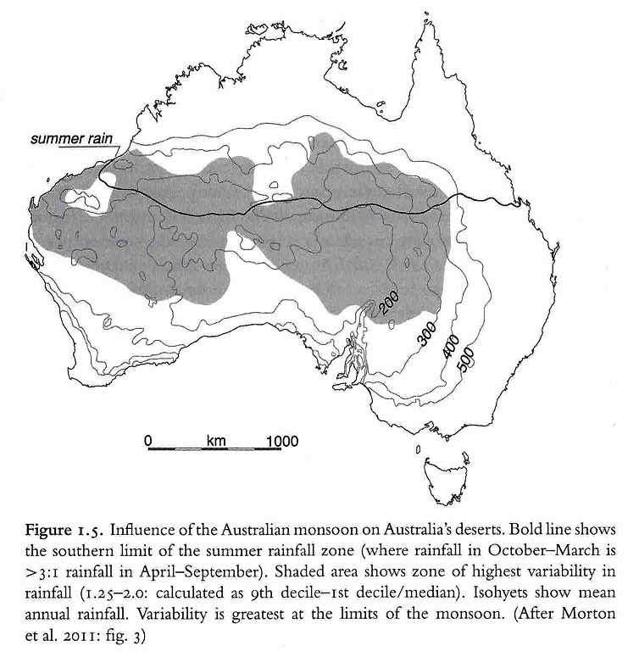

Map 3 Rainfall variability (from Smith 2013: 9 Fig 1.5)

Variability, unpredictability and extremes
Stereotypes of ‘the desert’ conjure up a picture of a vast homogeneous field of sand-dunes. However, ‘one of the surprising characteristics of deserts is their environmental diversity’ (Hiscock and Wallis 2005: 34). Each desert presents a mosaic of differing physical geology, geography, soil fertility, rainfall patterns, drainage patterns and forms of permanent water, which in turn set up diverse arrays of vegetation and animal distributions, and diversity in terms of history of the interaction of people with specific deserts through time.

A distinctive feature of Australian deserts is their extreme variability in rainfall. The arid zone is best understood in terms of extremes rather than averages. Rainfall is erratic, variable, unpredictable and unreliable, especially in the south (see Map 3), whereas evaporation rates are relentlessly high. Temperatures also vary hugely, from 47°+ to -5°C (Alice Springs data). On any one day there is a marked diurnal variation in temperature. There are long droughts and extensive floods.

This variability and unpredictability has both spatial and temporal dimensions: at different times the same place can present very different prospects. For example, Baldwin Spencer draws a detailed word picture of the contrast in the country near Charlotte Waters when he visited in the dry season
after drought in 1894, when ‘everything was parched and silent with no sign of animal life’ and then again in 1895 after heavy rain when ‘everything was green and bright and teeming with life’. ‘The whole change from sterility to exuberant life had taken place as if by magic within the space of only a few days’ (Spencer 1896: 17-18, 22).

While big rains are rare, they structure the characteristics of the environment, not only filling the water-retaining claypans, waterholes and playa lakes in the region of the fall, and triggering plant growth directly, but recharging the aquifers and sub-surface flows, so allowing a greater standing biomass of perennial plants than might otherwise be predicted (Stafford Smith and Morton 1990: 261).

All who live in the deserts must find ways of dealing with, adapting to, or avoiding, these extremes.

Forms of water
The forms in which water occur in the desert are rainfall, (northern monsoonal rains, which generate received water flows into the arid zone, are somewhat more reliable than the southern winter rains), ephemeral and permanent surface waters, sub-surface or sub-artesian soakages and wells, and deep artesian waters. The forms of water availability primarily reflect the regional geology and geomorphology. The combination of these generates the patterns of land use and occupation of the desert. Bayley (1999) provides a detailed study of Indigenous waters sources and knowledge of their use.

The key recognised forms in which water occurs in the Australian arid zone, together with the sources of the water are:

Table 3 Forms of water in the Australian arid zone
FORM |  | SOURCE/TYPE
Water absent (condition of aridity) |  | Water accessed by importation, storage or drilling, or pumping technology
Rain (northern zone of strongly summer monsoonal rainfall, and southern zone of non-seasonal and unpredictable rain) |  | Rain – direct and recieved
Claypans (ephemeral storage) |  | Rain - direct
Rock holes (more permanent storage including gnamma holes) |  | Rain - direct
Desert rivers (generally chains of waterholes) |  | Rain – direct and received and/or shallow groundwater
Soakages and waterholes |  | Shallow groundwater
Wells (including ‘native wells’) |  | Shallow groundwater and/or sub-artesian basin, windmills
Springs |  | Shallow groundwater and/or sub-artesian basin
Mound springs |  | Artesian basin (natural pressure waters)
Bores |  | Artesian basin

d) Vast scale, with long distances between patchily distributed resources
Australia’s arid areas are old landscapes, tectonically stable, highly weathered over eons so that the rugged ranges are worn down low, which affects rainfall and drainage patterns. Soils are leached and their infertility is a dominant feature of the ecology and potential land use (Woinarski et al 2014: 60). [See Map 4]. The combination of unpredictable water, poor soils and patchily distributed resources have always and continue to contribute to low population densities and remoteness, despite improved transport, communication and access (see Map 5 for mapping of comparative remoteness and Map 6 for a contemporary picture of population density).

The 21st century occupation of the arid zone, based on available demographic information, shows that 574,000 people were living in the arid and semi-arid zone of Australia in 2009; about 2.5% of the total Australian population. About half of these people were in regional service and mining centres, such as Kalgoorlie, Alice Springs, Mount Isa and Broken Hill, with populations of 10-30,000 each. A relatively high proportion of the Indigenous population live in these regional and remote areas (about 32%).

Population estimates for pre-colonial life in the desert vary, with a range from 1 person per 90-200km² in the sandy deserts to 1 per 13km² in the well-watered central ranges, 1 per 50km² in other uplands (Smith 2013: 10) to a highest density of 1/ 8km2 in the eastern rivers (W Jones 1979: 138 cited Smith 2013: 298).

The term ‘sparselands’ was used by geographer John Holmes in 1988 to characterise the qualities of Australia’s thinly populated arid zone. There is a clear inter-relationship between the character of the desert landscape leading to a sparsely distributed population. Sparse, remote populations in turn make regulation of economic production unpredictable. This feeds into a repeated history of abandonment of places that is a feature of historic arid zone settlements – ‘resources are so lean, degradation happens quickly once you have extracted what you can from a rich patch’ (M.A. Smith pers comm 14 June 2016). This in turn contributes to further population sparseness. Ecologist Mark Stafford Smith describes this as the ‘desert syndrome’ (2008). A ‘major historical dynamic’ of Indigenous people during drought, and in the most arid periods of the Quaternary, is also periodic abandonment of the most marginal parts of the arid zone, with reoccupation of the area when conditions ameliorate (Smith 2013: 110).

The link between unpredictable rainfall, patchy resource distribution and low population means that distance and ways to deal with it are an integral part of people’s life in the desert, necessarily involving movement, an extensive social network and forms of communication that can operate over distance, to overcome the isolation of ‘sparseness’. This puts a high premium on connectivity in the form of mobility and communication.

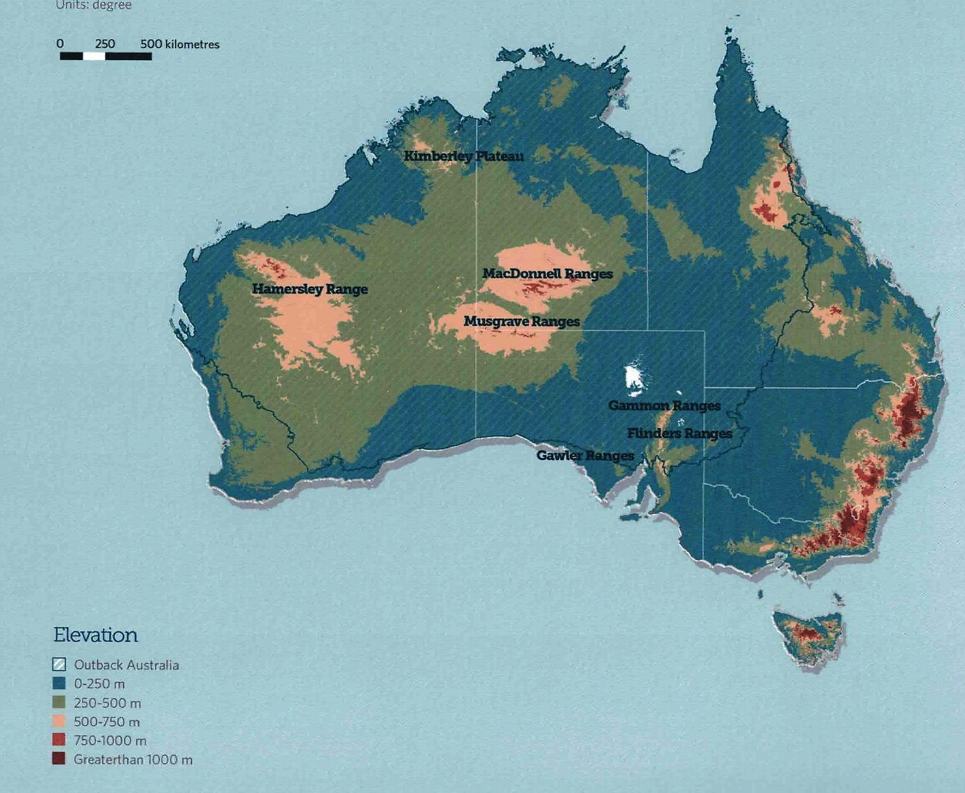

Map 4 Land forms - elevation (from Woinarski et al 2014: 62)

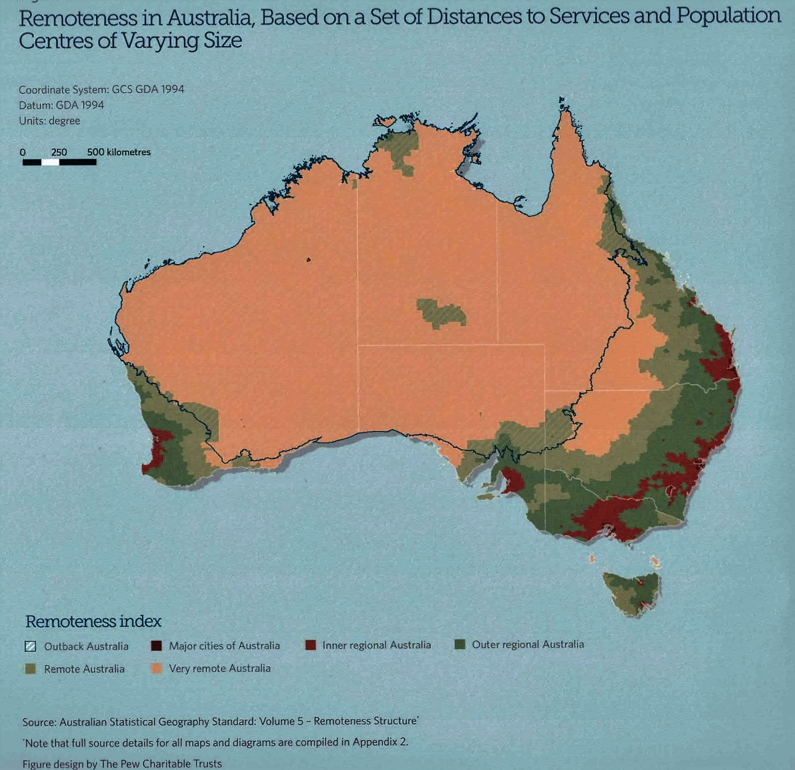
Map 5 Remoteness (from Woinarski et al 2014: 8)

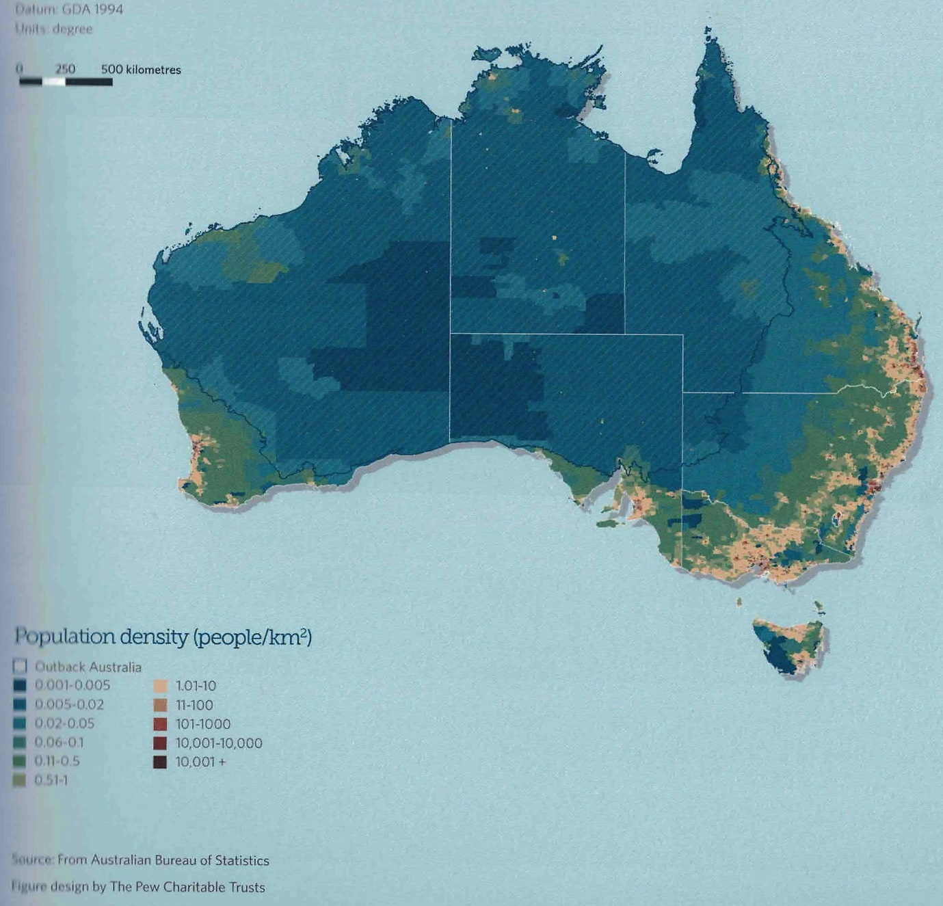
Map 6 Population density (from Woinarski et al 2014: 133)

A history of rangeland pastoral landuse
The term ‘rangelands’ defines the arid and semi-arid lands in terms of their potential use for pastoralism. Pastoralism is the use of land to run cattle or sheep on the vegetation that is present, although efforts to ‘improve’ these conditions through tree clearing, importing grasses, adding water sources, controlling competing animals such as dingoes and rabbits and controlling the fire regime are features of pastoral land management (Woinarski et al 2014: 173). The Australian rangelands are characterised by aridity, climate variability, poor soils and short growing seasons, with topography unsuitable for cropping/agriculture, but sufficiently fertile and wet for pastoralism. They include spinifex, mulga woodlands, and saltbush and bluebush shrublands (Bastin 2008).

Would-be pastoralists took up land leases for stock immediately the first European explorers reported accessible watered routes into the semi-arid and arid lands from the 1840s on (see table 3.1).

3.2 A contextual thematic history of the Australian Deserts: interactions of people, deserts and waters through time

Introduction
In order to ‘understand the cultural heritage significance of Australian deserts, as limited by the sub-theme of water’, as set out in the project Terms of Reference, this contextual thematic essay will show people’s responses through time to the characteristic qualities of Australian arid zone environments and associated waters. To do so highlights qualities of people’s lives in the desert that are significant and distinctive. Places that demonstrate these cultural responses well then emerge as those that are important in the cultural heritage of the Australian Deserts. These are compared with any other similar places.

The essay is structured around the four contextual themes that delineate distinctive features of human life in the deserts, described in section 2.2.1. Forms of arid zone waters and their usage are examined first to provide the underlying necessary environmental and historical context. A chronological overview of the important events making up the long term history of the arid zone is given in table 3.1. There are no existing syntheses of the deep time, colonial and recent histories of the arid zone, so this essay attempts to bring together a large body of information and interpretation under these contextual themes.

In addition, important aspects of the history of deserts that fall outside the parameters of this study are referred to (section 3.6), so that their contribution to the overall heritage of the arid zone is retained.

3.2.1 Waters of the Australian deserts
The scarce waters that do exist in deserts shape the lives that can be lived there: understanding life in the arid zone requires a close examination of the forms of water available to people there, how that availability has changed, and how this has shaped people’s lives and land use within the Australian arid zone. The specific forms of people’s interactions with those waters, and how they deal with their variability and unpredictability, are keys to understanding the histories of the region.
This examination leads to a nuanced understanding of water in the desert, capturing the full range of cultural values that are implicated. This component of the thematic essay sets out the characteristics of desert waters that inform the study’s ‘water indicators’ and the study’s four contextual themes.

3.2.1.1 Cultural meanings of water places: ‘not just water’
At a basic level it is obvious that water is vital for life, and especially so in a desert, but this very obviousness can lull us into thinking that we know what water is in all contexts: a practical necessity, a universal resource, with all water the same. Ecologically, the form of water affects its capacity to support life – eg a lake has a different and possibly poorer ecological value than a dispersed network of springs and soakages, as these give access to a wider swathe of country. Further, a generalised notion of water excludes the many, nuanced cultural meanings of water (See Ah Chee 2002, Rose 2004; Strang 1997, 2005; Toussaint, Sullivan and Yu 2005; Gibbs 2006, 2010, 2013, Macfarlane 2005, James 2006, Silcock 2010). A de-contextualised notion of ‘a water source’ as a neutral point in the landscape assumes that people’s relationship to water is a biological one solely, not one mediated through learnt cultural knowledge, inculcated in people’s understandings as they grow up involved in the world around them. Water places accrete personal histories, stories of the traditional Ancestors, and objects, as people interact with them. These distinguish each water-place from all others. ‘Each well means something: they are not ‘just water’ (Hercus and Clark 1986: 62).

We know that water will be a key focus for people’s actions in the desert. We can ask more involved questions than just whether or not water is present. What form does it take? What aspects of water
do people pay attention to, value? What expectations do they have of it? What stories do they tell of it? What are their practices in acquiring, maintaining and using it? In other words, what are their various cultures of relationship to water. These are discussed below.

Fig 3.1 Irrwanyere Ranger Dean Ah Chee’s drawing of the living Rainbow Serpent in Rainbow Spring, from which fresh water cannot be taken, used on the interpretation sign at the Irrwanyere spring camp ground, 2007.

3.2.1.2 Specialised desert water forms

Rain
Rainfall can be either direct rain or received rain, that is rain that falls at a distance and flows into the desert, such as the monsoons of northern Australia. Neither form of rainfall in the arid zone follows seasonally predictable patterns, so availability of surface waters is patchy, variable and unpredictable. For this reason time becomes a critical element in living strategically with the way desert water behaves – this is what makes it distinct from the water of temperate areas. Outside deserts, a thirsty person concerns themselves with where a body of water is located, not how long it will last. The majority of desert water is covert, not found on the surface but largely below ground. Surface water that does not evaporate percolates underground to form ground water.

Importantly, rain water is also stored and made available indirectly through the wild grains that spring up following rain, which in late Holocene desert life were exploited through the special technology of grinding stones (see 3.5.4 below), and by grazing stock for colonial pastoralists.

Soakages and waterholes
A relatively shallow sand mantle 1-10 m thick in Australian deserts generates a network of small wells and soakages that the 100-200 m deep South African Kalihari sand preludes (Smith and Hesse 2005: 6). ‘Native wells’ were formed by digging access holes into these below-ground soakages in ‘gum creeks’ (ie the better supplied watercourses that support coolibah eucalypts), in wide river beds such as the Finke, and in aquifers on the edge of some sand dunes. ‘The distribution of watering points (‘patches’) determines the parts of the desert landscape (the ‘matrix’) that people can reach and where and when they can harvest available resources, whether these be stone, ochre, plant foods or game’ (Smith 2005: 94). No one of these water places could support permanent occupation. They did so only as a network linked through people’s movement and knowledge of where there was available water, around which the Indigenous people organised their lives.

Mike Smith (1989) points out that the presence of permanent water is not sufficient in itself to sustain occupation. It is the density of water sources that are accessible that counts, and the resource base which they support. So while permanent wells were refuges that enabled people to continue living in an area rather than abandoning it in times of drought, they would soon exhaust the food supplies in the vicinity of the water. They would move between springs or wells, and when drought was over, would disperse to take advantage of other sources, and to allow the food sources in the refuges to regenerate (Hiscock 2008: 204). They monitored how many people had used the water place previously, and for how long. Big gatherings happened when there was the water to support them (Kimber and Smith 1987}.

Intimate systems of knowledge broadened the bases of water supply available, such as using roots of water-bearing plants, water-storing frogs, and macropod skin waterbags. In some areas, people also physically modified water storages to increase their capacity by building dams and enlarging rock holes.

Dams
The extreme arid conditions near Ooldea led to a rare form of water management in the form of clay dams built to capture and retain water. These are well documented by Edward Giles in 1875, and by Richard Maurice, who travelled in 1896 and 1900 with his team of camels and local Aboriginal friends and guides in the country north of the Nullarbor Plain to the Everard Ranges and to the WA border (Gara 1989). Tom Gara (1989) describes them:

These dams were usually low, semi-circular walls of clay, sometimes interlaced with boughs and foliage, constructed on claypans or other suitable depressions (Bates Australasian 27/8/1921). Giles discovered two such features, one at Pylebung, about 90 km south-east of Ooldea, and the other, which he named Boundary Dam, in the Forrest Lakes just over the border in Western Australia. Giles described Pylebung as: ‘a circular wall or dam of clay, nearly live feet high, with a segment open to the south to admit and retain the rain-water that occasionally flows over the flat into this artificial receptacle. This piece of work was two feet thick on the top of the wall, twenty yards in the length of its sweep, and at the bottom, where the water lodged, the embankment was nearly five feet thick. The clay of which this dam was composed had been dug out of the hole in which the water lay, with small native wooden shovels, and piled up to its present dimensions’ (Giles 1889: vol 2: 92-3).

In 1875 Tietkins discovered a dam at Arndinga, near Lake Maurice, (Giles 1889: Vol 11: 159) and during his explorations four years later he found another small dam called Winderabbi somewhere north-west of Punthanna (Tietkins 1961: 28). Maurice found a number of dams during his travels in the desert, including Midgening, about midway between Lake Maurice and the state border, Chilbinga, about 40 km south-east of Midgening, Paraminna, about 120 km north of Ooldea, and Minindoo, about 10 km north-west of Ooldabinna. Maurice also visited Boundary Dam on two occasions. …

… During his 1904 prospecting expedition George saw four dams. He described Arndinga, first found by Tietkins, as ‘elliptical in shape, 23 ft long, 18 ft wide on waterline, and from 12 in. to 18 in. deep.’ The three other dams were Waribinga, a small dam north-east of Lake Wyola, Koolkoona, on the western side of Lake Wyola, and Midgening (George 1905: 2-3).

Dams are also recorded in the Simpson Desert, where Wankangurru people prolonged the supply of water by building dams across deeper claypans to retain water (Hercus 1990: 154, Kimber 1986).

Rock holes
Major permanent waters in the central deserts are stored in the gorges and clefts of sandstone uplands. Mike Smith (pers comm May 2016) says these are the richest resource centres of the arid zone, barring the eastern arid rivers. The sequence of Bagots Springs, Kings Canyon, Rainbow Valley, James Range east, along the southern flank of the James Range is a good example. Similarly, in the northern Tanami and Great Sandy Deserts, mesas and escarpments that contain gorges, creeks and rockholes provide the primary supply of potable water and are thus the nuclei of traditional human settlement (Cane 1989, 2008). In the west are the major uplands of the Pilbara, with accompanying significant waterholes. This is part of the model of the arid zone developed by Peter Veth (1989) that sees the relatively well-watered major uplands of the Central ranges, the Pilbara, Flinders Ranges as refuges for people during the extremely arid period of the Glacial Maximum, and the sandy deserts as barriers to occupation at that time.

Granite outcrops collect water in naturally formed pools which were expanded and cleaned by Aboriginal people. Bayley (1999) has assembled explorers’ descriptions of these water places. In Western Australia these are termed ‘gnamma holes’ (Bindon 1997). In the Nullarbor, recording of the rock holes shows their extent and their interconnectedness through Ancestral paths and people’s paths. The importance of the Ooldea ‘water route’ is shown:

Rock hole | Association | Path to…
Yanguna | Eaglehawk (Walawuru) | Ooldea
Euria | Eaglehawk | Ooldea
Midgerie | Eaglehawk | Ooldea
Tallacootra | Two men (wadi kutjara) | Ooldea
Pidinga | Wanampi snake | Itself
Whitegin | Seven sisters
Kooniba | Eaglehawk & seven sisters
Inila | Eaglehawk & seven sisters
Yumbarra | Eaglehawk & seven sisters
Dinah | Seven sisters
Bulgana & Tjurdiya | Seven sisters | Oolabinna
Yellabinna & Oolabinna | Two women (Minyma Kutjara)
OTC | Eaglehawk | Euria, Koonibba
Kalanbi Gate | Eaglehawk | Euria
Eagle | Eaglehawk | Euria
Nalara | Seven sisters | Ooldea
Meelera | Two women, carpet snake (Kurnya)

Source: Nicholson, A, 1999, Iwari Kapa:
Rock waters of the Ceduna Area. Unpublished report to NEGP

Rivers and lakes
Classic arid rivers are mostly dry channels with saline groundwater outcropping in places, periodically reactivated during ‘boom’ years when they carry floodwaters from far-away uplands (the Macdonnell Ranges for the Finke, the northern monsoon for Coopers Creek and Warburton River Smith 2013: 68-9).

The Finke River
The Finke River is called Larapinta in Arrernte. An ancient river channel, it is the largest river entirely within the central deserts, its headwaters in the Macdonnell Ranges, running east until it turns a right-angle as it hits the mass of NNW-SSE oriented Simpson Desert sand ridges and runs out into the dunes. The Arkaya story of the Ancestral Kestrel hunting of the two Rainbow Serpents or ‘Stranger Snakes with the pretty markings’, gives the history of the formation of the Lower Finke River, well documented by Hercus and Potezny (1993). Semi-permanent waterholes here are important ritual centres associated with complex stone arrangements (Mountford and Campbell 1939, Hercus and Clark 1986: 52; Hercus 1989: 104). When the river flows, any sediments suspended in the water are deposited in this floodout area, enhancing its nutrient levels as well as its moisture. It thus provides a biological refuge in dry times, with enhanced levels of water, nutrients and food, which supports a high diversity of vegetation and fauna, a rich resource for Indigenous people, especially relative to the surroundings, and a focus for cattle stations since the Overland Telegraph Line was surveyed in 1871.

The Hermannsburg mission (Ntalia) was established near the Finke headwaters, and the landscape and history of the river is evoked in TGH Strehlow’s Journey to Horseshoe Bend (1969). Finke Gorge National Park including Palm Valley, Running Waters and Boggy Hole are also all important water sites on the course of the river (ALEC submission May 2016 Appendix 3).

Kati Thanda - Lake Eyre
Lake Eyre is the most arid part of Australia and the lowest point (16m below sea level) on the continent. It is the largest internally draining basin in Australia and one of the largest in the world (Kotwicki 1986: 4 cited by Gibbs 2006). It is rain in northern Australia, outside the arid zone, that flows slowly over 1000km inland to the Georgina-Diamantina-Warburton and Thomson-Barcoo-Cooper channels and eventually into Lake Eyre, Kati Thanda in Dieri. This adds yet another layer of variability in addition to local fluctuations in rainfall (Smith 2013: 57).

Below Windorah, Cooper Creek leaves its confined banks to open out into the ‘Channel
Country’, in places expanding to form semi- or permanent waterholes of 100m to over 20km long (Knighton & Nanson 2002: 1772). The Channel Country is now highly valued cattle grazing country, owned by grazing companies including Kidman Holdings.

Near Innamincka, a narrow constriction known locally as ‘the Choke’ has scoured Cullyamurra Waterhole, 7km long and up to 30 m deep which has not been dry in European history (Gibbs 2006). It is highly valued by the local people (see submission Appendix 3). It is included in the description of the Burke, Wills, King and Yandruwandha National Heritage Place.

Paruku - Lake Gregory
In an analogue with the Willandra Lakes, the massive inland Paraku Lake forms between the Tanami and Great Sandy Deserts when Sturt Creek flows from the north. Its surrounding dune sediments have provided a long term history of environmental change in these deserts, investigated by Jim Bowler, who discovered the first burial sites at Lake Mungo. An artefact excavated from these sediments dates to 45-50ka (Bowdler 2013).
Paruku is Walmajarri land, declared an Indigenous Protected Area. The Indigenous cultural values of this area have been vividly documented in the multi-disciplinary project presented in Desert Lake: art, science and stories from Paruku (2013 eds Morton, Martin, Mahood, Carty).

The Great Artesian Basin - mound springs or ‘pressure water’
The deepest layer of water in the arid and semiarid country is the ancient water of the Great Artesian Basin. It underlies about one fifth of mainland Australia, mainly under arid or semiarid country. Artesian springs or ‘pressure water’ are natural fractures in the rock cover through which the water escapes under pressure, often heated by the depth at which it lies underground. Mound springs are a particular form of pressure water,found only in the Lake Eyre artesian springs. Deposits of carbonate, sand, silt and clay form a raised mound up to 8 m in height and up to 30 m in diameter. A typical mound consists of a central pool of water, an outer rim of reeds and vegetation, an outflow channel and wetland. Prior to the 1870s, there were roughly 3,000 flowing springs around the Great Artesian Basin, in Queensland, NSW and SA (Blake and Clark 2006). Elizabeth Springs and Witjera-Dalhousie Springs are listed on the NHL for their natural values.

‘Sinking down, deeper down’: Bores and windmills
Meeting the high water demands of incomers’ stock animals was a major driver for changing the water regime of the deserts. The small-scale waters relied on by pre-colonial Aboriginal people were too small to support stock, and were degraded by stock use or in-filled with lack of people’s regular maintenance. Once they were identified by pastoralists, artesian springs were first used unaltered, then via increasingly deeply-drilled bores to establish reliable and more evenly distributed water supplies in the arid zone. Artesian waters were familiar in Europe, Asia and the US, and the specialist drilling technology to ‘dig deeper’ to access them was developed there in the mid nineteenth century (Blake and Cook 2006: 5). The first successful artesian bore is considered to be at Kallana (Pearson and Lennon 2010: 101) or Killara Station (Blake and Cook 2006: 12), north of Tilpa on the Darling River in 1878/9, with another early example at Anna Creek in 1881. These were relatively shallow with moderate flows, but in 1886-7 the first deep bore was drilled at Kembree station near Bourke, producing high flows (Pearson and Lennon 2010: 101) and in 1886 at Thurulgoonia Station near Cunnamulla (Blake and Cook 13-14). Tourists came to view the spectacle of the vast flow of water. The expense and difficulty of drilling required government support. Banjo Patterson’s poem ‘The Song of the Artesian Water’ (1896) captures the urgency and determination to extend the availability of bore water, as well as the effort and technology involved – ‘If the Lord won't send us water, oh, we'll get it from the devil; Yes, we'll get it from the devil deeper down.’

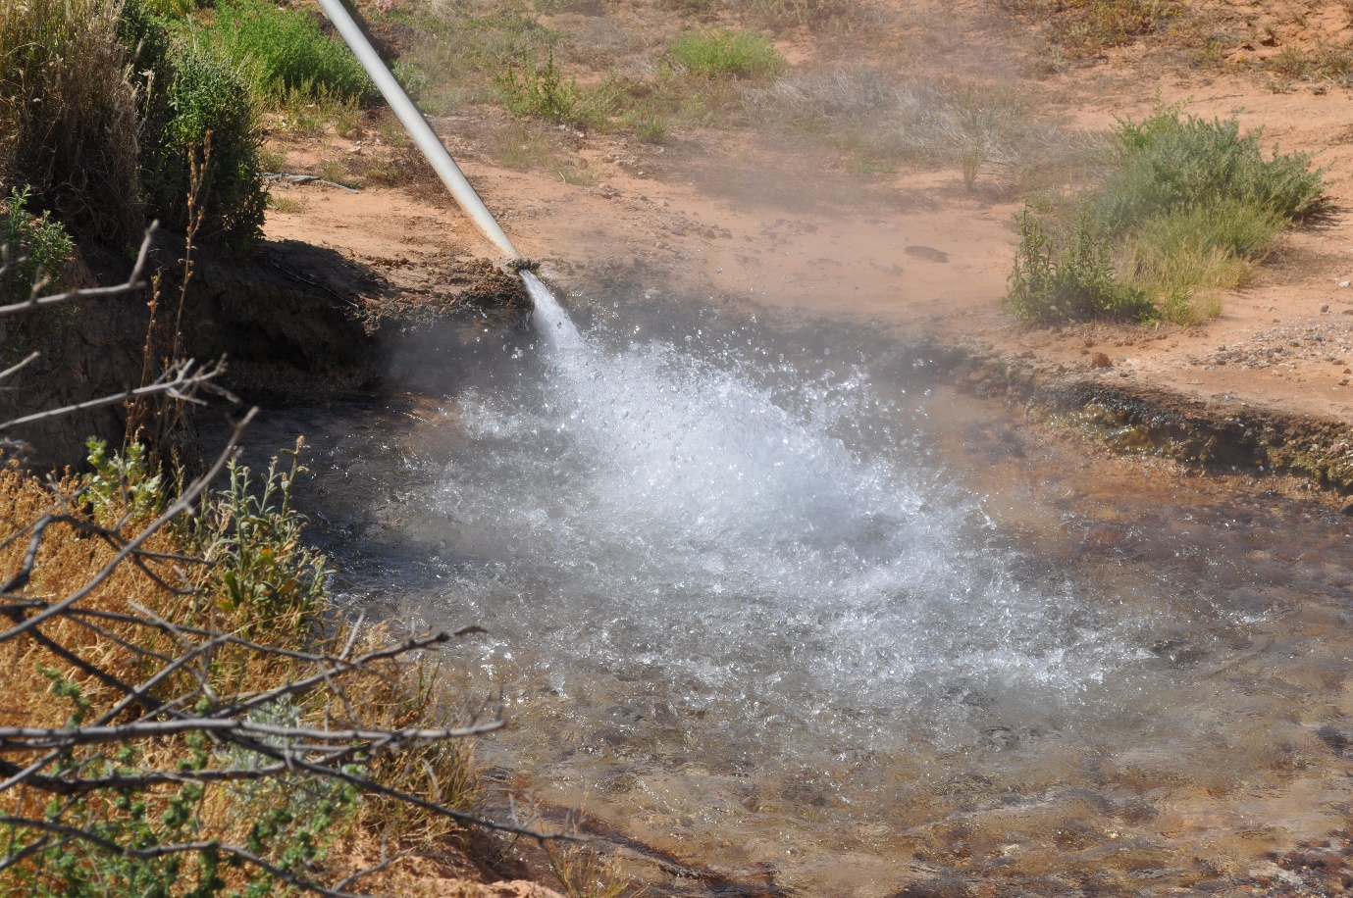
Fig 3 Open Artesian bore flowing, Carcory station, abandoned by Kidman 1906 (Birdsville track 2015)

In an artesian bore, the high pressure within the aquifer brings water to the surface, but shallower sub-artesian bores require a pump. Artesian bores could become sub-artesian as water pressure dropped after drilling. The iconic structure of a windmill became a part of the rangeland landscape after the production of windmills began in the 1870s. These were locally manufactured along with other essential equipment for stock (Pearson and Lennon 2010: 44).

The amount of water that could be obtained depended on the drill rig’s capacity and then on constant maintenance to keep them running. The number of bores increased rapidly. Not understanding the source of artesian water precisely, soon too much water was extracted and flows decreased, and about a third of the springs stopped flowing, with reduced flows for the remainder. Open flowing bores were capped.

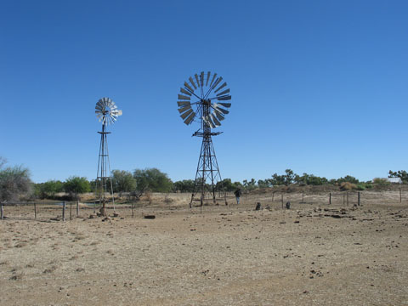

Fig 4 1920s Simplex Windmill at Kenya Station (now part of the collection of the
National Museum of Australia). See website for a history of windmills in Australia http://www.nma.gov.au/collections/highlights/kenya-station-windmill

Another part of the iconic stock-handling equipment is the ‘broncho rail’ (figure 3). Darrell Lewis (2007) describes the development of ‘bronchoing’ using these rails in the late nineteenth century - a way of roping cattle for branding initially in the open without stockyards. This was a local adaptation of American techniques that was suited to the vast area of Australian cattle stations and the low density of stock they supported.

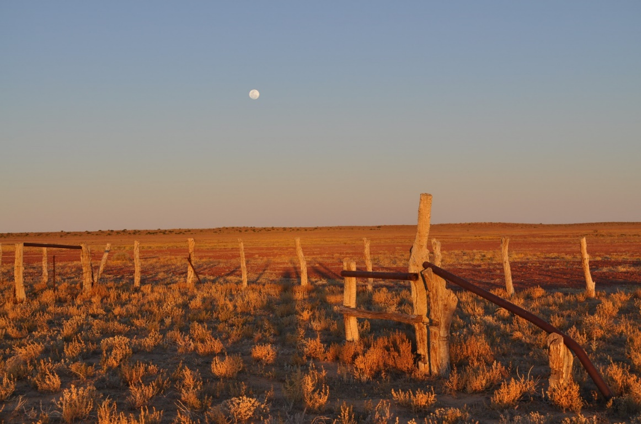

Fig 5 Stock yard, showing ‘brocho rail’, Birdsville Track 2015

Impacts of the bores on Indigenous access to water and country
How did all these new water points affect Indigenous people’s relations with their country? Often the deeper stock wells were extensions of existing soakages or wells, which were then lost to local Aboriginal people, as in the Canning Stock Route. However, on many stations, the network of new watering points provided by bores unintentionally replicated the pre-existing pattern of known water points and people’s flexible movement between them. The well-established practices and knowledge of Indigenous people provided the insight and labour that kept the cattle industry running in a way that allowed them to continue to live on country (see eg McGrath 1987) but was frequently exploitative (see Pilbara strike below).

Section 3.1 Conclusion
The discussion of the forms of water in the deserts above leads into and informs the themes that follow. Form, distribution and availability of water, or its lack, has two kinds of influence: direct and structural. Both of these are important in capturing the essence of the influence of water and aridity on human life in the deserts. Direct choices are, for example, the choice of location of a camp near a minor water supply, or a station near reliable spring water, or the importation of the desert-adapted transport-animal, the camel. Structural influences of unpredictable and variable water availability lead to the characteristically patchy distribution of resources and correspondingly low, dispersed population and the ‘sparseness’ of occupation described in section 3.5.3. These choices and influences relating to water are discussed in regard to the themes below.

3.2.2 Theme: ‘Learning how to live in the arid zone’
The Theme ‘Learning how to live in the arid zone’ captures human adaptations to the key desert physical qualities of aridity, variability, unpredictability and extremes, through time.

- Excavated archaeological sites
- Indigenous occupation sites and water places
- Early European explorers’ routes
Historic settlements based on particular water places

The inescapable aspect of water in the arid zone is aridity, or lack of water, with transient richness. Acceptance of drought as the norm rather than the exception, and understanding how to deal with the inherent variability and unpredictability of water availability has been one of the crucial aspects of people’s learning how to live successfully in the arid zone, 45-50,000 years ago into the present for Aboriginal peoples, and from the 19th century onwards for non-Aboriginal peoples.

3.2.2.1 Earliest occupation of the Australian deserts
At the time of the earliest recorded occupation of the Australian supercontinent at approximately 55,000 years ago, the deserts were already well established, considered to have been slightly larger in extent than today (Smith 2013: 68, 76). By 45-50,000 years ago, people were occupying parts of the arid zone and adapting to the conditions there. Thus it is a significant feature of the story of human occupation of the Australian continent that the early hunter-gatherers adapted to these conditions in parts of the then arid zone almost as soon as they reached it. This was at the same time that other hallmarks of modern human behaviour such as the use of ochre, making ornaments, making sea crossings become visible as parts of the modern human repertoire (Smith 2013: 106). Learning to live in arid lands was part of the story of the earliest human occupation of the continent.

There are 25 dates in the Australian deserts dated at 30-50ka (Smith 2013: 79-80 and map p73, plus the recently published 49ka date for Warratyi [Hamm et al 2016]). These Pleistocene arid zone sites excavated in the last 25 years are gradually contributing to a much more complex picture of early occupation in the six different regions of the desert. Carpenters Gap in the West Kimberley (National Heritage listed) had the oldest basal date at 44-48ka, now exceeded by the basal dates at Warratyi of 49ka (Hamm et al 2016). The Willandra Lakes (NH listed), outside the current boundary of the arid zone, are also dated to c50ka. Paraku (Lake Gregory) parallels the formation of the Willandra Lakes within the current arid zone, with similar paleo-lake dunes and lake bed. These have been investigated by Jim Bowler (2013). An excavated artefact in fluvial desposits near the lake has been dated at 45-50ka (Bowler 2013: 39, Veth et al 2009). Comparisons between excavated sequences show changes in occupation patterns relating to the climatic shifts over time, especially through the Last Glacial Maximum (LGM), the end of the glacial period through to the late Holocene and development of distinctive desert adaptations.

While each archaeological site has its own signal and character, interpretation of any one archaeological site requires comparison with all others of similar age depth and locale in order to see the patterns. It is considered that because they are each distinct and yet require consideration as a comparative group for interpretation, an approach to comparison is to establish a deep time archaeological sequence that can represent not only its own value, but the values of the other sites. Further sites of great significance may be found in the future, as demonstrated by the publication of the results from Warratyi (Hamm et al 2016) and recent new dates for Serpents Glen (Peter Veth pers comm 12/12/16). Sites that have historical status in the history of archaeology in Australia as well as significant archaeological content are also of key importance.

Puritjarra
Puritjarra, while not the oldest dated site, is outstanding due to its principal role in the history of archaeological understanding of patterns of Australian desert occupation. It was the first archaeological site excavated and dated which showed occupation in the heart of the arid zone at the glacial maximum (Smith 1987). This, combined with the exhaustive study of the site’s many facets – stone artefacts, rock art, ochre, vegetation (phytoliths and carbonised plant remains), colonial history, contemporary connection – based on excavations from 1986 to 1990 by Australian archaeologist Mike Smith, place the site centrally in the history of archaeological understanding of Australia.

Puritjarra is a large rockshelter located west of the MacDonnell Ranges, in the Cleland Hills, an outlier range which intersects with the sand desert. It is close to the permanent water of the Muantji rockhole. The sediments in the Puritjarra rock shelter contain evidence for human occupation from 35000 years ago through to the recent past. In the earliest phases, highly mobile people were using a ‘point-to-point strategy’, making use of a network of small semi-permanent springs and wells spaced about 25-30km apart that allowed people to range over a wide area, even during the highly arid last glacial maximum. Ochre was brought in from the Karrku mine in the Campbell Range, 125 km northwest ‘across a formidable dune field’ (Smith & Frankhauser 2009). White chalcedony/chert from Puli Tjukura quarry (approx. 50km northeast) was also brought to the shelter. In the less constrained conditions after 22,000 years ago, people stayed longer in the shelter, became more territorially-based, particularly around the permanent water of Murantji rockhole (Smith 2013: 135-6). Rock engravings were carved and pigment paintings and stencils were made. Direct dating has proved difficult by oxalate skin analysis, but Smith suggests a date of 5ka for the engravings, perhaps starting around 8ka. The art is both secular and sacred, with a long pigment art frieze which includes 279 hand stencils and 47 hand prints of both children and adults, plus long macropod tracks and totemic designs.

Also in the ‘Cleland Hills deep time cultural landscape’ are a number of other important sites. Tjungupu or Tarn of Auber, 30k from Puritjarra, is a cleft in the rock with semi-permanent water, with rock engravings, pigment art and grinding grooves, which was visited by Ernest Giles and then many other European exploring parties following his route. At the southern end of the range at Kaltara, Gill Creek there is a shady gorge with a series of paintings of horse in white ochre– possibly of the explorer Giles (Smith 2005: 18-19). At the northern end of the Cleland Hills, 16 km from Puritjarra is Alalya or Thomas Reservoir, where there are rock engravings of ‘archaic faces’, found through the western desert area.

Puritjarra is also of interest in that it has been the subject of a collaborative environmental art project that incorporates the perspectives of scholars of archaeology, ecology, environmental history, and the history of science as well as those of contemporary artists (Mandy Martin, Libby Robin and Mike Smith, eds 2005 Strata: Deserts Past, Present and Future. An Environmental Art Project about a Significant Cultural Place).

Serpents Glen
The longest known record of occupation in the Western Desert is from Serpents Glen, a large rockshelter in a valley in the Carnarvon Range, on the edge of the Little Sandy Desert. There are major permanent sources of water nearby. These encouraged repeated visits, the earliest of which have recently been dated at c. 50,000 (pers comm Prof Peter Veth 12/12/16). It was then abandoned – there is a clear unoccupied layer – and not re-occupied until about 5ka (O’Connor et al 1998 cited Smith 2013: 92). A large accumulation of seed grinding stones show that it was a favoured location in the recent past (Veth and O’Connor 1996). It has the only long archaeological sequence that can provide some information on the occupation of the sandy deserts during the
glacial maximum period of maximum aridity. Was it abandoned as part of a pattern of all lowland sandy deserts being abandoned at this time, or was it only this site? This is one of the key questions about occupation of the arid zone in the LGM – did people stay in upland refuges with networks of water available, as at Puritjarra, or did they move out to the desert margins. Smith (2013: 146) considers that there are not enough comparable sites similarly located and with as long sequences as Serpents Glen to be able to decide.

Koonalda cave
Koonalda cave is listed on the NHL under criterion A for ‘understanding of Pleistocene Australia, art, archaeology and occupation’. In a large limestone sinkhole in the Nullarbor Plain, 160km inland from the coast at the time of use 26.3-16.6ka, through the harsh LGM, it was then a refugia with permanent, if brackish, water. It was never lived in but was instead a special flint procurement place, associated with art production in the form of ‘finger flutings’ and incisions dated to 22ka, and possible stone arrangements. Use of the cave stops 12000 years ago. The site was an early excavation in the history of Australian archaeology and first demonstrated Pleistocene occupation of the southern margin of the arid zone. It contrasts with Puritjarra in that Puritjarra was a core central desert place used from 35ka to the present, and has been the subject of comprehensive dating and material analysis and historical studies that the material from Koonalda has not benefited from.

Warratyi rockshelter
The recently published results from the excavation at Warratyi rockshelter in the northern Flinders ranges, S.A. (Hamm et al 2016) demonstrate that our understandings of people’s lives in arid zone Pliestocene central Australia continue to emerge and are subject to ongoing refinement with further research. The findings from the excavation push back the dates for desert occupation and for use of particular technologies.

The excavated sequence from Warratyi rockshelter shows that people occupied the arid zone early in the course of occupation of Australia, 49000 years ago, and had the ‘technological sophistication’ to deal with the arid conditions of the centre. Hamm et al recovered the earliest known date for human occupation in the arid interior of Australia and the cultural evidence for the earliest known use in Australia of a bone point and backed artefacts, and the use of red ochre and gypsum as pigments. The site also preserves bone from Diprotodon optatum and eggshell of Genyornis newtoni. This is the only reliably dated, stratified record of extinct Australian megafauna alongside artefacts more than 46,000 years old. The site demonstrates how rapidly people learnt how to live in the conditions of the deserts following occupation of the continent. Given all this, it is plausible that the site will be considered for nomination to the National Heritage List when the findings have been subject to more study, especially comparative analysis.

3.2.2.2 European exploration and occupation
Desert life requires informed mobility, using the knowledge of water source locations as ‘stepping stones’ through the deserts. Often small, these permanent allowed long term Indigenous occupation, and also directed the routes of the explorers who successfully traversed the deserts by finding them. For example, John McDouall Stuart, with his first-through-the-Center single-minded pursuit of any water at all in order to keep his men and horses going, records all ‘gum creeks’ he sighted and the small native wells they harboured. The more scarce the water, the greater the impact of his party with their horses’ relatively great thirsts, draining the rare, fragile waters they found. For example:
Tuesday, 1st May, [1862] North-west Side of Mount Barkly. On examining the water, I find it is only a drainage from the rocks, and there is not more than two gallons for each horse. ... came upon a large gum creek … discovered a native well about four feet deep, in the east channel, close to a small hill of rocks. Cleared it out, and watered the horses with a quart pot, which took us long after dark - each horse drinking about ten gallons, and some of them more. Natives have been here lately, and from the tracks they seem to be numerous.
Stuart took the water as a right, with no concept of the disproportionate costs of his needs on the water supplies of the existing local people. In contrast, Alfred Giles, part of the first survey team for the Overland Telegraph Line, following Stuart’s track in 1870, expressed his awareness of the care the local people had taken to establish wells, and that his party’s presence was a threat to their precious water, maintained in an area where it was especially scarce:
We surprised a mob of blacks - five men, two or three women, and about a dozen piccaninnies - but their only water was a muddy claypan, and they had most ingeniously made the water to filter through sand by digging holes on the upper side of the claypan. … the fact of about a dozen blacks subsisting on so precarious a water supply proved beyond doubt its scarcity in their neighbourhood, and the hostile attitude in which they placed themselves can be attributed solely to that cause, and not to any hatred, but to guard their precious supply, which was threatened by an enormous animal and its rider which they had never previously looked upon.

The repeated pattern was for European explorers to follow Indigenous water routes, and pastoral grazing leases to follow rapidly on the explorers’ routes. For example, Dalhousie Springs and Owen Springs were both the earliest established station homesteads of their regions, immediate off-shoots of the survey of the Overland Telegraph line route, built in 1872 from local limestone, next to permanent artesian springs.

Competition for access to water sources was an inevitable component of the earliest interactions between local people and non-Indigenous incomers. Europeans imported a set of understandings and practices in relation to land and its waters that brought them, as colonisers, into direct conflict with Aboriginal people’s understandings of country and practices based on long term occupancy. Water as the scarcest resource in the arid zone becomes the site of the most bitter conflicts.

3.2.2.3 Holocene adaptations to desert conditions
The diversity of Indigenous cultures across arid Australia today appears to have begun to be established in the early Holocene, as people’s adaptations to local environments and conditions produced a wide range of cultural and economic expressions. The pattern of Holocene climatic change is complex and regional, but can be summarised as a change from more reliable water availability in the early Holocene to drier, less predictable surface water in the mid Holocene. The conditions then were not as harsh as in the LGM, but it was a severe deterioration from the early Holocene situation. There was a return to slightly more reliable water availability in the last 1000-2000 years (Hiscock 2008: 206; see Smith and Ross 2008).

There is much less archaeological information about the early Holocene than about the late Holocene. The general pattern seen is one of recolonization of deserts after the LGM, associated with population increase, spread of people into more areas of the deserts, more and larger sites established, and development of new inter-group economic and social networks (Smith 1993, 2005, Veth 1996, 2006, cited by Hiscock 2008:206-7). An increase in the number of grindstones
predominantly used for seed grinding is found in the late Holocene, about 2-1.5ka. This economic shift has been attributed to population increase, requiring the use of reliable but difficult to process grains to augment food sources (Smith 2005), with wetter conditions and more stable grassland environments, and expanded social networks (seen in long distance trade of goods and increasingly regionalised rock art production) and large meetings of people enabled by grain-based food supplies (Hiscock 2008: 209-10).

Amongst the earliest desert sites to be excavated was Puntatjarpa, which provides a sequence from the early to recent Holocene (as does Puritjarra, above).

Puntartjarpa
Puntatjarpa, near Warburton in the western desert, was excavated in 1967-70 by Richard Gould (1977). This was the first archaeological excavation in the western desert, a ‘pioneering exploratory dig’ (Smith 20113: 158). It is located in a rockshelter near a major soak, associated with the Ngintuka Ancestor (Smith 2013: 157). It was the largest excavation there has yet been in the arid zone, in one of the most remote sites - Smith (2013: 157) describes it as ‘audacious’ - and it is one of the best reported. It ’remains the richest mid-Holocene occupation deposit’ yet recorded in the arid zone and it shows the patterns of change in the arid zone mid-Holocene, ‘a crucial formative time in the desert’ (Smith 2013: 157-8). The basal date of 11.8ka is considered to document the time of expansion by people from the Central Australian Ranges into more marginal western desert country after the end of the glacial arid period.

On the basis of this archaeological sequence, Gould proposed that there was a long period of cultural and economic stability from the mid Holocene which he termed the ‘Australian Desert culture’. This was characterised as a distinctive desert adapted life: highly mobile, opportunistic to reduce risk, harvesting grain, using particular type of stone artefacts - hafted adzes and microliths (Smith 2013: 30-1). Gould proposed that there was 10,000 years of continuity through to the contemporary ethnographic desert culture, described as ‘dramatic cultural conservatism’ (1977: 182). This was influenced by north American models, which did not hold up under closer examination of the archaeological sequence as it showed the introduction of adzes and grinding stones. But the emphasis on the ancientness of an adapted desert occupation was, at that early stage in understanding the deep past of Australia, an important concept (Smith 2013: 31). Gould’s interpretation posed questions that needed answering – were there distinctive desert adaptations? Could these be traced in stone tool assemblages? The answers to these questions have been pursued in arid zone excavations ever since.

This archaeological site has been included in the Preliminary list because Gould’s research was carried out early in the development of understandings of the archaeological story of human life in the arid zone; it was well published and influential – a site interpretation that everyone afterwards had to contend with; the archaeological sequence captured some of the changes in Holocene desert occupations; and because Gould’s research contributed to ethno-archaeological studies, which were at a peak of interest globally at that time (Gould 1980, see Holdaway and Allen 2011 for a discussion of his approach). Also, Ian Dunlop filmed some of the same people near Warburton in his Desert People documentary.

3.2.2.4 Historic settlements based on particular water places
Several European settlements based directly on specifically selected water sources grew to be lasting regional centres, due in part to their available water sources, and in part to their development as nodes in transport networks. The iconic townships of Alice Springs (waterhole),
Marree (Hergott Springs), Bourke (bend in the Darling River) each had pivotal roles in shaping late 19th century life in central, southern and eastern parts of the arid zone respectively. The town of Alice grew from the telegraph line repeater station at Stuart, and in 1929 was the railhead of the ‘Ghan’ railway, Marree from the junction of the Oodnadatta and the Birdsville stock routes, and was the railhead from 1883, while Bourke was on the paddle steamer route on the Darling River and a Cobb & Co. Coach Terminus. All were also serviced by cameleer transport and had resident populations of so-called ‘Afghan’ cameleers and their families.

Cossack on the western arid coast was not based on a specific water source, but on its capacity as a port. It was a rare, early (1863) mixed pastoral and pearling regional centre with a markedly multi-ethnic population. Though pastoralism is generally thought of as an inland industry, the pastoral and maritime industries on this remote arid coast were co-dependent, as wool and stock had to be shipped from what became a 19th century international port. Alistair Patterson (in collaboration with others) has published widely on the archaeology and history of this area (2006, 2009, 2011, 2012, 2015). His work sees the Cossack area as an associative landscape which includes the Indigenous camps on the edges of the colonial pastoral and pearling stations, and colonial period rock art. This takes the understanding of these places beyond a focus on the township buildings.

3.2.3 Theme: Living in ‘sparselands’

- Cultural landscapes of particular environments/environment clusters
- Regional rock art complexes
- Songlines
- Water routes
- Trade routes
- Long distance transport routes
- Long distance communications routes
The Theme ‘Living in sparselands’ captures the characteristic of vastness, long distances and low population densities in Australian deserts and the need for mobility and communication.
This places included here demonstrate the structural influences of aridity and forms of water on people’s lives in the deserts.

Sparseness is not, however, the same as ‘empty’. Early exploration and land appropriation were based on assumptions of the arid and semi-arid zone deserts as unused, seen as offering great potential as rangelands ignoring the management of these lands through burning and selective harvesting (see Bruce Pascoe 2014 and map 7 Griffith Taylor’s 1926 ‘Habitability map’ of ‘the limits of land settlement’).

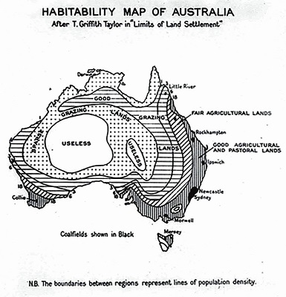
Map 7 Griffith Taylor 1926 (from Woinarski et al 2014 p 125)

3.3.3.1 Introduction: mobility and communication as characteristics of living in ‘sparselands’
Survival in the desert requires highly mobile strategies for acquiring adequate food and water, as these are patchily distributed, widely dispersed and subject to unpredictable fluctuations due to their dependency on unpredictable rainfall. This is in turn built into the social structures of arid zone adapted Indigenous people. Anthropologist TGH Strehlow summed this up: ‘the disciplinary measures of social control, the social obligations implicit in the intricate kinship terminology, and the whole system of territorial rights, were given their final shape by the challenges presented by the constant menace of recurring drought years’ (Strehlow 1965: 122). Desert cultures are described as having an ‘open’ structure, referred to as a ‘risk minimisation’ strategy, where there are accepted protocols for groups to move from an area of scarce water to a better watered area without transgressing boundaries. This movement is based on a network of kinship and ritual associations that is continually reinforced through reciprocal exchanges. This leads to a highly mobile social and ceremonial life, and also ensures that the practice of this high mobility can be successful (Hamilton 1987: 49).

Historian Minoru Hokari, working with Gurindji people in the Western Desert describes their ‘practice of everyday mobility’, as a ‘life of communicating with the country’: ‘their mobility is not for getting out of their home, but … for living in their home’ where ‘home’ is the massive sum of the component places that make up country, where family members live or have lived (Hokari 2001: 54-5).

Sailor and adventurer David Lewis, with a life-long interest in navigation, provides descriptions of way-finding by Aboriginal men in the Western Desert and in the western Simpson area (Lewis 1976). He travelled through this country with Aboriginal Elders in the early 1970s, making observations about the foundations of their profound locational competencies. He calls this picturing of the sequence of landmarks a ‘dynamic directional mental map’. He salutes the ‘almost total recall of every topographic feature of any country they have ever crossed’, especially in country where the variations in landforms were, to an unfamiliar eye, often minimal. This is not some miraculous capacity. It reflects long and intimate knowledge of a place, crossed with stories of others and of the Ancestors, so that no place is empty of meaning, and minor geographic features, including individual sand dunes, and the east and west faces of sand dunes, have distinctive names (Hercus 1990, Hercus in Rothwell 2008).
Working in north-west South Australia in the 1970s, anthropologist Annette Hamilton has argued that there is a common assumption that pre-colonial patterns of Indigenous people’s mobility continued directly into colonial circumstances. This has often been framed pejoratively as a hangover of inevitable tendencies to ‘nomadic’ ‘walkabout’. She makes the important point that it was Indigenous people’s adaptations of their prior patterns of life to the early years of cattle station life that generated the particular forms of high mobility that were evident in the late 20th century. These were ‘not a direct preservation of “the past”, but an Aboriginal social and political economy which has its roots in “the early days” of European settlement’. She goes on to show that ‘two essential elements of this economy are the maintenance of networks of communication across a variety of living spaces, with associated access to resources at those sites, and the ability to resolve the inevitable structural and interpersonal conflicts thrown up, by moving away from them’ (Hamilton 1987: 49, and case study p50-55. See also Doohan 1992, Davies 1995, Young 2002).

Nuanced Indigenous placename networks acted as ‘systematic mnemonics’, which evoked the specificity of a place through its name in a non-arbitrary relation. Topographic features were linked to webs of story, specific events there, people associated with that place. Placenames were an integral part of unfolding ancestral activities, travels and actions represented in story, song, dance, body decoration, sand painting (Hercus and Simpson 2002: 12) They formed networks in which sequences of placenames were arranged according to travels of ancestor: ‘by knowing the story one knows something about the place, and about its location vis-a-vis other places. Places are connected by story’ (Hercus and Simpson 2002: 12).

Cultural landscapes (listed in the study’s Preliminary and Priority lists) provide a way of capturing the significance of these networks of places and paths as a whole, rather than the individual component places.

In contrast to this intimately known network of paths, for non-locals who do not know the country another mode of connection between places are one-way, linear passages through country, made by surveyors, explorers, travellers and tourists. For example, once established, the Overland Telegraph Line became the dominant route-way from the port at Port Augusta into the centre and northwards, as it was well-watered and a clear route to follow. The range and tonnage of late 19th/early 20th century building materials, domestic goods, bottles, food and equipment whose remains still lie on the ground surface of western Simpson homesteads and camps were all imported. The journey from Adelaide to Oodnadatta took three days by train after 1890, plus a week on a camel dray or horse cart, following the Overland Telegraph Line track north and cross country from the line to a homestead.

Interestingly Graham and Thorley (1996) suggest that the Overland Telegraph Line also offered to Central Desert Indigenous people a corridor for freer movement with less friction with other
anguage groups, making possible longer range and faster mobility for them, which in turn made possible larger gatherings of people. They suggest that this enabled an increased spread of the existing trade networks and increased demand within those networks for introduced goods. They argue that this was a driver for accelerated rate of production and range of distribution of valuable large lelira stone blades, exchanged together with the introduced materials.
The construction of the Overland Telegraph Line was a crucial step for communicative success within Australia and internationally. In 1912, Arthur William Piper, President of the Royal Geographical Society of Australasia, South Australian Branch, stated with confidence that modernity had fully arrived in Australia: ‘we have cablegrams and telegrams coming across Australia every moment. We know that one can ride, drive, motor, or cycle from one end of the continent to the other, and never a day be without water’ (Royal Geographical Society of Australasia, 1912, p37). The Indian Pacific Railway east-west railway line (built 1917) was similarly a crucial route that concentrated movement along a single line, providing a watered route for travel, transport and a line of communication across the Nullarbor.
Communication is the linked important aspect for successful desert. Smith and Kimber (1988) describe the process of organising a major ceremony, ensuring supplies, arranging for groups’ attendance. Jones (2007: 246-251) discusses the use of smoke signals and way markers to show who has gone where.

The following sections look at prime exemplifications of these principles of mobility and communication in the Australian deserts. These features of arid zone survival contribute to the number of places in the preliminary and priority lists in this study that are not single, bounded places, but are inter-connected, multi-component areas, routes or associative landscapes, linked by travel and stories or representations of routes.

3.3.3.2 Water routes
Some water sources were part of networks of paths and waters with associated Ancestral story lines and historical stories that formed well-described water routes through the deserts. Stock routes followed some of the water routes – for example the Strezlecki track and the Canning Stock route used existing waterholes and wells, while other stock routes were reinforced by bore sinking.

Mikeri wells
An exceptional example of a water route and intimate knowledge of available waters is the line of soakages that cross the Simpson Desert known as mikeri wells. These hold water in a shallow aquifer on underlying stony, clay or calcrete pavements. They were reached by narrow underground passages, up to seven metres long, which reduced evaporation and spoilage, and required regular clearing and maintenance. They were a final reserve when the more variable supplies of surface waters in swamps on the edges of the dune field and in claypans throughout the dunes had gone. They enabled permanent residency in the vast Simpson dunefield for Wankangurru people. ‘The soaks were always there when all the surface water had dried out: there was no reason to leave the desert’ (Hercus 1985: 25).

In 1934 anthropologist Norman Tindale recorded one of the ‘people of the wells’, Ngaltjagintata’s description of how to travel across the sand desert between Pandi Pandi on the Diamantina River near Birdsville, to the ceremonially important waterholes on the Finke River via several mikiri. This is a two to three week journey. The instructions for travelling include ‘good water here, spell 2-3 days
here’, and nine times ‘camp in bush, no water’ overnight. The last person to cross using this route was Maggie Ayinyirda in 1930 or 31.

This water route follows an important Ancestral songline. It has been well researched and documented by linguist Luise Hercus (1985, 1989, 1990a, 1990b), and archaeologist Peter Clarke (Hercus and Clarke 1986; Smith and Clark 1993; see also Macfarlane 2005). The mikeri route is of continuing cultural significance to the descendants of the people who left them at the turn of the 20th century, as evidenced by the 2007 Mikeri Repatriation Project and the erection of seven plaques documenting their relationship to the wells at Tjilputha, Yelkerri and Puramuni. They are an outstanding example of a crucial water route joining different components of the arid zone – the western Simpson and the eastern Channel country.

The Jila waters
In the Great Sandy Desert there are about 200 permanent springs considered ‘living waters’, known as ‘jila’. About 30 are inhabited by powerful Ancestral beings that have to be approached using correct protocols (Yiwarra Kuju 2010: 129). They are linked by Songlines to country of people of different language groups (see Map 11 showing Songlines which cross the Canning Stock route). A number of the jila were appropriated to become wells at the northern end of the Canning Stock route (Yiwarra Kuju 2010: 113), and in building the well at Kulyayi, the great Rainbow Serpent Jila was killed. Everyone moved away: its ‘like Sydney Harbour Bridge, if someone came and bombed that … people would be devastated, empty’ (Lloyd Kwila, 2001 in Yiwarra Kuju 2010: 129). Jila ceremonies and paintings continue people’s connections to the living waters. The Wirnpa Story in section 3.5.3.4 below concerns a jila. Four jila waters in the northern Great Sandy Desert are mentioned in the values for the West Kimberley NH listing.

Ooldea soakage and water route
Ooldea was always an important permanent soak on the northern edge of the Nullarbor Plain. The country traditionally belonged to the Kokatha but was shared with neighbouring tribes during drought (Tindale 1974: 69). Explorer Maurice wrote that Ooldea was ‘a great meeting place of the blacks, where the different tribes assembled, bartered, exchanged the interesting topics of the day, settled any disputes and initiated the native boys into manhood’ (Gara 1989). It was an important mythological and ceremonial site, the point where several of the major Ancestral tracks crossing the Great Victoria Desert and Nullarbor Plain region meet and interconnect (Brockwell et al 1989) and it was part of a water route. Tracks radiated out in all directions from Ooldea Soak (Johnston 1941; Berndt & Berndt 1942).

There was a slow drift of the western desert peoples towards eastern settlements in the late 19th and early 20th century, especially during drought. This accelerated after the construction of the Trans-Australian Railway commenced in 1914, a process that continued into the 1950s and 1960s (Brady 1987, Gara 1989). It was this accelerating concentration of people at Ooldea that led Daisy Bates (1863-1951) to set up her 16 year camp at Ooldea (1919 – 1934) and attempt to assist the people there, providing food, clothing and medical treatment. Having worked with Aboriginal people in Western Australia, Bates was recorder of their knowledge systems and kinship and involved herself in campaigning for better welfare, with some success. She published 270 newspaper articles and several books, including The Passing of the Aborigines (London, 1938), and is the subject of several biographies. She was well known popularly, considered eccentric, and never accepted by academic anthropologists.

The United Aborigines Mission established a station at the Soak in 1933. A church, dormitory for the children, residences for the mission staff and other buildings were erected at the Soak. Government rations were provided to the Aborigines, who had their main camp a kilometre or so from the mission. Anthropologists Ronald and Catherine Berndt spent six months at Ooldea in 1941 undertaking research with the 200-500 people there (Berndt and Berndt 1942 cited by Brockwell et al 1989).

Archaeologists Sally Brockwell and Sarah Colley excavated at Ooldea (Brockwell et al 1989). They found dense archaeological stone artefact material that ‘highlights the Soak's importance in the distant past’. ‘For the Aborigines at Yalata and Oak Valley in particular, and for others on the west coast today, Ooldea is of considerable historical and cultural significance. For many Ooldea Soak and Mission of the older generation Ooldea was the place where they had their first sustained contact with white people after leaving the desert and it was there that they were introduced to European customs. For many, Ooldea was home for 20 years or more. The oldest among them remember Daisy Bates; others who came in later have fond memories of the Mission and its staff, despite the physical hardships they endured and the Mission's attempts to alter Aboriginal traditional beliefs and customs’ (Brockwell et al 1989).

Ooldea Soak was acquired by Commonwealth Railways to supply water for the steam locomotives after 1917, and the water supply was over exploited until it failed in 1923 (Bates l938:2ll-l2) and water had to be brought in by rail from Kingoonya (Brockwell et al 1989).

Ooldea is an associative landscape based around the important soak and the water route through the harsh desert country around it, the people’s paths and the Ancestral stories that cross through it, the European explorers who used it, the coming of the east-west railway, environmental damage, Daisy Bates, and the pattern of depopulation of the desert.

3.2.3.3 Rock art
Many of the major recognised rock art traditions are located in the arid zone. These occur in regional clusters where there are suitable rock surfaces. They are generally associated with reliable water sources. Particularly where suitable rock surfaces are absent, there are ceremonial stone arrangements, such as those in the Finke river floodout area. These physical alterations of the landscape can be evocations of the Ancestral stories in the ceremonial sphere, or markers of people’s visits to a place. They are part of the texture of life in the ‘sparselands’, and part of the way those lifeways worked successfully. They contribute to group survival as nodes for group and inter-group meeting. They are significant modes of social communication and social connection (see McDonald and Veth 2011 and Smith 2013). Rock art assemblages make connections between regions, as shown by McDonald and Veth’s comparative studies (2011, 2012).

The major rock art regions in the arid zone, with distinct geographic location and stylistic variation, as set out by Taçon 2001: Figure 17.1 are: Central Desert, Western Desert, Nullarbor, Flinders Ranges, Olary, Cobar, Pilbara and Ashburton/Lyons/Gascoyne). Morwood (2002: Figure 2.1) defined the whole arid zone study region as ‘Central Australian’, plus the Pilbara, Flinders Ranges and Cobar regions.

On dissected country with river valleys, gorges or rocky plateaus and rock pavements near more permanent water sources are extensive assemblages of rock engravings and paintings, in open or shelter sites. Specific examples are the engraving on open rock slabs and painted art on shelters at Mutawintji, Mount Grenfell and Sturts Meadow in NSW, N’Dhala Gorge, Ewaninga and Udnirr Ingita
(Emily Gap) in Central Australia, Panaramitee in SA, Port Hedland Complex, the Upper Yule River, and the Hammersley Plateau in the Pilbara, and Calvert Ranges (Kaalpi), the Carnarvon Ranges (Katjarra) and the Durba Hills (Jillakurru) in the Western Desert.

Much of the arid zone’s engraved rock art is considered by some to be as old as occupation in the desert regions, ie up to 50000 years. This is contested by Smith (2013) who argues that the earlest surviving engraved art is early Holocene, and relates to population growth and associated social challenges at this time. The practice of rock engraving continued into the late Holocene and recent past. Much effort has been directed into methods of dating rock art, but it remains difficult and is a disputed area. Recent art of the Holocene, especially the late Holocene, is important in tracing group identification and inter-group interaction at a time of much cultural change. There is also important inter-cultural contact rock art, for example in the Cossack area (Paterson 2012) and in Watarrka (Frederick 1999).

A comprehensive summary of the arid rock art assemblages and their associations, and the profound importance of these in Indigenous people’s intellectual, spiritual and economic life through time is beyond the scope of this project due to the scale and diversity of the art assemblages, and of the research work that has been, and continues to be, carried out on these places. Smith (2013 chapter 7) provides a major review of the age, structure and function of arid zone art. McDonald and Clayton (2016) have carried out an Australia-wide thematic study of the National Heritage status of rock art. Although the parameters of that study were broader, the recommendations regarding National Heritage potential for rock art assemblages in the arid zone made in that report are reinforced here.

Stone arrangements
In the arid zone, stone arrangements are an important cultural expression (not included within the brief of McDonald and Clayton’s study). Ross and Smith (in press 2017) provide a review of these structures in central Australia. Examples are included in the Dampier Archipelago and the Wurrwurrwuy National Heritage Listings. These important places are well represented by the stone arrangements of the Finke River flood out cultural area, documented by Luise Hercus in recording work carried out under the National Estate Grant scheme (see Priority lists section 5.2).

3.2.3.4 A ‘web of connection’: long distance exchange networks
Central Australian exchange networks involving ochre, grindstones, stone axes and pituri are exceptional in their vast extent, from the Gulf of Carpentaria to the Flinders Ranges and Port Augusta and from the Darling River to Lake Eyre and the Finke River (McBryde 1987, 1993, 1997, 1997a, 2000). Archaeologist Isabel McBryde’s work has shown that the exchange networks of eastern central Australia are among the most extensive and complex exchange systems known from hunter-gatherer societies worldwide (McBryde 1997: 11). The social values and exchange practices involved were adaptive strategies for life in the desert.
Wankanguru men from the western Simpson Desert would travel to the east Simpson and then south (Jones 2007: 357) to acquire highly prized ochre from the mines at Pukardu Hill in the Flinders Ranges, more than two months journey away. They exchanged boomerangs and spears with the Kuyani custodians of the mines (McBryde 1987: 259-262; Jones 2007: 353, 360). They sang the Pukardu song for setting out and returning along the traditional route, which followed a Story Line or Dreaming track that maintained and disseminated their knowledge of the route, and the geography of the landscape (McBryde 2000: 157; 1987: 269-71). They also acquired sandstone slabs from the Reephook Hill quarries in the Flinders Ranges to make grindstones to grind grass seed. In ethnographic times, men were recorded as carrying 30 kilogram cakes of the ochre plus the heavy grindstone slabs back to the sandhill country (McBryde 1987: 261, 271-2) [see map 8 and 9, fig 6].

Fig 6 Mrs Paddy grinding grass seed 2013 (photo I Morton Ngintuka 2014 p32)
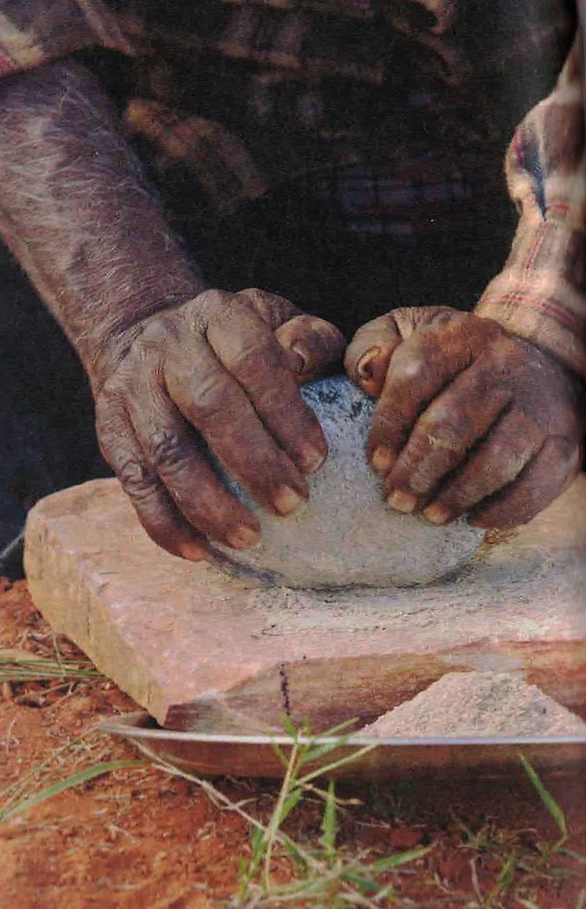
Journeys to the highly significant ochre quarries continued into the early twentieth century, with expeditioners taking advantage of being able to travel on the train between Marree and Leigh Creek when it went through in 1884. This enabled them to acquire ochre at less risk from pastoralists who were defending their sheep runs in the area (Jones 2007: 370, 375-6). The important movement, stories and return to the place were all maintained, with the mode of movement altered in the colonial context.
The people of the Mulligan and Georgina River area produced a superior quality, specially prepared pituri, a highly prized narcotic related to tobacco derived from Duboisia hopwoodii plants. This was harvested, dried and packed into special bags for trade. This was exchanged in a way that differed from other materials in that it was more like trade, with fixed rates. Goyders Lagoon was an intersection of communication routes from north, south-east and west, for large exchange gatherings (McBryde 1987: 267). Jennifer Silcock, M Tischler and Mike Smith (2012) mapped the distribution and density of D. hopwoodii, the nearby artesian springs and quantified the potential harvest of pituri, showing that large scale production was feasible.
This exchange was a cohesive component of desert life, its travel and ceremonies ‘important episodes in a recurring patterns of contacts and exchanges linking people and materials across great distances’ in a ‘complex web of connection’ (McBryde 1987: 261, 268). The objects referenced far
away yet known places, featured in songs and stories. The travel to acquire them, and the objects themselves reinforced chains of connections between places and groups. They ‘transmitted knowledge, materials and artefacts between local and regional communities otherwise isolated by vast distances’ (McBryde 1987: 267).
McBryde (1987) makes the case for why this is a cultural landscape, distinct from aggregations of places formed by people’s land use and settlement because the elements of the exchange network ‘in their patterned distribution of significant exotic items suggest a system … These patterns form an overlay above those of the subsistence regime and daily life. The places are also linked in stories of the activities of ancestral, creative beings, often forming long storylines or song cycles. The products of major quarries, whose creation is also celebrated in story, are known as objects of more than utilitarian meaning (eg. ochre from Pukardu Hill near Parachilna, grindstones from the Wadla Walyu quarry near Reaphook Hill [Vilivarunha])’.
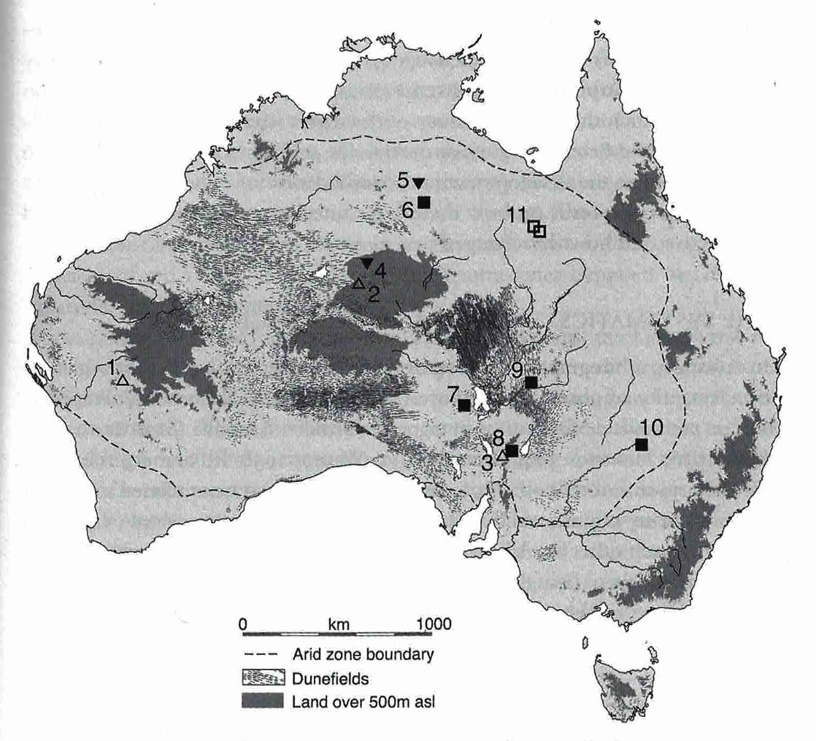

Map 8 Sites of major ochre quarries (open triangles): 1) Wilkie Mia (on NHL), 2) Karrku, 3) Pukardu Grindstone quarries (squares): 6) Kurutiti (Helen Springs) 7) Anna Creek (Palthirri-pirdi) 8) Tooths Nob (Wadla wadlyu) 9) Innaminka quarries 10) Yambacoona Hill. 11) Mt Isa axe quarries (4 and 5 not relevant to this discussion). (From Smith 2013: 268 fig 8.2)

Grindstones were highly prized in Indigenous societies. In Australian prehistory, the development of methods for harvesting seed and processing it by grinding it between abrasive stones to provide a low calorie and labour-intensive but reliable food is considered to have been a technological/economic/social change in response to increasingly dry and variable climatic conditions in the late Pleistocene: a specific semi-arid and arid zone adaptation. The timing of this change is debated, and seems to have varied in different parts of the arid zone, but was definitely
broadly well established in Australian desert cultures by the mid-Holocene, i.e. around 5000 years ago, with an increase in intensity of use between 1400 and 600 years ago (Smith 1986; Fullagar and Field 1997; Veth, Fullagar and Gould 1997; Hiscock 2008: 207-8, Smith 2013).
Isabel McBryde (1997: 13-14) clearly sets out the practical challenges posed in recognising the heritage values of the extensive exchange systems that are such important aspects of connection and organisation of Indigenous cultural life in the deserts. The argument for doing so is also made clear:
complex as the task of capturing such entities for the heritage register may seem, its rewards are rich. It is important that we incorporate into the domain of protected and recognised heritage these exchange linkages. The concept of cultural landscape offers an appropriate framework. Such entities are of vital importance for their creating cultures, past and present. To ignore them is to ignore significant aspects of Aboriginal culture. It also exposes us to the risk that we create in our registers a representation of Aboriginal culture, as exemplified in place that is predominantly monumental, conforming to our European traditions of 'heritage', rather than the values and practices of the creating culture (McBryde 1997: 14).

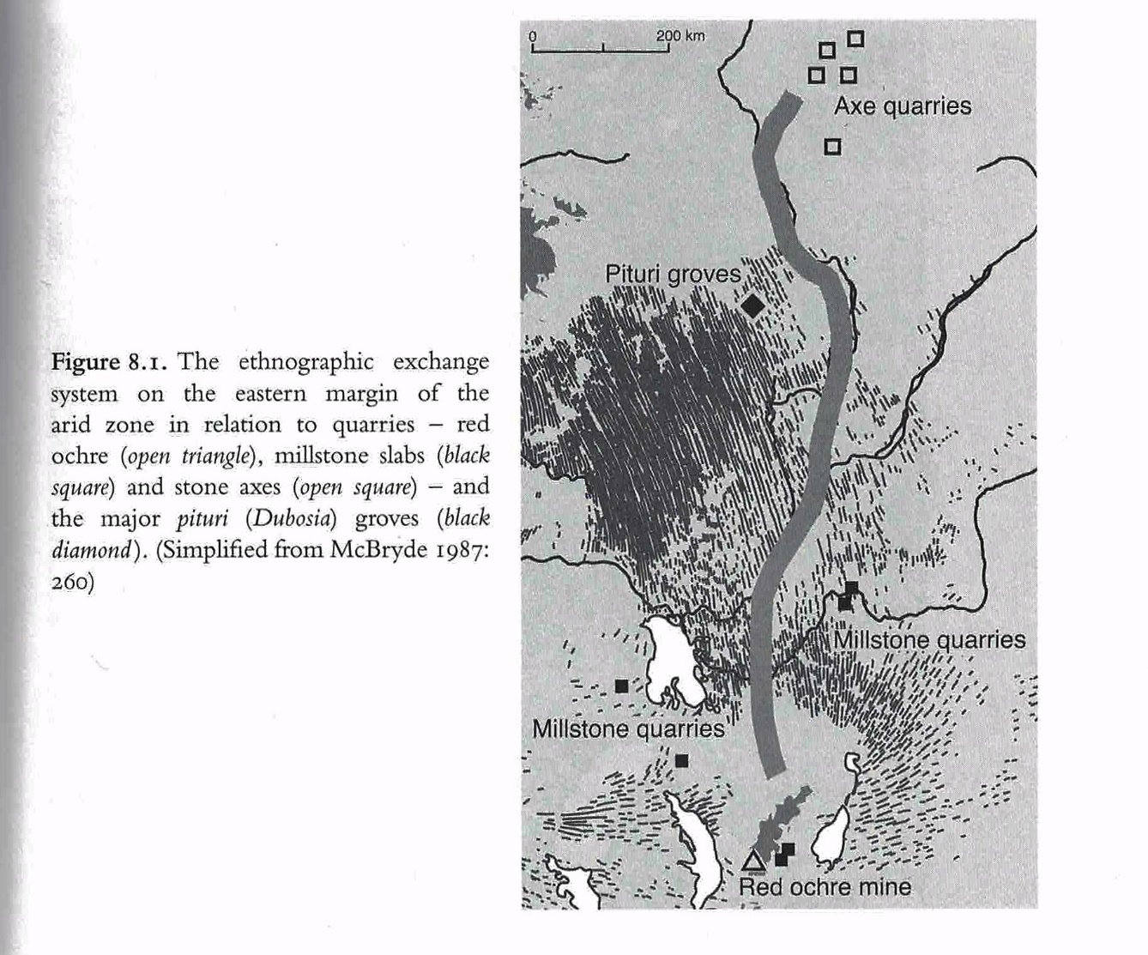

Map 9 Eastern Lake Eyre exchange map (from Smith 2013: 267 Fig 8.1)

3.2.3.5 Dreaming tracks and Songlines

Wirnpa the snake-man lived and hunted in the Percival Lakes area with a mob of rainmakers like himself. One day he left his home at Wirnpa waterhole and set of south. He stopped at a spring east of Mt Newman, where he met a mob of other ancestral beings. He hunted, and they cooked seedcakes and ate a feast. There, Wirnpa left some rainmaking paraphernalia. He went on south towards the Kalgoolie area. At a rockhole he met the Two Men ancestral beings, Wati Kuljarra, and they hunted and ate a feast. …He went east and camped at a number of places… He went on northwards and met the Kangaroo Ancestral being Marlu, who asked him for some rainmaking things … He saw the tracks of Minyipurru, the Seven Sisters Ancestral beings, and followed them east. … He saw that a lot of old rainmakers had turned into water snakes and were living in waterholes. … He lay down at Wirnpa and went inside the water as a big snake and big clouds came up from that waterhole. … Wirnpa travelled widely and met other ancestors and instituted the feasting, an important part of the rainmaking ceremony and part of what people must do.
Martu Story, Western Desert, recounted 1999 (in Cleared out, Davenport, Johnson and Yiwali 2005 p5-6)

This Wirnpa rainmaker story recounted above highlights features of the places and routes discussed in this section. It involves a track between connected places, often places of significant waters. It also shows the linkages of distant parts of the deserts, the meeting of various Ancestors, the significance of waterholes and rain, and the importance of seed grinding to make seed cakes (see below).
The whole of the arid zone is criss-crossed by the paths and places of Ancestral beings who formed the land through their actions (James 2013). Knowledge of the stories of the Law given by the Ancestors explains the nature and forms of the land, how to respect and manage that land, and organises the cultural, social and political world in ways that connect all of these. It is honoured, maintained and passed on to the next generations through performance of ceremony, song, dance, using particular objects, and through visiting country. ‘It is the conceptual vehicle through which people fulfil themselves, define their position in society and are guided through life. … as much a state of mind as a personal and communal charter.’ Adherence to it is ‘both fundamental and mandatory’ (Cane 2002: 82, based on Berndt 1970, Hiatt 1975, Tonkinson 1974: 70-1, Myers 1986: 47). It is ‘a metaphysic of life’ and a ‘mnemonic method of conveying large amounts of oral knowledge’ (James 2013: 33). The Ancestral Law, the Tjurkurpa (or Jukurrpa in the Western Desert, mura in the east), is familiar in its inadequate English translation as ‘the Dreaming’. It is the spiritual authority which connects people to the country of their birth (and, depending on the group, that of their father or mother’s birth, and grandmother or grandfather’s) and to their rights and responsibilities for that country, their relationships and responsibilities to other people.
Anthropologist Howard Morphy (1995: 187) refers to the ‘triadic relation between an individual, the ancestral past and the physical landscape’ - ie there are three interlinked forms of connection between places, based in individual experience, in historical events, and Ancestral actions. The landscape itself, its form, establishes integral linkages between the continuous Ancestral presence in places and an individual’s experience of living in those places.

Songlines are about Ancestral travels and actions that make and maintain country. For people to carry out their responsibilities to country necessarily involves mobility. Minoru Hokari describes this:
Dreaming has been active all the time. Dreaming tracks that connect sacred sites are not ‘roads’ that Dreaming beings sometimes travel, but more like a ‘river’ or stream through which Dreaming beings continuously move. Therefore the history of the maintained world can also mean the history of maintained mobility’ (Hokari 2001: 57, Rose 2003a makes a similar point).

Conditions of the desert regions set up requirements for social networks and connections, systems for movement and maintenance of country and of interaction with others. There are numerous minor, local, Law stories and tracks which bring the landscape to life. These may intersect ‘bigger’ Ancestral stories that take place across a wider region. A few truly ‘Big Law’ continental stories and tracks, or ‘Songlines’ cover vast distances and connect many different language groups, again intersecting other tracks (Sutton 1995:55, 57). For example, the Urumbula song cycle and its route cross several distinct social and linguistic groups in its 900km path from Amewara – modern Port Augusta – to the western Simpson Desert. The song is sung in Arrernte, even in areas where that is not the locally spoken language, as the story relates to places in Lower Southern Arrernte country. The Dreaming and its songs constitute a dynamic link through country (McBryde 2000: 158).

A recent research project has focussed on the especially long-reaching trans-desert Kungkarangkalpa (meaning many young women) Seven Sisters Songline. It is named for the cluster of stars known in Greek mythology as the Pleiades, daughters of Atlas. They are close to, and forever chased by lusty Orion, known as Yurla, Yula, and Wati Nyiru. This is a major Ancestral story. It links together three different deserts. The stars of the Seven Sisters and Orion are visible in both the southern and northern hemispheres. There is a potential to preserve ‘dark sky reserves’ in the desert area associated with the Songline, as less and less of the night sky is visible in settled areas (see below).

The Seven Sisters Songline
The Seven Sisters Songline is an epic story, one of the most widespread Ancestral Songlines in Australia, crossing from near Roebourne across the Pilbara, the Gibson Desert and the Great Victoria Desert; the country of many language groups. This major story is told in ceremonial dance and song, linking together distant country, recounting the locations of important water places. It has been painted on the walls of Walinyna (Cave Hill, northeast of Amata in the Musgrave Ranges) and pecked into the rock at the Kuli waterhole (James 2009:13) and in the last four decades elements of the Songline have frequently painted in acrylic form (see eg NMA 2010, Cane 2002: 100-1). When people paint the places of the Seven Sisters Songline, the women sing the songs so that the land is built into the painting. For example, Inawinytji Williamson, based at Kaltjiti (Fregon) paints the different inma walka – the marks painted on women’s breasts as they dance the parts of the story, representing different places along the path of the story (James 2009: 104-5).

The travels of the Sisters are associated with many places across the desert, including important water holes. For this reason ‘many of the sites on the Seven Sisters journey in the west were taken as wells on the Canning Stock route’ (NMA 2010: 53). The Martu (western desert language groups) Jukurpa (‘Dreaming’ or Ancestral) story of the Seven Sisters is Minyipuru. The story is the man Wati Nyiru chases the women across the desert, watching them from behind trees, tracking them, making the older sister sick (James 2009: 102-3). He wants to have sex with the women, his phallus represented by a carpet snake, which chases them across the Western Deserts. Water holes are a prominent part of the stopping places in the Songline, shown in the dances preformed in some of these places and filmed for the Songlines project.

In Pitjantjatjara/Ngaanyatjara land the Seven Sisters story is called Kungkarangkalpa, where ‘kunga’ is women.

Diana James describes an expedition to trace Seven Sisters sites that had not been visited for over 50 years to the south of the Musgrave Ranges – from Cave Hill and Alkanyunta in the east to Kuli (James 2009: 102-3). Walyinynga, Cave hill, in the Musgrave Ranges, 100km south of Uluru, in Pitjantjatjara lands, is an important site on the Seven Sisters Songline track, with pigment art relating to the Songline in the cave (James 2009: 13). It is now a Nature Reserve, and is currently visited by small-group tourism tours from Uluru. Robert Edwards proposed the place as a site museum of desert culture in 1972.

Parts of the story were filmed by Neil Turner in the mid-1980s at Ernabella. These are held at AIATSIS.

The Seven Sisters also pass through the Spinifex Country of the Great Victoria Desert (Cane 2002: 95-7), digging with their digging sticks, getting food and getting water, followed by old man Nyiiru. Rock features mark where they are sick, or hide, and intersect with other Tjukurrpa. They travel widely, and they are capable of flying. As Cane says, this is a complicated Tjukurrpa, which ‘pops up everywhere across the southern western desert’. He says it continues to near Coober Pedy (2002: 96). Different groups know different parts of the story best, but know where the story goes after it leaves their country. It is a story that is essentially of the Australian deserts, connecting travellers between waterholes over huge distances, under the stars, and it continues to make those linkages through performance and distribution of recorded performance.

The dances and songs of the story were also performed in Canberra at the NMA by the story’s custodians in March 2013. A film of the event is available, and was screened as part of 2016 NAIDOC week. These songs and dances are open - not restricted, but available for all ages and genders, although some elements are restricted to women only, not included in any of the stories, paintings or performances. There will be a Seven Sisters Songline Exhibition at the National Museum of Australia in September 2017.

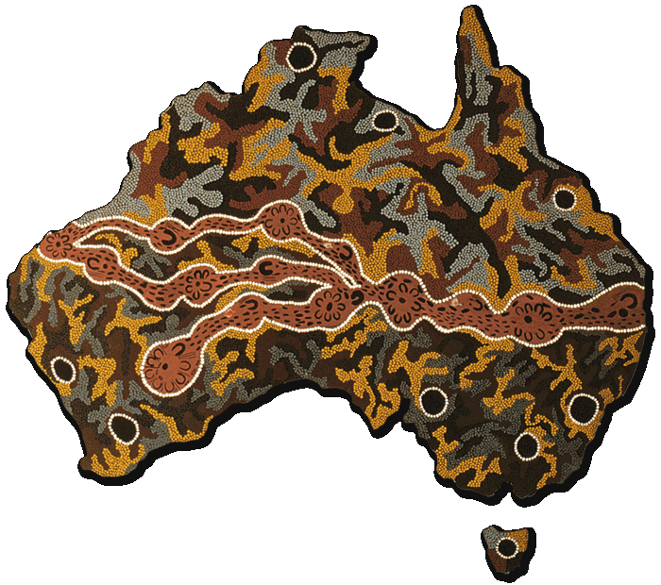

Fig 7 Seven Sisters Songline by Josephine Mick, Pipalyatjara, 1994. From the Kungkarangkalpa: Seven Sisters Songline website and the Alive with the Dreaming! Songlines of the Western Desert project. Accessed 7/7/16

Similarly, the Arrernte Women’s Project aims to actively take steps for culture to not only survive but flourish, through maintenance of knowledge of the richness of significant songs and dances and their connection to land and identity (Perkins 2016).

In the US and Europe, 99% of people cannot now see the Milky Way in the night sky due to light pollution. ‘Through our technology we’ve cut off that possibility [of experiencing the night sky] for multiple generations now’ (The Guardian 17/6/16: 12). Map 10 shows the Italian Institute of Light Pollution Science and Technology map of light pollution in Australia, which introduces another distinctive and increasingly valuable feature of the Australian deserts - their dark night skies. ‘The night skies beneath which we humans have evolved are woven through our very being, and they are important to us’ (Kiernan 2012). Astronomers have maps of ‘dark sky reserves’ for star appreciation in Australia and world-wide, and UNESCO has declared the Aoraki Mackenzie International Dark Sky Reserve in the centre of the South Island of New Zealand. One of the ‘things belonging to the sky’ that seems common to all Indigenous groups across Australia is the star cluster of the Pleiades. Dianne Johnson (2011) has traced various interpretations of this cluster in different Indigenous groups. The significance of the stellar formations in the timeless Seven Sisters Songlines highlights their importance as part people’s sense of place and identity. As dark sky and visible stars become increasingly rare in the world, the association of the ancient Songlines of Australian Deserts and the equivalent vastness of the desert night sky warrants consideration in National Heritage Listing.

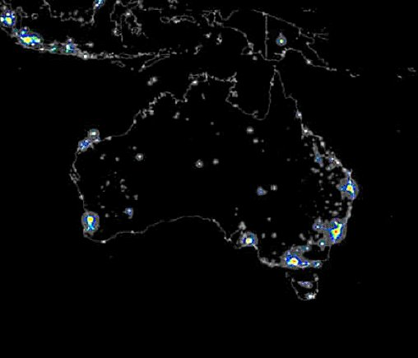

Map 10- Map of Australia showing light polluted areas
courtesy of Instituto di scienza e tecnologia dell’inquinamento luminoso
www.lightpollution.it/dmsp/

3.2.3.6 Communications - The Overland Telegraph Line
On the surface, it is clear that ‘the Overland Telegraph Line’ was a means of communication within Australia and with the rest of the world. At the time of its construction in 1870-2, there were existing telegraph services in south-eastern Australia, but it was on Thursday 22 August 1872 when the line was joined to the under-sea cables to Britain that Australia entered the era of modernity: a ‘great national work’ (Richards 1914: 5). Until then, communications took the same time as the travel between two places - three months for a letter from Sydney to London in the 1850s. With the wire came the capacity for instantaneous transmission of a message anywhere between Adelaide and Darwin, seven hours for one to reach London (Taylor 1980: 159, 160). Remoteness was now not necessarily isolating, distance was disconnected from time – a defining quality of modernity.

Physically, the first telegraph line was a 3000 km long strand of No. 8 galvanised wire. Despite the apparent simplicity of that single strand, it was a technological achievement to construct it through difficult and unknown territory, in only two years.

The Overland Telegraph Line followed Stuart’s route through central Australia. Stuart himself had been ‘anxious to direct attention to the establishment of a Telegraph line along his route’ and was clear about the connection between his route-finding and the developments which would follow, wanting to ‘confer the benefit on my fellow-men of opening up a line for rail and telegraphic communication with England’ (Stuart, cited Royal Geog Soc of Australia 1912: 36). In turn, the
orchestrator of the construction of the Overland Telegraph Line, Charles Todd, always saw the line as having the dual purpose of ‘opening up the unknown interior’ to land speculation and development and the ‘formation of settlement on the north coast’ for the benefit of South Australia, as well as providing communication.

The route and its attendant buildings, tracks and workers established a bridgehead into central, northern and west Australia. Stuart’s descriptions of grassy plains were ‘primarily responsible for stimulating South Australian interest in the north’ (Donovan 1981: 27; Powell 1996: 67-8) making it possible to ‘develop the advantages and resources of nature’s gifts, which Stuart and his followers have unfolded to our knowledge’ (Royal Geog Soc of Australia 1912: 38).

Without Stuart’s lead, it is likely Queensland would have won the competitive construction contract for meeting the undersea telegraph line from the UK instead of South Australia. The line would have come ashore at Normantown and gone overland through Far North Queensland. That it did not was a political and territorial coup for the young colony of South Australia. If it had, we can assume that official settlement in central Australia, in the form of the Alice Springs hub that came into existence in the 1870s, would not have taken off until a much later date, perhaps the early 20th century, if it did at all. Thus the Overland Telegraph Line had a decisive impact on the spatial history of Australia.

The continuity of the line required supporting poles with insulators to connect Port Augusta in South Australia and Port Essington, now Darwin, via eleven repeater stations. Each station had a bank of batteries to power the morse code receivers and transmitters, and a staff to read and re-send the messages and to maintain all these structures.

The repeater stations in the arid zone are Beltana, Strangways Springs, Peake, Charlotte Waters, Alice Springs, Barrow Creek, Tennant Creek, which connected those on the north and south (non- desert) Port Augusta, Powell Creek, Daly Waters, Katherine, Southport. They were solidly built, with confidence that they would endure. They had slits for guns, and a fully enclosed courtyard, in the expectation of attack by local Aboriginal people. Such an attack did occur at Barrow Creek in 1874 (see Mulvaney 1989: 119- 121). But overall the repeater stations were governmental centres, where people voted, police bases, collection centres for scientific specimens including the type specimens of several central Australian marsupials (see Morton and Mulvaney 1996) and ethnographic materials, and they stood as oases, way stations for travellers, offering rain water tanks and cups of tea or lime juice to stave off scurvy. Tourists travelled the route, on camel (Phillipa Bridges 1996 [1920]: 16) or by car, first in 1908 and increasingly in the 1920s (see Macfarlane 2010 chapter 3). The repeater stations are listed on the NT and SA heritage registers (and the RNE) and are generally in good condition.

JM Stuart’s 1862 route through the centre followed the waters that Aboriginal people of the central deserts relied on for successful life in those areas. The unintended but inevitable consequence of the construction of the line was the incision of a long linear contact zone through the country of the Aboriginal people of the central deserts. The repeater stations stand as seminal historical centres for understanding cross-cultural interactions. At Charlotte Waters (Macfarlane 2010) and at Strangways Springs (Paterson 2008), historical archaeology has shown complexes of informal living places associated with the formal establishment of the repeater station. Excavations at Strangways Springs demonstrated continued occupation from pre-colonial through European settlement of the same locations, implying that the good water and resources for dwelling that had drawn people to visit there prior to European arrival had continued in new forms after the construction of the station (Patterson 2008). Local Aboriginal people were actively coming and going from these establishments for casual work and rations, but were able to visit surrounding country when not in drought. This flexibility allowed the maintenance of ceremonial connections to country.

Anthropologist/biologist Baldwin Spencer and Francis Gillen, telegraph officer at Alice Springs and Charlotte Waters followed the line in a year-long traverse of the OTL in 1901-2, leading to the publication of The native tribes of Central Australia 1898, a formative influence on global understanding of Indigenous Australians, used by Freud in his ‘Totem and Taboo’ 1913 and Sir James Frazer, in revised editions of The Golden Bough. They pioneered the use of ethnographic sound recording on wax cylinders and were the first to shoot ethnographic movie film in Australia (Mulvaney and Calaby 1985: 359-60).

The Horn Scientific expedition also followed the Overland Telegraph Line in 1896 (see Morton and Mulvaney 1996).
The old ‘Ghan’ railway was also built along the same original water route, to Port Augusta in 1878, Marree in 1884, Oodnadatta in 1891, to Alice Springs in 1929 and Darwin in 2004, but had to be moved westwards due to constant flooding when it was extended in the 21st century. The Stuart highway has a related central Australian route, a bush track until development during and after WWII (see Kerr 2013).

After its grand beginnings, the Overland Telegraph Line ended with a whimper. The track was still used by drovers and pastoralists into the 1920s, but decreasingly so after the rail line was extended to Alice Springs. In the same period the telephone took over its communication function.

While the Overland Telegraph Line is a communication technology, a result of a vast engineering and construction feat successfully completed in the difficult and unknown circumstances of the central Australian deserts, it is simultaneously responsible for many other weighty national roles and impacts. It is the single main travel and transport artery into central Australia, the route to pastoral occupation of the central Australian lands, and for further explorers travelling west from the line. It lasted in its primary form for 60 years, becoming the foci of intense, concentrated interaction, leaving permanent changes to Australia’s spatial history and cultural geography, and in the people who lived there. It is physically still present, as a distinct route and series of places with valuable archaeological records, and retaining evidences of all the various ways in which it has been lived in: Indigenous Ancestral stories, personal histories, place names, cattle and goat yards, ration depots, stone-walled telegraph repeater stations with rain water tanks and bores, police centres, government records, photographs.

3.2.3.7 The ‘Afghan’ cameleers
Public advocacy for the importation of camels into Australia began as early as 1835 (Gibbs et al 2014). It was argued that camels would provide a robust, reliable and inexpensive form of transport for exploration and exploitation of the road-less arid interior. The failure of horses in Benjamin Babbage’s 1858 exploration of northern South Australia was cited as evidence for the advantages of camels and drought in 1862 increased demand for the remedy camels might provide. The first large importation was negotiated by pastoralist and venture financier Thomas Elder and his Indian-based business partner Samuel Stuckey who had experience of the benefits of camel transport overseas (Stevens, 2002). The 124 riding, draught and pack camels arrived in Port Augusta, SA with 31 cameleers from Kandahar, Kabul, the Sindh and northern India, and were established at Elder’s stations at Beltana and Umberatana in northern SA (Stevens, 2002; Jones and Kenny, 2007). These were the first of an estimated 6000 camels imported, until the last shipment in 1907 (Stevens, 2002, p22). They established a flourishing transport network between inland stations and mines, railheads and ports, carrying wool, grain, ore, stores, fencing equipment, bore pipes, even pianolas (Jones and Kenny, 2007). Thus the use of camels was an innovative solution to transport in a desert
environment, enabling early development of the Australian arid zone through the provision of critical transport.

Cameleers belonged to four distinct cultural and linguistic groupings – Pashtun, Baluchi, Punjabi and Sindhi – and came mainly from the arid areas of Afghanistan and present day Pakistan, but were known collectively in Australia as ‘Afghans’ (Jones and Kenny, 2007; Stevens, 2002). They came equipped with deep experience and the necessary standard equipment – nose-pegs, reins, leg hobbles, saddles, tackle, and skillful systems of roping loads onto pack camels’ backs. The designs of the 1860s riding- and pack-saddles they brought to Australia were copied by local harness makers, and continue to be used today (Jones and Kenny, 2007).

The cameleers lived in tents at first, but from the late 1800s bought smallholdings outside townships, and built corrugated iron huts. They planted date palms and fruit trees, and every such ‘Ghantown’ had a mosque, usually of corrugated iron (Stevens, 2002). ‘Ghantowns’ were always isolated physically and culturally from the rest of an outback community (Stevens, 2002). Remains of these exist in Marree, Oodnadatta, Alice Springs (Oodnadatta track heritage study), and Beltana, Farina and Broken Hill (Parkes 1997, chapter 4). Rebecca Parkes (1997) has carried out an archaeological study of disctinctive layout and material culture of ‘Afghan’ camps and potential identifiers of their presence in inland settlements.

The cameleers were always on the outer. A number of colonists had fought in the Anglo-Afghan wars and the Indian mutiny (Stevens, 2002), which gave them respect for camels and lack of respect for the people of those regions (Elder, 1894). Camels and their handlers were from the outset objects of Orientalist ambivalence for the Anglo-Australian populace. When an alternative became available, there was rapid adoption of the unambiguously useful truck as an alternative. Cameleers mainly went home, but many stayed with their Aboriginal or Chinese or European wives and families. They let their beloved camels loose, to become the largest herd of wild camels in the world, now causing environmental damage to native vegetation and waterholes.

The contribution of the cameleers to making the settlement of the desert inland feasible is only recently being given serious recognition. The Burke, Wills, King and Yandruwandha National Heritage Place listing includes mention of the role of Afghan cameleers as carriers on the Birdsville track.

3.2.3.8 Servicing vast regions
An iconic example of remoteness overcome is the history of the Australian Inland Mission (AIM) and its establishment of the Royal Flying Doctor Service and the follow-on development of the School of the Air in 1948.

The Royal Flying Doctor Service
‘The Royal Flying Doctor Service is one of the most iconic of Australian institutions. It is truly a valuable service to the heart of the nation’ Sir Peter Cosgrove

John Flynn (1880-1951) ‘the man on the $20 note’ spent his early mission years in the remote Victorian Alps then at Smith of Dunesk Mission in Beltana, northern Flinders Ranges, South Australia, which educated him regarding the implacable influence living in remote locations had on people’s lives. He worked to establish a mission that would provide ‘social service as well as the healing of the body’, recognising that isolation was a need in itself requiring redress, as much as making health services available. The Australian Inland Mission was established in 1912 by the Presbyterian Church on the basis of Flynn’s report on these needs. A network of fifteen nursing homes/ bush hospitals/ community centres were established in remote Australian locations, where pioneering nurses
delivered the all-round care he envisaged. The earliest was in Oodnadatta. Others were the Innamincka AIM Hospital, Birdsville AIM Hospital, Alice Springs Hospital 1926 -1961, Cloncurry.

The origins of the AIM Aerial Medical Service - later RFDS - are in Cloncurry in 1928, using the first flying doctor bi-plane, the ‘Victory’, linked to the early days of Qantas in Queensland. This has been included in the NH listing for the Longreach Hangar. However, the Cloncurry airport sheds are still standing, with the original RFDS sign. In the 1930s further expansion saw the establishment of the Alice Springs and Broken Hill operational bases.

What allowed the service to work so well was the invention of the first pedal powered wireless by Alfred Traeger in Adelaide, used first at the AIM RFDS Base in Alice Springs in 1929.

The School of the Air
The School of the Air began in 1948 in Alice Springs. Adelaide Miethke, a SA teacher had witnessed remote station children trained in using RFDS radios, and identified that these could provide a means for remote education incorporating direct contact, rather than correspondence. The first lessons were given from the RFDS base in Alice Springs in 1951. This was the first such service in the world.

A keen photographer, Flynn consciously recorded his work and life in many lantern slides and negatives, now in the National Library of Australia. He was awarded an OBE in 1933. His ashes are in a commemorative grave on Larapinta Drive near the Western McDonnell Ranges. A church dedicated to Flynn's memory was completed in Alice Springs in 1956.

Frontier Services took over the AIM role in 1986, their stated mission ‘To support, link and empower the people of Outback Australia by creating connections and mobilising resources.’

The RFDS is included in the values for the Longreach Hanger on the National Heritage List. The School of the Air is mentioned as a component of the QANTAS listing, but this only captures a small part of the history of the AIM, Flynn, the RFDS and School of the Air services.

3.2.4 Theme: Living in rangelands

- Early pastoral stations (sheep and cattle) based on different forms of natural water supply
- Stations demonstrating the history of exploitation of artesian waters with bores
- Exclusion fences to control threats to stock
- Stock routes
- Frontier and pastoral conflict locations
The Theme ’Living in rangelands’ captures the dominant colonial rangelands history of land use in the arid and semi-arid zone and the contrasting grain harvesting pre-colonial economy in the same areas.

Introduction to the theme
Explorers’ and surveyors’ maps, following Indigenous water routes into the deserts, provided the information base for claiming early pastoral grazing leases (see section 3.3.2.2). The expansion of pastoral land use is marked by repeated efforts to push into more marginal country. Hence the ‘frontier’ of first interactions between local Indigenous peoples and pastoralists importing stock to new leases pushed out from the points of entry along the Telegraph Line and the Birdsville track to the east (see section 3.3.4.1).

With Federation, Australian nationalism upheld the myth of the Bush but was ‘embarrassed’ by the deserts ‘neither profitable nor picturesque’ (Haynes 1998: 144). One approach was to deny the existence of the deserts as a permanent difficulty – Edwin Brady’s Australia Unlimited (1918) concluded that the so-called desert was shrinking and would cease to be an impediment to settlement (Haynes 1998: 144). Griffith Taylor’s 1926 ‘Habitability map’ (map 7) was an effort to counter such boosterish claims for ‘closer settlement’ and denser occupation of all of the inland.

Alfred Giles, early explorer and resident in Northern Territory for 50 years, expresses this vision of inevitable succession for the land, still held strongly when he wrote in 1926: ‘For the past 40 years, millions of these acres have been used for purely pastoral occupation, and that of cattle only, but this is only the customary procedure in opening up new areas. The pastoralist is always the advance guard, making the rough bush roads and finding the waters, and years afterwards is slowly but surely followed by the agriculturalist’ (Alfred Giles introducing his account of ‘Exploring in the ‘seventies’ 1926[1995]: xi).

The most important point about this history of ambition for maximising pastoral land use was the inability to accept that variability was the ‘normal’ for the arid zone, rather than the persistent conception that good seasons were ‘normal’ and drought an aberration.

Denial of this reality was a contributor to the pressure to fund expensive drilling for artesian water bores to even out the gaps in water supply – a principle of ‘just add water’. Following this vision of how things should happen made pastoralists generally unresponsive to what did happen, particularly the disconnection of provision of stock feed from provision of water. Ecologist and conservationist Francis Ratcliffe, who conducted field research on the effects of rabbits on grazing land controversially argued that it was overgrazing by stock as well as rabbits that caused erosion:
‘Whenever and wherever pastoral settlement is imposed on semi-desert areas with a variable and uncertain rainfall, the problem of the survival of certain components of the vegetation is automatically raised, and the species that are threatened happen to be those fodder plants on which the stability of pastoral enterprise largely depends; that is the long-lived drought resistant plants on which the stock fall back when the shorter lived feed fails’ (Ratcliffe 1937: 24).

Stocking during droughts led to erosion and permanent degradation of the land.
‘The rangeland ecosystems of Australia have adapted to drought and have probably weathered droughts far worse than have been encountered since European settlement. The main feature of degradation was the carrying of too many animals, for too long, on areas especially under stress from drought.’ The long paddock, Pasture Degradation and Recovery: Learning from History https://www.longpaddock.qld.gov.au/ accessed 5/6/16

This began early - In far northern SA, local pastoralists’ testimonies presented to the 1891 Land Commission, after 20 years of pastoral activity, showed there had been no increase in numbers of cattle and sheep for many years, and in extensive stretches of country the would-be pastoralists had abandoned their leases. Experienced locals talked of the bush being killed by stocking rather than being ‘improved’ by it (SA Pastoral Land Commission 1891: 112).

An important contrast can be made with the vast Indigenous grain harvests in the eastern arid rivers area and elsewhere in the semi-arid zone, recorded in early explorers’ journals. These descriptions have been collected together by Bruce Pascoe, following the work of Bill Gammage and Rupert Gerrittsen. Pascoe argues for recognition that under Aboriginal people’s management these same semi-arid areas supported rich grain fields – and could again – and this would be of benefit for the condition of the country as it would be drought protected (Pascoe 2014). Smith (2013: 198-202, 329-333) provides a detailed archaeological history of the development and proliferation of the seed grinding technology needed to utilize the rich wild grains that were the basis of high populations in the arid zone by the time the explorers encountered them in the recent historic period.

Competition for the resources for living – degradation of food and water supplies, lack of rights of access to raw materials and ceremonial places, to the familiarity of ‘home’ – was what was involved in taking over a large continent of hunter-gatherers by foreign economic and territorial colonisers who wanted the land to grow their own crops, their herds and their own population. As historians Attwood and Griffiths say ‘there is an inherent conflict between colonising another people’s country and supporting their rights’ (2010: 10). This was backed up by the belief that European civilization and Christianity would be of true benefit to the colonized, and the belief that they did not use the land they occupied and so it was vacant and available for proper exploitation – the concept of terra nullius.

It is an enduring feature of ‘outback mythology’ to see the arid zone as unoccupied ‘one dimensional, timeless landscapes’ (Gill 2005). There are two senses of the word ‘desert’ in the English language; one is the technical, quantitative measure of aridity, the other is concerned with potential habitability and emptiness – a desert island, for example, is one empty of people and ‘civilisation’. In common usage there is a bleeding of this second meaning into the first, which has led to a recurring generic sense of deserts being unoccupied; the home of no-one. It is significant that there are no English language or Judeo-Christian derived metaphors for desert as ‘home’. Explorer Cecil Madigan considered the Simpson Desert sand ridge country to be ‘quite useless and entirely unoccupied’ (Madigan 1938: 6), only to find traces of people’s occupation there in the form of stone artefacts (Madigan 1946: 64).

3.3.4.1 ‘First contacts’ in the deserts
In the Australian deserts, a succession of groups of Aboriginal people came in to contact with white- skinned outsiders for the first time as the colonial frontier moved through the arid zone, spreading northwest from the early colonised southeast into the Channel country, from the south into the centre, out from the Overland Telegraph line once it was constructed in 1872, and north from Swan River. The local people had heard stories of these strangers, and had traded in new materials such as glass and metal, and acquired new words well ahead of any actual meeting. They looked at the footprints of booted feet and horses and were telling vivid tales of their fear of these new imprints on their vigilantly monitored land, even 70 years after Stuart had passed by (Strehlow 1967: 8). They were rapidly in competition with cattle or sheep for water and land, subject to violence or dispossession, leading to the deserts emptying of their long-term residents. In the eastern Simpson, the last people walked out of the dune fields in 1900 (Hercus 1985, 1990); in the western desert it was in the 1960s and 1980s.

‘First contact’ is still in living memory of people in the deserts, and frontier violence is one generation away at Conniston.

In the 1960s, a group of women and children lived on the waters of the Percival Lakes area of the western desert. They were pursued by the patrol officers, trying to ‘clear them out’ from the threat of the Woomera rocket tests which were taking place overhead. This is vividly documented in detail by Sue Davenport, Peter Johnston and Yuwali (2005) - one of the girls involved. The waters that
supported them are also well described. This area has been suggested as one of the ‘cultural landscapes’, capturing the qualities of the western desert, highlighted by this association.

In the 1984 another family group of Pintubi people emerged from the desert near Lake Mackay, in the remote core of the Western Deserts. They were the last people to ‘come in’ from living as hunter-gatherers on these remote waters into a settlement (Smith 2013: 109, citing Myers 1988 and Kimber 2006).

The strong reverse movement, of people moving out of colonial settlements into remote homelands or outstations was a feature of Indigenous assertion of rights to land and self-determination occurring in the 1980s (see Peterson and Myers 2016). This history is captured, for example, in the story of the desert art movement in and around Papunya (section 3.3.5.2).

3.2.4.2 Pastoral empires
Ultra- successful pastoralists were those who came to understand the need to move stock to areas of available pasture in a chain of property holdings, and to far-off markets via stock routes and then rail and road. Called ‘big men’ they were seen as heroes of the late 19th and early 20th centuries, starting from meagre means to be major entrepeneurs – James Tyson, Samuel McCaughey, George Fairburn, Arthur Bryant Triggs, and most famously, Sidney Kidman (Pearson and Lennon 2010: 44-47).

The Kidman Empire
‘Cattle king’ Sir Sidney Kidman’s approach to land holdings exemplifies understanding of variability of the climate.

Sir Sidney Kidman (1857-1935), a national institution, was born near Adelaide, his first job in 'corner' country of New South Wales later became the heartland of Kidman's pastoral empire. He made money as a stock worker, a drover and a carter, and a butcher, ran a coach business, bought his first station in 1886, Owen Springs on the Hugh River, south-west of Alice Springs.

‘He conceived the idea of buying two chains of stations stretching in nearly continuous lines from the well-watered tropical country round the Gulf of Carpentaria, south through western Queensland to Broken Hill, and across the border into South Australia within easy droving distance of Adelaide. Many stations on this 'main chain' were watered by Cooper's Creek and the Georgina and Diamantina Rivers which sometimes brought northern tropical rain-waters to the centre even during droughts. By the 1890s he had begun to acquire his second chain of stations strung along the Overland Telegraph line from the Fitzroy River and Victoria River Downs in the north to Wilpena station in the Flinders Ranges near Adelaide. Thus, by moving stock from drought-stricken areas to others, by selling in markets where the price was highest, by his detailed knowledge of the country, and by his energy and bushcraft he withstood the depression of the 1890s and the great drought of 1902. By the time of World War I he controlled station country considerably greater in area than England or Tasmania, and nearly as great as Victoria’ (Russell Ward 1983).

‘Kidman’s properties were invariably stocked at less than full capacity, and were generally contiguous, forming chains that straddled stock routes and watercourses in the most arid zone of central Australia. Railheads at the ends of the chains provided access to the main capital city markets, and Kidman’s drovers supplied a wealth of information on competing cattle movements. This combination of features effectively afforded strategic transport flexibility and management choices, especially during severe region-wide droughts’ (Dobes 2012).

By 1927 when he retired, the name 'Kidman' meant ‘a complex of interlocking companies, partnerships and agencies with branches in all the mainland capital cities and some country towns’ controlled from Adelaide (Ward 1983).

Importantly, Kidman’s scheme exemplified how he had ‘learnt to live in the arid zone’, and in rangelands. ‘Faced with a highly variable and unpredictable climate, combined with the onset of erosion and the spread of rabbits, Kidman exemplifies the ability to adapt creatively to exogenous environmental shocks such as climate change’ (Dobes 2012).

3.2.4.3 Stock Routes
Stock routes were defined pathways through Crown Land which formed a network across the country, joining inland cattle and wool producing stations to far away markets in coastal cities, and connecting stations in different rainfall areas. They were an important part of the ‘inland corridor’ of lands between the arid core and the coastal fringe of Australia described by historian John McCarty (1988, see Alan Mayne 2011).

Three stock routes in the south-east Lake Eyre Basin—the Oodnadatta Track, the Birdsville Track and the Strzelecki Track—were established to transport cattle from the pastoral lands in the south-west of Queensland and the north of South Australia to the railhead at Marree to Adelaide. To improve the utility of the stock routes, colonial and then state governments established public wells, dams and tanks, and designated natural watering points along the routes, spaced one to two days walk apart (Yelland 2002: 41).

The Birdsville Track was the most intensively used of these. The first stages of the Birdsville Track made use of permanent waterholes on the Georgina and Diamantina Rivers at Goyder Lagoon, but the remaining stages were dependent on artesian bores as the track passed through the driest region of the Australian continent (Ratcliffe 1938; Yelland 2002: 53-61). Former policeman George Aiston (1879-1943) kept a shop at Mulka where he carried out extensive anthropological studies (Aiston and Horne 2009, Jones 1993). The Strezlecki track continued to rely on natural waters, not supplemented by bores. These tracks were also used by ‘Afghan’ cameleers for transport (see above). Many of the values of the Birdsville track are included in the Burke and Wills and Yandruwandah National Heritage listing.

Canning Stock Route
The Canning Stock Route was instigated by the WA state government as a way of joining the meat producing pastoral lands of the East Kimberley to the boom in demand created by the mines in the south of Western Australia. Cattle ticks were banned from being imported to the south, and as they could not survive the desert journey, this made the route a worthwhile economic effort. The government organised a survey from Wiluna in the south to Halls Creek in 1906, with Alfred Canning, fresh from surveying the rabbit-proof fence, in charge. He crossed the harsh western desert country in six months, identifying water plentiful enough for 100s of cattle to be watered for the months it would take them to travel the route. The main reason for his success in locating these waters was his use of local Aboriginal people as guides, who either volunteered their knowledge, or were coerced into showing waterplaces by Canning’s forceful measures. He ran people down on a horse and chained them with no water until they were forced to reveal a water source. This coercive approach to surveying was the subject of a Royal Commission in 1908, and the use of chains was condemned. Cattle movement along the route was never as great as originally anticipated due to the harsh conditions, but the stock route as a whole nevertheless has come to be a symbol of Australia’s pioneering enterprise (Yiwarra Kuju 2010: 33-35). Since the 1970s it has become a major 4WD
tourist route (Grimwade 1998). Four Wheel Drive Australia says ‘The Canning Stock Route is an iconic 4WD trail of national importance.’

The stock wells were dug deeply with straight sides that precluded the local people from continuing to access water from them. The combination of Canning’s treatment and the traumatic loss of water sources created long-running animosity. When the first drovers came down the stock route in 1910, they were speared. In response police killed at least 10 Aboriginal people near Well 37. Frustrated Aboriginal people damaged the wells. The route was rarely used for 20 years (Yiwarra Kuju 2010: 36). To re-open it, William Snell re-built the wells so that they were usable and accessible by the local people, and between 1932-1959 hundreds of cattle moved through the desert each year, damaging local sites and water holes as they went (Yiwarra Kuju 2010: 36).

The Canning Stock Route passes through three Western Australian deserts, the Little Sandy Desert, Great Sandy Desert and the Gibson Desert. Anthropologist Diana James points out that ‘the Stock route runs north-south against the grain of the Western Desert county, while the Indigenous foot-tracks follow the intelligence of the land; tracking waterhole to waterhole, diverging for good food sources, marking the trees, caves, hills, grass plains, creekbeds and water sources that sustain the life of people and animals travelling through that land’ (James 2013: 31, and see map 11). In this context, Canning’s apparently isolated track becomes one amongst many. Senior Martu man Billy Patch, part of the Canning Stock Route Art Project, drew this relationship on the sand – a solid grid which represented the songlines, the fundamental co-ordinates of the wesern desert, with the line of stock route superimposed over it (Mahood 2016: 193).

The importance of native water maps and associated names in the establishment of the Canning Stock Route is discussed by Tindale (1974: 148). The Canning Stock Route Project, a collaboration between FORM, the National Museum of Australia, and nine Aboriginal arts and cultural centres, leading to Yiwarra Kuju, a major publication and exhibition in 2010, encouraged painting the country of the jila waters, Lake Gregory and the soakages, and the sand dunes between them. This has been a restorative way for the history of the stock route, and the Woomera tests that also crossed this western desert country, to be reclaimed by the people who it most deeply affected. They have painted their personal history and the Ancestral histories at the wells to restore the connections of the country for all to see. The National Museum of Australia purchased the collection, regarding it as of ‘truly national significance, providing a unique archive of Indigenous social and cultural histories. It is an important addition to the nation’s heritage and history collections’ (Director Craddock Morton, National Museum of Australia, 2008).

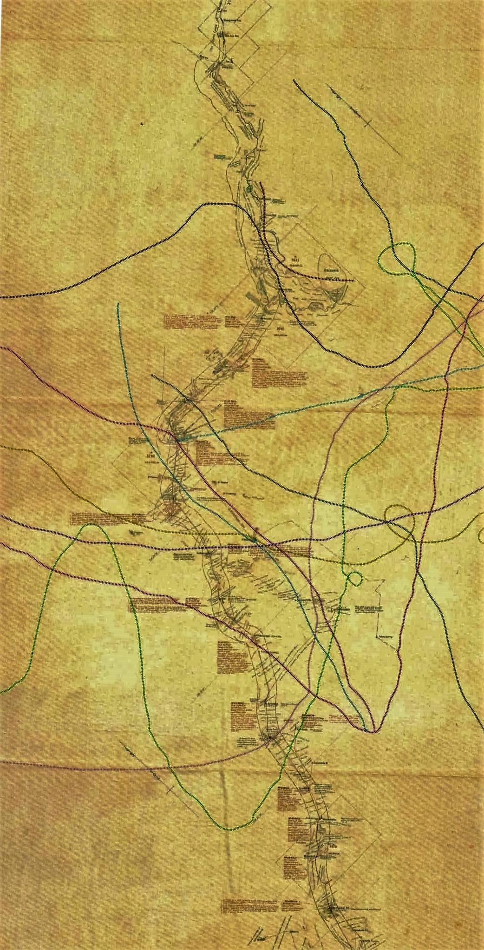
Map 11 Canning Stock route map crossed by Songline tracks (from Yiwarra Kuju 2010 p 18)

3.2.4.3 Lines across the continent: The Dog Fence, the Rabbit-Proof Fence (and Goyder’s Line)

The Dog Fence
At 5400 km long, crossing remote arid country from Fowlers Bay on the Great Australian Bight to Darling Downs on the Queensland coast, the Dog Fence - also known as the Dingo Barrier fence in Queensland and Border fence in NSW - is commonly regarded as ‘the longest fence in the world.’ It is maintained today, to protect sheep in SE Australia from dingos. It is considered to demarcate the division between cattle farming to the north and sheep farming to the south of it, and the division between arid and semi-arid vegetation and rainfall patterns (see Pastoral Board Annual Report 2014-15:5). It is substantial, at about 2m high with wire netting on wooden posts, with gates to allow traffic through roads which cross it. Travel along it is not permitted. It is a large-scale technical solution to the problem of dingo predation on sheep. It demonstrates organisation and cooperation between pastoralists and between them and state governments for its construction and, importantly, its continuing maintenance.

Initially, individual pastoralists built fences around their own holdings in response to the increase in dingoes in the late 19th century. This was an innovation - previous methods of control involved much labour by shepherds and ‘doggers’ (see below). The increase in dingo numbers has been attributed to the combination of dispossession of Indigenous people and their camp dingoes, who became feral, combined with the rabbit plague that spread – disastrously - to the arid zone in the late 1880s, providing food for the dingo (Leader Elliot and Iwanicki 2002: 160). Thus the building of the fence has built into it the history of appropriation of ’rangelands’ for sheep grazing and its impact on the resident populations of Indigenous people, and the introduction of destructive rabbits into the mix of impacts on that land.

A large degree of coordination through local associations was needed to get the individually fenced property boundaries linked together. In 1946 the SA state government’s Dog Fence Act levied money to fund a barrier-fence across the north of the state, and its maintenance. A similar history in Queensland led to the Dingo Barrier Fence in 1948. In NSW the fence follows the northwestern state borders, connecting to the SA and Queensland fences (Leader Elliot and Iwanicki 2002: 161).

Geographer Tom McKnight (1969: 335-6) discussed the historical status of the Dingo fence. His view is framed over 30 years ago, but it remains clear that historically, the barrier fence was a distinctively Australian approach to pastoral problems.

‘It is a curious fact that although barrier fencing is commonplace in Australia it is almost unknown in most other parts of the world. True, the concept of exclusion fencing is ubiquitous; small garden plots are everywhere fenced against cows, goats, and other herbivores. But barrier fences that are designed to exclude animals from large areas are both historically and contemporarily rare outside Australia. Large ungulates, such as deer in North America and antelope in Africa, have occasionally been the objects of barrier exclusion, but the experiments have been short-lived.

Why is exclusion-barrier fencing so uniquely Australian? The answer seems to lie in the nature of the landscape and in the pattern of settlement in Australia. From the standpoint of physical environment, Australia is simple and regular. Over most of the country the terrain is flat and the vegetation sparse, presenting relatively easy conditions for the construction of long fences. Moreover, human occupance of the land spread inland from coastal nodes, resulting in a gradation from intensive land use near the coast to extensive use in the
interior. With such a clear-cut pattern of land use, it was logical to try to prohibit vermin from encroaching on the intensively used coastal areas and to contain them in the interior.
The species concerned - primarily rabbit, dingo, emu, and kangaroo - tend to be excludable. … The other three animals were well established before the spread of human settlement, but they occupied the dry interior, again making it possible to consider exclusion from the areas of denser settlement and more intensive land use.

With this background, it is easy to see why the notion of exclusion fencing was accepted early in the history of Australia. It was given great impetus by desperation when the rabbit menace overwhelmed the land, and so has become entrenched in Australian thinking. The idea of exclusion-barrier fencing would be laughed at by wildlife managers in many parts of the world, but in Australia it is one of the first techniques considered.’

Large exclusion fences for conservation are now used to protect endangered native animals from feral predators in New Zealand’s Wellington ‘Zealandia’, and for example the Arid Recovery project at Roxby Downs, a 123km² fenced reserve to exclude feral cats, rabbits and foxes for conservation purposes.

There is debate about the long term ecological effects of the Dog Fence on kangaroos and emus and on feral cat populations on either side of the fence – the fence offers experimental possibilities for testing the role of peak predators in the arid zone.

In the early 20th century, the policy of dingo eradication also led to a high price for dingo scalps, north of the fence, showing the seriousness of the threat they posed to sheep farmers. It was enough money for ‘doggers’ to make a good living and to induce them to push into remote areas of arid northern SA where the densest populations of dingos lived. The Aboriginal people of the area provided scalps in exchange for rations, and Aboriginal women co-habited with these white men who trespassed into the Central Aborigines Reserve at the tri-state boundary (Kerin 2009). This was the first prolonged contact many of the Aboriginal people in the arid areas of northern SA had with Europeans and shows the range of possible relationships from exploitative to collaborative. Ernestine Hill describes the doggers as not only living ‘with the blacks’ but ‘like the blacks … travelling from soak to spring and from spring to waterhole, euro for their meat, flour and tea their only rations’ (Hill 1945 The great Australian loneliness cited Kerin 2009:141-2). Kerin (2009) examines the mixed outcomes and impacts of these little known relationships.

It is the scale of the Dog Fence that is atypical and impressive – the concept, its realisation and the maintenance of a cross-continental span makes it a nationally significant structure. It was nominated for National Heritage status by Lyn Leader Elliot and Iris Iwanicki 2002: 159-167) as part of their study of the Birdsville and Strezlecki tracks heritage. They consider that it is unique, the only comparative structures being the rabbit proof fences in WA. Leader Elliot and Iwanicki 2002:163 considered that ‘the Dog Fence is probably more significant at national level [than the Rabbit Fence] as it affects the economies of three states, and effectively creates a boundary between the sheep and cattle industries of much of Australia.’

The Rabbit Proof Fence
Introduced to Victoria in the 1850s, rabbits spread north and west in plague proportions. By 1896 they had reached Eyres Patch, 200 miles west of the SA-WA border. Alarmed, a physical barrier fence was proposed to keep them from spreading further west. Alfred Canning surveyed the route, and the 1833 km fence was finished in 1901-07. It was maintained by boundary riders on bicycles and camels. It was constructed of metal where timber was scarce.

Unfortunately rabbits were found west of the proposed fence line, and two years before the Number 1 Rabbit Proof Fence was finished a second was begun further west. The Number 2 Rabbit Proof Fence began at Point Ann on the south coast, passed through Cunderdin 150 kilometres east of Perth, and joined the original fence line at Gum Creek in the Murchison area, a total length of 1166 km.

A by-product of the fence were the maintenance depots built along the line. One of these became a camel breeding center and then Jigalong Mission in 1947.

The fences ultimately failed to keep the rabbits out of WA. The deployment of the virus myxomytosis in the 1950s effectively made the fences redundant. By then the fence was a salient part of the landscape, important in navigating and in providing watering points, laid on for the boundary riders who maintained the line. It famously played this role as described in Doris Pilkington Garimara’s 1996 book Follow the Rabbit-Proof Fence, a vivid account of her mother Molly Craig and her aunts’ trek away from the Moore River Native Settlement as children, making their way home after being taken away from their family near Jigalong. The 2002 Philip Noyce directed film based on that account in is widely viewed, playing an important role as a mainstream point of entry for reconciliation through understanding stories of the Stolen Generation. This has made the Rabbit Proof fence a familiar feature of the Western Australian deserts.

The fence is now known as the State Barrier Fence, or the Emu Fence, as its primary purpose is now to bar emus, as well as dingoes and kangaroos, from southern farms. Maintenance continues to the present. There is a controversial WA Government proposal to upgrade and extend the fence to protect more agricultural lands in the southwest, described by one source as an ‘outdated and inefficient approach to pest management’ (Australian Geographic Feb 21 2013).

Goyder’s Line
Another ‘line’ across the country of deep significance and relevance in the history of pastoral industry in arid margins is Goyder’s Line. This was named for Surveyor-General George W. Goyder. He drew the line to demarcate the effect of a drought in 1865, based on his own detailed observations. it maps the boundary of land suitable for pastoralism and that suitable for cropping in South Australia (see Meinig 1961 and Heathcote 1981). It has been compared to Wallace’s Line and the Palliser's Triangle in the Canadian Prairies, as human-derived lines which successfully describe important natural distinctions. It is rare in the world, and is recommended as a candidate for consideration for National Heritage Listing, although it falls outside the limits of this particular study, lying to the south of the study boundary. The line of memorials erected by the Geographical Society of South Australia follow the line.

3.2.4.4 Conflicts over land
Colonialism is a process not an event, and one that happened at different times in different places. Frontier conflicts were lived out at different times in different parts of Australia, with last episodes experienced in the 20th century in the arid zone of WA and NT, including the Conniston massacre of 1928 in the NT (41 years after the Bunuba resistance in the West Kimberley and 110 years after the Myall Creek massacre in NSW).

Conniston massacre place(s)
The killings at Conniston in 1928 remain a painful memory, still fresh in 2003, when a memorial was opened in the presence of descendants of both the policeman involved, Murray, and of the victims:
The site chosen was Yurrkuru, or Brooks Soak, named in English for the old dogger and prospector who is buried nearby. It was his murder that brought deadly gunfire upon the culpable and the innocent alike. Men and women, now elderly, who witnessed the events, were at the recent ceremony. Some spoke and some wept. Representatives of the family of George Murray spoke sorrowfully of profound regret and they apologised wholeheartedly. The apology was accepted. The Northern Territory Police were represented and spoke of regret for the harm to all involved. Community members, young and old, spoke in language and in English about the past but mostly about the future. After the speeches the senior women danced and, by the side of the road, a plaque was unveiled. (Warden 2003 ‘Making peace with the past: remembering the Coniston massacre 1928–2003’).

The killings resulted from pressures of a drought in the 1920s which brought Warlpiri people into watering places in the recently settled cattle country, only taken up in 1921, which led them to spear cattle for food out of desperation. Police constable Murray was in Conniston, north of Alice Springs, investigating reports of cattle killing, when he received a report of a white man, a dog trapper, being killed. Brooks had been involved with some of the local Warlpiri women, which is given as the reason for his killing by local people. In reprisal, the police officer and several vigilantes shot men women and children, a disputed number, from 35 up to 100 (See Wilson and O’Brien 2003, Read and Read 1991).

There was a Commission of Enquiry which found the ‘killing of all blacks to be justified’ as self- defence. ‘In truth he acted like a field commander at war — a general in the saddle who fought hand to hand just as he had done at Gallipoli and on the Western Front’ (Warden 2003). After the massacre the relatives moved away, going to larger settlements such as Tennant Creek – another force operating to concentrate people away from their country, only returning recently.

The history of Conniston also features in the development of highly successful Indigenous media organisation, Walpiri Media, now PAW Media (http://www.pawmedia.com.au/) based in Yuendumu. Elders in the community were concerned about the introduction of satellite television broadcast and its impact on their language and culture in the 1980s. They took control of self-representation making their own broadcast material, which included filming their own telling of the events of Conniston. This is discussed by Eric Michaels in The Aboriginal invention of television in Central Australia 1982-1986, Australian Institute of Aboriginal Studies, Canberra, 1986. (See also HInkson, M 2002, ‘New Media Projects at Yuendumu: inter-cultural engagement and self-determination in an era of accelerated globalization’, Continuum: Journal of Media & Cultural Studies, Vol. 16, No. 2). An award winning film ‘Conniston’ was made by PAW Media in 2012:

‘This documentary, a joint production by Yuendumu-based PAW Media and Melbourne-based Rebel Films, tells the story of those killing times from a Yapa (Warlpiri) perspective. Most of those interviewed had forebears who were present. Many lost mothers, fathers, grandparents and other family members when the armed possies roaming their land indiscriminately shot at hunting parties and even ceremonial gatherings.

The enormity of the task of retelling this story for the wider world emerges gradually but forcefully. The strong themes of family and country are ever present. Descendants of those who were there return to the country where the tragic events unfolded. Some old footage shot by the Warlpiri themselves is also used, revealing that this film has a long provenance. Key players comment on what they are being asked to do, and are then shown re-enacting scenes. In this way, the process of the filmmaking is also documented. We see the Yuendumu community planning to make the film, being led through various stages by veteran Warlpiri filmmaker Francis Jupurrurla Kelly.’
http://coniston.pawmedia.com.au/the-coniston-massacre).

The other side of conflict over land in these last colonised areas were early examples of resistance to this process, and the poor conditions of work for Indigenous pastoral workers. The Wave Hill walk off (an event and route already listed on the NHL) in 1966 saw the first land returned in 1975 to the Gurindgi people. The National Heritage values of the West Kimberley NH listing include Noonkumbah (1978-80), in the context of a history of activism, resistance and self-determination at Yirkala and Mer Island, but do not include the Pilbara Strike of 1946, which had nationally-felt consequences.

Pilbara Strike (1946-9)
The Pilbara workers’ strike highlights the essential role that Indigenous stock workers played in a pastoral industry reliant on ‘cheap Aboriginal labour’, excluded from the provisions of industrial awards and working and living under poor conditions (Hess 1994). Labour historian Michael Hess (1994) sets out the context of the Pilbara pastoral workers’ strike 1946-9.
On 1 May 1946 workers on some two dozen stations in the Pilbara region struck. The degree of co-ordination and solidarity they displayed first amazed and then infuriated both the white pastoralists and their representatives in the State Government. ... Efforts were made to end the strike quickly by gaoling 'key leaders'. This strategy failed miserably because, despite the apparent beliefs of officials, the strike was not merely the work of 'agitators' but enjoyed widespread support amongst both workers and their families.

‘While the strike did not end exploitation it limited the extent to which it would be possible to take Aboriginal labour for granted’ (Hess 1994). It is seen as the originator of wider recognition of Indigenous people’s loss of land and absence of rights as workers, the beginning of land claims, and the activism that fed into the Wave Hill walk-off 20 years later.

3.2.5 Theme: The Australian Desert as a conceptual environment

- Places selected for historic use based on the conceptualisation of deserts as wasteland
- Artistically represented places.

Theme: ‘The Australian Desert as a conceptual environment’ reflects people’s expectations of deserts in two ways - either in terms of stereotypical desert concepts that are not based in experience, or in representations of long-term intimate experience of deserts.

3.2.5.1 Woomera and Maralinga
The Woomera-Maralinga Weapons Testing Facility is the site of two nationally significant clusters of events crucial in the history of Australia’s international policy, with major local impacts on desert places. The stories of Woomera and Maralinga exemplify persistent attitudes to the arid zone as remote, uninhabitable and uninhabited wastelands. This attitude led to the joint UK-Australian
government decision to locate the Woomera rocket range (1947) and the Maralinga atomic testing range (1952) in the South Australian desert. Their aerial tests crossed the western deserts and the Central Aborigines Reserve, with long-lasting outcomes for the desert peoples moved away from their land, or unable to live in it as a result. The Maralinga tests also adversely affected many of the people involved in the testing, who worked in harsh conditions, were not always fully informed and were in some instances exposed to radiation (see, for example, the Australian Nuclear Veterans Association (http://anva.org.au/) and the McClelland Royal Commission 1985).

The Woomera Long Range Weapons Establishment was a joint Anglo-Australian project established in 1946, conceived within a context of increasing Cold War tensions, the threat of immanent global war and a push for economic development. The Cold War (1948-1954) was ‘a rejuvenating force for Australian identification with the British Empire, especially under Menzies from 1949’ (Lowe 1999: 17-18). It was Ben Chifley and the Labor government that enthusiastically agreed to build the facilities at Woomera, for defence, and as part of a program of national development: ‘The prospect of Australia being an arsenal for new weapons and a centre for industrial research had immediate appeal’, to such an extent that special legislation was passed to regulate organised protest (see below) against the construction of Woomera (Lowe 1999: 17-18). However, it was Bob Menzies’ government who welcomed the extension of the role of the Woomera Long Range Weapons Establishment to British atomic testing in 1952 (Lowe 1999: 141-2).

Woomera is the largest land testing range in the world, according to the Department of Defence. ‘It was a highly ambitious undertaking: the Australian Government agreed to build, within a short time-frame, a fully equipped guided weapons facility and residential centre in arid northern South Australia at a time of substantial material and labour shortages. That the facility and the permanent town were built is, in hindsight, a remarkable achievement. In part it speaks to the determination, persistence and resilience of those involved, as well as to the strength of the Cold War political purpose and to the powerful inﬂuence of the post-Hiroshima ‘spectre’ of atomic attack’ (Garnaut et al 2012).

It was the military programme at Woomera, to develop ballistic missiles, not civil applications, which led to Australia's first space development efforts (M James 1992). A range of air-to-air and surface-to-air weapons was developed, including Seawolf, Rapier, Sea Dart, Bloodhound and Blue Steel (a cruise missile), together with the Australian-designed and developed weapons Malkara (an anti-tank weapon) and Ikara (an anti-submarine weapon) and the target aircraft, Jindivik. In 1960 the prototype ballistic missile, Blue Streak, designed to carry the British independent nuclear deterrent was cancelled as it was made obsolete with the development of the Polaris system in the United States (Denis 2008: 330). ELDO, the European Launcher Development Organisation, was established in 1962 to develop a satellite launch vehicle for peaceful purposes. In return for providing a launch site at Woomera, Australia became the only non-European member of ELDO. The British Blue Streak rocket was the ﬁrst stage of a joint European launch vehicle called Europa. Ten launches of the ELDO Europa-1 (based on the Blue Streak) were made from 1964 to 1970, with five regarded as successful. However, no satellite was ever launched into orbit by the Europa vehicle (M James 1992).

Overall, between 1949 and the mid-1970s, Woomera saw the launching of defence missiles, scientiﬁc rockets, and satellites from nine launch areas and played a vital role in the development of the USA, UK and European space programmes (Morton, 1989 cited Gorman 2005: 93). Woomera represents themes of international cooperation during the Cold War 'space race'.

Woomera is one of the world’s earliest rocket launch sites: In 1947, there were only four in the world - Woomera, White Sands, Colomb-Bechar-Hammaguir and Kapustin Yar. It is included on the
American Institute of Aeronautics and Astronautics heritage list for the significant role it played in space exploration, including the launch of WRESAT-1, Australia’s ﬁrst satellite. This made Australia the fourth nation in space.

From the early 1950s an upper atmospheric research program at Woomera developed a series of Australian designed and built ‘sounding rockets’ to study the properties of the Earth’s upper atmosphere. New Australian motors for these were named after constellations of the southern sky, while the rockets bore the names of Australian native birds. This research provided a wealth of fundamental data on the properties of the upper atmosphere and contributed to the development of WRESAT in 1967 (Dougherty 2006).

A plaque at Woomera dedicated by the Australian Institution of Engineers in 1999 assesses the technical achievements at Woomera and associated research establishment in Salisbury, north of Adelaide:
‘… this range and the associated Weapons Research Establishment in Salisbury were the largest and most expensive scientific and engineering activity ever conducted in Australia in peacetime. The equipment used and tested here was at the forefront of technology and especially in fine mechanics, advanced optics, telemetry and rocket fuel chemistry. While participating in programmes conducted here, Australia was in the forefront of scientifically and technologically advanced nations. The successful launch of the WRESAT satellite from Woomera in 1967 gained Australia international recognition and membership of the exclusive 'Space Club'.

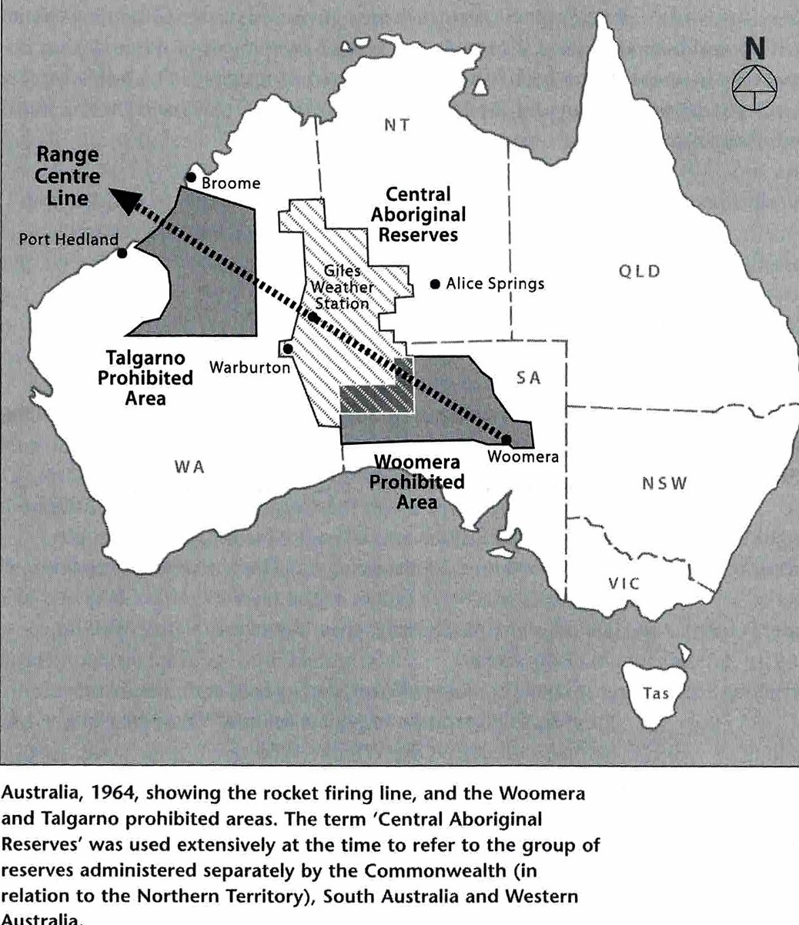

Map 12 Route of the Woomera rocket range over the Western Desert
(From Davenport et al 2005 p xiv)

Woomera is a rare example of a space site where Indigenous people and the space industry intersect in the same landscape (Gorman 2005: 98). In 1947, on the first reconnaissance for a place to build the township that would service the rocket range, surveyors found tens of thousands of stone tools at Phillip Ponds. Recognising that evidence of Aboriginal occupation also meant the presence of water, they selected this location for the Woomera Village (Gorman 2017). The area of the rocket range was a prohibited area, with movement restricted within it, so that from 1949 to 1970 the local, mainly Kokatja, Aboriginal peoples could no longer access ceremonial sites and resources there.
The design of Woomera village is unique in urban planning history of Australia, built from scratch and having to combine a modernist ideal of Australian family lifestyle with a Cold War classified, high-security environment in a remote, arid setting (Johnson et al 2002; Garnaut et al 2012). At the end of the Apollo program in 1972, redevelopment stopped at Woomera, leaving much of the original infrastructure. In the 1990s the range was opened to non-military use and mineral exploration.
‘Woomera Village was designed within two years of the start of the Cold War. Indeed, it was the ﬁrst new town designed and built, for any purpose, in post-war Australia. Signiﬁcantly,
its design and management throughout its various development phases demonstrated the post-war reconstruction ideal of creating a healthy and integrated community to maintain the morale of residents, despite the isolation, climate and high degree of social control. The success of these aims is reﬂected in the nostalgia, pride and memories of past residents evidenced by, for example, postings on websites like Woomera on the Web (Rigby 1997–2008), regular reunions in Adelaide and in Woomera, and by the artefacts and memorials scattered throughout the Village. Of the new towns that immediately followed in rural and regional Australia, no other was as comprehensive or as sophisticated in its plan as Woomera Village and none was built strictly for national defence purposes. Over time, although there have been various changes in the focus of defence projects which the Village has supported, it has sustained its primary function as a defence-centred residential facility. Woomera Village is a special and instructive example of a Cold War new community and of the contribution of town planning to shaping the social infrastructure required to support international weapons research and development and space and military surveillance programs through, and beyond, that era’ (Garnaut et al 2012: 557).

The locally available artesian water supply is too salty and the Morgan-Port Augusta-Woomera pipeline and large storage tanks were built in the 1940s to supply the town's residents with River Murray water.

Alice Gorman (2005, 2007) makes a strong argument for seeing Woomera as a continuing site of protest. When the rocket range was proposed in 1947, Dr Charles Duguid, founder of Ernabella Mission, was joined in protest by Pastor Doug Nichols, footballer and Aboriginal activist who later become the Governor of South Australia, as well as 50 other groups including trade unions, women’s groups, the Communist Party of Australia (CPA) and Aboriginal rights organizations such as the Australian Aborigines League (Gorman 2005: 96). Because of its distance from the metropole ‘the Woomera area remains a favoured place for the Australian Government to locate unpopular installations, such as the US military surveillance base, Nurrungar satellite tracking, nuclear tests, nuclear waste dumps and detention centres for asylum seekers (1999-2003). Kukatja people do not distinguish the impact of the missile and rocket programme from nuclear testing or nuclear waste dumps; they see them as part of the same process (Andrew Starkey, 2004, personal communication). For them, Woomera is a landscape of continuing protest. This is an intangible heritage of high signiﬁcance’ (Gorman 2005: 98).

Surveyor Len Beadell (1923-1995) is very much a part of the history of Woomera for his role in ‘opening up’ the arid interior of northwest SA and eastern WA, selecting the site for atomic testing at Emu Plains, and surveying a series of roads into the Great Sandy, Gibson and Great Victoria deserts, including the straight – hence ‘Gunbarrel’ highway – for the Woomera rocket tests, and providing access for establishment of the Giles rocket monitoring and weather station in 1955. This road was the first east-west link across Central Australia.

The availability of detailed and accurate weather forecasts was critical to carrying out Woomera rocket tests, and especially so for the nuclear tests – they could not proceed when cloud was forecast or winds were unfavourable due to risks of contamination of wide areas of the continent (see McClelland 1985). Hence there was an urgent need for a meteorological station located near the central range line. The location of the Giles meteorological station was chosen by Len Beadell for this reason in 1955. He named it for explorer Ernest Giles. However, as the location had water, it was regularly frequented by western Desert people. Patrol Officer Ian McDougall vehemently protested
the location, predicting the impact of the graded roads and the new station on the local Aboriginal people (McClelland 1985: 373, Dousset 2002).

The location of the Emu Field test area was also selected by Len Beadell to meet the criteria that it be at ‘a distance of 100 miles downwind from all homesteads, all inhabited areas and all lines of public transport’ (McClelland 1985: 168). RAAF aircraft provided the surveillance and monitoring of the tests from Woomera airport. After the two Totem atomic tests in 1953, the camp at Emu Field was rapidly disbanded (McClelland 1985: 224-6). The Emu site suffered from inadequate water supplies, and difficult terrain made supply and transportation generally expensive and inconvenient. The site now known as Maralinga, north of the transcontinental railway line between Cook and Ooldea, was selected to replace it in October 1953. The Australian Government agreed to the establishment of a permanent proving ground at Maralinga on 26 August 1954 (McClelland Royal Commission 1985: 278).

Maralinga Range
Between 1952 and 1963 the British Government, with the joint agreement and funding support of the Australian Government, carried out 12 nuclear tests at three sites in Australia. The first were at Monte Bello Islands off the Western Australian coast (October 1952 - Operation Hurricane, and again in 1956 Operation Mosaic). ‘The choice of a site was made on the basis that the United Kingdom had many ports used by international shipping. The view was taken that there should be an assessment of the effects of an atomic explosion in a port or harbour, produced by the firing of a device mounted below the waterline in the hold of a ship’ (McClelland 1985: 103). ‘With the successful detonation of a fission weapon at the Monte Bellos, the UK Joined the United States and the USSR to become the world’s third nuclear power’ (McClelland 1985: 107). The choice of site also reflected the necessity of undertaking such tests in relatively ‘uninhabited’ terrain for safety reasons.

The remaining trials were at Emu Field in October 1953 and at Maralinga in September–October 1956 (operation Buffalo) and September–October 1957 (Operation Antler). In addition, hundreds of minor trials, mostly involving components of nuclear weapons, took place at Maralinga between 1953 and 1963. It was these trials which caused long lasting contamination due the repeated contamination with radiation of the same area (McClelland 1985: 280, Denis 2008: 330). The UK used live animals in test experiments for the first time at Maralinga in Operation Buffalo to assess the direct effects of the explosions and the resultant ingestion, assimilation and retention of radioactive products (McClelland Royal Commission 1985: 277).

Woomera infrastructure supported these tests, with Woomera-based RAAF in-air testing from within the bomb’s radioactive cloud and contamination surveys (McClelland Royal Commission 1985). The McClelland Royal Commission assessed the evidence for impact on airmen and Woomera base support staff, and those carrying out the tests. They found that there was ‘excessive secrecy’ and a failure of those in authority to inform the participants fully of the nature of the activities in which they were engaged (McClelland 1985: 342, 346-7), which contributed to fears and potential breaches of safety protocols. As a result the Commission concluded ‘participation at the tests, including residence in the [Maralinga] village has increased the risk of cancer to those participants who were exposed to radiation, but the Royal Commission has been unable to quantify the probable increase’ (McClelland 1985: 348). Overall, however, the Royal Commission concluded that ‘radiological and physical safety arrangements for participants during the Buffalo tests were well planned and sound. … and security was strictly policed during the major tests but was relaxed afterwards’ (McClelland 1985: 347).

Macaulay the Patrol Officer attached to the Woomera Rocket Range project was given the task to ‘ascertain what natives, if any, are living in the Range area and to make suitable arrangements for
their evacuation’ (Royal Commission 1985: 303). Emu Field was located within the Woomera Prohibited Area.

Maralinga was officially closed following a clean-up operation (Operation Brumby) in 1967. A major inquiry into the fallout and effects of the tests was conducted by the McClelland Royal Commission into British Nuclear Tests in Australia in 1985. An official history was published by the Department of Resources and Energy in 1985 (JL Symonds, A History of British Atomic Tests in Australia, AGPS, Canberra). Two further efforts to ‘clean up’ the radioactive surface materials have followed.

In Cleared out Davenport et al (2005) give a detailed account of the impact of the weapons testing in desert places far from the location of Woomera itself. It tells the story of a family group living in the Percival Lakes area and of Macaulay, the patrol officer employed to ‘clear out’ the people resident in the desert areas in advance of tests in 1964. The multi-vocal eye-witness accounts provide an intimate depiction of the life on the soakages and in the dunes of the western desert, as lived by these last amongst the ‘first contacts’ of desert people with non-Indigenous outsiders.

The atomic tests drove some of the Spinifex People of the Great Victoria Desert into Cundalee Mission and into Ooldea (Palmer 1990). Others tried to stay, but could not support themselves, too frightened of being poisoned to cross country to get food and water. There are a number of direct accounts of the impact of the Maralinga tests on the local people living through the tests (Brady 1986; Palmer 1990; Eve Vincent 2010; Yvonne Edwards 2016).

One of the leading campaigners for recognition of the impacts of the tests, resulting in the 1984-5 Royal Commission, was Yami Lester OAM. He was born at Walyatjata in the north of South Australia and was at Wallatinna in 1953 at the time of the Totem 1 atomic test at Emu Field, and was apparently affected by a ‘black mist’ of fallout from the Maralinga tests (see McClelland 1985: section 6.4 pp174ff).

Maralinga site was only 109 km north of Ooldea a major traditional meeting place and node for many lines of travel for desert people (see section 3.3.3.2 Water routes). Establishment of the Maralinga test field required that the Ooldea Reserve be closed in 1954. Ignorance about the centrality of that locale to Indigenous patterns of life led authorities to assume that this closure would lead to an end to visitation of Ooldea and associated tracks, but there were documented instances of people using tracks which had been contaminated with radioactivity, walking through a recently created bomb crater, and people frightened by hearing and feeling the blasts (McClelland 1985; 300- 324).
‘An examination of these conflicts throws light on the attitudes of the UK and Australian officials to the issue of Aboriginal safety and the nuclear tests. Overall, the attempts to ensure Aboriginal safety during the [Maralinga] Buffalo series demonstrate ignorance, incompetence and cynicism on the part of those responsible for that safety. The inescapable conclusion is that if Aborigines were not injured or killed as a result of the explosions, this was a matter of luck rather than adequate organisation, management and resources allocated to ensuring safety.

For the Buffalo tests, a site was chosen on the false assumption that the area was not used by its traditional Aboriginal owners. Aborigines continued to move around and through the prohibited Zone and inadequate resources were allocated to locating them and to ensuring their safety. The reporting of sightings of Aboriginal people was discouraged and ignored.

Aboriginal people were kept away from Ooldea and other important places to the south and west of the Range. At the same time, the construction of the Giles meteorological station and roads brought intruders and detrimental effects to the people north-west of Maralinga’ (McClelland 1985: 322).

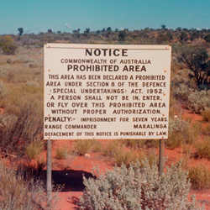

Fig 8: Maralinga, prohibited area sign on the Emu/Nawa Road, source http://www.naa.gov.au/collection/fact-sheets/fs129.aspx

One outcome of the McClelland Royal Commission was the formal hand-back of the huge area of land of the restricted area to the traditional owners, the Maralinga Tjarutja people in December 2009. However it remained subject to access restrictions until 2014 when 1,782km² was fully returned to the Maralinga Tjarutja people. $100 million was spent on rehabilitating the land between 1993 and 2001 following the recommendation of the Royal Commission. Andrew Collett, the legal representative of Maralinga Tjarutja says legal issues around the land have been resolved, and the village and all the land (except for the dangerous contaminated areas) have been returned to Maralinga Tjarutja people. They are now running tours of the village and bomb sites.

3.2.5.2 Depicting the deserts: representational landscapes
Textual descriptions are only one part of the body of representations of the Australian Deserts. Roslynn Haynes’ 1998 Seeking the Centre reviews the history of representation of central Australia by artists, novelists and filmmakers. Artists’ representations of the desert have played a crucial role in allowing people coming to the desert as an unfamiliar environment to understand and appreciate it as more than an empty wasteland, glowing with colour – a ‘red’ and ‘living’ heart not a ‘dead’ one (Haynes 1998: 148-9).

Hans Heysen
Sir Wilhelm Ernst Hans Heysen (1877–1968) was a catalyst for change in popular imaginaries of arid Australia. His name was already a household word for his depictions of gumtrees and pastoral landscapes when he first visited the Flinders Ranges in 1926. The clarity of the light, blocks of colour and sense of age and spaciousness, and the sharp outlines of the landscape intrigued him. To paint the visible vast distances required abandoning traditional foreground and background and simplifying forms (Haynes 1998: 164-5). Winning the Wynne prize for landscape nine times, his work reproduced widely on cards and calendars, Heysen’s depictions of the otherwise unfamiliar arid north of South Australia educated the public ‘to see barrenness as beautiful’ and was widely influential on other artists (Haynes 1998: 166).

Russell Drysdale
Unlike Heysen, Sir George Russell Drysdale (1912-1981) depicted human figures integrated into their desert landscapes. From the 1940s on, he painted barren, flat landscapes of drought-stricken western NSW populated by thin people, dead trees and the debris of abandoned buildings, but with a respectful optimism – his people are ‘at home in their desert’ (Haynes 1998: 168-169). After a long journey through arid Australia in 1956, Drysdale painted Aboriginal people as self-assured and part of their land (Haynes 1998: 170-171). His work was recognised nationally and internationally, and again defined popular imagination of desert character.

Albert Namatjira
Unlike the foreign born artists above, Albert (Elea) Namatjira (1902-1959), was born at Hermannsburg (Ntaria), a western Arrernte man. The story of his creative output is well documented and popularly acknowledged, and listed on the National Heritage List. Less well understood is that ‘Land was the centre of Namatjira’s being and his vision’ as Alison French explains in the major retrospective of Albert Namatjira’s work commissioned to mark the centenary of his birth in 2002 (French 2002). Namatjira’s work has been interpreted in many ways, but with greater understanding of the subjects he chose and the way he worked, it is accepted that he was ‘painting country’, especially in the western MacDonnell Ranges. That is, he was painting places that he was intimately, deeply aware of in terms of both western Arrernte Ancestral stories and histories of his relatives located in those places. In choosing to represent them in a mode of painting that was accessible and acceptable to non-Aboriginal audiences, he made his informed relationship to country available to them for the first time. He influenced a school of watercolour painting in western Arrernte country, and Vivian Johnson (2015) sees his presence in Papunya in 1959 as one of the seeds for the development of new artistic forms there in the 1970s.

It is Namatjira’s long-term underlying connection and knowledge of country that is being articulated, not a surface appearance, or ‘beauty’. ‘A region of extremes, Central Australia is far from a “dead heart”. Contrary to misconceptions, water is a powerful presence. … its absence or presence is the source for much of the diversity of visual forms and motifs that engaged Namatjira throughout his painting career’ (French 2002: 1). This reinforces the argument made in this essay about the centrality of forms of water for understanding the Central Desert region, and further, for understanding Namatjira’s work.

Members of Namatjira’s family and community also painted in watercolour, and are referred to collectively as the ‘Namatjira School’.

A suite of other artists of international standing also worked in arid Australia – John Olsen in Lake Eyre; Sidney Nolan who first painted the desert from the air, and a potent series of Burke and Wills studies; John Molvig who painted a nurturing desert; Fred Williams who painted the Pilbara from the air; Lloyd Rees who painted central Australia late in his life, and many other artists (see Haynes
1998). While their work has significantly influenced the art world, it arguably has had less impact on the popular envisioning of the desert.

Papunya
More than any other art movement, contemporary desert art production has granted outsiders a window into the core values of Australian desert living for Indigenous people – the long term, intimate knowledge of the Ancestral and historical places that populate the deserts, including water places, and the paths that link these. This art movement was an innovation born in the new settlement of Papunya under conditions of adaptation to living in ever-smaller areas due to pastoral appropriation of land. It thus encapsulates the various themes of this study.

The art movement that grew from Papunya has played a central role in redefining how the arid zone can be understood. Howard Morphy, anthropologist specialising in Indigenous art practice, has written ‘The colonial process has been a battle … between different ways of relating people to land, and since aesthetics has been close to the heart of Aboriginal relationships with land, colonialism has also been a struggle over the aesthetics of the Australian landscape’ (1988: 266). The process of development of the desert art movement may be compared to the Wurrwurrwuy stone arrangements listed on the NHL for criterion ‘B’ Rarity. There, an old technique of making stone pictures was used to depict new, unfamiliar and secular subjects. Papunya’s art movement shows a related process of expression of the experience of cultural change using new forms for important old ideas.

‘Papunya painting’ was a new artistic form named after the place of its invention, which is also the name of the major Honey Ant Dreaming site located there (Johnson 2015: 14, 19). Geoffrey Bardon, art teacher at Papunya in the 1970s, has told an ‘origin story’ for the genesis of the contemporary Indigenous art movement there (1979). His desire to engage his students in the forms of their culture led to interest by senior Pintubi men who worked as yardsmen at the school. They took the step to paint their stories with acrylic paints on the school walls. The first mural was the ‘Honey Ant Dreaming’, followed by ‘a sudden rediscovery of their artistic heritage … the sudden blossoming of their traditional art.’ A painting room was established, where painters - chanting the songs of the stories - would work out how to paint without including secret/sacred material that would ‘cause controversy’. ‘These guardians of the culture helped men living at the settlement, in conditions alien to their tribal past, to find a way back to their heritage, and also opened a way which the Aboriginal schoolchildren could follow’ (Bardon 1979: 13-16 in McLean 2011: 84-87).

The story of Papunya also offers the opportunity to recognise the significant homelands movement of the 1980s, as it involves camps of Warlpiri people outside the main township at Three Mile (Johnson 2015: 120) and outstations Yaiyai and Kintore (and others) as part of the Papunya story. Fred Myers tells of the painting activity that followed at Yayayi outstation in 1973-5. As there was then little or no demand for the paintings, they were largely bought by the Aboriginal Arts Board (Myers 2007: 43). From the powerful position that the art now has, and the ‘central position that [the art] has now taken in public representations of Aboriginal people’ it is important to hear Myers’ account of the ‘precarious’ position of painting in the early years. It is less than 100 years since ‘authentic Aboriginal art’ was considered by the non-Indigenous world to be rock art and nothing else. In that context, contemporary cultural productions such as Anangu wooden carvings were labelled ‘ethnographic’ rather than ‘Art’ (see Ian McLean 2016).

The emergence of this art of ‘traditional’ Ancestral stories, knowledge of country, and ceremonial practices in a new format and for different audiences is embedded in the history of the pastoral occupation of land in the central Australian ranges. Mike Smith (2005) documents the ‘emptying out’ of the central deserts from the time of the Overland Telegraph line and the pastoral industry that followed it, to the last people ‘coming in’ from the western desert near Lake Mackay in the mid-
1980s (Smith 2013: 109-110). People gradually moved into settlements, usually at times of drought, when inability to access all their country, plus alteration of water and food sources by cattle, rabbits and feral cats together made the hunter-gatherer economy less and less viable. They moved in to stations, and to Hermannsburg mission for rations. Established in this context, Papunya was a new assimilationist government-decreed settlement, built in 1958-9 to train people from Haasts Bluff how to live in European housing.

In the 1980s a group of the more recently arrived Pintubi residents left, returning west to their country when a bore was finally sunk successfully there, and they could establish the out-station of Kintore in Pintubi land – another centre of art production (Johnson 2015).

Vivien Johnson adds more layers to this art movement ‘origin story’, pointing out the prior experiences the men who led the painting movement had had with Adult Education painting, and with Albert Namatjira. They watched him paint when he was sent to Papunya to serve his prison sentence near the end of his life, rather than going to gaol (Johnson 2015: 28-57). His wife was from Papunya-area country, and he was at ease there, as there are many inter-relationships between the people of the two settlements. Johnson suggests that these prior exposures were a predisposing factor in prompting the transition to depiction of Ancestral stories on flat boards rather than in body painting, sand painting and ceremonial objects. (Hermannsburg Historic Precinct and Namatjira and his watercolour painting tradition are listed on the NHL).

In the 1980s, the Papunya Tula Artist Pty Ltd business was founded to distribute and sell art work, a continuing business, owned and directed by Aboriginal people from the Western Desert. There is now, finally, an art centre at Papunya on ‘Possum Crescent’ (Johnson 2015).

The artists from 1970s Papunya ‘are now part of Australian art history’: Kaapa Tjampitjinpa, Tim Leura Tjapaltjarri, Mick Namarari Tjapaltjarri, Turkey Tolson Tjupurrula, Uta Uta Tjangala, Clifford Possum Tjapaltjarri, Billy Stockman Tjapaltjarri, Long Jack Philipus Tjakamarra and Johnny Warangkula Tjupurrula (Johnson 2015: 11). In the intervening decades, women artists of Papunya have also taken up the role of important painters.

Papunya is also the home town of the Warumpi Band, the first rock band to have a song in their Indigenous language - Luritja - played on commercial radio, 'Jailanguru Pakarnu’ (Out from Jail), in 1983 (http://nfsa.gov.au/collection/sound/sounds-australia/2007-registry-additions/#warumpi).

In the period of self-determination policy, in 1974, the town plan for extending Papunya was drawn up by community members in the form of the Papunya Honey Ant Dreaming, so, while not completed, from the air the township embodies the Papunya-style representation of the Dreaming in its streetscape (Johnson 2015: 68-71).

‘Inter-relational trade in artistic ideas and materials is a powerful force across the Western Desert’ (James 2011: 87). Other art centres have followed the lead of the Pintubi artists from Papunya, painting their country, Ancestral stories and ceremonies throughout central and Western deserts and beyond. For example, the Spinifex people’s Arts Project 1996 recorded and documented ownership of the Spinifex area, painting a map of people’s birthplaces, showing ownership, responsibility for country and knowledge of country in a series of paintings given to people of Western Australia. They considered these to be historical documents, part of their successful Native Title claim to the area (see Cane 2002). Similarly, the great Ngurrara Canvas was painted by senior
traditional owners of the Great Sandy Desert of northern Western Australia as an expression of their claim to country, for presentation to the National Native Title Tribunal in 1997.
Some communities were hesitant to depict their cultural knowledge in forms that were generally accessible. The Pitjantjatjara preferred to paint bush tucker themes to avoid depiction of sacred symbols (James 2011: 87).

Emily Kame Kngwarreye (c1910-1996), who was born and worked in Alhalkere country near Utopia is an especially celebrated desert artist nationally and internationally, one of the greatest Australian painters of the twentieth century (McLean 2016: 177-182).

A huge market has grown up around the works of contemporary Indigenous artists, changing the shape of art trading in Australia. 13,000 artists were estimated to be working between 2003 and 2012 in remote Australia, selling 340,000 works, generating $A99.3 million (McLean 2016: 9). There have been problems with intellectual property rights and the way in which art is produced and sold, addressed in the work of Terri Janke, Indigenous arts lawyer, writer and consultant, for example in the seminal study Our culture, our future (1999).

This history, and the surrounding social context, of Papunya art is well documented. The above account is only a thumbnail of the main aspects of the import and interpretation of the art movement that was seeded in Papunya.

***

3.2.6 Important themes that do not relate to water
The following themes do not relate to water, but are important historical aspects of desert life which should not be left out of any overall consideration of the cultural heritage significance of Australian deserts.

3.2.6.1 Missions and Reserves
As land was occupied by pastoralism, and it became harder to access resources for living, Aboriginal people were condensed into smaller and smaller areas, and especially when droughts increased the pressure on them, they moved into missions and reserves. They are as much an economic and political product of pastoral appropriation of land, and competition for resources as they are religious institutions.

Of the missions and reserves in the arid zone, Hermannsburg is already listed on the NHL. Killalpaninna and Koperamana were also Lutheran missions, established earlier than Hermannsburg, (1866) near Lake Eyre. Reverend Johannes Reuther had a role equivalent to that of Strehlow’s at Hermannsburg. Luise Hercus (1990: 157) says ‘The great work undertaken by the Reverend Reuther at the turn of last century at the Killalpaninna Mission gives vast materials on the languages and traditions of the eastern Lake Eyre Basin. It is based mainly on Diyari, as Killalpaninna was in Diyari country, but shows a tremendous input from the Wankanguru people.’ He translated the New Testament into Dieri, created a Dieri dictionary, collected artefacts and recorded multiple volumes of information on the traditions and knowledge of the Dieri people (see Jones 2007, Christine Stevens 1994).

The Bungalow at Alice Springs telegraph station is associated with Charlie Perkins and Gordon Briscoe, who both escaped mission life through soccer, and went on to significant careers. Gordon Briscoe has a PhD in History from the ANU, and amongst many other achievements, assisted in the successful running of the National Trachoma and Eye Health Program for treatment of preventable blindness by Fred Hollows in the 1970s. From 1976 to 1978, his teams screened 100,000 people, 60% of whom were of Aboriginal or Torres Strait Islander heritage. Charles Perkins’ life as an activist and spokesman, leader and representative in the public service, in the Freedom Rides, ATSIC and the Aboriginal Development Commission is the subject of his autobiography and numerous biographies and other studies. The Bungalow could be listed as part of history of the Alice Springs repeater station, where it was located.

Other arid zone missions are listed in the Preliminary list. They each have significant regional and national histories and associations: Ooldea with Daisy Bates, Ernabella with Charles Duguid, Colebrook with Lowitja O'Donoghue, Cundalee with the Maralinga tests. An assessment of these places is outside the limitation of ‘water’ in this study. A scoping study of Australian missions has been undertaken, to begin to assess the national heritage potential of these institutions (Baulch nd 2002?). It is recommended that this study be re-appraised and brought up to date to complement the recent study of ‘Benevolent Institutions’ (Context 2014).

3.2.6.2 Extractive economies - Mining
Although large areas of the desert have no mineralisation hence no historic mining, where it did occur, large and enduring mines have been a significant aspect of arid zone land use, historically and in the present. Historically, mineral exploration and finds led to many of the access routes and concentrations of people in arid zone settlements.

The arid zone contains the largest exploited mineral fields for some economic minerals: The Eastern Goldfields centred on Kalgoorlie are Australia’s most productive gold field; the Cloncurry area is Australia’s most productive copper field; and Broken Hill Australia’s most productive silver–lead field. Broken Hill has been listed on the NHL in recognition of its national heritage.

A small number of present day mines are outstanding for their scale of mining and levels of production and can be considered to constitute the mining heritage of the near future. Places in this category include the Pilbara iron ore mines, Olympic Dam copper mine, Roxbury Downs uranium mine and the Moomba gas field.

Opal mining is also a feature of the Australian Arid Zone. Opal is a distinctively Australian product, and has become a symbol of Australia. Australia is the largest producer of gem quality opal in the world, generating 95% of the world’s precious opal until recently, when deposits were discovered in Ethiopia. 80% of all opal sold comes from SA. ‘It is ironic that in the most harsh of terrains the most beautiful of naturally occurring gems are now found’ (Opals exhibition, SA Museum 2015).

The opal mining regions in the Australian Arid Zone are in NSW - Lightning Ridge (established 1890) and White Cliffs (established 1901), in SA - Coober Pedy (established 1915) and Andamooka (1920s). Boulder opal mining in Queensland started earlier. Each of these places, except the boulder opal mining in Queensland, has resulted in the establishment of a dedicated opal mining town with distinctive underground living conditions, a response to the extreme desert conditions.

The provision of potable water has also been an issue for these opal mining towns. This has been a technical problem that has been solved through development of water catching techniques. Coober Pedy for example pipes water from a bore 25km North East of Coober Pedy. The water is then processed through a Desalination/Reverse Osmosis Plant.

Opal towns also have an indirect relationship to water through the nature and origin of the opal itself, as opal is formed in sediments of the ancient inland Eromanga Sea. This, rather than any other factor, has determined the location of the mines. The mineral opal also contains water, and it is this hydraulic quality that give opal its distinctive ‘opalescent’ sheen.

There is sparse academic literature on opal mines; mainly tourism and promotional writings. There are some state-based studies, but no national thematic study of mining heritage.

Mining falls outside the limitations of this study’s ‘water theme’, but mining as an important aspect of arid zone living and land use, and is highly recommended for targeted research and potential National Heritage listing.

3.2.7 Conclusion
The cover of this report shows a depiction of the Canning Stock Route and surrounding country painted in 2008 by 14 women artists at Kunawarritji (Well 33). It exemplifies the themes that are at the core of understanding people’s responses to Australian deserts. It features waterholes and the tracks between them – a visual codification of the key principles of intimate knowledge of a particular water-place and the Ancestral and historical events associated with them, and the mobility required to secure access between waterplaces. The contemporary desert art movement that has its origins in 1970s Papunya offers outsiders the gift of being able to see these central principles of desert life. At the same time, this painting depicts the overlaid history of the colonisation of the western desert by pastoralists, taking over access to the wells for the needs of thirsty cattle, leading to conflict over access to water and permanent disruption of the pattern of local people’s lives. It is both a statement of desert life principles and a historical document.

***

Table 3.1 Chronology of events in the arid zone

Name | Dates  (ka = 1000 years ago) | Brief description
Pleistocene | 2.6 million years – 11.7ka | A global geological period marked by a series of cycles of glaciation and warmer inter-glacial periods, ending with the Holocene period of rapid warming, end of glaciation and associated sea level rise
LGM (Last Glacial Maximum) | 26.5-19ka | ‘Peak glacial’ period in the Pleistocene, when glaciers globally reached their greatest extent. The period of peak aridity, and lowest sea levels, 135m below present level.
(Carpenters Gap 1, on the northern desert margins, outside study boundary) | 44-48ka | Large limestone rockshelter in the Napier Range, Kimberley, WA. Well-preserved plant remains, animal bone and ochre and stone artefacts. Red ochre covered rock slab older than 40ka  (included in values of West Kimberly NH listing)
Warratyi  South Australia | 49ka-recent | Elevated sandstone rockshelter in the northern Flinders Ranges. Stratified deposit containing stone artefacts – including early backed artefacts and hafted tools; bone, and eggshell - including evidence for association of people’s activities and extinct megafauna; an early- dated bone point; and evidence for early use of red ochre and white gypsum.
Serpents Glen  Western Australia | Recent dates of c. 50,000ka to 5.4ka, re-occupied in historic times | Large sandstone rockshelter in mouth of valley in Carnarvon Range, Little Sandy Desert, WA, near waterholes and soakages - used intensively in late Holocene to recent period, after a long break in visitation. Longest record of occupation in the Western Desert. Stone artefacts and ochre.
Lake Gregory/ Paraku | 45ka | Paleo lake, single inflow, source-bordering dunes – analogous to Willandra Lakes. Single stone artefact dated. In Great Sandy Desert, WA.  Well documented recent history of Mardu People, associated with surveyor Canning and construction and operation of the Canning Stock Route
Koonalda Cave | 26.3-16.6ka | Limestone sinkhole in Nullarbor Plain, 160km inland from Pleistocene coast. Underground water. Mining of underground flint. Finger flutings. With Allens Cave shows regional population living in extremely arid local conditions through the LGM, abandoned at end of LGM.
Allens Cave | 39.8 – 15ka sporadic,  10.8ka – 3ka main occupation | Limestone doline, repeated occupation. Shell brought from the coast 65km away and silcrete from northern plain 200km away
Puritjarra | 35ka – recent | Large rockshelter in Cleland Hills outlier 60km west of MacDonnell Ranges, Central Australian desert, NT. Close to large semipermanent Murantji waterhole. Intermittent repeated use starts 35ka- indicated by stone artefacts, from 60km away, red ochre from 125km away. More intensive use after 8.3ka, much more so in last 1000 years. Rock art
Puntatjarpa | 11.8ka - recent | Stone artefacts, red ochre, hearths and animal bone. Rock art dated to 7.5ka
JSN Site | 17.5, 17, 12.3, 2.5ka | The only pre-Holocene site recorded in a sandy desert, but close (40km) to Strezlecki Creek. In the Strezlecki desert, SA. Cluster of 9+ hearths, open artefact scatter, shell, the site re-visited multiple times, from the well-watered Cooper floodplains 115km NE, in the warmer wetter period after the LGM.
Willandra Lakes (including Lake Mungo) outside study boundary) | 40-50ka – recent | Paleo lakes and source-bordering dunes –lunettes. Ochre used in cremation and burial, hearths, artefact scatters including grindstones, small shell middens. Fossil human footprints. In NSW on the SE desert margin.
Early Holocene changes | 12-4ka | Wetter, improved availability of water sources, expansion of population in the deserts – differences in form according to location.  West coast - Sea level rise following end of glaciation – mangroves expand along the NW coast, contract again by 4.5ka. Mangrove shellfish start to be exploited together with broad range of terrestrial resources (eg in Silver Dollar site, Shark Bay, WA).  Nullarbor – cliffs exposed separating Nullarbor from the sea except in a few places. Human and animal footprints from 6ka.  In the inland deserts, sites abandoned in the LGM are re-occupied and used more intensively, new sites are occupied, more rock art is recorded.
Mid- Holocene changes | 4ka  4.6ka  4ka | Time of establishment of a distinctive adaptation to arid conditions at a time of high levels of environmental variability and aridity relative to early Holocene and present - onset of ENSO (El Nino-Southern Oscillation)-dominated climate.  Stabilisation of sea levels including on the arid western margin of the continent.  Dingo dispersed across continent – important socioeconomic addition  Addition of new tool kit elements – adzes, intensification in use of seed-grinding tools and composite tools of small stone artefacts wood sinew and resin, more diverse wooden implements  Content of both changes feature in Ancestral stories.  Increased diet-breadth – more seeds and grains- reduced need to move, when population higher
Late Holocene changes | 1.5ka - present | Expansion of settlement into more sites, more intensive use of existing sites, more use of peripheral habitats, higher population densities, reduced residential mobility – extended occupation times, acceleration in ritual and ceremonial activity, greater differentiation of a larger number of regional rock art complexes, establishment of long distance trade networks, widespread use of patch burning mosaics in sand deserts, intensified proliferation of seed-grinding implements and seed storage– offsets late dry reliance on limited water sources, allows longer duration stays.
Baler shell trade route |  | Trade from NW coast or Gulf of Carpentaria into the interior up to 1700km. Used for pendants – ceremonial use, and tools, containers
Pearl shell trade route | Post contact, 1870s on | Trade mirrors baler shell. Open system of exchange
Mikeri wells – water route across the Simpson Desert | Approx. 3ka - 1900 | The last resident Wankanguru people walked out of the desert to Kilalpinina Mission from one of these wells in the summer of 1899-1900 (Hercus 1985). Smith and Clarke (1993) dated occupation of the western-most, Murraburt, and Oolgawa swamp, on the south-west edge of the Simpson dune field, to at least 3000 years.
Ooldea,  Water route,  clay dams | ?probably late Holocene meeting place at the Ooldea soakage.  Bates’ camp 1919-1934  AIM Mission 1933  Rail 1917 | Long term permanent soak, meeting place, ceremonial site, tracks – water routes -radiated out from Ooldea into the Great Victoria Desert and the Nullarbor Plain.  Daisy Bates (1863-1951) established an aid camp.
Edward John Eyre  (1815-1901) | 1841 WA expedition | 1839 reached Lake Torrens  1840 explores north and formulates theory of the 'horseshoe' lake. Series of western expeditions. 1841 crossed to Albany WA from Eyre Peninsula, via Eucla.  Protector of Aborigines on the Murray River
Charles Sturt  (1795-1869) | Northern expedition  1844-6 | Expedition from Adelaide in search of inland sea and mountain range. Trapped by lack of water at Depot Glen Jan- July 1845. Reaches Strzelecki Creek and Cooper Creek area. Turned back by the Simpson Desert.
Augustus Charles Gregory | 1858 | Gregory arrives in Adelaide from Queensland through the previously impassable 'horseshoe' of salt lakes, demonstrating the possibility of an eastern access route.
Mound springs first sighted by European explorers | 1858 | Benjamin Herschel Babbage and Peter Egerton Warburton discover the Mound Springs near Lake Eyre
Burke and Wills expedition to cross Australia leaves Melbourne | 1860-1 | 1861 Burke & Wills perish at Cooper Creek.  Rescue expeditions led by Howitt, McKinlay, and Landsborough & Walker.
George Goyder surveys and names Lake Eyre | 1860
John McDouall Stuart  (1815–1866) | July 1862 first to cross from Adelaide to Indian Ocean | On Sturt’s expedition learnt arid land exploration techniques, especially travelling light. 1858 small expedition beyond Lake Gairdner and Lake Torrens. 1858, 1859, 1860, 1861 series of expeditions north. In 1860 named the Finke River and MacDonnell Ranges
Killalpinnina Mission | Est 1867, abandoned 1871, reopened 1878 – finally closed 1918 | Lutheran Mission. Association with Rev Johann  Reuther and Charles Hillier; toas; Dieri Bible and dictionary. Re-directed missionary activities to Hermannsburg.
Kopperamanna Mission | Est 1866 | Moravian Mission. Established on the site of a Dieri trading centre on the Cooper floodplain.
Overland Telegraph Line construction | 1870-2 | Adelaide – Port Essington (later Darwin)  Repeater stations within the arid zone: Beltana, Strangways Springs, Peake, Charlotte Waters, Alice Springs, Barrow Creek, Tennant Creek.  (non-arid zone repeater stations - Port Augusta, Powell Ck, Daly Waters, Katherine, Southport)  Start of European pastoral occupation along the line.  An important transport route through the centre, including Afghan cameleers.  Modernity for Australia.
Peter Warburton crosses Great Sandy Desert | 1872 | Led a party from Alice Springs to the northwest, across the Great Sandy Desert, first Europeans to travel from the centre to the west.
Artesian basin discovery by pastoralists, windmill and bore construction | 1870s | Production of windmills to pump sub-artesian water (not pressure water) to the surface
Telegraph line to Perth | 1877 | Telegraph connects Perth to Adelaide, Darwin and London.
Hermannsburg Mission | 1877 | Hermannsburg Mission established on the Finke River, Northern Territory
Kallana Station/ Killara Station, Tilpa NSW | 1878/9 | First successful bore, relatively shallow aquifer, near natural springs. Pastoral expansion based on securing more reliable water supplies
Kembree Station, Bourke;  Thurulgoonia Station near Cunnamulla, Qld | 1886/7 | First deep bores with high flows – tourists came to see them
Owen Springs, Hugh River SW of Alice Springs, NT | 1886 | First property purchased by Sir Sidney Kidman (1857-1935)
Anna Creek Station, Lake Eyre | Est 1863, early bore 1881 | A Kidman property. Strangways Springs repeater station on the property. Section of the Woomera Protected area on the station. Vast extent due to arid location – world’s largest working cattle station 24,000 Km²
Darling River Paddle steamer  Transport Route (Wentworth – Bourke) | 1864 -1914 | Crucial for establishment of semi-arid pastoralism; part of significant Inland Corridor route for trading and travel along the Darling River to Walgett via Louth, Tilpa, Wilcannia, Bourke - defined the form of settlement
Kalgoorlie and Coolgardie gold fields discovered | 1880s
Broken Hill | 1883 - present | silver/lead/zinc ore body of immense size, and enormous diversity of minerals
 | 1886 | Marree-Birdsville mail service established
Lightning Ridge Opal mines, NSW | 1890
Ghan Railway | 1891 reached Oodnadatta; 1929 Alice Springs, 2004 Darwin
Baldwin Spencer and Frank Gillen expedition | 1901 | Year-long anthropological recording expedition along the Overland Telegraph Line
White Cliffs, NSW Opal mines | 1901
Albert Namatjira | 1902–1959 | Hermannsburg, West MacDonnell Ranges
Rabbit Proof Fence No 1 | 1901-7 | Surveyed by Alfred Canning. Maintenance depot at Jigalong became a camel breeding centre then mission in 1947. Associated with book and film ‘Follow the Rabbit Proof Fence’ 1996/2002.
Canning Stock Route | 1906 survey | Route through the Western Desert. Surveyed by Alfred Canning. 1908 Royal Commission into his survey practices.
Mulka store | 1912 | George Aiston establishes Mulka store on the Birdsville track
Coober Pedy, SA Opal mines | 1915
Emily Kame Kngwarreye | Born 1916 Utopia, NT -1996
Great Eastern Railway | Construction completed 1917 | Sydney to Perth. One of the world’s longest train journeys (4,352 km), including the longest straight section (478km)
Conniston Massacre, NT | 1928 | Most recent recorded massacre of Aboriginal people in Auatralia, subject to Commission of Enquiry.
Royal Flying Doctor Service established | 1928 | Established by John Flynn (1880-1951)  Beltana 1911 Flynn’s first location, Smith of Dunesk Mission, AIM forerunner. Oodnadatta Nursing Hospital 1911. From 1912 the Australian Inland Mission established 15 nursing homes/bush hospitals in remote Australian locations: Innamincka AIM Hospital, Birdsville AIM Hospital, Alice Springs Hospital 1926.  Cloncurry 1928 start of the AIM Aerial Medical Service (later RFDS). Based in Cloncurry Hospital and airport. Serviced by QANTAS with base at Longreach airport.
Charles Nelson Perkins, AO | Born 1936 The Bungalow, Alice Springs - 2000 | Eastern Arrernte and Kalkadoon, soccer player, activist, spokesman, graduate, public servant and representative
Ernabella Mission established | 1938 | Presbyterian mission, associated with Charles Duguid
Pilbara Strike | 1946-9 | Skull Springs, Nullagine, where the strike was planned  Five Mile Camp, Marble Bar, site of police attack against strikers  Mt Edgar and Limestone Stations – first to create workers’ rights, set a new standard  First Aboriginal-owned and run stations - Strelley Station, Port Hedland.  Referred to as the ‘Black Eureka’ (Max Brown book title 1976)
The Dog Fence/ Dingo Barrier Fence | 1946/ 1948 | SA Dog Fence Act 1946, Queensland Dingo Barrier Fence 1948. Large degree of coordination of local property managers to join small scale dog fences into ‘the longest fence in the world’
School of the Air | 1948/  1950 | Pedal radio, developed by Alfred Traeger 1929. Extended to use for School of the Air based on the concept of Adelaide Miethke OBE (1881-1962), a SA teacher and school inspector. Trial in 1948 at the Alice Springs RFDS Base, began operating from Alice Springs Higher Primary School on 20 September 1950. First such service in the world.
Woomera | Est 1947 | Use of ‘waste’ (empty) lands; weapons testing and space research and rocket launching in the Cold War Era; 1947 protests by Charles Duguid, Pastor Doug Nicholls, Communist Party of Australia; ongoing use as an asylum seeker detention center; landscape of continuing protest.
Maralinga | 1952 | British atomic tests on the Monte Bello Islands. Emu Field and Maralinga were satellite bases/ ranges for nuclear testing
Giles meteorological station | 1955 | Road survey and construction, selection of Giles location by Len Beadell (1923-1995) a ‘last explorer’ who ‘opened up’ the Great Sandy, Gibson and Great Victoria deserts.
Papunya | Est 1958/9  1971 art movement origins | New settlement established in 1958/9 given its name from the Honey Ant Dreaming site at the location. On the site of Lyappa soakage, Western Arrernte land, built by the residents to accommodate the excess population at Haasts Bluff – part of the emptying of the western deserts. Elders encouraged to paint on the school walls in 1971 by teacher Geoff Bardon, generated widespread contemporary desert painting movement, one of Australia’s foremost cultural achievements.  1980 Homelands movement at Yaiyai and Kintore
Percival Lakes, WA | 1964 | Late ‘first contact’, in Great Sandy Desert, Mardu family, last phase of emptying of the deserts
Lake Mackay, WA | 1984 | Last ‘first contact’, called ‘the Pintubi nine’ in press reports, final emptying of the deserts
Iron ore mining | 1965 | First iron ore mine in the Pilbara, the Goldsworthy mine developed by Utah Development Co. BHP's operations in Newman date back to 1968, when the Mount Whaleback mine was opened, the biggest single open-pit iron ore mine in the world.
Gurindji Strike | 1966 | Walk off Wave Hill station to Daguragu
Commonwealth Referendum on Aboriginal status | 1967 | ‘Yes’ vote
Equal pay for Aboriginal workers came into practice | 1968 | Many Aboriginal workers forced off country under pastoral leases
Aboriginal Land Rights (NT) Act passed | 1976
SA Land Rights Act passed | 1981 | Anangu Pitjantjatjara Yankunytjatjara Land Rights Act, SA
First Indigenous language commercial music recording | 1983 | Warumpi Band of Papunya – sung ‘Jailanguru Pakarnu – Out from jail’ in Luritja, lingua franca of the town where six languages are spoken

PART 4 Identification and assessment of places of potential National Heritage significance

4.1 Assessed places of National Heritage significance (Preliminary List)

Table 4.1 is the Preliminary list of all places identified by the project which are considered to have outstanding national cultural heritage significance, and portential for listing on the National Heritage List. The study has identified 61 such places.

The locations of the places on the Preliminary list are shown in Figure 4.1. These locations are for general reference and are approximate. More detailed locational information, where available, is provided for Preliminary List places in Appendix 6, and for Priority Places in Section 5.3.

The approach to compiling this list is outlined Sections 2.1, 2.2.2 and 2.2.3 of this report. The values of the places in the Preliminary List, and the way in which each place meets various criteria and themes, as well as locational and existing listing details are provided in the Place Assessment Matrix in Appendix 6.

The Preliminary List is based on the review of a vast number of types of heritage and potential places of National Heritage significance in the Australian arid zone identified from research and advice from experts (refer Parts 2 and 3 of this report).

The places in the Preliminary List are those identified cultural heritage places in, or largely within, the Australian arid zone which are considered to best represent the dual themes of ‘desert’ and ‘water’, and are also considered to meet one or more of the criteria for the National Heritage List and to be of outstanding national significance (the threshold for inclusion on the National Heritage List).

The places in the Preliminary List have been ordered using the thematic indicators (refer Section 2.2.3) as a classification system. This was seen as the best mechanism for grouping ‘like’ places in the context of this study, something the project found difficult to do using other less specific classificatory approaches. These thematic indicators are key significant responses to how people live in Australian desert environments (with responses to water implicit in them). The places are ordered initially by the main response type, and secondarily by the key response sub-type (refer to the Place Assessment Matrix, Appendix 6, for a full assessment of places against response types/thematic indicators). It should be noted that this classification system is used in the Preliminary List solely as a classificatory system, and does not imply relative significance or a particular type of significance, and is not correlated with heritage type.

All places in the Preliminary List fall within the theme of ‘deserts’ and the sub-theme water. Places have either a direct relationship to water or an indirect relationship to water or to the condition of aridity. Direct relationships to water are where a place is located to take advantage of a particular water source. Indirect relationships are where a place relates to the responses of grasses and other plants and their consumers to rain, and to the patterns of residence that form in response to conditions of aridity.

It should also be noted that there are a number of places assessed as being of probable National Heritage significance that were identified though the thematic essay in Part 3 located in the
Australian Arid Zone, which are not related to one or both of the two study themes of ‘deserts’ and ‘water’. These places are briefly discussed in Section 4.2.

Table 4.1 Preliminary List of Australian arid zone desert water cultural heritage places (ie places assessed as being worthy of listing on the National Heritage List)

PLACE  (or organisation/ event) | RESPONSE TYPE  (Response sub-type) | LOCATION | IBRA | PLACE TYPE
Channel Country Desert Cultural Landscape | 1. High residential/ economic mobility  1a. broad scale subsistence/ economics | Qld-SA  (NE L. Eyre) | CHC/SSD | landscape
Witjira-Dalhousie Artesian Springs Desert Cultural Landscape | 1a. broad scale subsistence/ economics | SA  (Witjira-Dalhousie) | STP/SSD | landscape
Finke River Desert Water Route Cultural Landscape | 1a. broad scale subsistence/ economics | NT-SA  (MacDonnell Ra – Simpson Desert) | MAC/FIN/ STD/SSD | landscape
West MacDonnell Ranges Desert Uplands Cultural Landscape | 1a. broad scale subsistence/ economics | NT, Alice Springs  (MacDonnell Ra) | MAC | landscape
Spinifex Country Desert Cultural Landscape | 1a. broad scale subsistence/ economics | WA-SA  (southern Great Victoria Desert – northern Nullarbor Plain) | GVD | landscape
Western Desert Cultural Landscape | 1a. broad scale subsistence/ economics | WA, Telfer  (Percival Lakes Area) | GSD/GIB/LSD | landscape
Australian Maritime Desert Cultural Landscape | 1a. broad scale subsistence/ economics | WA  (Ningaloo – Onslow Coast incl Montebello & Barrow Is) | PIL/CAR | landscape
The Kidman Pastoral Empire | 1a. broad scale subsistence/ economics | WA - NT – Qld – NSW - SA | too numerous to list (inside & outside arid zone) | set of sites/places
Western Pearl Shell Trade Route | 1c. long distance travel routes | WA - SA  Kimberley (c.Derby) - c.Warburton – c.Tarcoola - Port Augusta | DAL/GSD/LSD/GID/SER/GVD/GAW | route
East Lake Eyre Trade Route  (includes the southern half of the Cape York – Cloncurry – Cooper Ck Baler Shell Trade Route) | 1c. long distance travel routes | SA – Qld  (Parachilna – Kopperamana – Goyders Lagoon – Bedourie - Cloncurry) | FLB/STP/ SSD/CHC/MGD/MII | route
Canning Stock Route / Western Desert Waters Route | 1c. long distance travel routes | WA  Wiluna to Halls Creek,  (Mid-West to Kimberly regions) | MUR/GAS/ LSD/GSD/ CEK/OVP | route
Strzelecki Track Stock Route | 1c. long distance travel routes | SA Lyndhurst to Innamincka | FLD/STP/ SSD/CHC | route
Birdsville Track Stock Route | 1c. long distance travel routes | QLD – SA,  Birdsville to Marree | CHC/SSD/ | route
Oodnadatta Track and Stock Route | 1c long distance travel routes | SA Marree – William Creek – Oodnadatta | STP/SSD | route
Darling River Transport Route | 1c. long distance travel routes | NSW  Wentworth – Bourke,  (Darling River, via Wilcannia & Menindee) | DRP/MDD | route
Mulligan River Pituri Area | 2. high degree of technical/ organisational flexibility  2a. changing environmental conditions & resource access | Qld, Bedourie | CHC | place/area
Owen Springs  (Kidman’s first property) | 2a. changing environmental conditions & resource access | NT, Alice Springs | MAC | place/area/ landscape
Anna Creek Station  (incl The Peake outstation) | 2a. changing environmental conditions & resource access | SA  William Creek,  (SW Lake Eyre) | STP/SSD | place/area
Wadla Wadlyu (Tooths Nob) Grindstone Quarry Complex | 2b. specialised resource technology | SA  E Flinders Ranges | FLB | area
Kurutiti (Helen Springs) Grindstone Quarry complex | 2b. specialised resource technology | NT  Elliot,  (Ashburton Range) | DMR/TAN/ STU/MGD | area
Palthirri- Pirdi (Anna Creek) Grindstone Quarry Complex | 2b. specialised resource technology | SA  William Creek,  (W. Lake Eyre) | SSD/STP | area
Innamincka Grindstone Quarry Complex (includes Wild Dog Hill, Mt McLeod) | 2b. specialised resource technology | SA  Innamincka | SSD | area
Kallana Station | 2b. specialised resource technology | NSW  Tilpa | MDD | place/area
Kembree Station | 2b. specialised resource technology | NSW  Bourke | DRP | place/area
Dog Fence (aka Dingo Fence) | 2b. specialised resource technology | SA – NSW/Qld border – Qld  (Jimbour, Darling Downs, Qld to Nundroo, Nullarbor Plains, SA) | NUL/GVD/GAW/STP/SSD/CHC/WAR/MUL/MGD/BBS | route/ linear place
Rabbit Proof Fence | 2b. specialised resource technology | WA  No.1 – N-S Line; Starvation Harbour, S. Coast to Cape Keravdren, NW Coast | No.1 – ESP/MAL/ COO/MUR/GAS/LSD/PIL/GSD/ DAL | route/ linear place
JM Stuart’s Exploration Route | 2c. adaption to newly experienced desert environment | SA – NT  (Adelaide – Darwin; via Coober Pedy, Alice Springs, Tennant Creek) | FLB/STP /GAW/SSD/ FIN/MAC/BRT/ TAN/STU/DAB/PCK/DAC | route
EJ Eyre’s Exploration Route | 2c. adaption to newly experienced desert environment | SA-WA  (Adelaide – Albany; via the Nullarbor) | FLB/EYR/ GAW/GVD/NUL/HAM/ MAL/ESP/JAF | route
Coober Pedy | 2d. specialised infrastructure technology | SA  Coober Pedy | STP | area
Overland Telegraph Line | 2d. specialised infrastructure technology | SA-NT  Adelaide, SA - Darwin (port Essington), NT | FLB/STP/GAW/SSD/ FIN/MAC/ BRT/TAN/STU/DAB/PCK/DAC | route, linear place
Royal Flying Doctor Service | 2d. specialised infrastructure technology | WA – NT – Qld – NSW - SA  Early core - today covers all of Australia | na (MAC/MII/ MGD/STP) | set of places
Puritjarra & the Cleland Hills Deep History Area  (also includes Murantji Rockhole, Tjungupu/Tarn of Auber) | 2e. long term flexibility in occupation or use | NT  Haast Bluff | GSD | place/area
Serpents Glen | 2e. long term flexibility in occupation or use | WA  Calvert Range,  (Little Sandy Desert) | LSD | place/area
Puntutjarpa Aboriginal Site | 2e. long term flexibility in occupation or use | WA  Warburton,  (Warburton Ranges) | CER | place/area
Warratyi Rockshelter | 2e. long term flexibility in occupation or use | SA  Leigh Creek  (Northern Flinders Ranges) | FLB | place/area
Papunya | 2e. long term flexibility in occupation or use | NT  Papunya,  (W MacDonnell Ranges) | MAC/GST/ BRT | place/area
Utopia | 2e. long term flexibility in occupation or use | NT  Urapuntja,  (Sandover River, Jervois Range) | BRT/TAN | place/area
Paruku (Lake Gregory) | 3. intimate knowledge of the landscape dynamics  3b. use of specialised water re/sources | WA  Balgo  (SW Kimberley) | GSD | area
Mikeri Wells Water Route | 3b. use of specialised water re/sources | SA  Simpson Desert | SSD/STP | route/ landscape
Finke River Floodout Aboriginal Landscape  (also the Arkaya Songline and stone arrangements) | 3b. use of specialised water re/sources | SA  Oodnadatta | STP/FIN/SSD | area/ landscape
Coongie Lakes | 3b. use of specialised water re/sources | SA  Innamincka,  (Cooper Creek) | SSD | area/ landscape
Callymurra Water Hole | 3b. use of specialised water re/sources | SA  Innamincka,  (Cooper Creek) | SSD/CHC | area
Kati Thanda /Lake Eyre | 3b. use of specialised water re/sources | SA  William Creek | SSD | area/ landscape
Ooldea and Associated Nullarbor ‘Water Routes’ & Structures | 3b. use of specialised water re/sources | SA  Ooldea | NUL/GVD | route/ landscape
Dalhousie Station | 3b. use of specialised water re/sources | SA  Oodnadatta | STP | place/area
Strangways Springs Station | 3b. use of specialised water re/sources | SA  William Creek,  (Oodnadatta Tk) | STP/SSD | place/area
Town of Alice Springs | 3b. use of specialised water re/sources | NT  Alice Springs,  (MacDonnell Ranges) | MAC | place/area
Town of Oodnadatta | 3b. use of specialised water re/sources | SA  Oodnadatta,  (SE L. Eyre region) | STP | place/area
Town of Marree | 3b. use of specialised water re/sources | SA  Marree,  (SE L. Eyre region) | SSD | place/area
Town of Bourke | 3b. use of specialised water re/sources | NSW  Bourke,  (Barwon R, Darling River system) | DRP | place/area
Cossack | 3b. use of specialised water re/sources | WA  Roebourne,  (Pilbara coast) | PIL | area
‘Seven Sisters’ Songline | 4. effective/viable social networks  4a. songlines | WA, SA & NT  (Roebourne – Western Desert – Cave Hill ) | PIL, LSD, GID, CER, GVD | route
Urumbulla Songline | 4a. songlines | SA –NT  (Port Augusts, SA – Simpson Desert - Gulf of Carpentaria, NT) | route insufficiently known to list IBRAs | route
Arkaya Songline | 4a. songlines | SA  (Finke River Floodout Area) | STP/FIN/ SSD | area / landscape
School of the Air  (RFDS Base) | 4b. long distance communications | NT  Stuart Tce, Alice Springs  (today covers all of Australia except ACT, Tas) | na (MAC) | place
The Albert Namitjira Representational Landscape | 5. understandings of deserts as places with special qualities  5a. aesthetic appreciation | West MacDonnell Ranges | MAC (& FIN?) | objects/ landscapes
The Hans Heysen Representational Landscape | 5a. aesthetic appreciation | Flinders Ranges | FLB | objects/ landscapes
The Russell Drysdale Representational Landscape | 5a. aesthetic appreciation | Western NSW | generalised (incl SSD, CHC, BHC, MMD, MUL) | objects/ landscapes
The Contemporary ‘desert art’ Tradition | 5a. aesthetic appreciation | desert – general | generalised  (focus in GSD, TAN, BRT, MAC, DMR) | objects/ landscapes
Desert Starscape (including Southern Cross, Seven Sisters (Pleiades) & Orion) | 5a. aesthetic appreciation | na | na | skyscape
Woomera Test Facility (including Maralinga) | 5b. misconceptions (as empty-unproductive) | SA Woomera,  (Woomera Village to Great Victoria Desert; Maralinga an adjacent property) | GAW/GVD/ NUL | area

Map 13 Preliminary List Places – Geographic Map

___________________________________________________________________________

KEY: MAP OF PRELIMINARY LIST PLACES – GEOGRAPHIC MAP OF ALL PLACES

Existing NHL places (in the arid zone)

Proposed cultural landscapes (places 1-7)
Proposed representational landscapes

Other proposed places:
- places generally

- songlines
- trade routes
- water routes
- exploration routes
- stock routes
- barrier fences

- defence related

Note:
1. All locations are approximate. Dashed lines are used for highly indicative locations.
2. The colour differentiation used above is primarily to enable individual linear or large area places to be easily recognised. The colours denote only the primary or original function, with many of places having had more complex functions.

UNMAPPED PLACES
The following places are extensive or otherwise not mappable at present:
- Kidman Pastoral Empire (# 9)
- Urumbulla Songline (# 52)
- Russell Drysdale Representational Landscape (# 57)
- Contemporary ‘Desert Art’ Tradition (# 58)
- Desert Starscape (# 59)

A numbered list of the Preliminary List places is provided on the page following the map – see below.

[The base map is taken from the Times Books (1999) The Times Comprehensive Atlas of the World (10th edition)]

_________________________________________________________________________________

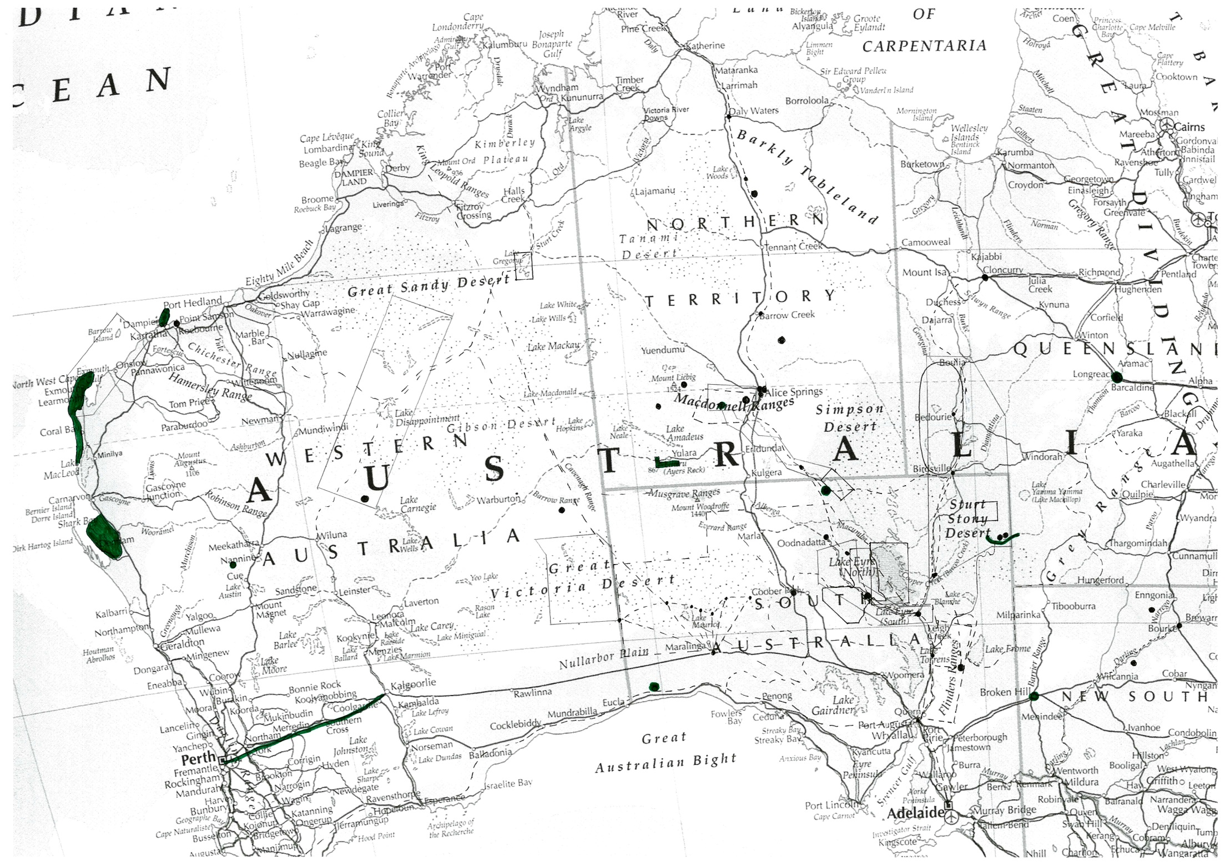

30
27 &

20

9
37
31-2

50
11
10

36

35
31-1

51
46
32
31-3
16

55
54
17

& 53
39
38
44
40
13
34
33
47
42
22
21
14
60
41

26
25
12

43
29
24
49
48
45
18

61
23
19

56
15
28

MAP 12 KEY, continued - Numbered list of the study Preliminary list of Australian arid zone desert water cultural heritage places – refer Map 12

NO. | PLACE |  | NO. | PLACE
1 | Channel Country Desert Cultural Landscape |  | 41 | Callymurra Water Hole
2 | Southern Artesian Mound Springs Desert Cultural Landscape |  | 42 | Kati Thanda /Lake Eyre
3 | Finke River Desert Water Route Cultural Landscape |  | 43 | Ooldea and Associated Nullarbor ‘Water Routes’ & Structures
4 | West MacDonnell Ranges Desert Uplands Cultural Landscape |  | 44 | Dalhousie Station
5 | Spinifex Country Desert Cultural Landscape |  | 45 | Strangways Springs Station
6 | Western Desert Cultural Landscape |  | 46 | Town of Alice Springs
7 | Australian Maritime Desert Cultural Landscape |  | 47 | Town of Oodnadatta
8 | The Kidman Pastoral Empire |  | 48 | Town of Marree
9 | Western Pearl Shell Trade Route |  | 49 | Town of Bourke
10 | East Lake Eyre Trade Route |  | 50 | Cossack
11 | Canning Stock Route / Western Desert Waters Route |  | 51 | ‘Seven Sisters’ Songline
12 | Strzelecki Track Stock Route |  | 52 | Urumbulla Songline
13 | Birdsville Track Stock Route |  | 53 | Arkaya Songline
14 | Oodnadatta Track and Stock Route |  | 54 | School of the Air (RFDS Base)
15 | Darling River Transport Route |  | 55 | The Albert Namitjira Representational Landscape
16 | Mulligan River Pituri Area |  | 56 | The Hans Heysen Representational Landscape
17 | Owen Springs  (Kidman’s first property) |  | 57 | The Russell Drysdale Representational Landscape
18 | Anna Creek Station (incl The Peake outstation) |  | 58 | The Contemporary ‘desert art’ Tradition
19 | Wadla Wadlyu (Tooths Nob) Grindstone Quarry Complex |  | 59 | Desert Starscape (including Southern Cross, Seven Sisters (Pleiades) & Orion)
20 | Kurutiti (Helen Springs) Grindstone Quarry complex |  | 60 | Woomera Test Facility (including Maralinga)
21 | Palthirri- Pirdi (Anna Creek) Grindstone Quarry Complex |  | 61 | Warratyi Rockshelter
22 | Innamincka Grindstone Quarry Complex
23 | Kallana Station
24 | Kembree Station
25 | Dog Fence (aka Dingo Fence)
26 | Rabbit Proof Fence
27 | JM Stuart’s Exploration Route
28 | EJ Eyre’s Exploration Route
29 | Coober Pedy
30 | Overland Telegraph Line
31 | Royal Flying Doctor Service
32 | Puritjarra & the Cleland Hills Deep History Area
33 | Serpents Glen
34 | Puntutjarpa Aboriginal Site
35 | Papunya
36 | Utopia
37 | Paruku (Lake Gregory)
38 | Mikeri Wells Water Route
39 | Finke River Floodout Aboriginal Landscape
40 | Coongie Lakes

4.2 Discussion

4.2.3 Issues in listing the complex and extensive places that occur in desert environments

Routes
Routes linking widely distributed and differing places are a definitive aspect of desert life. There are however evident issues with regard to how to approach their listing:
- what to physically nominate as a route? This is difficult to define because it can be complex, involving many different components in the whole (eg Songlines and trading routes), or there is a defined route but this has changed or been added to over time (eg Overland Telegraph Line, Birdsville Track).
- The operation of some routes is not confined only within the Australian arid zone. For those that extend outside the Australian arid zone, it is recommended that if listed the full site be included as that is how they successfully operated. For example, the Overland Telegraph Line
- where there is a known or evident actual route, this has been nominated. Where there is not, the approach taken is similar to that undertaken in WHA listing, referred to as ‘beads on a necklace’, where the primary heritage places are significant places on, or comprising the route (or remnant route evidence), and the route is a nominal line that indicates there are protective aspects but these are reduced and not spatially specific (such as limiting the crossing of the line, hence reducing the integrity of the ‘route’).

Cultural landscapes
Taking the opportunity to identify cultural landscapes provides an excellent mechanism for recognising significant arid zone heritage and continuity of use because cultural landscapes best reflect broad scale subsistence patterns and the whole of dispersed lifeways/economies. This type of heritage needs a systematic approach not required by other heritage types. They would all be listed under criterion (d).

The issue is complicated by the fact that there is no one model for the Australian arid zone, as these patterns differ in the diverse desert forms across the arid zone. The study has selected clear examples based on current knowledge, seen as a suite of different representative types. However it is difficult on the basis of available information to establish meaningful boundaries for these, and to be certain that there are not other additional significant cultural landscapes. Hence further work is needed to establish boundaries, and those proposed could be added to.

Serial sites
It is understood that, at present, sets of places (serial sites) are not able to be listed as a single place on the National Heritage List, due to the interpretation of the definition of place in the EPBC Act 1999.

In the arid environment however successful adaptions and economic survival required integrated responses spread over large distances, and resulted in diffuse occupation evidence, often with no marked on-the-ground links. In these cases, no single place can represent a significant process or event, as the process or event in question caused or necessitated different actions at different locations to occur, and to be successful. In these cases each individual place only represents a fragment of the one process or event, but all associated places are intrinsically interrelated. An
example is the pastoral industry, where success required a network of different properties to be located across the arid zone (and into the semi-arid zone and tropics) as was the case with the Kidman pastoral ‘empire’.

In the view of the project, a ‘serial site place’ is parallel to a cultural landscape or cultural route in relation to its heritage values, differing in its lack of spatial continuity. As with cultural landscapes or cultural routes, serial sites of national level significance may comprise all, some or no individual elements (places) that have outstanding significance to the nation, but it is the sum of the parts that is greater than the whole.

Given this, where the study has identified serial sites of assessed national significance, we have included these in the Preliminary List to indicate that this serial site best represents the identified heritage significance. However, the study has also identified one place that could be listed to emblematically represent the serial site, although this is seen as a less accurate approach to capturing the significance of the places.

We would argue however that there is a critical need for serial sites to be able to be included on the National Heritage List, including for arid zone heritage places, and we advocate that the EPBC Act be amended to enable the inclusion of serial site listings (as a single place).

4.2.2 Gaps in the Preliminary List
If the Preliminary List is examined in the light of the history of the Australian deserts, in tandem with the significant responses (thematic indicators), then it is clear that there are places that might be expected, but which are not there.

There are various reasons for this including 1. insufficient heritage knowledge to identify significant places; 2. the most significant associated places are outside the AAZ; 3. the values (usually more intangible values) are difficult to recognise in a place based listing system; or 4. there are historically significant places inside the AAZ, but they do not have sufficient significance or integrity individually at the national level to be included in the Preliminary List.

In relation to the latter category, a key example is the history of Afghan cameleers, who represent a very specialised and flexible or innovative response to living in a desert environment that is directly related to the general absence of water, hence is a very significant particular response. However, while there are a number of places associated with the Afghan cameleers in the arid few have strong enough associations to list in relation to this use. And for those places within the arid zone that have a strong direct and nationally significant associations (eg, various sites in the town of Marree), these have been found by the study to lack sufficient integrity for including since they have been largely destroyed by urban development or by time. Probably the best and most significant example of a place that is directly associated with the Afghan cameleers is the mosque in Adelaide.

Places representing ‘Afghan’ cameleer history stand out as an area that requires directed examination. As Jones and Kenny (2007:158) conclude their study: ‘With their roots in desert culture, their allegiance to Islam, and their vital contribution to Australia’s inland economy, the Muslim cameleers occupy an ambiguous, unresolved role in our national history.’ The Preliminary list includes townships that include the presence of the cameleers as part of their heritage – Marree, Oodnadatta, Alice Springs - but the integrity of these places is generally compromised. Places outside the arid zone, such as the 1888 mosque in Adelaide – the oldest city mosque in Australia, visited by the cameleers from the northern inland and strongly associated with their lives - might be more appropriate for consideration.

Heritage that is not easily accommodated in a place based system of recognition including movable heritage, intangible heritage that has no specific relation to place, historical constructs that have no physical expression, and heritage that is not located on the land or sea (eg, heritage documents, art works, traditions of making objects, aerial routes, constellations) . These are all difficult to ‘list’ in current listing mechanisms, including the National Heritage List, as they do not easily fit the concept of ‘place’. This type of heritage has mostly not been ‘captured’ by the present study (some such heritage is however noted in Section 4.2.3 where it is considered to have national level significance).

Rock art sites are not considered in this report – see McDonald and Clayton (2016).

4.2.3 Potential Places of National Heritage Significance that fall outside the study’s desert water themes
The limitation of the present study to the theme ‘desert’ and the sub-theme ‘water’ means that this study is not comprehensive with respect to understanding the heritage of the Australian arid zone, or identification of places of potential national heritage significance for the full Australian arid zone study area. In order to assist with any future thematic heritage assessments or to help in more fully identifying the national heritage cultural values of the Australian arid zone, the present study has compiled a list of places identified through research to be of high potential national heritage significance, but which fall outside the present study’s thematic scope.

The main types of places that have been identified which do not relate directly to water are missions, mining heritage, and aspects of pastoral heritage not picked up in the national pastoral assessment. There are also a small number of places identified by the project that while directly related to water, are on the edge of the arid zone study area and have values other than desert responses or adaptations.

These places which in the view of the study require further consideration for the National Heritage List are listed below by type. The lists below also contain places that are included in this study’s Preliminary List, but which are considered to be more appropriately considered under a different thematic framework. Brief comment on a possible assessment approach is also provided in some cases.

Missions
The following missions are recommended for consideration for listing on the National Heritage list via an alternate assessment study:

PLACE | LOCATION
The Bungalow | Alice Springs, NT
Killalpaninna & Koperamana | Etadunna, SA (Birdsville Track)
Australian Inland Mission | Established Oodnadatta, SA
Pukatja (Ernabella Mission) | Ernabella, SA (Musgrave Ra)
Nepabunna Mission | Nepabunna, SA (N Flinders Ranges)
Colebrook Mission | Oodnadatta, SA, Quorn, SA
Ooldea Mission | Ooldea, SA.
Cundeelee Mission | Zanthus, WA
Warburton Mission | Warburton, WA
Jigalong Mission & Community | Jigalong, WA (Little Sandy Desert)

It is suggested that the best mechanism to assess these places would be a national missions heritage study, extending from the initial scoping study undertaken by Baulach (nd 2002?). Missions and the establishment of missions in Australia are of national significance in relation to the social, cultural and economic development of Australia, and missions had a profound influence on Indigenous Australians. The national heritage study of benevolent and other care institutions (Context 2014) specifically excluded missions.

There may be some potential to expand a missions-based study into a post-contact adaptations study that could include places such as stations and reserves which had major Aboriginal involvement, and taking in the outstation/homelands movement as part of self-determination, as well as missions – see below. Places which should be considered in this respect include the following:

Aboriginal self-determination
A small number of places were identified which are considered to be of high level national significance in relation to the history of the Aboriginal struggle and determination for recognition and self-government which are not replicated by existing listings. They are in fact part of a single story and are complementary components, and have potential, along with other non-arid zone places, to be considered as a national serial site listing, should this become feasible.

As well as the places listed below, this category of place should include places related to the important homelands movement of the 1980s, missions, and reserves and pastoral stations which had major Aboriginal involvement.

PLACE | LOCATION
1946-49 Pilbara strike | Port Hedland, WA
Conniston Massacre Site | Yuendumu, NT (Reynolds Range)

The Semi-Arid ‘corridor’
The following pastoral places have been identified by this study and are recommended for consideration for listing on the National Heritage list via an alternate assessment study. A number of these places (eg, Town of Bourke, Darling river paddlesteamer route and the Strzelecki and Birdsville Tracks) are included in this study’s Preliminary List, but are felt to be better addressed via a thematic study that is not specifically desert focussed.

PLACE | LOCATION
Goyder’s Line | Ceduna, SA, to Spencer Gulf (near Arno Bay) to near Moonta, Crystal Brook, Peterborough, Burra, to near Blanchetown, then into Victoria.
Strzelecki Track Stock Route, SA | Lyndhurst to Innamincka, SA
Birdsville Track Stock Route, Qld-SA | Birdsville, Qld to Marree, SA
Oodnadatta Track and Stock Route, SA | Marree – William Creek – Oodnadatta, SA
Darling River Transport Route | Wentworth – Bourke, NSW  (Darling River, via Wilcannia & Menindee)
Town of Bourke | Bourke, NSW  (Barwon R, Darling River system)

Given that a national pastoral study has already been undertaken (Pearson & Lennon 2007) it is suggested that these places would be best assessed by a regional study of the semi-arid region of Australia. There are a small number of highly significant places or sets of places have not been picked up in previous assessments – in particular Goyder’s Line, and the band of overland stock routes that enabled trans-Australian overland droving. Goyder’s Line is considered by this study to be of outstanding significance to the nation (see Section 3.3.3.3).

Mining heritage
The following mining heritage places are listed in the Preliminary list and are recommended for consideration for listing on the National Heritage list via an alternate assessment study:

PLACE | LOCATION
Karrku Ochre Quarry | Giles, WA (Western Desert)
Ulpunyali Ochre Quarry | Watarrka (Kings Canyon), George Gills Range, NT
Pukardu/Parachilna Flinders Ranges Ochre Quarries | Parachilna, SA
Mt Isa Greenstone Axe Quarries | Mt Isa, NT
Coober Pedy | Coober Pedy, SA
Andamooka | Andamooka, SA
White Cliffs | Wilcannia, NSW
Broken Hill Mining Landscape (or precinct) | Broken Hill, NSW
Eastern Goldfields Mining Landscape | Kalogoorlie - Leonora, WA
Mt Isa – Cloncurry Copper Mining Landscape | Mt Isa – Cloncurry, NT
Boulder (Kalgoorlie) Mining Precinct | Kalgoorlie, WA
Gwalia Mining Precinct (or Sons of Gwalia Mine) | Leonora, Australia

As mining heritage is under-represented on the National Heritage list yet has been extremely important to Australia economically and has in other ways significantly influenced the development of Australia, it is suggested that the above places would be best assessed via a national mining heritage assessment. As can be seen from the above list, we would include Indigenous mining and quarrying in such a study. It would be important to recognise the different forms and techniques of mining, as well as the influences of different types of mineralisation.

Inspirational landscapes and cultural representations
The 2005 ‘Identifying Inspirational landscapes’ report by Crocker and Davies and previous work on this theme identified a list of inspirational landscapes. Of these, the Simpson Desert NP, Mutawintji NP, the Flinders Ranges NP, Vulcathunha-Gammon Ranges NP, Arkaroola Wilderness Sanctuary, Lake Eyre NP, Nullarbor NP, Uluru-Tjuta NP, West MacDonnell NP, Wartarrka (Kings Canyon) NP, Finke Gorge NP, Gregory NP, Shark Bay WHA, Ningaloo MP and Cape Range NP, Wolfe Creek Crater NP and Kanjini NP Pilbara are arid zone areas that were included in the study (17 of 68 places). Of these, only the West MacDonnell Ranges and the Flinders Ranges overlap with the ‘portrayed landscapes’ we have included in our Preliminary List.

Other significant cultural representations of the arid zone have not been systematically surveyed in this study, as this is a whole study in itself. These include films such as Bitter Springs, Jedda, popular literature such as Neville Shute’s ‘A town like Alice’, TGH Strehlow’s Journey to Horseshoe Bend, Ion Idress’ Flynn of the Inland and Cattle King, and the poetry of Banjo Paterson. These have all been formative in shaping the broad public imaginary of ‘the desert’. Roslyn Haynes’ (1999) excellent study of the representations of the arid zone has looked at this in detail.

PART 5 Priority Places for National Heritage Listing

5.1 Priority List of water-related desert Cultural Heritage Places

The development of a Priority List of places for consideration on the National Heritage List was a requirement of the project terms of reference, which specifically required a ‘ranked list of the top 10 places, based on a comparative analysis of the cultural heritage significance of the places when compared against other places identified as having similar attributes’.

Section 2.2.3 discusses the way in which the Priority List has been established. In essence the list is drawn from the Preliminary List of Places (refer Part 4) through comparative analysis with places with similar national heritage values. The values of the Priority List places, and those other places considered to have similar values and to hence be comparable, are contained in the Place Assessment Matrix (refer Appendix 6).

Initial Priority List
The initial priority assessment resulted in an initial list of 17 places that are viewed as the Priority Places for listing arising from this study. This list is presented below as Table 5.1. It is not a ranked list. It is presented so as to follow the order of the Preliminary List from which it is derived. This is a list of the most significant, hence highest priority, places identified by the study for each of the key, thematic-based values identified by the study, demonstrating these themes at the highest level. This result falls out from the broad assessment approach taken and the thematic scope of the project.

The significant cultural landscapes that have been identified in this study and included in the Preliminary List as representative heritage places are not amenable to comparative assessment for establishing priority listing. This suite of heritage places is discussed at the end of this section as an alternative approach to establishing priority places.

Table 5.1 Study key Priority places list (17 places, not ranked)

Place | Description of Place | Study Thematic Indicators | NHL Criteria | Location | IBRA
The Kidman Pastoral Empire | Ideally a serial site that includes a set of stations that demonstrate the key developmental stages and different operational elements of the Kidman Empire. Alternative option, is to base listing on emblematic place – Owen Springs Station (first property) | 1a. broad scale subsistence/ economics  (Owen Springs -2a) | (a), (d), (f), (h) | WA - NT – Qld – NSW - SA | too numerous to list (inside & outside arid zone)
East Lake Eyre Trade Route | Linear connecting primary route from the Flinders Ranges (Parachilna Ochre Quarry), SA, via Kopperamana and Goyders Lagoon to the Cloncurry area (greenstone axe quarries) in Qld. The route includes the above sites as specific places on the route. Include (if a linking mechanism exists) – the other components of the trade route - Mulligan River Pituri Area, and the Wadla Wadlyu (Tooths Nob), Kurutiti (Helen Springs), Palthirri- Pirdi (Anna Creek), and Innamincka Complex (includes Wild Dog Hill, Mt McLeod) grindstone quarry complexes.  (Also includes the southern half of the Cape York – Cloncurry – Cooper Ck Baler Shell Trade Route) | 1c. long distance travel routes  (grindstone quarry complexes - 2b) | (a), (b), (d) | SA – Qld  (Parachilna – Kopperamana – Goyders Lagoon – Bedourie - Cloncurry) | FLB/STP/ SSD/CHC/MGD/MII
‘One Road, Many Stories’ – the Canning Stock Route | Linear route from Wiluna, WA, to Halls Creek, WA.  To specifically also include the water sources and places with special specific stories. | 1c. long distance travel routes | (a), (b), (d), (g), (i) | Wiluna to Halls Creek, WA  (Mid-West to Kimberly regions) | MUR/GAS/ LSD/GSD/ CEK/OVP
Papunya & the contemporary ‘desert art’ movement | Area of Papunya, W MacDonnell Ranges, NT. | 2a. changing environmental conditions & resource access 5a. aesthetic appreciation | (a), (e), (f), (h) | Papunya, NT  (W MacDonnell Ranges) | MAC/GST/ BRT
Wadla Wadlyu (Tooths Nob) Grindstone Quarry Complex,  Value of trade route | Full quarry and associated workings area, East Flinders Ranges, SA  - may be possible to incorporate this place within the East Lake Eyre Trade Route | 2b. specialised resource technology | (c), (d) | E Flinders Ranges, SA | FLB
Dog Fence (aka Dingo Fence) | Linear Route of the Dog Fence from Nundroo, Nullarbor Plains, SA, to Jimbour, Darling Downs, Qld. | 2b. specialised resource technology | (a), (b), (g) | Jimbour, Darling Downs, Qld to Nundroo, Nullarbor Plains, SA | NUL/GVD/GAW/STP/SSD/CHC/WAR/MUL/MGD/BBS
Coober Pedy | Town of Coober Pedy (preferably including associated significant nearby opal diggings), SA. | 2d. specialised infrastructure technology | (a), (b), (f), (g) | Coober Pedy, SA | STP
Royal Flying Doctor Service | Represented in part by the existing QANTAS Hangar, Longreach  Ideally, a serial site listing comprising –  . Cloncurry Base Hospital (base hospital at start of AIM AMS, 1928),  . Longreach QANTAS Hangar (planes serviced here), and  . Alice Springs AIM RFDS Base (radio base, c.1929).  Could be expanded to include key AIM, pre-RFDS places (eg, Oodnadatta AIM Base) and other key locations (eg, Rev. J. Flynn’s grave in Alice Springs). | 2d. specialised infrastructure technology | (a), (b), (f), (g), (h) | Early core - WA – NT – Qld – NSW - SA  (today covers all of Australia) | na (MAC/MII/ MGD/STP)
‘North – South Trans-desert Crossings’ - (Overland Telegraph Line and John McDouall Stuart) Route | Full Overland Telegraph Line/John McDouall Stuart Exploration Route rote from Adelaide, SA, to Darwin, NT, via Coober Pedy, Alice Springs, Tennant Creek.  To specifically include the repeater stations and associated water sources on the route: within-desert places - Beltana, Strangways Springs, Peake, Charlotte Waters, Alice Springs, Barrow Creek, Tennant Ck; and associated non-desert places- Port Augusta – Powell Ck, Daly Waters, Katherine, Southport. | OTL - 2d. specialised infrastructure technology  (JM Stuart – 2c) | (a), (b), (d), (f), (g), (h) | Adelaide, SA - Darwin, NT | FLB/STP/GAW/SSD/ FIN/MAC/ BRT/TAN/STU/DAB/PCK/DAC
Puritjarra and the Cleland Hills Deep History Area | Area of the Cleland Hills - Haast Bluff, NT which includes Puritjarra Rockshelter, Murantji Rockhole, & Tjungupu-Tarn of Auber. | 2e. long term flexibility in occupation or use | (a), (b), (c) | Haast Bluff, NT | GSD
Mikeri wells water route | The route, waters and environs, Simpson Desert, NT | 3b. use of specialised water re/sources | (a), (b), (i) | Simpson Desert, NT | SSD/STP
Finke River Floodout Aboriginal Landscape | Landscape area encompassing the Finke River floodout, NE SA.  Includes the Arkaya Songline and associated stone arrangements.  Could be incorporated into the values of the Witjera-Dalhousie springs listing. | 3b. use of specialised water re/sources | (a), (b), (i) | Oodnadatta, SA | STP/FIN/SSD
Ooldea and associated Nullarbor water routes and structures | The key routes and associated water sources and other structures and related sites; Ooldea area, Nullarbor, SA. | 3b. use of specialised water re/sources | (a), (b), (i) | Ooldea, SA | NUL/GVD
‘Seven Sisters’ Songline | Long complex route from the Roebourne WA to north of the SA Gulf (near Port Augusta), specifically including key water sources and other significant sites (especially Cave Hill, SA).  Includes aspects of the Desert Starscape (Seven Sisters/ Pleiades and Orion constellations) | 4. effective/ viable social networks  4a. songlines  (Starscapes - 5a) | (a), (d), (i) | WA, SA & NT  (Roebourne – Western Desert – Cave Hill ) | PIL/ LSD/ GID/ CER
School of the Air | Given its diffuse and intangible nature, to be emblematically represented by the Alice Springs RFDS Base (location of pedal radio) - 8-10 Stuart Tce, Alice Springs. | 4b. long distance communicat-ions | (a), (b), (f), (g) | 8-10 Stuart Tce, Alice Springs, RNE listed)  (today covers all of Australia except ACT & Tas) | na (MAC)
The Albert Namatjira Represent-ational Landscape | Western MacDonnell Ranges and environs.  Significance covered partly by Hermannsburg listing and in West MacDonnell Ranges nomination. | 5a. aesthetic appreciation | (e), (h) | West. MacDonnell Ranges | NA
Woomera – Maralinga Weapons Testing Facility | Full Woomera Test Facility and the adjacent Maralinga testing area. Extends from Woomera Village to the Great Victoria Desert | 5b. misconcept-ions (as empty-unproductive) | (a), (b), (c), (f), (g), (h) | full Woomera Test Facility plus Maralinga, SA | GAW/GVD/ NUL

Ranked Priority List of Ten Places
To reduce these 17 Initial Priority places to the required ranked list of ten Priority places, several criteria for exclusion have been applied. Places which have been excluded are those which –
- are already covered at least to some extent by other National Heritage listings (eg, the Royal Flying Doctor Service, Namatjira representational landscape and Finke River floodout);
- are incorporated in another recommended priority place (eg, Wadla Wadlyu (Tooths Nob) grindstone quarry);
- do not relate directly or structurally to desert waters and hence fall outside the thematic scope of this study (eg, Coober Pedy).
- are difficult to list accurately without serial site nominations being possible (eg, the Kidman pastoral empire), especially where they are felt to be better dealt with by a broader theme.

The remaining ten places are shown in Table 5.2. They are located in the west, east and central components of the Australian deserts. With the exception of The School of the Air, they all have histories which comprise interwoven lives of Indigenous and non-Indigenous people. They all involve multiple inter-connected places for the reasons discussed in the thematic essay. Each exemplifies the study themes, study thematic indicators and water indicators at the highest level.

Ranking the ten places in relation to each other was not straightforward. The ten places are diverse and, unlike a suite of similar place types, cannot be compared with each other in terms of their heritage significance or values in any meaningful way – they are all ‘Number 1’s in this sense. In the absence of an ability to rank in these terms, and presuming that the purpose of the ranking is to guide the progressing of any potential National Heritage listing of the places, we have ranked the places in Table 5.2 according to our current understanding of the complexities involved in progressing listing, where ‘1’ is relatively clear-cut and ‘10’ is least straightforward.

The main issues identified in progressing listing of the places are 1) the limited information on the physical places and on their boundaries, 2) the critical need for consultation with the communities of interest, which has not been undertaken in this desktop study; and, to a lesser extent, the complexity of a place. The management of individual places is not discussed as this was not required in the Terms of Reference and is in many cases complex or unknown. However, management is discussed under ‘security of place’ in the Priority Place Individual Assessments in Appendix 7 where the management of a place is considered to susbstantively affect the security of a place.

Table 5.2 Short list of 10 ranked Priority Places

 | Place | NHL Criteria | Study Thematic Indicators | IBRA
1 | School of the Air | (a), (b), (f), (g) | 4b. long distance communications | na (MAC)
2 | Papunya and the contemporary ‘desert art’ movement | (a), (e), (f), (h) | 2a. changing environmental conditions & resource access  5a. aesthetic appreciation | MAC/GST/ BRT
3 | Puritjarra and the Cleland Hills Deep History Area | (a), (b), (c) | 2e. long term flexibility in occupation or use | GSD
4 | ‘One Road Many Stories’ - Canning Stock Route | (a), (b), (d), (g), (i) | 1c. long distance travel routes | MUR/GAS/ LSD/GSD/ CEK/OVP
5 | Woomera - Maralinga Weapons Testing Facility | (a), (b), (c), (f), (g), (h) | 5b. misconceptions (as empty-unproductive) | GAW/GVD/ NUL
6 | ‘North – South Trans-desert crossings’ (OTL and JM Stuart) Route | (a), (b), (d), (f), (g), (h) | 2d. specialised infrastructure technology  2c. adaption to newly experienced desert environment | FLB/STP/GAW/ SSD/ FIN/MAC/ BRT/TAN/STU/ DAB/PCK/DAC
7 | Dog Fence (aka Dingo Fence) | (a), (b), (g) | 2b. specialised resource technology | NUL/GVD/GAW/ STP/SSD/CHC/ WAR/MUL/MGD/BBS
8 | Mikeri Wells Water Route | (a), (b), (i) | 3b. use of specialised water re/sources | SSD/STP
9 | East Lake Eyre Trade Route | (a), (b), (d) | 1c. long distance travel routes | FLB/STP/ SSD/CHC/MGD/MII
10 | ‘Seven Sisters’ Songline | a), (d), (i) | 4. effective/viable social networks  4a. songline | PIL/ LSD/ GID/ CER

Detailed individual place data sheets for each of the above places are provided in Appendix 7, and their location is shown in Map 14, below.

Additional Representative Priority Places
In identifying places in the Australian arid zone worthy of consideration for the National Heritage List, the present study has identified a set of cultural landscapes, each of which reflects people’s varying use of differing desert environments and their forms of water through deep time to the present.

These desert cultural landscapes stand as a set of complementary representative cultural heritage places. In line with the project's framing, these cultural landscapes have been identified and selected on the basis of their ability to reflect lifeways based on different forms of water and reflecting the six different deserts of the Australian arid zone. They primarily reflect, and are designed to reflect, Aboriginal people’s desert lifeways.

The approach is essentially similar to that taken in the evaluation of the cultural values of Uluru - Kata Tjuta National Park National Heritage Listing (http://www.environment.gov.au/cgi-bin/ahdb/search.pl?mode=place_detail;place_id=105687) based on the recognition of cultural landscape values under criterion v for World Heritage Listing. In this study however, the desert cultural landscape examples have been defined on the basis of different types of landscape and occurrence of water (ie, in relation to the study scoping themes), which has led to distinctively different adaptations and lifeways.

These desert cultural landscapes are listed in Table 5.3 and their location and approximate boundaries are shown in Map 15.

These cultural landscapes are regarded as being of outstanding national significance as places that represent different desert adaptation histories, with each landscape recognised representing a different history of human use of the Australian arid zone. Although arguably of very high significance, this set of cultural landscapes were difficult to incorporate into the process for
determining priority for listing on the National Heritage List. The suite of representative cultural landscapes identified by this study (refer table 5.3 below) have therefore been included as an ‘additional’ or ‘adjunct’ set of priority places, with the intention that that they provide an alternate, but complementary, approach to considering desert cultural heritage at the national level.

This approach is seen as having two key benefits:
1) Representative cultural landscapes allow for Indigenous heritage values to have broad recognition hence it avoids having to compare the significance of similar Aboriginal sites in different regions which is frequently neither possible nor culturally appropriate. Importantly, this approach avoids having to attribute varying degrees of significance to individual Indigenous sites, which can be inappropriate given that Indigenous cultures allocate significance on a different basis from a western heritage-based approach (see discussion of comparative analysis of Indigenous places of significance in Section 2.3 Study Limitations).

2) It assists in considering the cultural heritage values together with the natural heritage values. These cultural landscapes, being extensive and natural environment based, are likely to mesh better with the identified biological and geoheritage values of National Heritage significance in the Australian arid zone than are the single small area places or linear routes identified here in the main Priority List. These cultural landscapes therefore can potentially help the Australian Heritage Council to explore the overlap of biological, geoheritage and cultural values, as is proposed in the terms of reference.

It should be noted that some of these cultural landscapes fall within, or partly within existing National Heritage listed places. For example the ‘Australian Maritime Desert Cultural Landscape’ overlaps with the ‘Ningaloo Coast’ listing.

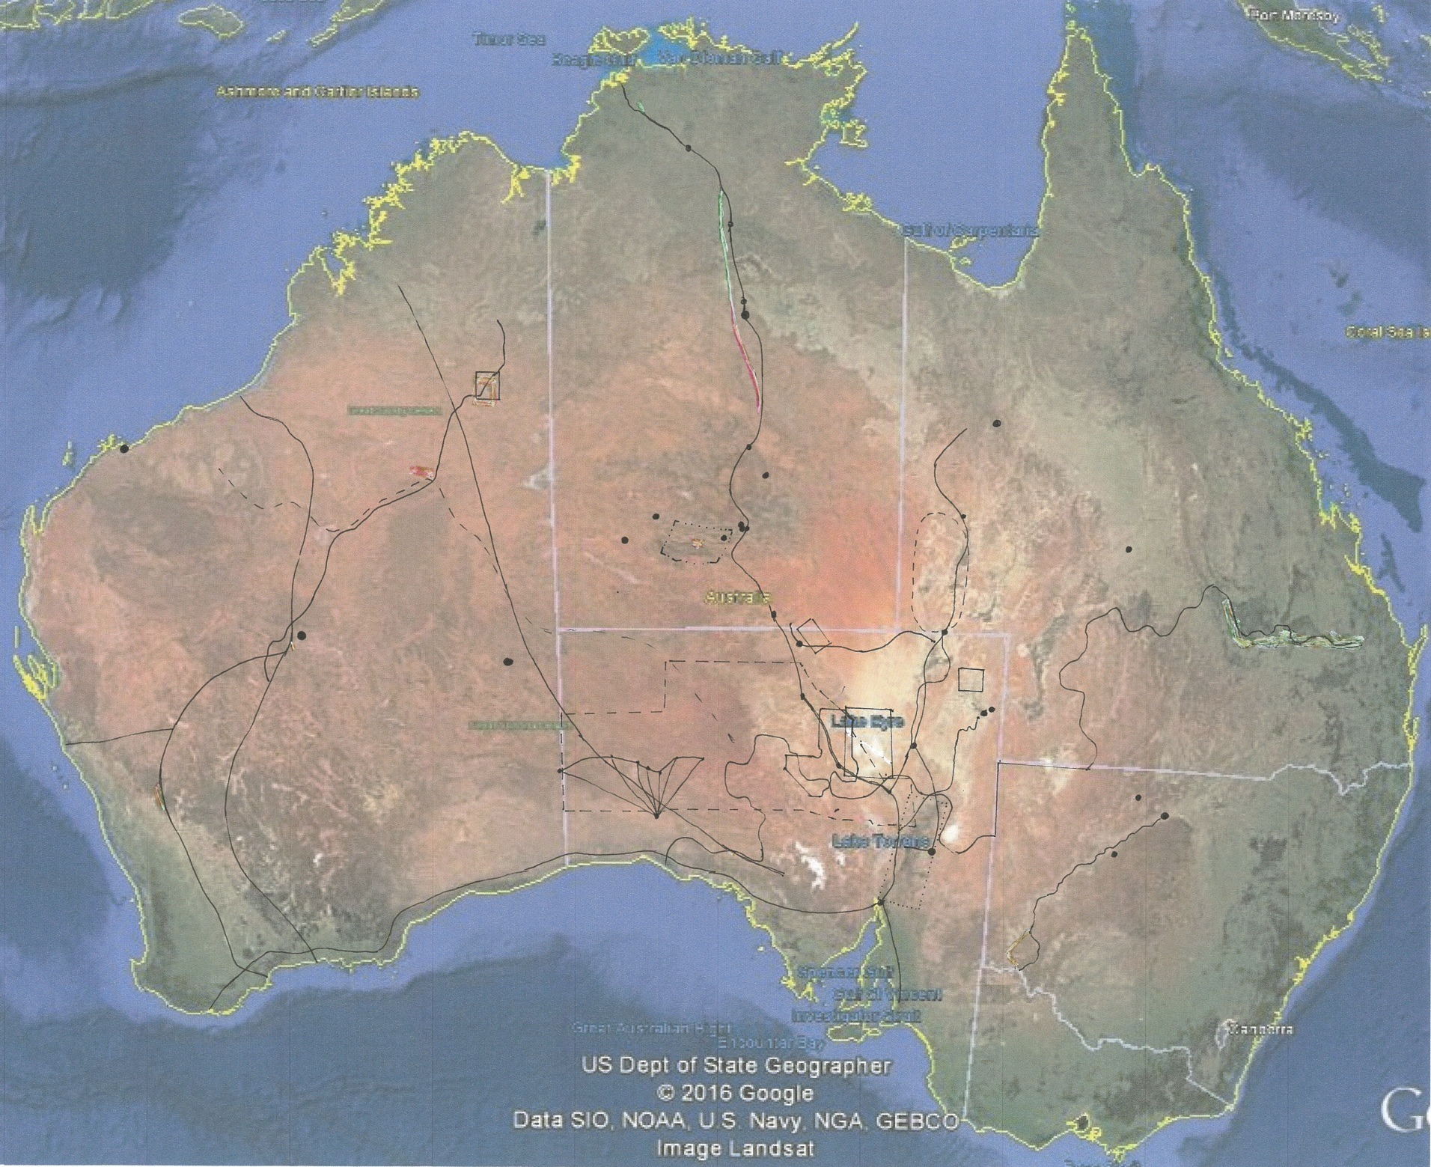

Map 14 LOCATION OF THE 10 RANKED PRIORITY PLACES [Base map – Google Earth satellite imagery, accessed Oct 2016]

NB: TL # - Preliminary List Number (refer Preliminary List mapping in Section 4).
1 | School of the Air (RFDS Base) (TL #54)
2 | Papunya and the Contemporary ‘Desert Art’ Movement (TL #35 & 58)
3 | Puritjarra & the Cleland Hills Deep History Area (TL #32)
4 | ‘One Road many Stories - Canning Stock (TL #11)
5 | Woomera - Maralinga Test Facility (including) (TL #60)
6 | North – South Trans-desert Crossings (OTL & JM Stuart) Route (TL #27 & 30)
7 | Dog Fence (aka Dingo Fence) (TL #25)
8 | Mikeri Wells Water Route (TL #38)
9 | East Lake Eyre Trade Route (TL #10)
10 | ‘Seven Sisters’ Songline (TL #51)

9
8
7
6
5
4
1
2
3
10
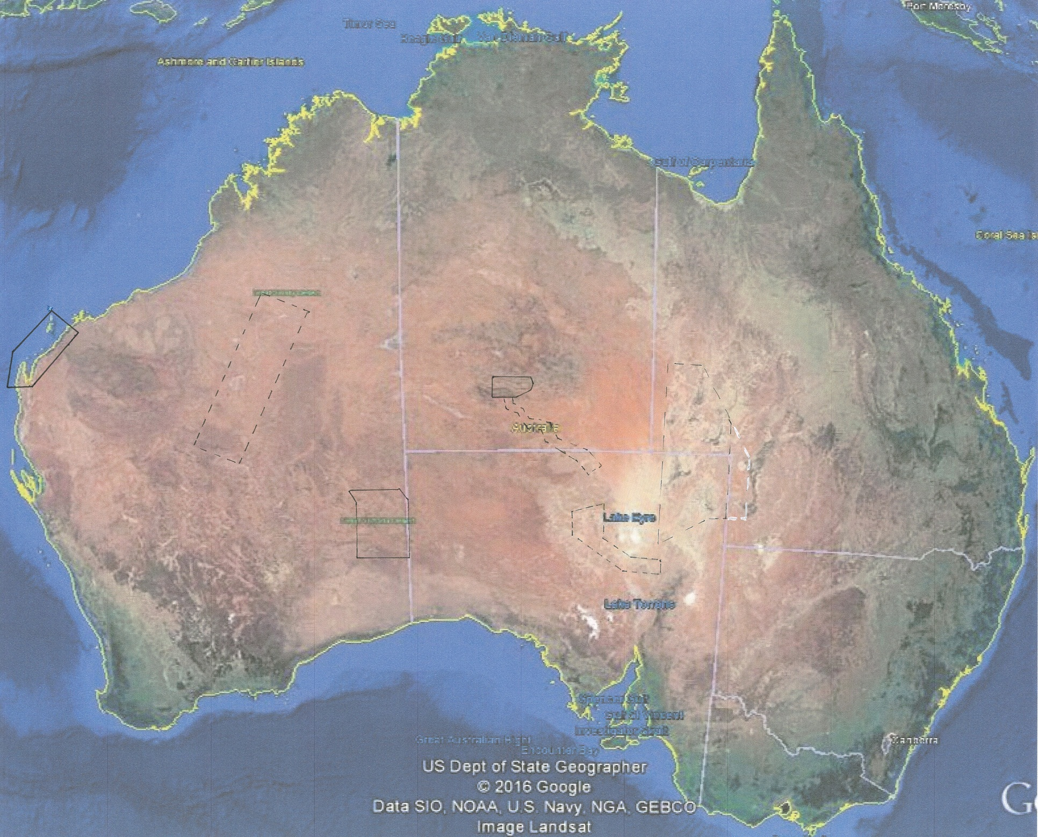

Map 15 LOCATION OF ADDITIONAL REPRESENTATIVE PRIORITY PLACES - 7 DESERT CULTURAL LANDSCAPES
[Base map – Google Earth satellite imagery, accessed Oct 2016]

1 | Channel Country Desert Cultural Landscape (TL #1)
2 | Southern Artesian Mound Springs Desert Cultural Landscape (TL #2)
3 | Finke River Desert Water Route Cultural Landscape (TL #3)
4 | West MacDonnell Ranges Desert Uplands Cultural Landscape (TL #4)
5 | Spinifex Country Desert Cultural Landscape (TL #5)
6 | Western Desert Cultural Landscape (TL #6)
7 | Australian Maritime Desert Cultural Landscape (TL #7)
NB: TL # - Preliminary List Number (refer Preliminary List mapping in Section 4).

The table of the identified representative cultural landscapes below is not a ranked list.

Table 5.3 Adjunct Priority places – representative cultural landscapes

Place | NHL Criteria | Study Thematic Indicators | IBRA
Channel Country Desert Cultural Landscape | whole place -  (a),(b), (c), (i) | 1. High residential/ economic mobility  1a. broad scale subsistence/ economics | CHC/SSD
Southern Artesian Mound Springs Desert Cultural Landscape | whole place -  (a),(b), (c) | 1a. broad scale subsistence/ economics | STP/SSD
Finke River Desert Water Route Cultural Landscape | whole place -  (a),(b), (c), (i) | 1a. broad scale subsistence/ economics | MAC/FIN/ STD/SSD
West MacDonnell Ranges Desert Uplands Cultural Landscape | whole place -  (a),(b), (c), (h), (i) | 1a. broad scale subsistence/ economics | MAC
Spinifex Country Desert Cultural Landscape | whole place -  (a),(b), (c), | 1a. broad scale subsistence/ economics | GVD
Western Desert Cultural Landscape | whole place -  (a),(b), (c), | 1a. broad scale subsistence/ economics | GSD/GIB/LSD
Australian Maritime Desert Cultural Landscape | whole place -  (a),(b), (c), | 1a. broad scale subsistence/ economics | PIL/CAR

An important step in progressing these cultural landscape places as listings will be to establish boundaries for each of the cultural landscapes as the boundaries cannot be easily defined from the values alone and on the basis of the present information for these areas (although the general area can be). The boundaries provided in this report (refer Map 15) are therefore indicative. Some cultural landscape boundaries will be more easily defined than others. For example the West MacDonnell Ranges is to some extent physically defined, and could potentially be encapsulated in the West MacDonnell National Park (although this would need to be assessed).

The indicative cultural landscape boundaries in this report have been selected in different ways, although all cultural landscapes are intended to include historic land use systems that encapsulate the full range of inter-dependent activities that occurred in the particular desert environment of each landscape, and consequently to include a representative range of heritage type places. The basis for the indicative boundaries for each of the desert cultural landscapes identified in this study is as follows -
- The Australian Maritime Desert Cultural Landscape area is based on the area described by Veth, Ditchfield and Hook (2014) in their paper on this Australian maritime desert.
- The Western Desert Cultural Landscape recognises the major importance of the Western Desert people (language group) in the Australian arid zone. The landscape area selected recognises the deep time of occupation through to the present and the cultural exchanges that are a significant
element of life in the arid zone. It specifically includes Serpents Glen (long term occupation, Holocene re-occupation of sandy deserts), Lake Disappointment, (a meeting place of a number of language groups), the Gascoyne, Gibson and Little Sandy deserts and associated rock art, and the location of a well-documented last ‘first contact’ at Percival Lakes.
- The Spinifex Country Desert Cultural Landscape area is based on Cane (2002: 7 and 8).
- The West MacDonnell Ranges Uplands Cultural Landscape area is largely physically defined to include the ranges (uplands), and was selected over other parts of the MacDonnell Ranges given its better documented heritage and the conservation status of much of the area.
- The Finke River Desert Water Route Cultural Landscape area was selected to include the full Finke River corridor from its headwaters to the Finke River Floodout, which is also the area of the Arkaya Songline. The width of the River corridor and its extension into the West MacDonnell Ranges will need to be further investigated.
- The Southern Artesian Mound Springs Desert Cultural Landscape area is based on Harris’ (2002) discussion of the heritage of South Australian mound springs and their location. The southern area has been selected as it has had a rich and varied history with considerable remnant associated heritage, and the relatively large linear landscape selected allows the importance of the string of spring mounds in the region as facilitating travel, communications and exchange to be understood.
- The Channel Country Desert Cultural Landscape area has been selected to encompass the main desert rivers of the Channel Country (Coopers Creek/Barcoo, Diamantina and Mulligan Rivers) and significant historical locations and resources of the Channel Country, many of which (eg, the water form [large waterholes], grasses, pituri) are very specific to this desert environment. It also has been selected to include a large section of the East Lake Eyre Trade Route, including the key exchange and meeting centre, Kopperamanna. Further research is required to determine if this large area can be reduced in size while still encompassing the same heritage values.

Further work will also be required to understand the full range of heritage and values within the designated cultural landscapes and to better understand the physical landscapes, and this information will also be needed to establish appropriate boundaries. Listing of the cultural landscapes will need consultation with the communities of interest.

5.2 Review of existing arid zone National Heritage Listings and Cultural Heritage values

Discussions with members of the Department of Environment and Energy in 2016 established that flagging any potentially constructive reconsiderations of the content, wording or status of current arid zone NH listings would be of benefit as part of this study, although this is not in the study terms of reference. These are indicated in Tables 5.4 and 5.5 below.

Table 5.4 Cultural Heritage places in the arid zone already registered on the National Heritage List (as at May 2016)

PLACE | LOCATION | AMENDMENT RECOMMENDED FOR CULTURAL VALUES INCLUSION
Dampier Archipelago (including Burrup Peninsula) | WA | No
Wilgie Mia Aboriginal Ochre Mine | WA | No
Koonalda Cave | WA | No
Hermannsburg Historic Precinct | NT | No
QANTAS Hangar Longreach | Longreach, Qld | Review in the future if at some stage there is provision for serial site listings on the National Heritage List.  - in such a case this listing should be included as part of a QANTAS serial site that recognises the full national (& international) significance of this company and service)
City of Broken Hill | Broken Hill, NSW | Review in in longer term  - review listing in the context of a national mining heritage assessment to ensure the listing fully and explicitly (including in the name) covers the highly significant mining heritage (which is the basis of the present listing)
The Burke, Wills, King and Yandruwandha National Heritage Place | Strzelecki Creek, SA | No

Table 5.5 Places in the arid zone registered for their Natural Values on the National Heritage List (as at May 2016) but which have Cultural Value at the national level

PLACE | LOCATION | AMENDMENT RECOMMENDED FOR CULTURAL VALUES INCLUSION
Great Artesian Basin Springs: Witjira-Dalhousie | SA | Yes - minor  - articulation of the Indigenous values in the NHL listing, in particular in the statement of significance
Uluru - Kata Tjuta National Park  [also WHA & C'WLTH (Indigenous) listed] | NT | No
The Ningaloo Coast  [also WHA & C'WLTH (Ningaloo Marine Area) listed] | WA | Yes  - this place at least partly falls within a larger area identified as a priority cultural landscape for listing - Australian Maritime Desert Cultural Landscape (Section 5.1), hence consideration will need to be given to how these two listing relate (it is suggested that this place be incorporated into the larger Maritime Desert Aboriginal Cultural Landscape).

5.3 Priority Place Individual Assessments – see Appendix 7

The ten Priority Place individual assessment sheets are provided in Appendix 7.

PART 6 Recommendations

The following summarises the key advice and recommendations arising from the ‘Waters of Australian Deserts’ Cultural Heritage Study. They clarify the key recommendations of the study regarding the potential listing of Indigenous and historic cultural heritage places of the Australian arid zone on the National Heritage List, and essential follow up work that will be required to do this.

Recommendation 1
That in further progressing the listing of Indigenous cultural heritage places of the Australian arid zone on the National Heritage List as recommended by the present study, appropriate consultation be undertaken with relevant Indigenous communities to establish whether such listing is appropriate and acceptable to the traditional owners and others with a demonstrated interest. This is seen as an essential action.

Recommendation 2
That the Australian Heritage Council use the Preliminary List of places generated by the present study (refer Part 4, Table 4.1) as the primary basis for progressing the listing of Indigenous and historic cultural heritage places of the Australian arid zone on the National Heritage List.

Recommendation 3
That the Australian Heritage Council give priority to those places identified by the present study as being of priority for listing (refer Table 5.1 and 5.2) in relation to the listing of Indigenous and historic cultural heritage places of the Australian arid zone on the National Heritage List.

Recommendation 4
That the Australian Heritage Council give consideration to the priority listing of the ‘desert cultural landscapes’ identified by the present study (refer Table 5.3) in relation to the listing of Indigenous and historic cultural heritage places of the Australian arid zone on the National Heritage List, in particular where areal, multi-value nominations are being considered.

Recommendation 5
That in recognition that the Australian arid zone also contains cultural heritage of outstanding value to the nation that is not directly related thematically to water, those places identified as being of potential National Heritage significance by the present study are considered for listing on the National Heritage List outside this study, potentially via other relevant thematic studies (refer Section 4.2.3).

PART 7 References

Acker, CD 2015, ‘Convergence: The Making of the Canning Stock Route Project and Yiwarra Kuju Exhibition’, Cultural Studies Review, 21(1): pp. 177–205, http://epress.lib.uts.edu.au/journals/index.php/csrj/index Accessed 3 October 2016.

Ah Chee, D 2002, ‘Kwatye: Indigenous people's connection with kwatye (water) in the Great Artesian Basin’, Environment South Australia, 9(1).

Aiston, G, and Horne, G 2009, ‘Savage Life in Central Australia’ (2nd edn.), Australian Aboriginal Culture Series No. 7, Australian Aboriginal Culture Series, Virginia, NT.
Allan, G E, and Southgate, R I 2002, ‘Fire regimes in the spinifex landscapes of Australia’, In: ‘Flammable Australia: The Fire Regimes and Biodiversity of a Continent’, Eds R A Bradstock, J E Williams and M A Gill, pp. 145–176, Cambridge University Press, Cambridge, UK.
Andrews, F W 1879 (in facsimile 1989), ‘Notes on the Aborigines met with on the trip of the exploring party to Lake Eyre, in command of Mr J. W. Lewis’, In: ‘The Folklore, Customs, and Languages of the South Australian Aborigines’, Ed. G. Taplin pp. 83–86, South Australian Government: Adelaide, SA.
Australia ICOMOS 2013, The Australia ICOMOS Charter for the Conservation of Places of Cultural Significance (The Burra Charter), (Revised edition).

Australian Heritage Commission 2001, Australian Historic Themes: A framework for use in heritage assessment and management, Australian Heritage Commission, Canberra, ACT.

Australian Heritage Commission 2002, Ask First - A guide to respecting Indigenous heritage places and values, Australian Heritage Commission, Environment Australia, Canberra, ACT.

Australian Heritage Council 2009, Guidelines for the Assessment of Places for the National Heritage List. Australian Heritage Council, Department of the Environment, Water, Heritage and the Arts, Canberra, ACT.

Bates, D M 1921, ‘Ooldea water’, Proceedings of the Royal Geographical Society of Australasia, South Australian Branch, Vol 21.

Bates, RL and Jackson, JA 1980, Glossary of Geology, American Geological Institute, Falls Church, Virginia, USA.

Bayly, I A E 1999, ‘Review of how indigenous people managed for water in desert regions of Australia’, Journal of the Royal Society of Western Australia, 82: 17-25.

Baulch, L 2002? ‘Scoping an approach to identifying national heritage significance for missions and reserves in Australia’ draft report to AHC Indigenous Heritage section.

Berndt, R M 1941, ‘Tribal migrations and myths centring on Ooldea, South Australia’, Oceania 12(1): 1-20.

Bindon, PR 1997, ‘Aboriginal people and granite domes’, Journal of the Royal Society of Western Australia, 80(3).

Blake, T and Cook, M 2006, Great Artesian Basin – historical review, State of Queensland Dept of Natural Resources and Mines.

Bonyhady T and T Griffiths (eds) 2002, Words for country: landscape and language in Australia, UNSW Press.

Bowdery, D 1998, Phytolith Analysis Applied to Pleistocene-Holocene Archaeological Sites in the Australian Arid Zone, Oxford: British Archaeological Reports Series 695.

Bowdler, J 2013, ‘Earth science in traditional lands: bridge ort barrier?’ in Morton et al (eds), Desert Lake: art, science and stories from Paraku, CSIRO Publishing, Canberra: 29-44.

Bowen, J 1987, Kidman, the forgotten king: the true story of the greatest pastoral landholder in modern history, Angus and Robertson.

Brady, M 1987, ‘Leaving the spinifex: the impact of rations, missions and the atomic tests on the southern Pitjantjatjara’, Records of the South Australian Museum 20: 35-45.

Bridges, P 1925 [1996], A walk-about in Australia, Reprinted Shanahan, Frank and John Dallwitz Adelaide, Gillingham Printers.

Brockwell, S, Gara, T, Colley, S and S Cane 1989, ‘The history and archaeology of Ooldea Soak and Mission’, Australian Archaeology (28): 55-78.

Broomhall, FH 2013, The Longest Fence in the World, Hesperian Press, Perth.

Brown, M 1976, The black Eureka, Australasian Book Society, Sydney.

Cairns, J 1859, ‘On the Weir Mallee, a water-yielding tree, the Bulrush, and Porcupine Grass of Australia’, Transactions of the Philosophical Institute of Victoria 3: 32-35.
Cane, S 2002, Pila Nguru: the Spinifex people, Fremantle Arts Centre Press, North Fremantle, WA.

Cane, S 1992, ’Heritage values of the Nullarbour Plain’, unpub. report to the Dept of Arts, Sport, Environment and Territories, Canberra.

Carty, J and M La Fontaine (eds) 2011, Ngurra Kuju Walyja - One Country, One People: Stories from the Canning Stock Route, Macmillan Art Publishing, Australia, pp. 396-403.

Clarke, I and F Cahir 2013, The Aboriginal Story of Burke and Wills: Forgotten Narratives, CSIRO Publishing, Canberra.

Collins, N 2015, The Unknown Explorer, the life, times and travels of Richard Thelwall Maurice, Openbook Howden Design and Print.

Colson, E 1940, ‘The first recorded crossing of the Simpson Desert from west to east’, Proceedings of the Royal Geographical Society of Australasia (South Australian Branch) Inc 41.

Commonwealth of Australia, Environmental Protection and Biodiversity (EPBC) Act 1999 (and 2003 (Heritage) Amendments) Regulations 2000.

Context 2003, Inspirational Landscapes Project Report (volume 1), Report for the Australian Heritage Commission by Context Pty Ltd, Brunswick, Victoria.

Context 2014, Thematic Heritage Study – Benevolent and Other Care Institutions (Final Report), Report for the Department of Environment by Context Pty Ltd, Brunswick, Victoria.

Crocker, R and Davies, B 2005, ‘Identifying Inspirational landscapes – Stage 2 vol 1 main project report’, unpub. report to the Dept of Environment and Heritage, Canberra.

Cultural Heritage Centre for Asia and the Pacific 2004, Creating an Australian Democracy, Report for the Department of Environment, by the Cultural Heritage Centre for Asia and the Pacific, Deakin University, Burwood, Victoria.

Curthoys, A 1999, ‘Expulsion, exodus and exile in white Australian historical mythology’, Journal of Australian Studies 61: 1-18.

Davenport, S P Johnson and Yiwali 2005, Yuwali: Cleared Out - First Contact in the Western Desert, Aboriginal Studies Press, Canberra.

Dennis, P (ed) 2008, The Oxford Companion to Australian Military History, Melbourne, Oxford University Press.

Department of Defence 2014, ‘Regulation Impact Statement – Implementation of Non-Defence User Management Arrangements for the Woomera Prohibited Area’. Unpublished document (accessed on line).

Department of Mines, South Australia 1959, Groundwater Handbook, Government Printer, Adelaide.

Deserts ANHAT Biodiversty Study 2011, Australian Natural Heritage Assessment Tool.

Dobes, L 2012, ‘Sir Sidney Kidman: Australia’s cattle king as a pioneer of adaptation to climatic uncertainty’, The Rangeland Journal 34(1) 1-15.

Donovan, V and C Wall (eds) 2004, Making connections: a journey along Central Australian Aboriginal trading routes, Arts Queensland, Brisbane.

Dougherty, K 2006, ‘Upper atmospheric research at Woomera: The Australian-built sounding rockets’, Acta Astronautica 59: 54–67.

Doussett, L 2002, ‘Politics and demography in a contact situation: the establishment of the Giles meterological station, Rawlinson Ranges, West Australia’, Aboriginal History 26: 1-22.

Duncan-Kemp, AM 1961, Our Sandhill Country: Man and Nature in South-Western Queensland. Angus and Robertson.

Eames, G M, and A C Collett 1985, ‘Royal Commission into British Nuclear Tests in Australia: Final submission by counsel on behalf of Aboriginal organisations and individuals’, AIAS R85/56, Adelaide.

Edwards, R 1972, ‘National Seminar on Aboriginal Antiquities in Australia – unpublished Report, 1972’ p 305-319, ‘Proposal to establish a site museum of desert culture at Cave Hill, North - West Aboriginal Reserve, South Australia’, held in AIATSIS library.

Gammage, W 2011, The Biggest Estate on Earth: How Aborigines made Australia, Allen and Unwin: Sydney, NSW.

Gara T 1989, ‘Aborigines of the Great Victoria Desert: the ethnographic observations of the explorer Richard Maurice’, Journal of the Anthropological Society, SA, Vol. 27(5).

Gara, T and S Cane 1988, ‘Environmental, anthropological and archaeological background to the Nullarbor Plains: a resource document for stage 1 of the Nullarbor Plains Project’, Anutech P/L.

Gara, T 1994, ‘”Tackling the back country”: Richard Maurice's expeditions in the Great Victoria Desert, 1897/1903’, South Australian Geographical Journal: 42.

Garnaut, C, R Freestone and I Iwanicki 2012, ‘Cold War heritage and the planned community: Woomera Village in outback Australia’, International Journal of Heritage Studies, 18:6: 541-563.

Gibbs, LM 2006, ‘Valuing water: variability and the Lake Eyre Basin, Central Australia’, Australian Geographer 37(1): 73-85.

Gibbs, LM 2009, ‘Just add water: colonisation, water governance and the Australian inland’, Environment and Planning A 41(12), 2964-2983.

Gibbs, LM 2013, ‘Bottles, bores, and boats: agency of water assemblages in post/colonial inland Australia’, Environment and Planning A 45.2: 467-484.

Giles, E 1899, Australia Twice Traversed, vol. 1, Sampson Low, Marston, Searle and Rivington.

Gill, NJ 2005, ‘Life and death in Australian 'heartlands': pastoralism, ecology and rethinking the outback’, Journal of Rural Studies, 21(1): 39-53.

Gill, N and A Paterson 2007, ‘A Work in Progress: The Past, Present and Future of Indigenous Pastoral Heritage’, In Loving a Sunburned Country? Geographies of Australian Heritages, Aldershot, Ashgate: 113-131.
Gorman, A 2007, ‘La Terre et l’Espace: Rockets, Prisons, Protests and Heritage in Australia and French Guiana’, Archaeologies: Journal of the World Archaeological Congress.

Gorman, A 2005, ‘The cultural landscape of interplanetary space’, Journal of Social archaeology, 5(85): 85-107.

Gorman, A 2017, ‘Trace fossils: The silence of Ediacara, the shadow of uranium’ Griffith Review 55.

Graham, R and Thorley, P 1996, ‘Central Australian Aboriginal stone knives: their cultural significance, manufacture and trade’, In SR Morton and Mulvaney, D (Eds.), Exploring Central Australia: society the environment and the 1894 Horn Expedition, pp. 74-89, Chipping Norton, NSW: Surrey Beatty and Sons.
Gregory, JW 1906, The Dead Heart of Australia: a Journey Around Lake Eyre in the Summer of 1901–1902, with Some Account of the Lake Eyre Basin and the Flowing Wells of Central Australia, John Murray, London, UK.
Gregory, AC and FT Gregory 1884, Journals of Australian Explorations, Australiana Facsimile Editions 14 (1969), Libraries Board of South Australia, Adelaide, SA.

Grimwade, G 1998, ‘The Canning Stock Route: Desert stock route to outback tourism’, Australasian Historical Archaeology, 16: 70-79.
Gould, RA 1980, Living archaeology, Cambridge, Cambridge University Press.

Gould, RA 1977, ‘Puntutjarpa rockshelter and the Australian Desert Culture’, Anthropological Papers of the American Museum of Natural History 54:1–187.
Hankel V 2010, ‘Introduction’, In Finding Burke and Wills, Adelaide, Friends of the State Library of SA.

Hallam, SJ 1975, Fire and Hearth: a Study of Aboriginal Usage and European Usurpation in South West Australia, Australian Institute of Aboriginal Studies, Canberra, ACT.
Hamm, G, Mitchell P, Arnold L, Prideaux G et al 2016, ‘Cultural innovation and megafauna interaction in the early settlement of arid Australia’, Nature, 539: 280–283.

Harris, C 2002, ‘Culture and geography: South Australia’s mound springs as trade and communication routes’, Historic Environment, 16 (2): 8-11.

Haynes, RD 1998, Seeking the Centre: The Australian Desert in Literature, Art and Film, Melbourne, Cambridge University Press.

Heathcote, RL 1981 [reprinted 2004], ‘Goyder's Line: a line for all seasons?’ South Australian Geographical Journal, 103: 73·94.

Hercus, LA 1980, ‘”How We Danced the Mudluyga”: Memories of 1901 and 1902’, Aboriginal History 4: 4-31.

Hercus, LA 1985, ‘Leaving the Simpson Desert’, Aboriginal History 9: 22-43.

Hercus, LA 1987a, ‘Just one toa’, Records of the South Australian Museum 20: 59-69.

Hercus, LA 1987b, ‘Looking for Ditji-mingka’, Records of the South Australian Museum 21(2): 149-156.

Hercus, LA 1989, ‘The status of women's cultural knowledge: Aboriginal society in north-east South Australia’, In Brock, P (Ed.), Women’s rites and sites: Aboriginal women's cultural knowledge, pp. 99-119, Allen and Unwin, Sydney.

Hercus, LA 1990, ‘Aboriginal people’, In: ‘Natural History of the North-east Deserts’, Eds M J Tyler, C R Twidale, M Davies and C B Wells, pp. 149–160, Royal Society of South Australia Inc., Adelaide, SA.
Hercus, LA 1994, ‘Songs from southern central Australia, In Duwell, M and Dixon, R (Eds.), Little Eva and Moonlight Creek and other Aboriginal song poems, pp. 89-123, St Lucia: Queensland University Press.

Hercus, LA and Clarke P 1986, ‘Nine Simpson Desert wells’, Archaeology in Oceania 21: 51-62.

Hercus, L and P Sutton (eds) 1986, This is what happened: Historical narratives by Aborigines, Canberra, Australian Institute of Aboriginal Studies.

Hercus, L and V Potezny, Vlad 1993, ‘Arkaya: the kestrel history’, Department of Environment and Planning, Adelaide [in NLA Nq 299.92 H539].

Hess, M 1994, ‘Black and red: the Pilbara pastoral workers’ strike’, Aboriginal History 18: 65-83.

Hinkson, M 2002, ‘New Media Projects at Yuendumu: inter-cultural engagement and self-determination in an era of accelerated globalization’, Continuum: Journal of Media and Cultural Studies, 16(2).

Hiscock, P and Veth, P 1991, ‘Change in the Australian desert culture: A reanalysis of tulas from Puntutjarpa rockshelter’, World Archaeology, 22(3): 332-345.

Holdaway SJ and H Allen 2011, ‘A retrospective review of Richard A Gould (1980) Living archaeology’, Ethnoarchaeology, 3(2): 203–220.

Holmes, J 1988, ‘New challenges in sparselands: the Australian experience’ In Land water and people: geographical essays, ed RL Heathcote and JA Mabbutt, Allen and Unwin, Sydney.

Howitt, A 2007, ‘Finding Burke and Wills’, The Friends of the State Library of South Australia, Adelaide, SA.
Hubbard, T 2014, ‘The Kangaroo Route: what significant fabric survives?’, Historic Environment 26 (1): 76-87.

Idriess, I 1961, The cattle king, Pacific Books.

James, D 2006, ‘Re-Sourcing the Sacredness of Water’ in K Lahiri-Dutt (ed.) Fluid Bonds: views on gender and water, in conjunction with the National Institute for the Environment, Australian National University, Canberra.

James, D 2013, ‘Signposted by song: cultural routes of the Australian Desert’, Historic Environment 25(3): 30-42.

James, D 2009, Painting the song, Kaltjiti Artists of the Sand Dune Country, McCulloch and McCulloch.

James, M 1992, ‘Australia's space heritage’, Space Policy: 315-324.

Janke, T 1999, Our culture, our future: Report on Australian Indigenous Cultural and Intellectual Property Rights, Aboriginal and Torres Strait Islander Commission and the Australian Institute of Aboriginal and Torres Strait Islander Studies, Canberra.

Johnson, V 2015, The streets of Papunya: the reinvention of Papunya painting, Newsouth Publishing, Sydney.

Johnson, D 2011, ‘Interpretations of the Pleiades in Australian Aboriginal astronomies’, International Astronomical Union, Proceedings of the International Astronomical Union, 7, 291-297.

Johnston, C and J Ramsay 2009, ‘Inspirational landscapes: Australia’s Heritage’, Draft report.

Johnston, TH 1941, ‘Some Aboriginal routes in the western portion of South Australia’, Proceedings of the Royal Geographical Society of Australasia, SA Branch, 42: 33-65.

Jones, P 1993, 'Aiston, George (Poddy) (1879–1943)', Australian Dictionary of Biography, Volume 13, Melbourne University Press.

Joyce, EB and DA McCann 2011, Burke and wills: the Scientific Legacy of the Victorian Exploring Expedition, CSIRO Publishing, Collingwood, Victoria.

Kerin, R 2009, ‘Dogging for a living; Aborigines and ‘undesirables’ in South Australia’, In Frontier, race, nation ed B Attwood and T Griffiths, Australian Scholarly Publishing, Melbourne.

Kerr, R 2013, ‘The Bitumen and beyond: the Stuart Highway as a cultural route’, Historic Environment 25(3): 74-87.

Kerwin, D 2010, Aboriginal Dreaming paths and trading routes: the colonisation of the Australian economic landscape, Sussex Academic Press.

Kiernan, K 2012, Light pollution, TNPA News, Hobart.

Kimber, RG 1982, 'Papunya Tula: Artists of the Central and Western Deserts of Australia', Australian Art Review, pp. 122-125.
Kimber, RG 1980, ‘Kangaroo skin water-bags; some early notes on manufacture and use in Central Australia’ Australian Institute of Aboriginal Studies Newsletter New Series 14: 14–15.
Kimber, RG 1983, ‘Black lightning: Aborigines and fire in central Australia and the Western Desert’, Archaeology in Oceania 18: 38–45.
Kimber, RG 1996, Man from Arltunga, Hesperian Press, Victoria Park, WA.
Kimber, RG and Smith, MA 1987, ‘An Aranda ceremony’, In: Australians: A Historical Library. Australians to 1788, Eds D J Mulvaney and J P White, pp 220–237, Fairfax, Syme and Weldon Associates: Sydney, NSW.

Latz, PK 1995, Bushfires and Bush Tucker: Aboriginal Plant use in Central Australia, IAD Press, Alice Springs, NT.

Leader-Elliot, Lyn and Iris Iwanicki 2002, ‘Heritage of the Birdsville and Strezleckli tracks’, South Australian Dept for Environment and Heritage, prepared by Austral Archaeology.

Lee, R 2003, ‘Communication by Post, Telephones and Telegraph, 1800-1970’, In Australia: Our national stories: Australia’s transport and communications 1788-1970, Australian Heritage Commission.

Lennon, J 2014, ‘”The Long Paddock”, Australia’s Travelling Stock Route Network – A distinctive cultural heritage’, Historic Environment 26 (1); 46-61.

Lewis, J W (1876), ‘Journal of Mr. Lewis’s Lake Eyre expedition, 1874–5’, South Australian Parliamentary Paper 19, South Australian State Legislature, Adelaide, SA, Australia.
Lewis, D 2007, ‘Broncoing’: A Uniquely Australian Cattle‐Handling Technology, Prometheus, 25(4): 415-431.
Lindsay, D 1888, Explorations in the northern territory of South Australia, H.F. Leader, Government Printer, Adelaide.

Litchfield, L 1983, Marree and the tracks beyond in black and white: commemorating the centenary of Marree, 1883-1983, L. Litchfield, [Marree, S. Aust.], reprinted 2008 by the author.

Lowe, D 1999, Menzies and the ‘Great World struggle’: Australia’s Cold War 1948-54, UNSW Press, Sydney.

Macfarlane, I 2005, ‘A water history of the Simpson Desert, Australia’, In Smith, M.A. and Hesse, P.P. (Eds.), 23° S: archaeology and environmental history of the southern deserts, pp. 308-324. Canberra: National Museum of Australia Press.

Macfarlane, I 2010, ‘Entangled places: interactive histories in the western Simpson Desert’ unpub PhD thesis ANU, Canberra, available online at https://digitalcollections.anu.edu.au/handle/1885/9048/browse?type=authorandorder=ASCandrpp=60andvalue=Macfarlane%2C+Ingereth+Ann+Sinclair

Madigan, C 1938, A review of the arid regions of Australia and their economic potentialities, Presidential address to Section P, Geography and Oceanography, ANZAAS, Wellington, New Zealand, Government Printer.

Mahood, K 2016, Position doubtful: mapping landscapes and memories, Scribe, Melbourne.

Magarey, AT 1895, ‘Aboriginal waterquest’, Proceedings of the Royal Geographical Society of Australasia (SA Branch), pp. 1-15.

Marshall, D 1995, ‘Study of Non-Indigenous Cultural World Heritage Values - South Australian Section of Lake Eyre Basin’, Report for the World Heritage Unit of the Department of the Environment, Sport and Territories.

Martin, M, Robin, L and MA Smith 2005, Strata: Deserts past, present and future – An environmental art project about a significant cultural place, Mandurama NSW. http://fennerschool.anu.edu.au/recent-books/strata-deserts-past-present-and-future

Mattingley C 2016, Maralinga's Long Shadow: Yvonne's Story, Allen and Unwin.

Mayne, A ed, 2011, 'Outside Country': A History of Inland Australia, Wakefield Press, Adelaide.

Mayne, A ed, 2008, Beyond the Black Stump: Histories of Outback Australia, Wakefield Press, Adelaide.

McBryde, I 1987, ‘Goods from another country: exchange networks and the people of the Lake Eyre Basin’, Australians to 1788, Fairfax Publishers: 252-273.

McBryde, I 1997, ‘The cultural landscapes of Aboriginal long distance exchange systems: can they be confined within our heritage registers?’ Historic Environment 13.3/4: 6.

McBryde, I 1997a, ‘’The landscape is a series of stories’: Grindstones, quarries and exchange in Aboriginal Australia: a Lake Eyre case study’ In A. Ramos-Millan and MA Bustillo (eds) Siliceous Rocks and Culture: 587-607.

McBryde, I 2000, ‘Travellers in storied landscapes: a case study in exchanges and heritage’, Aboriginal History 24: 152-174.

McClelland, JR, Fitch, J and Jonas, WJA 1985, The Report Of The Royal Commission Into British Nuclear Tests In Australia, AGPS, Canberra.

McCook, William, 1986, ‘Windmills of the world: a pictorial history of the multi-sailed wind engine’, published by the author, Springvale, Victoria.

McLean, I 2011, How Aborigines invented the idea of contemporary art, IMA and Power Publications, Sydney.

McConnell, A 1976, ‘Aboriginal Trade in the East Lake Eyre Region’, Unpublished M.Qual. Thesis, Australian National University, Canberra.

McConvell, P and MA Smith 2003, 'Millers and mullers: The archaeo-linguistic stratigraphy of technological change in Holocene Australia', in H Andersen (ed) Language contacts in prehistory: Studies in Stratigraphy, pp.177-200, John Benjamins, Amsterdam. Current Issues in Linguistic Theory, 239.

McDonald, J and L Clayton, 2016, ‘Rock Art Thematic Study’. Report for the Department of Environment and the Australian Heritage Council, by the Centre for Rock Art Research and Management, University of WA, Western Australia.

McDonald, J and P Veth 2011, ‘Information Exchange amongst Hunter-Gatherers of the Western Desert of Australia’, In Whallon, R, Lovis, W A and R K Hitchcock (eds) The Role of Information in Hunter-Gatherer Band Adaptations, pp. 221-234, Los Angeles, The Cotsen Institute of Archaeology Press of UCLA.
McDonald, J and P Veth 2012, ‘The social dynamics of aggregation and dispersal in the Western Desert’, In McDonald, JJ and PM Veth (eds) A Companion to Rock Art, pp. 90-102, Blackwell Companions to Anthropology Series, Oxford, Malden, Blackwell Publishing.

McDonald, J and P Veth 2009, ‘Dampier Archipelago petroglyphs: archaeology, scientific values and National Heritage Listing’, Archaeology in Oceania, 44(S1): 49-69.

McDonald, J, Steelman, KL, Veth, P, Mackey, J, Loewen, J, Thurber, CR and TP Guilderson 2014, ‘Results from the first intensive dating program for pigment art in the Australian arid zone: insights into recent social complexity’, Journal of Archaeological Science, 46, pp.195-204.
McGrath, A 1987, Born in the cattle: Aborigines in cattle country, Sydney, Allen and Unwin.

McKinlay, J 1862, [in facsimile 1962], Journal of Exploration in the Interior of Australia, Public Library of South Australia, Adelaide, SA.

McKnight, TK 1969, ‘Barrier Fencing for Vermin Control in Australia’ Geographical Review, 59(3): 330-347.

Meinig, DW 1961 [2005], ‘Goyder’s Line of rainfall: the role of a geographical concept in South Australian land policy and agricultural settlement’ [reprinted from Agricultural History v. 35, 1961, pp.207-216], South Australian Geographical Journal 104: 105-114

Meyers, F 2007, ‘Painting at Yayayi, 1974’ In Johnson, V (ed), Papunya Painting: out of the desert, NMA Publishing.

Michaels, E 1986, The Aboriginal invention of television in Central Australia 1982-1986, Australian Institute of Aboriginal Studies, Canberra.

Mooney, SD, Geiss C and MA Smith 2003, 'The use of mineral magnetic parameters to characterise archaeological ochres', Journal of Archaeological Science, 30: 511-523.

Morton, P 1989, Fire across the desert: Woomera and the Anglo-Australian Joint Project 1946-1980 AGPS publishing.

Morton, SR, M Martin, K Mahood, J Carty (eds) 2013, Desert Lake: Art, Science and Stories from Paruku, CSIRO Publishing, Canberra.

Morton, SR and DJ Mulvaney 1996 (Eds.), Exploring central Australia: society, the environment and the 1894 Horn Expedition. Chipping Norton, N.S.W., Surrey Beatty and Sons.

Morton, SR, DM Stafford Smith, MH Friedel, GF Griffin, G Pickup 1995, ‘The stewardship of arid Australia: Ecology and landscape management’, Journal of Environmental Management, 43(3): 195-208, 209-217.

Morton, SR, DM Stafford Smith, CR Dickman, DL Dunkerley, MH Friedel, RRJ McAllister, JRW Reid, DA Roshier, MA Smith, FJ Walsh, GA Wardle, IW Watson and M Westoby 2011, 'Review. A fresh framework for the ecology of arid Australia', Journal of Arid Environments, 75: 313-329.

Mountford, C, and Campbell, T 1939, ‘Stone arrangements of central Australia’ Transactions of the Royal Society of South Australia, 63(1): 17-21.

Mulvaney, DJ 1976, ‘The chain of connection: the material evidence’, In: ‘Tribes and Boundaries in Australia’. Social Anthropology Series 10. (Ed. N. Peterson.) pp. 72–94, Australian Institute of Aboriginal Studies, Canberra, ACT.
Mulvaney, D, and Calaby, J H 1985, 'So much that is new': Baldwin Spencer, 1860-1929, a biography, Carlton, Victoria, Melbourne University Press.

Mulvaney, D J 1989, Encounters in place, outsiders and Aboriginal Australians 1606-1985, St. Lucia, University of Queensland Press.
Nicholson, A, 1999, ‘Iwari Kapa: Rock waters of the Ceduna Area’, unpublished report to NEGP.

National Museum of Australia (NMA) 2010, Yiwarra Kuju: the Canning Stock Route, National Museum of Australia, Canberra.

Nile, R 2000, The Australian Legend And Its Discontents, UQP, Brisbane.

Noble, JC and RG Kimber 1997, ‘On the ethno-ecology of mallee root-water’, Aboriginal History: 170-202.

Norris, RP, and DW Hamacher 2009, ‘The astronomy of Aboriginal Australia’, International Astronomical Union, Proceedings of the International Astronomical Union, 5, 39-47.

Oodnadatta Track heritage survey: part of the Far North and Far West Region (Region 13) prepared by Austral Archaeology, in association with Historical Research, Dept. for Environment and Heritage, 2001, Adelaide.

Palmer, K 1990, ‘Dealing with the legacy of the past: Aborigines and atomic testing in South Australia’, Aboriginal History 14: 197-207.

Parkes, RL 1997, ‘Of Camels and Cameleers: the archaeology of Afghan settlements in Australia’, Unpub. BA9Hon) thesis, Department of Archaeology and Anthropology, The Faculties, Australian National University, Canberra.

Parkinson, A and Australian Broadcasting Corporation 2007, Maralinga: Australia's nuclear waste cover-up, ABC Books.

Pascoe, B 2014, Dark Emu - Black Seeds: Agriculture or Accident?, Magabala Books, Broome W.A.

Paterson, A 2003, 'The texture of agency: An example of culture-contact in central Australia', Archaeology in Oceania 38(2), 52-65.

Paterson, A 2005, 'Early pastoral landscapes and culture contact in Central Australia', Historical Archaeology, 39(3), 28-48.

Paterson, A 2005, 'Historical interactions between Aborigines and European pastoralists in Australia's drylands', in Smith, MA and Hesse, P (eds), 23 Degrees South: Archaeology and Environmental History of the Southern Deserts, National Museum of Australia, Canberra, 267-280.
Paterson, A 2005, 'Hunter-Gatherer interactions with sheep and cattle pastoralists from the Australian Arid Zone', in Smith, MA and Veth, P (eds), Desert Peoples: Archaeological Perspectives, Blackwell, Oxford, 276-292.
Paterson, A, Gill, N and Kennedy, MJ 2005, '‘Do you want to delete this?’ Hidden histories and hidden landscapes in the Murchison and Davenport ranges, Northern Territory, Australia', in A Muckle and GK Ward (eds), ‘The Power of Knowledge, the Resonance of Tradition’. Electronic publication of papers from the AIATSIS Indigenous Studies conference, September 2001, Research Program, AIATSIS, Canberra: 125-137.

Paterson, A 2008, The Lost Legions: Culture Contact in Central Australia, AltaMira Press, Lanham.

Paterson, A 2011, ‘Considering colonialism and capitalism in Australian historical archaeology: Two case studies of culture contact from the pastoral domain’, In The Archaeology of Capitalism in Colonial Contexts, S Croucher and L Weiss, (eds.) pp. 243-267, Global Contributions to Historical Archaeology, Springer.

Paterson, A 2012, ‘Rock art as historical sources in colonial contexts’ In Decolonising Indigenous Histories: Exploring prehistoric/colonial transitions in archaeology, University of Arizona Press, Tucson, pp.66-85.

Paterson, A and Wilson, A 2009, ‘Indigenous perceptions of contact at Inthanoona, northwest Western Australia’, Archaeology in Oceania, 44(S1): 99-111.

Pearce, H 1980, ‘Remote sites documentation report 1 - South Australian Aboriginal and historic relics administration’, National Estate Grant Program Report, Australian Heritage Commission, Canberra.

Pearson, M and J Lennon 2010, Pastoral Australia: fortunes, failures and hard yakka: a historical overview 1788-1967, CSIRO Publishing, Canberra.

Pearson, M and Lennon, J 2007, Boom, Bust and Drought: a history of the Australian pastoral industry. Unpublished draft essay for the Heritage Division, Department of Environment and Water Resources, Canberra, Australia.

Perkins, C 1975, A Bastard Like Me, Ure Smith, Sydney.

Perkins, R 2016, ‘Songs to live by: the Arrernte women’s project is preserving vital songs and culture’ The Monthly pp 30-5.

Peterson, N and F Myers (eds) 2016, Experiments in self-determination: histories of the outstation movement in Australia, ANU Press.

Purdie, R 1984, ‘Land Systems of the Simpson Desert Region’, Natural Resource Series No 2 (CSIRO Division of Water and Land Resources, Canberra, ACT.

Read, P 1990, Charles Perkins : a biography. Viking, Ringwood, Victoria.

Read, P and J (eds) 1991, Long time, olden time: Aboriginal accounts of Northern Territory history, Institute for Aboriginal Development Publications, Alice Springs, NT.

Richards, J B 1914, The overland telegraph line: its early history, South Australian Institute of Engineers, Adelaide.

Robin, L and Smith, M 2010, 'Desert channels: A continental perspective' in L Robin, CR Dickman and M Martin (eds), Desert channels: The impulse to conserve, pp. xiii-xvii, CSIRO Publishing, Collingwood.

Rose, DB, 2005, ‘Indigenous water philosophy in an uncertain land’, In From Disaster Response to Risk Management (pp. 37-50), Springer, Netherlands.

Rosenfeld, A and MA Smith 2002, ‘Rock-Art and the history of Puritjarra Rock Shelter, Cleland Hills, Central Australia’, Proceedings of the Prehistoric Society, 68: 103-124.

Ross, J and MA Smith 2007, ‘Research Report: A late Pleistocene site on Watarrka Plateau, Central Australia’, Australian Aboriginal Studies, 2007(1): 138-143.

Ross, J and MA Smith 2009, 'An engraved ‘archaic face’ in the northeastern Simpson Desert', Australian Archaeology, 69: 68-70.

Ross, J and MA Smith, in press [2017], ‘Making a totemic geography visible: The structure and function of stone arrangements in Central Australia’, Archaeology in Oceania.

Sexton, Sean 1996, ‘Homeland and Movement: High and Low Roads’, Aboriginal Law Bulletin 3(83)
Schiffer, MB 2013, ‘The archaeology of the space age’ In The Archaeology of Science, Manuals in Archaeological Method, Theory and Technique 9, Springer International Publishing Switzerland: 163-183.

Silcock, JL, Piddocke, TP and Fensham, RJ 2013, ‘Illuminating the dawn of pastoralism: evaluating the record of European explorers to inform landscape change’, Biological Conservation 159, 321–331.
Silcock, JL, M Tischler and MA Smith 2012, ‘Quantifying the Mulligan River Pituri, Duboisia hopwoodii ((F. Muell.) F.Muell.) (Solanaceae), trade of Central Australia’, Ethnobotany Research and Application, 10: 37-44.
Smith MA 2014, 'Ngintaka's Grindstones', in Ngintaka, compiled by James, D and Tregenza, E, Wakefield Press, Kent Town.

Smith, MA 2013, The Archaeology of Australia’s Deserts, Cambridge University Press, New York.

Smith, MA 2010, Puritjarra Rock Shelter: Final report on excavations 1986-1990, Technical Report 1, National Museum of Australia Press, Canberra.

Smith, MA 2009, ‘Late Quaternary landscapes in Central Australia: Sedimentary history and palaeoecology of Puritjarra rock shelter', Journal of Quaternary Science, 24:747-760.

Smith, MA, A Watchman and J Ross 2009, ‘Direct dating indicates a mid-Holocene age for archaic desert rock engravings in arid Central Australia’, Geoarchaeology, 24: 191-203.

Smith, MA and BL Fankhauser 2009, Geochemistry and identification of Australian red ochre deposits, Palaeoworks Technical Papers 9.

Smith, MA and J Ross 2008, ‘What happened at 1500-1000 BP in Central Australia? - Timing, impact and archaeological signatures’, The Holocene, 18(3): 379-388.

Smith, MA, A Williams, C Turney and M L Cupper 2008, ‘Human-environment interactions in Australian drylands: Exploratory time-series analysis of archaeological records’, The Holocene, 18(3): 389-401.

Smith, M A and J Ross 2008, ‘Glen Thirsty: The history and archaeology of a desert well’, Australian Archaeology, 66: 45-59.

Smith, MA 2006, ‘Deserts past - The archaeology and environmental history of the Australian deserts’, in D Trewin (ed) Year Book Australia No. 88 (2006), pp.11-19, Australian Bureau of Statistics, Canberra. (Invited feature article for the International Year of deserts and Desertification).

Smith, MA 2006b, ‘Characterising late Pleistocene and Holocene stone artefact assemblages from Puritjarra rock shelter: A long sequence from the Australian desert’, Records of the Australian Museum, 58: 371-410.

Smith, MA 2005a, ‘Moving into the Southern Deserts: An archaeology of dispersal and colonisation’, in Smith, MA and P Hesse (eds), 23°S: Archaeology and environmental history of the Southern Deserts, pp.92-107.

Smith, MA 2005, ’Peopling’ the Cleland Hills: Aboriginal history in western central Australia, 1850-1980, Aboriginal History Monograph 12, Canberra, Aboriginal History Inc.

Smith, M and P Hesse 2005, ‘Capricorn’s Deserts’, in Smith, MA and P Hesse (eds),23ºS: Archaeology and environmental history of the Southern Deserts, National Museum of Australia Press, Canberra, pp. 1-12.
Smith, MA and P Hesse (eds) 2005, 23° S: archaeology and environmental history of the southern deserts, Canberra, National Museum of Australia Press.

Smith, MA 2004, ‘The grindstone assemblage from Puritjarra rock shelter: Investigating the history of seed-based economies in arid Australia’, in T Murray (ed) Archaeology from Australia, pp.168-186, Melbourne, Australian Scholarly Publishing.

Smith, MA and PM Veth 2004, ‘Radiocarbon dates for baler shell in the Great Sandy Desert’, Australian Archaeology, 58: 37-38.

Smith, MA 1999, ‘Ochres’, in S Kleinert and M Neale (eds), The Oxford Companion to Aboriginal Art and Culture: 665-666.

Smith, M.A., 2004, ‘The grindstone assemblage from Puritjarra rock shelter: Investigating the history of seed-based economies in arid Australia’, In Archaeology from Australia, ed. T. Murray, pp. 168–186. Melbourne, Australian Scholarly Publishing.

Smith, MA and S Pell 1997, ‘Oxygen-isotope ratios in quartz as indicators of the provenance of archaeological ochres’, Journal of Archaeological Science, 24: 773-778.

Smith, MA 1996, ‘Prehistory and human ecology in Central Australia: An archaeological perspective’, in SR Morton and DJ Mulvaney (eds), Exploring Central Australia: Society, the Environment and the 1894 Horn Expedition: 61-73, Chipping Norton (Sydney), Surrey Beatty and Sons.

Smith, MA and PM Clark 1993, ‘Radiocarbon dates for prehistoric occupation of the Simpson Desert’, Records of the South Australian Museum 26(2): 121-127.

Smith, MA 1989, ‘Seed gathering in inland Australia: current evidence from seed-grinders on the antiquity of the ethnohistorical pattern of exploitation’, in D.R. Harris and G.C. Hillman
(eds) Foraging and Farming: the evolution of plant exploitation, pp.305-317. London: Unwin-Hyman.

Smith, MA 1989, ‘The case for a resident human population in the Central Australian Ranges during full glacial aridity’, Archaeology in Oceania, 24:93-105.

Smith, MA 1988, ‘Central Australian seedgrinding implements and Pleistocene grindstones’, in B Meehan and R Jones (eds) Archaeology with Ethnography: An Australian Perspective pp.94-108, Department of Prehistory, Research School of Pacific Studies, ANU, Canberra.

Smith, MA 1987, ‘Pleistocene occupation in arid Central Australia’, Nature, 328:710-1.

Smith, MA 1986, ‘A revised chronology for Intirtekwerle (James Range East) rockshelter, Central Australia’, The Beagle: Occasional Papers of the Northern Territory Museum of Arts and Sciences, 3(1):123-30.

Smith, MA 1986, ‘The antiquity of seedgrinding in arid Australia’, Archaeology in Oceania, 21: 29-39.

Smith, MA 1983, ‘Central Australia: Preliminary archaeological investigations’, Australian Archaeology, 16: 27-38.

Smith, MA, E Williams and RJ Wasson 1991, ‘The archaeology of the JSN site: some implications for the dynamics of human occupation in the Strzelecki Desert during the late Pleistocene’, Records of the South Australian Museum, 25(2):175-92.

Smith, MA, I McBryde and J Ross 2010, ‘The economics of grindstone production at Narcoonowie quarry, Strzelecki Desert’,Australian Aboriginal Studies 2010/1: 92-99.

Smith, M.A., B. Fankhauser & M. Jercher, 1998, ‘The changing provenance of red ochre at Puritjarra rock shelter, Central Australia: Late Pleistocene to present’, Proceedings of the Prehistoric Society 64: 275–292.

Smith, MA, JR Prescott and MJ Head 1997, ‘Comparison of 14C and luminescence chronologies at Puritjarra rock shelter, Central Australia’, Quaternary Science Reviews (Quaternary Geochronology), 16: 299-320.

Smith, MA, L Vellen and J Pask 1995, ‘Vegetation history from archaeological charcoals in central Australia: The late Quaternary record from Puritjarra rock shelter’, Vegetation History and Archaeobotany, 4: 171-77.

Smith, MA, MI Bird, CSM Turney, LK Fifield, GM Santos, PA Hausladen and ML di Tada 2001, ‘New ABOX AMS-14C ages remove dating anomalies at Puritjarra rock shelter’, Australian Archaeology, 53: 45-47.

Smith, MA, P Veth, P Hiscock and LA Wallis 2005, ‘Global deserts in perspective’ in Veth, P, M Smith and P Hiscock (eds) 2005, Desert Peoples: Archaeological perspectives, Blackwell, Oxford, pp. 1-13.

Smith, MA and J Ross 2007, ‘A re-investigation of the archaeology of Geosurveys Hill, northern Simpson Desert’, Australian Archaeology, 64: 50-52.

Spencer, B and FJ Gillen 1898, The native tribes of Central Australia. Macmillan and Company.

Stafford-Smith, M 2008, ‘The ‘desert syndrome’ – causally-linked factors that characterise outback Australia’, The Rangeland Journal 30: 3-14.

Strang, V 2004, The Meaning of water, Berg.

Strang, V 2005, ‘Common Senses: water, Sensory Experience and the Generation of Meaning’, Journal of Material Culture, 10: 92-120.

Strehlow, TGH 1967, Comments on the Journals of John McDouall Stuart, Libraries Board of South Australia: Adelaide, SA.
Strehlow, TGH 1970, ‘Geography and the totemic landscape in central Australia: a functional study’ In: ‘Australian Aboriginal Anthropology’, Ed. R. M. Berndt pp. 92–140, Australian Institute of Aboriginal Studies, Canberra and University of Western Australia: Perth, WA.
Sturt, C 1969, Narrative of an Expedition into Central Australia. Volumes 1 and 2, Greenwood Press: New York.
Sutton, P 1995, Country: Aboriginal boundaries and land ownership in Australia, Aboriginal History Monograph 3, Canberra

Symonds, JL 1985, A History of British Atomic Tests In Australia, AGPS, Canberra.

Stevens, C 1994, White Man's Dreaming: Killalpaninna Mission 1866-1915, OUP Melbourne.

Taylor, P 1980, An end to silence: the building of the Overland Telegraph Line from Adelaide to Darwin, Sydney, Methuen of Australia.

Thorley, P, P Faulkner and MA Smith 2011, ‘New radiocarbon dates for Kulpi Mara rockshelter, Central Australia’, Australian Archaeology, 72: 47-49.

Tietkens, WH 1889, The Nullabour Plains and the West Boundary of the Province, Geographical Society of Australasia, South Australian Branch.

Times Books 1999, The Times Comprehensive Atlas of the World (10th edition), Times Books Group Ltd, London.
Tolcher, HM 1986, Drought or deluge: man in the Copper’s Creek Region. Melbourne University Press.

Tolcher, HM 1999, Rogues and heroes: Policing the Cooper 1876–1952, Fast Books: Sydney, NSW.
Toussiant, S, Sullivan P and S Yu 2005, ‘Water ways in Aboriginal Australia: an interconnected analysis’, Anthropological Forum 15(1): 61–74.

Veth, P, MA Smith and M Haley 2001, ‘Kaalpi: The archaeology of an outlying range in the dunefields of the Western Desert’, Australian Archaeology, 56: 9-17.

Veth, P, MA Smith, J Bowler, K. Fitzsimmons, A Williams and P Hiscock 2009, ‘Excavations at Parnkupirti, Lake Gregory, Great Sandy Desert: OSL dates for occupation before the Last Glacial Maximum’, Australian Archaeology, 69: 1-10.

Veth, PM 2006, ‘Cycles of aridity and human mobility: risk minimisation among Late Pleistocene foragers of the Western Desert’ (reprint), In Sellet, F, Greaves, R and P Yu (eds) Archaeology and Ethnoarchaeology of Mobility, University Press of Florida.
Veth, PM and S O’Connor 2013, ‘Australia: the last 50,000 years’, In Bashford, A and S Macintyre (eds) Cambridge History of Australia, Volume 1 Colonial Australia. Cambridge University Press, Cambridge.

Veth, PM, Ditchfield, K and F Hook 2014, ‘Maritime Deserts of the Australian Northwest’, Australian Archaeology, 79: 156-166.

Veth, PM, Smith, MA and P Hiscock 2005, Desert Peoples: Archaeological Perspectives, Blackwell Publishing, Oxford.
Veth, PM (ed) 1993, Islands in the Interior: The Dynamics of Prehistoric Adaptations Within the Arid Zone of Australia, Ann Arbor, Michegan, International Monographs in Prehistory.

Veth, P, Williams, AN, and A Paterson 2014, ‘Australian Deserts- Extreme Environments in Archaeology’ In C Smith (Ed.), Encyclopedia of Global Archaeology (pp. 654-665), Springer.
Veth P, Smith MA, Bowler J, Fitzsimmons K, Williams A. and P Hiscock 2009, ‘Excavations at Parnkupirti, Lake Gregory, Great Sandy Desert: OSL dates for occupation before the Last Glacial Maximum’, Australian Archaeology 69: 1-10.
Vincent, E 2010, ‘Never Mind Our Country is the Desert’, In Making Settler Colonial Space: Perspectives on Race, Place and Identity, Tracey Banivanua Mar, Penelope Edmonds, (eds), Palgrave, p53-72.

Wakelin-King, GA and S White 2011, Potential GeoHeritage Values of Australian Desert Landscapes, Report for the Commonwealth Department of Sustainability, Environment, Water, Population and Communities, by Wakelin Associates Pty Ltd, Melbourne Australia.

Wakelin-King, GA and S White 2015, ‘The National Heritage Potential of Landscapes within the Australian Drylands’, Geoheritage 8.2: 105-118.

Warburton, PE 1866, ‘Major Warburton’s explorations, 1866’, South Australian Parliamentary Paper 177, South Australian State Legislature, Adelaide, SA.

Ward, K 1946, ‘The occurrence, composition testing and utilisation of underground water in South Australia and the search for further supplies’, Geological Survey of SA Bulletin 23, Department of Mines, Government Printer, Adelaide.

Ward, R 1983, ‘Sir Sidney Kidman’, Australian Dictionary of Biography, Volume 9, Melbourne University Press.

Warden, J 2003, ‘Making peace with the past: remembering the Coniston massacre 1928–2003’, Aboriginal History 27: v-vi.

Watson, P 1983, This precious foliage: A study of the Aboriginal psycho-active drug pituri (No. 26). University of Sydney.

Watson, PL 1998, Frontier Lands and Pioneer Legends: How Pastoralists Gained Kurawali Land, Allen and Unwin: Sydney, NSW.
White, S and GA Wakelin-King 2014, ‘Earth Sciences Comparative Matrix: a Comparative Method for Geoheritage Assessment’, Geographical Research, 52(2): 168–181.

White, SA 1918, ‘Ooldea on the East-West Railway and other sketches’, Reprinted from The Register, Adelaide 78.

Winnecke, C 1884, ‘Mr Winnecke’s explorations during 1883’, South Australian Parliamentary Paper 39. South Australian State Legislature, Adelaide, SA.

Williams, AN, S Ulm, ID Goodwin and MA Smith 2010, ‘Hunter-gatherer response to late Holocene climatic variability in northern and central Australia’, Journal of Quaternary Science, 25: 831-838.

Wilson, AN 1986, ‘Relics of the Overland Telegraph Line: Alice Springs to Port Augusta’, A National Estate Grant Program Report, Australian Heritage Commission, Canberra.

Wilson, AN 1983, ‘Report on the relics of the Overland Telegraph Line between Batchelor and Pine Creek’, unpub report to Conservation Commission of the Northern Territory.

Winton, V, Brown, V, Twaddle, J, Ward, I and N Taylor 2014, ‘A mid- to late Holocene sequence from Weld Range, MidWest, Western Australia, in local, regional and inter-regional context’. Australian Archaeology v79.

Woinarski, J, Traill, B and Booth 2014 The modern outback: nature, people and the future of remote Australia, report from the PEW charitable trusts, pewtrusts.org.au/outback

World Heritage Committee, 1994, United Nations Educational, Scientific and Cultural Organization Convention Concerning The Protection Of The World Cultural And Natural Heritage World Heritage Committee, Eighteenth session, Phuket, Thailand,12-17 December 1994’ [WHC-94/CONF.003/7.REV].

World Heritage Centre 2013, ‘Operational Guidelines for the Implementation of the World Heritage Convention’, United Nations Educational, Scientfic and Cultural Organisation.

Yalata and Oak Valley Communities with Christobel Mattingley 2012, Maralinga: the An̲angu story, Allen and Unwin, Crows Nest, N.S.W.

APPENDICES
Appendix 1 – Terms of reference for the study
Appendix 2 - copy of the letter sent to stakeholders regarding the study
Appendix 3 – responses received from stakeholder groups
Appendix 4 – List of stakeholders emailed by the Department of Environment
Appendix 5 - Experts consulted for the study
Appendix 6 - Place Assessment Matrix
Appendix 7 – Ten Individual Priority Place assessments

APPENDIX 1 – Terms of Reference for the study

The waters of Australian deserts – cultural thematic study
Terms of Reference

Background
The Australian Government’s plan for a Cleaner Environment is based on four pillars: Clean Air, Clean Land, Clean Water and Heritage Protection. The Australian Government Department of the Environment (the Department) develops and implements a range of policies and programmes under the Plan to protect and conserve the environment. Within the Department, the Heritage Branch has responsibility for National, World and Commonwealth heritage, including providing advice and secretariat support to the Australian Heritage Council (the Council).
The National Heritage List is a list of places of outstanding heritage value to the nation. The Council is an expert body established under the Australian Heritage Council Act 2003 and comprises a chair and three pairs of experts in the fields of natural, historic and Indigenous heritage. The Council is responsible for assessing the National Heritage values of places and providing advice to the Minister for the Environment on the inclusion of places in the National Heritage List.
The assessment of heritage values is central to the National Heritage List and to the protection afforded to listed places under the Australian Government’s Environment Protection and Biodiversity Conservation Act 1999. The legislation protects the National Heritage values of a listed place from significant impacts, rather than protecting the place as a whole. Listed places can continue to be owned, used and enjoyed in ways consistent with the protection of the National Heritage values.
As the number of places on the National Heritage List has grown to over 100, Council will direct grant funding over the next few years (2014-15 to 2016-17) to thematic studies in areas it considers may merit additional representation on the National Heritage List. In 2015-16, Council is seeking to commission preliminary research into the indicative cultural (historic and Indigenous) National Heritage values associated with Australian deserts as limited by the sub-theme of water.
Council considers Australian deserts to be a highly significant part of Australia’s heritage. The traditional and contemporary history of Australian deserts has centred on the availability of water. The rivers, waterholes and wetlands of Australian deserts are of great significance in Aboriginal traditional songs and stories, were important for the survival of Aboriginal peoples, early European explorers and needed to be carefully considered in the foundation of Australia’s inland agriculture. In the natural world, reliable water sources are critical for the survival of refugia communities of plants and animals. The natural, historic and Indigenous heritage significance of Australian deserts is intrinsically, although not always, associated with water. In order to provide a more prioritised approach at this point in time Council would like expert guidance on Australia’s desert Indigenous and historic heritage places of outstanding value to the nation as limited by the sub-theme of water.
This cultural heritage thematic study is intended to complement previous Council studies into the natural values associated with Australian deserts. These previous studies provided a national overview of the geoheritage and biodiversity heritage values associated with Australia’s arid zone (see Attachments 4 and 5). These reports can be made available to the successful contractor.
Once this cultural thematic study is complete the department will use all studies to analyse the distribution and coincidence of potential natural, historic and Indigenous National Heritage values of outstanding value to the nation that have been identified for each Australian desert system.

Project
Objective:
The Australian Heritage Council (the Council) is seeking expert assistance in identifying places of potential historic and Indigenous National Heritage values, as limited by the sub-theme of water located in, or associated with, Australian deserts.
Scope and Deliverables: The study must include:
- A thematic essay which provides a framework for understanding the cultural heritage significance of Australian deserts, as limited by the sub-theme of water;

- The identification of places with cultural (historic and Indigenous) heritage values likely to meet the threshold of ‘outstanding heritage value to the nation’ against one or more National Heritage criteria;

- a) The presentation of a rationale supporting the selection of these places, including:
b) an overview of the distribution,
c) diversity,
d) history,
e) known associations and identified cultural heritage values of these places,
f) sufficient level of detail to guide and explain the heritage significance of the selected places;

- A ranked list of the top 10 places, based on a
comparative analysis of the cultural heritage significance of the places when compared against other places identified as having similar attributes.
A clear rationale for this ranking must be provided;

- A brief explanation of how and why each place in the shortlist may be of outstanding heritage value to the nation, with reference to the national heritage criteria, comparison with other places if relevant, and the strength of available evidence about these matters;

- For each place that is considered to have the potential to be of outstanding heritage value to the nation, with reference to the National Heritage criteria, the following additional components are required;

6.a An indicative statement of significance stating how and why the place would meet one or more National Heritage criteria;

6.b A map which provides details of the location of each place, its boundaries and the attributes which explain its heritage values;

6.c A comparison of the place with other identified desert places having similar attributes, to determine the relative significance of those places;

6.d Any information relating to confidentiality or security of the place and its values that may need to be considered;

6.e The confidence that can be placed in this information, including the extent to which the information for a full assessment of the place is available or needs supplementary research;

6.f Any logistical issues that might impede a full heritage assessment or require additional resources.

Method and approach: This is a desktop study only.
- All published and unpublished sources are to be cited and listed.
- Maps should be used to depict regionalisation, distribution and data.
- Potential National Heritage significance is to be assessed against all relevant National Heritage criteria.

Quality:
- The study should be comprehensive in identifying all desert cultural values potentially above threshold where evidence exists. There should be clear, written explanation of all claims, which should be supported by relevant citation, authoritative sources and appropriate maps, figures and tables to support the text.
- The successful contractor will be required to address comments provided by the Department of the Environment on draft materials to ensure a product is delivered which meets the needs of the AHC in their assessment work.
- Reports should be provided electronically in Microsoft Word format to the Department of the Environment Project Officer.
Timeframe for project:
- The Recipient will be required to undertake the project within 12 weeks from commencement and produce the deliverables outlined above and specified in the Funding Agreement.
Assumptions: The following assumptions have been made for this project:
- The Recipient will have, or engage, relevant expertise in the field of historic and Indigenous heritage to prepare the specified overview and undertake an evidence-based assessment of Australian deserts as limited by the sub-theme of water, and their outstanding heritage value to the nation against the National Heritage criteria.
- Sources identified in the list of References will inform the Recipient in the development of the thematic study with particular regard to the application of the National Heritage criteria.
- A peer review may be proposed following completion of a draft report.
Commencement date: TBD

Qualifications and experience: Applicants must meet the following essential requirements:
- An established track record in relation to the delivery of projects relating to historic and/or Indigenous heritage, and demonstrate the appropriate technical knowledge and expertise to produce a sound report.
- An active Australian Business Number (ABN).

References:
- Guidelines for the assessment of places for the National Heritage List (http://www.environment.gov.au/resource/guidelines-assessment-places-national-heritage-list).
- The National Heritage List criteria (http://www.environment.gov.au/heritage/about/national/national-heritage-list-criteria).
- Cultural (historic and Indigenous) values associated with listed NHL places (http://www.environment.gov.au/heritage/places/national-heritage-list).
- Wakelin Associates 2011, Potential Geoheritage Values of Australian Desert Landscapes and their defined boundaries, an unpublished report to the Commonwealth Department of Sustainability, Environment, Water, Population and Communities (to be provided by the Department at the commencement of project).
- Department of the Environment 2011, Deserts ANHAT analysis, unpublished report (to be provided by the Department at the commencement of project).
- Other past NHL thematic assessments (http://www.environment.gov.au/topics/heritage/heritage-organisations/australian-heritage-council/thematic-studies).

Definitions
Arid zone - the Australian arid zone is based on the moisture index, which measures the ratio of moisture lost through evaporation, as compared to the moisture gained from rainfall. A value less than 1.0 indicates evaporation exceeds rainfall. Arid zone is defined for this study as places with a moisture index of less than 0.2 (see map at Attachment A).
Criteria - for the purposes of this study is the National Heritage List criteria should be used for cultural heritage value identification and preliminary thresholding: (http://www.environment.gov.au/heritage/about/national/national-heritage-list-criteria)
Cultural heritage values – for the purposes of this study include historic and Indigenous heritage values but not natural heritage values (e.g. biodiversity and geoheritage).
Deserts - are the driest regions in Australia and for the purposes of this study include all areas included in the Australian arid zone (defined above). In undertaking this study the Recipient will need to breakdown the study area into subregions to allow comparative analysis. It is recommended the IBRA bioregional system be used; as it was used in the Wakelin Associates (2011) geoheritage assessment (Attachment 4) of Australian desert landscapes. The IBRA bioregions range from sandy desert systems, stony plains, arid rangelands and ephemeral river catchments. All bioregions within should be considered “deserts” for the purpose of this study if they are found within the Australian arid zone boundary (see map at Attachment A).
Historic heritage values - may include, but is not limited to, buildings, monuments, gardens, landscapes, objects, archaeological sites and many other types of places which embody aesthetic, historic, scientific or social values. Historic places or objects tell us about the society we have formed in Australia over the past few centuries and provide us with a link to past events, processes and people. For the purpose of this study, historic heritage values do not include values associated with Indigenous history, tradition or traditional use.
IBRA – the Interim Biogeographic Regionalisation for Australia (IBRA) classifies Australia's landscapes into 89 large geographically distinct bioregions based on common climate, geology, landform, native vegetation and species information.
Indigenous heritage values - include tangible and intangible expressions of culture that link generations of Indigenous peoples over time. These can include spirituality, law, knowledge, practices, traditional resources or other beliefs or attachments.
Places - are a geographically defined area which may include elements, objects, spaces and views. Place may have tangible and intangible dimensions. Place has a broad scope and includes natural and cultural features. Place can be large or small: for example, a memorial, a tree, an individual building or group of buildings, the location of an historical event, an urban area or town, a cultural landscape, a garden, an industrial plant, a shipwreck, a site with in situ remains, a stone arrangement, a road or travel route, a community meeting place, or a site with spiritual or religious connections.
Theme and sub-themes - for the purposes of this study are recognisable categories of heritage values that can help guide NHL assessments. These may include, but not be limited to: explorer tracks/sites, trade routes, historic settlements, Indigenous dreaming tracks, and songlines.
Thresholds - as well as assessing a place against criteria for its heritage value, the Council is also required to apply a 'significance threshold'. This test helps Council to judge the level of significance of a place's heritage value by asking 'how important are these values?’To reach the threshold for the NHL, a place must have 'outstanding' heritage value to the nation. This is determined by comparing to other, similar places. The degree of significance can also relate to a geographic area, for instance, the extent of a place's significance locally, regionally, nationally or internationally.
Values - for the purposes of this study, relate to heritage values of “outstanding heritage value to the nation” which meet one or more of the National Heritage criteria.

APPENDIX 2: Copy of the letter sent to stakeholders regarding the study


C912_16

To whom it may concern

Re: Australian Deserts Cultural Heritage Study

I am writing to let you know the Australian Heritage Council (the Council) recently commissioned a study to identify cultural heritage places within arid Australia that may contain National Heritage values.

National Heritage List places are those which have heritage of outstanding value to the nation. This is a very high benchmark and since establishment in 2003, only 104 places have been included on the List.

This new Council thematic study, with a focus on waters of Australian deserts, will provide guidance to the Australian Heritage Council in setting priorities for future assessment of places for the National Heritage List. For a place to be added to the National Heritage List, it would need to be formally nominated for the Council’s assessment and further consultation would need to be undertaken.

As an organisation representing people with particular interests in the arid zone, we would be grateful if you would let members of your community know about this study, perhaps by distributing this letter and the attached Project Outline. This letter has been sent to approximately 100 representative bodies, Land Councils and local councils based within the area studied by the consultants.

If you would like to know more about this study, or to provide comment on places that you think should be considered, please contact the commissioned consultants. As the study is due for completion at the end of June 2016, we would ask you to provide any input by 30 May 2015. The principal consultant Dr Ingereth Macfarlane can be contacted at ingereth@gmail.com.

Yours sincerely

The Hon Professor Carmen Lawrence
Chair
Australian Heritage Council
13 April 2016

GPO Box 787 Canberra ACT 2601 Telephone 02 6274 1111 Facsimile 02 6274 2095

Appendix 3 - Responses received from stakeholder groups

Letters expressing interest in the project and requesting further information when the report is completed

Kanyirninpa Jukurrpa
Peter See
Chief Executive Officer
Kanyirninpa Jukurrpa
Phone: +61 8 9175 9700 | Mobile: +61 419 732 970 | Fax: +61 8 9175 5279
PO Box 504, Newman WA 6753
Email: peter.see@kj.org.au | www.kj.org.au

Central Land Council
Sam Rando for Central Land Council
Sam.Rando@clc.org.au

Longer submissions

Koa Traditional Owners, Winton, Queensland

Pamela Petrina Hegarty (Koa Traditional Owner) (Winton, Qld region)
28th May 2016
Proposal for Consideration:
* Identify and document the cultural record to include ownership and Engagement of the Koa traditional owners;
* Identify the interaction of traditional owner groups throughout the river/drainage systems of the Diamantina, Cooper, Thomson crossing the contemporary state boundaries;
* Identify and document the importance and diversity of natural resources of the river/drainage systems of the Diamantina River utilised by the Koa traditional owners;
* Determine the values held by traditional owner groups to protect and manage cultural heritage and historic sites and places of significance in their entirety;
* Recognition of the Aboriginal interaction during historical times with Chinese and Afghan connections;
* Recognition of Aboriginal people who were contracted by the Qld government to work on cattle stations (eg; domestic servants) from the mid 1800’s into the 1900’s;
Key Partners: For continuity of cultural representation and ownership, it is important to include traditional owners of the region with whom Koa people have had a continued association. These groups include - Maiawala, Karawulli. In addition, the inclusion of stakeholders such as Local Government, State and Commonwealth and Native Title Representative Body is fundamental in the process.

________________________________________________________________________

Arid Lands Environment Centre (ALEC) and Ten Deserts Initiative

Jimmy Cocking
Director
Arid Lands Environment Centre (ALEC)
Ph. 08 8952 2497
0423 511931
'Healthy futures for arid lands and people'
Street Address: 90 Gap Rd, The Gap, Alice Springs
Postal Address: PO 2796, Alice Springs, NT, 0871
Web: www.alec.org.au
Twitter: @AridLandsEC
Facebook: http://www.facebook.com/pages/Arid-Lands-Environment-Centre/

Firstly I want to acknowledge and thank you on behalf of the Arid Lands Environment Centre www.alec.org.au and as Coordinator of the Ten Deserts Initiative www.tendeserts.org for taking on this important research. It is hoped that this project will help our nation to acknowledge the importance of our desert water inlcuding permanent waterholes and soakages, ephremeral lakes and rivers and the vast groundwater basins, all of which have complex interactions that enable life to not only survive but thrive out here.

I have listed a number of specific sites that is by no means exhaustive. All of these sites have cultural significance and I recommend that in the next stage of research there is targetted engagement of traditional owners and custodians through the appropriate land councils and custodians of sacred sites.
My initial thoughts include:
Finke River - world's oldest river, permanent waterholes, strong cultural connections, flowing out into the Simpson Desert, historic settlements Hermannsburg (Ntalia) through to Finke (Apatula). Finke Gorge National Park including Palm Valley, Running Waters and Boggy Hole are also all important water sites.
Lake Eyre (Kati Thanda) - Australia's largest salt lake, basin extending through the heart of Australia - Hale, Finke, Cooper, Warburton, Macumba and Diamintina all flow inland to Lake Eyre. Strong cultural site across four state and territories.
Lake Eyre Basin - some great momentum in protecting and better understanding this complex river and lake systems that have incredible ecological, cultural and settler heritage values.

Lake Mackay - largest salt lake in the Western Deserts. Strong cultural connections and dreaming stories. Ephemeral like almost all water bodies in the arid zone.
Dalhousie Springs - Witjira National Park, permanent hot water springs. Strong cultural importance.
Police Station Waterhole - Western Davenports Ranges National Park. Interface of indigenous and settler heritage.
Lake Gregory - Paraku - important permanent lake and very signficant cultural site.

Longreach Waterhole (Lake Woods) - important bird nesting site and ephremenal wetlands (mostly permanent waterhole) near Elliot in the NT. Culturally important for both indigenous and settler histories and present.
Claypans including Ewaninga and Rainbow Valley - and many others also demonstrate the ephremenal nature of water in the deserts but also the strong cultural links to sites that even temporarily hold water.

All waterholes along the West and East MacDonnell Ranges - western side currently being assessed throught the NHC for National Heritage Listing, eastern side includes Trephina Gorge and Ndala Gorge which are both strong cultural sites for the Arrernte people.
Due to the nature of water in the arid zone, its presence is the difference between life and death out here.
Permanent waterholes and soakages have sustained human life out here for millennia. I do not have the cultural understanding nor permission to share but I encourage an ongoing engagement with the Ten Deserts initiative and the Indigenous Desert Alliance (I can provide contacts) to ascertain which aspects or sites within the Australian deserts that will stimulate further engagement and consultation.
There are many, many more important sites that I have missed here. I encourage you to engage groups specifically in South Australia and Western Australia as this list if NT focussed due to my geographic location.

Thanks for the opportunity to comment and good luck.

Indjalandji-Dhidhanu Aboriginal Corporation RNTBC, Camooweal Queensland

Indjalandji-Dhidhanu Aboriginal Corporation RNTBC
Dugalunji Camp, via Camooweal Q 4828
PO Box 2432, Mount Isa Q 4825
Sally Sheldon
T: 07 4749 0904 | F: 07 4749 1850
M: 0419 260 290
E: sallysheldon@myuma.org.au

On behalf of the Indjalandji-Dhidhanu traditional owners of the upper Georgina River basin, we thank you for providing us with information about the above-mentioned study and the opportunity to suggest a place/landscape that we would like considered for future assessment for the National Heritage List.

To this end please consider our nomination of the Camooweal Caves heritage landscape – referred to as Wiliyan-ngurru in the local Indjalandji-Dhidhanu language – which is situated within the identified arid zone study area, near Camooweal. This is an area of high cultural significance to the Indjalandji-Dhidhanu people and plays an important, but as yet relatively poorly-understood, role in the filtration and drainage of overland flow waters within the upper Georgina River basin into the greater Lake Eyre Basin drainage system and the underground aquifers of the Barkly Tableland.

The Indjalandji-Dhidhanu people are actively engaged in the conservation, restoration and interpretation of this significant ecosystem and would be supportive of a consultative and detailed research program that may very well reveal a place of outstanding significance to the nation.

We have provided background information about the significance of the area in the attached documents, comprising:
- Briefing document prepared by the heritage team at Dugalunji Aboriginal Corporation (the Indjalandji-Dhidhanu people’s registered cultural heritage body. Below).
- PDF copies of the interpretive signage displayed by Queensland Parks & Wildlife Service at the Camooweal Caves National Park (please note that these pdf versions are of prototypes for the signs and contain minor variations from the final versions. Not included in this report – available on request))
Thank you for taking the time to consider the Camooweal Caves heritage landscape as part of your study. Please don’t hesitate to contact myself or Mr Colin Saltmere (Indjalandji-Dhidhanu senior traditional owner) on m: 0429 437 412 if you would like to discuss our nomination or request additional information.

NOMINATION OF CAMOOWEAL CAVES (WILIYAN-NGURRU) HERITAGE LANDSCAPE

Geology

The Barkly karst region corresponds to the geological feature more commonly known as the Barkly Tableland, while the Camooweal karst area, located in the headwaters of the Georgina River and its tributaries, contains the highest known density of cave systems in the Barkly region (Eberhard 2003: 27). Karst topography is a landscape formed from the dissolution of soluble rocks such as limestone, dolomite, and gypsum (Grimes 2006: 27). It is characterised by underground drainage systems with sinkholes, dolines, and caves (Grimes 2006: 27).

The Camooweal karst system is unique in that it has formed in dolomite, rather than the limestone in which caves are more often found (for example, on the Nullarbor Plain). Camooweal’s sinkholes were created by water percolating through 500 million year-old layers of soluble dolomite (ancient seabeds), creating caverns linked by vertical shafts up to 75 metres deep (QPWS 2014).

There are numerous sinkholes situated throughout the Camooweal area, the most spectacular and well known of these being located within the Camooweal Caves National Park reserve. The depth of the sinkholes varies, with some only reaching depths of several metres, while others have been observed to exceed 10 metres in depth. An air study of the Queensland area of the Barkly Tableland, conducted during the 1970’s, revealed the existence of 80 definite and 67 possible sinkholes, the majority of which can be found in the Camooweal area (Jersey & Jack 1973).

The Camooweal Caves National Park lies south-east of Lake Francis, one of the semi-permanent waterholes on the Georgina River at Camooweal. Every wet season, large volumes of surface runoff water spread across the landscape during heavy rains, and drain in powerful torrents through the sinkholes into the tableland’s underground aquifers. The aquifer chambers connect together in complex, little-understood ways, sustaining the region’s sub-artesian water supplies.

Indjalandji-Dhidhanu elders speak also of further cave entrances that lie within the bed of the Georgina River itself. During wet season floods, these riverbed sinkholes generate dangerous whirlpools within the river, sucking water down inside the cave system.

Although spelologists – including teams of expert cave divers – have been researching the Camooweal karst landscape for decades, they have made only modest progress in mapping the underground cave system itself. The depth of Great Nowranie cave, within the National Park, is known to extend at least 100 metres below the ground surface – well below the current water table (at 70 metres). Recent exploration efforts have established that there is constant circulation of the water below the water table, which is continuing actively to shape the underwater cave passages (QPWS 2014).

Indigenous Heritage
The Camooweal Caves landscape is considered an important cultural place by the local Indjalandji-Dhidhanu native title holders, who respect a number of Dreamings associated with the area, including the:

Wiliyan-ngurru Dreaming
In the Dreamtime, Wiliyan-ngurru, a giant ridge-tailed monitor, created all the Camooweal caves and their chambers when he burrowed underground to make his home. He then bred many little ridge-tailed monitors that became smaller and smaller over time. Wiliyan-ngurru’s spirit now rests in the caves and the monitors that now live around the sinkholes are his descendants. The stippled rocks on the top of the sinkholes represent the ancestor spirit’s skin. The Wiliyan-ngurru Dreaming is respected as a particularly powerful one, with the sinkholes generally being treated as avoidance areas. For this reason, Indjalandji-Dhidhanu traditional owners have long been concerned about the safety of visitors to the Camooweal Caves, and work closely with QPWS, speleologists and visiting caving/abseiling groups to ensure that the sinkholes are appropriately respected.

Ilaga-Thuwani Dreaming
The Rainbow Serpent, Thuwani, whose movements in the Dreamtime created the Georgina River, is believed to have buried himself in the riverbed at Camooweal. According to Indjalandji-Dhidhanu tradition, his head is located at Lake Mary (north of Camooweal), while his back and body extend down the river through Lake Francis (near the Georgina River bridge), with his tail at Lake Canellan to the south. The Ilaga Thuwani Dreaming is closely connected to the Camooweal Caves through the association between the powerful Thuwani and Wiliyan-ngurru creator spirits.

Environmental Significance
Flora and Fauna
The Camooweal Cave sinkholes also play an important role in the environment of the area. Recent studies conducted by the Australian Speleological Foundation revealed the existence of a fragile ecosystem populated by several species of bats, insects, reptiles and fungi. One species of bat that has been identified in this area, Macroderma gigas (otherwise known as the Ghost Bat), has been listed as ‘vulnerable’ by the Department of Environment and Heritage Protection Queensland (EHP 2013). Several new species of stygobites (organisms that exist entirely in underground water systems) have also been discovered during research into this area (Eberhard 2003: 37).

Underground Water Systems
The Camooweal karst landscape sinkholes allow water from the surface to drain through a network of tunnels into underground water reserves. Due to the relative impermeability of the black clay soils in this region, which prevents diffuse infiltration, these caves and sinkholes are the major groundwater recharge points in the Camooweal area (Eberhard 2003: 37). As a result, these sites are particularly susceptible points for the injection of contaminants into the groundwater system (Eberhard 2003: 38). Environmental risks can arise when these ‘recharge’ points are used as a dumping place for rubbish, as has occurred in the past at certain sinkhole sites proximate to the Barkly Highway – several of which have been restored by Dugalunji Aboriginal Corporation in recent years, with the assistance of Queensland government funding. According to Eberhard (2003: 38), the Camooweal Caves area is important in virtue of its conservation significance as a karst hydro-geleolgoical and groundwater ecosystem that has preserved a history of regional landscape and faunal evolution in northern Australia during the Quaternary period.
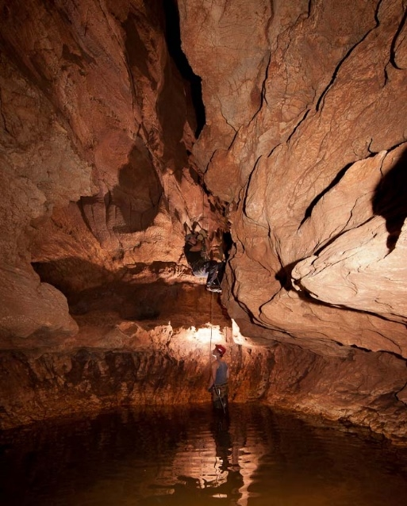
Right: Underground water pooled in a chamber within the interior of Great Niggle Cave, near Camooweal on the Barkly Tablelands.
(Photo Liz Rogers, Australian Speleological Foundation)

While it is well known that surface water in the region flows into Nowranie Creek and other tributaries of the Georgina River, and from there to Lake Eyre, we do not know exactly where the underground water flows. Nor do scientists currently know how far the Camooweal Caves underground water systems extend. Eberhard (2003: 35-36) states that the absence of groundwater springs near Camooweal indicates a long subterranean flow path for the Camooweal groundwater, with a distance of approximately 400km to the nearest likely output south of Boulia. This is well beyond the length reached in some of the world’s largest cave-spring systems (QPWS 2014).

References:
Department of Environment and Heritage Protection Queensland. 2013. Ghost Bat. Retrieved http://www.ehp.qld.gov.au/wildlife/animals-az/micro-bats/ghost_bat.html
Eberhard, S. 2003. Nowranie Caves and the Camooweal Karst Area, Queensland: Hydrology, Geomorphology and Speleogenesis, with Notes on Aquatic Biota. Helictite 38 (2): 27-38.
Grimes, K. 2006. Syngenetic Karst in Australia: a review. Helictite 39 (2): 27-38.
Jersey, D. & Jack, N (eds.) 1976. Brief Backgrounds: Camooweal Caves. Extracted from Geological Elements of the National Estate in Queensland, Geological Society of Australia Queensland Division: Brisbane.
Queensland Parks & Wildlife Service. 2014. Interpretive signage display for the Camooweal Caves National Park.

Carol Hopkins
Legal Secretary
South Australian Native Title Services Ltd
Level 4, 345 King William Street
Adelaide SA 5000
Ph: 08 8110 2829
Fax: 08 8110 2811
Email: carolh@nativetitlesa.org

Yandruwandha/Yawarrawarrka people

Cooper Creek, Cullyamurra Waterhole and Coongie Lakes

This submission is prepared in response to the request for information about the centrality of water and the significance of these waterways to the lives, songs and stories of the Yandruwandha and Yawarrawarrka people.

By way of background, the Yandruwandha and Yawarrawarrka tribes are indigenous to neighbouring areas in the Cooper Basin, in the north east of South Australia and western Queensland. Some years ago, the two groups came together to pursue their claim for native title over their traditional lands in South Australia, and native title by consent determination was awarded by the Federal Court to the Yandruwandha/Yawarrawarrka people in December 2015.

The Yandruwandha/Yawarrawarrka people achieved recognition under Federal Law as joint traditional owners over a homogeneous geographic region. However, it is important to note that the groups are keen to maintain recognition of their respective cultural practices, dreaming and songlines, where such exist. This submission is prepared with that in mind. This is our depiction of the significance of our people’s waterways and why we hope it becomes recognised as a heritage sites.

Please note that the information in this document privy to the Yawarrawarrka/Yandruwandha People. If you find this information useful, we would appreciate it if you consult with us further if there is any intent to disseminate it.

Aaron Paterson Lesley Nicholls
Yandruwandha Yawarrawarrka

The Yandruwandha perspective
Geographic / Anthropological
Cullyamurra Waterhole is recognised as one, if not the longest and widest – and certainly the deepest – waterhole in inland/arid Australia. The waterhole forms part of the 1,522-kilometre Cooper Creek, which starts in Windorah Queensland and feeds into Lake Eyre, South Australia.

Many tribes lived and camped along Cooper Creek and called it home for countless generations. Cullyamurra waterhole is in the lands of the Yandruwandha people.

Cullyamurra – or Kalyu-marru – waterhole supports a vast community of wildlife including fowl, fauna and flora, providing Yandruwandha people with food, as well as the resources to manufacture fishing nets, pirli yama, string bags, and wood implements.

The reliability of Kalyu-marru waterhole’s longevity is a key consideration to its importance to the region. Tribes from surrounding regions would come to Kalyu-marru for ceremony and trade immediately following flood events. The Cullyamurra Rock Carving gallery sits beside the waterhole and contains myriad petroglyphs, engraved by the Yandruwandha people. Some show red carvings in the black surface of the rocks, although age and weathering have blackened the more ancient carvings.
The history of the Yandruwandha are carved into the rocks and are our library cataloguing historical events. Some are as recent as 1845, when Charles Sturt left his horse on the Cooper in a weakened state. Carved into their rocks is a depiction of the horse, which survived its abandonment and lived along the creek for some 16 years. Its end came when Howitt’s 1861 party tried to capture it; the horse broke its leg and had to be shot.

The junction of the Barcoo and Thompson rivers in Queensland at Windorah are important to the Yandruwandha people too because, although sited on another tribe’s area, this is where the Cooper begins its snake-like journey, tracking to the south-west carrying flood waters with it to rejuvenate the land and water systems, bringing food and water to the tribes along its path.

Baryulah wetlands is a spectacular system of breakaway creeks, all called Cooper Creek. There are some 30 Cooper Creeks on the map through the wetland system. The main Cooper channel sits on its northern section. It turns at Baryulah waterhole, at the eastern-most boundary of Yandruwandha lands, and snakes east-southeast to Ngapamiri waterhole and Pulupulu waterhole, then onto Nguntu-Oontoo waterhole at the Queensland/South Australian border. A few kilometres on, the waters reach the eastern edge of Kalyu-marru waterhole.

Colonial history
In the mid-nineteenth century, the Victorian colonial government funded the Royal Society of Victoria’s largest exploration expedition in Australia. Robert O’Hara Burke led an 18-man team with camels and horses to reach the north Australian coastline, and return. Burke split up his party twice: first at Menindie NSW, and the second time at Camp 65 on Cooper Creek. With the second division of his team, four men remained at the depot, while Burke took three men to complete the mission to the Gulf. Burke and his team of three reached the Gulf, however one man died on the return journey near Lake Massacre. Burke, William Wills and John King on made it back at the depot, but found it abandoned on 21 April, 1861. Only John King survived by seeking help from the Yandruwandha people who kept him alive three months until his rescue on 15 September, 1861.

Burke died beside Yinimingka waterhole where it adjoins Kalyu-marru waterhole. The natives, led by King to where Burke's body lay, cried when they saw his condition and realised King was alone and kept him with them.

Contemporary times
More recently, Australian explorer and entrepreneur, Dick Smith has flown a light aircraft along Cullyamurra waterhole and, it is said, states it was his favourite place in the desert, or his favourite waterhole.

Even today the importance of Cullyamurra waterhole continues to be recognised and utilised by the Yandruwandha.

On the 22 January, 2016, Federal Minister for the Environment, Greg Hunt proclaimed the Burke, Wills, King and Yandruwandha places as #104 on the National Heritage List.

The Yawarrawarrka perspective
The water ways on our country were always, and still are, extremely significant to the laws, customs, ceremonies, dreaming and survival of the Yawarrawarrka.

The Rainbow Serpent is the Yawarrawarrka people’s tribal totem and part of our dreaming.
The Rainbow Serpent travels to its resting place at Coongie Lakes. Our great Uncle sang the great Rainbow Song to his family and talked about how important it is for our people to know the song, as the Rainbow Serpent would only come to us when he heard this song.

The Rainbow Serpent is our special totem he lets us know he’s around with big noises, sounds like a train when big rains are coming so our people can move to high ground like Scrubby Camp Waterhole or the big red Sandhill’s along Coongie Lakes. Scrubby Camp Waterhole is where our people lived and settled when big rains came, this is because of the deep waterways and high banks and our people could move about from both side of this special waterhole.

Our family totem is the Pelican, which inhabit the waterways and waterholes of our country. The Pelican gives us a sense of belonging throughout our lands and waterways, because everywhere our totem flies and swims they know they are home on our waters, as our people know we are home.

Malkumba-Coongie Lakes, named after my great-great-grandmother Coongie Maggie, is a meeting place where ceremonies were had with other tribes to celebrate the water coming down. This would mean Yawarrawarrka dreaming travelled through our waterways and lands to rest upon Coongie Lakes.
Yawarrawarrka women were the hunter and gatherers for our people. My grandmother told me the stories of how they hunted for ducks in Coongie Lakes. The women would cover themselves with claymud and use a long straw weed to breathe underwater. They would put a green lily pad on their heads and walk underwater and wait for the ducks to sit on the lily pads, then they would grab the ducks legs. We would also hunt for mussels with our feet by sliding our feet along the ground and finding them with our feet. Yawarrawarrka people would use the weeds along the Coongie Lakes to make their baskets and clothing, bedding for our babies and people.

A special weed which is used for medicinal purposes lies beneath Coongie Lakes. My grandmother talked about how special this weed is for our people as it makes our people better and helps with sores and other special things.

Our people would travel along the waterholes so they could have food on a daily basis. Our women and men would need to travel to and from other significant places such as Callyamurra Waterhole, Queerbidie Waterhole, Policeman’s Waterhole, Minkie Waterhole, Scrubby Camp Waterhole and Kudriemitchie Waterhole to perform their laws and customs and have ceremonies, dances and talk about Yawarrawarrka dreamings. Our people would draw or leave marks along the way. These Waterhole are very significant to my family because my aunty and uncles were born at theses Waterholes. Aunty Mary at Kudriemitchie Waterhole, Uncel Snider was born at Policeman’s Waterhole, Uncle Harold was born at Queerbidie Waterhole and Uncle Fred was born at Callyamurra Waterhole.
Callyamurra Waterhole is the traditional Yawarrawarrka name means “bloody good fishing here”. Callyamurra Waterhole is a significant sacred place for men’s and women’s business. Men’s business would be on one side and women’s business on the opposite side and both were used for initiating and ceremonies.

Women’s business site included a birthing place and cleansing. My grandmother told me the significant stories of birthing for our Yawarrawarrka women. Women would give birth to the babies in a warm holes (warmed by fire) next the water to cleans the babies after birth. If our women could not give birth at this significant place they would walk for days to wash and cleans their babies in the great Callyamurra Waterhole. My grandmother said it’s because our children/people need to be cleaned by our special water while singing the special songs for our Rainbow Serpent to smell and recognise Yawarrawarrka people when swimming in the waterhole. My grandmother had performed the songs many times during the birth of her children and families’ children and other children.

Callyamurra Waterhole is a playing and swimming area for our children, however it’s very deep. My grandmother would perform and sing the Yawarrawarrka Special Song to the Rainbow Serpent before our children would enter the water. When the children entered the waterhole, the water would become very shallow for the children to swim and play in and all the while the Rainbow Serpent would be watching and protecting our children and people.

Along the waterways is a significant rock carving site at the choke end of Callyamurra which has three creeks running into Callyamurra Waterhole. Yawarrawarrka tribal names of these Waterhole are Calyajuru, Turawilly and Nakamura. These carvings were used as communication to other nomadic tribes passing though. Tribes would be passing though for trade and ceremonies and the rock carvings would also be used to communicate the types of fishing and hunting available in the area.
One of the dreaming stories of the Innamincka township on the waterways near the Cooper Creek and Queerbidie Waterhole crossing, talks about Ngura-tu-lu-tura who was a wondering Mura-Mura. He was offended by a group of strangers, who laughed at his crooked legs and arms so he used his magic to cast them into a deep sleep, stole their magic grinding stone and when they woke a battle proceeded. He used the grinding stone as a shield and struck them with so much force that a deep pit was formed- from which the place was called Yidniminka (Innamincka) translated means “Thou a hole” (shall be).
On the other side of the Cooper Creek, before Cooper creek crossing and Queerbidie Waterhole, is a significant burial place for our Yawarrawarrka people. To this day my great great grandmother Coongie Maggie, Queen of the Yawarrawarrka tribe, and great Uncle Alfie (tribal man) are buried in our significant tribal grounds. Great Uncles talked about the special men’s bushes that laid along this part of the waterhole. The special bushes were used for smoking while they were doing men’s laws, customs and ceremony dances and other things, however that’s all they would say as this was for men only. My Grandmother was a medicine woman though her laws and customs along the banks. Nan spoke about some of the bushes she would use and sometimes she would use them on people that were bad or not doing the right thing by their laws and customs.

The waterways which run into Coongie Lakes are: Callyamurra Waterhole, Queerbidie Waterhole, Policeman’s Waterhole, Minkie Waterhole, Scrubby Camp Waterhole and Kudriemitchie Waterhole. These waterholes are very significant to our laws and customs, ceremonies, dreaming and survival of our people.

The waterways had, and still have, flora and fauna that were used to make clothing, materials, woven fish traps and shelter. Humpies were made along the river using claymud and sticks. The waterway also provided an abundance of bush tucker/food, like mussels, fish, turtles, mudclams and snotty gobbles. Wild bananas, wild rockmelon, pea trees and milk were all provided from the trees/plants that grew long the river.

Broken Hill City Council
Elizabeth Guest
Enviro,Waste & Recycling Specialist, Broken Hill City Council
240 Blende Street Broken Hill City Council NSW 2880 Australia
P. (08) 8080 3345
M. 0427 940 839
W. www.brokenhill.nsw.gov.au
E. Elizabeth.Guest@brokenhill.nsw.gov.au

Council has received a letter from the Australian Government advising of an Australian Deserts Cultural Heritage Study.
In response to the letter Council would like to draw your attention to the Living Desert, which is now registered as a State Park and managed by Council for its natural and cultural values, and is considered to represent the unique natural characteristics for the Broken Hill Region.
There are several cultural features including rock carvings, old fire hearths and a quartz quarry onsite from past Indigenous use of the area.
If you think this site may warrant further investigation as part of the Australian Deserts Cultural Heritage Study, please don’t hesitate to contact myself or Darrell Ford (Living Desert Ranger – cc’d in on the email) for further information.
It was intended to include more information in the first instance, however time has run short in this regard.

Appendix 4 – List of stakeholders emailed by the Department of Environment

Contact list - Waters of Australian Deserts cultural heritage thematic study
Council Name | Contact Person | Phone No. Reception | Postal Address | Email
WA
Ashburton Shire Council | Neil Hartley, CEO | (08) 9188 4444 (reception) | PO Box 567 TOM PRICE WA 6751 | soa@ashburton.wa.gov.au neil.hartley@ashburton.wa.gov.au
Carnarvon Shire Council | Ian D’arcy – Chief Executive | 9941 0050 (Reception) | PO Box 459, CARNARVON WA 6701 | ceo@carnarvon.wa.gov.au
Coolgardie Council | Paul Webb, CEO | (08) 9080 2111, 0407 085 535 | PO Box 138, KAMBALDA EAST, WA, 6442 | execsec@coolgardie.wa.gov.au, mail@coolgardie.wa.gov.au
Cue Shire Council | Rob Madson, CEO | (08) 9963 8602, 0427 080 205 | PO Box 84, CUE WA 6640 | shire@cue.wa.gov.au, ceo@cue.wa.gov.au
Dundas Shire Council | Doug Stead, CEO | (08) 9039 1205 | PO Box 163, NORSEMAN, WA, 6443 | shire@dundas.wa.gov.au
East Pilbara Shire Council | Allen Cooper, CEO | (08) 9175 8000 | PMB 22 NEWMAN WA 6753 | ceo@eastpilbara.wa.gov.au
Kalgoorlie-Boulder Council | CEO position currently vacant | (08) 9021 9600 | PO Box 2042, BOULDER, WA 6432 | mailbag@ckb.wa.gov.au
Laverton Council, | Mr Steven Deckert, CEO | (08) 9031 1202 option 4. 0427 080 205 | PO Box 42, LAVERTON, WA 6440 | ceo@laverton.wa.gov.au
Leonora Shire Council | Jim Epis, CEO | (08) 9037 6044 | PO Box 56, LEONORA WA 6438 | admin@leonora.wa.gov.au, jim.epis@leonora.wa.gov.au
Meekatharra Council |  | (08) 9981 1002 | PO Box 129, MEEKATHARRA WA 6642 | ceo@meekashire.wa.gov.au
Menzies Council | Pascoe Durtanovich, A/g CEO | (08) 9024 2041 | PO Box 4, MENZIES WA 6436 | ceo@menzies.wa.gov.au
Mount Magnet Council |  | (08) 9963 3000 | PO Box 62, MOUNT MAGNET, WA, 6638 | shire@mtmagnet.wa.gov.au
Murchison Council |  | (08) 9963 7999 | PO Box 61, MULLEWA WA 6630 | ceo@murchison.wa.gov.au
Ngaanyatjarraku Council |  | (08) 8956 7966 | PMB 87, KALGOORLIE WA 6430 | mail@ngaanyatjarraku.wa.gov.au
Port Hedland Council | Mal Osborne, CEO | (08) 9158 9300 | Po Box 41, PORT HEDLAND WA 6721 | council@porthedland.wa.gov.au
City of Karratha (formerly Shire of Roebourne) |  | (08) 9186 8555 |  | enquiries@karratha.wa.gov.au
Sandstone Council | Michael Huston, CEO | (08) 9963 5802 | Hack Street, SANDSTONE WA 6639 | reception@sandstone.wa.gov.au; ceo@sandstone.wa.gov.au
Shark Bay Council | Paul Anderson, CEO | (08) 9948 1218, 0427 948 925 | PO Box 126, DENHAM WA 6537 | admin@sharkbay.wa.gov.au
Upper Gascoyne Council | John McCleary | (08) 9943 0507 | 4 Scott Street, GASCOYNE JUNCTION WA 6705 | ceo@uppergascoyne.wa.gov.au
Wiluna Council | Dean Taylor, A/g CEO |  | PO Box 38, WILUNA WA 6646 | ceo@willuna.wa.gov.au
Yalgoo Council | Silvio Brenzi | (08) 9962 8042 | PO Box 40, YALGOO WA 6635 | pa@yalgoo.wa.gov.au; ceo@yalgoo.wa.gov.au
Yilgarn Council | Brian Jones, CEO | (08) 9049 1001 | PO Box 86, SOUTHERN CROSS WA 6426 | ceo@yilgarn.wa.gov.au; yilgarn@yilgarn.wa.gov.au
SA
Anangu Pitjantjatjara Yankunytjatjara (APY) | Richard King – General Manager, Bernard Singer - Chair | 8954 8111 (Reception) | PMB 227 UMUWA via Alice Springs | gmapy@anangu.com.au
The District Council of Ceduna | Geoffrey Moffatt, CEO | (08) 8625 3407 | PO Box 175, CEDUNA SA 5690 | council@ceduna.sa.gov.au
District Council of Coober Pedy | Tony Renshaw, CEO | (08) 8672 4600 | Po Box 425 COOBER PEDY SA 5723 | dccp@cpcouncil.sa.gov.au
The Flinders Ranges Council | Colin Davies, CEO | (08) 8620 0500, 0428 627 950 | PO Box 43, QUORN SA 5433 | cid@frc.sa.gov.au
Town of Gawler LGA | Henry Inat, CEO | (08) 8522 9241 | PO Box 130 GAWLER SA 5118 | Henry.inat@gawler.sa.gov.au
Gerard Community Council Inc. |  | (08) 8583 7304 | PMB Gerard, via WINKIE SA 5343 | gerardcouncil@bigpond.com.au
Regional Council of Goyder | John Brak, CEO | (08) 8892 0100 |  | jbrak@goyder.sa.gov.au
Light Regional Council | Brian Carr, CEO | 0885 253 200 (voice) | PO Box 72, KAPUNDA SA 5373 | Light@light.sa.gov.au
Maralinga Tjarutja Community Council | Peter Clark, General Manager | (08) 8625 2946 | Po Box 435 CEDUNA SA 5690 | pclark@oakvalley.com.au; reception@maralinga.com.au
Nepabunna Community Council Inc. |  | (08) 8648 3764 | C/- Post Office ce, Nepabunna 5732 | info@nepabunnatourism.com.au
District Council of Orroroo Carrieton | Stephen Rufus, CEO | (08) 8658 1260, 0438 854 274 | PO Box 3 ORROROO SA 5431 | council@orroroo.sa.gov.au
Outback Communities Authority | Mark Sutton, Director | (08) 8648 5970. 0427 001 969 | PO Box 2353 PORT AUGUSTA SA 5100 | oca@sa.gov.au, mark.sutton@sa.gov.au
District Council of Peterborough | Peter McGuinness, CEO | (08) 8651 3566 (réception) | Po Box 121 PETERBOROUGH SA 5422 | council@peterborough.sa.gov.au
Roxby Downs Municipal Council | Bill Boehm, Administrator | (08) 8671 0010 | Po Box 124, ROXBY DOWNS SA 5725 | roxby@roxbycouncil.com.au
Southern Mallee District Council | Mrs Mia Dohnt, CEO | (08) 8577 8002 | Po Box 49, PINNAROO SA 5304 | miadohnt@southernmallee.sa.gov.au
Whyalla City Council | Peter Peppin, CEO | (08) 8640 3423 | Po Box 126, WHYALLA SA 5600 | Peter.peppin@whyalla.sa.gov.au
Yalata Community | Danny Shorthouse, Operations Manager | (08) 8625 6040 | PMB 31, CEDUNA SA 5600 | Opsmanager.yalata@bigpond.com
NT
Alice Spring Town Councils | Rex Mooney, CEO | 0427 161 956, or (08) 8950 0500 | PO Box 1071, ALICE SPRINGS NT 0871 | astc@astc.nt.gov.au
MacDonnell Regional Council | Jeff MacLeod, CEO | (08) 8958 9600 | PO Box 5267 ALICE SPRINGS NT 0871 | info@macdonnell.nt.gov.au
Central Deserts Shire Council | Cathryn Hutton, CEO | (08) 8958 95330 | PO Box 2257, ALICE SPRINGS NT 0871 | Cathryn.hutton@centraldesert.nt.gov.au
Barkly Shire Council | Peter Holt, A/g CEO | (08) 8962 0000 | PO Box 821, TENNANT Creek, NT 0861 | reception@barkly.nt.gov.au
Victoria Daly Council |  | (08) 8972 0777 | Po Box 19, KATHERINE NT 0850 | Vicdaly.admin@vicdaly.nt.gov.au
NSW
Broken Hill City Council | Wincen Cuy - Mayor | (08) 8080 3300 | GPO Box 448, BROKEN HILL NSW 2880 | council@brokenhill.nsw.gov.au
Balranald Shire Council | Aaron Drenovski, General Manager | (03) 5020 1300 | PO Box 120, BALRANALD NSW 2715 | adrenovski@balranald.nsw.gov.au
Bland Shire Council | Ray Smith, General Manager | (02) 6972 2266 |  | council@blandshire@nsw.gov.au
Bourke Shire Council | Ross Earl, General Manager | (02) 6830 8000 | PO Box 21, BOURKE NSW 2840 | bourkeshire@bourke.nsw.gov.au
Brewarrina Shire Council | Dan Simmons, General Manager | (02) 6830 5100 | PO Box 125, BREWARRINA NSW 2839 | breshire@brewarrina.nsw.gov.au
Cabonne Shire Council | Andrew Hopkins, General Manager | (02) 6392 3200 | Po Box 17, MOLONG NSW 2866 | council@cabonne.nsw.gov.au
Central Darling Shire Council | Greg Wright, General Manager | (08) 8083 8900 | Po Box 165, WILCANNIA NSW 2836 | council@centraldarling.nsw.gov.au
Cobar Shire Council | VACANT – General Manager | (02) 6836 5888 | PO Box 223, COBAR NSW 2835 | mail@cobar.nsw.gov.au
Coonamble Shire Council | Rick Marren, General Manager | (02) 6827 1900 | PO Box 249, COONAMBLE NSW 2829 | council@coonambleshire.nsw.gov.au
Forbes Shire Council | Brian Steffen, General Manager | (02) 6850 2300 | PO Box 333, FORBES NSW 2871 | forbes@forbes.nsw.gov.au
Gilgandra Shire Council | Don Ramstand, General Manager | (02) 6817 8800 | PO Box 23, GILGANDRA NSW 2827 | council@gilgandra.nsw.gov.au
Lachlan Shire Council | John Medcalf, Mayor | (02) 6895 1900 | PO Box 216, CONDOBOLIN NSW 2877 | council@lachlan.nsw.gov.au
Narrabri Shire Council | Stewart Todd, General Manager | (02) 6799 6833 | PO Box 261, NARRABRI NSW 2390 | council@narrabri.nsw.gov.au
Narromine Shire Council | Greg Lamont, General Manager | (02) 6889 9999 | PO Box 115, NARROMINE NSW 2821 | mail@narromine.nsw.gov.au
QLD
Balonne Shire Council | VACANT, General Manager | (07) 4620 8888 | PO Box 201, ST GEORGE QLD 4487 | council@balonne.qld.gov.au
Barcaldine Regional Council | Rob Chandler, Mayor | (07) 4651 5600 | PO Box 191, BARCALDINE QLD 4724 | council@barc.qld.gov.au
Barcoo Shire Council | Bob O’Brien | (07) 4658 6900 | PO Box 14, JUNDAH QLD 4736 | ceo@barcoo.qld.gov.au
Blackall Tambo Shire Council | Ken Timms, CEO | (07) 4621 6600 | PO Box 21, BLACKALL QLD 4472 | ceo@btrc.qld.gov.au
Boulia Shire Council |  | (07) 4746 3188 |  | admin@boulia.qld.gov.au
Bulloo Shire Council | Lew Rojahn, A/g CEO | (07) 4621 8000 | PO Box 46, THARGOMINDAH QLD 4492 | council@bulloo.qld.gov.au
Cloncurry Shire Council | David Neeves, CEO | (07) 4742 4100 | PO Box 3, CLONCURRY QLD 4824 | council@cloncurry.qld.gov.au
Diamantina Shire Council |  | (07) 4746 1202 |  | admin@diamantina.qld.gov.au
Flinders Shire Council | Greg Jones, Mayor | (07) 4741 2900 | PO Box 274, HUGHENDEN QLS 4821 | flinders@flinders.qld.gov.au
Longreach Shire Council | Ian Bodill, CEO | (07) 4658 4111 |  | mayor@longreach.qld.gov.au
Maranoa Shire Council | Julie Reitano, CEO | 1300 007 662 |  | council@maranoa.qld.gov.au
Mt Isa City Council | Emilio Cianetti, CEO | (08) 4747 3200 | PO Box 815, MT ISA QLD 4825 | city@mountisa.qld.gov.au
McKinlay Shire Council | John Kelly, Interim CEO | (07) 4746 7166 | PO Box 177, JULIA CREEK QLD 4823 | ceo@mckinlay.qld.gov.au
Murweh Shire Council | Neil Polglase, CEO | (07) 4656 8355 | PO Box 63, CHARLEVILLE QLD 4470 | ceo@murweh.qld.gov.au
Paroo Shire Council | Chris Cowley, CEO | (07) 4655 8400 | PO Box 75, CUNNAMULLA QLD 4490 | Chris.cowley@paroo.qld.gov.au
Richmond Shire Council | Peter Bennett, CEO | (07) 4741 3277 |  | ceo@richmond.qld.gov.au
Quilpie Shire Council | Dave Burges, CEO | (07) 4656 0500 | PO Box 57, QUILPIE QLD 4480 | admin@quilpie.qld.gov.au
Winton Shire Council |  | (07) 4657 2666 | PO Box 288 WINTON QLD 4735

Appendix 5 - Experts consulted for the study

Peter Bell, Adelaide: mining heritage, regional heritage assessment South Australia
Dr Scott Cane, Port Lincoln: Nullarbor, Western Deserts, water
Dr John Carty, South Australian Museum, Adelaide: Canning stock route
Dr Ian Coates, National Museum of Australia, Canberra: Papunya
Tom Gara, Attorney Generals Department, Adelaide: Maralinga, Ooldea, Nullarbor
Dr Leah Gibbs, University of Wollongong: Lake Eyre, Cooper Creek
Dr Alice Gorman, Flinders University, Adelaide: Woomera and Maralinga
Gordon Grimwade, Yungburra Queensland: mining heritage, arid zone historic heritage
Dr Diana James, ANU Canberra: Seven Sisters and Ngintuka Songlines, value of water
Rebecca Jones, ANU Canberra: historical studies of reaction to drought
Dr Kevin Keirnan, Hobart: natural heritage significance, starscapes
Duncan Marshall, Canberra: Lake Eyre WHA
Prof Isabel McBryde, Canberra: trade routes
Prof Jo McDonald, University of Western Australia, Perth: desert rock art
Prof Alistair Paterson, University of Western Australia, Perth: Cossack and Overland Telegraph Line
Dr Libby Robin, ANU, Canberra: history of science in the deserts
Prof Mike Smith National Museum of Australia, Canberra: desert archaeology and culture
Prof Peter Veth, University of Western Australia, Perth: desert rock art and archaeology
Dr Keryn Walshe, South Australian Museum, Adelaide: Koonalda Cave, Ooldea, Nullarbor
Dr Sue White, La Trobe University, Melbourne: geoscience and deserts geoheritage
Dr Elizabeth Williams, Canberra, Lake Eyre, Cooper Creek: Channel country, eastern desert
Vivien Wood and Craig Westrall, Adelaide: Pilbara and Ooldea

Prof Mike Smith, Prof Peter Veth and Dr Elizabeth Williams, Dr Diana James, Dr Alice Gorman and Dr Kevin Kiernan kindly read and commented on the content of the draft report.

WATERS OF AUSTRALIAN DESERTS CULTURAL HERITAGE STUDY
APPENDIX 6 - PLACE ASSESSMENT MATRIX
Notes:
1. Total 61 places.
2. The column 2-4 criteria and indicators are described in Part 2 of the report.
3. The assessment is based on the information that was available and accessible at the time of the study and within the scope of the study.
PLACE / ASSESSMENT | NATIONAL HERITAGE LIST CRITERIA | NATIONAL HERITAGE INDICATORS  (Values in italics are important additional values which at this stage are not thought to be (but in some cases may be) of outstanding heritage value to the nation) | THEMATIC INDICATOR  (People-Desert-Water Significant Response Types) | WATER INDICATOR  (Relationship of Place to Key Desert Water Attributes) | PLACE INTEGRITY  (assessed) | THRESHOLD  (ranking 1-3)  (T1= well above threshold; T2 = above; T3 = highly likely above) | PLACE IDENTIFICATION  (Place/s that best represent/ /exemplify the broader place  comparative places  known listings (national or higher level)  [IBRA])
Channel Country Desert Cultural Landscape | whole place -  (a),(b), (c), (i)  within place –  needs further research | . This landscape is an evolved continuing landscape that exemplifies the adaptive response of Australian Aboriginal people over the period of Aboriginal occupation of Australia to a particular, distinctive and major desert environment type in Australia, ie, that of the Channel Country of W Queensland, E Northern Territory and NE South Australia, with the key water types being permanent and ephemeral water in a river complex context, which includes ‘received water’ from the north. (a)  . This cultural landscape in tandem with the other identified ‘desert cultural landscapes’ (refer this study) demonstrates the system of arid zone adaption in Australia, a system of national importance. (a)  . This cultural landscape contains an abundance and diversity of Aboriginal heritage values both tangible and intangible that are best expressed by this landscape and characterise a particular way of life (living in the Channel Country) that is now changed (but includes elements that are part of the present lifeway of the area.) (b).  . This suite of sites in their landscape context provides information on, and is the only source of information on, the Aboriginal history of an important Australian environment. (c).  . This cultural landscape is able to represent to a high level the key characteristics of an important component of the long term Aboriginal history of the Australian arid zone. (d)  . At least the southern part of this landscape is known to include places that hold Ancestral and ceremonial meaning and stories which were and continue to be of importance to the Indigenous people of the area. (i) | 1. High residential/ economic mobility  1a. broad scale subsistence/ economics  1b. residential mobility  2a. specialised responses to highly variable environment  2b. specialised resource technology  3b. use of specialised water re/sources  4a. Songlines  4c. social reciprocity & territorial access rights | . response to generalised aridity  . dependent on a unique combination of interrelated ephemeral and permanent surface waters | moderate to high | T2  (information limited) | Area centred on the Channel Country; extending from Coopers Creek (and including Callymurra Waterhole and Coongie Lakes)  unique  [IBRA – CHC, SSD]
Witjira-Dalhousie Artesian Springs Desert Cultural Landscape | whole place -  (a),(b), (c),  within place –  needs further research | . This landscape is an evolved landscape that exemplifies the adaptive response of Australian Aboriginal people over the period of Aboriginal occupation of Australia to a particular, distinctive and major desert environment type in Australia, ie, the ecotone of stony plains and sandy desert where water is reliable but sparse, with the key water type being mound springs, springs and soaks fed by the Great Artesian Basin. (a)  . This cultural landscape in tandem with the other identified ‘desert cultural landscapes’ (refer this study) demonstrates the system of arid zone adaption in Australia, a system of national importance. (a)  . This cultural landscape contains an abundance and diversity of Aboriginal heritage values both tangible and intangible that are best expressed by this landscape and characterise a particular way of life (living in the stony plains and sandy desert and utilising water from the Great Artesian Basin) that is now changed. (b).  . This suite of sites in their landscape context provides information on, and is the only source of information on, the Aboriginal history of an important Australian environment. (c).  . This cultural landscape is able to represent to a high level the key characteristics of an important component of the long term Aboriginal history of the Australian arid zone. (d) | 1. High residential/ economic mobility  1a. broad scale subsistence/ economics  1b. residential mobility  2a. specialised responses to highly variable environment  3a. use of refugia  3b. use of specialised water re/sources  4c. social reciprocity & territorial access rights | . response to generalised aridity  . dependent on Great Artesian Basin waters | high | T1 | Area centred on the Dalhousie Springs area.  unique  Part of area already listed on NHL for natural values.  [IBRA – STP, SSD]
Finke River Desert Water Route Cultural Landscape | whole place -  (a),(b), (c), (i)  within place –  needs further research | . This landscape is an evolved landscape that exemplifies the adaptive response of Australian Aboriginal people over the period of Aboriginal occupation of Australia to a particular, distinctive and major desert environment type in Australia, ie, the Central Desert with water and travel focused along the river corridor, in this case the Finke River, a largely dry river where water sources are primarily permanent waterholes, particularly in the headwaters. (a)  . This cultural landscape in tandem with the other identified ‘desert cultural landscapes’ (refer this study) demonstrates the system of arid zone adaption in Australia, a system of national importance. (a)  . This cultural landscape is an outstanding and rare example of the use of a dry river based water route, dry rivers that only occasionally flow for their full length being a significant feature of the Australian arid zone. (b)  . Also a rare, possibly unique, example as the full river from its source (MacDonnell Ra uplands) to its end (Finke River Floodout)) is used, including as a focus for travel (elsewhere only parts of rivers are used and included in travel routes) (b)  . It contains an abundance and diversity of Aboriginal heritage values both tangible and intangible that are best expressed by this landscape and characterise a particular way of life (Central Desert) and utilising water from an ephemeral river that is now changed but is also continuing in modified form). (b).  . This suite of sites in their landscape context provides information on, and is the only source of information on, the Aboriginal history of an important Australian environment. (c)  . This cultural landscape is able to represent to a high level the key characteristics of an important component of the long term Aboriginal history of the Australian arid zone. (d)  . The lower end of the Finke river, the Floodout area holds the recorded Arkaya songline which explains the origins of the river, and was and continues to be of importance to the Indigenous people of the area; and also numerous stone arrangements which are the ceremonial markers in country where rock art has not been practiced (i) | 1. High residential/ economic mobility  1a. broad scale subsistence/ economics  1b. residential mobility  3b. use of specialised water re/sources  4a. Songlines  4c. social reciprocity & territorial access rights | . response to generalised aridity  . dependent on permanent and ephemeral surface water | high | T1 | Corridor along the Finke River from the headwaters in the West MacDonnell Ranges to, and including, the Finke River Floodout  Unique – long desert river with central desert catchment  Source area in the West MacDonnells nominated to the NHL.  [IBRA – MAC, FIN, STP, SSD]
West MacDonnell Ranges Desert Uplands Cultural Landscape | whole place -  (a),(b), (c), (h), (i)  within place –  needs further research | . This landscape is an evolved landscape that exemplifies the adaptive response of Australian Aboriginal people over the period of Aboriginal occupation of Australia to a particular, distinctive and major desert environment type in Australia, in this case the use of uplands. (a)  . This cultural landscape exemplifies the critical role of the uplands in the arid zone as refugia in periods of extreme dryness. (a)  . This cultural landscape in tandem with the other identified ‘desert cultural landscapes’ (refer this study) demonstrates the system of arid zone adaption in Australia, a system of national importance. (a)  . This cultural landscape contains an abundance and diversity of Aboriginal heritage values both tangible and intangible that are best expressed by this landscape and characterise a particular way of life (Central Desert) strongly dependent and centred around the use and valuing of permanent rock waterholes that are a feature of upland areas that is now changed (but is also continuing in modified form). (b)  . This suite of sites in their landscape context provides rare information on the Aboriginal history of an important Australian environment. (c)  . This cultural landscape is able to represent to a high level the key characteristics of an important component of the long term Aboriginal history of the Australian arid zone. (d)  . This landscape is nationally recognised and valued aesthetically as a special and distinctly Australian landscape. (g)  . Of national significance for its association with nationally significant Aboriginal artist, Albert Namatjira, as the landscape he painted and which is widely represented in his art works (see Albert Namatjira Representational Landscape (4a), below). (h)  . The permanent rock waterholes hold special, highly significant Aboriginal traditional and spiritual values (i). | 1. High residential/ economic mobility  1a. broad scale subsistence/ economics  1b. residential mobility  2a. specialised responses to highly variable environment  3a. use of refugia  3b. use of specialised water re/sources  4c. social reciprocity & territorial access rights | . response to generalised aridity  . highly dependent on permanent surface water (waterholes) | high | T1 | West MacDonnell Ranges  Comparative places - other desert uplands (Warburton Ra, Murchison Ra).  Most of this landscape area is contained within the West MacDonnells NHL nomination.  [IBRA – MAC]
Spinifex Country Desert Cultural Landscape | whole place -  (a),(b), (c), (i)  within place –  needs further research | . This landscape is an evolved landscape that exemplifies the adaptive response of Australian Aboriginal people over the period of Aboriginal occupation of Australia to a particular, distinctive and major desert environment type in Australia, ie, the Great Victorian Desert, which is a culturally recognised desert area referred to as ‘spinifex country’. (a)  . This cultural landscape in tandem with the other identified ‘desert cultural landscapes’ (refer this study) demonstrates the system of arid zone adaption in Australia, a system of national importance. (a)  . This cultural landscape contains an abundance and diversity Aboriginal heritage values both tangible and intangible that are best expressed by this landscape and characterise a particular way of life (Great Victorian Desert/‘spinifex country) strongly dependent and centred around the use of ephemeral surface water (with very limited permanent water) that is now changed (but is also continuing in modified form). (b)  . This suite of sites in their landscape context provides rare information on the Aboriginal history of an important Australian environment. (c)  . This cultural landscape is able to represent to a high level the key characteristics of an important component of the long term Aboriginal history of the Australian arid zone. (d)  .The soakages in this region hold special, highly significant Aboriginal traditional and spiritual values (i). | 1. High residential/ economic mobility  1a. broad scale subsistence/ economics  1b. residential mobility  2a. specialised responses to highly variable environment  3b. use of specialised water re/sources  4a. Songlines  4c. social reciprocity & territorial access rights | . response to generalised aridity  . highly dependent on ephemeral surface water (rain,) and shallow aquifer water (soaks) | high | T1 | Great Victoria Desert - centered on the country represented in 1998 ‘government’ native title paintings (Cane 2002:8, 17), north from Tjuntjuntjara to Sydney Yeo Range, east to Miramirratjara and Forrest Lakes.  Unique  Would be significant overlap with land area of the proposed Woomera listing (this study).  [IBRA – GVD]
Western Desert Cultural Landscape | whole place -  (a),(b), (c), (d),  within place –  needs further research | . This landscape is an evolved landscape that exemplifies the adaptive response of Australian Aboriginal people over the period of Aboriginal occupation of Australia to a particular, distinctive and major desert environment type in Australia, ie, the ‘Western Desert’ which is a culturally recognised desert area which includes parts of the Great and Little Sandy Deserts and the Gibson Desert. (a)  . This cultural landscape in tandem with the other identified ‘desert cultural landscapes’ (refer this study) demonstrates the system of arid zone adaption in Australia, a system of national importance. (a)  . this cultural landscape contains an abundance and diversity of Aboriginal heritage values both tangible and intangible that are best expressed by this landscape and characterise a particular way of life (Western Desert country) strongly dependent and centred around the use of ephemeral surface water (lakes) and sub-artesian water that is now changed (but is also continuing in modified form). (b)  . This suite of sites in their landscape context provides rare information on the Aboriginal history of an important Australian environment. (c)  . This cultural landscape is able to represent to a high level the key characteristics of an important component of the long term Aboriginal history of the Australian arid zone. (d)  . Percival Lakes are associated with one of the last groups of desert people to come into contact with European people in 1964, as a result of the Maralinga tests (a) | 1. High residential/ economic mobility  1a. broad scale subsistence/ economics  1b. residential mobility  2a. specialised responses to highly variable environment  3b. use of specialised water re/sources  4a. Songlines  4c. social reciprocity & territorial access rights | . response to generalised aridity  . Highly dependent on ephemeral surface water (lakes), shallow aquifer water (soaks), and sub-artesian water (wells). | high | T1 | Area centred on the Percival Lakes, WA (requires more information to establish the exact location and boundaries for this place).  unique  [IBRA – GSD, GIB, LSD]
Australian Maritime Desert Cultural Landscape | whole place -  (a),(b), (c),  within place –  needs further research | . This landscape is an evolved landscape that exemplifies the adaptive response of Australian Aboriginal people over the period of Aboriginal occupation of Australia to a particular, distinctive and major desert environment type in Australia, in this case an extensive coastal edge desert area. (a)  . This cultural landscape is an outstanding varied and rich example of Australian Aboriginal coastal archaeology that demonstrates adaptation to changing sea level conditions. (a)  . This cultural landscape in tandem with the other identified ‘desert cultural landscapes’ (refer this study) demonstrates the system of arid zone adaption in Australia, a system of national importance. (a)  . It contains an abundance and diversity Aboriginal heritage values both tangible and intangible that are best expressed by this landscape and characterise a particular way of life (Western Australia coastal desert) strongly dependent and centred around the use of limited water and coastal resources that is now changed (but is also continuing in modified form). (b)  . This suite of sites in their landscape context provides rare information on the Aboriginal history of an important Australian environment. (c)  . This cultural landscape is able to represent to a high level the key characteristics of an important component of the long term Aboriginal history of the Australian arid zone. (d) | 1. High residential/ economic mobility  1a. broad scale subsistence/ economics  1b. residential mobility  2a. specialised responses to highly variable environment  2e. flexibility in occupation or use in long term  4c. social reciprocity & territorial access rights | . response to generalised aridity  . Highly dependent on ephemeral surface water | high | T1 | Ningaloo – Onslow Coast including the Montebello & Barrier Islands (requires more information to establish the exact location and boundaries for this place).  unique (similar place in relation to maritime association is the Nullarbor coast this however lacks clear evidence of the coastal dynamics responses)  A significant part of the landscape area is contained within the Ningaloo Coast NHL place  [IBRA – PIL, CAR]
The Kidman Pastoral Empire | (a), (d), (f), (h) | . Kidman was the chief originator and exponent in Australia of diversifying holdings geographically (as a system of interrelated components, primarily stations) to ensure a viable pastoral business in the more marginal arid and semi-arid region of Australia. This pastoral system was historically the backbone of the pastoral industry in central and northern Australia, an industry which is of national significance. (a)  The Kidman Empire was in the early –mid 1900s the largest (over100 cattle stations of a total area >3% of Australia) and the dominant beef cattle producing company in Australia. (a)  . This nationally significant and highly successful innovation was pioneered by Sir Sidney Kidman and the resultant ‘Kidman Empire’ demonstrates a high degree of innovative technical achievement. (f)  . The Kidman Empire is the largest and historically most outstanding example of pastoral geographic diversification and as a largely extant system (although no longer fully owned by the Kidman company) is able to demonstrate the nature of this system to a very high level. (d)  . The Kidman Empire is the outcome and legacy of Sir Sidney Kidman, a self-made Australian businessman who is nationally recognised for his role in developing the Australian cattle industry (recognised through a knighthood, place names, book/film). (h). | 1. High residential/ economic mobility  1a. broad scale subsistence/ economics  1c. long distance travel route  2a. specialised responses to highly variable environment  2b. specialised resource technology  2c. newly experienced desert environment | . response to generalised aridity  . utilised and dependent on a range of desert water types, but significant uses of a linkage of sites comprising –  Great Artesian Basin water, &  sub-artesian water (wells/bores). | high | T1 | Ideally a serial site that includes a set of stations that demonstrate the key developmental stages and different operational elements of the Kidman Empire. Includes WA, NT, Qld, NSW & SA.  Nominated emblematic place – Owen Springs Station  (first property)  comparative places – the Kidman empire is outstanding with no other comparable suite of historic pastoral holdings in Australia  [IBRA – MAC]
Western Pearl Shell Trade Route | (a), (b), | . Highly significant as one of the three recorded major trans-Australian traditional Aboriginal trade routes, which also provided long distance communications and social connection across many desert areas. (a)  . Significant in a national context as a unique route connecting peoples in the arid zone in the SW half of Australia and with its own songline/s. (a)  . Of outstanding significance as a trans-Australian Aboriginal trade route, because of the critical and specialised functions it served. (a)  . Very rare as a long distance trans-Australian traditional Aboriginal trade route (one of 3). (b) | 1. High residential/ economic mobility  1c. long distance travel routes  2a. specialised response to highly variable environment  2b. specialised infrastructure technology  4a. Songlines  4b. long distance communications  4c. social reciprocity & territorial access rights | . response to generalised aridity  . utilised and dependent on a range of desert water types, but significant uses of dominant local type of water which includes –  . sub-artesian water,  . shallow aquifer water,  . permanent surface water. and  . ephemeral surface water | unknown  (also currently limited knowledge of place) | T2 | Linear connecting routes from near Derby-Broome in the Kimberleys via the Warburton area to near Tarcoola-Port Augusta in SA  comparative – E. Lake Eyre trade route (shorter distance but significantly more complex trade); Baler Shell trade route in NE Australia (more diffuse/ less well defined)  Starting point of route contained in W. Kimberleys NHL listing  [IBRA – DAL, GSD, LSD, GID, SER, GVD, GAW]
Eastern Lake Eyre Trade Route | (a), (b), (d) | . Highly significant as one of the three recorded major trans-Australian traditional Aboriginal trade routes, which also provided long distance communications and social connection across many desert areas. (a)  . Of outstanding significance as a trans-Australian traditional Aboriginal trade route because of the critical and specialised functions it served, including as a focus for major eastern Australian arid zone gatherings at Kopperamana. (a)  . Foremost in a national context for the number and quantity of goods traded along this route (most other routes are limited to one to a few items), including for considerable lengths of the route for key goods (a)  . Very rare as a long distance trans-Australian traditional Aboriginal trade route (one of 3). (b)  . Best (and well) demonstrates in a national context a long distance traditional trade route with key components (key trade item sources, key gathering places, and a resource (food & water) based route). (d). | 1. High residential/ economic mobility  1c. long distance travel routes  2a. specialised response to highly variable environment  2b. specialised infrastructure technology  4b. long distance communications  4c. social reciprocity & territorial access rights | . response to generalised aridity  . utilised and dependent on a range of desert water types, but primarily –  . sub-artesian water,  . shallow aquifer water,  . permanent surface water, and  . ephemeral surface water. | high-moderate | T1 | Linear connecting primary route from the Flinders Ranges (Parachilna Ochre Quarry) ,SA, via Kopperamana and Goyders Lagoon to the Cloncurry area (greenstone axe quarries) in Qld  comparative – Western Pearl Shell trade route (longer but only 1 primary trade item and younger - colonial period); Baler Shell trade route the Cape York – Cloncurry – Cooper Ck (more diffuse/ less well defined)  [IBRA – FLB, STP, SSD, CHC, MGD, MII]
‘One road many stories’  Canning Stock Route | (a), (b), (d), (g), (i) | . The establishment of the Canning Stock Route is an integral part of the national story of development of the pastoral (cattle) industry in the western half of Australia, an industry of national significance (although the route was not as successful as expected. (a)  . The Canning Stock Route exemplifies how cattle were transported across the vast distances of Australia’s interior, with the stock routes being an essential part of the industry (the transport of cattle being critical to supplying stations and getting produce to markets). (a)  . The Canning Stock Route is the longest historic stock route in Australia (c.1, 850 km); and is claimed to be the longest stock route globally. (a)  . The Canning Stock Route is unusual in the national context as it was instigated by government (WA government) rather than developing through use. (b)  . The Canning Stock Route is rare in having its Indigenous history well documented by the Indigenous people who speak for the country it traverses in the ‘Canning Stock Route collection’ a nationally significant body of paintings now held by the National Museum of Australia (b)  . The Canning Stock Route as a place can demonstrate to a very high level the key characteristics of a long distance arid zone – semi arid zone stock route of the key period that these were used, the dependence of these routes on specialised water resources and the impacts on local Indigenous people. (d)  . The Canning Stock Route is significant to Aboriginal people nationally as it exemplifies many of the worst aspects of the European occupation and development of Australia, including enslavement, chaining and killing of Aboriginal people, and the loss and destruction of traditionally significant water sources which were also critical for survival. (g)  . The waters of the Canning Stock route are associated with numerous Ancestral stories and songlines. (i)  . Historical stock routes in arid – semi-arid Australia have folkloric status and are widely acknowledged as iconic or distinctively Australian. | 1. High residential/ economic mobility  1c. long distance travel routes  2b. specialised infrastructure technology  3b. use of specialised water re/sources  4b. long distance communications | . response to generalised aridity  . utilised and dependent on wells (shallow aquifer water) | high | T1 | Wiluna, WA to Halls Creek, WA.  Comparative – Birdsville Track (has lower integrity); Strzelecki Stock Route and Oodnadatta Track (as for Birdsville Track and also shorter tracks).  [IBRA – MUR, GAS, LSD, GSD, CEK, OVP]
Strzelecki Track Stock Route | (a), (d) | . A highly significant stock route supporting the national cattle industry, itself an industry of national significance. (a)  . The Strzelecki Track Stock Route exemplifies how cattle were transported across the vast distances of Australia’s interior, with the stock routes being an essential part of the industry (the transport of cattle being critical to supplying stations and getting produce to markets). (a)  . The Strzelecki Track stock route as a place can demonstrate to a high level the key characteristics of a long distance arid zone – semi arid zone historic stock route as it passes through diverse desert environments depending on the specialised water re/sources of each. (d)  The Strzelecki Track demonstrates the crucial role of ‘Afghan’ cameleer transport in the arid zone (a)  . Stock routes in arid – semi-arid Australia are widely acknowledged as distinctively Australian. | 1. High residential/ economic mobility  1c. long distance travel routes  2b. specialised infrastructure technology  3b. use of specialised water re/sources  4b. long distance communications | . response to generalised aridity  . utilised and dependent on permanent and ephemeral surface water and waterholes | high-moderate | T2 | Lyndhurst to Innamincka, SA  Comparative – Canning Stock Route and Birdsville Track (shorter route); Oodnadatta Track (similar).  [IBRA – FLD, STP. SSD, CHC]
Birdsville Track Stock Route | (a), (d), (g) | . The establishment of the Birdsville Track stock route was of national importance in opening up and establishing the pastoral (cattle) industry in the eastern Australian deserts, an industry of national significance. (a)  . The Birdsville Track exemplifies how cattle were transported across the vast distances of Australia’s interior, with the stock routes being an essential part of the industry (the transport of cattle being critical to supplying stations and getting produce to markets). (a)  . The Birdsville Track demonstrates the crucial role of ‘Afghan’ cameleer transport in the arid zone. (a)  . The Birdsville Track stock route as a place can demonstrate to a high level the key characteristics of a long distance arid zone – semi arid zone stock route of the key period that these were used, the dependence of these routes on specialised water resources, in this case the critical importance of the water associated with the ephemeral rivers of the Channel Country. (d)  . The Birdsville Track is nationally recognised as an historically significant route, including for its association with the cattle industry and long distance droving. (g)  . Stock routes in arid – semi-arid Australia are widely acknowledged as distinctively Australian. | 1. High residential/ economic mobility  1c. long distance travel routes  2b. specialised infrastructure technology  3b. use of specialised water re/sources  4b. long distance communications | . response to generalised aridity  . utilised and dependent on permanent and ephemeral surface water, waterholes and bores | high-moderate | T2 | Birdsville, Qld to Marree, SA.  Comparative – Birdsville Track (has lower integrity); Strzelecki Stock Route and Oodnadatta Track (as for Birdsville Track and also shorter tracks).  [IBRA – STP, SSD]
Oodnadatta Track and Stock Route | (a) | . The Oodnadatta Track exemplifies how cattle were transported across the vast distances of Australia’s interior, with the stock routes being an essential part of the industry (the transport of cattle being critical to supplying stations and getting produce to markets). (a)  The Oodnadatta Track demonstrates the crucial role of ‘Afghan’ cameleer transport in the arid zone. (a)  . Stock routes in arid – semi-arid Australia are widely acknowledged as distinctively Australian. | 1. High residential/ economic mobility  1c. long distance travel routes  2b. specialised infrastructure technology | . response to generalised aridity  . utilised and dependent on permanent and ephemeral surface water, waterholes and bores | moderate | T3 | Marree – William Creek – Oodnadatta, SA  Comparative – Canning Stock Route and Birdsville Track (shorter route); Strzelecki Track (similar).  [IBRA –STP, SSD]
Darling River Transport Route | (a), (d) | . The Darling River Route was crucial for the establishment of semi-arid pastoralism, and part of the significant semi-arid pastoral droving corridor in eastern Australia that was integral in connecting pastoral Australia. (a)  . The Darling River transport route exemplifies one of the key ways in which cattle and other goods were transported across the vast distances of Australia’s interior in this case using riverine transport, with such routes being essential for the supplying the inland and getting produce to markets). (a)  . The Darling River transport route as a place can demonstrate to a high level the key characteristics of a long distance arid zone – semi arid zone stock route of the key period that these were used, the dependence of these routes on specialised water resources, in this case a permanent unmodified rivers, but with highly variable flows. (d)  . Sites along this route demonstrate design adaptations to meet the inland river environment with highly variable flows, and limited construction material availability. (d). | 1. High residential/ economic mobility  1c. long distance travel routes  2b. specialised infrastructure technology  3b. use of specialised water re/sources  4b. long distance communications | . response to generalised aridity  . utilised and dependent on permanent surface water (river) | high-moderate | T2 | Darling River from Wentworth upstream, via Wilcannia & Menindee, to Bourke, NSW  comparative – Murray River (Echuca on NHL)  [IBRA – DRP, MDD]
Mulligan River Pituri Area | (a), (b) | . Pituri (Duboisia hopwoodii, a narcotic plant native to the arid zone) was historically a highly significant narcotic plant used by Aboriginal people in the arid zone, both for personal use, trade and in fish stunning. The most used narcotic substance in traditional Aboriginal Australia. (a)  It was widely traded (via the East L. Eyre) in eastern Central Australia, with its importance reflected in the amount of pituri traded and the large distances it was traded. (a)  The Mulligan River pituri area is the main area from which highly valued pituri was sourced and the only known large area of occurrence. It is therefore an uncommon significant cultural value (and to a lesser extent natural value) in an Australian context. (b) | 2. high degree of technical/ organisational flexibility  2a. changing environmental conditions & resource access | . dependent on ephemeral surface water (rain) | unknown | T2 | Area on the Mulligan River (exact boundary needs to be established through botanical and historical research; does not necessarily need to be the full extent of the occurrence, although that would reduce the authenticity of the place).  unique  [IBRA – CHC]
Owen Springs | (d), (c)?  - as part of the Kidman Empire - (a) | . Significant at the national level as part of the Kidman Empire suite of stations, in particular as the first property purchased by Kidman (1886) in the establishment of his pastoral system. (a)  . Because of its integrity as a property, the substantial remains (Aboriginal stockmen’s’ hut ruins, station homestead ruins, springs) and containing the remains of the earliest homestead in Central Australia (1872), it can provide a high level of information on the operation, technology and way of life on an early period Australian cattle station, and specialised adaptation for arid zone conditions (in particular in relation to dependence on permanent artesian spring water). (d)  . Potentially has scientific significance as remains of the earliest homestead in Central Australia, and an early Kidman property with substantial documentary evidence and archaeological remains (unlikely to be of national level significance as same time period as other OTL stations). (c) | 2. high degree of technical/ organisational flexibility  2a. changing environmental conditions & resource access  1a. broad scale subsistence/economics  3b. use of specialised water re/sources. | . dependent on and utilised Great Artesian Basin water (springs)  . to a lesser extent depended on permanent and ephemeral surface water. | high-moderate | T3 | Full station (as size of station and elements contributing to it are part of the significance) Alice Springs, NT  comparative – other OTL related stations and other Kidman stations (in particular Anna Creek Station)  In part State Reserve (Owen Springs Reserve (1,570 km2)),  [IBRA – MAC]
Anna Creek Station  (including The Peake, an outstation) | (c), (d)  - as part of Kidman Empire – (a) | . Very early arid zone station (1863) that was part of the forefront of pastoral expansion into the arid zone. (a – possibly not outstanding)  . A key integral element in the nationally significant Kidman Empire, the most arid of all the stations. (a – possibly not outstanding)  . Early successful artesian bore (1881). (a)  . Largest cattle station in Australia (and claimed to be the largest in the world) (c.6,000000 acres / 24,000 sq km) (a – possibly not outstanding).  . Demonstrates the impact of the Overland Telegraph Line on the region through the moving of the Station in 1872 to its present location. (a - – possibly not outstanding)  . Able to represent at a high level an arid zone pastoral (cattle) station through its complexity and size and integrity; including the dependence of such properties on reliable water. (d)  . Because of its size complexity, earliness, continued use and integrity can provide a high level of information on the operation, technology and way of life on an Australian cattle station over a comparatively long time period. (c) | 2. high degree of technical/ organisational flexibility  2a. changing environmental conditions & resource access  1b. residential mobility  3b. use of specialised water re/sources | . response to generalised aridity  . utilised and dependent on Great Artesian basin water.  . utilised and dependent on shallow aquifer water.  . utilised and dependent on ephemeral surface water / rain. | high | T2 | Full Station and Outstation properties (SW L. Eyre, near William Creek, SA)  comparative – other Kidman and OTL related stations  Listed on the SA Heritage Register –  . The Peake Ruins (former telegraph office, cemetery, mine site and lime kilns at the outstation)  . Strangways Springs Telegraph Station Ruins  [IBRA – STP, SSD]
Wadla Wadlyu (Tooths Nob) Grindstone Quarry Complex | (c), (d) | . Grindstone quarries are part of a major mid-Holocene desert adaption, using grain in the diet, with grindstones an essential tool for the processing and consumption of grain. (a - possibly not outstanding)  . Wadla Wadlyu is one of a small number of recorded major grindstone quarries in arid Australia, and is significant as it was the most used of the known quarries. (a - possibly not outstanding)  . Of significance as producing an important trade item, with stone being traded via the various trade routes, including the East Lake Eyre Trade Route. (a - possibly not outstanding)  . The place represents the principal characteristics of a seed grindstone quarry to a high level (given its extensiveness and integrity). (d)  . As a significant type place and given its high integrity the place can provide information on historical seed grindstone quarrying in Australia, a process that provided an essential tool for seed processing, which in turn provided a specialised and significant food resource for arid zone Aboriginal people. (c) | 2. high degree of technical/ organisational flexibility  2b. specialised resource technology  1a. broad scale subsistence/economics  1c. long distance travel route | . response to generalised aridity  . indirectly correlated with ephemeral surface water / rain via grain production. | high | T1 | Quarry area, East Flinders Ranges, SA  comparative – other listed grindstone quarries  [IBRA – FLB]
Kurutiti (Helen Springs) Grindstone Quarry complex | (d) | . Grindstone quarries are part of a major mid-Holocene desert adaption, using grain in the diet, with grindstones an essential tool for the processing and consumption of grain. (a - possibly not outstanding)  . Kurutiti is one of a small number of recorded major seed grindstone quarries in arid Australia, and represents the principal characteristics of a seed grindstone quarry to a high level. (d)  . As a significant type place and given its high integrity the place can provide information on historical seed grindstone quarrying in Australia, a process that provided an essential tool for seed processing, which in turn provided a specialised and significant food resource for arid zone Aboriginal people. (c – possibly not national level) | 2. high degree of technical/ organisational flexibility  2b. specialised resource technology  1a. broad scale subsistence/economics | . response to generalised aridity  .indirectly correlated with ephemeral surface water / rain via grain production. | high | T3 | Quarry area, near Elliott, NT  comparative – other listed grindstone quarries  [IBRA – DMR, TAN, STU, MGD]
Palthirri-Pirdi (Anna Creek) Grindstone Quarry Complex | (a)?, (c), (d) | . Grindstone quarries are part of a major mid-Holocene desert adaption, using grain in the diet, with grindstones an essential tool for the processing and consumption of grain. (a - possibly not outstanding)  . Palthirri Pirdi is one of a small number of recorded major seed grindstone quarries in arid Australia, and is significant as it was the most used of the known quarries. (a - possibly not outstanding)  . Of significance as producing an important trade item, with stone being traded long distances via the various trade routes. (a - possibly not outstanding)  . The place represents the principal characteristics of a seed grindstone quarry to a high level (given its extensiveness and integrity) (d)  . As a significant type place and given its high integrity and early historical documentation the place can provide information on historical seed grindstone quarrying in Australia, a process that provided an essential tool for seed processing, which in turn provided a specialised and significant food resource for arid zone Aboriginal people. (c) | 2. high degree of technical/ organisational flexibility  2b. specialised resource technology  1a. broad scale subsistence/economics  1c. long distance travel route | . response to generalised aridity  . indirectly correlated with ephemeral surface water / rain via gain production | high | T1 | Quarry area, near William Creek, W. Lake Eyre, SA  comparative – other listed grindstone quarries  [IBRA – SSD, STP]
Innamincka Grindstone Quarry Complex (includes Wild Dog Hill, Mt McLeod) | (c), (d) | . Grindstone quarries are part of a major mid-Holocene desert adaption, using grain in the diet, with grindstones an essential tool for the processing and consumption of grain. (a - possibly not outstanding)  . Innamincka Quarry is one of a small number of recorded major seed grindstone quarries in arid Australia (a - possibly not outstanding)  . Of significance as producing an important trade item. (a - possibly not outstanding)  . The place represents the principal characteristics of a seed grindstone quarry to a high level (given its extensiveness and integrity) (d)  . As a significant type place and given its high integrity the place can provide information on historical seed grindstone quarrying in Australia, a process that provided an essential tool for seed processing, which in turn provided a specialised and significant food resource for arid zone Aboriginal people. (c) | 2. high degree of technical/ organisational flexibility  2b. specialised resource technology  1a. broad scale subsistence/economics  1c. long distance travel route | . response to generalised aridity  . indirectly correlated with ephemeral surface water / rain via grain production | high | T2 | Quarry area, near Innamincka, W. Lake Eyre, SA  comparative – other listed grindstone quarries  [IBRA – SSD]
Kallana/ Killara Station | (a) | . Of outstanding national level significance as the first station in Australia to successfully tap the highly significant Great Artesian Basin water by bore (1879), a source of water that was of critical importance to the success of the Australian pastoral (cattle) industry. (a) | 2. high degree of technical/ organisational flexibility  2b. specialised resource technology | . utilised and dependent on Great Artesian basin water.  . first use of Great Artesian Basin bore water. | unknown  (assumed high) | T2 | Whole station, near Tilpa, NSW (at minimum the bore and setting, including buildings and structures if associated)  (A serial site listing of places that demonstrate key aspects of the use of the Great Artesian Basin waters would have higher national level significance – would also include Kembree Station and OTL stations)  unique  [IBRA – MDD]
Kembree Station | (a) | . Of outstanding national level significance as the first station in Australia to successfully put down a deep bore to tap the highly significant Great Artesian Basin water by bore (1886), a source of water that was of critical importance to the success of the Australian pastoral (cattle) industry. (a) | 2. high degree of technical/ organisational flexibility  2b. specialised resource technology | . utilised and dependent on Great Artesian basin water.  . first use of Great Artesian Basin bore water. | unknown  (assumed high) | T2 | Whole station, near Bourke, NSW (at minimum the bore and setting, including buildings and structures if associated)  (A serial site listing of places that demonstrate key aspects of the use of the Great Artesian Basin waters would have higher national level significance – would also include Kallana Station and OTL stations)  unique  [IBRA – DRP]
Dog Fence [also referred to as Dingo Fence] | (a), (b), (g) | . The Dog Fence is of outstanding national level significance as a major pest control measure, on a large scale, to protect Australia’s nationally significant pastoral industry (to protect sheep in the SE from dingoes in the NW) and for its highly significant influence on the Australian pastoral industry. It exemplifies the process of the pastoral industry’s experience of and response to the introduction of pest animals and environmental degradation, culminating in technological and administrative measures to manage the problem of dingo predation. It is also significant for its continuity of use and in relation to the fact that it continues to perform the same function today. (a)  . At c.5614km it is one of Australia’s (and the world’s) longest structures, representing a massive national undertaking, and demonstrates national level (as well as local and state level) cooperation in relation to the maintenance of the Australian pastoral industry. (a)  . The Dog Fence defines the approximate boundary between sheep and cattle grazing across much of Australia. (a)  . It is of outstanding significance as a rare national scale pest control measure. As a pest control measure its large scale is rare (the only other similar scale structure in Australia is the Rabbit Proof Fence), and the continued operational condition of the full fence (although not in many places in its original form) is also unusual. (b)  . This pest control fence is of outstanding national level significance as it demonstrates to a high degree the nature of major pest control fences in Australia and evolution of this type of national scale infrastructure. (d)  . The Dog Fence is an ingenious application of commonplace pastoral technology (the netting fence) to the national problem of dingo infestation through the daring solution of building a barrier fence on a national scale. (f)  The Dog Fence has national iconic status and is widely known and valued by Australians as a special Australian historic structure. (g)  . The Dog Fence, as part of the history of appropriation of ’rangelands’ for sheep grazing and its impact on the resident populations of Indigenous people, exemplifies in part the long process of dispossession of Australian indigenous peoples due to pastoral expansion and establishment across Australia. | 2. high degree of technical/ organisational flexibility  2b. specialised resource technology | . response to generalised aridity | high | T1 | Nundroo, Nullarbor Plains, SA, to Jimbour, Darling Downs, Qld.  comparative – Rabbit Proof Fence  [IBRA – NUL, GVD, GAW, STP, SSD, CHC, WAR, MUL, MGD, BBS]
Rabbit Proof Fence | (a), (b), (g) | . Erected between 1901 and 1907 this vermin proof fence is of outstanding national level significance as the second, and only one of two, major national scale pest control infrastructure measures in Australian history, in this case for protection against rabbits, which have been a nationally significant pest. (a)  . At c.3,256km it (all three fences – which intersect) is one of Australia’s longest structures, representing a massive undertaking to construct (and to maintain). (a)  . It has significance in relation to the fact that is continues to perform the same function today. (a)  . It demonstrates extremely well the major impacts that such large scale structures have on communities, as the Rabbit Proof Fence has had a significant impact on the Indigenous way of life, on communications and travel routes, on the supply of goods and on the pastoral industry (a)  . Of outstanding significance as an intact and rare national scale pest control measure. (b)  . Barrier fences that are designed to exclude animals from large areas are historically and contemporarily rare inside and outside Australia (b)  . Has national iconic status and is widely known and valued by Australians as a special Australian historic structure. This is reflected in the recent book and major Australian film, Rabbit Proof Fence that explores an aspect of Indigenous history that is of national significance. (g) | 2. high degree of technical/ organisational flexibility  2b. specialised resource technology | . response to generalised aridity | high | T1 | Recommended – all three fences.  At minimum the full No.1 Fence: N-S Line from Starvation Harbour, on the S coast of WA to Cape Keravdren on the NW Coast of WA.  comparative – Dog/Dingo Fence  [IBRA – ESP, MAL, COO, MUR, GAS, LSD, PIL, GSD, DAL]
John McDouall Stuart Exploration Route | (a), (d), (h) | . JM Stuart’s successful exploration of Central Australia and pioneering of a non-Indigenous routes from the south coast to the north coast (1862) is of outstanding national significance as it paved the way for, and led directly to, the colonial settlement of Central Australia and the opening up of the nationally significant trans-Australian route through Central Australia, along which the Overland Telegraph Line and later the Ghan Railway were constructed. (a)  . It can also be considered of outstanding national significance as the first successful north-south trans-Australian colonial exploration route. (a)  . The route and the water sources along it (still extant due to their importance) demonstrate at an exceptional level the critical and essential role of reliable water in the successful non-Indigenous settlement and broader use of the arid zone, including in the establishment of travel and communication routes (at least until the late 1900s). (d)  . JM Stuart is nationally recognised and celebrated for his mid-1800s exploration and survey work, in particular the establishment of the trans-Australian overland route through Central Australia (recognised in the naming of various features including the trans-Australian road, the Stuart Highway that approximately follows his exploration route. (h).  . JM Stuart’s exploration route has additional significant connections with the Overland Telegraph Line as his expedition was largely funded by James Chambers, who was interested in establishing an overland telegraph line, and this was a consideration for Stuart while exploring the route.  . JM Stuart’s exploration route, within the arid zone (from the south end to Alice Springs) largely followed traditional Aboriginal travel and water routes which have traditional meanings and associations, and his route relied on Aboriginal information about water, hence the route has additional historical and Indigenous values. | 2. high degree of technical/ organisational flexibility  2c. adaption to newly experienced desert environment | . response to generalised aridity  . utilised and dependent on a range of desert water types, but primarily Great Artesian Basin water | moderate | T1 | Full route from Adelaide, SA, to near Darwin, NT, via Coober Pedy, Alice Springs, Tennant Creek.  (If restricted to a desert theme nomination then the section from Port Augusta to Alice Springs should be listed)  comparative – E. Eyre’s E-W exploration routes, Burke & Wills exploration route  [IBRA – FLB, STP, GAW, SSD, FIN, MAC, BRT, TAN, STU, DAB, PCK, DAC]
EJ Eyre Exploration Route | (a), (h) | . EJ Eyre’s successful exploration (with Wylie, an Aboriginal man) of an overland route between eastern Australia and western Australia (1840-1841) demonstrated that a non-Indigenous overland connection was possible and opened the way for an E-W trans-Australian railway and highway, which has proved highly significant in terms of connecting Australia and for Australian industry (including mining). (a)  . Of outstanding national significance as the first successful east-west trans-Australian colonial exploration route, and as amongst the earliest long distance colonial exploration outside the eastern early settled part of the Australian continent (preceded only by Charles Sturt). (a)  . EJ Eyre is nationally recognised and celebrated for his early overland Australian (early-mid-1800s) exploration work, in particular his 1840-41 survey that connected by land eastern and Western Australia; as well as his later work as ‘protector’ of Aborigines on the Murray River (recognised in the naming of various features including L. Eyre, the Eyre Peninsula, and the E-W trans-Australian road, the Eyre Highway). (h).  . EJ Eyre’s explorations and E-W exploration relied heavily on Aboriginal knowledge of land and water, hence the route has additional Indigenous related historical values. | 2. high degree of technical/ organisational flexibility  2c. adaption to newly experienced desert environment | . response to generalised aridity  . utilised and dependent on a range of desert water types | moderate | T2 | Full route from Adelaide, SA, to Albany, WA, via the Nullarbor.  comparative – JM Stuart’s N-S exploration route, Burke & Wills exploration route  [IBRA – FLB, EYR, GAW, GVD, NUL, HAM, MAL, ESP, JAF]
Coober Pedy | (a), (b), (f), (g) | . The development of underground living at Coober Pedy is a significant technological adaption to the desert environment (the best national example). (f).  . This adaptation is rare at a national level and is demonstrated to a very high level in the township of Coober Pedy. (b)  . Opal and opal mining are recognised as a particularly Australian value and product. (a)  . The Coober Pedy opal field is the largest producer in Australia. (a)  . The town with its underground living is recognised nationally (and internationally) as a specialised desert adaption and significant and distinctively Australian place. (g) | 2. high degree of technical/ organisational flexibility  2d. specialised infrastructure technology | . response to generalised aridity  . utilises Great Artesian Basin water | high | T1 | Town of Coober Pedy (preferably including associated significant nearby opal diggings), SA.  Comparative – Andamooka, White Cliffs, Lightening Ridge.  [IBRA – STP]
Overland Telegraph Line | (a), (b), (f), (g), (h) | . Highly significant at the national level as trans-national communication infrastructure – the Overland Telegraph Line (OTL) provided the first rapid communication between Australia and the rest of the world via undersea cable (modernity) and between the north and the south of Australia, and across the interior of Australia. (a)  . It was a major and nationally significant infrastructure project due to its extent and the difficult arid terrain that it crossed, and the limited knowledge at the time of the terrain. (a).  . The establishment of the OTL was the most influential event (after JM Stuart’s successful trans-Australia crossing) in the non-Indigenous settlement of and establishment in the central Australian arid zone – it provided a communications link to the outside and within, was a focus (line) of travel, and the various repeater stations were centres of government, meeting places, bases for exploration and a focus of settlement and business. (a)  . The OTL is an extremely rare, and arguably the most significant, example of historical trans-national communications in Australia, and has particular significance for its ability to demonstrate the challenges associated with its construction through the design of the route with its focus on reliable water sources, as well as through its route through the centre of the arid zone of Australia which presented particular challenges for construction, exacerbated by the limited knowledge of the terrain at the time of its construction (b)  . Of high engineering significance for its pioneering nature, extreme scale and the extreme and minimally understood (at the time) environment in which it was constructed. (f)  . Associated with Baldwin Spencer and Francis Gillen whose publications based on their work along the OTL was nationally and internationally highly influential on anthropological theory and familiarity with central Australian Indigenous culture (h)  . The OTL is widely regarded as an iconic Australian historical structure. | 2. high degree of technical/ organisational flexibility  2d. specialised infrastructure technology  3b. use of specialised water re/sources  4b. long distance communications  4c. territorial access rights | . depends on a range of water types in particular –  . Great Artesian Basin water  . permanent surface water. | high-moderate | T1 | Full route from Adelaide, SA, to Pt Essington near Darwin, NT, via repeater stations Beltana, Strangways Springs, Peake, Charlotte Waters, Alice Springs, Barrow Creek, Tennant Creek, Powell Creek, Daly Waters, Katherine, Southport.  (If restricted to a desert theme nomination then the section from Port Augusta to Tennant Creek should be listed.)  comparative –E-W communications line  [IBRA – FLB, STP, GAW, SSD, FIN, MAC, BRT, TAN, STU, DAB, PCK, DAC]
Royal Flying Doctor Service | (a), (b), (f), (g), (h) | . Of outstanding national significance since its creation as the key provider of medical services in rural and remote Australia, and as an effective and irreplaceable medical service in remote areas, in particular in the arid zone where ground travel is impractical for serious or urgent medical needs. (a)  . the introduction of the use of the pedal radio (invented by Treager in 1929) in the second year of the RFDS (at that time the AIM AMS) and its early use by the RFDS as an integral part of the RFDS, resulted in the creation of a rural and remote radio communication network that revolutionised rural and remote communications in Australia (initially in the arid and semi-arid zone). (a)  . When created it was a unique (and effective) response to health provision in rural and remote areas and today is still the major way in which rural and remote health services are provided in Australia, and continues to be a rare example, and the most outstanding example, at the national and international level. (b)  . Realises the creative vision of the Rev. John Flynn to establish a ‘mantle of safety’ for the people of the Australian outback. The development of the RFDS utilised state of the art technology (aeroplanes, radio) in a highly innovative way to achieve its aims and was highly successful, and when established, unique. (f)  . The RFDS is, and has been, highly valued by Australians as an extremely important, and the pre-eminent, rural and remote Australian medical service since its inception. The RFDS and its originator, the Rev. John Flynn are household names throughout Australia. (g)  . The RFDS was the creation of the Rev. John Flynn, who through his work, initially with the Australian Inland Mission (AIM) and subsequently the RFDS (and its forerunner the AI Aerial Medical Service) is nationally recognised and respected for his services to the Australian people, particularly those in the arid zone. (h) | 2. high degree of technical/ organisational flexibility  2d. specialised infrastructure technology  1c. long distance travel route  4b. long distance communications | . response to generalised aridity | high | T1 | Serial site listing comprising – Cloncurry Base Hospital (base hospital at start of AIM AMS, 1928),  . Longreach QANTAS Hangar (planes serviced here),  . Alice Springs AIM RFDS Base (radio base, c.1929),  (Could be expanded to include key AIM, pre-RFDS places (eg, Oodnadatta AIM Base) and other key locations (eg, Rev. J. Flynn’s grave in Alice Springs)).  Unique  Values listed on NHL under Qantas Hanger listing  [IBRA – MAC, MII, MGD, STP respectively])
Puritjarra and the Cleland Hills Deep History Area | (a), (b), (c) | . Puritjarra has been a focus of occupation from deep time to the present, and is able to demonstrate this deep time cultural history through its deposits, associated sites and stories. The historical story held in Puritjarra is of national significance because it is the long term story of the peopling and subsequent occupation of the arid zone, an integral and significant part of Australia. (a)  . Puritjarra is a highly significant site in the history of archaeological investigation and understanding of arid zone occupation. (a)  . Puritjarra is a rare example, and the best exemplar, of an occupation site in the arid zone which has relatively continuous occupation from the Pleistocene through to the late Holocene and recent past. The surrounding landscape, which contains permanent water sources, other resources and other features that were critical for the successful long term use of the region and the Puritjarra shelter, is an essential part of the place as it contributes to the ability to demonstrate the nature of the successful adaptions that allowed Puritjarra to be relatively continuously occupied from the Pleistocene to the recent past. (b)  . The information held in Puritjarra and its surrounding landscape and associated sites is considered to be of outstanding value in relation to the long term occupation of the arid zone, including change over time. This is due in large part to the time depth of the deposits in Puritjarra, the site’s central location in the arid zone and the high level of detail in the investigation of the site can provide, which has been demonstrated. (c)  . Puritjarra is able to represent to a very high level the arid zone site types, typically rockshelters, that demonstrate Aboriginal occupation over deep time (ie, extending from the colonial period back into the Pleistocene). The landscape setting of Puritjarra is important in the ability of the place to represent this site type. (d) | 2. high degree of technical/ organisational flexibility  2e. long term flexibility in occupation or use  1a. broad scale subsistence/economics  1b. residential mobility  3a. use of refugia | . response to generalised aridity  . utilises permanent surface water (rock waterholes) | high | T1 | Area of the Cleland Hills - Haast Bluff, NT  - establishment of an exact boundary requires expert advice, but should include Puritjarra Rockshelter, Murantji Rockhole, & Tjungupu-Tarn of Auber  Comparative – Warratyi, Serpents Glen, Puntutjarpa, Koonalda.  (Listed in part on the RNE)  [IBRA – GSD]
Serpents Glen | (a), (b), (c), (i) | . Serpents Glen has been a focus of occupation from deep time to the recent past, and is able to demonstrate this deep time cultural history through its deposits, associated sites and stories. The historical story held in Serpents Glen is of national significance because it is the long term story of the peopling and subsequent occupation of the arid zone, an integral and significant part of Australia. (a)  . Serpents Glen is a rare example, of an occupation site in the arid zone which demonstrates reoccupation of the western desert after the LGM. (b)  . The information that Serpent’s Glen and its surrounding landscape can provide in relation to the long term occupation of the arid zone, including change over time, is considered to be high level, due in large part to the time depth of the deposits. (c)  . The information held in Serpent’s Glen and its surrounding landscape is considered to be of a high level in relation to the long term occupation of the arid zone, including change over time. This is due in large part to the time depth of the deposits in Serpent’s Glen, which has been demonstrated. (c)  . The place holds extremely important traditional values. (i) | 2. high degree of technical/ organisational flexibility  2e. long term flexibility in occupation or use  1a. broad scale subsistence/economics  1b. residential mobility  3a. use of refugia | . response to generalised aridity  . utilises permanent surface water (rock waterholes) | high | T2 | Area of the Calvert Range, WA  - establishment of an exact boundary requires expert advice  Comparative – Warratyi, Puritjarra, Puntutjarpa, Koonalda.  [IBRA – LSD]
Puntutjarpa Aboriginal Site | (a), (c), (i) | . Puntutjarpa has been a focus of occupation through the Holocene to the present, and is able to demonstrate this deep cultural history through its deposits, associated sites and stories. The historical story held in Puntutjarpa is of national significance because it is the long term story of the peopling and subsequent occupation of the arid zone, an integral and significant part of Australia. (a)  . Puntutjarpa is important in the history of archaeological investigation and understanding of arid zone occupation (a)  . The information held in Puntutjarpa and its surrounding landscape highly significant in relation to the Holocene occupation of the arid zone, including change over time. This significance is due in large part to the richness of the deposits in Puntutjarpa, which has been demonstrated through Gould’s late-1960s excavations at the site. This significance is also demonstrated by the important influence of Gould’s work on later archaeological and ethno- archaeological research. (c)  . The place holds extremely important Aboriginal traditional values. (i) | 2. high degree of technical/ organisational flexibility  2e. long term flexibility in occupation or use  1a. broad scale subsistence/economics  1b. residential mobility  3a. use of refugia | . response to generalised aridity  . utilises permanent surface water soakages | high | T2 | Area of the Warburton Range, WA  - establishment of an exact boundary requires expert advice  Comparative – Puritjarra, Serpents Glen, Warratyi, Koonalda.  [IBRA – CER]
Warratyi Rockshelter | (a), (c) | . Warratyi has been a focus of occupation from deep time to the recent past, and is able to demonstrate this deep time cultural history through its deposits, associated sites and stories. The historical story held in Warratyi is of national significance because it is the long term story of the peopling and subsequent occupation of the arid zone, an integral and significant part of Australia. (a)  . The information held in Warratyi and its surrounding landscape is considered to be highly significant in relation to the long term occupation of the arid zone, including change over time. This is due in large part to the time depth of the deposits in Warratyi, which has been demonstrated. (c) | 2. high degree of technical/ organisational flexibility  2e. long term flexibility in occupation or use  1a. broad scale subsistence/economics  1b. residential mobility  3a. use of refugia | . response to generalised aridity | high | T2 | Area of the Northern Flinders Ranges, SA  - establishment of an exact boundary requires expert advice  Comparative – Puritjarra, Serpents Glen, Koonalda.  [IBRA – CER]  FLB
Papunya | (a), (e), (f), (h) | . Papunya is of national significance as the centre in which Aboriginal people as a community took a significant, nationally recognised, step from a community of diverse Aboriginal people displaced by European settlement of the arid zone towards self-determination and sufficiency and a coherent community, through the introduction of a new form of Aboriginal art. (a)  . The Papunya desert art is outstanding for its ability to provide insights into how Aboriginal people represent and transmit knowledge about country, as well as the process of cultural adaptation to the pastoral and mission based era. (c)  . Aboriginal desert art, including ‘dot painting’, which originated from Papunya, is a unique and nationally and internationally recognised and appreciated modern Aboriginal art form. (e) (f)  . Papunya is a nationally recognised creative centre, with not only the ‘desert art movement evolving from Papunya, but also the ‘Warumpi Band’ a nationally recognised Australian country and Aboriginal rock group formed in Papunya with the first Indigenous language hit (1983). (f)  . Associated with nationally recognised artists, in particular Clifford Possum Tjapaltjarri, Billy Stockman Tjapaltjarri, Kaapa Tjampitjinpa, Kaapa Tjampitjinpa, Tim Leura Tjapaltjarri, Mick Namarari Tjapaltjarri, Turkey Tolson Tjupurrula, Uta Uta Tjangala, Long Jack Philipus Tjakamarra and Johnny Warangkula Tjupurrula. (h) | 2. high degree of technical/ organisational flexibility  2e flexibility in occupation or use in long term  4c. social reciprocity & territorial access rights | . response to generalised aridity | high | T2 | Papunya, W MacDonnell Ranges, NT  comparative - Namatjira, Utopia, Wurrwurrwuy stone arrangements  [IBRA – MAC, GST, BRT]
Utopia / Urapuntja | (a), (d), (e), (h) | . Utopia/Urapuntja is of national significance as one of the earlier successfully Aboriginal managed Aboriginal homelands that were a significant outcome of the Australian Aboriginal land rights movement. As one of the foremost and earliest examples of Aboriginal managed land post-land rights, Utopia demonstrates extremely well this nationally recognised historical refocusing onto land rights and self-management and self-determination. (a)  . The importance of Utopia in Australian Aboriginal history was recognised in John Pilger’s film Utopia (2013) which portrayed the historical and contemporary issues of Aboriginal communities in Australia.  . Utopia is associated with Rosalie Kunoth-Monks, who played the lead role in the classic Charles Chauvel film, Jedda (1955).  . Utopia has produced a nationally and internationally recognised and appreciated school of modern Aboriginal art that is based on traditional art, using modern materials. (e).  . Associated with nationally and internationally recognised artists who are exponents of the Utopia style, in particular Emily Kame Kngwarreye. (h) | 2. high degree of technical/ organisational flexibility  2e flexibility in occupation or use in long term  4c. social reciprocity & territorial access rights | . response to generalised aridity | high | T2 | Utopia/Urapuntja, Jervois Range, NT  (- a listing would preferably be the full homeland area (3,500 sq km))  comparative - Papunya, Strelley Station  [IBRA – BRT, TAN]
Paraku  Lake Gregory | (a), (b), (i) | . Paraku/Lake Gregory is a landscape that represents and demonstrates a specialised adaption to living in the desert that is fundamentally related to the landscape and to the specific form of water (ie, a terminal lake) in this region, with desert adaptions being a key part of the story of Australia’s settlement. (a)  . It is a rare good example of a desert adapted lifeway (in a special desert environment – a terminal lake). (b)  . Paraku is a rare example of a collaborative scientific/ artistic//Indigenous investigation of a significant place (2013) (b – possibly not outstanding)  . It is important as part of Indigenous tradition as this landscape holds multiple Ancestral stories. (i) | 3. intimate knowledge of the landscape dynamics  3b. use of specialised water re/sources  1a. broad scale subsistence/economics  1b. residential mobility  4a. Songlines. | . rare and specific use of a desert lake | High | T1 | Lake Gregory and environs, near Balgo, WA  - establishment of an exact boundary requires expert advice.  comparative – Willandra Lakes  [IBRA – GSD]
Mikeri Wells Water Route | (a), (b), (i) | . The Mikeri Wells is a linear landscape and route that represents and demonstrates a specialised adaption to living in the desert that is fundamentally related to the landscape and to the specific form of water (with desert adaptions being a key part of the story of Australia’s settlement). (b & d))  . It is a rare, good example of a desert adapted lifeway (in a special desert environment – natural desert wells that rely on relatively shallow subsurface water). (b)  . The Mikeri Wells route is able to demonstrate at an exceptional level a traditional Aboriginal water route given its location and the specific nature and location of the water sources of the route. (d)  . It is important as part of Indigenous tradition as this follows a significant Ancestral Story line. (i) | 3. intimate knowledge of the landscape dynamics  3b. use of specialised water re/sources  1a. broad scale subsistence/economics  1b. residential mobility  1c. long distance travel route  2b. specialised resource technology  4a. Songlines. | . utilises shallow aquifer waters/ sub-artesian waters  . rare and specific use of natural desert wells | high  [assuming key sites have not been damaged by recent mineral exploration] | T1 | The route and environs, Simpson Desert, NT  - establishment of an exact boundary requires expert advice.  comparative – unique  [IBRA – SSD, STP]
Finke River Floodout Aboriginal Landscape  (is also the Arkaya Songline and stone arrangements) | (a), (b), (i) | . Finke River Floodout is a landscape that represents and demonstrates a specialised adaption to living in the desert that is fundamentally related to the landscape and to the specific form of water, with desert adaptions being a key part of the story of Australia’s settlement. (a)  . It is a rare, good example of a desert adapted lifeway (in a special desert environment – a river floodout). (b)  . It is important as part of Indigenous tradition as this landscape holds the recorded Arkaya songline. (i) | 3. intimate knowledge of the landscape dynamics  3b. use of specialised water re/sources  1a. broad scale subsistence/economics  1b. residential mobility  4a. Songlines. | . utilises shallow surface waters  . utilises ephemeral surface waters  . rare and specific use of a desert river (part – floodout) | high | T1 | Finke Floodout, NE SA (natural & cultural environment)  - establishment of an exact boundary requires expert advice.  comparative - unique  Largely contained within Witjira National Park and the Simpson Desert Regional Reserve  [IBRA – FIN, SSD, STP]
Coongie Lakes | (a), (d) | . The Coongie Lakes is a landscape that represents and demonstrates a specialised adaption to living in the desert that is fundamentally related to the landscape and to the specific form of water (with desert adaptions being a key part of the story of Australia’s settlement). (a)  . It is a good example of a desert adapted lifeway in a special desert environment, ie, an ephemeral river-activated system of wetlands with significant seasonal resource variability, in this case a desert environment where received water floods out lakes and wetlands which lie within a sandridge desert. (d) | 3. intimate knowledge of the landscape dynamics  3b. use of specialised water re/sources  1a. broad scale subsistence/economics  1b. residential mobility  2a. specialised response to highly variable environment | . utilises ephemeral surface water (lakes) and permanent surface water (waterholes).  . specific use of a significant desert river water re/source (seasonal extensive wetland on Coopers Creek floodplain) | unknown  (assumed to be at least moderate) | T2 | Coongie Lakes & environs, Coopers Ck, SA (natural & cultural environment)  - possibly the Malkumba – Coongie Lakes NP (establishment of an exact boundary requires expert advice)  comparative - unique  Party contained within Malkumba – Coongie Lakes National Park  [IBRA – SSD]
Callymurra Water Hole | (a), (d), (i) | . The Callymurra Water Hole is a place that represents and demonstrates a specialised adaption to living in the desert that is fundamentally related to the landscape and to the specific form of water (with desert adaptions being a key part of the story of Australia’s settlement). (a)  . It is an extremely good single example of a desert adapted lifeway in a special desert environment, ie, an ephemeral river-activated permanent waterhole, in this case a long, permanent waterhole formed within a rocky area surrounded by sandridge desert. (d)  . This waterhole continues to have important Aboriginal use, connection and meaning. (i) | 3. intimate knowledge of the landscape dynamics  b. use of specialised water re/sources  1a. broad scale subsistence/economics  1b. residential mobility  3a. use of refugia. | . utilises permanent surface water  . specific use of a significant desert river water source (permanent water hole) | unknown  (assumed to be at least moderate) | T3 | Callymurra Water Hole & environs, Coopers Ck, SA  - establishment of an exact boundary requires expert advice  comparative - many  Contained within Malkumba – Coongie Lakes National Park  [IBRA – CHC, SSD]
Kati Thanda Lake Eyre | (a), (b), (i) | . Lake Eyre is a landscape that represents and demonstrates a specialised adaption to living in the desert that is fundamentally related to the landscape and to the specific form of water (with desert adaptions being a key part of the story of Australia’s settlement). (a)  . It is a rare, good example of a desert adapted lifeway (in a special desert environment – an ephemeral river fed ephemeral lake). (b)  . It is important as part of Indigenous tradition as this landscape holds Ancestral stories of the origin of the lake bed which remain of great significance to Dieri people. (i) | 3. intimate knowledge of the landscape dynamics  3b. use of specialised water re/sources  1a. broad scale subsistence/economics  1b. residential mobility  2a. specialised responses to highly variable environment | . utilises ephemeral surface water  . rare and specific use of a desert lake | unknown (assumed to be at least moderate) | T3 | Lake Eyre and environs, SA  - establishment of an exact boundary requires expert advice.  comparative – Lake Mackay  [IBRA – GSD]
Ooldea and associated Nullarbor ‘water routes’ and structures | (a), (b), (i), (h) | . The Ooldea Water Routes is a complex linear landscape of routes that represent and demonstrate a specialised adaption to living in the desert that is fundamentally related to the landscape and to the specific form of water (with desert adaptions being a key part of the story of Australia’s settlement). (a)  . It is a rare, good example of a desert adapted lifeway (in a special desert environment –limestone terrain (which has special water availability implications) and clay dams (unique in pre-Contact Australia) and wells and soakages that rely on relatively shallow subsurface water). (b)  . Associated with Daisy Bates advocate for Indigenous Australians, who made Indigenous culture known through her numerous newspaper articles. (h)  . It is important as part of Indigenous tradition as this landscape holds numerous Ancestral stories. (i) | 3. intimate knowledge of the landscape dynamics  3b. use of specialised water re/sources  1a. broad scale subsistence/economics  1b. residential mobility  1c. long distance travel route  4a. Songlines  4c. social reciprocity & territorial access rights | . utilises shallow aquifer waters/ sub-artesian waters  . rare and specific use of made clay dams (rare),  desert wells in a limestone environment | Medium/high | T1 | The key routes including in the area of Ooldea, Nullarbor, SA  - establishment of an exact boundary requires expert advice.  comparative - unique  [IBRA – NUL, GVD]
Dalhousie Station | (d) | . Dalhousie Station is a very fine example of an early non-Aboriginal settlement (pastoral settlement, sheep then cattle) that represents and demonstrates a specialised adaption to living in the desert that is fundamentally related to the landscape and to the specific form of water (natural Great Artesian Basin springs), with desert adaptions being a key part of the story of Australia’s settlement. (d) | 3. intimate knowledge of the landscape dynamics  3b. use of specialised water re/sources  3a. use of refugia. | . utilises and dependent upon Great Artesian Basin water (springs) | high | T2 | The full station, near Oodnadatta, SA.  (- at minimum the key area of the Dalhousie Springs and homestead and related infrastructure)  comparative – Strangways Springs Station, Owens Springs, many others  [IBRA – STP]
Strangways Springs Station | (d) | . Strangways Springs Station is a very fine example of an early non-Aboriginal settlement (pastoral settlement, sheep) that represents and demonstrates a specialised adaption to living in the desert that is fundamentally related to the landscape and to the specific form of water (natural Great Artesian Basin springs), with desert adaptions being a key part of the story of Australia’s settlement. (d)  . Associated with the functioning of the Overland Telegraph line – based on a repeater station. | 3. intimate knowledge of the landscape dynamics  3b. use of specialised water re/sources  3a. use of refugia | . utilises and dependent upon Great Artesian Basin water (springs) | high | T2 | The full station, near William Creek, SA.  (- at minimum the key area of the Strangways Springs and homestead and related infrastructure)  comparative – Dalhousie Station, Owens Springs, many others  [IBRA – STP, SSD]
Town of Alice Springs | (a), (b), (g), (h) | . Alice Springs was developed around, and was able to develop because of, the presence of reliable waterholes. The town demonstrates the ability to create permanent settlement in the arid zone where there is a reliable water re/source (and also that the opportunity for this is rare in the Australian arid zone). (a)  . Historically and today Alice Springs is arguably the most significant town in the Australian arid zone (not developed around a specific resource extraction, eg, Broken Hill) in a wholly desert context – it is primarily of importance as a transport and communications hub and commercial and administrative centre. It also today has become the Australian deserts’ cultural centre with the cultural focus being activities related to deserts. (a)  . Alice Springs is a very fine and rare example of a permanent settlement that represents and demonstrates a desert based settlement through its location beside permanent water holes. It is considered the best example of such a settlement type as the largest and earliest inland settlement of its type. (b)  . Alice Springs is nationally recognised and appreciated as an iconic feature of the Australian arid zone: It is synonymous with the Australian desert; it is appreciated for its historical role in the non-Aboriginal exploration and development of the Australian arid zone; and it tells these stories. Its iconic status has in part been established by Nevil Shute’s popular book A Town Like Alice and the subsequent film of the book. (g)  . Alice Springs is very strongly associated with the Rev. John Flynn, who has national recognition for his role in providing medical services to the outback Australia, in particular through the RFDS, as Alice Springs was the base for the communications system, and because Flynn was buried in Alice Springs. (h) | 3. intimate knowledge of the landscape dynamics  3b. use of specialised water re/sources | . Initially established because of and highly dependent on permanent surface water (waterholes).  . with population increase, utilises (non-sustainably) and is highly dependent on finite, small, deep artesian waters | high-moderate | T2 | The full town and associated early settlement sites on the outskirts, NT.  comparative – rare for water resource; but as a town - Oodnadatta, Marree, Tennant Creek  [IBRA – MAC]
Town of Oodnadatta | (a), (f)?, (g), (h) | . Oodnadatta was developed around, and was able to develop because of a permanent waterhole and then good artesian waters in an otherwise extremely arid region. The town demonstrates the ability to create permanent settlement in the arid zone where there is a reliable water re/source (and also that the opportunity for this is rare in the Australian arid zone). (a)  . Historically Oodnadatta was of critical importance as a transport and commercial centre. (a)  . Oodnadatta was the location of the origin of the Australian Inland Mission. (a)  . Oodnadatta is a key place associated with the ‘Afghan’ cameleers and their camels, who played an extremely important role in the development of the Australian arid zone, and are seen as nationally significant as an example of purpose specific immigration.(g)  . Potentially the use of camels can be seen as a highly creative (innovative) solution to transport in a desert environment, enabling ongoing development of the Australian arid zone through the provision of critical transport, until this role was filled by road transport. (f)  . Oodnadatta is associated with the Rev. John Flynn who lived and worked there. (h) | 3. intimate knowledge of the landscape dynamics  3b. use of specialised water re/sources  2d. specialised infrastructure technology | . initially established because of and highly dependent on a permanent surface water (waterhole).  . more recently utilises and highly dependent on artesian bore water | moderate  [low with respect to the Afghan cameleers] | T3 | The full town, in particular the Afghan and water supply related places, SA.  Comparative –as a town - Alice Springs, Marree, Tennant Creek; as an Afghan cameleer centre – Marree.  [IBRA – STP]
Town of Marree | (a), (f)?, (g) | . Marree was developed around, and was able to develop because of, permanent spring fed water in an otherwise extremely arid region. The town demonstrates the ability to create permanent settlement in the arid zone where there is a reliable water re/source (and also that the opportunity for this is rare in the Australian arid zone). (a)  . Historically Marree was of critical importance as a transport and communications hub and a commercial centre. (a)  . Marree was a centre for the ‘Afghan’ cameleers and their camels, who played an extremely important role in the development of the Australian arid zone, and are seen as nationally significant as an example of purpose specific immigration. (g)  . Potentially the use of camels can be seen as a highly creative (innovative) solution to transport in a desert environment, enabling ongoing development of the Australian arid zone through the provision of critical transport, until this role was filled by the railway. (f) | 3. intimate knowledge of the landscape dynamics  3b. use of specialised water re/sources  2d. specialised infrastructure technology | . initially established because of and highly dependent on Great Artesian Basin water (springs).  . more recently utilises and highly dependent on rainwater (tanks) | moderate  [low with respect to the Afghan cameleers’ structures] | T2 | The full town, in particular the Afghan transport and water supply related places, SA.  Comparative –as a town - Alice Springs, Oodnadatta, Tennant Creek; as an Afghan cameleer centre – Oodnadatta.  [IBRA – SSD]
Town of Bourke | (a)? (b), (g)? | . Bourke demonstrates the significance of the large permanent inland rivers of Australia as efficient transport routes and effective lines of communication. (a – may not meet national threshold)  . Historically Bourke was of critical importance as a transport and communications hub and a commercial centre, in particular as it was located at the boundary of the arid and semi-arid zone. (a – may not meet national threshold)  . Bourke is a rare, possibly unique, example nationally of a permanent arid zone settlement that developed as a permanent transport (& communications) hub that was unusually for the arid and semi-arid zone based on a port and river transport, and then overland transshipment. The town through its location and elements can demonstrate the evolution and nature of this type of town which is rare in a national context, not just arid zone context. (b)  . Bourke is nationally recognised as symbolising the boundary between the more populated areas of Australia and the sparsely populated arid zone (popularly defined as ‘back o’ Bourke’). It also has national iconic status as an outback Australian town. (g) | 3. intimate knowledge of the landscape dynamics  3b. use of specialised water re/sources  2d. specialised infrastructure technology | . dependent on a permanent river (ie, (not dependent on a desert form of water) | unknown (assumed to be at least moderate) | T3 | The full town, including the Darling River adjacent and river transport related places, NSW.  Comparative – other river based transport towns such as Echuca.  [IBRA – DRP]
Cossack | (a)?, (b), (c) | . Historically Cossack was of critical importance as a transport and communications hub, a commercial centre (primarily for the wool and cattle industry, but also for the pearling industry) and a produce centre (through Chinese market gardens),. (a – may not cross national threshold)  . Cossack was an important historical pearling centre (a - may not cross national threshold).  . Cossack is a rare, extremely good example of a permanent desert based settlement, in this case with multiple functions including as a sea port. (b).  . Cossack is also an extremely rare and good example of a permanent desert based strong multi-ethnic settlement (included Chinese, Malay, Philippine, Japanese, Aboriginal and European people) demonstrating the various significant economic contributions of migrants to Australia. (b).  . Cossack through its surviving historical fabric and setting is able to provide rare good evidence for Chinese work in Australia, the historical pearling industry and a rural desert settlement. (c) | 3. intimate knowledge of the landscape dynamics | . not established because of a particular water source but qualities as a port | high | T2 | The full town, in particular the Chinese related sites and water supply systems, and coastline including coastal infrastructure and near offshore islands, WA.  comparative – Broome  [Main town area listed on RNE (Historic Town of Cossack)]  [IBRA – PIL]
‘Seven Sisters’ Songline | (a), (d), (i) | . The Seven Sisters Songline typifies through its nature and related features and practices a critical element of Australian Aboriginal history, society and culture. (a)  The length of this songline represents at the highest level the connectivity of songlines, in this case at the trans-desert-trans-Australian level. (a)  . It is important because of its vast scale, crossing the western half of Australia and linking three deserts, and because it has been recorded. (b)  . The Seven Sisters Songline represents, and is able to demonstrate, at the highest level the nature of Aboriginal Songlines, a critical element of the connective Aboriginal social system, in particular a desert related songline. It particularly represents this in the desert context because of its location in Australian arid zone (and linked presence in a variety of desert environments). (d)  . The Seven Sisters Songline holds very special, highly significant Aboriginal traditional and spiritual values (i). | 4. effective/viable social networks  4a. songlines  1c. long distance communications  4c. long distance travel route | . response to generalised aridity  . utilises and is dependent on many forms of desert water | high | T1 | Long complex route from the Pilbara region to north of the SA Gulf  - establishment of an exact boundary requires expert advice  comparative - Urumbulla; and many other ‘major’ but shorter songlines  [IBRA – PIL, LSD, GID, CER]
Urumbulla Songline | (a), (d), (i) | . The Urumbulla Songline typifies through its nature and related features a critical element of Australian Aboriginal history, society and culture. (a)  The length of this songline represents at the highest level the connectivity of songlines, in this case at the trans-Australian level. (a)  . it is important because of its vast scale and because it has been recorded. (b)  . The Urumbulla Songline represents, and is able to demonstrate, at a very high level the nature of Aboriginal songlines (in particular a desert related songline), a critical element of the Aboriginal social system. It represents this in the desert context because of its location largely in the Australian arid zone (and in a variety of desert environments). (d)  . The Urumbulla Songline holds very special, highly significant Aboriginal traditional and spiritual values (i). | 4. effective/viable social networks  4a. songlines  1c. long distance communications  4c. long distance travel route | . response to generalised aridity  . utilises and is dependent on many forms of desert water | unknown  (assumed to be at least moderate) | T2 | Long complex route from near Port Augusta, SA, through the Simpson Desert to the Gulf of Carpentaria, NT.  - establishment of an exact boundary requires expert advice  comparative - Seven Sisters songline; Urumbulla; and many other ‘major’ but shorter songlines  [IBRA – ???? need to determine main route]
Arkaya Songline | (a), (d), (i) | . The Arkaya Songline typifies through its nature and related features a critical element of Australian Aboriginal history, society and culture. It typifies a desert songline through its relationship to a particular desert landscape (Finke River Floodout). It is also important because it is one of the few well recorded songlines. (a)  . The Arkaya Songline represents, and is able to demonstrate, at a very high level the nature of regional Aboriginal songlines (in particular a desert related songline), a critical element of the Aboriginal social system. As a regional songline in a very specific desert landscape it demonstrates the fundamental interconnected relationship between land and culture and the spiritual dimension. (d)  . The Arkaya Songline holds very special, highly significant Aboriginal traditional and spiritual values. (i). | 4. effective/viable social networks  4a. songlines  1c. long distance communications  4c. long distance travel route | . response to generalised aridity  . utilises and is dependent on ephemeral surface waters and shallow aquifer waters. | unknown  (assumed to be at least moderate) | T2 | Finke River floodout, NT & SA.  - establishment of an exact boundary requires expert advice  comparative - a number of other regional desert songlines  Elements are RNE listed  [IBRA – STP, FIN, SSD]
School of the Air  (RFDS Base) | (a), (b), (f), (g) | . The School of the Air, developed primarily for the arid zone where normal school based education was not possible, has provided a successful mode of delivery of education in the arid zone and broader regional Australia which has continued to the present. (a)  . The School of the Air was a new concept in education and an innovative use of new technologies (peddle radio) that established an Australia wide specialised school delivery mode (first such service in the world). (f)  . The School of the Air was a unique development in education delivery when established and continues to be a unique approach to education in Australia. (b)  . The School of the Air has provided education to a large number of Australians since 1951, and is valued by the Australian community as an historical and present day service. (g) | 4. Effective, maintained viable social networks  4b. long distance communications  2d) a specialised infrastructure technology | . response to generalised aridity | high | T1 | Alice Springs RFDS Base (location of pedal radio) - 8-10 Stuart Tce, Alice Springs,  unique  (RNE listed)  [IBRA – na (place – MAC)]
The Albert Namatjira Represent-ational Landscape | (e), (h) | . This Landscape is nationally recognised and aesthetically appreciated as an Australian desert landscape. It is widely regarded as typifying the Central Australian landscape. It has been brought to national attention largely through Albert Namatjira’s representational paintings of this landscape. (e)  . This landscape is the landscape that was painted by Albert Namatjira and is primarily associated with him as a nationally recognised painter, the first Indigenous artist to have national status. (h) | 5. understandings of deserts as special places  5a. aesthetic appreciation | . response to generalised aridity | high | T1 | Western MacDonnell Ranges and environs  - establishment of an exact boundary requires expert advice  Comparative – other nationally recognised portrayed desert landscapes.  [IBRA – NA]
The Hans Heysen Represent-ational Landscape | (e), (h) | . This Landscape is nationally recognised and aesthetically appreciated as a spectacular and rare Australian landscape. It is widely regarded as typifying an arid upland landscape. (e)  . The landscape is the landscape that was painted by Hans Heysen and is primarily associated with him as a nationally recognised landscape painter. (h) | 5. understandings of deserts as special places  5a. aesthetic appreciation | . response to generalised aridity | high - moderate | T1 | Southern Flinders Ranges and environs  - establishment of an exact boundary requires expert advice  Comparative – other nationally recognised portrayed desert landscapes.  [IBRA – NA]
The Russell Drysdale Represent-ational Landscape | (e), (h) | . This Western NSW landscape is the main subject to Drysdale’s work and is primarily associated with this nationally recognised artist. (e)  . Russell Drysdale brought to the national consciousness the nature of life in Australia’s centre through his portrayals of people in outback Australia and through his particular style. (h) | 5. understandings of deserts as special places  5a. aesthetic appreciation | . response to generalised aridity | high - moderate | T2 | Western NSW  - establishment of an exact boundary requires expert advice  Comparative – other nationally recognised portrayed desert landscapes.  [IBRA – NA]
The contemporary ‘desert art’ movement | (a), (e), (f), (h) | . Aboriginal ‘dot painting’ and related desert art forms, which originated out of Papunya, are a unique and nationally and internationally recognised and appreciated modern Aboriginal art genre or movement. (e)  . The development of the contemporary Aboriginal ‘desert art painting’ tradition was a highly significant creative development that uses as a basis traditional culture, but in an innovative format. (f)  . The development of the contemporary Aboriginal ‘desert art painting’ tradition can be considered the foremost Australian example of Aboriginal people finding a way forward which allows traditional culture to be used in an innovative manner for Aboriginal well-being and wide recognition and celebration of culture. (a)  . Associated with nationally recognised artists, in particular Clifford Possum Tjapaltjarri, Billy Stockman Tjapaltjarri, Kaapa Tjampitjinpa, Kaapa Tjampitjinpa, Tim Leura Tjapaltjarri, Mick Namarari Tjapaltjarri, Turkey Tolson Tjupurrula, Uta Uta Tjangala, Long Jack Philipus Tjakamarra and Johnny Warangkula Tjupurrula. (h) | 5. understandings of deserts as special places  5a. aesthetic appreciation  2e. flexibility in occupation or use in long term | . response to generalised aridity  . much of the art features specific arid land water sources/places. | high | difficult to fit into NHL approach | Could be recognised through the listing of Papunya (see above).
Desert Starscape  (including Southern Cross, Seven Sisters (Pleiades) and Orion) | (e), (g), (i) | . The desert is the best location from which to view the Australian night skyscape / starscape due to the clarity of the night sky in this environment which is due to the low air moisture, low atmospheric pollution and low light pollution of the arid zone. (e)  . The Australian starscape is of nationally recognised aesthetic value as a distinctively Australian phenomenon. This is enhanced through its viewing from desert regions. (e)  . The aesthetic quality of the desert starscape has been recognised through its portrayal by nationally recognised artist/cartoonist, Michael Leunig. (e)  . The Australian starscape is valued nationally as symbolising Australia. This applies to the Australian night sky and its specific arrangement of constellations, but also to particular constellations, of which the key one is the Southern Cross. The Southern Cross is used symbolically on the Australian flag, more generally it is one of the key symbols used to represent Australia; and it has been used historically to symbolise Australia or a particular event, movement or philosophy. (h)  . Many aspects of the Australian starscape are the embodiment of major Indigenous creation and other stories and beings. For example the Emu (Milky Way) and the Seven Sisters Songline (the Pleiades and Orion). (i) | 5. understandings of deserts as special places  5a. aesthetic appreciation  4a. Songlines. | . response to generalised aridity | high | difficult to fit into NHL approach | Not recommended for listing at this stage.  - Could be considered for inclusion in part in other related/relevant listings (eg, the Pleiades and Orion to be included in a Seven Sisters Songline listing).  - A constellation such as the Southern Cross could be selected to be emblematic of the Australian or desert skyscape (but would need to be linked to a land based place symbolising Australia (eg, the centre of Australia)
Woomera - Maralinga Weapons Testing Facility | (a), (b), (c), (f), (g), (h) | . The Woomera – Maralinga Weapons Testing Facility is of national significance as it marks the entry of Australia on the world stage in relation to large scale weapons testing, and continues this involvement to the present day. Maralinga (1956 & 57) in particular, together with Emu Field (1953) (contained within Woomera Prohibited Area) and the Monte Bello Islands (1952 & 1956), were the location of the first and only phase of Australian atomic weapons testing. (a)  . The Woomera Area is significant as marking the first significant military post-WWII re-engagement with Britain following a cutting of ties with Britain and a turning to other nations, in this case the USA, to defend the Pacific area in WWII. It also represents, as the first peace-time defense related facilities of its type on Australian soil, a key mid-1900s change in the orientation of Australia’s defense policy to develop defense related facilities, not as a requirement of Australia being part of the British Commonwealth, but on a broad international basis, a policy and program that continues to the present day. (a)  . The Woomera Area is of national significance in relation to Australia's role in the space exploration. This includes the launch of WRESAT-1 which made Australia the 4th nation in space (3rd according to some schemes). It represents themes of international cooperation during the Cold War 'space race' (US and ELDO). It is significant as one of the earliest phases of rocket launch sites after Peenemunde (there were only four in the world - Woomera, White Sands, Colomb-Bechar-Hammaguir and Kapustin Yar). (a)  . The Woomera – Maralinga Weapons Testing Facility is considered to best demonstrate, through its scale and nature as a weapons testing facility, a major non-Indigenous national (and British) misperception of the ‘Australian desert’ as ‘empty’ and a ‘wasteland’, which has had a nationally significant impact on the use of the Australian arid zone. (a)  . The Woomera – Maralinga Weapons Testing Facility is of national significance in relation to the poor treatment of Aboriginal people. Maralinga is also nationally known for the poor treatment of service personnel who worked on the atomic testing. (a)  . The Woomera – Maralinga Weapons Testing Facility through its scale and complex of elements is considered to best demonstrate at the national level a rare, but significant type of place – a major weapons testing facility. (b)  . The Woomera – Maralinga Weapons Testing Facility through its scale, complex of elements and their arrangement, and related documentation and stories is considered to have national level scientific value. (c)  . The Woomera – Maralinga Weapons Testing Facility demonstrates a high degree of technical achievement in relation to Australian defense ability and space exploration; and internationally. (f)  . The design of Woomera Village is unique in urban planning history of Australia. (f)  . Woomera, and in particular Maralinga, are understood and appreciated by Australians generally as being highly significant in Australia’s defense history. They are also understood and appreciated by Australians, and by Indigenous Australian in particular, as emblematic of the extent to which human life and health can be disregarded in the pursuit of science and defense objectives, and the place acts as warning against such future treatment. This is recognised in nationally and internationally known histories, personal stories, plays (eg, The Career Highlights of the Mamu by Trevor Jamieson and Scott Rankin), the Australian film Ground Zero and songs (eg, by Paul Kelly, Midnight Oil, and Alistair Hulett). (g)  . Woomera and Maralinga are associated with nationally recognised Indigenous figures, Sir Douglas Nicholls and Yami Lester. (h) | 5. understandings of deserts as special places  5b. misconceptions (as empty-unproductive) | . response to generalised aridity | generally high | T1 | Full Woomera Test Facility and the adjacent Maralinga testing area (1964 Woomera Prohibited Area boundary). Extends from Woomera Village to the Great Victoria Desert.  comparative –  Woomera – unique  Maralinga – Emu Field and the Montebello Islands  Listed on the American Institute of Aeronautics and Astronautics Heritage List  [IBRA – GAW, GVD, NUL]

Appendix 7: Priority Place Individual Assessments

1. PLACE: School of the Air 2
2. PLACE: Papunya and the Contemporary Desert Art Movement 5
3. PLACE: Puritjarra and the Cleland Hills Deep History Area 12
4. PLACE: ‘One Road Many Stories’ – The Canning Stock Route 20
5. PLACE: Woomera-Maralinga Weapons Testing Facility 27
6. PLACE: ‘North – South Trans-desert crossings’ (The Overland Telegraph Line and John McDouall Stuart’s exploration) Route 41
7. PLACE: Dog Fence (also referred to as the Dingo Fence) 49
8. PLACE: Mikeri Wells Water Route 54
9. PLACE: East Lake Eyre Trade Route 58
10. PLACE: ‘Seven Sisters’ Songline 64

1. PLACE: School of the Air

History summary:

The School of the Air, a national remote community education program began in 1948 in Alice Springs. The idea for the School of the Air came in 1946 from Miss Adelaide Miethke, a teacher, former inspector of girl's schools and Vice President of the South Australian wing of the Royal Flying Doctor Service (RFDS). She observed that outback children were all taught to use the RFDS radio service which had been recently established, and realised that the radio also could provide a means for remote education in a form that incorporated direct contact, rather than correspondence.

The key to the operation of the School of the Air was the ability to use the vast central Australian network of pedal-powered radio established from 1929, when Alfred Traeger developed this technology for the RFDS. The pedal radio was essential as it allowed communication between the RFDS and its widely scattered users in remote Australia.

In 1948, the Alice Springs RFDS base was used to broadcast the first school lessons to outback children as a trial. In 1951 the School of the Air was officially established with regular lessons provided to remote areas, with Alice Springs continuing to be the base for operations. It was the first such service in the world.

Until the 1950s and the advent of the School of the Air, children living in remote communities would either have to attend a boarding school, or complete their lessons by mail. This meant that students were either separated from their families or they had no interaction with their teacher and other students, and were subject to delays in mail delivery.

In 1956 the School of the Air program spread to New South Wales, with other states and territories following soon after. In the late 1960s, the School of the Air gained international fame when it featured on the popular Australian television program ‘Skippy the Bush Kangaroo’.

The School of the Air continues to operate today. By 2005, there were more than 16 Schools of the Air located around Australia, a network covering more than 1.5 million square kilometres, with the only states not having School of the Air being Tasmania and the ACT. As well as teaching children who live in geographically isolated areas, the School of the Air teaches children who are travelling around Australia or who can't, for medical or other reasons, attend a regular school.

[Based on http://www.australia.gov.au/about-australia/australian-story/school-of-the-air]

Place description:
Alice Springs RFDS Base (location of pedal radio), 8-10 Stuart Tce, Alice Springs, NT.
The place is located within the MAC biogeographic region (IBRA).
The RFDS base consists of two buildings, the Director’s Residence, which was the original building constructed in 1938/9, and the Communications Base constructed in 1949 (Australian Heritage Places Inventory, Place Id 19853).
This place is listed on the RNE (‘Royal Flying Doctor Base’, Place Id 16156), but is not listed on the State Heritage Register. The local government heritage listings have not been searched. The place is also included in the RNE ‘Alice Springs Heritage Precinct’ listing (Place Id19853).
The place currently operates as the ‘Royal Flying Doctor Service Alice Springs Tourist Facility’.

Assessed Integrity:
There is insufficient data to assess the integrity without detailed place-based research. The integrity however is presumed to be high since it is a recognised heritage place and part of a recognised heritage precinct.

Comparative Analysis:
The School of the Air was a unique service in Australia when it commenced, (as well as being the first such educational service globally). The service remains unique in Australia today.
Other remote and rural education delivery has been by correspondence, but this was unsatisfactory in much of regional Australia, in particular the arid zone where mail was infrequent and often unreliable. Correspondence was delivered by state education departments and therefore this mode of provision of education lacked a national framework. Today regional education is provided online in many instances, but this educational service lacks historical significance and again lacks a national framework.
The RFDS is not seen as a valid comparative example as it provided a completely different set of services, and originated and was run quite differently. Also, while the School of the Air utilised a development related to the RFDS (ie the pedal radio), it was not part of the RFDS.

Indicative statement of significance:
The School of the Air is of outstanding national significance as an innovative mode of education delivery specially designed to meet the needs of arid and regional Australia’s remote and widely dispersed residents; for its innovative use of the, at the time, new technology of the pedal radio; and for its success and continuity of use to the present. It is widely recognised by Australians, and valued both as an educational service and as a service that is ironically Australian.
The former RFDS base in Alice Springs was the hub of the early School of the Air service and the location of the pedal radio which made the service possible, and so it can be considered to best represent the School of the Air as a place. This place also has national significance as a core element of the RFDS.

National Heritage List Criteria
Criterion (a):
. The School of the Air, developed primarily for the arid zone where normal school based education was not possible, has provided a critical and successful mode of delivery of education in the arid zone and broader regional Australia which has continued to the present.
Criterion (b):
. The School of the Air was a unique development in education delivery when established, and continues to be a unique approach to education in Australia.
Criterion (f):
. The School of the Air was a new concept in education and an innovative use of new technologies (peddle radio) that established an Australia wide specialised school delivery mode (first such service in the world).
Criterion (g):
. The School of the Air has provided education to a large number of Australians since 1951 and is valued by the Australian community as an historical and present day service.

Thematic Indicators:
Primary: 4b. Effective, maintained viable social networks: Long distance communications
Secondary: 2d. A high degree of technical and organisational flexibility (& innovation): Specialised infrastructure technology adaptations

Water Indicators:
The place responds to / results from a general condition of aridity

The confidence that can be placed in this information, including the extent to which the information for a full assessment of the place is available or needs supplementary research
Easily accessible detailed and reliable information is relatively scarce both with respect to the history and significance of the School of the Air, and with respect to the RFDS Base, Alice Springs. More detailed research will be required.

Confidentiality or security of the place and its values that may need to be considered
None apparent.

Logistical issues for developing a nomination:
This listing is considered to be relatively straightforward as a well-defined place in an urban area. Likely issues are –
- Determining the physical attributes of the place in relation to the School of the Air that are of significance and hence require conservation/protection.
- Understanding the other aspects of significance of the place and incorporating this appropriately into the listing. In particular, another key and national level element of the significance of the place is its association with the RFDS, which this study recommends be acknowledged (refer RFDS in the Preliminary Place Matrix, Appendix 6). This significance is also recognised through the present function of the place as the ‘Royal Flying Doctor Service Alice Springs Tourist Facility’.
Other potential issues are owner conflict of interest in promoting the School of the Air given the current promotion of the RFDS, and lower integrity than assumed. These however are considered to be minor potential issues.

Map of place boundary
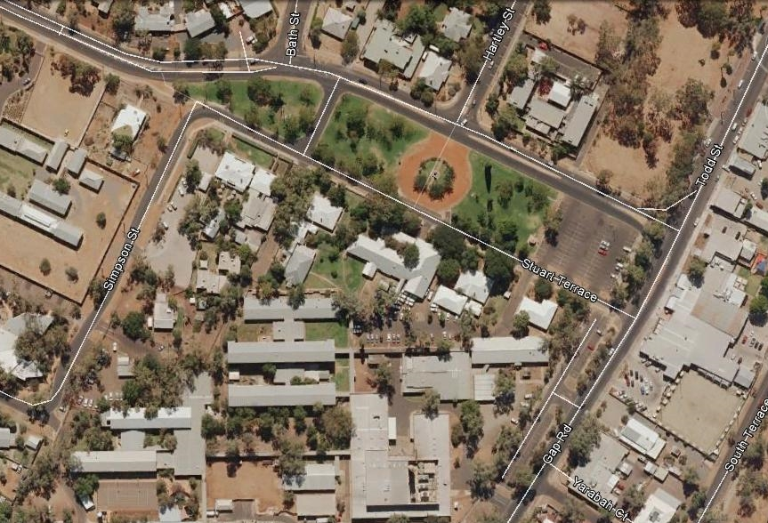
The recommended boundary is the curtilage of 8-10 Stuart Terrace, Alice Springs. (The approximate boundary is indicated by the red square in the plan below). [Plan taken from Google Earth, Dec 2016].

2. PLACE: Papunya and the Contemporary Desert Art Movement

History summary:
‘Papunya painting’ is a nationally and internationally recognised and valued contemporary artistic form named after the place of its invention, which is also the name of the major Honey Ant Dreaming site located near Papunya township (Johnson 2015: 14, 19). The artists from 1970s Papunya ‘are now part of Australian art history’. These include Kaapa Tjampitjinpa, Tim Leura Tjapaltjarri, Mick Namarari Tjapaltjarri, Turkey Tolson Tjupurrula, Uta Uta Tjangala, Clifford Possum Tjapaltjarri, Billy Stockman Tjapaltjarri, Long Jack Philipus Tjakamarra and Johnny Warangkula Tjupurrula (Johnson 2015: 11). In the intervening decades, women artists of Papunya have also taken up the role of important painters.
An ‘origin story’ for the genesis of the contemporary Indigenous art movement at Papunya is told by Geoffrey Bardon, art teacher at Papunya in the 1970s: His desire to engage his students in the forms of their culture led to interest by senior Pintubi men who worked as yardsmen at the school. They took the step to paint their stories with acrylic paints on the school walls. The first mural was the ‘Honey Ant Dreaming’, followed by ‘a sudden rediscovery of their artistic heritage … the sudden blossoming of their traditional art’. A painting room was established, where painters - chanting the songs of the stories - worked out how to paint without including secret/sacred material that would ‘cause controversy’. ‘These guardians of the culture helped men living at the settlement, in conditions alien to their tribal past, to find a way back to their heritage, and also opened a way which the Aboriginal schoolchildren could follow’ (Bardon 1979: 13-16 in McLean 2011: 84-87).
The emergence of this art movement of ‘traditional’ Ancestral stories, knowledge of country, and ceremonial practices in a new format and for different audiences is part of the history of the pastoral appropriation of land in the central Australian ranges. Mike Smith (2005) documents the ‘emptying out’ of the central deserts from the time of the Overland Telegraph line and the pastoral industry that followed it, to the last people ‘coming in’ from the western desert near Lake Mackay in the mid-1980s (Smith 2013: 109-110). People gradually moved into settlements, usually at times of drought, when inability to access all their country, plus alteration of water and food sources by cattle, rabbits and feral cats together made the hunter-gatherer economy less and less viable. They moved in to stations such as Lutheran missions and ration stations Haasts Bluff or Hermannsburg for rations, work and to be with relatives. Papunya was a newly built assimilationist government-decreed settlement, established by the Welfare Branch, with local Indigenous labour, to accommodate the overflow of people at Haasts Bluff (Kean 2007: 5-6).
The Papunya township was constructed in 1958-9, based on the good water supply from a bore at Lyappa soakage (Kean 2007: 5). In 1974, with the Institute for Aboriginal Development, a large scale expression of the self-determination policy of the time was development and execution of an extended town plan in the form of the Papunya Honey Ant Dreaming. Although buildings were not built along all the graded roads, from the air the township embodies the Papunya-style representation of the Dreaming in its streetscape (Johnson 2015: 68-71).
The story of Papunya also includes the significant homelands movement of the 1980s, as it involves camps of Warlpiri people outside the main township at Three Mile (Johnson 2015: 120) and outstations Yaiyai and Kintore (and others) as part of the Papunya story. Fred Myers tells of the painting activity that followed at Yayayi outstation in 1973-5. As there was then little or no demand for the paintings, they were largely bought by the Aboriginal Arts Board (Myers 2007: 43, Kean 2007: 8). From the powerful position that the art now has, and the ‘central position that [the art] has now taken in public representations of Aboriginal people’, Myers’ account of the ‘precarious’ position of painting in the early years is an important part of the story. It is less than 100 years since ‘authentic Aboriginal art’ was considered by the non-Indigenous world to be rock art and nothing else. In that context, contemporary cultural productions such as Anangu wooden carvings were labelled ‘ethnographic’ rather than ‘Art’ (see Ian McLean 2016).
A huge market has grown up around the works of contemporary Indigenous artists, changing the shape of art trading in Australia. Between 2003 and 2012, 13000 artists were estimated to be working in remote Australia, selling 340,000 works and generating $A99.3 million (McLean 2016: 9). There have been problems with intellectual property rights and the way in which art is produced and sold, addressed in the work of Terri Janke, Indigenous arts lawyer, writer and consultant, for example in the seminal study Our culture, our future (1999). In the 1980s, the Papunya Tula Artist Pty Ltd business was founded to distribute and sell art work, a continuing business, owned and directed by Aboriginal people from the Western Desert.
The desert art movement that grew from Papunya has played a central role in redefining how the arid zone can be understood. Howard Morphy, anthropologist specialising in Indigenous art practice, has written ‘The colonial process has been a battle … between different ways of relating people to land, and since aesthetics has been close to the heart of Aboriginal relationships with land, colonialism has also been a struggle over the aesthetics of the Australian landscape’ (1988: 266).
Papunya also has broader cultural significance. For example it is the home town of the Warumpi Band, the first rock band to have a song in their Indigenous language - Luritja - played on commercial radio, 'Jailanguru Pakarnu’ (Out from Jail), in 1983 (http://nfsa.gov.au/collection/sound/sounds-australia/2007-registry-additions/#warumpi).
A history of the township has been written and illustrated by students at the Papunya School. This has been published as Papunya School Book of Country and History, Allen and Unwin, and won the Children's Book Council of Australia Award for Information Books (2002).

Place description:
Papunya township is c.240 km northwest of Alice Springs in the Northern Territory. It is located on the north-western edge of the West MacDonnell Ranges and the southern edge of the Tanami Desert.
The place is located on the edge of the following biogeographic regions (IBRA) - MAC, GST and BRT.
The street plan of the Papunya township is unusual in that it depicts visually (from the air) the Papunya Honey Ant Dreaming (Johnson 2015: 68-9).
The Papunya School on Leura St is an important focus in the Papunya story as it was where the art movement began. The school contains the original 1970s Honey Ant Mural (which was painted over by the Department of Education in 1974, but remains on the wall under several layers of paint (Johnson 2015: 65-6)). There is also an art centre, which recognises the focus of the town, located on Possum Crescent (Johnson 2015). The outstations at Three Mile, Yaiyai and Kintore are important associated places for the desert art movement, but are not included in the place boundaries.
Neither Papunya, nor places within Papunya, appear to be heritage listed (note – State Aboriginal heritage registers have not been reviewed).
Many of the early Papunya paintings from the 1970s are in the collection of the National Museum of Australia and other cultural institutions, and should be considered as associated objects.

Indicative statement of significance:
Papunya painting is the core (and was the developmental core) of a nationally recognised, valued and commercially successful modern Australian Indigenous art movement, which was seminal in combining traditional art elements and personal histories into a new, innovative and publicly accessible contemporary form.
The Papunya painting form has also been seminal in influencing further development of desert art forms and traditions. As noted by (James 2011: 87) ‘Inter-relational trade in artistic ideas and materials is a powerful force across the Western Desert’, and as a consequence other art centres have followed the lead of the Pintubi artists from Papunya, painting their country, Ancestral stories and ceremonies throughout central and Western deserts and beyond. For example, the Spinifex People’s Arts Project 1996 recorded and documented ownership of the Spinifex area, painting a map of people’s birthplaces, showing ownership, responsibility for country and knowledge of country in a series of paintings given to people of Western Australia and also later used in a Native Title claim (Cane 2002). Similarly, the great Ngurrara Canvas was painted by senior traditional owners of the Great Sandy Desert of northern Western Australia as an expression of their claim to country, for presentation to the National Native Title Tribunal in 1997.
This art movement involves many nationally and internationally recognised artists.
The township of Papunya was where this art form first emerged and is a nationally recognised creative centre, not only for its desert art tradition, but for other cultural excellence, for example the nationally recognised Warumpi Band. The importance of the artistic and cultural tradition in this area and their deployment in innovative ways by the local people is shown not only in the painted art, but by the Honey Ant Dreaming art design layout of the Papunya township.
More than any other art movement, contemporary desert art production has granted outsiders a window into the core values of Australian desert living for Indigenous people – the long term, intimate knowledge of the Ancestral and historical places that populate the deserts, including water places, and the paths that link these. This art movement was an innovation born in the new settlement of Papunya under conditions of adaptation to living closer together in ever-smaller areas due to pastoral appropriation of land.
The township of Papunya is also significant in relation to this history of the pastoral appropriation of land in the central Australian ranges and the consequent adaptive move to non-traditional centres, which in the case of Papunya was a relatively modern government-decreed assimilationist settlement. Papunya is also part of the significant homelands movement of the 1980s as it involves camps of Warlpiri people outside the main township at the Three Mile and Yaiyai and Kintore outstations.

National Heritage List Criteria
Criterion (a):
. Papunya is the centre in which Aboriginal people as a community took a significant, rare and nationally recognised step from a community of diverse Aboriginal people displaced by European settlement of the arid zone towards self-determination and sufficiency and a coherent community through the introduction of a new form of Aboriginal art.
Criterion (c):
. The Papunya desert art is outstanding as a body of art for its ability to provide insights into how how Aboriginal people represent and transmit knowledge about country, as well as the process of cultural adaptation to the pastoral- and mission-based era.
Criterion (e):
. Aboriginal desert art, including ‘dot painting’, which originated from Papunya, is a unique and nationally and internationally recognised and appreciated modern Aboriginal art form.

Criterion (f):
. Papunya painting is the core (and was the developmental core) of a nationally recognised modern form of Indigenous art, which was seminal in combining traditional art elements and personal histories into a new, innovative and public accessible contemporary form.
. Papunya is a nationally recognised creative centre, with not only the ‘desert art movement’ evolving from Papunya, but also the Warumpi Band, a nationally recognised Australian country and Aboriginal rock group with the first Indigenous language hit (1983), being formed in Papunya.
Criterion (h):
. There are a number of nationally recognised Papunya painting artists, in particular Clifford Possum Tjapaltjarri, Billy Stockman Tjapaltjarri, Kaapa Tjampitjinpa, Kaapa Tjampitjinpa, Tim Leura Tjapaltjarri, Mick Namarari Tjapaltjarri, Turkey Tolson Tjupurrula, Uta Uta Tjangala, Long Jack Philipus Tjakamarra and Johnny Warangkula Tjupurrula.

Comparative analysis:
The process of development of the desert art movement may be compared to the Wurrwurrwuy stone arrangements listed on the National Heritage List for criterion ‘B’ Rarity. There, a traditional technique of making stone pictures was used to depict new, unfamiliar and secular subjects. Papunya’s art movement is more broadly innovative as it demonstrates modified traditional subjects, the use of new processes and materials to create the art, and an evolving process of expression of the experience of cultural change using new forms for important traditional ideas.
Both the work of Albert Namatjira and the later Papunya art movement arose in colonial conditions of cultural change. Albert Namatjira and his works are recognised as being of outstanding national significance (Hermannsburg National Heritage List and Western MacDonnell Ranges National Heritage List Nomination). Namatjira was the ‘first Aboriginal artist to be commercially exhibited nationally and internationally’ and ‘his work became widely acclaimed and a national symbol for Aboriginal achievement’. His artistic importance lies in ‘his development of a distinctive Aboriginal school of Central Australian landscape painting executed in watercolour’, using western art materials in an essentially European depictive style. His approach was the germ for establishment of the Hermannsburg ‘school’ of watercolour painting, with other artists including his sons Enos, Oscar, Ewald, Maurice and Keith and his grandson Gabriel, Wenten Rubuntja, Walter Ebatarinja, Otto, Ruben and Edwin Pareroultja. The major contrast between the Desert art tradition and the Hermannsburg ‘school’ is the strong base of traditional forms to the depiction of landscape and Ancestral and historical stories in the Desert art movement.
Albert Namatjira is thought to have contributed to the origins of the work of the Papunya painters as they watched him paint when he was sent to Papunya to serve his prison sentence near the end of his life in 1959. It has been suggested that this exposure was a predisposing factor in prompting the transition to depiction of Ancestral stories on flat boards rather than in body painting, sand painting and ceremonial objects (Johnston 2015: 28-57).
Papunya is the only township that is known to be laid out explicitly to represent a local Dreaming story.

Assessed Integrity:
It has not been possible in the scope of this project to fully assess the integrity of Papunya township in relation to its heritage significance. The township is the home to about 300 people, and the community school is extant and actively used. The current condition is not known in detail, but the
art works are conserved in institutions, and the Honey Ant mural is understood to be extant under several layers of paint, and was known to have been extant in this condition in 2008 (Johnson 2015: 65-6). Recent Google Earth images also indicate that the township’s Honey Ant Dreaming layout remains largely intact (see image below).

Thematic Indicators:
Primary: 2e. A high degree of technical and organisational flexibility (includes innovation): Flexibility in occupation or use strategy in the long term
Secondary: 4c. Effective, maintained viable social networks (includes knowledge and religious networks): Social reciprocity and territorial access rights

Water Indicators:
The place responds to / results from a general condition of aridity.

Confidentiality or security of the place and its values that may need to be considered
It is likely that there are Indigenous values that will be confidential regarding listing of the place of Papunya. Full consultation with the local community will be needed to determine confidentiality of values.

The confidence that can be placed in the information, including the extent to which the information for a full assessment of the place is available or needs supplementary research
While there are large amounts of information and assessments of the history and significance of the Papunya desert art movement and artists, there is little coherent information available about the township of Papunya and associated outstations where the art movement began in the 1970s. There have not been any previous heritage assessments of either the art or Papunya.

This study does not believe that NHL criterion (i) applies as, although the art works are based in traditional knowledge, they are now involved in a system of economic production rather than production for strictly traditional purposes; and although the township is laid out to represent the Honey Ant Dreaming the plan is considered an assertion of a tradition, but not integral to, or important as part of, that tradition. The application of criterion (i) is however something that should be clarified in consultation with the local Aboriginal community.

Logistical issues that might impede a full heritage assessment or require additional resources
Consultation with members of the local community is essential in relation to this nomination in relation to all aspects of the place and its nomination. Contact would best be made in the first instance through the Central Land Council http://www.clc.org.au/contact/.
Johnson’s discussion of the issues around the various attempts to uncover the painted-over 1970s Honey Ant Mural school wall mural indicates that there may be community sensitivity to how their local environment and cultural achievements are treated: ‘The people of Papunya in the past have not wanted the mural turned into something for tourists to come and photograph’ (Johnson 2015: 66).
Access permission is also required.
The place boundary will need to be defined through consultation and on a basis of more detailed research and assessment.

Map of place boundary
The preferred place boundaries are for the full township, which would allow individual places such as the schoolhouse and major Papunya artists’ residences to be included as well as the significant and highly evocative Honey Ant Dreaming town plan. If there are insurmountable issues with
recognising the full township, then the place could focus on the schoolhouse where the art movement began.
The following is a Google Earth Satellite image (accessed Nov 2016) showing the Honey Ant Dreaming town layout. The image can be taken to represent an indicative boundary. The place boundary for a nomination however will need to be determined on the basis of consultation and further research and assessment.
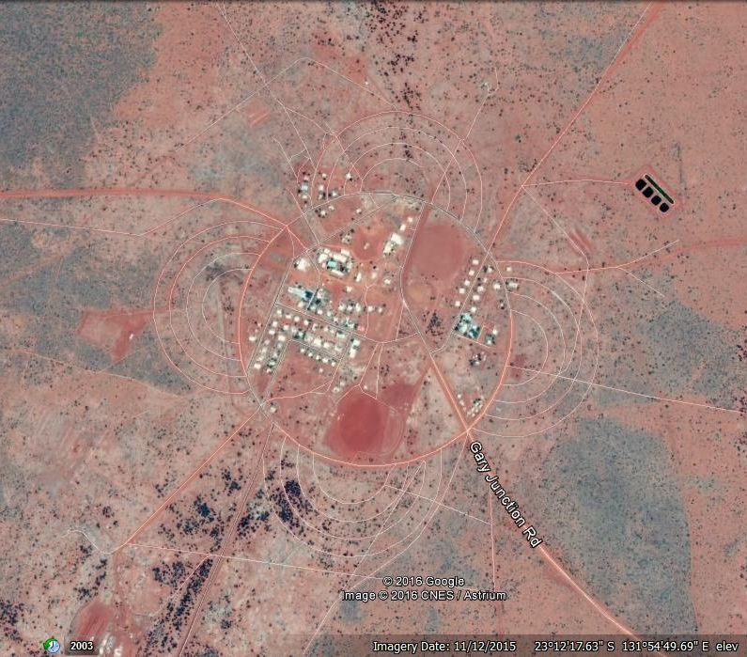

Schematic Papunya township plan (taken from Johnson 2015 p 68) showing key features of the township.
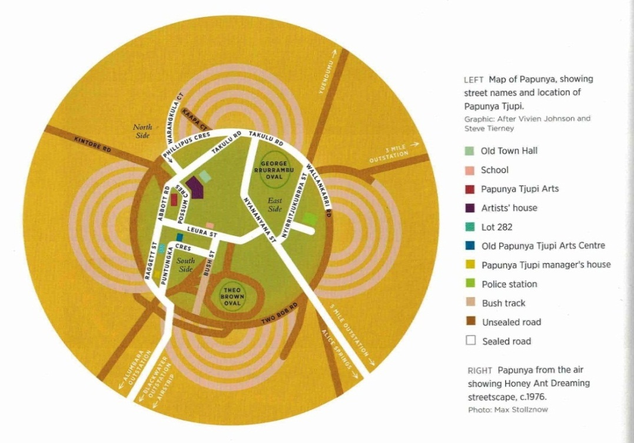

Map extract showing the relationship of Papunya to other centres in the region (taken from ‘Papunya painting: Out of the desert’ NMA online exhibition, http://www.nma.gov.au/exhibitions/papunya_painting/map accessed 20/11/16).

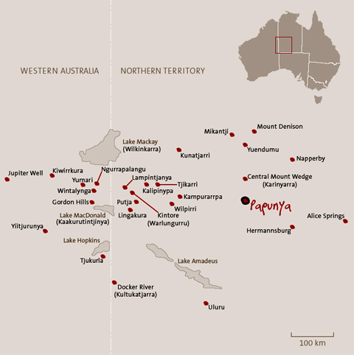

3. PLACE: Puritjarra and the Cleland Hills Deep History Area

History summary:
The sediments in the Puritjarra rock shelter contain evidence for human occupation from 35,000 years ago through to the recent past. The evidence indicates that in the earliest phases, highly mobile people made repeated short visits to the cave as part of a ‘point-to-point strategy’. This involved people moving from waterhole to waterhole in the course of a year, making use of a network of small semi-permanent springs and wells spaced about 25-30km apart that allowed people to range over a wide area (Smith 1989). ‘The distribution of watering points (‘patches’) determines the parts of the desert landscape (the ‘matrix’) that people can reach and where and when they can harvest available resources, whether these be stone, ochre, plant foods or game’ (Smith 2005: 94). No one of these water places could support permanent occupation. They did so only as a network linked through people’s movement and knowledge of where there was available water, around which the Indigenous people organised their lives. This adaptive approach continued even during the highly arid last glacial maximum, the long term continuity of use showing that the place was an important arid zone refugia (Smith et al 2001, Smith 2006).

Revisions to the chronology of the late Pleistocene deposits (Bowdery, 1995; Smith et al 1997) since the initial reports of the 1980s have provided a strong picture of water-tethered occupation during the LGM (Smith 2006). In the reduced aridity and less constrained conditions after 22,000 years ago, the evidence from Puritjarra indicates that people stayed longer in the shelter, becoming more locally based, particularly around the permanent water of Murantji rock hole (Smith 2006, Smith 2013: 135-6).

The latest phase of use of the site continues into the colonial period and the site’s archaeological record connects to the historical records for the area, as documented by Smith (2005). Smith (2005) draws on journals of explorers, prospectors and survey parties, Tindale’s anthropological records in 1929 and 1932, ration lists compiled by TGH Strehlow at Haasts Bluff in 1941, Hermannsburg Mission records, and Port Augusta Goal records to build up a local contact history in which the archaeological investigations are a recent element (Smith 2005: 3, 9, 80). Smith traces the identity of Kukatja people and families living through the contact period of their long term cultural and geographic connexions to the Cleland Hills.
Rock engravings were carved and pigment paintings and stencils were made in the rock shelter. Direct dating of the engraving has proved difficult, but Smith suggests the engravings date to 5,000 years ago, perhaps starting around 8,000 years ago. The cave’s art is both secular and sacred, with a long pigment art frieze which includes 279 hand stencils and 47 hand prints of both children and adults, plus long macropod tracks and totemic designs. Ochre transported into the cave indicates the range covered by people living in and around the cave: it was brought in from the Karrku mine in the Campbell Range, 125 km northwest ‘across a formidable dune field’ (Smith et al 1998, Rosenfeld and Smith 2002, Smith and Frankhauser 2009), and white ochre from Puli Tjukura quarry (approximately 50km northeast) was also brought to the shelter.
Puritjarra rock shelter was the first archaeological site excavated and dated which showed occupation in the heart of the arid zone at the glacial maximum, more than doubling the known history of human occupation in the area at that time (Smith 1987). This significant shift in time depth was taken up in the public discourse – eg an advertisement for Toyota Landcruisers employed the date (Weekend Australian 9-10 May 1992).
The site and its landscape setting have been the subject of an exhaustive study into the site’s many facets – 14C and luminescence chronology of the site (Smith et al., 1997; Smith et al. 2001), environmental evidence and sedimentary history (Bowdery 1998; Smith et al. 1995), flaked stone artefacts (Smith 2006), grindstones and plant use (Smith 2004), rock-art (Rosenfeld and Smith 2002), ochres (Smith et al, 1998) and colonial history and contemporary connection to the rock shelter (Smith 2005) – based on excavations from 1986 to 1990 led by Australian archaeologist Prof Mike Smith. Puritjarra has also been the subject of a collaborative environmental art project that incorporates the perspectives of scholars of archaeology, ecology, environmental history, and the history of science as well as those of contemporary artists (2005 Mandy Martin, Libby Robin, and Mike Smith, eds Strata: Deserts Past, Present and Future: An Environmental Art Project about a Significant Cultural Place).
Associated with the ‘Cleland Hills deep time cultural landscape’ is Tjungkupu, a ‘native well’ or semi-permanent water source re-named Tarn of Auber by Ernest Giles in 1872. Smith (1989) considers it is likely that Tjungkupu, which is c.40km east of Puritjarra and approximately equidistant between Puritjarra and the major ranges (eg George Gill Range) to the east, was an important waterhole since the Last Glacial Maximum, enabling travel to the extensive area of ranges to the east. If Tjungkupu also had reliable semi-permanent water in the more arid Last Glacial Maximum period, it may have been more important in enabling long distance travel to the east and may also have been a critical water source for those people using Puritjarra as part of the enlarged foraging area of these times proposed by Smith (1989), or if not so reliable, then it may be an example of important sand plains country that dropped out of use in the last glacial arid period, the alternative scenario proposed by Smith (1989). Regardless of which role it played, Tjungkupu is seen as an important associated place that, together with Puritjarra, can demonstrate the changing dynamics of land use in Central Australia from deep time to the recent past. Tjungkupu also has historical associations, with one of Giles’ party having added a drawing of a gun fight to the existing painted rock art during Giles’ expedition to the area (MA Smith 2005: 18-21). Once mapped by Giles, this small water source became a destination for future European exploring expeditions (Smith 2005: 21).

Place description:
Puritjarra is located in the Cleland Hills, which are west of the MacDonnell Ranges and south of Haast Bluff, NT, and c.350km west of Alice Springs. The Cleland Hills is an outlier range which intersects with the sand desert.
The place is located within the GSD biogeographic region (IBRA).
Puritjarra is a large rock shelter with an area of about 400 m² and a ceiling height of about 12m. It contains deep cultural stratified sediments which have been investigated through excavation. The rock shelter walls display over 300 motifs of rock art (see History, above).
The Puritjarra rock shelter is part of an associative landscape the core of which is the southern Cleland Hills. This area includes Murantji permanent rockhole which is 4 km north of Puritjarra, and was integral to the way people successfully occupied Puritjarra rock shelter. The associative cultural landscape comprises a line of east-facing rock cliffs that merge onto spinifex sandhill country and mulga woodland. On the west side is the plateau ridge of the Cleland Hills with Gill Creek dissecting the plateau and draining to the west; and Mt Winter is a high point at the southernmost end of the Cleland Hills. Gill Creek has a shady gorge and rockshelter called Kaltara where there is a series of white ochre paintings of horsemen (possibly of explorer Giles) (Smith 2005: 18-19).
Also associated, and an important adjunct permanent waterhole, is Tjungupu / Tarn of Auber, which is 40 km east of Puritjarra across sand plain country with occasional rocky ridges and scattered outcrop. Tjungupu / Tarn of Auber is a rock cleft with semi-permanent water and has associated rock engravings, including ‘archaic faces’, pigment art and grinding grooves (MA Smith pers comm. 14 June 2016).

The Puritjarra Rockshelter and Murantji Rock Hole area was listed on the RNE (Place Id 17674), as was Tjungupu / Tarn of Auber (Place Id 145). There is also a Cleland Hills Aboriginal Area listed on the
RNE (Place Id 147). None of these areas appear to be listed on the NT historic site register. State Indigenous heritage listings have not been researched.

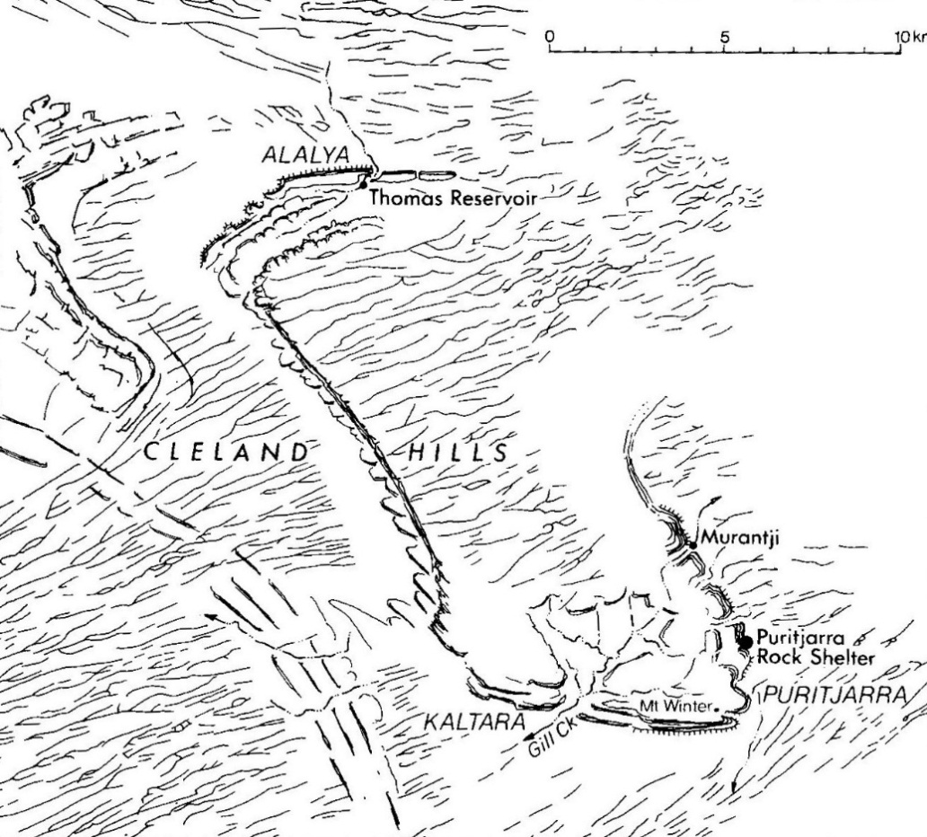

Puritjarra and its landscape setting in the Cleland Hills
[From Smith 2005: 8, scale in km, drawn by Winifred Mumford]

Assessed Integrity:
The integrity of this site is understood to be high as it is remote and not often accessed, with the main disturbance having been archaeological investigation (Mike Smith, pers comm 2016).

Comparative analysis:
Puritjarra is not rare in the Australian desert context as a site with a long record of occupation. Its significance lies rather in the relative antiquity of the site and its record of occupation up to the present day without any distinct period of abandonment (see Smith 2006), the presence of recent historical records that relate to the site, and to the multi-facetted, deeply contextualised understanding of the site that has been generated in research on the site.
There are 25 sites in the Australian deserts dated at 30-50ka (Smith 2013: 79-80 and map p73 plus Hamm 2016). Few individual sites demonstrate changes in occupation patterns relating to the climatic shifts over time from prior to the Last Glacial Maximum (LGM) through that hyper-arid period to the early and late Holocene with the development of distinctive desert adaptations. These occupation patterns are derived from comparisons of various sites. The sequence at Puritjarra however does provide a Central Australian uplands specific version of this sequence.
In relation to archaeological time depth, comparative places include:
- Kulpi Mara, another excavated archaeological sequence in the Central Australian uplands, in the catchment of the Palmer River. The sequence here shows a number of pulses of occupation, the earliest dating between c.34,178 and 29,102 cal BP, with little use of the
shelter in the intermediate periods. The site as a whole is predominantly a Pleistocene deposit overlain by a thin Holocene veneer. This contrasts with the more or less continuous sequence for Puritjarra rockshelter 165km to the west. These differences demonstrate intraregional variability in occupational histories of Pleistocene and Holocene sites in Central Australia and the Western Desert (Thorley et all 2011).
- Carpenters Gap in the West Kimberley (National Heritage listed) which has a basal date of 44-48ka.
- the Willandra Lakes (National Heritage listed) in south-west NSW, dated to c50ka.
- Paraku (Lake Gregory), within the arid zone, has similar palaeo-lake dunes and lake beds to the Willandra Lakes, with occupation dated at 45-50ka (Bowler 2013: 39).
- Warratyi rockshelter in the Flinders Ranges was occupied early in the course of occupation of Australia, 49000 years ago. The excavated deposits contain evidence for the earliest known use in Australia of a bone point and backed artefacts, and the use of red ochre and gypsum as pigments. The site also preserves bone from Diprotodon optatum and eggshell of Genyornis newtoni. This is the only reliably dated record of extinct Australian megafauna alongside artefacts more than 46,000 years old. The site demonstrates how rapidly people learnt how to live in the conditions of the deserts following occupation of the continent.
- Serpents Glen has the longest known record of occupation in the Western Desert, a rock shelter in the Carnarvon Range, on the edge of the Little Sandy Desert. It has recently recorded evidence for a basal date of 49ka (Peter Veth pers comm., December 2016), and demonstrates that people repeatedly visited the site from 30-28ka probably encouraged by the nearby major permanent water sources. It was then abandoned and not re-occupied until about 5ka (O’Connor et al 1998 cited Smith 2013: 92).
Although it does not have a continuous occupation sequence, Serpents Glen is also considered to be of outstanding national significance as it has the only long archaeological sequence that can provide some information on the occupation of the sandy deserts during the glacial maximum period of maximum aridity.
- Koonalda Cave (listed on the NHL under criterion A for ‘understanding of Pleistocene Australia, art, archaeology and occupation’) on the Nullarbor Plain was used somewhat later, c.26.3-16.6ka, and through the LGM, when it was a refugia (with permanent, if brackish, water). Use of the cave stops 5000 years ago. There is no evidence that Koonalda Cave was lived in. The evidence instead suggests it was a special flint procurement place with associated with art production in the form of ‘finger flutings’ and incisions (dated to 22ka), and possible stone arrangements. The site is also significant as an early excavation in the history of Australian archaeology and first demonstrated Pleistocene occupation of the southern margin of the arid zone. It also contrasts with Puritjarra in that Puritjarra was a core central desert occupation place from 35ka to the present, and has been the subject of comprehensive dating and material analysis and historical studies from which the material from Koonalda has not benefited.

Indicative statement of significance:
Puritjarra is considered to be of national significance as the excavations at Puritjarra rock shelter have provided a long term record of human occupation and use, from deep time to the recent past (c.35,000 years ago to the colonial period) and have played a principal role in the history of archaeological understanding of patterns of Australian desert occupation.
This long-term ‘deep history’, with synthesised archaeology and history of a particular locale, results in a deeply contextualised and ‘peopled’ history of the area which is very rare in a national context. The site’s significance in relation to its recent history is enhanced by the combination of historical
records of individuals living in the Cleland Hills (Smith 2005: 3, 9, 80) and the archaeological record of recent occupation on the modern floor of the site (Smith 2005: 81).
Puritjarra rock shelter is significant as the first archaeological site excavated and dated which showed occupation in the heart of the arid zone at the glacial maximum (Smith 1987). It is also significant for the extremely broad range of detailed collaborative studies that have been undertaken at site and of its landscape setting, and which not only provide a rich and unusually multi-facetted understanding of the site compared to other similar sites, but this work places the site centrally in the history of archaeological understanding of Australia.

Puritjarra, together with its surrounding landscape, is considered to be nationally significant for its ability to demonstrate the combination of factors that are required to allow for long term occupation in the arid zone of Australia. Critical elements in this respect are the form and location of the rock shelter, the presence of permanent waterholes, in this case rockholes and in particular Murantji, and the site’s location in a broader sand plain setting. The site in its landscape setting is also considered to be an extremely good and relatively rare example of its type (ie, a deep time arid zone site) given its well preserved rock shelter with its culturally rich deposits and a typical setting (rockshelter with associated permanent water in an unambiguous desert environment).

National Heritage List Criteria
Criterion (a):
. Puritjarra has been a focus of occupation from deep time to the present, and is able to demonstrate this deep time cultural history through its deposits, associated sites and stories. The historical story held in Puritjarra is of national significance because it is the long term story of the peopling and subsequent occupation of the arid zone, an integral and significant part of Australia. Puritjarra is also a highly significant site in the history of archaeological investigation and understanding of arid zone occupation.
Criterion (b):
. Puritjarra is a rare example, and the best exemplar, of an occupation site in the arid zone which has relatively continuous occupation from the Pleistocene through to the late Holocene and recent past. The surrounding landscape, which contains permanent water sources, other resources and other features that were critical for the successful long term use of the region and the Puritjarra shelter, is an essential part of the place as it contributes to the ability to demonstrate the nature of the successful adaptions that allowed Puritjarra to be relatively continuously occupied from the Pleistocene to the recent past.
Criterion (c):
. The information that Puritjarra, its surrounding landscape and associated sites can provide in relation to the long term occupation of the arid zone, including change over time, is considered to be outstanding, due in large part to the time depth of the deposits in Puritjarra, the site’s central location in the arid zone and the highly detailed level of investigation of the site.
Criterion (d):
. Puritjarra is able to represent to a very high level the arid zone site type - typically rockshelters in a desert upland environment - that demonstrate Aboriginal occupation over deep time (ie extending from the colonial period back into the Pleistocene). The landscape setting of Puritjarra is important to the ability of the place to represent this site type.

Thematic Indicators:
Primary: 2e: A high degree of technical and organisational flexibility (includes innovation): Flexibility in occupation or use strategy in the long term

Secondary: 1a: High residential or economic mobility which accommodates broad spectrum resource utilization: Broad scale subsistence/economy
1b: High residential or economic mobility which accommodates broad spectrum resource utilization: Residential mobility
3a: An intimate knowledge of the dynamics of the landscape: Use of refugia (event based or over time depth).

Water Indicators:
The place –
1. responds to / results from a general condition of aridity, and
2. utilises permanent surface water (rockholes).

Confidentiality or security of the place and its values that may need to be considered
It is possible that there are Indigenous values that will be confidential regarding listing of Puritjarra. Full consultation with the local community will be needed to determine any confidentiality of values.

The confidence that can be placed in this information, including the extent to which the information for a full assessment of the place is available or needs supplementary research
Large amounts of information are available as the place has been well-studied and its history researched in detail.

Any logistical issues that might impede a full heritage assessment or require additional resources
Consultation with members of the community is essential. According to Smith (2005: 4, 79-80), the community associated with the site lives mainly at an outstation called Kungkayunti, at the end of Deering Creek 49km from Cleland Hills (near Tarn of Auber), but contact in the first instance would be made through the Central Land Council http://www.clc.org.au/contact/.

Access permission is also required.

The boundary of the place will need further consideration to ensure the full place and its setting are adequately included. A particular issue to be resolved is whether Tjungupu / Tarn of Auber should, and can, be included (see also below). In considering the place boundary, the boundaries of the Register of the National Estate listings for Puritjarra Rockshelter and Murantji Rock Hole (Place Id 17674), Cleland Hills Aboriginal Area (Place Id 147) and Tjungupu / Tarn of Auber (Place Id 145) should also be reviewed.

Map of place boundary
There is inadequate information to provide a reliable place boundary. Establishment of an exact boundary requires further expert advice.
The following boundary (red outline on map 1) is an indicative boundary only. It is designed to encapsulate Puritjarra and its significant landscape setting which includes Murantji Rockhole, the uplands landscape context of Puritjarra Rockshelter, and it setting in a sand desert. It also includes other known associated historical sites. This approximate area is considered the core landscape setting.

The site can however be seen as having an important broader landscape setting that would allow the broader landscape use of Puritjarra to be demonstrated, hence better demonstrate its values. A place boundary with this broader setting should be considered (refer indicative place boundary in Map 2 below). The inclusion of the associated Tjungupu / Tarn of Auber site should also be considered in such a broader place.
Map 1: Indicative place boundary
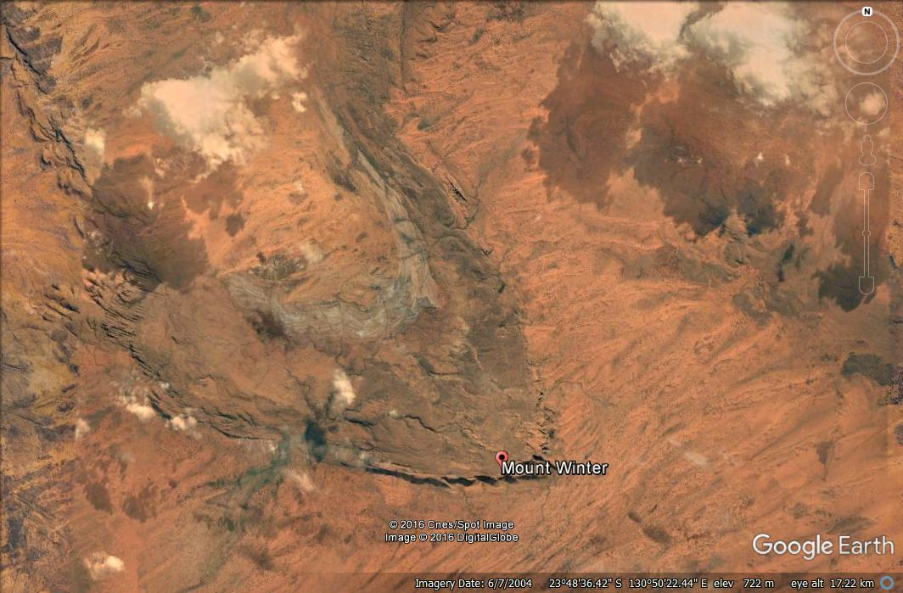
CLELAND HILLS

Muranjti Rockhole

Puritjarra Rockshelter

Gill Creek

[From Google Earth satellite image, March 2017. Note – the location of Puritjarra and Murnantji is approximate and based on the mapped locations in Smith 2005, p8]

Map 2: Indicative place boundary including broader landscape setting
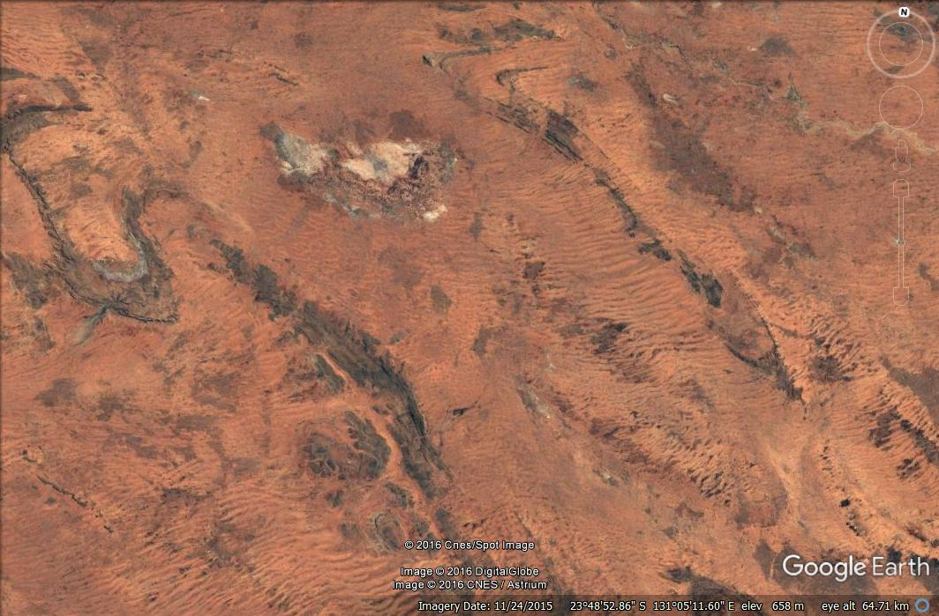

Muranjti Rockhole

Tjungupu / Tarn of Auber

[From Google Earth satellite image, March 2017]

Map 3: Puritjarra and the Cleland Hills in regional context

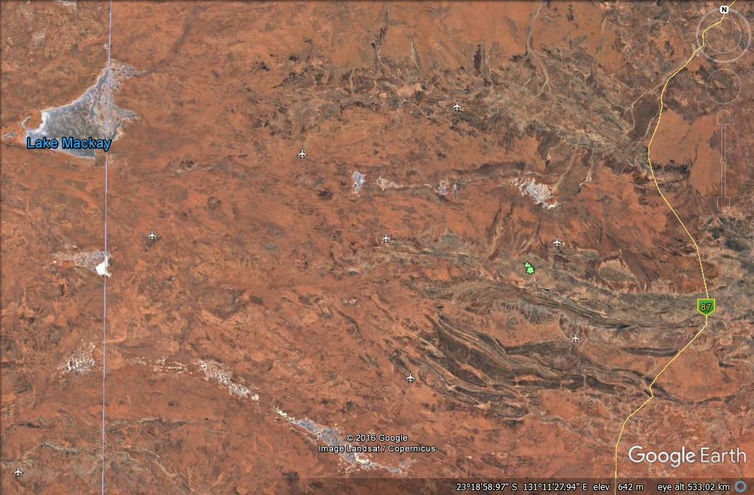

CLELAND HILLS
ALICE SPRINGS
Tjungupu / Tarn of Auber

[From Google Earth satellite image, March 2017]

4. PLACE: ‘One Road Many Stories’ – The Canning Stock Route

History summary:
The Canning Stock Route was instigated by the Western Australian state government as a way of joining the meat producing pastoral lands of the East Kimberley to the boom in demand created by the mines in the south of WA. Cattle ticks, which were banned from being imported to the south, could not survive the desert journey and made this a worthwhile economic effort.
The route was named for Alfred Canning, appointed by the WA government to survey the route north from Wiluna to Halls Creek in 1906. Fresh from surveying the rabbit-proof fence, Canning crossed the harsh western desert country in six months, identifying water plentiful enough for hundreds of cattle to be watered for the months it would take them to travel the route. The main reason for his success in locating these waters was his use of local Aboriginal people as guides, who either volunteered their knowledge, or were coerced into showing waterplaces by Canning’s forceful measures, such as running people down on a horse and chaining them with no water until they were forced to reveal a water source. This coercive approach to surveying was the subject of a Royal Commission in 1908, with the use of chains condemned.
The wells on the Stock Route were dug deeply with straight sides. This precluded the local people from continuing to access water from them. The combination of Canning’s treatment and the traumatic loss of water sources created long-running animosity. When the first drovers came down the stock route in 1910, they were speared. In response, police killed at least 10 Aboriginal people near Well 37. Frustrated, Aboriginal people retaliated by damaging the wells to such a degree that the route was only rarely used over the next 20 years (Yiwarra Kuju 2010: 36). To re-open it, William Snell re-built the wells so that they were usable and accessible by the local people, and between 1932-1959 hundreds of cattle moved through the desert each year. This traffic however resulted in damage to local sites and the water holes (Yiwarra Kuju 2010: 36). Cattle movement was never as great as originally anticipated, due to the harsh conditions, however the stock route as a whole came to be a symbol of Australia’s pioneering enterprise (Yiwarra Kuju 2010: 33-35). Since the 1970s it has become a major 4WD tourist route (Grimwade 1998).
The Canning Stock Route corridor cut across the country and home of more than 15 Western Desert Indigenous language groups (Yiwarra Kuju 2010: 14), and the important water places and Dreaming tracks or songlines to which they have cultural rights and ceremonial responsibilities. The disruption to access to major waterplaces and interruption of traditional patterns of movement that followed its construction and the spread of pastoralism into the surrounding lands forced many local people to move into surrounding townships, stations and missions. Many of these are now the locations of art centres. For example, Rover Thomas, a significant Australian artist who represented Australia at the 1990 Venice Biennale, and an initiator of the Warmun east Kimberley school of painting was born at Kunawarriji, Well 33 in about 1926. He moved to Billiluna and the Kimberleys as a stockman (Yiwarra Kuju 2010: 97). He started painting to tell the stories of the wells of the stock route and renew ceremonies for that country.
The Canning Stock Route Project was a collaboration between FORM, the National Museum of Australia, and nine Aboriginal arts and cultural centres, which led to Yiwarra Kuju: the Canning Stock Route, a major publication and NMA exhibition in 2010. It was designed to foster painting of the country of the jila waters, Lake Gregory and the soakages, and the sand dunes between them. This has been a way for the people who were most deeply affected by the construction of the Canning Stock Route to reclaim the country involved. They have painted their personal histories and the Ancestral histories at the wells, restoring connections to their country.

The National Museum of Australia purchased the Canning Stock Route Project collection of paintings, regarding it as of ‘truly national significance, providing a unique archive of Indigenous social and cultural histories [and] ... an important addition to the nation’s heritage and history collections’ (Director Craddock Morton, National Museum of Australia, 2008).

Place description:
The Canning Stock route is located in the north central part of Western Australia, with all but the northern end within the Australian arid zone. Approximately 1,850 km long, it runs from Wiluna on the central western edge of the Australian arid zone, northeast through the Gibson Desert, Little Sandy Desert and Great Sandy Desert to Halls Creek, WA.
The place is located within the MUR, GAS, LSD, GSD, CEK and OVP biogeographic regions (IBRA).
The Canning Stock Route is an unformed route linking 54 watering points, of which 48 are built wells, which were essential for stock survival. Of these, 37 were built on Aboriginal waterplaces. The track was a standard stock route, including stock yards – a 5 mile/8km wide surveyed corridor linking the water points (Grimwade 1998: 72). This is overlaid by a 4WD track (established in the 1970s), which does not always lie within the original corridor in the northern sections (Grimwade 1998: 73).

Assessed Integrity:
The integrity of the Canning Stock Route overall is considered relatively high with limited new settlements and infrastructure on the actual route. No comprehensive study of the current condition of the wells, or the impact of tourism on them, is known to have been carried out. Several wells are known to have been upgraded using modern materials in the 1980s and 1990s, without prior recording, and a 4WD track has been developed along the route, although it does not follow the exact route in northern areas (Grimwade 1998).
Comparative analysis:
Stock routes were defined pathways through Crown Land which formed a network across Australia, joining inland cattle and wool producing stations to far away markets in coastal cities, and connecting stations in different rainfall areas. They were an important part of the pastoral ‘inland corridor’ of lands between the arid core and the coastal fringe of Australia described by historian John McCarty (1988, see Alan Mayne 2011).

The other major stock routes in arid zone Australia were the Oodnadatta Track, the Birdsville Track and the Strzelecki Track in the south-east Lake Eyre Basin. These were established to transport cattle from the pastoral lands in the south-west of Queensland and the north of South Australia to the railhead at Marree for transport to Adelaide. To improve the utility of the stock routes, colonial and then state governments established public wells, dams and tanks, and designated natural watering points along the routes, spaced one to two days walk apart (Yelland 2002: 41). The Birdsville Track was the most intensively used of these. The first stages of the Birdsville Track made use of permanent natural waterholes on the Georgina and Diamantina Rivers at Goyders Lagoon, but the remaining stages were dependent on artesian bores as the track passed through the driest region of the Australian continent (Ratcliffe 1938; Yelland 2002: 53-61). The Strezlecki Track relied on natural waters, not supplemented by bores. The Oodnadatta Track is different in two ways: 1) Unlike the other major stockroutes, its development followed the communication route opened by the construction of the Overland Telegraph Line. 2) Like the Strezleki Track it relied on natural waters, but rather than surface waters, the Oodnadatta Track’s viability was dependent on GAB-derived mound springs.

In comparison, the Canning Stock Route, although having a similar purpose, is a purpose-built major route (credited with being the longest stock route globally) crossing through three distinct deserts, and constructed as a single concerted project. It is also considered to better demonstrate the critical nature of reliable water supply in establishing a viable stock route in arid Australia as the finding of wells, including native wells was critical, with the route essentially the linking of the 54 wells. The critical nature of the water places resulted in atrocities against the Aboriginal people who were dependent on these wells. The continuing integrity of the Canning Stock Route, due to its remoteness and less intense later use, also enables this route to better demonstrate physically a major Australian stock route.

Indicative statement of significance:
The Canning Stock route is of outstanding national significance. As one of the most important Australian stock routes, it exemplifies how cattle were transported across the vast distances of inland Australia, with the stock routes being an essential part of the industry (in this case from the pastoral lands in northern Australia [primarily the East Kimberley] to the booming markets in the south [primarily the developing mining areas in southern WA]). The establishment of the Canning Stock Route is an integral part of the national story of development of the pastoral industry in the western half of Australia, an industry of national significance.

The Canning Stock Route is significant nationally, and in particular to Indigenous Australians, as it exemplifies many of the worst aspects of the European occupation and development of Australia, including enslavement, chaining and killing of Aboriginal people, and the loss and destruction of traditionally significant water sources which were also critical for survival. It is also rare in the Australian context in having its Indigenous history well documented by the local Indigenous people (ie in the ‘Canning Stock Route collection’). The Canning Stock route is also of significance to Indigenous people because parts of the route cross traditional story and songlines, including the Seven Sisters Song Line, and features of the route such as the traditional water holes also hold social and spiritual significance.
Because of the critical importance of stock routes to the Australian pastoral industry, and because of the folklore surrounding the droving of cattle, historical droving and the historical stock routes are generally viewed as distinctively, or iconically Australian at the national and international level. The Canning Stock Route is well known as an historical stock route in Australia, in part because of its particular history and also due to the present day tourist use of the route.
The Canning Stock Route is significant at the national level as a relatively well preserved major overland stock route as it demonstrates to a very high level the key characteristics of a long distance arid zone - semi-arid zone stock route of the key period that these were used. In particular, the routing of the stock route from well to well, which were and are primarily traditional Aboriginal waterplaces, demonstrates the dependence of these inland routes on these specialised water resources. The history of locating the wells and their subsequent modification over time also exemplifies, and the actual wells demonstrate, the importance of access to water in the arid zone of Australia, and the history of the appropriation of Indigenous resources and rights in Australia.

National Heritage List Criteria
Criterion (a):
. The establishment of the Canning Stock Route is an integral part of the national story of development of the pastoral (cattle) industry in the western half of Australia, an industry of national significance.
. The Canning Stock Route exemplifies how cattle were transported across the vast distances of inland Australia, with the stock routes being an essential part of the industry (the transport of cattle being critical to supplying stations and getting beef to markets).
. The Canning Stock Route exemplifies some of the worst treatment of Australian Aboriginal people historically, with this treatment highlighting the lack of regard with which Aboriginal people were treated in Australia. It also exemplifies the continuance of such treatment into the twentieth century.
. The Canning Stock Route is the longest historic stock route in Australia at c.1850 km (and is claimed to be the longest stock route globally).
Criterion (b):
. The Canning Stock Route is unusual in the national context as it was instigated by government (the WA government) rather than developing through use, as was the normal process.
. The Canning Stock Route has an unusually (uncommonly) strong, and painful, Indigenous history. It is also rare in the Australian context in having its Indigenous history well documented by the Indigenous people who speak for the country it traverses (ie in the ‘Canning Stock Route collection’ a nationally significant body of paintings now held by the National Museum of Australia).
Criterion (d):
. The Canning Stock Route as a place can demonstrate to a very high level the key characteristics of a long distance arid zone – semi arid zone stock route of the key period in which these were used, the dependence of these routes on specialised water resources and the impacts on local Indigenous people.
Criterion (g):
. The Canning Stock Route is significant to Aboriginal people nationally as it exemplifies many of the worst aspects of the European occupation and development of Australia, including enslavement, chaining and killing of Aboriginal people, and the loss and destruction of traditionally significant water sources which were also critical for survival.
Criterion (i):
. The waters of the Canning Stock route are associated with numerous Ancestral stories and songlines. Part of the Canning Stock route is associated with a section of the Seven Sisters Songline.

Thematic Indicators:
Primary: 1c: High residential or economic mobility which accommodates broad spectrum resource utilisation: Long distance travel routes.
Secondary: 2d: A high degree of technical and organisational flexibility (includes innovation): specialised infrastructure technology adaptations.
3b: An intimate knowledge of the dynamics of the landscape: Use of specialised water re/sources.
4b: Effective, maintained viable social networks (includes knowledge and religious networks): Long distance communications.

Water Indicators:
The place 1. responds to / results from a general condition of aridity, and 2. utilised and was dependent on wells (shallow aquifer water).

Confidentiality or security of the place and its values that may need to be considered
It is probable that there are Indigenous values associated with the Canning Stock Route that will be confidential. Full consultation with the local community will be needed to determine any confidentiality of values.

The confidence that can be placed in this information, including the extent to which the information for a full assessment of the place is available or needs supplementary research
The Canning Stock Route is a well-studied and reported place. Well documented Indigenous histories of the route exist as a consequence of the Canning Stock Route Project, a collaboration between FORM, the National Museum of Australia, and nine Aboriginal arts and cultural centres, which led to a major publication and exhibition, Yiwarra Kuju, in 2010. This material shares and explores the art, culture, histories and connections of the people, country and communities surrounding the Canning Stock Route. Also, large numbers of oral histories, historic photographs, and maps are held by the National Library of Australia.
Other than Grimwade’s (1998) inventory of the extant material culture at the Canning Stock Route wells (eg, head windlasses, buckets, troughs, fencing, and graves), there has been no systematic assessment or documentation of the whole of the Canning Stock Route, or of sections of it.

Any logistical issues that might impede a full heritage assessment or require additional resources
Consultation with members of the community is essential. Contact would best be made through the appropriate representative organisations. The Canning Stock Route runs through five determined native title areas - Tjurabalan, Ngurrara, Martu and Birriliburu and Wiluna. Representatives of these native title areas come together in Kuju Wangka, which is focused on preserving the environmental, cultural and heritage values of the country along the Stock Route. Kuju Wangka is supported by the Kimberley Land Council, Mungarlu Ngurrarankatja Rirraunkaja Aboriginal Corporation, Kanyirninpa Jukurrpa, and Central Desert Native Title Services. These agencies work with the traditional owners to help them to preserve and protect their culture, heritage and sites.

As an extensive cultural route there will complexities in establishing the nature and boundary of the place. The extensive length and breadth of this place will also necessitate development of a specific approach to designating and managing to protect the significant values of the Canning Stock Route (see also comment accompanying the Canning Stock Route map, below).
Stakeholder consultation will be critical:
- Full consultation with community members is essential and will be critical in developing a nomination, in defining the place and its boundaries, in determining the values of the place, and getting support for the listing.
- Broader stakeholder consultation will also be required, particularly with landowners along the route (where these are not Indigenous entities).
Access:
- 4WD access permits to wells 16 –39 on behalf of the Martu people’s Western Desert Aboriginal Lands Corporation (WDLAC) are issued by Four Wheel Drive Australia. The permit explains that ‘the Canning Stock Route is a public access easement which varies in width along the length of the route. Moving off the track for camping should be limited to less than two kilometres. Other permits are required for travel between wells 5-15 and 40-51.
Native Title matters:
- The Native title holders are concerned about the protection of their native title rights and interests and their adjoining lands may not be accessed without first obtaining a permit. Within the easement, springs and other sites including many wells are also subject to native title rights. The following prescribed bodies corporate under the Native Title Act 1993 represent the traditional owners of the Canning Stock Route:
Tjurabalan Native Title Aboriginal Corporation (RNTBC)
Wells 50 to 51 – representing the Tjurabalan native title holders
Yanunijarra Aboriginal Corporation (RNTBC)
Wells 40 to 49 – representing the Ngurrara native title holders
Mungarlu Ngurrarankatja Rirraunkaja (Aboriginal Corporation)
Wells 5 to 15 – representing the Birriliburu native title holders

This information comes from the Kuju Wangka website which provides more detailed information concerning appropriate contacts for consultation:

Other Stakeholder Contacts:
. Cunyu Station (no access): +61 8 9981 2934
. Granite Peak Station: +61 8 9981 2983
. Glenayle Station: +61 8 9981 2989
. Neds Creek Station: +61 8 9981 2969
. Billiluna IPA Office: +61 8 9168 8988 Billiluna - Home of the Kururrungku Community
. Mulan-Paruku IPA Office: +61 8 9168 8256
. Australian National 4WD Council Canning Stock Route Manager: +61 438 853 342
. Central Desert Native Title Services: +61 8 9425 2000 Central Desert Native Title Services
. Contacts for Prescribed Bodies Corporate
Shire of Halls Creek
Shire of Wiluna
Central Desert Native Title Services
Western Desert Lands Aboriginal Corporation
Kimberley Land Council

Map of place boundary
There is currently inadequate easily available mapped information to provide a reliable boundary for the place.
The following mapped route (the dotted line between Wiluna and Halls Creek) is approximate, and hence is indicative only. Establishment of the exact route and an exact boundary requires further expert advice, and access to more detailed mapping.
Based on the nature and significance of the Canning Stock Route as assessed by the present study, consideration should be given to listing the full length of the historical route, and to specifically including all individual significant features identified, in particular the wells and other historical or otherwise important locations. Because the route meets criterion (d) it is also recommended that the listed place be the full 5 mile/8 km historical width, and to compensate for this large width (and consequently, large area) high and low conservation areas within the place be designated with a conservation management plan or policy developed to clarify where conservation measures (and what measures) are required/ not required.

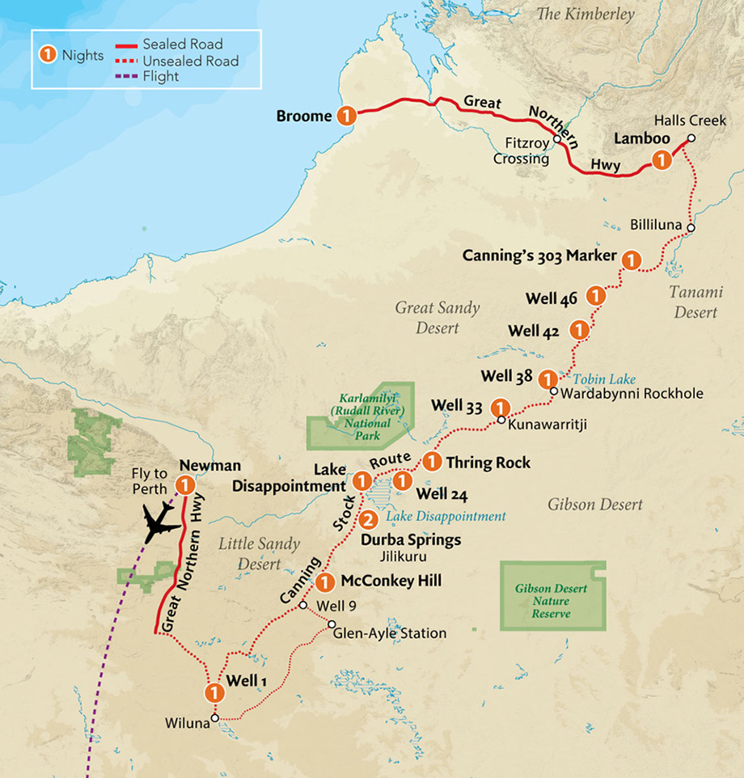

[from Outback Spirit Tours website, accessed Nov 2016]

5. PLACE: Woomera-Maralinga Weapons Testing Facility

History Summary:
The Woomera-Maralinga Weapons Testing Facility is the site of two nationally significant clusters of events crucial in the history of Australia’s international policy, with major local impacts on desert places. The stories of Woomera and Maralinga exemplify persistent attitudes to the arid zone as remote, uninhabitable and uninhabited wastelands. This attitude led to the decision to locate the Woomera rocket range (1947) and the Maralinga atomic testing range (1952) in the South Australian desert. Their aerial tests crossed the western deserts and the Central Aborigines Reserve, with long-lasting outcomes for the desert peoples moved away from their land, or unable to live in it as a result. The Maralinga tests also adversely affected many of the people involved in the testing, who worked in harsh conditions and were exposed to radiation (see, for example, the Australian Nuclear Veterans Association (http://anva.org.au/) and the McClelland Royal Commission 1985).

The Woomera Long Range Weapons Establishment was a joint Anglo-Australian project established in 1946, conceived within a context of increasing Cold War tensions, the threat of immanent global war and a push for economic development. The Cold War (1948-1954) was ‘a rejuvenating force for Australian identification with the British Empire, especially under Menzies from 1949’ (Lowe 1999: 17-18). It was Ben Chifley and the Labor government that enthusiastically agreed to build the facilities at Woomera, for defence, and as part of a program of national development: ‘The prospect of Australia being an arsenal for new weapons and a centre for industrial research had immediate appeal’, to such an extent that special legislation was passed to regulate organised protest (see below) against the construction of Woomera (Lowe 1999: 17-18). However, it was Bob Menzies’ government who welcomed the extension of the role of the Woomera Long Range Weapons Establishment to British atomic testing in 1952 (Lowe 1999: 141-2).

Woomera is the largest land testing range in the world, according to the Department of Defence. ‘It was a highly ambitious undertaking: The Australian Government agreed to build, within a short time-frame, a fully equipped guided weapons facility and residential centre in arid northern South Australia at a time of substantial material and labour shortages. That the facility and the permanent town were built is, in hindsight, a remarkable achievement. In part it speaks to the determination, persistence and resilience of those involved, as well as to the strength of the Cold War political purpose and to the powerful inﬂuence of the post-Hiroshima ‘spectre’ of atomic attack’ (Garnaut et al 2012).

It was military programmes at Woomera, to develop ballistic missiles, not civil applications, which led to Australia's first space development efforts (M James 1992). A range of air-to-air and surface-to-air weapons was developed, including Seawolf, Rapier, Sea Dart, Bloodhound and Blue Steel (a cruise missile), together with the Australian-designed and developed weapons Malkara (an anti-tank weapon) and Ikara (an anti-submarine weapon) and the target aircraft, Jindivik. In 1960 the prototype ballistic missile, Blue Streak, designed to carry the British independent nuclear deterrent was cancelled as it was made obsolete with the development of the Polaris system in the United States (Denis 2008: 330). ELDO, the European Launcher Development Organisation, was established in 1962 to develop a satellite launch vehicle for peaceful purposes. In return for providing a launch site at Woomera, Australia became the only non-European member of ELDO. The British Blue Streak rocket was the ﬁrst stage of a joint European launch vehicle called Europa. Ten launches of the ELDO Europa-1 (based on the Blue Streak) were made from 1964 to 1970, with five regarded as successful. However, no satellite was ever launched into orbit by the Europa vehicle (M James 1992).

Overall, between 1949 and the mid-1970s, Woomera saw the launching of defence missiles, scientiﬁc rockets, and satellites from nine launch areas and played a vital role in the development of the USA, UK and European space programmes (Morton, 1989 cited Gorman 2005: 93). Woomera represents themes of international cooperation during the Cold War 'space race'.

Woomera is one of the world’s earliest rocket launch sites: In 1947, there were only four in the world - Woomera, White Sands, Colomb-Bechar-Hammaguir and Kapustin Yar. It is included on the American Institute of Aeronautics and Astronautics heritage list for the significant role it played in space exploration, including the launch of WRESAT-1, Australia’s ﬁrst satellite. This made Australia the fourth nation in space.

From the early 1950s an upper atmospheric research program at Woomera developed a series of Australian designed and built ‘sounding rockets’ to study the properties of the Earth’s upper atmosphere. New Australian motors for these were named after constellations of the southern sky, while the rockets bore the names of Australian native birds. This research provided a wealth of fundamental data on the properties of the upper atmosphere and contributed to the development of WRESAT in 1967 (Dougherty 2006).

A plaque at Woomera dedicated by the Australian Institution of Engineers in 1999 assesses the technical achievements at Woomera and associated research establishment in Salisbury, north of Adelaide:
‘… this range and the associated Weapons Research Establishment in Salisbury were the largest and most expensive scientific and engineering activity ever conducted in Australia in peacetime. The equipment used and tested here was at the forefront of technology and especially in fine mechanics, advanced optics, telemetry and rocket fuel chemistry. While participating in programmes conducted here, Australia was in the forefront of scientifically and technologically advanced nations. The successful launch of the WRESAT satellite from Woomera in 1967 gained Australia international recognition and membership of the exclusive 'Space Club'.

The design of Woomera village is unique in urban planning history of Australia, built from scratch and having to combine a modernist ideal of Australian family lifestyle with a Cold War classified, high-security environment in a remote, arid setting (Johnson et al 2002; Garnaut et al 2012). At the end of the Apollo program in 1972, redevelopment stopped at Woomera, leaving much of the original infrastructure. In the 1990s the range was opened to non-military use and mineral exploration.
‘Woomera Village was designed within two years of the start of the Cold War. Indeed, it was the ﬁrst new town designed and built, for any purpose, in post-war Australia. Signiﬁcantly, its design and management throughout its various development phases demonstrated the post-war reconstruction ideal of creating a healthy and integrated community to maintain the morale of residents, despite the isolation, climate and high degree of social control. The success of these aims is reﬂected in the nostalgia, pride and memories of past residents evidenced by, for example, postings on websites like Woomera on the Web (Rigby 1997–2008), regular reunions in Adelaide and in Woomera, and by the artefacts and memorials scattered throughout the Village. Of the new towns that immediately followed in rural and regional Australia, no other was as comprehensive or as sophisticated in its plan as Woomera Village and none was built strictly for national defence purposes. Over time, although there have been various changes in the focus of defence projects which the Village
has supported, it has sustained its primary function as a defence-centred residential facility. Woomera Village is a special and instructive example of a Cold War new community and of the contribution of town planning to shaping the social infrastructure required to support international weapons research and development and space and military surveillance programs through, and beyond, that era’ (Garnaut et al 2012: 557).

The locally available artesian water supply is too salty for human consumption and the Morgan-Port Augusta-Woomera pipeline and large storage tanks were built in the 1940s to supply the town's residents with River Murray water.

Surveyor Len Beadell (1923-1995) is very much a part of the history of Woomera for his role in ‘opening up’ the arid interior of northwest SA and eastern WA, selecting the site for atomic testing at Emu Plains, and surveying a series of roads into the Great Sandy, Gibson and Great Victoria deserts, including the straight – hence ‘Gunbarrel’ highway – for the Woomera rocket tests, and providing access for establishment of the Giles rocket monitoring and weather station in 1955. This road was the first east-west link across Central Australia.

The availability of detailed and accurate weather forecasts was critical to carrying out Woomera rocket test, but especially so for the nuclear tests – they could not proceed when cloud was forecast or winds were unfavourable due to risks of contamination of wide areas of the continent (see McClelland 1985). Hence there was an urgent need for a meteorological station located near the central range line. The location was chosen by Len Beadell for this reason in 1955. He named it for explorer Ernest Giles. However, it also had water, and hence was regularly frequented by western Desert groups. Patrol Officer Ian McDougall vehemently protested the location, predicting the impact of the graded roads and the new station on the local Aboriginal people (McClelland 1985: 373, Dousset 2002).

The location of Emu Field test area was also selected by Len Beadell to meet the criteria that it be at ‘a distance of 100 miles downwind from all homesteads, all inhabited areas and all lines of public transport’ (McClelland 1985: 168). RAAF aircraft provided the surveillance and monitoring of the tests from Woomera airport. After the two Totem atomic tests in 1953, the camp at Emu Field was rapidly disbanded (McClelland 1985: 224-6). The Emu site suffered from inadequate water supplies, and difficult terrain made supply and transportation generally expensive and inconvenient. The site now known as Maralinga, north of the transcontinental railway line between Cook and Ooldea, was selected to replace it in October 1953. The Australian Government agreed to the establishment of a permanent proving ground at Maralinga on 26 August 1954 (McClelland Royal Commission 1985: 278).

Woomera is a rare example of a space site where Indigenous people and the space industry intersect in the same landscape (Gorman 2005: 98). In 1947, on the first reconnaissance for a place to build the township that would service the rocket range, surveyors found tens of thousands of stone tools at Phillip Ponds. Recognising that evidence of Aboriginal occupation also meant the presence of water, they selected this location for the Woomera Village (Gorman 2017). The area of the rocket range was a prohibited area, with movement restricted within it, so that from 1949 to 1970 the local, mainly Kukatja, Aboriginal peoples could no longer access ceremonial sites and resources there.

Alice Gorman (2005, 2007) makes a strong argument for seeing Woomera as a continuing site of protest. When the rocket range was proposed in 1947, Dr Charles Duguid, founder of Ernabella Mission, was joined in protest by Pastor Doug Nichols, footballer and Aboriginal activist who later become the Governor of South Australia, as well as 50 other groups including trade unions, women’s groups, the Communist Party of Australia (CPA) and Aboriginal rights organizations such as the Australian Aborigines League (Gorman 2005: 96). Because of its distance from the metropole ‘the Woomera area remains a favoured place for the Australian Government to locate unpopular installations, such as the US military surveillance base, Nurrungar satellite tracking, nuclear tests, nuclear waste dumps and detention centres for asylum seekers (1999-2003). Kukatja people do not distinguish the impact of the missile and rocket programme from nuclear testing or nuclear waste dumps; they see them as part of the same process (Andrew Starkey, 2004, personal communication). For them, Woomera is a landscape of continuing protest. This is an intangible heritage of high signiﬁcance’ (Gorman 2005: 98).

Maralinga Range
Between 1952 and 1963 the British Government, with the joint agreement and funding support of the Australian Government, carried out 12 nuclear tests at three sites in Australia. The first were at Monte Bello Islands off the Western Australian coast (October 1952 - Operation Hurricane, and again in 1956 Operation Mosaic). ‘The choice of a site was made on the basis that the United Kingdom had many ports used by international shipping. The view was taken that there should be an assessment of the effects of an atomic explosion in a port or harbour, produced by the firing of a device mounted below the waterline in the hold of a ship’ (McClelland 1985: 103). ‘With the successful detonation of a fission weapon at the Monte Bellos, the UK Joined the United States and the USSR to become the world’s third nuclear power’ (McClelland 1985: 107). The choice of site also reflected the necessity of undertaking such tests in relatively ‘uninhabited’ terrain for safety reasons.

The remaining trials were at Emu Field in October 1953 and at Maralinga in September–October 1956 (operation Buffalo) and September–October 1957 (Operation Antler). In addition, hundreds of minor trials, mostly involving components of nuclear weapons, took place at Maralinga between 1953 and 1963. It was these trials which caused long lasting contamination due the repeated contamination with radiation of the same area (McClelland 1985: 280, Denis 2008: 330). The UK used live animals in test experiments for the first time at Maralinga in Operation Buffalo to assess the direct effects of the explosions and the resultant ingestion, assimilation and retention of radioactive products (McClelland Royal Commission 1985: 277).

Woomera infrastructure supported these tests, with Woomera-based RAAF in-air testing from within the bomb’s radioactive cloud and contamination surveys (McClelland Royal Commission 1985). The McClelland Royal Commission assessed the evidence for impact on airmen and Woomera base support staff, and those carrying out the tests. They found that there was ‘excessive secrecy’ and a failure of those in authority to inform the participants fully of the nature of the activities in which they were engaged (McClelland 1985: 342, 346-7), which contributed to fears and potential breaches of safety protocols. As a result the Commission concluded ‘participation at the tests, including residence in the [Maralinga] village has increased the risk of cancer to those participants who were exposed to radiation, but the Royal Commission has been unable to quantify the probable increase’ (McClelland 1985: 348). Overall, however, the Royal Commission concluded that ‘radiological and physical safety arrangements for participants during the Buffalo tests were well planned and sound. … and security was strictly policed during the major tests but was relaxed afterwards’ (McClelland 1985: 347).

Macaulay the Patrol Officer attached to the Woomera Rocket Range project was given the task to ‘ascertain what natives, if any, are living in the Range area and to make suitable arrangements for
their evacuation’ (Royal Commission 1985: 303). Emu Field was located within the Woomera Prohibited Area.

Maralinga was officially closed following a clean-up operation (Operation Brumby) in 1967. A major inquiry into the fallout and effects of the tests was conducted by the McClelland Royal Commission into British Nuclear Tests in Australia in 1985. An official history was published by the Department of Resources and Energy in 1985 (JL Symonds, A History of British Atomic Tests in Australia, AGPS, Canberra). Two further efforts to ‘clean up’ the radioactive surface materials have followed.

In Cleared out Davenport et al (2005) give a detailed account of the impact of the weapons testing in desert places far from the location of Woomera itself. It tells the story of a family group living in the Percival Lakes area and of Macaulay, the patrol officer employed to ‘clear out’ the people resident in the desert areas in advance of tests in 1964. The multi-vocal eye-witness accounts provide an intimate depiction of the life on the soakages and in the dunes of the western desert, as lived by these last amongst the ‘first contacts’ of desert people with non-Indigenous outsiders.

The atomic tests drove some of the Spinifex People of the Great Victoria Desert into Cundalee Mission and into Ooldea (Palmer 1990). Others tried to stay, but could not support themselves, too frightened of being poisoned to cross country to get food and water. There are a number of direct accounts of the impact of the Maralinga tests on the local people living through the tests (Brady 1986; Palmer 1990; Eve Vincent 2010; Yvonne Edwards 2016).

One of the leading campaigners for recognition of the impacts of the tests, resulting in the 1984-5 Royal Commission, was Yami Lester OAM. He was born at Walyatjata in the north of South Australia and was at Wallatinna in 1953 at the time of the Totem 1 atomic test at Emu Field, and was apparently affected by a ‘black mist’ of fallout from the Maralinga tests (see McClelland 1985: section 6.4 pp174ff).

Maralinga site was only 109 km north of Ooldea a major traditional meeting place and node for many lines of travel for desert people (see section 3.3.3.2 Water routes). Establishment of the Maralinga test field required that the Ooldea Reserve be closed in 1954. Ignorance about the centrality of that locale to Indigenous patterns of life led authorities to assume that this closure would lead to an end to visitation of Ooldea and associated tracks, but there were documented instances of people using tracks which had been contaminated with radioactivity, walking through a recently created bomb crater, and people frightened by hearing and feeling the blasts (McClelland 1985; 300- 324).
‘An examination of these conflicts throws light on the attitudes of the UK and Australian officials to the issue of Aboriginal safety and the nuclear tests. Overall, the attempts to ensure Aboriginal safety during the [Maralinga] Buffalo series demonstrate ignorance, incompetence and cynicism on the part of those responsible for that safety. The inescapable conclusion is that if Aborigines were not injured or killed as a result of the explosions, this was a matter of luck rather than adequate organisation, management and resources allocated to ensuring safety.

For the Buffalo tests, a site was chosen on the false assumption that the area was not used by its traditional Aboriginal owners. Aborigines continued to move around and through the prohibited Zone and inadequate resources were allocated to locating them and to ensuring their safety. The reporting of sightings of Aboriginal people was discouraged and ignored.

Aboriginal people were kept away from Ooldea and other important places to the south and west of the Range. At the same time, the construction of the Giles meteorological station and roads brought intruders and detrimental effects to the people north-west of Maralinga’ (McClelland 1985: 322).

One outcome of the McClelland Royal Commission was the formal hand-back of the huge area of land of the restricted area to the traditional owners, the Maralinga Tjarutja people in December 2009. However it remained subject to access restrictions until 2014 when 1,782km² was fully returned to the Maralinga Tjarutja people. $100 million was spent on rehabilitating the land between 1993 and 2001 following the recommendation of the Royal Commission. Andrew Collett, the legal representative of Maralinga Tjarutja says legal issues around the land have been resolved, and the village and all the land (except for the dangerous contaminated areas) have been returned to Maralinga Tjarutja people. They are now running tours of the village and bomb sites.

Place Description:
The Woomera-Maralinga Weapons Testing Facility place, defined as the 1964 Woomera Prohibited Area, covers a large area of western South Australia, extending from just north of the Trans-Australian Railway north into the Musgrave Ranges and from the West Australian border east to Lake Eyre. The majority of the terrain is South Australian Crown land covered by pastoral leases and mining tenements granted by the South Australian Government.

The place is located within the GAW, GVD and NUL biogeographic region (IBRA).

The Woomera-Maralinga Weapons Testing Facility comprises two areas, the main area which is the Woomera Prohibited Area (referred to as the ‘Woomera Area’), which also includes Emu Field (one of the three Australian nuclear testing sites) and a small block in the southwest corner that is the ‘Maralinga Area’. These are described separately below:

Woomera
The Woomera Protected Area contains infrastructure related to rocket launching - the range head, instrumentation buildings, workshops, blockhouses, security checkpoints, tracking stations (on Island Lagoon, Red Lake, Mirikata), antennae sites, airport, weather station, connecting roads, and nine launch areas, of which the ELDO launch pads on the edge of a vast salt lake show the changing technologies and political requirements of the facility (Gorman 2005: 93-4). The purpose-built Woomera township is a Cold War modernist planned environment in a remote arid environment which still supports a population of around 200 people.

The rocket testing trajectory area’s range was extended north-west from the Woomera launch area in 100-mile stages, passing through the Central Aboriginal Reserve, and eventually extending to the Western Australian coast between Port Hedland and Broome (McClelland 1985: 153-4).

The Woomera Prohibited Area includes Emu Field. It does not however include the Giles Meteorological Station which is located in Western Australia near the Northern Territory border, about 750 kilometres from Alice Springs. Beadell’s grader, used in the construction of the Gunbarrel Highway, and wreckage from the first Blue Streak missile launched from Woomera in 1964, are on display at Giles weather station.

Maralinga
Maralinga Range is within the Woomera Meteorological Station (see map below and Map 13 in the main body of the report). It consists of Maralinga village, airstrip, Ground Zero points, burial pits containing contaminated topsoil vehicles and other equipment used in the final clean up.

Part of the Maralinga Protected area was listed on the RNE as Maralinga Village and Forward Area, Watson - Maralinga Rd, Maralinga via Cook, SA, Australia (Place Id 17636). Although no longer a statutory maintained list, the information on it is useful in the absence of any updates: ‘The village site has generally been cleared of buildings although numerous foundations and the road system remains. Only about five buildings and three water tanks remain and a few modern structures have been introduced. The airfield remains and was a major collection point for rainwater for the village; one building remains at the airfield. The Forward Area contains an extensive track network; minor relics from the period of use; other earthworks associated with the tests; firing pads from the minor trials; and plinths marking the major explosion sites.’
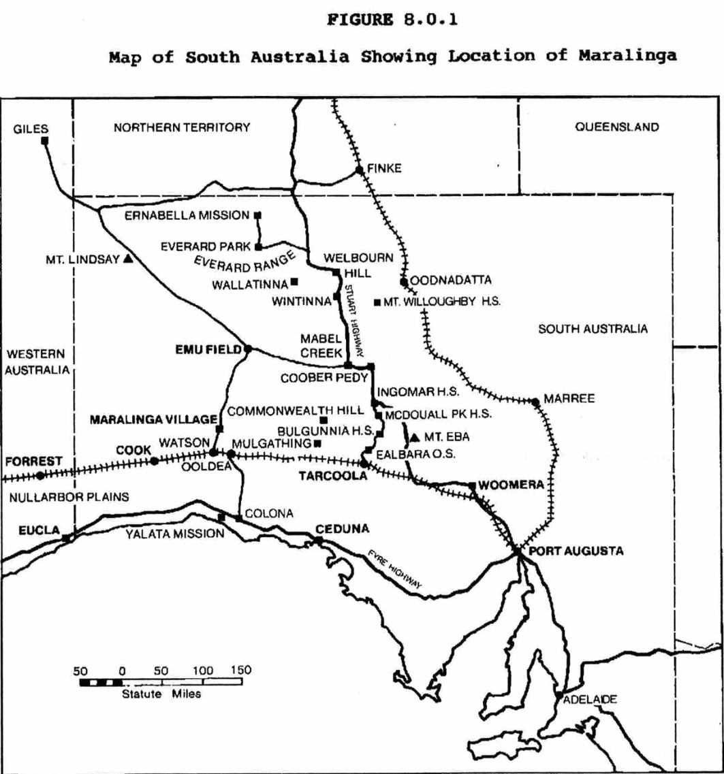

Map showing the location of Woomera, Emu Field and Maralinga [From McClelland Royal Commission into British Nuclear Tests in Australia 1984-5 p274]

Assessed Integrity:
The integrity of the Woomera-Maralinga Weapons Testing Facility is unknown (due largely to the absence of accessible information for the Woomera Area).

The available information for the Maralinga Area (RNE Listing - Maralinga Village and Forward Area, Watson) indicates that the village site contains only a few buildings and other structures, although many footings remain of other buildings and structures, while the airstrip is still in good condition and one building remains at this site. It also notes that the village area and forward area contain minor relics and earthworks associated with the major atomic weapons tests and minor trials. There are likely to have been impacts on the historical features and structures as part of the extensive decontamination work that has been carried out. Also, the Maralinga Tjartja community run organised tours to the village and launch areas, but it is not known if this has had any impact on the structures.

Comparative Analysis:
The Woomera-Maralinga Weapons Testing Facility is unique in the Australian context as a weapons testing site, and also as a rocket research and testing site. The Woomera Defence complex is the only one of its type in Australia, and is claimed to be unique in a world context. The size of the complex would appear to be part of its uniqueness and significance.’

It is also highly significant at an international level. This is demonstrated by Woomera’s inclusion on the American Institute of Aeronautics and Astronautics heritage list (for the significant role it played in space exploration, including the launch of WRESAT-1 which made Australia the fourth nation in space). It is also demonstrated by the inclusion of the comparable White Sands 1947 V2 test site, New Mexico, being listed on the US National Register of Historic Places.

In relation to atomic testing in Australia, Maralinga is one of only three nuclear test sites, the others being the Montebello Islands and Emu Field (see McClelland Royal Commission 1985). The Montebello Islands are significant as the location of the 1952 test, which was the first atomic test in Australia, and the first conducted by the British government. One of the two tests in 1956 was the largest atomic explosion in Australia. Emu Field was the location of a pair of tests - the first test on mainland Australia, but Its location was found to be unsuitable for further use, and the location now known as Maralinga was selected instead as it had better access. Emu Field can be regarded therefore as the least significant of the three Australian atomic test sites.

Although not the first atomic test site, nor the one with the largest explosion, the Maralinga field was significant as the site of the majority of the major tests and also the location of extensive programs of minor trials conducted in 1962-63. It was the repeated use of the same area that led to the build-up of high levels of radioactive contamination in the Maralinga test site area that contribute to Maralinga’s very high historical and social significance, unmatched by the Montebello Islands or Emu Field, as a site of extreme contamination and consequent health and access issues, hence as a site of protest.
The Woomera complex is also of outstanding significance as an example of the post-WWII development of Australia. In this respect the only other comparable example in Australia is the Snowy Mountains Scheme which was established to provide hydroelectricity and some irrigation for
south-eastern Australia. The national significance of the planned post-WWII development has been recognised by the National Heritage listing of the Snowy Mountains Scheme. The Woomera- Maralinga Weapons Testing Facility is considered to provide an equally significant example of this, but for a very different purpose, of defence, and in a very different remote, arid environment.

In relation to the significance of the layout and design of Woomera Village, it has been judged as ‘an almost textbook example of post-war community planning ideals, with the Village’s public buildings and their setbacks, together with the physical spaces between them, and the streetscapes, contributing collectively to a unique sense of place’ (Garnaut et al 2012). In Australia, it is considered to be matched only by the ﬁrst generation of public housing estates and contemporaneous parts of inner Canberra. However, by virtue of its isolated desert setting, Woomera’s impact is considered more profound.). The Village is also considered to be different to the Canberra example because of its defence associations. As Garnaut et al (2012: 559) state, the Village evidences a particular Cold War response to the organisation of national security, namely the construction of a completely new planned community. Such places exemplify efforts made by the government to marry national defence and progressive social welfare objectives within planned built environments.

Woomera – Maralinga is considered one of the best mid-late twentieth century examples of the poor treatment of Aboriginal people as the result of government policy. It is considered to be unique compared to the other major sites of this type which primarily relate to pastoral expansion and dispossession and/or workers’ rights, because the weapons testing was a national program and development, and because the lack of serious attention given to attempting to mitigate the known potential impacts of the incursions into Indigenous people’s lands and lives, known potential impacts on their health from radioactive contamination, as well as the length of time of the impacts of land contamination, and the vast area affected by this single conflicting land use.

Because of its history and location, the Woomera – Maralinga Weapons Testing Facility can demonstrate to a greater extent than any other single development the frequent misapprehension by outsiders that deserts, and in this case the Australian arid zone is ‘wasteland’, uninhabitable and uninhabited, and the negative consequences that this can generate.

Indicative statement of significance:
The Woomera – Maralinga Weapons Testing Facility is of outstanding national significance for its key role in Australian defence capacity development and for its role in international weapons testing in the Cold War context and more recently: It was the first peace-time defence-related complex of its type on Australian soil, and remains the only such type of facility in Australia. It also remains the only space exploration facility in Australia, with the military programmes at Woomera to develop ballistic missiles leading to Australia's first space development efforts, also at Woomera. The launch of WRESAT-1, Australia’s ﬁrst satellite, in 1967 made Australia the fourth nation in space (for which Woomera is recognised by the American Institute of Aeronautics and Astronautics). From the 1950s Woomera was also the location of a significant upper atmospheric research program, with a series of small rockets for this purpose designed and built at Woomera.

The development of the Woomera Rocket Range marked the entry of Australia on the world stage in relation to large-scale weapons testing. It also marked the first significant military post-WWII re-engagement with Britain following the need to cut ties with Britain during WWII to provide defence in the Pacific arena. Australia also became the only non-European member of the European Launcher Development Organisation (ELDO, established in 1962) in return for providing a launch site at Woomera.

Woomera was seen by the Australian government as a major post-war construction and development exercise for Australia, comparable only with the Snowy Mountain Authority. The development of a planned village for personnel with modern design principles, the ﬁrst new town designed and built for a special purpose in post-war Australia, reflected the importance of Woomera in this context. As the largest land testing range in the world, Woomera also shows the importance placed on it by the Australian government to create jobs, to create a specialised, internationally relevant and competitive enterprise and to be a significant player on the world defence and space exploration stage.

The historical significance of Woomera is enhanced by the nationally significant story of atomic weapons testing in Australia. Maralinga (1956 and 1957) in particular, together with Emu Field (1953) (contained within Woomera Prohibited Area) and the Monte Bello Islands (1952 and 1956), were the locations of the first and only phase of Australian atomic weapons testing. This atomic testing was supported by the Woomera Facility. The Maralinga area specifically is historically significant as the site for the fourth and fifth series of atomic weapons testing by the United Kingdom which included seven of the twelve major fission explosions in Australia. Maralinga is also significant for the approximately 600 minor trials that were conducted there (but not at the other two sites). Repeated testings there generated high levels of radioactivity built up in the surface sediments.

The Woomera-Maralinga Weapons Testing Facility is also of outstanding historical importance at the national level for its story of the treatment of the Aboriginal people of the region who were denied access to sites of traditional significance, discouraged from a traditional lifestyle and movement across the Prohibited area and the test range, who were dispossessed by the use of the range and may have suffered adverse health effects from exposure to radioactive contamination. The story of Woomera-Maralinga exemplifies how the misperception of deserts, and in this case the ‘Australian desert’, as ‘empty’ and a ‘wasteland’ can lead to desert uses that have unanticipated long-lasting impacts due to the these misperceptions – impacts on the desert environment and long-term land use, as well as on the desert peoples. Service personnel who were exposed to radiation during the tests at Maralinga have also had to fight for recognition of continuing health concerns.

The Woomera-Maralinga Weapons Testing Facility is also of national historical significance as the focus of broad-based community opposition to the continued testing of weapons in Australia in the 1940s and 1950s. It is significant also as a site of continuing national protest, with the protests today in relation to nuclear waste dumps and the detention of asylum seekers.

The Woomera facility is also regarded as having national level engineering significance: Woomera and the associated Weapons Research Establishment in Salisbury were the largest and most expensive scientific and engineering activity ever conducted in Australia in peacetime. The equipment used and tested at Woomera was at the time at the forefront of technology within Australia and globally, especially in fine mechanics, advanced optics, telemetry and rocket fuel chemistry. Woomera Village is also considered to have national level technical significance in relation to its design which is unique in post-WWII urban planning in Australia and which reflected the needs of residents in a remote special purpose town.

The Woomera-Maralinga Weapons Testing Facility is considered to be nationally highly significant as a rare (unique) example of a large weapons testing and space exploration facility in Australia. This significance is enhanced by the range of test sites in the facility, the complexity of the site and diversity of features, and a relative lack of overprinting to date of the physical evidence of the weapons testing, the preservation of the landscape setting, and the preservation of a significant range of different elements of the weapons testing infrastructure and associated features. These
attributes, plus a large body of related documentation and stories, also result in the Facility having important scientific value.

The Woomera-Maralinga Weapons Testing Facility, in particular Maralinga, is considered to have national level social significance as a place where political decisions were made based on a misperception of the arid zone as wasteland, that had major negative, even catastrophic, impacts on the local environment, the local Indigenous people, and on some of the service personnel who worked there. It has become part of a national consciousness, in some ways the ‘type site’ in Australia, in relation to the deleterious effects of atomic warfare and the struggle to have this recognised in relation to the Australian desert atomic tests. The importance of Maralinga in this respect is recognised nationally and internationally in literature, film and song.

The Woomera-Maralinga Weapons Testing Facility also has strong associations with Sir Douglas Nicholls and Yami Lester, both nationally distinguished Indigenous figures in relation to Indigenous rights, activism and recognition.

National Heritage List Criteria
Criterion (a):
. The Woomera – Maralinga Weapons Testing Facility is of national significance as it marks the entry of Australia on the world stage in relation to large scale weapons testing, and continues this involvement to the present day. The place is also unique in Australia as a large scale weapons testing site. Maralinga (1956 and 1957) in particular, together with Emu Field (1953) (contained within Woomera Prohibited Area) and the Monte Bello Islands (1952 and 1956), were the location of the first and only phase of atomic weapons testing in Australia.
. The Woomera Area is significant as marking the first significant military post-WWII re-engagement with Britain following the cutting of ties with Britain and turning to the USA to defend the Pacific area in WWII. It is also the first peace-time defence-related complex of this type on Australian soil, marking a key mid-20th century change in the orientation of Australia’s defence policy to develop defence related facilities, not as a requirement of Australia being part of the British Commonwealth, but on a broad international basis; a policy and program that continues to the present day.
. The Woomera Area is of national significance in relation to Australia's role in space exploration. This includes the launch of WRESAT-1 which made Australia the 4th nation in space. It represents themes of international cooperation during the Cold War 'space race' (US and ELDO). It is significant as one of the earliest phases of rocket launch sites (there were only four in the world - Woomera, White Sands, Colomb-Bechar-Hammaguir and Kapustin Yar).
. The Woomera-Maralinga Weapons Testing Facility is considered to best demonstrate, through its scale and nature as a weapons testing facility and its location, a major non-Indigenous national (and British) misperception of the ‘Australian desert’ as ‘empty’ and a ‘wasteland’ (hence suited to weapons testing with its associated contamination), which has had a nationally significant impact on the use of the Australian arid zone.
. The Woomera-Maralinga Weapons Testing Facility, in particular Maralinga, is of national significance in relation to the poor treatment of the Aboriginal people who lived in the testing areas. Maralinga is also nationally known for the poor treatment of service personnel who worked on the atomic tests, at the time and post-test.

Criterion (b):
. The Woomera-Maralinga Weapons Testing Facility through its scale and complex of elements is considered to best demonstrate at the national level a rare, but significant type of place – a major weapons testing facility.

Criterion (c):
. The Woomera-Maralinga Weapons Testing Facility through its scale, complex of elements and their arrangement, and related documentation and stories is considered to have national level scientific value.

Criterion (f):
. The Woomera-Maralinga Weapons Testing Facility demonstrates a high degree of technical achievement in relation to Australian defence ability and space exploration; and internationally.
. The design of Woomera Village as a planned special purpose village is unique in urban planning history in Australia.

Criterion (g):
. The Woomera-Maralinga Weapons Testing Facility, and in particular Maralinga, are understood and appreciated by Australians generally as being highly significant in Australia’s defence history. This place is also understood and appreciated by Australians, and by Indigenous Australians in particular, as emblematic of the extent to which human life and health can be disregarded in the pursuit of science and defence objectives; and the place acts as warning against such treatment. This is recognised in nationally and internationally known histories, personal stories, plays (eg, The Career Highlights of the Mamu by Trevor Jamieson and Scott Rankin), the Australian film Ground Zero and songs (eg by Paul Kelly, Midnight Oil, and Alistair Hulett).

Criterion (h):
. The Woomera-Maralinga Weapons Testing Facility is associated with nationally recognised Indigenous figures Sir Douglas Nicholls and Yami Lester.

Confidentiality or security of the place and its values that may need to be considered
Consultation with members of the Kokatha Uwankara native title claimant group and Maralinga Tjartja community is essential.

There is potentially some sensitivity for the Department of Defence in relation to the weapons testing history and they may restrict access to certain areas of the place (see also ‘Logistical Issues’ below.

There may be some ongoing legal cases relating to Indigenous rights and/or sickness compensation claims. While these may constrain access to some information, this is not seen as having an impact on the preparation, or the success, of a National Heritage listing nomination.

The confidence that can be placed in this information, including the extent to which the information for a full assessment of the place is available or needs supplementary research
While there is a substantial body of information accumulated about the various aspects of Woomera and Maralinga history and significance, this has not been consolidated. The Department of Defence apparently carried out a heritage assessment of the Woomera cultural landscape but we have not been able to obtain this for this report. Dr Alice Gorman at Flinders University, SA is able to provide expert advice on Woomera and Maralinga.

Any logistical issues that might impede a full heritage assessment or require additional resources.
Full consultation with the Maralinga Tjartja and Kokotha Uwankara native title claimant group will be required to understand the place sand its values, as well as potential issues with listing. No particular Indigenous issues however have been identified by the present study.

Full consultation and access permission is required from Department of Defence. There may also be restricted access to some areas for documentation and assessment since the major part of the place is a declared prohibited area, and access for non-Defence use requires Commonwealth approval and is on the proviso that Defence activities will not be unduly compromised (http://www.defence.gov.au/woomera/about.htm).

In 2010-2011 the Department of Defence undertook a review (the Review into Security and Economic Interests in the Woomera Prohibited Area (WPA), also known as the Hawke Review) to make recommendations about the best use of the Woomera Prohibited Area (WPA) in response to increasing demand for access to the WPA by the resources sector and the challenge this posed to Defence activity. The report made a number of recommendations aimed at improving the co-existence of the various parties that had an interest in the WPA which the Government agreed to implement in three stages. The implementation of the Review recommendations should lead to greater non-Defence access to the WPA, but may also lead to increased negative impacts on heritage values (Department of Defence 2014).

The Department of Defence has acknowledged that it owns a number of culturally signiﬁcant sites and that its task is to manage them ‘responsibly and openly’. Although it commissioned a European Heritage Management Plan for Woomera Village in 2002, that document is not in the public domain (Garnaut et al 2012: 558). The project has been advised by other heritage researchers that there has also been a heritage assessment for the Woomera Prohibited Area, or part of it, undertaken by the Department of Defence, but that the Department of Defence has not provided access to that report for heritage research purposes in the past. Access to this report would reduce the resources required to progress the nomination of this place.

Ex-service personnel comprise a major group for consultation, but many of these people still suffer health impacts from the testing, which is a significant continuing issue for them. As a consequence there may be some legal and access issues in consulting with this group.

Map of place boundary

Woomera
The recommended boundary for the Woomera – Maralinga Weapons Testing Facility place is the 1964 Woomera Prohibited Area as shown in the map below (see area outlined in red). This map boundary is not precise and the exact boundary of the 1964 Woomera Prohibited Area should be established from archival documentation.
Because the area is extremely large, the listing should attempt to identify areas that do not need specific conservation management. This could be achieved by including an assessment of areas of high and low significance and contributory and non-contributory value, or similar, with accompanying policy to clarify where conservation measures (and what measures) are required and not required.
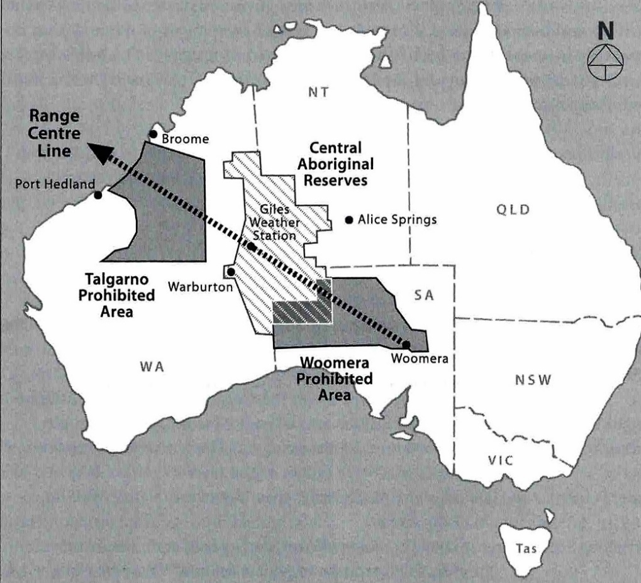

Australia 1964 showing the rocket firing line and the Woomera and Talgarno Prohibited Areas.
[Map from Davenport et al 2005: xiv)

6. PLACE: ‘North – South Trans-desert Crossings (Overland Telegraph Line and John McDouall Stuart’s Exploration) Route

History Summary:
The Overland Telegraph Line was constructed as a means to of providing rapid communication within Australia and with the rest of the world. At the time of its construction in 1870-2, there were existing telegraph services in south-eastern Australia, but it was on Thursday 22 August 1872 when the line was joined to the under-sea cables to Britain, bringing about a ‘great national work’ (Richards 1914:5). From this moment Australia entered the era of modernity. Remoteness was now not necessarily isolating, and distance was disconnected from time – a defining quality of modernity.
The Overland Telegraph Line followed JM Stuart’s 1862 route through central Australia. This route through central Australia followed, and was dependent upon, the waters that Aboriginal people of the central deserts relied on for living successfully in those areas. In selecting his route Stuart had been ‘anxious to direct attention to the establishment of a Telegraph line along his route’ and was clear about the connection between his route finding and the developments which would follow, wanting to ‘confer the benefit on my fellow-men of opening up a line for rail and telegraphic communication with England’ (Stuart, cited Royal Geog Soc of Australia 1912: 36). In turn, the orchestrator of the construction of the Overland Telegraph Line, Charles Todd, always saw the line as having the dual purpose of ‘opening up the unknown interior’ to land speculation and development and the ‘formation of settlement on the north coast’ for the benefit of South Australia, as well as providing communication.
Physically, the first telegraph line was a 3000 km long strand of No. 8 galvanised wire. Despite the apparent simplicity of that single strand, it was a technological achievement to construct it through difficult and unknown territory, in only two years.
The route and its attendant buildings, tracks and workers established a bridgehead into central, northern and Western Australia. Stuart’s descriptions of grassy plains were ‘primarily responsible for stimulating South Australian interest in the north’ (Donovan 1981: 27; Powell 1996: 67-8) making it possible to ‘develop the advantages and resources of nature’s gifts, which Stuart and his followers have unfolded to our knowledge’ (Royal Geog Soc of Australia 1912: 38). An unintended, but inevitable, consequence of the construction of the line was the incision of a long linear contact zone through the country of the Aboriginal people of the central deserts.
Without Stuart’s lead, it is likely Queensland would have won the competitive construction contract for meeting the undersea telegraph line from the UK instead of South Australia using a route from Normantown overland through Far North Queensland. That it didn’t, was a political and territorial coup for the young colony of South Australia. If it had, we can assume that official settlement in central Australia, in the form of the Alice Springs hub that came into existence in the 1870s, would not have taken off until a much later date, perhaps the early 20th century, if it did at all. Thus the Overland Telegraph Line had a decisive impact on the spatial history of Australia.
The continuity of the line required supporting poles with insulators to connect Port Augusta in South Australia and Port Essington, now Darwin, via eleven repeater stations. Each station had a bank of batteries to power the Morse code receivers and transmitters, and staff to read and re-send the messages and to maintain all these structures. The telegraph (repeater) stations are from south to north - Port Augusta, Beltana, Strangways Springs, The Peake, Charlotte Waters, Alice Springs, Barrow Creek, Tennant Creek, Powell Creek, Daly Waters, Katherine, and Southport. Generally the repeater stations also served as governmental centres, police bases, collection centres for scientific specimens, and oases and way stations for travellers (Macfarlane 2010 chapter 3). They were solidly built, with confidence that they would endure. They had slits for guns, and a fully enclosed
courtyard, in the expectation of attack by local Aboriginal people. Such an attack did occur at Barrow Creek in 1874 (Mulvaney 1989: 119- 121).
The repeater stations stand as seminal historical centres for understanding cross-cultural interactions. At Charlotte Waters (Macfarlane 2010) and at Strangways Springs (Paterson 2008), historical archaeology has shown complexes of Aboriginal informal living places associated with the formal establishment of the repeater station. Excavations at Strangways Springs demonstrated continued occupation from pre-colonial through European settlement of the same locations, implying that the good water and resources for dwelling that had drawn people to visit there prior to European arrival had continued in modified forms after the construction of the station (Patterson 2008). Local Aboriginal people were actively coming and going from these establishments for casual work and rations, but were able to visit surrounding country when not in drought. This flexibility allowed the maintenance of ceremonial connections to country.
Anthropologist/biologist Baldwin Spencer and Francis Gillen, telegraph officer at Alice Springs and Charlotte Waters, followed the line in a year-long traverse of the Overland Telegraph Line in 1901-2, leading to the publication of The native tribes of Central Australia 1898. The existence of the Overland Telegraph Line was the catalyst for this important anthropological work, Gillen’s role as the Alice Springs telegraph officer/postmaster was critical in initiating this project, and the Overland Telegraph Line route infrastructure met their key logistical needs for access/transport and accommodation (they did their work at several of the repeater stations). Spencer and Gillen’s publication was a formative influence on global understanding of Indigenous Australians, used by Freud in his ‘Totem and Taboo’ 1913 and Sir James Frazer, in revised editions of The Golden Bough. The Horn Scientific expedition also followed the Overland Telegraph Line in 1896 (see Morton and Mulvaney 1996).
The old ‘Ghan’ railway was built along the same original water route, to Port Augusta in 1878, Marree in 1884, Oodnadatta in 1891, to Alice Springs in 1929 and Darwin in 2004, but had to be moved westwards from the original route when it was extended in the 21st century due to constant flooding. The Stuart Highway followed a similar central Australian route, as a bush track until development during and after WWII and sealing in the 1980s (see Kerr 2013).
The Overland Telegraph Line route was still used by drovers and pastoralists into the 1920s, but less so after the rail line was extended to Alice Springs. In the same period the telephone replaced its communication function. It lasted in its primary form for 60 years, becoming the focus of intense, concentrated interaction, permanently changing Australia’s spatial geography and the people who lived there.
The Overland Telegraph Line itself is a communication technology, the result of a vast engineering and construction feat successfully completed in the difficult and unknown circumstances of the central Australian deserts. It also has had other significant national roles and impacts: It is the single main travel and transport artery into central Australia, it was the route to the pastoral occupation of the central Australian lands and for further exploration west from the line.

Place Description:
The North – South Trans-desert Crossings (Overland Telegraph Line and John McDouall Stuart’s Exploration) Route runs from Adelaide, SA, north through Central Australia to Port Essington near Darwin, NT, via repeater stations at Port Augusta, Beltana, Strangways Springs, and The Peake in South Australia, and Charlotte Waters, Alice Springs, Barrow Creek, Tennant Creek, Powell Creek, Daly Waters, Katherine and Southport in the Northern Territory.
The place runs through the following biogeographic regions (IBRA) - FLB, STP, GAW, SSD, FIN, MAC, BRT, TAN, STU, DAB, PCK and DAC.
The North – South Trans-desert Crossings Route, which comprises the Overland Telegraph Line and consequently JM Stuart’s overland exploration route, survives physically as a distinct route with a number of nodes, which are the 12 repeater stations that were built along the route and were generally a complex of buildings (see History, above). Little survives of the original telegraph line itself, however the repeater stations, or telegraph stations, retain built, other structural and archaeological evidence of all the various ways in which these locations have been occupied over time, including Indigenous Ancestral stories, personal histories, place names, cattle and goat yards, ration depots, stone-walled telegraph repeater stations with rain water tanks and bores, police centres. The Northern Territory Heritage Register listings of the Overland Telegraph Line repeater stations list complexes of not only the formal building footings and walls but the surrounding associated informal camps and activity areas formed by travellers, Indigenous people receiving rations, working at the station, and cameleers and that are a feature of these places. Historical documentary records such as government records, photographs also survive. Although most of these locations were based on the route of John McDouall Stuart, it appears that there is no definitive physical remains relating to Stuart’s exploration.
The condition of the actual Overland Telegraph Line is poor, although in some places the original poles and wires are still extant. The repeater stations are in variable condition, ranging from ruins to relatively intact complexes of structures and archaeology. Overall the suite can be considered to be in relatively good good condition, with at least five repeater stations being largely structurally extant.
Eight of the historic Overland Telegraph Line repeater stations are listed on the Northern Territory or South Australian state heritage registers and/or the RNE. The listings are as follow:
Beltana Telegraph Station – OTL Site: RNE (Place Id 5992)
Strangways Springs Telegraph Station: SA Heritage Register (Place Id 10320), RNE (Place Id 5967)
The Peake Historic Site: SA Heritage Register (Place Id 13624)
Charlotte Waters Telegraph Station Historic Reserve: NT Heritage Register (Place Id 134), RNE (Place Id 16394)
Alice Springs Telegraph Station Historic Reserve: NT Heritage Register (Place Id 302), RNE (Place Id 165)
Barrow Creek Telegraph Station Historic Reserve: NT Heritage Register (Place Id 13), RNE (Place Id 1994)
Powell Creek Telegraph Station Historic Reserve: NT Heritage Register (Place Id 134), RNE (Place Id 16394)
Tennant Creek Telegraph Station Historic Reserve: NT Heritage Register (Place Id 75), RNE (Place Id 13878)

Assessed Integrity:
The integrity of the North – South Trans-desert Crossings Route overall, as a route, is understood to be relatively high. The route of the original Overland Telegraph Line, also JM Stuart’s exploration route, is extant, known, and is preserved through the surviving historical infrastructure; and new development along the route which potentially impacts on the landscape setting of the route is limited (limited new settlements, new infrastructure or other development on the actual route). In a number of cases the areas of the Overland Telegraph Line repeater stations have been recognised as being of historical significance and have been preserved.
Although there is limited surviving actual telegraph line historical fabric, there is surviving evidence of the repeater stations. Of the 12 Overland Telegraph Line repeater stations, the Alice Springs, Powell Creek and Tennant Creek stations are highly intact and Beltana station is regarded as the best preserved example in South Australia, with the Charlotte Waters, Strangways Springs and The Peake repeater stations only surviving as ruins. The condition and integrity of the Port Augusta, Daly Waters, Katherine and Southport repeater stations has not been established, but these are the most likely to have been impacted by recent developments and therefore to have less integrity.

Comparative Analysis:
The North – South Trans-desert Crossings Route, as an historical trans-Australian route with significant exploration, communications and transport functions (the latter two resulting directly from Stuart’s exploration) is unique in Australia. The only other similar trans-Australian route was Edward Eyre’s east-west crossing, but although this was followed by a trans-Australian railway, associated telegraph line, and road, this infrastructure did not follow Eyre’s route, but lay to the north of Eyre’s route. Also, in this case the telegraph line did not have the same significance that the Overland Telegraph Line did in connecting Australia.

In relation to exploration, the expedition by Burke and Wills in 1860-61 to find a north-south route across Australia was ultimately unsuccessful – the expedition did not reach the north coast and the party perished on its return. Its main result, increased knowledge of the eastern side of Lake Eyre by non-Indigenous colonists, was in fact due to the exploration by rescue parties. It also did not lead to major spatial reorganization of the arid region as did JM Stuart’s exploration route. Although Edward Eyre’s early (1840-1841) exploration can be regarded as the first successful trans-Australian crossing, and it successfully established a route from Adelaide, SA, to Albany, WA, via the Nullarbor Plain, as well as opening the way for an E-W trans-Australian railway and highway, Eyre’s exploration did not decisively alter the spatial history and cultural geography of Australia as the construction of the Overland Telegraph Line did, and the later communication and transport linkages did not follow Eyre’s route.

In relation to communications, other telegraph communication and transport lines were established earlier through south-eastern Australia, but were only able to serve as a local inter-colonial network until connected to the overseas telegraph cable via the Overland Telegraph Line, marking the entry of Australia into modernity. As noted in Lee (2003) ‘No other telegraph project in Australia, and few anywhere in the world, had quite the same renown or ambition as the overland telegraph from Adelaide to Port Darwin.’

Indicative statement of significance:
The North – South Trans-desert Crossings Route is of outstanding national significance historically for providing an early and highly important trans-Australian connection: It is of high national significance as the route of JM Stuart’s successful exploration of Central Australia and the first successful pioneering route by a non-Indigenous person from the south coast to the north coast (1862). This route is of outstanding national significance as it paved the way for, and led directly to, the colonial settlement of Central Australia and the opening up of a nationally significant trans-Australian route through Central Australia, along which the Overland Telegraph Line and later the Ghan Railway were constructed. It was also initially an extremely significant bridgehead from the settled areas of south eastern Australia into the arid zone and the centre of Australia, enabling an enormous and rapid expansion of Australia’s pastoral industry into this area.
The Overland telegraph Line is of outstanding national significance in its own right as the building and operation of the line represents a major milestone in Australia’s history of communications, providing direct and rapid communication across Australia and between Australian and the rest of the world, ending the strong sense of isolation experienced by Australians, half a world away from England. The Overland Telegraph Line is also significant in the promoting of overland transport and the opening up of Central Australia, since the line created a route that could be followed and the permanent structures provided services, security and camping locations. The construction of the Overland Telegraph Line is also one of Australia’s most outstanding engineering achievements in its time, given its length (c.3000km), its construction through difficult arid terrain that was essentially unknown to its builders, and its construction in under two years.
The North – South Trans-desert Crossings Route is highly significant because of its ability to demonstrate to an exceptional level through the extant route, the extant water sources along it and the largely extant critical Overland Telegraph Line repeater stations, as well as the key historical travel and communication uses overlaid on essentially the same route, the critical and essential role of reliable water in the successful non-Indigenous settlement and broader use of the arid zone, including in the establishment of historical travel and communication routes.
The North – South Trans-desert Crossings Route has direct and important associations with a number of well-known figures, including nationally recognised figures. These include JM Stuart who pioneered the route, and who saw it as a route for an overland telegraph line; Charles Todd, an astronomer, meteorologist and engineer who oversaw the planning and construction of the Overland Telegraph Line; and Baldwin Spencer and Francis Gillen whose publications based on their work along the Overland Telegraph Line was nationally and internationally highly influential on anthropological theory and resulted in national and international familiarity with central Australian Indigenous culture.
The Overland Telegraph Line specifically is embedded as a major achievement in Australian history and is recognised and valued nationally as a symbol of the development of Australia which needed to overcome the problems of large distances, difficult terrain and other hardships such as scarce resources.
Because the North – South Trans-desert Crossings Route within the arid zone (from the south end to Alice Springs) largely followed traditional Aboriginal travel and water routes which have traditional meanings and associations, and the route relied on Aboriginal information about water, the route also has historical and traditional Indigenous values.

National Heritage List Criteria
Note – the following values all apply to the North – South Trans-desert Crossings Route.
Criterion (a):
. JM Stuart’s successful exploration of Central Australia and pioneering of a non-Indigenous routes from the south coast to the north coast (1862) is of outstanding national significance as it paved the way for, and led directly to, the colonial settlement of Central Australia and the opening up of the nationally significant trans-Australian route through Central Australia, along which the Overland Telegraph Line and later the Ghan Railway were constructed.
. JM Stuart’s exploration is of outstanding national significance as the first successful north-south trans-Australian exploration route.
. The Overland Telegraph Line is highly significant at the national level as trans-national communication infrastructure as it provided the first rapid communication between Australia and the rest of the world via undersea cable and between the north and the south of Australia, and across the interior of Australia (in this respect it provided a communications link to overseas and within Australia, was a focus (line) of travel, and the various repeater stations were centres of government, meeting places, bases for exploration and a focus of settlement and business).. The establishment of the Overland Telegraph Line was the most influential event (after JM Stuart’s
successful trans-Australia crossing) in the non-Indigenous settlement of and establishment in the central Australian arid zone.
. The Overland Telegraph Line was a major and nationally significant infrastructure project due to its extent and the difficult arid terrain that it crossed, and the limited knowledge at the time of the terrain.
Criterion (b):
. The Overland Telegraph Line is an extremely rare, and arguably the most significant, example of historical trans-national communications in Australia, and has particular significance for its ability to demonstrate the challenges associated with its construction through the design of the route with its focus on reliable water sources, through the centre of the arid zone of Australia which presented particular challenges for construction, exacerbated by the limited knowledge of the terrain at the time of its construction.
Criterion (d):
. The North – South Trans-desert Crossings Route and the water sources along it (which are still extant since they have been maintained due to their water supply importance) demonstrate at an exceptional level the critical and essential role of reliable water in the successful colonial settlement and broader use of the arid zone, including in the establishment of travel and communication routes (at least until the Stuart highway was sealed in the 1980s). The construction of a communications route along the original exploration route, followed by the use of the route as a travel route, then a railway line, and then approximated by a major national highway demonstrates this to a remarkable degree.
Criterion (f):
. The Overland Telegraph Line is of outstanding national engineering significance for its pioneering nature, extreme scale and the extreme and minimally understood (at the time) environment in which it was constructed.
Criterion (h):
. JM Stuart is nationally recognised and celebrated for his mid-1800s exploration and survey work, in particular the establishment of the trans-Australian overland route through Central Australia (recognised in the naming of various features including the trans-Australian road, the Stuart Highway that approximately follows his exploration route).
. The Overland Telegraph Line is associated with Baldwin Spencer and Francis Gillen whose publications based on their work along the Overland Telegraph Line was nationally and internationally highly influential on anthropological theory and familiarity with central Australian Indigenous culture.

Thematic Indicators:
Primary: 1c: High residential or economic mobility which accommodates broad spectrum resource utilization: Long distance travel routes.
Secondary: 2c: A high degree of technical and organisational flexibility (includes innovation): specialised infrastructure technology adaptations: Adaption to newly experienced desert environments.
2d: A high degree of technical and organisational flexibility (includes innovation): Specialised infrastructure technology.
3b: An intimate knowledge of the dynamics of the landscape: Use of specialised water re/sources.
4b: Effective, maintained viable social networks (includes knowledge and religious networks: Long distance communications.
4c: Effective, maintained viable social networks (includes knowledge and religious networks: social reciprocity and territorial access rights.
Water Indicators:
The place 1. responds to / results from a general condition of aridity, and 2. was located to make use of, and was dependent upon, a range of water types, in particular the Great Artesian Basin waters and permanent surface water. Utilised and was dependent on wells (shallow aquifer water).

Confidentiality or security of the place and its values that may need to be considered
With such a long linear place, it is likely that there will be lengths of the Route that may have some confidentiality or security issues. Specific issues however were not identified by the present study.
There may be confidentiality issues in relation to the Aboriginal values of parts of the Route and to the repeater stations and/or their settings, as most of these locations were also important Aboriginal places. Consultation with members of the Aboriginal community will therefore be essential.

The confidence that can be placed in this information, including the extent to which the information for a full assessment of the place is available or needs supplementary research
There is a considerable body of historical information and heritage place recording and assessment, but most needs updating and not all this information is available: It is three decades since the only systematic heritage assessments of the Overland Telegraph Line were undertaken (Wilson 1983, 1986 and Pearce 1980). There was also an ARC funded Central Australia Archaeological Project survey undertaken by Birmingham and Wilson in 1992, but this has not been published. The State heritage registers relate only to the repeater stations and do not include all of these, and only include minimal place descriptions and condition assessments, which date to when the place was nominated, or prior.

Any logistical issues that might impede a full heritage assessment or require additional resources
As an extensive cultural route there will complexities in establishing the nature and boundary of the place. The large length and breadth of this place will also necessitate development of a specific approach to designating, and managing the place to protect the significant values (see also comment accompanying the North – South Trans-desert Crossing (The Overland Telegraph Line and John McDouall Stuart’s Exploration) Route map, below).
Stakeholder consultation will be critical:
- Full consultation with community members is essential and will be critical in developing a nomination, in defining the place and its boundaries, in determining the values of the place, and getting support for the listing.
- Broader stakeholder consultation will also be required, particularly with landowners along the route (where these are not Indigenous entities).
The full route may need re-mapping and documentation depending on what has been re-mapped and documented by Wilson (1986) and by Pearce (1980) and the quality of this work. Wilson (1986) mapped the Overland Telegraph Line from Alice Springs to Port Augusta in SA and from Batchelor to Pine Creek in the NT, and Pearce (1980) has remapped the SA section of the Overland Telegraph Line. This suggests that at minimum, remapping will be required gap between Pine Creek and Alice Springs.
The fact that seven of the 12 repeater stations are relatively recent listings on the Northern Territory or South Australian Heritage Register should assist with the nomination process, as relatively good data will be available for these sites at least and their heritage significance has been assessed and is widely acknowledged.

Map of place boundary
There is inadequate easily available mapped information to provide a reliable boundary for this place.
The mapped route presented here is provided for illustrative purposes only. It is approximate, hence is indicative only. Establishment of the exact route and an exact boundary requires further expert advice, access to more detailed mapping, and review of the current boundaries of the listed repeater stations.
Based on the nature and significance of the North – South Trans-desert Crossing (The Overland Telegraph Line and John McDouall Stuart’s Exploration) Route as assessed by the present study, consideration should be given to listing the full length of the route along its historical alignment, and to specifically include all individual significant historical infrastructure identified. Additional features which are closely associated and contribute to the significance of the place should also be considered for inclusion.
It is suggested that the place include the linear route, with a nominal width to include the fixed line and a small buffer zone, with the repeater stations recognised as key nodes along the route, and other water sources that were important in the location and operation of the route also recognised as nodes along the route. The boundaries of the key nodes should include, but not necessarily be limited to, the full suite of Overland Telegraph Line heritage (including archaeology), the water sources which were the basis for the location of the repeater stations and JM Stuart related sites. The current boundaries of the listed repeater stations may be adequate but should be reviewed.
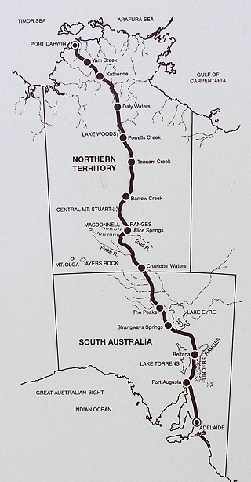

[Map from http://www.travelling-australia.info/Infsheets/ Overlandtelegraph.html]

7. PLACE: Dog Fence (also referred to as the Dingo Fence)

History summary:
The Dog Fence (also known as the Dingo Fence in South Australia, the Dingo Barrier Fence in Queensland and the Border Fence in NSW) is a barrier or pest exclusion fence. Its purpose was to protect sheep in the southeast of Australia by excluding dingoes that were prevalent to the northwest. The full Dog Fence was not completed until the 1940s, however in Queensland it utilises (and modified) much of the State Rabbit Proof Fence that was constructed in the 1880s (by 1884), and in South Australia it was formed by connecting earlier pest exclusion fencing around individual properties. It is one of the few major barrier fences to be constructed in Australia (the other being the 1880s Rabbit Proof Fence in Queensland and the Rabbit Proof Fence in Western Australia, constructed in 1901-7). It is also one of the longest in Australia and in the world extending from the Great Australian Bight in South Australia through the south eastern part of the Australian arid zone to south-eastern Queensland). It is also taken to demarcate the division between cattle farming to the north and sheep farming to the south of it, and the division between arid and semi-arid vegetation and rainfall patterns (see Pastoral Board Annual Report 2014-15:5).
There was a significant increase in dingo numbers in the late 19th century, which lead to the erection of this national scale barrier fence. The increase in dingo numbers has been attributed to the combination of dispossession of Indigenous people and their camp dingoes, who became feral, combined with the rabbit plague that spread – disastrously - to the arid zone in the late 1880s, providing food for the dingo (Leader-Elliot and Iwanicki 2002: 160). Thus the building of the fence has built into it the history of appropriation of ’rangelands’ for sheep grazing and its impact on the resident populations of Indigenous people, and the introduction of destructive rabbits into the mix of impacts on that land.
The earliest pest exclusion fences in Australia were created to protect small plots of cropland from the predation by marsupials, usually around individual properties. This was an innovation - previous methods of control involved much labour by shepherds and ‘doggers’ (Kerin 2009:141-2). In the 1860s and 1870s, introduced rabbit populations began to spread rapidly across southern Australia. As more sheep farms were established the interest for dingo-proof barriers increased and government funds were being used to heighten and expand the fence, at least in Queensland. In 1930 in Queensland an estimated 32,000 km of dog netting alone was being used on top of rabbit fences (Land Protection 2005).
To create a single connected barrier fence, the individually fenced property boundaries and sections rabbit proof fencing were linked together and heightened, requiring a large degree of coordination through local associations as well as state government intervention. In Queensland alone prior to the Dingo Barrier Fence Scheme, 38 dingo Boards were set up around the State and paid out considerable bonuses for the destruction of marsupials, dingoes and foxes. Up until 1930 it was estimated that there were some 32 000 km of dog netting in the State, much of which was constructed as top netting on rabbit fences (Land Protection 2005).
In 1946 the SA state government’s Dog Fence Act levied money to fund a barrier-fence across the north of the state, as well as its ongoing maintenance. A similar history in Queensland led to the Queensland section of the Dog Fence (the Dingo Barrier Fence) being established in 1948.
In Queensland most landholders desired the establishment of such a fence and wire netting was delivered to properties free of cost if the landowner undertook to construct the barrier fencing on their property. The fence was built to certain specifications and a contribution was provided
annually for repairs and maintenance. Six inspectors stationed in western Queensland supervised the construction and maintenance of the fence (Land Protection 2005).
Ongoing repair and maintenance has been a major element in the functionality of the Dog Fence. Up until the early 1970s in Queensland, most of the barrier fence was maintained. In 1975 in Queensland a review indicated that the cost of bringing the whole of the original barrier Queensland section of fence up to dog-proof condition was $915 000. This work did not occur, and in 1982, the Queensland government implemented a program to upgrade parts of the existing fence and realign the fence to exclude previously protected areas in central-western Queensland and north-western Queensland. In addition to the main barrier fence, a number of check fences were reconstructed and renewed in the southern Darling Downs area, but even with this work the Dog Fence only now provides protection from wild dogs and dingoes to central southern Queensland (Land Protection 2005).

Place Description:
The Dog Fence runs from the coast at Nundroo, Nullarbor Plains, SA, east through the southern part of the arid zone in South Australia via Coober Pedy, the Northern Flinders Ranges to the SA-NSW border just south of Coopers Creek, then runs north up the state border to the Qld-SA-NSW border junction, east along the Qld-NSW border to west of Coopers Creek/Barcoo, then north east and east to Jimbour on the Darling Downs in Queensland, its route in Queensland running west of Thargomindah and south of Blackall.
The place runs through the following biogeographic region (IBRA) - NUL, GVD, GAW, STP, SSD, CHC, WAR, MUL, MGD, BBS.
The full fence is c.5400 km long and is the longest single fence in Australia. It is substantial, at c.180m high with wire netting on wooden posts, with gates to allow traffic through roads which cross it. Travel along it is not permitted.
The fence varies in construction. In Queensland, the barrier fence is described as being constructed using wooden posts, strainers, star pickets, wire and different types and sizes of netting. The fence line is cleared on both sides to a width of 5m. Floodway fences are constructed using heavy cable. The fence stands 1.8 m high with the netting at ground level laid a further 1.5 m along the ground. Wire netting is secured at ground level using straight timber logs placed on the downstream side of the fence (Bauer 1964). Some sections in South Australia comprise multi-strand electric fence. A series of gates or grids on tracks and roads allow vehicles to pass through the fence.
There is no readily available information on the location, nature or current condition of the historical elements of the Dog Fence.

Comparative Analysis:
It is the scale of the Dog Fence that is atypical and impressive – the concept, its realisation and the maintenance of a cross-continental span makes it a nationally significant structure.
The only comparative structure is the Western Australian Rabbit Proof Fence (3 sections built in 1901-7). Although the Western Australian Rabbit Proof Fence can be considered more significant than the Dog Fence given that the full No.1 fence was constructed as one stage and is earlier Leader Elliot and Iwanicki (2002:163) consider that the Dog Fence is likely to be more significant at national level as ‘it affects the economies of three states, and effectively creates a boundary between the sheep and cattle industries of much of Australia.’ The Dog Fence also incorporates the Queensland Rabbit Proof Fence which was the first large scale pest control fence to be erected in Australia.
Both the Western Australian Rabbit Proof Fence and the Dog Fence continue to operate, however the Rabbit Proof Fence was never fully effective, and is now ineffective against rabbits (its original function), while the Dog Fence continues to be used, at least in part as a barrier fence for dingoes.

Assessed Integrity:
The route of the Dog Fence is understood to be largely the original route, although some small sections have been re-rerouted, and the fence has high integrity as a largely intact fence line. The fence however has been substantially modified over time, so only minor amounts of historical fabric are understood to survive. This however does not affect the integrity of the Dog Fence as the ongoing evolution is part of the history of the fence, and the historical fabric is not considered to be of national level significance (although it is of significance).

Indicative Statement of Significance
The Dog Fence is of outstanding national level significance for the major influence it has had on Australia’s pastoral industry, in particular the sheep industry, itself of national historical and economic significance, through the role it played in protecting sheep in south-eastern Australia from dingo and wild dog predation from the north and west. The Dog Fence also is of historical significance at the national level as it has built into it the history of appropriation of ’rangelands’ for sheep grazing and its impact on the resident populations of Indigenous people, as well as the introduction of destructive rabbits into the mix of impacts on that land.
The Dog Fence is a large, national scale technical solution to the problem of dingo predation on sheep, and is technically simple solution as it used standard, easily available and relatively inexpensive pastoral materials and techniques of the time. Although it built on the 1880s Queensland Rabbit Proof Fence, the scale and use of commonplace pastoral technology make it a significant innovation. The construction of the fence through two states, and with three state borders involved, makes it a nationally significant example of organisation and cooperation between pastoralists, and between them and state governments for its construction and, importantly, its continuing maintenance.
Physically it is of national and international significance being Australia’s longest single fence, and one of the longest structures in the world, and the world's longest fence (it is approximately It 5,614 kilometres long). The extent of historical fabric is unknown, but it is assumed that it includes some historical remains including elements of the 1884 Queensland Rabbit Proof Fence. If this is the case, then these historical remnants are considered to be of significance as they provide information on the early fence construction techniques and materials.
Geographer Tom McKnight (1969: 335-6) discussed the historical status of the Dog Fence. His view is framed over 30 years ago, but it remains clear that this barrier fence was and is a distinctively Australian approach to pastoral problems (see section 3.3.4.3).

National Heritage List Criteria
Criterion (a):
. The Dog Fence is of outstanding national level significance as a major pest control measure to protect Australia’s nationally significant pastoral industry (to protect sheep in the SE from dingoes in the NW) and for its highly significant influence on the Australian pastoral industry. It exemplifies the process of the pastoral industry’s experience of and response to the introduction of pest animals and environmental degradation, culminating in technological and administrative measures to manage the problem of dingo predation. It is also significant for its continuity of use and in relation to the fact that it continues to perform the same function today.
. At c.5614km the Dog Fence is one of Australia’s (and the world’s) longest structures, representing a massive national undertaking, and demonstrates national level (as well as local and state level) cooperation in relation to the maintenance of the Australian pastoral industry.
. The Dog Fence defines the approximate boundary between sheep and cattle grazing across much of Australia.
Criterion (b).
. The Dog Fence is of outstanding significance as a rare national scale pest control measure. As a pest control measure its large scale is rare (the only other similar scale structure in Australia is the Rabbit Proof Fence), and the continued operational condition of the full fence (although not in many places in its original form) is also unusual.
Criterion (d):
. This pest control fence is of outstanding national level significance as it demonstrates to a high degree the nature of major pest control fences in Australia and evolution of this type of national scale infrastructure.
Criterion (f):
. The Dog Fence is an ingenious application of commonplace pastoral technology (the netting fence) to the national problem of dingo infestation through the daring solution of building a barrier fence on a national scale.
Criterion (g):
. The Dog Fence has national iconic status and is widely known and valued by Australians as a special Australian historic structure.

Thematic Indicators:
Primary 2d. A high degree of technical and organisational flexibility (and innovation): Specialised resource technology

Water Indicators:
The place responds to / results from a general condition of aridity

Confidentiality or security of the place and its values that may need to be considered
As a state government/s managed entity which has public access, it is unlikely that there will be issues of confidentiality or security.

The confidence that can be placed in this information, including the extent to which the information for a full assessment of the place is available or needs supplementary research
There is relatively limited good synthesised historical material for this place, and no detailed information on the physical nature and condition was located. Although there has been one heritage assessment of the Dog Fence (Elliot and Iwanicki 2002), there appears to be no comprehensive assessment of the full fence. Accessing the information is made more difficult as the available information mainly appears to relate only to the fence in a particular state and very little relates to the full fence. Reliable mapping of the full dog fence will also be required (this is likely to exist, but will need to be sourced).

Any logistical issues that might impede a full heritage assessment or require additional resources
It will be critical to undertake detailed research into the history and physical nature of the Dog Fence as whole, and this will be time consuming as it will require working across three state governments (SA, Qld and NSW).
Consideration will need to be given to what physical attributes are included in the nomination (see also below).

Map of place boundary
There is inadequate information to provide a reliable boundary.
The following mapped fence line is indicative only. Establishment of an exact boundary requires further expert advice, and access to more detailed mapping.
Based on the nature and significance of the Dog Fence as assessed by the present study, consideration should be given to listing the full length of current Dog Fence with the linear corridor to be the fence plus a 5m zone each side (ie, the width of current management), and to specifically include all individual significant features identified, in particular sections of fence that relate to the 1884 Rabbit Proof Fence and sections with well-preserved fencing dating up to, and including c.1948 (ie, the main final construction phase that fully connected the fence).
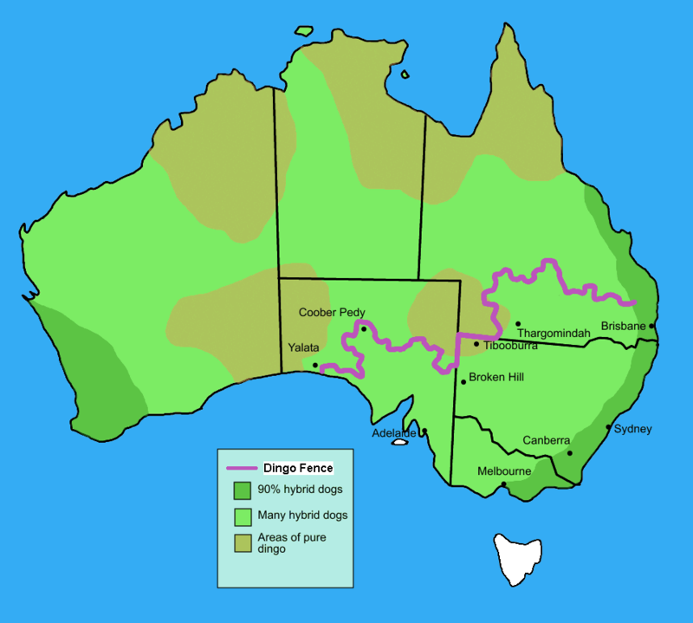

[Taken from Wikipedia - https://en.wikipedia.org/wiki/Dingo_Fence accessed June 2016.]

8. PLACE: Mikeri Wells Water Route

History Summary:
This line of soakages that cross the Simpson Desert, known as mikeri wells, is an exceptional example of a water route and intimate knowledge of available desert waters. These soakages hold permanent waters in a shallow aquifer on underlying stony or clay pavements. They were reached by narrow underground passages, up to seven metres long, which reduced evaporation and spoilage, and required regular clearing and maintenance. They were a final reserve when the more variable supplies of surface waters in swamps on the edges of the dune field and in claypans throughout the dunes had gone. They enabled permanent residency in the vast Simpson dunefield for Wankangurru people. ‘The soaks were always there when all the surface water had dried out: there was no reason to leave the desert’ (Hercus 1985: 25).

In 1934 anthropologist Norman Tindale recorded one of the ‘people of the wells’, Ngaltjagintata’s description of how to travel across the sand desert between Pandi Pandi on the Diamantina River near Birdsville, to the ceremonially important waterholes on the Finke River via several mikiri. This is a two to three week journey. The instructions for travelling include ‘good water here, spell 2-3 days here’, and nine times ‘camp in bush, no water’ overnight. The last person to cross using this route was Maggie Ayinyirda Naylon in 1930 or 31. They were located, with guidance from Wankanguru man ‘Paddy’ and mapped by explorer David Lindsay in 1886 and relocated by Denis Bartel and Peter Clarke and Luise Hercus in 1983 (Hercus 1986). They were re-visited in 2007.

The Mikeri Wells Water Route does not appear to have been used as a trade route, although some small trade items may have moved along the route. The route was used largely travel for ceremony and for communications. Its lack of use as a trade route is likely to be due primarily to the limited nature of the water on the route, which was unlikely to sustain large parties and/or frequent use, and was also not an easy route to travel as the route necessitated camping at least twice without water (Hercus 1987).

This water route follows an important Ancestral songline – the Two Boys story. It has been well researched and documented by linguist Luise Hercus (1985, 1989, 1990a, 1990b), and archaeologist Peter Clarke (Hercus and Clarke 1986; see also Macfarlane 2005). The mikeri route is of continuing cultural significance to the descendants of the people who left them at the turn of the 20th century, as evidenced by the 2007 Mikeri Repatriation Project and the erection of seven plaques documenting their relationship to the wells at Tjilputha, Yelkerri and Puramuni. They are an outstanding example of a crucial water route joining different components of the arid zone – the western Simpson and the eastern Channel country.

Place description:
The Mikeri Wells Water Route is located in South Australia in the north-east corner, although for a short distance it lies just north of the Queensland border. It runs from just south of Birdsville, west to the Finke River via Dalhousie Springs

The place is located within the SSD biogeographic region (IBRA).
The Mikeri Wells Water Route is a water route/ line of travel across the Simpson Desert between Pandi Pandi on the Diamantina River near Birdsville and the large, ceremonially important waterholes (Eweila) on the Finke River floodout and the mound springs now called Witjera/ Dalhousie Springs, via a channel of Georgina River above old Alton Downs, then via nine mikiri (sub-artesian) wells. Of these, Puramana mikeri, in Queensland on the eastern side was one of several timbered by the surveyors who surveyed the state borders, and on the western side, Marubadi / Murraburt mikeri, was the main habitation site of the western Simpson Desert (Hercus and Clarke 1986: 56). Hercus and Clarke (1986: 51) provide a table of the names of these wells. There is varied archaeological evidence of occupation at the wells (Hercus and Clarke 1986).

Assessed Integrity:
The integrity of this site is unknown, but is considered to be high given its remoteness, general lack of access and the main land use of the area. It is possible however that some parts of the route have been intersected by mineral exploration lines, and some specific sites may also have been disturbed by mineral exploration activities.

Comparative Analysis:
Only two major ‘water routes’ are known and recorded (at least in part). These are Mikeri Wells Water Route and the Ooldea Water Route complex. Both these demonstrate at a high level water routes that were not incorporated into European usages (unlike the stock routes and the Overland Telegraph Line that effectively co-opted Indigenous waters for stock), which contributes significantly to their significance as water routes.

The Ooldea Water Route complex was a highly important water place with people’s lines of travel and Ancestral tracks through the desert linking it to soakages in the Great Victoria Desert. However, people’s use of this system of waterplaces and paths was disrupted by pastoralism, the construction of the east-west railway line and the Maralinga weapons tests. In comparison, the Mikeri Wells Water Route remained intact after people left it at the turn of the twentieth century, and the knowledge of how to use it was retained, and the places were undisturbed. As such it is a uniquely preserved refined adaptation to harsh desert living. The Mikeri Wells Water Route is also more comprehensively researched as a route than the Ooldea Water Route complex.

Indicative statement of significance:
The Mikeri Wells Water Route, which crosses the major sandridge desert now known as the Simpson Desert, is of outstanding significance as a traditional Indigenous route that represents and demonstrates a specialised adaption to living in the desert that is fundamentally related to the landscape and to a specific form of water occurrence, with desert adaptions being a key part of the story of Australia’s settlement. The Route is considered to be an outstanding example of this type of route due to its location and the nature of the water on the route, in particular the made wells. This significance is enhanced by the knowledge of the route having been retained and the location of the route and wells and associated Ancestral stories having been well documented. The route and associated traditional stories remain an important part of the Indigenous cultures of the eastern and western sides of the Simpson Desert, hence have traditional significance.

National Heritage List Criteria
Criterion (b):
. The Mikeri Wells Water Route is a rare, good example of a desert adapted lifeway (in a special desert environment – natural desert wells that rely on relatively shallow subsurface water).

Criterion (d):
. The Mikeri Wells Water Route is able to demonstrate at an exceptional level a traditional Aboriginal water route given its location and the specific nature and location of the water sources of the route.

Criterion (i):
. The Mikeri Wells Water Route is important as part of Indigenous tradition and history as this follows a significant Ancestral Story line.

Thematic Indicators:
Primary: 3. intimate knowledge of the landscape dynamics
3b. use of specialised water re/sources
Secondary: 1a. broad scale subsistence/economics
1b. residential mobility
1c. long distance travel route
2b. specialised resource technology
4a. Songlines.

Water Indicators:
- Utilises shallow aquifer waters/ sub-artesian waters
- Rare and specific use of natural desert wells

Confidentiality or security of the place and its values that may need to be considered
Consultation with members of the relevant communities is essential to determine if there are confidentiality matters.

The confidence that can be placed in this information, including the extent to which the information for a full assessment of the place is available or needs supplementary research
Published, archival and recorded archaeological, linguistic and oral traditional information is available. It should be noted however that knowledge of the traditional route may now be limited.

No heritage assessments are available. It is possible that there have been some impacts to the wells and route through mineral exploration activities, and it would be advisable to research this.

Any logistical issues that might impede a full heritage assessment or require additional resources.
Access permission and full consultation with relevant community members is required.

The route and well location mapping is difficult to access and may not be available for the full route. Further research of existing knowledge (eg, Indigenous knowledge, archaeological field work (eg, P. Clarke’s work) and recent information (eg, Australian Desert Expeditions recent finds)) will be required.

Indigenous knowledge of the traditional route may now be limited and it may therefore be difficult to re-locate all the wells.

Map of boundaries
There is no readily available mapped information and the accessible place specific information is inadequate to establish a reliable route provide boundary for this place.
The mapped route shown here has been reconstructed by the present study from the documented description in Hercus (1985), which uses the information in Tindale (1962), and Hercus and Clarke (1986) of how the route was travelled, and is indicative. Tindale’s (1962) and Hercus and Clarke’s (1986) information are the only descriptions of the route that have been located by the present study.
Establishment of the exact route and an exact boundary will require further information from Aboriginal people with knowledge of this water route, and further expert advice to determine how best to define this cultural route for listing purposes.

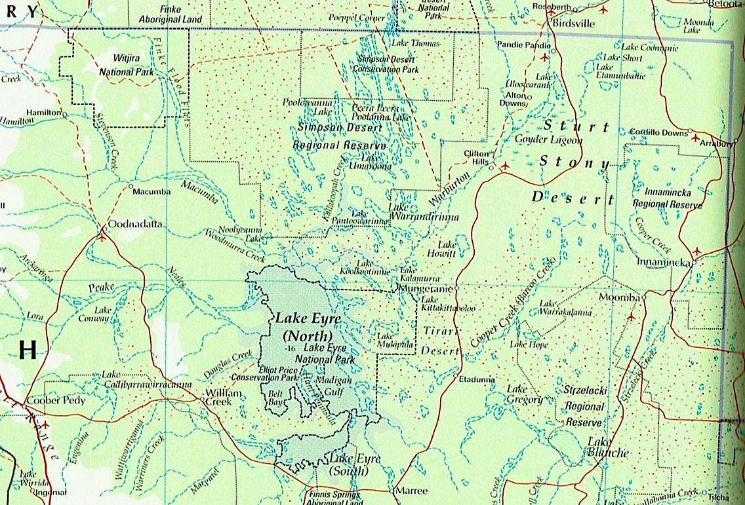

[Base map taken from Times Books (1999, p7). Top of Map is North].

Note: The route is described as having the eastern end at Pandi Pandi Station, crossing just up into Queensland (north of Alton Downs Station and 15 miles north of the border), via several ‘mikeri’ to Poolowanna Lake, via several more ‘mikeri’ west of Poolowanna lake, crossing the Finke River (at Ulura waterhole), via Dalhousie Springs, with the western end at the big waterholes (Oleita and Murulura waterholes) on the Finke River.

9. PLACE: East Lake Eyre Trade Route

History Summary:
Central Australian exchange networks involving ochre, grindstones, stone axes and pituri are exceptional in their vast extent, from the Gulf of Carpentaria to the Flinders Ranges and Port Augusta and from the Darling River to Lake Eyre and the Finke River (McBryde 1987, 1993, 1997, 2000b). Archaeologist Isabel McBryde’s work has shown that the exchange networks of eastern central Australia are among the most extensive and complex exchange systems known from hunter-gatherer societies worldwide (McBryde 1997: 11). The social values and exchange practices involved were adaptive strategies for life in the desert.
Wankanguru men from the western Simpson Desert would travel to the eastern Simpson and then south to acquire highly prized ochre from the mines at Pukardu Hill in the Flinders Ranges, more than two months journey away (Jones 2007: 357). They exchanged boomerangs and spears with the Kuyani custodians of the mines (McBryde 1987: 259-262; Jones 2007: 353, 360). They sang the Pukardu song for setting out and returning along the traditional route, which followed a Story Line or Dreaming track that maintained and disseminated their knowledge of the route, and the geography of the landscape (McBryde 2000b: 157; 1987: 269-71). They also acquired sandstone slabs from the Anna Creek (Palthirri-pirdi), Tooths Nob (Wadla wadlyu) and Innaminka quarries to make grindstones to grind grass seed (Smith 2013: 272-3). In ethnographic times, they were recorded as carrying 30 kilogram cakes of the ochre plus the heavy grindstone slabs back to the sandhill country (McBryde 1987: 261, 271-2). The products of major quarries also were important in that they had spiritual as well as utilitarian meaning.
Journeys to the highly significant eastern ochre quarries continued into the early twentieth century, with expeditioners taking advantage of being able to travel on the train between Marree and Leigh Creek when it went through in 1884. This enabled them to acquire ochre at less risk from pastoralists who were defending their sheep runs in the area (Jones 2007: 370, 375-6). The important movement, stories and return to the place were all maintained, with the mode of movement altered in the colonial context.
The people of the Mulligan and Georgina River area produced a superior quality, specially prepared pituri, the highly prized narcotic related to tobacco, packed into special bags. This was exchanged in a way that differed from other materials in that it was more like trade, with fixed rates. Goyders Lagoon was an intersection of communication routes from north, south-east and west, for large exchange gatherings (McBryde 1987: 267).
This exchange was a cohesive component of desert life, its travel and ceremonies ‘important episodes in a recurring pattern of contacts and exchanges linking people and materials across great distances’ in a ‘complex web of connection’ (McBryde 1987: 261, 268). The objects referenced far away, yet known places, featured in songs and stories. The travel to acquire them, and the objects themselves reinforced chains of connections between places and groups. They ‘transmitted knowledge, materials and artefacts between local and regional communities otherwise isolated by vast distances’ (McBryde 1987: 267).
McBryde makes the case for why this is a cultural landscape, distinct from aggregations of places formed by people’s land use and settlement, because the elements of the exchange network ‘in their patterned distribution of significant exotic items suggest a system … These patterns form an overlay above those of the subsistence regime and daily life. The places are also linked in stories of the activities of Ancestral, creative beings, often forming long storylines or song cycles.

Place Description:
The ‘East Lake Eyre Trade Route’ place as defined by this study for the purposes of National Heritage Listing is the core or trunk route of the East Lake Eyre trade complex or network. Because the network is very extensive and is not discrete, but instead links into other trade networks to the east, north, west and south, it is difficult to define the route for the purposes of listing. The core of the East Lake Eyre Trade Route network however is arguably the most significant part of the network and is able to demonstrate the historical use and key elements of the trade route and trade item sources.

The core route, or trunk, of the East Lake Eyre Trade Route runs north-south from the Flinders Ranges in South Australia, and into Queensland via Birdsville, terminating in the Selwyn Ranges just south of Cloncurry.

The place runs through the following biogeographic region (IBRA) - FLB, STP, SSD, CHC, MGD and MII.
The East Lake Eyre Trade Route runs from the Pukardu ochre quarries near Parachilna in the central Flinders Ranges east through the Flinders Ranges to the Wadla Wadlyu (Tooths Nob) grindstone quarries on the east of the Central Flinders Ranges, then north to Kopperamana and Killilapaninna on Coopers Creek, north to Goyders Lagoon and Birdsville on the Diamantina River, and then through the Mulligan River Pituri Area (which lies mainly to the west) and north to Boulia on the Georgina River. The Route then sweeps to the northwest via Roxborough then northeast to the greenstone axe quarries in the Selywn Ranges south of Cloncurry. (There were also important trade offshoots to Innamincka, Anna Creek, the Macdonnell Ranges and Carlo, but these have not been included).

The core route includes the specific sites of the Pukardu (Parachilna) ochre quarries in the central Flinders Ranges (forms the southern end of the Route), the Wadla Wadlyu (Tooths Nob) grindstone quarries to the east of the Central Flinders Ranges, the Mulligan River Pituri Area in southwest Queensland, and the Selywn Ranges greenstone axe quarries south of Cloncurry (forms the northern end of the Route). Other important specific locations included are Kopperamana, Goyders Lagoon, Birdsville and Bedourie which were all important meeting and trading locations.

The individual places which are part of the route are not described here, but descriptions can be found in various place listings (see below) and other research reports and papers (eg, McBryde 1987, 1997; Smith 2013; Leader-Elliot & Iwanicki 2002).

The Killilapaninna Mission Site is listed on the SA Heritage Register (Place Id 12618). Tooths Nob Grindstone Quarries is listed on the Register of the National Estate (Place Id 6015).

Assessed Integrity:
The integrity of the East Lake Eyre Trade Route as a place is not known. Given that this general route was also important in colonial times and through to the present (eg, part of the route comprises the historic Birdsville Track stock route and present day 4WD route), in spite of its relative remoteness it is likely that the integrity has been compromised to some extent by new tracks and other recent historical development. The setting integrity is also likely to have compromised to various degrees by these developments and land modification. It should be noted however in relation to this site that the cultural significance of the Route is not strongly dependent on its integrity.

Comparative Analysis:
Comparable Aboriginal trade routes are the Western Pearl Shell trade route which runs from the Kimberley in Western Australia southwest to near Port Augusta in South Australia, and the northern Baler Shell trade route from Kimberley and Cape York to Cloncurry and Cooper Creek. The Western Pearl Shell trade route is longer than the East Lake Eyre Trade Route, but involves only one primary trade item and is much younger, dating to the colonial period [Smith 2013: 275]). The Baler Shell trade route is less well defined and involves a less complicated set of interactions.

Indicative Statement of Significance:
The East Lake Eyre Trade Route is of outstanding national significance as a major trans-Australian historical Indigenous trade route which, although it did not cross the full breadth of Australia, enabled a large variety of items and a number of important resources (eg, greenstone axes, seed grindstones, ochre and pituri) to be traded to and from southern Australia and northern Australia. The main trade occurred along the core, or trunk, which ran from the Flinders Ranges in South Australia, to the Selwyn Ranges in Queensland; and various offshoot trade routes and further connecting trade routes enabled traded goods to be distributed into central Australia, Northern Australia and Eastern Australia. The five major exchange centres on the East Lake Eyre Trade Route, enabled a wide range of Aboriginal groups from the eastern arid zone and semi-arid zone to meet to not only exchange goods, but to exchange information and to conduct ceremony and social activities. All these activities were of critical importance in the maintenance of traditional Aboriginal society and enabling survival in Australia’s arid zone environment with its sparse and widely dispersed resources.

The East Lake Eyre Trade Route is also of significance as a rare major trade route, with only two others such major routes) having been documented, and is considered unique given the large volume and large variety of items traded along it (a large part of the trunk route carried at least 10 different major trade items (McConnell 1976)), with the other main routes carrying primarily a single primary trade item (the Western Pearl Shell trade route, which is longer, but involves only one primary item (pearl shell) and may not have been established until the colonial period (Smith 2013: 275) and the northern Baler Shell trade route, which is less well documented but has only one known one primary item, the baler shell that was traded large distances). The difference in the variety of goods traded reflects the different nature of the East Lake Eyre Trade Route compared to the other two routes - the East Lake Eyre Trade Route is unique as a trade route, because as far as is currently known, it was implemented specifically to trade goods while the other two major trade routes were used primarily for movements between parts of country and had more informal trading arrangements. In the case of the Western Pearl Shell trade route, its function was particularly for cultural exchange and ceremony, rather than the movement of goods.

The nature of the East Lake Eyre Trade Route as an extensive trunk route with exchange (and ceremonial) nodes and a number of sources of the goods traded along the route also occurring on the route, as well as its rarity, make the Route of exceptional significance in being able to demonstrate a major Australian trade route and its principal characteristics. This significance would
be enhanced if the route and key places are of high integrity, but the integrity is only known for a small number of the resource sources and Kopperamana. The integrity of these places appears to be high.

A number of individual places which are part of the East Lake Eyre Trade Route are significant in their own right. These include Wadla Wadlyu (Tooths Nob) Grindstone Quarry Complex which was an important historical seed grindstone source and which, because of its extensiveness and integrity, also is able to its represent the principal characteristics of a seed grindstone quarry to a high level; the Mulligan River pituri area, which the Route passes through, which was the only known large area of occurrence and therefore of cultural significance (and possibly natural significance) as a rare resource in an Australian context; Pukardu (Parachilna) Ochre quarries which produced one of the most highly prized red ochres in Australia; and Kopperamana, which appears to be the most important exchange centre on the Route, hence is regarded as one of the most important exchange centres nationally.

The scientific importance of the East Lake Eyre Trade Route has not been established due to the lack of detailed investigation of the nature and setting of the route and its component places, but is potentially high. The Route however can provide important information on Aboriginal trade in Australia and how a major Australian trade system operated through the existing and relatively well researched documentary records. Those trade item sources that have been investigated have demonstrated that these places can also provide important information, in these cases on the nature of the resources that were traded and how they were acquired and processed. Kopperamana, as a major exchange centre is also regarded as having the potential to provide valuable information on the nature and use of such trade centres.

The significance of the East Lake Eyre Trade Route in relation to traditional value to Indigenous Australians has also not been established.

National Heritage List Criteria
Criterion (a):
. The East Lake Eyre Trade Route is highly significant as one of the three major trans-Australian traditional Aboriginal trade routes, which also provided long distance communications and social connection.
. The East Lake Eyre Trade Route is of outstanding significance as a trans-Australian traditional Aboriginal trade route because of the critical and specialised functions it served, including as a focus for major eastern Australian arid zone gatherings at Kopperamana.
. The East Lake Eyre Trade Route is foremost in a national context for the number and quantity of goods traded along this route (most other routes are limited to one to a few items), including for considerable lengths of the route for key goods.
. The East Lake Eyre Trade Route is also significant in relation to pituri (Duboisia hopwoodii) which was widely traded (via the East Lake Eyre) in eastern Central Australia, including along the East Lake Eyre Trade Route, with its importance reflected in the amount of pituri traded and the large distances it was traded. Pituri is a narcotic plant native to the arid zone that was historically a highly significant narcotic plant used by Aboriginal people in the arid zone, both for personal use, trade and in fish-stunning; and was the most used narcotic substance in traditional Aboriginal Australia.

Criterion (b):
. The East Lake Eyre Trade Route is of very high significance as a rare long distance trans-Australian traditional Aboriginal trade route. It is only one of three, and is outstanding in relation to the high volume of trade, the long distance that items were traded and for the variety of items traded.

Criterion (c):
The East Lake Eyre Trade Route is able to provide information on the nature of trade routes to a very high level compared to other such trade routes through its route, the route setting and its trade item sources. The inclusion of major resource sites also allows the Route to provide information on historical ground axes (via the Selwyn Ranges quarries) and red ochre (via the Pukardu quarries) which were specialised and significant, widely traded resources in the eastern half of Australia; and on the seed grindstone quarrying in Australia, a process that provided an essential tool for seed processing, which in turn provided a specialised and significant food resource for arid zone Aboriginal peopleand on the nature of historical seed grindstone quarrying in Australia.

Criterion (d):
. The East Lake Eyre Trade Route is of outstanding national significance for its ability to demonstrates in a national context a long distance traditional trade route with key components (ie, key trade item sources, key gathering places, and as a resource (food & water) based route).

Criterion (i): [Note – the significance of the East Lake Eyre Trade Route in relation to this criterion has not been able to be established by the present study, but is considered likely].

Thematic Indicators:
Primary - 1. High residential/ economic mobility
Secondary - 1c. long distance travel routes
2a. specialised response to highly variable environment
2b. specialised infrastructure technology
4b. long distance communications
4c. social reciprocity and territorial access rights

Water Indicators:
Response to generalised aridity. Utilised and dependent on a range of desert water types, but primarily – sub-artesian water, shallow aquifer water, permanent surface water, and ephemeral surface water.

Confidentiality or security of the place and its values that may need to be considered
Not established by the present study. Consultation with members of the local Indigenous communities will be essential to determine if there are issues of confidentiality or security of the place or components of the place.

The confidence that can be placed in this information, including the extent to which the information for a full assessment of the place is available or needs supplementary research
Archaeological and ethnographic information on the trade route are available, as is a statement of heritage significance (McBryde 1997). The East Lake Eyre Trade Route however has not been systematically mapped and documented, and further work may be required in this respect to fill existing data gaps.

The Kopperamanna Mission Site and the Kallilapaninna Mission Site have been inspected and documented as part of the Birdsville and Strzelecki Tracks Heritage Survey (Leader-Elliott & Iwanicki 2002). The Kallilapaninna Mission Site is also documented as part of its SA Heritage Register listing.

Any logistical issues that might impede a full heritage assessment or require additional resources.
Access permission is required and full consultation with community members.

Mapping detail of the places will require consultation and further research.
Map of Place Boundary
There is inadequate mapped information to provide a reliable boundary for this place.
The following map, taken from McBride (1997: 6) shows the key trade routes in the East Lake Eyre – Lake Eyre region, many of which are part of, or linked to, what is generally referred to as the East Lake Eyre Trade Route. The central line indicates the main, or trunk, route, along which the greatest variety of goods moved. Based on the nature and significance of the East Lake Eyre Trade Route as assessed by the present study, it is recommended that the place be the full trunk route (see Place Description, above).

The mapped route provided here is approximate, hence is indicative only. Establishment of the exact route and an exact boundary requires further Indigenous consultation and other expert advice.

It is suggested that the place include the linear route, adopting a nominal, practical width, and includes the key meeting and exchange places (including Kopperamanna, Killalpaninna and Goyders Lagoon) as key nodes along the route. Important localised resource locations for materials traded on the route should also be included as minor nodes, particularly where their location defines the location of the route. These should include the Pukardu (Parachilna) Ochre Quarry and Wadla Wadlyu (Tooths Nob Grindstone Quarry Complex) at Reaphook Hill at the south end, and the Selwyn Ranges greenstone axe quarries (or one major one) in the north. The Mulligan River pituri area is considered to be too large to include and overwhelms the trade route which is the place, not the resources it moved and should therefore not be included in this place – although its values should be included in the significance statement as the route passes through the area so the resource can be acknowledged indirectly.
The boundaries of the nodes will also need to be established on the basis of further research and expert advice.
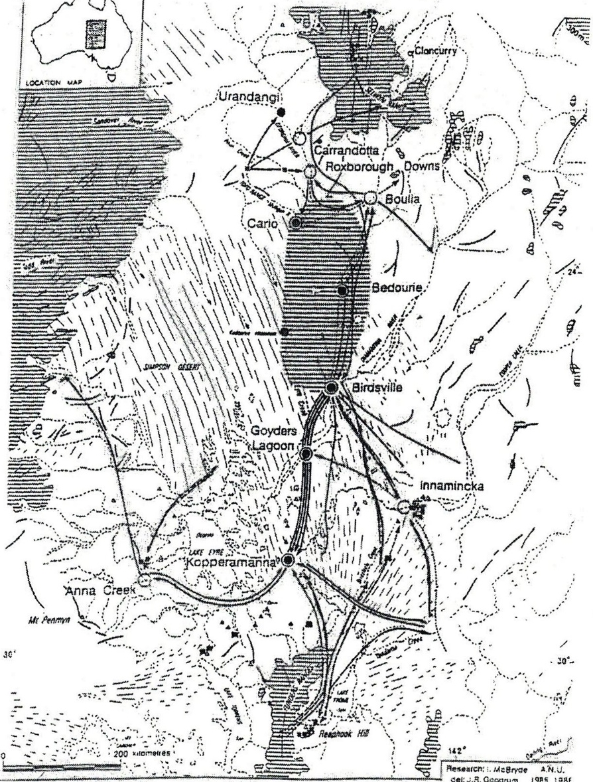
Map of eastern Lake Eyre trade route and major exchange nodes {from McBryde 1997: 6]

10. PLACE: ‘Seven Sisters’ Songline

History Summary:
The Seven Sisters Songline is an epic story, and the most widespread Ancestral Songline in Australia. The songline is named for the cluster of stars known in Greek mythology as the Pleiades, daughters of Atlas. They are close to, and forever chased by lusty Orion, known as Yurla, Yula, and Wati Nyiru. The stars of the Seven Sisters and Orion are visible in both the southern and northern hemispheres.

The travels of the Seven Sisters are associated with many places across the desert, including important water holes. For this reason ‘many of the sites on the Seven Sisters journey in the west were taken as wells on the Canning Stock route’ (NMA 2010: 53). The Martu (western desert language groups) Jukurpa (‘Dreaming’ or Ancestral) story of the Seven Sisters is Minyipuru. The story is the man Wati Nyiru chases the women across the desert, watching them from behind trees, tracking them, making the older sister sick (James 2009: 102-3). He wants to have sex with the women, his phallus represented by a carpet snake, which chases them across the Western Deserts. Water holes are a prominent part of the stopping places in the Songline, shown in the dances preformed in some of these places and filmed for the Songlines project (see section 3.3.3 for detailed descriptions of the locations and import of these filmed site-based performances of the Seven Sisters ceremonies). In Pitjantjatjara/Ngaanyatjara land the Seven Sisters story is called Kungkarangkalpa, meaning many young women.

The Seven Sisters also pass through the Spinifex Country of the Great Victoria Desert (Cane 2002: 95-7), digging with their digging sticks, getting food and getting water, followed by old man Nyiiru. Rock features mark where they are sick, or hide, and intersect with other Tjukurrpa. They travel widely, and they are capable of flying. As Cane says, this is a complicated Tjukurrpa, which ‘pops up everywhere across the southern western desert’. He says it continues to near Coober Pedy (2002: 96). Different groups know different parts of the story best, but know where the story goes after it leaves their country. It is a story that is essentially of the Australian deserts, connecting travellers, across three deserts and between waterholes over huge distances, under the stars, and it continues to make those linkages through performance and distribution of recorded performance.

The Seven Sisters Songline, travels from near Roebourne in Western Australia across the Pilbara, the Gibson Desert and the Great Victoria Desert; the country of many language groups. This major story is told in ceremonial dance and song, linking together distant country, recounting the locations of important water places. It has been painted on the walls of Walinyna (Cave Hill, northeast of Amata in the Musgrave Ranges) and pecked into the rock at the Kuli waterhole (James 2009:13) and in the last four decades elements of the Songline have frequently painted in acrylic form (see eg NMA 2010, Cane 2002: 100-1). When people paint the places of the Seven Sisters Songline, the women sing the songs so that the land is built into the painting. For example, Inawinytji Williamson, based at Kaltjiti (Fregon) paints the different inma walka – the marks painted on women’s breasts as they dance the parts of the story, representing different places along the path of the story (James 2009: 104-5).

Diana James describes an expedition to trace Seven Sisters sites that had not been visited for over 50 years to the south of the Musgrave Ranges – from Cave Hill and Alkanyunta in the east to Kuli (James 2009: 102-3).

Walyinynga, Cave Hill, in the Musgrave Ranges, 100km south of Uluru, in Pitjantjatjara lands, is an important site on the Seven Sisters Songline track, with pigment art relating to the Songline in the cave (James 2009: 13). It is now a Nature Reserve, and is currently visited by regular, small tourist groups from Uluru. Robert Edwards proposed the place as a site museum of desert culture in 1972.

Parts of the story were filmed by Neil Turner in the mid-1980s at Ernabella. These are held at AIATSIS. Diana James, Senior Research Associate for the ‘Alive with the Dreaming Project’ writes (8/7/16 email) of the various components of the Seven Sisters Songline, and recording them using film. Her account gives a sense of the dynamics of the Songline, its significance to those who retell it and the difficulties in mapping it precisely (see section 3.3.3).

The dances and songs of the story were also performed in Canberra at the National Museum of Australia by the story’s custodians in March 2013. A film of the event is available, and was screened as part of 2016 NAIDOC week. These songs and dances are open - not restricted, but available for all ages and genders, although some elements are restricted to women only, and not included in any of the stories, paintings or performances. There will be a Seven Sisters Songline Exhibition at the National Museum of Australia in September 2017.

Similarly, the Arrernte Women’s Project aims to actively take steps for culture to not only survive but flourish, through maintenance of knowledge of the richness of significant songs and dances and their connection to land and identity (Perkins 2016).

Place Description:
The Seven Sisters Songline is a long complex route that starts in Roebourne in Western Australia and trends east then southeast through the Western Desert and into South Australia, almost to Cooper Pedy. It links three deserts – the Little Sandy Desert, the Gibson Desert and the Great Victoria Desert.

The place runs through (is located within) the following biogeographic regions (IBRA) – PIL, LSD, GID and CER.

This study has defined the ‘Seven Sisters Songline’ place for the purposes of National Heritage Listing as the route and key places associated with the Seven Sisters story. This definition has been applied as the full Seven Sisters Songline is extensive and very complex (refer Section 3.2.3.5): The Seven Sisters Songline is not a single line, but is a woven set of lines that come together and disperse, and that have numerous additional lines spreading out from them. This extensive non-linear form also presents issues for establishing the appropriate management of the place.

The Seven Sisters Songline place is a linear route with the endpoints being Roebourne (WA) and Innga (SA).
The route is defined primarily by linking the key locations of the Seven Sisters story (for an outline of the story refer Section 3.2.3.5 of the main report). These places are, from west to east, as follow:
Western Journey
- Roebourne, WA [start of journey]
- Parnngur, WA – a Western Desert Waterhole (Martu place)
- Kalypa, WA - Canning Stock Route well 23
- Pangkapini, WA – located between Canning Stock Route wells 35 & 36
- Marapinti, WA - located E of previous site
- Wantili, WA - near Canning Stock Route well 25)
- Tiwa, WA - Canning Stock Route well 26
- Juntu Juntu, WA - permanent spring near Canning Stock Route well 30
- Mutingarra, WA - permanent waterhole in cave (Eye of the Night Owl)
- Mirapinti, WA, rock hole west of Kiwirrkurra

Eastern Journey
- Pirilyi, SA – inside SA-WA border
- Puyatu, SA
- Tjakaltjara, SA – a rock hole
- Kuru Ala
- Apulupulu, SA - pass in the Musgrave Ranges midway on road from Umuwa to Amata
- Kuli, SA - Musgrave Ranges
- Waliny (Walinyna), SA - Cave Hill, Musgrave Ranges
- Ipunturkula, SA - Musgrave Ranges
- Alkanyunta, SA - Musgrave Ranges
- Kungka Yuu, SA - Musgrave Ranges
- Alkara, SA – location not established, but in sandhill and spinifex country
- Atila, SA
- Tjukaltjara, SA
- Tjintjira Kutjara, SA
- Witapula, SA – west of Mulga Park?
- Innga, SA - Musgrave Ranges, possibly near Coober Pedy (see Cane 2002) [where the Seven Sisters ascend to the heavens]

As the songline is about a readily observed star constellation (the Pleiades) and most of the long distance travel in the story is achieved by flying there is a potential for the songline to recognised in the skies, including in the night sky, through for example a ‘dark sky reserve’ associated with the Songline in the desert area, especially as less and less of the night sky is visible in settled areas.

Assessed Integrity:
The integrity of the Seven Sisters Songline place was not able to be assessed by the project due to a lack of information on this.

Recent filming of places along the Songline shows that the significant waterholes along the Songline are undisturbed, and Walyinyna (Cave Hill) - an important site on the Seven Sisters Songline track is maintained and in a South Australian Nature Reserve, hence is considered to have probable high integrity. Walyinyna however is currently visited by small groups of tourists, and it is not known what impact this visitation is having.

Comparative Analysis:
The only comparable major recorded songline in Australia is that associated with the Urumbula song cycle, and which is a 900km long route from Amewara – modern Port Augusta – to the western Simpson Desert, crossing several distinct social and linguistic groups on its path. The song is sung in Arrernte, even in areas where that is not the locally spoken language, as the story relates to places in Lower Southern Arrernte country. Although this linking Songline covers a vast distance across desert country from north-south, the Seven Sisters songline connects an even greater diversity and expanse of desert country and peoples.

Indicative Statement of Significance:
The Seven Sisters Songline is an epic story and one of the most widespread and long distance Ancestral songlines in Australia. As such it links together many different Aboriginal ‘countries’ from the Pilbara through the Western Desert and into the Musgrave Ranges and Great Victoria Desert, also linking many important water places. This major story is told, and continues to be told, in ceremonial dance and song. It has also been manifested traditionally as rock paintings and engravings, and in the last four decades elements of the Songline have frequently been painted in acrylic form, often accompanied by women singing the songs so that the land is built into the painting. Because of its cultural importance, its reach, and because of the importance of songlines in making and maintaining country, the Seven Sisters Songline is of outstanding national historical significance. It is also of outstanding significance for its ability to exemplify an important Australian cultural process, in this case the role of songlines in establishing and maintaining social networks and connections, systems for movement and maintenance of country, all of which are essential for long term survival in desert environments.

The Seven Sisters Songline is also considered to be an outstanding example of its type given its large extent, the knowledge of the route, the large number of key places on the route (many of which are important arid zone waterholes) that are known and continue to exist; and the continued telling of the songline story.

The vast web of connections established and maintained through the Seven Sisters Songline, and the ongoing maintenance of the songline, in spite of the high degree of disruption to traditional life as the result of colonisation, clearly demonstrate that the Seven Sisters Songline is of extremely high traditional (social and spiritual) importance.

National Heritage List Criteria
Criterion (a):
. The Seven Sisters Songline is considered to be of outstanding national level significance because it typifies through its nature and related features and practices a critical element of Australian Aboriginal history, society and culture, with songlines being a mechanism by which country is cared for and maintained, and social networks are established and maintained. The vast scale of the songline, crossing the western half of Australia and linking three deserts, contributes to this significance. The length of this songline represents at the highest level the connectivity of songlines in Australia, in this case at the trans-desert and trans-Australian level.

Criterion (d):
. The Seven Sisters Songline represents, and is able to demonstrate, at the highest level, the nature of Aboriginal songlines, a critical element of the connective Aboriginal social system. It particularly represents this in the desert context because of its location in Australian arid zone, its linking of a variety of desert environments, and the importance of wells and other water sources as part of the route. The preservation of the story and other knowledge and ceremony associated with the songline, and the recording of the songline all contribute to this significance.

Criterion (i):
. The Seven Sisters Songline holds very special, highly significant Aboriginal traditional and spiritual values.

Thematic indicators:
Primary 4. effective/viable social networks
4a. songlines
Secondary 1c. long distance communications
4c. long distance travel route

Water indicators:
- Response to generalised aridity
- Utilises and is dependent on many forms of desert water

Confidentiality or security of the place and its values that may need to be considered
Consultation with members of the community will be essential to determine if there are issues of confidentiality or security of the place or components of the place.

Some aspects of the story/ies associated with the songline, and the existence and/or location of some places may be restricted knowledge.

The confidence that can be placed in this information, including the extent to which the information for a full assessment of the place is available or needs supplementary research
There is a large body of traditional information about this Songline told in stories and recorded in film and paintings.
Transferring this information to specific geographic locations however requires consultation with the traditional custodians of the information.

The Seven sisters Songline route and the key places on it are likely to need additional recording to provide the necessary information for preparing a National Heritage List nomination.

Any logistical issues that might impede a full heritage assessment or require additional resources.
Access permission is required and full consultation with community members.

Defining and understanding the place for listing is seen as a major logistical issue for progressing the listing of this place:
. There may be a lack of willingness to assist on the part of knowledge-holders for some parts of the songline.
. As noted above, there may be issues with explicitly recognising some key places due to knowledge confidentiality issues. This may require a particular approach to be taken to defining the key places and mapping them, for example such places may need to be recognised and mapped as a zone rather than a specific place.
. The songline is generally not mapped accurately geographically, and is instead mostly directly recorded in film of the places that make it up. The Alive with the Dreaming Songlines ARC project is seeking to map more of these places documented in film form. The determination of a route and the place boundaries for this place listing will therefore require extensive and intensive consultation with the knowledge-holders for the various parts of the songline.
. This study has recommended an approach to defining the Seven Sisters Songline place (see ‘Place Description, above, and ‘Map of Place Boundary’, below), but there may be a different views held when consultation is undertaken. Reviewing how the Seven Sisters Songline place is defined should
therefore also be part of developing the nomination for the place and the consultation associated with this.

Map of Place Boundary
There is inadequate information to provide a reliable place boundary. The following boundary (red outline on map 1) is an indicative boundary only.

This mapped route is very approximate as the location of many of the key places along it were not able to be established by the present study. Establishment of an accurate route therefore requires further Indigenous consultation and other expert advice.

As noted in ‘Place Description’, above, the Seven Sisters Songline place has been defined by this study as the linear route that represents the main story of the Seven Sisters, as well as the key Seven Sisters Songline story places along the route (refer to ‘Place Description’, above, for a list of these).

As a songline is a conceptual vehicle, the extent to which there is a prescribed route between the key story places is not clear, and will need to be established. Since most of the travel between the key story places by the Ancestral being was by flying, it is suggested that where the actual location of the route is not significant or prescribed, then the route be a single line and direct line between the key story places. Because the route was flown, it is unlikely that the route has significance as a physical place (although it is assumed that the landscape setting has some importance), hence it is suggested that for the purposes of listing, the place route be a small nominal width (eg, as in the case of the Burke and Wills and Yandruwandah National Heritage listing) to denote the importance of the linking function of the route, but to indicate that there is no significant, physical on-ground route.

Because the key story places are not well understood, these places were not able to be mapped, and the boundaries of the individual places were not able to be established by this study. The locations and boundaries of the key story places will therefore also need to be established from further research and expert advice.
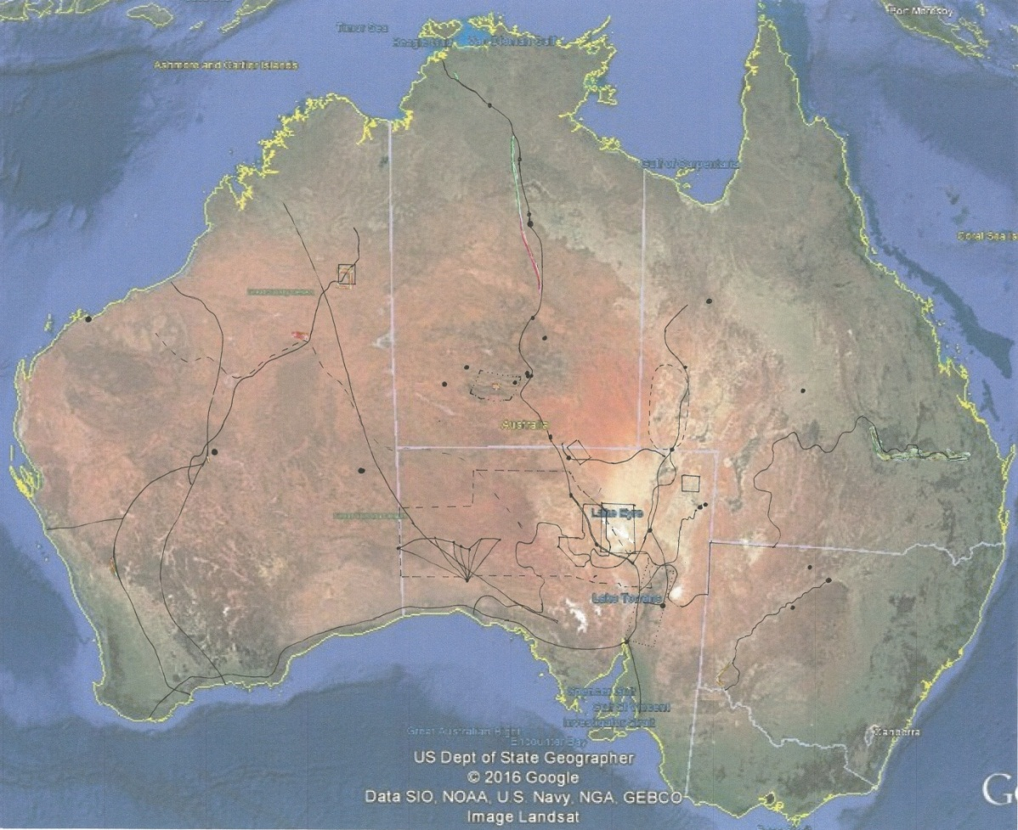
[From Google Earth satellite image, Oct 2017; inked points and lines are the other Preliminary List places identified by this study]

Smith and Hesse 2005:4-6.
Excludes Antarctica. Australian Bureau of Meteorology 2008: 45 cited by Smith 2013:2.
see Heathcote 1965, Mayne 2008, Griffiths 2002.
eg see critiques of Russell Ward’s 1958 rural ‘Australian Legend’ in Nile 2000, Ann Curthoys’ 1999 ‘Expulsion, exodus and exile in white Australian historical mythology’ and Nicholas Gill’s 2005 examination of ‘outback mythology’.
Austrade data show the number of visitors to outback Queensland, outback NSW, outback SA and the Flinders Ranges between 2009 and 2015 were between 325,000 and 511,000 each year, with 288,000-380,000 visiting Alice Springs. From ‘OVERNIGHT VISITORS, BY TOURISM REGION: 2006–07 to 2014–15’ http://tra.gov.au/Tourism_Region_Profiles/Region_profiles/index.html#Outback-Qld, accessed 1/5/2016.
Terms of reference, Appendix 1.
McDonald and Clayton 2016; Context 2014.
Commissioned by the SA Government and the Commonwealth Government.
The exception to this is the McDonald & Clayton (2016) rock art study in which the arid zone is treated at the same level as the rest of Australia, and which identifies several rock sites or complexes as having, or having potential, national heritage significance.
There is also a large amount of regional Aboriginal heritage work undertaken as part of environmental impact assessments, particularly in relation to mining in Western Australia. Little of this work is directly available due to its commercial nature.
These reviews were based on lists of heritage within the Australian arid zone provided by the Department of the Environment in April 2016.
Although the Register of the National Estate was set up for listing places of national heritage significance, the framework for assessing this was less robust than for the National Heritage List and the knowledge of heritage in Australia was more limited. Consequently, if reviewed today, a number of places might be found not to have national level significance, and only a relatively small proportion of places are likely, or have been found, to meet the threshold for National Heritage listing.
This represents some 30 years of identification and listing from the mid-1970s.
See discussion page 52 below.
State heritage registers were however reviewed as potenntial sources of information for the priority places (where these have been previously listed).
Glossary in the project terms of reference.
Glossary, Project Terms of Reference.
The approach also reflects Article 13 of the Burra Charter (Australia ICOMOS 2013) which states that ‘co-existence of cultural values should be recognised, respected and encouraged’.
Glossary, Project Terms of Reference.
We understand that sets of places (serial sites) are not able to be listed as a single place on the National Heritage List, due to the interpretation of the definition of place in the EPBC Act 1999, but they have been included in the study as they appear to be an important place type construct for recognising desert hertiage values. (It is also noted that there is some recognition of serial sites in the National Heritage List Guidelines, where for example it is stated that ‘criterion (a) can be applied to a site, buildings, cultural landscapes or a series of sites’ [study emphasis]).
It is noted that in some cases (eg, Commonwealth land) that airspace is a recognised area, however in these cases it is only where the airspace is over Commonwealth land or sea (EPBC Act 1999, section 525 (1)).
See also Wakelin-King & White (2015) and White & Wakelin-King (2014).
Guidelines for the Assessment of Places for the National Heritage List (AHC 2009).
The study used the general national indicators because it found it difficult to establish meaningful study-specific national indicators given the particular scope of the study.
This is an indicator for cultural heritage places that are iconic desert places or have iconic desert related associations at the national level. Examples of such places are Uluru, the Alice Springs Township, Albert Namitjira and the landscapes painted by him, and the desert art tradition.
The management of individual places is not discussed as this was not required and is in many cases complex or unknown. However, management is discussed under security of place where the management of a place is considered to susbstantively affect the security of a place.
The primary reference is World atlas of desertification (United nations environment programme), edited by N Middleton and DSG Thomas, Edward Arnold, London, 1992.
Smith and Hesse 2005:6.
Brown DA, Taylor J, Bell MA 2008, ‘The demography of desert Australia’, The Rangeland Journal 30(1) 29–43. This paper makes the point that demographic studies treating the arid zone as a distinct region are rare.
Latz 1995: 209, 190, 194; Magarey 1895; Gillen 1968: 21; Alfred Giles 1926[1995]: 28; Hercus 1985.
See review by Barry Hill, The Monthly Feb 2016 https://www.themonthly.com.au/issue/2016/february/1454245200/barry-hill/journey-horseshoe-bend-tgh-strehlow
Primary reference is Veth P, Smith MA, Bowler J, Fitzsimmons K, Williams A. and P. Hiscock 2009, ‘Excavations at Parnkupirti, Lake Gregory, Great Sandy Desert: OSL dates for occupation before the Last Glacial Maximum’, Australian Archaeology 69: 1-10.
McCook 1986, Windmills of the world.
The LGM, dated 25-17,000 years ago, was exceptionally cold and dry, referred to as a ‘cold drought’. Sea levels were at their lowest, 135m below present and so the inland was further from the sea, although not on the west coast of Western Australia. The average temperature was 6 degrees cooler than present. ‘Changes in precipitation, temperature and surface water availability acted together to enlarge desert landscapes … and deserts grew more inhospitable than they are today’ (Hiscock 2008: 56-7). There was an expanded desert area, reduced vegetation, lowering of water tables and drying of surface waters. People withdraw to refugia in uplands or desert margins (Hiscock 2008: 207).
A term used by Colin Harris et al 2002, cited Blake & Cook 2006: 8, in relation to explorers. Mike Smith points out that the explorers used the same stepping stones that Indigenous people had relied on previously (pers comm 2016).
Stuart 1865 chapter 6.
A. Giles 1926[1995]: 27.
see Dunlop’s notes on this early recording project at http://nfsa.gov.au/collection/film-australia-collection/program-sales/programs/attachments/911_peopleauswestdesert.pdf
Luise Hercus pers comm Canberra 1998 and documented in the Diamontina Shire Bedourie tourist information museum displays October 2015.
Managed by the community, Diamontina Shire Council, Queenslad Parks and Wildlife, documented in the Diamontina Shire Bedourie tourist information museum displays October 2015.
See the review of stone arrangements in central Australia by Ross and Smith (in press).
Wilkie Mia is a major ochre mine, not part of this trade route, located in WA which is listed on the NHL under Criteria ABDFI.
The West Kimberley National Heritage Listing includes the values of Rainbow Serpents associated with different forms of water, and the listing of Witjera mound springs under Criterion I recognises the many Ancestral stories crossing through and associated with particular springs.
Alive with the Dreaming! Songlines of the Western Desert Project an ARC funded research project (2013-16).
In 2015 they went to Parnngur to film the Seven Sisters’ travels through that country. The Minyipuru film has been seen and approved by all those involved. It can be viewed at https://vimeo.com/167658526 (Password: SevenSisters). In this Martu women tell the story to Pangkapini, with Yula following them all the way, his snake-like penis chasing them. A big group of Ancestral women and their mothers start at Roebourne in the west. They flew close to Parnngurr, where they dance (NMA 2010: 55, Minyipuru film 2016). As they travel, members of the group are lost, until only the seven sisters continue. At Kalypa (Canning Stock Route Well 23) they meet a group of Ancestral men – the first they have seen. The men try to grab them, the women hit them with their digging sticks and leave them lying as they run away. At Pangkapini (between wells 35 and 36), they see Yurla, or Yula, an Ancestral Old Man, who has been following them all the way. He grabs one sister, but they rescue her by tricking him, flying away from the ladder he builds. ‘Poor old fella, he had a rough time. He was trying and trying and trying’ (NMA 2010: 54). He catches five sisters further east, and again they escape, flying to Marapinti. The Sisters sit down and rest at many rock holes and soaks including Wantili (near Well 25) and then Tiwa (Well 26) and Juntujuntu, a permanent spring next to Well 30 (NMA 2010: 57). Mujingarra (Mutingarra) is another permanent water nearby where the Seven Sisters stopped. It is a large clear pool which supported large groups of people, 6m below ground in a cave known as kurru, the eye of Kurrkurr the night owl (NMA 2010: 58). The eastern most place in the Seven Sisters’ western journey is a rockhole west of Kiwirrkurra named Mirapinti. They travelled there singing and dancing and creating waters and landforms as they went. ‘That’s how we used to travel as a family in bush days, from soak to soak’ (Minyipuru film 2016). They pierce their noses here, then fly east toward Pintupi Country (NMA 2010: 59), also into Ngaanyatajarra and Pitjantjatjarra country (Minyipuru film 2016). There is another film at Kuru Ala in 2014, with the story of the Kungkarangkalpa filmed in that area, around the Pitjantjatjara/Ngaanyatjara border country. It has been approved by Papulankutja women. Kungkarangkalpa Seven Sisters at Kuru Ala (Short Version). Password: Songlines4 https://vimeo.com/165234575 This shows the more eastern travels of the Seven Sisters, Pirilyi to Puyatu and to the rock hole at Tjakaltjara then to Kuru Ala – on the SA side of the SA/WA border. The Traditional Owners for the Songline from the Ngaanyatjara Council dance and sing the story in one of the many places it passes through.
Diana James, Senior Research Associate for the ‘Alive with the Dreaming Project’ writes (8/7/16 email): The first Seven Sisters recorded and edited production was ‘Apulupulu to Alkara’ November 1984, travelling from the pass where they came through the Musgrave Ranges (midway on road from Umuwa to Amata) south through ’Kuli’ and ‘Kungka Yuu’ into sandhill and spinifex country to ‘Alkara’ where the older sister passed away. The second one was called “Kungkarangkalpa - Seven Sisters Mt Conner” (32 min.) recorded April 1985 from Atila through ‘Tjukaltjara’, ‘Tjintjira Kutjara’, ‘Witapula’ to near Mulga Park. This is on Indigitube - http://indigitube.com.au/video/item/673 - and still gets airplay on ICTV to this day. It was edited by Rex Guthrie for a wider audience with a “making of” preamble and limited English titles. We recorded two other expeditions in, I think, 1986 and 1987. One to fill the gap in the songline from Waliny (Cave Hill) through Ipunturkula to Alkanyunta and a remake of the 1984 Kuli to Kungka Yuu filling in bits missed on the first trip. We still didn’t get to the last site where they ascend to the heavens at Innga, as we ran out of supplies and fuel. Neither of these trips ever got edited and published, and some of the footage at least on the first expedition seems to have got lost, but remaining VHS camera originals were still in the EVTV archive. PY Media’s first recording at Kuruala was in 1990 ‘Tjukurpa Kungkarangkalpa Kurualala (Seven sisters at Kuruala)’ 24 min which is on Indigitube http://indigitube.com.au/video/item/694 We returned the following year 1991 for a remake with CAAMA crew who included sections in their documentary ‘Satellite Dreaming’. Ngaanyatjarra Media (Belle and Noeli directing) also did a remake in 2009 “Tjukurpa Kungkarangkalpa Kurualala – Seven Sisters Story at Kuru-ala” (30 min) which is on Indigitube http://indigitube.com.au/video/item/356 (This is the place in the latest 2015 film.)
http://www2.astronomicalheritage.net/index.php/show-entity?identity=53&idsubentity=1
Closer settlement was that belief, and government policy that ideally all land should be used intensively, for agriculture not pastoralism. Agricultural smallholdings ‘supported a more populous, more civilised and more democratic society, with its wealth more equally distributed’. Improvement of the land was a moral requirement: in the colonial ethos, ‘planting a population on uncivilized soil was an act of cultivation, designed to create model societies’ (Gosden 2004: 126).
http://www.anfwdc.asn.au/canning_stock_route.php, accessed 20/11/16.
‘An independent, non-profit cultural organisation that develops and advocates for excellence in creativity and artistic practice in Western Australia’: http://www.form.net.au/our-organisation/about-form/
http://www.environment.sa.gov.au/about-us/our-reports/annual-reports accessed 1/7/2016
Eg - Moseby, K.E. and Read, J.L., 2006. The efficacy of feral cat, fox and rabbit exclusion fence designs for threatened species protection. Biological Conservation, 127(4), pp.429-437; Letnic, M., Crowther, M.S. and Koch, F., 2009. Does a top‐predator provide an endangered rodent with refuge from an invasive mesopredator?. Animal Conservation, 12(4), pp.302-312.
https://www.agric.wa.gov.au/invasive-species/state-barrier-fence-overview Accessed 10/7/16.
http://www.australiangeographic.com.au/news/2013/02/controversy-over-was-rabbit-proof-fence-plans/ Accessed 10/7/16.
See http://monumentaustralia.org.au/themes/disaster/drought/display/51042-goyder%60s-line Accessed 10/7/16.
Woomera rocket range and Maralinga Weapons Testing Facility share a common boundary.
http://www.defence.gov.au/woomera/about.htm, accessed 15/11/16.
Gorman (2007) makes a comparison between Woomera and French Guiana in the 1960s.
Monument Australia http://monumentaustralia.org.au/themes/people/discovery/display/61207-len-beadell accessed 20/8/16.
http://www.naa.gov.au/collection/fact-sheets/fs129.aspx
Available at http://www.industry.gov.au/resource/Documents/radioactive_waste/RoyalCommissioninToBritishNucleartestsinAustraliaVol%201.pdf accessed 29/11/16.
‘The most charitable conclusion which can be drawn regarding the ground patrols for Buffalo (test) is that they were chaotic. Macaulay, who in his evidence said he was given no briefing in relation to the tests [Trans., p.1590], was totally unprepared for his task, was placed in the field to cover thousands of square miles in a vehicle which had to be borrowed, and was without a radio’ (McClelland Royal Commission 1985: 316).
http://www.minister.defence.gov.au/2014/11/05/minister-for-defence-ceremony-marks-the-return-of-maralinga-tjarutja-lands-at-woomera/ accessed 20/09/16
Pers comm 23/8/16, Historian Tom Gara, Crown Solicitor’s Office, SA Government.
see - http://www.maralingatours.com.au accessed 20/10/16
See http://www.nma.gov.au/exhibitions/ngurrara_the_great_sandy_desert_canvas_/home (accessed 29/9/16).
See the extensive bibliography on Kngwarreye’s life and works at http://www.nma.gov.au/exhibitions/utopia_the_genius_of_emily_kame_kngwarreye/further_reading (accessed 1/10/16).
See Briscoe’s autobiography 2010 Racial Folly: A Twentieth-Century Aboriginal Family, ANU E-Press, Canberra.
A barstard like me, 1975; eg Peter Read 1990.
https://www.cooberpedy.sa.gov.au/page.aspx?u=115 accessed 10 July 2016.
Opal is a hydrous silica mineral or mineral gel. The composition of opal is SiO2.nH2O, with a water content that can range from 3% up to 20%, although it is usually no greater than 9% (Bates et al, 1980).
It should be noted however that there is some recognition of serial sites in the National Heritage List Guidelines, where for example it is stated that “criterion (a) can be applied to a site, buildings, cultural landscapes or a series of sites”.
It is noted that in some cases (eg, Commonwealth land) that airspace is a recognised area, however in these cases it is only where the airspace is over Commonwealth land or sea (EPBC Act 1999, section 525 (1)).
See discussion of the Inland Corridor in Mayne 2011.
It is the view of the present study that the mining heritage of Broken Hill should be assessed in the comparative framework of Australian mining.
ICOMOS recommended inscription under cultural criteria (v) and (vi) “as it considered the property to be one of the most ancient managed landscapes in the world and an outstanding illustration of successful human adaptation over many millennia to the exigencies of a hostile environment; and forming an integral part of the traditional belief system of one of the oldest human societies in the world” (WHC-94/CONF.003/7.REV, p12).
see http://www.nma.gov.au/exhibitions/papunya_painting/home, accessed 20/11/16.
See http://www.nma.gov.au/exhibitions/ngurrara_the_great_sandy_desert_canvas_/home (accessed 29/9/16).
Other communities at the same time (1974) incorporated locally significant images into their overall town plans eg Fregon (‘dog foot’), Aileron (sacred board), Indulkana (kangaroo footprint), Ernabella (Seven Sisters) but these were never realised (Johnson 2015: 69).
‘An independent, non-profit cultural organisation that develops and advocates for excellence in creativity and artistic practice in Western Australia’: http://www.form.net.au/our-organisation/about-form/
This claim has not been verified by the present study.
http://canningstockroute.org.au/ accessed 29/11/16.
http://www.anfwdc.asn.au/canning_stock_route.php accessed 30/11/16.
http://permits.canningstockroute.net.au/Resources.aspx accessed 29/11/16.
http://permits.canningstockroute.net.au/Resources.aspx accessed 29/11/16.
This map is a tourist map, and other than for the wells, the specific locations shown on the route are tourist points of interest, not necessarily historically significant locations.
Woomera rocket range and Maralinga Weapons Testing Facility share a common boundary.
http://www.defence.gov.au/woomera/about.htm, accessed 15/11/16.
Monument Australia http://monumentaustralia.org.au/themes/people/discovery/display/61207-len-beadell accessed 20/8/16.
Gorman (2007) makes a comparison between Woomera and French Guiana in the 1960s.
http://www.naa.gov.au/collection/fact-sheets/fs129.aspx
Available at http://www.industry.gov.au/resource/Documents/radioactive_waste/RoyalCommissioninToBritishNucleartestsinAustraliaVol%201.pdf accessed 29/11/16.
‘The most charitable conclusion which can be drawn regarding the ground patrols for Buffalo (test) is that they were chaotic. Macaulay, who in his evidence said he was given no briefing in relation to the tests [Trans., p.1590], was totally unprepared for his task, was placed in the field to cover thousands of square miles in a vehicle which had to be borrowed, and was without a radio’ (McClelland Royal Commission 1985: 316).
http://www.minister.defence.gov.au/2014/11/05/minister-for-defence-ceremony-marks-the-return-of-maralinga-tjarutja-lands-at-woomera/ accessed 20/09/16
Pers comm 23/8/16, Historian Tom Gara, Crown Solicitor’s Office, SA Government.
see - http://www.maralingatours.com.au accessed 20/10/16
As of 2015, the term Woomera Range Complex is used to describe the entire Woomera test and evaluation capability, comprised of the Woomera Test Range, RAAF Base Woomera and associated facilities within the complex (http://www.defence.gov.au/woomera/about.htm accessed 15/11/16.).
(https://www.nps.gov/whsa/learn/historyculture/places.htm accessed 29/11/16).
According to the Australian Department of Defence ‘the Woomera Range Complex is a globally unique military testing range. It covers 122,188 square kilometres in north-west South Australia, about 450 kilometres NNW of Adelaide. It is the largest land testing range in the world (http://www.defence.gov.au/woomera/about.htm, accessed January 2017).
http://www.defence.gov.au/woomera/review/submissions/KokathaUwankaraClaimants.pdf accessed 20/11/16
They also pioneered the use of ethnographic sound recording on wax cylinders and were the first to shoot ethnographic movie film in Australia (Mulvaney and Calaby 1985: 359-60).
The values of this exploration are incorporated in the Burke and Wills and Yandruwandah National Heritage listing.
Land Protection 2005 accessed 25 June 2016.
http://www.environment.sa.gov.au/about-us/our-reports/annual-reports accessed 1/7/2016.
Leader-Elliott and Iwanicki 2002: 159-162.
It was nominated for National Heritage status by Lyn Leader Elliot and Iris Iwanicki (2002: 159-167) as part of their study of the Birdsville and Strezlecki tracks heritage.
‘Native Route across the Arunta Desert’. SAM AA 338/1/24 ‘Journal of Field work in and near the Simpson Desert (Arunta Desert) Central Australia by Norman B. Tindale, Adelaide, 1962 - [1963]: 65-7, held in the South Australian Museum Archive. This document shows the detail of the route taken, further discussed in Hercus 1987: 67-8.
Luise Hercus pers comm Canberra 1998, Hercus 1986, and documented in the Diamantina Shire Bedourie tourist information museum displays October 2015.
Managed by the community, Diamantina Shire Council, Queensland Parks and Wildlife, documented in the Diamantina Shire Bedourie tourist information museum displays October 2015.
Tindale 1962, Hercus 1986.
The core, or trunk, route has been generally defined, using the work of McConnell (1976) and McBryde (1997) as that part of the trade network that carried the greatest variety of goods [and possibly quantity, although this is difficult to establish] and carried what are considered to be the most important items, in most cases from their source. It also includes the major sources of these key goods [or runs through the area in which these goods occur where these are extensively sourced goods) and the key ceremonial and exchange centres of the network.
Anna Creek and Innamincka in South Australia and Carlo, in Queensland, were also an important exchange centre (McConnell 1976, McBryde 1997), but are considered to be too far off the trunk trade route to be included.
Alive with the Dreaming! Songlines of the Western Desert Project an ARC funded research project (2013-16).

