Carbon + Biodiversity Pilot

Guide to using the agsteward.com.au web portal
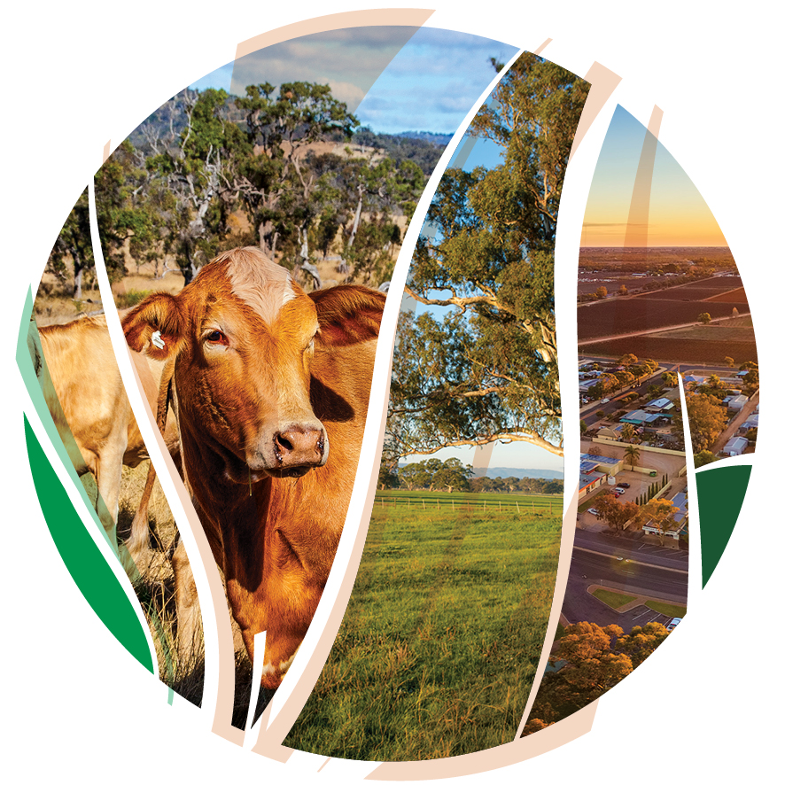
© Commonwealth of Australia 2021
Ownership of intellectual property rights
Unless otherwise noted, copyright (and any other intellectual property rights) in this publication is owned by the Commonwealth of Australia (referred to as the Commonwealth).
Creative Commons licence
All material in this publication is licensed under a Creative Commons Attribution 4.0 International Licence except content supplied by third parties, logos and the Commonwealth Coat of Arms.
Inquiries about the licence and any use of this document should be emailed to copyright@awe.gov.au.

Cataloguing data
This publication (and any material sourced from it) should be attributed as: DAWE 2021, Carbon + Biodiversity Pilot. Guide to using the agsteward.com.au web portal, Department of Agriculture, Water and the Environment, Canberra, March. CC BY 4.0.
This publication is available at https://www.agriculture.gov.au/ag-farm-food/natural-resources/landcare/sustaining-future-australian-farming
Inquiries can be made by email at agstewardship@awe.gov.au.
Department of Agriculture, Water and the Environment
GPO Box 858 Canberra ACT 2601
Telephone 1800 900 090
Web awe.gov.au
Disclaimer
The Australian Government acting through the Department of Agriculture, Water and the Environment has exercised due care and skill in preparing and compiling the information and data in this publication. Notwithstanding, the Department of Agriculture, Water and the Environment, its employees and advisers disclaim all liability, including liability for negligence and for any loss, damage, injury, expense or cost incurred by any person as a result of accessing, using or relying on any of the information or data in this publication to the maximum extent permitted by law.
Acknowledgements
We thank Dr Tyrone Lavery, Professor Andrew Macintosh, Dr Don Butler, and Dr Dean Ansell from the Australian National University (ANU) for their assistance in preparing this document.

Acknowledgement of Country
We acknowledge the Traditional Owners of Country throughout Australia and their continuing connection to land, sea and community. We pay our respects to them and their cultures and to their elders past, present and emerging.

Contents
Acknowledgement of Country 3
1. Role of the Web Portal Guide 5
2. Overview of the Web Portal 6
Landing Page 6
Mapping Page 6
Application Form Page 7
3. Six steps to submitting an application using the Web Portal 9
4. Questions and feedback 15

Role of the Web Portal Guide
The Guide to using the agsteward.com.au web portal (Web Portal Guide) has been developed to help farmers who are considering applying to participate in the Agriculture Stewardship – Carbon + Biodiversity Pilot (C+B Pilot). The C +B pilot documentation explains how the pilot will operate and should be read prior to engaging with the Web Portal and commencing an application.

Overview of the Web Portal
All applications to participate in the C+B Pilot must be made through the Web Portal at: https://www.agsteward.com.au.
The Web Portal consists of three main web pages:
- the Landing Page;
- the Mapping Page; and
- the Application Form Page.

Landing Page
The Landing Page provides an overview of the C+B Pilot, including:
- how the biodiversity payments offered to applicants will be determined;
- how projects will be selected using a benefit–cost score, and how the biodiversity benefit scores will be determined; and
- the eligibility requirements to participate in the C+B Pilot.
The Landing Page also contains maps of the eligible Natural Resource Management (NRM) Regions and details the 6 steps required to submit an application:
Step 1: Click on your NRM region below
Step 2: Draw planting areas on the map
Step 3: Add contact details
Step 4: Add costing information for each planting area
Step 5: Supply a bid price for the biodiversity payment (optional)
Step 6: Submit your application

Mapping Page
There are separate Mapping Pages for each NRM region.
To access your NRM region, click on the applicable NRM Region map on the Landing Page.
The Mapping Page allows applicants to identify their properties and map their planting areas (i.e. the areas where plantings will be established) using a mapping tool.
Once a planting area has been mapped, the site will provide you with:
- an estimate of the size of the planting area (in hectares);
- an estimate of the proportion of the planting area that is likely to be eligible (this is based purely on whether mapped areas are suspected of having forest cover in the previous 7 years – if they are, they are deemed to be ineligible; and
- an estimate of the total amount of carbon dioxide (CO2) that could be sequestered in the eligible portion of the planting area over 25 years under average climate conditions.
The Mapping Page allows you to map multiple planting areas.
Once mapped, these planting areas are then carried forward to the Application Form Page.

Application Form Page
The Application Form Page requires applicants to answer a series of questions and provide specific information. It also allows applicants to submit a bid price (the submission of a bid price is optional). The information provided through the Application Form Page will be used to:
- test eligibility;
- determine the potential biodiversity payment offer for each project; and
- determine the biodiversity benefit score for each project.
This information will ultimately be used to select projects and make biodiversity payment offers.
To make the Application Form Page more accessible, it is divided into three sub-pages:
- the ‘project information page’;
- the ‘planting area page’ (or pages, depending on how many planting areas there are); and
- the ‘submit a bid page’.
The project information page requires information on:
- the applicant;
- the location of the project;
- whether the applicant holds the freehold title for the planting areas; and
- whether the project will have a 25- or 100-year permanence period under the Emissions Reduction Fund (ERF).
The planting area pages require proponents to provide information on each of the planting areas. The required information includes:
- how many mature native trees will be retained and protected within the planting area;
- the proportion of the planting area that is native pastures, improved pastures, crops, weeds or ‘other’;
- whether the planting will be a ‘local vegetation community planting’ or ‘simple mixed native planting’ (as defined in the Planting Protocols);
- details of the type and number of pre-planting weed control treatments that will be undertaken for the project (if any), and the estimated cost of these treatments;
- details of how the soil will be prepared for the plantings and the estimated cost of these soil preparation works;
- details of how the plantings will be established on the site (manual tubestock, mechanical tubestock, direct seeding) and the estimated cost of the plants, seeds and other planting costs;
- details of any tree protection (fencing, guards) that will be installed in the planting area and its estimated cost (broken down by cost component); and
- details of the recurrent management actions that you propose to take in the planting area and the estimated average annual cost of these actions, in 2021 dollar terms (e.g. pest and weed control, and fence maintenance).
The submit a bid page allows applicants to submit a bid price for the biodiversity payment. This is optional. If applicants do not submit a bid price, they will receive a biodiversity payment offer based on the estimated costs of the project.
The submit a bid page also requires applicants to
- commit to act with the utmost good faith in their engagements with the C+B Pilot; and
- consent to the information in the application being transmitted to, and used by, the Department of Agriculture, Water and the Environment to assess participation in the C+B Pilot.

Six steps to submitting an application using the Web Portal
Prior to commencing your application on the Web Portal, you should have read the C+B Pilot Guidelines and Planting Protocol and Pricing Guide for your NRM region (see here), and properly planned you project. Amongst other things, in planning your project you should:
- determine what type of planting you intend to establish (a ‘local vegetation community planting’ or ‘simple mixed native planting’);
- identify where the plantings will be located;
- evaluate what types of species you need to plant and where you can obtain the relevant seedlings or seed;
- determine how you intend to:
  - prepare the site (weeding and soil preparation);
  - plant the plantings (manual tubestock, mechanical tubestock, direct seeding);
  - protect the plantings from livestock and feral grazing pressures (fencing, guards); and
- estimate the likely costs of the project.
Once you have done the project planning, you will be in a position to submit an application through the Web Portal, following the six steps below.

Step 1: Click on your NRM region on the Landing Page
After reading through the explanatory information, click on the map of your NRM region at the bottom of the Landing Page. This will take you through to the Mapping Page for your NRM region.

Step 2: Draw planting areas on the map
Once on the Mapping Page for your region, you will need to locate your property. This can be done using:
- the map controls (either your mouse or the + and – buttons in the bottom right of the page); or
- the property search tool, located at the top of the map (the white box that says ‘search by address’).
There are also tabs at the top of the page that provide background information about the project, important contacts, and relevant documents related to the pilot program, such as information in the Emmissions Reduction Fund.
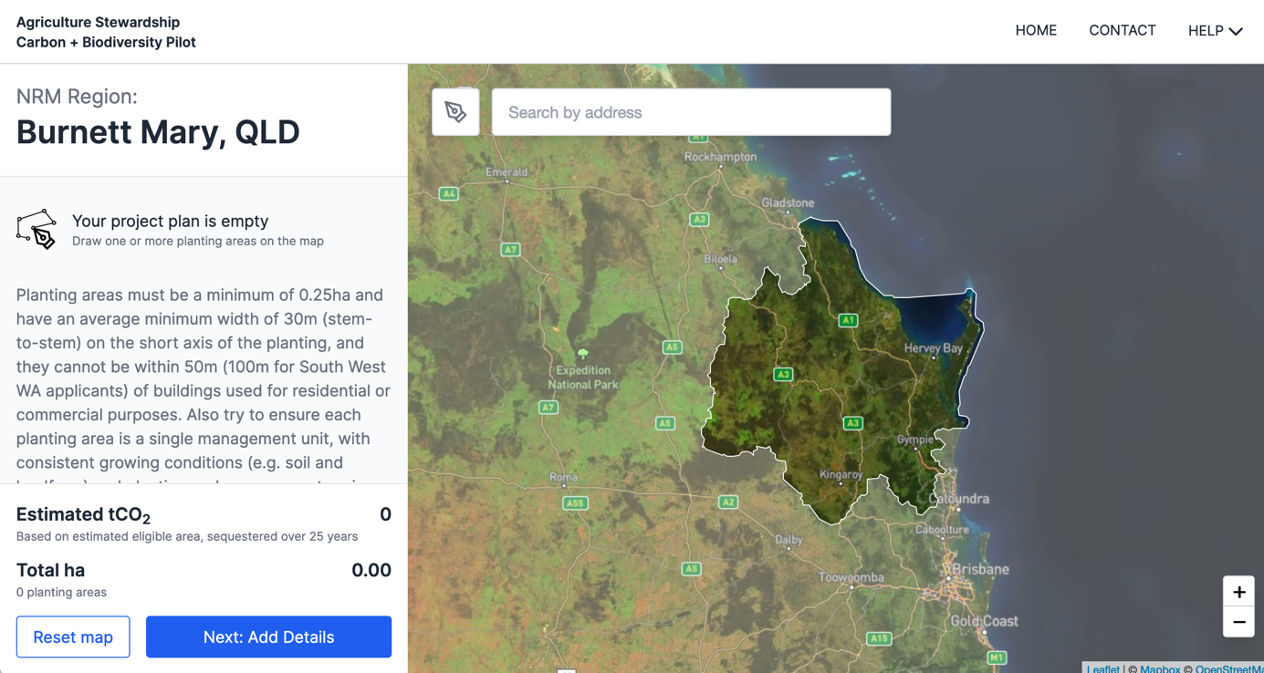
Once you have identified your property, you will need to locate your first proposed planting area.
Having done this, you will need to map the area using the drawing tools on the site. To do this, select the pen tool in the top left corner of the map. 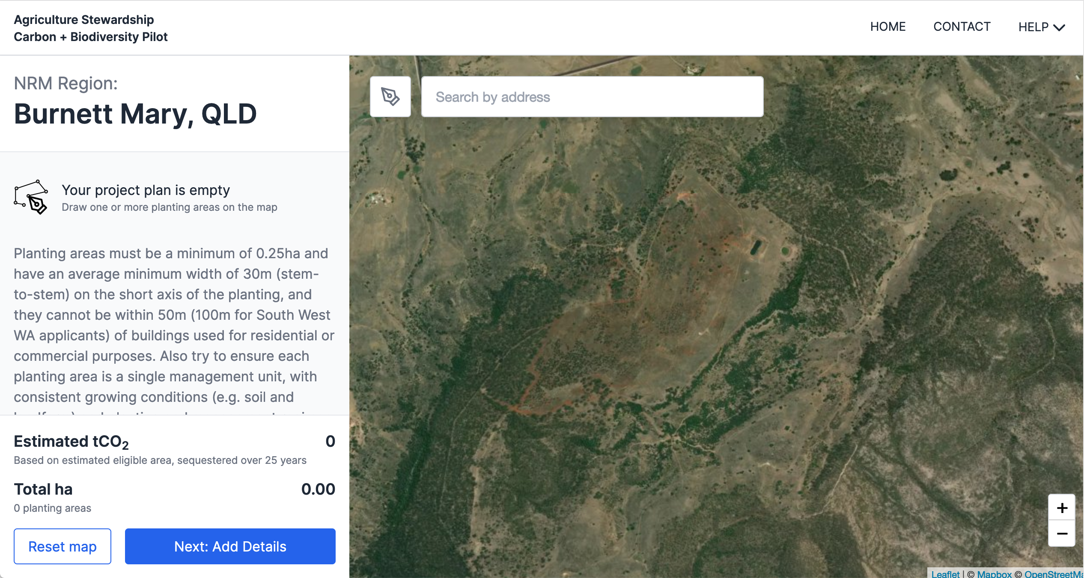
After selecting the pen tool, draw a polygon (a shape consisting of a series of straight line segments) around the boundary of your proposed planting area. You do this by clicking the left button on your mouse at each point where you want to establish a new straight line segment. To complete the polygon, click on the first point you created in the shape.
If you are unhappy with the accuracy of your mapped planting area, it can be erased by clicking on the polygon and then click on the cross at the top left of the map.

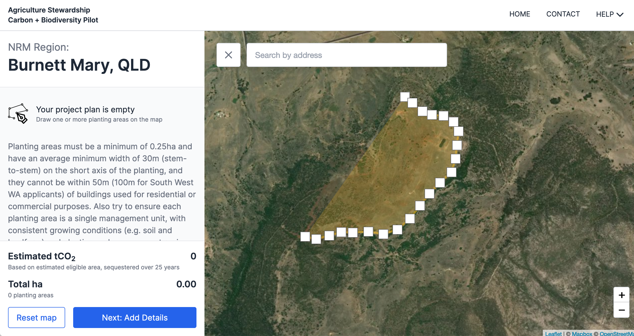
Once the planting area has been mapped, the site will automatically provide you with an estimate of the size of the planting area (in hectares), the proportion of the planting area that is likely to be eligible and the total amount of CO₂ that could be sequestered in the eligible portion of the planting area over 25 years under average climate conditions. This information will be displayed in the panel on the left-hand side of the Mapping Page.
If you have more than one planting area, you will need to map the remaining planting areas following the same procedure. As each planting area is mapped, summary details on the areas will be added to the panel on the left-hand side of the page. At the bottom of this panel, the site provides an aggregate of the planting areas and the amount of CO₂ that could be sequestered in the eligible portions of the planting areas over 25 years.
If you are not happy with your planting areas, you can start again by click “Reset map”, which will erase all of your proposed planting areas. If you want to delete individual planting areas, click on them one at a time and delete them using the cross that appears at the top left of the map.
Once you are happy with your mapped planting areas, click the “Next: Add Details” button at the bottom left of the screen. This will take you through to the Application Form Page.

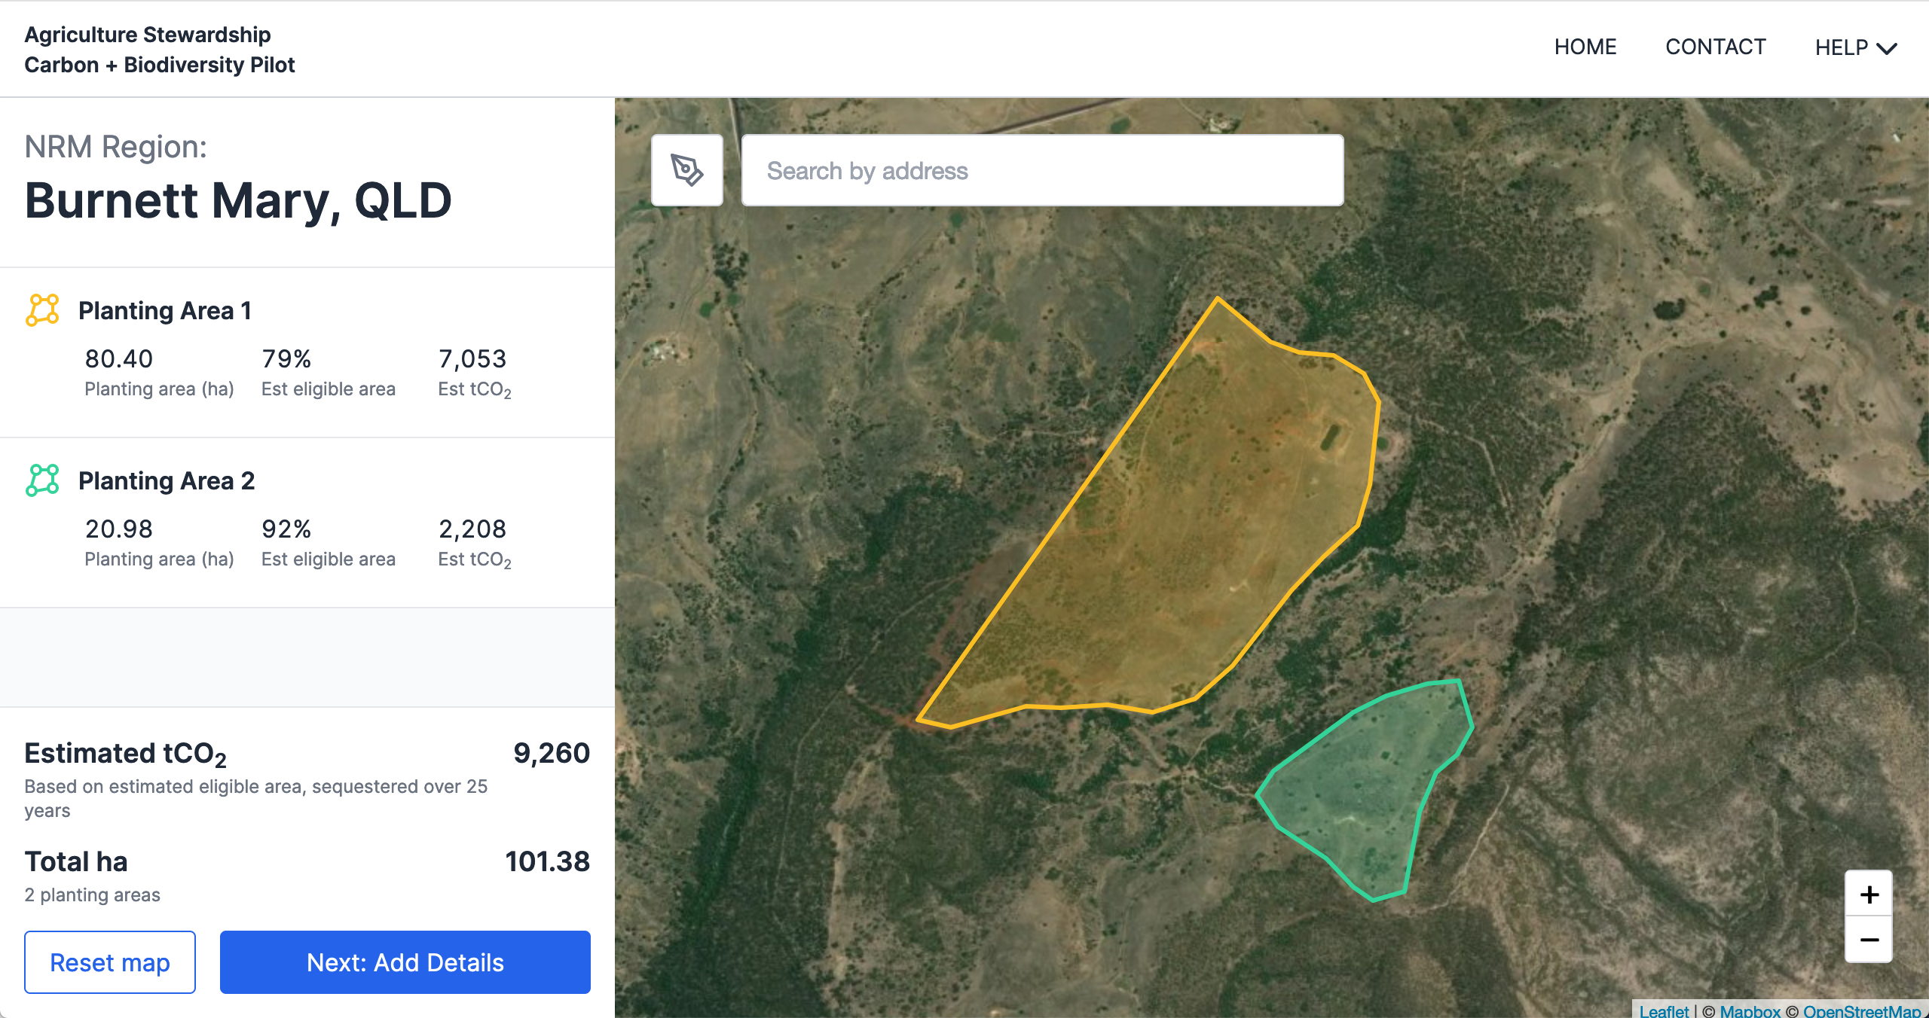 As discussed in section 2 above, the Application Form Page is divided into three sub-pages:
- the ‘project information page’;
- the ‘planting area page’ (or pages, depending on how many planting areas there are); and
- the ‘submit a bid page’., you will be required to add information related to your project and planting area(s).
Before proceeding with the application, you may wish to download additional information on your project areas via the csv link below the map on the right hand side of the project information page. The link provides you with a csv spreadsheet that can be opened in Microsoft Excel. The spreadsheet provides estimates of tonnes of CO₂ that are likely to be sequestered each year in the eligible portions of the planting areas. This information can assist in project planning.
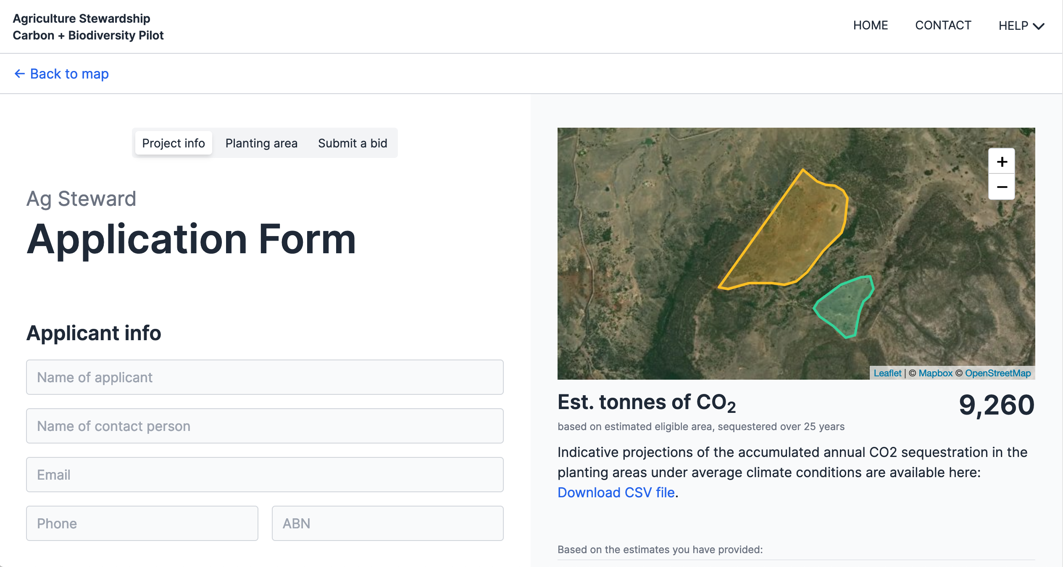

Step 3: Add contact details
The project information page requires applicants to provide the following.
- Applicant information under the title ‘Applicant info’, including:
  - the name of the applicant and their Australian Business Number (ABN); and
  - the name of the contact person for the application and their email and phone number.
- Details of the project under the title ‘Project details’, including:
  - the primary street address for the project; and
  - confirmation that the applicant holds the freehold title for the property or properties on which the project will be located.
- Whether the project will have a 25- or 100-year permanence period under the Emissions Reduction Fund (ERF).
Having provided this information, click “Next” at the bottom of the page to progress to the planting area page.

Step 4: Add costing information for each planting area
Once on the planting area page, you will need to provide detailed project and cost information for each proposed planting area. The required information includes the following.
- Details of how many mature native trees will be retained and protected within the planting area. To qualify as a mature native tree, a tree must:
  - be native to the local area;
  - have a diameter at breast height (130 cm above the ground) of ≥50cm for Eucalypt species and ≥20cm for other native tree species; and
  - be surrounded by a carbon estimation area and located in an exclusion area that will not be grazed by livestock.
- The proportion of the planting area that is native pastures, improved pastures, crops, weeds or ‘other’.
- Confirmation whether the planting will be a ‘local vegetation community planting’ or ‘simple mixed native planting’ (as defined in the Planting Protocols).
- Details of the type and number of pre-planting weed control treatments that will be undertaken for the project (if any), and the estimated cost of these treatments.
- Details of how the soil will be prepared for the plantings and the estimated cost of the soil preparation works (if any).
- Details of how the plantings will be established on the site (manual tubestock, mechanical tubestock, direct seeding) and the estimated cost of the plants, seeds and other planting costs.
- Details of any tree protection (fencing, guards) that will be installed in the planting area and its estimated cost (broken down by cost component).
- Details of the recurrent management actions that you propose to take in the planting areas and the estimated average annual cost of these actions, in 2021 dollar terms (e.g. pest and weed control, and fence maintenance).
Once this information is provided, click “Next” at the bottom of the page to progress to the submit a bid page.

Step 5: Supply a bid price for the biodiversity payment (optional)
The submit a bid page allows applicants to submit a bid price for the biodiversity payment. This is optional. If applicants do not submit a bid price, they will receive a biodiversity payment offer based on the estimated costs of the project.
You submit a bid price by entering the dollar amount you would like to receive as the biodiversity payment under the C+B Pilot.

Step 6: Submit your application
The last three things you need to do to submit your application is:
- agree to act with the utmost good faith in their engagements with the C+B Pilot;
- consent to the information in the application being transmitted to, and used by, the Department of Agriculture, Water and the Environment to assess participation in the C+B Pilot; and
- finally, click on the “Submit” button at the bottom of the submit a bid page.

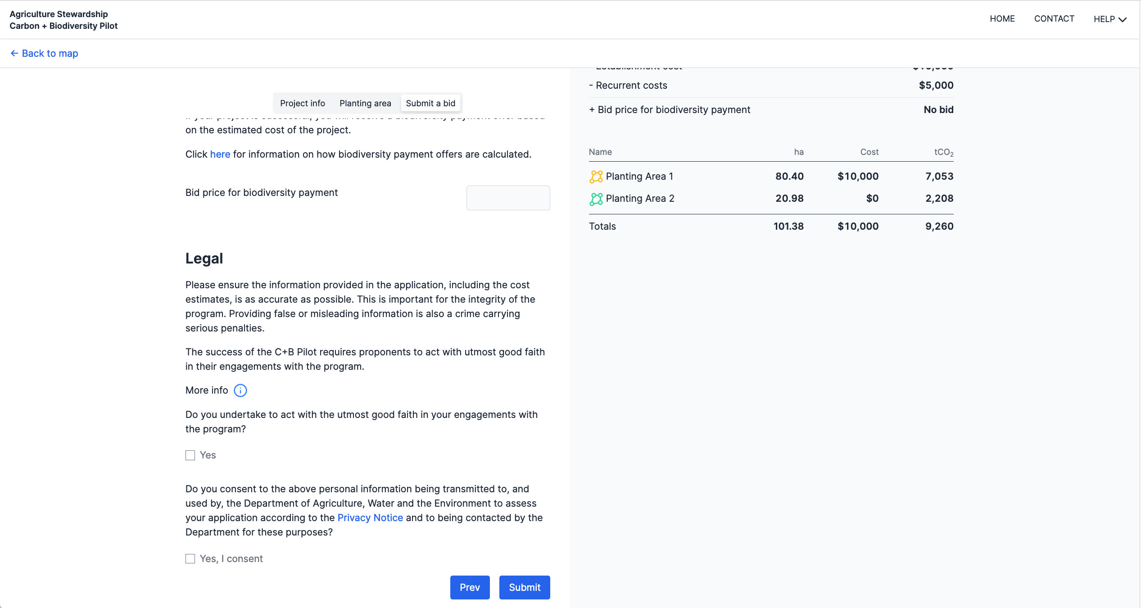

Questions and feedback
Any questions or feedback about this document should be sent to agstewardship@awe.gov.au or you can contact the Department of Agriculture, Water and the Environment on 1800 329 055.

