## No. 29/2025 24 July 2025

# Summary of key issues

* In the week ending 23 July 2025, frontal systems brought rainfall totals of up to 100 millimetres to parts of southern Australia, and up to 50 millimetres in the east. High-pressure systems kept much of the remainder of Australia largely dry.
  + Rainfall was variable across cropping regions, with much of Western Australian and Queensland regions, as well as parts of New South Wales seeing 5-50 millimetres. Meanwhile western areas of South Australia and eastern areas of Victoria received 5-15 millimetres.
  + The ongoing lack of rainfall across the drought affected Mallee regions of South Australia and Victoria continues to present a downside production risk for winter crops.
* Over the coming eight days, rainfall is expected across much of Australia, with southern and eastern regions seeing high rainfall totals.
  + Cropping regions in Queensland, South Australia and Victoria are expected to record between 25-50 millimetres of rainfall, with isolated areas seeing up to 100 millimetres. Falls of between 15-50 millimetres are expected across New South Wales. Western Australian cropping regions are likely to see lower rainfall of 10-50 millimetres. If realised, this should provide timely moisture to support the establishment and growth of winter crops across most growing regions.
* The national rainfall outlook for August to October 2025 indicates an increased probability of above median rainfall across much of central and eastern Australia. Most western regions are likely to see close to average rainfall.
  + If realised, the expectation of average to above average August to October 2025 rainfall across most winter cropping regions is likely be sufficient to support the growth and development of winter crops.

## **Climate**

### Rainfall this week

In the week ending 23 July 2025, **a series of cold fronts** brought rainfall to parts of southern and eastern Australia, while remaining areas of Australia stayed largely dry.

* Rainfall totals of between 10-150 millimetres were recorded across Tasmania.
* Falls of between 5-50 millimetres occurred across parts of southern South Australia, Victoria, and Western Australia, as well as parts of eastern New South Wales and Queensland.
  + Isolated areas of southwest Western Australia and eastern Victoria saw up to 100 millimetres of rainfall.
* Remaining areas of Australia received little to no rainfall over the period.

Rainfall was highly variable across cropping regions in the week ending 23 July 2025.

* Rainfall totals of between 5-15 millimetres occurred across much of Victoria and South Australia, with isolated areas in eastern Victoria and western South Australia seeing higher rainfall.
* Between 5-50 millimetres across much of Western Australia, as well as parts of New South Wales and Queensland.
* These conditions have provided some useful follow-up moisture in parts of southern Australia, including western South Australia and parts of eastern Victoria, New South Wales and Queensland, to support crop growth and development.
  + However, the ongoing lack of rainfall across the drought affected Mallee regions of South Australia and Victoria continues to present an increasing downside production risk for winter crops.

#### Rainfall for the week ending 23 July 2025

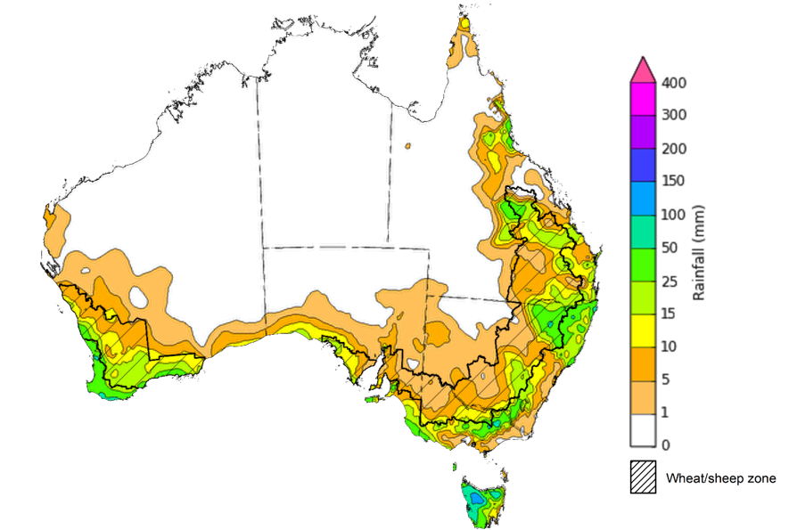

©Commonwealth of Australia 2025, Australian Bureau of Meteorology Issued: 23/7/2025

Note: The rainfall analyses and associated maps utilise data contained in the Bureau of Meteorology climate database, the Australian Data Archive for Meteorology (ADAM). The analyses are initially produced automatically from real-time data with limited [quality control](http://www.bom.gov.au/climate/headers/qc.shtml). They are intended to provide a general overview of rainfall across Australia as quickly as possible after the observations are received. For further information go to <http://www.bom.gov.au/climate/rainfall/>

### Rainfall forecast for the next eight days

Over the 8 days to 24 July 2025, **cold fronts and a northwest cloudband** are expected to bring rainfall to every state and territory, with southern and eastern areas expected to see higher rainfall totals.

* Rainfall totals of between 10-50 millimetres are expected across New South Wales, Victoria, South Australia and Tasmania, as well as southern and central regions of Western Australia and Queensland, and the south of the Northern Territory. Falls of up to 100 millimetres are forecast for isolated areas of eastern Victoria, and southern New South Wales and South Australia.
* Falls of between 5-15 millimetres are forecast for much of the north, with exceptions in the Cape York region where isolated falls of up to 50 millimetres are expected.

Rainfall is expected across all cropping regions over the coming week.

* Falls of between 15-50 millimetres are forecast across Queensland and New South Wales. Higher falls of 25-100 millimetres are expected in Victoria and South Australia. In Western Australia, rainfall totals between 10-50 millimetres are expected across most cropping regions.
  + If realised, this should provide timely moisture to support the growth and development of winter crops across all growing regions, particularly in the Mallee regions of South Australia and Victoria following relatively dry conditions during late June and early July in these areas.

#### Total forecast rainfall for the period 24 July to 31 July 2025

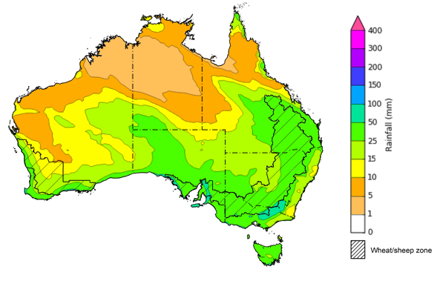

©Commonwealth of Australia 2025, Australian Bureau of Meteorology Issued 24/7/2025

Note: This rainfall forecast is produced from computer models. As the model outputs are not altered by weather forecasters, it is important to check local forecasts and warnings issued by the Bureau of Meteorology.

* 1. **National Climate Outlook**

The El Niño Southern Oscillation (ENSO) and Indian Ocean Dipole (IOD) climate drivers are currently neutral and having minimal influence on Australian rainfall. The ENSO is likely to remain neutral until December. In contrast, the Southern Annular Mode (SAM) is currently strongly positive, but is likely to return to neutral over the coming week. A positive SAM has contributed to reduced cold front rainfall across parts of south-eastern Australia over recent weeks relative to a neutral SAM expectation.

The most recent **rainfall outlook for August 2025** provided by the Bureau of Meteorology indicates that much of the **northern half of Australia** is likely to see **above median rainfall,** with much of **south-western** and parts of the **far south-east of Australia** likely to see close to **below average** falls**.**

* The Bureau of Meteorology’s climate model indicates a 75% chance of August rainfall totals between 5-50 millimetres across much of southern Australia, including southern South Australia, Victoria, eastern and central New South Wales, south-eastern Queensland, Tasmania, southern Western Australia and Tasmania. Meanwhile, parts of south-western Western Australia, western Tasmania and alpine regions of New South Wales and Victoria are expected to see between 50-200 millimetres.
* Despite the increased probabilities of above average rainfall across much of northern Australia, August is within the northern Australian dry season. During this time of year, most of the northern two-thirds of Australia typically receives very low rainfall, with average rainfall less than 5 millimetres for the month of August.
* Across cropping regions, there is a **75% chance** of rainfall totals of between **10-50 millimetres across most southern cropping regions.** If realised, this is expected to provide sufficient moisture to support the growth and development of winter crops across most southern growing regions. In contrast, most Queensland and north-eastern New South Wales cropping regions are likely to see 5-25 millimetres. These lower expected rainfall totals are unlikely to adversely impact crop growth as crops will be able to utilise soil moisture reserves to support their growth and development.

**Rainfall totals that have a 75% chance of occurring in August 2025**

©Commonwealth of Australia 2025, Australian Bureau of Meteorology Issued: 24/7/2025

The **rainfall outlook for August to October 2025** indicates an increased probability of **above median rainfall across much of central and eastern Australia,** including much of Queensland, New South Wales, South Australia, and the Northern Territory. In contrast, isolated areas of western Tasmania and the west of Western Australia are showing a slightly increased probability of **below median rainfall**. Much of Victoria and remainder of Western Australia have an equal probability of above or below average rainfall.

Across cropping regions, the chance of receiving above median rainfall is between 65-85% across Queensland and New South Wales, while South Australia and parts of northern Victoria have a 60-80% probability of receiving above median rainfall over the period. In Western Australia, the probability of above median rainfall is slightly lower at 35-55%.

**Chance of exceeding the median rainfall August 2025 to October 2025**

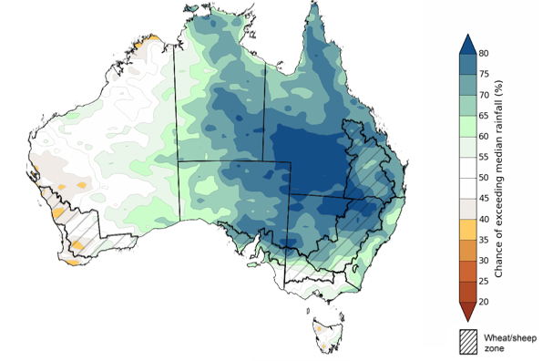

©Commonwealth of Australia 2025, Australian Bureau of Meteorology Issued: 24/7/2025

The **rainfall outlook for August through to October 2025** suggests a 75% chance of receiving rainfall totals of between 25-200 millimetres of rainfall are forecast across much of south-eastern Queensland, New South Wales, Victoria, southern South Australia, southern Western Australia, and eastern Tasmania. Between 200-600 millimetres are expected across the far south-west of Western Australia, western Tasmania, and alpine areas of New South Wales and Victoria. Across much of northern and central Australia, little to no rainfall is forecast over the period.

In **cropping regions**, there is a **75% chance** of receiving between **50-200 millimetres** acrossNew South Wales, Victoria and South Australia. In Queensland and Western Australia, falls of 25-100 millimetres are expected. If realised, these falls are likely be sufficient to support the growth and development of winter crops.

**Rainfall totals that have a 75% chance of occurring August 2025 to October 2025**

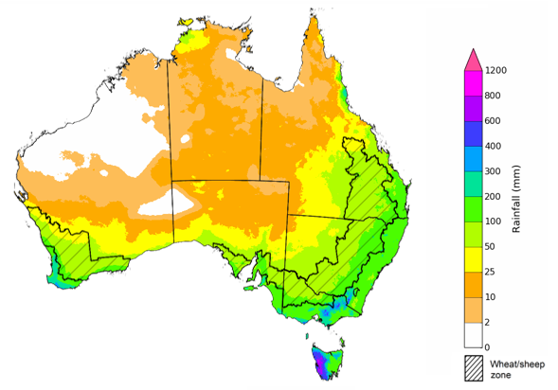

©Commonwealth of Australia 2025, Australian Bureau of Meteorology Issued: 24/7/2025

## **Commodities**

|  |  |  |  |  |  |  |  |  |
| --- | --- | --- | --- | --- | --- | --- | --- | --- |
| **Indicator** | **Week average** | **Unit** | **Latest Price** | **Previous Week** | **Weekly change** | | **Price 12 months ago** | **Annual change** |
| **Selected world indicator prices** |  |  |  |  |  |  | |  |
| AUD/USD Exchange rate | 23-Jul | A$/US$ | 0.65 | 0.65 | 0% | 0.67 | | -2% |
| Wheat – US no. 2 hard red winter wheat, FOB Gulf | 23-Jul | US$/t | 234 | 233 | 0% | 260 | | -10% |
| Corn – US no. 2 yellow corn, FOB Gulf | 23-Jul | US$/t | 194 | 193 | 0% | 177 | | 9% |
| Canola – Rapeseed, Canada, FOB Vancouver | 23-Jul | US$/t | 537 | 533 | 1% | 494 | | 9% |
| Cotton – Cotlook A Index | 23-Jul | USc/lb | 79 | 79 | 0% | 81 | | -3% |
| Sugar – Intercontinental Exchange, nearby futures, no.11 contract | 23-Jul | USc/lb | 16 | 17 | -2% | 19 | | -16% |
| Wool – Eastern Market Indicator | 23-Jul | Ac/kg clean | 1,239 | 1,221 | 1% | 1,093 | | 13% |
| Wool – Western Market Indicator | 23-Jul | Ac/kg clean | 1,373 | 1,355 | 1% | 1,254 | | 9% |
| **Selected Australian grain export prices** |  |  |  |  |  |  | |  |
| Australian Premium White (APW) Wheat, FOB Port Adelaide, SA | 23-Jul | A$/t | 386 | 389 | -1% | 424 | | -9% |
| Australian Standard White (ASW) Wheat, FOB Port Adelaide, SA | 23-Jul | A$/t | 382 | 385 | -1% | 415 | | -8% |
| Feed Barley – FOB Port Adelaide, SA | 23-Jul | A$/t | 369 | 374 | -1% | 367 | | 0% |
| Canola – FOB Kwinana, WA | 23-Jul | A$/t | 819 | 808 | 1% | 757 | | 8% |
| Grain Sorghum – FOB Brisbane, QLD | 23-Jul | A$/t | 426 | 426 | 0% | 411 | | 3% |
| **Selected domestic livestock indicator prices** |  |  |  |  |  |  | |  |
| Beef – Eastern Young Cattle Indicator | 23-Jul | Ac/kg cwt | 756 | 738 | 3% | 631 | | 20% |
| Mutton – Mutton indicator (18–24 kg fat score 2–3), VIC | 23-Jul | Ac/kg cwt | 692 | 693 | 0% | 415 | | 67% |
| Lamb – National Trade Lamb Indicator | 23-Jul | Ac/kg cwt | 1,190 | 1,171 | 2% | 813 | | 46% |
| Pig – Eastern Seaboard (60.1–75 kg), NSW buyer price | 09-Jul | Ac/kg cwt | 452 | 452 | 0% | 409 | | 11% |
| Live cattle – Light steers to Indonesia | 16-Jul | Ac/kg lwt | 345 | 340 | 1% | 300 | | 15% |
| **Global Dairy Trade (GDT) weighted average prices** |  |  |  |  |  |  | |  |
| Dairy – Whole milk powder | 16-Jul | US$/t | 3,928 | 3,859 | 2% | 3,180 | | 24% |
| Dairy – Skim milk powder | 16-Jul | US$/t | 2,785 | 2,718 | 2% | 2,576 | | 8% |
| Dairy – Cheddar cheese | 16-Jul | US$/t | 4,589 | 4,860 | -6% | 4,099 | | 12% |
| Dairy – Anhydrous milk fat | 16-Jul | US$/t | 6,973 | 6,928 | 1% | 6,641 | | 5% |
|  | | | | | | | | |

### Selected world indicator prices

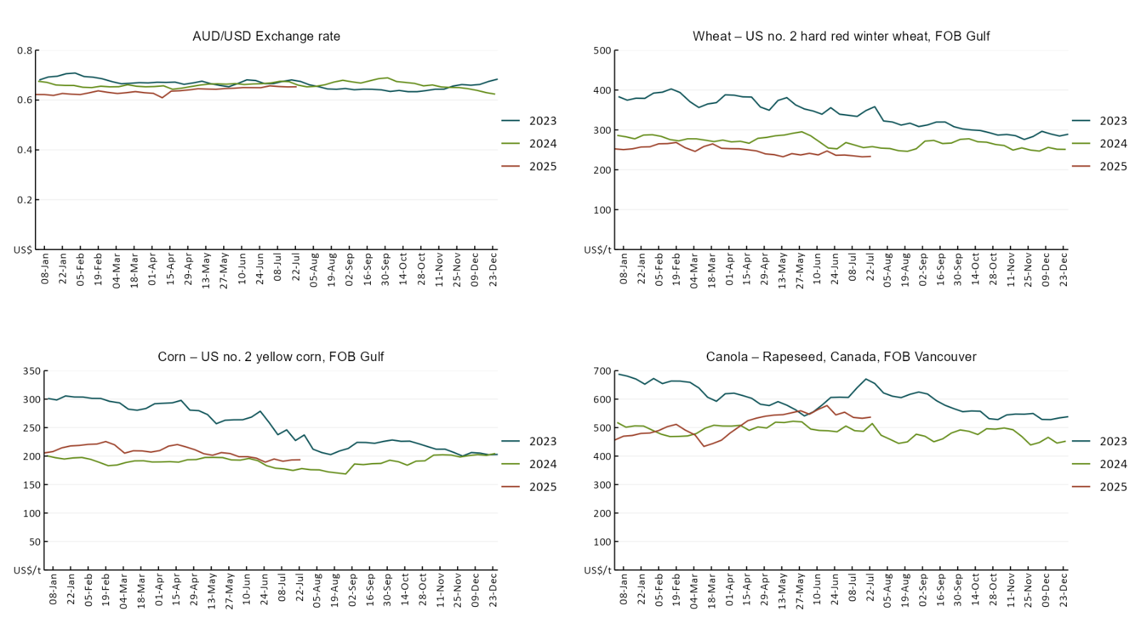

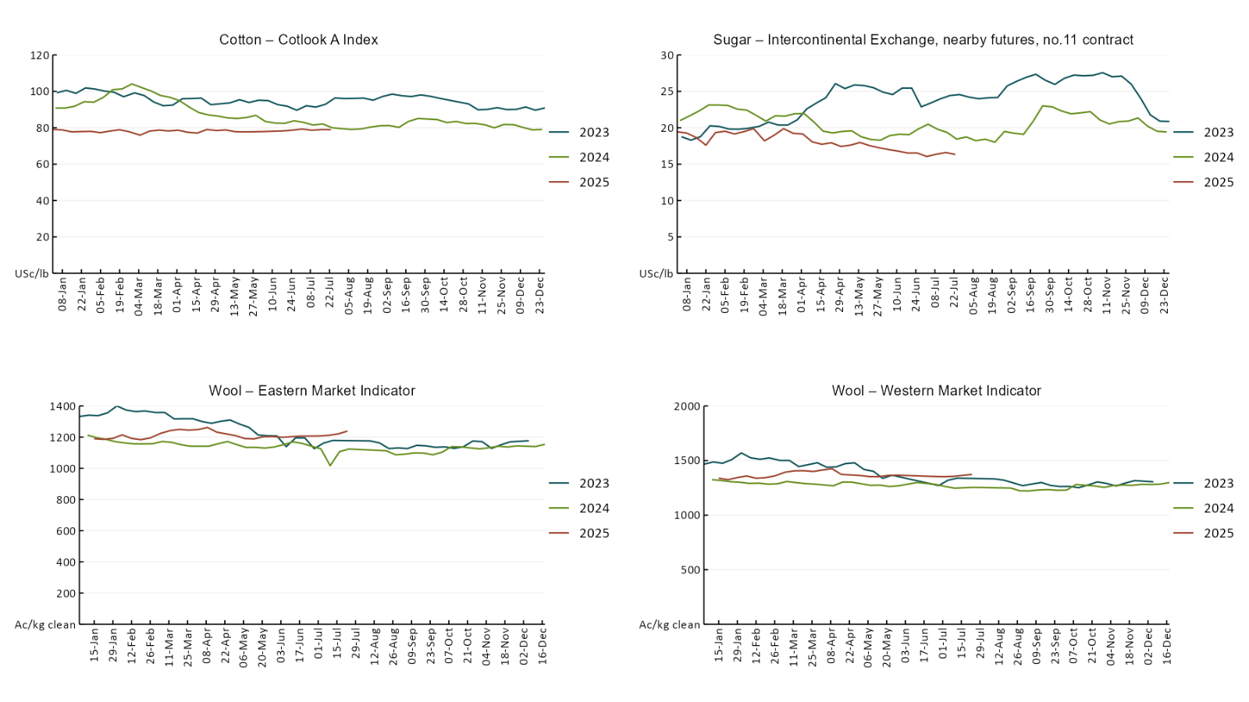

### 3.2 Selected domestic crop indicator prices A line chart of major domestic crop prices. For more information, refer to https://www.agriculture.gov.au/abares/data/weekly-commodity-price-update/world-agricultural-prices

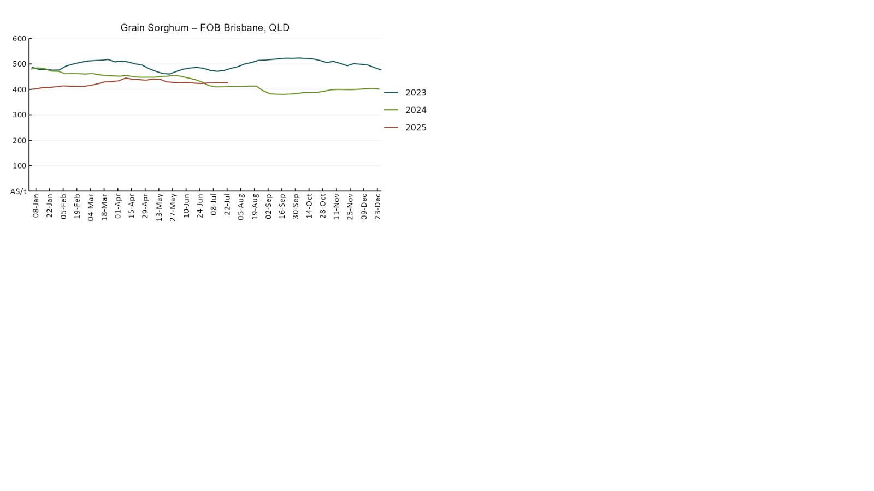

### 3.3 Selected domestic livestock indicator prices

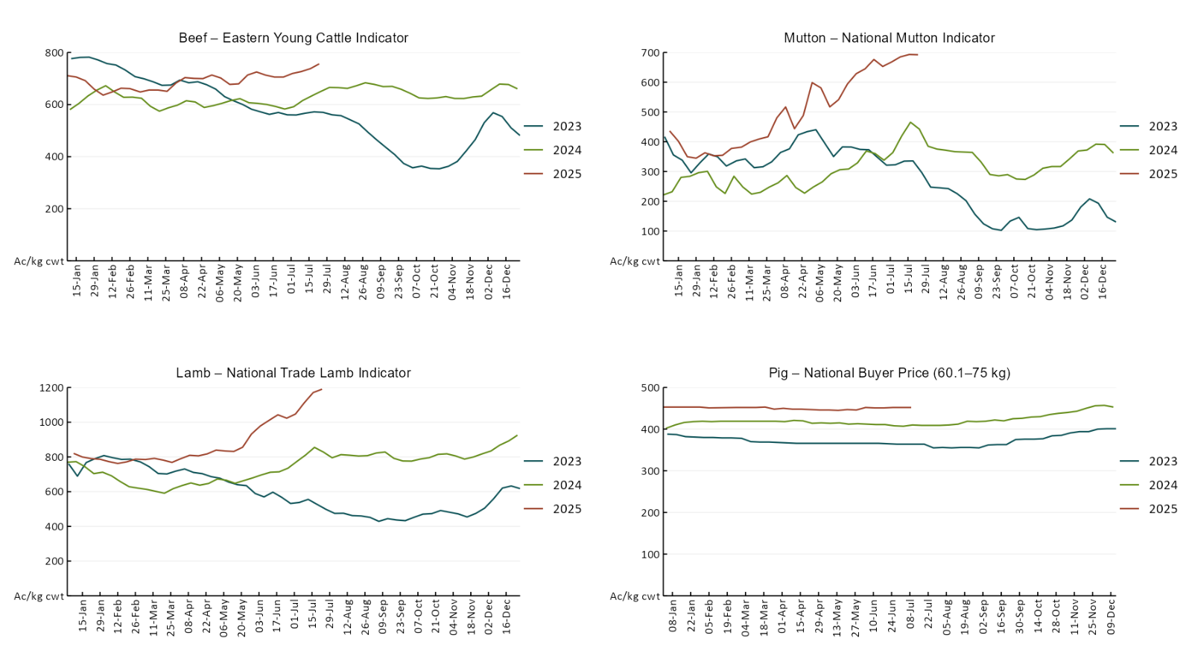

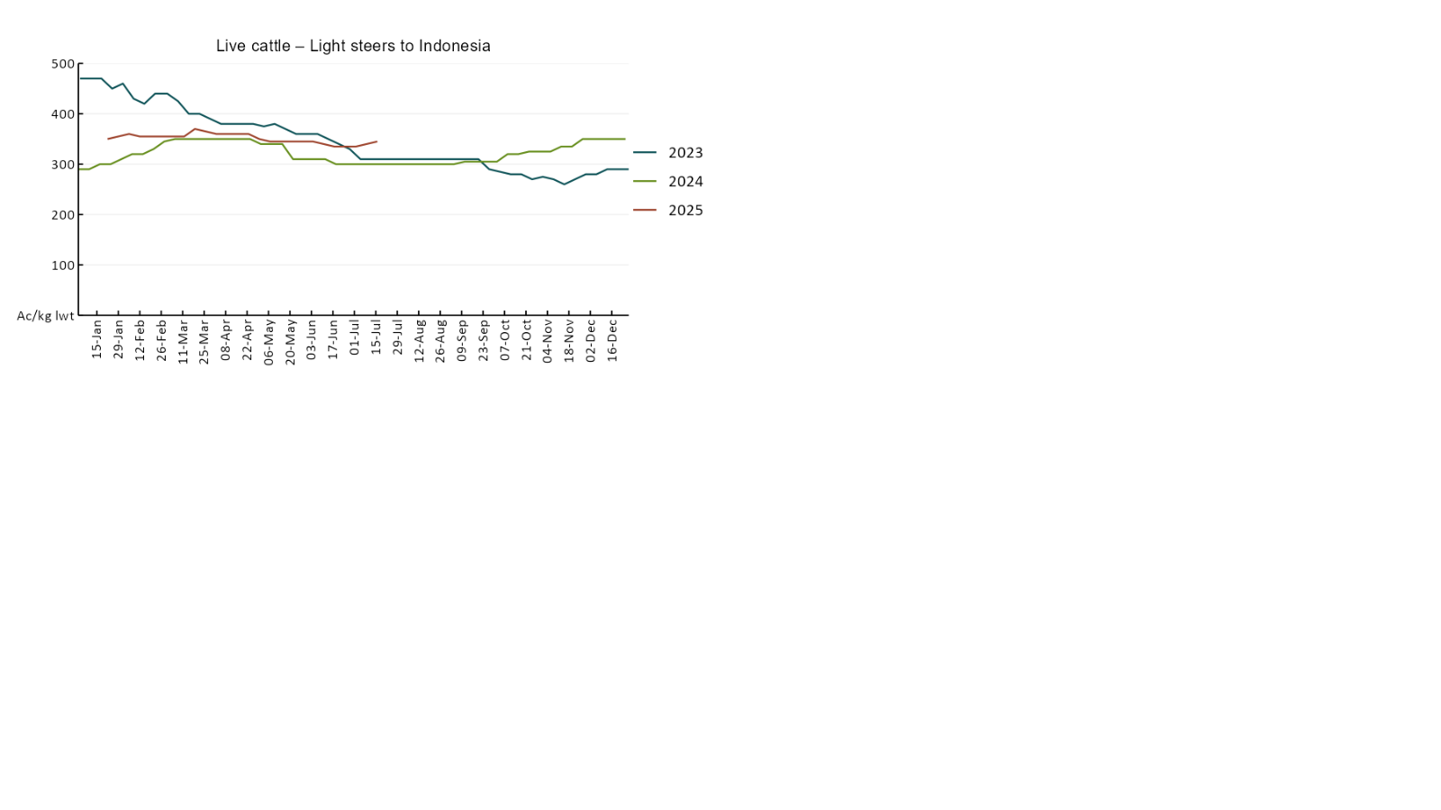

### 3.4 Global Dairy Trade (GDT) weighted average pricesA line chart of Global Dairy Trade prices. For more information, refer to https://www.agriculture.gov.au/abares/data/weekly-commodity-price-update/world-agricultural-prices

### 3.5 Selected fruit and vegetable prices

### A line chart of fruit and vegetable prices. For more information, refer to https://www.agriculture.gov.au/abares/data/weekly-commodity-price-update/world-agricultural-prices

### A line chart of fruit and vegetable prices. For more information, refer to https://www.agriculture.gov.au/abares/data/weekly-commodity-price-update/world-agricultural-prices

### 3.6 Selected domestic fodder indicator prices

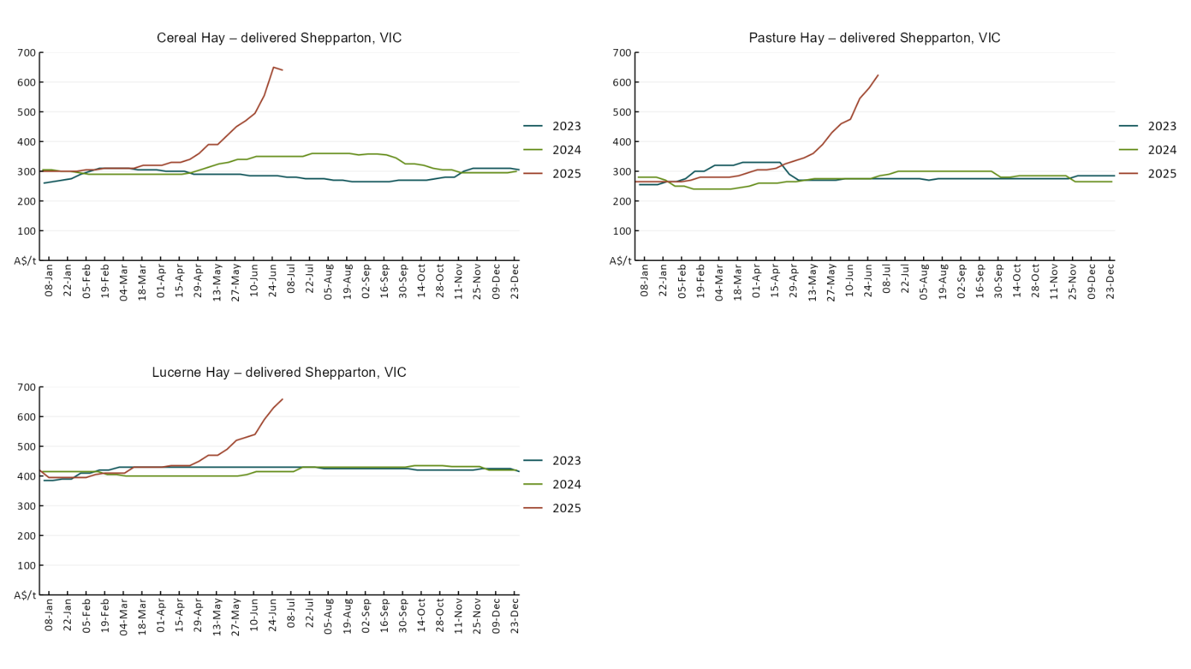

## **4. Data attribution**

### Climate

* Bureau of Meteorology
* Weekly rainfall totals: www.bom.gov.au/climate/maps/rainfall/
* Monthly and last 3-month rainfall percentiles: [www.bom.gov.au/water/landscape/](http://www.bom.gov.au/water/landscape/)
* Temperature anomalies: [www.bom.gov.au/jsp/awap/temp/index.jsp](http://www.bom.gov.au/jsp/awap/temp/index.jsp)
* Rainfall forecast: [www.bom.gov.au/jsp/watl/rainfall/pme.jsp](http://www.bom.gov.au/jsp/watl/rainfall/pme.jsp)
* Seasonal outlook: [www.bom.gov.au/climate/outlooks/#/overview/summary/](http://www.bom.gov.au/climate/outlooks/#/overview/summary/)
* Climate drivers: <http://www.bom.gov.au/climate/enso/>
* Soil moisture: [www.bom.gov.au/water/landscape/](http://www.bom.gov.au/water/landscape/)
* Other
* Pasture growth: [www.longpaddock.qld.gov.au/aussiegrass/](http://www.longpaddock.qld.gov.au/aussiegrass/)
* 3-month global outlooks: [Environment and Climate Change Canada](https://weather.gc.ca/saisons/image_e.html?img=s234pfe1p_cal&bc=prob), [NOAA Climate Prediction Center](https://www.cpc.ncep.noaa.gov/products/predictions/long_range/seasonal.php?lead=2), [EUROBRISA CPTEC/INPE](http://eurobrisa.cptec.inpe.br/), European Centre for Medium-Range Weather Forecasts, [Hydrometcenter of Russia](https://meteoinfo.ru/en/climate/seasonal-forecasts), [National Climate Center Climate System Diagnosis and Prediction Room (NCC)](https://cmdp.ncc-cma.net/pred/cs2gen.php?pred_elem=RAINP#pred_seasonal), [International Research Institute for Climate and Society](https://iri.columbia.edu/our-expertise/climate/forecasts/seasonal-climate-forecasts/)
* Global production: <https://ipad.fas.usda.gov/ogamaps/cropmapsandcalendars.aspx>
* Autumn break: Pook et al., 2009, <https://rmets-onlinelibrary-wiley-com.virtual.anu.edu.au/doi/epdf/10.1002/joc.1833>

### Water

Prices

* Waterflow: <https://www.waterflow.io/>
* Ruralco: <https://www.ruralcowater.com.au/>
* Bureau of Meteorology:
* Allocation trade: <http://www.bom.gov.au/water/dashboards/#/water-markets/mdb/at>
* Storage volumes: <http://www.bom.gov.au/water/dashboards/#/water-storages/summary/drainage>
* Trade constraints:
* Water NSW: <https://www.waternsw.com.au/customer-service/ordering-trading-and-pricing/trading/murrumbidgee>
* Victorian Water Register: <https://www.waterregister.vic.gov.au/TradingRules2019/>

### Commodities

* Fruit and vegetables
* Datafresh: [www.freshstate.com.au](http://www.freshstate.com.au)
* Pigs
* Australian Pork Limited: [www.australianpork.com.au](http://www.australianpork.com.au)
* Dairy
* Global Dairy Trade: [www.globaldairytrade.info/en/product-results/](http://www.globaldairytrade.info/en/product-results/)
* World wheat, canola
* International Grains Council
* World coarse grains
* United States Department of Agriculture
* World cotton
* Cotlook: [www.cotlook.com/](http://www.cotlook.com/)
* World sugar
* New York Stock Exchange - Intercontinental Exchange
* Wool
* Australian Wool Exchange: [www.awex.com.au/](http://www.awex.com.au/)
* Domestic wheat, barley, sorghum, canola and fodder
* Jumbuk Consulting Pty Ltd: http://www.jumbukag.com.au/
* Cattle, beef, mutton, lamb, goat and live export
* Meat and Livestock Australia: [www.mla.com.au/Prices-and-market](http://www.mla.com.au/Prices-and-market)

© Commonwealth of Australia 2025

### Ownership of intellectual property rights

Unless otherwise noted, copyright (and any other intellectual property rights, if any) in this publication is owned by the Commonwealth of Australia (referred to as the Commonwealth).

### Creative Commons licence

All material in this publication is licensed under a [Creative Commons Attribution 4.0 International Licence](https://creativecommons.org/licenses/by/4.0/legalcode) except content supplied by third parties, logos and the Commonwealth Coat of Arms.

Inquiries about the licence and any use of this document should be emailed to [copyright@awe.gov.au](mailto:copyright@awe.gov.au).

https://www.agriculture.gov.au/sites/default/files/images/creative-commons-logo-small.png

### Cataloguing data

This publication (and any material sourced from it) should be attributed as:

ABARES 2025, Weekly Australian Climate, Water and Agricultural Update, Australian Bureau of Agricultural and Resource Economics and Sciences, Canberra, 24 July 2025. CC BY 4.0 DOI: <https://doi.org/10.25814/5f3e04e7d2503>

ISSN **2652-7561**

This publication is available at https://www.agriculture.gov.au/abares/products/weekly_update

Department of Agriculture, Fisheries and Forestry

GPO Box 858 Canberra ACT 2601

Telephone 1800 900 090

Web [agriculture.gov.au/abares](http://awe.gov.au/abares)

### Disclaimer

The Australian Government acting through the Department of Agriculture, Fisheries and Forestry, represented by the Australian Bureau of Agricultural and Resource Economics and Sciences, has exercised due care and skill in preparing and compiling the information and data in this publication. Notwithstanding, the Department of Agriculture, Fisheries and Forestry, ABARES, its employees and advisers disclaim all liability, including liability for negligence and for any loss, damage, injury, expense or cost incurred by any person as a result of accessing, using or relying on any of the information or data in this publication to the maximum extent permitted by law.

### Statement of Professional Independence

The views and analysis presented in ABARES publications, including this one, reflect ABARES professionally independent findings, based on scientific and economic concepts, principles, information and data. These views, analysis and findings may not reflect or be consistent with the views or positions of the Australian Government, or of organisations or groups who have commissioned ABARES reports or analysis. More information on [professional independence](https://www.agriculture.gov.au/abares/about/research-and-analysis#professional-independence) is provided on the ABARES website.

### Acknowledgements

This report was prepared by Holly Beale and Matt Miller.