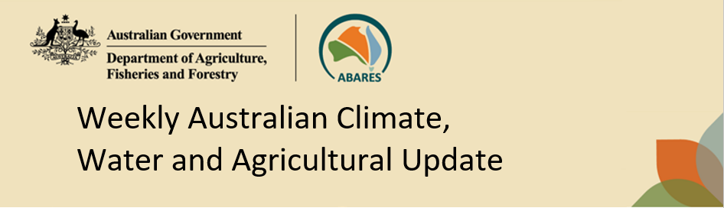
No. 18/2023 11 May 2023

Summary of key issues
- For the week ending 10 May 2023, high-pressure systems kept much of Australia clear and dry. However, a series of colds fronts moved across the south-east of the country, bringing frosty conditions to southern parts of Australia and showers in southern Victoria, southeast New South Wales, southern South Australia and western Tasmania. Troughs brought isolated showers and storms in southwestern Western Australia and the far north of Queensland.
- Little to no rainfall was recorded for most cropping regions, except for some northern Western Australia regions which received rainfall totals of up to 25 millimetres. The predominately dry conditions will have aided the finalisation of summer crop harvest for both northern and southern cropping region. Where soil moisture levels allowed, the mostly dry conditions would have encouraged increased winter crop planting activity, with many growers eager to complete planting programs within the ideal planting window (see Section 1.1).
- The El Niño–Southern Oscillation is in its neutral phase. The El Niño WATCH issued by the Bureau of Meteorology continues. Climate models suggest sea-surface temperatures in the tropical Pacific will exceed El Niño thresholds in July. While the Indian Ocean Dipole (IOD) is currently neutral, a positive IOD event may develop in the coming months. A positive IOD can suppress winter and spring rainfall over much of Australia, potentially exacerbating the drying effect of El Niño (see Section 1.2).
- For June 2023, there is a 75% chance of rainfall totals of between 10 and 50 millimetres across most southern cropping regions. The exceptions being Queensland, northern New South Wales and parts of northern Victoria and eastern South Australia where June rainfall totals are expected to be below 10 millimetres. These are drier than average conditions (see Section 1.3).
- Given that many southern Australian winter cropping regions have received enough rainfall to constitute a consolidated autumn break in March and April, these forecast rainfall totals are likely to be sufficient to provide a favourable start to the winter season. Across parts of northern New South Wales and Queensland where soil moisture levels are below average the expectation of rainfall totals of below 10 millimetres present a significant downside risk for winter crop production (see Section 1.3).
- Over the 8-days to 18 May, high-pressure systems will keep much of the country dry. Fronts and troughs are forecast to bring showers to southern parts of Australia. Moist onshore winds will bring showers to coastal New South Wales and Queensland. Across Australian cropping regions, rainfall totals of up to 15 millimetres are expected for southeast Queensland. Little to no rainfall is expected for the remaining cropping regions in the next eight days (see Section 1.4).
- Water storage levels in the Murray-Darling Basin (MDB) remained steady at 90 percent of total capacity between 4 May 2023 and 11 May 2023. Current volume of water held in storage is 20 128 GL. This is 1 percent or 213 GL more than at the same time last year.
- Allocation prices in the Victorian Murray below the Barmah Choke decreased from $11 on 4 May 2023 to $10 on 11 May 2023. Prices are lower in the Murrumbidgee and regions above the Barmah choke due to the binding of the Murrumbidgee export limit.

Climate

Rainfall this week
For the week ending 10 May 2023, high-pressure systems kept much of Australia clear and dry. However, a series of cold fronts moved across the south-east of the country, bringing frosty conditions to southern parts of Australia and showers in southern Victoria, southeast New South Wales, southern South Australia and western Tasmania. Troughs brought isolated showers and storms in southwestern Western Australia and the far north of Queensland.
Little to no rainfall was recorded for most cropping regions, except for some northern Western Australia regions which received rainfall totals of up to 25 millimetres. The predominately dry conditions will have aided the finalisation of summer crop harvest for both northern and southern cropping regions. Where soil moisture levels allowed, the mostly dry conditions would have encouraged increased winter crop planting activity, with many growers eager to complete planting programs within the ideal planting window.

Rainfall for the week ending 10 May 2023
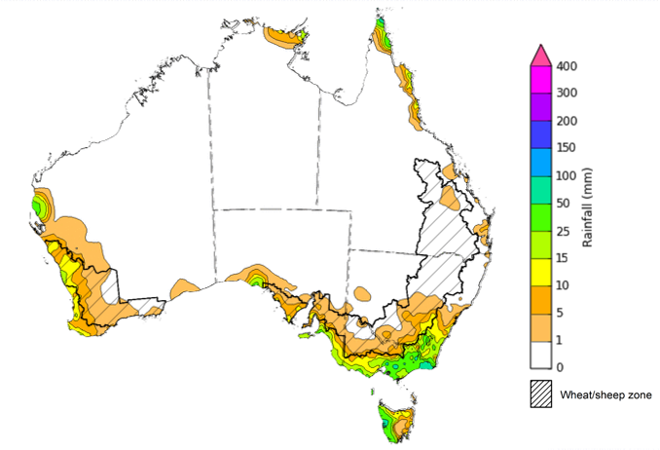
©Commonwealth of Australia 2023, Australian Bureau of Meteorology Issued: 10/05/2023
Note: The rainfall analyses and associated maps utilise data contained in the Bureau of Meteorology climate database, the Australian Data Archive for Meteorology (ADAM). The analyses are initially produced automatically from real-time data with limited quality control. They are intended to provide a general overview of rainfall across Australia as quickly as possible after the observations are received. For further information go to http://www.bom.gov.au/climate/rainfall/

Climate Drivers
The climate drivers with the largest potential impact on Australia’s climate patterns are the El Niño–Southern Oscillation (ENSO), Madden-Julian Oscillation (MJO), Indian Ocean Dipole (IOD) and Southern Annular Mode (SAM). These climate drivers are likely to influence harvest progress of later planted summer crops in northern growing regions, pasture growth across both northern and southern Australia, and planting opportunities and the establishment and growth for winter crops.
The Madden–Julian Oscillation (MJO) pulse is currently over the Maritime continent and is forecast to move into the western Pacific region. At this time of the year MJO has little influence on northern Australia rainfall. However, an MJO pulse over the western Pacific would likely weaken trade winds across the equatorial Pacific Ocean. This, in turn, would result in further warming of the equatorial Pacific Ocean and hence drive further development towards El Niño.
The ENSO is in its neutral phase with both oceanic and atmospheric indicators having returned to neutral levels. Oceanic indicators are measured in terms of the sea surface temperature (SST) anomalies. The weekly difference from average SST between 1 to 7 May the SST were warmer than average over the eastern equatorial Pacific Ocean, with anomalies over 4°C in the far east. The atmospheric indicators are measured in terms of the surface air pressure difference between Tahiti and Darwin, called Southern Oscillation Index (SOI). For the period ending 8 May 2023, the 30-day SOI was -2.2 and the 90-day SOI was +2.5, both in ENSO neutral range. The gradual decrease in the 90-day SOI continues to indicate the formation of an El-Niño event.

Difference from average sea surface temperature observations 1 May to 7 May 2023
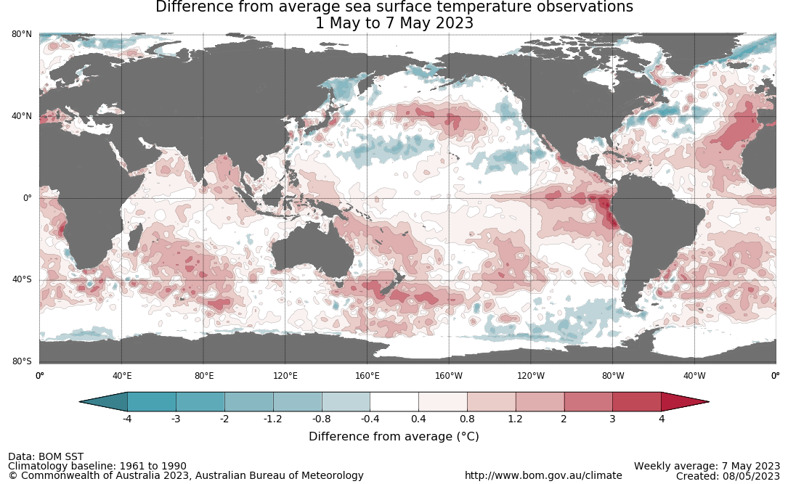

30-day Southern Oscillation Index (SOI) values ending 8 May 2023
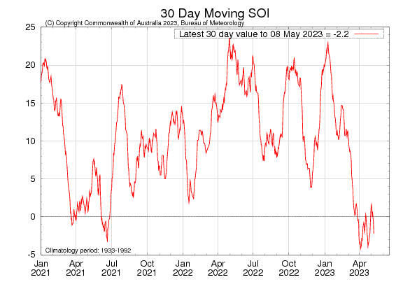
The El Niño WATCH issued by the Bureau of Meteorology continues. This indicates that there is around a 50% chance that an El Niño may develop later in 2023. El Niño WATCH is not a guarantee that El Niño will occur, but it is an indication that some of the typical precursors are currently observed. A significant amount of warmer than average water temperature exists in the western and central tropical Pacific sub-surface, and warmer than average SSTs have emerged in parts of the eastern tropical Pacific in recent weeks. All but one international climate model surveyed by the Australian Bureau of Meteorology suggest sea-surface temperatures in the tropical Pacific will exceed El Niño thresholds in July.

International climate model outlooks for the ENSO in NINO 3.4 region
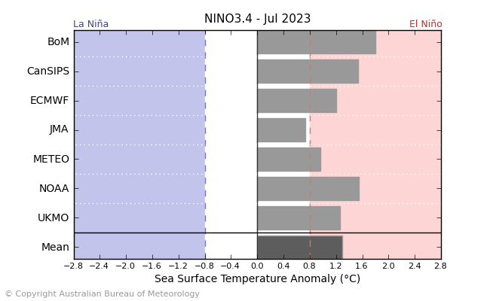
©Commonwealth of Australia 2023, Australian Bureau of Meteorology Issued: 9/5/2023

The Indian Ocean Dipole (IOD) is currently neutral. A negative phase typically sees above average winter-spring rainfall in Australia, while a positive phase brings drier than average seasons. All international climate models surveyed by the Bureau of Meteorology suggest a positive IOD event may develop in June. A positive IOD can supress winter and spring rainfall over much of central and south-eastern Australia, potentially exacerbating the drying effect of El Niño.

International climate model outlook for the Indian Ocean Dipole
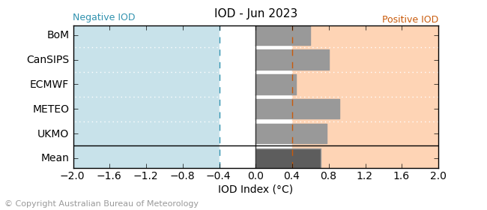
©Commonwealth of Australia 2023, Australian Bureau of Meteorology Issued: 9/5/2023

The Southern Annular Mode (SAM) index is currently positive and is expected to return to neutral towards the end of May. SAM typically has a weaker influence on Australian rainfall during autumn, but as we approach winter, positive SAM often has a drying influence for parts of south-west and south-east Australia.
Southern Annular Mode (SAM) daily index
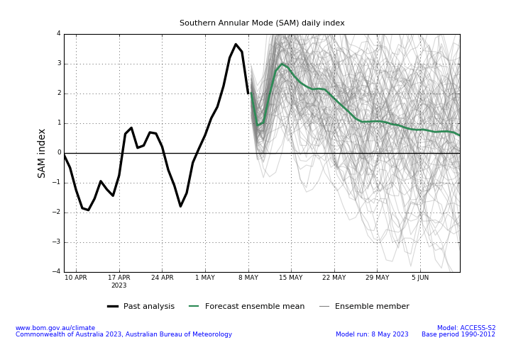

National Climate Outlook
These climate outlooks are generated by ACCESS–S (Australian Community Climate Earth-System Simulator–Seasonal). ACCESS–S is the Bureau of Meteorology's dynamic (physics-based) weather and climate model used for monthly, seasonal, and longer-lead climate outlooks. For further information, go to http://www.bom.gov.au/climate/ahead/about/.
The Bureau of Meteorology’s latest rainfall outlook for June 2023 indicates drier than average conditions are expected across much of Australia.
The ACCESS-S climate model suggests that there is a 75% chance of rainfall totals between 10 and 50 millimetres across eastern New South Wales, scattered areas of coastal Queensland, much of Victoria and Tasmania, southern South Australia, and the southwest of Western Australia. Rainfall totals in excess of 100 millimetres are expected along coastal southwest Western Australia and western Tasmania.
There is a 75% chance of rainfall totals of between 10 and 50 millimetres across most southern cropping regions. The exceptions being Queensland, northern New South Wales and parts of northern Victoria and eastern South Australia where June rainfall totals are expected to be below 10 millimetres. Given that many southern Australian winter cropping regions have received enough rainfall to constitute a consolidated autumn break in March and April, these forecast rainfall totals are likely to be sufficient to provide a favourable start to the winter season. Across parts of northern New South Wales and Queensland where soil moisture levels are below average and the expectation of rainfall totals of below 10 millimetres present a significant downside risk for winter crop production.
Rainfall totals that have a 75% chance of occurring in June 2023
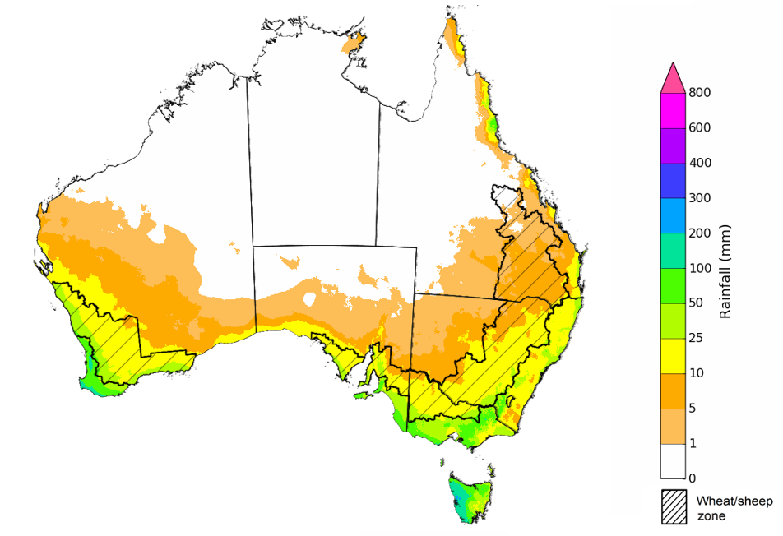

©Commonwealth of Australia 2023, Australian Bureau of Meteorology Issued: 11/05/2023

The rainfall outlook for June to August 2023 suggests that below median rainfall is likely to very likely (60% to greater than 80% chance) for much of Australia. However, there is close to equal chances of above or below median rainfall for parts of tropical Queensland and the Northern Territory, coastal New South Wales, central and northern Western Australia, as well as in the western Tasmania.
Bureau of Meteorology rainfall outlooks for June to August have greater than 55% past accuracy across most of Australia. Outlook accuracy is greater than 65% across large areas of western and eastern Australia. However, there is low past accuracy for scattered areas of northern Australia.
Chance of exceeding the median rainfall June to August 2023
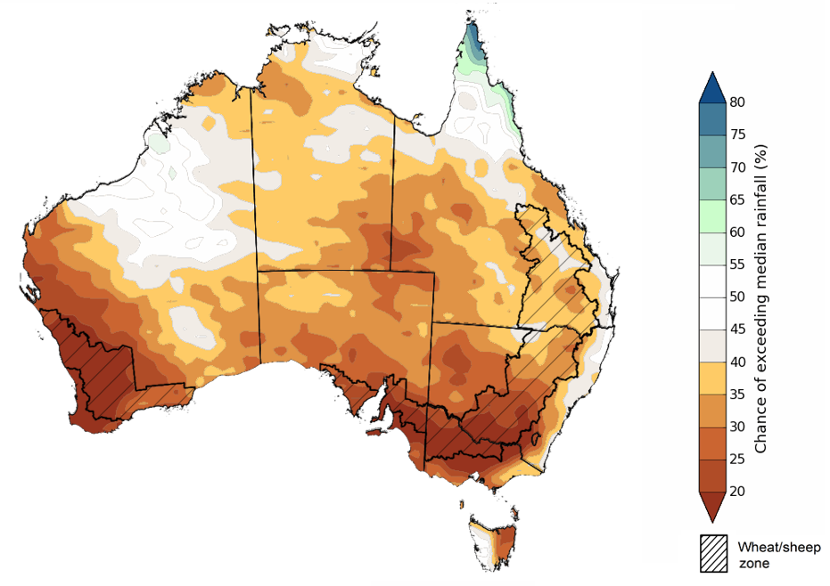
©Commonwealth of Australia 2023, Australian Bureau of Meteorology Issued: 11/05/2023

The outlook for June to August 2023 suggests there is a 75% chance of rainfall totals between 25 and 200 millimetres across central and eastern New South Wales, the southeast and coastal Queensland, southern parts of South Australia and Western Australia, and much of Victoria and Tasmania. Rainfall totals more than 200 millimetres are forecast for alpine regions of Victoria and New South Wales (snowy mountains), part of coastal northeast Queensland, far southwest of Western Australia and western Tasmania.
Across most winter cropping regions there is a 75% chance of receiving between 25 and 100 millimetres, except for northern Queensland where rainfall totals are expected to be below 25 millimetres.
Rainfall totals that have a 75% chance of occurring June to August 2023 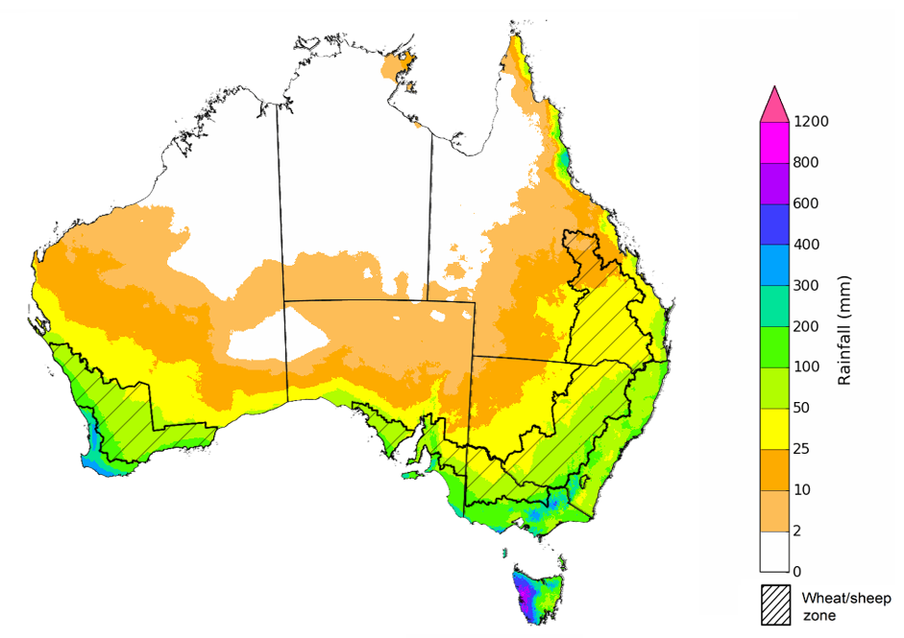
©Commonwealth of Australia 2023, Australian Bureau of Meteorology Issued: 11/05/2023

The temperature outlook for June to August 2023 indicates that maximum temperatures across the tropical north and central Australia are likely to be close to the 1990-2012 average (-1°C to +1°C) while slightly warmer (up to +2°C) across much of New South Wales, central and southern Western Australia, southern Queensland, northern Victoria, and in parts of South Australia and isolated parts of southern Tasmania. The minimum temperatures across most of Australia are expected to be close to the 1990-2012 average (-1°C to +1°C).
Predicted maximum temperature anomaly for June to August 2023
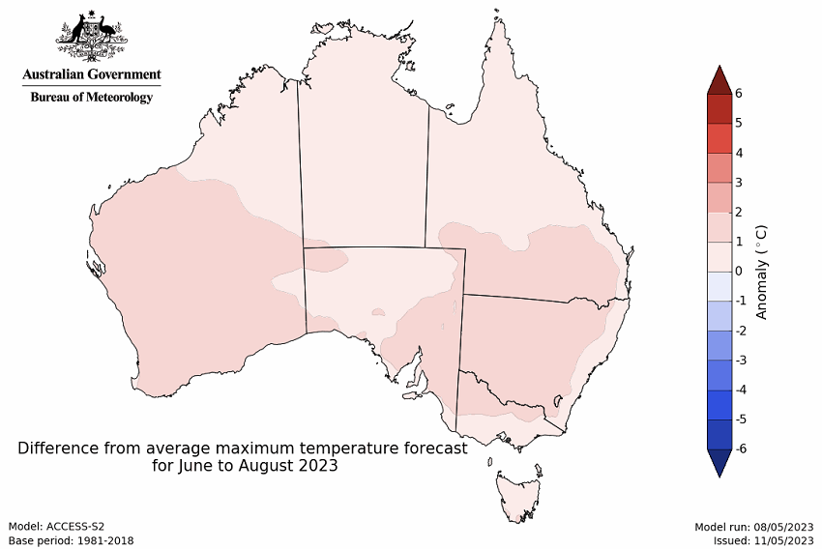
Predicted minimum temperature anomaly for June to August 2023
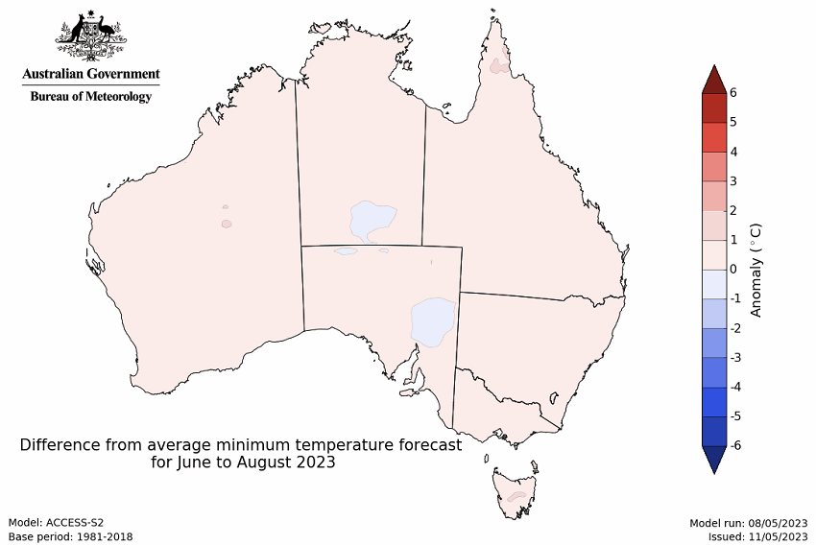

Rainfall forecast for the next eight days
Over the 8-days to 18 May 2023, high-pressure systems will keep much of the country dry. Fronts and troughs will bring showers to southern parts of Australia. Moist onshore winds will bring showers along the coasts of New South Wales and Queensland.
Across Australian cropping regions, rainfall totals of up to 15 millimetres are expected for southeast Queensland. Little to no rainfall is expected for the remaining cropping regions in the next eight days. Despite the lack of a typical autumn break across some southern growing regions, numerous lower rainfall total (5 to 15 millimetre) events have slowly built up the level of soil moisture, giving growers increased confidence to continue to plant winter crops given above average soil moisture levels in many regions.

Total forecast rainfall for the period 11 May to 18 May 2023
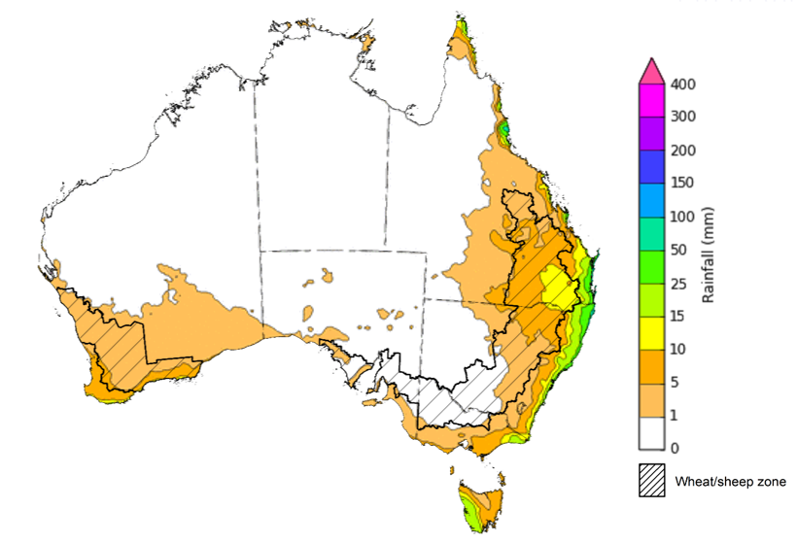

©Commonwealth of Australia 2023, Australian Bureau of Meteorology Issued 11/05/2023
Note: This rainfall forecast is produced from computer models. As the model outputs are not altered by weather forecasters, it is important to check local forecasts and warnings issued by the Bureau of Meteorology.

Water

Water markets – current week
Water storage levels in the Murray-Darling Basin (MDB) remained steady at 90 percent of total capacity between 4 May 2023 and 11 May 2023. Current volume of water held in storage is 20 128 GL. This is 1 percent or 213 GL more than at the same time last year.

Water storages in the Murray-Darling Basin, 2013–2023
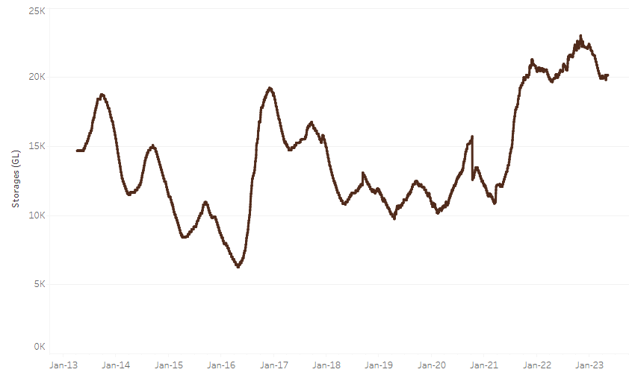
Allocation prices in the Victorian Murray below the Barmah Choke decreased from $11 on 4 May 2023 to $10 on 11 May 2023. Prices are lower in the Murrumbidgee and regions above the Barmah choke due to the binding of the Murrumbidgee export limit.
Water storage data is sourced from the Bureau of Meteorology.

Region | $/ML
NSW Murray Above | 7
NSW Murrumbidgee | 4
VIC Goulburn-Broken | 9
VIC Murray Below | 10

Surface water trade activity, Southern Murray–Darling Basin
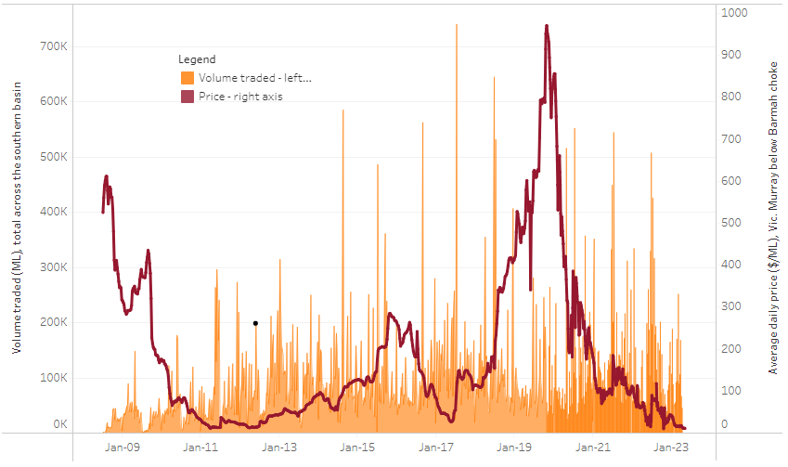
The trades shown reflect estimated market activity and do not encompass all register trades. The price is shown for the VIC Murray below the Barmah choke. Historical prices (before 1 July 2019) are ABARES estimates after removing outliers from BOM water register data. Prices after 1 July 2019 and prior to the 30 October 2019 reflect recorded transaction prices as sourced from Ruralco. Prices after the 30 October 2019 are sourced from Waterflow. Data for volume traded is sourced from the BOM water register. Only the price data shown is current on 11 May 2023.

To access the full, interactive, weekly water dashboard, which contains the latest and historical water storage, water market and water allocation information, please visit https://www.agriculture.gov.au/abares/products/weekly_update/weeakly-update-11523

Commodities
Indicator | Week ended | Unit | Latest Price | Previous Week | Weekly change | Price 12 months ago | Annual change
Selected world indicator prices
AUD/USD Exchange rate | 10-May | A$/US$ | 0.68 | 0.67 | 2% | 0.70 | -3%
Wheat – US no. 2 hard red winter wheat, fob Gulf | 10-May | US$/t | 371 | 338 | 10% | 558 | -33%
Corn – US no. 2 yellow corn, fob Gulf | 10-May | US$/t | 274 | 277 | -1% | 346 | -21%
Canola – Rapeseed, Canada, fob Vancouver | 10-May | US$/t | 599 | 569 | 5% | 965 | -38%
Cotton – Cotlook 'A' Index | 10-May | USc/lb | 95 | 94 | 1% | 165 | -42%
Sugar – Intercontinental Exchange, nearby futures, no.11 contract | 10-May | USc/lb | 25.8 | 25.2 | 2% | 20 | 29%
Wool – Eastern Market Indicator | 03-May | Ac/kg clean | 1,284 | 1,310 | -2% | 1,384 | -7%
Wool – Western Market Indicator | 03-May | Ac/kg clean | 1,418 | 1,479 | -4% | 1,451 | -2%
Selected Australian grain export prices
Milling Wheat – APW, Port Adelaide, SA | 10-May | A$/t | 434 | 445 | -2% | 617 | -30%
Feed Wheat – ASW, Port Adelaide, SA | 10-May | A$/t | 405 | 419 | -3% | 582 | -30%
Feed Barley – Port Adelaide, SA | 10-May | A$/t | 387 | 401 | -4% | 547 | -29%
Canola – Kwinana, WA | 10-May | A$/t | 859 | 869 | -1% | 1,310 | -34%
Grain Sorghum – Brisbane, QLD | 10-May | A$/t | 476 | 483 | -1% | 447 | 6%
Selected domestic livestock indicator prices
Beef – Eastern Young Cattle Indicator | 10-May | Ac/kg cwt | 633 | 660 | -4% | 1,105 | -43%
Mutton – Mutton indicator (18–24 kg fat score 2–3), Vic | 10-May | Ac/kg cwt | 415 | 456 | -9% | 626 | -34%
Lamb – Eastern States Trade Lamb Indicator | 10-May | Ac/kg cwt | 628 | 650 | -3% | 802 | -22%
Pig – Eastern Seaboard (60.1–75 kg), average of buyers & sellers | 26-Apr | Ac/kg cwt | 357 | 357 | 0% | 368 | -3%
Goats – Eastern States (12.1–16 kg) | 05-Apr | Ac/kg cwt | 280 | 280 | 0% | 815 | -66%
Live cattle – Light steers ex Darwin to Indonesia | 17-Aug | Ac/kg lwt | 420 | 480 | -13% | 320 | 31%
Live sheep – Live wethers (Muchea WA saleyard) to Middle East | 14-Sep | $/head | 93 | 113 | -18% | 114 | -18%
Global Dairy Trade (GDT) weighted average prices ª
Dairy – Whole milk powder | 10-May | A$/US$ | 0.68 | 0.67 | 2% | 0.70 | -3%
Dairy – Skim milk powder | 10-May | US$/t | 371 | 338 | 10% | 558 | -33%
Dairy – Cheddar cheese | 10-May | US$/t | 274 | 277 | -1% | 346 | -21%
Dairy – Anhydrous milk fat | 10-May | US$/t | 599 | 569 | 5% | 965 | -38%
a Global Dairy Trade prices are updated twice monthly on the first and third Tuesday of each month.

Selected world indicator prices
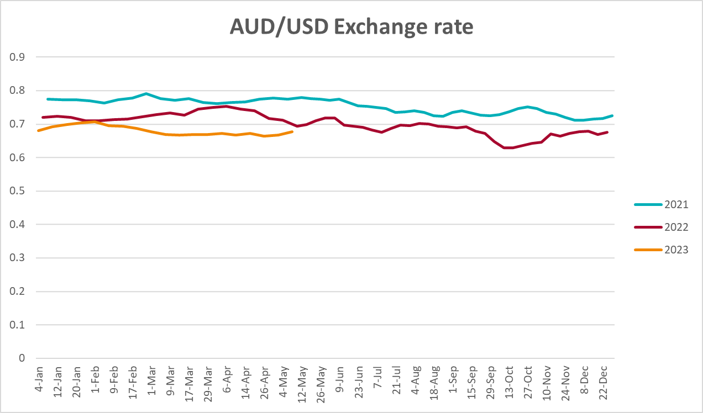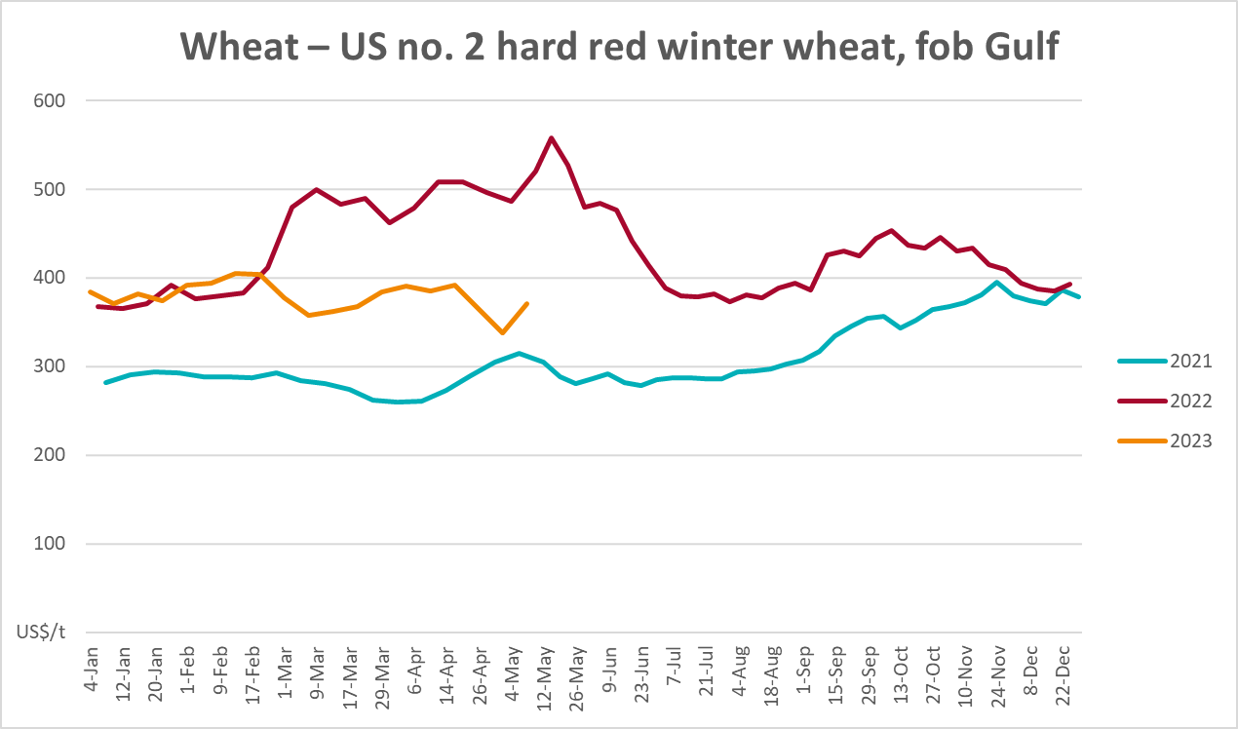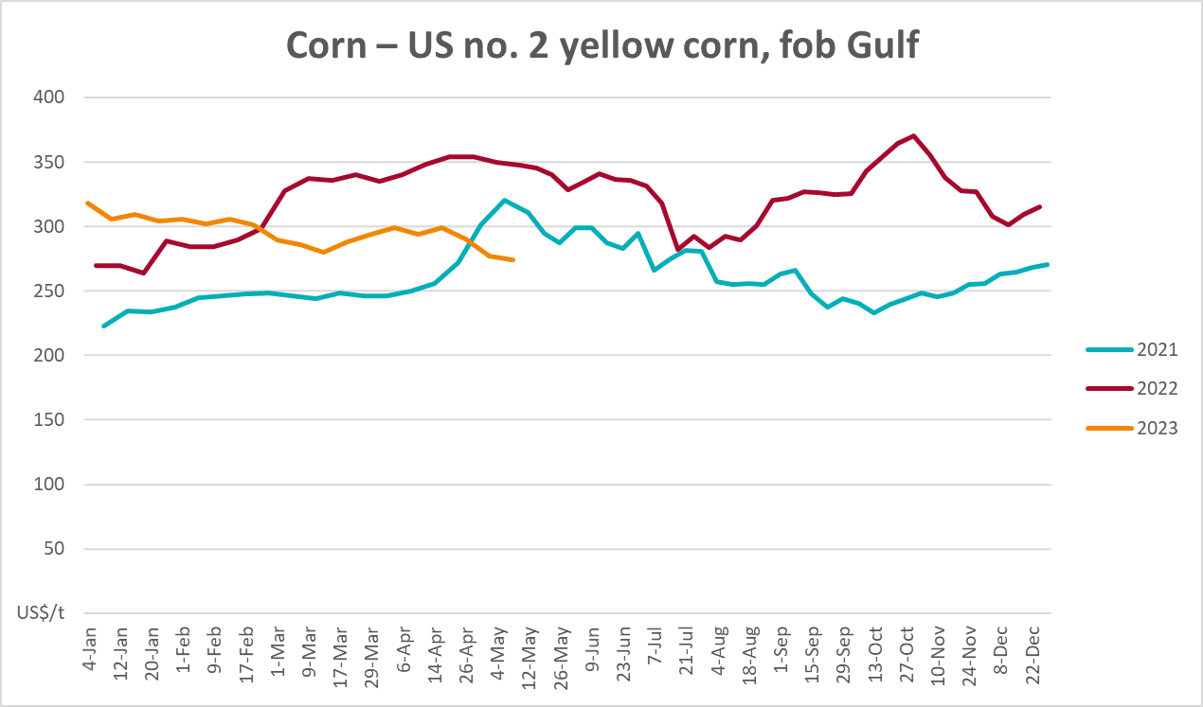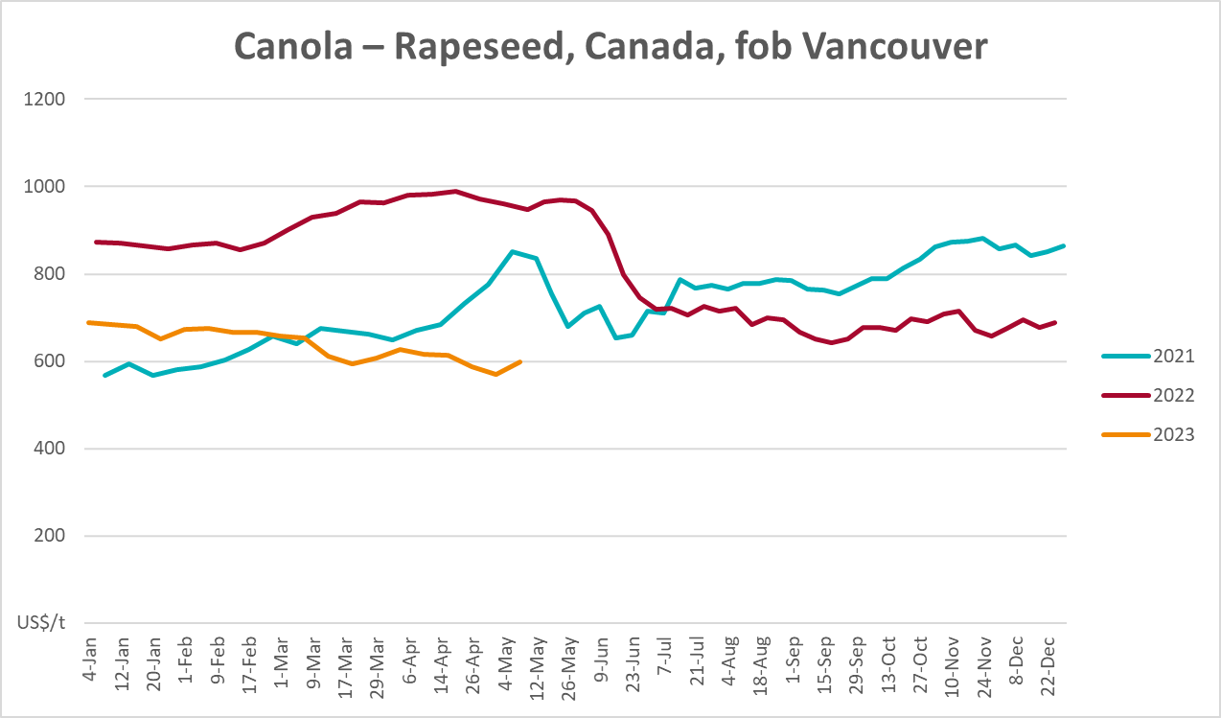
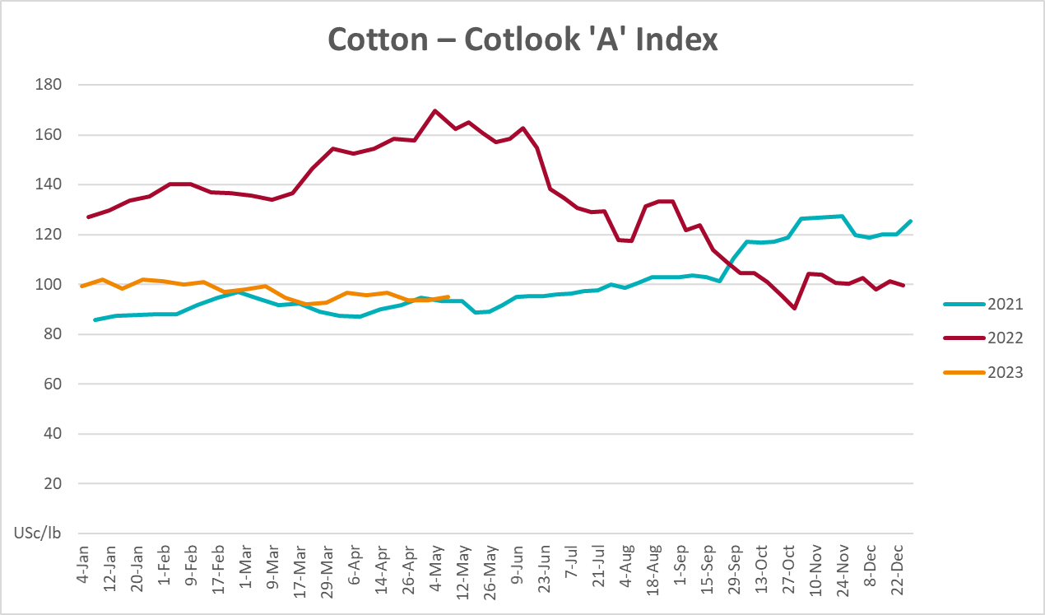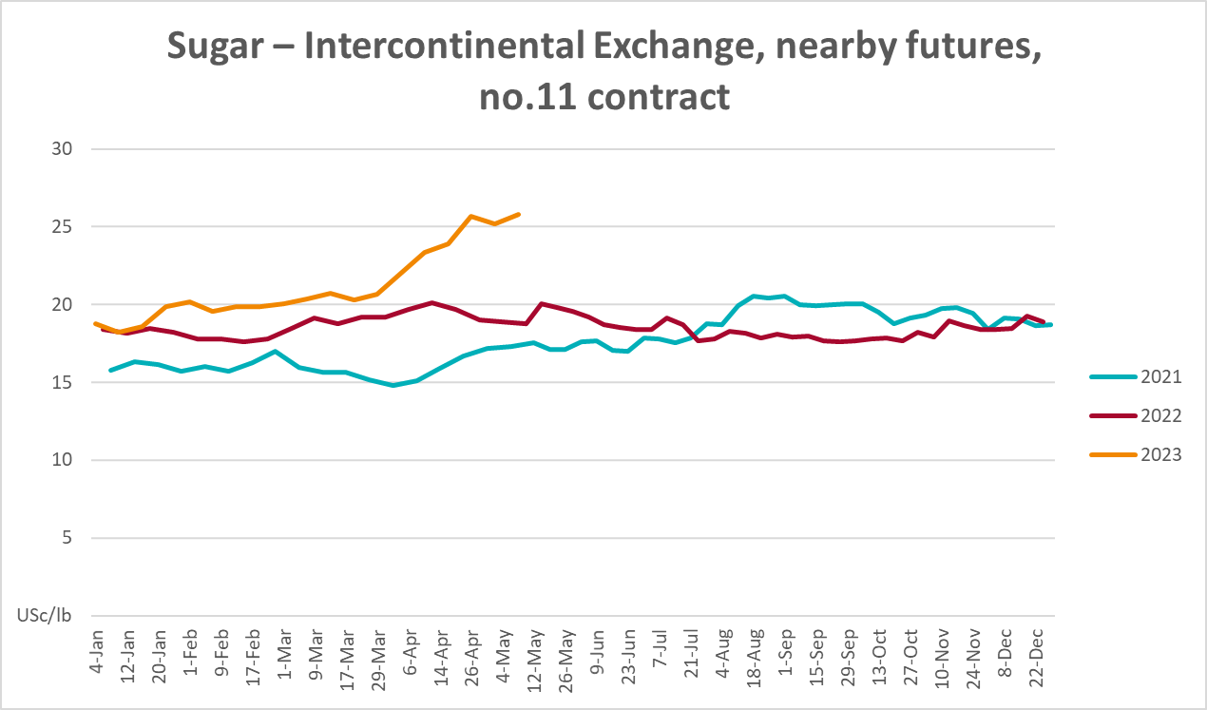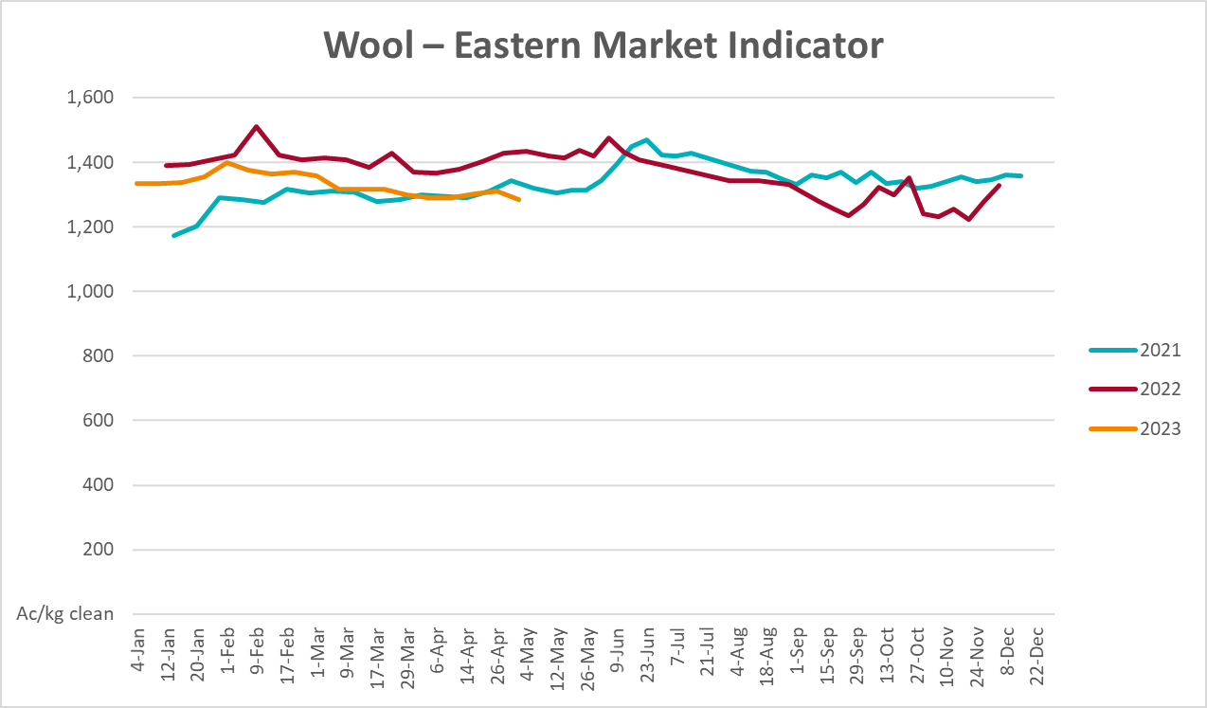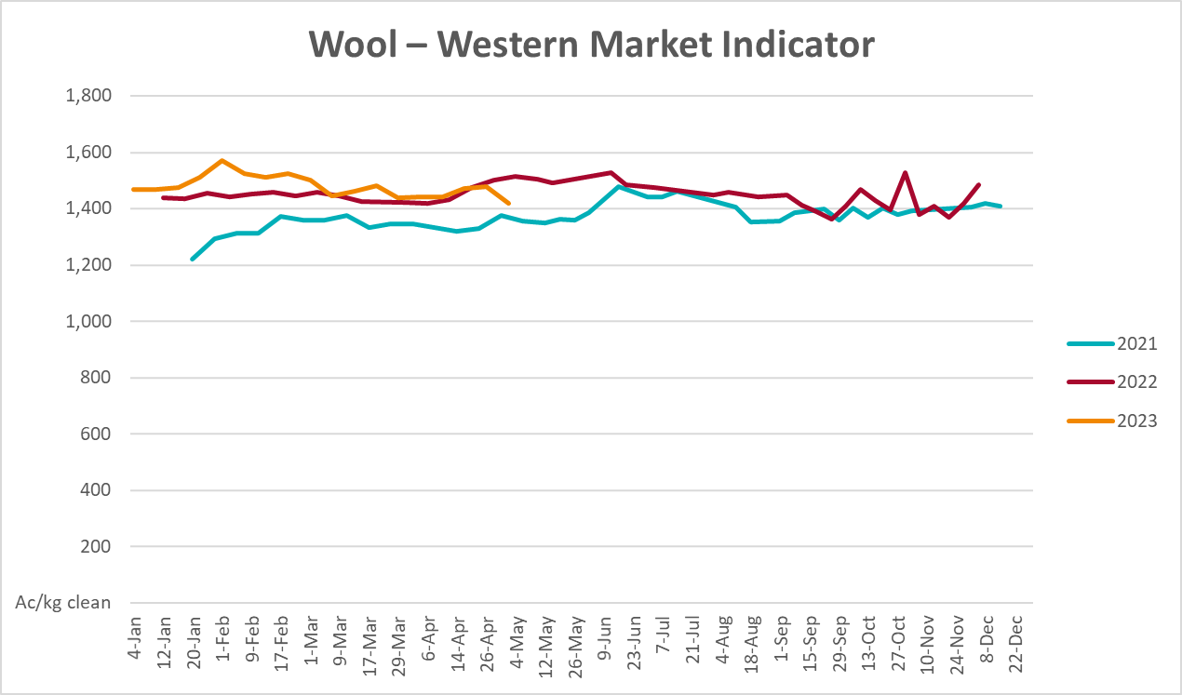

Selected domestic crop indicator prices
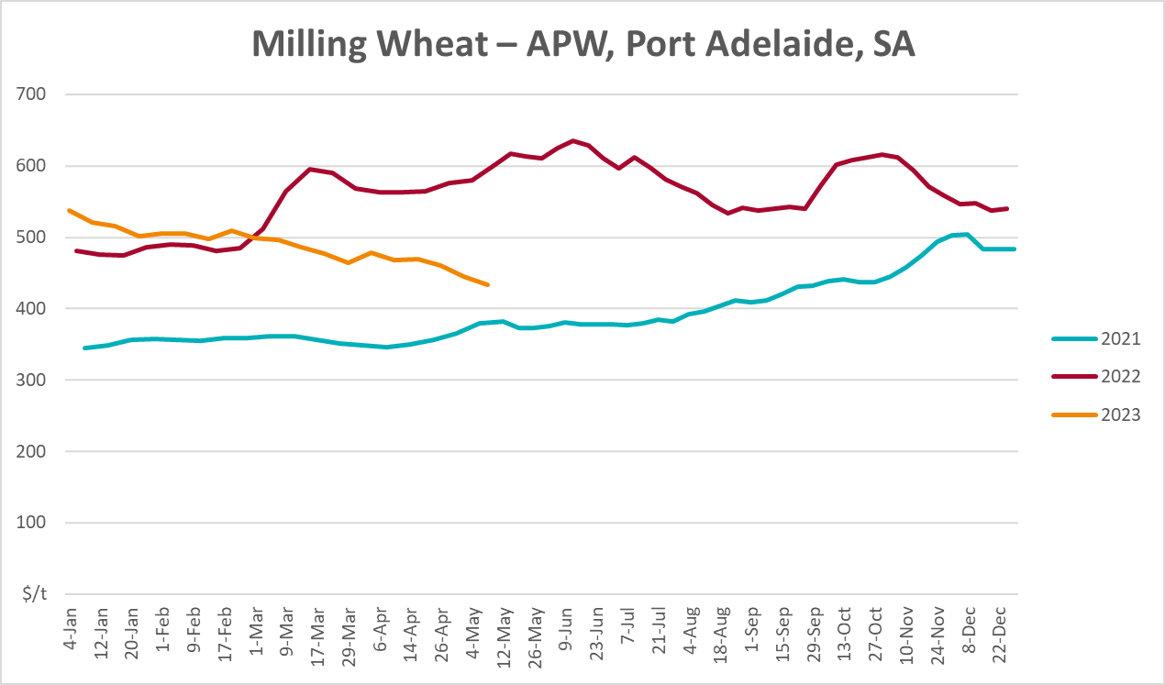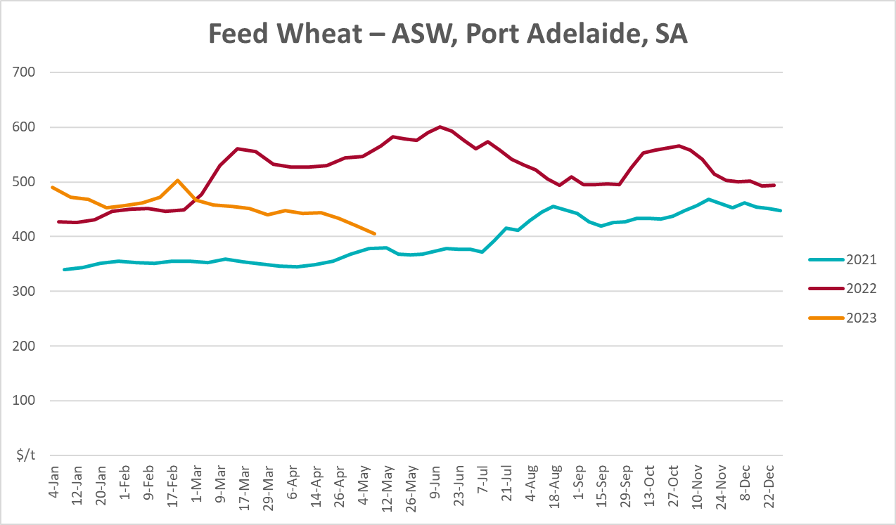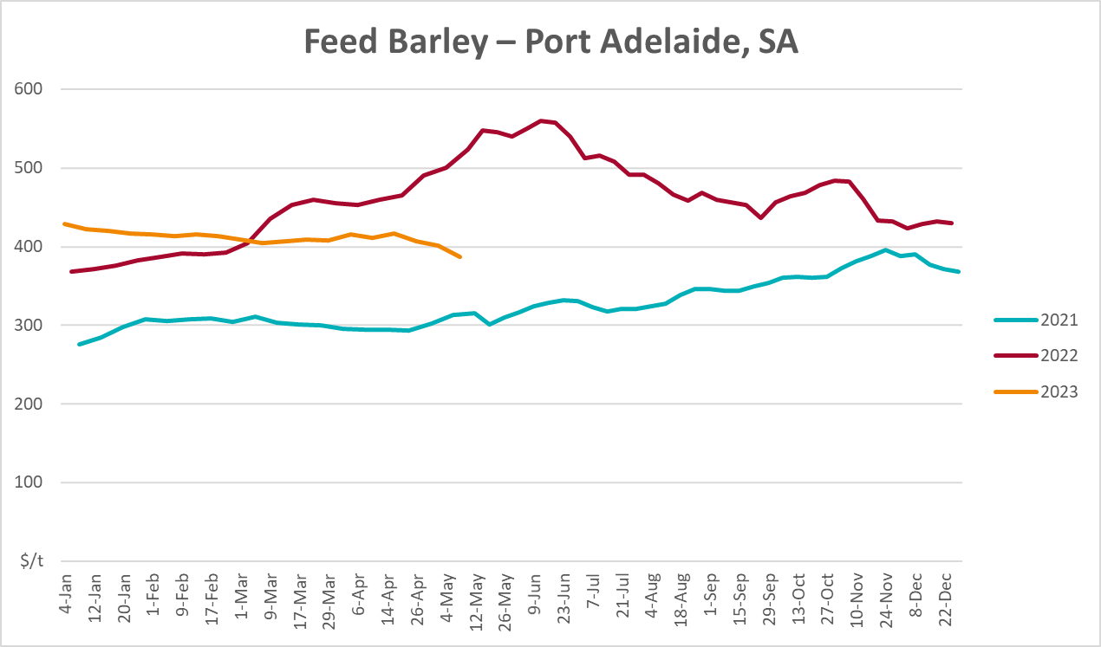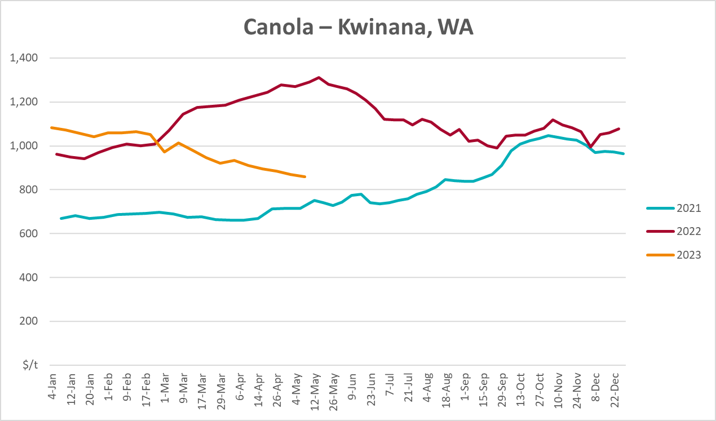
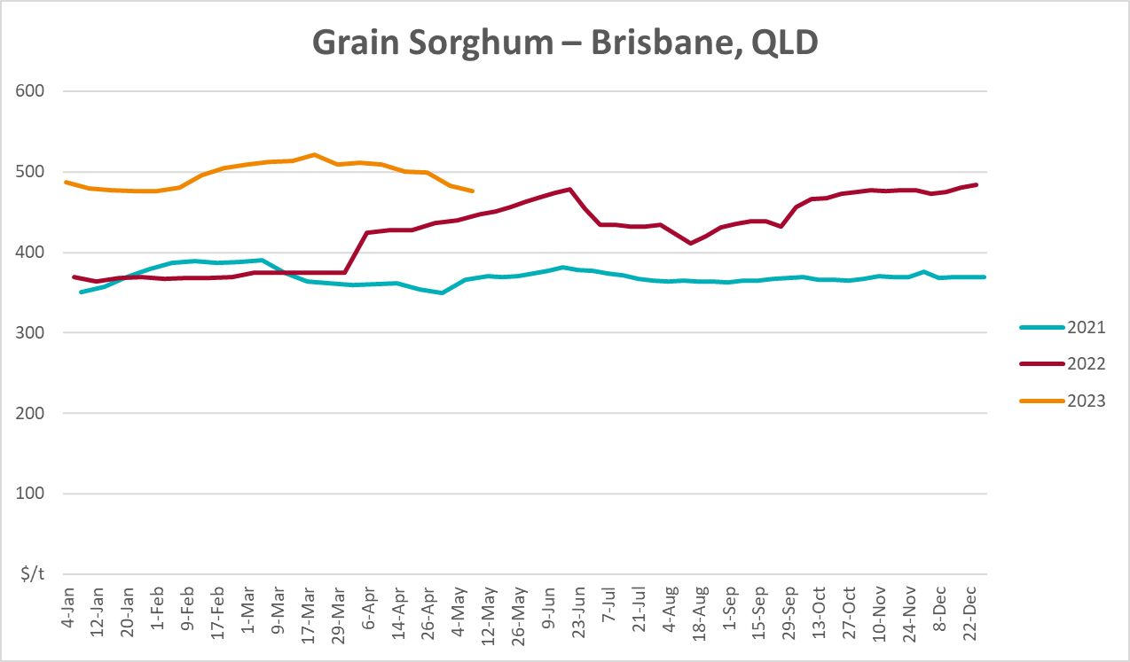

Selected domestic livestock indicator prices
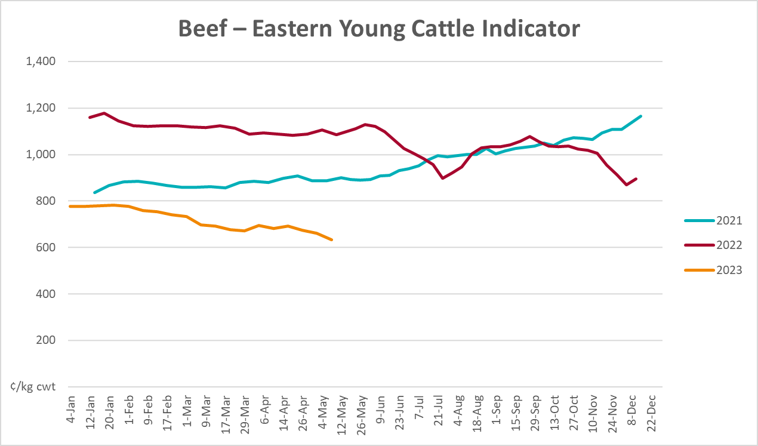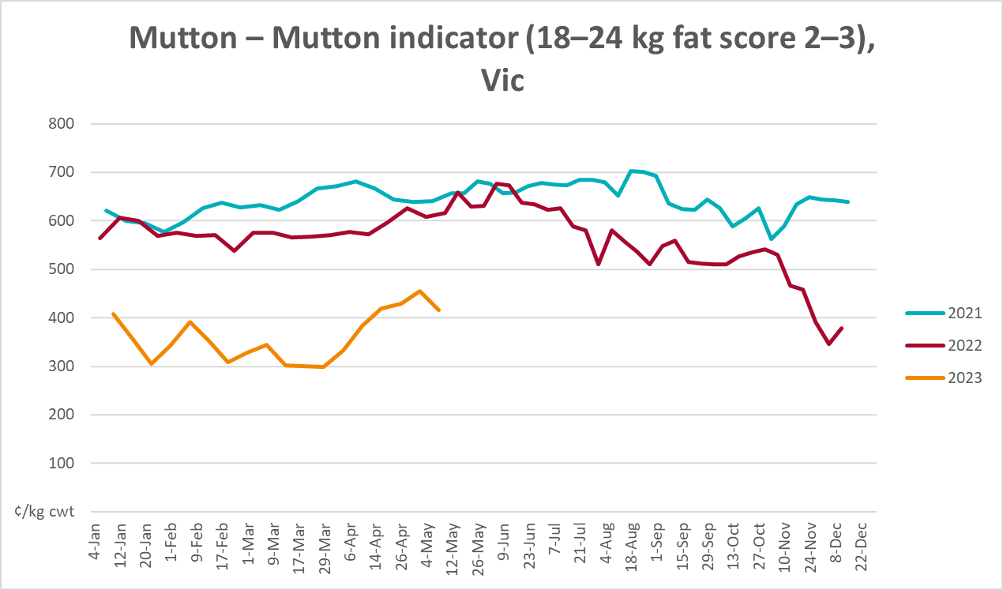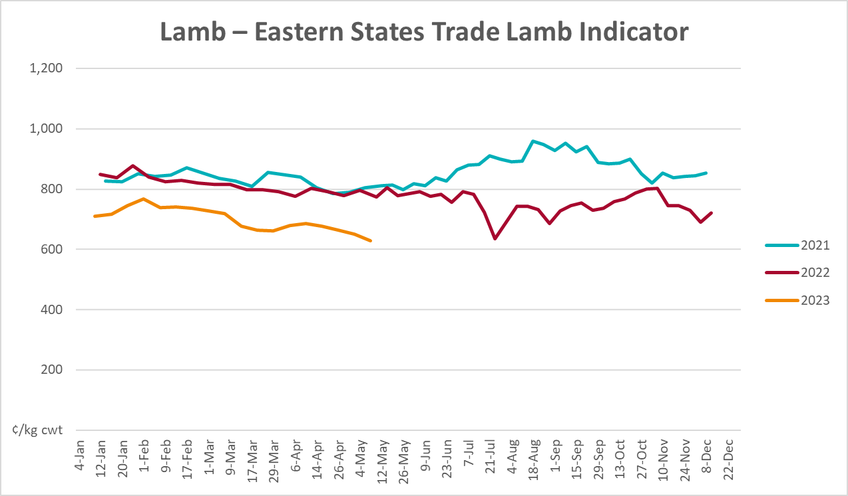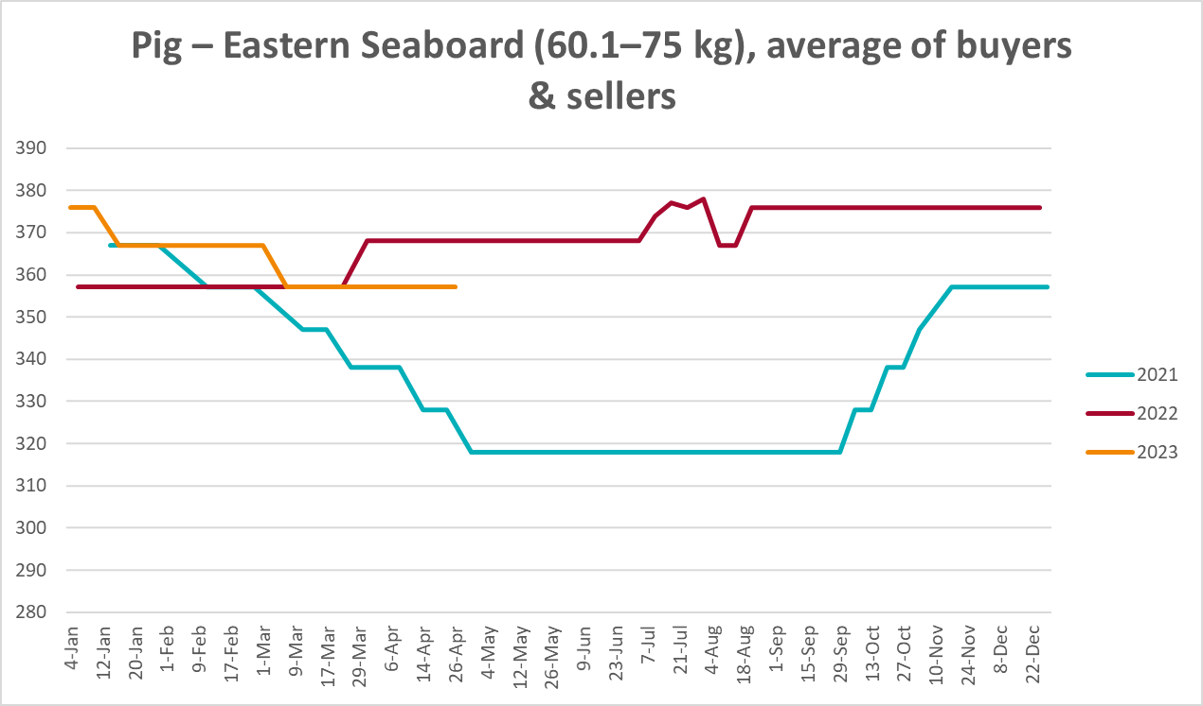
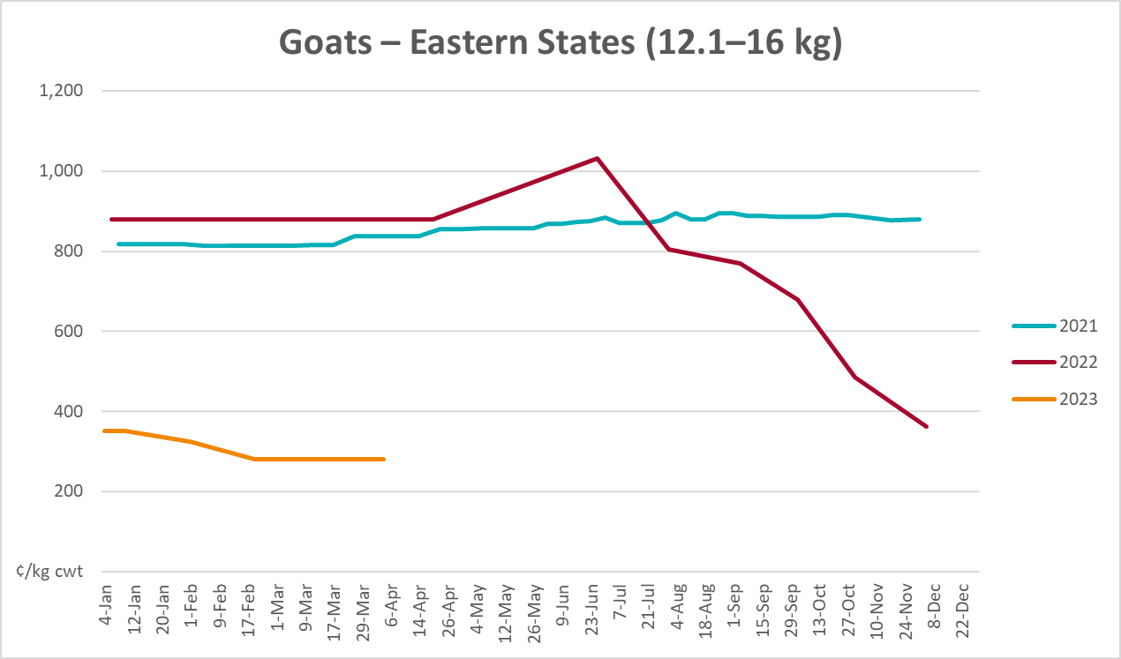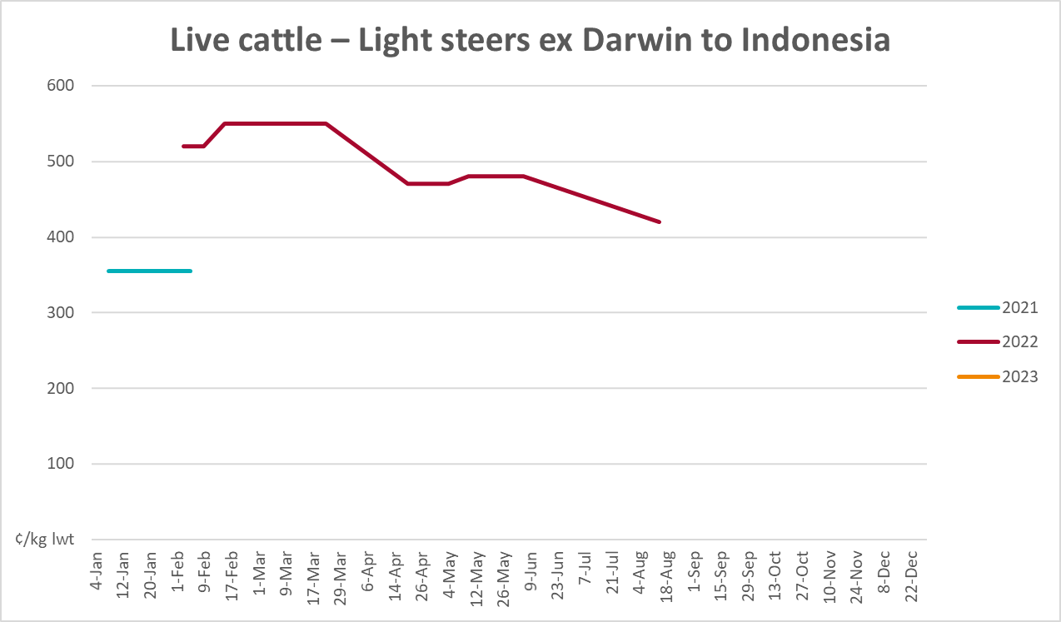
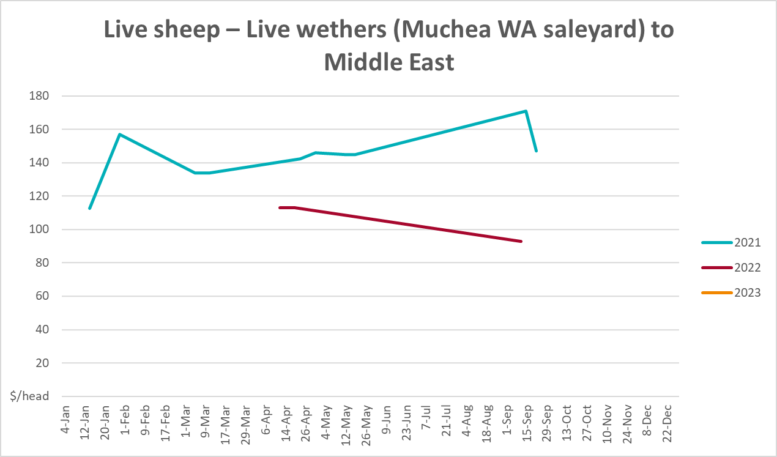

Global Dairy Trade (GDT) weighted average prices
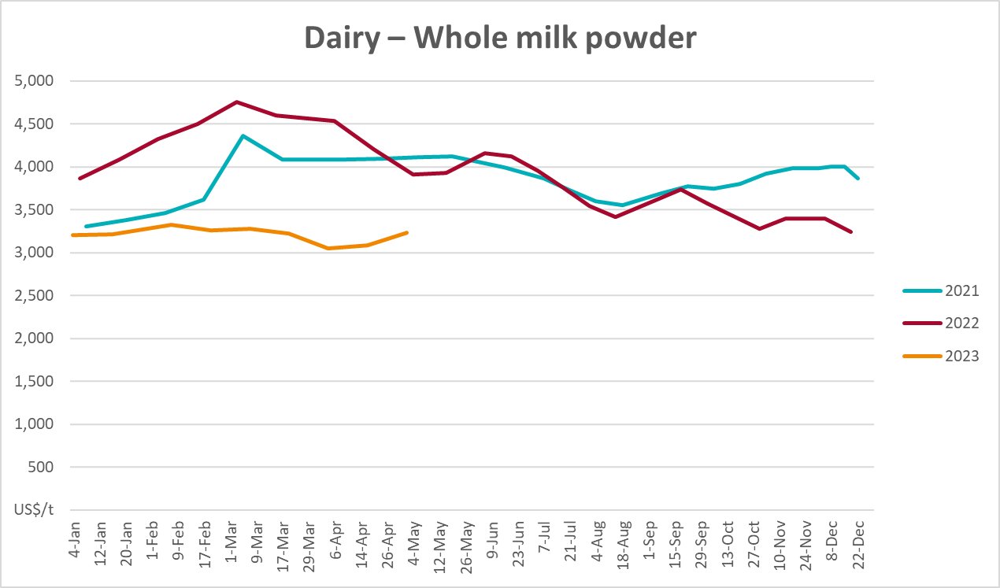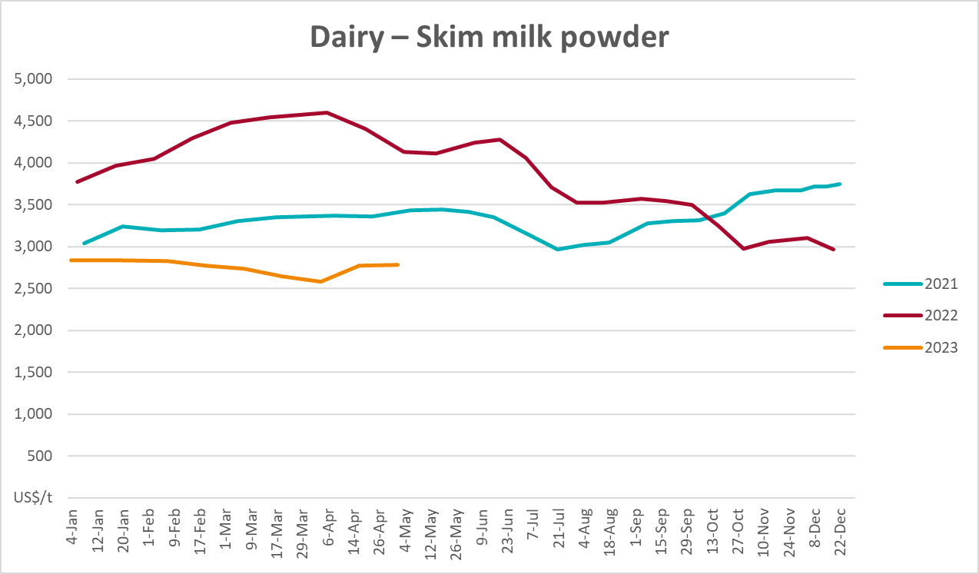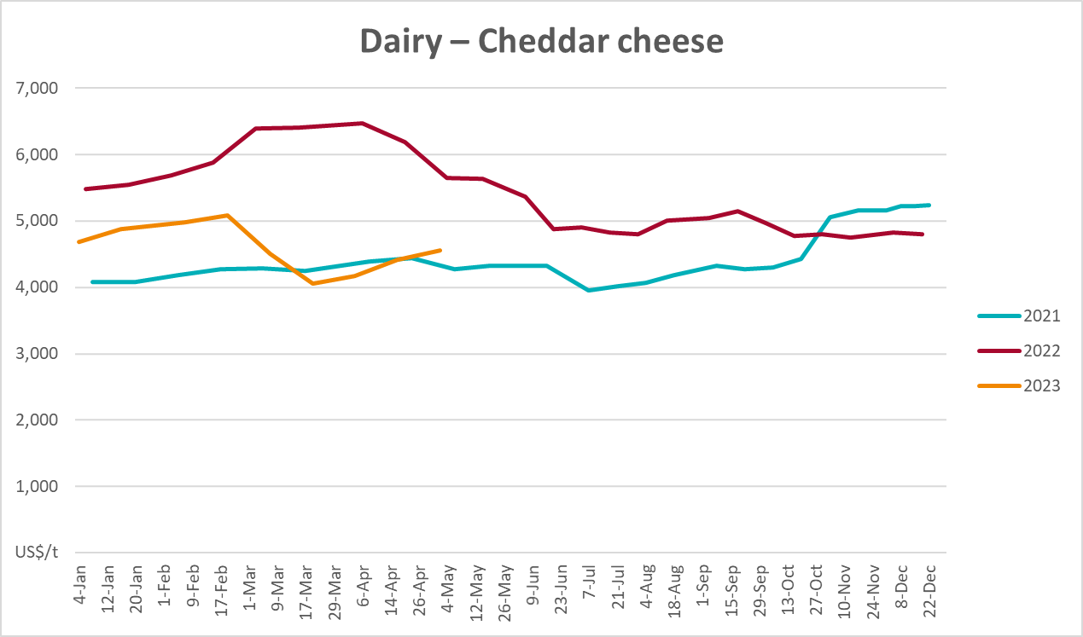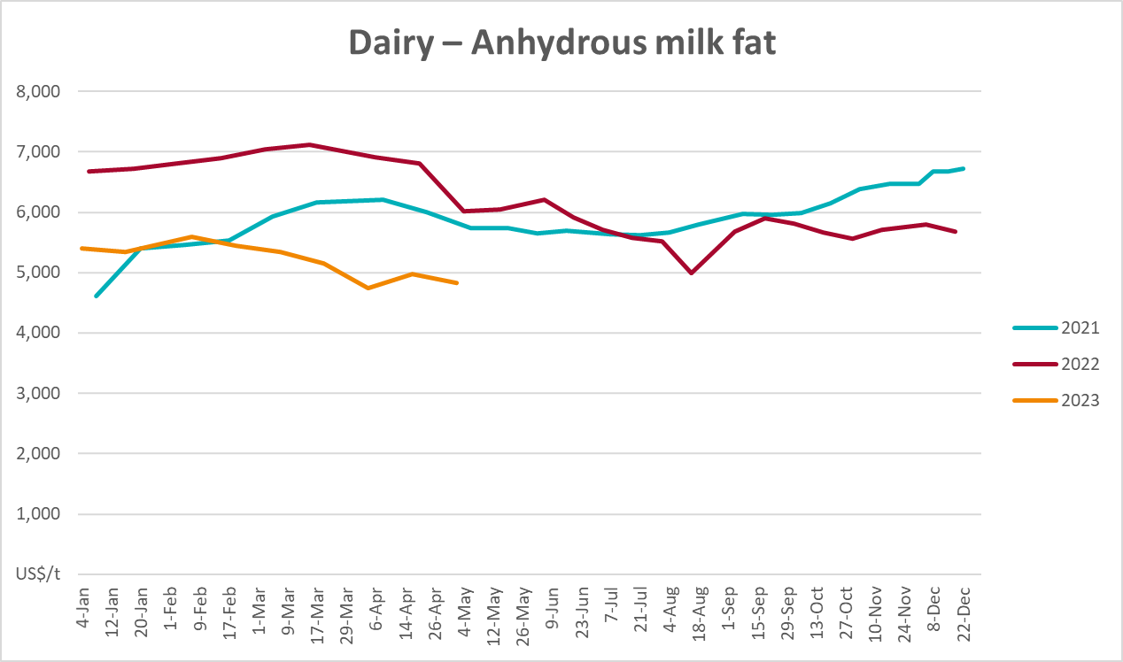

Selected fruit and vegetable prices
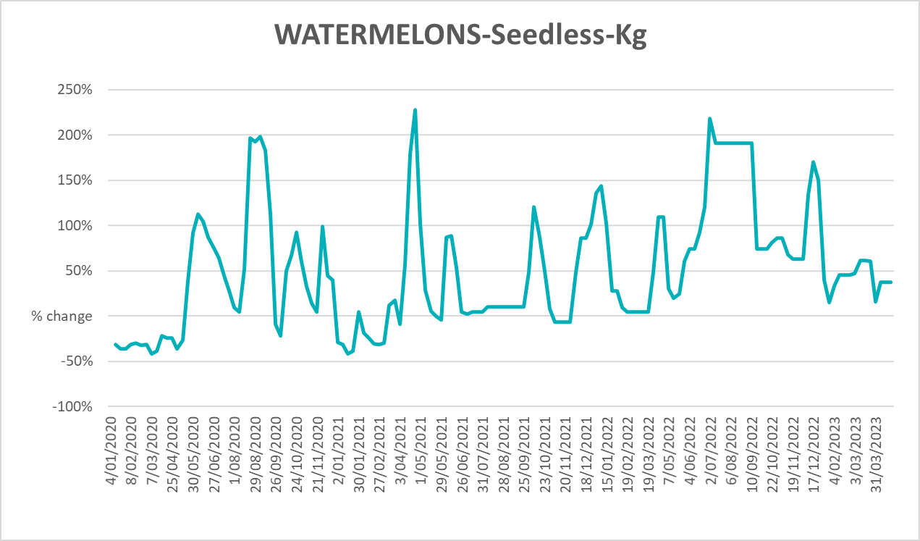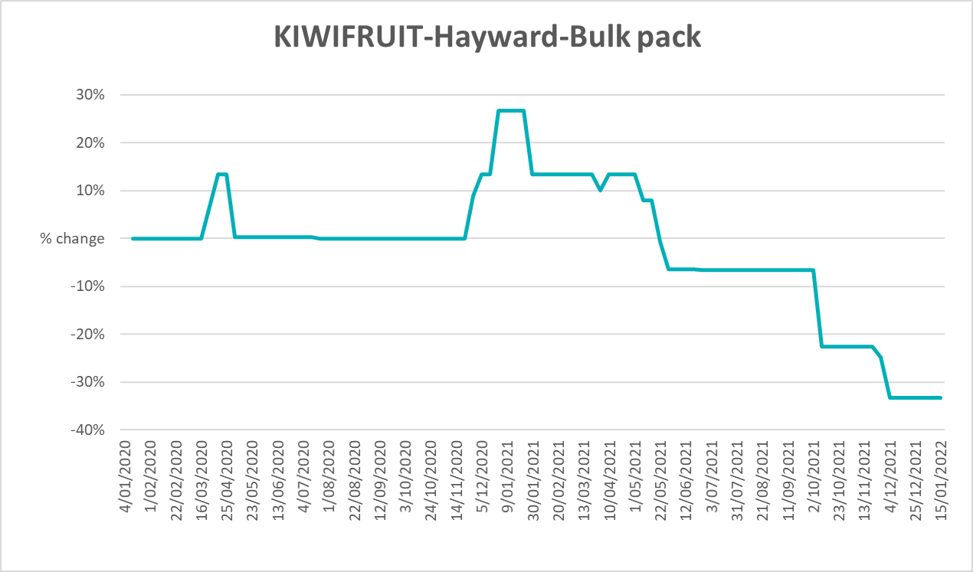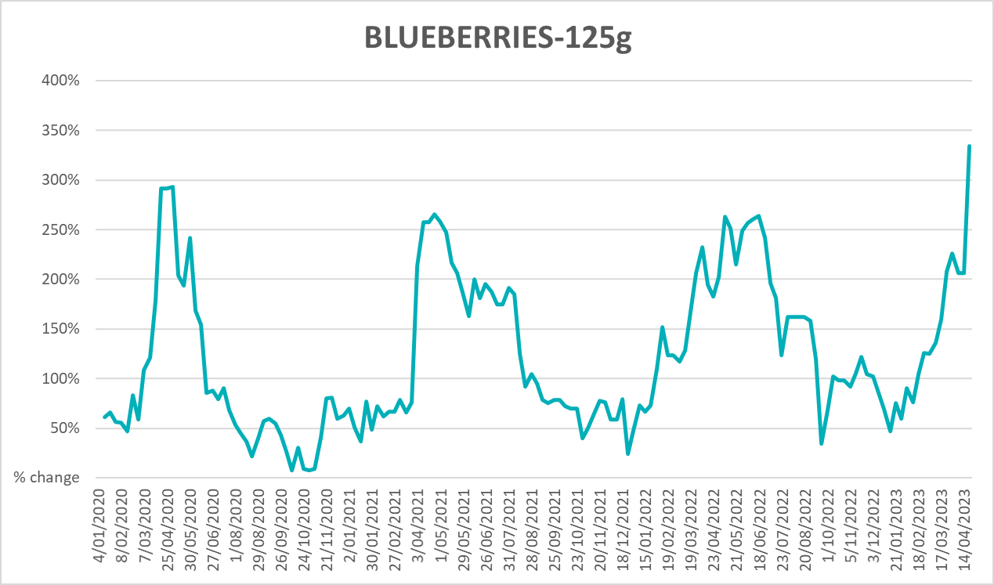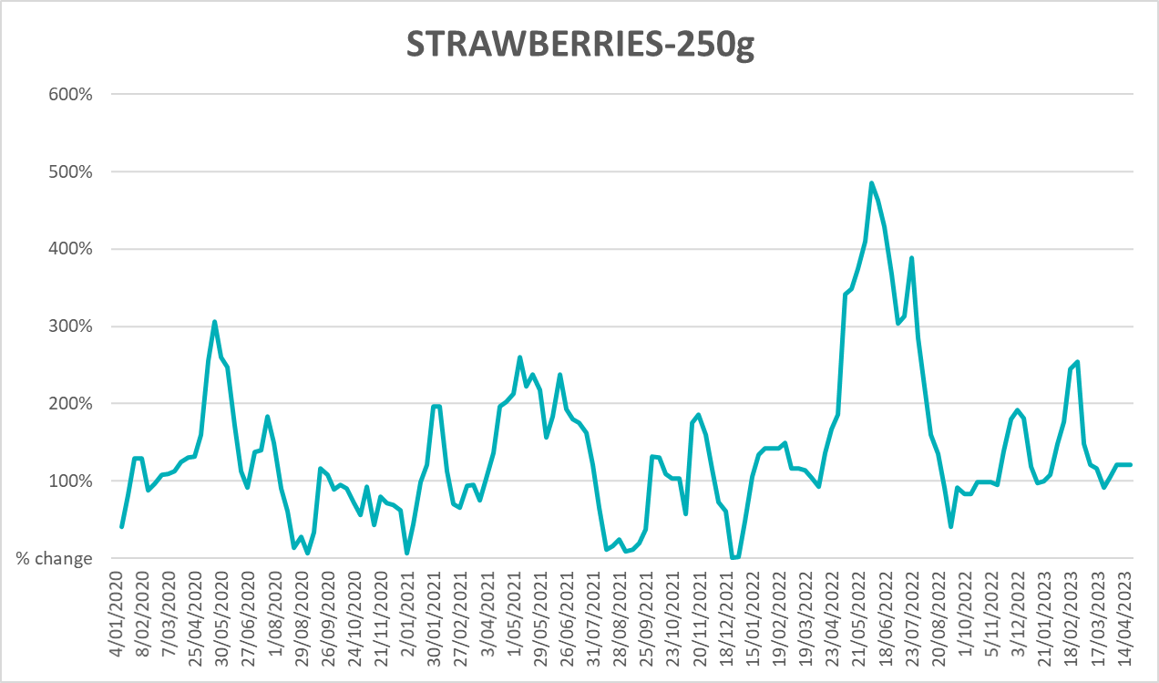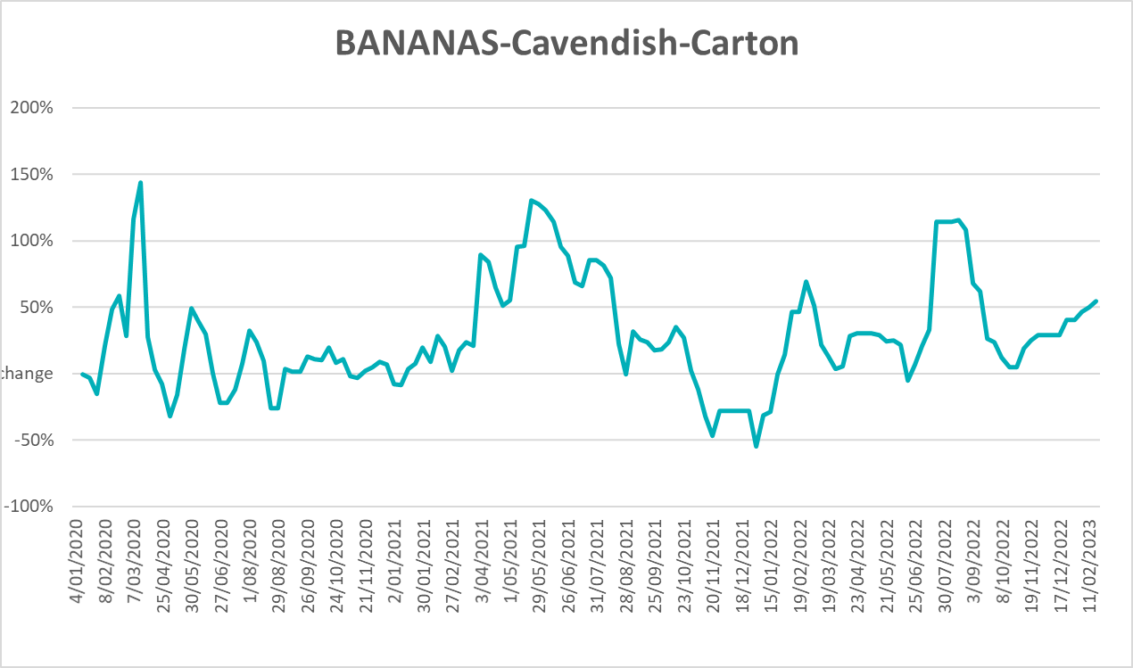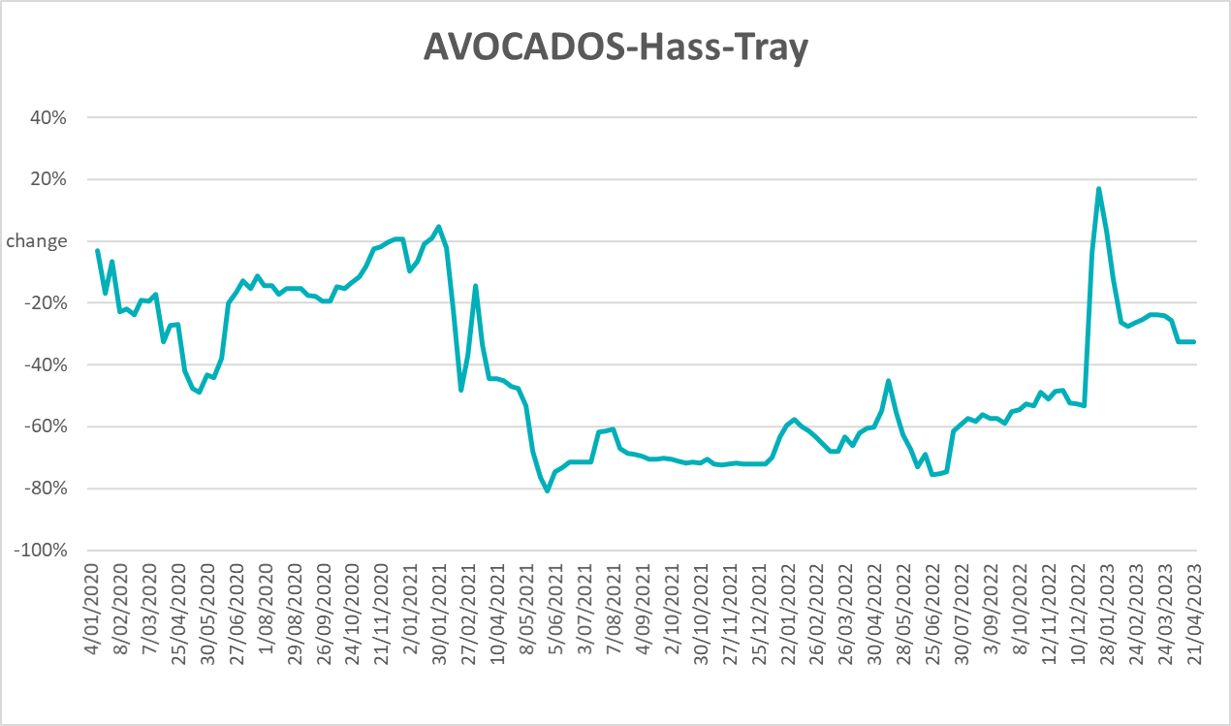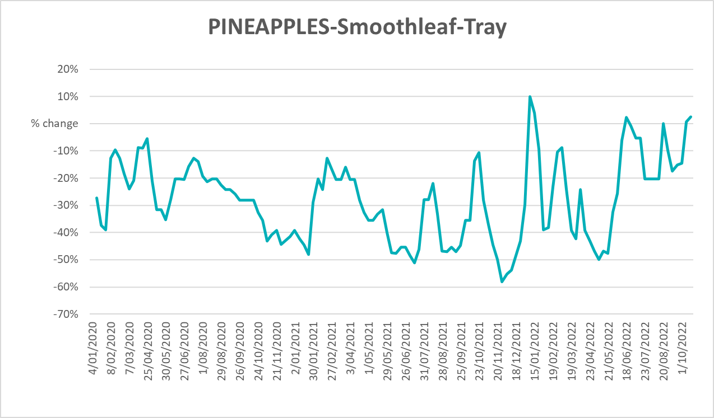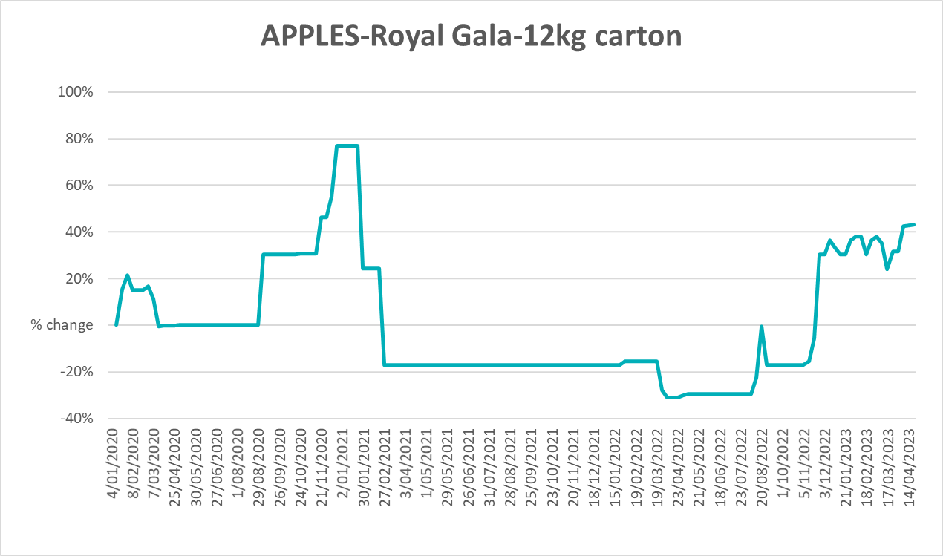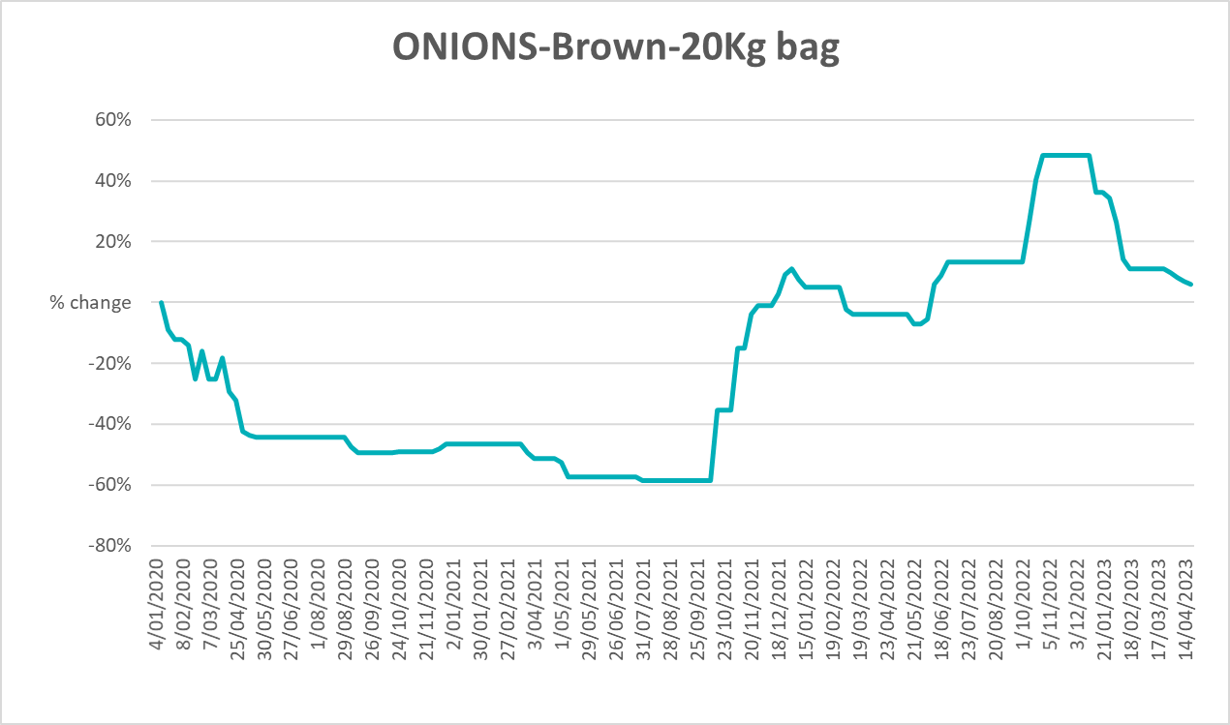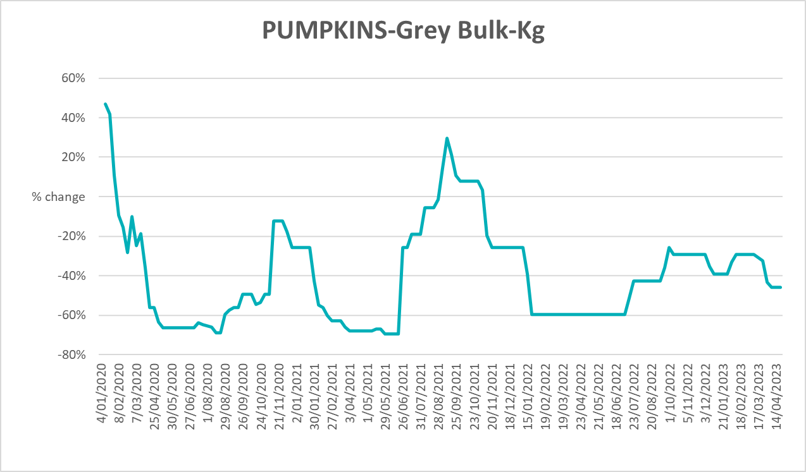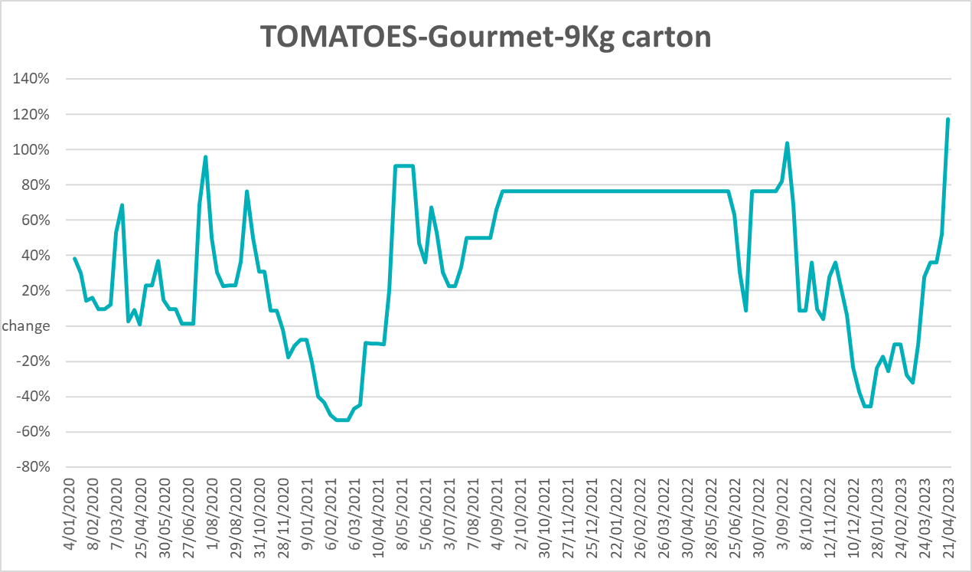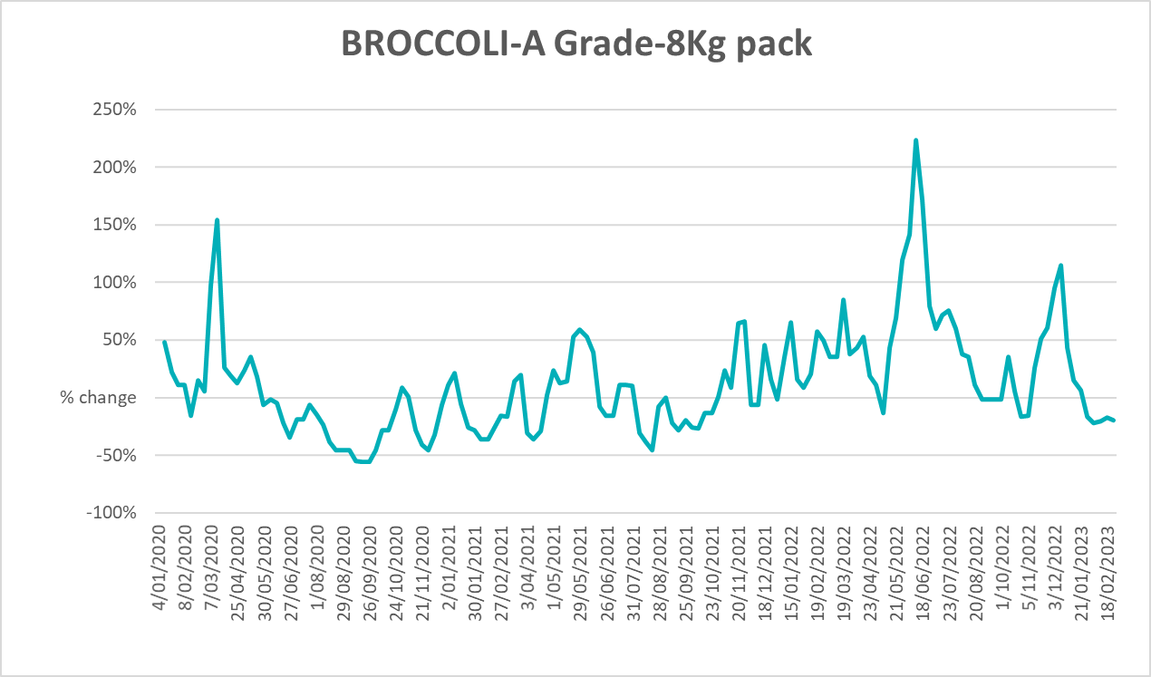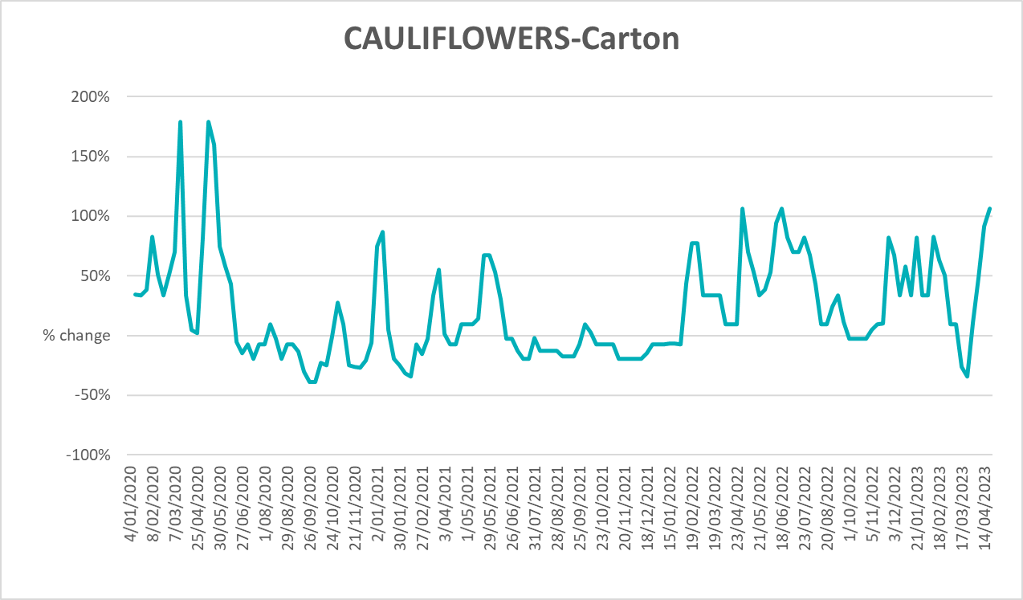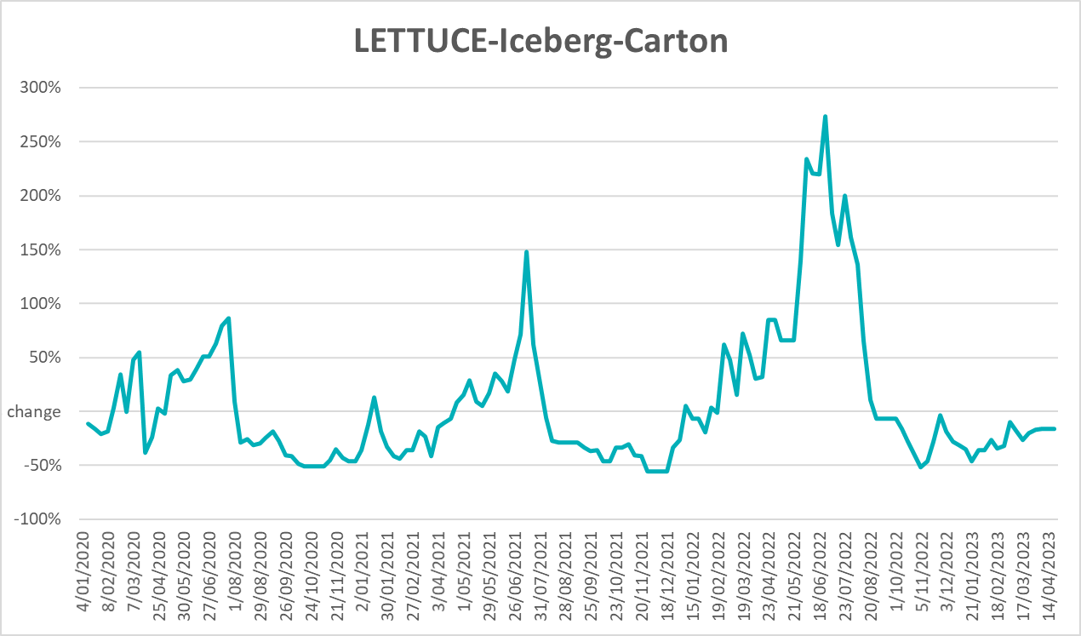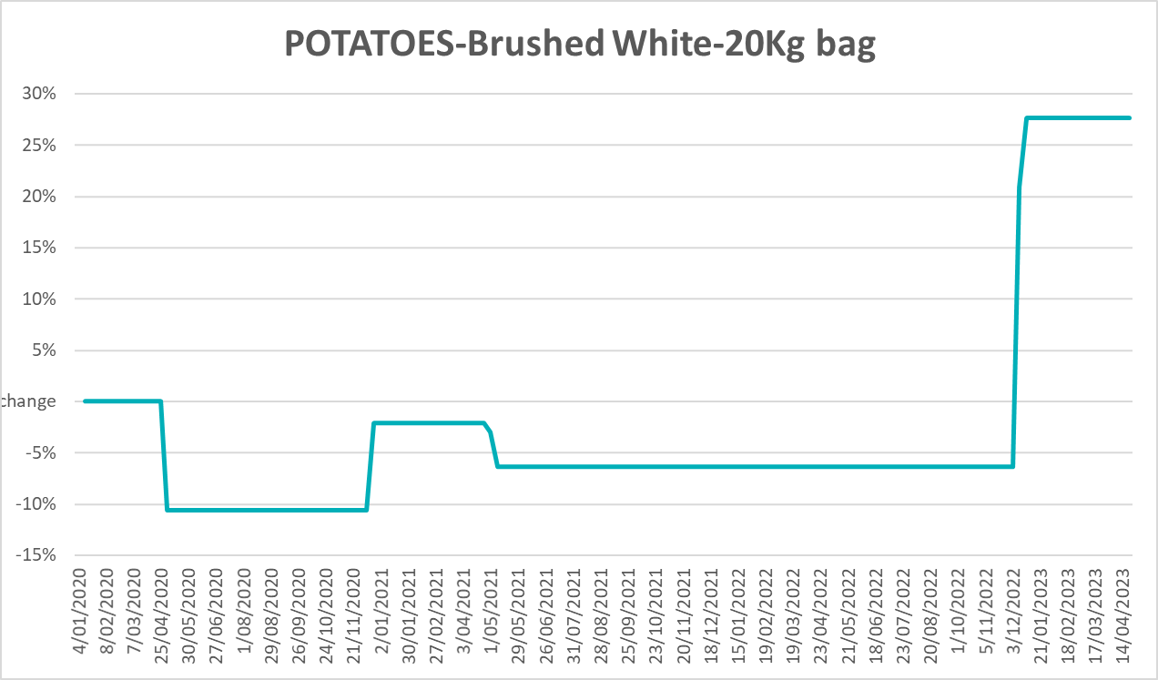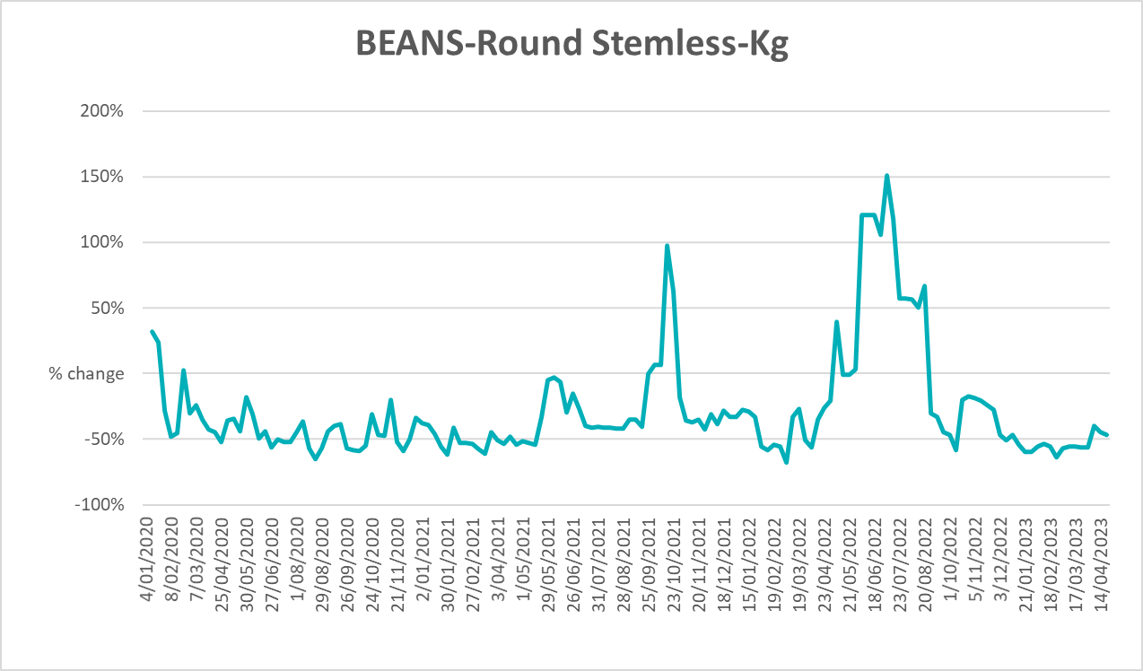

3.6 Selected domestic fodder indicator prices
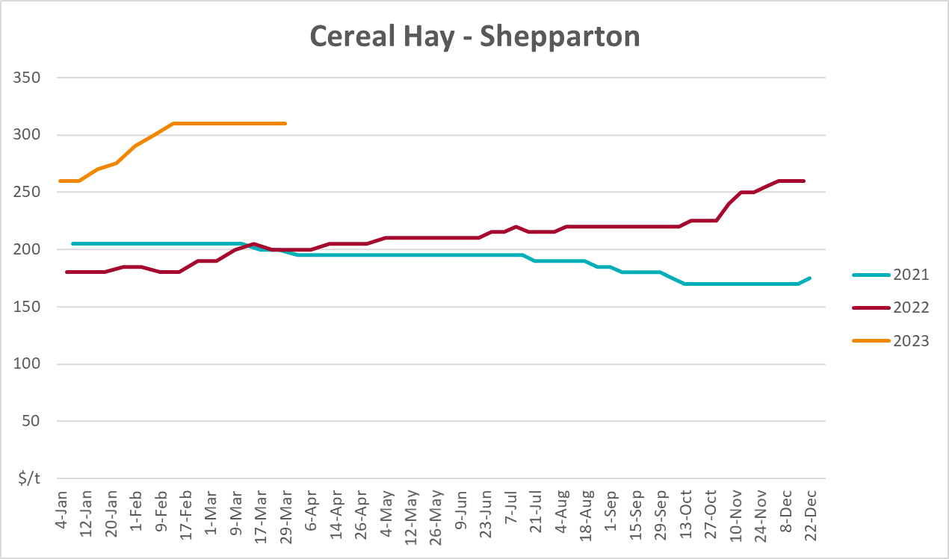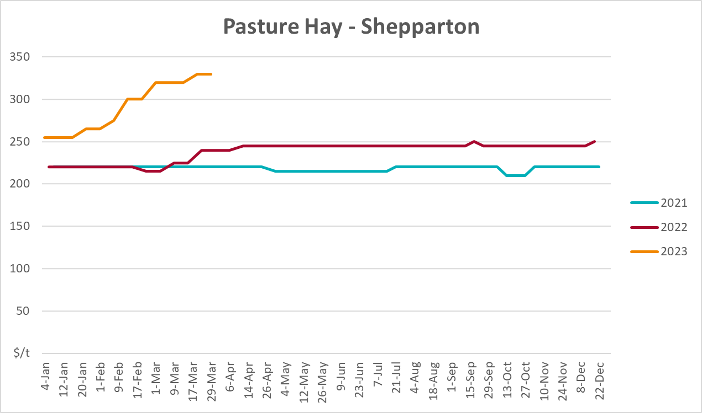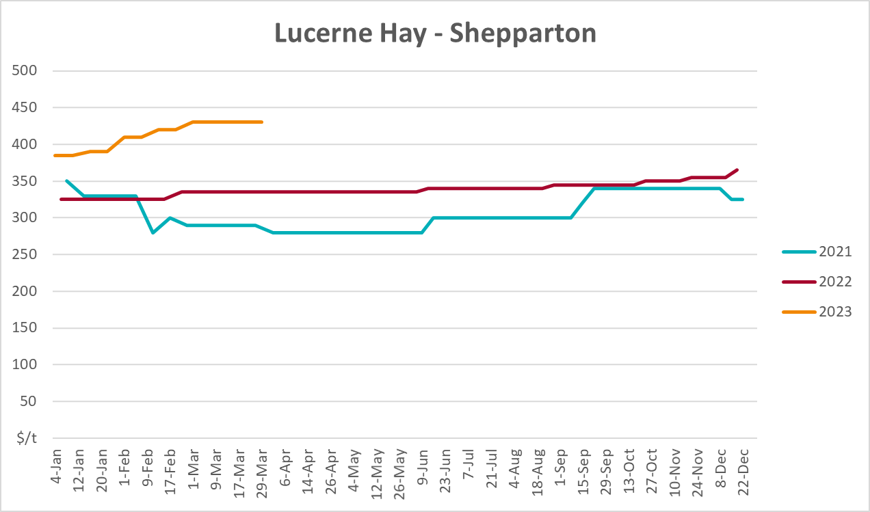

4. Data attribution

Climate
Bureau of Meteorology
- Weekly rainfall totals: www.bom.gov.au/climate/maps/rainfall/
- Monthly and last 3-month rainfall percentiles: www.bom.gov.au/water/landscape/
- Temperature anomalies: www.bom.gov.au/jsp/awap/temp/index.jsp
- Rainfall forecast: www.bom.gov.au/jsp/watl/rainfall/pme.jsp
- Seasonal outlook: www.bom.gov.au/climate/outlooks/#/overview/summary/
- Climate drivers: http://www.bom.gov.au/climate/enso/
- Soil moisture: www.bom.gov.au/water/landscape/
Other
- Pasture growth: www.longpaddock.qld.gov.au/aussiegrass/
- 3-month global outlooks: Environment and Climate Change Canada, NOAA Climate Prediction Center, EUROBRISA CPTEC/INPE, European Centre for Medium-Range Weather Forecasts, Hydrometcenter of Russia, National Climate Center Climate System Diagnosis and Prediction Room (NCC), International Research Institute for Climate and Society
- Global production: https://ipad.fas.usda.gov/ogamaps/cropmapsandcalendars.aspx
- Autumn break: Pook et al., 2009, https://rmets-onlinelibrary-wiley-com.virtual.anu.edu.au/doi/epdf/10.1002/joc.1833

Water
Prices
- Waterflow: https://www.waterflow.io/
- Ruralco: https://www.ruralcowater.com.au/
Bureau of Meteorology:
- Allocation trade: http://www.bom.gov.au/water/dashboards/#/water-markets/mdb/at
- Storage volumes: http://www.bom.gov.au/water/dashboards/#/water-storages/summary/drainage
Trade constraints:
- Water NSW: https://www.waternsw.com.au/customer-service/ordering-trading-and-pricing/trading/murrumbidgee
- Victorian Water Register: https://www.waterregister.vic.gov.au/TradingRules2019/

Commodities
Fruit and vegetables
- Datafresh: www.freshstate.com.au
Pigs
- Australian Pork Limited: www.australianpork.com.au
Dairy
- Global Dairy Trade: www.globaldairytrade.info/en/product-results/
World wheat, canola
- International Grains Council
World coarse grains
- United States Department of Agriculture
World cotton
- Cotlook: www.cotlook.com/
World sugar
- New York Stock Exchange - Intercontinental Exchange
Wool
- Australian Wool Exchange: www.awex.com.au/
Domestic wheat, barley, sorghum, canola and fodder
- Jumbuk Consulting Pty Ltd: http://www.jumbukag.com.au/
Cattle, beef, mutton, lamb, goat and live export
- Meat and Livestock Australia: www.mla.com.au/Prices-and-market
© Commonwealth of Australia 2023

Ownership of intellectual property rights
Unless otherwise noted, copyright (and any other intellectual property rights, if any) in this publication is owned by the Commonwealth of Australia (referred to as the Commonwealth).

Creative Commons licence
All material in this publication is licensed under a Creative Commons Attribution 4.0 International Licence except content supplied by third parties, logos and the Commonwealth Coat of Arms.
Inquiries about the licence and any use of this document should be emailed to copyright@awe.gov.au.
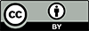

Cataloguing data
This publication (and any material sourced from it) should be attributed as:
ABARES 2023, Weekly Australian Climate, Water and Agricultural Update, Australian Bureau of Agricultural and Resource Economics and Sciences, Canberra, 11 May 2023. CC BY 4.0 DOI: https://doi.org/10.25814/5f3e04e7d2503
ISSN 2652-7561
This publication is available at https://www.agriculture.gov.au/abares/products/weekly_update
Department of Agriculture, Fisheries and Forestry
GPO Box 858 Canberra ACT 2601
Telephone 1800 900 090
Web agriculture.gov.au/abares

Disclaimer
The Australian Government acting through the Department of Agriculture, Fisheries and Forestry, represented by the Australian Bureau of Agricultural and Resource Economics and Sciences, has exercised due care and skill in preparing and compiling the information and data in this publication. Notwithstanding, the Department of Agriculture, Fisheries and Forestry, ABARES, its employees and advisers disclaim all liability, including liability for negligence and for any loss, damage, injury, expense or cost incurred by any person as a result of accessing, using or relying on any of the information or data in this publication to the maximum extent permitted by law.

Statement of Professional Independence
The views and analysis presented in ABARES publications, including this one, reflect ABARES professionally independent findings, based on scientific and economic concepts, principles, information and data. These views, analysis and findings may not reflect or be consistent with the views or positions of the Australian Government, or of organisations or groups who have commissioned ABARES reports or analysis. More information on professional independence is provided on the ABARES website.

Acknowledgements
This report was prepared by Kavina Dayal and Matthew Miller.

