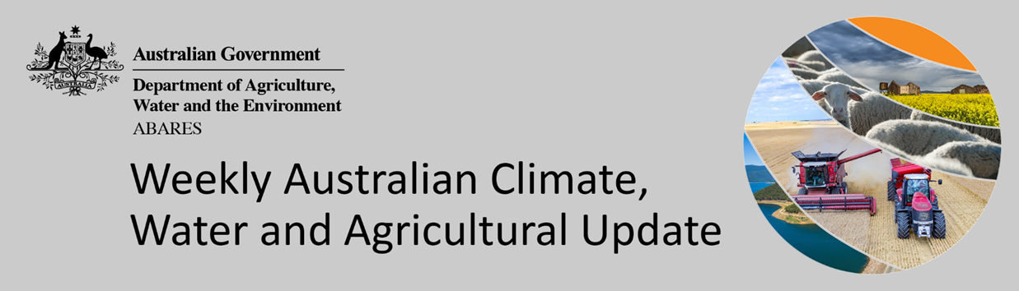
No. 6/2021

18 February 2021

Summary of key issues
- During the 7 days to 17 February 2021, troughs, low-pressure systems, fronts and onshore flow generated showers and thunderstorm activity across much of Australia away from the southern coastline. In those summer cropping regions that recorded rainfall this week, these falls are likely to benefit the production prospects and yield potential of dryland crops (see Section 1.1).
- Global crop production conditions continue to be favourable despite dry conditions across parts of Argentina, Brazil, the Russian Federation, Turkey and the United States, affecting the production potential of wheat, corn and soybeans (see Section 1.2).
- January rainfall percentiles and current production conditions are similar to the global conditions seen during October, which were used to formulate ABARES forecasts of global grain supplies and the impact on world prices in its December 2020 edition of Agricultural commodities (see Section 1.2).
- The global climate outlook indicates that average to above average rainfall is slightly more likely between March and May 2021 for most of the world's major grain- and oilseed-producing regions. Partly due to the influence of La Niña, below average rainfall is expected for parts of eastern and southern Argentina, far southern Brazil, western Europe, western and central India, Indonesia, southern Kazakhstan, the southern United States and western Ukraine (see Section 1.2).
- Over the next 8 days, troughs, low-pressure systems, onshore flow and a strong cold front are expected to generate showers and storms over parts of northern, western and eastern Australia.
- In Australia’s summer cropping regions, rainfall totals of between 5 and 25 millimetres is expected for much of northern and eastern New South Wales and Queensland, and isolated parts of eastern Western Australia over the next 8 days (see Section 1.4).
- Water storage levels in the Murray-Darling Basin (MDB) decreased by 56 gigalitres (GL) between 10 February 2021 and 17 February 2021. The current volume of water held in storage is 13,563 GL, which represents 54% of total capacity.
- Allocation prices in the Victorian Murray below the Barmah Choke decreased from $105 per ML on 11 February 2021 to $95 per ML on 18 February 2021. Prices are lower in Murrumbidgee due to binding of the Murrumbidgee export limit.
 | ABARES Outlook 2021 virtual conference - Growing Australian agriculture in an uncertain world  Join us online from 2-5 March. Discover the program, speakers and register for free at www.awe.gov.au/abares/Outlook.

Climate

Rainfall this week
During the 7 days to 17 February 2021, troughs, low-pressure systems, fronts and onshore flow generated showers and thunderstorm activity across much of Australia away from the southern coastline.
Rainfall totals of between 15 and 100 millimetres were recorded across much of Queensland, the northern two-thirds of Western Australia and the north and south of the Northern Territory, and parts of central and eastern New South Wales, northern South Australia and Tasmania. Rainfall totals in excess of 100 millimetres were recorded across isolated parts of the tropical north.
In Australia’s summer cropping regions, rainfall totals of between 10 and 50 millimetres were recorded across much central and north-eastern New South Wales and western and southern Queensland. Rainfall totals in excess of 50 millimetres were recorded in cropping regions across parts of central New South Wales and central Queensland. Little to no rainfall was recorded in cropping regions across southern Australian during the 7 days to 17 February 2021.
In those summer cropping regions that recorded rainfall during the 7 days to 17 February 2021, these falls are likely to benefit the production prospects and yield potential of dryland crops.

Rainfall for the week ending 17 February 2021

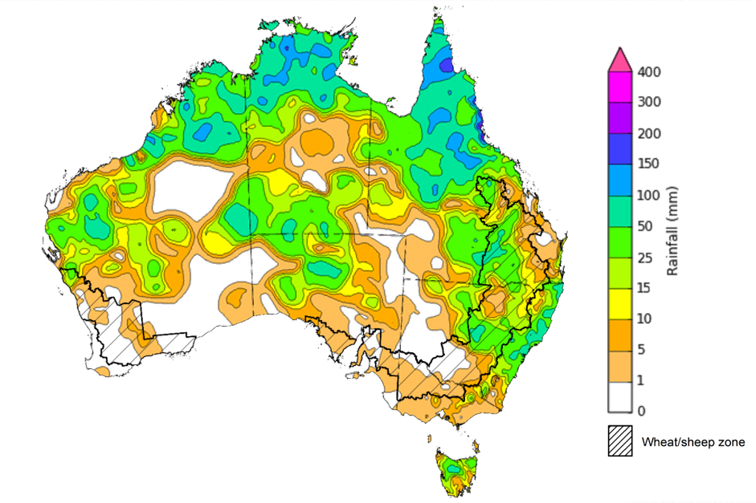
©Commonwealth of Australia 2021, Australian Bureau of Meteorology Issued: 17/02/2021
Note: The rainfall analyses and associated maps utilise data contained in the Bureau of Meteorology climate database, the Australian Data Archive for Meteorology (ADAM). The analyses are initially produced automatically from real-time data with limited quality control. They are intended to provide a general overview of rainfall across Australia as quickly as possible after the observations are received. For further information go to http://www.bom.gov.au/climate/rainfall/

Global production conditions and climate outlook
Crop production is affected by long-term trends in average rainfall and temperature, interannual climate variability, shocks during specific phenological stages, and extreme weather events (IPCC 2012). Some crops are more tolerant than others to certain types of stresses, and at each phenological stage, different types of stresses affect each crop species in different ways.
The precipitation anomalies and outlooks presented here give an indication of the current and future state of production conditions for the major grain and oilseed producing countries which are responsible for over 80% of global production. This is an important input to assessing the global grain supply outlook.
January precipitation percentiles and current production conditions
As at the end of January 2021, precipitation was mixed for the world’s major grain and oil producing regions.
In the northern hemisphere, January precipitation was above average in parts of southern and eastern Europe, Indonesia, Malaysia, the Philippines, the south of the Russian Federation, the south of the United Kingdom and the centre of the United States of America.
Precipitation was below average across parts of Canada, south-eastern China, Kazakhstan, the north and centre of the Russian Federation and the north-east of the United States of America. Snow cover in the United States of America has been low this season, resulting in less insulation for dormant winter wheat and increasing the risk of frost damage. Precipitation was generally average across the remainder of major grain and oil producing regions in the northern hemisphere.
In the southern hemisphere, January rainfall was above average across parts of central Argentina, south-eastern Australia and South Africa. Rainfall was below average across parts of southern Argentina, north-eastern and south-western Australia and central Brazil. Rainfall was generally average across the remainder of major grain and oil producing regions in the southern hemisphere.

Global precipitation percentiles, January 2021
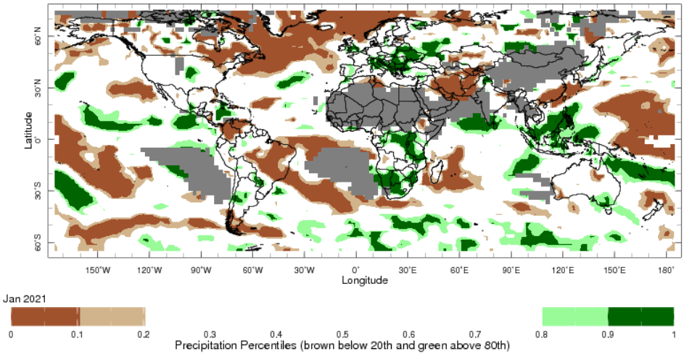
Note: The world precipitation percentiles indicate a ranking of precipitation for January, with the driest (0th percentile) being 0 on the scale and the wettest (100th percentile) being 1 on the scale. Percentiles are based on precipitation estimates from the NOAA Climate Prediction Center's Climate Anomaly Monitoring System Outgoing Precipitation Index dataset. Precipitation estimates for January 2021 are compared with rainfall recorded for that period during the 1981 to 2010 base period.
Source: International Research Institute for Climate and Society
As at 28 January 2021 global production conditions were generally favourable, despite some dryness affecting the production potential of wheat, corn and soy.
Conditions for wheat in Australia were mixed for the end of harvest. In the northern hemisphere, conditions were generally favourable for wheat development in Canada, the European Union, Ukraine, the United Kingdom and dormancy in China. Conditions were mixed in the Russian Federation, Turkey and the United States of America due to dryness in some areas. Conditions were favourable for winter wheat sowing in India.
Conditions for corn in Argentina were mixed for early-planted crop development due to drought and generally favourable for late-planted crop development. Similarly in Brazil, conditions were mixed for spring-planted crop development due to dryness in the South Region. Conditions were favourable in Brazil for sowing the summer-planted crop. In India, conditions were favourable for Rabi crop development. In South Africa, conditions were exceptional for crop development due to average temperatures and widespread above average rainfall.
Conditions were favourable for transplanting of Rabi rice in India. Harvesting conditions were generally favourable for the harvesting of dry-season rice in Indonesia and sowing of wet-season rice. In the Philippines, conditions were generally favourable for the harvest of wet-season and sowing of dry-season rice, with previous damage to some dry-season rice caused by tropical cyclones. Conditions were favourable in Thailand for the harvest of wet-season rice and mixed for the sowing of dry-season rice, due to extended cold conditions and low irrigated water availability. In Vietnam, conditions were favourable in the south for the harvest of wet-season rice and sowing of dry-season rice in the south.
Conditions for soybeans were mixed in Argentina, with generally favourable conditions supporting the late-planted crop and drought impacting the early-planted crop. Sowing conditions for soybeans improved to favourable in Brazil, due to increased rainfall totals and better distribution. Harvesting in Brazil has also begun under favourable conditions.

Crop conditions, AMIS countries, 28 January 2021
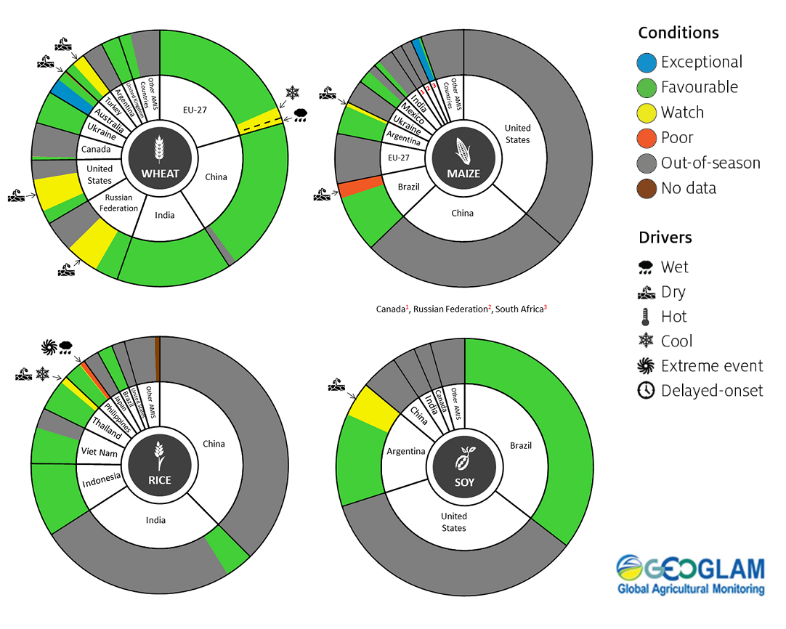
AMIS Agricultural Market Information System.
Source: AMIS

Rainfall outlook and potential impact on the future state of production conditions between March and May 2021
Region | March-May rainfall outlook | Potential impact on production
Argentina | Above average rainfall is more likely for parts of north-western Argentina and below average rainfall is more likely across parts of eastern and southern Argentina between March and May 2021. | Below average rainfall in eastern cropping regions may adversely affect the development and harvesting of sorghum, rice, millet, soybeans, corn, sunflower, cotton and nuts, and the planting of wheat in May 2021. Above average rainfall in the north-west is likely to support the development of crops in this region.
Black Sea Region | Ukraine - Below average rainfall is more likely across isolated parts of western Ukraine.  Kazakhstan - Below rainfall is more likely across parts of southern Kazakhstan.  The Russian Federation - Above average rainfall more likely across large parts of central-eastern Russia and parts of western Russia, and below average rainfall is more likely for isolated parts southern Russia north of Kazakhstan. | Below average rainfall in parts of Ukraine and Kazakhstan may adversely affect winter wheat and canola development and cotton, corn and sunflower planting from March 2021. Average or better rainfall across the Russian Federation is likely to support similar crops in the south and the planting and development of spring wheat planting in the north from April 2021.
Brazil | Above average rainfall is more likely across much of Brazil and below average rainfall is more likely across parts of far southern Brazil between March and May 2021. | Above average rainfall across much of Brazil is likely to support the development of cotton and corn, and the harvesting of soybeans in the central-west. Below average rainfall in parts of the south may adversely affect the development and harvesting of rice, sorghum, millet, sunflower, soybeans, cotton, nuts and corn, and the planting of wheat in May 2021.
Canada | Above average rainfall is more likely for parts of south-western and north-western Canada between March and May 2021. | Average to above average rainfall is likely to support winter wheat development in Canada from March 2021 and the planting of spring wheat, canola, corn, soybeans and sunflower from May 2021.
China | Above average rainfall is more likely across much of China and below average rainfall is more likely across isolated parts of western China. | Above average rainfall across much of China is likely to support the development of winter wheat and canola and the planting and development of early rice, single rice, cotton, spring wheat, corn, sorghum, soybeans, sunflower and nuts from March 2021.
Europe | Below average rainfall more likely for parts of western Europe and above average rainfall is more likely for parts of central and north-eastern Europe between March and May 2021. | Average to above average rainfall across much of Europe is likely to support winter wheat and canola development and the planting and development of corn, cotton, spring wheat, soybeans, sunflower and sorghum. Below average rainfall in the south-west may adversely affect the planting and development of these crops between March and May 2021.
South Asia (India) | Below average rainfall is more likely across parts of western and central India and above average rainfall is more likely parts of the coastline of India between March and May 2021. | Below average rainfall may adversely affect the development of wheat and canola in parts of western and central India. Average to above average rainfall across the remainder of India is likely to support crop development prior to harvest in April 2021.
Southeast Asia (SEA) | Above average rainfall is more likely for most northern SEA countries and below average rainfall is more likely for parts of north Myanmar. The rainfall outlook is mixed for Indonesia, with scattered areas of below and above average rainfall more likely between March and May 2021. | Average or better rainfall across most of Southeast Asia is likely to benefit corn and rice planting, development and harvesting. Below average rainfall in parts of Indonesia and Myanmar may adversely impact rice, corn and soybean production.
The United States of America | Above average rainfall is more likely for parts of the north-eastern and north-western US and below average rainfall is more likely for the south-western, central and far south-eastern US between March and May 2021. | Average or better rainfall in the northern and eastern US is likely to support winter wheat as it comes out of dormancy, as well as the planting and development of spring wheat, canola, corn, cotton, rice, soybeans and nuts. Below average rainfall in the central and southern US may adversely impact the development of winter wheat and the planting and development of corn, cotton, nuts, rice and soybeans.

Rainfall forecast for the next eight days
Troughs, low-pressure systems, onshore flow and a strong cold front are expected to generate showers and storms over parts of northern, western and eastern Australia during the next 8 days.
Rainfall totals of between 10 and 100 millimetres are forecast for parts of eastern New South Wales, south-eastern and northern Queensland, southern and northern Western Australia, the north of the Northern Territory and Tasmania. Rainfall totals in excess of 100 millimetres are expected across parts of northern Queensland and the north of the Northern Territory.
In Australia’s cropping regions, rainfall of between 5 and 25 millimetres is expected for much of northern and eastern New South Wales and Queensland and isolated parts of eastern Western Australia.

Total forecast rainfall (mm) for the period 18 February to 25 February 2021
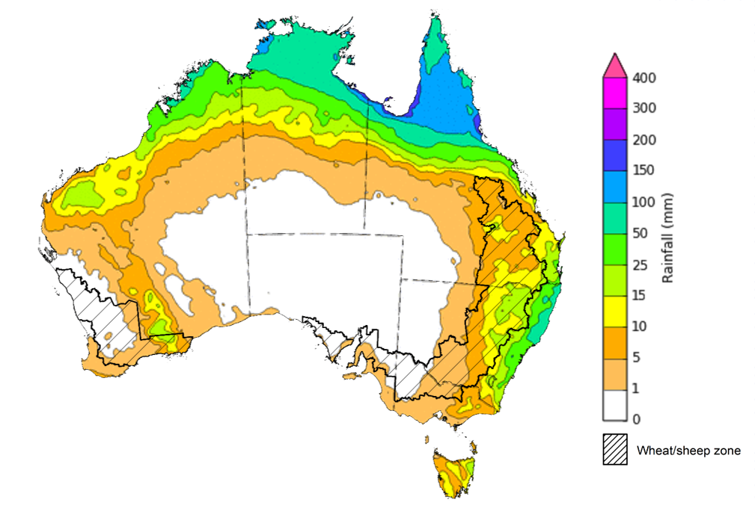
©Commonwealth of Australia 2021, Australian Bureau of Meteorology Issued: 18/02/2021

Water
Note: This rainfall forecast is produced from computer models. As the model outputs are not altered by weather forecasters, it is important to check local forecasts and warnings issued by the Bureau of Meteorology.

Water markets – current week
Water storage in the Murray–Darling Basin (MDB) decreased by 56 gigalitres (GL) between 10 February 2021 and 17 February 2021. The current volume of water held in storage is 13,563 GL, which represents 54% of total capacity. This is 67% or 5,437 GL more than at the same time last year.

Water storages in the Murray-Darling Basin, 2013–2021
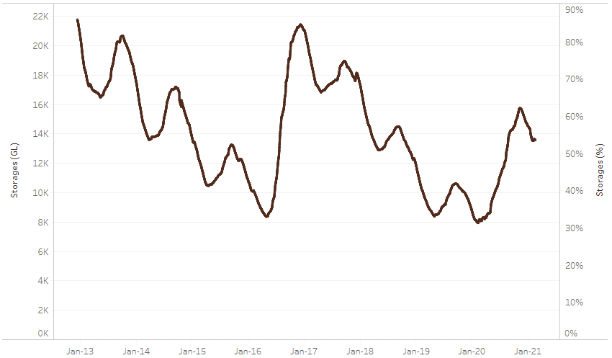
Water storage data is sourced from the Bureau of Meteorology.
Allocation prices in the Victorian Murray below the Barmah Choke decreased from $105 per ML to $95 per ML between 11 February 2021 and 18 February 2021. Prices are lower in the Murrumbidgee due to binding of the Murrumbidgee export limit.
Region | $/ML
NSW Murray Above | 95
NSW Murrumbidgee | 50
VIC Goulburn-Broken | 100
VIC Murray Below | 95

Surface water trade activity, Southern Murray–Darling Basin

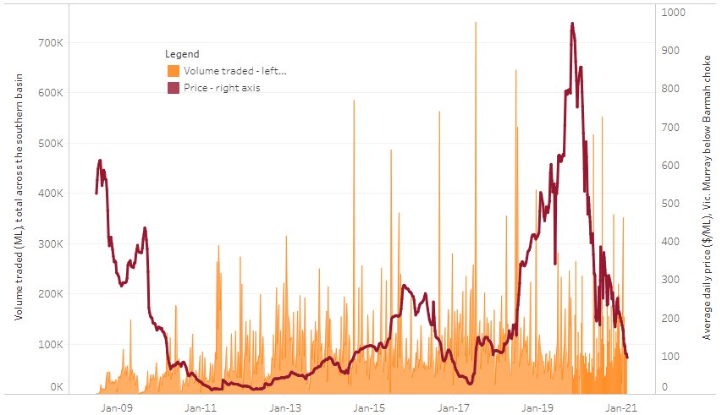
To access the full, interactive, weekly water dashboard, which contains the latest and historical water storage, water market and water allocation information, please visit http://www.agriculture.gov.au/abares/products/weekly_update/weekly-update-180221
The trades shown reflect estimated market activity and do not encompass all register trades. The price is shown for the VIC Murray below the Barmah choke. Historical prices (before 1 July 2019) are ABARES estimates after removing outliers from BOM water register data. Prices after 1 July 2019 and prior to the 30 October 2019 reflect recorded transaction prices as sourced from Ruralco. Prices after the 30 October 2019 are sourced from Waterflow. Data for volume traded is sourced from the BOM water register. Data shown is current at 18 February 2021.

Commodities
Indicator | Week ended | Unit | Latest price | Previous week | Weekly change | Price 12 months ago | Annual change
Selected world indicator prices
AUD/USD Exchange rate | 17-Feb | A$/US$ | 0.78 | 0.77 | 1% | 0.66 | 18%
Wheat – US no. 2 hard red winter wheat, fob Gulf | 17-Feb | US$/t | 284 | 287 | -1% | 224 | 27%
Corn – US no. 2 yellow corn, fob Gulf | 17-Feb | US$/t | 251 | 249 | 1% | 165 | 53%
Canola – Rapeseed, Canada, fob Vancouver | 17-Feb | US$/t | 614 | 602 | 2% | 364 | 69%
Cotton – Cotlook 'A' Index | 17-Feb | USc/lb | 93 | 90 | 3% | 75 | 24%
Sugar – Intercontinental Exchange, nearby futures, no.11 contract | 17-Feb | USc/lb | 16 | 16 | 0% | 15 | 4%
Wool – Eastern Market Indicator | 10-Feb | Ac/kg clean | 1,275 | 1,285 | -1% | 1,492 | -15%
Wool – Western Market Indicator | 10-Feb | Ac/kg clean | 1,314 | 1,313 | 0% | 1,672 | -21%
Selected Australian grain export prices
Milling Wheat – APW, Port Adelaide, SA | 17-Feb | A$/t | 359 | 354 | 1% | 370 | -3%
Feed Wheat – ASW, Port Adelaide, SA | 17-Feb | A$/t | 355 | 350 | 1% | 368 | -4%
Feed Barley – Port Adelaide, SA | 17-Feb | A$/t | 309 | 305 | 1% | 320 | -3%
Canola – Kwinana, WA | 17-Feb | A$/t | 683 | 691 | -1% | 661 | 3%
Grain Sorghum – Brisbane, QLD | 17-Feb | A$/t | 386 | 389 | -1% | 458 | -16%
Selected domestic livestock indicator prices
Beef – Eastern Young Cattle Indicator | 10-Feb | Ac/kg cwt | 873 | 882 | -1% | 507 | 72%
Mutton – Mutton indicator (18–24 kg fat score 2–3), Vic | 10-Feb | Ac/kg cwt | 655 | 611 | 7% | 621 | 5%
Lamb – Eastern States Trade Lamb Indicator | 10-Feb | Ac/kg cwt | 847 | 842 | 1% | 810 | 5%
Pig – Eastern Seaboard (60.1–75 kg), average of buyers & sellers | 27-Jan | Ac/kg cwt | 367 | 367 | 0% | 411 | -11%
Goats – Eastern States (12.1–16 kg) | 10-Feb | Ac/kg cwt | 813 | 813 | 0% | 879 | -8%
Live cattle – Light steers ex Darwin to Indonesia | 03-Feb | Ac/kg lwt | 355 | 355 | 0% | 330 | 8%
Live sheep – Live wethers (Muchea WA saleyard) to Middle East | 18-Nov | $/head | 118 | 108 | 9% | N/A | N/A

Indicator | Week ended | Unit | Latest price | Previous week | Weekly change | Price 12 months ago | Annual change
Global Dairy Trade (GDT) weighted average prices ª
Dairy – Whole milk powder | 17-Feb | US$/t | 3,615 | 3,458 | 5% | 2,705 | 34%
Dairy – Skim milk powder | 17-Feb | US$/t | 3,207 | 3,198 | 0% | 2,201 | 46%
Dairy – Cheddar cheese | 17-Feb | US$/t | 4,268 | 4,178 | 2% | 3,371 | 27%
Dairy – Anhydrous milk fat | 17-Feb | US$/t | 5,527 | 5,463 | 1% | 5,137 | 8%
a Global Dairy Trade prices are updated twice monthly on the first and third Tuesday of each month.

Selected world indicator prices

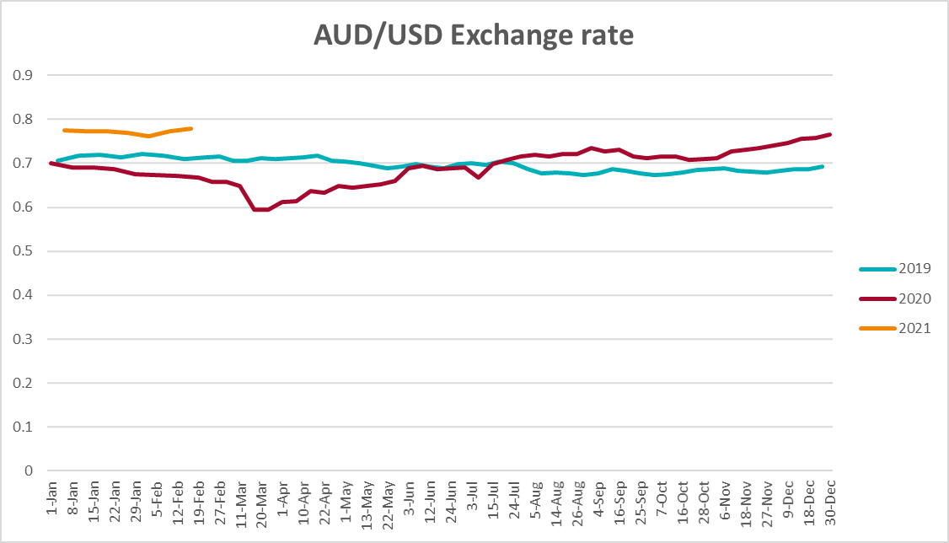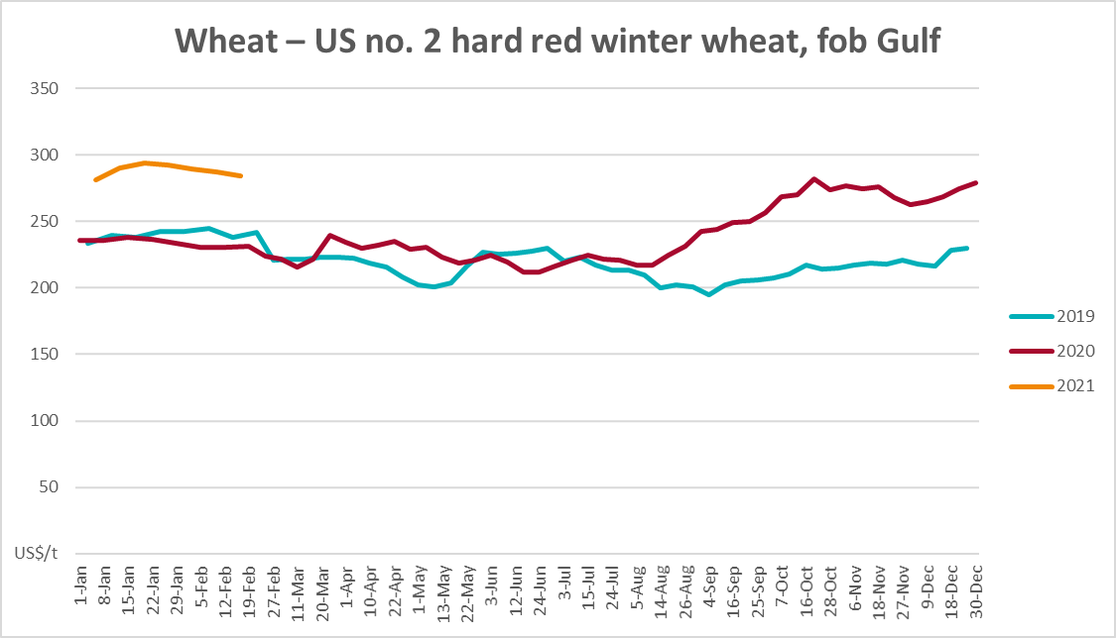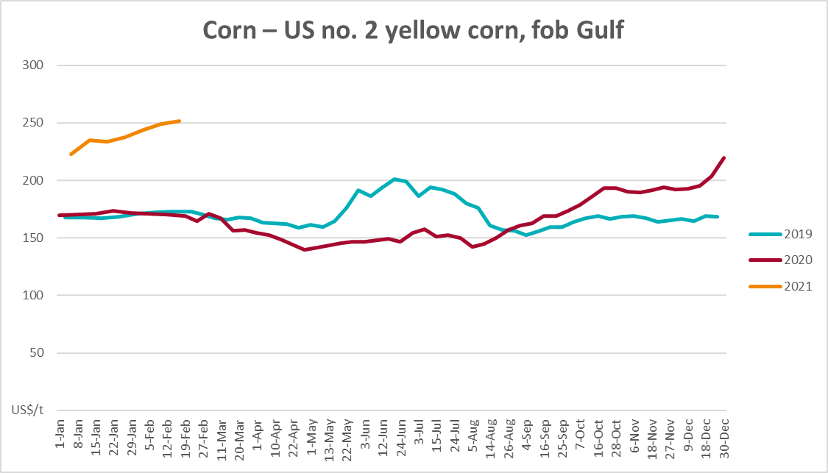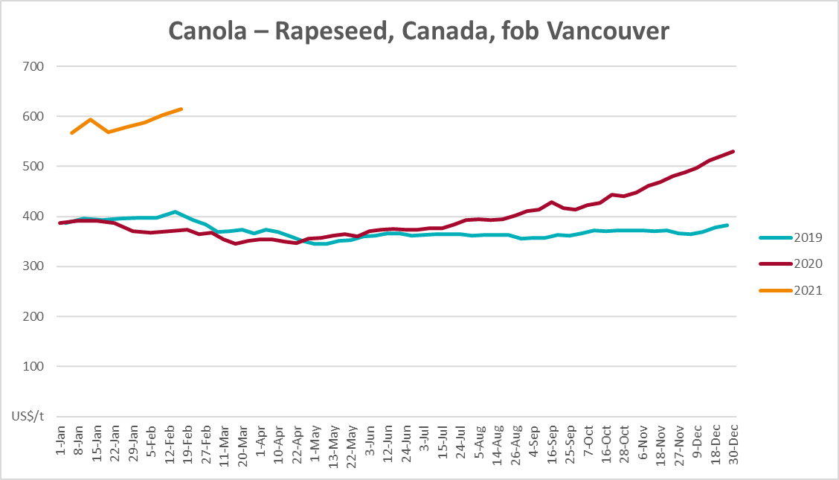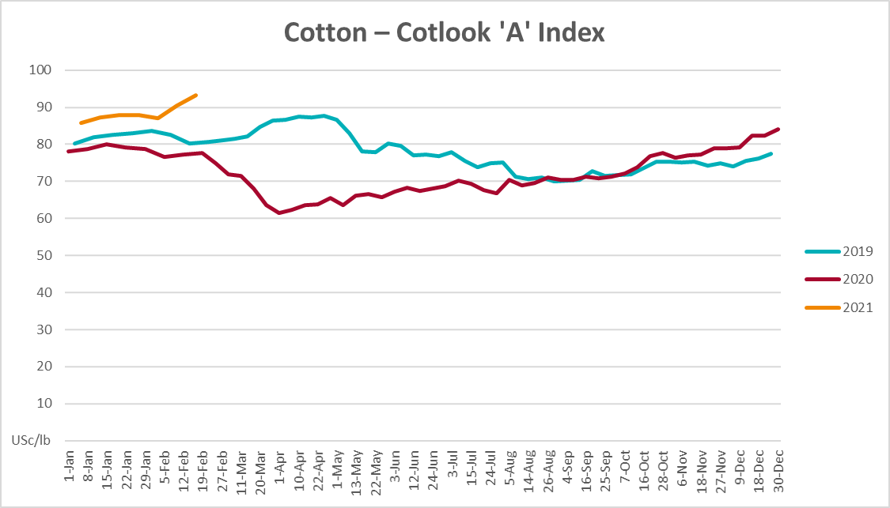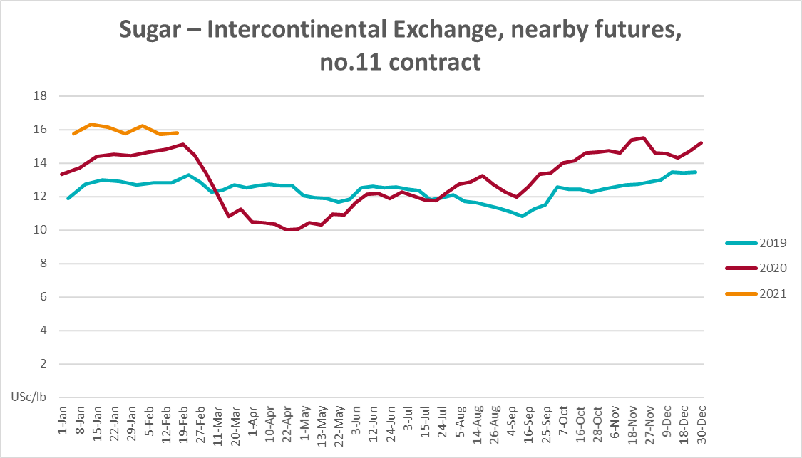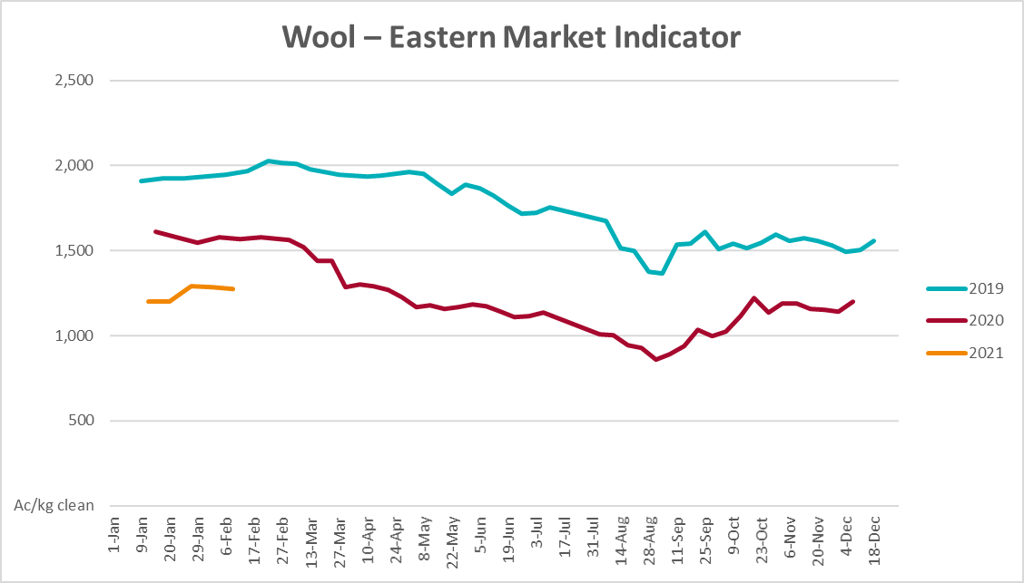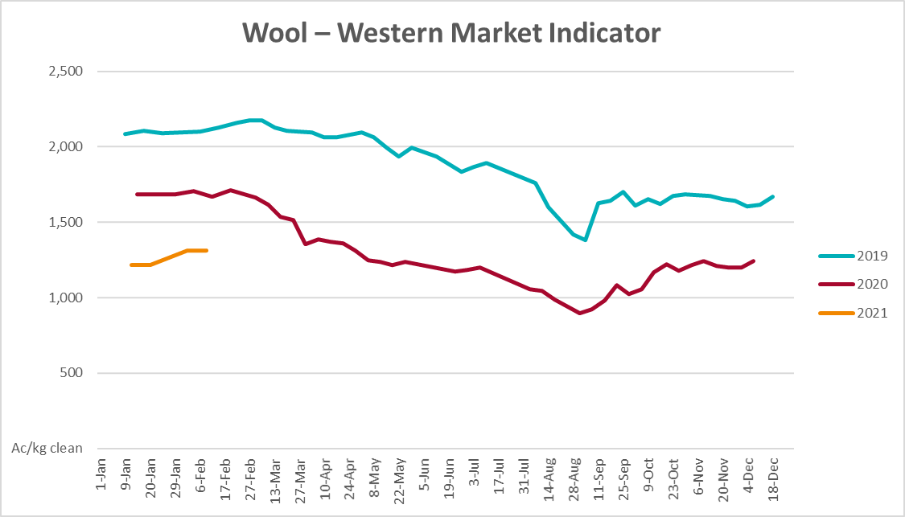

Selected domestic crop indicator prices

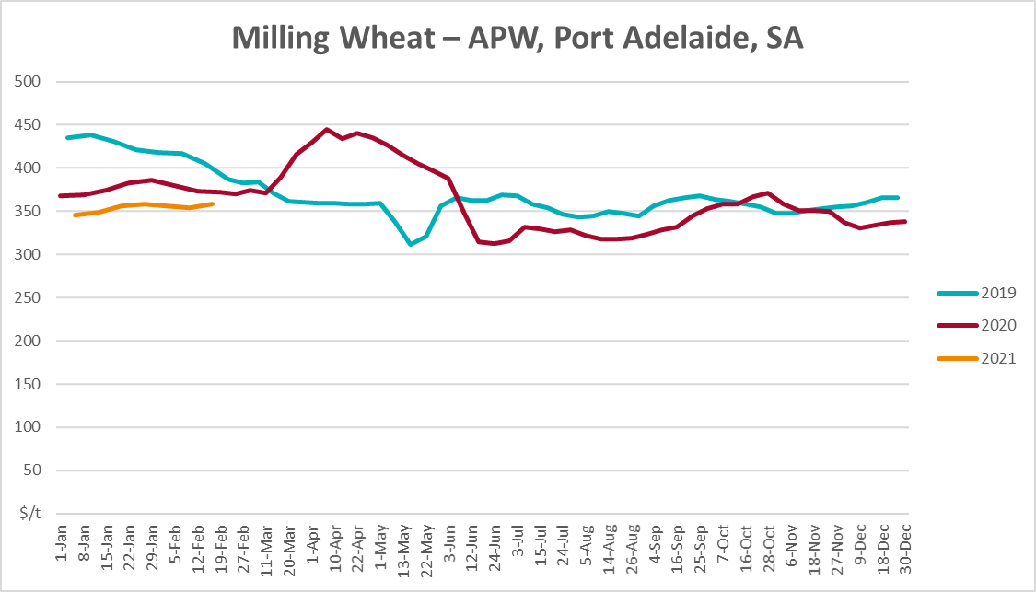
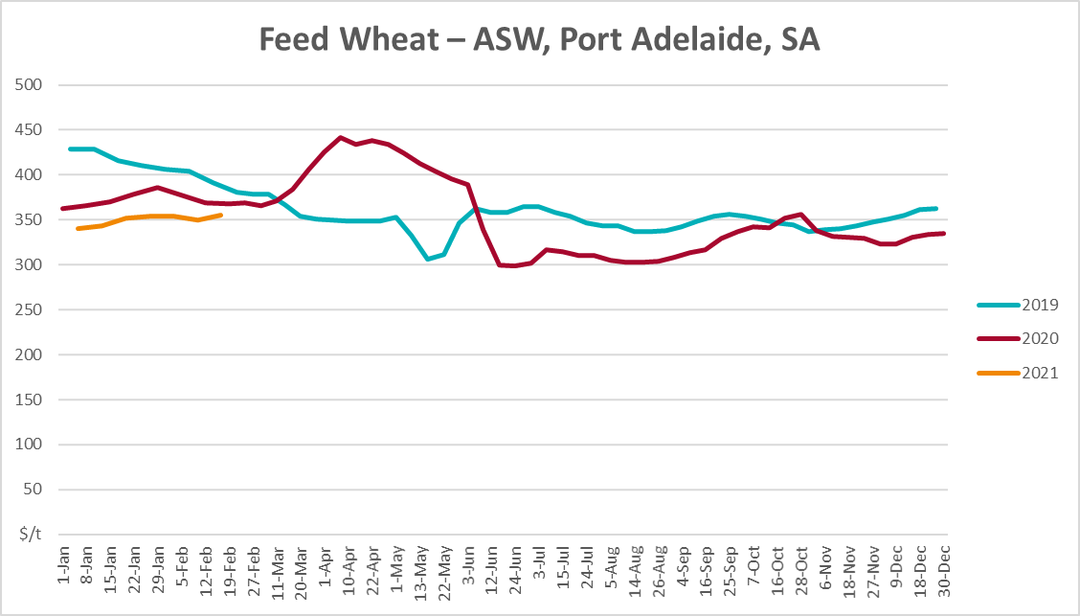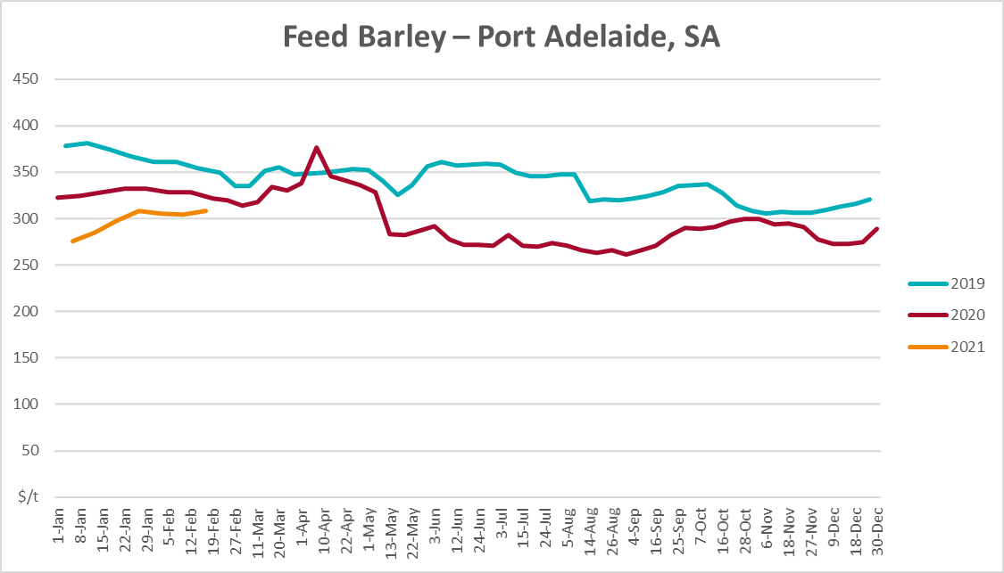

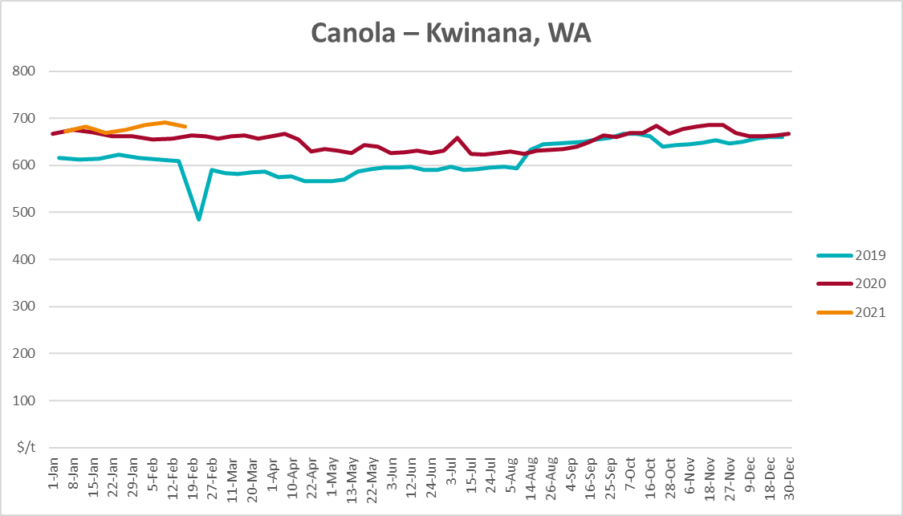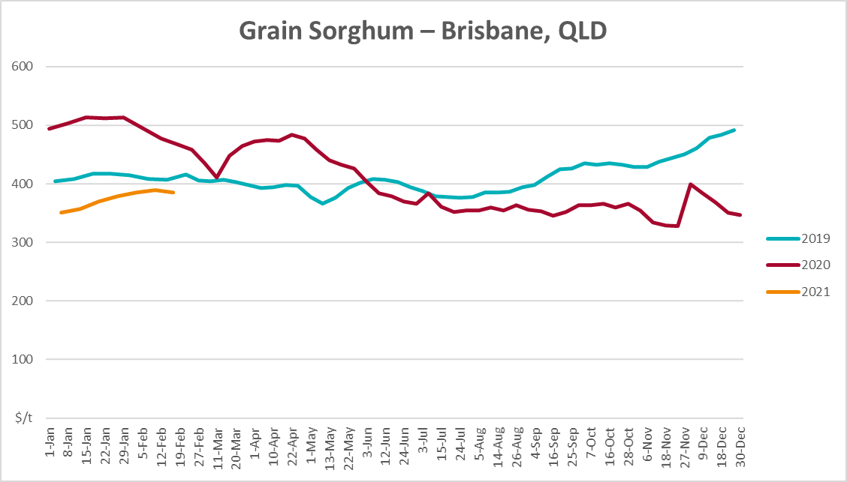

Selected domestic livestock indicator prices

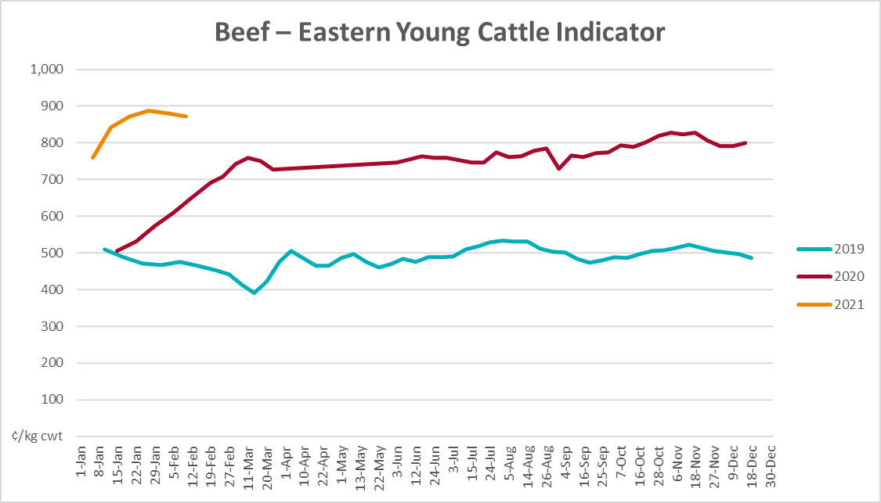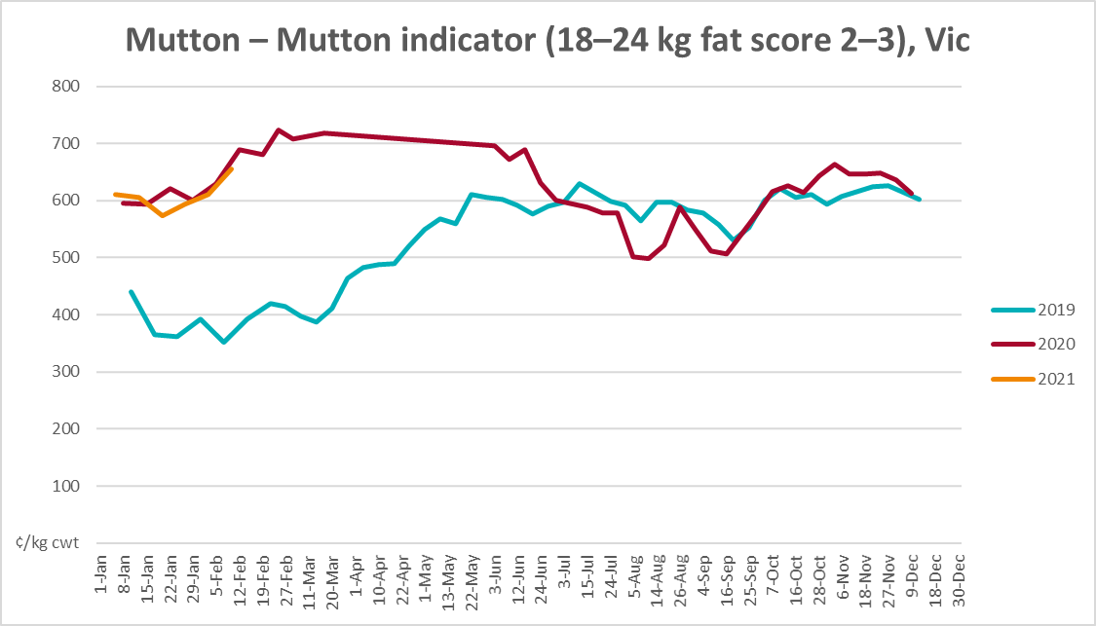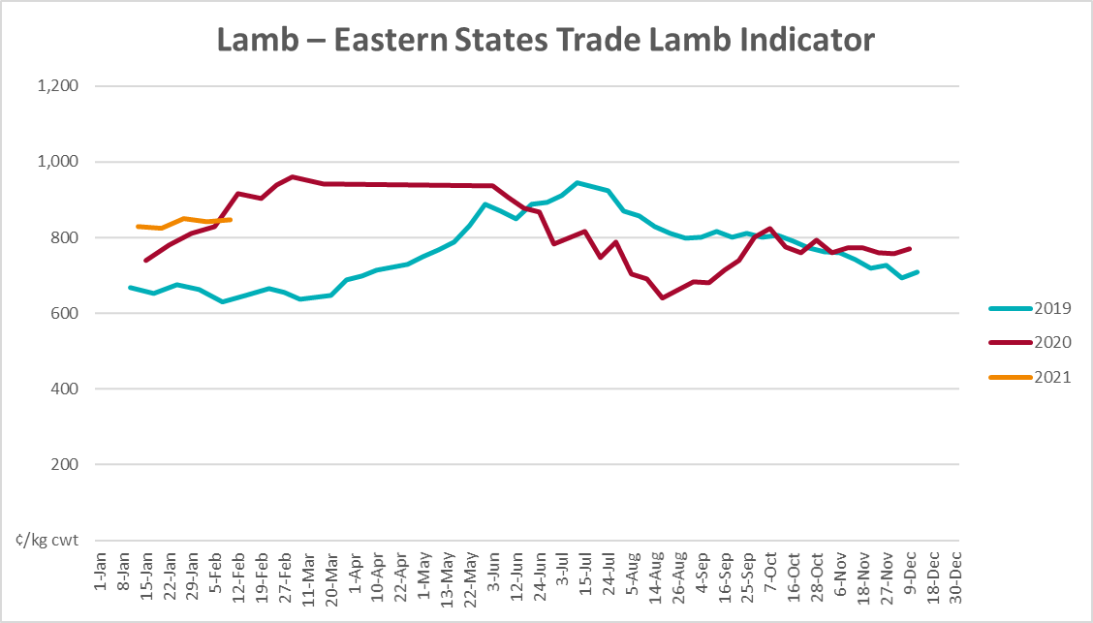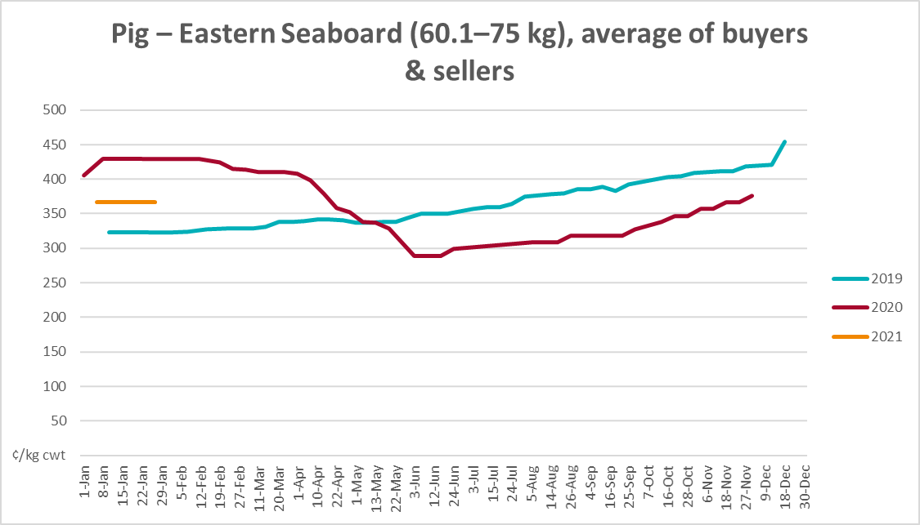

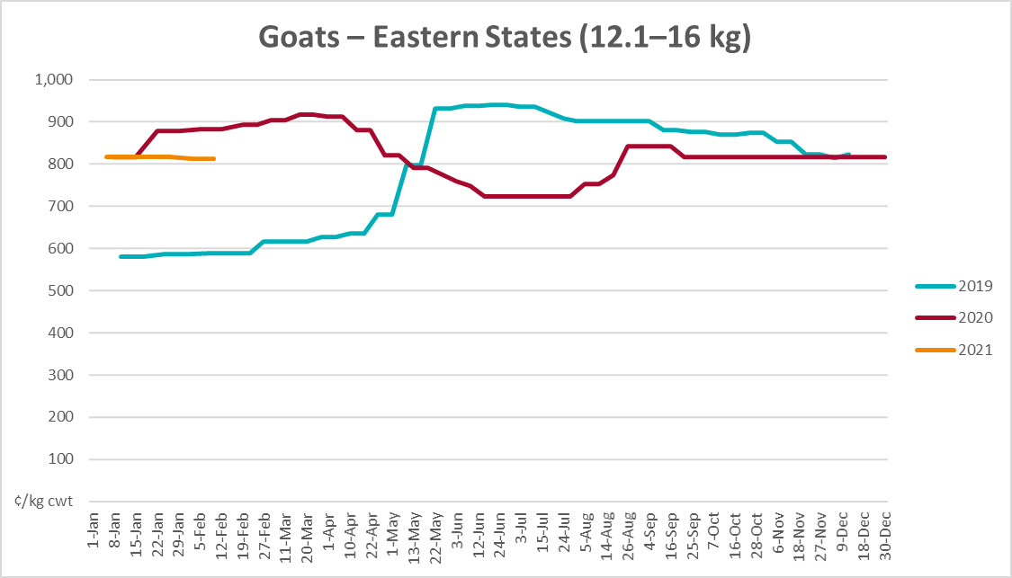
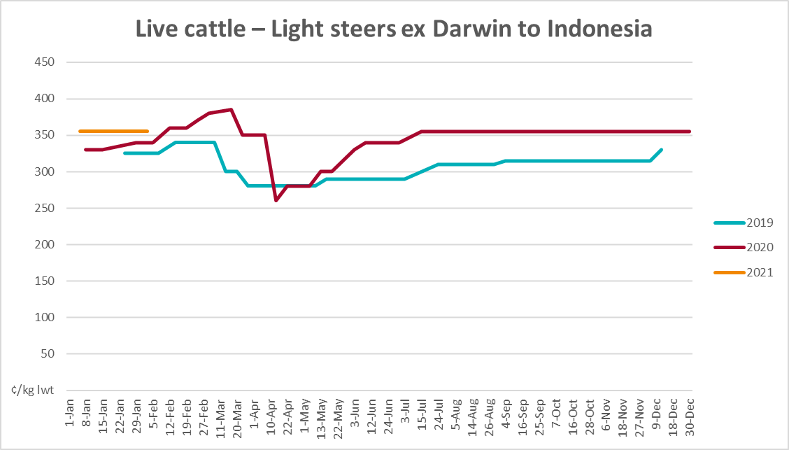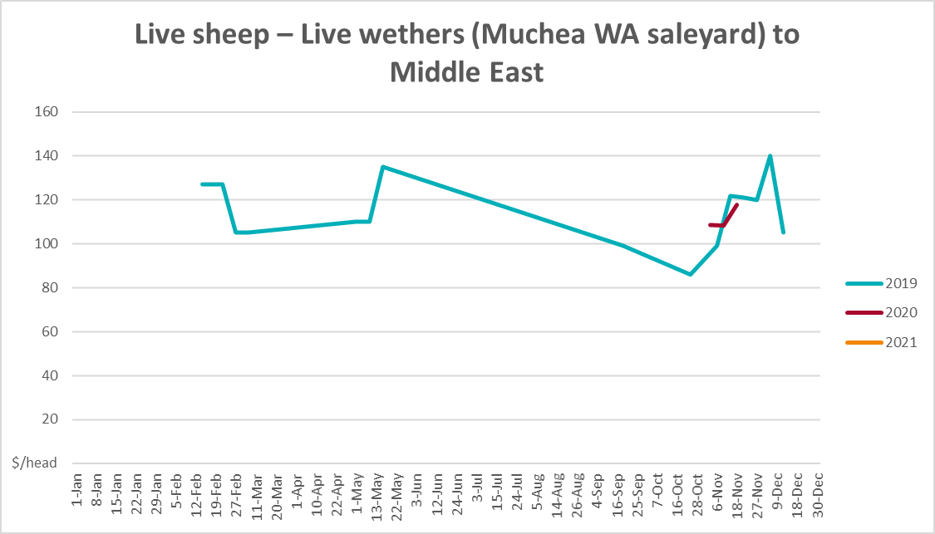

Global Dairy Trade (GDT) weighted average prices
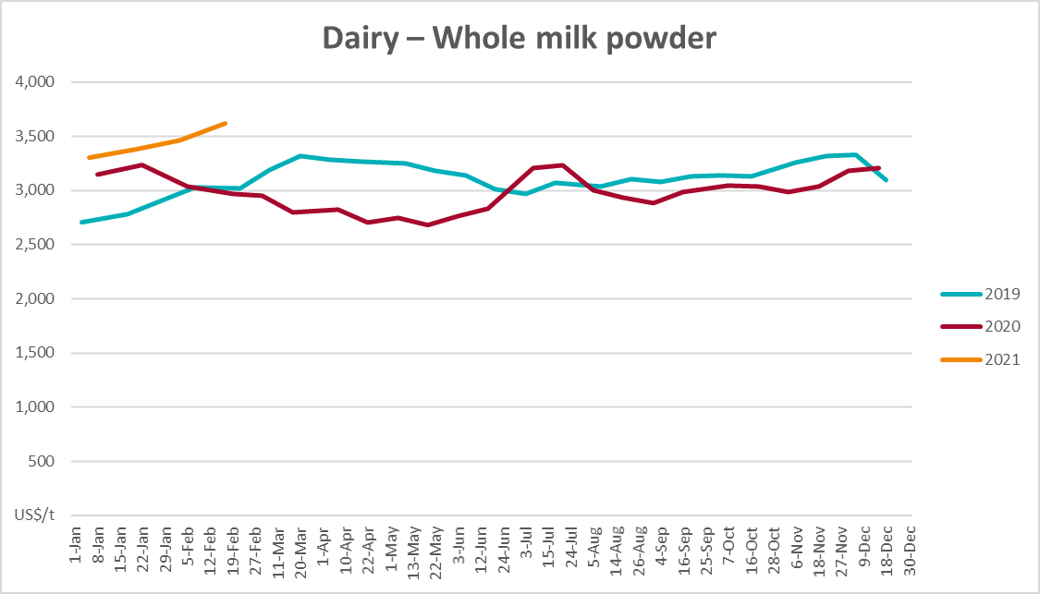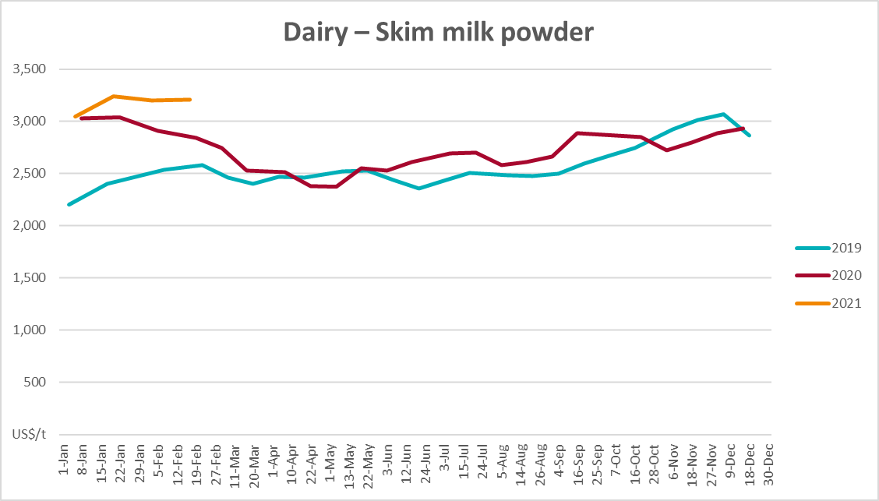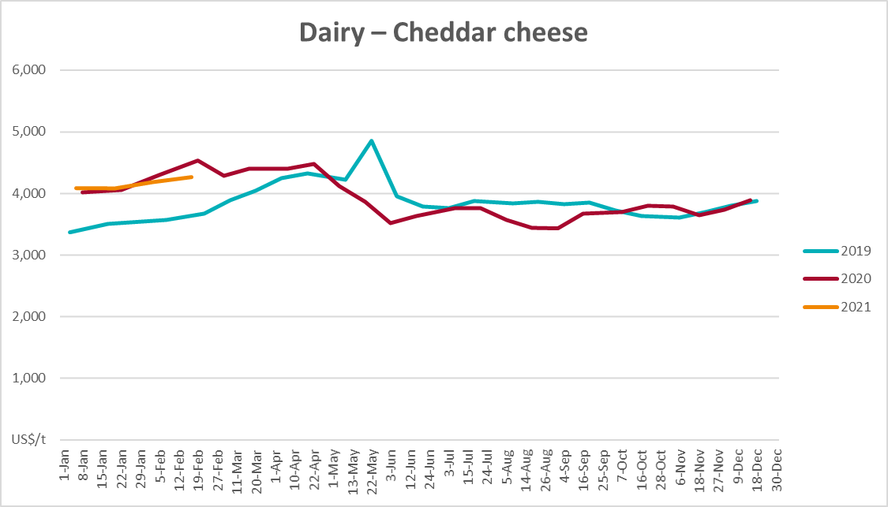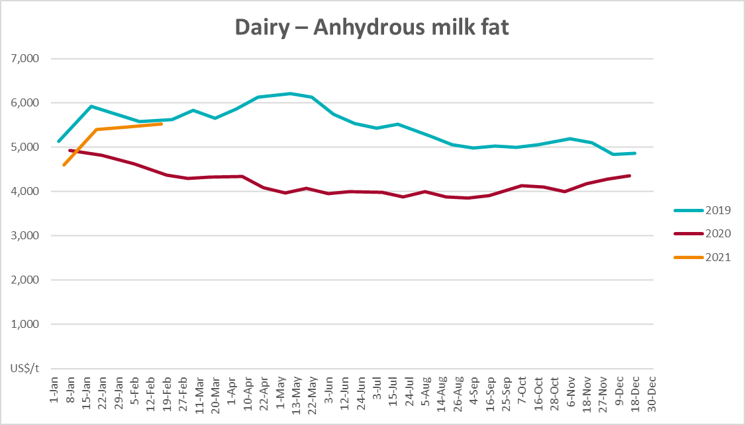

Selected fruit and vegetable prices

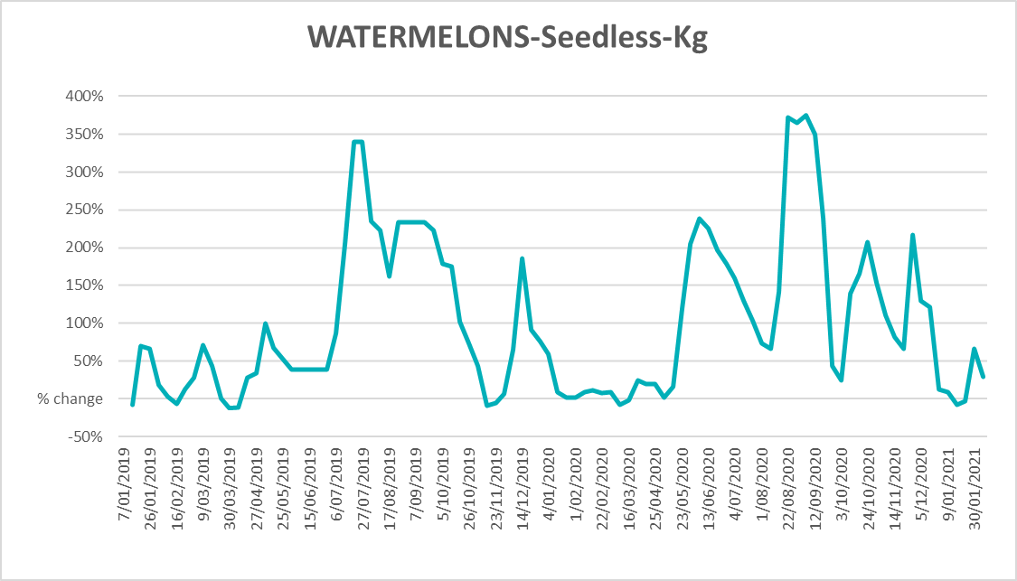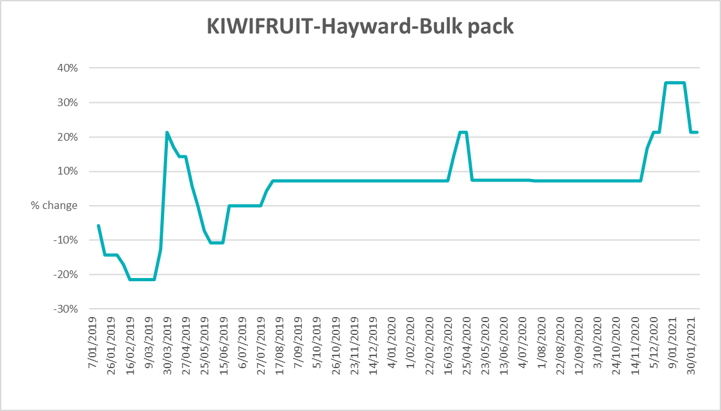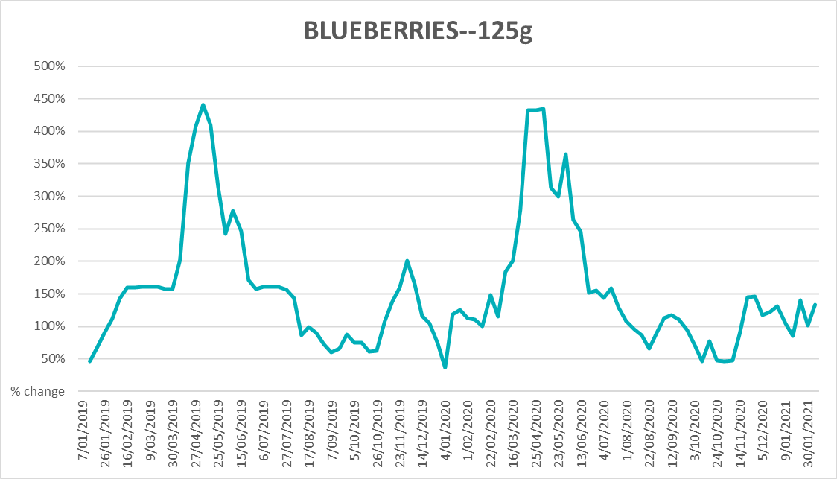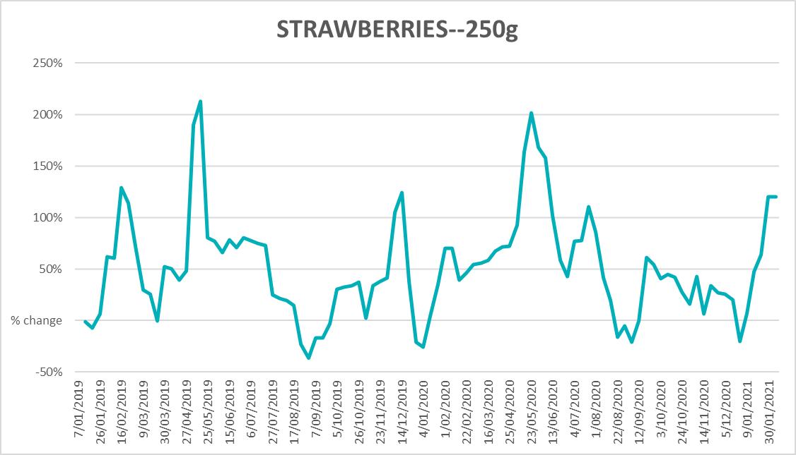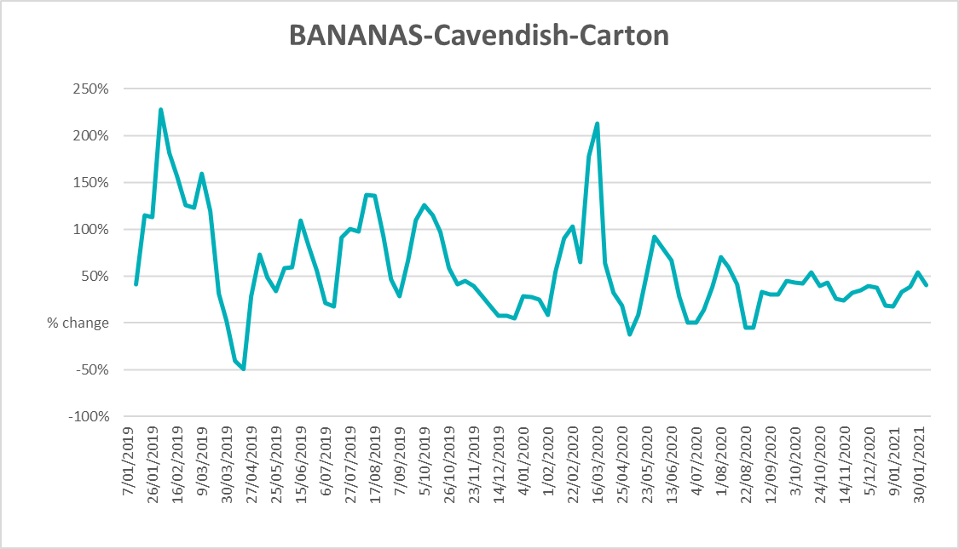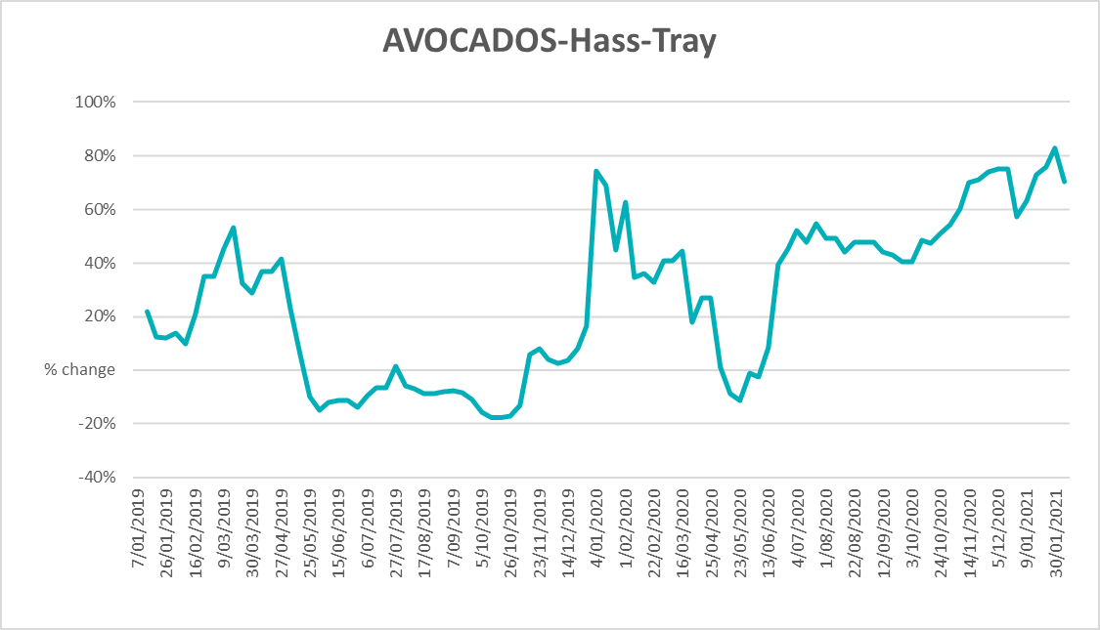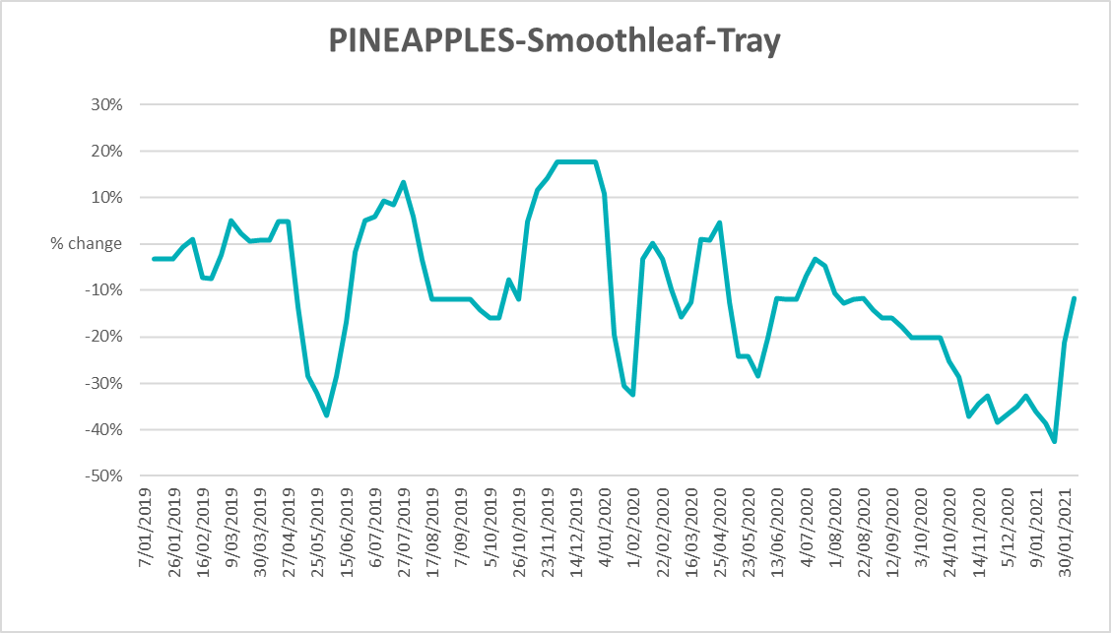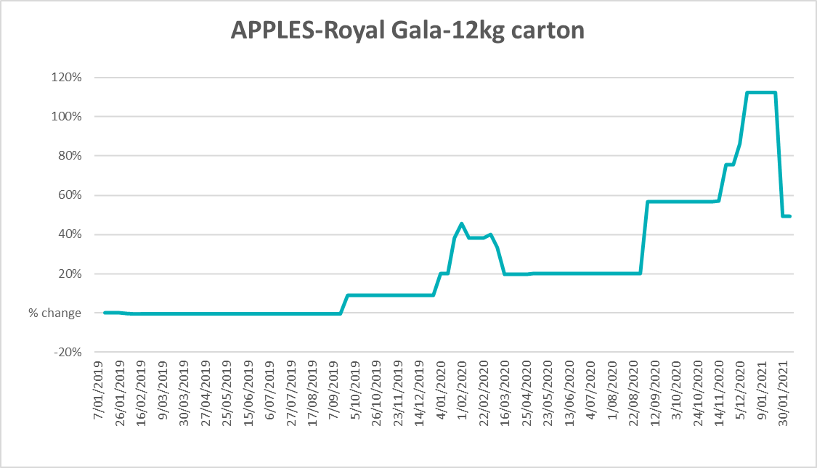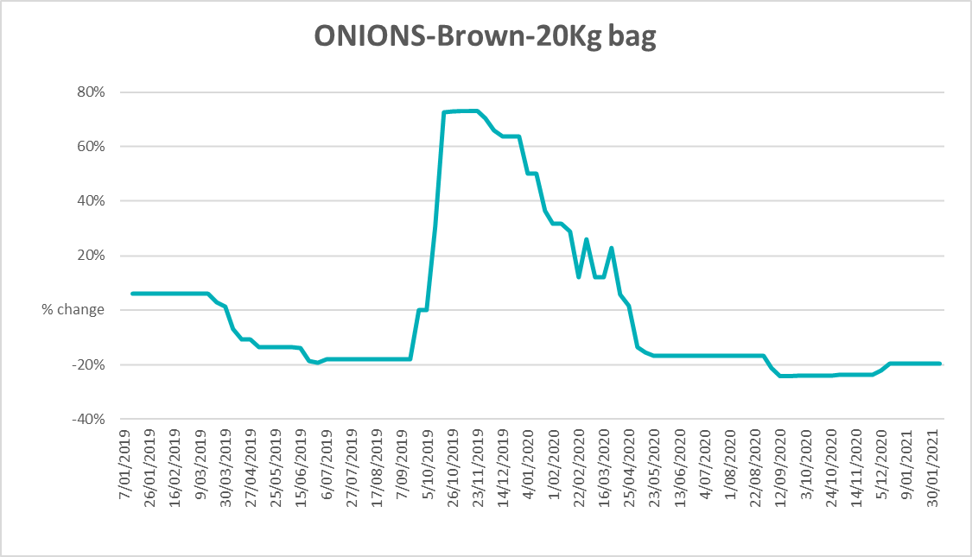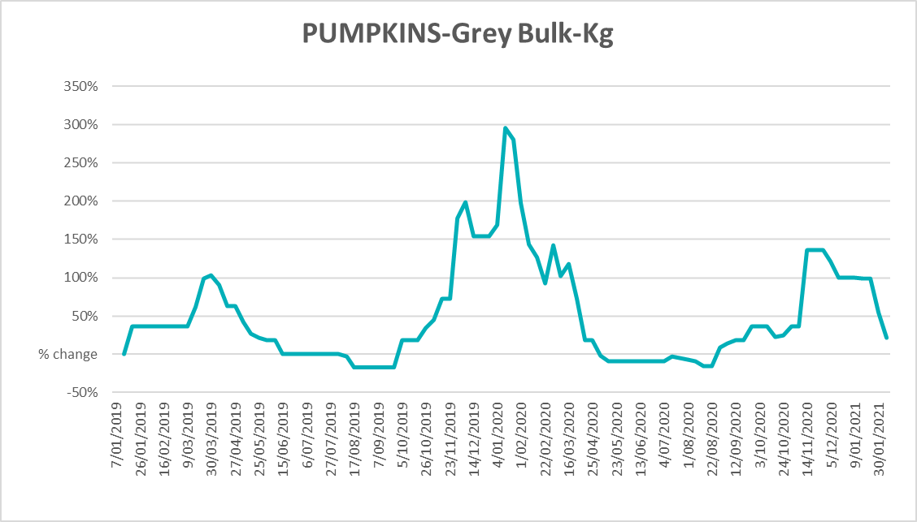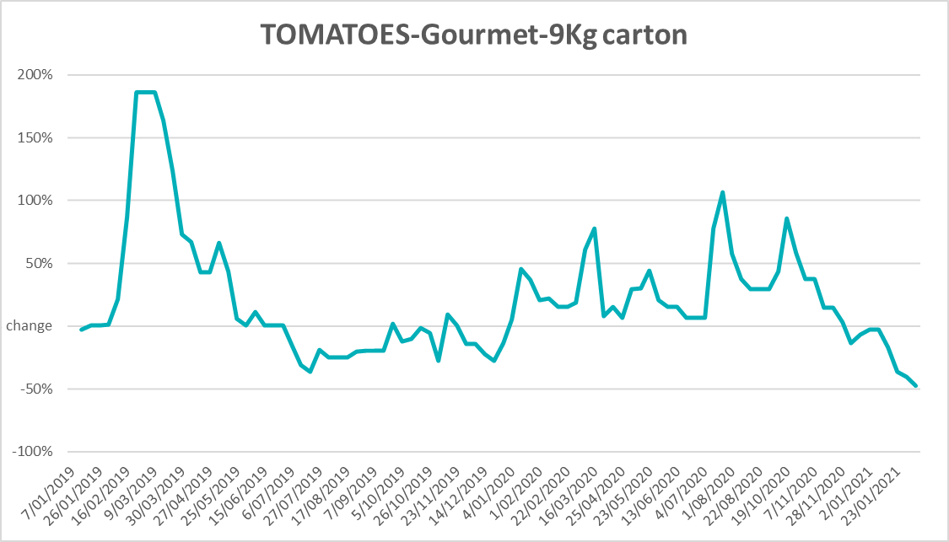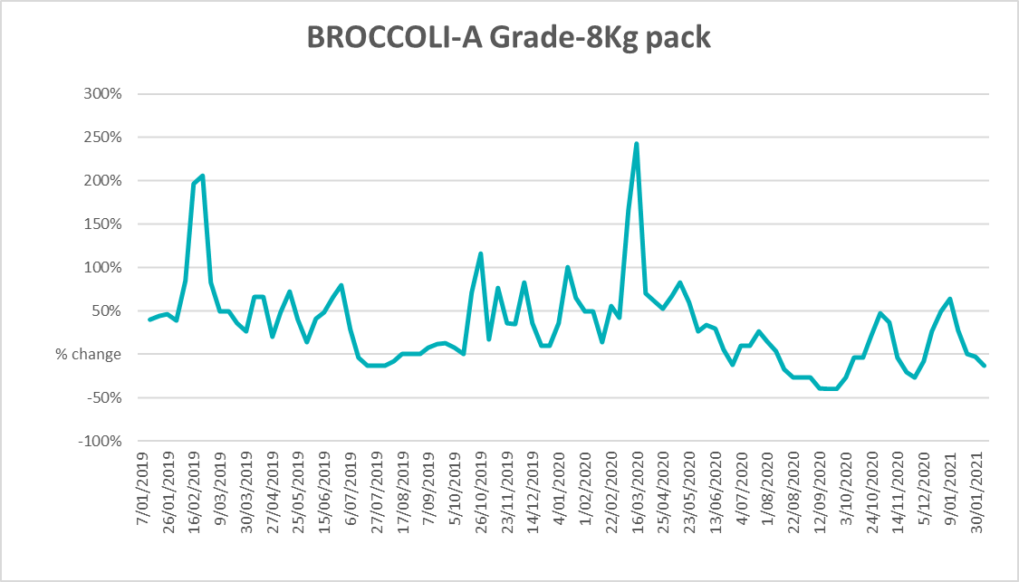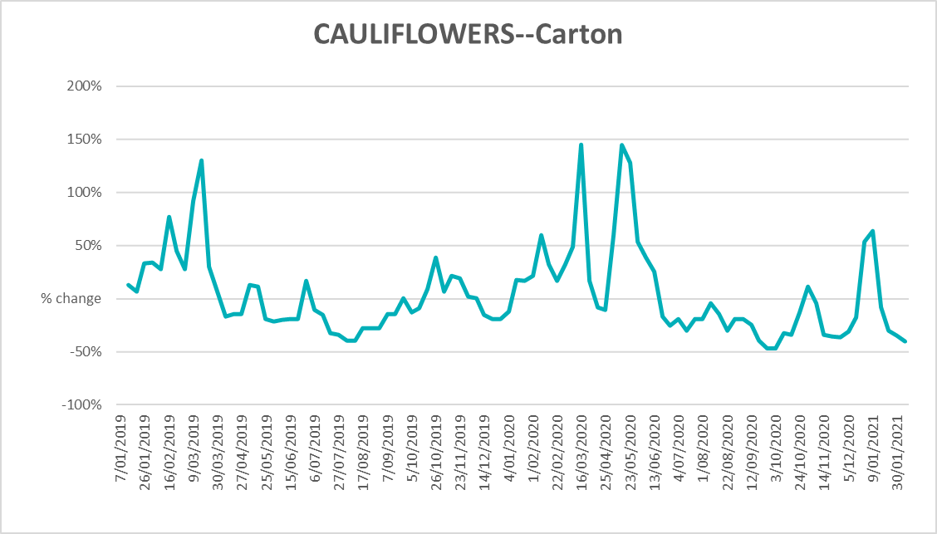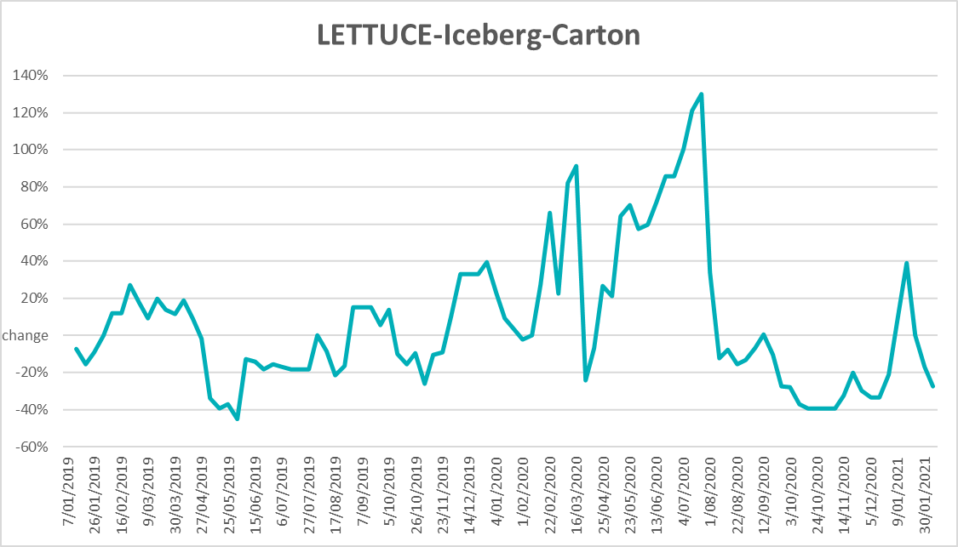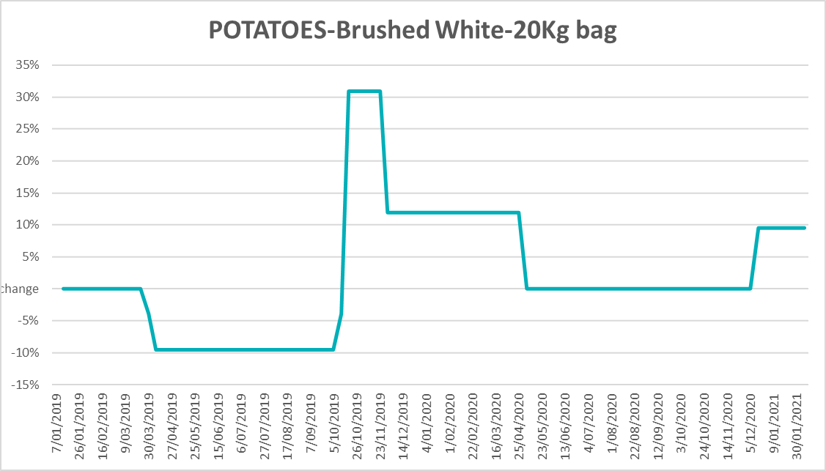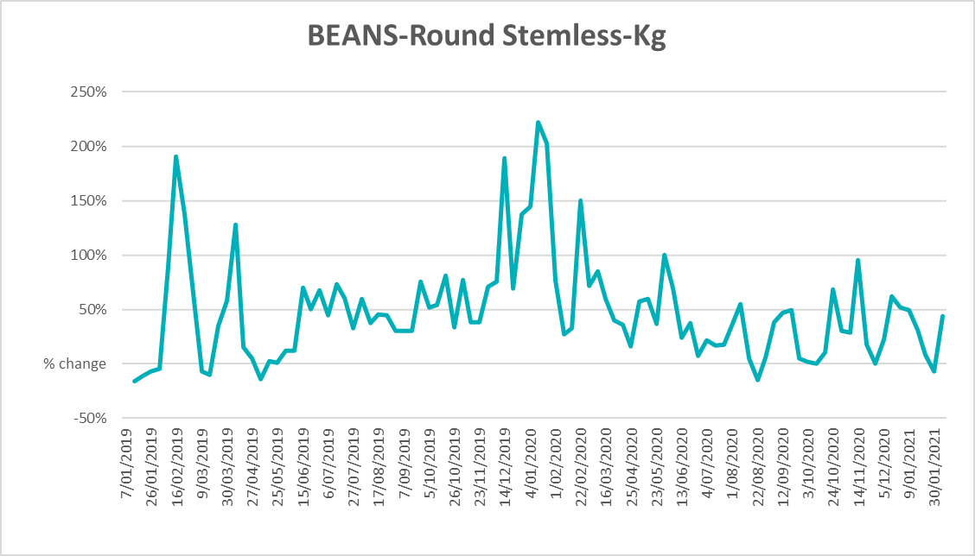

Data attribution

Climate
Bureau of Meteorology
- Weekly rainfall totals: www.bom.gov.au/jsp/awap/rain/index.jsp
- Monthly and last 3-month rainfall percentiles: www.bom.gov.au/jsp/awap/rain/index.jsp
- Temperature anomalies: www.bom.gov.au/jsp/awap/temp/index.jsp
- Rainfall forecast: www.bom.gov.au/jsp/watl/rainfall/pme.jsp
- Seasonal outlook: www.bom.gov.au/climate/outlooks/#/overview/summary/
- Drought statement: www.bom.gov.au/climate/drought/drought.shtml
- Soil moisture: www.bom.gov.au/water/landscape/
Other
- Pasture growth: https://www.longpaddock.qld.gov.au/aussiegrass/
- 3-month global outlooks: Environment and Climate Change Canada, NOAA Climate Prediction Center, EUROBRISA CPTEC/INPE, European Centre for Medium-Range Weather Forecasts, Hydrometcenter of Russia, National Climate Center Climate System Diagnosis and Prediction Room (NCC), International Research Institute for Climate and Society
- Global production: https://ipad.fas.usda.gov/ogamaps/cropmapsandcalendars.aspx

Water
New South Wales
- New South Wales Water Information: http://waterinfo.nsw.gov.au/
- New South Wales Office of Water, Department of Primary Industries: www.water.nsw.gov.au/Home/default.aspx
- Available water determinations register: www.water.nsw.gov.au/water-licensing/registers
Queensland
- Sunwater: www.sunwater.com.au
- Seqwater: http://seqwater.com.au
South Australia
- SA Water: www.sawater.com.au/community-and-environment/the-river-murray/river-reports/daily-flow-report
- South Australian Department of Environment, Water and Natural Resources: www.environment.sa.gov.au
Victoria
- Goulburn–Murray Water: www.g-mwater.com.au

Commodities
Fruit and vegetables
- Datafresh: www.freshstate.com.au
Pigs
- Australian Pork Limited: www.australianpork.com.au
Dairy
- Global Dairy Trade: www.globaldairytrade.info/en/product-results/
World wheat, canola
- International Grains Council
World coarse grains
- United States Department of Agriculture
World cotton
- Cotlook: www.cotlook.com/
World sugar
- New York Stock Exchange - Intercontinental Exchange
Wool
- Australian Wool Exchange: www.awex.com.au/
Domestic wheat, barley, sorghum and canola
- Jumbuk Consulting Pty Ltd: http://www.jumbukag.com.au/
Cattle, beef, mutton, lamb, goat and live export
- Meat and Livestock Australia: www.mla.com.au/Prices-and-market
© Commonwealth of Australia 2021

Ownership of intellectual property rights
Unless otherwise noted, copyright (and any other intellectual property rights, if any) in this publication is owned by the Commonwealth of Australia (referred to as the Commonwealth).

Creative Commons licence
All material in this publication is licensed under a Creative Commons Attribution 4.0 International Licence except content supplied by third parties, logos and the Commonwealth Coat of Arms.
Inquiries about the licence and any use of this document should be emailed to copyright@awe.gov.au.


Cataloguing data
This publication (and any material sourced from it) should be attributed as:
ABARES 2021, Weekly Australian Climate, Water and Agricultural Update, Australian Bureau of Agricultural and Resource Economics and Sciences, Canberra, 18 February 2021. CC BY 4.0 DOI: https://doi.org/10.25814/5f3e04e7d2503
ISSN 2652-7561
This publication is available at https://www.agriculture.gov.au/abares/products/weekly_update
Department of Agriculture, Water and the Environment
GPO Box 858 Canberra ACT 2601
Telephone 1800 900 090
Web awe.gov.au/abares

Disclaimer
The Australian Government acting through the Department of Agriculture, Water and the Environment, represented by the Australian Bureau of Agricultural and Resource Economics and Sciences, has exercised due care and skill in preparing and compiling the information and data in this publication. Notwithstanding, the Department of Agriculture, Water and the Environment, ABARES, its employees and advisers disclaim all liability, including liability for negligence and for any loss, damage, injury, expense or cost incurred by any person as a result of accessing, using or relying on any of the information or data in this publication to the maximum extent permitted by law.

Statement of Professional Independence
The views and analysis presented in ABARES publications, including this one, reflect ABARES professionally independent findings, based on scientific and economic concepts, principles, information and data. These views, analysis and findings may not reflect or be consistent with the views or positions of the Australian Government, or of organisations or groups who have commissioned ABARES reports or analysis. More information on professional independence is provided on the ABARES website.

Acknowledgements
This report was prepared by Emma Pearce and Matthew Miller.

