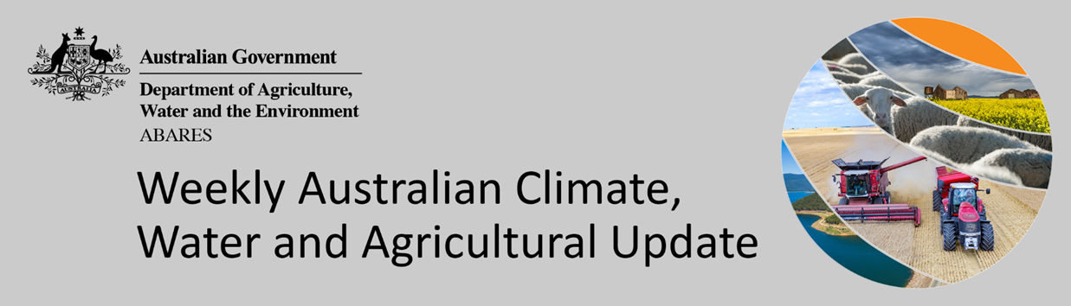
No. 31/2021

12 August 2021

Summary of key issues
- During the week ending 11 August 2021, low pressure systems and cold fronts brought rainfall to parts of western and southern Australia. High pressure systems and clear skies, on the other hand, resulted in little to no rainfall across much of eastern, central and northern Australia (see Section 1.1).
- For the 3 months to July 2021, low rainfall totals limited pasture production across parts of southern and northern Australia. In contrast, average or better rainfall and generally average soil moisture benefitted pasture production across large areas of western and eastern Australia (see Section 1.2).
- The Bureau of Meteorology reports that the negative Indian Ocean Dipole (IOD) event continues. A negative IOD event increases the chance of above average rainfall for southern and eastern Australia and the far north during winter and spring. It is also typically associated with an early onset of northern rainfall (see Section 1.3).
- The outlook for September 2021 indicates that there is a 75% chance of rainfall totals between 10 and 100 millimetres across parts of eastern, south-western and far southern Australia. Rainfall totals in excess of 100 millimetres are expected across alpine regions of New South Wales and Victoria, and western Tasmania (see Section 1.4).
- The rainfall outlook for spring 2021 (September to November) suggests there is a greater than 70% chance of exceeding average rainfall across much of New South Wales, Queensland, Victoria, South Australia and the Northern Territory. There is an increased chance of below average rainfall across the north and part of south-west Western Australia and western Tasmania during spring 2021.
- The influence of slow-moving high-pressure systems is likely to bring clear skies and dry conditions across much of Australia over the next eight days. Rainfall is likely to be limited to west facing southern coastlines and onshore flow will bring showers to isolated areas of Australia’s eastern coast (see Section 1.5).
- Little to no rainfall is forecast for most of Australia’s cropping regions during the next 8-days. These dry conditions across most cropping regions will allow for drying of saturated soil profiles in some areas, reducing the impact of waterlogging and associated water-damage. Crop development is expected to progress unimpeded with high levels of plant available moisture in most areas provided by previous heavy falls.
- Water storage in the Murray–Darling Basin (MDB) increased by 317 gigalitres (GL) between 4 August 2021 and 11 August 2021. The current volume of water held in storage is 19,638 GL, which represents 78% of total capacity. This is 54% or 6,889 GL more than at the same time last year.

Climate

Rainfall this week
During the week ending 11 August 2021, low pressure systems and cold fronts brought rainfall to parts of western and southern Australia. High pressure systems and clear skies, on the other hand, resulted in little to no rainfall across much of eastern, central and northern Australia.
Rainfall totals of between 10 and 50 millimetres were recorded across isolated parts of Queensland, Victoria, southern South Australia, much of the south-west of Western Australia and western Tasmania. Rainfall totals in excess of 50 millimetres were recorded in isolated parts of south-west Western Australia and western Tasmania.
In cropping regions, rainfall totals of between 10 and 50 millimetres were recorded across much of Western Australia. Little to no rainfall was recorded in cropping regions of New South Wales, Queensland, Victoria and South Australia.
Continued wet conditions in the south-west of Western Australia has likely exacerbated waterlogging in some areas, negatively impacting crop growth. The drier conditions in eastern cropping regions provided a welcome break, with ample soil moisture to support ongoing plant development. Recent wet conditions across Australia have restricted access to fields and delayed spraying of crops for pest and disease control and applications of urea. A run of dry weather in some eastern and western cropping regions will be required to allow field access, otherwise aerial spraying may become necessary.

Rainfall for the week ending 11 August 2021

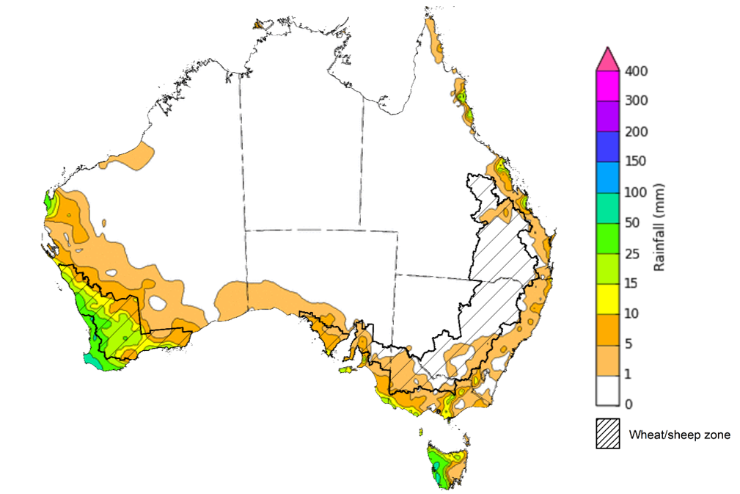
©Commonwealth of Australia 2021, Australian Bureau of Meteorology Issued: 11/08/2021
Note: The rainfall analyses and associated maps utilise data contained in the Bureau of Meteorology climate database, the Australian Data Archive for Meteorology (ADAM). The analyses are initially produced automatically from real-time data with limited quality control. They are intended to provide a general overview of rainfall across Australia as quickly as possible after the observations are received. For further information go to http://www.bom.gov.au/climate/rainfall/

Pasture growth
Pasture growth during the May to July period is typically low across large areas of central and northern Australia as it enters a seasonally low growth period due to cooler temperatures and little to no rainfall. Across southern Australia, May to July pasture growth influences the number of livestock than can be supported without supplementary feeding over winter and the level of reliance on hay and grain during this period.
For the 3 months to July 2021, low rainfall totals limited pasture production across parts of southern and northern Australia. In contrast, average or better rainfall and generally average soil moisture benefitted pasture production across large areas of western and eastern Australia.
Modelled pasture growth was extremely low to below average across parts of western New South Wales, parts of central Queensland, western Victoria, eastern South Australia, central and northern Western Australia, and parts of central Northern Territory. As a result, livestock producers across parts of western New South Wales, western Victoria and eastern South Australia will be heavily reliant on rainfall over the remainder of winter to build soil moisture levels and supplementary feed to maintain current stock numbers.
In contrast, modelled pasture growth was above average to extremely high across large areas of central and northern New South Wales, eastern Queensland, and large areas of Western Australia. This growth is likely to enable farmers to continue to rebuild stock numbers and provide opportunities to replenish fodder supplies during spring.

Relative pasture growth for 3-months ending July 2021 (1 May to 31 July 2021)
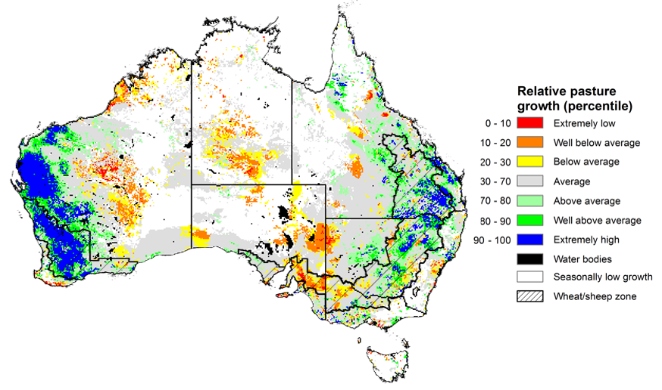
Notes: AussieGRASS pasture growth estimates are relative to the long-term record and shown in percentiles. Percentiles rank data on a scale of zero to 100. This analysis ranks pasture growth for the selected period against average pasture growth for the long-term record (1957 to 2016). Pasture growth is modelled at 5km2 grid cells.
Source: Queensland Department of Science, Information Technology and Innovation

Climate Drivers
Throughout winter the climate drivers with the largest potential impact on Australia’s climate patterns are the El Niño–Southern Oscillation (ENSO), the Indian Ocean Dipole (IOD) and the Southern Annular Mode (SAM). These climate drivers will likely influence the outlook for Australia’s winter cropping season.
The Bureau of Meteorology reports that the negative Indian Ocean Dipole (IOD) event continues. A negative IOD event increases the chance of above average rainfall for southern and eastern Australia and the far north during winter and spring. It is also typically associated with an early onset of northern rainfall.
ENSO conditions, on the other hand, remain neutral according to most oceanic and atmospheric indicators, reducing its influence on Australia’s climate. International climate models surveyed by the Bureau of Meteorology agree that ENSO conditions are likely to remain neutral throughout August. Three of the seven models, however, expect the development of a La Niña event in mid-to-late spring. Only two models expect a La Niña event in December. The SAM is currently positive but is expected to rapidly return to neutral values over the coming days and remain there in the coming weeks. It is therefore unlikely to have a significant influence on Australia’s climate.
Sea surface temperature anomalies were close to average across the tropical Pacific Ocean over the previous week. Warm anomalies in the western Pacific have weakened slightly, while warm anomalies near the Maritime Continent and along the east coast of Australia have persisted. Neutral Pacific equatorial sea surface temperatures are associated with neutral ENSO conditions.
Warm sea surface temperature anomalies have persisted near Western Australia and Indonesia. Meanwhile, sea surface temperatures in the western Indian Ocean largely cooled slightly over the past week. The warm anomalies in the eastern Indian Ocean and the ocean surrounding Australia underpin the continuation of the negative IOD event.

Difference from average sea surface temperature observations 26 July to 1 August 2021
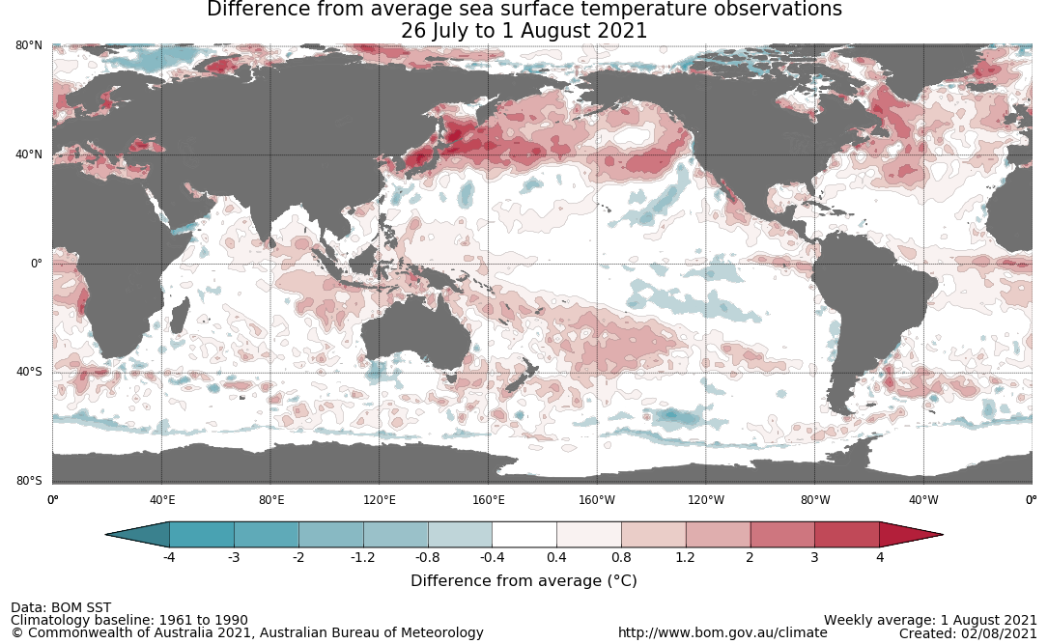

As at 1 August 2021, the Indian Ocean Dipole (IOD) weekly value was -0.76°C. The IOD index has generally been below the negative IOD threshold (−0.4 °C) since mid-May. A negative IOD, and warmer sea surface temperatures in the eastern Indian Ocean, is associated with above average rainfall for much of southern Australia in winter and spring. It also increases the chances of below average maximum temperatures in southern Australia, while increasing the chances of above average minimum and maximum temperatures in northern Australia.
The majority of international climate models surveyed by the Bureau of Meteorology expect the negative IOD event to persist until November, with all but one model expecting a return to neutral conditions in December.

Monthly sea surface temperature anomalies for IOD region
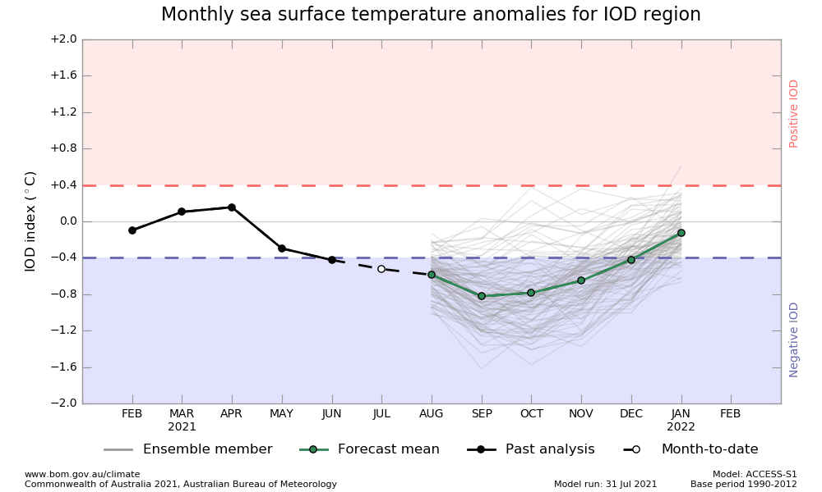

National Climate Outlook
These climate outlooks are generated by ACCESS–S (Australian Community Climate Earth-System Simulator–Seasonal). ACCESS–S is the Bureau of Meteorology's dynamical (physics-based) weather and climate model used for monthly, seasonal and longer-lead climate outlooks.
For further information, go to http://www.bom.gov.au/climate/ahead/about/
The Bureau of Meteorology’s latest rainfall outlook indicated wetter than average conditions are expected for much of eastern and central Australia during August. The wetter than average conditions expected for most cropping regions reaffirms the positive production outlook for Australia’s 2021 winter cropping season. The ACCESS-S climate model suggests there is close to a 65% chance of exceeding average September rainfall totals across much of Australia.
The outlook for September 2021 indicates that there is a 75% chance of rainfall totals between 10 and 100 millimetres across parts of eastern, south-western and far southern Australia. Rainfall totals in excess of 100 millimetres are expected across alpine regions of New South Wales and Victoria, and western Tasmania.
Across cropping regions there is a 75% chance of rainfall totals of between 5 and 10 millimetres in parts of northern Queensland. There is a 75% chance of rainfall totals between 10 and 50 millimetres for New South Wales, southern Queensland, Victoria, South Australia and Western Australia. This expected rainfall for September is likely to be sufficient to support the ongoing growth, and eventual yield development, of winter crops in most regions.
Rainfall totals that have a 75% chance of occurring September 2021
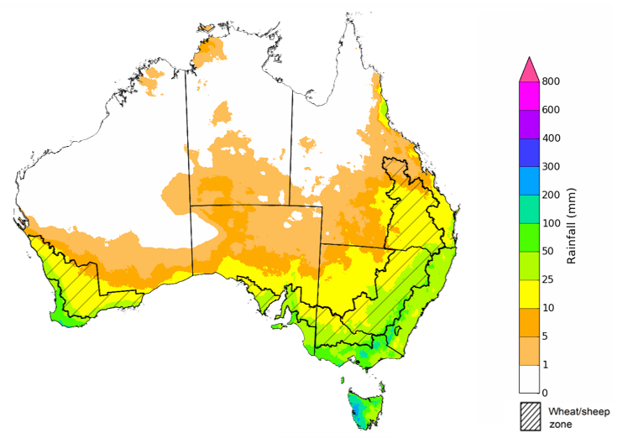
©Commonwealth of Australia 2021, Australian Bureau of Meteorology Issued: 5/08/2021

The rainfall outlook for spring 2021 (September to November) suggests there is a greater than 70% chance of exceeding average rainfall across much of New South Wales, Queensland, Victoria, South Australia and the Northern Territory. There is an increased chance of below average rainfall across the north and part of south-west Western Australia and western Tasmania during spring 2021 (Bureau of Meteorology ‘National Climate Outlook’, 5 August 2021).
Bureau of Meteorology rainfall outlooks for spring have greater than 55% past accuracy across most of Australia. Outlook accuracy is greater than 65% across much of New South Wales, Victoria, Queensland, South Australia and much of the Northern Territory. On the other hand, there is low past accuracy for large areas of northern and central Western Australia.
Chance of exceeding the median rainfall September to November 2021
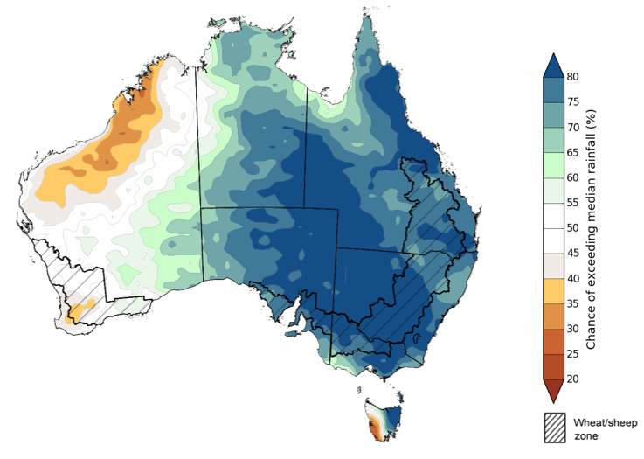
©Commonwealth of Australia 2021, Australian Bureau of Meteorology Issued: 5/08/2021
The outlook for spring 2021 suggests there is a 75% chance of rainfall totals between 50 and 200 millimetres across much of New South Wales, Victoria, southern and eastern Queensland, the south of Southern Australia, the far south-west and north-east of Western Australia, Tasmania, and large areas of the Northern Territory. Rainfall totals in excess of 300 millimetres are likely across parts of eastern New South Wales and Victoria, and western Tasmania.
Across cropping regions, there is a 75% chance of receiving between 50 and 200 millimetres in New South Wales, Victoria, South Australia, Queensland and southern Western Australia. Totals of less than 50 millimetres are expected across remaining cropping regions in Western Australia.
These rainfall totals are below average for this three-month period across most Western Australian cropping regions, and slightly above average for cropping regions of New South Wales. Above average soil moisture levels in Western Australia, and the probability of average or better in-season rainfall in September and October, will assist with maintaining or improving current yield potential in most winter cropping regions.
Rainfall totals that have a 75% chance of occurring September to November 2021

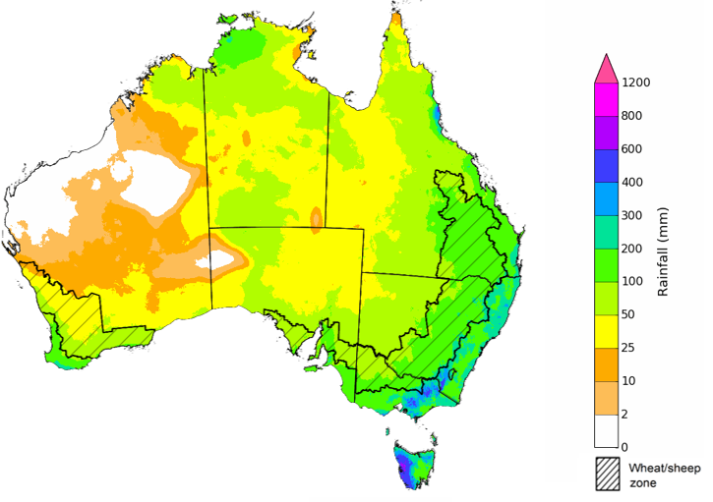
©Commonwealth of Australia 2021, Australian Bureau of Meteorology Issued: 5/08/2021
The temperature outlook for September to November 2021 indicates that maximum temperatures across most of Australia are likely to be close to the 1990-2012 average (- 1°C to 1°C). Minimum temperatures are expected to be slightly above average for much of Northern Australia (Bureau of Meteorology ‘National Climate Outlook’, 5 August 2021).
Predicted maximum temperature anomaly for September to November 2021

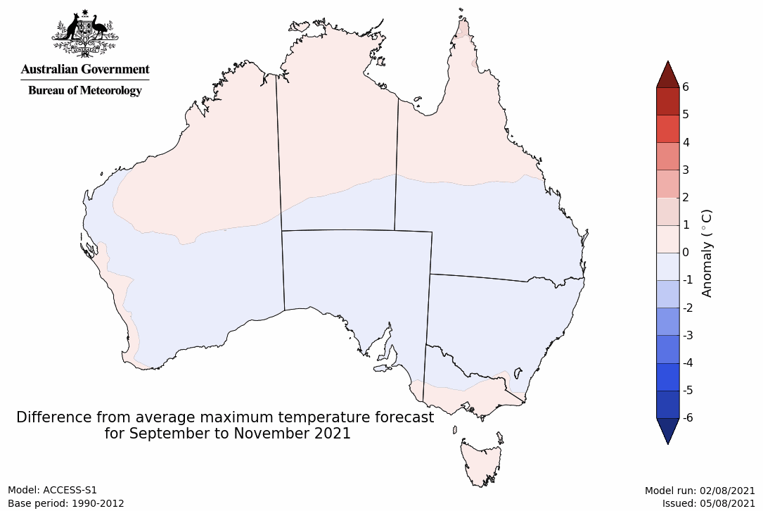
Predicted minimum temperature anomaly for September to November 2021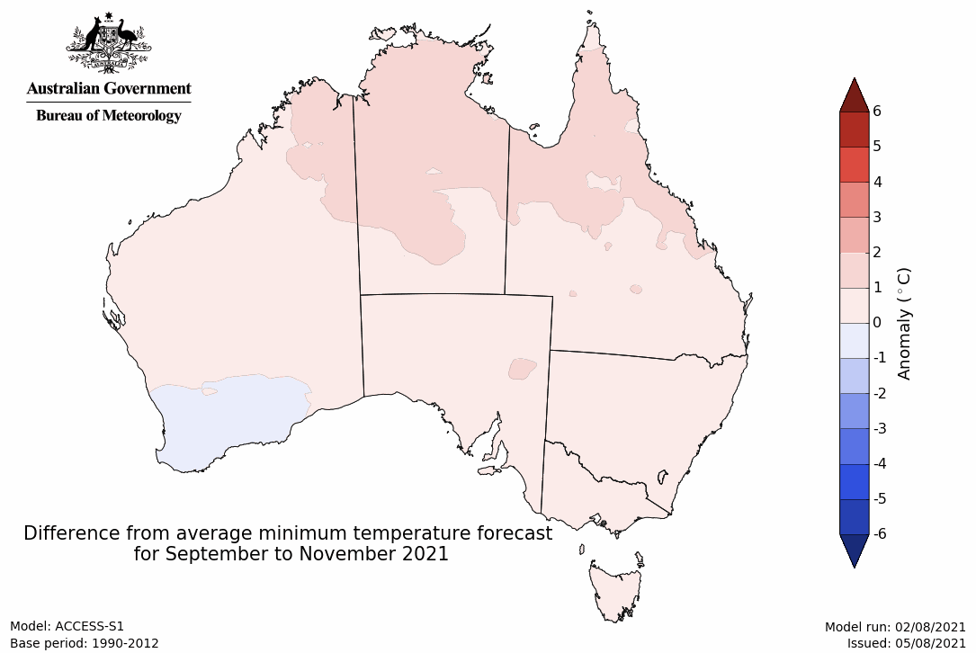

Rainfall forecast for the next eight days
The influence of slow-moving high-pressure systems is likely to bring clear skies and dry conditions across much of Australia over the next eight days. Rainfall is likely to be limited to west facing southern coastlines and onshore flow will bring showers to isolated areas of Australia’s eastern coast.
Rainfall totals of between 5 and 15 millimetres are forecast for isolated parts of southern and north-eastern New South Wales, north-eastern Queensland, as well as parts of Victoria, the south-east of South Australia, south-west Western Australia and Tasmania. Larger falls of between 15 and 100 millimetres are forecast for western Tasmania and parts of north-eastern Queensland.
Little to no rainfall is forecast for most of Australia’s cropping regions during the next 8-days. These dry conditions across most cropping regions will allow for drying of saturated soil profiles in some areas, reducing the impact of waterlogging and associated water-damage. Crop development is expected to progress unimpeded with high levels of plant available moisture provided by previous heavy falls. With the continuation of dry conditions from last week, growers will be able to gain unimpeded access to paddocks for top-dressing of fertilizer and for the allocation of pest and disease control programs in the coming week.

Total forecast rainfall (mm) for the period 12 August to 19 August 2021
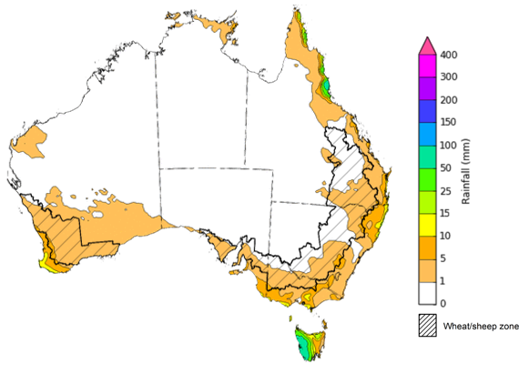
©Commonwealth of Australia 2021, Australian Bureau of Meteorology Issued: 12/08/2021
Note: This rainfall forecast is produced from computer models. As the model outputs are not altered by weather forecasters, it is important to check local forecasts and warnings issued by the Bureau of Meteorology.

Water

Water markets – current week
Water storage in the Murray–Darling Basin (MDB) increased by 317 gigalitres (GL) between 4 August 2021 and 11 August 2021. The current volume of water held in storage is 19,638 GL, which represents 78% of total capacity. This is 54% or 6,889 GL more than at the same time last year.

Water storages in the Murray-Darling Basin, 2013–2021
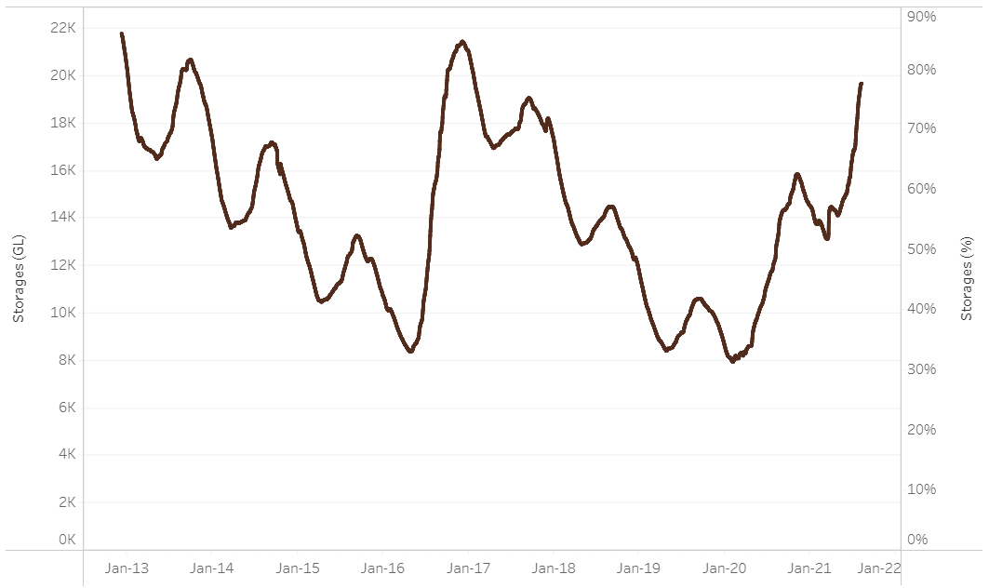
Water storage data is sourced from the Bureau of Meteorology.

Allocation prices in the Victorian Murray below the Barmah Choke decreased from $125 per ML on 30 July 2021 to $113 per ML on 6 August 2021. Prices are lower in the Goulburn-Broken, Murrumbidgee, and regions above the Barmah choke due to the binding of the Goulburn intervalley trade limit, Murrumbidgee export limit, and Barmah choke trade constraint.
Region | $/ML
NSW Murray Above | 71
NSW Murrumbidgee | 73
VIC Goulburn-Broken | 83
VIC Murray Below | 113

Surface water trade activity, Southern Murray–Darling Basin

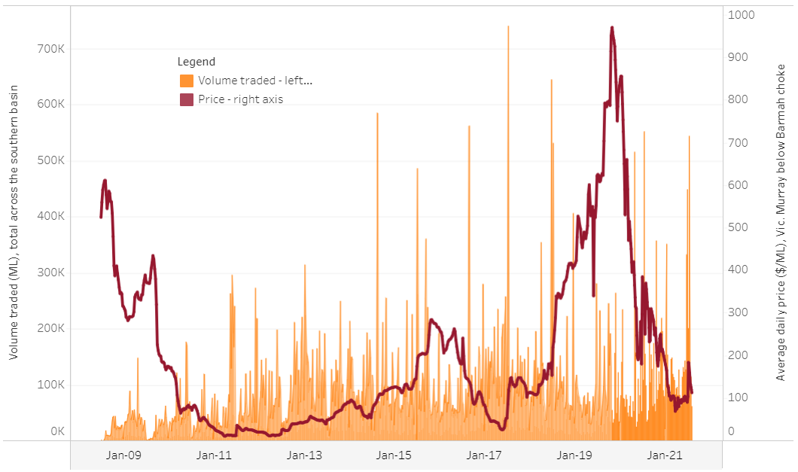
To access the full, interactive, weekly water dashboard, which contains the latest and historical water storage, water market and water allocation information, please visit http://www.agriculture.gov.au/abares/products/weekly_update/weekly-update-120821
The trades shown reflect estimated market activity and do not encompass all register trades. The price is shown for the VIC Murray below the Barmah choke. Historical prices (before 1 July 2019) are ABARES estimates after removing outliers from BOM water register data. Prices after 1 July 2019 and prior to the 30 October 2019 reflect recorded transaction prices as sourced from Ruralco. Prices after the 30 October 2019 are sourced from Waterflow. Data for volume traded is sourced from the BOM water register. Data shown is current at 12 August 2021.

Commodities
Indicator | Week ended | Unit | Latest price | Previous week | Weekly change | Price 12 months ago | Annual change
Selected world indicator prices
AUD/USD Exchange rate | 11-Aug | A$/US$ | 0.73 | 0.74 | -1% | 0.72 | 2%
Wheat – US no. 2 hard red winter wheat, fob Gulf | 11-Aug | US$/t | 321 | 320 | 0% | 225 | 43%
Corn – US no. 2 yellow corn, fob Gulf | 11-Aug | US$/t | 248 | 260 | -5% | 150 | 65%
Canola – Rapeseed, Canada, fob Vancouver | 11-Aug | US$/t | 687 | 675 | 2% | 385 | 78%
Cotton – Cotlook 'A' Index | 11-Aug | USc/lb | 100 | 98 | 2% | 69 | 44%
Sugar – Intercontinental Exchange, nearby futures, no.11 contract | 11-Aug | USc/lb | 19.5 | 18.5 | 5% | 13 | 47%
Wool – Eastern Market Indicator | 14-Jul | Ac/kg clean | 1,428 | 1,420 | 1% | 1,183 | 21%
Wool – Western Market Indicator | 14-Jul | Ac/kg clean | 1,462 | 1,442 | 1% | 1,370 | 7%
Selected Australian grain export prices
Milling Wheat – APW, Port Adelaide, SA | 11-Aug | A$/t | 402 | 396 | 2% | 317 | 27%
Feed Wheat – ASW, Port Adelaide, SA | 11-Aug | A$/t | 395 | 392 | 1% | 303 | 31%
Feed Barley – Port Adelaide, SA | 11-Aug | A$/t | 326 | 324 | 1% | 263 | 24%
Canola – Kwinana, WA | 11-Aug | A$/t | 808 | 788 | 3% | 631 | 28%
Grain Sorghum – Brisbane, QLD | 11-Aug | A$/t | 365 | 363 | 0% | 355 | 3%
Selected domestic livestock indicator prices
Beef – Eastern Young Cattle Indicator | 11-Aug | Ac/kg cwt | 1,000 | 995 | 0% | 774 | 29%
Mutton – Mutton indicator (18–24 kg fat score 2–3), Vic | 11-Aug | Ac/kg cwt | 671 | 723 | -7% | 516 | 30%
Lamb – Eastern States Trade Lamb Indicator | 11-Aug | Ac/kg cwt | 881 | 907 | -3% | 782 | 13%
Pig – Eastern Seaboard (60.1–75 kg), average of buyers & sellers | 28-Jul | Ac/kg cwt | 318 | 318 | 0% | 386 | -18%
Goats – Eastern States (12.1–16 kg) | 04-Aug | Ac/kg cwt | 878 | 871 | 1% | 723 | 21%
Live cattle – Light steers ex Darwin to Indonesia | 17-Feb | Ac/kg lwt | 355 | 355 | 0% | 360 | -1%
Live sheep – Live wethers (Muchea WA saleyard) to Middle East | 19-May | $/head | 145 | 145 | 0% | N/A | N/A

Indicator | Week ended | Unit | Latest price | Previous week | Weekly change | Price 12 months ago | Annual change
Global Dairy Trade (GDT) weighted average prices ª
Dairy – Whole milk powder | 04-Aug | US$/t | 3,598 | 3,730 | -4% | 3,006 | 20%
Dairy – Skim milk powder | 04-Aug | US$/t | 3,020 | 2,971 | 2% | 2,358 | 28%
Dairy – Cheddar cheese | 04-Aug | US$/t | 4,065 | 4,022 | 1% | 3,756 | 8%
Dairy – Anhydrous milk fat | 04-Aug | US$/t | 5,668 | 5,615 | 1% | 5,433 | 4%
a Global Dairy Trade prices are updated twice monthly on the first and third Tuesday of each month.

Selected world indicator prices
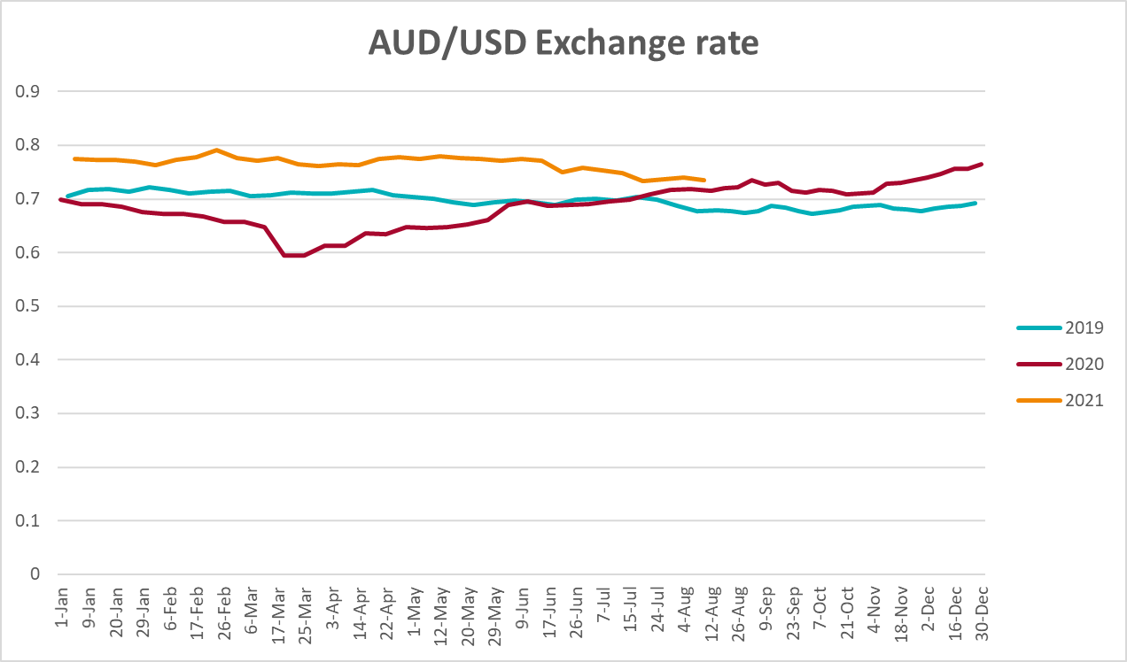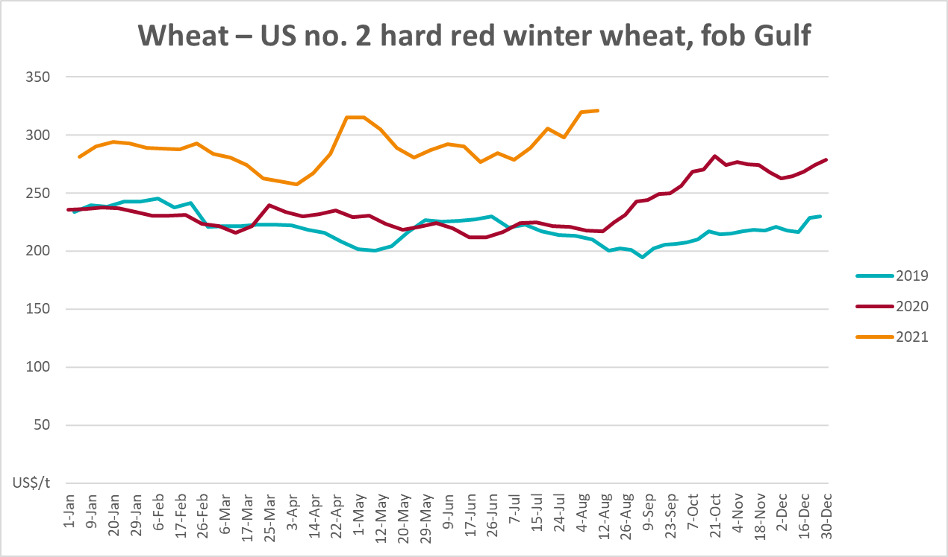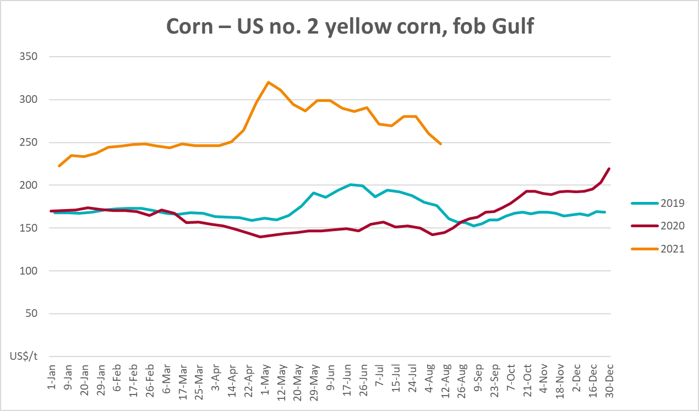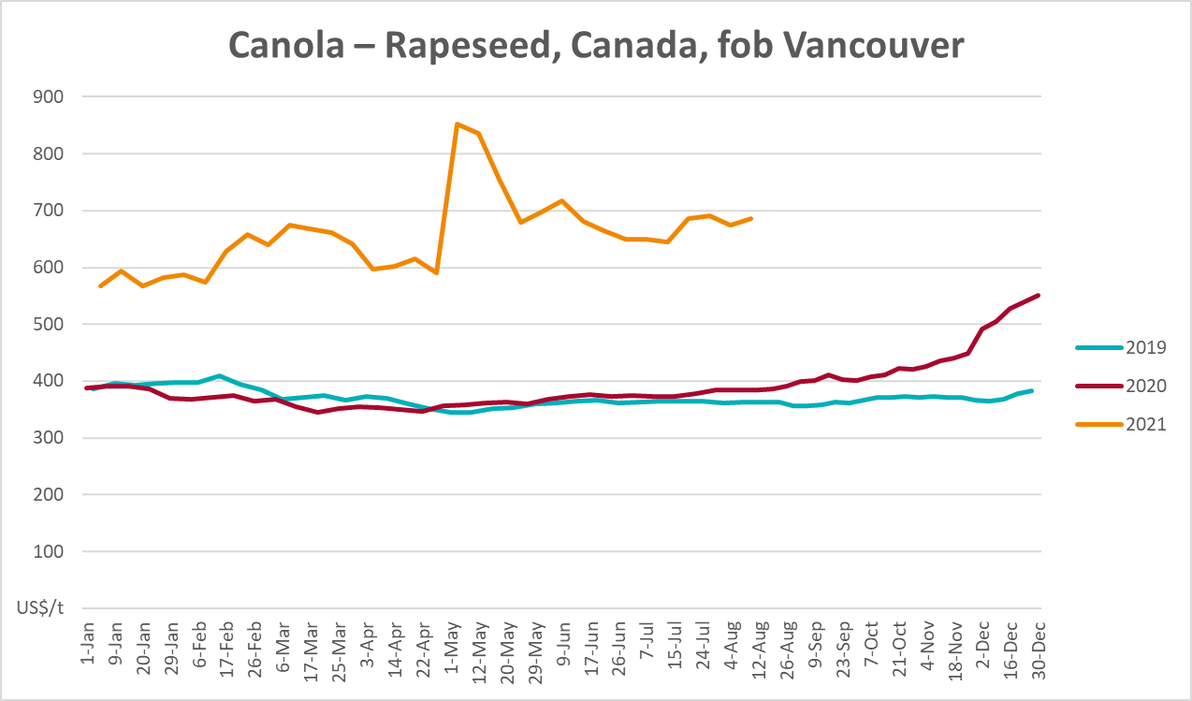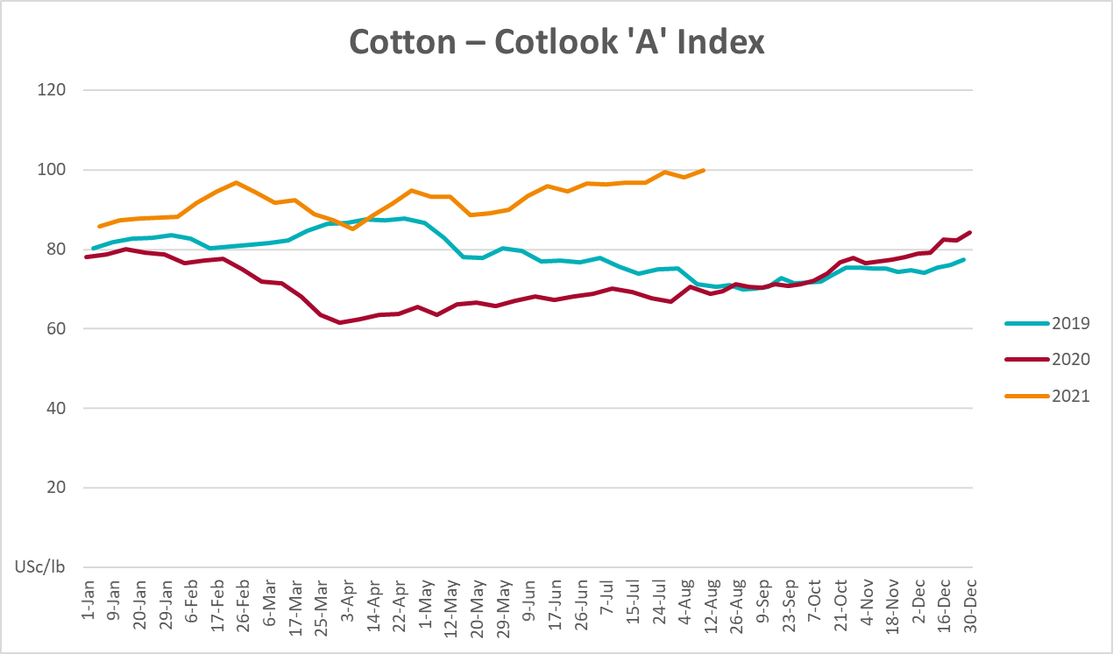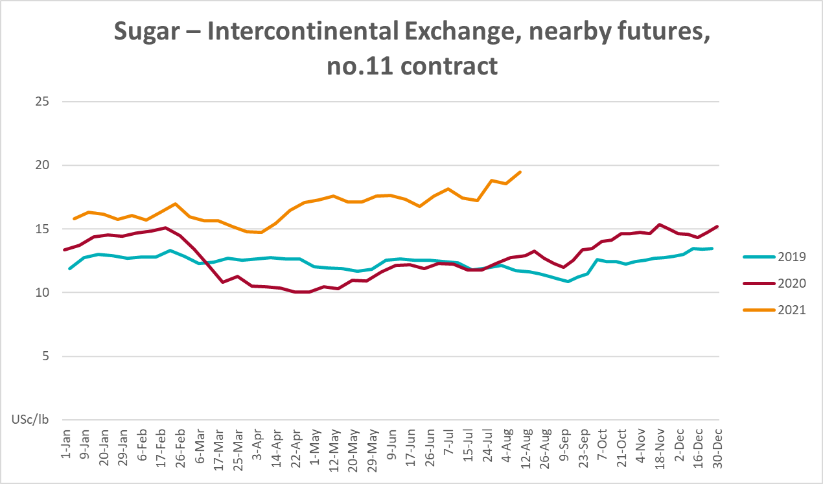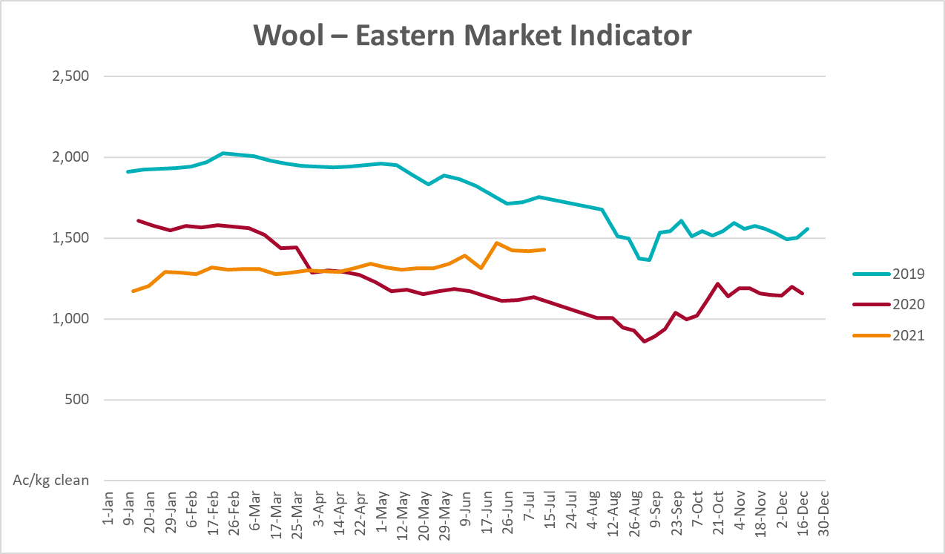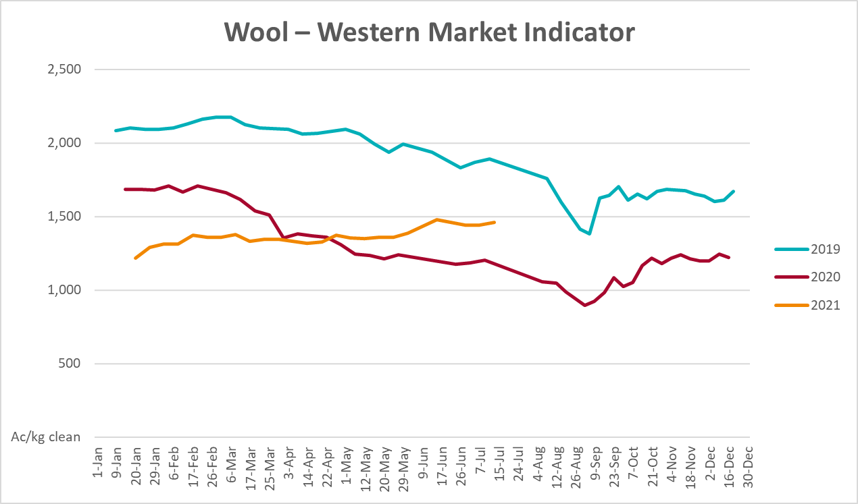

Selected domestic crop indicator prices
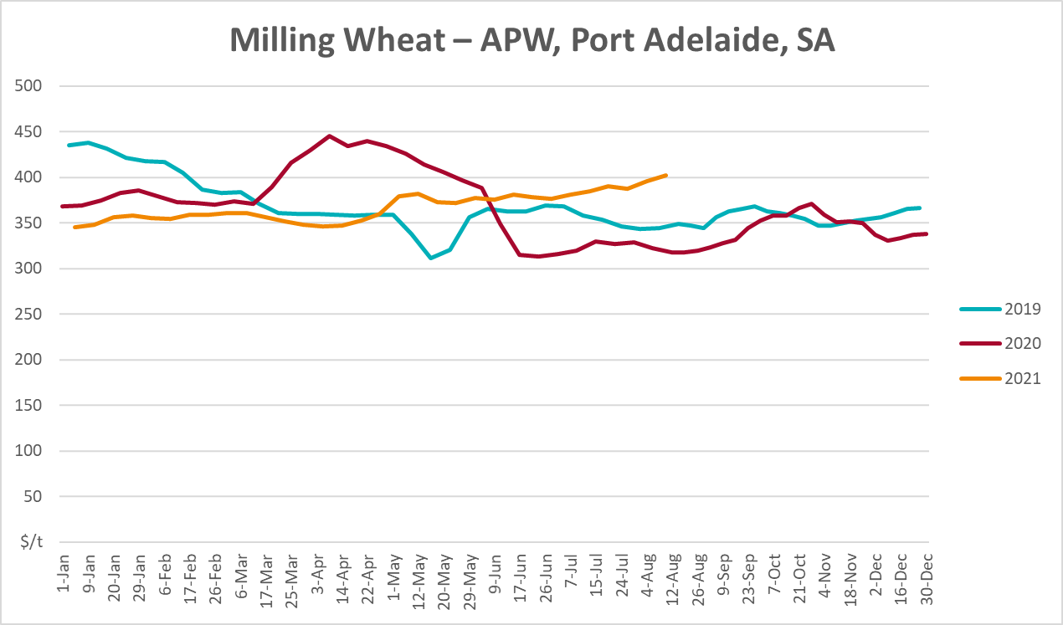
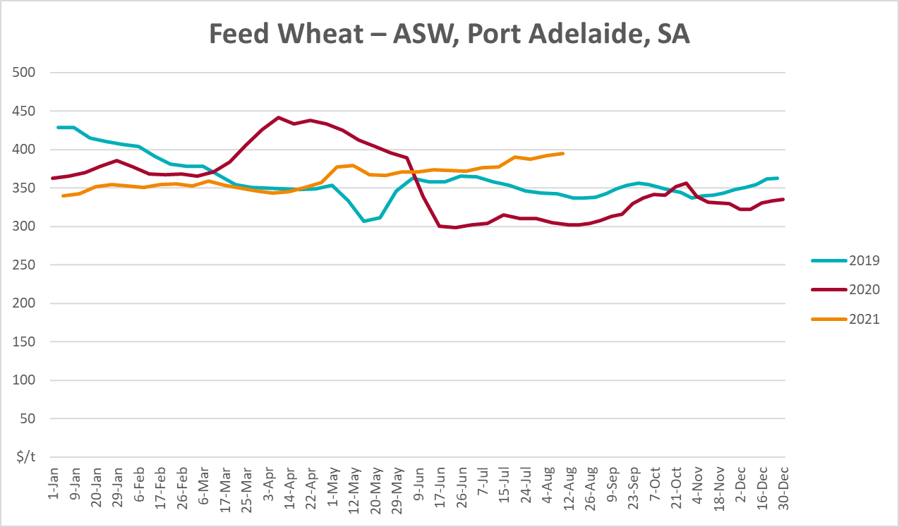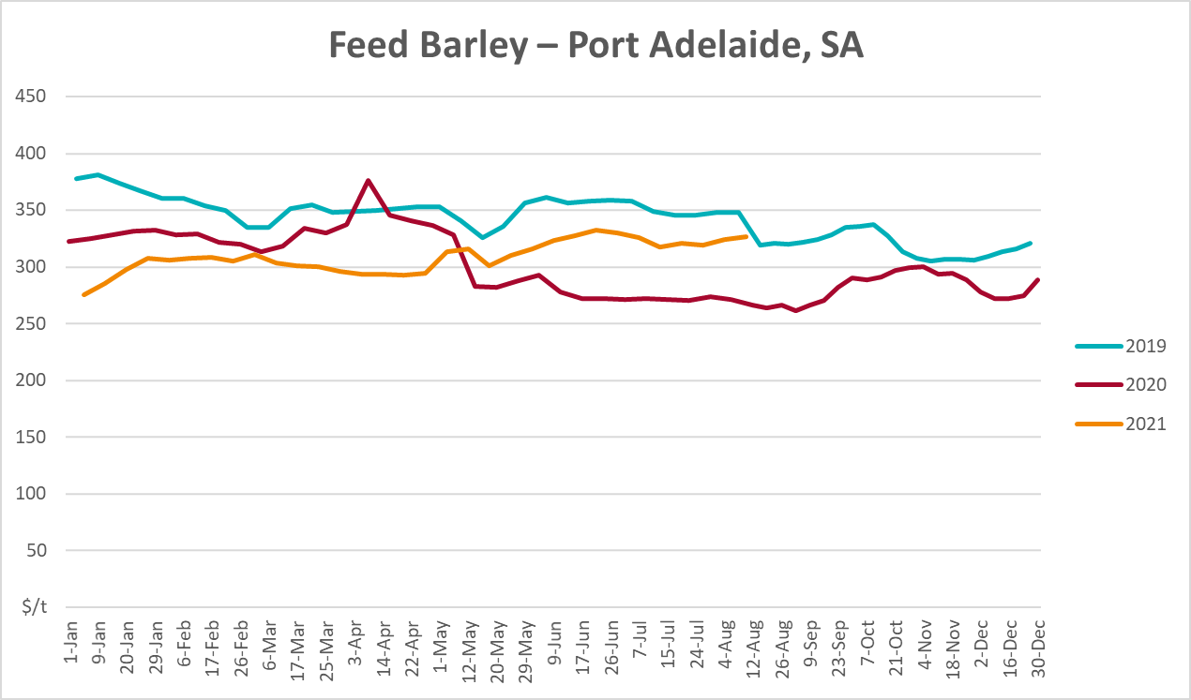
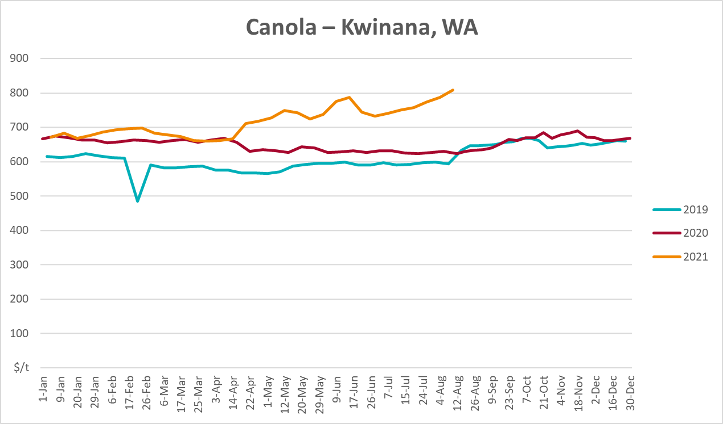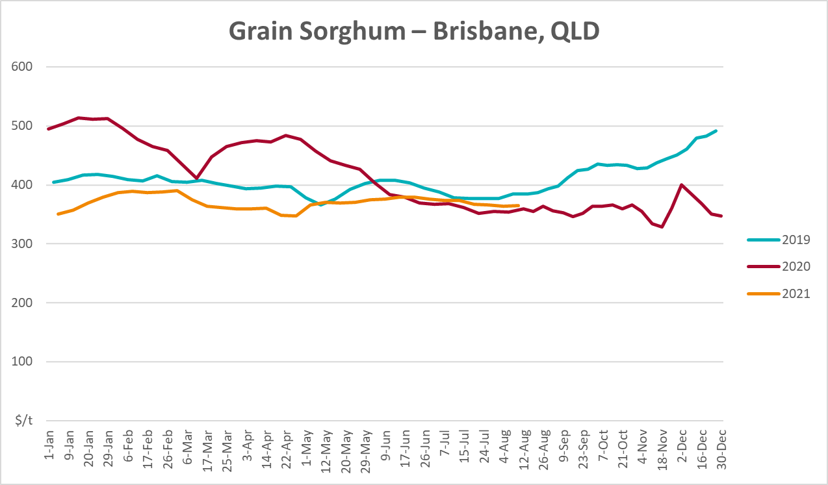

Selected domestic livestock indicator prices
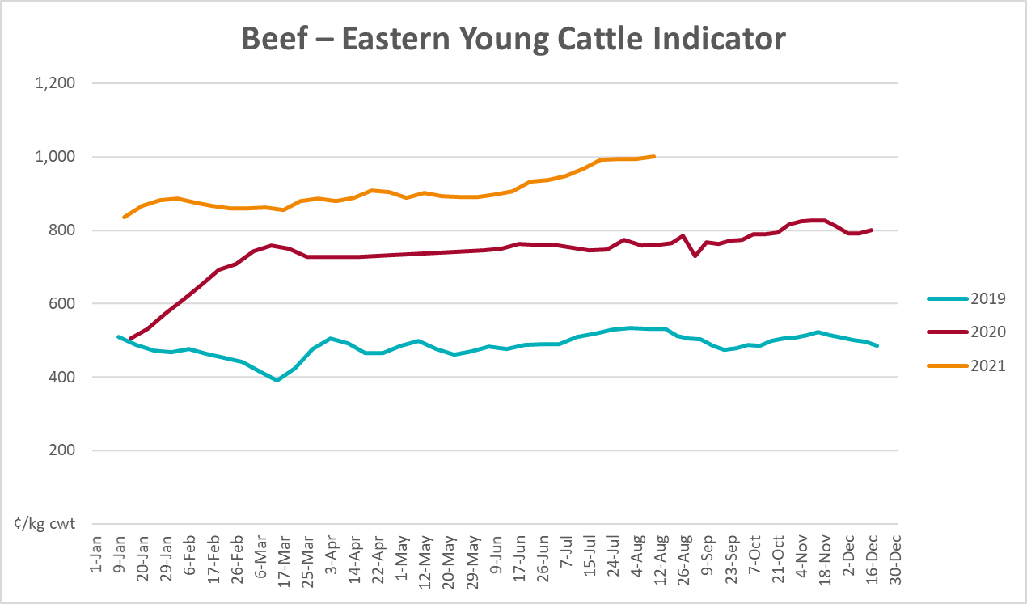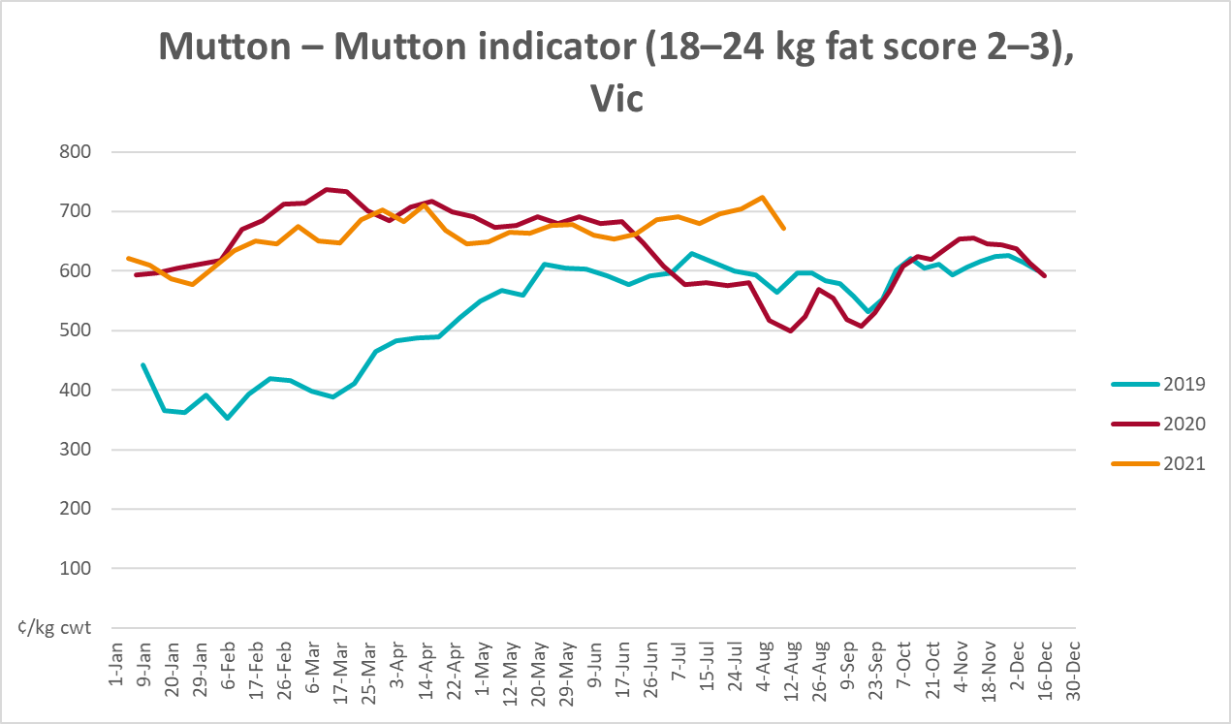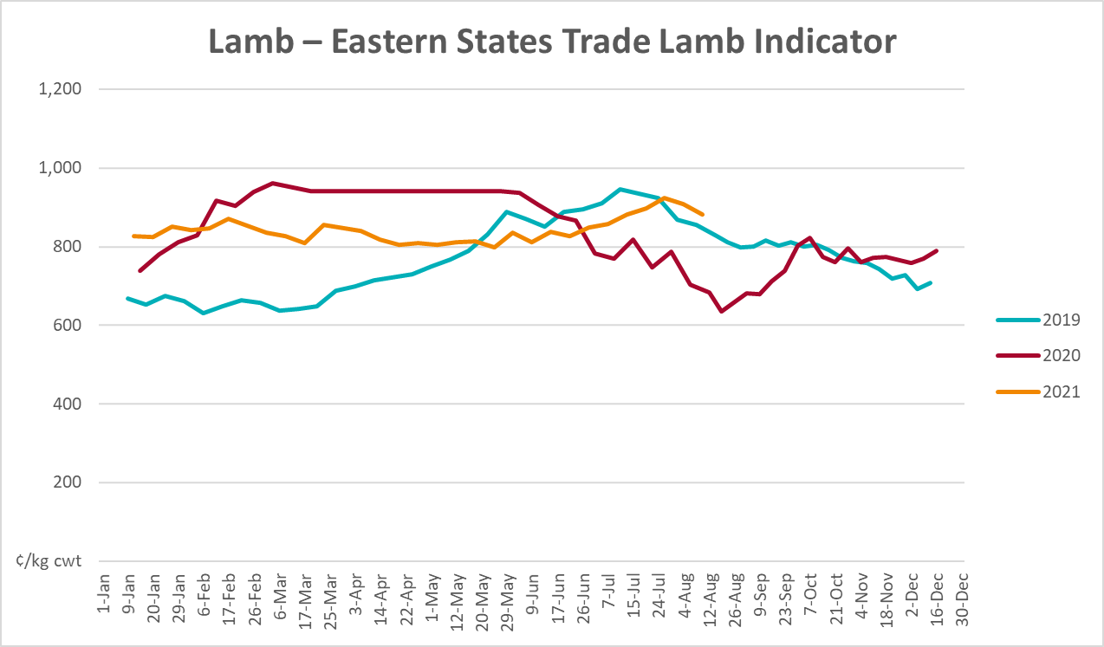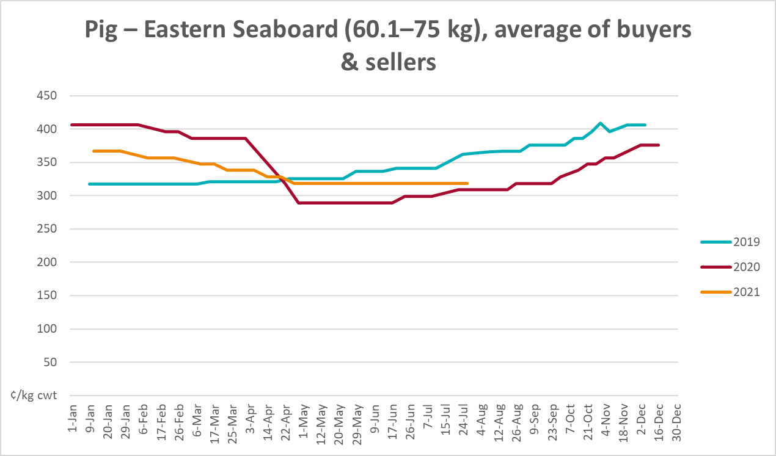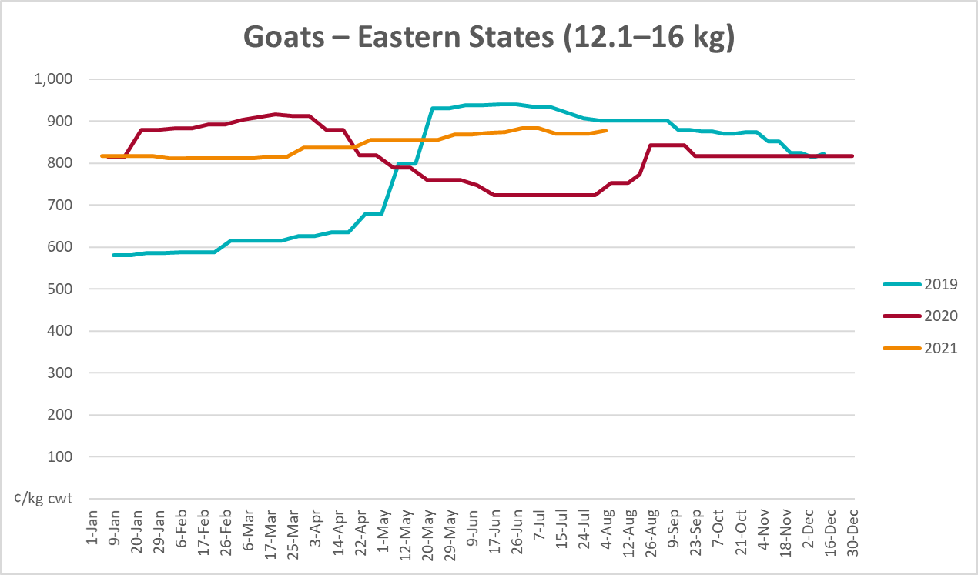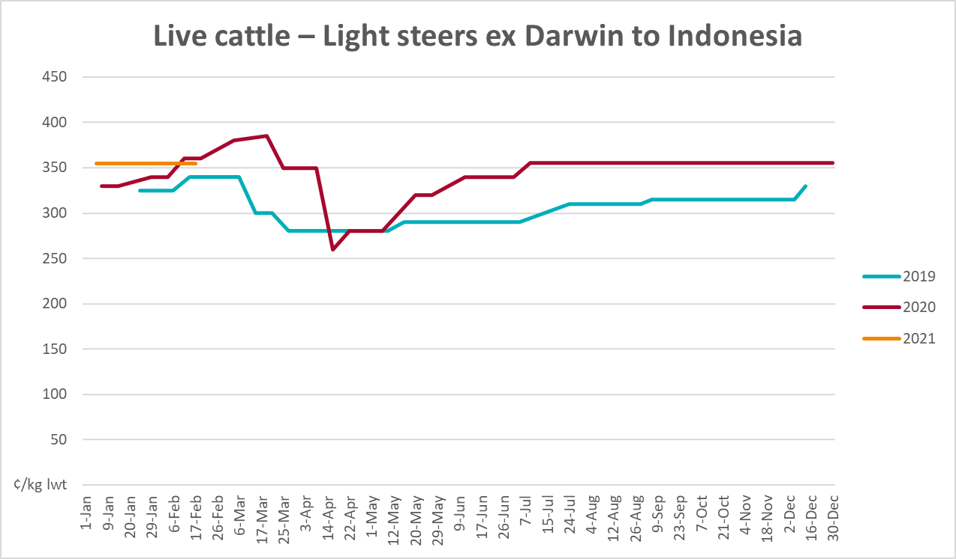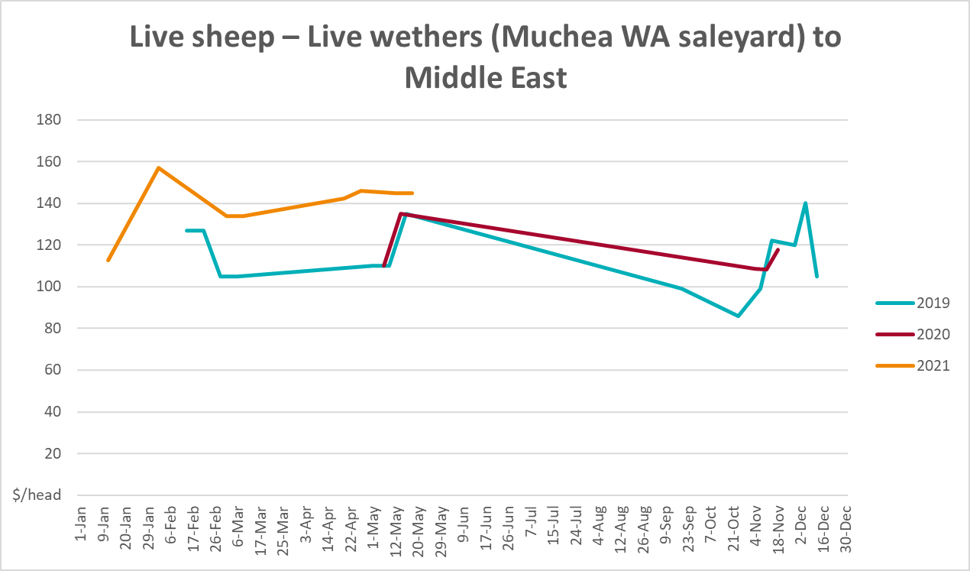

Global Dairy Trade (GDT) weighted average prices
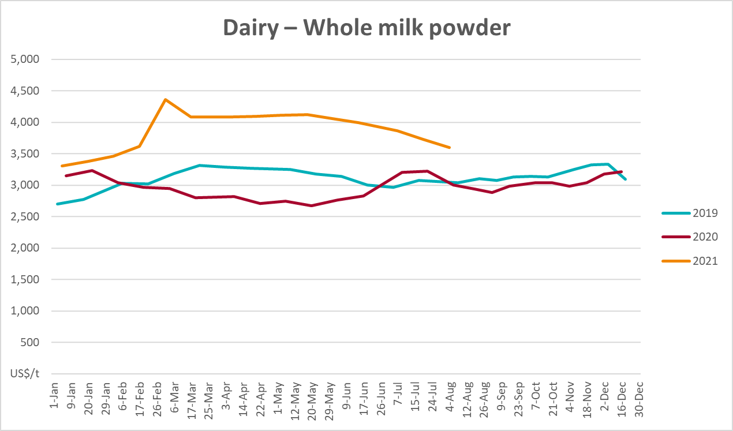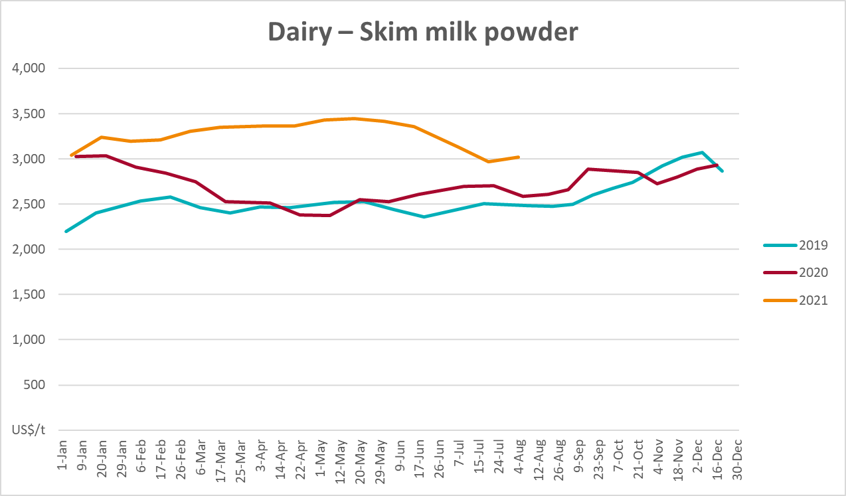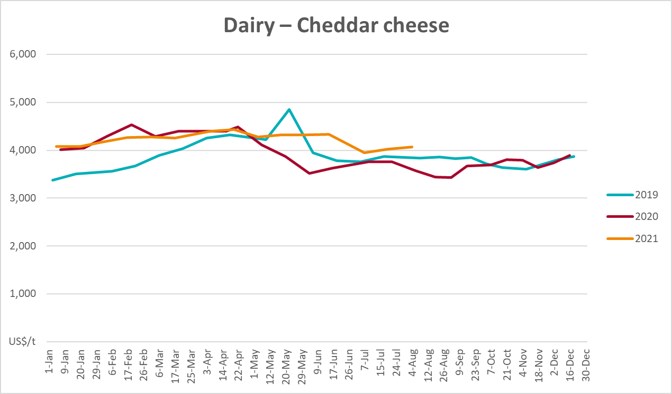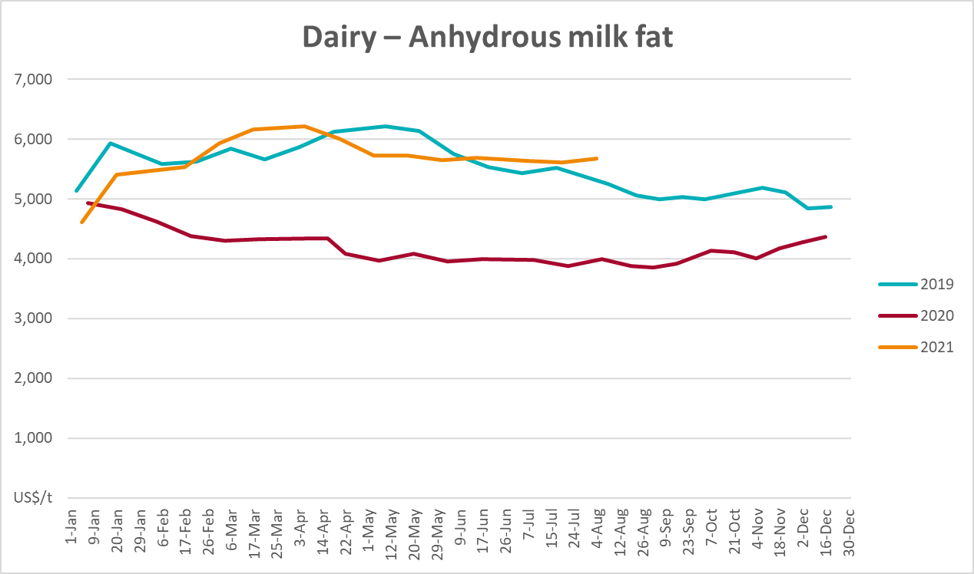

Selected fruit and vegetable prices
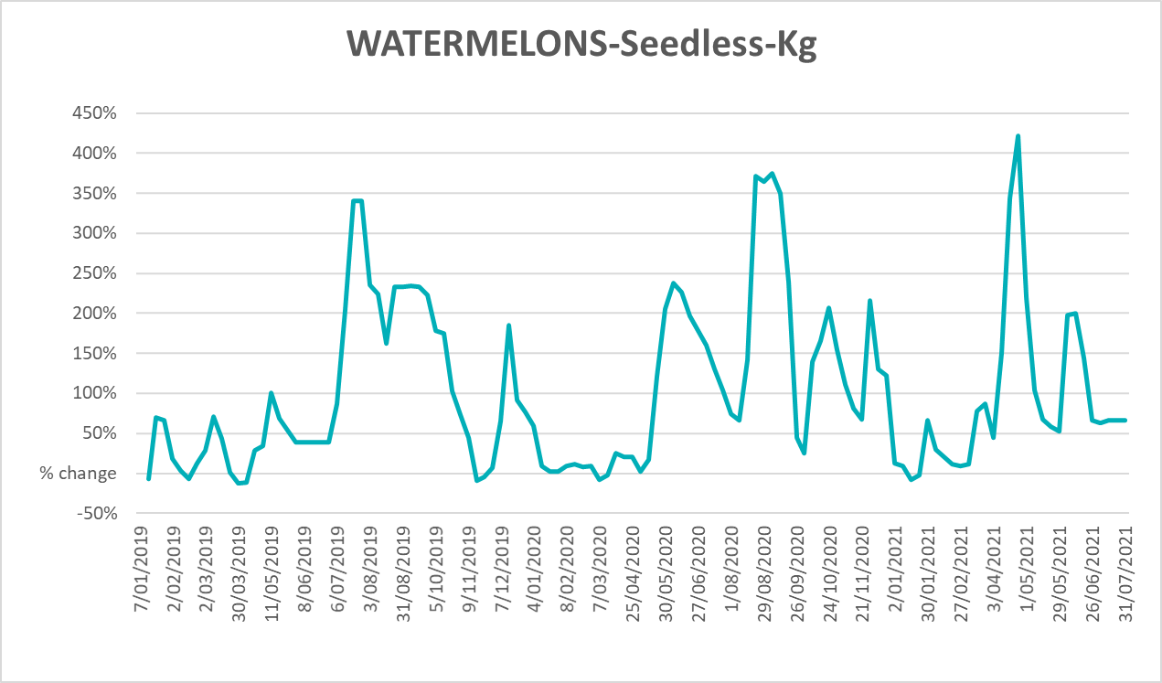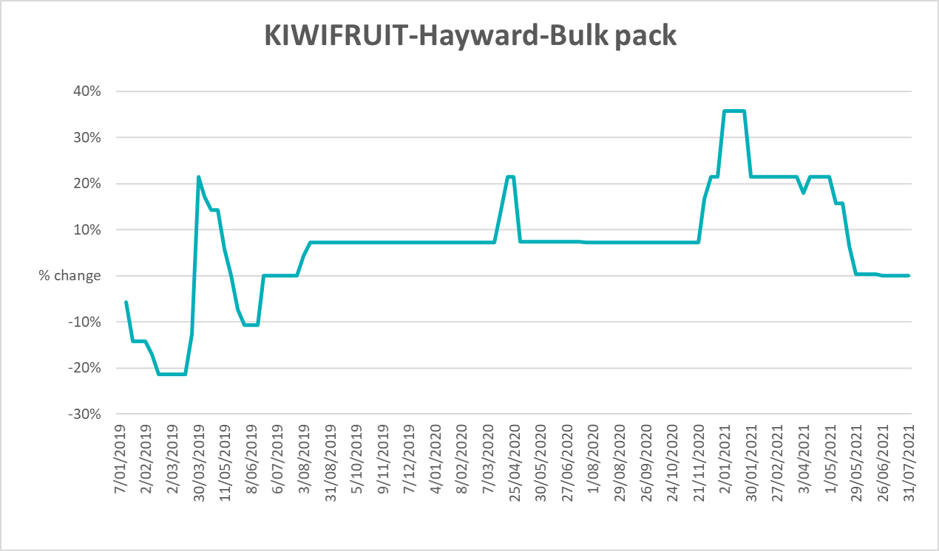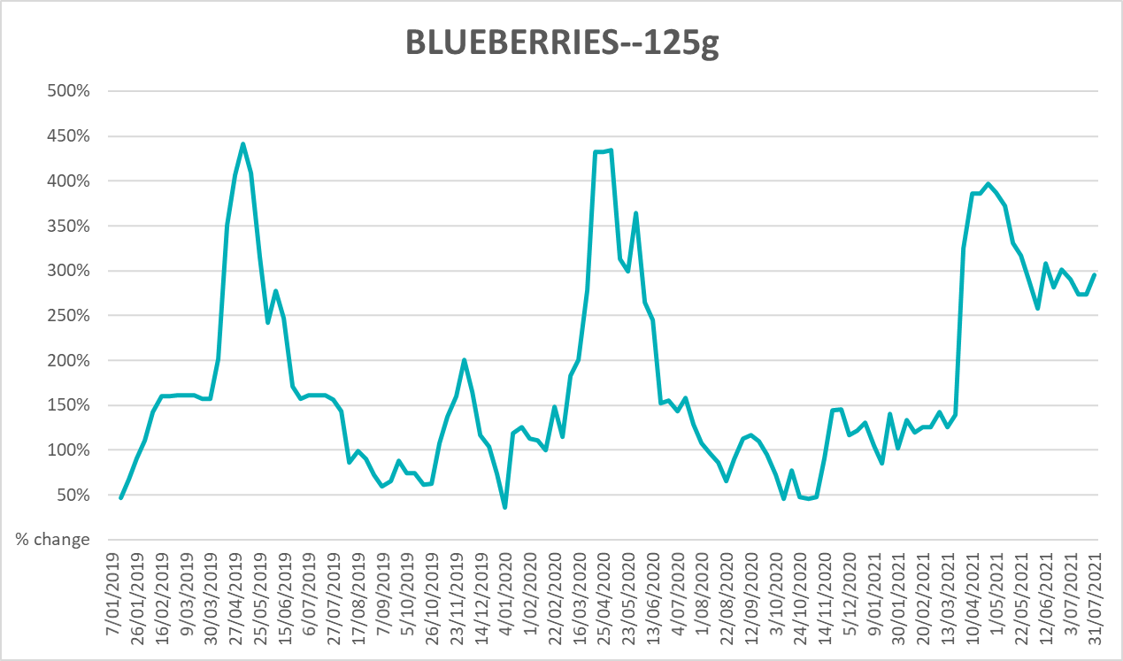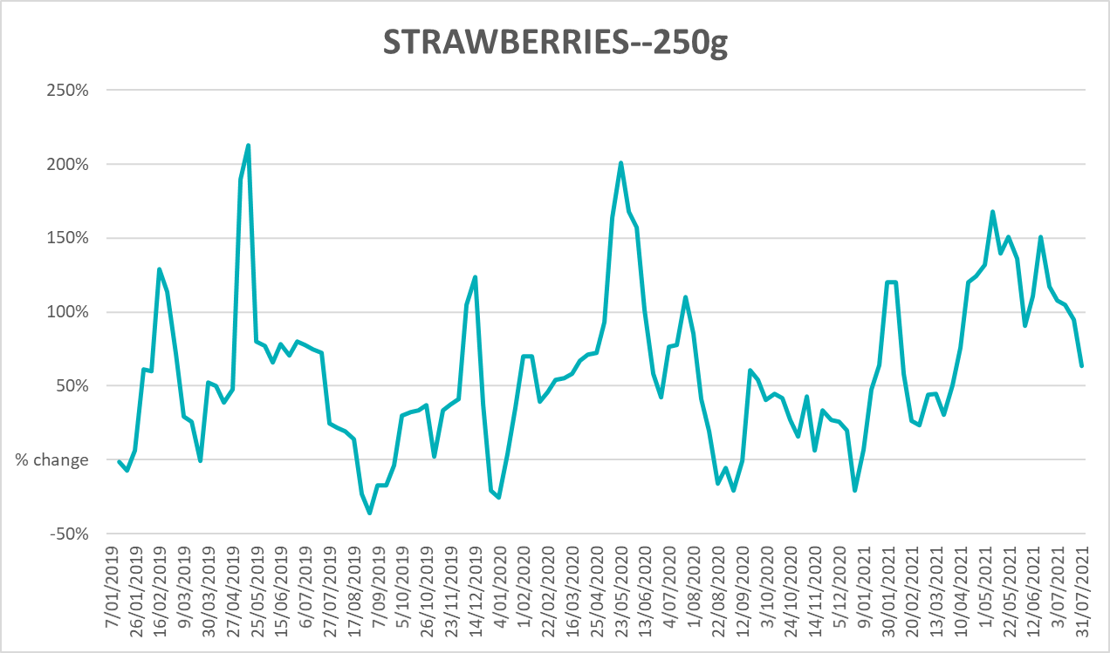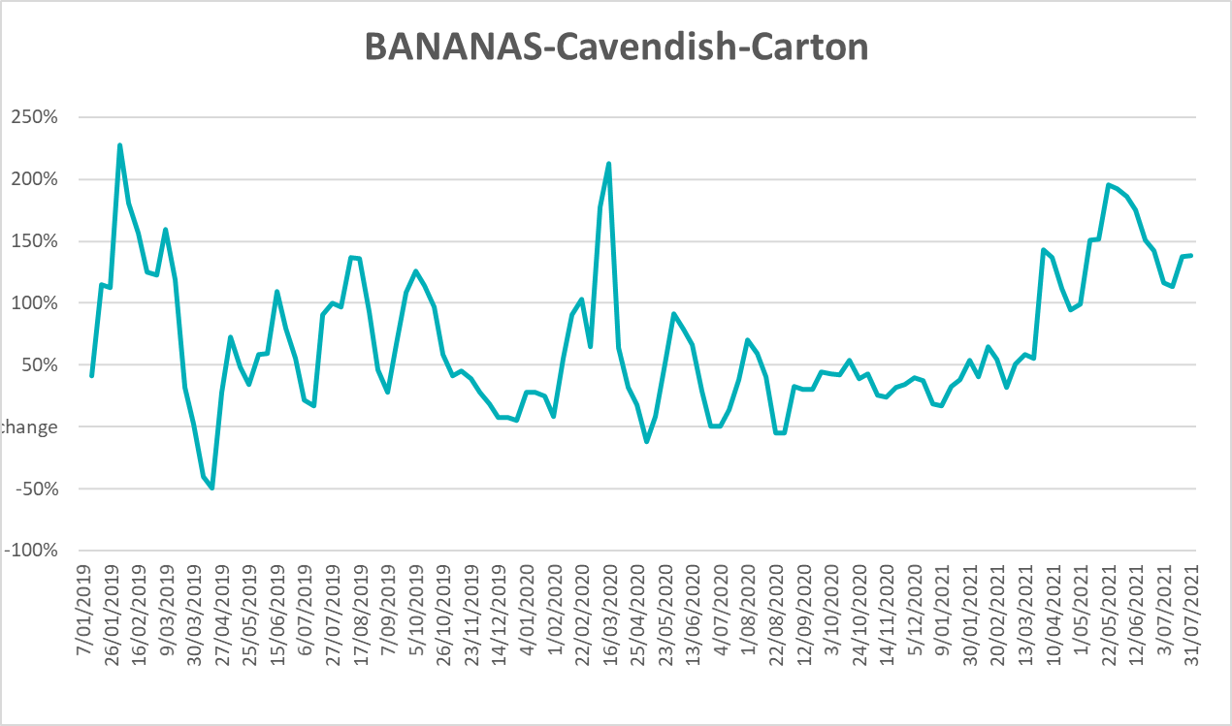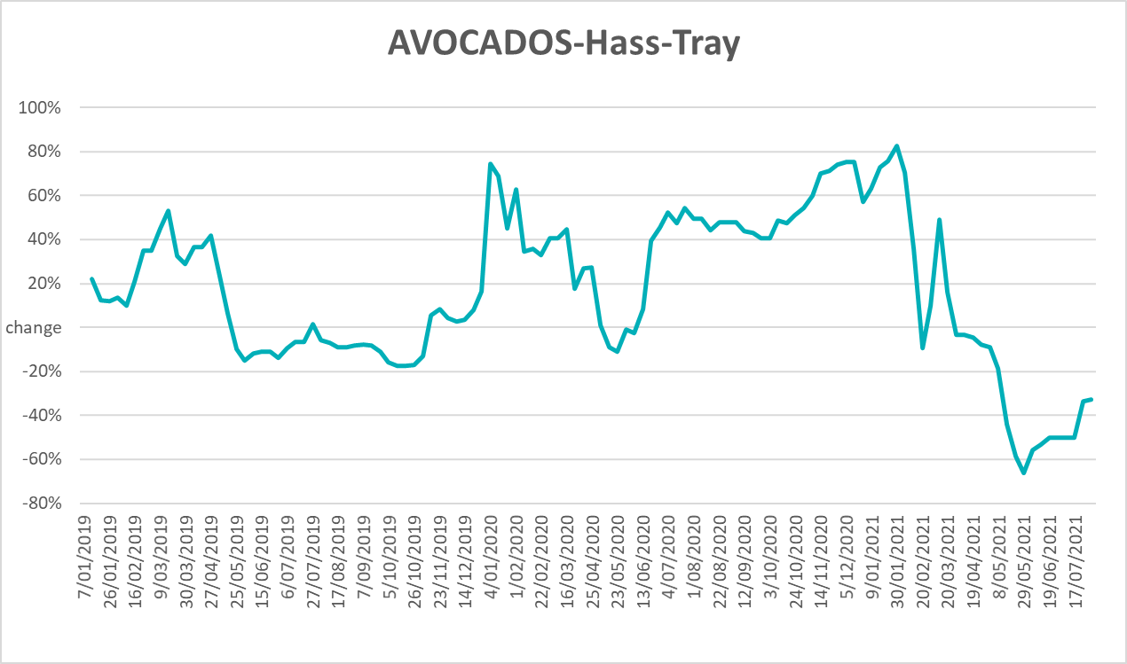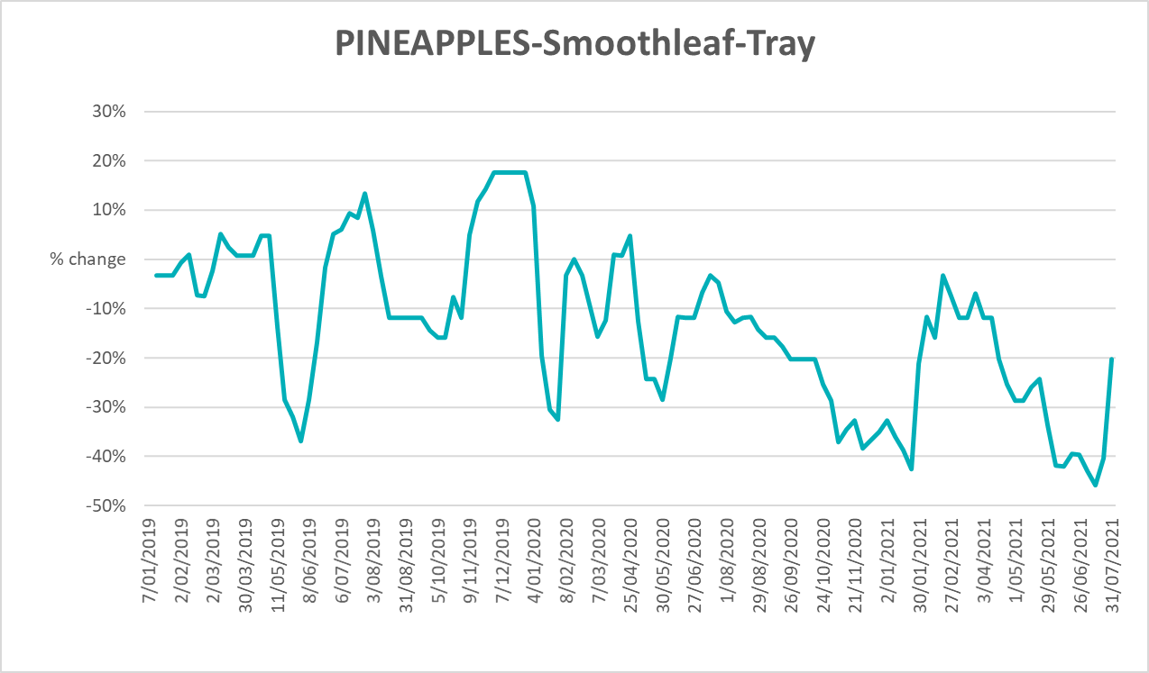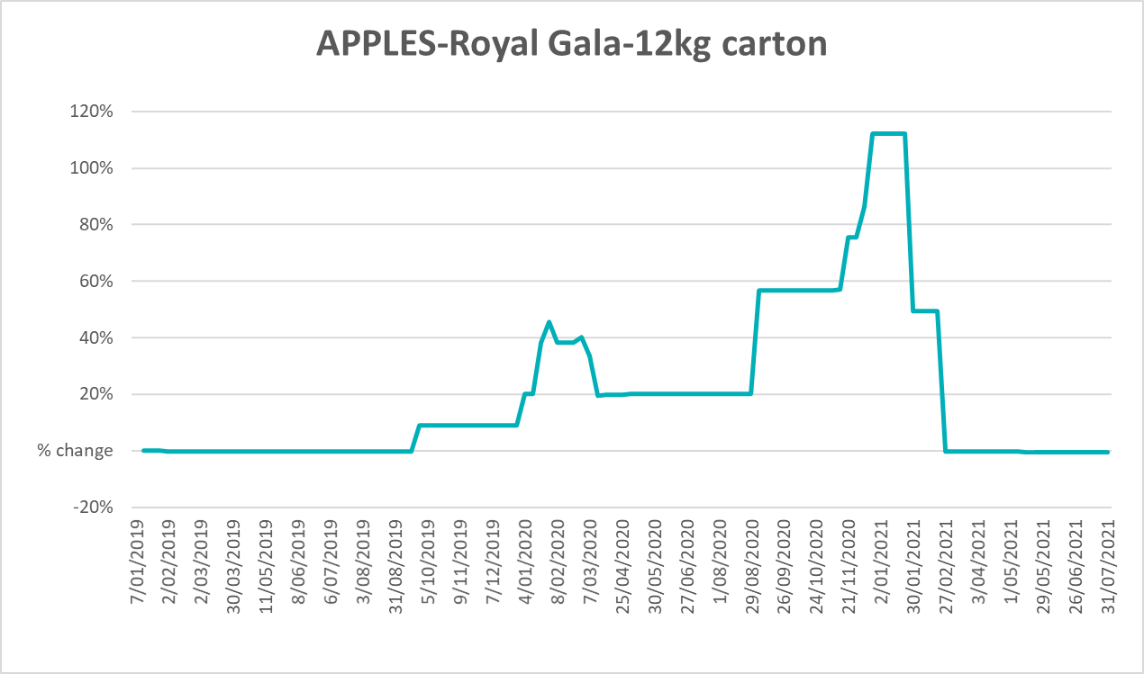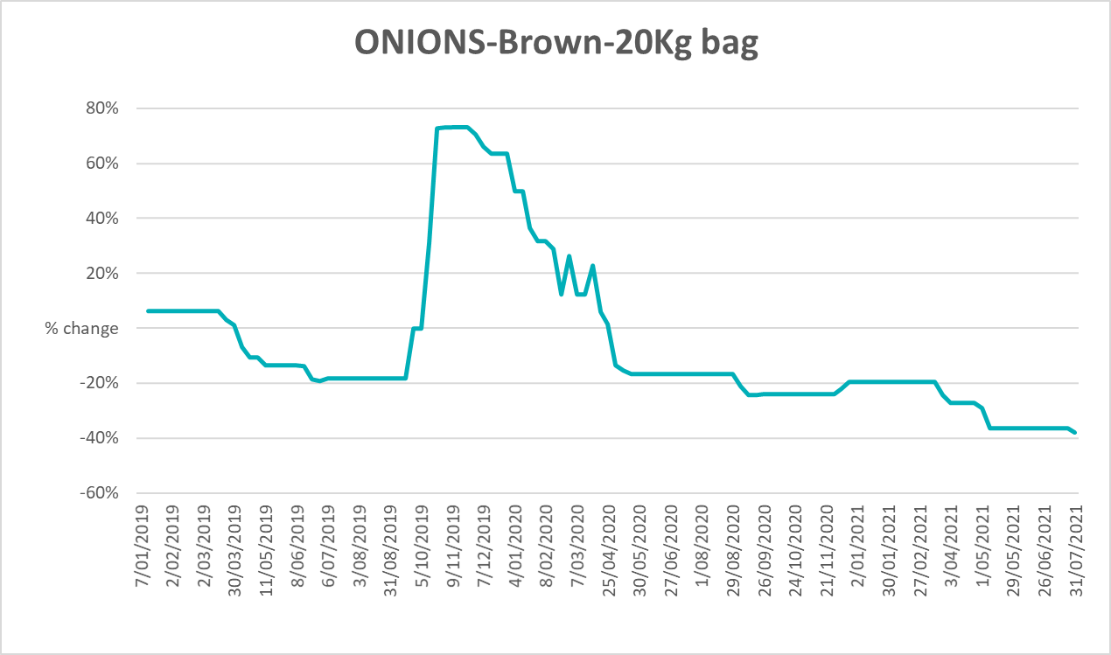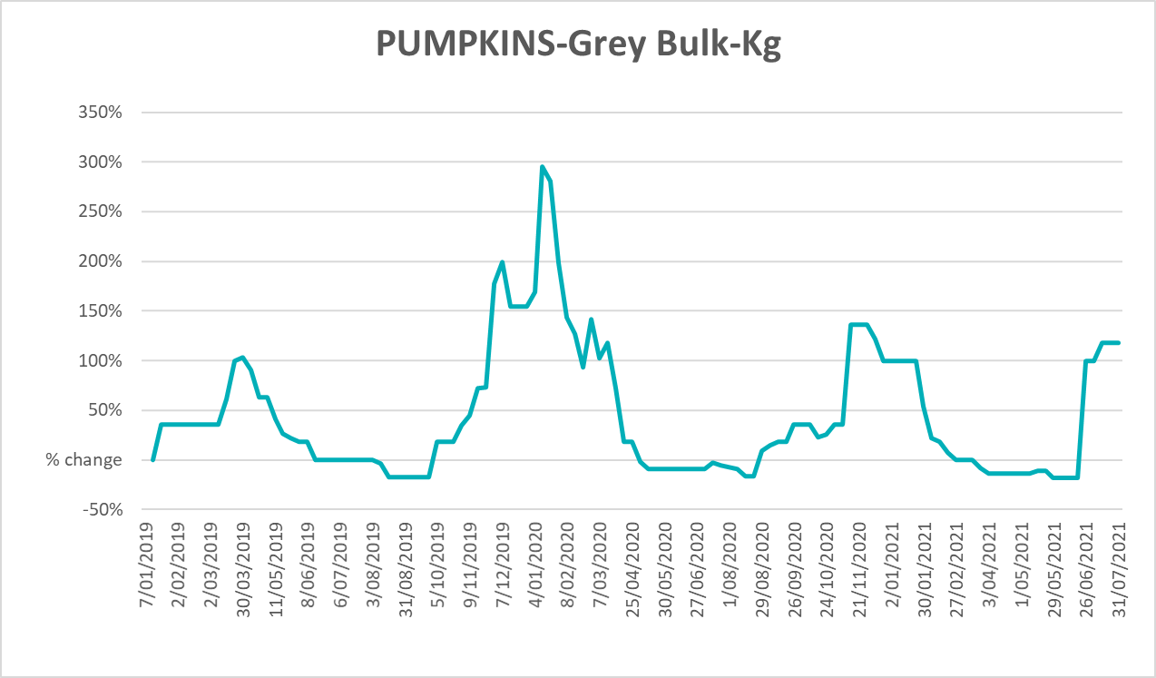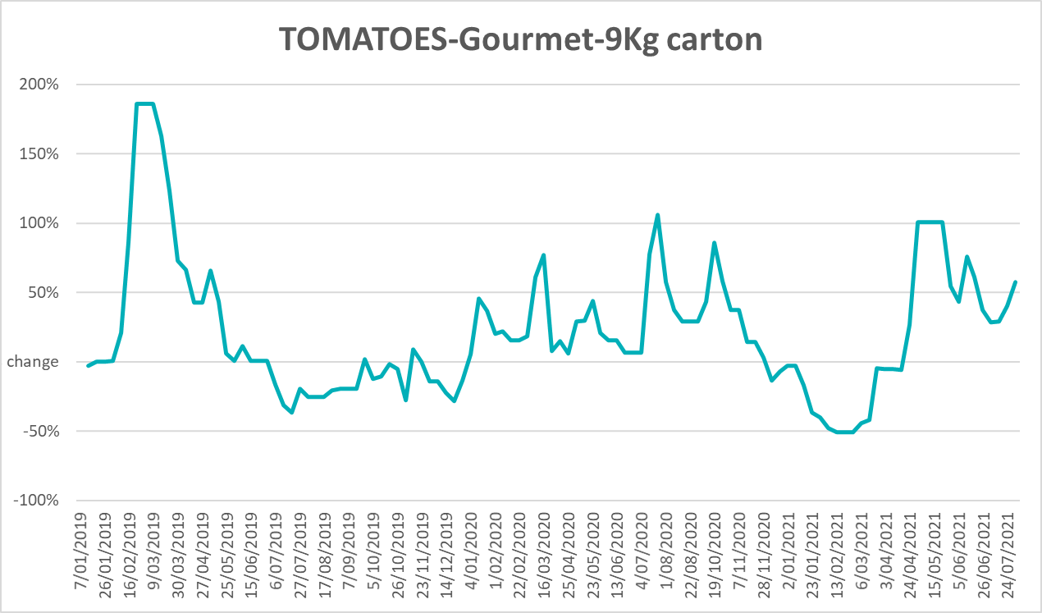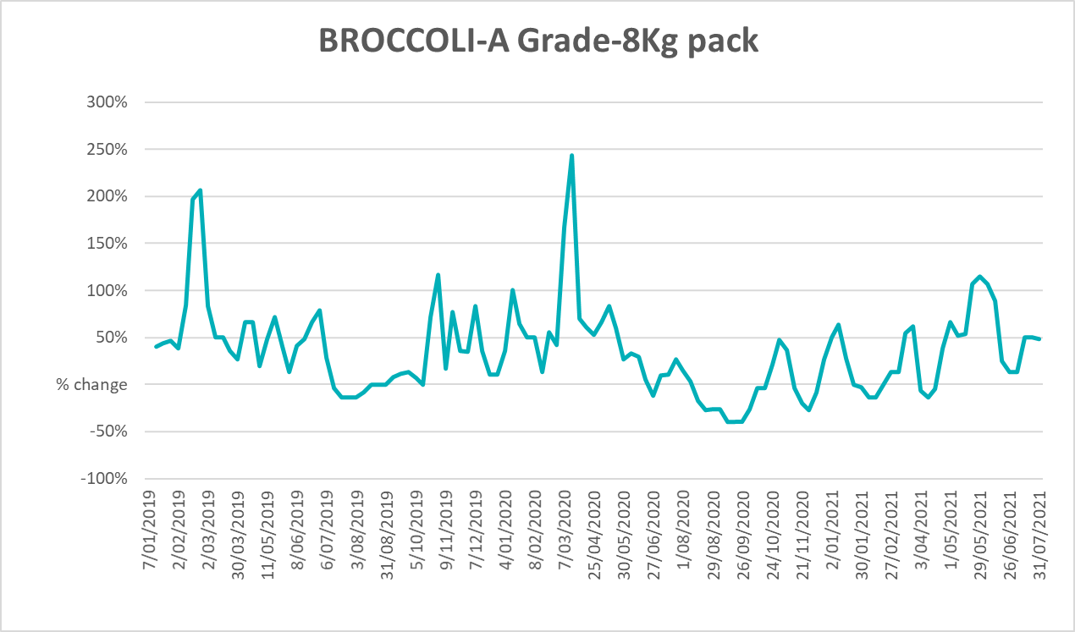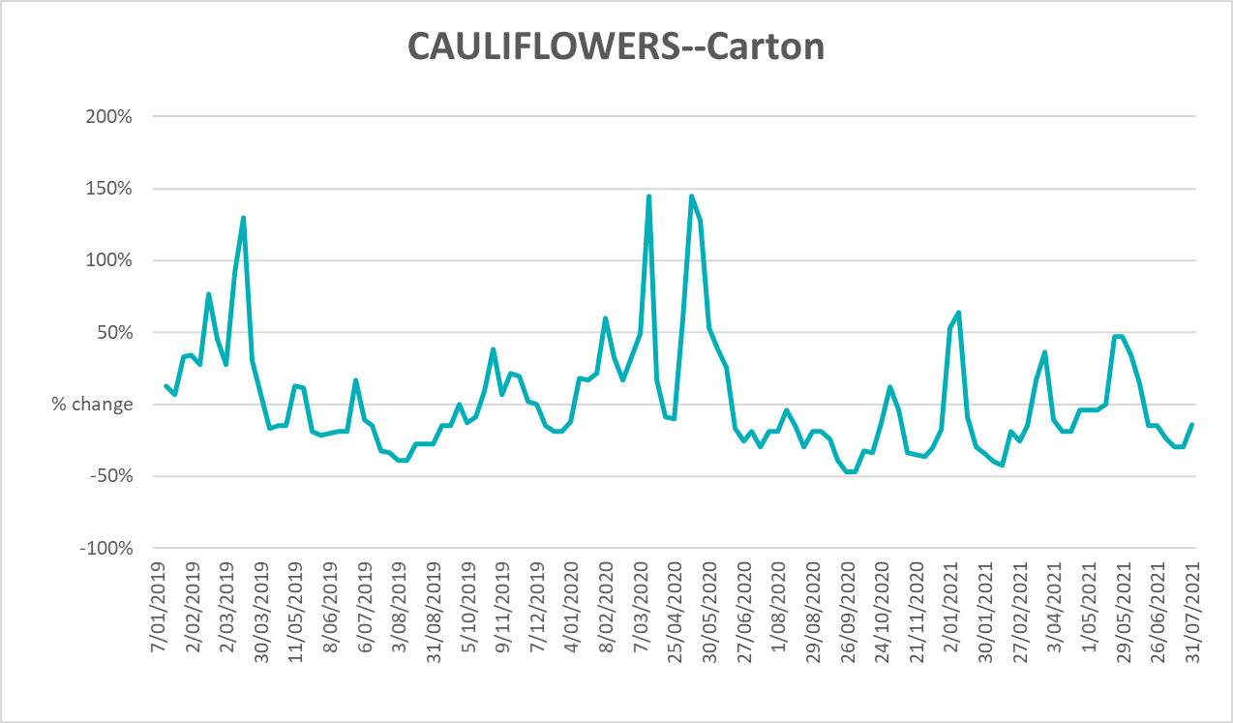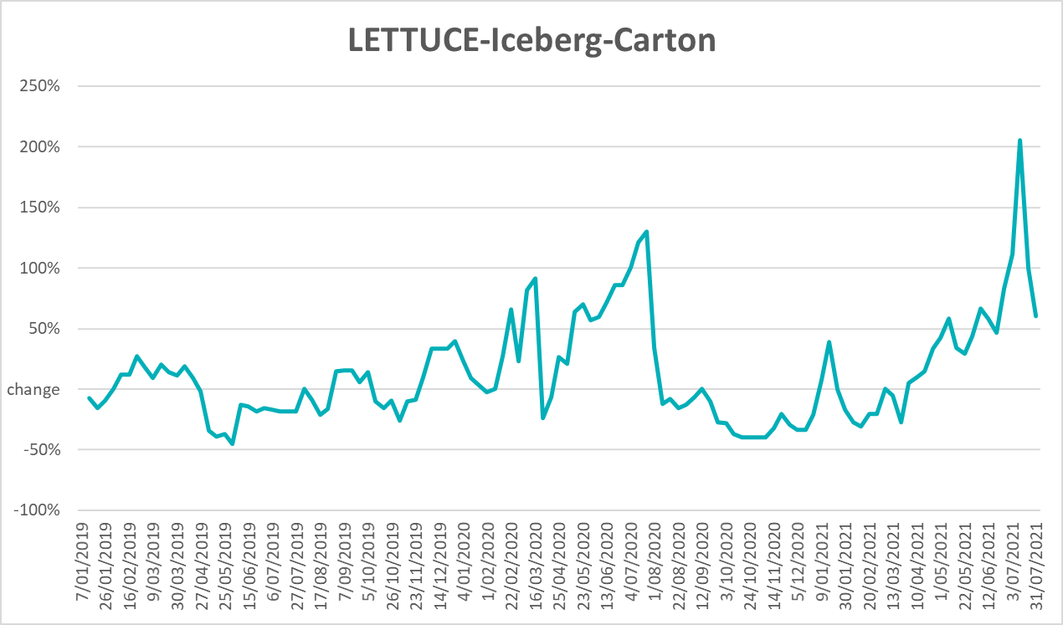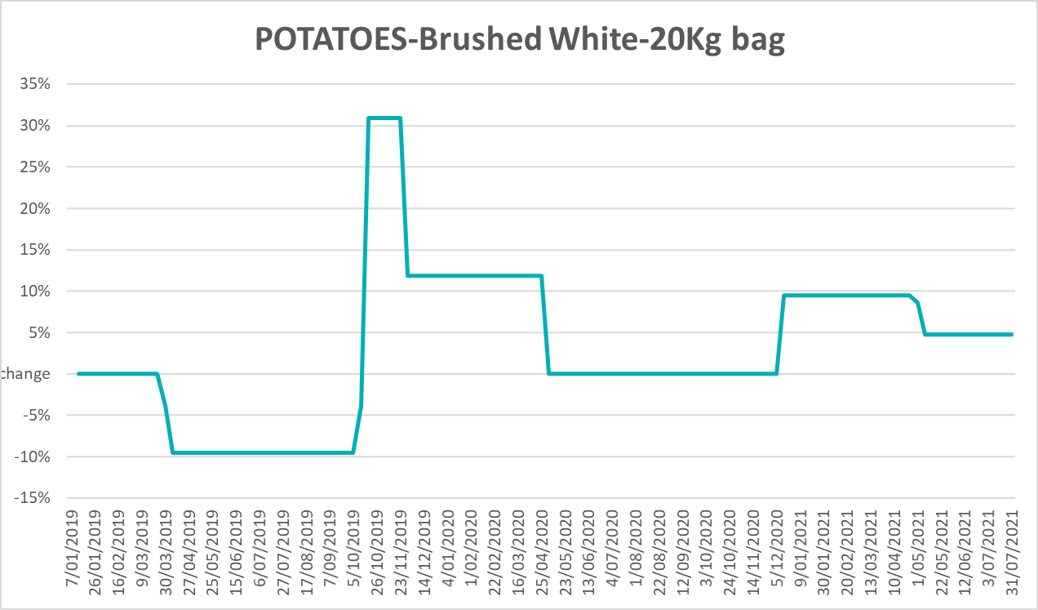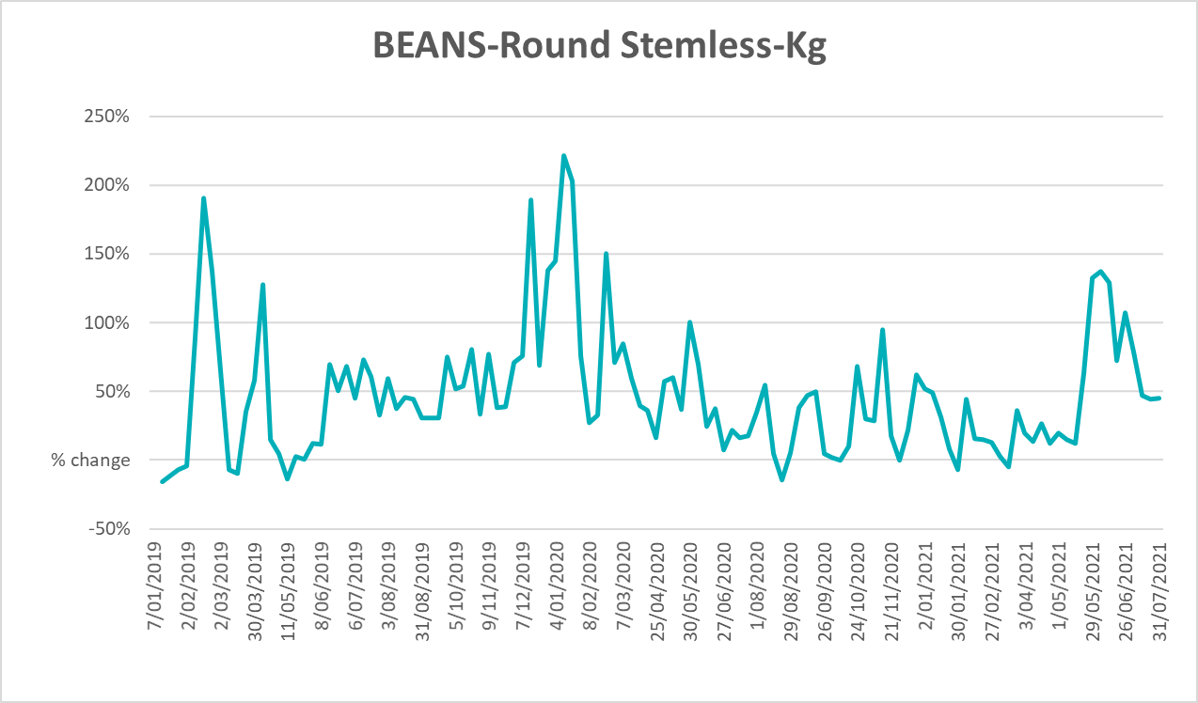

Selected domestic fodder indicator prices

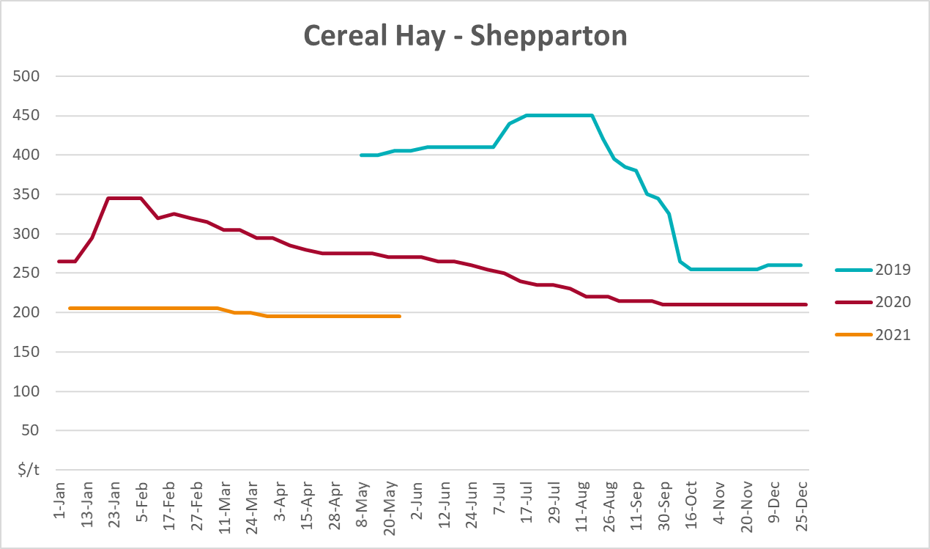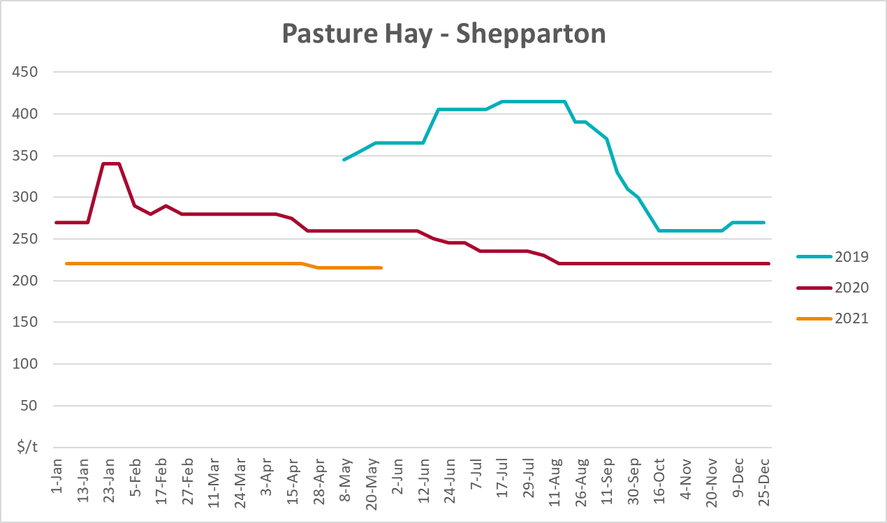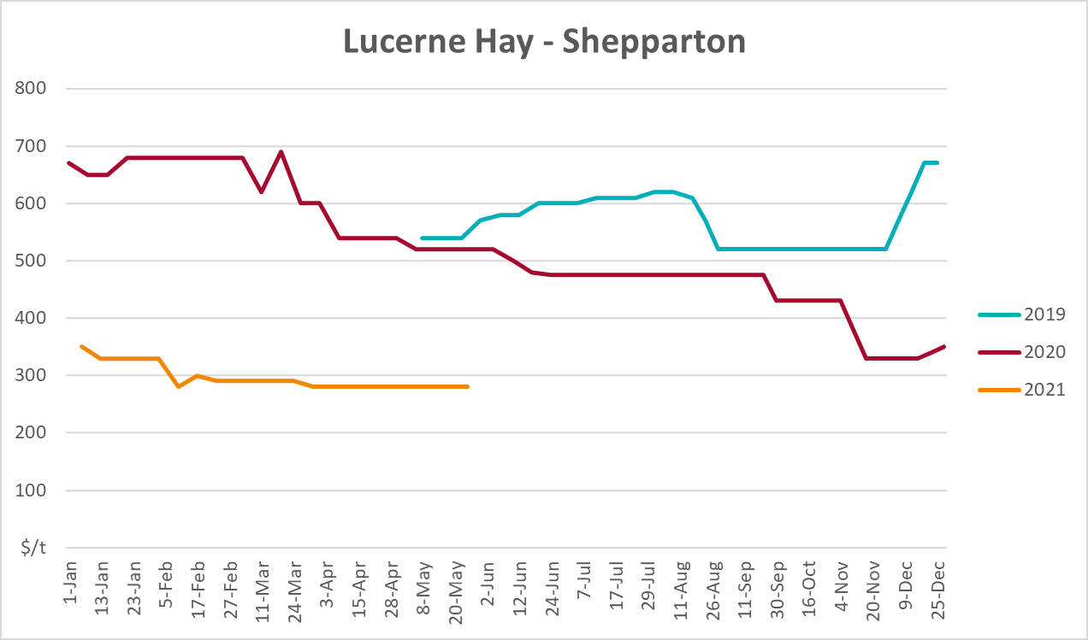

Data attribution

Climate
Bureau of Meteorology
- Weekly rainfall totals: www.bom.gov.au/climate/maps/rainfall/
- Monthly and last 3-month rainfall percentiles: www.bom.gov.au/water/landscape/
- Temperature anomalies: www.bom.gov.au/jsp/awap/temp/index.jsp
- Rainfall forecast: www.bom.gov.au/jsp/watl/rainfall/pme.jsp
- Seasonal outlook: www.bom.gov.au/climate/outlooks/#/overview/summary/
- Climate drivers: http://www.bom.gov.au/climate/enso/
- Soil moisture: www.bom.gov.au/water/landscape/
Other
- Pasture growth: www.longpaddock.qld.gov.au/aussiegrass/
- 3-month global outlooks: Environment and Climate Change Canada, NOAA Climate Prediction Center, EUROBRISA CPTEC/INPE, European Centre for Medium-Range Weather Forecasts, Hydrometcenter of Russia, National Climate Center Climate System Diagnosis and Prediction Room (NCC), International Research Institute for Climate and Society
- Global production: https://ipad.fas.usda.gov/ogamaps/cropmapsandcalendars.aspx
- Autumn break: Pook et al., 2009, https://rmets-onlinelibrary-wiley-com.virtual.anu.edu.au/doi/epdf/10.1002/joc.1833

Water
Prices
- Waterflow: https://www.waterflow.io/
- Ruralco: https://www.ruralcowater.com.au/
Bureau of Meteorology:
- Allocation trade: http://www.bom.gov.au/water/dashboards/#/water-markets/mdb/at
- Storage volumes: http://www.bom.gov.au/water/dashboards/#/water-storages/summary/drainage
Trade constraints:
- Water NSW: https://www.waternsw.com.au/customer-service/ordering-trading-and-pricing/trading/murrumbidgee
- Victorian Water Register: https://www.waterregister.vic.gov.au/TradingRules2019/

Commodities
Fruit and vegetables
- Datafresh: www.freshstate.com.au
Pigs
- Australian Pork Limited: www.australianpork.com.au
Dairy
- Global Dairy Trade: www.globaldairytrade.info/en/product-results/
World wheat, canola
- International Grains Council
World coarse grains
- United States Department of Agriculture
World cotton
- Cotlook: www.cotlook.com/
World sugar
- New York Stock Exchange - Intercontinental Exchange
Wool
- Australian Wool Exchange: www.awex.com.au/
Domestic wheat, barley, sorghum, canola and fodder
- Jumbuk Consulting Pty Ltd: http://www.jumbukag.com.au/
Cattle, beef, mutton, lamb, goat and live export
- Meat and Livestock Australia: www.mla.com.au/Prices-and-market
© Commonwealth of Australia 2021

Ownership of intellectual property rights
Unless otherwise noted, copyright (and any other intellectual property rights, if any) in this publication is owned by the Commonwealth of Australia (referred to as the Commonwealth).

Creative Commons licence
All material in this publication is licensed under a Creative Commons Attribution 4.0 International Licence except content supplied by third parties, logos and the Commonwealth Coat of Arms.
Inquiries about the licence and any use of this document should be emailed to copyright@awe.gov.au.


Cataloguing data
This publication (and any material sourced from it) should be attributed as:
ABARES 2021, Weekly Australian Climate, Water and Agricultural Update, Australian Bureau of Agricultural and Resource Economics and Sciences, Canberra,12 August 2021. CC BY 4.0 DOI: https://doi.org/10.25814/5f3e04e7d2503
ISSN 2652-7561
This publication is available at https://www.agriculture.gov.au/abares/products/weekly_update
Department of Agriculture, Water and the Environment
GPO Box 858 Canberra ACT 2601
Telephone 1800 900 090
Web awe.gov.au/abares

Disclaimer
The Australian Government acting through the Department of Agriculture, Water and the Environment, represented by the Australian Bureau of Agricultural and Resource Economics and Sciences, has exercised due care and skill in preparing and compiling the information and data in this publication. Notwithstanding, the Department of Agriculture, Water and the Environment, ABARES, its employees and advisers disclaim all liability, including liability for negligence and for any loss, damage, injury, expense or cost incurred by any person as a result of accessing, using or relying on any of the information or data in this publication to the maximum extent permitted by law.

Statement of Professional Independence
The views and analysis presented in ABARES publications, including this one, reflect ABARES professionally independent findings, based on scientific and economic concepts, principles, information and data. These views, analysis and findings may not reflect or be consistent with the views or positions of the Australian Government, or of organisations or groups who have commissioned ABARES reports or analysis. More information on professional independence is provided on the ABARES website.

Acknowledgements
This report was prepared by Cameron Van-Lane and Matthew Miller.

