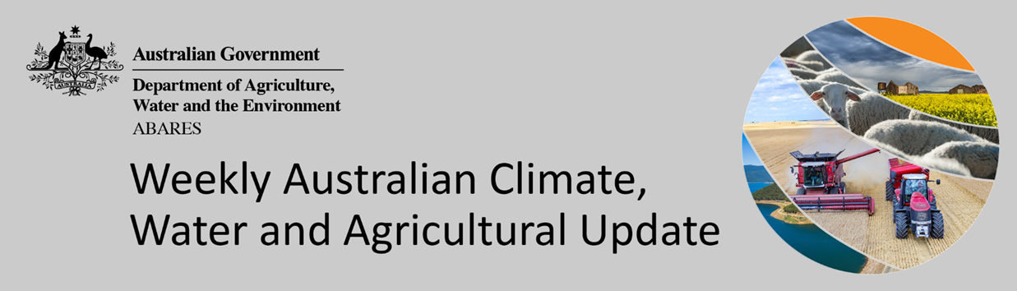
No. 32/2021

19 August 2021

Summary of key issues
- During the week ending 18 August 2021, high pressure systems dominated southern Australia, resulting in little rainfall across much of the continent. Cold fronts brought rainfall to western Tasmania and parts of southern Victoria, and low-pressure systems produced isolated rainfall for north-eastern Australia (see Section 1.1).
- As at 28 July 2021 global production conditions were generally favourable. A lack of precipitation and excessive heat has affected the production potential of wheat and corn, and to a lesser extent soybeans in some key grain exporters and importers (see Section 1.2).
- Production conditions for wheat in particular have declined further during July for some key grain exporters. This represents a deterioration in conditions compared to what was expected back in April, which were used to formulate ABARES forecasts of global grain supplies and world prices in its June 2021 edition of Agricultural commodities.
- The global climate outlook indicates that average to above average rainfall is more likely between September and November 2021 for some of the world's major grain-producing and oilseed-producing regions. If realised, this is likely to benefit corn, soybeans, sunflower, millet, rice, sorghum and cotton production and wheat and rapeseed planting in the northern hemisphere. In Australia, this positive outlook will support winter wheat and canola production and corn, cotton, soybeans, sunflower planting (see Section 1.2).
- However, below average rainfall is more likely across much of Argentina and southern Brazil. This would adversely affect the development of wheat crops, and the planting of corn, soybeans, sorghum, cotton, sunflower, rice and millet. Below average rainfall between September and November 2021 is also more likely for parts of the Russian Federation, China and the United States of America. In these northern hemisphere growing regions, this is likely to benefit the harvest of spring wheat and canola, but adversely affect the development of corn, cotton, soybeans, sorghum and sunflower.
- High pressure systems are likely to bring clear skies and dry conditions across much of eastern Australia over the next eight days. Parts of southern Australia are expected to receive rainfall from cold fronts moving off the Southern Ocean (see Section 1.3).
- Water storage in the Murray–Darling Basin (MDB) increased by 240 gigalitres (GL) between 10 August 2021 and 17 August 2021. The current volume of water held in storage is 19,869 GL, which represents 78% of total capacity. This is 52% or 6,761 GL more than at the same time last year.
- Allocation prices in the Victorian Murray below the Barmah Choke increased from $113 per ML on 6 August 2021 to $117 per ML on 13 August 2021. Prices are lower in the Goulburn-Broken, Murrumbidgee, and regions above the Barmah choke due to the binding of the Goulburn intervalley trade limit, Murrumbidgee export limit, and Barmah choke trade constraint.

Climate

Rainfall this week
During the week ending 18 August 2021, high pressure systems dominated southern Australia, resulting in little rainfall across much of the continent. Cold fronts brought rainfall to western Tasmania and parts of southern Victoria, and low-pressure systems produced isolated rainfall for north-eastern Australia.
Rainfall totals of between 10 and 50 millimetres were recorded across isolated parts of New South Wales, Queensland, southern Victoria, the south-east of South Australia and Western Australia. Rainfall totals in excess of 50 millimetres were recorded in isolated parts of northern Queensland and western Tasmania.
In cropping regions, rainfall totals of between 10 and 15 millimetres were recorded across isolated parts of New South Wales and Victoria. Little to no rainfall was recorded in cropping regions of much of the remainder New South Wales and Victoria, Queensland, South Australia and Western Australia.
The dry conditions across most of Australia’s cropping regions will be a reprieve from substantial rainfall totals already recorded this season. A second week of little to no rainfall for much of eastern Australia has allowed growers to access fields to apply urea and spray for pests and diseases. Parts of Western Australia had been struggling with waterlogging, but clear weather over the past week likely allowed for drying of saturate soils.

Rainfall for the week ending 18 August 2021

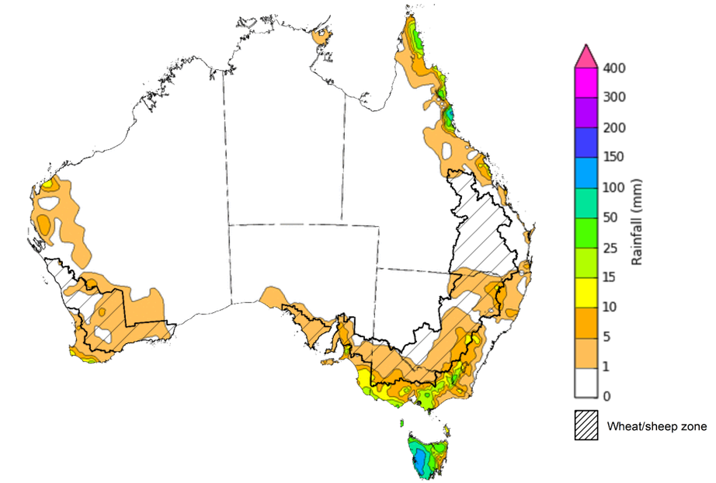
©Commonwealth of Australia 2021, Australian Bureau of Meteorology Issued: 18/08/2021
Note: The rainfall analyses and associated maps utilise data contained in the Bureau of Meteorology climate database, the Australian Data Archive for Meteorology (ADAM). The analyses are initially produced automatically from real-time data with limited quality control. They are intended to provide a general overview of rainfall across Australia as quickly as possible after the observations are received. For further information go to http://www.bom.gov.au/climate/rainfall/

Global production conditions and climate outlook
Crop production is affected by long-term trends in average rainfall and temperature, interannual climate variability, shocks during specific growth stages, and extreme weather events (IPCC 2012). Some crops are more tolerant than others to certain types of stresses, and at each growth stage, different types of stresses affect each crop species in different ways.
The precipitation anomalies and outlooks presented here give an indication of the current and future state of production conditions for the major grain and oilseed producing countries which are responsible for over 80% of global production. This is an important input to assessing the global grain supply outlook.
July precipitation percentiles and current production conditions
As of the end of July 2021, rainfall was generally favourable for the world’s major grain and oil producing regions.
In the northern hemisphere, July precipitation was above average in parts of central Africa, south-western and north-eastern China, western Europe, India, Ukraine, Turkey, and parts of southern and eastern United States of America.
Precipitation was below average across much of southern Canada, the north of the United States of America, northern Europe, and the west of the Russian Federation. Precipitation was generally average across the remainder of major grain and oil producing regions in the northern hemisphere.
In the southern hemisphere, July precipitation was below average across much of Argentina and parts of southern Brazil. Precipitation was generally average to above average across the remainder of major grain and oil producing regions in the southern hemisphere.

Global precipitation percentiles, July 2021
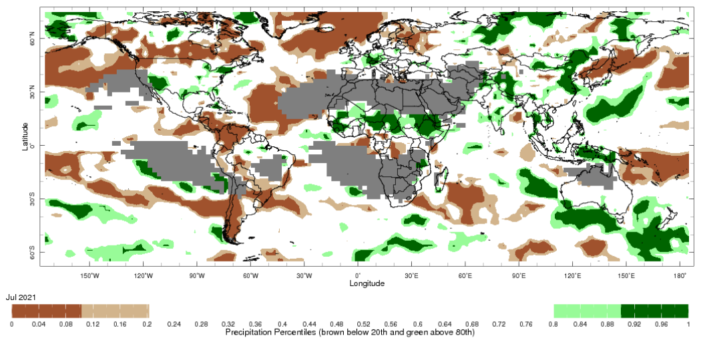
Note: The world precipitation percentiles indicate a ranking of precipitation for July, with the driest (0th percentile) being 0 on the scale and the wettest (100th percentile) being 1 on the scale. Percentiles are based on precipitation estimates from the NOAA Climate Prediction Center's Climate Anomaly Monitoring System Outgoing Precipitation Index dataset. Precipitation estimates for July 2021 are compared with rainfall recorded for that period during the 1981 to 2010 base period.
Source: International Research Institute for Climate and Society
As at 28 July 2021 global production conditions were generally favourable. However, a lack of precipitation and excessive heat has affected the production potential of wheat, corn and soybeans in some key grain exporting and importing countries.
Conditions for wheat development were generally favourable in Australia, Argentina, China, the European Union, United Kingdom, and Ukraine. Dry and unseasonably hot temperatures have resulted in variable production prospects across much of Canada, Kazakhstan, Turkey, the Russian Federation, and for much of northern and parts of central United States of America (US).
Conditions for corn in Argentina were generally favourable as harvest wraps up for the late-planted crop. In Brazil, production potential is mixed due to excessive dryness and frosts during the critical reproductive stage as harvesting commences. In Mexico production conditions are favourable as harvest wraps up for the autumn-winter crop and for the sowing of the spring-summer crop. Conditions were favourable for crop development in the European Union, India, Ukraine, and the Russian Federation. In the US, production potential is mixed as persistent hot and dry conditions extend across much of the northern Corn Belt. In China, production potential is also mixed as excess rainfall and flooding affect areas in the northeast and persistent dry affects crop in the northwest.
Conditions for rice were favourable for crop development in China and the US. Favourable growing conditions have supported production prospects for dry-season rice in Indonesia and wet-season rice in Vietnam. Growing conditions are also favourable in India, the Philippines and Thailand.
Production conditions for soybeans are mixed in Canada and in northern and western areas of the Mid-West of the US, as hot and dry conditions persist. Production conditions are favourable across remaining soybean producing regions.

Crop conditions, AMIS countries, 28 July 2021
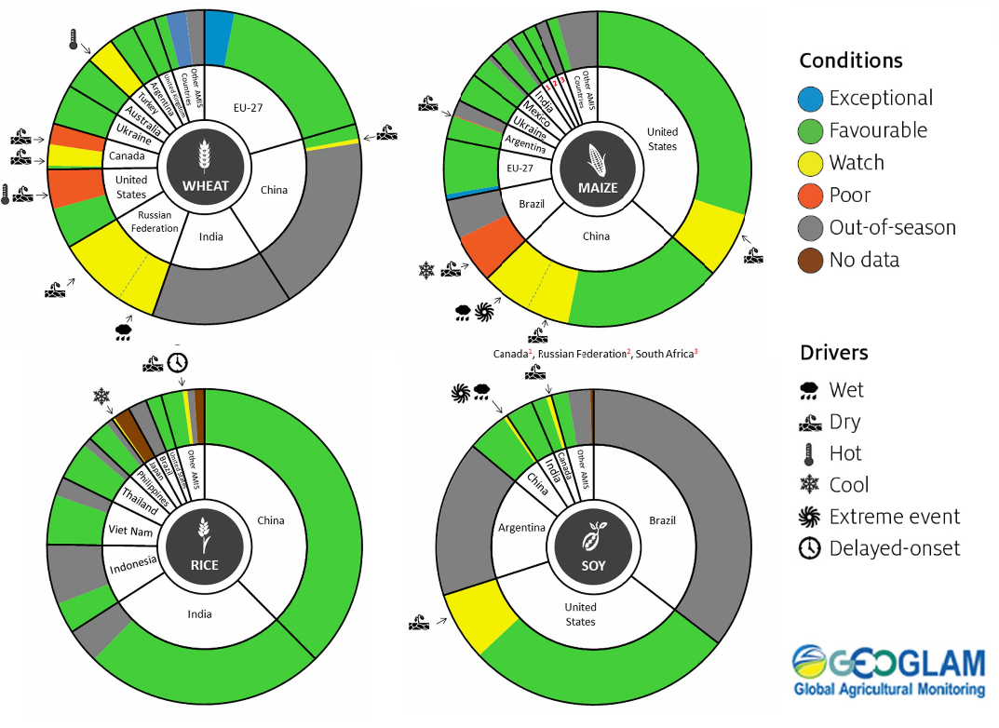
AMIS Agricultural Market Information System.
Source: AMIS
The global climate outlook for September to November 2021 indicates that average to above average rainfall is more likely for most of the world's major grain-producing and oilseed-producing regions. Outlooks and potential production impacts for the major grain and oilseed producing countries are presented in the table.
Rainfall outlook and potential impact on the future state of production conditions between September and November 2021
Region | September-November rainfall outlook | Potential impact on production
Argentina | Below average rainfall is expected across most of Argentina between September to November 2021. | Below average rainfall is likely to adversely affect the heading and filling of wheat and the planting of corn, cotton and soybeans through September and October. These conditions may also adversely impact early corn silking, and the planting of soybeans, sunflower, rice, sorghum and millet in November.
Black Sea Region | Kazakhstan and Ukraine - No strong tendency towards either above or below average rainfall between September to November 2021.  The Russian Federation - Below average rainfall is expected across central and southern regions | Below average rainfall is likely to support spring wheat harvesting in the north-east of Russia and early cotton harvesting in southern regions. Average rainfall across Kazakhstan and Ukraine is likely to support winter wheat and rapeseed planting in September, and corn and sunflower filling in September and October.
Brazil | Above average rainfall is more likely in northern Brazil while below average rainfall is more likely across the south of Brazil. | Below average rainfall in parts of southern Brazil is likely to adversely affect wheat filling leading up to harvest in October, as well as corn and soybean planting and development in September and October. This may also affect the planting of groundnuts, sorghum, cotton, sunflower, rice and millet in November.
Canada | There is no strong tendency towards below or above average rainfall across much of Canada between September to November 2021. | Average rainfall is unlikely to be sufficient to increase the yield potential of corn, soybeans and sunflower at the grain filling and maturing stage through September and October.
China | Above average rainfall is likely across much of southern China and below average across western and north-eastern China between September to November 2021. | Below average rainfall is likely to adversely affect the development and harvest of cotton, corn, sorghum, soybean, sunflower, groundnuts and spring wheat across north-eastern and western China. In southern China, average to above average rainfall is likely to support late rice heading in September and planting of winter wheat and rapeseed in October.
Europe | Below average rainfall more likely for parts of southern Europe between September to November 2021. | Below average rainfall may adversely impact the development and harvest of corn, cotton and sorghum in southern Europe. Below average rainfall may also impact winter wheat and rapeseed planting in parts of southern and eastern Europe during October and November.
South Asia (India) | Above average rainfall between September to November 2021 is likely across much of India. | Average to above average rainfall is likely to benefit cotton blooming in the south during September and corn, sorghum, rice, millet, groundnuts and sunflower filling in September leading up to harvest in October and November, and winter wheat and rapeseed planting in November.
Southeast Asia (SEA) | Above average rainfall is likely for northern SEA, with a strong likelihood of above average rainfall for Indonesia between September to November 2021. | Above average rainfall in SEA is likely to support corn and rice maturing during September leading up to harvest in October.
The United States of America | Above average rainfall is more likely for parts of eastern US and below average rainfall is more likely across much of the centre and the western half of the US. | Below average rainfall is likely to adversely affect the filling and maturing of soybeans, sunflower, millet, cotton, rice, corn, sorghum and groundnuts in September leading up to harvest in October and November.

Rainfall forecast for the next eight days
High pressure systems are likely to bring clear skies and dry conditions across much of eastern Australia over the next eight days. Parts of southern Australia are expected to receive rainfall from cold fronts moving off the Southern Ocean.
Rainfall totals of between 10 and 50 millimetres are forecast for parts of eastern New South Wales, southern and eastern Victoria, the south-east of South Australia, the south-west of Western Australia and eastern Tasmania. Rainfall in excess of 50 millimetres is expected in north-eastern Queensland, parts of south-west Western Australia and western Tasmania.
In Australian cropping regions, rainfall totals of between 10 and 25 millimetres are expected in parts of eastern New South Wales, southern Victoria, central South Australia and parts of the south-west of Western Australia. Little to no rainfall is forecast for much of New South Wales, Queensland, northern Victoria, much of South Australia and Western Australia cropping regions during the next 8-days.
The dry conditions across most cropping regions are expected to have a positive impact for crop development. Most regions have average to above-average plant available soil moisture, which will support ongoing crop development. In areas previously affected by waterlogging, the continued dry conditions will allow proper drainage of soils and is likely to positively impact crop growth. The dry conditions will also allow greater access to paddocks for crop management activities.

Total forecast rainfall (mm) for the period 19 August to 26 August 2021
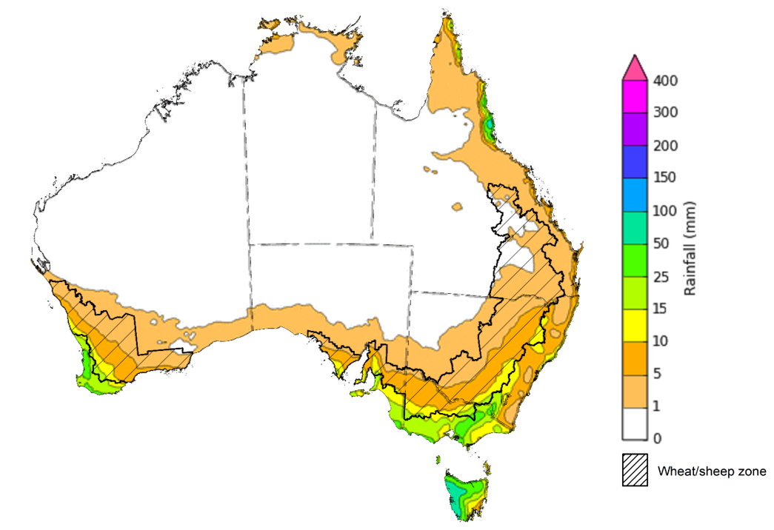
©Commonwealth of Australia 2021, Australian Bureau of Meteorology Issued: 19/08/2021
Note: This rainfall forecast is produced from computer models. As the model outputs are not altered by weather forecasters, it is important to check local forecasts and warnings issued by the Bureau of Meteorology.

Water

Water markets – current week
Water storage in the Murray–Darling Basin (MDB) increased by 240 gigalitres (GL) between 10 August 2021 and 17 August 2021. The current volume of water held in storage is 19,869 GL, which represents 78% of total capacity. This is 52% or 6,761 GL more than at the same time last year.

Water storages in the Murray-Darling Basin, 2013–2021
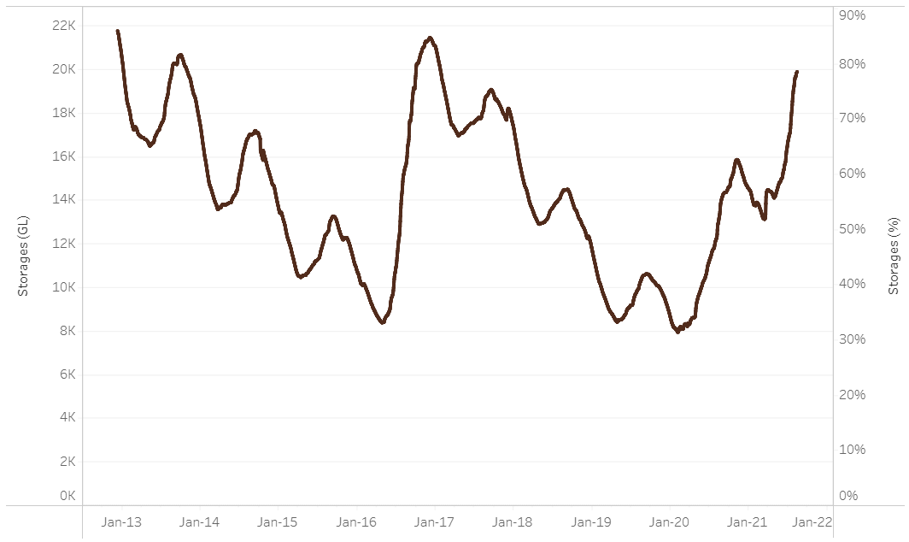
Water storage data is sourced from the Bureau of Meteorology.

Allocation prices in the Victorian Murray below the Barmah Choke increased from $113 per ML on 6 August 2021 to $117 per ML on 13 August 2021. Prices are lower in the Goulburn-Broken, Murrumbidgee, and regions above the Barmah choke due to the binding of the Goulburn intervalley trade limit, Murrumbidgee export limit, and Barmah choke trade constraint.
Region | $/ML
NSW Murray Above | 77
NSW Murrumbidgee | 77
VIC Goulburn-Broken | 82
VIC Murray Below | 117

Surface water trade activity, Southern Murray–Darling Basin

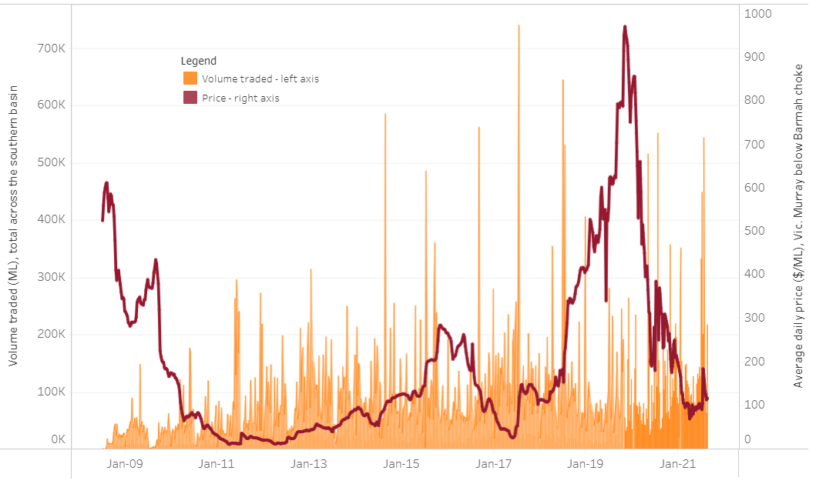
To access the full, interactive, weekly water dashboard, which contains the latest and historical water storage, water market and water allocation information, please visit http://www.agriculture.gov.au/abares/products/weekly_update/weekly-update-190821
The trades shown reflect estimated market activity and do not encompass all register trades. The price is shown for the VIC Murray below the Barmah choke. Historical prices (before 1 July 2019) are ABARES estimates after removing outliers from BOM water register data. Prices after 1 July 2019 and prior to the 30 October 2019 reflect recorded transaction prices as sourced from Ruralco. Prices after the 30 October 2019 are sourced from Waterflow. Data for volume traded is sourced from the BOM water register. Data shown is current at 19 August 2021.

Commodities
Indicator | Week ended | Unit | Latest price | Previous week | Weekly change | Price 12 months ago | Annual change
Selected world indicator prices
AUD/USD Exchange rate | 18-Aug | A$/US$ | 0.73 | 0.73 | -1% | 0.72 | 1%
Wheat – US no. 2 hard red winter wheat, fob Gulf | 18-Aug | US$/t | 333 | 321 | 4% | 231 | 44%
Corn – US no. 2 yellow corn, fob Gulf | 18-Aug | US$/t | 258 | 248 | 4% | 157 | 64%
Canola – Rapeseed, Canada, fob Vancouver | 18-Aug | US$/t | 699 | 687 | 2% | 391 | 79%
Cotton – Cotlook 'A' Index | 18-Aug | USc/lb | 103 | 100 | 3% | 71 | 45%
Sugar – Intercontinental Exchange, nearby futures, no.11 contract | 18-Aug | USc/lb | 20.6 | 19.5 | 6% | 13 | 63%
Wool – Eastern Market Indicator | 18-Aug | Ac/kg clean | 1,335 | 1,428 | -7% | 1,171 | 14%
Wool – Western Market Indicator | 18-Aug | Ac/kg clean | 1,351 | 1,462 | -8% | 1,358 | -1%
Selected Australian grain export prices
Milling Wheat – APW, Port Adelaide, SA | 18-Aug | A$/t | 409 | 402 | 2% | 319 | 28%
Feed Wheat – ASW, Port Adelaide, SA | 18-Aug | A$/t | 405 | 395 | 2% | 304 | 33%
Feed Barley – Port Adelaide, SA | 18-Aug | A$/t | 333 | 326 | 2% | 266 | 25%
Canola – Kwinana, WA | 18-Aug | A$/t | 846 | 808 | 5% | 633 | 34%
Grain Sorghum – Brisbane, QLD | 18-Aug | A$/t | 363 | 365 | -1% | 363 | 0%
Selected domestic livestock indicator prices
Beef – Eastern Young Cattle Indicator | 18-Aug | Ac/kg cwt | 998 | 1,000 | 0% | 759 | 31%
Mutton – Mutton indicator (18–24 kg fat score 2–3), Vic | 18-Aug | Ac/kg cwt | 674 | 671 | 1% | 500 | 35%
Lamb – Eastern States Trade Lamb Indicator | 18-Aug | Ac/kg cwt | 914 | 881 | 4% | 770 | 19%
Pig – Eastern Seaboard (60.1–75 kg), average of buyers & sellers | 28-Jul | Ac/kg cwt | 318 | 318 | 0% | 386 | -18%
Goats – Eastern States (12.1–16 kg) | 11-Aug | Ac/kg cwt | 879 | 878 | 0% | 753 | 17%
Live cattle – Light steers ex Darwin to Indonesia | 17-Feb | Ac/kg lwt | 355 | 355 | 0% | 360 | -1%
Live sheep – Live wethers (Muchea WA saleyard) to Middle East | 19-May | $/head | 145 | 145 | 0% | N/A | N/A

Indicator | Week ended | Unit | Latest price | Previous week | Weekly change | Price 12 months ago | Annual change
Global Dairy Trade (GDT) weighted average prices ª
Dairy – Whole milk powder | 18-Aug | US$/t | 3,552 | 3,598 | -1% | 2,969 | 20%
Dairy – Skim milk powder | 18-Aug | US$/t | 3,052 | 3,020 | 1% | 2,430 | 26%
Dairy – Cheddar cheese | 18-Aug | US$/t | 4,184 | 4,065 | 3% | 3,869 | 8%
Dairy – Anhydrous milk fat | 18-Aug | US$/t | 5,791 | 5,668 | 2% | 5,523 | 5%
a Global Dairy Trade prices are updated twice monthly on the first and third Tuesday of each month.

Selected world indicator prices
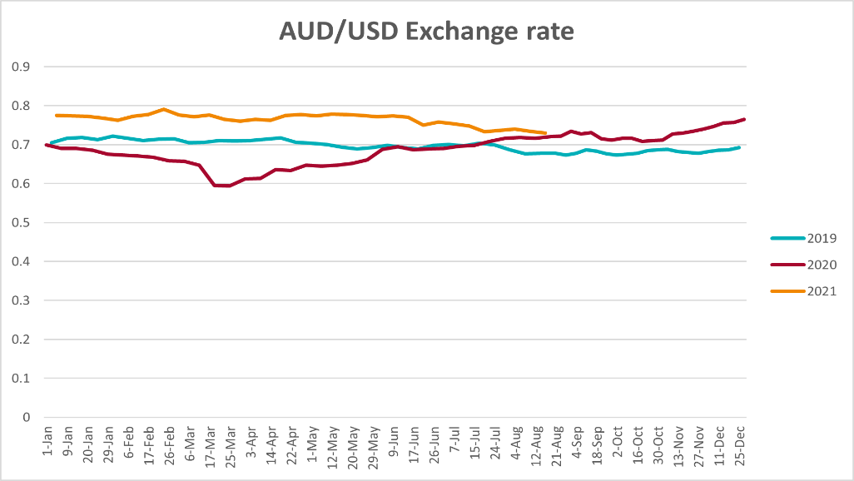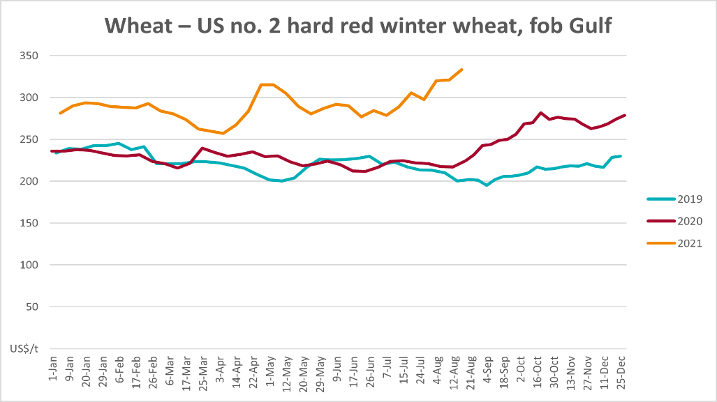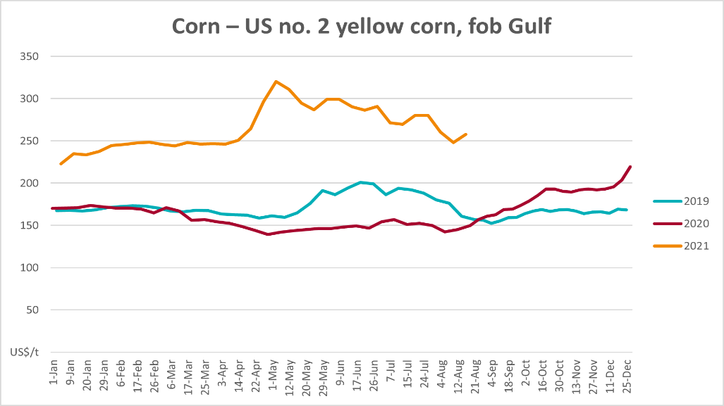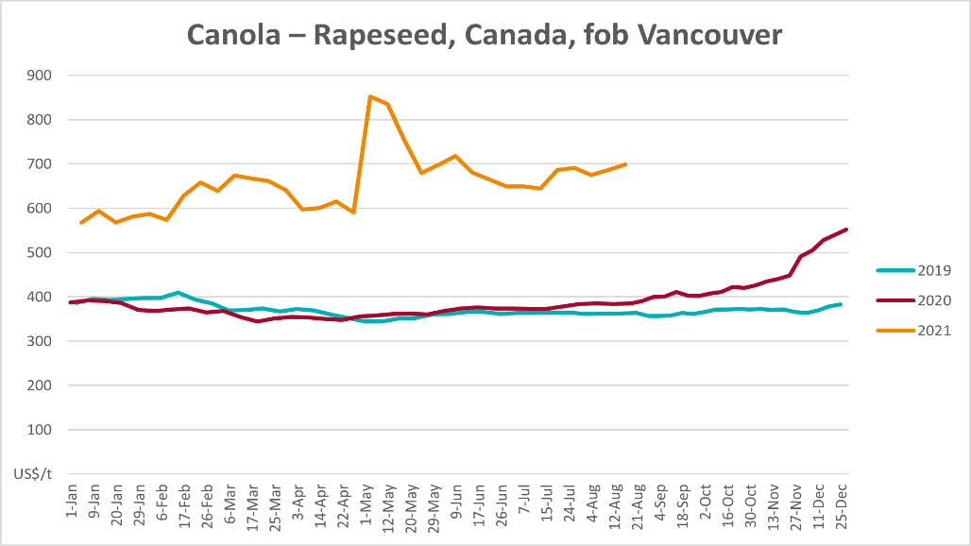

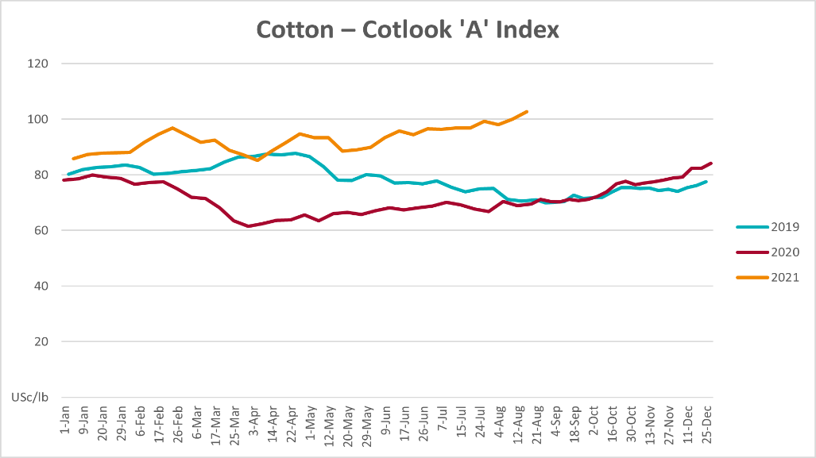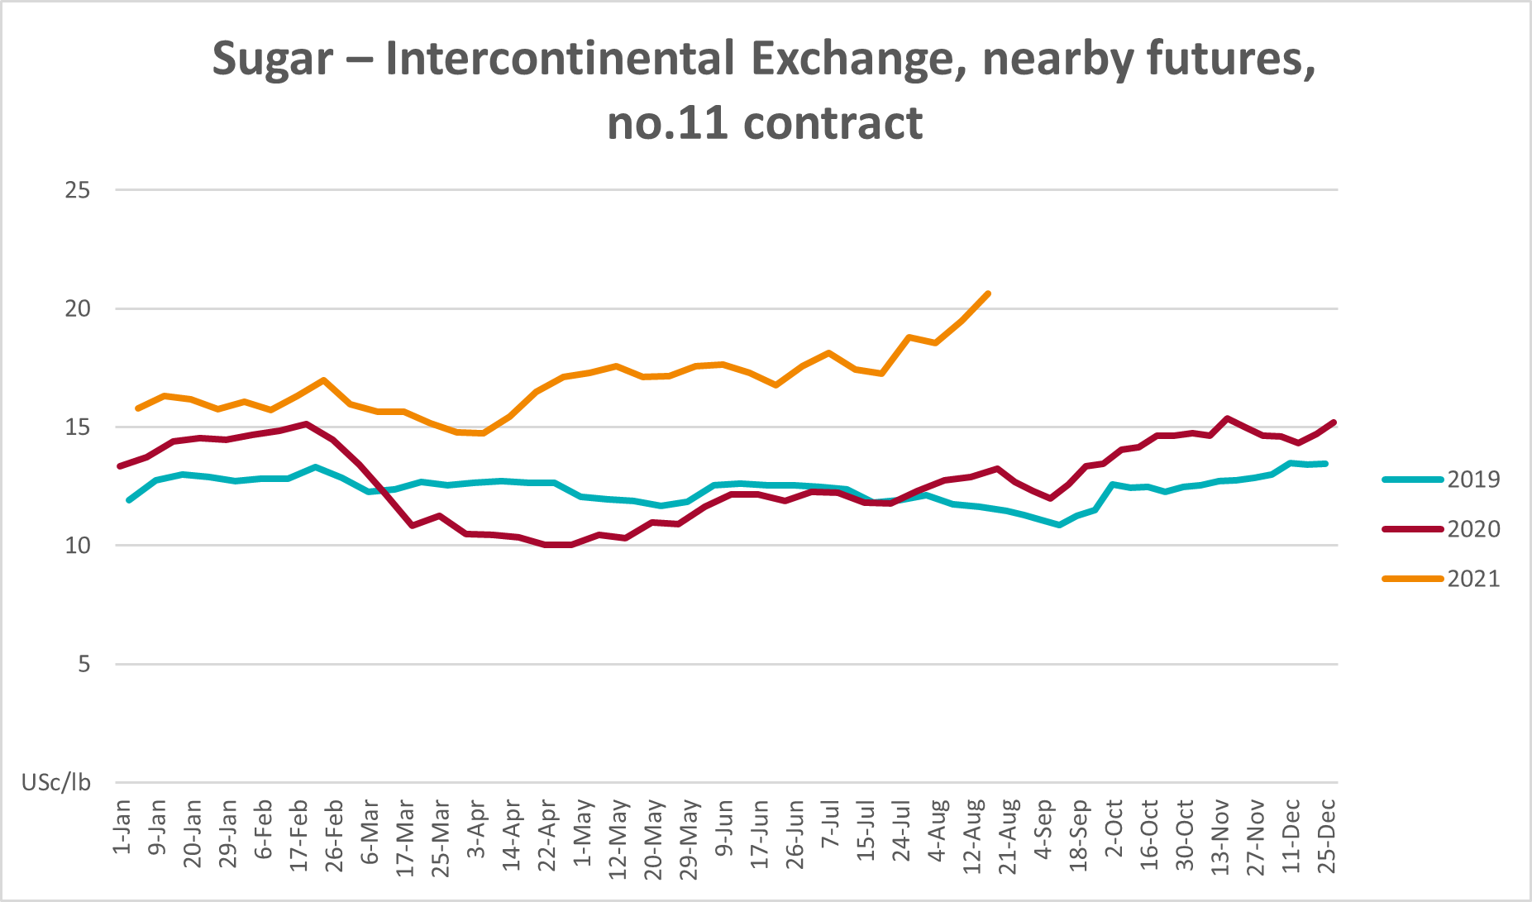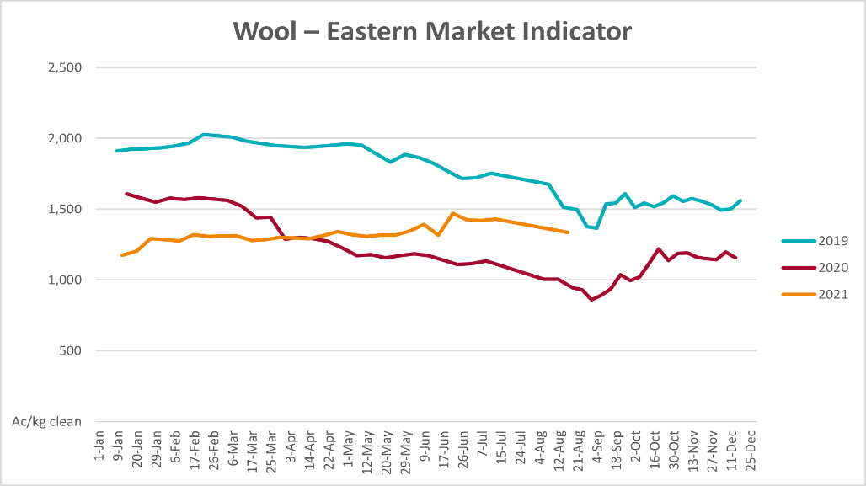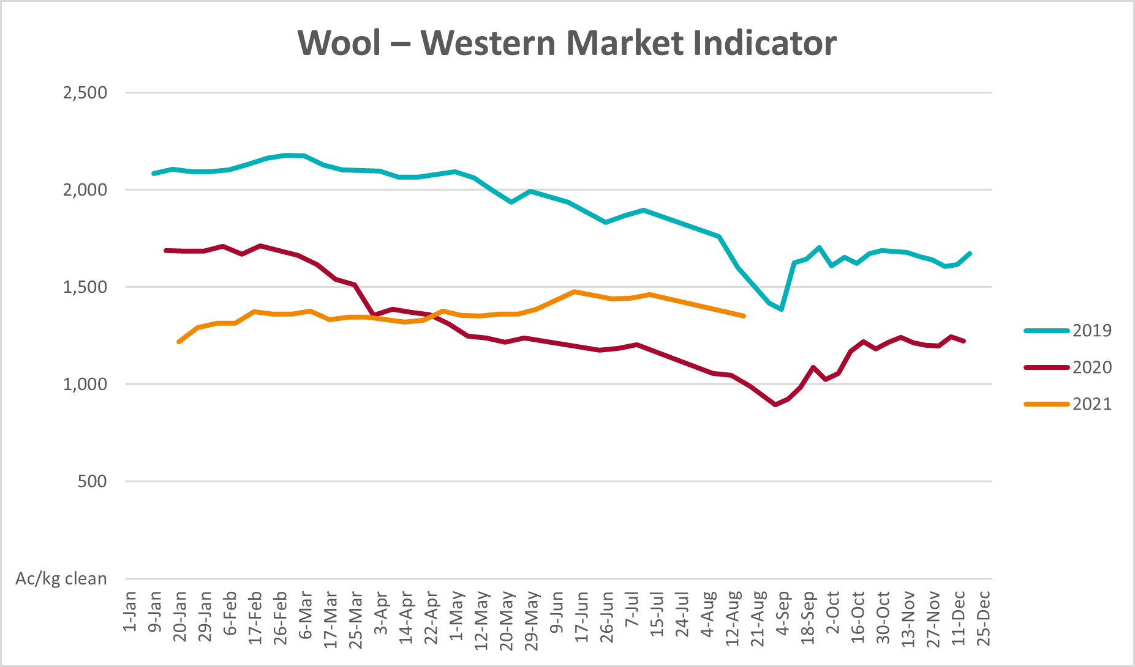

Selected domestic crop indicator prices
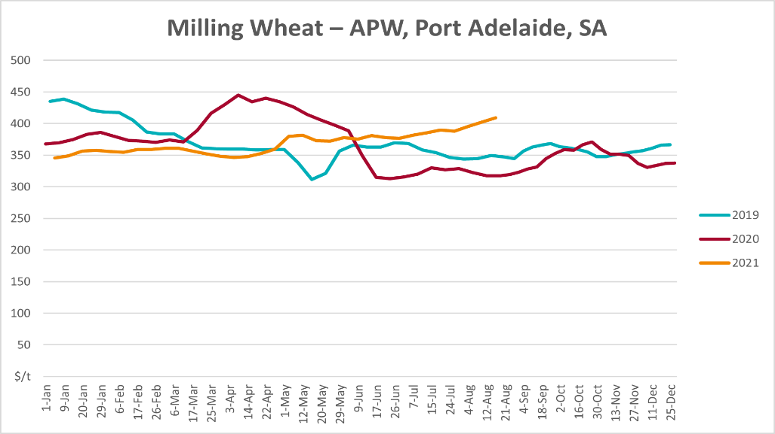
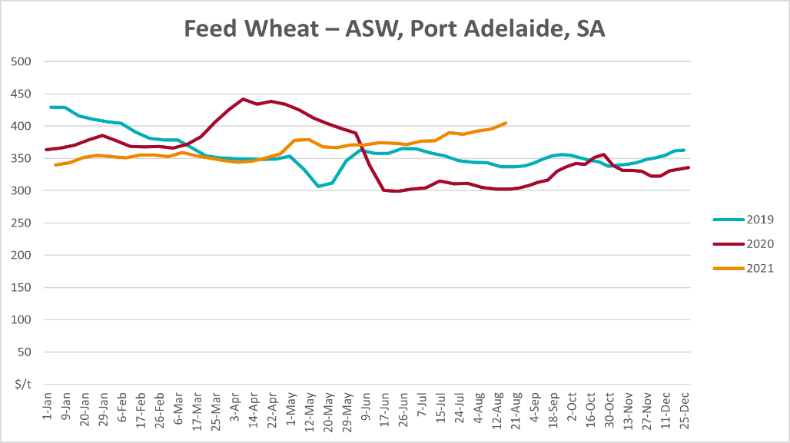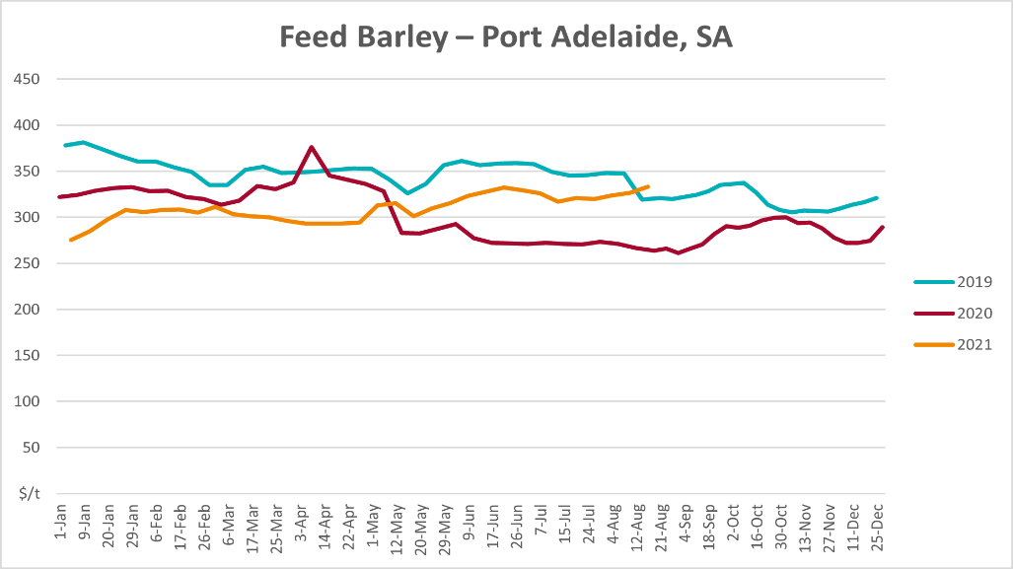
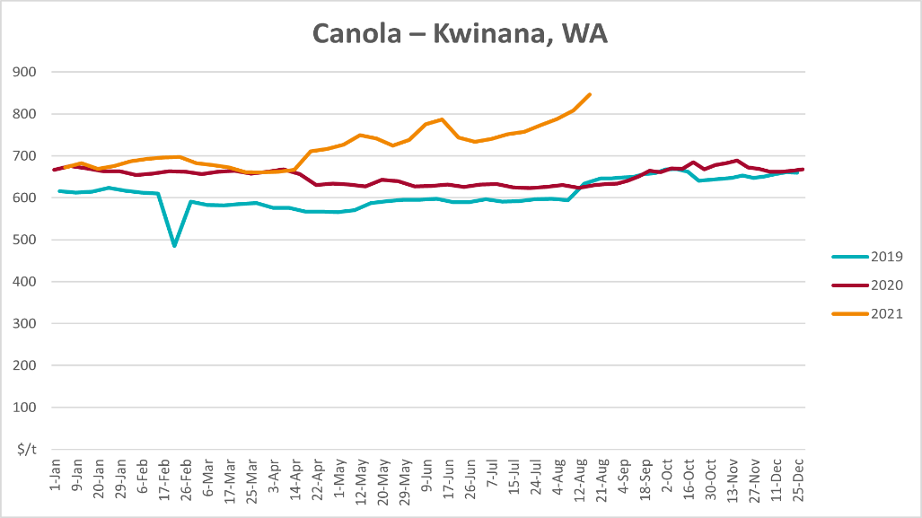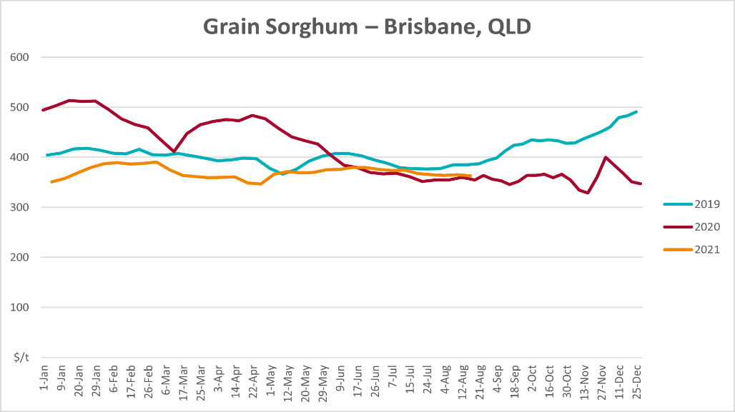

Selected domestic livestock indicator prices
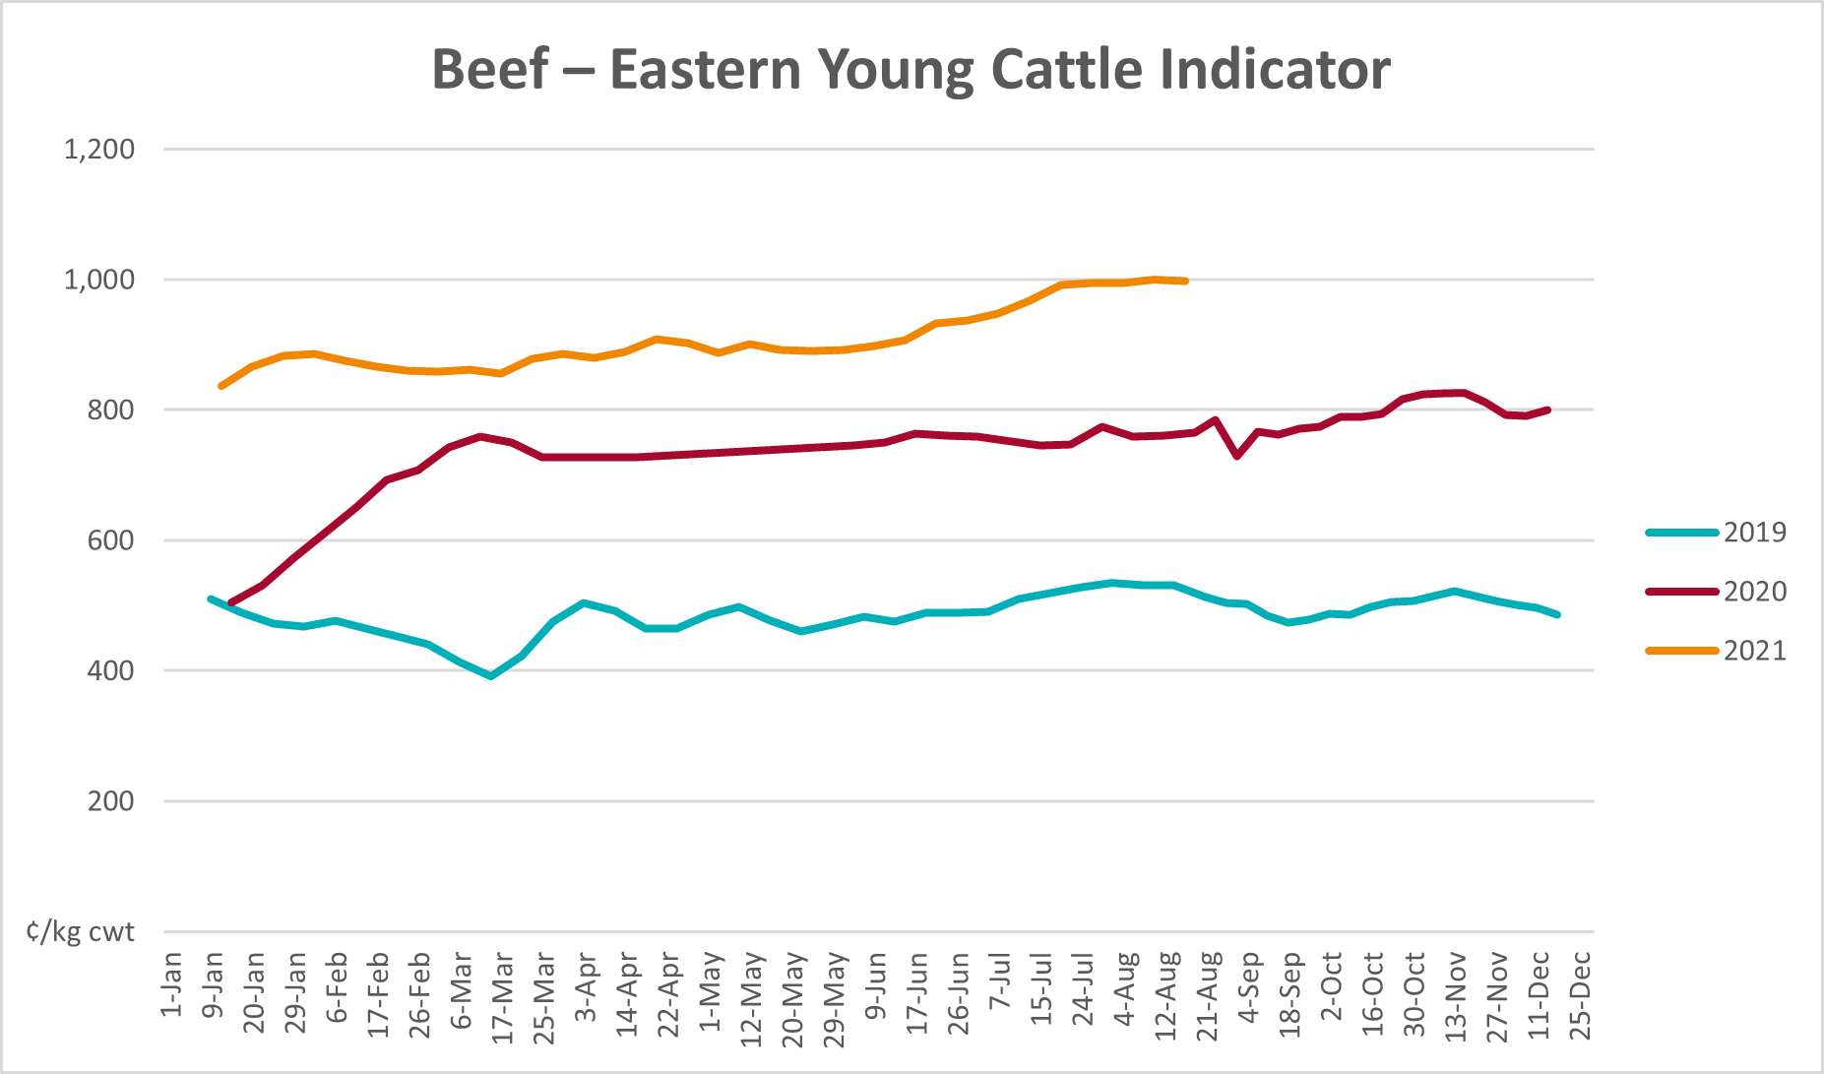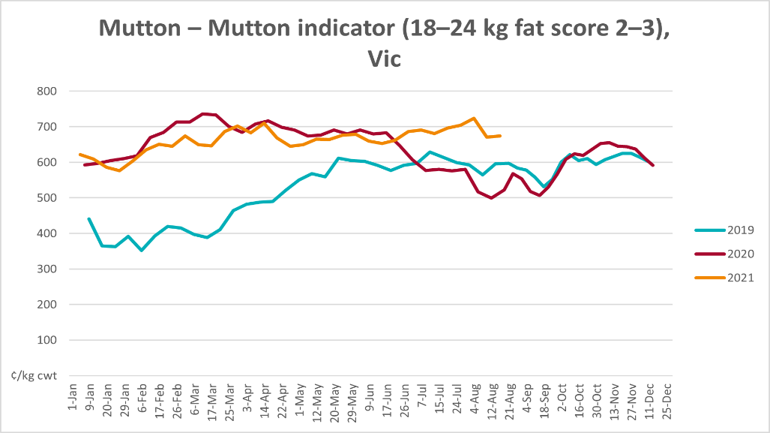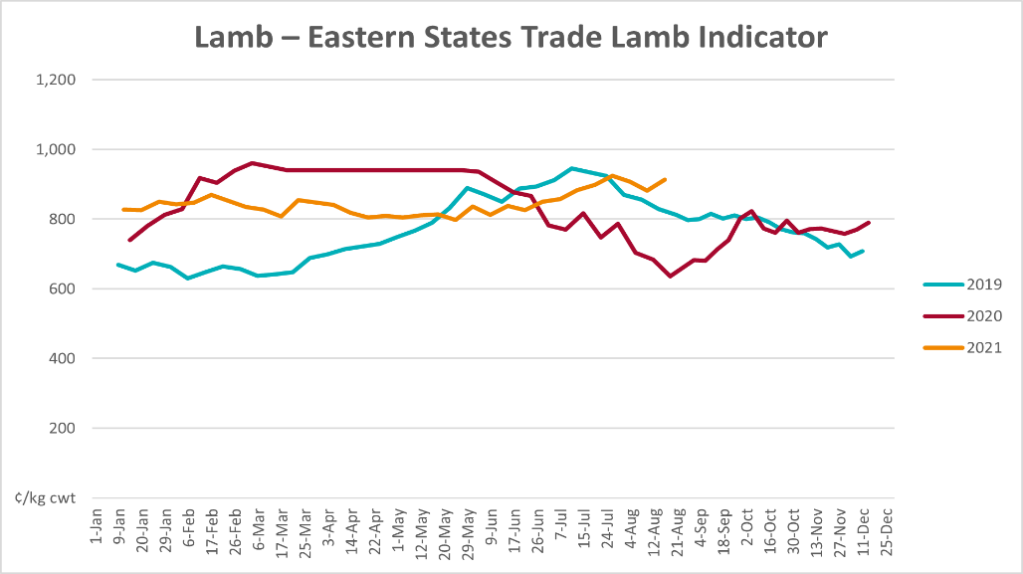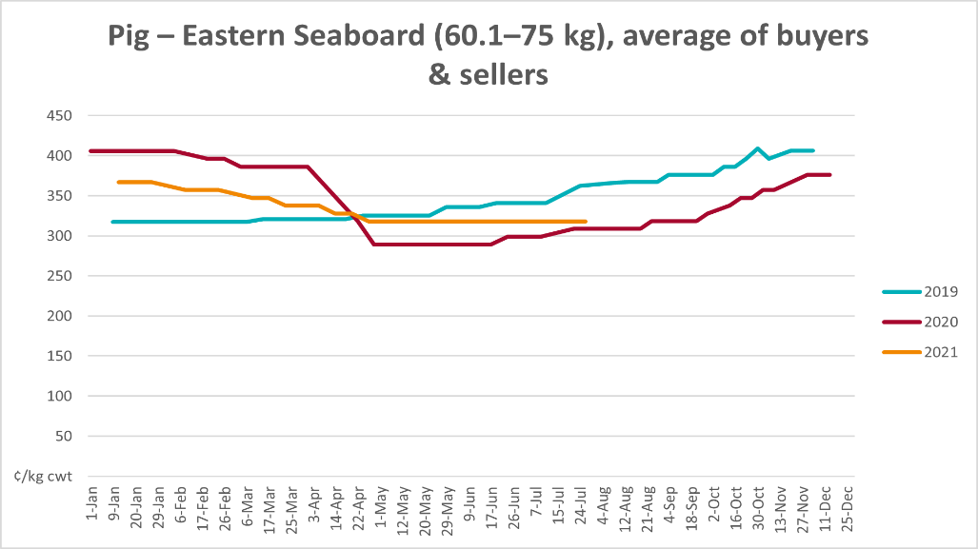
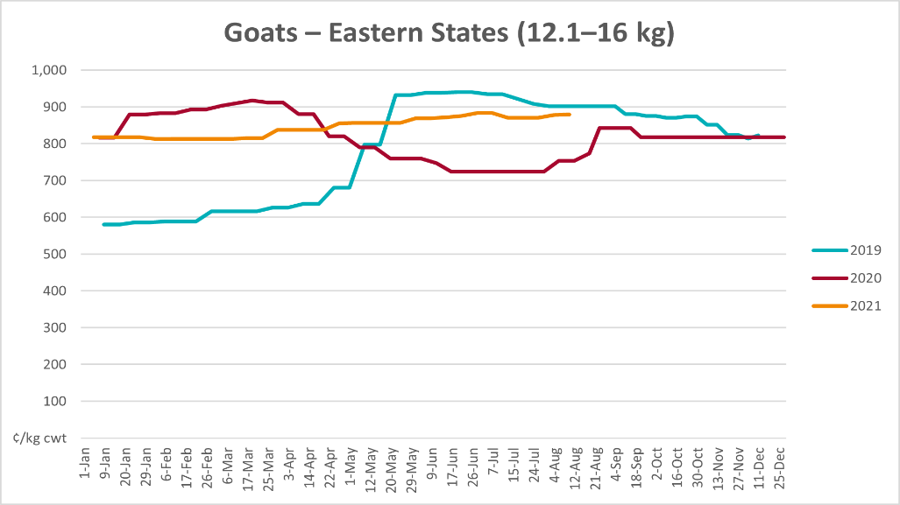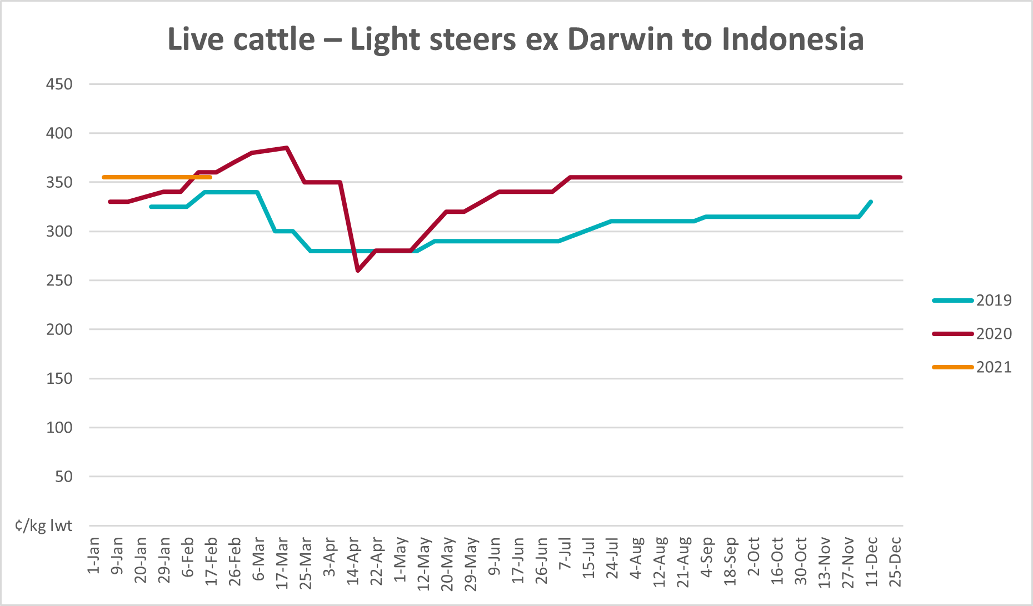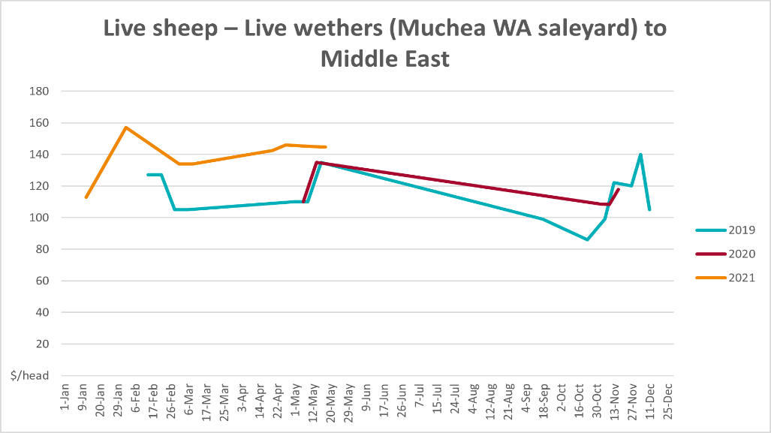

Global Dairy Trade (GDT) weighted average prices
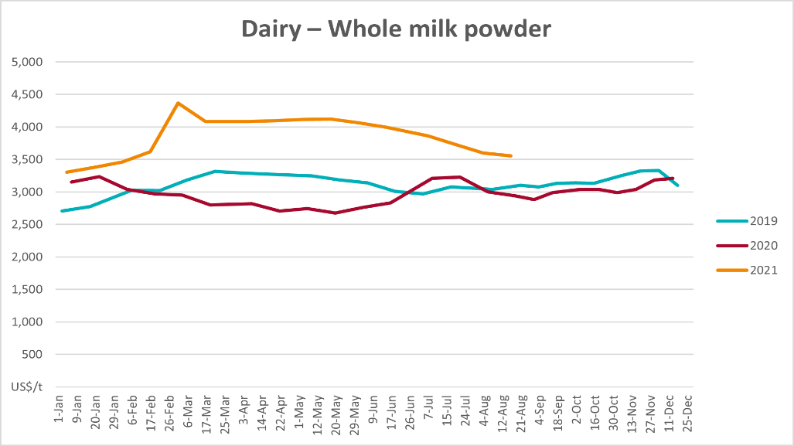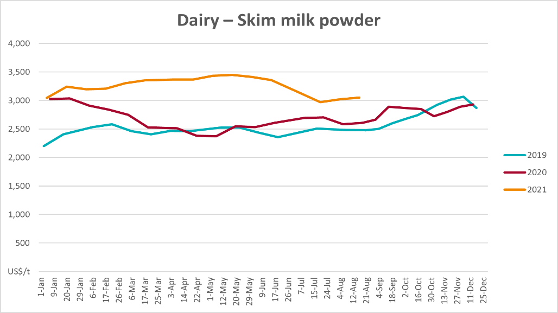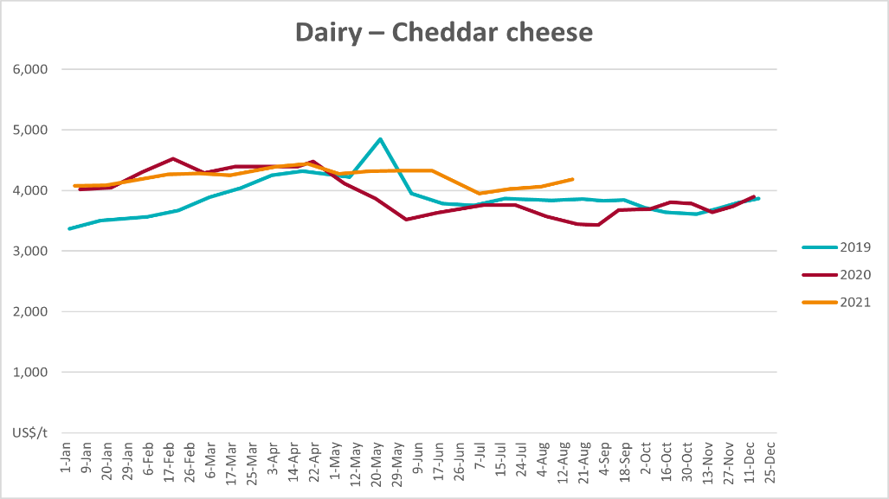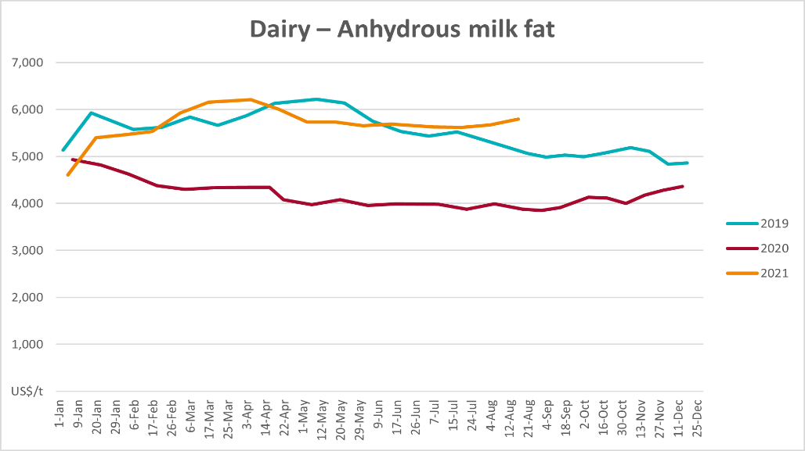

Selected fruit and vegetable prices
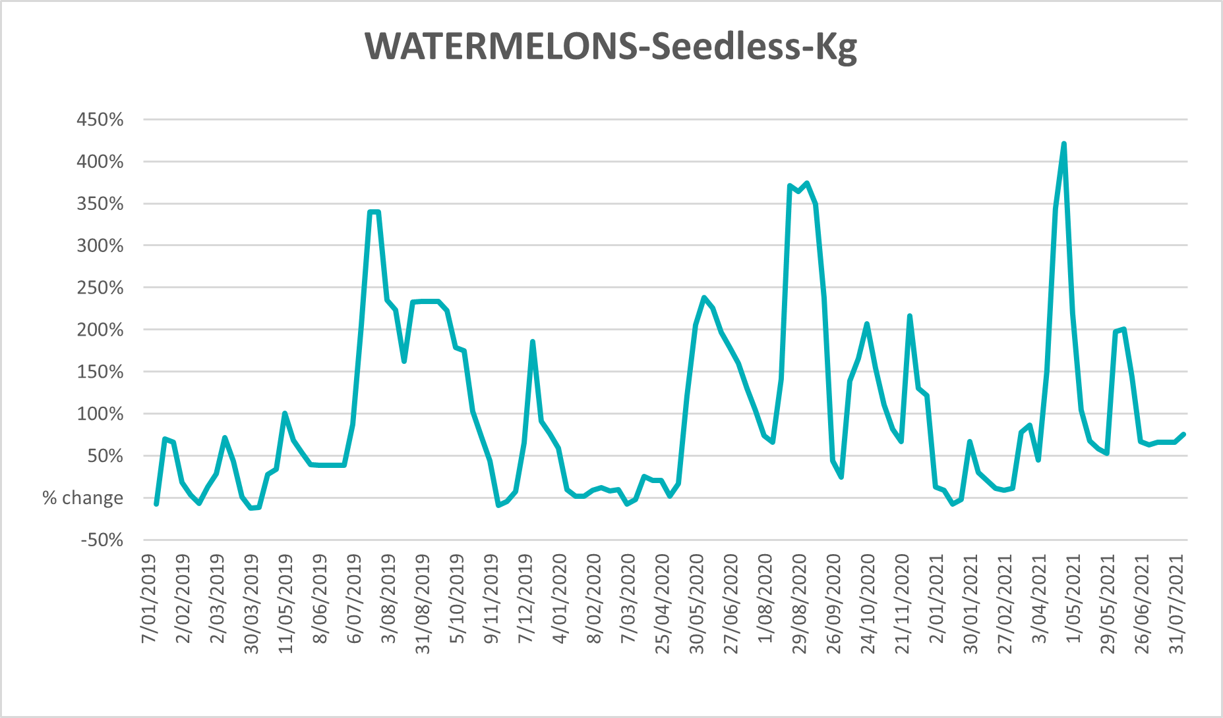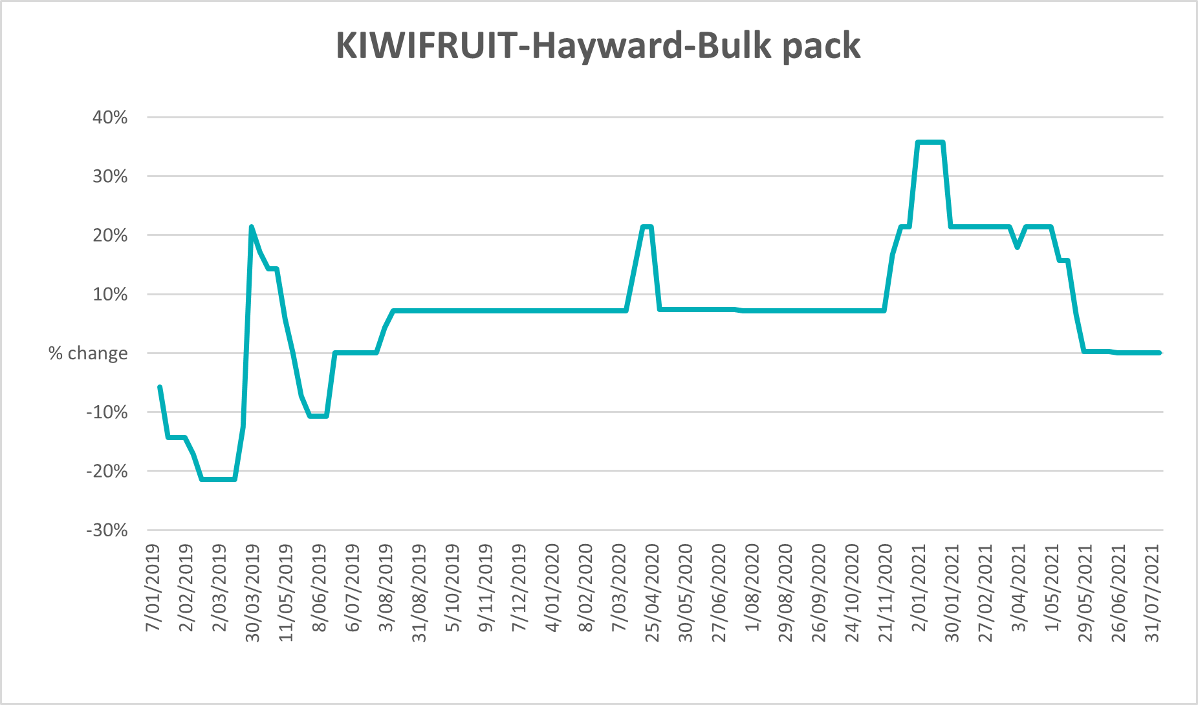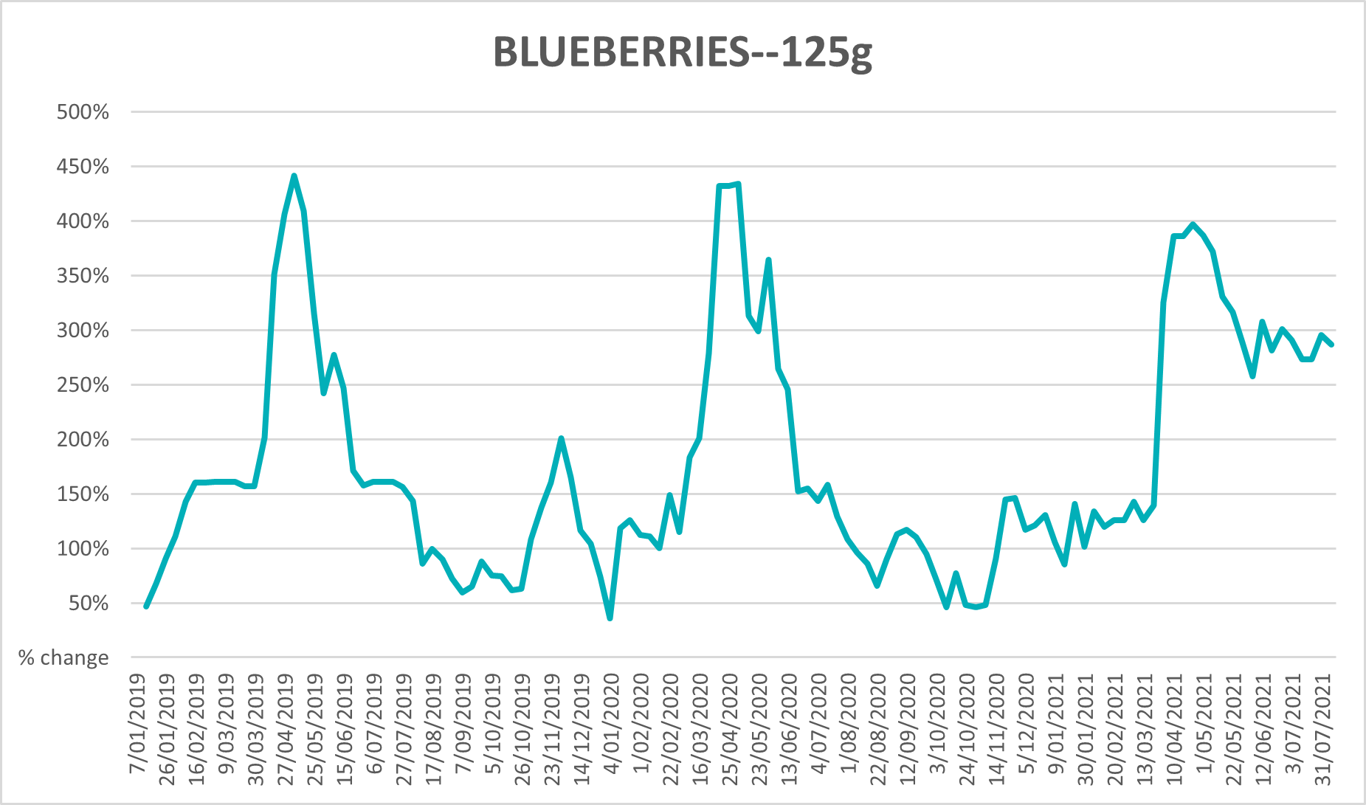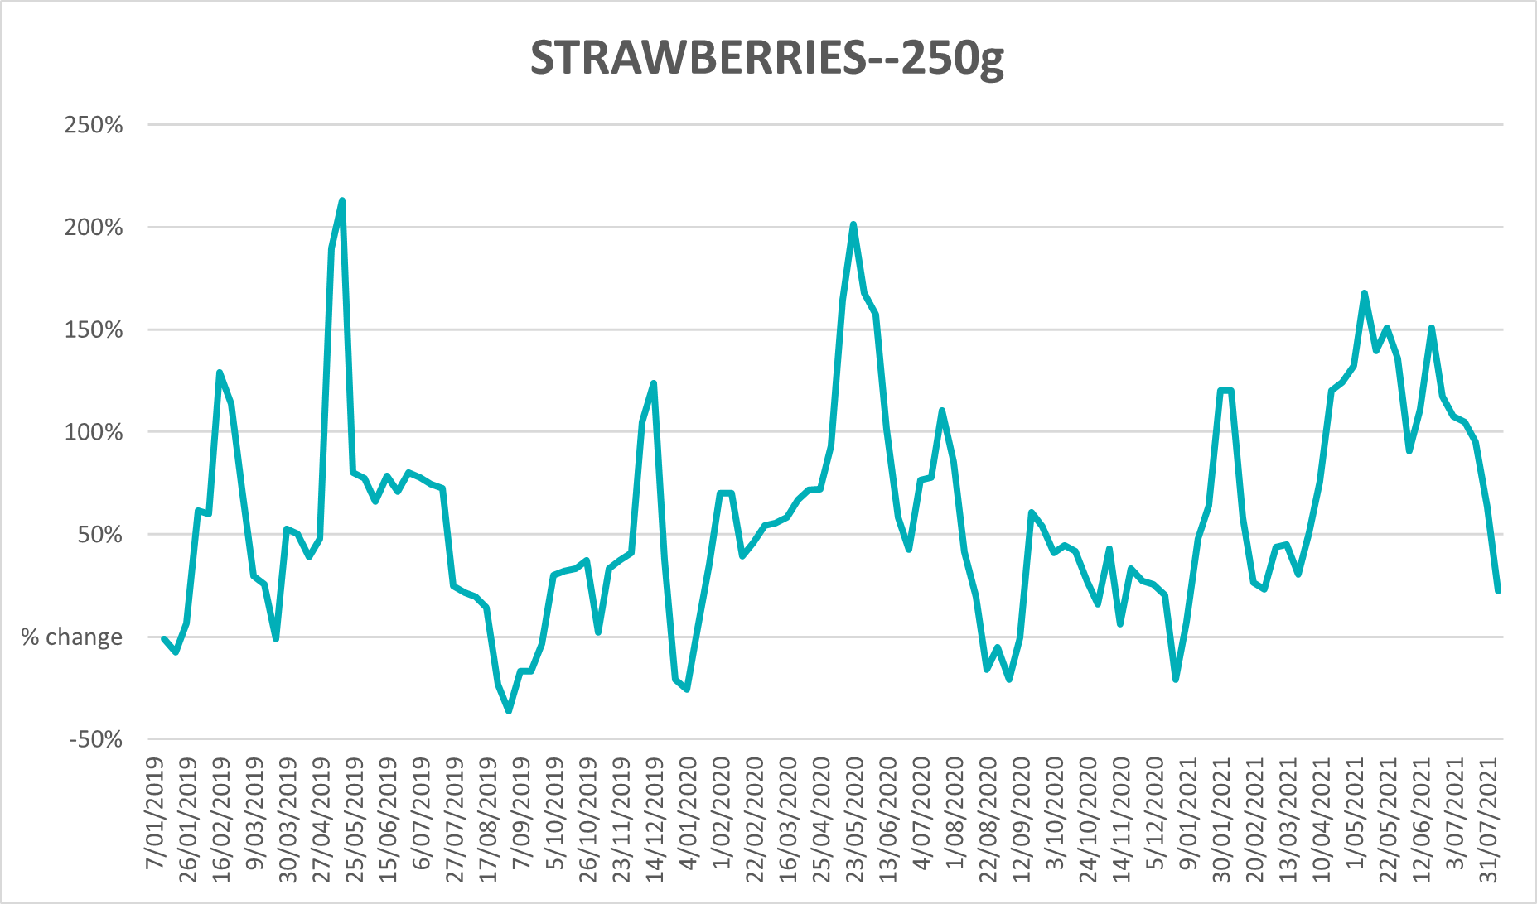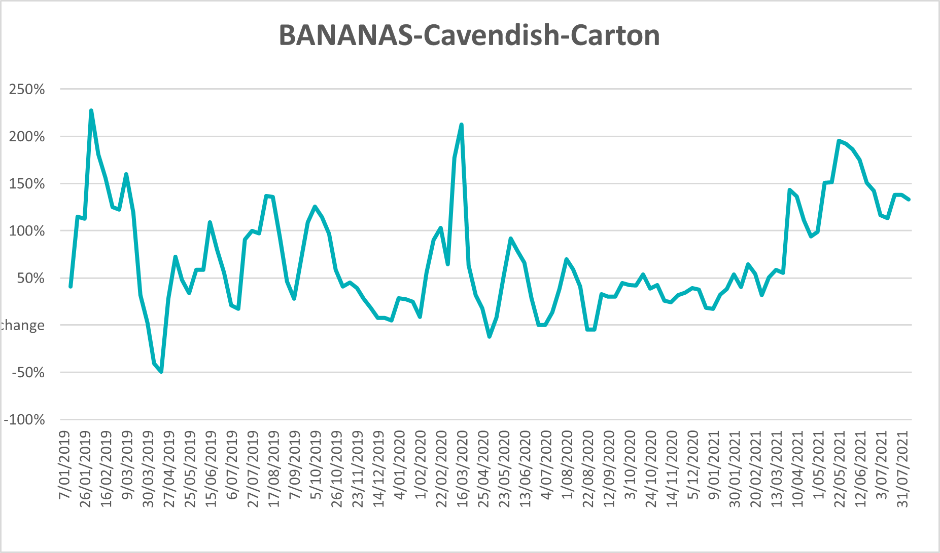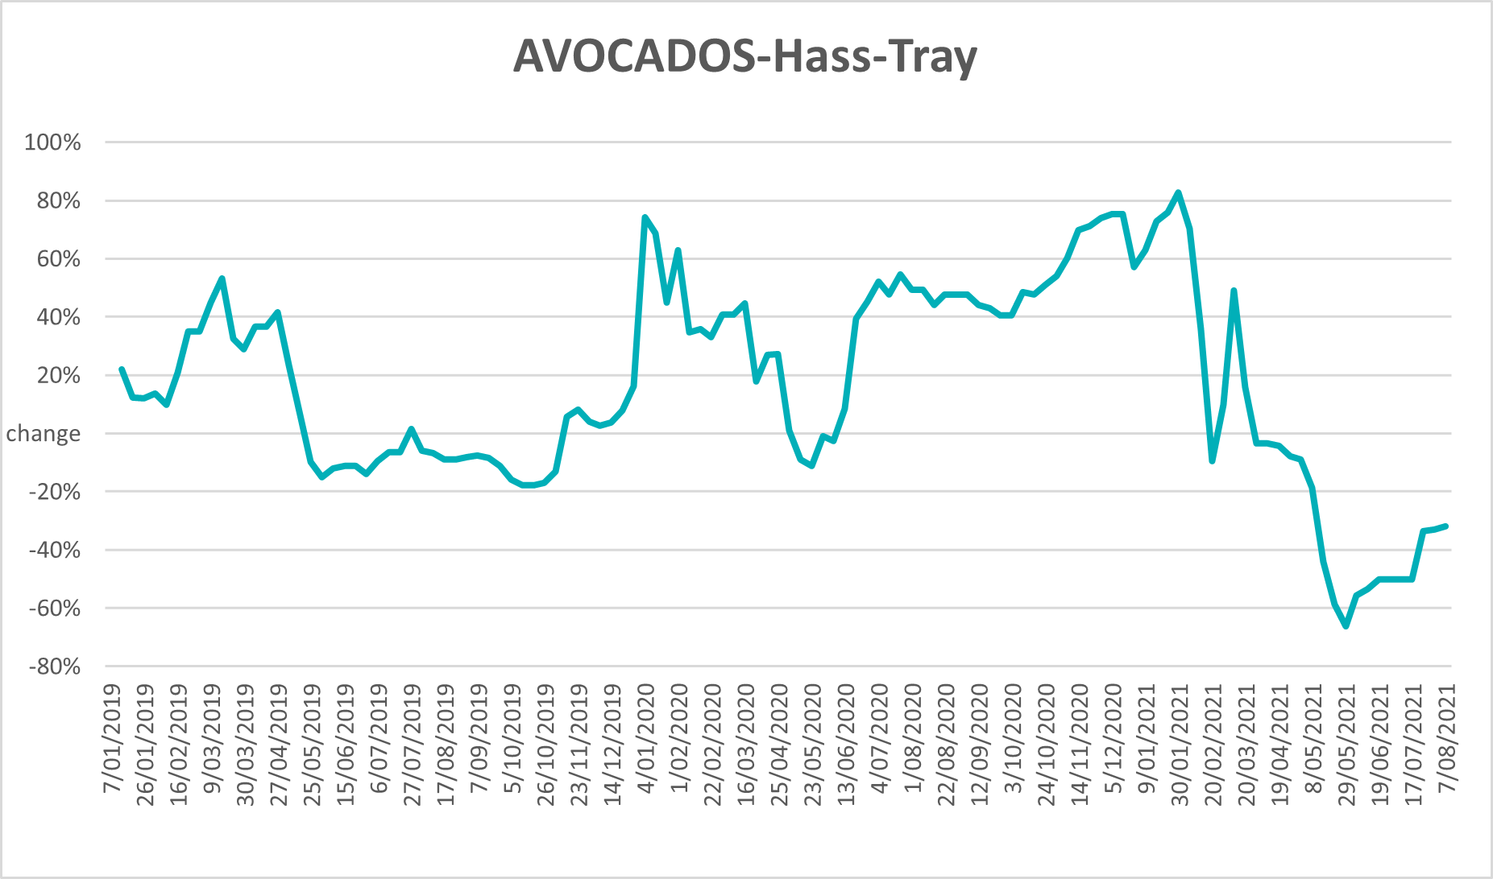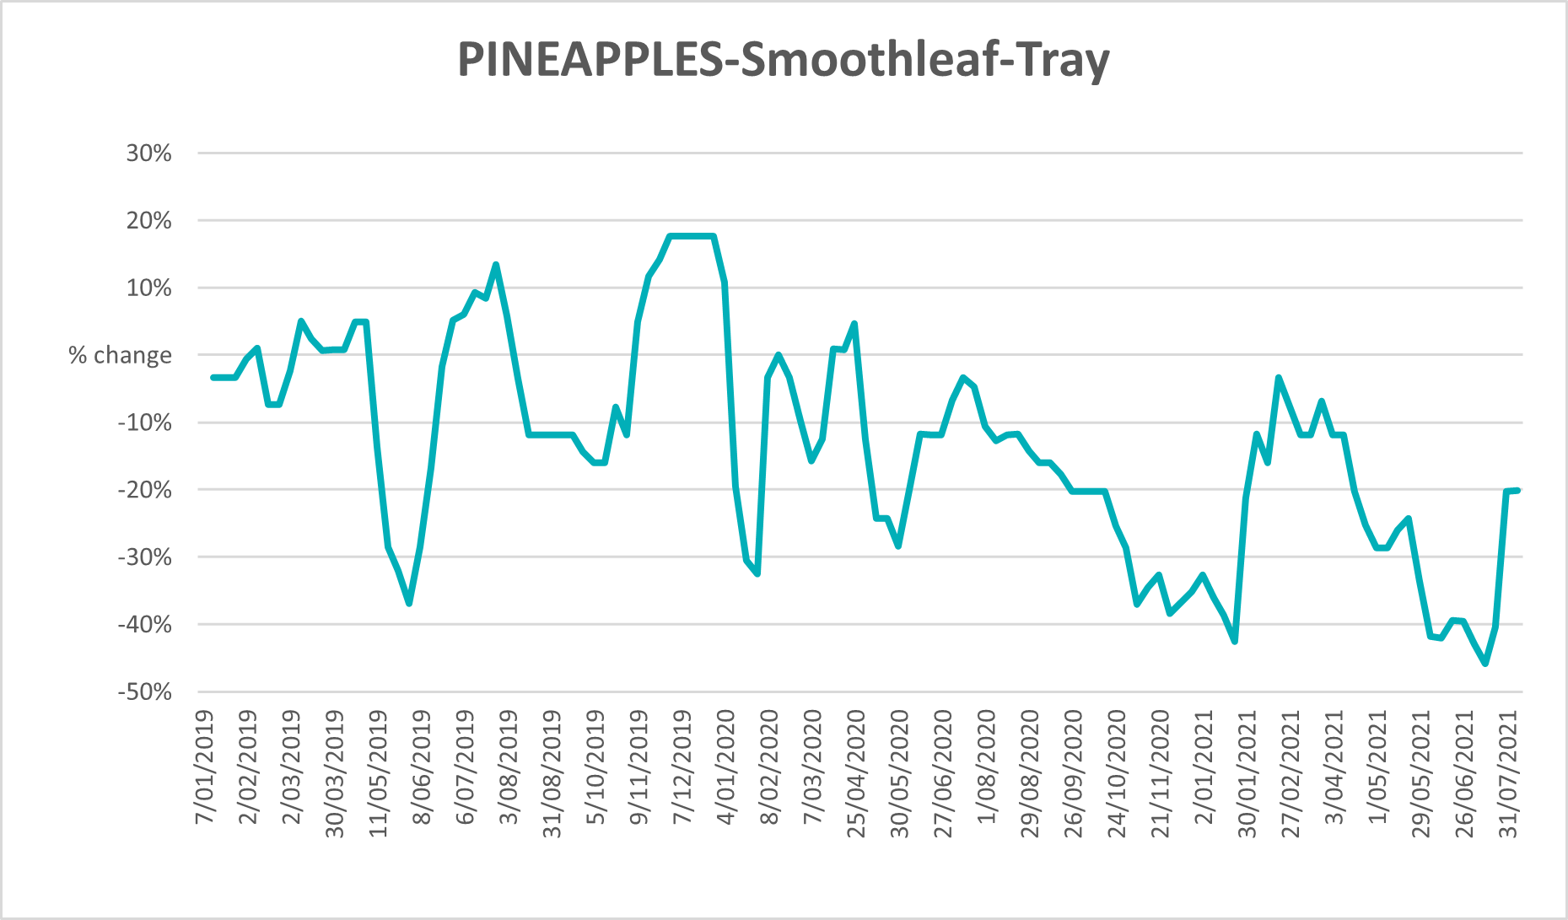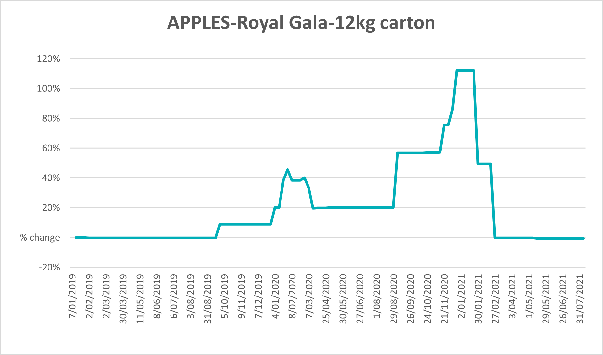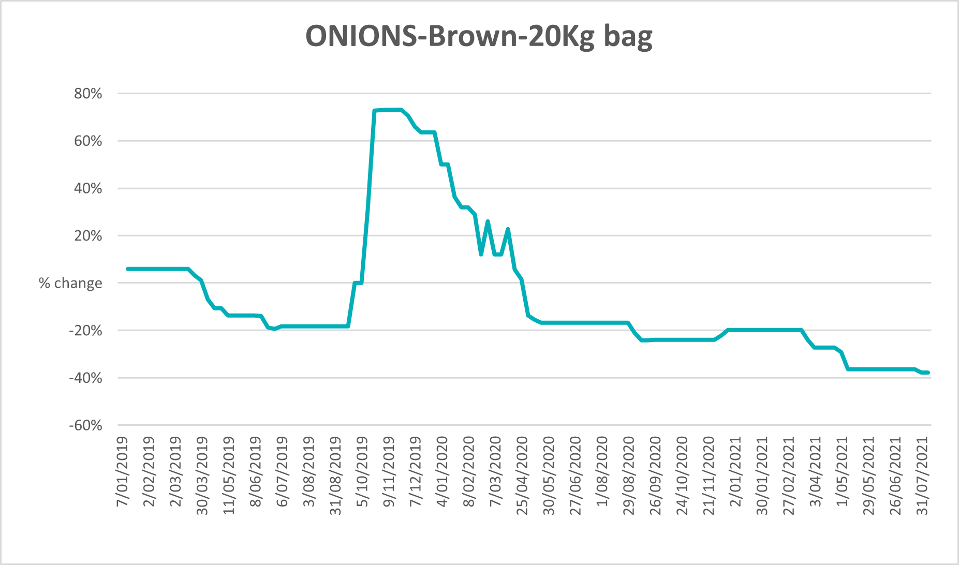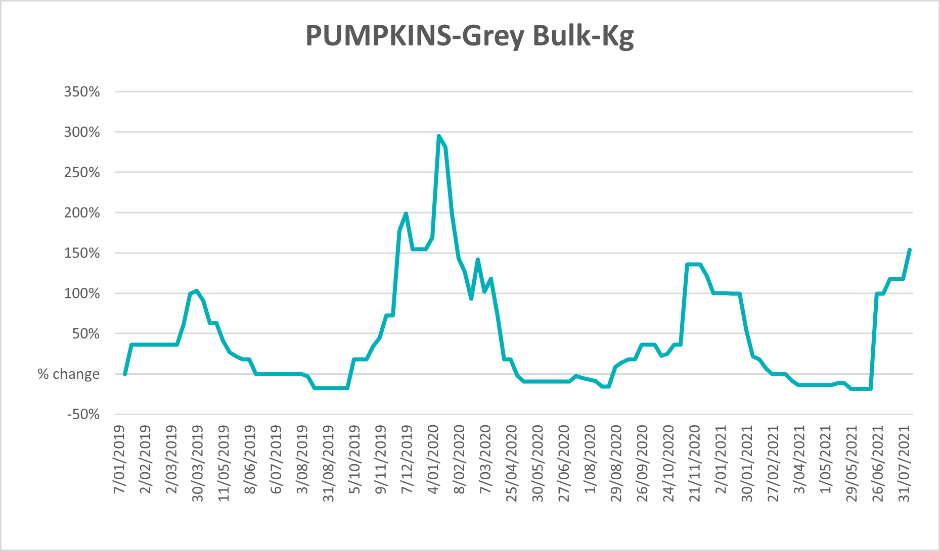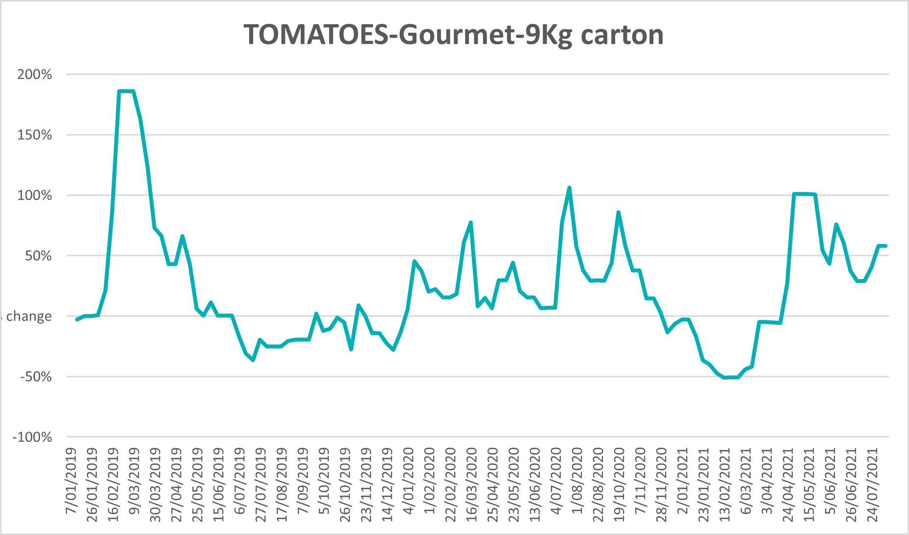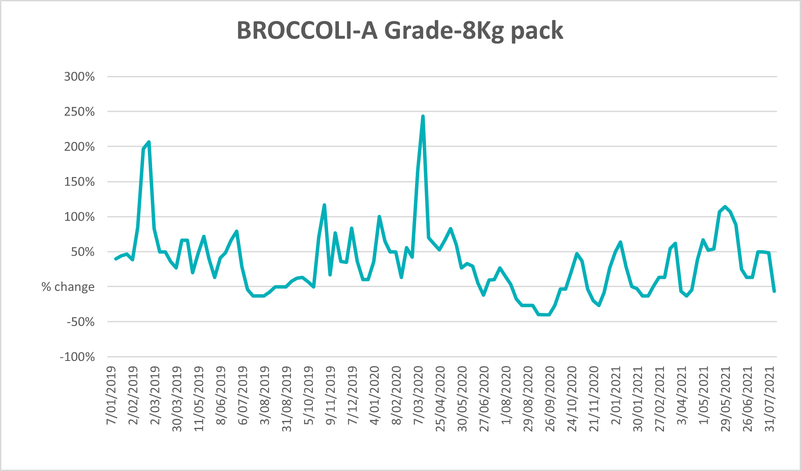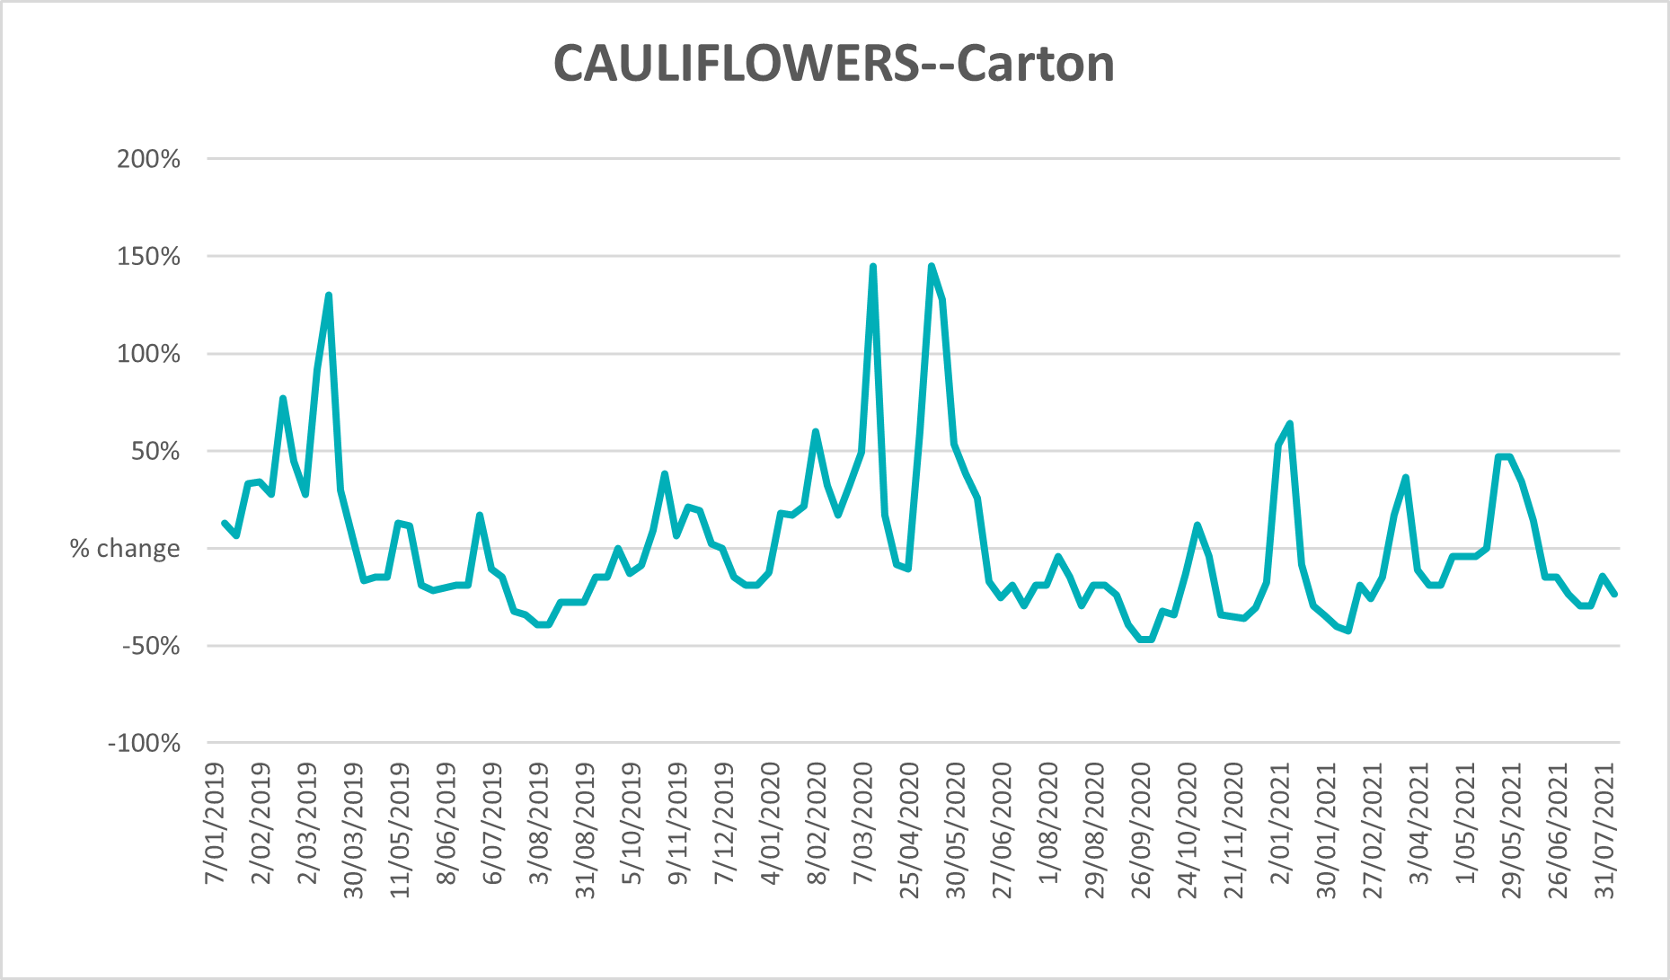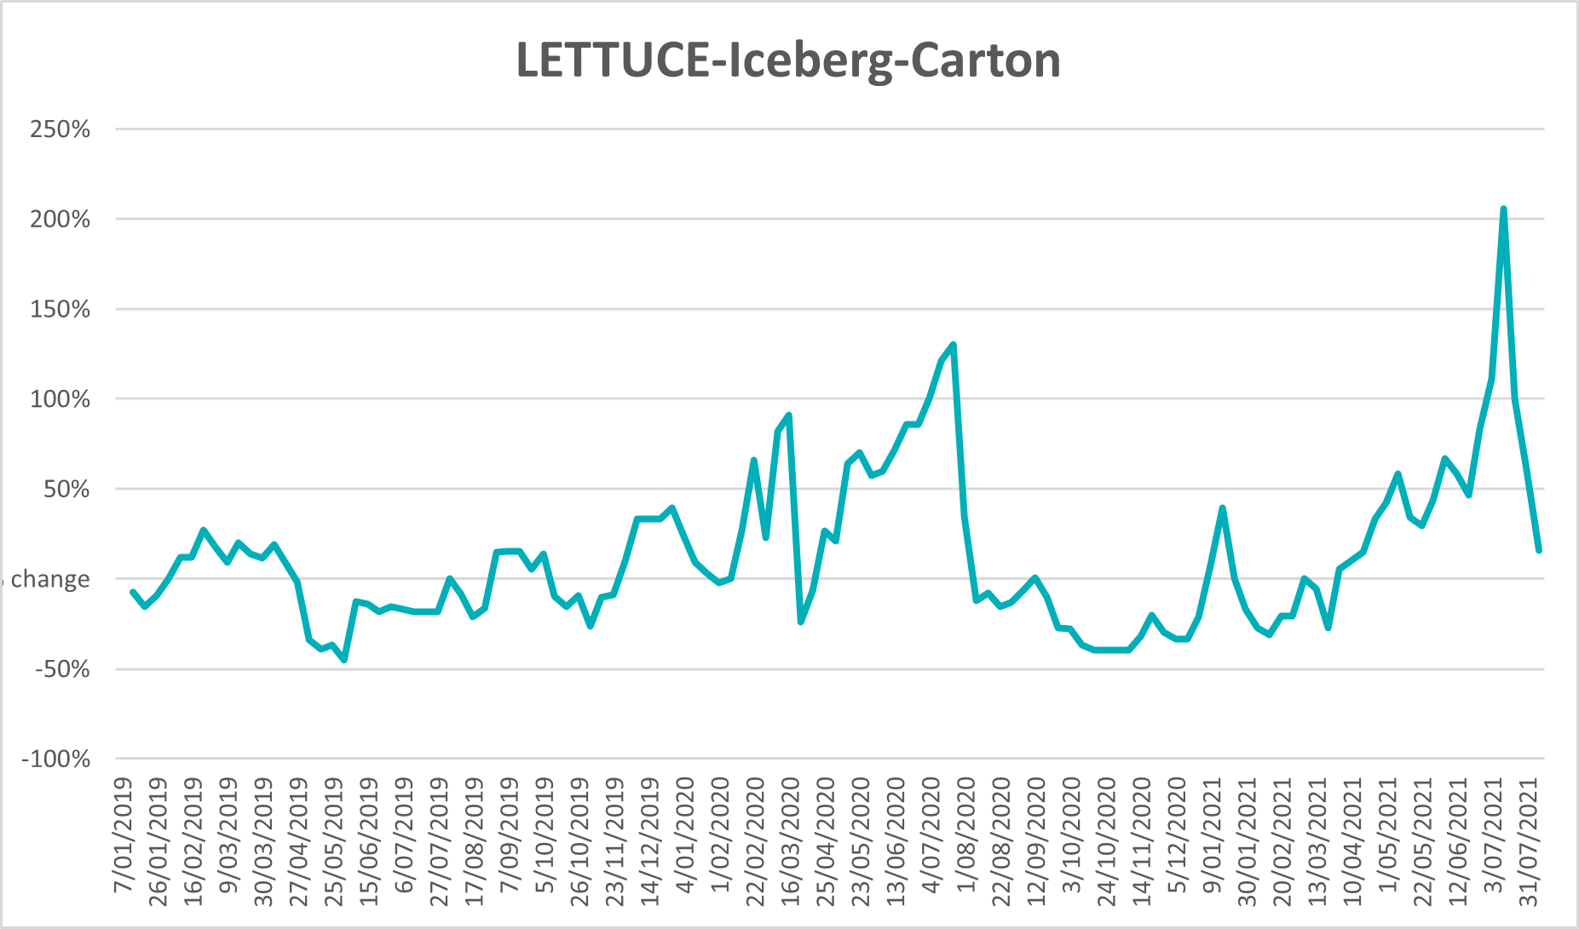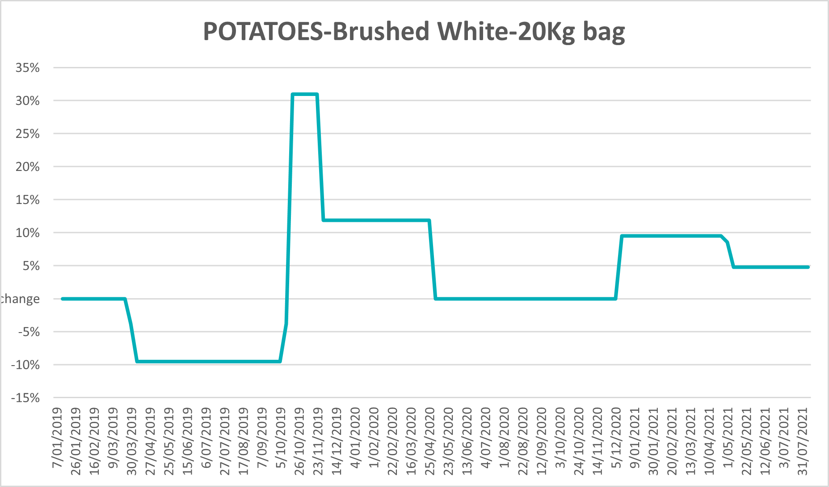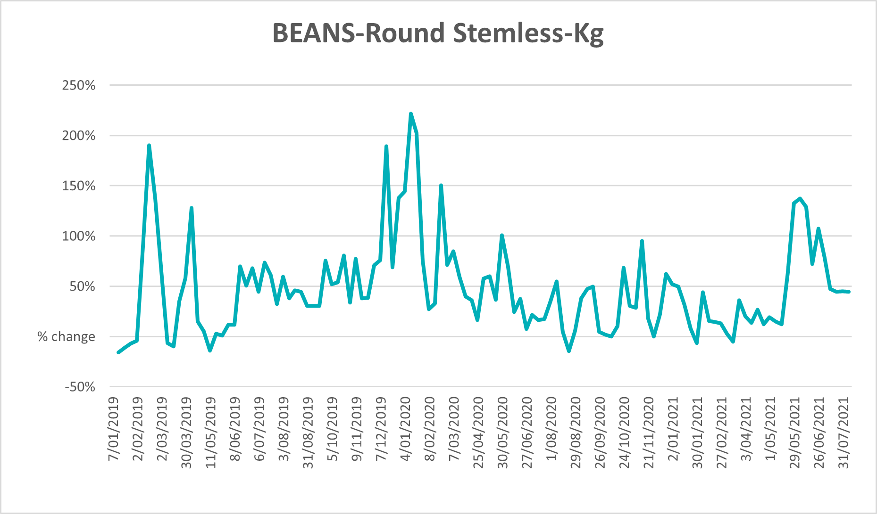

Selected domestic fodder indicator prices
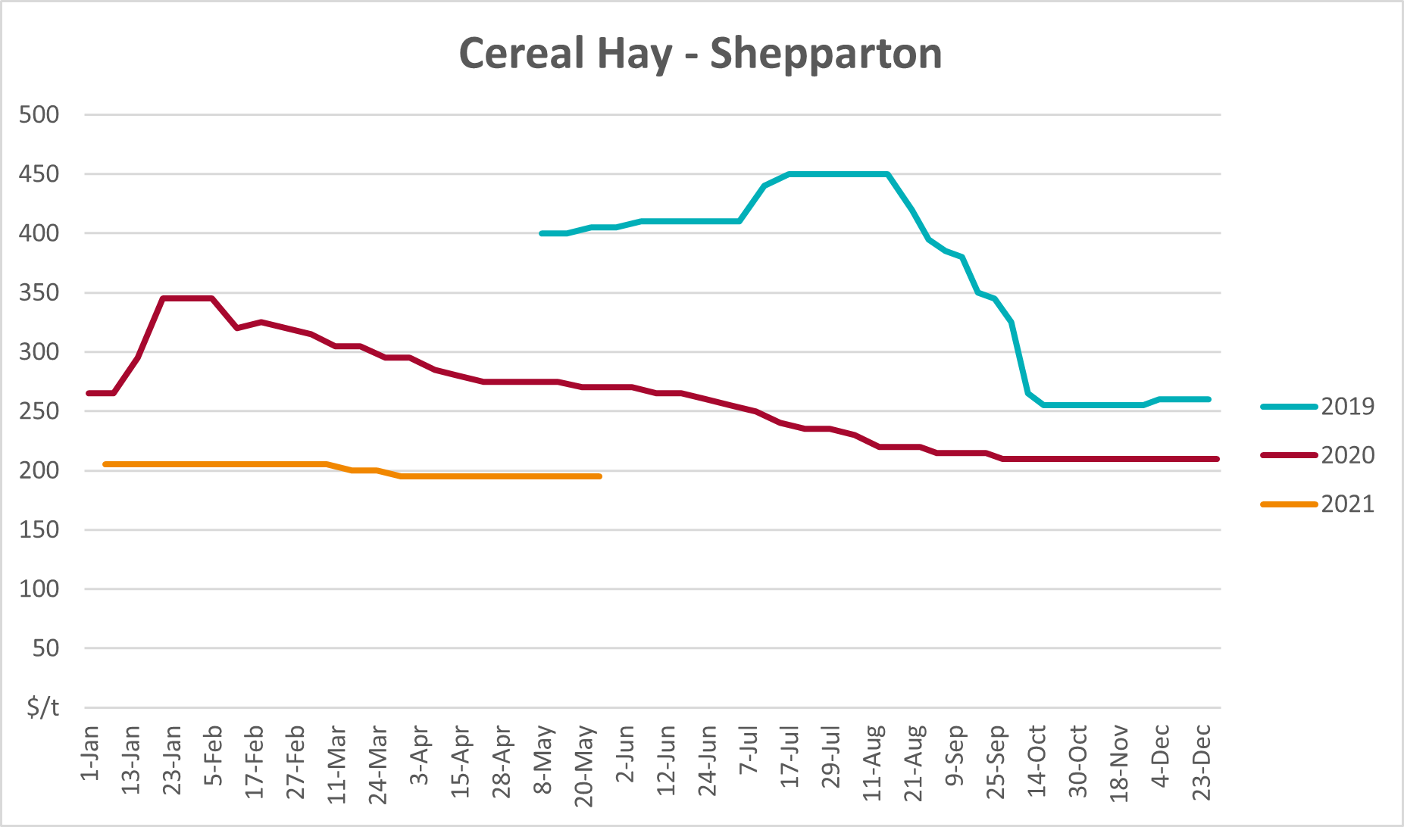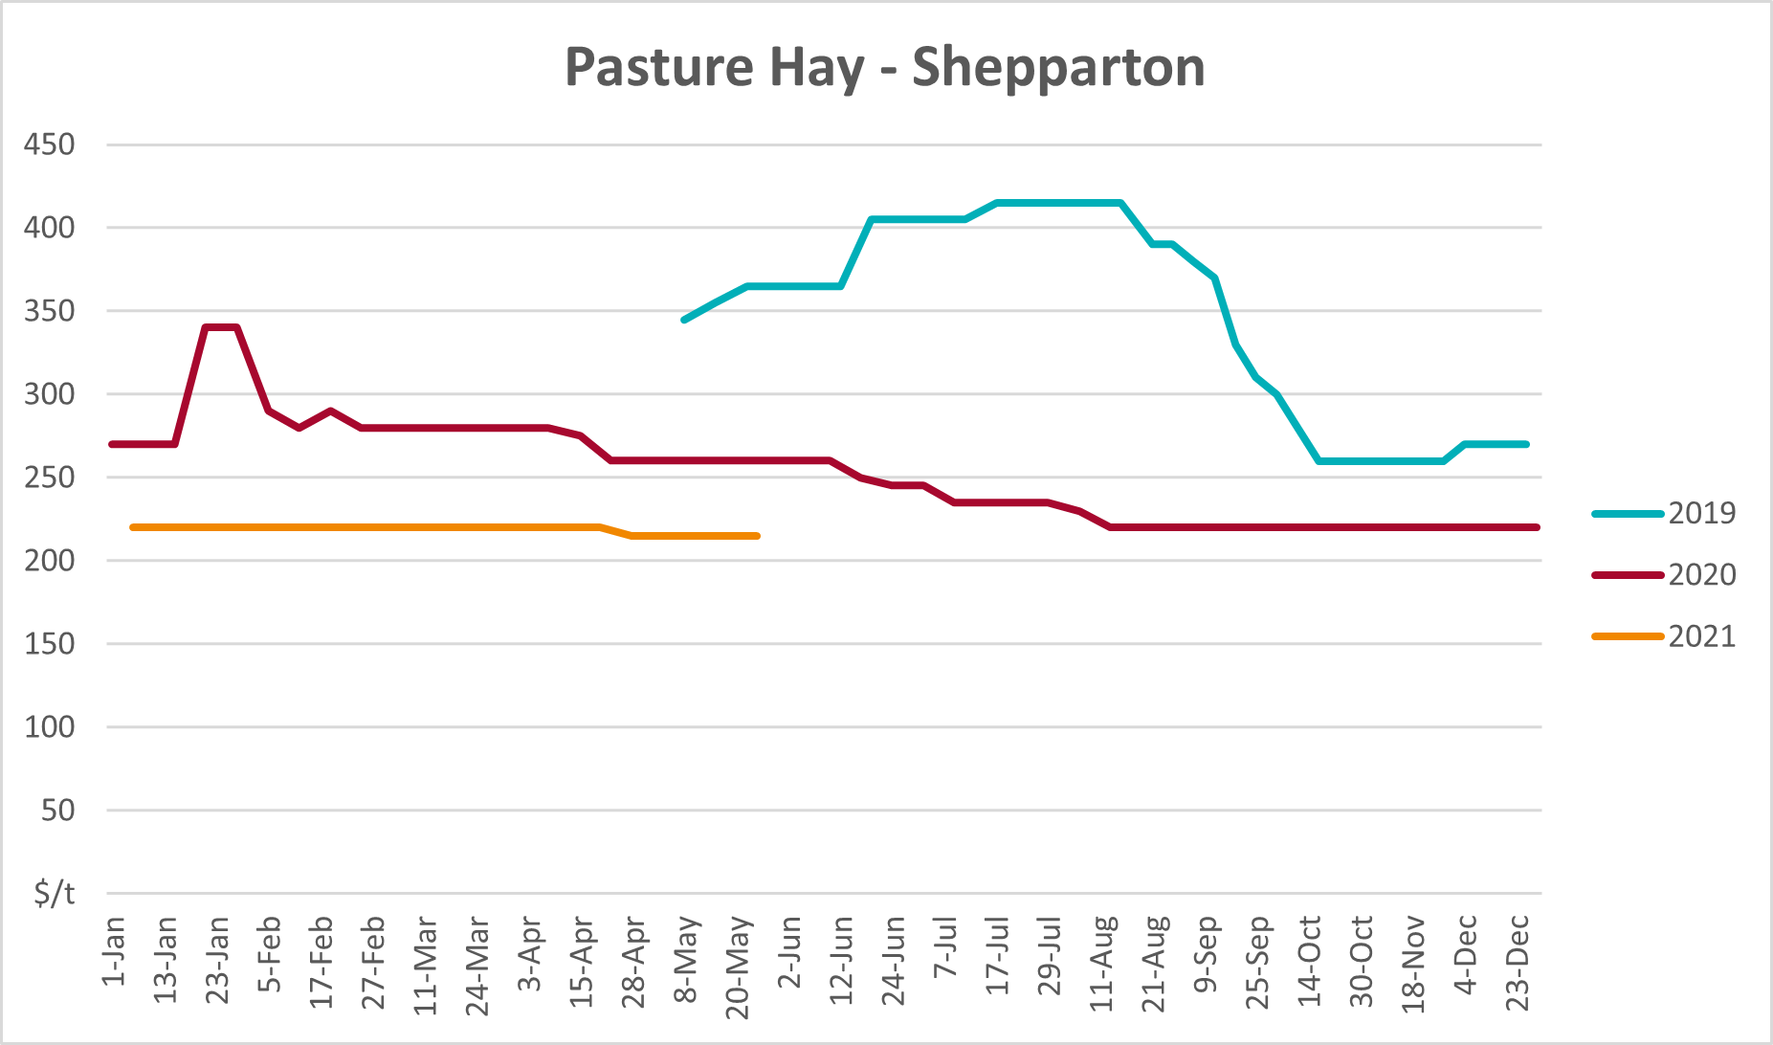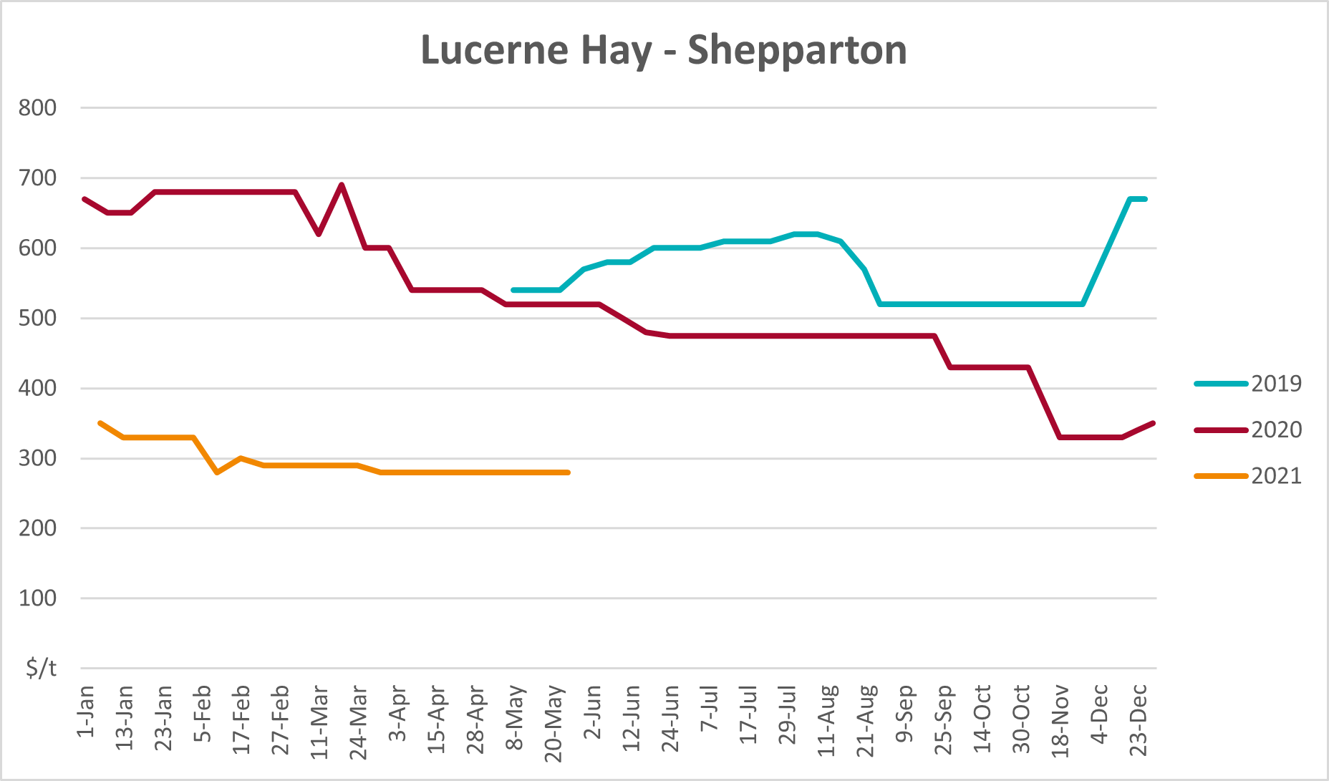

Data attribution

Climate
Bureau of Meteorology
- Weekly rainfall totals: www.bom.gov.au/climate/maps/rainfall/
- Monthly and last 3-month rainfall percentiles: www.bom.gov.au/water/landscape/
- Temperature anomalies: www.bom.gov.au/jsp/awap/temp/index.jsp
- Rainfall forecast: www.bom.gov.au/jsp/watl/rainfall/pme.jsp
- Seasonal outlook: www.bom.gov.au/climate/outlooks/#/overview/summary/
- Climate drivers: http://www.bom.gov.au/climate/enso/
- Soil moisture: www.bom.gov.au/water/landscape/
Other
- Pasture growth: www.longpaddock.qld.gov.au/aussiegrass/
- 3-month global outlooks: Environment and Climate Change Canada, NOAA Climate Prediction Center, EUROBRISA CPTEC/INPE, European Centre for Medium-Range Weather Forecasts, Hydrometcenter of Russia, National Climate Center Climate System Diagnosis and Prediction Room (NCC), International Research Institute for Climate and Society
- Global production: https://ipad.fas.usda.gov/ogamaps/cropmapsandcalendars.aspx
- Autumn break: Pook et al., 2009, https://rmets-onlinelibrary-wiley-com.virtual.anu.edu.au/doi/epdf/10.1002/joc.1833

Water
Prices
- Waterflow: https://www.waterflow.io/
- Ruralco: https://www.ruralcowater.com.au/
Bureau of Meteorology:
- Allocation trade: http://www.bom.gov.au/water/dashboards/#/water-markets/mdb/at
- Storage volumes: http://www.bom.gov.au/water/dashboards/#/water-storages/summary/drainage
Trade constraints:
- Water NSW: https://www.waternsw.com.au/customer-service/ordering-trading-and-pricing/trading/murrumbidgee
- Victorian Water Register: https://www.waterregister.vic.gov.au/TradingRules2019/

Commodities
Fruit and vegetables
- Datafresh: www.freshstate.com.au
Pigs
- Australian Pork Limited: www.australianpork.com.au
Dairy
- Global Dairy Trade: www.globaldairytrade.info/en/product-results/
World wheat, canola
- International Grains Council
World coarse grains
- United States Department of Agriculture
World cotton
- Cotlook: www.cotlook.com/
World sugar
- New York Stock Exchange - Intercontinental Exchange
Wool
- Australian Wool Exchange: www.awex.com.au/
Domestic wheat, barley, sorghum, canola and fodder
- Jumbuk Consulting Pty Ltd: http://www.jumbukag.com.au/
Cattle, beef, mutton, lamb, goat and live export
- Meat and Livestock Australia: www.mla.com.au/Prices-and-market
© Commonwealth of Australia 2021

Ownership of intellectual property rights
Unless otherwise noted, copyright (and any other intellectual property rights, if any) in this publication is owned by the Commonwealth of Australia (referred to as the Commonwealth).

Creative Commons licence
All material in this publication is licensed under a Creative Commons Attribution 4.0 International Licence except content supplied by third parties, logos and the Commonwealth Coat of Arms.
Inquiries about the licence and any use of this document should be emailed to copyright@awe.gov.au.


Cataloguing data
This publication (and any material sourced from it) should be attributed as:
ABARES 2021, Weekly Australian Climate, Water and Agricultural Update, Australian Bureau of Agricultural and Resource Economics and Sciences, Canberra,19 August 2021. CC BY 4.0 DOI: https://doi.org/10.25814/5f3e04e7d2503
ISSN 2652-7561
This publication is available at https://www.agriculture.gov.au/abares/products/weekly_update
Department of Agriculture, Water and the Environment
GPO Box 858 Canberra ACT 2601
Telephone 1800 900 090
Web awe.gov.au/abares

Disclaimer
The Australian Government acting through the Department of Agriculture, Water and the Environment, represented by the Australian Bureau of Agricultural and Resource Economics and Sciences, has exercised due care and skill in preparing and compiling the information and data in this publication. Notwithstanding, the Department of Agriculture, Water and the Environment, ABARES, its employees and advisers disclaim all liability, including liability for negligence and for any loss, damage, injury, expense or cost incurred by any person as a result of accessing, using or relying on any of the information or data in this publication to the maximum extent permitted by law.

Statement of Professional Independence
The views and analysis presented in ABARES publications, including this one, reflect ABARES professionally independent findings, based on scientific and economic concepts, principles, information and data. These views, analysis and findings may not reflect or be consistent with the views or positions of the Australian Government, or of organisations or groups who have commissioned ABARES reports or analysis. More information on professional independence is provided on the ABARES website.

Acknowledgements
This report was prepared by Cameron Van-Lane and Matthew Miller.

