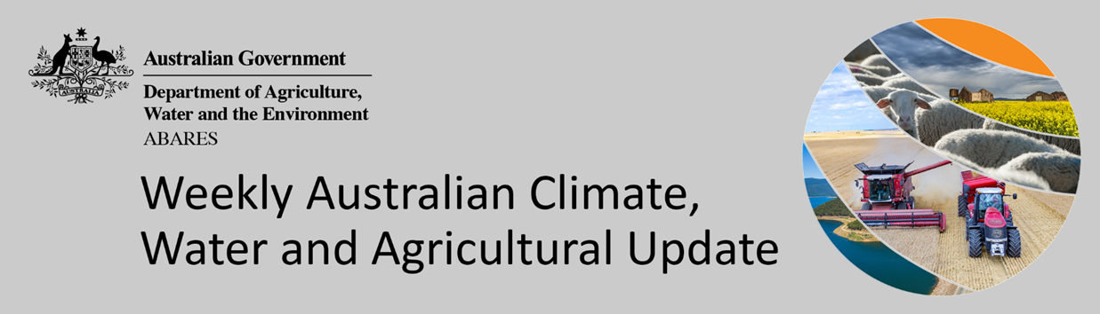
No. 36/2021

16 September 2021

Summary of key issues
- During the week ending 15 September 2021, a trough of low-pressure systems across northern parts of Australia resulted in very little rainfall. High pressure systems to the south-east brought clear, dry conditions for much of eastern Australia. Cold fronts coming off the Southern Ocean brought substantial rainfall to the south-west and Tasmania (see Section 1.1).
- As at 28 August 2021 global production conditions were generally favourable for the production of rice and soybean. However, a lack of precipitation and extreme temperatures have affected the production potential of wheat and corn in some key grain exporting and importing countries (see Section 1.2).
- Precipitation was below average across much of eastern Canada, western Europe, and the west of the Russian Federation. Precipitation was generally average across the remainder of major grain-producing and oilseed-producing regions in the northern hemisphere. In the southern hemisphere, August precipitation was below average across parts of Argentina and eastern Brazil. Precipitation was generally average across the remainder of major grain-producing and oilseed-producing regions in the southern hemisphere.
- Temperature extremes and continued dry conditions have impacted wheat production in Canada, the Russian Federation and northern growing regions of the United States (US), with below average yield expectations for winter wheat and poor yield expectations for spring wheat. In contrast, production conditions for wheat have been favourable in China, the European Union, Turkey, the Ukraine, the United Kingdom, with average and above average yield expected.
- The global climate outlook for October to December 2021 indicates that mixed rainfall conditions are expected for the world's major grain-producing and oilseed-producing regions. Below average rainfall is expected for parts of Argentina, Brazil, Europe, and the US. Above rainfall is forecast for parts of China, South Asia and Southeast Asia.
- Over the 8-days to 23 September 2021 a trough of low-pressure across central and south-eastern Australia is likely to result in limited rainfall. Low-pressure systems and associated cold fronts to the south of Australia are expected to bring moderate to high rainfall to parts of southern Australia. High-pressure systems across remaining parts of Australia are expected to provide clear, dry conditions (see Section 1.3).
- Water storage in the Murray–Darling Basin (MDB) increased by 35 gigalitres (GL) between 8 September 2021 and 15 September 2021. The current volume of water held in storage is 21,245 GL, which represents 84% of total capacity. This is 48% or 6,904 GL more than at the same time last year.
- Allocation prices in the Victorian Murray below the Barmah Choke increased from $155 per ML on 4 September 2021 to $129 per ML on 10 September 2021. Prices are lower in the Goulburn-Broken, Murrumbidgee, and regions above the Barmah choke due to the binding of the Goulburn intervalley trade limit, Murrumbidgee export limit, and Barmah choke trade constraint.

Climate

Rainfall this week
During the week ending 15 September 2021, a trough of low-pressure systems across northern parts of Australia resulted in very little rainfall. High pressure systems to the south-east brought clear, dry conditions for much of eastern Australia. Cold fronts coming off the Southern Ocean brought substantial rainfall to the south-west and Tasmania.
Rainfall totals of between 10 and 50 millimetres were recorded in isolated parts of eastern New South Wales, northern Queensland, southern Victoria, the south of South Australia and the north of the Northern Territory, as well as the southwest of Western Australia and much of Tasmania. Rainfall totals in excess of 50 millimetres were recorded in western Tasmania.
In cropping regions, rainfall totals of between 10 and 50 millimetres were recorded in southern parts of Western Australia. Little to no rainfall was recorded across remaining cropping regions.
Soil moisture levels have been average to above average across most cropping regions which likely supported ongoing crop development over the past week. However, more rainfall across southern cropping regions will be required in the coming weeks to consolidate forecast production prospects.

Rainfall for the week ending 15 September 2021

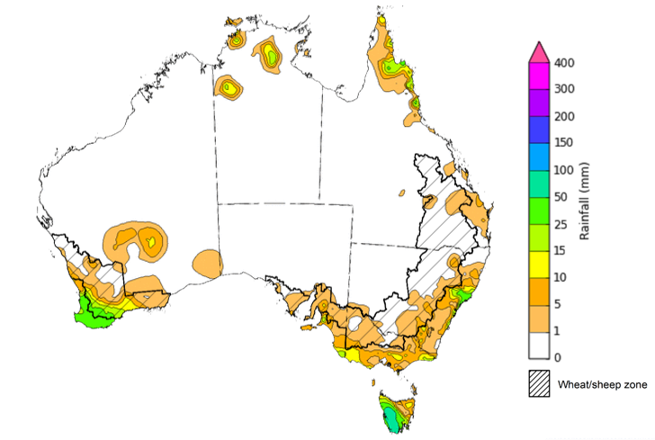
©Commonwealth of Australia 2021, Australian Bureau of Meteorology Issued: 15/09/2021
Note: The rainfall analyses and associated maps utilise data contained in the Bureau of Meteorology climate database, the Australian Data Archive for Meteorology (ADAM). The analyses are initially produced automatically from real-time data with limited quality control. They are intended to provide a general overview of rainfall across Australia as quickly as possible after the observations are received. For further information go to http://www.bom.gov.au/climate/rainfall/

Global production conditions and climate outlook
Crop production is affected by long-term trends in average rainfall and temperature, interannual climate variability, shocks during specific growth stages, and extreme weather events (IPCC 2012). Some crops are more tolerant than others to certain types of stresses, and at each growth stage, different types of stresses affect each crop species in different ways.
The precipitation anomalies and outlooks presented here give an indication of the current and future state of production conditions for the major grain and oilseed producing countries which are responsible for over 80% of global production. This is an important input to assessing the global grain supply outlook.
August precipitation percentiles and current production conditions
As of the end of August 2021, rainfall was favourable for the world’s major grain-producing and oilseed-producing regions. In the northern hemisphere, August precipitation was above average in parts of central Africa, south-western and central China, central Europe, Ukraine, and parts of north-western and south-eastern United States of America.
Precipitation was below average across much of eastern Canada, western Europe, and the west of the Russian Federation. Precipitation was generally average across the remainder of major grain-producing and oilseed-producing regions in the northern hemisphere.
In the southern hemisphere, August precipitation was below average across parts of Argentina and western Brazil. Precipitation was generally average across the remainder of major grain-producing and oilseed-producing regions in the southern hemisphere.

Global precipitation percentiles, August 2021
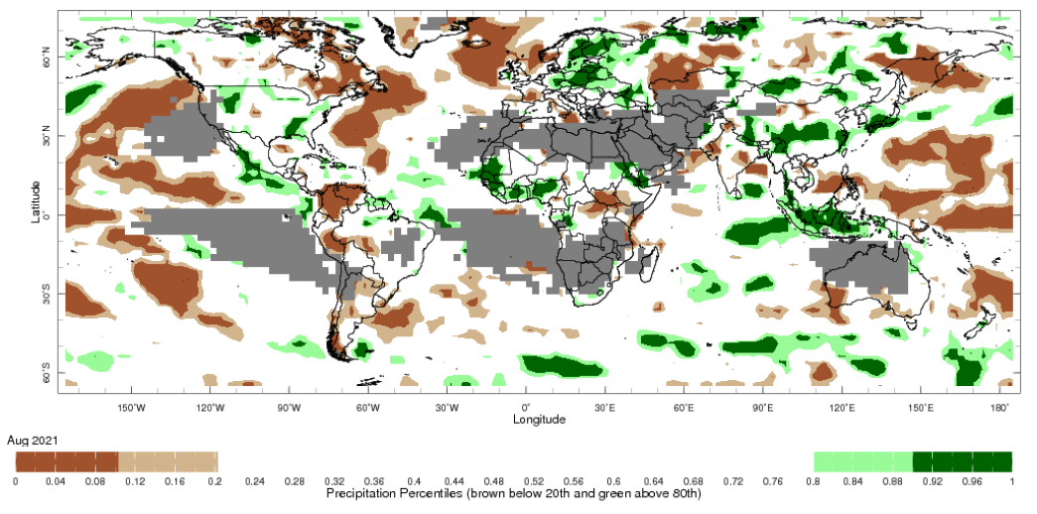
Note: The world precipitation percentiles indicate a ranking of precipitation for August, with the driest (0th percentile) being 0 on the scale and the wettest (100th percentile) being 1 on the scale. Percentiles are based on precipitation estimates from the NOAA Climate Prediction Center's Climate Anomaly Monitoring System Outgoing Precipitation Index dataset. Precipitation estimates for August 2021 are compared with rainfall recorded for that period during the 1981 to 2010 base period.
Source: International Research Institute for Climate and Society
As at 28 August 2021 global production conditions were generally favourable for the production of rice and soybean. However, a lack of precipitation and extreme temperatures have affected the production potential of wheat and corn in some key grain exporting and importing countries.
Across the northern hemisphere production conditions for wheat have been mixed. Temperature extremes and continued dry conditions have impact wheat production in Canada, the Russian Federation and northern growing regions of the United States (US), with below average yield expectations for winter wheat and poor yield expectations for spring wheat. In contrast, production conditions for wheat have been favourable in China, the European Union, Turkey, the Ukraine, the United Kingdom with average and above average yield expected. In the southern hemisphere, production conditions for wheat development in Argentina and Australia have been generally favourable, with dry conditions affecting some regions in Argentina.
Conditions for corn were favourable for crop development in Argentina, Canada, China, the European Union, India, Mexico, Russia, South Africa, Ukraine and much of the US. Dry conditions and periods of frost have negatively impacted summer-planted corn in Brazil. Dry conditions in parts of northern US are also expected to negatively impact yields.
Conditions for rice were favourable for crop development in most growing regions, with harvesting underway in the parts of Vietnam, Japan and the US. A cool, wet finish to the season is hampering the harvest in southern Japan.
Production conditions for soybeans are mixed in Canada and in northern and western areas of the Mid-West of the US, as dry conditions persist in some areas. Production conditions are favourable across remaining soybean producing regions.

Crop conditions, AMIS countries, 28 August 2021
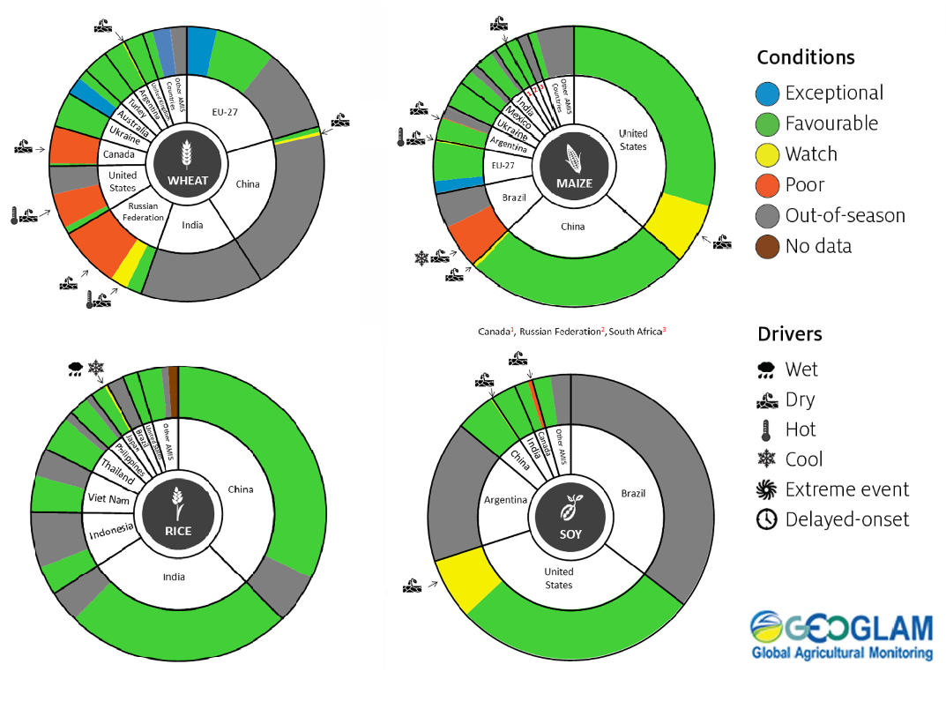
AMIS Agricultural Market Information System.
Source: AMIS
The global climate outlook for October to December 2021 indicates that mixed rainfall conditions are expected for the world's major grain-producing and oilseed-producing regions. Outlooks and potential production impacts for the major grain and oilseed producing countries are presented in the table.

Rainfall outlook and potential impact on the future state of production conditions between October and December 2021
Region | October-December rainfall outlook | Potential impact on production
Argentina | Below average rainfall is expected across most of Argentina between October to December 2021. | Below average rainfall is likely to adversely affect the heading and grain development of wheat and the planting and establishment of cotton and late-planted corn in October. These conditions may also adversely impact early corn silking, and the flowering of cotton and late corn in November and December.
Black Sea Region | There is no strong tendency towards either above or below average rainfall between October to December 2021. | Average rainfall is likely to support boll development and grain filling for cotton, corn and sunflower, as well as the development of winter wheat and canola in October. In November and December winter wheat and canola will enter dormancy, and average rainfall is likely to provide sufficient snowpack to precent winterkill.
Brazil | Above average rainfall is more likely in northern Brazil and parts of the central west, while below average rainfall is more likely across the south of Brazil. | Below average rainfall in parts of southern Brazil will provide favourable conditions for harvesting of wheat in October and November. However, below average rainfall is likely to adversely affect flowering of corn and soybeans in December. In the central west, the planting, growth and flowering of soybean will be adversely impacted by dry conditions in parts but may benefit from above average rainfall in other parts.
Canada | There is no strong tendency towards above or below average rainfall across much of Canada between October to December 2021. | Average rainfall will support the harvesting of canola, corn, soybean, spring wheat and sunflower in October and November. Average rainfall is also likely to provide sufficient snowpack to prevent winterkill of winter wheat in December.
China | Above average rainfall is likely across much of southern and eastern China and below average rainfall is expected across western China between October to December 2021. | Above average rainfall in southern and eastern China is likely to impede the harvesting of cotton, corn, sorghum, soybean, sunflower, groundnuts and single rice. However, these conditions will likely benefit grain filling of late-sown rice in October and November. Above average rainfall will likely provide sufficient snowpack for winter wheat and canola as they enter dormancy in December. In western China, below average rainfall will support harvesting activities.
Europe | Below average rainfall more likely for parts of southern and central Europe between October to December 2021. | Below average rainfall may support harvesting of corn, cotton, sorghum, soybean and sunflower in southern and central Europe. Average to above average rainfall in northern Europe is likely to benefit the planting of canola and winter wheat during October to December.
South Asia (India) | Average to above average rainfall is likely across much of India. However, below average rainfall is expected in parts of northern India between October to December 2021. | Average to above average rainfall is likely to benefit cotton boll formation in the south during October and the planting of canola and winter wheat in November. However, these conditions may impede harvesting of corn, sorghum, rice, millet, groundnuts and sunflower.
Southeast Asia (SEA) | Above average rainfall is likely across much of SEA, with below average rainfall in parts of western Indonesia and northern Papua New Guinea between October to December 2021. | Above average rainfall in SEA is likely to impede corn and rice harvesting in October.
The United States of America | Above average rainfall is more likely for the north-western US and below average rainfall is more likely across much of the central and southern half of the US. | Below average rainfall across the southern US is likely to support harvesting of soybeans, sunflower, millet, cotton, rice, corn, sorghum and groundnuts in October and November. The average rainfall conditions expected across the northern US is likely to support establishment and growth of canola and winter wheat, as well as sufficient snow cover in December.

Rainfall forecast for the next eight days
Over the 8-days to 23 September 2021 a trough of low-pressure across central and south-eastern Australia is likely to result in limited rainfall. Low-pressure systems and associated cold fronts to the south of Australia are expected to bring moderate to high rainfall to parts of southern Australia. High-pressure systems across remaining parts of Australia are expected to provide clear, dry conditions.
Rainfall totals of between 10 and 50 millimetres are forecast for parts of southern New South Wales, southern and eastern Victoria, the south of South Australia, the south-west of Western Australia and parts of Tasmania. Rainfall in excess of 50 millimetres is expected in western Tasmania.
In Australian cropping regions, rainfall totals of between 5 and 10 millimetres are expected in isolated parts of south-eastern New South Wales and southern Victoria and the far south-west of Western Australia. Little to no rainfall is forecast for cropping regions in Queensland, South Australia and remaining parts of New South Wales, Victoria and Western Australia during the next 8-days.
Soil moisture levels remains average to above average across most cropping regions of Australia for this time of year. Despite the lack of rainfall over the past week, and the expectation of another dry week ahead, winter crop development is expected to continue unimpeded in most cropping regions. Further rainfall will be required through spring as crops enter stages in which they are most sensitive to water deficiencies (flowering and grain filling). The dry conditions in Queensland are continuing to assist cotton planting, with the forecast of a wet spring/summer to support dryland yield potentials.

Total forecast rainfall (mm) for the period 16 September to 23 September 2021
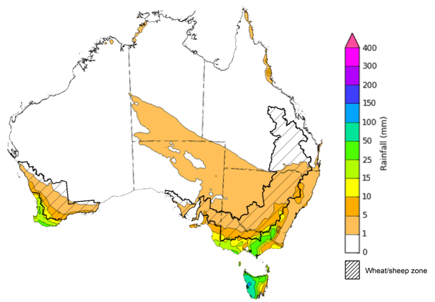
©Commonwealth of Australia 2021, Australian Bureau of Meteorology Issued: 16/09/2021
Note: This rainfall forecast is produced from computer models. As the model outputs are not altered by weather forecasters, it is important to check local forecasts and warnings issued by the Bureau of Meteorology.

Water

Water markets – current week
Water storage in the Murray–Darling Basin (MDB) increased by 35 gigalitres (GL) between 8 September 2021 and 15 September 2021. The current volume of water held in storage is 21,245 GL, which represents 84% of total capacity. This is 48% or 6,904 GL more than at the same time last year.

Water storages in the Murray-Darling Basin, 2013–2021
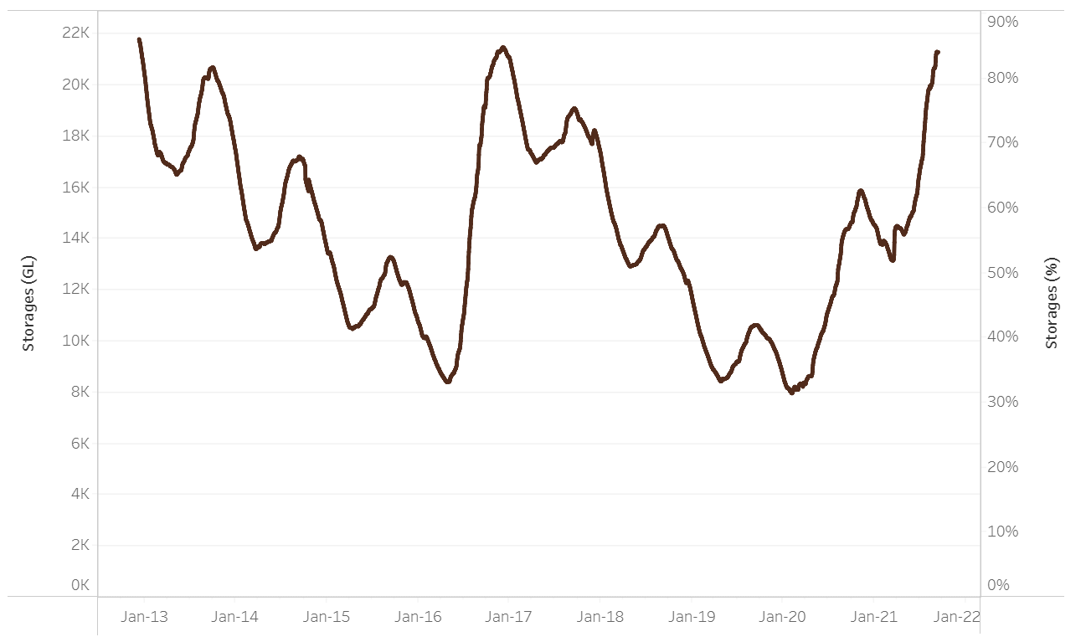
Water storage data is sourced from the Bureau of Meteorology.

Allocation prices in the Victorian Murray below the Barmah Choke increased from $155 per ML on 4 September 2021 to $129 per ML on 10 September 2021. Prices are lower in the Goulburn-Broken, Murrumbidgee, and regions above the Barmah choke due to the binding of the Goulburn intervalley trade limit, Murrumbidgee export limit, and Barmah choke trade constraint.
Region | $/ML
NSW Murray Above | 110
NSW Murrumbidgee | 112
VIC Goulburn-Broken | 106
VIC Murray Below | 129

Surface water trade activity, Southern Murray–Darling Basin

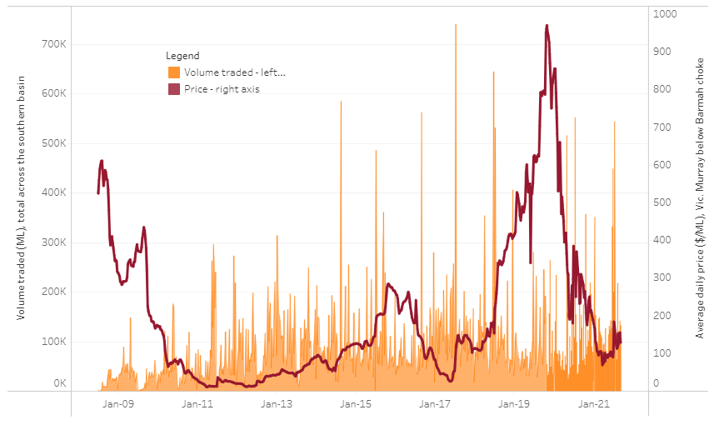
To access the full, interactive, weekly water dashboard, which contains the latest and historical water storage, water market and water allocation information, please visit http://www.agriculture.gov.au/abares/products/weekly_update/weekly-update-160921
The trades shown reflect estimated market activity and do not encompass all register trades. The price is shown for the VIC Murray below the Barmah choke. Historical prices (before 1 July 2019) are ABARES estimates after removing outliers from BOM water register data. Prices after 1 July 2019 and prior to the 30 October 2019 reflect recorded transaction prices as sourced from Ruralco. Prices after the 30 October 2019 are sourced from Waterflow. Data for volume traded is sourced from the BOM water register. Data shown is current at 16 September 2021.

Commodities
Indicator | Week ended | Unit | Latest price | Previous week | Weekly change | Price 12 months ago | Annual change
Selected world indicator prices
AUD/USD Exchange rate | 15-Sep | A$/US$ | 0.73 | 0.74 | -1% | 0.72 | 3%
Wheat – US no. 2 hard red winter wheat, fob Gulf | 15-Sep | US$/t | 328 | 332 | -1% | 250 | 31%
Corn – US no. 2 yellow corn, fob Gulf | 15-Sep | US$/t | 254 | 266 | -4% | 169 | 50%
Canola – Rapeseed, Canada, fob Vancouver | 15-Sep | US$/t | 758 | 782 | -3% | 403 | 88%
Cotton – Cotlook 'A' Index | 15-Sep | USc/lb | 103 | 103 | 0% | 71 | 45%
Sugar – Intercontinental Exchange, nearby futures, no.11 contract | 15-Sep | USc/lb | 19.7 | 19.6 | 0% | 13 | 47%
Wool – Eastern Market Indicator | 15-Sep | Ac/kg clean | 1,352 | 1,361 | -1% | 1,134 | 19%
Wool – Western Market Indicator | 15-Sep | Ac/kg clean | 1,392 | 1,386 | 0% | 1,237 | 13%
Selected Australian grain export prices
Milling Wheat – APW, Port Adelaide, SA | 15-Sep | A$/t | 417 | 415 | 1% | 344 | 21%
Feed Wheat – ASW, Port Adelaide, SA | 15-Sep | A$/t | 416 | 407 | 2% | 330 | 26%
Feed Barley – Port Adelaide, SA | 15-Sep | A$/t | 343 | 344 | 0% | 282 | 22%
Canola – Kwinana, WA | 15-Sep | A$/t | 845 | 837 | 1% | 664 | 27%
Grain Sorghum – Brisbane, QLD | 15-Sep | A$/t | 365 | 364 | 0% | 352 | 4%
Selected domestic livestock indicator prices
Beef – Eastern Young Cattle Indicator | 15-Sep | Ac/kg cwt | 1,026 | 1,006 | 2% | 729 | 41%
Mutton – Mutton indicator (18–24 kg fat score 2–3), Vic | 15-Sep | Ac/kg cwt | 622 | 690 | -10% | 518 | 20%
Lamb – Eastern States Trade Lamb Indicator | 15-Sep | Ac/kg cwt | 940 | 927 | 1% | 703 | 34%
Pig – Eastern Seaboard (60.1–75 kg), average of buyers & sellers | 25-Aug | Ac/kg cwt | 318 | 318 | 0% | 289 | 10%
Goats – Eastern States (12.1–16 kg) | 15-Sep | Ac/kg cwt | 887 | 895 | -1% | 773 | 15%
Live cattle – Light steers ex Darwin to Indonesia | 17-Feb | Ac/kg lwt | 355 | 355 | 0% | 360 | -1%
Live sheep – Live wethers (Muchea WA saleyard) to Middle East | 19-May | $/head | 145 | 145 | 0% | #N/A | #N/A

Indicator | Week ended | Unit | Latest price | Previous week | Weekly change | Price 12 months ago | Annual change
Global Dairy Trade (GDT) weighted average prices ª
Dairy – Whole milk powder | 08-Sep | US$/t | 3,691 | 3,552 | 4% | 3,074 | 20%
Dairy – Skim milk powder | 08-Sep | US$/t | 3,274 | 3,052 | 7% | 2,505 | 31%
Dairy – Cheddar cheese | 08-Sep | US$/t | 4,328 | 4,184 | 3% | 3,838 | 13%
Dairy – Anhydrous milk fat | 08-Sep | US$/t | 5,970 | 5,791 | 3% | 5,246 | 14%
a Global Dairy Trade prices are updated twice monthly on the first and third Tuesday of each month.

Selected world indicator prices
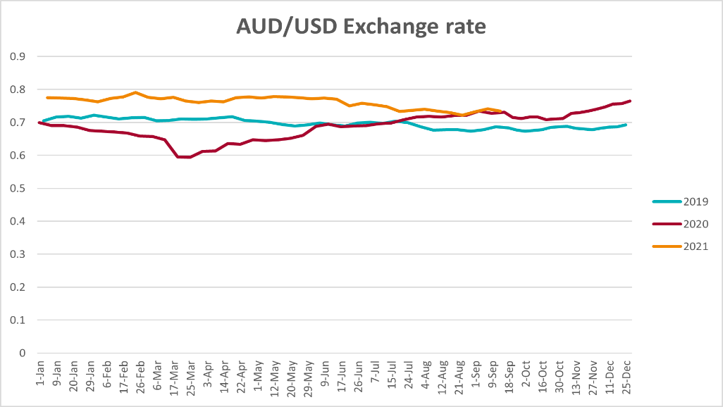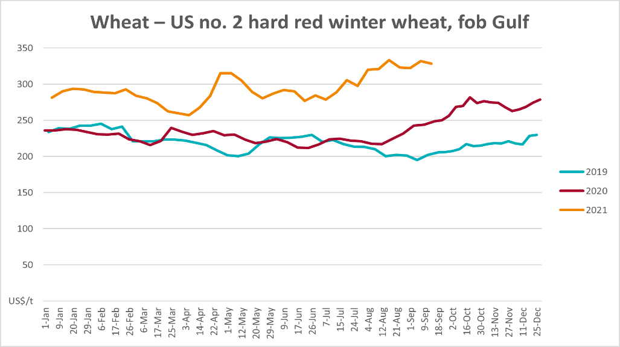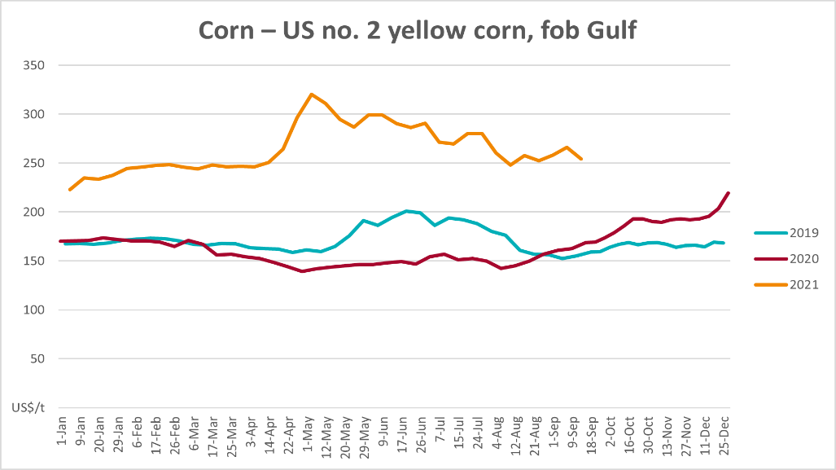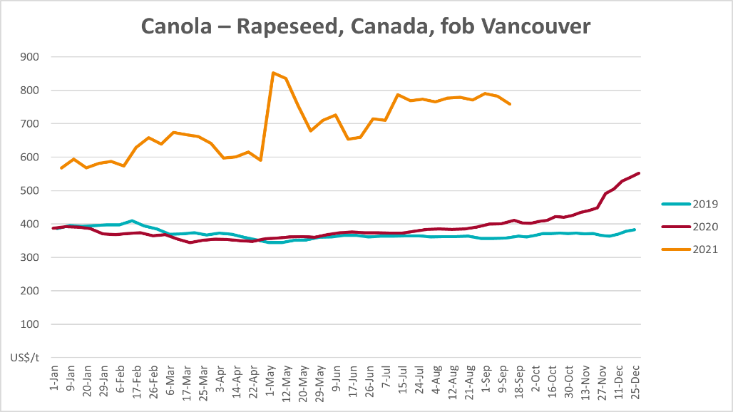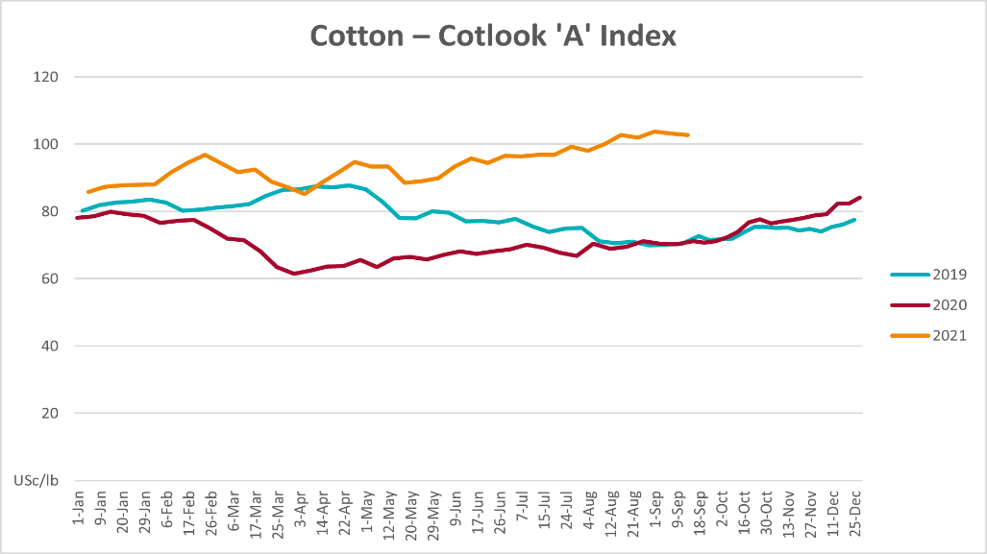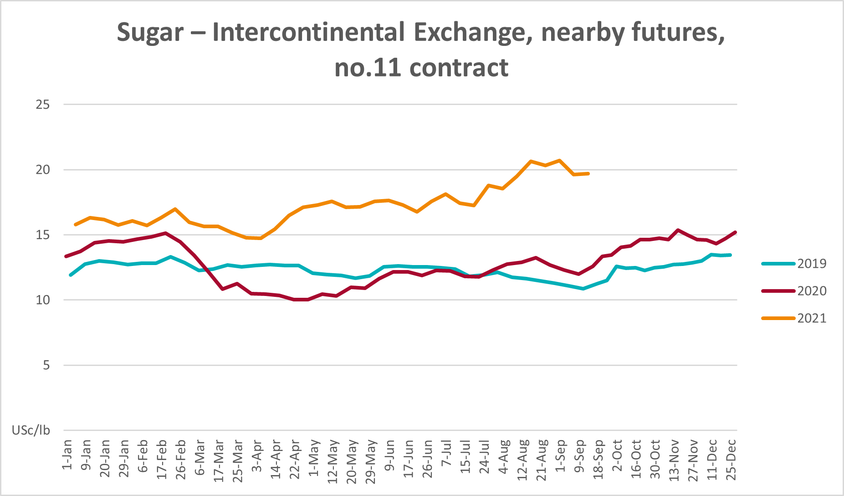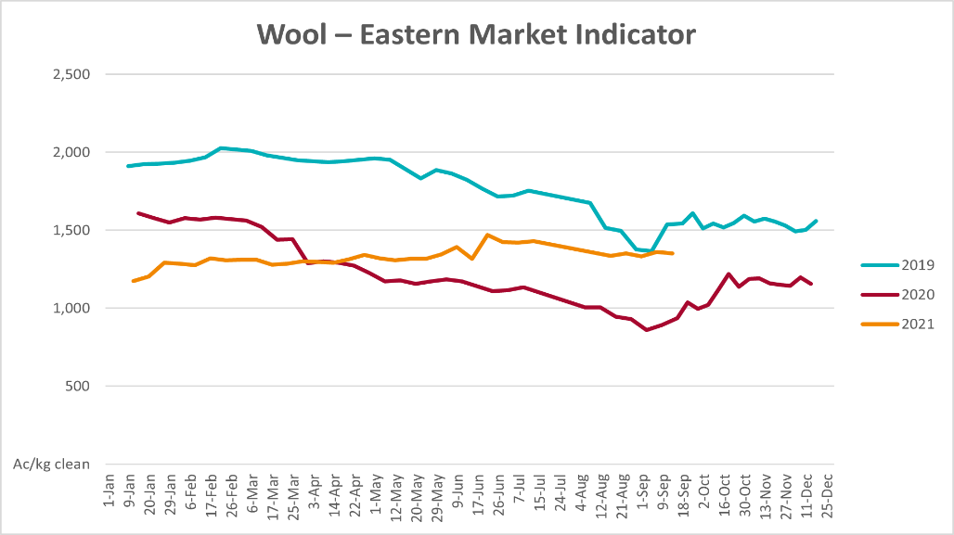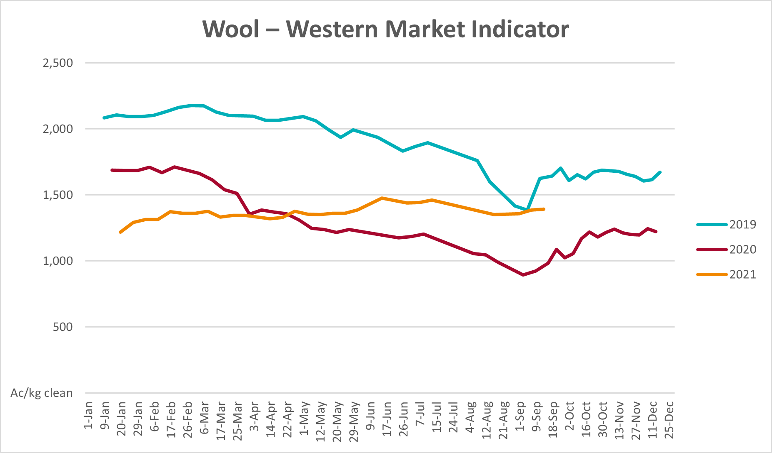

Selected domestic crop indicator prices
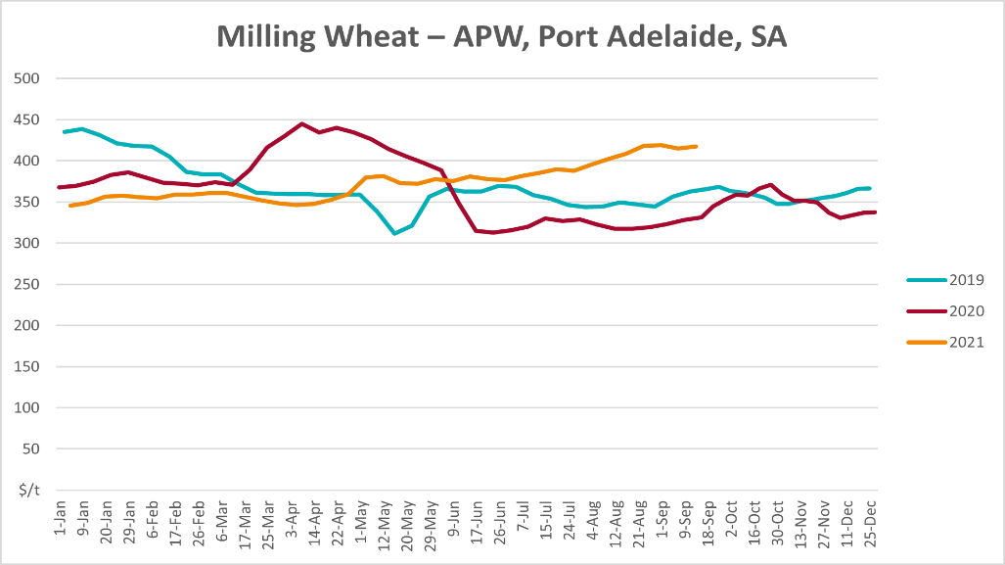
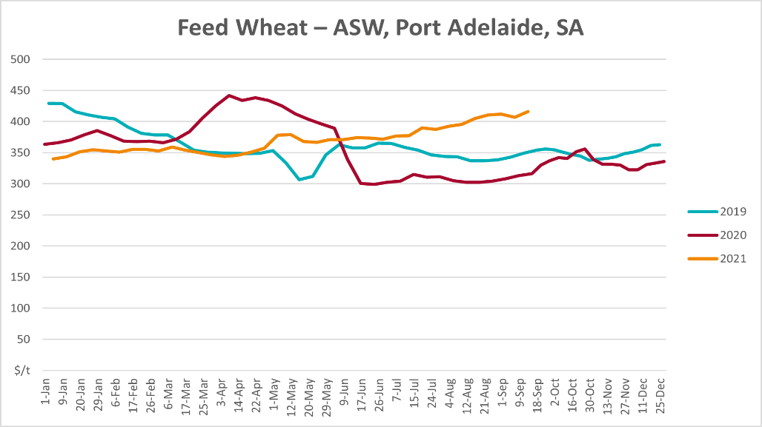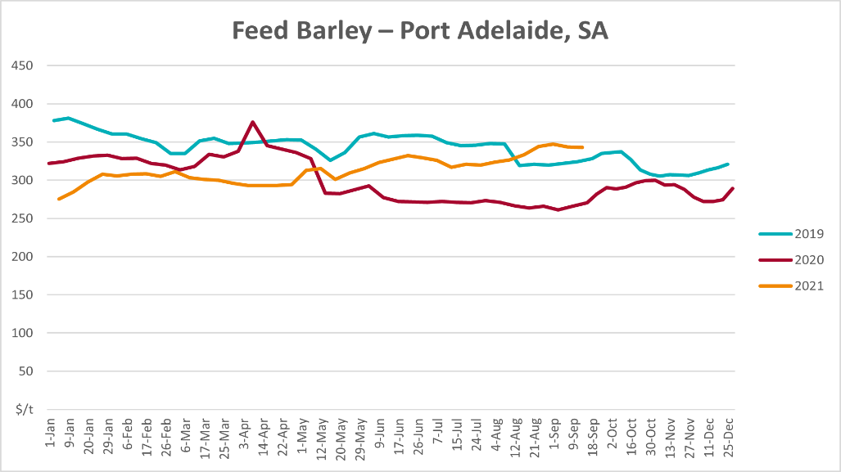
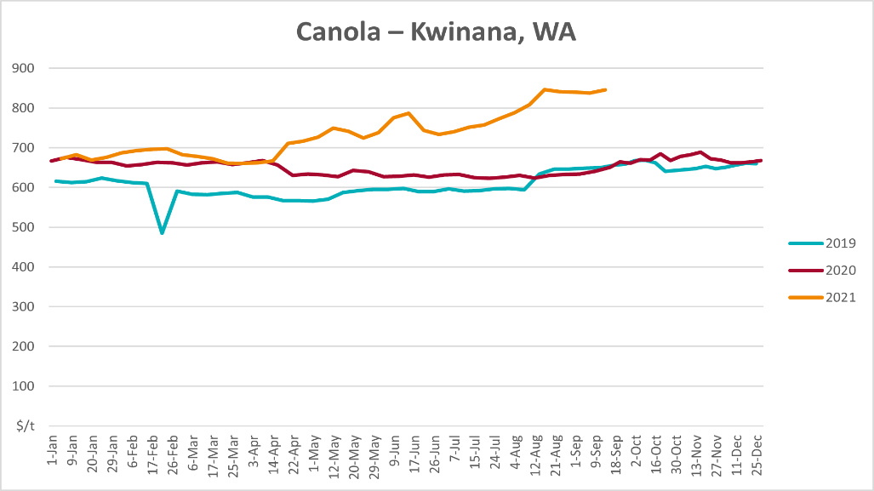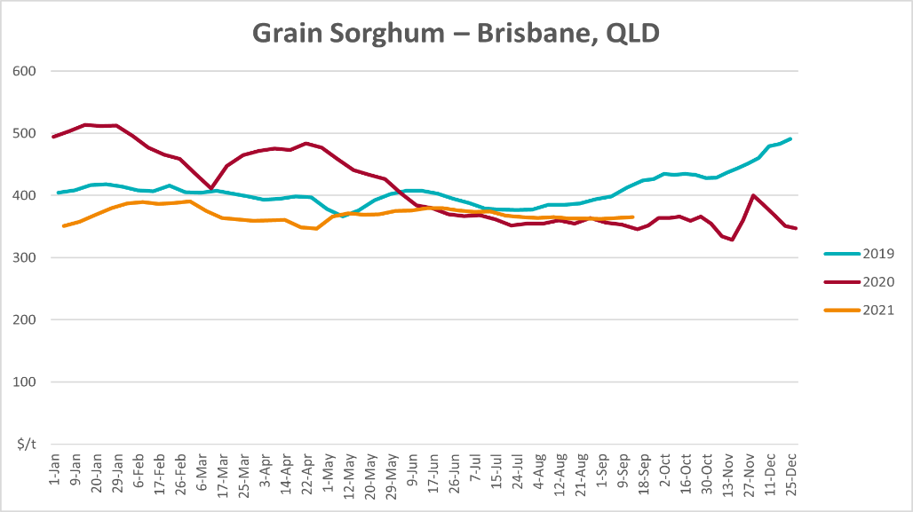

Selected domestic livestock indicator prices
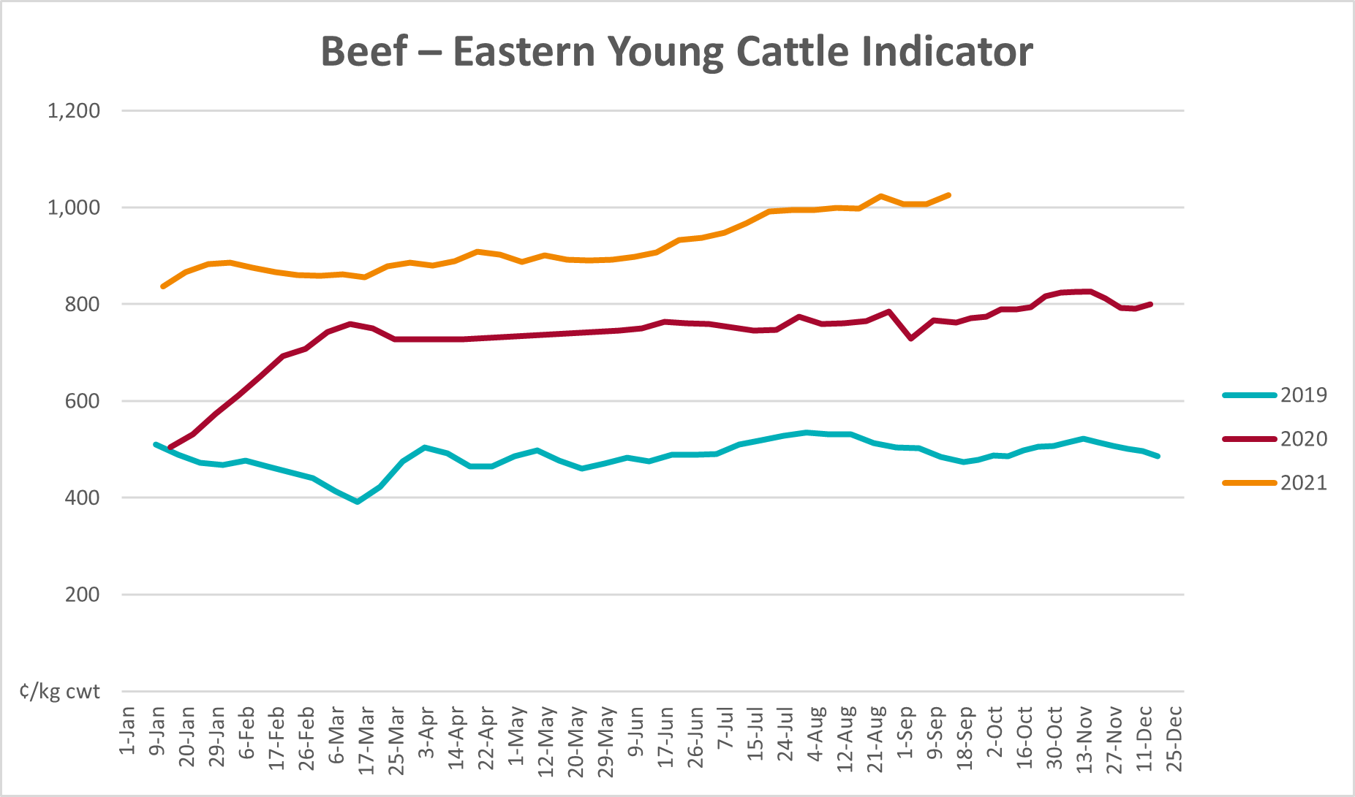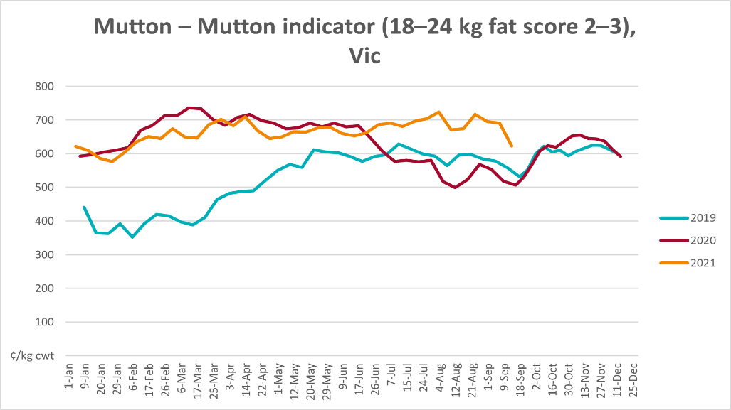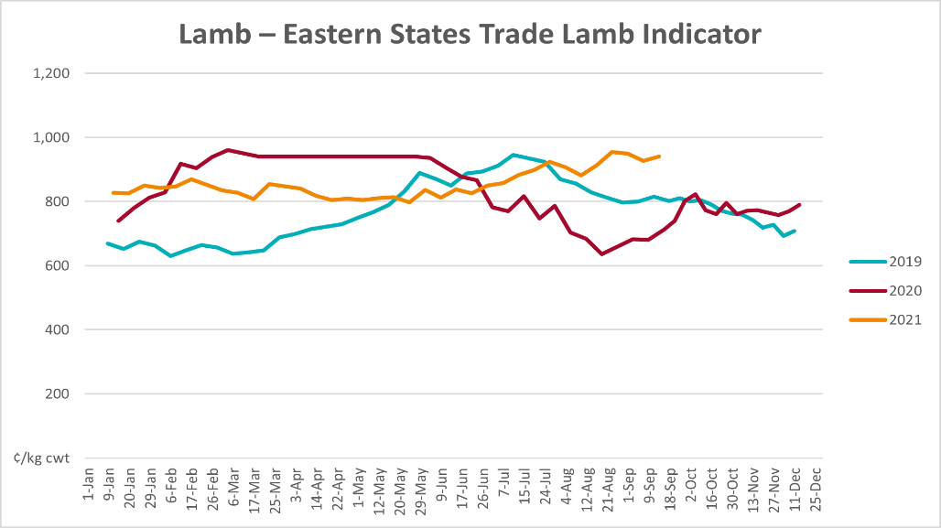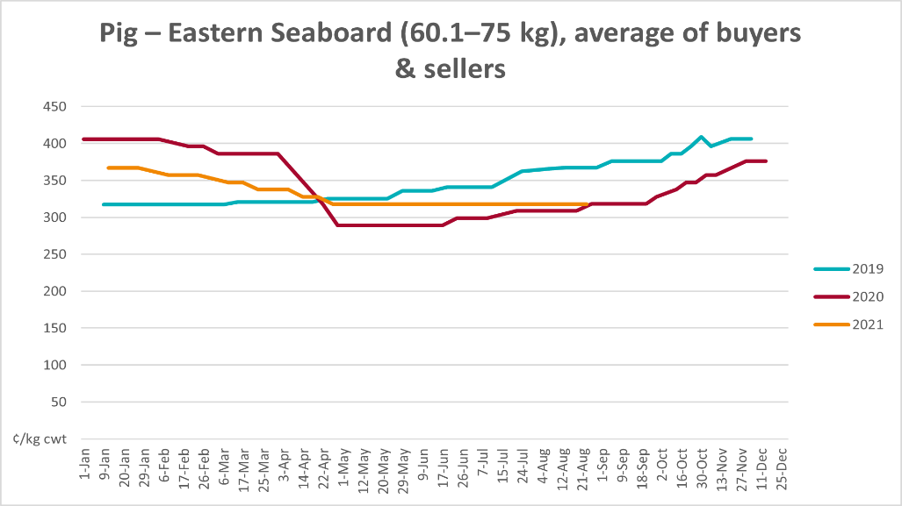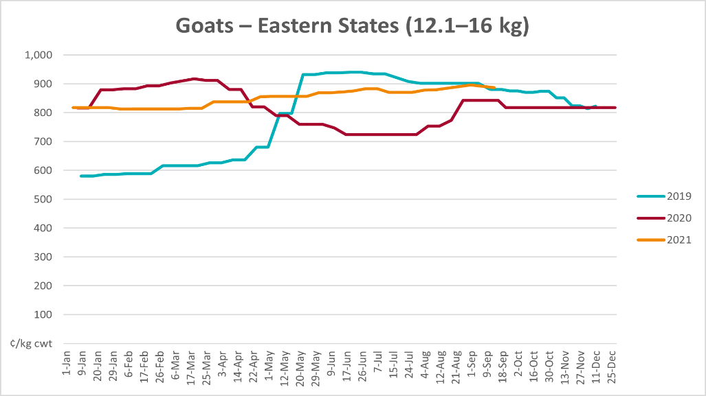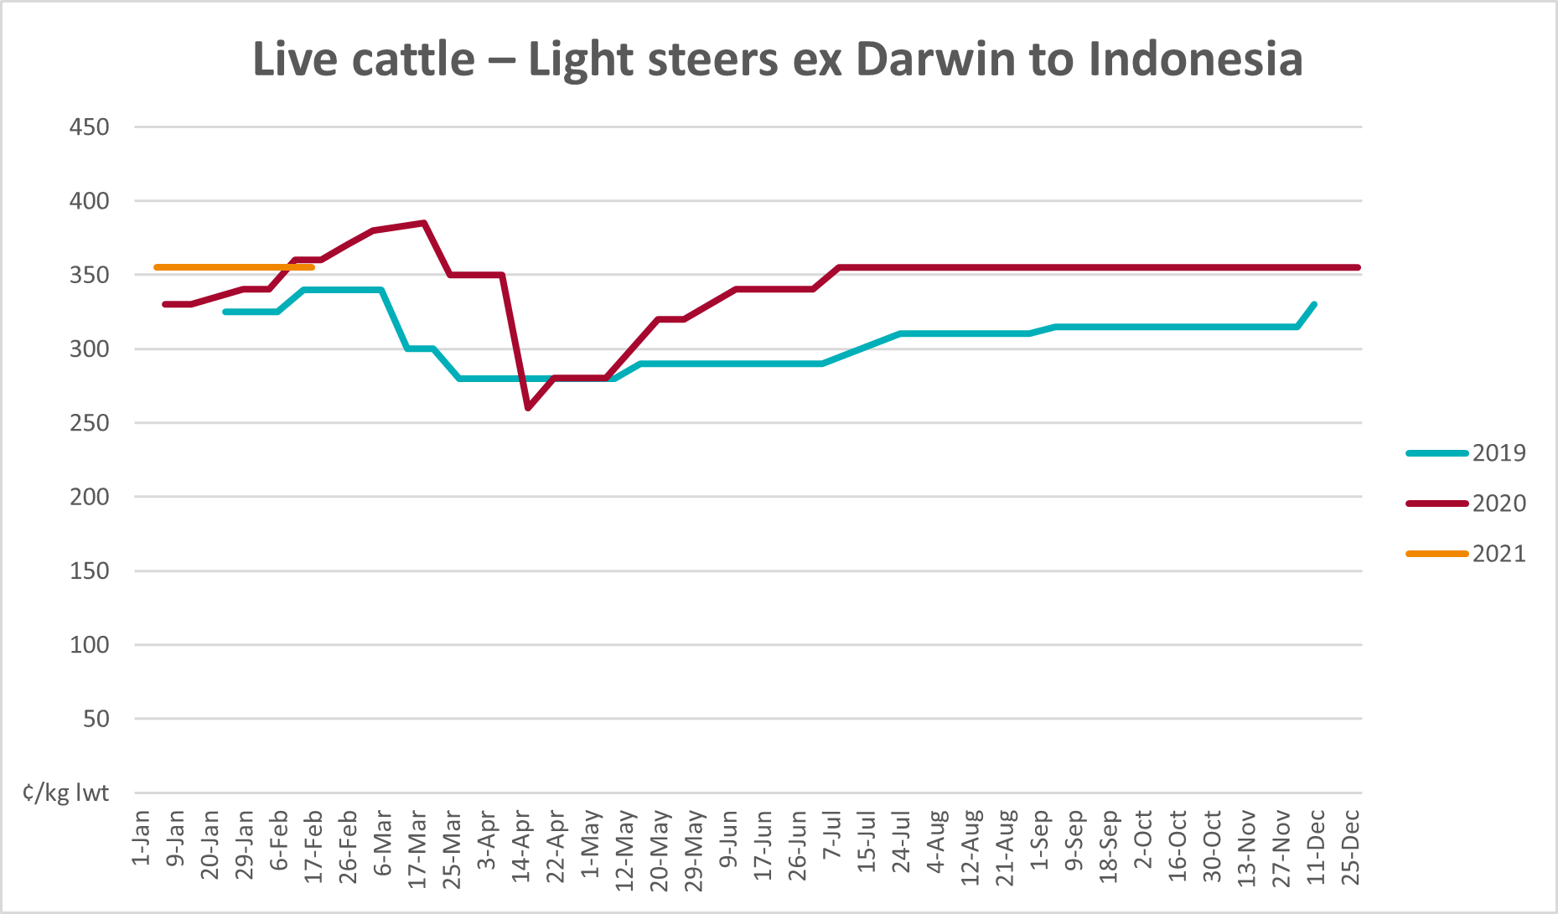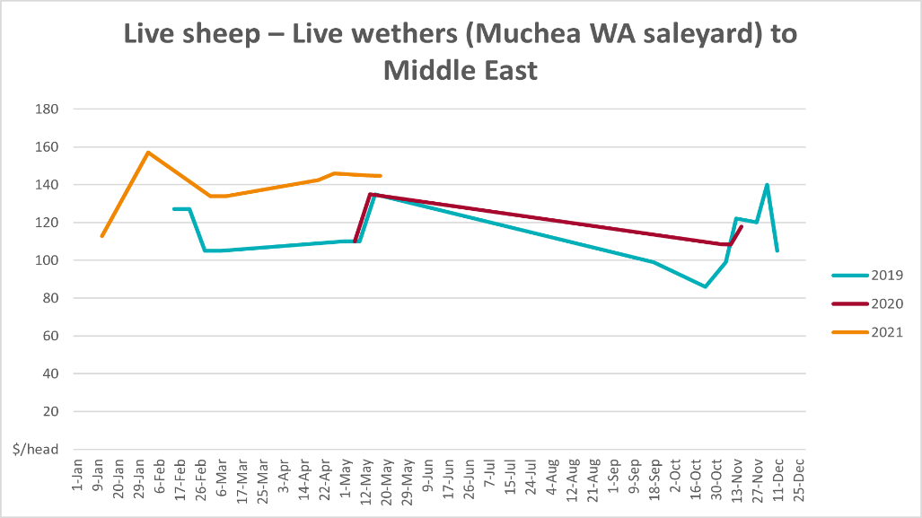

Global Dairy Trade (GDT) weighted average prices
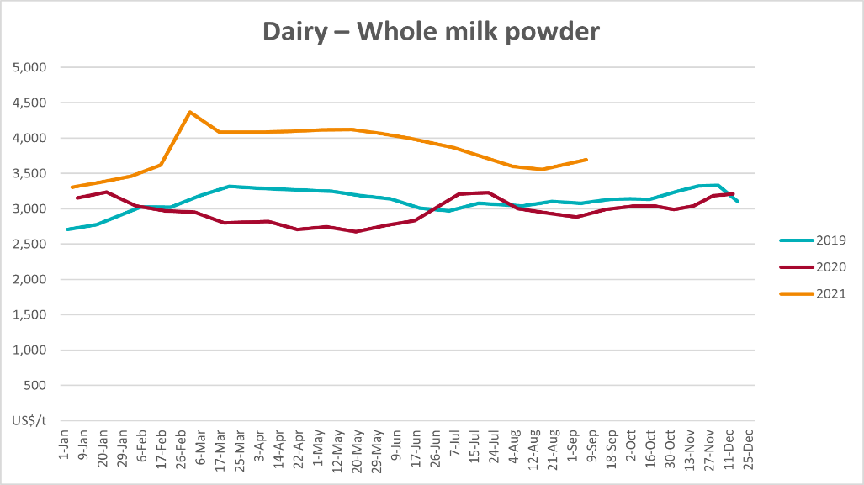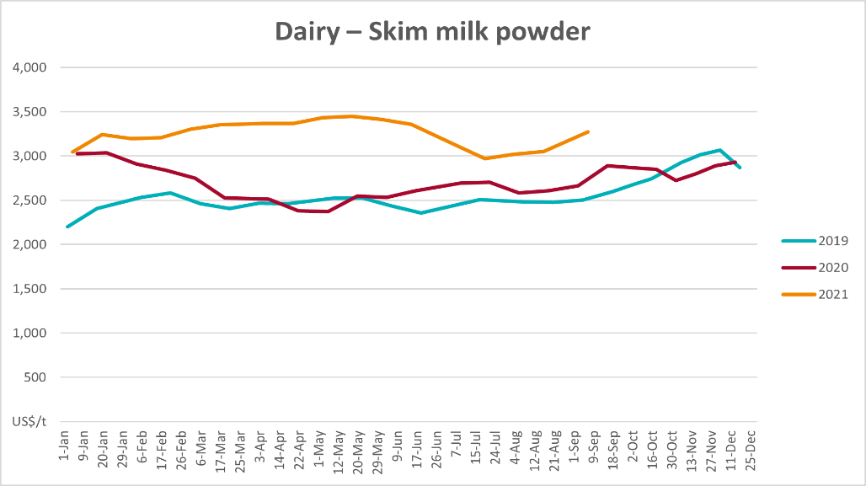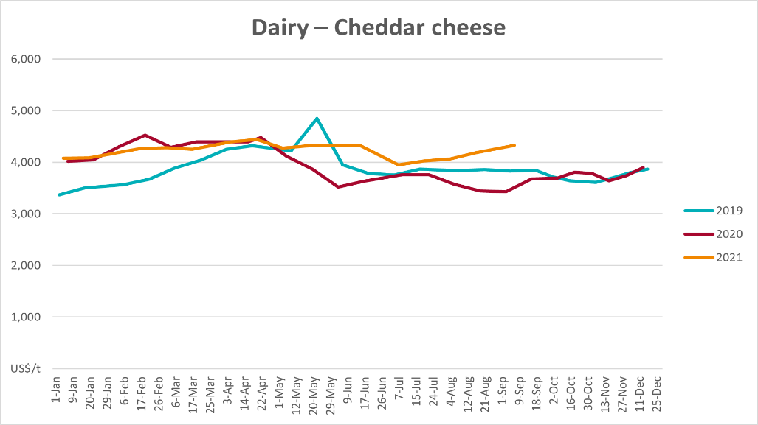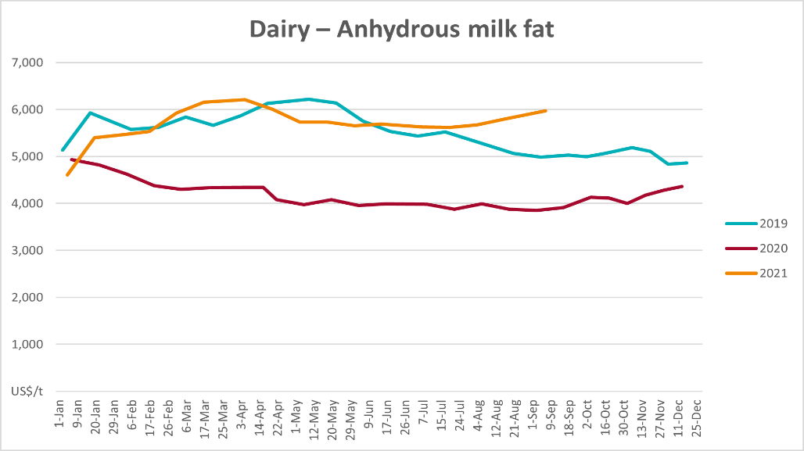

Selected fruit and vegetable prices
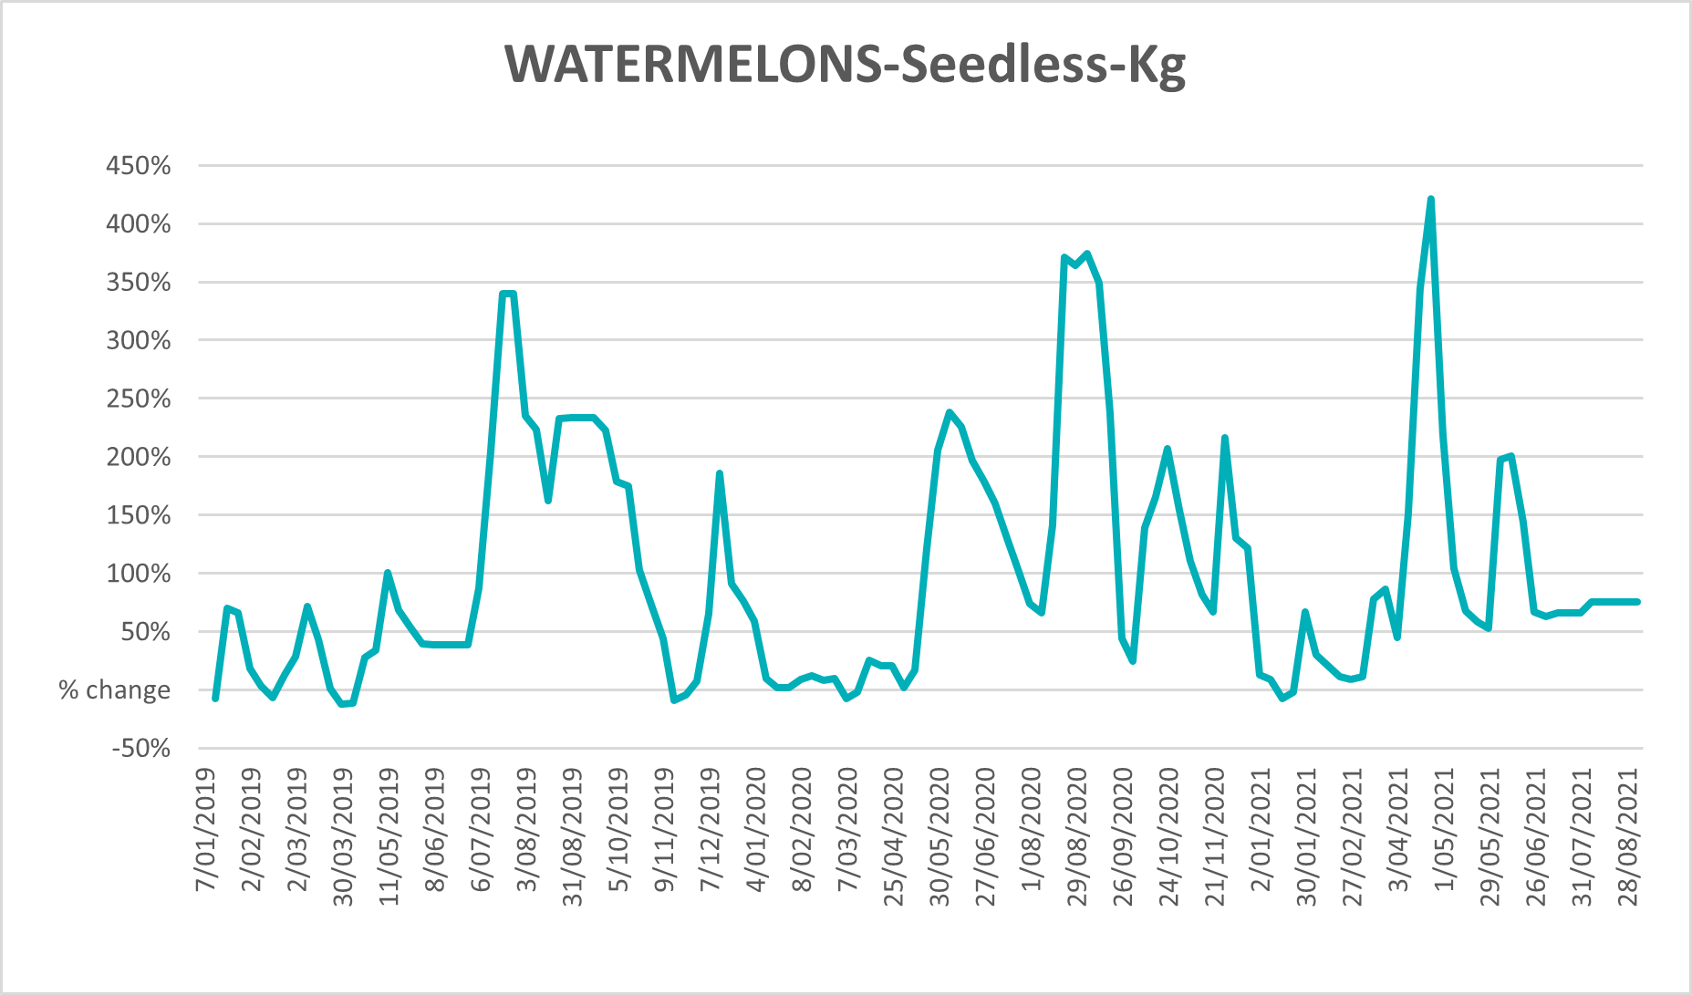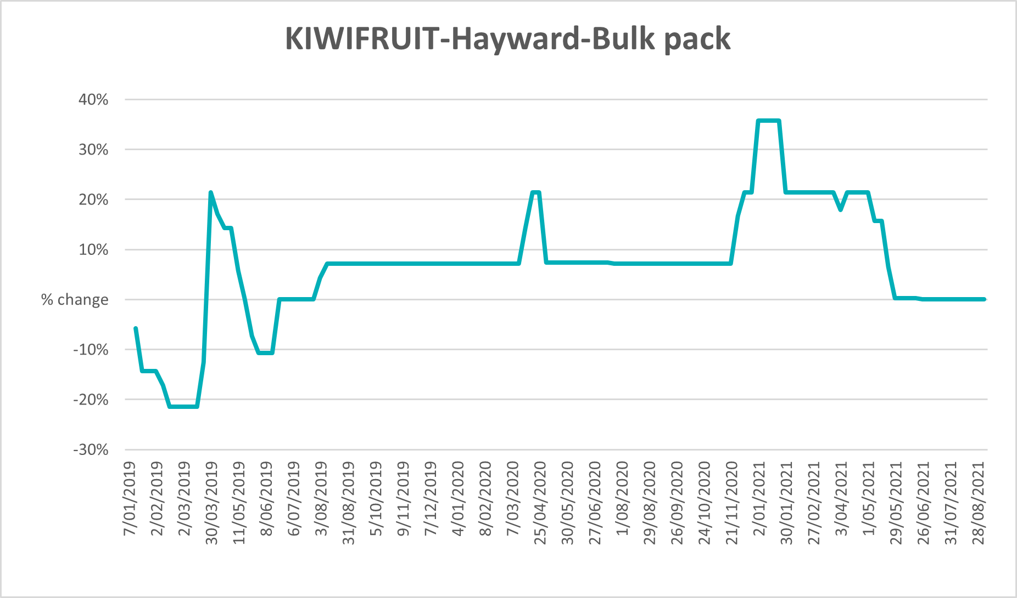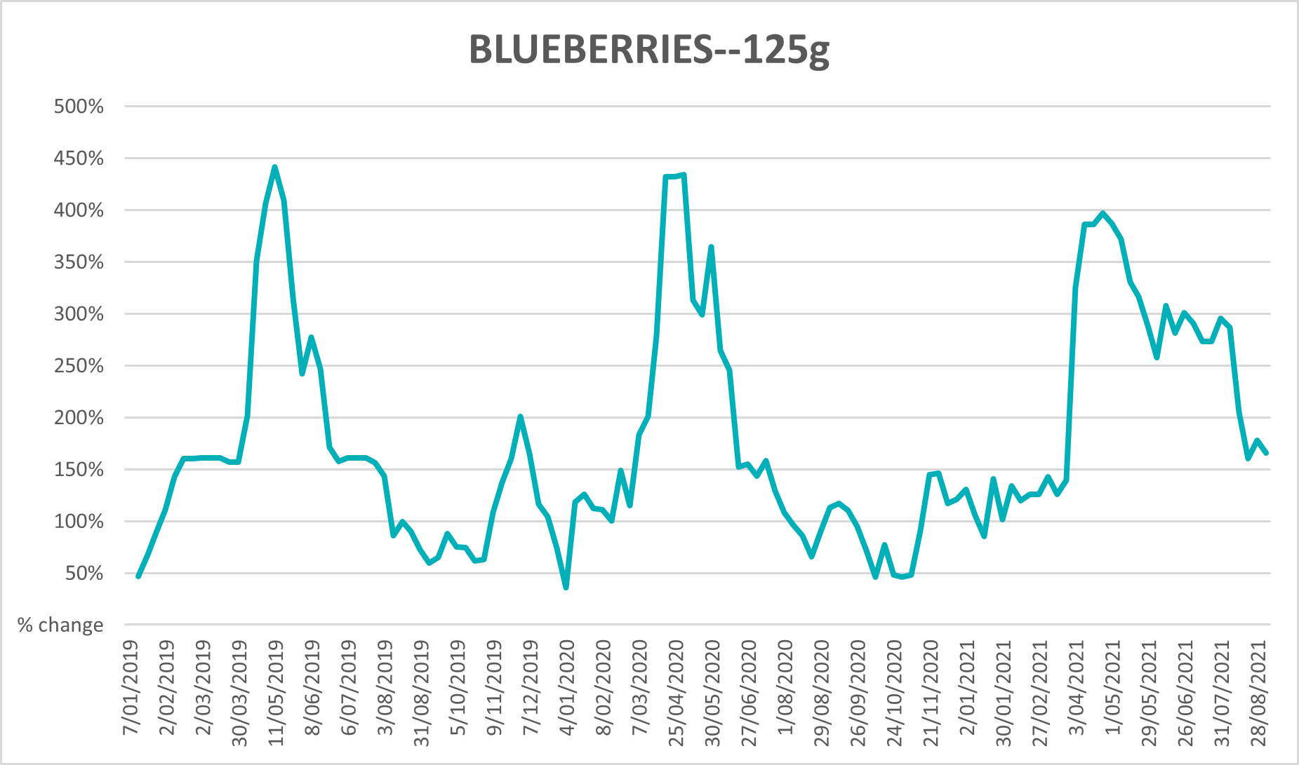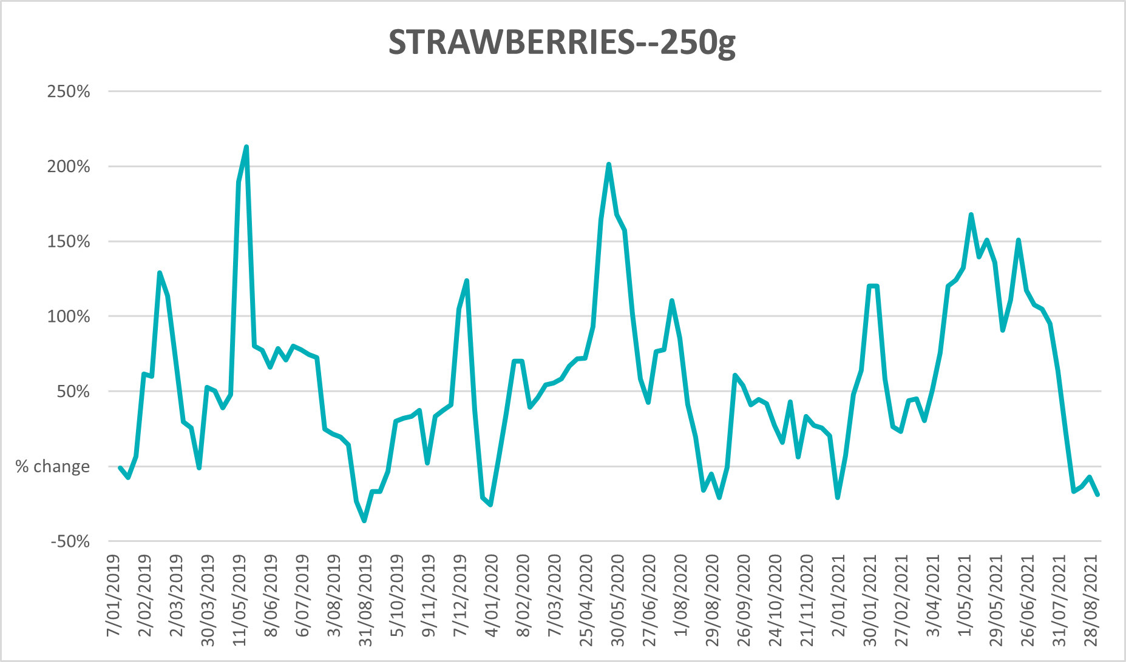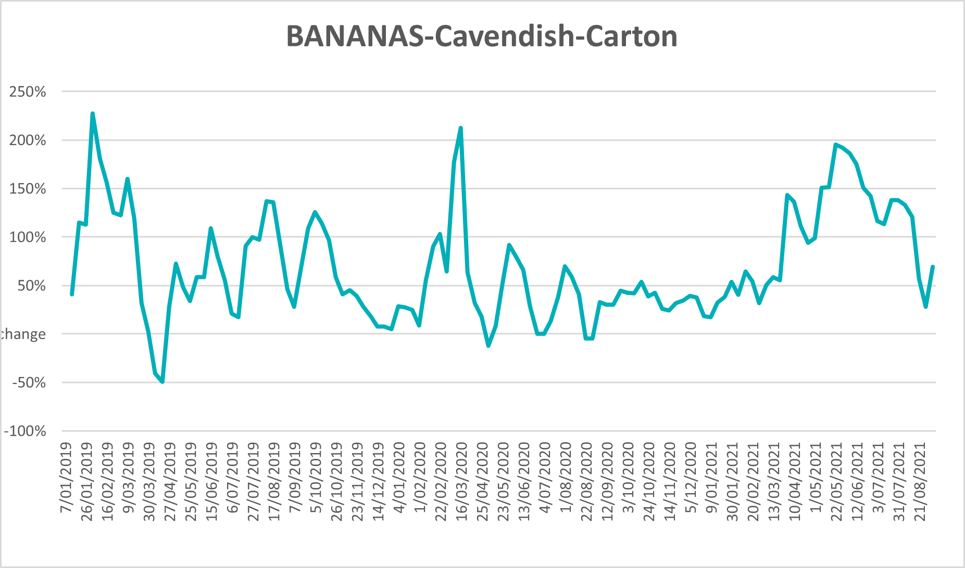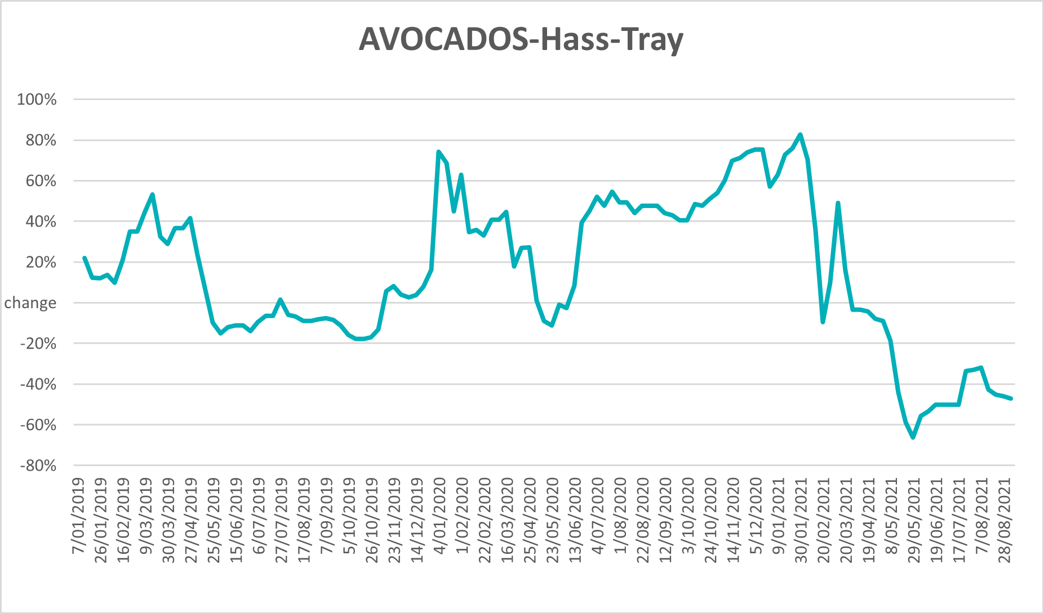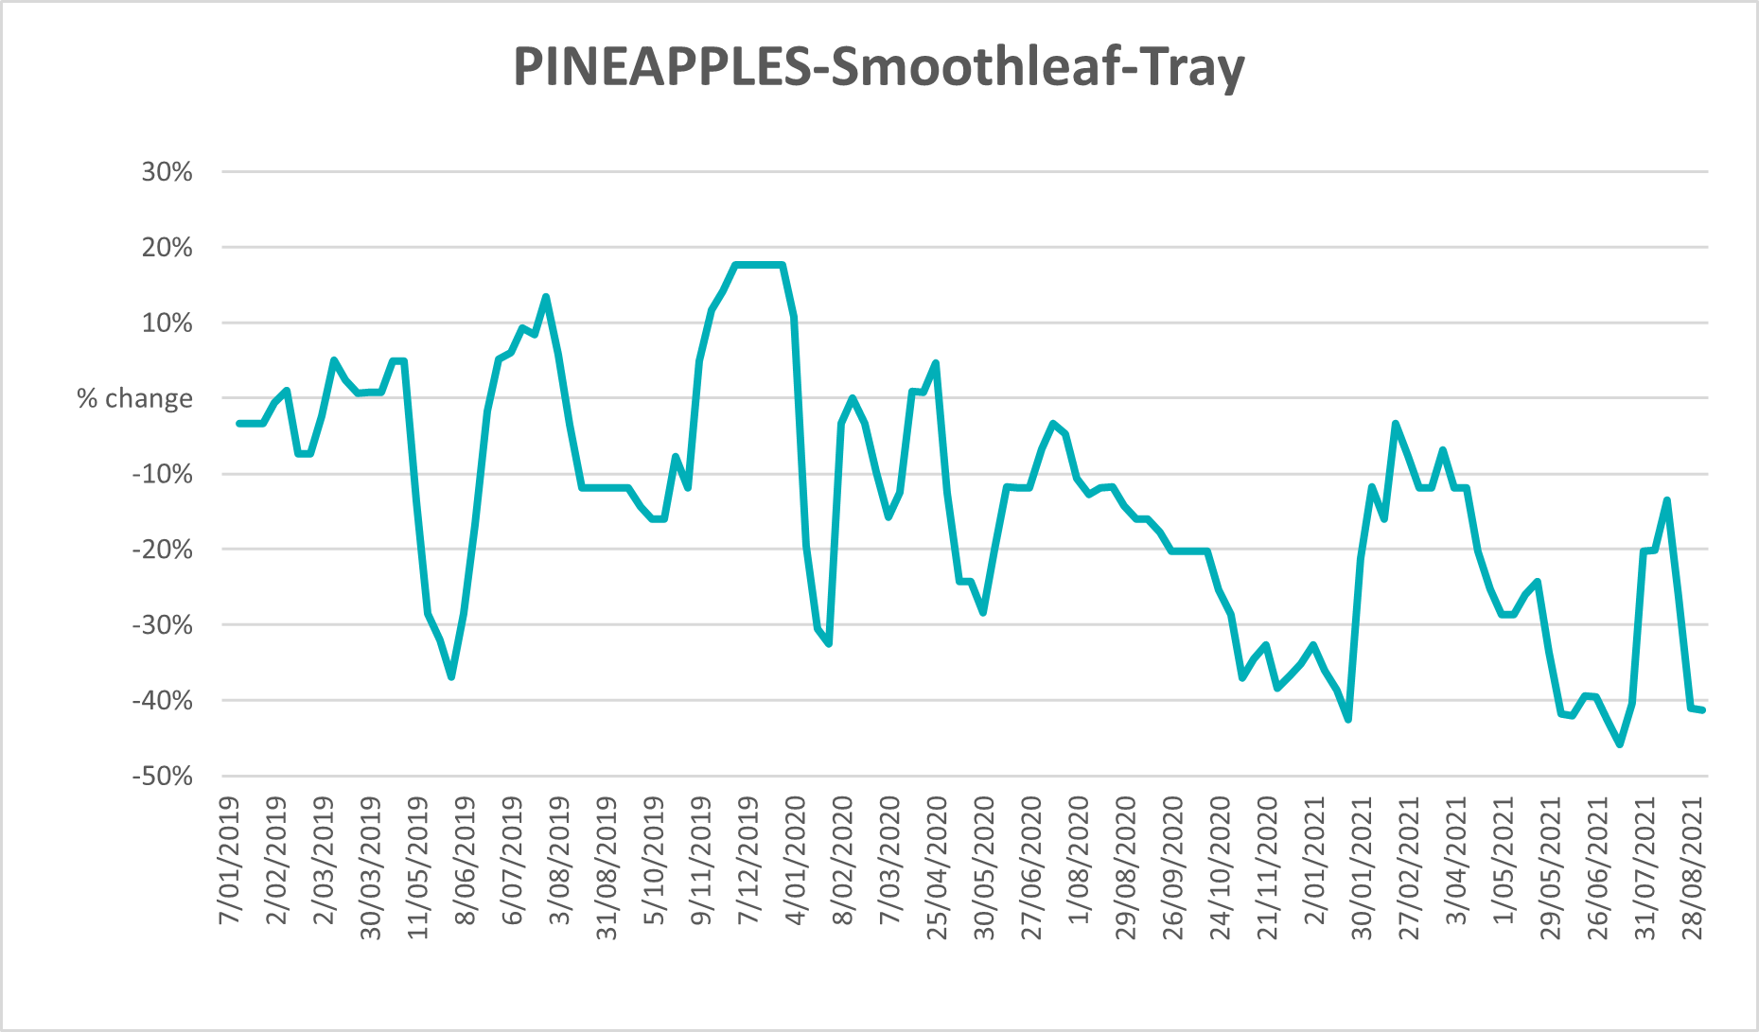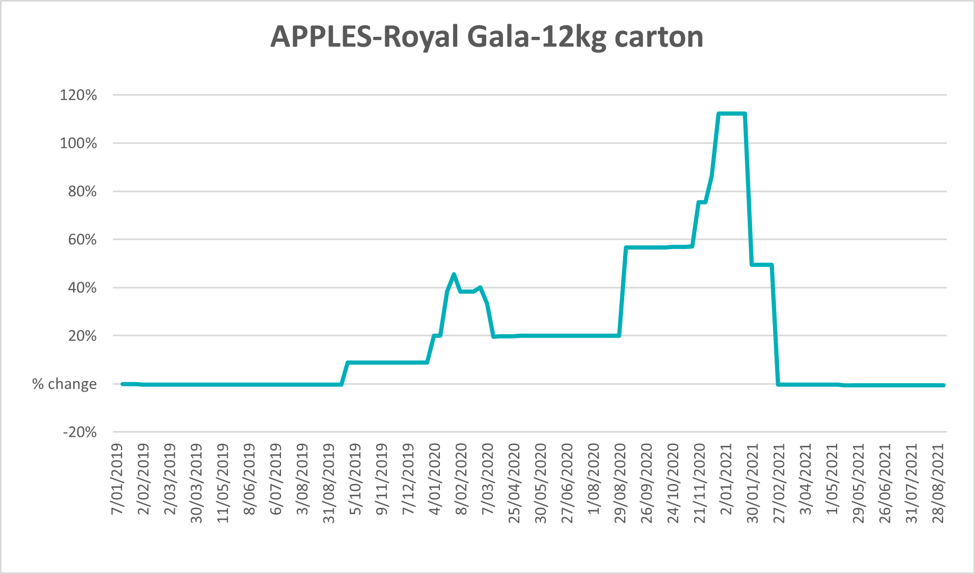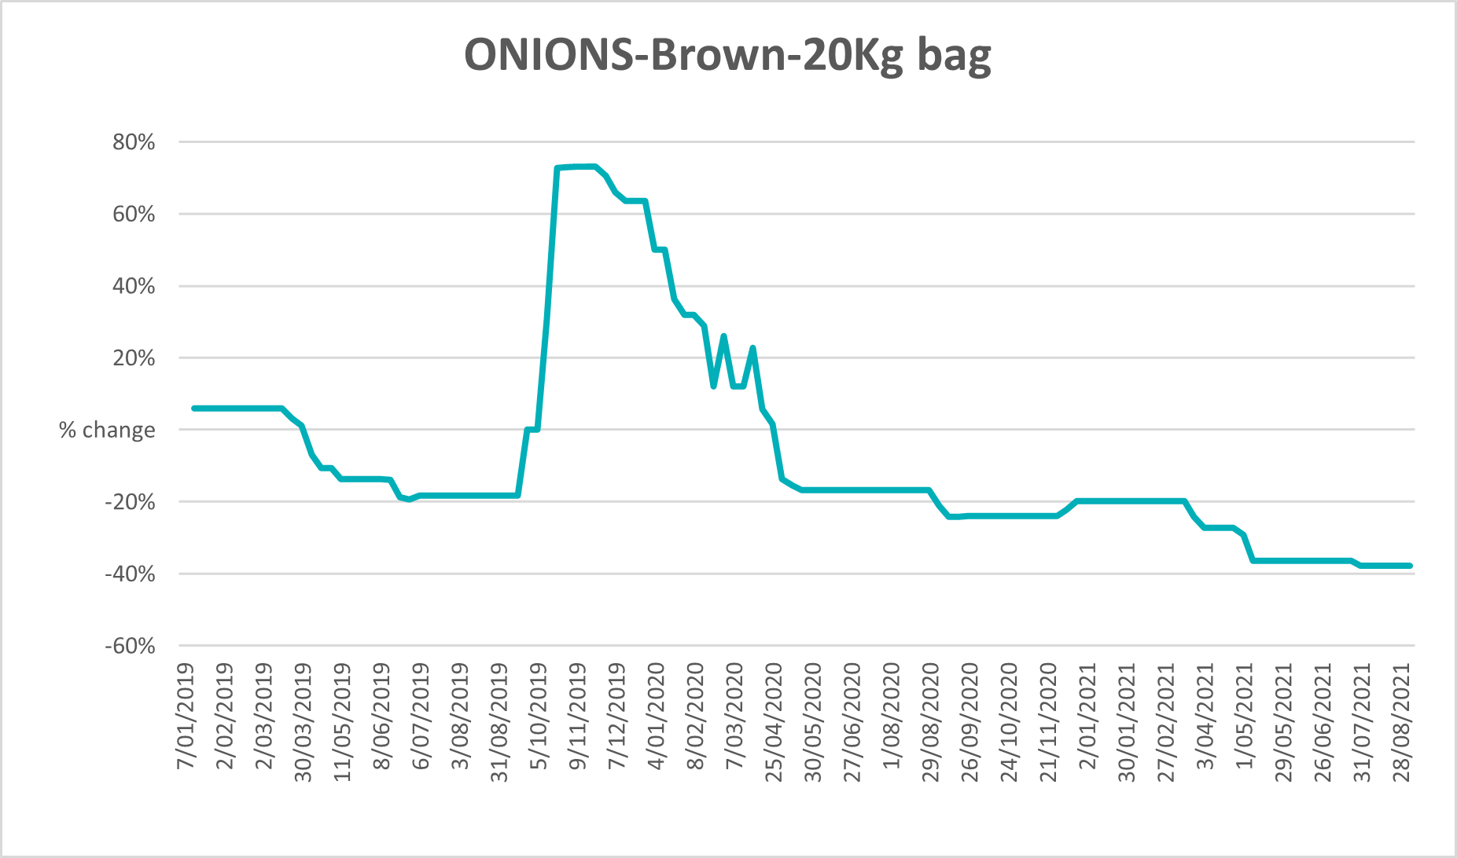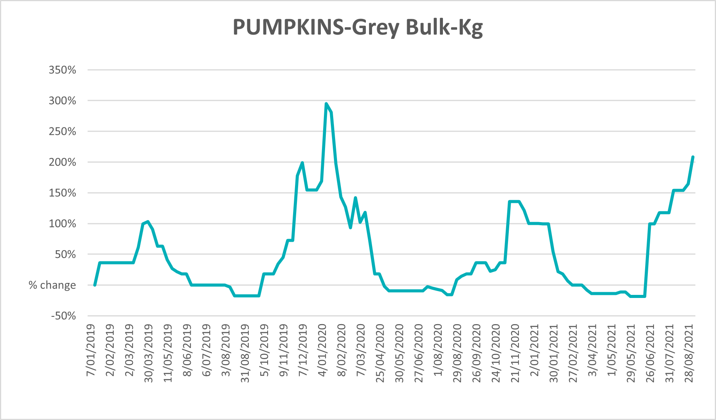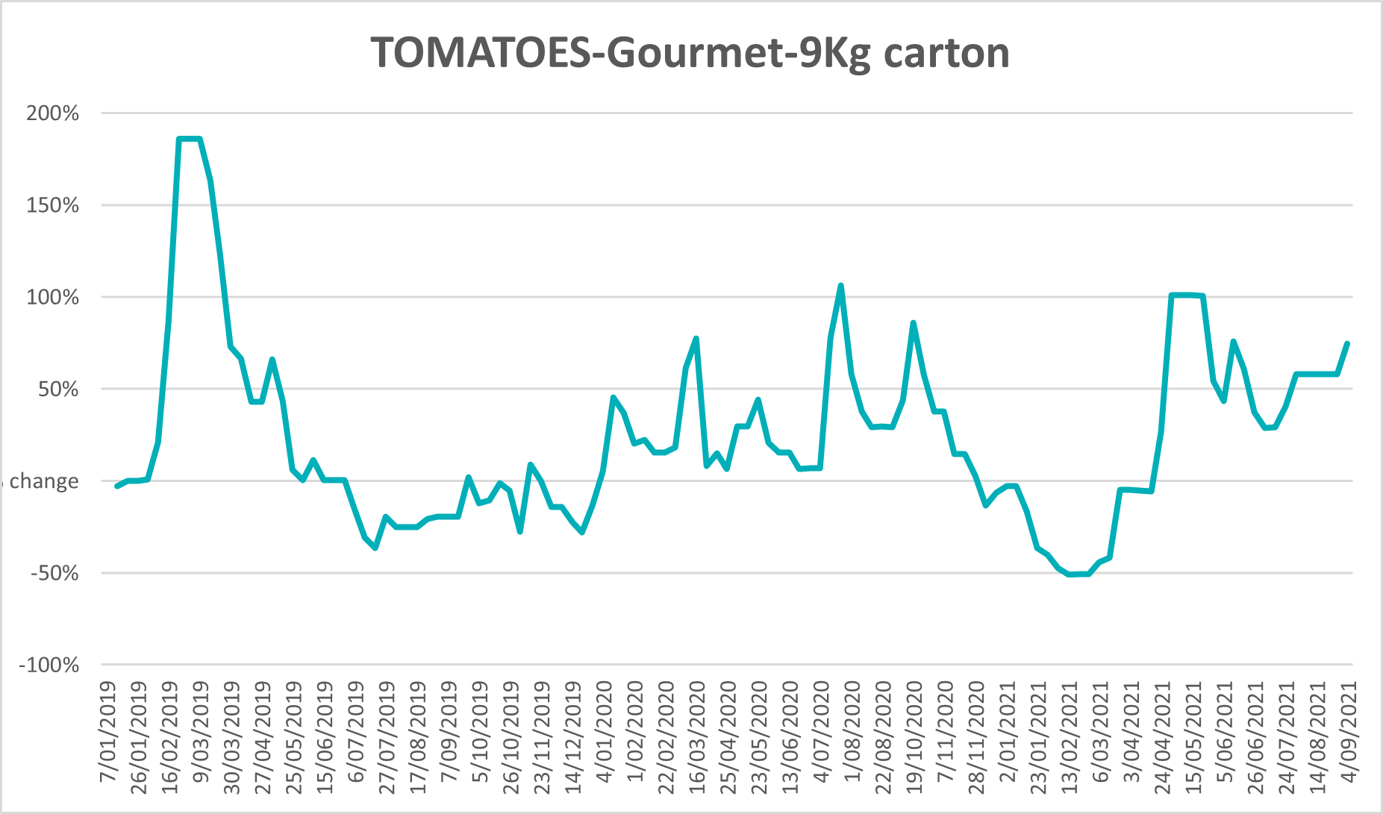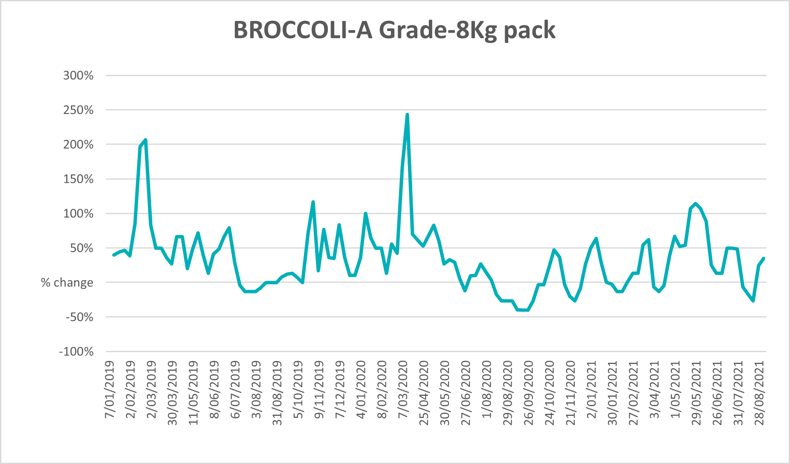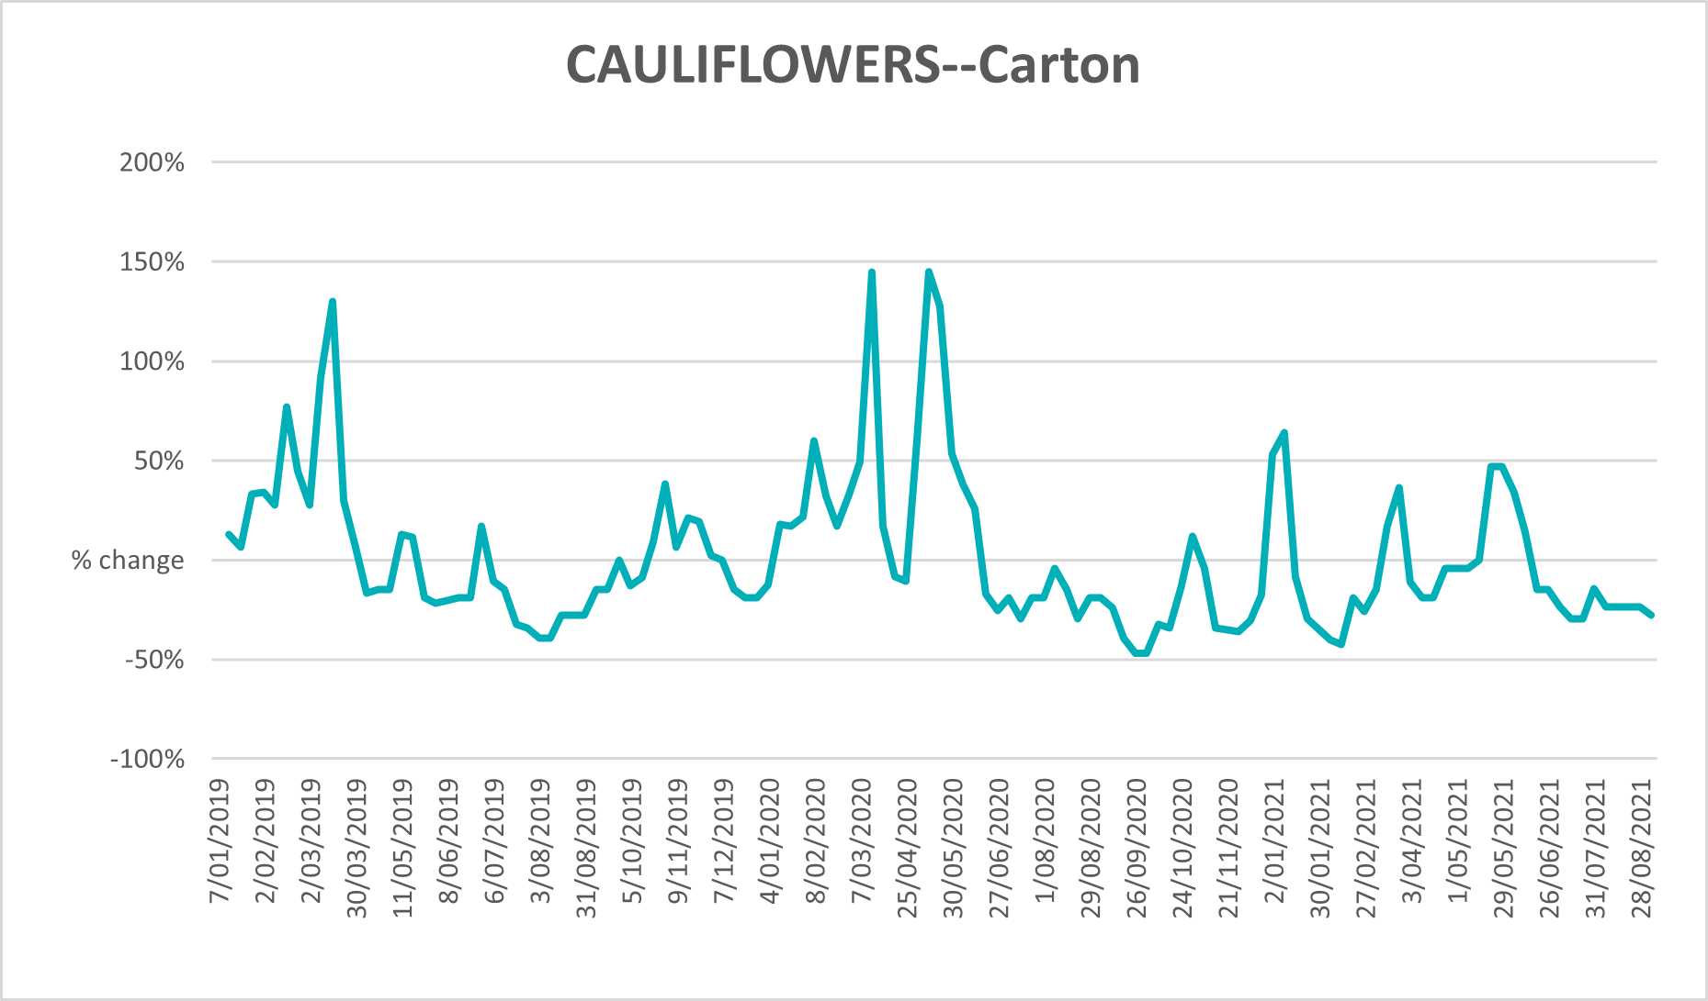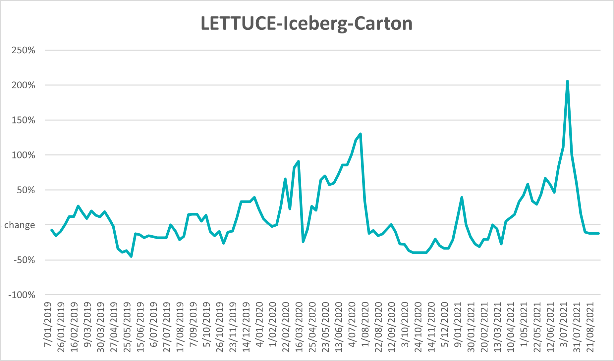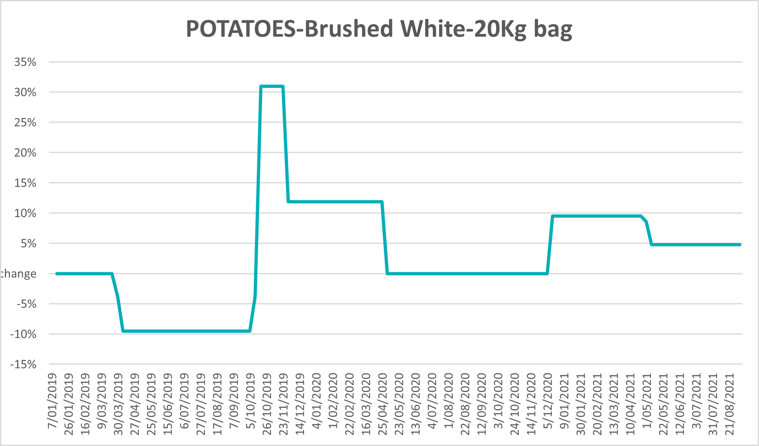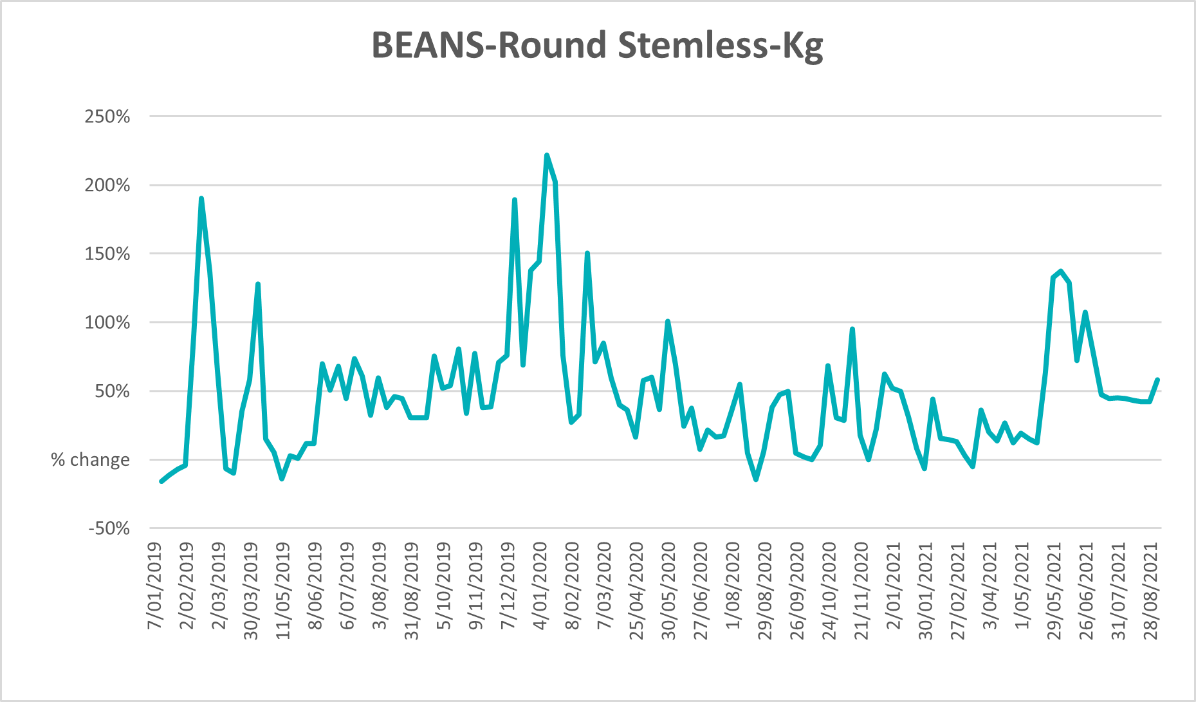

Selected domestic fodder indicator prices

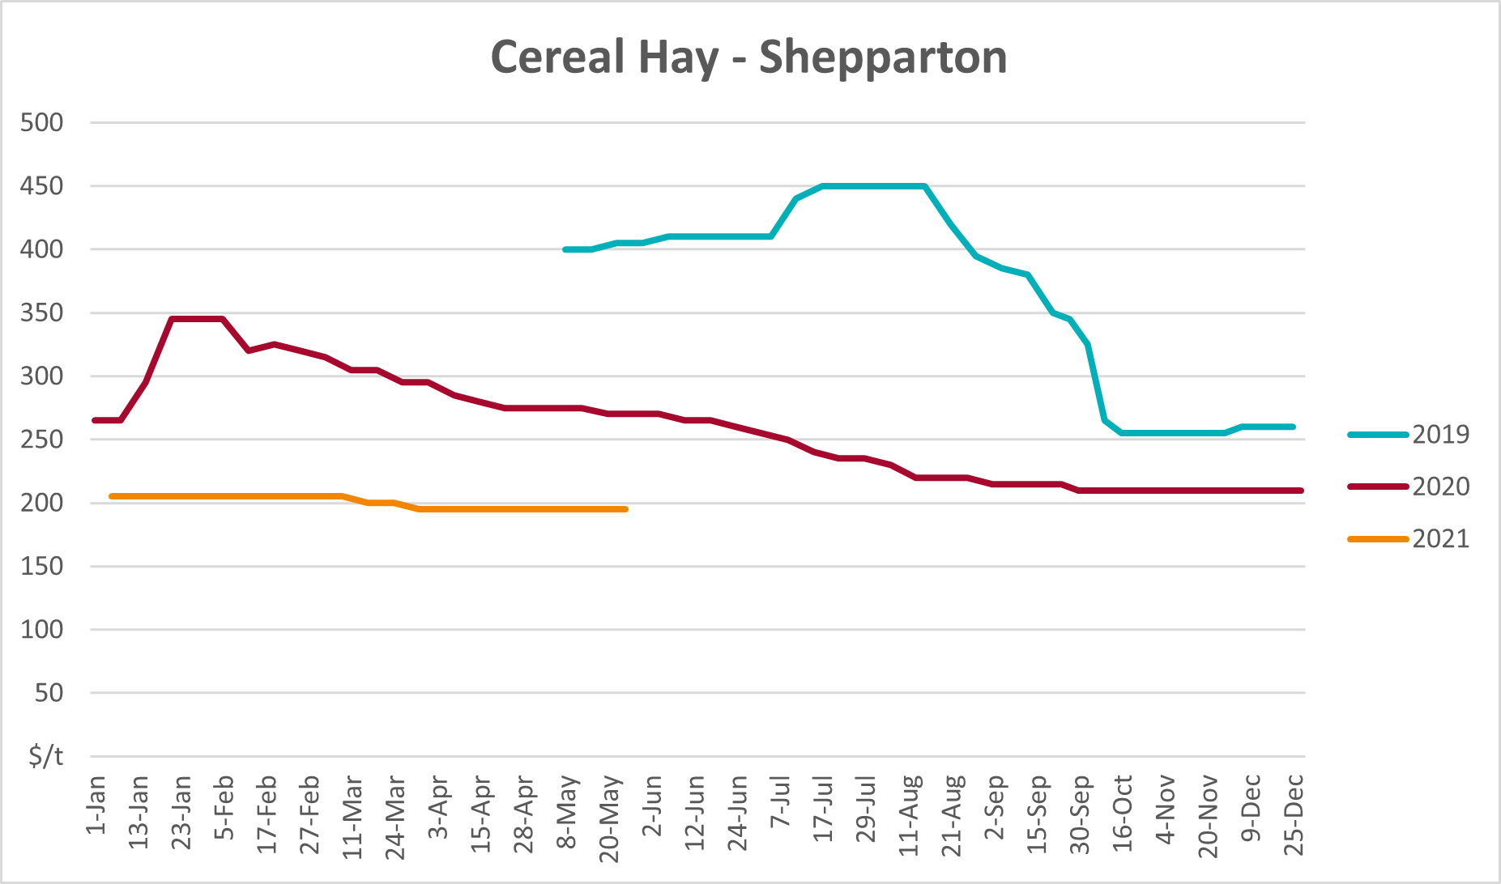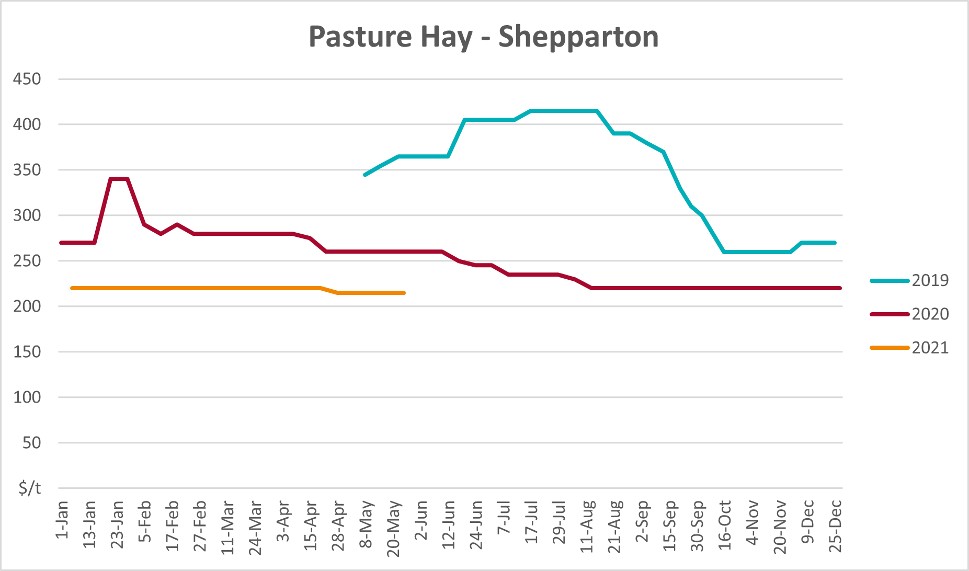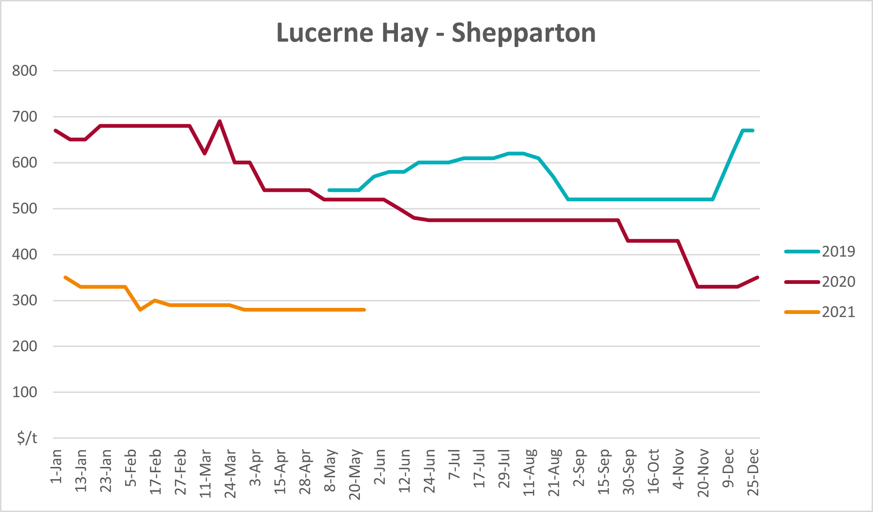

Data attribution

Climate
Bureau of Meteorology
- Weekly rainfall totals: www.bom.gov.au/climate/maps/rainfall/
- Monthly and last 3-month rainfall percentiles: www.bom.gov.au/water/landscape/
- Temperature anomalies: www.bom.gov.au/jsp/awap/temp/index.jsp
- Rainfall forecast: www.bom.gov.au/jsp/watl/rainfall/pme.jsp
- Seasonal outlook: www.bom.gov.au/climate/outlooks/#/overview/summary/
- Climate drivers: http://www.bom.gov.au/climate/enso/
- Soil moisture: www.bom.gov.au/water/landscape/
Other
- Pasture growth: www.longpaddock.qld.gov.au/aussiegrass/
- 3-month global outlooks: Environment and Climate Change Canada, NOAA Climate Prediction Center, EUROBRISA CPTEC/INPE, European Centre for Medium-Range Weather Forecasts, Hydrometcenter of Russia, National Climate Center Climate System Diagnosis and Prediction Room (NCC), International Research Institute for Climate and Society
- Global production: https://ipad.fas.usda.gov/ogamaps/cropmapsandcalendars.aspx
- Autumn break: Pook et al., 2009, https://rmets-onlinelibrary-wiley-com.virtual.anu.edu.au/doi/epdf/10.1002/joc.1833

Water
Prices
- Waterflow: https://www.waterflow.io/
- Ruralco: https://www.ruralcowater.com.au/
Bureau of Meteorology:
- Allocation trade: http://www.bom.gov.au/water/dashboards/#/water-markets/mdb/at
- Storage volumes: http://www.bom.gov.au/water/dashboards/#/water-storages/summary/drainage
Trade constraints:
- Water NSW: https://www.waternsw.com.au/customer-service/ordering-trading-and-pricing/trading/murrumbidgee
- Victorian Water Register: https://www.waterregister.vic.gov.au/TradingRules2019/

Commodities
Fruit and vegetables
- Datafresh: www.freshstate.com.au
Pigs
- Australian Pork Limited: www.australianpork.com.au
Dairy
- Global Dairy Trade: www.globaldairytrade.info/en/product-results/
World wheat, canola
- International Grains Council
World coarse grains
- United States Department of Agriculture
World cotton
- Cotlook: www.cotlook.com/
World sugar
- New York Stock Exchange - Intercontinental Exchange
Wool
- Australian Wool Exchange: www.awex.com.au/
Domestic wheat, barley, sorghum, canola and fodder
- Jumbuk Consulting Pty Ltd: http://www.jumbukag.com.au/
Cattle, beef, mutton, lamb, goat and live export
- Meat and Livestock Australia: www.mla.com.au/Prices-and-market
© Commonwealth of Australia 2021

Ownership of intellectual property rights
Unless otherwise noted, copyright (and any other intellectual property rights, if any) in this publication is owned by the Commonwealth of Australia (referred to as the Commonwealth).

Creative Commons licence
All material in this publication is licensed under a Creative Commons Attribution 4.0 International Licence except content supplied by third parties, logos and the Commonwealth Coat of Arms.
Inquiries about the licence and any use of this document should be emailed to copyright@awe.gov.au.


Cataloguing data
This publication (and any material sourced from it) should be attributed as:
ABARES 2021, Weekly Australian Climate, Water and Agricultural Update, Australian Bureau of Agricultural and Resource Economics and Sciences, Canberra, 16 September 2021. CC BY 4.0 DOI: https://doi.org/10.25814/5f3e04e7d2503
ISSN 2652-7561
This publication is available at https://www.agriculture.gov.au/abares/products/weekly_update
Department of Agriculture, Water and the Environment
GPO Box 858 Canberra ACT 2601
Telephone 1800 900 090
Web awe.gov.au/abares

Disclaimer
The Australian Government acting through the Department of Agriculture, Water and the Environment, represented by the Australian Bureau of Agricultural and Resource Economics and Sciences, has exercised due care and skill in preparing and compiling the information and data in this publication. Notwithstanding, the Department of Agriculture, Water and the Environment, ABARES, its employees and advisers disclaim all liability, including liability for negligence and for any loss, damage, injury, expense or cost incurred by any person as a result of accessing, using or relying on any of the information or data in this publication to the maximum extent permitted by law.

Statement of Professional Independence
The views and analysis presented in ABARES publications, including this one, reflect ABARES professionally independent findings, based on scientific and economic concepts, principles, information and data. These views, analysis and findings may not reflect or be consistent with the views or positions of the Australian Government, or of organisations or groups who have commissioned ABARES reports or analysis. More information on professional independence is provided on the ABARES website.

Acknowledgements
This report was prepared by Cameron Van-Lane and Matthew Miller.

