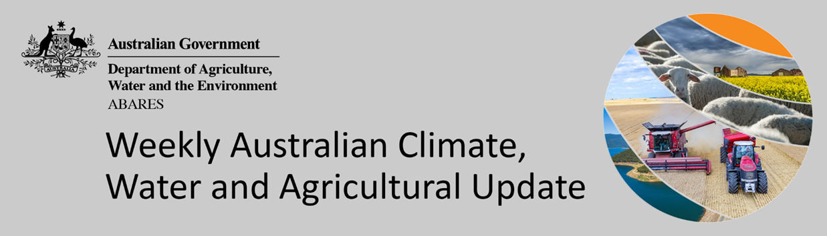
No. 48/2021

9 December 2021

Summary of key issues
- For the week ending 8 December 2021, low-pressure troughs over northern and eastern Australia brought more storms and rainfall. A blocking high-pressure system over the Australian Bight caused dry conditions in most of Western Australia and large areas of central Australia (see Section 1.1).
- Modelled pasture growth was average to extremely high across much of New South Wales, Victoria, Queensland, South Australia and parts of Western Australia. This growth is likely to enable farmers to continue to rebuild stock numbers and provide opportunities to replenish fodder supplies during spring. In contrast, modelled pasture growth was extremely low to below average across scattered areas of southern New South Wales and south-western Western Australia (see Section 1.2).
- ENSO indicators suggest that La Niña is currently active in the tropical Pacific. La Niña events are associated with above-average rainfall for northern and eastern Australia during spring and summer. The SAM continues to be positive. During summer, a positive SAM is associated with above average rainfall for eastern parts of Australia at this time of year, as well as below average rainfall for south-westerly exposed coastal areas. The MJO is also expected to influence rainfall patterns in Australia over the coming weeks, increasing the likelihood of above average rainfall across northern Australia, as well as accelerating the onset of the northern monsoon (see Section 1.3).
- The outlook for January 2022 indicates that there is a 75% chance of rainfall totals between 10 and 100 millimetres across much of New South Wales, Queensland, Victoria, the Northern Territory and the north of Western Australia. Rainfall totals in excess of 100 millimetres are expected in parts of north-eastern New South Wales, south-east and northern Queensland, the north of the Northern Territory and Western Australia, and western Tasmania (see Section 1.4).
- The outlook for January to March 2022 suggests there is a 75% chance of rainfall totals between 50 and 300 millimetres across much of New South Wales, Queensland, southern Victoria, northern Western Australia, the Northern Territory and Tasmania. Rainfall totals in excess of 200 millimetres are forecast for eastern New South Wales and Queensland, as well as northern parts of Queensland, Western Australia and the Northern Territory.
- Over the 8-days to 16 December 2021, low-pressure systems across northern and eastern Australia are expected to bring rainfall across northern Australia, as well as coastal areas in eastern Australia. Meanwhile, high-pressure systems over the Great Australian Bight will bring clear, dry conditions to much of the remainder of Australia over the next 8-days (see Section 1.5).
- Water storage in the Murray–Darling Basin (MDB) decreased by 289 gigalitres (GL) between 1 December 2021 and 8 December 2021. The current volume of water held in storage is 22,462 GL, which represents 89% of total capacity. This is 49% or 7,367 GL more than at the same time last year.
- Allocation prices in the Victorian Murray below the Barmah Choke increased from $93 per ML on 26 November 2021 to $97 per ML on 3 December 2021. Prices are lower in the Goulburn-Broken, Murrumbidgee, and regions above the Barmah Choke due to the binding of the Goulburn intervalley trade limit, Murrumbidgee export limit, and Barmah Choke trade constraint.

Climate

Rainfall this week
For the week ending 8 December 2021, low-pressure troughs over northern and eastern Australia brought more storms and rainfall. A blocking high-pressure system over the Australian Bight caused dry conditions in most of Western Australia and large areas of central Australia.
Rainfall totals of between 10 and 100 millimetres were recorded across large areas of eastern New South Wales, eastern Victoria, parts of south-eastern and northern Queensland, and scattered areas of South Australia, Western Australia, Tasmania and the Northern Territory. Rainfall totals in excess of 100 millimetres were recorded on the eastern coastal border between New South Wales and Queensland. Meanwhile, much of Western Australia and central Australia received little to no rainfall.
In cropping regions, rainfall totals of between 10 and 100 millimetres were recorded across much of Queensland and parts of north-eastern and southern New South Wales. Little to no rainfall was recorded across cropping regions in Victoria, South Australia and Western Australia. Relatively dry conditions across cropping regions of Victoria, South Australia and Western Australia would have supported the maturing and harvesting of winter crops.
The continuation of substantial rainfall across parts of New South Wales and Queensland has led to prolonged flooding events in multiple catchments. The wet conditions have not only hindered harvesting activities but also pose a risk to crop yields and quality. The wet conditions are also likely to have stalled summer planting activity, and negatively impacted the germination and established of crops.

Rainfall for the week ending 8 December 2021

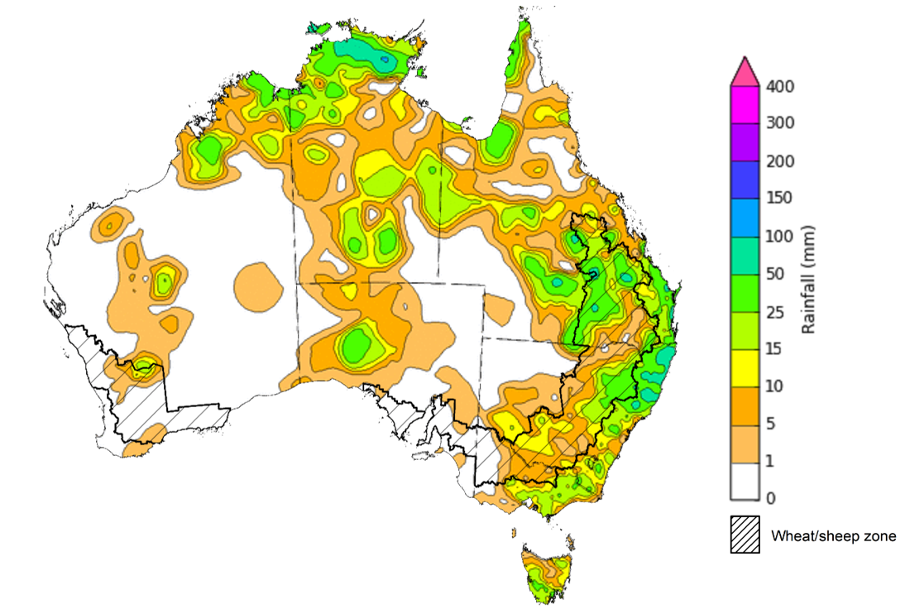

©Commonwealth of Australia 2021, Australian Bureau of Meteorology Issued: 8/12/2021
Note: The rainfall analyses and associated maps utilise data contained in the Bureau of Meteorology climate database, the Australian Data Archive for Meteorology (ADAM). The analyses are initially produced automatically from real-time data with limited quality control. They are intended to provide a general overview of rainfall across Australia as quickly as possible after the observations are received. For further information go to http://www.bom.gov.au/climate/rainfall/

Pasture growth
Pasture growth during the September to November period is typically low across large areas of central Australia as it is the end of the dry season. Across southern Australia, September to November is the peak pasture growth period which typical provides a bulk of feed and allow for fodder conservation to maintain production through the low pasture growth months of summer. It also influences the growth and branding and marking rates of lambs and calves, and the production of meat, milk, and wool over this peak production period.
For the 3 months to November 2021, above average rainfall totals and mild temperatures resulted in average to well above average pasture production for this time of year across most grazing regions.
Modelled pasture growth was average to extremely high across much of New South Wales, Victoria, Queensland, South Australia and parts of Western Australia. This growth is likely to enable farmers to continue to rebuild stock numbers and provide opportunities to replenish fodder supplies during spring. In contrast, modelled pasture growth was extremely low to below average across scattered areas of southern New South Wales and south-western Western Australia.
Across parts of western Victoria and the east of South Australia, improved climatic conditions during spring has resulted in generally average pasture growth. As a result, livestock producers in western Victoria and eastern South Australia have likely been able to build up some fodder reserves and maintain current stocking rates following a difficult winter period. Meanwhile, below average modelled pasture grow rates across parts of Western Australia comes after extremely high pasture growth during winter which has resulted in average to above average pasture availability for this time of year.

Relative pasture growth for 3-months ending November 2021 (1 September to 30 November 2021)
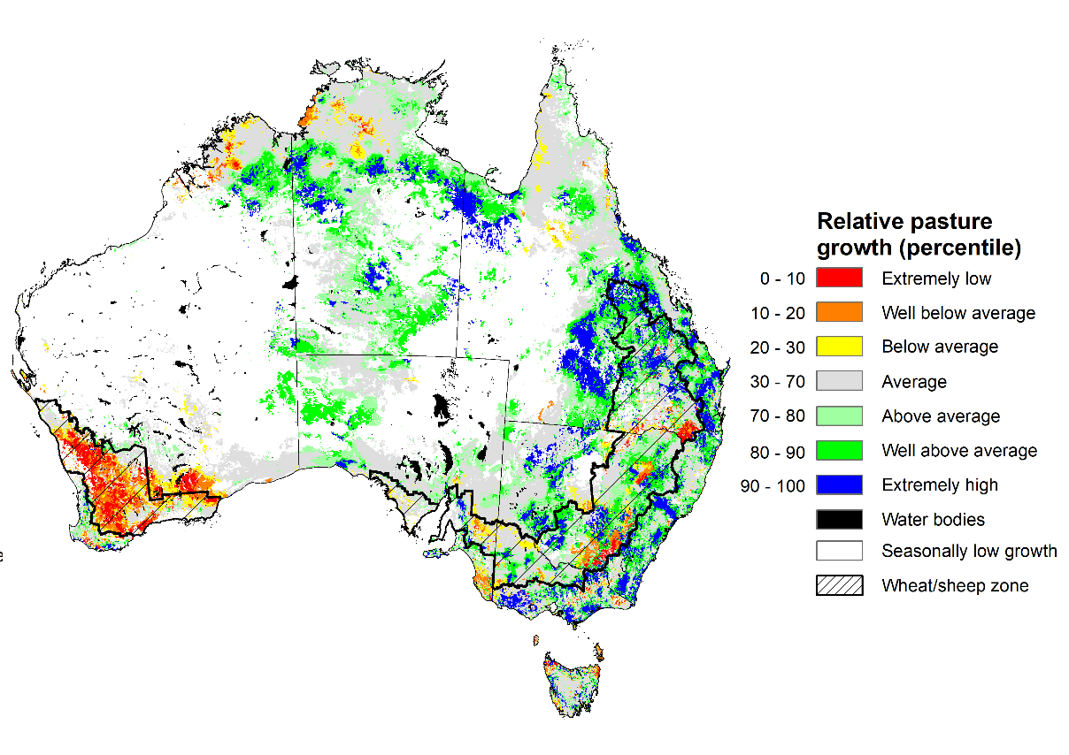
Notes: AussieGRASS pasture growth estimates are relative to the long-term record and shown in percentiles. Percentiles rank data on a scale of zero to 100. This analysis ranks pasture growth for the selected period against average pasture growth for the long-term record (1957 to 2016). Pasture growth is modelled at 5km2 grid cells.
Source: Queensland Department of Science, Information Technology and Innovation

Climate Drivers
Throughout summer the climate drivers with the largest potential impact on Australia’s climate patterns are the El Niño–Southern Oscillation (ENSO), the Southern Annular Mode (SAM) and the Madden-Julian Oscillation (MJO). These climate drivers are likely to influence the growth and development of summer crops in northern growing regions and pasture growth across northern Australia with the onset of the northern wet season.
ENSO indicators suggest that La Niña is currently active in the tropical Pacific. La Niña events are associated with above-average rainfall for northern and eastern Australia during spring and summer. International climate models expect the La Niña event will be short-lived. For 2021-22 to be considered a La Niña year, the event must remain active for at least three months. Nevertheless, the presence of La Niña atmospheric and oceanic patterns is likely to influence rainfall patterns in northern and eastern Australia over the coming months.
The SAM continues to be positive. During summer, a positive SAM is associated with above average rainfall for eastern parts of Australia at this time of year, as well as below average rainfall for south-westerly exposed coastal areas. The MJO is also expected to influence rainfall patterns in Australia over the coming weeks, increasing the likelihood of above average rainfall across northern Australia, as well as accelerating the onset of the northern monsoon. Meanwhile, the Indian Ocean Dipole has returned to within the neutral range and is expected to dissipate further, however, residual atmospheric and oceanic patterns are likely to still influence rainfall patterns in Australia in the short-term.
Below average sea surface temperature (SST) anomalies increased in the eastern tropical Pacific Ocean over the past two weeks, moving the NINO3.4 index into La Niña values. SST in the equatorial Pacific are expected to cool further. Current SST anomalies reflect typical La Niña patterns, with below average SST along the equator, and warm SST anomalies to the north and south. Despite the easing of negative IOD conditions, warm SST anomalies persist to the north-west of Australia.

Difference from average sea surface temperature observations 29 November to 5 December 2021
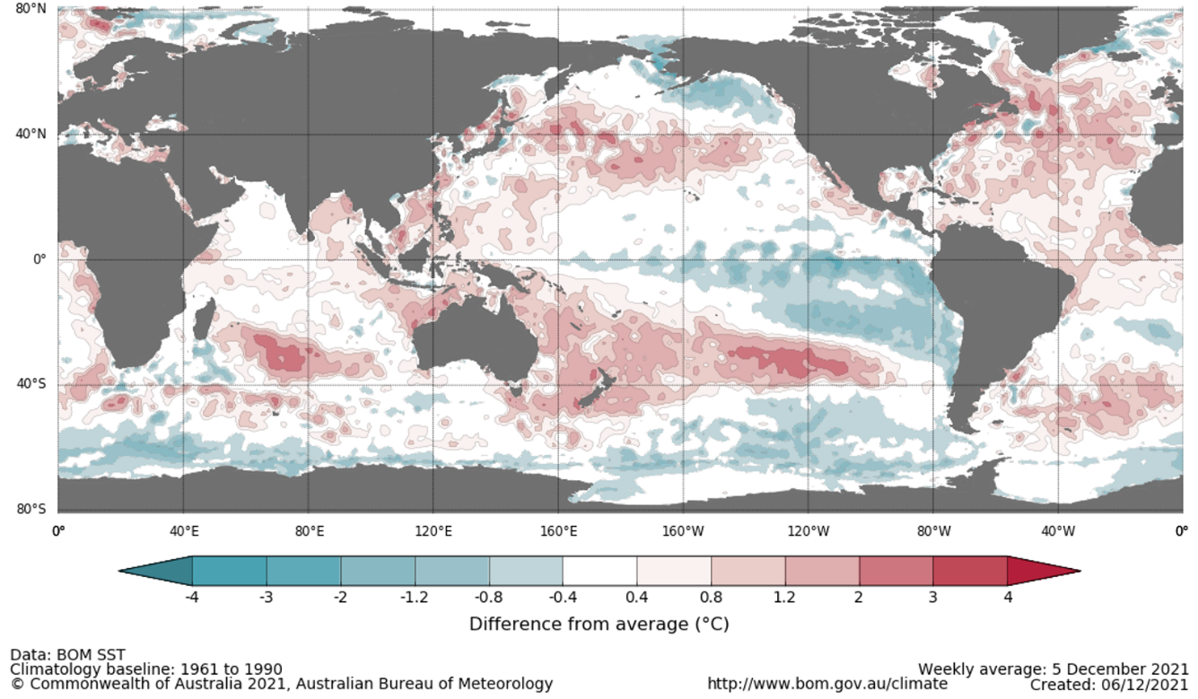

International climate model outlooks for the NINO 3.4 region in January 2022
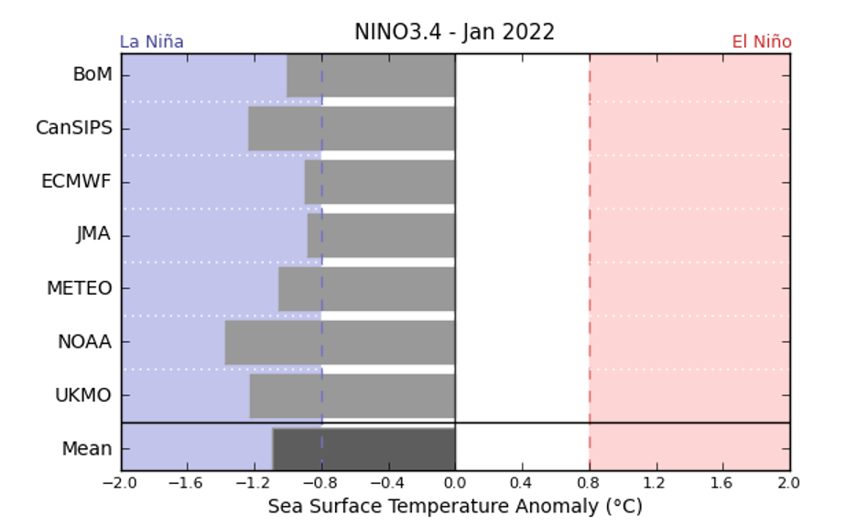
©Commonwealth of Australia 2021, Australian Bureau of Meteorology Issued: 12/10/2021
A La Niña event has become firmly established in the Pacific Ocean. All climate models surveyed by the Bureau of Meteorology expect the La Niña event to continue into January. However, six of the seven models expect it to dissipate by March 2022. For the period ending 5 December 2021, the 30-day SOI was +13.8 and the 90-SOI was +9.9, both above the La Niña threshold of +7. Above average SST anomalies have continued across parts of the Maritime Continent and northern Australia. A slight strengthening of trade winds across parts of the central and western Pacific, while cloudiness near the Date Line has been consistently below average. All indications consistent with the establishment of a La Niña event.

30-day Southern Oscillation Index (SOI) values ending 6 December 2021
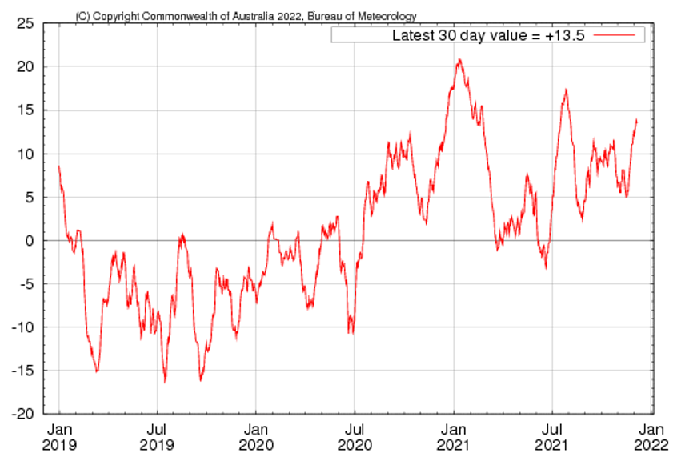

The Southern Annular Mode (SAM) is strongly positive and expected to weaken slightly over the coming weeks but remain positive. The SAM refers to the north-south shift of the band of rain-bearing westerly winds and weather systems in the Southern Ocean compared to the usual position.

Southern Annular Mode (SAM) daily index

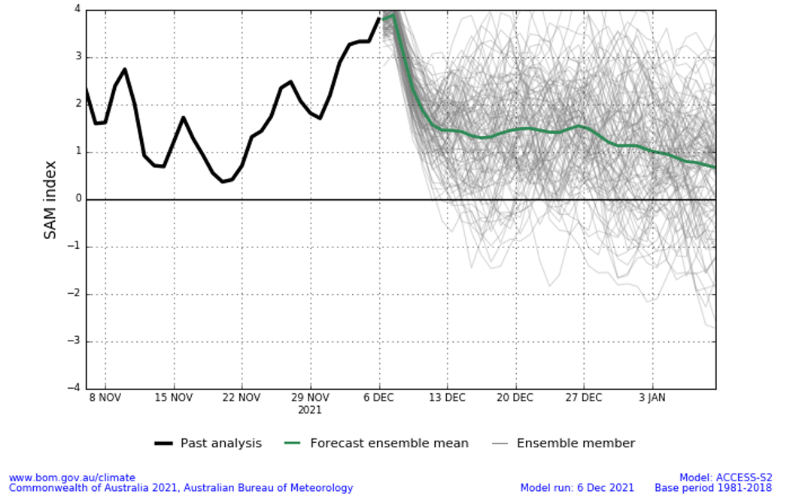
As at 6 December 2021 the Madden–Julian Oscillation (MJO) was strengthening and moving into the western Pacific Ocean. The MJO is a pulse of cloud and rainfall that moves eastward along the equator and increases the chance of above average cloudiness and rainfall across northern Australia.
Madden–Julian Oscillation (MJO) daily index
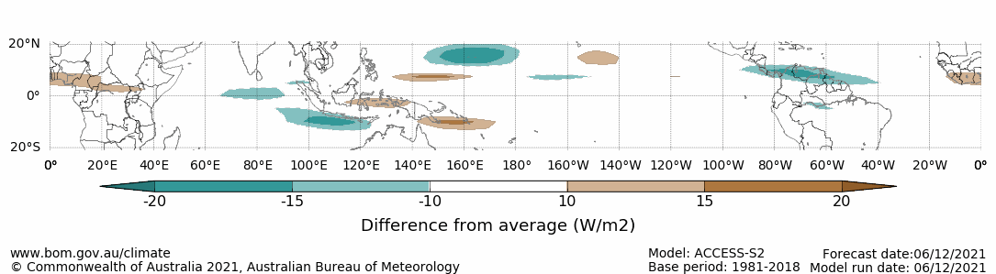
Note: This map displays the forecast outgoing longwave radiation (OLR) difference from expected cloudiness to identify convective rain clouds and the position of the Madden–Julian Oscillation (MJO). The blue shading indicates higher than normal, active or enhanced tropical weather and the brown shading indicates lower than normal clouds or suppressed conditions.

National Climate Outlook
These climate outlooks are generated by ACCESS–S (Australian Community Climate Earth-System Simulator–Seasonal). ACCESS–S is the Bureau of Meteorology's dynamical (physics-based) weather and climate model used for monthly, seasonal and longer-lead climate outlooks.
For further information, go to http://www.bom.gov.au/climate/ahead/about/
The Bureau of Meteorology’s latest rainfall outlook indicated wetter than average conditions are expected across eastern parts of Australia during January. The ACCESS-S climate model suggests there is close to a 60% chance of exceeding median January rainfall totals across much of eastern Australia.
The outlook for January 2022 indicates that there is a 75% chance of rainfall totals between 10 and 100 millimetres across most of New South Wales, Queensland, Victoria, the Northern Territory and the north of Western Australia. Rainfall totals in excess of 100 millimetres are expected in parts of north-eastern New South Wales, south-east and northern Queensland, the north of the Northern Territory and Western Australia, and western Tasmania.
Across cropping regions there is a 75% chance of rainfall totals of between 10 and 100 millimetres across New South Wales, Queensland, Victoria and parts of South Australia. There is a 75% chance of rainfall less than 10 millimetres for most of Western Australia and western areas of South Australia. The wetter than average conditions expected for most eastern Australian cropping regions is likely to support the growth and development of early-planted summer crops, as well as the establishment of late-planted summer crops in New South Wales and Queensland.
Rainfall totals that have a 75% chance of occurring January 2022
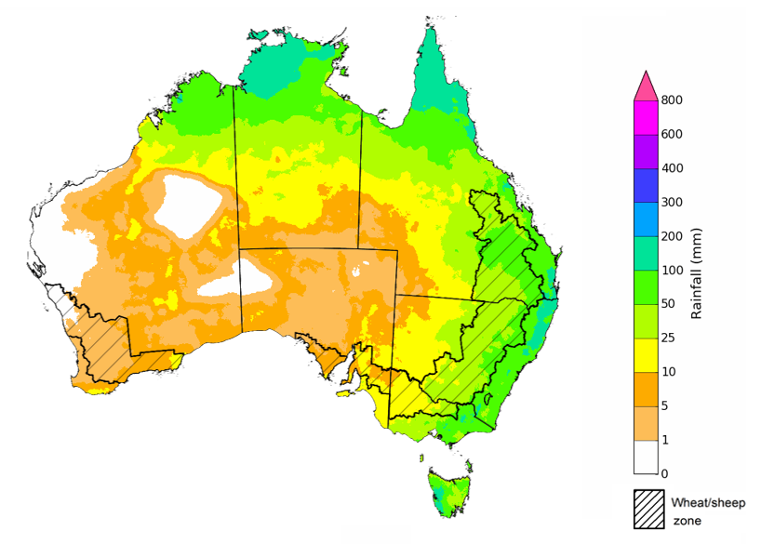
©Commonwealth of Australia 2021, Australian Bureau of Meteorology Issued: 2/12/2021

The rainfall outlook for January to March 2022 suggests there is a greater than 60% chance of exceeding median rainfall across much of New South Wales, Queensland, Victoria, the Northern Territory and eastern Tasmania. For remaining regions of Australia, there is roughly an equal chance of above and below median rainfall, with only isolates areas of central Western Australia expecting to receive below average rainfall between January to March 2022 (Bureau of Meteorology ‘National Climate Outlook’, 2 December 2021).
Bureau of Meteorology rainfall outlooks for January to March have greater than 55% past accuracy across most of Australia. Outlook accuracy is greater than 65% across isolated parts of the country. However, there is low past accuracy for parts of north-eastern and south-eastern New South Wales, western Queensland, the west of South Australia, the north-east of Western Australia, as well as central and northern parts of the Northern Territory.
Chance of exceeding the median rainfall January to March 2022
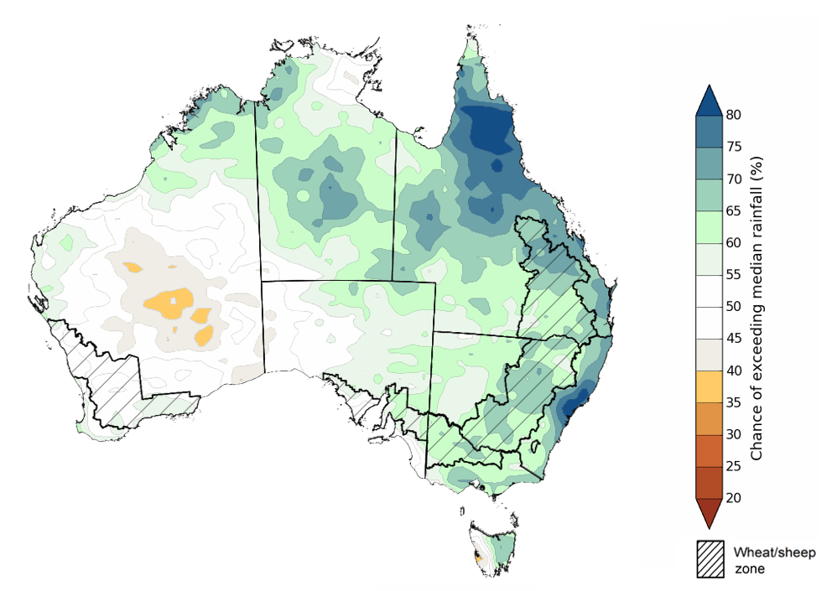
©Commonwealth of Australia 2021, Australian Bureau of Meteorology Issued: 2/12/2021

The outlook for January to March 2022 suggests there is a 75% chance of rainfall totals between 50 and 300 millimetres across much of New South Wales, Queensland, southern Victoria, northern Western Australia, the Northern Territory and Tasmania. Rainfall totals in excess of 200 millimetres are forecast for eastern New South Wales and Queensland, as well as northern parts of Queensland, Western Australia and the Northern Territory.
Across cropping regions, there is a 75% chance of receiving between 50 and 200 millimetres across much of New South Wales, Queensland and eastern Victoria. Rainfall totals in excess of 200 millimetres are forecast for northern cropping regions in Queensland. Totals of less than 50 millimetres are expected across remaining cropping regions in Victoria, and South Australia and Western Australia.
These rainfall totals are slightly below average to average for this three-month period across most New South Wales and Queensland cropping regions, and slightly below average for cropping regions in Victoria, South Australia and Western Australia. The wet finish to the 2021 winter cropping season may push harvesting activities into January 2022, which will be supported by the prospect of below average rainfall. Likewise, planting of summer crops in parts of New South Wales and Queensland may be delayed until January. Soil moisture levels across northern cropping regions are well above average due to the substantial rainfall in November and early December. As a consequence, below average rainfall in January is unlikely to negatively impact summer crop growth.
Rainfall totals that have a 75% chance of occurring January to March 2022

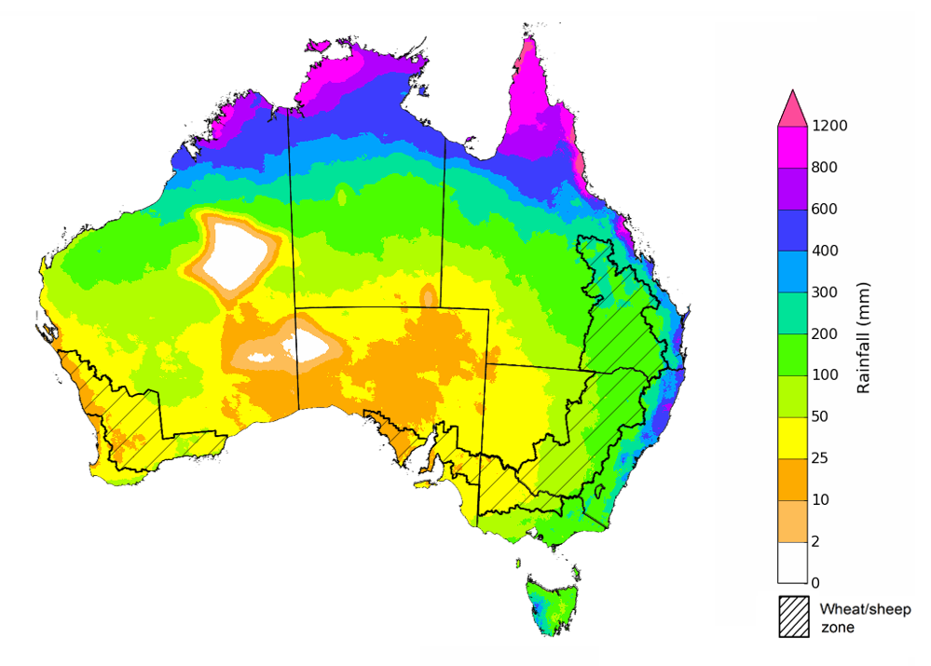
©Commonwealth of Australia 2021, Australian Bureau of Meteorology Issued: 2/12/2021
The temperature outlook for January to March 2022 indicates that maximum temperatures across most of Australia are likely to be close to the 1990-2012 average (- 1°C to 1°C), with isolated patches of above average maximum temperatures in Victoria, South Australia, Western Australia and Tasmania. Minimum temperatures are expected to be slightly above average for parts of western New South Wales, south-west Queensland, north-western Victoria and the east of South Australia, and close to average for the rest of Australia (Bureau of Meteorology ‘National Climate Outlook’, 2 December 2021).
Predicted maximum temperature anomaly for January to March 2022

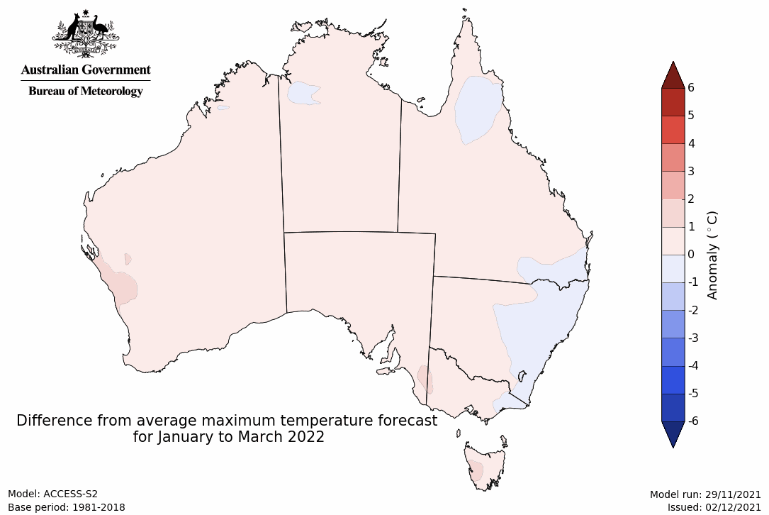
Predicted minimum temperature anomaly for January to March 2022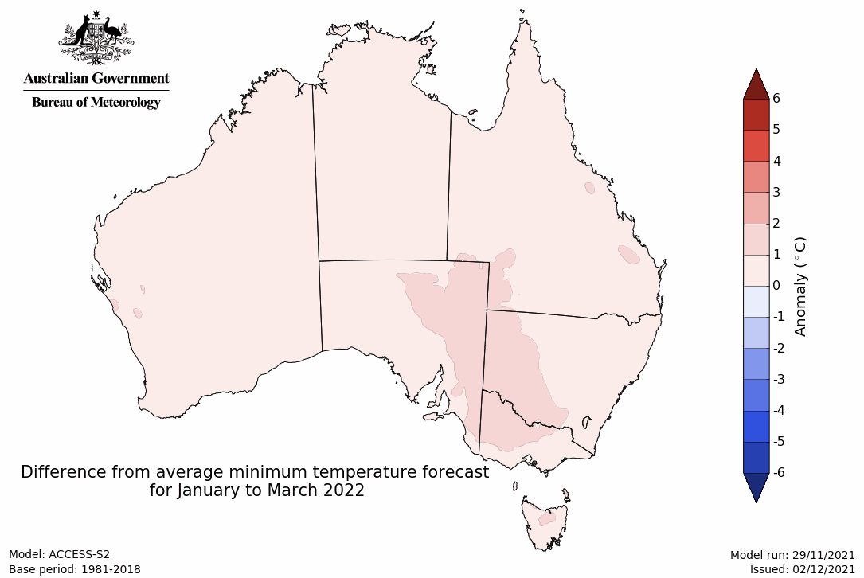

Rainfall forecast for the next eight days
Over the 8-days to 16 December 2021, low-pressure systems across northern and eastern Australia are expected to bring rainfall across northern Australia, as well as coastal areas in eastern Australia. Meanwhile, high-pressure systems over the Great Australian Bight will bring clear, dry conditions to much of the remainder of Australia over the next 8-days.
Rainfall totals of between 10 and 50 millimetres are forecast for eastern parts of New South Wales, Queensland and Victoria, as well as northern parts of Queensland, Western Australia and the Northern Territory and western Tasmania. Rainfall in excess of 50 millimetres is expected in parts of south-eastern New South Wales, far-eastern Victoria and northern Queensland.
In Australian cropping regions, rainfall totals of between 10 and 50 millimetres are expected across isolated parts of eastern New South Wales, Queensland and Victoria. Little to no rainfall is forecast for remaining cropping regions of New South Wales and Victoria, as well as cropping regions of Queensland, South Australia and Western Australia during the next 8-days.
The dry conditions expected across New South Wales cropping regions will allow flooding to subside in effected areas and saturated soil profiles to drain. If the dry conditions persist, harvesting activities of winter crops will be able to resume over the coming weeks. Planting activities for summer crops will also be able to resume if dry conditions continue, as well as allowing farmers to apply post-emergence fertiliser and pest management programs. For Victoria, South Australia and Western Australia, conditions remain conducive for harvesting to continue, with high grain quality expected.

Total forecast rainfall (mm) for the period 9 December to 16 December 2021
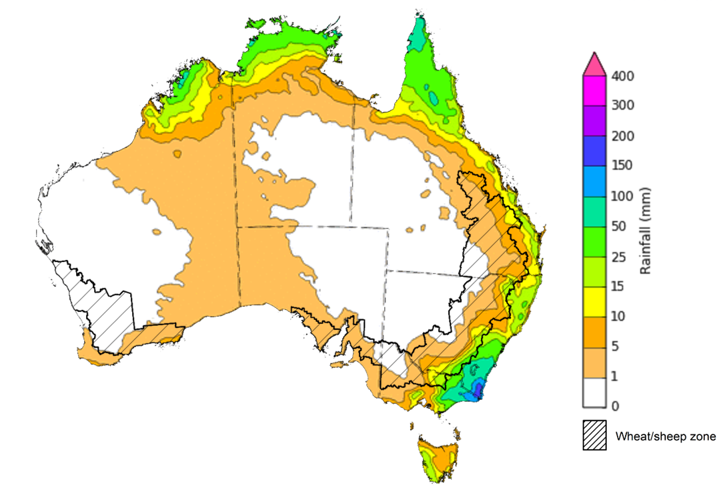
©Commonwealth of Australia 2021, Australian Bureau of Meteorology Issued: 8/12/2021

Water
Note: This rainfall forecast is produced from computer models. As the model outputs are not altered by weather forecasters, it is important to check local forecasts and warnings issued by the Bureau of Meteorology.

Water markets – current week
Water storage in the Murray–Darling Basin (MDB) decreased by 289 gigalitres (GL) between 1 December 2021 and 8 December 2021. The current volume of water held in storage is 22,462 GL, which represents 89% of total capacity. This is 49% or 7,367 GL more than at the same time last year.

Water storages in the Murray-Darling Basin, 2013–2021
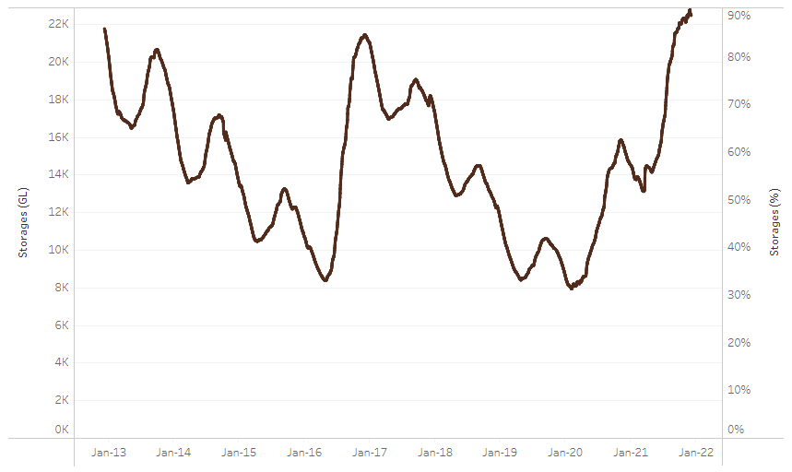
Allocation prices in the Victorian Murray below the Barmah Choke increased from $93 per ML on 26 November 2021 to $97 per ML on 3 December 2021. Prices are lower in the Goulburn-Broken, Murrumbidgee, and regions above the Barmah Choke due to the binding of the Goulburn intervalley trade limit, Murrumbidgee export limit, and Barmah Choke trade constraint.
Water storage data is sourced from the Bureau of Meteorology.

Region | $/ML
NSW Murray Above | 73
NSW Murrumbidgee | 76
VIC Goulburn-Broken | 77
VIC Murray Below | 97

Surface water trade activity, Southern Murray–Darling Basin

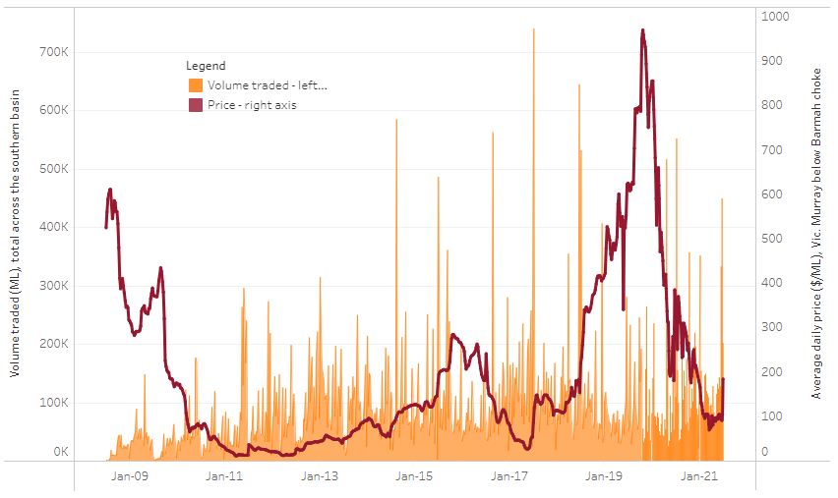
To access the full, interactive, weekly water dashboard, which contains the latest and historical water storage, water market and water allocation information, please visit http://www.agriculture.gov.au/abares/products/weekly_update/weekly-update-091221
The trades shown reflect estimated market activity and do not encompass all register trades. The price is shown for the VIC Murray below the Barmah choke. Historical prices (before 1 July 2019) are ABARES estimates after removing outliers from BOM water register data. Prices after 1 July 2019 and prior to the 30 October 2019 reflect recorded transaction prices as sourced from Ruralco. Prices after the 30 October 2019 are sourced from Waterflow. Data for volume traded is sourced from the BOM water register. Data shown is current at 9 December 2021.

Commodities
Indicator | Week ended | Unit | Latest price | Previous week | Weekly change | Price 12 months ago | Annual change
Selected world indicator prices
AUD/USD Exchange rate | 08-Dec | A$/US$ | 0.71 | 0.72 | -1% | 0.76 | -6%
Wheat – US no. 2 hard red winter wheat, fob Gulf | 08-Dec | US$/t | 379 | 390 | -3% | 269 | 41%
Corn – US no. 2 yellow corn, fob Gulf | 08-Dec | US$/t | 266 | 266 | 0% | 195 | 36%
Canola – Rapeseed, Canada, fob Vancouver | 08-Dec | US$/t | 865 | 871 | -1% | 528 | 64%
Cotton – Cotlook 'A' Index | 08-Dec | USc/lb | 118 | 126 | -6% | 82 | 43%
Sugar – Intercontinental Exchange, nearby futures, no.11 contract | 08-Dec | USc/lb | 18.5 | 19.0 | -3% | 14 | 29%
Wool – Eastern Market Indicator | 08-Dec | Ac/kg clean | 1,360 | 1,346 | 1% | 1,117 | 22%
Wool – Western Market Indicator | 08-Dec | Ac/kg clean | 1,417 | 1,405 | 1% | 922 | 54%
Selected Australian grain export prices
Milling Wheat – APW, Port Adelaide, SA | 08-Dec | A$/t | 503 | 504 | 0% | 334 | 51%
Feed Wheat – ASW, Port Adelaide, SA | 08-Dec | A$/t | 444 | 456 | -3% | 330 | 34%
Feed Barley – Port Adelaide, SA | 08-Dec | A$/t | 392 | 392 | 0% | 272 | 44%
Canola – Kwinana, WA | 08-Dec | A$/t | 983 | 1,027 | -4% | 661 | 49%
Grain Sorghum – Brisbane, QLD | 08-Dec | A$/t | 368 | 376 | -2% | 368 | 0%
Selected domestic livestock indicator prices
Beef – Eastern Young Cattle Indicator | 08-Dec | Ac/kg cwt | 1,114 | 1,107 | 1% | 811 | 37%
Mutton – Mutton indicator (18–24 kg fat score 2–3), Vic | 08-Dec | Ac/kg cwt | 641 | 650 | -1% | 637 | 1%
Lamb – Eastern States Trade Lamb Indicator | 08-Dec | Ac/kg cwt | 851 | 844 | 1% | 761 | 12%
Pig – Eastern Seaboard (60.1–75 kg), average of buyers & sellers | 24-Nov | Ac/kg cwt | 357 | 338 | 6% | 309 | 16%
Goats – Eastern States (12.1–16 kg) | 08-Dec | Ac/kg cwt | 879 | 877 | 0% | 818 | 8%
Live cattle – Light steers ex Darwin to Indonesia | 17-Feb | Ac/kg lwt | 355 | 355 | 0% | 360 | -1%
Live sheep – Live wethers (Muchea WA saleyard) to Middle East | 22-Sep | $/head | 147 | 171 | -14% | 126 | 17%

Indicator | Week ended | Unit | Latest price | Previous week | Weekly change | Price 12 months ago | Annual change
Global Dairy Trade (GDT) weighted average prices ª
Dairy – Whole milk powder | 01-Dec | US$/t | 3,987 | 3,987 | 0% | 3,133 | 27%
Dairy – Skim milk powder | 01-Dec | US$/t | 3,676 | 3,676 | 0% | 2,743 | 34%
Dairy – Cheddar cheese | 01-Dec | US$/t | 5,162 | 5,162 | 0% | 3,609 | 43%
Dairy – Anhydrous milk fat | 01-Dec | US$/t | 6,472 | 6,472 | 0% | 5,191 | 25%
a Global Dairy Trade prices are updated twice monthly on the first and third Tuesday of each month.

Selected world indicator prices
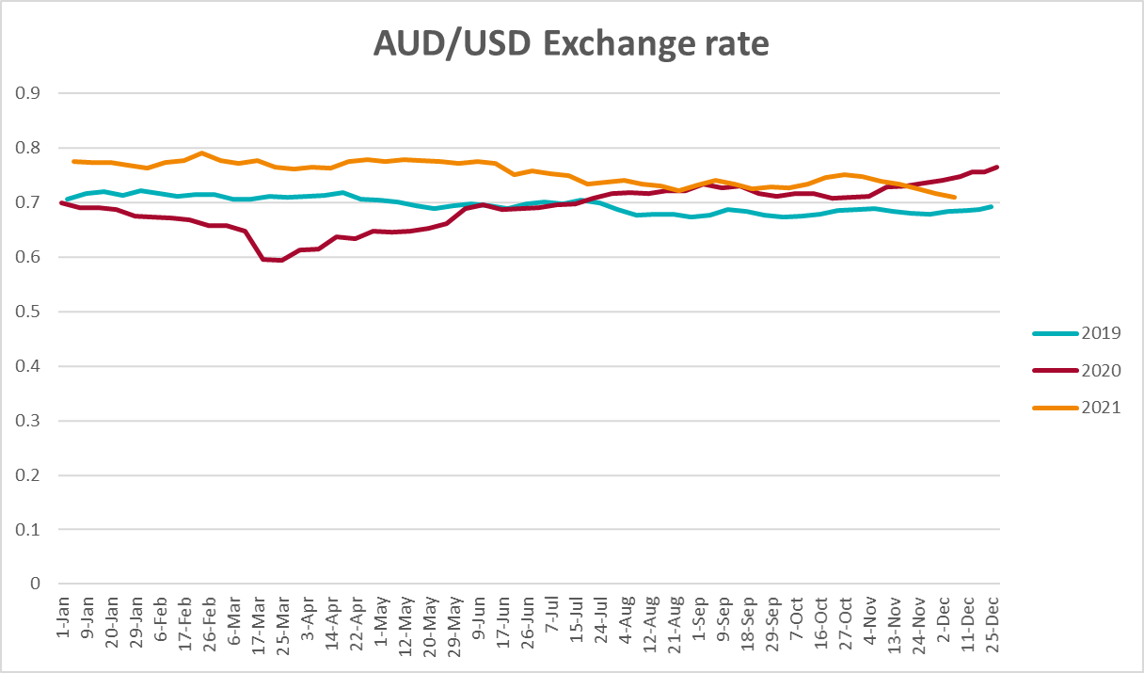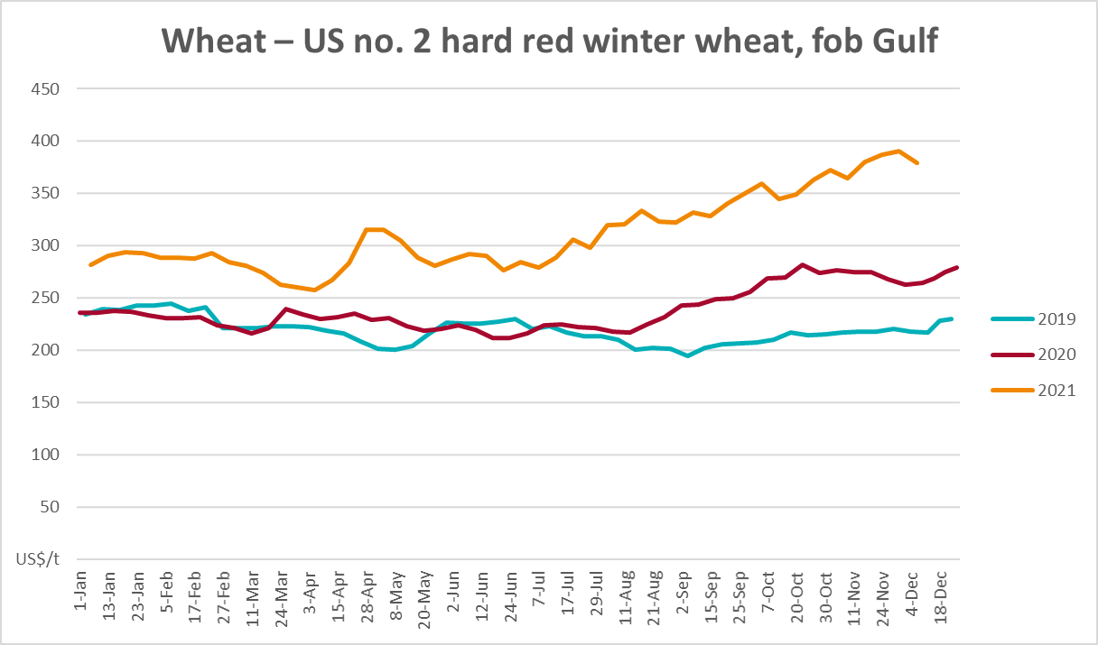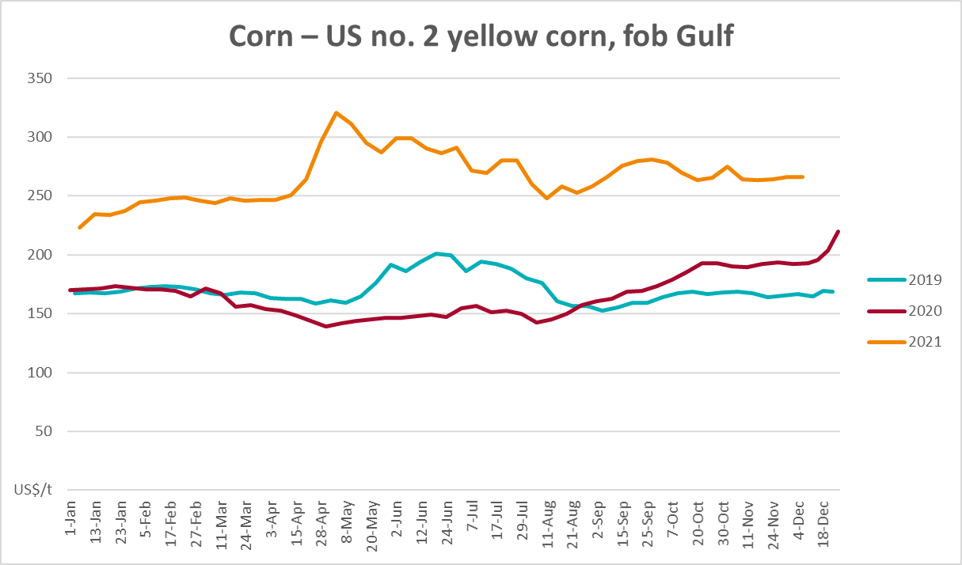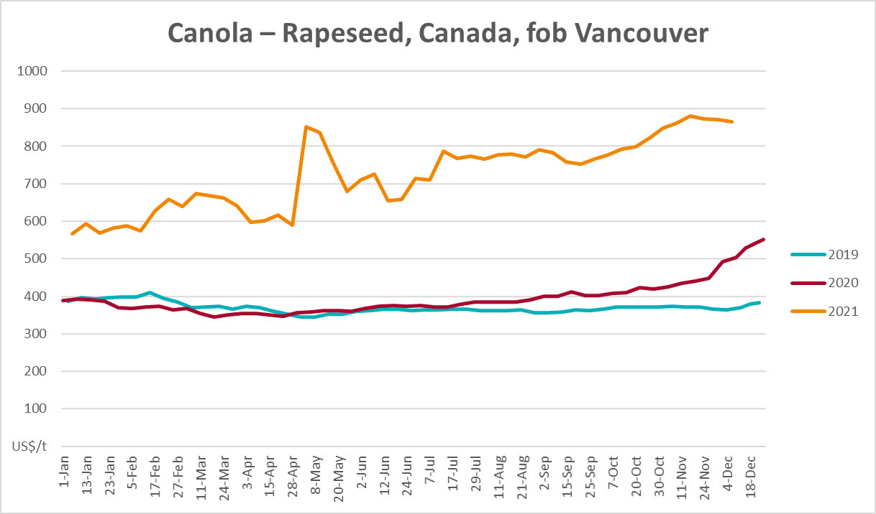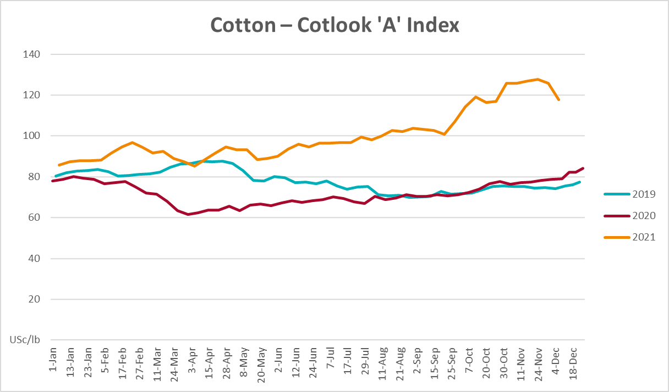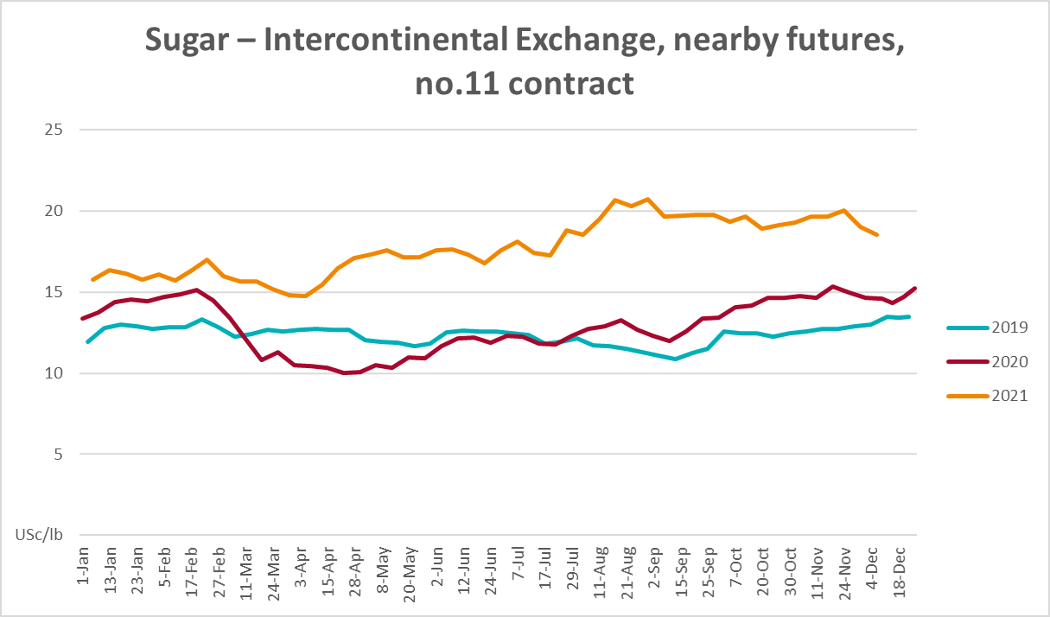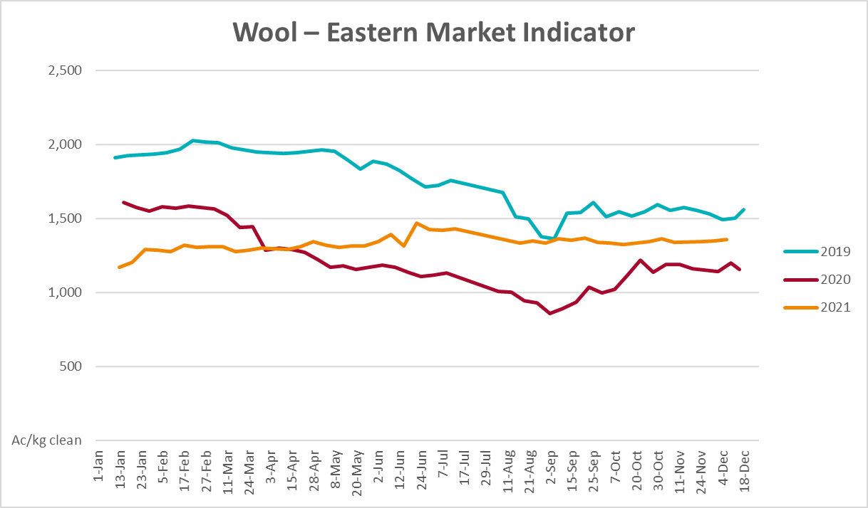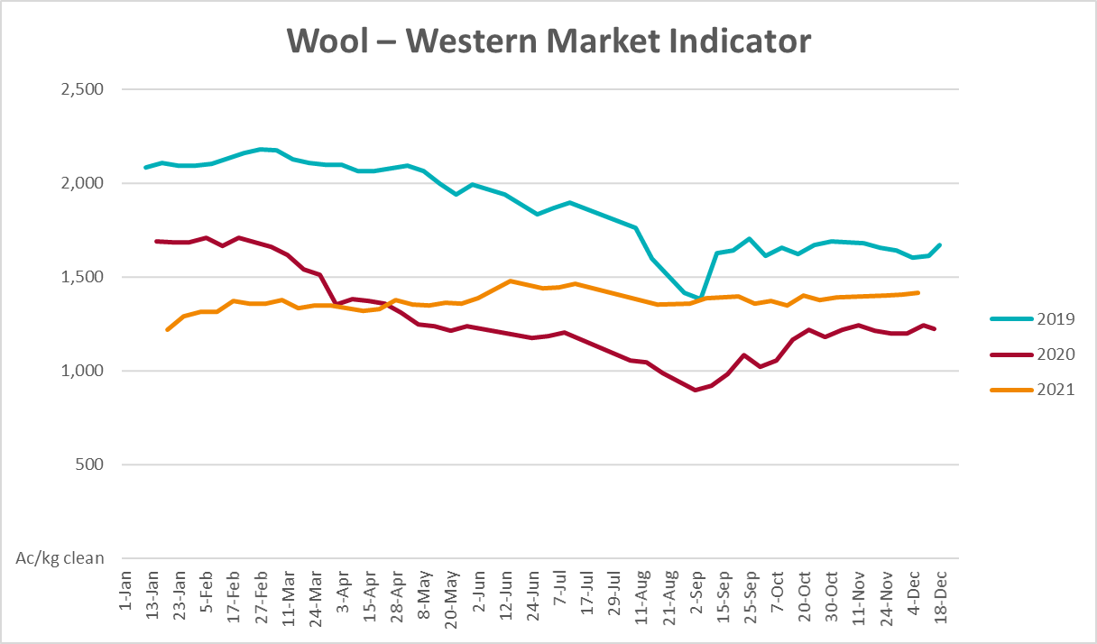

Selected domestic crop indicator prices
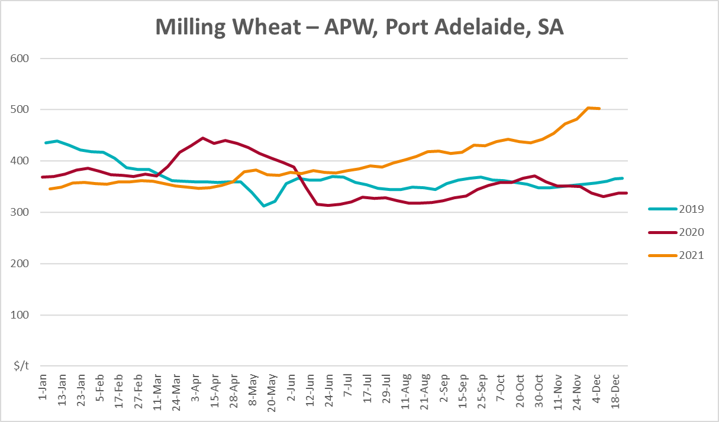
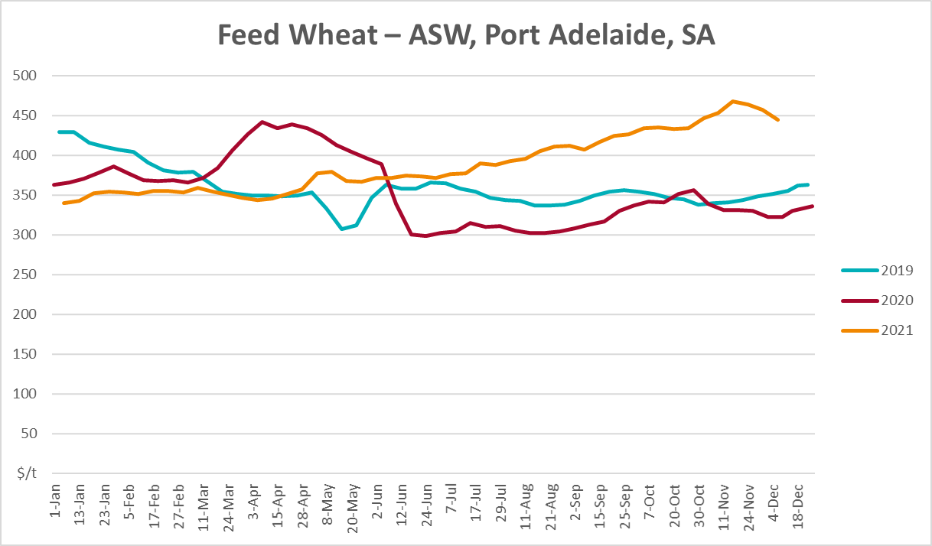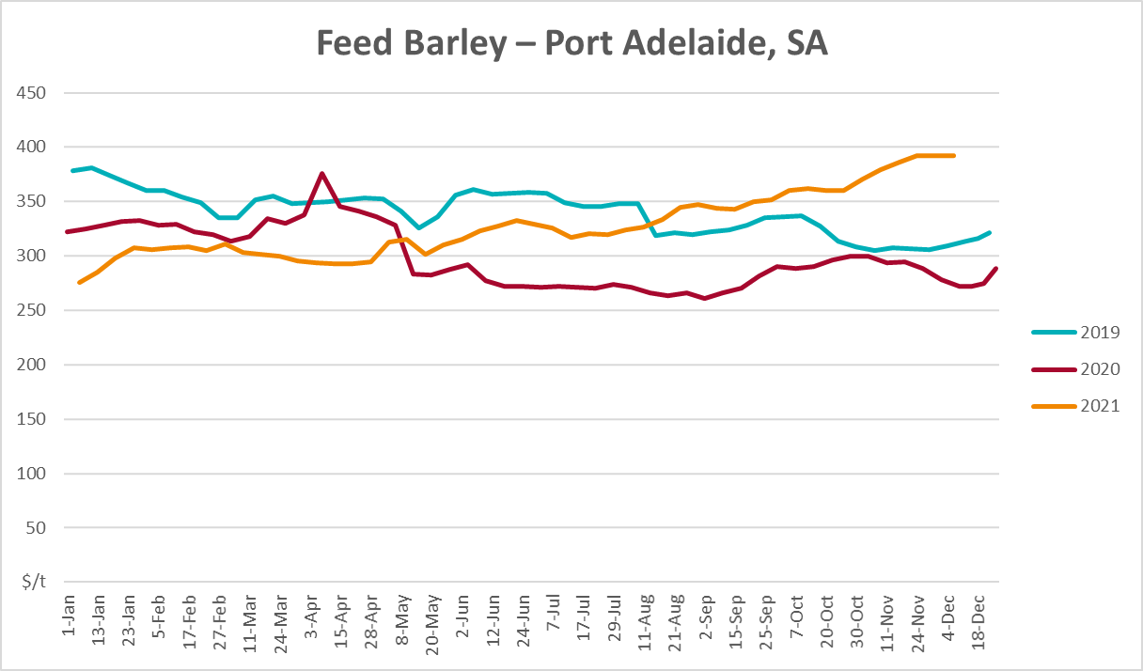
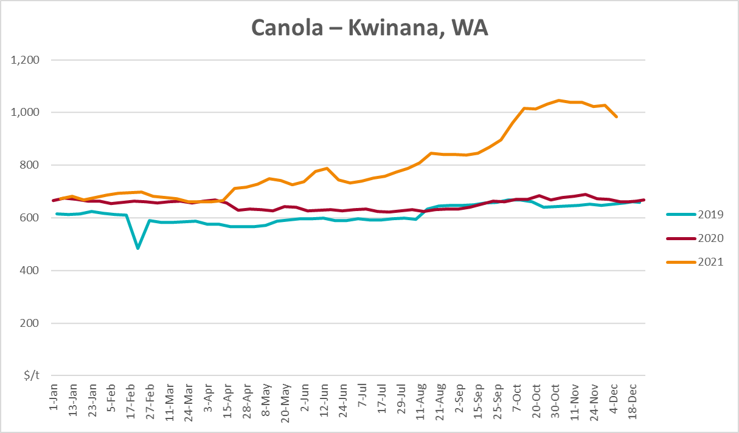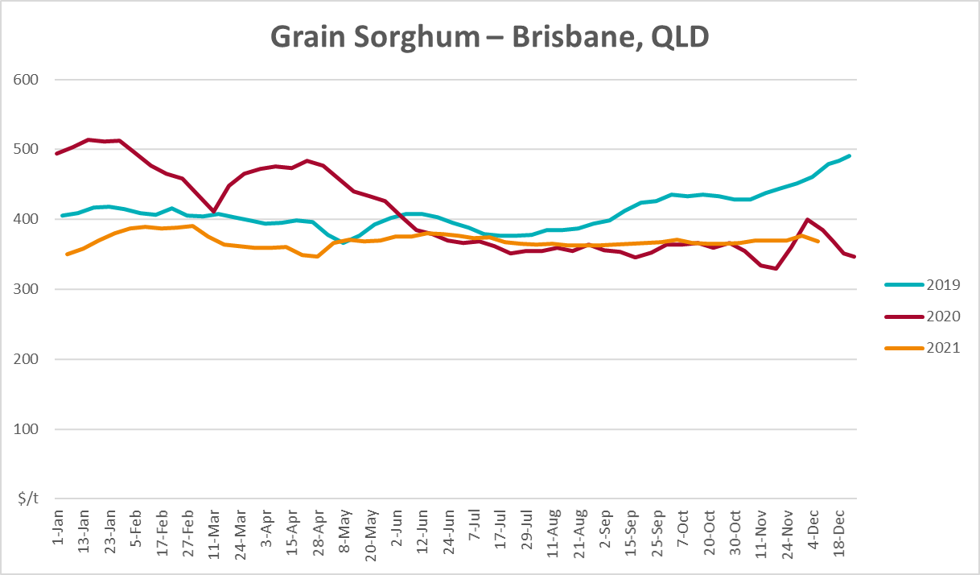

Selected domestic livestock indicator prices
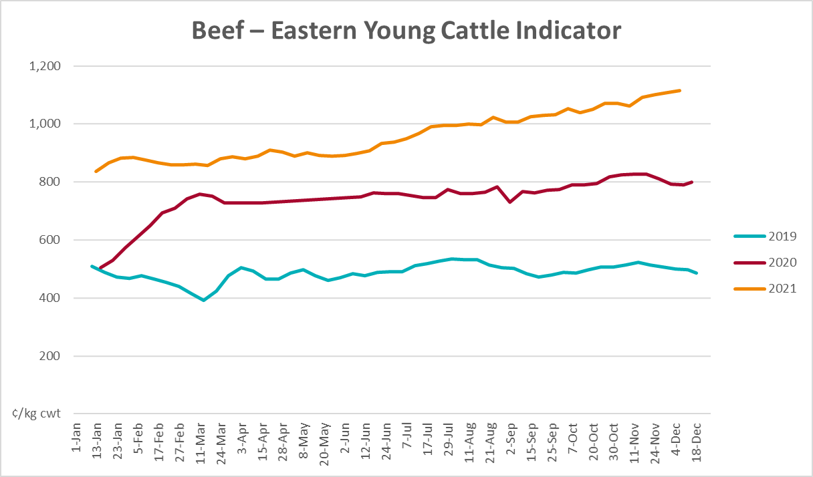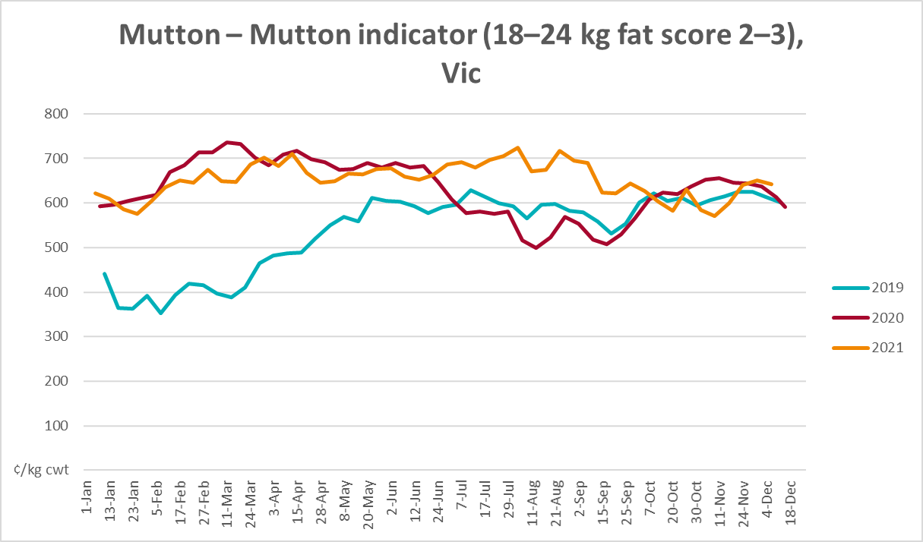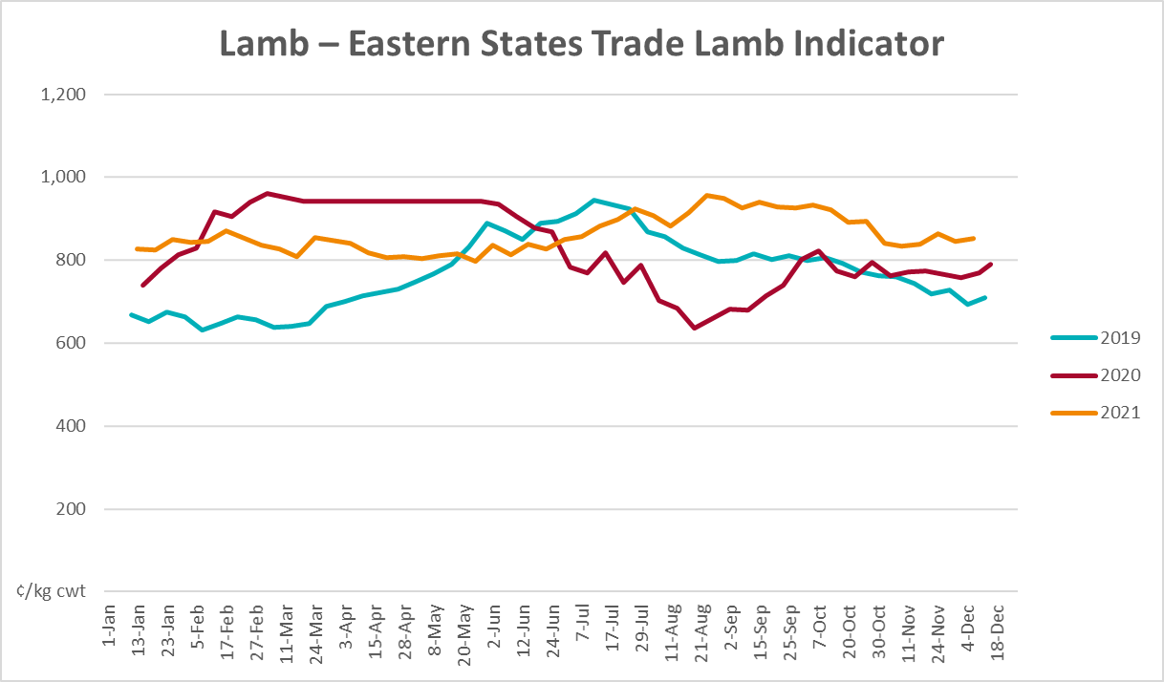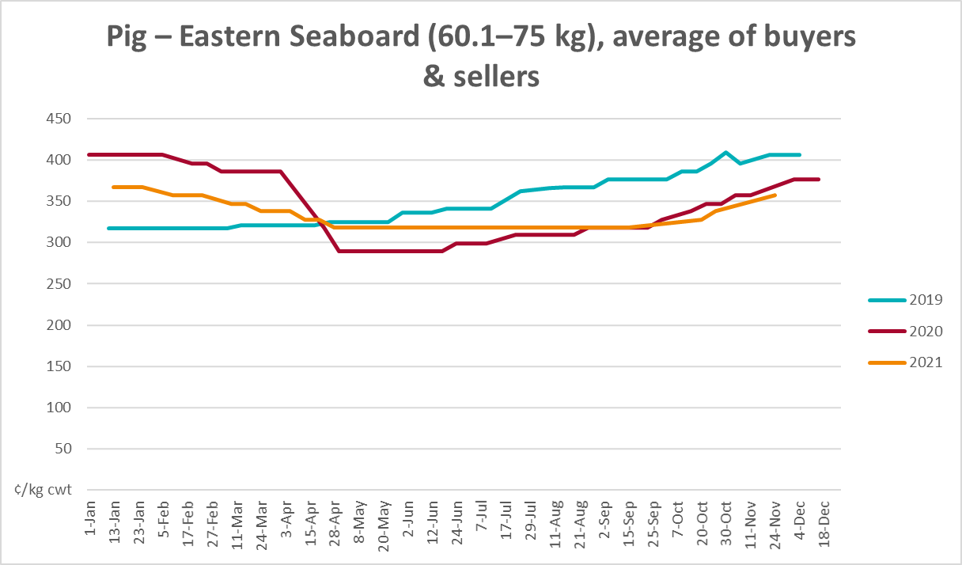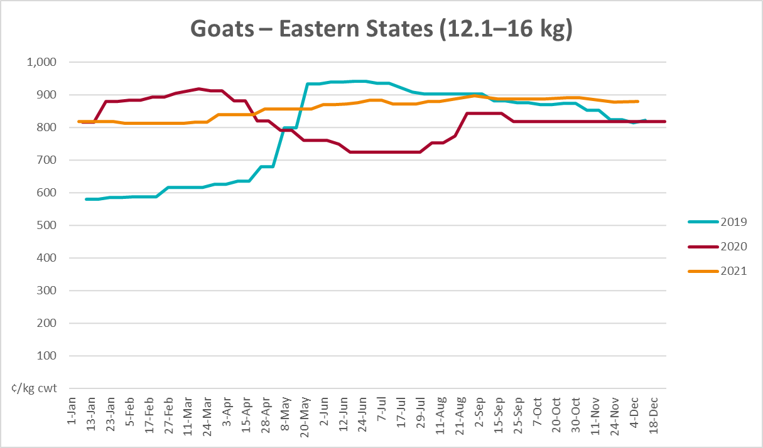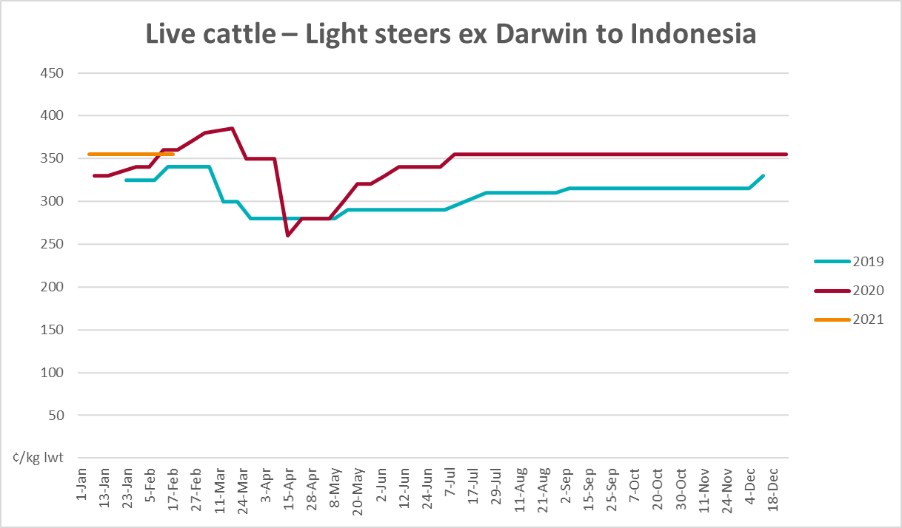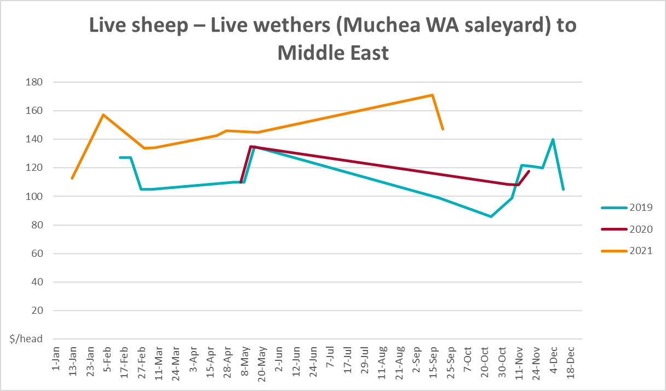

Global Dairy Trade (GDT) weighted average prices
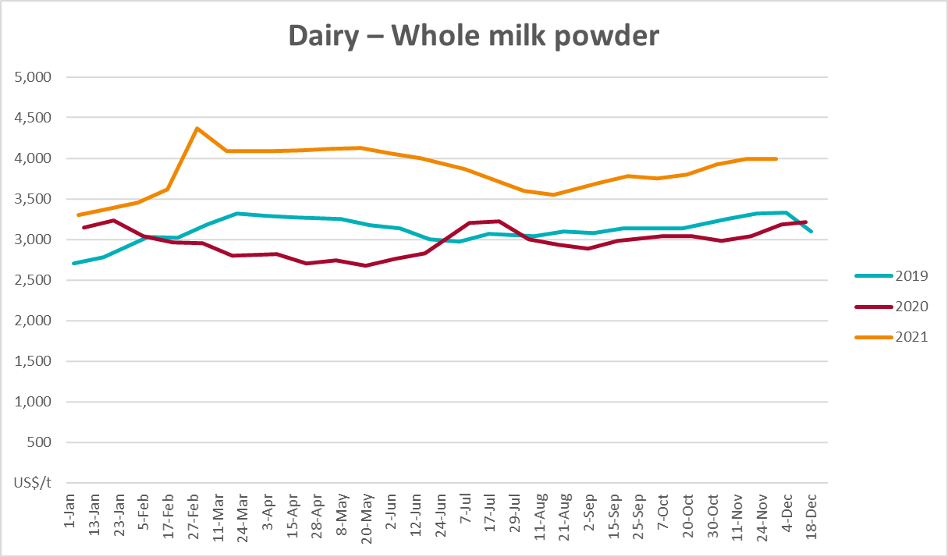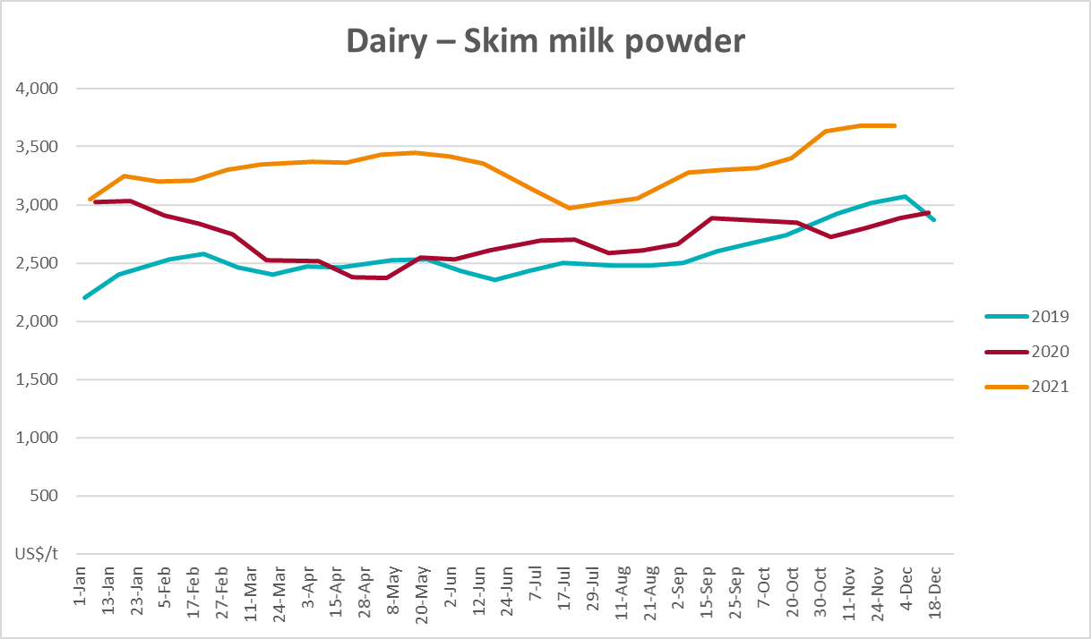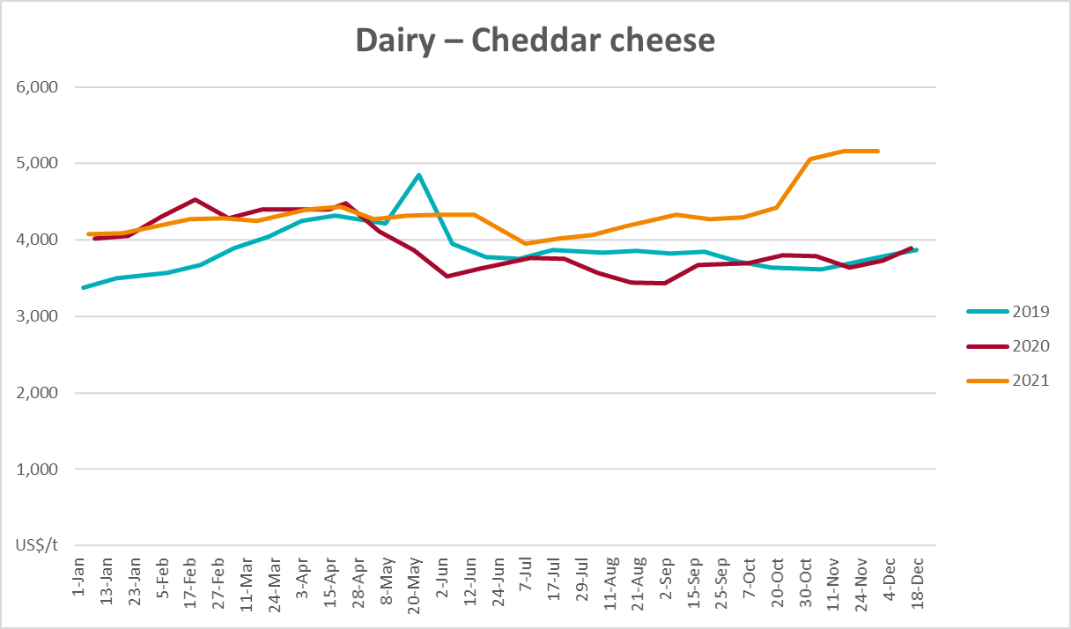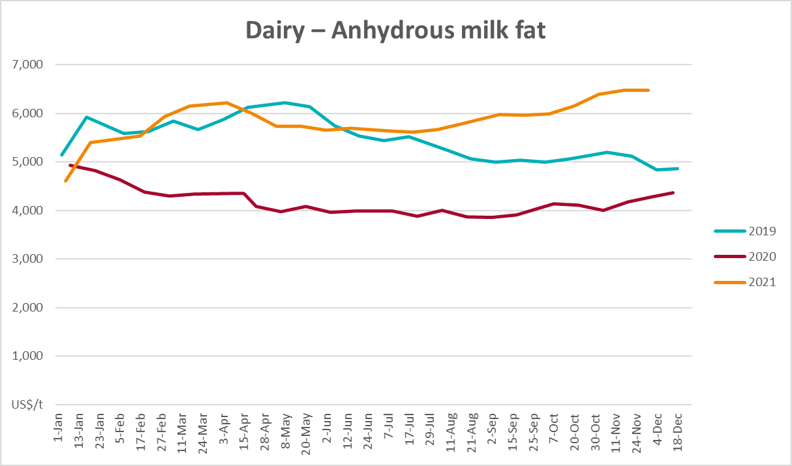

Selected fruit and vegetable prices
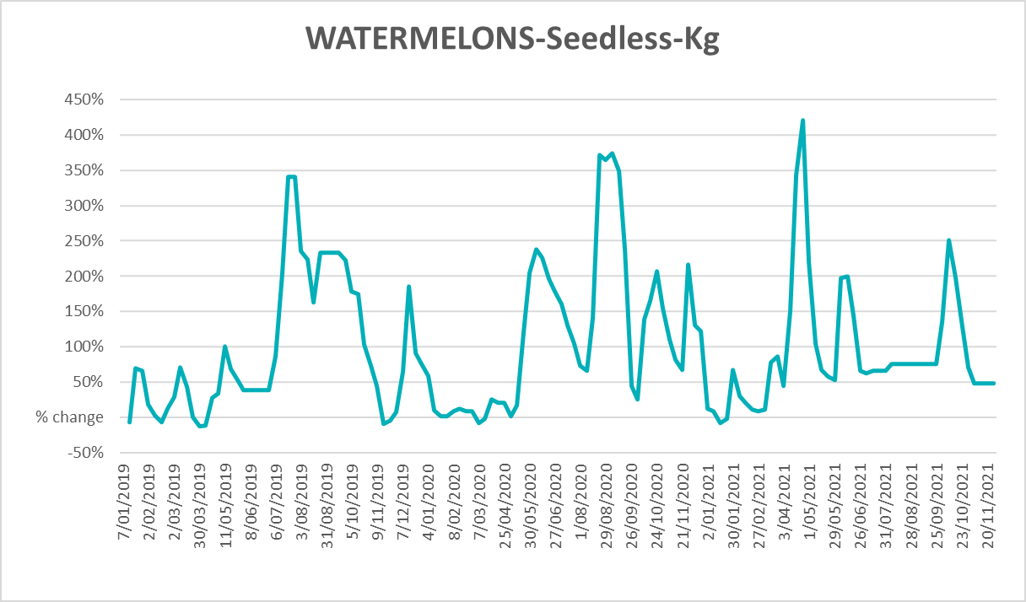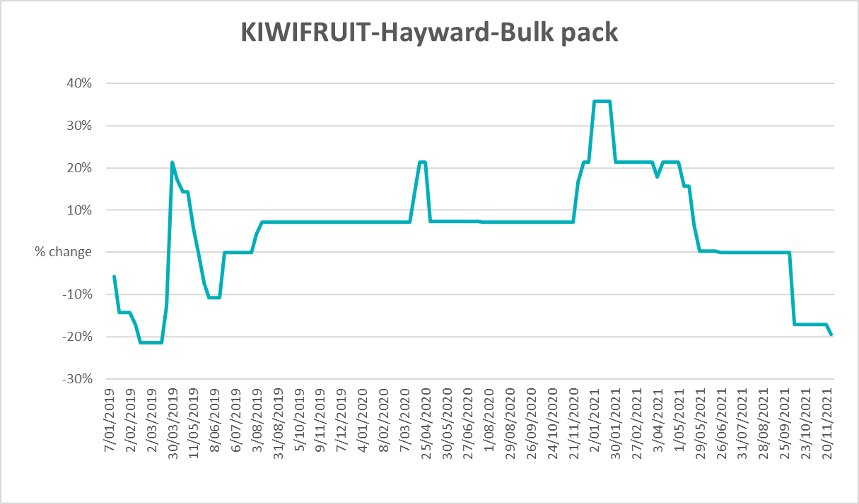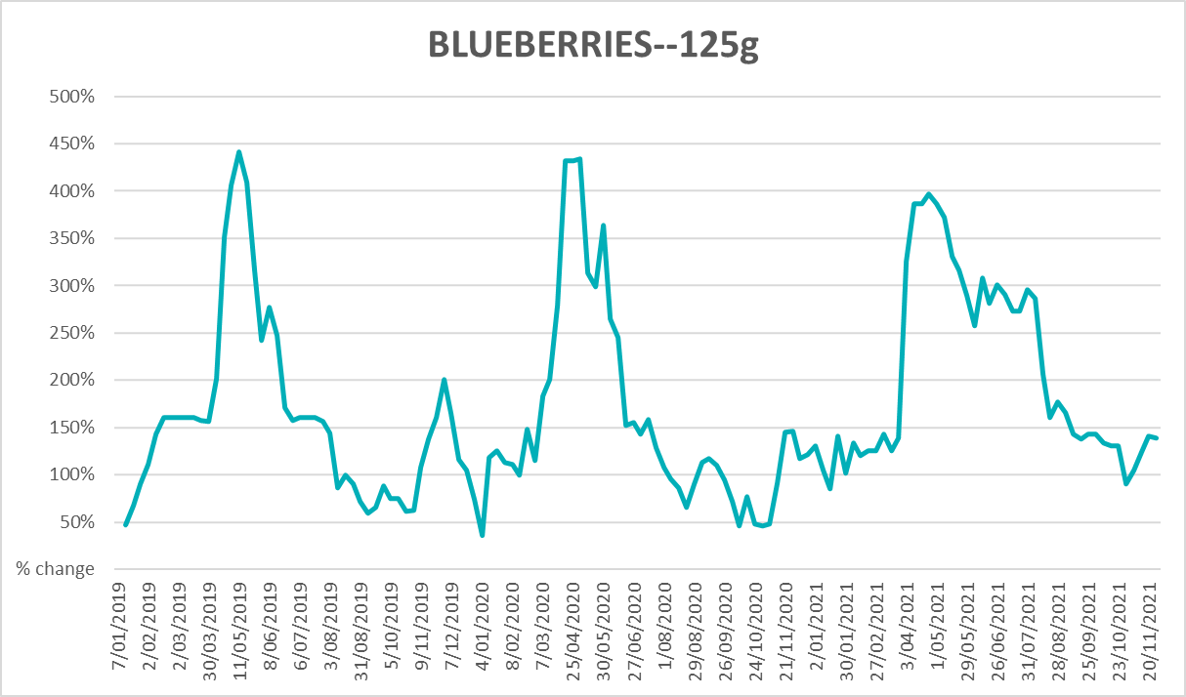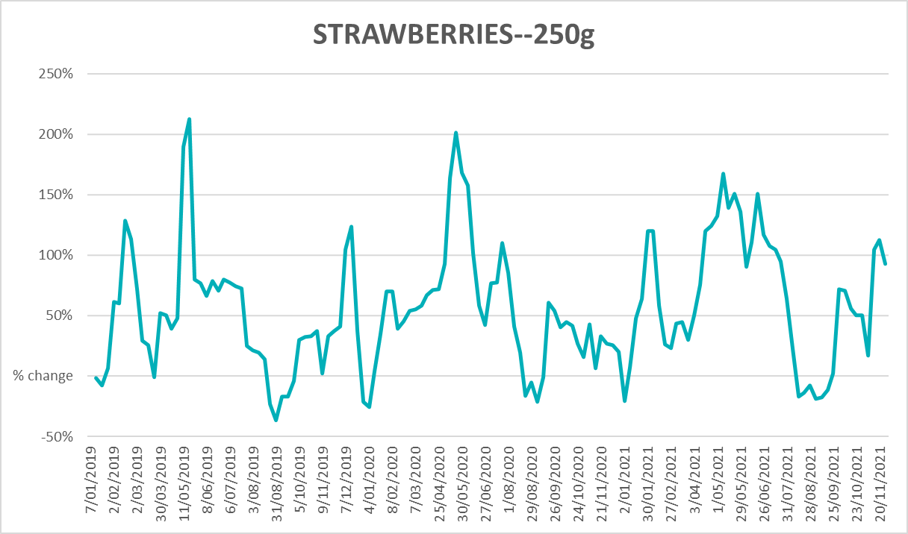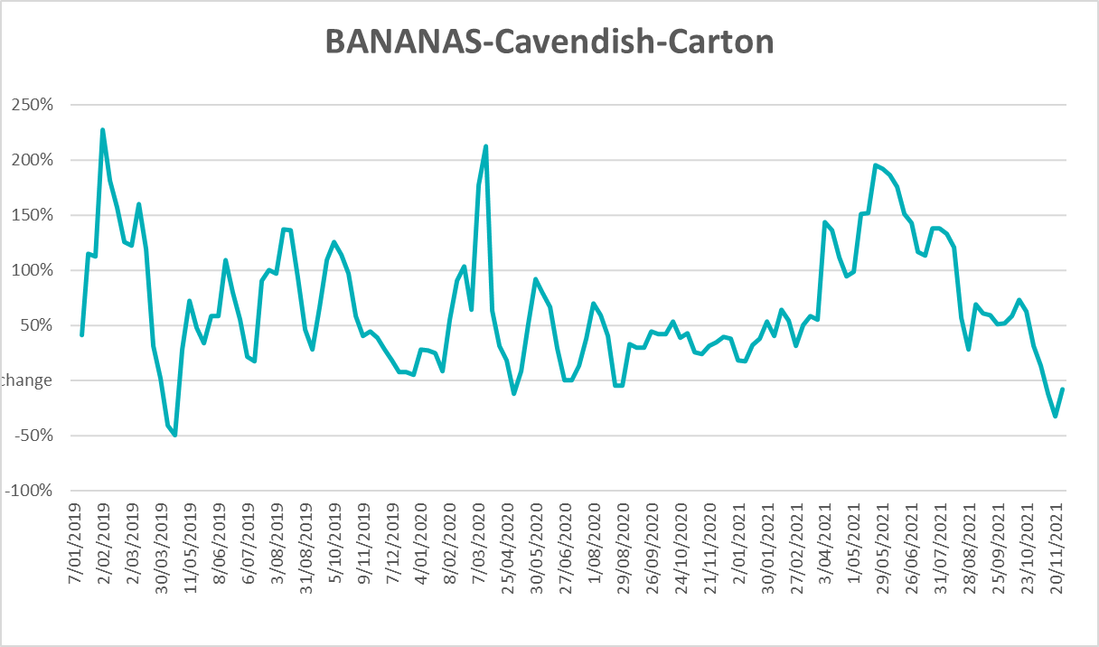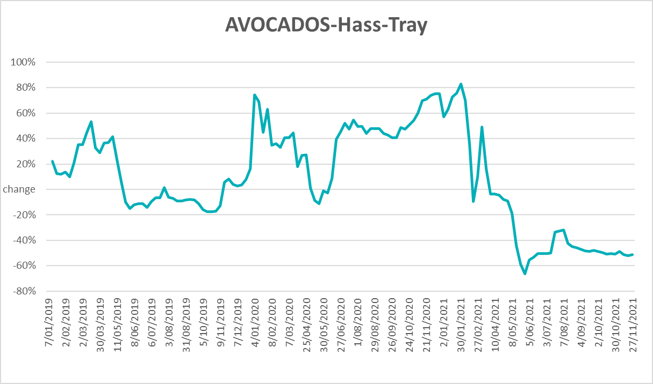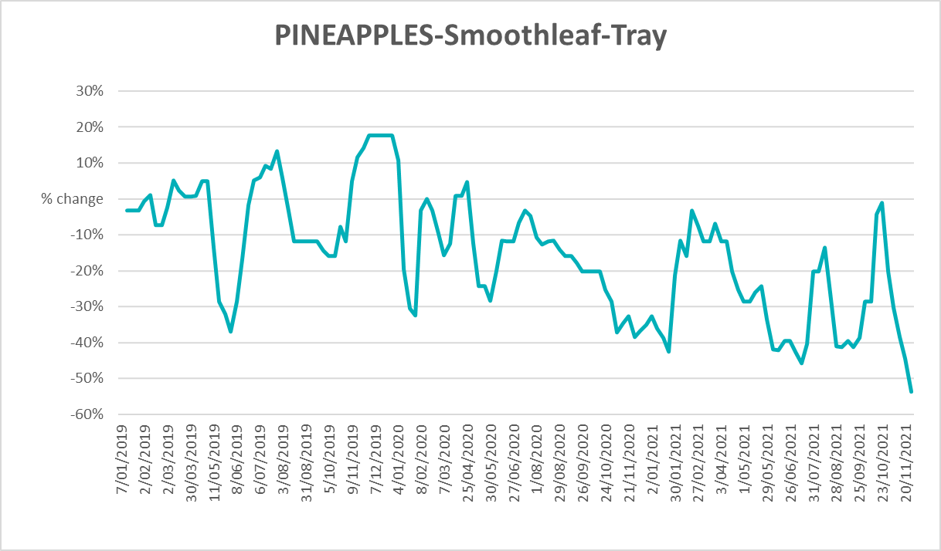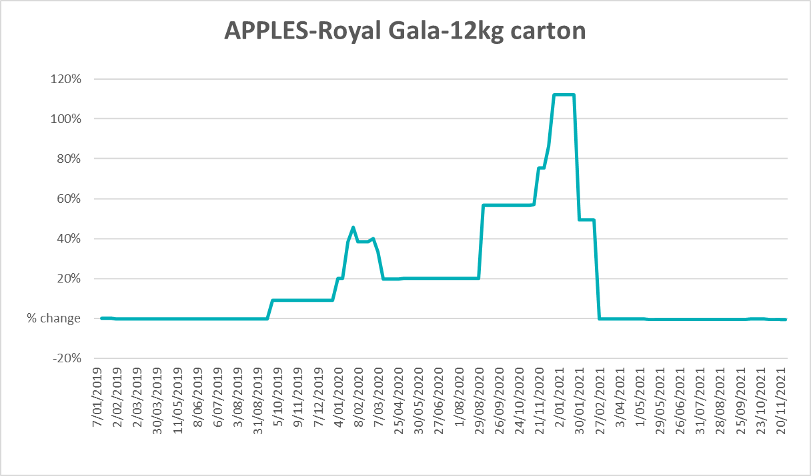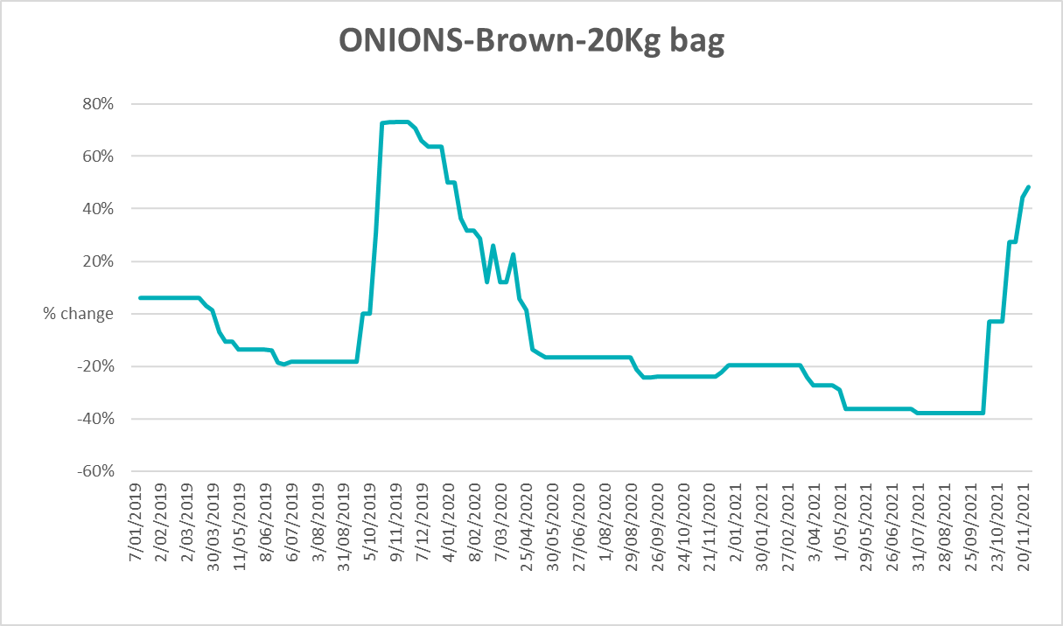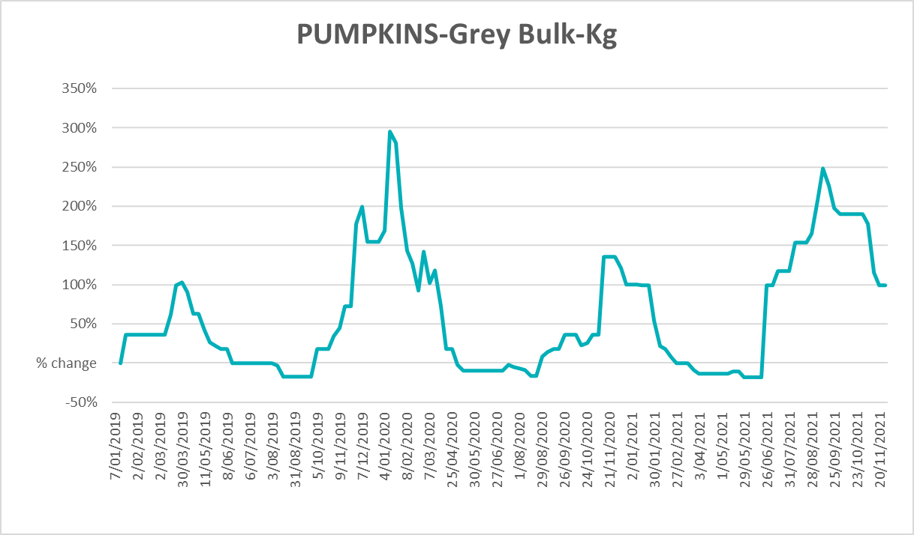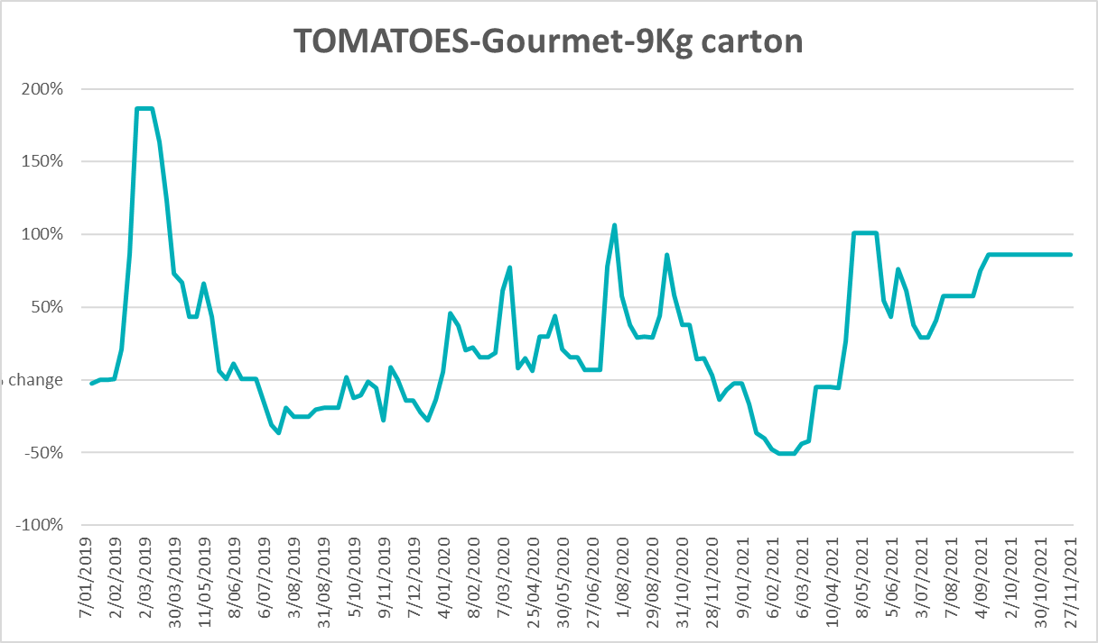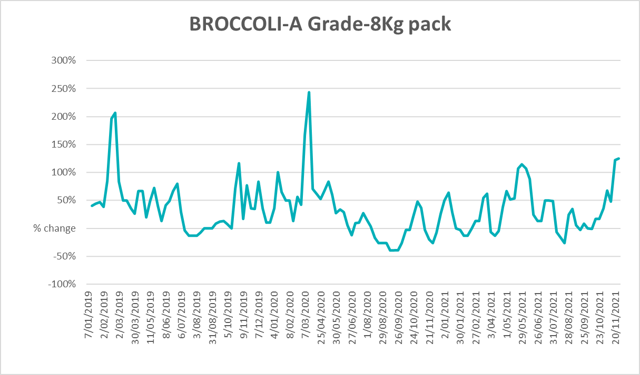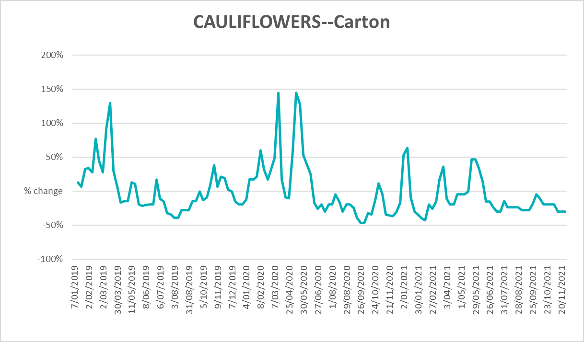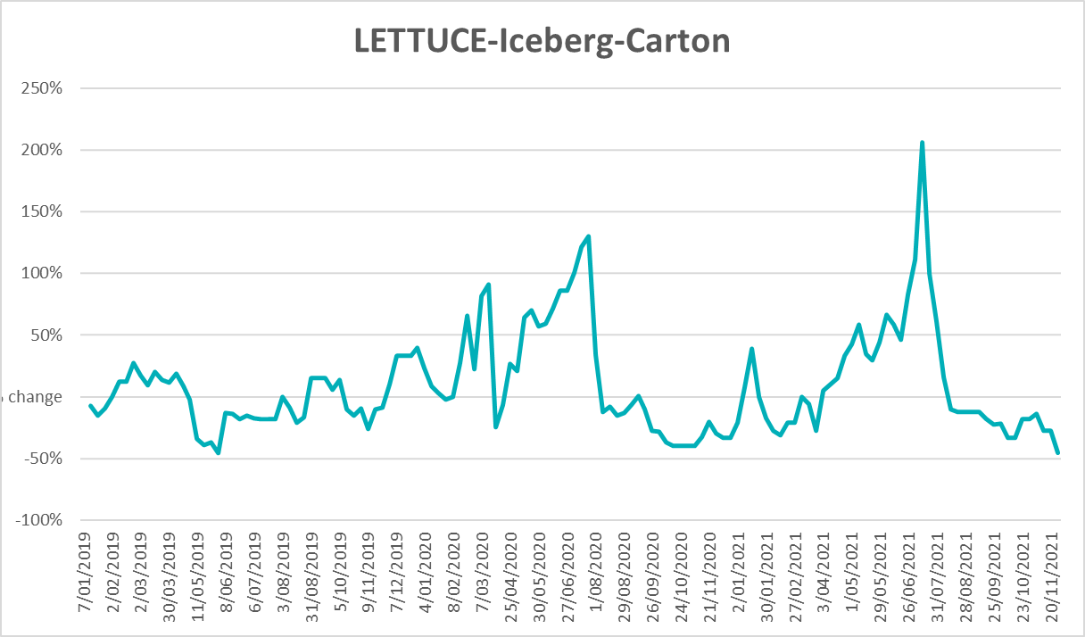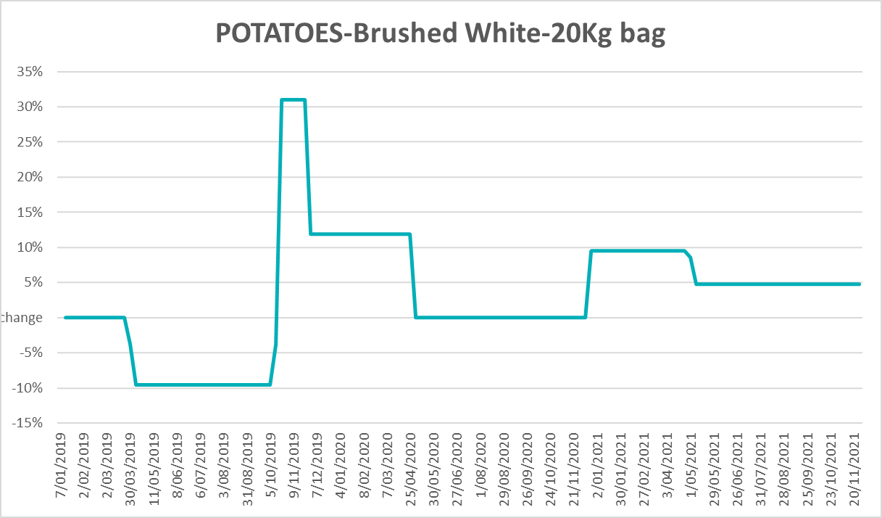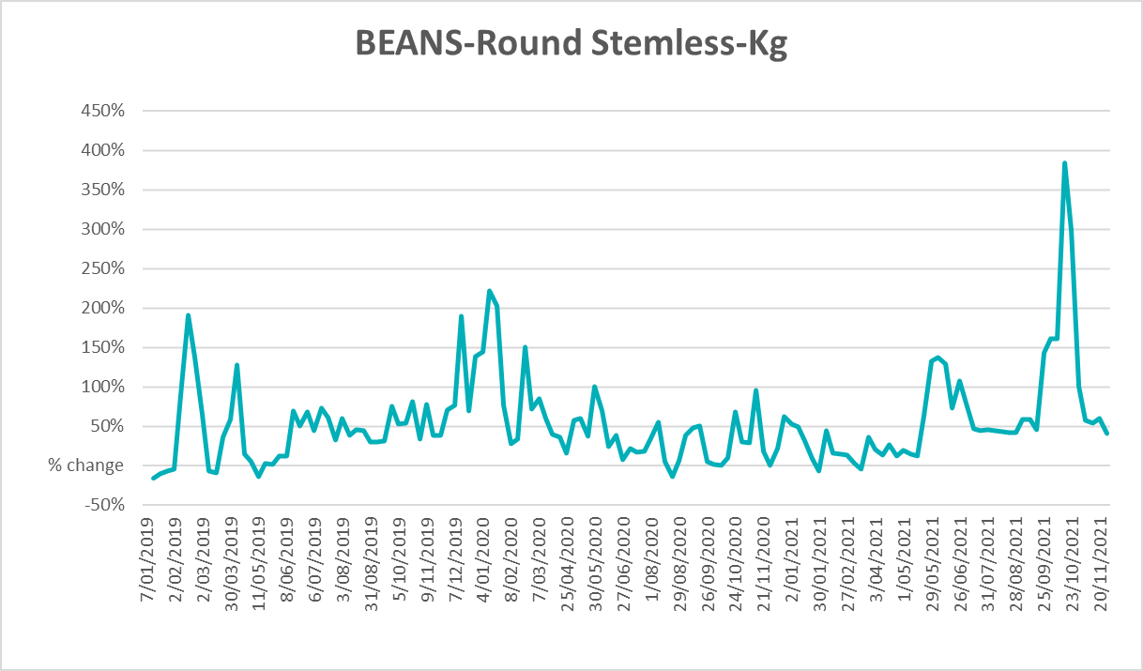

Selected domestic fodder indicator prices
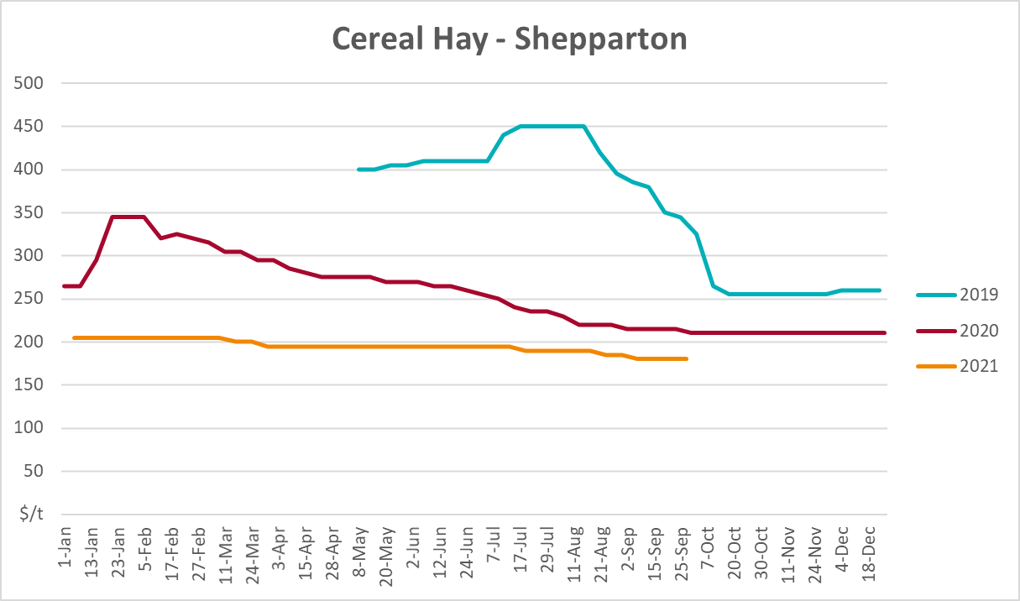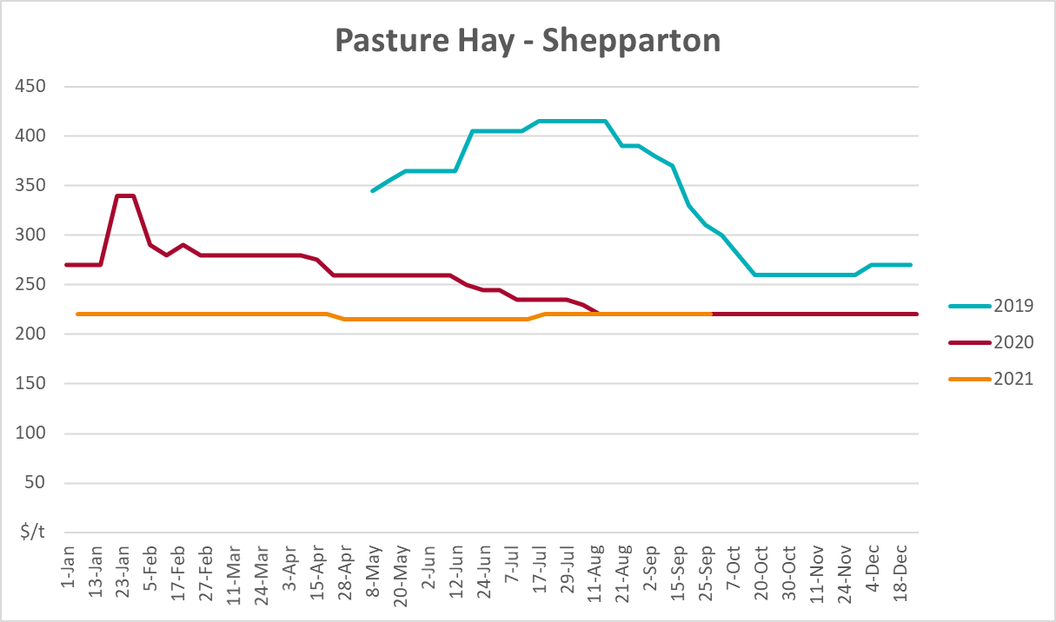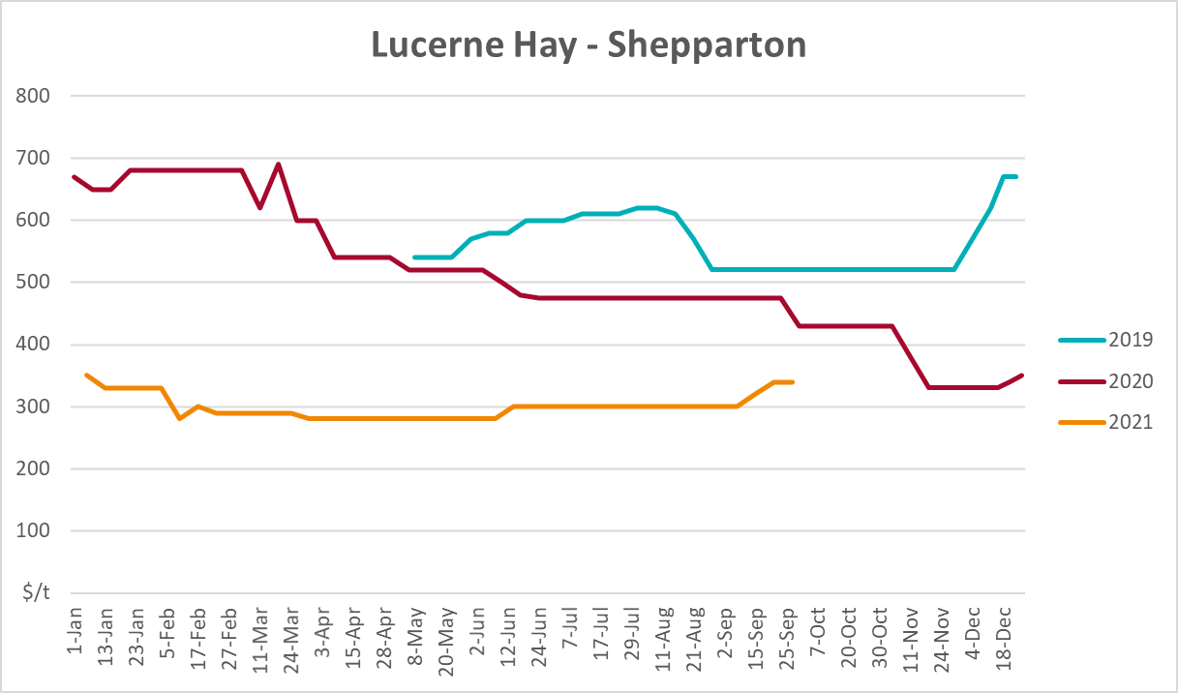

Data attribution

Climate
Bureau of Meteorology
- Weekly rainfall totals: www.bom.gov.au/climate/maps/rainfall/
- Monthly and last 3-month rainfall percentiles: www.bom.gov.au/water/landscape/
- Temperature anomalies: www.bom.gov.au/jsp/awap/temp/index.jsp
- Rainfall forecast: www.bom.gov.au/jsp/watl/rainfall/pme.jsp
- Seasonal outlook: www.bom.gov.au/climate/outlooks/#/overview/summary/
- Climate drivers: http://www.bom.gov.au/climate/enso/
- Soil moisture: www.bom.gov.au/water/landscape/
Other
- Pasture growth: www.longpaddock.qld.gov.au/aussiegrass/
- 3-month global outlooks: Environment and Climate Change Canada, NOAA Climate Prediction Center, EUROBRISA CPTEC/INPE, European Centre for Medium-Range Weather Forecasts, Hydrometcenter of Russia, National Climate Center Climate System Diagnosis and Prediction Room (NCC), International Research Institute for Climate and Society
- Global production: https://ipad.fas.usda.gov/ogamaps/cropmapsandcalendars.aspx
- Autumn break: Pook et al., 2009, https://rmets-onlinelibrary-wiley-com.virtual.anu.edu.au/doi/epdf/10.1002/joc.1833

Water
Prices
- Waterflow: https://www.waterflow.io/
- Ruralco: https://www.ruralcowater.com.au/
Bureau of Meteorology:
- Allocation trade: http://www.bom.gov.au/water/dashboards/#/water-markets/mdb/at
- Storage volumes: http://www.bom.gov.au/water/dashboards/#/water-storages/summary/drainage
Trade constraints:
- Water NSW: https://www.waternsw.com.au/customer-service/ordering-trading-and-pricing/trading/murrumbidgee
- Victorian Water Register: https://www.waterregister.vic.gov.au/TradingRules2019/

Commodities
Fruit and vegetables
- Datafresh: www.freshstate.com.au
Pigs
- Australian Pork Limited: www.australianpork.com.au
Dairy
- Global Dairy Trade: www.globaldairytrade.info/en/product-results/
World wheat, canola
- International Grains Council
World coarse grains
- United States Department of Agriculture
World cotton
- Cotlook: www.cotlook.com/
World sugar
- New York Stock Exchange - Intercontinental Exchange
Wool
- Australian Wool Exchange: www.awex.com.au/
Domestic wheat, barley, sorghum, canola and fodder
- Jumbuk Consulting Pty Ltd: http://www.jumbukag.com.au/
Cattle, beef, mutton, lamb, goat and live export
- Meat and Livestock Australia: www.mla.com.au/Prices-and-market
© Commonwealth of Australia 2021

Ownership of intellectual property rights
Unless otherwise noted, copyright (and any other intellectual property rights, if any) in this publication is owned by the Commonwealth of Australia (referred to as the Commonwealth).

Creative Commons licence
All material in this publication is licensed under a Creative Commons Attribution 4.0 International Licence except content supplied by third parties, logos and the Commonwealth Coat of Arms.
Inquiries about the licence and any use of this document should be emailed to copyright@awe.gov.au.


Cataloguing data
This publication (and any material sourced from it) should be attributed as:
ABARES 2021, Weekly Australian Climate, Water and Agricultural Update, Australian Bureau of Agricultural and Resource Economics and Sciences, Canberra, 9 December 2021. CC BY 4.0 DOI: https://doi.org/10.25814/5f3e04e7d2503
ISSN 2652-7561
This publication is available at https://www.agriculture.gov.au/abares/products/weekly_update
Department of Agriculture, Water and the Environment
GPO Box 858 Canberra ACT 2601
Telephone 1800 900 090
Web awe.gov.au/abares

Disclaimer
The Australian Government acting through the Department of Agriculture, Water and the Environment, represented by the Australian Bureau of Agricultural and Resource Economics and Sciences, has exercised due care and skill in preparing and compiling the information and data in this publication. Notwithstanding, the Department of Agriculture, Water and the Environment, ABARES, its employees and advisers disclaim all liability, including liability for negligence and for any loss, damage, injury, expense or cost incurred by any person as a result of accessing, using or relying on any of the information or data in this publication to the maximum extent permitted by law.

Statement of Professional Independence
The views and analysis presented in ABARES publications, including this one, reflect ABARES professionally independent findings, based on scientific and economic concepts, principles, information and data. These views, analysis and findings may not reflect or be consistent with the views or positions of the Australian Government, or of organisations or groups who have commissioned ABARES reports or analysis. More information on professional independence is provided on the ABARES website.

Acknowledgements
This report was prepared by Matthew Miller, Stephanie Blake and Cameron Van-Lane.

