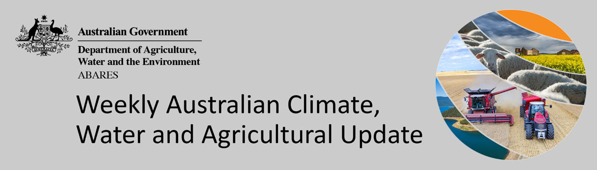

No. 49/2021

16 December 2021
This week’s Update will be the last for 2021.

The next Update will be published on 13 January 2022.

Summary of key issues
- For the week ending 15 December 2021, a surface trough resulted in storms and significant rainfall across parts of northern Australia. Low-pressure systems along the east coast also brought substantial rainfall, especially in coastal regions of south-eastern Australia over the past 8-days (see Section 1.1).
- As of 28 November 2021, global production conditions were generally favourable for corn, rice and soybean. However, a lack of precipitation has affected the production potential of wheat in some key grain exporting countries. Wheat production conditions declined during November when compared to those conditions that were expected back in October, which were used to formulate ABARES forecasts of global grain supplies and world prices in its December 2021 edition of Agricultural Commodities (see Section 1.2).
- In the northern hemisphere, November precipitation was below average across much of the United States, eastern Canada and the United Kingdom. Precipitation was above average for south Asia, north-eastern China and parts of Kazakhstan, and the Russian Federation. In the southern hemisphere, precipitation was below average across southern Africa and parts of southern Brazil. Precipitation was above average across most of northern and western Brazil and eastern Australia.
- In the northern hemisphere production conditions for wheat have been mixed. Dry conditions are causing some production concerns across growing regions in the Ukraine, Turkey, western and southern areas of the European Union and northern United States. In the Russian Federation, production concerns remain despite average to above average rainfall in November. In other growing regions, including China, India and eastern Canada, conditions have been favourable for winter wheat. In the southern hemisphere, harvesting in Australia has been delayed due to excessive rainfall, while in Argentina, barring the north, harvest is continuing under favourable conditions.
- Over the 8-days to 23 December 2021, rainfall is expected across parts of eastern and northern Australia. High pressure systems in the south-east of Australia will provide clear, mostly dry conditions during the first 4-days. However, a trough of low-pressure systems and an associated cold front is expected to bring rainfall to parts of northern and eastern Australia over the latter 4-days.
- Water storage in the Murray–Darling Basin (MDB) increased by 83 gigalitres (GL) between 8 December 2021 and 15 December 2021. The current volume of water held in storage is 22,522 GL, which represents 89% of total capacity. This is 52% or 7,660 GL more than at the same time last year.
- Allocation prices in the Victorian Murray below the Barmah Choke decreased from $97 per ML on 3 December 2021 to $90 per ML on 10 December 2021. Prices are lower in the Goulburn-Broken, Murrumbidgee, and regions above the Barmah Choke due to the binding of the Goulburn intervalley trade limit, Murrumbidgee export limit, and Barmah Choke trade constraint.

Climate

Rainfall this week
For the week ending 15 December 2021, a surface trough resulted in storms and significant rainfall across parts of northern Australia. Low-pressure systems along the east coast also brought substantial rainfall, especially in coastal regions of south-eastern Australia over the past 8-days.
Rainfall totals of between 10 and 50 millimetres were recorded across eastern New South Wales, Queensland and Victoria, as well as northern parts of Western Australia and the Northern Territory. Rainfall totals in excess of 50 millimetres were recorded in south-eastern New South Wales, eastern Victoria and northern parts of Queensland, Western Australia and the Northern Territory. Meanwhile, little to no rainfall was recorded across much of the remainder of the country.
In cropping regions, rainfall totals of between 10 and 50 millimetres were recorded across parts of northern New South Wales and eastern Queensland. Little to no rainfall was recorded across remaining cropping regions in New South Wales and Queensland, as well as Victoria, South Australia and Western Australia.
Rainfall in parts of northern New South Wales adds to the substantial rainfall received over recent weeks and may have prolong localised flooding events. While river levels have receded across most areas, parts of the Namoi River remain flooded. For most cropping regions, the dry conditions will have allowed harvesting activities to continue. However, some parts of New South Wales require more time for soil profiles to drain to allow field access. The impact of the substantial November rainfalls is starting to be reported as harvesting resumes, with grain quality downgrades for parts of New South Wales. Planting of summer crops has also likely resumed, further encouraged by above average soil moisture levels across northern cropping regions.

Rainfall for the week ending 15 December 2021

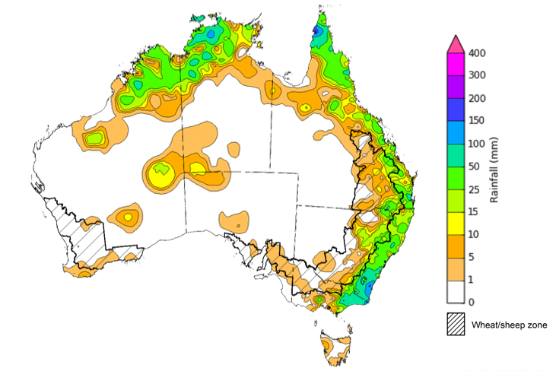

©Commonwealth of Australia 2021, Australian Bureau of Meteorology Issued: 15/12/2021
Note: The rainfall analyses and associated maps utilise data contained in the Bureau of Meteorology climate database, the Australian Data Archive for Meteorology (ADAM). The analyses are initially produced automatically from real-time data with limited quality control. They are intended to provide a general overview of rainfall across Australia as quickly as possible after the observations are received. For further information go to http://www.bom.gov.au/climate/rainfall/

Global production conditions and climate outlook
Crop production is affected by long-term trends in average rainfall and temperature, interannual climate variability, shocks during specific growth stages, and extreme weather events (IPCC 2012). Some crops are more tolerant than others to certain types of stresses, and at each growth stage, different types of stresses affect each crop species in different ways.
The precipitation anomalies and outlooks presented here give an indication of the current and future state of production conditions for the major grain and oilseed producing countries which are responsible for over 80% of global production. This is an important input to assessing the global grain supply outlook.
November precipitation percentiles and current production conditions
As of the end of November 2021, rainfall was mixed for the world’s major grain-producing and oilseed-producing regions.
In the northern hemisphere, precipitation was below average across much of the United States, eastern Canada and the United Kingdom. Precipitation was above average for south Asia, north-eastern China and parts of Kazakhstan, and the Russian Federation. Precipitation was close to average across the remainder of major grain-producing and oilseed-producing regions in the northern hemisphere.
In the southern hemisphere, November precipitation was below average across southern Africa and parts of southern Brazil. Precipitation was above average across most of northern and western Brazil and eastern Australia. Precipitation was close to average across the remainder of major grain-producing and oilseed-producing regions in the southern hemisphere.

Global precipitation percentiles, November 2021
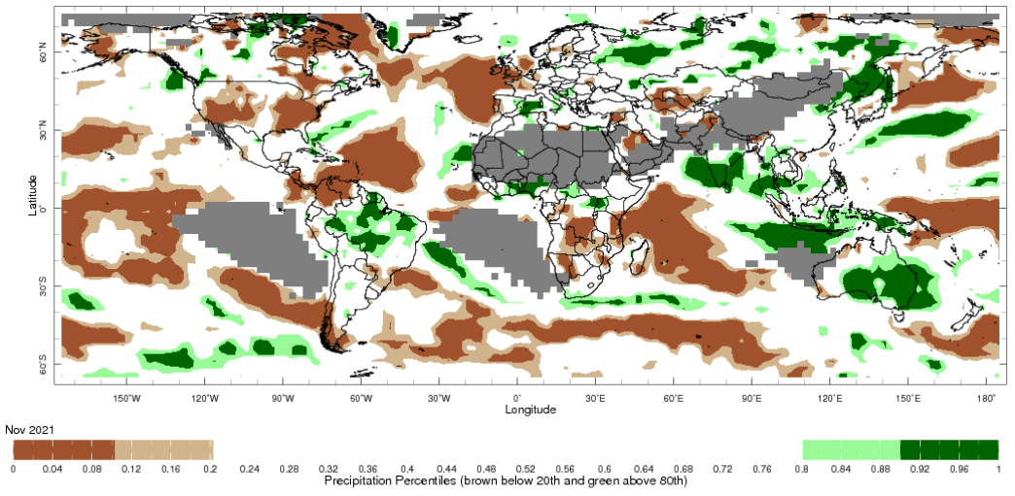
Note: The world precipitation percentiles indicate a ranking of precipitation for November, with the driest (0th percentile) being 0 on the scale and the wettest (100th percentile) being 1 on the scale. Percentiles are based on precipitation estimates from the NOAA Climate Prediction Center's Climate Anomaly Monitoring System Outgoing Precipitation Index dataset. Precipitation estimates for November 2021 are compared with rainfall recorded for that period during the 1981 to 2010 base period.
Source: International Research Institute for Climate and Society
As at 28 November 2021 global production conditions were generally favourable for the production of corn, rice and soybean. However, a lack of precipitation has affected the production potential of wheat in some key grain exporting and importing countries.
In the northern hemisphere production conditions for wheat have been mixed. Winter wheat planting is well underway with dry conditions causing concern across growing regions in the Ukraine, Turkey, western and southern areas of the European Union and northern United States. In the Russian Federation, production concerns remain despite average to above average rainfall in November. Below average rainfall across the United Kingdom hasn’t negatively affected the outlook for winter wheat production. In other growing regions, including China, India and eastern Canada, conditions have been favourable for winter wheat. In the southern hemisphere, harvesting in Australia has been delayed due to excessive rainfall, while in all key production regions in Argentina, barring the north, harvest is continuing under favourable conditions.
Conditions for corn sowing were favourable in Argentina, South Africa, Brazil, and India. Conditions were also favourable for harvesting of corn in Canada, Mexico, Ukraine and most of the northern United States, barring the Dakotas where persistent dryness has reduced yields.
Conditions for rice were favourable for crop development in most growing regions, with harvesting underway in China, India, Indonesia, and northern Vietnam. Wet season rice in Thailand and the Philippines is harvesting under mixed conditions due to excess rainfall and flooding. Sowing of Rabi rice has also begun in India. Meanwhile, sowing of wet-season rice has begun in Indonesia, southern Vietnam, and Brazil.
Production conditions for soybeans are largely favourable across current growing regions in Brazil, Argentina, and Canada. However, dry conditions in the prairie region in Canada has negatively impacted yields. Harvesting is underway in Canada, while sowing is progressing in Brazil and Argentina.
Crop conditions, AMIS countries, 28 November 2021
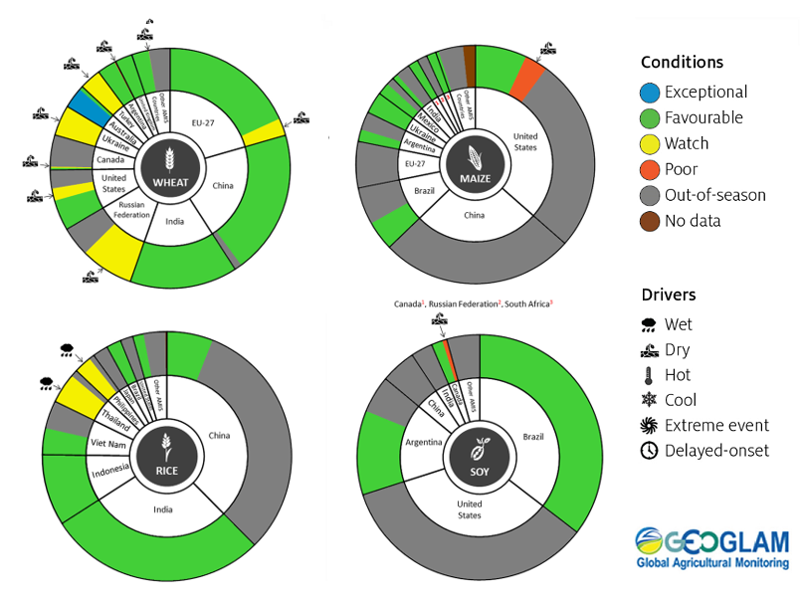
AMIS Agricultural Market Information System.
Source: AMIS

The global climate outlook for December 2021 to February 2022 indicates that mixed rainfall conditions are expected for the world's major grain-producing and oilseed-producing regions. Outlooks and potential production impacts for the major grain and oilseed producing countries are presented in the table.
Rainfall outlook and potential impact on the future state of production conditions between December 2021 to February 2022
Region | December-February rainfall outlook | Potential impact on production
Argentina | Below average rainfall is expected in north-eastern Argentina between December 2021 and February 2022, however, above average rainfall is expected in the north-west of the country. | Below average rainfall is likely to adversely affect the flowering of corn, soybeans, sunflower, groundnuts, cotton, sorghum, and millet. The dry conditions are likely to negatively impact yield potentials for these crops.
Black Sea Region | Below average to average rainfall is forecast for parts of Kazakhstan, while above average to average rainfall is expected across southern parts of the Russian Federation between December 2021 and February 2022. | Winter wheat and canola will remain dormant between December 2021 and February 2022. The average rainfall conditions are likely to provide sufficient snowpack to prevent winterkill from freezing temperatures across most regions. However, below average rainfall in parts of Kazakhstan increases the risk of winterkill due to below average snowpack.
Brazil | Above average rainfall is expected in northern Brazil and parts of the central west between December 2021 to February 2022. Southern Brazil is expected to receive below-average rainfall. | Below average rainfall in parts of southern Brazil is likely to adversely affect flowering and yield potential of corn and soybeans in December, as well as cotton and groundnut flowering for southern growing regions in January. In the central west, flowering of soybean may benefit from above average rainfall.
Canada | Average to above average rainfall is expected across much of Canada between December 2021 and February 2022. | Through December, January and February, winter wheat and canola will remain dormant. Above average rainfall will likely provide sufficient snowpack to prevent winterkill of winter wheat.
China | Below average to average rainfall is likely across much of China between December 2021 to February 2022. | Through December, January and February, winter wheat and canola will remain dormant. Below average rainfall increases the risk of insufficient snowpack to prevent winterkill of crops.
Europe | Below average rainfall is likely for most of Europe between December 2021 and February 2022, however, above average rainfall is expected for Norway and Sweden. | Through December, January and February, winter wheat and canola will remain dormant. Below average rainfall increases the risk of winterkill of crops due to below average snowpack.
South Asia (India) | Above average rainfall is likely across much of southern India and along the east coast. However, below average rainfall is expected in parts of central and northern India between December 2021 to February 2022. | Below average rainfall in parts of central and northern India is likely to negatively impact the vegetative growth and heading of winter wheat and canola between December and January. In the south, winter crops may benefit from above average rainfall.
Southeast Asia (SEA) | Above average rainfall is likely across much of maritime SEA between December 2021 to February 2022, particularly in the Philippines. Mainland SEA will likely experience below average rainfall. | Above average rainfall across SEA is likely to support the vegetative growth of wet season corn and rice production. However, excessive rainfall may result in flooding and crop damage. Below average rainfall for parts of mainland SEA may negatively impact the germination and establishment of spring rice.
The United States of America | Above average rainfall is more likely for the north-western and north-eastern United States, while below average rainfall is more likely across much of the southern half of the United States. | The above average rainfall conditions expected across the northern United States is likely to support dormancy of canola and winter wheat and provide sufficient snow cover in December, January and February.

Rainfall forecast for the next eight days
Over the 8-days to 23 December 2021, rainfall is expected across parts of eastern and northern Australia. High pressure systems in the south-east of Australia will provide clear, mostly dry conditions during the first 4-days. However, a trough of low-pressure systems and an associated cold front is expected to bring rainfall to parts of northern and eastern Australia over the latter 4-days.
Rainfall totals of between 10 and 50 millimetres are forecast for eastern parts of New South Wales and Victoria, as well as the south-east and north-west of Queensland and northern parts of Western Australia and the Northern Territory. Rainfall in excess of 50 millimetres is expected in northern parts of Western Australia and the Northern Territory, and western Tasmania.
In Australian cropping regions, rainfall totals of between 10 and 50 millimetres are expected across parts of eastern New South Wales and Victoria, as well as parts of southern and central Queensland. Little to no rainfall is forecast for remaining cropping regions of New South Wales, Queensland and Victoria, as well as cropping regions of South Australia and Western Australia during the next 8-days.
Soil moisture levels across eastern growing regions remain well above average. The forecast rainfall for parts of New South Wales, Queensland and Victorian cropping regions may saturate soil profiles and delay harvesting activities for winter crops. Likewise, further rainfall may prevent planting of summer crops and the application of post-emergence fertiliser and pest management programs. However, for most winter cropping regions, the expected dry conditions will be favourable for harvesting activities to continue and for crops affected by recent rains to desiccate.

Total forecast rainfall (mm) for the period 16 December to 23 December 2021
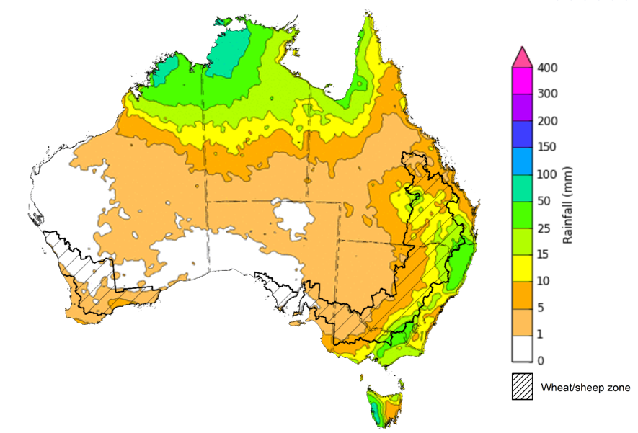
©Commonwealth of Australia 2021, Australian Bureau of Meteorology Issued: 15/12/2021

Water
Note: This rainfall forecast is produced from computer models. As the model outputs are not altered by weather forecasters, it is important to check local forecasts and warnings issued by the Bureau of Meteorology.

Water markets – current week
Water storage in the Murray–Darling Basin (MDB) increased by 83 gigalitres (GL) between 8 December 2021 and 15 December 2021. The current volume of water held in storage is 22,522 GL, which represents 89% of total capacity. This is 52% or 7,660 GL more than at the same time last year.

Water storages in the Murray-Darling Basin, 2013–2021
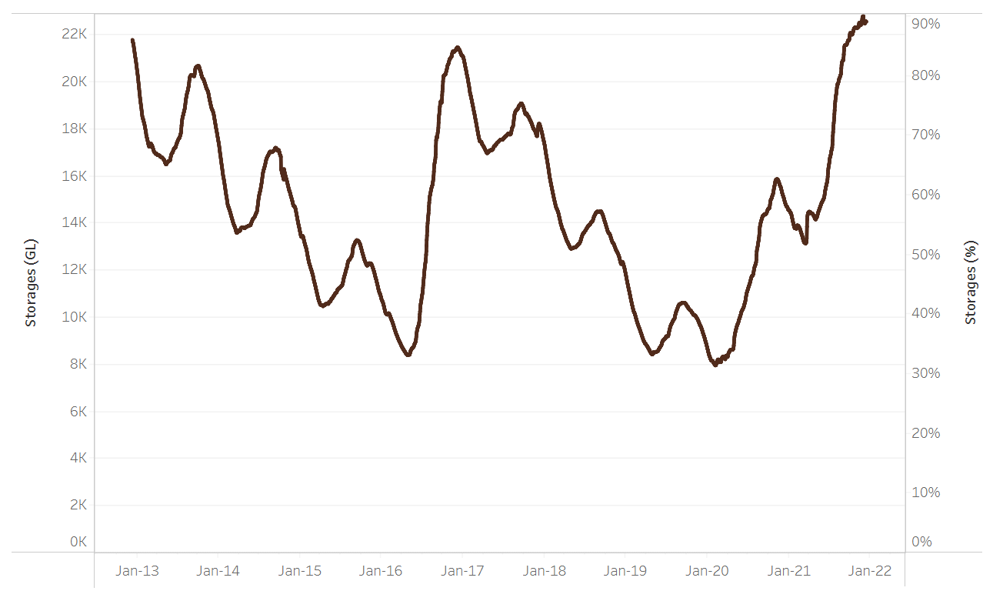
Allocation prices in the Victorian Murray below the Barmah Choke decreased from $97 per ML on 3 December 2021 to $90 per ML on 10 December 2021. Prices are lower in the Goulburn-Broken, Murrumbidgee, and regions above the Barmah Choke due to the binding of the Goulburn intervalley trade limit, Murrumbidgee export limit, and Barmah Choke trade constraint.
Water storage data is sourced from the Bureau of Meteorology.

Region | $/ML
NSW Murray Above | 65
NSW Murrumbidgee | 74
VIC Goulburn-Broken | 74
VIC Murray Below | 90

Surface water trade activity, Southern Murray–Darling Basin

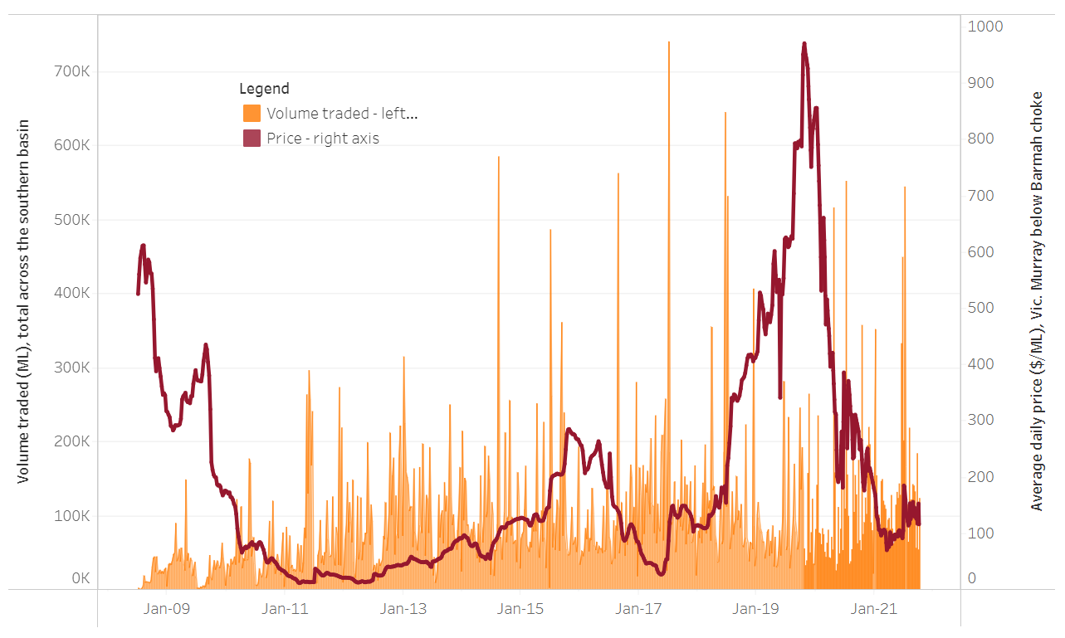
To access the full, interactive, weekly water dashboard, which contains the latest and historical water storage, water market and water allocation information, please visit http://www.agriculture.gov.au/abares/products/weekly_update/weekly-update-161221
The trades shown reflect estimated market activity and do not encompass all register trades. The price is shown for the VIC Murray below the Barmah choke. Historical prices (before 1 July 2019) are ABARES estimates after removing outliers from BOM water register data. Prices after 1 July 2019 and prior to the 30 October 2019 reflect recorded transaction prices as sourced from Ruralco. Prices after the 30 October 2019 are sourced from Waterflow. Data for volume traded is sourced from the BOM water register. Data shown is current at 16 December 2021.

Commodities
Indicator | Week ended | Unit | Latest price | Previous week | Weekly change | Price 12 months ago | Annual change
Selected world indicator prices
AUD/USD Exchange rate | 15-Dec | A$/US$ | 0.71 | 0.71 | 0% | 0.76 | -6%
Wheat – US no. 2 hard red winter wheat, fob Gulf | 15-Dec | US$/t | 372 | 379 | -2% | 274 | 35%
Corn – US no. 2 yellow corn, fob Gulf | 15-Dec | US$/t | 267 | 266 | 1% | 203 | 31%
Canola – Rapeseed, Canada, fob Vancouver | 15-Dec | US$/t | 854 | 865 | -1% | 539 | 58%
Cotton – Cotlook 'A' Index | 15-Dec | USc/lb | 120 | 118 | 2% | 82 | 45%
Sugar – Intercontinental Exchange, nearby futures, no.11 contract | 15-Dec | USc/lb | 19.3 | 18.5 | 4% | 15 | 31%
Wool – Eastern Market Indicator | 15-Dec | Ac/kg clean | 1,358 | 1,360 | 0% | 1,219 | 11%
Wool – Western Market Indicator | 15-Dec | Ac/kg clean | 1,408 | 1,417 | -1% | 984 | 43%
Selected Australian grain export prices
Milling Wheat – APW, Port Adelaide, SA | 15-Dec | A$/t | 488 | 503 | -3% | 337 | 45%
Feed Wheat – ASW, Port Adelaide, SA | 15-Dec | A$/t | 460 | 444 | 4% | 333 | 38%
Feed Barley – Port Adelaide, SA | 15-Dec | A$/t | 379 | 392 | -3% | 274 | 38%
Canola – Kwinana, WA | 15-Dec | A$/t | 976 | 983 | -1% | 664 | 47%
Grain Sorghum – Brisbane, QLD | 15-Dec | A$/t | 369 | 368 | 0% | 351 | 5%
Selected domestic livestock indicator prices
Beef – Eastern Young Cattle Indicator | 15-Dec | Ac/kg cwt | 1,164 | 1,114 | 5% | 792 | 47%
Mutton – Mutton indicator (18–24 kg fat score 2–3), Vic | 15-Dec | Ac/kg cwt | 640 | 641 | 0% | 612 | 4%
Lamb – Eastern States Trade Lamb Indicator | 15-Dec | Ac/kg cwt | 854 | 851 | 0% | 771 | 11%
Pig – Eastern Seaboard (60.1–75 kg), average of buyers & sellers | 24-Nov | Ac/kg cwt | 357 | 338 | 6% | 309 | 16%
Goats – Eastern States (12.1–16 kg) | 08-Dec | Ac/kg cwt | 879 | 877 | 0% | 818 | 8%
Live cattle – Light steers ex Darwin to Indonesia | 17-Feb | Ac/kg lwt | 355 | 355 | 0% | 360 | -1%
Live sheep – Live wethers (Muchea WA saleyard) to Middle East | 22-Sep | $/head | 147 | 171 | -14% | 126 | 17%

Indicator | Week ended | Unit | Latest price | Previous week | Weekly change | Price 12 months ago | Annual change
Global Dairy Trade (GDT) weighted average prices ª
Dairy – Whole milk powder | 15-Dec | US$/t | 4,008 | 3,987 | 1% | 3,254 | 23%
Dairy – Skim milk powder | 15-Dec | US$/t | 3,721 | 3,676 | 1% | 2,924 | 27%
Dairy – Cheddar cheese | 15-Dec | US$/t | 5,220 | 5,162 | 1% | 3,701 | 41%
Dairy – Anhydrous milk fat | 15-Dec | US$/t | 6,668 | 6,472 | 3% | 5,108 | 31%
a Global Dairy Trade prices are updated twice monthly on the first and third Tuesday of each month.

Selected world indicator prices
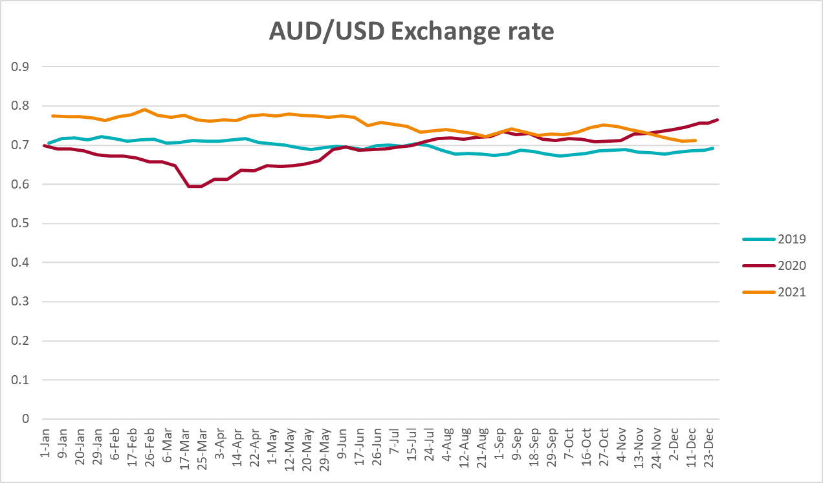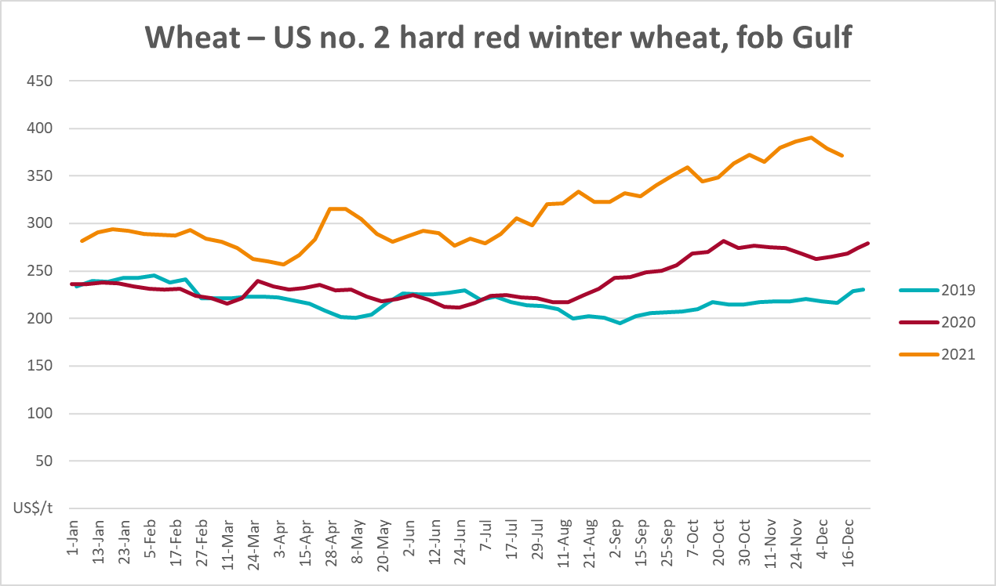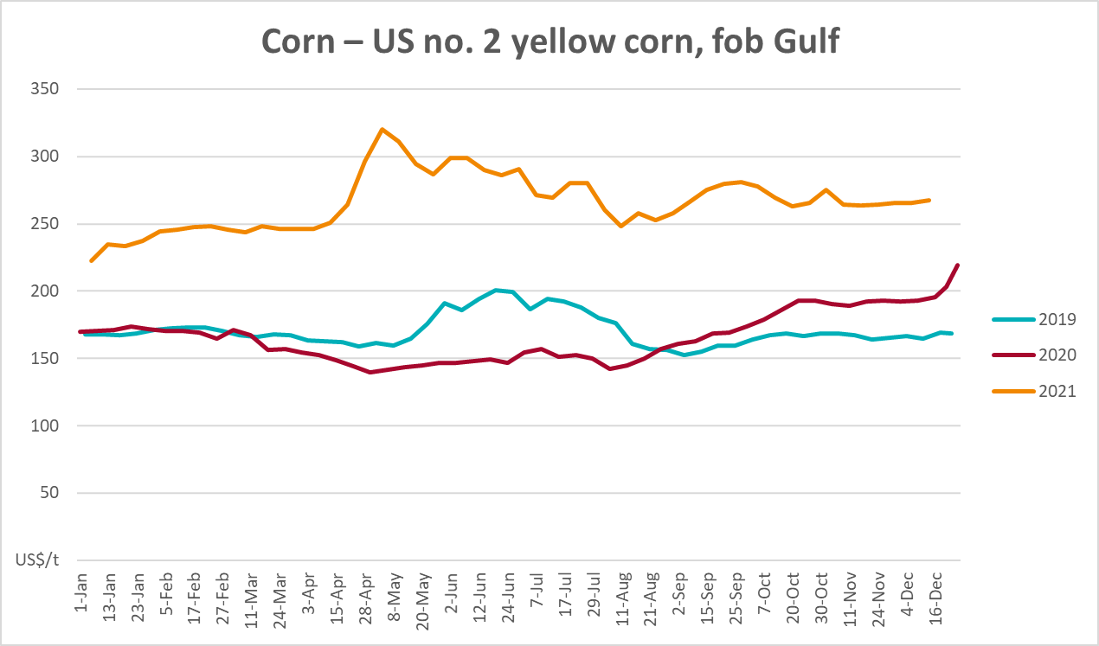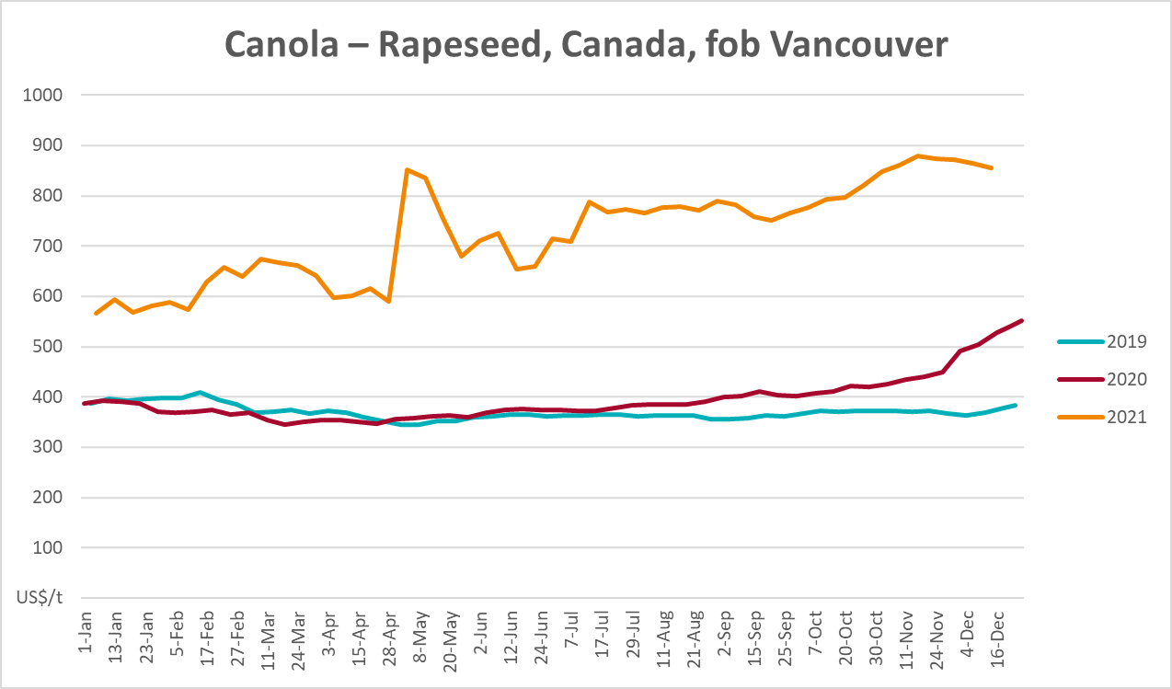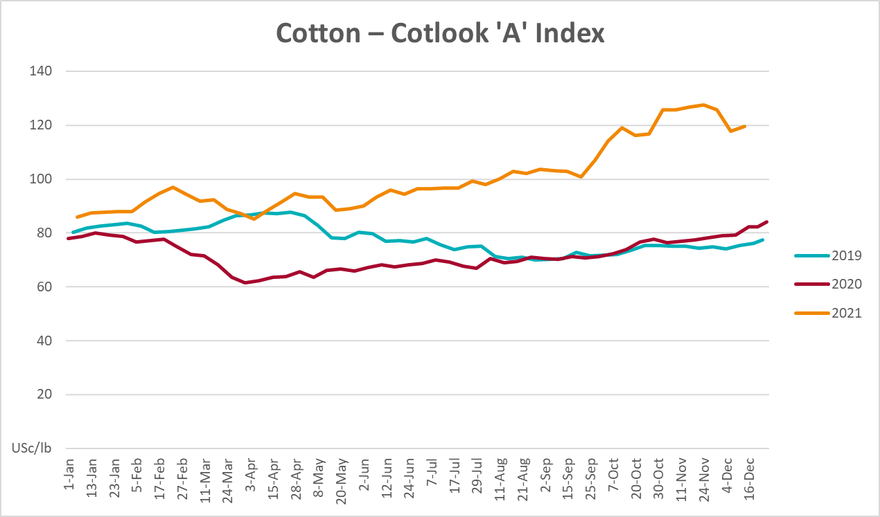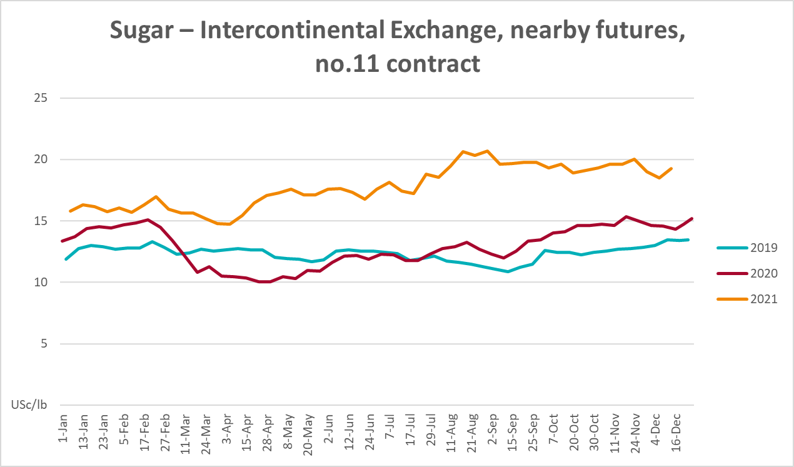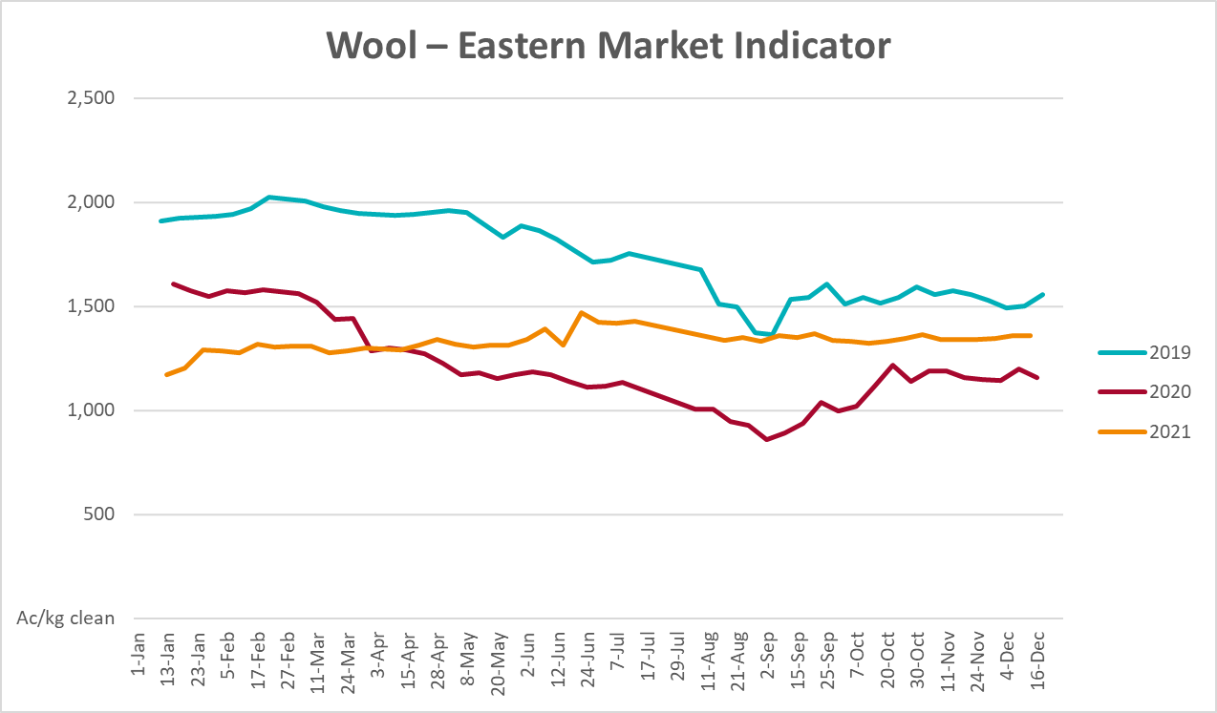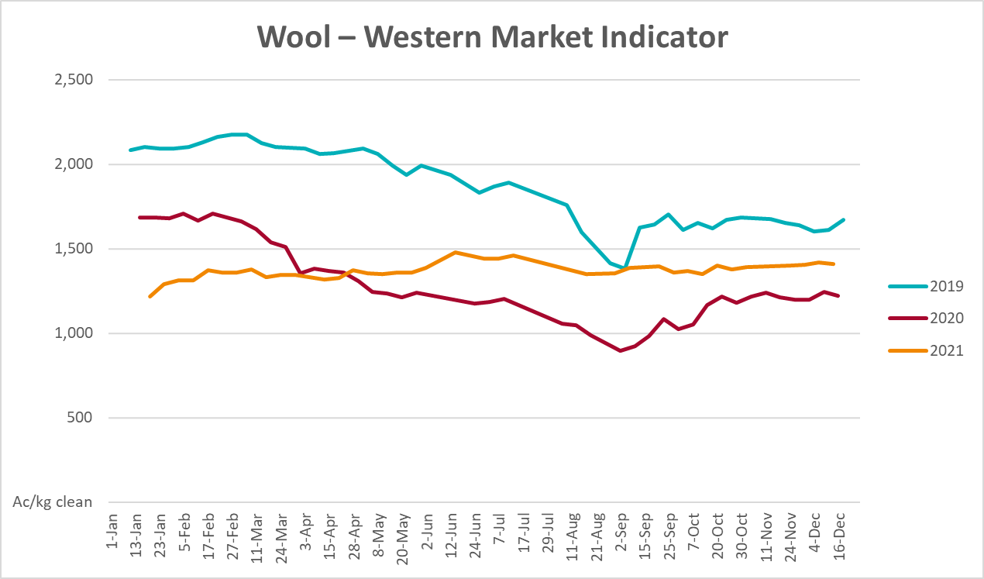

Selected domestic crop indicator prices
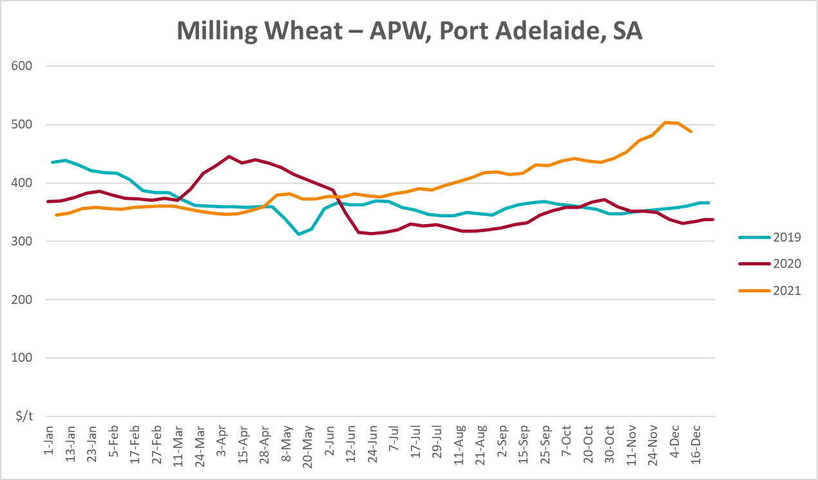
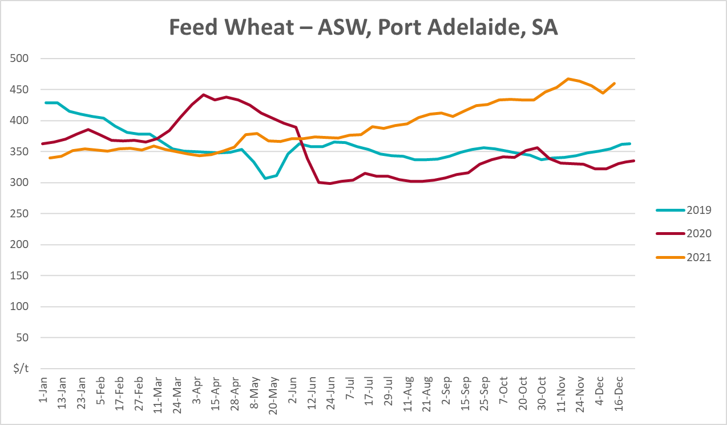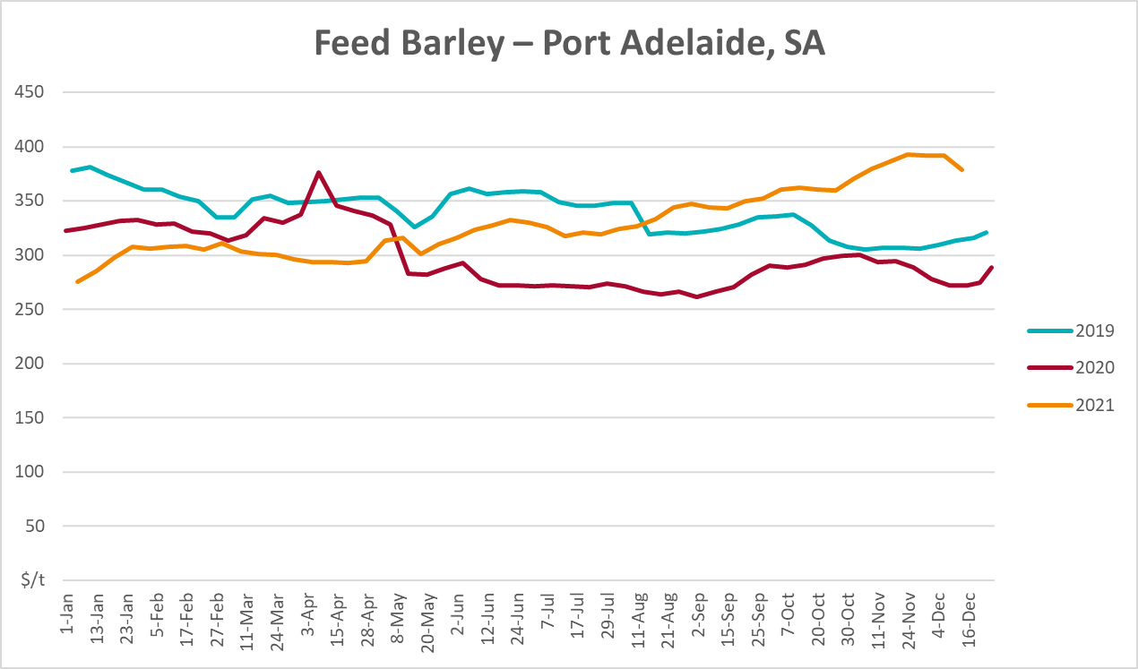
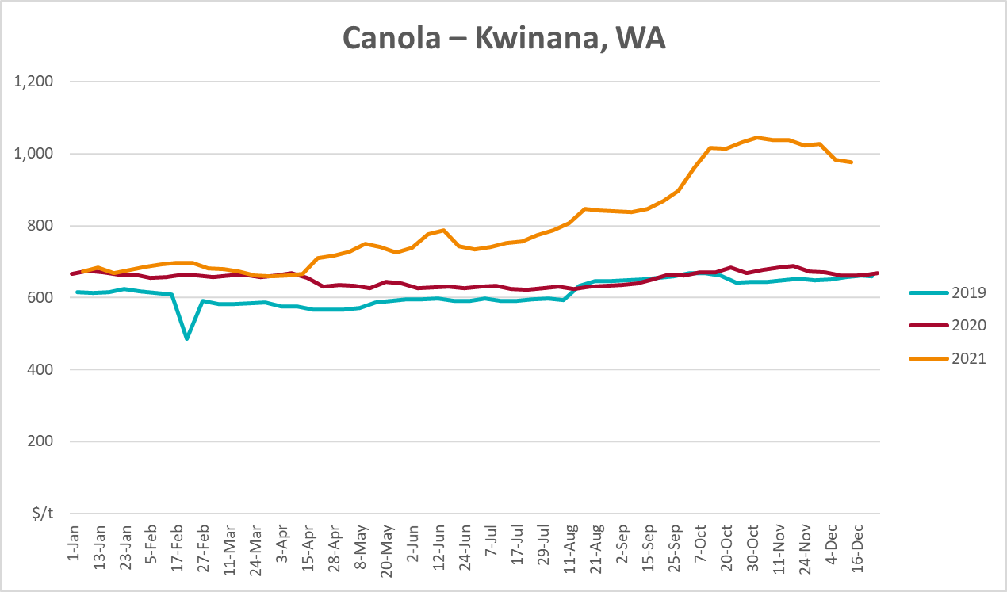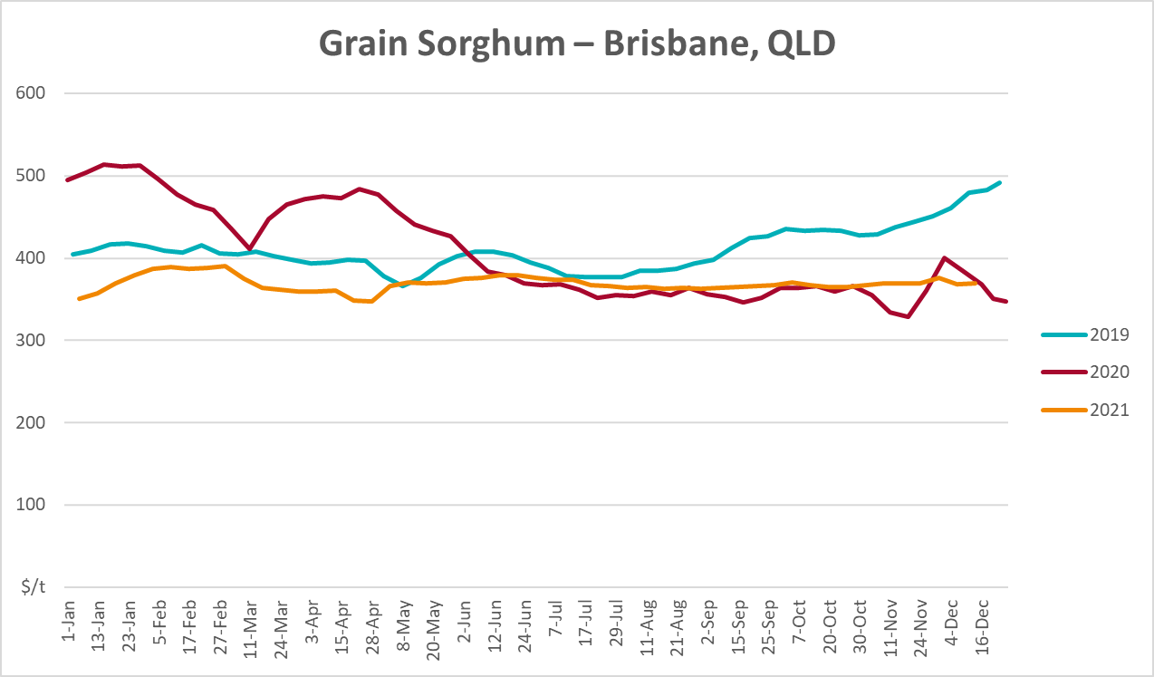

Selected domestic livestock indicator prices
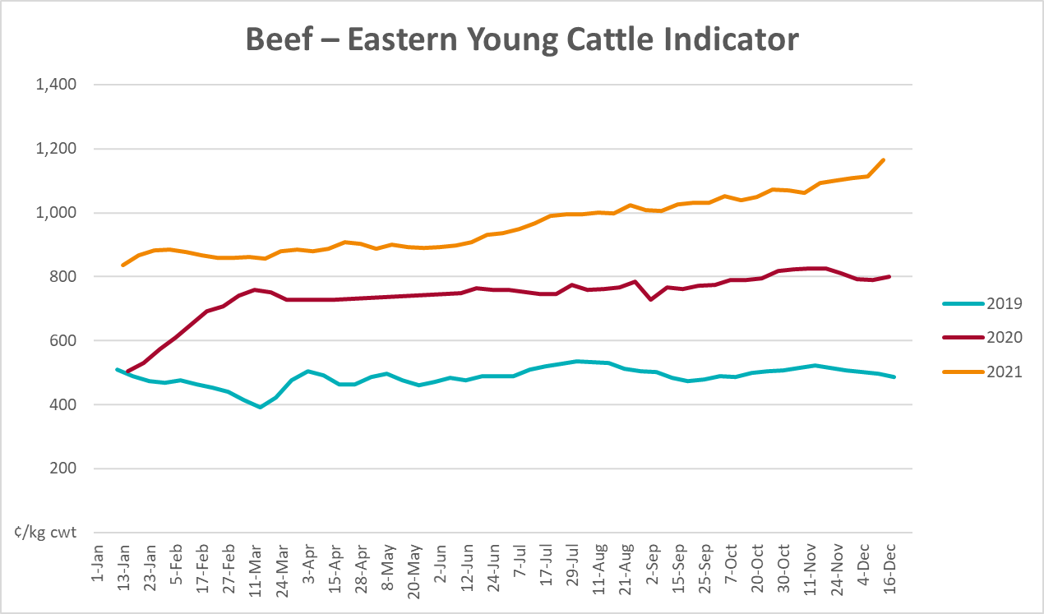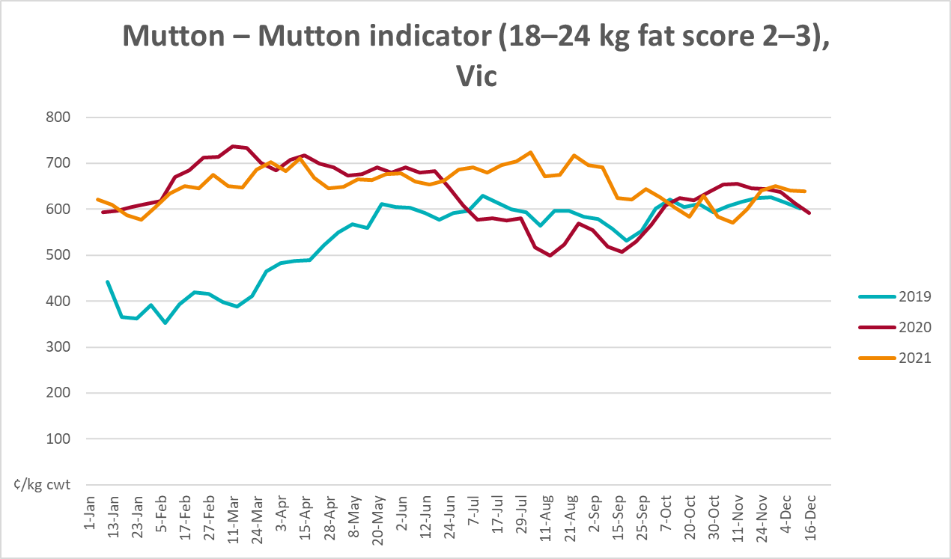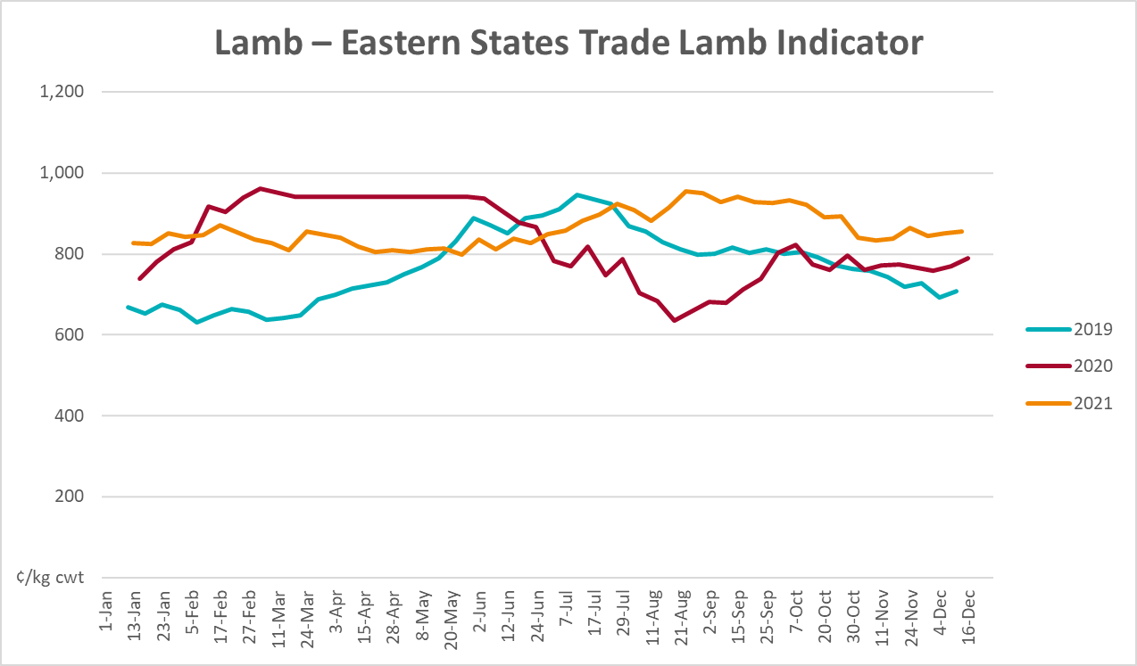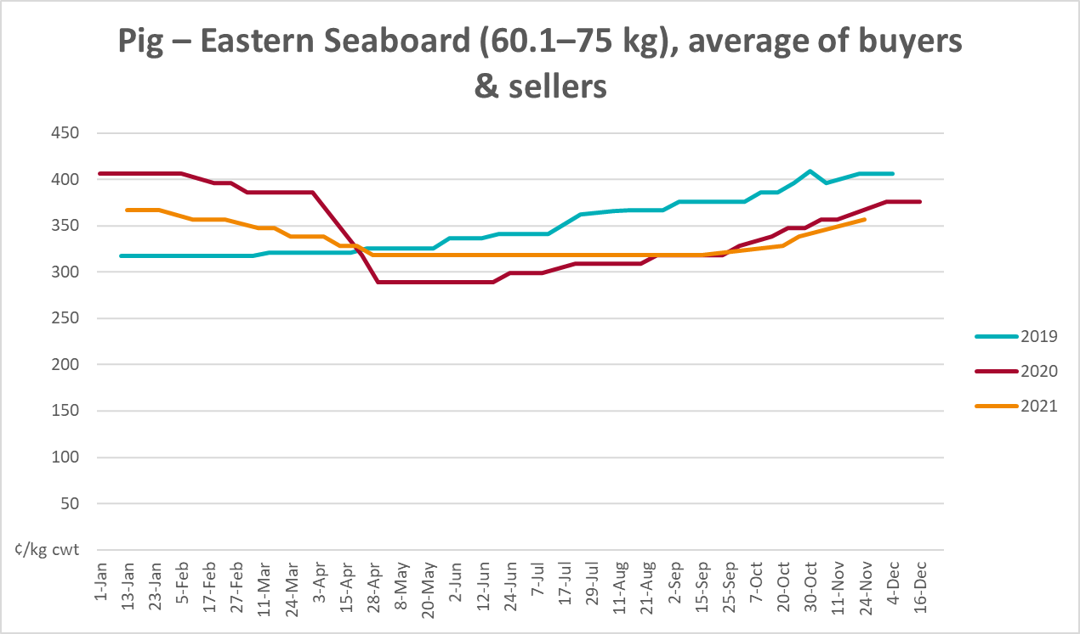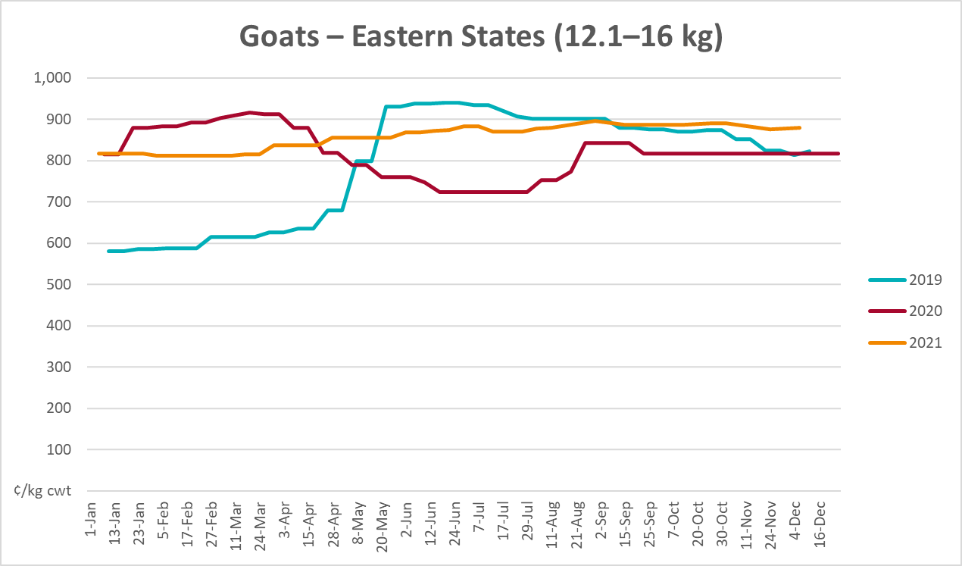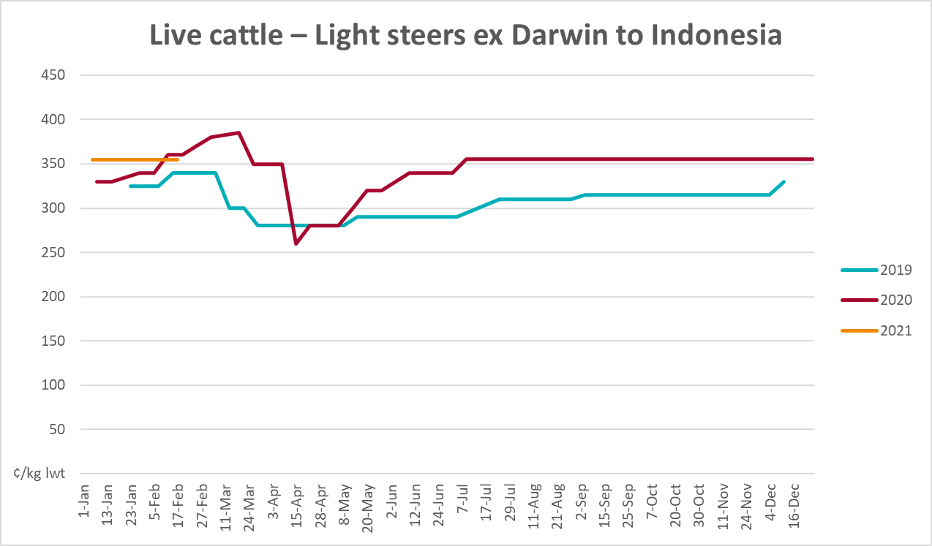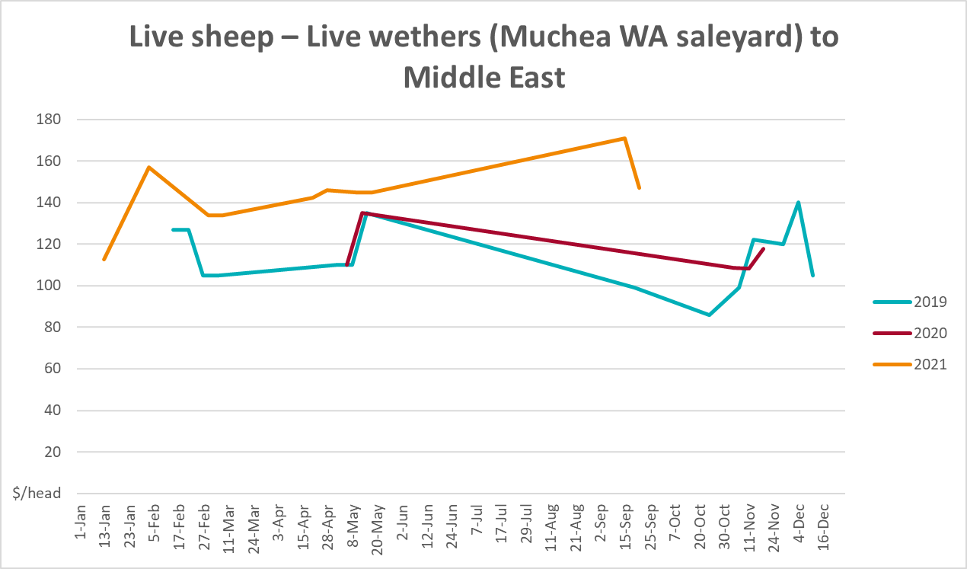

Global Dairy Trade (GDT) weighted average prices
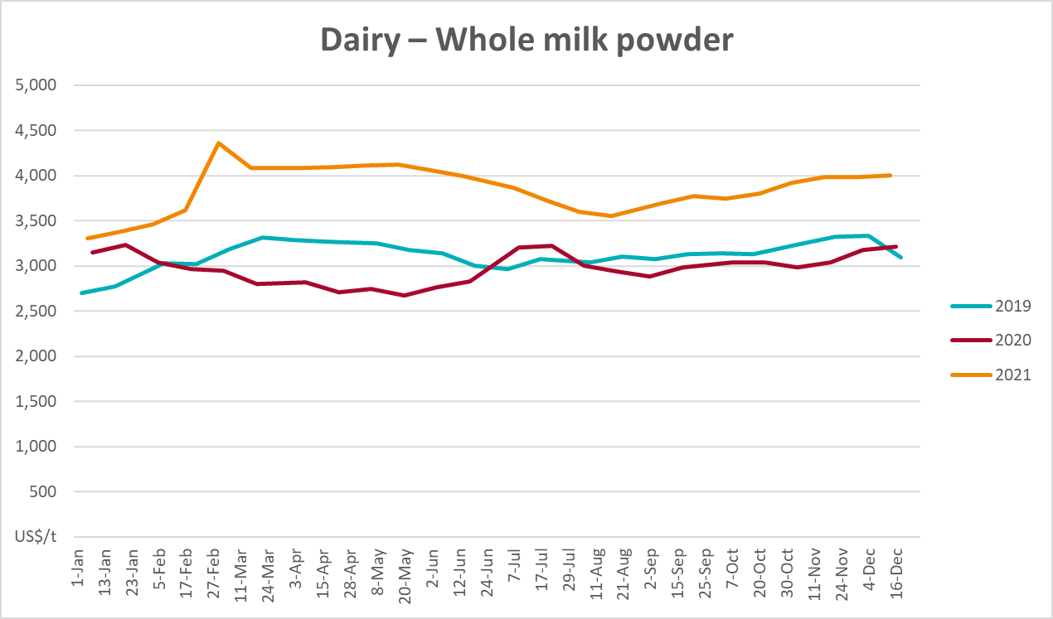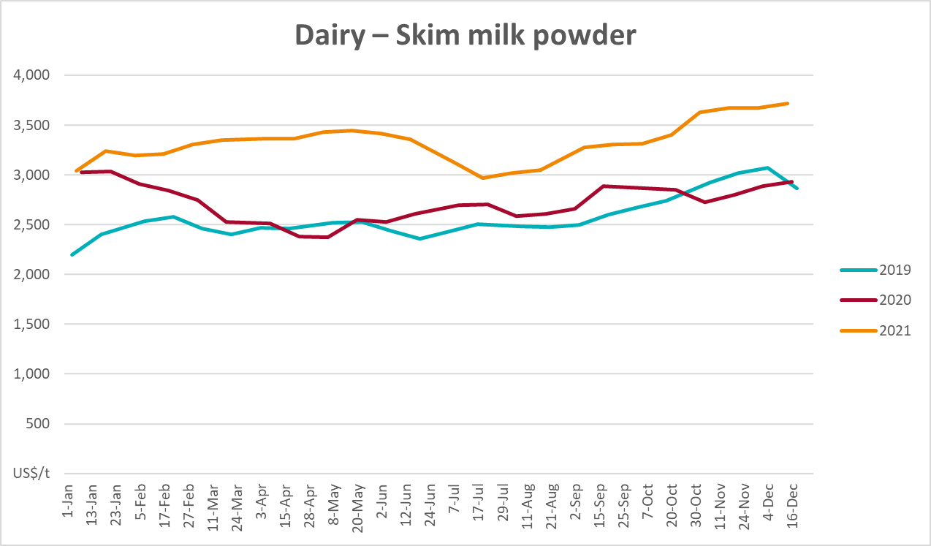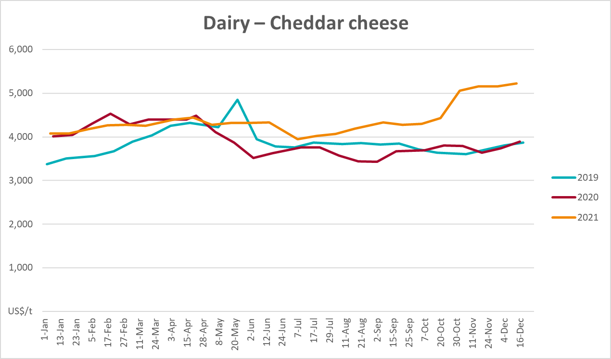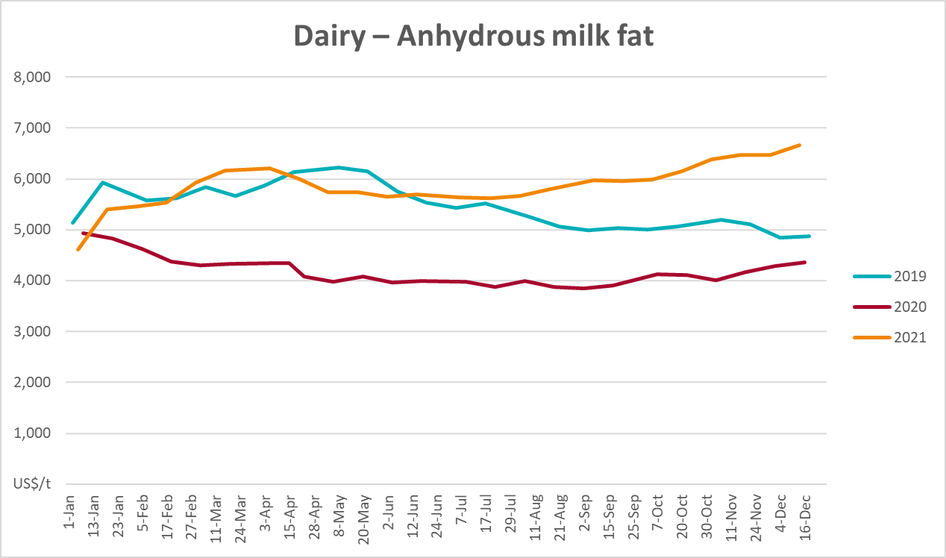

Selected fruit and vegetable prices
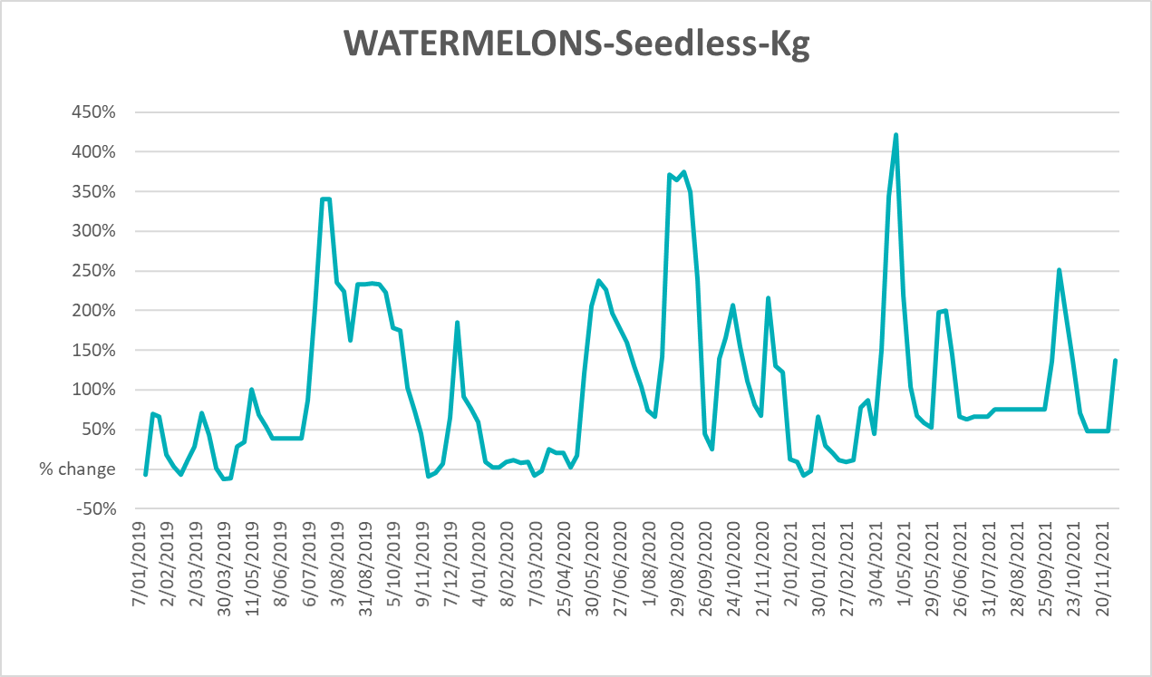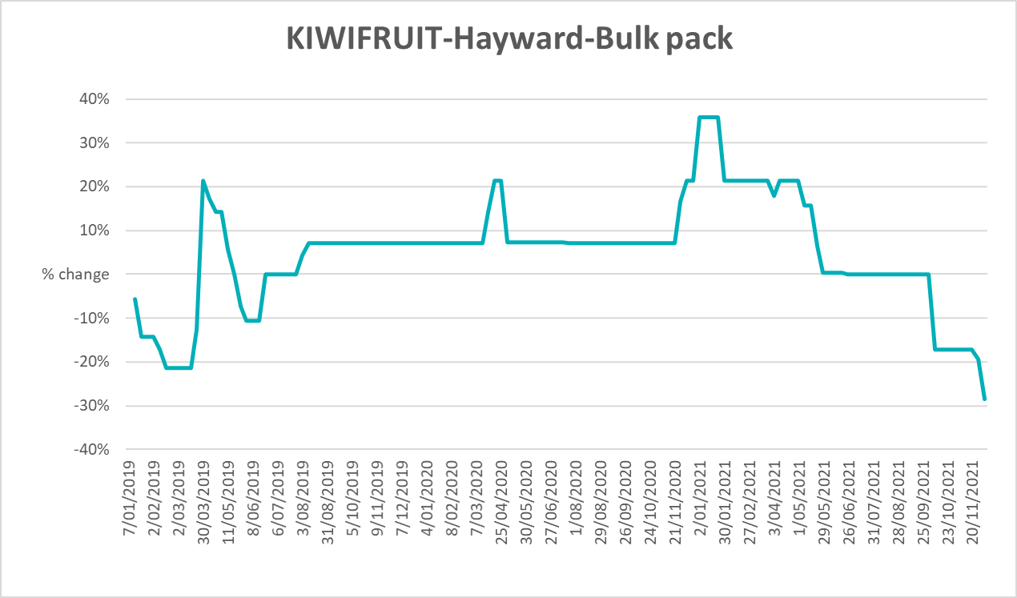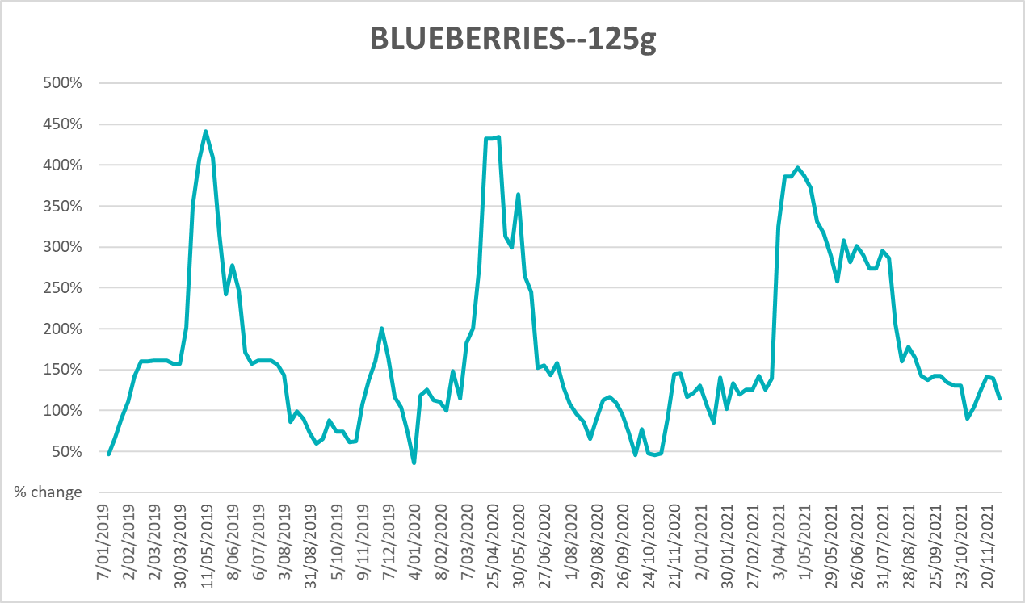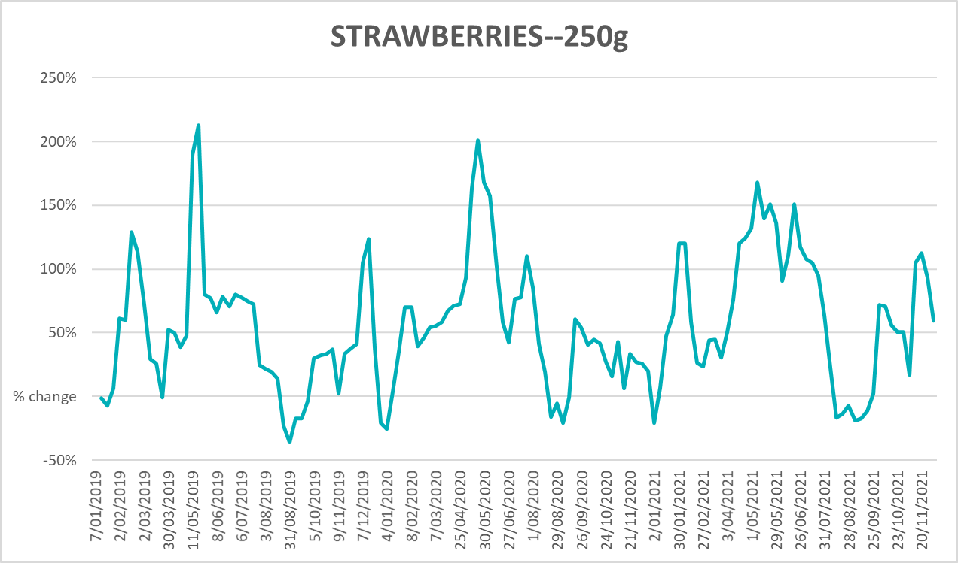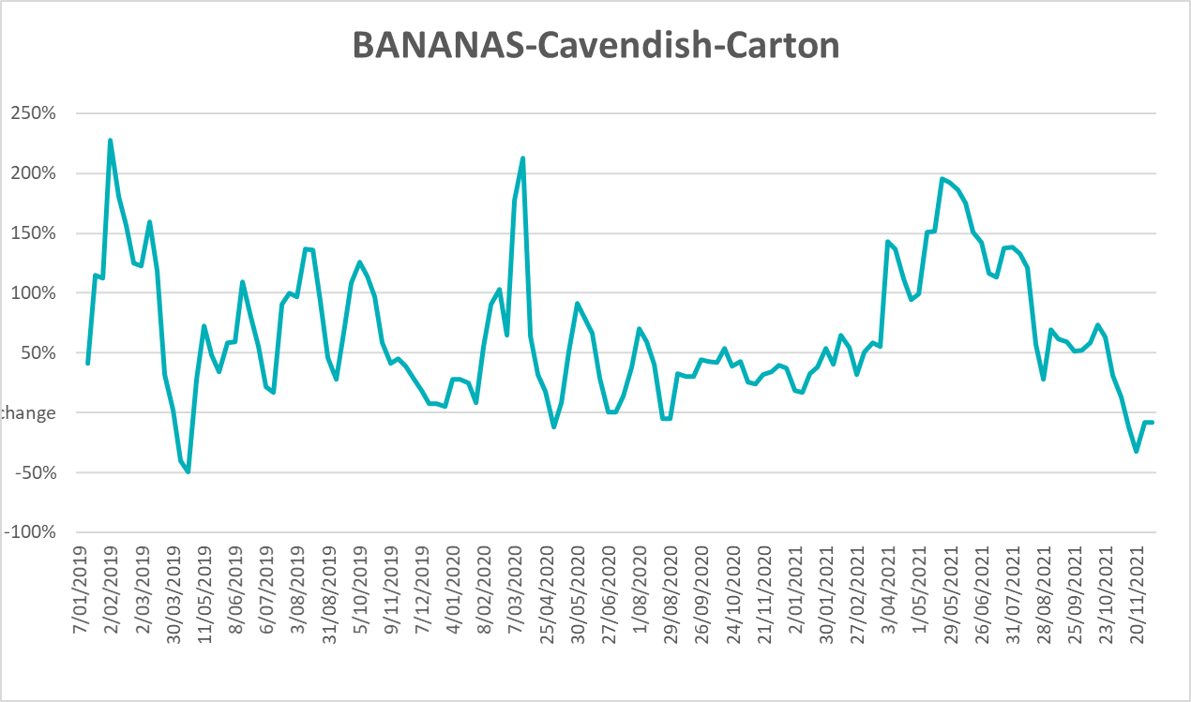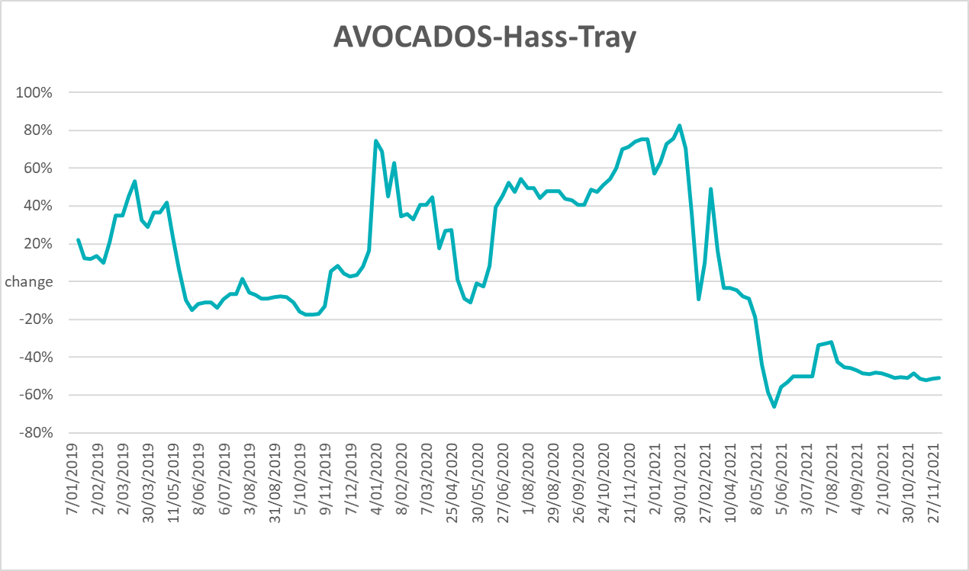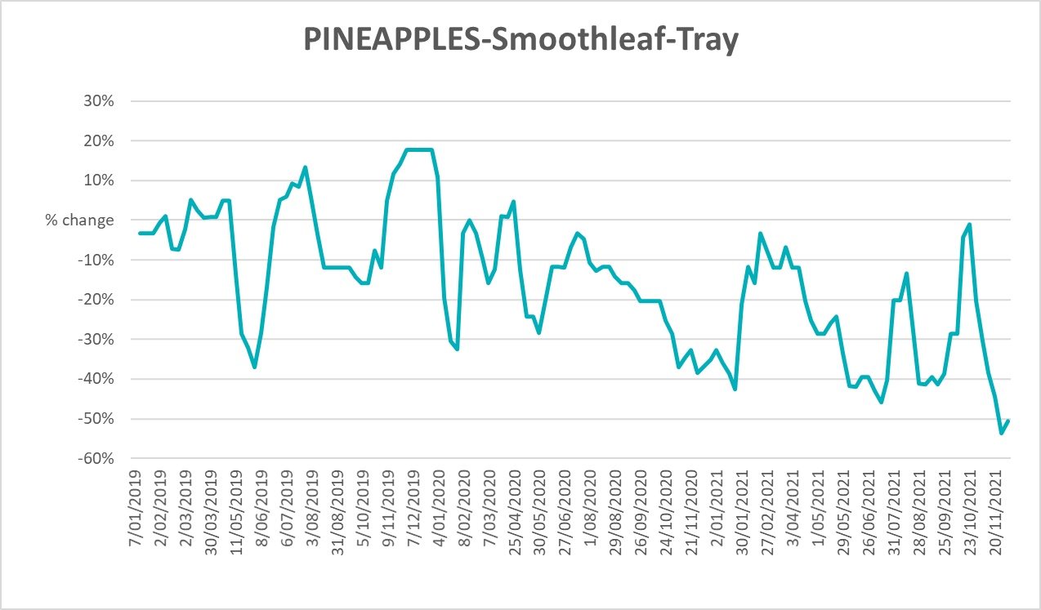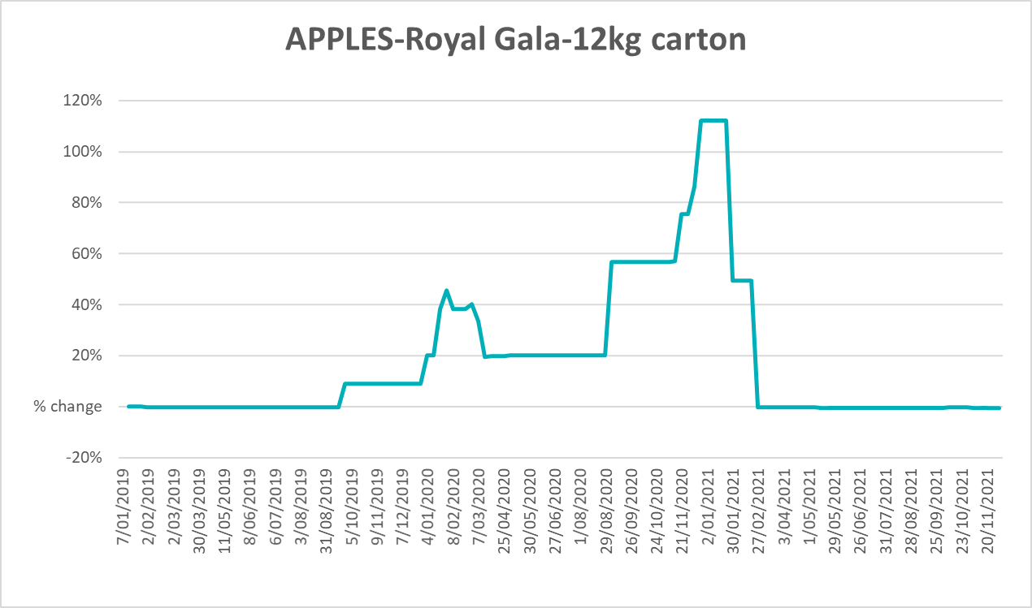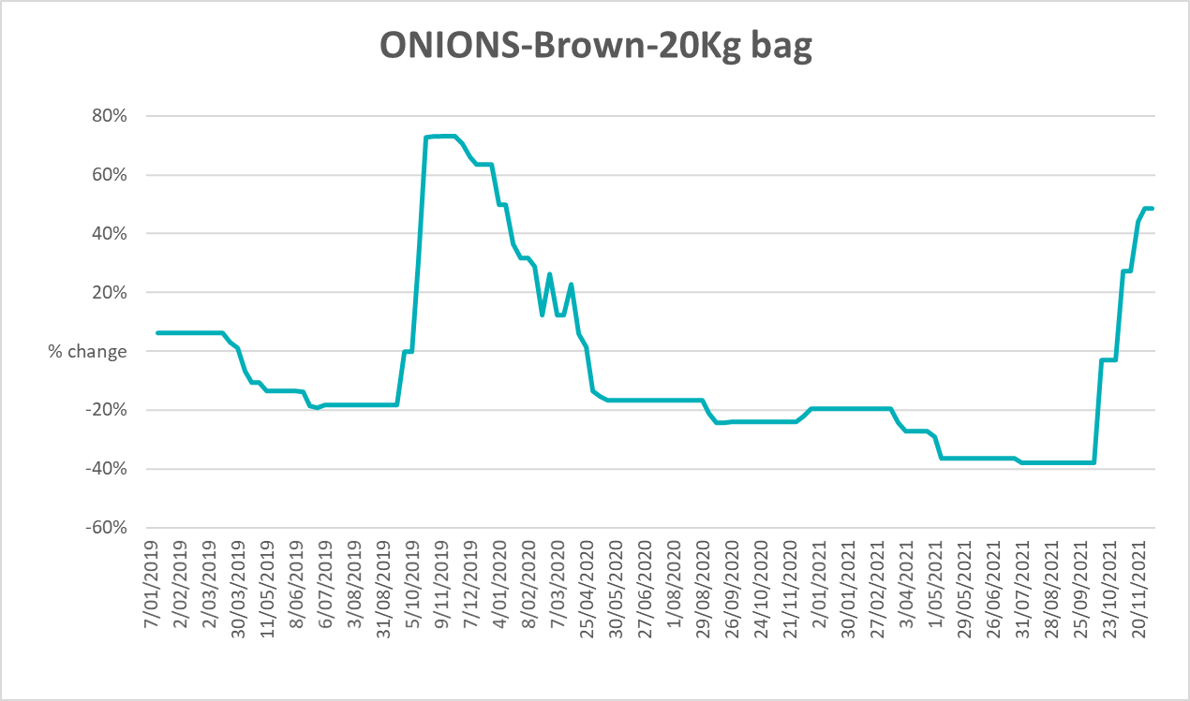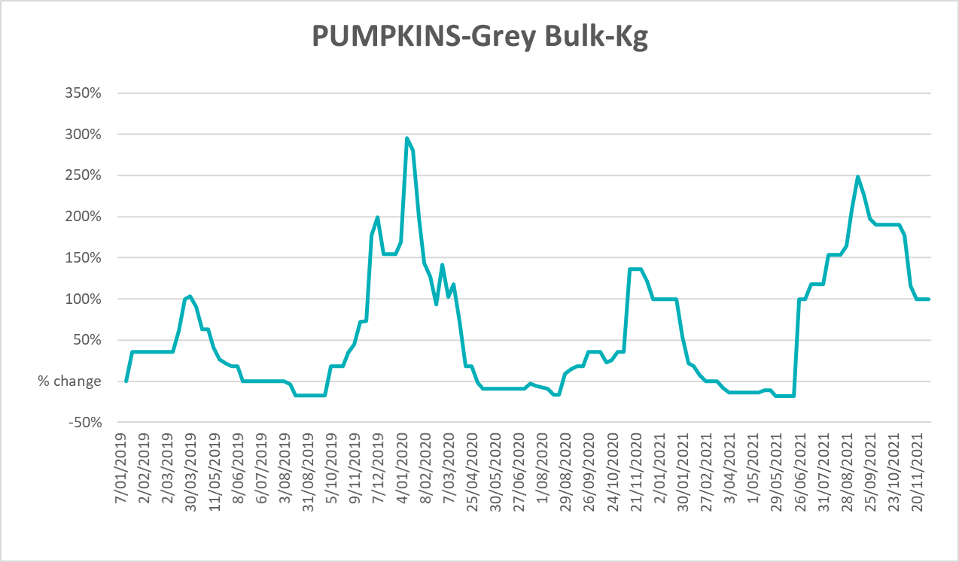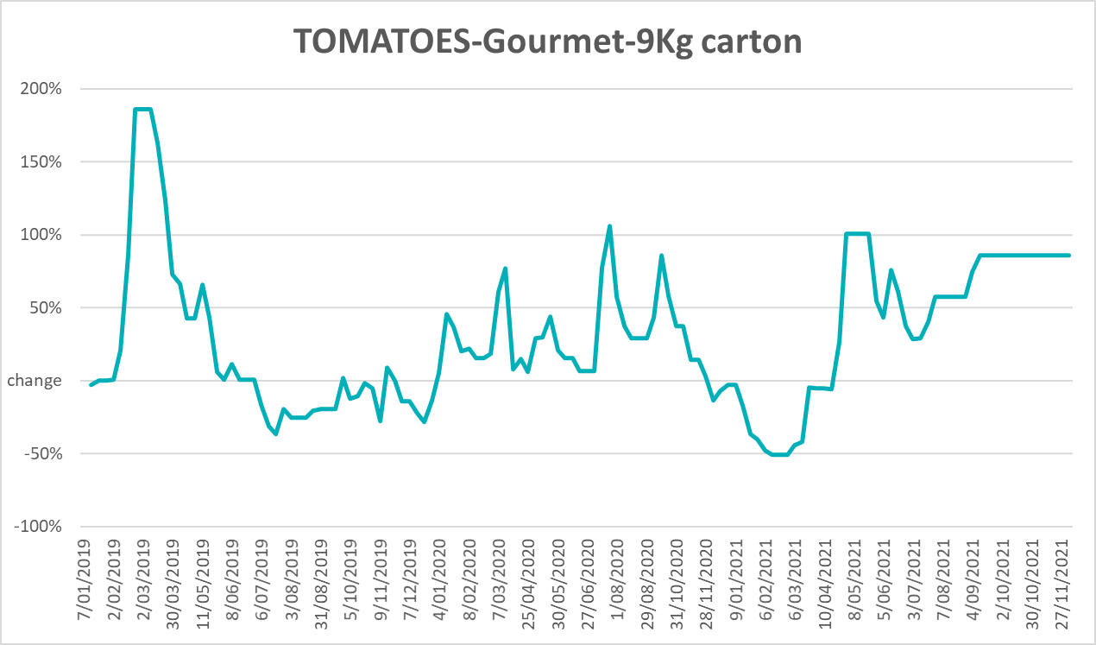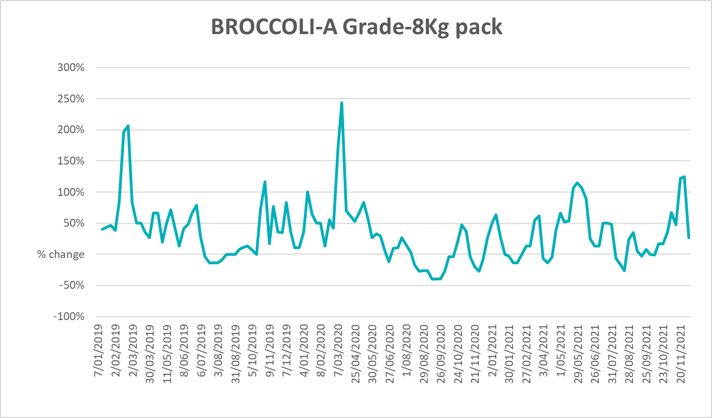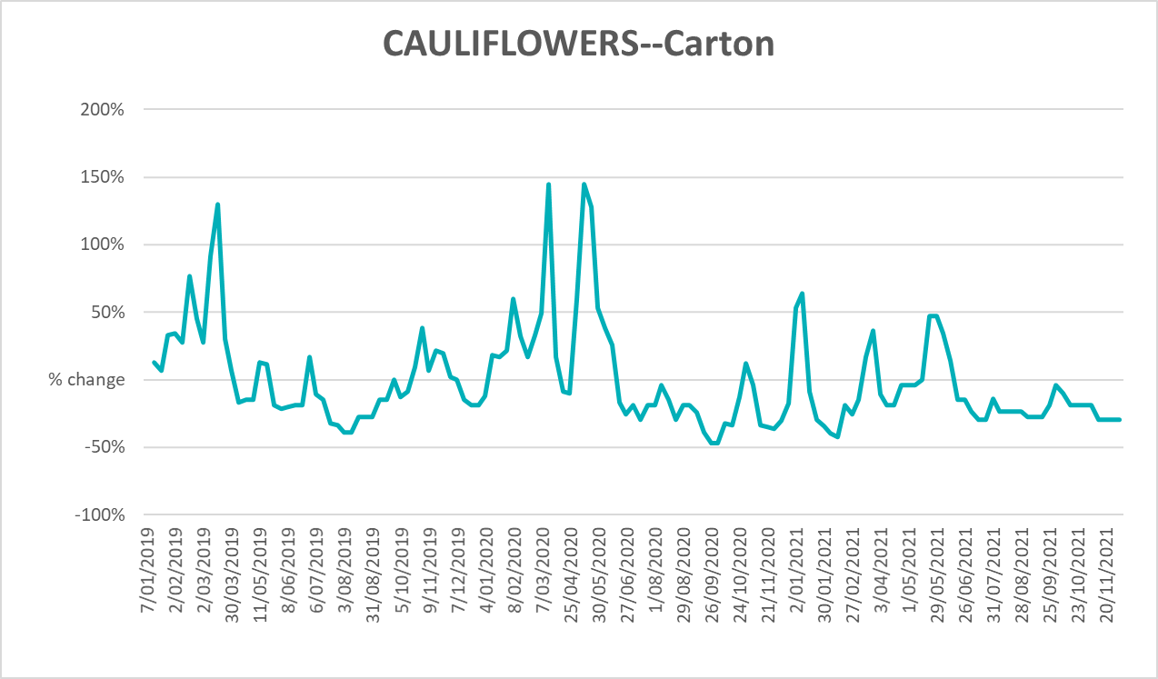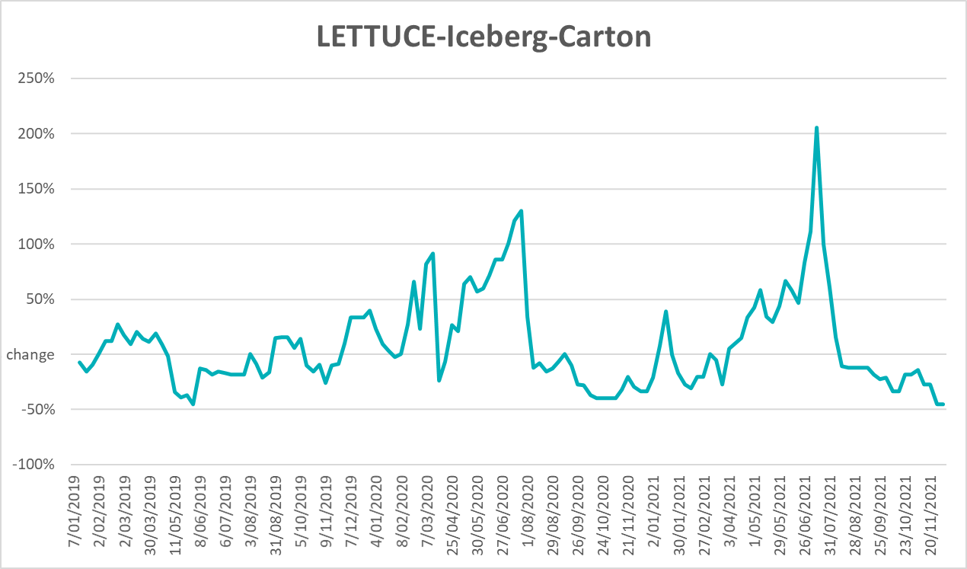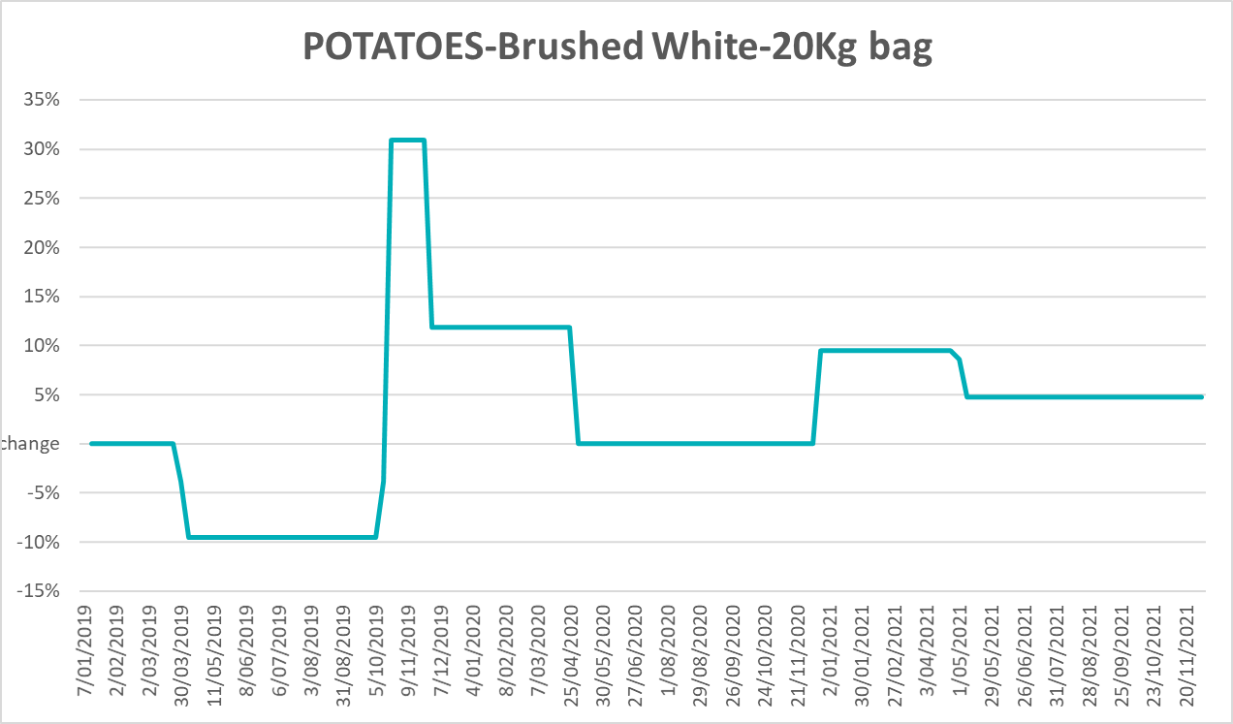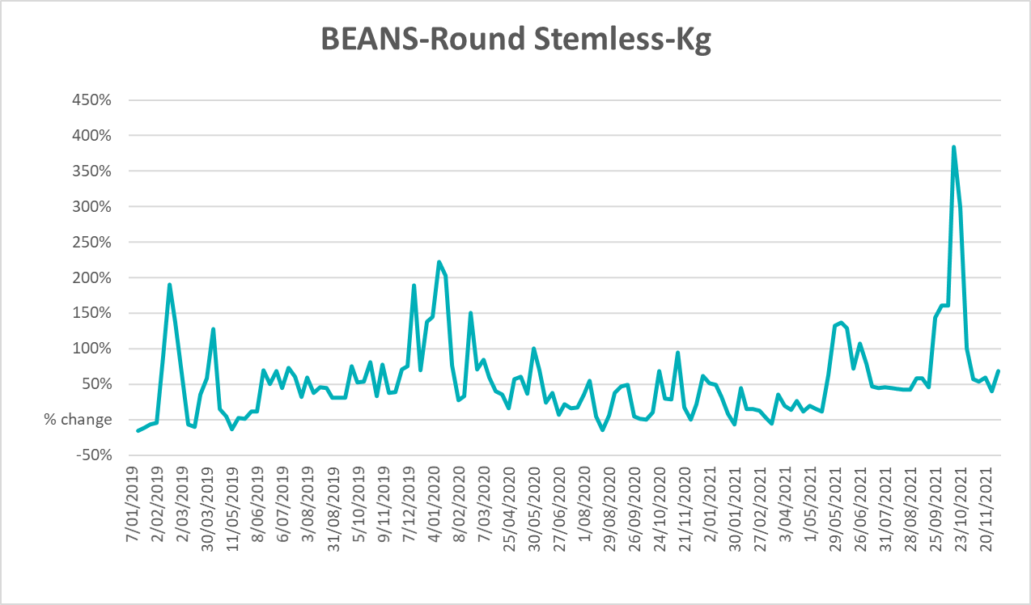

Selected domestic fodder indicator prices
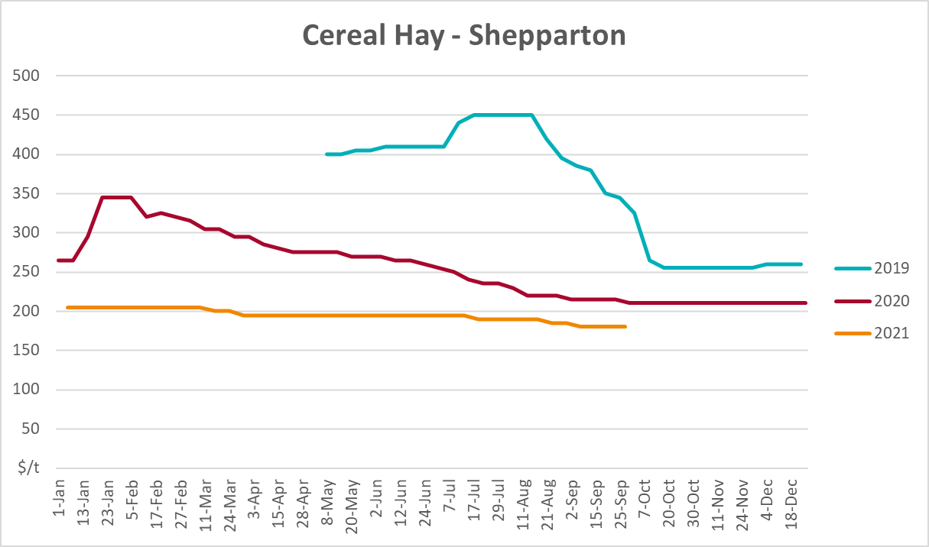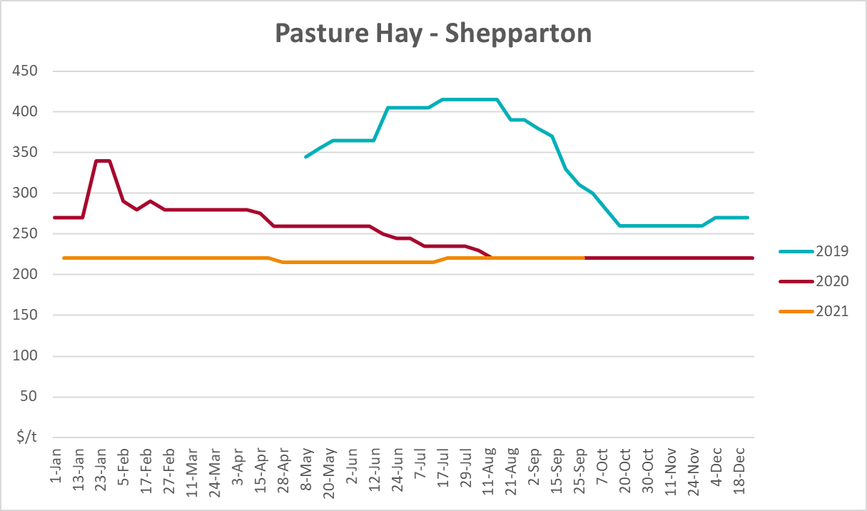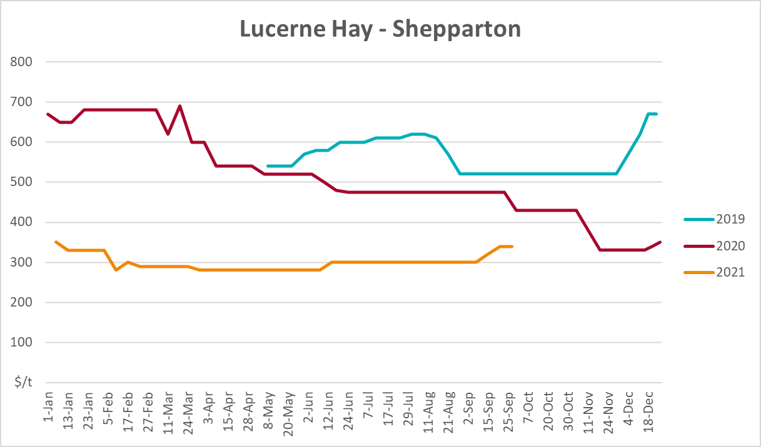

Data attribution

Climate
Bureau of Meteorology
- Weekly rainfall totals: www.bom.gov.au/climate/maps/rainfall/
- Monthly and last 3-month rainfall percentiles: www.bom.gov.au/water/landscape/
- Temperature anomalies: www.bom.gov.au/jsp/awap/temp/index.jsp
- Rainfall forecast: www.bom.gov.au/jsp/watl/rainfall/pme.jsp
- Seasonal outlook: www.bom.gov.au/climate/outlooks/#/overview/summary/
- Climate drivers: http://www.bom.gov.au/climate/enso/
- Soil moisture: www.bom.gov.au/water/landscape/
Other
- Pasture growth: www.longpaddock.qld.gov.au/aussiegrass/
- 3-month global outlooks: Environment and Climate Change Canada, NOAA Climate Prediction Center, EUROBRISA CPTEC/INPE, European Centre for Medium-Range Weather Forecasts, Hydrometcenter of Russia, National Climate Center Climate System Diagnosis and Prediction Room (NCC), International Research Institute for Climate and Society
- Global production: https://ipad.fas.usda.gov/ogamaps/cropmapsandcalendars.aspx
- Autumn break: Pook et al., 2009, https://rmets-onlinelibrary-wiley-com.virtual.anu.edu.au/doi/epdf/10.1002/joc.1833

Water
Prices
- Waterflow: https://www.waterflow.io/
- Ruralco: https://www.ruralcowater.com.au/
Bureau of Meteorology:
- Allocation trade: http://www.bom.gov.au/water/dashboards/#/water-markets/mdb/at
- Storage volumes: http://www.bom.gov.au/water/dashboards/#/water-storages/summary/drainage
Trade constraints:
- Water NSW: https://www.waternsw.com.au/customer-service/ordering-trading-and-pricing/trading/murrumbidgee
- Victorian Water Register: https://www.waterregister.vic.gov.au/TradingRules2019/

Commodities
Fruit and vegetables
- Datafresh: www.freshstate.com.au
Pigs
- Australian Pork Limited: www.australianpork.com.au
Dairy
- Global Dairy Trade: www.globaldairytrade.info/en/product-results/
World wheat, canola
- International Grains Council
World coarse grains
- United States Department of Agriculture
World cotton
- Cotlook: www.cotlook.com/
World sugar
- New York Stock Exchange - Intercontinental Exchange
Wool
- Australian Wool Exchange: www.awex.com.au/
Domestic wheat, barley, sorghum, canola and fodder
- Jumbuk Consulting Pty Ltd: http://www.jumbukag.com.au/
Cattle, beef, mutton, lamb, goat and live export
- Meat and Livestock Australia: www.mla.com.au/Prices-and-market
© Commonwealth of Australia 2021

Ownership of intellectual property rights
Unless otherwise noted, copyright (and any other intellectual property rights, if any) in this publication is owned by the Commonwealth of Australia (referred to as the Commonwealth).

Creative Commons licence
All material in this publication is licensed under a Creative Commons Attribution 4.0 International Licence except content supplied by third parties, logos and the Commonwealth Coat of Arms.
Inquiries about the licence and any use of this document should be emailed to copyright@awe.gov.au.


Cataloguing data
This publication (and any material sourced from it) should be attributed as:
ABARES 2021, Weekly Australian Climate, Water and Agricultural Update, Australian Bureau of Agricultural and Resource Economics and Sciences, Canberra, 16 December 2021. CC BY 4.0 DOI: https://doi.org/10.25814/5f3e04e7d2503
ISSN 2652-7561
This publication is available at https://www.agriculture.gov.au/abares/products/weekly_update
Department of Agriculture, Water and the Environment
GPO Box 858 Canberra ACT 2601
Telephone 1800 900 090
Web awe.gov.au/abares

Disclaimer
The Australian Government acting through the Department of Agriculture, Water and the Environment, represented by the Australian Bureau of Agricultural and Resource Economics and Sciences, has exercised due care and skill in preparing and compiling the information and data in this publication. Notwithstanding, the Department of Agriculture, Water and the Environment, ABARES, its employees and advisers disclaim all liability, including liability for negligence and for any loss, damage, injury, expense or cost incurred by any person as a result of accessing, using or relying on any of the information or data in this publication to the maximum extent permitted by law.

Statement of Professional Independence
The views and analysis presented in ABARES publications, including this one, reflect ABARES professionally independent findings, based on scientific and economic concepts, principles, information and data. These views, analysis and findings may not reflect or be consistent with the views or positions of the Australian Government, or of organisations or groups who have commissioned ABARES reports or analysis. More information on professional independence is provided on the ABARES website.

Acknowledgements
This report was prepared by Matthew Miller, Stephanie Blake and Cameron Van-Lane.

