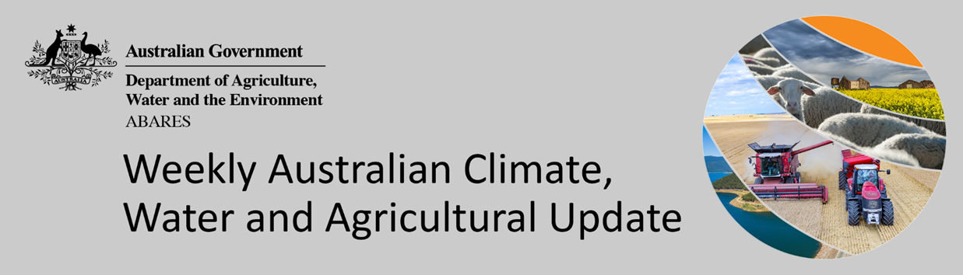
No. 2/2022

20 January 2022

Summary of key issues
- For the week ending 19 January 2022, troughs extending across eastern Australia resulted in scatted rainfall across southern Queensland, and eastern New South Wales and Victoria. Tropical cyclone activity and seasonal thunderstorms were also active during the week, bringing significant rainfall to the northern regions of Queensland and Western Australia and much of the Northern Territory (see Section 1.1).
- Global crop production conditions have been generally favourable for the major grain and oilseed producing countries despite dry conditions across parts of Argentina, Brazil, and the United States, affecting the production potential of wheat, corn and soybeans (see Section 1.2).
- While well below average rainfall during December is likely to result in lower-than-expected winter wheat production in the United States, and decreased corn and soybean production across parts of Argentina and Brazil, average to above rainfall across the Black Sea Region and part of Europe is likely to improve production prospected in these key production regions. This is providing, on aggregate, similar global production conditions to those seen back in November 2021, that were used to formulate ABARES forecasts of global grain supplies and the impact on world prices in its December 2021 edition of Agricultural commodities (see Section 1.2).
- The global climate outlook indicates that average to above average rainfall is slightly more likely between February and April 2022 for most of the world's major grain- and oilseed-producing regions. Partly due to the influence of La Niña, below average rainfall is expected for parts of north-eastern Argentina, southern Brazil, western and the far east of China, southern India, Kazakhstan and the southern United States (see Section 1.2).
- Over the 8-days to 20 January 2022, rainfall is expected across much of Australia. Remnants of ex-tropical cyclone Tiffany and low-pressure troughs are expected to bring heavy rain and storms to large areas of Australia’s tropical north, as well as large area of central and eastern Australia (see Section 1.3).
- Water storage in the Murray–Darling Basin (MDB) decreased by 43 gigalitres (GL) between 12 January 2022 and 19 January 2022. The current volume of water held in storage is 22,523 GL, which represents 89% of total capacity. This is 60% or 8,452 GL more than at the same time last year.
- Allocation prices in the Victorian Murray below the Barmah Choke increased from $99 per ML on 7 January 2022 to $107 per ML on 14 January 2022. Prices are lower in the Goulburn-Broken, Murrumbidgee, and regions above the Barmah Choke due to the binding of the Goulburn intervalley trade limit, Murrumbidgee export limit, and Barmah Choke trade constraint.

Climate

Rainfall this week
For the week ending 19 January 2022, troughs extending across eastern Australia resulted in scatted rainfall across southern Queensland, and eastern New South Wales and Victoria. Tropical cyclone activity and seasonal thunderstorms were also active during the week, bringing significant rainfall to the northern regions of Queensland and Western Australia and much of the Northern Territory.
Rainfall totals of between 10 and 50 millimetres were recorded across large areas of eastern and central New South Wales, eastern Victoria, Queensland, northern South Australia and the north and centre of Western Australia and the Northern Territory. Rainfall totals in excess of 50 millimetres were recorded across scatted areas of eastern Victoria, eastern New South Wales, through central Queensland and the Cape York Peninsula, central and northern South Australia, northern and southern areas of the Northern Territory and the northwest of Western Australia.
In cropping regions, rainfall totals of between 10 and 100 millimetres were recorded across much of New South Wales and southern Queensland. Little to no rainfall was recorded across remaining cropping regions in Queensland, Victoria, South Australia and Western Australia.
Significant rainfall in parts of eastern Australia has triggered localised flood warnings. The impact of persistent rainfall and flooding throughout November and December has slowed harvesting and degraded some crops in areas of New South Wales and Queensland and caused significant infrastructure damage which is compounding supply chain issues. However, above average soil moisture levels are likely to benefit summer crop production in Queensland and New South Wales.

Rainfall for the week ending 19 January 2022

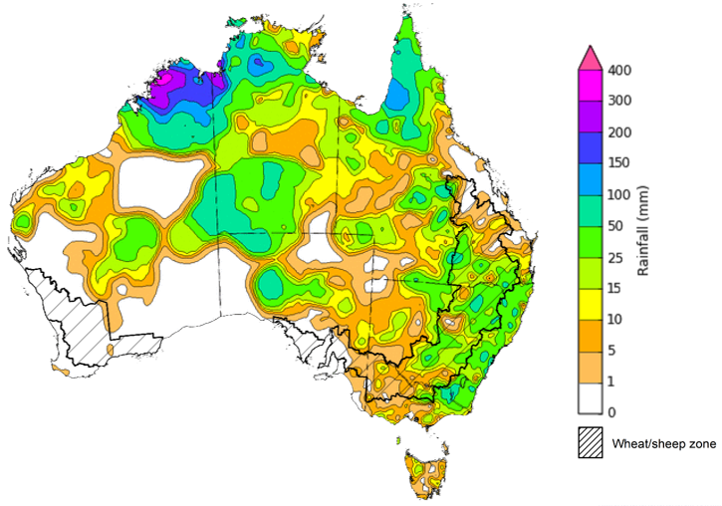
©Commonwealth of Australia 2022, Australian Bureau of Meteorology Issued: 19/01/2022
Note: The rainfall analyses and associated maps utilise data contained in the Bureau of Meteorology climate database, the Australian Data Archive for Meteorology (ADAM). The analyses are initially produced automatically from real-time data with limited quality control. They are intended to provide a general overview of rainfall across Australia as quickly as possible after the observations are received. For further information go to http://www.bom.gov.au/climate/rainfall/

Global production conditions and climate outlook
Crop production is affected by long-term trends in average rainfall and temperature, interannual climate variability, shocks during specific growth stages, and extreme weather events (IPCC 2012). Some crops are more tolerant than others to certain types of stresses, and at each growth stage, different types of stresses affect each crop species in different ways.
The precipitation anomalies and outlooks presented here give an indication of the current and future state of production conditions for the major grain and oilseed producing countries which are responsible for over 80% of global production. This is an important input to assessing the global grain supply outlook.
December precipitation percentiles and current production conditions
As of the end of December 2021, rainfall was mixed for the world’s major grain-producing and oilseed-producing regions.
In the northern hemisphere, precipitation was below average in the central southern United States, the north-eastern coast of China, southern Kazakhstan, some northern areas of the Russian Federation, and parts of coastal Canada. Precipitation was above average for parts of the Ural, Volga, southern Siberian and the Far Eastern districts of the Russian Federation, central Canada, the south-western coast of the United States and western Ukraine. Precipitation was close to average across the remainder of the major grain-producing and oilseed-producing regions in the northern hemisphere.
In the southern hemisphere, December precipitation was below average in north-eastern Argentina, Paraguay, Uruguay, southern Brazil, western and southern Australia, and parts of southern Africa. Precipitation was above average across northern and central Brazil, Bolivia, South Africa and parts of the Philippines and Indonesia. Precipitation was close to average across the remainder of major grain-producing and oilseed-producing regions in the southern hemisphere.

Global precipitation percentiles, December 2021
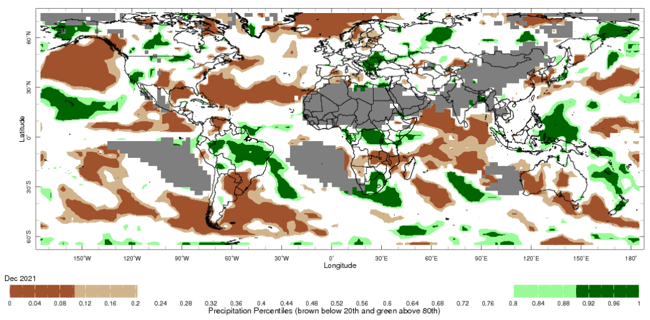
Note: The world precipitation percentiles indicate a ranking of precipitation for December, with the driest (0th percentile) being 0 on the scale and the wettest (100th percentile) being 1 on the scale. Percentiles are based on precipitation estimates from the NOAA Climate Prediction Center's Climate Anomaly Monitoring System Outgoing Precipitation Index dataset. Precipitation estimates for December 2021 are compared with rainfall recorded for that period during the 1981 to 2010 base period.
Source: International Research Institute for Climate and Society
The global climate outlook for February 2022 to April 2022 indicates that mixed rainfall conditions are expected for the world's major grain-producing and oilseed-producing regions. Outlooks and potential production impacts for the major grain and oilseed producing countries are presented in the table.
Rainfall outlook and potential impact on the future state of production conditions between February 2022 to April 2022
Region | February-April rainfall outlook | Potential impact on production
Argentina | Below average rainfall is expected in north-eastern Argentina between February and April 2022, however, above average rainfall is expected in the north-west of the country. | Below average rainfall across parts of Argentina is likely to adversely affect the flowering of soybeans, sorghum, rice, and millet in February. The dry conditions are likely to negatively impact yield potentials for these crops.
Black Sea Region | Below average rainfall is forecast for parts of Kazakhstan. Ukraine and the Russian Federation are more likely to record close to average rainfall between February and April 2022. | Below average rainfall may adversely affect winter wheat and canola development and cotton, corn and sunflower planting in parts of Kazakhstan from March 2022. Average or better rainfall across Russia and the Ukraine is likely to support the development and planting of these crops as well as spring wheat planting in the north in April 2022.
Brazil | Above average rainfall is expected in northern and central Brazil between February and April 2022. Southern Brazil is expected to receive below-average rainfall. | Average to above average rainfall across much of Brazil is likely to support the development of soybeans, cotton, rice, sorghum, millet, sunflower, nuts and corn prior to harvesting of some crops beginning in March 2021. Below average rainfall in the far south may adversely affect the development and harvesting of crops in that region.
Canada | Average to above average rainfall is expected across much of Canada between February and April 2022. | Through February, March and April, winter wheat and canola will progress from dormant to heading. Average to above average rainfall will likely provide sufficient snowpack to prevent winterkill of wheat and support vegetative growth and heading.
China | Average to below average rainfall is likely across much of western China between February and April 2022, as well as along the east coast. Average to above average rainfall is likely in central China. | During February, winter wheat and canola will remain dormant and be susceptible to reduced snowpack should rainfall drop below average. Winter wheat will begin heading in April during which dry conditions may negatively impact yield potentials.
Europe | Average to slightly below average rainfall is likely for most of Europe between February and April 2022. Above average rainfall is expected for Norway and Sweden. | During February, winter wheat and canola will remain dormant and be susceptible to reduced snowpack should rainfall drop below average. Winter wheat will begin heading in southern Europe during March and April. Dry conditions may negatively impact yield potentials for these crops.
South Asia (India) | Below average rainfall is likely across much of southern India between February and April 2022. | The development of wheat and canola in parts of central and northern India is likely to be supported by above average rainfall and these crops may be adversely affected by below average rainfall in southern India.
Southeast Asia (SEA) | Above average rainfall is likely across much of SEA between February and April 2022, particularly in the Philippines, Vietnam, Thailand and Malaysia. Below average rainfall is predicted for Myanmar and parts of Indonesia. | Above average rainfall across SEA is likely to support the planting and vegetative growth of early and single rice production. However, excessive rainfall may result in flooding, crop damage and limited access to fields.
The United States of America | Above average rainfall is more likely for far north-western United States and in the north and centre of eastern United States. Below average rainfall is more likely across the southern half of the United States. | Following dormancy, average to above average rainfall is likely to support wheat development in the northern and eastern US from March 2022 and the planting of spring wheat, canola, cotton, corn and rice from April 2022. Below average rainfall may adversely impact crop development and planting in the southern US.

Rainfall forecast for the next eight days
Over the 8-days to 27 January 2022, rainfall is expected across much of Australia. Remnants of ex-tropical cyclone Tiffany and low-pressure troughs are expected to bring heavy rain and storms to large areas of Australia’s tropical north, as well as large area of central and eastern Australia. Meanwhile, high pressure systems are expected to bring mostly dry conditions to much of Western Australia.
Rainfall totals of between 10 and 50 millimetres are forecast for New South Wales and Victoria, as well as Queensland, South Australia, the Northern Territory and north-eastern Western Australia. Rainfall in excess of 50 millimetres is expected across much of the eastern half of South Australia, northern and western parts of Queensland, the northeast of Western Australia and much of the Northern Territory.
In Australian cropping regions, rainfall totals of between 10 and 25 millimetres are expected across New South Wales and Victoria, as well as most of Queensland. Falls in excess of 25 millimetres are expected across much of South Australia. Little to no rainfall is forecast for cropping regions of Western Australia during the next 8-days.
Soil moisture levels across eastern Australian cropping regions remain well above average. The forecast rainfall for parts of New South Wales, Queensland and Victorian cropping regions may saturate soil profiles and delay harvesting activities for those areas of New South Wales and Victoria yet to harvest winter crops. Likewise, further rainfall may prevent the harvest of early planted summer crops in northern New South Wales and southern Queensland. However, the falls are likely to benefit pasture growth and build soil moisture levels across affected areas and extent the growing season across southern growing regions.

Total forecast rainfall (mm) for the period 20 January to 27 January 2022
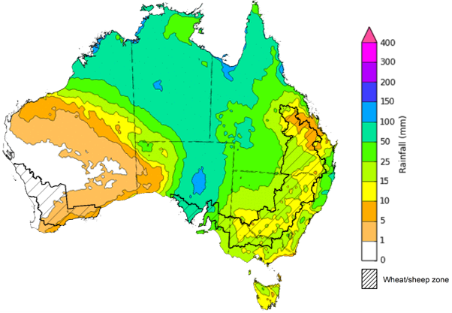
©Commonwealth of Australia 2022, Australian Bureau of Meteorology Issued: 20/01/2022

Water
Note: This rainfall forecast is produced from computer models. As the model outputs are not altered by weather forecasters, it is important to check local forecasts and warnings issued by the Bureau of Meteorology.

Water markets – current week
Water storage in the Murray–Darling Basin (MDB) decreased by 43 gigalitres (GL) between 12 January 2022 and 19 January 2022. The current volume of water held in storage is 22,523 GL, which represents 89% of total capacity. This is 60% or 8,452 GL more than at the same time last year.

Water storages in the Murray-Darling Basin, 2013–2022
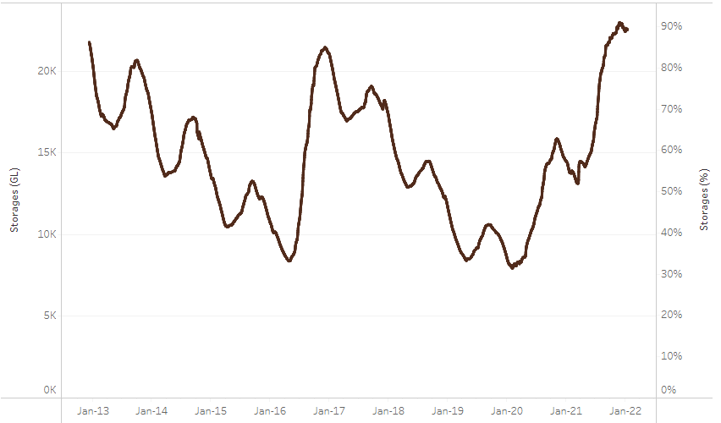
Allocation prices in the Victorian Murray below the Barmah Choke increased from $99 per ML on 7 January 2022 to $107 per ML on 14 January 2022. Prices are lower in the Goulburn-Broken, Murrumbidgee, and regions above the Barmah Choke due to the binding of the Goulburn intervalley trade limit, Murrumbidgee export limit, and Barmah Choke trade constraint.
Water storage data is sourced from the Bureau of Meteorology.

Region | $/ML
NSW Murray Above | 53
NSW Murrumbidgee | 58
VIC Goulburn-Broken | 76
VIC Murray Below | 107

Surface water trade activity, Southern Murray–Darling Basin

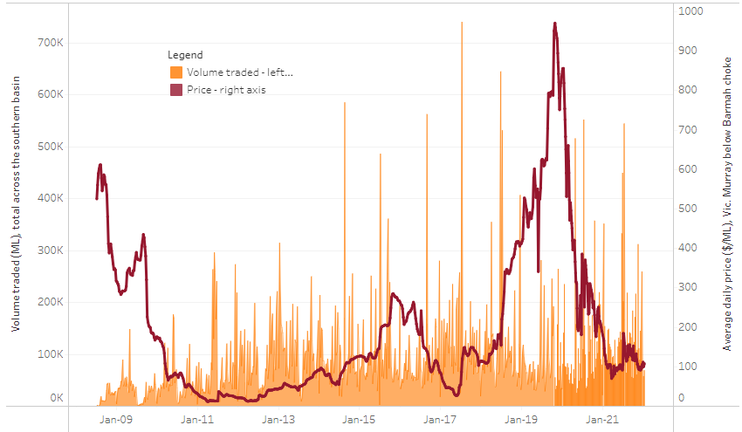
To access the full, interactive, weekly water dashboard, which contains the latest and historical water storage, water market and water allocation information, please visit http://www.agriculture.gov.au/abares/products/weekly_update/weekly-update-200122
The trades shown reflect estimated market activity and do not encompass all register trades. The price is shown for the VIC Murray below the Barmah choke. Historical prices (before 1 July 2019) are ABARES estimates after removing outliers from BOM water register data. Prices after 1 July 2019 and prior to the 30 October 2019 reflect recorded transaction prices as sourced from Ruralco. Prices after the 30 October 2019 are sourced from Waterflow. Data for volume traded is sourced from the BOM water register. Data shown is current at 13 Januaryr 2022.

Commodities
Indicator | Week ended | Unit | Latest price | Previous week | Weekly change | Price 12 months ago | Annual change
Selected world indicator prices
AUD/USD Exchange rate | 19-Jan | A$/US$ | 0.72 | 0.72 | 0% | 0.77 | -6%
Wheat – US no. 2 hard red winter wheat, fob Gulf | 19-Jan | US$/t | 362 | 371 | -3% | 293 | 24%
Corn – US no. 2 yellow corn, fob Gulf | 19-Jan | US$/t | 280 | 280 | 0% | 237 | 18%
Canola – Rapeseed, Canada, fob Vancouver | 19-Jan | US$/t | 854 | 879 | -3% | 582 | 47%
Cotton – Cotlook 'A' Index | 19-Jan | USc/lb | 133 | 128 | 4% | 88 | 51%
Sugar – Intercontinental Exchange, nearby futures, no.11 contract | 19-Jan | USc/lb | 18.3 | 18.0 | 2% | 16 | 16%
Wool – Eastern Market Indicator | 19-Jan | Ac/kg clean | 1,435 | 1,440 | 0% | 1,189 | 21%
Wool – Western Market Indicator | 15-Dec-21 | Ac/kg clean | 1,408 | 1,417 | -1% | 984 | 43%
Selected Australian grain export prices
Milling Wheat – APW, Port Adelaide, SA | 19-Jan | A$/t | 472 | 478 | -1% | 358 | 32%
Feed Wheat – ASW, Port Adelaide, SA | 19-Jan | A$/t | 441 | 442 | 0% | 354 | 24%
Feed Barley – Port Adelaide, SA | 19-Jan | A$/t | 375 | 368 | 2% | 308 | 22%
Canola – Kwinana, WA | 19-Jan | A$/t | 938 | 957 | -2% | 676 | 39%
Grain Sorghum – Brisbane, QLD | 19-Jan | A$/t | 368 | 363 | 1% | 379 | -3%
Selected domestic livestock indicator prices
Beef – Eastern Young Cattle Indicator | 19-Jan | Ac/kg cwt | 1,167 | 1,162 | 0% | 799 | 46%
Mutton – Mutton indicator (18–24 kg fat score 2–3), Vic | 19-Jan | Ac/kg cwt | 648 | 556 | 17% | 622 | 4%
Lamb – Eastern States Trade Lamb Indicator | 19-Jan | Ac/kg cwt | 847 | 846 | 0% | 758 | 12%
Pig – Eastern Seaboard (60.1–75 kg), average of buyers & sellers | 22-Dec-21 | Ac/kg cwt | 357 | 357 | 0% | 309 | 16%
Goats – Eastern States (12.1–16 kg) | 19-Jan | Ac/kg cwt | 879 | 879 | 0% | 818 | 8%
Live cattle – Light steers ex Darwin to Indonesia | 17-Feb-21 | Ac/kg lwt | 355 | 355 | 0% | 360 | -1%
Live sheep – Live wethers (Muchea WA saleyard) to Middle East | 22-Sep-21 | $/head | 147 | 171 | -14% | 126 | 17%

Indicator | Week ended | Unit | Latest price | Previous week | Weekly change | Price 12 months ago | Annual change
Global Dairy Trade (GDT) weighted average prices ª
Dairy – Whole milk powder | 19-Jan | US$/t | 4,082 | 3,866 | 6% | 3,331 | 23%
Dairy – Skim milk powder | 19-Jan | US$/t | 3,963 | 3,773 | 5% | 3,068 | 29%
Dairy – Cheddar cheese | 19-Jan | US$/t | 5,546 | 5,487 | 1% | 3,869 | 43%
Dairy – Anhydrous milk fat | 19-Jan | US$/t | 6,720 | 6,668 | 1% | 4,866 | 38%
a Global Dairy Trade prices are updated twice monthly on the first and third Tuesday of each month.

Selected world indicator prices
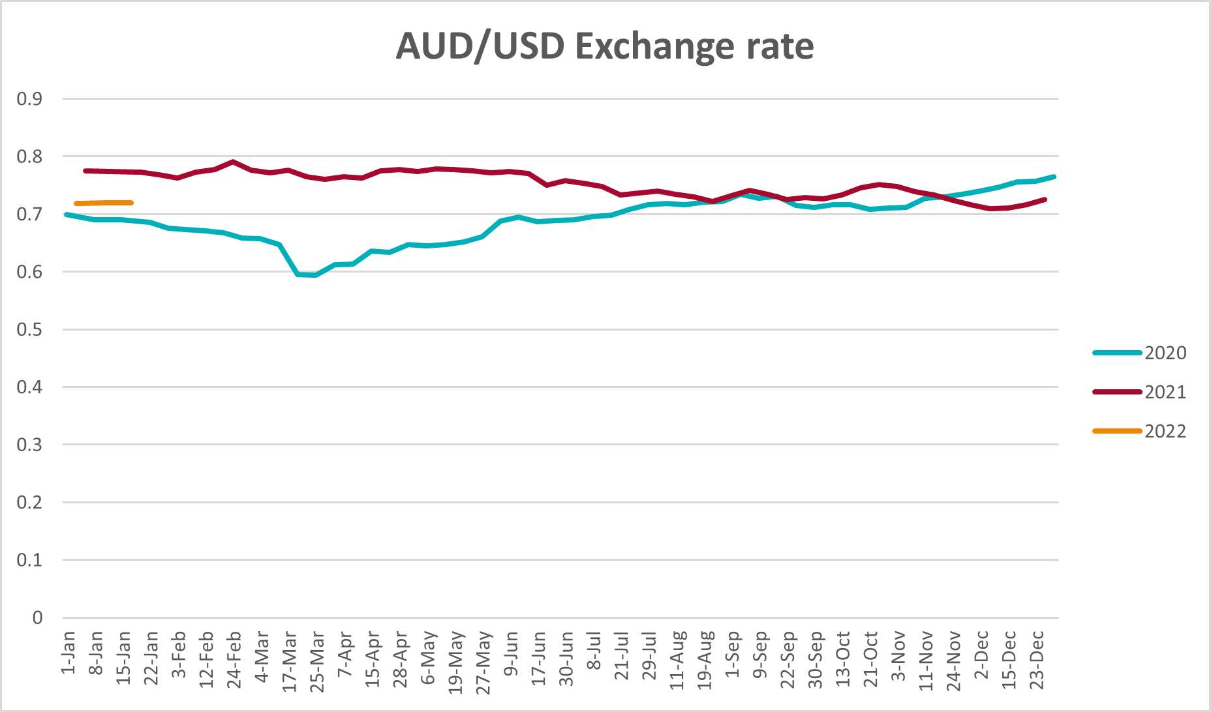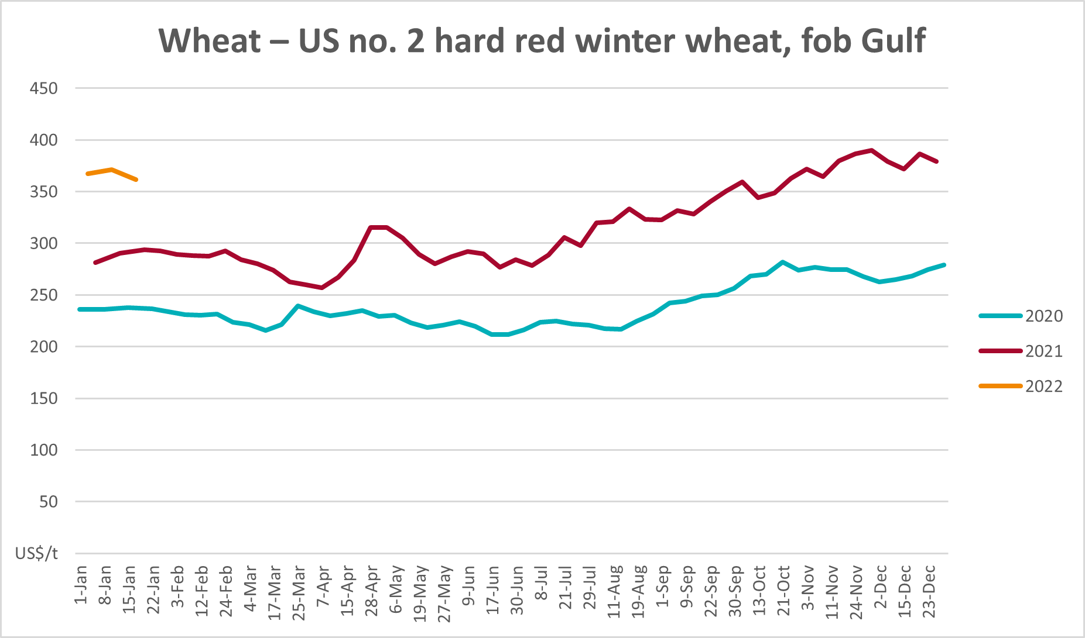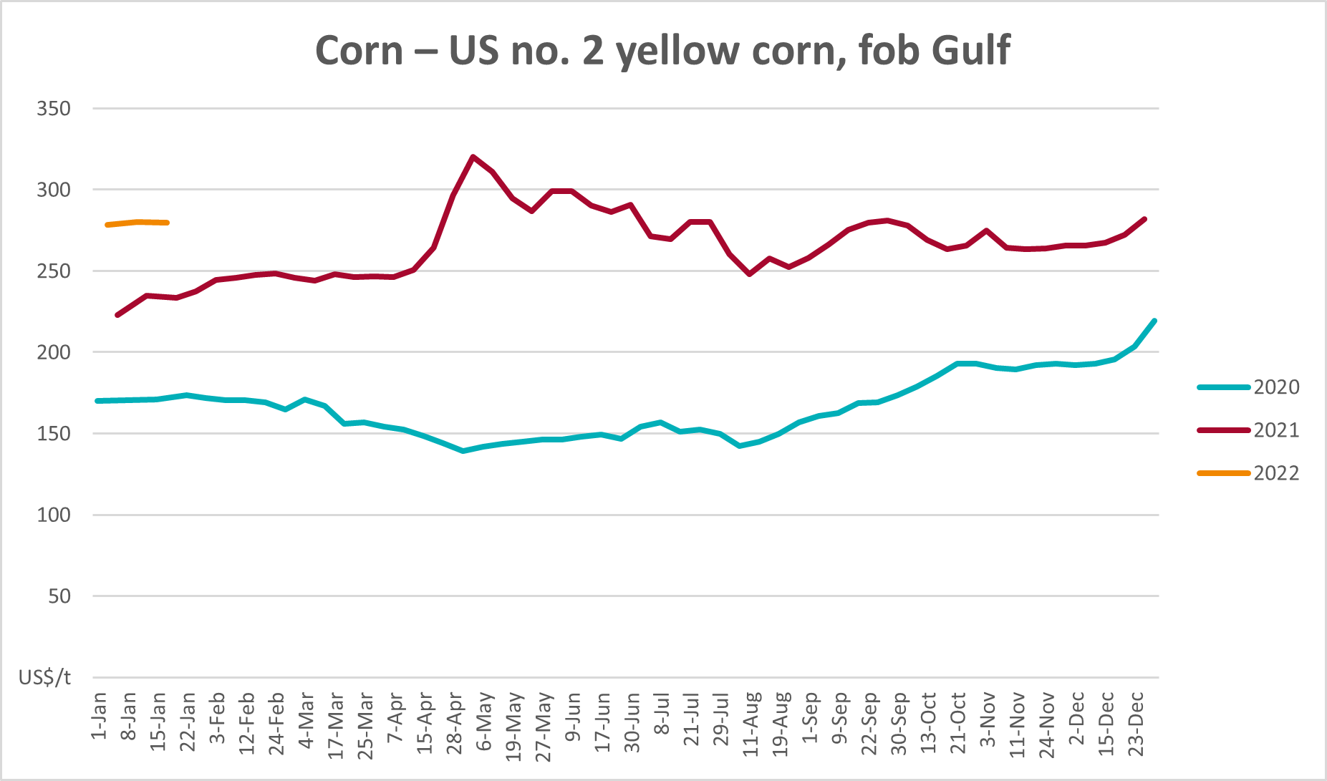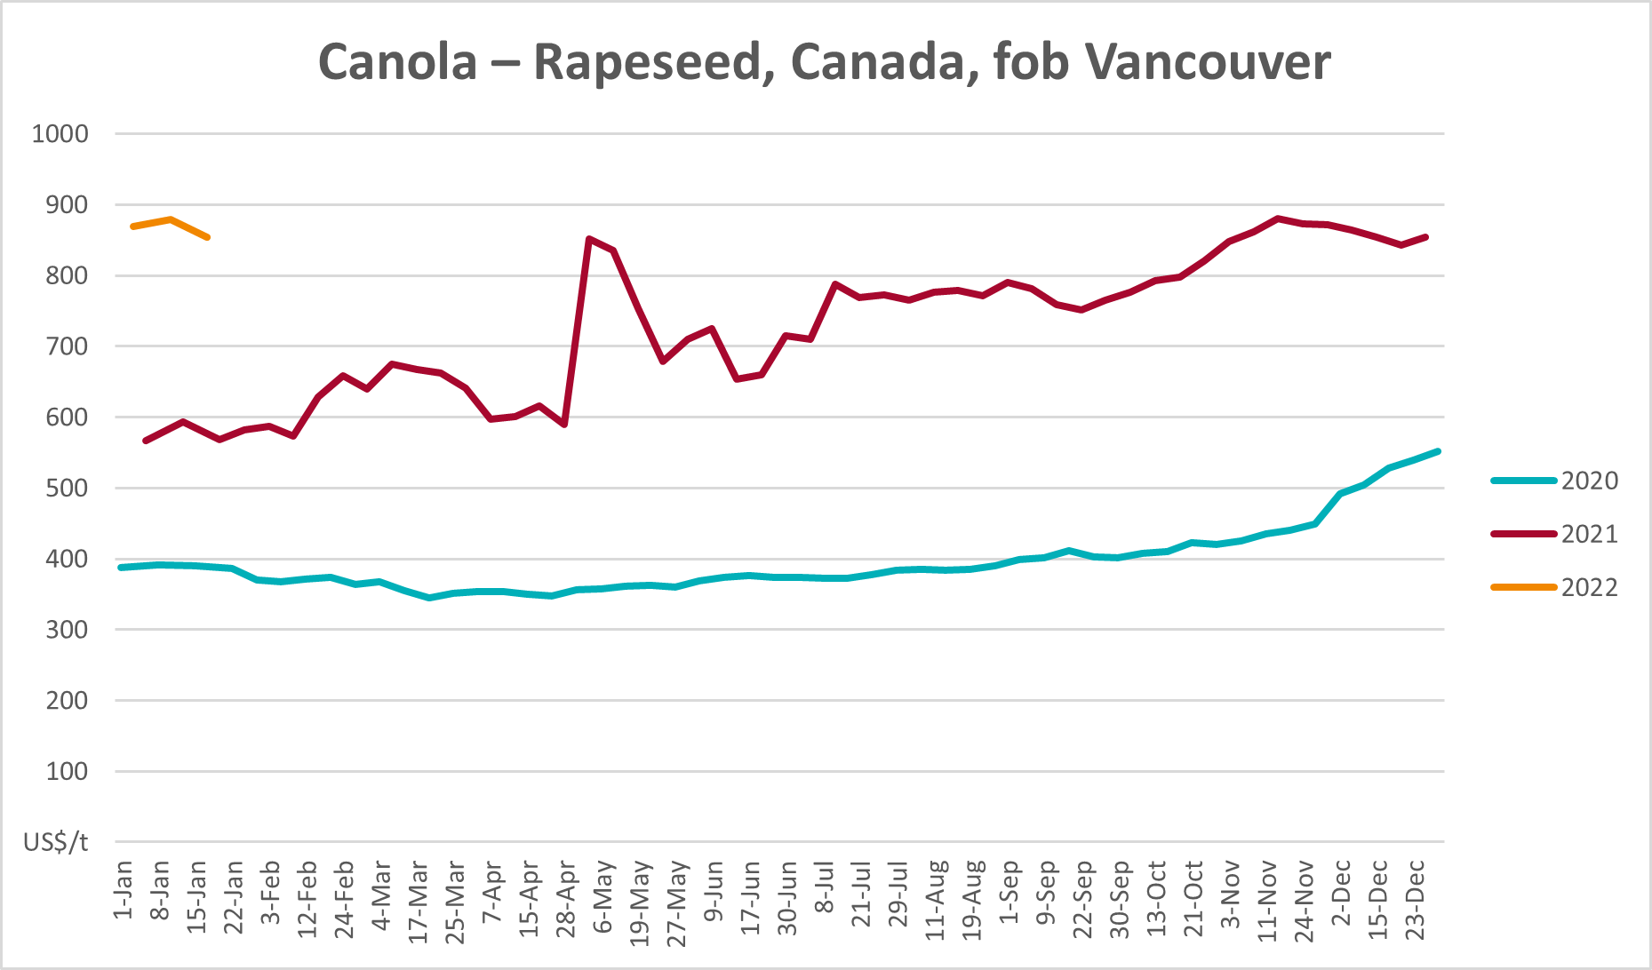

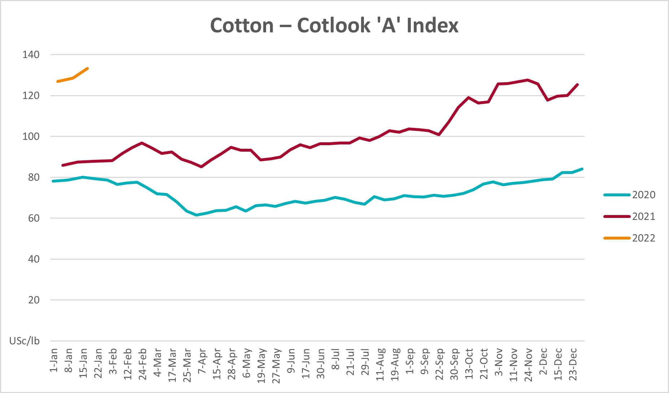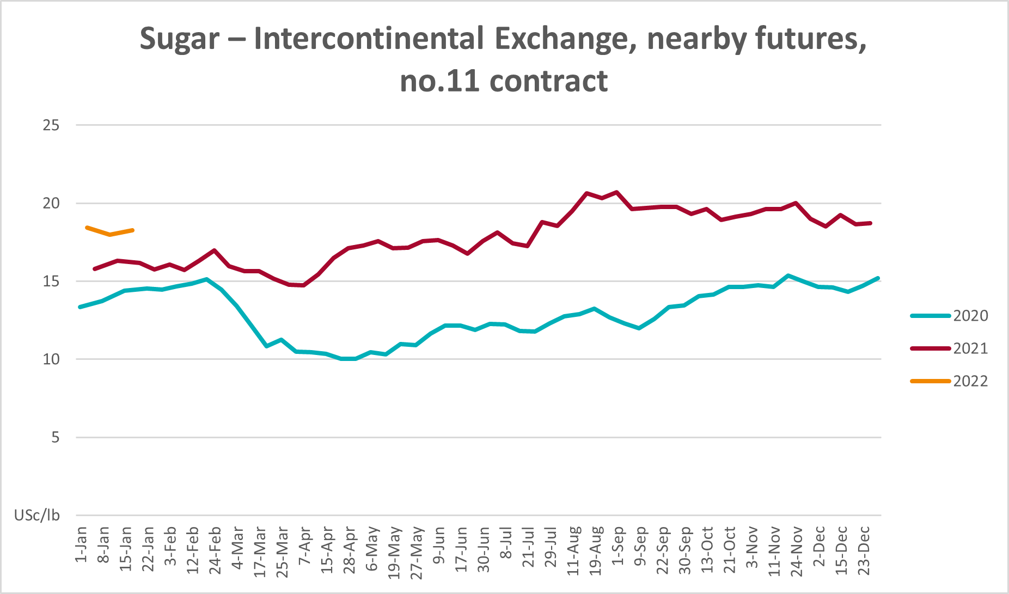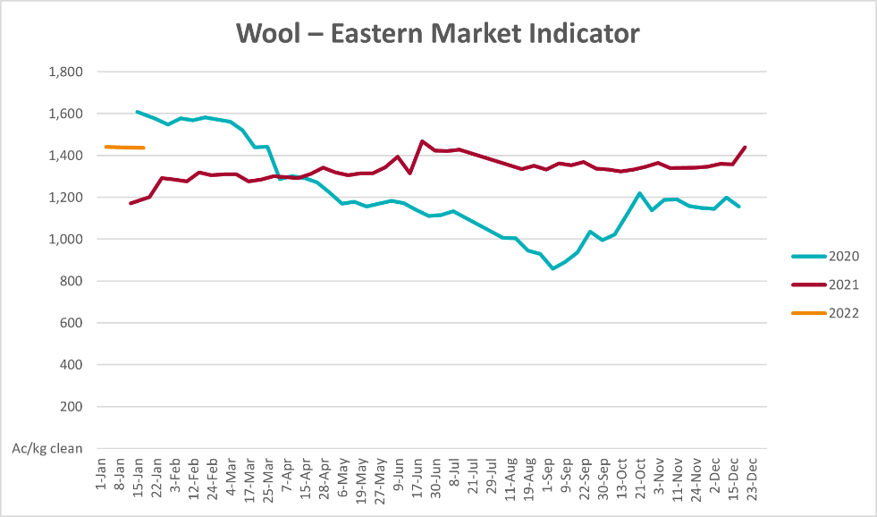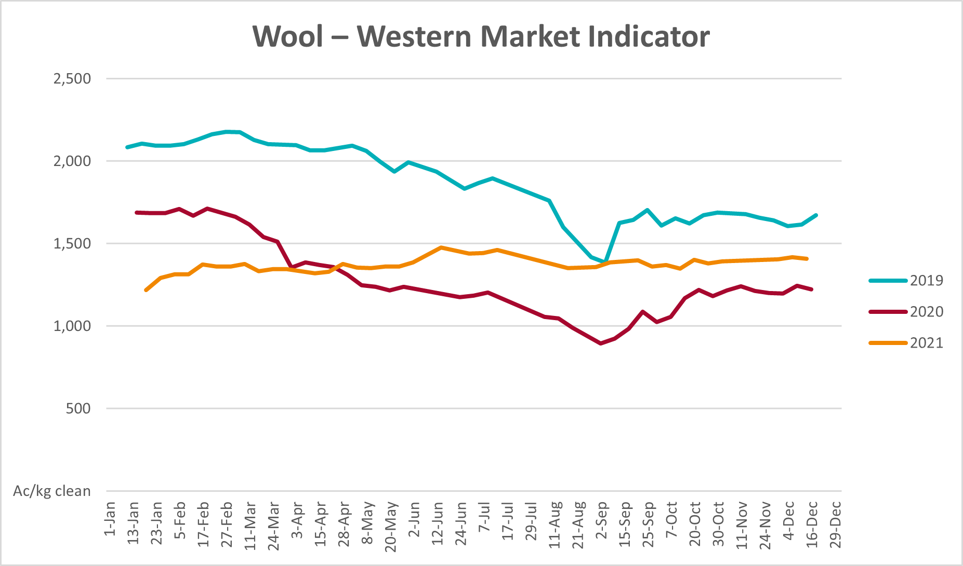

Selected domestic crop indicator prices
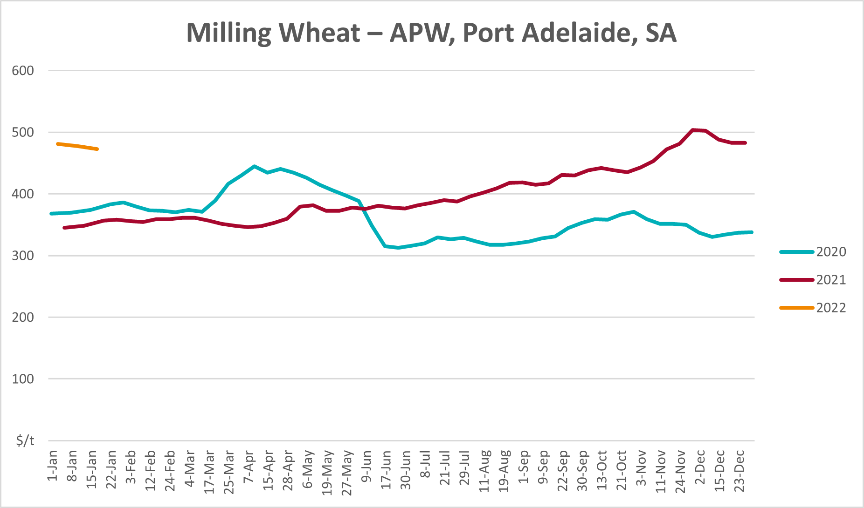
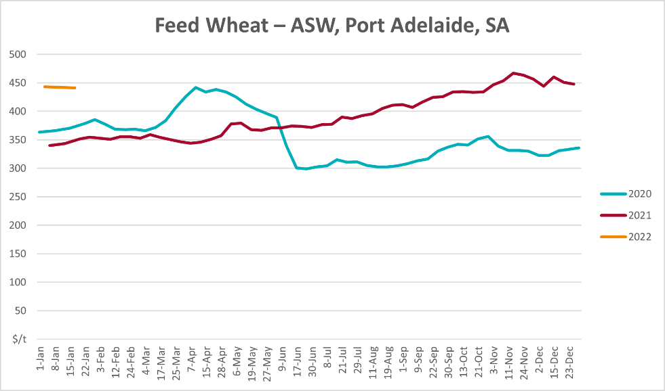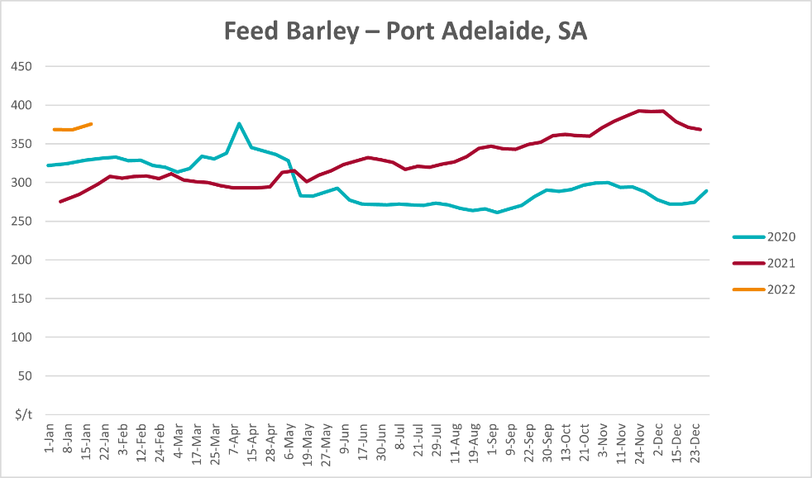

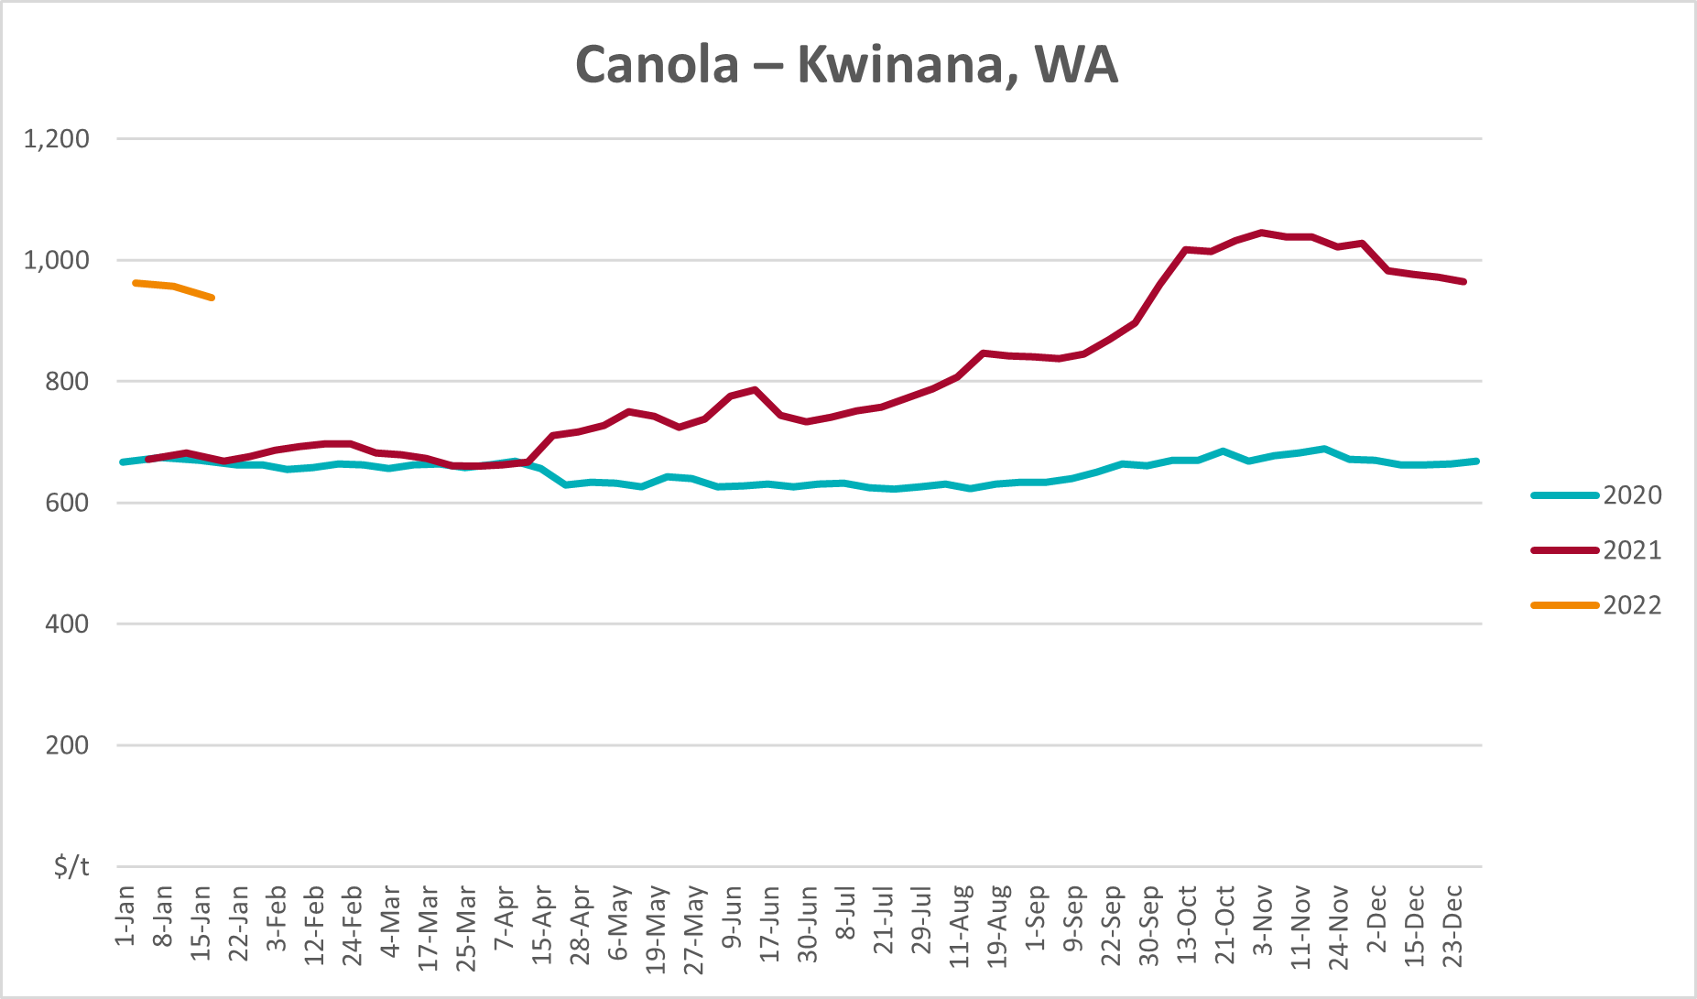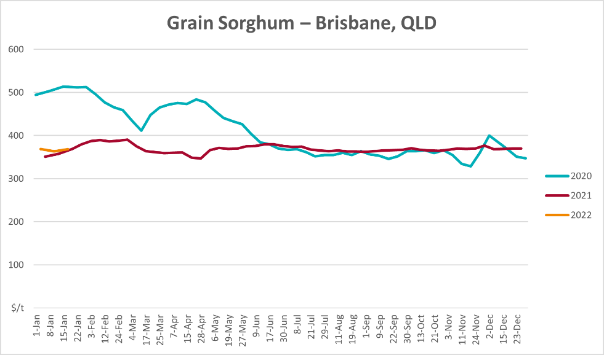

Selected domestic livestock indicator prices
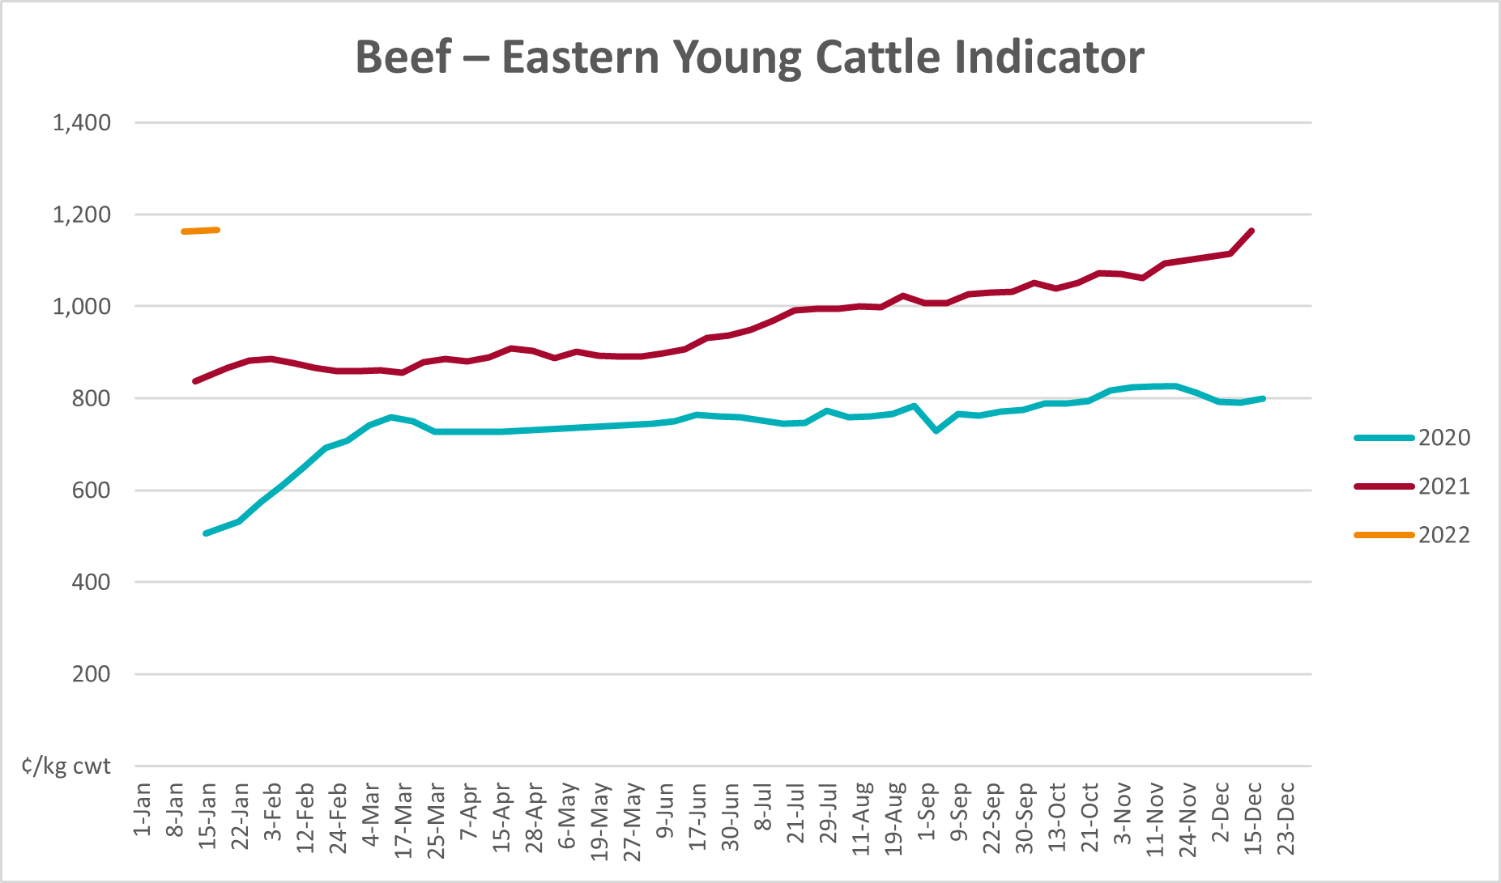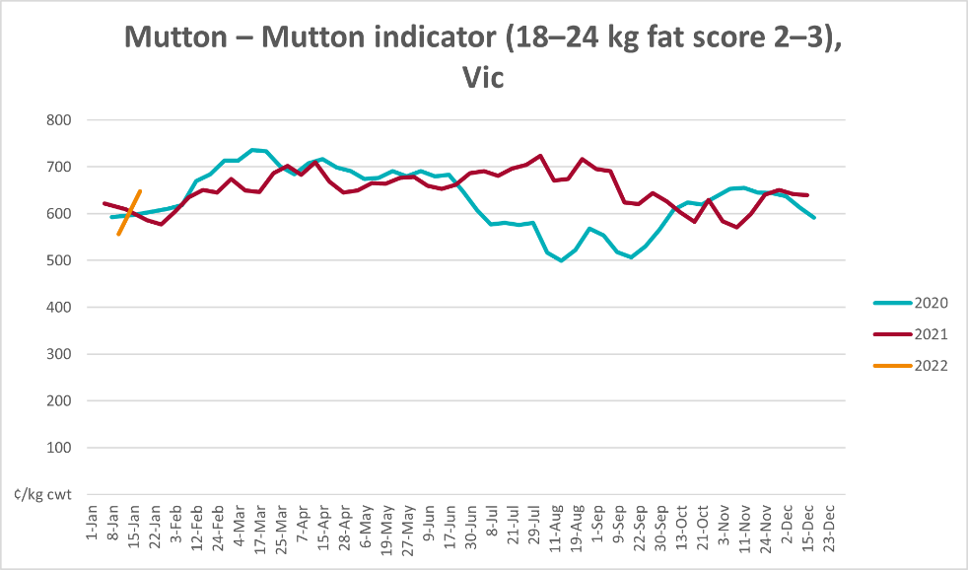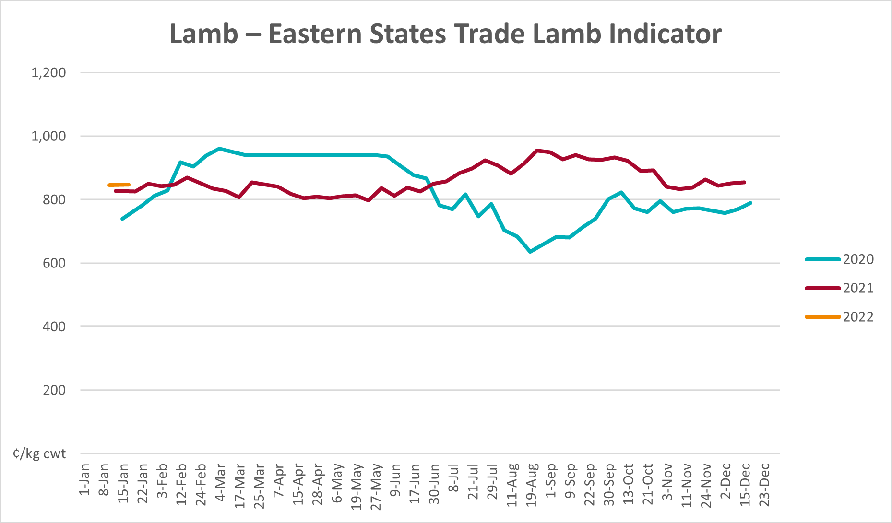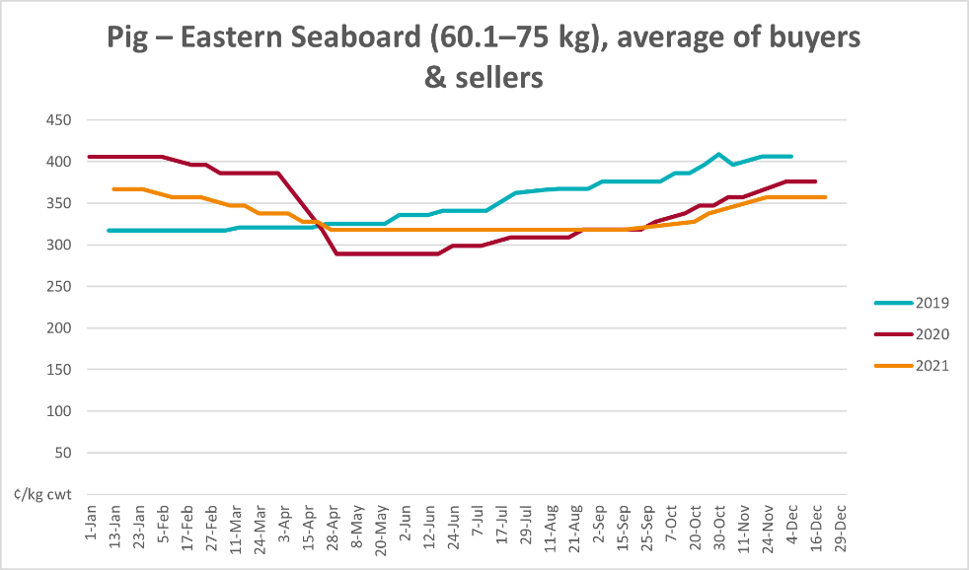

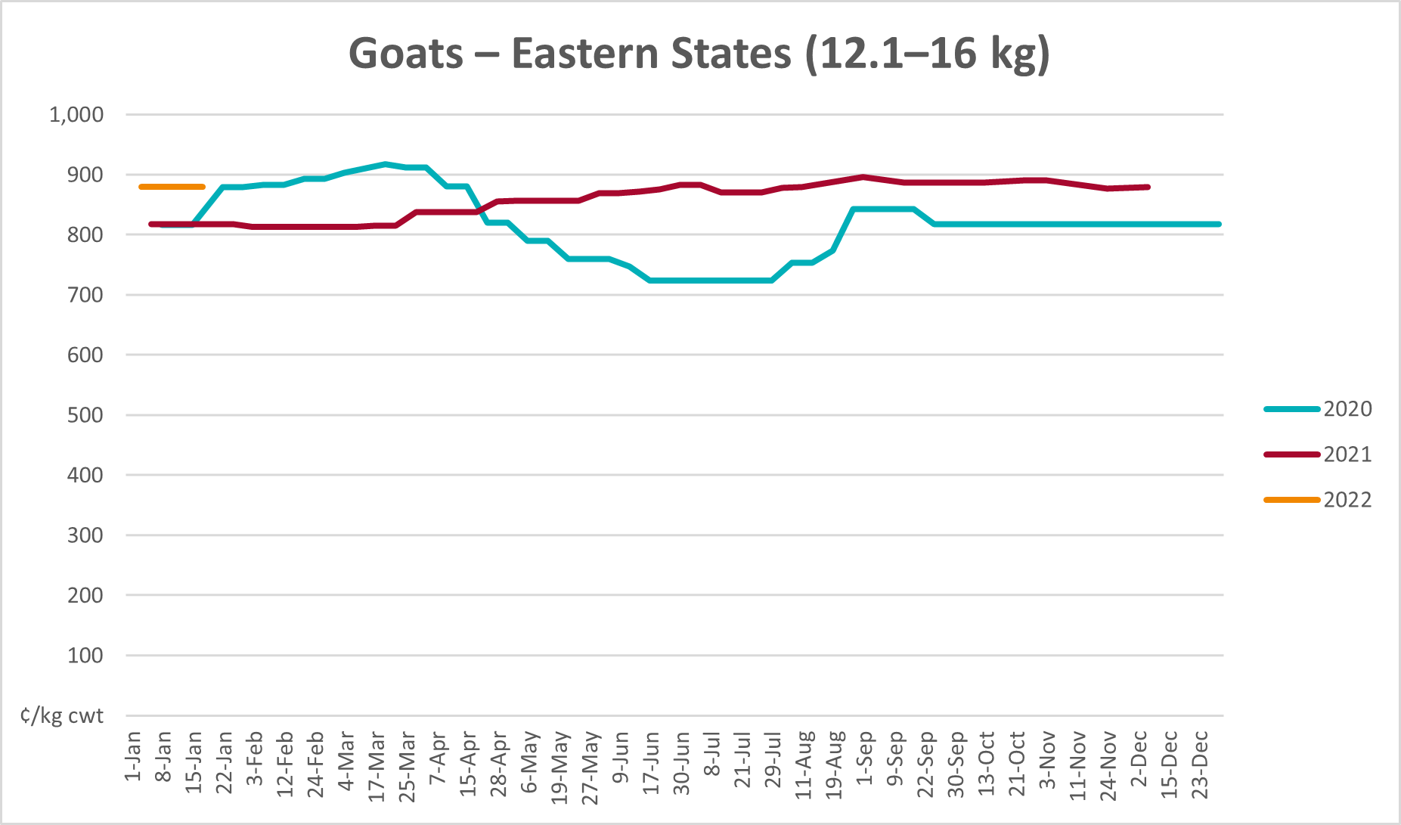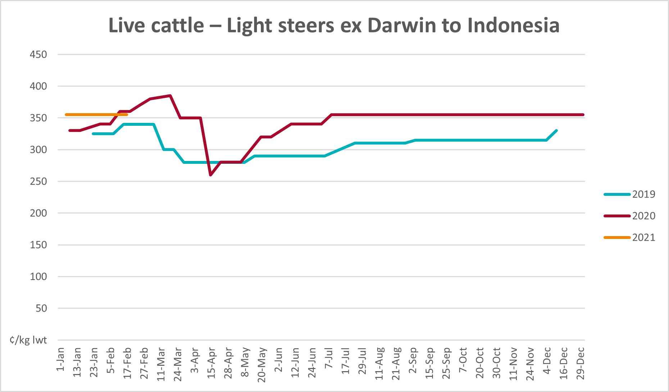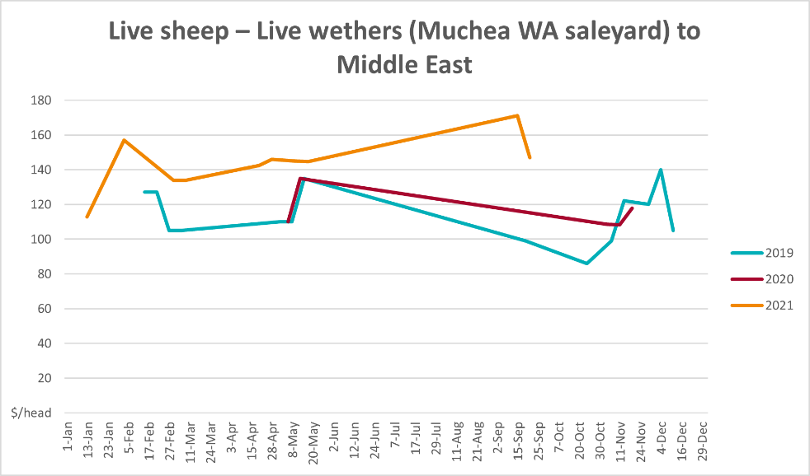

Global Dairy Trade (GDT) weighted average prices
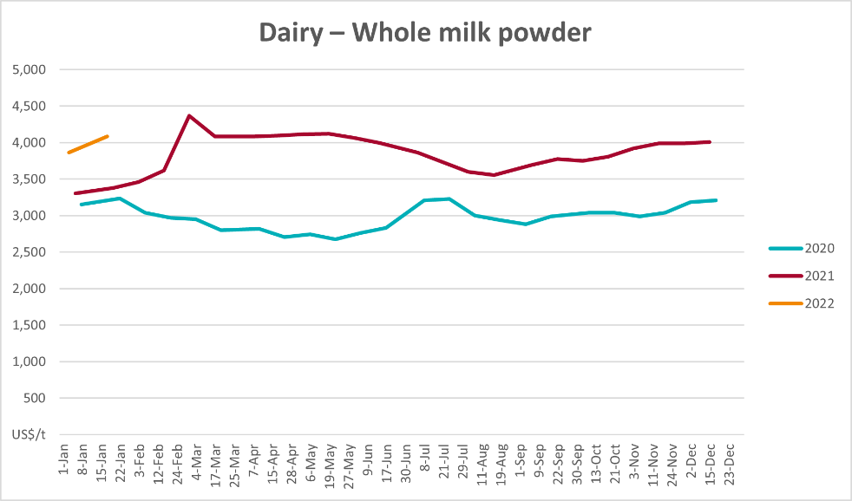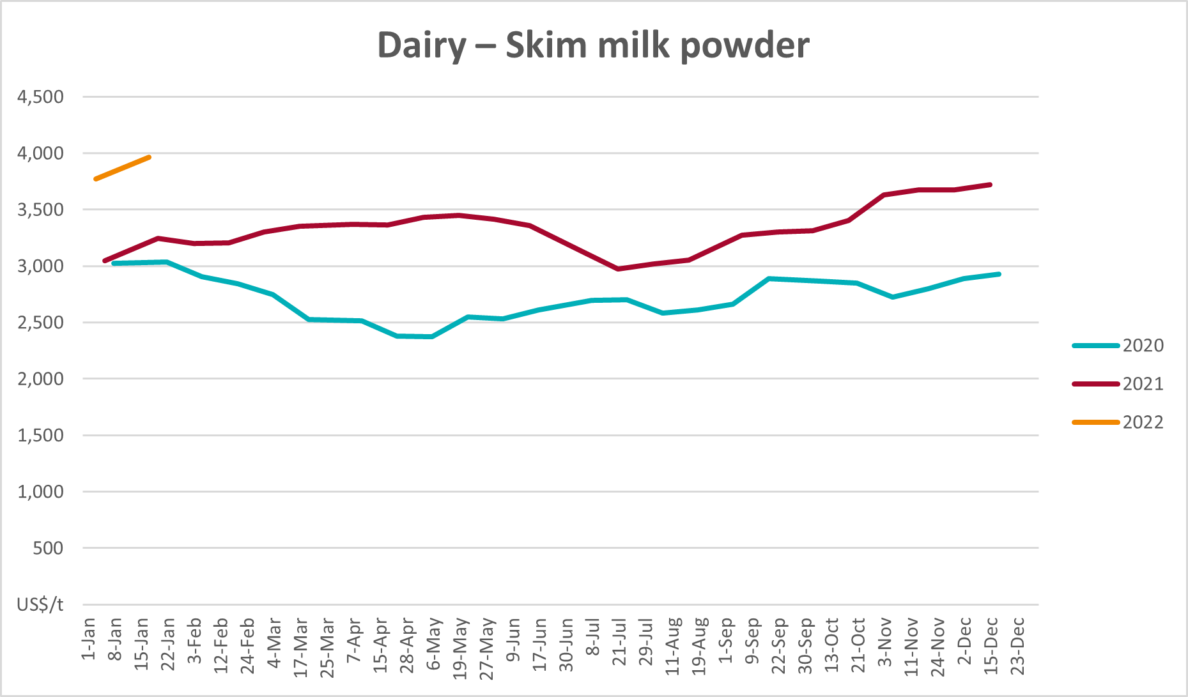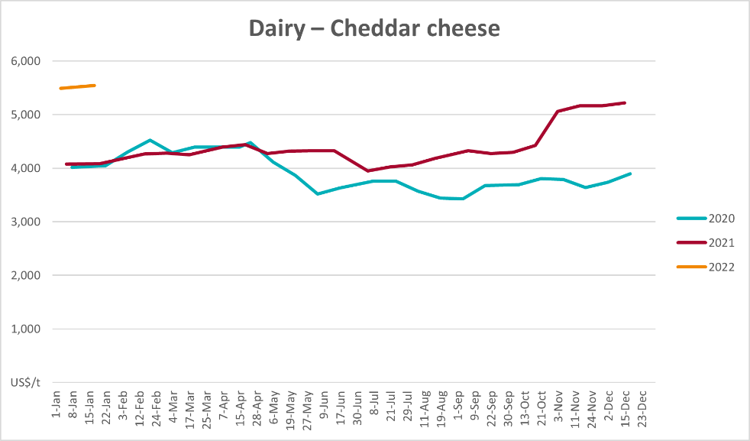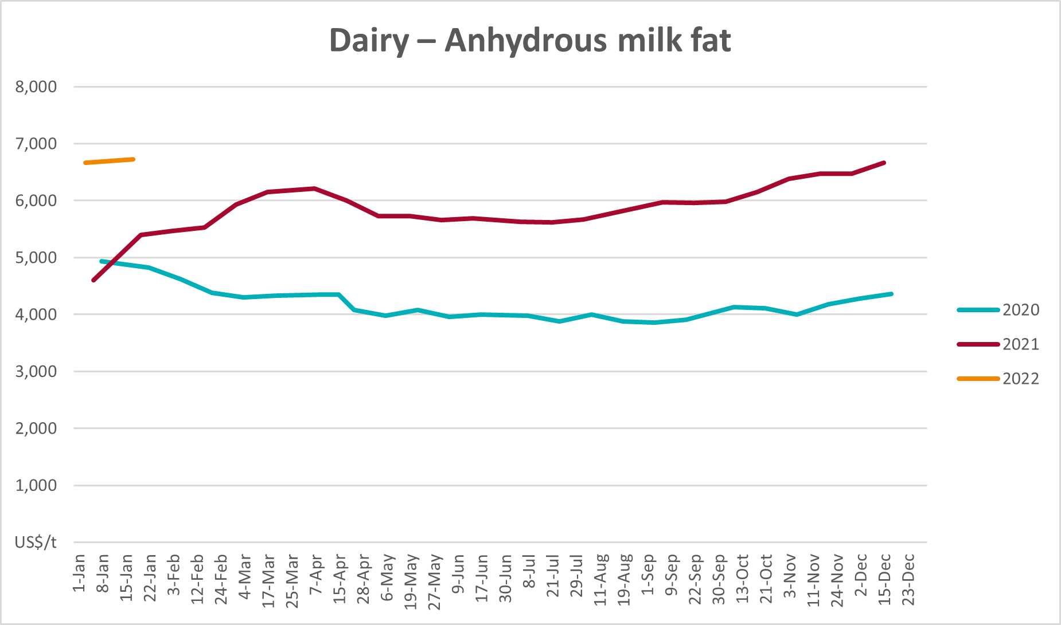

Selected fruit and vegetable prices
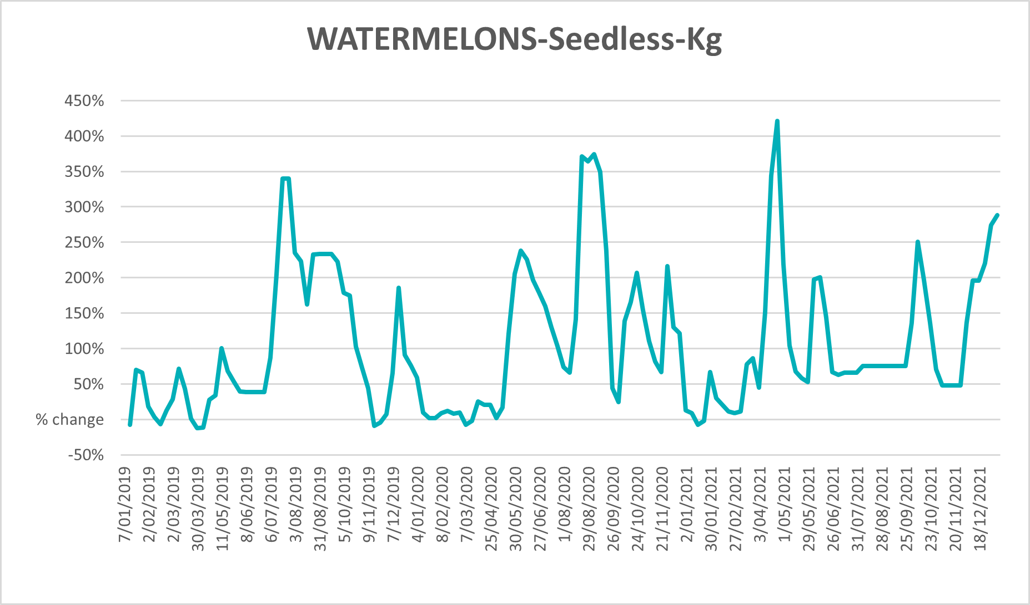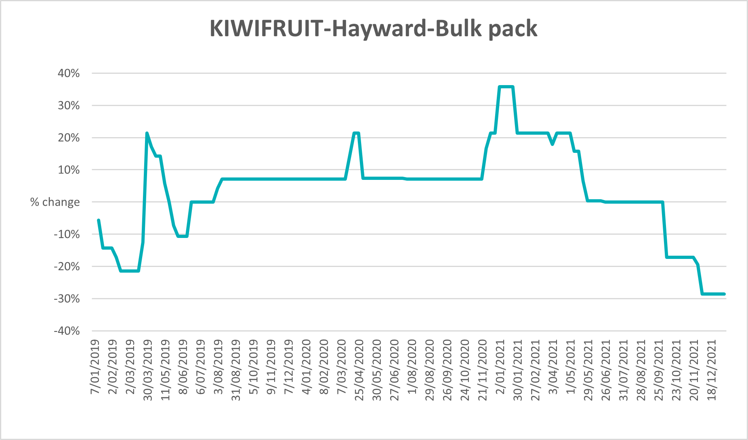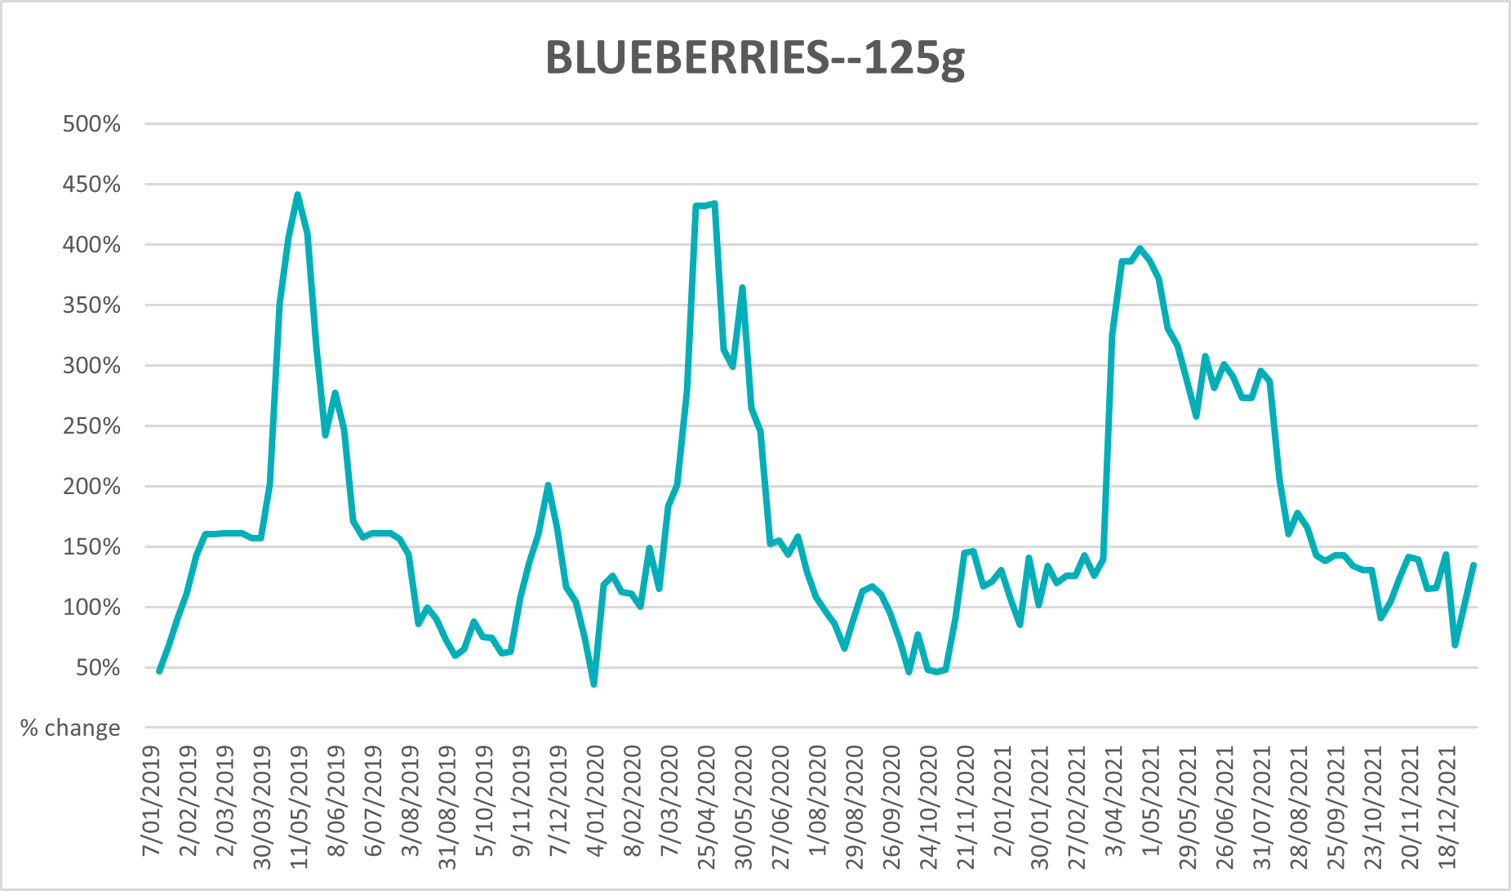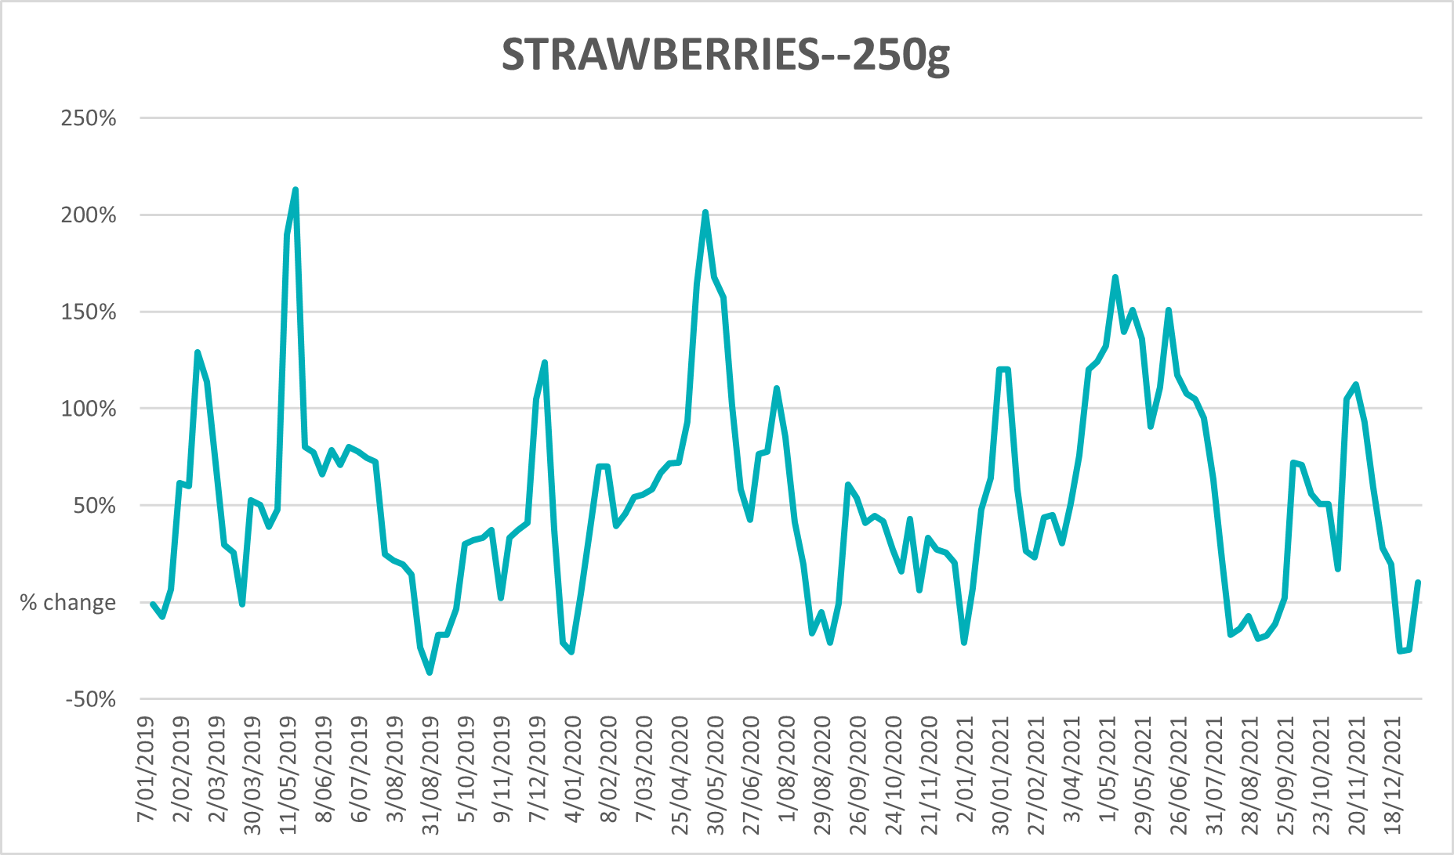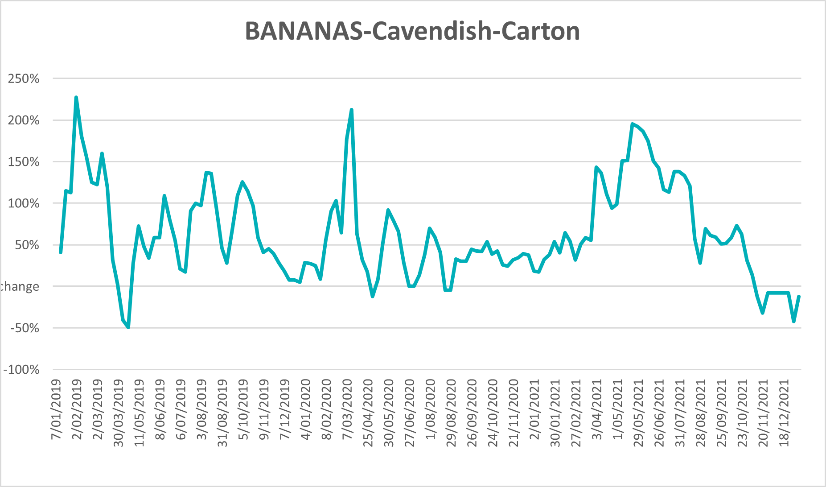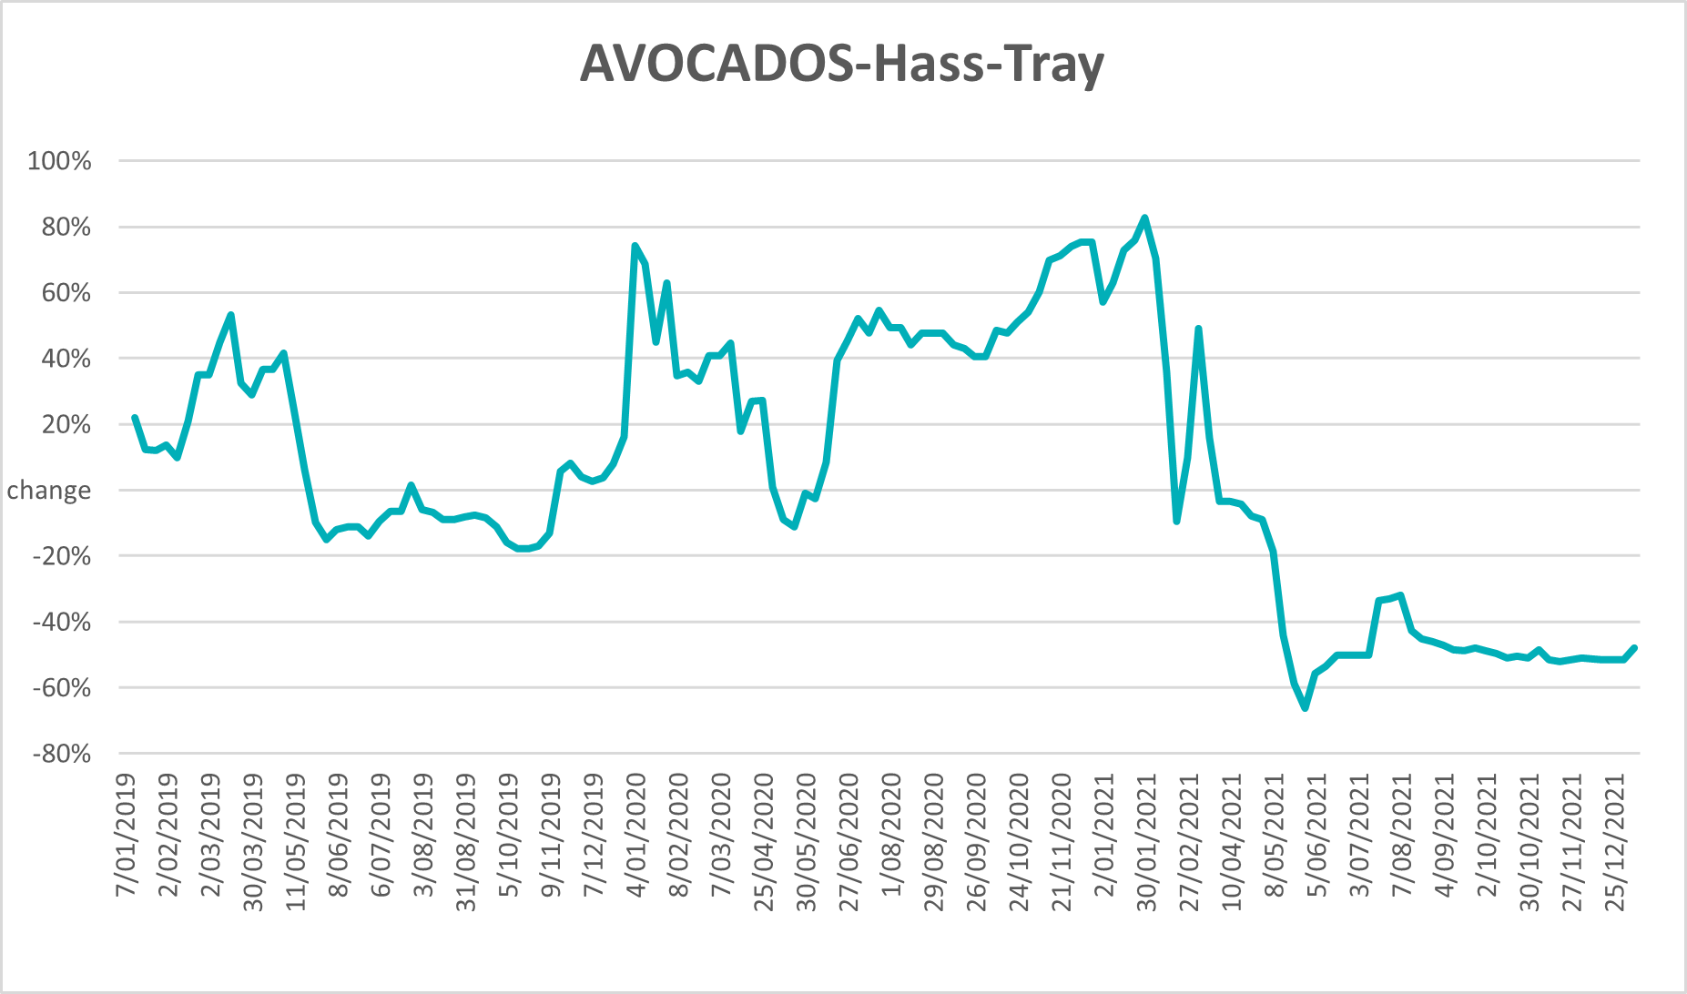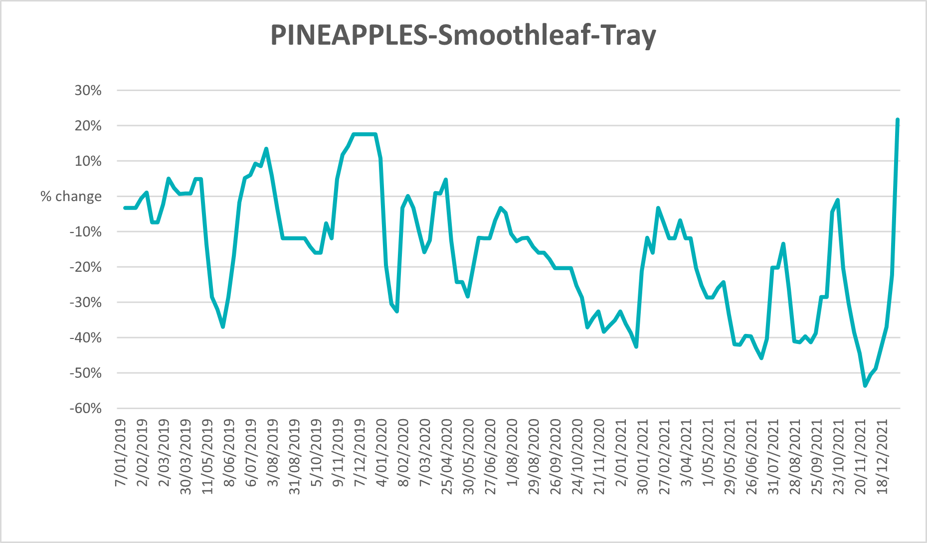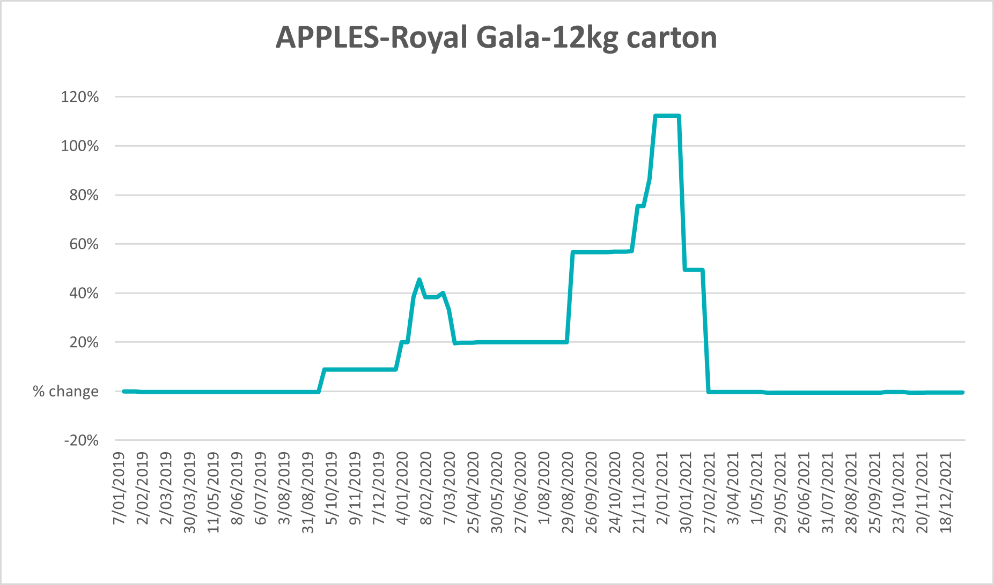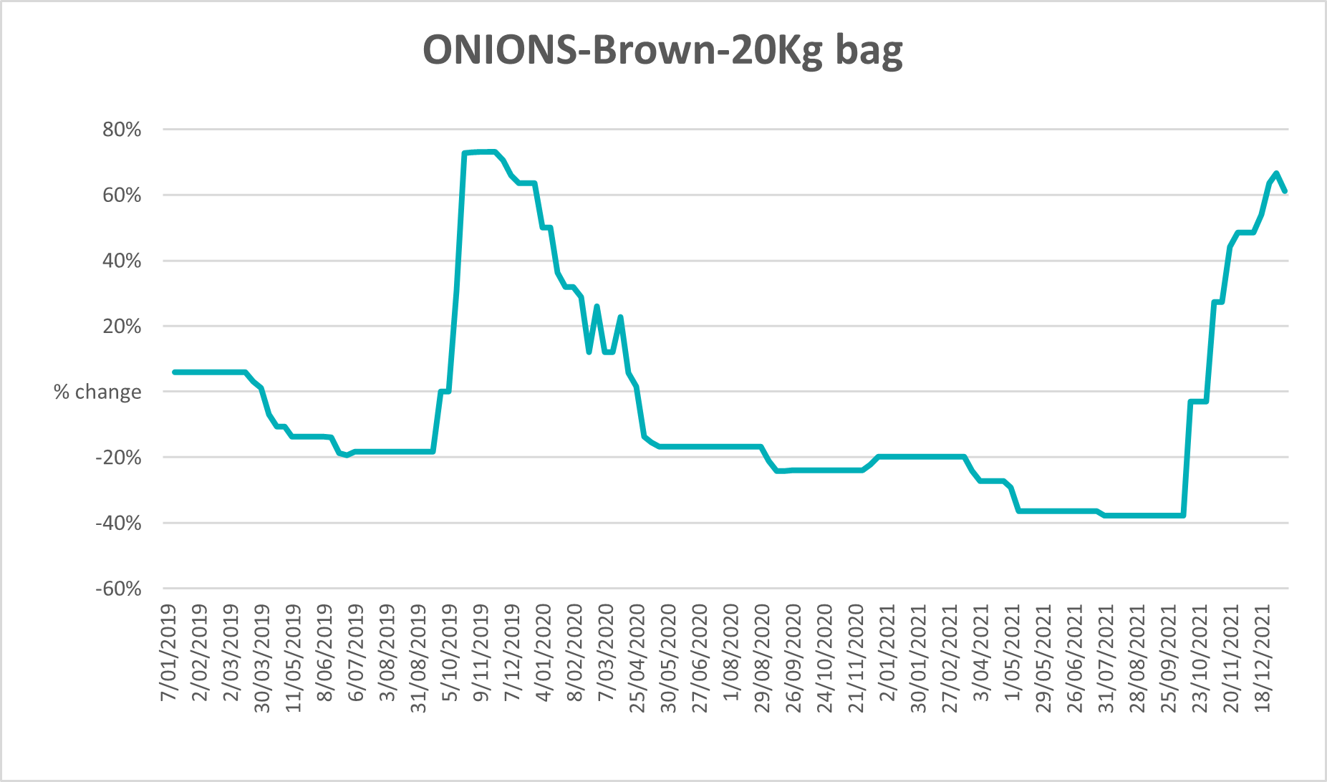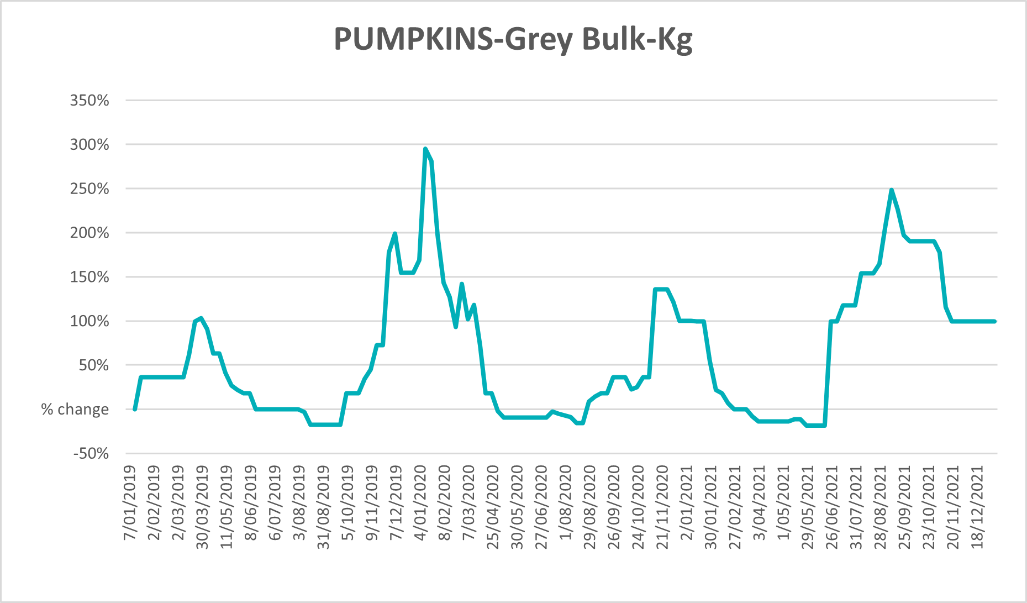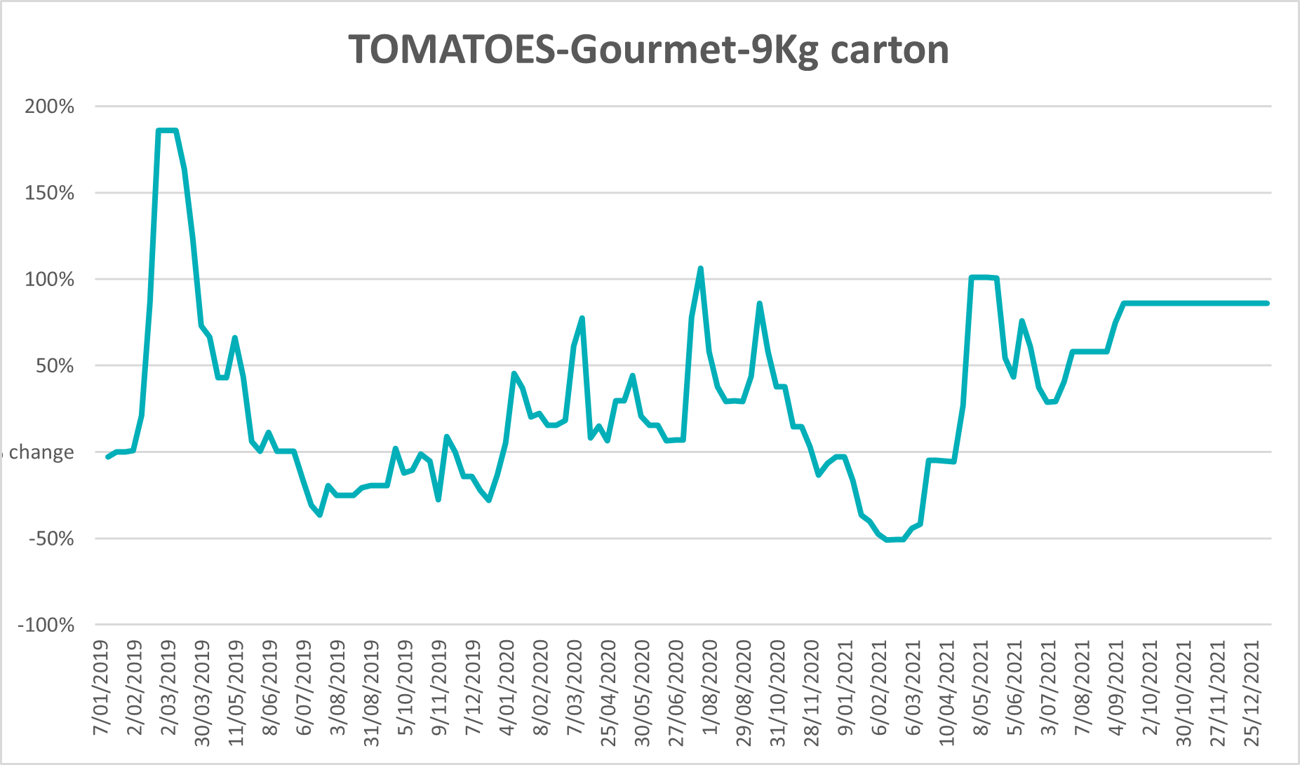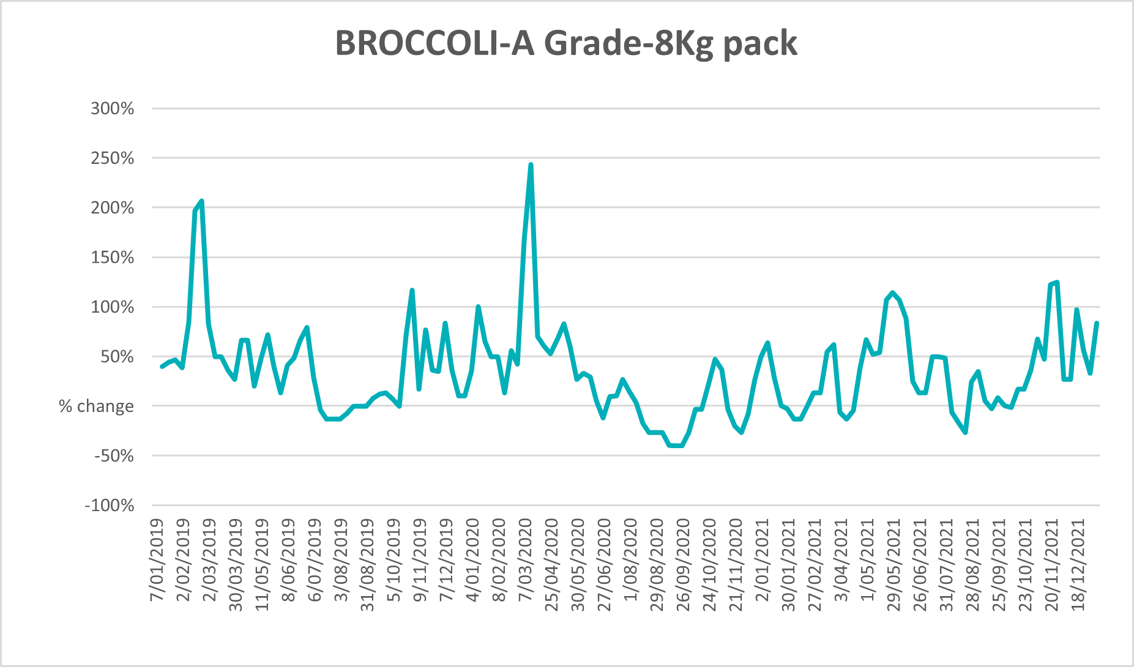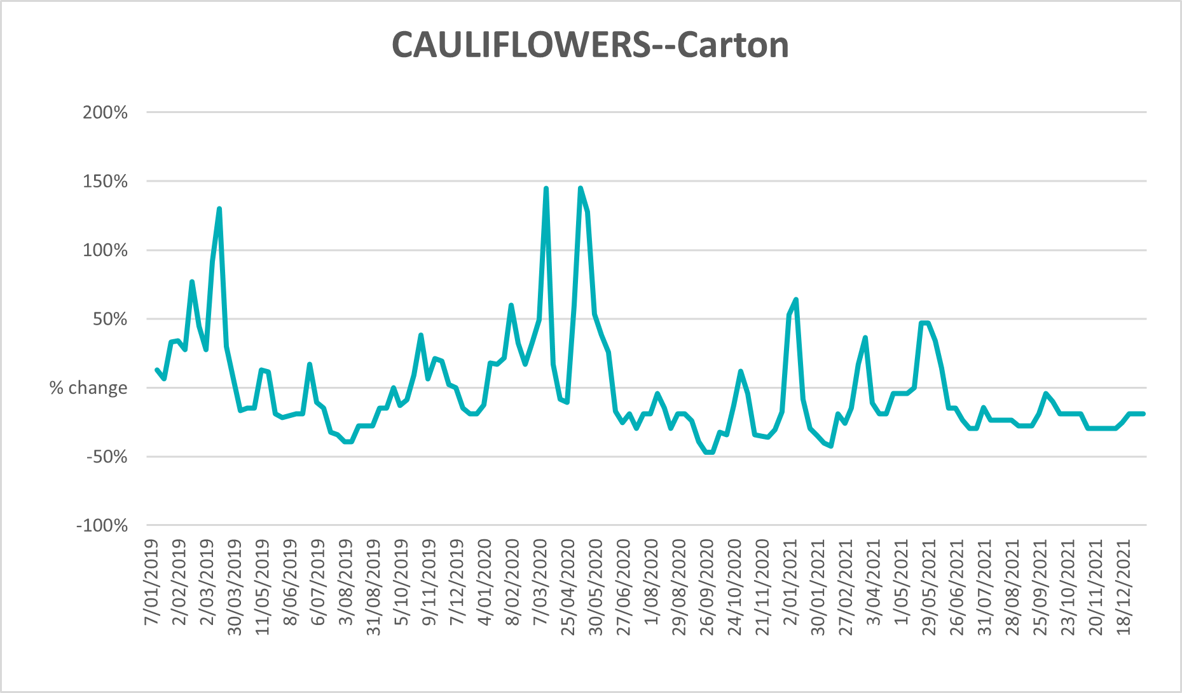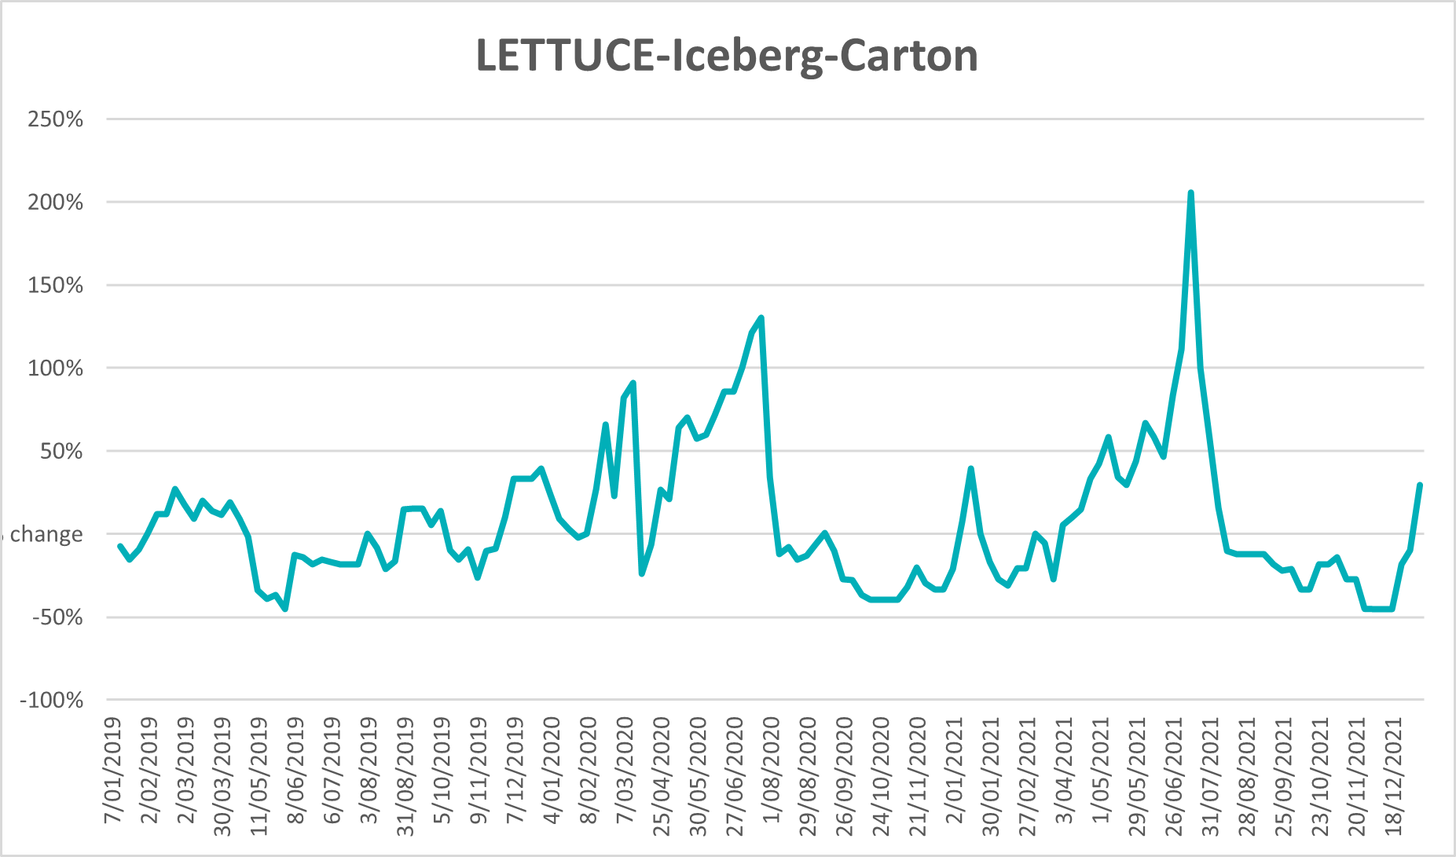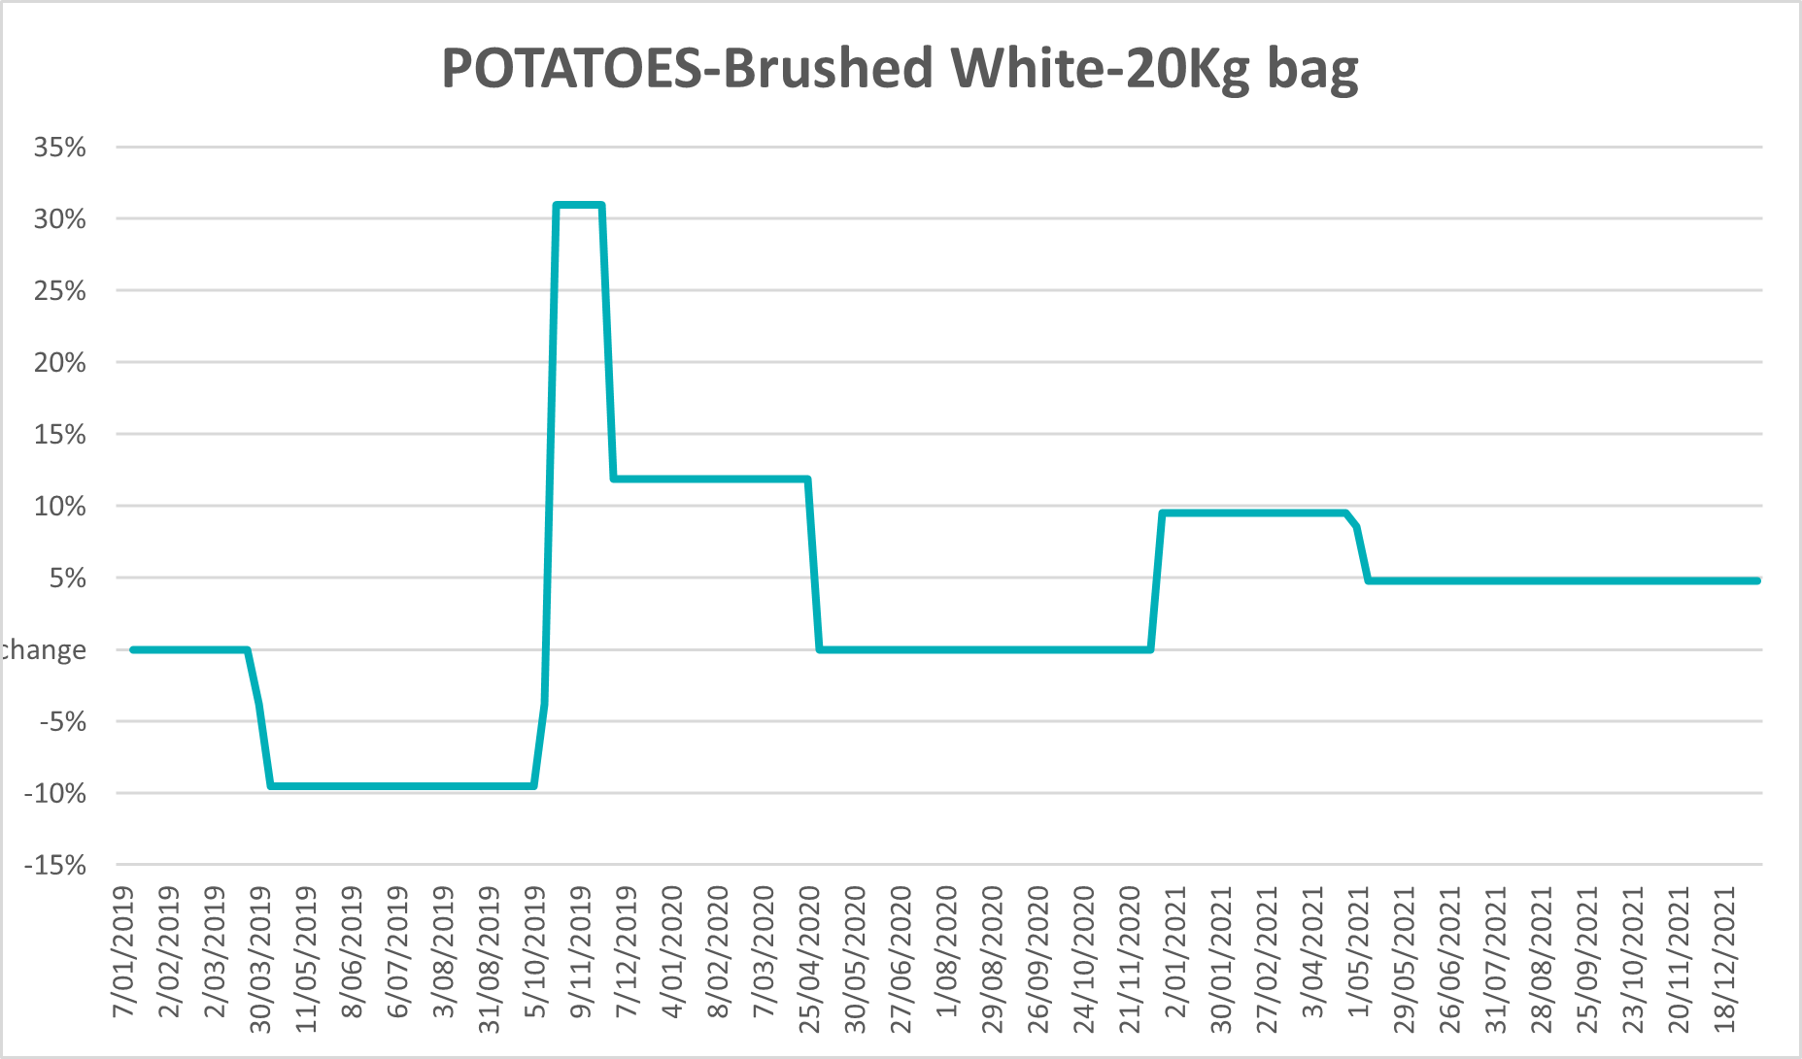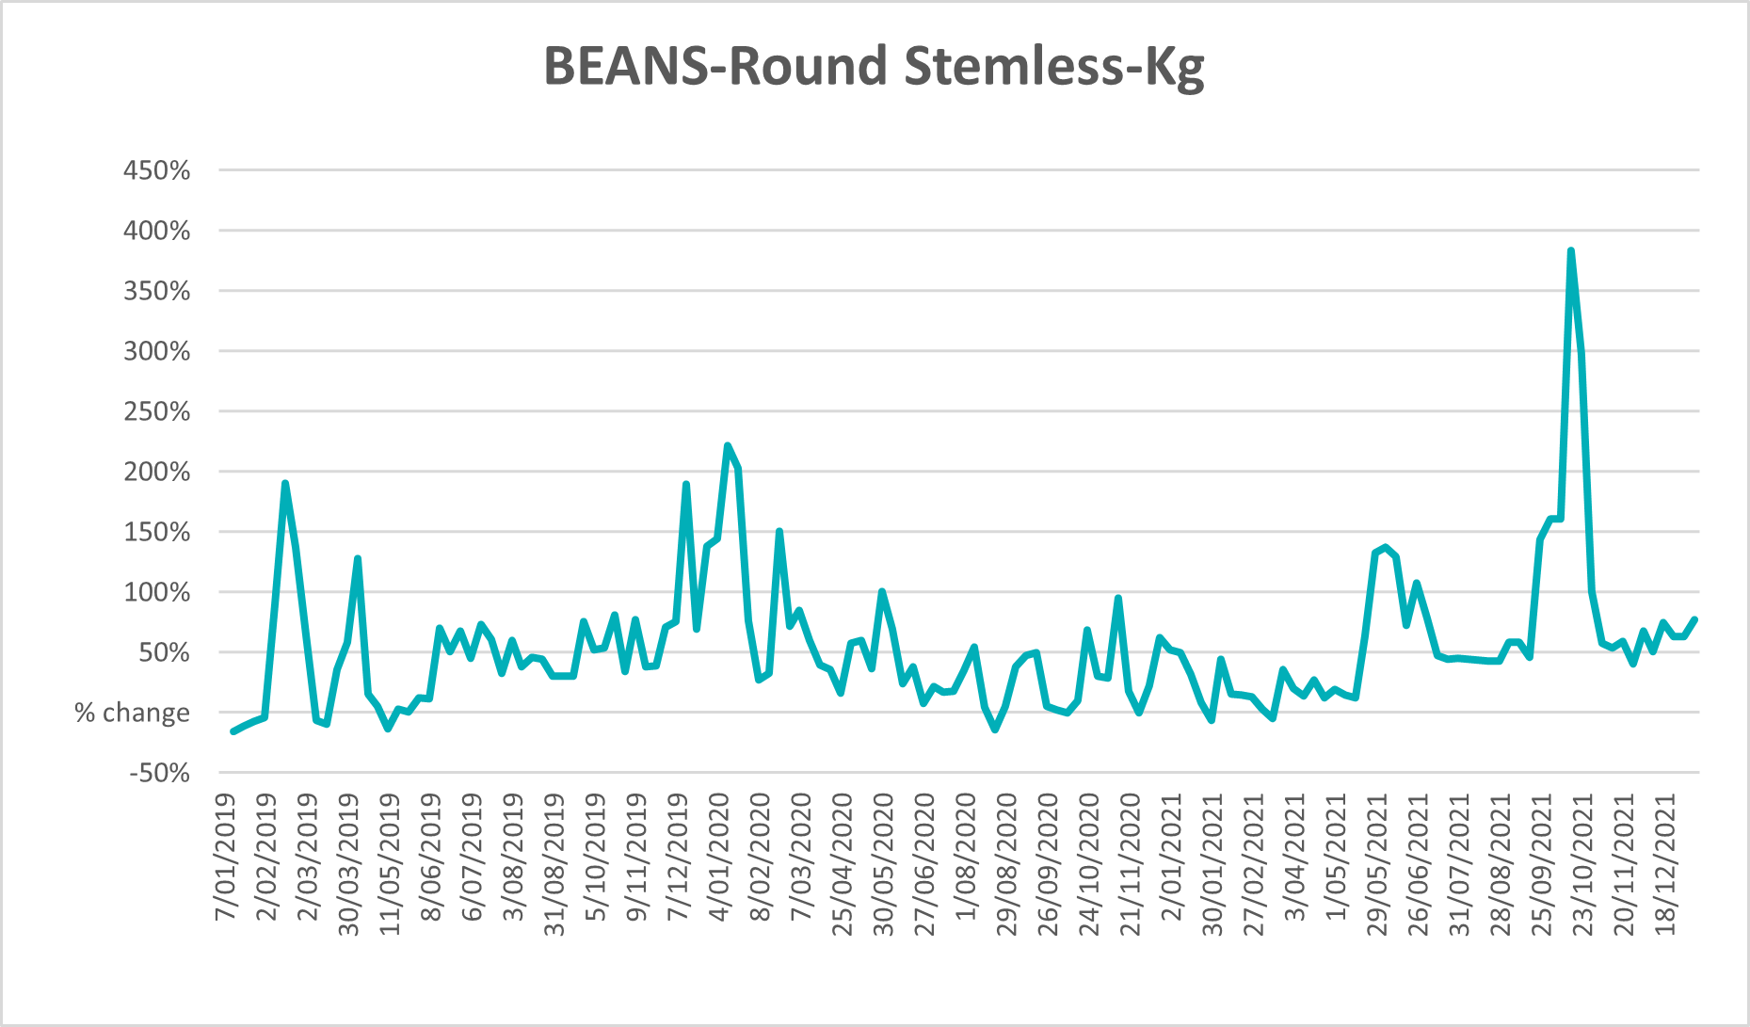

Selected domestic fodder indicator prices
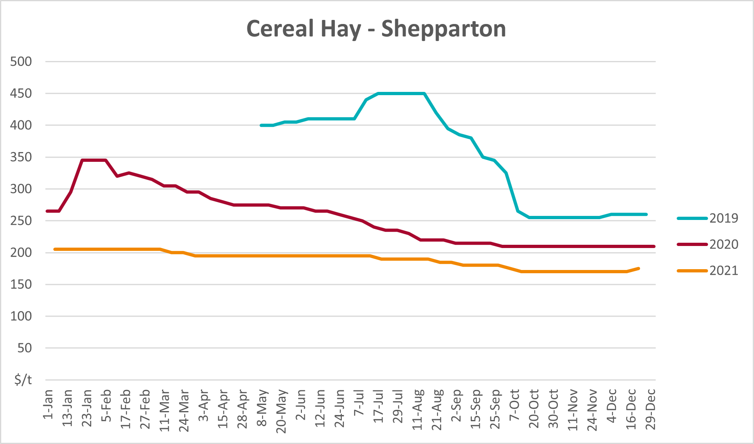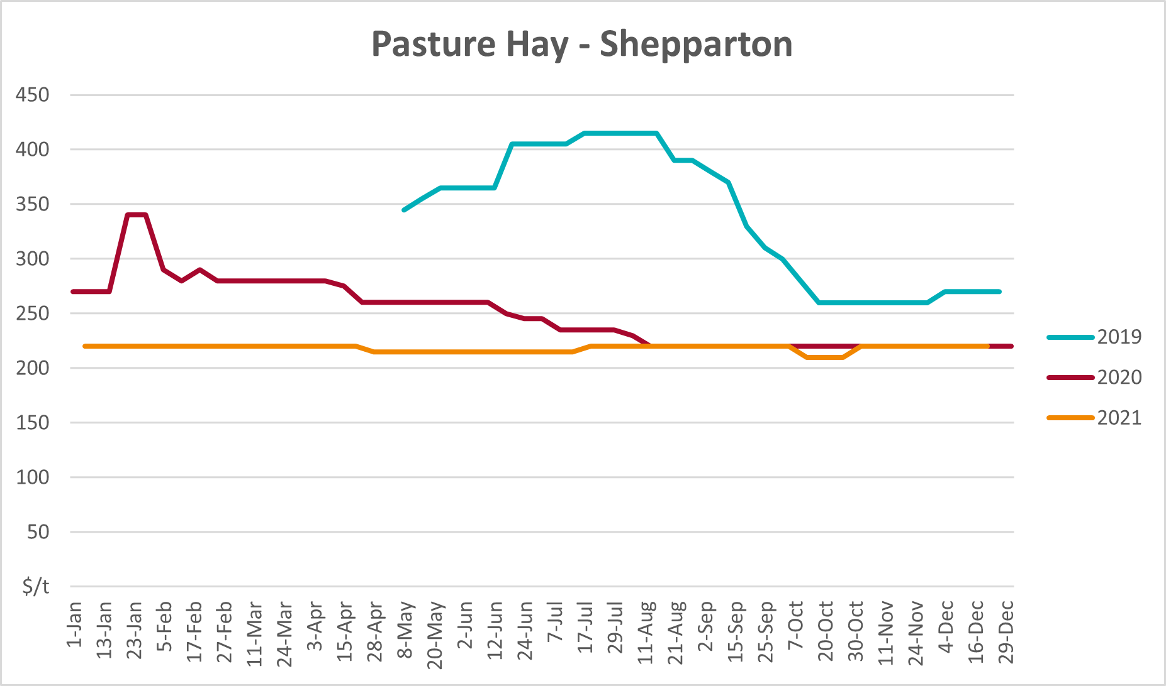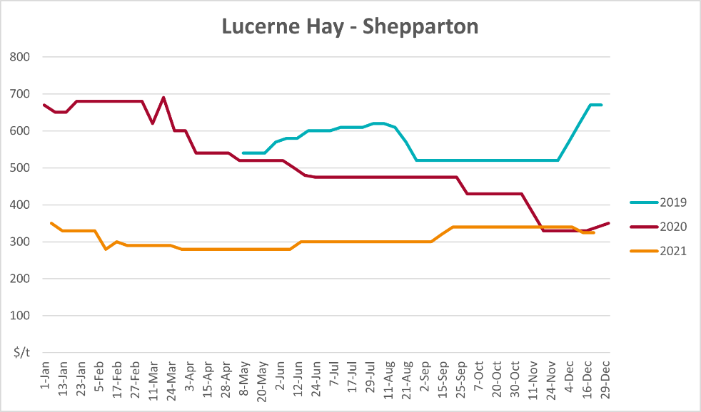

Data attribution

Climate
Bureau of Meteorology
- Weekly rainfall totals: www.bom.gov.au/climate/maps/rainfall/
- Monthly and last 3-month rainfall percentiles: www.bom.gov.au/water/landscape/
- Temperature anomalies: www.bom.gov.au/jsp/awap/temp/index.jsp
- Rainfall forecast: www.bom.gov.au/jsp/watl/rainfall/pme.jsp
- Seasonal outlook: www.bom.gov.au/climate/outlooks/#/overview/summary/
- Climate drivers: http://www.bom.gov.au/climate/enso/
- Soil moisture: www.bom.gov.au/water/landscape/
Other
- Pasture growth: www.longpaddock.qld.gov.au/aussiegrass/
- 3-month global outlooks: Environment and Climate Change Canada, NOAA Climate Prediction Center, EUROBRISA CPTEC/INPE, European Centre for Medium-Range Weather Forecasts, Hydrometcenter of Russia, National Climate Center Climate System Diagnosis and Prediction Room (NCC), International Research Institute for Climate and Society
- Global production: https://ipad.fas.usda.gov/ogamaps/cropmapsandcalendars.aspx
- Autumn break: Pook et al., 2009, https://rmets-onlinelibrary-wiley-com.virtual.anu.edu.au/doi/epdf/10.1002/joc.1833

Water
Prices
- Waterflow: https://www.waterflow.io/
- Ruralco: https://www.ruralcowater.com.au/
Bureau of Meteorology:
- Allocation trade: http://www.bom.gov.au/water/dashboards/#/water-markets/mdb/at
- Storage volumes: http://www.bom.gov.au/water/dashboards/#/water-storages/summary/drainage
Trade constraints:
- Water NSW: https://www.waternsw.com.au/customer-service/ordering-trading-and-pricing/trading/murrumbidgee
- Victorian Water Register: https://www.waterregister.vic.gov.au/TradingRules2019/

Commodities
Fruit and vegetables
- Datafresh: www.freshstate.com.au
Pigs
- Australian Pork Limited: www.australianpork.com.au
Dairy
- Global Dairy Trade: www.globaldairytrade.info/en/product-results/
World wheat, canola
- International Grains Council
World coarse grains
- United States Department of Agriculture
World cotton
- Cotlook: www.cotlook.com/
World sugar
- New York Stock Exchange - Intercontinental Exchange
Wool
- Australian Wool Exchange: www.awex.com.au/
Domestic wheat, barley, sorghum, canola and fodder
- Jumbuk Consulting Pty Ltd: http://www.jumbukag.com.au/
Cattle, beef, mutton, lamb, goat and live export
- Meat and Livestock Australia: www.mla.com.au/Prices-and-market
© Commonwealth of Australia 2022

Ownership of intellectual property rights
Unless otherwise noted, copyright (and any other intellectual property rights, if any) in this publication is owned by the Commonwealth of Australia (referred to as the Commonwealth).

Creative Commons licence
All material in this publication is licensed under a Creative Commons Attribution 4.0 International Licence except content supplied by third parties, logos and the Commonwealth Coat of Arms.
Inquiries about the licence and any use of this document should be emailed to copyright@awe.gov.au.


Cataloguing data
This publication (and any material sourced from it) should be attributed as:
ABARES 2022, Weekly Australian Climate, Water and Agricultural Update, Australian Bureau of Agricultural and Resource Economics and Sciences, Canberra, 20 January 2022. CC BY 4.0 DOI: https://doi.org/10.25814/5f3e04e7d2503
ISSN 2652-7561
This publication is available at https://www.agriculture.gov.au/abares/products/weekly_update
Department of Agriculture, Water and the Environment
GPO Box 858 Canberra ACT 2601
Telephone 1800 900 090
Web awe.gov.au/abares

Disclaimer
The Australian Government acting through the Department of Agriculture, Water and the Environment, represented by the Australian Bureau of Agricultural and Resource Economics and Sciences, has exercised due care and skill in preparing and compiling the information and data in this publication. Notwithstanding, the Department of Agriculture, Water and the Environment, ABARES, its employees and advisers disclaim all liability, including liability for negligence and for any loss, damage, injury, expense or cost incurred by any person as a result of accessing, using or relying on any of the information or data in this publication to the maximum extent permitted by law.

Statement of Professional Independence
The views and analysis presented in ABARES publications, including this one, reflect ABARES professionally independent findings, based on scientific and economic concepts, principles, information and data. These views, analysis and findings may not reflect or be consistent with the views or positions of the Australian Government, or of organisations or groups who have commissioned ABARES reports or analysis. More information on professional independence is provided on the ABARES website.

Acknowledgements
This report was prepared by Stephanie Blake and Matthew Miller.

