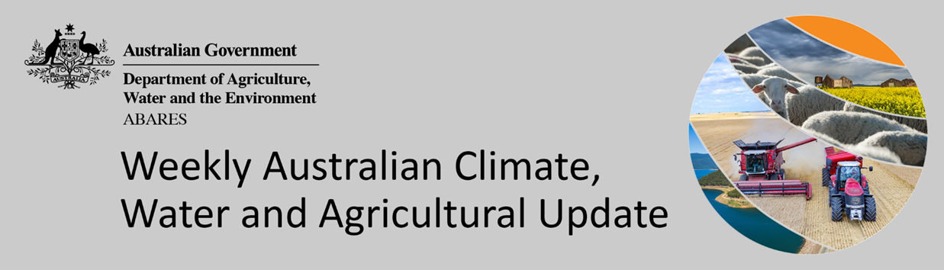
No. 3/2022

27 January 2022

Summary of key issues
- For the week ending 26 January 2022, remnants of ex-tropical cyclone Tiffany and low-pressure troughs brought heavy rain and storms to large areas of Australia’s tropical north, as well as large areas of central and eastern Australia (see Section 1.1).
- The significant rainfall recorded in parts of South Australia has triggered localised flood warnings. However, given that harvest of winter crops has largely finished these falls are unlikely to impact 2021 production levels. Further rainfall across southern Queensland may have prevented the harvest of early planted summer crops. The falls over much of northern and central Australia are likely to benefit pasture growth and build soil moisture levels.
- El Niño–Southern Oscillation (ENSO) indicators suggest that La Niña remains active in the tropical Pacific. Most climate models suggest the 2021–22 La Niña will persist until early in the southern hemisphere autumn. La Niña events are associated with above-average rainfall for northern and eastern Australia during summer (see Section 1.2).
- The outlook for February 2022 indicates that there is a 75% chance of rainfall totals between 10 and 100 millimetres across most of eastern New South Wales, most of Queensland, eastern Victoria, and the north of the Northern Territory and Western Australia. Rainfall totals in excess of 100 millimetres are expected in parts of north-eastern New South Wales, northern Queensland, and the north of the Northern Territory and Western Australia (see Section 1.3).
- The outlook for February to April 2022 suggests there is a 75% chance of rainfall totals between 50 and 300 millimetres across much of eastern New South Wales, Queensland, southern Victoria, northern Western Australia, the Northern Territory and Tasmania. Rainfall totals in excess of 300 millimetres are forecast for the east coast of New South Wales and parts of eastern and northern Queensland, as well as northern parts of Western Australia and the Northern Territory.
- Over the 8-days to 3 February 2022, rainfall is expected across much of Australia. A monsoon trough and deep low-pressure system are expected to bring heavy rain and storms to large areas of Australia’s tropical north, while troughs and frontal activity is expected to bring showers and storms to large area of central and eastern Australia (see Section 1.4).
- The forecast rainfall for parts of New South Wales and Queensland may further prevent the harvest of early planted summer crops. Rainfall across northern Australia likely to benefit pasture growth and build soil moisture levels.
- Water storage in the Murray–Darling Basin (MDB) decreased by 92 gigalitres (GL) between 19 January 2022 and 26 January 2022. The current volume of water held in storage is 22,419 GL, which represents 89% of total capacity. This is 62% or 8,616 GL more than at the same time last year.
- Allocation prices in the Victorian Murray below the Barmah Choke decreased from $107 per ML on 14 January 2022 to $92 per ML on 21 January 2022. Prices are lower in the Goulburn-Broken, Murrumbidgee, and regions above the Barmah Choke due to the binding of the Goulburn intervalley trade limit, Murrumbidgee export limit, and Barmah Choke trade constraint.

Climate

Rainfall this week
For the week ending 26 January 2022, remnants of ex-tropical cyclone Tiffany and low-pressure troughs brought heavy rain and storms to large areas of Australia’s tropical north, as well as large area of central and eastern Australia.
Rainfall totals of between 10 and 50 millimetres were recorded across scattered areas of northern New South Wales, much of Queensland, central and northern South Australia, northern Western Australia and much of the Northern Territory. Rainfall totals in excess of 50 millimetres were recorded across parts of north-eastern New South Wales, through central Queensland and the Cape York Peninsula, central and north-eastern South Australia, northern and central areas of the Northern Territory and the northwest of Western Australia.
In cropping regions, rainfall totals of between 10 and 50 millimetres were recorded across scattered areas of northern New South Wales, southern Queensland and central and western South Australia. Little to no rainfall was recorded across remaining cropping regions in Queensland, Victoria, South Australia and Western Australia.
Significant rainfall in parts of South Australia has triggered localised flood warnings. However, given that harvest of winter crops has largely finished these falls are unlikely to impact 2021 production levels. Further rainfall across southern Queensland may have prevented the harvest of early planted summer crops. The falls over much of northern and central Australia are likely to benefit pasture growth and build soil moisture levels.

Rainfall for the week ending 26 January 2022

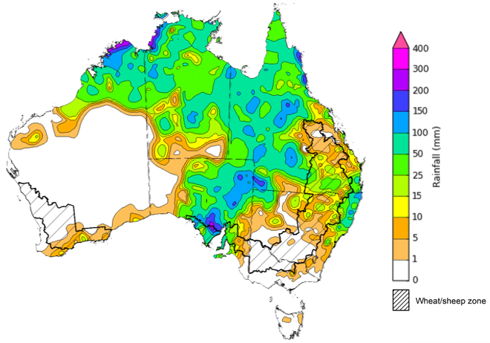
©Commonwealth of Australia 2022, Australian Bureau of Meteorology Issued: 26/01/2022
Note: The rainfall analyses and associated maps utilise data contained in the Bureau of Meteorology climate database, the Australian Data Archive for Meteorology (ADAM). The analyses are initially produced automatically from real-time data with limited quality control. They are intended to provide a general overview of rainfall across Australia as quickly as possible after the observations are received. For further information go to http://www.bom.gov.au/climate/rainfall/

Climate Drivers
Throughout summer the climate drivers with the largest potential impact on Australia’s climate patterns are the El Niño–Southern Oscillation (ENSO), the Southern Annular Mode (SAM) and the Madden-Julian Oscillation (MJO). These climate drivers are likely to influence the growth and development of summer crops in northern growing regions and pasture growth across northern Australia with the onset of the northern wet season.
ENSO indicators suggest that La Niña remains active in the tropical Pacific. La Niña events are associated with above-average rainfall for northern and eastern Australia during summer. Climate models suggest the 2021–22 La Niña will persist until early in the southern hemisphere autumn. The presence of La Niña atmospheric and oceanic patterns is likely to influence rainfall patterns in northern and eastern Australia over the coming months.
The SAM currently neutral and the MJO is inactive in the Australian region reducing their influence on climatic conditions in Australia.
Both warm and cool sea surface temperature (SST) anomalies across the tropical Pacific Ocean remain similar to two weeks ago and show a well-developed La Niña pattern.

Difference from average sea surface temperature observations 10 January to 16 January 2022
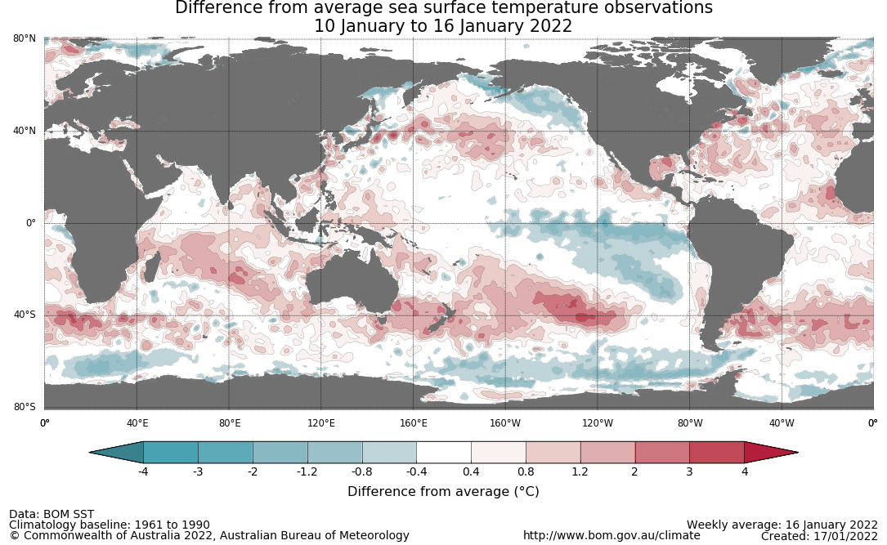

International climate model outlooks for the NINO 3.4 region in April 2022
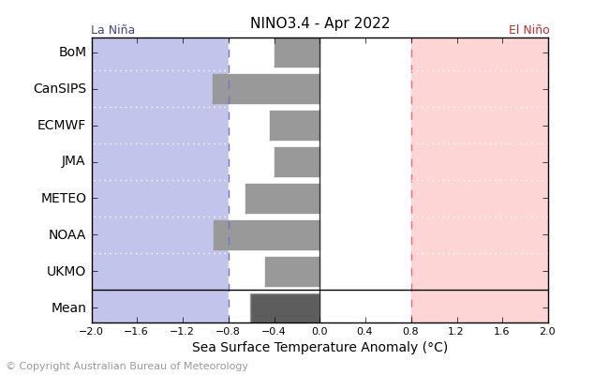
©Commonwealth of Australia 2022, Australian Bureau of Meteorology Issued: 8/01/2022
A La Niña event has become firmly established in the Pacific Ocean. Most climate models surveyed by the Bureau of Meteorology expect the La Niña event to continue into February. However, five of the seven models expect it to dissipate by April 2022. For the period ending 16 January 2022, the 30-day Southern Oscillation Index (SOI) was +2.5 and the 90-SOI was +6.8, both below the La Niña threshold of +7. It should be noted that movement in the SOI like this is not uncommon during the northern wet season as the SOI can experience fluctuations from transient tropical weather. This means the recent SOI changes may be short-term, with other ENSO indicators continuing to maintain patterns broadly typical of La Niña.
Above average SST anomalies have continued across parts of the Maritime Continent and northern Australia. A slight strengthening of trade winds across parts of the central and western Pacific, while cloudiness near the Date Line has been consistently below average. All indications consistent with an ongoing La Niña event.

30-day Southern Oscillation Index (SOI) values ending 26 January 2022
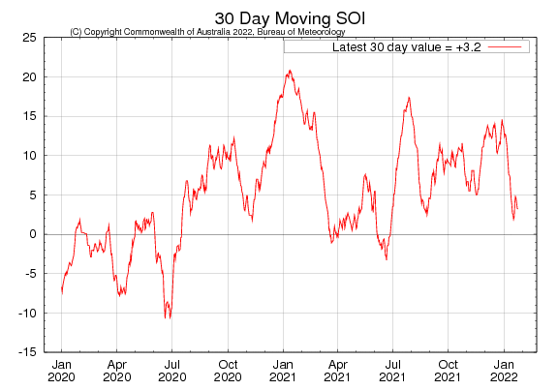

National Climate Outlook
These climate outlooks are generated by ACCESS–S (Australian Community Climate Earth-System Simulator–Seasonal). ACCESS–S is the Bureau of Meteorology's dynamical (physics-based) weather and climate model used for monthly, seasonal and longer-lead climate outlooks.
For further information, go to http://www.bom.gov.au/climate/ahead/about/
The Bureau of Meteorology’s latest rainfall outlook indicated wetter than average conditions are expected across parts of eastern Australia during February. The ACCESS-S climate model suggests there is close to a 60% chance of exceeding median February rainfall totals across parts of eastern New South Wales, Victoria and Queensland.
The outlook for February 2022 indicates that there is a 75% chance of rainfall totals between 10 and 100 millimetres across most of eastern New South Wales, most of Queensland, eastern Victoria, and the north of the Northern Territory and Western Australia. Rainfall totals in excess of 100 millimetres are expected in parts of north-eastern New South Wales, northern Queensland, and the north of the Northern Territory and Western Australia.
Across cropping regions there is a 75% chance of rainfall totals of between 10 and 50 millimetres across much of New South Wales and Queensland. There is a 75% chance of rainfall less than 10 millimetres for most remaining cropping regions. The wetter than average conditions expected for most eastern Australian cropping regions is likely to support the growth and development of later-planted summer crops, as well as continuing to support above pasture growth rates for this time of year across much of eastern and northern Australia.
Rainfall totals that have a 75% chance of occurring February 2022
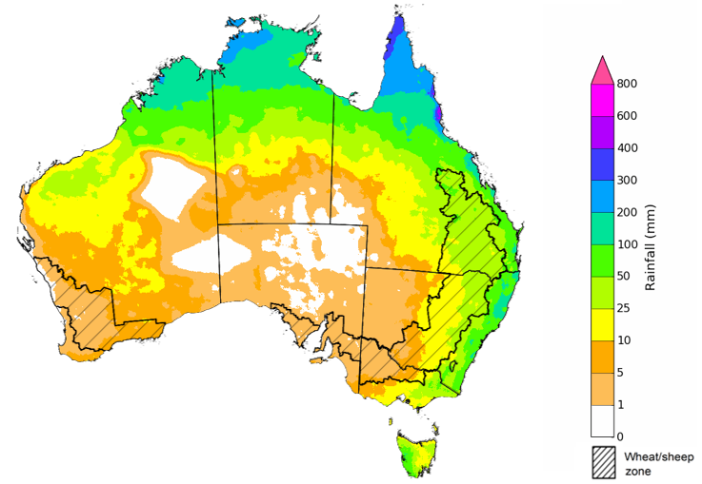
©Commonwealth of Australia 2022, Australian Bureau of Meteorology Issued:20/01/2022

The rainfall outlook for February to April 2022 suggests there is a greater than 60% chance of exceeding median rainfall across parts of eastern and central New South Wales, Queensland, and the north of the Northern Territory. For remaining regions of Australia, there is roughly an equal chance of above and below median rainfall, with only isolates areas of Western Australia expecting to receive below average rainfall between February to April 2022 (Bureau of Meteorology ‘National Climate Outlook’, 20 January 2022).
Bureau of Meteorology rainfall outlooks for February to April have greater than 55% past accuracy across most of Australia. Outlook accuracy is greater than 65% across isolated parts of the country. However, there is low past accuracy for parts of north-western New South Wales, western Queensland, central Western Australia, as well as south-eastern parts of the Northern Territory.
Chance of exceeding the median rainfall February to April 2022
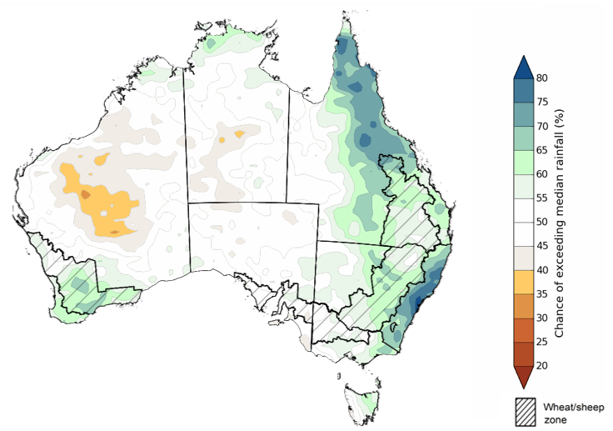
©Commonwealth of Australia 2022, Australian Bureau of Meteorology Issued: 20/01/2022

The outlook for February to April 2022 suggests there is a 75% chance of rainfall totals between 50 and 300 millimetres across much of eastern New South Wales, Queensland, southern Victoria, northern Western Australia, the Northern Territory and Tasmania. Rainfall totals in excess of 300 millimetres are forecast for the east coast of New South Wales and parts of eastern and northern Queensland, as well as northern parts of Western Australia and the Northern Territory.
Across cropping regions, there is a 75% chance of receiving between 50 and 200 millimetres across much of New South Wales and Queensland. Totals of less than 50 millimetres are expected across remaining cropping regions in Victoria, and South Australia and Western Australia.
These rainfall totals are slightly below average for this three-month period across most cropping regions. However, soil moisture levels across northern cropping regions are well above average due to the substantial rainfall in November, December and early January. Therefore, below average rainfall during the February to April period is unlikely to negatively impact summer crop growth and yield prospects.
Rainfall totals that have a 75% chance of occurring February to April 2022

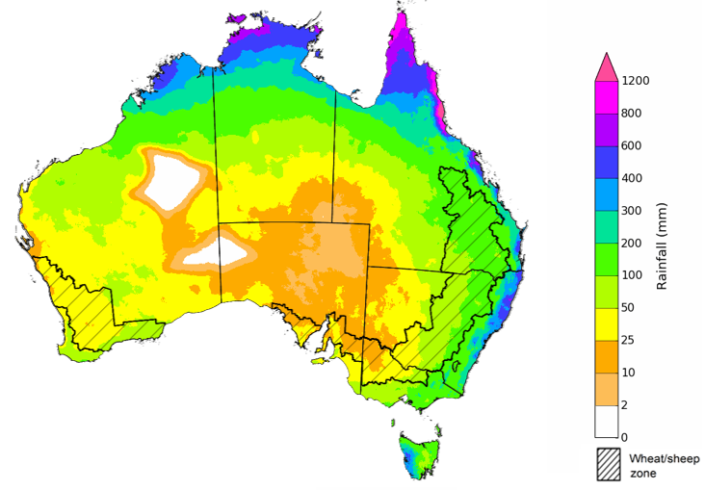
©Commonwealth of Australia 2022, Australian Bureau of Meteorology Issued: 20/01/2022
The temperature outlook for February to April 2022 indicates that maximum and minimum temperatures across most of Australia are likely to be close to the 1990-2012 average (- 1°C to 1°C), with an isolated area of above average maximum temperatures in Western Australia and below average maximum temperatures in eastern New South Wales and Victoria (Bureau of Meteorology ‘National Climate Outlook’, 20 January 2022).
Predicted maximum temperature anomaly for February to April 2022

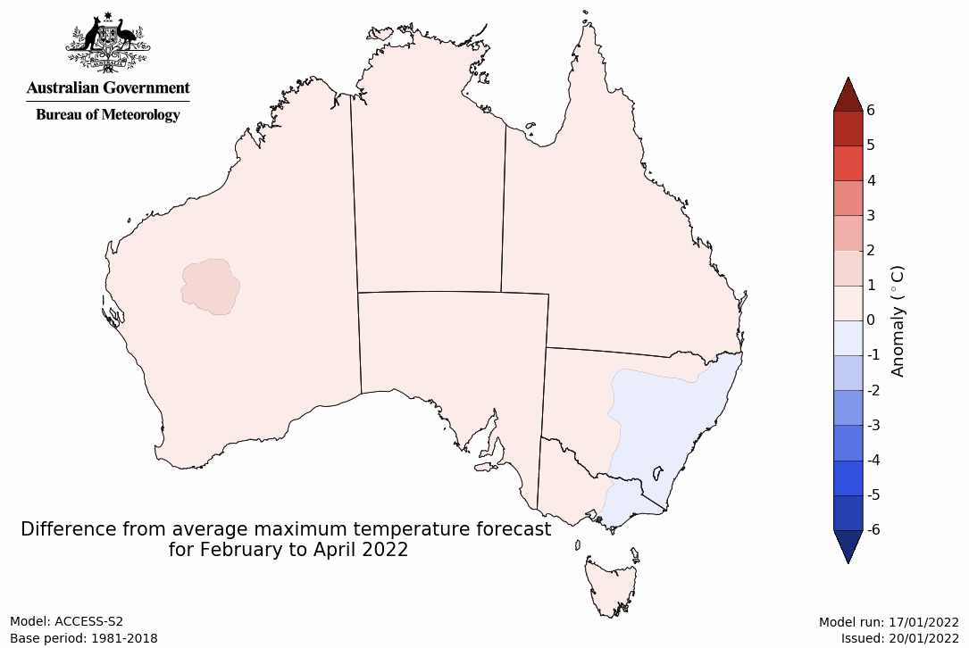
Predicted minimum temperature anomaly for February to April 2022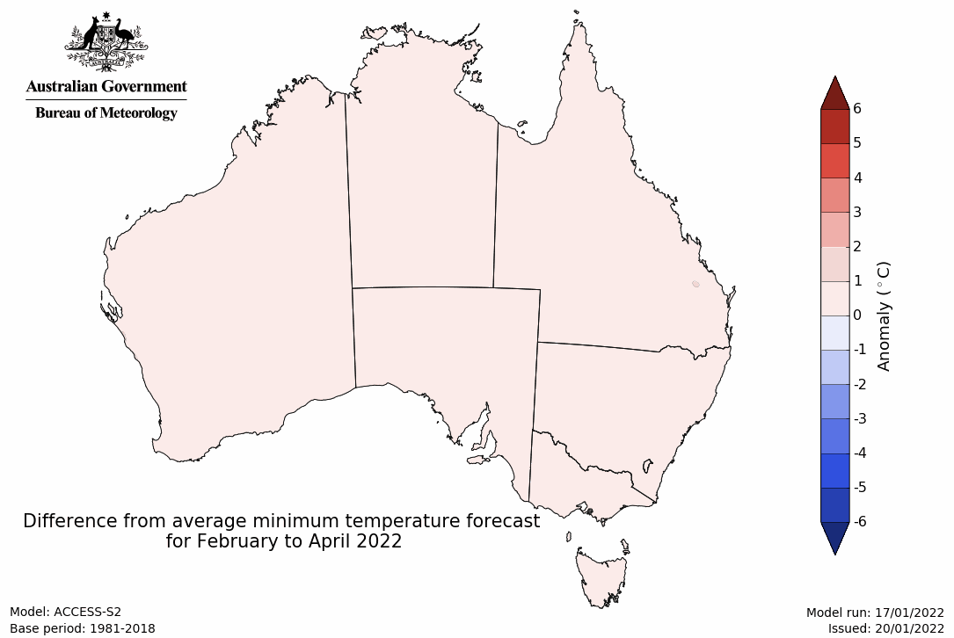

Rainfall forecast for the next eight days
Over the 8-days to 3 February 2022, rainfall is expected across much of Australia. A monsoonal trough and deep low-pressure system are expected to bring heavy rain and storms to large areas of Australia’s tropical north, while troughs and frontal activity is expected to bring showers and storms to large area of central and eastern Australia. Meanwhile, high pressure systems are expected to bring mostly dry conditions to much of southern Western Australia.
Rainfall totals of between 10 and 50 millimetres are forecast for New South Wales and Victoria, as well as much of Queensland, South Australia, the Northern Territory and north-eastern Western Australia. Rainfall in excess of 50 millimetres is expected across parts of northern South Australia, northern Queensland, the northeast of Western Australia and much of the Northern Territory.
In Australian cropping regions, rainfall totals of between 10 and 25 millimetres are expected across New South Wales and Victoria, as well as most of Queensland and parts of South Australia. Falls in excess of 25 millimetres are expected across much of southern New South Wales and eastern Victoria. Little to no rainfall is forecast for cropping regions of Western Australia and remaining areas in Queensland, South Australia and western Victoria during the next 8-days.
Soil moisture levels across eastern Australian cropping regions remain well above average. The forecast rainfall for parts of New South Wales and Queensland may further prevent the harvest of early planted summer crops. However, the falls are likely to benefit pasture growth and build soil moisture levels across affected areas and extent the peak pasture production season across southern growing regions.

Total forecast rainfall (mm) for the period 27 January to 3 February 2022
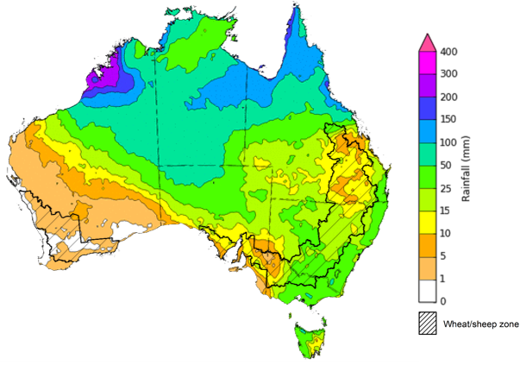
©Commonwealth of Australia 2022, Australian Bureau of Meteorology Issued: 27/01/2022

Water
Note: This rainfall forecast is produced from computer models. As the model outputs are not altered by weather forecasters, it is important to check local forecasts and warnings issued by the Bureau of Meteorology.

Water markets – current week
Water storage in the Murray–Darling Basin (MDB) decreased by 92 gigalitres (GL) between 19 January 2022 and 26 January 2022. The current volume of water held in storage is 22,419 GL, which represents 89% of total capacity. This is 62% or 8,616 GL more than at the same time last year.

Water storages in the Murray-Darling Basin, 2013–2022
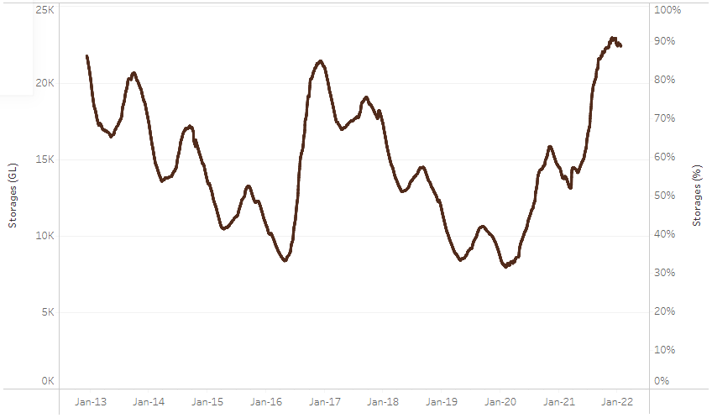
Allocation prices in the Victorian Murray below the Barmah Choke decreased from $107 per ML on 14 January 2022 to $92 per ML on 21 January 2022. Prices are lower in the Goulburn-Broken, Murrumbidgee, and regions above the Barmah Choke due to the binding of the Goulburn intervalley trade limit, Murrumbidgee export limit, and Barmah Choke trade constraint.
Water storage data is sourced from the Bureau of Meteorology.

Region | $/ML
NSW Murray Above | 47
NSW Murrumbidgee | 45
VIC Goulburn-Broken | 75
VIC Murray Below | 92

Surface water trade activity, Southern Murray–Darling Basin

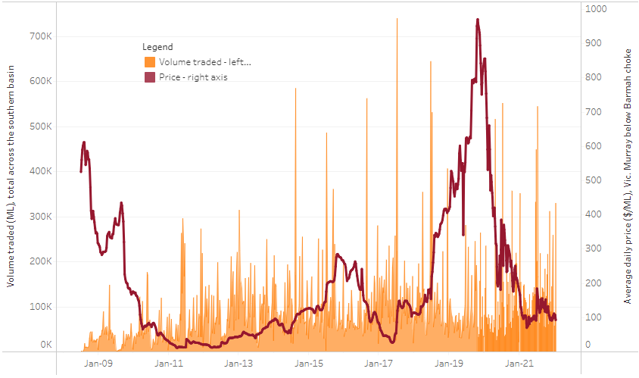
To access the full, interactive, weekly water dashboard, which contains the latest and historical water storage, water market and water allocation information, please visit http://www.agriculture.gov.au/abares/products/weekly_update/weekly-update-270122
The trades shown reflect estimated market activity and do not encompass all register trades. The price is shown for the VIC Murray below the Barmah choke. Historical prices (before 1 July 2019) are ABARES estimates after removing outliers from BOM water register data. Prices after 1 July 2019 and prior to the 30 October 2019 reflect recorded transaction prices as sourced from Ruralco. Prices after the 30 October 2019 are sourced from Waterflow. Data for volume traded is sourced from the BOM water register. Data shown is current at 27 January 2022.

Commodities
Indicator | Week ended | Unit | Latest price | Previous week | Weekly change | Price 12 months ago | Annual change
Selected world indicator prices
AUD/USD Exchange rate | 26-Jan | A$/US$ | 0.72 | 0.72 | -1% | 0.76 | -6%
Wheat – US no. 2 hard red winter wheat, fob Gulf | 26-Jan | US$/t | 395 | 362 | 9% | 289 | 37%
Corn – US no. 2 yellow corn, fob Gulf | 26-Jan | US$/t | 288 | 280 | 3% | 244 | 18%
Canola – Rapeseed, Canada, fob Vancouver | 26-Jan | US$/t | 869 | 854 | 2% | 587 | 48%
Cotton – Cotlook 'A' Index | 26-Jan | USc/lb | 135 | 133 | 1% | 88 | 53%
Sugar – Intercontinental Exchange, nearby futures, no.11 contract | 26-Jan | USc/lb | 18.5 | 18.3 | 1% | 16 | 15%
Wool – Eastern Market Indicator | 26-Jan | Ac/kg clean | 1,426 | 1,435 | -1% | 1,159 | 23%
Wool – Western Market Indicator | 15-Dec-2021 | Ac/kg clean | 1,408 | 1,417 | -1% | 984 | 43%
Selected Australian grain export prices
Milling Wheat – APW, Port Adelaide, SA | 26-Jan | A$/t | 482 | 472 | 2% | 356 | 35%
Feed Wheat – ASW, Port Adelaide, SA | 26-Jan | A$/t | 452 | 441 | 3% | 353 | 28%
Feed Barley – Port Adelaide, SA | 26-Jan | A$/t | 379 | 375 | 1% | 305 | 24%
Canola – Kwinana, WA | 26-Jan | A$/t | 960 | 938 | 2% | 687 | 40%
Grain Sorghum – Brisbane, QLD | 26-Jan | A$/t | 367 | 368 | 0% | 387 | -5%
Selected domestic livestock indicator prices
Beef – Eastern Young Cattle Indicator | 26-Jan | Ac/kg cwt | 1,170 | 1,167 | 0% | 836 | 40%
Mutton – Mutton indicator (18–24 kg fat score 2–3), Vic | 26-Jan | Ac/kg cwt | 576 | 648 | -11% | 609 | -5%
Lamb – Eastern States Trade Lamb Indicator | 26-Jan | Ac/kg cwt | 834 | 847 | -1% | 770 | 8%
Pig – Eastern Seaboard (60.1–75 kg), average of buyers & sellers | 19-Jan | Ac/kg cwt | 357 | 357 | 0% | 309 | 16%
Goats – Eastern States (12.1–16 kg) | 19-Jan | Ac/kg cwt | 879 | 879 | 0% | 818 | 8%
Live cattle – Light steers ex Darwin to Indonesia | 17-Feb-2021 | Ac/kg lwt | 355 | 355 | 0% | 360 | -1%
Live sheep – Live wethers (Muchea WA saleyard) to Middle East | 22-Sep-2021 | $/head | 147 | 171 | -14% | 126 | 17%

Indicator | Week ended | Unit | Latest price | Previous week | Weekly change | Price 12 months ago | Annual change
Global Dairy Trade (GDT) weighted average prices ª
Dairy – Whole milk powder | 19-Jan | US$/t | 4,082 | 3,866 | 6% | 3,331 | 23%
Dairy – Skim milk powder | 19-Jan | US$/t | 3,963 | 3,773 | 5% | 3,068 | 29%
Dairy – Cheddar cheese | 19-Jan | US$/t | 5,546 | 5,487 | 1% | 3,869 | 43%
Dairy – Anhydrous milk fat | 19-Jan | US$/t | 6,720 | 6,668 | 1% | 4,866 | 38%
a Global Dairy Trade prices are updated twice monthly on the first and third Tuesday of each month.

Selected world indicator prices
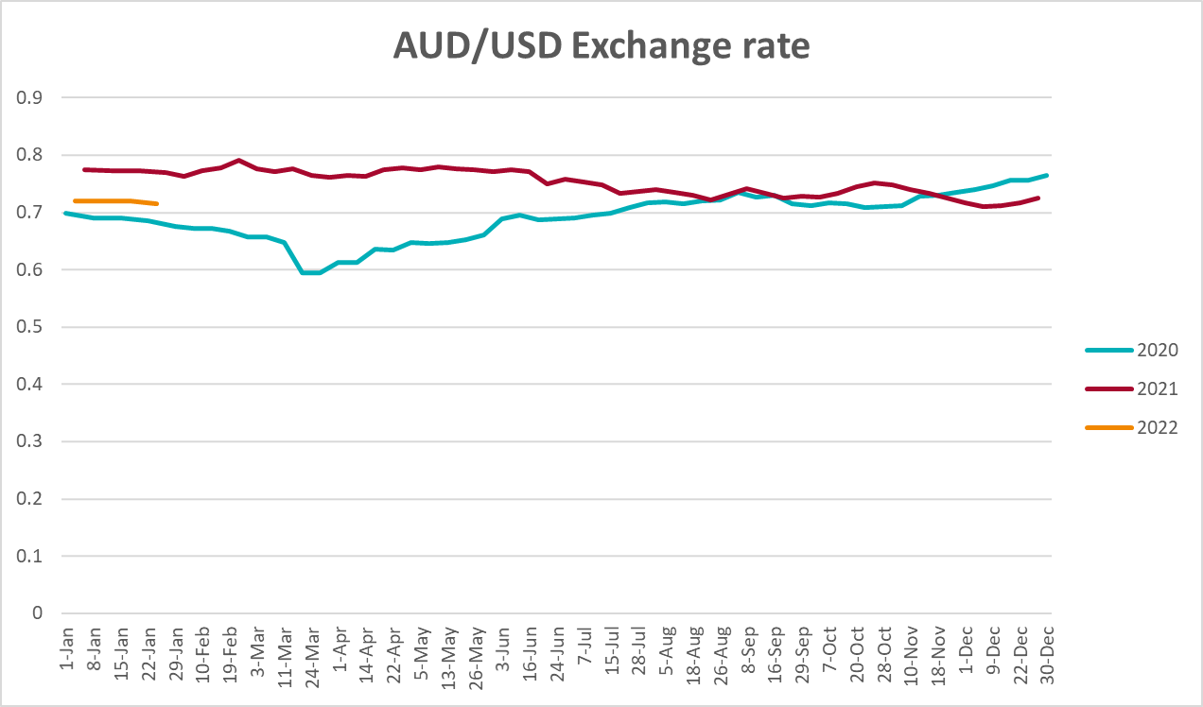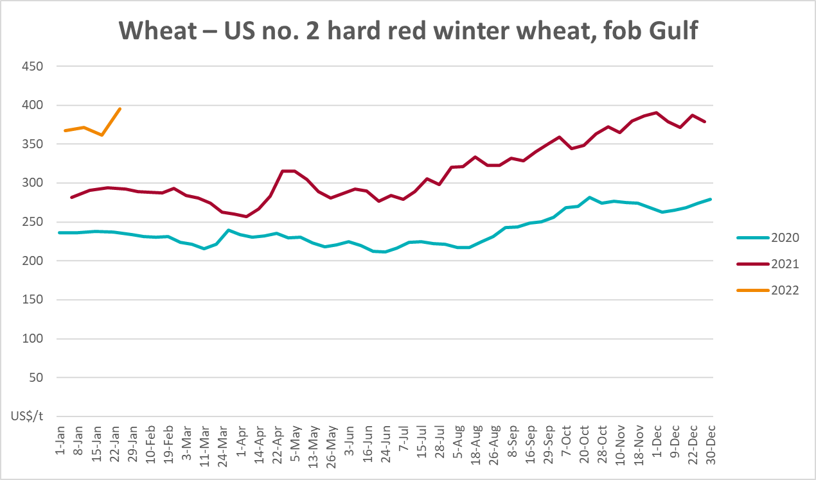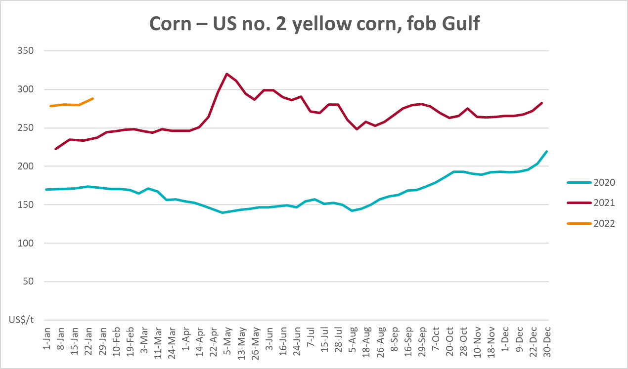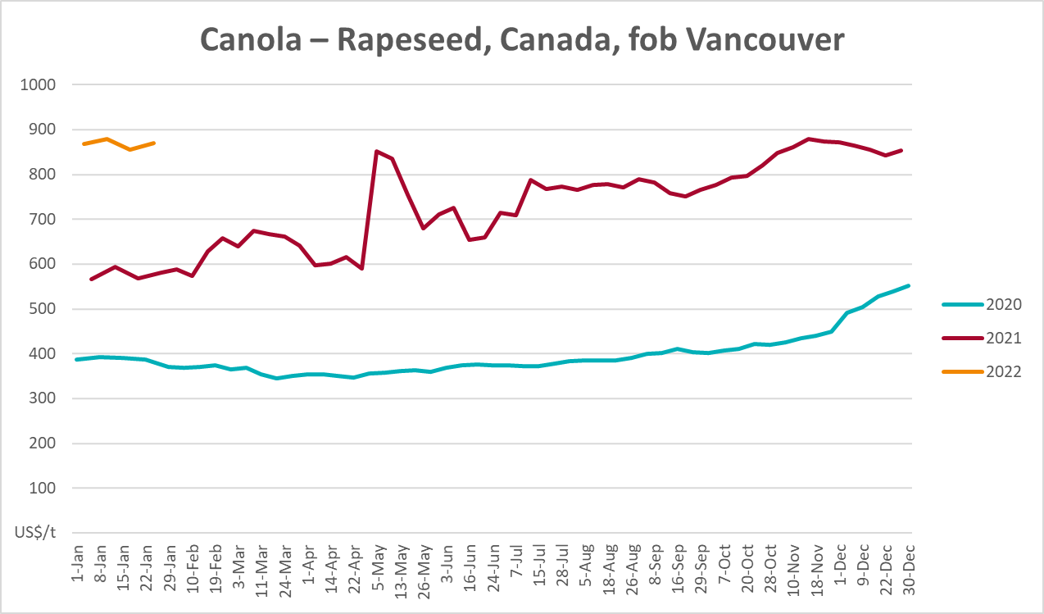

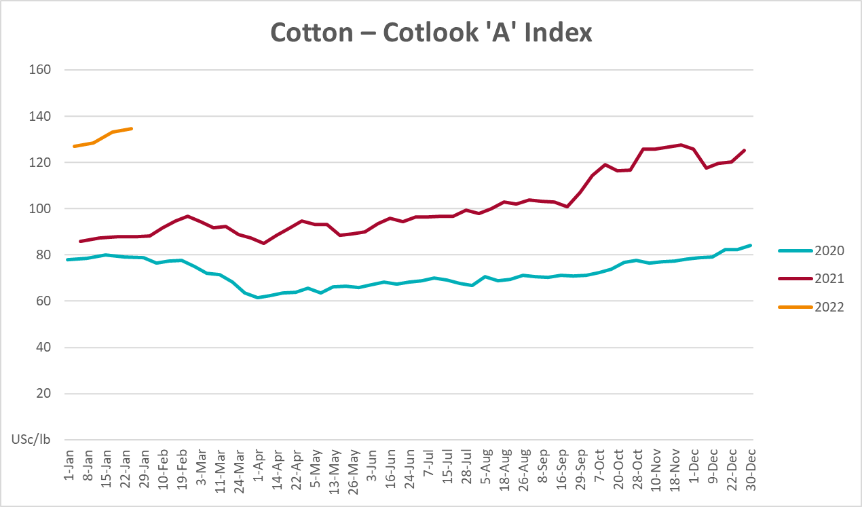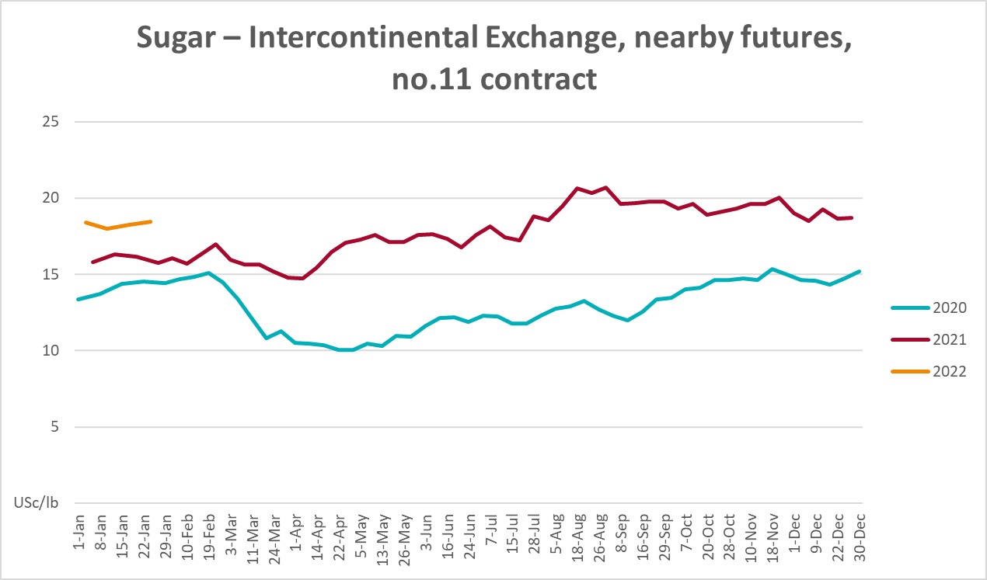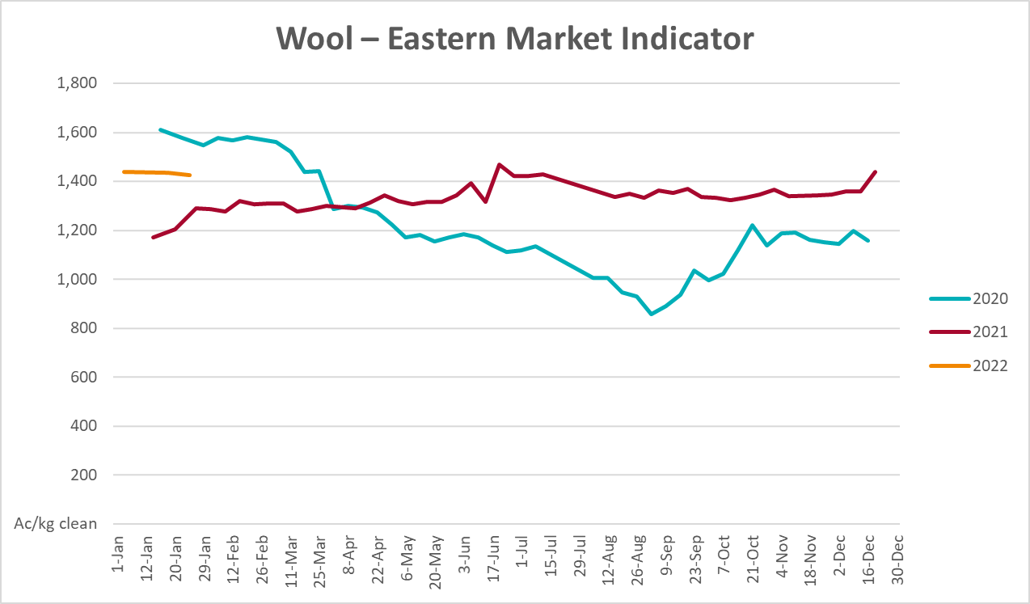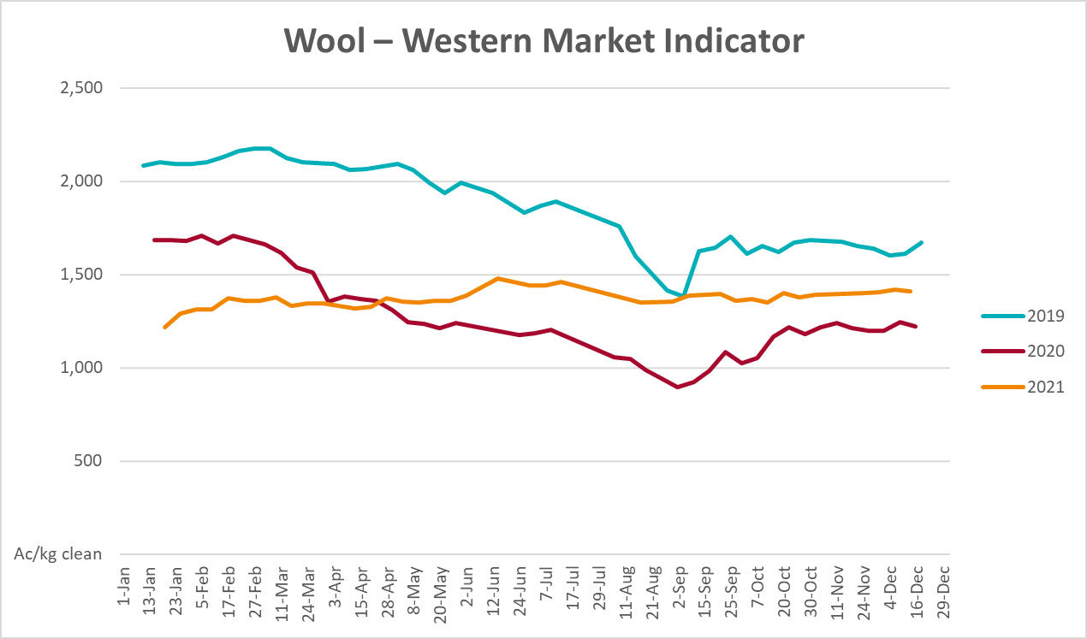

Selected domestic crop indicator prices
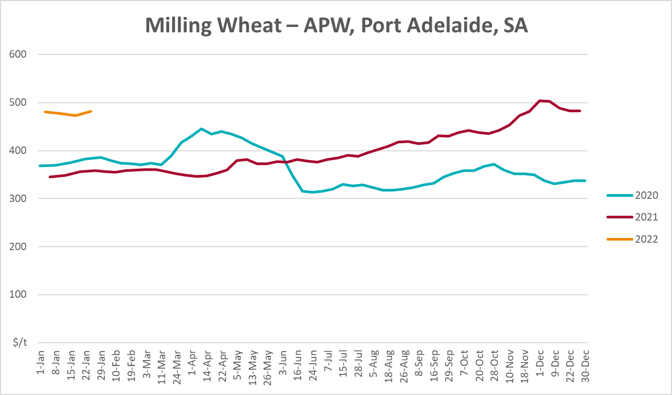
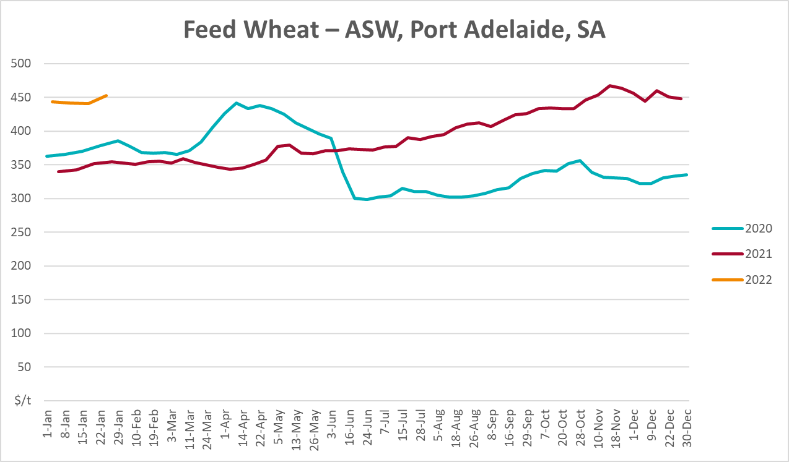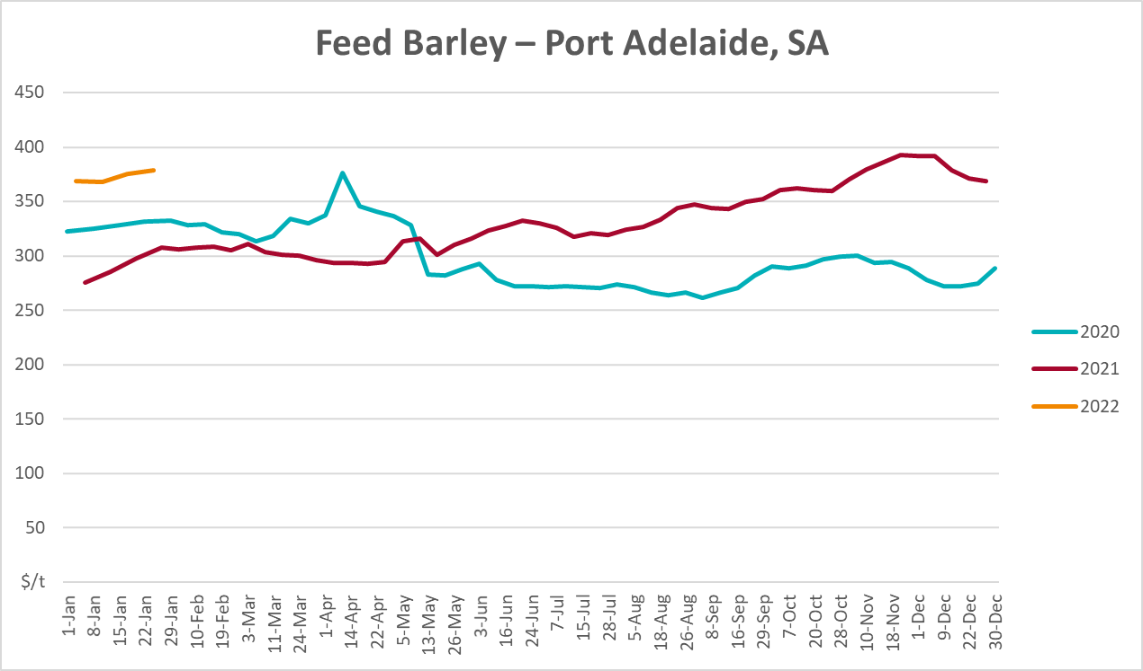

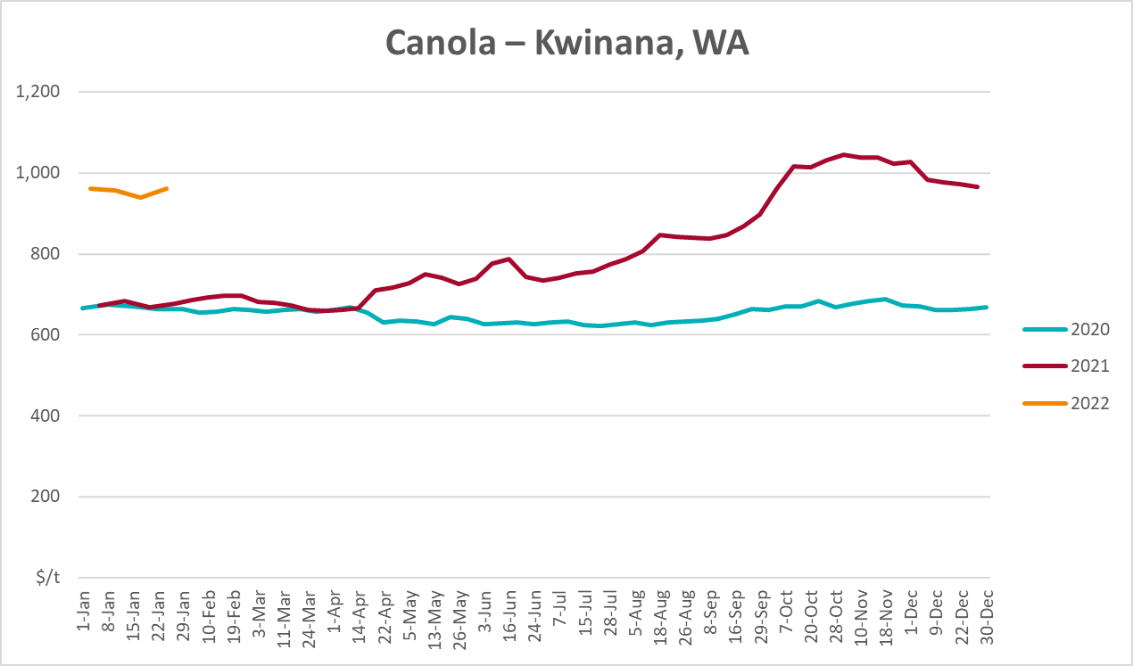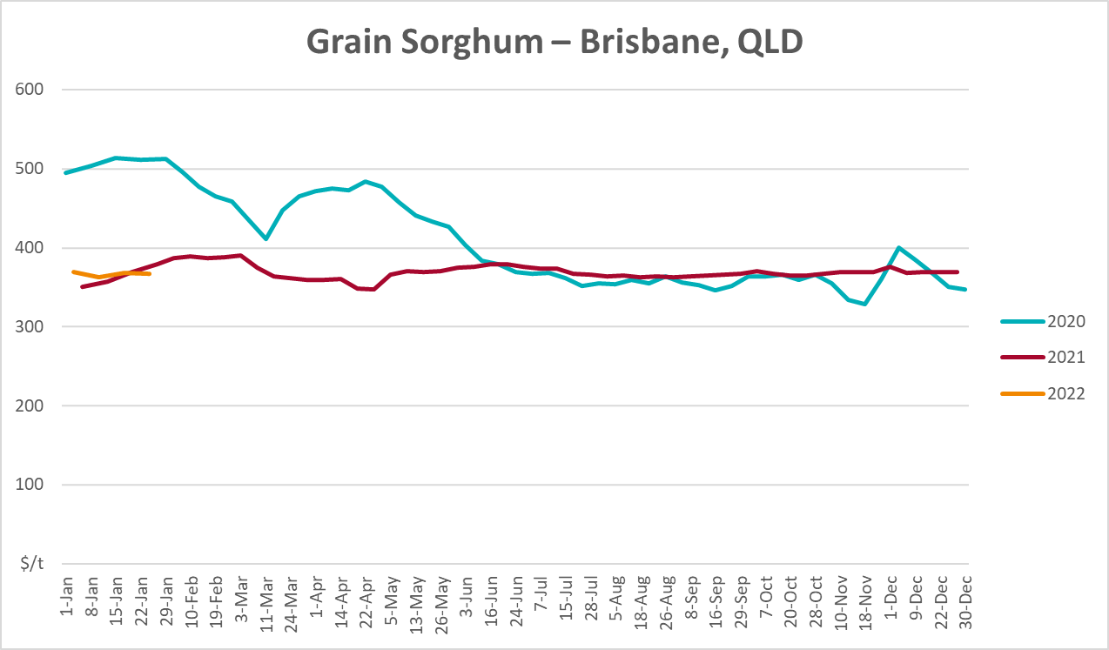

Selected domestic livestock indicator prices
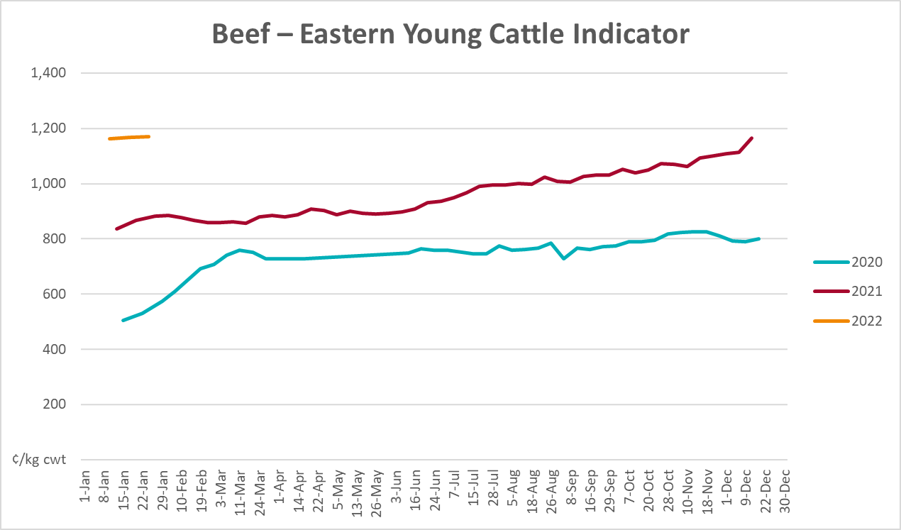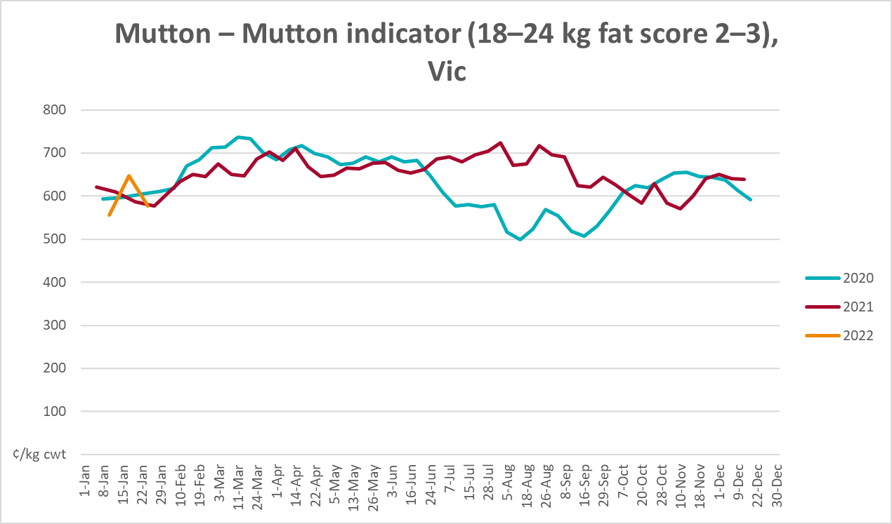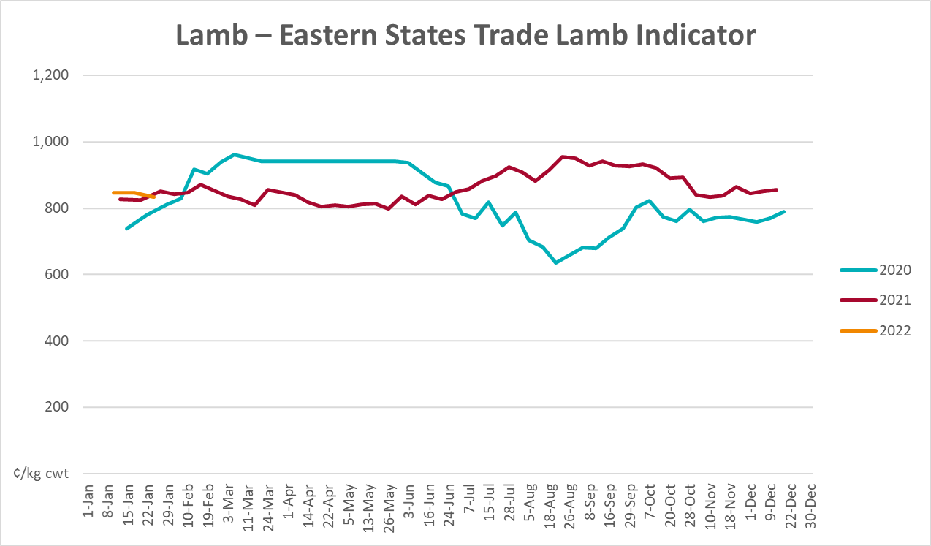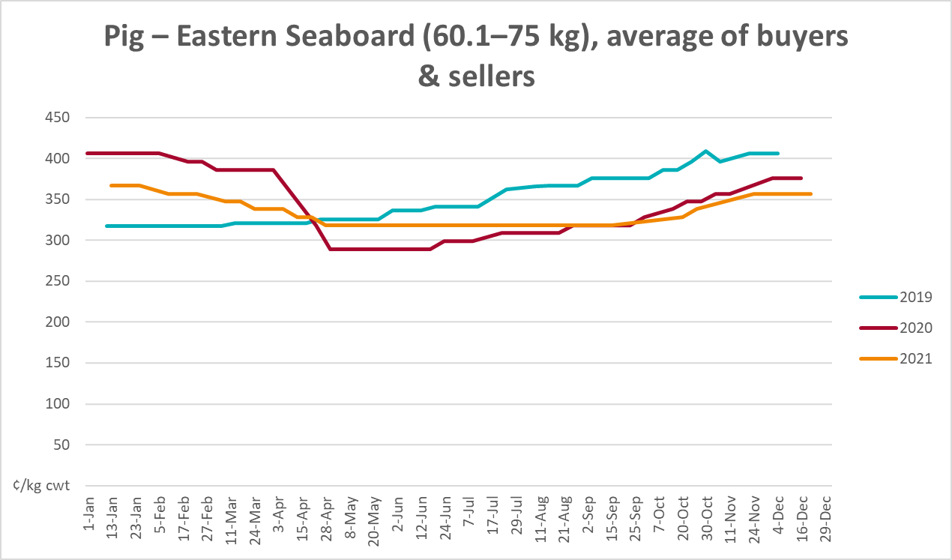

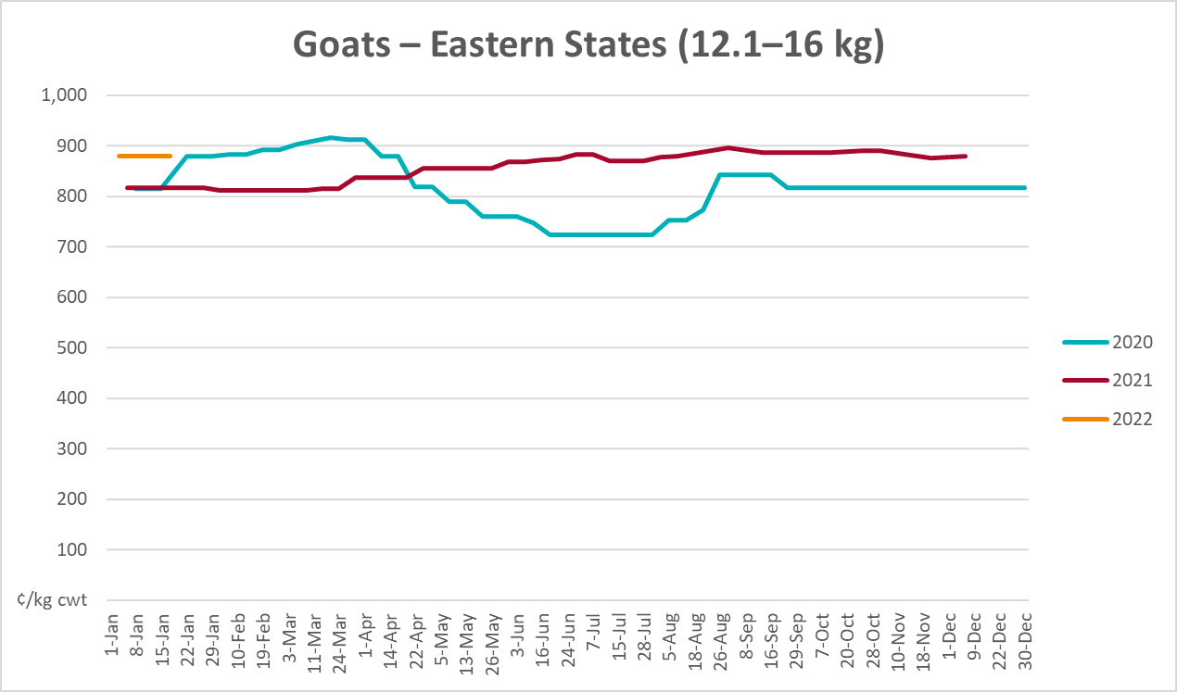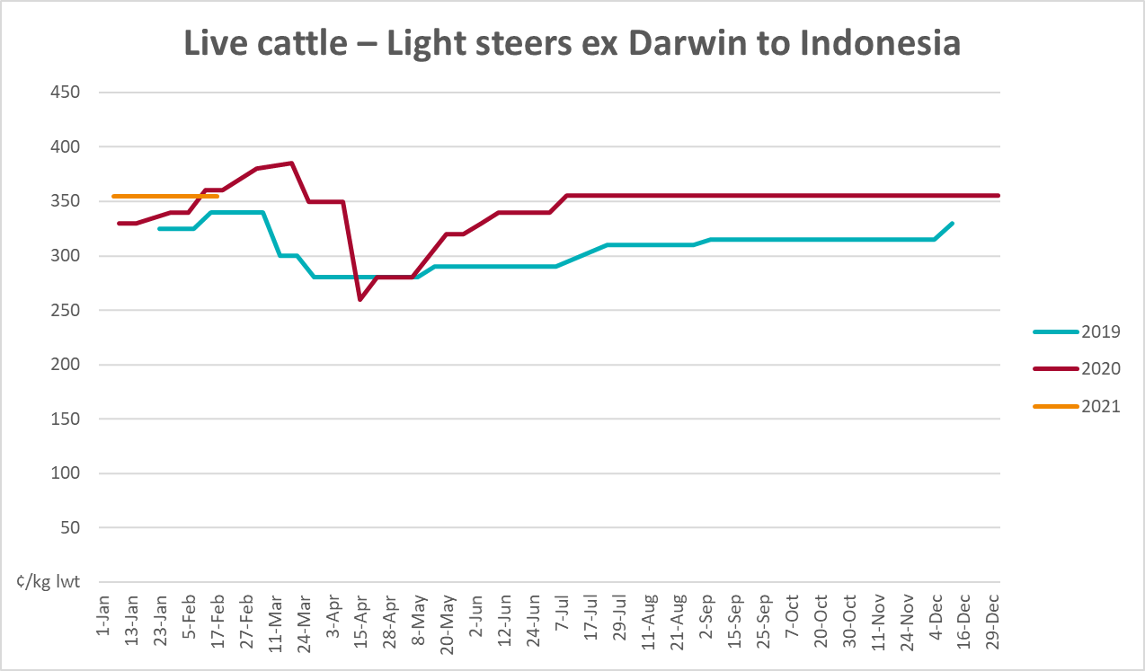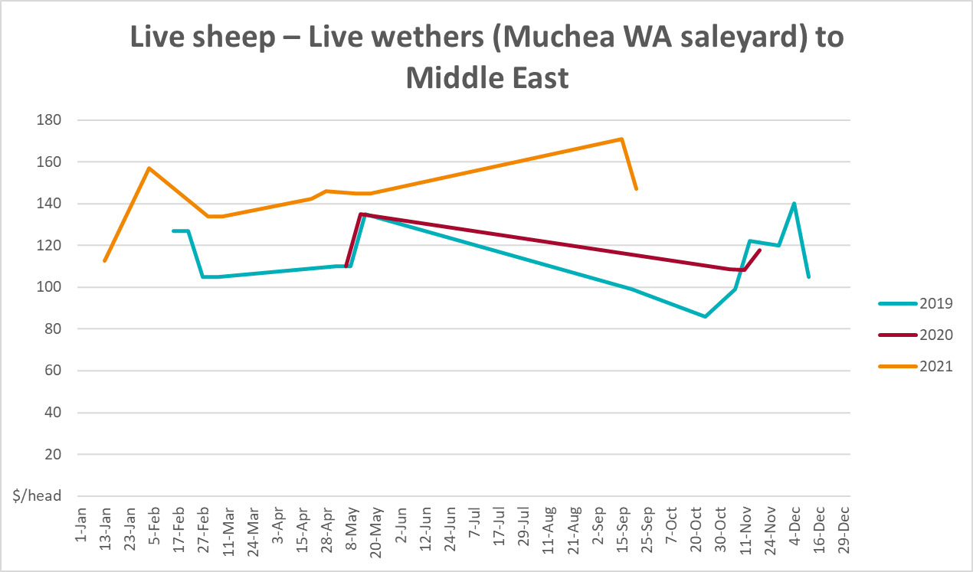

Global Dairy Trade (GDT) weighted average prices
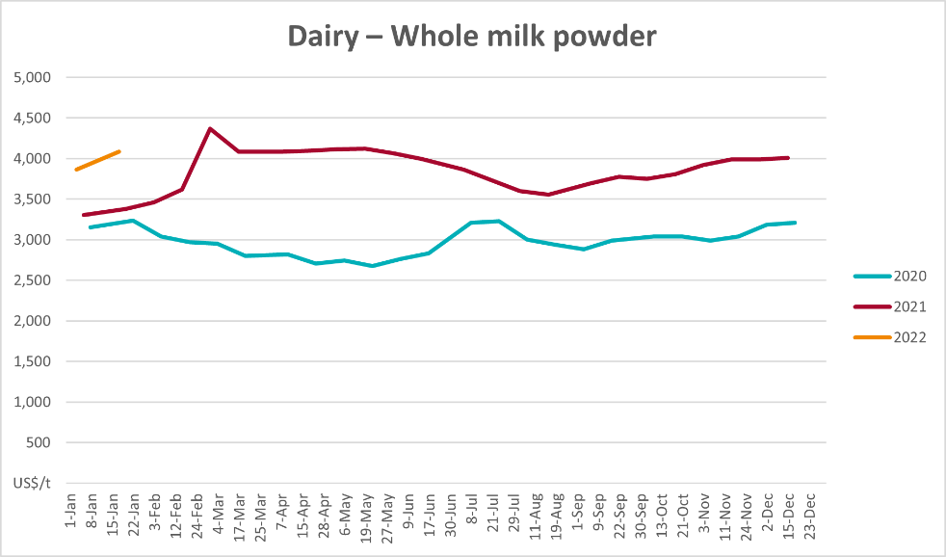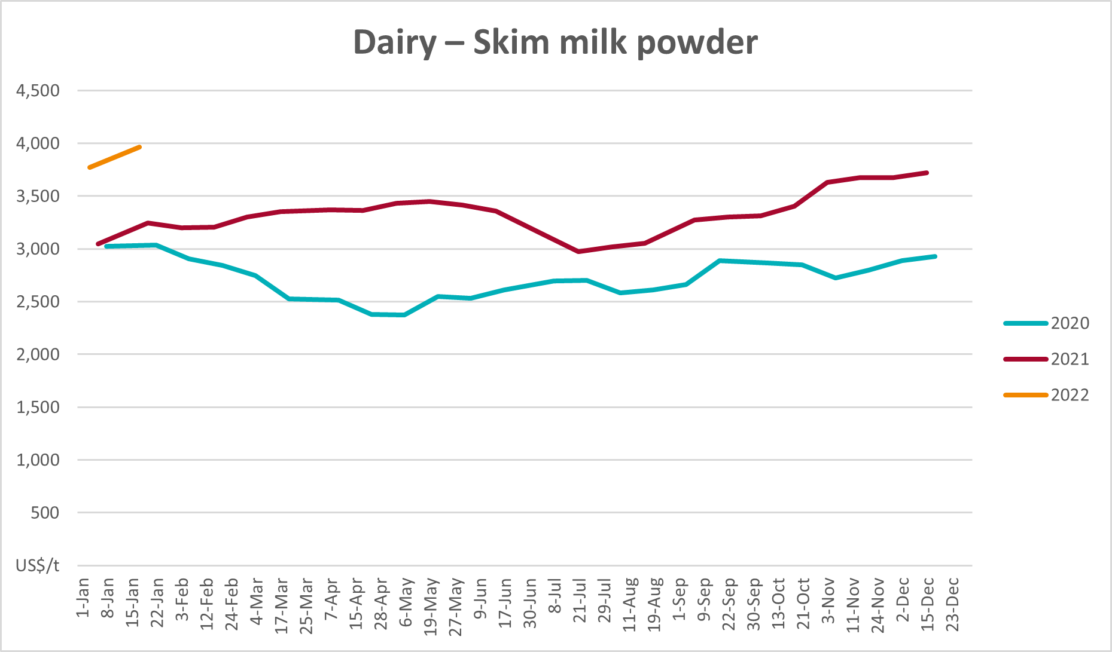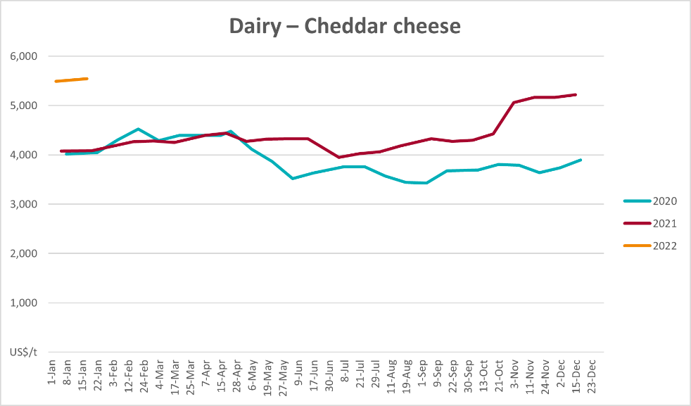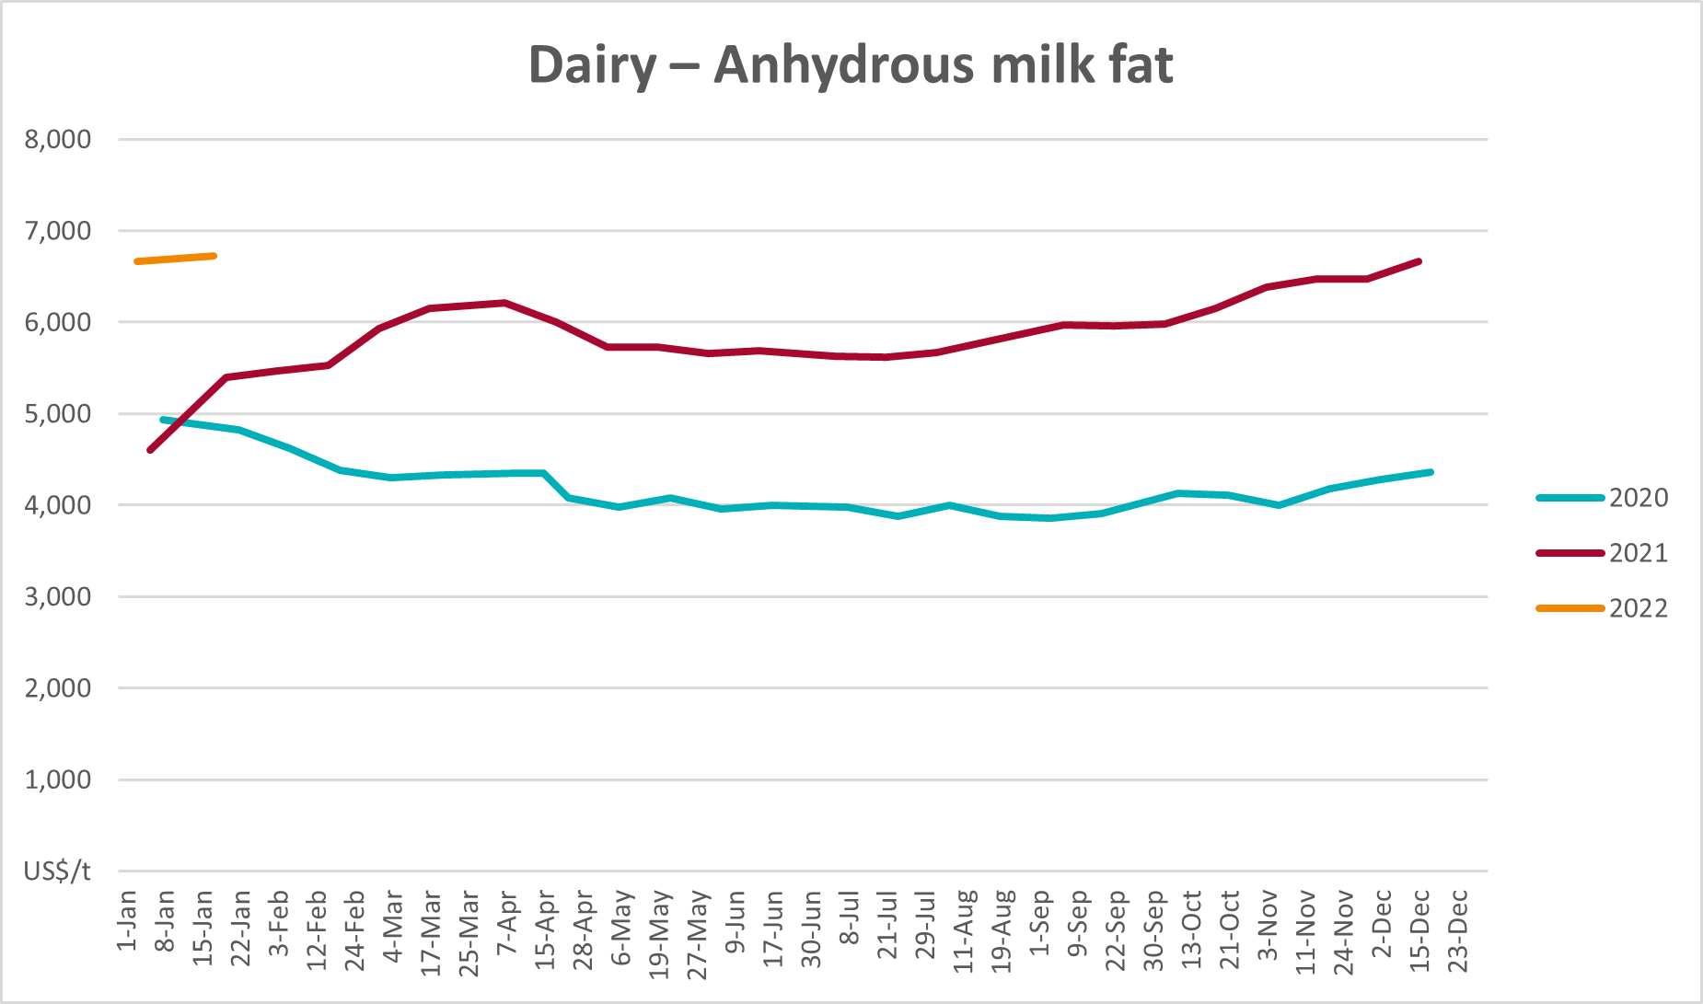

Selected fruit and vegetable prices
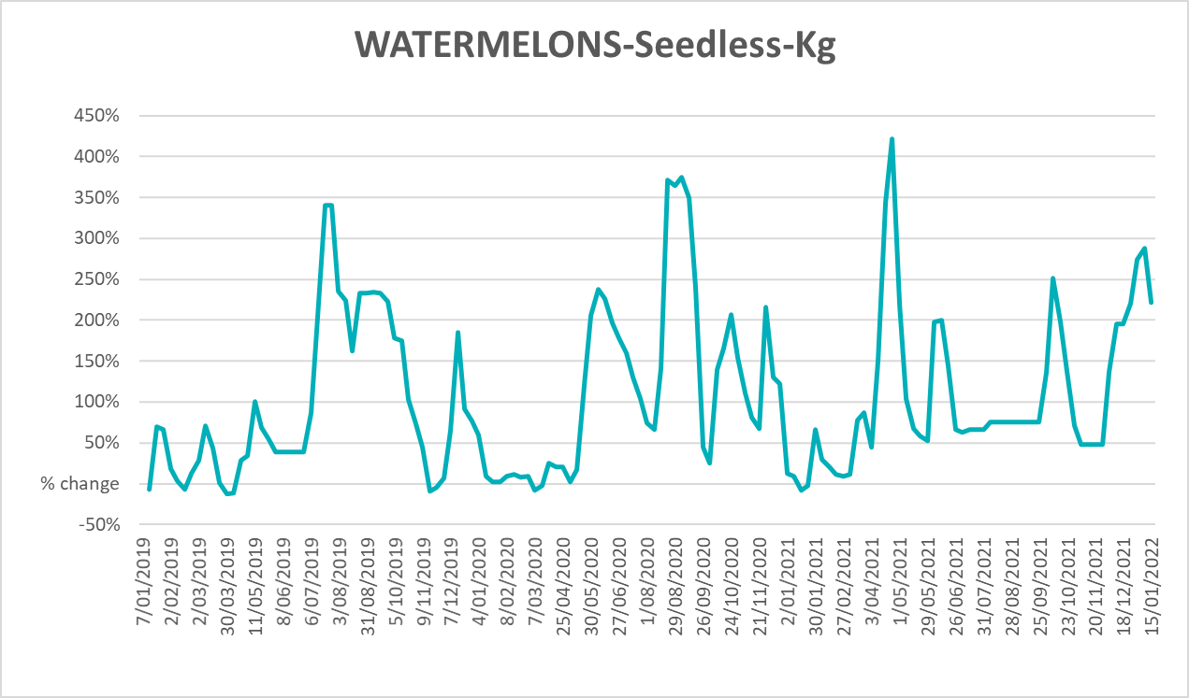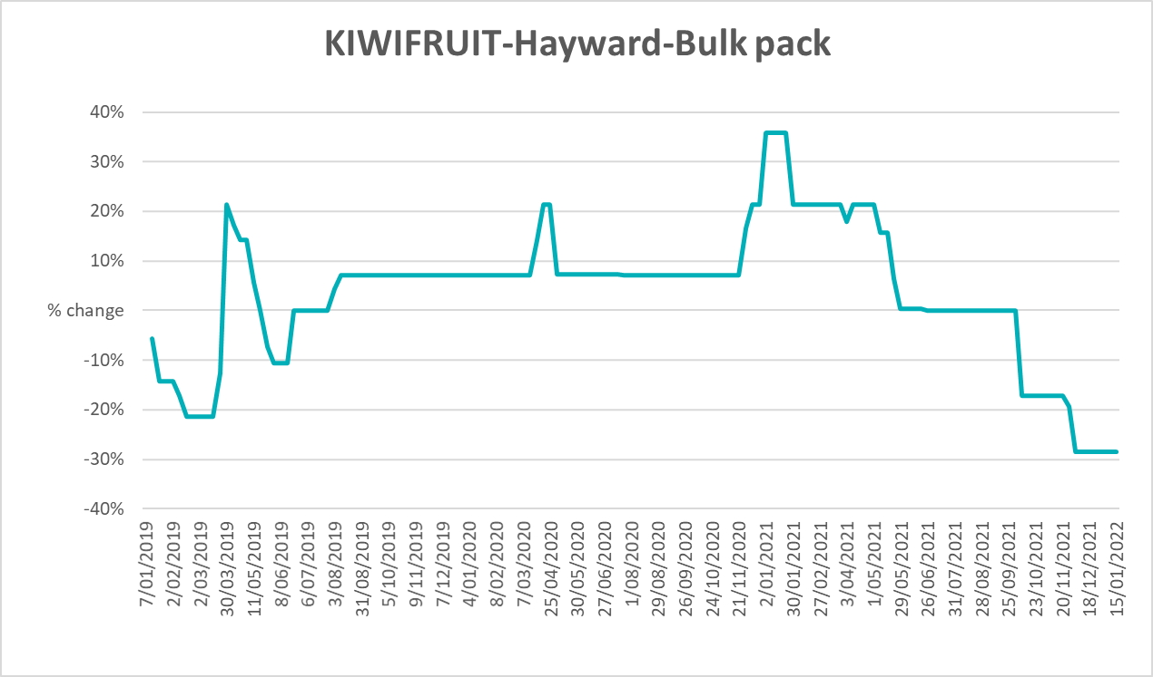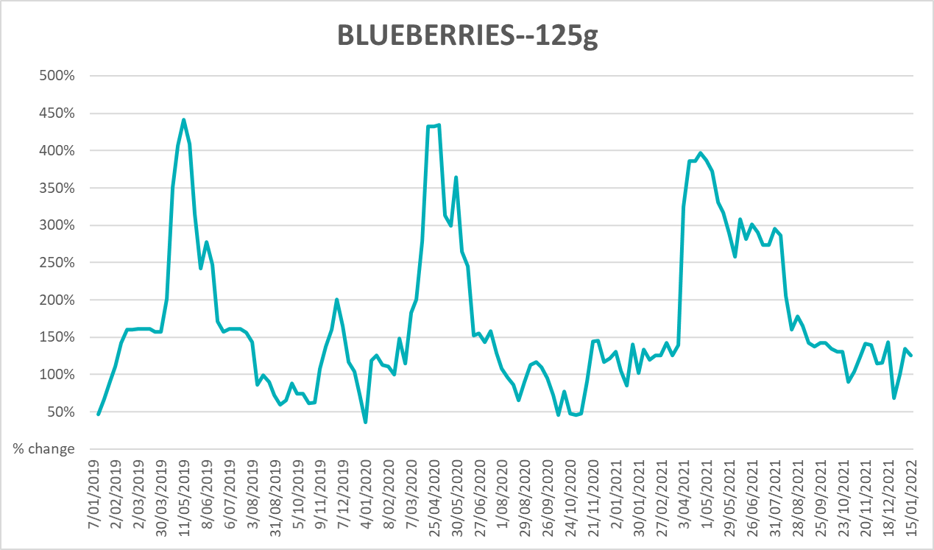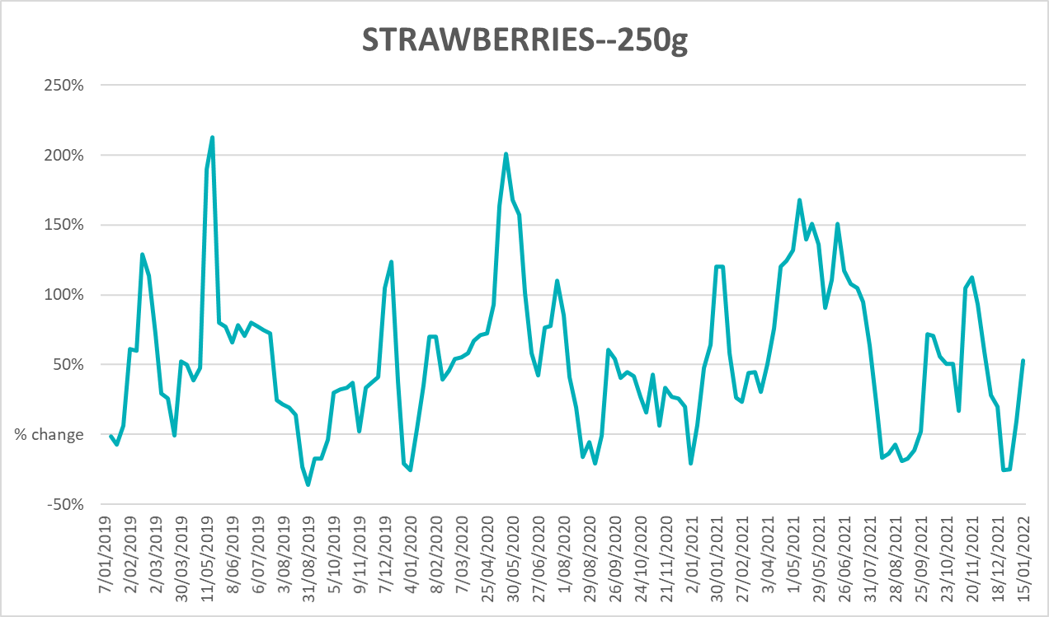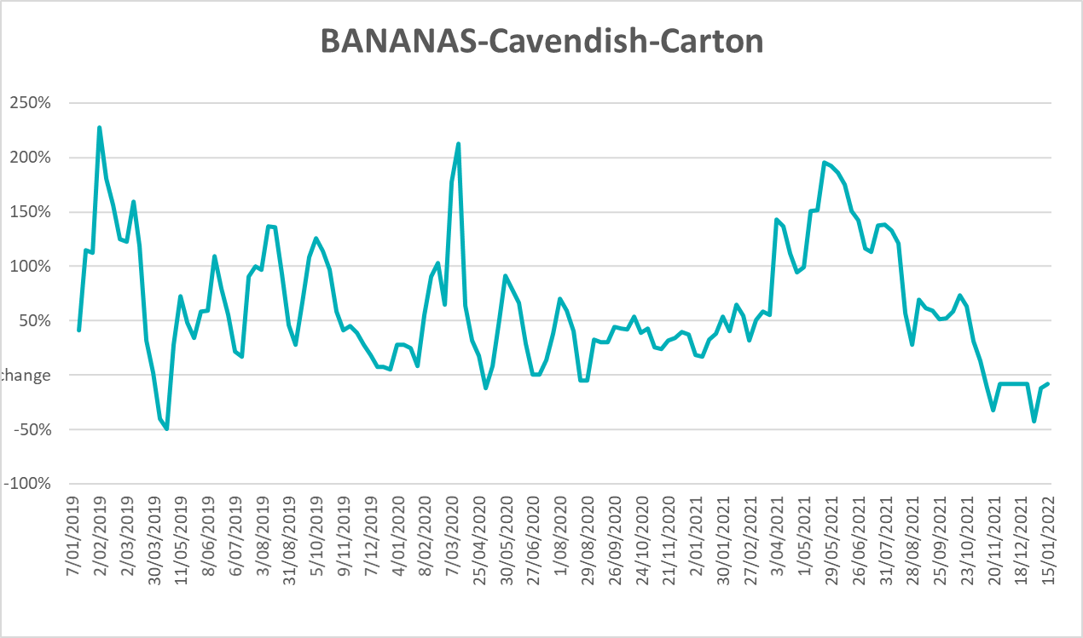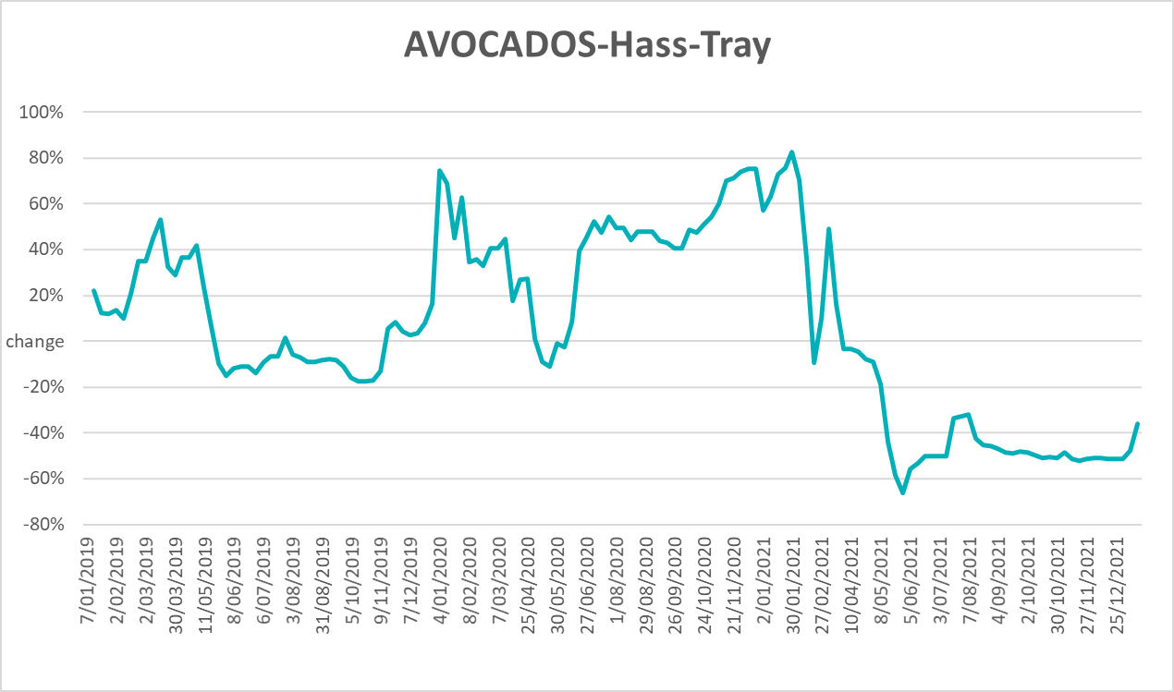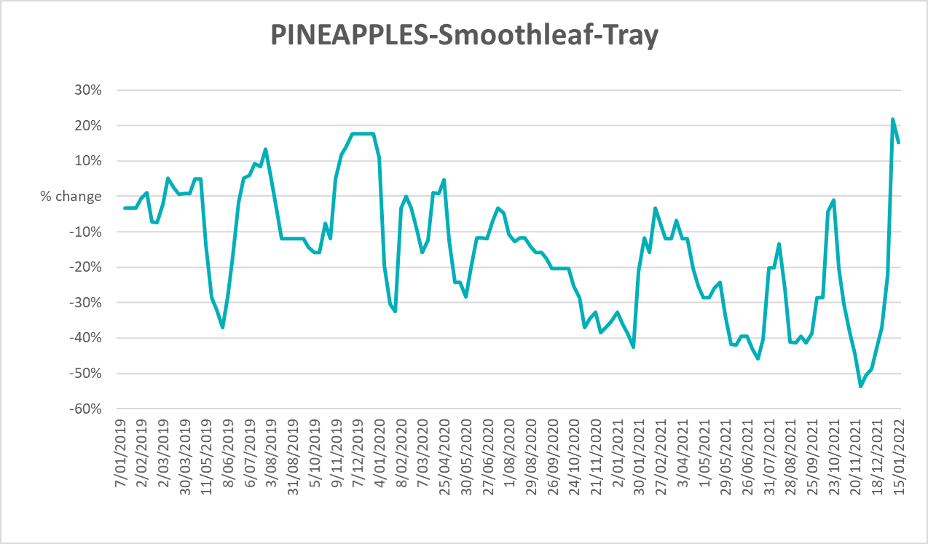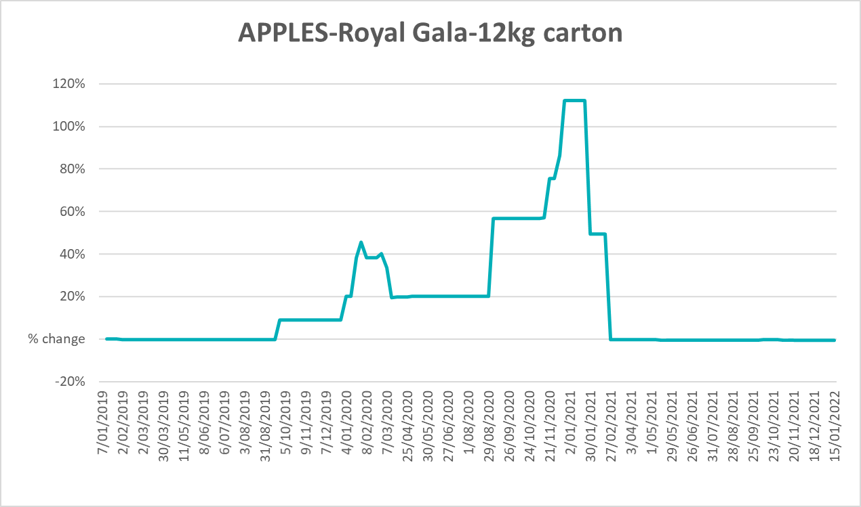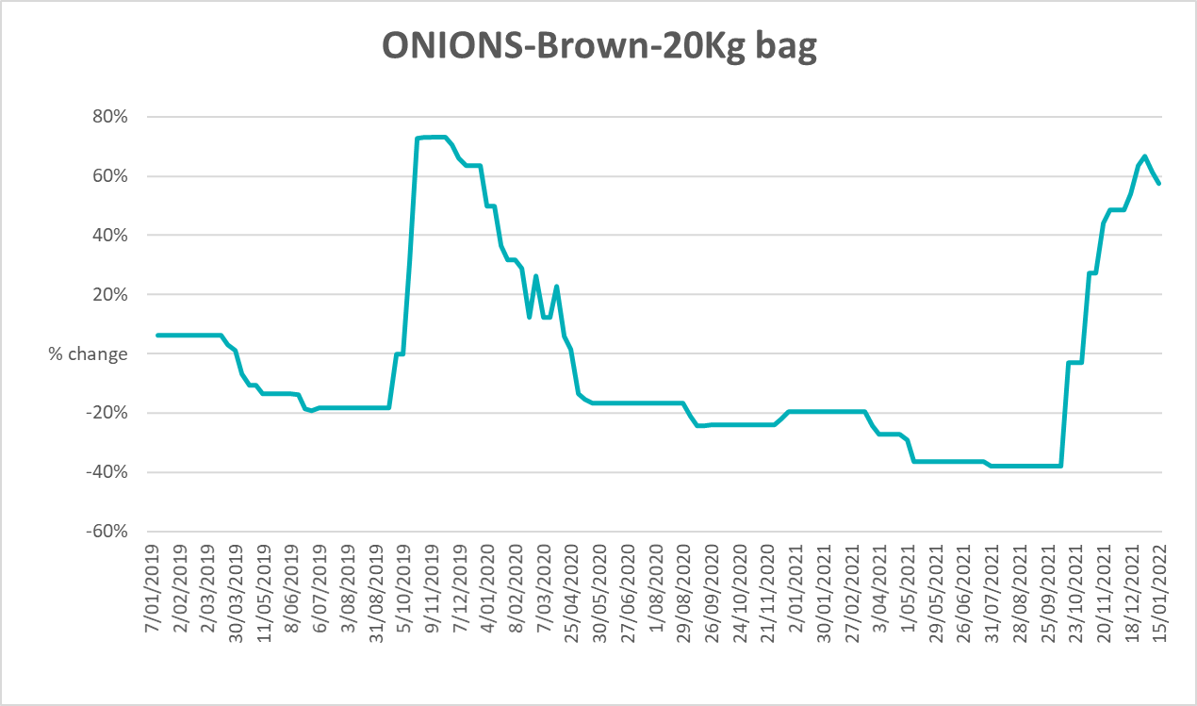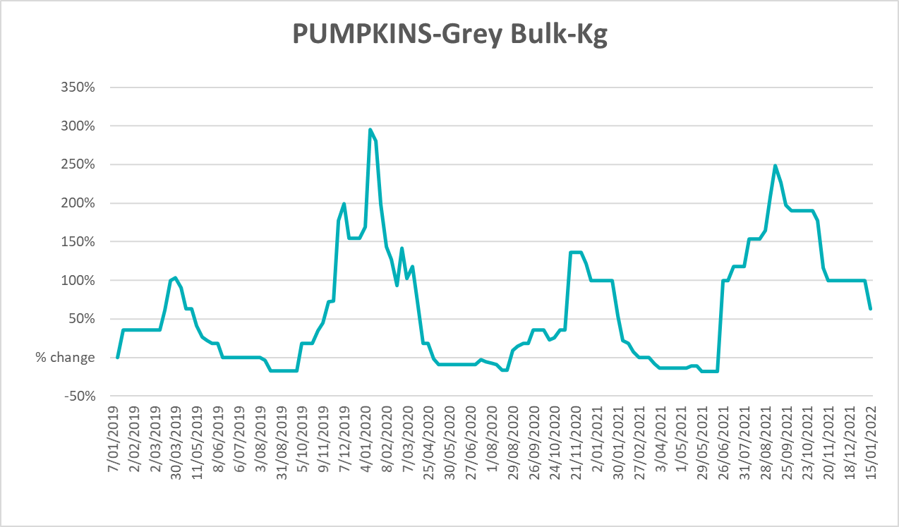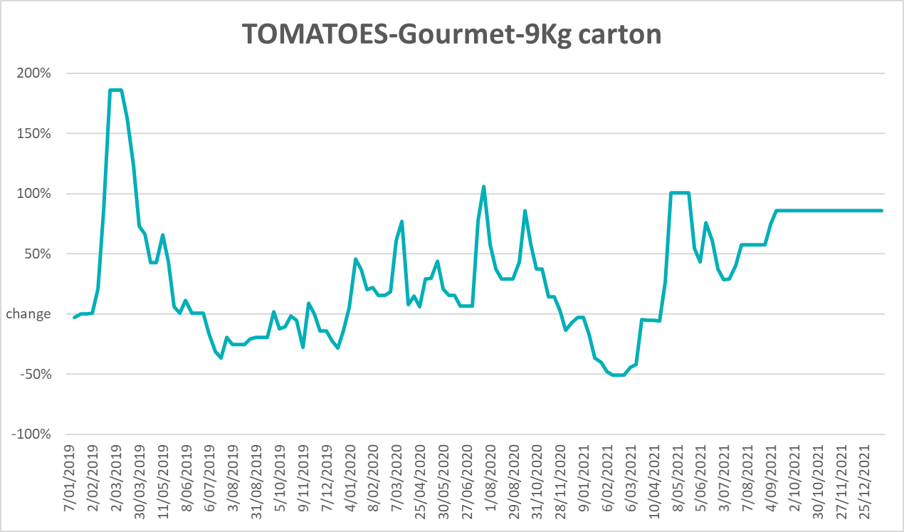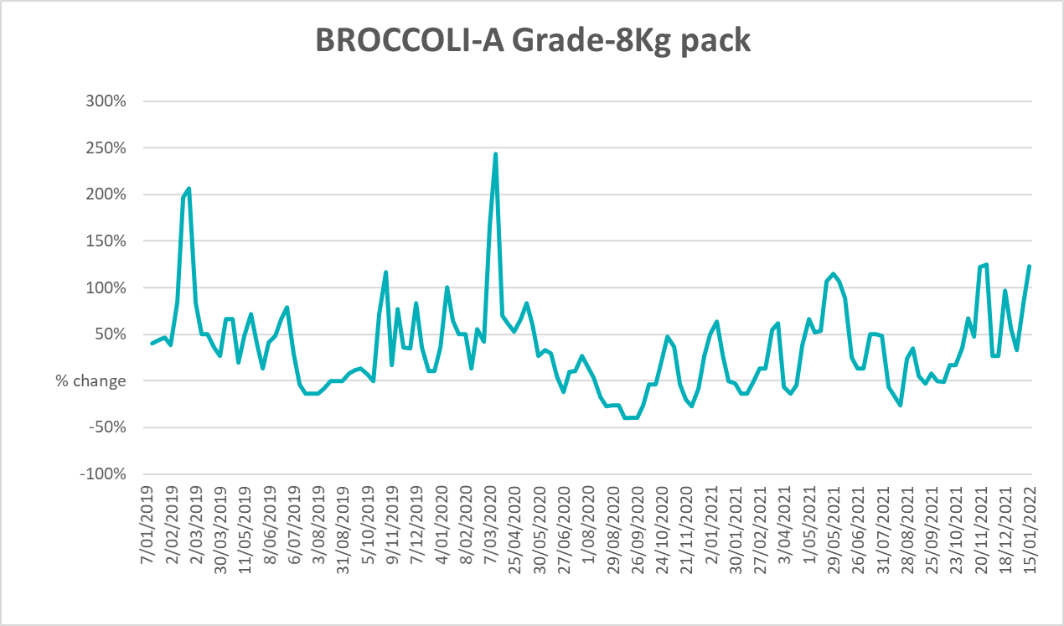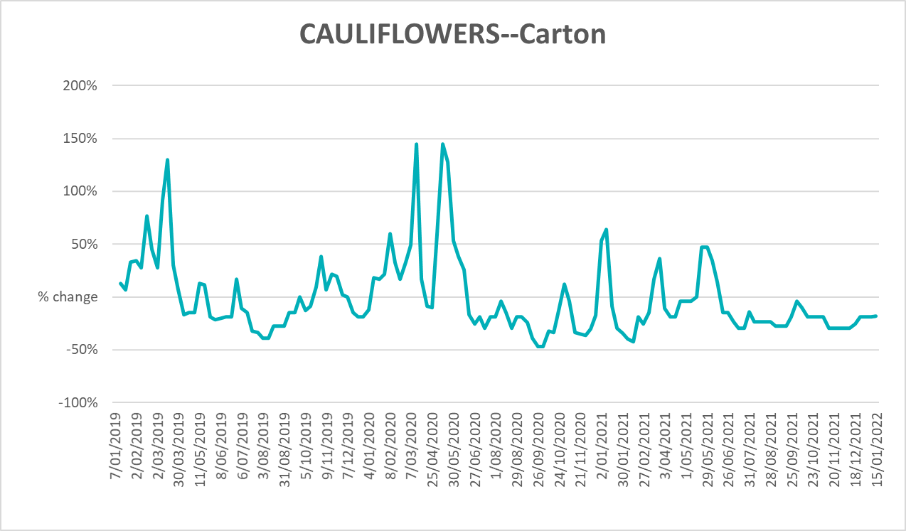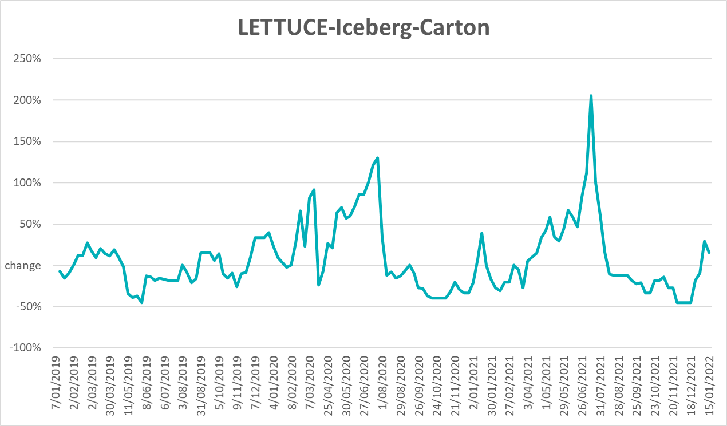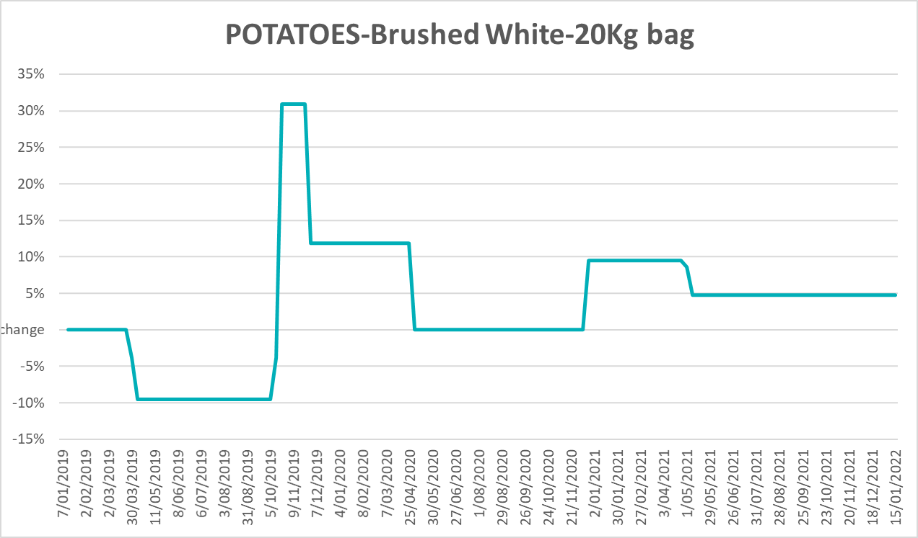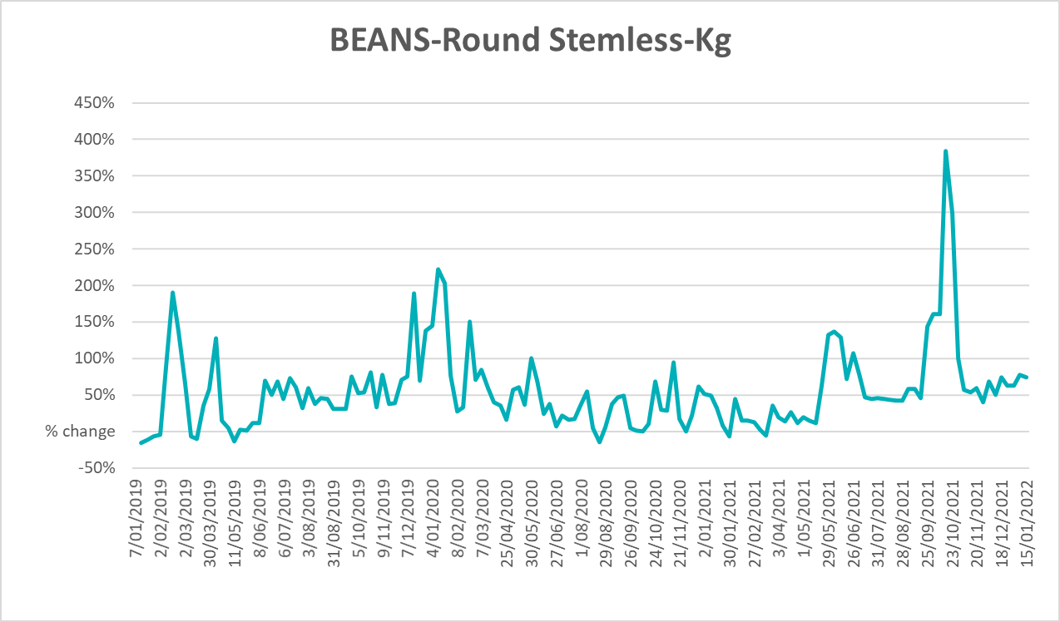

Selected domestic fodder indicator prices
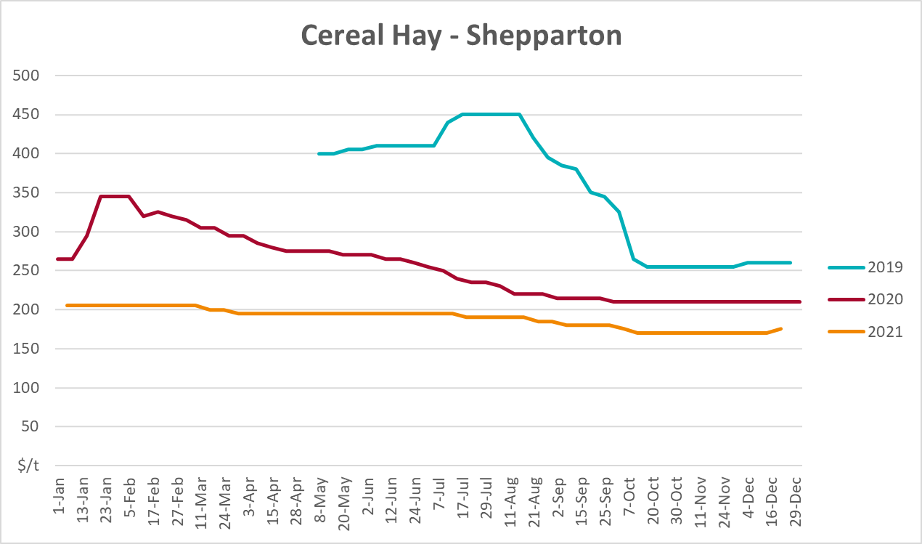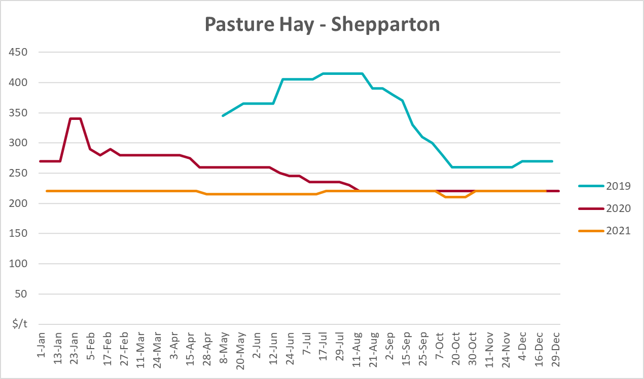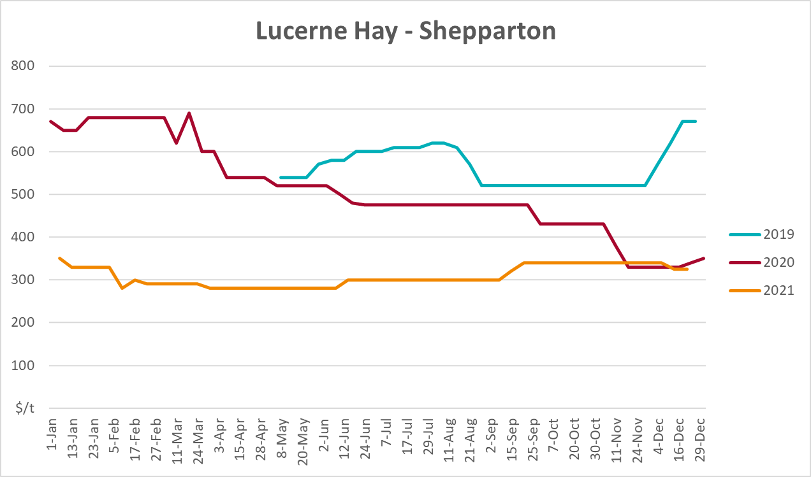

Data attribution

Climate
Bureau of Meteorology
- Weekly rainfall totals: www.bom.gov.au/climate/maps/rainfall/
- Monthly and last 3-month rainfall percentiles: www.bom.gov.au/water/landscape/
- Temperature anomalies: www.bom.gov.au/jsp/awap/temp/index.jsp
- Rainfall forecast: www.bom.gov.au/jsp/watl/rainfall/pme.jsp
- Seasonal outlook: www.bom.gov.au/climate/outlooks/#/overview/summary/
- Climate drivers: http://www.bom.gov.au/climate/enso/
- Soil moisture: www.bom.gov.au/water/landscape/
Other
- Pasture growth: www.longpaddock.qld.gov.au/aussiegrass/
- 3-month global outlooks: Environment and Climate Change Canada, NOAA Climate Prediction Center, EUROBRISA CPTEC/INPE, European Centre for Medium-Range Weather Forecasts, Hydrometcenter of Russia, National Climate Center Climate System Diagnosis and Prediction Room (NCC), International Research Institute for Climate and Society
- Global production: https://ipad.fas.usda.gov/ogamaps/cropmapsandcalendars.aspx
- Autumn break: Pook et al., 2009, https://rmets-onlinelibrary-wiley-com.virtual.anu.edu.au/doi/epdf/10.1002/joc.1833

Water
Prices
- Waterflow: https://www.waterflow.io/
- Ruralco: https://www.ruralcowater.com.au/
Bureau of Meteorology:
- Allocation trade: http://www.bom.gov.au/water/dashboards/#/water-markets/mdb/at
- Storage volumes: http://www.bom.gov.au/water/dashboards/#/water-storages/summary/drainage
Trade constraints:
- Water NSW: https://www.waternsw.com.au/customer-service/ordering-trading-and-pricing/trading/murrumbidgee
- Victorian Water Register: https://www.waterregister.vic.gov.au/TradingRules2019/

Commodities
Fruit and vegetables
- Datafresh: www.freshstate.com.au
Pigs
- Australian Pork Limited: www.australianpork.com.au
Dairy
- Global Dairy Trade: www.globaldairytrade.info/en/product-results/
World wheat, canola
- International Grains Council
World coarse grains
- United States Department of Agriculture
World cotton
- Cotlook: www.cotlook.com/
World sugar
- New York Stock Exchange - Intercontinental Exchange
Wool
- Australian Wool Exchange: www.awex.com.au/
Domestic wheat, barley, sorghum, canola and fodder
- Jumbuk Consulting Pty Ltd: http://www.jumbukag.com.au/
Cattle, beef, mutton, lamb, goat and live export
- Meat and Livestock Australia: www.mla.com.au/Prices-and-market
© Commonwealth of Australia 2022

Ownership of intellectual property rights
Unless otherwise noted, copyright (and any other intellectual property rights, if any) in this publication is owned by the Commonwealth of Australia (referred to as the Commonwealth).

Creative Commons licence
All material in this publication is licensed under a Creative Commons Attribution 4.0 International Licence except content supplied by third parties, logos and the Commonwealth Coat of Arms.
Inquiries about the licence and any use of this document should be emailed to copyright@awe.gov.au.


Cataloguing data
This publication (and any material sourced from it) should be attributed as:
ABARES 2022, Weekly Australian Climate, Water and Agricultural Update, Australian Bureau of Agricultural and Resource Economics and Sciences, Canberra, 27 January 2022. CC BY 4.0 DOI: https://doi.org/10.25814/5f3e04e7d2503
ISSN 2652-7561
This publication is available at https://www.agriculture.gov.au/abares/products/weekly_update
Department of Agriculture, Water and the Environment
GPO Box 858 Canberra ACT 2601
Telephone 1800 900 090
Web awe.gov.au/abares

Disclaimer
The Australian Government acting through the Department of Agriculture, Water and the Environment, represented by the Australian Bureau of Agricultural and Resource Economics and Sciences, has exercised due care and skill in preparing and compiling the information and data in this publication. Notwithstanding, the Department of Agriculture, Water and the Environment, ABARES, its employees and advisers disclaim all liability, including liability for negligence and for any loss, damage, injury, expense or cost incurred by any person as a result of accessing, using or relying on any of the information or data in this publication to the maximum extent permitted by law.

Statement of Professional Independence
The views and analysis presented in ABARES publications, including this one, reflect ABARES professionally independent findings, based on scientific and economic concepts, principles, information and data. These views, analysis and findings may not reflect or be consistent with the views or positions of the Australian Government, or of organisations or groups who have commissioned ABARES reports or analysis. More information on professional independence is provided on the ABARES website.

Acknowledgements
This report was prepared by Matthew Miller.

