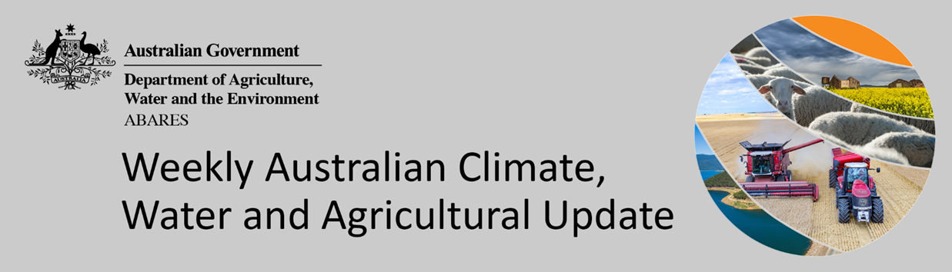
No. 4/2022

3 February 2022

Summary of key issues
- For the week ending 2 February 2022, low-pressure troughs across much of Australia drew down tropical, moist air, resulting in heavy rain and storms in large areas of northern and central Australia, as well as rainfall in south-eastern Australia (see Section 1.1).
- Dry conditions across southern Queensland likely improved field access for the harvesting of early sown summer crops to continue without delay. However, dry conditions in the Central Queensland growing region, is likely to delay the germination of late sown summer crops. The rainfall across much of New South Wales will support yield potential of summer crops as they near flowering.
- January 2022 was wetter than normal compared to the January long-term average. Below average rainfall in Queensland during January would have benefited the harvest of early sown summer crops. Across New South Wales and southern Queensland, average January rainfall would have provided ideal growing condition for summer crops and pastures, however, it may also have led to some disruptions in the harvest of early sown summer crops (see Section 1.2).
- Lower layer soil moisture for January 2022 was well above average to extremely high for this time of year across parts of south-eastern, south-central and northern Australia. High levels of lower layer soil moisture will continue to support above average yield prospects for summer crops and above average pasture growth rates for this time of year across New South Wales and southern Queensland (see Section 1.3).
- Average to extremely high pasture production across much of New South Wales, Victoria Queensland, South Australia and the Northern Territory will likely enable farmers to continue to rebuild stock numbers and provide opportunities to replenish fodder supplies during late spring and early summer (see Section 1.4).
- Over the 8-days to 10 February 2022, rainfall is expected to be restricted to northern and part of eastern Australia. A monsoonal trough is expected to bring heavy rain and storms to large areas of Australia’s tropical north, while onshore winds are expected to bring showers along the eastern seaboard (see Section 1.5).
- The forecast rainfall for cropping regions in Queensland may further prevent the harvest of early planted summer crops. However, the falls are likely to benefit pasture growth and build upper layer soil moisture levels benefitting the germination of late sown summer crops.
- Water storage in the Murray–Darling Basin (MDB) increased by 105 gigalitres (GL) between 26 January 2022 and 2 February 2022. The current volume of water held in storage is 22,535 GL, which represents 89% of total capacity. This is 64% or 8,784 GL more than at the same time last year.
- Allocation prices in the Victorian Murray below the Barmah Choke decreased from $92 per ML on 21 January 2022 to $85 per ML on 28 January 2022. Prices are lower in the Goulburn-Broken, Murrumbidgee, and regions above the Barmah Choke due to the binding of the Goulburn intervalley trade limit, Murrumbidgee export limit, and Barmah Choke trade constraint.

Climate

Rainfall this week
For the week ending 2 February 2022, low-pressure troughs across much of Australia drew down tropical, moist air, resulting in heavy rain and storms in large areas of northern and central Australia, as well as rainfall in south-eastern Australia.
Rainfall totals of between 10 and 100 millimetres were recorded across much of New South Wales, Victoria and the Northern Territory, western and northern Queensland and Tasmania, as well as northern parts of South Australia and Western Australia. Rainfall totals in excess of 100 millimetres were recorded across parts of northern Queensland, South Australia and Western Australia, and across large areas of the Northern Territory.
In cropping regions, rainfall totals of between 10 and 50 millimetres were recorded across much of New South Wales and Victoria, as well as parts of central South Australia. Rainfalls in excess of 50 millimetres were recorded in isolated parts of New South Wales and northern Queensland cropping regions. Little to no rainfall was recorded across remaining cropping regions in Queensland, South Australia and Western Australia.
Dry conditions across southern Queensland likely improved field access for the harvesting of early sown summer crops to continue. However, dry conditions in the Central Queensland growing region, is likely to delay the germination of late sown summer crops. The rainfall across much of New South Wales will support yield potential of summer crops as they near flowering.

Rainfall for the week ending 2 February 2022

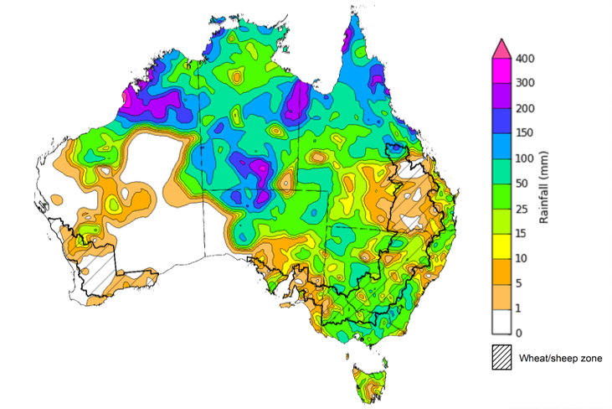
©Commonwealth of Australia 2022, Australian Bureau of Meteorology Issued: 02/02/2022
Note: The rainfall analyses and associated maps utilise data contained in the Bureau of Meteorology climate database, the Australian Data Archive for Meteorology (ADAM). The analyses are initially produced automatically from real-time data with limited quality control. They are intended to provide a general overview of rainfall across Australia as quickly as possible after the observations are received. For further information go to http://www.bom.gov.au/climate/rainfall/

Monthly rainfall
Rainfall during January 2022 was 22% above average for Australia as a whole. However, severely deficient to below average rainfall was recorded across western Tasmania, parts of the west of Western Australia, and an area of eastern Queensland across the Central Highlands and Coalfields, the Central Coast, Capricornia and northern parts of the Wide Bay and Burnett districts. In contrast, areas of above average to extremely high rainfall were recorded across much of New South Wales, western Queensland, Victoria, South Australia, north-eastern Western Australia, north-east Tasmania and the central and southern parts of the Northern Territory.
The active La Niña event on the Pacific was the main climate influence during the month. Extremely high rainfall total across the south-east, centre and north of Australia were associated with the movement and break down of ex-tropical cyclones Seth and Tiffany.
January rainfall was average to above average across cropping regions of New South Wales and southern Queensland, Victoria and South Australia, with below average falls dominated cropping regions in northern Queensland and Western Australia.
Below average rainfall in Queensland during January would have benefited the harvest of early sown summer crops. Across New South Wales and southern Queensland, average January rainfall would have provided ideal growing condition for summer crops and pastures, however, it may also have led to some disruptions in the harvest of early sown summer crops

Rainfall percentiles for January 2022

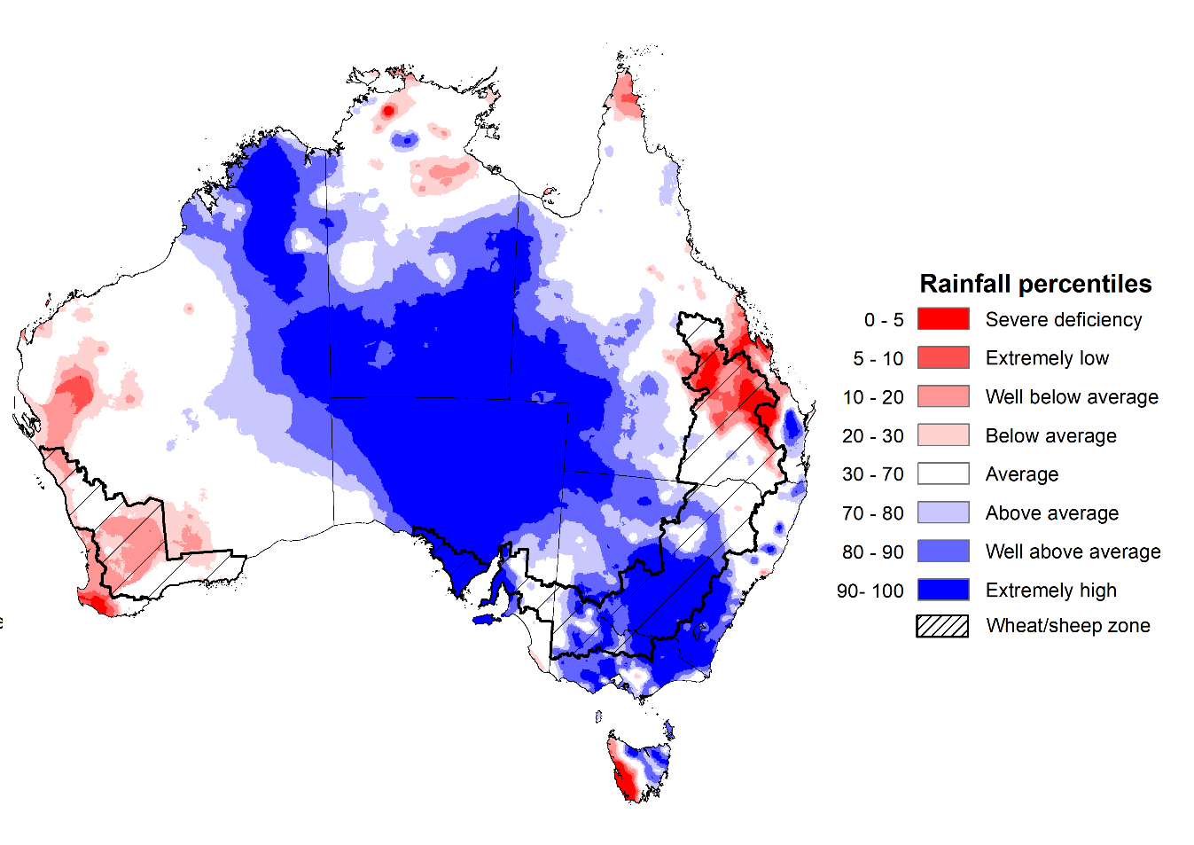
Note: Rainfall for January 2022 is compared with rainfall recorded for that period during the historical record (1900 to present). For further information, go to http://www.bom.gov.au/jsp/awap/
Source: Bureau of Meteorology

Monthly soil moisture
Upper layer soil moisture in January 2022 was average for this time of year across most of Queensland, northern Western Australia and the north of the Northern Territory, despite a dry start to the month in these areas. Modelled upper layer soil moisture was extremely low for parts of central Queensland, southern and central areas of Western Australian, as well as western Tasmania due to below average rainfall in these areas during January. Extremely high soil moisture was evident across large areas of New South Wales, western Queensland, Victoria, South Australia, the north and east of Western Australia, as well as southern and central parts of the Northern Territory, reflecting the heavy rainfall in the latter parts of January.
At this time of year, upper layer soil moisture is important for late planted summer crops in the Central Queensland growing region and for pasture growth across northern Australia since plant germination and establishment utilise this moisture. It is also important indicator of the ability to access paddocks to undertake harvest and planting activities.
Upper layer soil moisture was average to above average for this time of year across cropping regions in northern New South Wales and southern Queensland. Upper layer soil moisture was extremely low to average for much of the Central Queensland growing region. Extremely high to above average upper layer soil moisture was evident across much of New South Wales, Victoria and South Australian cropping regions. Average levels of upper layer soil moisture would have allowed paddock access for harvesting of early planted summer crops in northern New South Wales and southern Queensland. Meanwhile, the below average upper soil moisture levels in Central Queensland growing region may impede germination of late planted summer crops.

Modelled upper layer soil moisture for January 2022

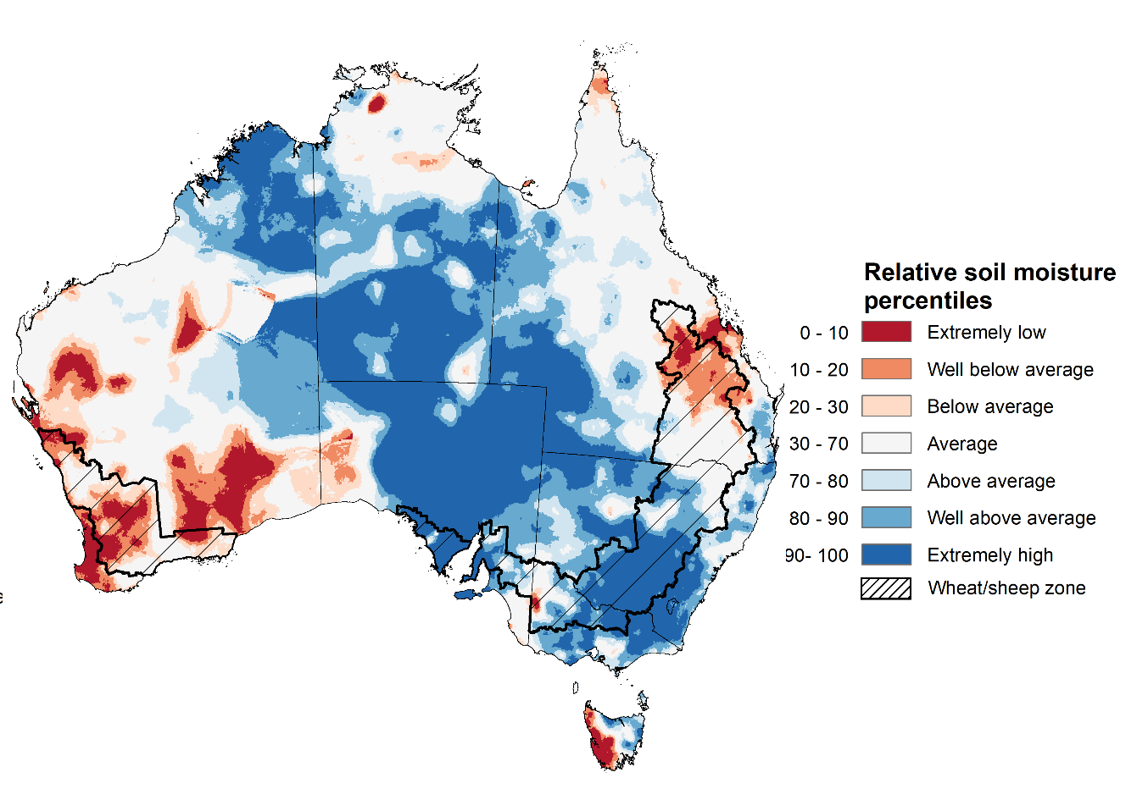

Note: This map shows the levels of modelled upper layer soil moisture (0 to 10 centimetres) during January 2022. This map shows how modelled soil conditions during January 2022 compare with January conditions modelled over the reference period (1911 to 2016). Dark blue areas on the maps were much wetter in January 2022 than during the reference period. The bulk of plant roots occur in the top 20 centimetres of the soil profile. Soil moisture in the upper layer of the soil profile is therefore useful indicator of the availability of water, particularly for germinating seed.
Source: Bureau of Meteorology (Australian Water Resources Assessment Landscape model)

Lower layer soil moisture for January 2022 was well above average to extremely high for this time of year across parts of south-eastern, south-central central and northern Australia. Lower layer soil moisture was well below average to below average across the much of Western Australia and western Tasmania, as well as along the southern border between South Australia and Victoria.
In cropping regions, lower layer soil moisture was well above average to extremely high for much of southern and central New South Wales, parts of southern and northern Queensland, as well as central and western parts of South Australia. High levels of lower layer soil moisture will continue to support above average yield prospects for summer crops and above average pasture growth rates for this time of year across New South Wales and southern Queensland.
Modelled lower layer soil moisture for January 2022
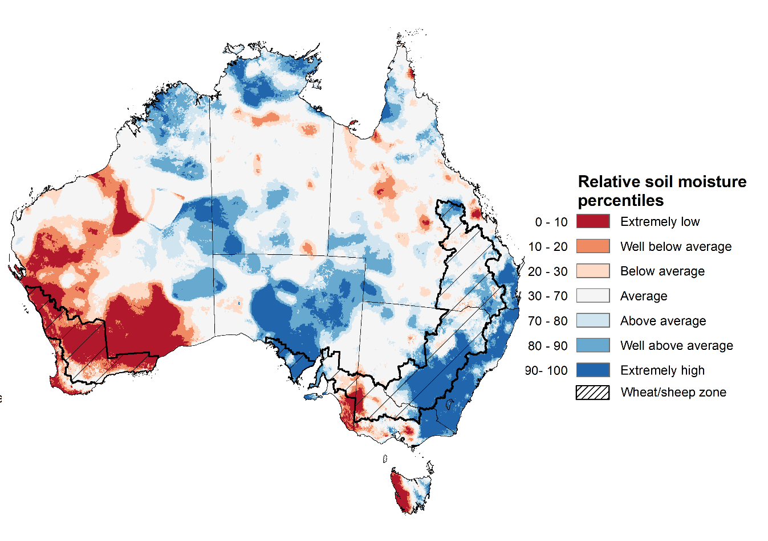
Note: This map shows the levels of modelled lower layer soil moisture (10 to 100 centimetres) during January 2022. This map shows how modelled soil conditions during January 2022 compare with January conditions modelled over the reference period (1911 to 2016). Dark blue areas on the maps were much wetter in January 2022 than during the reference period. The dark red areas were much drier than during the reference period. The bulk of plant roots occur in the top 20 centimetres of the soil profile. The lower layer soil moisture is a larger, deeper store that is slower to respond to rainfall and tends to reflect accumulated rainfall events over longer time periods.
Source: Bureau of Meteorology (Australian Water Resources Assessment Landscape model)

Pasture growth
Pasture growth during the November to January period is the peak pasture growth period which typical provides a bulk of feed to maintain production through the low pasture growth months of the northern dry season. Across southern Australia, November to January pasture growth is typically low reflecting lower rainfall totals, high temperature and high evapotranspiration rates at this time of year. Pasture availability during this period influences the growth and branding and marking rates of lambs and calves, livestock turnoff and the production of meat, milk, and wool.
For the 3 months to January 2022, above average rainfall totals and mild temperatures resulted in average to well above average pasture production for this time of year across most grazing regions in New South Wales, Queensland, northern Victoria, South Australia, northern Western Australia and the Northern Territory. Extremely low to below average pasture growth rates were recorded across southern Western Australia, consistent with above average temperatures and below average rainfall.
Average to extremely high pasture production across much of New South Wales, Victoria Queensland, South Australia and the Northern Territory will likely enable farmers to continue to rebuild stock numbers and provide opportunities to replenish fodder supplies during late spring and early summer. Below average rainfall and well above average temperatures in Western Australia may have restricted late spring pasture growth, however, it comes after extremely high pasture growth during winter that supplied average to above average pasture availability.

Relative pasture growth for 3-months ending January 2022 (1 November to 31 January 2022)
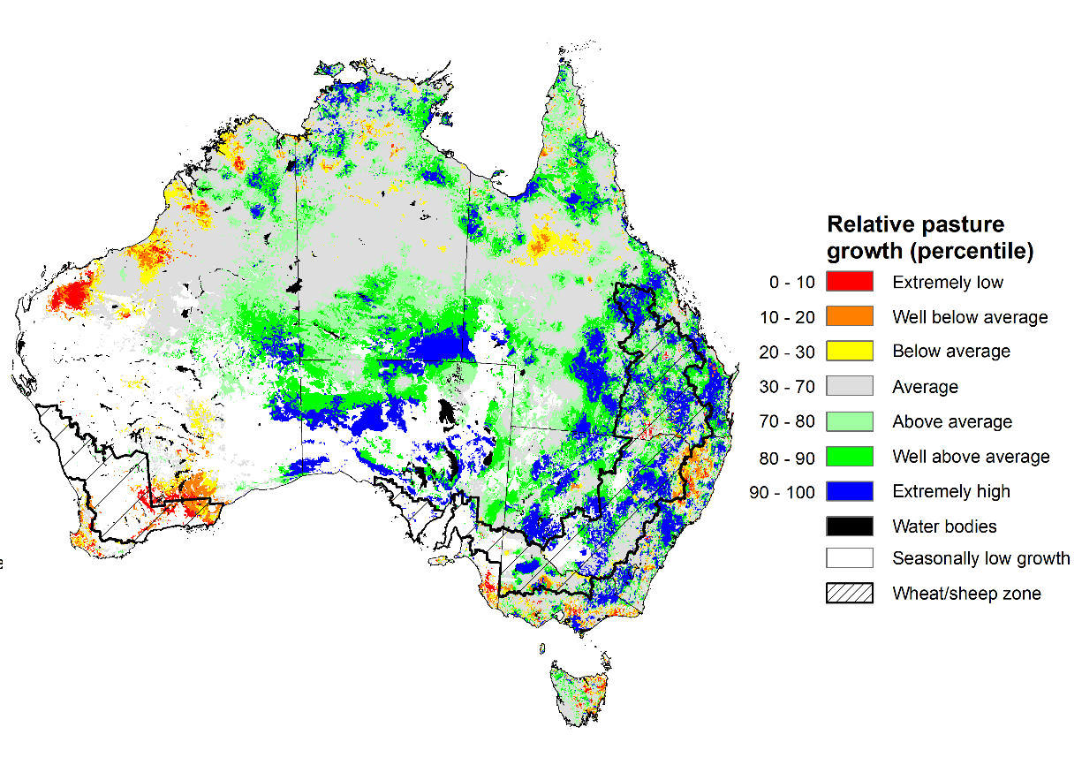
Notes: AussieGRASS pasture growth estimates are relative to the long-term record and shown in percentiles. Percentiles rank data on a scale of zero to 100. This analysis ranks pasture growth for the selected period against average pasture growth for the long-term record (1957 to 2016). Pasture growth is modelled at 5km2 grid cells.
Source: Queensland Department of Science, Information Technology and Innovation

Rainfall forecast for the next eight days
Over the 8-days to 10 February 2022, rainfall is expected to be restricted to northern and part of eastern Australia. A monsoonal trough is expected to bring heavy rain and storms to large areas of Australia’s tropical north, while onshore winds are expected to bring showers along the eastern seaboard. Meanwhile, high pressure systems are expected to bring mostly dry conditions to much of southern and central Australia.
Rainfall totals of between 10 and 50 millimetres are forecast for the far east of New South Wales and Victoria, as well as much of eastern and northern Queensland, and the north of Western Australia and the Northern Territory. Rainfall in excess of 50 millimetres is expected across parts of the north of Western Australia and the Northern Territory, parts of northern and eastern Queensland and scattered areas of eastern New South Wales.
In Australian cropping regions, rainfall totals of between 10 and 50 millimetres are expected across as most of Queensland. Little to no rainfall is forecast for all remaining cropping regions during the next 8-days.
Soil moisture levels through the entire rootzone remain average to above average across most summer cropping regions. The forecast rainfall for parts Queensland may further prevent the harvest of early planted summer crops. However, the falls are likely to benefit pasture growth and build upper layer soil moisture levels benefitting the germination of late sown summer crops. The heavy rainfall forecast for much of Northern Australia will continue to boost soil moisture level and pasture growth rate dung this peak production season.

Total forecast rainfall (mm) for the period 3 February to 10 February 2022
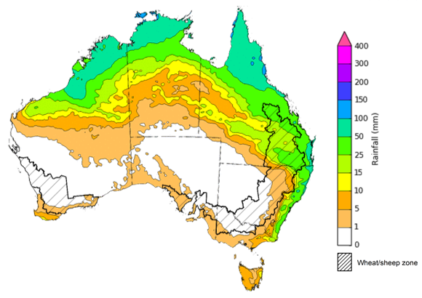
©Commonwealth of Australia 2022, Australian Bureau of Meteorology Issued: 03/02/2022

Water
Note: This rainfall forecast is produced from computer models. As the model outputs are not altered by weather forecasters, it is important to check local forecasts and warnings issued by the Bureau of Meteorology.

Water markets – current week
Water storage in the Murray–Darling Basin (MDB) increased by 105 gigalitres (GL) between 26 January 2022 and 2 February 2022. The current volume of water held in storage is 22,535 GL, which represents 89% of total capacity. This is 64% or 8,784 GL more than at the same time last year.

Water storages in the Murray-Darling Basin, 2013–2022
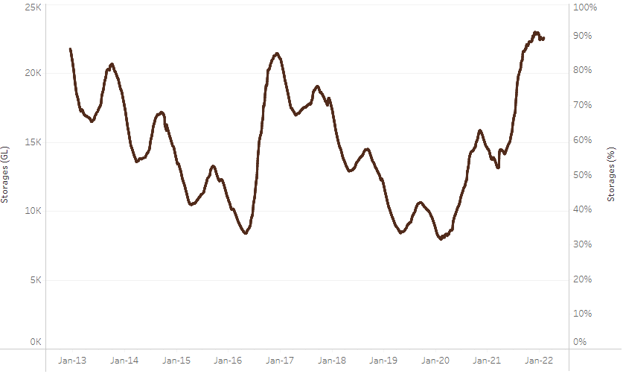
Allocation prices in the Victorian Murray below the Barmah Choke decreased from $92 per ML on 21 January 2022 to $85 per ML on 28 January 2022. Prices are lower in the Goulburn-Broken, Murrumbidgee, and regions above the Barmah Choke due to the binding of the Goulburn intervalley trade limit, Murrumbidgee export limit, and Barmah Choke trade constraint.
Water storage data is sourced from the Bureau of Meteorology.

Region | $/ML
NSW Murray Above | 36
NSW Murrumbidgee | 30
VIC Goulburn-Broken | 71
VIC Murray Below | 85

Surface water trade activity, Southern Murray–Darling Basin

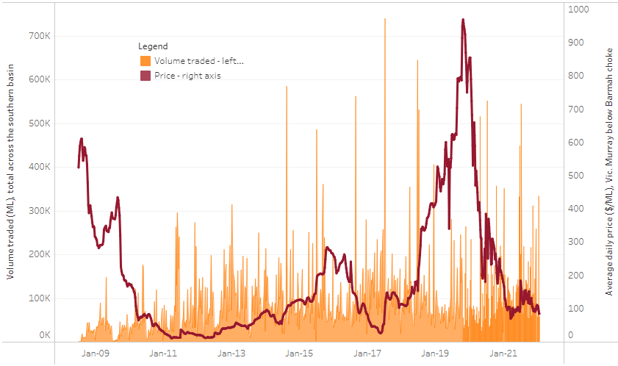
To access the full, interactive, weekly water dashboard, which contains the latest and historical water storage, water market and water allocation information, please visit http://www.agriculture.gov.au/abares/products/weekly_update/weekly-update-030222
The trades shown reflect estimated market activity and do not encompass all register trades. The price is shown for the VIC Murray below the Barmah choke. Historical prices (before 1 July 2019) are ABARES estimates after removing outliers from BOM water register data. Prices after 1 July 2019 and prior to the 30 October 2019 reflect recorded transaction prices as sourced from Ruralco. Prices after the 30 October 2019 are sourced from Waterflow. Data for volume traded is sourced from the BOM water register. Data shown is current at 3 February 2022.

Commodities
Indicator | Week ended | Unit | Latest price | Previous week | Weekly change | Price 12 months ago | Annual change
Selected world indicator prices
AUD/USD Exchange rate | 02-Feb | A$/US$ | 0.71 | 0.72 | -1% | 0.77 | -8%
Wheat – US no. 2 hard red winter wheat, fob Gulf | 02-Feb | US$/t | 380 | 395 | -4% | 288 | 32%
Corn – US no. 2 yellow corn, fob Gulf | 02-Feb | US$/t | 296 | 288 | 3% | 246 | 20%
Canola – Rapeseed, Canada, fob Vancouver | 02-Feb | US$/t | 864 | 869 | -1% | 574 | 51%
Cotton – Cotlook 'A' Index | 02-Feb | USc/lb | 139 | 135 | 4% | 92 | 52%
Sugar – Intercontinental Exchange, nearby futures, no.11 contract | 02-Feb | USc/lb | 17.9 | 18.5 | -3% | 16 | 14%
Wool – Eastern Market Indicator | 02-Feb | Ac/kg clean | 1,436 | 1,426 | 1% | 1,150 | 25%
Wool – Western Market Indicator | 15-Dec | Ac/kg clean | 1,408 | 1,417 | -1% | 984 | 43%
Selected Australian grain export prices
Milling Wheat – APW, Port Adelaide, SA | 02-Feb | A$/t | 491 | 482 | 2% | 355 | 38%
Feed Wheat – ASW, Port Adelaide, SA | 02-Feb | A$/t | 461 | 452 | 2% | 351 | 31%
Feed Barley – Port Adelaide, SA | 02-Feb | A$/t | 387 | 379 | 2% | 308 | 26%
Canola – Kwinana, WA | 02-Feb | A$/t | 986 | 960 | 3% | 693 | 42%
Grain Sorghum – Brisbane, QLD | 02-Feb | A$/t | 367 | 367 | 0% | 389 | -6%
Selected domestic livestock indicator prices
Beef – Eastern Young Cattle Indicator | 02-Feb | Ac/kg cwt | 1,121 | 1,170 | -4% | 866 | 30%
Mutton – Mutton indicator (18–24 kg fat score 2–3), Vic | 02-Feb | Ac/kg cwt | 564 | 576 | -2% | 586 | -4%
Lamb – Eastern States Trade Lamb Indicator | 02-Feb | Ac/kg cwt | 873 | 834 | 5% | 790 | 10%
Pig – Eastern Seaboard (60.1–75 kg), average of buyers & sellers | 26-Jan | Ac/kg cwt | 357 | 357 | 0% | 309 | 16%
Goats – Eastern States (12.1–16 kg) | 19-Jan | Ac/kg cwt | 879 | 879 | 0% | 818 | 8%
Live cattle – Light steers ex Darwin to Indonesia | 17-Feb | Ac/kg lwt | 355 | 355 | 0% | 360 | -1%
Live sheep – Live wethers (Muchea WA saleyard) to Middle East | 22-Sep | $/head | 147 | 171 | -14% | 126 | 17%

Indicator | Week ended | Unit | Latest price | Previous week | Weekly change | Price 12 months ago | Annual change
Global Dairy Trade (GDT) weighted average prices ª
Dairy – Whole milk powder | 02-Feb | US$/t | 4,324 | 4,082 | 6% | 3,099 | 40%
Dairy – Skim milk powder | 02-Feb | US$/t | 4,051 | 3,963 | 2% | 2,867 | 41%
Dairy – Cheddar cheese | 02-Feb | US$/t | 5,684 | 5,546 | 2% | 4,015 | 42%
Dairy – Anhydrous milk fat | 02-Feb | US$/t | 6,800 | 6,720 | 1% | 4,929 | 38%
a Global Dairy Trade prices are updated twice monthly on the first and third Tuesday of each month.

Selected world indicator prices
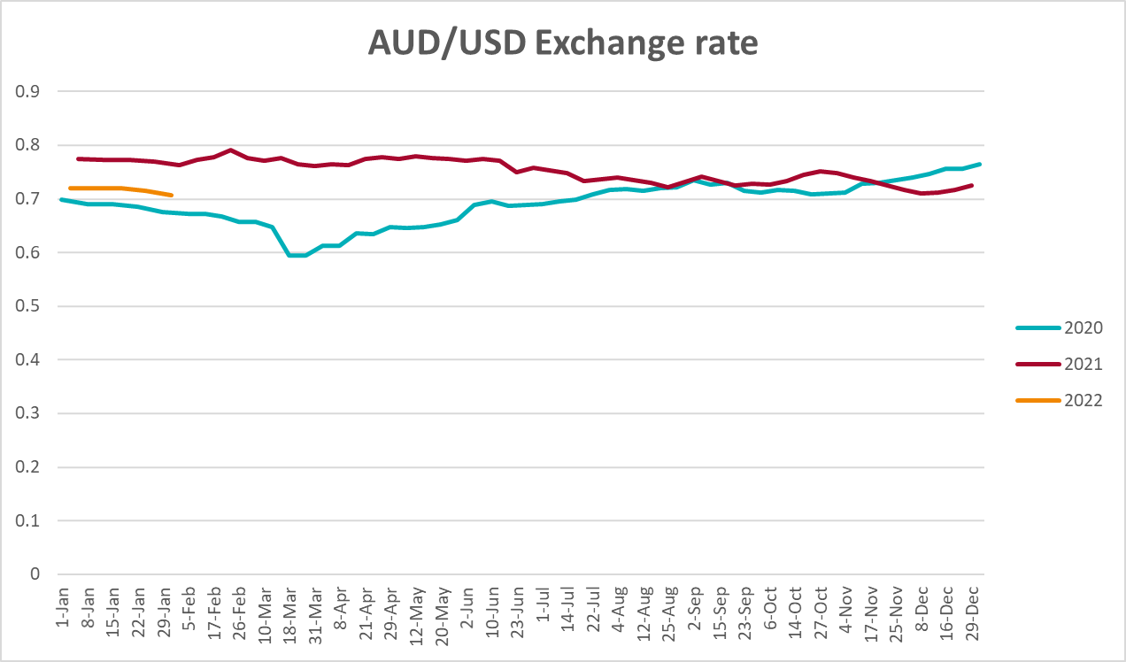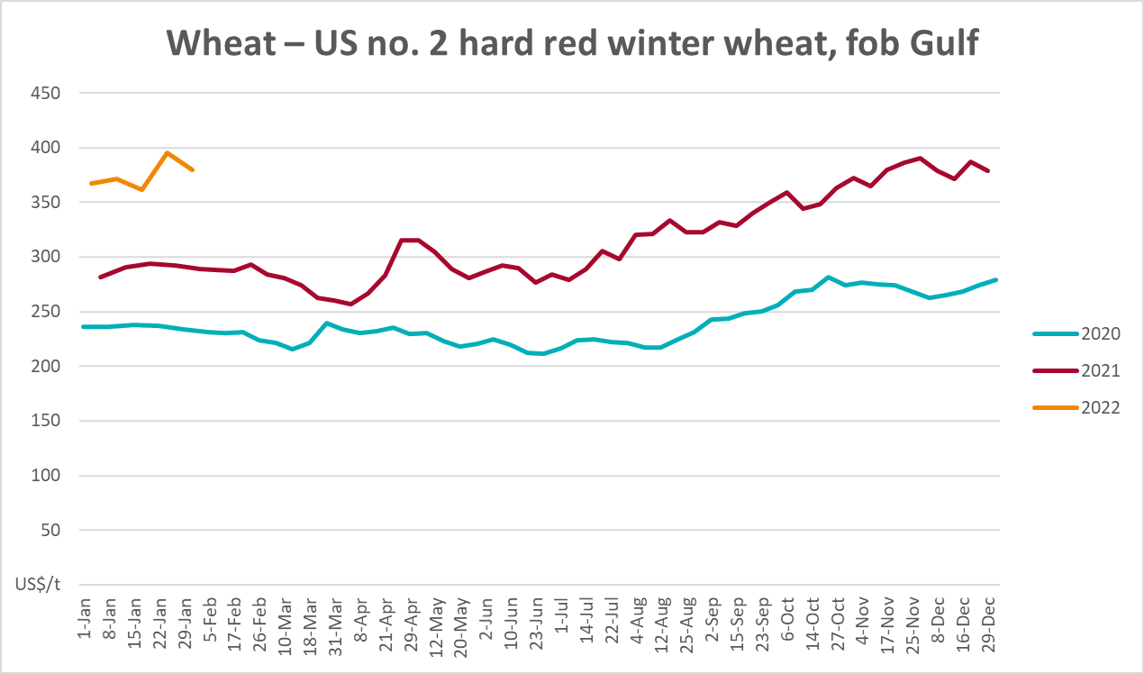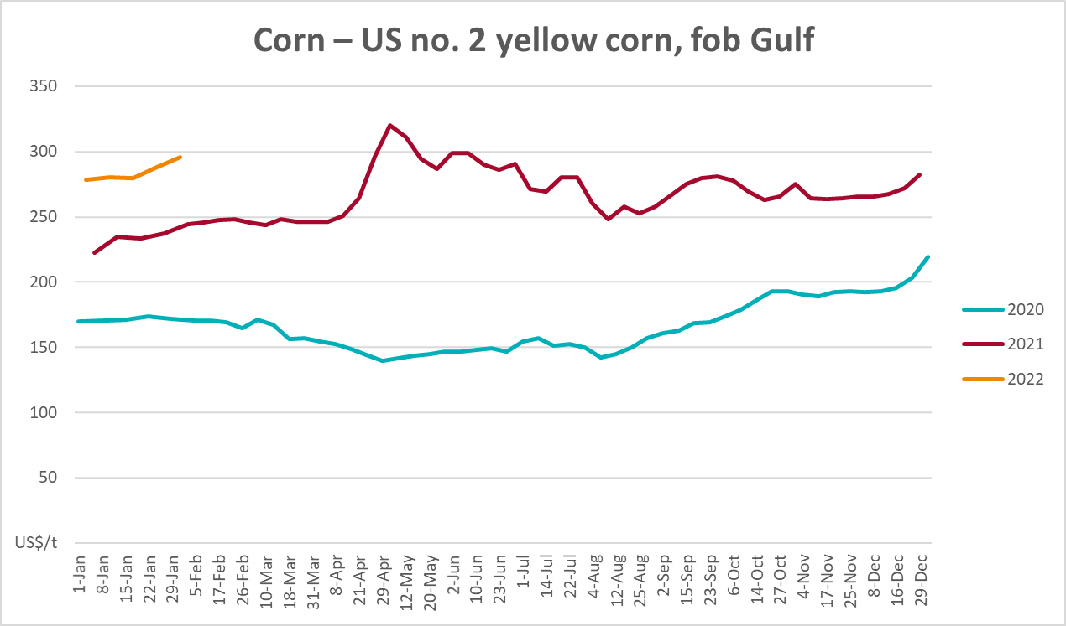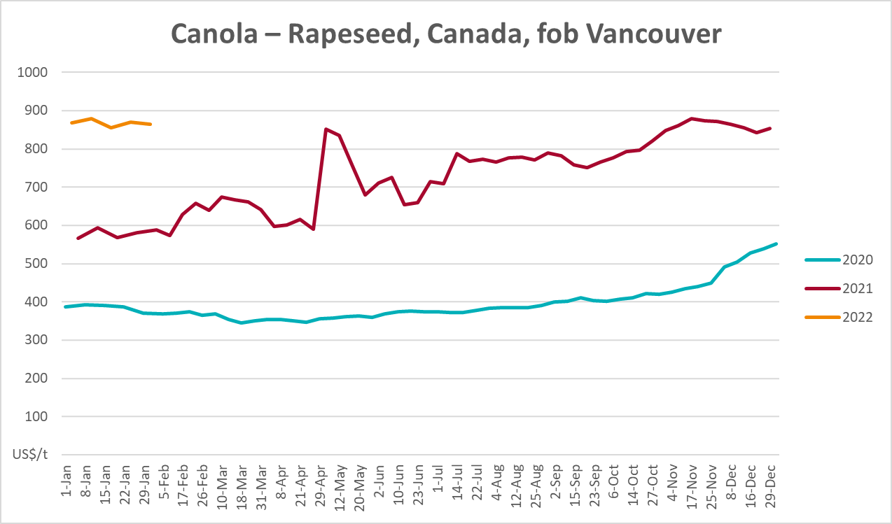

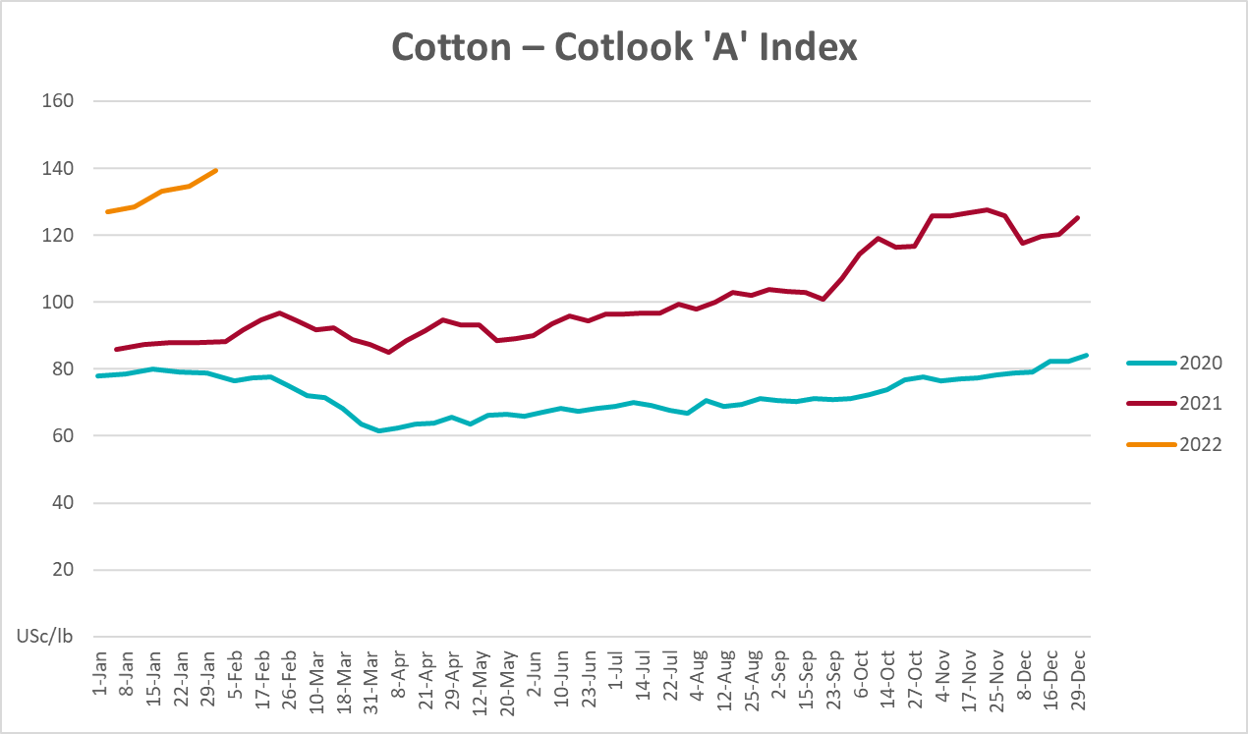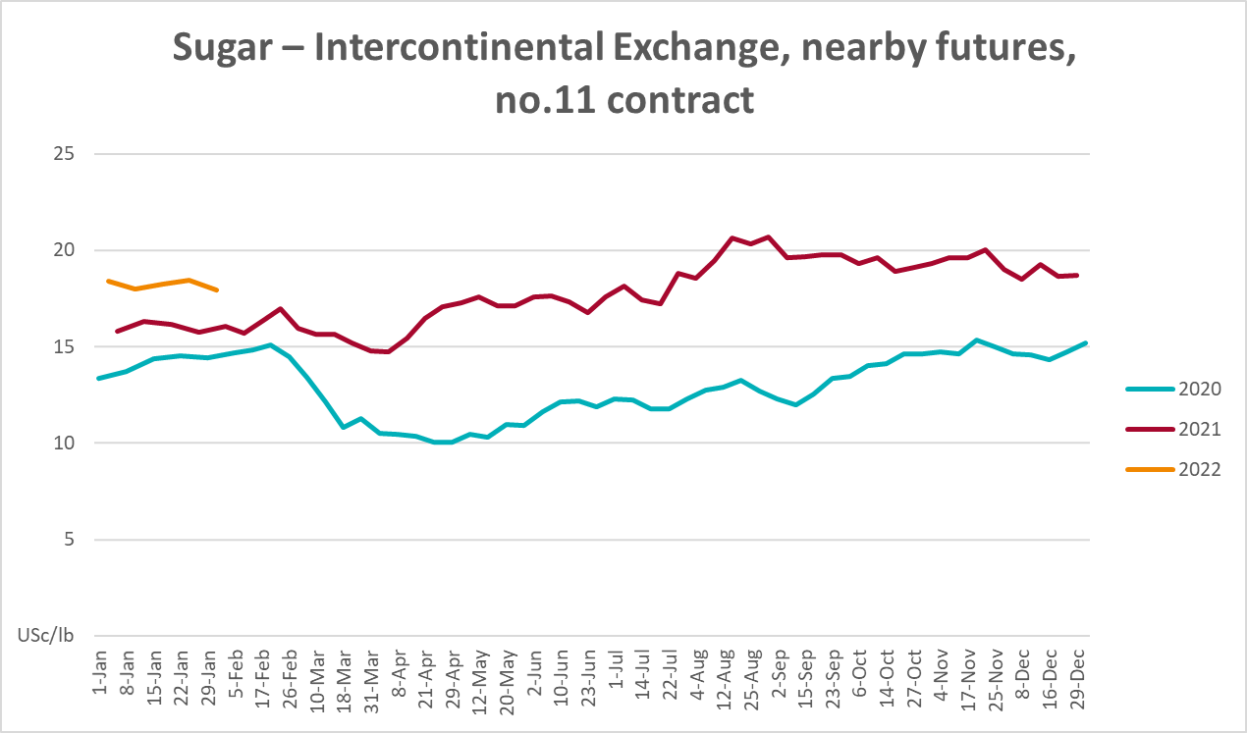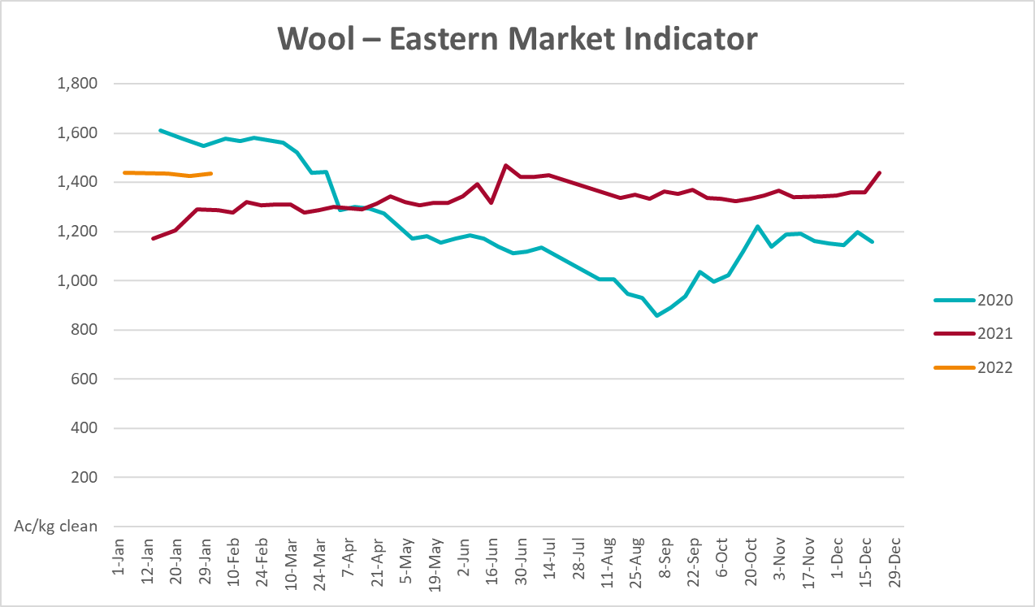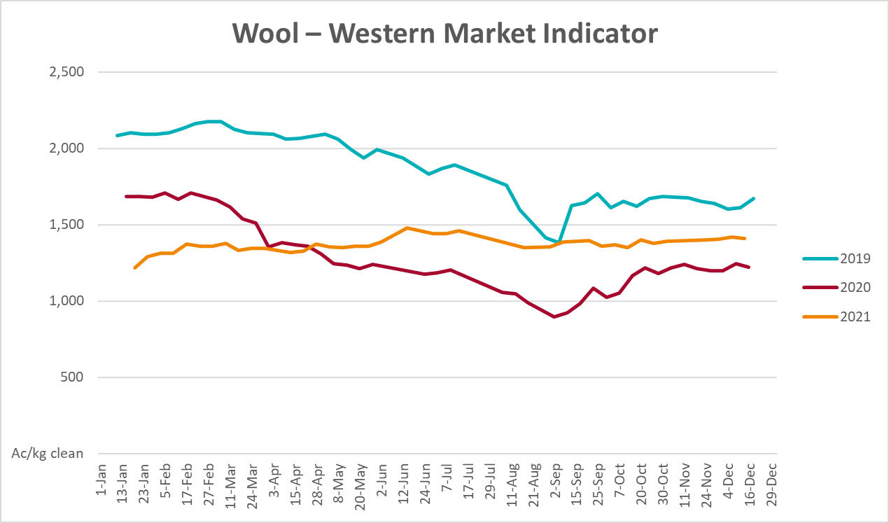

Selected domestic crop indicator prices
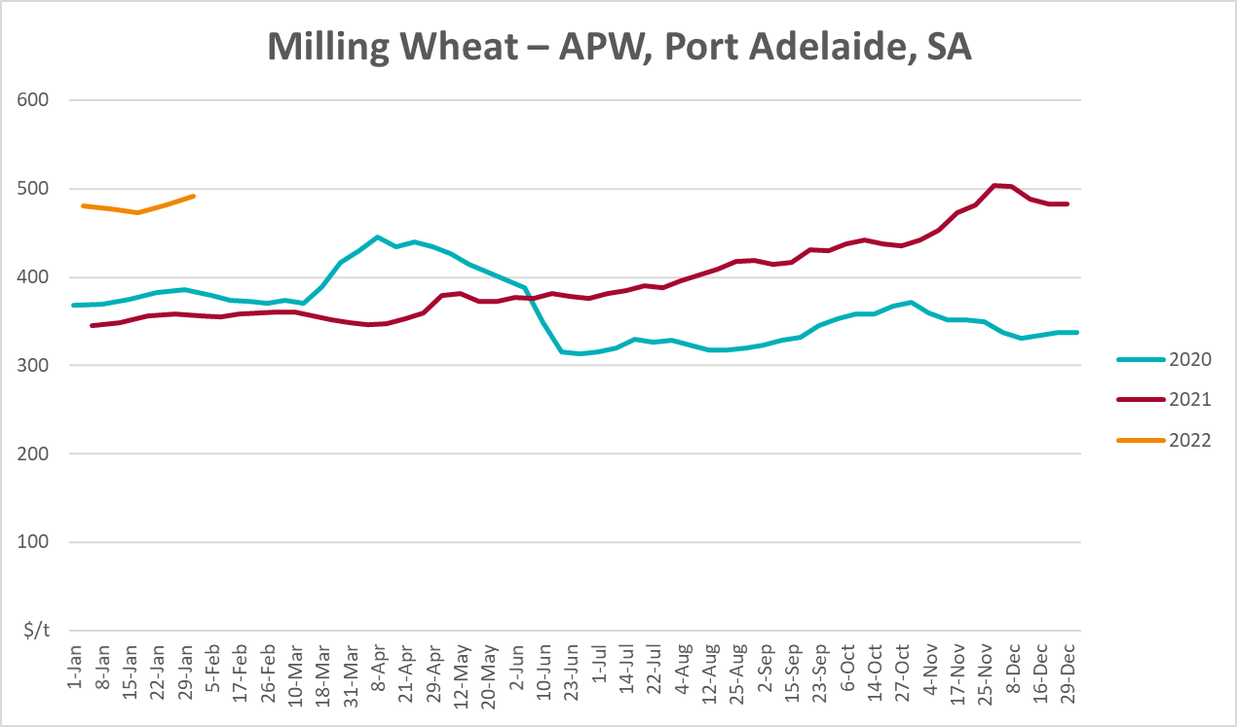
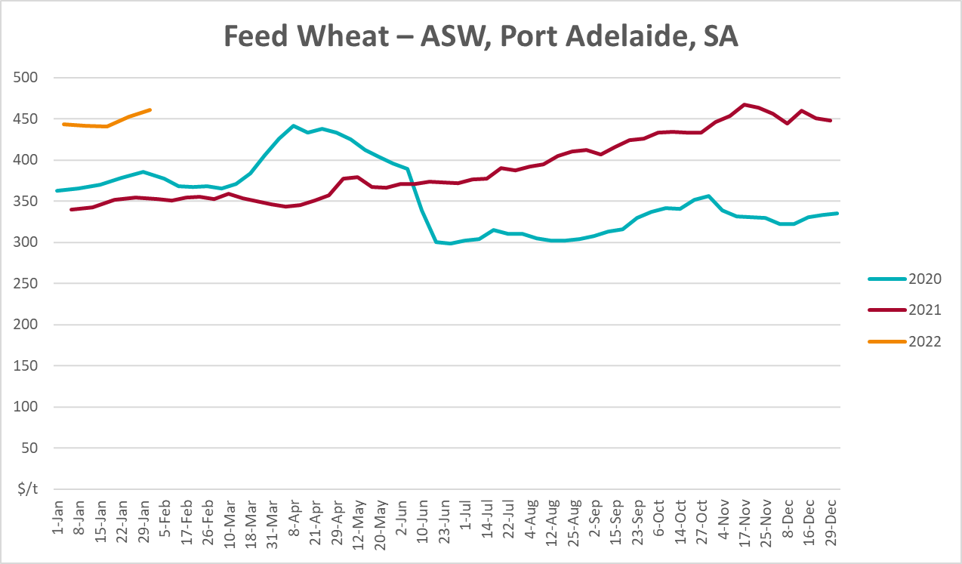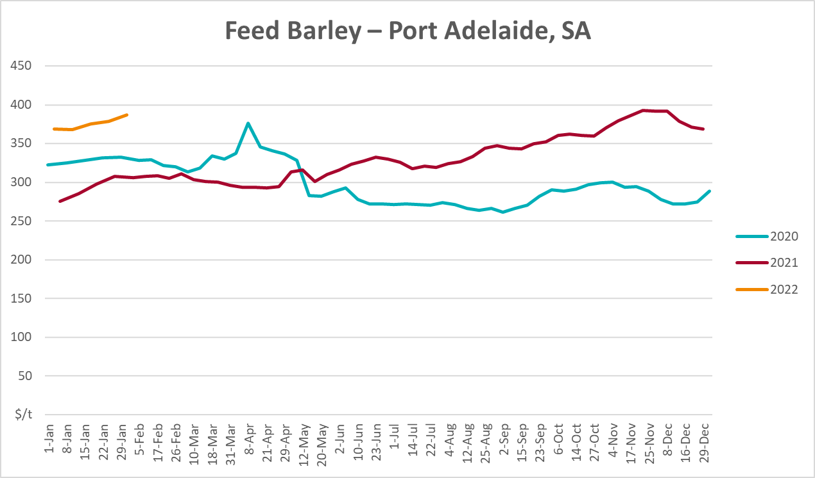

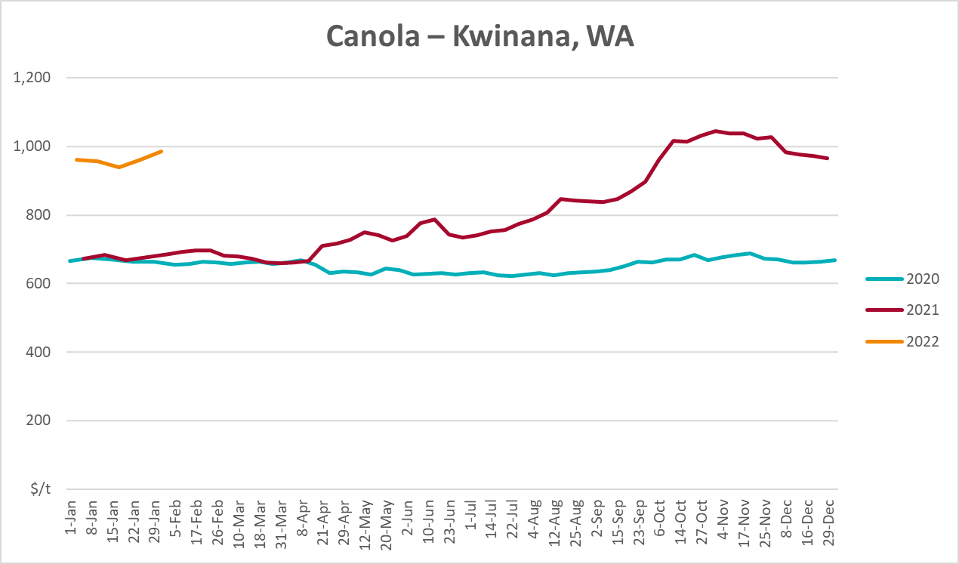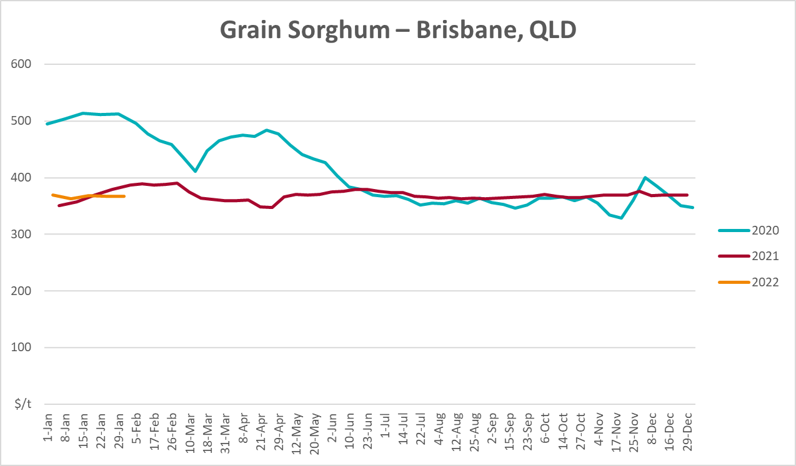

Selected domestic livestock indicator prices
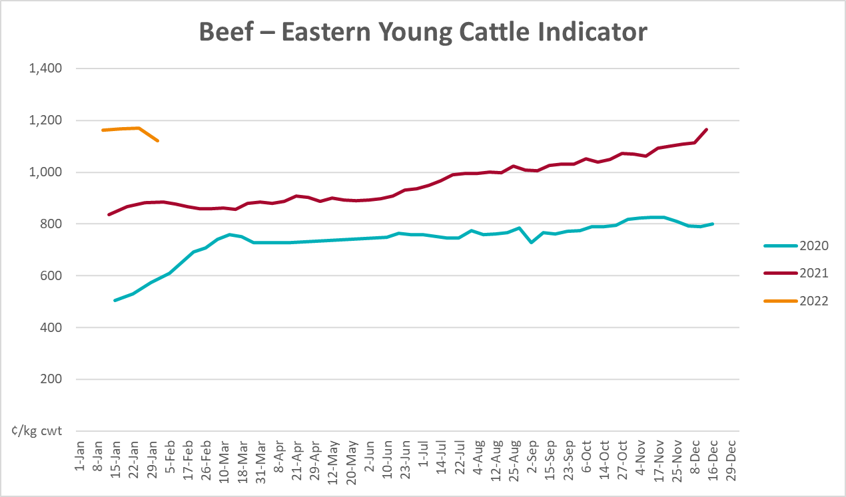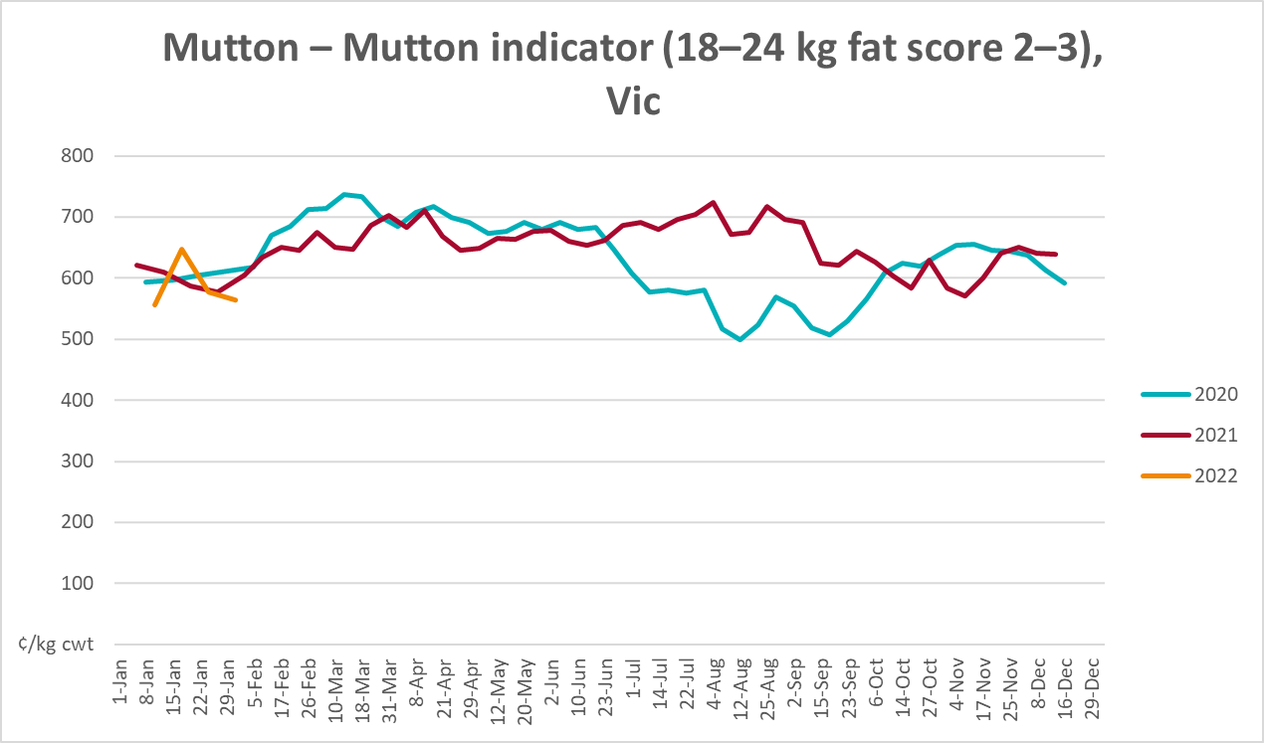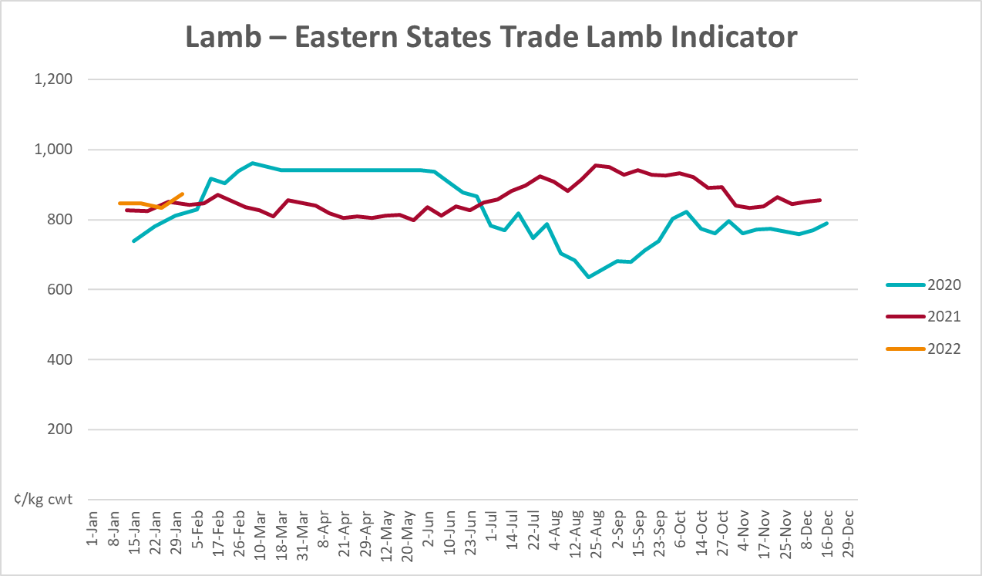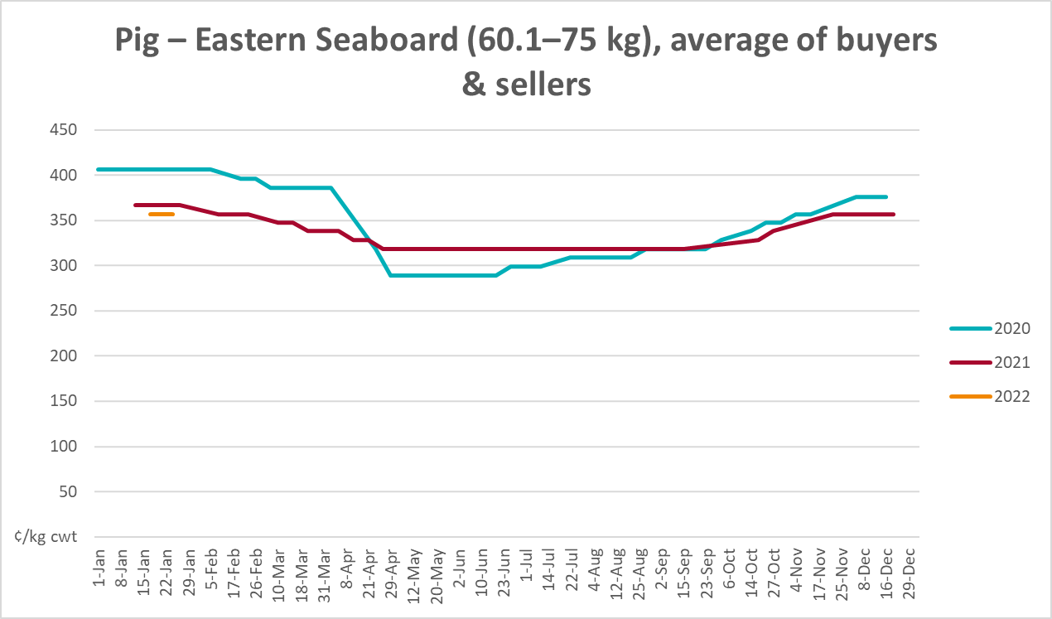

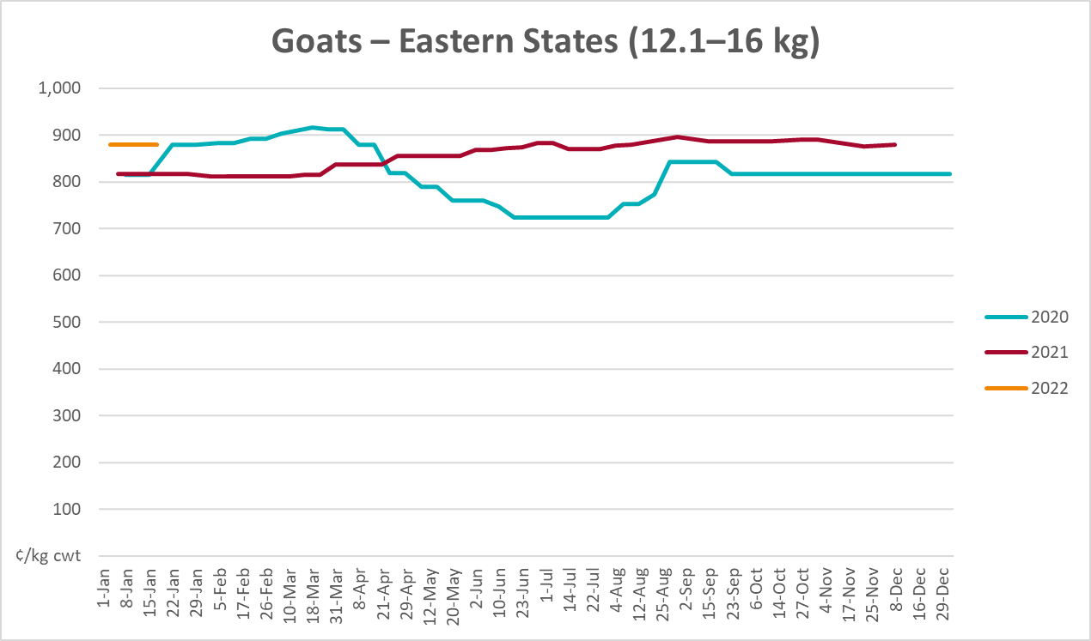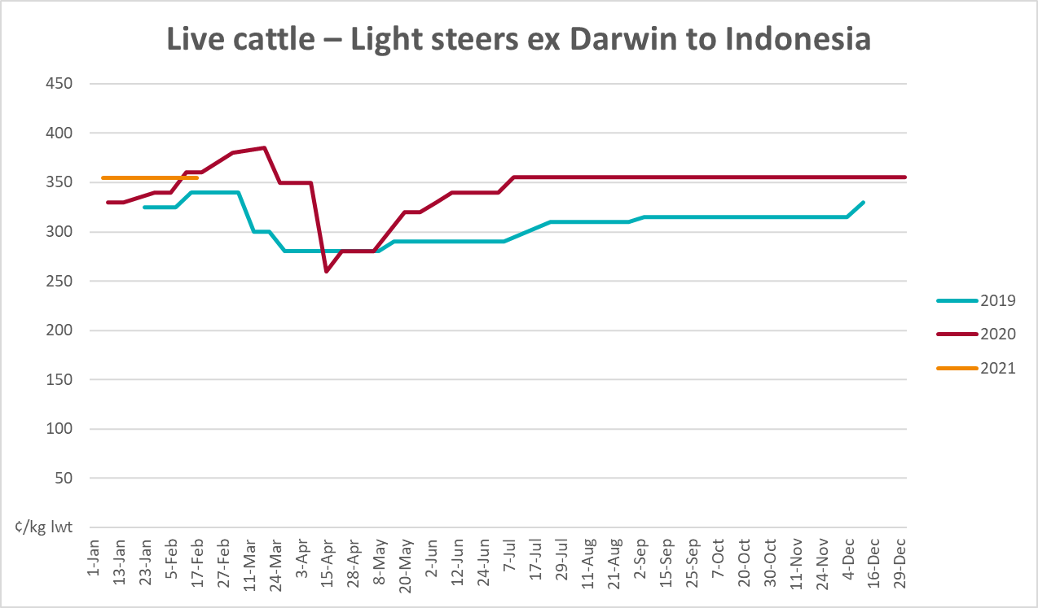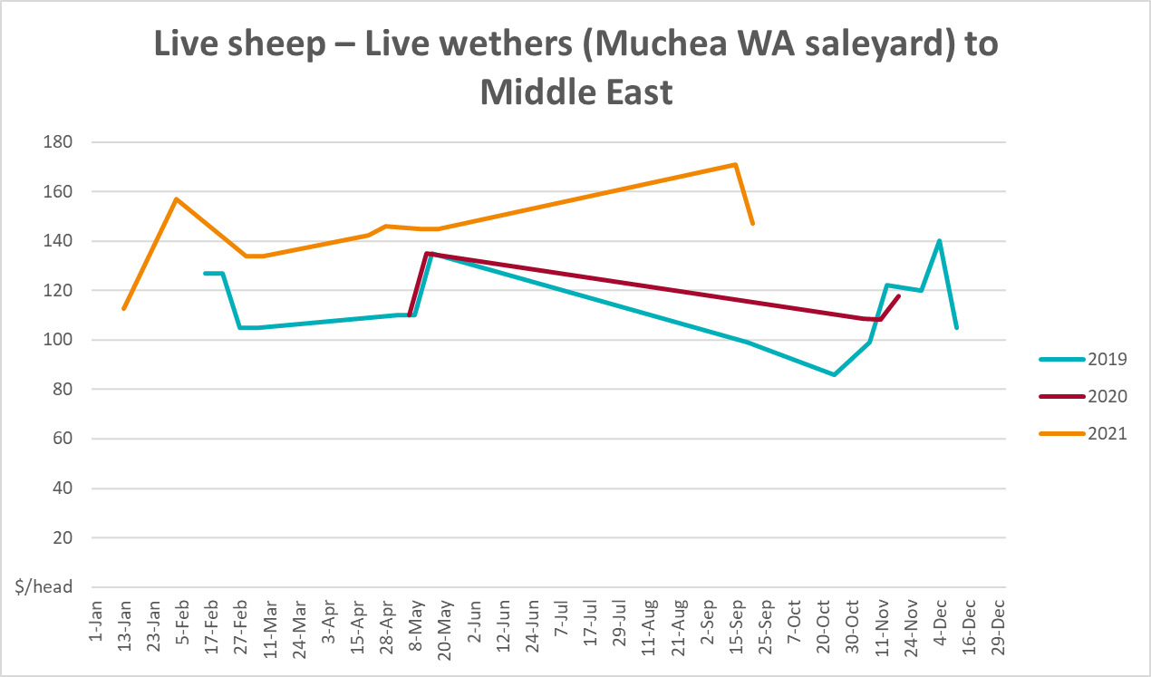

Global Dairy Trade (GDT) weighted average prices
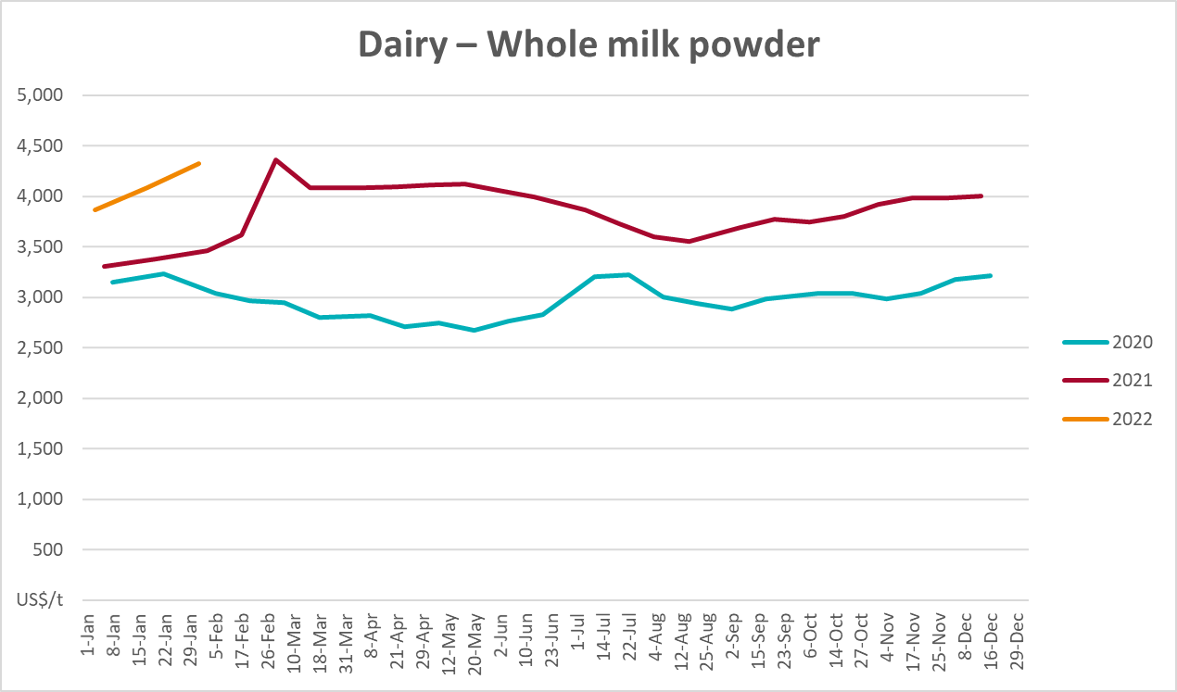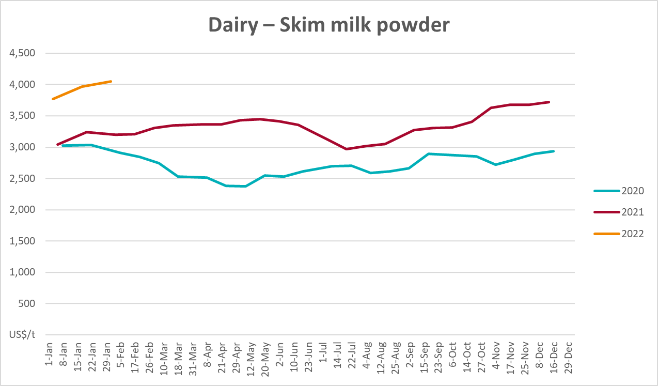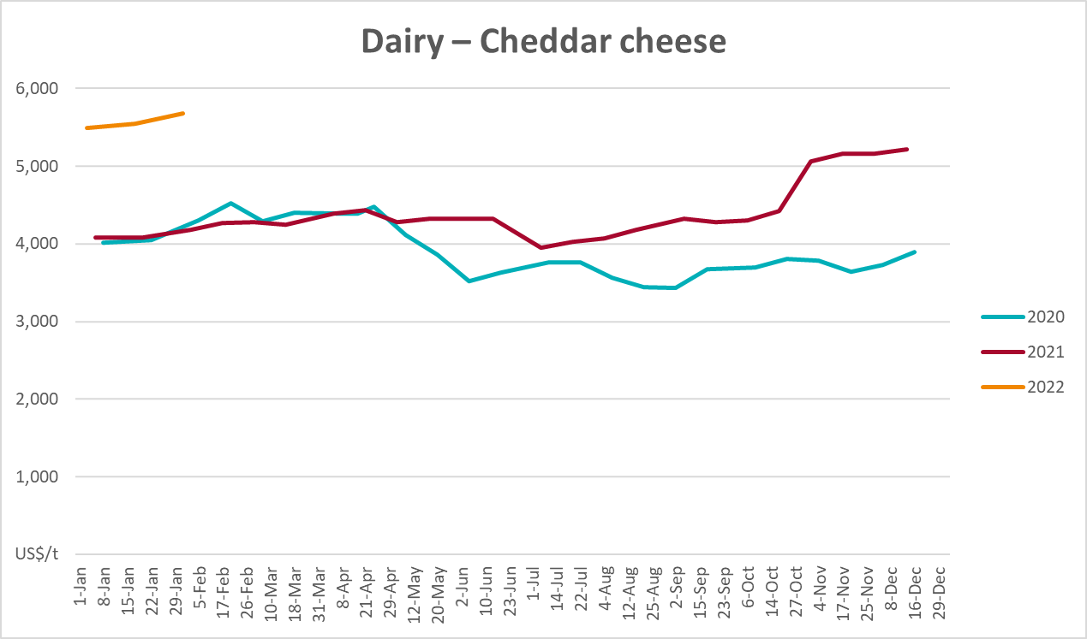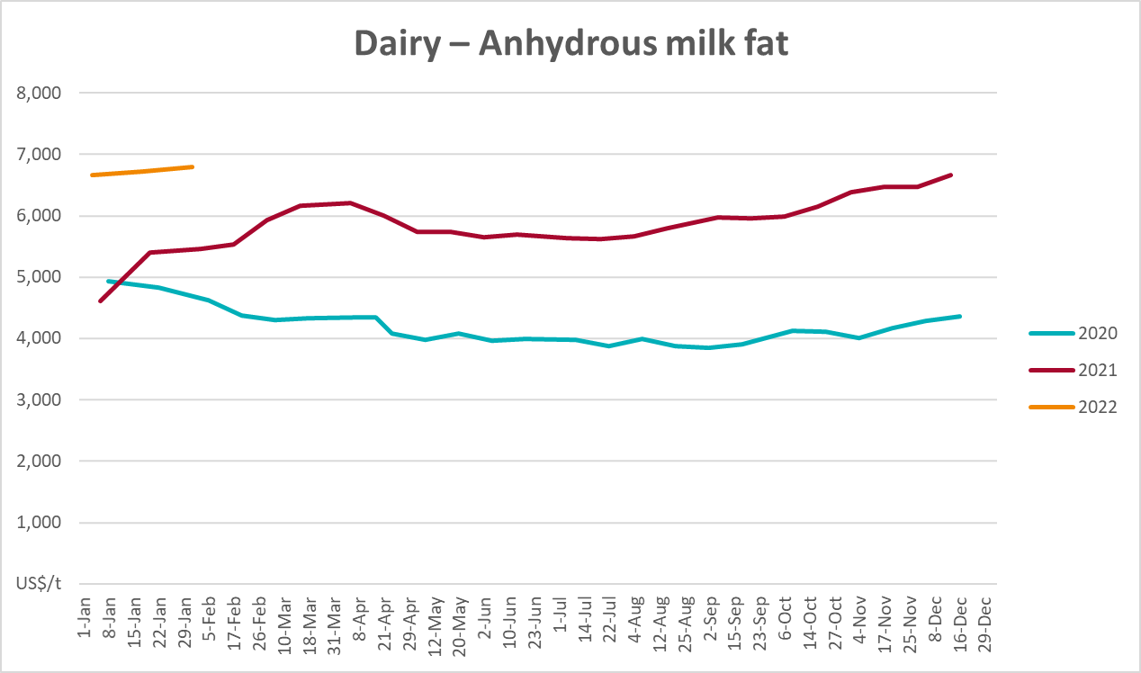

Selected fruit and vegetable prices
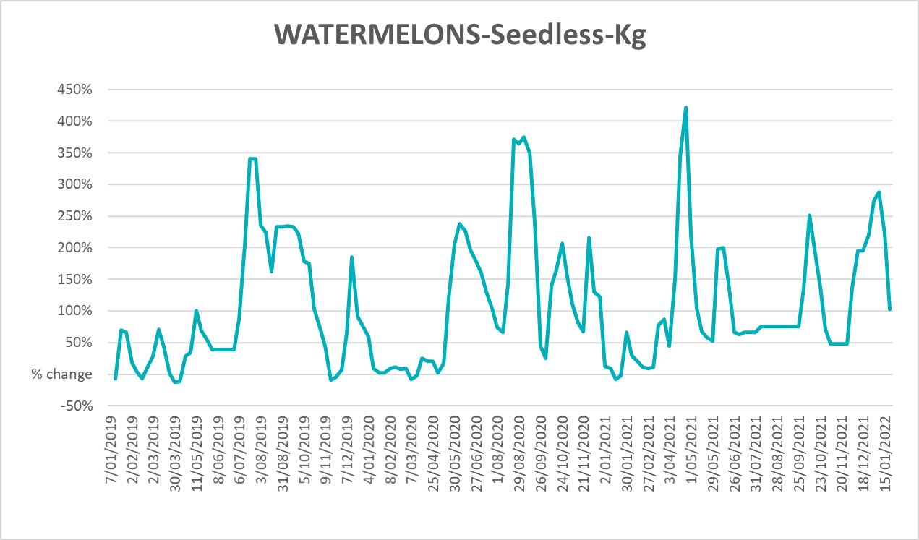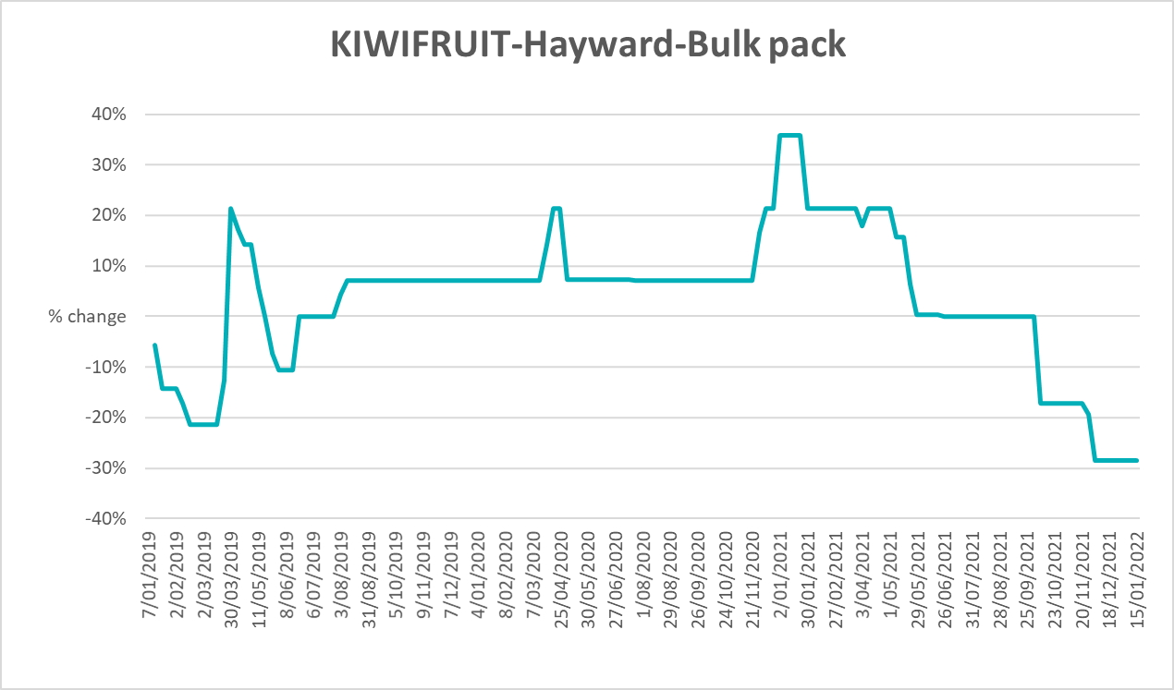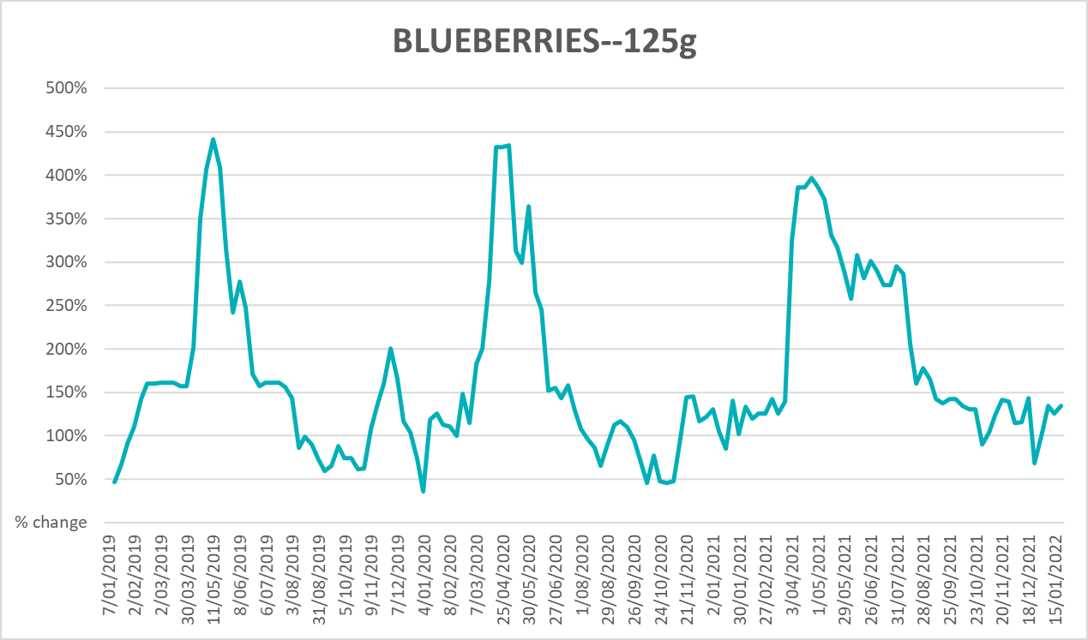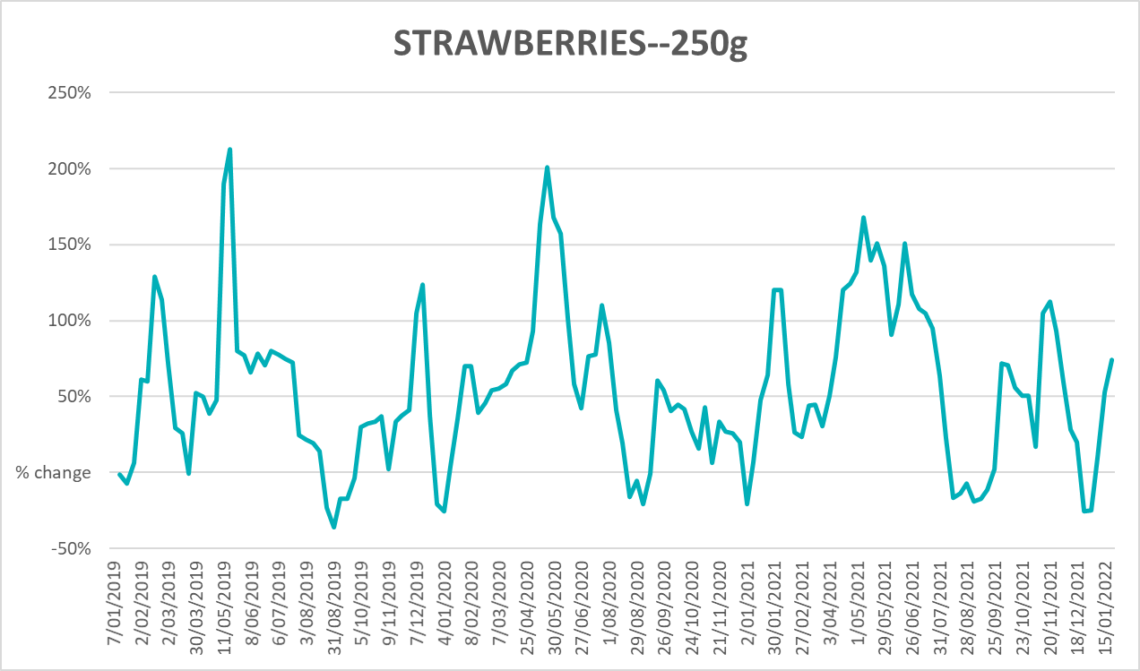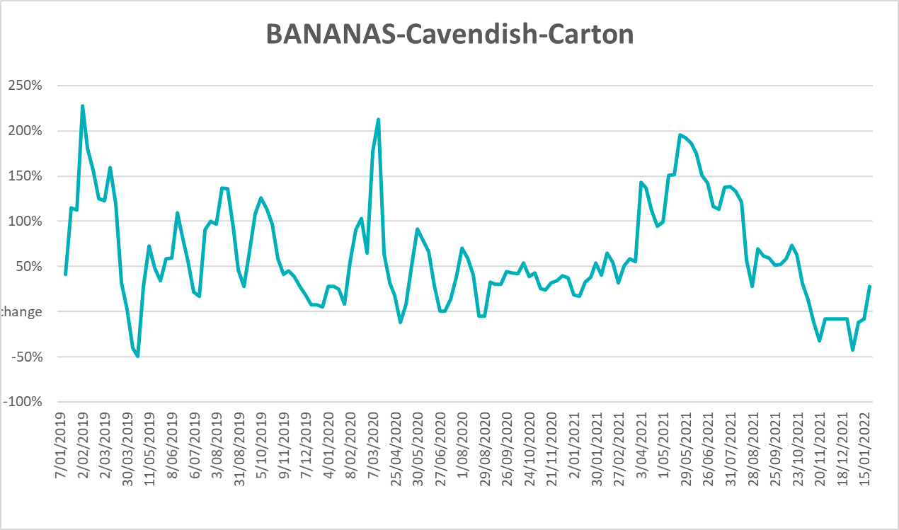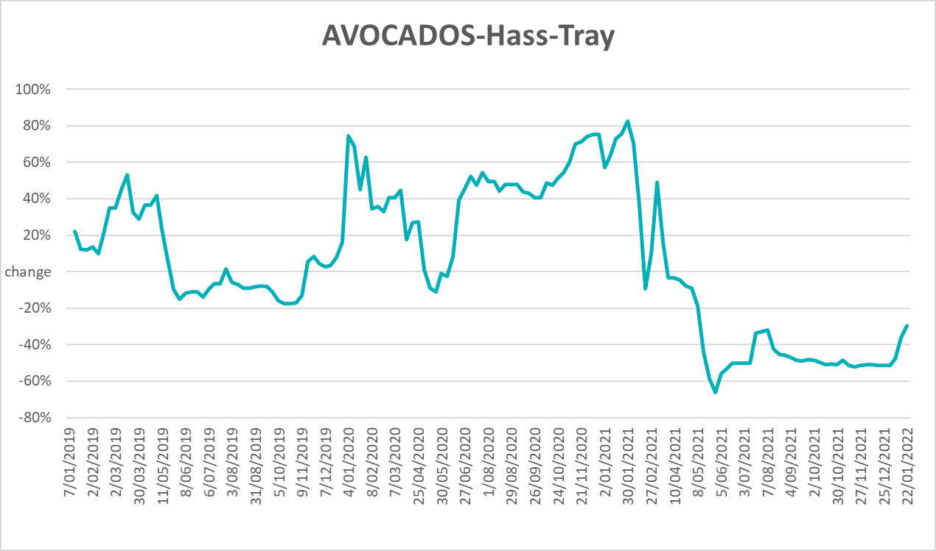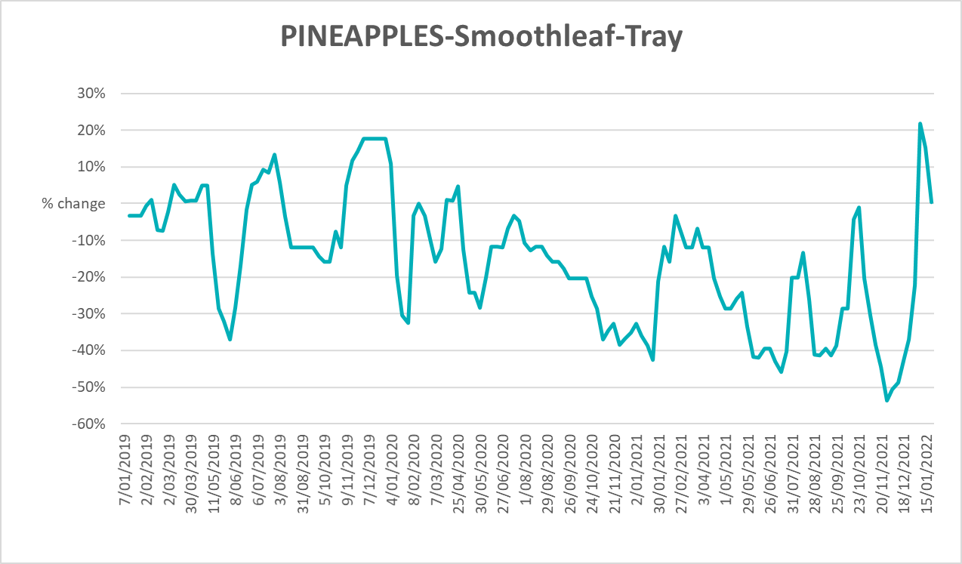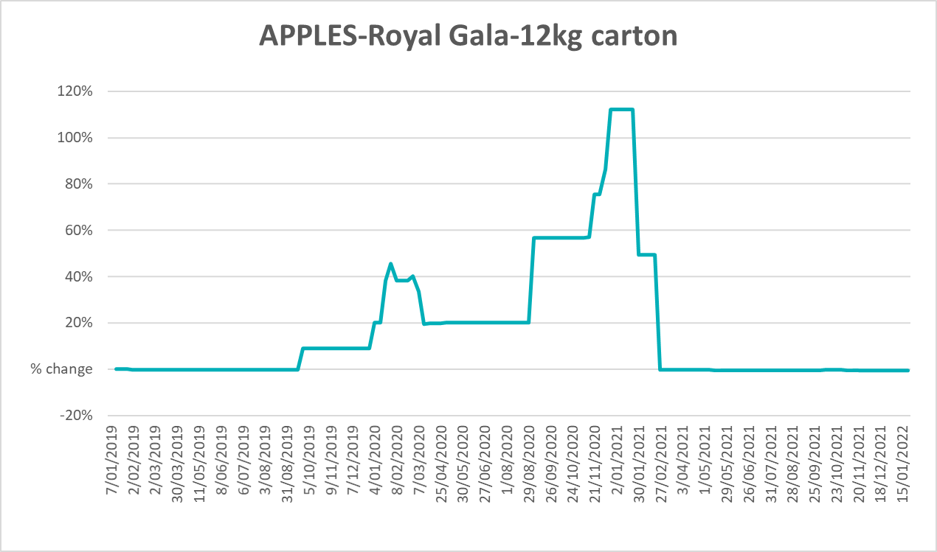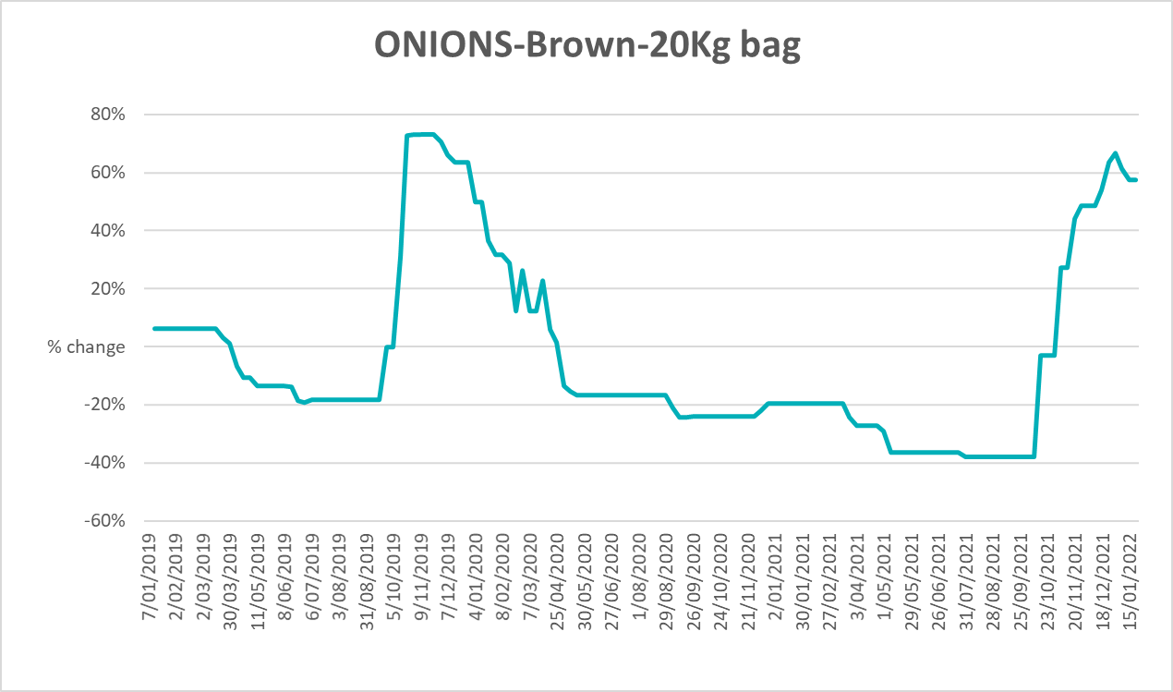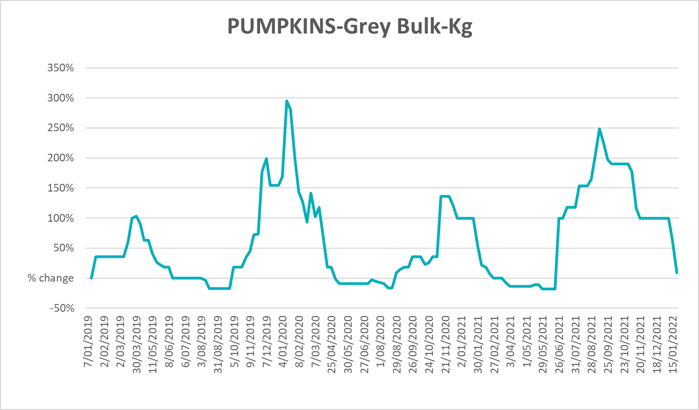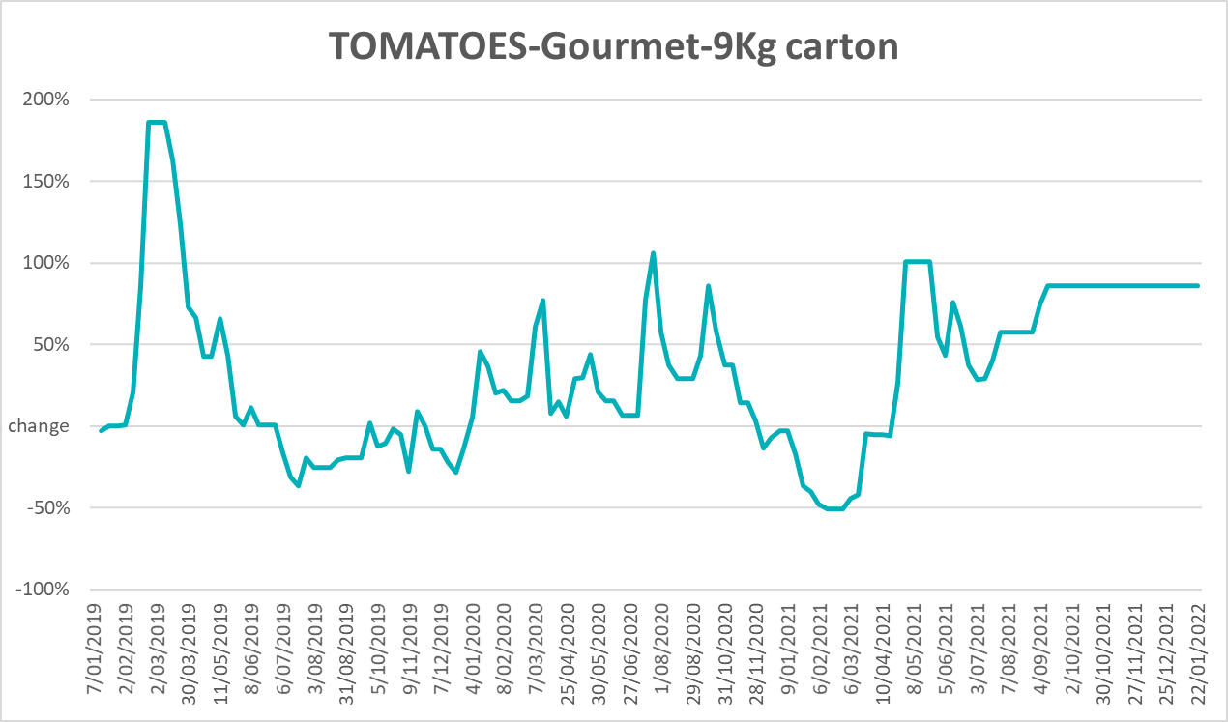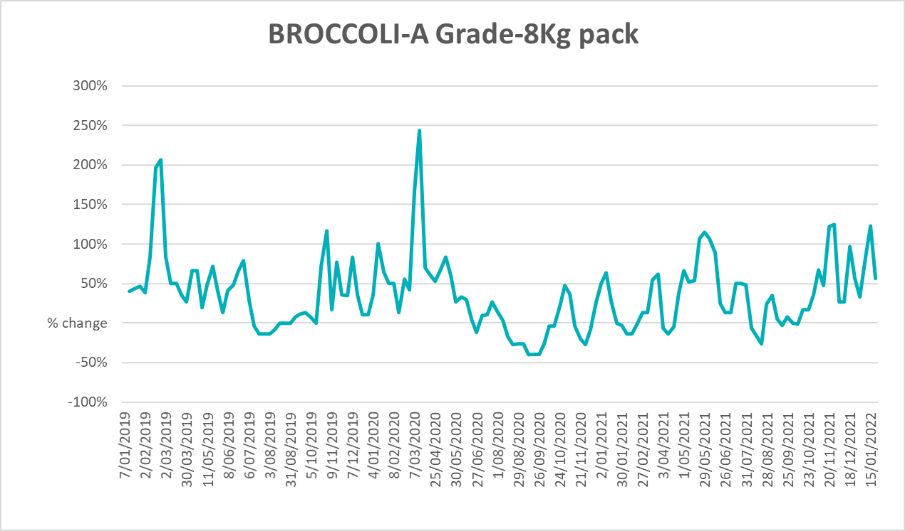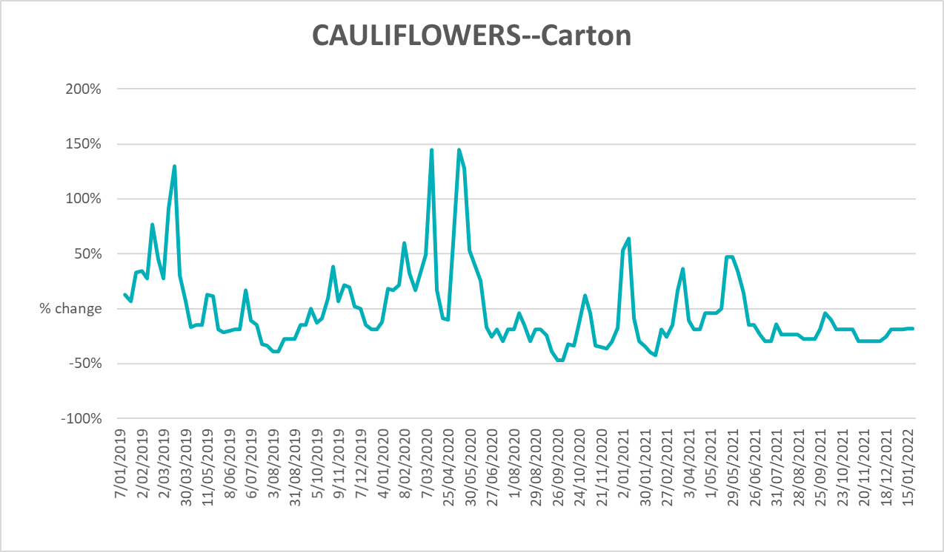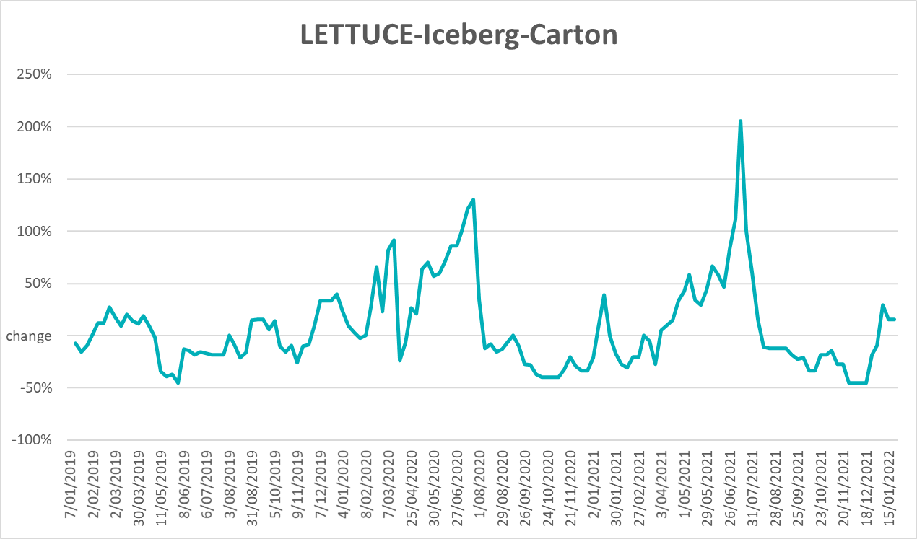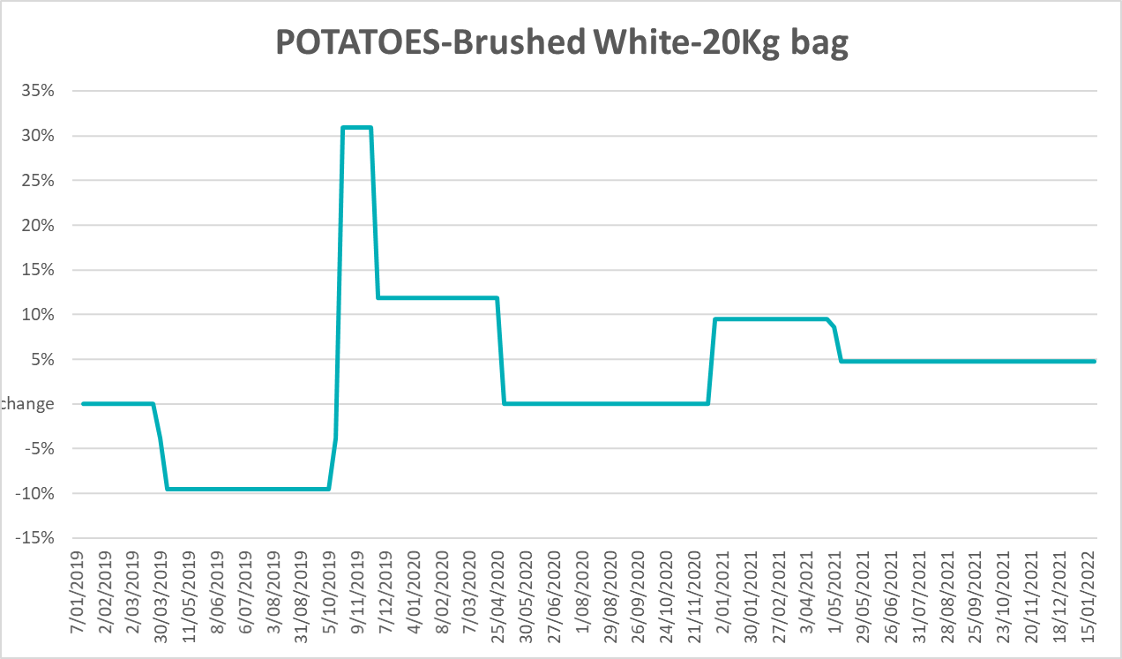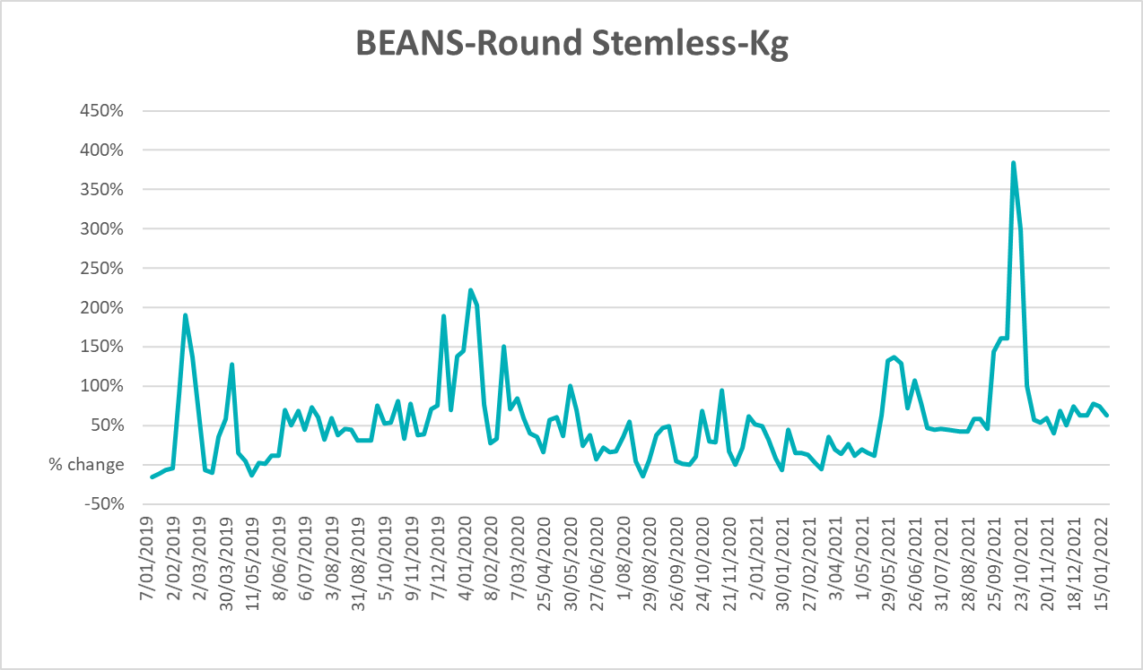

Selected domestic fodder indicator prices
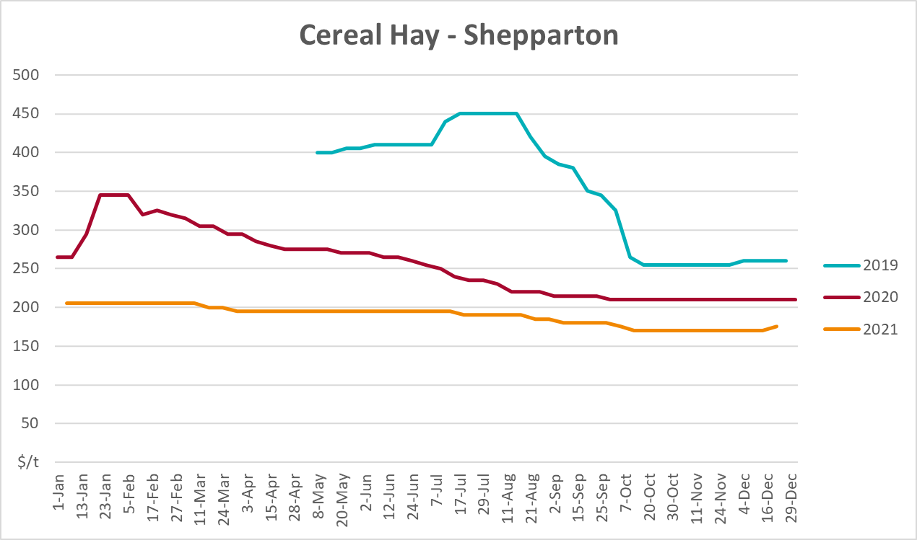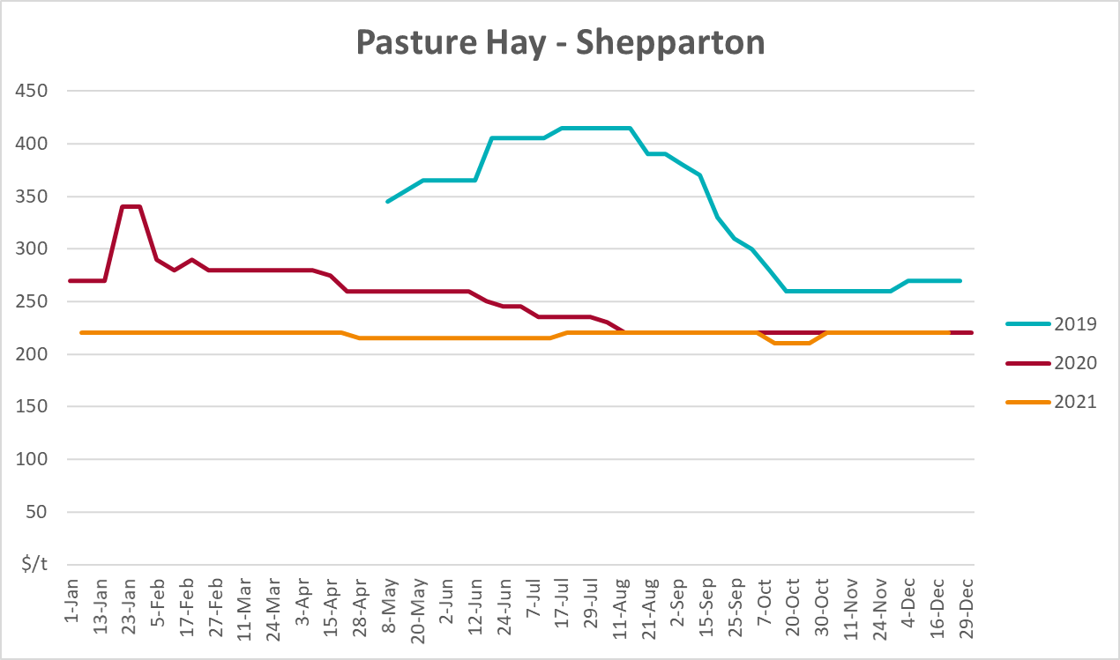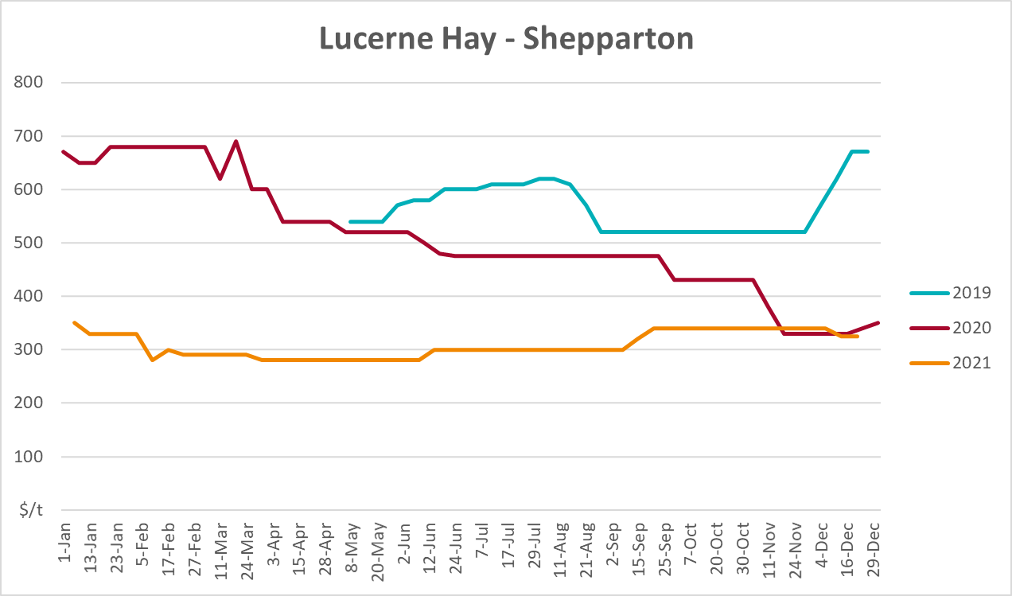

Data attribution

Climate
Bureau of Meteorology
- Weekly rainfall totals: www.bom.gov.au/climate/maps/rainfall/
- Monthly and last 3-month rainfall percentiles: www.bom.gov.au/water/landscape/
- Temperature anomalies: www.bom.gov.au/jsp/awap/temp/index.jsp
- Rainfall forecast: www.bom.gov.au/jsp/watl/rainfall/pme.jsp
- Seasonal outlook: www.bom.gov.au/climate/outlooks/#/overview/summary/
- Climate drivers: http://www.bom.gov.au/climate/enso/
- Soil moisture: www.bom.gov.au/water/landscape/
Other
- Pasture growth: www.longpaddock.qld.gov.au/aussiegrass/
- 3-month global outlooks: Environment and Climate Change Canada, NOAA Climate Prediction Center, EUROBRISA CPTEC/INPE, European Centre for Medium-Range Weather Forecasts, Hydrometcenter of Russia, National Climate Center Climate System Diagnosis and Prediction Room (NCC), International Research Institute for Climate and Society
- Global production: https://ipad.fas.usda.gov/ogamaps/cropmapsandcalendars.aspx
- Autumn break: Pook et al., 2009, https://rmets-onlinelibrary-wiley-com.virtual.anu.edu.au/doi/epdf/10.1002/joc.1833

Water
Prices
- Waterflow: https://www.waterflow.io/
- Ruralco: https://www.ruralcowater.com.au/
Bureau of Meteorology:
- Allocation trade: http://www.bom.gov.au/water/dashboards/#/water-markets/mdb/at
- Storage volumes: http://www.bom.gov.au/water/dashboards/#/water-storages/summary/drainage
Trade constraints:
- Water NSW: https://www.waternsw.com.au/customer-service/ordering-trading-and-pricing/trading/murrumbidgee
- Victorian Water Register: https://www.waterregister.vic.gov.au/TradingRules2019/

Commodities
Fruit and vegetables
- Datafresh: www.freshstate.com.au
Pigs
- Australian Pork Limited: www.australianpork.com.au
Dairy
- Global Dairy Trade: www.globaldairytrade.info/en/product-results/
World wheat, canola
- International Grains Council
World coarse grains
- United States Department of Agriculture
World cotton
- Cotlook: www.cotlook.com/
World sugar
- New York Stock Exchange - Intercontinental Exchange
Wool
- Australian Wool Exchange: www.awex.com.au/
Domestic wheat, barley, sorghum, canola and fodder
- Jumbuk Consulting Pty Ltd: http://www.jumbukag.com.au/
Cattle, beef, mutton, lamb, goat and live export
- Meat and Livestock Australia: www.mla.com.au/Prices-and-market
© Commonwealth of Australia 2022

Ownership of intellectual property rights
Unless otherwise noted, copyright (and any other intellectual property rights, if any) in this publication is owned by the Commonwealth of Australia (referred to as the Commonwealth).

Creative Commons licence
All material in this publication is licensed under a Creative Commons Attribution 4.0 International Licence except content supplied by third parties, logos and the Commonwealth Coat of Arms.
Inquiries about the licence and any use of this document should be emailed to copyright@awe.gov.au.


Cataloguing data
This publication (and any material sourced from it) should be attributed as:
ABARES 2022, Weekly Australian Climate, Water and Agricultural Update, Australian Bureau of Agricultural and Resource Economics and Sciences, Canberra, 3 February 2022. CC BY 4.0 DOI: https://doi.org/10.25814/5f3e04e7d2503
ISSN 2652-7561
This publication is available at https://www.awe.gov.au/abares/products/weekly_update
Department of Agriculture, Water and the Environment
GPO Box 858 Canberra ACT 2601
Telephone 1800 900 090
Web awe.gov.au/abares

Disclaimer
The Australian Government acting through the Department of Agriculture, Water and the Environment, represented by the Australian Bureau of Agricultural and Resource Economics and Sciences, has exercised due care and skill in preparing and compiling the information and data in this publication. Notwithstanding, the Department of Agriculture, Water and the Environment, ABARES, its employees and advisers disclaim all liability, including liability for negligence and for any loss, damage, injury, expense or cost incurred by any person as a result of accessing, using or relying on any of the information or data in this publication to the maximum extent permitted by law.

Statement of Professional Independence
The views and analysis presented in ABARES publications, including this one, reflect ABARES professionally independent findings, based on scientific and economic concepts, principles, information and data. These views, analysis and findings may not reflect or be consistent with the views or positions of the Australian Government, or of organisations or groups who have commissioned ABARES reports or analysis. More information on professional independence is provided on the ABARES website.

Acknowledgements
This report was prepared by Matthew Miller and Cameron Van-Lane.

