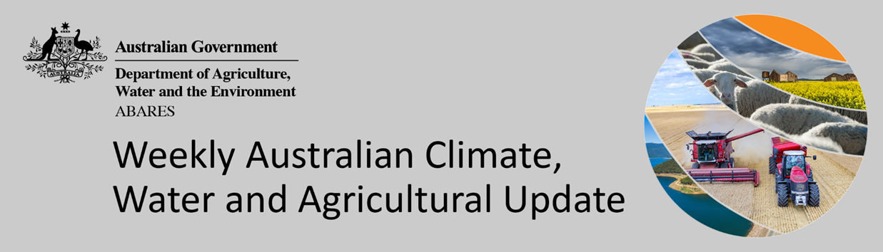
No. 6/2022

17 February 2022

Summary of key issues
- For the week ending 16 February 2022, a series of low-pressure troughs resulted in rainfall across western, northern and coastal areas of eastern Australia. High-pressure systems to the south of Australia brought clear, dry conditions to large areas of central, eastern and southern Australia (see Section 1.1).
- Dry conditions across southern Queensland and northern New South Wales have likely allowed harvesting of early sown summer crops to resume, after rainfall last week stalled activity. Sowing of late sown summer crops in Central Queensland has likely continued over the past week. However, upper soil moisture levels are currently average to below average, and further rainfall will be needed to support germination and establishment.
- Global crop production conditions have been generally favourable for the major grain and oilseed producing countries despite dry conditions across parts of Argentina, Brazil, and the United States, affecting the production potential of wheat, corn and soybeans (see Section 1.2).
- Below average rainfall during January is likely to result in lower-than-expected winter wheat production in the United States and decreased corn and soybean production across parts of Argentina and Brazil. Average to above average rainfall across the Black Sea Region and part of Europe is likely to improve production prospects in these key production regions. This is providing, on balance, similar global production conditions to those seen back in November 2021, that were used to formulate ABARES forecasts of global grain supplies and the impact on world prices in its December 2021 edition of Agricultural commodities (see Section 1.2).
- The global climate outlook indicates that average to above average rainfall is slightly more likely between March and May 2022 for most of the world's major grain- and oilseed-producing regions. Partly due to the influence of La Niña, below average rainfall is expected for Argentina, southern Brazil, parts of western Europe, west Asia, and southern and western United States (see Section 1.2).
- Over the 8-days to 24 February 2022, rainfall is expected across northern and eastern parts of Australia. Onshore winds and tropical moisture are expected to bring showers and storms to northern Australia, while low-pressure troughs are forecast to bring showers to eastern parts of the country. Meanwhile, high pressure systems are expected to bring mostly dry conditions to much of western, central and southern Australia (see Section 1.3).
- Water storage in the Murray–Darling Basin (MDB) decreased by 55 gigalitres (GL) between 9 February 2022 and 16 February 2022. The current volume of water held in storage is 22,237 GL, which represents 88 of total capacity. This is 61% or 8,425 GL more than at the same time last year.
- Allocation prices in the Victorian Murray below the Barmah Choke decreased from $85 per ML on 28 January 2022 to $75 per ML on 4 February 2022. Prices are lower in the Goulburn-Broken, Murrumbidgee, and regions above the Barmah Choke due to the binding of the Goulburn intervalley trade limit, Murrumbidgee export limit, and Barmah Choke trade constraint.

Climate

Rainfall this week
For the week ending 16 February 2022, a series of low-pressure troughs resulted in rainfall across western, northern and coastal areas of eastern Australia. High-pressure systems to the south of Australia brought clear, dry conditions to large areas of central, eastern and southern Australia.
Rainfall totals of between 10 and 50 millimetres were recorded across parts of eastern New South Wales, eastern and northern Queensland, southern parts of South Australia, western and northern parts of Western Australia and the north of the Northern Territory. Rainfall totals in excess of 50 millimetres were recorded in parts of northern Queensland, the west and north of Western Australia and isolated parts in the north of the Northern Territory. Remaining parts of Australia received little to no rainfall.
In cropping regions, rainfall totals of between 10 and 50 millimetres were recorded across western parts of South Australia and much of Western Australia. Little to no rainfall was recorded across cropping regions in New South Wales, Queensland and Victoria, as well as eastern parts of South Australia.
Dry conditions across southern Queensland and northern New South Wales have likely allowed harvesting of early sown summer crops to resume, after rainfall last week stalled activity. Given the ample soil moisture availability at the start of the summer cropping season and the largely dry finish for early sown crops, above average yields and good grain quality are expected. Sowing of late sown summer crops in Central Queensland has likely continued over the past week. However, upper soil moisture levels are currently average to below average, and further rainfall will be needed to support germination and establishment.

Rainfall for the week ending 16 February 2022

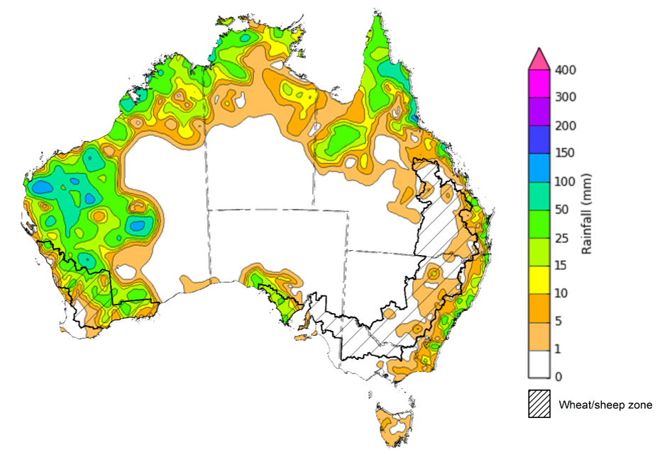

©Commonwealth of Australia 2022, Australian Bureau of Meteorology Issued: 16/2/2022
Note: The rainfall analyses and associated maps utilise data contained in the Bureau of Meteorology climate database, the Australian Data Archive for Meteorology (ADAM). The analyses are initially produced automatically from real-time data with limited quality control. They are intended to provide a general overview of rainfall across Australia as quickly as possible after the observations are received. For further information go to http://www.bom.gov.au/climate/rainfall/

Global production conditions and climate outlook
Crop production is affected by long-term trends in average rainfall and temperature, interannual climate variability, shocks during specific growth stages, and extreme weather events (IPCC 2012). Some crops are more tolerant than others to certain types of stresses, and at each growth stage, different types of stresses affect each crop species in different ways.
The precipitation anomalies and outlooks presented here give an indication of the current and future state of production conditions for the major grain and oilseed producing countries which are responsible for over 80% of global production. This is an important input to assessing the global grain supply outlook.
January precipitation percentiles and current production conditions
As of the end of January 2022, rainfall was mixed for the world’s major grain-producing and oilseed-producing regions.
In the northern hemisphere, precipitation was below average in the central southern and western United States, southern Kazakhstan, western Europe, the United Kingdom and parts of eastern Canada. Precipitation was above average for Southern Russia and Volga districts of the Russian Federation, central Canada, central China, northern Ukraine. Precipitation was close to average across the remainder of the major grain-producing and oilseed-producing regions in the northern hemisphere.
In the southern hemisphere, January precipitation was below average in northern Argentina, Paraguay, Uruguay and western Australia. Precipitation was above average across parts of northern Brazil and South Africa. Precipitation was close to average across the remainder of major grain-producing and oilseed-producing regions in the southern hemisphere.

Global precipitation percentiles, January 2022
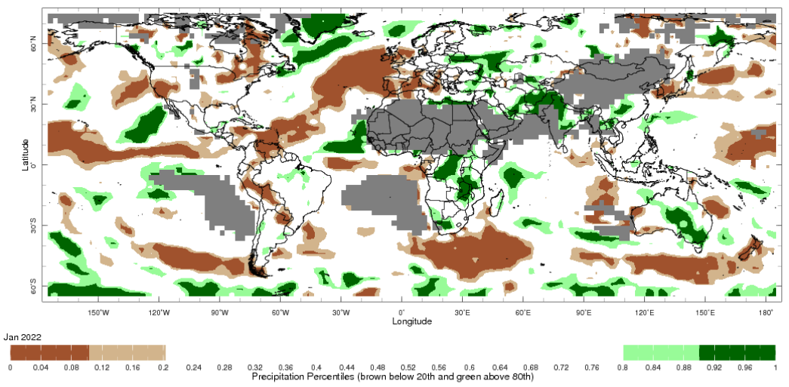
Note: The world precipitation percentiles indicate a ranking of precipitation for January, with the driest (0th percentile) being 0 on the scale and the wettest (100th percentile) being 1 on the scale. Percentiles are based on precipitation estimates from the NOAA Climate Prediction Center's Climate Anomaly Monitoring System Outgoing Precipitation Index dataset. Precipitation estimates for January 2022 are compared with rainfall recorded for that period during the 1981 to 2010 base period.
Source: International Research Institute for Climate and Society
As at 28 January 2022 global production conditions were generally favourable for the production of rice and wheat. However, a lack of precipitation has affected the production potential of corn and soybeans in some key grain exporting and importing countries.
In the northern hemisphere production conditions for wheat have been generally favourable. Climatic conditions have been favourable for wheat development in Canada, China, the European Union, the Russian Federation, Turkey, Ukraine and the United Kingdom. Production is mixed in the United States due to dryness in some areas. Conditions were favourable for winter wheat sowing in India.
Conditions for corn in Argentina for early- and late-planted crop development are rated at below average due to drought and high temperatures affecting yield potential. Similarly in Brazil, conditions were mixed for spring-planted crop development due to dryness in the south. Conditions were favourable in Brazil for sowing the summer-planted crop. In India, conditions were favourable for Rabi crop development. In South Africa, conditions are favourable for crop development.
Conditions were favourable for transplanting of Rabi rice in India. Harvesting conditions were favourable for dry-season rice in Indonesia and sowing of wet-season rice. In the Philippines, Thailand and Vietnam conditions were favourable for the harvest of wet-season and sowing of dry-season rice. In Brazil, conditions are under watch due to low irrigated water availability.
Conditions for soybeans were mixed in Argentina. The early-planted crop is under below average to poor conditions because of a prolonged drought and high temperatures. Sowing of the late-planted crop is wrapping up under slightly better conditions as the drought conditions occurred during the early vegetative stages and recent rainfall has been beneficial. In Brazil, most crops are in the reproductive stages, with harvest just beginning in some places. In northern and central regions, crops are under favourable conditions. However, in the southern region reduced yields are expected due to dryness.
Crop conditions, AMIS countries, 28 January 2022
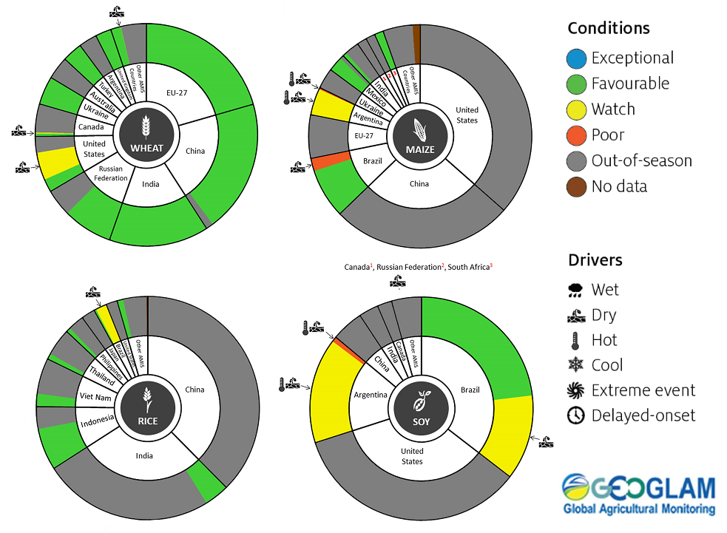
AMIS Agricultural Market Information System.
Source: AMIS
The global climate outlook for March 2022 to May 2022 indicates that mixed rainfall conditions are expected for the world's major grain-producing and oilseed-producing regions. Outlooks and potential production impacts for the major grain and oilseed producing countries are presented in the table.
Rainfall outlook and potential impact on the future state of production conditions between March 2022 to May 2022
Region | March-May rainfall outlook | Potential impact on production
Argentina | Below average rainfall is more likely across much of Argentina between March and May 2022. | Below average rainfall may adversely affect the development and harvesting of sorghum, rice, millet, soybeans, corn, sunflower, cotton and nuts, and the planting of wheat in May 2022.
Black Sea Region | Below average rainfall is forecast for parts of Kazakhstan. Ukraine and the Russian Federation are more likely to record close to average rainfall between February and April 2022. | Below average rainfall in parts of Kazakhstan may adversely affect winter wheat and canola development, as well as cotton, corn and sunflower planting from March 2022. Average or better rainfall across Ukraine and the Russian Federation is likely to support similar crops in the south and the planting and development of spring wheat planting in the north from April 2022.
Brazil | Above average rainfall is more likely across northern and central Brazil and below average rainfall is more likely across much of southern Brazil between March and May 2022. | Above average rainfall across northern Brazil is likely to support the development of cotton and corn, and the harvesting of soybeans. Below average rainfall in the south may adversely affect the development and harvesting of rice, sorghum, millet, sunflower, soybeans, cotton, nuts and corn, and the planting of wheat in May 2022.
Canada | Average rainfall is more likely across much of Canada between March and May 2022. | Average rainfall is likely to support winter wheat development in Canada from March 2022 and the planting of spring wheat, canola, corn, soybeans and sunflower from May 2022.
China | Above average rainfall is more likely across much of China and below average rainfall is more likely across isolated parts of western China. | Above average rainfall across much of China is likely to support the development of winter wheat and canola and the planting and development of early rice, single rice, cotton, spring wheat, corn, sorghum, soybeans, sunflower and nuts from March 2022.
Europe | Below average rainfall is more likely for much of western and central Europe and average rainfall is more likely for eastern Europe between March and May 2022. | Average rainfall across much of eastern Europe is likely to support winter wheat and canola development and the planting and development of corn, cotton, spring wheat, soybeans, sunflower and sorghum. Below average rainfall in the west may adversely affect the planting and development of these crops between March and May 2022.
South Asia (India) | Below average rainfall is more likely across much of northern India and above average rainfall is more likely in the south between March and May 2022. | Below average rainfall may adversely affect the development of wheat and canola in parts of northern and central India. Average to above average rainfall across the remainder of India is likely to support crop development prior to harvest in April 2022.
Southeast Asia (SEA) | Above average rainfall is more likely for most SEA countries. The rainfall outlook is mixed for Indonesia, with scattered areas of below and above average rainfall more likely between March and May 2022. | Average or better rainfall across most of Southeast Asia is likely to benefit corn and rice planting, development and harvesting. Below average rainfall in parts of Indonesia may adversely impact rice, corn and soybean production.
The United States of America | Above average rainfall is more likely for parts of the north-eastern and north-western US and below average rainfall is more likely for the south-western and far south-eastern US between March and May 2022. | Average or better rainfall in the northern and eastern US is likely to support winter wheat as it comes out of dormancy, as well as the planting and development of spring wheat, canola, corn, cotton, rice, soybeans and nuts. Below average rainfall in the southern US may adversely impact the development of winter wheat and the planting and development of corn, cotton, nuts, rice and soybeans.

Rainfall forecast for the next eight days
Over the 8-days to 24 February 2022, rainfall is expected across northern and eastern parts of Australia. Onshore winds and tropical moisture are expected to bring showers and storms to northern Australia, while low-pressure troughs are forecast to bring showers to eastern parts of the country. Meanwhile, high pressure systems are expected to bring mostly dry conditions to much of western, central and southern Australia.
Rainfall totals of between 10 and 50 millimetres are forecast for northern and eastern New South Wales, southern, central and northern part of Queensland, as well as northern parts of Western Australia, the Northern Territory and western Tasmania. Rainfall in excess of 50 millimetres is expected in isolated parts of eastern New South Wales, as well as northern parts of Queensland, Western Australia and the Northern Territory.
In Australian cropping regions, rainfall totals of between 10 and 50 millimetres are expected across northern New South Wales and much of Queensland. Little to no rainfall is forecast for all remaining cropping regions during the next 8-days.
The forecast rainfall for northern New South Wales and southern Queensland is likely to delay harvesting of early sown summer crops. For later summer crops, the expected rainfall will assist with crop establishment as well as boosting soil moisture levels. Given the current state of soil moisture levels across cropping regions in Queensland, more rainfall will be required over the coming months to support yield potentials. Continued heavy falls across northern Australia will support pasture growth rates during this peak production season.

Total forecast rainfall (mm) for the period 17 February to 24 February 2022
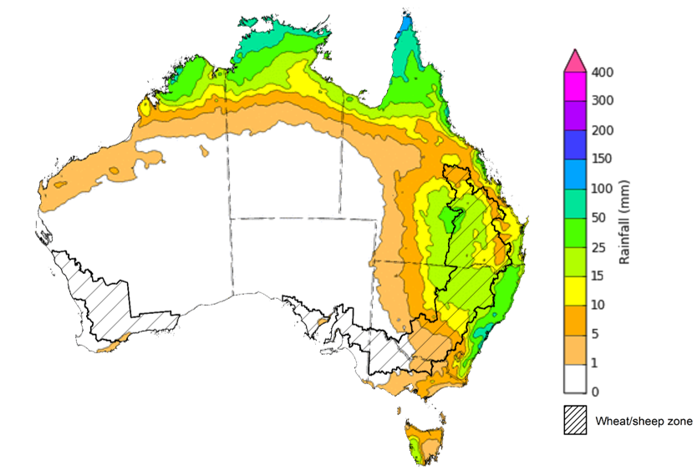
©Commonwealth of Australia 2022, Australian Bureau of Meteorology Issued: 16/02/2022

Water
Note: This rainfall forecast is produced from computer models. As the model outputs are not altered by weather forecasters, it is important to check local forecasts and warnings issued by the Bureau of Meteorology.

Water markets – current week
Water storage in the Murray–Darling Basin (MDB) decreased by 55 gigalitres (GL) between 9 February 2022 and 16 February 2022. The current volume of water held in storage is 22,237 GL, which represents 88 of total capacity. This is 61% or 8,425 GL more than at the same time last year.

Water storages in the Murray-Darling Basin, 2013–2021
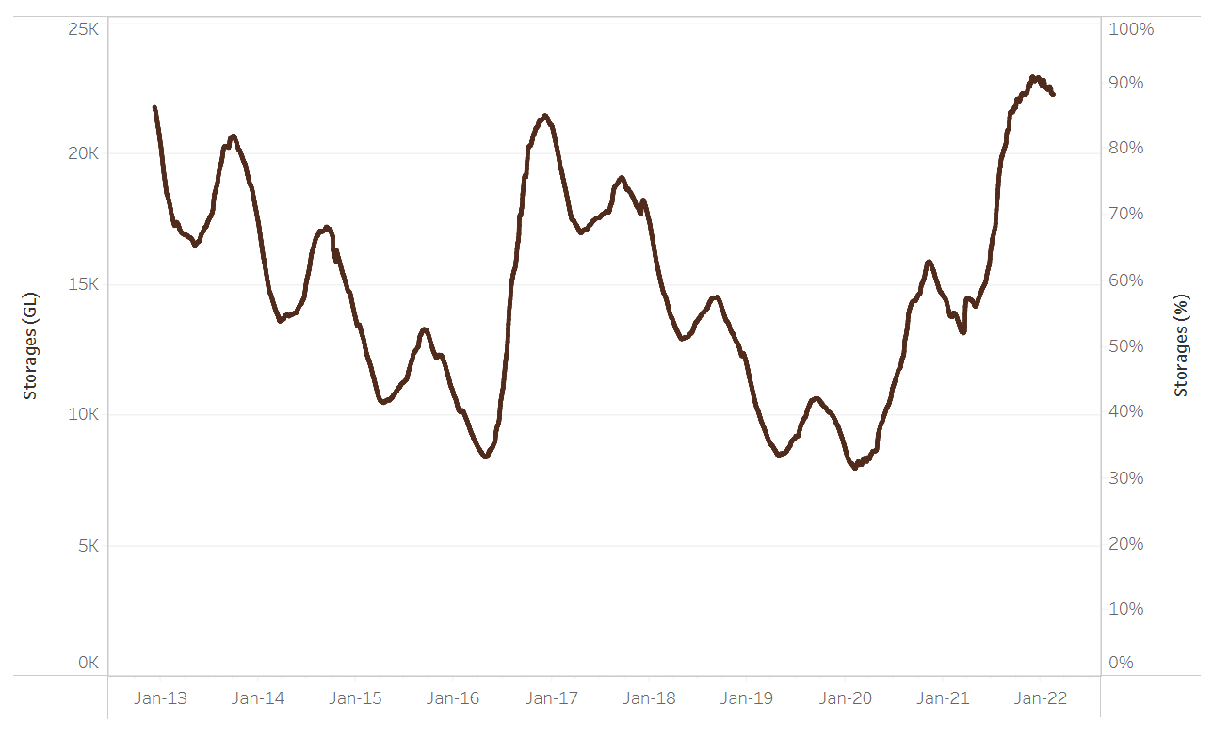
Allocation prices in the Victorian Murray below the Barmah Choke decreased from $85 per ML on 28 January 2022 to $75 per ML on 4 February 2022. Prices are lower in the Goulburn-Broken, Murrumbidgee, and regions above the Barmah Choke due to the binding of the Goulburn intervalley trade limit, Murrumbidgee export limit, and Barmah Choke trade constraint.
Water storage data is sourced from the Bureau of Meteorology.

Region | $/ML
NSW Murray Above | 37
NSW Murrumbidgee | 29
VIC Goulburn-Broken | 63
VIC Murray Below | 75

Surface water trade activity, Southern Murray–Darling Basin

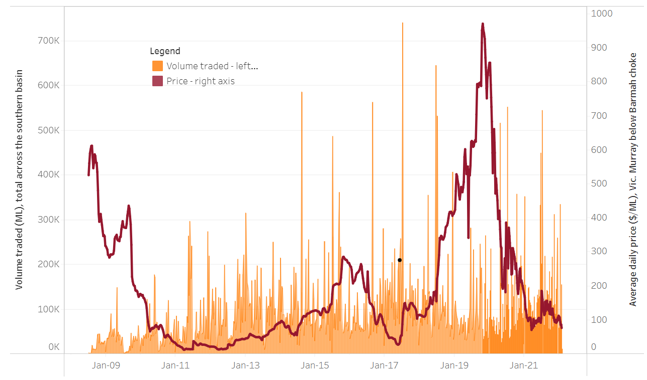
To access the full, interactive, weekly water dashboard, which contains the latest and historical water storage, water market and water allocation information, please visit http://www.agriculture.gov.au/abares/products/weekly_update/weekly-update-170222
The trades shown reflect estimated market activity and do not encompass all register trades. The price is shown for the VIC Murray below the Barmah choke. Historical prices (before 1 July 2019) are ABARES estimates after removing outliers from BOM water register data. Prices after 1 July 2019 and prior to the 30 October 2019 reflect recorded transaction prices as sourced from Ruralco. Prices after the 30 October 2019 are sourced from Waterflow. Data for volume traded is sourced from the BOM water register. Data shown is current at 17 February 2022.

Commodities

Indicator | Week ended | Unit | Latest price | Previous week | Weekly change | Price 12 months ago | Annual change
Selected world indicator prices
AUD/USD Exchange rate | 16-Feb | A$/US$ | 0.71 | 0.71 | 0% | 0.79 | -10%
Wheat – US no. 2 hard red winter wheat, fob Gulf | 16-Feb | US$/t | 383 | 378 | 1% | 293 | 31%
Corn – US no. 2 yellow corn, fob Gulf | 16-Feb | US$/t | 299 | 293 | 2% | 248 | 20%
Canola – Rapeseed, Canada, fob Vancouver | 16-Feb | US$/t | 861 | 846 | 2% | 658 | 31%
Cotton – Cotlook 'A' Index | 16-Feb | USc/lb | 138 | 140 | -2% | 97 | 43%
Sugar – Intercontinental Exchange, nearby futures, no.11 contract | 16-Feb | USc/lb | 17.6 | 17.8 | -1% | 17 | 4%
Wool – Eastern Market Indicator | 09-Feb | Ac/kg clean | 1,454 | 1,422 | 2% | 1,144 | 27%
Wool – Western Market Indicator | 02-Feb | Ac/kg clean | 1,443 | 1,455 | -1% | 1,024 | 41%
Selected Australian grain export prices
Milling Wheat – APW, Port Adelaide, SA | 16-Feb | A$/t | 485 | 488 | -1% | 359 | 35%
Feed Wheat – ASW, Port Adelaide, SA | 16-Feb | A$/t | 452 | 457 | -1% | 355 | 27%
Feed Barley – Port Adelaide, SA | 16-Feb | A$/t | 391 | 390 | 0% | 305 | 28%
Canola – Kwinana, WA | 16-Feb | A$/t | 1,007 | 1,007 | 0% | 697 | 45%
Grain Sorghum – Brisbane, QLD | 16-Feb | A$/t | 369 | 367 | 0% | 388 | -5%
Selected domestic livestock indicator prices
Beef – Eastern Young Cattle Indicator | 16-Feb | Ac/kg cwt | 1,119 | 1,126 | -1% | 885 | 26%
Mutton – Mutton indicator (18–24 kg fat score 2–3), Vic | 16-Feb | Ac/kg cwt | 570 | 579 | -1% | 604 | -6%
Lamb – Eastern States Trade Lamb Indicator | 16-Feb | Ac/kg cwt | 827 | 826 | 0% | 825 | 0%
Pig – Eastern Seaboard (60.1–75 kg), average of buyers & sellers | 26-Jan | Ac/kg cwt | 357 | 357 | 0% | 309 | 16%
Goats – Eastern States (12.1–16 kg) | 19-Jan | Ac/kg cwt | 879 | 879 | 0% | 818 | 8%
Live cattle – Light steers ex Darwin to Indonesia | 09-Feb | Ac/kg lwt | 520 | 520 | 0% | 370 | 41%
Live sheep – Live wethers (Muchea WA saleyard) to Middle East | 22-Sep | $/head | 147 | 171 | -14% | 126 | 17%

Indicator | Week ended | Unit | Latest price | Previous week | Weekly change | Price 12 months ago | Annual change
Global Dairy Trade (GDT) weighted average prices ª
Dairy – Whole milk powder | 16-Feb | US$/t | 4,503 | 4,324 | 4% | 3,150 | 43%
Dairy – Skim milk powder | 16-Feb | US$/t | 4,295 | 4,051 | 6% | 3,026 | 42%
Dairy – Cheddar cheese | 16-Feb | US$/t | 5,881 | 5,684 | 3% | 4,048 | 45%
Dairy – Anhydrous milk fat | 16-Feb | US$/t | 6,889 | 6,800 | 1% | 4,821 | 43%
a Global Dairy Trade prices are updated twice monthly on the first and third Tuesday of each month.

Selected world indicator prices
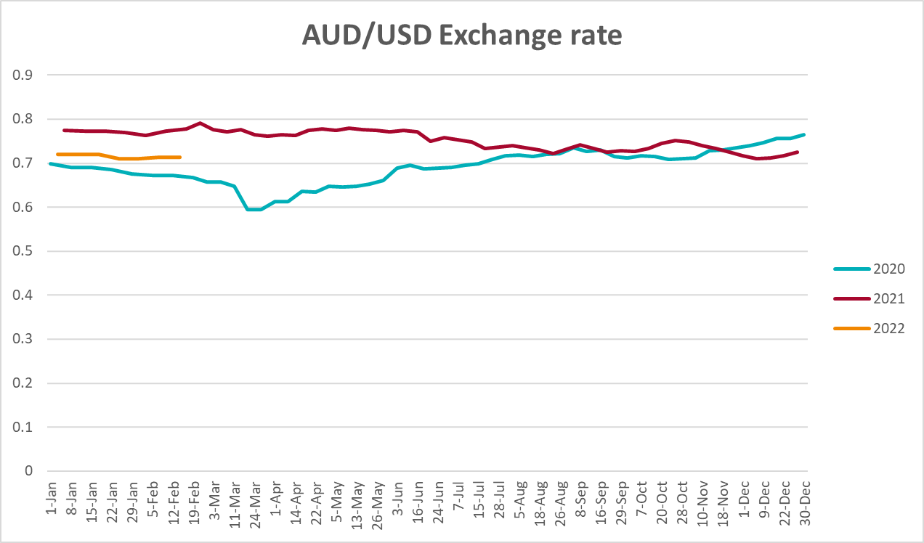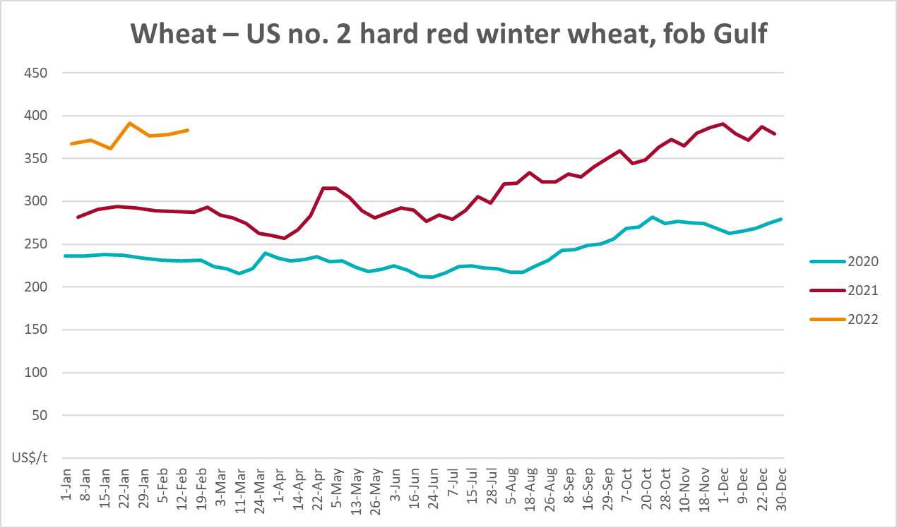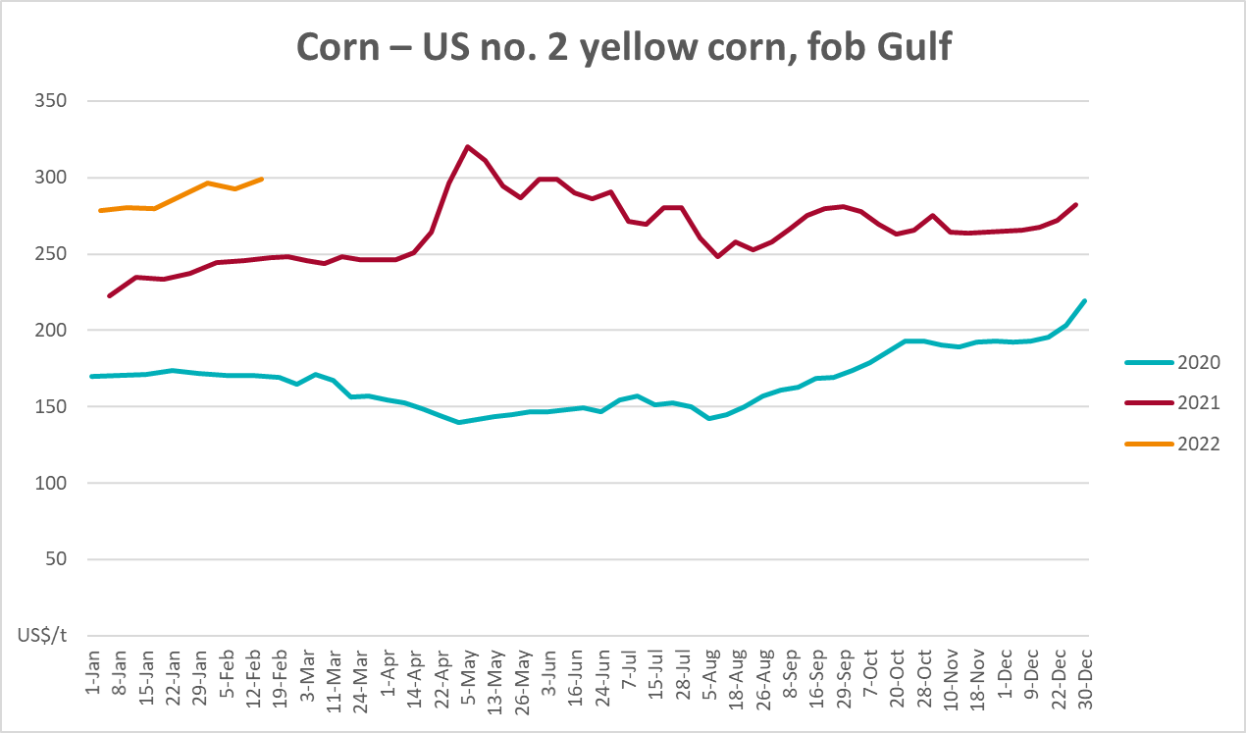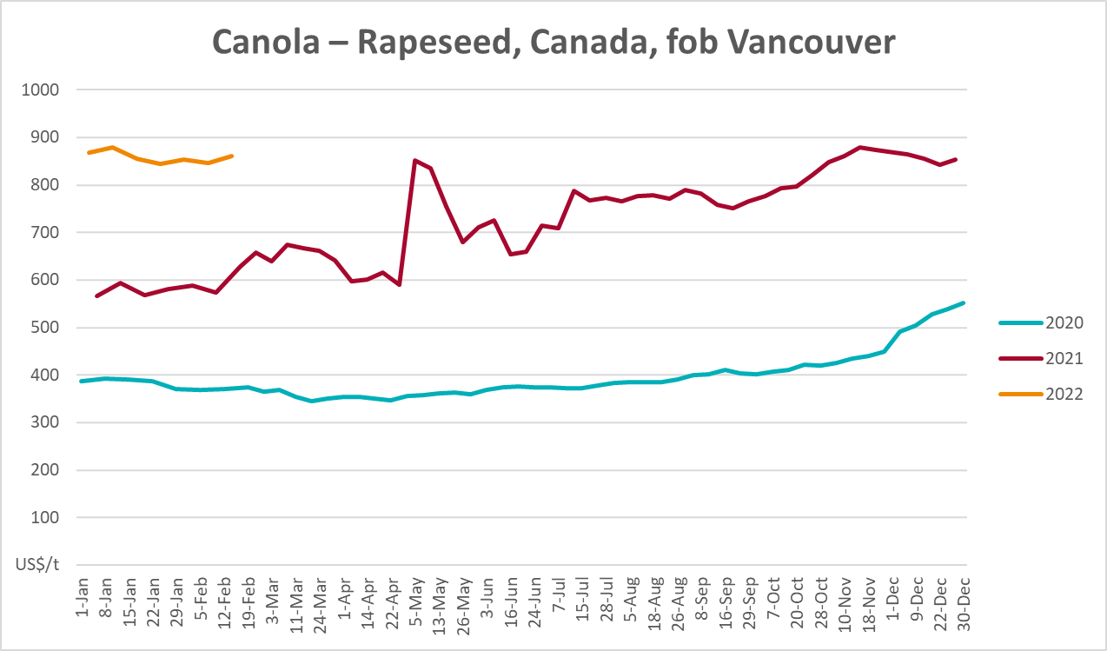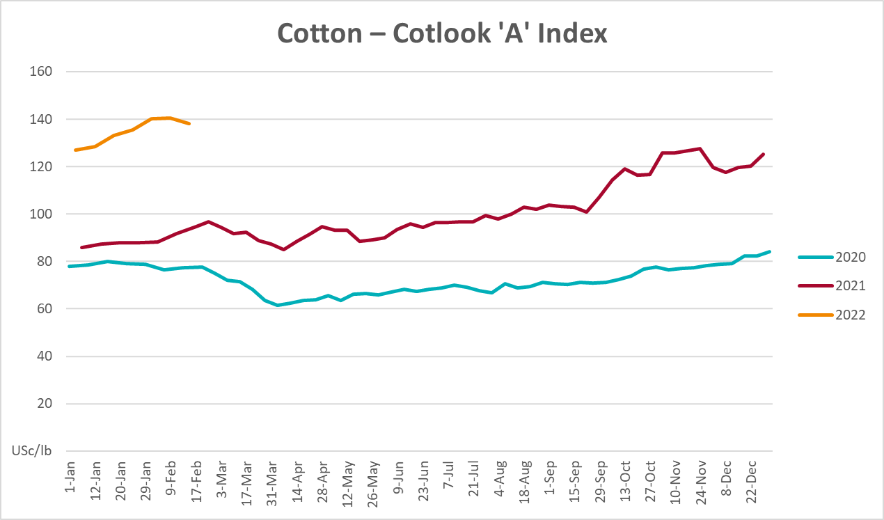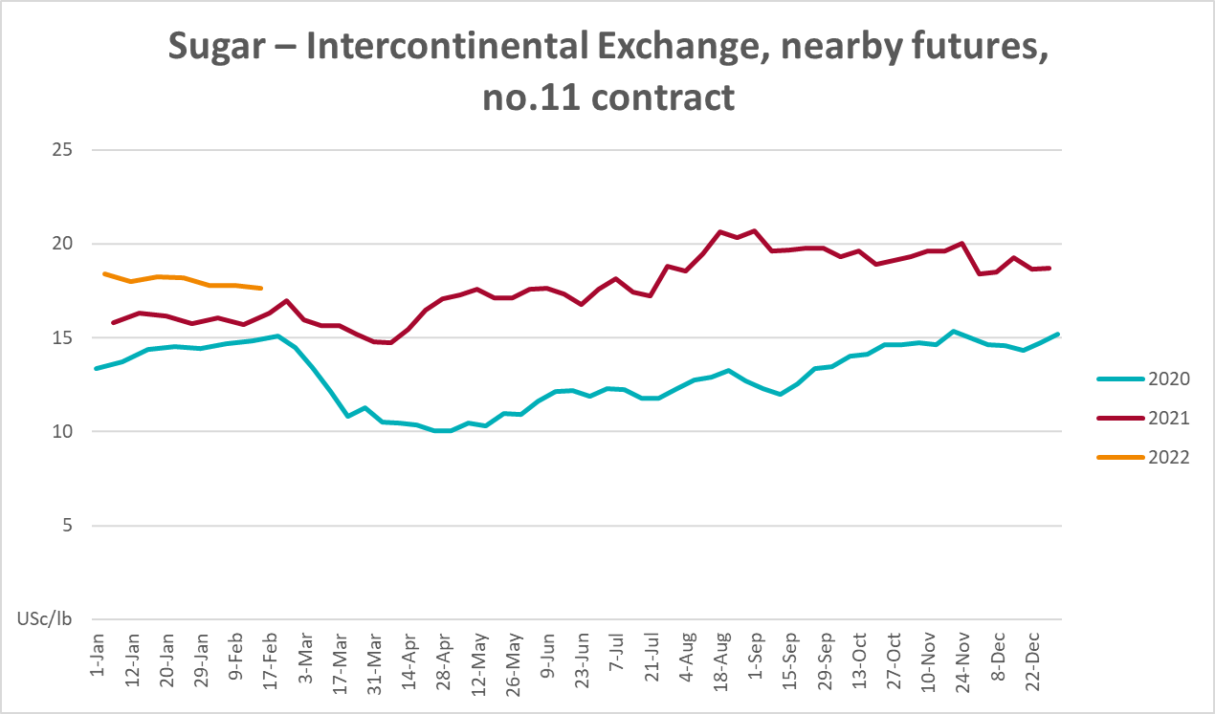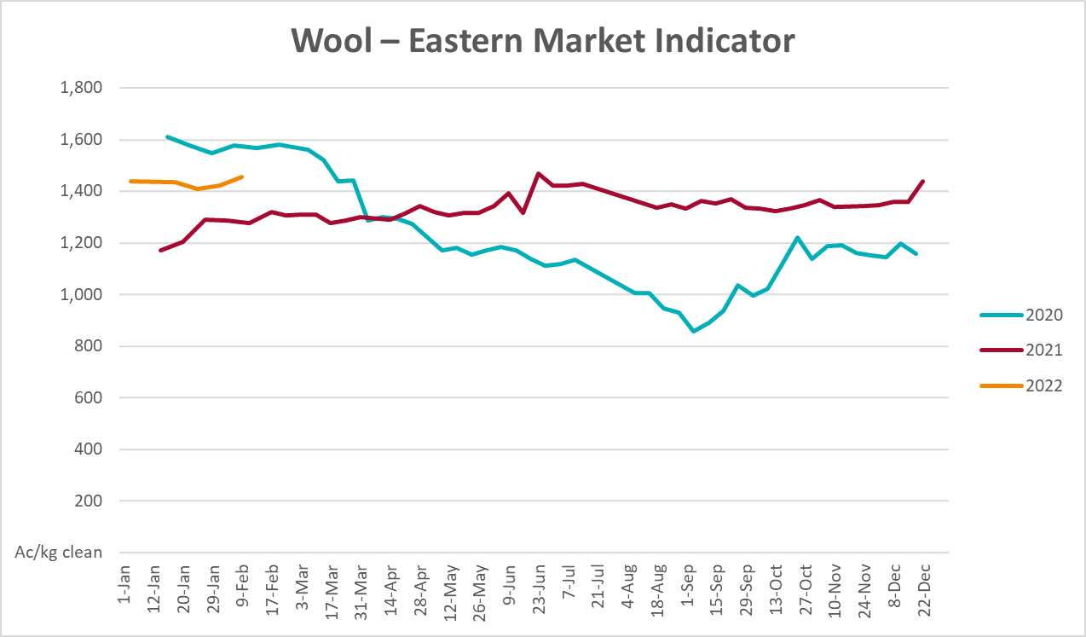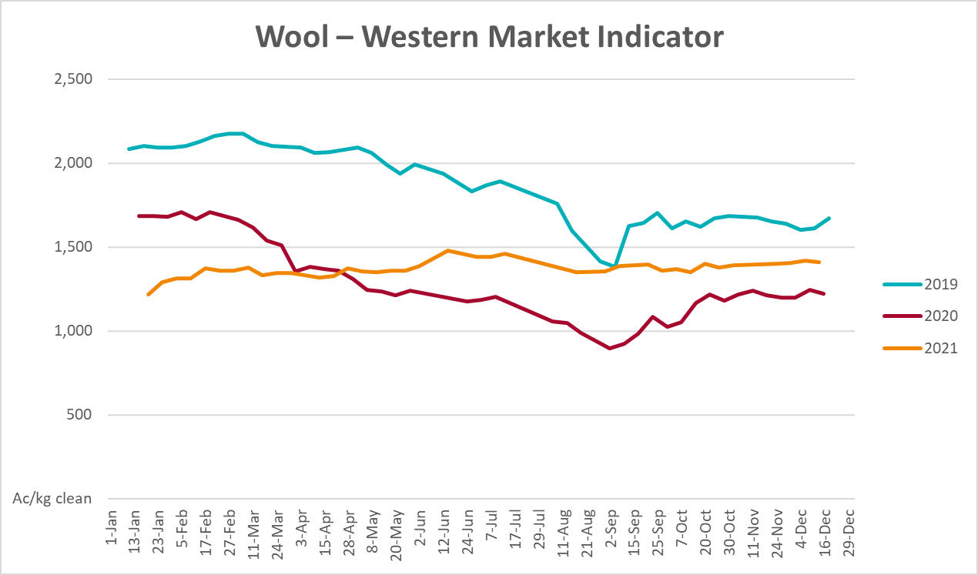

Selected domestic crop indicator prices
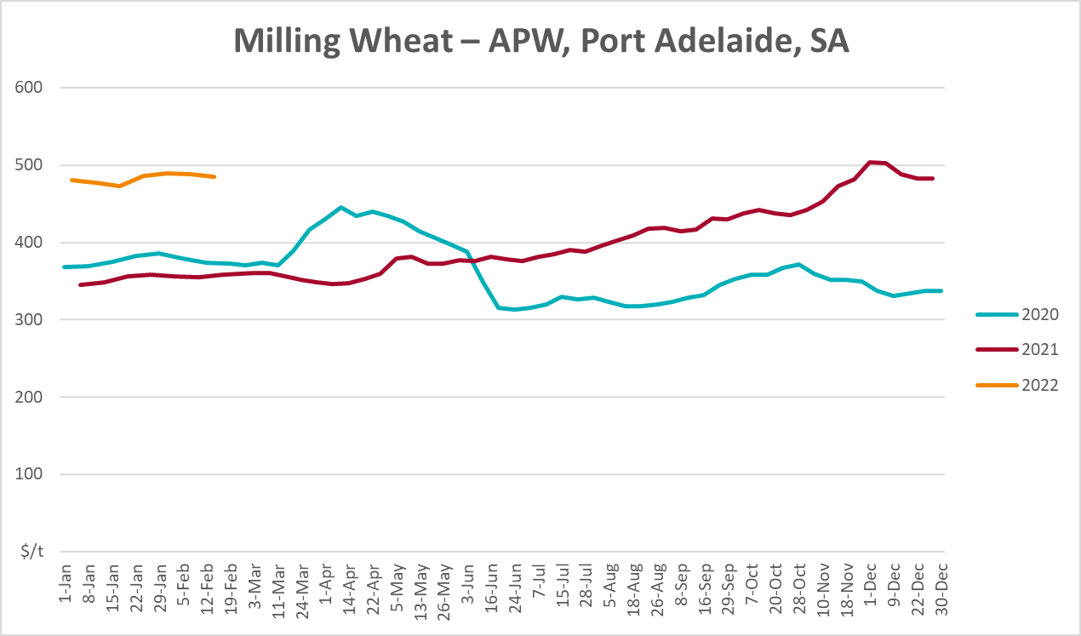
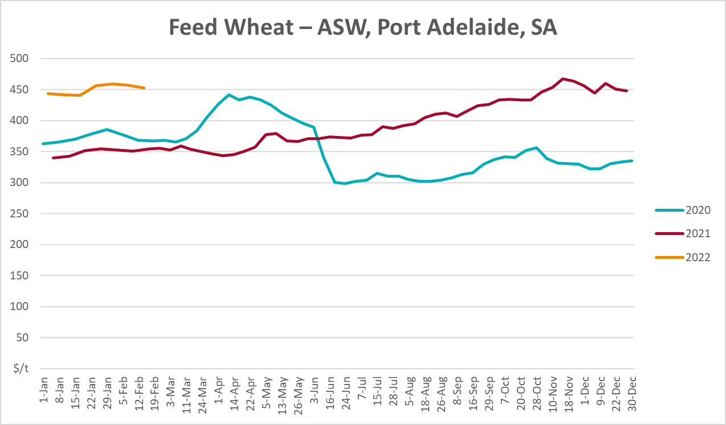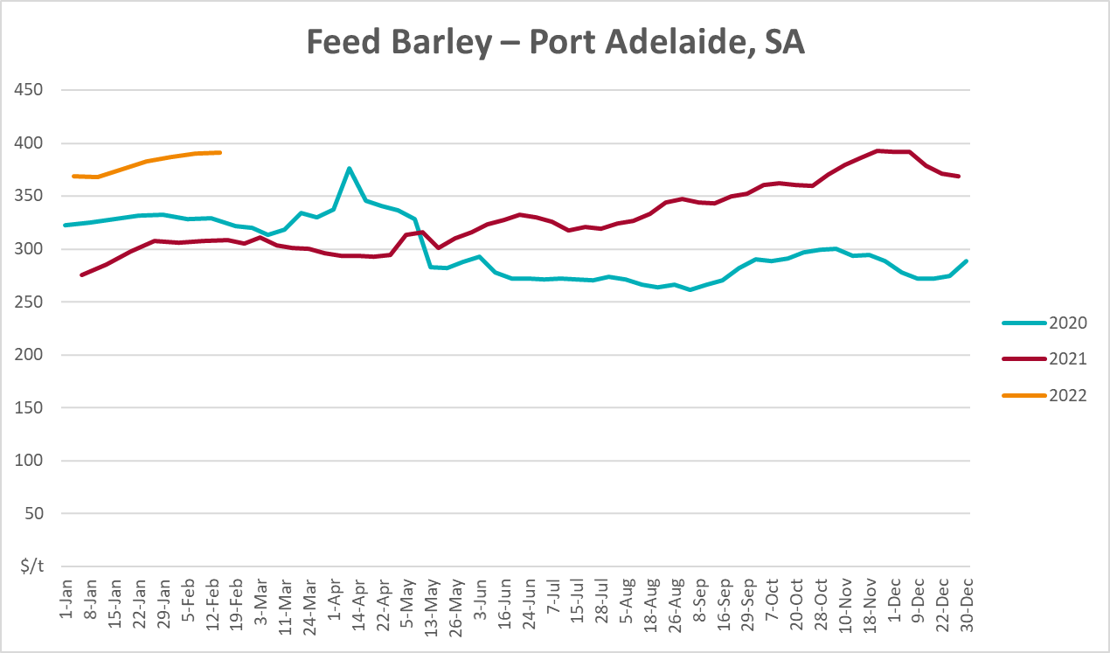
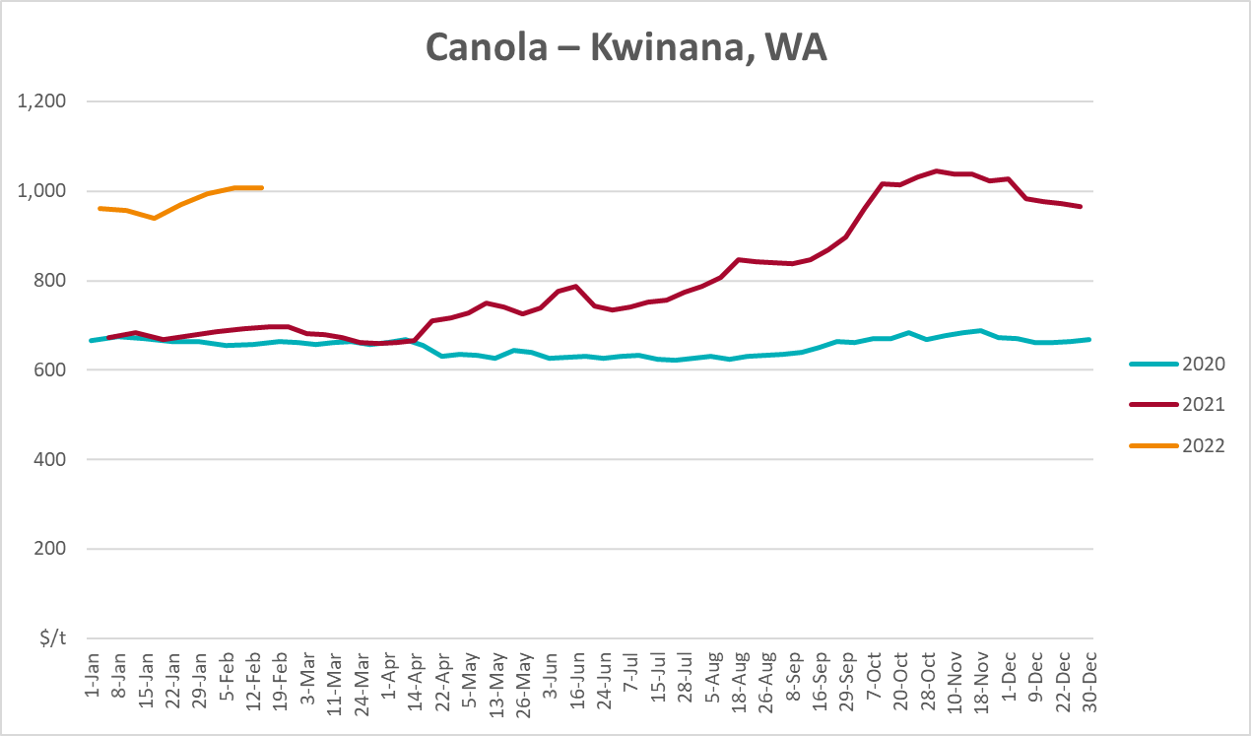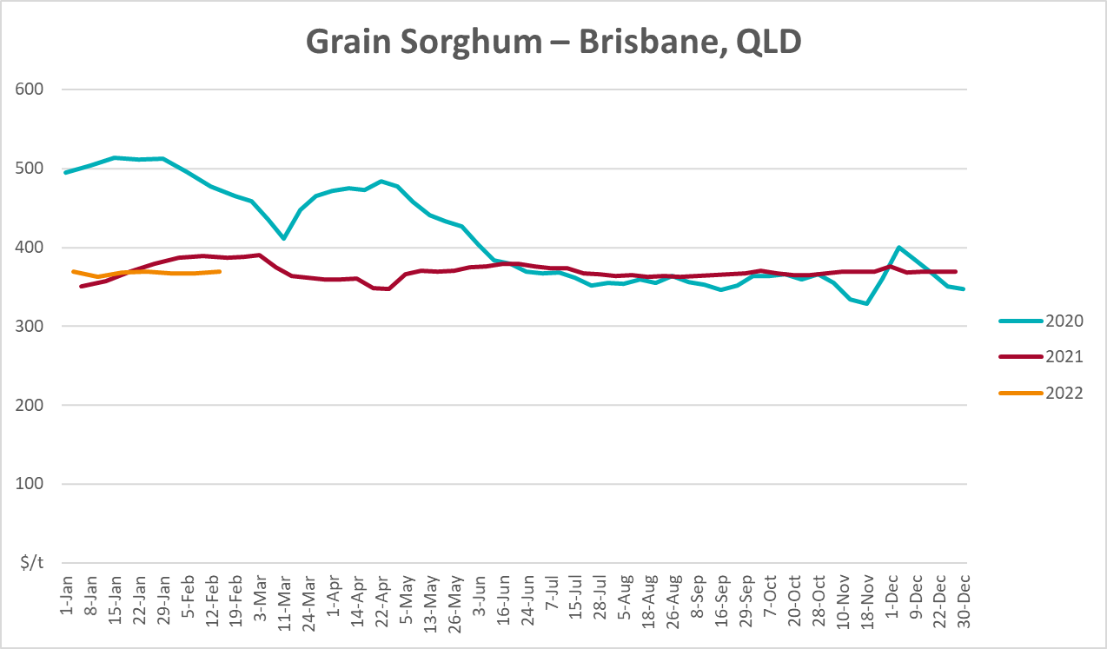

Selected domestic livestock indicator prices
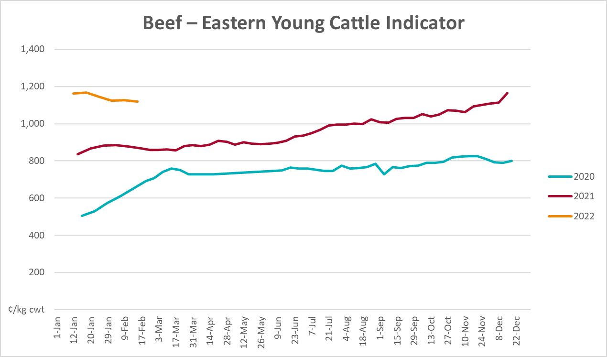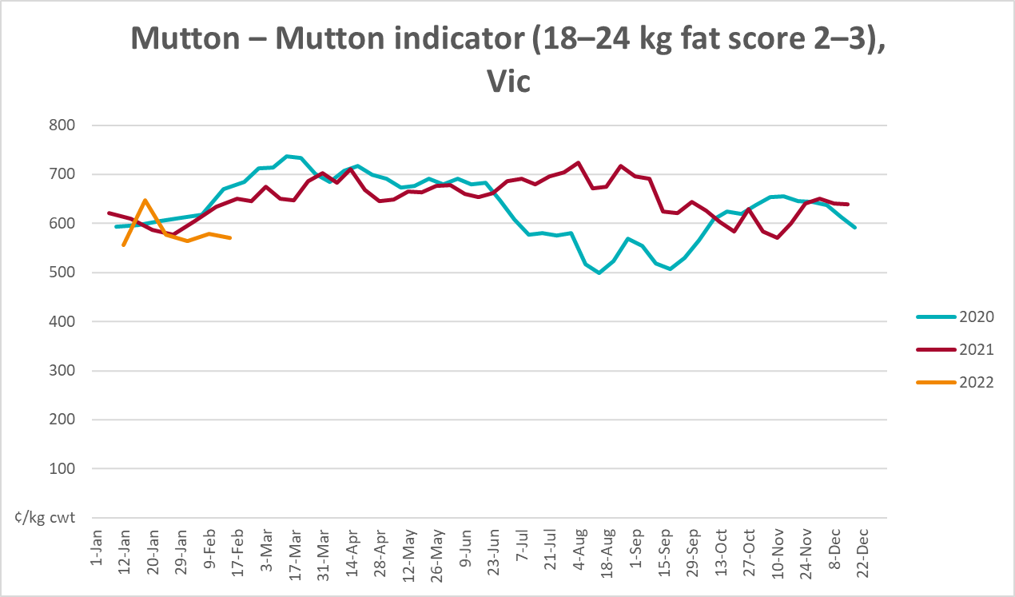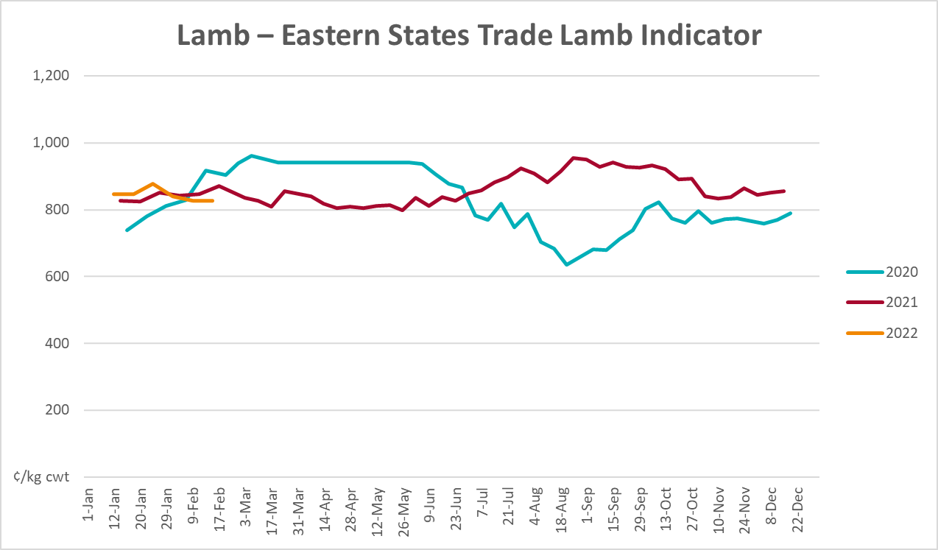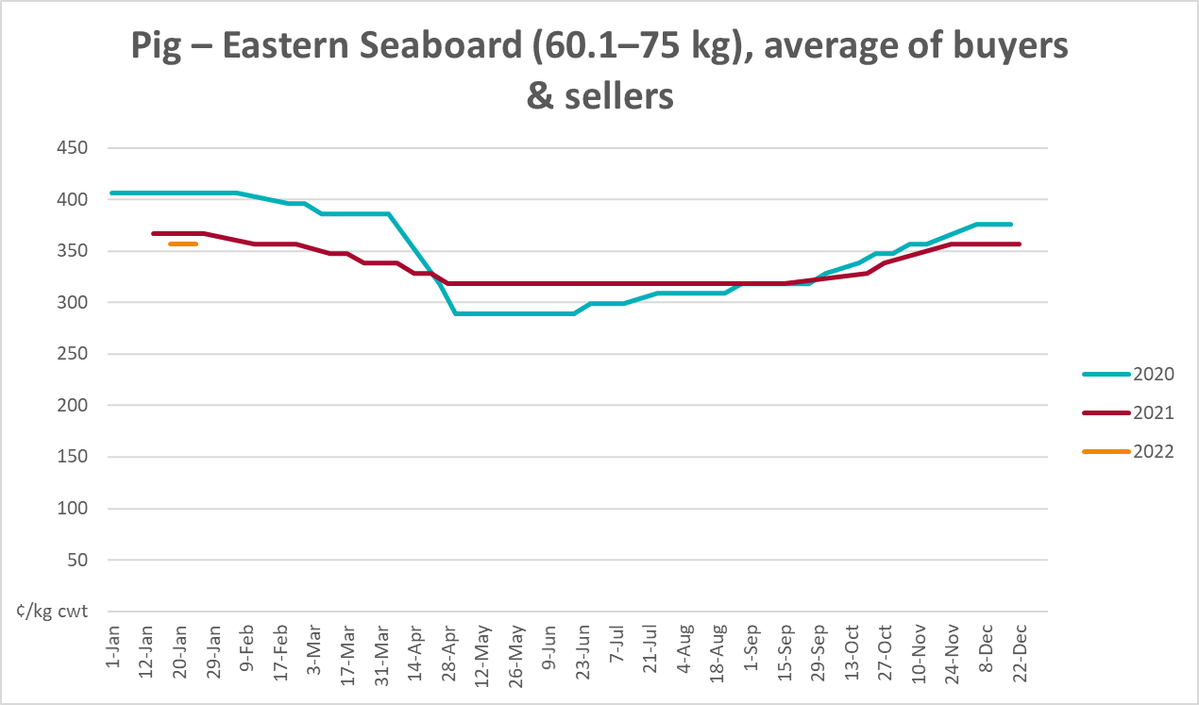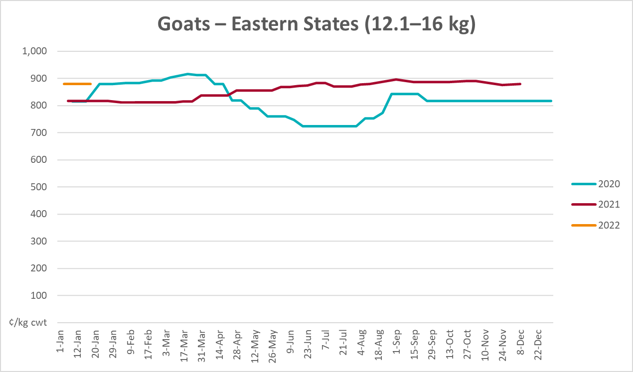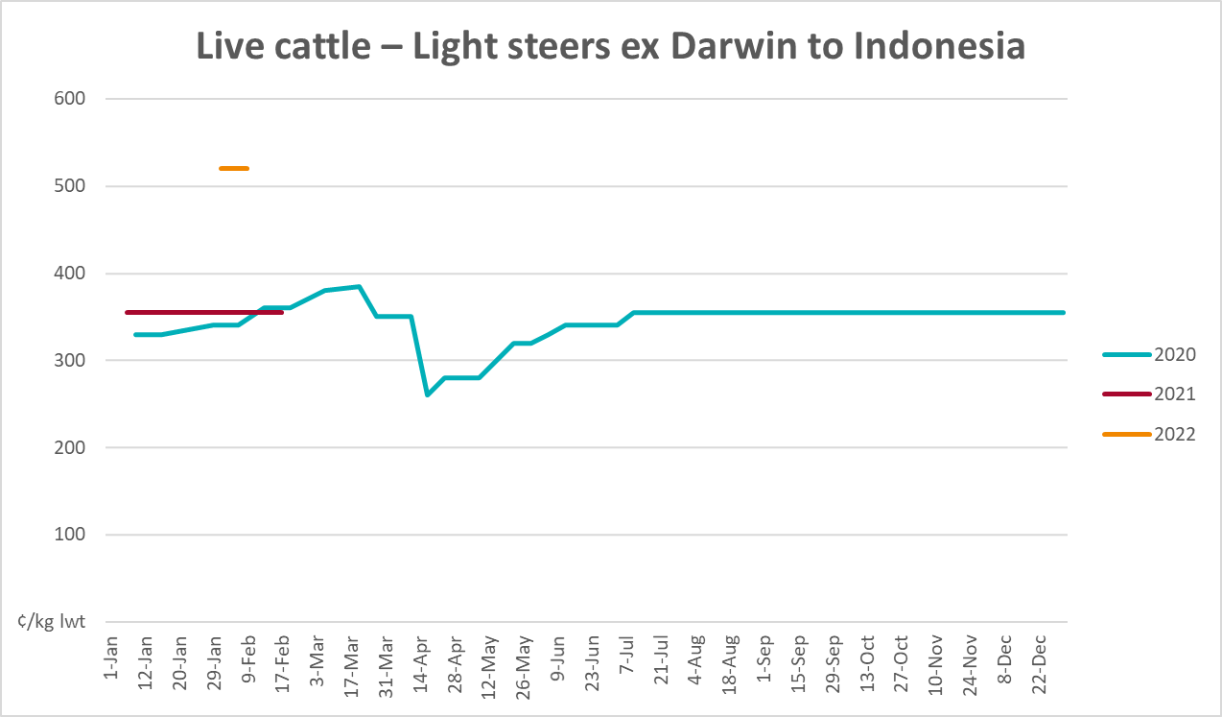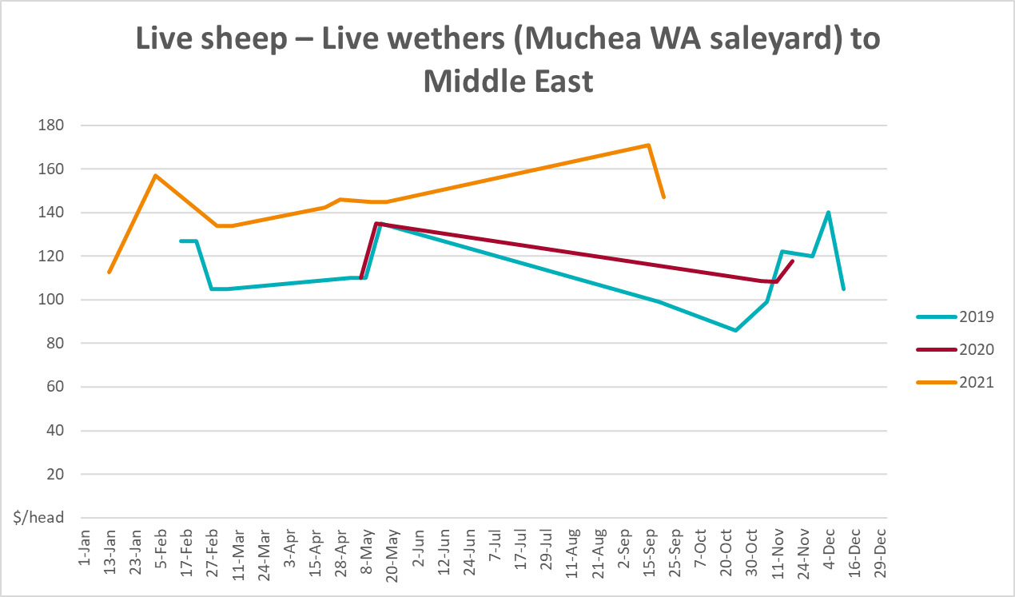

Global Dairy Trade (GDT) weighted average prices
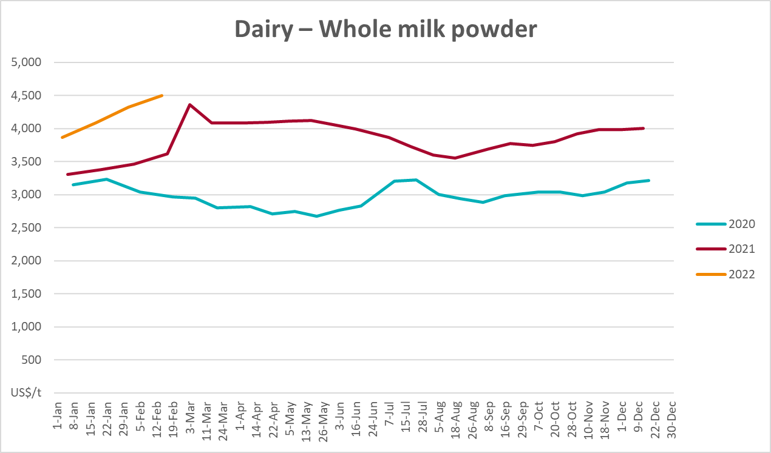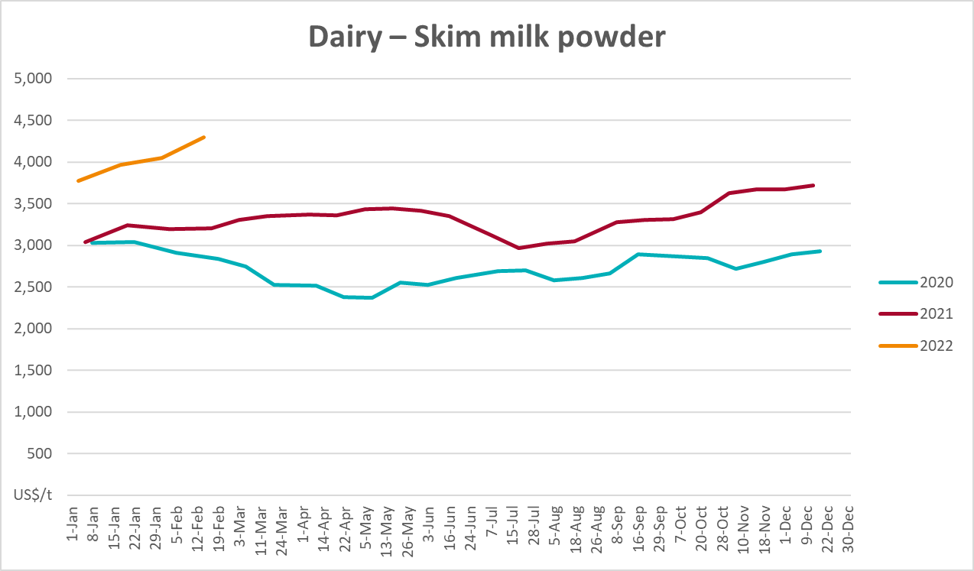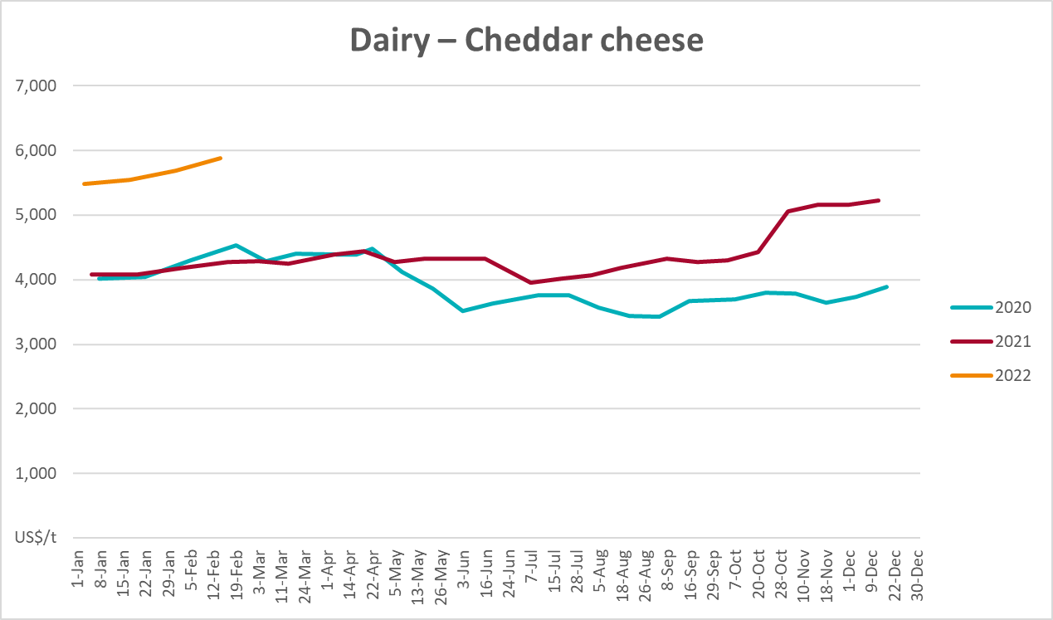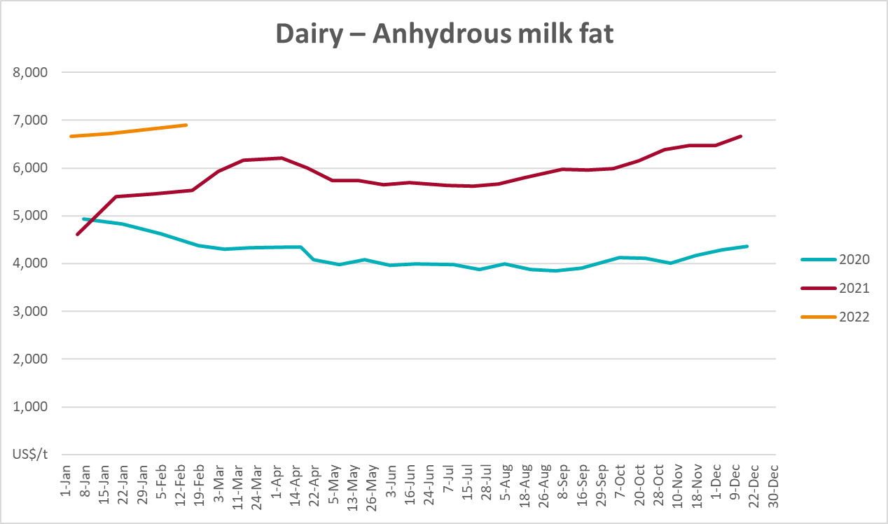

Selected fruit and vegetable prices
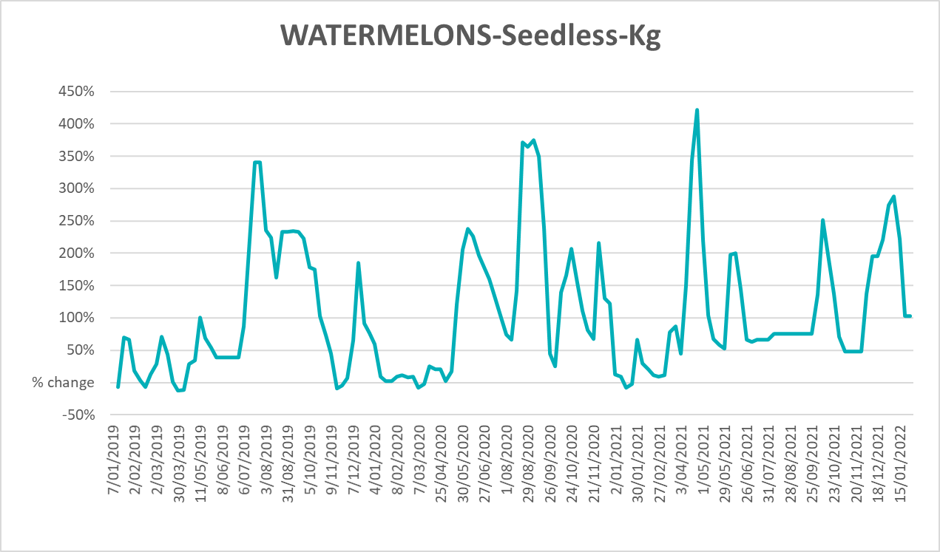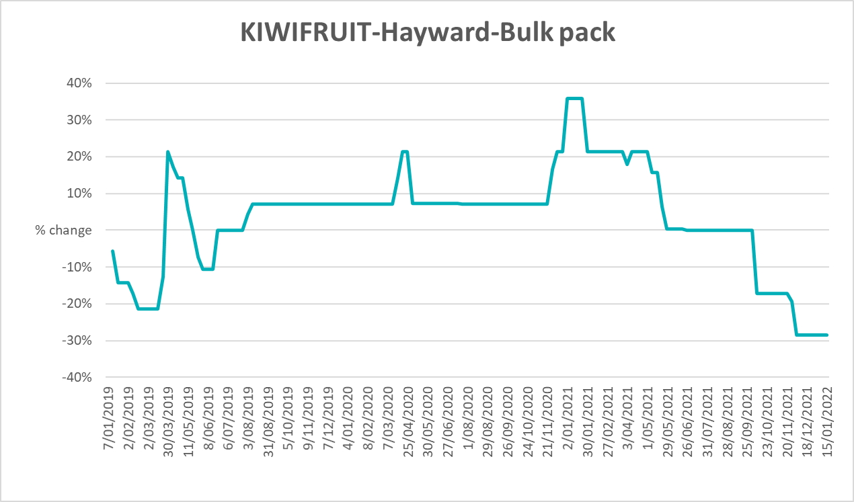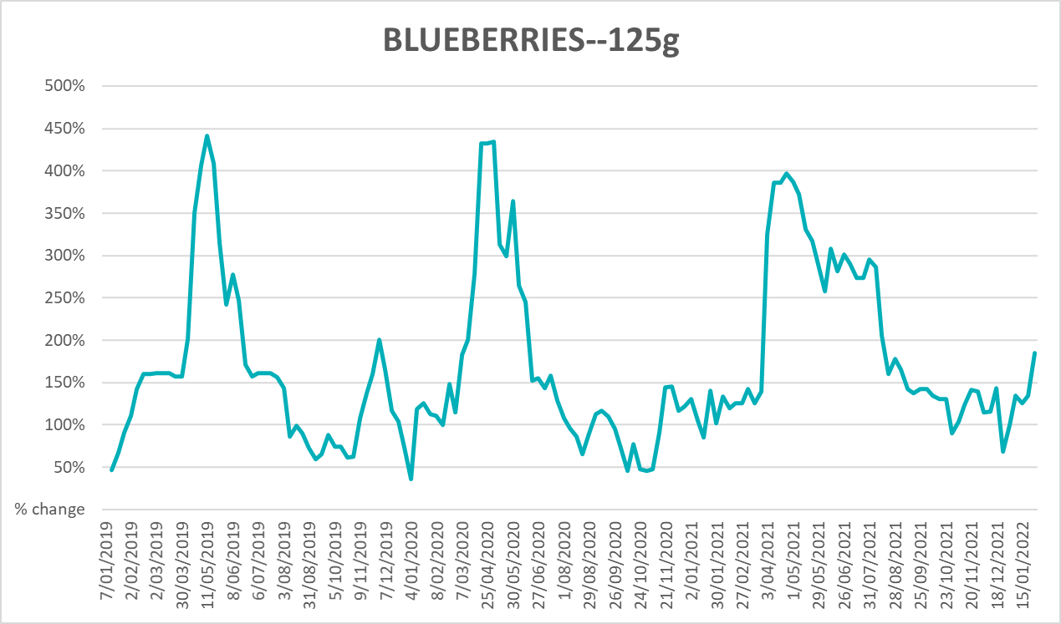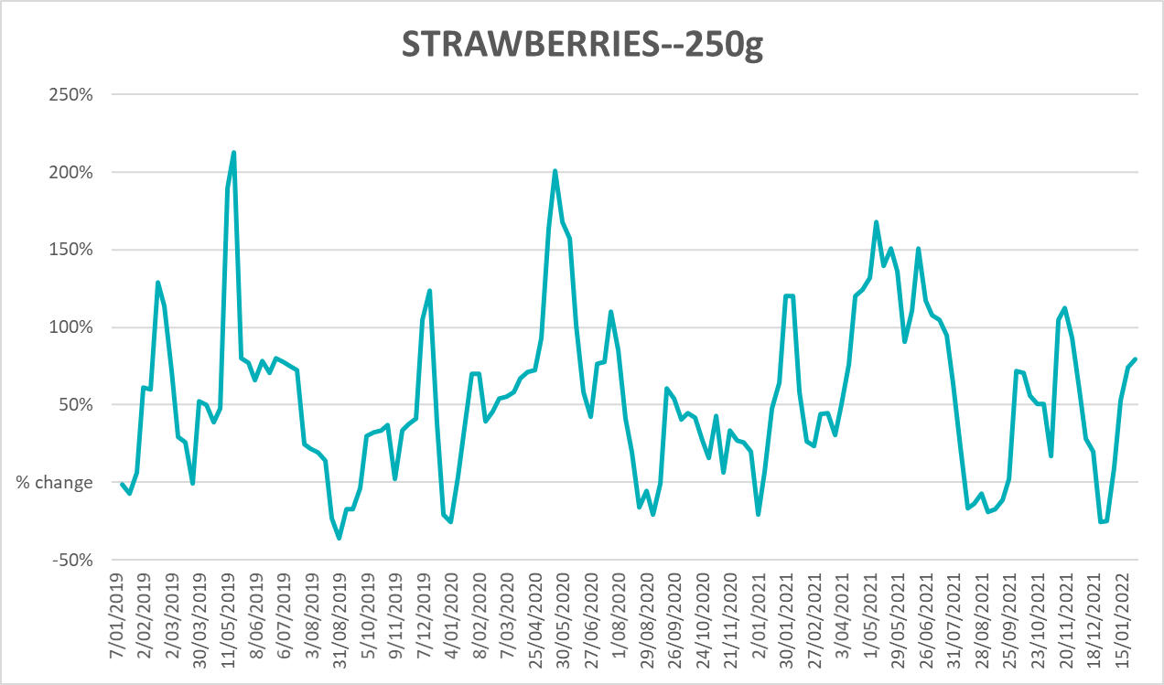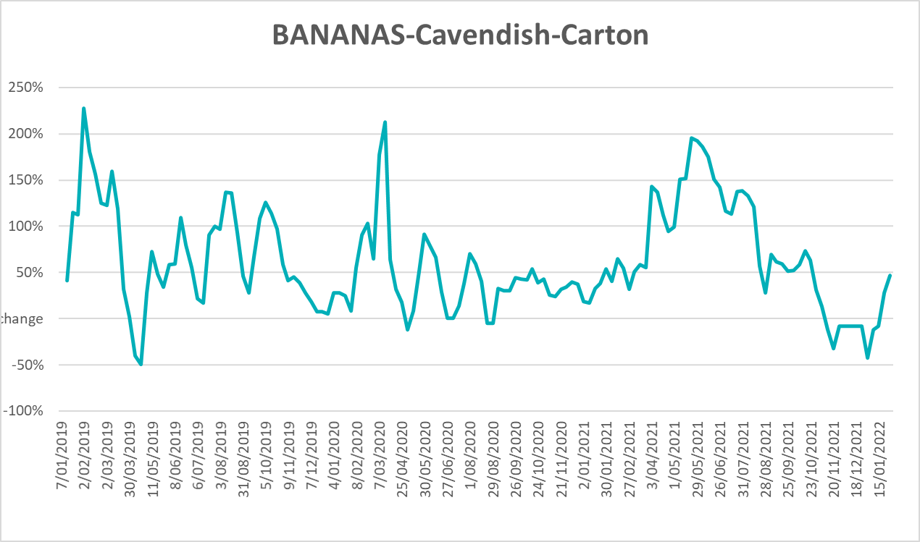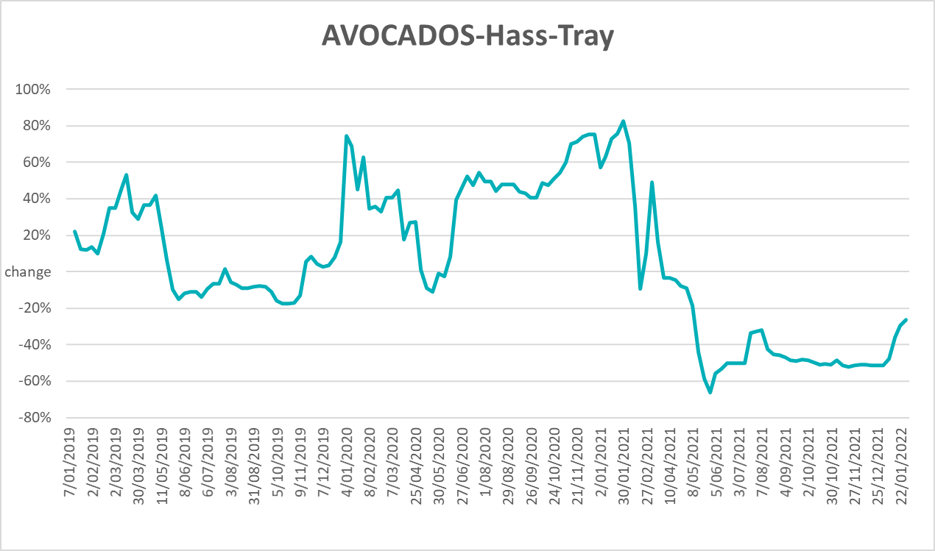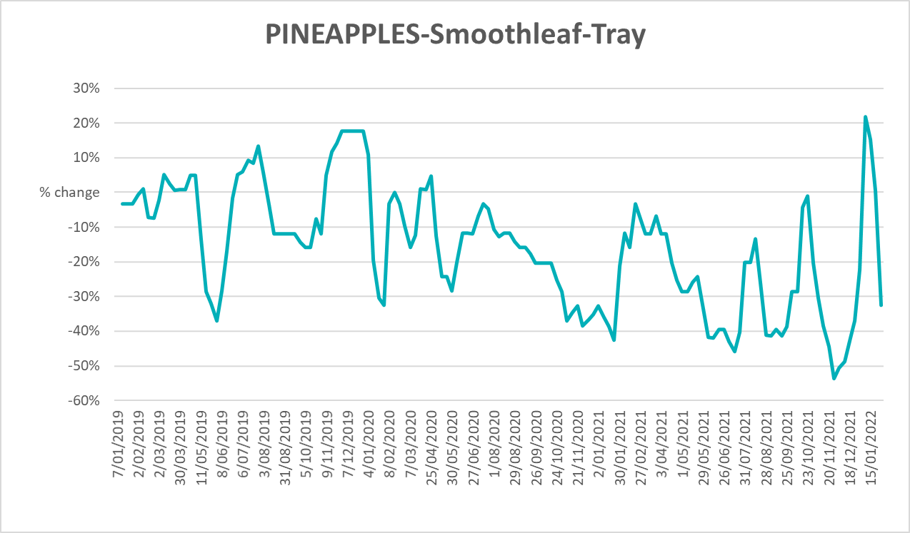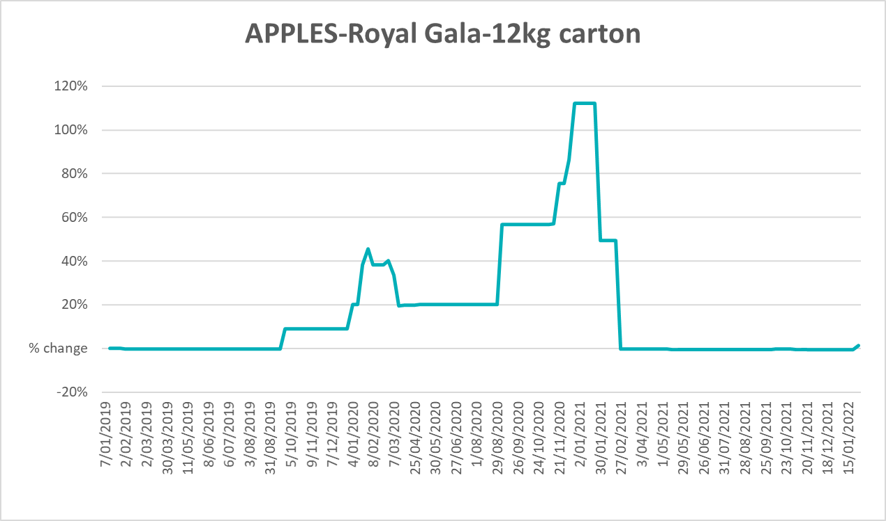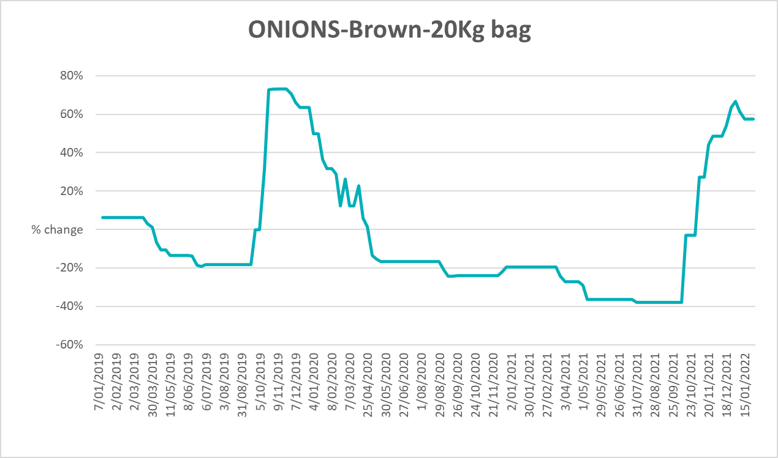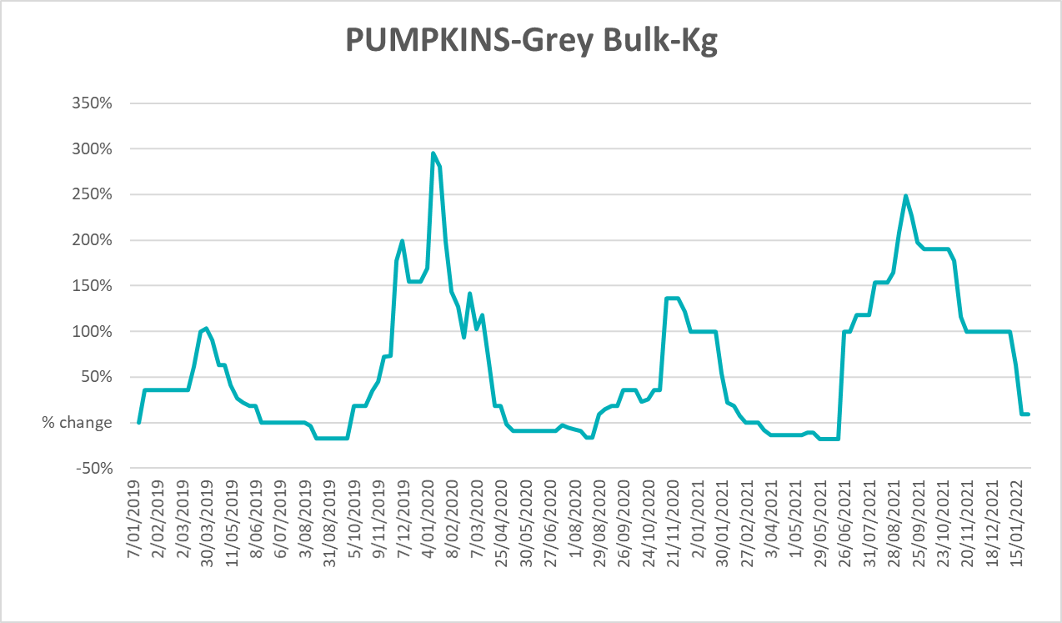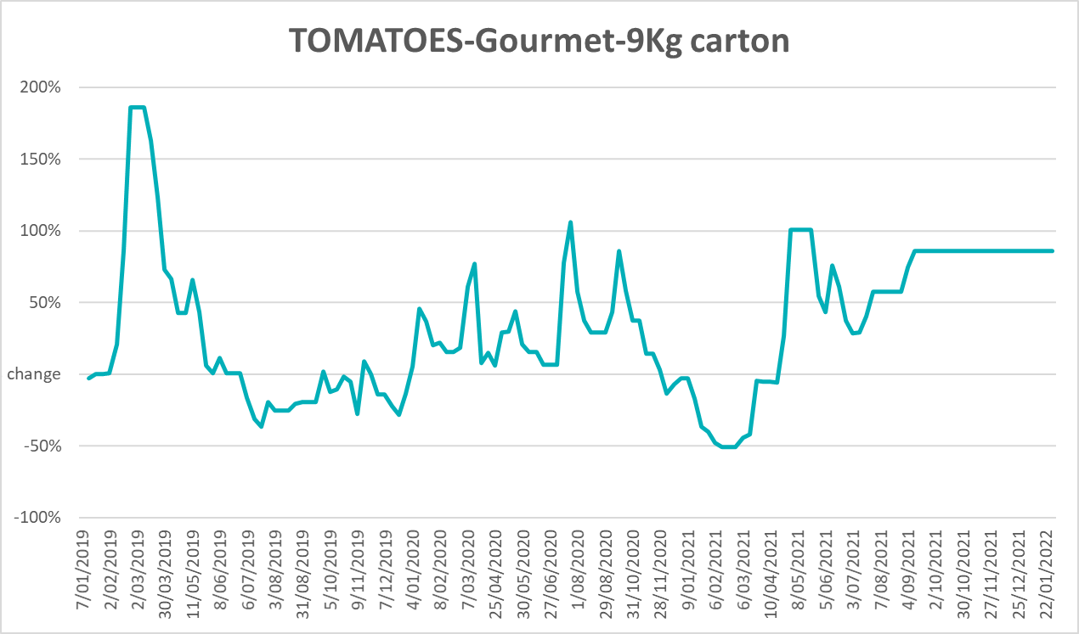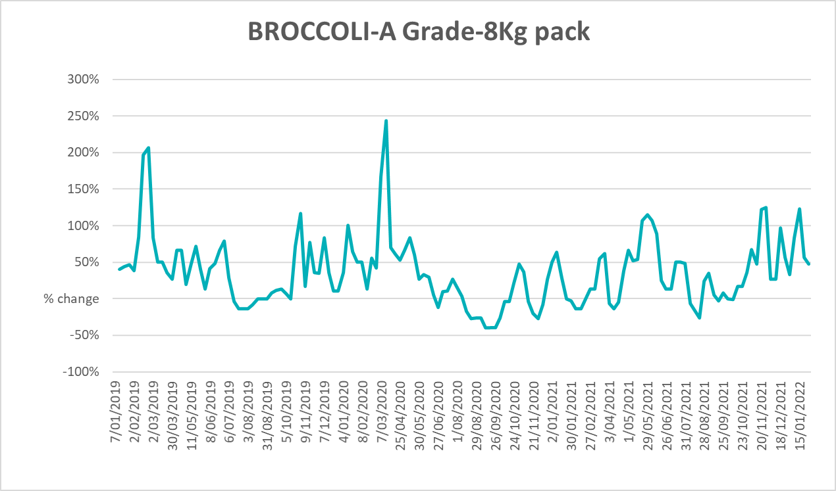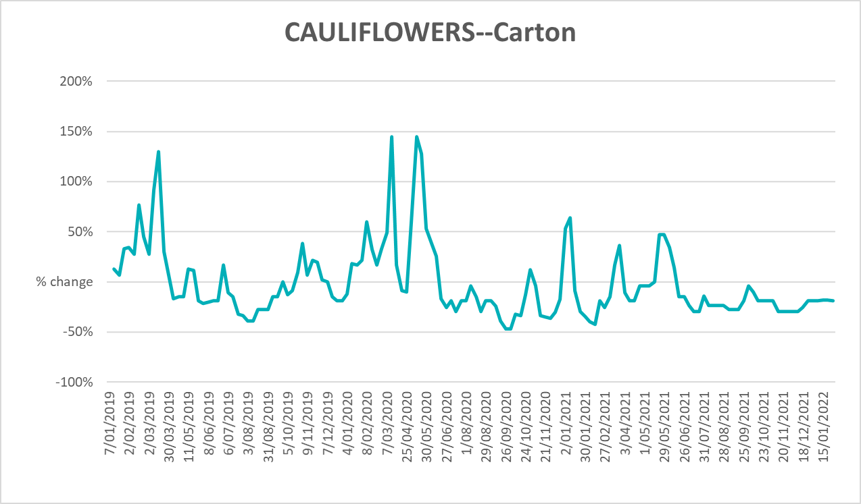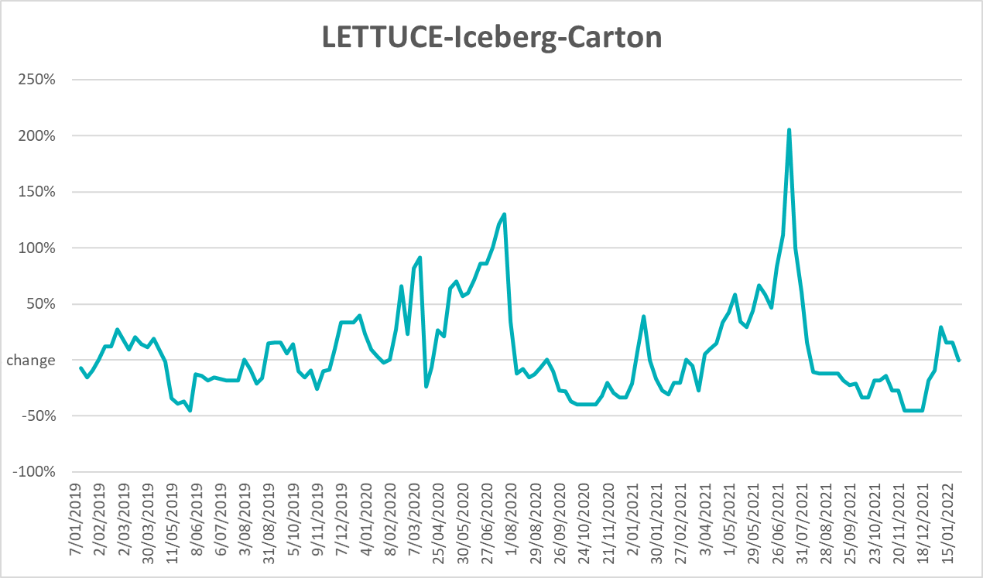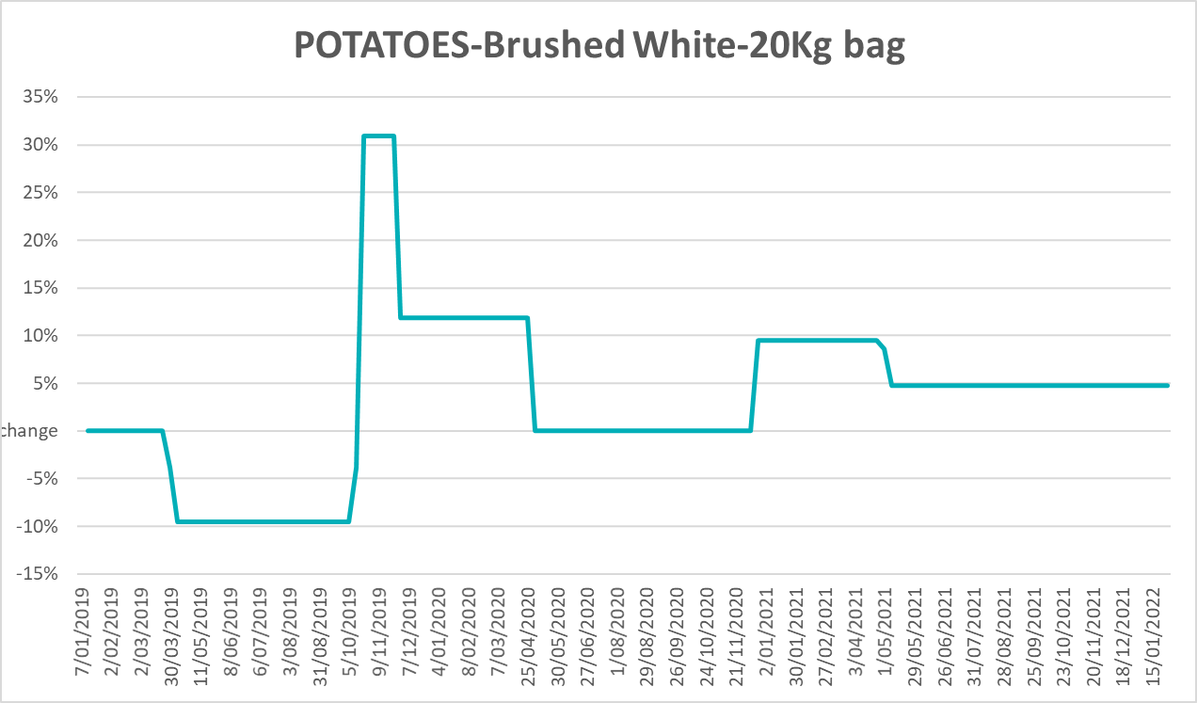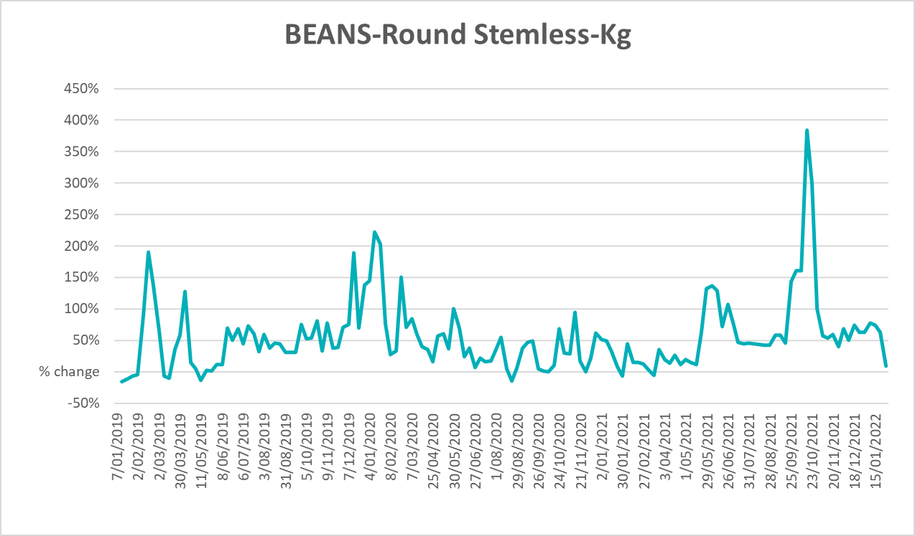

Selected domestic fodder indicator prices
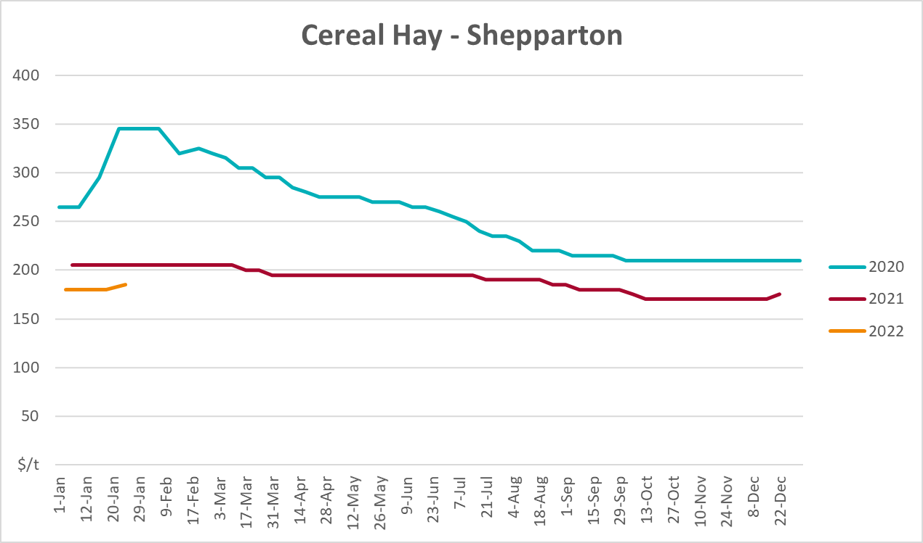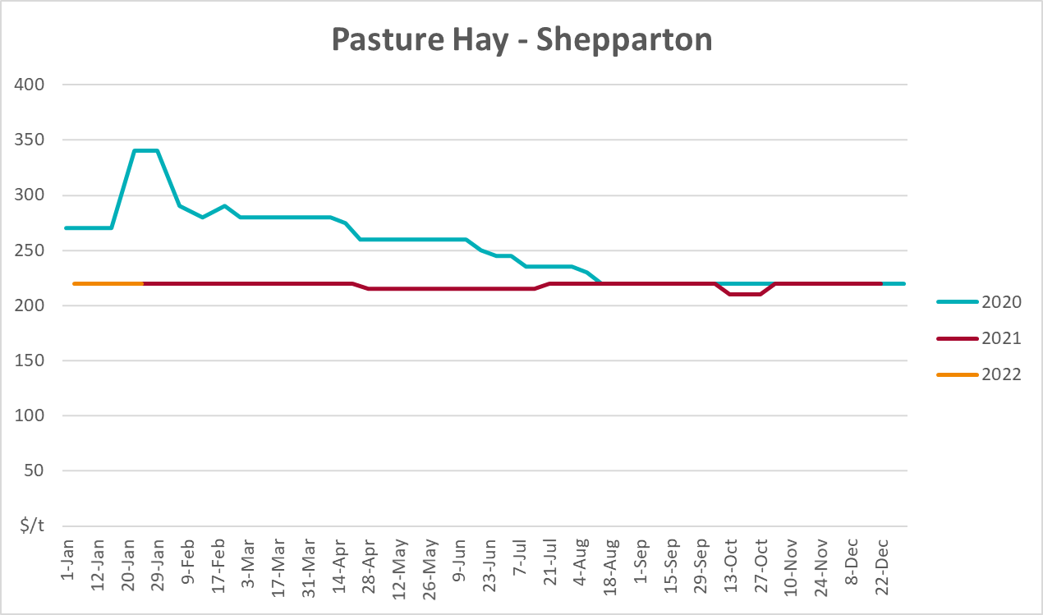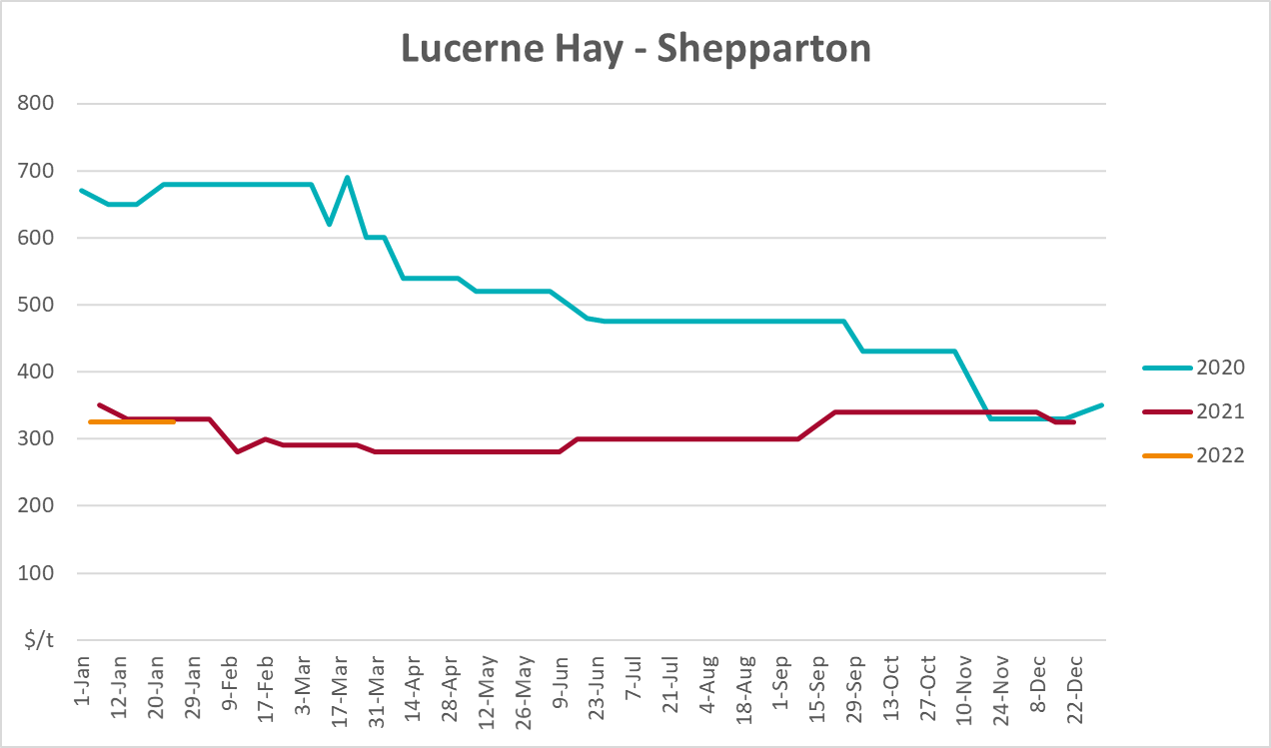

Data attribution

Climate
Bureau of Meteorology
- Weekly rainfall totals: www.bom.gov.au/climate/maps/rainfall/
- Monthly and last 3-month rainfall percentiles: www.bom.gov.au/water/landscape/
- Temperature anomalies: www.bom.gov.au/jsp/awap/temp/index.jsp
- Rainfall forecast: www.bom.gov.au/jsp/watl/rainfall/pme.jsp
- Seasonal outlook: www.bom.gov.au/climate/outlooks/#/overview/summary/
- Climate drivers: http://www.bom.gov.au/climate/enso/
- Soil moisture: www.bom.gov.au/water/landscape/
Other
- Pasture growth: www.longpaddock.qld.gov.au/aussiegrass/
- 3-month global outlooks: Environment and Climate Change Canada, NOAA Climate Prediction Center, EUROBRISA CPTEC/INPE, European Centre for Medium-Range Weather Forecasts, Hydrometcenter of Russia, National Climate Center Climate System Diagnosis and Prediction Room (NCC), International Research Institute for Climate and Society
- Global production: https://ipad.fas.usda.gov/ogamaps/cropmapsandcalendars.aspx
- Autumn break: Pook et al., 2009, https://rmets-onlinelibrary-wiley-com.virtual.anu.edu.au/doi/epdf/10.1002/joc.1833

Water
Prices
- Waterflow: https://www.waterflow.io/
- Ruralco: https://www.ruralcowater.com.au/
Bureau of Meteorology:
- Allocation trade: http://www.bom.gov.au/water/dashboards/#/water-markets/mdb/at
- Storage volumes: http://www.bom.gov.au/water/dashboards/#/water-storages/summary/drainage
Trade constraints:
- Water NSW: https://www.waternsw.com.au/customer-service/ordering-trading-and-pricing/trading/murrumbidgee
- Victorian Water Register: https://www.waterregister.vic.gov.au/TradingRules2019/

Commodities
Fruit and vegetables
- Datafresh: www.freshstate.com.au
Pigs
- Australian Pork Limited: www.australianpork.com.au
Dairy
- Global Dairy Trade: www.globaldairytrade.info/en/product-results/
World wheat, canola
- International Grains Council
World coarse grains
- United States Department of Agriculture
World cotton
- Cotlook: www.cotlook.com/
World sugar
- New York Stock Exchange - Intercontinental Exchange
Wool
- Australian Wool Exchange: www.awex.com.au/
Domestic wheat, barley, sorghum, canola and fodder
- Jumbuk Consulting Pty Ltd: http://www.jumbukag.com.au/
Cattle, beef, mutton, lamb, goat and live export
- Meat and Livestock Australia: www.mla.com.au/Prices-and-market
© Commonwealth of Australia 2022

Ownership of intellectual property rights
Unless otherwise noted, copyright (and any other intellectual property rights, if any) in this publication is owned by the Commonwealth of Australia (referred to as the Commonwealth).

Creative Commons licence
All material in this publication is licensed under a Creative Commons Attribution 4.0 International Licence except content supplied by third parties, logos and the Commonwealth Coat of Arms.
Inquiries about the licence and any use of this document should be emailed to copyright@awe.gov.au.


Cataloguing data
This publication (and any material sourced from it) should be attributed as:
ABARES 2021, Weekly Australian Climate, Water and Agricultural Update, Australian Bureau of Agricultural and Resource Economics and Sciences, Canberra, 17 February 2021. CC BY 4.0 DOI: https://doi.org/10.25814/5f3e04e7d2503
ISSN 2652-7561
This publication is available at https://www.agriculture.gov.au/abares/products/weekly_update
Department of Agriculture, Water and the Environment
GPO Box 858 Canberra ACT 2601
Telephone 1800 900 090
Web awe.gov.au/abares

Disclaimer
The Australian Government acting through the Department of Agriculture, Water and the Environment, represented by the Australian Bureau of Agricultural and Resource Economics and Sciences, has exercised due care and skill in preparing and compiling the information and data in this publication. Notwithstanding, the Department of Agriculture, Water and the Environment, ABARES, its employees and advisers disclaim all liability, including liability for negligence and for any loss, damage, injury, expense or cost incurred by any person as a result of accessing, using or relying on any of the information or data in this publication to the maximum extent permitted by law.

Statement of Professional Independence
The views and analysis presented in ABARES publications, including this one, reflect ABARES professionally independent findings, based on scientific and economic concepts, principles, information and data. These views, analysis and findings may not reflect or be consistent with the views or positions of the Australian Government, or of organisations or groups who have commissioned ABARES reports or analysis. More information on professional independence is provided on the ABARES website.

Acknowledgements
This report was prepared by Matthew Miller and Cameron Van-Lane.

